Pass it on graph style
Students play a game of ‘Pass it on’ using different graphs to highlight the need for shared terminology of the features used to describe graphs.
Students will need at least one digital device per pair to interact with an Excel spreadsheet during this lesson.

Visible learning

Learning intention
- To be able to describe the features of a graph.

Success criteria
- I can identify clusters, gaps and outliers in graphs.
- I can describe a dataset as having no modes, one mode, 2 modes or multiple modes.

Syllabus outcomes
A student:
- develops understanding and fluency in mathematics through exploring and connecting mathematical concepts, choosing and applying mathematical techniques to solve problems, and communicating their thinking and reasoning coherently and clearly MAO-WM-01
- analyses simple datasets using measures of centre, range and shape of the data
MA4-DAT-C-02
Mathematics K–10 Syllabus © NSW Education Standards Authority (NESA) for and on behalf of the Crown in right of the State of New South Wales, 2022.

Activity structure

Launch
- Assign students the desmos classroom activity ‘Pass it on’. Students will be paired up by the program and will take turns guessing each other’s graphs. Students should play the game multiple times to ensure they have the opportunity to describe different types of graphs.
- Use a Pose-Pause-Pounce-Bounce (PDF 557 KB) (bit.ly/posepausepouncebounce) questioning strategy to discuss which graphs were the easiest and hardest to describe and why.
For more information on how to set up and assign a desmos classroom activity, visit bit.ly/desmosclassroomstrategy.

Alternative activity if technology not available
- Distribute Appendix A ‘Pass it on’, cut into cards, to each pair of students. This Appendix contains a variety of graphs.
- Verbally share the instructions of the game ‘Pass it on’. They can be found below or in Appendix A ‘Pass it on’:
- In pairs, decide who will be Player 1 and Player 2.
- Player 1 should select a card.
- Player 1 is to describe the graph on their card for Person 2 to draw.
- Once they have finished, they should compare the drawing with the original graph.
- The pairs should swap roles and repeat.
Students should complete at least 4 rounds of this activity, so that each student can describe a graph at least twice.
- Use a Pose-Pause-Pounce-Bounce (PDF 557 KB) (bit.ly/posepausepouncebounce) questioning strategy to discuss which graphs were the easiest and hardest to describe and why.

Explore
- Brainstorm with students to create a word cloud of the terms they used to describe the graphs from the desmos activity or the cards in Appendix A.
Word clouds can be created using Mentimeter (mentimeter.com).
- In a Think-Pair-Share (bit.ly/thinkpairsharestrategy) students should discuss which words or phrases they feel would best help them to explain graphs and why.
- Display the terms cluster, gap, outlier, uniform, unimodal, bimodal and multimodal.
Students were introduced to the terms uniform, unimodal, bimodal and multimodal in Year 7 Unit 2 – making decisions, but they may not yet form part of their everyday vocabulary.
- In visibly random groups of 3 (bit.ly/visiblegroups) on vertical non-permanent surfaces (bit.ly/VNPSstrategy), ask students to write down definitions for these words and draw examples.
It may be beneficial to draw students’ attention back to the word cloud and the graphs from the Launch activity, as students may be able to use some of those words and pictures for their definitions and examples.
- Students are to do a gallery walk (bit.ly/DLSgallerywalk) to compare their definitions with those of their peers.

Definitions of each word are listed below:
- A cluster is when a collection of data values is positioned around similar points.
- A gap is when there is a large break between numbers in a dataset.
- An outlier is a data value that appears to stand out from the other members of the dataset by being unusually high or low.
- When a dataset is uniform it means that there is no mode, as all values are consistent and occur the same number of times.
- When a dataset is unimodal it means that it has one mode.
- When a dataset is bimodal it means that it has 2 modes.
- When a dataset is multimodal it means that it has multiple modes.
- Use a Pose-Pause-Pounce-Bounce questioning technique for student to share their favourite definition and example from another group.
- Add these terms to the word cloud along with any other terms students may have missed such as positively skewed, negatively skewed, symmetrical. Highlight any colloquial terms that may have been used that could be replaced with mathematical terminology.

Summarise
- Students are to create notes to their forgetful future selves (bit.ly/notesstrategy) by looking around the room to find the best definition of the terminology provided and to draw an example.
- Students are to use the desmos classroom activity or the cards from Appendix A ‘Pass it on’ to play the game again and see if they find it easier to describe the graphs.

Apply
- Give students access to a local copy of the Excel spreadsheet Pass it on graph style.
Instructions on how to distribute an Excel sheet can be found in Appendix B ‘File sharing and saving’.
- Students are to select at least one of the datasets from the spreadsheet to create a mini presentation. This must include:
- A visual display of data in a graph of their choice.
- An explanation as to why that graph is the best way to display the data.
- A description of the shape of the data.
- An explanation of why the data may have taken on that distribution.
Students can use the functions of spreadsheets to draw their graphs. You can find tutorials on the Microsoft Office support page ‘Create a chart from start to finish’ (bit.ly/helpexcelgraph).
It is suggested that teachers use Flip (flipgrid.com) for students to create and submit their mini presentations.
- Students are to give peer feedback on each other’s presentations using the TAG feedback format (bit.ly/TAGstrategy).

Assessment and differentiation

Suggested opportunities for differentiation
Launch
- All students will be able to participate using differing levels of terminology.
- After students have played the game once, encourage them to think about terms they have learnt during this unit.
Explore
- There are no correct answers creating the word cloud so all students should be encouraged to participate and share their thoughts.
- Students develop definitions in groups and can select their favourite or join definitions that make sense to them.
- Students could draw visual representations as their definitions to show their understanding.
Summarise
- Students are supported by being able to choose definitions from around the room to include in their notes. Students can be challenged by choosing more sophisticated examples to accompany their definitions.
Apply
- Students can find their own data to create their presentation.
- Encourage students to refer to the word cloud for terms to describe their graph.
- Teachers can alter the length and level of detail required in student’s presentations to match their level of readiness.

Suggested opportunities for assessment
Explore
- The word cloud can be used to show student’s vocabulary and what words they understand the meaning of.
Summarise
- Collect student’s definitions and examples to check for understanding.
- Students will demonstrate their working mathematically skills in discussions when re-playing the game.
Apply
- Student’s presentations can be collected as evidence of learning or summative assessment.

Appendix A

Pass it on

Rules
- In pairs, decide who will be Player 1 and Player 2.
- Player 1 should select a card which has a picture of a graph on it.
- Player 1 is to describe the graph on their card for Person 2 to draw.
- Once they have finished, they should compare the drawing with the original graph.
- The pairs should swap roles and repeat.

Graphs
- 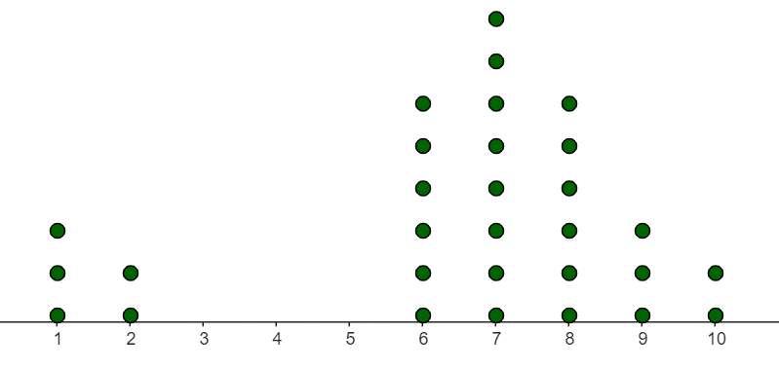
- 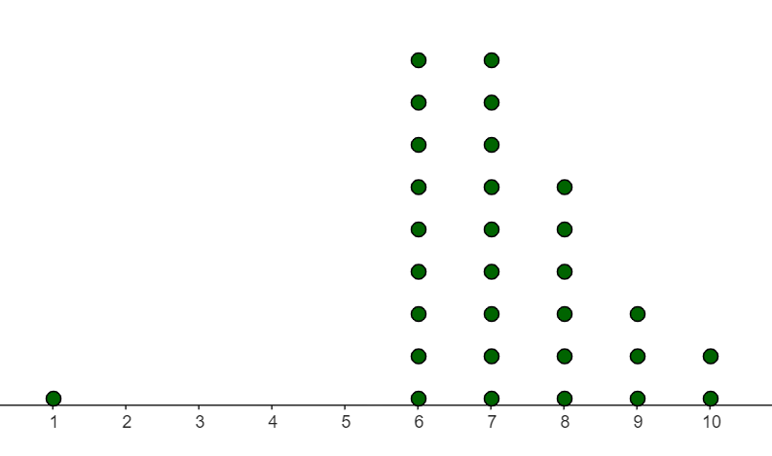
- 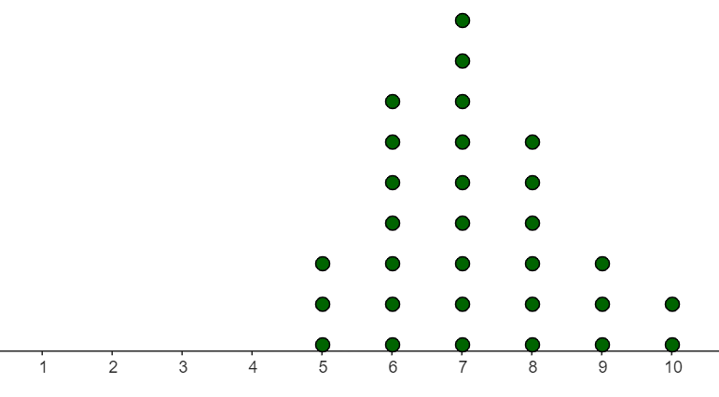
- 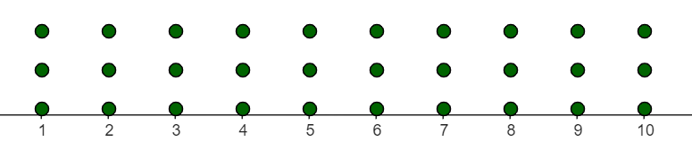
- 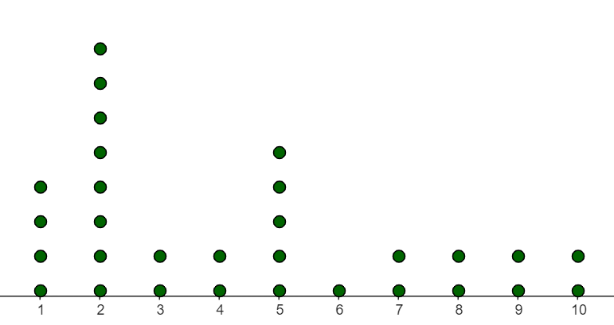
- 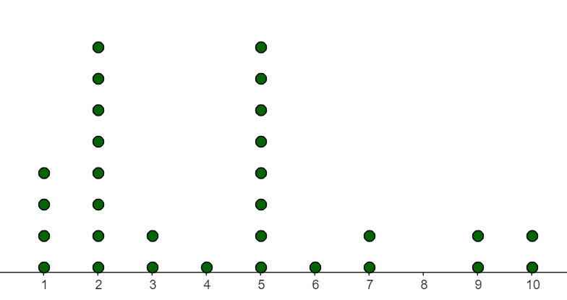
- 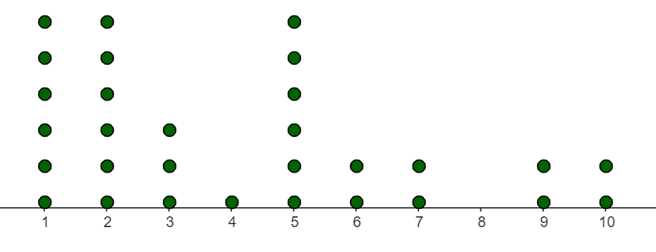
- 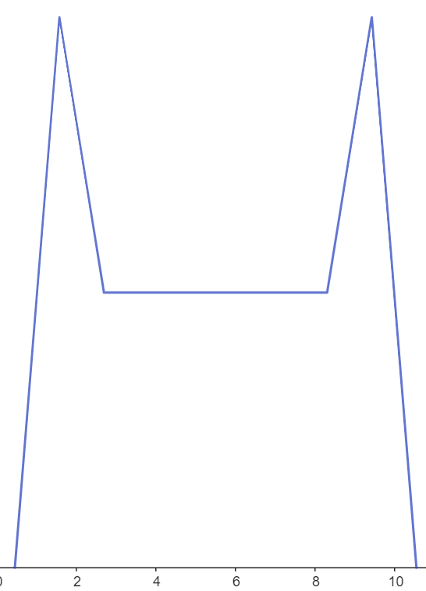
- 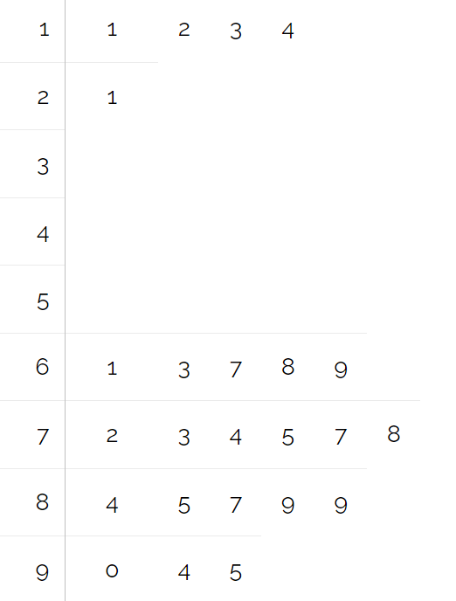
- 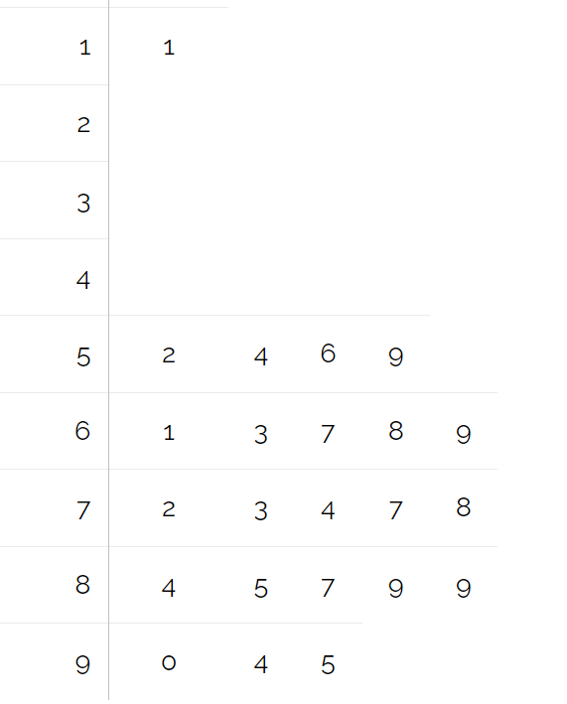
- 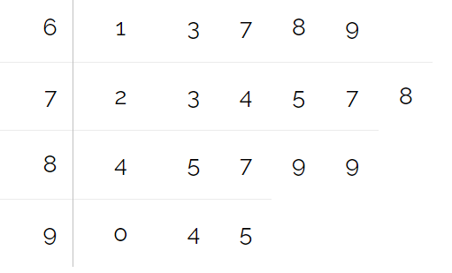
- 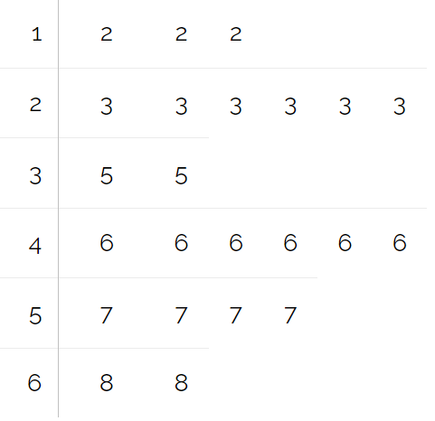
- 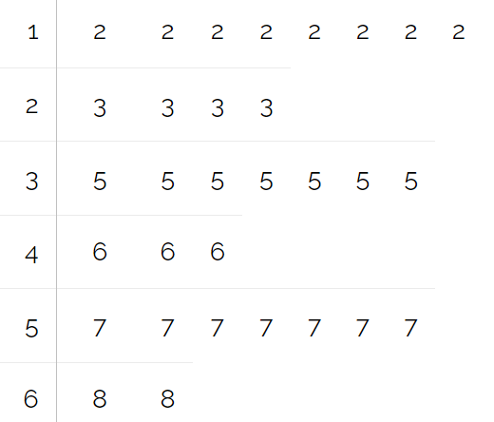
- 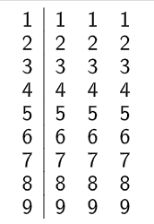
- 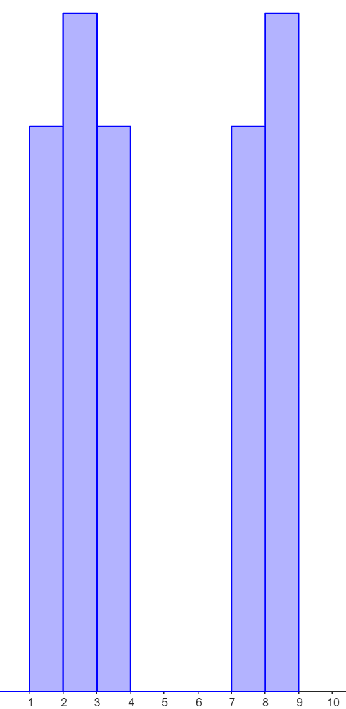
- 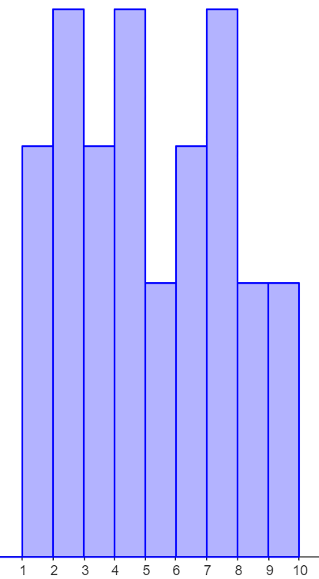
- 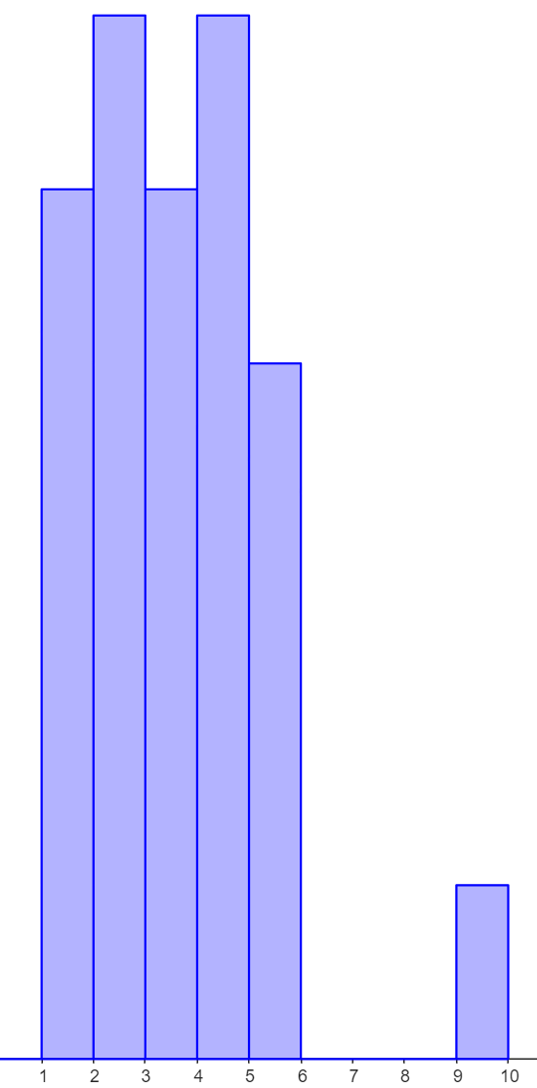
- 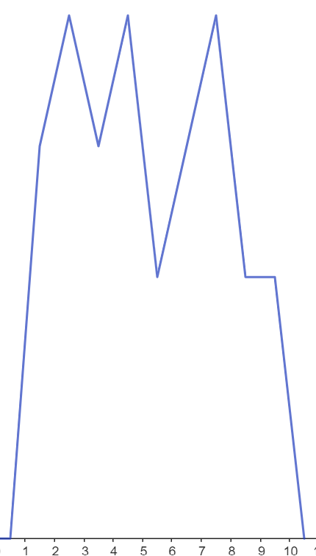

Appendix B

File sharing and saving
- Save the Excel file Pass it on graph style in a place where students can easily access the file.
This might be via Google classrooms, using a link in OneNote or emailing students a copy of the document.
- Have students open the document on their own device.
- Instruct students to select the File tab and then Save a Copy.
Figure 1: 'Save a Copy' screenshot
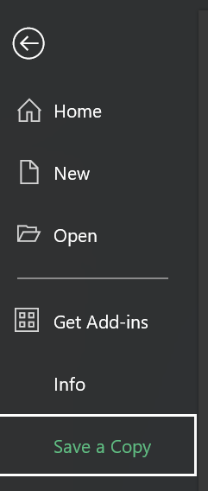
- Students can save the document to their individual OneDrive by selecting this option.
Figure 2: save to OneDrive screenshot
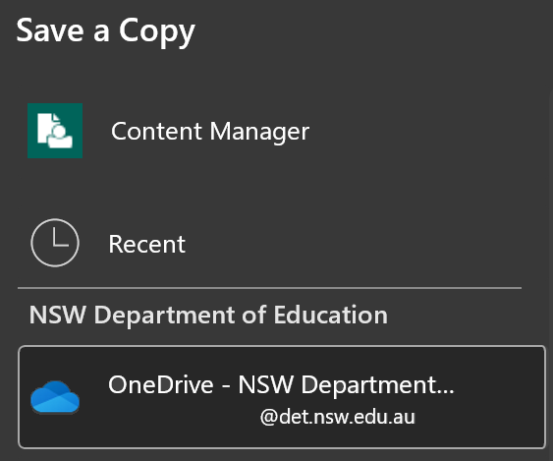
- Best practice would be to keep the file name the same and add their name to the end. Students can then select Save and a copy will be stored in their OneDrive.
Figure 3: save with the same file name screenshot
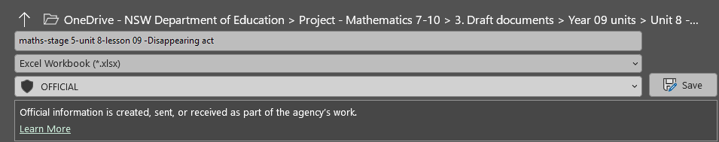

References
This resource contains NSW Curriculum and syllabus content. The NSW Curriculum is developed by the NSW Education Standards Authority. This content is prepared by NESA for and on behalf of the Crown in right of the State of New South Wales. The material is protected by Crown copyright.
Please refer to the NESA Copyright Disclaimer for more information https://educationstandards.nsw.edu.au/wps/portal/nesa/mini-footer/copyright.
NESA holds the only official and up-to-date versions of the NSW Curriculum and syllabus documents. Please visit the NSW Education Standards Authority (NESA) website https://educationstandards.nsw.edu.au/ and the NSW Curriculum website https://curriculum.nsw.edu.au/home.
Mathematics K–10 Syllabus © NSW Education Standards Authority (NESA) for and on behalf of the Crown in right of the State of New South Wales, 2022.

© State of New South Wales (Department of Education), 2024
The copyright material published in this resource is subject to the Copyright Act 1968 (Cth) and is owned by the NSW Department of Education or, where indicated, by a party other than the NSW Department of Education (third-party material).
Copyright material available in this resource and owned by the NSW Department of Education is licensed under a Creative Commons Attribution 4.0 International (CC BY 4.0) license.
This license allows you to share and adapt the material for any purpose, even commercially.
Attribution should be given to © State of New South Wales (Department of Education), 2024.
Material in this resource not available under a Creative Commons license:
- the NSW Department of Education logo, other logos and trademark-protected material
- material owned by a third party that has been reproduced with permission. You will need to obtain permission from the third party to reuse its material.
Links to third-party material and websites
Please note that the provided (reading/viewing material/list/links/texts) are a suggestion only and implies no endorsement, by the New South Wales Department of Education, of any author, publisher, or book title. School principals and teachers are best placed to assess the suitability of resources that would complement the curriculum and reflect the needs and interests of their students.
If you use the links provided in this document to access a third-party's website, you acknowledge that the terms of use, including licence terms set out on the third-party's website apply to the use which may be made of the materials on that third-party website or where permitted by the Copyright Act 1968 (Cth). The department accepts no responsibility for content on third-party websites.

