Picture perfect
Students describe the skewness of frequency histograms and polygons in reference to exposure in photographs.

Visible learning

Learning intention
- To be able to describe the shape of a frequency graph.

Success criteria
- I can describe the skewness of a frequency graph.
- I can explain whether to use the median or mean as a measure of centre for different shaped frequency graphs.
- I can interpret a frequency graph to draw conclusions.

Syllabus outcomes
A student:
- develops understanding and fluency in mathematics through exploring and connecting mathematical concepts, choosing and applying mathematical techniques to solve problems, and communicating their thinking and reasoning coherently and clearly MAO-WM-01
- classifies and displays data using a variety of graphical representations MA4-DAT-C-01
- analyses simple datasets using measures of centre, range and shape of the data
MA4-DAT-C-02
Mathematics K–10 Syllabus © NSW Education Standards Authority (NESA) for and on behalf of the Crown in right of the State of New South Wales, 2022.

Activity structure
Please use the associated PowerPoint Picture perfect to display images in this lesson.

Launch
- Display slide 2 from the PowerPoint Picture perfect to show students the Figure 1 and its corresponding exposure polygon in Figure 2.
Figure 1: a cow and calf
Figure 2: photo exposure polygon
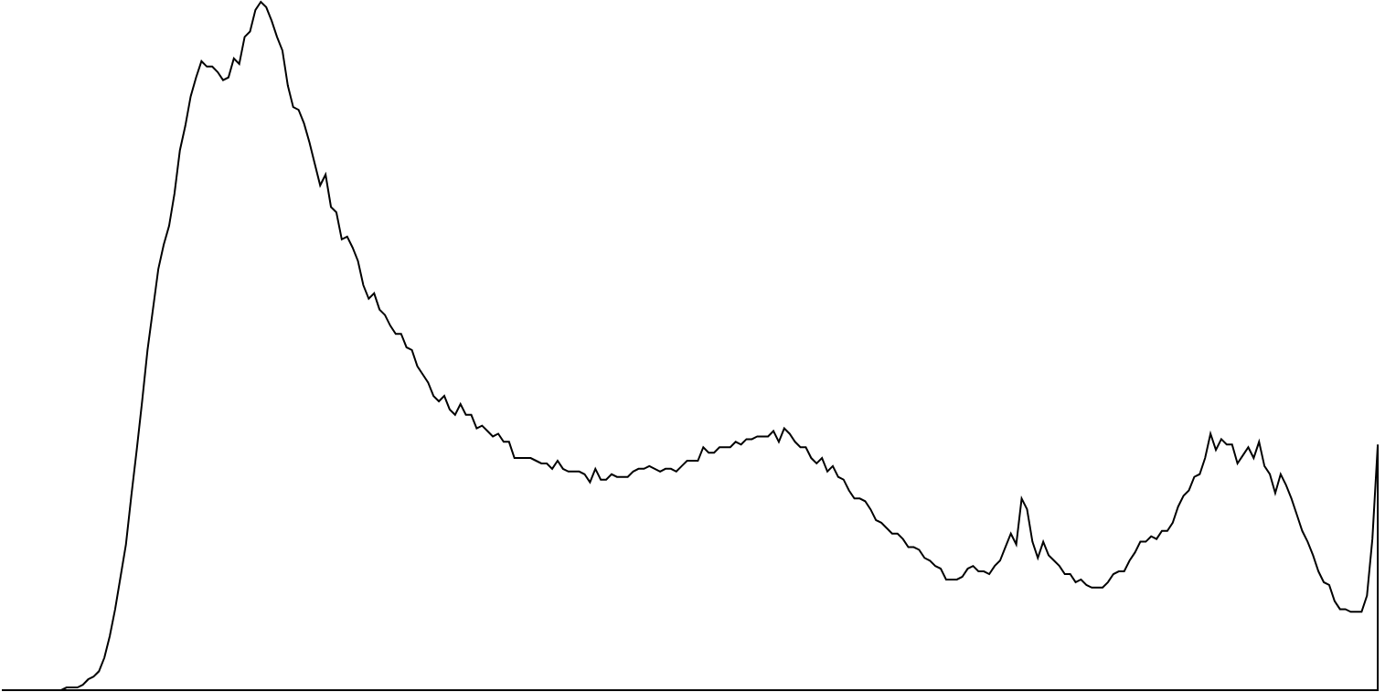
- In a Think-Pair-Share (bit.ly/thinkpairsharestrategy), ask students how they think the picture and frequency polygon are related.
- Explain to students that the frequency polygon shows the exposure of a photo, or the relationship between the brightness of a pixel and the number of pixels there are of that brightness.
Exposure is the amount of light that reaches your camera’s sensor. The light is recorded by the sensor as digital data made up of millions of pixels which are combined to form the final image.
A pixel is a small area of light on a display screen, one of many from which an image is made.
JPEG files use 256 brightness values (0–255) and these are displayed along the x-axis. The left side of the graph represents black and dark areas, the middle represents medium grey and the right represents light and whites.
- In a Think-Pair-Share (bit.ly/thinkpairsharestrategy), ask students to discuss the connection between the graph and the photo, knowing that the graph is representing brightness levels. Ask students to consider whether the photo is mostly made up of dark areas or light. How does the graph show this?
- Use a Pose-Pause-Pounce-Bounce (PDF 557KB) (bit.ly/posepausepouncebounce) questioning strategy for students to share their thoughts.

Explore
- Distribute Appendix A ‘Graphs’ to each pair of students.
- In pairs, students are to group graphs that have a similar shape.
- Use a Pose-Pause-Pounce-Bounce questioning strategy to ask students how they grouped their graphs.
It is assumed students will group their graphs in terms of how the data is distributed.
- Show slide 3 from the PowerPoint Picture perfect, which shows the terms: positively skewed, negatively skewed, symmetrical and bimodal. In pairs, students should discuss which groups of graphs they think relate to each term and why.
- Use a Pose-Pause-Pounce-Bounce questioning strategy to share student thoughts. Students may need assistance to distinguish between positively skewed and negatively skewed data.
For positively skewed data, most of the data is situated to the left side of the graph and for negatively skewed data, it is situated to the right.
- Instruct students to find the mean and mode of one dataset in each group.
Students may find it easier to convert the graphs to frequency tables or raw data to find the mean.
- Ask students to notice and wonder about the mean and mode for negatively skewed data versus positively skewed data. Students could be prompted to consider which is larger in each group or to consider what happens when they subtract the mode from the mean (mean − mode).
Students should discover that when they subtract the mode from the mean, they get a negative solution when the graph is negatively skewed, a positive solution when it is positively skewed and a solution close to zero when the graph is symmetrical. It is impossible to get a solution when it is bimodal, as there are 2 modes.

Summarise
- Students are to complete the Desmos classroom activity ‘Shapes of Distributions’ (https://bit.ly/Distribution_Shapes) to reinforce their knowledge of skewness and measures of central tendency.
Information on how to use Desmos classroom activities can be found at (bit.ly/desmosclassroomstrategy).
- Students are to create notes to their future forgetful selves (bit.ly/notesstrategy) on the different shapes of distributions.

Apply
- Display slide 4 of the PowerPoint Picture perfect. This slide shows pictures with their associated frequency polygons.
- In a Think-Pair-Share, ask students to discuss what they notice and wonder.
Figure 3 – photos and their exposure polygons
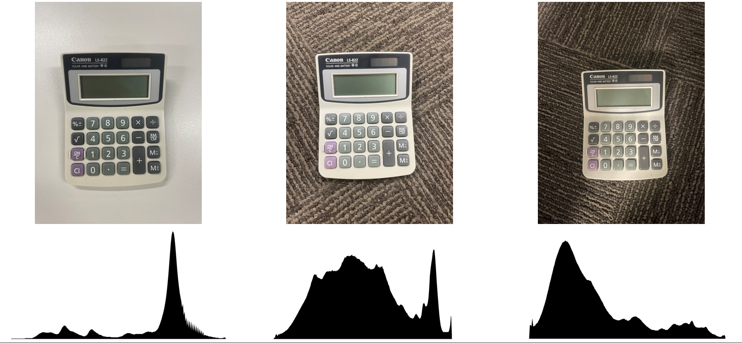
Students should notice that photographs with positively skewed graphs have more dark tones, symmetrical graphs are neutral, and negatively skewed graphs contain lighter tones. They may connect from prior knowledge that pictures that have both extremes of light and dark create a bimodal distribution.
- Display slide 5 from the PowerPoint Picture perfect to display Figure 4.
Figure 4 – pixel art beach scene
Image licensed under Pixabay Content License.
- Ask students how bright they think the picture is and to draw a frequency polygon to represent the brightness of the image.
- Explain to students that they will be making their own exposure histograms. Although JPEG pictures use brightness levels between 0 and 255, they will restrict these to values between 0 and 17.
- Distribute Appendix B ‘Pixel art’ to pairs of students. This Appendix displays Figure 4 and the brightness value and frequency of its pixels.
- Students should now create a frequency graph from the table of values.
- Students should compare the graph to the frequency polygon they estimated earlier.
Students can further explore the shape of distributions of photographs and know when each setting is best by researching photos with extreme contrast, exposed to the left, exposed to the right, overexposed and underexposed.

Assessment and differentiation

Suggested opportunities for differentiation
Launch
- There are no correct answers during the Launch and all students should be encouraged to participate and share their thoughts and reasoning.
Explore
- All students will be able to group the graphs but may display levels of reasoning.
Apply
- You can change the subject of the picture to increase student interest.
- If you have access to cameras that display a frequency polygon, challenge students to create the graphs of different shapes themselves to compare with others in the class.
- Students can be challenged to create, find or modify pixel art that creates a symmetrical distribution.

Suggested opportunities for assessment
Explore
- A Think-Pair-Share provides students with the opportunity to reflect on their understanding.
- Students will demonstrate their Working mathematically skills in discussions and justifications when grouping their frequency distributions.
Summarise
- Review students’ notes to their future forgetful selves.
Apply
- The pixel art activity can be collected as evidence of student learning.

Appendix A

Graphs
Group the graphs that have similar shaped distributions.
- 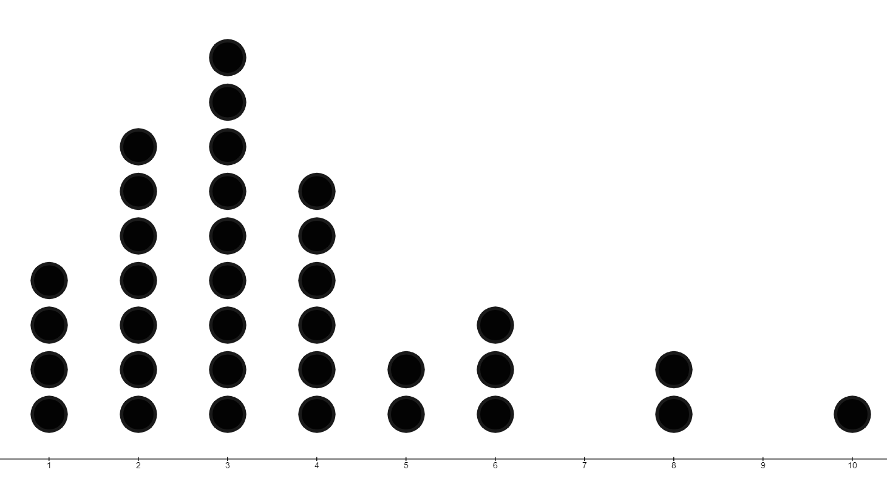
- 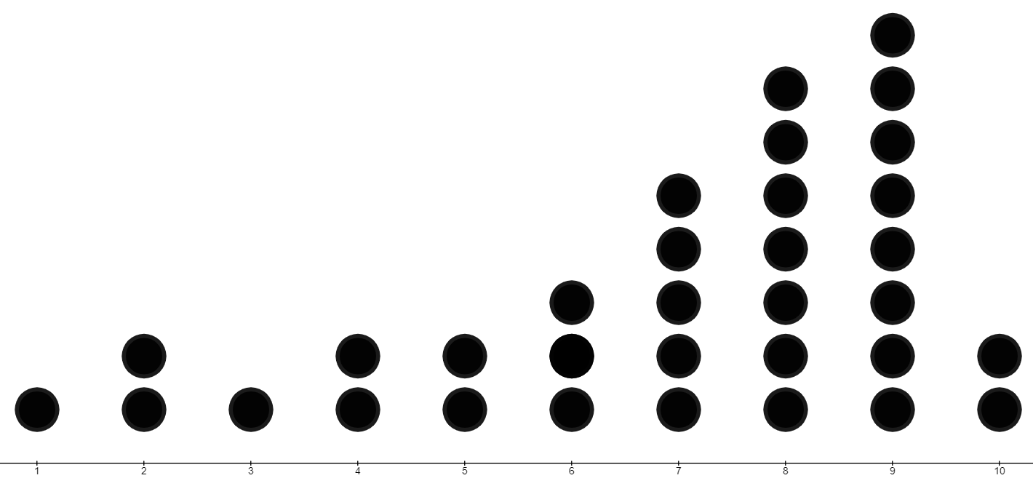
- 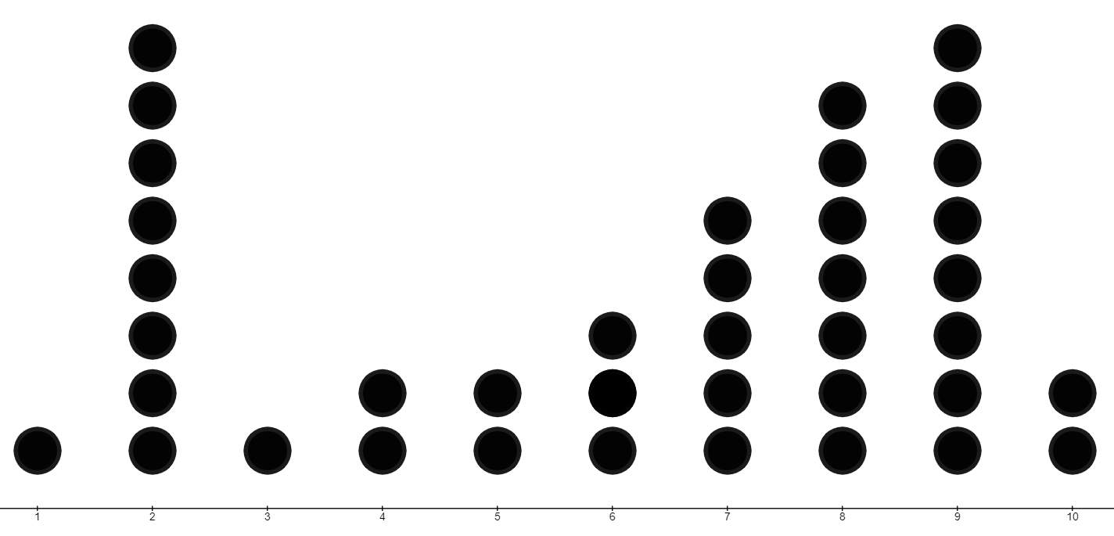
- 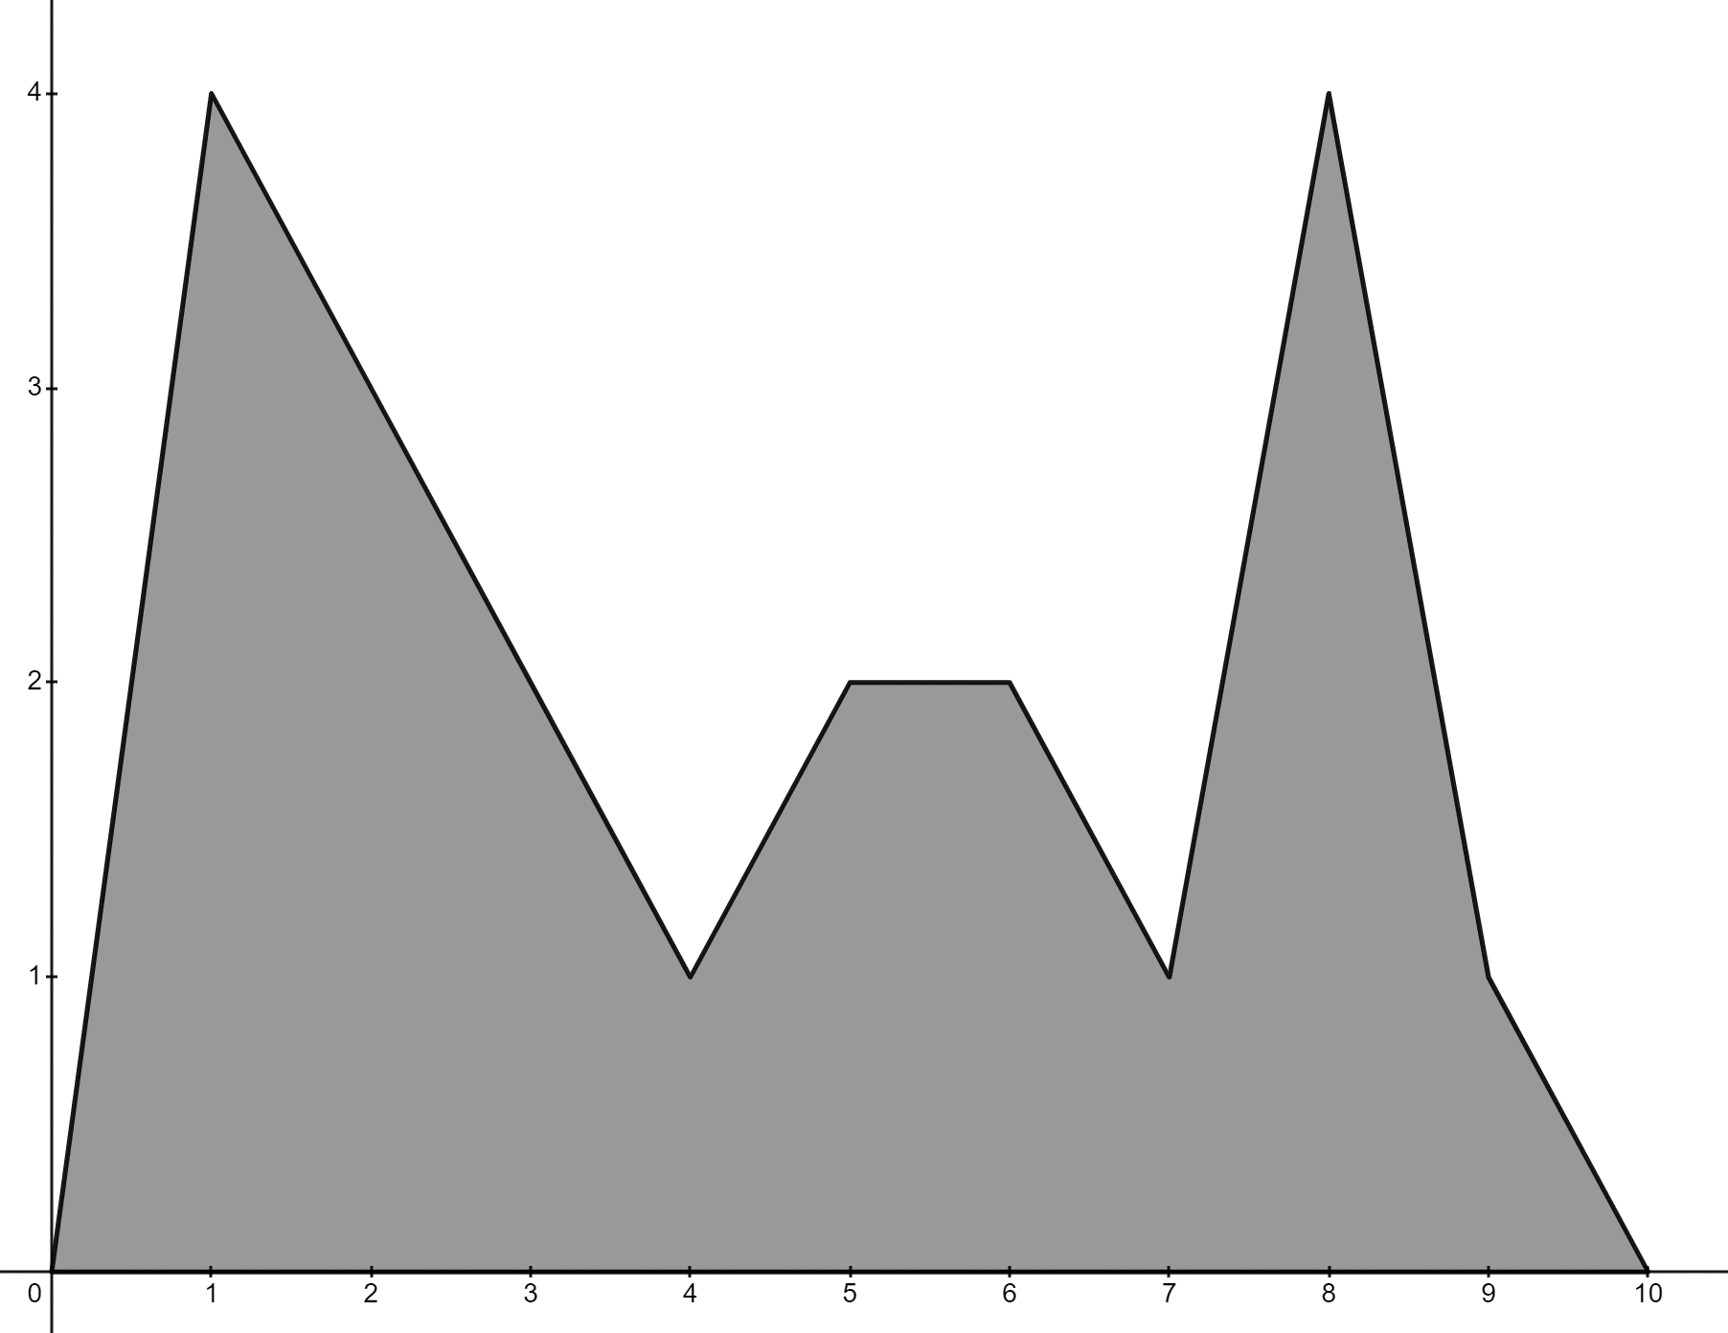
- 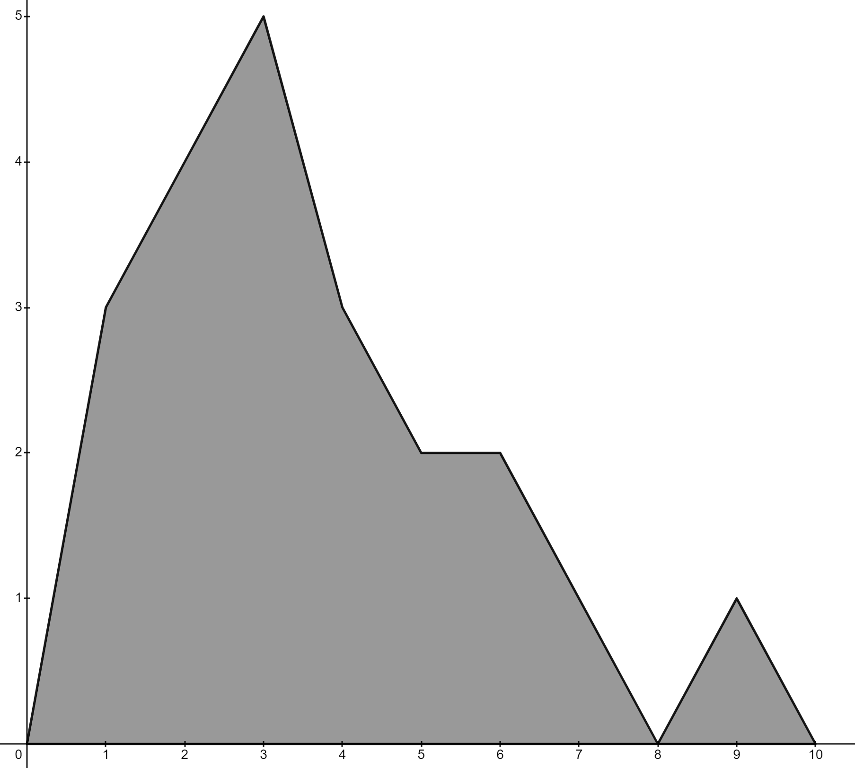
- 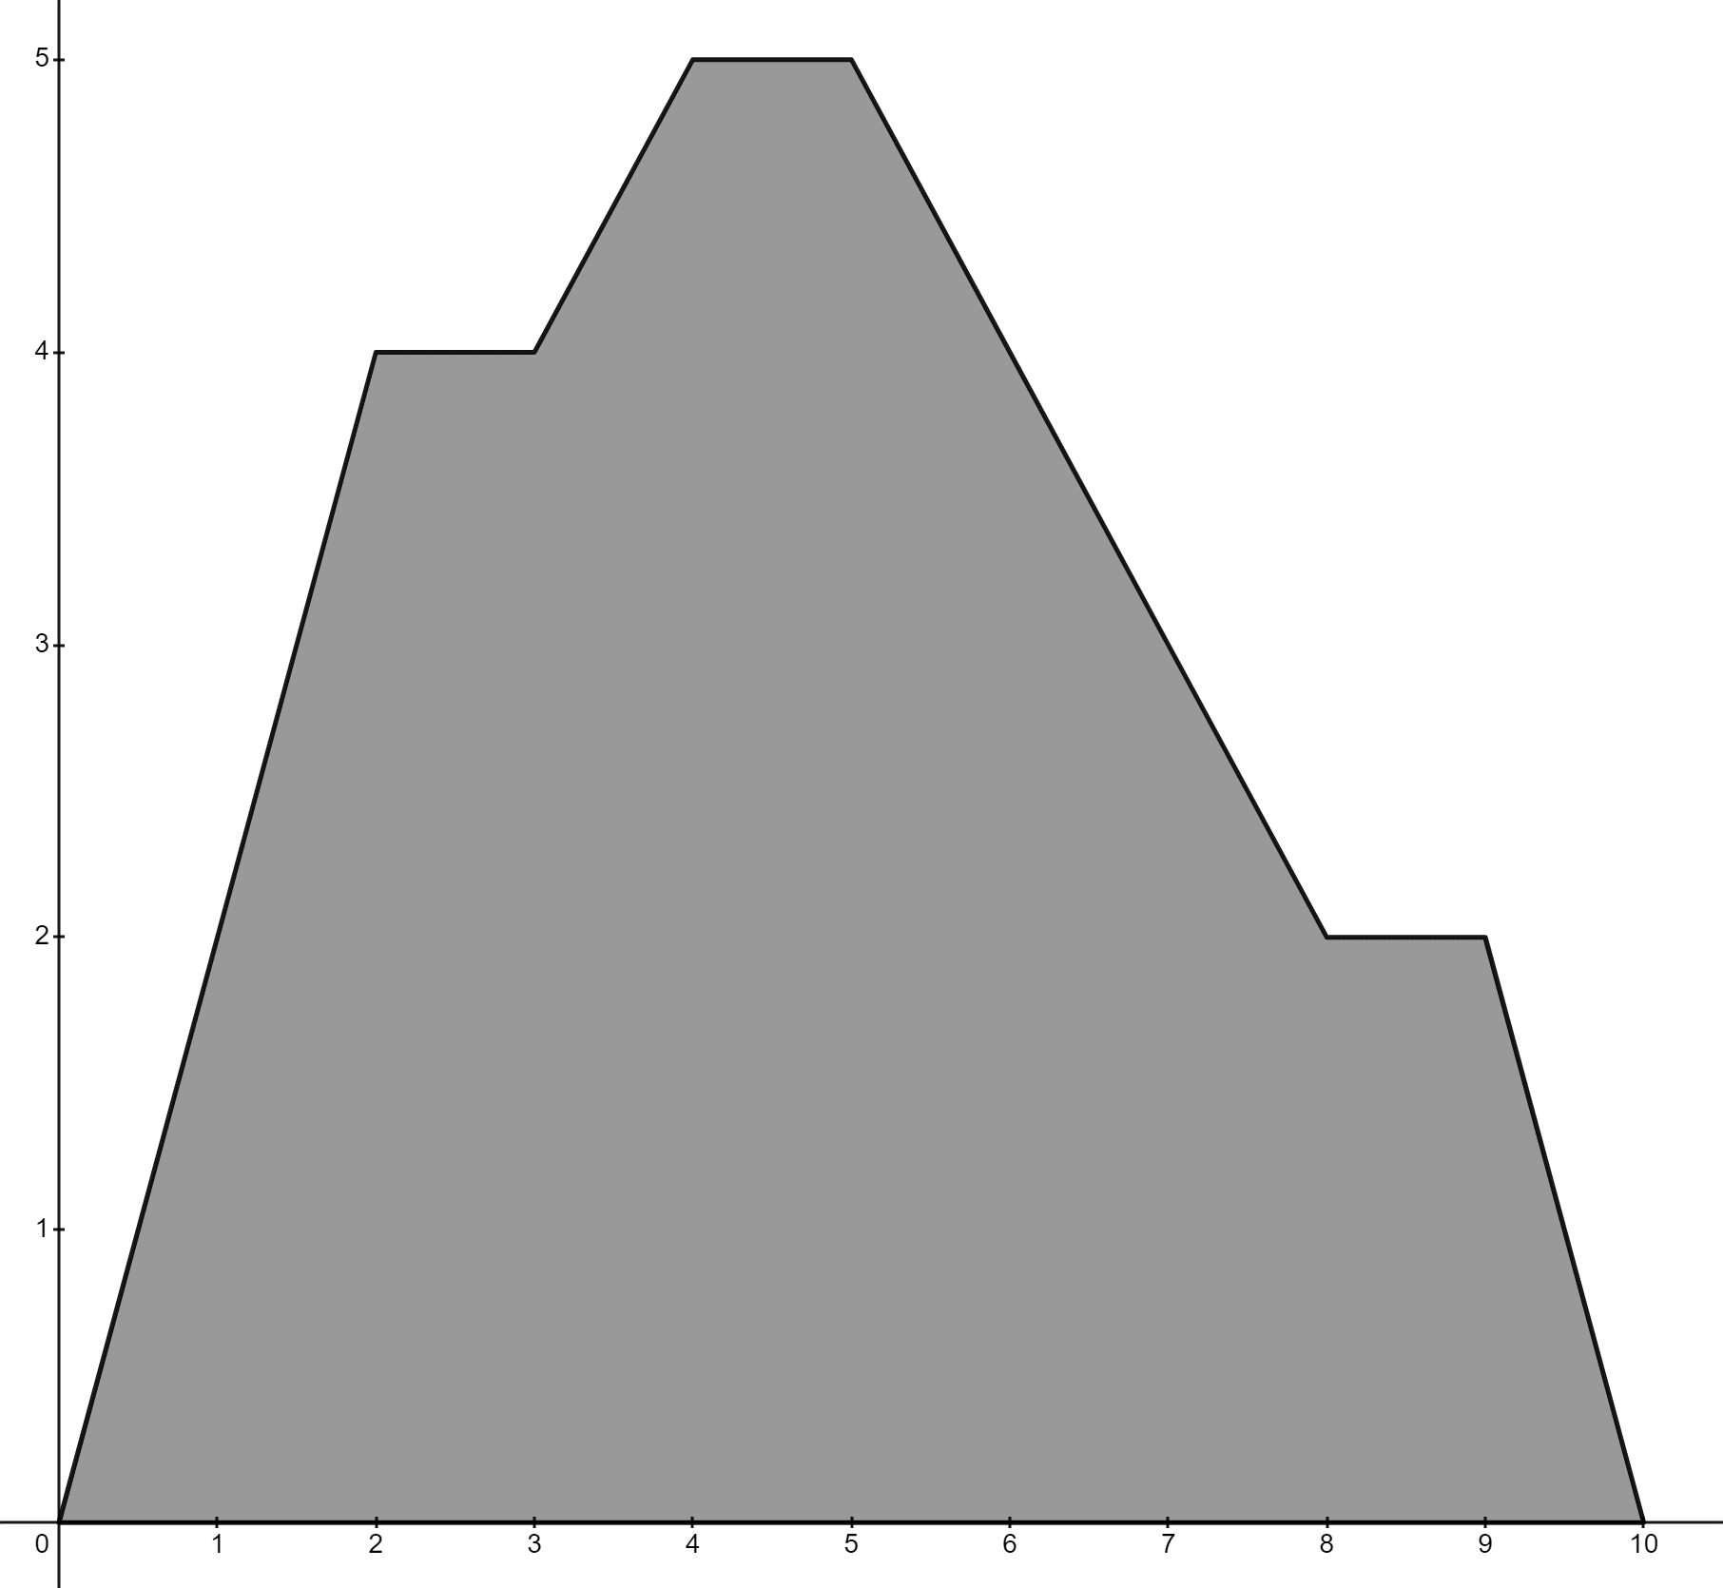
- 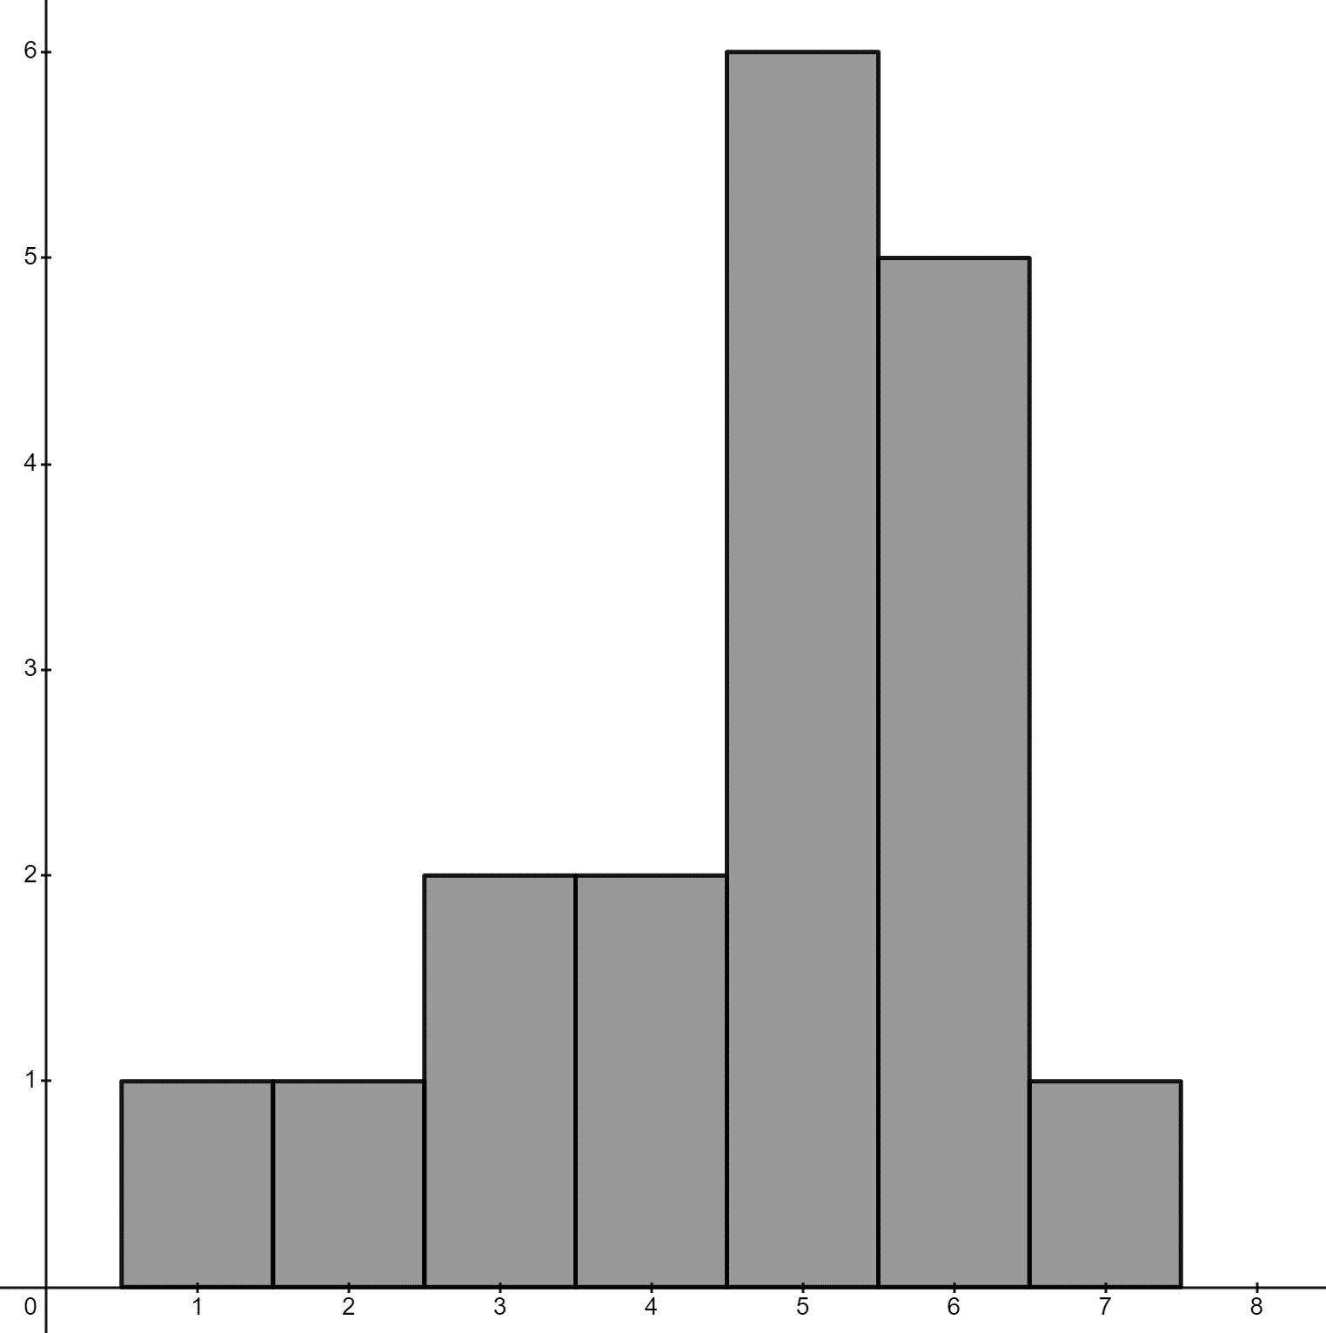
- 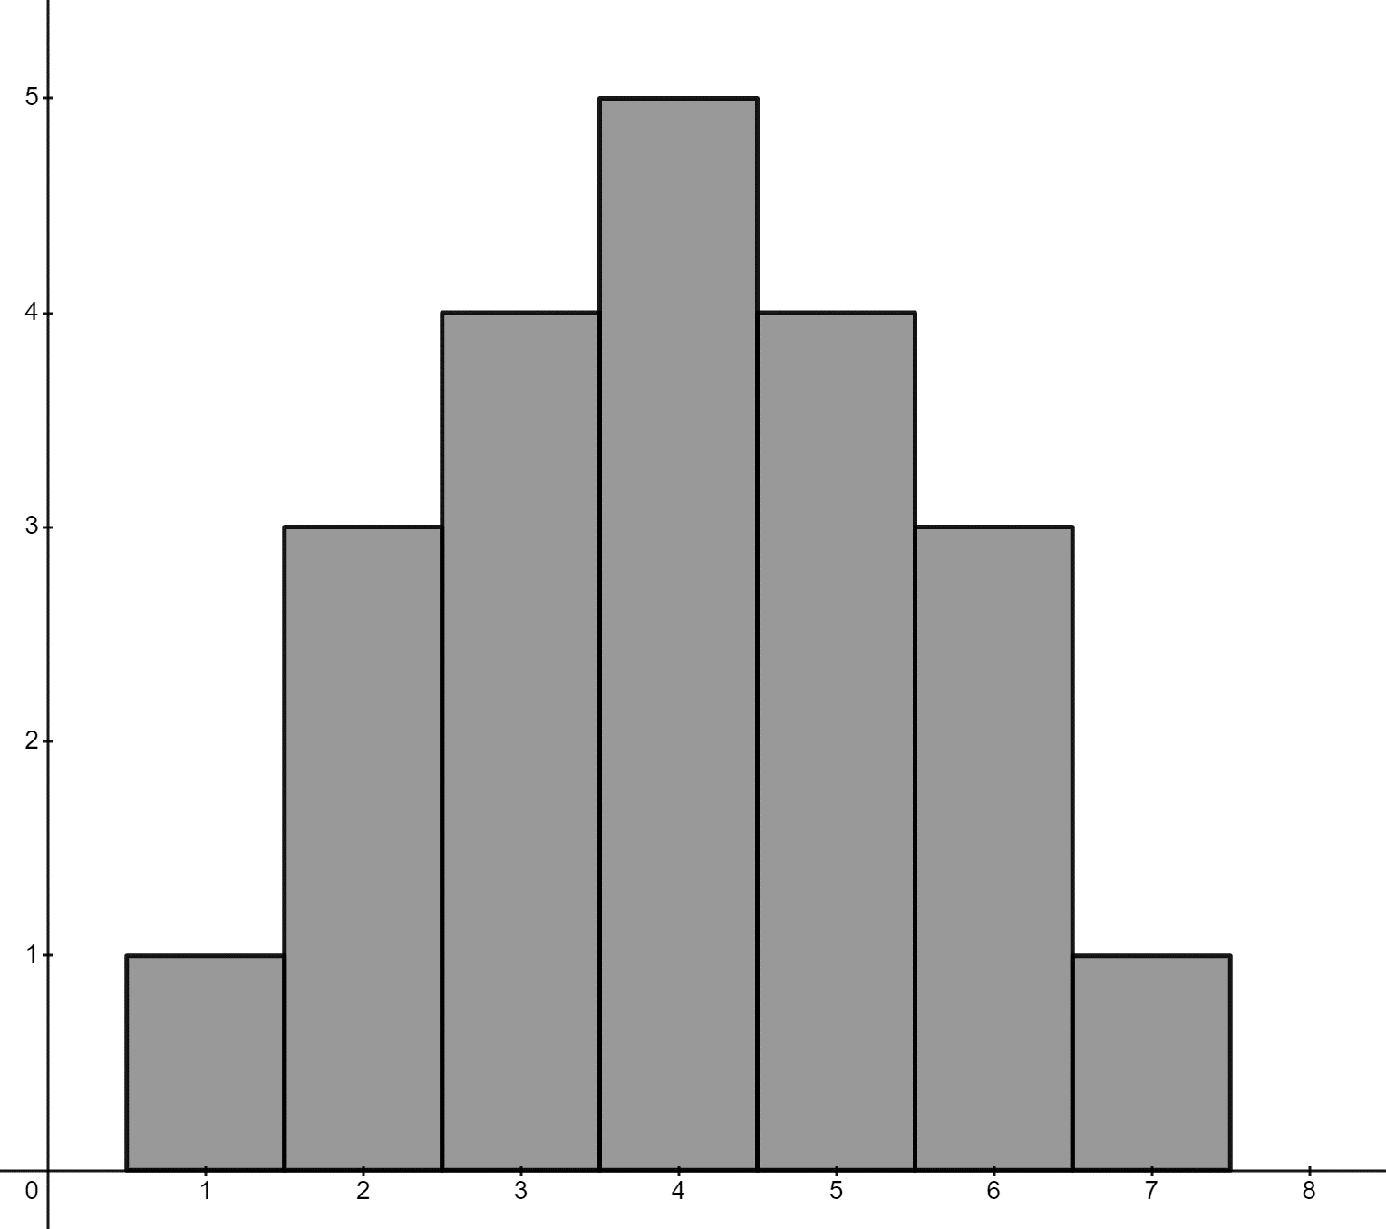
- 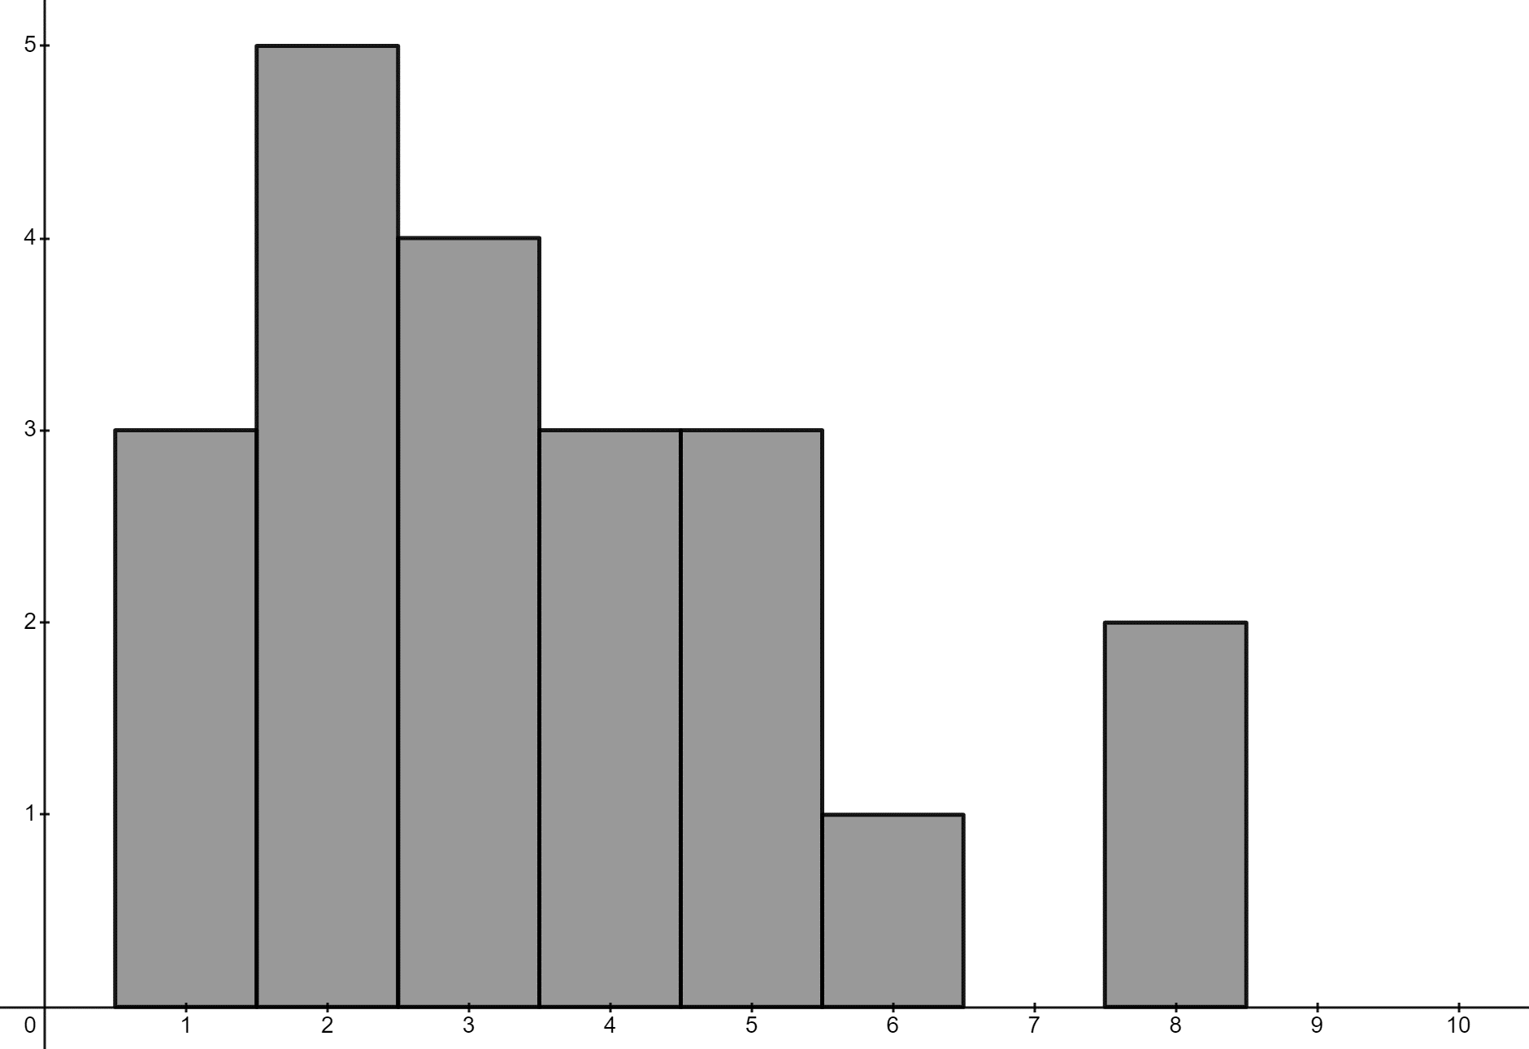

Appendix B

Pixel art
Image licensed under Pixabay Content License.
The image above is made using large pixels. Each colour has been assigned a brightness value and the frequency of each colour is shown in the table below.
Brightness level | Frequency
0 | 67
1 | 152
2 | 380
3 | 163
4 | 210
5 | 133
6 | 284
7 | 125
8 | 290
9 | 189
10 | 39
11 | 142
12 | 75
13 | 97
14 | 68
15 | 70
16 | 12
17 | 103

Sample solutions

Appendix A – graphs
Group the graphs that have similar shaped distributions.
Shape | Graphs
Symmetrical | 6, 8, 11
Positively skewed | 1, 5, 9
Negatively skewed | 2, 7, 12
Bimodal | 3, 4, 10

Mean and mode
Graph | Mean | Mode | Mean - mode
1 – positively skewed | 3.6 (1 d.p.) | 3 | 0.6
2 – negatively skewed | 6.9 (1 d.p.) | 9 | −2.1
3 – bimodal | 6.2 (1 d.p.) | 2 and 9 | 4.2 and −2.8
8 – symmetrical | 4 | 4 | 0

Appendix B

Pixel art
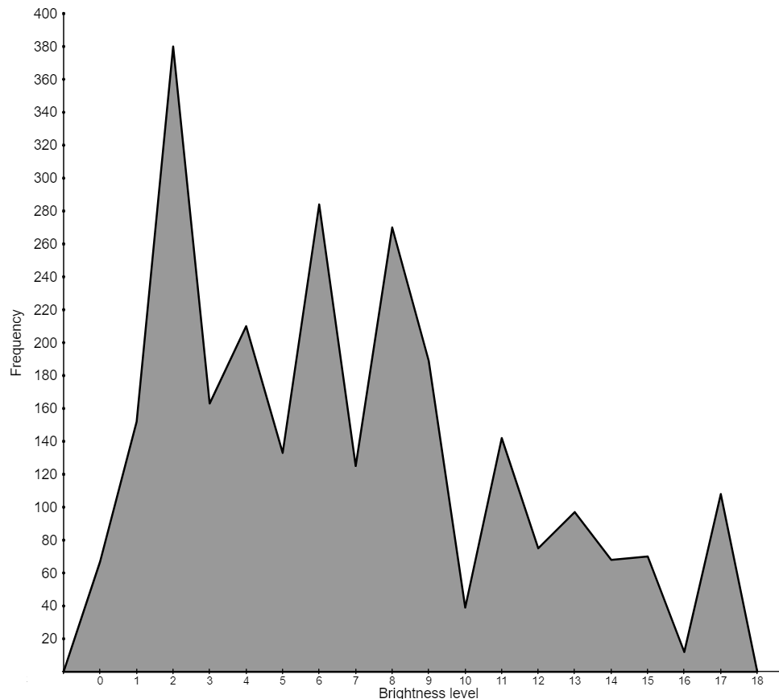

References
This resource contains NSW Curriculum and syllabus content. The NSW Curriculum is developed by the NSW Education Standards Authority. This content is prepared by NESA for and on behalf of the Crown in right of the State of New South Wales. The material is protected by Crown copyright.
Please refer to the NESA Copyright Disclaimer for more information https://educationstandards.nsw.edu.au/wps/portal/nesa/mini-footer/copyright.
NESA holds the only official and up-to-date versions of the NSW Curriculum and syllabus documents. Please visit the NSW Education Standards Authority (NESA) website https://educationstandards.nsw.edu.au and the NSW Curriculum website https://curriculum.nsw.edu.au.
Mathematics K–10 Syllabus © NSW Education Standards Authority (NESA) for and on behalf of the Crown in right of the State of New South Wales, 2022.

© State of New South Wales (Department of Education), 2024
The copyright material published in this resource is subject to the Copyright Act 1968 (Cth) and is owned by the NSW Department of Education or, where indicated, by a party other than the NSW Department of Education (third-party material).
Copyright material available in this resource and owned by the NSW Department of Education is licensed under a Creative Commons Attribution 4.0 International (CC BY 4.0) license.
This license allows you to share and adapt the material for any purpose, even commercially.
Attribution should be given to © State of New South Wales (Department of Education), 2024.
Material in this resource not available under a Creative Commons license:
- the NSW Department of Education logo, other logos and trademark-protected material
- material owned by a third party that has been reproduced with permission. You will need to obtain permission from the third party to reuse its material.
Links to third-party material and websites
Please note that the provided (reading/viewing material/list/links/texts) are a suggestion only and implies no endorsement, by the New South Wales Department of Education, of any author, publisher, or book title. School principals and teachers are best placed to assess the suitability of resources that would complement the curriculum and reflect the needs and interests of their students.
If you use the links provided in this document to access a third-party's website, you acknowledge that the terms of use, including licence terms set out on the third-party's website apply to the use which may be made of the materials on that third-party website or where permitted by the Copyright Act 1968 (Cth). The department accepts no responsibility for content on third-party websites.

