Footy fit
Students will draw a stem-and-leaf plot using data from NRL player statistics. They will then analyse the data using the range, mode, median and mean, and draw conclusions based on their findings.

Visible learning

Learning intention
- To be able to analyse data displayed in a stem-and-leaf plot.

Success criteria
- I can draw a stem-and-leaf plot.
- I can calculate the range, mode, median and mean from a stem-and-leaf plot.
- I can use data from a stem-and-leaf plot to justify a decision.

Syllabus outcomes
A student:
- develops understanding and fluency in mathematics through exploring and connecting mathematical concepts, choosing and applying mathematical techniques to solve problems, and communicating their thinking and reasoning coherently and clearly MAO-WM-01
- classifies and displays data using a variety of graphical representations MA4-DAT-C-01
- analyses simple datasets using measures of centre, range and shape of the data
MA4-DAT-C-02
Mathematics K–10 Syllabus © NSW Education Standards Authority (NESA) for and on behalf of the Crown in right of the State of New South Wales, 2022.

Activity structure
Please use the associated PowerPoint Footy fit to display images in this lesson.

Launch
- Display slide 3 of the PowerPoint Footy fit.
- In a Think-Pair-Share (bit.ly/thinkpairsharestrategy) ask students to discuss what they notice and what they wonder (bit.ly/noticewonderstrategy) about these players.
- Display slide 4 of the PowerPoint Footy fit.
- Ask a student to volunteer to read the information from the middle of the slide.
- Use a Pose-Pause-Pounce-Bounce (PDF 557 KB) (bit.ly/posepausepouncebounce) questioning strategy for students to explain and justify which player would be a forward and which would be a back.
The Rugby league players are:
- Adam Clune, a back from the Newcastle Knights
- Wiremu Greig, a forward from the Parramatta Eels
It may be useful to show a short video of NRL for students who have not seen it being played.
Some students may be able to identify the players and know their playing positions. Ask those students to use the data on the slide to explain the player positions.
- In pairs, ask students to discuss ‘How big do you have to be, to be a forward?’ If we had a player who was 185 cm tall and weighed 100 kg, would they be big enough? How could we tell?
- Use a Pose-Pause-Pounce-Bounce questioning strategy for students to share their thoughts and reasoning.

Explore
- Display slide 6 of the PowerPoint Footy fit which shows the heights of backs in the Newcastle Knights.
- Assign students to visibly random groups of 3 (bit.ly/visiblegroups) to work on vertical non-permanent surfaces (bit.ly/VNPSstrategy).
- Ask students to order and/or rearrange the data into a format which would make it easier to see patterns as well as making it easier to calculate the mean, median, mode and range.
Students may simply place the data into ascending order. Encourage them to consider other ways of arranging the data, that doesn’t involve drawing graphs.
- Students are to conduct a gallery walk (bit.ly/DLSgallerywalk) to allow them to give feedback on their peers’ arrangements using Two stars and a wish (bit.ly/2starwish).
- The teacher should draw attention to interesting arrangements and the advantages and disadvantages of different arrangements.

Summarise
- Display slide 7 of the PowerPoint which shows the heights from the Explore activity arranged in a stem and leaf plot.
- Use a Think-Pair-Share for students to discuss the stem and leaf plot and answer the self-explanation prompts.
- Use a Pose-Pause-Pounce-Bounce questioning technique for pairs to share their answers and reasoning.
- Distribute Appendix A ‘How tall are the forwards?’ to each pair.
- Ask students to draw a stem-and-leaf plot using the data in Appendix A.
- Display slides 8 to 23 of the PowerPoint Footy fit for explicit teaching of analysing data in a stem-and-leaf plot.
The explicit teaching technique used in the PowerPoint is ‘Your turn’. The first slide is a worked example which should be displayed for the students before using the following steps.
- Reveal the question to students and its solution.
- Students read in silence.
- Students individually explain to themselves what is happening in each step.
- Students hold a thumbs up to the teacher when they have finished reading and have some sort of understanding.
- Think-Pair-Share. Students explain the solution to their partner.
- In pairs, students then answer the self-explanation questions.
- Finally, randomly select students to share their answers with the whole class.
- Distribute Appendix B ‘How much do they weigh?’ to each pair and ask students to analyse the stem-and-leaf plots using the statistical measures of mode, median, mean and range.
- Ask students to decide which graph shows the data for the backs and which one is for the forwards and justify their decision, using a class discussion to share their thoughts.
Teachers may need to revisit slide 3, which describes the attributes of a forward and a back.
- Print Appendix C ‘4 quadrant notes’ on A3 paper, place in plastic pockets and use adhesive putty to stick up around the room.
- Assign students to new random groups of 3 and assign each group a plastic pocket to work at. Provide each group with one whiteboard marker and cloth.
Using plastic pockets and a whiteboard marker allows students to risk writing something, as mistakes can be erased. If plastic pockets are not available, attach paper to the vertical workspace.
- Groups are to discuss and work through the 4 quadrant notes as described below:
- Students complete the first example. This could be done as a class.
- Example 1: students complete the example provide.
- Example 2: students complete an example but this time choosing the number of values in the dataset.
- Things to remember: students write down anything they think would be important for their future forgetful selves to remember.
- Allow students time to do a gallery walk before completing a set of notes for themselves in their workbook.

Apply
- Students are to continue to work in their groups of 3 at the vertical non-permanent surfaces.
- Distribute Appendix D ‘Which team will win?’ to each group and ask students to analyse the stem-and-leaf plots.
- Ask students to decide which team they think will win when they play each other, using the data to support their decision.
The data represents the information available at a point in time at the beginning of the 2024 season. Teachers can choose to find out the results of the games during the 2024 season, when the teams played each other. This would be done after students have made their predictions.

Assessment and differentiation

Suggested opportunities for differentiation
Launch
- The teacher should not force any student to read. If no students volunteer to read, the teacher should read the information to the class.
Explore
- There are no correct answers to this activity so all students should be encouraged to participate and practise communicating their reasoning.
Summarise
- Challenge students by asking them to consider how they can find the range, mode, median and mean from the stem and leaf plot before they are explicitly shown.
- Support students to find the range, mode, median and mean by providing them with a smaller stem and leaf plot of only 5 numbers.
- Students could access a stem-and-leaf plot generator so they can focus on analysing the data.
- Extend students by asking them to describe the shape and skew of the data.
- When completing their individual 4 quadrant notes, students may choose to include examples and tips from another group’s work.
Apply
- Students can collect data about other players, teams, seasons, or sports and use that data to make predictions.

Suggested opportunities for assessment
Summarise
- Monitor student responses, checking they can calculate the range, mode, median and mean.
- Monitor student reasoning to decide which graph is the backs and which is the forwards.
Apply
- Use a formative assessment monitoring sheet to collect information on student ability to calculate range, mode, median and mean and their ability to use the data to justify a decision.

Appendix A

How tall are the forwards?
Height, in centimetres, of the forwards players in the Newcastle Knights.
179, 183, 190, 185, 184, 193, 195, 190, 195, 186, 191, 190, 183, 194, 184, 188, 194, 198, 192, 183.

Appendix B

How much do they weigh?
Weight, in kilograms, of players in the Newcastle Knights.
One graph shows the weight of players in the forwards and the other graph shows the weight of the players in the backs.
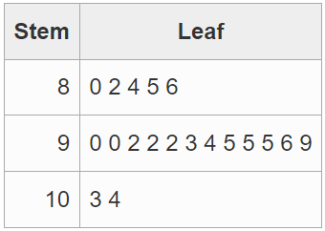
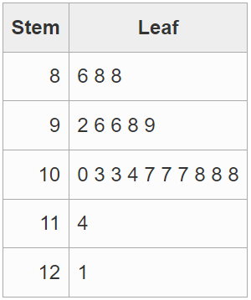

Appendix C

4 quadrant notes
Guided example  Draw a stem-and-leaf plot for this set of data and calculate the mode, median, mean and range.  12, 17, 18, 20, 23, 24, 24, 27, 31, 34, 45  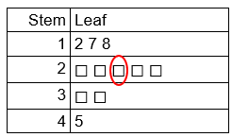  $$Mode= ☐$$  $$Median=☐$$  $$Mean= \frac{275}{☐} \\ =☐$$  $$Range=45-☐$$  $$=☐$$ | Example 1  Draw a stem-and-leaf plot for this set of data and calculate the mode, median, mean and range.  66, 57, 68, 74, 64, 69, 70, 40, 49, 78, 79, 82, 57, 43, 57, 35, 81, 54, 54, 59  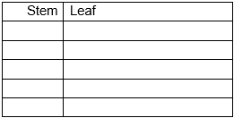
Things to remember | Example 2

Appendix D

Which team will win?

Height of Parramatta Eels players
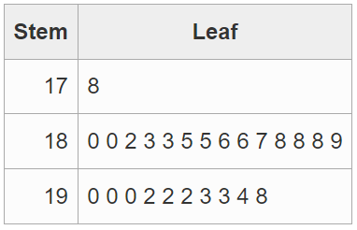

Weight of Parramatta Eels players
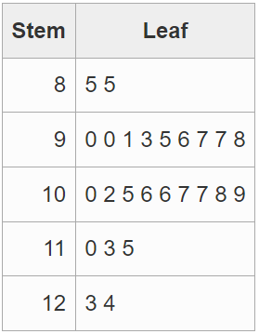

Height of Penrith Panthers players
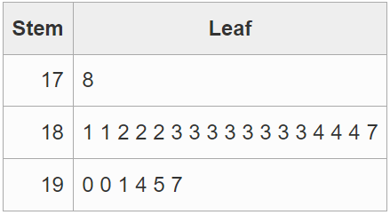

Weight of Penrith Panthers players
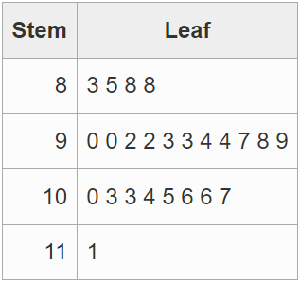

Sample solutions

Appendix A – How tall are the forwards?
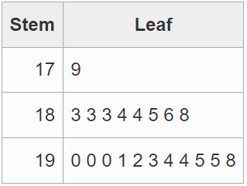

Appendix B – How much do they weigh?
Measure | Newcastle Knights backs | Newcastle Knights forwards
Range | 24 | 35
Mean | 91.95 | 101.7
Median | 92 | 103
Mode | 92, 95 | 107, 108

Appendix C – 4 quadrant notes
Measure | Guided example | Example 1
Stem-and-leaf plot | 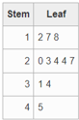 | 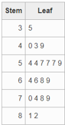
Range | 33 | 47
Mean | 25 | 61.8
Median | 24 | 61.5
Mode | 24 | 57

Appendix D – Which team will win?
Measure | Eels height | Eels weight | Panthers height | Panthers weight
Range | 20 | 39 | 19 | 28
Mean | 187.7 | 102.1 | 185.5 | 96.71
Median | 188 | 102 | 183 | 95.5
Mode | 188, 190, 192 | No mode | 183 | No mode
The range in height is similar for both teams, but the mean height for Parramatta is slightly higher. The range in weight is much higher in the Eels with some very heavy players, compared to the Panthers. The mean weight for the Eels is over 5 kg higher than the mean weight for the Panthers. The median weight for the Panthers is even lower than the mean. The Eels have a lot of heavy players who will tire, and the Panthers have more lighter players who are more agile.
Prediction: Panthers to win when they play the Eels.

References
This resource contains NSW Curriculum and syllabus content. The NSW Curriculum is developed by the NSW Education Standards Authority. This content is prepared by NESA for and on behalf of the Crown in right of the State of New South Wales. The material is protected by Crown copyright.
Please refer to the NESA Copyright Disclaimer for more information https://educationstandards.nsw.edu.au/wps/portal/nesa/mini-footer/copyright.
NESA holds the only official and up-to-date versions of the NSW Curriculum and syllabus documents. Please visit the NSW Education Standards Authority (NESA) website https://educationstandards.nsw.edu.au and the NSW Curriculum website https://curriculum.nsw.edu.au.
Mathematics K–10 Syllabus © NSW Education Standards Authority (NESA) for and on behalf of the Crown in right of the State of New South Wales, 2022.

© State of New South Wales (Department of Education), 2024
The copyright material published in this resource is subject to the Copyright Act 1968 (Cth) and is owned by the NSW Department of Education or, where indicated, by a party other than the NSW Department of Education (third-party material).
Copyright material available in this resource and owned by the NSW Department of Education is licensed under a Creative Commons Attribution 4.0 International (CC BY 4.0) license.
This license allows you to share and adapt the material for any purpose, even commercially.
Attribution should be given to © State of New South Wales (Department of Education), 2024.
Material in this resource not available under a Creative Commons license:
- the NSW Department of Education logo, other logos and trademark-protected material
- material owned by a third party that has been reproduced with permission. You will need to obtain permission from the third party to reuse its material.
Links to third-party material and websites
Please note that the provided (reading/viewing material/list/links/texts) are a suggestion only and implies no endorsement, by the New South Wales Department of Education, of any author, publisher, or book title. School principals and teachers are best placed to assess the suitability of resources that would complement the curriculum and reflect the needs and interests of their students.
If you use the links provided in this document to access a third-party's website, you acknowledge that the terms of use, including licence terms set out on the third-party's website apply to the use which may be made of the materials on that third-party website or where permitted by the Copyright Act 1968 (Cth). The department accepts no responsibility for content on third-party websites.

