Shooting hoops
Students learn how to find median and range from a frequency table and graphs by testing their skills of throwing scrunched paper into a bin from a distance.

Visible learning

Learning intention
- To be able to find the median and range from a frequency graph.

Success criteria
- I can draw a dot plot from a frequency table.
- I can find the range from a frequency table and graph.
- I can find the median from a frequency graph.

Syllabus outcomes
A student:
- develops understanding and fluency in mathematics through exploring and connecting mathematical concepts, choosing and applying mathematical techniques to solve problems, and communicating their thinking and reasoning coherently and clearly MAO-WM-01
- classifies and displays data using a variety of graphical representations MA4-DAT-C-01
- analyses simple datasets using measures of centre, range and shape of the data
MA4-DAT-C-02
Mathematics K–10 Syllabus © NSW Education Standards Authority (NESA) for and on behalf of the Crown in right of the State of New South Wales, 2022.

Activity structure

Launch
- Place a bin in your classroom and mark a line made of masking tape 3 metres away from the bin as seen in the following diagram.
Figure 1: bin set up
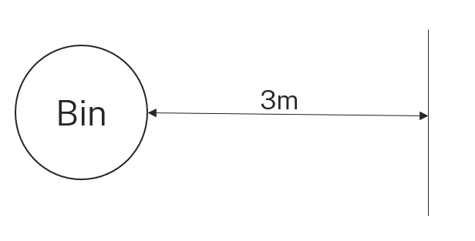
This distance may need to vary depending on the diameter of the bin.
- Pose the following scenario to start a class discussion:
If I were to give you a scrunched piece of paper and give you 10 shots at the bin from behind this line, how many shots would you get in? How many shots would you need to get in to be better than half the class?
- Students should record their predictions to come back to later in the lesson.

Explore

Equipment
- One waste bin per group
- Piece of masking tape
- One piece of A4 paper per student

Method
- Assign students into random groups of 4 or 5, and provide the equipment listed above.
- Ask each group to find a space to set up their bin, and to place the masking tape approximately 3 metres from the bin by taking 3 steps back from it.
- Students are to take turns making their shots at the bin until they have completed 10 each. They need to count how many times they successfully threw the paper in the bin.
- Display the Excel spreadsheet Shooting hoops.
- Ask students for their results and use the spreadsheet to collate the data into a frequency table.
- Ask students if this study is a census or a sample of the class and why.
Students may say it is a census, but if one student is absent that day it could be argued to be a sample as it does not include all students.
- In a Think-Pair-Share (bit.ly/thinkpairsharestrategy), ask students how many shots a ‘normal’ student would get in the bin.
- Use a Pose-Pause-Pounce-Bounce questioning strategy to ask students how they determined what was normal. What measure(s) of centre did they use? Were there some that were easier to find than others?

Students may have been able to find the range and mode quite easily, and the mean from the previous lesson ‘The big sick’, but not the median.
A common error students make in finding the range is finding the largest and smallest frequencies and finding their difference, instead of using the largest and smallest scores.

Finding the median from a frequency graph
- Ask random students to remind the class what a median is. Select multiple students and ask them to add on or revoice (bit.ly/classroomtalkmoves) what previous students have stated.
- Distribute one copy of Appendix A ‘Finding the median’ per student. This Appendix enables students to develop the ability to find the median in a dot plot using variation theory (variationtheory.com/introduction/).
- In a Think-Pair-Share, ask students to complete the Appendix, focussing on how they might locate the median.
- In their pairs, students are to write a procedure on how to find the median from a dot plot.
- Ask students if they could modify their instructions to suit a frequency table.
- Instruct students to swap their instructions with another pair, and to test the instructions by finding the median of the ‘Shooting hoops’ data from the frequency table.
- Students should provide feedback on the instructions using Two stars and a wish (bit.ly/2starwish).
- Instruct students to draw a frequency histogram or frequency polygon from the frequency table for the ‘Shooting hoops’ data.
- Students should attempt to calculate the median from the frequency histogram or frequency polygon, mentally comparing the process to calculating the median from a frequency table.
- Ask students to answer the question from the launch, ‘How many shots would you need to get in to be better than half the class?’.

Summarise
- Students are to use the instructions they wrote with their partner, and the feedback they were provided to write their own notes to their future forgetful self (bit.ly/notesstrategy) about how to find the median from a frequency table, dot plot or frequency histogram or polygon.
- Distribute Appendix B ‘Class shooting data’ to each student. This shows data from other classes who have completed the ‘Shooting hoops’ activity.
- Ask students to complete Appendix B independently.
- Initiate the sharing of ideas and reasoning by using Pose-Pause-Pounce-Bounce (PDF 557 KB) (bit.ly/posepausepouncebounce) for the comparison of each class’s data.

Apply
- Distribute Appendix C ‘Stephen Curry free-throws’ which shows the frequency of free-throws that Stephen Curry has successfully made in the 2021 to 2022, 2022 to 2023 and 2023 to 2024 seasons.
- Students should independently complete the questions from Appendix C ‘Stephen Curry free throws.’
- Collect student work as an exit ticket (bit.ly/exitticketstrategy) for the lesson.

Assessment and differentiation

Suggested opportunities for differentiation
Explore
- If students need more practice representing data in frequency tables, students can manually create the table rather than using the Excel spreadsheet.
- For schools using the Stage-based scope and sequence, you can modify the graphs students use to engage in this lesson.
- To support students, teachers may choose to present an example of finding the median from raw data before students attempt to find the median from a dot plot.
- Students could be challenged to consider how we could find the median of a frequency table that uses classes, for instance, 0–2, 3–5
- Students with low readiness could continue to work with dot plots, rather than progress to frequency tables and frequency graphs.
Summarise/Apply
- Students could complete Appendix B in pairs to grow their confidence before attempting Appendix C independently.
- For students with low readiness, teachers should provide a smaller subset of data. Counters or other manipulatives could be used to assist students in calculating and visualizing the measures of centre.

Suggested opportunities for assessment
Explore
- You can check students’ understanding on a census and sample from their response to the class discussion.
Summarise
- Collect students' instructions to check for their understanding of calculating the median from a frequency table or graph.
- You can check student understanding of drawing frequency graphs in Appendix B.
Apply
- Collect Appendix C as an exit ticket for evidence of student learning.

Appendix A

Finding the median
Find the median of each dot plot. Justify why that value is the median.
- 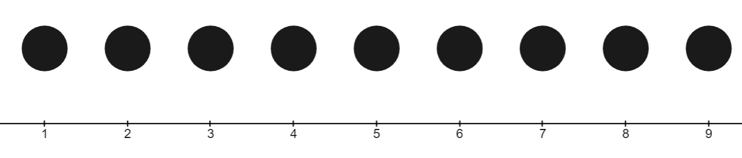
- 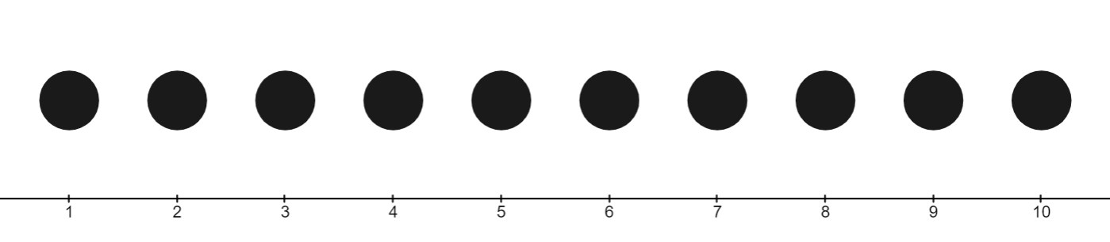
- 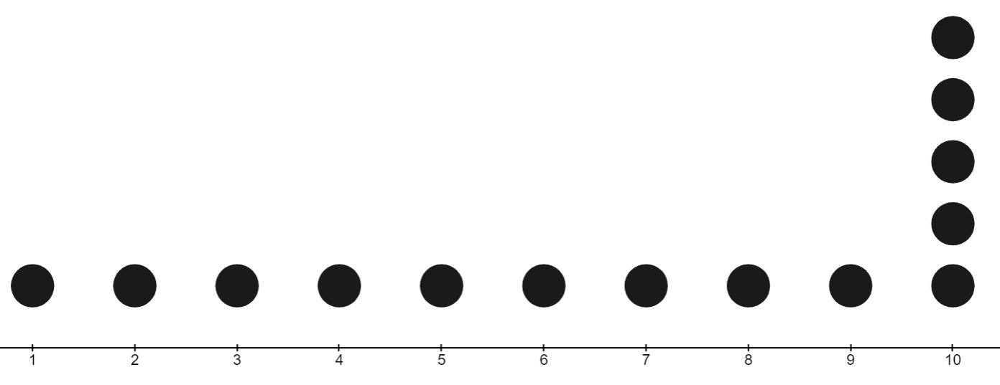
- 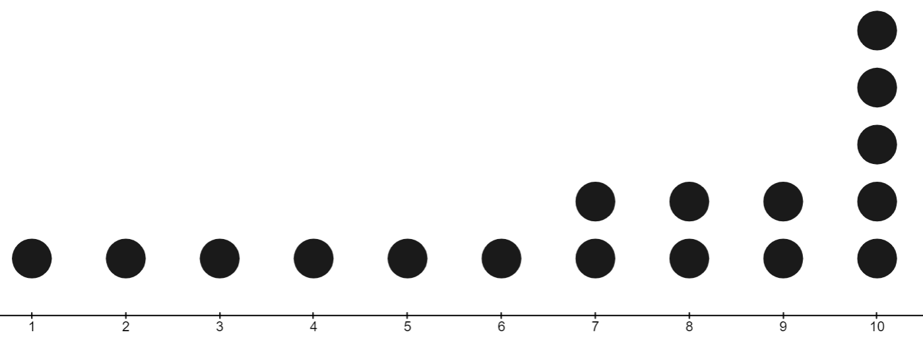

Appendix B

Class shooting data
- Using the frequency table below, draw and represent each class’s data with a different type of frequency graph from the ones listed below:
- dot plot
- frequency histogram
- frequency polygon
Score | Class A | Class B | Class C
0 | 4 | 5 | 3
1 | 2 | 6 | 2
2 | 3 | 5 | 4
3 | 1 | 4 | 4
4 | 5 | 3 | 5
5 | 2 | 3 | 3
6 | 4 | 1 | 0
7 | 3 | 0 | 1
8 | 2 | 2 | 4
9 | 1 | 0 | 2
10 | 3 | 0 | 0
- Find the median for each dataset.
- Compare the medians of these classes with your class. Where do you sit?

Appendix C

Stephen Curry free-throws

Number of successful free-throws by Stephen Curry each game in the 2023 to 2024 season
Successful free-throws $(x$) | Games $(f$)
1 | 7
2 | 0
3 | 8
4 | 8
5 | 8
6 | 5
7 | 3
8 | 4
9 | 1
10 | 1
11 | 2

Number of successful free-throws by Stephen Curry each game in the 2022 to 2023 season
Successful free-throws $(x$) | Games $(f$)
0 | 4
1 | 4
2 | 5
3 | 11
4 | 6
5 | 12
6 | 8
7 | 3
8 | 4
9 | 3
10 | 1
11 | 2

Number of successful free-throws by Stephen Curry each game in the 2021 to 2022 season
Successful free-throws $(x$) | Games $(f$)
0 | 8
1 | 8
2 | 10
3 | 6
4 | 5
5 | 5
6 | 7
7 | 6
8 | 5
9 | 6
10 | 1
11 | 0
12 | 1
13 | 1
Data collected 12 February 2024.

Questions
- Draw a frequency graph for each season.
- Find the median and range for the free-throws Stephen Curry successfully made each season.
- Which season did he consistently score the most free-throws?
- Estimate what the median will be for all 3 seasons combined. Explain why you picked that number.
- Create a dot plot, histogram or polygon that shows all the season’s data combined.
- Find the median from the data.
- How close was your estimate from the actual median? Why do you think that was the case?

Sample solutions

Appendix A – finding the median
Find the median of each dot plot. Justify why that is the median.
- 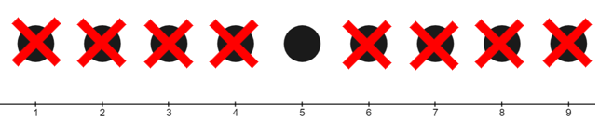
Median is 5.
- 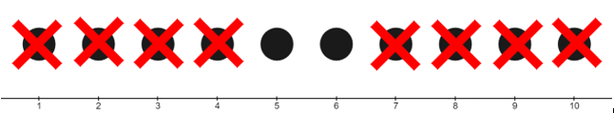
Median is 5.5.
- 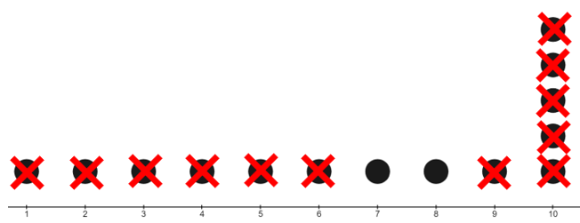
Median is 7.5.
- 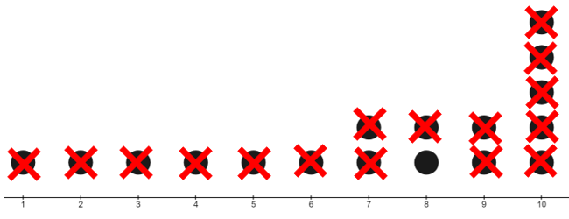
Median is 8.

Appendix B – class shooting data

Class A – dot plot
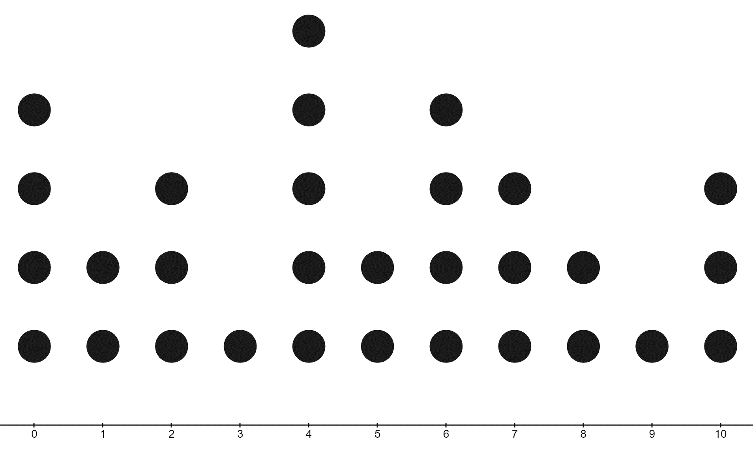
Successful shots in the bin
Median is 4.5.

Class B – frequency histogram
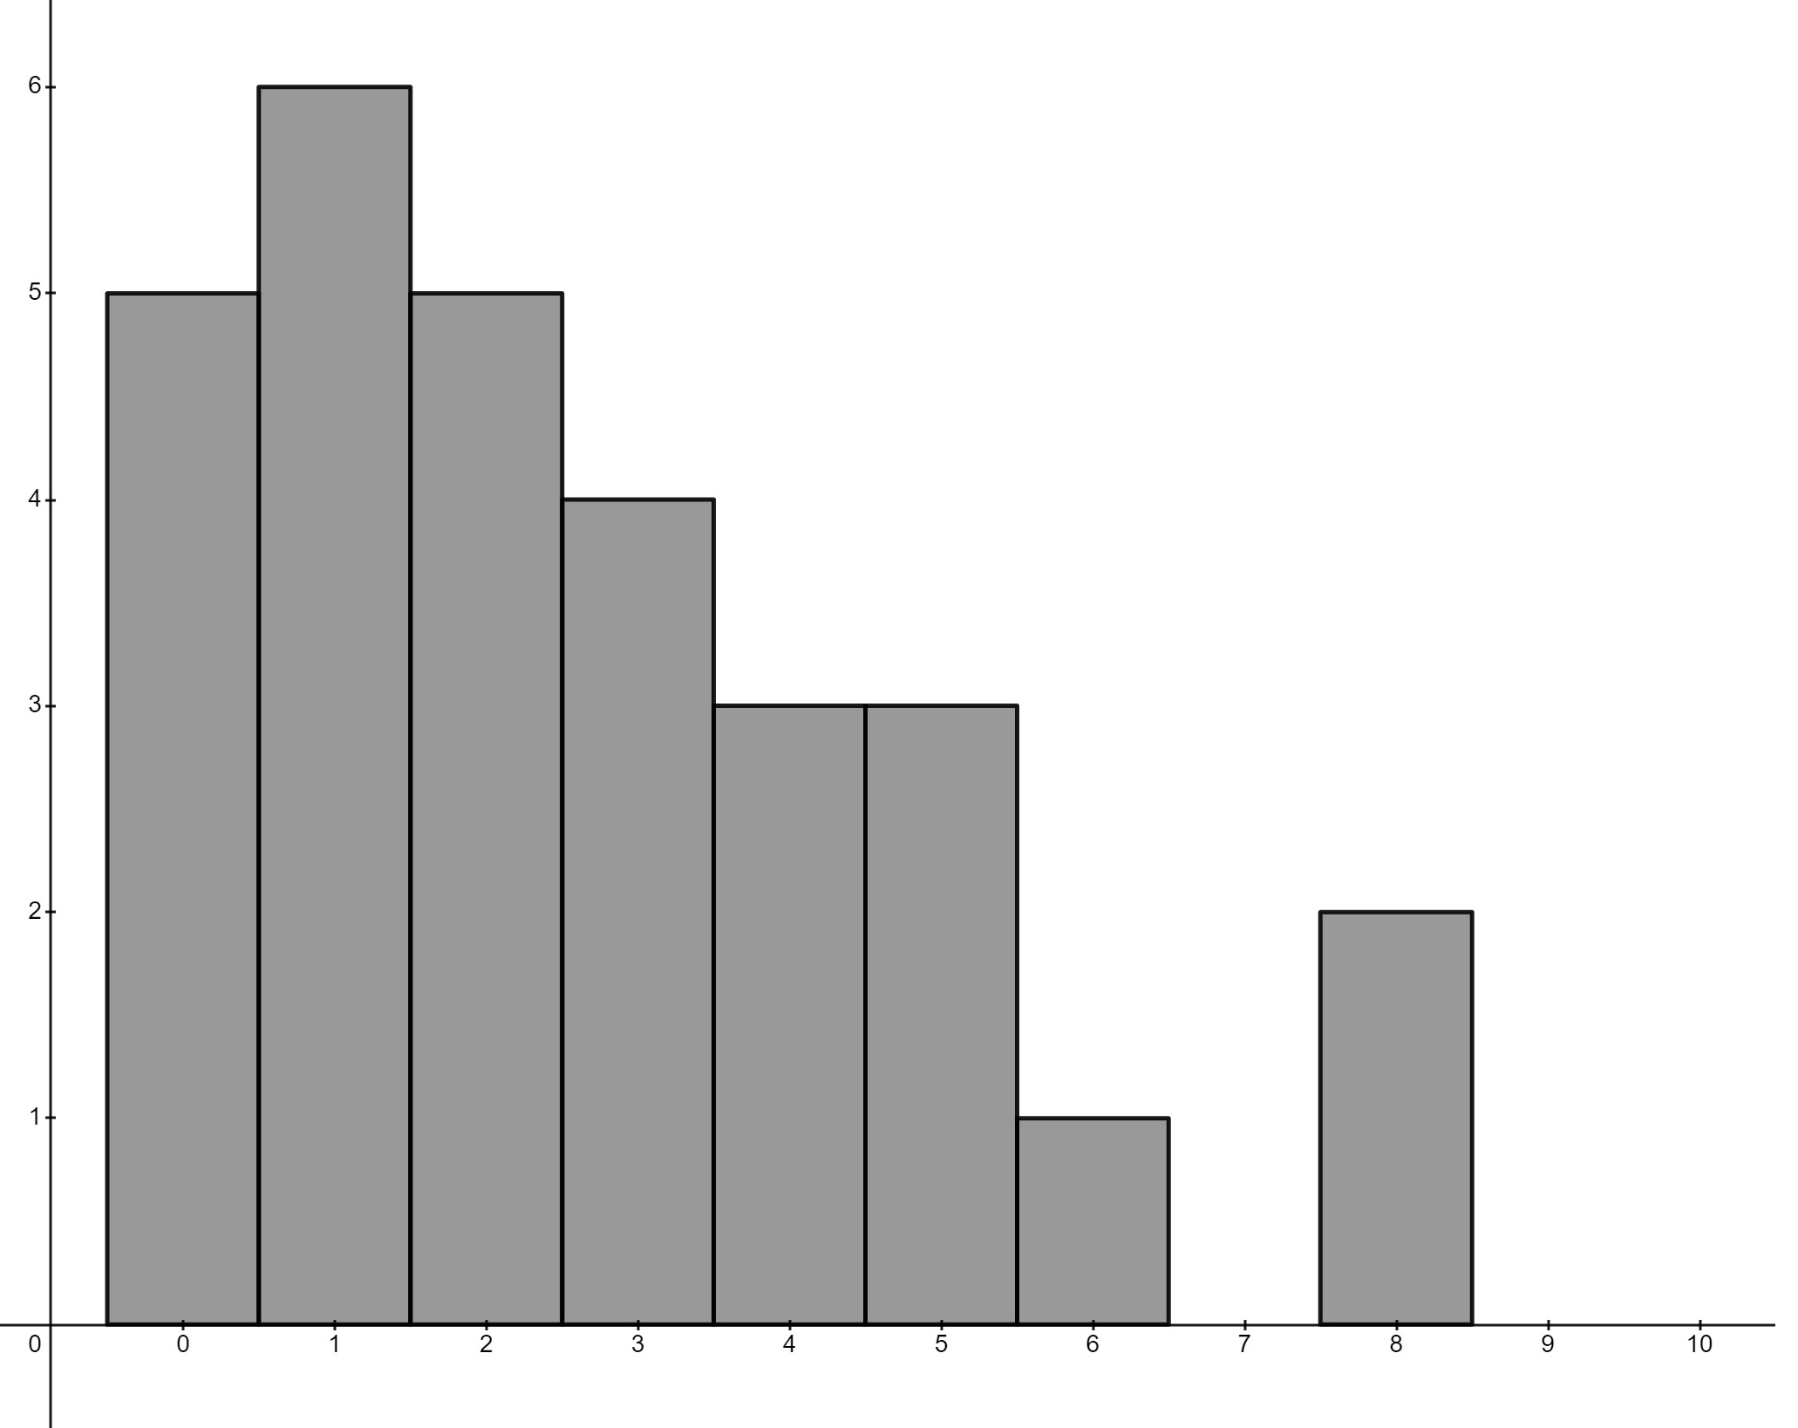
Median is 2.

Class C – frequency polygon
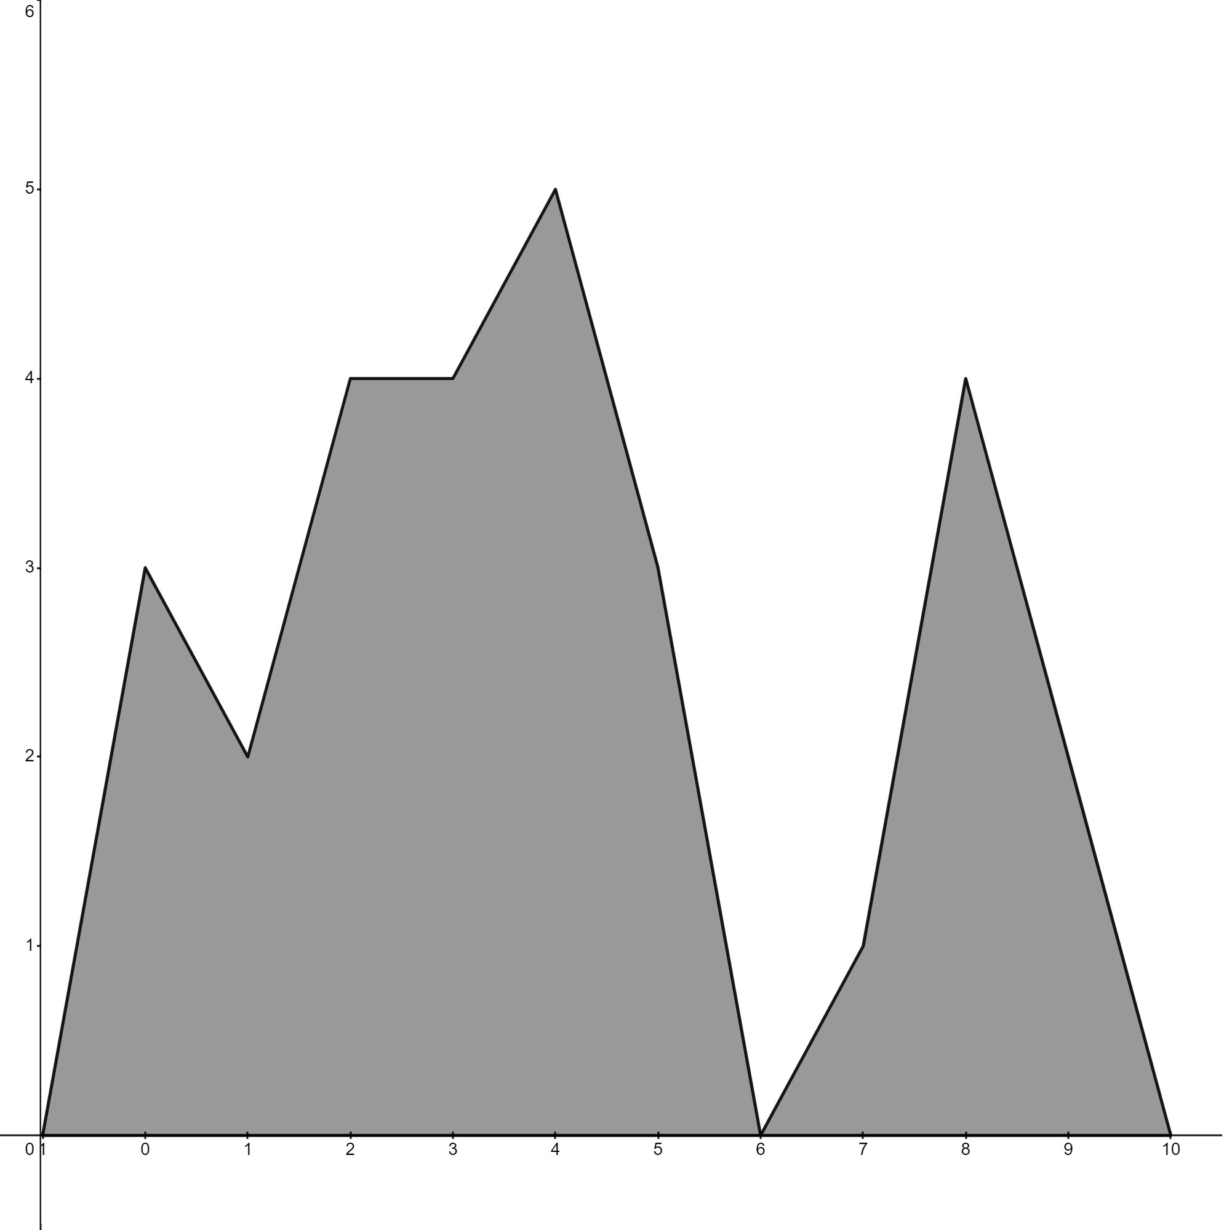
Median is 4.
Class A is the best class, then Class C and then Class B, as their median scores show the middle of the data and that more than 50% of the class scored over that amount.

Appendix C – Stephen Curry free-throws

Number of successful free-throws by Stephen Curry each game in the 2023 to 2024 season
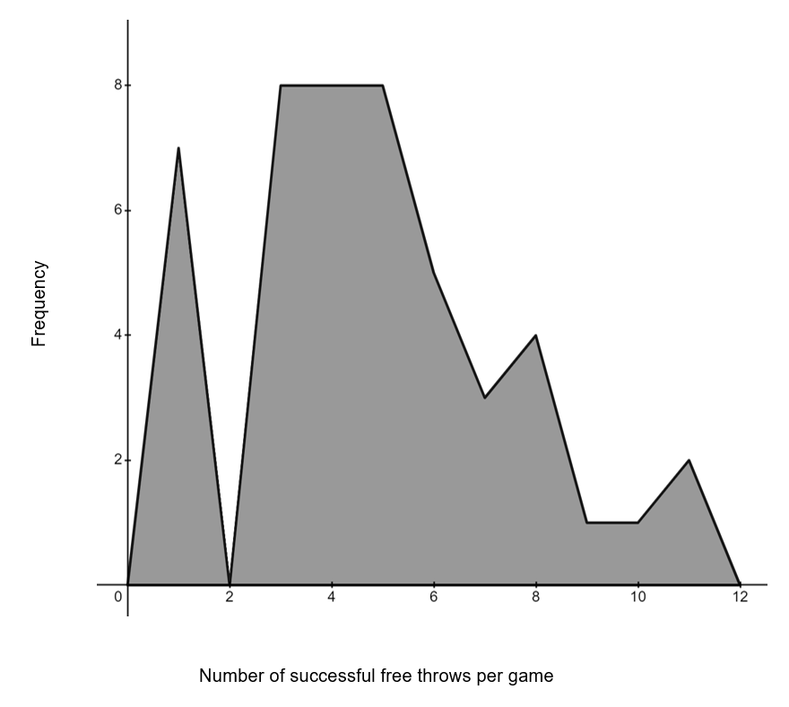

Number of successful free-throws by Stephen Curry each game in the 2022 to 2023 season
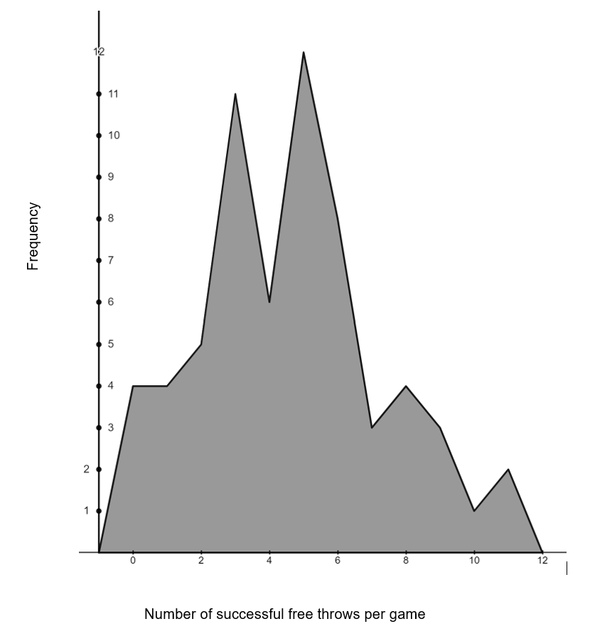

Number of successful free-throws by Stephen Curry each game in the 2021 to 2022 season
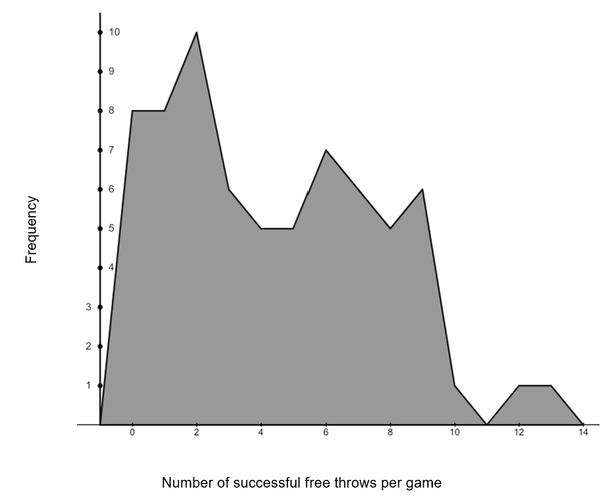

Questions
- Table of medians
Season | Median | Range
2023 to 2024 | 5 | 10
2022 to 2023 | 5 | 11
2021 to 2022 | 4 | 13
- He was consistent in the 2023 to 2024 season and 2022 to 2023 season.
- I estimate he will have a median of 5, as 2 of the seasons were that and one of 4.
- Frequency table
Score | Frequency
0 | 12
1 | 19
2 | 15
3 | 25
4 | 19
5 | 25
6 | 20
7 | 12
8 | 13
9 | 10
10 | 3
11 | 4
12 | 1
13 | 1
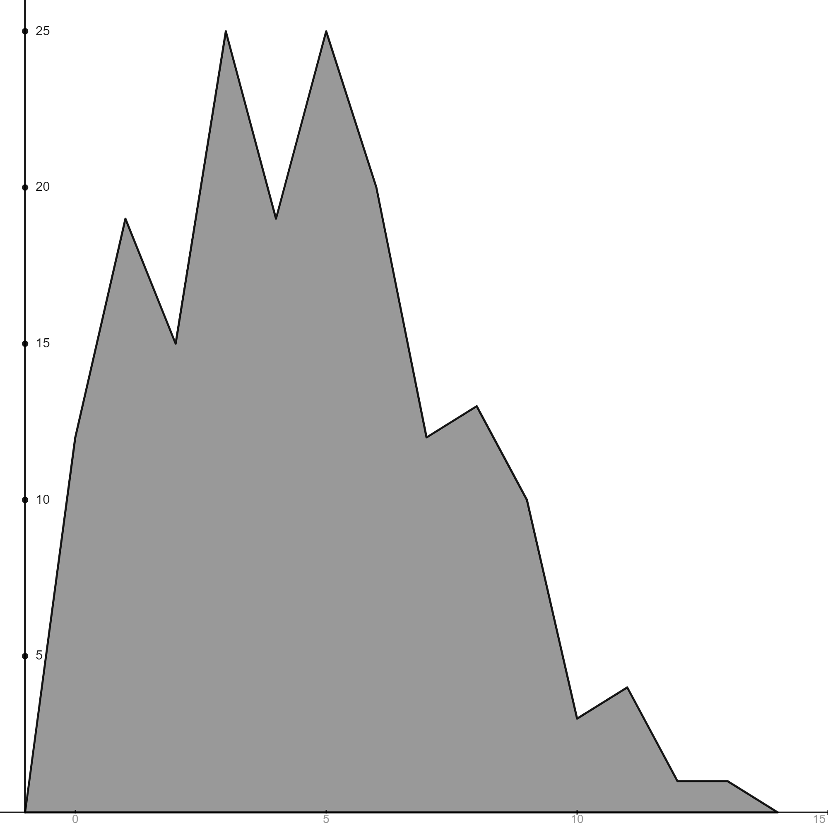
- The median is 4.
- I was one off the actual median. This must be because there are different amounts of games each season, so more data points were added to the lower 50%.

References
This resource contains NSW Curriculum and syllabus content. The NSW Curriculum is developed by the NSW Education Standards Authority. This content is prepared by NESA for and on behalf of the Crown in right of the State of New South Wales. The material is protected by Crown copyright.
Please refer to the NESA Copyright Disclaimer for more information https://educationstandards.nsw.edu.au/wps/portal/nesa/mini-footer/copyright.
NESA holds the only official and up-to-date versions of the NSW Curriculum and syllabus documents. Please visit the NSW Education Standards Authority (NESA) website https://educationstandards.nsw.edu.au and the NSW Curriculum website https://curriculum.nsw.edu.au.
Mathematics K–10 Syllabus © NSW Education Standards Authority (NESA) for and on behalf of the Crown in right of the State of New South Wales, 2022.

© State of New South Wales (Department of Education), 2024
The copyright material published in this resource is subject to the Copyright Act 1968 (Cth) and is owned by the NSW Department of Education or, where indicated, by a party other than the NSW Department of Education (third-party material).
Copyright material available in this resource and owned by the NSW Department of Education is licensed under a Creative Commons Attribution 4.0 International (CC BY 4.0) license.
This license allows you to share and adapt the material for any purpose, even commercially.
Attribution should be given to © State of New South Wales (Department of Education), 2024.
Material in this resource not available under a Creative Commons license:
- the NSW Department of Education logo, other logos and trademark-protected material
- material owned by a third party that has been reproduced with permission. You will need to obtain permission from the third party to reuse its material.
Links to third-party material and websites
Please note that the provided (reading/viewing material/list/links/texts) are a suggestion only and implies no endorsement, by the New South Wales Department of Education, of any author, publisher, or book title. School principals and teachers are best placed to assess the suitability of resources that would complement the curriculum and reflect the needs and interests of their students.
If you use the links provided in this document to access a third-party's website, you acknowledge that the terms of use, including licence terms set out on the third-party's website apply to the use which may be made of the materials on that third-party website or where permitted by the Copyright Act 1968 (Cth). The department accepts no responsibility for content on third-party websites.

