The big sick
Students determine whether a company should pay for the flu vaccine by analysing data to determine the mean number of sick days used by staff each year.

Visible learning

Learning intention
- To be able to find the mean from a frequency table and graphs.

Success criteria
- I can record data in a frequency table.
- I can create and complete an $fx$ column in a frequency table.
- I can find the mean from a frequency table.
- I can use the mean from a dataset to inform decisions.

Syllabus outcomes
A student:
- develops understanding and fluency in mathematics through exploring and connecting mathematical concepts, choosing and applying mathematical techniques to solve problems, and communicating their thinking and reasoning coherently and clearly MAO-WM-01
- classifies and displays data using a variety of graphical representations MA4-DAT-C-01
- analyses simple datasets using measures of centre, range and shape of the data
MA4-DAT-C-02
Mathematics K–10 Syllabus © NSW Education Standards Authority (NESA) for and on behalf of the Crown in right of the State of New South Wales, 2022.

Activity structure
Please use the associated PowerPoint The big sick to display images in this lesson.

Warm up
Students are to attempt the NRICH activity ‘Wipeout’ (nrich.maths.org/wipeout).

Launch
- Assign students into visibly random groups of 3 (bit.ly/visiblegroups).
- Pose the scenario to students:
Shefali owns a distribution company. She wants to find out if it is worthwhile to pay for her employees to get the flu vaccine, as she thinks it might reduce employee absences over winter.
- Use a Think-Pair-Share (bit.ly/thinkpairsharestrategy) for students to discuss what data Shefali might need and what analysis she should do to answer this question.
- Initiate a sharing of ideas and reasoning using the Pose-Pause-Pounce-Bounce question strategy (PDF 557KB) (bit.ly/posepausepouncebounce).

Explore
- Display slide 3 from the PowerPoint The big sick.
- This slide shows the number of sick days for each of Shefali’s employees from the previous winter.
- Ask students if they think this data represents a census or a sample and why.
- Using a Think-Pair-Share, ask students to calculate the mean, median and mode for the data.
- Use a Pose-Pause-Pounce-Bounce questioning technique for students to share the strategies they used to find the mean.
Students may use a levelling up strategy or variations of the algorithm. Highlight efficient strategies such as recognising that 4 + 4 + 4 + 4 + 4 is equivalent to 5 × 4.
- Display slide 4 from the PowerPoint The big sick. This slide shows the raw data organised into a frequency table.
- In their pairs, ask students to discuss how they might calculate the mean now that the data has been displayed in a frequency table. Students should test their strategy by calculating the mean and comparing it to their original calculation using the raw data.

Summarise
- Use a Pose-Pause-Pounce-Bounce questioning technique for students to share their strategies for calculating the mean from a frequency table.
- Use slides 6 to 9 from the PowerPoint The big sick for explicit teaching of how to calculate the mean from a frequency table.
The explicit teaching technique used in the associated PowerPoint is ‘Your turn.’ The first slide is a worked example which should be displayed for the students and then use the following steps.
- Reveal the question to students and its solution.
- Students read in silence.
- Students individually explain to themselves what is happening in each step.
- Students hold a thumbs up to the teacher when they have finished reading and have some sort of understanding.
- Think-Pair-Share. Students explain the solution to their partner.
- In pairs, students then answer the self-explanation questions.
- Finally, randomly select students to share their answers with the whole class.
- Distribute Appendix A ‘Yearly absences’ to each student. Appendix A contains a frequency table for each of the remaining seasons, showing the absence data for the company in each season.
- Ask students to find the mean of absences for each season.
- Display slide 10 and/or slide 11 from the PowerPoint The big sick. These graphs show the number of days absent from the previous winter.
The data has also been provided as a dot plot for schools using the stage-based scope and sequence.
- Use a Think-Pair-Share for students to discuss how they could calculate the mean for the data when it is represented as a histogram (and/or a dot plot).
- Use a Pose-Pause-Pounce-Bounce questioning technique for students to share their answers and their reasoning.
Students should realise that they can convert the data into a frequency table or use the same technique to calculate the mean from the histogram or dot plot.
- Ask students to complete the frequency table from the graph in Appendix B and find the mean.
- Ask students to determine whether Shefali should pay for the flu vaccine for her staff using the data provided. Students should justify their decision.
- Students are to create notes to their future forgetful selves (bit.ly/notesstrategy), outlining how to find the mean from frequency graphs and tables.

Apply
During this section, students will work in visibly random groups of 3 on vertical non-permanent surfaces (bit.ly/VNPSstrategy).
- Explain that the data Shefali was using, was collected prior to the COVID-19 pandemic.
- Start a class discussion about what they think would happen to the absences of Shefali’s staff during the COVID-19 pandemic.
- Explain to students that during the COVID-19 pandemic, many employees exceeded their sick days, which meant they were no longer paid when they were off sick. During this time, Shefali decided to grant special leave to her employees so they would still be paid.
- Distribute Appendix C ‘COVID-19 extra absences’ to each student. This data shows the number of days that her employees exceeded their allocated sick days by for the year.
- Ask students to decide the number of special absence days that Shefali should offer her staff. Students should be asked to use different data displays and analysis to justify their choices.

Assessment and differentiation

Suggested opportunities for differentiation
Warm up
- Suggestions for supporting students, and possible solution strategies, are outlined on the NRICH website https://nrich.maths.org/wipeout/note.
Launch
- As this activity has no incorrect answers and is subject to opinion, all students should be able to access the lesson content.
Explore
- Students should be challenged to make connections with prior knowledge by finding the mean using the leveling-up strategy.
- Students may benefit from first revising frequency tables to check student understanding of what the frequency total represents.
Summarise
- Students can be extended by asking about limitations of the data, which can include that the table only shows data for one year and the information on why staff were absent isn’t included so we can’t relate it to the flu.
- Students can be supported by using counters or blocks to represent the data in the frequency table and using a levelling-up strategy.
Apply
- There are no correct answers during the Apply activity, and all students should be encouraged to participate and share their thoughts and reasoning.
- Students with low readiness can continue to use a levelling-up strategy.

Suggested opportunities for assessment
Explore
- A Think-Pair-Share provides students with the opportunity to reflect on their understanding.
- Students will demonstrate their Working mathematically skills in class discussions and justifications.
Summarise and Apply
- Review students’ notes to their future forgetful selves.
- Collect Appendices A, B and C to check for understanding.

Appendix A

Yearly absences
The frequency tables display the number of absences for Shefali’s employees over spring, summer and autumn.

Spring

Days absent $(x)$ | Frequency $(f)$ | $$fx$$
1 | 1
2 | 4
3 | 5
4 | 10
5 | 6
6 | 1
7 | 1
8 | 0
9 | 1
10 | 0
Totals | 29

Summer

Days absent $(x)$ | Frequency $(f)$ | $$fx$$
1 | 3
2 | 6
3 | 0
4 | 5
5 | 0
6 | 4
7 | 3
8 | 4
9 | 3
10 | 1
Totals | 29

Autumn

Days absent $(x)$ | Frequency $(f)$ | $$fx$$
1 | 1
2 | 3
3 | 4
4 | 5
5 | 6
6 | 5
7 | 2
8 | 2
9 | 1
10 | 0
Totals | 29

Appendix B

Previous winter histogram and dot plot
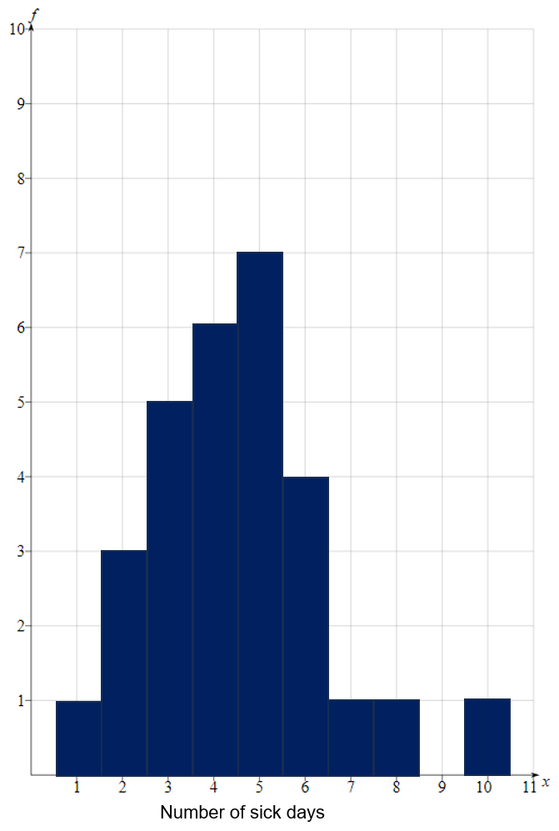
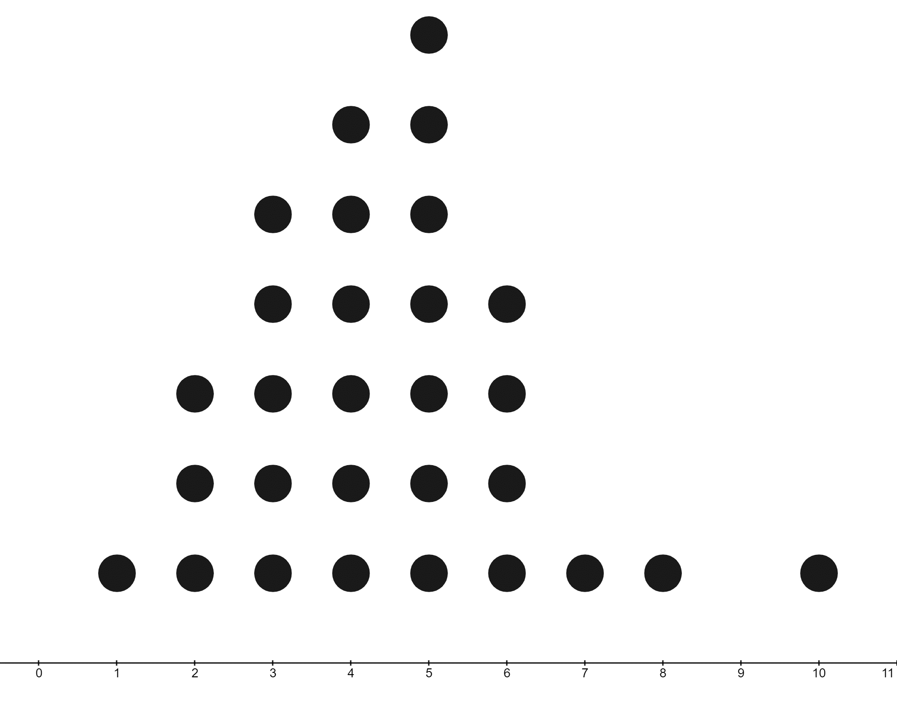
Number of sick days
Days absent $(x)$ | Frequency $(f)$ | $$fx$$
1
2
3
4
5
6
7
8
9
10
Totals

Appendix C

COVID-19 extra absences
By using the data in the frequency polygon, decide the number of special absence days that Shefali should offer her staff during the COVID-19 pandemic. Show all working, including data displays and analysis to justify your choice.

Number of extra absences per staff member above the allocated sick leave
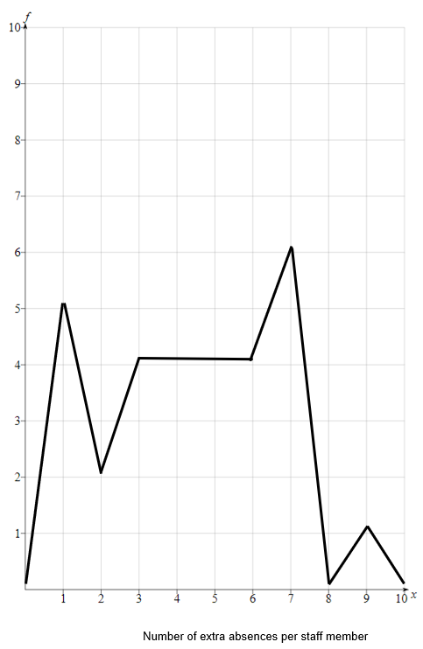

Sample solutions

Appendix A – yearly absences
The frequency tables display the number of absences Shefali’s employees had over spring, summer and autumn.

Spring

Days absent $(x)$ | Frequency $(f)$ | $$fx$$
1 | 1 | 1
2 | 4 | 8
3 | 5 | 15
4 | 10 | 40
5 | 6 | 30
6 | 1 | 6
7 | 1 | 7
8 | 0 | 0
9 | 1 | 9
10 | 0 | 0
Totals | 29 | 116
Mean $=\frac{116}{29}=4$ absences.

Summer

Days absent $(x)$ | Frequency $(f)$ | $$fx$$
1 | 3 | 3
2 | 6 | 12
3 | 0 | 0
4 | 5 | 20
5 | 0 | 0
6 | 4 | 24
7 | 3 | 21
8 | 4 | 32
9 | 3 | 27
10 | 1 | 10
Totals | 29 | 149
Mean $=\frac{149}{29}≈5.1$ absences.

Autumn

Days absent $(x)$ | Frequency $(f)$ | $$fx$$
1 | 1 | 1
2 | 3 | 6
3 | 4 | 12
4 | 5 | 20
5 | 6 | 30
6 | 5 | 30
7 | 2 | 14
8 | 2 | 16
9 | 1 | 9
10 | 0 | 0
Totals | 29 | 138
Mean $=\frac{138}{29}≈4.8$ absences.

Appendix B – previous winter histogram and dot plot
Days absent $(x)$ | Frequency $(f)$ | $$fx$$
1 | 1 | 1
2 | 3 | 6
3 | 5 | 15
4 | 6 | 24
5 | 7 | 35
6 | 4 | 24
7 | 1 | 7
8 | 1 | 8
9 | 0 | 0
10 | 1 | 10
Totals | 29 | 130
Mean $=\frac{130}{29}≈4.5$ absences.
Looking at the data from the previous year, all seasons seem to have around the same number of absences on average, so I would not pay for the flu vaccine.

Appendix C – COVID-19 extra absences
Extra days absent $(x)$ | Frequency $(f)$ | $$fx$$
1 | 5 | 5
2 | 2 | 4
3 | 4 | 12
4 | 4 | 16
5 | 4 | 20
6 | 4 | 24
7 | 5 | 35
8 | 0 | 0
9 | 1 | 9
10 | 0 | 0
Totals | 29 | 125
Mean $=\frac{125}{29}=4.3$ extra absences.
Due to the mean of the data, I would tell Shefali to allow staff an extra 4–5 sick days during the COVID-19 pandemic, as this provides full cover for a lot of the staff and minor loss of income for ones over that amount.

References
This resource contains NSW Curriculum and syllabus content. The NSW Curriculum is developed by the NSW Education Standards Authority. This content is prepared by NESA for and on behalf of the Crown in right of the State of New South Wales. The material is protected by Crown copyright.
Please refer to the NESA Copyright Disclaimer for more information https://educationstandards.nsw.edu.au/wps/portal/nesa/mini-footer/copyright.
NESA holds the only official and up-to-date versions of the NSW Curriculum and syllabus documents. Please visit the NSW Education Standards Authority (NESA) website https://educationstandards.nsw.edu.au and the NSW Curriculum website https://curriculum.nsw.edu.au.
Mathematics K–10 Syllabus © NSW Education Standards Authority (NESA) for and on behalf of the Crown in right of the State of New South Wales, 2022.

© State of New South Wales (Department of Education), 2024
The copyright material published in this resource is subject to the Copyright Act 1968 (Cth) and is owned by the NSW Department of Education or, where indicated, by a party other than the NSW Department of Education (third-party material).
Copyright material available in this resource and owned by the NSW Department of Education is licensed under a Creative Commons Attribution 4.0 International (CC BY 4.0) license.
This license allows you to share and adapt the material for any purpose, even commercially.
Attribution should be given to © State of New South Wales (Department of Education), 2024.
Material in this resource not available under a Creative Commons license:
- the NSW Department of Education logo, other logos and trademark-protected material
- material owned by a third party that has been reproduced with permission. You will need to obtain permission from the third party to reuse its material.
Links to third-party material and websites
Please note that the provided (reading/viewing material/list/links/texts) are a suggestion only and implies no endorsement, by the New South Wales Department of Education, of any author, publisher, or book title. School principals and teachers are best placed to assess the suitability of resources that would complement the curriculum and reflect the needs and interests of their students.
If you use the links provided in this document to access a third-party's website, you acknowledge that the terms of use, including licence terms set out on the third-party's website apply to the use which may be made of the materials on that third-party website or where permitted by the Copyright Act 1968 (Cth). The department accepts no responsibility for content on third-party websites.

