Goal-free soccer
Students learn how to draw and interpret frequency histograms and polygons in reference to statistics in sport.

Visible learning

Learning intention
- To be able to draw and interpret a frequency histogram and polygon.

Success criteria
- I can draw a frequency histogram from a dataset.
- I can draw a frequency polygon from a dataset.
- I can interpret a frequency histogram and polygon to draw conclusions.

Syllabus outcomes
A student:
- develops understanding and fluency in mathematics through exploring and connecting mathematical concepts, choosing and applying mathematical techniques to solve problems, and communicating their thinking and reasoning coherently and clearly MAO-WM-01
- classifies and displays data using a variety of graphical representations MA4-DAT-C-01
Mathematics K–10 Syllabus © NSW Education Standards Authority (NESA) for and on behalf of the Crown in right of the State of New South Wales, 2022.

Activity structure
Please use the associated PowerPoint Goal-free soccer to display images in this lesson.

Launch
- Display slide 2 from the PowerPoint Goal-free soccer.
- Using a Think-Pair-Share (bit.ly/thinkpairsharestrategy), ask students to discuss what they notice and what they wonder.
- Explain to students that this game holds the world record for the largest number of goals scored in a single match. More information can be found at https://jobsinfootball.com/blog/highest-scoring-soccer-games-ever/.
- In a Think-Pair-Share ask students the following question:
If we were to watch a game of soccer, how many goals should we expect? Why do you think that is the case?
To continue the conversation, you can use some further questions or statements such as:
- Would you expect a difference between the number of goals in a home and away game versus a final?
- Would you expect your local team to score the same number of goals as our Australian teams?

Explore
- Display slide 3 from the PowerPoint Goal-free soccer.
- Use a Think-Pair-Share to ask students to discuss how many goals we could expect the Matildas to score in a game.
- Use a Pose-Pause-Pounce-Bounce (PDF 557 KB) (bit.ly/posepausepouncebounce) questioning strategy for students to share their thoughts and reasoning.
- Display slide 3 from the PowerPoint Goal-free soccer.
- Conduct a data talk (bit.ly/datatalklink) about the data provided on the slide. Students should consider and compare the ease of use of the raw data on slide 3 versus the graph on slide 4.
A data talk is a short 5–10-minute classroom discussion to help students develop data literacy. Students are shown a data visual and asked what they notice and wonder.
- Explain to students that the type of graph they have been looking at is called a frequency histogram.
Students were introduced to histograms in Lesson 11 – going to the movies of Unit 2 – making decisions.
- Distribute Appendix A ‘Column graphs versus frequency histograms’ and Appendix B ‘Venn diagram’ to each pair of students. Appendix A has a collection of column graphs and frequency histograms. Appendix B has a Venn diagram for students to complete.
- In a Think-Pair-Share ask students to discuss and complete the Venn diagram with the similarities and differences between the 2 types of graphs.
- During the sharing process, students should add any features they haven’t considered to their own Venn diagram. A copy of the Venn diagram can be found on slide 5 of the PowerPoint Goal-free soccer.

Students should not only think about the features of the graphs but should consider the types of data that are displayed in each graph.
A column graph compares the frequency of categorical data while a frequency histogram compares the frequency of numerical dataset.
- By working in visibly random groups of 3 (bit.ly/visiblegroups) on vertical non-permanent surfaces (bit.ly/VNPSstrategy), ask students to complete a goal-free problem (bit.ly/goalfreeproblems) by finding all the information they can from the graph on slide 4 of the PowerPoint Goal-free soccer.
Students can use the graph to create frequency tables, find measures of centre and assess the spread, among many other things. This can be used as an opportunity for students to revisit content from Stage 4 Unit 2 – Making decisions.
Students will explore finding the mean and median from frequency tables and histograms in future lessons.
- Use assessing and advancing questions to progress student thinking. Some examples are in the table below:
Table 1: assessing and advancing questions
Assessing questions | Advancing questions
What can you tell me about the graph? | Could you display the data in a different way?
What does the tallest column represent? | How many goals can we expect them to score in a match?
What does the 0 mean on the horizontal axis? | What conclusions would you make, based on the graph?
Assessing questions draw out students’ thinking about a problem and what methods they have tried so far. Advancing questions are intended to help move students’ thinking forward toward the lesson goals. We want to draw their attention to something they may not have noticed or considered yet.
- Students are to do a gallery walk (bit.ly/DLSgallerywalk) of student work to try and find further information from other groups.
- Select a non-volunteer student to present and share what was the most interesting thing they discovered from their own group’s work or the work of another group.

Summarise
- Brainstorm and collate with students the information they can gain from a frequency histogram.
- Use slides 6–13 from the Goal-free soccer PowerPoint for explicit teaching of drawing a frequency histogram and polygon from a frequency table. Students should be provided with grid paper to complete this activity.
Grid paper can be found on the website ‘Free Online Graph Paper’ (https://print-graph-paper.com/).
The explicit teaching technique used in the PowerPoint is ‘Your turn’. The first slide is a worked example which should be displayed for the students before using the following steps.
- Reveal the question to students and its solution.
- Students read in silence.
- Students individually explain to themselves what is happening in each step.
- Students hold a thumbs up to the teacher when they have finished reading and have some sort of understanding.
- Think-Pair-Share. Students explain the solution to their partner.
- In pairs, students then answer the self-explanation questions.
- Finally, randomly select students to share their answers with the whole class.
- Facilitate a class discussion on the similarities and differences between a frequency histogram and a frequency polygon.

Histograms and polygons both show the distribution of data.
Polygons should be used when representing multiple data displays, as it makes it easier to compare multiple datasets.

Apply
- Students are to select a sport statistic for which they can create a frequency histogram or polygon. Some examples are included below:
- tries in a rugby league game
- hours taken for a match of tennis
- number of overs in a test cricket match.
- Students are to create a poster to share with the class about their sport statistic, which must include:
- a frequency histogram or polygon
- summary statistics, including mean, median, range and mode
- a conclusion of what story the data is telling us.
- Students are to display their posters around the room for a gallery walk. As students visit the posters, they should give feedback using the two stars and a wish strategy (bit.ly/2starwish).
Students can make online posters that include frequency polygons on Canva (canva.com).

Assessment and differentiation

Suggested opportunities for differentiation
Explore
- Students may benefit from reviewing summary statistics such as mean, median, range and mode, and frequency tables explored in Unit 2 – Making decisions.
- All students will be able to interpret simple things from the graph but may need assistance connecting the same data in different displays.
Summarise
- Challenge students to decide which graph would be best to use between a frequency histogram and polygon and to justify their choice.
Apply
- Teachers can decide whether to let students draw their graphs by hand or using technology.
- Students can calculate mean, median, mode and range from their raw data.
- Encourage students to explore what would happen if the range of the data was very large and the frequency of each value was very small to lead them into the purpose of needing classes of data.

Suggested opportunities for assessment
Explore
- Monitor responses in the data talk to check for student understanding of interpreting graphs.
- When placed in groups of 3, students provide and receive peer feedback on their understanding.
- Collect the Venn diagrams of students to assess understanding of the most appropriate data display for different data.
Summarise
- Monitor student responses in the ‘Your turn’ section to check for understanding.
Apply
- Students give peer feedback using two stars and a wish.
- Collect student posters as an exit ticket for the lesson.

Appendix A

Column graphs versus frequency histograms

Frequency histograms

Number of patrons wait time for a roller coaster
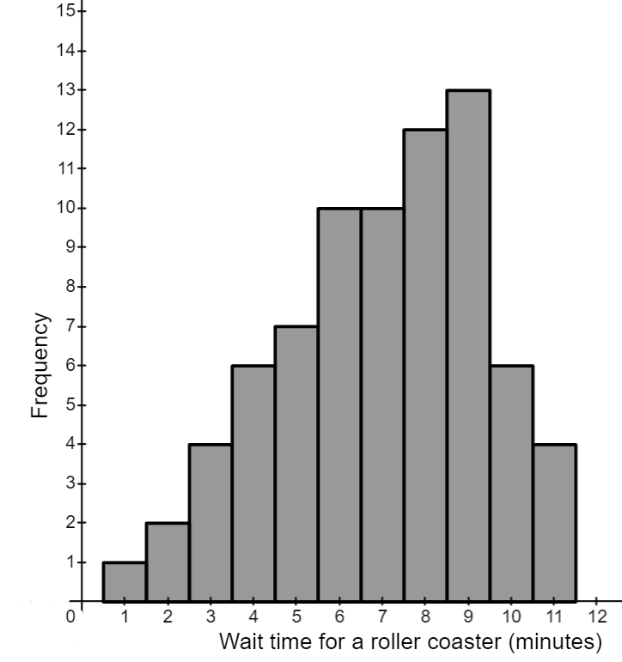

Salaries of people working for a large clothes company
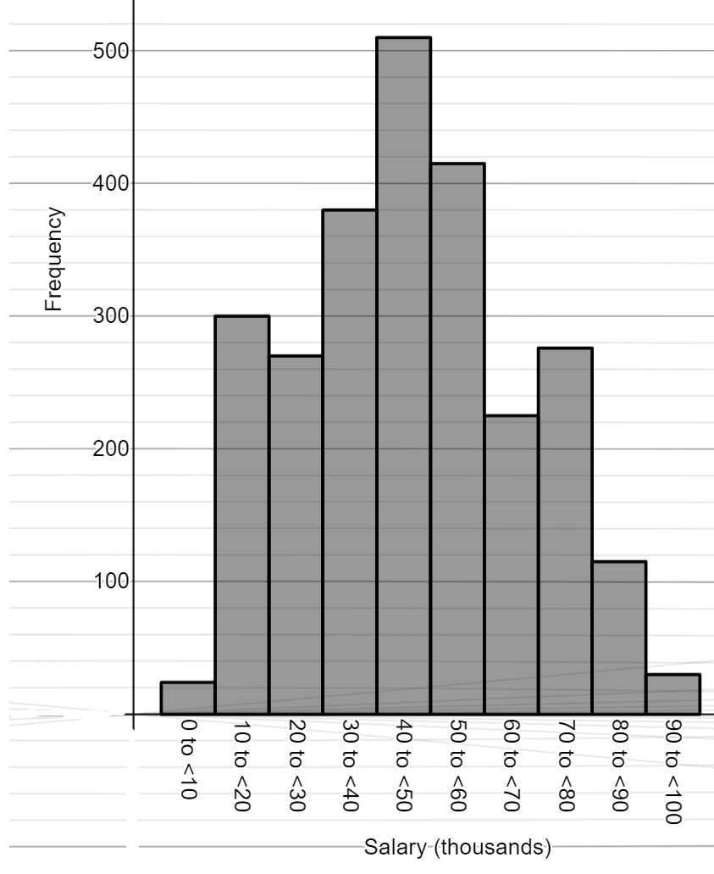

Ages of people in the local choir
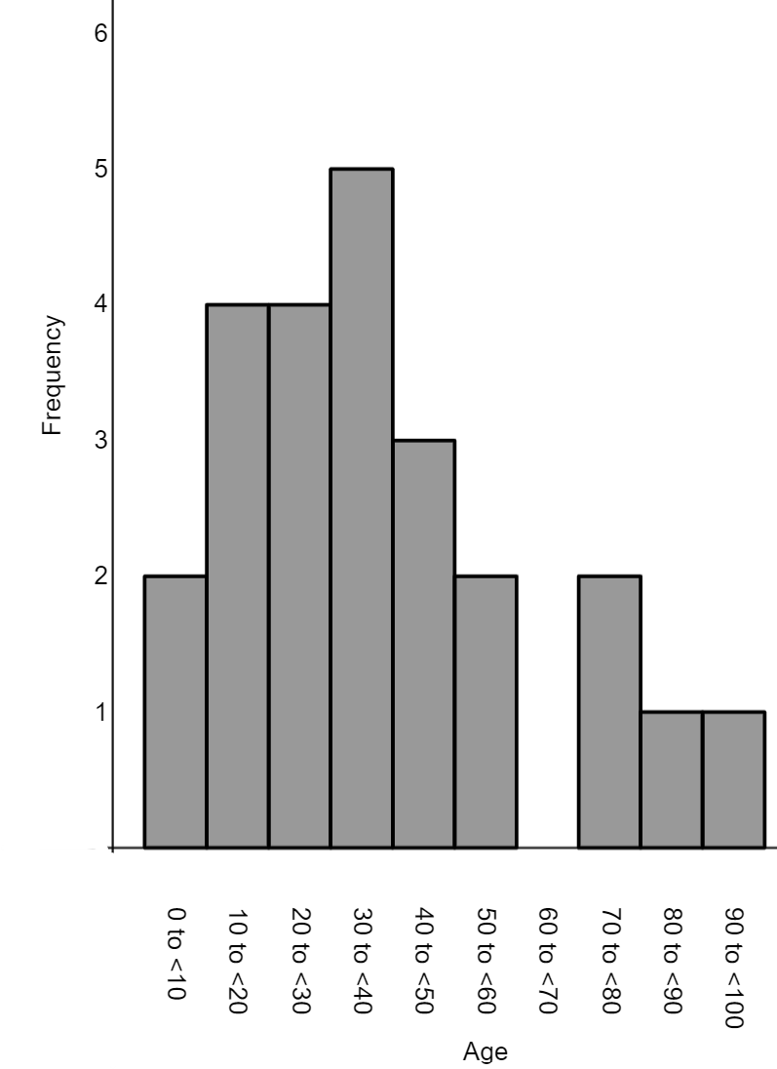

Column graphs

Appendix B

Venn diagram
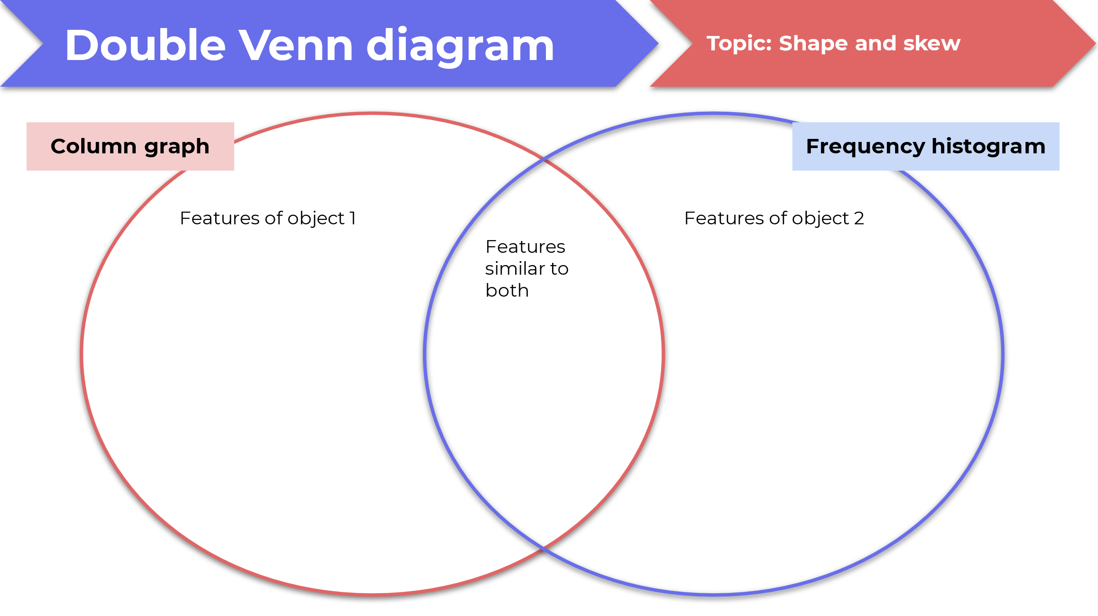

Sample solutions

Appendix A – goal-free soccer
0 0 0 1 1 1 1 1 2 2 2 2 2 2 3 3 3 3 3 4 4 4 4 4 5 5 5 6 7 7 7 8
Mean = $\frac{102}{32}=3.1875$ $≈3$ goals
Median is between the 16th and 17th score. Those scores both lie in 3 goals, so the median is 3.
Mode is 2 goals
Range $8-0=8$
Data mostly around 1–4 goals.

Appendix B – Venn diagram
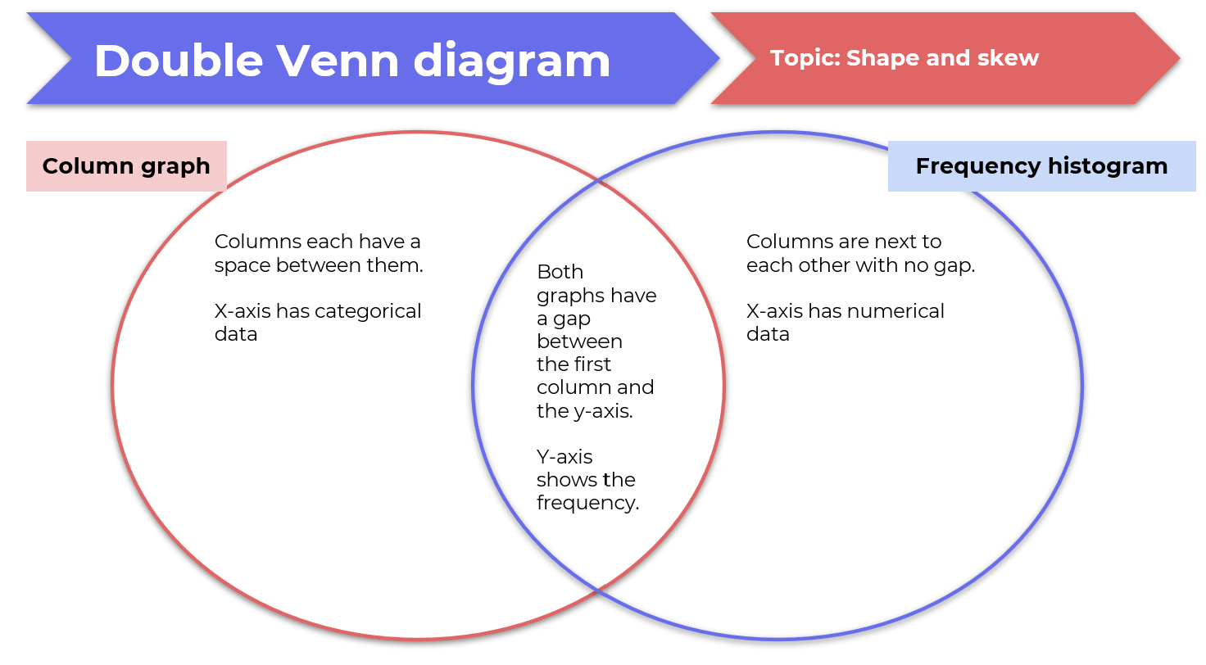

Apply section
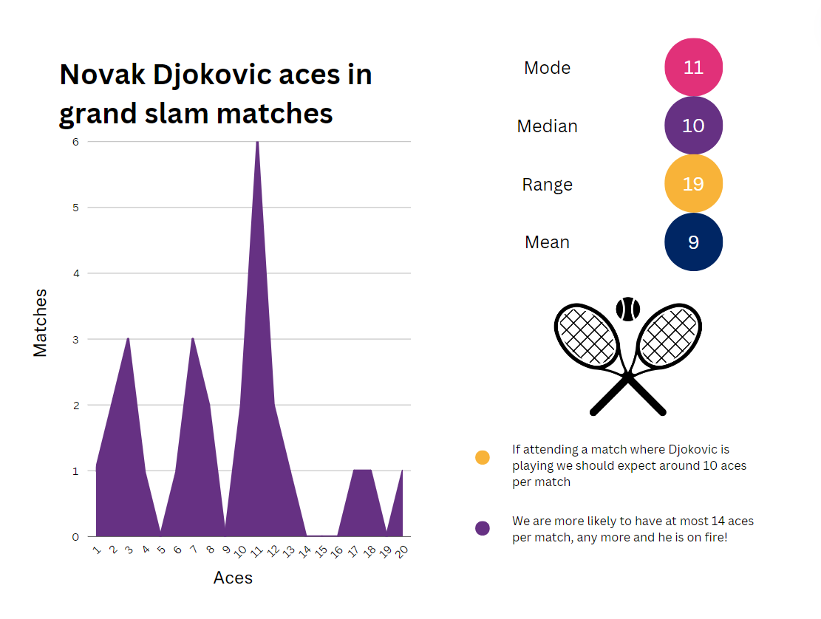

References
This resource contains NSW Curriculum and syllabus content. The NSW Curriculum is developed by the NSW Education Standards Authority. This content is prepared by NESA for and on behalf of the Crown in right of the State of New South Wales. The material is protected by Crown copyright.
Please refer to the NESA Copyright Disclaimer for more information https://educationstandards.nsw.edu.au/wps/portal/nesa/mini-footer/copyright.
NESA holds the only official and up-to-date versions of the NSW Curriculum and syllabus documents. Please visit the NSW Education Standards Authority (NESA) website https://educationstandards.nsw.edu.au and the NSW Curriculum website https://curriculum.nsw.edu.au.
Mathematics K–10 Syllabus © NSW Education Standards Authority (NESA) for and on behalf of the Crown in right of the State of New South Wales, 2022.

© State of New South Wales (Department of Education), 2024
The copyright material published in this resource is subject to the Copyright Act 1968 (Cth) and is owned by the NSW Department of Education or, where indicated, by a party other than the NSW Department of Education (third-party material).
Copyright material available in this resource and owned by the NSW Department of Education is licensed under a Creative Commons Attribution 4.0 International (CC BY 4.0) license.
This license allows you to share and adapt the material for any purpose, even commercially.
Attribution should be given to © State of New South Wales (Department of Education), 2024.
Material in this resource not available under a Creative Commons license:
- the NSW Department of Education logo, other logos and trademark-protected material
- material owned by a third party that has been reproduced with permission. You will need to obtain permission from the third party to reuse its material.
Links to third-party material and websites
Please note that the provided (reading/viewing material/list/links/texts) are a suggestion only and implies no endorsement, by the New South Wales Department of Education, of any author, publisher, or book title. School principals and teachers are best placed to assess the suitability of resources that would complement the curriculum and reflect the needs and interests of their students.
If you use the links provided in this document to access a third-party's website, you acknowledge that the terms of use, including licence terms set out on the third-party's website apply to the use which may be made of the materials on that third-party website or where permitted by the Copyright Act 1968 (Cth). The department accepts no responsibility for content on third-party websites.

