Broccoli soup
Students will explore the first steps of a statistical investigation by considering when a census is needed and how to avoid bias when selecting a sample to collect data.

Visible learning

Learning intention
- To be able to understand factors to consider when collecting data.

Success criteria
- I can explain the difference between a census and a sample.
- I can identify when a census is needed in data collection.
- I can avoid bias when selecting a sample to collect data.

Syllabus outcomes
A student:
- develops understanding and fluency in mathematics through exploring and connecting mathematical concepts, choosing and applying mathematical techniques to solve problems, and communicating their thinking and reasoning coherently and clearly MAO-WM-01
- classifies and displays data using a variety of graphical representations MA4-DAT-C-01
- analyses simple datasets using measures of centre, range and shape of the data
MA4-DAT-C-02
Mathematics K–10 Syllabus © NSW Education Standards Authority (NESA) for and on behalf of the Crown in right of the State of New South Wales, 2022.

Activity structure
Please use the associated PowerPoint Broccoli soup to display images in this lesson.

Launch
- Display slide 3 of the PowerPoint Broccoli soup.
- Use a Think-Pair-Share (bit.ly/thinkpairsharestrategy) for students to discuss the cartoon. Discussion points could include:
- How might we decide on a new food item in the canteen?
- What information might need to be considered when introducing a new food item?
- Who should be consulted when choosing a new food item?
- Use a Pose-Pause-Pounce-Bounce (PDF 557 KB) (bit.ly/posepausepouncebounce) questioning strategy for students to share their thoughts and reasoning.

Explore
- Explain to students that they will be exploring the important step of deciding who to involve and where to obtain data from in a statistical investigation.
- Display slide 5 of the PowerPoint Broccoli soup.
- Use a Think-Pair-Share for students to discuss the following question:
If the canteen manager wanted to introduce a new food in the canteen, who should they ask for ideas?
Prompting questions may include:
- Which people at the school could they talk to?
- Are there people outside the school they should consult?
- How many people should be involved in making the decision?
- Use a Pose-Pause-Pounce-Bounce questioning strategy to allow students to share their thoughts and reasoning.
Advise students that they are going to watch a video showing how scientists collect data about penguins. The video explains the difference between observing all penguins and observing a small number of penguins.
- Distribute Appendix A ‘SWOT analysis’ to each student.
- Display slide 6 of the PowerPoint Broccoli soup and explain how to complete a SWOT analysis (bit.ly/dlsSWOTanalysis).
Explain to students that a SWOT analysis involves identifying Strengths, Weaknesses, Opportunities and Threats to gain a comprehensive understanding of a project or decision. The diagram on slide 6 of the PowerPoint Broccoli soup provides a leading question in each section.
- Show the video ‘BitMaths Teaching Video: Population census and sample (2:25)’ (bit.ly/censusample).
- Whilst watching the video, students are to fill in the SWOT analysis, comparing the 2 ways we can collect data; with a census or with a sample group.
When filling in the SWOT analysis template, encourage students to consider census and sample generally and in the context of accessing primary and secondary data, as mentioned in the video.
Primary and secondary data are not included in the syllabus but teachers may choose to extend their students by introducing these terms and concepts.
- Present the following scenario to students: the canteen manager has decided to ask everyone in the school community about new food choices for the canteen.
- Use a Think-Pair-Share for students to discuss the advantages and disadvantages of using a census or a sample in this scenario. Questions which may promote discussion include:
- Who would be included in our school community?
- What might a sample group look like at our school?
- How would we ask everyone in our community?
- How long might it take to ask everyone in our community?
- Initiate a sharing of ideas and reasoning using the Pose-Pause-Pounce-Bounce questioning strategy.

Summarise
- Distribute one copy of Appendix B ‘Sample v census’ between pairs of students and ask students to complete the sorting activity.
- Initiate a sharing of ideas and reasoning using the Pose-Pause-Pounce-Bounce questioning strategy.
- Explain to students that there are many ways to select a sample.
- Show the video ‘What is sampling? (1:47)’ (bit.ly/srsdata).
- Discuss the following scenarios with students. Students should provide reasoning by referring to information from the video.
- Would you change the menu after asking just 2 people?
- Would you change the menu after asking 15 teenagers?
- Would you change the menu by just consulting with the principal?
- You ask the whole school and there is no consensus on what to add. Do you add nothing?
The video provides information about how a sample group may be selected. Discussion should focus on sampling techniques, ways to avoid bias in the data and ways to ensure random data selection.
Students do not need to know specific sampling techniques or the names of techniques.
- Distribute a copy of Appendix C ‘What do you think?’ to each student.
- Students will analyse the plan for collecting data by answering the questions in the appendix.
- Use a class discussion to allow students to share their thoughts.

Apply
- In Appendix D ‘Planning ideas’ there are 9 topic cards. Print and cut individual cards.
- Distribute one card to each pair.
- Explain to students that they have been given a planning card for conducting a statistical investigation and that each card has a topic and a driving question. They will need to complete the planning card, based on the topic. Students should communicate information about:
- whether a census or a sample should be used
- which groups of people should be surveyed
- how the samples could be selected to make sure they are random and representative
- how bias is avoided.
There are many ways to select sample groups. Students do not need to be familiar with all of them or be able to name them. Students should be encouraged to think creatively about how to select a sample group. For example:
- arranging students in a class alphabetically, starting with the second letter of their first name and selecting every 5th student
- selecting each student in a class who draws the short straw, in groups of 5.
- Students are to display their planning sheets from Appendix D around the room for a gallery walk (bit.ly/DLSgallerywalk).

Assessment and differentiation

Suggested opportunities for differentiation
Launch
- There are no right answers so all students should be encouraged to participate and share their ideas.
- Use discussion to assist students to identify who might be included as members of the school community.
- Challenge students to suggest other sources of information for the topic.
Explore
- Support students by providing ways to select sample groups for them to choose between.
- Support students by providing a range of statements for them to choose whether they are strengths, weaknesses, opportunities or threats.
Summarise
- Challenge students to consider both primary and secondary data sources that could be used to increase recycling at school.
Apply
- Challenge students to consider both primary and secondary data sources for their topic.
- Students are supported by working in pairs to share their ideas.

Suggested opportunities for assessment
Explore
- Monitor student completion of the sorting activity to ensure students understand the difference between census and sample.
Summarise
- Collect student answers to the questions on the planning sheet to determine the extent of student understanding.
Apply
- Monitor completion of the planning sheet to gauge student understanding of how to identify when a census or sample is appropriate and how to select a sample group.

Appendix A

SWOT analysis
Complete the SWOT analysis, considering the strengths, weaknesses, opportunities and threats of a census and a sample.
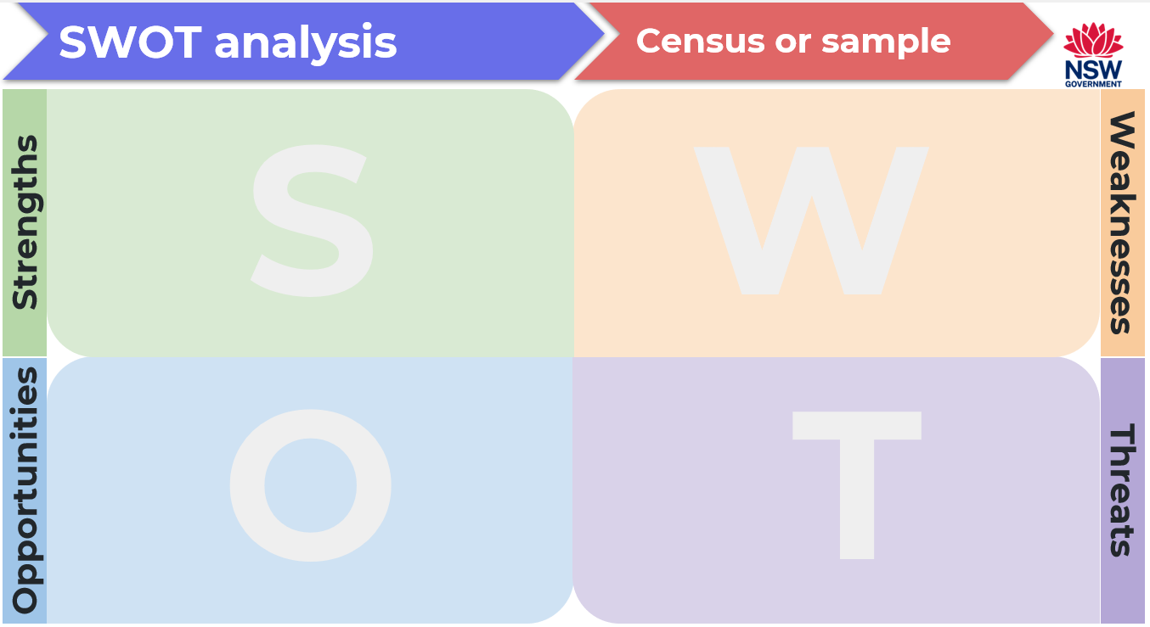

Appendix B

Sample v census
The cards show a topic area for a statistical investigation.
Cut out the cards and sort them under the headings ‘Sample’ or ‘Census’, according to whether a census or a sample would be used to collect data.
Sample | Electing a new school captain.
Census | A new school uniform.
A manufacturer testing their tennis balls for bounce. | A company doing a stocktake of bicycles in all the stores.
The school librarian wants new shelving in the library. | The RSPCA has funding for a new dog shelter.
A federal election. | Designing a new skate park.
A chip company making a new flavour. | The school has been given money to spend in the library.
A crash test of new cars just manufactured by a factory. | Council wants information on the height of buildings.
Asking all the teachers at your school whether they approve of a new school timetable. | Changes to the school’s homework policy.

Appendix C

What do you think?
This is an example of a planning sheet for a statistical investigation. Use the planning sheet to answer the questions underneath.

Sample planning sheet
What is the issue?
We want to be more environmentally friendly at school
What is my driving question?
How can we recycle more at school?
Who will I include in my survey and how will I collect their responses?
Teachers – I think I should ask some teachers. I will number 5 craft sticks and get them in groups of 5 to pick a stick. I will use the ones who pick the number 2 stick.
Students – I will choose 5 students from each class. Using a class roll, I will roll a die to choose my starting point. I will then pick every 5th name.
Parents – I think I should ask some because they might have good ideas. I will stand at the gate one afternoon and ask the parents who come to pick up their children.

Questions
- Is this a suitable sample of teachers? Explain your reasoning.
- Is the method used to sample students an effective way to collect the data? Explain your reasoning.
- How could there be bias in the data collection?
- Should a census be used, or is a sample of students acceptable?

Appendix D

Planning ideas
What is the issue?
The Student Representative Council needs to do some fundraising.
What is my driving question?
What fundraising activities will raise the most money?
Who will I include in my survey and how will I collect their responses?

What is the issue?
The entertainment for the end of year school assembly needs to be organised.
What is my driving question?
What entertainment is popular at important school assemblies?
Who will I include in my survey and how will I collect their responses?

What is the issue?
A change to the start of the school day is being considered.
What is my driving question?
What start time would suit the most students?
Who will I include in my survey and how will I collect their responses?

What is the issue?
The prefects think school assemblies need to be more interesting.
What is my driving question?
How can we change the way the school assemblies are run to make them more interesting?
Who will I include in my survey and how will I collect their responses?

What is the issue?
Students are tired at the start of the day.
What is my driving question?
How can we ensure the students have enough energy to start their day?
Who will I include in my survey and how will I collect their responses?

What is the issue?
The school library isn’t used very much.
What is my driving question?
What can we do to increase the use of our school library?
Who will I include in my survey and how will I collect their responses?

What is the issue?
The playground isn’t very user friendly.
What is my driving question?
What can we do to make our playground a nicer place to be?
Who will I include in my survey and how will I collect their responses?

What is the issue?
Students have been arguing at lunchtime.
What is my driving question?
What can we do to make our playground a happier place to be?
Who will I include in my survey and how will I collect their responses?

What is the issue?
More students are riding their bike or skateboard to school each day.
What is my driving question?
How can we make sure our students get to school safely?
Who will I include in my survey and how will I collect their responses?

Sample solutions

Appendix B – sample v census
Sample
A new school uniform.
A manufacturer testing their tennis balls for bounce.
The school librarian wants new shelving in the library.
The RSPCA has funding for a new dog shelter.
Designing a new skate park.
A chip company making a new flavour.
The school has been given money to spend in the library.
A crash test of new cars just manufactured by a factory.
Changes to the school’s homework policy.
Electing a new school captain.

Census
A company doing a stocktake of bicycles in all the stores.
Council wants information on the height of buildings.
A federal election.
Asking all the teachers at your school whether they approve of a new school timetable.

References
This resource contains NSW Curriculum and syllabus content. The NSW Curriculum is developed by the NSW Education Standards Authority. This content is prepared by NESA for and on behalf of the Crown in right of the State of New South Wales. The material is protected by Crown copyright.
Please refer to the NESA Copyright Disclaimer for more information https://educationstandards.nsw.edu.au/wps/portal/nesa/mini-footer/copyright.
NESA holds the only official and up-to-date versions of the NSW Curriculum and syllabus documents. Please visit the NSW Education Standards Authority (NESA) website https://educationstandards.nsw.edu.au and the NSW Curriculum website https://curriculum.nsw.edu.au.
Mathematics K–10 Syllabus © NSW Education Standards Authority (NESA) for and on behalf of the Crown in right of the State of New South Wales, 2022.

© State of New South Wales (Department of Education), 2024
The copyright material published in this resource is subject to the Copyright Act 1968 (Cth) and is owned by the NSW Department of Education or, where indicated, by a party other than the NSW Department of Education (third-party material).
Copyright material available in this resource and owned by the NSW Department of Education is licensed under a Creative Commons Attribution 4.0 International (CC BY 4.0) license.
This license allows you to share and adapt the material for any purpose, even commercially.
Attribution should be given to © State of New South Wales (Department of Education), 2024.
Material in this resource not available under a Creative Commons license:
- the NSW Department of Education logo, other logos and trademark-protected material
- material owned by a third party that has been reproduced with permission. You will need to obtain permission from the third party to reuse its material.
Links to third-party material and websites
Please note that the provided (reading/viewing material/list/links/texts) are a suggestion only and implies no endorsement, by the New South Wales Department of Education, of any author, publisher, or book title. School principals and teachers are best placed to assess the suitability of resources that would complement the curriculum and reflect the needs and interests of their students.
If you use the links provided in this document to access a third-party's website, you acknowledge that the terms of use, including licence terms set out on the third-party's website apply to the use which may be made of the materials on that third-party website or where permitted by the Copyright Act 1968 (Cth). The department accepts no responsibility for content on third-party websites.

