Mathematics Stage 4  
(Year 7) – Pirozzo grid assessment – activity outlines

Triangles and quadrilaterals, length and area

Contents

Student reflection 3

Peer feedback 5

Activity A1 – perimeter and area concept map 6

Activity A3 – strike a pose 7

Activity A4 – triangles foldable instructions 8

Activity A5 – triangle splat 9

Activity A6 – which is which? 10

Activity A7 – table of quadrilateral properties 11

Activity B2 – less, same, more 12

Activity B3 – regular tessellation 13

Activity B4 – perimeter pentominoes 14

Activity B6 – shapely pairs 15

Challenge cards 16

Activity B7 – angle size 17

Activity C1 – worded problems 18

Activity C2 – puzzling perimeters 19

Activity C3 – untangling rectangles 21

Activity C4 – open middle problem 22

Activity C6 – area maze 23

Activity C7 – practical problems 28

Activity D1 – what happens? 29

Activity D2 – joining 2 triangles 30

Activity D3 – flags 31

Activity D4 – folding paper, doing geometry figures 32

Activity D5 – make a triangle 33

Activity D6 – what is a square most like? 34

Activity D7 – tricky triangles 35

Activity E1 – how green is my garden? 36

Activity E2 – design a garden 37

Activity E3 – design a flag 38

Activity E4 – fly a kite 39

Equipment 39

Method 39

Activity E5 – area of shapes spreadsheet 40

Activity E6 – record a video 41

Activity E7 – geometry mosaic 42

Activity F1 – soapbox 43

Activity F2 – decision making 44

Activity F3 – the shapes we see 45

Activity F4 – handball rules! 46

Activity F5 – PMI 47

Activity F7 – how do I know? 48

## Student reflection

Use the tables below to reflect on your understanding after completing the Pirozzo grid assessment.

|  |
| --- |
| How might knowing about the different types of triangles help you understand how to calculate their perimeter and area? |
|  |

|  |
| --- |
| How might knowing about the different types of quadrilaterals help you understand how to calculate their perimeter and area? |
|  |

|  |
| --- |
| Describe how using diagrams helped you to complete an activity. |
|  |

|  |
| --- |
| Describe an activity that you completed that needed you to use knowledge from different areas of mathematics. |
|  |

|  |
| --- |
| Describe an activity that you completed that needed you to think about shapes in an unexpected way. |
|  |

## Peer feedback

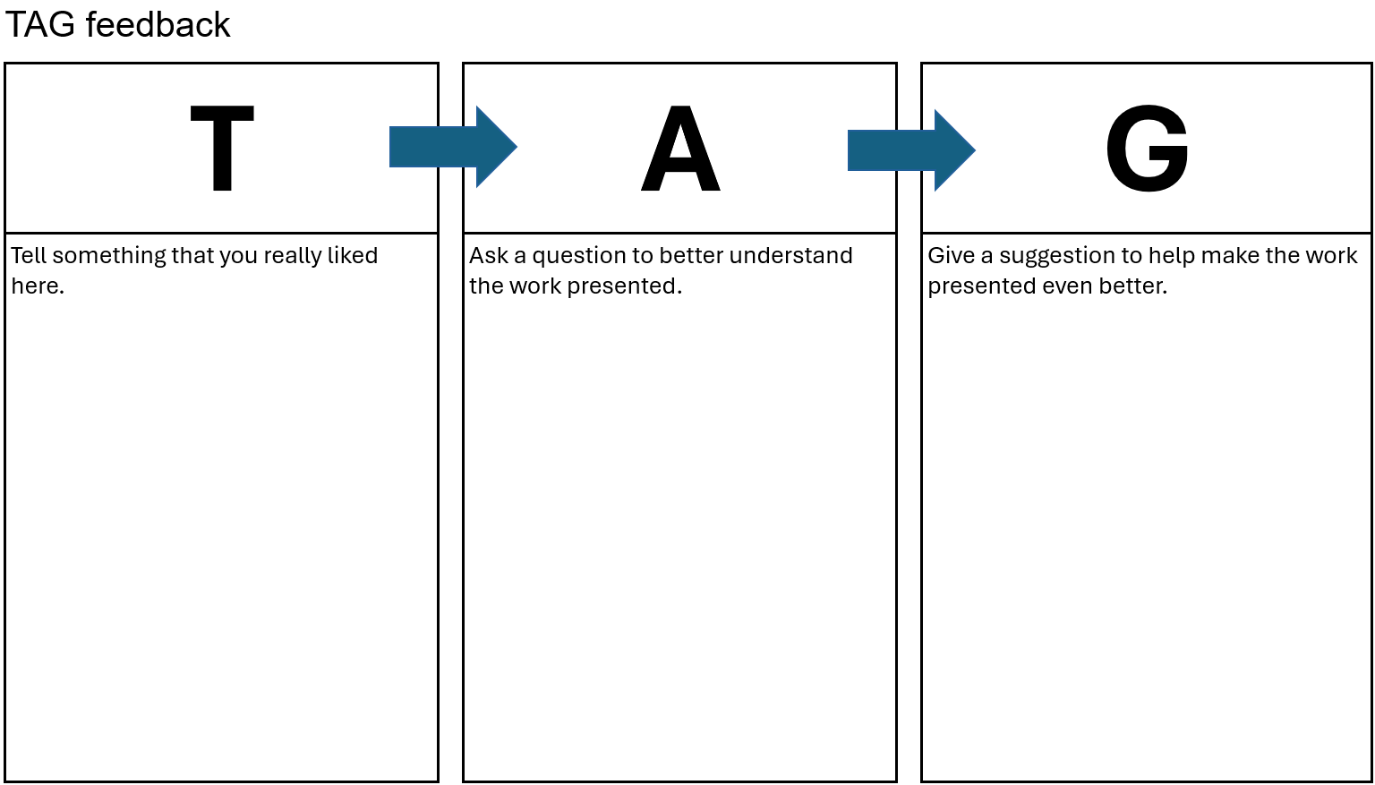

## Activity A1 – perimeter and area concept map

Complete the concept map by filling in the circles with information about perimeter and area. Some of the circles represent information that is common to both.

## Activity A3 – strike a pose

Select one of the following images (or find your own) and sketch the angles and lines that are represented in it.

Describe and measure the angles in your picture.

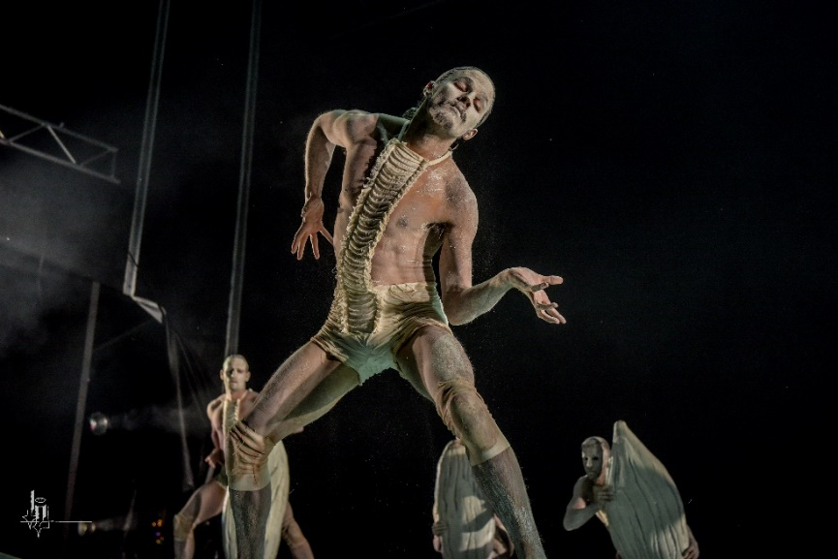

'[Bangarra Dance Theatre](https://www.flickr.com/photos/38834306@N00/52774463680)' by [badjonni](https://www.flickr.com/photos/38834306@N00) is licensed under [CC BY NC SA 2.0](https://creativecommons.org/licenses/by-nc-sa/2.0/?ref=openverse).

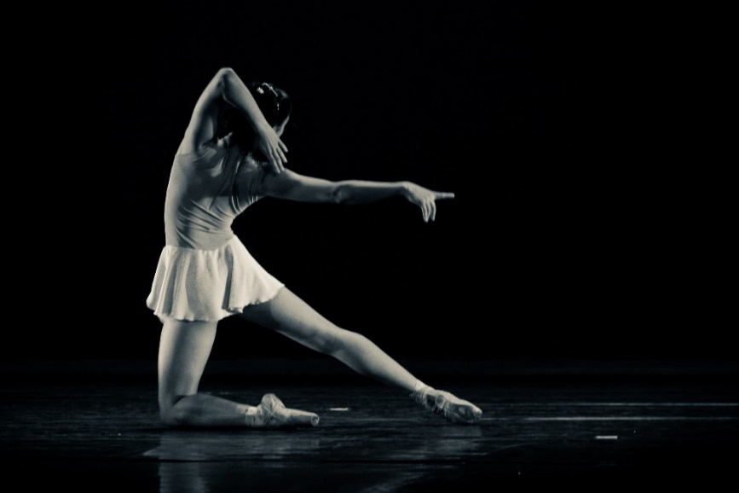

'[para lá](https://www.flickr.com/photos/29551889@N08/4761773341) by [rdenubila](https://www.flickr.com/photos/29551889@N08) is licensed under [CC BY SA 2.0](https://creativecommons.org/licenses/by-sa/2.0/?ref=openverse).

## Activity A4 – triangles foldable instructions

A foldable is a type of graphic organiser. It can be useful to display a summary of information.

Make a foldable displaying information about classifying a triangle according to its angles or sides.

The instructions below show you how to set the foldable out.

Use geometry notations in your diagrams to show equal angles and equal sides.

Refer to acute, obtuse and right angles when describing the triangles.

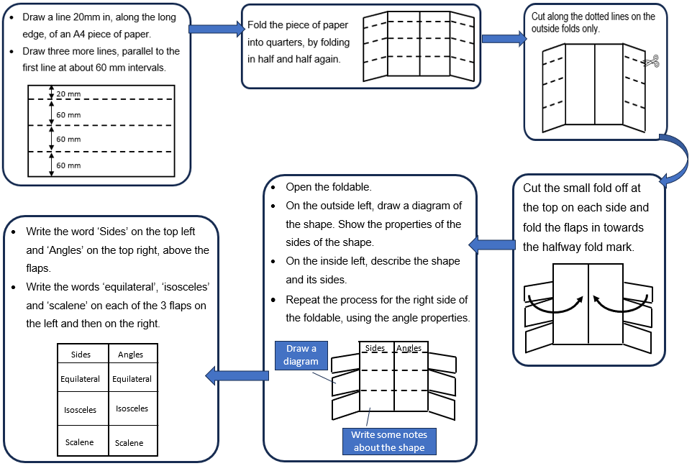

## Activity A5 – triangle splat

The game ‘Triangle Splat’ is an online, one-player game found on the Sheppard Software website ([bit.ly/geometrysplat](https://bit.ly/geometrysplat)).

The game can be played with angles or triangles, which are flying across the screen. The aim is to correctly click on the type of angle or triangle identified. The more correct clicks, the higher the score.

There are 3 games and different game modes within each. Play the different games and try the different modes.

Take a screen shot of your best score.

## Activity A6 – which is which?

1. Cut out and sort the cards into 2 groups: one group for questions or scenarios regarding area and one for perimeter.
2. Once you have sorted the cards, glue them onto a sheet of paper under separate headings ‘Perimeter’ and ‘Area’.

|  |  |
| --- | --- |
| Stringing party lights around the house. | Laying stones to form a new patio. |
| Laying grass in the backyard. | Building seats around a sandbox. |
| Jo wants to paint a wall in the family room.  How much surface will need to be painted? | Dani is building a fence around a garden.  How much fencing is needed? |
| A stone path surrounds a square field.  How long is the stone path? | If Bon wants to create a flag, how much material is needed? |
| Ari is buying a new carpet for a bedroom.  How much carpet does Ari need to buy? | Jerry has a mirror.  How much glass was used to make the mirror? |
| Charlie is decorating a rectangular picture frame by gluing a ribbon around the edge of the frame.  How much ribbon is needed? | Dom has a large baking tray and a smaller baking tray.  How much more space is there on the large baking tray? |
| Akani is creating a mosaic using ceramic tiles.  How many tiles has Akani used in the design?  A mosaic made up of yellow, blue and orange squares. | Imagine this rectangle is a frame for a picture. Each unit is one centimetre of frame.  How many centimetres of frame are there?  A grid with a brown rectangle around the edges forming a frame. |

## Activity A7 – table of quadrilateral properties

Place a tick in the appropriate cells so that the table shows the properties of each quadrilateral.

|  |  |  |  |  |  |  |
| --- | --- | --- | --- | --- | --- | --- |
|  | Square | Rhombus | Rectangle | Parallelogram | Trapezium | Kite |
| Opposite sides are parallel. |  |  |  |  |  |  |
| Opposite sides are equal. |  |  |  |  |  |  |
| All sides are equal. |  |  |  |  |  |  |
| Adjacent sides are perpendicular. |  |  |  |  |  |  |
| Opposite angles are equal. |  |  |  |  |  |  |
| Diagonals are equal. |  |  |  |  |  |  |
| Diagonals bisect each other. |  |  |  |  |  |  |
| Diagonals bisect each other at right angles. |  |  |  |  |  |  |
| Diagonals bisect the angles of the quadrilateral. |  |  |  |  |  |  |

## Activity B2 – less, same, more

Draw rectangles in each cell of the table that match the given conditions for that cell.

For example, in the top left cell, you need to draw a rectangle that has less area and less perimeter than the one given to you in the middle cell.

A white grid with a row at the top for area and the subheadings less, same, more.
A column on the left has a heading perimeter and subheadings of less, same, more.
There are 9 cells in a 3 by 3 grid. The centre cell has a 3 by 8 rectangle.

## Activity B3 – regular tessellation

In a regular tessellation, all the shapes are the same regular polygon, where all the angles and sides are equal.

* Complete the table below by finding the interior angle of each regular polygon and then calculating how many degrees different numbers of vertices make when meeting at a point.
* Explain why only some of the regular polygons can tesselate and circle the shapes which can tesselate.

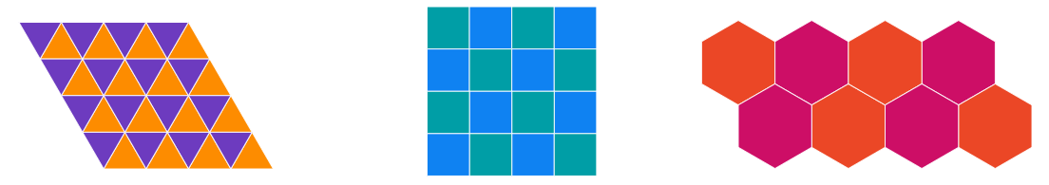

Images created using the free virtual manipulatives from [Polypad by Amplify](https://polypad.amplify.com/) ([polypad.amplify.com](https://polypad.amplify.com/)).

|  |  |  |  |  |  |  |
| --- | --- | --- | --- | --- | --- | --- |
| Regular polygons | Each interior angle | 2 vertices | 3 vertices | 4 vertices | 5 vertices | 6 vertices |
| Triangle | $$60°$$ | $$120°$$ | $$180°$$ | $$240°$$ | $$300°$$ | $$360°$$ |
| Square | $$90°$$ | $$180°$$ | $$270°$$ | $$360°$$ |  |  |
| Pentagon |  |  |  |  |  |  |
| Hexagon |  |  |  |  |  |  |
| Heptagon |  |  |  |  |  |  |
| Octagon |  |  |  |  |  |  |
| Nonagon |  |  |  |  |  |  |
| Decagon |  |  |  |  |  |  |
| Dodecagon |  |  |  |  |  |  |
| Pentadecagon |  |  |  |  |  |  |
| Icosagon |  |  |  |  |  |  |
| Triacontagon |  |  |  |  |  |  |

## Activity B4 – perimeter pentominoes

The following shapes are called pentominoes because they each have 5 squares.

1. Find the perimeter and area of each shape.
2. Cut the pentominoes out.
3. To join pentominoes they must share at least one side and not overlap. Make 5 different shapes by joining together 2 different pentominoes.
4. Trace the shapes into your workbook and find the perimeters of the shapes they make.
5. What is the smallest perimeter of a shape made by joining 2 pentominoes together?
6. What is the largest perimeter of a shape made by joining 2 pentominoes together?

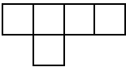 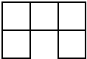 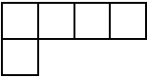

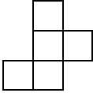 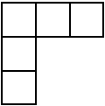 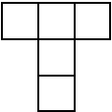 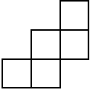

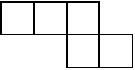 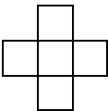 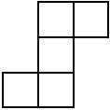 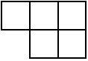

5 squares joined together in a row.

## Activity B6 – shapely pairs

1. To play, players shuffle the cards and lay them face down, arranged in rows.
2. Players take it in turns to turn over 2 cards.
3. If the player can draw a triangle with the 2 properties shown, they take the cards. If not, all the players have a chance to look at the 2 cards and the cards are turned back over.
4. The game finishes when no matter which 2 cards are turned over, there is no triangle with both of those properties.
5. The winner is the person with the most cards at the end of the game.
6. Once the game has been played, players can then attempt the challenge cards below.

|  |  |  |  |
| --- | --- | --- | --- |
| Contains a right angle and has just 2 equal angles | Contains a right angle and all its sides are of different lengths | Contains a right angle | All its angles are of different sizes |
| Has no line of symmetry | Does not contain a right angle | All its sides are of different lengths | Has just 2 equal angles |
| Contains a right angle and has just 2 equal sides | Does not contain a right angle and has just 2 equal sides | Contains a right angle but does not have a line of symmetry | Has only one line of symmetry |
| Has all its sides equal | Has just 2 equal sides | Has 3 lines of symmetry | Has all its angles equal |

### Challenge cards

Submit your answers to the challenge cards.

|  |
| --- |
| **Challenge 1:**  Classify each of the triangles that have been drawn as right, equilateral, isosceles, scalene, acute and obtuse. |
| **Challenge 2:**  Suppose instead of having the cards face down we have them all face up. If it's your turn first, and you want to take a pair of cards, how many possible pairs of cards could you choose? Can you list all the possible pairs? |
| **Challenge 3:**  At the end of the game, you might be left with some cards that can't be paired up. What is the largest number you could be left with like this? What is the smallest? Give examples for each. |

## Activity B7 – angle size

Determine the size of as many unknown angles in the diagram as you can.

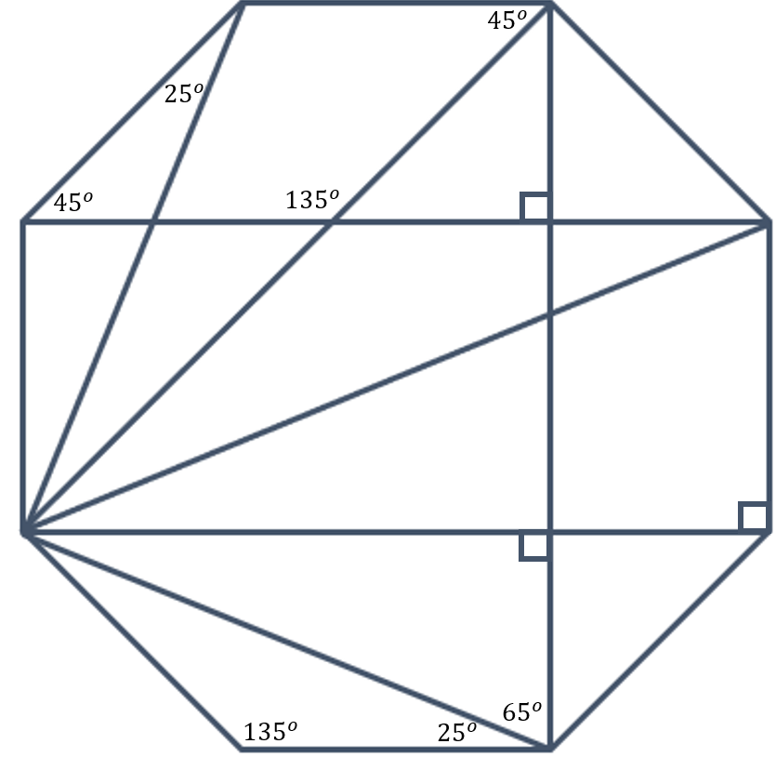

## Activity C1 – worded problems

Answer the following questions. Draw a diagram for each question and mark on the diagram as much information as you can.

1. A square and equilateral triangle have the same perimeter. If the length of one side of the triangle is 4 units, find the side length of the square.
2. The length of a rectangle is 3 times as long as its width. Find the length and width of the rectangle if the perimeter is 56 units.
3. A kite has a perimeter of 2688 mm. Its longer sides are 10% longer than the shorter sides. Find the length in millimetres of one of the shorter sides.
4. The lengths of adjacent sides of a parallelogram are consecutive numbers. If the perimeter is 42 units find the length of the longest side of the parallelogram. Hint: you may need to ask your teacher what the words ‘adjacent’ and ‘consecutive’ mean.
5. The length of a rectangle is 2 cm less than 7 times its width. The perimeter is 60 cm. What are the dimensions of the rectangle?
6. The first side of a triangle is 8 cm shorter than the second side. The third side is 4 times larger than the second side. The perimeter is 52 cm. What are the lengths of the triangle?

## Activity C2 – puzzling perimeters

Solve the following perimeter problems. Use a visual representation and reasoning to explain your solution.

1. Find the value of $k$ if the perimeter of the rectangle is equal to 55 units.

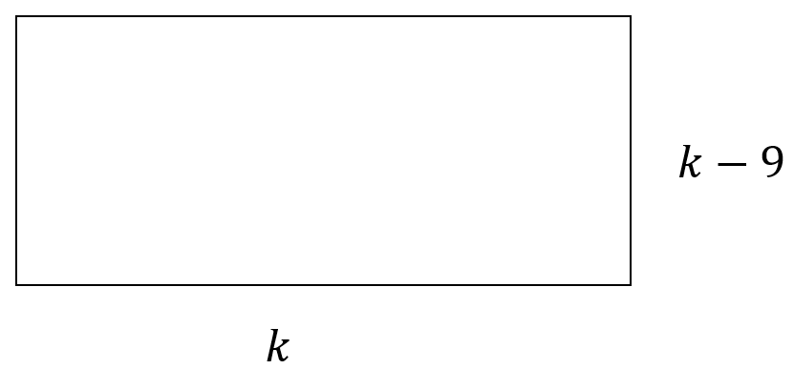

1. Find the value of $m$ if the perimeter of the rectangle is equal to 64 units.

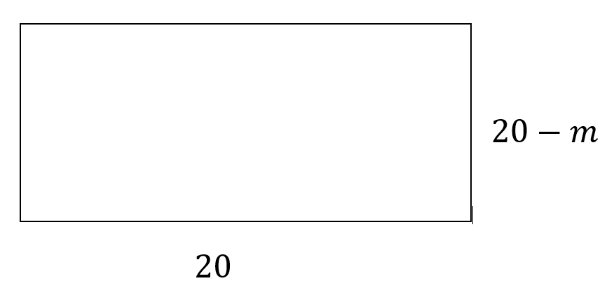

1. Find the value of $d$ if the perimeter of the triangle is equal to 22 units.

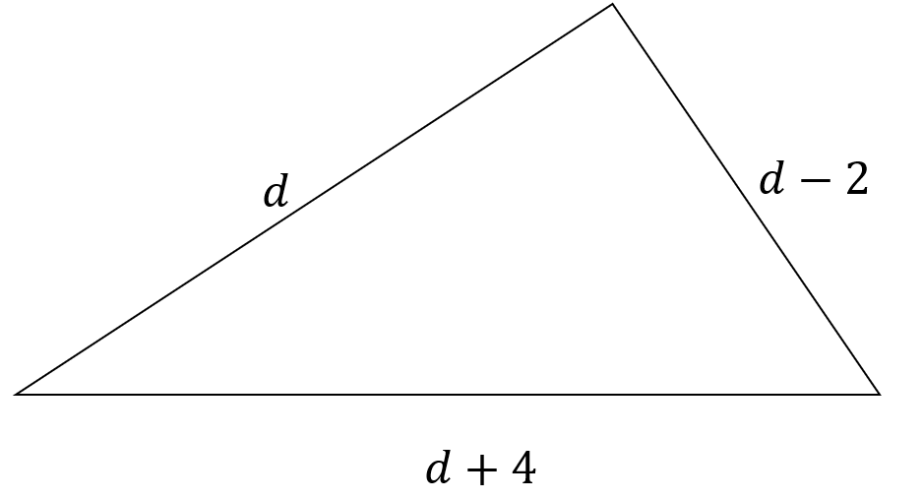

1. Find the value of $t$ if the perimeter of the pentagon is equal to 37 units.

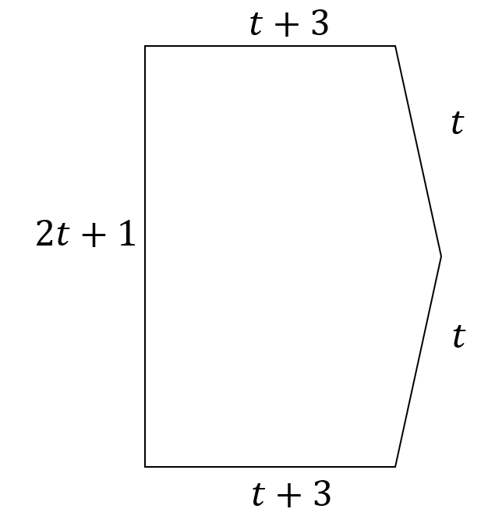

1. Find the value of $n$ if the perimeter of the pentagon is equal to 471 units.

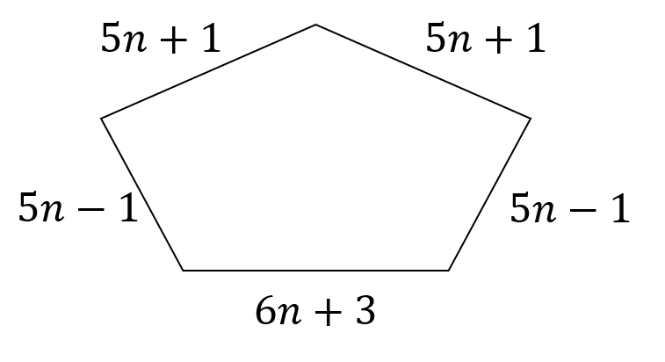

1. Find the value of $w$ if the perimeter of the shape is equal to 288 units.

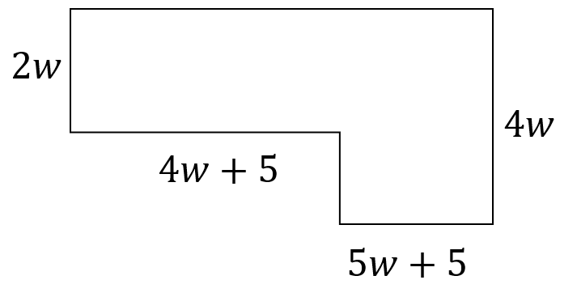

## Activity C3 – untangling rectangles

Cut, by drawing a line, each shape in at most **2 places** and rearrange to make a rectangle. Measure the base length and height of each rectangle, calculate the area and identify the largest shape.

|  |  |
| --- | --- |
| Shape A  An image of a shape made in Desmos. This blue shape is an irregular hexagon. | Shape B  An image of a shape made in Desmos. This red shape is an irregular hexagon. |
| Shape C  An image of a shape made in Desmos. This green shape is an irregular decagon. | Shape D  An image of a black parallelogram made in Desmos. |
| Shape E  An image of a shape made in Desmos. This purple shape appears as a rectangle with a semicircle cut out of the bottom and then placed on top. | Shape F  An image of an orange kite made in Desmos. |

Images created using [Desmos](https://www.desmos.com/?lang=en) and is licensed under the [Desmos Terms of Service](https://www.desmos.com/terms?lang=en).

## Activity C4 – open middle problem

Determine the area of the shape.

You may use a ruler to measure dimensions.

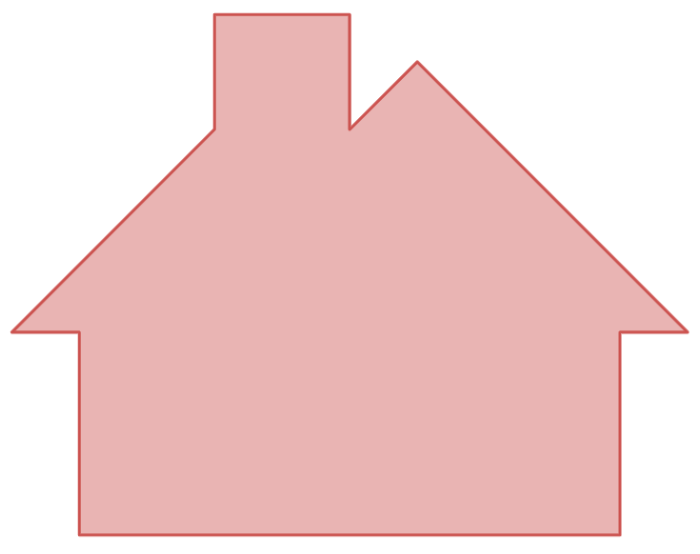

Image created using [Desmos](https://www.desmos.com/?lang=en) and is licensed under the [Desmos Terms of Service](https://www.desmos.com/terms?lang=en).

## Activity C6 – area maze

Find the value of the question marks in the following diagrams.

All the shapes are rectangles but are not drawn to scale.

Your working should only contain whole numbers.

|  |  |
| --- | --- |
|  | A rectangle split into 2 sections, one orange and one green. The dimensions are 2 centimetres and 9 centimetres. The area of the orange rectangle is 8 square centimetres and the area of the green rectangle is unknown. |
|  | A rectangle split into 2 sections, one yellow and one blue. The dimensions are 3 centimetres and the other is unknown. The area of the yellow rectangle is 6 square centimetres and the area of the blue rectangle is 12 square centimetres. |
|  | A composite shape with 2 rectangles in an l shape. The top rectangle is split into 2 sections, one green and one blue. The area of the green rectangle is unknown. The width of the blue rectangle is 5 centimetres and the area of the blue rectangle is 20 square centimetres. The bottom rectangle is yellow. Its height is 3 centimetres. The area of the yellow rectangle is 18 square centimetres. |
|  | A composite shape with 2 rectangles in an l shape. The top rectangle is split into two sections, one blue and one green. The width of the blue rectangle is unknown. The area of the blue rectangle is 36 square centimetres. The area of the green rectangle is 24 square centimetres. The bottom rectangle is rust. Its height is 2 centimetres. The area of the rust rectangle is 12 square centimetres. |
|  | A composite shape with 2 rectangles in an l shape. The taller rectangle on the left rectangle is blue. Its width is 4 centimetres and its area is 32 square centimetres. The shorter rectangle on the right is green. Its width is 5 centimetres and its area is 25 square centimetres. The vertical length on the right side of the taller rectangle, above the shorter rectangle is unknown. |
|  | A composite shape with one longer rectangle and 2 smaller rectangles below, with a gap between them. The top rectangle is 3 centimetres tall and has an area of 60 square centimetres. The rectangle on the bottom left is dark blue. It has a height of 3 centimetres and an area of 18 square centimetres. The rectangle on the bottom right is also dark blue. It has a height of 4 centimetres and its area is unknown. There is a 9 centimetre gap between the two lower rectangles. |
|  | A rectangle split into 2 rows of 2 rectangles. The top left rectangle is orange. It has a height of 3 centimetres and an area of 30 square centimetres. The top right rectangle is blue. It has an area of 24 square centimetres. The bottom right rectangle is green and has an area of 32 square centimetres. The bottom left rectangle is yellow. Its area is unknown. |
|  | A rectangle with a height of 15 centimetres, split horizontally into 2 rectangles. The top rectangle is green. It has a height of 7 centimetres and an area of 175 square centimetres. The bottom rectangle is blue. Its area is unknown. |
|  | A rectangle split into 4 rectangles, 2 rows of 2. The top left rectangle is orange. It has a height of 6 centimetres and an area of 30 square centimetres. The top right rectangle is grey. It has a height of 6 centimetres and an area of 42 square centimetres. The bottom left rectangle is blue. It has a height of 8 centimetres and an area of 72 square centimetres. The bottom right rectangle is yellow. It has a height of 8 centimetres. Its area is unknown. |
|  | A rectangle, with a height of 15 centimetres and a width of 12 centimetres, is split into 4 rectangles, 2 rows of 2. The top left rectangle is green and has an area of 45 square centimetres. The bottom left rectangle is red and has an area of 25 square centimetres. The bottom right rectangle is blue and has an area of 80 square centimetres. The top right rectangle is yellow. Its area is unknown. |
|  | A composite shape that is 12 centimetres wide is split into 3 adjacent rectangles. The tallest rectangle, which is on the left, is yellow. It has a height of 11 cm and an area of 33 square centimetres. The bottom right of this rectangle, below the adjacent rectangle, is 7 centimetres in length. The shortest rectangle is the middle rectangle. It is pink and its area is 16 square centimetres. The rectangle on the right is grey. Its area is 35 square centimetres. The bottom left of this rectangle, below the adjacent rectangle, has a length which is unknown. |
|  | A composite shape, split into 3 horizontal rectangles, with the bottom rectangle longer than the one above it, which is longer than the one above it. The top rectangle is blue. It has a height of 4 centimetres and an area of 24 square centimetres. The middle rectangle  has an area of 34 square centimetres and the top left of the rectangle, beside the top rectangle, has a length of 2 centimetres. The bottom rectangle is yellow. It has an area of 44 square centimetres. The top left of the rectangle, beside the green rectangle, has a length of 3 centimetres. The height of the bottom rectangle is unknown. |
|  | A composite shape with a height of 15 centimetres, split into 3 horizontal rectangles, with the bottom rectangle longer than the one above it, which is longer than the one above it. The top rectangle is green. Its area is unknown. The middle rectangle is blue. It has a height of 5 centimetres and an area of 40 square centimetres. The top right of the rectangle, beside the top rectangle, has a length of 3 centimetres. The bottom rectangle is purple. It has an area of 60 square centimetres. The top right of the rectangle, beside the blue rectangle, has a length of 2 centimetres. |
|  | A large rectangle split into 4 rectangles. The top right rectangle is grey. It has an area of 40 square centimetres. The bottom right rectangle is pink. It has a height of 3 centimetres and an area of 15 square centimetres. The bottom left rectangle is tan. It has an area of 54 square centimetres. The top left rectangle is yellow. It has an area of 45 square centimetres. Its height is unknown. |
|  | A rectangle split into 5 rectangles. The bottom rectangle extends across the large rectangle. It is orange, has an area of 72 square centimetres. Its height is unknown. A green rectangle is on the right, extending from the orange rectangle up to the top of the large rectangle. Its area is 48 square centimetres. There is a purple rectangle in the middle, extending from the left along to the green rectangle. It area is 32 square centimetres. Above it are 2 rectangles. The left rectangle is pink. It has an area of 40 square centimetres. The rectangle on the right, which is at the top middle of the large rectangle, is peach. It has an area of 24 square centimetres and a width of 6 centimetres. |

## Activity C7 – practical problems

Solve the following 3 problems, by exploring possible rectangles.

|  |  |
| --- | --- |
| Problem | Answer |
| 1. A farmer has 60 metres of fencing available. She wants to fence a rectangular area that gives as much space as possible for her sheep. What is the largest area she can create with this fencing? |  |
| 1. The farmer has now decided to create an area beside a building and use a brick wall as one of the sides of the rectangle. Therefore the 60 metres of fencing will be used for the other 3 sides. What is the largest area she can create with this fencing? |  |
| 1. A school will be keeping 4 sheep and needs to build a pen to house them to reduce the risk of injury or attack by predators. The pen needs to provide 10 square metres of area for the sheep. What is the minimum amount of fencing that the school can buy to create a pen for the 4 sheep? |  |

## Activity D1 – what happens?

Write an explanation for what happens in each of the following scenarios.

1. What happens to the perimeter when you take a bite out of it?

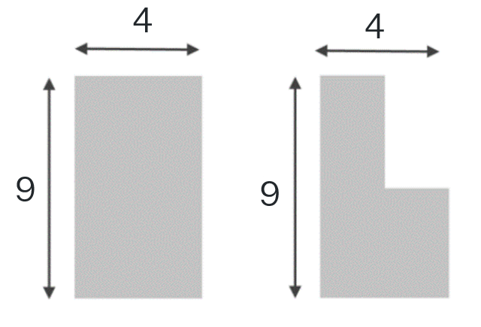

1. What happens to the perimeter when you add another shape onto a corner?

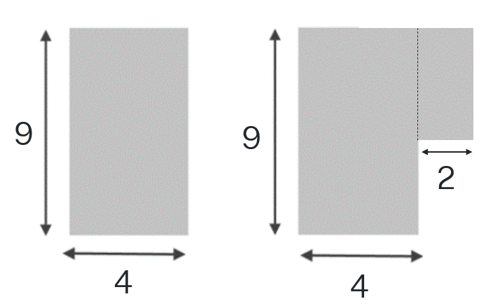

1. What happens to the perimeter when you add another shape onto a side?

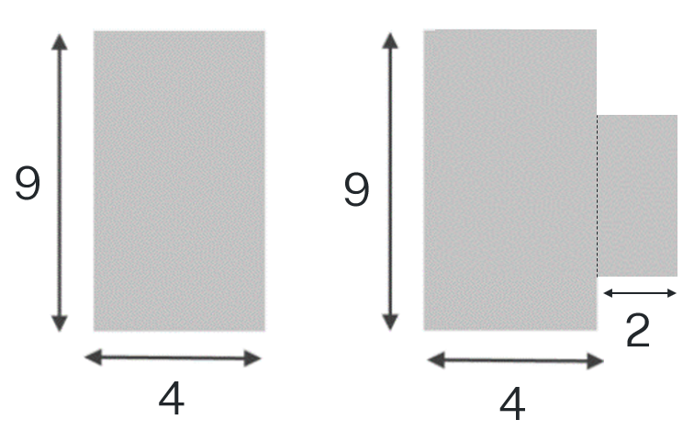

1. What happens to the perimeter when the bite is in the middle of the shape?

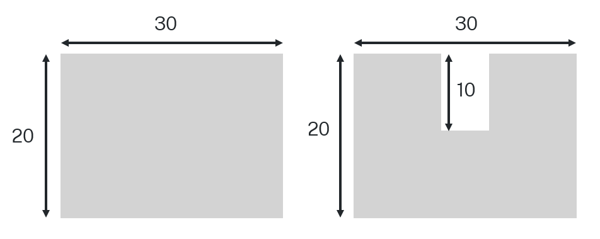

1. Estimate the perimeter of Australia’s coastline using Google maps or a scaled map of Australia. Explain what assumptions you made to make the estimate.

## Activity D2 – joining 2 triangles

Marlow joins 2 identical equilateral triangles and believes she has created a rhombus.

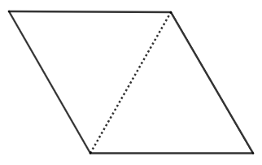

Nakul joins 2 identical isosceles triangles and believes he has created a rhombus.

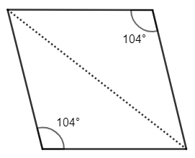

Images created using [GeoGebra](https://www.geogebra.org/).

1. Use your knowledge of the properties of each of the triangles to record as much information as possible on each diagram.
2. Compare each diagram’s properties by listing the similarities and differences of each quadrilateral.
3. Decide which person might be correct, Marlow or Nakul, giving reasons.

## Activity D3 – flags

1. Select 2 flags. Describe each flag, referring to the shapes, angles and colours.
2. By taking measurements of the flags below, calculate the area and perimeter of the 2 flags and the area of each shape in the flag.
3. Select one of the flags and redraw it with its dimensions doubled. Explain how this affects the area of the flag and the colours on the flag.

|  |  |
| --- | --- |
| Figure 1: Denmark  The flag of Denmark. | Figure 2: Republic of the Congo  The Republic of the Congo flag. |
| Figure 3: Guyana  The Guyana flag. | Figure 4: Kuwait  The flag of Kuwait. |
| Figure 5: Czechia  The Czechia flag. | Figure 6: Saint Vincent and the Grenadines  The Saint Vincent and the Grenadines flag. |

## Activity D4 – folding paper, doing geometry figures

1. Navigate to the GeoGebra activity ‘Folding paper, doing geometry figures (<https://bit.ly/GeometryFolding>).
2. Follow the ‘folding’ instructions to fold a triangle, kite, parallelogram, trapezium and rhombus.
3. Measure any necessary sides and/or angles to confirm the shape you have folded.

Extension: You can choose to fold and confirm other shapes from the site.

## Activity D5 – make a triangle

1. Go to the GeoGebra applet ‘What Makes a Triangle a Triangle?’ ([bit.ly/canyoumakeatriangle](https://bit.ly/canyoumakeatriangle)) and follow the instructions to investigate what makes a triangle.
2. Answer the following questions as you complete the online activity.

* Can we use any 3 side lengths to make a triangle?
* Explain why or why not it works.
* What segment lengths DO make a triangle?
* Write down TWO side length combinations for sides $a$ and $b$ that work and ONE that does not work to make triangle ABC. Do you notice anything?
* At what point does the triangle stop being a triangle?
* Where is it NOT a triangle? At what point does it stop being a triangle?

## Activity D6 – what is a square most like?

List the properties that belong in each region. If you think a region is impossible to fill, convince me why!

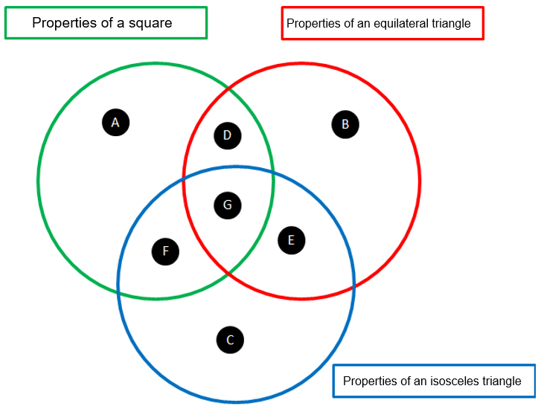

## Activity D7 – tricky triangles

The figure shows 3 squares of sides 3 cm, 8 cm, and 6 cm.

1. Find the total area of A and B.
2. Find the area of the shaded part.

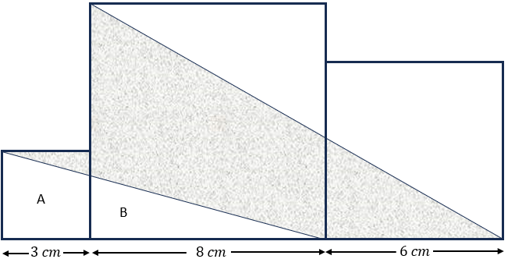

## Activity E1 – how green is my garden?

Cut out the storyboards below and rearrange them in your preferred order. Use your storyboard to write a story that incorporates how to find perimeter and area.

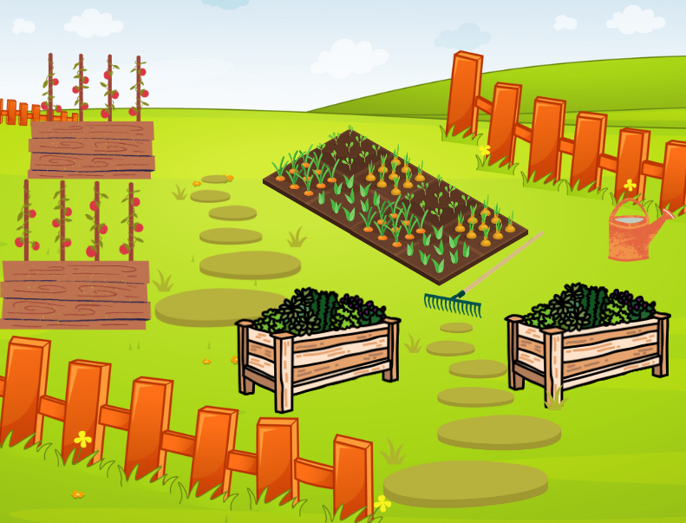 

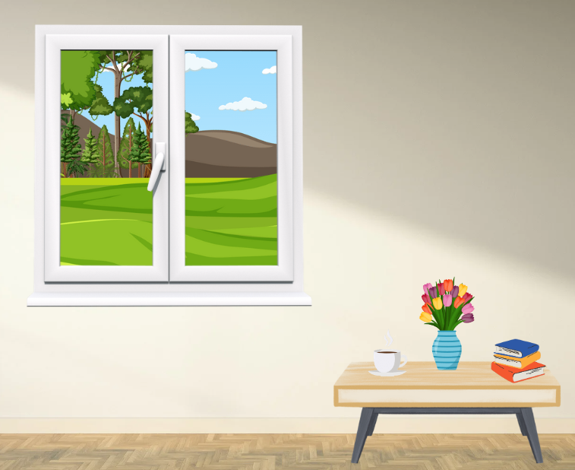 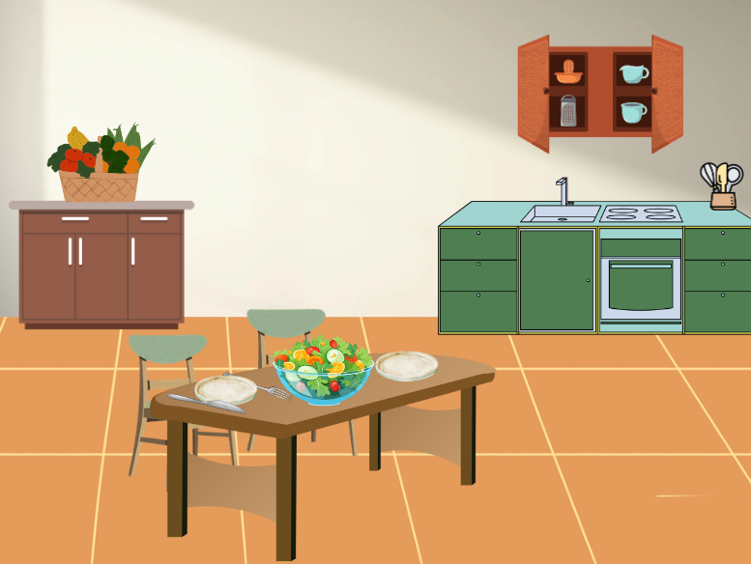

## Activity E2 – design a garden

You will design a garden within an 8 m by 10 m enclosure.

You need to decide on the layout, size and number of garden beds, as well as any extra features you would like to include such as water tanks, ponds and grassed areas.

You will need to include at least one rectangular, triangular or trapezium shaped element and at least one parallelogram, kite or rhombus shaped element in the design. You might consider including composite shapes, such as an L-shape, to make better use of the space.

* Draw the 8 m by 10 m rectangle on graph paper, using a suitable scale.
* Draw the layout of the garden (to scale), showing the positions and sizes of garden beds, pathways and any additional features.
* Determine the perimeter and area of each element in the garden.
* Determine the area of the pathways to be covered by pavers.
* Colour the different elements. For example, garden beds in green and pathways in brown.

## Activity E3 – design a flag

Design a flag that represents you.

Flag design rules:

* Keep it simple. A good flag is easy to remember.
* Use meaningful symbolism. Powerful symbols evoke emotion. Use symbols that you can attach some meaning to.
* Use geometrical shapes to represent ideas. You will need to include:
* at least one rectangle, one triangle and one trapezium shaped element
* at least one parallelogram, kite or rhombus shaped element in the design. You might also consider including some composite shapes.
* Be purposeful about the colours you use, ensuring they are meaningful.
* No lettering. Seen from behind, letters can be backwards.
* Be distinctive. Your flag shouldn’t be so similar to a flag of a nation that it could be easily confused.
* Describe the flag, showing the area of each element in the design, and explain why you chose to use the shapes and colours in the design.

## Activity E4 – fly a kite

Constructing kites with the aim to observe which one can float for the longest time.

### Equipment

* Skewers or similar
* Various sized sheets of paper
* Stopwatches
* Rulers
* Protractors
* Sticky tape
* Scissors

### Method

1. Construct some kites, exploring different sizes, interior angles and side lengths, which maintain the properties of a kite.
2. To construct the kites, use the skewers to form perpendicular diagonals of the kite, sticking these to a sheet of paper.
3. Measure the side lengths and interior angles of the kites, drawing a representation of each kite in your workbooks, with important information labelled.
4. Calculate the area of each kite.
5. To trial how well the kite flies, drop the kite from a height and time how long it takes to reach the ground.
6. Record the time taken for each kite to reach the ground next to the workbook drawings.
7. Identify which of the kites took the longest to reach the ground. Compare the properties and the area of this kite with the properties and area of the other kites.

## Activity E5 – area of shapes spreadsheet

**You are to design a spreadsheet, similar to the figure below, that uses formulas to calculate the area of different shapes.**

**The user will enter the appropriate measurements and the spreadsheet should calculate the area using formulas.**

**A tutorial explaining how to create formulas in Microsoft Excel can be found at ‘**Microsoft Excel Tutorial for Beginners #3 - Calculations (Formulas)’ **(8:38)** ([bit.ly/spreadsheet_formulas](https://bit.ly/spreadsheet_formulas)**).**

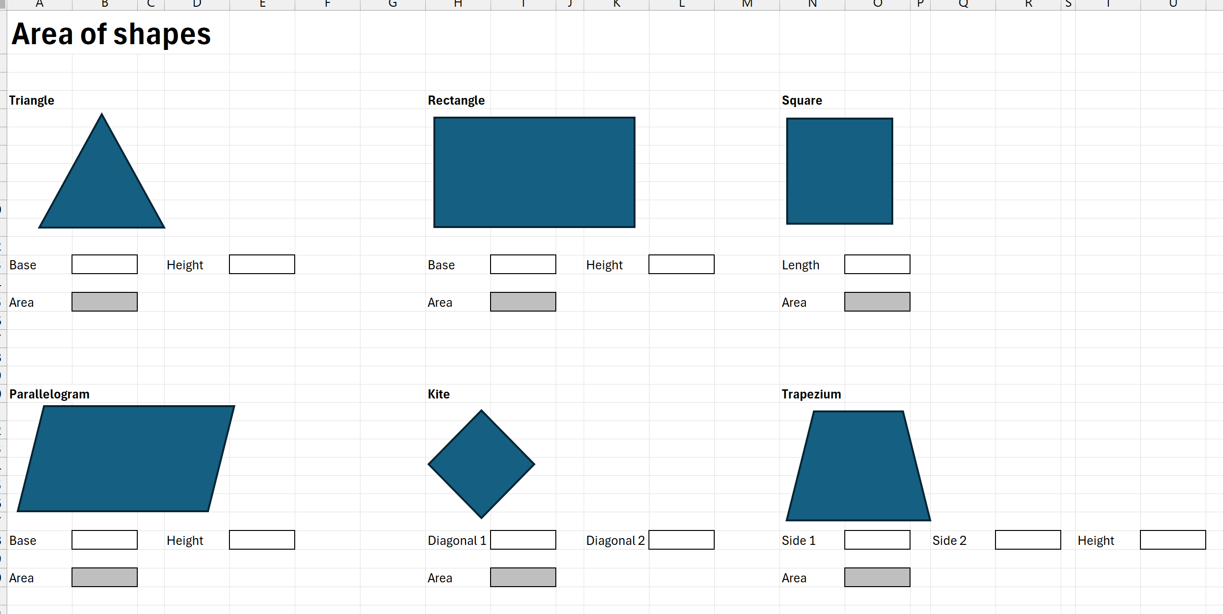

## Activity E6 – record a video

Your task is to record a video that explains how to find the area of at least 3 different shapes.

You may wish to discuss the topic on your own or you may wish to create a video in the style of a talk show.

The video should have:

* a clear beginning, middle and end
* be conversational, not just reading from a script
* be entertaining.

You will need to record your video and may need to seek assistance from your teacher to do this.

**Tips:**

* Watch some videos to ensure you understand their format and purpose.
* Write a script or create a storyboard to plan your video.
* Enlist the help of a friend to either chat with during the video or help you feel as though you are talking with someone.
* Be prepared to practise recording your video before you get it right.

## Activity E7 – geometry mosaic

You will use as many different quadrilaterals or triangles as you can to create a mosaic image of your choice. This could be a person, animal or scene.

1. Use coloured paper or cardstock to cut out a variety of triangles and quadrilaterals. Make some the same and others different in size and colour.
2. Arrange the shapes on a large sheet of paper or poster board.
3. Once you are satisfied with your arrangement, glue the shapes onto the paper or poster board to create a permanent collage. Ensure that all parts of the image are securely attached and that the shapes are neatly aligned.
4. Calculate the area of each shape used in your mosaic, and the area of paper wasted from the original sheet you cut your shapes from.
5. Calculate the percentage of paper that was wasted.

## Activity F1 – soapbox

A soapbox speech historically was a speech delivered when standing on a street corner, on a soapbox. The speaker had to compete with the hustle of street life to attract attention and they spoke with passion to draw a crowd.

Your task is to create a 2-minute soapbox speech.

You don’t need to stand on a soapbox, but you do need to convince everyone of your answer to the following question:

’Which is happier, a square or a triangle?’

## Activity F2 – decision making

Jo, Kai and Ash were asked to find the area of the following shape. Their answers are below.

Explain how Jo, Kai and Ash each calculated the area of the shape, which method you prefer and why you prefer that method.

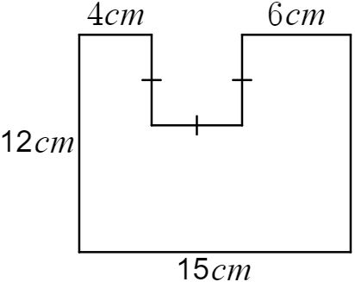

|  |  |  |
| --- | --- | --- |
| **Jo’s method** | **Kai’s method** | **Ash’s method** |
| $$A=7×15+4×5+6×5 \\ =155 {cm}^{2}$$ | $$A=12×15-5×5 \\ =155 {cm}^{2}$$ | $$A=4×12+5×7+6×12 \\ =155 {cm}^{2}$$ |
| **Explanation:** | **Explanation:** | **Explanation:** |

I prefer Jo’s/Kai’s/Ash’s method because

Calculate the area of the following shape.

A diagram of a staircase.

The steps are 6, 7 and 8 cm wide and all steps have the same height of 6 cm.

## Activity F3 – the shapes we see

Explore and compare the artwork of Wassily Kandinsky and Bridget Riley.

Kandinsky (1866–1944) and Riley (1931) are both abstract painters who use geometrical forms in their work.

Look online at the work of both artists, focusing on the following pieces, and read the quote from each artist.

|  |  |
| --- | --- |
| Kandinsky | Riley |
| Composition VIII – 1923  Black and violet – 1923  Yellow, red, blue – 1925 | Movement in Squares – 1961  Descending – 1965  An ode to joy – 1989 |
| ’The impact of the acute angle of a triangle on a circle is actually as overwhelming in effect as the finger of God touching the finger of Adam in Michelangelo.’ | ’I couldn’t get near what I wanted through seeing, recognizing and recreating, so I stood the problem on its head. I started studying squares, rectangles, triangles and the sensations they give rise to.’ |

1. Write about what you see in the paintings of Kandinsky and Riley, focusing on their use of geometric shapes.
2. Write a short reflection about their artwork. Things you might consider reflecting on include:

* What shapes are used the most?
* How are the shapes used?
* How are the sizes of the shapes used?
* Suggest reasons for each artist’s choice of shapes and sizes.

## Activity F4 – handball rules!

Investigate and evaluate the impact of perimeter and area on a handball ‘square’. As a result, determine the best-sized rectangle to play handball in.

You might use the following scaffold to complete the investigation.

|  |  |
| --- | --- |
| **Objective** | To investigate the effect of changing the dimensions of perimeter and area to find the best-sized handball square. |
| **Hypothesis** | What do you think the results will show? |
| **Materials needed** | * Suitable playing area * Tape or chalk * Measuring tape or ruler * Ball * Notebook * Stopwatch (optional) |
| **Data to be recorded** | What data can be collected to determine which size handball ‘square’ is best? |
| **Conducting the experiment** | Describe how the investigation will be conducted, what data will be collected and how it will be collected.  You need to consider how you would define a good game of handball. |
| **Data** | Display the data collected during the investigation. |
| **Analysing data** | Explain what the data shows. |
| **Conclusions** | Identify what size ‘square’ is best for handball and why, using the data to support your decision. Refer to your hypothesis and whether your prediction was correct. |

## Activity F5 – PMI

* Many videos explain how to find the area of a trapezium. Choose one of the following videos to watch:
* Video 1: ‘Area of a Trapezium 12:28’ ([bit.ly/MrWoo_AreaTrapezium](https://bit.ly/MrWoo_AreaTrapezium))
* Video 2: ‘How to find the Formula for the Area of a Trapezoid (Trapezium) 3:16’ ([bit.ly/MathsDoctor_AreaTrapezium](https://bit.ly/MathsDoctor_AreaTrapezium))
* Video 3: ‘Area of Trapezium 3:09’ ([bit.ly/BYJUs_AreaTrapezium](https://bit.ly/BYJUs_AreaTrapezium))
* Video 4: ‘Trapezoid Area (visual proof) 1:18’ ([bit.ly/VisualProof_AreaTrapezium](https://bit.ly/VisualProof_AreaTrapezium))
* Video 5: ‘Area of a Trapezoid: How Does the Formula Work? 2:17’ ([bit.ly/MiddleSchool_AreaTrapezium](https://bit.ly/MiddleSchool_AreaTrapezium))
* Draw a PMI table with 3 columns – positives, negatives and interesting. Fill in the table by identifying the positives, negatives and anything you find interesting about the video and the strategy used in the video.

## Activity F7 – how do I know?

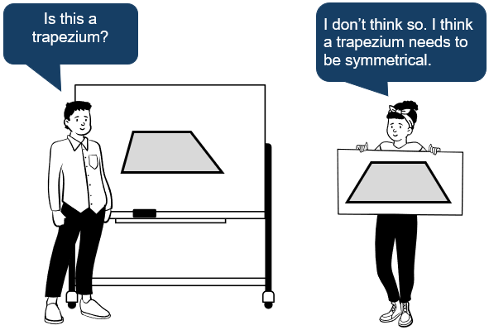

Think about this question:

Brendan and Meagan have different ideas of what a trapezium looks like.

‘How does having clear definitions for shapes help us in real-world applications?’

Create a cartoon strip that highlights a situation where having clear definitions for shapes can be useful.

The cartoon strip can be drawn by hand or can be created online, using a tool such as Canva.

**© State of New South Wales (Department of Education), 2024**

The copyright material published in this resource is subject to the Copyright Act 1968 (Cth) and is owned by the NSW Department of Education or, where indicated, by a party other than the NSW Department of Education (third-party material).

Copyright material available in this resource and owned by the NSW Department of Education is licensed under a [Creative Commons Attribution 4.0 International (CC BY 4.0) license](https://creativecommons.org/licenses/by/4.0/).

[](https://creativecommons.org/licenses/by/4.0/)

This license allows you to share and adapt the material for any purpose, even commercially.

Attribution should be given to © State of New South Wales (Department of Education), 2024.

Material in this resource not available under a Creative Commons license:

* the NSW Department of Education logo, other logos and trademark-protected material
* material owned by a third party that has been reproduced with permission. You will need to obtain permission from the third party to reuse its material.

**Links to third-party material and websites**

Please note that the provided (reading/viewing material/list/links/texts) are a suggestion only and implies no endorsement, by the New South Wales Department of Education, of any author, publisher, or book title. School principals and teachers are best placed to assess the suitability of resources that would complement the curriculum and reflect the needs and interests of their students.

If you use the links provided in this document to access a third-party's website, you acknowledge that the terms of use, including licence terms set out on the third-party's website apply to the use which may be made of the materials on that third-party website or where permitted by the Copyright Act 1968 (Cth). The department accepts no responsibility for content on third-party websites.