Mathematics Stage 3 – Unit 37
Multiplicative thinking involves flexible use of multiplication and division concepts, strategies and representations

Contents
Unit description and duration 5
Syllabus outcomes 5
Working mathematically 6
Student prior learning 6
Lesson overview and resources 8
Lesson 1 14
Daily number sense – Mental or written? – 10 minutes 14
Core lesson – your prime – 35 minutes 15
Discuss and connect the mathematics – 15 minutes 19
Lesson 2 22
Daily number sense – better deal – 10 minutes 22
Core lesson – 40 metre fence – 40 minutes 24
Discuss and connect the mathematics – 10 minutes 27
Lesson 3 29
Daily number sense – broken calculator – 10 minutes 29
Core lesson – biscuit busting – 45 minutes 31
Discuss and connect the mathematics – 10 minutes 36
Lesson 4 38
Daily number sense – 10 minutes 38
Core lesson – parallelograms and triangles – 25 minutes 38
Consolidation and meaningful practice – 20 minutes 41
Lesson 5 43
Daily number sense – racquet discount – 10 minutes 43
Core lesson – cubes and cubes – 35 minutes 44
Discuss and connect the mathematics – 20 minutes 49
Lesson 6 51
Daily number sense – valuable percentages – 10 minutes 51
Core lesson – a box of boxes – 50 minutes 52
Discuss and connect the mathematics – 10 minutes 57
Lesson 7 59
Daily number sense – shopping percentages – 10 minutes 59
Core lesson – green thumbs – 45 minutes 61
Discuss and connect the mathematics – 10 minutes 65
Lesson 8 67
Daily number sense – 10 minutes 67
Core lesson – parcel in the post – 40 minutes 67
Discuss and connect the mathematics – 10 minutes 70
Resource 1 – sorted numbers 73
Resource 2 – primes 74
Resource 3 – better deal 75
Resource 4 – fence it 76
Resource 5 – possible fencing dimensions 77
Resource 6 – biscuit problem 78
Resource 7 – parallelogram proof 79
Resource 8 – design a biscuit 80
Resource 9 – parallelogram Venn 81
Resource 10 – bigger cubes 82
Resource 11 – patterns in volume 83
Resource 12 – recording table 84
Resource 13 – cube subtraction 85
Resource 14 – calculate the volume 86
Resource 15 – valuable percentages 87
Resource 16 – box of boxes 88
Resource 17 – recording boxes 89
Resource 18 – staff discount 90
Resource 19 – Lisa’s landscaping 91
Resource 20 – Nanna Meg’s mail 92
Resource 21 – post office information 93
Syllabus outcomes and content 94
References 100

Unit description and duration
This unit develops the big idea that multiplicative thinking involves the flexible use of multiplication and division concepts, strategies and representations.
In this 2-week unit students are provided opportunities to:
- select and apply strategies to solve problems involving multiplication and division with whole numbers
- dissect two-dimensional shapes and rearrange them using translations, reflections and rotations
- recognise the multiplicative structure for finding volume.

Syllabus outcomes
- MAO-WM-01 develops understanding and fluency in mathematics through exploring and connecting mathematical concepts, choosing and applying mathematical techniques to solve problems, and communicating their thinking and reasoning coherently and clearly
- MA3-RN-03 determines percentages of quantities, and finds equivalent fractions and decimals for benchmark percentage values
- MA3-MR-01 selects and applies appropriate strategies to solve multiplication and division problems
- MA3-GM-02 selects and uses the appropriate unit and device to measure lengths and distances including perimeters
- MA3-2DS-02 selects and uses the appropriate unit to calculate areas, including areas of rectangles
- MA3-2DS-03 combines, splits and rearranges shapes to determine the area of parallelograms and triangles
- MA3-3DS-02 selects and uses the appropriate unit to estimate, measure and calculate volumes and capacities

Working mathematically
In the Mathematics K–10 Syllabus, there is one overarching Working mathematically outcome (MAO-WM-01). The Working mathematically processes should be embedded within the concepts being taught. The Working mathematically processes present in the Mathematics K–10 Syllabus are:
- communicating
- understanding and fluency
- reasoning
- problem solving.
Mathematics K–10 Syllabus © NSW Education Standards Authority (NESA) for and on behalf of the Crown in right of the State of New South Wales, 2022.

Student prior learning
Before engaging in these teaching and learning activities, students would benefit from prior experience with:
- using partitioning and place value to multiply 2-, 3- and 4-digit numbers by one-digit numbers to calculate the areas of rectangles using familiar metric units
- measuring lengths to find perimeters
- using cubic metres for measurement of volume.
In NSW classrooms there is a diverse range of students, including Aboriginal and/or Torres Strait Islander students, students learning English as an additional language or dialect, high potential and gifted students, and students with disability. Some students may identify with more than one of these groups or possibly all of them. Refer to Curriculum planning for every student – advice for further information.

Lesson overview and resources
The table below outlines the sequence and approximate timing of lessons, learning intentions and resources.
Lesson | Content | Duration and resources
Lesson 1  Daily number sense learning intention:  - select and apply strategies to solve problems involving multiplication and division with whole numbers | Lesson core concept: known number facts and strategies support multiplicative thinking.  Core concept learning intentions:  - use partitioning and place value to multiply 2-, 3- and 4-digit numbers by one-digit numbers  - determine products and factors | Lesson duration: 60 minutes  - Resource 1 – sorted numbers  - Resource 2 – primes  - Individual whiteboards  - Writing materials
Lesson 2  Daily number sense learning intention:  - select and apply strategies to solve problems involving multiplication and division with whole numbers | Lesson core concept: area model structures can support multiplicative thinking.  Core concept learning intentions:  - calculate the areas of rectangles using familiar metric units  - measure lengths to find perimeters | Lesson duration: 60 minutes  - Resource 3 – better deal  - Resource 4 – fence it  - Resource 5 – possible fencing dimensions  - Individual whiteboards  - Writing materials
Lesson 3  Daily number sense learning intention:  - select and apply strategies to solve problems involving multiplication and division with whole numbers | Lesson core concept: the known area of a shape can help calculate the area of a more complex shape (parallelograms).  Core concept learning intentions:  - dissect two-dimensional shapes and rearrange them using translations, reflections and rotations  - calculate the area of a parallelogram using subdivision and rearrangement | Lesson duration: 65 minutes  - Resource 6 – biscuit problem  - Resource 7 – parallelogram proof  - Resource 8 – design a biscuit  - Resource 9 – parallelogram Venn  - 30 cm rulers  - Calculators  - Individual whiteboards  - Scissors  - Square centimetre grid paper  - Writing materials
Lesson 4  Daily number sense learning intention:  - teacher-identified task based on student needs | Lesson core concept: the known area of a shape can help calculate the area of a more complex shape (triangles).  Core concept learning intentions:  - dissect two-dimensional shapes and rearrange them using translations, reflections and rotations  - determine the area of a triangle | Lesson duration: 55 minutes  - 30 cm rulers  - Individual whiteboards  - Scissors  - Square centimetre grid paper  - Writing materials
Lesson 5  Daily number sense learning intention:  - make connections between benchmark fractions, decimals and percentages | Lesson core concept: mathematicians estimate, measure and record volume using cm³ and m³.  Core concept learning intentions:  - recognise the multiplicative strategy for finding volume  - find the volumes of rectangular prisms in cubic centimetres and cubic metres | Lesson duration: 65 minutes  - Resource 10 – bigger cubes  - Resource 11 – patterns in volume  - Resource 12 – recording table  - Resource 13 – cube subtraction  - Resource 14 – calculate the volume  - Blocks  - Individual whiteboards  - Sticky notes  - Writing materials
Lesson 6  Daily number sense learning intention:  - make connections between benchmark fractions, decimals and percentages | Lesson core concept: the multiplicative relationship between the length, width and height of an object can be used to calculate volume.  Core concept learning intentions:  - find the volumes of rectangular prisms in cubic centimetres and cubic metres  - recognise the multiplicative structure for finding volume | Lesson duration: 70 minutes  - Resource 15 – valuable percentages  - Resource 16 – box of boxes  - Resource 17 – recording boxes  - Individual whiteboards  - Interlocking blocks or centimetre cubes  - Sample boxes  - Writing materials
Lesson 7  Daily number sense learning intention:  - make connections between benchmark fractions, decimals and percentages | Lesson core concept: multiplication and volume are connected concepts.  Core concept learning intentions:  - recognise the multiplicative structure for finding volume  - select and apply strategies to solve problems involving multiplication and division with whole numbers | Lesson duration: 65 minutes  - Resource 18 – staff discount  - Resource 19 – Lisa’s landscaping  - The marvel of mulch (PDF 641 KB)  - Calculators  - Individual whiteboards  - Metre rulers  - Trundle wheels  - Tape measures  - Writing materials
Lesson 8  Daily number sense learning intention:  - teacher-identified task based on student needs | Lesson core concept: comparing and converting units of measurement helps to make sense of our world.  Core concept learning intentions:  - select and apply strategies to solve problems involving multiplication and division with whole numbers  - find the volumes of rectangular prisms in cubic centimetres and cubic metres | Lesson duration: 60 minutes  - Resource 20 – Nanna Meg’s mail  - Resource 21 – post office information  - Calculators  - Beach towel  - Writing materials

Lesson 1
Core concept: known number facts and strategies support multiplicative thinking.

Daily number sense – Mental or written? – 10 minutes
Daily number sense activities for Lessons 1 to 3 ‘activate’ prior number knowledge and support the learning of new content in the unit. These activities can also assist teachers to identify the starting points for learning by revealing the extent of students’ existing knowledge.
The table below contains a suggested learning intention and success criteria. These are best co-constructed with students.
Daily number sense learning intention | Daily number sense success criteria
Students are learning to:  - select and apply strategies to solve problems involving multiplication and division with whole numbers. | Students can:  - select and use efficient strategies to multiply whole numbers of up to 4 digits by one- and 2-digit numbers.
- Explain to students that they will be using efficient strategies to solve multiplication equations. In pairs, one student will only use mental strategies, and the other student will only use written strategies.
- Students work in pairs with a whiteboard each. Remind students they are only allowed to use their allocated strategy.
- Display one multiplication equation at a time. Examples include 5 × 10 001, 237 × 4, 326 × 11, 95 × 20.
- After each question, ask:
- Which strategy was more efficient, the mental strategy or the written strategy? Why?
- How did you solve the multiplication problem? Explain your thinking and reasoning.
This table details opportunities for assessment.
Assessment opportunities | Links
What to look for:  - Can students select and use efficient strategies to multiply whole numbers of up to 4 digits by one- and 2-digit numbers?  [MAO-WM-01, MA3-MR-01] | Links to National Numeracy Learning Progressions (NNLP):  - MuS7, MuS8.  Links to suggested Interview for Student Reasoning (IfSR) tasks:  - IfSR-MT: 3A.1, 3A.2, 3A.3, 3A.4, 3A.5.

Core lesson – your prime – 35 minutes
The table below contains suggested learning intentions and success criteria. These are best co-constructed with students.
Core concept learning intentions | Core concept success criteria
Students are learning to:  - use partitioning and place value to multiply 2-, 3- and 4-digit numbers by one-digit numbers  - determine products and factors. | Students can:  - use informal written strategies such as the area model to solve multiplication and division problems  - use the term product to describe the result of multiplying 2 or more numbers  - determine whether a number is prime, composite or neither (0 or 1)  - determine factors for a given whole number.
This activity is an adaptation of In Your Prime from NZ Maths by New Zealand Ministry of Education.
- Display Resource 1 – sorted numbers. Ask students the following questions:
- How have these numbers been sorted?
- What could the headings of this table be? (Prime numbers, composite numbers).
- What strategy did you use to work this out?
- Can you think of another number that could go into each category?
- Would the number one belong in any of these categories? (No, one is neither prime nor composite as it has exactly one unique factor.)
- Revise with students the definition of prime and composite numbers. If necessary, ask students to create an array for 11 and 12 to highlight the difference between a prime and composite number.
Prime Numbers: a number that has only 2 factors (itself and one).
Composite Numbers: a number with more than 2 factors.
- Display Resource 2 – primes. Explain that these are the first 4 prime numbers. If the first 2 cards are multiplied, a product of 6 is achieved. Ask students:
- Which 2 cards would be multiplied to get a product of 21?
- What other numbers are products of 2 cards if no card can be used twice, for example 5 × 5?
- What other products would be possible if a card could be used twice?
- Students work independently or in pairs to investigate the task.
- Regroup to discuss the findings. Ask students:
- What products did you get?
- How do you know you have all the possibilities?
- How could you categorise the products made from multiplying 2 cards together? (Square and composite numbers).
- Pose the problem: What products can be made from multiplying 3 cards, using each card one, 2 or 3 times?
- Students work individually or in pairs to complete the task. Move around the room and support students to use appropriate strategies, such as the area model when working with larger numbers such as 7 × 7 × 7.
Note: formative assessment data can be gathered by observing strategies that students use to multiply 3 single-digit numbers. This data will inform whether students are ready to approach the tasks on volume in this unit.
When solving problems such as 7 × 5 × 2, students should be encouraged to draw on the associative property of multiplication to look for multiplication facts that simplify the problem, such as 5 × 2. When solving 7 × 7 × 7, students might see that 7 × 7 × 7 = 49 × 7, which could be solved by thinking about 50 × 7.
This table details opportunities for differentiation.
Too hard? | Too easy?
Students cannot use informal written strategies such as the area model to solve multiplication and division problems.  - Reduce Resource 2 – primes. Students complete the task using the first 3 prime numbers (2, 3, 5).  - Model an example of how the associative property of multiplication can help to simplify problems such as 9 × 5 × 2. Model identifying known multiplication facts first, such as 5 × 2.  - A multiplication chart can be used to support students’ multiplication. When multiplying numbers larger than 12, students may benefit from having the area model drawn on grid paper. | Students can use informal written strategies such as the area model to solve multiplication and division problems.  - Students explore whether it is possible that the numbers from 1 to 100 are products of the numbers on Resource 2 – primes. Ask students what they notice about the numbers that cannot be made.  - Pose the question: Is it possible that all the numbers from 2 to 200 are products of 2, 3, 5, 7 and 11? If not, what numbers need to be used?

Discuss and connect the mathematics – 15 minutes
- Regroup and review the question: What products can be made from multiplying 3 cards, using each card one, 2 or 3 times? Students communicate their solutions and reasoning. Record the multiplication equations and the products generated on the board.
- Ask students the following questions:
- How many different products were created using 3 numbers? (20)
- How did you know that you had generated all possibilities?
- What multiplication strategies did you use to determine these products?
- Are any of the products created prime numbers? Why or why not?
- How could you group or categorise the products created?
- Students turn and talk to explore ways of grouping the products created.
- Regroup and share student ideas. Ask:
- How did you group your products?
- Are there products that can be categorised in more than one way?
- How might you use the word factor to describe how the products can be grouped?
This table details opportunities for assessment.
Assessment opportunities | Links
What to look for:  - Can students use informal written strategies such as the area model to solve multiplication and division problems?  [MAO-WM-01, MA3-MR-01]  - Can students use the term product to describe the result of multiplying 2 or more numbers? [MAO-WM-01, MA3-MR-01]  - Can students determine whether a number is prime, composite or neither (0 or 1)? [MAO-WM-01, MA3-MR-01]  - Can students determine factors for a given whole number?  [MAO-WM-01, MA3-MR-01] | Links to National Numeracy Learning Progressions (NNLP):  - MuS6, MuS7.  Links to suggested Interview for Student Reasoning (IfSR) tasks:  - IfSR-MT: 2A.7.

Lesson 2
Core concept: area model structures can support multiplicative thinking.

Daily number sense – better deal – 10 minutes
The table below contains a suggested learning intention and success criteria. These are best co-constructed with students.
Daily number sense learning intention | Daily number sense success criteria
Students are learning to:  - select and apply strategies to solve problems involving multiplication and division with whole numbers. | Students can:  - solve word problems involving rates using multiplication and division.
Note: this activity is an adaptation of ‘Best Value’ from Open-Ended Maths Activities by Sullivan and Lilburn.
- Display Resource 3 – better deal. Tell students that 12 bottles of water costs $8.00 and single bottles cost $0.75. Ask:
- If I want to buy 12 bottles of water, which is the better deal?
- How can this problem be presented visually and numerically?
- Provide students with time to solve the problem using a variety of strategies on whiteboards.
- Students turn and talk to discuss their strategies with a partner.
- Select a range of student solutions and representations to share with the class. Include a variety of equations and visual representations (see Figure 1).
Figure 1 – better deal solution methods
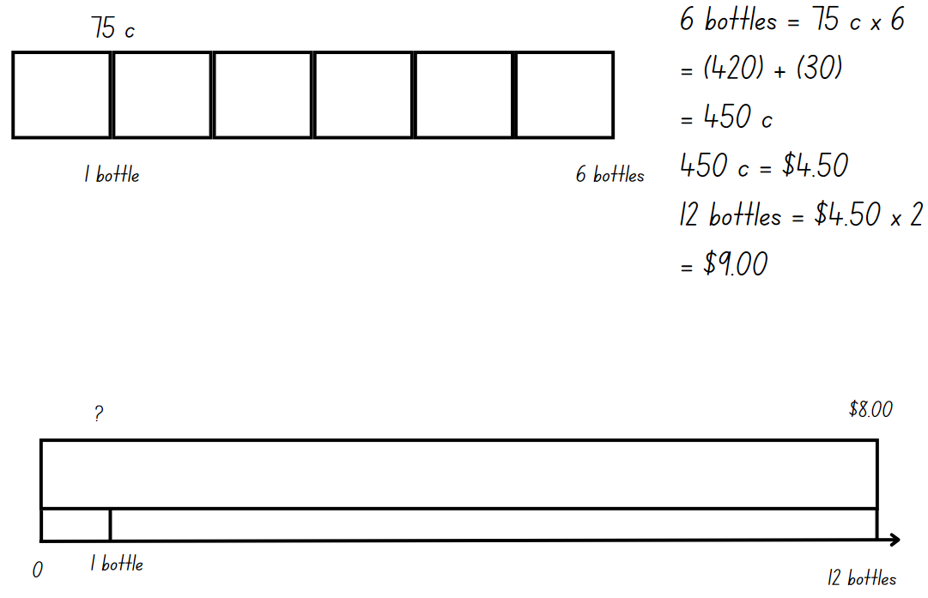
This table details opportunities for assessment.
Assessment opportunities | Links
What to look for:  - Can students solve word problems involving rates using multiplication and division? [MAO-WM-01, MA3-MR-01] | Links to National Numeracy Learning Progressions (NNLP):  - MuS7, MuS8  - PrT4.  Links to suggested Interview for Student Reasoning (IfSR) tasks:  - IfSR-PT: 3A.2.

Core lesson – 40 metre fence – 40 minutes
The table below contains suggested learning intentions and success criteria. These are best co-constructed with students.
Core concept learning intentions | Core concept success criteria
Students are learning to:  - calculate the areas of rectangles using familiar metric units  - measure lengths to find perimeters. | Students can:  - calculate areas of rectangles in square metres (m²)  - investigate and compare the areas of rectangles that have the same perimeter  - recognise that rectangles with the same perimeter may have different dimensions.
This lesson is an adaptation of Fence It from NRICH by University of Cambridge.
- Explain to students that a builder wants to fence off a rectangular block so that it has a perimeter of 40 metres.
- Ask students:
- What are the dimensions of a rectangle that has a perimeter of 40 metres?
- How many different possibilities are there?
- Will all the rectangles have the same area?
- Provide students with time to explore the problem.
- Regroup to share the possible solutions. Ask the following questions to check for understanding:
- What strategies did you use to help you find the different possibilities?
- Do you notice a pattern between the different possible dimensions of the rectangle?
- What was the largest possible area? (100 m²).
- How is area different to perimeter?
- Do rectangles with the same perimeter have the same area?
- If necessary, revise the terms ‘area’ and ‘perimeter’ with students.
Perimeter: the outer edge of a flat shape or area.
Area: the amount of surface inside a closed flat (two-dimensional) shape.
- Display Resource 4 – fence it and read the problem aloud. Ask students:
- How is this problem similar or different to the first problem?
- How might the strategies you used in the first problem help you with this problem?
- Students work in pairs or small groups to solve this problem. Encourage students to draw a diagram and record the possibilities generated.
This table details opportunities for differentiation.
Too hard? | Too easy?
Students cannot recognise that rectangles with the same perimeter can have different dimensions.  - Provide students with a starting value for the width of the rectangle when using 40 metres of fencing without a wall. Support students to work systematically and determine possible dimensions.  - Provide students with a supplementary task using a different amount of fencing, for example 60 metres. | Students can recognise that rectangles with the same perimeter can have different dimensions.  - Pose the challenge: What is the largest L-shaped area that you could fence with 80 metres of fencing? 100 metres of fencing?  - Ask students to calculate the cost if the area was covered in synthetic grass that is $26.75 per square metre.

Discuss and connect the mathematics – 10 minutes
- Regroup and ask:
- What was the largest area possible? (200 m²).
- How do you know you have found all the possibilities?
- Display Resource 5 – possible fencing dimensions. Ask:
- What patterns do you notice?
- What are the missing values in the table?
- Do you notice any patterns between the possible areas in the first and second task?
- Draw students’ attention to the largest possible area for each task. The largest area for the first task can be represented by 10 × 10. The largest area for the second task can be represented by 20 × 10.
- Explain the associative property for students where 20 × 10 = 2 × 10 × 10. Encourage students to find similar patterns with other dimensions.
This table details opportunities for assessment.
Assessment opportunities | Links
What to look for:  - Can students use informal written strategies such as the area model to solve multiplication and division problems?  [MAO-WM-02, MA3-MR-01]  - Can students calculate areas of rectangles in square metres (m²)? [MAO-WM-01, MA3-2DS-02]  - Can students investigate and compare the areas of rectangles that have the same perimeter? [MAO-WM-01, MA3-2DS-02]  - Can students recognise that rectangles with the same perimeter may have different dimensions? [MAO-WM-01, MA3-GM-02] | Links to National Numeracy Learning Progressions (NNLP):  - MuS6, MuS7  - UuM6, UuM7  - UGP6.

Lesson 3
Core concept: the known area of a shape can help calculate the area of a more complex shape (parallelograms).

Daily number sense – broken calculator – 10 minutes
The table below contains a suggested learning intention and success criteria. These are best co-constructed with students.
Daily number sense learning intention | Daily number sense success criteria
Students are learning to:  - select and apply strategies to solve problems involving multiplication and division with whole numbers. | Students can:  - select and use efficient strategies to multiply whole numbers of up to 4 digits by one- and 2-digit numbers.
This lesson is an adaptation of a task from Open-Ended Maths Activities by Sullivan and Lilburn.
- Pose the problem. How could you calculate 17 × 26 if the number 7 button on your calculator is broken? Ask:
- How would you approach this task?
- What properties of multiplication might help solve this problem?
- How might we use grouping symbols to show our thinking?
- What other operations might need to be considered?
- Students turn and talk to share their ideas and record their thinking on a whiteboard. Explain that students don’t need to find the answer at this stage. Their task is to plan a strategy.
- Select a variety of students’ strategies to share with the class. For example:
- 17 partitioned in ways other than 10 and 7, for example 8 and 9 or 5 and 12
- multiply 26 by another number and then add or subtract 26. For example, 18 × 26 − 26.
- Ask:
- What strategies could be used to solve the new multiplication?
- Can factorising the numbers help you solve this problem mentally?
- Is it more efficient to use a calculator, or to use a mental or written strategy to solve this problem?
- Offer calculators for students to test their strategies and compare their solutions.

This table details opportunities for assessment.
Assessment opportunities | Links
What to look for:  - Can students select and use efficient strategies to multiply whole numbers of up to 4 digits by one- and 2-digit numbers?  [MAO-WM-01, MA3-MR-01] | Links to National Numeracy Learning Progressions (NNLP):  - MuS7, MuS8.  Links to suggested Interview for Student Reasoning (IfSR) tasks:  - IfSR-MT: 3A.1, 3A.2, 3A.3, 3A.4, 3A.5.

Core lesson – biscuit busting – 45 minutes
The table below contains suggested learning intentions and success criteria. These are best co-constructed with students.
Core concept learning intentions | Core concept success criteria
Students are learning to:  - dissect two-dimensional shapes and rearrange them using translations, reflections and rotations  - calculate the area of a parallelogram using subdivision and rearrangement. | Students can:  - dissect and rearrange one shape to make another  - show how to transform a parallelogram into a rectangle to find its area  - record, using words, a method for finding the area of any parallelogram.
This activity is an adaptation of That Takes the Biscuit from NZ Maths by New Zealand Ministry of Education.
- Write the words rectangle and parallelogram on the board. Ask: How are these shapes similar and different?
- Students turn and talk to discuss their ideas.
- Regroup and revise the properties of rectangles and parallelograms as necessary.
Rectangle: a polygon with 4 straight sides and 4 angles that are equal. The opposite sides are equal in length and parallel. All angles are right angles (90°).
Parallelogram: a polygon with 4 straight sides. The opposite sides are equal in length and parallel. The opposite angles are equal.
- Display and read aloud Resource 6 – biscuit problem.
- Ask: How could Mei check whether the dog biscuits are the same size? Brainstorm some approaches to checking if the biscuits are the same size. Explain that same size means the same area in this context.
- Provide pairs of students with Resource 6 – biscuit problem and scissors to test their ideas.
- Regroup to discuss student findings.
- If not discovered by students, model how the shapes can be dissected and rearranged to make another shape (see Figure 2).
Figure 2 – dissected shape
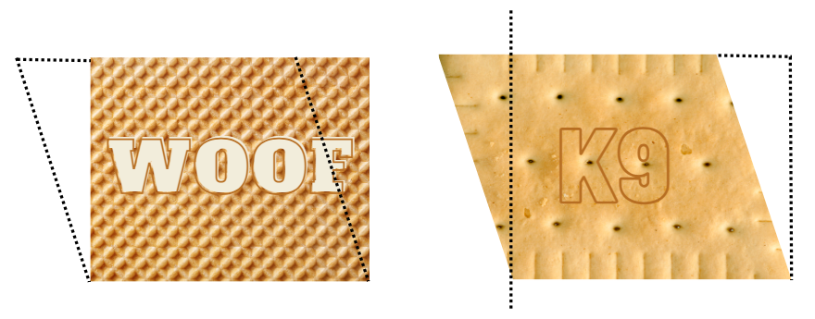
- Students turn and talk to discuss the following questions:
- Is it possible to change any rectangle to a parallelogram?
- Is it possible to change any parallelogram into a rectangle?
- Does the area stay the same?
- Display Resource 7 – parallelogram proof.
- Explain to students that they will be testing whether any parallelogram can be transformed into a rectangle.
- Provide pairs of students with Resource 7 – parallelogram proof, square centimetre grid paper, rulers, scissors and writing materials for the task.
- Students explore the parallelograms on Resource 7 – parallelogram proof. Then they draw their own parallelograms on the square centimetre grid paper to test the proof.
- Regroup and share findings. Ask students:
- How did you dissect the parallelograms to transform it into a rectangle? (see Figure 3).
- Is it possible to rearrange any parallelogram into a rectangle?
- How can you use what you’ve discovered to determine the area of a parallelogram?
Figure 3 – parallelogram proof
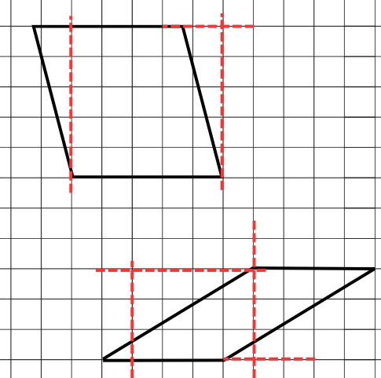
- If not identified in the discussion, explain that the area of a parallelogram can be determined in a similar way to a rectangle. The area of a parallelogram = base × height.
Note: some students may have a misconception that the height of a parallelogram is the same as its length. Clarify for students that the height of a parallelogram is the perpendicular distance between the base and the opposite parallel side.
- Display Resource 8 – design a biscuit and read the task aloud.
- Provide pairs of students with square centimetre grid paper, writing materials and rulers to complete the task.
This table details opportunities for differentiation.
Too hard? | Too easy?
Students cannot show how to transform a parallelogram into a rectangle to find its area.  - Revise how to calculate the area of a rectangle. Square centimetre grid paper may be beneficial.  - Support students to draw parallelograms on square centimetre grid paper where the diagonals bisect each grid. Encourage students to combine bisected grids to determine the area. | Students can show how to transform a parallelogram into a rectangle to find its area.  - Students explore ways to calculate the area of an irregular hexagon as in Figure 4, making connections to the area of a parallelogram.  Figure 4 – irregular hexagon  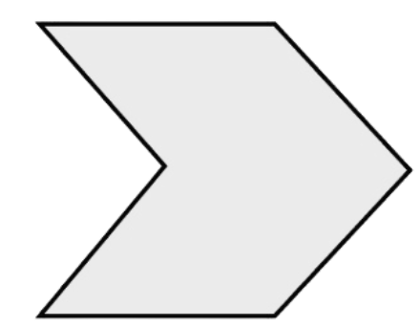  - Provide students with Resource 9 – parallelogram Venn.

Discuss and connect the mathematics – 10 minutes
- Display student solutions to the design task and conduct a gallery walk. Ask:
- Which shapes have the same area?
- Do the shapes with the same area have the same dimensions?
- How is this possible?
- Use this question to check for understanding: A parallelogram has an area of 36 cm². What might its dimensions be?
- Students record their ideas on a whiteboard.
This table details opportunities for assessment.
Assessment opportunities | Links
What to look for:  - Can students dissect and rearrange one shape to make another? [MAO-WM-01, MA3-2DS-03]  - Can students show how to transform a parallelogram into a rectangle to find its area? [MAO-WM-01, MA3-2DS-03]  - Can students record, using words, a method for finding the area of any parallelogram? [MAO-WM-01, MA3-2DS-03] | Links to National Numeracy Learning Progressions (NNLP):  - UuM7, UuM10.

Lesson 4
Core concept: the known area of a shape can help calculate the area of a more complex shape (triangles).

Daily number sense – 10 minutes
- From a class need surfaced through formative assessment data, identify a short, focused activity that targets students’ knowledge, understanding and skills. Example activities may be drawn from the following resources:
- Mathematics K–6 resources
- Universal Resources Hub.

Core lesson – parallelograms and triangles – 25 minutes
The table below contains suggested learning intentions and success criteria. These are best co-constructed with students.
Core concept learning intentions | Core concept success criteria
Students are learning to:  - dissect two-dimensional shapes and rearrange them using translations, reflections and rotations  - determine the area of a triangle. | Students can:  - use the terms translate, reflect and rotate to describe transformations of two-dimensional shapes  - dissect and rearrange one shape to make another  - investigate the area of a triangle by comparing it to the area of a parallelogram with the same base length and height  - record, using words, a method for finding the area of any triangle.
- Write the word ‘transformations’ on the board. Students brainstorm other words they could use to describe transformations of two-dimensional shapes.
- Revise the terms ‘translate’, ‘reflect’ and ‘rotate’ if necessary.
Translation: in a translation (slide) every point on the original image moves in the same direction for the same distance to transform the new image.
Reflection: a reflection (flip) requires a line of reflection. A reflection is a transformation in which an object is flipped across the line of reflection.
Rotation: a rotation (turn) requires a centre of rotation (a point) and a degree of rotation, for example, 90 degrees or a quarter-turn.
- Pose the following conjecture: A parallelogram can be formed when a triangle is duplicated and rotated.
- Provide students with square centimetre grid paper, a ruler, scissors and writing materials to test the conjecture. Encourage them to experiment with many different types of triangles and dimensions.
- Ensure that students label the width (base) and height of the triangles and the parallelograms formed.
- Regroup and share student’s findings. Highlight that a triangle is half of a parallelogram with the same base and height (see Figure 5).
Figure 5 – triangle is half a parallelogram
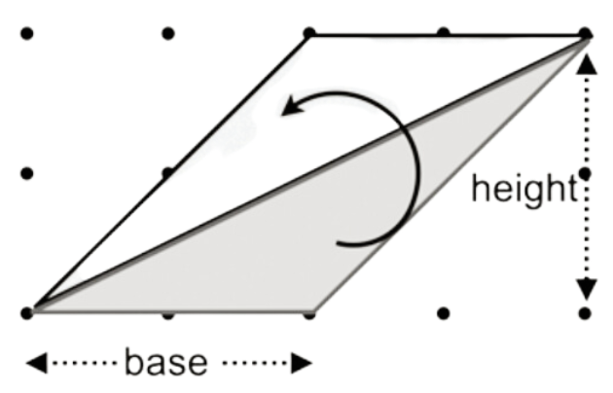
- Ask: How can I prove the area of the triangle is half the area of the parallelogram? Is this also true for the area of a triangle and the area of a rectangle?
- Students calculate the areas and record findings in a table to compare the area of the triangle with the area of the parallelograms.
- Regroup and share a selection of student work samples.
This table details opportunities for differentiation.
Too hard? | Too easy?
Students cannot investigate the area of a triangle by comparing it to the area of a parallelogram with the same base length and height.  - Revise calculating the area of a parallelogram. Support students to draw a parallelogram with an area of 4 cm² on grid paper, ensuring that the diagonals bisect each grid from corner to corner. Draw additional parallelograms on grid paper to visualise the area.  - Support students to draw right-angle triangles on grid paper and determine the area. Students duplicate these to form rectangles. | Students can investigate the area of a triangle by comparing it to the area of a parallelogram with the same base length and height.  - Pose the following problem to students: How can other shapes be dissected and rearranged to help determine its area?  - Students explore ways to calculate the area of a trapezium, making connections to the area of a triangle and the area of a rectangle (see Figure 6).  Figure 6 – trapezium

Consolidation and meaningful practice – 20 minutes
- Students work on the following problem: What are some possible dimensions for triangles with an area of 12, 16, 36 and 44 cm²?
- Ask: How did your knowledge of factors help you with this task?
- Use this question to check for understanding: How are the areas of a parallelogram, rectangle and triangle related to each other?
- Students record their ideas on a whiteboard or workbook. Student responses may be displayed as an anchor chart in the classroom.
Note: some students may have a misconception that the height of a triangle is the same as its side length. Clarify for students that the height of a triangle is the perpendicular distance between the vertex and the opposite side.
This table details opportunities for assessment.
Assessment opportunities | Links
What to look for:  - Can students use the terms translate, reflect and rotate to describe transformations of two-dimensional shapes?  [MAO-WM-01, MA3-2DS-03]  - Can students dissect and rearrange one shape to make another? [MAO-WM-01, MA3-2DS-03]  - Can students investigate the area of a triangle by comparing it to the area of a parallelogram with the same base length and height? [MAO-WM-01, MA3-2DS-03]  - Can students record, using words, a method for finding the area of any triangle? [MAO-WM-01, MA3-2DS-03] | Links to National Numeracy Learning Progressions (NNLP):  - UGP5, UGP6  - UuM10.

Lesson 5
Core concept: mathematicians estimate, measure and record volume using cm³ and m³.

Daily number sense – racquet discount – 10 minutes
Daily number sense activities for Lessons 5 to 7 ‘loop’ back to concepts and procedures covered in previous units to assist students to build an increasingly connected network of ideas. These concepts may differ from the core concepts being covered by the unit.
The table below contains a suggested learning intention and success criteria. These are best co-constructed with students.
Daily number sense learning intention | Daily number sense success criteria
Students are learning to:  - make connections between benchmark fractions, decimals and percentages. | Students can:  - recognise that 10% is one-tenth of 100% and use this to find 10% of a quantity.
- Pose the problem: Sophie was given a 10% discount on the price of a tennis racquet. If the original price was $20, how much would Sophie save with a 10% discount?
- Provide students with whiteboards to record their solution strategies.
- Select a range of student responses to share with the class.
- Ask:
- What strategy did you use to calculate 10% of the price?
- If Sophie was given a 20% discount, how might your strategy for calculating the discount change? 50% discount? 25% discount?
This table details opportunities for assessment.
Assessment opportunities | Links
What to look for:  - Can students recognise that 10% is one-tenth of 100% and use this to find 10% of a quantity? [MAO-WM-01, MA3-RN-03] | Links to National Numeracy Learning Progressions (NNLP):  - UnM8.  Links to suggested Interview for Student Reasoning (IfSR) tasks:  - IfSR-PT: 2A.5.

Core lesson – cubes and cubes – 35 minutes
The table below contains suggested learning intentions and success criteria. These are best co-constructed with students.
Core concept learning intentions | Core concept success criteria
Students are learning to:  - recognise the multiplicative structure for finding volume  - find the volumes of rectangular prisms in cubic centimetres and cubic metres. | Students can:  - record, using words, the method for finding the volumes of rectangular prisms  - calculate volumes of rectangular prisms in cubic centimetres (cm³) and cubic metres (m³).
- Revise the units of measurement for volume.
- Display Resource 10 – bigger cubes and read the information as a class.
- Use the prompt table below to discuss the problem.
The table below outlines stimulus prompts to generate conversation about the topic, along with anticipated responses from students.
Prompts | Anticipated student responses
- What did Heide’s first cube look like? | - Heide’s first cube looked like 2 layers of 4 cubes.
- How could the volume of a prism be calculated? | - The volume of a prism can be calculated by identifying the number of cubes in one layer × number of layers.
- What multiplication equation could you write to calculate the smaller cubes volume? | - 2 cm × 2 cm × 2 cm = 8 cm³
- What are the dimensions of this bigger cube? | - 6 cm long × 6 cm wide × 6 cm high
- What is the volume of this cube? | - 216 cm³
- What multiplication equation could you write for the volume of this cube? | - 6 cm × 6 cm × 6 cm = 216 cm³
- If the larger cube was 3 times as big as the smaller cube, what should the volume be? What might this look like? | - If the volume was 3 times bigger, the volume should be 24 cm³. There are multiple possibilities for what the prism could look like, for example, 2 × 4 × 3 or 6 × 2 × 2.
- Do you agree with Heide’s bigger cube being 3 times as big as the smaller cube? | - No. Heide made each dimension (length, width and height) 3 times as big. She needs to think about the volume being 3 times as big instead.
- Display Resource 11 – patterns in volume and ask: What do you notice about these objects? (They are all like a cube with a smaller cube missing. They get bigger each time by the same amount. There is a pattern.)
- Provide students with Resource 12 – recording table as a scaffold to find the volume of each object. Students record their working and answers in Resource 12 – recording table. Ensure that students record answers using appropriate units of measurement.
- Use the prompt table below to facilitate a discussion about the students’ findings.
The table below outlines stimulus prompts to generate conversation about the topic, along with anticipated responses from students.
Prompts | Anticipated student responses
- What is the volume of the first object? How did you calculate it? | - It is 7 cm³. I multiplied 2 cm × 2 cm × 2 cm = 8 cm³, then took one off.
- What was the volume of the second cube? | - It has 19 cubes. I multiplied 3 cm × 3 cm × 3 cm = 27 cm³, then took 8 cm³ off.
- What was the volume of the cube taken away? | - The cube taken away has a volume of 8 cm³. I multiplied 2 cm × 2 cm × 2 cm = 8 cm³.
- What is the volume of the third object? | - The third object has a volume of 37 cm³.
- Can you use multiplication to work it out efficiently? | - Yes, I multiplied 4 cm × 4 cm × 4 cm = 64 cm³. The missing cube from it measured 3 cm × 3 cm × 3 cm, which is 27 cubes. 64 cm³ −27 cm³ = 37 cm³.
- What makes it difficult to count this volume one by one? | - There are lots of blocks to count!
- What else did you notice? | - I saw a pattern, that the volume of the object before is the volume of the cube being taken away in the next object.
- Display Resource 13 – cube subtraction. Students record their working out independently, by continuing the table from the previous objects.
This table details opportunities for differentiation.
Too hard? | Too easy?
Students cannot calculate volumes of rectangular prisms in cubic centimetres (cm³) and cubic metres (m³).  - Provide students with blocks to build a 5 cm × 5 cm × 5 cm cube. Support student to work out that a 5 cm × 5 cm × 5 cm cube has a volume of 125 cm³.  - Students make other cubes with blocks and record the dimensions and the volume in a table. | Students can calculate volumes of rectangular prisms in cubic centimetres (cm³) and cubic metres (m³).  - Ask: Will the remaining volume always have a prime number value? Can you prove or disprove it?  Note: this is disproved by (8 cm × 8 cm × 8 cm) − (7 cm × 7 cm × 7 cm) = 169 cm³ (which is 13 × 13).  - Students create a rule to describe the pattern and predict the result for (7 cm × 7 cm × 7 cm) − (6 cm × 6 cm × 6 cm).

Discuss and connect the mathematics – 20 minutes
- Students conduct a gallery walk. Ask:
- Did you agree with all the results?
- How did you calculate the volumes?
- How did you use multiplication?
- How does multiplication help find the volume of any prism?
- Display Resource 14 – calculate the volume. Ask the following question to check for understanding: What is the volume of this cube?
- Students solve it, recording their working out and calculation on a sticky note as an exit slip.
This table details opportunities for assessment.
Assessment opportunities | Links
What to look for:  - Can students record, using words, the method for finding the volumes of rectangular prisms? [MAO-WM-01, MA3-3DS-02]  - Can students calculate volumes of rectangular prisms in cubic centimetres (cm³)? [MAO-WM-01, MA3-3DS-02] | Links to National Numeracy Learning Progressions (NNLP):  - UuM5.

Lesson 6
Core concept: the multiplicative relationship between the length, width and height of an object can be used to calculate volume.

Daily number sense – valuable percentages – 10 minutes
The table below contains a suggested learning intention and success criteria. These are best co-constructed with students.
Daily number sense learning intention | Daily number sense success criteria
Students are learning to:  - make connections between benchmark fractions, decimals and percentages. | Students can:  - recognise that 10% is one-tenth of 100% and use this to find 10% of a quantity.
- Display Resource 15 – valuable percentages.
- Students solve the problem and record their ideas on whiteboards.
- Discuss students’ findings. Ask the following questions:
- How can calculating 10% help calculate other percentages?
- What strategies did you use to calculate the different percentages?
- What connections do you notice?
Note: students may notice the commutative property of percentages from this activity. For example, 50% of 10 is the same as 10% of 50. This property may be something to explore further with students if time permits.
This table details opportunities for assessment.
Assessment opportunities | Links
What to look for:  - Can students recognise that 10% is one-tenth of 100% and use this to find 10% of a quantity? [MAO-WM-01, MA3-RN-03] | Links to National Numeracy Learning Progressions (NNLP):  - UnM8.  Links to suggested Interview for Student Reasoning (IfSR) tasks:  - IfSR-PT: 2A.5.

Core lesson – a box of boxes – 50 minutes
The table below contains suggested learning intentions and success criteria. These are best co-constructed with students.
Core concept learning intentions | Core concept success criteria
Students are learning to:  - find the volumes of rectangular prisms in cubic centimetres and cubic metres  - recognise the multiplicative structure for finding volume. | Students can:  - recognise that rectangular prisms with the same volume may have different dimensions  - establish the relationship between the number of cubes in one layer and the number of layers to find the volume of a rectangular prism.
This activity is an adaptation of ‘A box of boxes’ from Mindset Mathematics: Visualizing and Investigating Big Ideas, Grade 5 by Boaler et al.
- Display some small boxes and model what happens when you pack them into a larger box.
- Describe the scenario that you need to send this package in the post and you want to make sure there is as little empty space as possible. This prevents the objects inside from rattling around, it saves paper and it protects the box from getting squashed.
- Display Resource 16 – box of boxes. Explain that the goal is for students to design a box that will hold all 4 smaller boxes (prisms) and have the least amount of empty space. The box must be a rectangular prism, as most packing boxes and parcels are.
- Explain that students will be trying to find the smallest packing box that can hold the 4 smaller boxes.
- Provide pairs of students with a copy of Resource 16 – box of boxes. Draw attention to the dimensions of the 4 smaller boxes they'll be trying to fit together into a larger box.
- Students turn and talk to discuss the following:
- What materials could you use to help solve this problem?
- What are some different ways you could stack the 4 boxes?
- How could building a model help you determine the length and width of your box?
- How could building a model help you visualise the layers needed for the larger box?
- How could you record your thinking and your solution?
- Provide students with interlocking blocks or centimetre cubes and a copy of Resource 17 – recording boxes. Students will use these to create models of the smaller boxes, as well as record the dimensions and volume of each.
- In pairs, students try to create a box with the smallest volume of empty space. They record their solutions in a table to compare the dimensions and volumes of the possible larger packing boxes. See Figure 7 for an example of students recording their solutions.
Figure 7 – example of student recording
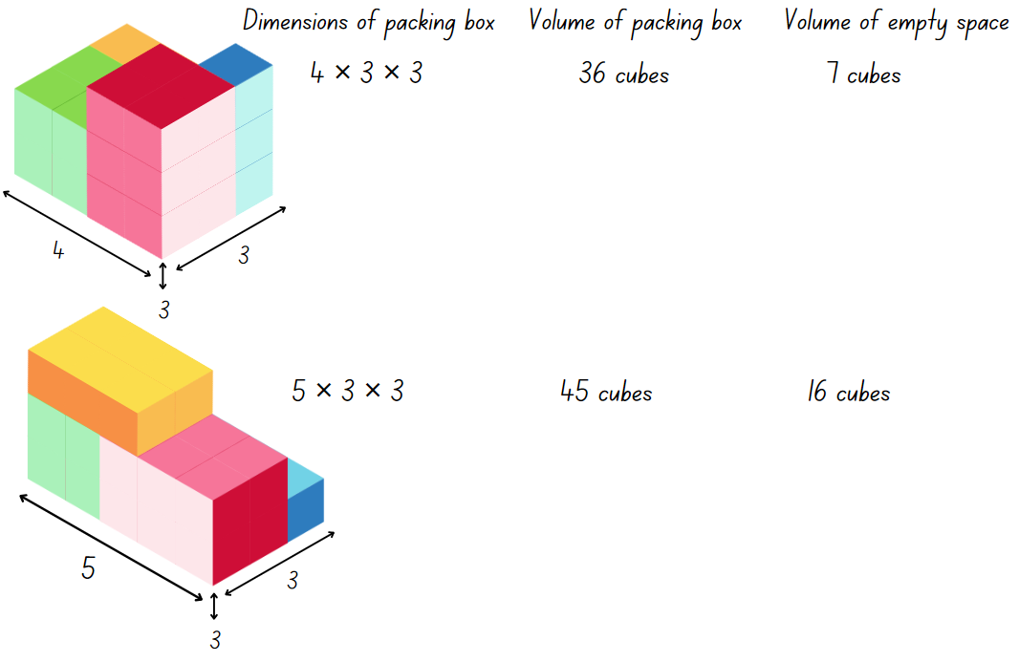
- Discuss the solutions students discovered and how to minimise the empty space. Ask:
- What is the smallest packing box you can make that will hold all the boxes?
- What are the dimensions of your box? What is its volume?
- How much empty space will be left in your box?
- Pose the following problem: Is it possible to create a box with the same volume but different dimensions?
- Prompt students to consider how multiplication or division could help them with this.
- Students work in pairs or individually to select one of the boxes they designed. They determine whether it is possible to create another box with the same volume, but different dimensions.
- Students share their findings through a gallery walk.
- Discuss how thinking about volume helps in designing the boxes. Ask:
- How did you find the volume of the boxes you created?
- How did you calculate the amount of empty space in each of your packing boxes?
- Which box leaves the least amount of empty space?
- What strategies did you come up with for minimising the empty space?
- How can you be sure that you have found the smallest packing box possible?
Note: if not identified by students, draw attention to the way that multiplicative structure can be used to support their thinking. Encourage students to look for the relationship between the number of cubes in one layer and the number of layers for finding the volume of a rectangular prism.
This table details opportunities for differentiation.
Too hard? | Too easy?
Students cannot establish the relationship between the number of cubes in one layer and the number of layers to find the volume of a rectangular prism.  - Reduce the sizes of the smaller boxes and support students to arrange them efficiently. Identify the number of cubes in one layer of each box, then the number of layers.  - Model how to use the dimensions to calculate the space taken up by the smaller boxes and the volume of the larger box. Support students to find the difference, to identify the empty space in the larger packing box. | Students can establish the relationship between the number of cubes in one layer and the number of layers to find the volume of a rectangular prism.  - Students create a new set of little boxes, each with different volumes to fit in a new larger box. They look for ways they can use multiplication to simplify their calculations. For example, students might combine several smaller boxes that have some dimensions in common, to create a larger shape and reduce the number of calculations they need to make.

Discuss and connect the mathematics – 10 minutes
- Regroup and ask:
- What interesting things did you discover when trying to pack boxes?
- What kinds of small boxes are challenging to pack? Why?
- How did you refine your strategies for finding the smallest box?
- How can using one layer of a prism help you find the total volume?
- Did anyone find a set of boxes that leaves no empty space? Why does this work for those boxes?
- How does thinking about volume help you design a packing box?
This table details opportunities for assessment.
Assessment opportunities | Links
What to look for:  - Can students recognise that rectangular prisms with the same volume may have different dimensions? [MAO-WM-01,  MA3-3DS-02]  - Can students establish the relationship between the number of cubes in one layer and the number of layers to find the volume of a rectangular prism? [MAO-WM-01, MA3-3DS-02] | Links to National Numeracy Learning Progressions (NNLP):  - UuM5.

Lesson 7
Core concept: multiplication and volume are connected concepts.

Daily number sense – shopping percentages – 10 minutes
The table below contains a suggested learning intention and success criteria. These are best co-constructed with students.
Daily number sense learning intention | Daily number sense success criteria
Students are learning to:  - make connections between benchmark fractions, decimals and percentages. | Students can:  - recognise that 10% is one-tenth of 100% and use this to find 10% of a quantity.
This lesson is an adaptation of ‘Percentage Challenge 2’ from Enrich-e-matics! A graded maths enrichment programme – Book F by Joshua.
- Display Resource 18 – staff discount and read the problem as a class.
- Give students time to consider the problem and record their ideas on whiteboards.
- Gather students to discuss their findings. Ask:
- What did you discover?
- Why might the employee think they were entitled to a 20% discount?
- Write the following problem on the board. In a certain country you must pay 10% sales tax on every item you purchase. In a sale, a 20% discount is offered on all items. Which would you prefer to have calculated first – the discount or tax?
- Give students time to solve the problem and record their ideas on whiteboards. Provide students with a prompt to use an item with a cost of $100 if necessary.
- Gather students to discuss their findings. Ask:
- Is it better to calculate the discount or tax first?
- What strategies did you use to solve the problem?
This table details opportunities for assessment.
Assessment opportunities | Links
What to look for:  - Can students recognise that 10% is one-tenth of 100% and use this to find 10% of a quantity? [MAO-WM-01, MA3-RN-03] | Links to National Numeracy Learning Progressions (NNLP):  - UnM8.  Links to suggested Interview for Student Reasoning (IfSR) tasks:  - IfSR-PT: 2A.5.

Core lesson – green thumbs – 45 minutes
The table below contains suggested learning intentions and success criteria. These are best co-constructed with students.
Core concept learning intentions | Core concept success criteria
Students are learning to:  - recognise the multiplicative structure for finding volume  - select and apply strategies to solve problems involving multiplication and division with whole numbers. | Students can:  - calculate volumes of rectangular prisms in cubic centimetres (cm³) and cubic metres (m³)  - establish the relationship between the number of cubes in one layer and the number of layers to find the volume of a rectangular prism  - solve word problems involving rates using multiplication and division.
This activity is an adaptation of ‘Green thumbs’ from Teaching Measurement STAGE 2 – STAGE 3 (PDF 686 KB) p 93, by State of New South Wales (Department of Education).
Note: this lesson requires students to measure garden beds within the school. It may be helpful to identify these before the lesson. This could also be done with a garden locally or globally using a digital map. Local landscape businesses can be contacted to provide accurate prices for materials referred to in the lesson.
- Revise the previous lesson and that the multiplicative relationship between the dimensions of an object can be used to find its volume.
- Refer to The marvel of mulch (PDF 641 KB) to briefly highlight the benefits of using organic material to cover the soil.
Note: depending on the school context, it may be more appropriate to use the example of topsoil on a grass area within the school. This would provide students with an opportunity to calculate the cost of larger areas and volumes.
- Explain that students will be working in pairs to calculate the cost of laying mulch on a garden in the school, to a depth of 10 cm. They will use what they have learnt about measuring volume to find how much mulch will need to be ordered for a particular garden.
- Display Resource 19 – Lisa’s landscapes. Identify the cost of one cubic metre of the different mulches.
- Draw attention to the image of a cubic metre. Use the prompt table below to discuss the 10 cm layers.
The table below outlines stimulus prompts to generate conversation about the topic, along with anticipated responses from students.
Prompts | Anticipated student responses
- In each cubic metre of mulch, how many 10 cm thick layers would there be? | - For each cubic metre of mulch, there are 10 × 10 cm layers.
- What would the area of each 10 cm thick layer cover in the garden bed? | - Each 10 cm thick layer has an area of one square metre (m²).
- How many square metres of garden bed would each cubic metre of mulch cover to a depth of 10 cm? | - The 10 × 10 cm layers cover 10 square metres (10 m²).
Note: steps 12 to 17 model and guide the class to measure and calculate the amount of mulch needed for a garden bed. Depending on their level of understanding, some students may enjoy the challenge of working through this problem independently from step 18.
- Choose an appropriate rectangular garden bed within the school to use as an example. Explain that the length and width of the garden bed will need to be measured to the nearest centimetre.
- Select a pair of students to measure the garden bed’s length and width. They use a metre ruler, trundle wheel or measuring tape. Use the prompt table below to support students to calculate the area.
The table below outlines stimulus prompts to generate conversation about the topic, along with anticipated responses from students.
Prompts | Anticipated student responses
- How can we use the length and width to find the area of this rectangular garden bed? | - Multiply the length by the width.
- What strategies could you use to multiply the length by the width? | - Allow for students to discuss various written and mental multiplicative strategies they could use.
- Which strategy will you choose? Why? | - Various responses. Allow for several strategies to be identified.
- What is the difference between the area of a surface and the volume of a space? | - Area measures a flat, two-dimensional surface. Volume measures the amount of space taken up by a three-dimensional object.
Note: this provides an opportunity to identify student misconceptions with recognising the multiplicative structure for finding area and volume. Depending on whether they measured the garden bed using metres or centimetres, students may need support finding the equivalent area of the garden in square metres. 10 000 cm² has an area of 1 m².
- Once the class has calculated the area, ask: Now that we know the area of the garden, how many square metre layers of 10 cm thick mulch will we need to cover the garden? (Support the class to calculate the answer).
- Revise that one cubic metre of mulch provides 10 × 10 cm layers, that would cover a total area of 10 m². Discuss whether a full cubic metre of mulch will be needed, or if more than one cubic metre will be required. Model how this can be recorded using both a number sentence and an annotated diagram.
- Refer to the cost of mulch on Resource 19 – Lisa’s landscaping. Discuss how to calculate the cost of mulch, depending on the type chosen.
- As a class, calculate the cost of the mulch for the garden bed.
- In pairs, students choose a rectangular garden bed to find how much mulch would be needed. They use a copy of Resource 19 – Lisa’s landscaping and a metre ruler, trundle wheel or measuring tape to calculate the area. They calculate and record the amount of mulch required and the total cost.
This table details opportunities for differentiation.
Too hard? | Too easy?
Students cannot calculate volumes of rectangular prisms in cubic centimetres (cm³) and cubic metres (m³).  - Provide the dimensions of a garden for students to solve, then support them to calculate the area and the volume of mulch needed.  - Identify the relationship between the length, width, height and volume of the garden bed. | Students can calculate volumes of rectangular prisms in cubic centimetres (cm³) and cubic metres (m³).  - Ask students to investigate finding the cost of mulching a garden bed that it a composite shape. They can also investigate the cost of mulching each garden bed to a depth of 15 cm.  - Students design their own garden bed within the school and calculate the cost of covering it with deluxe mulch.

Discuss and connect the mathematics – 10 minutes
- Regroup and ask:
- How did you calculate the volumes of the mulch?
- How did you use multiplicative thinking to support your calculations?
- What strategies did you use to calculate the cost of the mulch?
This table details opportunities for assessment.
Assessment opportunities | Links
What to look for:  - Can students recognise that rectangular prisms with the same volume may have different dimensions? [MAO-WM-01,  MA3-3DS-02]  - Can students calculate volumes of rectangular prisms in cubic centimetres (cm³) and cubic metres (m³)? [MAO-WM-01,  MA3-3DS-02]  - Can students establish the relationship between the number of cubes in one layer and the number of layers to find the volume of a rectangular prism? [MAO-WM-01, MA3-3DS-02] | Links to National Numeracy Learning Progressions (NNLP):  - UuM5.

Lesson 8
Core concept: comparing and converting units of measurement helps to make sense of our world.

Daily number sense – 10 minutes
- From a class need surfaced through formative assessment data, identify a short, focused activity that targets students’ knowledge, understanding and skills. Example activities may be drawn from the following resources:
- Mathematics K–6 resources
- Universal Resources Hub.

Core lesson – parcel in the post – 40 minutes
The table below contains suggested learning intentions and success criteria. These are best co-constructed with students.
Core concept learning intentions | Core concept success criteria
Students are learning to:  - select and apply strategies to solve problems involving multiplication and division with whole numbers  - find the volumes of rectangular prisms in cubic centimetres and cubic metres. | Students can:  - select and use efficient strategies to multiply whole numbers of up to 4 digits by one- and 2-digit numbers  - solve word problems involving rates using multiplication and division  - recognise that rectangular prisms with the same volume may have different dimensions.
This activity is an adaptation of Measurement: Parcel in the Post from reSolve by Australian Academy of Science.
- Display Resource 20 – Nanna Meg’s mail and read the problem as a class.
- Show students a beach towel. Ask:
- Is 1600 cm³ a reasonable estimate for the volume of the towel? Why or why not? (No, the dimensions of the beach towel are 160 cm × 80 cm × 1 cm. 160 × 10 × 1 = 1600, so it is not a reasonable estimate for the dimensions given).
- What strategy could you use to determine the volume of the towel?
- How might the dimensions of the towel change if it is folded in half? (The dimensions would measure 80 cm × 80 cm × 2 cm or 160 cm × 40 cm × 2 cm).
- How could drawing a diagram help you determine the dimensions of a folded towel?
- Model how the dimensions of the towel change if it is folded in quarters? (The dimensions would measure 80 cm × 40 cm × 4 cm or 160 cm × 20 cm × 4 cm).
- What dimensions would be most suitable for posting?
- Hand out calculators. Display Resource 21 – post office information and discuss the information in the tables. Provide an opportunity to clarify any questions students may have.
- Students turn and talk to discuss the following questions. Ask:
- Which of the satchels/boxes will be able to hold an item with a volume of 2250 cm3?
- How do you know?
- Did you estimate or use the calculator? How did rounding help you solve this problem?
- Give students a copy of Resource 20 – Nanna Meg’s mail and Resource 21 – post office information. Students work on the problems individually, with a partner or as a group.
This table details opportunities for differentiation.
Too hard? | Too easy?
Students cannot use efficient strategies to multiply whole numbers of up to 4 digits by one- and 2-digit numbers.  - Model how to use diagrams to find the volume of the first box. Support them to use diagrams to represent their thinking as they find the volumes of the other boxes.  - Provide students with calculators to support them as they find the volumes of the other boxes. | Students can use efficient strategies to multiply whole numbers of up to 4 digits by one- and 2-digit numbers.  - Provide the problem: Nanna bought the towels and paid for the cheapest postage. In total, she spent $616. If all the towels were the same price, how much was each?  - Provide the problem: Nanna gets offered a deal for a discount on satchels. What percentage discount would she need to make the satchels a cheaper option than the box?
Note: while students are working, monitor their progress with the tasks. You may need to stop at certain points to have successful students share their working or model how to solve a step.
- The answers to the questions in Resource 20 – Nanna Meg’s mail are:
- 1053 cm³, 2244 cm³, 13 020 cm³, 2880 cm³, 15 288 cm³, 20 944 cm³
- The extra-large satchel (volume= 13 020 cm³), the large box (volume= 15 288 cm³) and the extra-large box (volume= 20 944 cm³)
- The large box at $22
- It would be cheaper to buy them individually (22 × 8 = $176 instead of 18 × 8 + 48 = $192).

Discuss and connect the mathematics – 10 minutes
- Bring students together to share their working and address any misconceptions.
- Ask students:
- Why was the folding of the towel important?
- What would be different in this problem if Nanna was sending something rigid like a book?
- Pose the following problem to students: Nanna wants to send 10 small packages to her friends and family. The cost is $106 for 10 satchels or $11 for one. What is the better deal?
- Model how to solve this problem by either:
- finding how much a single letter costs in the pack (106 ÷ 10 = $10.60)
- finding the total cost for 10 letters if bought individually (11 × 10 = $110).
This table details opportunities for assessment.
Assessment opportunities | Links
What to look for:  - Can students select and use efficient strategies to multiply whole numbers of up to 4 digits by one- and 2-digit numbers?  [MAO-WM-01, MA3-MR-01]  - Can students solve word problems involving rates using multiplication and division? [MAO-WM-01, MA3-MR-01]  - Can students recognise that rectangular prisms with the same volume may have different dimensions? [MAO-WM-01,  MA3-3DS-01] | Links to National Numeracy Learning Progressions (NNLP):  - MuS7, MuS8  - PrT4.

Resource 1 – sorted numbers
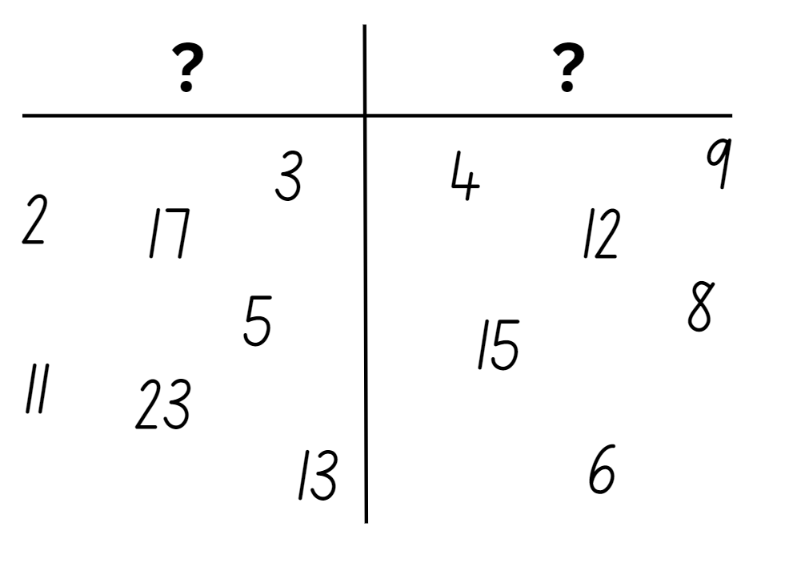

Resource 2 – primes
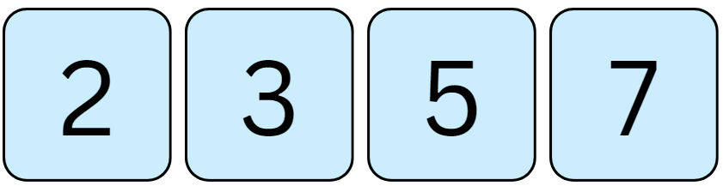

Resource 3 – better deal
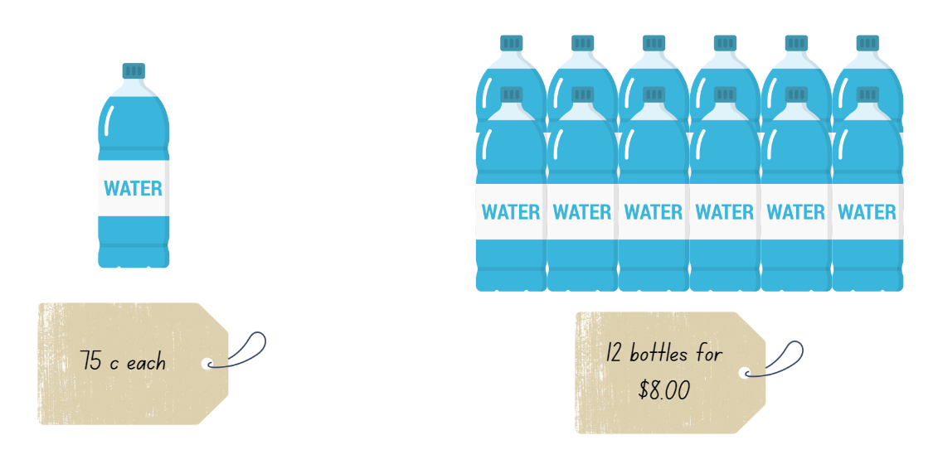

Resource 4 – fence it
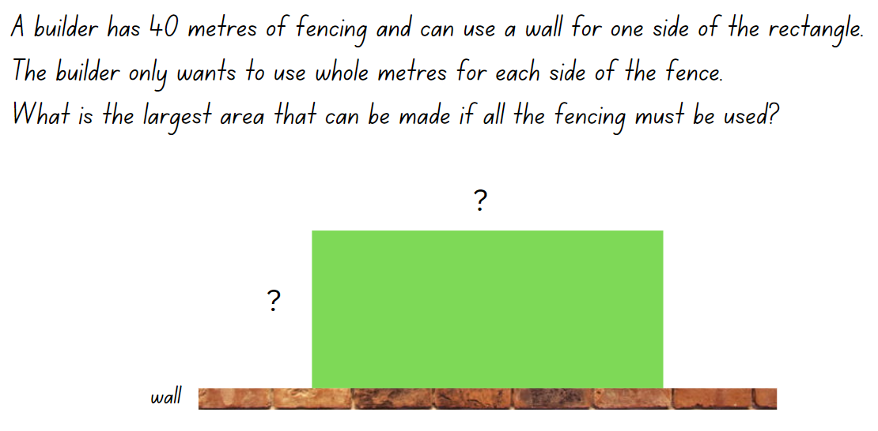

Resource 5 – possible fencing dimensions
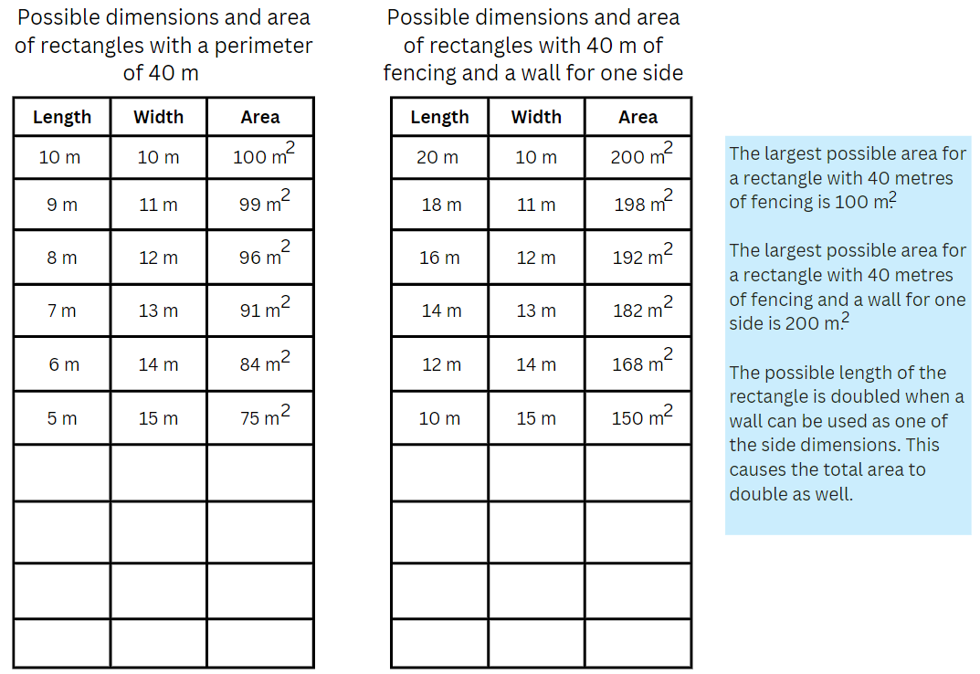

Resource 6 – biscuit problem
Mei bought 2 types of biscuits for her dogs. She wants to make sure that the biscuits are the same size.
Is it possible that a rectangular biscuit is the same size as a parallelogram shaped biscuit?
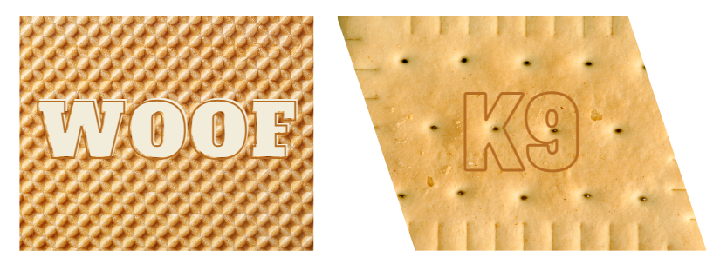

Resource 7 – parallelogram proof
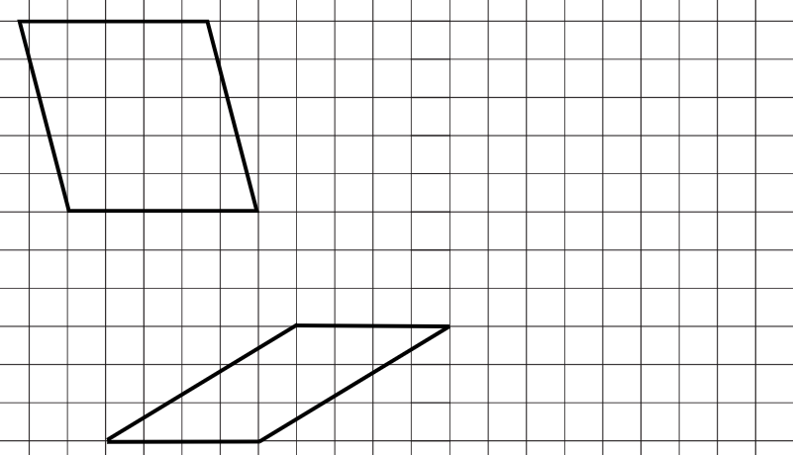

Resource 8 – design a biscuit
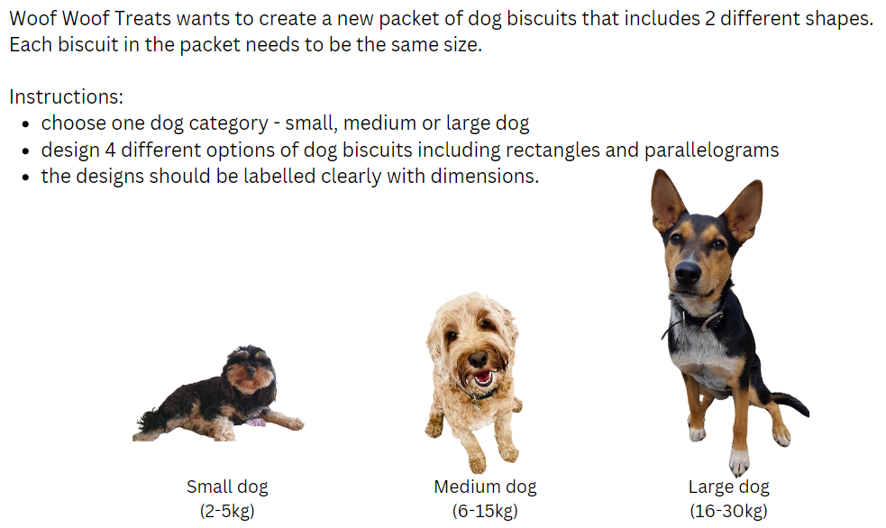

Resource 9 – parallelogram Venn
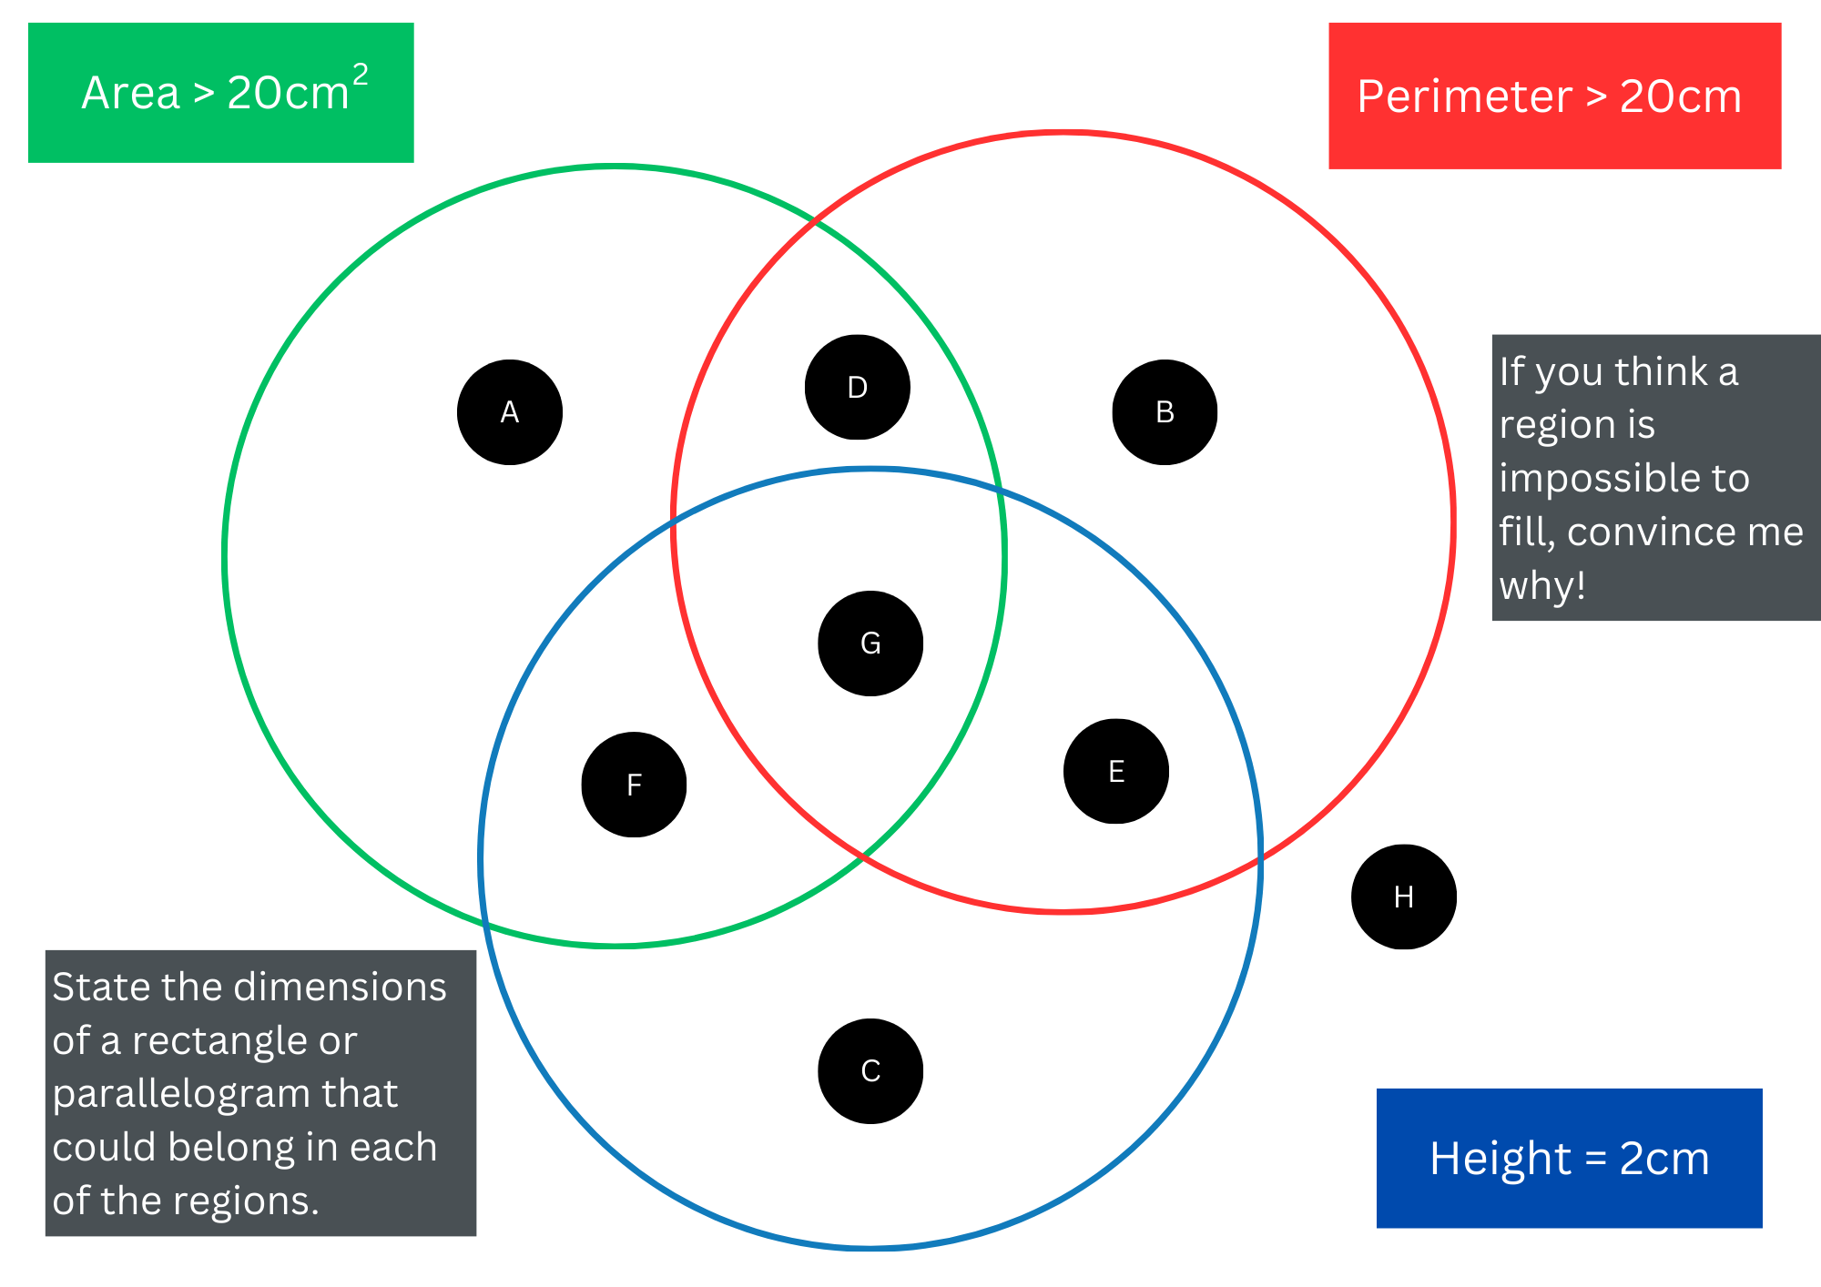
Adapted from Barton (2018).

Resource 10 – bigger cubes
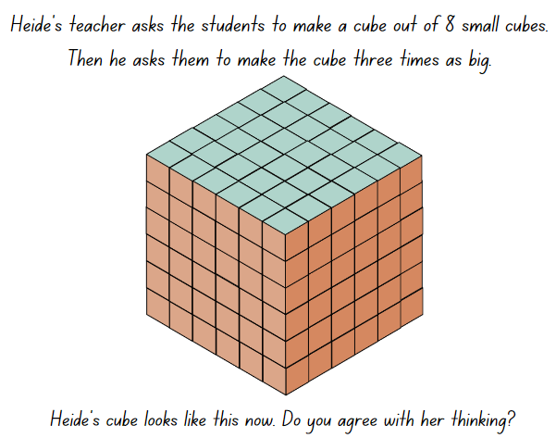

Resource 11 – patterns in volume
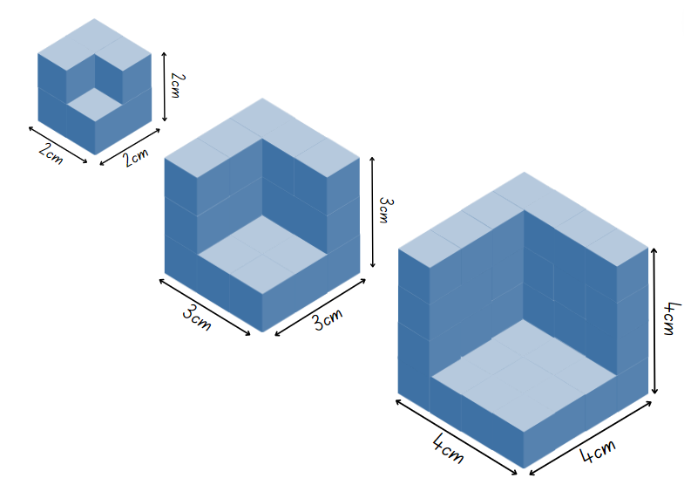

Resource 12 – recording table
Dimensions | Original cube volume | Missing cube volume | Remaining volume

Resource 13 – cube subtraction
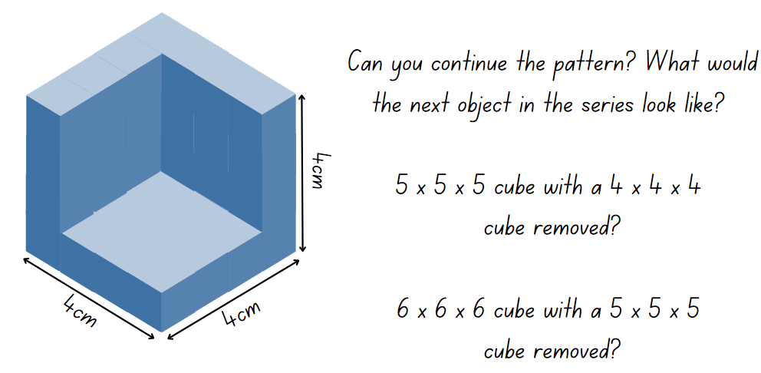

Resource 14 – calculate the volume
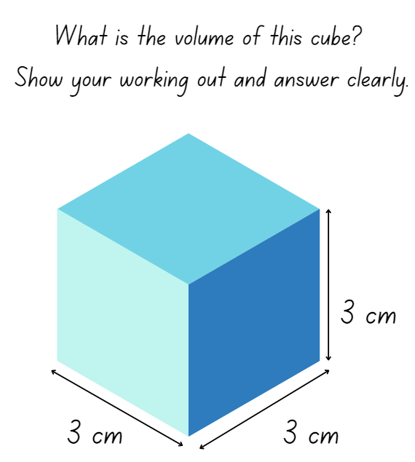

Resource 15 – valuable percentages
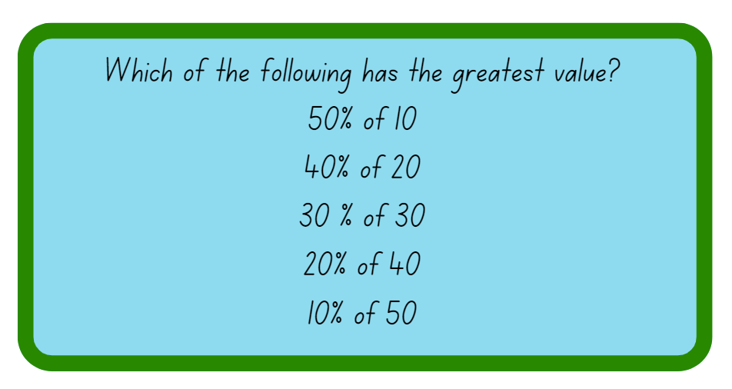

Resource 16 – box of boxes
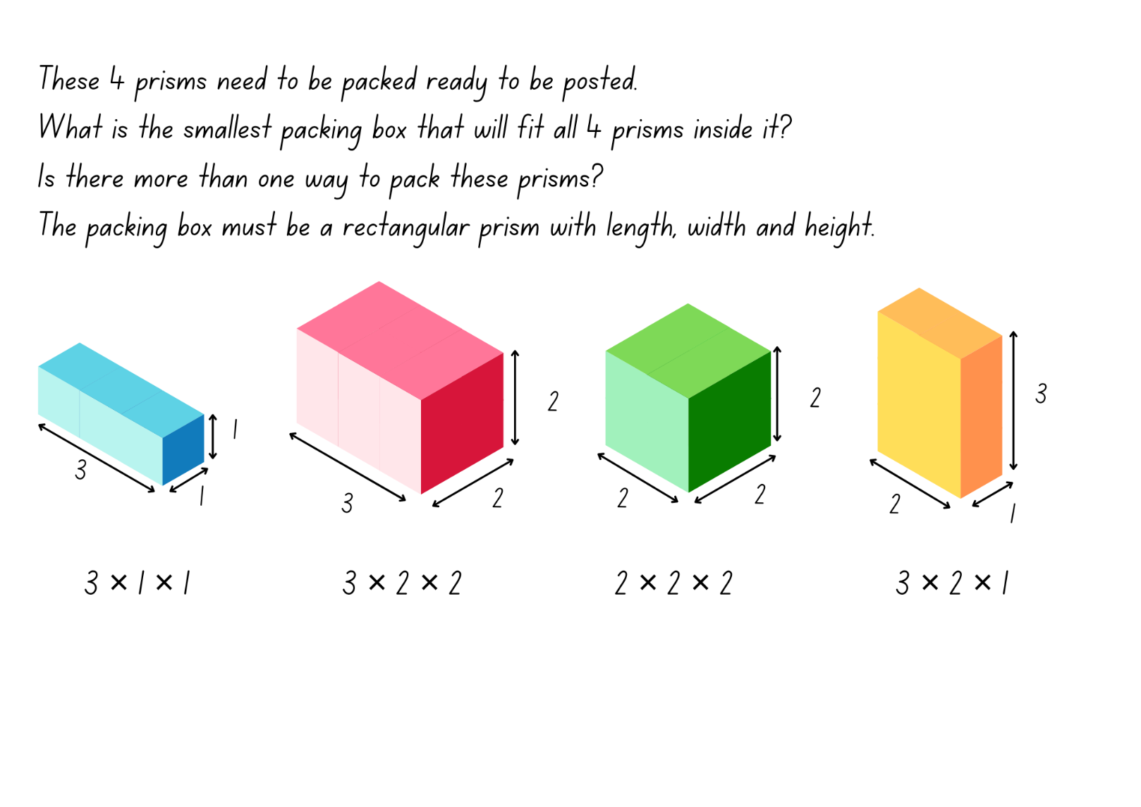
Adapted from Boaler et al. (2018).

Resource 17 – recording boxes
Dimensions of packing box | Volume of packing box | Volume of empty space
Adapted from Boaler et al. (2018).

Resource 18 – staff discount
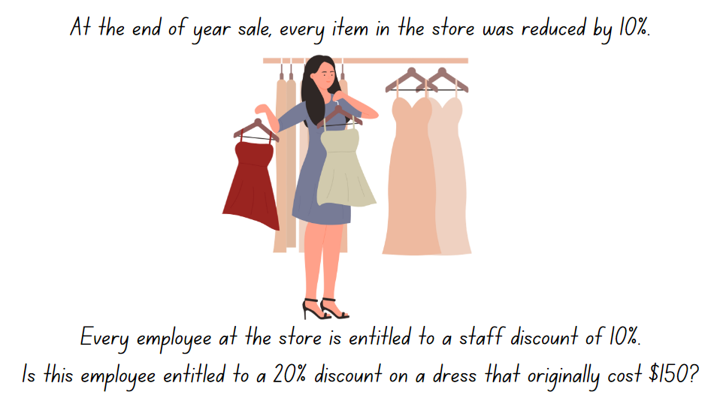

Resource 19 – Lisa’s landscaping
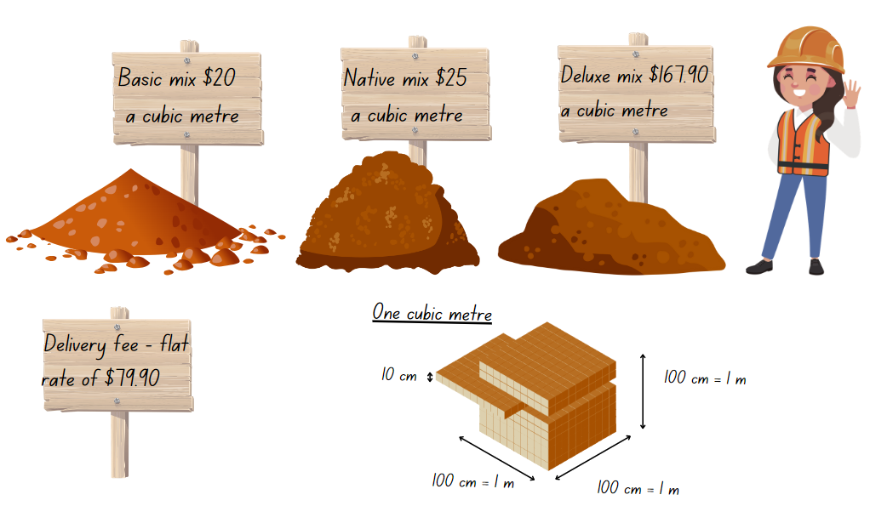

Resource 20 – Nanna Meg’s mail
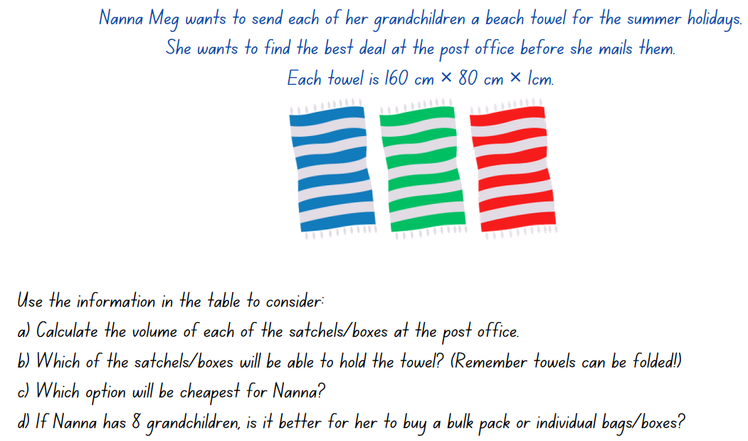

Resource 21 – post office information
Bags/satchels – postage included
Satchel size | Satchel dimensions | Cost/bag | Cost/10 bags
Medium | 39 × 27 × 1 cm | $15 | $145
Large | 51 × 44 × 1 cm | $23 | $219
Extra large | 70 × 62 × 3 cm | $30 | $289
Boxes – postage needs to be added
Box size | Box dimensions | Cost/box | Cost/20 boxes | Postage/each
Medium | 24 × 10 × 12 cm | $3 | $38 | $14
Large | 39 × 28 × 14 cm | $4 | $48 | $18
Extra large | 44 × 28 × 17 cm | $5 | $55 | $21

Syllabus outcomes and content
The table below outlines the syllabus outcomes and range of relevant syllabus content covered in this unit. Content is linked to National Numeracy Learning Progression (version 3).
Outcomes and content | 1 | 2 | 3 | 4 | 5 | 6 | 7 | 8
Represents numbers B: Decimals and percentages: Make connections between benchmark fractions, decimals and percentages
[MAO-WM-01, MA3-RN-02, MA3-RN-03]
- Recognise that the symbol % means percent and 100% is the whole amount |  |  |  |  | x | x | x
- Recognise that 10% is one-tenth of 100% and use this to find 10% of a quantity (Reasons about relations) |  |  |  |  | x | x | x
Multiplicative relations A: Determine products and factors
[MAO-WM-01, MA3-MR-01]
- Use the term product to describe the result of multiplying 2 or more numbers | x
- Determine factors for a given whole number | x
- Determine whether a number is prime, composite or neither (0 or 1) | x
Multiplicative relations A: Use partitioning and place value to multiply 2-, 3- and 4-digit numbers by one-digit numbers
[MAO-WM-01, MA3-MR-01]
- Use informal written strategies such as the area model to solve multiplication and division problems | x | x
Multiplicative relations A: Use estimation and rounding to check the reasonableness of answers to calculations
[MAO-WM-01, MA3-MR-01]
- Use estimation to check the reasonableness of answers to multiplication and division calculations |  |  |  |  |  |  |  | x
Multiplicative relations B: Select and apply strategies to solve problems involving multiplication and division with whole numbers
[MAO-WM-01, MA3-MR-01]
- Select and use efficient strategies to multiply whole numbers of up to 4 digits by one- and 2-digit numbers | x | x | x |  | x | x | x | x
Geometric measure A: Length: Measure lengths to find perimeters
[MAO-WM-01, MA3-GM-02]
- Calculate perimeters of common two-dimensional shapes, including squares, rectangles and triangles |  | x
- Recognise that rectangles with the same perimeter may have different dimensions (Spatial reasoning) |  | x
Two-dimensional spatial structure A: Area: Calculate the areas of rectangles using familiar metric units
[MAO-WM-01, MA3-2DS-02]
- Establish the relationship between the lengths, widths and areas of rectangles |  | x
- Calculate areas of rectangles in square centimetres (cm2), square metres (m2) and square kilometres (km2) |  | x
- Recognise that rectangles with the same area may have different dimensions |  | x
- Investigate and compare the areas of rectangles that have the same perimeter |  | x
Two-dimensional spatial structure B: Dissect two-dimensional shapes and rearrange them using translations, reflections and rotations
[MAO-WM-01, MA3-2DS-03]
- Use the terms translate, reflect and rotate to describe transformations of two-dimensional shapes |  |  |  | x
- Dissect and rearrange one shape to make another |  |  | x | x
Two-dimensional spatial structure B: Calculate the area of a parallelogram using subdivision and rearrangement
[MAO-WM-01, MA3-2DS-02, MA3-2DS-03]
- Show how to transform a parallelogram into a rectangle to find its area |  |  | x
- Record, using words, a method for finding the area of any parallelogram |  |  | x
Two-dimensional spatial structure B: Determine the area of a triangle
[MAO-WM-01, MA3-2DS-02]
- Investigate the area of a triangle by comparing it to the area of a parallelogram with the same base length and height |  |  |  | x
- Establish the relationship between the area of a triangle and the area of a parallelogram formed by duplicating and rotating the triangle |  |  |  | x
- Record, using words, a method for finding the area of any triangle |  |  |  | x
Three-dimensional spatial structure B: Volume: Use cubic metres for measurement of volume
[MAO-WM-01, MA3-3DS-02]
- Estimate and measure volumes in cubic metres |  |  |  |  |  |  | x
Three-dimensional spatial structure B: Volume: Recognise the multiplicative structure for finding volume
[MAO-WM-01, MA3-3DS-02]
- Describe the length, width and height of a rectangular prism as the dimensions of the prism |  |  |  |  | x
- Describe arrangements of cubic-centimetre blocks in terms of layers |  |  |  |  | x
- Establish the relationship between the number of cubes in one layer and the number of layers to find the volume of a rectangular prism (Reasons about spatial structure) |  |  |  |  | x | x
Three-dimensional spatial structure B: Volume: Find the volumes of rectangular prisms in cubic centimetres and cubic metres
[MAO-WM-01, MA3-3DS-02]
- Construct rectangular prisms using cubic-centimetre blocks and determine the volumes |  |  |  |  |  | x
- Record, using words, the method for finding the volumes of rectangular prisms |  |  |  |  | x
- Recognise that rectangular prisms with the same volume may have different dimensions (Reasons about spatial structure) |  |  |  |  |  | x |  | x
- Calculate volumes of rectangular prisms in cubic centimetres (cm³) and cubic metres (m³) |  |  |  |  | x | x | x | x
Mathematics K–10 Syllabus © NSW Education Standards Authority (NESA) for and on behalf of the Crown in right of the State of New South Wales, 2022.

References
This resource contains NSW Curriculum and syllabus content. The NSW Curriculum is developed by the NSW Education Standards Authority. This content is prepared by NESA for and on behalf of the Crown in right of the State of New South Wales. The material is protected by Crown copyright.
Please refer to the NESA Copyright Disclaimer for more information https://educationstandards.nsw.edu.au/wps/portal/nesa/mini-footer/copyright.
NESA holds the only official and up-to-date versions of the NSW Curriculum and syllabus documents. Please visit the NSW Education Standards Authority (NESA) website https://educationstandards.nsw.edu.au and the NSW Curriculum website https://curriculum.nsw.edu.au.
Mathematics K–10 Syllabus © NSW Education Standards Authority (NESA) for and on behalf of the Crown in right of the State of New South Wales, 2022.
National Numeracy Learning Progression © Australian Curriculum, Assessment and Reporting Authority (ACARA) 2010 to present, unless otherwise indicated. This material was downloaded from the Australian Curriculum website (National Literacy Learning Progression) (accessed 9 April 2024) and was not modified.
Australian Academy of Science (2020) Measurement: Parcel in the Post, reSolve website, accessed 3 April 2024.
Barton C (2018) Area > 20, perimeter > 20, height = 2, Maths Venns website, accessed 8 April 2024.
Boaler J, Munson J, Williams C (2018) Mindset Mathematics: Visualizing and Investigating Big Ideas, Grade 5, Jossey Bass, San Francisco.
Department of Environment & Climate Change NSW (2009) The marvel of mulch [PDF 641 KB], DECC, accessed 9 April 2024.
Joshua A (1997) Enrich-e-matics! A graded maths enrichment programme – Book F, Addison Wesley Longman Australia, Melbourne.
New Zealand Ministry of Education (n.d.) In Your Prime, NZ maths website, accessed 9 April 2024.
New Zealand Ministry of Education (n.d.) That Takes the Biscuit, NZ maths website, accessed 9 April 2024.
State of New South Wales (Department of Education Learning and Teaching Directorate) (2017) Teaching Measurement: Stage 2 – Stage 3 [PDF 685 KB], NSW Government, accessed 8 April 2024.
Sullivan P and Lilburn P (2017) Open-Ended Maths Activities, Oxford University Press Australia and New Zealand, Great Britain.
University of Cambridge (n.d.) Fence It, NRICH website, accessed 4 April 2024.
© State of New South Wales (Department of Education), 2024
The copyright material published in this resource is subject to the Copyright Act 1968 (Cth) and is owned by the NSW Department of Education or, where indicated, by a party other than the NSW Department of Education (third-party material).
Copyright material available in this resource and owned by the NSW Department of Education is licensed under a Creative Commons Attribution 4.0 International (CC BY 4.0) license.
This license allows you to share and adapt the material for any purpose, even commercially.
Attribution should be given to © State of New South Wales (Department of Education), 2024.
Material in this resource not available under a Creative Commons license:
- the NSW Department of Education logo, other logos and trademark-protected material
- material owned by a third party that has been reproduced with permission. You will need to obtain permission from the third party to reuse its material.
Links to third-party material and websites
Please note that the provided (reading/viewing material/list/links/texts) are a suggestion only and implies no endorsement, by the New South Wales Department of Education, of any author, publisher, or book title. School principals and teachers are best placed to assess the suitability of resources that would complement the curriculum and reflect the needs and interests of their students.
If you use the links provided in this document to access a third-party's website, you acknowledge that the terms of use, including licence terms set out on the third-party's website apply to the use which may be made of the materials on that third-party website or where permitted by the Copyright Act 1968 (Cth). The department accepts no responsibility for content on third-party websites.

