Mathematics Stage 3 – Unit 36
Fractions represent multiple ideas and can be represented in different ways

Contents
Unit description and duration 6
Syllabus outcomes 6
Working mathematically 7
Student prior learning 7
Lesson overview and resources 9
Lesson 1 14
Daily number sense – tower building – 10 minutes 14
Core lesson 1 – different-sized wholes – 10 minutes 16
Core lesson 2 – build it up – 30 minutes 17
Discuss and connect the mathematics – 10 minutes 21
Lesson 2 23
Daily number sense – How much more? – 10 minutes 23
Core lesson – recording equivalent fractions, decimals and percentages – 35 minutes 24
Consolidation and meaningful practice – 15 minutes 28
Lesson 3 31
Daily number sense – finding more again – 10 minutes 31
Core lesson 1 – exploring one-tenth – 15 minutes 32
Core lesson 2 – recording fractions, decimals and percentages – 25 minutes 36
Consolidation and meaningful practice – 10 minutes 38
Lesson 4 40
Daily number sense – 10 minutes 40
Core lesson 1 – rectangle fractions – 15 minutes 40
Core lesson 2 – equal parts of the whole – 15 minutes 42
Consolidation and meaningful practice – 25 minutes 44
Lesson 5 48
Daily number sense – number patterns using geometric shapes – 15 minutes 48
Core lesson 1 – mixed bag of lollies – 25 minutes 51
Core lesson 2 – ordering fractions – 15 minutes 53
Discuss and connect the mathematics – 10 minutes 57
Lesson 6 59
Daily number sense – not following the rule – 10 minutes 59
Core lesson – closest to the whole – 35 minutes 61
Discuss and connect the mathematics – 10 minutes 63
Lesson 7 65
Daily number sense – number pattern – 15 minutes 65
Core lesson 1 – fraction problem – 10 minutes 67
Core lesson 2 – adding and subtracting fractions – 25 minutes 68
Consolidation and meaningful practice – 15 minutes 71
Lesson 8 74
Daily number sense – 10 minutes 74
Core lesson 1 – take a chance – 10 minutes 74
Core lesson 2 – unequal chance – 25 minutes 76
Consolidation and meaningful practice –15 minutes 78
Resource 1 – fraction wall 80
Resource 2 – numerator denominator cards 81
Resource 3 – build it up 82
Resource 4 – mathematical reasoning prompts 83
Resource 5 – How much more? 84
Resource 6 – shade and label 85
Resource 7 – student non-example 86
Resource 8 – tape diagrams 87
Resource 9 – finding more again 88
Resource 10 – representing tenths 89
Resource 11 – 100 grid 90
Resource 12 – blank 100 grids 91
Resource 13 – 10% sale 92
Resource 14 – rectangle fractions 93
Resource 15 – area model fractions 94
Resource 16 – partitioning hexagons 95
Resource 17 – Harry’s hexagons 96
Resource 18 – 8 equal parts 97
Resource 19 – tape diagram example 98
Resource 20 – lolly shop cards 99
Resource 21 – fraction cards 100
Resource 22 – fraction card order 101
Resource 23 – fractions 102
Resource 24 – fraction problems 104
Resource 25 – spinners 105
Resource 26 – gameboard 106
Syllabus outcomes and content 107
References 112
Further reading 114

Unit description and duration
This unit develops the big idea that fractions represent multiple ideas and can be represented in different ways.
In this 2-week unit students are provided opportunities to:
- make connections between benchmark fractions, decimals and percentages
- compare common fractions with related denominators
- solve problems involving addition and subtraction of fractions with related denominators.

Syllabus outcomes
- MAO-WM-01 develops understanding and fluency in mathematics through exploring and connecting mathematical concepts, choosing and applying mathematical techniques to solve problems, and communicating their thinking and reasoning coherently and clearly
- MA3-RN-03 determines percentages of quantities, and finds equivalent fractions and decimals for benchmark percentage values
- MA3-AR-01 selects and applies appropriate strategies to solve addition and subtraction problems
- MA3-MR-01 selects and applies appropriate strategies to solve multiplication and division problems
- MA3-RQF-01 compares and orders fractions with denominators of 2, 3, 4, 5, 6, 8 and 10
- MA3-RQF-02 determines $\frac{1}{2},\frac{1}{4},\frac{1}{5}$and $\frac{1}{10}$ of measures and quantities
- MA3-CHAN-01 conducts chance experiments and quantifies the probability

Working mathematically
In the Mathematics K–10 Syllabus, there is one overarching Working mathematically outcome (MAO-WM-01). The Working mathematically processes should be embedded within the concepts being taught. The Working mathematically processes present in the Mathematics K–10 Syllabus are:
- communicating
- understanding and fluency
- reasoning
- problem solving.
Mathematics K–10 Syllabus © NSW Education Standards Authority (NESA) for and on behalf of the Crown in right of the State of New South Wales, 2022.

Student prior learning
Before engaging in these teaching and learning activities, students would benefit from prior experience with:
- recognising the role of the number one as representing the whole
- comparing and representing fractions of a whole shape and a collection of objects
- solving word problems involving addition and subtraction of fractions and fractional quantities of whole numbers.
In NSW classrooms there is a diverse range of students, including Aboriginal and/or Torres Strait Islander students, students learning English as an additional language or dialect, high potential and gifted students and students with disability. Some students may identify with more than one of these groups or possibly all of them. Refer to Curriculum planning for every student – advice for further information.

Lesson overview and resources
The table below outlines the sequence and approximate timing of lessons, learning intentions and resources.
Lesson | Content | Duration and resources
Lesson 1  Daily number sense learning intention:  - use equivalence to add and subtract fractional quantities | Lesson core concept: the unit whole for quantity fractions is always 1.  Core concept learning intentions:  - recognise the role of the number 1 as representing the whole  - build up to the whole from a given fractional part | Lesson duration: 60 minutes  - Resource 1 – fraction wall  - Resource 2 – numerator denominator cards  - Resource 3 – build it up  - Resource 4 – mathematical reasoning prompts  - Individual whiteboards  - Writing materials
Lesson 2  Daily number sense learning intention:  - use equivalence to add and subtract fractional quantities | Lesson core concept: fractions, decimals and percentages are formed by dividing a whole.  Core concept learning intention:  - make connections between benchmark fractions, decimals and percentages | Lesson duration: 60 minutes  - Resource 5 – How much more?  - Resource 6 – shade and label  - Resource 7 – student non-example  - Resource 8 – tape diagrams  - Writing materials
Lesson 3  Daily number sense learning intention:  - use equivalence to add and subtract fractional quantities | Lesson core concept: connections can be made between fractions, decimals and percentages using number lines and diagrams.  Core concept learning intention:  - make connections between benchmark fractions, decimals and percentages | Lesson duration: 60 minutes  - Resource 9 – finding more again  - Resource 10 – representing tenths  - Resource 11 – 100 grid  - Resource 12 – blank 100 grids  - Resource 13 – 10% sale  - Individual whiteboards  - Writing materials
Lesson 4  Daily number sense learning intention:  - teacher-identified task based on student needs | Lesson core concept: fractions of a whole shape can be compared and represented.  Core concept learning intention:  - compare common fractions with related denominators | Lesson duration: 65 minutes  - Resource 14 – rectangle fractions  - Resource 15 – area model fractions  - Resource 16 – partitioning hexagons  - Resource 17 – Harry’s hexagons  - Resource 18 – 8 equal parts  - Coloured pencils  - Individual whiteboards  - Writing materials
Lesson 5  Daily number sense learning intention:  - represent and describe number patterns formed by multiples | Lesson core concept: fractions of collections of objects can be compared and represented.  Core concept learning intentions:  - compare common fractions with related denominators  - find fractional quantities of whole numbers | Lesson duration: 65 minutes  - Resource 4 – mathematical reasoning prompts  - Resource 19 – tape diagram example  - Resource 20 – lolly shop cards  - Resource 21 – fraction cards  - Resource 22 – fraction card order  - Playing cards  - Writing materials
Lesson 6  Daily number sense learning intention:  - represent and describe number patterns formed by multiples | Lesson core concept: complement principles can help find the difference.  Core concept learning intentions:  - solve problems involving addition and subtraction of fractions with the same denominator  - use equivalence to add and subtract fractional quantities | Lesson duration: 55 minutes  - Resource 23 – fractions  - 9-sided dice  - Counters  - Individual whiteboards  - Writing materials
Lesson 7  Daily number sense learning intention:  - represent and describe number patterns formed by multiples | Lesson core concept: mathematicians solve problems with fractions.  Core concept learning intentions:  - use equivalence to add and subtract fractional quantities  - find fractional quantities of whole numbers | Lesson duration: 65 minutes  - Resource 24 – fraction problems  - Individual whiteboards  - Writing materials
Lesson 8  Daily number sense learning intention:  - teacher-identified task based on student needs | Lesson core concept: mathematicians solve problems with fractions.  Core concept learning intention:  - create random generators and describe probabilities using fractions | Lesson duration: 60 minutes  - Resource 25 – spinners  - Resource 26 – gameboard  - Counters  - Interlocking cubes  - Opaque bag  - Paper clips  - Paper cups  - Writing materials

Lesson 1
Core concept: the unit whole for quantity fractions is always 1.

Daily number sense – tower building – 10 minutes
Daily number sense activities for Lessons 1 to 3 ‘activate’ prior number knowledge and support the learning of new content in the unit. These activities can also assist teachers to identify the starting points for learning by revealing the extent of students’ existing knowledge.
The table below contains a suggested learning intention and success criteria. These are best co-constructed with students.
Daily number sense learning intention | Daily number sense success criteria
Students are learning to:  - use equivalence to add and subtract fractional quantities. | Students can:  - solve word problems involving adding or subtracting fractional quantities with related denominators.
- Pose the problem: Gabby built one-third ( $\frac{1}{3}$ ) of the tower with 18 bricks. Robbie built three-sixths ( $\frac{3}{6}$ ) of the tower. How many bricks has Robbie built the tower with? What fraction of the tower is still to be built? How many bricks will be needed after Gabby and Robbie’s fractional parts have been built to make the whole tower?
- Prompt students use bar models on individual whiteboards to solve the problem. For example, they could draw double-sided bar models to show the fraction addition and numerical addition (see Figure 1).
Figure 1 – possible student recording
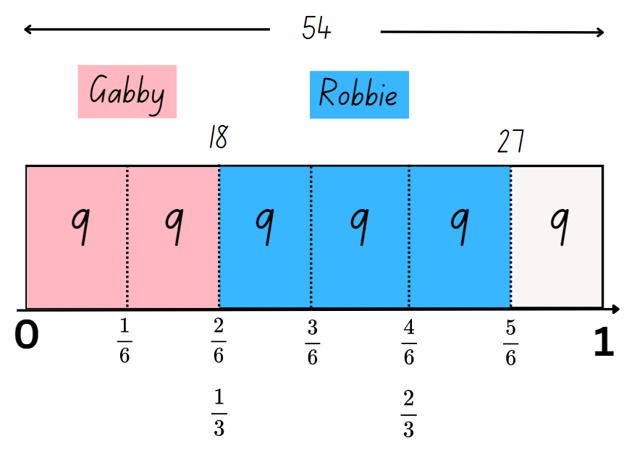
- Ask students to share their working and model double-sided bar models on the board.
This table details an opportunity for assessment.
Assessment opportunity | Links
What to look for:  - Can students solve word problems involving adding or subtracting fractional quantities with related denominators?  [MAO-WM-01, MA3-RQF-01] | Links to National Numeracy Learning Progressions (NNLP):  - InF8.  Links to suggested Interview for Student Reasoning (IfSR) tasks:  - IfSR-MT: 4B.1.

Core lesson 1 – different-sized wholes – 10 minutes
The table below contains suggested learning intentions and success criteria. These are best co-constructed with students.
Core concept learning intentions | Core concept success criteria
Students are learning to:  - recognise the role of the number 1 as representing the whole  - build up to the whole from a given fractional part. | Students can:  - compare halves and quarters of different-sized wholes  - justify the need for fractions to refer to the number 1 as the common whole  - generate the whole quantity from non-unit fractional parts such as quarters, eighths, thirds, sixths, fifths and tenths.
Note: some students may think that one-quarter ( $\frac{1}{4}$ ) will always represent a smaller amount than one-half ( $\frac{1}{2}$ ). The following problem highlights this misconception and shows the importance of considering the size of each whole, before determining the size of each fraction.
- Pose the following problem: Ms Brunetta sent half of the students she was supervising to help set up for the sports carnival. Mrs Kew sent a quarter of the students she was supervising to help set up for the sports carnival. Mrs Kew said she sent more students to help. How could she be correct?
- Students record as many answers to the problem as they can on individual whiteboards. For example, if Mrs Kew was supervising 60 students, a quarter of 60 is 15. If Ms Brunetta was supervising 20 students, a half of 20 is 10.
- Students share their reasoning for the answers they have recorded.
- Discuss the importance of the size of the whole in determining which fraction amount is the largest. Revise that when there are different-sized wholes, the size of the fractional parts is dependent on how large the whole is.

Core lesson 2 – build it up – 30 minutes
- Display Resource 1 – fraction wall. Discuss with students the fractional parts that make one whole. For example, 2 halves make one whole. 4 quarters also make one whole.
Note: for this game, each student will require the 2 sets of number cards from Resource 2 – numerator denominator cards. Decks of cards could be used instead of the resource to create fractions. Each student will need 2 sets of cards with the numerator numbers of 1, 1, 2, 2, 3, 3 and the denominator cards of 3, 4, 5, 6, 8 and 10.
- Provide students with Resource 3 – build it up. Explain that for this activity:
- each bar equals one.
- students flip over their numerator and denominator cards one at a time to create a fraction. For example, a 3 and an 8 creates the fraction $\frac{3}{8}$.
- students shade and record the fractional part. They also record the fraction needed to build up to the whole. For example, the fraction I shaded is $\frac{3}{8}$. I need $\frac{5}{8}$ to build up to the whole.
- Students then record the total of the whole. For example, $\frac{8}{8}$ (see Figure 2).
Figure 2 – example of student responses
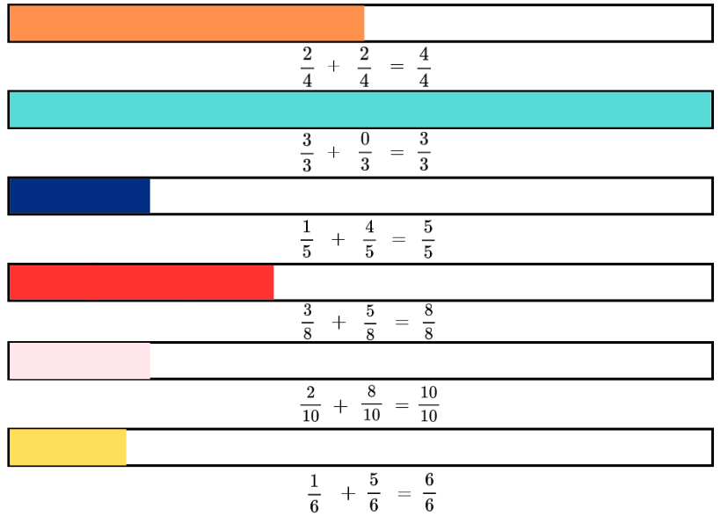
- Students conduct a gallery walk to compare their recordings, checking for accuracy. Ask:
- Did anyone shade the same fraction of the whole as you? What is it?
- Are there any recordings you do not agree with? Why? justify your reasoning and explain how you would help this student with their thinking.
- Are there any equivalent fractions shaded? If so, what are they? For example, $\frac{1}{5}$ and $\frac{2}{10}$.
- Revise that when there are different-sized wholes, the size of the fractional parts is dependent on the whole. For example, when comparing half of Ms Brunetta’s students to a quarter of Mrs Kew’s students, the size of each fractional part was dependent on the size of the different wholes.
- Explain that the number ‘one’ is the common whole for the ‘build it up’ task they completed. It is ‘one whole’. This common whole enables all the fractional quantities in the game to be compared, ordered, added or subtracted.
- Students record as many fractional quantities as possible with different denominators that can be combined to make 1 (the common whole). For example, two-quarters ( $\frac{2}{4}$ ) and three-sixths ( $\frac{3}{6}$ ).
This table details opportunities for differentiation.
Too hard? | Too easy?
Students cannot generate the whole quantity from non-unit fractional parts such as quarters, eighths, thirds, sixths, fifths and tenths.  - Provide strips of paper and support students to fold their strips into equal fractional parts. For example, folding the fraction strip in half and in half again to represent quarters.  - Provide students with a copy of Resource 1 – fraction wall to assist students with identifying equivalent fractions of the whole. | Students can generate the whole quantity from non-unit fractional parts such as quarters, eighths, thirds, sixths, fifths and tenths.  - Provide students with opportunities to work with fractions with different denominators. For example, 7, 9, 11 and 12.  - Challenge students to write a problem with non-unit fractional parts with a different-sized whole. For example, Mr Ford sent two-quarters ( $\frac{2}{4}$ ) of his class to the hall. Mr Holden sent three-eighths  ( $\frac{3}{8}$ ) of his class to the hall. Mr Holden said that he sent more students. How could he be correct? Students swap with a partner to solve.

Discuss and connect the mathematics – 10 minutes
- Display Resource 4 – mathematical reasoning prompts. Explain that these questions help to reflect on their mathematical thinking when solving problems.
- Pose the following problem: Fred laid three-quarters ( $\frac{3}{4}$) of the edging for a garden bed and Ted laid one-half ( $\frac{1}{2}$) of the edging for a garden bed. Ted said he has laid more edging than Fred. How could he be correct?
- Students share their solution, while also explaining their reasoning. Use Resource 4 – mathematical reasoning prompts to facilitate the discussion.
This table details opportunities for assessment.
Assessment opportunities | Links
What to look for:  - Can students compare halves and quarters of different sized wholes? [MAO-WM-01, MA3-RQF-02]  - Can students justify the need for fractions to refer to the number 1 as the common whole? [MAO-WM-01, MA3-RQF-02]  - Can students generate the whole quantity from non-unit fractional parts such as quarters, eighths, thirds, sixths, fifths and tenths? [MAO-WM-01, MA3-RQF-01, MA3-RQF-02] | Links to National Numeracy Learning Progressions (NNLP):  - InF5.

Lesson 2
Core concept: fractions, decimals and percentages are formed by dividing a whole.

Daily number sense – How much more? – 10 minutes
The table below contains a suggested learning intention and success criteria. These are best co-constructed with students.
Daily number sense learning intention | Daily number sense success criteria
Students are learning to:  - use equivalence to add and subtract fractional quantities. | Students can:  - represent fractional quantities with the same or related denominators to add and subtract fractions.
- Display and provide students with Resource 5 – How much more? Students use the fraction strip and number line representations to work out how much more four-fifths ( $\frac{4}{5}$) is than three-tenths ( $\frac{3}{10}$ ).
- Students turn and talk with a partner to work on their answer. Ask:
- What strategy did you use to solve the problem?
- What did you notice about the denominators represented in this question? (They are related denominators.)
- Are the related denominators helpful to solving this problem?
- If $\frac{4}{5}$ is $\frac{5}{10}$ more than $\frac{3}{10}$, how many more tenths are added to make one whole? ($\frac{5}{10}$ + $\frac{3}{10}$ + $\frac{2}{10}$ = one whole.)
- How else could one whole be made adding fifths and tenths? (For example, $\frac{4}{5}$ + $\frac{2}{10}$ = one whole.)
This table details an opportunity for assessment.
Assessment opportunity | Links
What to look for:  - Can students represent fractional quantities with the same or related denominators to add and subtract fractions?  [MAO-WM-01, MA3-RQF-01] | Links to National Numeracy Learning Progressions (NNLP):  - InF8.

Core lesson – recording equivalent fractions, decimals and percentages – 35 minutes
The table below contains a suggested learning intention and success criteria. These are best co-constructed with students.
Core concept learning intention | Core concept success criteria
Students are learning to:  - make connections between benchmark fractions, decimals and percentages. | Students can:  - recognise that the symbol % means percent and 100% is the whole amount  - recall commonly used equivalent percentages, decimals and fractions including $\frac{1}{2}$, $\frac{1}{4}$, and $\frac{3}{4}$  - represent common percentages of quantities and lengths as fractions and decimals.
- Draw the percent (%) symbol on the board. Ask: What is this and why you would use it?
- Revise that a percentage can be written as a fraction out of 100. For example, $\frac{20}{100}$ = 20%, $\frac{60}{100}$ = 60% and $\frac{80}{100}$= 80%.
- Provide students with Resource 6 – shade and label. Explain that to complete the bars, they need to:
- shade in the bar models with the percentages 25%, 50% and 75%
- place the fractions $\frac{1}{4},$ $\frac{1}{2},$ $\frac{3}{4}$ above the number line and decimals 0.25, 0.5 and 0.75 below the number line (see Figure 3.)
- justify their reasoning in the box the number line.
Figure 3 – possible student recording
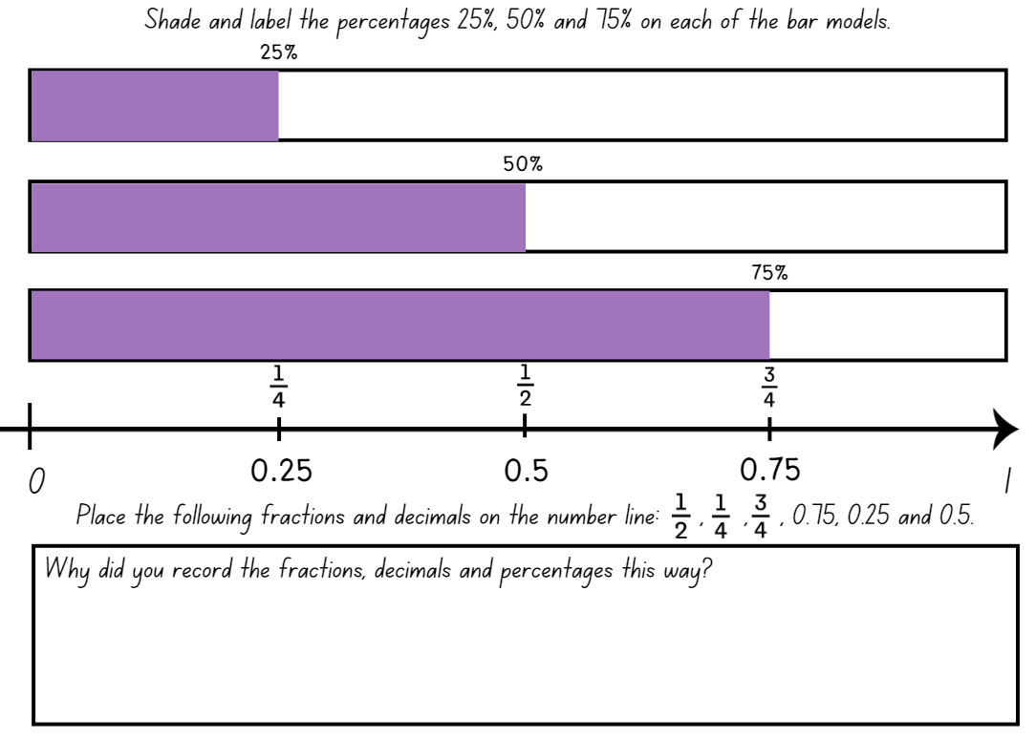
Note: monitoring students as they work on Resource 6 – shade and label is an opportunity for formative assessment.
- Regroup as a class. Students turn and talk with a partner to read aloud the fractions, decimals and percentages they have recorded. Ask students to use the word ‘and’ to connect the decimal fraction with the whole number. For example, ‘zero and 5 tenths’.
Note: to support place value and fractional understanding, 0.25 would be read as twenty-five hundredths. Interpreting decimals used in different contexts can change the way that students read them. In the context of measuring timber, it is appropriate to read the decimal 2.75 as ‘two point seven five metres’. Without a relevant context, encourage students to read the decimal as ‘two and seventy-five hundredths’. Students share their responses. They justify why they recorded the fractions, decimals and percentages in this way.
- Display Resource 7 – student non-example. Ask:
- Do you agree with the part the student has identified as 50%? Why or why not?
- How would you help the student find 50% of the bar model? (For example, folding the bar model in half).
- Do you agree with $\frac{1}{2}$ being placed in that position on the number line? Why or why not?
- How could you help this student to see the connection between five-tenths, half and 50%?
- Do you agree with their thinking that the more numbers after the decimal numbers, the bigger the number is?
- How could you help this student with their place value understanding? (Explain that more numbers after the decimal point doesn’t always make a larger decimal).
Note: the Stage 3 Teaching advice for Representing numbers using place value B states that when students first encounter decimals, the most common misconception identified is the belief that longer decimals are always larger decimals. A student who believes that longer decimals are always larger will indicate that 0.25 is larger than 0.5 (NESA 2024a).
This table details opportunities for differentiation.
Too hard? | Too easy?
Students cannot recall commonly used equivalent percentages, decimals and fractions including $\frac{1}{2}$, $\frac{1}{4}$, and $\frac{3}{4}$.  - Provide students with a strip of paper. Support them to fold the paper strip in half and half again, then label the folds $\frac{1}{4}$, $\frac{1}{2}$ and $\frac{3}{4}$.  - Support students with their understanding of percentages being written as a fraction out of 100. Assist them to record the benchmark percentages with their equivalent fractions with a denominator of 100. For example, 25% = $\frac{25}{100}$, 50% = $\frac{50}{100}$ and 75% = $\frac{75}{100}$. | Students can recall commonly used equivalent percentages, decimals and fractions including $\frac{1}{2}$, $\frac{1}{4}$, and $\frac{3}{4}$.  - Students draw a blank number line from 0–2. They place the following fractions, decimals and percentages on the number line: 0.3, 0.9, 1.2, 2.0, 1$\frac{2}{3}$, $\frac{6}{8}$, 1$\frac{5}{6}$, $\frac{5}{5}$, 30% and 100%.  - Students play Matching Fractions, Decimals and Percentages from NRICH. They self-select from 5 levels of challenge and try to beat their best times.

Consolidation and meaningful practice – 15 minutes
- Discuss that percentages can be used to find an amount of a quantity. For example, 25% of 120 = 30, 50% of 120 = 60 and 75% of 120 = 90.
- Provide students with Resource 8 – tape diagrams. Students calculate 25%, 50% and 75% of each of the quantities and record the number at the correct position. For example, 25% of 180 = 45, 50% of 180 = 90 and 75% of 180 = 135 (see Figure 4).
Figure 4 – tape diagrams example
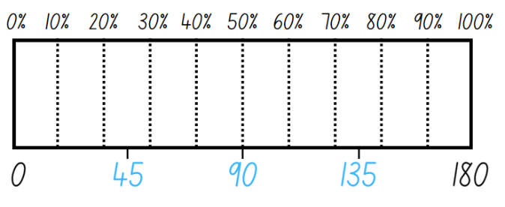
- Once students have calculated all solutions for each quantity, ask:
- What strategy did you use to find the different percentages of the amounts?
- Is it helpful to know how to work out common percentages, like 50%, to work out other benchmark percentages? (For example, 25% and 75%?)
- Is there a more efficient strategy that was just shared that you would use next time?
- Did you see connections between any of the answers you recorded? (For example, 180 = 100% of 180 on the first tape diagram, 180 = 75% of 240 on the second tape diagram and 180 = 50% of 360 on the last tape diagram).
This table details opportunities for assessment.
Assessment opportunities | Links
What to look for:  - Can students recognise that the symbol % means percent and 100% is the whole amount? [MAO-WM-01, MA3-RN-03]  - Can students recall commonly used equivalent percentages, decimals and fractions including $\frac{1}{2}$, $\frac{1}{4}$, and $\frac{3}{4}$?  [MAO-WM-01, MA3-RN-03]  - Can students represent common percentages of quantities and lengths as fractions and decimals? [MAO-WM-01, MA3-RN-03] | Links to National Numeracy Learning Progressions (NNLP):  - PrT1, PrT2, UnM8, InF7.

Lesson 3
Core concept: connections can be made between fractions, decimals and percentages using number lines and diagrams.

Daily number sense – finding more again – 10 minutes
The table below contains a suggested learning intention and success criteria. These are best co-constructed with students.
Daily number sense learning intention | Daily number sense success criteria
Students are learning to:  - use equivalence to add and subtract fractional quantities. | Students can:  - represent fractional quantities with the same or related denominators to add and subtract fractions.
- Display Resource 9 – finding more again. Students use the fraction strip and number line representations to find the difference between six-eights ($\frac{6}{8}$ ) and one-quarter ( $\frac{1}{4}$ ).
- Students turn and talk with a partner to share their reasoning. Ask:
- What strategy did you use to solve the problem?
- Was the strategy different to the one you used for the daily number sense problem in Lesson 2? If yes, why?
- Is there more than one answer to this problem using the related denominators or 4 and 8? ( $\frac{2}{4}$ and $\frac{4}{8}$)
- Can you explain why there can be 2 answers to this problem using the related denominators or 4 and 8? ($\frac{2}{4}$ and $\frac{4}{8}$ are equivalent fractions as they both occupy the same point on the number line.)
- Is there another fractional quantity we could use to explain the relationship between the 2 fractions? ( $\frac{1}{4} i$s a third of $\frac{6}{8}$.)
This table details an opportunity for assessment.
Assessment opportunity | Links
What to look for:  - Can students represent fractional quantities with the same or related denominators to add and subtract fractions?  [MAO-WM-01, MA3-RQF-01] | Links to National Numeracy Learning Progressions (NNLP):  - InF8.

Core lesson 1 – exploring one-tenth – 15 minutes
The table below contains a suggested learning intention and success criteria. These are best co-constructed with students.
Core concept learning intention | Core concept success criteria
Students are learning to:  - make connections between benchmark fractions, decimals and percentages. | Students can:  - recall commonly used equivalent percentages, decimals and fractions including $\frac{1}{2}$, $\frac{1}{4}$, and $\frac{3}{4}$  - represent common percentages of quantities and lengths as fractions and decimals  - recognise that 10% is one-tenth of 100% and use this to find 10% of a quantity.
This activity is an adaptation of ‘Hundredths and percentages’ from Teaching Mathematics: Foundation to Middle Years by Siemon et al.
- Draw a rectangle with one whole written inside (see Figure 5). Ask: How could you break up one whole into tenths?
Figure 5 – one whole
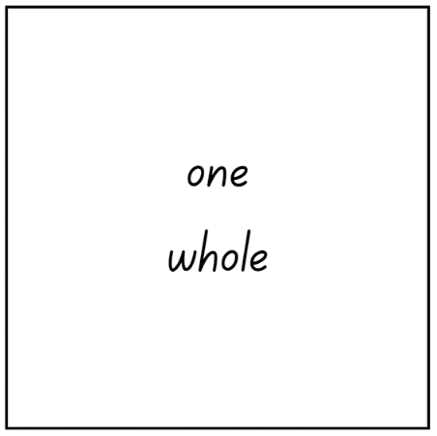
Note: the Stage 3 Teaching advice for Represents numbers B states that benchmark fraction values are extended to include one-tenth (10%, 0.1) (NESA 2024b).
- Students record their thinking on individual whiteboards. They turn and talk to share their representations with a partner.
- Display Resource 10 – representing tenths. Discuss that the image shows how the one whole is broken into 10 equal pieces. Explain that one-tenth is 10% of 100% and this can be used to find 10% of a quantity.
- Display Resource 11 – 100 grid. Ask:
- How could one-tenth be recorded as a fraction?
- Is there more than one way one-tenth could be written as a fraction?
- How could one-tenth be recorded as a decimal?
- How could one-tenth be recorded as a percentage?
- Select students to share their thinking and record responses given on the whiteboard (see Figure 6).
Figure 6 – possible student responses
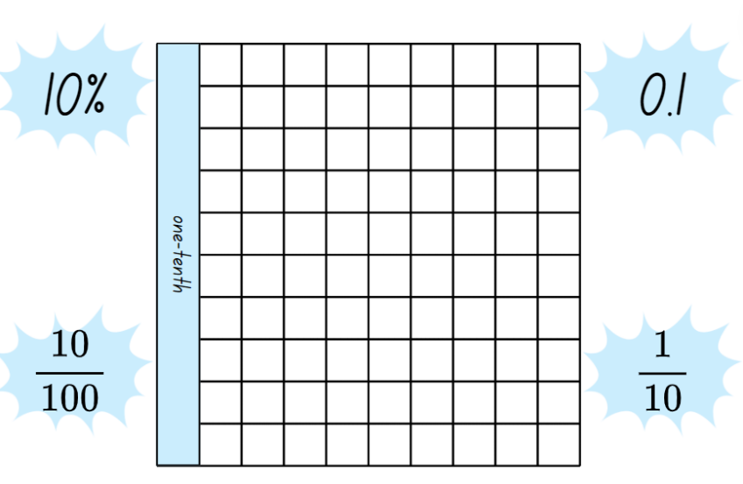
- Revise that a percentage can be written as a fraction out of 100. For example, $\frac{10}{100}$.
Note: one-tenth can be expressed as a decimal with hundredths. The Stage 3 Teaching advice for Represents numbers A states that the role of zero as a place holder assists in understanding how we say and write decimals. Zero is written in the ones place in a decimal to reduce the risk of misreading the decimal as a whole number (NESA 2024c). For example, the number 0.1 has the same value as 0.10. The link between hundredths and per cent can be made using a hundredths diagram (Siemon et al. 2021).

Core lesson 2 – recording fractions, decimals and percentages – 25 minutes
- Ask: Can you remember any benchmark fractions? (For example, $\frac{1}{4}$, $\frac{1}{2}$and $\frac{3}{4} ).$ Revise that benchmark fractions are used as a reference point.
Note: it is important that students develop a robust understanding of the equivalent representations of benchmark values (Fuchs et al. 2017). Students should know that 0.5 equals one-half ( $\frac{1}{2}$ ) and 0.5 is not one-fifth ( $\frac{1}{5}$).
- Provide students with Resource 12 – blank 100 grids.
- Explain that students are to represent the benchmark fractions of $\frac{1}{4}$, $\frac{1}{2}$and $\frac{3}{4}$on the grids provided. Students then record the representations on the grids as fractions, decimals and a percentage (see Figure 7).
Figure 7 – possible student recordings
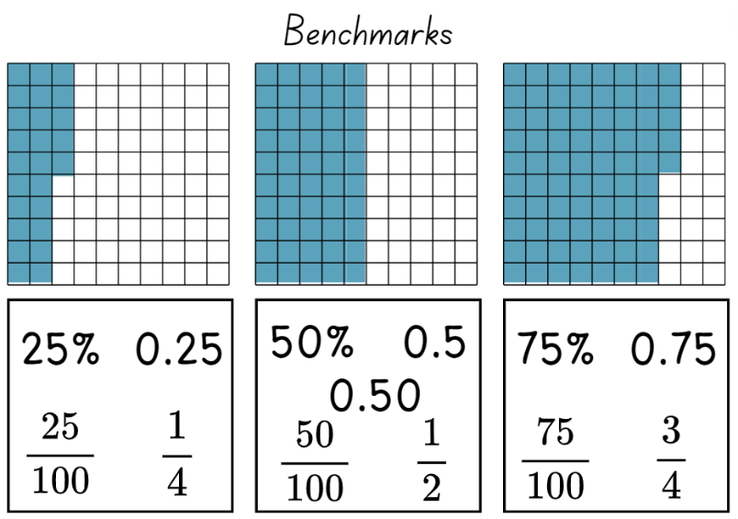
- Students go on a gallery walk. Ask:
- Were the representations similar to yours?
- Do you notice anything different to yours?
- Did you notice any fraction or decimal recordings that you did not consider?
This table details opportunities for differentiation.
Too hard? | Too easy?
Students cannot represent common percentages of quantities and lengths as fractions and decimals.  - Support students to focus on 50% as the benchmark percentage. Assist them to recognise $\frac{1}{2}$ and 0.5 in relation to the hundreds grid.  - Use MAB materials as a visual representation to support students’ understanding of fractions, decimals and percentages. | Students can represent common percentages of quantities and lengths as fractions and decimals.  - Provide another copy of Resource 12 – blank 100 grids and ask students to select non-benchmark fractions to record on the sheet.  - Students play an interactive game where percentages are used on a 10 × 10 grid. For example, Playground Percentages from ABC Education.

Consolidation and meaningful practice – 10 minutes
- Revise how the base-10 number system makes it easy to find 10% of a quantity, and that 10% reflects one-tenth ($\frac{1}{10}$ ) of the total. For example, 10% of 150 is 15.
- Explain that finding 10% is the same as dividing by 10.
- Display Resource 13 – 10% sale. Students find 10% of the price of each item, recording their answers on individual whiteboards.
- Students turn and talk with a partner, explaining the process they used to solve. For example, $70 divided by 10 = $7.
- Once students have calculated the 10% of each item, challenge them to find 40%, 60% and 90% of the price of each item. Remind them to use the benchmark of 10% to assist their calculation.
This table details opportunities for assessment.
Assessment opportunities | Links
What to look for:  - Can students recall commonly used equivalent percentages, decimals and fractions including $\frac{1}{2}$, $\frac{1}{4}$, and $\frac{3}{4}$?  [MAO-WM-01, MA3-RN-03]  - Can students represent common percentages of quantities and lengths as fractions and decimals? [MAO-WM-01, MA3-RN-03]  - Can students recognise that 10% is one-tenth of 100% and use this to find 10% of a quantity? [MAO-WM-01, MA3-RN-03] | Links to National Numeracy Learning Progressions (NNLP):  - PrT2, UnM8, InF7.

Lesson 4
Core concept: fractions of a whole shape can be compared and represented.

Daily number sense – 10 minutes
- From a class need surfaced through formative assessment data, identify a short, focused activity that targets students’ knowledge, understanding and skills. Example activities may be drawn from the following resources:
- Mathematics K–6 resources
- Universal Resources Hub.

Core lesson 1 – rectangle fractions – 15 minutes
The table below contains suggested learning intention and success criteria. These are best co-constructed with students.
Core concept learning intention | Core concept success criteria
Students are learning to:  - compare common fractions with related denominators. | Students can:  - subdivide the area of a rectangle by both length and width to represent the multiplicative relationship between common fractions  - compare and represent fractions with denominators of 2, 4 and 8; 3 and 6; 5 and 10 of a whole shape (area model) and a collection of objects (discrete model).
Note: the Stage 3 Teaching advice for Representing quantity fractions B states that students need opportunities to actively explore different ways to divide the areas of shapes. For example, subdividing rectangles by both length and width can help develop an understanding of how to produce equivalent fractions, and how to create a common denominator. Subdividing the shape emphasises the relationship between the denominators of the component fractions. Subdividing shapes establishes a better understanding of the area model of fractions than simply counting shaded parts (NESA 2024a).
This concept was introduced in Stage 3 Unit 16.
- Display Resource 14 – rectangle fractions. Explain that the first yellow rectangle is the whole and each rectangle is equal to one. Ask: What fraction does the blue squares represent in each rectangle?
- Students record their thinking on individual whiteboards. They recreate each of the rectangles, then subdivide the area and record equivalent fractions they can see.
- Regroup and explain that the rectangle can be divided into equal 8 squares arranged as 2 by 4. Therefore, the blue squares represent:
- two eighths or one quarter of the first rectangle
- four eighths, 2 quarters or one-half of the second rectangle
- six eighths or 3 quarters of the third triangle.
- Model the subdivision of the rectangles on the board (see Figure 8).
Figure 8 – subdividing rectangles
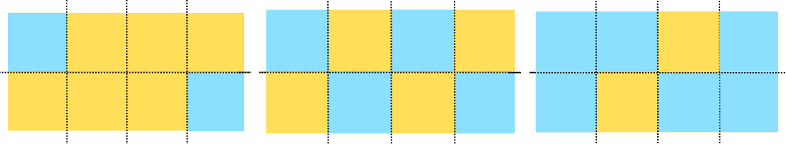
- Students turn and talk to discuss the connections between fractions and division.
Note: the Stage 3 Teaching advice for Multiplicative relations B states that fraction notation brings together a division problem with its solution. For example, 1 divided by 2 is half ($\frac{1}{2}$) just as 2 divided by 4 is 2 quarters ($\frac{2}{4}$). An area model can be used to represent dividing that area of shapes. This can be reinforced by describing fractions as divisions. Instead of describing one-half as ‘1 over 2’ or 3-quarters as ‘3 over 4’ introduce the language of division: ‘1 divided by 2’ or ‘3 divided by 4’ (NESA 2024d).

Core lesson 2 – equal parts of the whole – 15 minutes
This activity is an adaptation of ‘Equal parts of the whole’ in Challenging Mathematical Tasks by Sullivan.
- Provide students with a copy of Resource 15 – area model fractions. Explain that their task is to determine the fractions represented by different colours of the whole shapes.
- Students record the fractions represented next to each shape. Encourage them to also record any equivalent fractions (see Figure 9).
Figure 9 – example of a student recording
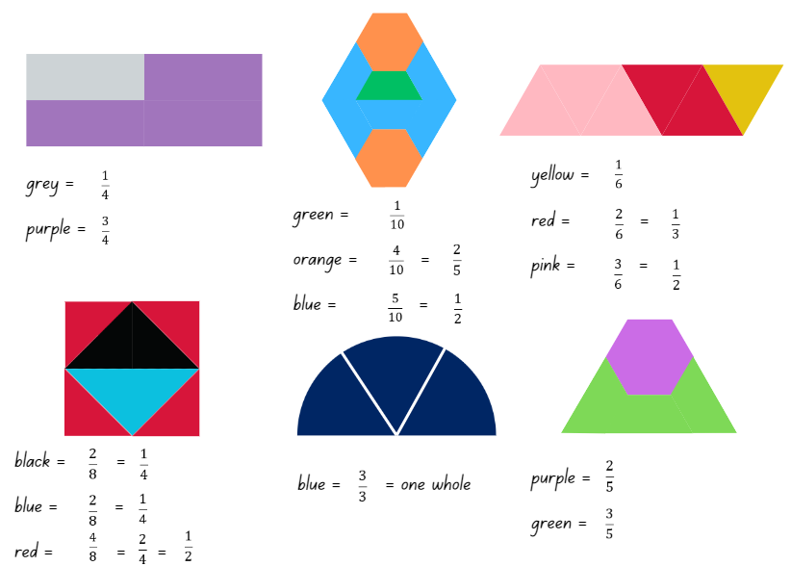
This table details opportunities for differentiation.
Too hard? | Too easy?
Students cannot compare and represent fractions with denominators of 2, 4 and 8; 3 and 6; 5 and 10 of a whole shape (area model) and a collection of objects (discrete model).  - Provide students with pattern blocks to recreate the whole shapes and manipulate the fractional parts of the whole.  - Provide students with Resource 1 – fraction wall. Support them to compare fractions with related and equivalent denominators. | Students can compare and represent fractions with denominators of 2, 4 and 8; 3 and 6; 5 and 10 of a whole shape (area model) and a collection of objects (discrete model).  - Pose the problem: ‘I made a shape with 2 trapeziums and 2 triangles. The shape I made has the common whole of one. What fractions could I make?’  - Students design their own fractional shapes to swap with a partner. They find the fractions covered by each colour.

Consolidation and meaningful practice – 25 minutes
This activity is an adaptation of ‘Partitioning geometric shapes’ in Teaching Mathematics: Foundation to Middle Years by Siemon et al.
- Provide students with a copy of Resource 16 – partitioning hexagons.
- Students equally partition the hexagons in as many ways as they can.
Note: a common misconception is for students to focus on the ‘number of parts’ without appreciating that these parts need to be equal in size or amount. They may also believe that fractional parts in area models need to be congruent and fail to recognise that parts can look different but still be equivalent in area (Australian Academy of Science n.d.).
- Students turn and talk with a partner to share and explain their thinking. Ask:
- Did you have any partitioned hexagons that looked similar to your partner’s?
- Did your partner have any partitioned hexagons that looked different to yours? Can you describe the difference?
- How many equal parts did you partition your hexagons into? For example, 2, 3, 4 or 6 equal parts.
- Display Resource 17 – Harry’s hexagons. Explain to students that Harry was asked to partition the hexagons into equal parts. Ask:
- Which hexagons did Harry equally partition?
- Did any of Harry’s equally-partitioned hexagons match any of your partitioned hexagons? Which ones?
- Did Harry equally partition any of the hexagons in a way you didn’t think of? Which ones?
- Are there any hexagons that Harry partitioned into unequal parts? (Yes, the hexagon unequally partitioned into 8 parts.)
- Is there a way that Harry could partition a hexagon into 8 equal parts?
- Ask students to draw another hexagon on Resource 16 – partitioning hexagons. Challenge students to think of a way to partition the hexagon into 8 equal parts. Allow a short amount of time to explore equally partitioning the hexagon, checking student recordings.
- Provide students with Resource 18 – 8 equal parts. Ask: Is the grid under the hexagon helpful to identify where the equal partitions would be on the shape?
- Students record their equal partitioning using coloured pencils (see Figure 10).
Figure 10 – student example of a hexagon equally partitioned
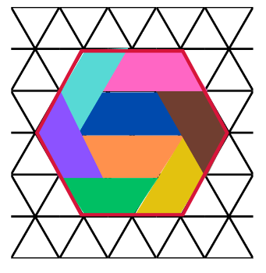
- Students turn and talk, comparing their equal partitioning with a partner.
Note: if students are unable to equally partition the hexagon into 8 parts, display Resource 18 – 8 equal parts. Model how to equally partition the shape, as in Figure 10.
This table details opportunities for assessment.
Assessment opportunities | Links
What to look for:  - Can students subdivide the area of a rectangle by both length and width to represent the multiplicative relationship between common fractions? [MAO-WM-01, MA3-RQF-01]  - Can students compare and represent fractions with denominators of 2, 4 and 8; 3 and 6; 5 and 10 of a whole shape (area model) and a collection of objects (discrete model)?  [MAO-WM-01, MA3-RQF-01] | Links to National Numeracy Learning Progressions (NNLP):  - InF5.  Links to suggested Interview for Student Reasoning (IfSR) tasks:  - IfSR-PT: 1A.11, 1A.12.

Lesson 5
Core concept: fractions of collections of objects can be compared and represented.

Daily number sense – number patterns using geometric shapes – 15 minutes
Daily number sense activities for Lessons 5 to 7 ‘loop’ back to concepts and procedures covered in previous units to assist students to build an increasingly connected network of ideas. These concepts may differ from the core concepts being covered by the unit.
The table below contains a suggested learning intention and success criteria. These are best co-constructed with students.
Daily number sense learning intention | Daily number sense success criteria
Students are learning to:  - represent and describe number patterns formed by multiples. | Students can:  - use a given geometric pattern involving multiples to create a table of values  - determine a rule describing the relationship between the bottom number and the top number in a table.
This activity is an adaption from Talking about Patterns & Algebra: Early Stage 1 to Stage 3 (PDF 3.28 KB) by State of NSW (Department of Education and Training Curriculum K–12 Directorate).
- Draw a hexagon on the board and Table 1.
Table 1 – shapes and sides
Number of shapes | 1 | 2 | 3 | 4 | 5 | 6 | 7 | 8 | 9 | 10
Number of sides
- Ask: How many sides are there? Record the number 6 below the diagram, in the first box of the table.
- Draw another hexagon next to the first one and pose the question: I have drawn another hexagon, how many sides have I drawn altogether? Record the number 12 below the second diagram and in the second box of the table.
- Students continue the sequence to the tenth term and record it in a table (see Table 1).
- Discuss the pattern using the prompt box below.
The table below outlines stimulus prompts to generate conversation about the topic, along with anticipated responses from students.
Prompts | Anticipated student responses
How many ways can you describe the pattern? | - The numbers in the pattern are increasing by 6.  - The pattern is made up of numbers that are multiples of 6. The third number in the pattern is 3 × 6. The fourth number in the pattern is 4 × 6 and it continues.
How does the table help determine the relationship between the number of shapes and the number of sides? | - The table helps me see that I do not need to add 6 to continue the pattern. I can see that if I take the number of shapes and multiply it by 6 it will give me the number of sides.  - For every new hexagon, the sides increase by 6. I can say for every 1 hexagon, there are 6 more sides.
Can you create a rule using multiplication to determine the number of sides for any given number of shapes? | - The rule is: number of shapes × 6 = number of sides. (Highlight that the number of shapes multiplied by 6 always determines the number of sides.)
This table details opportunities for assessment.
Assessment opportunities | Links
What to look for:  - Can students use a given geometric pattern involving multiples to create a table of values? [MAO-WM-01, MA3-MR-01]  - Can students determine a rule describing the relationship between the bottom number and the top number in a table?  [MAO-WM-01, MA3-MR-01] | Links to National Numeracy Learning Progressions (NNLP):  - NPA5.

Core lesson 1 – mixed bag of lollies – 25 minutes
The table below contains suggested learning intentions and success criteria. These are best co-constructed with students.
Core concept learning intentions | Core concept success criteria
Students are learning to:  - compare common fractions with related denominators  - find fractional quantities of whole numbers. | Students can:  - order common fractions with related denominators using diagrams and number lines  - compare and represent fractions with denominators of 2, 4 and 8; 3 and 6; 5 and 10 of a whole shape (area model) and a collection of objects (discrete model)  - calculate quarters and fifths of whole numbers that are multiples of the denominator, using a tape diagram.
- Explain that in Lesson 2, students used a tape diagram to calculate the percentages of a quantity. Discuss that tape diagrams can also be used to find fractions of a quantity.
- Revisit tape diagrams by displaying Resource 19 – tape diagram example. Explain that $\frac{1}{5}$ of 30 is 6. Ask students to explain how to find four fifths ( $\frac{4}{5}$ ) of 30.
- Shade in parts on the tape diagram as students identify them, asking them to explain their reasoning. For example, ‘You can multiply 4 by 6 to get the answer of 24’.
- Pose the following question: ‘There were 3 apple trees in the garden. Each tree had 12 apples on it. What is $\frac{1}{4}$of the total of the apples?’
- Students record their thinking on an individual whiteboard using a tape diagram. Ask:
- What do we need to do prior to working out how much one-quarter ( $\frac{1}{4}$ ) is?
- How does multiplication and division help you solve this problem?
- Provide students with Resource 20 – lolly shop cards and a deck of cards with 3, 6, 7, 8, 9 (with the picture cards removed). To play the game:
- Place the lolly shop cards in one pile.
- Place the playing cards into a pile.
- Player 1 flips over 2 cards. The highest number will be the denominator. For example, if 5 and 2 are flipped the fraction will be two-fifths
( $\frac{2}{5}$ ).
- Player 1 then flips over a lolly shop card and calculates the fraction using a tape diagram.
- Player 2 repeats the same steps.
- If there is a remainder, the player loses a turn.
- Continue until all the cards have been used. The winner is the player with the most lollies after all the cards have been played.

Core lesson 2 – ordering fractions – 15 minutes
- Draw a number line on the board with the fractions marked as in Figure 11.
Figure 11 – number line with fractions
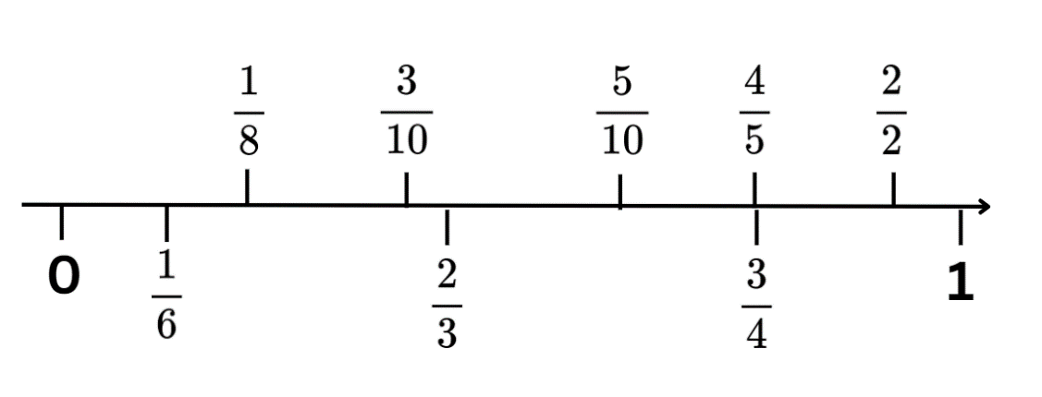
- Students turn and talk about what they notice in the image. Select students to share and explain, recording responses on the board.
The table below outlines stimulus prompts to generate conversation about the topic, along with anticipated responses from students.
Prompts | Anticipated student responses
- Do you think these fractions were in the correct order? Why or why not? If not, where do they belong? | - $\frac{1}{6}$ is larger than $\frac{1}{8}$ so should be closer to 1.  - $\frac{3}{10}$ and $\frac{5}{10}$ are too close together and there is not enough space for $\frac{4}{10}$.  - $\frac{4}{5}$ and $\frac{3}{4}$ are not equivalent and shouldn’t be in the same point on the number line.  - $\frac{2}{2}$ is equal to 1 so should be on top of the number 1.  - $\frac{5}{10}$ is equal to half so should be in the middle.
- Correct the placements of the fractions on the number line and discuss strategies to ensure accuracy (see Figure 12).
Figure 12 – correct fraction placements
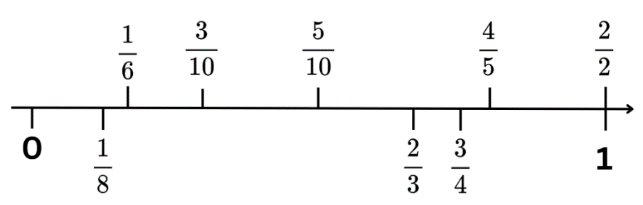
- Display Resource 21 – fraction cards. Students draw an empty number line from 0–1 on their individual whiteboard. They record fractions in the correct order.
- Students turn and talk, justifying their reasoning for the ordering of the fractions.
- Display Resource 22 – fraction card order and ask:
- Which fraction did you place first on the number line? Why?
- Which fraction did you place last? Why?
- Were the fractions in the same order as yours? Why or why not?
- Is there anything you noticed about the fractions on the number line?
- Which fractions have related denominators?
- Did you see any equivalent fractions on the number line?
This table details opportunities for differentiation.
Too hard? | Too easy?
Students cannot compare and represent fractions with denominators of 2, 4 and 8; 3 and 6; 5 and 10 of a whole shape (area model) and a collection of objects (discrete model).  - Support students to use only benchmark fractions when playing the lolly shop game. For example, $\frac{1}{4}$, $\frac{1}{2}$, $\frac{3}{4}$.  - Provide students with unit fractions only while playing the lolly shop game. For example, $\frac{1}{3},\frac{1}{5},\frac{1}{6},\frac{1}{8}$ and $\frac{1}{10}.$ | Students can compare and represent fractions with denominators of 2, 4 and 8; 3 and 6; 5 and 10 of a whole shape (area model) and a collection of objects (discrete model).  - Challenge students to play the game again expressing remainders as decimals and percentages.  - Pose the following problem: Four-tenths ( $\frac{4}{10}$ ) of Taylor’s marbles are red. One-quarter ( $\frac{1}{4}$ ) of her marbles are blue. She has 6 more red marbles than blue marbles. How many marbles does she have altogether? How did you work out the answer? (see Figure 13).  Figure 13 – marbles answer  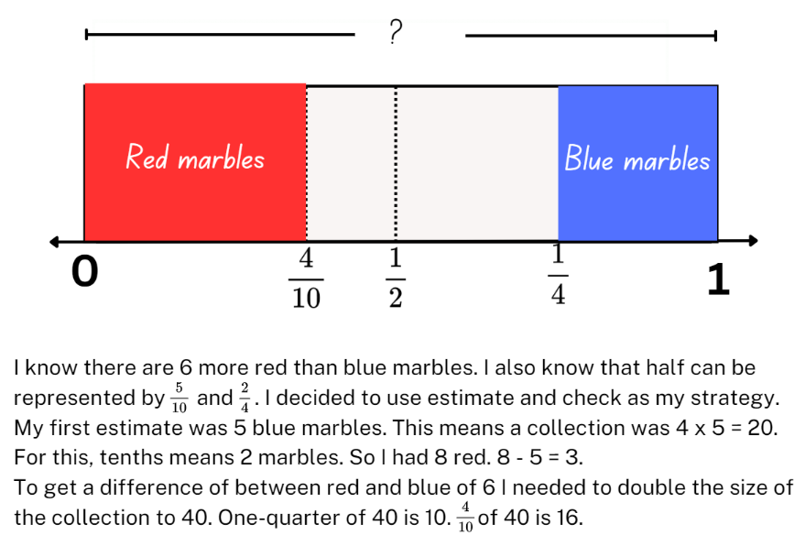

Discuss and connect the mathematics – 10 minutes
- Regroup and reflect on the following questions about the mixed bag of lollies game:
- How did you work out your answers?
- Was using the tape diagram helpful to figure out the fraction of the quantity? Why or why not?
- What fractions were the easiest to work out the answer for? Why?
- Did your understanding of equivalent fractions help you with this task? How?
Note: Resource 4 – mathematical reasoning prompts can be used to facilitate further discussion of students’ thinking.
This table details opportunities for assessment.
Assessment opportunities | Links
What to look for:  - Can students order common fractions with related denominators using diagrams and number lines? [MAO-WM-01, MA3-RQF-01]  - Can students compare and represent fractions with denominators of 2, 4 and 8; 3 and 6; 5 and 10 of a whole shape (area model) and a collection of objects (discrete model)?  [MAO-WM-01, MA3-RQF-01, MA3-RQF-02]  - Can students calculate quarters and fifths of whole numbers that are multiples of the denominator, using a tape diagram?  [MAO-WM-01, MA3-RQF-01, MA3-RQF-02] | Links to National Numeracy Learning Progressions (NNLP):  - InF5, InF6, InF8.  Links to suggested Interview for Student Reasoning (IfSR) tasks:  - IfSR-PT: 1A.9.

Lesson 6
Core concept: complement principles can help find the difference.

Daily number sense – not following the rule – 10 minutes
The table below contains a suggested learning intention and success criteria. These are best co-constructed with students.
Daily number sense learning intention | Daily number sense success criteria
Students are learning to:  - represent and describe number patterns formed by multiples. | Students can:  - describe a pattern formed by multiples in words, in terms of multiplication rather than addition  - determine a rule describing the relationship between the bottom number and the top number in a table.
- Draw the following table of values on the board (see Table 2).
Table 2 – torches and batteries
Torches | 1 | 3 | 7 | 2 | 4
Total batteries needed | 3 | 8 | 21 | 6 | 12
- Explain that the table is not in numerical order. There is also an error in the table of values. Students turn and talk to identify the error.
- Select students to share their ideas with the class. Ask:
- What value is incorrect in the table?
- How did you determine the error?
- What is the multiplicative rule describing the relationship between the bottom number and the top number?
- Did the order make a difference?
- Students record the table of values in their workbook with the error corrected. They describe the pattern formed by the multiples in the table.
- Students create their own table of values with an error. They swap with a partner to solve.
This table details opportunities for assessment.
Assessment opportunities | Links
What to look for:  - Can students describe a pattern formed by multiples in words, in terms of multiplication rather than addition?  [MAO-WM-01, MA3-MR-01]  - Can students determine a rule describing the relationship between the bottom number and the top number in a table?  [MAO-WM-01, MA3-MR-01] | Links to National Numeracy Learning Progressions (NNLP):  - NPA4, NPA5.

Core lesson – closest to the whole – 35 minutes
The table below contains suggested learning intentions and success criteria. These are best co-constructed with students.
Core concept learning intentions | Core concept success criteria
Students are learning to:  - solve problems involving addition and subtraction of fractions with the same denominator  - use equivalence to add and subtract fractional quantities. | Students can:  - use diagrams, objects and mental strategies to subtract a unit fraction from any whole number including 1 (the complement principle)  - represent fractional quantities with the same or related denominators to add and subtract fractions.
- Demonstrate how to play ‘closest to the whole’, by playing against the class:
- One player rolls a 9-sided die to get the starting whole number.
- Both players flip a card from Resource 23 – fractions. The card determines the fraction that will be subtracted from the starting whole number.
Note: if the 9-sided dice have zero, explain to students that it will represent 10 for this game.
- Players draw a number line on an individual whiteboard. They mark the fractional parts and record the solution above it (see Figure 14).
Figure 14 – closest to whole example
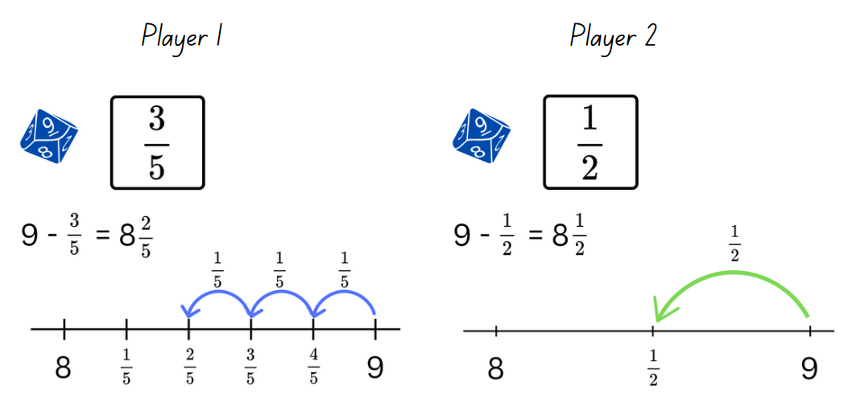
- Players discuss who is the closest to the target number. That player receives a point.
- Players continue taking turns rolling the die to get the starting whole. The first player to get 11 points wins.
- Once students are confident playing the game, provide individual whiteboards, a copy of Resource 23 – fractions and a 9-sided die.
This table details opportunities for differentiation.
Too hard? | Too easy?
Students cannot use diagrams, objects and mental strategies to subtract a unit fraction from any whole number including 1 (the complement principle).  - Provide students with only $\frac{1}{2}$, $\frac{1}{4}$ and $\frac{1}{3}$ cards from Resource 23 – fractions to support their knowledge of these unit fractions.  - Provide concrete materials, such as number chart and counters. Support students to represent the parts of the fraction, then subtract from the starting whole number. | Students can use diagrams, objects and mental strategies to subtract a unit fraction from any whole number including 1 (the complement principle).  - Challenge students to explain their reasoning, using a drawing or representation to justify why they are closest to the whole.  - Students select 2 cards from Resource 23 – fractions and subtract from the starting whole number. The player closest to a whole who can justify their answer, wins.

Discuss and connect the mathematics – 10 minutes
- Regroup as a class. Summarise the lesson together by drawing out key mathematical ideas. Ask:
- Did the number line help subtract the fraction?
- Are there any other strategies that would help? Explain.
- Was there a fraction that was more challenging than the others? Why?
- How did you and your partner determine who was closest to the whole number?
- Did you experience any challenges in this activity? How did you overcome them?
This table details opportunities for assessment.
Assessment opportunities | Links
What to look for:  - Can students use diagrams, objects and mental strategies to subtract a unit fraction from any whole number including 1 (the complement principle)? [MAO-WM-01, MA3-RQF-02]  - Can students represent fractional quantities with the same or related denominators to add and subtract fractions?  [MAO-WM-01, MA3-RQF-02] | Links to National Numeracy Learning Progressions (NNLP):  - InF7, InF8.

Lesson 7
Core concept: mathematicians solve problems with fractions.

Daily number sense – number pattern – 15 minutes
The table below contains a suggested learning intention and success criteria. These are best co-constructed with students.
Daily number sense learning intention | Daily number sense success criteria
Students are learning to:  - represent and describe number patterns formed by multiples. | Students can:  - determine a rule describing the relationship between the bottom number and the top number in a table.
This activity is an adaptation of Fencing the freeway (PDF 70 KB) by the State of Victoria (DEECD).
- Explain that a deer farmer wants to fence a paddock to keep the deer safe. The farmer knows they will need a post for every 3 metres of fencing. They will also need one at each end.
- Draw the following table of values that represents the fencing requirements (see Table 3).
Table 3 – fencing and posts
Length of fencing (metres) | 3 | 6 | 9 | 12 | 15 | 27
Number of posts | 2 | 3 | 4 | 5 | 6
- Ask students to identify the rule describing the relationship between the length of fencing and number of posts. If not identified, explain that in this example, the number of posts required is determined by:
- the total length of fencing ÷ 3 posts + 1 starting post
- −1 starting post × 3 posts.
- Students calculate the number of posts needed for 27 metres of fence. They complete the table in their workbooks.
- Select students to share and explain their solution.
- Students then calculate and record the number of posts of length of fence needed for the following:
- 90 metres of fencing (31 posts)
- 240 metres of fencing (81 posts)
- 72 posts (25 posts).
- Regroup as a class and select students to share and justify their calculations.
This table details an opportunity for assessment.
Assessment opportunity | Links
What to look for:  - Can students determine a rule describing the relationship between the bottom number and the top number in a table?  [MAO-WM-01, MA3-MR-01] | Links to National Numeracy Learning Progressions (NNLP):  - NPA5.

Core lesson 1 – fraction problem – 10 minutes
The table below contains suggested learning intentions and success criteria. These are best co-constructed with students.
Core concept learning intentions | Core concept success criteria
Students are learning to:  - use equivalence to add and subtract fractional quantities  - find fractional quantities of whole numbers. | Students can:  - solve word problems involving adding or subtracting fractional quantities with related denominators  - represent fractional quantities with the same or related denominators to add and subtract fractions  - solve word problems involving a fraction of a quantity.
This activity is an adaptation of ‘Adding and Subtracting Fractions’ from Challenging Mathematical Tasks by Sullivan.
- Pose the following problem: ‘I did a fraction addition question on the computer, but when I printed it out some of the numbers did not print. What might the missing numbers be?’
- Write the following equation on the board: 2 $\frac{?}{4}$ + $\frac{?}{8}$ = 3$.$
- Students record as many possibilities as they can think of on individual whiteboards. For example, 2$\frac{1}{4}$ + $\frac{6}{8}$ = 3, 2 $\frac{3}{4}$ + $\frac{2}{8}$ = 3, 2 $\frac{2}{4}$ + $\frac{4}{8}$ = 3.
- Students turn and talk to share their answers and explain their reasoning.
- Record a sample of student responses and test these using the bar model method.

Core lesson 2 – adding and subtracting fractions – 25 minutes
This activity is an adaptation of ‘Addition and Subtraction’ from Primary and Middle Years Mathematics: Teaching Developmentally by Van de Walle et al.
- Write the following problem: Dan runs 2 $\frac{1}{2}$ kilometres a day. If he just passed the 1 $\frac{1}{4}$ kilometre mark, how far does he still need to go?
- Model a think-aloud on how to read the problem, find the important information and what operation is required to solve (see Figure 15).
Figure 15 – think aloud example
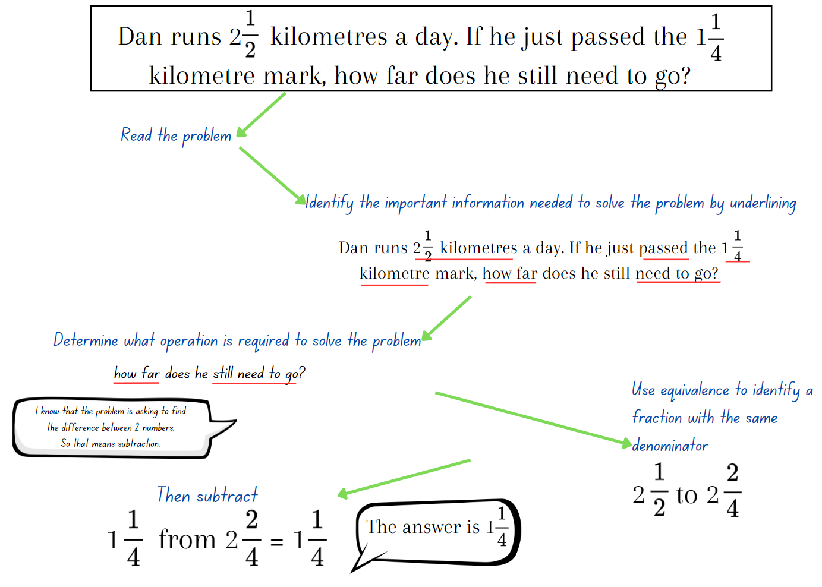
- Provide students with Resource 24 – fraction problems. Remind them to follow the steps modelled in the think aloud, as the problems may require either addition or subtraction.
- Students work on the task, either individually or with a partner.
- Regroup as a class. Ask the following questions:
- How did you work out what operation the problem was asking you to use?
- How did you use equivalence to identify a fraction with the same denominator?
- Did you find subtracting or adding more challenging? Explain your reasoning.
This table details opportunities for differentiation.
Too hard? | Too easy?
Students cannot solve word problems involving adding or subtracting fractional quantities with related denominators.  - Support students to use a bar model to represent the word problem. Assist them to shade and label it to solve the problem.  - Provide students with problems that contain fractions with the same denominator. For example, Francis ate three-eights ( $\frac{3}{8}$ ) of a chocolate bar, then another four-eights ( $\frac{4}{8}$ ) of the chocolate bar. How much did he eat? | Students can solve word problems involving adding or subtracting fractional quantities with related denominators.  - Students create their own fraction word problems and swap with a partner. They solve them using diagrams and fractional notation.  - Provide the equation: ? $\frac{?}{?}$ + ? $\frac{?}{?}$ = 7. Explain that all the missing digits are different. What might the missing numbers be?

Consolidation and meaningful practice – 15 minutes
This activity is adapted from ‘Gardening together’ from Primary and Middle Years Mathematics: Teaching Developmentally by Van de Walle et al.
- Pose the following problem: Annie, Ben, Crystal, Danica, Hank and Fletcher are each given a portion of the school garden for spring planting. The portions are:
- Annie = $\frac{1}{4}$
- Ben = $\frac{1}{8}$
- Crystal = $\frac{3}{16}$
- Danica = $\frac{1}{16}$
- Hank = $\frac{1}{4}$
- Fletcher = $\frac{1}{8}$.

Note: the expectation for Stage 3 students is adding and subtracting fractional quantities with the related denominators of 4 and 8. The related denominator of 16 was previously explored in Stage 3 Year A Unit 24 Lesson 3. If students are finding it challenging to work with fractions with the denominator of 16 in this task, it can be adapted to include fractions with denominators of 4 and 8 only. For example, Crystal and Danica can have a one-eighth ( $\frac{1}{8}$ ) portion of the garden each instead.
- The students decided to work together and combine their parts. What fraction of the garden will each of the following groups have if they combine their portions of the garden? The groups are:
- Ben and Danica
- Annie and Crystal
- Fletcher and Hank
- Crystal, Fletcher and Annie.
- Students draw their garden in their workbook, labelling it to explain their thinking.
Note: some students may require the area model to help with solving the problem. Draw a large empty rectangle on a piece of paper and assist students with partitioning it into the required portions.
- Regroup as a class and ask:
- Which group had the biggest portion of the garden?
- Which group had the smallest portion of the garden?
- How did you use equivalence to identify a fraction with the same denominator in the problem?
This table details opportunities for assessment.
Assessment opportunities | Links
What to look for:  - Can students solve word problems involving adding or subtracting fractional quantities with related denominators?  [MAO-WM-01, MA3-RQF-02]  - Can students represent fractional quantities with the same or related denominators to add and subtract fractions?  [MAO-WM-01, MA3-RQF-02]  - Can students solve word problems involving a fraction of a quantity? [MAO-WM-01, MA3-RQF-02] | Links to National Numeracy Learning Progressions (NNLP):  - InF8.  Links to suggested Interview for Student Reasoning (IfSR) tasks:  - IfSR-MT: 4B.1.

Lesson 8
Core concept: mathematicians solve problems with fractions.

Daily number sense – 10 minutes
- From a class need surfaced through formative assessment data, identify a short, focused activity that targets students’ knowledge, understanding and skills. Example activities may be drawn from the following resources:
- Mathematics K–6 resources
- Universal Resources Hub.

Core lesson 1 – take a chance – 10 minutes
The table below contains a suggested learning intention and success criteria. These are best co-constructed with students.
Core concept learning intention | Core concept success criteria
Students are learning to:  - create random generators and describe probabilities using fractions. | Students can:  - record the outcomes for chance experiments where the outcomes are not equally likely to occur and assign probabilities to the outcomes using fractions (denominators of 2, 3, 4, 5, 6, 8 and 10)  - use knowledge of benchmark fractions, decimals and percentages to assign probabilities to the likelihood of outcomes.
- Revise students' knowledge of chance and equal chance by asking: What activities have an equal chance outcome?
- Remind students that the total of the probabilities of the outcomes in a chance experiment equals one.
- Students turn and talk about activities that have equal chance outcomes. Select some students to share their answers, explaining their reasoning. If not discussed, highlight that flipping a heads or tails has an equal chance and rolling a die has equal chance outcomes.
- Ask the following questions:
- How do I record the fraction of flipping a heads or tails? ($\frac{1}{2}$)
- How is the chance of flipping a coin recorded with decimals and percentages? (0.5 and 50%)
- How is the chance of rolling a 6 on a die recorded with fractions? ($\frac{1}{6}$)

Core lesson 2 – unequal chance – 25 minutes
- Place 24 interlocking cubes in an opaque bag; 12 red, 8 green and 4 blue. Tell students the total number of cubes and how many of each colour there are.
- Students turn and talk discussing the fraction, decimals and percentages of each colour in the bag. Select students to share and explain their thinking, recording the answers on the board. For example, Red = $\frac{1}{2}$, 0.50 and 50%.
- Students draw Table 4 in the workbook and discuss the predicted outcome. For example, red should be selected more often than green and blue, it is more likely that red will occur than green and blue.
Table 4 – colour of cubes
Colour selected | Number of cubes
Red
Green
Blue
- Choose several students to select a cube from the bag. Record the colour selected using tally marks.
- Discuss outcome of results and see if it matches the students’ predictions.
- Display and provide students with copies of Resource 25 – spinners.
- Explain that students will create both an equal and unequal chance spinner. Each spinner must have purple, red, green, blue and orange sections. For the unequal chance spinner students can choose the fractional part for each colour.
- Once students have created their spinners, they record the fraction, decimals and percentages of each colour. They predict the outcome of using their spinners in a game. For example, purple = $\frac{1}{5}$, 20% and 0.2.
This table details opportunities for differentiation.
Too hard? | Too easy?
Students cannot use knowledge of benchmark fractions, decimals and percentages to assign probabilities to the likelihood of outcomes.  - Support students to create a random generator spinner with only 3 colours. Have one colour representing more than one half.  - Students describe the probabilities of only half. Support students to recognise that half is $\frac{1}{2}$ in fractions, 0.5 in decimals and 50%. | Students can use knowledge of benchmark fractions, decimals and percentages to assign probabilities to the likelihood of outcomes.  - Play Mystery Spinner: Challenge from ABC Education. Students recreate a mystery spinner to try and match the results on the graph.  - Conduct an experiment: Cup toss. Students predict out of 20 tosses what fraction, decimal and percentage the cup will be upside down, right-side up and on its side. Record the results of the experiment and compare these to the initial predictions.

Consolidation and meaningful practice –15 minutes
- Provide pairs with Resource 26 – gameboard and counters. Explain that students will use their created spinners to play the game. One student will use the equal chance spinner and the partner will use the unequal chance spinner.
- Players take turns spinning for the colour that they will move to next. For example, if player one spins red, they will move to the next red box along the gameboard. The winner is the first player to spin green to land on the finish box.
- Once students have played the game, ask:
- Did the equal or unequal spinner player win?
- Was the outcome the same as you predicted?
- Did having different spinners make a difference to the game? Why or why not?
- Would the outcome of the game always be the same? Explain.
This table details opportunities for assessment.
Assessment opportunities | Links
What to look for:  - Can students record the outcomes for chance experiments where the outcomes are not equally likely to occur and assign probabilities to the outcomes using fractions (denominators of 2, 3, 4, 5, 6, 8 and 10)? [MAO-WM-01, MA3-CHAN-01]  - Can students use knowledge of benchmark fractions, decimals and percentages to assign probabilities to the likelihood of outcomes? [MAO-WM-01, MA3-CHAN-01] | Links to National Numeracy Learning Progressions (NNLP):  - UnC4, InF6, PrT3.

Resource 1 – fraction wall
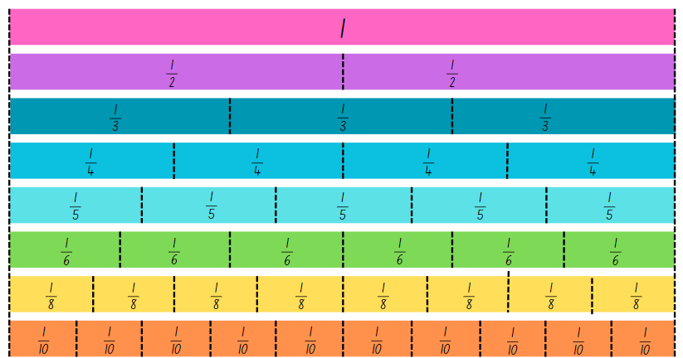

Resource 2 – numerator denominator cards
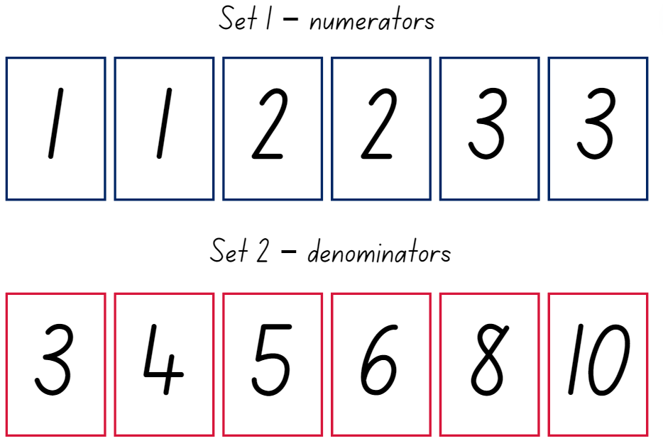

Resource 3 – build it up

Resource 4 – mathematical reasoning prompts
Questions to prompt mathematical reasoning | Questions for collaborative reasoning | Questions to make connections with mathematical reasoning | Questions to reflect on mathematical reasoning
- What is this problem about?  - Could you reword that in a simpler way?  - How did you begin to think about this problem?  - What is another way you could solve this problem?  - How could you prove ______?  - Can you break the problem into parts? What would the parts be?  - How could you organise your thinking? | - What strategy did you use? Can you convince us why it makes sense?  - What do others think about this?  - Did anyone get a different answer?  - How would you explain this to someone who was away today? | - Did you see any mathematical connections or relationships?  - What ideas have we explored before that were useful in solving this problem?  - Is there a pattern? Is there a general rule?  - What was one thing you learned (or two, or more)?  - What were the mathematical ideas in this problem?  - What are the variables in this problem? What stays constant? | - Is this a reasonable answer? Does it make sense?  - Why do you think that? Why is that true?  - Will that strategy always work?  - Can you draw a picture or make a model to show that?  - Does anyone want to revise his or her answer?  - How were you sure your answer was right?
Adapted from Kersaint (2017).

Resource 5 – How much more?
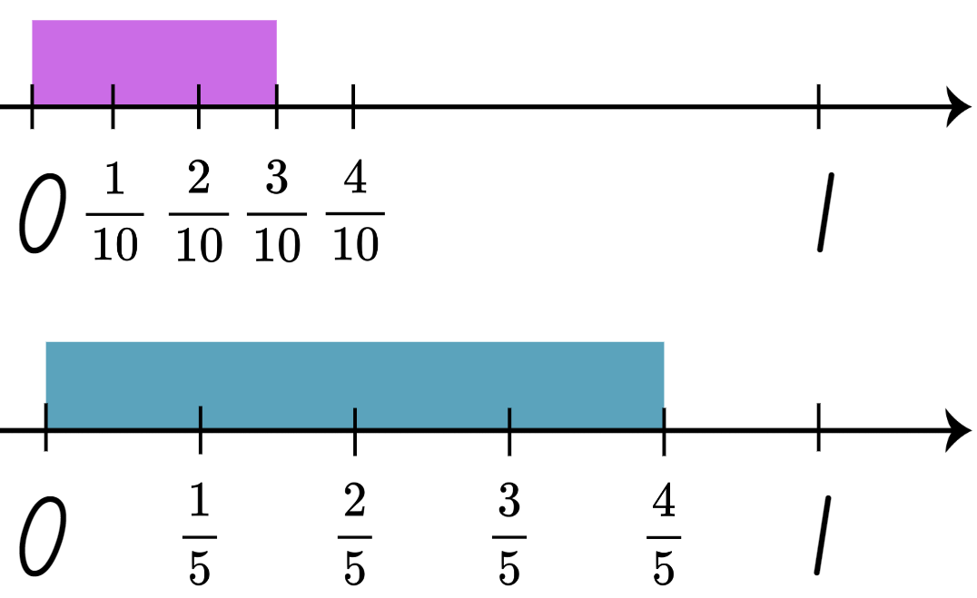

Resource 6 – shade and label
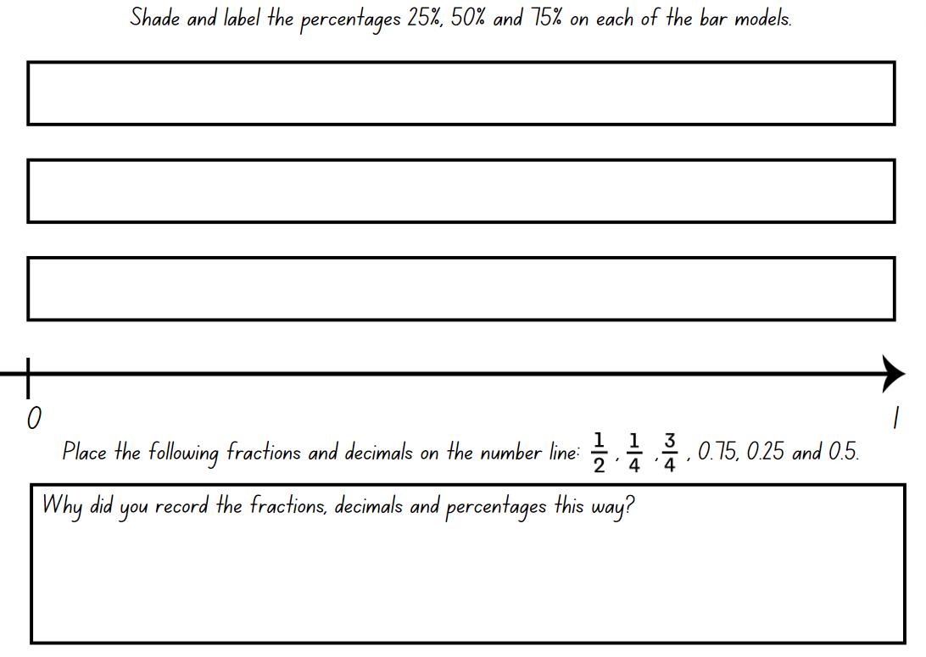

Resource 7 – student non-example
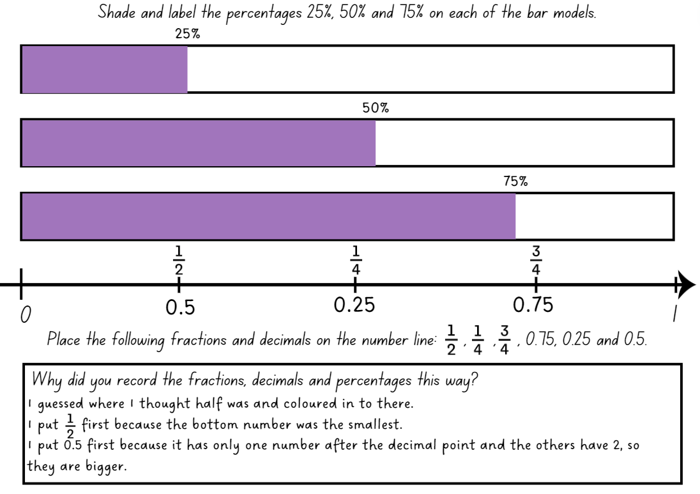

Resource 8 – tape diagrams
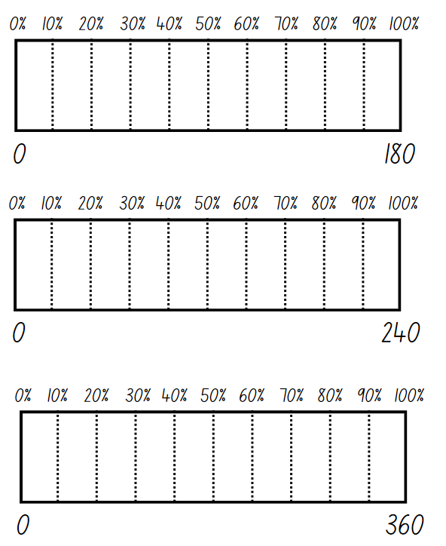

Resource 9 – finding more again
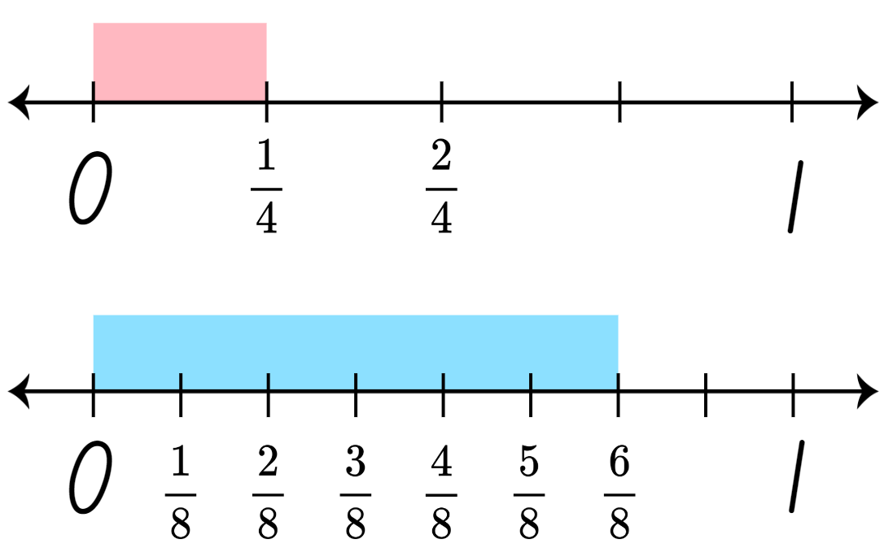

Resource 10 – representing tenths
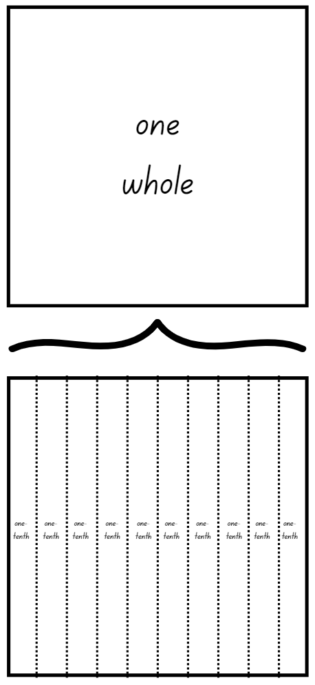

Resource 11 – 100 grid
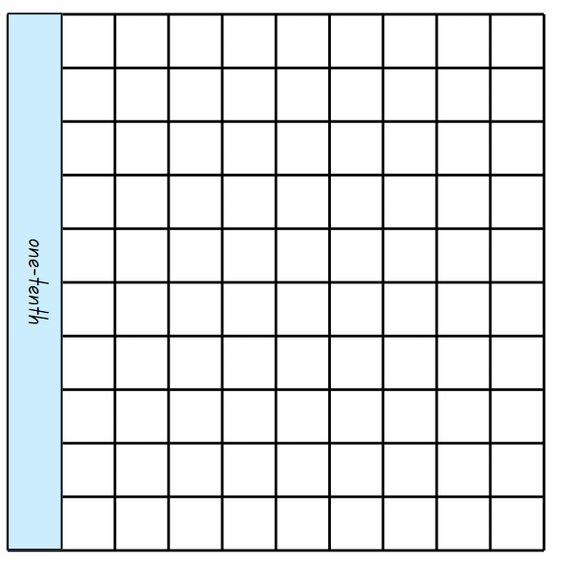

Resource 12 – blank 100 grids
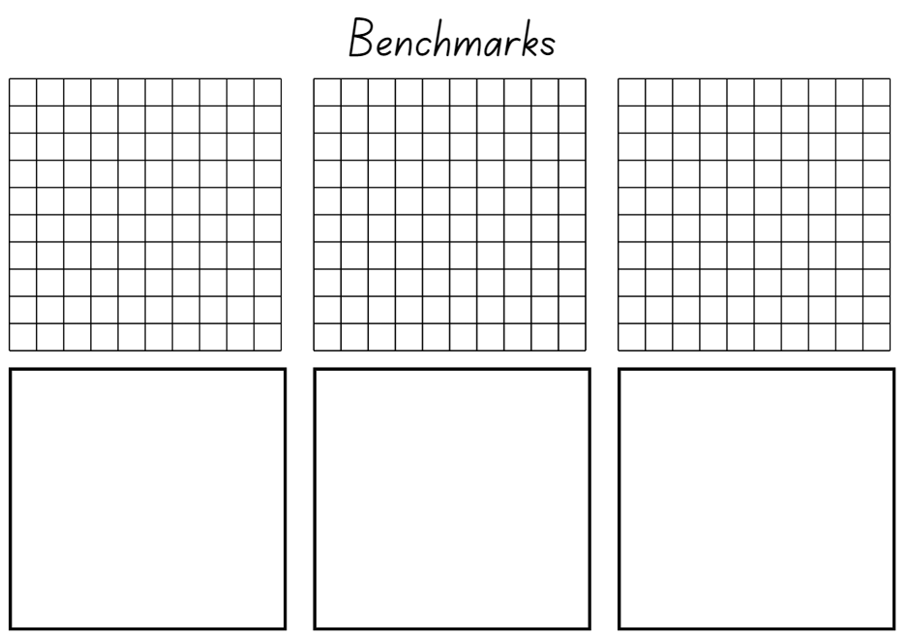

Resource 13 – 10% sale
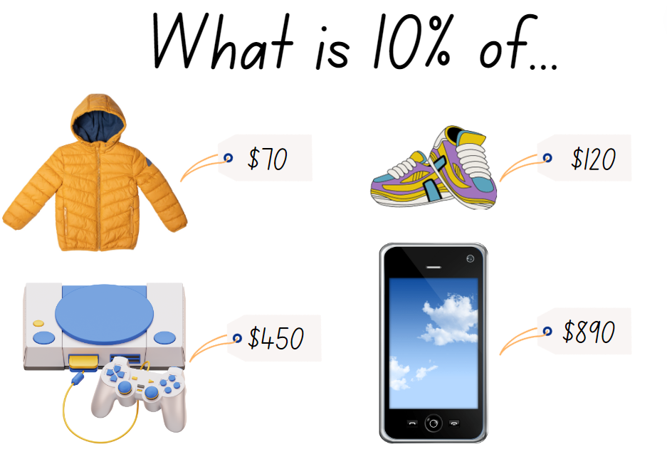

Resource 14 – rectangle fractions
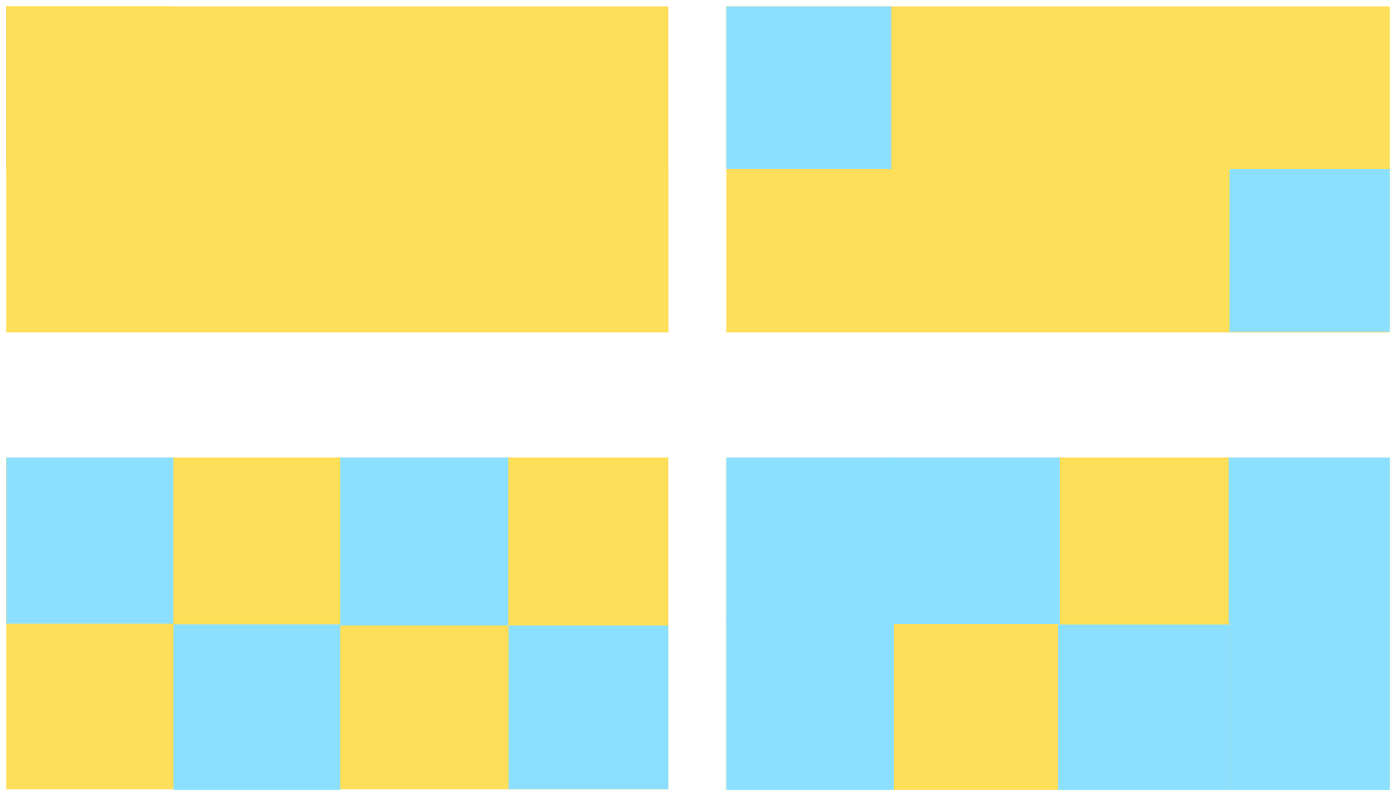

Resource 15 – area model fractions
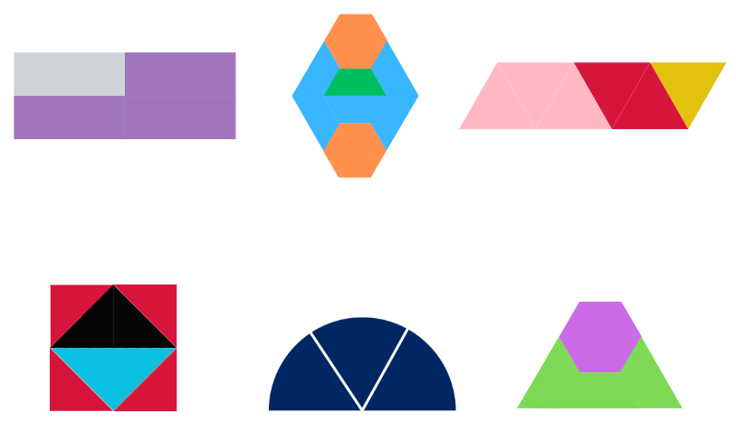

Resource 16 – partitioning hexagons
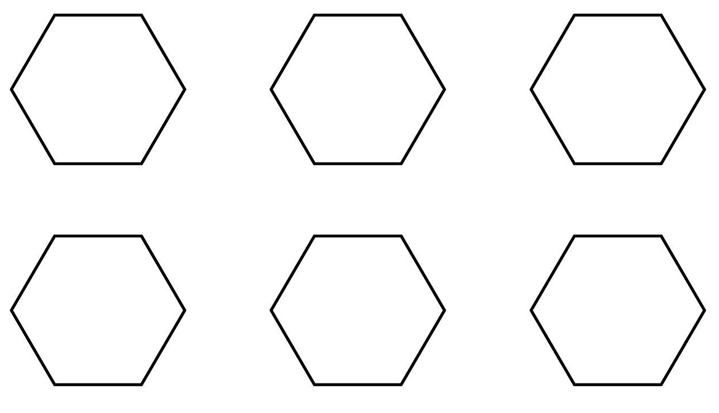

Resource 17 – Harry’s hexagons
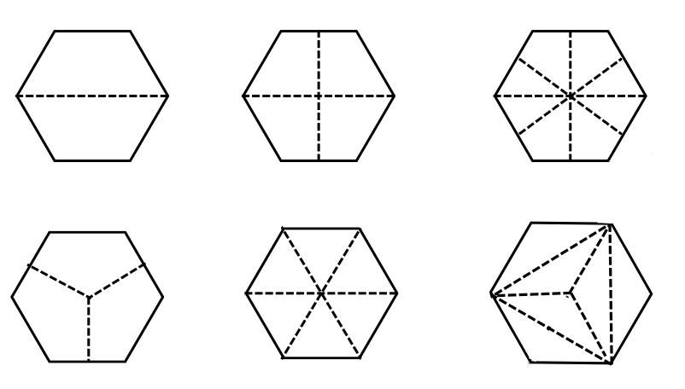

Resource 18 – 8 equal parts
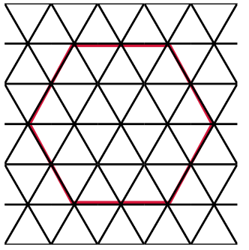

Resource 19 – tape diagram example
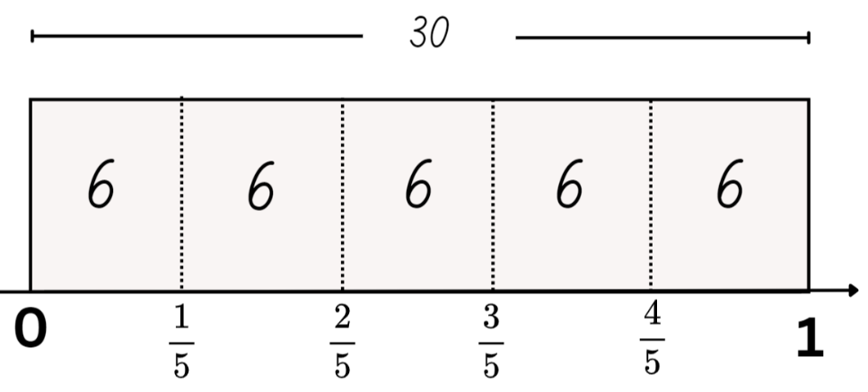

Resource 20 – lolly shop cards
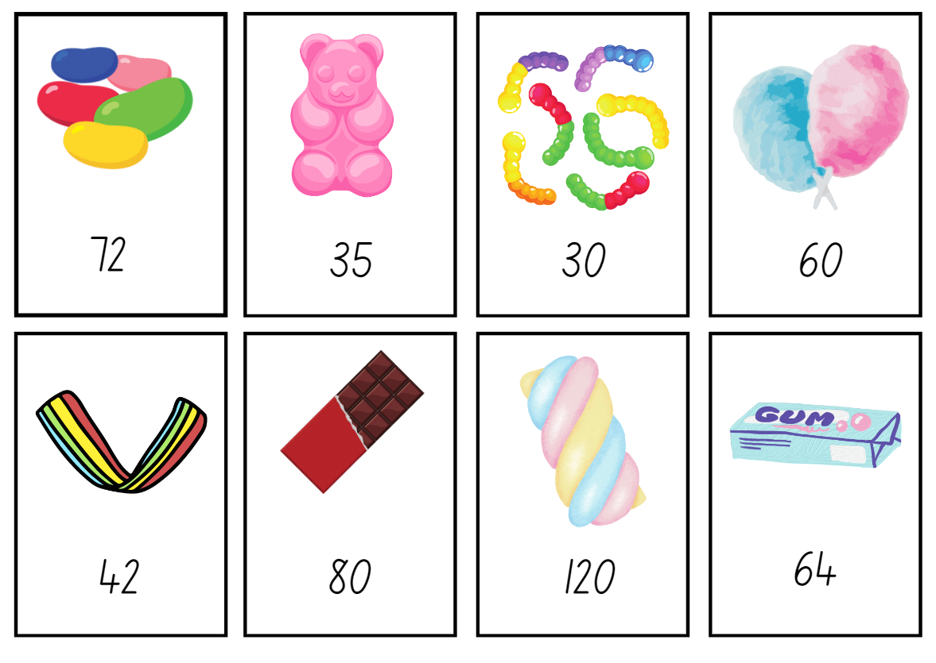

Resource 21 – fraction cards
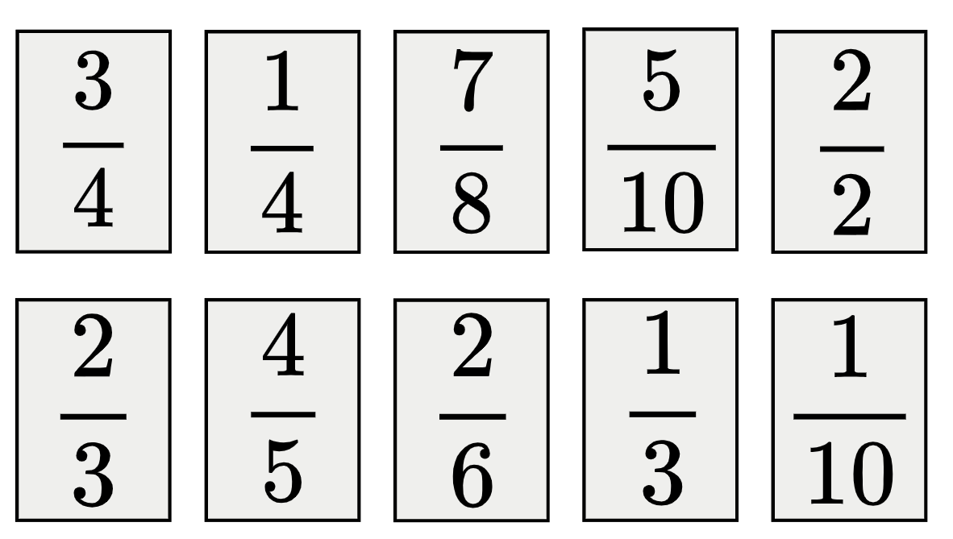

Resource 22 – fraction card order
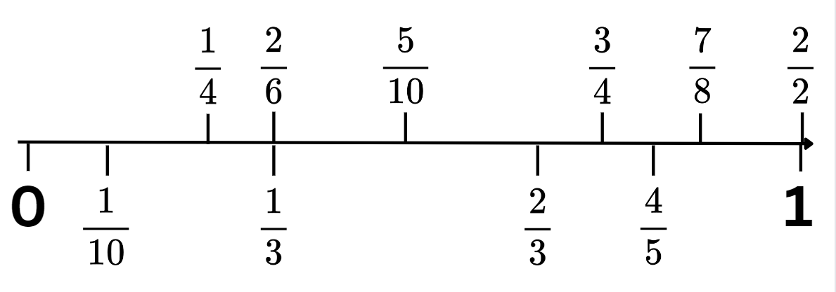

Resource 23 – fractions
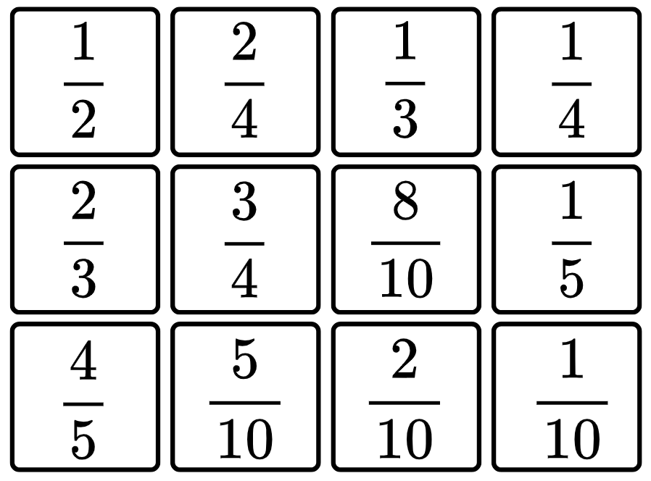

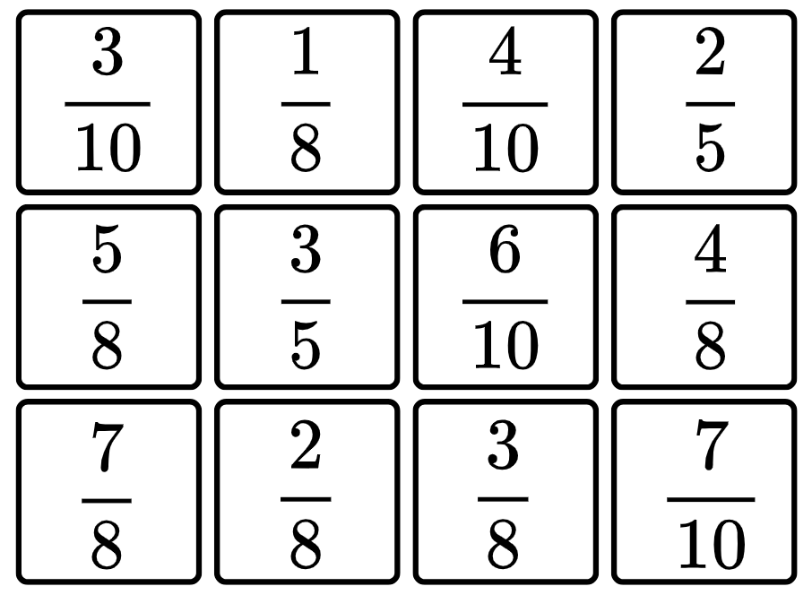

Resource 24 – fraction problems
Natalia ran 2 $\frac{1}{2}$ kilometres on Friday, 3 $\frac{3}{4}$ kilometres on Saturday and 4 $\frac{3}{4}$ kilometres on Sunday. How many kilometres did she run over 3 days?

Nancy picked 1 $\frac{5}{6}$ kilograms of snow peas and Brooke picked 1 $\frac{2}{4}$ kilograms. Who picked the most snow peas? How much more did they pick?

In measuring the wood needed for a picture frame, Liz worked out that she needed 2 pieces that were 5 $\frac{1}{5}$ centimetres and 2 pieces that were 7 $\frac{7}{10}$ centimetres. What length of wood does she need to build her picture frame?

Resource 25 – spinners
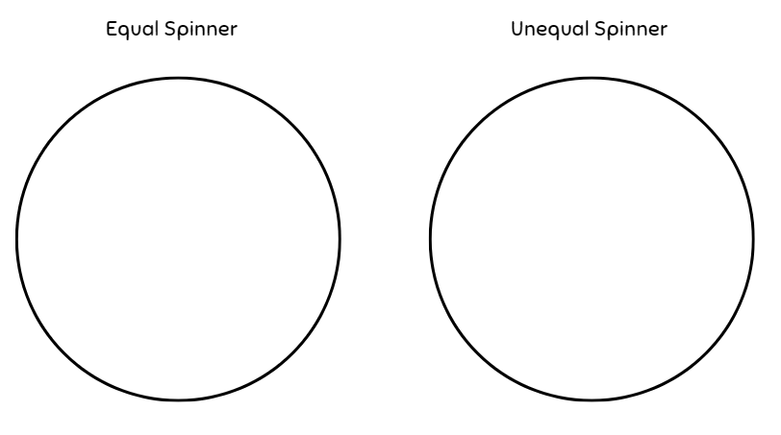

Resource 26 – gameboard
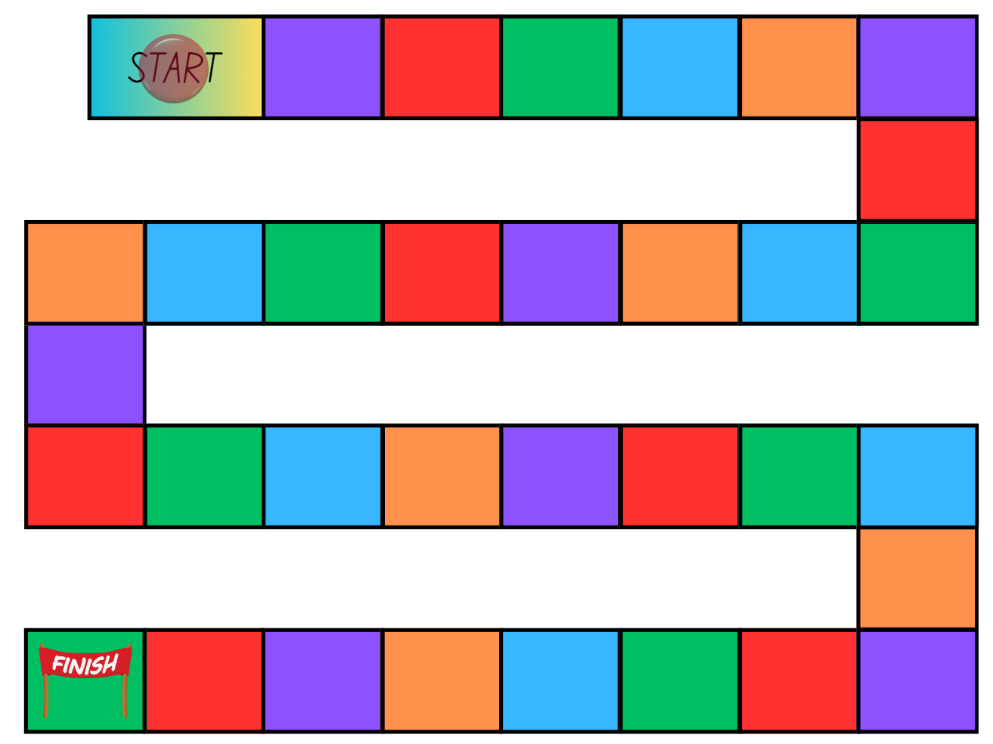

Syllabus outcomes and content
The table below outlines the syllabus outcomes and range of relevant syllabus content covered in this unit. Content is linked to National Numeracy Learning Progression (version 3).
Outcomes and content | 1 | 2 | 3 | 4 | 5 | 6 | 7 | 8
Represents numbers B: Decimals and percentages: Make connections between benchmark fractions, decimals and percentages
[MAO-WM-01, MA3-RN-03]
- Recognise that the symbol % means percent and 100% is the whole amount |  | x
- Recall commonly used equivalent percentages, decimals and fractions including $\frac{1}{2}$, $\frac{1}{4}$, and $\frac{3}{4}$ |  | x | x
- Represent common percentages of quantities and lengths as fractions and decimals |  | x | x
- Recognise that 10% is one-tenth of 100% and use this to find 10% of a quantity (Reasons about relations) |  |  | x
Multiplicative relations B: Represent and describe number patterns formed by multiples
[MAO-WM-01, MA3-MR-01]
- Use a given geometric pattern involving multiples to create a table of values |  |  |  |  | x
- Describe a pattern formed by multiples in words, in terms of multiplication rather than addition |  |  |  |  |  | x
- Determine a rule describing the relationship between the bottom number and the top number in a table (Algebraic reasoning) |  |  |  |  | x | x | x
Representing quantity fractions A: Recognise the role of the number 1 as representing the whole
[MAO-WM-01, MA3-RQF-01, MA3-RQF-02]
- Compare halves and quarters of different sized wholes | x
- Justify the need for fractions to refer to the number 1 as the common whole (Reasons about quantity) | x
Representing quantity fractions A: Compare and order common unit fractions
[MAO-WM-01, MA3-RQF-01, MA3-RQF-02]
Representing quantity fractions A: Solve problems involving addition and subtraction of fractions with the same denominator
[MAO-WM-01, MA3-RQF-01, MA3-RQF-02]
- Use diagrams, objects and mental strategies to subtract a unit fraction from any whole number including 1 (the complement principle) |  |  |  |  |  | x
Representing quantity fractions B: Compare common fractions with related denominators
[MAO-WM-01, MA3-RQF-01, MA3-RQF-02]
- Order common fractions with related denominators using diagrams and number lines |  |  |  |  | x
- Subdivide the area of a rectangle by both length and width to represent the multiplicative relationship between common fractions |  |  |  | x
- Compare and represent fractions with denominators of 2, 4 and 8; 3 and 6; 5 and 10 of a whole shape (area model) and a collection of objects (discrete model) |  |  |  | x | x
Representing quantity fractions B: Build up to the whole from a given fractional part
[MAO-WM-01, MA3-RQF-01, MA3-RQF-02]
- Generate the whole quantity from non-unit fractional parts such as quarters, eighths, thirds, sixths, fifths and tenths (Reversible reasoning) | x
Representing quantity fractions B: Use equivalence to add and subtract fractional quantities
[MAO-WM-01, MA3-RQF-01, MA3-RQF-02]
- Solve word problems involving adding or subtracting fractional quantities with related denominators | x |  |  |  |  |  | x
- Represent fractional quantities with the same or related denominators to add and subtract fractions (Reasons about relations) |  | x | x |  |  | x | x
Representing quantity fractions B: Find fractional quantities of whole numbers (halves, quarters, fifths and tenths)
[MAO-WM-01, MA3-RQF-01, MA3-RQF-02]
- Calculate quarters and fifths of whole numbers that are multiples of the denominator, using a tape diagram |  |  |  |  | x
- Solve word problems involving a fraction of a quantity |  |  |  |  |  |  | x
Chance B: Create random generators and describe probabilities using fractions
[MAO-WM-01, MA3-CHAN-01]
- Record the outcomes for chance experiments where the outcomes are not equally likely to occur and assign probabilities to the outcomes using fractions (denominators of 2, 3, 4, 5, 6, 8 and 10) |  |  |  |  |  |  |  | x
- Use knowledge of benchmark fractions, decimals and percentages to assign probabilities to the likelihood of outcomes |  |  |  |  |  |  |  | x
Mathematics K–10 Syllabus © NSW Education Standards Authority (NESA) for and on behalf of the Crown in right of the State of New South Wales, 2022.

References
This resource contains NSW Curriculum and syllabus content. The NSW Curriculum is developed by the NSW Education Standards Authority. This content is prepared by NESA for and on behalf of the Crown in right of the State of New South Wales. The material is protected by Crown copyright.
Please refer to the NESA Copyright Disclaimer for more information https://educationstandards.nsw.edu.au/wps/portal/nesa/mini-footer/copyright.
NESA holds the only official and up-to-date versions of the NSW Curriculum and syllabus documents. Please visit the NSW Education Standards Authority (NESA) website https://educationstandards.nsw.edu.au and the NSW Curriculum website https://curriculum.nsw.edu.au.
Mathematics K–10 Syllabus © NSW Education Standards Authority (NESA) for and on behalf of the Crown in right of the State of New South Wales, 2022.
National Numeracy Learning Progression © Australian Curriculum, Assessment and Reporting Authority (ACARA) 2010 to present, unless otherwise indicated. This material was downloaded from the Australian Curriculum website (National Numeracy Learning Progression) (accessed 1 March 2024) and was not modified.
ABC (2024) Playground Percentages, ABC Education website, accessed 1 March 2024.
ABC (Australian Broadcasting Corporation) (2024) Mystery Spinner: Challenge, ABC Education website, accessed 1 March 2024.
Australian Academy of Science (n.d.) What you need to know about fractions [PDF 420 KB], reSolve website, accessed 29 February 2024.
Fuchs LS, Malone AS, Schumacher RF, Namkung J and Wang A (2017) 'Fraction intervention for students with mathematics difficulties: Lessons learned from five randomized controlled trials', Journal of Learning Disabilities, 50(6):631–639, doi:10.1177/0022219416677249.
Kersaint G (2017) 100 questions that promote mathematical discourse [PDF 1.09 MB], Curriculum Associates, LLC, accessed 30 January 2024.
NESA (NSW Education Standards Authority) (2024a) ‘Teaching advice for Representing numbers using place value B’, Stage 3, NESA website, accessed 23 May 2024.
NESA (2024b) ‘Teaching advice for Represents numbers B’, Stage 3, NESA website, accessed 23 May 2024.
NESA (2024c) ‘Teaching advice for Represents numbers A’, Stage 3, NESA website, accessed 23 May 2024.
NESA (2024d) ‘Teaching advice for Multiplicative relations B’, Stage 3, NESA website, accessed 23 May 2024.
Siemon D, Warren E, Beswick K, Faragher R, Miller J, Horne M, Jazby D, Breed M, Clark J and Brady K (2021) Teaching Mathematics: Foundations to Middle Years, 3rd edn, Oxford University Press Australia and New Zealand.
State of NSW (Department of Education and Training Curriculum K–12 Directorate) (2010) Talking about Patterns & Algebra: Early Stage 1 to Stage 3 [PDF 3.28 MB], NSW Education and Training, accessed 1 March 2024.
State of Victoria (DEECD) (2008) Fencing the freeway [PDF 69.7 KB], DEECD, accessed 1 March 2024.
Sullivan P (2018) Challenging Mathematical Tasks: Unlocking the potential of all students, Oxford University Press, Australia and New Zealand.
University of Cambridge (n.d.) Matching Fractions, Decimals and Percentages, NRICH website, accessed 1 March 2024.
Van de Walle J, Karp K, Bay-Williams JM, Brass A, Bentley B, Ferguson S, Goff W, Livy S, Marshman M, Martin D, Pearn C, Prodromou T, Symons D and Wilkie K (2019) Primary and Middle Years Mathematics: Teaching Developmentally, 1st Australian edn, Pearson Education Australia, Melbourne.

Further reading
State of Victoria (Department of Education) (2024) Theoretical and Experimental Probability, Arc Learning Sequences website, accessed 1 March 2024.
© State of New South Wales (Department of Education), 2024
The copyright material published in this resource is subject to the Copyright Act 1968 (Cth) and is owned by the NSW Department of Education or, where indicated, by a party other than the NSW Department of Education (third-party material).
Copyright material available in this resource and owned by the NSW Department of Education is licensed under a Creative Commons Attribution 4.0 International (CC BY 4.0) license.
This license allows you to share and adapt the material for any purpose, even commercially.
Attribution should be given to © State of New South Wales (Department of Education), 2024.
Material in this resource not available under a Creative Commons license:
- the NSW Department of Education logo, other logos and trademark-protected material
- material owned by a third party that has been reproduced with permission. You will need to obtain permission from the third party to reuse its material.
Links to third-party material and websites
Please note that the provided (reading/viewing material/list/links/texts) are a suggestion only and implies no endorsement, by the New South Wales Department of Education, of any author, publisher, or book title. School principals and teachers are best placed to assess the suitability of resources that would complement the curriculum and reflect the needs and interests of their students.
If you use the links provided in this document to access a third-party's website, you acknowledge that the terms of use, including licence terms set out on the third-party's website apply to the use which may be made of the materials on that third-party website or where permitted by the Copyright Act 1968 (Cth). The department accepts no responsibility for content on third-party websites.

