Mathematics Stage 3 – Unit 35
Addition and subtraction problems can be solved by using a variety of strategies

Contents
Unit description and duration 6
Syllabus outcomes 6
Working mathematically 7
Student prior learning 7
Lesson overview and resources 9
Lesson 1 16
Daily number sense – True or false? – 10 minutes 16
Core lesson 1 – additive strategies (part 1) – 10 minutes 18
Core lesson 2 – travel plan – 40 minutes 20
Discuss and connect the mathematics – 10 minutes 22
Lesson 2 24
Daily number sense – nutrition in fruit – 15 minutes 24
Core lesson 1 – additive strategies (part 2) – 25 minutes 26
Core lesson 2 – number lines – 25 minutes 27
Discuss and connect the mathematics – 10 minutes 31
Lesson 3 33
Daily number sense – convince me – 10 minutes 33
Core lesson 1 – decimal addition and subtraction – 15 minutes 35
Core lesson 2 – going shopping – 25 minutes 38
Consolidation and meaningful practice – 10 minutes 39
Lesson 4 41
Daily number sense – 10 minutes 41
Core lesson 1 – decimal fluency – 15 minutes 41
Core lesson 2 – benchmark percentages – 15 minutes 43
Core lesson 3 – celebrity concert – 25 minutes 44
Discuss and connect the mathematics – 10 minutes 46
Lesson 5 48
Daily number sense – inverse operations – 10 minutes 48
Core lesson 1 – price of chocolate – 20 minutes 50
Core lesson 2 – clothing shop – 20 minutes 53
Discuss and connect the mathematics – 15 minutes 55
Lesson 6 57
Daily number sense – inverse operations – 10 minutes 57
Core lesson – rounding and estimating – 35 minutes 59
Discuss and connect the mathematics – 15 minutes 62
Lesson 7 65
Daily number sense – equivalent number sentences – 10 minutes 65
Core lesson – zoo investigation (part 1) – 40 minutes 67
Discuss and connect the mathematics – 10 minutes 70
Lesson 8 72
Daily number sense – 10 minutes 72
Core lesson – zoo investigation (part 2) – 30 minutes 72
Discuss and connect the mathematics – 20 minutes 73
Resource 1 – shopping receipt 76
Resource 2 – additive strategies 77
Resource 3 – superstar sightseeing 81
Resource 4 – map and payments 82
Resource 5 – place value chart 84
Resource 6 – nutrition in fruit 85
Resource 7 – data sources 86
Resource 8 – data activities 88
Resource 9 – garden designs 89
Resource 10 – decimats 90
Resource 11 – reflection chart 91
Resource 12 – 1–3 spinner 92
Resource 13 – shopping problems 93
Resource 14 – high jump results 94
Resource 15 – score 4 95
Resource 16 – blank grid 96
Resource 17 – concert hall 97
Resource 18 – chocolate costs 1 98
Resource 19 – chocolate costs 2 99
Resource 20 – raw to retail 100
Resource 21 – Imogen’s T-shirt shop 101
Resource 22 – product cost 102
Resource 23 – mountain climbing think board 103
Resource 24 – estimation activities 104
Resource 25 – think board 106
Resource 26 – zoo excursion planner 107
Resource 27 – zoo map 109
Resource 28 – entry and activities 110
Resource 29 – zoo menu 111
Syllabus outcomes and content 112
References 117

Unit description and duration
This unit develops the big idea that addition and subtraction problems can be solved by using a variety of strategies.
In this 2-week unit students are provided opportunities to:
- apply known strategies to add and subtract large numbers and decimals
- choose and use efficient strategies to solve addition and subtraction problems including decimals and percentages
- engage in rich real world tasks including problems that require more than one operation.

Syllabus outcomes
- MAO-WM-01 develops understanding and fluency in mathematics through exploring and connecting mathematical concepts, choosing and applying mathematical techniques to solve problems, and communicating their thinking and reasoning coherently and clearly
- MA3-RN-03 determines percentages of quantities, and finds equivalent fractions and decimals for benchmark percentage values
- MA3-AR-01 selects and applies appropriate strategies to solve addition and subtraction problems
- MA3-MR-02 constructs and completes number sentences involving multiplicative relations, applying the order of operations to calculations
- MA3-NSM-02 measures and compares duration, using 12- and 24-hour time and am and pm notation

Working mathematically
In the Mathematics K–10 Syllabus, there is one overarching Working mathematically outcome (MAO-WM-01). The Working mathematically processes should be embedded within the concepts being taught. The Working mathematically processes present in the Mathematics K–10 Syllabus are:
- communicating
- understanding and fluency
- reasoning
- problem solving.
Mathematics K–10 Syllabus © NSW Education Standards Authority (NESA) for and on behalf of the Crown in right of the State of New South Wales, 2022.

Student prior learning
Before engaging in these teaching and learning activities, students would benefit from prior experience with:
- using start and finish times to calculate the elapsed time of events and adding and subtracting time mentally using bridging strategies
- modelling the addition and subtraction of decimals up to 3 decimal places using appropriate representations
- equating 10% to dividing by 10, 25% to finding a quarter by dividing by 4, and 50% to finding half.

In NSW classrooms there is a diverse range of students, including Aboriginal and/or Torres Strait Islander students, students learning English as an additional language or dialect, high potential and gifted students and students with disability. Some students may identify with more than one of these groups or possibly all of them. Refer to Curriculum planning for every student –advice for further information.

Lesson overview and resources
The table below outlines the sequence and approximate timing of lessons, learning intentions and resources.
Lesson | Content | Duration and resources
Lesson 1  Daily number sense learning intention:  - apply known strategies to add and subtract decimals | Lesson core concept: place value understanding helps solve addition and subtraction problems.  Core concept learning intentions:  - apply efficient mental and written strategies to solve addition and subtraction problems  - choose and use efficient strategies to solve addition and subtraction problems  - solve problems involving duration, using 12- and 24-hour time | Lesson duration: 70 minutes  - Resource 1 – shopping receipt  - Resource 2 – additive strategies  - Resource 3 – superstar sightseeing  - Resource 4 – map and payments  - Resource 5 – place value chart  - Calculator  - Cards (0–9)  - Writing materials
Lesson 2  Daily number sense learning intention:  - apply known strategies to add and subtract decimals | Lesson core concept: addition can help solve subtraction problems.  Core concept learning intentions:  - apply efficient mental and written strategies to solve addition and subtraction problems  - choose and use efficient strategies to solve addition and subtraction problems | Lesson duration: 75 minutes  - Resource 2 – additive strategies  - Resource 6 – nutrition in fruit  - Resource 7 – data sources  - Resource 8 – data activities  - Resource 9 – garden designs  - Resource 10 – decimats  - Resource 11 – reflection chart  - Calculator  - Writing materials
Lesson 3  Daily number sense learning intention:  - apply known strategies to add and subtract decimals | Lesson core concept: known strategies for addition and subtraction can be applied to decimals.  Core concept learning intentions:  - recognise that the place value system can be extended beyond hundredths  - apply known strategies to add and subtract decimals | Lesson duration: 60 minutes  - Resource 2 – additive strategies  - Resource 12 – 1-3 spinner  - Resource 13 – shopping problems  - Resource 14 – high jump results  - Cards (0–9)  - Pencils  - Paper clips  - Spinner  - Sticky notes  - Writing materials
Lesson 4  Daily number sense learning intention:  - teacher-identified task based on student needs | Lesson core concept: number lines and bar models help solve addition and subtraction problems.  Core concept learning intentions:  - make connections between benchmark fractions, decimals and percentages  - determine percentage discounts of 10%, 25% and 50%  - apply known strategies to add and subtract decimals | Lesson duration: 75 minutes  - Resource 15 – score 4  - Resource 16 – blank grid  - Resource 17 – concert hall  - MAB materials  - Sticky notes  - String  - Writing materials
Lesson 5  Daily number sense learning intention:  - use equivalent number sentences involving multiplication and division to find unknown quantities | Lesson core concept: place value understanding helps us to make use of benchmark percentages.  Core concept learning intentions:  - make connections between benchmark fractions, decimals and percentages  - determine percentage discounts of 10%, 25% and 50% | Lesson duration: 65 minutes  - Resource 18 – chocolate costs 1  - Resource 19 – chocolate costs 2  - Resource 20 – raw to retail  - Resource 21 – Imogen’s T-shirt shop  - Resource 22 – product cost  - Digital devices  - MAB materials  - Workbooks  - Writing materials
Lesson 6  Daily number sense learning intention:  - use equivalent number sentences involving multiplication and division to find unknown quantities | Lesson core concept: estimating and place value understanding helps to determine the reasonableness of solutions.  Core concept learning intentions:  - round numbers appropriately when obtaining estimates to numerical calculations  - use estimation and place value understanding to determine the reasonableness of solutions  - use mental strategies to estimate discounts of 10%, 25% and 50%  - apply known strategies to add and subtract decimals | Lesson duration: 60 minutes  - Resource 23 – mountain climbing think board  - Resource 24 – estimation activities  - Resource 25 – think board  - Workbook  - Writing materials
Lesson 7  Daily number sense learning intention:  - use equivalent number sentences involving multiplication and division to find unknown quantities | Lesson core concept: mathematicians solve addition and subtraction problems with more than one operation.  Core concept learning intentions:  - choose and use efficient strategies to solve addition and subtraction problems  - apply known strategies to add and subtract decimals  - solve problems involving duration, using 12- and 24-hour time | Lesson duration: 60 minutes  - Resource 26 – zoo excursion planner  - Resource 27 – zoo map  - Resource 28 – entry and activities  - Resource 29 – zoo menu  - Calculators
Lesson 8  Daily number sense learning intention:  - teacher-identified task based on student needs | Lesson core concept: mathematicians compare and evaluate strategies used to solve addition and subtraction problems, reasoning which strategy may be most efficient.  Core concept learning intentions:  - choose and use efficient strategies to solve addition and subtraction problems  - apply known strategies to add and subtract decimals  - solve problems involving duration, using 12- and 24-hour time | Lesson duration: 60 minutes  - Resource 26 – zoo excursion planner  - Resource 27 – zoo map  - Resource 28 – entry and activities  - Resource 29 – zoo menu  - Calculators

Lesson 1
Core concept: place value understanding helps solve addition and subtraction problems.

Daily number sense – True or false? – 10 minutes
Daily number sense activities for Lessons 1 to 3 ‘activate’ prior number knowledge and support the learning of new content in the unit. These activities can also assist teachers to identify the starting points for learning by revealing the extent of students’ existing knowledge.
The table below contains a suggested learning intention and success criteria. These are best co-constructed with students.
Daily number sense learning intention | Daily number sense success criteria
Students are learning to:  - apply known strategies to add and subtract decimals. | Students can:  - solve word problems involving the addition and subtraction of decimals up to 3 decimal places  - justify why the strategy used to solve addition and subtraction word problems is appropriate.
- Display Resource 1 – shopping receipt and explain how to read the figures on the receipt.
- Ask students to solve the following true or false statements using the information on the receipt.
- The total cost of the shopping trip is $39.80 before the loyalty discount. (False: $39.20)
- The total mass of the top 2 items on the receipt is 1.228 kg. (False: 1.22 kg)
- The total mass of the broccoli, Brussels sprouts, grapes and peas is 2.522 kg. (True)
- If you ate 0.550 kg of the grapes on your way home, only 0.885 kgs is left for your family. (False: 0.624 kg)
- You were over-charged on the 3 special items if you paid $4.98. (False: $3.48)
- You paid using a $50 note and received $11.20 change. (False: $10.80)
- Regroup as a class and students share their answers.
- Discuss the efficiency and accuracy of the various strategies used by students.
This table details opportunities for assessment.
Assessment opportunities | Links
What to look for:  - Can students solve word problems involving the addition and subtraction of decimals up to 3 decimal places? [MAO-WM-01, MA3-AR-01]  - Can students justify why the strategy used to solve addition and subtraction word problems is appropriate? [MAO-WM-01,  MA3-AR-01] | Links to National Numeracy Learning Progressions (NNLP):  - AdS9.  Links to suggested Interview for Student Reasoning (IfSR) tasks:  - IfSR-AT: 4A.1, 4A.2, 4A.3, 4A.4.

Core lesson 1 – additive strategies (part 1) – 10 minutes
The table below contains suggested learning intentions and success criteria. These are best co-constructed with students.
Core concept learning intentions | Core concept success criteria
Students are learning to:  - apply efficient mental and written strategies to solve addition and subtraction problems  - choose and use efficient strategies to solve addition and subtraction problems  - solve problems involving duration, using 12- and 24-hour time. | Students can:  - use place value to add or subtract 3 or more numbers with different numbers of digits  - determine when it would be more efficient to use a calculator to add numbers  - compare, evaluate and communicate strategies used to solve addition and subtraction problems  - use start and finish times to calculate the elapsed time of events.
This activity is an adaptation of Celebrity Travel Planning [PDF 195 KB] by Liljedahl.
- As a class, brainstorm the strategies students use when solving addition and subtraction. Write them on the board and ask students to name the strategy. For example, inverse relations, commutative property, associative property, algorithms, levelling, constant difference, partitioning, regrouping and equivalence.
- As a class co-construct an additive strategy anchor chart with examples for each strategy (see Figure 1).
Figure 1 – additive strategies
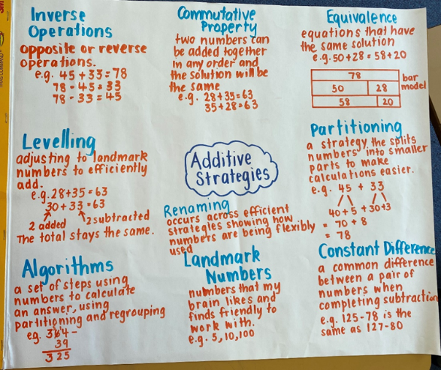
- Alternatively, display or provide Resource 2 – additive strategies to support students.

Core lesson 2 – travel plan – 40 minutes
- Display and discuss Resource 3 – superstar sightseeing. Ask students to suggest which superstar it might be.
- Discuss how students will know they have successfully completed the task.
- Co-design a checklist of important items that students might need to consider, including:
- arrival time
- time at each venue
- rate of pay
- travel time between the venues
- departure time.
- Provide Resource 3 – superstar sightseeing, Resource 4 – map and payments and writing materials.
- Students may work individually or in pairs. They can create a table to help organise their travel plan.
This table details opportunities for differentiation.
Too hard? | Too easy?
Students cannot use place value to add or subtract 3 or more numbers with different numbers of digits.  - Adjust the figures in Resource 3 – superstar sightseeing to be only whole dollar amounts. Provide students with calculators to work out the amounts raised.  - Provide students with Resource 5 – place value chart. Students randomly select cards (0–9) from a pack to create and then read the numbers. Students are asked how many more to make a whole number, such as 23.4 + 0.6 = 24. | Students can use place value to add or subtract 3 or more numbers with different numbers of digits.  - Ask students to plan the optional challenge on Resource 3 – superstar sightseeing, visiting each capital city in Australia for one event at each stop.  - Ask students to calculate penalties for being late to events. If the celebrity is between 10 and 20 minutes late there is a $120 payment reduction. If they are more than 20 minutes late, there is a $150 payment reduction.

Discuss and connect the mathematics – 10 minutes
- Discuss when it will be more efficient to use a calculator to add numbers.
- Students swap their work with another group and use a calculator to check some of calculations.
- Students give each other feedback and make corrections.
- Groups review the comments on their work and ask clarifying questions if necessary.
- Regroup as a class and display the anchor chart. Ask:
- What additive strategies did you use? Why?
- Were there strategies that you did not use? Why not?
- Did you use more than one strategy? Why or why not?
- Are there strategies that you used that are not on our anchor chart?
- What approaches did you take to raise the most money? Did they work?
- Where did your celebrity lose time or money?
- Share the amounts the groups raised.
This table details opportunities for assessment.
Assessment opportunities | Links
What to look for:  - Can students use place value to add or subtract 3 or more numbers with different numbers of digits? [MAO-WM-01,  MA3-AR-01]  - Can students determine when it would be more efficient to use a calculator to add numbers? [MAO-WM-01, MA3-AR-01]  - Can students compare, evaluate and communicate strategies used to solve addition and subtraction problems? [MAO-WM-01, MA3-AR-01]  - Can students use start and finish times to calculate the elapsed time of events? [MAO-WM-01, MA3-NSM-02] | Links to National Numeracy Learning Progressions (NNLP):  - AdS7, AdS8, AdS9.  Links to suggested Interview for Student Reasoning (IfSR) tasks:  - IfSR-AT: 3A.5.

Lesson 2
Core concept: addition can help solve subtraction problems.

Daily number sense – nutrition in fruit – 15 minutes
The table below contains a suggested learning intention and success criteria. These are best co-constructed with students.
Daily number sense learning intention | Daily number sense success criteria
Students are learning to:  - apply known strategies to add and subtract decimals. | Students can:  - solve word problems involving the addition and subtraction of decimals up to 3 decimal places  - justify why the strategy used to solve addition and subtraction word problems is appropriate.
- As a class, discuss strategies students already know about reading and solving word problems.
- Display, read and discuss Resource 6 – nutrition in fruit.
- Ask students the following question: If you and a friend made a berry smoothie to share, calculate the total carbohydrates and protein each person consumed after drinking the smoothie.
- In small groups, ask students to create 2 addition and/or subtraction word problems using Resource 6 – nutrition in fruit. For example, On Thursday, Mina ate an orange for breakfast and had a peach and figs for afternoon tea. How much protein did Mina eat?
- Once complete, ask groups to swap their problems and solve them.
- Ask students to consider the most efficient and fluent additive strategies for the problems presented.
- Regroup as a class and select students to share strategies used to solve the word problems.
This table details opportunities for assessment.
Assessment opportunities | Links
What to look for:  - Can students solve word problems involving the addition and subtraction of decimals up to 3 decimal places? [MAO-WM-01, MA3-WM-01]  - Can students justify why the strategy used to solve addition and subtraction word problems is appropriate? [MAO-WM-01,  MA3-WM-01] | Links to National Numeracy Learning Progressions (NNLP):  - AdS9.  Links to suggested Interview for Student Reasoning (IfSR) tasks:  - IfSR-AT: 4A.1, 4A.2, 4A.3, 4A.4.

Core lesson 1 – additive strategies (part 2) – 25 minutes
The table below contains suggested learning intentions and success criteria. These are best co-constructed with students.
Core concept learning intentions | Core concept success criteria
Students are learning to:  - apply efficient mental and written strategies to solve addition and subtraction problems  - choose and use efficient strategies to solve addition and subtraction problems. | Students can:  - apply known strategies such as levelling, addition for subtraction, using constant difference, and bridging  - use place value to add or subtract 3 or more numbers with different numbers of digits  - compare, evaluate and communicate strategies used to solve addition and subtraction problems.
- Review the additive anchor chart from Lesson 1 or Resource 2 – additive strategies.
- Review and model the inverse operations, remind students that addition can be used to solve subtraction problems. For example, to solve 5009 − 3997, start at 3997 and add until 5009 is reached. Adding 3 to 3997 makes 4000, then 1009 to get to 5009. The difference is 1012. Model ‘Addition for subtraction’ on an empty number line.
- Add ‘Addition for subtraction’ to the class additive anchor chart.
Note: ‘Addition for subtraction’ is a specific strategy referred to in Additive relations A, alongside levelling, using constant difference, and bridging. It is part of the inverse relationship between addition and subtraction.
- Display and discuss Resource 7 – data sources. Draw student attention to the approximate totals available in the column graph.
- Provide students with a copy of Resource 7 – data sources.
- Display and read Resource 8 – data activities. Ask students to answer the questions using the ‘Addition for subtraction’ strategy where appropriate and to show their working on a number line.

Core lesson 2 – number lines – 25 minutes
- Display and read Resource 9 – garden designs.
- Remind students that the addition for subtraction strategy can be used to compare lengths or calculate differences.
- Encourage students to answer the questions using an empty number line to support their calculations noting they may choose another effective strategy.
The table below outlines stimulus prompts to generate conversation about the topic, along with anticipated responses from students.
Prompts | Anticipated student responses
- What is the final length of the garden? | Final garden length:  - 7.95 + 2.15 + 3.85 − 1.15 = 12.8 m
- What is the difference between the initial and final garden length? | Final length − initial length:  - 12.8 m − 7.95 m = 4.85 m
- How much shorter is the flower bed than the fruit trees? | Fruit trees – flower bed:  - 3.85 − 2.15 = 1.7 m (see Figure 2).  Figure 2 – example of solution 1  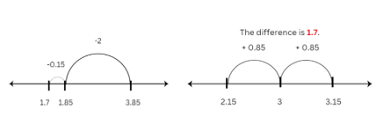
- How much longer is the flower bed than the path? | Flower bed – path:  - 2.15 m − 1.15 m = 1.00 m
- Where would the middle of the garden be for the path? | - Final length is 12.8 m. The middle is 6.4 m (see Figure 3).  Figure 3 – example of solution 2  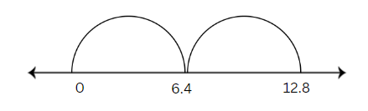
- If you divide the garden into 4 equal sections, what would be the length of each section? | The final garden divided into 4 equal parts:  - 12.8 divided by 4, half and half again, making 3.2 m (see Figure 4).  Figure 4 – example of solution 3  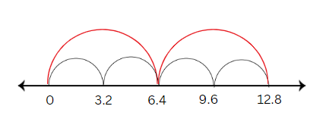
- If the owner asked you to make the garden 25% longer, how much would you need to add? How long would the garden now be? | - 25% is the same as a quarter.  - You would need to add 3.2 m.  - This would make the garden 12.8 + 3.2 = 16 metres long.
This table details opportunities for differentiation.
Too hard? | Too easy?
Students cannot apply known strategies such as levelling, addition for subtraction, using constant difference, and bridging.  - Students use whole numbers to solve the garden bed and calculator problem.  - Provide concrete materials such as Resource 10 – decimats to support students to solve the decimal problems. Note: the decimats can be used as visual representations of decimals to help students make sense of decimal size and decimal place value (see Figure 5). | Students can apply known strategies such as levelling, addition for subtraction, using constant difference, and bridging.  - Provide students a budget and a cost per metre for the flowers, trees and path. Challenge the students to create the most visually appealing garden while staying within the allocated budget.  - Students write their own garden problems and share them with their peers. Students need to consider the strategies used and justify its efficiency in solving the problem.
Figure 5 – decimats
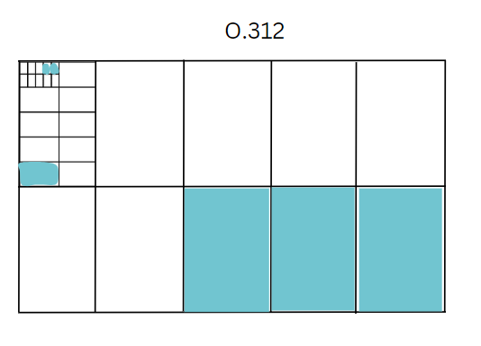

Discuss and connect the mathematics – 10 minutes
- Display and read Resource 11 – reflection chart.
- Discuss and reflect on the efficiency and accuracy of the number line strategy used by students.
- Ask students to share their strategies for solving the garden bed word problems.
This table details opportunities for assessment.
Assessment opportunities | Links
What to look for:  - Can students apply known strategies such as levelling, addition for subtraction, using constant difference, and bridging?  [MAO-WM-01, MA3-AR-01]  - Can students use place value to add or subtract 3 or more numbers with different numbers of digits? [MAO-WM-01,  MA3-AR-01]  - Can students compare, evaluate and communicate strategies used to solve addition and subtraction problems? [MAO-WM-01, MA3-AR-01] | Links to National Numeracy Learning Progressions (NNLP):  - AdS7, AdS8, AdS9.  Links to suggested Interview for Student Reasoning (IfSR) tasks:  - IfSR-AT: 3A.4, 3A.5.

Lesson 3
Core concept: known strategies for addition and subtraction can be applied to decimals.

Daily number sense – convince me – 10 minutes
The table below contains a suggested learning intention and success criteria. These are best co-constructed with students.
Daily number sense learning intention | Daily number sense success criteria
Students are learning to:  - apply known strategies to add and subtract decimals. | Students can:  - model the addition and subtraction of decimals up to 3 decimal places using appropriate representations.
This activity is an adaptation of Work samples (Additive relations) by NSW Education Standards Authority (NESA).
- Present the following problem: Sam worked out this decimal equation 3.25 − 1.5 and got the answer 3.10. The answer is incorrect.
- Ask students to convince you it is wrong and share their solutions.
- How did you know?
- What error or misconception has Sam made? Sam has considered 1.5 as a whole unit after the decimal point. He has solved the question as follows 3.25 − 0.15.
- Jeremy got the answer 2.20. What error or misconception has he made? Jeremy has not considered the correct place value for 1.5 and the role of zero. He solved the problem as follows 3.25 − 1.05.
- Charlotte got the answer 2.35. What error or misconception has she made? Charlotte has not considered the correct place value for 1.5. She solved the problem as follows 3.25 − 1 and then added 0.10.
- What might the subtraction question have been if the correct answer was 2.10?
- Ask students if a visual representation could have helped show the relationship between the numbers 3.25 and 1.5 (see Figure 6).
Figure 6 – visual representations
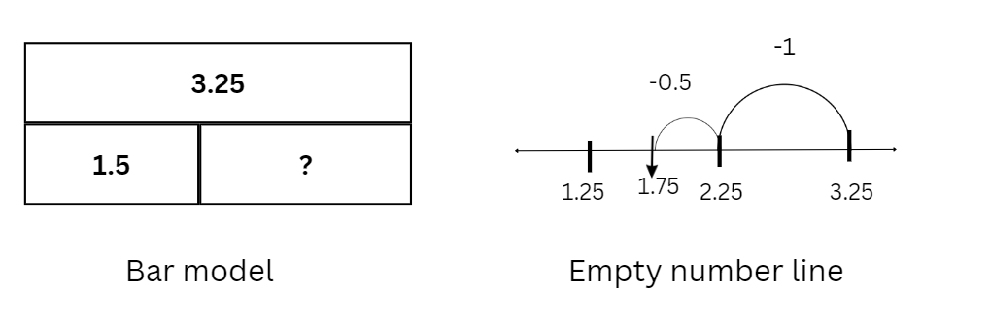
This table details opportunities for assessment.
Assessment opportunities | Links
What to look for:  - Can students model the addition and subtraction of decimals up to 3 decimal places using appropriate representations?  [MAO-WM-01, MA3-AR-01] | Links to National Numeracy Learning Progressions (NNLP):  - AdS9.

Core lesson 1 – decimal addition and subtraction – 15 minutes
The table below contains suggested learning intentions and success criteria. These are best co-constructed with students.
Core concept learning intentions | Core concept success criteria
Students are learning to:  - recognise that the place value system can be extended beyond hundredths  - apply known strategies to add and subtract decimals. | Students can:  - express thousandths as decimals  - use place value to partition decimals  - model the addition and subtraction of decimals up to 3 decimal places using appropriate representations  - justify why the strategy used to solve addition and subtraction word problems is appropriate.
- Review the additive anchor chart from Lesson 1 or Resource 2 – additive strategies.
- Provide students with Resource 12 – 1–3 spinner, sticky notes, a pencil, a paper clip and cards (multiple numeral cards 0–9).
- In pairs, students randomly select cards to make 2 numbers with 6 digits which turn into numbers with decimals.
- Students use the pencil, paper clip and spinner template to make the spinner.
- Students spin to determine the position of the decimal point, for example, spin a 2 and create a number with 2 decimal places.
- Students choose an addition or subtraction sticky note to complete an equation (see Figure 7).
Figure 7 – decimal equation
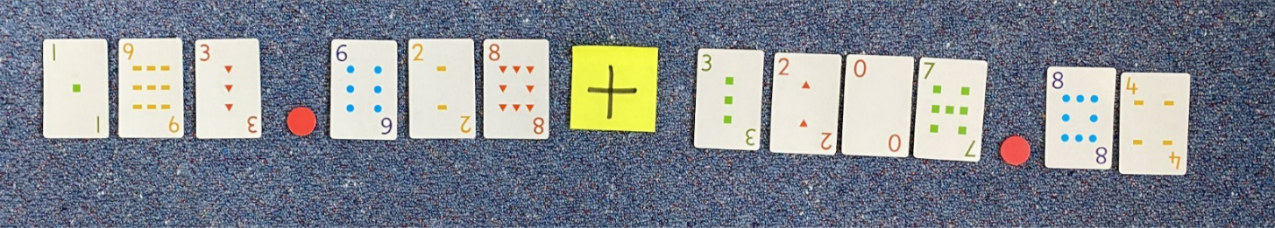
- Students select a number to partition and represent the calculation using an empty number line.
- Revise and discuss different models of representations to help support students efficiently solve the equations (see Figure 8).
Figure 8 – visual representations
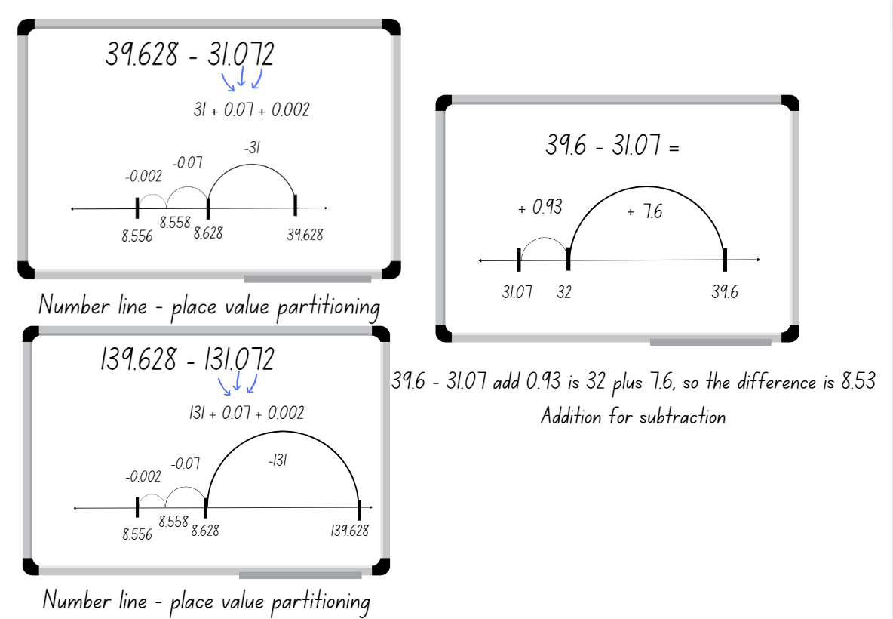
- Repeat the activity, ensuring students alternate between addition and subtraction.
- Regroup as a class and select students to share which number they chose to partition and why.
- Students repeat this task and add or subtract another 2 numbers together using what they believe is the most efficient strategy from those displayed.
- They record their work on a sticky note and attach it to their class anchor chart or Resource 2 – additive strategies.

Core lesson 2 – going shopping – 25 minutes
This activity is an adaptation of Shopping Basket from NRICH by University of Cambridge.
- Display and read Resource 13 – shopping problems. Discuss how students might solve these problems.
- Ask students to work on each question and to consider the most fluent and efficient strategy to use.
Note: for an optional challenge, change the total of question 4 to $100 or another total that promotes calculation with decimals. For $100, the prices will be $55, $27.50 and $17.50. Encourage students to use a bar model or another visual representation.
- Regroup as a class and ask students to share their working out and to justify the most fluent and efficient strategy used to solve the word problems.
This table details opportunities for differentiation.
Too hard? | Too easy?
Students cannot model the addition and subtraction of decimals up to 3 decimal places using appropriate representations.  - Revise student knowledge of whole number partitioning of numbers up to 5 digits. Guide the transfer of those skills to partitioning and naming decimals.  - Provide concrete materials such as Resource 10 – decimats to support students to solve the decimal problems. Note: the decimats can be used as visual representations of decimals to help students make sense of decimal size and decimal place value. | Students can model the addition and subtraction of decimals up to 3 decimal places using appropriate representations.  - Choose events from the NSWPSSA Athletics championships results. Ask students to make and calculate comparisons between different results, such as first and second place, or 8-year-olds and 12-year-olds.  - Challenge students to create multi-step decimal problems that represent real-world additive situations involving decimals. Have students exchange these problems with peers and request an explanation of the strategies used to solve the given problems.

Consolidation and meaningful practice – 10 minutes
This activity is an adaptation of Decimals: Connect 4 by JustMaths.
- Display and read Resource 14 – high jump results. Explain that 3 schools took part in an athletics carnival. The result of the high jump is decided on the combined height jumped by the top 2 competitors from each school.
- Ask students to discuss and share the additive strategies used to determine the answers to the following questions:
- What is the total combined height for each school?
- If Happy Valley PS improved its combined height by 0.1 m, and Mountain Top PS decreased its combined height by 0.07 m, what are the new total heights for these 2 schools?
- What is the difference between each school’s combined height in centimetres?
This table details opportunities for assessment.
Assessment opportunities | Links
What to look for:  - Can students express thousandths as decimals? [MAO-WM-01, MA3-RN-02]  - Can students use place value to partition decimals?  [MAO-WM-01, MA3-RN-02]  - Can students model the addition and subtraction of decimals up to 3 decimal places using appropriate representations?  [MAO-WM-01, MA3-AR-01]  - Can students justify why the strategy used to solve addition and subtraction word problems is appropriate? [MAO-WM-01,  MA3-AR-01] | Links to National Numeracy Learning Progressions (NNLP):  - NPV7, NPV8, AdS9.  Links to suggested Interview for Student Reasoning (IfSR) tasks:  - IfSR-AT: 4A.1, 4A.2, 4A.3, 4A.4.

Lesson 4
Core concept: number lines and bar models help solve addition and subtraction problems.

Daily number sense – 10 minutes
- From a class need surfaced through formative assessment data, identify a short, focused activity that targets students’ knowledge, understanding and skills. Example activities may be drawn from the following resources:
- Mathematics K–6 resources
- Universal Resources Hub.

Core lesson 1 – decimal fluency – 15 minutes
The table below contains suggested learning intentions and success criteria. These are best co-constructed with students.
Core concept learning intentions | Core concept success criteria
Students are learning to:  - make connections between benchmark fractions, decimals and percentages  - determine percentage discounts of 10%, 25% and 50%  - apply known strategies to add and subtract decimals. | Students can:  - recognise that 10% is one-tenth of 100% and use this to find 10% of a quantity  - equate 10% to dividing by 10, 25% to finding a quarter by dividing by 4, and 50% to finding half  - model the addition and subtraction of decimals up to 3 decimal places using appropriate representations.
This activity is an adaptation of ‘Adding and subtracting decimals’ from Decimals: Connect 4 by JustMaths.
To develop fluency in addition and subtraction of decimals, students are encouraged to use various additive strategies and representations to solve decimal equations, for example, number lines, partitioning place value and bar models.
- Display and read Resource 15 – score 4. Explain the rules:
- In pairs, students take turns to select and answer a question from the question grid.
- The correct solution will be found in the answer grid. If your solution is not in the grid, you need to reconsider your answer.
- Students colour or cover the solution in the box on the answer grid. To win, students need to connect 4 answers in a box or a line (horizontally, vertically or diagonally) on the answer grid.
- Ask students to record calculations during play.
- Select students to share the strategies and representations they used to solve the decimal equations.
- Optional: provide students Resource 16 – blank grid to create their own game for their peers.

Core lesson 2 – benchmark percentages – 15 minutes
- Place students into groups of 3.
- Provide each group with sticky notes and one metre of string.
- Ask students to construct a number line between zero and one, showing known decimals and fractions.
Note: monitor the construction of the number lines as a formative assessment opportunity.
- Explain to students that percent relies on an understanding of common fractions and decimals.
Note: a percentage is a fraction out of 100 and can be expressed as a decimal with hundredths. Students can make connections easily when both fractions and decimals are illustrated as hundredths, for example, $\frac{75}{100}$ equals 0.75, which is equivalent to 75%. At this level, it is appropriate to focus on known benchmarks such as 50%, 25% and 10%. The link between hundredths and percent can be made using a hundredths diagram (Siemon et al. 2021).
- Introduce the benchmark percentages of 10%, 25%, 50%, 75% and 100%. Connect these percentages to known decimals and fractions for example, 50% = $\frac{50}{100}$= $\frac{1}{2}$, 25% = $\frac{25}{100}$ = $\frac{1}{4}$ and so on.
- Discuss how our base-10 number system makes it easy to find 10% of a quantity. For example, 10% of 150 is 15, so 20% of 150 is 2 lots of 15, 30% is 3 lots of 15 and so on. Explain that 10% is dividing by 10, 25% is dividing by 4, 50% is dividing by 2 and 75% is dividing by 4 to determine 25% and then multiplying by 3.
- Ask students to represent these on a number line (see Figure 9).
Figure 9 – number line
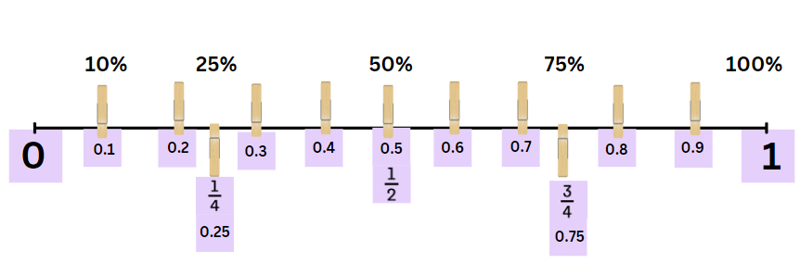

Core lesson 3 – celebrity concert – 25 minutes
- Display Resource 17 – concert hall. Explain that the celebrity from Lesson 1 has decided to put on a special charity concert for 100 people in the local hall. The celebrity has insisted that there are 3 categories of tickets:
- Category 1 – $200 each
- Category 2 – $100 each
- Category 3 – $50 each.
- Including at least one benchmark percentage of 10%, 25% or 50%, design at least 2 different seating plans for the concert (see Figure 10).
Figure 10 – concert hall examples
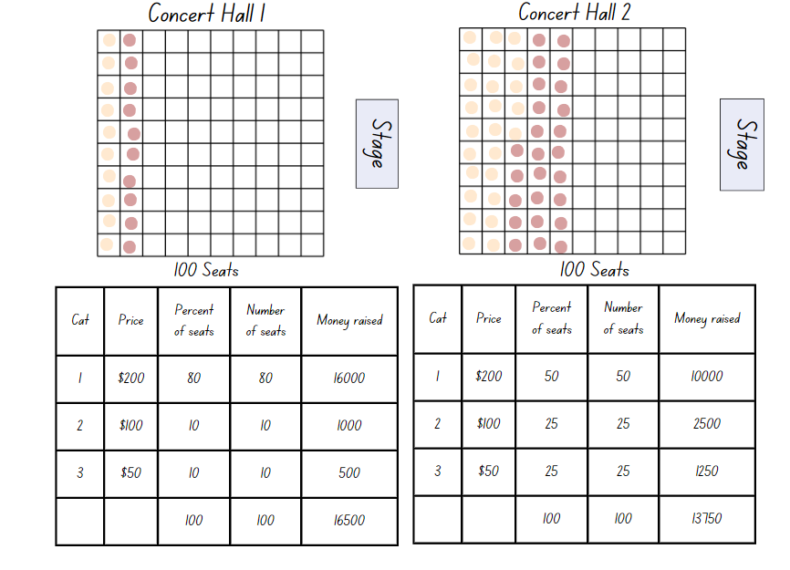
This table details opportunities for differentiation.
Too hard? | Too easy?
Students cannot model the addition and subtraction of decimals up to 3 decimal places or make connections between benchmark fractions, decimals and percentages.  - Using place value knowledge, partition decimal numbers with students to assist with number line jump increments.  - For the concert activity, use MAB materials to model the seating plan. Guide students to flexibly partition 100 tickets into the 3 categories using only 10, 25 and 50. Link the partitions to percentages. | Students can model the addition and subtraction of decimals up to 3 decimal places and make connections between benchmark fractions, decimals and percentages.  - Play Matching Fractions, Decimals and Percentages from NRICH. Students can self-select from 5 levels of challenge and try to beat their own best times.  - Ask students to complete the concert hall activity assuming that there are 300 tickets, not one hundred. Can this be achieved using only benchmark percentages?  - Ask students to use non-benchmark fractions in the allocation of seating, linking 10% to 1%. Students could also add a platinum seat category with a price of $500.

Discuss and connect the mathematics – 10 minutes
- Regroup as a class. Ask students:
- Which seating plan raised the most money?
- Which seating plan raised the least money?
- Did anyone else raise more money than you?
- Which arrangement is the fairest? Why?
- Ask students to turn and talk and share connections that they can make between fractions, decimals and percentages.
- Select students to share their responses.
This table details opportunities for assessment.
Assessment opportunities | Links
What to look for:  - Can students represent common percentages of quantities and lengths as fractions and decimals? [MAO-WM-01, MA3-RN-03]  - Can students recognise that 10% is one-tenth of 100% and use this to find 10% of a quantity? [MAO-WM-01, MA3-RN-03]  - Can students model the addition and subtraction of decimals up to 3 decimal places using appropriate representations?  [MAO-WM-01, MA3-AR-01] | Links to National Numeracy Learning Progressions (NNLP):  - AdS9, UnM8, PrT2.

Lesson 5
Core concept: place value understanding helps us to make use of benchmark percentages.

Daily number sense – inverse operations – 10 minutes
Daily number sense activities for Lessons 5 to 7 ‘loop’ back to concepts and procedures covered in previous units to assist students to build an increasingly connected network of ideas. These concepts may differ from the core concepts being covered by the unit.
The table below contains a suggested learning intention and success criteria. These are best co-constructed with students.
Daily number sense learning intention | Daily number sense success criteria
Students are learning to:  - use equivalent number sentences involving multiplication and division to find unknown quantities. | Students can:  - identify and use inverse operations to assist with the solution of number sentences.
- Pose the following problem to the students: Jason arranged 34 shelves in his bookstore, and each shelf held 12 books. How many books did he arrange in total?
- Ask students:
- How would you solve this problem?
- How would you check your answer?
- Select students to share responses.
- Once students have worked out that this problem requires multiplying 34 and 12 and the answer is 408, pose the following questions:
- What is the inverse operation to multiplication?
- How can this problem be changed so that division instead of multiplication is required to solve it?
- In pairs, ask students to use the 408 books to create a division problem, reminding them that if 34 times 12 is 408, using the inverse operation can help to create this new problem.
- Students share their new problem with the class. Answers might include:
- Jason arranged 408 books on 34 shelves. How many books were on each shelf?
- Jason arranged 408 books so that each shelf contained 12 books. How many shelves were there?
- Jason arranged 408 books on some shelves. What other combinations of books and shelves can you make? Use a pattern to explore as many combinations as possible. For example, 1 shelf with 408 books, 2 shelves with 204 books, 3 shelves with ... and so on.
This table details an opportunity for assessment.
Assessment opportunity | Links
What to look for:  - Can students identify and use inverse operations to assist with the solution of number sentences? [MAO-WM-01, MA3-MR-02] | Links to National Numeracy Learning Progressions (NNLP):  - NPA3, NPA4, MuS7.  Links to suggested Interview for Student Reasoning (IfSR) tasks:  - IfSR-MT: 3A.10.

Core lesson 1 – price of chocolate – 20 minutes
The table below contains suggested learning intentions and success criteria. These are best co-constructed with students.
Core concept learning intentions | Core concept success criteria
Students are learning to:  - make connections between benchmark fractions, decimals and percentages  - determine percentage discounts of 10%, 25% and 50%. | Students can:  - represent common percentages of quantities and lengths as fractions and decimals  - recognise that 10% is one-tenth of 100% and use this to find 10% of a quantity  - equate 10% to dividing by 10, 25% to finding a quarter by dividing by 4, and 50% to finding half.
- Refer to the percentages of seats sold for the charity concert in Lesson 4. Explain that students will again use a rectangle to represent benchmark percentages.
- Ask the students:
- Have you ever wondered where your clothes, food and furniture come from?
- Have you thought about what happens before these items reach the shop?
- What do you know about how chocolate is made?
- What do you know about how T-shirts are made?
- Display Resource 18 – chocolate costs 1. Use the table below to guide discussion.
The table below outlines stimulus prompts to generate conversation about the topic, along with anticipated responses from students.
Prompts | Anticipated student responses
- What do you notice? What do you wonder? | - Varied responses depending on background knowledge.  - There are chocolate bars made from small squares.  - There are 20 rows of 5.  - There are 100 squares in the block altogether.  - The number of squares matches the percentage recorded on it, for example, there are 30 squares on the 30% for retailers.  - A markup is the amount added to the cost price of goods to cover overheads and profit.
- What does the bar of chocolate represent? | - The entire cost of a chocolate bar. Note: the percentages are not a true representation of chocolate manufacturing. Proportions were provided to support the task.
- Who receives the highest/lowest percentage? | - Manufacturers (highest); transportation (lowest).
- Why do you think manufacturers need the largest percentage? | - They have the highest costs such as workers/employees, utilities, rent, taxes, quality assurance, insurance, marketing, profit.
- Do you think the share is fair? Why or why not? | - Varied responses depending on background knowledge.
- If the chocolate bar costs $10, how much does each sector receive? How can you work that out? | - Half of 10 is $5, and half goes to the manufacturer.  - 10% means the same as one tenth, so 10% is $1. The farmer gets $1.  - 30% is 3 times 10%, so the retailer gets $3.  - 5% is half of 10%, so transport and other costs are half of a dollar which is 50c each.
- Provide a copy of Resource 19 – chocolate costs 2 or ask students to complete the activity in their workbooks.
- Ask students:
- What is the same/different compared to Resource 18 – chocolate costs 1?
- What strategies can you use to work out the cost for each component?
- What is the first cost you would work out? Why?

Core lesson 2 – clothing shop – 20 minutes
This activity is an adaptation of ‘Raw to retail’ from Middle School Mathematics Lessons to Explore, Understand, and Respond to Social Injustice by Conway et al.
- Display Resource 20 – raw to retail.
- Discuss the process of producing something from raw materials to a finished product in a retail shop:
- Raw materials are grown by farmers or mined then transported to processing or manufacturing plants.
- Raw materials are then made into products, sometimes being transported again to be created into further products. For example, zippers might be made in one factory and then transported to another factory to be used in clothing.
- When complete, products are transported to wholesalers, also known as intermediary businesses, that help move the goods from one business to another.
- Next, the goods are branded ready for sale.
- Finally, the goods are transported to shops for retailers to sell.
- Optional: using digital devices, have students find a piece of clothing they would like to purchase. Students could also use catalogues or Resource 21 – Imogen’s T-shirt shop.
- Explain that students can now determine the percentage that is paid to each sector represented in Resource 20 – raw to retail for their chosen item.
- Students complete Resource 22 – product cost.
Note: students may explore uncommon percentages during this investigation. Stage 3 content requires the understanding of common/benchmark percentages of 10%, 25%, 50% and 75%.
This table details opportunities for differentiation.
Too hard? | Too easy?
Students cannot make connections between benchmark fractions, decimals and percentages.  - Provide students with MAB materials to make 100. Explain that 100% represents the whole cost of the item. Guide students to allocate MAB materials to each step in Resource 20 – raw to retail.  - Ask students to select an item that costs $10 or $100 and to only use benchmark percentages of 50%, 25% and 10% for the cost components. | Students can make connections between benchmark fractions, decimals and percentages.  - Students use uncommon or non-benchmark percentages.  - Using the percentages determined for the item of clothing, ask what would happen if the retailer decided to have a 50% off sale? Would they receive a profit or a loss? How much by? What percentage discount would still provide the retailer with some profit?

Discuss and connect the mathematics – 15 minutes
- Regroup as a class. Select students to share their distribution of percentages for each sector.
- Select students to answer the following questions:
- How did Resource 22 – product cost help your understanding of the various components involved in the pricing of your chosen clothing item?
- What strategy or strategies did you use to find the dollar amount? Explain and justify your response.
- Were there any challenges or surprises while working out the costs for each sector?
- How does this task relate to real-world scenarios in terms of product pricing and the distribution of costs in the fashion industry?
This table details opportunities for assessment.
Assessment opportunities | Links
What to look for:  - Can students represent common percentages of quantities and lengths as fractions and decimals? [MAO-WM-01, MA3-RN-03]  - Can students recognise that 10% is one-tenth of 100% and use this to find 10% of a quantity? [MAO-WM-01, MA3-RN-03]  - Can students equate 10% to dividing by 10, 25% to finding a quarter by dividing by 4, and 50% to finding half? [MAO-WM-01, MA3-RN-03] | Links to National Numeracy Learning Progressions (NNLP):  - UnM8, PrT1, PrT2.

Lesson 6
Core concept: estimating and place value understanding helps to determine the reasonableness of solutions.

Daily number sense – inverse operations – 10 minutes
The table below contains a suggested learning intention and success criteria. These are best co-constructed with students.
Daily number sense learning intention | Daily number sense success criteria
Students are learning to:  - use equivalent number sentences involving multiplication and division to find unknown quantities. | Students can:  - identify and use inverse operations to assist with the solution of number sentences.
- Draw a rectangle on the whiteboard marking one side as 8 m and the area in the middle as 152 m² (see Figure 11).
Figure 11 – rectangle for whiteboard
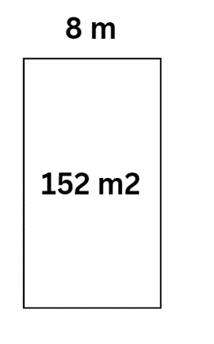
- Write 8 m × __ m = 152 m² on the board.
- Ask students:
- Which operation would you use to help solve this problem?
- What is the answer?
- Allow students time to Think-Pair-Share. Explain how division can be used to solve the problem.
Note: a mental strategy for division that uses the inverse relationship is ‘think of multiplication’ or ‘what do I multiply by?’. In this example, students could estimate by multiplying 8 by 20, then adjust to 8 by 19 (Siemon et al. 2021).
- In pairs, students create a word problem to go with Figure 11 above. For example, the rectangular playground had an area of 152 m² and one side was 8 m long. How long was the other side?
- Students write another problem with the same playground area context where multiplication and division are required.
This table details opportunities for assessment.
Assessment opportunities | Links
What to look for:  - Can students identify and use inverse operations to assist with the solution of number sentences? [MAO-WM-01, MA3-MR-02] | Links to National Numeracy Learning Progressions (NNLP):  - NPA3, NPA4, MuS7.  Links to suggested Interview for Student Reasoning (IfSR) tasks:  - IfSR-MT: 3A.10.

Core lesson – rounding and estimating – 35 minutes
The table below contains suggested learning intentions and success criteria. These are best co-constructed with students.
Core concept learning intentions | Core concept success criteria
Students are learning to:  - use estimation and place value understanding to determine the reasonableness of solutions  - determine percentage discounts of 10%, 25% and 50%  - apply known strategies to add and subtract decimals. | Students can:  - round numbers appropriately when obtaining estimates to numerical calculations  - use estimation to check the reasonableness of solutions to addition and subtraction calculations  - use mental strategies to estimate discounts of 10%, 25% and 50%  - solve word problems involving the addition and subtraction of decimals up to 3 decimal places.
This activity is an adaptation of Applications with decimals by State of New South Wales (Department of Education).
Note: estimation is used widely in everyday life. A deep understanding of place value supports students to produce reasonable estimates. In the following activities, students are not asked to calculate answers but instead value their estimate. Using language such as ‘about,’ ‘close,’ ‘just about’ or ‘approximate’ emphasises that there is not one correct answer. Students can compare estimates to evaluate if they fall within an acceptable range. Having students reflect on the strategies used by peers supports additional strategy development (Van de Walle et al 2023:274).
- Discuss contexts for estimation in everyday life. Ask students:
- When is it important to be precise? Measuring medicine, measuring for cake recipes, time for exams, paying the right amount for an item in the shop.
- When is an estimate good enough? How long to walk to school, how long a movie goes for and distance of a long drive.
- Display and read Resource 23 – mountain climbing think board.
- Jointly complete the think board to match the mountain climbing problem (see Figure 12).
Figure 12 – estimation think board example
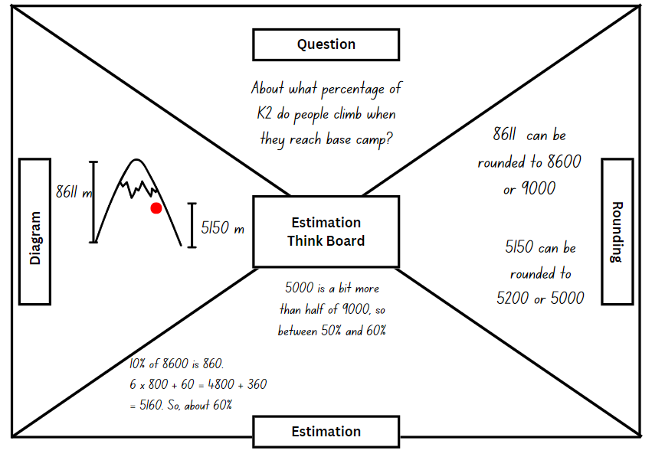
- Ask students for different approaches to calculating percentages, linking back to content from Lesson 5. Reinforce that there is no requirement for a precise calculation.
- Display and read Resource 24 – estimation activities.
- Ask students to select activities and to record their thinking on Resource 25 – think board, or a similar learning scaffold in their workbook.
- The answers to the questions are approximations, not precise calculations.
- Ask students to compare their solutions after each activity. If there is a notable difference in their solutions, students can pair up with a peer and work through the rounding and estimating together.
This table details opportunities for differentiation.
Too hard? | Too easy?
Students cannot round numbers appropriately when obtaining estimates to numerical calculations.  - Students are given numbers of varying sizes to round to the nearest hundred, ten, tenth or hundredth. Guide students to round the numbers in Resource 24 – estimation activities.  - Students round 2 amounts such as $25.60 and $14.10, to estimate the total (about $40) and the difference between them (about $10). Guide students to round and estimate totals and differences in the activities on Resource 24 – estimation activities. | Students can round numbers appropriately when obtaining estimates to numerical calculations.  - Students select an item of interest and compare discounts available from various sources. Students compare and justify the best available price (explaining their reasoning).  - Students make a list of sports or classroom equipment needed at the school. Investigate available prices and discounts for those items. Calculate the best overall cost.

Discuss and connect the mathematics – 15 minutes
- Regroup as a class. Select some questions from the list below to prompt reflection and discussion.
- Did your estimation skills improve while working on the think board activities?
- Can you identify a specific part of an activity where rounding played a role in arriving at an accurate estimate?
- Reflect on the process of comparing solutions with your peer. How did this collaboration help your understanding of estimation?
- Were there any challenges you faced in the estimation activities, and how did you overcome them?
- Describe a situation where the think board helped you visualise and organise your thoughts to solve a problem effectively.
- Reflect on the importance of estimation skills in real-life situations. How might these skills be applicable beyond the classroom?
- Share an example where rounding played a key role in simplifying a complex mathematical problem during the think board activities.
- How did discussing and working through rounding and estimating with a peer contribute to your overall learning experience?
- In what ways did the think board activities strengthen your overall mathematical reasoning and problem-solving abilities?
- Was there an activity where you thought that estimation was not appropriate, and that you should have made a precise calculation instead? Why?
This table details opportunities for assessment.
Assessment opportunities | Links
What to look for:  - Can students round numbers appropriately when obtaining estimates to numerical calculations? [MAO-WM-01, MA3-AR-01]  - Can students use estimation to check the reasonableness of solutions to addition and subtraction calculations? [MAO-WM-01, MA3-AR-01]  - Can students use mental strategies to estimate discounts of 10%, 25% and 50%? [MAO-WM-01, MA3-RN-03]  - Can students solve word problems involving the addition and subtraction of decimals up to 3 decimal places? [MAO-WM-01, MA3-AR-01] | Links to National Numeracy Learning Progressions (NNLP):  - NPV6, NPV7, AdS8, AdS9.

Lesson 7
Core concept: mathematicians solve addition and subtraction problems with more than one operation.

Daily number sense – equivalent number sentences – 10 minutes
The table below contains a suggested learning intention and success criteria. These are best co-constructed with students.
Daily number sense learning intention | Daily number sense success criteria
Students are learning to:  - use equivalent number sentences involving multiplication and division to find unknown quantities. | Students can:  - complete number sentences that involve more than one operation by calculating missing numbers.
This activity is an adaptation of Multiply and Divide Within A Hundred 1 by Kaplinsky from the Open Middle website.
- Draw Figure 13 on the whiteboard.
Figure 13 – multiplication and division equation
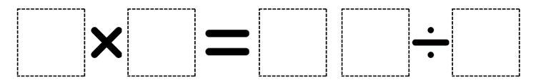
- In pairs, students use digits 2 to 9 (only once each), placing a digit in each box to make an equation. For example, 3 × 6 = 72 ÷ 4
Note: the task can be made easier by allowing students to use digits more than once.
- As a class, share and compare solutions. Ask students to identify the strategies they used and justify their choices.
This table details opportunities for assessment.
Assessment opportunities | Links
What to look for:  - Can students complete number sentences that involve more than one operation by calculating missing numbers? [MAO-WM-01, MA3-MR-02] | Links to National Numeracy Learning Progressions (NNLP):  - NPA3, MuS8.  Links to suggested Interview for Student Reasoning (IfSR) tasks:  - IfSR-MT: 3A.8, 3A.9.

Core lesson – zoo investigation (part 1) – 40 minutes
The table below contains suggested learning intentions and success criteria. These are best co-constructed with students.
Core concept learning intentions | Core concept success criteria
Students are learning to:  - choose and use efficient strategies to solve addition and subtraction problems  - apply known strategies to add and subtract decimals  - solve problems involving duration, using 12- and 24-hour time. | Students can:  - solve multistep word problems, including problems that require more than one operation  - compare, evaluate and communicate strategies used to solve addition and subtraction problems  - solve word problems involving the addition and subtraction of decimals up to 3 decimal places  - use start and finish times to calculate the elapsed time of events.
Note: this investigation is designed to be completed over Lessons 7 and 8 of this unit. Groups can work at their own pace, with teacher assistance when required.
- Explain that your class has been asked to write a review about a new zoo in the area. The principal has given permission for the class to organise the whole excursion, including the budgeting for the day and how long it will take.
- As a class, brainstorm what students might need to include in their excursion planning, including:
- When will you go?
- How will you travel to and from the zoo?
- When will you need to leave? When will you arrive back at school?
- How many teachers/adults will you need?
- How much will your excursion cost?
- What will you do when you are there?
- Display and read Resource 26 – zoo excursion planner. Clarify any elements of the task as needed.
Note: the investigation can be approached in sections that suit the needs of your class, bringing the students back together when ready to move on to the next section. Students can make calculations for the cost of the excursion based on the exact number of students in your class or Stage 3 at your school. Alternatively, students calculate the cost per student as if there were 50 students attending the excursion.
- Group students into investigation teams. Provide each group with a copy of the following resources:
- Resource 26 – zoo excursion planner
- Resource 27 – zoo map
- Resource 28 – entry and activities
- Resource 29 – zoo menu
- Monitor the organisation of the task and student progress.
Note: the most efficient strategy for some of these problems will include the use of a multiplicative strategy. Some students might require support to recognise this. Calculating The Heights Buses cost and ticket prices will involve the use of multiplication and division.
This table details opportunities for differentiation.
Too hard? | Too easy?
Students cannot choose and use efficient strategies to solve addition and subtraction problems.  - For the cost of buses, link 25% with quarters. Guide students to use non-standard partitions that support finding quarters (562 = 400 + 160 + 2). Use a bar model representation (see Figure 14).  - Provide students with calculators, allowing them to engage with the same tasks.  - Guide students to complete one aspect of the investigation with teacher support. | Students can choose and use efficient strategies to solve addition and subtraction problems.  - Ask students to further explore the map and investigate the distances and time between exhibits. For example, the zoo has asked you to design a tour with the distance and time recorded between each exhibit.  - Develop a report to provide the zoo with feedback and information from your investigation.
Figure 14 – non-standard partitioning
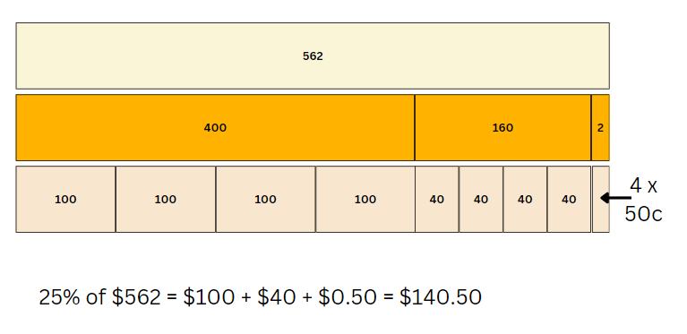

Discuss and connect the mathematics – 10 minutes
- Invite students to a whole class discussion about their excursion so far. Prompts could include:
- Which bus company did you go with? Why?
- Have you found any calculations challenging?
- Which strategies have you used?
- Were you able to solve any calculations mentally?
- Have you checked your solutions using another method?
This table details opportunities for assessment.
Assessment opportunities | Links
What to look for:  - Can students solve multi-step word problems, including problems that require more than one operation? [MAO-WM-01, MA3-AR-01]  - Can students compare, evaluate and communicate strategies used to solve addition and subtraction problems? [MAO-WM-01, MA3-AR-01]  - Can students solve word problems involving the addition and subtraction of decimals up to 3 decimal places? [MAO-WM-01, MA3-AR-01]  - Can students use start and finish times to calculate the elapsed time of events? [MAO-WM-01, MA3-NSM-02] | Links to National Numeracy Learning Progressions (NNLP):  - AdS7-AdS9, MuS8, MeT4.  Links to suggested Interview for Student Reasoning (IfSR) tasks:  - IfSR-AT: 3A.5.

Lesson 8
Core concept: mathematicians compare and evaluate strategies used to solve addition and subtraction problems, reasoning which strategy may be most efficient.

Daily number sense – 10 minutes
- From a class need surfaced through formative assessment data, identify a short, focused activity that targets students’ knowledge, understanding and skills. Example activities may be drawn from the following resources:
- Mathematics K–6 resources
- Universal Resources Hub.

Core lesson – zoo investigation (part 2) – 30 minutes
The table below contains suggested learning intentions and success criteria. These are best co-constructed with students.
Core concept learning intentions | Core concept success criteria
Students are learning to:  - choose and use efficient strategies to solve addition and subtraction problems  - apply known strategies to add and subtract decimals  - solve problems involving duration, using 12- and 24-hour time. | Students can:  - solve multistep word problems, including problems that require more than one operation  - compare, evaluate and communicate strategies used to solve addition and subtraction problems  - solve word problems involving the addition and subtraction of decimals up to 3 decimal places  - use start and finish times to calculate the elapsed time of events.
Note: Lesson 8 is a continuation of Lesson 7 – a 2-lesson investigation into designing a zoo excursion. You may like to start your lesson with feedback from Lesson 7, including if you noticed any challenges students were facing.
- Students return to their groups and continue with their investigation.
- As students work, monitor progress, assisting with the organisation of the task. While prompts have been provided, if students are working collaboratively and proceeding well, allow them to determine their own strategies and methods.

Discuss and connect the mathematics – 20 minutes
- Pair groups together to share and compare their calculations and findings. Ask each group to:
- explain their excursion plans
- share strategies they used and how they checked their answers
- identify sections they found challenging and those that were easier.
- At the end of the discussion, ask students to write a personal reflection of their learning in additive relations. Some prompts might include:
- Where have you been flexible in your mathematics?
- When did you explain your thinking clearly?
- Can you provide an example of when you were accurate and efficient?
- What are 2 connections you can make about additive relations?
This table details opportunities for assessment.
Assessment opportunities | Links
What to look for:  - Can students solve multistep word problems, including problems that require more than one operation? [MAO-WM-01, MA3-AR-01]  - Can students compare, evaluate and communicate strategies used to solve addition and subtraction problems? [MAO-WM-01, MA3-AR-01]  - Can students solve word problems involving the addition and subtraction of decimals up to 3 decimal places? [MAO-WM-01, MA3-AR-01]  - Can students use start and finish times to calculate the elapsed time of events? [MAO-WM-01, MA3-NSM-02] | Links to National Numeracy Learning Progressions (NNLP):  - AdS7-AdS9, MuS8, MeT4.  Links to suggested Interview for Student Reasoning (IfSR) tasks:  - IfSR-AT: 3A.5.

Resource 1 – shopping receipt
BIG FRUIT BARN – Shopping Receipt | Cost
Zucchini 0.778kg NET @ $5.99/kg | $4.66
Bananas 0.442kg NET @ $2.99/kg | $1.32
Special | $0.99
Special | $1.50
Potatoes 1.328kg NET @ $2.99/kg | $3.97
Brussel sprouts 0.322kg NET @ $15.99/kg | $5.15
Broccoli 0.808kg NET @ $5.99 | $4.84
Special | $0.99
Grapes green 1.174kg NET @ $5.99/kg | $7.03
Snow peas 0.218kg NET @ $14.99 | $3.27
Cherry tomatoes | $2.99
Lettuce Iceberg | $2.49
Subtotal | $39.20
Loyalty card discount | -$15.00
Total | $24.20
Cash | $50.00
Change | $25.80

Resource 2 – additive strategies
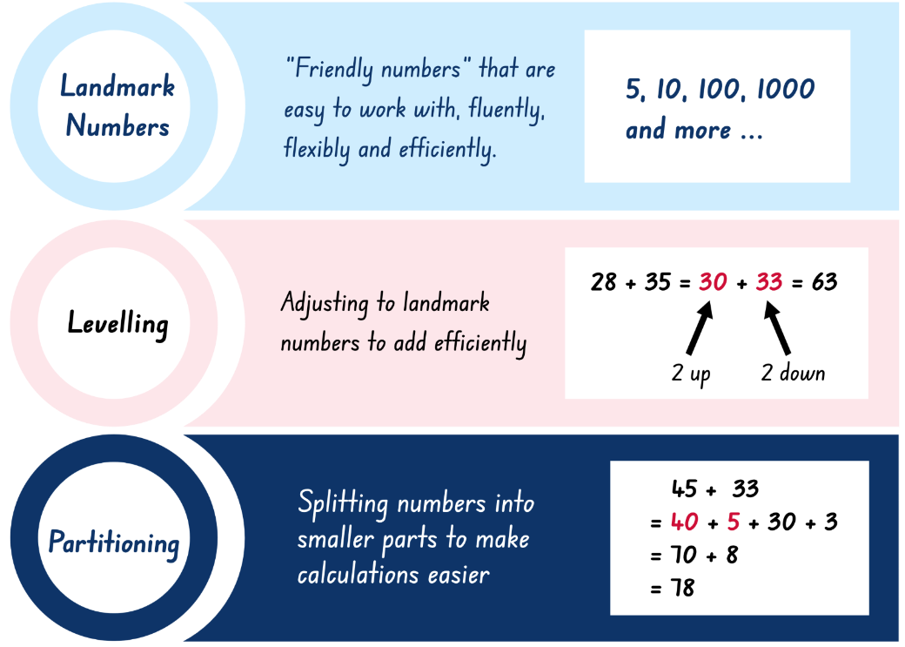
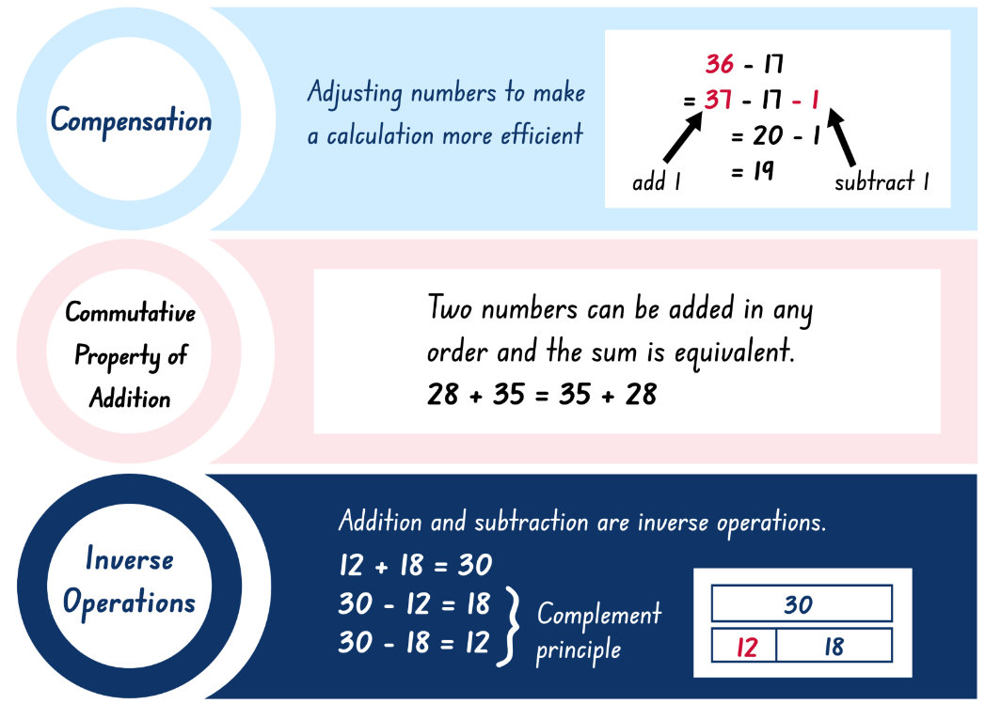
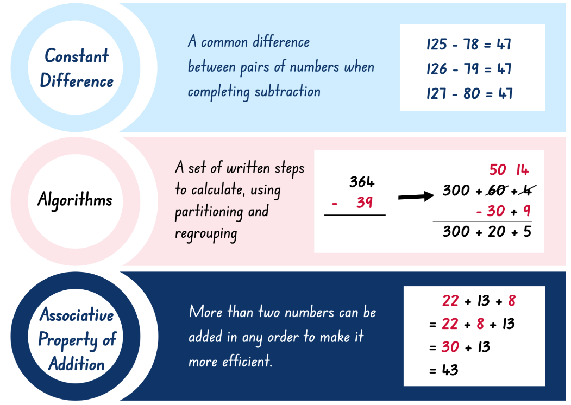
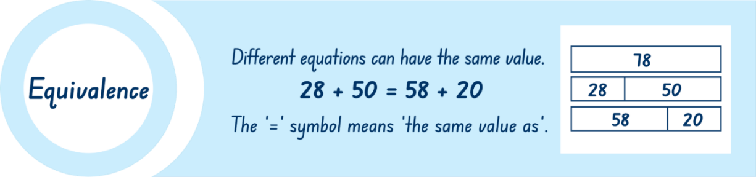

Resource 3 – superstar sightseeing
You are the organiser of a new superstar singer’s sightseeing tour of your town. The singer and entourage will be arriving at 9:00 am on a private plane. Once here, they want to visit as many places as they can to earn money for their cause, ‘Children in Crisis’.
As the organiser, you need to design a schedule for the group to visit as many places as they can, before being back at the airport by 4:00 pm, when they will fly to their next destination. Along with a map of the possible places to visit and the time taken to drive between them, you have also been given a payment guide that states how much money each location will pay towards the charity.
There is one condition; your celebrity can visit any of the places as many times and for as long as you plan. However, they will only be paid for one visit and only for the time indicated. The only exception is the shopping centre, which will pay $52 for every half hour the superstar is there.
Do not forget – the superstar and their entourage must be at the airport by 4 pm!
Design your schedule to make as much money for the charity as you can.

Resource 4 – map and payments
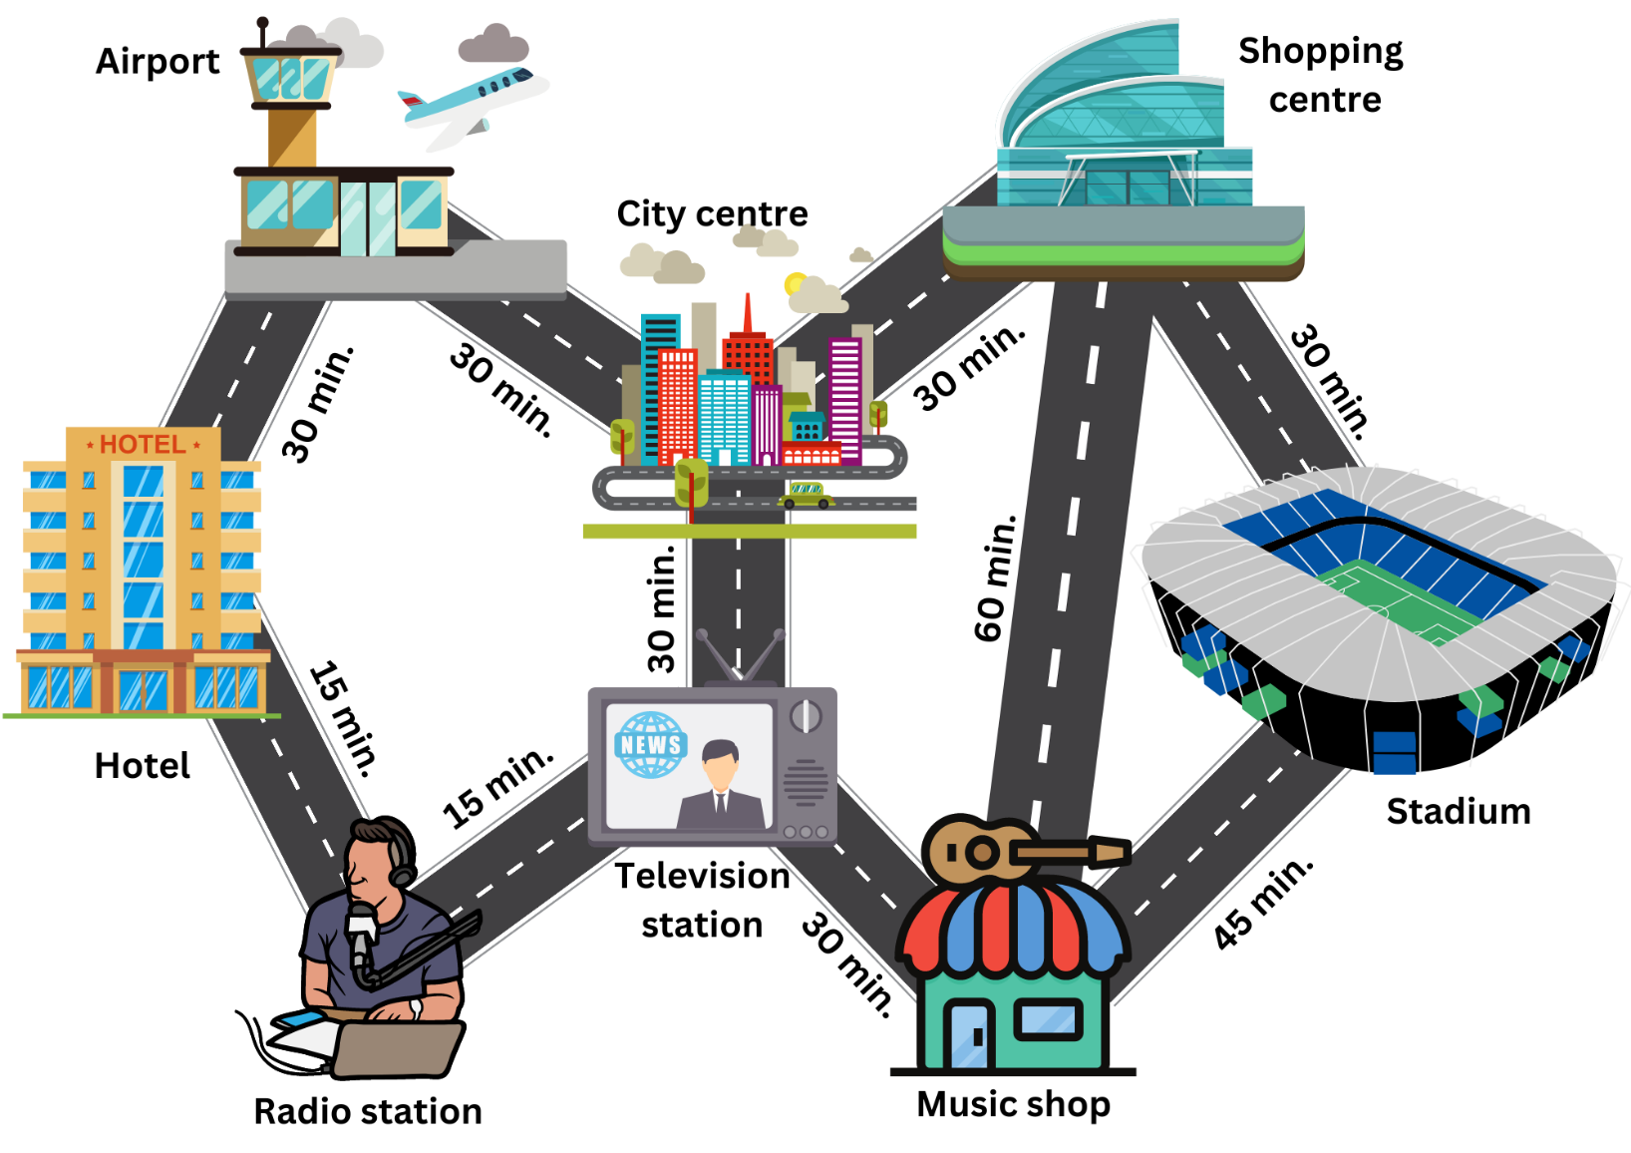
Location | Length of visit | Charity payment
Hotel | 20 minutes | $401
Radio station | 40 minutes | $1130
Television station | 25 minutes | $808
Music Shop | 30 minutes | $790
Stadium | 1 hour | $2670
Shopping centre | Unlimited | $52 per 30 minutes
City centre | 35 minutes | $1410

Resource 5 – place value chart
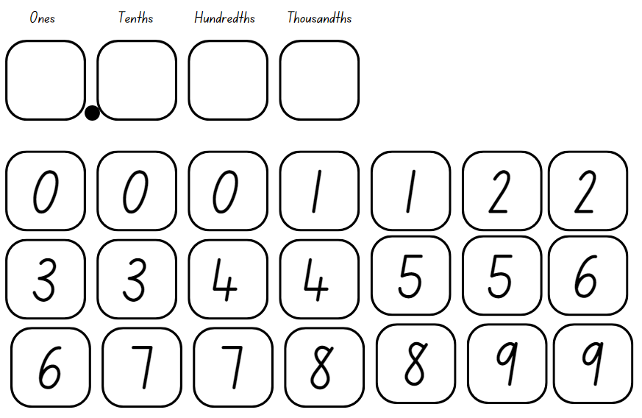

Resource 6 – nutrition in fruit
Fruits – serving size 100 grams | Carbohydrates (g) | Protein (g) | Fruits – serving size 100 grams | Carbohydrates (g) | Protein (g)
Apples | 13.81 | 2.26 | Grapes | 16.26 | 0.67
Apricots | 11.12 | 1.45 | Lemons | 16 | 1.5
Bananas | 88.28 | 3.89 | Oranges | 11.75 | 0.94
Blackberries | 23.1 | 1.31 | Peaches | 9.54 | 0.91
Blueberries | 22.06 | 0.65 | Plums | 11.89 | 0.705
Cherries | 12.18 | 1.36 | Strawberries | 7.907 | 0.608
Figs | 19.38 | 2.75 | Watermelon | 7.689 | 1.067

Resource 7 – data sources
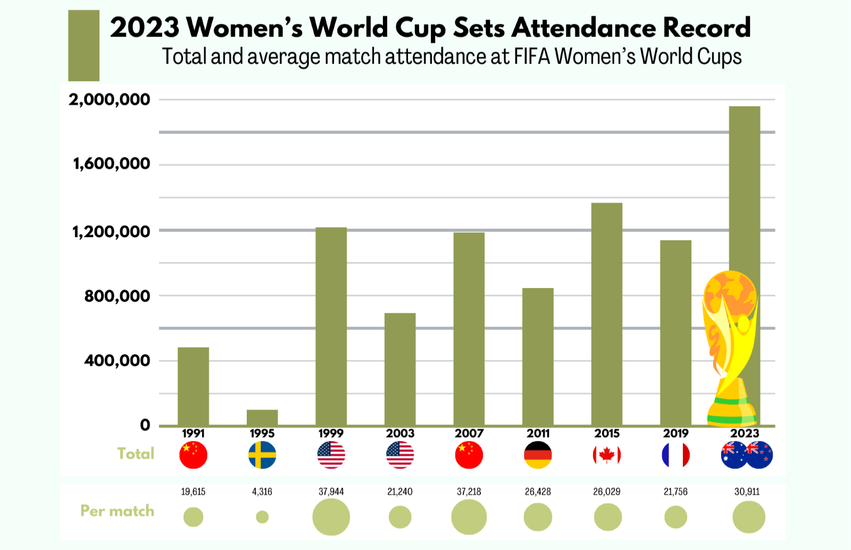
‘2023 Women’s World Cup Sets Attendance Record’ by statista.com is licensed under the Creative Commons License CC BY-ND 3.0.
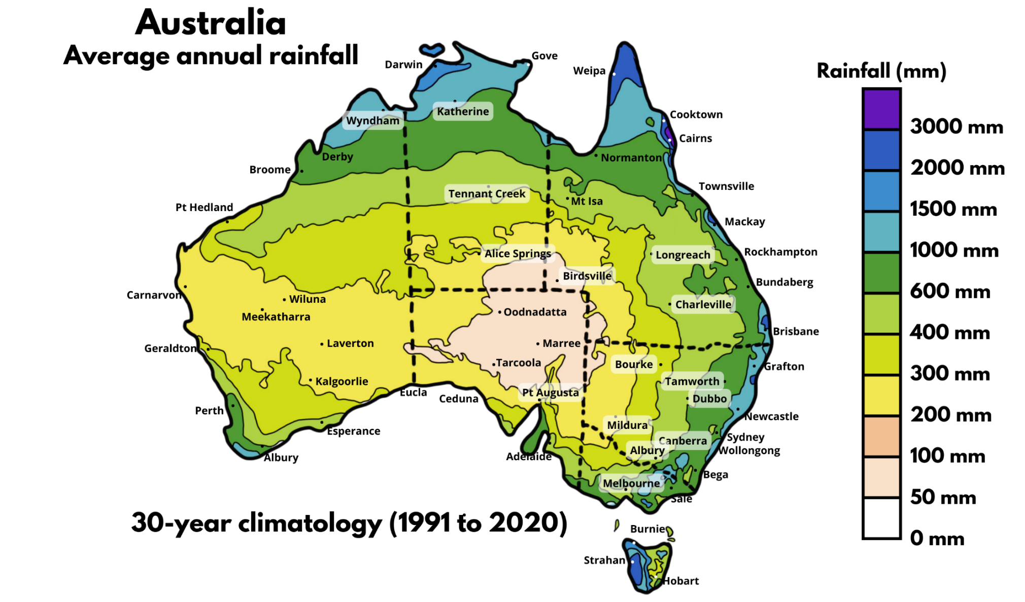
Adapted from Commonwealth of Australia (2021)

Resource 8 – data activities
- Calculate the difference in total attendance for World Cup matches in 2023 and 2003.
- How many additional people attended per match in 1999 compared to 1995?
- Calculate the difference between the smallest and largest match attendance total.
- What is the difference between the smallest and largest attendance per match?
- About how much more rainfall does Oodnadatta SA need to reach the shaded purple level (3000 mm)?
- Calculate the additional rainfall needed for Bourke NSW to be shaded dark blue (2000 mm).
- What is the difference in average annual rainfall between Mildura NSW and Darwin NT?

Resource 9 – garden designs
Your task is to look after a rectangular garden initially measuring 7.95 metres long. You decide to extend the garden by planting flowers, which adds 2.15 m to the garden’s length. Later, you extend the garden length by an extra 3.85 m to plant fruit trees. Finally, a brick path is added across the middle of the garden, reducing the total garden length by 1.15 m.
Questions:
- What is the final length of the garden?
- What is the difference between the initial and final garden length?
- How much shorter is the flower bed than the fruit trees?
- How much longer is the flower bed than the path?
- Where would the middle of the garden be for the path?
- If you divide the garden into 4 equal sections, what would be the length of each section?
- If the owner asked you to make the garden 25% longer, how much would you need to add? How long would the garden now be?

Resource 10 – decimats
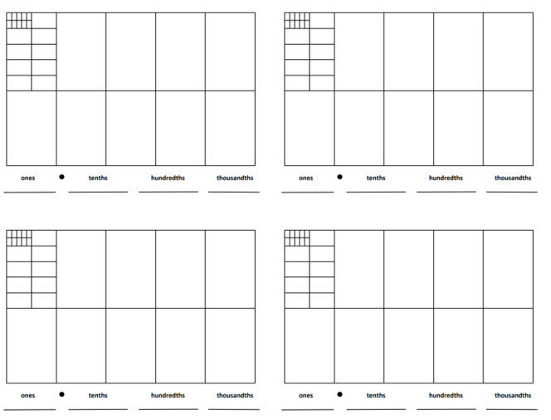

Resource 11 – reflection chart
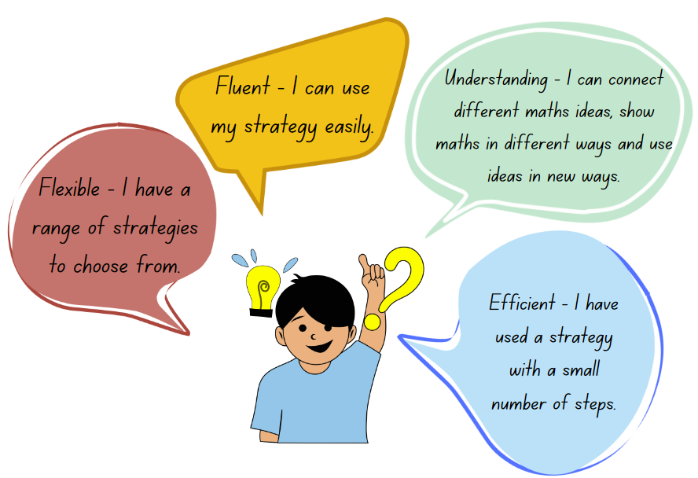

Resource 12 – 1–3 spinner
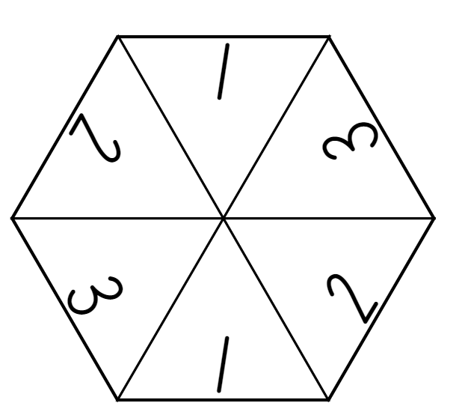

Resource 13 – shopping problems
Problem 1
A teenager goes into a supermarket and buys 4 items, each costing one dollar or more. The sale assistant tells the teenager the total is $8.95. Calculate the possible prices of the 4 items.
Problem 2
A shopper visits a tech store and buys 3 electronic gadgets, each more than $25. At the checkout, the sales assistant tells her the total is $120.75. Calculate the possible prices of the 3 items.
Problem 3
A bookkeeper purchased 4 items of stationery. The total cost was $42.69 but he was overcharged $6.55. Calculate the possible prices of the 4 items.
Problem 4
In a tech store, Alex gets 3 gadgets. The prices are a bit unclear and when Alex goes to pay the total is $110. The first gadget costs twice as much as the second, and the third gadget costs $10 less than the second. Can you find out how much each gadget costs?

Resource 14 – high jump results
Student | School | Height
Joesphine | Happy Valley PS | 1.61 m
Yin Lee | Happy Valley PS | 1.51 m
Zoran | Mountain Top PS | 1.47 m
Mitchell | Galaxy PS | 1.55 m
Carolina | Galaxy PS | 1.59 m
Zeinab | Mountain Top PS | 1.54 m
- What is the total combined height for each school?
- If Happy Valley PS improved its combined height by 0.1 m, and Mountain Top PS decreased its combined height by 0.07 m, what are the new total heights for these 2 schools?
- What is the difference between each school’s combined height in centimetres?

Resource 15 – score 4
Questions |  |  |  | Answers
0.4 + 0.1 | 0.88 − 0.34 | 72.2 − 4.95 | 0.772 + 0.201 | 0.54 | 39.018 | 1.30 | 34.15
0.48 + 0.99 | 6.198 + 63.91 | 0.6 + 0.2 | 0.96 − 0.25 | 39.46 | 0.973 | 0.45 | 77.03
5.14 + 26.3 | 0.54 + 0.74 | 0.82 − 0.33 | 86.7 − 9.67 | 0.49 | 0.50 | 67.25 | 1.66
0.59 − 0.14 | 41.8 − 2.782 | 1.76 + 37.7 | 0.5 + 0.8 | 1.28 | 2.94 | 70.108 | 1.20
4.2 − 1.26 | 0.8 + 0.4 | 0.96 + 0.7 | 3.25 + 30.9 | 0.8 | 31.44 | 1.47 | 0.71

Resource 16 – blank grid
Questions |  |  |  | Answers

Resource 17 – concert hall
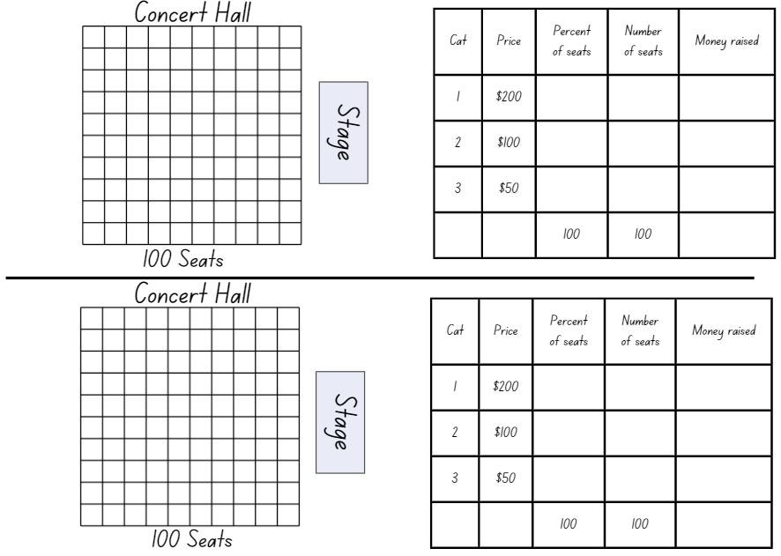

Resource 18 – chocolate costs 1
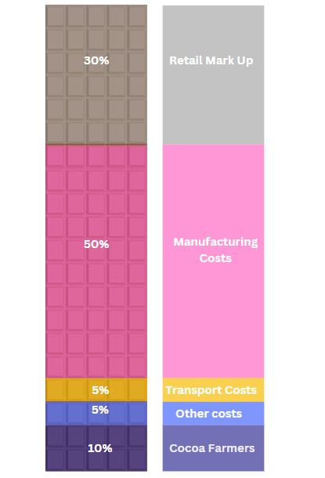

Resource 19 – chocolate costs 2
You have just purchased a block of chocolate for $4.00. Using the grid below, show how the costs are distributed. Record how much money each sector would receive out of your block of chocolate.
Sector | Percentage | Amount | Sector | Percentage | Amount
Cocoa farmer | 10% |  | Manufacturing | 50%
Other costs | 5% |  | Retail | 30%
Transportation | 5%

Resource 20 – raw to retail
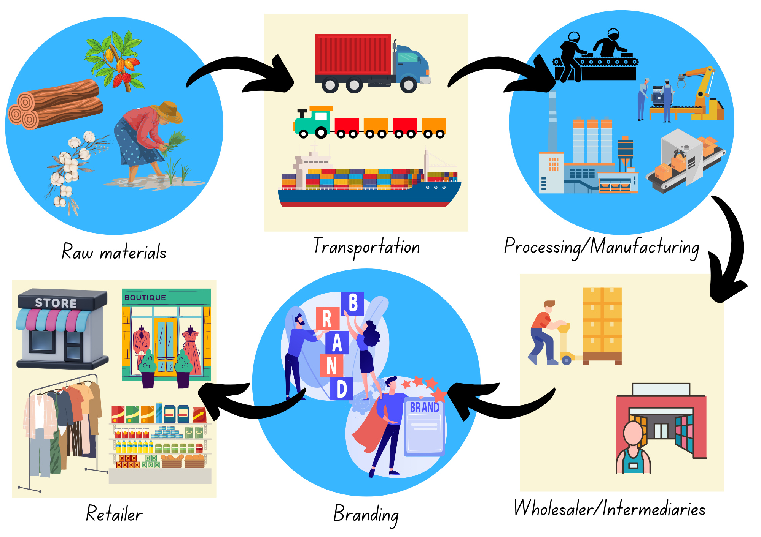

Resource 21 – Imogen’s T-shirt shop
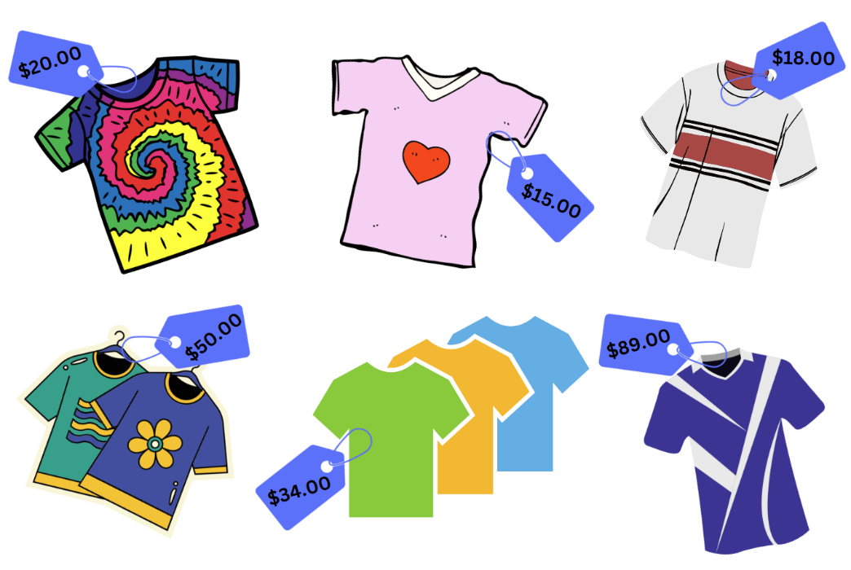

Resource 22 – product cost
Complete the grid and table for your chosen item of clothing, stating the percentages and money distributed between each sector.
What is the cost of your item?
Sector | Percentage | Amount | Sector | Percentage | Amount
Raw materials |  |  | Branding
Transportation |  |  | Wholesalers
Manufacturing |  |  | Retail

Resource 23 – mountain climbing think board
K2 is the world’s second highest mountain. Of the 5 highest mountains in the world, K2 is the deadliest.
The highest point of the mountain (summit) is 8611 m above sea level. Many people who attempt to climb K2 only reach Base Camp, which is 5150 m above sea level. About what percentage of the mountain do the mountaineers climb when they reach base camp?
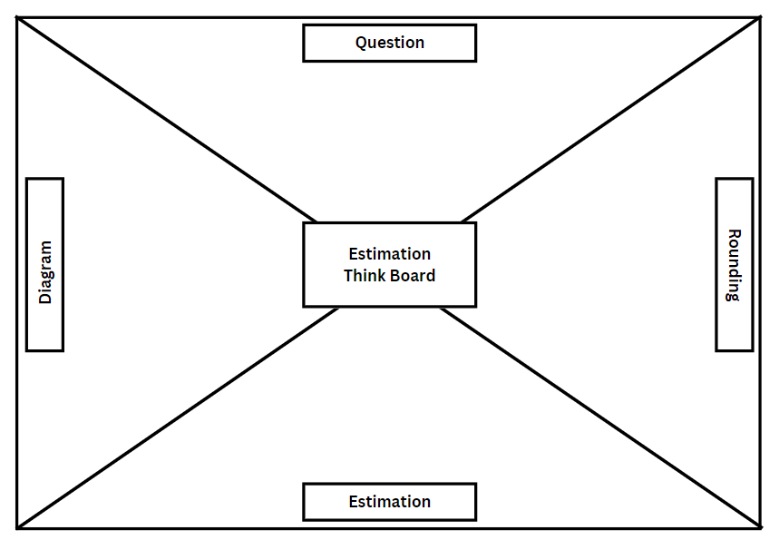

Resource 24 – estimation activities
Activity 1: Temperature readings
The playground temperature was monitored every hour in the morning, as seen in the table below. What was the approximate temperature difference between the highest and lowest temperature? What was the approximate percentage increase?
Time | 8:00 am | 9:00 am | 10:00 am | 11:00 am | 12:00 pm
Temperature | 17.37℃ | 18.4℃ | 19.29℃ | 22.08℃ | 25.46℃
Activity 2: Easter Show budget
Mike went to the Easter Show. He was given $150 spending money for the day. He spent money on the following items. Estimate how much money Mike had left at the end of the day.
Item | Cost
Return train ticket | $10.90
Entry ticket to the show | $32.00
Rides | 5 rides for $12.00 each
Food and drinks | $23.40
Show bag | $7.50
Activity 3: Make-up discounts
Mary’s mother went to her favourite store to buy make-up, listed in the table below. When she approached the counter to pay for the products, she was told that she could choose between 25% off the Mascara and eyeliner when purchased together or $10 off the price of the combined price of the foundation and lipstick. Estimate which option would give her the better saving.
Item | Cost
Mascara | $29.60
Eyeliner | $18.45
Foundation | $63.70
Lipstick | $34.99
Activity 4: Sports promotion
Coach Mark went to purchase a new set of balls for his soccer team. The store had a sale on bulk buys as shown in the table. If coach Mark bought 30 balls, what was the approximate percentage of his saving compared to the single ball price?
Quantity | Cost
1 ball | $15.50 each
5 pack | $14.75 each
10 pack | $14 each

Resource 25 – think board

Resource 26 – zoo excursion planner
The cost of the zoo excursion needs to include hiring a bus, entry tickets and cafe food.
Bus hire
You only need one bus for your excursion. There are 2 bus companies to choose from:
- Eppinorm Buses charge $562 to hire a bus for the day, but because you are a local school, they will give you a 25% discount.
- The Heights Buses costs $250 to hire for the day plus $3.25 for every kilometre it travels. The zoo is 21.5 km away.
Which company would be the cheapest? How much would each student have to pay? Show your calculations.
Entry tickets
The zoo’s rules say that there needs to be a supervision ratio of 1:10. Do you have enough teachers for this rule, or will you need to bring some parents? Explain your reasons.
Using the prices on the Entry and Activities boards, work out the cheapest way of buying tickets for everyone. Do not forget the teachers/adults.
For school excursions, the ticket cost for teachers/adults is paid for by the students. Using the best price you found, find the cost for each student. Add this to the bus hire fee per student. How much does each student need to pay for the excursion now?

Lunch packs
To ensure the zoo has enough food on the day, they have asked you to form a lunch pack. Use the zoo menu to make a lunch pack that includes one lunch food, one snack and one drink without going over $15 and then add to the total cost.
Schedule for the day
Make a timetable for the day that includes visits to all the animals. To complete this, you must consider the following:
- What time does school start? Will you need to leave earlier than this to get the most out of the day?
- What time do you need to get back to school?
- How long will it take the bus to get to the zoo and return to school?
- How long do you need for recess and lunch breaks?
- There are daily experiences at the zoo shown on the Entry and Activities board. Which feeding or talks will students attend? Are there any that are not possible?
- A map has been provided. How long will it take to move between each animal exhibit?
Note: Eppinorm Zoo opens at 9 am and closes at 4:30 pm. Zoo staff say that it takes about 30 minutes to walk from the zoo shop to the penguin exhibit, past the elephants and lions. The bus company has estimated the bus ride to the zoo will take 40 minutes in the morning and 30 minutes to return to the school in the afternoon.

Resource 27 – zoo map
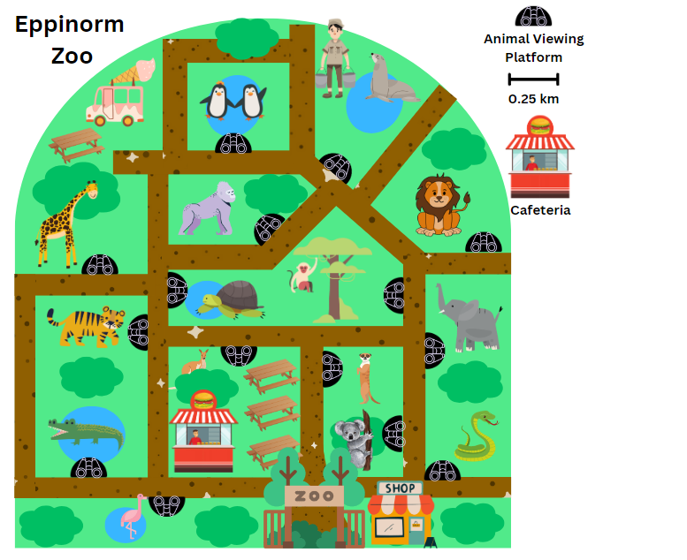

Resource 28 – entry and activities
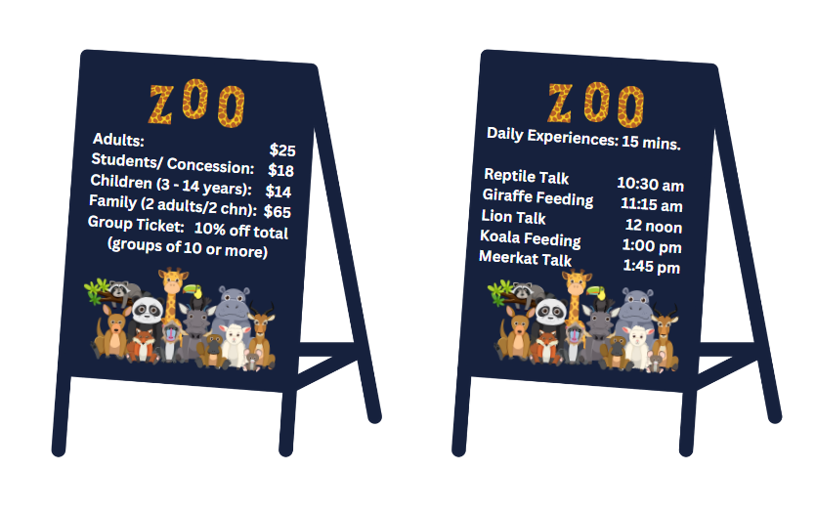

Resource 29 – zoo menu
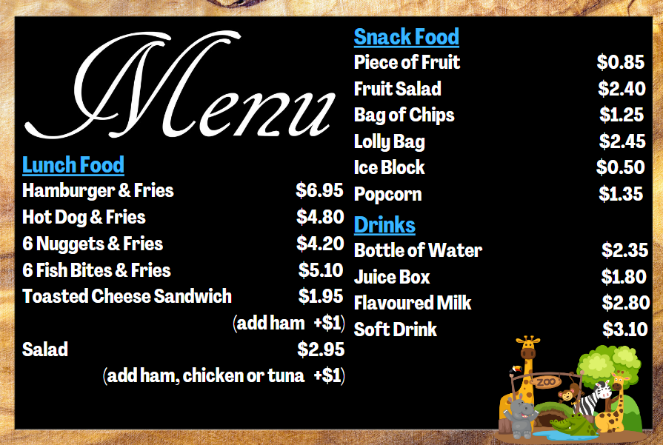

Syllabus outcomes and content
The table below outlines the syllabus outcomes and range of relevant syllabus content covered in this unit. Content is linked to National Numeracy Learning Progression (version 3).
Outcomes and content | 1 | 2 | 3 | 4 | 5 | 6 | 7 | 8
Represents numbers A: Decimals and percentages: Recognise that the place value system can be extended beyond hundredths
MAO-WM-01, MA3-RN-03
- Express thousandths as decimals | x | x | x |  | x
- Use place value to partition decimals |  | x | x |  | x
Representing numbers B: Decimals and percentages: Make connections between benchmark fractions, decimals and percentages
MAO-WM-01, MA3-RN-03
- Represent common percentages of quantities and lengths as fractions and decimals |  |  |  | x | x | x
- Recognise that 10% is one-tenth of 100% and use this to find 10% of a quantity (Reasons about relations) |  |  |  | x | x | x
Representing numbers B: Decimals and percentages: Determine percentage discounts of 10%, 25% and 50%
MAO-WM-01, MA3-RN-03
- Equate 10% to dividing by 10, 25% to finding a quarter by dividing by 4, and 50% to finding half |  |  |  | x | x
- Use mental strategies to estimate discounts of 10%, 25% and 50% |  |  |  |  | x | x
Additive relations A: Apply efficient mental and written strategies to solve addition and subtraction problems
MAO-WM-01, MA3-AR-01
- Apply known strategies such as levelling, addition for subtraction, using constant difference, and bridging (Reasons about relations) | x | x | x
- Use place value to add or subtract 3 or more numbers with different numbers of digits | x | x | x
Additive relations A: Use estimation and place value understanding to determine the reasonableness of solutions
MAO-WM-01, MA3-AR-01
- Round numbers appropriately when obtaining estimates to numerical calculations |  |  |  |  |  | x
- Use estimation to check the reasonableness of solutions to addition and subtraction calculations |  |  |  |  |  | x
Additive relations B: Choose and use efficient strategies to solve addition and subtraction problems
MAO-WM-01, MA3-AR-01
- Solve multistep word problems, including problems that require more than one operation |  |  | x |  |  |  | x | x
- Compare, evaluate and communicate strategies used to solve addition and subtraction problems | x | x | x |  |  |  | x | x
Additive relations B: Applies known strategies to add and subtract decimals
MAO-WM-01, MA3-AR-01
- Model the addition and subtraction of decimals up to 3 decimal places using appropriate representations | x | x | x | x
- Solve word problems involving the addition and subtraction of decimals up to 3 decimal places | x | x | x |  |  | x | x | x
Multiplicative relations B: Use equivalent number sentences involving multiplication and division to find unknown quantities
MAO-WM-01, MA3-MR-02
- Complete number sentences that involve more than one operation by calculating missing numbers |  |  |  |  |  | x | x
- Identify and use inverse operations to assist with the solution of number sentences |  |  |  |  | x | x
Non-spatial measure B: Time: Solve problems involving duration, using 12- and 24-hour time
MAO-WM-01, MA3-NSM-02
- Use start and finish times to calculate the elapsed time of events | x |  |  |  |  |  | x | x
Mathematics K–10 Syllabus © NSW Education Standards Authority (NESA) for and on behalf of the Crown in right of the State of New South Wales, 2022.

References
This resource contains NSW Curriculum and syllabus content. The NSW Curriculum is developed by the NSW Education Standards Authority. This content is prepared by NESA for and on behalf of the Crown in right of the State of New South Wales. The material is protected by Crown copyright.
Please refer to the NESA Copyright Disclaimer for more information https://educationstandards.nsw.edu.au/wps/portal/nesa/mini-footer/copyright.
NESA holds the only official and up-to-date versions of the NSW Curriculum and syllabus documents. Please visit the NSW Education Standards Authority (NESA) website https://educationstandards.nsw.edu.au/ and the NSW Curriculum website https://curriculum.nsw.edu.au.
Mathematics K–10 Syllabus © NSW Education Standards Authority (NESA) for and on behalf of the Crown in right of the State of New South Wales, 2022.
National Numeracy Learning Progression © Australian Curriculum, Assessment and Reporting Authority (ACARA) 2010 to present, unless otherwise indicated. This material was downloaded from the Australian Curriculum website (National Literacy Learning Progression) (accessed 24 January 2024) and was not modified.
Commonwealth of Australia (2021) Average annual, seasonal and monthly rainfall maps, Bureau of Meteorology website, accessed 9 November 2023.
Conway IV BM, Id-Deen L, Raygoza MC, Ruiz A, Staley JW and Thanheiser E (2023) Middle School Mathematics Lessons to Explore, Understand, and Respond to Social Injustice, Corwin Press Inc, USA.
JustMaths (2013) Decimals: Connect 4, STEM Learning website, assessed 9 November 2023.
Kaplinsky R (n.d.) Multiply and Divide Within A Hundred 1, Open Middle website, accessed 9 November 2023.
Liljedahl P (n.d.) Celebrity Travel Planning [PDF 195 KB], Peter Liljedahl website, accessed 9 November 2023.
NSW Education Standards Authority (NESA) (2022) Mathematics Stage 3: Activity 2 – Work samples (Additive relations), NESA website, accessed 25 January 2024.
Richter F (2023) 2023 Women’s World Cup Sets Attendance Record, Statista website, accessed 9 November 2023.
Siemon D, Warren E, Beswick K, Faragher R, Miller J, Horne M, Jazby D, Breed M, Clark J and Brady K (2021) Teaching Mathematics Foundations to Middle Years, 3rd edn, Oxford University Press, Australia and New Zealand.
State of New South Wales (Department of Education) (2023a) Applications with decimals (DOCX 1.57 MB), NSW Department of Education website, accessed 25 January 2024.
State of New South Wales (Department of Education) (2023b) 2023 Results for NSWPSSA - Athletics - Championship, School Sport Unit website, accessed 25 January 2024.
The Australian Nutrition Foundation (2021) Australian Dietary Guidelines: Standard serves, Nutrition Australia website, accessed 9 November 2023.
University of Cambridge (n.d.) Matching Fractions, Decimals and Percentages, NRICH website, accessed 18 January 2024.
University of Cambridge (n.d.) Shopping Basket, NRICH website, accessed 18 January 2024.
Van de Walle J, Karp K, Bay-Williams JM, Brass A, Bentley B, Ferguson S, Goff W, Livy S, Marshman M, Martin D, Pearn C, Prodromou T, Symons D and Wilkie K (2019) Primary and Middle Years Mathematics: Teaching Developmentally, 1st Australian edn, Pearson Education Australia, Melbourne.

© State of New South Wales (Department of Education), 2024
The copyright material published in this resource is subject to the Copyright Act 1968 (Cth) and is owned by the NSW Department of Education or, where indicated, by a party other than the NSW Department of Education (third-party material).
Copyright material available in this resource and owned by the NSW Department of Education is licensed under a Creative Commons Attribution 4.0 International (CC BY 4.0) license.
This license allows you to share and adapt the material for any purpose, even commercially.
Attribution should be given to © State of New South Wales (Department of Education), 2024.
Material in this resource not available under a Creative Commons license:
- the NSW Department of Education logo, other logos and trademark-protected material
- material owned by a third party that has been reproduced with permission. You will need to obtain permission from the third party to reuse its material.
Links to third-party material and websites
Please note that the provided (reading/viewing material/list/links/texts) are a suggestion only and implies no endorsement, by the New South Wales Department of Education, of any author, publisher, or book title. School principals and teachers are best placed to assess the suitability of resources that would complement the curriculum and reflect the needs and interests of their students.
If you use the links provided in this document to access a third-party's website, you acknowledge that the terms of use, including licence terms set out on the third-party's website apply to the use which may be made of the materials on that third-party website or where permitted by the Copyright Act 1968 (Cth). The department accepts no responsibility for content on third-party websites.

