Mathematics Stage 3 – Unit 34
What needs to be measured determines the unit of measurement
Contents
Unit description and duration 5
Syllabus outcomes 5
Working mathematically 6
Student prior learning 6
Lesson overview and resources 8
Lesson 1 13
Daily number sense – fractions, decimals and percentages – 10 minutes 13
Core lesson – pumpkin mass – 50 minutes 17
Consolidation and meaningful practice – 10 minutes 20
Lesson 2 22
Daily number sense – solving a problem – 10 minutes 22
Core lesson 1 – Which unit is best? – 10 minutes 23
Core lesson 2 – rubbish masses – 20 minutes 25
Core lesson 3 – landfill masses – 20 minutes 25
Discuss and connect the mathematics – 10 minutes 27
Lesson 3 29
Daily number sense – odd one out – 10 minutes 29
Core lesson – mass word problems – 40 minutes 30
Discuss and connect the mathematics – 10 minutes 34
Lesson 4 36
Daily number sense – 10 minutes 36
Core lesson – crocodile measurements – 40 minutes 36
Consolidation and meaningful practice – 15 minutes 38
Lesson 5 40
Daily number sense – build to the whole 1 – 10 minutes 40
Core lesson – different shapes can have the same perimeter – 40 minutes 41
Consolidation and meaningful practice – 15 minutes 45
Lesson 6 47
Daily number sense – build to the whole 2 – 10 minutes 47
Core lesson – How much fencing? – 40 minutes 48
Consolidation and meaningful practice – 15 minutes 50
Lesson 7 53
Daily number sense – given fraction parts – 10 minutes 53
Core lesson – mystery bones – 50 minutes 54
Discuss and connect the mathematics – 10 minutes 57
Lesson 8 59
Daily number sense – 10 minutes 59
Core lesson – mega trees – 45 minutes 59
Consolidation and meaningful practice – 15 minutes 62
Resource 1 – grid paper 64
Resource 2 – world’s largest pumpkin 65
Resource 3 – solving problems 66
Resource 4 – Grams, kilograms, tonnes? 67
Resource 5 – kilograms-tonnes conversion 68
Resource 6 – household waste 69
Resource 7 – landfill waste 70
Resource 8 – odd one out 71
Resource 9 – mass word problems 72
Resource 10 – crocodile facts 76
Resource 11 – crocodile measurements 77
Resource 12 – crocodile conversion chart 78
Resource 13 – perimeter modelling 79
Resource 14 – missing perimeter problems 80
Resource 15 – Darryl’s fencing 82
Resource 16 – Cup ‘n’ Saucer 83
Resource 17 – mystery bones 84
Resource 18 – bone measurement prediction 85
Resource 19 – anthropology investigations 86
Resource 20 – conversion chart 87
Resource 21 – mega trees 88
Resource 22 – mega trees questions 89
Syllabus outcomes and content 90
References 95

Unit description and duration
This unit develops the big idea that what needs to be measured determines the unit of measurement.
In this 2-week unit students are provided opportunities to:
- solve problems by comparing and measuring lengths and recording solutions using the appropriate units of measurement
- convert between common metric units of mass (grams, kilograms, tonnes) and lengths (millimetres, centimetres, kilometres)
- record lengths and distances using decimal notation
- make connections between benchmark fractions, decimals and percentages
- use efficient strategies to calculate the perimeter of various shapes.

Syllabus outcomes
- MAO-WM-01 develops understanding and fluency in mathematics through exploring and connecting mathematical concepts, choosing and applying mathematical techniques to solve problems, and communicating their thinking and reasoning coherently and clearly
- MA3-RN-01 applies an understanding of place value and the role of zero to represent the properties of numbers
- MA3-RN-02 compares and orders decimals up to 3 decimal places
- MA3-RQF-02 determines $\frac{1}{2}$ , $\frac{1}{4}$ , $\frac{1}{5}$ , and $\frac{1}{10}$ of measures and quantities
- MA3-GM-02 selects and uses the appropriate unit and device to measure lengths and distances including perimeters
- MA3-NSM-01 selects and uses the appropriate unit and device to measure the masses of objects

Working mathematically
In the Mathematics K–10 Syllabus, there is one overarching Working mathematically outcome (MAO-WM-01). The Working mathematically processes should be embedded within the concepts being taught. The Working mathematically processes present in the Mathematics K–10 Syllabus are:
- communicating
- understanding and fluency
- reasoning
- problem solving.
Mathematics K–10 Syllabus © NSW Education Standards Authority (NESA) for and on behalf of the Crown in right of the State of New South Wales, 2022.

Student prior learning
Before engaging in these teaching and learning activities, students would benefit from prior experience with:
- identifying the appropriate unit and device to measure mass when solving problems involving different units
- recognising the equivalence of whole-number and decimal representations of measurements of mass
- using a variety of measuring devices to measure lengths and distances in different contexts including perimeter.
In NSW classrooms there is a diverse range of students, including Aboriginal and/or Torres Strait Islander students, students learning English as an additional language or dialect, high potential and gifted students and students with disability. Some students may identify with more than one of these groups or possibly all of them. Refer to Curriculum planning for every student – advice for further information.

Lesson overview and resources
The table below outlines the sequence and approximate timing of lessons, learning intentions and resources.
Lesson | Content | Duration and resources
Lesson 1  Daily number sense learning intention:  - make connections between benchmark fractions, decimals and percentages | Lesson core concept: the context determines the most suitable standard unit, sometimes a kilogram is too small or too large.  Core concept learning intention:  - convert between common metric units of mass | Lesson duration: 70 minutes  - Resource 1 – grid paper  - Resource 2 – world’s largest pumpkin  - Equal-arm balances or digital scales  - Individual whiteboards  - Metric weights  - Pumpkins  - Sticky notes  - Writing materials
Lesson 2  Daily number sense learning intention:  - make connections between benchmark fractions, decimals and percentages | Lesson core concept: the larger the unit, the smaller the measure.  Core concept learning intentions:  - convert between common metric units of mass  - apply efficient mental and written strategies to solve addition and subtraction problems | Lesson duration: 70 minutes  - Resource 3 – solving problems  - Resource 4 – Grams, kilogram, tonnes?  - Resource 5 – kilogram-tonnes conversion  - Resource 6 – household waste  - Resource 7 – landfill waste  - Writing materials
Lesson 3  Daily number sense learning intention:  - make connections between benchmark fractions, decimals and percentages | Lesson core concept: a mass can be renamed using different units of measurement.  Core concept learning intention:  - convert between common metric units of mass  - apply efficient mental and written strategies to solve addition and subtraction problems | Lesson duration: 60 minutes  - Resource 8 – odd one out  - Resource 9 – mass word problems  - Various kitchen and bathroom scales  - Metric weights  - Writing materials
Lesson 4  Daily number sense learning intention:  - teacher-identified task based on student needs | Lesson core concept: metric units of measurement can be described using the decimal place value system.  Core concept learning intention:  - connect decimal representations to the metric system | Lesson duration: 65 minutes  - Resource 10 – crocodile facts  - Resource 11 – crocodile measurements  - Resource 12 – crocodile conversion chart  - Writing materials
Lesson 5  Daily number sense learning intention:  - build up to the whole from a given fractional part | Lesson core concept: different shapes can have the same perimeter.  Core concept learning intention:  - solve problems involving the comparison of lengths using appropriate units | Lesson duration: 65 minutes  - Resource 13 – perimeter modelling  - Resource 14 – missing perimeter problems  - 1 cm grid paper  - 30 cm rulers  - 6-sided dice  - Individual whiteboards  - Writing materials
Lesson 6  Daily number sense learning intention:  - build up to the whole from a given fractional part | Lesson core concept: decimal size and place value can be represented by different models.  Core concept learning intentions:  - apply known strategies to add decimals  - solve problems involving the comparison of lengths using appropriate units | Lesson duration: 65 minutes  - Resource 15 – Darryl’s fencing  - Resource 16 – Cup ‘n’ Saucer  - Individual whiteboards  - Writing materials
Lesson 7  Daily number sense learning intention:  - build up to the whole from a given fractional part | Lesson core concept: mathematicians compare and evaluate strategies used to solve measurement problems.  Core concept learning intention:  - solve problems involving the comparison of lengths using appropriate units | Lesson duration: 70 minutes  - Resource 17 – mystery bones  - Resource 18 – bone measurement prediction  - Resource 19 – anthropologist investigations  - Individual whiteboards  - Soft measuring tape  - Writing materials
Lesson 8  Daily number sense learning intention:  - teacher-identified task based on student needs. | Lesson core concept: comparing and converting units of measurement helps to make sense of our world.  Core concept learning intentions:  - convert between common metric units of length  - solve problems involving the comparison of lengths using appropriate units | Lesson duration: 70 minutes  - Resource 20 – conversion chart  - Resource 21 – mega trees  - Resource 22 – mega tree questions  - Cones  - Skipping ropes  - Trundle wheels  - Writing materials

Lesson 1
Core concept: the context determines the most suitable standard unit, sometimes a kilogram is too small or too large.

Daily number sense – fractions, decimals and percentages – 10 minutes
Daily number sense activities for Lessons 1 to 3 ‘activate’ prior number knowledge and support the learning of new content in the unit. These activities can also assist teachers to identify the starting points for learning by revealing the extent of students’ existing knowledge.
The table below contains a suggested learning intention and success criteria. These are best co-constructed with students.
Daily number sense learning intention | Daily number sense success criteria
Students are learning to:  - make connections between benchmark fractions, decimals and percentages. | Students can:  - recognise that the symbol % means percent  - identify and use equivalent percentages, decimals and fractions, such as $\frac{1}{2}$ , 50% and 0.5 to solve problems.
- Provide students with Resource 1 – grid paper and writing materials.
- Ask students to turn and talk with a partner estimating how many squares there are all together.
- Display instructions on the board such as:
- Colour $\frac{1}{3}$ of the squares in blue
- Put an ‘X’ in 50% of the remaining squares
- Put a black dot in 0.25 of the remaining squares
- Put your initials in $\frac{1}{5}$ of the remaining squares.
- Students can record solutions in various ways, such as in Figure 1.
Figure 1 – examples of solutions
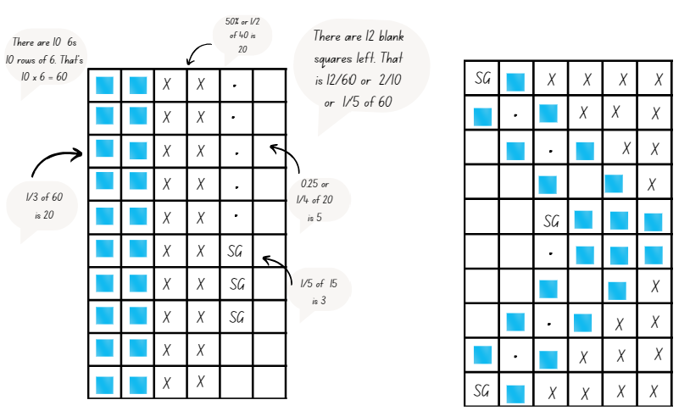
- Regroup as a class. Ask:
- How many squares did you start off with?
- How did you work out 0.25 of the remaining squares?
- How many squares are still blank?
- Display a student’s representation. Ask: If there are 12 blank squares, how can you represent that as a fraction of the whole you started with? ($\frac{12}{60}$ or $\frac{2}{10}$ or $\frac{1}{5}$).
- Model solutions displaying various strategies. For example, if both the numerator and denominator are even numbers, repeated division by 2 can be used to simplify both the numerator and denominator (12 ÷ 2 and 60 ÷ 2 and so on).
- Ask students if there are other factors that can be used to divide both the numerator and denominator, such as 12 ÷ 6 and 60 ÷ 6; 12 ÷ 4 and 60 ÷ 4; 12 ÷ 3 and 60 ÷ 3 and so on.
- Ask: How can we represent $\frac{2}{10}$ as a decimal? (0.2). Select students to share solutions.
This table details opportunities for assessment.
Assessment opportunities | Links
What to look for:  - Can students recognise that the symbol % means percent?  [MAO-WM-01, MA3-RN-03]  - Can students identify and use equivalent percentages, decimals and fractions, such as $\frac{1}{2}$ , 50% and 0.5 to solve problems?  [MAO-WM-01, MA3-RN-03] | Links to National Numeracy Learning Progressions (NNLP):  - PrT1, PrT2, UuM8.

Core lesson – pumpkin mass – 50 minutes
The table below contains a suggested learning intention and success criteria. These are best co-constructed with students.
Core concept learning intention | Core concept success criteria
Students are learning to:  - convert between common metric units of mass. | Students can:  - convert between kilograms and grams and between kilograms and tonnes  - solve problems involving different units of mass.
Note: a whole pumpkin (or watermelon) and 5 different sized pieces of pumpkin labelled A, B, C, D and E will be needed for this lesson.
- Investigate the mass of the whole pumpkin by passing the pumpkin around the class. After hefting, students estimate its mass and record their estimate on a sticky note. Display sticky notes on the board and as a class, order these in ascending order. Ask:
- What unit(s) of mass did you use in your estimate? Why?
- Are the estimates close or within a small range? Why might this be?
- What is the difference between the largest and smallest estimate?
- What is the best measuring device to measure the whole pumpkin? Why?
- Students draw a table titled ‘Pumpkin Mass’ in their workbook, labelling the columns ‘Pumpkin Piece’, ‘Mass Estimate', ‘Mass in grams’ and ‘Mass in kg’.
- Students heft to estimate the mass of the 5 labelled pieces of pumpkin, recording their estimates in the table.
- Explain that students now need to choose an appropriate measuring device and measure the mass of each piece of the pumpkin. Record results in kilograms (kg) and grams (g).
- Once students have weighed all the pieces of pumpkin, they refer to the completed tables to answer the following questions in their workbooks:
- What was the difference in mass between your largest and smallest estimate?
- What was the difference in mass between your largest and second largest piece of pumpkin?
- What is the combined mass of the 2 smallest pieces of pumpkin?
- Compare your estimates with your recorded measurements – give yourself a star rating as an estimator, for example, 5 stars = excellent, 1 star = needs more practice.
- Tell students that each year farmers in different countries grow giant pumpkins, trying to break the world record for the heaviest pumpkin. Display Resource 2 – world’s largest pumpkins. Students answer and record the following questions:
- What is the mass of each pumpkin in tonnes?
- What year was the heaviest pumpkin grown?
- What is the difference in mass between the lightest and heaviest pumpkin grown?
- What is the difference in grams between the 2020 and the 2022 pumpkin?
- How many more grams did the 2017 pumpkin weigh than the 2020 pumpkin?
- How would a farmer transport such a large pumpkin?
- How would it be weighed?
- Discuss answers as a class, with students justifying their answers and communicating their reasoning.
This table details opportunities for differentiation.
Too hard? | Too easy?
Students cannot convert between kilograms and grams and between kilograms and tonnes to solve problems involving different units of mass.  - Provide 3 pieces of pumpkin and metric weights. Support students to estimate, compare, weigh and order the pumpkin pieces. Assist students to read the scales as they calculate the difference in mass of the 3 pumpkin pieces.  - Using Resource 2 – world’s largest pumpkins, support students to convert and identify how many tonnes and kilograms each pumpkin weighs. | Students can convert between kilograms and grams and between kilograms and tonnes to solve problems involving different units of mass.  - Students calculate how many of the smallest pieces of pumpkin would be required to make a pumpkin soup recipe if the recipe requires 1.5 kilograms of pumpkin.  - Students calculate the total mass of all the world’s largest pumpkins. Record answers in tonnes (t) and kilograms (kg).

Consolidation and meaningful practice – 10 minutes
- Explain that Grandma Florence has a pumpkin scone recipe that requires 225 grams of cooked, mashed pumpkin and makes 15 scones.
- Give students individual whiteboards to work out and record their answers to the following questions:
- How many grams of pumpkin would be in each scone?
- How much pumpkin is needed to make 45 scones?
- How many scones can be made using the whole pumpkin the class weighed at the start of the lesson?
- How many batches of scones could be made using the 2021 champion pumpkin?
- Select students to share and explain their answers.
This table details opportunities for assessment.
Assessment opportunities | Links
What to look for:  - Can students convert between kilograms and grams and between kilograms and tonnes? [MAO-WM-01, MA3-NSM-01]  - Can students solve problems involving different units of mass? [MAO-WM-01, MA3-NSM-01] | Links to National Numeracy Learning Progressions (NNLP):  - UuM6, UuM8.

Lesson 2
Core concept: the larger the unit, the smaller the measure.

Daily number sense – solving a problem – 10 minutes
The table below contains a suggested learning intention and success criteria. These are best co-constructed with students.
Daily number sense learning intention | Daily number sense success criteria
Students are learning to:  - make connections between benchmark fractions, decimals and percentages. | Students can:  - recognise that the symbol % means percent  - identify and use equivalent percentages, decimals and fractions, such as $\frac{1}{2}$ , 50% and 0.5 to solve problems.
- Display Resource 3 – solving problems. Ask students to turn and talk to discuss ideas and strategies for finding out the solution. Ask:
- What is the problem asking you to find out?
- What is a strategy you could use to work out the answer?
- How will you know you have the correct answer?
- Provide students with writing materials to solve the problem.
- Select students to share and justify their thinking.
This table details opportunities for assessment.
Assessment opportunities | Links
What to look for:  - Can students recognise that the symbol % means percent?  [MAO-WM-01, MA3-RN-03]  - Can students identify and use equivalent percentages, decimals and fractions, such as $\frac{1}{2}$ , 50% and 0.5 to solve problems?  [MAO-WM-01, MA3-RN-03] | Links to National Numeracy Learning Progressions (NNLP):  - PrT1, PrT2, UuM8.

Core lesson 1 – Which unit is best? – 10 minutes
The table below contains a suggested learning intention and success criteria. These are best co-constructed with students.
Core concept learning intention | Core concept success criteria
Students are learning to:  - convert between common metric units of mass. | Students can:  - convert between kilograms and grams and between kilograms and tonnes  - solve problems involving different units of mass.
- Display Resource 4 – Grams, kilograms, tonnes? Students write the list of items into their workbooks.
- Ask students to consider each item and record the best unit of measurement to measure the mass of the item. Students turn and talk with a partner to explain and justify their choices.
- Select students to share and communicate their reasoning. Ask:
- Would we measure a bag of apples in tonnes? Why or why not?
- Are grams a sensible unit to measure a school bag? Why or why not? Is there a more appropriate unit?
- A dining table has a mass of 100 000 grams, 100 kilograms or 0.1 tonnes. What do you notice about how these numbers change? Which unit of mass is best to use and why?
- Do we measure the mass of everything in grams? Why or why not?

Core lesson 2 – rubbish masses – 20 minutes
- Watch Australia's Plastic Waste Problem (3:42).
- Display Resource 5 – kilograms-tonnes conversion and remind students how to convert between kilograms (kg) and tonnes (t).
- Display Resource 6 – household waste. Students recreate the table in their workbooks and complete the conversions between units of measurement.
- Using the information on Resource 6 – household waste, students calculate the following and record in their workbooks:
- Based on the number of people who live in your household, how much rubbish is produced per week?
- Based on the number of people who live in your household, how much rubbish is produced per year?
- What would be the difference in the mass of rubbish produced weekly between a 6-person household and a 2-person household?
- How much waste have you produced already in your lifetime?
- By the time you turn 30, what will be the total mass of waste you have produced?

Core lesson 3 – landfill masses – 20 minutes
This lesson has been adapted from Types of Rubbish from NZ Maths by New Zealand Ministry of Education.
- Explain to students that according to Clean Up Australia, in 2017 approximately 22 million tonnes of waste generated by Australians was disposed of in landfill (Clean Up Australia 2024).
- Provide students with Resource 7 – landfill waste. Ask students to complete conversions from tonnes (t) to kilograms (kg).
- Based on the information on Resource 7 – landfill waste, students answer the following questions in their books:
- What is the combined total mass of waste in tonnes per year? In kilograms?
- What is the total mass of timber and rubble, metals and hazardous material per year? In kilograms?
- If we recycled paper and plastic waste, how much less waste would there be each year?
- If there are 115 000 tonnes of organic waste produced each year, how much is produced each week?
- How much less hazardous material goes into landfill compared to timber and rubble?
- How do you think the mass of each type of waste is measured?
This table details opportunities for differentiation.
Too hard? | Too easy?
Students cannot convert between kilograms and grams and between kilograms and tonnes to solve problems involving different units of mass.  - Provide students with the converted answers to match with the correct place Resource 6 – household waste and Resource 7 – landfill waste.  - Provide students with smaller numbers to complete landfill waste calculations with. | Students can convert between kilograms and grams and between kilograms and tonnes to solve problems involving different units of mass.  - Ask, if you reduced the amount of household waste you produce per week to 7 kilograms, how much less waste would you produce per year?  - Challenge students to calculate the following: If we produced $\frac{1}{4}$ less of each type of landfill waste per year, what would the combined total mass be?

Discuss and connect the mathematics – 10 minutes
- Facilitate a class discussion referring to Resource 7 – landfill waste:
- Why are grams (g) excluded as a unit of mass for this activity?
- If grams were included, what would those numbers look like?
- Would these numbers make calculations easier or more difficult? Why?
- What do you notice about the numbers in the tonnes (t) column and the numbers in the kilograms (kg) column?
- What does the statement ‘the larger the unit, the smaller the measure’ mean?
This table details opportunities for assessment.
Assessment opportunities | Links
What to look for:  - Can students convert between kilograms and grams and between kilograms and tonnes? [MAO-WM-01, MA3-NSM-01]  - Can students solve problems involving different units of mass? [MAO-WM-01, MA3-NSM-01] | Links to National Numeracy Learning Progressions (NNLP):  - UuM6, UuM8.

Lesson 3
Core concept: a mass can be renamed using different units of measurement.

Daily number sense – odd one out – 10 minutes
The table below contains a suggested learning intention and success criteria. These are best co-constructed with students.
Daily number sense learning intention | Daily number sense success criteria
Students are learning to:  - make connections between benchmark fractions, decimals and percentages. | Students can:  - identify and use equivalent percentages, decimals and fractions, such as $\frac{1}{2}$ , 50% and 0.5 to solve problems.
- Provide pairs of students with Resource 8 – odd one out and writing materials.
- Explain that students need to find pairs and match up fractions, decimals and/or percentages to determine which is the odd one out after they have all been paired up.
- As a class ask:
- What was an easy pair to identify? Why?
- Which pair was the most challenging and how did you solve it?
- Are there any pairs that you are still wondering about?
- Which fraction and decimal was easy to pair up? Why?
- Which decimal and percentage was easy to pair up? Why?
This table details an opportunity for assessment.
Assessment opportunity | Links
What to look for:  - Can students identify and use equivalent percentages, decimals and fractions, such as $\frac{1}{2}$ , 50% and 0.5 to solve problems?  [MAO-WM-01, MA3-RN-03] | Links to National Numeracy Learning Progressions (NNLP):  - PrT1, PrT2, UuM8.

Core lesson – mass word problems – 40 minutes
The table below contains suggested learning intentions and success criteria. These are best co-constructed with students.
Core concept learning intentions | Core concept success criteria
Students are learning to:  - convert between common metric units of mass  - apply efficient mental and written strategies to solve addition and subtraction problems. | Students can:  - interpret decimal notation for masses  - convert between kilograms and grams and between kilograms and tonnes.  - solve problems involving different units of mass  - apply known strategies such as levelling, addition for subtraction, using constant difference and bridging
This activity is adapted from Open-ended Maths Activities: Using ‘Good’ Questions to Enhance Learning in Mathematics, Revised edn by Sullivan and Lilburn and ‘Accurate?’ from Teaching Measurement: Stage 2 – Stage 3 by NSW Department of Education Learning and Teaching Directorate.
Note: each small group of students will need a kitchen or bathroom scale, as well as one set of Resource 9 – mass word problems prepared prior to the lesson.
- Pose the following to students: Sue and Mark weighed a suitcase using bathroom scales. Sue said the mass was 25 kilograms and Mark said the mass was 24 kilograms. How could this happen? Draw students' attention to the difference in mass and discuss using the questions in the table below to generate conversation about the topic.
Prompts | Anticipated student responses
- What could be causing the different results? | - Sue might be leaning on the suitcase, adding more mass.  - Sue’s hand could be holding the suitcase to balance it.  - Mark could have placed the suitcase unevenly on the scale.  - Mark could be holding the suitcase off the scale while trying to balance it.
- Is using a bathroom scale the best way to find the mass of a suitcase? Why or why not? | - No, because the scale is too small.  - No, because bathroom scales are usually square, and a suitcase is rectangular so you can’t fit it on top accurately.  - No, because the screen is small so you must move the suitcase to be able to read the mass and that can make it inaccurate.  - Yes, because you can weigh yourself and then weigh yourself holding the suitcase. Then you subtract your mass to work out the mass of the suitcase.
- Choose students to communicate their thinking.
- Tell students they will work in small groups to check the accuracy of kitchen and bathroom scales. Instruct students to draw a table in their workbooks titled ‘Scale accuracy.’
- Provide groups with access to several different bathroom and kitchen scales and 500 g, 1 kg and 2 kg metric weights.
- Groups measure each metric weight on all available scales and record in grams (g) and kilograms (kg).
- Once students have checked each scale, they write a comment on the accuracy of each scale.
- Regroup as a class and select a representative from each group to share their findings. Ask:
- What do we need to ensure when we are using scales to measure mass?
- When is it important to be able to measure mass accurately? Why?
- Provide each group of students with a set of Resource 9 – mass word problems. Students work through the challenge cards and record answers in their workbook.
This table details opportunities for differentiation.
Too hard? | Too easy?
Students cannot convert between common metric units of mass.  - Provide concrete materials to assist with answering the challenge cards.  - Assist students to complete challenge cards in one unit of measurement only. | Students can convert between common metric units of mass.  - Students write their own mass challenge question for a partner to solve.  - A recycling centre collected 4.5 tonnes (t) of paper in a month. The paper is distributed in bags holding 250 kilograms (kg) each. How many bags will be needed?

Discuss and connect the mathematics – 10 minutes
- Share challenge card responses in a class discussion. Select students to justify their answers and explain strategies used. Ask:
- Which card was the most challenging? Why?
- After listening to your classmates, would you use any different strategies? Which ones? Why?
- What do you notice about the numbers when you convert between units of mass?
This table details opportunities for assessment.
Assessment opportunities | Links
What to look for:  - Can students interpret decimal notation for masses?  [MAO-WM-01, MA3-NSM-01]  - Can students convert between kilograms and grams and between kilograms and tonnes? [MAO-WM-01, MA3-NSM-01]  - Can students solve problems involving different units of mass? [MAO-WM-01, MA3-NSM-01] | Links to National Numeracy Learning Progressions (NNLP):  - UuM6, UuM8.

Lesson 4
Core concept: metric units of measurement can be described using the decimal place value system.

Daily number sense – 10 minutes
- From a class need surfaced through formative assessment data, identify a short, focused activity that targets students’ knowledge, understanding and skills. Example activities may be drawn from the following resources:
- Mathematics K–6 resources
- Universal Resources Hub.

Core lesson – crocodile measurements – 40 minutes
The table below contains a suggested learning intention and success criteria. These are best co-constructed with students.
Core concept learning intention | Core concept success criteria
Students are learning to:  - connect decimal representations to the metric system. | Students can:  - recognise the equivalence of whole-number and decimal representations of measurements of mass and length  - interpret decimal notation for masses and lengths  - record mass and length using decimal notation of up to 3 decimal places.
- Tell students that saltwater crocodiles are the largest living reptile in the world. They are found throughout the world in warm tropical areas. Display Resource 10 – crocodile facts. Ask:
- What units of measurement do you notice in the table?
- How do we convert between metres and centimetres? Tonnes, kilograms and grams?
- How much heavier is a male saltwater crocodile than a female saltwater crocodile?
- How much heavier is a female saltwater crocodile than a baby saltwater crocodile?
- How do we convert the length of a male saltwater crocodile to centimetres?
- How do we convert the length of a baby saltwater crocodile to metres?
Note: it is optional to provide students with a copy of Resource 10 – crocodile facts or students can recreate the table in their workbooks.
- Provide students with Resource 11 – crocodile measurements and display Resource 12 – crocodile conversion chart.
- Students recreate the table in their workbooks, writing in the given measurements for length and mass. Remind students to put the measurement in the correct column.
- Students complete the table by converting measurements between metres (m) and centimetres (cm) and tonnes (t), kilograms (kg) and grams (g).
This table details opportunities for differentiation.
Too hard? | Too easy?
Students cannot interpret decimal notation for masses and lengths.  - Give students a completed copy of Resource 12 – crocodile conversion chart with the crocodiles de-identified. Students match measurements with the crocodiles.  - Supports students to use a metric conversion chart to record and complete Resource 12 – crocodile conversion chart. | Students can interpret decimal notation for masses and lengths.  - The mass of an average car is 2 tonnes. How many baby saltwater crocodiles would equal the mass of an average car?  - Calculate how many of ‘you’ is equivalent to a male saltwater crocodile.

Consolidation and meaningful practice – 15 minutes
- Using the information on their completed crocodile conversion chart, students answer the following questions in their workbooks, answering in all units of measurement:
- How much longer is Crocodile D than Crocodile A?
- What is the combined mass of Crocodiles C, G and H?
- How many of Crocodile F standing nose to tail would it take to exceed the length of 1 km?
- What is the combined length of all the crocodiles?
- What is the combined mass of all the crocodiles?
- What 3 crocodiles have a combined mass of 3680 kg?
This table details opportunities for assessment.
Assessment opportunities | Links
What to look for:  - Can students recognise the equivalence of whole-number and decimal representations of measurements of mass and length? [MAO-WM-01, MA3-NSM-01, MA3-GM-02]  - Can students interpret decimal notation for masses and lengths? [MAO-WM-01, MA3-NSM-01, MA3-GM-02]  - Can students record mass and length using decimal notation of up to 3 decimal places? [MAO-WM-01, MA3-NSM-01, MA3-GM-02] | Links to National Numeracy Learning Progressions (NNLP):  - NPV7, NPV8, NPV9.

Lesson 5
Core concept: different shapes can have the same perimeter.

Daily number sense – build to the whole 1 – 10 minutes
Daily number sense activities for Lessons 5 to 7 ‘loop’ back to concepts and procedures covered in previous units to assist students to build an increasingly connected network of ideas. These concepts may differ from the core concepts being covered by the unit.
The table below contains a suggested learning intention and success criteria. These are best co-constructed with students.
Daily number sense learning intention | Daily number sense success criteria
Students are learning to:  - build up to the whole from a given fractional part. | Students can:  - generate the whole quantity from non-unit fractional parts.
- Ask students: if you are given three-fifths ($\frac{3}{5}$) of a length of rope, how can you find the total length?
- Provide students with individual whiteboards. Allow time for students to think and turn and talk to discuss how they could find the total length.
- Select students to share and explain their strategy. Record and test student responses. Ask:
- Does it matter what fraction of the length of rope you are given?
- How did the fraction of the length of rope determine what strategy you used?
- Can you use the same strategy to find the total length if you are given $\frac{5}{8}$ of a length? Select students to test and justify strategies used.
This table details opportunities for assessment.
Assessment opportunities | Links
What to look for:  - Can students generate the whole quantity from non-unit fractional parts? [MAO-WM-01, MA3-RQF-02] | Links to National Numeracy Learning Progressions (NNLP):  - InF5.

Core lesson – different shapes can have the same perimeter – 40 minutes
The table below contains a suggested learning intention and success criteria. These are best co-constructed with students.
Core concept learning intention | Core concept success criteria
Students are learning to:  - solve problems involving the comparison of lengths using appropriate units. | Students can:  - investigate and compare perimeters of rectangles with the same area  - determine the number of different rectangles that can be formed using whole-number dimensions for a given area.
Note: the perimeter of an object, shape or location is the same as the boundary. Perimeter is the length around an object, shape or location. Perimeter is calculated by adding the length of all the sides. Area is the measure of the amount of space enclosed by the boundaries or sides of a two-dimensional shape. It is expressed in square units, such as square centimetres (cm²) and square metres (m²).
- Review student understanding of perimeter and area. Create a poster, anchor chart or a window or door display to review what parts of a shape are measured when calculating area and perimeter (see Figure 2).
Figure 2 – classroom display example
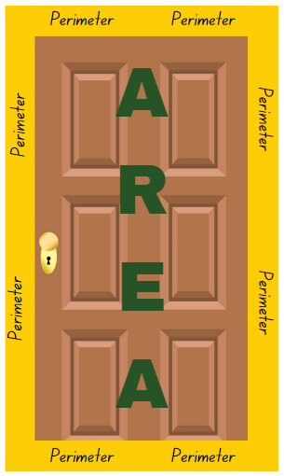
- Display Resource 13 – perimeter modelling. Explain that each of these shapes has an area of 12 squares, but all have different perimeters. For the purpose of this activity, the scale is 1 square = 1 cm^{2.}
- Model calculating the perimeter of each of the shapes on Resource 13 – perimeter modelling.
- Provide students with 1 cm grid paper and a 30 cm ruler. Students create as many squares or rectangles as they can that have an area of 24 cm^{2.}
- Students calculate the perimeter of each shape they have drawn. Ask:
- Did you make all possible rectangles with an area of 24 cm²? How do you know?
- What was the length of the longest perimeter?
- What was the length of the shortest perimeter?
- What is the quickest way to calculate the area of a rectangle? Explain your answer.
- How could you work out the perimeter of a shape if all side lengths are not labelled?
- Provide students Resource 14 – missing perimeter problems. Students work through each problem independently.
- Regroup as a class and discuss any challenges faced when completing the problems.
This table details opportunities for differentiation.
Too hard? | Too easy?
Students cannot solve and record solutions for perimeter and/or area problems involving various lengths.  - Provide students with the missing side measurements on Resource 14 – missing perimeter problems.  - Provide students with a perimeter definition to reference when completing tasks. | Students can solve and record solutions for perimeter and/or area problems involving various lengths.  - You have an irregular shaped garden. The perimeter fencing totals 15.5 metres. What could the length of its 4 sides be?  - You have an irregular shaped pool fence with a perimeter of 37.2 metres. What could the length of its 4 sides be?

Consolidation and meaningful practice – 15 minutes
- Tell students that they will make a ‘weird robot’ using measurements of perimeter.
- Provide students with 1 cm grid paper or their grid workbook and two 6-sided dice.
- Explain that students will roll the pair of dice 6 times. Each roll will provide 2 side measurements of a rectangle or square that form a different body part of their robot as follows:
- Roll 1 – head
- Roll 2 – body
- Roll 3 – arm 1
- Roll 4 – arm 2
- Roll 5 – leg 1
- Roll 6 – leg 2.
Note: if time permits, extra rolls could be added for more details such as hands or feet.
- Students calculate the perimeter for each body part of their robot and record the measurement on the part.
- An additional challenge is for students to calculate the total perimeter of the robot and record in centimetres.
This table details opportunities for assessment.
Assessment opportunities | Links
What to look for:  - Can students investigate and compare perimeters of rectangles with the same area? [MAO-WM-01, MA3-GM-02]  - Can students determine the number of different rectangles that can be formed using whole-number dimensions for a given area (Reasons about spatial structure)? [MAO-WM-01, MA3-GM-02] | Links to National Numeracy Learning Progressions (NNLP):  - UuM6, UuM7.

Lesson 6
Core concept: decimal size and place value can be represented by different models.

Daily number sense – build to the whole 2 – 10 minutes
The table below contains a suggested learning intention and success criteria. These are best co-constructed with students.
Daily number sense learning intention | Daily number sense success criteria
Students are learning to:  - build up to the whole from a given fractional part. | Students can:  - generate the whole quantity from non-unit fractional parts.
- Ask students: if you are told five-eighths ($\frac{5}{8}$) of the length of the table, how can you find the total length of the table?
- Provide students with individual whiteboards. Allow time for students to think and then turn and talk to discuss how they could find the total length.
- Select students to share and explain their strategy. Record and test student responses.
This table details an opportunity for assessment.
Assessment opportunity | Links
What to look for:  - Can students generate the whole quantity from non-unit fractional parts? [MAO-WM-01, MA3-RQF-02] | Links to National Numeracy Learning Progressions (NNLP):  - InF5.

Core lesson – How much fencing? – 40 minutes
The table below contains suggested learning intentions and success criteria. These are best co-constructed with students.
Core concept learning intentions | Core concept success criteria
Students are learning to:  - apply known strategies to add decimals  - solve problems involving the comparison of lengths using appropriate units. | Students can:  - solve word problems involving the addition and subtraction of decimals  - justify why the strategy used to solve addition and subtraction word problems is appropriate  - investigate and compare perimeters of rectangles with the same area  - determine the number of different rectangles that can be formed using whole-number dimensions for a given area  - solve a variety of problems involving length and perimeter, including problems involving different units of length.
This activity is adapted from Fred’s Rent-a-fence from NZ Maths by New Zealand Ministry of Education.
- Refer to Figure 2 and revise prior learning on perimeter and area.
- Pose the following: Darryl rents out fences. Today he is putting up some fences to help keep the crowds safe at the showground during the annual show. Darryl’s fence panels come in panel lengths of 100 centimetres and 120 centimetres long. He is using them to fence rectangular spaces.
- Provide students with Resource 15 – Darryl’s fencing. Students solve each task and answer the questions in their workbooks.
- Regroup as a class. Ask:
- What strategy did you use to convert the fence panel measurement from centimetres to metres?
- When did you convert from centimetres to metres? At the beginning of the problem-solving process, or at the end? Why?
- What fenced off area was best for the skydivers to land safely? Justify your answer.
- Would this also be the best fence arrangement for spectators? Why or why not?
- What was the most challenging part of this task? Why?
This table details opportunities for differentiation.
Too hard? | Too easy?
Students cannot add decimals to solve problems involving the comparison of lengths.  - Provide students with the factors of 80 and 48, a decimal place value chart and/or a hundred chart to assist with calculations.  - Support students to complete Task 1 from Resource 15 – Darryl’s fencing using 100 cm fencing. | Students can add decimals to solve problems involving the comparison of lengths.  - Challenge students to design an irregular rectangle that has an area of 65 m² and is enclosed with fencing panels that are 120.5 cm in length.  - Ask: what is the difference between the cost of fencing a rectangular area with a perimeter of 24 m using the 100 cm panels or the 120 cm panels?

Consolidation and meaningful practice – 15 minutes
- Display Resource 16 – Cup ‘n’ Saucer and tell students that Darryl has fenced off a space for the Whirling Cup ’n’ Saucer ride.
- Provide students with individual whiteboards. Ask:
- What is the length of the long side?
- What is the perimeter of the fenced space?
- How many 120-centimetre fence panels will be needed to fence the Cup ‘n’ Saucer ride?
- How many 100-centimetre fence panels will be needed to fence the Cup ‘n’ Saucer ride?
- Choose students to share and justify answers.
This table details opportunities for assessment.
Assessment opportunities | Links
What to look for:  - Can students solve word problems involving the addition and subtraction of decimals? [MAO-WM-01, MA3-AR-01]  - Can students justify why the strategy used to solve addition and subtraction word problems is appropriate? [MAO-WM-01,  MA3-AR-01]  - Can students investigate and compare perimeters of rectangles with the same area? [MAO-WM-01, MA3-GM-02]  - Can students determine the number of different rectangles that can be formed using whole-number dimensions for a given area? [MAO-WM-01, MA3-GM-02]  - Can students solve a variety of word problems involving length and perimeter, including problems involving different units of length? [MAO-WM-01, MA3-GM-02] | Links to National Numeracy Learning Progressions (NNLP):  - AdS9  - UuM6, UuM7.  Links to suggested Interview for Student Reasoning (IfSR) tasks:  - IfSR-AT: 4A.1, 4A.2, 4A.3, 4A.4.

Lesson 7
Core concept: mathematicians compare and evaluate strategies used to solve measurement problems.

Daily number sense – given fraction parts – 10 minutes
The table below contains a suggested learning intention and success criteria. These are best co-constructed with students.
Daily number sense learning intention | Daily number sense success criteria
Students are learning to:  - build up to the whole from a given fractional part. | Students can:  - generate the whole quantity from non-unit fractional parts.
- Ask students: if you are given four-tenths ($\frac{4}{10}$) of a collection of objects, how can you find the total number of objects?
Note: to further support students, revise Daily number sense lessons 5 and 6, drawing on students thinking and strategies used to solve each task.
- Provide students with individual whiteboards. Allow time for students to think and the turn and talk to discuss how they could find the total number.
- Select students to share and explain their strategy. Record and test student responses.
This table details an opportunity for assessment.
Assessment opportunity | Links
What to look for:  - Can students generate the whole quantity from non-unit fractional parts? [MAO-WM-01, MA3-RQF-02] | Links to National Numeracy Learning Progressions (NNLP):  - InF5.

Core lesson – mystery bones – 50 minutes
The table below contains a suggested learning intention and success criteria. These are best co-constructed with students.
Core concept learning intention | Core concept success criteria
Students are learning to:  - solve problems involving the comparison of lengths using appropriate units. | Students can:  - explain and use the relationship between the size of a unit and the number of units needed  - solve a variety of problems involving length including problems involving different units of length.
This lesson is adapted from The Case of the Mystery Bone: A Unit of Work on Measurement for Grades 5 to 8 by Clarke.
- Revise how to use a soft measuring tape. Instruct students to use a soft measuring tape to find 3 objects in the room with a length between 15 centimetres and 16 centimetres. Regroup as a class and ask:
- What do you need to remember when you are using a measuring tape?
- Was it easy to find 3 objects within this length range? Why or why not?
- How did you choose objects to measure for this task?
- Announce: ‘Newsflash! Human bones have been found washed up on the banks of the Macquarie River. Forensic anthropologists have established that the bones are a radius and a tibia. The radius measured 28 centimetres long and the tibia 44 centimetres long. Police are yet to discover the identity of the deceased person but hope to soon determine their gender. As investigations continue, more details will become known.’
- Discuss where on the body the radius and tibia bones are found.
- Give students copies of Resource 17 – mystery bones. Students take the measurements in centimetres of the length of the radius and tibia bone and the height of 5 people in their class (person A, B, C, D and E). Record results in the table on Resource 17 – mystery bones.
- Using the data, students answer the questions on Resource 17 – mystery bones.
- Discuss as a whole class:
- Did you notice any patterns between height and the length of the radius? Explain your answer.
- Did you notice any patterns between height and the length of the tibia? Explain your answer.
- Can you predict the height of the deceased using their tibia? Explain your strategy.
- Could the 2 bones discovered at the river (radius and tibia) belong to the same person? How do you know?
- Forensic anthropologists assess skeletal remains to determine a range of details about the deceased person. Display Resource 18 – bone measurement prediction.
- Say ‘Imagine you are a Forensic Anthropologist today! Forensic Anthropologists use these formulas to calculate the height of a deceased person when they only have partial skeletal remains.’
- Provide students with copies of Resource 18 – bone measurement prediction and Resource 19 – anthropology investigations.
- Students use the formulas from Resource 18 – bone measurement prediction to solve predictions for both the male and female heights, recording answers in their workbooks. Students then answer the questions on Resource 19 – anthropology investigations.
This table details opportunities for differentiation.
Too hard? | Too easy?
Students cannot solve problems involving the comparison of lengths using appropriate units.  - Support students to record the height, radius and tibia measurement of 3 people in the class using a tape measure.  - In small groups, students select 2 students that are of a different height. Using a measuring tape and modelling clay, students measure and reproduce each radius and tibia bone, recording results in centimetres on a sticky note. Using the formulas on Resource 18 – bone measurement prediction, student predict the height for each student and record predictions on a strip of paper that accurately represents the predicted measurement. Students then use a measuring tape to measure the height of each student and compare and discuss the results. | Students can solve problems involving the comparison of lengths using appropriate units.  - Challenge students to calculate the height of a person with a radius of 230 mm in length, recording their answer in millimetres and centimetres.  - Students investigate the tallest person in the world and predict and calculate in millimetres their radius, tibia and humerus bone length.

Discuss and connect the mathematics – 10 minutes
- Regroup as a class and summarise the lesson, drawing out key mathematical ideas. Ask:
- Was there a result that was not consistent? Why?
- Describe a situation where the length of a bone would not be enough to determine the height of a person.
- What other body parts could forensic scientists measure to work out the height of a person?
- Can you think of another career that would use the length of bones to determine the height of something?
- What challenges did you face during the activity? How did you overcome them?
This table details opportunities for assessment.
Assessment opportunities | Links
What to look for:  - Can students solve a variety of problems involving length including problems involving different units of length? [MAO-WM-01,  MA3-GM-02]  - Can students explain and use the relationship between the size of a unit and the number of units needed? [MAO-WM-01,  MA3-GM-02] | Links to National Numeracy Learning Progressions (NNLP):  - UuM6, UuM7.

Lesson 8
Core concept: comparing and converting units of measurement helps to make sense of our world.

Daily number sense – 10 minutes
- From a class need surfaced through formative assessment data, identify a short, focused activity that targets students’ knowledge, understanding and skills. Example activities may be drawn from the following resources:
- Mathematics K–6 resources
- Universal Resources Hub.

Core lesson – mega trees – 45 minutes
The table below contains suggested learning intentions and success criteria. These are best co-constructed with students.
Core concept learning intentions | Core concept success criteria
Students are learning to:  - convert between common metric units of length  - solve problems involving the comparison of lengths using appropriate units. | Students can:  - use the decimal place value system to convert between metres and kilometres  - convert measurements to the same unit to compare lengths and distances  - solve a variety of problems involving length including problems involving different units of length.
- Display Resource 20 – conversion chart. Revise student knowledge of the procedure used to convert measurements between metres (m) and kilometres (km).
- Watch National Tree Day (1.39).
- Display Resource 21 – mega trees and explain that trees are the tallest plants on Earth. Highlight that some of the trees have reached phenomenal heights.
- Divide the class into 3 groups. Assign each group one of the trees. Explain they will be marking out the dimensions of their assigned tree to understand how big these ‘mega trees’ are.
- Each group uses a trundle wheel and cones to measure and mark the height of their assigned tree on the playground.
- Groups measure and mark the width (diameter) of their tree with trundle wheels and use skipping ropes to outline the circumference of the trunk based on this measurement.
- Regroup and look at each of the marked tree dimensions. Ask:
- Were you able to mark out the tree height measurement in a straight line? If not, how did you complete the task?
- What strategy did your group use to ensure your tree width (diameter) was even all the way around?
- How many classmates can stand inside the marked ‘trunk’ of each tree?
- Do you think these trees deserve to be called ‘mega’ trees? Why or why not?
Note: Fermi questions are problems that require estimation, named after the Nobel Prize winning physicist Enrico Fermi, who was known for his ability to make good approximate calculations with little or no actual data. These questions prompt students to use their reasoning skills, rounding and estimations when calculating.
- Return to the classroom and display Resource 22 – mega tree questions. Provide small groups of students with Resource 21 – mega trees and workbooks to record the answers to the questions.
This table details opportunities for differentiation.
Too hard? | Too easy?
Students cannot convert between common metric units of length and solve problems involving the comparison of lengths using appropriate units.  - Provide students with Resource 20 – conversion chart and support them to use the chart when completing mega tree questions.  - Support students to complete questions in Resource 22 – mega tree questions. | Students can convert between common metric units of length and solve problems involving the comparison of lengths using appropriate units.  - Challenge students to convert tree diameters and heights to centimetres and millimetres.  - Ask: What is the height difference between each tree? What is the difference in diameter? Is there a relationship between the 2 measurements?

Consolidation and meaningful practice – 15 minutes
- Coast Redwoods are among the fastest-growing trees on Earth. They grow 122 centimetres in height each year. Students record solutions to the following questions in their workbooks using more than one unit of measurement.
- How tall will a Coast Redwood be after 15 years of growth?
- A Coast Redwood has a height of 54.9 metres. How many years has it been growing for?
- A Coast Redwood is 100 metres tall and has a mass of 5500 tonnes. What is the mass of 10 metres of the trunk?
- A log truck can carry 40 000 kilograms. How many truck loads would be needed to transport a Coast Redwood with a mass of 4200 tonnes?
This table details opportunities for assessment.
Assessment opportunities | Links
What to look for:  - Can students use decimal place value system to convert between metres and kilometres? [MAO-WM-01, MA3-GM-02]  - Can students convert measurements to the same unit to compare lengths and distances? [MAO-WM-01, MA3-GM-02]  - Can students solve a variety of problems involving length including problems involving different units of length? [MAO-WM-01,  MA3-GM-02] | Links to National Numeracy Learning Progressions (NNLP):  - NPV8, UuM8.

Resource 1 – grid paper
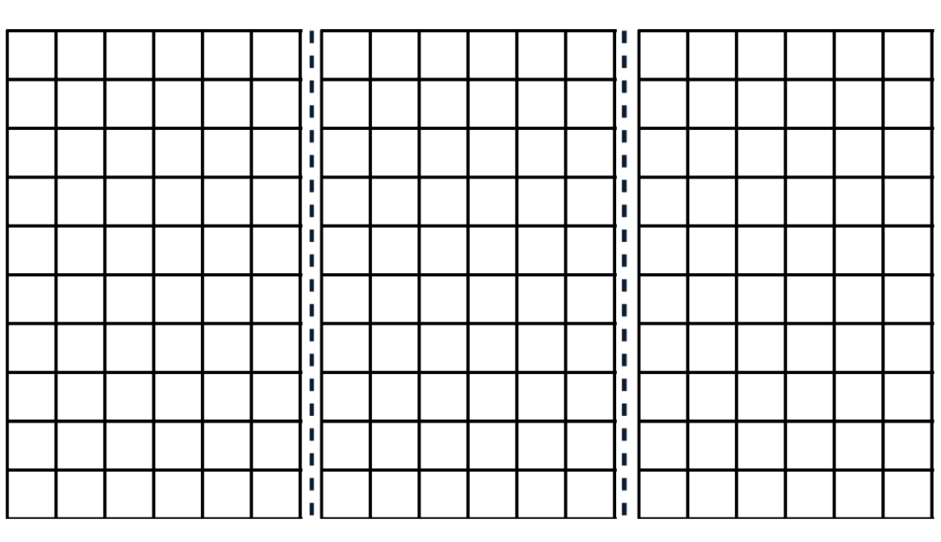

Resource 2 – world’s largest pumpkin
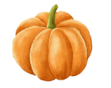World’s largest pumpkins
Year pumpkin was grown | Mass in kilograms (kg) | Mass in tonnes (t)
2017 | 1190.5 kg
2019 | 1136.7 kg
2020 | 1176.5 kg
2022 | 1119 kg
2023 | 1204.8 kg

Resource 3 – solving problems
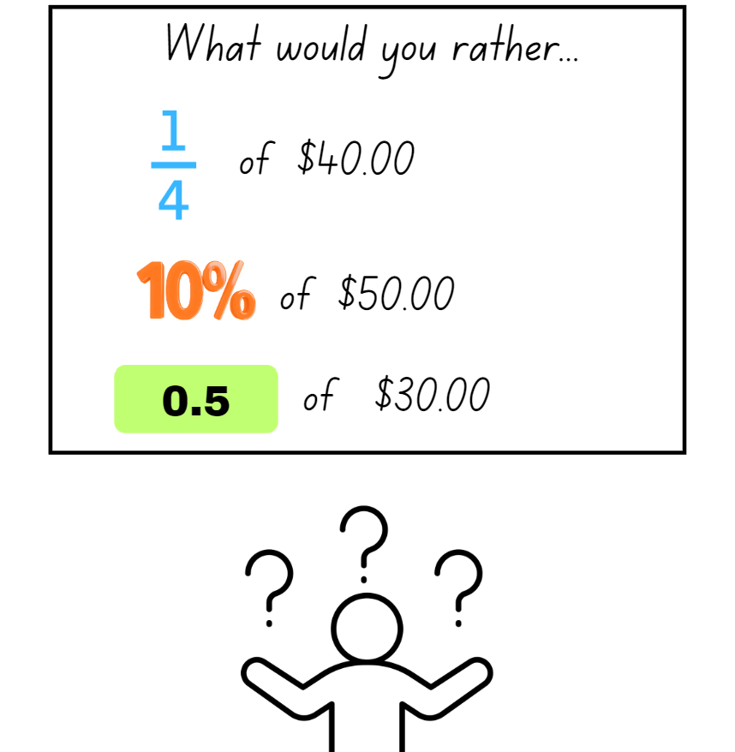

Resource 4 – Grams, kilograms, tonnes?
Object | Grams (g) | Kilograms (kg) | Tonnes (t)
Bag of apples
One apple
School bag
Car
Person
Pencil
Table
Truck

Resource 5 – kilograms-tonnes conversion
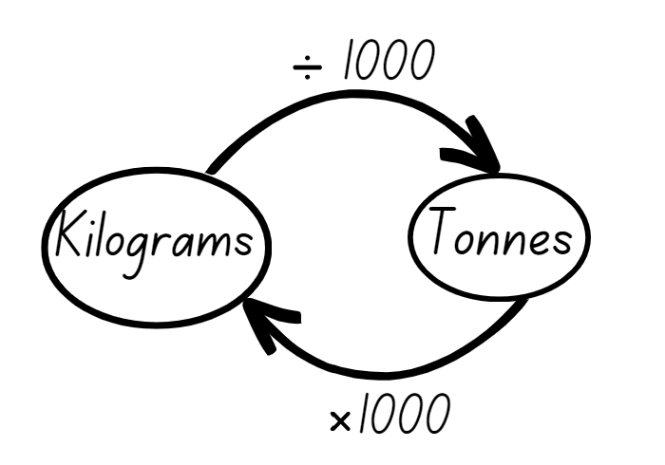

Resource 6 – household waste
Rubbish produced per person | Grams (g) | Kilograms (kg) | Tonnes (t)
Per week | 10 000 g
Per year |  | 520 kg
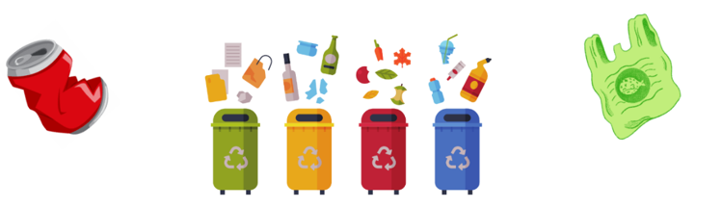

Resource 7 – landfill waste
Types of waste per year | Tonnes (t) | Kilograms (kg)
Timber and rubble | 130 000
Organic | 115 000
Paper | 75 000
Hazardous material | 55 000
Plastics | 45 000
Other (glass/rubber/textiles) | 40 000
Metals | 25 000
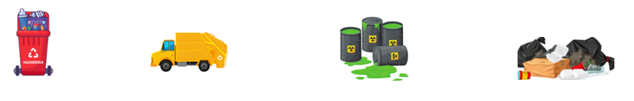

Resource 8 – odd one out
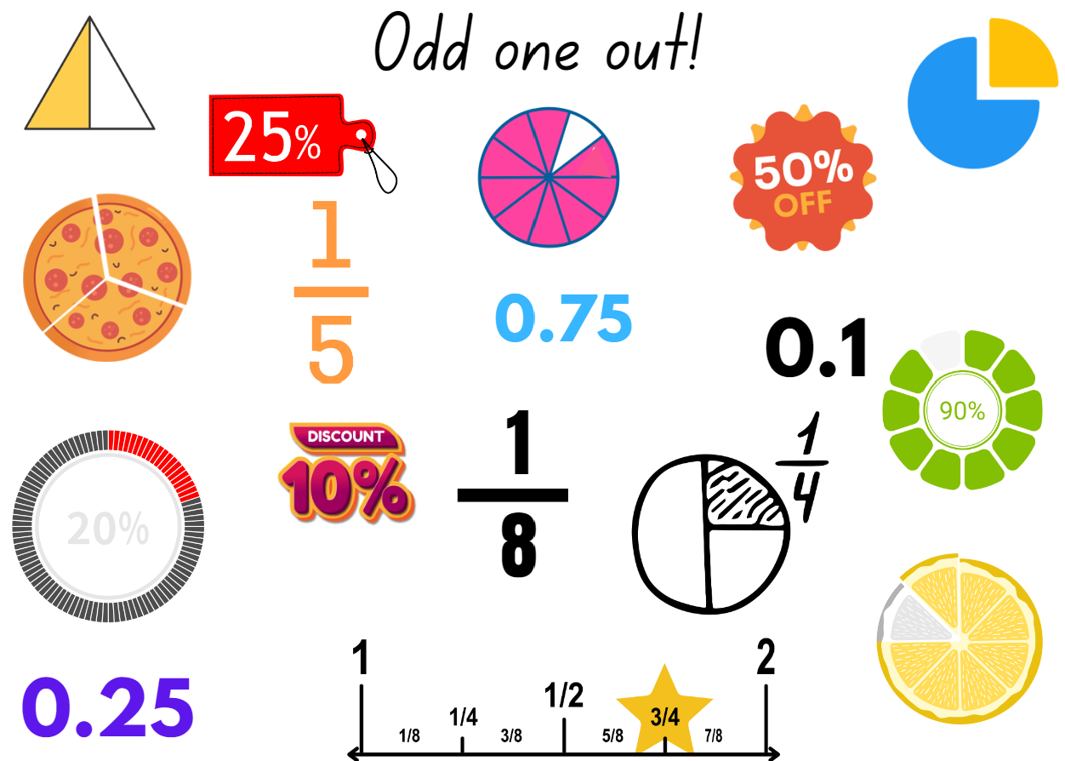

Resource 9 – mass word problems
1. The baker has 5 dozen eggs that weigh 550 g per dozen. She also has 300 g of butter and 735 g of sugar. What is the total mass of her ingredients?  Answer in grams and kilograms and then order the masses in ascending order.  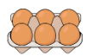 |  | 2. Find the total mass of 5 items weighing 8005 g, 8.60 kg, 2340 g, 3025 g and 4.05 kg.  Answer in grams and kilograms and then order the masses in ascending order.
3. A cook prepares 3700 g of flour, 0.81 kg of melted butter and 1 kg 225 g of brown sugar. What is the total mass of ingredients?  Answer in grams and kilograms and then order the masses in descending order. |  | 4. A florist orders 4 boxes of flowers. The boxes contain 3.75 kg of yellow roses, 2.95 kg of purple irises and 6325 g of flannel flowers.  Answer in grams and kilograms and then round your answer up to the nearest kg.  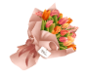
5. Regina buys 4 kg of red lollies, a box of chocolate weighing 3.75 kg, a 1.25 kg box of cupcakes and a 1.5 kg container of ice cream. How much does she have altogether?  Answers in grams and kilograms and then order the masses in descending order. |  | 6. You are opening a new gym. You purchase a medicine ball weighing 8 kg, 2 sets of 15.5 kg barbells and a weighted skipping rope that weighs 3.5 kg.  Order the masses in descending order. What is the difference in mass between the medicine ball and the skipping rope? What is the total mass of all the equipment? Record answers in grams and kilograms.
7. Sarah orders a dress that weighs 750 g, a necklace that weighs 525 g and a pair of high heels that weigh 873 g. What is the weight of her 3 items?  Answers in grams and kilograms and then order the masses in descending order. |  | 8. Find the total mass of 3 items weighing 897 g, 9.44 kg and 476 g.  Answers in grams and kilograms and then order the masses in descending order.
9. Find the total mass of 3 vehicles weighing 1900 kg, 2.6 t and 3240 kg.  What is the difference in mass between the heaviest and lightest vehicles? Answer in kilograms and tonnes. |  | 10. A landscape gardener had 5.2 t of topsoil, 3400 kg of bark chips and 2.95 t of pebbles delivered.  How many more kg of topsoil than pebbles did he order? What is the combined total mass of materials? Answer in tonnes and kilograms.
11. There are 6.82 t of rice, 7425 kg of wheat and 5.79 t of barley stored in a warehouse. What is the combined total mass? What is the difference in mass between rice and barley?  Answer in tonnes and kilograms.  How many 10 tonne loads would be required to move the grain?  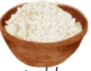 |  | 12. Over 3 consecutive years a mine produced 1985 000 t coal. The amount produced in the second year was double the yield from the first year. The third year also produced more than the first year. What could the amounts of coal produced each year be?  Justify your answer.  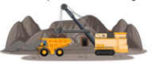
13. A chef has one dozen eggs that weigh 845 g. He also has 3.55 kg of flour and 2045 g of melted butter. What is the total mass of his ingredients?  Answers in grams and kilograms and then order the masses in descending order. |  | 14. A father orders 3 boxes of flowers for his 3 daughters. Each box contains 5 kg of red roses, 5450 g of gardenias and 2.5 kg of baby’s breath. What is the total mass of flowers ordered?  Answers in grams and kilograms and then order the masses in descending order.
15. Thomas purchases food for his camping trip. He buys 2764 g of strawberries, a 1.60 kg box of cereal and a 2500 g box of fruit. What is the total mass of the food he buys?  Answers in grams and kilograms and then order the masses in descending order.  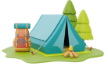 |  | 16. Find the total mass of 3 items weighing 6.45 kg, 1.976 kg and 1877 g.  Answers in grams and kilograms and then order the masses in descending order.  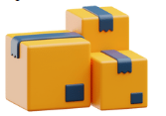

Resource 10 – crocodile facts
Crocodile facts
Crocodile type | Length | Mass
Male saltwater | 6.5 metres | 1.5 tonnes
Female saltwater | 3 metres | 300 kilograms
Baby saltwater | 30 centimetres | 70 grams
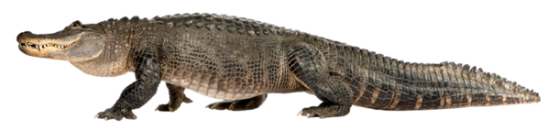

Resource 11 – crocodile measurements
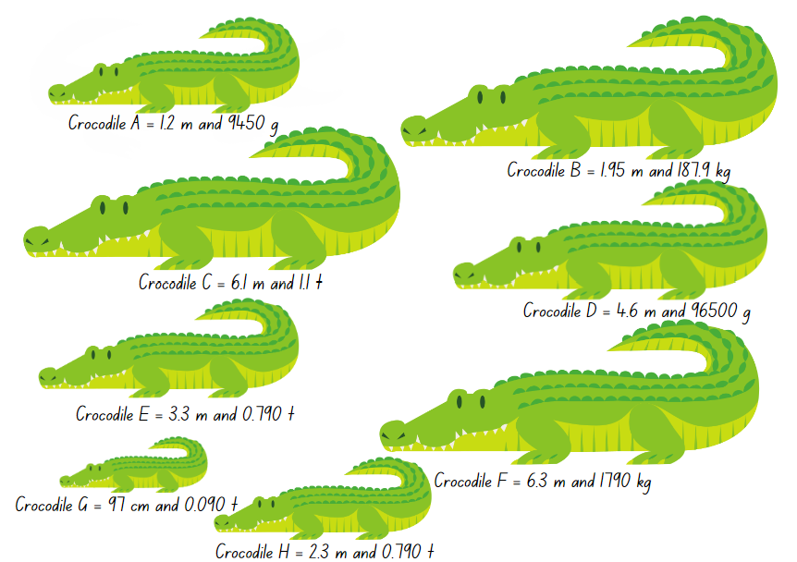

Resource 12 – crocodile conversion chart
Crocodile | Metres (m) | Centimetres (cm) | Tonnes (t) | Kilograms (kg) | Grams (g)
Crocodile A
Crocodile B
Crocodile C
Crocodile D
Crocodile E
Crocodile F
Crocodile G
Crocodile H

Resource 13 – perimeter modelling
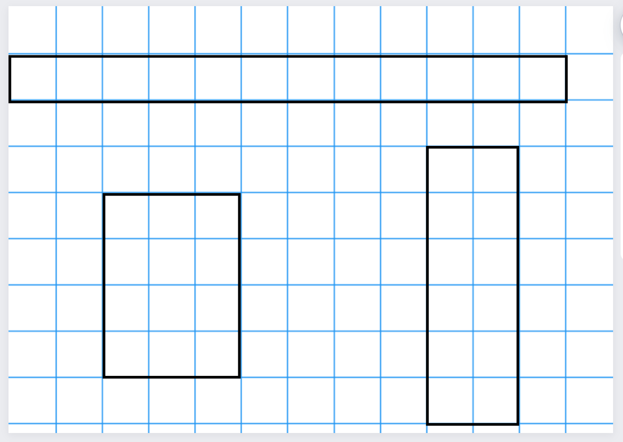

Resource 14 – missing perimeter problems
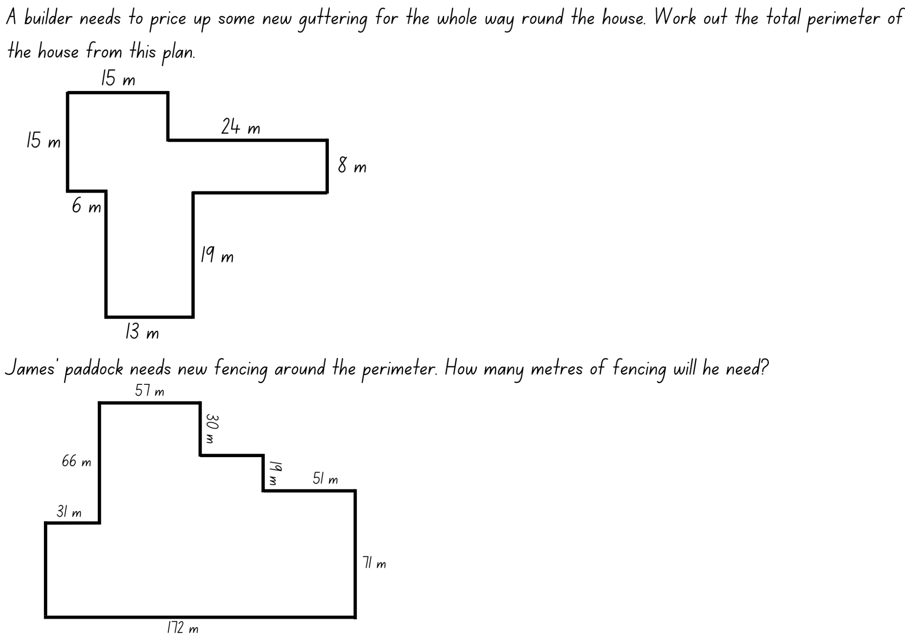
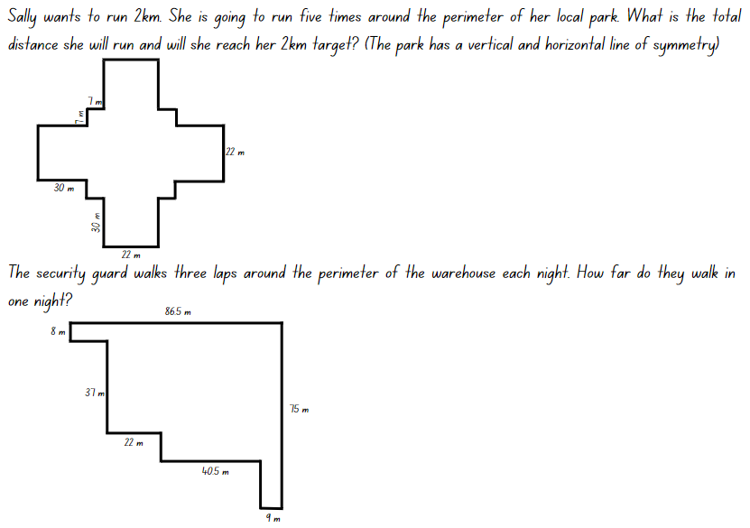

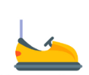
Resource 15 – Darryl’s fencing
Task 1: Darryl is fencing off a space for the dodgems with his 120 cm length panels. They have rented 80 square metres of space.  Draw and label the different rectangular shapes that Darryl could enclose with his fence posts to cover 80 square metres.  - Which of these would be suitable for the dodgems? Why?  - Fencing costs $3.50 per 120 cm panel to hire. Find the cheapest way to fence 80 square metres.  - What would be the most expensive fence design?  - Is this one of the shapes that will suite the dodgems? Why?  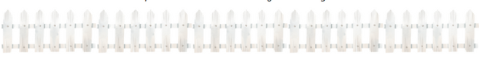 | Task 2: Darryl is fencing off space for the skydivers to land in. For this job he will use his fence panels that are 100 cm in length.  - How many different-shaped rectangles could he make using 48 one-metre panels?  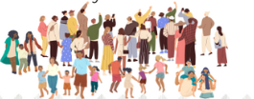  - The skydivers are nervous about landing with all the people around and want the biggest possible area fenced off. What is the largest rectangular area that can be made with 48 metres of fencing?

Resource 16 – Cup ‘n’ Saucer
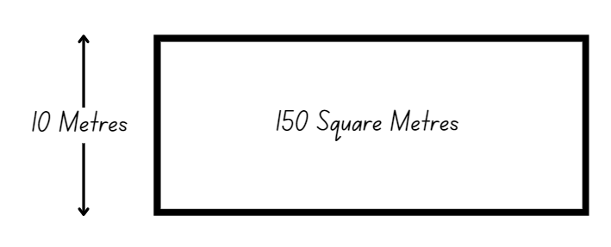

Resource 17 – mystery bones
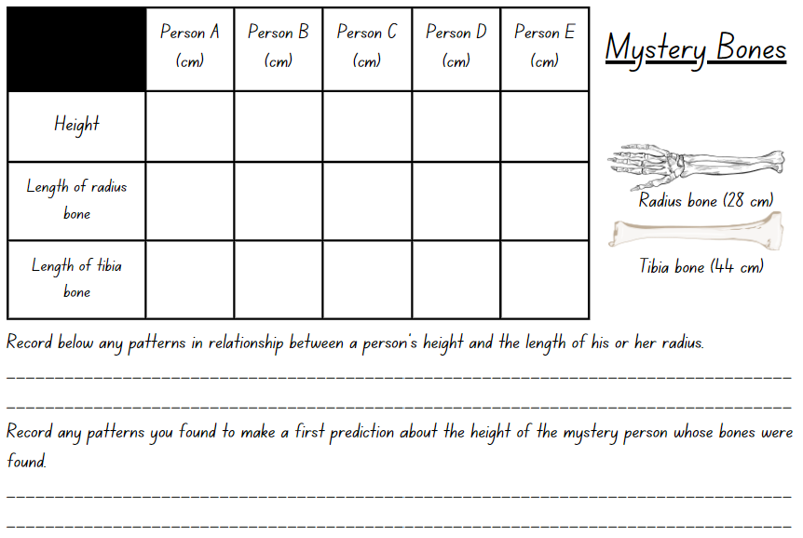

Resource 18 – bone measurement prediction
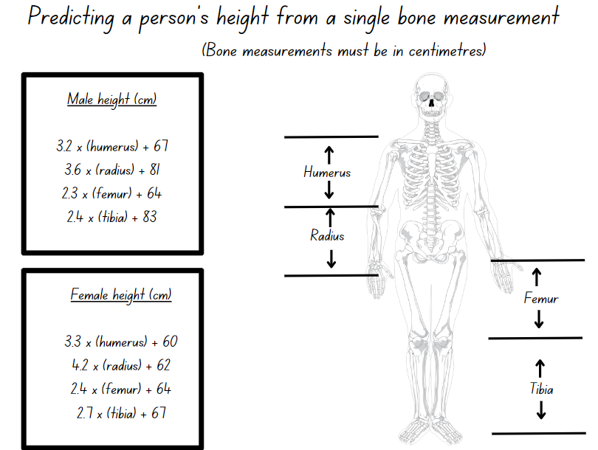

Resource 19 – anthropology investigations
Use the information for a female with a radius bone of 28 cm. How does this compare with your earlier prediction recorded on Resource 17?
Use the information for a male with a radius bone length of 28 cm. How does this compare with your earlier prediction recorded on Resource 17?
Use the information for a female with a tibia bone of 44 cm. How does this compare with your earlier prediction recorded on Resource 17?
Use the information for a male with radius bone of length 44 cm. How does this compare with your earlier prediction recorded on Resource 17?
After making comparisons, please comment, with justification, on whether the 2 bones are likely to belong to the same person.
The tallest female twins in the world are Ann and Claire Recht, volleyball players who are 200.7 cm tall. Use the table to predict the length of their humerus bones.

Resource 20 – conversion chart
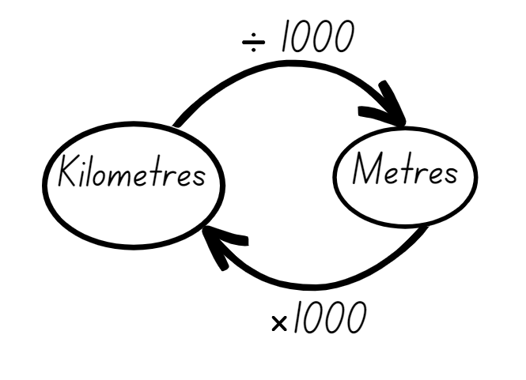

Resource 21 – mega trees
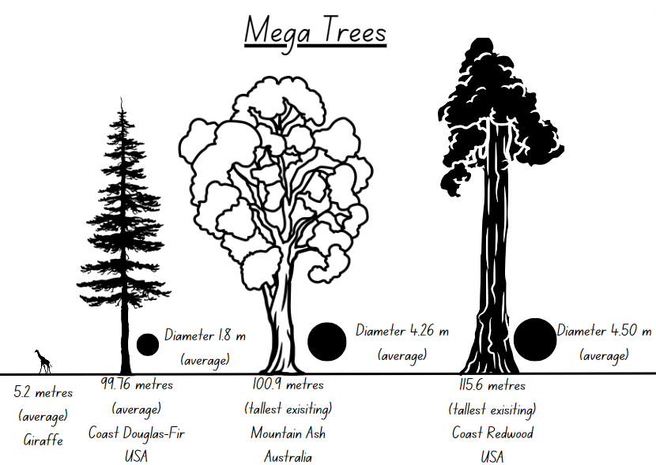

Resource 22 – mega trees questions
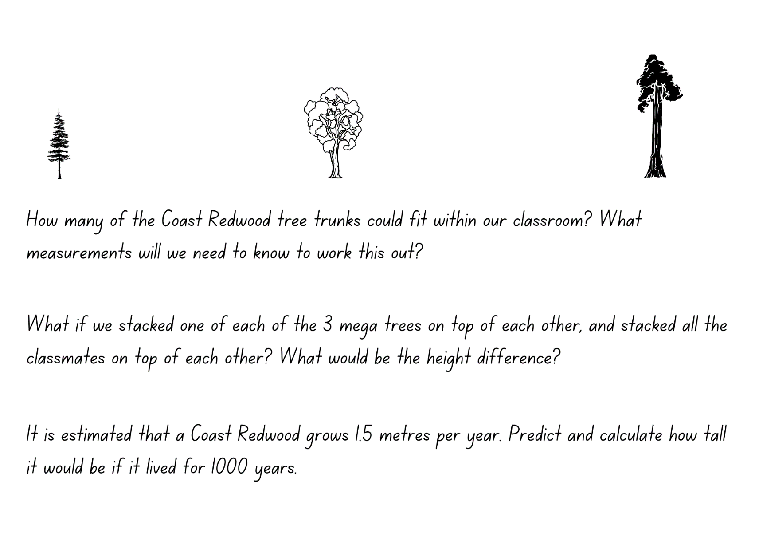

Syllabus outcomes and content
The table below outlines the syllabus outcomes and range of relevant syllabus content covered in this unit. Content is linked to National Numeracy Learning Progression (version 3).
Outcomes and content | 1 | 2 | 3 | 4 | 5 | 6 | 7 | 8
Represents numbers B: Decimals and percentages: Make connections between benchmark fractions, decimals and percentages
[MAO-WM-01, MA3-RN-01, MA3-RN-02, MA3-RN-03]
- Recognise that the symbol % means percent and 100% is the whole amount | x | x
- Recall commonly used equivalent percentages, decimals and fractions including $\frac{1}{2}$,$\frac{1}{4}$ and $\frac{3}{4}$ | x | x | x
Additive relations A: Apply efficient mental and written strategies to solve addition and subtraction problems
[MAO-WM-01, MA3-AR-01]
- Solve word problems including multistep problems |  |  | x
- Apply known strategies such as levelling, addition for subtraction, using constant difference, and bridging (Reasons about relations) |  |  | x
Additive relations B: Applies known strategies to add and subtract decimals
[MAO-WM-01, MA3-AR-01]
- Solve word problems involving the addition and subtraction of decimals up to 3 decimal places |  |  |  |  |  | x
Representing quantity fractions B: Build up to the whole from a given fractional part
[MAO-WM-01, MA3-RQF-02]
- Generate the whole quantity from non-unit fractional parts such as quarters, eighths, thirds, sixths, fifths and tenths (Reversible reasoning) |  |  |  |  | x | x | x
Geometric measure B: Length: Connect decimal representations to the metric system
[MAO-WM-01, MA3-GM-02]
- Recognise the equivalence of whole-number and decimal representations of measurements of length |  |  |  | x
- Interpret decimal notation for lengths and distances |  |  |  | x
- Record lengths and distances using decimal notation |  |  |  | x |  |  | x | x
Geometric measure B: Length: Convert between common metric units of length
[MAO-WM-01, MA3-GM-02]
- Use decimal place value system to convert between metres and kilometres |  |  |  |  |  |  |  | x
- Convert measurements to the same unit to compare lengths and distances |  |  |  |  |  | x |  | x
- Explain and use the relationship between the size of a unit and the number of units needed |  |  |  |  |  |  | x | x
Geometric measure B: Length: Solve problems involving the comparison of lengths using appropriate units
[MAO-WM-01, MA3-GM-02]
- Investigate and compare perimeters of rectangles with the same area |  |  |  |  | x | x
- Determine the number of different rectangles that can be formed using whole-number dimensions for a given area (Reasons about spatial structure) |  |  |  |  | x | x
- Solve a variety of problems involving length and perimeter, including problems involving different units of length |  |  |  |  |  | x | x
Non-spatial measure A: Mass: Connect decimal representations to the metric system
[MAO-WM-01, MA3-NSM-01]
- Recognise the equivalence of whole-number and decimal representations of measurements of mass |  |  |  | x
- Interpret decimal notation for masses |  |  | x | x
- Measure mass using scales and record using decimal notation of up to 3 decimal places |  |  |  | x
Non-spatial measure B: Mass: Convert between common metric units of mass
[MAO-WM-01, MA3-NSM-01]
- Convert between kilograms and grams and between kilograms and tonnes | x | x | x
- Solve problems involving different units of mass | x | x | x
Mathematics K–10 Syllabus © NSW Education Standards Authority (NESA) for and on behalf of the Crown in right of the State of New South Wales, 2022.

References
This resource contains NSW Curriculum and syllabus content. The NSW Curriculum is developed by the NSW Education Standards Authority. This content is prepared by NESA for and on behalf of the Crown in right of the State of New South Wales. The material is protected by Crown copyright.
Please refer to the NESA Copyright Disclaimer for more information https://educationstandards.nsw.edu.au/wps/portal/nesa/mini-footer/copyright.
NESA holds the only official and up-to-date versions of the NSW Curriculum and syllabus documents. Please visit the NSW Education Standards Authority (NESA) website https://educationstandards.nsw.edu.au/wps/portal/nesa/home and the NSW Curriculum website https://curriculum.nsw.edu.au/.
Mathematics K–10 Syllabus © NSW Education Standards Authority (NESA) for and on behalf of the Crown in right of the State of New South Wales, 2022.
National Numeracy Learning Progression © Australian Curriculum, Assessment and Reporting Authority (ACARA) 2010 to present, unless otherwise indicated. This material was downloaded from the Australian Curriculum website (National Literacy and Numeracy Learning Progression) (accessed 21 September 2023 and was not modified.
Behind the News (29 August 2017) ‘National Tree Day – Behind the News’ [video], Behind the News, YouTube, accessed 27 March 2024.
Behind the News (6 August 2023) ‘Australia's Plastic Waste Problem – Behind the News’ [video], Behind the News, YouTube, accessed 27 March 2024.
Clarke D (1996) The Case of the Mystery Bone: A Unit of Work on Measurement for Grades 5 to 8, Australian Association of Mathematics Teachers Inc, Australia.
Clean Up Australia (2024) Clean Up Our Waste, Clean Up Australia website, accessed 18 April 2024.
Grant J, Lewis E and Woods A (2007) Cambridge Maths in-a-Box 3, Cambridge University Press, Australia.
New Zealand Ministry of Education (n.d.) ‘Fred’s Rent-a-Fence’, Resource, NZ Maths website, accessed 21 September 2023.
New Zealand Ministry of Education (n.d.) ‘Types of Rubbish’, Resource, NZ Maths website, accessed 21 September 2023.
NSW Department of Education Learning and Teaching Directorate (2017) Teaching Measurement: Stage 2 – Stage 3, NSW Department of Education website, accessed 27 March 2024.
Sullivan P and Lilburn P (2017) Open-ended Maths Activities: Using ‘Good’ Questions to Enhance Learning in Mathematics, Revised edn, Oxford University Press ANZ, Great Britain.

© State of New South Wales (Department of Education), 2024
The copyright material published in this resource is subject to the Copyright Act 1968 (Cth) and is owned by the NSW Department of Education or, where indicated, by a party other than the NSW Department of Education (third-party material).
Copyright material available in this resource and owned by the NSW Department of Education is licensed under a Creative Commons Attribution 4.0 International (CC BY 4.0) license.
This license allows you to share and adapt the material for any purpose, even commercially.
Attribution should be given to © State of New South Wales (Department of Education), 2024.
Material in this resource not available under a Creative Commons license:
- the NSW Department of Education logo, other logos and trademark-protected material
- material owned by a third party that has been reproduced with permission. You will need to obtain permission from the third party to reuse its material.
Links to third-party material and websites
Please note that the provided (reading/viewing material/list/links/texts) are a suggestion only and implies no endorsement, by the New South Wales Department of Education, of any author, publisher, or book title. School principals and teachers are best placed to assess the suitability of resources that would complement the curriculum and reflect the needs and interests of their students.
If you use the links provided in this document to access a third-party's website, you acknowledge that the terms of use, including licence terms set out on the third-party's website apply to the use which may be made of the materials on that third-party website or where permitted by the Copyright Act 1968 (Cth). The department accepts no responsibility for content on third-party websites.

