Mathematics Stage 3 – Unit 32
Understanding relationships between the properties of 2D shapes helps visualise and organise spaces in the world
Contents
Unit description and duration 5
Syllabus outcomes 5
Working mathematically 6
Student prior learning 6
Lesson overview and resources 8
Lesson 1 13
Daily number sense – number patterns – 10 minutes 13
Core lesson – symmetry – 35 minutes 15
Consolidation and meaningful practice – 15 minutes 19
Lesson 2 22
Daily number sense – not following the rule – 10 minutes 22
Core lesson – conserved properties of two-dimensional shapes – 35 minutes 24
Consolidation and meaningful practice – 15 minutes 26
Lesson 3 29
Daily number sense – rule breaker – 10 minutes 29
Core lesson – rearranging shapes – 25 minutes 31
Consolidation and meaningful practice – 20 minutes 33
Lesson 4 35
Daily number sense – 10 minutes 35
Core lesson – area of composite figures – 25 minutes 35
Consolidation and meaningful practice – 25 minutes 39
Lesson 5 42
Daily number sense – integer number line – 10 minutes 42
Core lesson – area of parallelogram – 30 minutes 44
Discuss and connect the mathematics – 10 minutes 48
Lesson 6 50
Daily number sense – temperature – 10 minutes 50
Core lesson – area of a triangle – 40 minutes 52
Consolidation and meaningful practice – 20 minutes 57
Lesson 7 59
Daily number sense – weather – 15 minutes 59
Core lesson – area of composite figures 2 – 20 minutes 60
Consolidation and meaningful practice – 30 minutes 62
Lesson 8 66
Daily number sense – 10 minutes 66
Core lesson – playground design – 45 minutes 66
Discuss and connect the mathematics – 15 minutes 70
Resource 1 – properties of polygons 72
Resource 2 – classifying shapes 73
Resource 3 – transforming polygons 74
Resource 4 – triangle reflection grid 75
Resource 5 – parallelogram on a grid 76
Resource 6 – 4 parallelograms and a grid 77
Resource 7 – 4 parallelograms on a grid 78
Resource 8 – minimum overnight temperatures 79
Resource 9 – triangles 80
Resource 10 – area of triangles 81
Resource 11 – weather wonders 82
Resource 12 – composite figure 84
Resource 13 – composite figure 2 85
Resource 14 – sample playgrounds 86
Resource 15 – playground items 87
Syllabus outcomes and content 88
References 94

Unit description and duration
This unit develops the big idea that understanding relationships between the properties of 2D shapes helps visualise and organise spaces in the world.
In this 2-week unit students are provided opportunities to:
- explore and manipulate polygons to understand the properties of regular and irregular shapes
- translate, rotate and reflect rectangles and triangles to form compound shapes
- examine the relationship between the area of a parallelogram and the area of a triangle
- apply their knowledge of 2D space to calculate the area of composite shapes.

Syllabus outcomes
- MAO-WM-01 develops understanding and fluency in mathematics through exploring and connecting mathematical concepts, choosing and applying mathematical techniques to solve problems, and communicating their thinking and reasoning coherently and clearly
- MA3-RN-01 applies an understanding of place value and the role of zero to represent the properties of numbers
- MA3-MR-01 selects and applies appropriate strategies to solve multiplication and division problems
- MA3-2DS-01 investigates and classifies two-dimensional shapes, including triangles and quadrilaterals based on their properties
- MA3-2DS-02 selects and uses the appropriate unit to calculate areas, including areas of rectangles
- MA3-2DS-03 combines, splits and rearranges shapes to determine the area of parallelograms and triangles

Working mathematically
In the Mathematics K–10 Syllabus, there is one overarching Working mathematically outcome (MAO-WM-01). The Working mathematically processes should be embedded within the concepts being taught. The Working mathematically processes present in the Mathematics K–10 Syllabus are:
- communicating
- understanding and fluency
- reasoning
- problem solving.
Mathematics K–10 Syllabus © NSW Education Standards Authority (NESA) for and on behalf of the Crown in right of the State of New South Wales, 2022.

Student prior learning
Before engaging in these teaching and learning activities, students would benefit from prior experience with:
- exploring and manipulating polygons to understand the properties of triangles and quadrilaterals
- combining, splitting and rearranging shapes to form composite shapes
- selecting and using the appropriate unit to calculate the area of a rectangle.
In NSW classrooms there is a diverse range of students, including Aboriginal and/or Torres Strait Islander students, students learning English as an additional language or dialect, high potential and gifted students and students with disability. Some students may identify with more than one of these groups or possibly all of them. Refer to Curriculum planning for every student – advice for further information.

Lesson overview and resources
The table below outlines the sequence and approximate timing of lessons, learning intentions and resources.
Lesson | Content | Duration and resources
Lesson 1  Daily number sense learning intention:  - represent and describe number patterns formed by multiples | Lesson core concept: different forms of symmetry can be seen when shapes are reflected and rotated.  Core concept learning intention:  - classify two-dimensional shapes and describe their properties | Lesson duration: 60 minutes  - Interactive Rotational Symmetry  - Pattern blocks  - Writing materials
Lesson 2  Daily number sense learning intention:  - represent and describe number patterns formed by multiples | Lesson core concept: the properties of a shape are conserved when its position or orientation changes.  Core concept learning intentions:  - classify two-dimensional shapes and describe their properties  - dissect two-dimensional shapes and rearrange them using translations, reflections and rotation | Lesson duration: 60 minutes  - Resource 1 – properties of polygons  - Resource 2 – classifying shapes  - Resource 3 – transforming polygons  - 1 cm grid paper, geoboards, or virtual geoboards  - 30 cm rulers  - GeoGebra Classic  - Writing materials
Lesson 3  Daily number sense learning intention:  - represent and describe number patterns formed by multiples | Lesson core concept: simple shapes can be found hiding in more complex shapes.  Core concept learning intention:  - dissect two-dimensional shapes and rearrange them using translations, reflections and rotation | Lesson duration: 55 minutes  - Resource 4 – triangle reflection grid  - Scissors  - Writing materials
Lesson 4  Daily number sense learning intention:  - teacher-identified task based on student needs | Lesson core concept: parts of a composite figure can be split, duplicated and rotated to find the total area.  Core concept learning intention:  - find the area of composite figures | Lesson duration: 60 minutes  - Square pattern blocks  - Writing materials
Lesson 5  Daily number sense learning intention:  - locate and represent integers on a number line | Lesson core concept: parts of a composite figure can be split, duplicated and rotated to find the total area.  Core concept learning intentions:  - dissect two-dimensional shapes and rearrange them using translations, reflections and rotations  - calculate the area of a parallelogram using subdivision and rearrangement | Lesson duration: 50 minutes  - Resource 5 – parallelogram on grid  - Resource 6 – 4 parallelograms and a grid  - Resource 7 – 4 parallelograms on a grid  - A3 paper  - Scissors  - Writing materials
Lesson 6  Daily number sense learning intention:  - locate and represent integers on a number line | Lesson core concept: the known area of a shape can be used to help calculate the area of other shapes.  Core concept learning intention:  - determine the area of a triangle | Lesson duration: 70 minutes  - Resource 8 – minimum overnight temperatures  - Resource 9 – triangles  - Resource 10 – area of a triangle  - Student integer number line from Lesson 5  - 1 cm grid paper, geoboards or virtual geoboards  - Scissors  - 30 cm rulers  - Writing materials
Lesson 7  Daily number sense learning intention:  - locate and represent integers on a number line | Lesson core concept: there are many ways to dissect a shape to determine its area.  Core concept learning intentions:  - find the area of composite figures  - determine the area of a triangle | Lesson duration: 65 minutes  - Resource 11 – weather wonders  - Resource 12 – composite figure  - Resource 13 – composite figure 2  - Writing materials
Lesson 8  Daily number sense learning intention:  - teacher-identified task based on student needs | Lesson core concept: relationships between the sides and angles of shapes help us visualise, organise and design the world around us.  Core concept learning intentions:  - calculate areas, including areas of rectangles, parallelograms, triangles and composite figures  - use estimation and rounding to check the reasonableness of answers to calculations  - use partitioning and place value to multiply 2-, 3- and 4-digit numbers by one-digit numbers | Lesson duration: 70 minutes  - Resource 14 – sample playgrounds  - Resource 15 – playground items  - 1 cm grid paper  - 30 cm rulers  - Writing materials

Lesson 1
Core concept: different forms of symmetry can be seen when shapes are reflected and rotated.

Daily number sense – number patterns – 10 minutes
Daily number sense activities for Lessons 1 to 3 ‘activate’ prior number knowledge and support the learning of new content in the unit. These activities can also assist teachers to identify the starting points for learning by revealing the extent of students’ existing knowledge.
The table below contains a suggested learning intention and success criteria. These are best co-constructed with students.
Daily number sense learning intention | Daily number sense success criteria
Students are learning to:  - represent and describe number patterns formed by multiples. | Students can:  - describe a pattern formed by multiples in words, in terms of multiplication rather than addition  - determine a rule describing the relationship between the bottom number and the top number in a table.
- Draw the following table of values on the board:
Number of shapes | 1 | 2 | 3 | 4 | 5
Number of sides | 12 | 24 | 36 | 48 | 60
- In pairs, students discuss and identify the rule to determine the number of sides for any value in the top row. For example, students may use wording such as ‘to determine the number of sides, you need to multiply the number of shapes by 12'. Remind students that the multiplication rule needs to describe the relationship between the top number and the bottom number in the table.
- Select students to share the rule and apply it to a value not displayed in the table. For example, if the number of shapes is 10, the number of sides is 120.
- In their workbooks, students draw possible shapes that could represent the sequence in the table. For example, see Figure 1.
Figure 1 – dodecagons
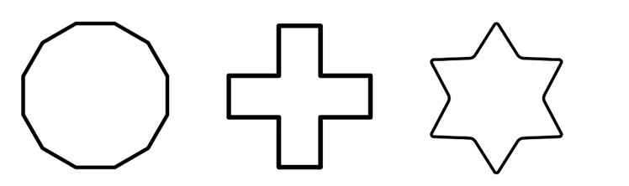
- Students describe the geometric pattern they have drawn.
- Ask students:
- How many sides would there be if there were 10 shapes? How did you work out the answer?
- If there were 96 sides, how many shapes would there be? How did you work out your answer?
- How does the table help determine the relationship between the number of shapes and the number of sides?
This table details opportunities for assessment.
Assessment opportunities | Links
What to look for:  - Can students describe a pattern formed by multiples in words, in terms of multiplication rather than addition?  [MAO-WM-01, MA3-MR-01]  - Can students determine a rule describing the relationship between the bottom number and the top number in a table?  [MAO-WM-01, MA3-MR-01] | Links to National Numeracy Learning Progressions (NNLP):  - NPA4, NPA5.

Core lesson – symmetry – 35 minutes
The table below contains suggested learning intentions and success criteria. These are best co-constructed with students.
Core concept learning intention | Core concept success criteria
Students are learning to:  - classify two-dimensional shapes and describe their properties. | Students can:  - investigate the symmetry properties (line and rotational) of polygons  - identify regular and irregular polygons.
- Provide pairs of students with a range of pattern blocks, including quadrilaterals and triangles.
- Revise the properties of quadrilaterals and triangles by asking pairs of students to classify the pattern blocks in as many ways as possible. For example, by number of sides, number of angles, regular and irregular shapes.
- Select pairs of students to share their thinking, identify the shapes in each group by name, and discuss the ways that the shapes have been classified. Ask if there is a correct way to classify the pattern blocks.
- Introduce the term polygon, explaining that it refers to a shape with 3 or more straight sides.
Polygon: a plane shape bounded by 3 or more line segments.
- Repeat the activity above, this time adding other regular polygons, such as pentagons, hexagons and octagons.
- Revise lines of symmetry and rotational symmetry, including definitions and examples where appropriate.
Line of symmetry: a shape has line symmetry if matching parts are produced when it is folded along a line of symmetry. Each part represents the mirror image of the other.
Rotational symmetry: a shape has rotational symmetry if an outline of the figure can be rotated or turned about its centre to match its original shape.
- Ask students how many lines of symmetry a regular pentagon has. Students turn and talk to share their thinking before justifying their answer to the class.
- Repeat with an octagon.
- Pose the conjecture: the number of lines of symmetry in a regular shape is equal to the number of sides.
- Students to work in pairs and investigate at least 2 more regular polygons to test the conjecture.
- Select students to share their results. Correct and discuss any discrepancies.
- Ask students if the same conjecture applies to irregular shapes.
- Students to work in pairs and investigate at least 3 irregular polygons to test the conjecture.
- Select students to share their results. Correct and discuss any discrepancies.
- Display interactive Rotational Symmetry and demonstrate using the resource by dragging the vertices to form a square.
Note: select show/hide rotation to move the degree slider to rotate the shape. There is also an alternative feature on Rotational Symmetry to change the polygon according to the number of sides and vertices. This feature explores regular polygons.
- Rotate the square to complete a full rotation (360°) to demonstrate how the tool can be used. Rotate the square a second time and ask the students to count the number of times the square matches to its original stencil.
- Remind students that the order of symmetry is the number of times a shape matches the original exactly in one full rotation. Clarify that a square can be turned 4 times and match its original shape exactly. It has a rotational symmetry order of 4.
Order of symmetry: this is the number of times a shape matches the original in one full rotation.
- Pose the conjecture: the rotational symmetry order of a regular shape is equal to the number of sides.
- Ask students to work in pairs and use the interactive Rotational Symmetry website, pattern blocks or paper shapes to investigate at least 2 more regular polygons to test the conjecture.
- Select students to share their results. Correct and discuss any discrepancies.
- Allow students time to investigate the rotational symmetry property of a variety of irregular polygons.
This table details opportunities for differentiation.
Too hard? | Too easy?
Students cannot identify lines of symmetry or rotational symmetry.  - Support students to construct and cut out polygons on paper. Draw an ‘x’ in the centre of each shape. Model how the shape can be rotated and count the number of times the shape matches the original.  - Provide further modelling on the interactive Rotational Symmetry website, using a variety of regular and irregular polygons. | Students can identify lines of symmetry or rotational symmetry.  - Ask students how many lines of symmetry and order of rotational symmetry a circle has. Students justify their answer.  - Challenge students to draw a shape that has one line of symmetry and an order of rotational symmetry of one (a kite).

Consolidation and meaningful practice – 15 minutes
This activity is an adaptation of Always, Sometimes or Never? Shape at NRICH by the University of Cambridge.
- Provide a list of statements and ask students to work in pairs or small groups to classify them as always true, sometimes true or never true. Statements could include:
- a hexagon has 6 lines of symmetry
- a square has 4 equal sides and 4 right angles
- an irregular pentagon has an order of rotational symmetry of 5
- a regular octagon has 8 lines of symmetry and an order of rotational symmetry of 8
- a triangle has 3 straight sides and 3 angles
- a triangle cannot have more than 3 lines of symmetry
- a triangle can have one line of symmetry
- a rhombus has 4 lines of symmetry
- all sides can be equal in an irregular shape
- a rectangle can have 4 lines of symmetry and an order of rotational symmetry of 4.
- Select students to share their thinking. Ask questions, such as:
- How do you know your answer is correct?
- If the answer is ‘sometimes’, can you explain when it is true and when it is not true?
- Can you rewrite the statements in the ‘sometimes’ category so that they are always true?
- Students to write additional statements for each classification.
- Select students to share their thinking.
This table details opportunities for assessment.
Assessment opportunities | Links
What to look for:  - Can students investigate the symmetry properties (line and rotational) of polygons? [MAO-WM-01, MA3-2DS-01]  - Can students identify regular and irregular polygons?  [MAO-WM-01, MA3-2DS-01] | Links to National Numeracy Learning Progressions (NNLP):  - UPG4, UPG5.

Lesson 2
Core concept: the properties of a shape are conserved when its position or orientation changes.

Daily number sense – not following the rule – 10 minutes
The table below contains a suggested learning intention and success criteria. These are best co-constructed with students.
Daily number sense learning intention | Daily number sense success criteria
Students are learning to:  - represent and describe number patterns formed by multiples. | Students can:  - describe a pattern formed by multiples in words, in terms of multiplication rather than addition  - determine a rule describing the relationship between the bottom number and the top number in a table.
- Draw the following table of values on the board:
Length across river (metres) | 1 | 4 | 5 | 2 | 10
Length of wood needed for crossing (metres) | 3 | 8 | 15 | 6 | 30
- Explain that there is an error in the table of values. Students turn and talk to identify the error.
- Select students to share their ideas with the class. Ask students:
- What value is incorrect in the table?
- How did you determine the error?
- What is the multiplication rule describing the relationship between the bottom number and the top number in the table?
- Students record the table of values in their workbook with the error corrected.
- Students describe the pattern formed by the multiples in the table.
This table details opportunities for assessment.
Assessment opportunities | Links
What to look for:  - Can students describe a pattern formed by multiples in words, in terms of multiplication rather than addition?  [MAO-WM-01, MA3-MR-01]  - Can students determine a rule describing the relationship between the bottom number and the top number in a table?  [MAO-WM-01, MA3-MR-01] | Links to National Numeracy Learning Progressions (NNLP):  - NPA4, NPA5.

Core lesson – conserved properties of two-dimensional shapes – 35 minutes
The table below contains suggested learning intentions and success criteria. These are best co-constructed with students.
Core concept learning intentions | Core concept success criteria
Students are learning to:  - classify two-dimensional shapes and describe their properties  - dissect two-dimensional shapes and rearrange them using translations, reflections and rotation. | Students can:  - compare side and angle properties of triangles and quadrilaterals using measurement and symmetry  - identify regular and irregular polygons  - use the terms translate, reflect and rotate to describe transformations of two-dimensional shapes  - recognise that translations, reflections or rotations change the position and orientation but not the size of shapes.
- Revise key terms from Lesson 1. Ask students:
- What is a polygon?
- Can you name some polygons and give reasons why they meet the definition of a polygon? (For example, a triangle is a polygon because it has 3 straight sides that are connected to make a closed shape.)
- What properties can we use to categorise polygons? (For example, number of sides, number of angles, diagonals, lines of symmetry, regular and irregular. Ensure students recognise that triangles and quadrilaterals can be classified in more than one way.)
- Provide students with Resource 1 – properties of polygons. Students draw each polygon and record its properties. Encourage students to describe each property rather than recording just the number of each property. For example, rhombuses have 4 equal sides and 2 pairs of equal angles.
- As a class revise the definition of a regular polygon, irregular polygon and non-polygon, asking students to provide examples of each.
- Provide pairs of students with Resource 2 – classifying shapes. Students discuss the different shapes, identifying them as either a regular polygon, irregular polygon or not a polygon. Students justify their answer.
- In pairs, students draw or make regular and irregular polygons on grid paper, a geoboard or a virtual geoboard. Students record the properties of each shape.
- Distribute Resource 3 – transforming polygons to students and display a quadrilateral on GeoGebra Classic. Demonstrate translating, reflecting and rotating the shape.
- Students:
- draw the shape and list its properties
- draw the shape rotated 90 degrees
- draw the shape reflected
- draw the shape translated
- identify if the properties of the shape stayed the same when rotated, reflected and translated
- identify if the size of the shape stayed the same when rotated, reflected and translated.
- Select students to share their thinking.

Consolidation and meaningful practice – 15 minutes
- In pairs, students use GeoGebra Classic to investigate other polygons. Encourage students to explore a mix of regular and irregular polygons.
- Ask students:
- What happens to a shape when it is rotated? (Its orientation changes)
- What happens to a shape when it is reflected? (Its orientation changes)
- What happens to a shape when it is translated? (Its position changes)
- Does changing a polygon’s orientation or position affect its properties?
- Does changing a polygon’s orientation or position affect its size?
- What would affect the size of a polygon?
This table details opportunities for differentiation.
Too hard? | Too easy?
Students cannot recognise that translations, reflections or rotations change the position and orientation but not the size of shapes.  - Students explore regular polygons only.  - Students use grid paper to draw and cut out shapes before translating, reflecting and rotating them. | Students can recognise that translations, reflections or rotations change the position and orientation but not the size of shapes.  - Students investigate 2 transformations at once (for example, rotation and reflection).  - Students investigate the changes to polygons that do change the size of the shape.
This table details opportunities for assessment.
Assessment opportunities | Links
What to look for:  - Can students compare side and angle properties of triangles and quadrilaterals using measurement and symmetry?  [MAO-WM-01, MA3-2DS-01]  - Can students identify regular and irregular polygons?  [MAO-WM-01, MA3-2DS-01]  - Can students use the terms translate, reflect and rotate to describe transformations of two-dimensional shapes?  [MAO-WM-01, MA3-2DS-01]  - Can students recognise that translations, reflections or rotations change the position and orientation but not the size of shapes? [MAO-WM-01, MA3-2DS-01] | Links to National Numeracy Learning Progressions (NNLP):  - UGP4, UGP5, UGP6.

Lesson 3
Core concept: simple shapes can be found hiding in more complex shapes.

Daily number sense – rule breaker – 10 minutes
The table below contains a suggested learning intention and success criteria. These are best co-constructed with students.
Daily number sense learning intention | Daily number sense success criteria
Students are learning to:  - represent and describe number patterns formed by multiples. | Students can:  - describe a pattern formed by multiples in words, in terms of multiplication rather than addition  - determine a rule describing the relationship between the bottom number and the top number in a table.
- Revise table of values from Lesson 2 – Daily number sense. Ensure students understand that multiplication rules describe the relationship between the bottom number and the top number in a table.
- In their workbooks, students create their own table of values with an error in it.
- Students swap tables with a partner to:
- identify the error
- record the multiplication rule
- correct the error
- describe the pattern formed by the multiples in the table.
- Ask students:
- How did you identify the error?
- What is the multiplication rule describing the relationship between the bottom number and the top number in the table?
- How did you determine the relationship?
This table details opportunities for assessment.
Assessment opportunities | Links
What to look for:  - Can students describe a pattern formed by multiples in words, in terms of multiplication rather than addition?  [MAO-WM-01, MA3-MR-01]  - Can students determine a rule describing the relationship between the bottom number and the top number in a table?  [MAO-WM-01, MA3-MR-01] | Links to National Numeracy Learning Progressions (NNLP):  - NPA4, NPA5.

Core lesson – rearranging shapes – 25 minutes
The table below contains a suggested learning intention and success criteria. These are best co-constructed with students.
Core concept learning intention | Core concept success criteria
Students are learning to:  - dissect two-dimensional shapes and rearrange them using translations, reflections and rotation. | Students can:  - use the terms translate, reflect, and rotate to describe transformations of two-dimensional shapes  - dissect and rearrange one shape to make another  - recognise that translations, reflections or rotations change the position and orientation but not the size of shapes.
- Revise the terms reflection, rotation and translation from Lesson 2.
- Provide each student with Resource 4 – triangle reflection grid and instruct students to cut out the black triangle. Students can write their name on the triangle to help recognise reflection, rotation and translation of the triangle.
- Students rotate, reflect or translate the right-angled triangle onto Resource 4 – triangle reflection grid as many times as required to fill the rectangle with the area of 24 squares.
- Students trace the triangle movements as they fill the rectangle (see Figure 2).
Figure 2 – sample grid with traced triangles
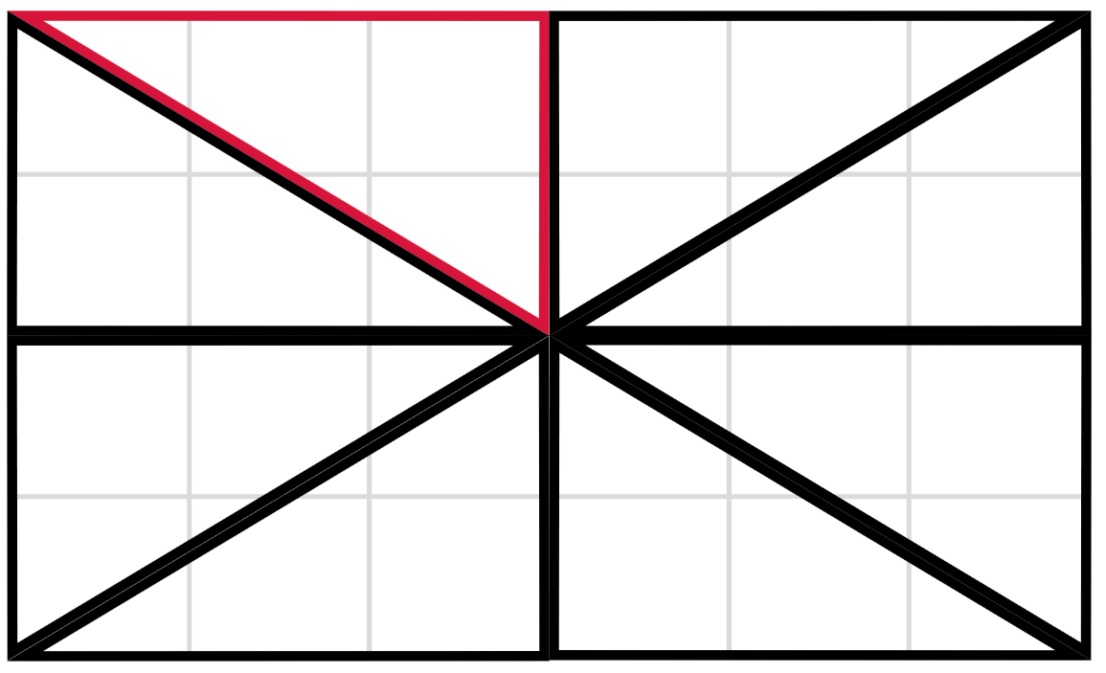
- Pairs of students turn and talk to identify a strategy to find the area of one triangle. Ask students how the grid might be used to help find the area.
Note: it is sufficient in this lesson for students to learn that area is conserved after reflection, rotation, or translation. Students will explore area calculations in later lessons. The printed size of the grid will dictate whether area can be expressed in square centimetres, or as the number of grid squares.
- Students share how they used rotation, reflection or translation to fill the rectangle, and the strategy to determine the area of one triangle.
This table details opportunities for differentiation.
Too hard? | Too easy?
Students cannot identify whether a shape has undergone translation, reflection or rotation or recognise shape conservation.  - Mark the cut-out triangle from Resource 4 – triangle reflection grid with a capital B. Ensure the B is visible on both sides of the paper, with the reversed image visible on one side. Use this to support understanding of reflection, rotation, and translation.  - Have students cut out a completed version of Resource 4 – triangle reflection grid or Figure 2. Overlay triangles to demonstrate conservation of shape. | Students can identify whether a shape has undergone translation, reflection or rotation or recognise shape conservation.  - Students use a combination of rotations, translations or reflections to draw a triangle with a new orientation. Student A provides the drawing and student B must identify which movements have been used to arrive at the triangle’s new orientation.  - Students create a trapezium, parallelogram, 2 different rectangles by rotating, reflecting, and translating their cut-out triangle. Students calculate the area of each shape.

Consolidation and meaningful practice – 20 minutes
- Challenge students to create 3 different shapes by reflecting, rotating, or translating the cut-out triangle. Students may combine the 3 transformations to form their shapes. Draw shapes on grid paper and calculate the area of each shape.
- Conduct a class gallery walk and ask students to compare the different shapes and the areas that have been produced.
- Regroup as a class and select students to share their observations.
- Ask students:
- Is there an efficient way to recognise each of the movements?
- What did you notice about the area of a triangle and the area of any shapes formed by several triangles?
This table details opportunities for assessment.
Assessment opportunities | Links
What to look for:  - Can students use the terms translate, reflect, and rotate to describe transformations of two-dimensional shapes?  [MAO-WM-01, MA3-2DS-01]  - Can students dissect and rearrange one shape to make another? [MAO-WM-01, MA3-2DS-02]  - Can students recognise that translations, reflections or rotations change the position and orientation but not the size of shapes? [MAO-WM-01, MA3-2DS-01] | Links to National Numeracy Learning Progressions (NNLP):  - UGP5, UGP6.

Lesson 4
Core concept: parts of a composite figure can be split, duplicated and rotated to find the total area.

Daily number sense – 10 minutes
- From a class need surfaced through formative assessment data, identify a short, focused activity that targets students’ knowledge, understanding and skills. Example activities may be drawn from the following resources:
- Mathematics K–6 resources
- Universal Resources Hub.

Core lesson – area of composite figures – 25 minutes
The table below contains a suggested learning intention and success criteria. These are best co-constructed with students.
Core concept learning intention | Core concept success criteria
Students are learning to:  - find the area of composite figures. | Students can:  - find different ways to calculate the area of a composite L-shape figure.
- Provide pairs or small groups of students with 10 square pattern blocks and explain that each block represents an area of one square metre.
- Students use the blocks to make shapes with an area of 10 square metres. Students find as many combinations as possible and record their findings.
- Select groups to share their results.
- Ask students what they notice. (It does not matter which way the shape is formed. If it is a quadrilateral, or an octagon, the shape has the same area and same number of squares).
- Display a composite L-shaped figure (see Figure 3) and explain that students are to work in pairs or small groups to find different ways to calculate the area. Remind students that the area of a rectangle is found by multiplying the number of units of length by the number of units of width and that the result of multiplying 2 numbers is called the product.
Note: remind students to record area in square centimetres (cm²), square metres (m²) and square kilometres (km²).
Figure 3 – composite L-shape
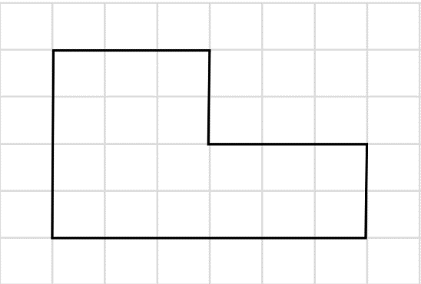
- Select groups to share their thinking. Ensure that each of the following strategies are modelled by either students or the teacher:
- partitioning (see Figure 4).
Figure 4 – composite shapes with partitioning
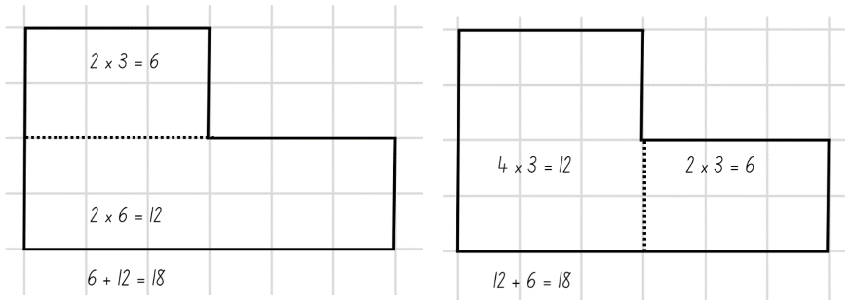
- dissecting and translating (see Figure 5).
Figure 5 – composite shapes with dissecting and translating
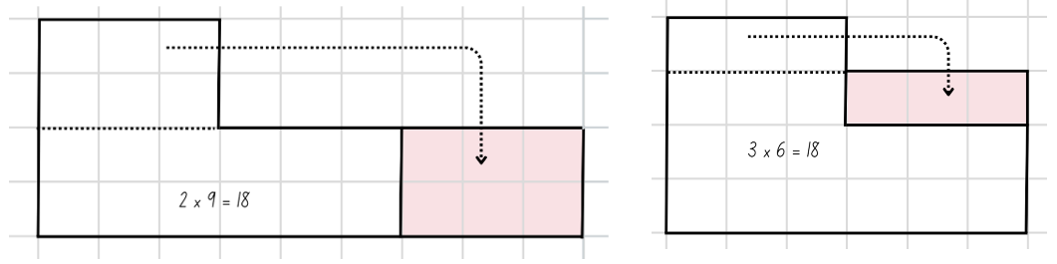
- duplicating and rotating (see Figure 6).
Figure 6 – composite shapes with duplication and rotation
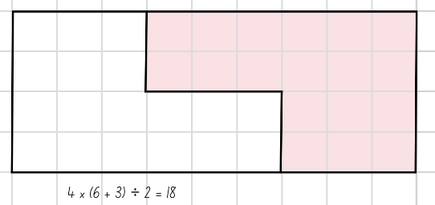
- Discuss the activity, asking questions such as:
- Which strategy do you prefer? Why?
- Which strategy do you think is the most efficient? Why?
- What units did you use to record the area of the composite shapes?
- When might it be necessary to calculate the area of a composite shape?
- What knowledge or skills did you need to be able to complete the task?

Consolidation and meaningful practice – 25 minutes
This activity is an adaptation of ‘Composite shapes’ from Challenging Mathematical Tasks by Sullivan.
- Students to work in pairs or small groups to draw a diagram showing a composite L-shaped figure that has an area of 60 cm². Students provide at least 2 possible solutions. For example, see Figure 7.
Figure 7 – composite shape with possible solution
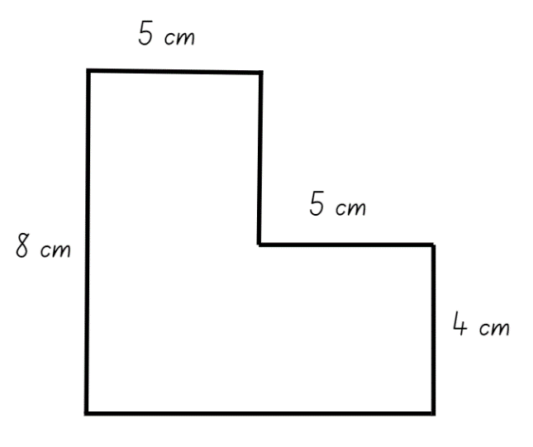
- Conduct a gallery walk to view student work, discussing similarities and differences between solutions.
- Ask students:
- What strategy did you use?
- How did you use factors to draw your shapes?
- How do you know your answer is correct?
- How many ways can you check?
- What might your answer look like if the area had to be 30 square centimetres?
This table details opportunities for differentiation.
Too hard? | Too easy?
Students cannot draw a composite shape with a specified area.  - Demonstrate how to draw a rectangle with an area of 40 cm² by using a pair of factors to determine the length of the sides.  - Students draw a rectangle with an area of 20 cm². by using a pair of factors to determine the length of the sides. Join the rectangles together to create a composite L-shaped figure that has an area of 60 cm². | Students can draw a composite shape with a specified area.  - Ask students how many different rectangles can be made with an area of 60 cm² and how they know that all possibilities have been found (12).  - Challenge students to find the shortest possible perimeter for a composite L-shaped figure that has an area of 60 cm².
This table details opportunities for assessment.
Assessment opportunities | Links
What to look for:  - Can students find different ways to calculate the area of a composite L-shape figure?  [MAO-WM-01, MA3-2DS-02, MA3-2DS-03] | Links to National Numeracy Learning Progressions (NNLP):  - UuM7, UuM10.

Lesson 5
Core concept: parts of a composite figure can be split, duplicated and rotated to find the total area.

Daily number sense – integer number line – 10 minutes
Daily number sense activities for Lessons 5 to 7 ‘loop’ back to concepts and procedures covered in previous units to assist students to build an increasingly connected network of ideas. These concepts may differ from the core concepts being covered by the unit.
The table below contains a suggested learning intention and success criteria. These are best co-constructed with students.
Daily number sense learning intention | Daily number sense success criteria
Students are learning to:  - locate and represent integers on a number line. | Students can:  - recognise the location of negative whole numbers in relation to zero and place them on a number line  - use the term integers to describe positive and negative whole numbers and zero.
This activity is an adaptation of ‘Folding around zero’ from Mindset Mathematics Visualizing and Investigating Big Ideas Grade 6 by Boaler et al.
- Explain that students will create a number line to explore integers.
Integer: a whole number, positive, negative or zero, for example 3, -2, -1, 0, 1, 2...
- Cut A3 paper into 20 × 420 mm strips and provide each student with a strip. Ask students to fold the strip in half and mark this mid-point as zero.
- Students re-fold the strip in half at the zero and then in half 4 more times. This will make 16 segments on each side of the zero.
- Students label the integer values on the fold lines to the right of the zero.
- Draw students’ attention to the fold lines to the left of the zero. Ask students to point to the fold line to the left of the zero and turn and talk to a partner about the integer that might go on that point.
- Through discussion, come to the agreement that the number name given to the fold immediately left of the zero is −1. This is called ‘negative one,’ which can be thought of as the opposite of one.
- Students continue labelling their number line with the negative integers. Encourage students to use the pattern represented by the integers they have recorded on their strip to the right of the zero to support their thinking.
- In pairs, students consider what they notice about the number line.
- Re-group and record students’ observations about the number line on an anchor chart.
Note: students will use their number line in Lesson 6.
This table details opportunities for assessment.
Assessment opportunities | Links
What to look for:  - Can students recognise the location of negative whole numbers in relation to zero and place them on a number line?  [MAO-WM-01, MA3-RN-01]  - Can students use the term integers to describe positive and negative whole numbers and zero? [MAO-WM-01, MA3-RN-01] | Links to National Numeracy Learning Progressions (NNLP):  - NPV9.

Core lesson – area of parallelogram – 30 minutes
The table below contains suggested learning intentions and success criteria. These are best co-constructed with students.
Core concept learning intentions | Core concept success criteria
Students are learning to:  - dissect two-dimensional shapes and rearrange them using translations, reflections and rotations  - calculate the area of a parallelogram using subdivision and rearrangement. | Students can:  - dissect and rearrange one shape to make another  - recognise that translations, reflections or rotations change the position and orientation but not the size of shapes  - show how to transform a parallelogram into a rectangle to find its area  - record, using words, a method for finding the area of any parallelogram.
- Display Resource 5 – parallelogram on grid and revise the properties of parallelograms. Remind students that opposite sides are parallel and of equal length, and in the parallelogram in the resource, the height is 5 squares and the width is 7 squares.
- Provide students with Resource 5 – parallelogram on grid for students to estimate the area of the parallelogram. The dotted lines may support student thinking.
- Prompt students with the following questions:
- Are there familiar shapes within the parallelogram that can help find the total area?
- Can we use our knowledge of dissecting shapes to help us find the area?
- How might the grid help to us find the area of the parallelogram?
- Pairs of students turn and talk to estimate or calculate the area of the parallelogram.
- Regroup as a class and select students to share their strategies. Use the display of Resource 5 – parallelogram on grid to affirm or clarify their thinking.
Note: emphasise that a parallelogram can be subdivided and rearranged to form a rectangle. Encourage students to use terms such as translate, rotate and reflect when referring to the movement of the subdivided triangle.
- Use the students’ ideas and strategies to co-create a method for finding the area of any parallelogram.
- Provide Resource 6 – 4 parallelograms and a grid, to pairs of students. Students work in pairs to find the area of each parallelogram, using scissors to cut out the parallelograms.
Note: students may trial different orientations of the parallelogram as they determine the most efficient strategy (see Figure 8).
Figure 8 – parallelograms overlaid on grid
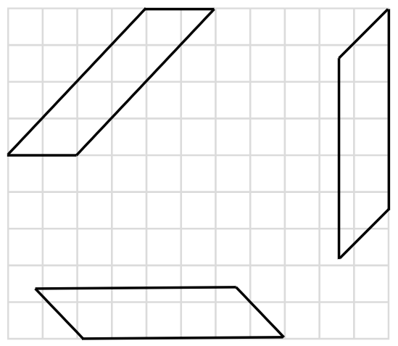
- Regroup as a class and ask:
- What strategy did you use to find the area of each parallelogram?
- What was the most efficient strategy?
- Did the orientation of the parallelogram change the area?
- Did you notice any differences when determining the area of the 4 parallelograms?
This table details opportunities for differentiation.
Too hard? | Too easy?
Students cannot dissect two-dimensional shapes and rearrange them using translations, reflections and rotations.  - Use Resource 5 – parallelogram on grid to model dissecting and translating the triangle from the parallelogram to form a rectangle.  - Students cut out the shapes and translate the triangle to form a rectangle.  Students cannot use subdivision and rearrangement to calculate the area of a parallelogram.  - Provide Resource 5 – parallelogram on grid and use the dotted lines to model subdivision.  - Students cut out the parallelograms and rearrange the subdivided shapes to discover the area of each parallelogram. | Students can use subdivision and rearrangement to calculate the area of a parallelogram.  - Challenge pairs of students to examine how a parallelogram can be divided into 2 triangles and determine the relationship between the area of a triangle and parallelogram.  - Students share ideas with other pairs of students to compare and justify their thinking.

Discuss and connect the mathematics – 10 minutes
- Regroup as a class and ask students:
- Did you subdivide all the parallelograms in the same way? Explain your answer.
- How did your knowledge of rotating, reflecting and translating help you with today's task?
- How are the height and width of a parallelogram related to its area?
- How did you find the most efficient strategy for finding the area of a parallelogram?
- What did you notice about the relationship between triangles and parallelograms?
This table details opportunities for assessment.
Assessment opportunities | Links
What to look for:  - Can students dissect and rearrange one shape to make another? [MAO-WM-01, MA3-2DS-01]  - Can students recognise that translations, reflections or rotations change the position and orientation but not the size of shapes? [MAO-WM-01, MA3-2DS-01]  - Can students show how to transform a parallelogram into a rectangle to find its area and use words to describe a method for finding the area of any parallelogram?  [MAO-WM-01, MA3-2DS-03] | Links to National Numeracy Learning Progressions (NNLP):  - UuM7, UuM10.

Lesson 6
Core concept: the known area of a shape can be used to help calculate the area of other shapes.

Daily number sense – temperature – 10 minutes
The table below contains a suggested learning intention and success criteria. These are best co-constructed with students.
Daily number sense learning intention | Daily number sense success criteria
Students are learning to:  - locate and represent integers on a number line. | Students can:  - interpret integers in everyday contexts  - recognise that negative whole numbers can result from subtraction.
- Review the integer number line from Lesson 5.
- Display Resource 8 – minimum overnight temperatures. Ask students what they notice about the temperatures displayed on the map.
- Students record the temperatures and their locations on their integer number line.
- Ask students:
- What is the highest overnight temperature?
- What is the lowest overnight temperature?
- Ask students how the integer line can be used to calculate differences in temperatures. For example, the difference between the temperature in Rockhampton and Alice Springs. Explain that this method is useful when calculating the difference between positive and negative integers. Model, using multiple examples if required.
- Ask students:
- What is the difference between the temperature in Rockhampton and Launceston?
- How much warmer is it in Alice Springs compared to Falls Creek?
- Explain that the meteorologist has left some temperatures off the map. He has provided some clues to help complete the integer number line. Ask students to record the following locations and temperatures on their integer number line:
- Broken Hill, New South Wales is 7°c cooler than Rockhampton (2°c)
- Mount Wellington, Tasmania is 8°c cooler than Launceston (−10°c)
- Mt Gambier, South Australia is 7°c warmer than Thredbo (3°c)
- In pairs, students take turns offering a clue to their partner, who attempts to guess the location. For example, this location is 7°c warmer than Canberra (Coffs Harbour).
This table details opportunities for assessment.
Assessment opportunities | Links
What to look for:  - Can students interpret integers in everyday contexts?  [MAO-WM-01, MA3-RN-01]  - Can students recognise that negative whole numbers can result from subtraction? [MAO-WM-01, MA3-RN-01] | Links to National Numeracy Learning Progressions (NNLP):  - NPV9.

Core lesson – area of a triangle – 40 minutes
The table below contains a suggested learning intention and success criteria. These are best co-constructed with students.
Core concept learning intention | Core concept success criteria
Students are learning to:  - determine the area of a triangle. | Students can:  - investigate the area of a triangle by comparing it to the area of a parallelogram with the same base length and height  - establish the relationship between the area of a triangle and the area of a parallelogram formed by duplicating and rotating the triangle  - record, using words, a method for finding the area of any triangle.
This lesson is an adaptation of Triangles by NZ Maths by the New Zealand Ministry of Education.
Note: for this activity grid paper, geoboards or virtual geoboards can be used.
- Provide each student with grid paper or a geoboard. Students cut a rectangle out of the grid paper or make a rectangle on the geoboard, ensuring that its base length and height are whole square amounts. Depending on student ability, limit the size of the rectangle.
- Students work out the area of their rectangle.
- Ask students:
- What is the area of your rectangle?
- What units did you use to record your answer?
- What method did you use to calculate your area?
- Students rule a line from one corner of their rectangle to the diagonally opposite corner (see Figure 9). Ensure students see the 2 right-angled triangles they have created.
Figure 9 – grid paper with diagonal line from one corner to opposite corner
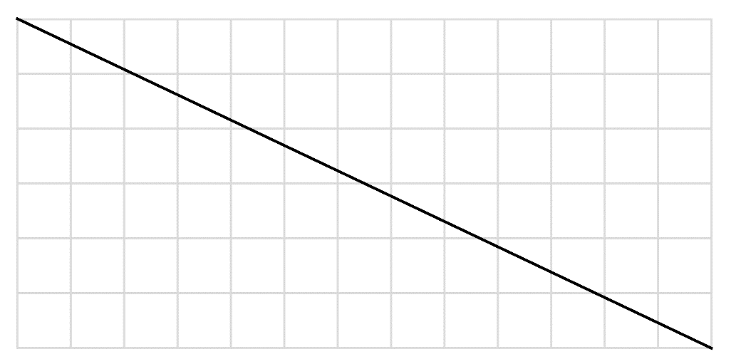
- Ask the following questions:
- Can a right-angled triangle be duplicated and transformed to create a rectangle?
- How did you transform the triangle to form a rectangle?
- What does this tell you about the relationship between area of the right-angled triangle and the area of the rectangle?
- Students use the area of the rectangle to determine the area of each triangle.
- Ask students:
- What do you notice about the area of the triangles? (The 2 triangles have the same area.)
- How does the area of the triangle compare to the area of the rectangle? (The area of each triangle is half the area of the rectangle.)
- Can you describe a rule for the area of a right-angled triangle?
Note: if students worked out the areas by counting, ask them to use multiplication to check their counting.
- In pairs students experiment with different rectangles to see that the rule holds true for any rectangle.
- Students draw a right-angled triangle on their grid paper or geoboard.
- Students duplicate the right-angled triangle to make a rectangle, work out the area of the completed rectangle and that of the triangle.
- Students to repeat for multiple triangles, checking answers with a partner.
- Ask students:
- What is the relationship between the triangle and the rectangle?
- Does your rule work for every right-angled triangle?
- How do you know?
- Students record a rule for the area of right-angled triangles in their own words.
- Provide students with a copy of Resource 9 – triangles.
- Ask students what information will be needed to work out the area of each triangle. It is likely that students will say the length of 2 sides is needed.
- Discuss why knowing the length of 2 sides does not work. Emphasise that in a non-right-angled triangle the height is not equal to either of the sides.
Note: the height of a triangle is the distance from the highest vertex, straight down to the base (or the perpendicular height).
- Students to work in pairs and use what has been learnt about the area of a parallelogram in Lesson 5 to find the area of each of the triangles. Encourage students to duplicate and rotate the triangle by folding the grid paper in half, drawing a triangle on the folded paper and cutting it out, making 2 identical copies. Students to use the copies to fit the triangles together into a parallelogram.
Note: students should realise that a triangle can be doubled to make a parallelogram then rearranged to a rectangle.
- To ensure a method that will work for any triangle, students to draw a new triangle on grid paper and use the method to determine the area of the triangle.
- As a class, discuss the relationship between the area of a triangle and parallelogram. Ask students:
- Can you describe a rule for the area of any triangle? (The area of a triangle is half the area of a parallelogram with the same base and height.)
- How do you know the rule works for every triangle?
- Are there any clever tricks to make the mathematics easier? (Divide one of the sides by 2 before multiplying.)

Consolidation and meaningful practice – 20 minutes
- Distribute copies of Resource 10 – area of a triangle and additional grid paper to students.
- Students to find the area of each triangle in the resource. Encourage students to draw the corresponding parallelogram around the triangle to work out the area of the parallelogram first.
- Ask students:
- What was the area of the triangle?
- How did you calculate the area?
- Did you use the same method for all the triangles? Why or why not?
This table details opportunities for differentiation.
Too hard? | Too easy?
Students cannot determine the area of a triangle by comparing it to the area of a parallelogram with the same base length and height.  - Support students to draw each triangle onto grid paper. Students to duplicate and rotate the triangle to form a parallelogram on the grid paper before calculating the area.  - Students only calculate the area of right-angled triangles. | Students can determine the area of a triangle by comparing it to the area of a parallelogram with the same base length and height.  - Students sketch and label a right-angled triangle that has an area of 12 cm².  - Students sketch and label a non-right-angled triangle that has an area of 24 cm².  - Students explore how many different triangles they can draw with the same base length and height.
This table details opportunities for assessment.
Assessment opportunities | Links
What to look for:  - Can students investigate the area of a triangle by comparing it to the area of a parallelogram with the same base length and height? [MAO-WM-01, MA3-2DS-02, MA3-2DS-03]  - Can students establish the relationship between the area of a triangle and the area of a parallelogram formed by duplicating and rotating the triangle? [MAO-WM-01, MA3-2DS-02, MA3-2DS-03]  - Can students record, using words, a method for finding the area of any triangle? [MAO-WM-01, MA3-2DS-03] | Links to National Numeracy Learning Progressions (NNLP):  - UuM10.

Lesson 7
Core concept: there are many ways to dissect a shape to determine its area.

Daily number sense – weather – 15 minutes
The table below contains a suggested learning intention and success criteria. These are best co-constructed with students.
Daily number sense learning intention | Daily number sense success criteria
Students are learning to:  - locate and represent integers on a number line. | Students can:  - interpret integers in everyday contexts  - recognise that negative whole numbers can result from subtraction.
- Display and discuss Resource 11 – weather wonders.
- Ask students if a number line would be useful when answering the questions. Students justify their answers.
- Students to answer the word problems using a number line. Draw attention to the fact that negative whole numbers can result from subtraction.
- Students to turn and talk and discuss their thinking. Allow students to adjust their answers.
- Select students to share their thinking.
This table details opportunities for assessment.
Assessment opportunities | Links
What to look for:  - Can students interpret integers in everyday contexts?  [MAO-WM-01, MA3-RN-01]  - Can students recognise that negative whole numbers can result from subtraction? [MAO-WM-01, MA3-RN-01] | Links to National Numeracy Learning Progressions (NNLP):  - NPV9.

Core lesson – area of composite figures 2 – 20 minutes
The table below contains suggested learning intentions and success criteria. These are best co-constructed with students.
Core concept learning intentions | Core concept success criteria
Students are learning to:  - find the area of composite figures  - determine the area of a triangle. | Students can:  - find different ways to calculate the area of a composite figure  - investigate the area of a triangle by comparing it to the area of a parallelogram with the same base length and height  - establish the relationship between the area of a triangle and the area of a parallelogram formed by duplicating and rotating the triangle.
- Display Resource 12 – composite figure. Explain that it is not to scale. Ask students what they notice and wonder.
- Revise calculating the area of a composite figure from Lesson 4, including using partitioning and dissecting and rearranging. Ask:
- Can the area of this shape be calculated? Why or why not?
- How might the missing measurements be determined?
- Is it possible to accurately determine all the missing measurements? Why or why not?
- Students work in pairs or small groups to determine what the area of the composite figure might be, giving more than one possible answer. Ensure that students record their thinking, including multiplication strategies.
- Select students to share their thinking. Highlight strategies used and reasons for the different areas given. Ask questions, such as:
- What values did you use for the missing measurements? Why?
- How did you partition the composite figure? Why?
- What multiplication strategies did you use? Why? Can you think of a strategy that is more efficient?
- Would you use different multiplication strategies if the sides were longer? Why?

Consolidation and meaningful practice – 30 minutes
- Display Resource 13 – composite figure 2. Students to work in pairs or small groups to explore different ways to calculate the area and record their thinking. Challenge students to calculate the area by partitioning the figure into:
- rectangles (see Figure 10)
- rectangles and triangles (see Figure 11)
- rectangles, triangles and at least one parallelogram (see Figure 12).
Figure 10 – shape partitioned into rectangles
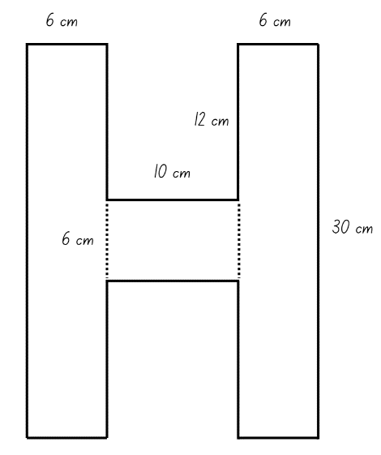
Figure 11 – shape partitioned into rectangles and triangles
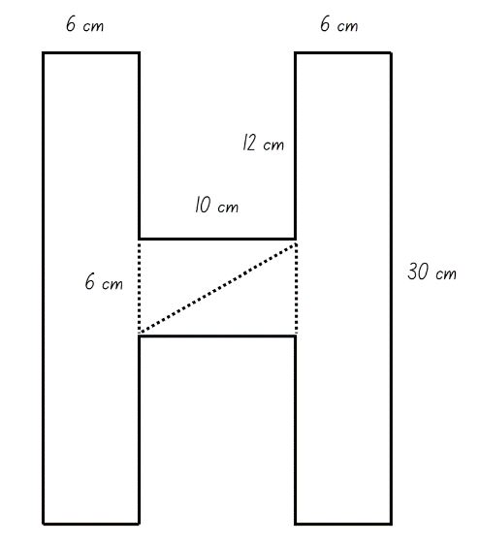
Figure 12 – shape partitioned into rectangles, triangles and at least one parallelogram
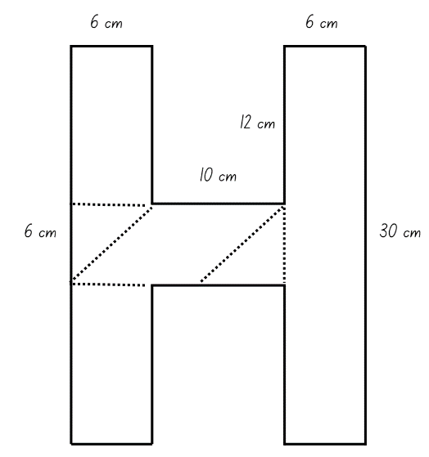
- Select students to share their thinking. Ask questions, such as:
- What is the area of the composite figure?
- How many shapes did you partition the composite figure into? Are there other ways to do it?
- How did you calculate the area of the smaller shapes?
- What multiplication strategies did you use? Why?
- What was the most efficient strategy for calculating the area of the composite figure? Why?
This table details opportunities for differentiation.
Too hard? | Too easy?
Students cannot partition and calculate the area of a composite figure.  - Model partitioning the composite figure into rectangles. Ask students if they could partition it in a different way.  - Change the length of the sides so the numbers are smaller. | Students can partition and calculate the area of a composite figure.  - Students partition the composite figure in multiple ways.  - Students create, partition and calculate the area of a different letter, such as E, K or Z.
This table details opportunities for assessment.
Assessment opportunities | Links
What to look for:  - Can students find different ways to calculate the area of a composite figure? [MAO-WM-01, MA3-2DS-02, MA3-2DS-03]  - Can students investigate the area of a triangle by comparing it to the area of a parallelogram with the same base length and height? [MAO-WM-01, MA3-2DS-02, MA3-2DS-03]  - Can students establish the relationship between the area of a triangle and the area of a parallelogram formed by duplicating and rotating the triangle? [MAO-WM-01, MA3-2DS-02, MA3-2DS-03] | Links to National Numeracy Learning Progressions (NNLP):  - UuM7, UuM10.

Lesson 8
Core concept: relationships between the sides and angles of shapes help us visualise, organise and design the world around us.

Daily number sense – 10 minutes
- From a class need surfaced through formative assessment data, identify a short, focused activity that targets students’ knowledge, understanding and skills. Example activities may be drawn from the following resources:
- Mathematics K–6 resources
- Universal Resources Hub.

Core lesson – playground design – 45 minutes
The table below contains suggested learning intentions and success criteria. These are best co-constructed with students.
Core concept learning intentions | Core concept success criteria
Students are learning to:  - calculate areas, including areas of rectangles, parallelograms, triangles and composite figures  - use estimation and rounding to check the reasonableness of answers to calculations  - use partitioning and place value to multiply 2-, 3- and 4-digit numbers by one-digit numbers. | Students can:  - find different ways to calculate the area of rectangles, parallelograms, triangles and composite figures  - use informal written strategies such as the area model to solve multiplication and division problems  - use estimation to check the reasonableness of answers to multiplication and division calculations.
- Display Resource 14 – sample playgrounds and ask students to identify familiar shapes in each playground. For example, rectangles, parallelograms, and triangles.
- Introduce playground design by identifying and describing common features of a playground and discussing the size requirements of each item. For example, describe the size of the swing and the cleared area around the swing.
- Help students recognise design principles by asking:
- What do you notice about the layout of the structures and empty spaces?
- How did the designer consider the needs of the user? (For example, age of user, shade requirements, seating requirements, accessibility, fences and access).
- Do the objects in the playground fit neatly into geometric shapes?
- What shapes, including composite shapes, can you identify?
- What measurements would you need to know to design a playground?
- How could estimation be used in playground design?
- Provide students with 1 cm grid paper and Resource 15 – playground items. Explain that students have been asked to design a playground for the local council.
- Explain that the playground must meet the following requirements:
- The playground can be any shape, but the items in the playground must have a total area of 250 square metres.
- The design must include a range of shapes, such as rectangles, triangles and composite figures.
- The playground must include a slide, climbing frame, toilet, swings, picnic table and grass area.
- The playground may include optional items such as a cubby house, large and small trees, paved areas and sand pit.
- As a class, discuss and determine appropriate dimensions for each playground item on Resource 15 – playground items. For example, see Figure 13.
Note: depending on student ability, this task could be complete as a class or modelled for several items, with students completing the remaining items in pairs.
Figure 13 – sample playground item dimensions
- Brainstorm other items that could be added to the playground designs, particularly objects that could be represented by composite shapes.
- Remind students that objects can be placed in any orientation, and to consider the space required around each piece of equipment. For example, the slide should not be placed directly in front of the swings.
- In pairs, students:
- Calculate the area required for each item.
- Determine the total number of items possible while meeting the criteria of the playground design. Encourage students to use estimation to determine whether more than one of each item can be included.
- Calculate the total area of the items in the playground. Remind students that the total area cannot exceed 250 m².
- Draw the playground design on the grid paper, using a scale of 1 cm² = 1 m².
This table details opportunities for differentiation.
Too hard? | Too easy?
Students cannot use different strategies to find the area of shapes, including composite shapes.  - Encourage students to cut out shapes that represent each item and move them around the grid paper to help visualise the design.  - Remind students of the method for finding the area of each shape.  - Model partitioning the composite figures and calculating the area of each shape. | Students can use different strategies to find the area of shapes, including composite shapes.  - Students to investigate other possible item dimensions that would result in the same area.  - Students calculate how much grass is required to fill the remaining areas of the playground.

Discuss and connect the mathematics – 15 minutes
- Students display their playgrounds and go on a gallery walk, looking at other designs.
- Regroup as a class and summarise the lesson drawing out key mathematical ideas. Ask:
- Did you see a design feature that you would like to add to your playground design?
- What shape did you find easiest to calculate the area of? What method did you use to calculate the area?
- What shape did you find most challenging to calculate the area of? Why?
- How did estimation help you plan your playground?
- How did you ensure that your items did not exceed 250 m²?
- What was challenging about this activity? How did you overcome these challenges?
This table details opportunities for assessment.
Assessment opportunities | Links
What to look for:  - Can students find different ways to calculate the area of rectangles, parallelograms, triangles and composite figures? [MAO-WM-01, MA3-2DS-02, MA3-2DS-03]  - Can students use informal written strategies such as the area model to solve multiplication and division problems?  [MAO-WM-01, MA3-MR-01]  - Can students use estimation to check the reasonableness of answers to multiplication and division calculations?  [MAO-WM-01, MA3-MR-01] | Links to National Numeracy Learning Progressions (NNLP):  - UuM6, UuM7, UuM10  - MuS6.  Links to suggested Interview for Student Reasoning (IfSR) tasks:  - IfSR-MT: 3A.1, 3A.2, 3A.3.

Resource 1 – properties of polygons
Polygon | Drawing | Sides | Angles | Lines of symmetry
Quadrilateral
Pentagon
Triangle
Rhombus

Resource 2 – classifying shapes
Shape | Regular polygon | Irregular polygon | Not a polygon | Justification
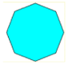

Resource 3 – transforming polygons
Polygon | Properties | Polygon rotated 90 degrees | Polygon reflected | Polygon translated | Did the properties stay the same? | Did the size stay the same?
 | Sides: 2 pairs of equal sides  Angles: 2 pairs of equal angles  Lines of symmetry: none |  |  |  | Yes | Yes
Sides:
Angles:
Lines of symmetry:
Other:
Sides:
Angles:
Lines of symmetry:
Other:
Sides:
Angles:
Lines of symmetry:
Other:

Resource 4 – triangle reflection grid
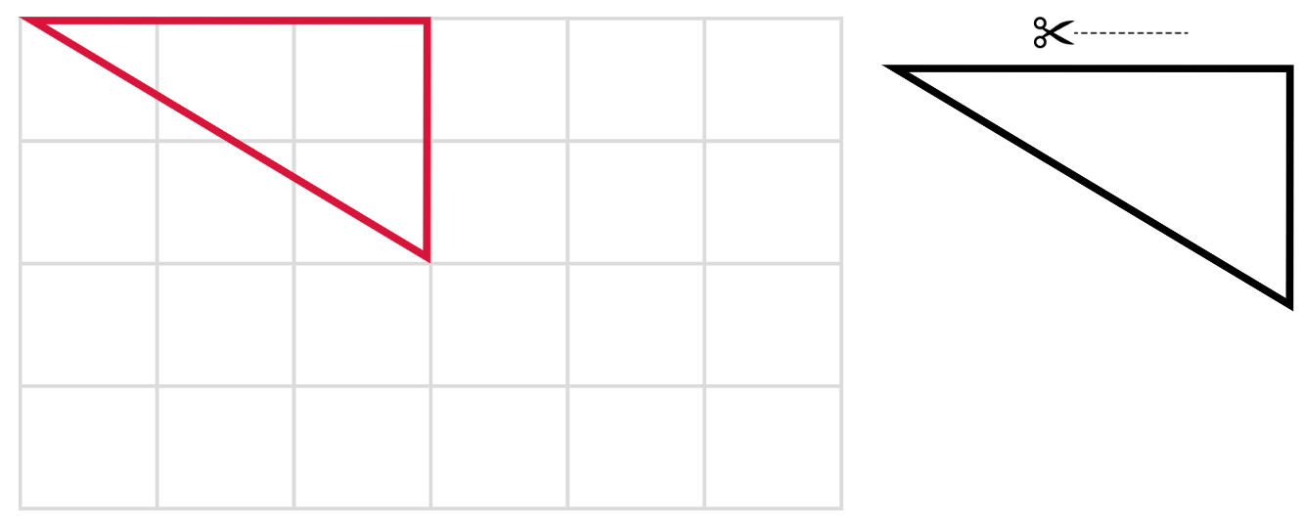

Resource 5 – parallelogram on a grid
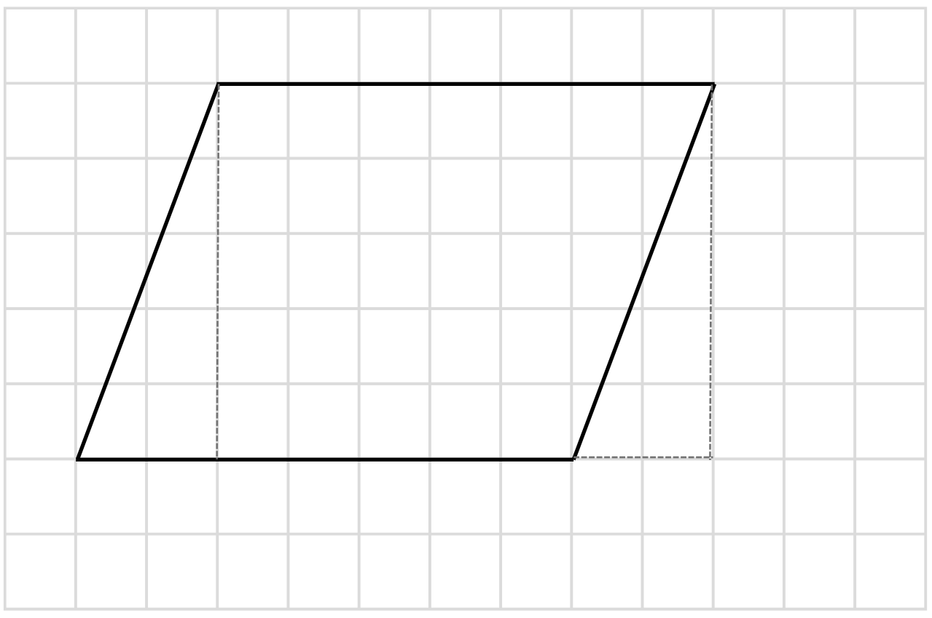

Resource 6 – 4 parallelograms and a grid
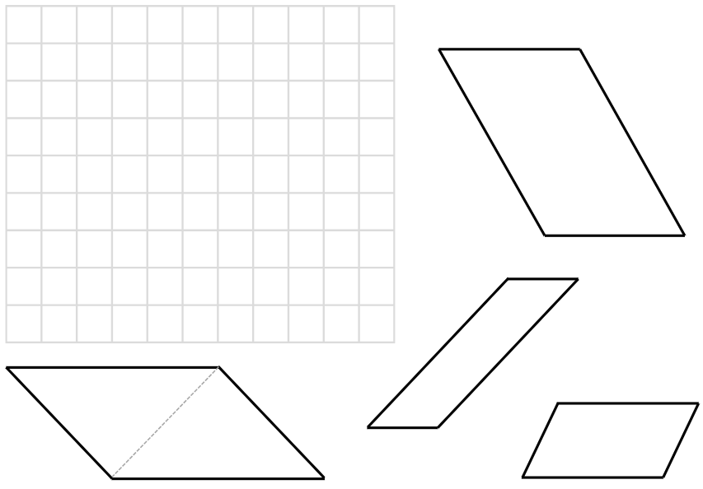

Resource 7 – 4 parallelograms on a grid
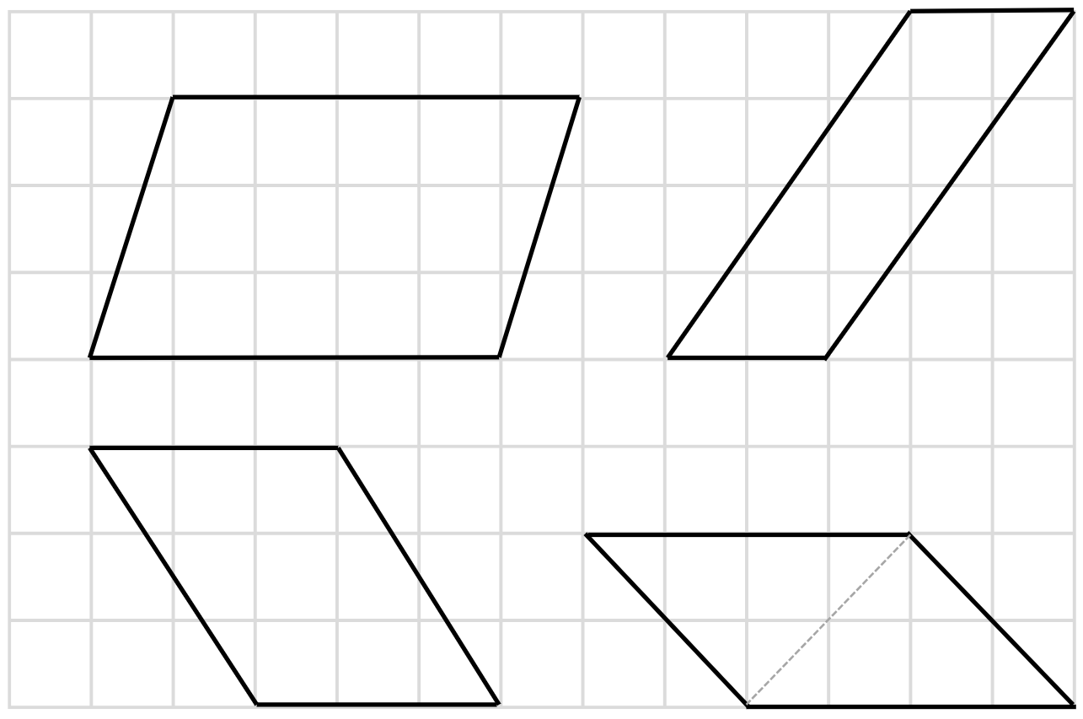

Resource 8 – minimum overnight temperatures
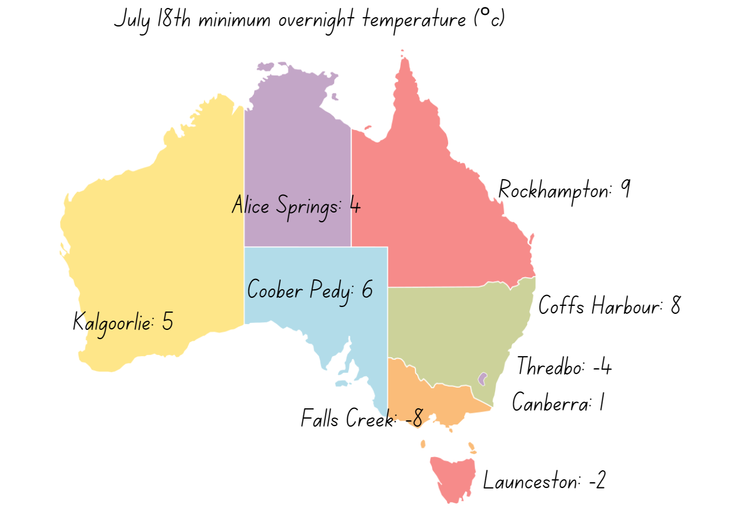

Resource 9 – triangles
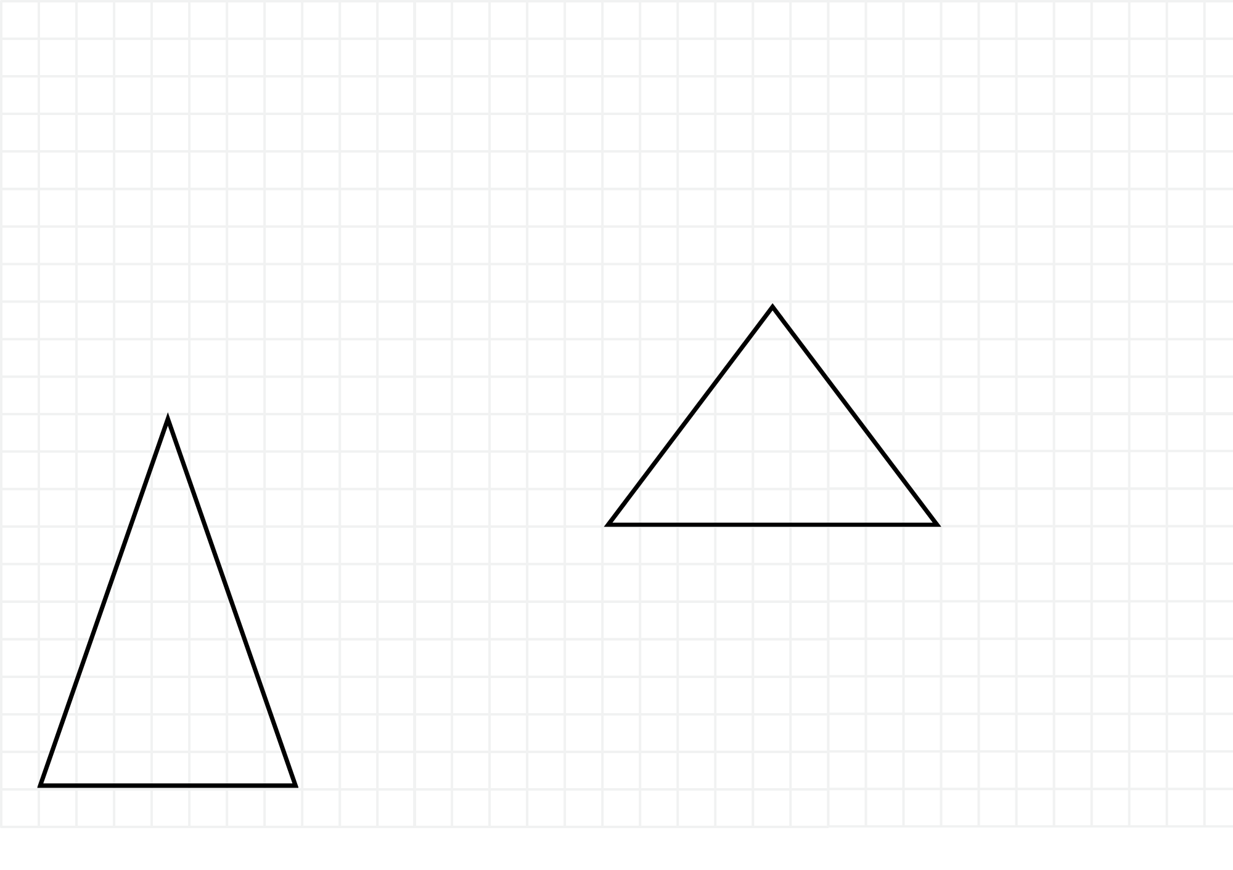

Resource 10 – area of triangles
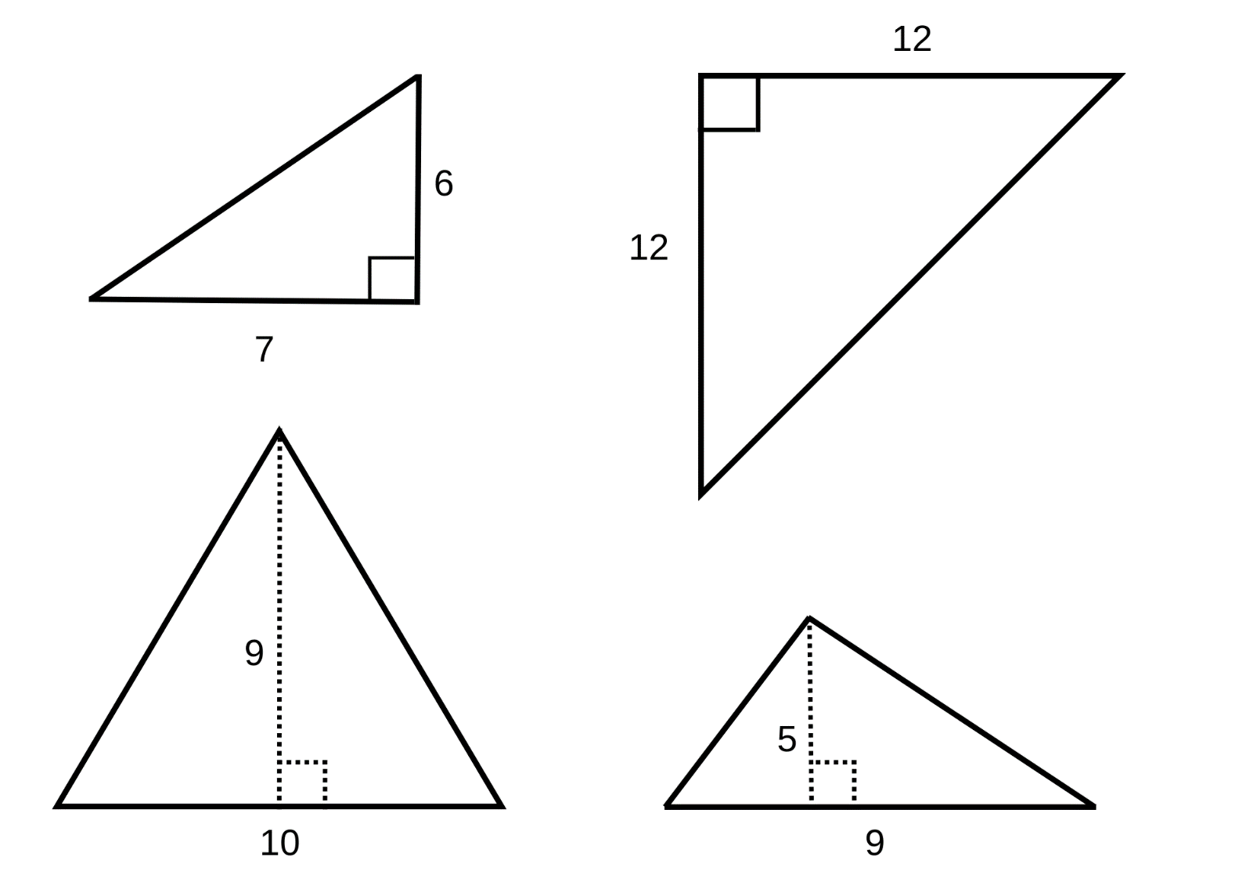

Resource 11 – weather wonders
Is it colder in Quebec or Calgary in January? | By how many degrees is Calgary colder in January than May? | What is the difference between Quebec and Toronto’s temperatures in January?
Find the difference between the warmest temperature and the coldest temperature. | Find the December temperatures for each city if they were 2 degrees colder than the January temperatures? | What is the difference between the temperature in Quebec in February and April?
Find the September temperature for Calgary if it was 13°C warmer than the February temperature. | Find the November temperatures for each city if they were 3 degrees warmer than the February temperatures. | Find the October temperature for Quebec if it was 12°C warmer than the March temperature.

City | January | February | March | April | May
Quebec City | −14°C | −13°C | −7°C | 1°C | 8°C
Toronto | −8°C | −7°C | −3°C | 3°C | 9°C
Calgary | −11°C | −9°C | −5°C | 0°C | 5°C
Vancouver | 2°C | 3°C | 4°C | 6°C | 9°C

Resource 12 – composite figure
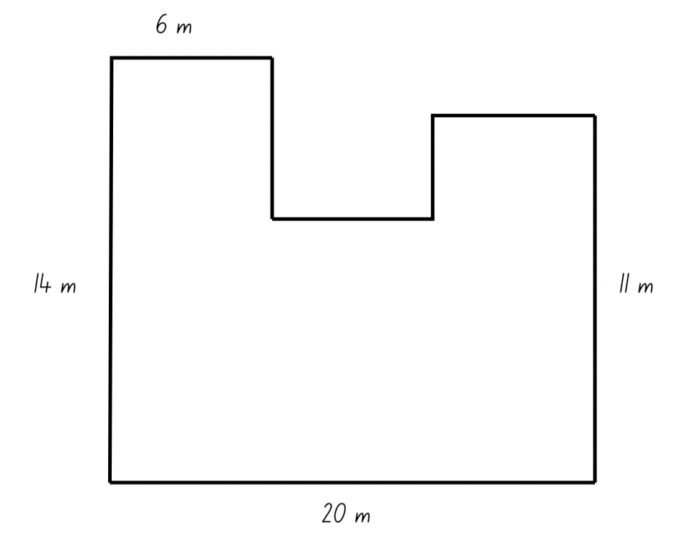

Resource 13 – composite figure 2
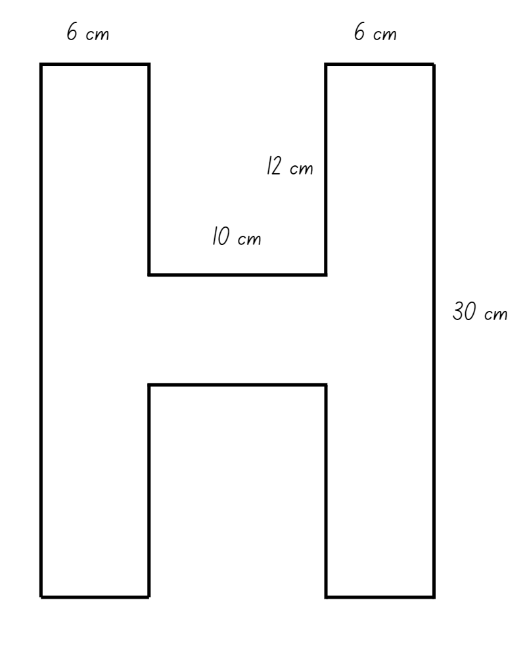

Resource 14 – sample playgrounds
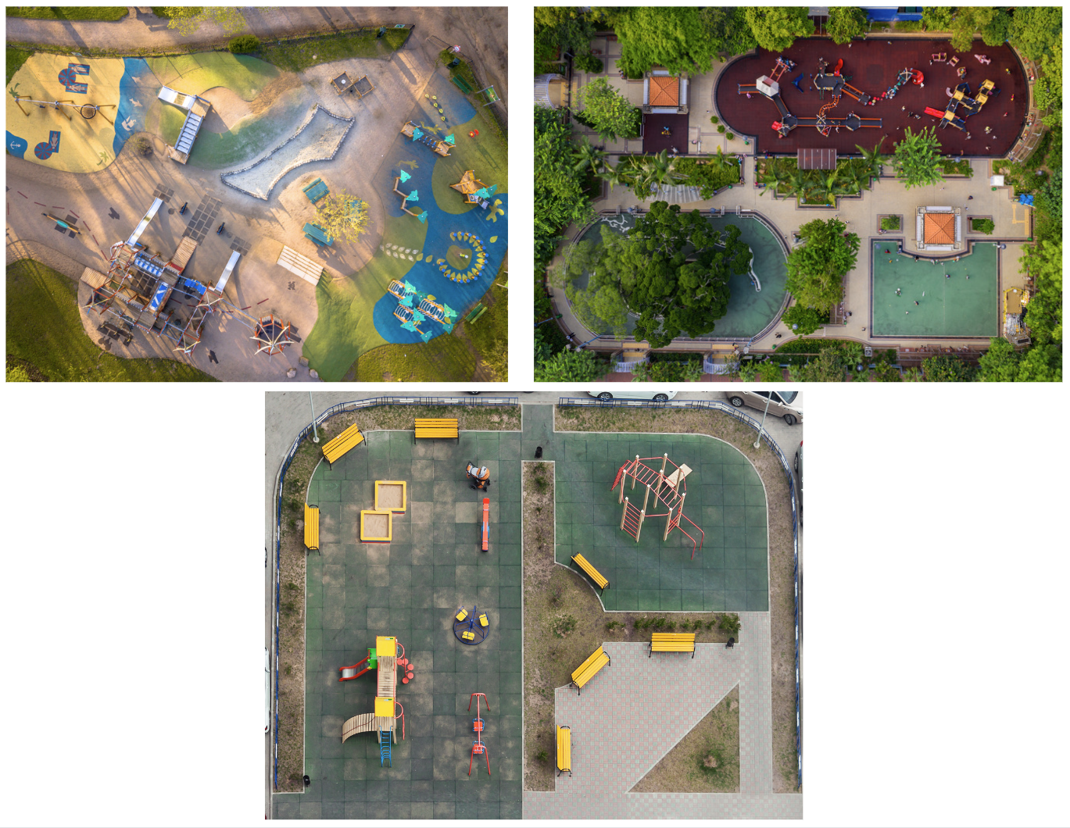

Resource 15 – playground items
Required items | Shape | Dimensions | Area required for one item | Number of items | Total area required
Slide | Rectangle
Climbing frame | Triangle
Toilet | Parallelogram
Swings | Square
Picnic table | Rectangle
Grass area | Composite L shape

Syllabus outcomes and content
The table below outlines the syllabus outcomes and range of relevant syllabus content covered in this unit. Content is linked to National Numeracy Learning Progression (version3).
Outcomes and content | 1 | 2 | 3 | 4 | 5 | 6 | 7 | 8
Represents numbers B: Whole numbers: Locate and represent integers on a number line
[MAO-WM-01, MA3-RN-01]
- Recognise the location of negative whole numbers in relation to zero and place them on a number line |  |  |  |  | x | x
- Use the term integers to describe positive and negative whole numbers and zero |  |  |  |  | x | x | x
- Interpret integers in everyday contexts |  |  |  |  |  | x | x
- Recognise that negative whole numbers can result from subtraction (Reasons about quantity) |  |  |  |  |  | x | x
Multiplicative relations A: Determine products and factors
[MAO-WM-01, MA3-MR-01]
- Use the term product to describe the result of multiplying 2 or more numbers |  |  |  | x
- Determine factors for a given whole number |  |  |  | x
Multiplicative relations A: Use partitioning and place value to multiply 2-, 3- and 4-digit numbers by one-digit
[MAO-WM-01 MA3-MR-01]
- Use informal written strategies such as the area model to solve multiplication and division problems |  |  |  |  |  |  | x | x
- Record the product of multiplying by a one-digit number using a formal algorithm |  |  |  |  |  |  | x | x
Multiplicative relations A: Use estimation and rounding to check the reasonableness of answer to calculations
[MAO-WM-01, MA3-MR-01]
- Use estimation and rounding to check the reasonableness of answers to multiplication and division calculations |  |  |  |  | x |  |  | x
Multiplicative relations B: Select and apply strategies to solve problems involving multiplication and division with whole numbers
[MAO-WM-01, MA3-MR-02]
- Select and use efficient strategies to multiply whole numbers of up to 4 digits by one- and 2-digit numbers |  |  |  |  |  |  | x | x
Multiplicative relations B: Represent and describe number patterns formed by multiples
[MAO-WM-01, MA3-MR-02]
- Describe a pattern formed by multiples in words, in terms of multiplication rather than addition | x | x | x
- Determine a rule describing the relationship between the bottom number and the top number in a table (Algebraic reasoning) | x | x | x
Two-dimensional spatial structure A: 2D shapes: Classify two-dimensional shapes and describe their properties
[MAO-WM-01, MA3-2DS-01]
- Recognise that triangles and quadrilaterals can be classified in more than one way (Reasons about spatial relations) | x | x
- Compare side and angle properties of triangles and quadrilaterals using measurement and symmetry | x | x
- Investigate the symmetry properties (line and rotational) of quadrilaterals | x | x
- Identify regular and irregular polygons | x | x
Two-dimensional spatial structure A: Area: Calculate the areas of rectangles using familiar metric units
[MAO-WM-01, MA3-2DS-02]
- Establish the relationship between the lengths, widths and areas of rectangles |  |  |  | x | x |  | x | x
- Record, using words, the method for finding the area of any rectangle |  |  |  | x | x |  | x | x
- Calculate areas of rectangles in square centimetres (cm²), square metres (m²) and square kilometres (km²⁾ |  |  |  | x | x |  | x | x
- Recognise that rectangles with the same area may have different dimensions |  |  |  |  |  |  |  | x
Two-dimensional spatial structure B: 2D shapes: Dissect two-dimensional shapes and rearrange them using translations, reflections and rotations
[MAO-WM-01, MA3-2DS-01]
- Use the terms translate, reflect and rotate to describe transformations of two-dimensional shapes |  | x | x | x | x
- Dissect and rearrange one shape to make another |  |  | x | x | x |  |  | x
- Recognise that translations, reflections or rotations change the position and orientation but not the size of shapes (Reasons about spatial orientation) |  | x | x |  | x |  |  | x
Two-dimensional spatial structure B: Area: Find the area of composite figures
[MAO-WM-01, MA3-2DS-02]
- Find different ways to calculate the area of a composite L-shape figure |  |  |  | x |  |  | x | x
Two-dimensional spatial structure B: Area: Calculate the area of a parallelogram using subdivision and rearrangement
[MAO-WM-01, MA3-2DS-03]
- Show how to transform a parallelogram into a rectangle to find its area |  |  |  |  | x |  | x | x
- Record, using words, a method for finding the area of any parallelogram |  |  |  |  | x |  | x
Two-dimensional spatial structure B: Area: Determine the area of a triangle
[MAO-WM-01, MA3-2DS-03]
- Investigate the area of a triangle by comparing it to the area of a parallelogram with the same base length and height |  |  |  |  |  | x | x | x
- Establish the relationship between the area of a triangle and the area of a parallelogram formed by duplicating and rotating the triangle |  |  |  |  |  | x | x
- Record, using words, a method for finding the area of any triangle |  |  |  |  |  | x | x
Mathematics K–10 Syllabus © NSW Education Standards Authority (NESA) for and on behalf of the Crown in right of the State of New South Wales, 2022.

References
This resource contains NSW Curriculum and syllabus content. The NSW Curriculum is developed by the NSW Education Standards Authority. This content is prepared by NESA for and on behalf of the Crown in right of the State of New South Wales. The material is protected by Crown copyright.
Please refer to the NESA Copyright Disclaimer for more information https://educationstandards.nsw.edu.au/wps/portal/nesa/mini-footer/copyright.
NESA holds the only official and up-to-date versions of the NSW Curriculum and syllabus documents. Please visit the NSW Education Standards Authority (NESA) website https://educationstandards.nsw.edu.au/wps/portal/nesa/home and the NSW Curriculum website https://curriculum.nsw.edu.au/.
Mathematics K–10 Syllabus © NSW Education Standards Authority (NESA) for and on behalf of the Crown in right of the State of New South Wales, 2022.
National Numeracy Learning Progression © Australian Curriculum, Assessment and Reporting Authority (ACARA) 2010 to present, unless otherwise indicated. This material was downloaded from the Australian Curriculum website (National Numeracy Learning Progression) (accessed 13 November 2023) and was not modified.
Boaler J, Munson J and Williams C (2019) Mindset Mathematics Visualizing and Investigating Big Ideas Grade 6, Jossey-Bass, San Francisco.
New Zealand Ministry of Education (n.d.) ‘Triangles’, Resource Finder, NZ Maths website, accessed 6 December 2023.
Sullivan P (2018) Challenging Mathematical Tasks, Oxford University Press, South Melbourne.
University of Cambridge (2023) Always, Sometimes or Never? Shape, NRICH website, accessed 29 November 2023.

© State of New South Wales (Department of Education), 2024
The copyright material published in this resource is subject to the Copyright Act 1968 (Cth) and is owned by the NSW Department of Education or, where indicated, by a party other than the NSW Department of Education (third-party material).
Copyright material available in this resource and owned by the NSW Department of Education is licensed under a Creative Commons Attribution 4.0 International (CC BY 4.0) license.
This license allows you to share and adapt the material for any purpose, even commercially.
Attribution should be given to © State of New South Wales (Department of Education), 2024.
Material in this resource not available under a Creative Commons license:
- the NSW Department of Education logo, other logos and trademark-protected material
- material owned by a third party that has been reproduced with permission. You will need to obtain permission from the third party to reuse its material.
Links to third-party material and websites
Please note that the provided (reading/viewing material/list/links/texts) are a suggestion only and implies no endorsement, by the New South Wales Department of Education, of any author, publisher, or book title. School principals and teachers are best placed to assess the suitability of resources that would complement the curriculum and reflect the needs and interests of their students.
If you use the links provided in this document to access a third-party's website, you acknowledge that the terms of use, including licence terms set out on the third-party's website apply to the use which may be made of the materials on that third-party website or where permitted by the Copyright Act 1968 (Cth). The department accepts no responsibility for content on third-party websites.

