Mathematics Stage 3 – Unit 17
Multiplicative thinking involves flexible use of multiplication and division concepts, strategies and representations
Contents
Unit description and duration 5
Syllabus outcomes 5
Working mathematically 6
Student prior learning 6
Lesson overview and resources 8
Lesson 1 14
Daily number sense – rearrange arrays – 10 minutes 14
Core lesson – product pathways – 40 minutes 16
Discuss and connect the mathematics – 10 minutes 19
Lesson 2 21
Daily number sense – factors fun – 15 minutes 21
Core lesson – playground problem – 40 minutes 23
Discuss and connect the mathematics – 15 minutes 26
Consolidation and meaningful practice – 5 minutes 27
Lesson 3 29
Daily number sense – factor multiple chains – 15 minutes 29
Core lesson – composite shapes – 35 minutes 31
Discuss and connect the mathematics – 10 minutes 33
Lesson 4 35
Daily number sense – 10 minutes 35
Core lesson – area models – 40 minutes 35
Discuss and connect the mathematics – 10 minutes 38
Lesson 5 40
Daily number sense – decimals on a line – 10 minutes 40
Core lesson – same volume, different shape – 40 minutes 43
Discuss and connect the mathematics – 10 minutes 45
Lesson 6 47
Daily number sense – fill the stairs – 15 minutes 47
Core lesson – calculating volume – 45 minutes 49
Discuss and connect the mathematics – 10 minutes 53
Lesson 7 56
Daily number sense – approximating decimals – 10 minutes 56
Core lesson – cubic metres – 45 minutes 57
Consolidation and meaningful practice – 15 minutes 61
Lesson 8 63
Daily number sense – 10 minutes 63
Core lesson – classroom cubic metres – 40 minutes 63
Consolidation and meaningful practice – 15 minutes 67
Resource 1 – route product 69
Resource 2 – place value houses 70
Resource 3 – factors fun game 71
Resource 4 – factors fun gameboard 72
Resource 5 – factors fun spinner 73
Resource 6 – garden bed 74
Resource 7 – area problem 75
Resource 8 – factor-multiple chains 76
Resource 9 – blank chains 77
Resource 10 – combining arrays 78
Resource 11 – array solutions 79
Resource 12 – combining arrays 2 80
Resource 13 – smaller combined array 81
Resource 14 – partitioning area 82
Resource 15 – recording sheet 83
Resource 16 – decimal cards 84
Resource 17 – two prisms 85
Resource 18 – same volume prism 86
Resource 19 – fill the stairs 87
Resource 20 – prism clue 88
Resource 21 – prism solution 89
Resource 22 – calculating volumes 90
Resource 23 – cubic metre 91
Syllabus outcomes and content 92
References 98

Unit description and duration
This unit develops the big idea that multiplicative thinking involves flexible use of multiplication and division concepts, strategies and representations.
In this 2-week unit students are provided opportunities to:
- select and apply appropriate strategies to solve multiplication and division problems
- estimate and measure areas of rectangles and composite shapes using square centimetres and square metres
- recognise the relationship between the dimensions of a prism and its volume to calculate volumes in cubic centimetres and cubic metres.

Syllabus outcomes
- MAO-WM-01 develops understanding and fluency in mathematics through exploring and connecting mathematical concepts, choosing and applying mathematical techniques to solve problems, and communicating their thinking and reasoning coherently and clearly
- MA3-RN-01 applies an understanding of place value and the role of zero to represent the properties of numbers
- MA3-RN-02 compares and orders decimals up to 3 decimal places
- MA3-MR-01 selects and applies appropriate strategies to solve multiplication and division problems
- MA3-GM-02 selects and uses the appropriate unit and device to measure lengths and distances including perimeters
- MA3-2DS-02 selects and uses the appropriate unit to calculate areas, including areas of rectangles
- MA3-3DS-02 selects and uses the appropriate unit to estimate, measure and calculate volumes and capacities

Working mathematically
In the Mathematics K–10 Syllabus, there is one overarching Working mathematically outcome (MAO-WM-01). The Working mathematically processes should be embedded within the concepts being taught. The Working mathematically processes present in the Mathematics K–10 Syllabus are:
- communicating
- understanding and fluency
- reasoning
- problem solving.
Mathematics K–10 Syllabus © NSW Education Standards Authority (NESA) for and on behalf of the Crown in right of the State of New South Wales, 2022.

Student prior learning
Before engaging in these teaching and learning activities, students would benefit from prior experience with:
- applying a range of strategies to solve multiplication and division problems
- estimating, measuring and comparing areas using square centimetres and metres
- describing and calculating volumes of rectangular prisms.
In NSW classrooms there is a diverse range of students, including Aboriginal and/or Torres Strait Islander students, students learning English as an additional language or dialect, high potential and gifted students and students with disability. Some students may identify with more than one of these groups or possibly all of them. Refer to Curriculum planning for every student – advice for further information.

Lesson overview and resources
The table below outlines the sequence and approximate timing of lessons, learning intentions and resources.
Lesson | Content | Duration and resources
Lesson 1  Daily number sense learning intention:  - determine products and factors | Lesson core concept: known number facts and strategies support multiplicative understanding.  Core concept learning intentions:  - determine products and factors  - use partitioning and place value to multiply 2-, 3- and 4-digit numbers by one-digit numbers | Lesson duration: 60 minutes  - Resource 1 – route product  - Resource 2 – place value houses  - Individual whiteboards  - Writing materials
Lesson 2  Daily number sense learning intention:  - determine products and factors | Lesson core concept: structures can support multiplicative thinking.  Core concept learning intentions:  - use partitioning and place value to multiply 2-, 3- and 4-digit numbers by one-digit numbers  - calculate the areas of rectangles using familiar metric units  - measure lengths to find perimeters | Lesson duration: 75 minutes  - Resource 3 – factors fun game  - Resource 4 – factors fun gameboard  - Resource 5 – factors fun spinner  - Resource 6 – garden bed  - Resource 7 – area problem  - Video: Factors fun! (8:25)  - Counters  - Paperclips  - Writing materials
Lesson 3  Daily number sense learning intention:  - determine products and factors | Lesson core concept: parts of a composite figure can be split, duplicated and rotated to find the total area.  Core concept learning intention:  - find the area of composite figures | Lesson duration: 60 minutes  - Resource 8 – factor-multiple chains  - Resource 9 – blank chains  - Resource 10 – combining arrays  - Resource 11 – array solutions  - Resource 12 – combining arrays 2  - Resource 13 – smaller combined array  - Scissors  - Writing materials
Lesson 4  Daily number sense learning intention:  - teacher-identified task based on student needs | Lesson core concept: area underpins multiplication and the use of the area model.  Core concept learning intentions:  - use partitioning and place value to multiply 2-, 3- and 4-digit numbers by one-digit numbers  - calculate the areas of rectangles using familiar metric units | Lesson duration: 60 minutes  - Resource 14 – partitioning area  - Resource 15 – recording sheet  - Writing materials
Lesson 5  Daily number sense learning intention:  - compare, order and represent decimals | Lesson core concept: objects with the same volume may be different shapes.  Core concept learning intention:  - find the volumes of rectangular prisms in cubic centimetres | Lesson duration: 60 minutes  - Resource 16 – decimal cards  - Resource 17 – two prisms  - Resource 18 – same volume prism  - Writing materials
Lesson 6  Daily number sense learning intention:  - compare, order and represent decimals | Lesson core concept: the multiplicative relationship between the length, width and height of an object can be used to determine volume.  Core concept learning intentions:  - select and apply strategies to solve problems involving multiplication and division with whole numbers  - recognise the multiplicative structure for finding volume | Lesson duration: 70 minutes  - Resource 19 – fill the stairs  - Resource 20 – prism clue  - Resource 21 – prism solution  - Resource 22 – calculating volumes  - 10-sided dice (3 per student)  - Isometric dot paper  - MAB materials  - Writing materials
Lesson 7  Daily number sense learning intention:  - compare, order and represent decimals | Lesson core concept: the context determines the most suitable standard unit for measuring volume, sometimes a cubic centimetre is too small.  Core concept learning intention:  - use cubic metres for measurement of volume | Lesson duration: 70 minutes  - Resource 23 – cubic metre  - 9-sided dice  - Cardboard  - Individual whiteboards  - Masking tape  - Metre rulers  - Newspaper  - Writing materials
Lesson 8  Daily number sense learning intention:  - teacher-identified task based on student needs | Lesson core concept: mathematicians estimate, measure and record volume using m³.  Core concept learning intentions:  - use estimation to check the reasonableness of answers to multiplication and division calculations  - use cubic metres for measurement of volume  - find the volumes of rectangular prisms in cubic centimetres and cubic metres | Lesson duration: 65 minutes  - Metre rulers  - Writing materials

Lesson 1
Core concept: known number facts and strategies support multiplicative understanding.

Daily number sense – rearrange arrays – 10 minutes
Daily number sense activities for Lessons 1 to 3 ‘activate’ prior number knowledge and support the learning of new content in the unit. These activities can also assist teachers to identify the starting points for learning by revealing the extent of students’ existing knowledge.
The table below contains a suggested learning intention and success criteria. These are best co-constructed with students.
Daily number sense learning intention | Daily number sense success criteria
Students are learning to:  - determine products and factors. | Students can:  - model different ways to show a whole number as a product  - determine factors for a given whole number.
- Pose the following question: I have 36 counters arranged in an array. How might they be arranged?
- Students turn and talk and record their ideas on individual whiteboards. For example, 36 as 6 by 6, 9 by 4 or 12 by 3.
- Ask the following questions:
- How many possibilities are there?
- How did multiplication help you with this problem?
- How could the words product and factor help you describe the numbers you have used and their relationship with each other?
Factor: a number which divides another number without a remainder. For example, 1, 2, 3 and 6 are factors of 6, but 4 and 5 are not.
Product: the result of multiplying 2 or more numbers together, for example, 12 is the product of 4 × 3.
- Explain that 36 is a product of 9 × 4, 6 × 6, 12 × 3. The factors of 36 are 1, 2, 3, 4, 6, 9, 12, 18, 36.
- Pose the following question: I have 72 counters arranged in an array. How might they be arranged?
- Ask students to record their ideas as number sentences where 72 is the product and identify the factors of 72.
- Ask the following questions:
- How many possibilities are there?
- Did the factors of 36 help you work out the factors of 72? Explain your thinking.
This table details opportunities for assessment.
Assessment opportunities | Links
What to look for:  - Can students model different ways to show a whole number as a product? [MAO-WM-01, MA3-MR-01]  - Can students determine factors for a given whole number?  [MAO-WM-01, MA3-MR-01] | Links to National Numeracy Learning Progressions (NNLP):  - MuS6, MuS7.  Links to suggested Interview for Student Reasoning (IfSR) tasks:  - IfSR-MT: 2A.7.

Core lesson – product pathways – 40 minutes
The table below contains suggested learning intentions and success criteria. These are best co-constructed with students.
Core concept learning intentions | Core concept success criteria
Students are learning to:  - determine products and factors  - use partitioning and place value to multiply 2-, 3- and 4-digit numbers by one-digit numbers. | Students can:  - use the term product to describe the result of multiplying 2 or more numbers  - use mental strategies to multiply one-digit numbers by 10, 100, 1000 and their multiples  - estimate the product of 2 numbers (one-digit by 2- or 3-digit numbers) using multiples of 10 or 100.
This lesson is an adaptation of Route Product from NRICH by the University of Cambridge.
- Write the number sentence 29 × 98 on the board. Ask the following questions:
- How could you use rounding to help estimate the product?
- Is 2900 or 3000 a better estimate? Why?
- Is there ever a situation where it might be better to underestimate?
Note: the purpose of this discussion is to explore mental estimation strategies. Rounding 98 to 100 will give you 2900. Rounding both to the nearest decade will give you 3000.
- Display Resource 1 – route product. Explain that there are many different routes from A to B in the diagram. The task is to work out the product of the numbers on the different routes from A to B without visiting a point more than once. Ask the following questions:
- Which route do you estimate will give the largest product? Why?
- Which route do you estimate will give the smallest product? Why?
- There are numbers on the diagram that are multiples of 10. How might this help you?
- Provide small groups of students with copies of Resource 1 – route product to determine the product of all possible routes. Students record their number sentences and products of each route.
- After some exploration time, ask the following questions:
- How do you know you have looked at all the possible routes?
- What strategies can be used to calculate the product each time?
- If not discussed, highlight the use of factorising and halving as strategies. For example, 6 × 50 can be represented as 6 × 5 × 10 or 3 × 2 × 50 with factorisation. 6 × 50 can also be represented as 6 × 100 ÷ 2 using a halving strategy.
- Provide students with further opportunities to explore the different possibilities.
This table details opportunities for differentiation.
Too hard? | Too easy?
Students cannot use mental strategies to multiply one-digit numbers by 10, 100, 1000 and their multiples.  - Provide students with a copy of Resource 2 – place value houses. Support students to identify the changes in place value when multiplying by 10 and their multiples. | Students can use mental strategies to multiply one-digit numbers by 10, 100, 1000 and their multiples.  - Students create their own grid so that the product of all routes is 100 without using the number 100.

Discuss and connect the mathematics – 10 minutes
- Ask the following questions:
- Which route or routes give the largest product? (40 × 50 × 20 × 10 = 400 000)
- What strategy did you use to calculate the largest product?
- Which route or routes give the smallest product? (5 × 10)
- How many possible routes were there in total?
- How did your understanding of place value and factorisation help with this task?
- Does multiplying more numbers together give you a larger product? Is this always the case? (No, it depends on the size of the numbers being multiplied.)
- Write the number sentence 7 × 5 on the board. Ask the following questions:
- How does this number sentence help you solve 70 × 5?
- What is another problem that this number sentence could help you solve? (700 × 5 and 7 × 50 are some examples)
- Could this number sentence help you solve 49 × 5?
- What are some other ways you could solve 49 × 5?
- How could estimation help you check your answer?
Note: it is a common misconception that multiplying by 10 can be done by simply ‘adding a zero’ and multiplying by 100 can be done by ‘adding 2 zeros’. This should be avoided as it detracts from a deeper understanding of place value, multiplicative thinking and the link between them.
This table details opportunities for assessment.
Assessment opportunities | Links
What to look for:  - Can students use the term product to describe the result of multiplying 2 or more numbers? [MAO-WM-01, MA3-MR-01]  - Can students estimate the product of 2 numbers (one-digit by 2- or 3-digit numbers) using multiples of 10 or 100?  [MAO-WM-01, MA3-MR-01]  - Can students use mental strategies to multiply one-digit numbers by 10, 100, 1000 and their multiples? [MAO-WM-01, MA3-MR-01] | Links to National Numeracy Learning Progressions (NNLP):  - MuS6, MuS7.  Links to suggested Interview for Student Reasoning (IfSR) tasks:  - IfSR-MT: 3A.1, 3A.2, 3A.3, 3A.4, 3A.5.

Lesson 2
Core concept: structures can support multiplicative thinking.

Daily number sense – factors fun – 15 minutes
The table below contains a suggested learning intention and success criteria. These are best co-constructed with students.
Daily number sense learning intention | Daily number sense success criteria
Students are learning to:  - determine products and factors. | Students can:  - determine factors for a given whole number.
This lesson is an adaptation of Factors fun! from Mathematics K–6 resources by the State of New South Wales (Department of Education).
- Provide pairs of students with Resource 3 – factors fun game, Resource 4 – factors fun gameboard, Resource 5 – factors fun spinner, counters, a paperclip and pencils. Watch the Factors fun! (8:25) video about the steps and reasoning used in this game.
- Students take it in turns to spin the spinner and divide the number by the chosen divisor. For example, 5.
- Players work out the solution and explain their thinking to their partner.
- The partner records their thinking and, if they agree, the player places one of their counters on the number on the gameboard, claiming that place.
- If the number is taken, students miss a turn.
- If there are no new counters that can be added to the gameboard, players must move an existing counter to a new place.
- Players win by getting 4 counters in a row (in any orientation, including a square).
- If preferred, students can use 5 or 6 counters, looking for 4 in a row.
- Observe student reasoning and completed gameboards, see Figure 1.
Figure 1 – factors fun gameboard
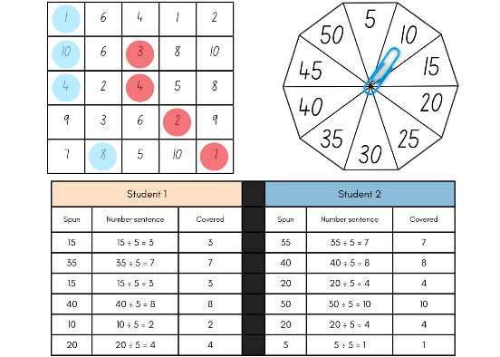
This table details an opportunity for assessment.
Assessment opportunity | Links
What to look for:  - Can students determine factors for a given whole number?  [MAO-WM-01, MA3-MR-01] | Links to National Numeracy Learning Progressions (NNLP):  - MuS6, MuS7.  Links to suggested Interview for Student Reasoning (IfSR) tasks:  - IfSR-MT: 2A.7.

Core lesson – playground problem – 40 minutes
The table below contains suggested learning intentions and success criteria. These are best co-constructed with students.
Core concept learning intentions | Core concept success criteria
Students are learning to:  - use partitioning and place value to multiply 2-, 3- and 4-digit numbers by one-digit numbers  - calculate the areas of rectangles using familiar metric units  - measure lengths to find perimeters. | Students can:  - use informal written strategies such as the area model to solve multiplication and division problems  - calculate areas of rectangles in square metres (m²)  - recognise that rectangles with the same area may have different dimensions  - use efficient strategies to calculate the perimeter of a large rectangular area in metres.
- Revise the term ‘area’ with students. Ask the following questions:
- What does area measure?
- What units of measurement are used for area?
- How are these units of measurement different to those used for length?
Area: the amount of surface inside a closed flat (2D) shape.
- Explain that measurements in square centimetres can be recorded as cm² and square metres can be recorded as m².
- Display Resource 6 – garden bed and pose the following problem: The length of the garden bed is 12 m and the area is 60 m². What is the width of the garden bed?
- Students turn and talk to discuss the problem. Ask the following questions:
- What number sentence could be used to represent this problem? (12 × _ = 60 or 60 ÷ 12 = _)
- How could you calculate the missing length?
- What would the perimeter of the garden bed be?
- What unit of measurement is used to communicate the perimeter?
- If another garden bed was constructed with an area of 60 m², could it have different dimensions? What might they be? (Some examples include 30 m × 2 m, 15 m × 4 m.)
- Display Resource 7 – area problem and pose the following problem: Robertson Public School and Jackson Public School both have rectangular grassy spaces for their students to play on. The difference between the area of the spaces is 28 m². Ask the following questions:
- What could the area of each grassy space be?
- What could the length and width of these areas be? Can you find any other possibilities?
- What could the perimeter of the grassy space be?
- Students work independently or with a partner to explore and record different solutions.
This table details opportunities for differentiation.
Too hard? | Too easy?
Students cannot recognise that rectangles with the same area may have different dimensions.  - Provide students with square centimetre grid paper to model their areas with rows and columns.  - Provide students with an area such as 24 m². Support students to use a multiplication grid to find possible dimensions by identifying factors of 24. | Students can recognise that rectangles with the same area may have different dimensions.  - Pose the following problem: Can you find any solutions where the perimeter is the same as the area?  - Pose the following problem: What could the area and perimeter of a grassy space be if it was a square? What patterns do you notice?

Discuss and connect the mathematics – 15 minutes
- Regroup and have students share their thinking. Ask the following questions:
- Which areas gave you the most possibilities with dimensions?
- Were there any areas that only had one possible set of dimensions? What do you notice about these areas? (If the area chosen was a prime number there is only one solution as there are only 2 factors).
- Can you make a generalisation in words a method for finding the area of any rectangle?
Area of a rectangle = number of units of length × number of units of width.
Note: when generalising their methods to calculate areas, students in Stage 3 should use words. Algebraic formulas for areas are not introduced until Stage 4.
- What strategies did you use to calculate the perimeter of a rectangle?
- What is the most efficient strategy to calculate the perimeter of a rectangle or square?
- Do all rectangles with the same area have the same perimeter? Why or why not?

Consolidation and meaningful practice – 5 minutes
- Pose the following problem: the area of the grass is 36 m². What might be the perimeter of the space? Give at least 3 different answers.
- Use this sample as an exit slip and work sample for the lesson.
This table details opportunities for assessment.
Assessment opportunities | Links
What to look for:  - Can students use informal written strategies such as the area model to solve multiplication and division problems?  [MAO-WM-01, MA3-MR-01]  - Can students calculate areas of rectangles in square metres (m²)? [MAO-WM-01, MA3-2DS-02]  - Can students recognise that rectangles with the same area may have different dimensions? [MAO-WM-01, MA3-2DS-03]  - Can students use efficient strategies to calculate the perimeter of a large rectangular area in metres? [MAO-WM-01, MA3-GM-02] | Links to National Numeracy Learning Progressions (NNLP):  - MuS6, MuS7  - UuM5, UuM6, UuM7  - UGP6.  Links to suggested Interview for Student Reasoning (IfSR) tasks:  - IfSR-MT: 3A.1, 3A.2, 3A.3, 3A.4, 3A.5.

Lesson 3
Core concept: parts of a composite figure can be split, duplicated and rotated to find the total area.

Daily number sense – factor multiple chains – 15 minutes
The table below contains a suggested learning intention and success criteria. These are best co-constructed with students.
Daily number sense learning intention | Daily number sense success criteria
Students are learning to:  - determine products and factors. | Students can:  - determine factors for a given whole number.
This lesson is an adaptation of Factor-multiple Chains from NRICH by the University of Cambridge.
- Display Resource 8 – factor-multiple chains. Ask the following questions:
- Can you see how this works?
- What does the word factor mean?
- What does the word multiple mean?
- Can you explain the connection between the numbers in the chain?
- Are there any numbers that could change to still make it a chain?
- Provide students with Resource 9 – blank chains or use Factor-multiple Chains (XLSX 41 KB). Ask students to develop their own factor-multiple chains with numbers from 2 to 100 using one of the resources.
Note: the Factor-multiple Chains (XLSX 41 KB) resource can be used by students or as a class to check whether chains are correct.
- Students turn and talk and share their ideas. Ask the following questions:
- What are the smallest numbers that will make a complete chain? (2, 4, 8, 16).
- What are the largest numbers that will make a complete chain? (5, 25, 50, 100).
- What numbers cannot appear in any chain? (Prime numbers larger than 12 do not work and prime numbers smaller than 12 can only appear at the start.)
This table details an opportunity for assessment.
Assessment opportunity | Links
What to look for:  - Can students determine factors for a given whole number?  [MAO-WM-01, MA3-MR-01] | Links to National Numeracy Learning Progressions (NNLP):  - MuS6, MuS7.  Links to suggested Interview for Student Reasoning (IfSR) tasks:  - IfSR-MT: 2A.7.

Core lesson – composite shapes – 35 minutes
The table below contains a suggested learning intention and success criteria. These are best co-constructed with students.
Core concept learning intention | Core concept success criteria
Students are learning to:  - find the area of composite figures. | Students can:  - find different ways to calculate the area of a composite L-shape figure.
This activity is an adaptation of ‘Combining Arrays’ and ‘Composite Shapes’, in Challenging Mathematical Tasks: Unlocking the potential of all students by Sullivan.
- Display Resource 10 – combining arrays. Ask the following questions:
- How many small squares have been used to make this shape?
- How might you partition or rearrange this shape to complete this task?
- Can you find the answer in 2 or more different ways?
- Provide pairs of students with Resource 10 – combining arrays, scissors and writing materials. Allow students time to explore the task and record their strategies.
- Select students to share that reflect a variety of strategies used. Ask the following questions:
- What strategy did you use to determine the number of small squares in this shape?
- How did multiplication help you with this task?
- How could you represent your strategy using a number sentence?
- How did partitioning or rearranging the shape help with calculating the total number of small squares?
- Display Resource 11 – array solutions and draw students’ attention to any strategies that were not already discussed.
- Display Resource 12 – combining arrays 2. Explain that students need to determine the number of small squares used to make this shape. Ask the following questions:
- How might the grid paper in the background be used to complete this task?
- Can you find the answer in 2 or more different ways?
- Provide each student with Resource 12 – combining arrays 2. Encourage students to find multiple solutions and record the corresponding number sentences.
This table details opportunities for differentiation.
Too hard? | Too easy?
Students cannot find different ways to calculate the area of a composite L-shape figure.  - Provide students with Resource 13 – smaller combined array and scissors. Ask students to calculate the number of small squares in 2 different ways by cutting up the diagram.  - Support students to partition the shapes into separate rectangular shapes. Support students to identify arrays and utilise a multiplication chart where necessary. | Students can find different ways to calculate the area of a composite L-shape figure.  - Pose the following question: What would a shape like the letter ‘L’ made from 60 squares look like?  - Provide students with Rod Area from NRICH. Students design a U shape which has a perimeter of 20 cm. Challenge students to design a shape which has an area that is an odd number as well as an even number.

Discuss and connect the mathematics – 10 minutes
- Conduct a gallery walk. Ask the following questions:
- Are there any strategies that you have not thought of?
- Which strategy is the most efficient? Why?
- Write this problem on the board: An L shape is made of 30 small squares. What might it look like?
- Students record their ideas on a whiteboard.
This table details an opportunity for assessment.
Assessment opportunity | Links
What to look for:  - Can students find different ways to calculate the area of a composite L-shape figure? [MAO-WM-01, MA3-2DS-02] | Links to National Numeracy Learning Progressions (NNLP):  - UuM7, UuM10.

Lesson 4
Core concept: area underpins multiplication and the use of the area model.

Daily number sense – 10 minutes
- From a class need surfaced through formative assessment data, identify a short, focused activity that targets students’ knowledge, understanding and skills. Example activities may be drawn from the following resources:
- Mathematics K–6 resources
- Universal Resources Hub.

Core lesson – area models – 40 minutes
The table below contains suggested learning intentions and success criteria. These are best co-constructed with students.
Core concept learning intentions | Core concept success criteria
Students are learning to:  - use partitioning and place value to multiply 2-, 3- and 4-digit numbers by one-digit numbers  - calculate the areas of rectangles using familiar metric units. | Students can:  - use informal written strategies such as the area model to solve multiplication and division problems  - recognise the importance of using the same units of length on the sides of rectangles to create ‘square units’  - establish the relationship between the lengths, widths and areas of rectangles  - investigate and compare the areas of rectangles that have the same perimeter.
- Display Resource 14 – partitioning area. Ask the following questions:
- What unit of measurement would the missing value use?
- Why can’t the missing value be measured in metres or millimetres?
- How might the missing measurement be determined?
- What mathematical ideas have you explored before that are useful in solving this problem?
- How could partitioning 108 help you solve this problem?
- What is the perimeter of this shape?
- Students turn and talk and record their ideas on a whiteboard.
- Regroup and share strategies used. Ask the following questions:
- What strategy did you use?
- How did you partition the numbers to solve this problem?
- How could an inverse operation help you check your answer?
- How could you describe the relationship between the length, width and area of a rectangle?
- How did this help you with solving the problem?
- What strategies can be used to determine the perimeter of a rectangle?
- Confirm that the missing value on Resource 14 – partitioning area is 27 cm and the perimeter is 62 cm.
- Pose the following conjecture: Any rectangle that has a perimeter of 62 cm will have an area of 108 cm².
- Ask the following questions:
- What might the dimensions be of a rectangle with a perimeter of 62 cm?
- How can partitioning 31 cm in multiple ways help you with this task?
- How could division and addition help you with determining different dimensions? (Half the perimeter is 31 cm. I can then use my addition and subtraction knowledge to generate different lengths and widths that total 31 cm.)
- Students work in pairs or groups of 3 to test the conjecture. Provide students with Resource 15 – recording sheet.
- Move around the room and support students where necessary. As students progress with the task, encourage students to look for patterns that may assist them in generating all possible solutions.
This table details opportunities for differentiation.
Too hard? | Too easy?
Students cannot investigate and compare the areas of rectangles that have the same perimeter.  - Provide students with a smaller perimeter to work with such as 40 cm. Support students to make the connection between the side properties of a rectangle and how the given perimeter can be partitioned accordingly.  - Provide students with square centimetre grid paper to record their rectangles. Support students to partition the area into smaller arrays to determine the total area. | Students can investigate and compare the areas of rectangles that have the same perimeter.  - Provide students with a copy of Area and Perimeter by NRICH. Students design shapes to meet the criteria posed in the problem.

Discuss and connect the mathematics – 10 minutes
- Regroup and ask the following questions:
- What patterns did you notice?
- How could you use these patterns to determine all the possible dimensions of a rectangle with a perimeter of 62 cm?
- What strategies did you use to calculate the area?
- Do rectangles with the same perimeter have the same area?
This table details opportunities for assessment.
Assessment opportunities | Links
What to look for:  - Can students use informal written strategies such as the area model to solve multiplication and division problems?  [MAO-WM-01, MA3-MR-01]  - Can students recognise the importance of using the same units of length on the sides of rectangles to create ‘square units’?  [MAO-WM-01, MA3-2DS-02]  - Can students establish the relationship between the lengths, widths and areas of rectangles? [MAO-WM-01, MA3-2DS-02]  - Can students investigate and compare the areas of rectangles that have the same perimeter? [MAO-WM-01, MA3-2DS-02] | Links to National Numeracy Learning Progressions (NNLP):  - MuS6, MuS7  - UuM6, UuM7  - UGP6.

Lesson 5
Core concept: objects with the same volume may be different shapes.

Daily number sense – decimals on a line – 10 minutes
Daily number sense activities for Lessons 5 to 7 ‘loop’ back to concepts and procedures covered in previous units to assist students to build an increasingly connected network of ideas. These concepts may differ from the core concepts being covered by the unit.
The table below contains a suggested learning intention and success criteria. These are best co-constructed with students.
Daily number sense learning intention | Daily number sense success criteria
Students are learning to:  - compare, order and represent decimals. | Students can:  - compare and order numbers of up to 3 decimal places  - interpret zero digit(s) at the end of a decimal  - place decimal numbers of up to 3 decimal places on a number line.
Note: pre-cut Resource 16 – decimal cards before the start of the lesson.
- Display a large, blank number line on the board.
- Give each student a card from Resource 16 – decimal cards. Ask the following question: Which decimal cards should be placed first to provide a benchmark for other numbers? For example, 0.0, 1.0, 2.0, 3.0 and 4.0.
- Ask students with benchmark number cards to say their numbers aloud and place them onto the blank number line.
- Remaining students say their number aloud and then decide where it should be placed on the number line, see Figure 2.
Figure 2 – decimal number line
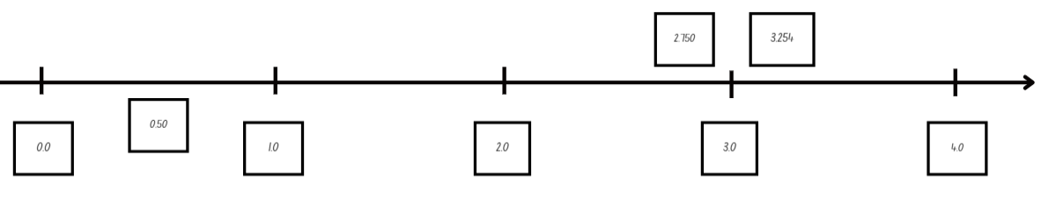
Note: to support place value conceptual understanding, 3.254 would be read as three and two hundred and fifty-four thousandths. The language connects the decimal fraction with the whole number and makes a connection with common fractions.
- Students place their number on the number line and explain their reasoning for placing the number in that position.
- Discuss how the decimals on the number line help decide where the card goes.
- Once students have placed all numbers, ask the following questions:
- Are there any numbers that need to have their position adjusted? If yes, explain why.
- Which decimals are closest to the benchmark numbers?
- Are there any numbers you have seen represented in more than one way? For example, 2.75 and 2.750.
This table details opportunities for assessment.
Assessment opportunities | Links
What to look for:  - Can students compare and order decimal numbers of up to 3 decimal places? [MAO-WM-01, MA3-RN-02]  - Can students interpret zero digit(s) at the end of a decimal? [MAO-WM-01, MA3-RN-02]  - Can students place decimal numbers of up to 3 decimal places on a number line? [MAO-WM-01, MA3-RN-02] | Links to National Numeracy Learning Progressions (NNLP):  - NPV8.  Links to suggested Interview for Student Reasoning (IfSR) tasks:  - IfSR-NP: 4D.1, 4D.4, 4D.6.

Core lesson – same volume, different shape – 40 minutes
The table below contains a suggested learning intention and success criteria. These are best co-constructed with students.
Core concept learning intention | Core concept success criteria
Students are learning to:  - find the volumes of rectangular prisms in cubic centimetres. | Students can:  - recognise that rectangular prisms with the same volume may have different dimensions  - calculate volumes of rectangular prisms in cubic centimetres (cm³).
- Display Resource 17 – two prisms. Ask the following questions:
- How could you describe the volume of these prisms in layers?
- What is the volume of these prisms?
- What unit of measurement is used to communicate the volume of a prism?
- Can you record how you calculated the volume of each prism using a number sentence?
- How is it possible that prisms with different dimensions have the same volume?
- Remind students that volume is measured using cubic centimetres. Explain that this can be recorded using the notation cm³.
- Write this problem on the board: A rectangular prism has a volume of 128 cubic centimetres. What might it look like?
- Ask the following questions:
- What is the smallest number of layers a prism can have?
- How can multiplication and division help with this task?
- How can you use this to start the task?
- How could you work out the dimensions of the prism if it had 2 layers?
- Provide pairs or groups of 3 with Resource 18 – same volume prism to record their ideas. Students record the number of layers in each prism and the number of cubes in one layer to complete the task. Encourage students to explore different possibilities for the dimensions of each layer. For example, if the prism has 2 layers, each layer will have 64 cubic centimetres. This could be an array of 8 × 8, 16 × 4, 32 × 2, 64 × 1, see Table 1.
Table 1 – possible student solutions
Number of layers | Number of cubes in one layer | Possible dimensions of each layer
2 | 64 | 8 cm × 8 cm, 16 cm × 4 cm, 32 cm × 2 cm, 64 cm × 1 cm
This table details opportunities for differentiation.
Too hard? | Too easy?
Students cannot recognise that rectangular prisms with the same volume may have different dimensions:  - Using interlocking cubes, model the creation of a smaller prism using 32 cubic centimetres. Have students write its dimensions and then create another prism with the same volume.  - Give students the layers and area of the base for example, layers = 2, base = 64. Have students create possible dimensions for 64. | Students can recognise that rectangular prisms with the same volume may have different dimensions:  - Pose the question: What could the dimensions be for a prism that has a volume of 1 000 000 cubic centimetres?  - What might an object look like with a volume of 128 cubic centimetres if it is not a regular prism?

Discuss and connect the mathematics – 10 minutes
- Ask the following questions:
- How do you know if you have all the solutions?
- Are any of your solutions the same numbers but in a different order? For example, 32 × 2 × 2 = 2 × 32 × 2. What does this tell us about the order in which we multiply?
- What properties of multiplication did you use to help calculate the dimensions of the prism?
- Have students write their answer to this question on a sticky note: Do all prisms that have the same volume need to look the same? Why or why not?
This table details opportunities for assessment.
Assessment opportunities | Links
What to look for:  - Can students explain that objects with the same volume may be different shapes? [MAO-WM-01, MA3-3DS-02]  - Can students recognise that rectangular prisms with the same volume may have different dimensions?  [MAO-WM-01, MA3-3DS-02]  - Can students calculate volumes of rectangular prisms in cubic centimetres and cubic metres? [MAO-WM-01, MA3-3DS-02] | Links to National Numeracy Learning Progressions (NNLP):  - UuM5.

Lesson 6
Core concept: the multiplicative relationship between the length, width and height of an object can be used to determine volume.

Daily number sense – fill the stairs – 15 minutes
The table below contains a suggested learning intention and success criteria. These are best co-constructed with students.
Daily number sense learning intention | Daily number sense success criteria
Students are learning to:  - compare, order and represent decimals. | Students can:  - compare and order decimal numbers of up to 3 decimal places.
Note: this lesson is an adaptation of Fill the Stairs from Math for Love by Cook.
- Display Resource 19 – fill the stairs. Explain that the numbers must increase as they go up the stairs. The number at the base of the stairs is zero and the number at the top of the stairs is one.
- Explain the instructions for this activity. Small groups of students will need three 10-sided dice, Resource 19 – fill the stairs. One die will represent the ‘tenths’, one die will represent ‘hundredths’ and one die will be the ‘thousandths’ die. For example, if 3, 7 and 8 are rolled, some possible combinations are 0.378, 0.873 or 0.387. Students take turns rolling all 3 dice to make a number with 3 decimal places and write it on one of the stairs. If a number can’t be used, the number is written under the stairs and students skip a turn.
- Model for students one turn of the game highlighting the strategies that can be used once the 3 dice are rolled. Discuss with students the possible combinations for the decimal number that is formed.
- Ask the following questions:
- Where are you going to put that number? Why?
- What number are you hoping for on the next roll?
- How will you know where to place the next number rolled?
- How can the digits of a decimal be reordered to make sure the number can fit on the stairs?
- Give small groups of students time to complete the activity.
This table details an opportunity for assessment.
Assessment opportunity | Links
What to look for:  - Can students compare and order decimal numbers of up to 3 decimal places? [MAO-WM-01, MA3-RN-02] | Links to National Numeracy Learning Progressions (NNLP):  - NPV8.  Links to suggested Interview for Student Reasoning (IfSR) tasks:  - IfSR-NP: 4D.1, 4D.4, 4D.6.

Core lesson – calculating volume – 45 minutes
The table below contains suggested learning intentions and success criteria. These are best co-constructed with students.
Core concept learning intentions | Core concept success criteria
Students are learning to:  - select and apply strategies to solve problems involving multiplication and division with whole numbers  - recognise the multiplicative structure for finding volume. | Students can:  - select and use efficient strategies to multiply whole numbers of up to 4 digits by one- and 2-digit numbers  - describe the length, width and height of a rectangular prism as the dimensions of the prism  - describe arrangements of cubic-centimetre blocks in terms of layers  - establish the relationship between the number of cubes in one layer and the number of layers to find the volume of a rectangular prism.
Note: volume is calculated by developing the row by column structure (base array) of each layer, multiplied by the number of layers. In this way, the multiplicative relationship between the dimensions (length, width and height) of a prism can be used to determine volume.
- Model how isometric dots can be used to represent a three-dimensional object. Provide pairs of students with isometric dot paper and support them to experiment drawing a representation of MAB materials.
- Display Resource 20 – prism clue. Explain that each cube represents a cubic centimetre.
- Students use isometric dot paper to draw the top view of the shape.
- Allow time for students to use the clue to determine the volume of the prism and draw it.
- Use the prompt table below to facilitate a discussion about the process for calculating the volume of a prism.
The table below outlines stimulus prompts to generate conversation about the topic, along with anticipated responses from students.
Prompts | Anticipated student responses
- What are the dimensions of the prism? | - The top face has a length of 3 cm and a length of 2 cm. The clue says that it has 4 layers, so the height is 4 cm.
- How did you use the dimensions determine the volume of this prism? | - I thought each square could be 1 cm long. I multiplied the length of 3 cm by the width of 2 cm to get the number of cubes in one layer. This would be 6 cubes which is the same as 6 cm². Then I multiplied 6 cm² by the height of 4 cm to get a volume of 24 cm³.  - I used the row by column by layer structure.
- How did multiplication help you with calculating the volume of this prism? | - I multiplied the number of cubes in the layer by the number of layers.
- How could you record this using a number sentence? | - I recorded it as 3 × 2 × 4 = 24. With centimetre units this is 3 cm × 2 cm × 4 cm = 24 cm³.
- Do you need to use grouping symbols for this number sentence? | - No, because they are all the same operation. Grouping symbols could be used to show numbers that are easier to multiply first.
- Could you determine the volume without drawing the prism? What information helps you calculate this? | - Yes, multiplying the length by the width helps determine the number of cubes in one layer. Then the height determines how many layers there are altogether. The dimensions could be counted using the square lines on the image.
- What are the properties of rectangular prisms that helps you calculate the volume without seeing the whole prism? | - Even if you cannot see the rectangular prism, if you know the dimensions you can multiply them to calculate the volume.
- Display Resource 21 – prism solution and ask the following questions:
- Do you agree that this prism has been created correctly?
- Can you explain why, or why not? (Yes, because multiplying the base area by the height equals 24 cm³. This is the same as multiplying the length, width and height, which also equals 24 cm³).
- Display Resource 22 – calculating volumes and provide students with a copy. Explain that the table provides the base area of the prism. The task is to determine the volume of the prism with varying numbers of layers.
- Students work independently or in pairs to calculate the volume of each rectangular prism.
This table details opportunities for differentiation.
Too hard? | Too easy?
Students cannot establish the relationship between the number of cubes in one layer and the number of layers to find the volume of a rectangular prism.  - Model how to use the table to record mathematical thinking.  - Provide concrete materials such as cubes or interlocking blocks. Support students to use blocks to build a 3 × 2 array as a base and find the area. Model how to add another layer, writing the multiplication number sentence that calculates the volume. | Students can establish the relationship between the number of cubes in one layer and the number of layers to find the volume of a rectangular prism.  - Students find 2 strategies to work out the last problem in the table. They then justify to another student why they think it is the most efficient strategy.  - Provide students with Volume of a Cuboid Maths Venn (Barton 2019). Students generate different solutions for various prisms that meet the criteria of the task.
- Discuss the following questions:
- Which prism’s volume did you find the easiest to calculate? Why?
- Which prism’s volume did you find the most challenging to calculate? Why?
- What strategies did you use to multiply the dimensions in convenient ways?
Note: an important focus here is to identify the flexible and efficient strategies students are using for multiplication.
- Students use isometric dot paper to draw one or more of their prisms. They label the dimensions and write the number sentence used to calculate the volume.

Discuss and connect the mathematics – 10 minutes
- Conduct a gallery walk to identify the different strategies used to calculate the volumes.
The table below outlines stimulus prompts to generate conversation about the topic, along with anticipated responses from students.
Prompts | Anticipated student responses
- Was the view of the base and the number of layers enough information to calculate the volume? | - Yes, by multiplying the length by the width and by the height. The dimensions could be counted using the square lines on the image.
- Is there any other prism that could be created? | - Yes, by rearranging the cubes you could make other rectangular prims with different dimensions but the same volume. For example, the first prism (5 × 6 × 5 layers) could be rearranged to have dimensions of 10 × 5 × 3 and have the same volume.
- How did you use your knowledge of multiplication to find the volumes of each rectangular prism? | - 5 layers = double, double again and then one more group. For example, 30 × 5 = (30 × 4) + 30.  - 10 layers = place value knowledge. For example, 84 × 10 = 840.  - 15 layers = distributive property of multiplication. Add the answers for 5 layers and 10 layers. For example, 84 × 15 = 84 ×10 + 84 × 5.  - 100 layers = place value knowledge.  - 130 layers = distributive property. Multiply by 100, then 30. For example, 84 × 100 = 8400. 84 × 30 = (84 × 2) + 84, then multiply by 10: 252 × 10 = 2520. 8400 + 2520 = a total of 10 920.
- Can you describe the connection between the dimensions in this process? | - It doesn’t matter which order you multiply the dimensions in, they will still have the same volume.
This table details opportunities for assessment.
Assessment opportunities | Links
What to look for:  - Can students select and use efficient strategies to multiply whole numbers of up to 4 digits by one- and two- digit numbers?  [MAO-WM-01, MA3-MR-01]  - Can students describe the length, width and height of a rectangular prism as the dimensions of the prism?  [MAO-WM-01, MA3-3DS-02]  - Can students describe arrangements of cubic-centimetre blocks in terms of layers? [MAO-WM-01, MA3-3DS-02]  - Can students establish the relationship between the number of cubes in one layer and the number of layers to find the volume of a rectangular prism? [MAO-WM-01, MA3-3DS-02] | Links to National Numeracy Learning Progressions (NNLP):  - MuS7, MuS8  - UuM5.  Links to suggested Interview for Student Reasoning (IfSR) tasks:  - IfSR-MT: 3A.1, 3A.2, 3A.3, 3A.4, 3A.5.

Lesson 7
Core concept: the context determines the most suitable standard unit for measuring volume, sometimes a cubic centimetre is too small.

Daily number sense – approximating decimals – 10 minutes
The table below contains a suggested learning intention and success criteria. These are best co-constructed with students.
Daily number sense learning intention | Daily number sense success criteria
Students are learning to:  - compare, order and represent decimals. | Students can:  - approximate the size of decimals  - compare and order decimal numbers of up to 3 decimal places.
- Explain that there are four 9-sided dice. When they are rolled, they can be combined in different ways to make a number less than 10 with 3 decimal places. For example, if I roll a 2, 3, 5 and 7, I could choose to make 7.235, 3.257 or 5.327. Students will record this number and approximate the number to 2 decimal places. For example, 7.235 approximated to 2 decimal places is 7.24.
- Provide small groups of students with four 9-sided dice and individual whiteboards. Give students time to generate several decimals.
- Ask students to order their approximated decimals in ascending order.
- Regroup with students, discussing the following questions based on their answers on their individual whiteboards:
- What happened to decimals when they were approximated and had 5 thousandths?
- What was the largest approximated decimal you recorded?
- What was the smallest approximated decimal you recorded?
This table details opportunities for assessment.
Assessment opportunities | Links
What to look for:  - Can students approximate the size of decimals?  [MAO-WM-01, MA3-RN-02]  - Can students compare and order decimal numbers of up to 3 decimal places? [MAO-WM-01, MA3-RN-02] | Links to National Numeracy Learning Progressions (NNLP):  - NPV8.  Links to suggested Interview for Student Reasoning (IfSR) tasks:  - IfSR-NP: 4D.1, 4D.4, 4D.6.

Core lesson – cubic metres – 45 minutes
The table below contains a suggested learning intention and success criteria. These are best co-constructed with students.
Core concept learning intention | Core concept success criteria
Students are learning to:  - use cubic metres for measurement of volume. | Students can:  - recognise the need for a formal unit larger than the cubic centimetre  - construct and use the cubic metre as a unit to measure larger volumes.
Note: it is recommended that a cubic metre is constructed prior to the lesson. It can then be used as a model for students while they are constructing their own cubic metre with newspaper, cardboard and masking tape. It will also assist students to visualise the space taken up by a cubic metre.
- Revise with students the difference between volume and capacity:
- volume is the space taken up by a 3-dimensional object.
- capacity is the internal volume, which is how much a 3-dimensional object can hold.

Note: the Stage 3 Teaching advice for Three-dimensional spatial structure A states that capacity refers to the amount a container can hold (internal volume) and is measured in units, such as millilitres (mL) and litres (L). Capacity is only used in relation to containers and generally refers to liquid measurement (although internal volume can be measured with cubic units as well). The capacity of a closed container will be slightly less than its volume – capacity is based on the inside dimensions, while volume is determined by the outside dimensions of the container. It is not necessary to refer to these definitions with students in K–6 (capacity is not taught as a concept separate from volume until Stage 4) (NESA 2024).
- Display an MAB unit. Ask students to determine if this would be a suitable unit to measure the volume of the classroom. Why or why not? (No, it is a very small unit for the space. They would be difficult to stack and count).
- Display Resource 23 – cubic metre and use the prompt box to elicit students’ thinking.
The table below outlines stimulus prompts to generate conversation about the topic, along with anticipated responses from students.
Prompts | Anticipated student responses
- Why are some volumes measured in cubic metres and not cubic centimetres? | - The context determines the most suitable standard unit for measuring volume, sometimes a cubic centimetre is too small.
- What are the labelled dimensions of this prism? | - The dimensions are the length, width and depth. They are all one metre.
- Can you use your body to show how big you think a cubic metre would be in real life? | - Students try to indicate the approximate length, width and depth of a cubic metre).
- What might we measure in cubic metres? | - Various responses including the volume or capacity of a room, furniture, large appliances and garden mulch.
- What is the product of 1 × 1 × 1? | - The product of 1 × 1 × 1 = 1.
- If this is a cubic metre, how do we write the abbreviation? | - The abbreviation of a cubic metre is 1 m³.
- How many cubic centimetres do you think are in one cubic metre? | - A cubic metre’s dimensions are a length of 1 m (100 cm), a width of 1 m (100 cm) and a height of 1 m (100 cm). Multiplying these as 100 × 100 × 100 = 1 000 000 cm³, or one million cubic centimetres.
- Demonstrate how newspaper can be folded and taped to make the edges of a three-dimensional skeletal model. Before joining the edges to form the cubic metre, explain that the edges need to be measured with precision to create an accurate cubic metre.
- Students work in small groups to construct a cubic metre using newspaper or rigid cardboard, masking tape and metre rulers.
This table details opportunities for differentiation.
Too hard? | Too easy?
Students cannot construct and use the cubic metre as a unit to measure larger volumes.  - Mark out a square metre on the floor and stack the space (to a height of one metre) with everyday objects from the classroom to support students’ ability to visualise a cubic metre. | Students can construct and use the cubic metre as a unit to measure larger volumes.  - Pose the following question: What would the dimensions be on a different prism that had volume of a cubic metre?

Consolidation and meaningful practice – 15 minutes
- Display the cubic metres made by the class. Ask the following questions:
- Is a cubic metre bigger or smaller than you visualised?
- How many school bags would fit inside a cubic metre?
- Students write their estimates on a sticky note.
- Use a cubic metre to test how many school bags will fill the volume of a cubic metre.
Note: if not identified by the students, draw attention to how the sizes of the bags will affect how many will fit inside the cubic metre.
- Compare the results to the students’ predictions.
- Student record 3 things that could be measured using cubic metres on sticky notes.
This table details opportunities for assessment.
Assessment opportunities | Links
What to look for:  - Can students recognise the need for a formal unit larger than the cubic centimetre? [MAO-WM-01, MA3-3DS-02]  - Can students construct and use the cubic metre as a unit to measure larger volumes? [MAO-WM-01, MA3-3DS-02] | Links to National Numeracy Learning Progressions (NNLP):  - UuM5.

Lesson 8
Core concept: mathematicians estimate, measure and record volume using m³.

Daily number sense – 10 minutes
- From a class need surfaced through formative assessment data, identify a short, focused activity that targets students’ knowledge, understanding and skills. Example activities may be drawn from the following resources:
- Mathematics K–6 resources
- Universal Resources Hub.

Core lesson – classroom cubic metres – 40 minutes
The table below contains suggested learning intentions and success criteria. These are best co-constructed with students.
Core concept learning intentions | Core concept success criteria
Students are learning to:  - use estimation to check the reasonableness of answers to multiplication and division calculations  - use cubic metres for measurement of volume  - find the volumes of rectangular prisms in cubic centimetres and cubic metres. | Students can:  - use estimation to check the reasonableness of answers to multiplication and division calculations  - estimate and measure volumes in cubic metres  - calculate volumes of rectangular prisms in cubic metres (m³).
This lesson is an adaptation of Claustrophobia (PDF 686 KB) from Teaching Measurement: Stage 2 and 3 by Department of Education Learning and Teaching Directorate.
- Revise the use and dimensions of a cubic metre with students. Ask the following questions:
- How big is a cubic metre?
- What could be measured with a cubic metre?
- How can cubic metres be recorded as an abbreviation?
- How many students could fit in a cubic metre?
- Students turn and talk and record their estimates on how many students could fit into a cubic metre.
- Regroup and determine how many students fit into a cubic metre. Encourage students to trial several methods of arranging themselves before a result is recorded.
- Students turn and talk to discuss the following questions. Ask the following questions:
- What do you estimate the volume of the classroom to be in cubic metres?
- What information could we use to guide the estimate?
- How could a model of a cubic metre help you make a reasonable estimate?
- How do I calculate the volume of the classroom to the nearest cubic metre?
- What other information might I need to complete this task? (Clarify for students whether the volume includes cabinets, shelves and storerooms).
- Students turn and talk and record their estimates. Ensure that students understand that the dimensions of the classroom must be measured to then determine the volume of the classroom.
- Provide groups of 3 with a metre ruler to measure the dimensions of the classroom. Students may wish to record their measurements using a labelled diagram of the classroom.
- Regroup and compare measurements. Ask the following questions:
- What strategy did your group use to get an accurate measurement?
- Did every group get the exact same measurements? Why or why not?
- Do you want to change your estimation for the volume of the classroom?
- How can you use your measurements to calculate the volume of the classroom?
- Allow students to reflect on their estimation before calculating the volume of the classroom.
- Select students to share their calculations. Ask the following questions:
- What strategy did you use to calculate the volume of the classroom?
- How did rounding help you when calculating the volume of the classroom?
- Did you round your measurements up or down?
- Is there a situation where it would be better to round up or down?
- How close was your first estimate to your final calculation?
- Using the number of students that fit into a cubic metre, how many students could occupy the volume of the classroom?
Note: the purpose of the final calculation is to provide students with another opportunity to visualise and appreciate the size of a cubic metre.
This table details opportunities for differentiation.
Too hard? | Too easy?
Students cannot estimate and measure volumes in cubic metres.  - Support students to compare the length, width and height of the classroom to the cubic metre models made in Lesson 7.  - Revise the relationship between the number of cubes in one layer and the number of layers to find the volume of a rectangular prism with students. | Students can estimate and measure volumes in cubic metres.  - Ask students to estimate the volume of large items in the classroom such as a cupboard, bookshelf and teacher desk. Students then measure and calculate the volume of these items.

Consolidation and meaningful practice – 15 minutes
- Write this problem on the board: A classroom has a length of 9.95 m, height of 3.5 m and width of 7.89 metres. Ask the following questions:
- Is 250 m³ or 300 m³ a better estimate for the volume of the classroom?
- How should the measurements be rounded to get the closest estimate?
- Students turn and talk to discuss their ideas and then share their responses with the class.
- Pose the following problem: Andrew states that the volume of a classroom is 400 cubic metres. What might the dimensions of the classroom be? What would be reasonable?
- Students work individually or in pairs to determine possible dimensions for the classroom.
- Regroup and select students to share their ideas and strategies.
This table details opportunities for assessment.
Assessment opportunities | Links
What to look for:  - Can students use estimation to check the reasonableness of answers to multiplication and division calculations?  [MAO-WM-01, MA3-MR-01]  - Can students estimate and measure volumes in cubic metres? [MAO-WM-01, MA3-3DS-02]  - Can students calculate volumes of rectangular prisms in cubic centimetres (cm³) and cubic metres (m³)?  [MAO-WM-01, MA3-3DS-02] | Links to National Numeracy Learning Progressions (NNLP):  - MuS7  - UuM5.

Resource 1 – route product
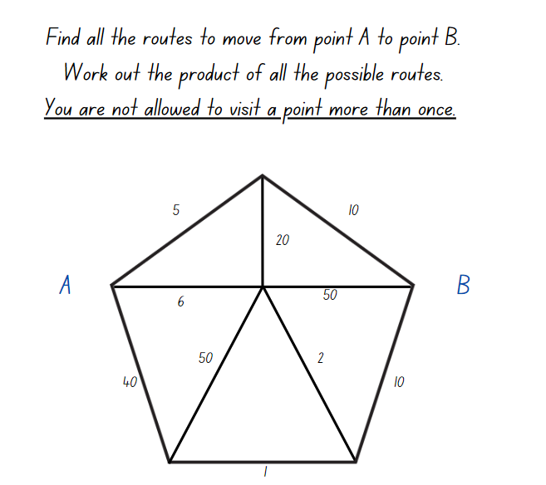

Resource 2 – place value houses
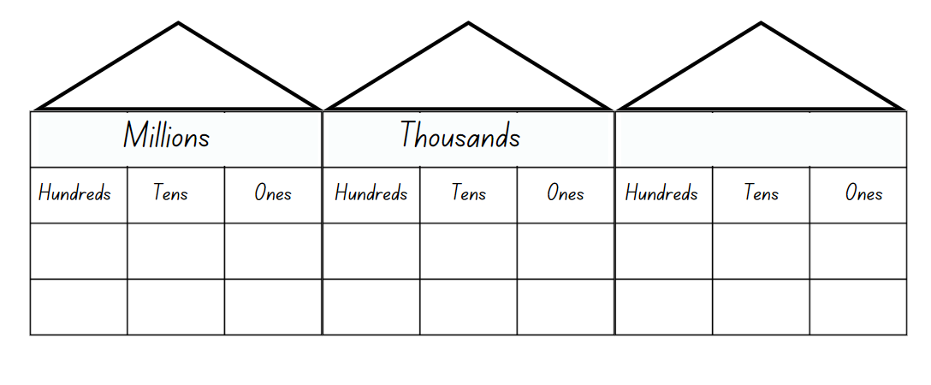

Resource 3 – factors fun game
Instructions to play:
- Select a number to focus on, for example multiples of 9.
- Fill in the spinner with multiples of your chosen number.
- Take turns to spin the spinner and divide the number by the chosen divisor (for example, 9).
- Players work out the solution and explain their thinking to their partner.
- The partner records their thinking and if they agree, the player can place one of their counters on the number on the game board, claiming that place.
- If the number is taken, students miss a turn.
- If there are no new counters that can be added to the game board, players must move an existing counter to a new place.
- Players win by getting four counters in a row (in any orientation, including a square).
- If preferred, students can use 5 or 6 counters, looking for 4 in a row.

Resource 4 – factors fun gameboard
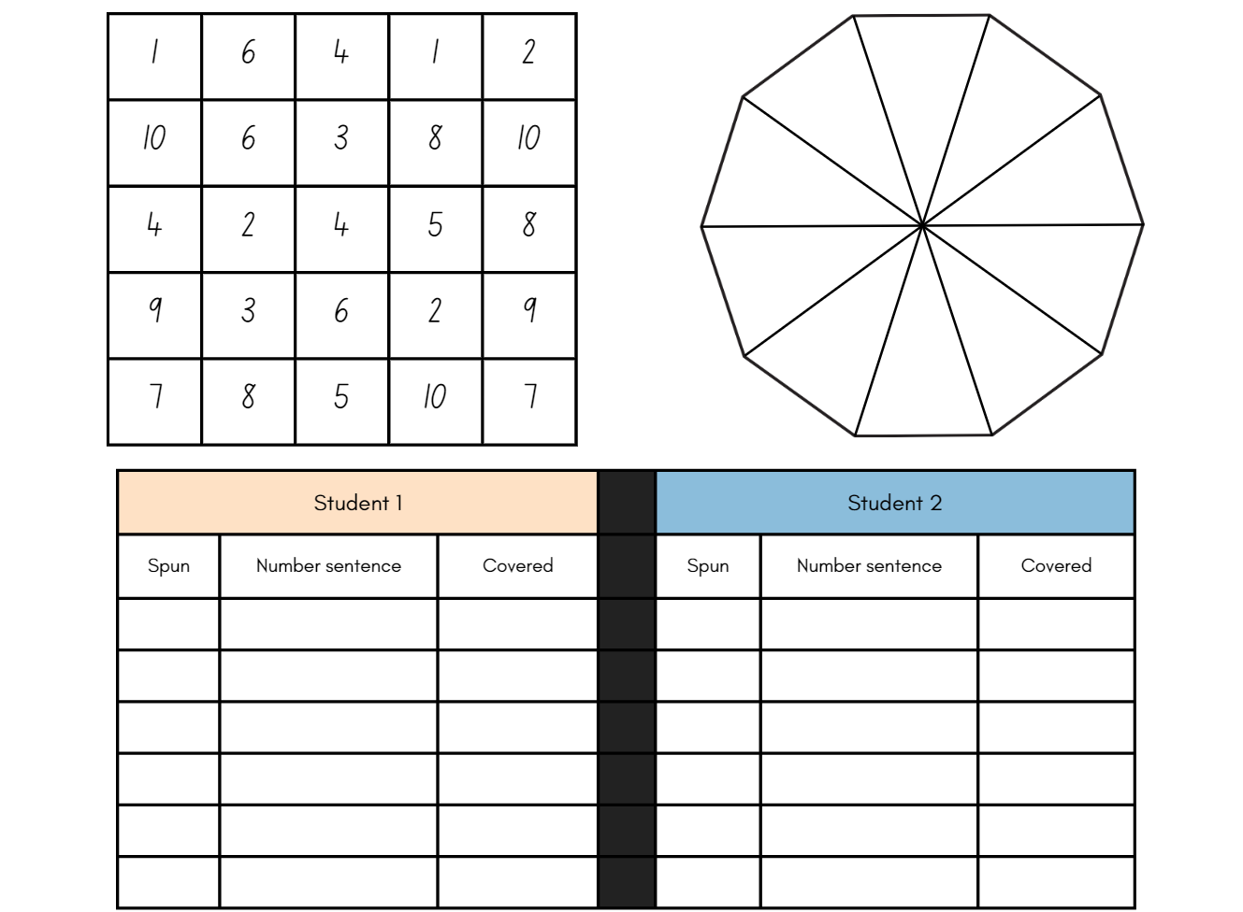

Resource 5 – factors fun spinner
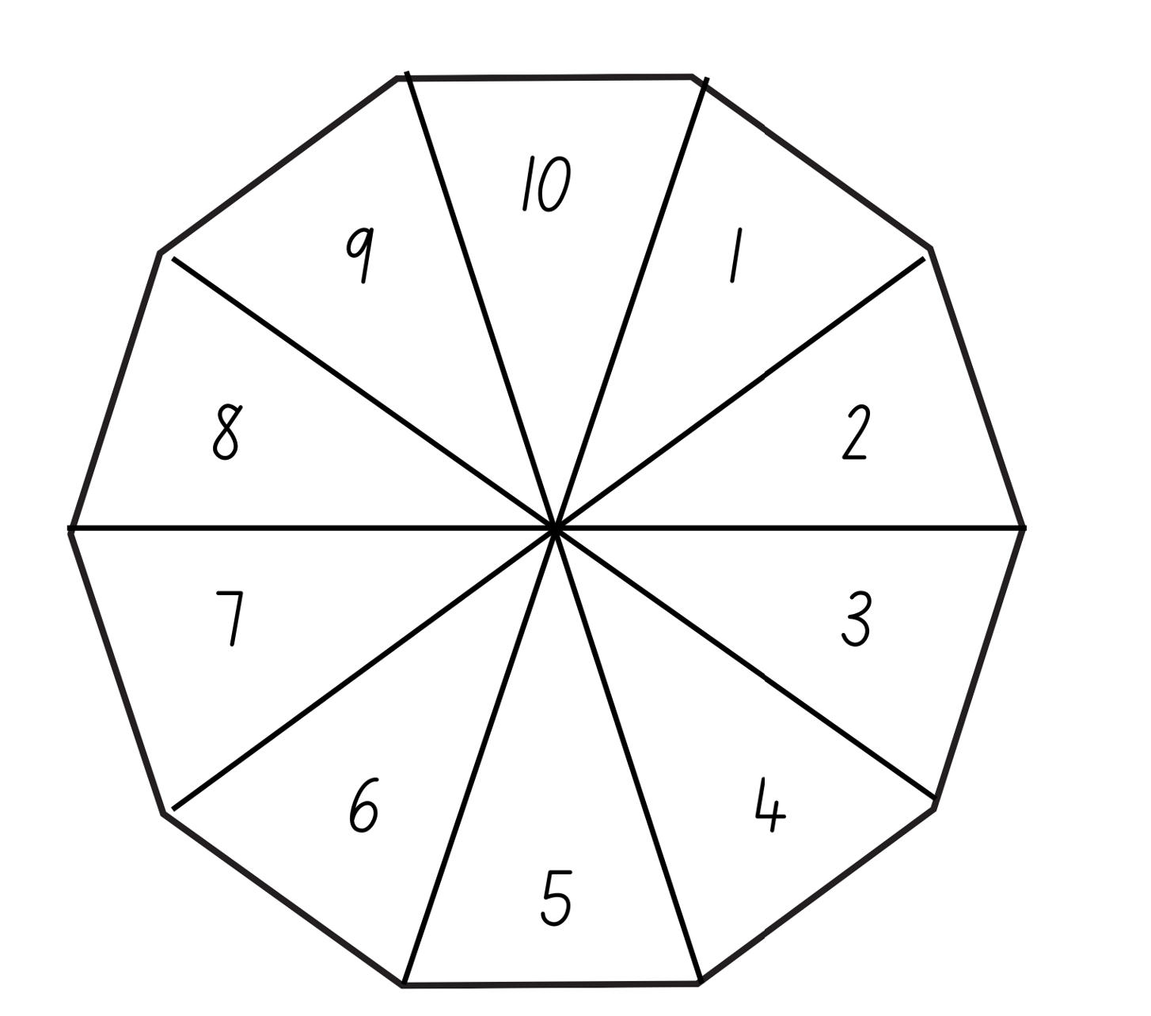

Resource 6 – garden bed
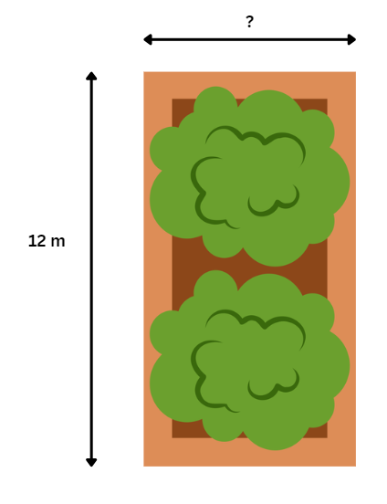

Resource 7 – area problem
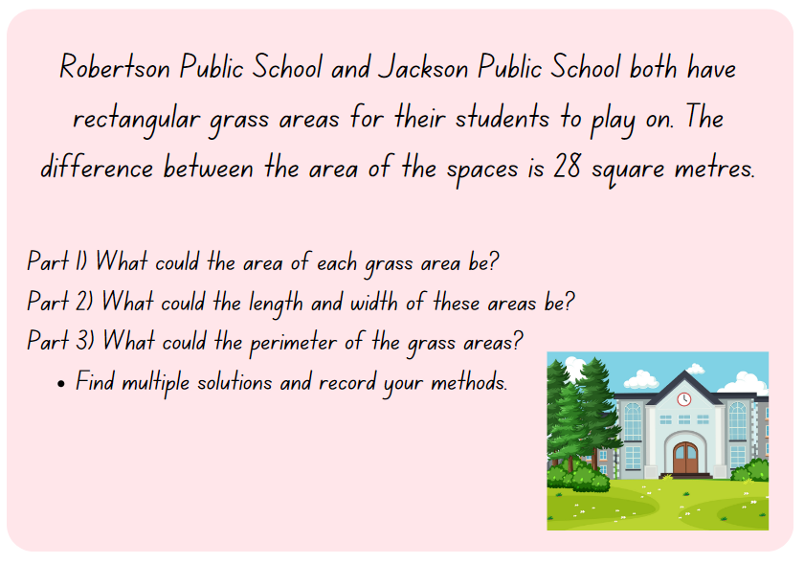

Resource 8 – factor-multiple chains
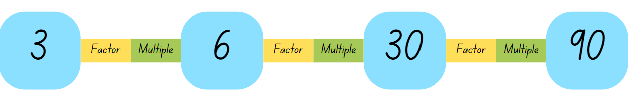

Resource 9 – blank chains
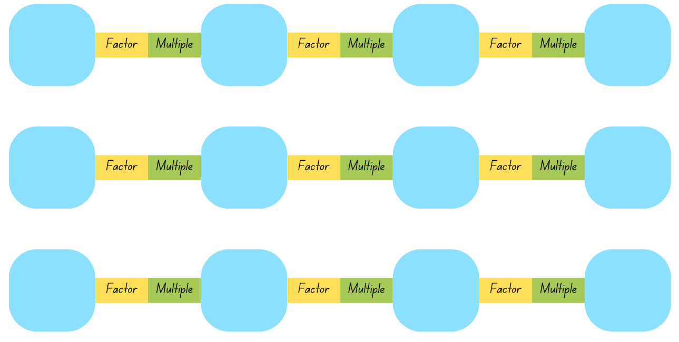

Resource 10 – combining arrays
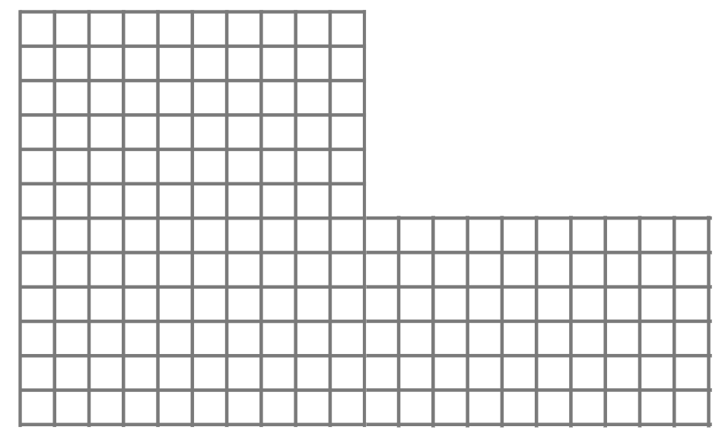

Resource 11 – array solutions
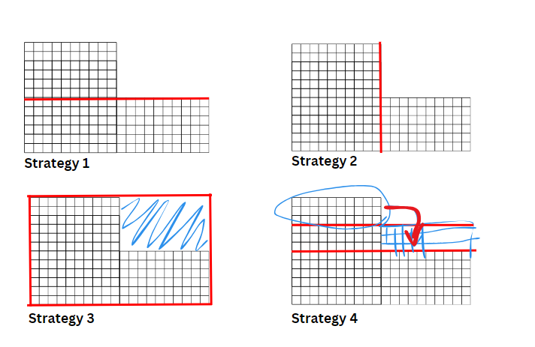

Resource 12 – combining arrays 2
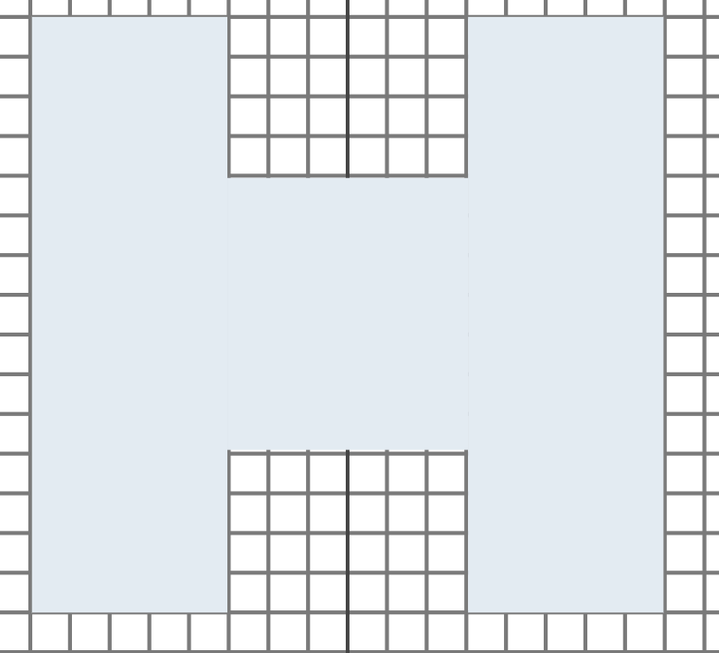

Resource 13 – smaller combined array
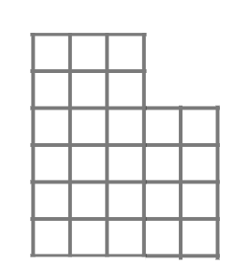

Resource 14 – partitioning area
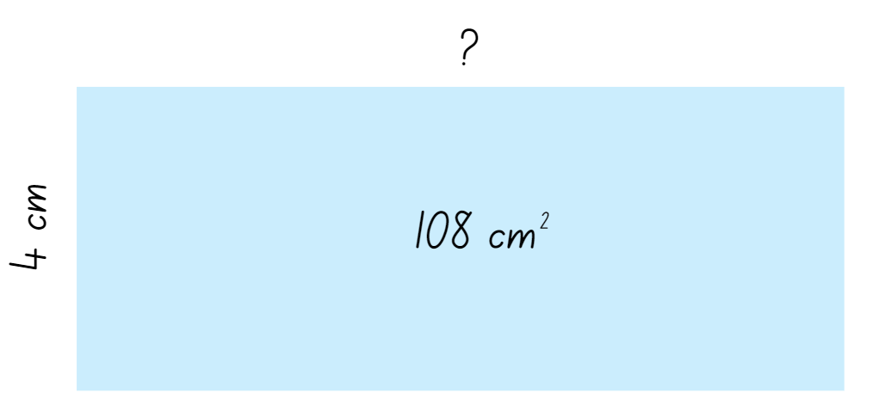

Resource 15 – recording sheet
Conjecture: Any rectangle that has a perimeter of 62 cm will have an area of 108 cm².
Use the table below to record your solutions.
Length | Width | Area

Resource 16 – decimal cards
1.0 | 2.705 | 0.50 | 1.522 | 3.901 | 4.125
3.025 | 0.001 | 1.49 | 3.0 | 0.625 | 2.750
0.90 | 2.0 | 3.5 | 1.68 | 0.595 | 3.825
2.75 | 1.490 | 0.25 | 3.254 | 2.40 | 1.909
1.842 | 2.59 | 0.337 | 2.22 | 4.0 | 3.61
0.0 | 2.220 | 3.50 | 1.25 | 2.914 | 3.708

Resource 17 – two prisms
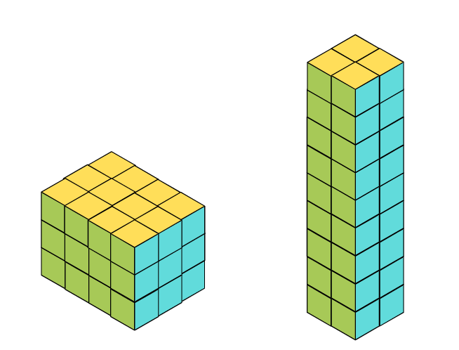

Resource 18 – same volume prism
Number of layers | Number of cubes in one layer | Possible dimensions of each layer

Resource 19 – fill the stairs
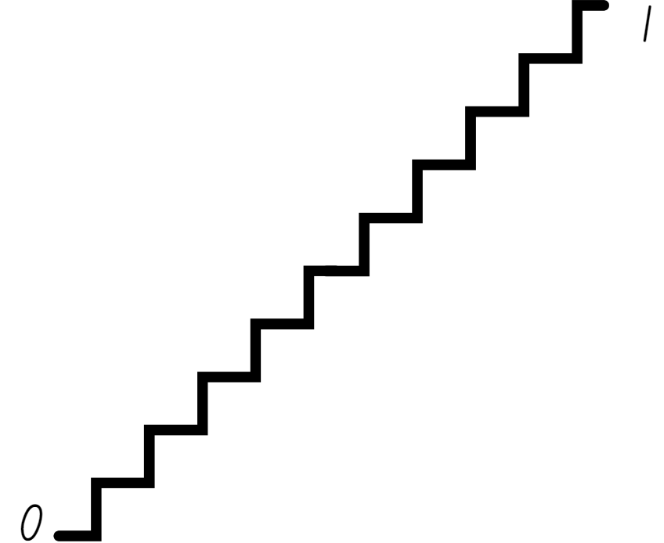

Resource 20 – prism clue
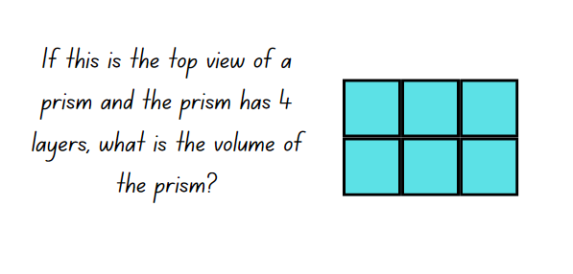

Resource 21 – prism solution
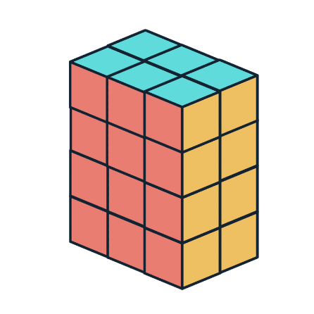

Resource 22 – calculating volumes
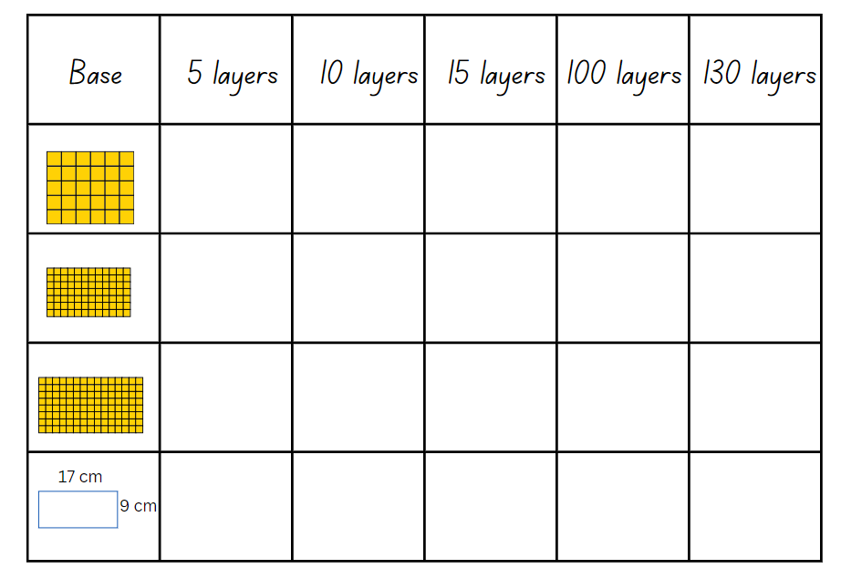

Resource 23 – cubic metre
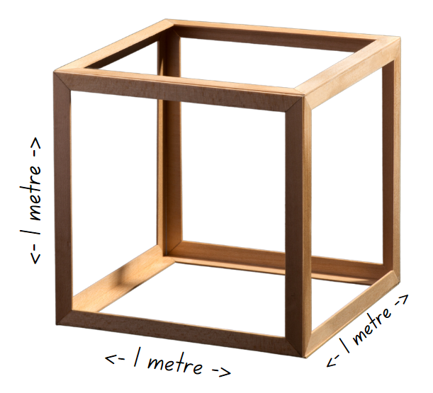

Syllabus outcomes and content
The table below outlines the syllabus outcomes and range of relevant syllabus content covered in this unit. Content is linked to National Numeracy Learning Progression (version 3).
Outcomes and content | 1 | 2 | 3 | 4 | 5 | 6 | 7 | 8
Represents numbers A: Compare, order and represent decimals
[MAO-WM-01, MA3-RN-01, MA3-RN-02]
- Compare and order decimal numbers of up to 3 decimal places |  |  |  |  | x | x | x
- Interpret zero digit(s) at the end of a decimal |  |  |  |  | x
- Approximate the size of decimals |  |  |  |  |  |  | x
- Place decimal numbers of up to 3 decimal places on a number line |  |  |  |  | x
Multiplicative relations A: Determine products and factors
[MAO-WM-01, MA3-MR-01]
- Use the term product to describe the result of multiplying 2 or more numbers | x
- Model different ways to show a whole number as a product (Reasons about structure) | x
- Determine factors for a given whole number | x | x | x
Multiplicative relations A: Use partitioning and place value to multiply 2-, 3- and 4-digit numbers by one-digit numbers
[MAO-WM-01, MA3-MR-01]
- Use mental strategies to multiply one-digit numbers by 10, 100, 1000 and their multiples | x
- Estimate the product of 2 numbers (one-digit by 2- or 3-digit numbers) using multiples of 10 or 100 | x
- Use informal written strategies such as the area model to solve multiplication and division problems |  | x | x | x
Multiplicative relations A: Use estimation and rounding to check the reasonableness of answers to calculations
[MAO-WM-01, MA3-MR-01]
- Use estimation to check the reasonableness of answers to multiplication and division calculations |  |  |  |  |  |  |  | x
Multiplicative relations B: Select and apply strategies to solve problems involving multiplication and division with whole numbers
[MAO-WM-01, MA3-MR-01]
- Select and use efficient strategies to multiply whole numbers of up to 4 digits by one- and 2-digit numbers |  |  |  |  |  | x
Geometric measure A: Length: Measure lengths to find perimeters
[MAO-WM-01, MA3-GM-02]
- Use efficient strategies to calculate the perimeter of a large rectangular area in metres |  | x
- Calculate perimeters of common two-dimensional shapes, including squares, rectangles and triangles |  | x
- Recognise that rectangles with the same perimeter may have different dimensions (Spatial reasoning) |  |  |  | x
Two-dimensional spatial structure A: Area: Calculate the areas of rectangles using familiar metric units
[MAO-WM-01, MA3-2DS-02]
- Recognise the importance of using the same units of length on the sides of rectangles to create ‘square units’ |  | x | x | x
- Establish the relationship between the lengths, widths and areas of rectangles |  | x | x | x
- Calculate areas of rectangles in square centimetres (cm²), square metres (m²) and square kilometres (km²) |  | x | x | x
- Recognise that rectangles with the same area may have different dimensions |  | x | x
- Investigate and compare the areas of rectangles that have the same perimeter |  | x | x | x
Two-dimensional spatial structure B: Area: Find the area of composite figures
[MAO-WM-01, MA3-2DS-02]
- Find different ways to calculate the area of a composite L-shape figure |  |  | x
Three-dimensional spatial structure B: Volume: Use cubic metres for measurement of volume
[MAO-WM-01, MA3-3DS-02]
- Recognise the need for a formal unit larger than the cubic centimetres |  |  |  |  |  |  | x | x
- Construct and use the cubic metre as a unit to measure larger volumes |  |  |  |  |  |  | x | x
- Estimate and measure volumes in cubic metres |  |  |  |  |  |  | x | x
Three-dimensional spatial structure B: Volume: Recognise the multiplicative structure for finding volume
[MAO-WM-01, MA3-3DS-02]
- Describe the length, width and height of a rectangular prism as the dimensions of the prism |  |  |  |  | x | x
- Describe arrangements of cubic-centimetre blocks in terms of layers |  |  |  |  | x | x
- Establish the relationship between the number of cubes in one layer and the number of layers to find the volume of a rectangular prism (Reasons about spatial structure) |  |  |  |  | x | x
Three-dimensional spatial structure B: Volume: Find the volumes of rectangular prisms in cubic centimetres and cubic metres
[MAO-WM-01, MA3-3DS-02]
- Construct rectangular prisms using cubic-centimetre blocks and determine the volumes |  |  |  |  | x
- Explain that objects with the same volume may be different shapes (Reasons about spatial structure) |  |  |  |  | x
- Record, using words, the method for finding the volumes of rectangular prisms |  |  |  |  | x | x | x
- Recognise that rectangular prisms with the same volume may have different dimensions (Reasons about spatial structure) |  |  |  |  | x
- Calculate volumes of rectangular prisms in cubic centimetres (cm³) and cubic metres (m³) |  |  |  |  | x | x | x | x
Mathematics K–10 Syllabus © NSW Education Standards Authority (NESA) for and on behalf of the Crown in right of the State of New South Wales, 2022.

References
This resource contains NSW Curriculum and syllabus content. The NSW Curriculum is developed by the NSW Education Standards Authority. This content is prepared by NESA for and on behalf of the Crown in right of the State of New South Wales. The material is protected by Crown copyright.
Please refer to the NESA Copyright Disclaimer for more information https://educationstandards.nsw.edu.au/wps/portal/nesa/mini-footer/copyright.
NESA holds the only official and up-to-date versions of the NSW Curriculum and syllabus documents. Please visit the NSW Education Standards Authority (NESA) website https://educationstandards.nsw.edu.au and the NSW Curriculum website https://curriculum.nsw.edu.au.
Mathematics K–10 Syllabus © NSW Education Standards Authority (NESA) for and on behalf of the Crown in right of the State of New South Wales, 2022.
National Numeracy Learning Progression © Australian Curriculum, Assessment and Reporting Authority (ACARA) 2010 to present, unless otherwise indicated. This material was downloaded from the Australian Curriculum website (National Literacy Learning Progression) (accessed 8 April 2024 and was not modified.
Barton C (2019) Volume of a cuboid 1, Maths Venns Website, accessed 8 April 2024.
Department of Education Learning and Teaching Directorate (2017) Teaching Measurement: Stage 2 and 3 [PDF 701 KB], NSW Government, accessed 8 April 2024.
Finkel D (2019) Fill the Stairs, Math for Love website, accessed 8 April 2024.
NESA (NSW Education Standards Authority) (2024) ‘Teaching advice for Three-dimensional spatial structure A’, Stage 3, NESA website, accessed 30 May 2024.
State of New South Wales (Department of Education) (2023) ‘Factors fun’, Mathematics K–6 resources, NSW Department of Education website, accessed 3 April 2024.
Sullivan P (2018) Challenging Mathematical Tasks, Oxford University Press Australia and New Zealand.
University of Cambridge (n.d.a) Area and Perimeter, NRICH website, accessed 4 April 2024.
——(n.d.b) Factor-multiple Chains, NRICH website, accessed 4 April 2024.
——(n.d.c) Rod Area, NRICH website, accessed 4 April 2024.
——(n.d.d) Route Product, NRICH website, accessed 4 April 2024.

© State of New South Wales (Department of Education), 2024
The copyright material published in this resource is subject to the Copyright Act 1968 (Cth) and is owned by the NSW Department of Education or, where indicated, by a party other than the NSW Department of Education (third-party material).
Copyright material available in this resource and owned by the NSW Department of Education is licensed under a Creative Commons Attribution 4.0 International (CC BY 4.0) license.
This license allows you to share and adapt the material for any purpose, even commercially.
Attribution should be given to © State of New South Wales (Department of Education), 2024.
Material in this resource not available under a Creative Commons license:
- the NSW Department of Education logo, other logos and trademark-protected material
- material owned by a third party that has been reproduced with permission. You will need to obtain permission from the third party to reuse its material.
Links to third-party material and websites
Please note that the provided (reading/viewing material/list/links/texts) are a suggestion only and implies no endorsement, by the New South Wales Department of Education, of any author, publisher, or book title. School principals and teachers are best placed to assess the suitability of resources that would complement the curriculum and reflect the needs and interests of their students.
If you use the links provided in this document to access a third-party's website, you acknowledge that the terms of use, including licence terms set out on the third-party's website apply to the use which may be made of the materials on that third-party website or where permitted by the Copyright Act 1968 (Cth). The department accepts no responsibility for content on third-party websites.

