Mathematics Stage 3 – Unit 16
Fractions represent multiple ideas and can be represented in different ways

Contents
Unit description and duration 5
Syllabus outcomes 5
Working mathematically 6
Student prior learning 6
Lesson overview and resources 8
Lesson 1 13
Daily number sense – lolly machines – 15 minutes 13
Core lesson 1 – the language of fractions – 15 minutes 15
Core lesson 2 – ordering fractions – 30 minutes 18
Discuss and connect the mathematics – 10 minutes 21
Lesson 2 23
Daily number sense – lolly malfunctions – 15 minutes 23
Core lesson – ordering fractions – 35 minutes 25
Discuss and connect the mathematics – 20 minutes 31
Lesson 3 33
Daily number sense – who is correct? – 10 minutes 33
Core lesson 1 – tenths – 15 minutes 34
Core lesson 2 – fraction strips to number lines – 25 minutes 36
Consolidation and meaningful practice – 10 minutes 39
Lesson 4 41
Daily number sense – 10 minutes 41
Core lesson – representing fractions and percentages – 45 minutes 41
Consolidation and meaningful practice – 10 minutes 47
Lesson 5 49
Daily number sense – area models – 10 minutes 49
Core lesson – fraction problems – 30 minutes 52
Discuss and connect the mathematics – 10 minutes 55
Lesson 6 57
Daily number sense – area models – 10 minutes 57
Core lesson – adding and subtracting fractions – 40 minutes 59
Discuss and connect the mathematics – 10 minutes 63
Lesson 7 65
Daily number sense – magic square – 15 minutes 65
Core lesson 1 – lines, areas and collections – 15 minutes 67
Core lesson 2 – collection problems – 20 minutes 71
Discuss and connect the mathematics – 10 minutes 72
Lesson 8 75
Daily number sense – 10 minutes 75
Core lesson – connecting fraction representations – 30 minutes 75
Consolidation and meaningful practice – 20 minutes 80
Resource 1 – lolly machines 82
Resource 2 – lolly recipes 83
Resource 3 – ‘Fraction Wars’ cards 84
Resource 4 – cards template 85
Resource 5 – lolly malfunctions 86
Resource 6 – fraction puzzle 87
Resource 7 – Venn diagram fractions 88
Resource 8 – student responses 89
Resource 9 – fraction strip template 90
Resource 10 – folded strips 91
Resource 11 – fraction area models 92
Resource 12 – comparing bar models 93
Resource 13 – gardening centre 94
Resource 14 – additive bar model 95
Resource 15 – new area models 96
Resource 16 – more fraction models 97
Resource 17 – happy holidays 98
Resource 18 – magic square 99
Resource 19 – lines, areas and collections 100
Resource 20 – pin packets 101
Syllabus outcomes and content 102
References 106

Unit description and duration
This unit develops the big idea that fractions represent multiple ideas and can be represented in different ways.
In this 2-week unit students are provided opportunities to:
- represent fractions using number lines, bar models, area models and discrete models
- make connections between fractions, decimals and percentages
- apply efficient mental and written strategies to solve addition and subtraction problems.

Syllabus outcomes
- MAO-WM-01 develops understanding and fluency in mathematics through exploring and connecting mathematical concepts, choosing and applying mathematical techniques to solve problems, and communicating their thinking and reasoning coherently and clearly
- MA3-RN-03 determines percentages of quantities, and finds equivalent fractions and decimals for benchmark percentage values
- MA3-AR-01 selects and applies appropriate strategies to solve addition and subtraction problems
- MA3-MR-01 selects and applies appropriate strategies to solve multiplication and division problems
- MA3-RQF-01 compares and orders fractions with denominators of 2, 3, 4, 5, 6, 8 and 10
- MA3-RQF-02 determines $\frac{1}{2}$, $\frac{1}{4}$, $\frac{1}{5}$ and $\frac{1}{10}$ of measures and quantities

Working mathematically
In the Mathematics K–10 Syllabus, there is one overarching Working mathematically outcome (MAO-WM-01). The Working mathematically processes should be embedded within the concepts being taught. The Working mathematically processes present in the Mathematics K–10 Syllabus are:
- communicating
- understanding and fluency
- reasoning
- problem solving.
Mathematics K–10 Syllabus © NSW Education Standards Authority (NESA) for and on behalf of the Crown in right of the State of New South Wales, 2022.

Student prior learning
Before engaging in these teaching and learning activities, students would benefit from prior experience with:
- comparing and ordering fractions using number lines and bar models
- understanding what happens when a fraction exceeds a whole
- solving problems involving addition and subtraction of fractions with the same denominator.
In NSW classrooms there is a diverse range of students, including Aboriginal and/or Torres Strait Islander students, students learning English as an additional language or dialect, high potential and gifted students and students with disability. Some students may identify with more than one of these groups or possibly all of them. Refer to Curriculum planning for every student – advice for further information.

Lesson overview and resources
The table below outlines the sequence and approximate timing of lessons, learning intentions and resources.
Lesson | Content | Duration and resources
Lesson 1  Daily number sense learning intention:  - determine products and factors | Lesson core concept: the importance of the whole as 1 and the language of fractions.  Core concept learning intention:  - compare and order unit fractions | Lesson duration: 70 minutes  - Resource 1 – lolly machines  - Resource 2 – lolly recipes  - Resource 3 – ‘Fraction Wars’ cards  - Resource 4 – cards template  - Writing materials
Lesson 2  Daily number sense learning intention:  - determine products and factors | Lesson core concept: fractions are formed by dividing a whole.  Core concept learning intention:  - compare common fractions with related denominators | Lesson duration: 70 minutes  - Resource 1 – lolly machines  - Resource 2 – lolly recipes  - Resource 4 – cards template  - Resource 5 – lolly malfunctions  - Resource 6 – fraction puzzle  - Resource 7 – Venn diagram fractions  - Blank cardboard for puzzle cards  - ‘Fraction Wars’ cards  - Individual whiteboards  - Writing materials
Lesson 3  Daily number sense learning intention:  - determine products and factors | Lesson core concept: number lines are important models used to represent fractions and decimals.  Core concept learning intentions:  - make connections between benchmark fractions, decimals and percentages | Lesson duration: 60 minutes  - Resource 4 – cards template  - Resource 8 – student responses  - Resource 9 – fraction strip template  - Resource 10 – folded strips  - Thin card for fraction strips  - Writing materials
Lesson 4  Daily number sense learning intention:  - teacher-identified task based on student needs | Lesson core concept: connections can be made between fractions, decimals and percentages.  Core concept learning intentions:  - make connections between benchmark fractions, decimals and percentages  - determine percentage discounts of 10%, 25% and 50% | Lesson duration: 65 minutes  - Resource 4 – cards template  - A4 paper  - ‘Fraction Wars’ cards  - Individual whiteboards  - Plastic sleeves  - Strips of paper  - Writing materials
Lesson 5  Daily number sense learning intention:  - solve problems involving addition and subtraction of fractions with the same denominator | Lesson core concept: bar models and fraction strips can be used to represent fractions.  Core concept learning intentions:  - apply efficient mental and written strategies to solve addition and subtraction problems  - solve problems involving addition and subtraction of fractions with the same denominator | Lesson duration: 50 minutes  - Resource 11 – fraction area models  - Resource 12 – comparing bar models  - Resource 13 – gardening centre  - Resource 14 – additive bar model  - Student workbooks  - Writing materials
Lesson 6  Daily number sense learning intention:  - solve problems involving addition and subtraction of fractions with the same denominator | Lesson core concept: mathematicians solve problems with fractions.  Core concept learning intentions:  - apply efficient mental and written strategies to solve addition and subtraction problems  - solve problems involving addition and subtraction of fractions with the same denominator | Lesson duration: 60 minutes  - Resource 4 – cards template  - Resource 15 – new area models  - Resource 16 – more fraction models  - Resource 17 – happy holidays  - ‘Fraction Wars’ cards  - Writing materials
Lesson 7  Daily number sense learning intention:  - solve problems involving addition and subtraction of fractions with the same denominator | Lesson core concept: mathematicians solve problems with fractions.  Core concept learning intentions:  - apply efficient mental and written strategies to solve addition and subtraction problems  - solve problems involving addition and subtraction of fractions with the same denominator | Lesson duration: 60 minutes  - Resource 17 – happy holidays  - Resource 18 – magic square  - Resource 19 – lines, areas and collections  - Resource 20 – pin packets  - Writing materials
Lesson 8  Daily number sense learning intention:  - teacher-identified task based on student needs | Lesson core concept: mathematicians make connections between fractions, decimals and percentages.  Core concept learning intentions:  - make connections between benchmark fractions, decimals and percentages  - compare common fractions with related denominators | Lesson duration: 60 minutes  - Resource 7 – Venn diagram fractions  - ‘Fraction Wars’ cards  - Writing materials

Lesson 1
Core concept: the importance of the whole as 1 and the language of fractions.

Daily number sense – lolly machines – 15 minutes
Daily number sense activities for Lessons 1 to 3 ‘activate’ prior number knowledge and support the learning of new content in the unit. These activities can also assist teachers to identify the starting points for learning by revealing the extent of students’ existing knowledge.
The table below contains a suggested learning intention and success criteria. These are best co-constructed with students.
Daily number sense learning intention | Daily number sense success criteria
Students are learning to:  - determine products and factors. | Students can:  - model different ways to show a whole number as a product  - determine factors for a given whole number.
This lesson is an adaptation of Liquorice Factory from Arc Learning Sequences by State of Victoria (Department of Education) and was introduced in Stage 3 Unit 13.
- Display Resource 1 – lolly machines.
- Revise students’ understanding of products and factors.
Product: the result of multiplying 2 or more numbers together. For example, 12 is the product of 4 × 3.
Factors: a number which divides another number without a remainder. For example, 1, 2, 3 and 6 are factors of 6 but 4 and 5 are not.
- Explain that lollies at a factory are produced by passing through different machines to extend their lengths. For example, a one-unit length of lolly is put through a × 2 machine twice to result in a lolly 4 units in length. Similarly, the lolly can be passed through both the × 2 and × 3 machines to double and then triple the lolly. This will produce a stretched lolly equal to 6 units, or 6 times as long as the original piece.
- State that the owner of a lolly shop is expanding into a franchise. As part of the business expansion, the owner must record recipes and steps for future new store owners to ensure consistency of lollies produced. There are many machines available to purchase.
- Provide students with Resource 2 – lolly recipes and demonstrate how a 21-unit length lolly is made using a × 3 and × 7 machine.
- Write the multiplicative statement 3 × 7 = 21 on the board and explain that 3 and 7 are factors of 21.
- Students record as many combinations of machines as possible. The first 2 examples have been done.
Note: preface the activity by reminding students to complete as many as possible. However, not every unit length has a solution.
This table details opportunities for assessment.
Assessment opportunities | Links
What to look for:  - Can students model different ways to show a whole number as a product? [MAO-WM-01, MA3-MR-01]  - Can students determine factors for a given whole number?  [MAO-WM-01, MA3-MR-01] | Links to National Numeracy Learning Progressions (NNLP):  - MuS6, MuS7.  Links to suggested Interview for Student Reasoning (IfSR) tasks:  - IfSR-MT: 2A.7, 3A.8.

Core lesson 1 – the language of fractions – 15 minutes
The table below contains a suggested learning intention and success criteria. These are best co-constructed with students.
Core concept learning intention | Core concept success criteria
Students are learning to:  - compare and order unit fractions. | Students can:  - compare unit fractions as numbers to the benchmark value of $\frac{1}{2}$  - compare and order unit fractions with denominators of 2, 3, 4, 5, 6, 8 and 10 by placing them on a number line.
- Explain that using mathematical words to communicate fraction concepts helps to organise and explain thinking more clearly. Being familiar with these words helps us to understand others and communicate our own ideas.
Note: the Mathematics K–10 Syllabus states that when Working mathematically, students need experience in relating their knowledge to the vocabulary and conceptual frameworks of mathematics (NESA 2022).
After playing the following game, display the words prominently and ask students to refer to the display when they communicate their thinking. The word list will be built on throughout the unit.
- Introduce the ‘Word Wizard’ game and explain the rules:
- The student selected to be the word wizard is given one target word and some banned words. The wizard describes the target word to the class without using the target word or the banned words in the description.
- The class tries to guess the word. If they do not succeed, the wizard makes a second, and then third attempt to define the word.
- After 3 failed attempts, the word wizard can choose a friend to help them work out one final clue.
- If the class still cannot guess, the teacher provides the word. (Possible definitions are included in Table 1.)
- After each word, a different student is selected to be the word wizard.
Table 1 – suggested word list
Word | Banned words | Possible definitions
unit fraction | numerator, top | One part of a whole that has been divided into equal parts.
whole | total, everything | All the parts, all of one thing, can be represented by the number 1 or 100%.
denominator | top, bottom, numerator | How many equal parts something has been divided into.  The number that represents the equal pieces required to make one whole in a fraction.
benchmark fraction | half, quarter, per cent, 0.5 | Common fractions used when measuring, comparing or ordering other fractions.
number line | points, marks | A line used to represent numbers (according to their distance from a zero point).  A line with numbers placed in their correct position.
equivalent fractions | equivalence, like | Fractions at the same point on the number line.  Fractions that are equal or have the same value even though they have different denominators.

Core lesson 2 – ordering fractions – 30 minutes
Note: students are introduced to a game involving fraction cards. Throughout the unit, students build on these cards to engage with a range of activities. When drawing 0–1 number lines, ensure that the line extends beyond 1.
- Record on the board $\frac{1}{5}$, $\frac{1}{8}$, $\frac{1}{4}$, $\frac{1}{3}$, $\frac{1}{10}$, $\frac{1}{2}$ and draw an empty 0–1 number line.
- Ask students what they notice about these numbers (all fractions, different denominators, all unit fractions, all less than 1).
- Provide students with writing materials to draw a 0–1 number line.
- Students order the unit fractions by placing them on the number line. Circulate and observe student approaches.
- Explain that in the following discussion, students should make use of the wizard words on the display to communicate their ideas. Ask:
- Which were the first 2 fractions you placed on the number line? Why?
- Which was the last fraction you placed on the number line? Why?
- Which fraction would you advise not to start with?
- What do you notice about where the fractions are positioned on the number line?
- Do you notice a pattern as the fraction gets closer to zero? (The denominator gets larger as the whole has been split into a larger number of equal parts.)
- Regroup as a class and select students to place fractions on the number line on the board to create an accurate model. Encourage students to discuss and challenge the placement of fractional numbers if they are not accurate.
- Display Resource 3 – ‘Fraction Wars’ cards. Ask:
- What do you notice about the fractions? (They are all unit fractions.)
- Will changing the orientation of the card change the value of the fraction?
- What might be represented by the card with a squiggly line? (string, rope, lolly snake)
- What fraction is represented by the card with the squiggly line? How do you know?
- If you straighten the squiggly line, will the one-sixth ( $\frac{1}{6}$ ) fraction mark remain in the same position? Why?
- Explain that every student will get a ‘Fraction Wars’ starter pack to cut out. Over the course of the unit, students will make new fraction wars cards to extend their set and play different games.
- Display Resource 4 – cards template. Draw students’ attention to the card with 8 dots. Ask:
- How might you represent one-eighth ( $\frac{1}{8}$ ) on this card?
- What other unit fractions could you represent using these 8 dots?
- Can you rename your unit fraction using a different numerator?
Note: the Stage 2 Teaching advice for Partitioned fractions A states that using discrete models such as collections of objects can cause difficulty for students. Discrete models can reinforce the idea that fractions are 2 numbers (or 2 counts) rather than a single number. For example, students may incorrectly visualise 2 coloured dots and 6 black dots in a set of 8 dots as two-sixths rather than two-eighths (NESA 2024).
- Provide each student with Resource 3 – ‘Fraction Wars’ cards and Resource 4 – cards template.
- Students make a list of all the unit fractions represented on the pre-made cards. Using the template, students make 9 new cards which use the discrete model to represent the list of unit fractions.
Note: before cutting out their set, students initial the back of each card so they can be returned to the owner after each game.
- Introduce the game by explaining that ‘Fraction Wars’ is played between 2 students.
- In round 1, players draw a 0–1 number line and mark the target number one-half ( $\frac{1}{2}$ ) on the line.
- Students shuffle their own deck and take turns flipping over the top card of their pile and placing it face-up in front of them, so it is visible for both players.
- Each student locates the 2 fractions on their number line and the student with the card closest to one-half ( $\frac{1}{2}$ ) wins the point and claims the cards.
- If both cards are equal in value, students mix them back in their pack.
- The student with the most cards at the end of the game wins. After round 1, both players note down the number of cards they have won.
- Students shuffle and re-distribute the cards to play round 2. When the cards are flipped, players place their fraction on a 0–1 number line. The player with the largest fraction wins.
- At the end of round 2, students add their round 1 points to their round 2 points to identify the winner. Students collect their own cards for future lesson activities.
This table details opportunities for differentiation.
Too hard? | Too easy?
Students cannot compare and order unit fractions on a number line.  - Students use a folded length of paper to find the unit fractions, then transfer them to the number line.  - Before the start of play, students complete a 0–1 number line and place unit fractions with denominators of 2, 3, 4, 6, 8 and 10 on it as a reference. | Students can compare and order unit fractions on a number line.  - Students play ‘Fraction Wars’ using different target numbers such as one-quarter or one-third.  - Students add non-unit fraction cards to their set and play the game.

Discuss and connect the mathematics – 10 minutes
- Regroup after the game and ask:
- Did having a card with a drawing or model of the fraction help you identify its size?
- Did you see any patterns or relationships that helped you identify the size of the fraction before you plotted it on the number line?
- Can you think of examples in daily life where you might need to use the benchmark fraction of one-half ( $\frac{1}{2}$ )?
This table details opportunities for assessment.
Assessment opportunities | Links
What to look for:  - Can students compare unit fractions to the benchmark value of $\frac{1}{2}$? [MAO-WM-01, MA3-RQF-01]  - Can students compare and order unit fractions with denominators of 2, 3, 4, 5, 6, 8 and 10? [MAO-WM-01, MA3-RQF-01] | Links to National Numeracy Learning Progressions (NNLP):  - InF5, InF6, InF7.  Links to suggested Interview for Student Reasoning (IfSR) tasks:  - IfSR-PT: 1A.2, 1A.3.

Lesson 2
Core concept: fractions are formed by dividing a whole.

Daily number sense – lolly malfunctions – 15 minutes
The table below contains a suggested learning intention and success criteria. These are best co-constructed with students.
Daily number sense learning intention | Daily number sense success criteria
Students are learning to:  - determine products and factors. | Students can:  - determine factors for a given whole number  - determine whether a number is prime or composite.
- Display Resource 1 – lolly machines from Lesson 1 and a student example of Resource 2 – lolly recipes.
- What machine would you need to produce a lolly that is 11 units in length. Explain.
- Explain that 11 is a prime number which means it only has 2 factors, one and itself. It is, therefore, not a length that can be produced using a combination of other machines. Emphasise that one is not a prime number as it does not have 2 distinct factors.
Prime number: a prime number is a positive integer which has exactly 2 distinct factors, itself and one. Modelled as an array, it has only one row. Zero is not an integer and therefore is neither prime nor composite.
Composite number: a non-zero natural number that has a factor other than one and itself. For example, all even numbers besides 2 are composite numbers. Some odd numbers are composite (for example, 21).
- Provide students with Resource 5 – lolly malfunctions.
- Demonstrate writing a multiplicative statement with factors for 12. For example, 2 × 2 × 3 = 12.
- Ask if it will make a difference if the lolly is first passed through the × 2 or × 3 machine. Demonstrate by writing a second multiplicative statement 3 × 2 × 2 = 12.
- Explain that the associative property applies in multiplication statements as the order in which quantities are multiplied does not change the result.
- Instruct students to fill in the missing values by:
- identifying the provided numbers as prime, composite or neither
- writing the multiplicative statement to reflect the use of factors to result in a product
- using the provided multiplicative statements to determine the product.
- Challenge students to identify a machine to produce a lolly 49 units in length in exactly 2 steps.

This table details opportunities for assessment.
Assessment opportunities | Links
What to look for:  - Can students model different ways to show a whole number as a product? [MAO-WM-01, MA3-MR-01]  - Can students determine factors for a given whole number?  [MAO-WM-01, MA3-MR-01] | Links to National Numeracy Learning Progressions (NNLP):  - MuS6, MuS7.  Links to suggested Interview for Student Reasoning (IfSR) tasks:  - IfSR-MT: 2A.7, 3A.8.

Core lesson – ordering fractions – 35 minutes
The table below contains a suggested learning intention and success criteria. These are best co-constructed with students.
Core concept learning intention | Core concept success criteria
Students are learning to:  - compare common fractions with related denominators. | Students can:  - order fractions with related denominators using diagrams and number lines.
This activity is an adaptation of Fix It: An Activity for Ordering Fractions by Marilyn Burns Math.
- Play the ‘Word Wizard’ game introduced in Lesson 1. Remind students that using mathematical words to communicate fraction concepts helps to organise and explain thinking more clearly. Being familiar with these words helps us to understand others and communicate our ideas. After playing the game, add the new vocabulary to the word display and support students to refer to them throughout the lesson.
Table 2 – Word Wizard list
Word | Banned words | Possible definition
tenth | ordinal numbers (8th, 9th, 10th and so on), ‘one over ten’ | One part out of 10 equal parts, 0.1, 10% as a fraction, the denominator when a whole has been divided into 10 equal parts.
numerator | top, bottom, denominator | How many parts of the whole have been selected.  How many parts you have out of the total number of parts.
equal | like, similar | The same as, having the same amount or value.
fraction bar | top, bottom | The horizontal line in a fraction separating the numerator from the denominator, the vinculum, the line that represents division in a fraction.
ascending order | biggest, littlest, big, little | Arranged from the smallest to the largest value or amount.
related denominators | skip count | Fractions where the denominators are multiples of each other, fractions that are easy to compare, add and subtract.
- Write 3 sets of fractions on the board:
- Set A: $\frac{1}{6}$, $\frac{5}{6}$, $\frac{3}{6}$ (same denominators)
- Set B: $\frac{6}{10}$, $\frac{2}{5}$, $\frac{4}{5}$ (related denominators)
- Set C: $\frac{2}{3}$, $\frac{5}{8}$, $\frac{7}{10}$ (unrelated denominators).
- Students draw a number line for each set and order the fractions on the line. Ask:
- Which set was easier to order? Why? (Set A. When the fractional parts are the same for each fraction, the size of the fraction depends on the numerator.)
- What do you notice about the denominator of the fractions in Set B?
- Can you find an equivalent fraction for six-tenths ( $\frac{6}{10}$ ) in Set B so that all 3 fractions have the same denominator?
- How could you show this using a number line or diagram?
- Write 5 fractions with related denominators on the board in no particular order. Explain to students that their job is to place the set of fractions in ascending order.
- Students Think-Pair-Share to order the fraction set. When sharing their ideas with the class, encourage students to refer to the word list and/or represent their ideas using a diagram or model.
- Repeat this process for another set of fractions and ensure at least one of the fractions displayed is larger than 1.
- Explain that instead of continuing to solve puzzles, students will make a fraction puzzle for someone else to solve. Display Resource 6 – fraction puzzle and tell students they will be using these instructions to create fraction puzzle cards for the class. Students choose fractions with related denominators (2, 4 and 8, or 3 and 6, or 5 and 10).
- To solve a puzzle card, students must place the fractions on the card in ascending order and justify their thinking. The creator of the puzzle makes a solution sheet for classmates to check their answers.
- Model closely referring to Resource 6 – fraction puzzle to make a puzzle by:
- Writing 5 fractions purposefully out of order on the board.
- Checking the fractions meet the criteria of related denominators, denominators that fall between 1 and 10, and no fractions are equivalent to each other.
- Thinking aloud to re-write the fractions in ascending order.
- Checking the solution and recording their thinking for others to use as a solution sheet.
- Making a puzzle card by writing the 5 fractions out of order on an index card. Explain that it is important to write your name on the card so other students can get help or check their work by looking at your explanation (see Figure 1).
Figure 1 – fraction puzzle solution teacher model
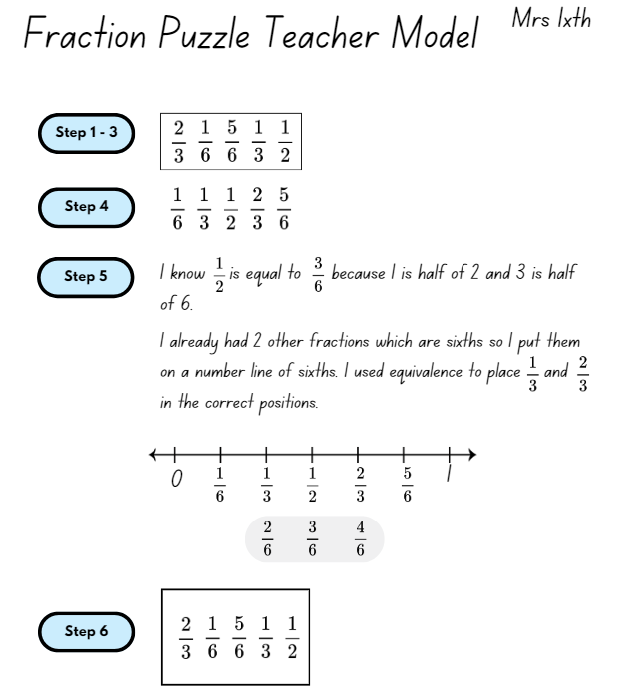
- Provide students with time to choose a fraction set and write a solution sheet. After checking the solution sheets, provide students with blank card to record their fraction set as a puzzle set for others to solve (see Figure 2).
Figure 2 – fraction puzzle card
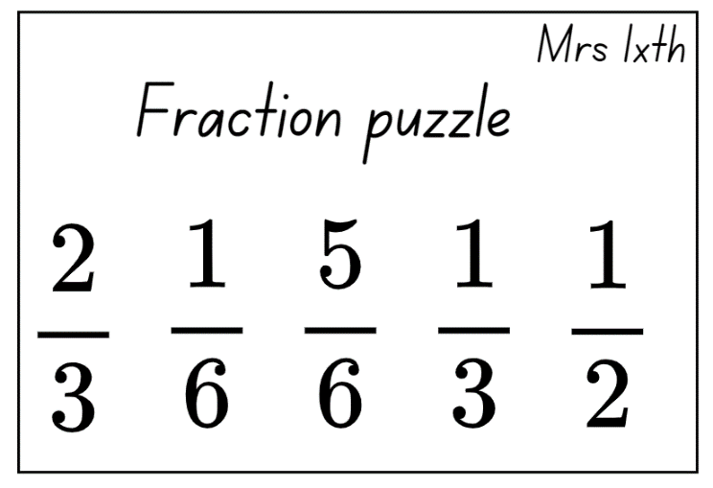
- Before students begin to solve other’s puzzles, remind them to use a separate sheet or individual whiteboard to copy the fractions out of order, rearrange them underneath in order, and record their thinking using words and diagrams, just as they did for their own puzzle. The individual puzzle cards can be collected and reused by other students in the class.
This table details opportunities for differentiation.
Too hard? | Too easy?
Students cannot order fractions with related denominators using number lines and diagrams.  - Students order unit fractions.  - Students use a folded length of paper to create the fractions before ordering the set. | Students can order fractions with related denominators using number lines and diagrams.  - Students make challenges using fractions with any denominator.  - Students make challenges where fractions are ordered according to their distance from one-half.

Discuss and connect the mathematics – 20 minutes
- Display Resource 3 – ‘Fraction Wars’ cards and Resource 4 – cards template. Discuss and name the different fraction representations such as, symbols, words, discrete or area models.
- Draw 2 circles on the board. Label one circle as ‘fractions greater than or equal to $\frac{1}{2}$’ and the other circle as ‘fractions less than or equal to $\frac{1}{2}$’.
- Students turn and talk to a partner to brainstorm fractions for each circle.
- Select students to provide some example fractions for each circle and explain their reasoning.
- Students draw their own circles and label them. Allow students one minute to fill the circles with as many fractions as possible that match the labels.
- Regroup and select students to add to the circles on the board. Ask:
- In which circle did you place your first fraction? Why?
- Was one circle easier to complete? Why?
- Did you place any fractions that exceeded one? Why or why not?
- Were there any fractions which belong in both circles? (Yes, fractions equal to one-half.)
- Display Resource 7 – Venn diagram fractions. Explain that Venn diagrams are a tool mathematicians use to help organise similarities and differences about a topic.
- Discuss the areas of the Venn diagram and select students to suggest fractions for the areas A, B and C.
- Provide students with Resource 4 – cards template.
- Students choose 6 fractions from the Venn diagram to add to their fraction card set. The fractions must be non-unit fractions.
This table details opportunities for assessment.
Assessment opportunities | Links
What to look for:  - Can students order fractions with related denominators using diagrams and number lines? [MAO-WM-01, MA3-RQF-01] | Links to National Numeracy Learning Progressions (NNLP):  - InF5, InF6, InF7.  Links to suggested Interview for Student Reasoning (IfSR) tasks:  - IfSR-PT: 1A.2, 1A.3.

Lesson 3
Core concept: number lines are important models used to represent fractions and decimals.

Daily number sense – who is correct? – 10 minutes
The table below contains a suggested learning intention and success criteria. These are best co-constructed with students.
Daily number sense learning intention | Daily number sense success criteria
Students are learning to:  - determine products and factors. | Students can:  - determine factors for a given whole number  - determine whether a number is prime, composite or neither (0 or 1).
- Display Resource 8 – student responses and read the statement: I am thinking of a number. Its factors are 1, 2, 3 and 4. Which number could this be, 24, 48 or 71?
- Select students to share their understanding of factors.
- Students turn and talk to determine the factors for 24, 48 and 71. Ask:
- Which answer is correct? 24, 48 or 71?
- Why is 71 not a possible answer?
- Why are 24 and 48 both correct?
This table details opportunities for assessment.
Assessment opportunities | Links
What to look for:  - Can students determine factors for a given whole number?  [MAO-WM-01, MA3-MR-01]  - Can students determine whether a number is prime, composite or neither (0 or 1)? [MAO-WM-01, MA3-MR-01] | Links to National Numeracy Learning Progressions (NNLP):  - MuS6, MuS7.  Links to suggested Interview for Student Reasoning (IfSR) tasks:  - IfSR-MT: 2A.7, 3A.8.

Core lesson 1 – tenths – 15 minutes
The table below contains a suggested learning intention and success criteria. These are best co-constructed with students.
Core concept learning intention | Core concept success criteria
Students are learning to:  - make connections between benchmark fractions and decimals. | Students can:  - represent quantities and lengths as fractions and decimals.
Note: teaching resources created and used in this lesson should be kept for subsequent lessons throughout this unit. Prior to the lesson, photocopy Resource 9 – fraction strip template onto thin card for each student.
- Introduce vocabulary to be used in this lesson, including ‘bar model’, ‘partition’, ‘benchmark decimal’ and ‘length’. Add these words to the word display from Lesson 1.
- Provide Resource 9 – fraction strip template and ask students to fold the strip of paper into tenths so that the red horizontal line is partitioned into 10 parts.
- Pose the following questions, partners turn and talk to answer:
- How do you know the strip represents tenths?
- What are some important things to consider when folding the strip? (Focus on equal parts, attending to the length of the red line.)
- Did you start by folding the strip into halves or fifths?
- Is there an efficient and accurate strategy to fold tenths of a strip?
- Select students who have made exemplar tenths of a strip to share their strategies with the class.
- If necessary, provide students with time to use the second strip in Resource 9 – fraction strip template to improve their folding and create more accurate representations of tenths.
- Students label each section as one-tenth ( $\frac{1}{10}$ ) (see Figure 3).
Figure 3 – labelled tenths strip
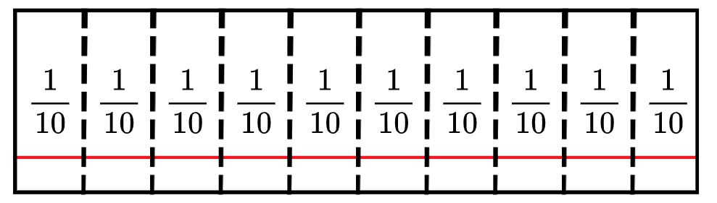

Core lesson 2 – fraction strips to number lines – 25 minutes
Note: the Stage 2 Teaching advice for Partitioned fractions A reinforces the importance of connecting fraction strips to number lines as a tool for representational transfer. The number line is linked to the fraction strip by using it as a ruler to illustrate benchmark fractions of $\frac{1}{2}$ or $\frac{1}{4}$ (NESA 2024). Representational transfer occurs when tasks make use of a common representation, and the solution procedure is derived from the representation (Novick 1990). That is, the one method of representing a problem is used across different types of problems.
- Display Resource 10 – folded strips.
- Draw attention to the intersection between the red horizontal line and each fold on the strip.
- Ask:
- What do you know about the position on the line marked A?
- Is there a label that can be used for the point marked A? ( $\frac{1}{10}$ )
- Is there a label that can be used for the point marked B? ( $\frac{2}{10}$)
- Can you indicate the correct placement for five-tenths ( $\frac{5}{10}$ ) of the length?
- Is there a way to write five-tenths without using fraction symbols? (0.5)
- Provide students with individual whiteboards and writing materials to create 2 related number lines (see Figure 5).
Figure 5 – strips to lines
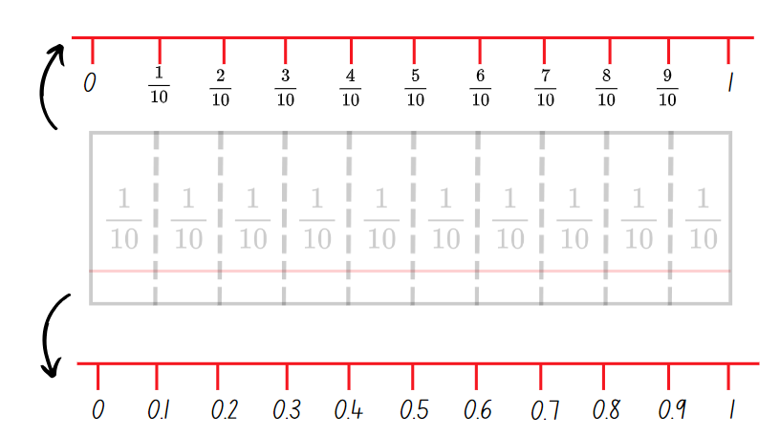
- Using the top edge of the cardboard strips, students record a number line from 0–1 and fractional increments from one-tenth ( $\frac{1}{10}$ ) to nine-tenths ( $\frac{9}{10}$ ) recorded on each fold.
- Students trace the bottom edge to record a number line from 0–1 and decimal notation in 0.1 increments.
Note: to support place value conceptual understanding, read 0.1 as ‘one-tenth’, connecting the decimal with common fractions.
- Students Think-Pair-Share what is the same and what is different about the 2 traced lines. (Same number of partitions, represent the same quantity, different ways of recording the same fraction.)
- Explain that the bar model and number line can be used interchangeably to represent quantities.
- Use Resource 4 – cards template for students to add 5 new cards to their ‘Fraction Wars’ set, representing decimal notation including benchmarks of 0.25 and 0.75.
This table details opportunities for differentiation.
Too hard? | Too easy?
Students cannot represent quantities and lengths as fractions and decimals.  - Provide students with a 20 cm paper strip. Students fold paper strips into halves and align the paper strip with a ruler to show that half of the 20 cm paper strip is 10 cm. Label the fold as $\frac{1}{2}$ or five-tenths (0.5). Repeat folding and labelling with various lengths of paper strips.  - Revise students’ understanding of the benchmark fractions and decimals. Students fold and label fraction strips and record these on a number line. Ask students if they can use the fraction strip and drawn number line to determine 0.5 of 20 cm, 0.25 of 20 cm and 0.75 of 20 cm. | Students can represent quantities and lengths as fractions and decimals.  - Provide students with 3 additional paper strips of equal lengths (for example 10 cm) to represent quarters, fifths and tenths. Students align each of the paper strips and create a number line to represent related fractions and decimals.  - Challenge students to fold a paper strip so that there are only 3 fold lines visible to indicate 0.2, $\frac{1}{2}$ and $\frac{3}{4}$. Students may use previous paper strips to assist.

Consolidation and meaningful practice – 10 minutes
- Pose the statement: Zuhaira baked a total of 260 biscuits on the weekend. She shared the biscuits equally with 9 friends, keeping an equal number for herself.
- Students use fraction strips and number lines to represent their working out for the following questions (see Figure 6):
- What fraction of the total number of biscuits did she keep for herself?
- How many biscuits did Zuhaira keep for herself?
- What fraction did she give away?
- How many biscuits did she give away?
- How many biscuits did each of her friends receive?
Figure 6 – sample student response
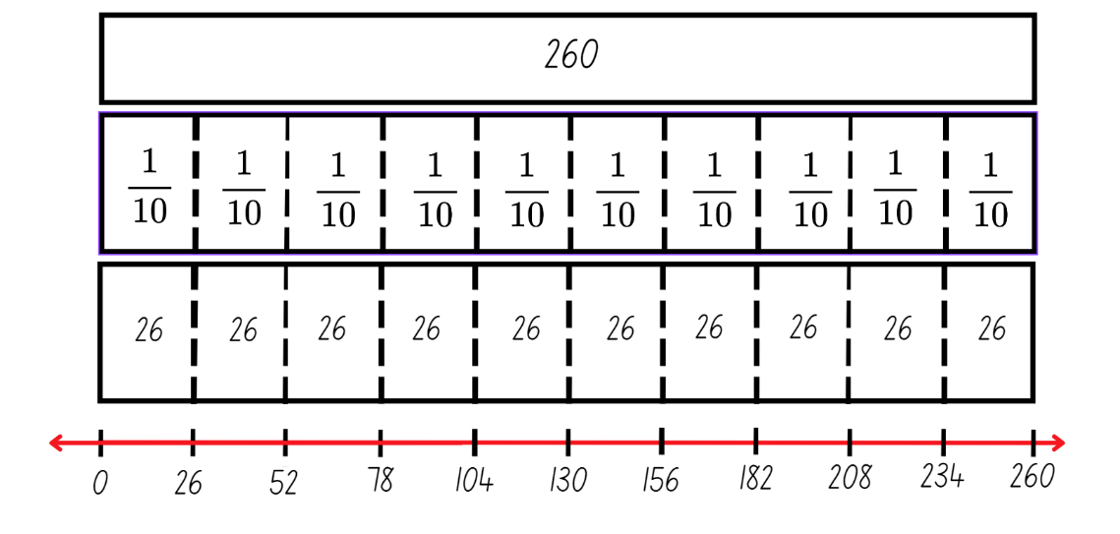
This table details opportunities for assessment.
Assessment opportunities | Links
What to look for:  - Can students represent quantities and lengths as fractions and decimals? [MAO-WM-01, MA3-RN-03] | Links to National Numeracy Learning Progressions (NNLP):  - InF7  - PrT2.

Lesson 4
Core concept: connections can be made between fractions, decimals and percentages.

Daily number sense – 10 minutes
- From a class need surfaced through formative assessment data, identify a short, focused activity that targets students’ knowledge, understanding and skills. Example activities may be drawn from the following resources:
- Mathematics K–6 resources
- Universal Resources Hub.

Core lesson – representing fractions and percentages – 45 minutes
The table below contains suggested learning intentions and success criteria. These are best co-constructed with students.
Core concept learning intentions | Core concept success criteria
Students are learning to:  - make connections between benchmark fractions, decimals and percentages  - determine percentage discounts of 10%, 25% and 50%. | Students can:  - recall commonly used equivalent percentages, decimals and fractions including $\frac{1}{2}$, $\frac{1}{4}$ and $\frac{3}{4}$  - represent common percentages of quantities and lengths as fractions and decimals  - recognise that 10% is one-tenth of 100% and use this to find 10% of a quantity  - equate 10% to dividing by 10, 25% to finding a quarter by dividing by 4, and 50% to finding half.
- Introduce vocabulary to be used in this lesson, including ‘per cent’ and ‘benchmark per cent’. Add these words to the word display from Lesson 1.
- Draw and discuss the per cent symbol %.
- Revise folding a paper strip into fifths and halves to represent one-tenth ($\frac{1}{10} )$.
- Ask: How can you determine 10% and 50% of the total length of a paper strip?
- Students turn and talk to discuss strategies.
- Provide individual whiteboards, writing materials and paper strips.
- Challenge students to record representations to support their reasoning (see Figure 7).
Figure 7 – sample student recording
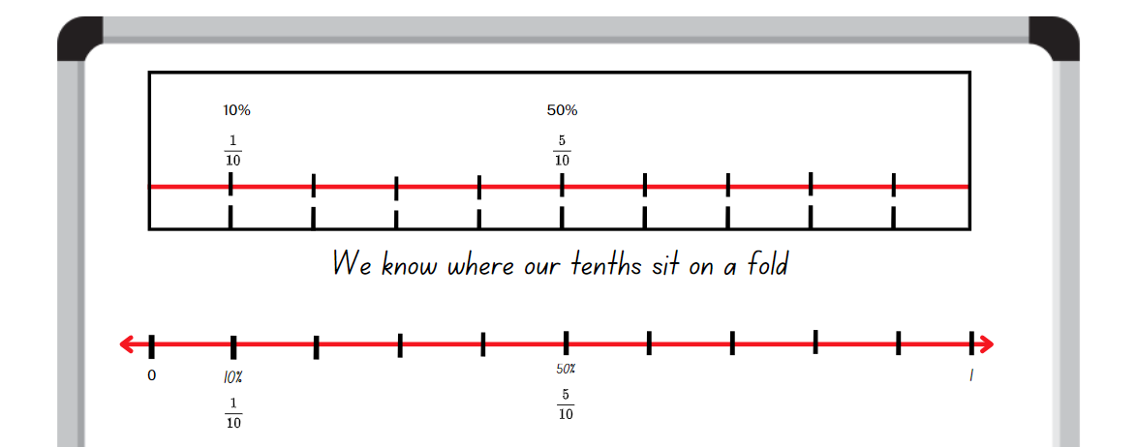
- Select pairs of students to share their representations with the class.
- Remind students that they have previously learnt about 10% as one-tenth ($\frac{1}{10} )$ and 50% as one-half ($\frac{1}{2} )$ in Stage 3 Unit 15.
- Demonstrate folding the A4 paper into tenths. Explicitly describe folding the paper into half then fifths to form a total of 10 smaller rectangles (see Figure 8).
Figure 8 – folds on A4 paper
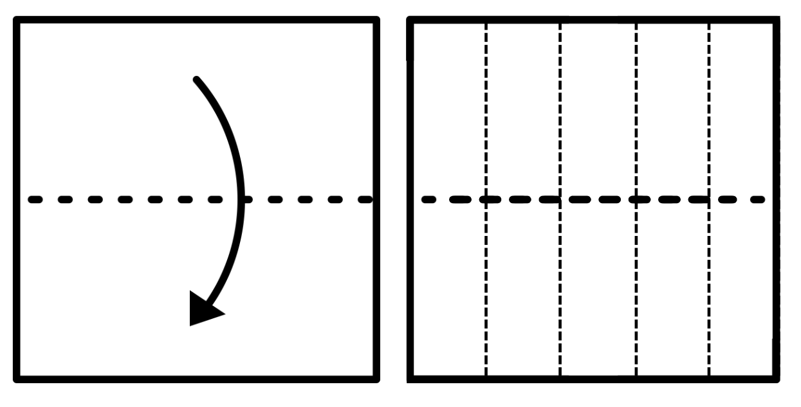
- Explain that this method of folding produces a 2 by 5 array.
- Provide pairs of students with a piece of A4 paper, plastic sleeves and whiteboard markers. Students insert the folded A4 sheet (see Figure 8) into a plastic sleeve.
- Using whiteboard markers and plastic sleeves, students demonstrate their understanding of 10%.
- Reinforce the idea that 10% is one-tenth and can be written as a fraction $\frac{1}{10}$ and 0.1.
- In pairs, students use whiteboard markers and plastic sleeves (with paper inserts) to record possible representations for:
- 10%, $\frac{1}{10}$ or 0.1
- 50%, $\frac{1}{2}$ or 0.5
- 20%, $\frac{1}{5}$ or 0.2.
- Regroup as a class and select students to share their representations.
- Challenge students to represent 25%, 0.25 or one-quarter ( $\frac{1}{4}$ ) and three-quarters ( $\frac{3}{4}$ ), 0.75 or 75% using folded paper. Explain that if one rectangle represents 10%, half of a rectangle represents 5%.
- Encourage students to justify their representations using vocabulary from the word display.
- Pose the problem: Oliver wants to buy a concert ticket to his favourite band. If he purchases the ticket in the next 24 hours, he gets a 10% discount on the full price of a ticket costing $100. What will he pay for the discounted ticket?
- Students use number lines or folded paper strips as fraction bars to solve the problem.
- After students have worked on their solution, ask:
- How much is the 10% discount of the ticket price?
- How could tools such as paper strips and bar models help Oliver calculate how much he could save with the discount?
- Can you use this knowledge to work out 20%, 50% and 25% of the price?
- What fractional knowledge will you need to check this? (25% is one-quarter)
- Can you use this knowledge to work out if 25% of $100 is the same as one-quarter ( $\frac{1}{4}$ ) of $100?
- Pose the problem: Joseph went for dinner with 4 friends. The total amount was $200. How much did each person have to pay for dinner?
- Students use number lines or folded paper strips as fraction bars to solve the problem.
- Explain that the group receives a 20% discount if they pay using cash. Ask:
- How much is the total cost if they decide to pay with cash?
- How much does each person pay?
- Was it easier to determine the 20% discount first and then the cost per person? Why?
- Was it easier to determine the total cost per person and then the 20% discount? Why?
- Select students to share solutions and strategies.
- Pose other problems or quantities that provide challenge to your students.
This table details opportunities for differentiation.
Too hard? | Too easy?
Students cannot recall commonly used equivalent percentages, decimals and fractions including $\frac{1}{2}$, $\frac{1}{4}$ and $\frac{3}{4}$.  - Revise place value understanding with students by interpreting decimal notations as tenths and hundredths. Write various decimal numbers for students to recognise and partition before recording on a blank hundreds chart.  - Assist students in creating an anchor chart for benchmark percentages, decimals and fractions to be represented using fraction strips and number lines. Refer to the anchor chart as required. | Students can recall commonly used equivalent percentages, decimals and fractions including $\frac{1}{2}$, $\frac{1}{4}$ and $\frac{3}{4}$.  - Students solve percentage questions using quantities which are not multiples of 10, for example 85, 7, $22.  - Ask students to create a list of examples where they have seen or used benchmark percentages, decimals and fractions in daily life. For example, half-time in sports, health bars in computer games or 50% discounts.

Consolidation and meaningful practice – 10 minutes
- Regroup to share the various visual representations of benchmark fractions and percentages of 10%, 20%, 25%, 50%, 75% and 100%.
- Students record these representations as additional cards for ‘Fraction Wars’ using Resource 4 – cards template.
This table details opportunities for assessment.
Assessment opportunities | Links
What to look for:  - Can students recall commonly used equivalent percentages, decimals and fractions including $\frac{1}{2}$, $\frac{1}{4}$ and $\frac{3}{4}$? [MAO-WM-01,  MA3-RN-03]  - Can students represent common percentages of quantities and lengths as fractions and decimals? [MAO-WM-01, MA3-RN-03]  - Can students recognise that 10% is one-tenth of 100% and use this to find 10% of a quantity? [MAO-WM-01, MA3-RN-03]  - Can equate 10% to dividing by 10, 25% to finding a quarter by dividing by 4, and 50% to finding half? [MAO-WM-01,  MA3-RN-03] | Links to National Numeracy Learning Progressions (NNLP):  - PrT2  - InF7  - UuM8.  Links to suggested Interview for Student Reasoning (IfSR) tasks:  - IfSR-PT: 2A.1, 2A.2, 2A.5, 2A.6.

Lesson 5
Core concept: bar models and fraction strips can be used to represent fractions.

Daily number sense – area models – 10 minutes
Daily number sense activities for Lessons 5 to 7 ‘loop’ back to concepts and procedures covered in previous units to assist students to build an increasingly connected network of ideas. These concepts may differ from the core concepts being covered by the unit.
Daily number sense learning intention | Daily number sense success criteria
Students are learning to:  - solve problems involving addition and subtraction of fractions with the same denominator. | Students can:  - represent the sum of fractions with the same denominator, recreating the whole, where the result may exceed one  - find the difference between fractions with the same denominator and interpret the answer.
- Display image A from Resource 11 – fraction area models.
- Explain that for image A:
- the large rectangle represents a whole or 1
- each section represents one-sixth ( $\frac{1}{6}$ )
- the dotted area can be named two-sixths ( $\frac{2}{6}$) or one-third ( $\frac{1}{3}$ )
- the hatched area can be named three-sixths ( $\frac{3}{6}$) or one-half ( $\frac{1}{2}$ ).
- Provide students with writing materials to record at least 4 addition or subtraction sentences that match image A. Examples may include:
- $\frac{1}{6}$ + $\frac{2}{6}$+ $\frac{3}{6}$= 1
- $\frac{3}{6}$+ $\frac{2}{6}$= $\frac{5}{6}$
- $\frac{3}{6}$ − $\frac{2}{6}$= $\frac{1}{6}$
- 1 − $\frac{1}{6}$= $\frac{5}{6}$.
- Select students to share their responses.
- Display images A and B from Resource 11.
- Explain that image B represents one and a half and that each section still represents one-sixth ( $\frac{1}{6}$ ) of the whole.
- Students record at least 4 addition or subtraction sentences that match image B. Examples may include:
- $\frac{4}{6}$+ $\frac{3}{6}$+ $\frac{2}{6}$ = $\frac{9}{6}$ = $1\frac{1}{2}$
- $\frac{4}{6}$+ $\frac{3}{6}$= $\frac{7}{6}$= $1\frac{1}{6}$
- $1\frac{3}{6}$ − $\frac{2}{6}$= $1\frac{1}{6}$ = $\frac{7}{6}$.
- Select students to share their responses.
Note: in the syllabus, the expression ‘fraction greater than one’ is used instead of the term ‘improper fraction’ or ‘mixed numeral.’
This table details opportunities for assessment.
Assessment opportunities | Links
What to look for:  - Can students represent the sum of fractions with the same denominator, recreating the whole, where the result may exceed one? [MAO-WM-01, MA3-RQF-01, MA3-RQF-02]  - Can students find the difference between fractions with the same denominator and interpret the answer? [MAO-WM-01,  MA3-RQF-01, MA3-RQF-02] | Links to National Numeracy Learning Progressions (NNLP):  - InF7, InF8.

Core lesson – fraction problems – 30 minutes
The table below contains suggested learning intentions and success criteria. These are best co-constructed with students.
Core concept learning intentions | Core concept success criteria
Students are learning to:  - apply efficient mental and written strategies to solve addition and subtraction problems  - solve problems involving addition and subtraction of fractions with the same denominator. | Students can:  - apply known strategies such as addition for subtraction  - solve word problems that involve fractions with the same denominator  - use diagrams, objects and mental strategies to subtract a unit fraction from any whole number including 1.
- Play the ‘Word Wizard’ game introduced in Lesson 1. Remind students that using mathematical words to communicate fraction concepts helps to organise and explain thinking more clearly. Being familiar with these words helps us to understand others and communicate our own ideas.
- Introduce target vocabulary to be used in this lesson. Other vocabulary from the word display can also be added as a review. See Table 3.
Table 3 – suggested word list
Word | Banned words | Possible definition
commutative property | turn around fact | Two numbers can be added or multiplied in any order and the solution will be the same.
subtraction | minus, take away, opposite | The difference between 2 numbers or a way of comparing them. The inverse of addition.
complement | compliment | The part required to form the whole. For example, $\frac{1}{4}$ is the complement of $\frac{3}{4}$.  Note: distinguish this from ‘compliment’.
bar model | bar, blocks | A diagram that shows parts of a whole.
- Display Resource 12 – comparing bar models. Ask how the models are the same and how they are different.
- Explain that the commutative property of addition and the complement principle of subtraction apply to whole numbers and fractions.
Note: using the complement principle in Stage 3 is limited to the subtraction of unit fractions from whole numbers, including 1.
- Group students in threes to write addition and subtraction number sentences to accompany bar model 2 from Resource 12 – comparing bar models. Share and record student responses.
- Explain that students will be exploring different scenarios for adding and subtracting fractions with the same denominators. They will use the complement principle and make connections between fractions, decimals and percentages.
- Display and read Resource 13 – gardening centre. Support student understanding of the context words such as potting mix and fertiliser.
- Use the think aloud strategy to model appropriate use of vocabulary and to explore options for solving each question.
Note: not all students will require the strategies to be modelled. Also, note that questions 4, 5 and 6 from Resource 13 – gardening centre have more than one step and that questions 6 and 7 have multiple correct answers.
- Allow time for students to complete each question in Resource 13 – gardening centre, recording their answer in their workbook.
- Select students to share their responses using the vocabulary on the word display.
This table details opportunities for differentiation.
Too hard? | Too easy?
Students cannot solve word problems that involve fractions with the same denominator or use diagrams, objects and mental strategies to subtract a unit fraction from any whole number including 1.  - Provide students with Resource 14 – additive bar model. Revise the complement principle and the commutative property of addition. Jointly construct other bar models, including fractions, and write matching number sentences.  - Guide students on how to fold and colour paper strips to represent each part of the problems on Resource 13 – gardening centre. | Students can solve word problems that involve fractions with the same denominator and use diagrams, objects and mental strategies to subtract a unit fraction from any whole number including 1.  - Students draw fraction models to show the complement principle for fractions other than unit fractions, such as $\frac{4}{6}$ or $\frac{2}{10}$.  - Students write a set of instructions or make an instructional video for other students that explains complements and the usefulness of the complement principle.  - Students write word problems involving adding or subtracting fractional quantities with related denominators.

Discuss and connect the mathematics – 10 minutes
- Display the fractions seven-eighths ( $\frac{7}{8}$ ) and nine-tenths ( $\frac{9}{10}$ ). Ask students to discuss which is closest to 1, using the complement principle to justify their answer. (The complement for each is a unit fraction. One-tenth ( $\frac{1}{10}$ )is smaller than one-eighth ( $\frac{1}{8}$ ), so nine-tenths ( $\frac{9}{10}$ ) is closest to 1.)
- Select students to share their responses, their reasons and how they approached the question.
- Repeat the discussion with other pairs or related groups of fractions, decimals and percentages such as: one-eight ( $\frac{1}{8}$ ) and 50%; 75% and 0.5; or two-thirds ( $\frac{2}{3}$ ) and five-sixths ( $\frac{5}{6}$ ).
This table details opportunities for assessment.
Assessment opportunities | Links
What to look for:  - Can students apply known strategies such as addition for subtraction? [MAO-WM-01, MA3-AR-01]  - Can students solve word problems that involve fractions with the same denominator? [MAO-WM-01, MA3-RQF-01, MA3-RQF-02]  - Can students use diagrams, objects and mental strategies to subtract a unit fraction from any whole number including 1 (the complement principle)? [MAO-WM-01, MA3-RQF-01,  MA3-RQF-02] | Links to National Numeracy Learning Progressions (NNLP):  - AdS7, AdS8  - InF7, InF8.  Links to suggested Interview for Student Reasoning (IfSR) tasks:  - IfSR-AT: 3A.3.

Lesson 6
Core concept: mathematicians solve problems with fractions.

Daily number sense – area models – 10 minutes
The table below contains a suggested learning intention and success criteria. These are best co-constructed with students.
Daily number sense learning intention | Daily number sense success criteria
Students are learning to:  - solve problems involving addition and subtraction of fractions with the same denominator. | Students can:  - represent the sum of fractions with the same denominator, recreating the whole, where the result may exceed one  - use diagrams, objects and mental strategies to subtract a unit fraction from any whole number including 1 (the complement principle).
- Display Resource 15 – new area models. Ask:
- If image A represents a whole, what fraction is it partitioned into? (sixths)
- What is shown in image B? (two wholes, in a different orientation)
- What fraction is represented by the cross-hatched sections in image B? ($\frac{6}{6}$ or one whole)
- What fraction is represented by the dotted sections in image B? ($\frac{4}{6}$ or $\frac{2}{3}$)
- What fraction is represented by the white sections in image B? ($\frac{2}{6}$ or $\frac{1}{3}$)
- Write the following equations on the board:
- 2 − $\frac{6}{6}$ = _?
- 2 − $\frac{1}{3}$ = _?
- 2 − $\frac{2}{3}$ = _?
- Students Think-Pair-Share to complete each equation verbally.
- Select students to share their responses and explain their thinking.
This table details opportunities for assessment.
Assessment opportunities | Links
What to look for:  - Can students represent the sum of fractions with the same denominator, recreating the whole, where the result may exceed one? [MAO-WM-01, MA3-RQF-01, MA3-RQF-02]  - Can students use diagrams, objects and mental strategies to subtract a unit fraction from any whole number including 1 (the complement principle)? [MAO-WM-01, MA3-RQF-01,  MA3-RQF-02] | Links to National Numeracy Learning Progressions (NNLP):  - InF7, InF8.

Core lesson – adding and subtracting fractions – 40 minutes
The table below contains suggested learning intentions and success criteria. These are best co-constructed with students.
Core concept learning intentions | Core concept success criteria
Students are learning to:  - apply efficient mental and written strategies to solve addition and subtraction problems  - solve problems involving addition and subtraction of fractions with the same denominator. | Students can:  - solve word problems, including multistep problems  - solve word problems that involve fractions with the same denominator  - use diagrams, objects and mental strategies to subtract a unit fraction from any whole number including 1 (the complement principle).
- Revise the number lines from Lesson 3 and Lesson 4 that link benchmark fractions, decimal fractions and percentages, as seen in Figure 9.
Figure 9 – combined number line
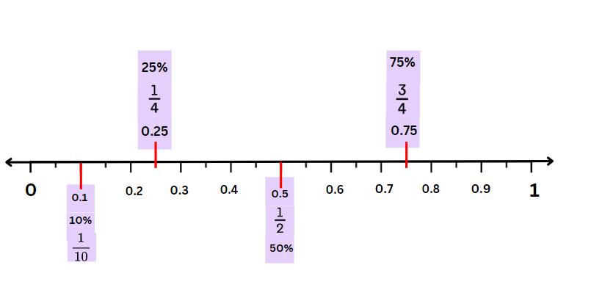
- Revise vocabulary from previous lessons and the word display.
- Display Resource 16 – more fraction models. Explain that for the discrete models, the collection of dots represents a whole. Each dot represents a fraction of the whole.
- Explain that for the 5-dot dice image, 5 can be seen as the whole collection, or 1. A relevant number sentence would be $\frac{1}{5}$ (the black dot) plus $\frac{4}{5}$ (the green dots) = $\frac{5}{5}$ (the whole collection), and not 1 + 4 = 5.
- Groups of students generate and record:
- addition sentences using the commutative property of addition
- subtraction sentences using the complement principle for each of the models displayed.
- Select groups to share responses.
- Provide students with the cards for the ‘Fraction Wars’ game from previous lessons.
- Students group cards into those that have a unit fraction complement and those that do not.
- If students cannot find a card in their set with a unit fraction complement, provide cards from Resource 4 – cards template for the student to make 3 new cards.
- Students select 3 cards with a unit fraction complement and represent each one using a bar model and a number line, showing where the complement unit fraction is in each representation (see Figure 10).
Figure 10 – fraction card complements
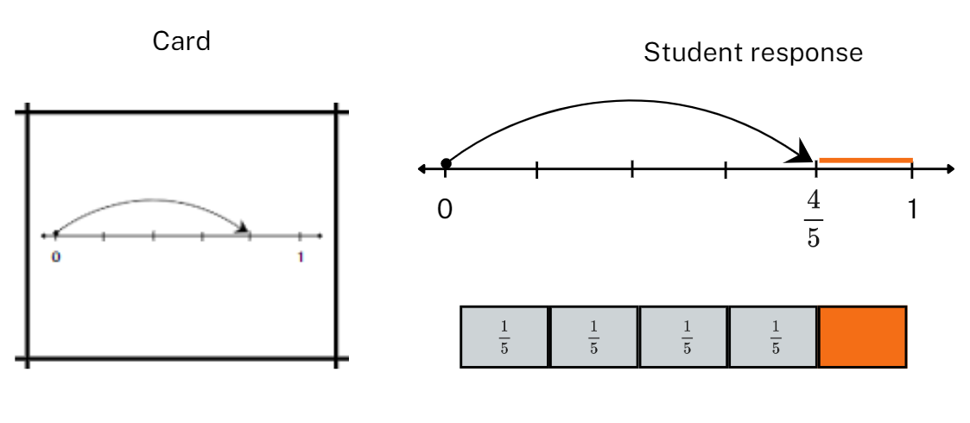
- Students then order the fraction cards from furthest and closest to one and explain their thinking.
- Encourage students to refer to the size of the complements when justifying the order of the cards.
- Explain that students will be exploring different scenarios for adding and subtracting fractions with the same denominators. They will use the complement principle and make connections between fractions, decimals and percentages.
- Display and read Resource 17 – happy holidays.
- Allow time for guided or independent practise using Resource 17 – happy holidays.
- Select students to share responses and strategies.

This table details opportunities for differentiation.
Too hard? | Too easy?
Students cannot solve word problems that involve fractions with the same denominator.  - Provide identical strips of paper for students to fold into fractions with denominators of 2, 4 and 8; 3 and 6; 5 and 10. Label each partition using fractional notation. Use the strips as rulers to make matching number lines (see Stage 2 Teaching Advice for Partitioned fractions A).  - Provide identical strips of paper for students to fold into fractions with denominators of 2, 4 and 10. Label relevant partitions with benchmark decimals and percentages of 25% and 50%. Support students to make a connection between fractional notation for tenths, 0.1 and 10%. | Students can solve word problems that involve fractions with the same denominator.  - Present the equation $\frac{1}{3}$ +$\frac{1}{6}$=$\frac{1}{2}$. Ask students to explore this statement: The sum of 2-unit fractions is also a unit fraction. What are some examples where this statement is true and when it is not true? (Adapted from Sum of unit fractions inquiry by Blair.)  - Provide students with cards for the numbers 1, 3, 4, 5, 6 and 7 and a template with $\frac{}{}+\frac{}{}.$ Ask students to arrange the cards in the boxes so that when you add them the answer is as close to 1 as possible, but not equal to one. (Adapted from ‘Construct a number’ in Clarke and Roche).

Discuss and connect the mathematics – 10 minutes
- Display Resource 17 – happy holidays.
- Provide students with 4 blank cards from Resource 4 – cards template.
- Students use the fractions from the resource displayed to make 4 new cards for their ‘Fraction Wars’ pack.
This table details opportunities for assessment.
Assessment opportunities | Links
What to look for:  - Can students solve word problems, including multistep problems? [MAO-WM-01, MA3-AR-01]  - Can students solve word problems that involve fractions with the same denominator? [MAO-WM-01, MA3-RQF-01, MA3-RQF-02]  - Can students use diagrams, objects and mental strategies to subtract a unit fraction from any whole number including 1 (the complement principle)? [MAO-WM-01, MA3-RQF-01,  MA3-RQF-02] | Links to National Numeracy Learning Progressions (NNLP):  - AdS8  - InF7, InF8.

Lesson 7
Core concept: mathematicians solve problems with fractions.

Daily number sense – magic square – 15 minutes
The table below contains a suggested learning intention and success criteria. These are best co-constructed with students.
Daily number sense learning intention | Daily number sense success criteria
Students are learning to:  - solve problems involving addition and subtraction of fractions with the same denominator. | Students can:  - represent the sum of fractions with the same denominator, recreating the whole, where the result may exceed one.
This activity is an adaptation of Magic Square Fun by Learn With Math Games.com and was introduced in Stage 3 Unit 4.
- Display Resource 18 – magic square. Explain that this is a form of puzzle where each fraction needs to be placed in a box so that when added, the rows, diagonals and columns add up to one and a half.
- Review the combined number line shared in Lesson 6. Make explicit connections between fractions, decimals and percentages.
- Ask students to look at the fractions available and share what they notice. (All fractions are tenths or can be written as equivalent fractions to tenths. The percentages and decimals are different representations of tenths.)
- Explain that the magic number is one and a half. Students Think-Pair-Share another way to make one and a half by adding the fractional parts.
- Provide students with writing materials and ask them to solve the puzzle in a group of 3.
- Regroup and select students to share their strategies and solutions (see Figure 11).
Figure 11 – completed magic square
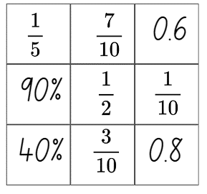
This table details opportunities for assessment.
Assessment opportunities | Links
What to look for:  - Can students represent the sum of fractions with the same denominator, recreating the whole, where the result may exceed one? [MAO-WM-01, MA3-RQF-01, MA3-RQF-02] | Links to National Numeracy Learning Progressions (NNLP):  - InF7, InF8.

Core lesson 1 – lines, areas and collections – 15 minutes
The table below contains suggested learning intentions and success criteria. These are best co-constructed with students.
Core concept learning intentions | Core concept success criteria
Students are learning to:  - apply efficient mental and written strategies to solve addition and subtraction problems  - solve problems involving addition and subtraction of fractions with the same denominator. | Students can:  - solve word problems, including multistep problems  - solve word problems that involve fractions with the same denominator  - use diagrams, objects and mental strategies to subtract a unit fraction from any whole number including 1 (the complement principle).
- Revise vocabulary on the word display. Introduce vocabulary to be used in this lesson.
Table 4 – suggested word list
Word | Banned words | Possible definition
Linear model | line | A model that divides the length of the whole into equal lengths.
Area model | array, rectangle | A way of showing fractions of a two-dimensional shape.  A model that shows a whole shape split into equal parts.
Discrete model | collection, discreet, discrete | A way of showing fractions of a set of objects split into equal parts.  Note: distinguish its meaning from ‘discreet’.
- Display Resource 19 – lines, areas and collections.
- Students turn and talk to share their responses to the following true or false statements:
- From root to tip, plant 1 is 10% shorter than plant 2.
- Four-tenths of plant 2 is below the soil.
- More than half of plant 1 is above the ground.
- For image B, 70% of squares have nothing on them.
- For image B, one-fifth of the squares have a star on them.
- For image C, $\frac{1}{3}$ of the coins are upside down.
- For image C, 70% of the coins are the right way up.
The table below outlines stimulus prompts to generate conversation about the topic, along with anticipated responses from students.
Prompts | Anticipated student responses
- Using the metre ruler as the common whole, what fraction, decimal or percentage statements or equations can we make about image A? | - The rulers are 10 squares each; $\frac{1}{2}$, 50% or 0.5 of the squares are black or white.  - Plant 1 is $\frac{9}{10}$ of a ruler long; plant 2 is the length of a whole ruler.  - Plant 2 is $\frac{1}{10}$ of a ruler longer than plant 1.  - The roots of plant 1 are $\frac{1}{10}$ longer than the visible part of the plant.  - The roots of plant 2 are $\frac{2}{10}$ shorter than the visible part of the ground.  - For plant 2, 40% is below ground and 60% is above ground.
- What fraction, decimal or percentage statements or equations can we make about image B? | - $\frac{1}{10}$, 10% or 0.1 of the squares have a star on them.  - 20%, $\frac{2}{10}$, $\frac{1}{5}$ or 0.2 of the squares have dots.  - $\frac{1}{2}$, 50% or 0.5 of the squares are black or white.
- What fraction, decimal or percentage statements or equations can we make about image C? | - 100% of the collection are Australian coins.  - $\frac{7}{10}$, 0.7 or 70% of the coins are the right way up.  - $\frac{1}{2}$, 50% or 0.5 of the coins are either $1 or 5 cents.
- How are these 3 images the same? | - Each model uses tenths as a benchmark fraction, decimal or percentage.  - In each model there is a representation of one-half and one-tenth.
- How are these 3 images different? | - Image A uses a linear model of fractions.  - Image B uses an area model of fractions.  - Image C uses a discrete model of fractions (a collection of objects).

Core lesson 2 – collection problems – 20 minutes
- Display and read Resource 20 – pin packets.
- Explain that because pins are discrete (a collection of objects) and not continuous (like the linear or area models), this series of questions is most like image C from Resource 19 – lines, areas and collections.
- Make connections to the type of questions and the strategies for solving them used in Lesson 5 and Lesson 6.
- Allow time for students to complete each question in Resource 20 – pin packets with a partner or in a small group.
- Select students to share their responses using the appropriate vocabulary. Refer students to the word display as necessary.
This table details opportunities for differentiation.
Too hard? | Too easy?
Students cannot solve word problems that involve fractions with the same denominator.  - Guide students to construct a model pin packet using coloured counters, starting with 5 counters with the correct proportions. Students use the colour pattern to build the collection to a total of 90 counters and use the model to answer questions.  - Provide students with 2 orange and one red, one green and one blue counter. Provide students with a strip of paper and have them fold it into fifths. Students place a counter into each of the paper partitions to make connections between the linear and discrete models. | Students can solve word problems that involve fractions with the same denominator.  - Ask students to solve word problems that involve fractions with related denominators, such as 2, 4 and 8; 3 and 6; or 5 and 10.  - Students investigate the contents of a readily available packet of pins, paperclips, counters or coloured lollies. Ask students to write fraction addition and subtraction questions using that resource. (Note: students may need to adjust the numbers in the packet to better reflect the expectations of the Stage 3 syllabus).

Discuss and connect the mathematics – 10 minutes
- Display these questions from Resource 17 – happy holidays and Resource 20 – pin packets for students to analyse and compare:
- happy holidays: If the total trip was 800 kilometres, how far would the family have travelled after three-tenths of the journey?
- pin packets: If each packet has 90 pins in it, how many will there be of each colour?
- Ask students to Think-Pair-Share about what is the same and what is different between the 2 questions.
- Select students to share their responses.
The table below outlines stimulus prompts to generate conversation about the topic, along with anticipated responses from students.
Prompts | Anticipated student responses
- What is the same? | - For both questions you need to calculate a fraction of the whole.  - For both questions, the whole is represented by a number.  - For both you could use a bar model or a number line to show your working out.
- What is different? | - Happy holidays is a fraction of a line, pin packets is a fraction of a collection.  - The whole trip is 800 km but the whole packet is 90 pins, so the units and the quantities are different.  - Happy holidays focuses on tenths, and pin packets focuses on fifths.

This table details opportunities for assessment.
Assessment opportunities | Links
What to look for:  - Can students solve word problems, including multistep problems? [MAO-WM-01, MA3-AR-01]  - Can students solve word problems that involve fractions with the same denominator? [MAO-WM-01, MA3-RQF-01, MA3-RQF-02]  - Can students use diagrams, objects and mental strategies to subtract a unit fraction from any whole number including 1 (the complement principle)? [MAO-WM-01, MA3-RQF-01,  MA3-RQF-02] | Links to National Numeracy Learning Progressions (NNLP):  - AdS8  - InF7, InF8.

Lesson 8
Core concept: mathematicians make connections between fractions, decimals and percentages.

Daily number sense – 10 minutes
- From a class need surfaced through formative assessment data, identify a short, focused activity that targets students’ knowledge, understanding and skills. Example activities may be drawn from the following resources:
- Mathematics K–6 resources
- Universal Resources Hub.

Core lesson – connecting fraction representations – 30 minutes
The table below contains suggested learning intentions and success criteria. These are best co-constructed with students.
Core concept learning intentions | Core concept success criteria
Students are learning to:  - make connections between benchmark fractions, decimals and percentages  - compare common fractions with related denominators. | Students can:  - recall commonly used equivalent percentages, decimals and fractions including $\frac{1}{2}$, $\frac{1}{4}$and $\frac{3}{4}$  - compare and represent fractions with denominators of 2, 4 and 8; 3 and 6; 5 and 10 of a whole shape (area model) and a collection of objects (discrete model)  - record equivalent fractions using diagrams, words and fraction notation.
This activity is an adaptation of Venn Diagram Rich Tasks from the Mr Barton maths website by Barton.
- Play a game of ‘Word Wizard’ to revise fractional language covered in this unit.
- Review Resource 7 – Venn diagram fractions. Remind students that Venn diagrams are a tool mathematicians use to help to organise similarities and differences about a topic.
- Explain that students will use the Venn diagram structure to sort selected ‘Fraction Wars’ cards.
- Each group combines their 3 sets of cards. Students discard cards that are duplicates to create one set.
- Explain that, to make connections between the different representations of fractions, students will select and sort different fraction cards into categories.
- Guide students to follow these steps. Observe students’ level of competence in Working mathematically by their appropriate choice of strategy, representations and vocabulary.
- Step 1: find all the cards in the pack that represent (for example, a half).
- Step 2: sort those cards into 2 groups (for example, fractions or decimals).
Note: if students are not sure where a card should be placed, make a third pile. For an example, see Figure 12.
Figure 12– select and sort example
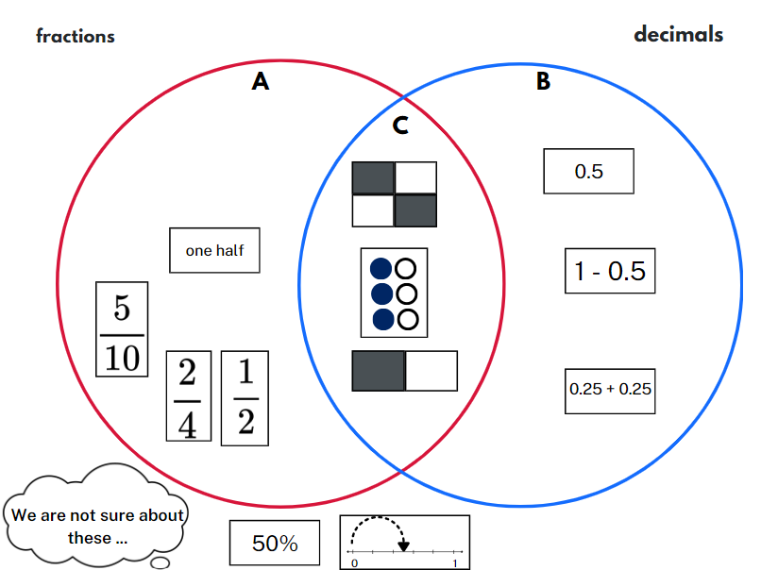
- Ask:
- How did you begin to think about this problem?
- Which cards were easiest to place? Why?
- Was there a card that was difficult for you to place? Which strategies did you use to decide where to place it?
- Are there any cards that could belong in more than one group? Explain.
- Are there any cards that you could not place into one of the groups? Why not?
- Are you able to identify a pattern or rule for this sort?
- What is the most interesting new card you could make to fit one of these sorts?
- Students reform their pack ready for another round.
- Repeat the steps with other prompts to target learning or assessment needs in your class. Suggested prompts and groupings are in the table below.
Steps | Possible prompts
- Step 1 – Find cards that ... | - represent a benchmark fraction, decimal or percentage  - have a complement of a unit fraction  - are complements of each other (that is, they add to one)  - have a difference of a unit fraction  - cannot be grouped with any other card  - have an area model.
- Step 2 – Sort the cards into 2 categories: | - decimals and percentages  - symbols and diagrams  - related denominators such as 2, 4 and 8; 3 and 6  - area model and discrete model  - are less than or equal to one-half; are more than or equal to one-half.
- After a few turns, students record a sort in their workbooks or using a digital device.

This table details opportunities for differentiation.
Too hard? | Too easy?
Students cannot recall commonly used equivalent percentages, decimals and fractions.  - Provide a set of 6 suitable cards for each selection and sort.  - Support students by limiting the sort cards to benchmark fractional amounts such as $\frac{1}{4},$ $\frac{1}{2}$ and $\frac{3}{4}$. | Students can recall commonly used equivalent percentages, decimals and fractions.  - Students add a third category to their original sort and move cards accordingly. Students identify any section of the sort where it is impossible to place a card.  - Students make their own selection and sort to present to a peer without any labels. The peer identifies the selection and sort, then confirms/challenges placement of cards.

Consolidation and meaningful practice – 20 minutes
- Play ‘Fraction Wars’ using the following prompts or allow students to set the rules for their own games.
- In round 1, players draw a 0–1 number line and mark the target number one-half ( $\frac{1}{2}$ ) on the line. Each student locates the 2 fractions on their number line and the student with the card furthest from one-half ( $\frac{1}{2}$ ) wins the point and claims the cards. If both cards are equal in value, students mix them back in their pack. The student with the most cards at the end of the game wins. After round 1, both players note down the number of cards they have won.
- In round 2, students repeat the game using an empty 0–1 number line. When the cards are flipped, players place their fraction on the number line and the player with the fraction closest to 1 wins.
- At the end of round 2, students add their round 1 total to their round 2 total to identify the winner.
This table details opportunities for assessment.
Assessment opportunities | Links
What to look for:  - Can students recall commonly used equivalent percentages, decimals and fractions including $\frac{1}{2}$, $\frac{1}{4}$and $\frac{3}{4}$? [MAO-WM-01,  MA3-RN-03]  - Can students compare and represent fractions with denominators of 2, 4 and 8; 3 and 6; 5 and 10 of a whole shape (area model) and a collection of objects (discrete model)? [MAO-WM-01,  MA3-RQF-01, MA3-RQF-02]  - Can students record equivalent fractions using diagrams, words and fraction notation? [MAO-WM-01, MA3-RQF-01] | Links to National Numeracy Learning Progressions (NNLP):  - PrT2  - UnM8  - InF5.  Links to suggested Interview for Student Reasoning (IfSR) tasks:  - IfSR-PT: 2A.1

Resource 1 – lolly machines
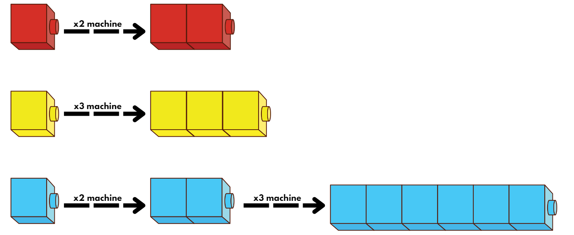

Resource 2 – lolly recipes
To produce a lolly of (product) | Steps | Machines required (factors)
6 units | × 2, × 3 | × 2, × 3
12 units | × 2, × 2, × 3  × 3, × 2, × 2 | × 2, × 3
21 units
24 units
28 units
30 units
45 units

Resource 3 – ‘Fraction Wars’ cards
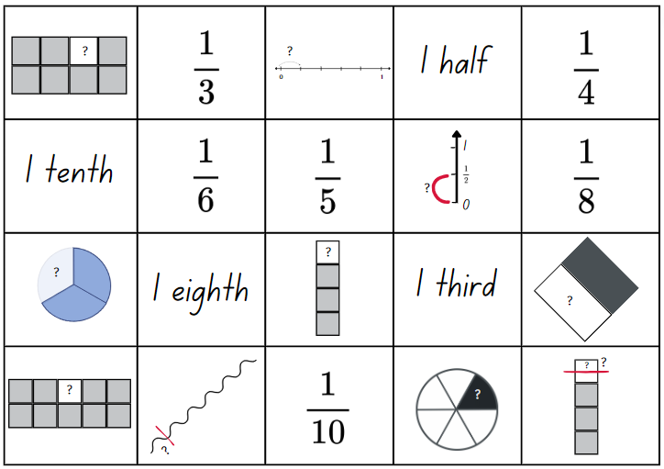

Resource 4 – cards template
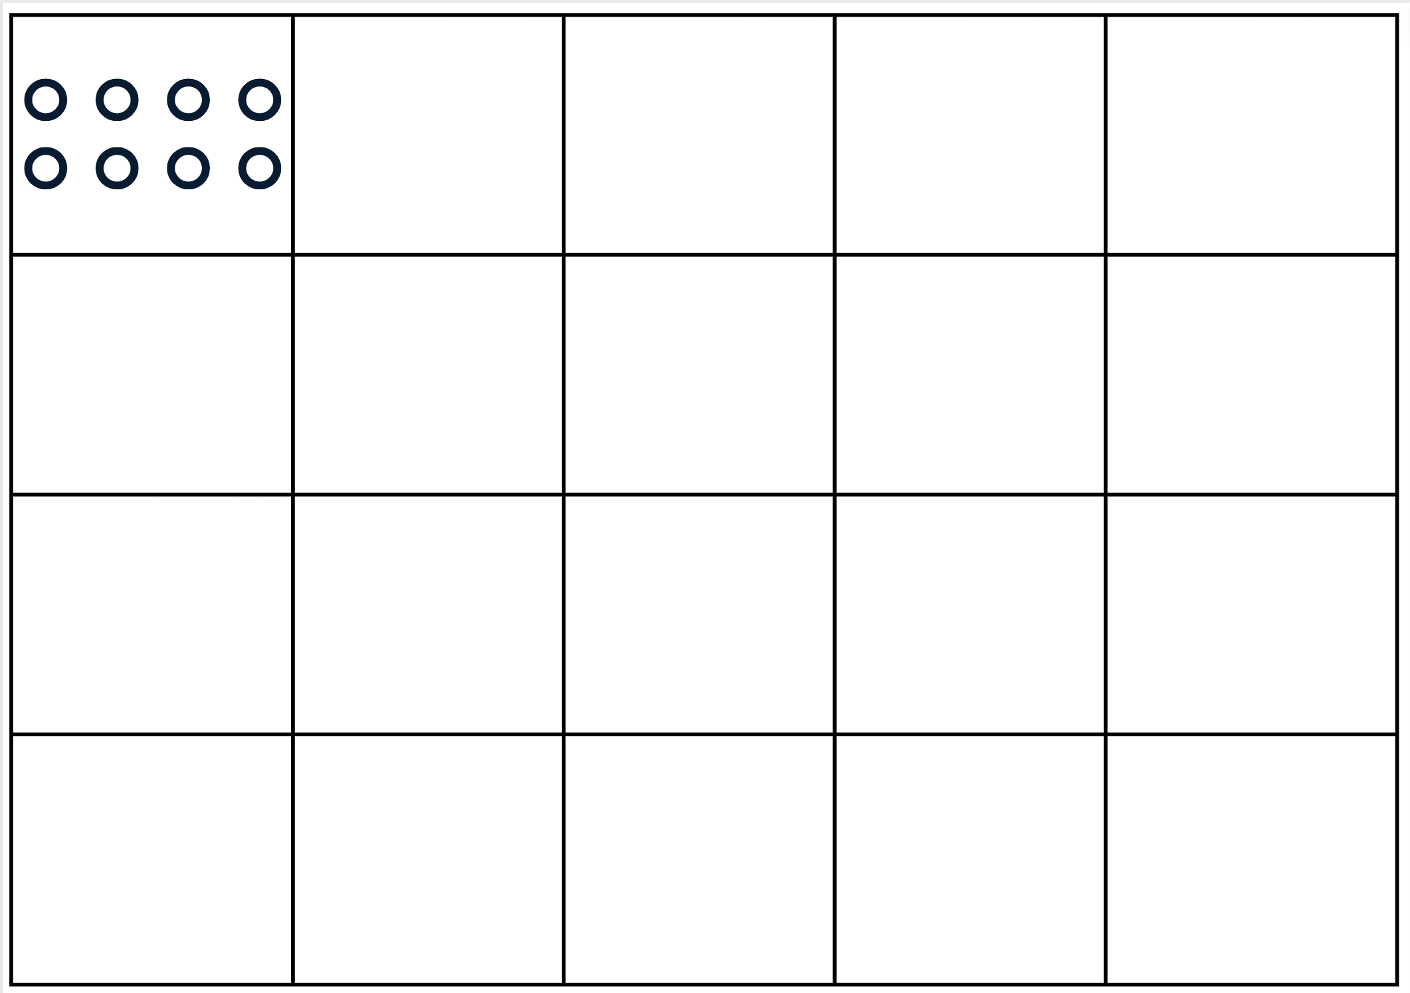

Resource 5 – lolly malfunctions
To produce a lolly with a length of | Prime, composite or neither | Factors | Multiplicative sentence
6 units |  | 1, 2, 3 | 1 × 2 × 3
12 units
 |  | 1, 2, 3 | 2 × 2 × 3 × 3
 |  | 1, 2, 3, 4 | 2 × 2 × 3 × 4
54 units
63 units
72 units

Resource 6 – fraction puzzle
- Pick 5 fractions with related denominators.
- Check that the fractions are not equivalent. For example, two-quarters ( $\frac{2}{4}$ ) and one-half ( $\frac{1}{2}$ ).
- Write the fractions out of order.
- Then write them in order.
- Record your thinking and check your work.
- Write a puzzle card.

Resource 7 – Venn diagram fractions
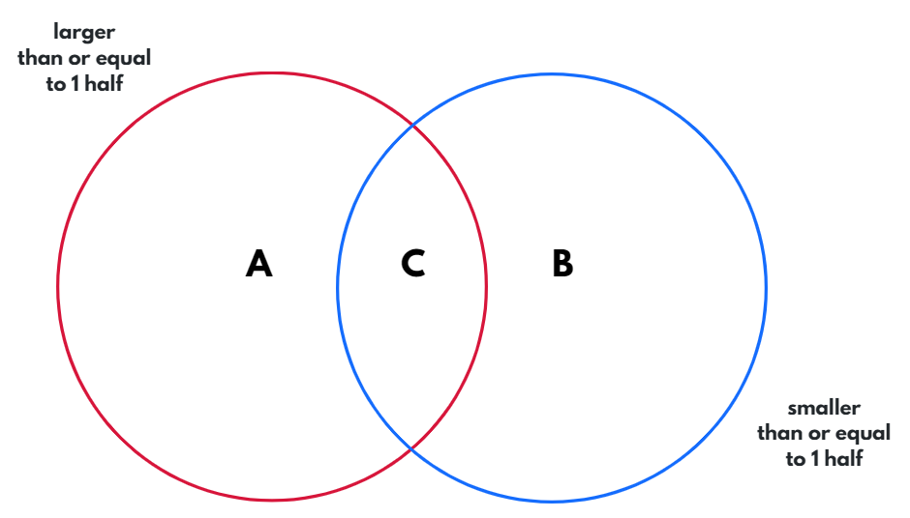

Resource 8 – student responses
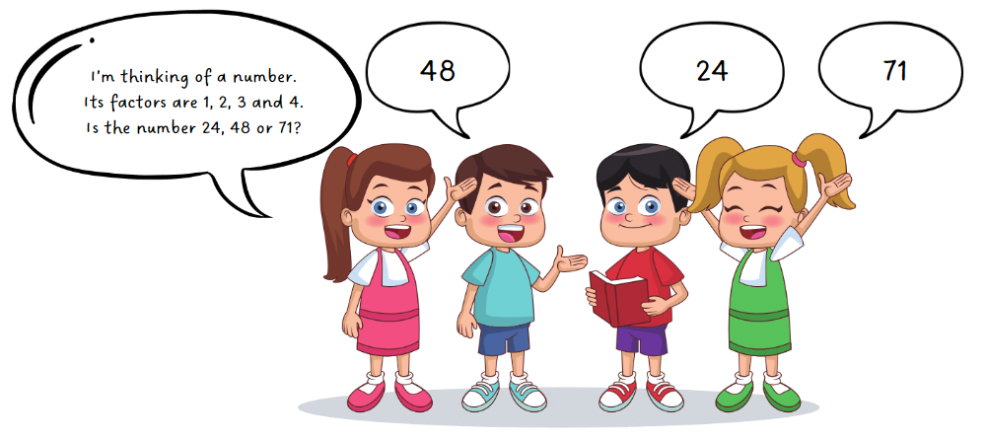

Resource 9 – fraction strip template

Resource 10 – folded strips
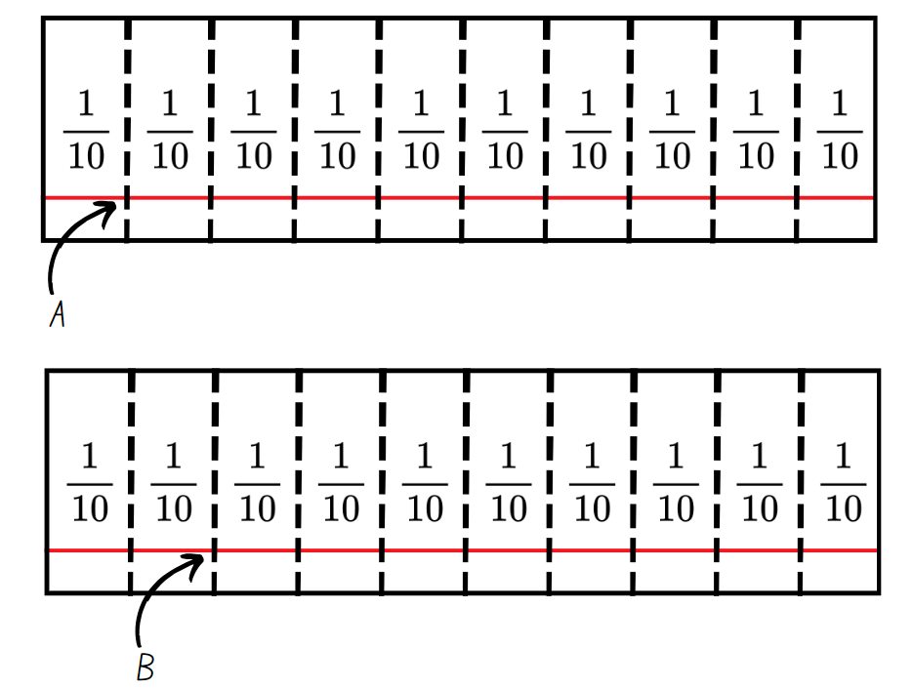

Resource 11 – fraction area models
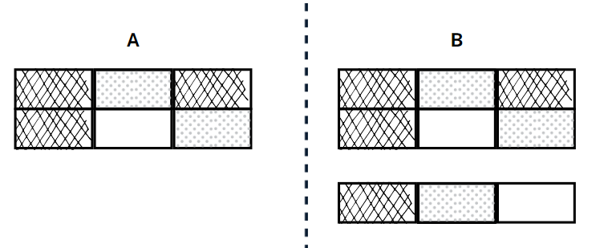

Resource 12 – comparing bar models
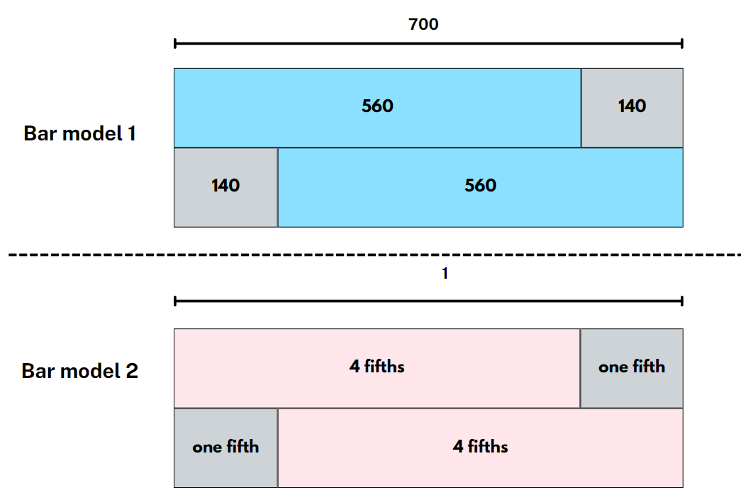

Resource 13 – gardening centre
The local gardening centre makes bags of potting mix. Answer these questions using a paper strip, a drawing, bar model or number line to show your thinking.
- One-fifth ( $\frac{1}{5}$ ) of each bag is sand. Three-fifths ( $\frac{3}{5}$ ) of each bag is compost. What fraction of each bag is made from compost and sand?
- Two gardeners have one open bag of potting mix each. One is four-fifths ( $\frac{4}{5}$ ) full and the other is three-fifths ( $\frac{3}{5}$ ) full. How much potting mix do the gardeners have altogether.
- A gardener has one bag of potting mix that is 75% full. They use half of a full bag to fill up their pots. How much would they now have left? Is it more or less than 20% of the bag?
- One-fifth ( $\frac{1}{5}$ ) of each bag is sand. Three-fifths ( $\frac{3}{5}$ ) of each bag is compost. If the rest of the bag is made from fertiliser, what fraction of each bag is made from fertiliser and sand?
- If each bag has a mass of 20 kg, how much would a bag weigh if one-tenth ( $\frac{1}{10}$ ) had been used?
- A gardener has used less than one-half of a full bag of potting mix. Draw a diagram or number line to show how much could remain in that bag.
- A gardener had 2 partly used bags of potting mix. The difference between the amount in one bag, and the amount in the other, was one-half ( $\frac{1}{2}$ ). How much might there be in each bag? Provide at least 3 possibilities.

Resource 14 – additive bar model
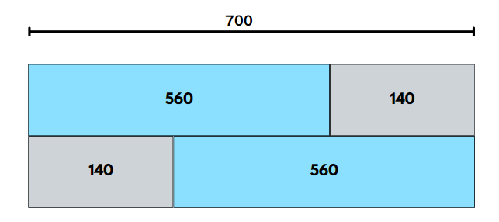

Resource 15 – new area models
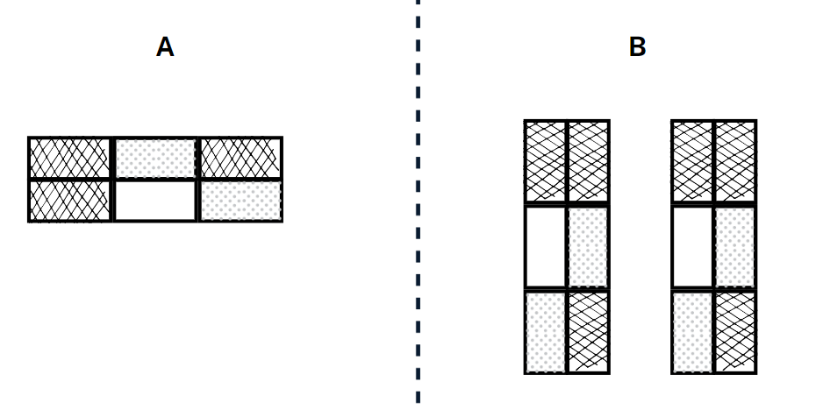

Resource 16 – more fraction models
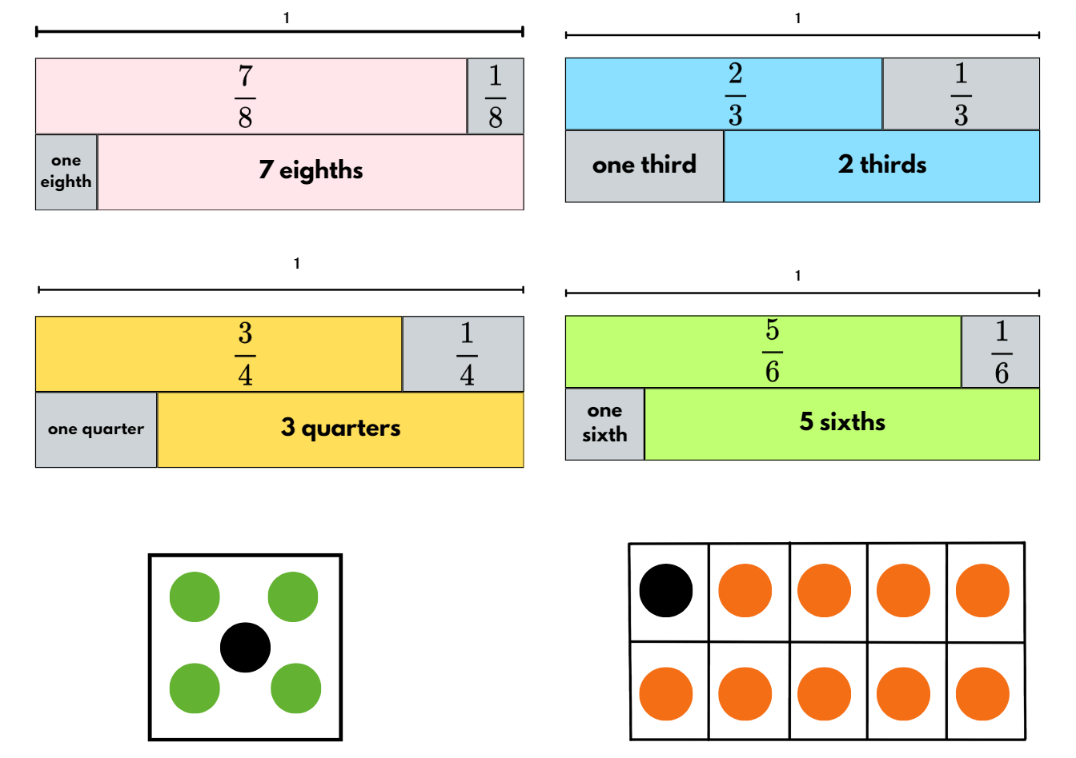

Resource 17 – happy holidays
A family is driving across New South Wales for a holiday. Answer these questions using a paper strip, a drawing, bar model or number line to show your thinking.
- On the first day, they drive two-eighths ( $\frac{2}{8}$ ) of the journey. The next day they drive a further five-eighths ( $\frac{5}{8}$ ) of the journey. How much of the journey have they completed? How much of the journey remains?
- On the first day they use two-fifths ( $\frac{2}{5}$ ) of a tank of petrol. The next day they use four-fifths ( $\frac{4}{5}$ ) of a tank. What fraction of a tank have they used so far on the trip?
- On the trip they listen to an audio book. On the first day they listen to 20% of the book. On the second day they listen to one-half ($\frac{1}{2}$ ) of the total book. How much of the book do they have left to listen to?
- On day 3 of the trip, the petrol tank is 70% full. If the family use 0.5 of a tank, would they have more or less than a quarter of the tank left?
- If the total trip was 800 kilometres, how far would the family have travelled after three-tenths ( $\frac{3}{10} )$of the journey?
- The audio book finished with less than a quarter of the journey remaining. Draw a diagram or number line to show how much of the journey could have remained when the audio book finished. Use fractions, decimals and percentages.
- Two families are on the same journey. The difference between them is three-eighths ( $\frac{3}{8}$ ) of the entire journey. How much of the journey might each family have completed? Provide at least 3 possibilities.

Resource 18 – magic square
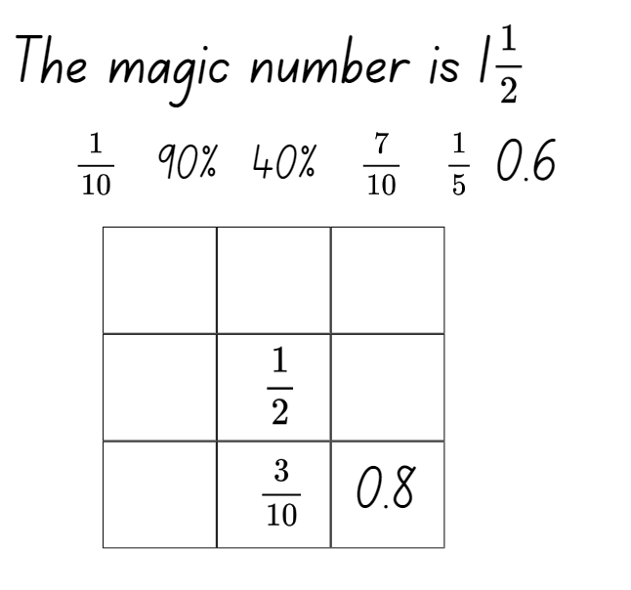

Resource 19 – lines, areas and collections
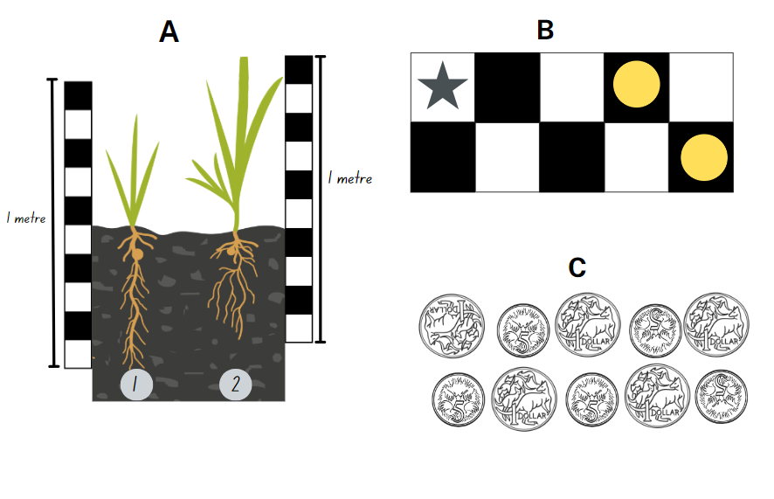

Resource 20 – pin packets
A teacher has some identical packets of pins. Two-fifths of each packet are orange. The remaining pins are an equal share of red, green and blue. Answer these questions, showing your thinking.
- What fraction of the pins are blue?
- Some students use two-thirds ($\frac{2}{3}$) of a full packet to put up a wall display. How much of the packet would they have left? Could they use only 2 colours to put up their display? Explain why or why not.
- A teacher finds 2 open packets of pins in their desk drawer. One packet is eight-tenths ($\frac{8}{10}$) full. The second packet is half empty. What fraction of a packet does the teacher find altogether?
- If each packet has 90 pins in it, how many will there be of each colour?
- A teacher uses 36 pins to display student work. What fraction of the pins is still in the packet?
- A teacher finds a packet of pins that has split, spilling out more than half of the pins into the drawer. What fraction might remain in the packet?
- A teacher has 2 open packets of pins. The difference between the amount in one packet, and the amount in the other, is one-quarter ($\frac{1}{4} )$ of a whole packet. How much might there be in each bag? Provide at least 3 possibilities.

Syllabus outcomes and content
The table below outlines the syllabus outcomes and range of relevant syllabus content covered in this unit. Content is linked to National Numeracy Learning Progression (version 3).
Outcomes and content | 1 | 2 | 3 | 4 | 5 | 6 | 7 | 8
Represents numbers B: Decimals and percentages: Make connections between benchmark fractions, decimals and percentages
[MAO-WM-01, MA3-RN-03]
- Recall commonly used equivalent percentages, decimals and fractions including $\frac{1}{2}$, $\frac{1}{4}$ and $\frac{3}{4}$ |  |  |  | x |  |  |  | x
- Represent common percentages of quantities and lengths as fractions and decimals |  |  | x | x
- Recognise that 10% is one-tenth of 100% and use this to find 10% of a quantity (Reasons about relations) |  |  |  | x
Represents numbers B: Decimals and percentages: Determine percentage discounts of 10%, 25% and 50%
[MAO-WM-01, MA3-RN-03]
- Equate 10% to dividing by 10, 25% to finding a quarter by dividing by 4, and 50% to finding half |  |  |  | x
Additive relations A: Apply efficient mental and written strategies to solve addition and subtraction problems
[MAO-WM-01, MA3-AR-01]
- Solve word problems, including multistep problems |  |  |  |  |  | x | x
- Apply known strategies such as levelling, addition for subtraction, using constant difference, and bridging (Reasons about relations) |  |  |  |  | x
Multiplicative relations A: Determine products and factors
[MAO-WM-01, MA3-MR-01]
- Model different ways to show a whole number as a product (Reasons about structure) | x
- Determine factors for a given whole number | x | x | x
- Determine whether a number is prime, composite or neither (0 or 1) |  | x | x
Representing quantity fractions A: Recognise the role of the number 1 as representing the whole
[MAO-WM-01, MA3-RQF-01, MA3-RQF-02]
- Justify the need for fractions to refer to the number 1 as the common whole (Reasons about quantity) |  |  |  |  | x | x | x
Representing quantity fractions A: Compare and order common unit fractions
[MAO-WM-01, MA3-RQF-01, MA3-RQF-02]
- Compare unit fractions as numbers to the benchmark value $\frac{1}{2}$ | x
- Compare and order unit fractions with denominators of 2, 3, 4, 5, 6, 8 and 10 by placing them on a number line | x
Representing quantity fractions A: Solve problems involving addition and subtraction of fractions with the same denominator
[MAO-WM-01, MA3-RQF-01, MA3-RQF-02]
- Represent the sum of fractions with the same denominator, recreating the whole, where the result may exceed one |  |  |  |  | x | x | x
- Find the difference between fractions with the same denominator and interpret the answer |  |  |  |  | x | x | x
- Solve word problems that involve fractions with the same denominator |  |  |  |  | x | x | x
- Use diagrams, objects and mental strategies to subtract a unit fraction from any whole number including 1 (the complement principle) |  |  |  |  | x | x | x
Representing quantity fractions B: Compare common fractions with related denominators
[MAO-WM-01, MA3-RQF-01, MA3-RQF-02]
- Order common fractions with related denominators using diagrams and number lines |  | x
- Compare and represent fractions with denominators of 2, 4 and 8; 3 and 6; 5 and 10 of a whole shape (area model) and a collection of objects (discrete model) |  |  |  |  |  | x | x | x
- Record equivalent fractions using diagrams, words and fraction notation |  | x |  |  |  |  |  | x
Mathematics K–10 Syllabus © NSW Education Standards Authority (NESA) for and on behalf of the Crown in right of the State of New South Wales, 2022.

References
This resource contains NSW Curriculum and syllabus content. The NSW Curriculum is developed by the NSW Education Standards Authority. This content is prepared by NESA for and on behalf of the Crown in right of the State of New South Wales. The material is protected by Crown copyright.
Please refer to the NESA Copyright Disclaimer for more information https://educationstandards.nsw.edu.au/wps/portal/nesa/mini-footer/copyright.
NESA holds the only official and up-to-date versions of the NSW Curriculum and syllabus documents. Please visit the NSW Education Standards Authority (NESA) website https://educationstandards.nsw.edu.au and the NSW Curriculum website https://curriculum.nsw.edu.au.
Mathematics K–10 Syllabus © NSW Education Standards Authority (NESA) for and on behalf of the Crown in right of the State of New South Wales, 2022.
National Numeracy Learning Progression © Australian Curriculum, Assessment and Reporting Authority (ACARA) 2010 to present, unless otherwise indicated. This material was downloaded from the Australian Curriculum website (National Numeracy Learning Progression) (accessed 3 March 2024) and was not modified.
Barton C (n.d.) ‘Venn Diagram Rich Tasks’, Venn Diagram Activities, Mr Barton maths website, accessed 3 March 2024.
Blair A (n.d.) ‘Sum of unit fractions inquiry’, Number prompts, Inquiry Maths website, accessed 26 February 2024.
Burns M (2015) Fix It: An Activity for Ordering Fractions, MB math website, accessed 1 March 2024.
Clarke D and Roche A (2009) ‘Students’ fraction comparison strategies as a window into robust understanding and possible pointers for instruction’, Educational Studies in Mathematics, 72(1):127–138, doi:10.1007/s10649-009-9198-9, accessed 26 February 2024.
Evidence for Learning (2022) Planning a think aloud in mathematics, Evidence for Learning, accessed 28 February 2024.
NESA (NSW Education Standards Authority) (2024) ‘Teaching advice for Partitioned fractions A’, Stage 2, NESA website, accessed 20 May 2024.
State of Victoria (Department of Education) (2020) ‘Liquorice Factory’ It’s All in the Numbers, Arc Learning Sequences website, accessed 28 February 2024.
www.learn-with-math-games.com (n.d.) Magic Square Fun, learn-with-math-games.com website, accessed 28 February 2024.

© State of New South Wales (Department of Education), 2024
The copyright material published in this resource is subject to the Copyright Act 1968 (Cth) and is owned by the NSW Department of Education or, where indicated, by a party other than the NSW Department of Education (third-party material).
Copyright material available in this resource and owned by the NSW Department of Education is licensed under a Creative Commons Attribution 4.0 International (CC BY 4.0) license.
This license allows you to share and adapt the material for any purpose, even commercially.
Attribution should be given to © State of New South Wales (Department of Education), 2024.
Material in this resource not available under a Creative Commons license:
- the NSW Department of Education logo, other logos and trademark-protected material
- material owned by a third party that has been reproduced with permission. You will need to obtain permission from the third party to reuse its material.
Links to third-party material and websites
Please note that the provided (reading/viewing material/list/links/texts) are a suggestion only and implies no endorsement, by the New South Wales Department of Education, of any author, publisher, or book title. School principals and teachers are best placed to assess the suitability of resources that would complement the curriculum and reflect the needs and interests of their students.
If you use the links provided in this document to access a third-party's website, you acknowledge that the terms of use, including licence terms set out on the third-party's website apply to the use which may be made of the materials on that third-party website or where permitted by the Copyright Act 1968 (Cth). The department accepts no responsibility for content on third-party websites.

