Mathematics Stage 3 – Unit 15
Addition and subtraction problems can be solved by using a variety of strategies
Contents
Unit description and duration 6
Syllabus outcomes 6
Working mathematically 7
Student prior learning 7
Lesson overview and resources 9
Lesson 1 14
Daily number sense – across NSW – 15 minutes 14
Core lesson 1 – reviewing whole numbers – 20 minutes 16
Core lesson 2 – reviewing decimals – 20 minutes 20
Discuss and connect the mathematics – 10 minutes 23
Lesson 2 25
Daily number sense – estimation – 10 minutes 25
Core lesson 1 – anchor chart – 15 minutes 27
Core lesson 2 – choosing additive strategies – 25 minutes 29
Consolidation and meaningful practice – 15 minutes 33
Lesson 3 35
Daily number sense – rounding on a number line – 15 minutes 35
Core lesson 1 – strategy review – 20 minutes 37
Core lesson 2 – applying strategies – 20 minutes 40
Discuss and connect the mathematics – 10 minutes 41
Lesson 4 43
Daily number sense – 10 minutes 43
Core lesson – balancing parcels – 40 minutes 43
Discuss and connect the mathematics – 10 minutes 46
Lesson 5 48
Daily number sense – find the area – 15 minutes 48
Core lesson 1 – revising decimals and fractions – 15 minutes 51
Core lesson 2 – linking percentages – 25 minutes 53
Discuss and connect the mathematics – 5 minutes 58
Lesson 6 60
Daily number sense – solve it – 15 minutes 60
Core lesson 1 – benchmark percentages – 25 minutes 62
Core lesson 2 – percentage problems – 25 minutes 66
Discuss and connect the mathematics – 5 minutes 67
Lesson 7 68
Daily number sense – age maths puzzle – 10 minutes 68
Core lesson – decimal problems – 20 minutes 69
Core lesson 2 – school enrolments – 25 minutes 71
Discuss and connect the mathematics – 5 minutes 72
Lesson 8 74
Daily number sense – 10 minutes 74
Core lesson 1 – rounding – 10 minutes 74
Core lesson 2 – guided Fermi question – 15 minutes 76
Core lesson 3 – Fermi problems – 25 minutes 77
Discuss and connect the mathematics – 10 minutes 78
Resource 1 – NSW map 80
Resource 2 – place value slider 81
Resource 3 – decimal misconceptions 82
Resource 4 – additive strategies 83
Resource 5 – reflection chart 87
Resource 6 – Which strategy? 88
Resource 7 – Which strategy? 2 89
Resource 8 – ABC Motors 90
Resource 9 – levelling/constant difference 91
Resource 10 – word problems 92
Resource 11 – balancing parcels 93
Resource 12 – Perfect Post shipping 94
Resource 13 – Spring sales 95
Resource 14 – Perfect Post problems 96
Resource 15 – percentages 97
Resource 16 – place value equivalence 98
Resource 17 – number wheel 99
Resource 18 – percentage links 100
Resource 19 – benchmark percentages 101
Resource 20 – percent problems 102
Resource 21 – percent models 104
Resource 22 – multistep problems 105
Resource 23 – digit manipulatives 106
Resource 24 – first day data 107
Resource 25 – open middle problems 108
Resource 26 – rounding large numbers 109
Resource 27 – Fermi checklist 110
Resource 28 – Fermi problems 111
Syllabus outcomes and content 112
References 118
Further reading 120

Unit description and duration
This unit develops the big idea that addition and subtraction problems can be solved using a variety of strategies.
In this 2-week unit students are provided opportunities to:
- apply known strategies to add and subtract large numbers and decimals
- solve multistep word problems, including problems that require more than one operation
- make use of benchmark percentages to determine discounts.

Syllabus outcomes
- MAO-WM-01 develops understanding and fluency in mathematics through exploring and connecting mathematical concepts, choosing and applying mathematical techniques to solve problems, and communicating their thinking and reasoning coherently and clearly
- MA3-RN-01 applies an understanding of place value and the role of zero to represent the properties of numbers
- MA3-RN-02 compares and orders decimals up to 3 decimal places
- MA3-RN-03 determines percentages of quantities, and finds equivalent fractions and decimals for benchmark percentage values
- MA3-AR-01 selects and applies appropriate strategies to solve addition and subtraction problems
- MA3-MR-01 selects and applies appropriate strategies to solve multiplication and division problems
- MA3-MR-02 constructs and completes number sentences involving multiplicative relations, applying the order of operations to calculations

Working mathematically
In the Mathematics K–10 Syllabus, there is one overarching Working mathematically outcome (MAO-WM-01). The Working mathematically processes should be embedded within the concepts being taught. The Working mathematically processes are:
- communicating
- understanding and fluency
- reasoning
- problem solving.
Mathematics K–10 Syllabus © NSW Education Standards Authority (NESA) for and on behalf of the Crown in right of the State of New South Wales, 2022.

Student prior learning
Before engaging in these teaching and learning activities, students would benefit from prior experience with:
- recognising that the place value system can be extended beyond hundredths
- applying efficient mental and written strategies to solve addition and subtraction problems
- solving word problems, including multistep problems.
In NSW classrooms there is a diverse range of students, including Aboriginal and/or Torres Strait Islander students, students learning English as an additional language or dialect, high potential and gifted students and students with disability. Some students may identify with more than one of these groups or possibly all of them. Refer to Curriculum planning for every student – advice for further information.

Lesson overview and resources
The table below outlines the sequence and approximate timing of lessons, learning intentions and resources.
Lesson | Content | Duration and resources
Lesson 1  Daily number sense learning intention:  - use estimation and place value understanding to determine the reasonableness of solutions | Lesson core concept: place value understanding helps solve addition and subtraction problems.  Core concept learning intentions:  - apply efficient mental and written strategies to solve addition and subtraction problems  - use estimation and place value understanding to determine the reasonableness of solutions | Lesson duration: 65 minutes  - Resource 1 – NSW map  - Resource 2 – place value slider  - Resource 3 – decimal misconceptions  - 10-sided dice (0–9)  - Calculators  - Writing materials
Lesson 2  Daily number sense learning intention:  - use estimation and place value understanding to determine the reasonableness of solutions | Lesson core concept: a variety of additive strategies help solve addition and subtraction problems.  Core concept learning intention:  - apply efficient mental and written strategies to solve addition and subtraction problems | Lesson duration: 65 minutes  - Resource 4 – additive strategies  - Resource 5 – reflection chart  - Resource 6 – Which strategy?  - Resource 7 – Which strategy? 2  - Resource 8 – ABC Motors  - MAB materials  - Writing materials
Lesson 3  Daily number sense learning intention:  - use estimation and place value understanding to determine the reasonableness of solutions | Lesson core concept: flexible methods of addition and subtraction involve decomposing and composing numbers.  Core concept learning intention:  - apply efficient mental and written strategies to solve addition and subtraction problems | Lesson duration: 65 minutes  - Resource 9 – levelling/constant difference  - Resource 10 – word problems  - 10-sided dice (0–9)  - Digital number line  - Sticky notes  - Writing materials
Lesson 4  Daily number sense learning intention:  - teacher-identified task based on student needs | Lesson core concept: number lines help solve addition and subtraction problems.  Core concept learning intentions:  - apply efficient mental strategies to solve addition and subtraction problems  - use estimation and place value understanding to determine the reasonableness of solutions | Lesson duration: 60 minutes  - Resource 11 – balancing parcels  - Resource 12 – Perfect Post shipping  - Resource 13 – Spring sales  - Resource 14 – Perfect Post problems  - Writing materials
Lesson 5  Daily number sense learning intention:  - select and apply mental and written strategies to multiply 2- and 3-digit numbers by 2-digit numbers | Lesson core concept: place value understanding helps make use of benchmark percentages.  Core concept learning intention:  - make connections between benchmark fractions, decimals and percentages | Lesson duration: 60 minutes  - Resource 15 – percentages  - Resource 16 – place value equivalence  - Resource 17 – number wheel  - Writing materials
Lesson 6  Daily number sense learning intention:  - select and apply mental and written strategies to multiply 2- and 3-digit numbers by 2-digit numbers | Lesson core concept: place value understanding helps to make use of benchmark percentages in determining discounts.  Core concept learning intentions:  - determine percentage discounts of 10%, 25% and 50%  - choose and use efficient strategies to solve addition and subtraction problems | Lesson duration: 70 minutes  - Resource 18 – percentage links  - Resource 19 – benchmark percentages  - Resource 20 – percent problems  - Resource 21 – percent model  - 100 grids  - Pegs  - Small pieces of paper  - String or wool  - Writing materials
Lesson 7  Daily number sense learning intention:  - select and apply mental and written strategies to multiply 2- and 3-digit numbers by 2-digit numbers | Lesson core concept: mathematicians solve addition and subtraction problems with multiple steps.  Core concept learning intentions:  - apply efficient mental and written strategies to solve addition and subtraction problems  - applies known strategies to add and subtract decimals | Lesson duration: 60 minutes  - Resource 4 – additive strategies  - Resource 22 – multistep problems  - Resource 23 – digit manipulatives  - Resource 24 – first day data  - Resource 25 – open middle problems  - Whiteboards  - Writing materials
Lesson 8  Daily number sense learning intention:  - teacher-identified task based on student needs | Lesson core concept: mathematicians compare and evaluate strategies used to solve addition and subtraction problems, reasoning which strategy may be most efficient.  Core concept learning intentions:  - choose and use efficient strategies to solve addition and subtraction problems  - applies known strategies to add and subtract decimals | Lesson duration: 70 minutes  - Resource 26 – rounding large numbers  - Resource 27 – Fermi checklist  - Resource 28 – Fermi problems  - Calculators  - Counters or marbles  - Writing materials

Lesson 1
Core concept: place value understanding helps solve addition and subtraction problems.

Daily number sense – across NSW – 15 minutes
Daily number sense activities for Lessons 1 to 3 ‘activate’ prior number knowledge and support the learning of new content in the unit. These activities can also assist teachers to identify the starting points for learning by revealing the extent of students’ existing knowledge.
The table below contains a suggested learning intention and success criteria. These are best co-constructed with students.
Daily number sense learning intention | Daily number sense success criteria
Students are learning to:  - use estimation and place value understanding to determine the reasonableness of solutions. | Students can:  - round numbers appropriately when obtaining estimates to numerical calculations.
Note: consider researching and providing destinations and distances that are relevant to your school context.
- Display and discuss Resource 1 – NSW map.
- Explain the following scenario: Imagine your family is planning a road trip within New South Wales and the Australian Capital Territory. You have the following distances to consider:
- Sydney City, Gadigal Country to Newcastle, Awabakal Country: 117 kilometres
- Sydney to Wollongong, Tharawal Country: 68 kilometres
- Wollongong to Coffs Harbour, Gumbainggir Country: 504 kilometres
- Coffs Harbour to Sydney: 623 kilometres
- Sydney to Canberra, Ngunnawal Country: 286 kilometres
- Canberra to Wollongong: 235 kilometres.
- Say that students need to choose 4 destinations and distances, then estimate the total distance. Explain that when making an estimate, it is not necessary to calculate the actual distance. Instead, each distance can be rounded to the nearest 10 or 100 kilometres so that it is easier to estimate the total distance.
- Students estimate the total distance they would travel for their road trip visiting at least 4 of the destinations.
- Ask selected questions such as:
- What is your estimated total distance?
- What strategies did you use to help you find the estimate for your road trip?
- What would be the shortest trip for 4 destinations?
- What would be the longest trip for 4 destinations?
- What would be the shortest way to visit all destinations?
- If your car uses one litre of petrol for every 10 kilometres, how much petrol will you need for your journey?
This table details opportunities for assessment.
Assessment opportunities | Links
What to look for:  - Can students round numbers appropriately when obtaining estimates to numerical calculations? [MAO-WM-01, MA3-AR-01] | Links to National Numeracy Learning Progressions (NNLP):  - NPV6, NPV7.

Core lesson 1 – reviewing whole numbers – 20 minutes
The table below contains suggested learning intentions and success criteria. These are best co-constructed with students.
Core concept learning intentions | Core concept success criteria
Students are learning to:  - apply efficient mental and written strategies to solve addition and subtraction problems  - use estimation and place value understanding to determine the reasonableness of solutions. | Students can:  - determine when it would be more efficient to use a calculator to add numbers  - use place value understanding to check for errors in calculations  - use estimation to check the reasonableness of solutions to addition and subtraction calculations.
Note: for part 2 of this lesson, if students do not have access to a place value slider from previous units, they should make one using Resource 2 – place value slider. This activity is an adaptation of (Even more) 5 minutes of fun! from fractionfanatic by Morgan.
- Introduce a whole class game called ‘Make a million’.
- The aim of the game is to write two 6-digit numbers that, when added together, make as close to 1 million as possible. Explain that the total may not go over 1 million.
- Ask students to each draw a gameboard (see Figure 1).
Figure 1 – make a million
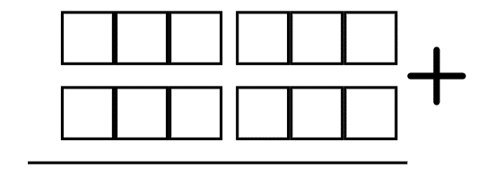
Note: 4-, 5- and 6-digit numbers are named as thousands, such as three thousand, thirty thousand, three hundred thousand. To assist reading numbers, the convention for writing numbers of more than 4 digits requires a space, not a comma, to the left of each group of 3 digits. For example, 16 234.
- Roll a 10-sided die (0–9) and call out the digit.
- Students build their numbers by writing a digit in a box on their board. Although they can choose which box to place each number in, they cannot change the position of the digits once written. Continue to roll until all spaces are filled.
- Students read the two 6-digit numbers they have written to a partner. Then they add the numbers together and check their partner’s addition using a calculator.
- Observe if students can read their numbers fluently and identify the place value of digits in different positions.
- The student who is closest to one million, correctly adds and reads their final number, wins. Ask:
- What strategies did you use to place your numbers? Did it work? Why or why not?
- What changes would you make next time you play? Why?
- Why is a calculator more efficient when checking a partner’s calculation?
- Repeat the game to give students an opportunity to apply strategies learned from round one.
- Alternatively, modify the game with the aim to get closest to one hundred thousand using the board shown in Figure 2.
Figure 2 – one hundred thousand
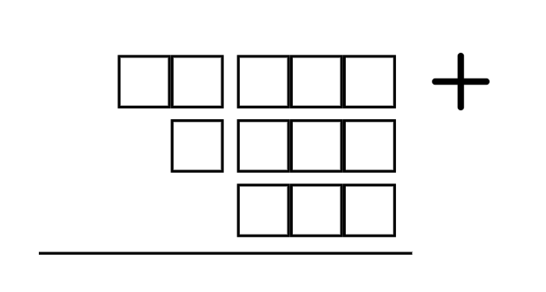
- Regroup as a class. Identify the strategies students used in placing digits and making estimates to get the closest total to one million.

Core lesson 2 – reviewing decimals – 20 minutes
- Display Resource 3 – decimal misconceptions. Students turn and talk about the responses in the example.
- Share students’ ideas with the class and clarify any misconceptions.
Note: both Lars and Jayden are correct. Lars’ language is the most supportive of place value understanding. Jayden’s is the most used, especially in measurement contexts. Mikayla has missed or does not understand the function of the decimal point. Angus is reading the number as 2 independent whole numbers.
- Distribute Resource 2 – place value slider.
- Individually or in pairs, students select a 2-digit number.
Note: a common misunderstanding is that the decimal point moves when a number is multiplied by powers of 10. The place value slider has a fixed decimal marker and is an effective way of addressing this misunderstanding. Zeros should be added to a number slider as place holders when multiplying and dividing by powers of 10. This assists when comparing the place value of digits by determining numbers that are 10, 100 or 1000 times the original number.
- Students use the place value slider to multiply and divide their number by 10, between the millions and thousandths places (see Figure 3).
Figure 3 – place value slider example
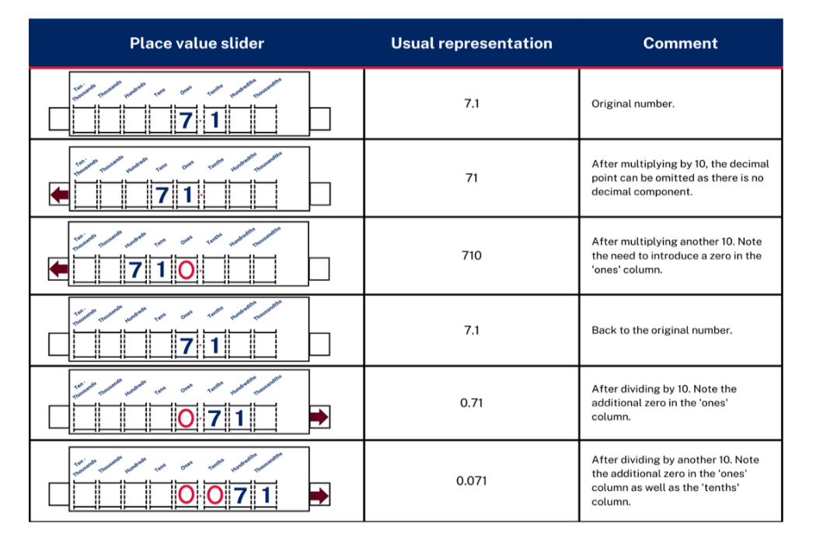
Adapted from Stacey et al. (2011).
- Students record the numbers at each step in a table, as in Figure 3.
- Once completed, students select 2 numbers from their list and identify the relationship between them. For example, 23 is 10 times larger than 2.3, or 5400 is 1000 times smaller than 5 400 000.
Note: this is an opportunity to develop Working mathematically outcomes with students, exploring and connecting mathematical concepts across place value and multiplicative relations.
This table details opportunities for differentiation.
Too hard? | Too easy?
Students cannot apply an understanding of place value and the role of zero to represent the properties of numbers.  - ‘Make a million’ can be adjusted to ‘Make a thousand’. Students take cards (0–9) from a pack to create their numbers. They put them on a place value chart, before adding them with mental or written strategies.  - Adjust the place value slider to only represent whole numbers. Use this to reinforce place value and the connection to multiplicative thinking. | Students can apply an understanding of place value and the role of zero to represent the properties of numbers.  - Students to plan a journey to 7 destinations around the world. They estimate the total distance travelled, to the nearest 1000 kilometres.  - With a partner, students play a variation of ‘Make a million’ that includes decimals. They list 3 things that are the same and 3 that are different to the original game.

Discuss and connect the mathematics – 10 minutes
- Introduce using estimation to check the reasonableness of solutions for addition and subtraction.
- Write the algorithm as shown in Figure 4. Ask: Is this a reasonable answer?
Figure 4 – reasonable calculations
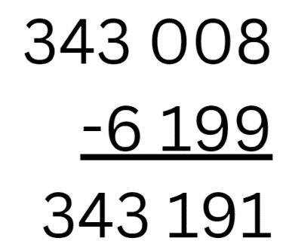
Note: this answer is unreasonable because it is larger than the starting number. It has examples of a common misconception called the ‘smaller-from-larger error’. When faced with 8 minus 9, students switch the numbers to 9 minus 8.
- Students turn and talk about if it is reasonable, and what a reasonable answer would be.
- Share student their responses.
This table details opportunities for assessment.
Assessment opportunities | Links
What to look for:  - Can students determine when it would be more efficient to use a calculator to add numbers? [MAO-WM-01, MA3-AR-01]  - Can students use place value understanding to check for errors in calculations? [MAO-WM-01, MA3-AR-01]  - Can students use estimation to check the reasonableness of solutions to addition and subtraction calculations? [MAO-WM-01, MA3-AR-01] | Links to National Numeracy Learning Progressions (NNLP):  - NPV5, NPV6, NPV7, NPV8.  - AdS8.  Links to suggested Interview for Student Reasoning (IfSR) tasks:  - IfSR-PT: 1A.7, 1A.8  - IfSR-AT: 4B.2  - IfSR-NP: 4D.8.

Lesson 2
Core concept: a variety of additive strategies help solve addition and subtraction problems.

Daily number sense – estimation – 10 minutes
The table below contains a suggested learning intention and success criteria. These are best co-constructed with students.
Daily number sense learning intention | Daily number sense success criteria
Students are learning to:  - use estimation and place value understanding to determine the reasonableness of solutions. | Students can:  - use estimation to check the reasonableness of solutions to addition and subtraction calculations.
- Revise the purpose of estimating. Emphasise that students should not calculate an answer.
- Using whiteboards, students estimate the total of some of the following equations. They will need to justify if the answers are reasonable or unreasonable:
- 812 + 514 = 1514
- 923 + 346 = 1200
- 2357 + 6106 = 8460
- 4216 + 3942 = 8000
- 43 892 + 92 106 = 135 900
- 628 − 413 = 215
- 781 − 234 = 550
- 7842 − 5209 = 2600
- 8456 − 4234 = 6120
- 73 812 – 28 492 = 40 320.
- Select students to share their thinking.
This table details opportunities for assessment.
Assessment opportunities | Links
What to look for:  - Can students use estimation to check the reasonableness of solutions to addition and subtraction calculations? [MAO-WM-01, MA3-AR-01] | Links to National Numeracy Learning Progressions (NNLP):  - NPV6, AdS8.

Core lesson 1 – anchor chart – 15 minutes
The table below contains a suggested learning intention and success criteria. These are best co-constructed with students.
Core concept learning intention | Core concept success criteria
Students are learning to:  - apply efficient mental and written strategies to solve addition and subtraction problems. | Students can:  - apply known strategies such as levelling, addition for subtraction, using constant difference, and bridging  - identify efficient and inefficient multidigit addition and subtraction strategies.
- Brainstorm and list the strategies students use when solving addition and subtraction. The list may include inverse relations, commutative property, associative property, algorithms, levelling, constant difference, partitioning, regrouping, compensation or equivalence.
- As a class, co-construct an additive strategy anchor chart, recording examples for each strategy to support student understanding. For example, see Figure 5.
Figure 5 – example anchor chart
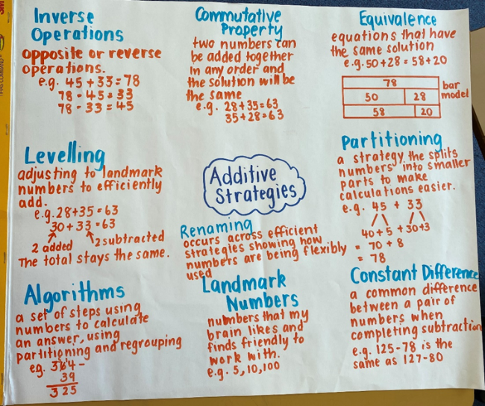
- Alternatively, Resource 4 – additive strategies can be displayed or provided to support students.

Core lesson 2 – choosing additive strategies – 25 minutes
This activity is an adaptation from Engaging Maths: Higher Order Thinking with Thinkers Keys by Attard.
- Display and review Resource 5 – reflection chart.
- Remind students that when they work with numbers, the aim is to be flexible, efficient and accurate.
Note: in Stage 3, mental strategies, including students’ informal recordings, need to be continually reinforced. Some strategies are more efficient than others. To foster choice and flexibility, students need opportunities to identify different strategies and what makes them appropriate. Many methods involving addition and subtraction take advantage of one number’s proximity to a multiple of 10 or 100 (NESA 2024a).
- Display the following equations on the board.
- 3597 + 5349 = _?
- _ − 8078 = 464
- 12 672 − 8985 = _?
- Students turn and talk to discuss:
- How would you work this out?
- Would you use a written or mental strategy?
- Would you use a different strategy for each equation? Why?
- Select students to share their responses.
The table below outlines stimulus prompts to generate conversation about the topic, along with anticipated responses from students.
Prompts | Anticipated student responses
- 3597 + 5349 | - I would use a mental strategy such as:  - levelling: for example, 3600 + 5346 = 8946.  - bridging: for example, 3597 + 3 = 3600, 3600 + 5346 = 8946.  - I would use an algorithm.
- _ − 8078 = 464 | - I would use inverse relations 8078 + 464 = _?; then either a mental or written strategy such as levelling (8100 + 442) or bridging (8078 + 2 + 20 + 442).  - I would write 8078 + 464 = 8542.
- 12 672 − 8 985 | - I would use a mental strategy such as constant difference, adding 15 to both sides: 12 687 − 9000 = 3687.  - I would use an inverse operation and bridging: 8985 + 15 + 1000 + 2672.  - I would use an algorithm.
- Display the class anchor chart or refer to Resource 4 – additive strategies.
- Identify the strategies used. Add any additional strategies to the class anchor chart.
- Display or provide Resource 6 – Which strategy?
- Students record in workbooks the name of the most efficient strategy and complete the equation using it. See the example in Table 1.
Table 1 – strategy examples
Equation | Most efficient strategy | Solution
- 2364 + 407 | Mental strategy using levelling of ones | 2364 + 407 = 2370 + 401 = 2771
- 3689 − 2562 | Written strategy using constant difference then mental partitioning | 3689 − 2562 = 3690 − 2563 =1127
- _ − 7289 = 158 | Mental strategy using inverse relations then levelling | _ − 7289 = 158  Inverse: 7289 + 158 =  Levelling: 7290 + 157 = 7447
- 67.7 + 108.67 | Using a formal written algorithm | 67.7  + 108.67  176.37
- 5440 + 266 | Mental strategy using levelling of tens place value | 5440 + 266 = 5400 + 306 = 5706
- 7302 − _ = 4861 | Written strategy using the complement principle then vertical algorithm | 7302 − _ = 4861  7302  − 4861  2441
- Students complete a gallery walk to view other students’ responses to the tasks.

This table details opportunities for differentiation.
Too hard? | Too easy?
Students cannot identify efficient and inefficient multidigit addition and subtraction strategies.  - Provide students with Resource 7 – Which strategy? 2. They identify a number-based strategy to support more efficient calculations. For example, partitioning numbers.  - Provide students with MAB materials to assist with addition and subtraction. | Students can identify efficient and inefficient multidigit addition and subtraction strategies.  - Students write equations to demonstrate understanding of when each mental and written strategy would be the most efficient.  - Provide students with Resource 8 – ABC Motors. They solve the problem, reflecting on the most efficient strategies used.

Consolidation and meaningful practice – 15 minutes
- Students record all the mental and written strategies for addition and subtraction in their workbook.
- They rate them in order from easiest to most difficult to use. Use the results to form a class tally.
- Display Resource 5 – reflection chart. Discuss the class tally results, justifying and explaining the reasons for the order of each strategy.

This table details opportunities for assessment.
Assessment opportunities | Links
What to look for:  - Can students identify efficient and inefficient multidigit addition and subtraction strategies? [MAO-WM-01, MA3-AR-01]  - Can students apply known strategies such as levelling, addition for subtraction, using constant difference, and bridging?  [MAO-WM-01, MA3-AR-01] | Links to National Numeracy Learning Progressions (NNLP):  - AdS7, AdS8.  Links to suggested Interview for Student Reasoning (IfSR) tasks:  - IfSR-AT: 3A.4, 3A.5.

Lesson 3
Core concept: flexible methods of addition and subtraction involve decomposing and composing numbers.

Daily number sense – rounding on a number line – 15 minutes
The table below contains a suggested learning intention and success criteria. These are best co-constructed with students.
Daily number sense learning intention | Daily number sense success criteria
Students are learning to:  - use estimation and place value understanding to determine the reasonableness of solutions. | Students can:  - use place value understanding to check for errors in calculations.
- Explain that students are going to play a game in pairs. The aim is to get 4 numbers in a row.
- Provide pairs with three 0–9 dice and whiteboards. They draw one number line with interval marks of 100 (see Figure 6).
Figure 6 – number line
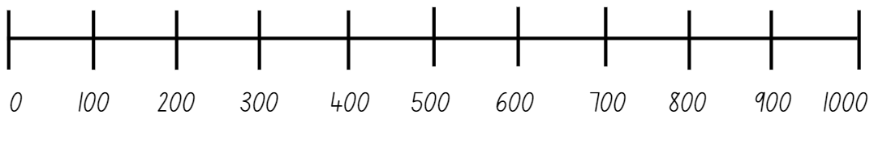
- Students take turns rolling the dice to form a 3-digit number. They write each number on the number line.
- The first player to get 4 numbers in a row without being blocked, wins the game (see Figure 7).
Figure 7 – sample number line
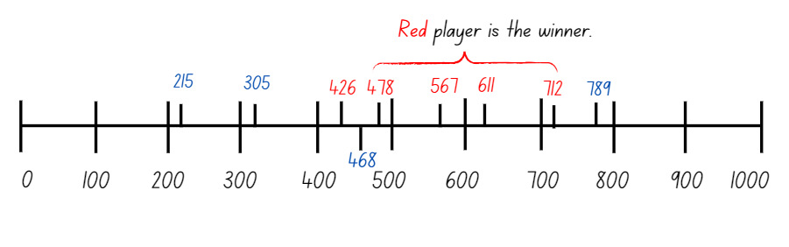
Note: as students form their own numbers to position on the number line, they need to consider whether to block their partner's progress. The blue player in Figure 7 could have blocked the red player by choosing 503 or 530 instead of 305.
- Once students get 4 in a row, they round and add 2 of their numbers and provide an approximate answer, for example 426 + 478 = 900.
- They check the reasonableness of their rounding by using place value understanding to form a vertical algorithm of the original numbers. This is used to find the actual total.
This table details an opportunity for assessment.
Assessment opportunity | Links
What to look for:  - Can students use place value understanding to check for errors in calculations? [MAO-WM-01, MA3-AR-01] | Links to National Numeracy Learning Progressions (NNLP):  - NPV5, NPV6  - AdS8.

Core lesson 1 – strategy review – 20 minutes
The table below contains suggested a learning intention and success criteria. These are best co-constructed with students.
Core concept learning intention | Core concept success criteria
Students are learning to:  - apply efficient mental and written strategies to solve addition and subtraction problems. | Students can:  - solve word problems, including multistep problems  - apply known strategies such as levelling, addition for subtraction using constant difference and bridging  - identify efficient and inefficient multi-digit subtraction strategies.
- Review the terms levelling and constant difference with the students.
Levelling: adjusting to landmark numbers to add efficiently. It is used to adjust the numbers in addition, for example: 28 + 35 = 30 + 33 = 63.
Constant difference: a common difference between pairs of numbers. It can be used to adjust the numbers in subtraction, for example: 148 − 68 = 150 − 70 = 80.
- Display and discuss Resource 9 – levelling/constant difference.
- Co-create examples of levelling and constant difference with students. Use decimals up to 3 decimal places and numbers up to 6 digits in the examples, such as Figure 8.
Figure 8 – levelling and constant difference
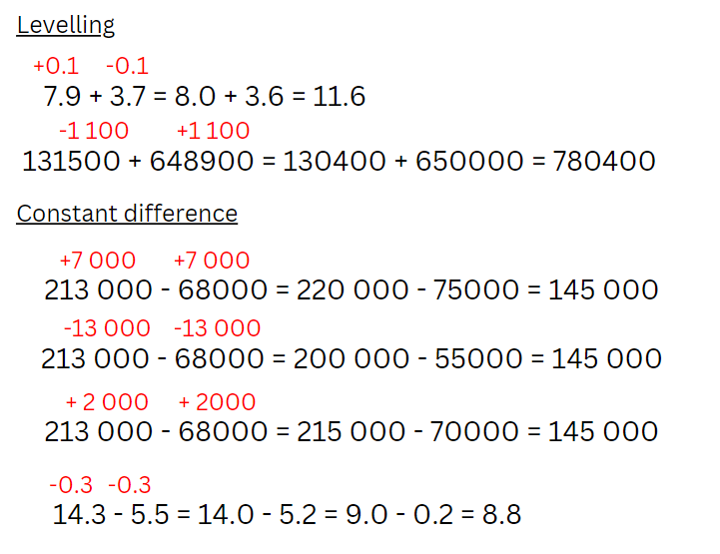
- Add levelling and constant difference to the additive strategies anchor chart from Lesson 2 if not already included.
- Provide opportunities to practise levelling and constant difference. Use numbers that can be readily rounded to 10, 100 or 1000 such as:
- 356 + 44
- 489 − 51
- 772 + 45
- 960 − 183
- 678 + 222
- 821 − 319
- 4257 + 562
- 7870 – 1280.
- Students record their solutions and share with a partner.

Core lesson 2 – applying strategies – 20 minutes
- Display and read Resource 10 – word problems. Students solve the problems in their workbooks and share with a partner.
- Regroup as a class and ask:
- What strategy did you use to solve the problems?
- Are levelling and constant difference efficient strategies for solving the questions? Why or why not?
- When can levelling and constant difference be efficient? (When the numbers are adjusted to landmark numbers in an equation to make the addition or subtraction simpler).
This table details opportunities for differentiation.
Too hard? | Too easy?
Students cannot solve word problems, including multistep problems, or apply known strategies such as levelling and using constant difference.  - Students practise levelling and constant difference with 2-digit number problems instead of 3-digits. For example, 72 − 27, 53 + 28.  - Practise levelling and constant difference with single-step word problems using a digital number line. | Students can solve word problems, including multistep problems, or apply known strategies such as levelling and using constant difference.  - Students represent examples of levelling or constant difference using a digital number line for 3-digit numbers and/or decimals to thousandths. Note: use the number line settings to adjust the place value.  - In pairs, students write a problem for their partner to solve using either levelling or constant difference. They use a digital number line to explain their reasoning.

Discuss and connect the mathematics – 10 minutes
- Distribute 2 sticky notes to each student to use as exit slips.
- On one slip, ask students to explain the term levelling, providing an example using 3- or 4-digit numbers.
- On the second slip, ask students to explain the term constant difference, providing an example using 3- or 4-digit numbers.
This table details opportunities for assessment.
Assessment opportunities | Links
What to look for:  - Can students solve word problems, including multistep problems? [MAO-WM-01, MA3-AR-01]  - Can students apply known strategies such as levelling, addition for subtraction, using constant difference, and bridging?  [MAO-WM-01, MA3-AR-01]  - Can students identify efficient and inefficient multi-digit subtraction strategies? [MAO-WM-01, MA3-AR-01] | Links to National Numeracy Learning Progressions (NNLP):  - AdS7, AdS8.  Links to suggested Interview for Student Reasoning (IfSR) tasks:  - IfSR-AT: 3A.4, 3A.5.

Lesson 4
Core concept: number lines help solve addition and subtraction problems.

Daily number sense – 10 minutes
- From a class need surfaced through formative assessment data, identify a short, focused activity that targets students’ knowledge, understanding and skills. Example activities may be drawn from the following resources:
- Mathematics K–6 resources
- Universal Resources Hub.

Core lesson – balancing parcels – 40 minutes
The table below contains suggested learning intentions and success criteria. These are best co-constructed with students.
Core concept learning intentions | Core concept success criteria
Students are learning to:  - apply efficient mental strategies to solve addition and subtraction problems  - use estimation and place value understanding to determine the reasonableness of solutions. | Students can:  - solve word problems, including multistep problems  - apply known strategies such as levelling, addition for subtraction, using constant difference, and bridging  - identify efficient and inefficient multi-digit subtraction strategies  - round numbers appropriately when obtaining estimates to numerical calculations.
This activity is an adaptation of Add and Subtract Decimals – Discussion Problems from Classroom Secrets.
Note: the syllabus Teaching advice for Stage 3 Additive relations A encourages reinforcement of recording mental strategies. Empty number lines can be a useful tool for students to show thinking and strategies.
- Display Resource 11 – balancing parcels. Identify and discuss the items that have a weight that extends to 3 decimal places. Indicate the place value of the digits in those weights.
- Interpret the decimal notation for thousandths in the weight of the parcels. For example, 32.713 kg is equivalent to 32 kg and 713 g.
- Explain that delivery drivers need to carry bundles of roughly equal weight. Introduce the problems for both scales:
- Scale 1 has a parcel on one side. Which combination of parcels can be used to balance the scale?
- Scale 2: create 2 groups of parcels, each with approximately equal weights. Find at least 3 different combinations of parcels.
- Students use estimating, rounding, partitioning or an empty number line to demonstrate their working out.
Note: some students may prefer to use a formal algorithm. Encourage students to first use a number line to represent their flexible thinking and then check their calculations with an algorithm.
- Encourage efficiency (fewer steps) by prompting students to identify the number that requires the least partitioning (see Figure 9).
Figure 9 – partitioning example
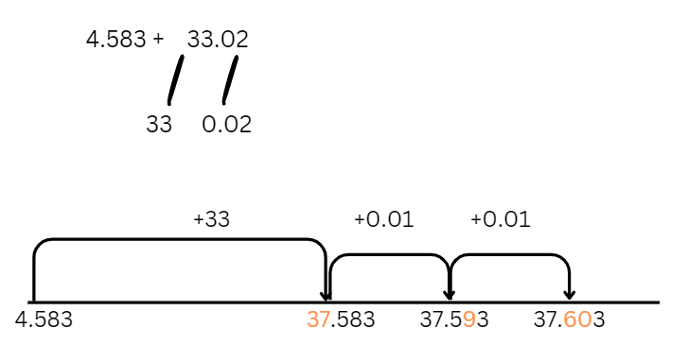
- Provide copies of Resource 12 – Perfect Post shipping and Resource 13 – Spring sales. Discuss the shipping cost and identify the domestic and international shipping rates based on parcel weight. Review the catalogue of sale items and note the prices and weights of each.
- Encourage students to use efficient strategies to solve problems on Resource 14 – Perfect Post problems.

This table details opportunities for differentiation.
Too hard? | Too easy?
Students cannot represent solutions to addition and subtraction problems, including word problems, using an empty number line or bar model.  - Support students to model addition and subtraction using a number line and bar model. Provide MAB materials or change the decimal numbers to whole numbers.  - Build a number line on the floor with masking tape and model 2-digit addition and subtraction questions using concrete materials. | Students can represent solutions to addition and subtraction problems, including word problems, using an empty number line or bar model.  - Students solve the problem: The number 747 can be formed by adding a 3-digit number with its reversal for example, 621 + 126 = 747. Can you find the other 2 ways of making 747 in this way? Note: this is adapted from Forwards Add Backwards from NRICH by University of Cambridge.  - Students research current shipping costs from various companies and use that data to find the best value for sending one of their chosen items domestically or internationally.

Discuss and connect the mathematics – 10 minutes
- Regroup and share some students’ responses to the questions.
- Brainstorm what additive strategies could be used to support students working efficiently.

This table details opportunities for assessment.
Assessment opportunities | Links
What to look for:  - Can students solve word problems, including multistep problems, identify efficient and inefficient multi-digit subtraction strategies? [MAO-WM-01, MA3-AR-01]  - Can students apply known strategies such as levelling, addition for subtraction, using constant difference, and bridging?  [MAO-WM-01, MA3-AR-01]  - Can students identify efficient and inefficient multi-digit subtraction strategies? [MAO-WM-01, MA3-AR-01]  - Can students round numbers appropriately when obtaining estimates to numerical calculations? [MAO-WM-01, MA3-AR-01] | Links to National Numeracy Learning Progressions (NNLP):  - NPV6, NPV7  - AdS7, AdS8.  Links to suggested Interview for Student Reasoning (IfSR) tasks:  - IfSR-AT: 3A.4, 3A.5.

Lesson 5
Core concept: place value understanding helps make use of benchmark percentages.

Daily number sense – find the area – 15 minutes
Daily number sense activities for Lessons 5 to 7 ‘loop’ back to concepts and procedures covered in previous units to assist students to build an increasingly connected network of ideas. These concepts may differ from the core concepts being covered by the unit.
The table below contains a suggested learning intention and success criteria. These are best co-constructed with students.
Daily number sense learning intention | Daily number sense success criteria
Students are learning to:  - select and apply mental and written strategies to multiply 2- and 3-digit numbers by 2-digit numbers. | Students can:  - extend the area model to represent 2-digit by 2-digit multiplication  - solve multiplication word problems.
- Display the following problem: A new section of artificial turf is being added to the local soccer club’s field. The area is 47 metres long and 23 metres wide. How much turf will the club need to order?
- Draw Figure 10 on the board.
Figure 10 – area of turf
- Students Think-Pair-Share and use whiteboards to find the area of the field. Ask:
- What strategies did you use to solve this problem?
- How could partitioning be used to solve this problem?
- How could partitioning be represented using the area model?
- Is there more than one way that the area model could be used?
- If turf cost $9 per square metre, estimate the total cost to the nearest thousand dollars. Explain your thinking.
- Select students to share a variety of strategies with the class.
- Highlight the use of the area model to represent students’ thinking (see Figure 11).
- Explain that 47 × 23 is represented in 2 ways with the area model where one example shows 47 partitioned into its place value and the second example shows 47 and 23 partitioned into its place value.
Figure 11 – area model
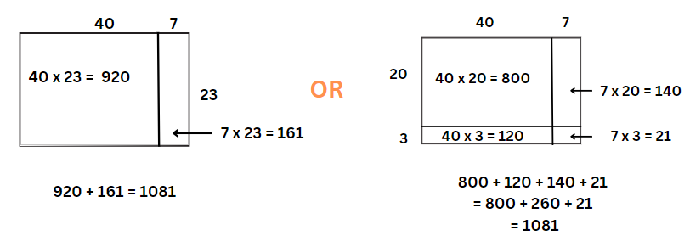
- Optional problem: A different area of the club’s soccer field is also getting an upgrade. It is 94 metres long and 46 metres wide. Ask students:
- What is the area of this field?
- How much larger is this field than the first one? Why? (4 times larger, it is the same as ‘double, double’).
- If turf is only sold in rolls of 50 m long by 5 m wide, what is the smallest number of rolls the club needs to order?
- Students turn and talk to discuss their strategies with a partner. They record their ideas on whiteboards.
This table details opportunities for assessment.
Assessment opportunities | Links
What to look for:  - Can students extend the area model to represent 2-digit by 2-digit multiplication? [MAO-WM-01, MA3-MR-01, MA3-MR-02]  - Can students solve multiplication word problems? [MAO-WM-01, MA3-MR-01] | Links to National Numeracy Learning Progressions (NNLP):  - MuS6, MuS7, MuS8.  Links to suggested Interview for Student Reasoning (IfSR) tasks:  - IfSR-MT: 3A.4, 3A.5.

Core lesson 1 – revising decimals and fractions – 15 minutes
The table below contains a suggested learning intention and success criteria. These are best co-constructed with students.
Core concept learning intention | Core concept success criteria
Students are learning to:  - make connections between benchmark fractions, decimals and percentages. | Students can:  - recognise that the symbol % means percent and 100% is the whole amount  - recall commonly used equivalent percentages, decimals and fractions including $\frac{1}{2}$, $\frac{1}{4}$ and $\frac{3}{4}$.
Note: the purpose of this activity is for students to understand the concept of percentage and the connections between decimals and fractions. It is important that this skill is developed before students are encouraged to determine strategies for solutions, such as discounts.
- Provide groups of students with a piece of string or wool (approximately 1 m in length), pegs and small pieces of paper. Students display zero at one end of the string and one at the other end of the string, as in Figure 12.
Figure 12 – number line
- Students use the pegs and paper to mark known benchmark decimals and fractions between the zero and one.
Note: a benchmark fraction is a commonly used reference fraction for comparisons, such as one-half (50%, 0.5) or one-quarter (25%, 0.25). In Stage 3, one-tenth (10%, 0.1) is introduced as a benchmark value for its relationship to the base-10 numbering system. It is important that students have a good understanding of equivalent representations of benchmark values. Students should understand that 0.5 = $\frac{1}{2}$ and 0.5 is not $\frac{1}{5}$. (NESA 2024b).
- If students require prompting, display the following on the board, 0.1, 0.2, 0.3, 0.4, 0.5, 0.6, 0.7, 0.8, 0.9, 0.25, 0.75, $\frac{1}{2}$, $\frac{1}{4}$ and $\frac{3}{4}$.
- Students complete a gallery walk and provide feedback to peers. They make any changes to their own number line if required (see Figure 13).
Figure 13 – number line example
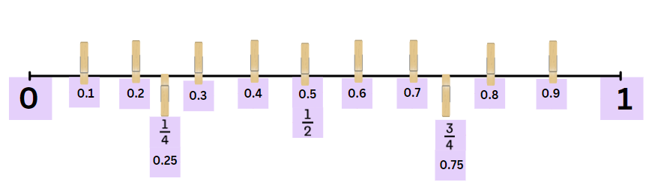
Note: monitor for 2 common misconceptions with decimals. The first misconception is sometimes called ‘Longer is larger’, where students consider that the number with more decimal places is larger. Students may think that 0.25 is larger than 0.3 based on their understanding of whole numbers. The second misconception is sometimes called ‘Shorter is larger’, where students consider that the number with fewer decimal places is larger, for example, deciding that 0.3 is larger than 0.496 (Steinle V and Stacey K 1998).

Core lesson 2 – linking percentages – 25 minutes
- Display Resource 15 – percentages. Students turn and talk to discuss the following:
- What do you see or notice?
- Do you know the name of the sign?
- Where have you seen this sign before?
- What is it used for?
- What does it represent?
- Explain percent and discuss when and where it is used.
Note: percent means parts per 100 and is shown by the symbol %. Percents are often used for presenting data, discount sales, bank interest rates and taxes. Percentages are another way of expressing fractions in terms of hundredths. It is derived from the Latin words per (for) and centum (hundred).
- Provide copies of Resource 16 – place value equivalence and writing materials.
- Students shade half of the first grid and label it with $\frac{1}{2}$. Ask:
- Can $\frac{1}{2}$ be represented as a decimal? Explain why.
- How many squares are shaded out of 100? How can this be represented as a fraction? ($\frac{50}{100}$)
- How did you represent the bar model? (See Figure 14.)
Figure 14 – student example
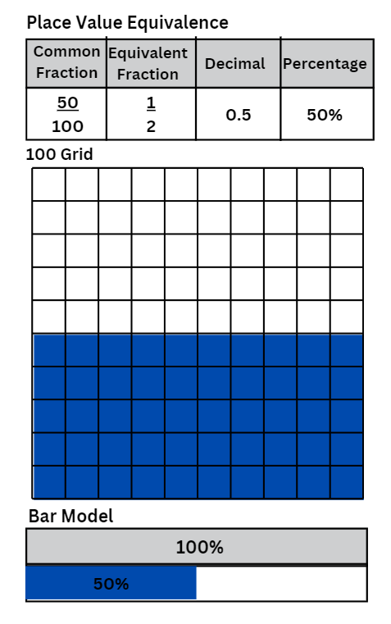
- Use the table below to discuss connections between benchmark fractions, decimals and percentages.
The table below outlines stimulus prompts to generate conversation about the topic, along with anticipated responses from students.
Prompts | Anticipated student responses
- What is half of a half?  - If you shade the next grid, how many small squares will you colour in? | - A quarter  - 25
- Using your understanding of fractions, decimals and percentages, what could we include on your label to show equivalence of $\frac{1}{4}$ ? | - 25%, 0.25, $\frac{25}{100}$
- How would you label the bar model? | - 25% and 75%
- Repeat the task for $\frac{3}{4}$ and $\frac{1}{10}$.
- Once students have finished, discuss the following as a class:
- What links can you see between the parts per hundred that have been shaded and the percentage?
- What would 100% look like on your grid? How could you represent it using fractions and/or decimals?
- What would 10% look like on your grid? How could you represent it using fractions and/or decimals?
- What could you include on your peg number line to show equivalence?
- Students add the labels 10%, 25%, 50% and 75% on their peg number line (see Figure 15).
Figure 15 – equivalence example
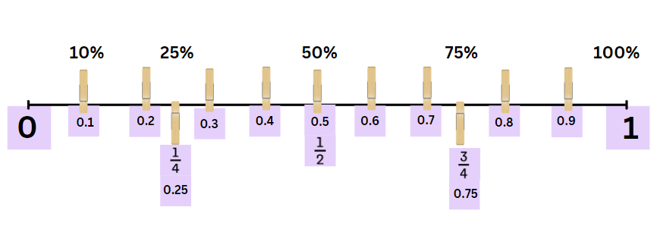
This table details opportunities for differentiation.
Too hard? | Too easy?
Students cannot recall commonly used equivalent percentages, decimals and fractions including $\frac{1}{2}$, $\frac{1}{4}$, and$\frac{3}{4}$.  - Make a collage of everyday use of percentages from magazines and newspapers.  - Use concrete materials such as Resource 19 – number wheel and a 10 × 10 grid to model and explain benchmark fractions and decimals (see Figure 16). | Students can recall commonly used equivalent percentages, decimals and fractions including $\frac{1}{2}$, $\frac{1}{4}$ and $\frac{3}{4}$.  - Students find non-benchmark equivalent percentages, decimals and fractions.  - Students play an interactive game where percentages are used on a 10 × 10 grid such as Playground Percentages – ABC Education or Matching Fractions, Decimals and Percentages from NRICH by University of Cambridge.
Figure 16 – number wheel example
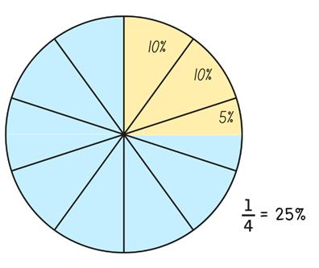

Discuss and connect the mathematics – 5 minutes
- Students complete an exit slip on a sticky note, answering: What would be an equivalent fraction, decimal and percentage for $\frac{20}{100}$?
This table details opportunities for assessment.
Assessment opportunities | Links
What to look for:  - Can students recognise that the symbol % means percent and that 100% is the whole amount? [MAO-WM-01, MA3-RN-03]  - Can students recall commonly used equivalent percentages, decimals and fractions including, $\frac{1}{2}$, $\frac{1}{4}$ and $\frac{3}{4}$? [MAO-WM-01,  MA3-RN-03] | Links to National Numeracy Learning Progressions (NNLP):  - PrT1, PrT2  - UnM8.

Lesson 6
Core concept: place value understanding helps to make use of benchmark percentages in determining discounts.

Daily number sense – solve it – 15 minutes
The table below contains a suggested learning intention and success criteria. These are best co-constructed with students.
Daily number sense learning intention | Daily number sense success criteria
Students are learning to:  - select and apply mental and written strategies to multiply 2- and 3-digit numbers by 2-digit numbers. | Students can:  - factorise numbers to aid mental multiplication.
This activity is an adaptation of ‘Building understanding and fluency: Addition and Subtraction’ by Tripet.
Associative property: the associative property states that when more than 2 numbers are multiplied, the result is unchanged regardless of how they are grouped or associated. For example, 14 × 7 = 7 × 7 × 2.
Commutative property: the commutative property of multiplication means that 2 numbers can be multiplied in any order and the product will be the same. For example, 7 × 14 = 14 × 7.
Distributive property: the distributive property means multiplying a number by a group of numbers added together is the same as doing each multiplication separately. For example, for 14 × 7 = 10 × 7 + 4 × 7.
- Display 14 × 7 = and ask:
- What are the factors of 14?
- How could you use the factors of 14 to make this number sentence easier to solve?
- Display the following equation on the board: (14 × 7) + (14 × 3) + (23 × 10) + (13 × 10).
- Discuss what the grouping symbols mean. Ask students:
- Are there any patterns or relationships between the numbers?
- Can you rearrange the order of the numbers in the grouping symbols to make it easier to calculate? (Yes, you can).
- What property allows you to do that? (The commutative property of multiplication).
- Can you break any of the numbers into factors to make it easier to calculate?
- Regroup as a class and ask students to share their strategies.
- Use some of the following question prompts to support the class discussion:
- What was your first step in solving this equation? Why did you choose that operation first?
- What do you notice about the operations in this equation?
- What are the commutative, distributive and associative properties of multiplication? How can they be applied to this equation?
- Is it possible to solve this only using mental strategies?
- Discuss the efficiency and accuracy of the various strategies used by students.
This table details an opportunity for assessment.
Assessment opportunity | Links
What to look for:  - Can students factorise numbers to aid multiplication?  [MAO-WM-01, MA3-MR-01, MA3-MR-02] | Links to National Numeracy Learning Progressions (NNLP):  - MuS6, MuS7.  Links to suggested Interview for Student Reasoning (IfSR) tasks:  - IfSR-MT: 3A.4, 3A.5.

Core lesson 1 – benchmark percentages – 25 minutes
The table below contains suggested learning intentions and success criteria. These are best co-constructed with students.
Core concept learning intentions | Core concept success criteria
Students are learning to:  - determine percentage discounts of 10%, 25% and 50%  - choose and use efficient strategies to solve addition and subtraction problems. | Students can:  - equate 10% to dividing by 10, 25% to finding a quarter by dividing by 4, and 50% to finding half  - use mental strategies to estimate discounts of 10%, 25% and 50%  - calculate the sale price of an item after a discount of 10%, 25% and 50%  - solve multistep word problems, including problems that require more than one operation.
This activity is an adaptation of Calculating percentages (DOC 4.7 MB) by the State of New South Wales (Department of Education).
- Revise benchmark fractions and decimals from Lesson 5.
- Display Resource 18 – percentage links.
- Pose the question: Would you rather have 10% of $50 or 25% of $20? Students turn and talk to decide on their answer. They estimate first using mental strategies, without any formal calculations.
- Students share some of their mental strategies used to estimate the answer.
- Ask: What is the same or different about the strategies that have been shared?
Note: do not answer the question for students. The same question is included in the lesson conclusion.
- Display Resource 19 – benchmark percentages. Read and discuss the columns, reviewing the examples provided.
- Explain that the ‘Description in words’ column can approximate what the percentages represent, such ‘almost all of it’.
- Students work in small groups to complete the table, see Table 2.
Table 2– benchmark percentages
Percent | Description in words | Efficient strategies to find | Equivalent fractions and decimals
100% | The whole thing/all | It is the same as the total. | ten-tenths, 1, $\frac{10}{10}$
90% | Nearly all, most of it | Find 10% and subtract this from the total. | nine-tenths, $\frac{9}{10}$, 0.9
80% | A bit more than three-quarters | Find 10% and double it. Then subtract this from the total. | eight-tenths $\frac{8}{10},$ $\frac{4}{5}$, 0.8
75% | Three-quarters | Halve the total and then halve again.  Add half and a quarter together. | $\frac{3}{4}$, 0.75
60% | Just over a half | Find 10% then multiply by 6.  Find 10% then add it to a half. | six-tenths, $\frac{6}{10}$, $\frac{3}{5}$, 0.6
50% | Half | Halve the total. | five-tenths $\frac{1}{2}, \frac{5}{10}$, 0.5
40% | Just under a half | Find 10% and multiply by 4. | four-tenths, $\frac{4}{10}$, $\frac{2}{5},$ 0.4
30% | A bit more than a quarter | Find 10% and multiply by 3. | three-tenths, $\frac{3}{10}$, 0.3
25% | A quarter, one of 4 equal parts | Halve the total and then halve it again. | $\frac{1}{4}$, 0.25
20% | A fifth, a bit less than a quarter | Find 10% and double it. | two-tenths, $\frac{2}{10},$ $\frac{1}{5},$0.2
10% | A tenth part | Use multiplicative thinking, divide it by 10. | one-tenth$, \frac{1}{10}$, 0.1
0% | Nothing | The answer is zero. | 0

Core lesson 2 – percentage problems – 25 minutes
- Display, read and discuss Resource 20 – percent problems.
- Select students to share possible approaches to one of the problems.
- Provide copies of Resource 20 – percent problems, writing materials and 100 grids. Students choose efficient strategies to calculate solutions to the problems.
This table details opportunities for differentiation.
Too hard? | Too easy?
Students cannot calculate the sale price of an item after a discount of 10%, 25% and 50%.  - Adjust the percentages in Resource 20 – percent problems to only include benchmark percentages.  - Provide Resource 21 – percent models. Guide students to show 25% of $40, 50% of $60, 75% of $120 and 10% of $90. Students draw bar models for other amounts and benchmark fractions, then make a problem that matches each model. | Students can calculate the sale price of an item after a discount of 10%, 25% and 50%.  - Adjust the percentages in Resource 20 – percent problems to include non-benchmark percentages. Guide students to make a connection between 10% and 1% of an amount. Challenge students to determine a method to calculate 1% of an amount and when would it be useful to find 1%.  - Students investigate price increases instead of discounts, or the use of percentages over 100%.

Discuss and connect the mathematics – 5 minutes
- Students reflect on their answers for ‘Which would you rather have? 10% of $50 or 25% of $20?’.
- Ask: Would you give the same answer from the beginning of the lesson, or would you change your response? Why?
- Students record their reflection in their workbooks.
This table details opportunities for assessment.
Assessment opportunities | Links
What to look for:  - Can students equate 10% to dividing by 10, 25% to finding a quarter by dividing by 4, and 50% to finding half? [MAO-WM-01, MA3-RN-03]  - Can students use mental strategies to estimate discounts of 10%, 25% and 50%? [MAO-WM-01, MA3-RN-03]  - Can students calculate the sale price of an item after a discount of 10%, 25% and 50%? [MAO-WM-01, MA3-RN-03]  - Can students solve multistep word problems, including problems that require more than one operation? [MAO-WM-01, MA3-AR-01] | Links to National Numeracy Learning Progressions (NNLP):  - PrT1, PrT2  - AdS8  - UnM8  - MuS8.

Lesson 7
Core concept: mathematicians solve addition and subtraction problems with multiple steps.

Daily number sense – age maths puzzle – 10 minutes
The table below contains a suggested learning intention and success criteria. These are best co-constructed with students.
Daily number sense learning intention | Daily number sense success criteria
Students are learning to:  - select and apply mental and written strategies to multiply 2- and 3-digit numbers by 2-digit numbers. | Students can:  - solve multiplication word problems.
- Ask students to solve the following questions related to their next birthday:
- How old will you be on your next birthday?
- How could you provide your answer in months?
- How could you provide your answer in weeks?
- How could you provide your answer in minutes?
- How could you provide your answer in seconds?
- Share students results as a class and ask the following questions:
- How did you approach calculating your age in months, days and other time units?
- Did you notice any specific multiplication patterns or shortcuts when figuring out your age in different time units?
- Can you share any multiplication strategies that made these calculations easier or more efficient for you?
This table details an opportunity for assessment.
Assessment opportunity | Links
What to look for:  - Can students solve multiplication word problems? [MAO-WM-01,  MA3-MR-01] | Links to National Numeracy Learning Progressions (NNLP):  - MuS6, MuS7, MuS8.

Core lesson – decimal problems – 20 minutes
The table below contains suggested learning intentions and success criteria. These are best co-constructed with students.
Core concept learning intentions | Core concept success criteria
Students are learning to:  - apply efficient mental and written strategies to solve addition and subtraction problems  - applies known strategies to add and subtract decimals. | Students can:  - solve word problems, including multistep problems  - model the addition and subtraction of decimals up to 3 decimal places using appropriate representations  - solve word problems involving the addition and subtraction of decimals up to 3 decimal places.
- Display, read and discuss Resource 22 – multistep problems.
- Students work through the problems in small groups.
Note: providing students with a strip from Resource 23 – digit manipulatives allows them to place and move the digits around, encouraging trial and error and risk taking. An alternative option is to display a task card on the board. Students use playing cards and counters (for decimal points) and recreate this in their own space.
- Regroup as a class and refer to Resource 4 – additive strategies. Ask:
- What helped you find a solution?
- What challenges did you experience?
- What additive strategies did you use? Which ones were the most efficient?

Core lesson 2 – school enrolments – 25 minutes
- Display and discuss Resource 24 – first day data.
Note: local school enrolment data can be used to contextualise some of these activities.
- In pairs, ask students to solve the following problems using the information provided in Resource 24 – first day data:
- What is the total number of students attending school from Preschool to Year 12 in NSW?
- Use the percentages to calculate how many students come from remote, regional and metropolitan areas.
- What is the total number of students that come from an Aboriginal and Torres Strait Islander cultural background and language background other than English?
- What percentage of students have an English language background?
- What percentage of students did not attend a preschool or childcare setting in 2023?
- How many teachers work in remote and regional schools?
- What is the difference between the number of students starting primary and secondary school?

This table details opportunities for differentiation.
Too hard? | Too easy?
Students cannot model the addition and subtraction of decimals up to 3 decimal places using appropriate representations.  - Revisit the number slider from Lesson 1. Individually or in pairs, students select a 2-digit number. Use the number slide to model multiplying and dividing their number from the ones and tens to the millions and thousandths. They draw different representations, such as on a place value chart, number line or bar model.  - Guide students to solve a question from Resource 22 – multistep problems using think-alouds and number lines. Discuss, record and evaluate the problem-solving strategies used. | Students can model the addition and subtraction of decimals up to 3 decimal places using appropriate representations.  - Students research an area of interest that they can draw statistics from, to write additive relation problems. For example, comparing large distances between planets or comparing bird migration data.  - Provide copies of Resource 25 – open middle problems. Students work on the problems, then share the strategies they used to solve them.

Discuss and connect the mathematics – 5 minutes
- Regroup as a class and share student responses to the questions.
- Brainstorm which additive strategies they found useful for solving the problems.

This table details opportunities for assessment.
Assessment opportunities | Links
What to look for:  - Can students solve word problems, including multistep problems? [MAO-WM-01, MA3-AR-01]  - Can students model the addition and subtraction of decimals up to 3 decimal places using appropriate representations?  [MAO-WM-01, MA3-AR-01]  - Can students solve word problems involving the addition and subtraction of decimals up to 3 decimal places? [MAO-WM-01, MA3-AR-01] | Links to National Numeracy Learning Progressions (NNLP):  - AdS8, AdS9.

Lesson 8
Core concept: mathematicians compare and evaluate strategies used to solve addition and subtraction problems, reasoning which strategy may be most efficient.

Daily number sense – 10 minutes
- From a class need surfaced through formative assessment data, identify a short, focused activity that targets students’ knowledge, understanding and skills. Example activities may be drawn from the following resources:
- Mathematics K–6 resources
- Universal Resources Hub.

Core lesson 1 – rounding – 10 minutes
The table below contains suggested learning intentions and success criteria. These are best co-constructed with students.
Core concept learning intentions | Core concept success criteria
Students are learning to:  - choose and use efficient strategies to solve addition and subtraction problems  - apply known strategies to add and subtract decimals. | Students can:  - solve multistep word problems, including problems that require more than one operation  - compare, evaluate and communicate strategies used to solve addition and subtraction problems  - justify why the strategy used to solve addition and subtraction word problems is appropriate.
Note: the purpose of this lesson is to encourage students to embrace different types of problems. Fermi questions are problems that require estimation, named after the Nobel Prize winning physicist Enrico Fermi. He was known for his ability to make good approximate calculations with little or no actual data. These questions prompt students to use their reasoning, rounding and estimations when calculating.
- Explain that the goal of Fermi problems is to encourage students to think and communicate like mathematicians. When solving these problems, it is important to make reasonable estimations, not exact calculations.
- Display Resource 26 – rounding large numbers. Choose students to read each of the numbers in Series 1.
- Discuss the reasons for rounding numbers, for example, when looking only for an approximate number.
- Select numbers from Series 1 to round to the nearest thousand, ten thousand, hundred thousand and million.
- Discuss that 1000 millions is one billion, so that some of the millions can be read as billions. For example, 628 456 000 could be rounded to half a billion and 1 102 000 307 could be rounded to one billion.
- If needed, repeat the rounding practice using numbers in Series 2 of Resource 26 – rounding large numbers.

Core lesson 2 – guided Fermi question – 15 minutes
- Ask the question: Could one million dollars' worth of $1 coins fit in our classroom? Why or why not?
- Display and read Resource 27 – Fermi checklist.
- For the million dollars of coins question, ask students to Think-Pair-Share the answer:
- What is the question asking you?
- What information might you need?
- What measurements might help you? Why?
- What steps would you take? Why?
- What might you have missed in your estimate?
Note: if students require more guidance, pose the question: If everyone in Australia held hands in a line, would the line stretch the whole way across Australia? Why or why not? Repeat the guiding questions above.

Core lesson 3 – Fermi problems – 25 minutes
- Display and read Resource 28 – Fermi problems.
- Explain that students will group together to select an investigation.
- Provide groups with a copy of Resource 27 – Fermi checklist, writing materials and calculators.
- Students explore their selected problem and record their thinking.
Note: it is preferable for students to work in small groups to engage with this task before seeking teacher assistance. Encourage students to experience productive struggle before providing prompts. If required, guide students to break the task up into components, make estimates, state assumptions and explain and justify solutions using visual representations and calculations.
- After a suitable amount of time, pair groups together to share their results. Students explain their steps and reasoning.
This table details opportunities for differentiation.
Too hard? | Too easy?
Students cannot solve multistep word problems, including problems that require more than one operation.  - Provide 10 coloured chocolate buttons. Guide students to organise the buttons into a rectangular array. Trace and cut the array. Use the array to find how many buttons would fit onto a table.  - Display a small container filled with counters or marbles. Students estimate the total quantity. Model how to use their estimates to calculate how many objects would fit into a large box. | Students can solve multistep word problems, including problems that require more than one operation.  - Students write and investigate their own Fermi problem using very large numbers. They add a multiplicative and additive element to their investigation.  - Students investigate a Fermi problem that involves decimals or very small objects. For example, how many bacteria could there be on a mobile phone?

Discuss and connect the mathematics – 10 minutes
- Students reflect on their group’s work. Select 3 prompts to use as part of a reflection or exit slip:
- Were your estimations reasonable?
- Did you use rounding to help with your estimates?
- What assumptions did you make while working on the Fermi problem?
- Was each step of your working out clear?
- Describe another group’s reasoning that worked well.
- How did you communicate your reasoning to others?
- What strategies did you use to approach the Fermi question?
- Do you think your strategies were efficient? Why or why not?
- Was the calculator a useful device to help approach the Fermi questions? Why or why not?
- Were there any challenges you encountered while working on the Fermi question? How did you overcome them?
- What will you do differently if you tackle similar Fermi problems in the future?
This table details opportunities for assessment.
Assessment opportunities | Links
What to look for:  - Can students solve multistep word problems, including problems that require more than one operation? [MAO-WM-01, MA3-AR-01]  - Can students compare, evaluate and communicate strategies used to solve addition and subtraction problems? [MAO-WM-01, MA3-AR-01]  - Can students justify why the strategy used to solve addition and subtraction word problems is appropriate? [MAO-WM-01,  MA3-AR-01] | Links to National Numeracy Learning Progressions (NNLP):  - AdS7, AdS8, AdS9  - MuS8.  Links to suggested Interview for Student Reasoning (IfSR) tasks:  - IfSR-AT: 3A.5, 4A.1, 4A.2, 4A.3, 4A.4.

Resource 1 – NSW map
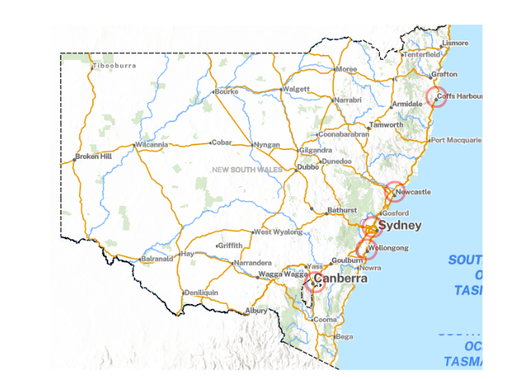 | - Sydney City, Gadigal Country to Newcastle, Awabakal Country: 117 kilometres  - Sydney to Wollongong, Tharawal Country: 68 kilometres  - Wollongong to Coffs Harbour, Gumbainggir Country: 504 kilometres  - Coffs Harbour to Sydney: 623 kilometres  - Sydney to Canberra, Ngunnawal Country: 286 kilometres  - Canberra to Wollongong: 235 kilometres
© Spatial Collaboration Portal (2020)

Resource 2 – place value slider
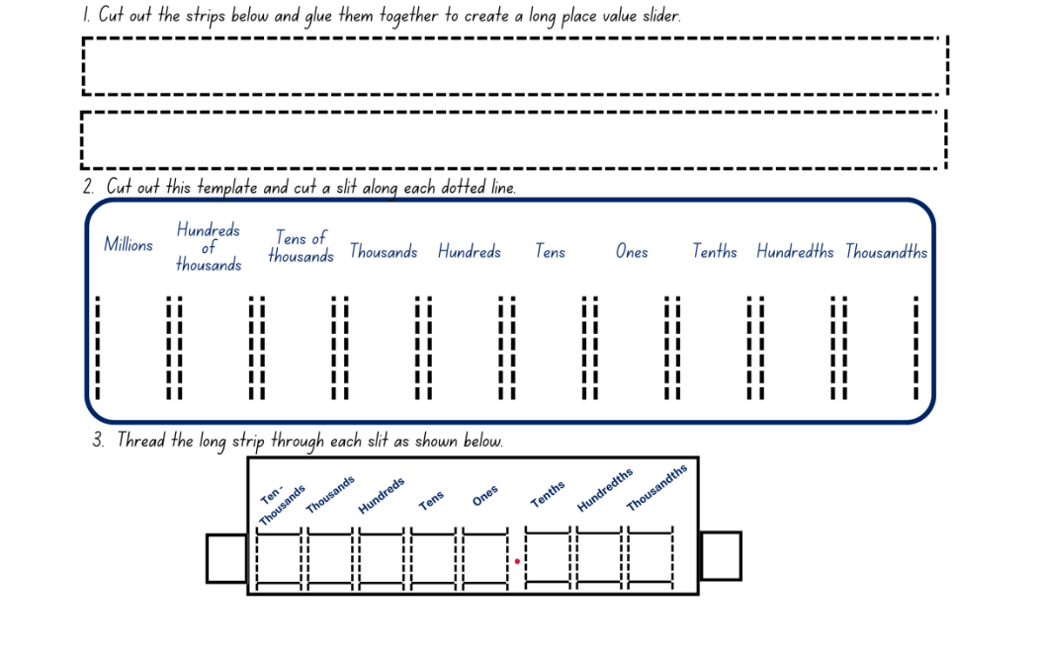

Resource 3 – decimal misconceptions
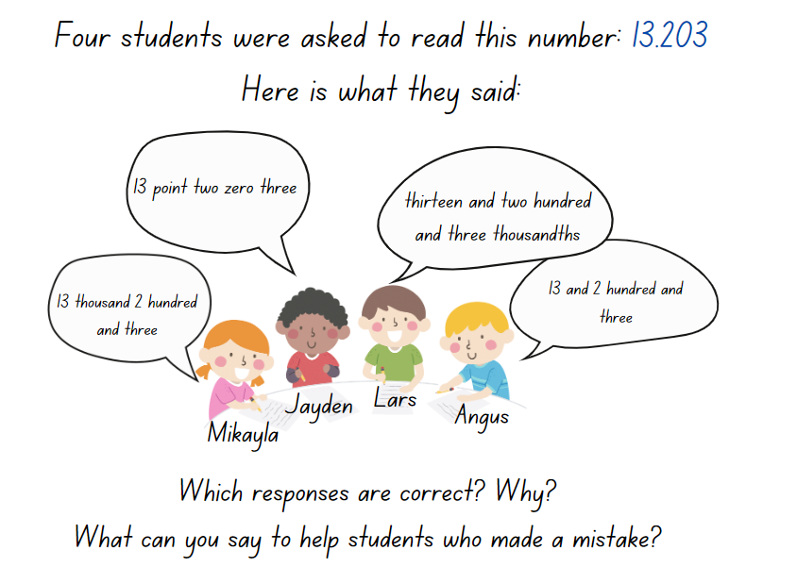

Resource 4 – additive strategies
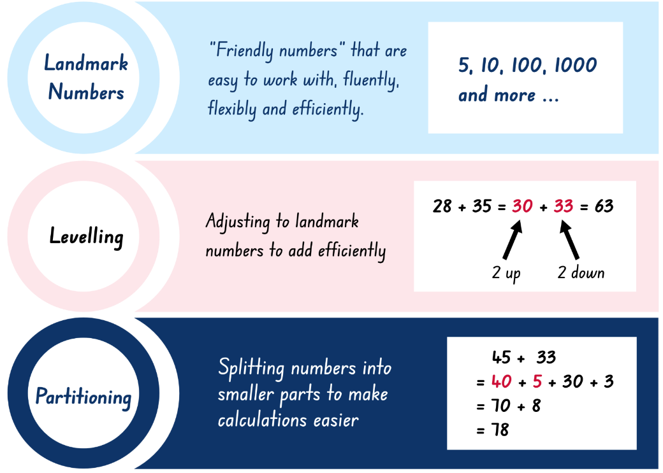
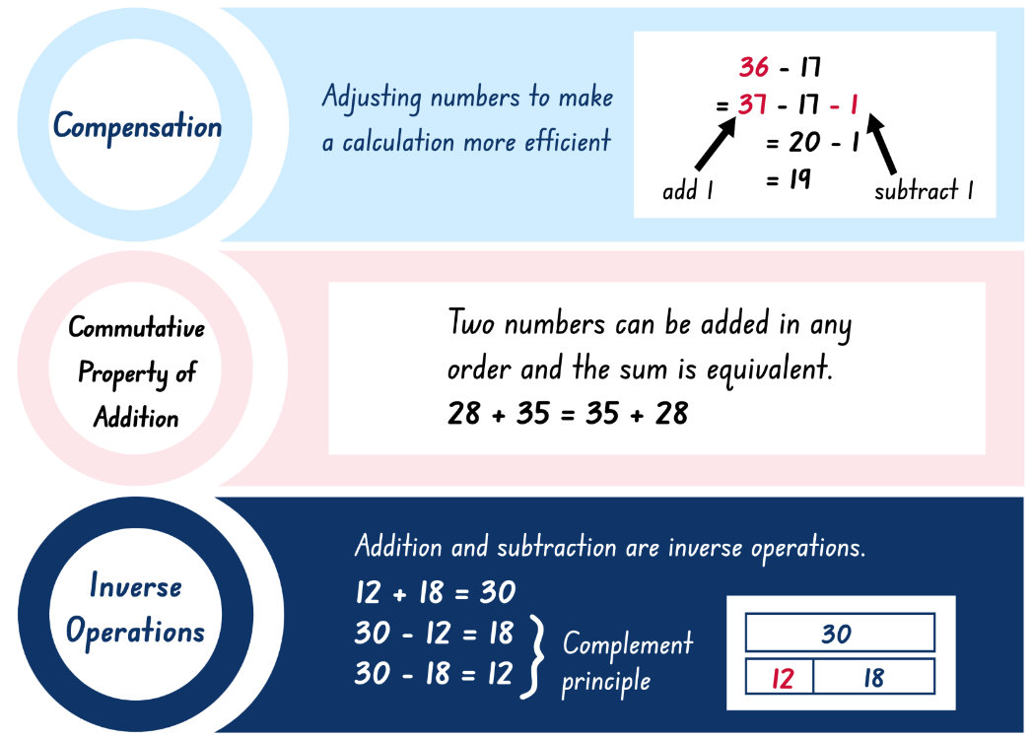
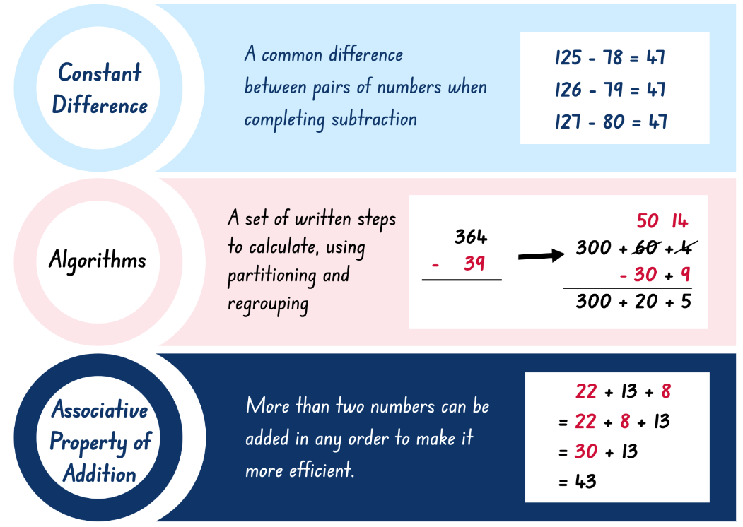
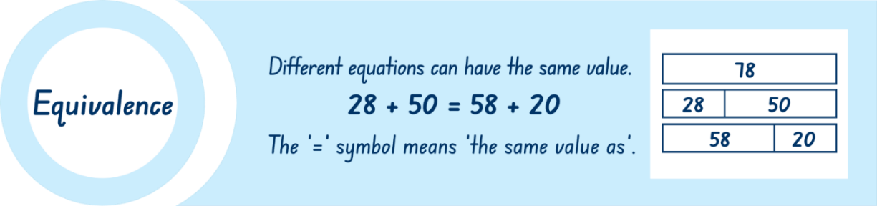

Resource 5 – reflection chart
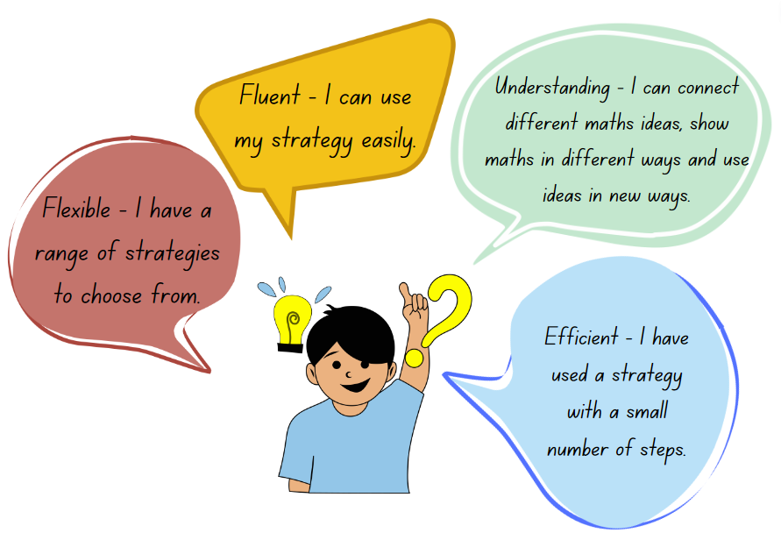

Resource 6 – Which strategy?
Equation | Most efficient strategy | Solution
- 2364 + 407
- 3689 − 2562
- _ − 7289 = 158
- 67.7 + 108.67
- 5440 + 266
- 7302 − _ = 4861
Write your own equations for the strategy provided and then solve them.
Written using inverse relations
Mentally using constant difference
Written using the complement principle then your choice.

Resource 7 – Which strategy? 2
Equation | Most efficient strategy | Solution
- 64 + 27
- 89 – 62
- _ − 99 = 58
- 77 + 67
- 40 + 66
- 102 − _ = 61
Write your own equations for the strategy provided and then solve them.
Written using inverse relations
Mentally using constant difference
Written using the complement principle then your choice.

Resource 8 – ABC Motors
ABC Motors is a popular car dealership that experienced steady growth in sales over the past 3 months. In the first month, 5678 cars were sold. In the second month, 8890 cars were sold. In the third month the sales increased further, reaching 11 567 cars. Assuming this trend continues, project the sales for the fourth and fifth month. Justify your response.

Resource 9 – levelling/constant difference
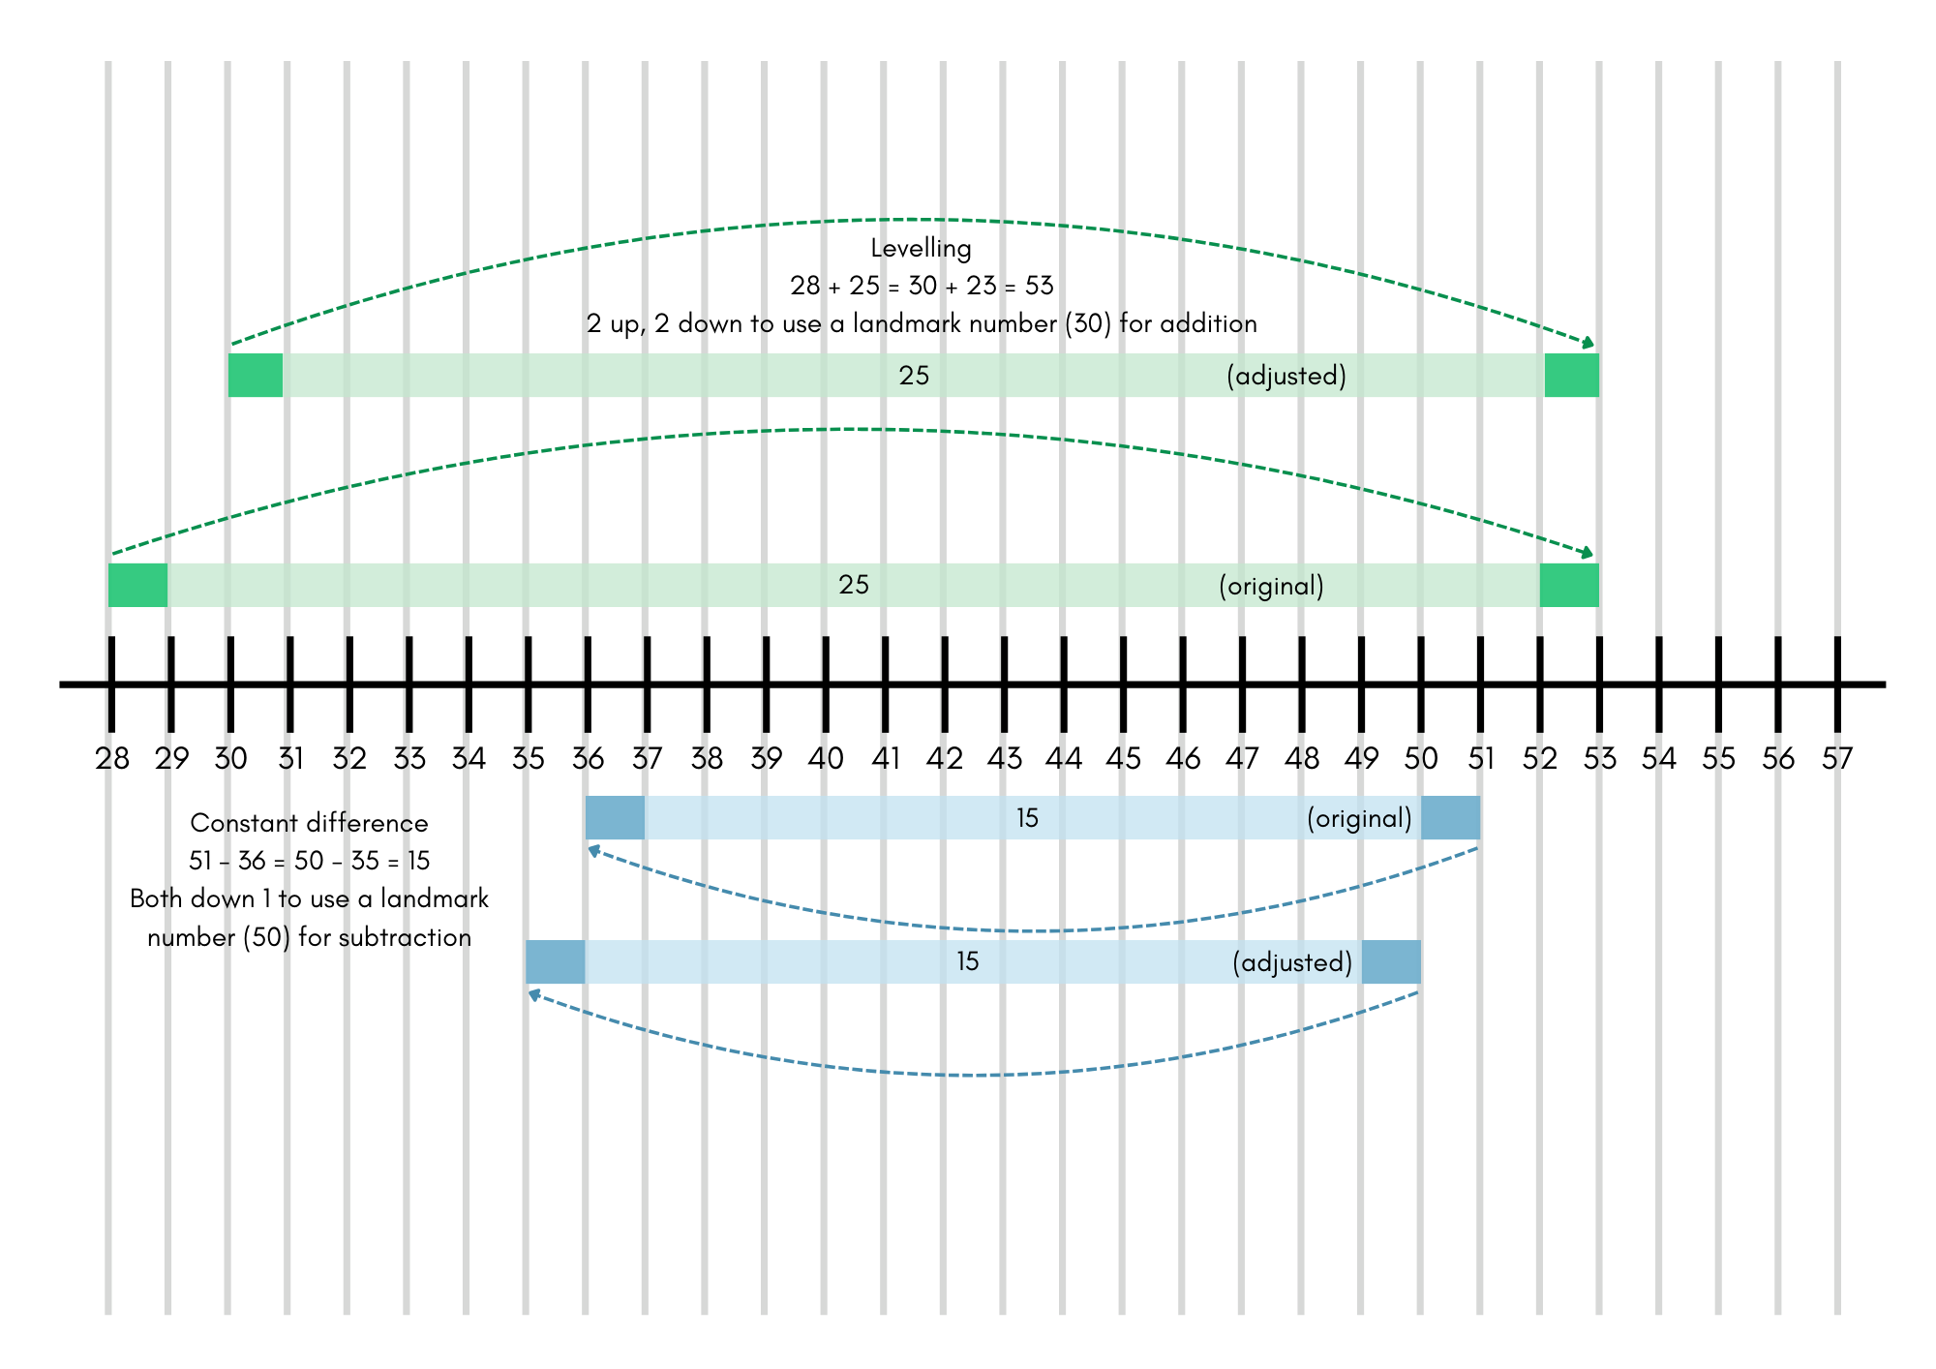

Resource 10 – word problems
Mass – a farmer weighs his chickens. Barbara the chicken is extremely underweight and weighs in at 1.998 kg. Doris the chicken has been enjoying the new chicken feed and weighs in at 7.615 kg. How much do Doris and Barbara weigh altogether?
How much more do they have to put on to reach the farmer’s goal of 11.5 kg in total for both chickens?

Length – Sydney to Perth is 3256 km. The plane needs to refuel after travelling 6506 km. Does the plane have enough fuel for the return trip to Sydney? Explain your answer.

Money – Nikhita and Monish each received $7.50 a week in pocket money for 4 weeks. They each took their savings to their favourite lolly shop. All items in the lolly shop were between $2.50 and $6.00. Nikhita purchased 4 items and Monish purchased 7 items. All items they chose were different prices. What is the most Nikhita and Monish could have spent?
How much change would they each receive?

Resource 11 – balancing parcels
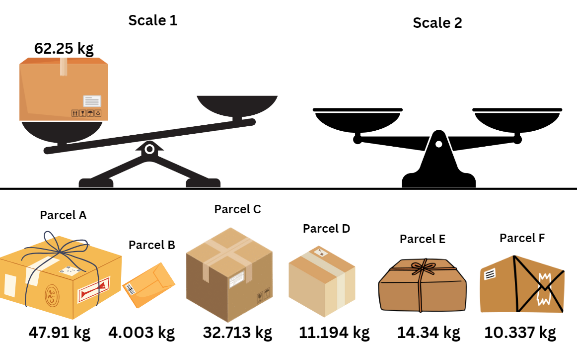

Resource 12 – Perfect Post shipping
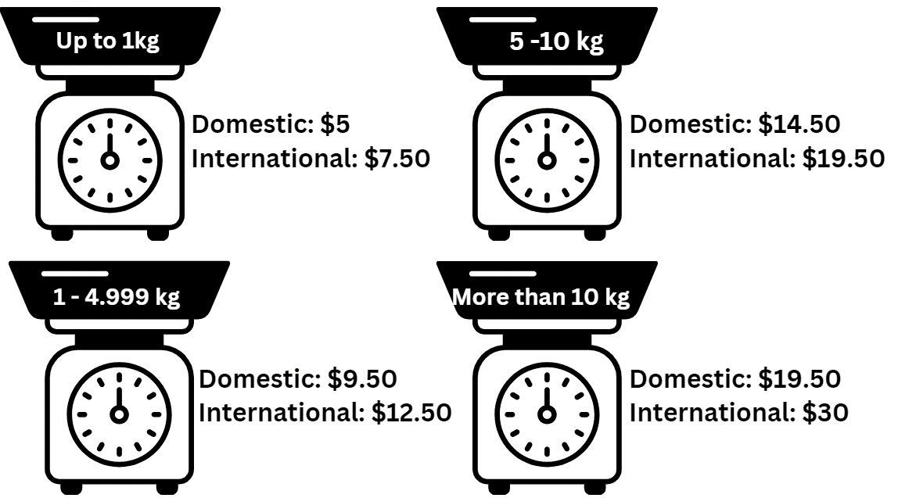

Resource 13 – Spring sales

Resource 14 – Perfect Post problems
- Choose a few items from the spring sales catalogue and then:
- calculate the shipping costs for both domestic and international orders based on their weights
- compare the total cost (item price + shipping cost) for domestic and international shipping.
- Investigate combinations of items you could buy with a $700 budget. Calculate the shipping costs if the store was offering a discount of half price off shipping costs.
- Calculate how much you could spend if you purchased gifts for 3 friends overseas and 2 friends in Australia. What are the express shipping costs if you purchase next day delivery for an additional $13.50 for each of these gifts. What is the total cost?
- Kate is torn between buying a multi-game pack (6 kg for $60.70) from a local or an international store. The international store charges $19.50 for shipping, while the local store offers free shipping for orders above $70. Compare the total costs of both options and advise Kate on her decision.
- The store is introducing a special bundle offer for an electro box and multi games pack. If the bundle costs $950.70 and has a total weight of 10.16 kg, calculate the potential savings compared to buying each item individually (including the postage).
- Clare wants to buy a mix of light and heavy items for her younger siblings. She is considering a phone, a digital watch and a laptop. Calculate the total cost for domestic shipping and determine if there are any strategies to reduce costs.
- Explore the concept of bulk orders. If you were to purchase 10 laptops individually for friends in Australia and got them sent to each friend’s house, what would be the total cost compared to bulk orders delivered to one place.

Resource 15 – percentages

Resource 16 – place value equivalence
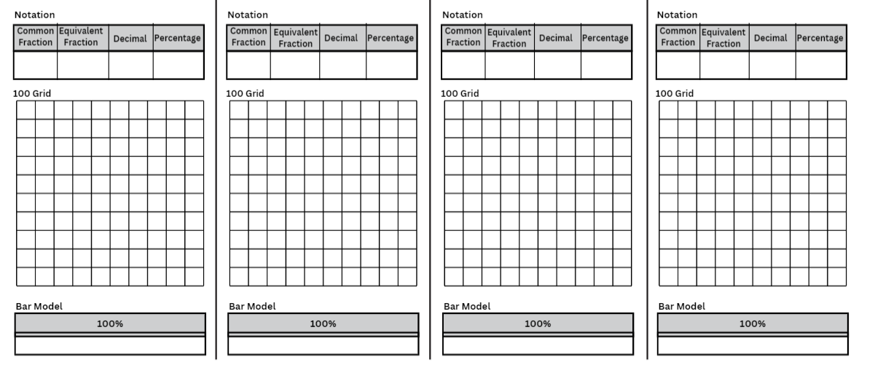

Resource 17 – number wheel
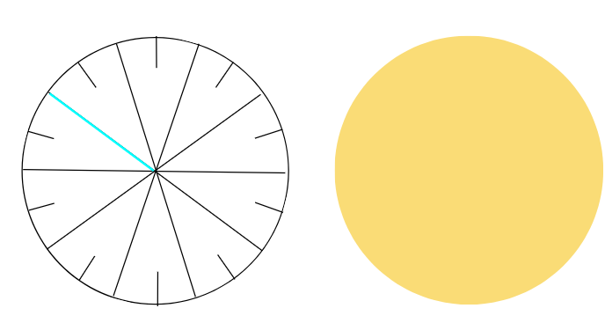
- Cut out both circles.
- Place the circles on top of each other, then cut along the bright blue line to the centre.
- Slide the 2 circles together using the cuts.
- Rotate the 2 circles to show fractions, decimals and percents.
Adapted from Van de Walle et al. (2023) p 427.

Resource 18 – percentage links

Resource 19 – benchmark percentages
Percent | Description in words | Efficient strategies to find | Equivalent fractions and decimals
100% |  |  | 1, $\frac{10}{10}$, ten-tenths
90% | Almost all; most of it
80%
75%
60%
50% |  | Divide by 2, halve
40%
30% |  |  | 0.3, $\frac{3}{10}$
25%
20%
10% |  | Divide the total by 10
0% | None, nothing

Resource 20 – percent problems
Problem 1: Calculate 25% of $40 and 75% of $80. Show your working out using a bar model.
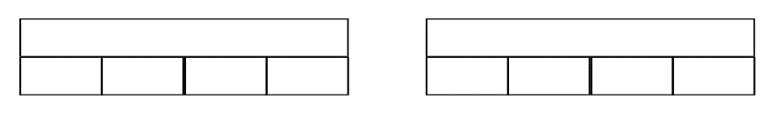

Problem 2: Sarah went to the supermarket and spent $50 on groceries. Which would she rather have? $10 off the cost or 10% off the cost? Are they the same thing? Explain your reasoning.

Problem 3: Henry lost 10% of his original weight of 80 kg in one month. How much weight did he lose? How much does he weigh now? Show your working out in a bar model or 100 grid.

Problem 4: Tony bought a new watch. It was discounted by 20% from the original price of $150. How much did Tony pay for the watch? Show your working out in a bar model.

Problem 5: Sahana works at a local café. She gets a 25% discount on anything she buys at the cafe. Write a list of items and set some prices. Calculate how much Sahana can save on each item. Show your working out in a bar model or 100 grid.

Problem 6: Yusuf bought a notebook with 240 pages for mathematics. In 8 months he has used up 70% of it. How many pages does he have left for the rest of the year? Show your working out in a bar model or 100 grid.

Resource 21 – percent models
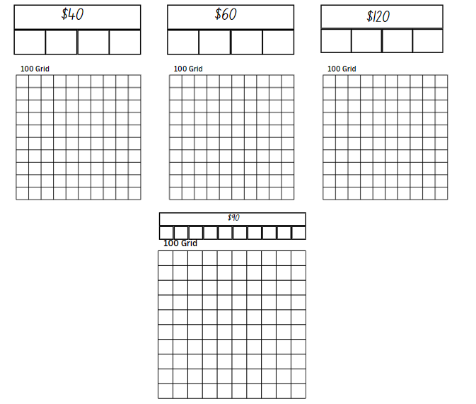

Resource 22 – multistep problems
Jim's mowing: Jim has $10. He spends $1.50 on a drink. Jim's dad gives him $50 for mowing the grass. Calculate the total amount of money Jim has now.
Finally, Jim decides to donate 10% of his money to charity. Calculate the amount he donates.
Ronnie's cupcakes: Ronnie is organising a birthday party and needs 101 cupcakes at $1.00 each. He already has 21 chocolate cupcakes and 32 vanilla cupcakes. How many more cupcakes should Ronnie buy?
Ronnie realises that he has a coupon for 25% off his cupcake purchase. Calculate the final cost of the cupcakes after applying the discount.
Janet's shopping spree: Janet's mother gave her $760 to go to the store. She decided to buy 2 birthday presents for her twin brothers at $150 each and 2 cakes for $30 each. How much money does Janet have left?
Janet decides to save 25% of her remaining money. Determine the amount she puts into savings.
Suzy's tech purchase: Suzy decides to buy an iPad for $462 and a case for $47. If she gives the cashier $550, how much change she will receive?
Suzy then decides to donate 20% of her change to a local charity. How much does Suzy donate to charity?

Resource 23 – digit manipulatives
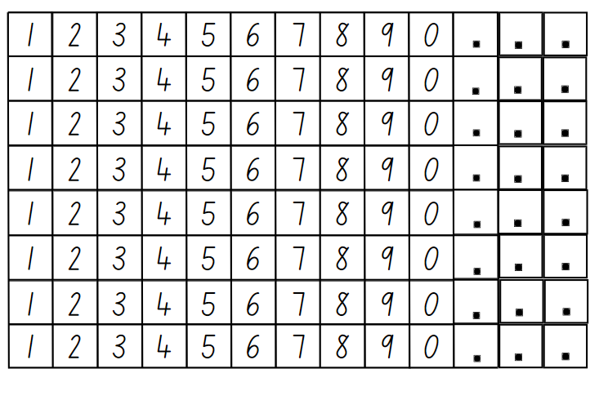

Resource 24 – first day data
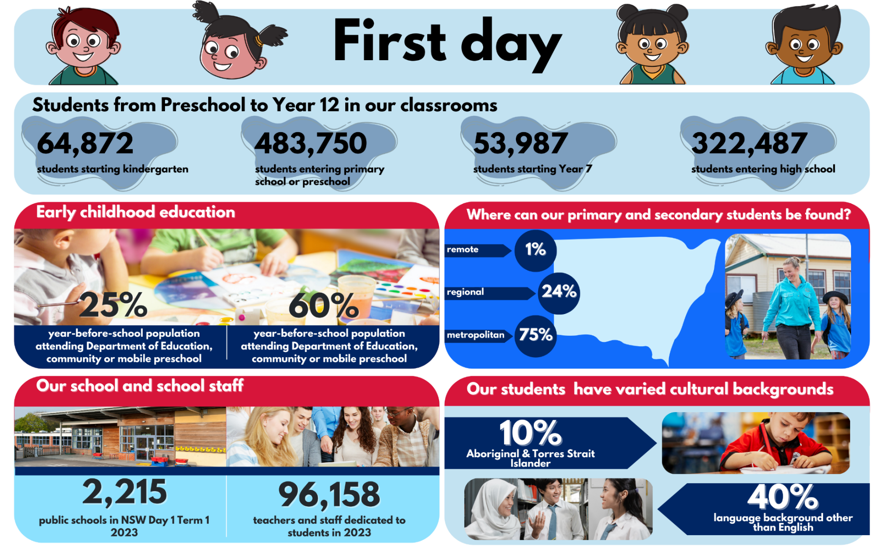

Resource 25 – open middle problems
Problem 1: using the digits 1 to 9 once each, fill in the boxes to make a true statement. Make at least 2 true statements.
Problem 2: using the digits 1 to 9 once each, fill in the boxes to make the largest difference. Then find the smallest difference.
Problem 3: using the digits 1 to 9 once each, fill in the boxes to make 3 decimals whose sum is as close to one as possible.
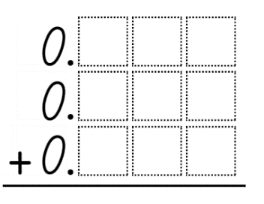
Adapted from Open Middle Partnership (2023).

Resource 26 – rounding large numbers
Series 1 | Series 2
456 | 781
1456 | 6781
21 456 | 76 781
156 456 | 376 781
2 456 000 | 8 376 781
28 456 000 | 38 376 781
628 456 000 | 238 376 781
998 327 000 | 1 102 000 307

Resource 27 – Fermi checklist
- Read the question aloud, as a group.
- Discuss what it is asking you to estimate.
- Take a wild guess without any calculating.
- List the pieces of information you will need.
- Gather data – perform experiments, conduct surveys, make measurements, or search for information that would help you to obtain a more precise estimate.
- Round numbers to make them easier to work with.
- Record your steps.
- Be ready to explain and justify what you did when coming up with your solution.
- Compare your approach to others. What might you have missed?

Resource 28 – Fermi problems
- Coloured chocolate buttons: using only 10 small, coloured buttons or lollies, estimate how many you would need to cover your desk, your teacher’s desk, the entire floor of your classroom and then the floor of the school hall. Calculate the difference between your estimate for the classroom and the estimate for your desk.
- Books: estimate the number of fiction and non-fiction books in your classroom. Use this estimate to work out how many books there might be in your school, and then in 2000 primary schools in New South Wales. Calculate the difference between the fiction and non-fiction books in classrooms across New South Wales.
- Pencils: estimate how many pencils you have altogether at school. Identify the number or percentage of pencils that have a broken tip. Use this information to estimate how many pencils there might be in 6000 primary schools around Australia. Subtract the estimated percentage that have a broken tip.
- Jellybeans: using only 10 jellybeans, estimate how many you would need to fill a bucket or other large container. Subtract the estimated number of yellow jellybeans from the total.
- Reading time: calculate how many hours a week you spend reading and how many hours a week you spend on an electronic device. Estimate those amounts for all the students in your school, the 400 000 students in NSW primary schools and the 4 million students in Australian schools. What is the difference between the reading time and screen time for all students in Australia?
- Canteen lunch: estimate how many canteen lunches and lunches from home are made for your class each term. Estimate the number for your whole school and the 2000 primary schools in New South Wales. Calculate the difference between the estimates.

Syllabus outcomes and content
The table below outlines the syllabus outcomes and range of relevant syllabus content covered in this unit. Content is linked to National Numeracy Learning Progression (version 3).
Outcomes and content | 1 | 2 | 3 | 4 | 5 | 6 | 7 | 8
Representing numbers A: Whole numbers: Recognise, represent and order numbers in the millions
[MAO-WM-01, MA3-RN-01]
- Name millions using the place value grouping of ones, tens and hundreds | x
Representing numbers A: Whole numbers: Apply place value to partition, regroup and rename numbers to 1 billion
[MAO-WM-01, MA3-RN-01]
- Recognise 1000 thousands is 1 million and 1000 millions is 1 billion |  |  |  |  |  |  |  | x
Representing numbers A: Decimals and percentages: Recognise that the place value system can be extended beyond hundredths
- [MAO-WM-01, MA3-RN-02]
- Interpret decimal notation for thousandths |  |  |  | x
Representing numbers A: Decimals and percentages: Compare, order and represent decimals
- [MAO-WM-01, MA3-RN-02]
- Compare the place value of digits by determining numbers that are 10 or 100 times the original decimal number as well as $\frac{1}{10}$ or $\frac{1}{100}$ times the original decimal numbers | x
Represents numbers B: Decimals and percentages: Make connections between benchmark fractions, decimals and percentages
[MAO-WM-01, MA3-RN-03]
- Recognise that the symbol % means percent and 100% is the whole amount |  |  |  |  | x
- Recall commonly used equivalent percentages, decimals and fractions including $\frac{1}{2}$, $\frac{1}{4}$and $\frac{3}{4}$. |  |  |  |  | x
Represents numbers B: Decimals and percentages: Determine percentage discounts of 10%, 25% and 50%
[MAO-WM-01, MA3-RN-03]
- Equate 10% to dividing by 10, 25% to finding a quarter by dividing by 4, and 50% to finding half |  |  |  |  |  | x
- Use mental strategies to estimate discounts of 10%, 25% and 50% |  |  |  |  |  | x
- Calculate the sale price of an item after a discount of 10%, 25% and 50% |  |  |  |  |  | x
Additive relations A: Apply efficient mental and written strategies to solve addition and subtraction problems
[MAO-WM-01, MA3-AR-01]
- Solve word problems, including multistep problems |  |  | x | x |  |  | x
- Apply known strategies such as levelling, addition for subtraction, using constant difference, and bridging (Reasons about relations) |  | x | x | x
- Determine when it would be more efficient to use a calculator to add numbers | x |  |  |  |  |  |  | x
- Identify efficient and inefficient multidigit subtraction strategies |  | x | x | x
Additive relations A: Use estimation and place value understanding to determine the reasonableness of solutions
[MAO-WM-01, MA3-AR-01]
- Round numbers appropriately when obtaining estimates to numerical calculations | x |  |  | x
- Use place value understanding to check for errors in calculations | x |  | x
- Use estimation to check the reasonableness of solutions to addition and subtraction calculations | x | x
Additive relations B: Choose and use efficient strategies to solve addition and subtraction problems
[MAO-WM-01, MA3-AR-01]
- Solve multistep word problems, including problems that require more than one operation |  |  |  |  |  | x |  | x
- Compare, evaluate and communicate strategies used to solve addition and subtraction problems |  |  |  |  |  |  |  | x
Additive relations B: Applies known strategies to add and subtract decimals
[MAO-WM-01, MA3-AR-01]
- Model the addition and subtraction of decimals up to 3 decimal places using appropriate representations |  |  |  |  |  |  | x
- Solve word problems involving the addition and subtraction of decimals up to 3 decimal places |  |  |  |  |  |  | x
- Justify why the strategy used to solve addition and subtraction word problems is appropriate (Reasons about quantity) |  |  |  |  |  |  |  | x
Multiplicative relations A: Select and apply mental and written strategies to multiply 2- and 3-digit numbers by 2-digit numbers
[MAO-WM-01, MA3-MR-01, MA3-MR-02]
- Factorise numbers to aid mental multiplication |  |  |  |  |  | x
- Extend the area model to represent 2-digit by 2-digit multiplication |  |  |  |  | x
- Solve multiplication word problems |  |  |  |  | x |  | x
Mathematics K–10 Syllabus © NSW Education Standards Authority (NESA) for and on behalf of the Crown in right of the State of New South Wales, 2022.

References
This resource contains NSW Curriculum and syllabus content. The NSW Curriculum is developed by the NSW Education Standards Authority. This content is prepared by NESA for and on behalf of the Crown in right of the State of New South Wales. The material is protected by Crown copyright.
Please refer to the NESA Copyright Disclaimer for more information https://educationstandards.nsw.edu.au/wps/portal/nesa/mini-footer/copyright.
NESA holds the only official and up-to-date versions of the NSW Curriculum and syllabus documents. Please visit the NSW Education Standards Authority (NESA) website https://educationstandards.nsw.edu.au/wps/portal/nesa/home/ and the NSW Curriculum website https://curriculum.nsw.edu.au.
Mathematics K–10 Syllabus © NSW Education Standards Authority (NESA) for and on behalf of the Crown in right of the State of New South Wales, 2022.
National Numeracy Learning Progression © Australian Curriculum, Assessment and Reporting Authority (ACARA) 2010 to present, unless otherwise indicated. This material was downloaded from the Australian Curriculum website (National Numeracy Learning Progression) (accessed 18 January 2024) and was not modified.
AIATSIS (The Australian Institute of Aboriginal and Torres Strait Islander Studies) (2023) Map of Indigenous Australia, AIATSIS website, accessed 9 November 2023.
Attard C (2013) Engaging Maths: Higher Order Thinking with Thinkers Keys, Modern Teaching Aids Pty Limited.
Classroom Secrets (2023) Add and Subtract Decimals – Discussion Problems, Classroom secrets website, accessed 12 October 2023.
Education Services Australia Ltd (2016) Playground Percentages [online game], ABC Education website, accessed 12 October 2023.
Morgan J (29 July 2016) ‘(Even more) 5 minutes of fun!’, fractionfanatic, accessed 12 October 2023.
NESA (New South Wales Education Standards Authority) (2024a) Teaching advice for Additive relations A, NESA website, accessed 15 December 2023.
NESA (New South Wales Education Standards Authority) (2024b) Teaching advice for Represents numbers B, NESA website, accessed 15 December 2023.
Open Middle Partnership (2023) Open Middle [website], accessed 19 December 2023.
Stacey K, Steinle V, Marston K, Chambers D and Varughese N (2011) Teaching Numeracy in the Middle Years: Number Slides, the University of Melbourne, accessed 9 November 2023.
State of New South Wales (Department of Education) (2023) Calculating Percentages [DOC 4.7 MB], NSW Department of Education, accessed 13 October 2023.
Spatial Collaboration Portal (2020) Map viewers, NSW Government website, accessed 13 October 2023.
Steinle V and Stacey K (1998) ‘The incidence of misconceptions of decimal notation amongst students in Grades 5 to 10’ in Kanes C, Goos M & Warren E (eds) Teaching Mathematics in New Times, Proceedings of the 21st Annual Conference of the Mathematics Education Research Group of Australasia, 2:548-555, Gold Coast, Australia: MERGA.
Swan & Ridgeway (2001) 'Plausible Estimation' Tasks [PDF 35 KB], The Mathematics Assessment Resource Service, accessed 9 November 2023.
Tripet K (7 September 2023) ‘Building understanding and fluency: Addition and Subtraction’ [unpublished conference paper], Mathematics Specialisation K–6 Conference, Sydney.
University of Cambridge (n.d) Forwards Add Backwards, NRICH website, accessed 18 January 2024.
Van de Walle J, Karp K, Bay-Williams JM, Brass A, Bentley B, Ferguson S, Goff W, Livy S, Marshman M, Martin D, Pearn C, Prodromou T, Symons D and Wilkie K (2019) Primary and Middle Years Mathematics: Teaching Developmentally, 1st Australian edn, Pearson Education Australia, Melbourne.

Further reading
State of New South Wales (Department of Education) (2023) Stage 2 – number – addition and subtraction, NSW Department of Education website, accessed 3 April 2024.
State of New South Wales (Department of Education) (2023) Stage 2 – number – addition and subtraction – money, NSW Department of Education website, accessed 3 April 2024.
State of New South Wales (Department of Education) (2023) Stage 3 – addition and subtraction, NSW Department of Education website, accessed 3 April 2024.
State of New South Wales (Department of Education) (2023) Stage 3 – number – subtraction, NSW Department of Education website, accessed 3 April 2024.
Parrish SD (2011) ‘Number Talks Build Numerical Reasoning’, Teaching Children Mathematics, 18(3):198–206, https://doi.org/10.5951/teacchilmath.18.3.0198.
Yeap BH (2011) Bar Modelling – A problem-solving Tool: From Research to Practice (An effective Singapore Math Strategy), Marshall Cavendish Education, Singapore.
© State of New South Wales (Department of Education), 2024
The copyright material published in this resource is subject to the Copyright Act 1968 (Cth) and is owned by the NSW Department of Education or, where indicated, by a party other than the NSW Department of Education (third-party material).
Copyright material available in this resource and owned by the NSW Department of Education is licensed under a Creative Commons Attribution 4.0 International (CC BY 4.0) license.
This license allows you to share and adapt the material for any purpose, even commercially.
Attribution should be given to © State of New South Wales (Department of Education), 2024.
Material in this resource not available under a Creative Commons license:
- the NSW Department of Education logo, other logos and trademark-protected material
- material owned by a third party that has been reproduced with permission. You will need to obtain permission from the third party to reuse its material.
Links to third-party material and websites
Please note that the provided (reading/viewing material/list/links/texts) are a suggestion only and implies no endorsement, by the New South Wales Department of Education, of any author, publisher, or book title. School principals and teachers are best placed to assess the suitability of resources that would complement the curriculum and reflect the needs and interests of their students.
If you use the links provided in this document to access a third-party's website, you acknowledge that the terms of use, including licence terms set out on the third-party's website apply to the use which may be made of the materials on that third-party website or where permitted by the Copyright Act 1968 (Cth). The department accepts no responsibility for content on third-party websites.

