Mathematics Stage 3 – Unit 14
What needs to be measured determines the unit of measurement

Contents
Unit description and duration 5
Syllabus outcomes 5
Working mathematically 6
Student prior learning 6
Lesson overview and resources 8
Lesson 1 13
Daily number sense – missing decimal numbers – 10 minutes 13
Core lesson – metric conversion – 40 minutes 15
Consolidation and meaningful practice – 20 minutes 18
Lesson 2 20
Daily number sense – before and after – 10 minutes 20
Core lesson – How far can you jump? – 40 minutes 21
Consolidation and meaningful practice – 15 minutes 24
Discuss and connect the mathematics – 10 minutes 26
Lesson 3 27
Daily number sense – making thousandths – 10 minutes 27
Core lesson – calculating the perimeter of our school – 40 minutes 29
Consolidation and meaningful practice – 20 minutes 32
Lesson 4 35
Daily number sense – 10 minutes 35
Core lesson – town planning – 40 minutes 35
Consolidation and meaningful practice – 10 minutes 38
Lesson 5 40
Daily number sense – ordering fractions – 10 minutes 40
Core lesson – investigating mass – 20 minutes 41
Investigation task 1 – tonnes – 10 minutes 43
Investigation task 2 – lasagne – 15 minutes 44
Investigation task 3 – Rick’s cans – 10 minutes 45
Discuss and connect the mathematics – 10 minutes 46
Lesson 6 48
Daily number sense – rolling fractions – 10 minutes 48
Core lesson – harvest time – 30 minutes 50
Consolidation and meaningful practice – 20 minutes 51
Lesson 7 54
Daily number sense – fractions and minutes – 10 minutes 54
Core lesson – kilograms and tonnes – 40 minutes 55
Discuss and connect the mathematics – 10 minutes 58
Lesson 8 60
Daily number sense – 10 minutes 60
Core lesson – dinosaur measurements – 35 minutes 60
Discuss and connect the mathematics – 15 minutes 62
Resource 1 – missing decimal numbers 65
Resource 2 – metric conversion display 66
Resource 3 – golf modelling conversion 67
Resource 4 – Tiger’s game map 68
Resource 5 – before and after 69
Resource 6 – jump recording sheet 70
Resource 7 – making thousandths 71
Resource 8 – composite shape perimeters 72
Resource 9 – town requirements 73
Resource 10 – fractions 74
Resource 11 – recording mass 75
Resource 12 – Which is heavier? 76
Resource 13 – making tonnes 77
Resource 14 – harvest photos 78
Resource 15 – harvest facts 79
Resource 16 – harvest questions 80
Resource 17 – load the truck 81
Resource 18 – fraction line 83
Resource 19 – conversion chart 84
Resource 20 – tonnes to kilograms 85
Resource 21 – dino challenge cards 86
Resource 22 – dino facts 89
Syllabus outcomes and content 90
References 95

Unit description and duration
This unit develops the big idea that what needs to be measured determines the unit of measurement.
In this 2-week unit students are provided opportunities to:
- identify the appropriate unit and device to measure mass when solving problems
- recognise whole-number and decimal representations of mass
- use a variety of measuring devices to measure lengths and distances in different contexts, including perimeter.

Syllabus outcomes
- MAO-WM-01 develops understanding and fluency in mathematics through exploring and connecting mathematical concepts, choosing and applying mathematical techniques to solve problems, and communicating their thinking and reasoning coherently and clearly
- MA3-RN-01 applies an understanding of place value and the role of zero to represent the properties of numbers
- MA3-RN-02 compares and orders decimals up to 3 decimal places
- MA3-RQF-01 compares and orders fractions with denominators of 2, 3, 4, 5, 6, 8 and 10
- MA3-GM-02 selects and uses the appropriate unit and device to measure lengths and distances including perimeters
- MA3-NSM-01 selects and uses the appropriate unit and device to measure the masses of objects

Working mathematically
In the Mathematics K–10 Syllabus, there is one overarching Working mathematically outcome (MAO-WM-01). The Working mathematically processes should be embedded within the concepts being taught. The Working mathematically processes present in the Mathematics K–10 Syllabus are:
- communicating
- understanding and fluency
- reasoning
- problem solving.
Mathematics K–10 Syllabus © NSW Education Standards Authority (NESA) for and on behalf of the Crown in right of the State of New South Wales, 2022.

Student prior learning
Before engaging in these teaching and learning activities, students would benefit from prior experience with:
- identifying the appropriate unit and device to measure mass, using scales to measure mass and recording using decimal notation
- estimating lengths and distances using an appropriate unit and recording using the abbreviation for metres (m) and kilometres (km)
- calculating perimeters of common two-dimensional shapes.
In NSW classrooms there is a diverse range of students, including Aboriginal and/or Torres Strait Islander students, students learning English as an additional language or dialect, high potential and gifted students and students with disability. Some students may identify with more than one of these groups or possibly all of them. Refer to Curriculum planning for every student – advice for further information.

Lesson overview and resources
The table below outlines the sequence and approximate timing of lessons, learning intentions and resources.
Lesson | Content | Duration and resources
Lesson 1  Daily number sense learning intention:  - recognise that the place value system can be extended beyond hundredths  - compare, order and represent decimals | Lesson core concept: collections of tenths, hundredths and thousandths are really useful in measurement.  Core concept learning intentions:  - connect decimal representations to the metric systems  - convert between metric units of length | Lesson duration: 70 minutes  - Resource 1 – missing decimal numbers  - Resource 2 – metric conversion display  - Resource 3 – golf modelling conversion  - Resource 4 – Tiger’s game map  - Ruler with millimetres (one per student)  - Writing materials
Lesson 2  Daily number sense learning intention:  - recognise that the place value system can be extended beyond hundredths | Lesson core concept: decimals can be compared by analysing the place value parts of standard units of measurement.  Core concept learning intentions:  - use metres for length and distances  - connect decimal representations to the metric system | Lesson duration: 75 minutes  - Resource 5 – before and after  - Resource 6 – jump recording sheet  - Masking tape  - Measuring tapes  - Metre rulers  - Writing materials
Lesson 3  Daily number sense learning intention:  - recognise that the place value system can be extended beyond hundredths | Lesson core concept: known lengths of shapes can be used to calculate unknown lengths.  Core concept learning intentions:  - use metres and kilometres for length and distances  - measure lengths to find perimeters | Lesson duration: 70 minutes  - Resource 7 – making thousandths  - Resource 8 – composite shape perimeters  - Grid paper  - Trundle wheels (one per group)  - Writing materials
Lesson 4  Daily number sense learning intention:  - teacher-identified task based on student needs | Lesson core concept: known lengths of shapes can be used to calculate unknown lengths.  Core concept learning intentions:  - use metres and kilometres for length and distances  - measure lengths to find perimeters | Lesson duration: 60 minutes  - Resource 9 – town requirements  - 30 cm rulers  - Glue  - Grid paper (2 pieces per student)  - Scissors  - Writing materials
Lesson 5  Daily number sense learning intention:  - compare and order common fractions | Lesson core concept: the context determines the most suitable standard unit; sometimes a kilogram is too small or too large.  Core concept learning intentions:  - choose appropriate units of measurement for mass  - convert between common metric units of mass | Lesson duration: 75 minutes  - Resource 10 – fractions  - Resource 11 – recording mass  - Resource 12 – Which is heavier?  - Resource 13 – making tonnes  - Grocery items labelled (g) and (kg) such as rice, flour, canned goods or cereal  - Writing materials
Lesson 6  Daily number sense learning intention:  - compare and order common fractions | Lesson core concept: estimation of mass is guided by known masses/weights as benchmarks.  Core concept learning intentions:  - choose appropriate units of measurement for mass  - convert between common metric units of mass | Lesson duration: 60 minutes  - Resource 14 – harvest photos  - Resource 15 – harvest facts  - Resource 16 – harvest questions  - Resource 17 – load the truck  - 6-sided dice (2 per pair)  - 10-sided dice  - Individual whiteboards  - Plastic sleeves  - Writing materials
Lesson 7  Daily number sense learning intention:  - compare and order common fractions | Lesson core concept: a mass can be renamed using different units of measurement.  Core concept learning intentions:  - connect decimal representations to the metric system  - convert between common metric units of mass | Lesson duration: 60 minutes  - Resource 18 – fraction line  - Resource 19 – conversion chart  - Resource 20 – tonnes to kilograms  - Individual whiteboards
Lesson 8  Daily number sense learning intention:  - teacher-identified task based on student needs | Lesson core concept: the context determines the most suitable device to measure lengths and masses.  Core concept learning intentions:  - use metres and kilometres for length and distances  - choose appropriate units of measurement for mass | Lesson duration: 60 minutes  - Resource 21 – dino challenge cards (one set per group)  - Resource 22 – dinosaur facts  - Writing materials

Lesson 1
Core concept: collections of tenths, hundredths and thousandths are really useful in measurement.

Daily number sense – missing decimal numbers – 10 minutes
Daily number sense activities for Lessons 1 to 3 ‘activate’ prior number knowledge and support the learning of new content in the unit. These activities can also assist teachers to identify the starting points for learning by revealing the extent of students’ existing knowledge.
The table below contains suggested learning intentions and success criteria. These are best co-constructed with students.
Daily number sense learning intentions | Daily number sense success criteria
Students are learning to:  - recognise that the place value system can be extended beyond hundredths  - compare, order and represent decimals. | Students can:  - express thousandths as decimals  - indicate the place value of digits in decimal numbers of up to 3 decimal places  - place decimal numbers of up to 3 decimal places on a line.
- Display Resource 1 – missing decimal numbers and ask:
- What do you see?
- What are you wondering?
- Explain that the labelled sticky notes fell off the number line and need to be placed back on in ascending order.
- Provide students with Resource 1 – missing decimal numbers and writing materials. Instruct students to read the decimal aloud as it is placed on the number line. Remind students that the decimal 0.918 is read as ‘918 thousandths’, not ‘zero point nine one eight’.
- Students turn and talk with a partner and share strategies and their solution. Ask:
- What would be the closest whole number?
- Can you explain the place value for each of the digits in a decimal number, for example 0.901?
- How can you check that you have placed the decimal numbers in the correct order along the number line?
- Did you place all the sticky notes? Why or why not?
- What was a useful strategy? Explain.

This table details opportunities for assessment.
Assessment opportunities | Links
What to look for:  - Can students express thousandths as decimals? [MAO-WM-01, MA3-RN-02]  - Can students indicate the place value of digits in decimal numbers of up to 3 decimal places? [MAO-WM-01, MA3-RN-02]  - Can students place decimal numbers of up to 3 decimal places on a line [MAO-WM-01, MA3-RN-02] | Links to National Numeracy Learning Progressions (NNLP):  - NPV7, NPV8.  Links to suggested Interview for Student Reasoning (IfSR) tasks:  - IfSR-PT: 1A.5  - IfSR-NP: 4D.2, 4D.6.

Core lesson – metric conversion – 40 minutes
The table below contains suggested learning intentions and success criteria. These are best co-constructed with students.
Core concept learning intentions | Core concept success criteria
Students are learning to:  - connect decimal representations to the metric systems  - convert between metric units of length. | Students can:  - use decimal place value system to convert between metres and kilometres  - interpret decimal notation for lengths and distances  - measure 100 metres and recognise that 10 times 100 metres is one kilometre, for example 1000 metres is equivalent to one kilometre  - record lengths and distances using decimal notation.
- Watch the first minute of Garden path (2:44). Ask:
- Why does Juliana measure in millimetres?
- What does Juliana do to convert her millimetre measurement into metres?
- Why does she need to do this?
- If pavers are sold by the metre, how many metres of pavers should Juliana purchase? Explain your answer.
- What will Juliana have to do to convert metres back into millimetres? How do you know?
- How can Juliana convert her measurement into kilometres?
- When recording numbers in decimal notation, what do the numerals before the decimal point mean? After the decimal point?
- Revisit Resource 2 – metric conversion display. Explain that students are going to use this conversion display to help convert units between millimetres (mm), centimetres (cm), metres (m) and kilometres (km). Model how to correctly use the conversion display. For example, 2 km converts to 2000 m then 200 000 cm as in Figure 1.
Figure 1 – example of conversions
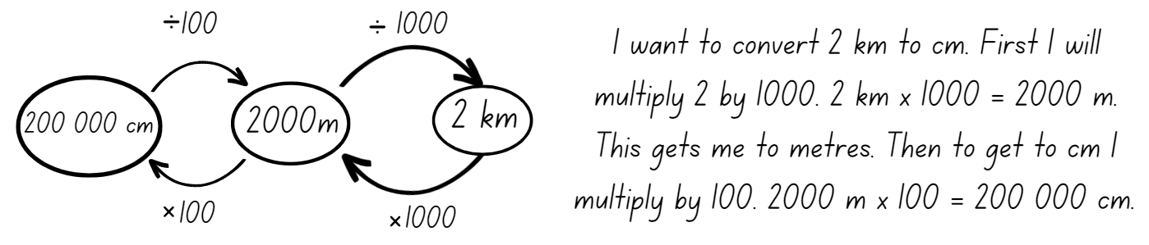
- Display Resource 3 – golf modelling conversion and instruct students to draw a table titled ‘Golf Shot Conversion’ in their books with the headings: Golf shot, kilometres (km), metres (m), centimetres (cm) and millimetres (mm). Students independently fill in the missing unit conversion for each shot.
This table details opportunities for differentiation.
Too hard? | Too easy?
Students cannot use the decimal place value system to convert between centimetres, metres and kilometres.  - Support students to only convert measurements from metres (m) to centimetres (cm).  - Provide students with Resource 2 – metric conversion display to reference when completing the Golf shot conversion task. | Students cannot use the decimal place value system to convert between centimetres, metres and kilometres.  - Challenge students to calculate the total kilometres for each hole and then convert to metres and centimetres.  - Students order distances of shots in descending order.

Consolidation and meaningful practice – 20 minutes
- Display Resource 4 – Tiger’s game map and explain that Tiger has mapped the first three holes of his golf game. Direct student attention to the scale where 1 mm = 1 metre.
- Using Resource 4 – Tiger’s game map and a ruler with millimetre markings, have students measure and record each shot made in millimetres and apply the scale. For example, 25 mm = 25 m. Students record the shot distance on Resource 4 – Tiger’s game map in metres (m).
- After measuring, students draw and complete a table in their workbooks (see Table 1). Remind students to use the conversion table if required.
Table 1 – golf table example
Hole | Total number of shots | Total metres | Total kilometres
1
2
3
- Students answer the following questions in their workbooks. Ask:
- What is the difference between the longest and shortest hole? Record your answer in centimetres (cm).
- What is the combined total distance of the 3 holes in kilometres?
- What is the most challenging part of this task? Why?
This table details opportunities for assessment.
Assessment opportunities | Links
What to look for:  - Can students use decimal place value system to convert between metres and kilometres? [MAO-WM-01, MA3-GM-02]  - Can students interpret decimal notation for lengths and distances? [MAO-WM-01, MA3-GM-02]  - Can students measure 100 metres and recognise that 10 times 100 metres is one kilometre? For example, 1000 metres is equivalent to one kilometre. [MAO-WM-01, MA3-GM-02]  - Can students record lengths and distances using decimal notation? [MAO-WM-01, MA3-GM-02] | Links to National Numeracy Learning Progressions (NNLP):  - NPV7, UuM6, NPV8, NPV9.

Lesson 2
Core concept: decimals can be compared by analysing the place value parts of standard units of measurement.

Daily number sense – before and after – 10 minutes
The table below contains a suggested learning intention and success criteria. These are best co-constructed with students.
Daily number sense learning intention | Daily number sense success criteria
Students are learning to:  - recognise that the place value system can be extended beyond hundredths. | Students can:  - express thousandths as decimals  - indicate the place value of digits in decimal numbers of up to 3 decimal places.
- Provide students with Resource 5 – before and after and writing materials.
- Students record the decimal number that comes before and after each displayed decimal number.
- Select students to say a chosen decimal number aloud and identify the ones, tenths, hundredths and thousandths.

- Ask the following questions:
- Which decimal is the largest? How do you know?
- Which decimal is the smallest? How do you know?
- Which decimal is closest to a whole number? Explain how you know.
This table details opportunities for assessment.
Assessment opportunities | Links
What to look for:  - Can students express thousandths as decimals? [MAO-WM-01, MA3-RN-02]  - Can students indicate the place value of digits in decimal numbers of up to 3 decimal places? [MAO-WM-01, MA3-RN-02] | Links to National Numeracy Learning Progressions (NNLP):  - NPV7, NPV8.  Links to suggested Interview for Student Reasoning (IfSR) tasks:  - IfSR-PT: 1A.5  - IfSR-NP: 4D.2, 4D.6.

Core lesson – How far can you jump? – 40 minutes
The table below contains suggested learning intentions and success criteria. These are best co-constructed with students.
Core concept learning intentions | Core concept success criteria
Students are learning to:  - use metres for length and distances  - connect decimal representations to the metric system. | Students can:  - estimate lengths and distances using an appropriate unit  - use a variety of measuring devices to measure lengths and distances in different contexts  - record lengths and distances using decimal notation.
This activity is adaptation from Measurement: Jump! from reSolve by the Australian Academy of Science.
- Watch the video of the Long jump world record (0:32) at the Tokyo Olympics 2020.
- Record 8.69 metres as the length jumped by the athlete in the video. As a class measure out and mark this distance with masking tape on the classroom floor or an outdoor surface near the classroom. Ask students:
- How far do you think you can you jump?
- Would it be easier to jump with 2 feet together or from just one foot?
- Would it help to have a running start?
- Explain that students are going to estimate and measure their own jumps. Jumps should be measured from the starting line to the back of the foot (as with long jump), in metres using a decimal point. Display and discuss Resource 6 – jump recording sheet.
- Model how to estimate and measure each of the following jumps:
- two feet together from standing
- one-foot leap from standing
- one-foot leap with a short run-up.
- Provide students with Resource 6 – jump recording sheet and record their estimate for each type of jump.
- Mark a clear starting line for jumps. Students complete each type of jump, measure using a metre ruler or a tape measure and record on Resource 6 – jump recording sheet.
- Students convert their measurements from metres to centimetres. Ask:
- How much further can you jump with a short run-up?
- What is the difference between your shortest and longest jump?
- How many of your longest jumps would it take to exceed 9 metres?

This table details opportunities for differentiation.
Too hard? | Too easy?
Students cannot use a variety of measuring devices to measure lengths and distances in different contexts.  - Model and support students how to measure using appropriate devices.  - Support students to only complete measurements in centimetres (cm), reinforcing knowledge of centimetres. | Students can use a variety of measuring devices to measure lengths and distances in different contexts.  - Challenge students to combine the length of all their own jumps and record in metres (m) and centimetres (cm).  - Students calculate the number of Olympic record jumps that would be needed to reach a total distance. For example, one kilometre.

Consolidation and meaningful practice – 15 minutes
- Students record each of their jumps on a sticky dot. Use the sticky dots to create a class dot plot for each type of jump. The x-axis should be labelled ‘Distance jumped (cm)’ and use a scale appropriate for the class data, for example, 20−29 cm, 30−39 cm as shown in Figure 2.
Figure 2 – example of recordings a dot plot
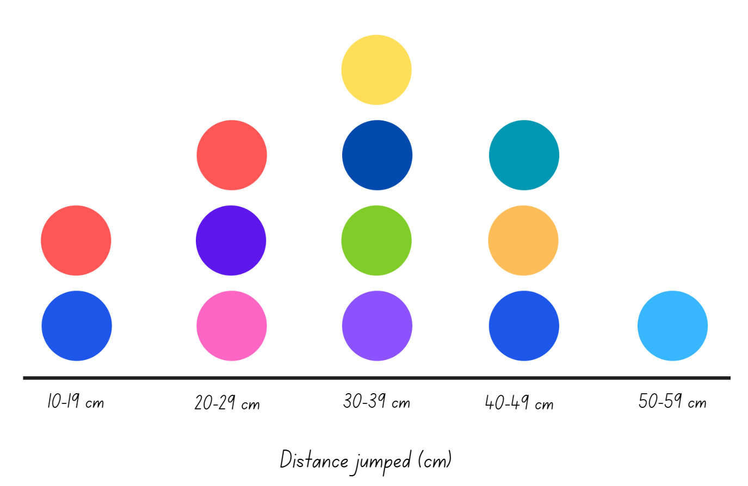
- Students turn and talk with a partner to discuss the results. As a class, use the information on the graph in Figure 2 to answer the following questions:
- What is the longest jump for each type of jump made? The shortest?
- What is the difference between the shortest and longest one-foot leap and short run-up jump?
- What is the most common distance jumped when starting from standing and leaping? Why do you think this is so?
- How much more does the second longest one-foot leap with a small run-up need in centimetres to be the same or more than the longest one-foot leap with a small run-up jump?

Discuss and connect the mathematics – 10 minutes
- Students measure and mark their personal best jump against the Olympic jump, placing their initials along the masking tape length.
- Ask: What is the difference between your longest jump and the Olympic jump?
- Select students to share and discuss their calculations.
This table details opportunities for assessment.
Assessment opportunities | Links
What to look for:  - Can students estimate lengths and distances using an appropriate unit? [MAO-WM-01, MA3-GM-02]  - Can students use a variety of measuring devices to measure lengths and distances in different contexts? [MAO-WM-01,  MA3-GM-02] | Links to National Numeracy Learning Progressions (NNLP):  - UuM6, NPV7, NPV8.

Lesson 3
Core concept: known lengths of shapes can be used to calculate unknown lengths.

Daily number sense – making thousandths – 10 minutes
The table below contains a suggested learning intention and success criteria. These are best co-constructed with students.
Daily number sense learning intention | Daily number sense success criteria
Students are learning to:  - recognise that the place value system can be extended beyond hundredths. | Students can:  - express thousandths as decimals  - indicate the place value of digits in decimal numbers of up to 3 decimal places.
- Provide students with Resource 7 – making thousandths.
- Instruct students to record the largest and the smallest decimal number that can be made using 4 of the digits. For example, the smallest decimal is 1.234 and the largest decimal is 5.432.
- Select students to share and explain solutions. Ask:
- How do you know your numbers are the largest and the smallest possible decimal numbers?
- If you could repeat a digit, which one would it be and why?
- What strategy is most helpful?
- How did you check your solutions?
- For an additional challenge offer students to either repeat one digit or use a zero. Select students to explain which one they would select and why.
This table details opportunities for assessment.
Assessment opportunities | Links
What to look for:  - Can students express thousandths as decimals? [MAO-WM-01, MA3-RN-02]  - Can students indicate the place value of digits in decimal numbers of up to 3 decimal places? [MAO-WM-01, MA3-RN-02] | Links to National Numeracy Learning Progressions (NNLP):  - NPV7, NPV8.  Links to suggested Interview for Student Reasoning (IfSR) tasks:  - IfSR-PT: 1A.5  - IfSR-NP: 4D.2, 4D.6.

Core lesson – calculating the perimeter of our school – 40 minutes
The table below contains suggested learning intentions and success criteria. These are best co-constructed with students.
Core concept learning intentions | Core concept success criteria
Students are learning to:  - use metres and kilometres for length and distances  - measure lengths to find perimeters. | Students can:  - estimate lengths and distances using an appropriate unit  - record distances using the abbreviation for metres (m) and kilometres (km)  - use a variety of measuring devices to measure lengths and distances in different contexts  - determine which side lengths are needed to find the perimeter of a shape  - recognise that rectangles with the same perimeter may have different dimensions.
- Review student understanding of perimeter. The perimeter of an object, shape or location is the same as the boundary.
Perimeter: the length around an object, shape or location. Perimeter is calculated by combining the length of all the sides using addition.
- Provide students with grid paper to complete the following task: A shape has a perimeter of 24 metres (m). Draw and label what this shape could look like.
- Students place their grid paper on the board or on the floor, where all students can see. Ask:
- What do you notice?
- Are all shapes the same?
- How are the shapes different?
- What are the common lengths of some of the sides?
- Explain that students will be conducting a school perimeter investigation. List school buildings on the board that will be measured. Students draw a table titled ‘School perimeters’ in their workbooks with the headings: building, estimate and measurement. Ask:
- What would be the best measuring device to use? Why?
- Which unit will you use to record your answer? Why?
- Revisit how to use a trundle wheel including how to keep the count when measuring metres. For example, using tally marks or using a drawing to record the measurement for each side and then doubling or adding.
- Provide small groups with a trundle wheel. Students estimate, using their knowledge of benchmarking, then measure the perimeter of the selected buildings and record the results.
- After measuring, discuss student’s results. Ask:
- What is the perimeter for each building?
- How did you calculate the total perimeter of the buildings?
- Do some measurements differ from group to group? Why or why not?
- How accurate are your estimates?
- Were there any challenges when completing this task?
- After listening to others, would you change your strategy for measuring perimeter? Explain your answer.
- Students combine the perimeter measurements of all buildings and covert into kilometres using decimal notation. Remind students that kilometres are recorded as km and the conversion table can help convert to kilometres if needed.
This table details opportunities for differentiation.
Too hard? | Too easy?
Students cannot measure lengths to find perimeters.  - Model and support students to measure one length using the trundle wheel.  - Support students to add the length of the sides together using additive strategies such as levelling and bridging. | Students can measure lengths to find perimeters.  - Challenge students to determine the area of the buildings.  - Students identify whether any buildings with different dimensions have a similar perimeter or if the perimeter measurements of 2 or more buildings can be combined to match the perimeter of the largest building.

Consolidation and meaningful practice – 20 minutes
This activity is an adaptation of 'Composite Shapes’ from Challenging Mathematical Tasks: Unlocking the Potential of All Students by Sullivan.
- Display Resource 8 – composite shape perimeters. Ask:
- What is perimeter the measurement of?
- What kinds of locations may have perimeters like these?
- Who might use perimeter measurements as part of their job?
- How can you calculate the length the of the sides that are blank?
- Model how to calculate the perimeter of a composite shape when each side length is not labelled using a think aloud (see Figure 3).
Figure 3 – calculating missing lengths.
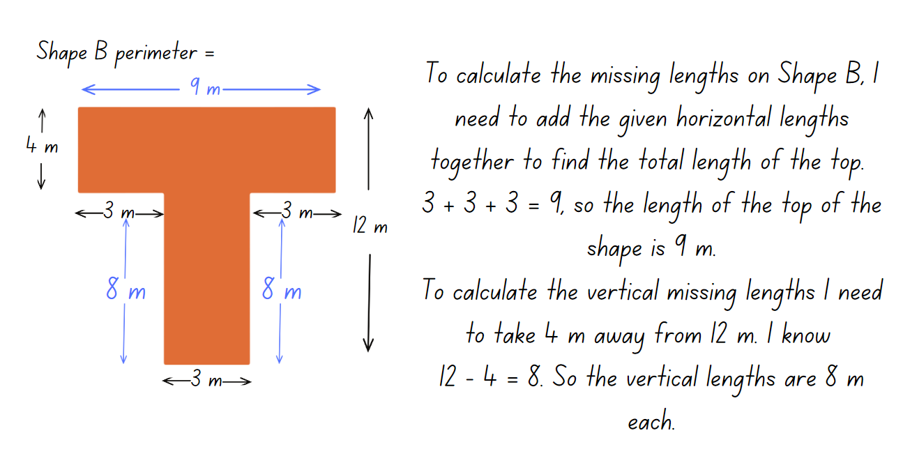
- Provide students with Resource 8 – composite shape perimeters. Students work out the perimeter of each shape. Remind them to take note of the unit used when recording their answers.
- Select students to share solutions and explain how they calculated the shape perimeter when not all measurements are shown.
This table details opportunities for assessment.
Assessment opportunities | Links
What to look for:  - Can students estimate lengths and distances using an appropriate unit? [MAO-WM-01, MA3-GM-02]  - Can students record distances using the abbreviation for metres (m) and kilometres (km)? [MAO-WM-01, MA3-GM-02]  - Can students use a variety of measuring devices to measure lengths and distances in different contexts? [MAO-WM-01,  MA3-GM-02]  - Can students determine which side lengths are needed to find the perimeter of a shape? [MAO-WM-01, MA3-GM-02]  - Can students recognise that rectangles with the same perimeter may have different dimensions? [MAO-WM-01, MA3-GM-02] | Links to National Numeracy Learning Progressions (NNLP):  - UuM5, UuM6, UuM7.

Lesson 4
Core concept: known lengths of shapes can be used to calculate unknown lengths.

Daily number sense – 10 minutes
- From a class need surfaced through formative assessment data, identify a short, focused activity that targets students’ knowledge, understanding and skills. Example activities may be drawn from the following resources:
- Mathematics K–6 resources
- Universal Resources Hub.

Core lesson – town planning – 40 minutes
The table below contains suggested learning intentions and success criteria. These are best co-constructed with students.
Core concept learning intentions | Core concept success criteria
Students are learning to:  - use metres and kilometres for length and distances  - measure lengths to find perimeters. | Students can:  - record distances using the abbreviation for metres (m)  - determine which side lengths are needed to find the perimeter of a shape  - recognise that rectangles with the same perimeter may have different dimensions.
- Explain that students will become town planners and will be designing a new town. However, the town must include specified buildings and locations (see Figure 4).
Figure 4 – examples of buildings
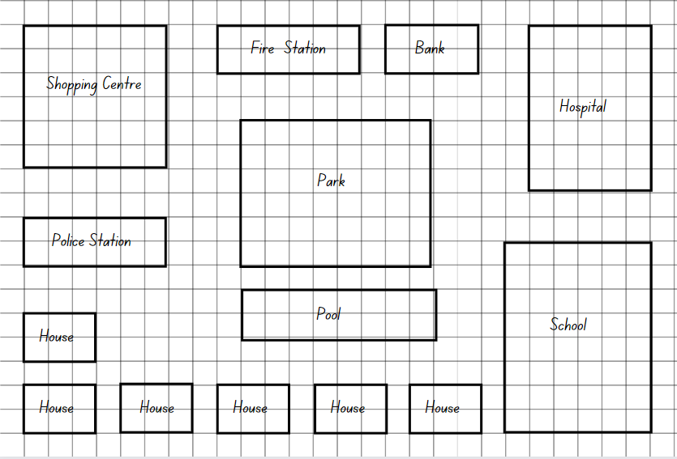
- Brainstorm with the class what buildings and locations might be required. Ask:
- What kinds of buildings do towns require?
- What would a town planner need to consider when deciding where to place houses and other buildings?
- Should certain locations be placed or not be placed near each other? Why or why not?
- Provide students with Resource 9 – town requirements and 2 pieces of grid paper.
- Students use a ruler and the grid lines to draw the buildings for their new town, ensuring all the required buildings and locations are included. Students then cut out the buildings and glue them on the other piece of grid paper when they are happy with their location.
- Instruct students to calculate the perimeter of each building and record on Resource 9 – town requirements. Tell students that the length of the side of one grid square equals one metre for the purposes of this task.
This table details opportunities for differentiation.
Too hard? | Too easy?
Students cannot calculate perimeters  - Provide students with a shorter list of buildings and locations to be included and support them to measure the perimeter of each building, counting the number of squares.  - Provide students with specified perimeters for the buildings and locations for them to draw on their town plan. | Students can calculate perimeters.  - Students calculate the combined perimeters of all buildings and locations in their town.  - Students include a natural feature such as a river or mountain in their town to fit their buildings and locations around. Students find the length and width of the river or mountain.

Consolidation and meaningful practice – 10 minutes
This activity is an adaptation of ‘Area of Rectangles and Squares’ from Creative Problem Solving in School Mathematics by Lenchner.
- Explain that a landscaper was asked to prepare designs for a bush tucker garden. The landscaper asked for the dimensions of the site. The client could not remember the exact dimensions but said that the site is shaped like a rectangle and that 90 metres of fencing is needed to enclose it. The site is exactly twice as long as it is wide. The landscaper said that was all the information needed and that she would have some designs ready soon.
- Students use individual whiteboards or their workbooks to draw solutions to determine the dimensions of the site. Ask:
- Can you find the length and width of the garden site?
- Did you have to try more than once to find a solution?
- Is there more than one solution?
- What strategy worked and why?

This table details opportunities for assessment.
Assessment opportunities | Links
What to look for:  - Can students determine which side lengths are needed to find the perimeter of a shape? [MAO-WM-01, MA3-GM-02]  - Can students recognise that rectangles with the same perimeter may have different dimensions? [MAO-WM-01, MA3-GM-02] | Links to National Numeracy Learning Progressions (NNLP):  - UuM5, UuM6, UuM7.

Lesson 5
Core concept: the context determines the most suitable standard unit; sometimes a kilogram is too small or too large.

Daily number sense – ordering fractions – 10 minutes
Daily number sense activities for Lessons 5 to 7 ‘loop’ back to concepts and procedures covered in previous units to assist students to build an increasingly connected network of ideas. These concepts may differ from the core concepts being covered by the unit.
The table below contains a suggested learning intention and success criteria. These are best co-constructed with students.
Daily number sense learning intention | Daily number sense success criteria
Students are learning to:  - compare and order common fractions. | Students can:  - compare and order fractions with denominators of 2, 3, 4, 5, and 8 by placing them on a number line.
- Provide students with Resource 10 – fractions. Students place the fractions in the correct place on the number line.
- Students then add any other common fractions to the number line that they know. For example, $\frac{1}{6}$.
- Select students to share and explain the placement of the fractions.
This table details opportunities for assessment.
Assessment opportunities | Links
What to look for:  - Can students compare and order fractions with denominators of 2, 3, 4, 5, and 8 by placing them on a number line? [MAO-WM-01, MA3-RQF-01] | Links to National Numeracy Learning Progressions (NNLP):  - InF6.  Links to suggested Interview for Student Reasoning (IfSR) tasks:  - IfSR-NP/AT/MT: Insert IfSR task codes  - IfSR-NP/AT/MT: Insert IfSR task codes.

Core lesson – investigating mass – 20 minutes
The table below contains suggested learning intentions and success criteria. These are best co-constructed with students.
Core concept learning intentions | Core concept success criteria
Students are learning to:  - choose appropriate units of measurement for mass  - convert between common metric units of mass. | Students can:  - recognise situations where mass would be measured in thousands of kilograms or tonnes (t)  - convert between kilograms and grams and between kilograms and tonnes  - solve problems involving mass.
This activity is an adaptation of ‘Top heavy’ from Stage 3 Mass by State of New South Wales (Department of Education).
Note: real examples of grocery items are needed for this lesson.
- Review what students know about measuring mass. Ask:
- When we measure mass, what are we measuring?
- What units do we use to measure mass?
- When might we need to measure the mass of objects?
- What unit do we use to measure the mass of objects that are very heavy (tonnes) or light (grams)?
- Display Resource 11 – recording mass. Select students to assist with the completion of the table. Discuss:
- When are kilograms more likely to be used and when are grams more likely to be used?
- Where do we commonly see grams (g) and kilograms (kg) written?
- What is a unit bigger than a kilogram? How many kilograms in one tonne (t)?
- Why would we need to measure in tonnes?
- What kinds of things would be measured in tonnes?
- Show examples of grocery items labelled grams (g) and kilograms (kg) such as rice, flour, canned goods or cereal. Select students to convert the mass of items labelled grams into kilograms and record this on a sticky note and attach to the item. Repeat the activity converting the mass of items labelled kilograms into grams.
Note: a set of Resource 12 – Which is heavier? cards will need to be prepared for each pair of students.
- Demonstrate how to play ‘Which is heavier?’ Explain that each card has a mass written on it in either grams, kilograms or tonnes.
- Cards are shuffled and dealt face down to each player. Players each turn over a card and the player who has the card with the heavier mass, scores one point. Play continues until all cards have been played. The player with the highest score wins.
- Provide pairs of students with Resource 12 – Which is heavier? to play.

Investigation task 1 – tonnes – 10 minutes
These investigation tasks are an adaptation of Weighty Problems from NZ Maths by the New Zealand Ministry of Education.
- Refer to completed Resource 11 – recording mass and remind students that 1000 kilograms is equal to one tonne.
- Tell students that the largest sumo wrestler in the world had a mass of 287 kilograms. Students need to calculate how many sumo wrestlers of this size would weigh one tonne.
- Display Resource 13 – making tonnes. Students draw a table in their workbooks and calculate how many of each item would make a total mass of one tonne. Students show working out in their workbooks.

Investigation task 2 – lasagne – 15 minutes
- Pose the problem: The world’s largest lasagne was made in 2012 at a restaurant in Wieliczka, Poland. It weighed 4865 kilograms and measured 25 metres by 2.5 metres. The ingredients were: 2500 kilograms of pasta, 800 kilograms of mince, 400 kilograms of mozzarella cheese, 100 kilograms of peas, 100 kilograms of carrots, and equal amounts of white sauce and tomato sauce.
- Ask the students to calculate and show working out in their workbooks:
- How much did the white sauce and tomato sauce weigh?
- If we had to make a quarter of the lasagne, what would be the mass of each ingredient?
- Peas come in 500-gram packets; how many packets of peas would be required to make the lasagne?
- If there were only 200-gram packets of mozzarella cheese available at the supermarket, how many packets would need to be purchased to make 400 kilograms of mozzarella cheese?
- Challenge: What would be the perimeter of a 500 gram piece of the lasagne?

Investigation task 3 – Rick’s cans – 10 minutes
- Rick’s shopping trolley contains a load of cans from the supermarket. The cans each have a different mass as follows: baked beans (245 grams), peaches (365 grams), pickles (125 grams) and creamed corn (650 grams).
- Rick has 12 cans of baked beans, 9 cans of peaches, 7 cans of pickles and 9 cans of creamed corn. What is the total mass of the cans in kilograms?
- How many cans of pickles are required to have a mass of 5 kilograms?
- What combination of items would total the closest to 2.5 kilograms?
- What is the difference in mass between the total amount of peaches and creamed corn?
This table details opportunities for differentiation.
Too hard? | Too easy?
Students cannot convert between kilograms and grams and between kilograms and tonnes.  - Provide conversion chart to support students converting between grams and kilograms.  - Support students to use Resource 11 – recording mass when completing investigation tasks. | Students cannot convert between kilograms and grams and between kilograms and tonnes.  - Challenge students to solve the problem: A shipment of apples weighs 1.2 tonnes, and each apple weighs 150 grams. How many apples are there in the shipment?  - Students answer and explain which is heavier, 4500 kilograms of rice or 3.5 tonnes of sand?

Discuss and connect the mathematics – 10 minutes
- Regroup as a class and ask students to decide if the following statements are true or false. Students will reason and justify their answers:
- 500 grams is the same as 5 kilograms
- 3.5 tonnes are heavier than 3500 kilograms
- 455 grams is a quarter of one kilogram
- 75 kilograms is three-quarters of a tonne.
This table details opportunities for assessment.
Assessment opportunities | Links
What to look for:  - Can students recognise situations where mass would be measured in thousands of kilograms or tonnes (t)? [MAO-WM-01, MA3-NSM-01]  - Can students convert between kilograms and grams and between kilograms and tonnes? [MAO-WM-01, MA3-NSM-01]  - Can students solve problems involving mass identify the appropriate unit and device to measure mass? [MAO-WM-01, MA3-NSM-01] | Links to National Numeracy Learning Progressions (NNLP):  - UuM6.

Lesson 6
Core concept: estimation of mass is guided by known masses/weights as benchmarks.

Daily number sense – rolling fractions – 10 minutes
The table below contains a suggested learning intention and success criteria. These are best co-constructed with students.
Daily number sense learning intention | Daily number sense success criteria
Students are learning to:  - compare and order common fractions. | Students can:  - compare and order fractions with denominators of 2, 3, 4, 5, 6, 8 and 10 by placing them on a number line.
- Provide each student with a 10-sided dice and an individual whiteboard. Students draw a number line from 0–1.
- Revise the meaning of the denominator, numerator and fraction line.
Numerator: the top number is the numerator, which identifies the number of parts. The line separating the top number from the bottom number is called the fraction bar; it is also sometimes referred to as the vinculum.
Denominator: the bottom number is called the denominator and is the total number of equal parts the whole is broken into.
Unit fraction: a unit fraction can be defined as a fraction whose numerator is 1.
- Students roll the dice and use the number rolled as the denominator with the numerator always being one. For example, if students roll a 5 the fractions will be $\frac{1}{5}$.
- Students place the fraction on the number line in the correct location.
- Select students to share and explain the placement of the fractions.
This table details opportunities for assessment.
Assessment opportunities | Links
What to look for:  - Can students compare and order fractions with denominators of 2, 3, 4, 5, 6, 8 and 10 by placing them on a number line?  [MAO-WM-01, MA3-RQF-01] | Links to National Numeracy Learning Progressions (NNLP):  - InF6.

Core lesson – harvest time – 30 minutes
The table below contains suggested learning intentions and success criteria. These are best co-constructed with students.
Core concept learning intentions | Core concept success criteria
Students are learning to:  - choose appropriate units of measurement for mass  - convert between common metric units of mass. | Students can:  - recognise situations where mass would be measured in thousands of kilograms or tonnes (t)  - convert between kilograms and grams and between kilograms and tonnes  - solve problems involving different units of mass.
- Discuss the importance of agriculture in Australia and how it contributes to the country’s economy. Watch the video Farm Kids (3:12).
- Display Resource 14 – harvest photos. Discuss the meaning of the following words related to harvest:
- Harvest: the process of gathering in crops
- Silo: a tall tower or pit on a farm used to store wheat
- Wheat header: a tractor like machine used for cutting and collecting wheat
- Grain: wheat
- Crop: a cultivated plant that is grown on a large scale commercially.
- Ask students to discuss which unit they would use to measure the mass of wheat crops.
- Provide students with Resource 15 – harvest facts and their workbooks.
- Display Resource 16 – harvest questions. Students answer the questions and show working in their workbooks.
This table details opportunities for differentiation.
Too hard? | Too easy?
Students cannot solve problems involving mass.  - Provide students with smaller numbers to work with by reducing the total yield of the wheat crop.  - Support students to access the problems by identifying key information to answer the questions. | Students can solve problems involving mass.  - Challenge students to write 2 questions relating to ‘Farmer Joe’s Harvest Facts’ for a partner to answer.  - Students work on the problem: Farmer Joe’s rooster consumes 200 grams of wheat each day. Calculate how many days' worth of feed can be stored in a 40 kilogram bag of wheat?

Consolidation and meaningful practice – 20 minutes
Note: to reuse Resource 17 – load the truck for multiple rounds, place it in a plastic sleeve or laminate.
- Explain how to play ‘Load the truck’. The aim of the game is to get a total as close to a truck load of 10 tonnes as possible, without going over.
- Players take turns rolling the dice.
- The number rolled indicates how many 40 kg bags of wheat the player will ‘load’ on their truck. For example, Player A rolls a 7, this represents 7 × 40 kilogram bags of wheat, so Player A writes 280 kilograms on their recording table.
- Students keep a running total in the third column.
- After 10 rolls each, the player closest to the truck mass limit of 10 tonnes without going over wins.
- Provide pairs of students with Resource 17 – load the truck, two 6-sided dice and a whiteboard marker. Students play multiple rounds in the time allowed.
- This table details opportunities for assessment.
Assessment opportunities | Links
What to look for:  - Can students recognise situations where mass would be measured in thousands of kilograms or tonnes (t)? [MAO-WM-01, MA3-NSM-01]  - Can students convert between kilograms and grams and between kilograms and tonnes? [MAO-WM-01, MA3-NSM-01]  - Can students solve problems involving different units of mass? [MAO-WM-01, MA3-NSM-01] | Links to National Numeracy Learning Progressions (NNLP):  - UuM6, UuM8.

Lesson 7
Core concept: a mass can be renamed using different units of measurement.

Daily number sense – fractions and minutes – 10 minutes
The table below contains a suggested learning intention and success criteria. These are best co-constructed with students.
Daily number sense learning intention | Daily number sense success criteria
Students are learning to:  - compare and order common fractions. | Students can:  - compare and order unit fractions with denominators of 2, 3, 4, 5, 6, 8 and 10 by placing them on a number line.
- Show students Resource 18 – fraction line and ask in what situation one whole equals 60 of something.
Note: provide time for students to make the connection between one hour and 60 minutes, or prompt them if needed.
- Explain that on Resource 18 – fraction line students need to place the fractions in the correct place on the number line and then record the equivalent minutes above the line (see Figure 5).
Figure 5 – fractions and minutes
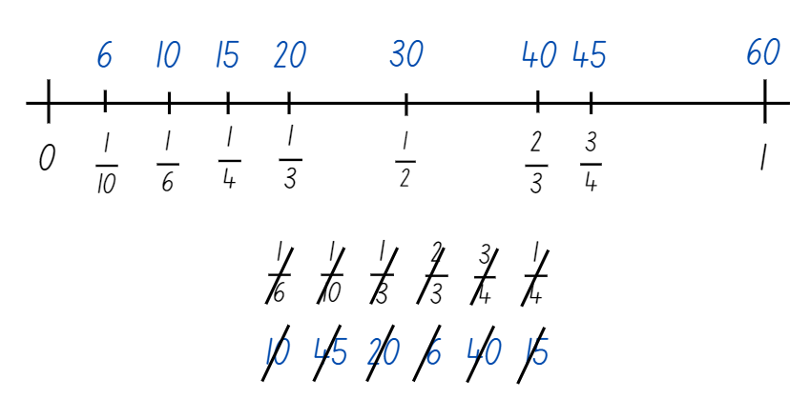
- Select students to share and explain their placement of the fractions and the equivalent minutes.
This table details opportunities for assessment.
Assessment opportunities | Links
What to look for:  - Can students compare and order unit fractions with denominators of 2, 3, 4, 5, 6, 8 and 10 by placing them on a number line?  [MAO-WM-01, MA3-RQF-01] | Links to National Numeracy Learning Progressions (NNLP):  - InF6.

Core lesson – kilograms and tonnes – 40 minutes
The table below contains suggested learning intentions and success criteria. These are best co-constructed with students.
Core concept learning intentions | Core concept success criteria
Students are learning to:  - connect decimal representations to the metric system  - convert between common metric units of mass. | Students can:  - recognise the equivalence of whole-number and decimal representations of measurements of mass  - interpret decimal notation for masses  - convert between kilograms and grams and between kilograms and tonnes.
Note: less than (<) and greater than (>) symbols are not specifically referenced in the Mathematics K–10 Syllabus but are important symbols for students to understand. This lesson provides an opportunity for students to use these symbols in context.
- Display Resource 19 – conversion chart. Ask:
- What can be measured in tonnes?
- Why do we use tonnes as a unit of measurement?
- How many kilograms are in a tonne?
- What tools are used to measure tonnes?
- Using Resource 19 – conversion chart, explain the procedure of converting tonnes to kilograms and kilograms to tonnes. Introduce the less than (<), greater than (>) and equals sign (=) and explain their meaning in relation to the size or quantity of mass.
- Students use Resource 19 – conversion chart and complete the activity on Resource 20 – tonnes to kilograms.
- Select students to explain the strategy they used to complete conversions on Resource 20 – tonnes to kilograms.
- Revise students’ understanding of the equivalence of the whole-number and decimal representations of measurements of mass. 3 kilograms and 250 grams is equivalent to 3.25 kg, and 2.08 kg is the same as 2 kilograms and 80 grams.
- Reinforce this concept by displaying the following questions to practice converting measurements into decimals. Students copy and complete these questions in their workbooks:
- 4 kilograms and 250 grams as a decimal is __
- 3 kilograms and 126 grams as a decimal is __
- 5 kilograms and 75 grams as a decimal is __.
- Explain and use the relationship between the size of a unit and the number of units needed to determine whether multiplication or division is required when converting between units. For example, 'More grams than kilograms will be needed to measure the same mass. So, to convert from kilograms to grams, I need to multiply'. Write the following examples on the board to calculate with students:
- 1.2 kilograms is _____ grams (1200 g)
- 3.45 kilograms is _______ grams (3450 g)
- 1254 grams is _____ kilograms (1.254 kg).
This table details opportunities for differentiation.
Too hard? | Too easy?
Students cannot convert between kilograms and grams and between kilograms and tonnes.  - Model using scaled instruments to compare 1000 g and 1 kg objects.  - Support students to use the conversion chart when completing Resource 20 – tonnes to kilograms. | Students can convert between kilograms and grams and between kilograms and tonnes.  - Students research facts about the mass of very large animals and create a fact file about these animals. Students then create combinations of different animals’ mass. For example, one elephant equals 130 big dogs.  - Challenge students to create word problems that require converting between units of mass for a partner to solve.

Discuss and connect the mathematics – 10 minutes
This activity is an adaptation of ‘Heavy loads’ from Maths-in-a-Box 3 by Grant et al.
- Explain that semi-trailers transport large loads over great distances to supply many different types of goods. They sometimes pull single trailers or become a road train when there are 2 or 3 trailers. A semi-trailer can carry up to 45 tonnes. A double road train can carry up to 85 tonnes and a triple road train can carry up to 125 tonnes.
- Provide students with a whiteboard to answer the following questions:
- What unit is used to measure the mass of semi-trailers and road trains?
- How many kilograms are there in 45 tonnes? 85 tonnes? 125 tonnes?
- Which abbreviation is used for tonnes?
- What is the combined mass of 2 semi-trailers and a triple road train?
- What is the combined mass of a double road train and a semi-trailer?
This table details opportunities for assessment.
Assessment opportunities | Links
What to look for:  - Can students recognise the equivalence of whole-number and decimal representations of measurements of mass?  [MAO-WM-01, MA3-NSM-01]  - Can students interpret decimal notation for masses?  [MAO-WM-01, MA3-NSM-01]  - Can students convert between kilograms and grams and between kilograms and tonnes? [MAO-WM-01, MA3-NSM-01] | Links to National Numeracy Learning Progressions (NNLP):  - UuM8.

Lesson 8
Core concept: the context determines the most suitable device to measure lengths and masses.

Daily number sense – 10 minutes
- From a class need surfaced through formative assessment data, identify a short, focused activity that targets students’ knowledge, understanding and skills. Example activities may be drawn from the following resources:
- Mathematics K–6 resources
- Universal Resources Hub.

Core lesson – dinosaur measurements – 35 minutes
The table below contains suggested learning intentions and success criteria. These are best co-constructed with students.
Core concept learning intentions | Core concept success criteria
Students are learning to:  - use metres and kilometres for length and distances  - choose appropriate units of measurement for mass. | Students can:  - estimate lengths and distances using an appropriate unit  - record distances using the abbreviation for centimetres (cm), metres (m) and kilometres (km)  - identify the appropriate unit and device to measure mass  - recognise situations where mass would be measured in thousands of kilograms or tonnes (t).
This lesson is an adaptation of Weighty Problems 4: Jumbo Facts from NZ Maths by the New Zealand Ministry of Education.
Note: one set of Resource 21 – dino challenge cards per small group should be prepared prior to the lesson.
- Display Resource 22 – dinosaur facts and explain that dinosaurs are reptiles that dominated the land for over 140 million years. Fossil remains show they were some of the heaviest and longest creatures that have lived on earth.
- Explain that students will convert the measurements for each dinosaur from tonnes to kilograms and metres to centimetres and record in their workbooks.
- Put students into small groups and provide each group a set of Resource 21 – dino challenge cards.
- Using Resource 22 – dinosaur facts, students work through the challenge cards and answer questions in their workbook.
- Share answers in a whole class discussion. Select students to justify their answers and explain strategies used to solve the challenge questions.
This table details opportunities for differentiation.
Too hard? | Too easy?
Students cannot use metres and kilometres for length and distances and choose appropriate units of measurement for mass.  - Provide students with length and mass conversion charts.  - Complete answers in one unit of measurement only. | Students can use metres and kilometres for length and distances and choose appropriate units of measurement for mass.  - Students develop their own challenge questions to pose to the class.  - Students convert from tonnes to grams and kilometres to millimetres.

Discuss and connect the mathematics – 15 minutes
This activity is an adaptation from Open-ended Maths Activities: Using ‘Good’ Questions to Enhance Learning in Mathematics, Revised edn by Sullivan and Lilburn.
- Present students with ‘Is it possible?’ statements. Students answer with ‘possible’ or ‘impossible’ and justify their responses:
- A hippopotamus has a mass of 2000 kilograms.
- A trundle wheel is used to measure the length of an ant.
- The width of a soccer goal is a little more than 700 centimetres.
- A train carriage has a mass of 6000 tonnes.
- The smallest bird in the world is 50 centimetres long.
- A kitchen scale is used to measure the mass of a fridge.
- The tallest football player is 2000 millimetres tall.
- The mass of a grasshopper is 1000 grams.
- An emu egg has a mass of $\frac{1}{2}$ kg.
This table details opportunities for assessment.
Assessment opportunities | Links
What to look for:  - Can students record distances using the abbreviation for centimetres (cm), metres (m) and kilometres (km)? [MAO-WM-01, MA3-GM-02]  - Can students identify the appropriate unit and device to measure mass? [MAO-WM-01, MA3-NSM-01]  - Can students recognise situations where mass would be measured in thousands of kilograms or tonnes (t)? [MAO-WM-01, MA3-NSM-01] | Links to National Numeracy Learning Progressions (NNLP):  - UuM6, UuM8.

Resource 1 – missing decimal numbers
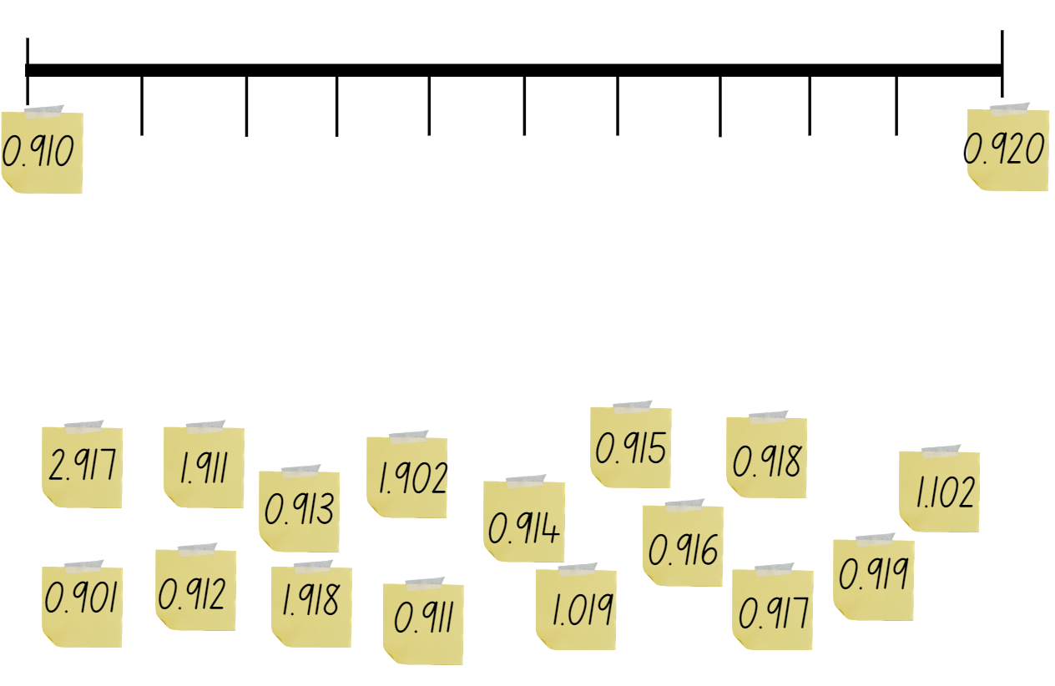

Resource 2 – metric conversion display
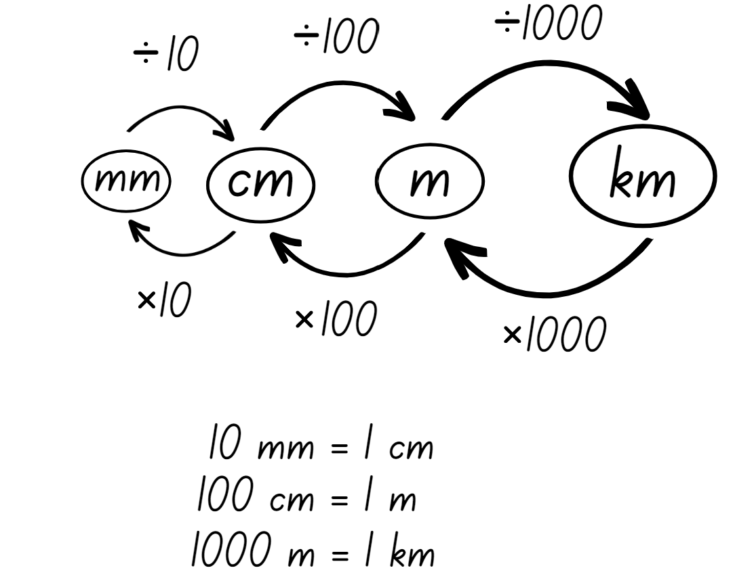

Resource 3 – golf modelling conversion
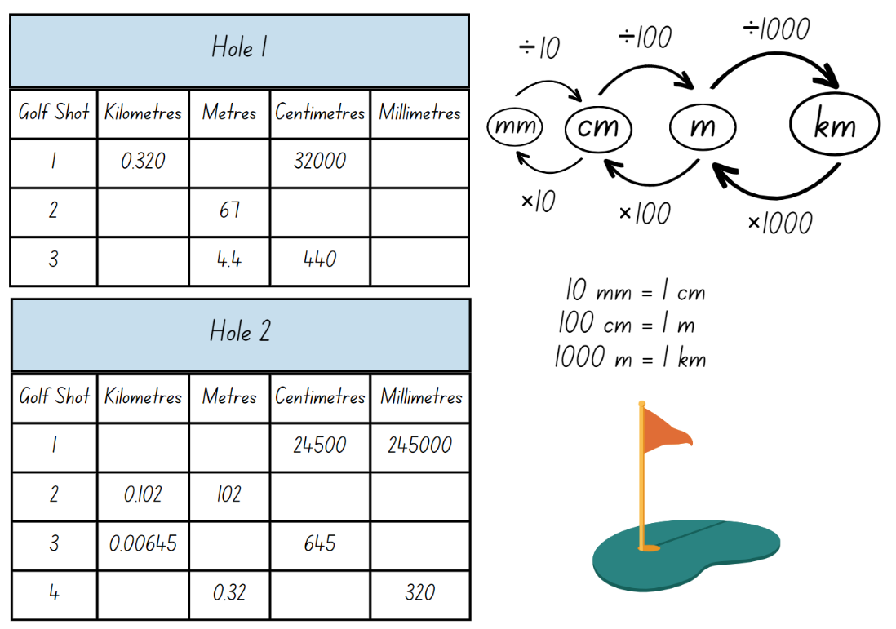

Resource 4 – Tiger’s game map
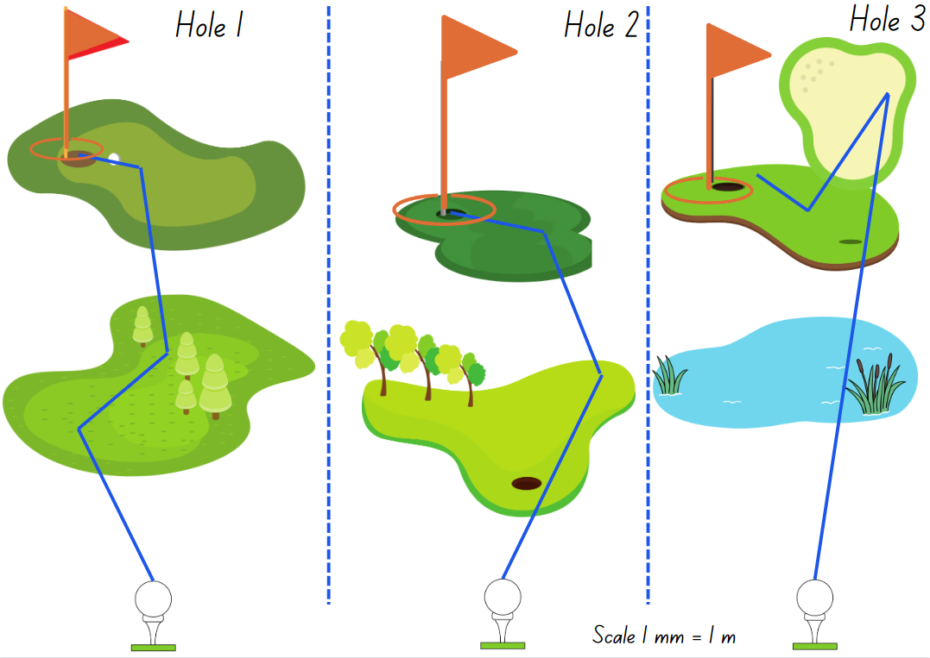

Resource 5 – before and after
Before | Decimal number | After
 | 0.125
 | 2.065
 | 1.988
 | 6.107
 | 0.002
 | 0.999

Resource 6 – jump recording sheet
Type of jump | Estimate | Record (m) | Convert measurement from m to cm
Two feet together
One-foot leap from standing
One-foot leap with a short run-up

Resource 7 – making thousandths
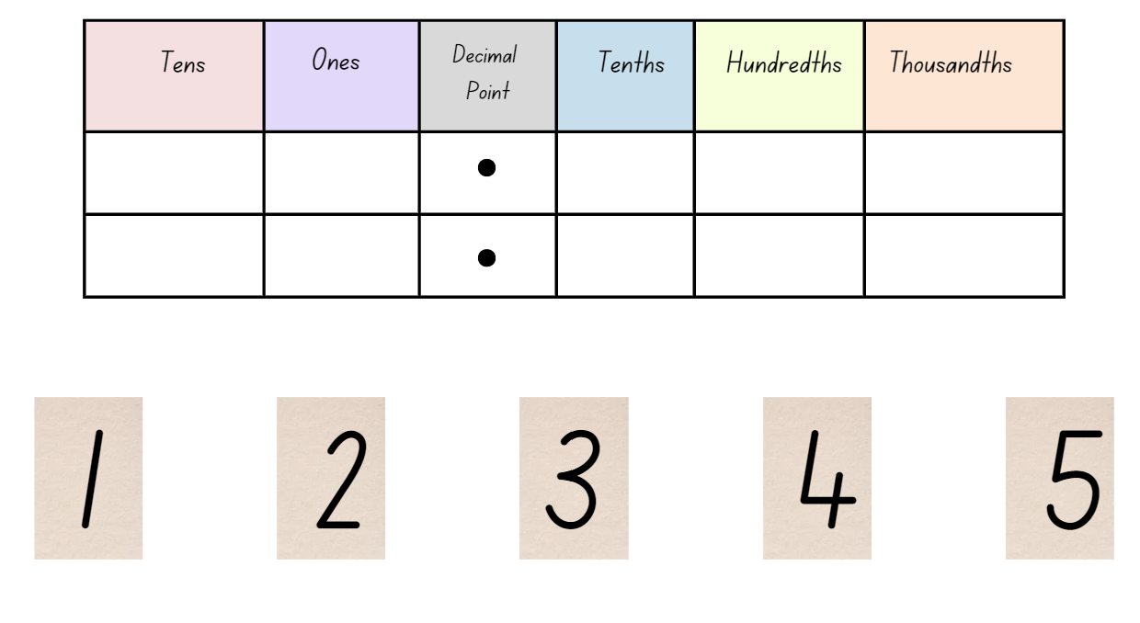

Resource 8 – composite shape perimeters
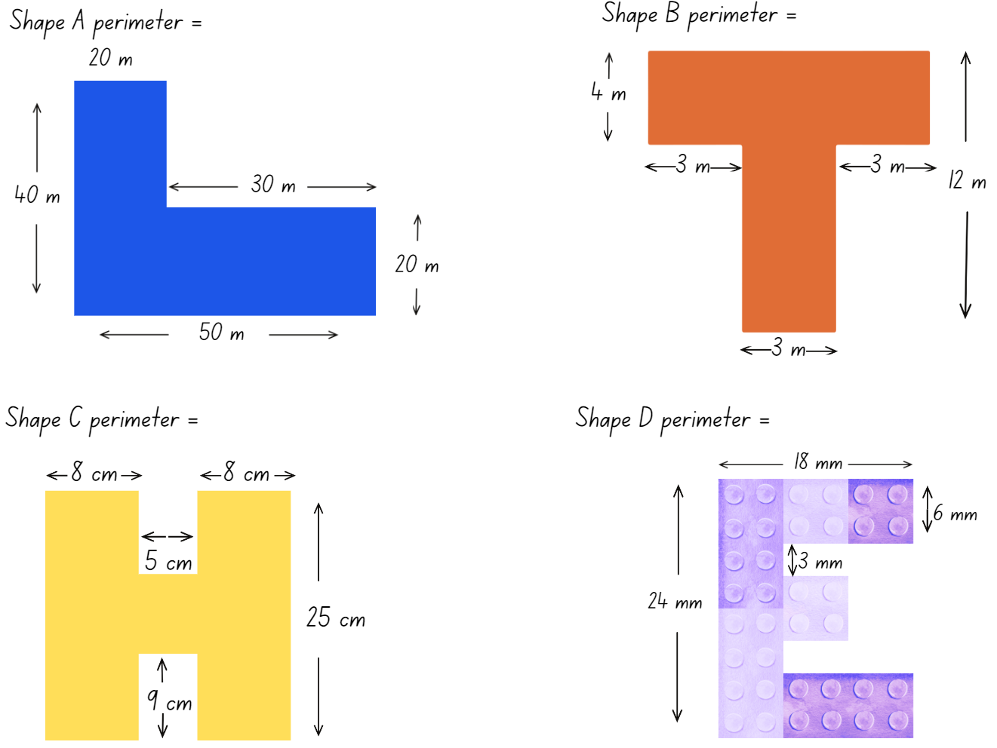

Resource 9 – town requirements
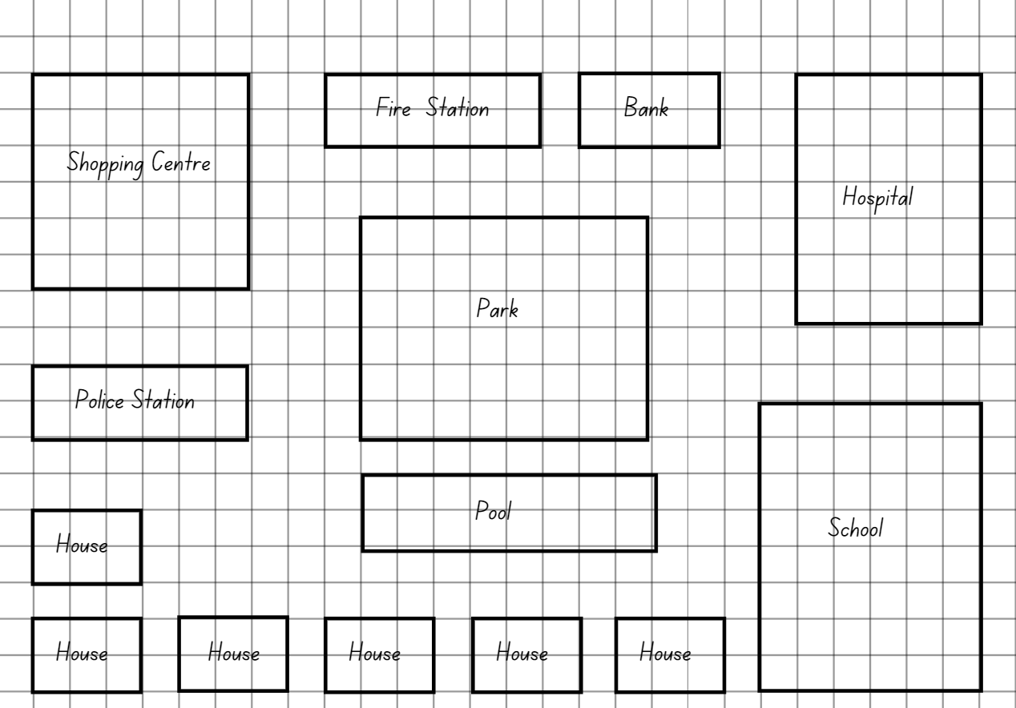

Resource 10 – fractions
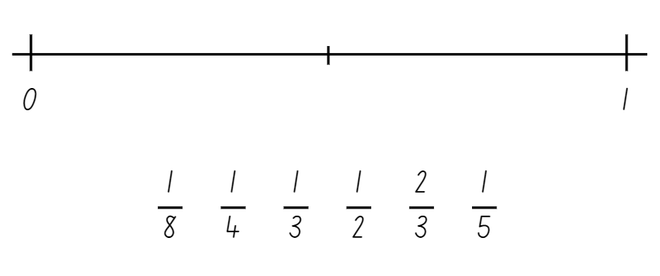

Resource 11 – recording mass
One kilogram | 1 kilogram | 1kg | 1000 grams | 1000 g
One half of a kilogram
One-quarter of a kilogram
Three-quarters of a kilogram
One tonne | 1 tonne

Resource 12 – Which is heavier?
2000 g | 5637 g | 0.234 t | 0.51 t | 0.01 kg
4.6 kg | 1 t | 2678 g | 3120 g | 3600 g
17 g | 9.8 kg | 5 kg | 1.5 t | 0.03 kg
3.1 t | 0.02 kg | 1.2 kg | 46 g | 2.8 kg

Resource 13 – making tonnes
Object | Mass kg | Tonne
Sumo wrestler | 287 kg
School bag | 5 kg
Microwave oven | 15 kg
Bag of cement | 50 kg
Watermelon | 23 kg

Resource 14 – harvest photos
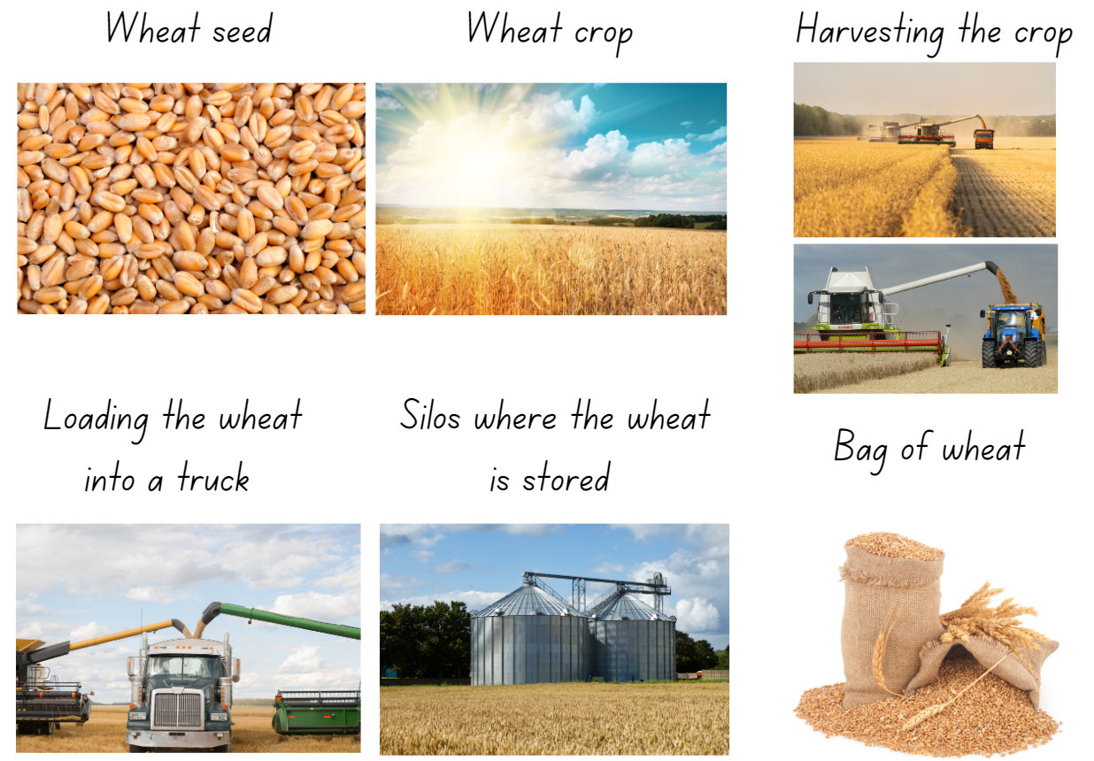

Resource 15 – harvest facts
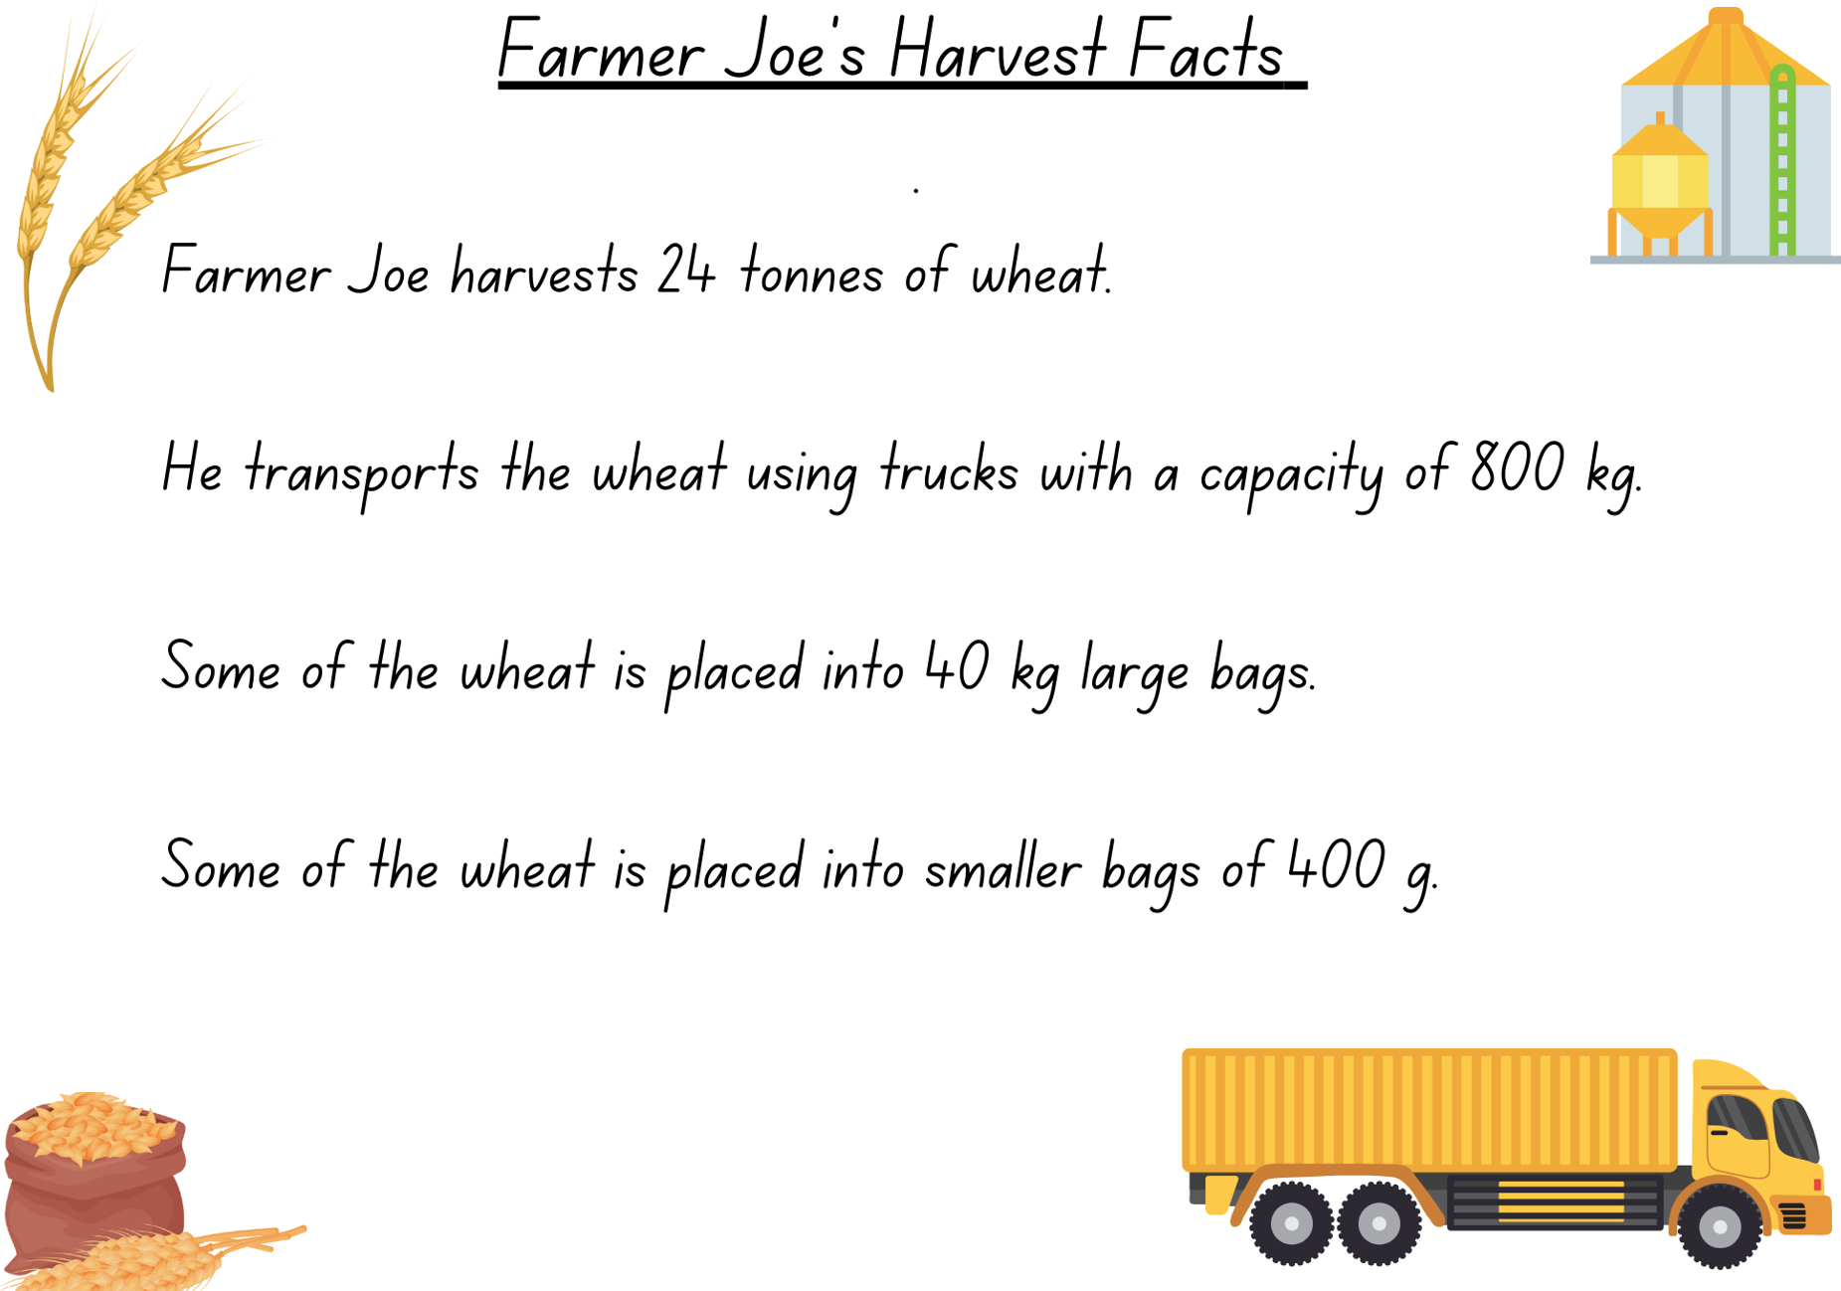

Resource 16 – harvest questions
Harvest questions
- If the harvest takes 6 days, how many tonnes were harvested each day? How many kilograms does this equal? How many grams does this equal?
- Farmer Joe took 4 tonnes of wheat to the market. How many truck loads were needed?
- What combination of large bags and small bags could be delivered to a customer wanting 245.2 kg of wheat?
- How many 40 kg bags of wheat make one fifth of a tonne?
- Farmer Joe uses 800 g of wheat each day to feed his chickens. How many days does a 40 kg bag last?
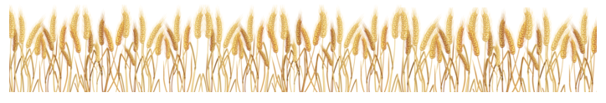

Resource 17 – load the truck
Load the truck
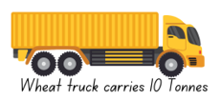
Players: 2
What you need: two 6-sided dice
Aim: To get a total as close to a truckload of 10 tonnes as possible, but not to go over.
- Players take turns rolling the dice.
- The number rolled will indicate how many 40 kg bags of wheat the player will 'load' on their truck. Example: Player A rolled a 7, this represents 7 × 40 kg bags of wheat so they put 280 kg on their recording table.
- Record the amount of wheat in kilograms on the recording sheet for each roll. Students keep a running total in the third column.
- After 10 dice rolls each, the player closest to the truck mass limit of 10 tonnes wins. If you exceed the 10 tonne mass limit, you have lost.
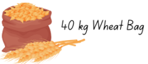
Load the truck recording sheet
Roll | Total | Running total
1
2
3
4
5
6
7
8
9
10

Resource 18 – fraction line
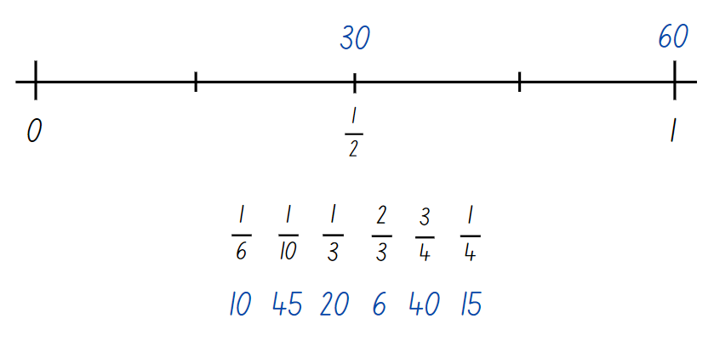

Resource 19 – conversion chart
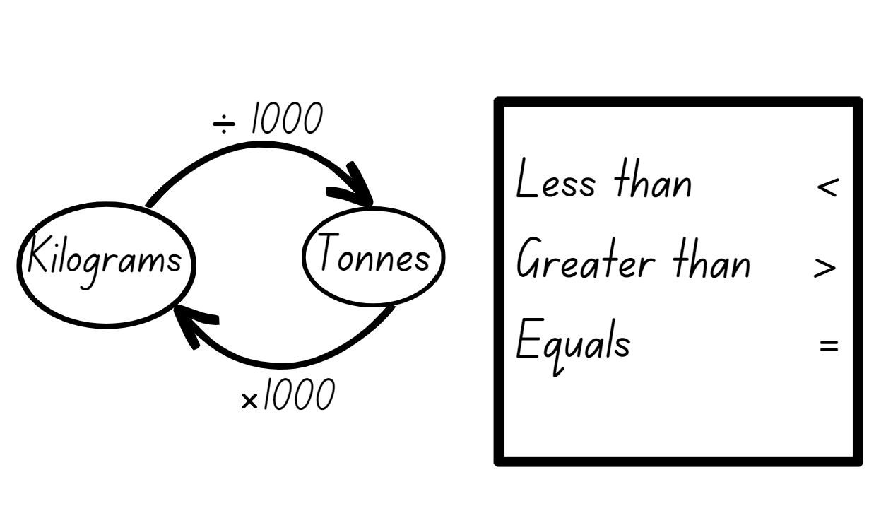

Resource 20 – tonnes to kilograms
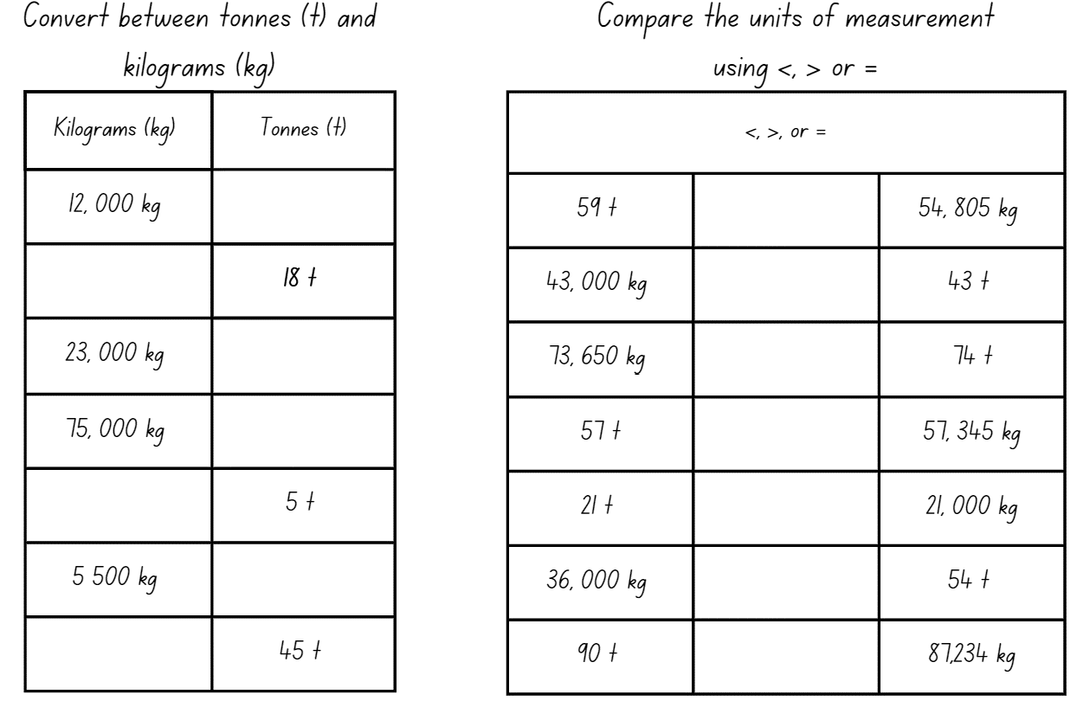

Resource 21 – dino challenge cards
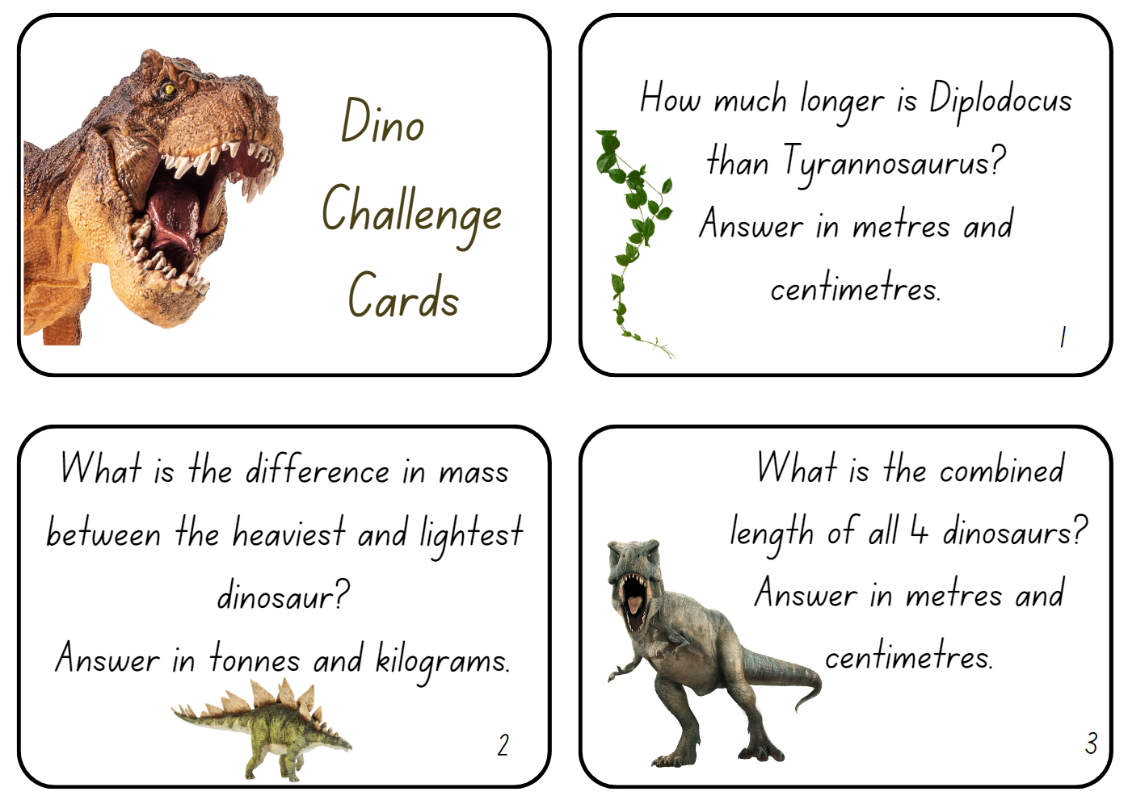
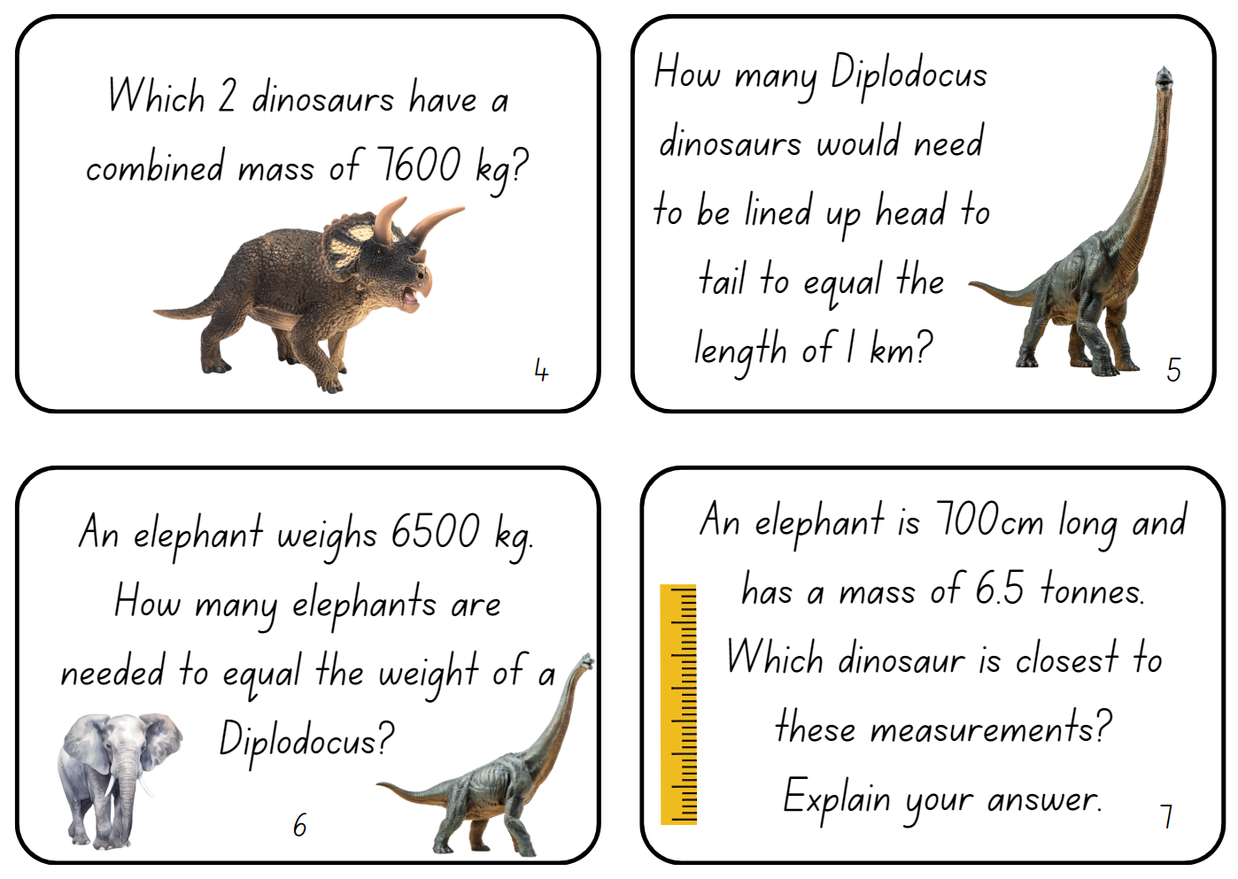
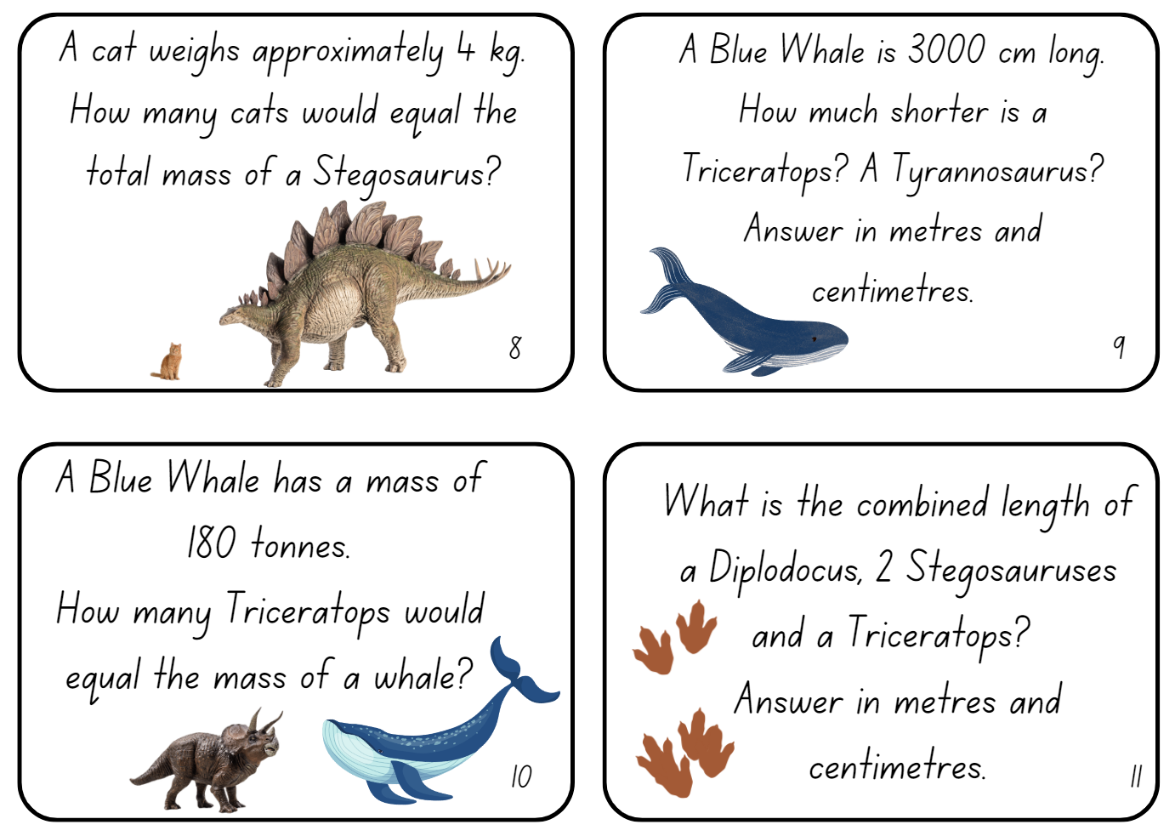

Resource 22 – dino facts
Dinosaur | Mass | Length
Tyrannosaurus | 6 tonnes | 12.3 metres
Stegosaurus | 1.6 tonnes | 6.5 metres
Diplodocus | 22.6 tonnes | 28 metres
Triceratops | 8 tonnes | 9 metres
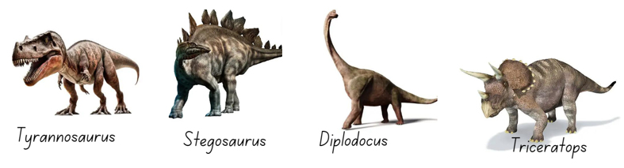

Syllabus outcomes and content
The table below outlines the syllabus outcomes and range of relevant syllabus content covered in this unit. Content is linked to National Numeracy Learning Progression (version 3).
Outcomes and content | 1 | 2 | 3 | 4 | 5 | 6 | 7 | 8
Represents numbers A: Decimals and percentages: Recognise that the place value system can be extended beyond hundredths
[MAO-WM-01, MA2-RN-01, MA2-RN-02]
- Express thousandths as decimals | x | x | x
- Indicate the place value of digits in decimal numbers of up to 3 decimal places | x | x | x
- Use place value to partition decimals | x
Represents numbers A: Decimals and percentages: Compare order and represent decimals
[MAO-WM-01, MA2-RN-01, MA2-RN-02]
- Compare and order decimal numbers of up to 3 decimal places | x | x
- Place decimal numbers of up to 3 decimal places on a number line | x
Representing quantity fractions A: Compare and order common unit fractions
[MAO-WM-01, MA3-RQF-01]
- Compare and order unit fractions with denominators of 2, 3, 4, 5, 6, 8 and 10 by placing them on a number line |  |  |  |  | x | x | x
Geometric measure A: Length: Use metres and kilometres for length and distances
[MAO-WM-01, MA3-GM-02]
- Recognise the need for a formal unit longer than the metre for measuring distance
- Measure 100 metres and recognise that 10 times 100 metres is one kilometre, ie 1000 metres = 1 kilometre | x
- Estimate lengths and distances using an appropriate unit |  | x | x
- Record distances using the abbreviation for kilometres (km) | x |  | x |  |  |  |  | x
- Use a variety of measuring devices to measure lengths and distances in different contexts |  | x
Geometric measure A: Length: Measure lengths to find perimeters
[MAO-WM-01, MA3-GM-02]
- Determine which side lengths are needed to find the perimeter of a shape (Reasons about relations) |  |  | x | x
- Recognise that rectangles with the same perimeter may have different dimensions (Spatial reasoning) |  |  | x | x
Geometric measure B: Length: Connect decimal representations to the metric system
[MAO-WM-01, MA3-GM-02]
- Interpret decimal notation for lengths and distances | x
- Record lengths and distances using decimal notation | x | x
Geometric measure B: Length: Convert between common metric units of length
[MAO-WM-01, MA3-GM-02]
- Use decimal place value system to convert between metres and kilometres | x
- Convert measurements to the same unit to compare lengths and distances | x | x
Non-spatial measure A: Mass: Choose appropriate units of measurement for mass
[MAO-WM-01, MA3-NSM-01]
- Identify the appropriate unit and device to measure mass |  |  |  |  |  |  |  | x
- Recognise situations where mass would be measured in thousands of kilograms or tonnes (t) |  |  |  |  | x | x | x | x
Non-spatial measure A: Mass: Connect decimal representations to the metric system
[MAO-WM-01, MA3-NSM-01]
- Recognise the equivalence of whole-number and decimal representations of measurements of mass |  |  |  |  | x | x | x
- Interpret decimal notation for masses |  |  |  |  | x | x | x
Non-spatial measure B: Mass: Convert between common metric units of mass
[MAO-WM-01, MA3-NSM-01]
- Convert between kilograms and grams and between kilograms and tonnes |  |  |  |  | x | x | x
- Solve problems involving different units of mass |  |  |  |  | x | x
Mathematics K–10 Syllabus © NSW Education Standards Authority (NESA) for and on behalf of the Crown in right of the State of New South Wales, 2022.

References
This resource contains NSW Curriculum and syllabus content. The NSW Curriculum is developed by the NSW Education Standards Authority. This content is prepared by NESA for and on behalf of the Crown in right of the State of New South Wales. The material is protected by Crown copyright.
Please refer to the NESA Copyright Disclaimer for more information https://educationstandards.nsw.edu.au/wps/portal/nesa/mini-footer/copyright.
NESA holds the only official and up-to-date versions of the NSW Curriculum and syllabus documents. Please visit the NSW Education Standards Authority (NESA) website https://educationstandards.nsw.edu.au/wps/portal/nesa/home/ and the NSW Curriculum website https://curriculum.nsw.edu.au.
Mathematics K–10 Syllabus © NSW Education Standards Authority (NESA) for and on behalf of the Crown in right of the State of New South Wales, 2022.
National Numeracy Learning Progression © Australian Curriculum, Assessment and Reporting Authority (ACARA) 2010 to present, unless otherwise indicated. This material was downloaded from the Australian Curriculum website (National Numeracy Learning Progression) (accessed 20 September 2023) and was not modified.
Australian Government Department of Education and Australian Academy of Science (2020) 'Measurement: Jump!', Classic sequences for AC V8.4, reSolve website, accessed 20 September 2023.
Grant J, Lewis E and Woods A (2007) Cambridge Maths in-a-Box 3, Cambridge University Press, Australia.
Lenchner G (2022) Creative Problem Solving in School Mathematics, Australasian Problem Solving Mathematical Olympiad (APSMO), Australia.
Maa Ki ch bete (10 October 2019) 'Long jump world record' [video], Maa Ki chu bete, YouTube, accessed 20 September 2023.
New Zealand Ministry of Education (n.d.) ‘Weighty Problems 4: Jumbo Facts’, Resource, NZ Maths website, accessed 20 September 2023.
New Zealand Ministry of Education (n.d.) ‘Weighty Problems’, Resource, NZ Maths website, accessed 20 September 2023.
State of New South Wales (Department of Education), Stage 3 Mass, Universal Resources Hub, NSW Department of Education website, accessed 20 September 2023.
Sullivan P (2017) Challenging Mathematical Tasks: Unlocking the Potential of All Students, Oxford University Press ANZ, Great Britain.
Sullivan P and Lilburn P (2017) Open-ended Maths Activities: Using ‘Good’ Questions to Enhance Learning in Mathematics, Revised edn, Oxford University Press ANZ, Great Britain.

© State of New South Wales (Department of Education), 2024
The copyright material published in this resource is subject to the Copyright Act 1968 (Cth) and is owned by the NSW Department of Education or, where indicated, by a party other than the NSW Department of Education (third-party material).
Copyright material available in this resource and owned by the NSW Department of Education is licensed under a Creative Commons Attribution 4.0 International (CC BY 4.0) license.
This license allows you to share and adapt the material for any purpose, even commercially.
Attribution should be given to © State of New South Wales (Department of Education), 2024.
Material in this resource not available under a Creative Commons license:
- the NSW Department of Education logo, other logos and trademark-protected material
- material owned by a third party that has been reproduced with permission. You will need to obtain permission from the third party to reuse its material.
Links to third-party material and websites
Please note that the provided (reading/viewing material/list/links/texts) are a suggestion only and implies no endorsement, by the New South Wales Department of Education, of any author, publisher, or book title. School principals and teachers are best placed to assess the suitability of resources that would complement the curriculum and reflect the needs and interests of their students.
If you use the links provided in this document to access a third-party's website, you acknowledge that the terms of use, including licence terms set out on the third-party's website apply to the use which may be made of the materials on that third-party website or where permitted by the Copyright Act 1968 (Cth). The department accepts no responsibility for content on third-party websites.

