Mathematics Stage 3 – Unit 13
Multiplicative thinking involves flexible use of multiplication and division concepts, strategies and representations
Contents
Unit description and duration 4
Syllabus outcomes 4
Working mathematically 5
Student prior learning 5
Lesson overview and resources 7
Lesson 1 12
Daily number sense – Kindergarten sports groups – 10 minutes 12
Core lesson – the lolly shop – 40 minutes 14
Discuss and connect the mathematics – 10 minutes 19
Lesson 2 21
Daily number sense – partitioning numbers to divide – 10 minutes 21
Core lesson – multiplying and dividing – 40 minutes 23
Consolidation and meaningful practice – 10 minutes 27
Lesson 3 29
Daily number sense – division word problems – 10 minutes 29
Core lesson – Can I do that? – 40 minutes 31
Consolidation and meaningful practice – 10 minutes 34
Lesson 4 36
Daily number sense – 10 minutes 36
Core lesson – division boxes – 25 minutes 36
Consolidation and meaningful practice – 25 minutes 39
Lesson 5 43
Daily number sense – addition algorithm errors – 10 minutes 43
Core lesson – distributive property with partial products – 40 minutes 44
Discuss and connect the mathematics – 10 minutes 47
Lesson 6 49
Daily number sense – subtraction algorithm errors – 10 minutes 49
Core lesson – area model 1000 – 30 minutes 51
Consolidation and meaningful practice – 20 minutes 54
Lesson 7 56
Daily number sense – checking using estimating – 10 minutes 56
Core lesson 1 – the athletics carnival – 15 minutes 57
Core lesson 2 – ribbons for the carnival – 35 minutes 60
Discuss and connect the mathematics – 10 minutes 64
Lesson 8 67
Daily number sense – 10 minutes 67
Core lesson – interpreting division in worded problems – 35 minutes 67
Consolidation and meaningful practice – 15 minutes 70
Resource 1 – candy possibilities 73
Resource 2 – Are we allowed? 74
Resource 3 – What am I? 75
Resource 4 – task cards 76
Resource 5 – box puzzle 77
Resource 6 – addition algorithm errors 78
Resource 7 – carnival ribbons 79
Resource 8 – number chart 80
Resource 9 – table recording 81
Resource 10 – problems to solve 82
Syllabus outcomes and content 83
References 87
Further reading 88

Unit description and duration
This unit develops the big idea that multiplicative thinking involves the flexible use of multiplication and division concepts, strategies and representations.
In this 2-week unit students are provided opportunities to:
- determine products and factors
- use partitioning and place value to multiply 2-, 3- and 4-digit numbers by one-digit numbers
- represent and solve division problems with whole number remainders.

Syllabus outcomes
- MAO-WM-01 develops understanding and fluency in mathematics through exploring and connecting mathematical concepts, choosing and applying mathematical techniques to solve problems, and communicating their thinking and reasoning coherently and clearly
- MA3-RN-01 applies an understanding of place value and the role of zero to represent the properties of numbers
- MA3-AR-01 selects and applies appropriate strategies to solve addition and subtraction problems
- MA3-MR-01 selects and applies appropriate strategies to solve multiplication and division problems

Working mathematically
In the Mathematics K–10 Syllabus, there is one overarching Working mathematically outcome (MAO-WM-01). The Working mathematically processes should be embedded within the concepts being taught. The Working mathematically processes present in the Mathematics K–10 Syllabus are:
- communicating
- understanding and fluency
- reasoning
- problem solving.
Mathematics K–10 Syllabus © NSW Education Standards Authority (NESA) for and on behalf of the Crown in right of the State of New South Wales, 2022.

Student prior learning
Before engaging in these teaching and learning activities, students would benefit from prior experience with:
- using factors to determine whether a number is prime, composite or neither (0 or 1)
- using the area model to partition numbers in multiplication problems
- selecting and applying appropriate strategies to solve multiplication and division problems.
In NSW classrooms there is a diverse range of students, including Aboriginal and/or Torres Strait Islander students, students learning English as an additional language or dialect, high potential and gifted students and students with disability. Some students may identify with more than one of these groups or possibly all of them. Refer to Curriculum planning for every student – advice for further information.

Lesson overview and resources
The table below outlines the sequence and approximate timing of lessons, learning intentions and resources.
Lesson | Content | Duration and resources
Lesson 1  Daily number sense learning intention:  - select and apply strategies to divide a number with 3 or more digits by a one-digit divisor | Lesson core concept: prime numbers are building blocks.  Core concept learning intention:  - determine products and factors | Lesson duration: 60 minutes  - Resource 1 – candy possibilities  - Individual whiteboards  - Interlocking cubes  - Writing materials
Lesson 2  Daily number sense learning intention:  - select and apply strategies to divide a number with 3 or more digits by a one-digit divisor | Lesson core concept: known number facts and strategies support multiplicative understanding.  Core concept learning intentions:  - determine products and factors  - use partitioning and place value to multiply 2-, 3- and 4-digit numbers by one-digit numbers | Lesson duration: 60 minutes  - Individual whiteboards  - Writing materials
Lesson 3  Daily number sense learning intention:  - select and apply strategies to divide a number with 3 or more digits by a one-digit divisor | Lesson core concept: flexible methods of computation in multiplication and division involve composing and decomposing numbers.  Core concept learning intentions:  - use partitioning and place value to multiply 2-, 3-, and 4-digit numbers by one-digit numbers  - apply place value to partition, regroup and rename numbers to 1 billion | Lesson duration: 60 minutes  - Resource 2 – Are we allowed?  - 10-sided dice  - Individual whiteboards  - Writing materials
Lesson 4  Daily number sense learning intention:  - teacher-identified task based on student needs | Lesson core concept: flexible methods of computation in multiplication and division involve composing and decomposing numbers.  Core concept learning intentions:  - use partitioning and place value to multiply 2-, 3- and 4-digit numbers by one-digit numbers  - use estimation and rounding to check the reasonableness of answers to calculations | Lesson duration: 60 minutes  - Resource 3 – What am I?  - Resource 4 – task cards  - Resource 5 – box puzzle  - Calculators  - Individual whiteboards  - Writing materials
Lesson 5  Daily number sense learning intention:  - use estimation and place value understanding to determine the reasonableness of solutions | Lesson core concept: structures can support multiplicative thinking.  Core concept learning intentions:  - use partitioning and place value to multiply 2-, 3- and 4-digit numbers by one-digit numbers  - apply place value to partition, regroup and rename numbers to 1 billion | Lesson duration: 60 minutes  - Resource 6 – addition algorithm errors  - Calculators  - Individual whiteboards  - Writing materials
Lesson 6  Daily number sense learning intention:  - use estimation and place value understanding to determine the reasonableness of solutions | Lesson core concept: mathematicians use algorithms with understanding to solve multiplicative problems.  Core concept learning intention:  - use partitioning and place value to multiply 2-, 3- and 4-digit numbers by one-digit numbers  - select and apply mental and written strategies to multiply 2- and 3-digit numbers by 2-digit numbers | Lesson duration: 60 minutes  - 6-sided die  - Calculators  - Individual whiteboards  - Writing materials
Lesson 7  Daily number sense learning intention:  - use estimation and place value understanding to determine the reasonableness of solutions | Lesson core concept: Euclidean division emphasises the relationship between multiplication and division.  Core concept learning intentions:  - represent and solve division problems with whole number remainders  - apply place value to partition, regroup and rename numbers to 1 billion | Lesson duration: 70 minutes  - Resource 7 – carnival ribbons  - Resource 8 – number chart  - Resource 9 – table recording  - Individual whiteboards  - Writing materials
Lesson 8  Daily number sense learning intention:  - teacher-identified task based on student needs | Lesson core concept: worded problems can be solved using multiplicative thinking.  Core concept learning intention:  - select and apply strategies to divide a number with 3 or more digits by a one-digit divisor. | Lesson duration: 60 minutes  - Resource 10 – problems to solve  - Individual whiteboards  - Writing materials

Lesson 1
Core concept: prime numbers are building blocks.

Daily number sense – Kindergarten sports groups – 10 minutes
Daily number sense activities for Lessons 1 to 3 ‘activate’ prior number knowledge and support the learning of new content in the unit. These activities can also assist teachers to identify the starting points for learning by revealing the extent of students’ existing knowledge.
The table below contains a suggested learning intention and success criteria. These are best co-constructed with students.
Daily number sense learning intention | Daily number sense success criteria
Students are learning to:  - select and apply strategies to divide a number with 3 or more digits by a one-digit divisor. | Students can:  - use knowledge of multiples to partition as appropriate and divide  - apply and record appropriate strategies to solve division word problems.
- Pose the following problem: A new school has 128 Kindergarten students starting next year. They need to be allocated into one of the 4 sports groups. How many students will be in each group?
- Provide students with individual whiteboards and ask to use partitioning to solve the problem (see Figure 1).
Figure 1 – possible student response
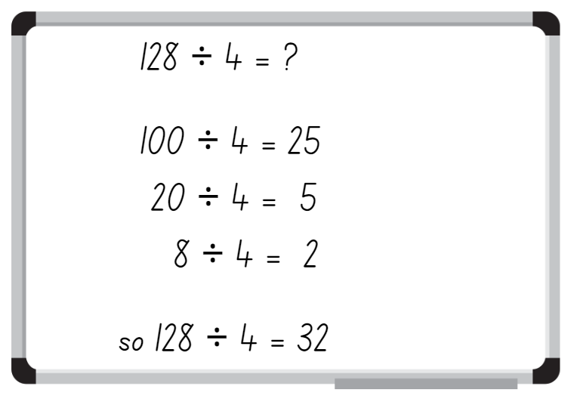
- Students turn and talk to compare and justify their answer with a partner.
- Pose the following problem: There are 136 Year 1 students at this school. These students also need to be allocated into one of the 4 sporting teams. How many students will be in each team?
- Students use whiteboards to record how to use partitioning to solve this problem.
- Students turn and talk to compare and justify their answers with a partner.
This table details opportunities for assessment.
Assessment opportunities | Links
What to look for:  - Can students use knowledge of multiples to partition as appropriate and divide? [MAO-WM-01, MA3-MR-01]  - Can students apply and record appropriate strategies to solve division word problems? [MAO-WM-01, MA3-MR-01] | Links to National Numeracy Learning Progressions (NNLP):  - MuS6, MuS7, MuS8.  Links to suggested Interview for Student Reasoning (IfSR) tasks:  - IfSR-MT: 3A.6, 3A.7.

Core lesson – the lolly shop – 40 minutes
The table below contains a suggested learning intention and success criteria. These are best co-constructed with students.
Core concept learning intention | Core concept success criteria
Students are learning to:  - determine products and factors. | Students can:  - determine factors for a given whole number  - determine whether a number is prime, composite or neither.
This lesson is an adaptation of Liquorice Factory from Arc Learning Sequences by the State Government of Victoria (Department of Education).
- Explain the following problem to students: A lolly shop produces traditional rock candy by hand-rolling and stretching lengths of candy. The shop owner has decided to increase productivity by buying machines to stretch the candy.
- Provide students with interlocking cubes and explain that each cube represents a single unit length of candy.
- Demonstrate that one interlocking cube can be put through a × 2 machine to stretch the candy out to double the length (see Figure 2).
- Repeat the process to demonstrate how a × 3 machine can be used to stretch the candy to triple the length (see Figure 2).
- Ask what would happen if the single block of candy was put through the × 2 machine followed by the × 3 machine (see Figure 2).
Figure 2 – demonstration of different machines
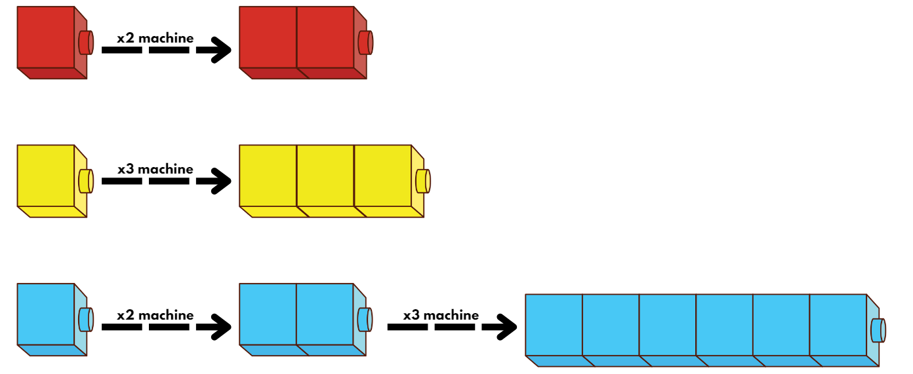
- Explain that the candy can be passed through both the × 2 and × 3 machine to double and then triple the length of candy. (This will produce a stretched length of candy equal to 6 units, or 6 times as long).
- Ask: What would happen if the candy passed through the × 3 machine twice? (This will produce a candy measuring 9 units in length, or 9 times as long).
- Students use interlocking cubes to demonstrate what would happen if they passed one unit of candy through a × 2 machine twice and then through a × 3 machine.
- Students turn and talk and compare representations.
- Explain that the shop owner decided to purchase 3 candy making machines. These produce × 2, × 3 and × 5 lengths of candy.
- Ask: What are some lengths of candy that can be made using these machines? For example, by using a × 2 machine, lengths of 4, 8 and 16 units can be made by repeatedly doubling the one unit of candy.
- Students draw and record the possibilities on whiteboards.
- Ask:
- Can a candy length of 32 units be made using the × 2, × 3 and × 5 machines? How?
- Can a candy length of 61 units be made using these machines?
- Why is it not possible to make a candy with the length of 61 units?
Note: ensure students understand that 61 is a prime number. Therefore, it cannot be made using the × 2, × 3 or × 5 machine. 61 does not have any other factors, except 1 and 61.
- Explain to students that the lolly shop owner has decided to purchase more machines to increase candy production. The factory can produce candy making machines to stretch any unit length from 2–100. As each piece of candy starts as 1 unit length, a machine for 1 is not needed but the 1 unit is included in all processes.
- Display Resource 1 – candy possibilities. Inform students that each number represents a length of candy.
- Ask: If the owner could have any candy making machines from 2–100, what different machines could make candy 12 units in length?
- Provide an example using a think aloud strategy: To make a candy 12 units long, I could use the × 2 machine, then the × 6 machine, so I am going to record 2 and 6. I could also use the × 3 machine and the ×4 machine, so I will record 3 and 4 in my list. I could also use the × 12 machine so I will record 1 and 12 on my list (see Figure 3).
Figure 3 – student candy possibilities recording example
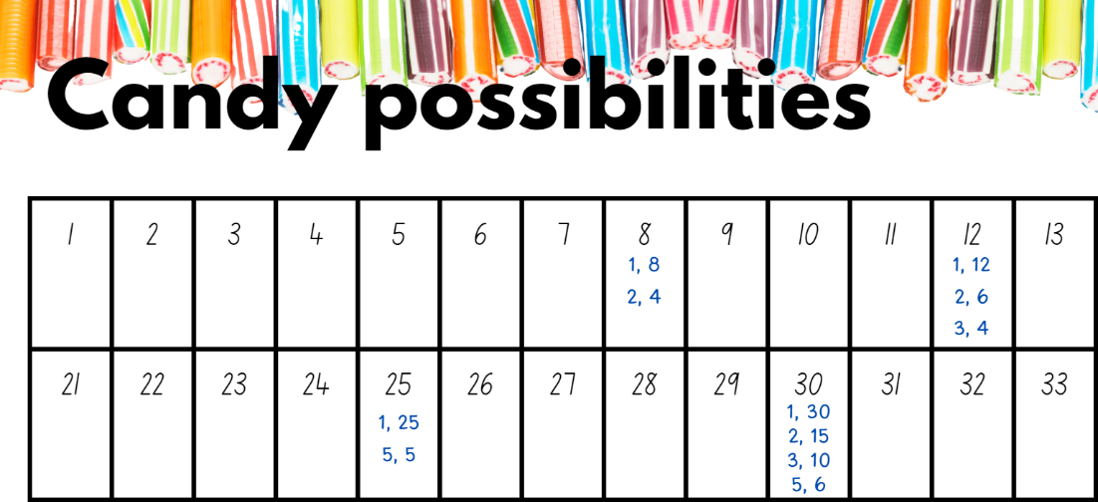
- Record student responses on Resource 1 – candy possibilities.
- Explain to students that the number 12 is a composite number as it has more than one factor.
- Provide students with Resource 1 – candy possibilities.
- In pairs, students determine all the possible machines that can be used to make each length of candy.
- Students record the different combinations of machines that can be used to make lengths of candy (see Figure 3).
- Regroup as a class and discuss the different combinations used to create the lengths of candy.
- Students identify the numbers that do not have many options.
Prime number: a prime number is a positive integer which has exactly 2 distinct factors, itself and one. Modelled as an array, it has only one row. Zero is not an integer and therefore is neither prime nor composite.
Composite number: a non-zero natural number that has a factor other than one and itself. For example, all even numbers besides 2 are composite numbers. Some odd numbers are composite (for example, 21).
- Students highlight or colour the numbers that have only 2 options. Discuss and define these numbers as prime numbers. See definition above.
- Pose the question: If the numbers with only 2 options are prime numbers, what are the other numbers called?
- Discuss and define these numbers as composite numbers. Refer to the definitions of prime and composite numbers. Include in the discussion the fact that zero and one are neither prime nor composite.
This table details opportunities for differentiation.
Too hard? | Too easy?
Students cannot determine factors for a given whole number.  - Provide students with interlocking cubes, with each cube representing one unit in length. Support students to model the doubling and tripling effect of the × 2 machine and the × 3 machine.  - Assist students to use a 6-sided die to generate 2 factors by rolling the die twice. Students multiply to determine the product (length of candy). If the second roll lands on the same number as the first roll, students roll again. | Students can determine factors for a given whole number.  - Roll a 10-sided die 3 times to create a 3-digit number. Record all the factors for the number.  - Pose the problem: One of the × 4 machines broke down overnight. They have had an order to produce candy that is 512 units in length. How can the lolly shop meet the demands of this order? Which machines will they use?

Discuss and connect the mathematics – 10 minutes
- Revise the definitions of prime and composite numbers. Ensure students understand that the number 1 is neither a prime nor a composite number. It has only one factor.
- In pairs, students select a composite number between 1–100. They discuss the most efficient way to create a candy of the selected length. For example, a candy with 25-units of length can be created using the ×5 machine, passing through it twice.
This table details opportunities for assessment.
Assessment opportunities | Links
What to look for:  - Can students determine factors for a given whole number?  [MAO-WM-01, MA3-MR-01]  - Can students determine whether a number is prime, composite or neither? [MAO-WM-01, MA3-MR-01] | Links to National Numeracy Learning Progressions (NNLP):  - MuS6, MuS7.

Lesson 2
Core concept: known number facts and strategies support multiplicative understanding.

Daily number sense – partitioning numbers to divide – 10 minutes
The table below contains a suggested learning intention and success criteria. These are best co-constructed with students.
Daily number sense learning intention | Daily number sense success criteria
Students are learning to:  - select and apply strategies to divide a number with 3 or more digits by a one-digit divisor. | Students can:  - use knowledge of multiples to partition as appropriate and divide.
Note: this activity uses the ‘chipping away’ strategy developed through Stage 3 Year A Unit 7 and Stage 3 Year A Unit 11. When using the ‘chipping away’ strategy, students make progress on a larger task by breaking it into a series of smaller, more easily completed steps.
- Draw the area model for the equation 258 ÷ 6 (see Figure 4).
Figure 4 – area models
- Encourage students to use the ‘chipping away’ strategy to solve the equation 258 ÷ 6.
- Students turn and talk to compare and justify their answers.
- Repeat the process with the equation 741 ÷ 3.
This table details opportunities for assessment.
Assessment opportunities | Links
What to look for:  - Can students use knowledge of multiples to partition as appropriate and divide? [MAO-WM-01, MA3-MR-01] | Links to National Numeracy Learning Progressions (NNLP):  - MuS6, MuS7.  Links to suggested Interview for Student Reasoning (IfSR) tasks:  - IfSR-MT: 3A.6, 3A.7.

Core lesson – multiplying and dividing – 40 minutes
The table below contains suggested learning intentions and success criteria. These are best co-constructed with students.
Core concept learning intentions | Core concept success criteria
Students are learning to:  - determine products and factors  - use partitioning and place value to multiply 2-, 3- and 4-digit numbers by one-digit numbers. | Students can:  - use the term product to describe the result of multiplying 2 or more numbers  - use mental strategies to multiply one-digit numbers by 10, 100, 1000 and their multiples  - estimate the product of 2 numbers (one-digit by 2- or 3-digit numbers) using multiples of 10 or 100.
This lesson is an adaptation of ‘Multiplying numbers by 10, 100 …’ from Building engagement in middle years mathematics: Learning sequences for mixed-ability classrooms by Sullivan.
- Write the equation 6 × 5 = 30 on the whiteboard. Then, write 6 × 50 =.
- Teacher thinks aloud: ‘I know 6 × 5 is 30, and 50 is 10 times larger than 5, so the answer must be 10 times larger than 30’.
- Ask students to determine the answer to the question.
- Using this information, students complete the following equations without using written working out:
- 60 × 5 =
- 600 × 5 =
- 60 × 50 =
- 6 × 5000 =.
Note: the purpose of this activity is for students to realise that the answer for additional equations will be ‘3’ ‘0’ something. For the first equation, students can use estimation to see that the answer is more than 100, but less than 1000, so the answer is 300.
- Ask:
- If 6 × 5 = 30, how did you work 6 × 50?
- What did you notice about the products?
- Do you notice any similarities or differences between the equations?
- Do you see a pattern as you solve the equations?
- How did identifying numbers that are 10 or 100 times as large help to determine the answers?
- Using the information from the previous task, students complete the following equations without written working out:
- 30 ÷ 5 = _
- 300 ÷ 6 = _
- 300 ÷ 50 = _
- 3000 ÷ 5 = _
- 3000 ÷ 60 = _.
- Ask:
- If 6 × 5 = 30, how did you work out 30 ÷ 5?
- How did your knowledge of multiplication and division help you solve these equations?
- What did you notice about the products?
- How did the pattern help to predict what would happen when changing from multiplication to division?
- Pose the question: I am thinking of 2 numbers. One of the numbers has a 0 in the ones place. When I multiply the 2 numbers, the product is 120. What might the numbers be?
- Students turn and talk to discuss solutions and record their ideas on whiteboards.
- Select students to share their solutions and communicate their strategies.
- As an additional task, pose the question: ‘I am thinking of 2 numbers. One of them has a 4 in it. When I multiply the 2 numbers, the product is 800. What might the numbers be?’
- Students turn and talk to discuss solutions and record their ideas on whiteboards.
- Select students to share their solutions and to communicate their strategies.
This table details opportunities for differentiation.
Too hard? | Too easy?
Students cannot use mental strategies to multiply one-digit numbers by 10, 100, 1000 and their multiples.  - Provide resources such as a number slider, hundreds and/or multiplication charts to support multiplicative understanding.  - Support students to focus on multiplying and dividing one-digit numbers by 10 and its multiples. | Students can use mental strategies to multiply one-digit numbers by 10, 100, 1000 and their multiples.  - In pairs, students provide a starting equation for their partner to apply the same strategies as above. For example, student A provides 9 × 5 = 45. Student B completes additional equations to reflect their understanding of 10, 100, 1000 and their multiples.  - Students create their own word problems to determine the factors and products. Encourage students to write statements about each factor and product. For example, ‘I am thinking of 2 numbers. One of the numbers is a prime number. The other number has a zero in the units place. One of the numbers has a 7 in the units place. When I multiply the 2 numbers, the product is 170. What might the numbers be?’

Consolidation and meaningful practice – 10 minutes
- Pose the question: I am thinking of 2 numbers. One of the digits in one of the numbers is 5. When I divide the 2 numbers, the quotient is 4. What might the numbers be?
- Students turn and talk to discuss solutions and record their ideas on whiteboards.
- Select students to share their solutions and to communicate their strategies.
This table details opportunities for assessment.
Assessment opportunities | Links
What to look for:  - Can students use the term product to describe the result of multiplying 2 or more numbers? [MAO-WM-01, MA3-MR-01]  - Can students use mental strategies to multiply one-digit numbers by 10, 100, 1000 and their multiples? [MAO-WM-01, MA3-MR-01]  - Can students estimate the product of 2 numbers (one-digit by 2- or 3-digit numbers) using multiples of 10 or 100?  [MAO-WM-01, MA3-MR-01] | Links to National Numeracy Learning Progressions (NNLP):  - MuS6, MuS7.  Links to suggested Interview for Student Reasoning (IfSR) tasks:  - IfSR-MT: 3A.1, 3A.2, 3A.3.

Lesson 3
Core concept: flexible methods of computation in multiplication and division involve composing and decomposing numbers.

Daily number sense – division word problems – 10 minutes
The table below contains a suggested learning intention and success criteria. These are best co-constructed with students.
Daily number sense learning intention | Daily number sense success criteria
Students are learning to:  - select and apply strategies to divide a number with 3 or more digits by a one-digit divisor. | Students can:  - apply and record appropriate strategies to solve division word problems  - use and interpret remainders in solutions to division problems.
- Write the equation 123 ÷ 6 on the board.
- Before offering writing materials, students estimate the solution for 123 ÷ 6 and determine if there will be a remainder.
- Provide students with whiteboards to record their strategy to solve the equation.
- Pose the question: Farmer Cluck collected 123 eggs and wants to pack them into cartons that hold 6 eggs each. How many cartons can he make?
- Ask:
- How is this question the same or different to the equation you have solved?
- What is a problem that Farmer Cluck may have?
- How can he solve this problem?
- Explain to students that Farmer Cluck cannot divide the remaining eggs into parts. As the remaining objects cannot be divided, the answer will need to be rounded up. Farmer Cluck will need an additional carton to store the remaining 3 eggs.
- Using the same values as above, rewrite the following word problem for students: If 6 books cost $123, how much does one book cost?
- Discuss with students how this question is the same or different to the previous problem.
- Explain that division problems involving money will not have a remainder, because dollars and cents in the Australian currency allow us to deal with the remainder as parts.
This table details opportunities for assessment.
Assessment opportunities | Links
What to look for:  - Can students apply and record appropriate strategies to solve division word problems? [MAO-WM-01, MA3-MR-01]  - Can students use and interpret remainders in solutions to division problems? [MAO-WM-01, MA3-MR-01] | Links to National Numeracy Learning Progressions (NNLP):  - MuS6, MuS7, MuS8.

Core lesson – Can I do that? – 40 minutes
The table below contains suggested learning intentions and success criteria. These are best co-constructed with students.
Core concept learning intentions | Core concept success criteria
Students are learning to:  - use partitioning and place value to multiply 2-, 3-, and 4-digit numbers by one-digit numbers  - apply place value to partition, regroup and rename numbers to 1 billion. | Students can:  - use mental strategies to multiply one-digit numbers by 10, 100, 1000 and their multiples  - estimate the product of 2 numbers (one-digit by 2- or 3- digit numbers) using multiples of 10 or 100  - use the distributive property with partial products to solve problems by multiplying the hundreds, then the tens and then the ones  - regroup numbers in different forms.
- Display Resource 2 – Are we allowed?
- In pairs, students explore and discuss the responses reflected on the resource.
- Ask:
- Which student response is correct?
- Which student response is incorrect?
- Can you find the mistake in their calculations?
- Select pairs of students to justify their reasoning.
- Write the equation 22 × 8 on the board.
- Prompt students to think of a way to solve this multiplication using their knowledge of multiples of 10.
- Provide students with whiteboards. Using their knowledge of multiples of 10, they use the distributive property to record how the equation could be represented in different ways. For example, (20 × 8) + (2 × 8) or (10 × 8) + (10 × 8) + (2 × 8) or (10 × 8) + (12 × 8).
Distributive property: multiplication of numbers is distributive over addition because the product of one number with the sum of 2 others equals the sum of the products of the first number with each of the others. For example, the product of 3 with (4 + 5) gives the same result as the sum of 3 × 4 + 3 × 5.
- Explain the connections between this task and the first task using Resource 2 – Are we allowed?
- Write the following equations on the board:
- 39 × 5
- 4 × 881
- 7628 × 7.
- Students record the different ways each of the equations could be represented using the distributive property.
- Conduct a gallery walk to compare the strategies. Ask:
- Did you see any representations the same as one you recorded?
- Did you see any representations different from ones you recorded?
- What strategies did you use to partition the numbers?
This table details opportunities for differentiation.
Too hard? | Too easy?
Students cannot use the distributive property with partial products to solve problems by multiplying the hundreds, then the tens and then the ones.  - Provide students with alternative equations to multiply 2-digit numbers by a one-digit number. For example, 22 × 4. Assist students to see the relationship between 22 × 4 and 22 × 2 by doubling the answer.  - Support students by providing access to concrete or digital manipulatives such as counters, 10 × 10 multiplication facts chart or digital area model tool. | Students can use the distributive property with partial products to solve problems by multiplying the hundreds, then the tens and then the ones.  - Provide students with a 6-sided die. Students roll the die 4 times to generate a 2-digit number multiplied by 2-digit number. They write 3 statements that are correct and one incorrect statement on a whiteboard. Students swap whiteboards with a partner to identify the statement that is incorrect.  - Provide students with the distributive property to reflect  (200 × _) + (30 × _) + (3 × _) = 666. They find the missing values, then create their own examples for a partner to solve.

Consolidation and meaningful practice – 10 minutes
- Provide students with a 10-sided die and whiteboards.
- Students roll the die 5 times and record each roll on the whiteboard to create an equation that multiplies a 4-digit number by a one-digit number. For example, 4823 × 6. If students land on a 0 as their first or last roll, they roll again.
- Students record different ways each of the equations can be represented using the distributive property to multiply the thousands, hundreds, tens and then the ones. For example, 4821 × 6 = (400 × 6) + (800 × 6) + (20 × 6) + (3 × 6).
This table details opportunities for assessment.
Assessment opportunities | Links
What to look for:  - Can students use mental strategies to multiply one-digit numbers by 10, 100, 1000 and their multiples? [MAO-WM-01, MA3-MR-01]  - Can students estimate the product of 2 numbers (one-digit by 2- or 3- digit numbers) using multiples of 10 or 100?  [MAO-WM-01, MA3-MR-01]  - Can students use the distributive property with partial products to solve problems by multiplying the hundreds, then the tens and then the ones? [MAO-WM-01, MA3-MR-01]  - Can students regroup numbers in different forms?  [MAO-WM-01, MA3-RN-01] | Links to National Numeracy Learning Progressions (NNLP):  - MuS6, MuS7  - NPV6.  Links to suggested Interview for Student Reasoning (IfSR) tasks:  - IfSR-MT: 3A.1, 3A.2, 3A.3.

Lesson 4
Core concept: flexible methods of computation in multiplication and division involve composing and decomposing numbers.

Daily number sense – 10 minutes
- From a class need surfaced through formative assessment data, identify a short, focused activity that targets students’ knowledge, understanding and skills. Example activities may be drawn from the following resources:
- Mathematics K–6 resources
- Universal Resources Hub.

Core lesson – division boxes – 25 minutes
The table below contains suggested learning intentions and success criteria. These are best co-constructed with students.
Core concept learning intentions | Core concept success criteria
Students are learning to:  - use partitioning and place value to multiply 2-, 3- and 4-digit numbers by one-digit numbers  - use estimation and rounding to check the reasonableness of answers to calculations. | Students can:  - use the distributive property with partial products to solve problems by multiplying the hundreds, then the tens and then the ones  - use estimation to check the reasonableness of answers to multiplication and division calculations.
This lesson is an adaptation of ‘Divisibility tests’ from Building engagement in middle years mathematics: Learning sequences for mixed-ability classrooms by Sullivan.
- Display Resource 3 – What am I?
- Discuss how the boxes can be filled using the digits 1–6 to make the following statements true:
- The first digit is divisible by 3.
- The first 2 digits are the product of 4 × 8.
- The last digit is neither a prime nor a composite number.
- It is an odd number.
- Demonstrate strategies that can be used to solve each statement, drawing attention to any prior knowledge required. For example:
- For a number to be divisible by 3, it must be a multiple of 3. Multiples of 3 include 3, 6 and 9.
- A product is the result of 2 numbers multiplied by each other. Four multiplied by 8 is 32.
- If the number is neither prime nor composite, then the number must be 0 or 1.
Multiples: products formed using the same base number multiplied by different whole numbers. For example, 3, 6, 9, 12 …
- Write 320 and 321 on the whiteboard and discuss if either of these numbers will make all the statements true:
- The first digit is 3 and is divisible by 3.
- The product of 4 multiplied by 8 is 32.
- The first 2 digits are 3 and 2.
- The last digit is 0 or 1 and it is not a prime or a composite number.
- 320 isn’t an odd number. The correct answer must be 321.
- Provide students with whiteboards and Resource 4 – task cards.
- In pairs, students complete task cards.
- Regroup as a class and select students to share their solutions and justifications.
- Ask how their knowledge of the following helped solve the problem:
- prime and composite numbers
- factors and products
- place value and partitioning.
This table details opportunities for differentiation.
Too hard? | Too easy?
Students cannot use the distributive property with partial products to solve problems by multiplying the hundreds, then the tens and then the ones.  - Assist students by providing resources such as a hundred chart and/or multiplication facts charts to support multiplicative understanding.  - Provide different 2-digit numbers for students to write statements about. For example, provide the number 24. Students write statements about 24. | Students can use the distributive property with partial products to solve problems by multiplying the hundreds, then the tens and then the ones.  - Students create their own task cards and swap with a partner to solve.  - Provide students with Resource 5 – box puzzle to solve. They try and find as many possibilities as they can to solve the puzzle.

Consolidation and meaningful practice – 25 minutes
- Write the number sentence 321 × 9.
- Explain that using knowledge of multiples of 10 will help, that is, 321 × 9 will be close to, but less than, 321 × 10.
- Provide students with whiteboards and calculators to estimate the answer.
- Demonstrate using the distributive property by writing (300 × 9) + (20 × 9) + (1 × 9). Discuss the place value of each part, asking students to turn and talk to share their thinking.
- Provide time for students to solve the number sentence 321 × 9 and check their answer with a calculator.
- Ask if there is way to use the distributive property and subtraction to solve this problem.
- Students turn and talk to discuss their ideas.
- Demonstrate solving the problem by using the equation (321 × 10) - (321 × 1).
- In pairs, students use the distributive property to estimate a solution then check their answers with a calculator.
- 1384 × 8
- 2473 × 7
- 3842 × 5.
Note: the example 3842 × 5 provides an opportunity for students to explore the idea of 3842 × 10 and then halve the answer. If this is not something that is discovered naturally, students should be encouraged to explore this idea.
This table details opportunities for differentiation.
Too hard? | Too easy?
Students cannot use estimation to check the reasonableness of answers to multiplication calculations.  - Provide students with a set of 3-digit numbers multiplied by a one-digit number to estimate a solution using the distributive property. For example, 384 × 2, 423 × 3 and 842 × 4.  - Assist students in using an area model to partition the 3- and 4-digit number before estimating each part of the distributive property statement. For example, partition 1384 as 1000 + 300 + 80 + 4. Stating 1000 × 8 is close to, but less than, 1000 × 10. | Students can use estimation to check the reasonableness of answers to multiplication calculations.  - Provide students with 5-digit numbers multiplied by a one-digit number to estimate a solution using the distributive property. For example, 92 384 × 6, 79 867 × 8 and 88 675 × 9.  - Students write a set of number sentences to swap with a partner. They use estimation and justify the reason they made that estimation with their partner.
This table details opportunities for assessment.
Assessment opportunities | Links
What to look for:  - Can students use the distributive property with partial products to solve problems by multiplying the hundreds, then the tens and then the ones? [MAO-WM-01, MA3-MR-01]  - Can students use estimation to check the reasonableness of answers to multiplication and division calculations?  [MAO-WM-01, MA3-MR-01] | Links to National Numeracy Learning Progressions (NNLP):  - MuS7.  Links to suggested Interview for Student Reasoning (IfSR) tasks:  - IfSR-MT: 3A.1, 3A.2, 3A.3.

Lesson 5
Core concept: structures can support multiplicative thinking.

Daily number sense – addition algorithm errors – 10 minutes
Daily number sense activities for Lessons 5 to 7 ‘loop’ back to concepts and procedures covered in previous units to assist students to build an increasingly connected network of ideas. These concepts may differ from the core concepts being covered by the unit.
The table below contains a suggested learning intention and success criteria. These are best co-constructed with students.
Daily number sense learning intention | Daily number sense success criteria
Students are learning to:  - use estimation and place value understanding to determine the reasonableness of solutions. | Students can:  - use place value understanding to check for errors in calculations.
- Display Resource 6 – addition algorithm errors. Explain that a student has made some errors with their calculations.
- Ask:
- What errors has the student made in the first algorithm?
- What advice would you give so the error does not happen again?
- What error has the student made in the second algorithm?
- What advice would you give so the error does not happen again?
- Provide students with whiteboards to record the correct working out for both algorithms.
- Students share their working out with a partner and communicate the correct process for the vertical algorithm.
This table details opportunities for assessment.
Assessment opportunities | Links
What to look for:  - Can students use place value understanding to check for errors in calculations? [MAO-WM-01, MA3-AR-01] | Links to National Numeracy Learning Progressions (NNLP):  - NPV5, NPV6  - AdS8.

Core lesson – distributive property with partial products – 40 minutes
The table below contains suggested learning intentions and success criteria. These are best co-constructed with students.
Core concept learning intentions | Core concept success criteria
Students are learning to:  - use partitioning and place value to multiply 2-, 3-, and 4-digit numbers by one-digit numbers  - apply place value to partition, regroup and rename numbers to 1 billion. | Students can:  - use the distributive property with partial products to solve problems by multiplying the hundreds, then the tens and then the ones  - regroup numbers in different forms.
This lesson is an adaptation of Distributive Property with Four by Katz from the Open Middle website.
- Display the number sentence 321 × 9, that was used in the previous lesson. Revise how it could be solved using the distributive property (300 × 9) + (20 × 9) + (1 × 9).
- Write 28 = ( _ _ × 2) + ( _ × 2). Ask: What numbers could be used to make the statement true?
- Explain that this statement is a form of distributive property using partial products.
- Work through the problem on the whiteboard, modelling thinking aloud. For this statement to be true:
- we’re working backwards, so we need to use the inverse of multiplication to find the partial products (the missing numbers).
- so, 28 must first be divided by 2. This equals 14.
- the missing numbers in the blanks must add up to 14.
- 14 can be regrouped in different ways using standard partitioning of 10 and 4, or non-standard regrouping of 11 and 3.
- I cannot use 9 and 5 because one of the numbers needs to have 2 digits.
- Write the statements 28 = (10 × 2) + (4 × 2) and 28 = (11 × 2) + (3 × 2).
- Write another statement 456 = ( _ _ _ × 2) + ( _ _ × 2) + ( _ × 2).
- Provide students with whiteboards and calculators.
- In pairs, students discuss and solve the statement to find the missing numbers. Students can use calculators to test answers where required.
- Regroup as a class and discuss how the solutions may change if the factor 2 is changed to a 4. For example:
- 456 = ( _ _ _ × 4) + ( _ _ × 4) + ( _ × 4).
Factor: a number which divides another number without a remainder. For example, 1, 2, 3 and 6 are factors of 6 but 4 and 5 are not.
- Rewrite the statement 456 = (100 × 4) + (10 × 4) + (4 × 4) and ask if this statement is true.
- In pairs, students find as many solutions as possible for the following statements, using calculators to test answers:
- 366 = ( _ _ _ × 3) + ( _ _ × 3) + ( _ × 3)
- 516 = ( _ _ _ × 4) + ( _ _ × 4) + ( _ × 4)
This table details opportunities for differentiation.
Too hard? | Too easy?
Students cannot use the distributive property to solve multiplication problems.  - Provide students with a set of 2-digit numbers to partition into tens and ones before multiplying by a one-digit number. Support students as they work through the steps to find the solution.  - Assist students in partitioning the number into hundreds, tens and ones before factorising each of the numbers. For example, partition 124 as 100 + 20 + 4, then factorise 100, 20 then 4. | Students can use the distributive property to solve multiplication problems.  - Provide students with a 10-sided die to roll up to 5 times. Students generate a 4-digit number and a factor. The first die roll determines the factor that will be used for each distributive property statement. Each subsequent die roll will determine the first digit of the place value. For example, dice rolls of 5, 6, 3, 7 and 9 will produce a statement of  (6000 × 5) + (300 × 5) + (70 × 5) + (9 × 5).  - Pose the question: 128 = ( _ × 4) + ( _ × 4) + ( _ _ × 4). Challenge students to fill in each blank with the digits 0-9. Each digit can only be used once. There are many possibilities.  For example, 128 = (7 × 4) + (9 × 4) + (16 × 4).

Discuss and connect the mathematics – 10 minutes
- Regroup as a class and select students to share their solutions for 366 = ( _ _ _ × 3) + ( _ _ × 3) + ( _ × 3). Although 366 is a multiple of 3, there are many solutions to the number. This will depend on how it is partitioned. Students may use standard or non-standard partitioning to find:
- 366 = (100 × 3) + (20 × 3) + (2 × 3)
- 366 = (100 × 3) + (15 × 3) + (7 × 3)
- In groups, students share their solutions for 516 = ( _ _ _ × 4) + ( _ _ × 4) + ( _ × 4) and use calculators to check answers.
This table details opportunities for assessment.
Assessment opportunities | Links
What to look for:  - Can students use the distributive property with the area model to partition numbers in representing multiplication problems?  [MAO-WM-01, MA3-MR-01]  - Can students use the distributive property with partial products to solve problems by multiplying the hundreds, then the tens and then the ones? [MAO-WM-01, MA3-MR-01]  - Can students regroup numbers in different forms?  [MAO-WM-01, MA3-RN-01] | Links to National Numeracy Learning Progressions (NNLP):  - MuS7  - NPV6.  Links to suggested Interview for Student Reasoning (IfSR) tasks:  - IfSR-MT: 3A.1, 3A.2, 3A.3.

Lesson 6
Core concept: mathematicians use algorithms with understanding to solve multiplicative problems.

Daily number sense – subtraction algorithm errors – 10 minutes
The table below contains a suggested learning intention and success criteria. These are best co-constructed with students.
Daily number sense learning intention | Daily number sense success criteria
Students are learning to:  - use estimation and place value understanding to determine the reasonableness of solutions. | Students can:  - use place value understanding to check for errors in calculations  - use estimation to check the reasonableness of solutions to addition and subtraction calculations.
- Write the algorithm 43 − 16 = 33 on the board. Ask:
- Can you estimate to determine if the answer to this equation is reasonable? Why or why not?
- What error has been made in this algorithm?
- Why might this error have been made?
- What advice would you give so this error does not happen again?
- Students turn and talk to discuss their thinking.
- Provide students with whiteboards to record the correct working out for the equation.
- Students share their working out with a partner and communicate the process used to solve it.
- Write the algorithm 3004 − 468 = 3644 on the board. Ask:
- Can you estimate to determine if the answer to this equation is reasonable? Why or why not?
- What errors have been made in this algorithm?
- Why might these errors have been made?
- What advice would you give so this error does not happen again?
- Provide students with whiteboards to record the correct working out for the equation.
- Students share their working out with a partner and communicate the process used to solve it.
This table details opportunities for assessment.
Assessment opportunities | Links
What to look for:  - Can students use place value understanding to check for errors in calculations? [MAO-WM-01, MA3-AR-01]  - Can students use estimation to check the reasonableness of solutions to addition and subtraction calculations?  [MAO-WM-01, MA3-AR-01] | Links to National Numeracy Learning Progressions (NNLP):  - NPV5, NPV6  - AdS8.

Core lesson – area model 1000 – 30 minutes
The table below contains suggested learning intentions and success criteria. These are best co-constructed with students.
Core concept learning intentions | Core concept success criteria
Students are learning to:  - use partitioning and place value to multiply 2-, 3- and 4-digit numbers by one-digit numbers  - select and apply mental and written strategies to multiply 2- and 3-digit numbers by 2-digit numbers. | Students can:  - use the distributive property with the area model to partition numbers in representing multiplication problems  - extend the area model to represent 2-digit by 2-digit multiplication  - use a multiplication algorithm with understanding.
This activity is an adaptation of Multiplying Two-Digit Numbers – Closest to 7000 by Tolomeo from the Open Middle website.
- Revise using the area model to multiply 2-digit by a one-digit number.
- Provide students with whiteboards, a 6-sided die and calculators.
- Ask: Can you predict how an area model could be used to multiply a 2-digit number by a 2-digit number? Students draw on their whiteboards how this could be represented.
- Students turn and talk to discuss their representations.
- Draw an area model to represent 24 × 35 and demonstrate the use of the area model to solve the equation (see Figure 5).
Figure 5 – area model example
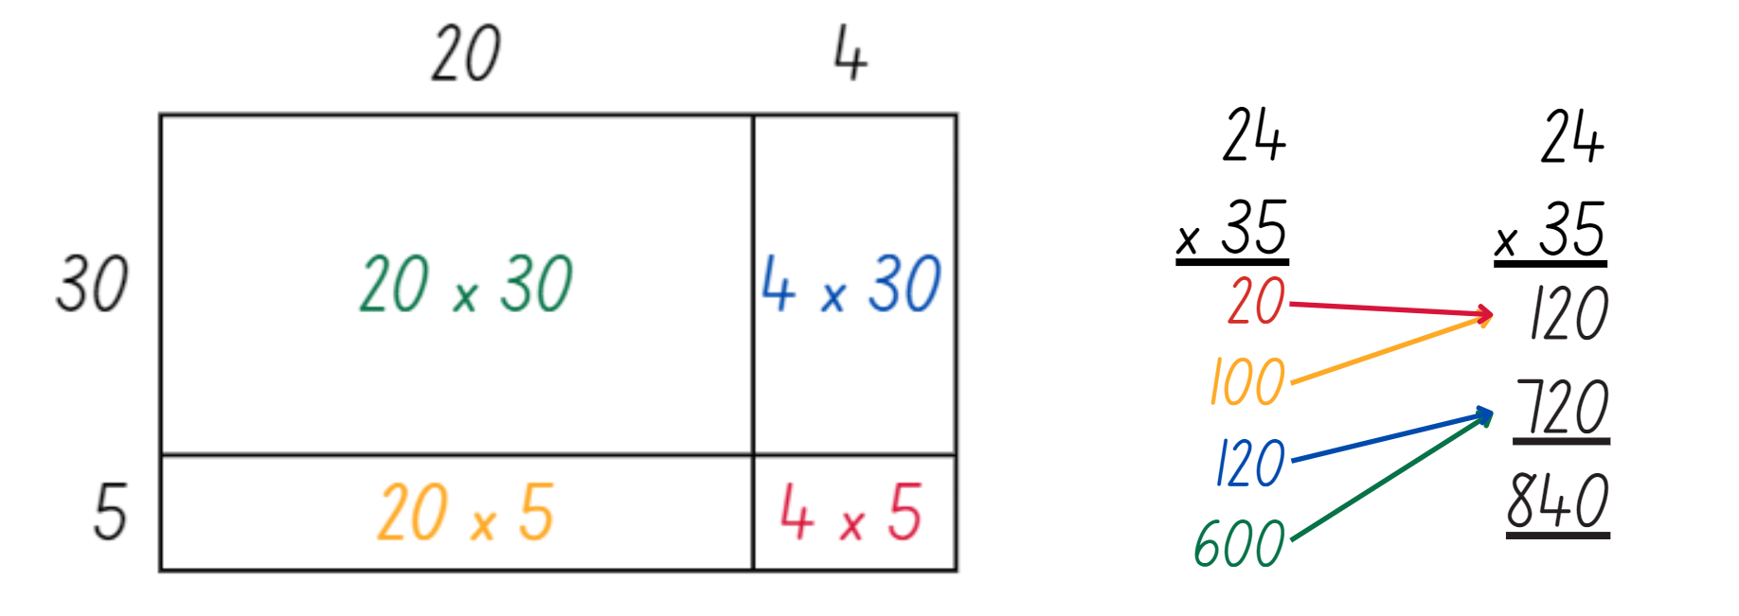
- Select students to compare similarities and differences between the use of an area model and a multiplication algorithm (see Figure 6).
Figure 6 – area model with algorithm
- Explain that the use of an algorithm involves adding a 0 at the end of each subsequent line to represent the change in place values.
- In pairs, students roll a 6-sided die 4 times to generate two 2-digit numbers. The result of each die roll does not determine the order of the digits. For example, if the roll lands on 3, 4, 6, 0, students may choose to multiply 34 × 60 or 30 × 46.
- Students use calculators to check their answers for each quadrant of the area model.
This table details opportunities for differentiation.
Too hard? | Too easy?
Students cannot extend the area model to represent 2-digit by 2-digit multiplication.  - Assist students to partition numbers into 2-digit by one-digit multiplication statements incorporating their understanding of 10 times as large (see Figure 7).  Figure 7 – partition and multiply  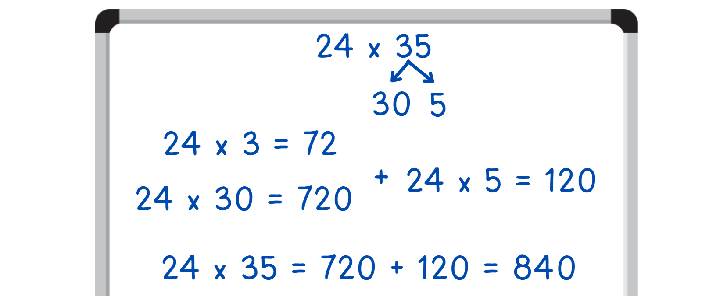  - Support students to use the digital area model tool to partition and solve the equations. | Students can extend the area model to represent 2-digit by 2-digit multiplication.  - Provide students with a 10-sided die to determine the product of two 2-digit numbers up to 99. Students use the area model or multiplication algorithm to solve.  - Provide students with a 6-sided die. Students roll the die 5 times to produce a 3-digit number and a 2-digit number to multiply. Students use multiplication algorithms to solve.

Consolidation and meaningful practice – 20 minutes
- Repeat this activity by introducing ‘closest to 1000’. The aim of the game is to have the answer closest to 1000.
- In pairs, students roll the die 4 times. Student A decides on two 2-digit numbers from the die roll, and Student B decides on another two 2-digit number from the die roll.
- Students solve the multiplication of their two 2-digit numbers using the area model.
- Provide calculators to check solutions, if required.
- The student with the answer closest to 1000 wins that round.
This table details opportunities for assessment.
Assessment opportunities | Links
What to look for:  - Can students use partitioning and place value to multiply 2-, 3- and 4-digit numbers by one-digit numbers?  [MAO-WM-01, MA3-MR-01]  - Can students extend the area model to represent 2-digit by 2-digit multiplication? [MAO-WM-01, MA3-MR-01]  - Can students use a multiplication algorithm with understanding? [MAO-WM-01, MA3-MR-01] | Links to National Numeracy Learning Progressions (NNLP):  - MuS6, MuS7, MuS8.  Links to suggested Interview for Student Reasoning (IfSR) tasks:  - IfSR-MT: 3A.1, 3A.2, 3A.3, 3A.4, 3A.5.

Lesson 7
Core concept: Euclidean division emphasises the relationship between multiplication and division.

Daily number sense – checking using estimating – 10 minutes
The table below contains a suggested learning intention and success criteria. These are best co-constructed with students.
Daily number sense learning intention | Daily number sense success criteria
Students are learning to:  - use estimation and place value understanding to determine the reasonableness of solutions. | Students can:  - use place value understanding to check for errors in calculations  - use estimation to check the reasonableness of solutions to addition and subtraction calculations.
This activity is an adaptation of Checking Addition and Subtraction by Estimation from NZ Maths by the New Zealand Ministry of Education.
- Pose the following problem: Finn adds 45 678 and 589 on his calculator and gets 45 089.
- Write the algorithm 45 678 + 589 = 45 089 on the board. Ask:
- Why must Finn’s calculations be wrong? Answer: the answer must be bigger than 45 678 because he is adding.
- What do you think Finn did wrong when calculating? (Answer: he pressed the subtraction button rather than the addition button).
- What is a reasonable estimation for the solution of 45 678 + 589?
- Students justify their thinking. For example, 678 + 589 is going to be over 1000, so the answer must be just over 46 000.
This table details opportunities for assessment.
Assessment opportunities | Links
What to look for:  - Can students use place value understanding to check for errors in calculations? [MAO-WM-01, MA3-AR-01]  - Can students use estimation to check the reasonableness of solutions to addition and subtraction calculations?  [MAO-WM-01, MA3-AR-01] | Links to National Numeracy Learning Progressions (NNLP):  - NPV5, NPV6  - AdS8.

Core lesson 1 – the athletics carnival – 15 minutes
The table below contains suggested learning intentions and success criteria. These are best co-constructed with students.
Core concept learning intentions | Core concept success criteria
Students are learning to:  - represent and solve division problems with whole number remainders  - apply place value to partition, regroup and rename numbers to 1 billion. | Students can:  - model division, including where the answer involves a remainder, using materials or diagrams  - record remainders in words to division problems  - show the connection between division and multiplication involving the divisor and quotient.  - regroup numbers in different forms.
This activity is an adaptation of ‘Patterns with remainders’ from Challenging mathematical tasks: Unlocking the potential of all students by Sullivan.
- Revise the idea that when solving division problems, the answers may include remainders. Explain that the context of the problem will determine if the remainders can be parts, or whether they need to be whole numbers.
- Pose the question: Some students were competing in an event at the athletics carnival. When they were put into groups of 3, one student was left over. When they were put into groups of 4 there were 2 students left over. How many students might have been competing in the event at the athletics carnival?
- Using whiteboards, students record their solutions using a table, or drawings (see Figure 8).
Figure 8 – possible student recordings
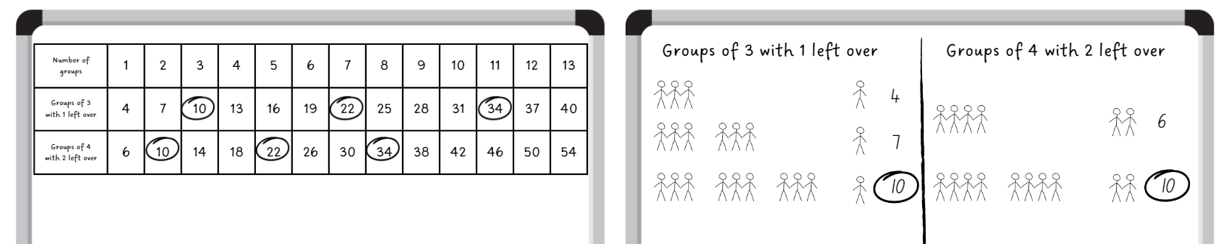
Note: there is a pattern in the possible answers, but do not mention this at first. Once students find one answer, ask them to find more and to notice if there is a pattern with the answers. Encourage students to record the solutions using a table, rather than drawings. This will allow them to see the pattern more clearly.
- Ask:
- How many students might have competed in the event at the athletics carnival?
- Can you see a pattern forming with the possible number of students competing? What is it? (The pattern is increasing by twelves).
- Now that you have noticed the pattern, can you think of more possibilities for numbers of students that you did not record? What are they?
This table details opportunities for differentiation.
Too hard? | Too easy?
Students cannot model division, including where the answer involves a remainder, using materials or diagrams.  - Provide students with counters to form equal groups of 3 with one remainder and equal groups of 4 with 2 remainders to assist in finding possible solutions.  - Support students to create a table, as in Figure 8 to record their results in, drawing their attention to the pattern formed when recording numbers. | Students can model division, including where the answer involves a remainder, using materials or diagrams.  - In pairs, students consider why the pattern was increasing by 12. Explain why this was happening to another pair of students.  - Pose the following problem for students to solve: Some other students were competing in another event at the athletics carnival. When they were put into groups of 6, 2 students were left over. When they were put into groups of 8 there were 4 students left over. How many students might have competed in this event at the athletics carnival?

Core lesson 2 – ribbons for the carnival – 35 minutes
This activity is an adaptation of Susie’s dilemma from Arc Learning: Mathematics Curriculum Companion by the State Government of Victoria (Department of Education).
- Explain that after the athletics carnival Mrs Kelly had to organise the ribbons for the students who came first, second and third in all the events.
- Display Resource 7 – carnival ribbons.
- Pose the following problem: Mrs Kelly keeps the ribbons for the athletics carnival in a box in the storeroom. She has no idea how many ribbons are in the box and begins counting them one by one. After a few attempts Mrs Kelly noticed that she would always lose count when she got to 100. To make counting easier, she decided to divide them into equal stacks. Using the clues provided, figure out how many ribbons were in the box. What advice would you give Mrs Kelly for organising her ribbons?
- The clues are:
- Mrs Kelly divided them into stacks of 5. This resulted in a remainder of 2 ribbons.
- She tried making stacks of 7. When she finished there were 6 left over.
- Next, she tried stacks of 8. This resulted in a remainder of 4 ribbons.
- Then she tried stacks of 9. When she had finished there were 6 left over.
- She also noticed any stacks she made of 25 or more ribbons would collapse.
- Provide students with a whiteboard and Resource 8 – number chart. The whiteboard can be used for working out. The number chart is for keeping a record of eliminated numbers based on the clues provided. It will also show the number that is the solution to the problem.
- Remind students that the problem stated that there are more than 100 ribbons in the box.
- Encourage students to use their knowledge of multiplication to assist in solving the first step of this problem. They record remainders in words. For example:
- 130 is a multiple of 5. 130 ÷ 5 = 26. 132 ÷ 5 = 26 remainder 2.
- 126 is a multiple of 7. 126 ÷ 7 = 18. 132 ÷ 7 = 18 remainder 6.
- 128 is a multiple of 8. 128 ÷ 8 = 16. 132 ÷ 8 = 16 remainder 4.
- 126 is a multiple of 9. 126 ÷ 9 = 14. 132 ÷ 9 = 14 remainder 6.
- Remind students that Mrs Kelly does not want to make stacks of 25 ribbons or more because they fall over. Encourage students to use their knowledge of multiplication and factors to assist them in solving the next step of this problem (see Figure 9).
Figure 9 – possible student recording
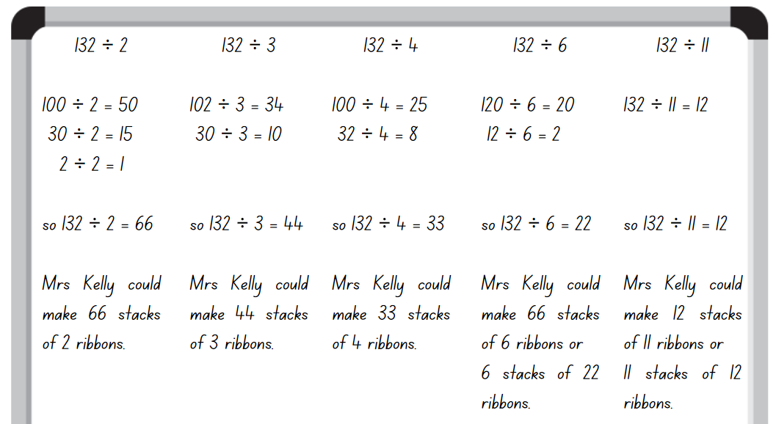
- Ask:
- How many ribbons did Mrs Kelly have in the box? (132).
- How many possible solutions did you find? What were they?
- What would be the most reasonable answer for this problem? (For example, Mrs Kelly making 66 stacks of 2, 44 stacks of 3 or 33 stacks of 4 would not be the most productive way for her to count the ribbons).
- How did your knowledge of multiplication help you to solve this problem?
This table details opportunities for differentiation.
Too hard? | Too easy?
Students cannot model division, including where the answer involves a remainder, using materials or diagrams.  - Provide students with a multiplication chart and/or a hundred chart to assist them in recognising the patterns of multiples and factors of given numbers. For example, 5 or 2.  - Assist students to use Resource 8 – number chart to find the possibilities and impossibilities to solve the problem. | Students can model division, including where the answer involves a remainder, using materials or diagrams.  - Students create their own word problem with remainders and swap with a partner to solve.  - Students use the strategies they have used during this lesson to solve the following problem: There are 6 age groups, 4 track events and 4 field events at the athletics carnival each year. Ribbons are awarded to the students who come first, second or third in each event for each age group. Ribbons come in bulk packs of 100 ribbons per box. If Mrs Kelly wanted to order ribbons for the following 6 years, how many boxes would she need to order and how many ribbons would she have remaining for the following year? (Answer: 864 = 9 boxes of 100 ribbons with 36 remaining).

Discuss and connect the mathematics – 10 minutes
Note: the Stage 3 teaching advice states that Euclidean division is whole number division with a remainder, where the remainder is recorded as a whole number. Euclidean division can also be expressed using multiplication. For example, the result 53 ÷ 3 = 17 with remainder 2, can be expressed as 53 = 3 × 17 + 2 (NESA 2022).
- Display Resource 9 – table recording. Remind students about the connection between division and multiplication.
- Write 34 ÷ 4 = 8 remainder 2 and 32 = 4 × 8 + 2 on the board. Ask students to identify what connections they see between the 2 equations.
- Explain that in the first equation, the dividend is 34, the divisor is 4, the quotient is 8 and the remainder is 2. In the second equation, 4 and 8 are multiplied together to make 30, with the 2 remainders added to equal 32.
Dividend: the number that is divided or distributed in a division problem. For example, in 12 ÷ 3 = 4, 12 is the dividend.
Divisor: a number by which another number is divided by. For example, in 12 ÷ 3 = 4, 3 is the divisor.
Quotient: the result of dividing one number or algebraic expression by another. For example, in 12 ÷ 3 = 4, 4 is the quotient.
Note: although multiplication is commutative, division is not. Therefore, distinguishing between the divisor and the dividend is important. When modelling division problems, it is important to identify the divisor and its position following the division symbol.
- Students record connected division and multiplication equations on whiteboards using the data from Resource 9 – table recording. For example, 10 ÷ 3 = 3 remainder 1 and 10 = 3 × 3 + 1.
This table details opportunities for assessment.
Assessment opportunities | Links
What to look for:  - Can students model division, including where the answer involves a remainder, using materials or diagrams?  [MAO-WM-01, MA3-MR-01]  - Can students record remainders in words to division problems? [MAO-WM-01, MA3-MR-01]  - Can students show the connection between division and multiplication involving the divisor and quotient?  [MAO-WM-01, MA3-MR-01]  - Can students regroup numbers in different forms?  [MAO-WM-01, MA3-RN-01] | Links to National Numeracy Learning Progressions (NNLP):  - MuS6, MuS7  - NPV6.

Lesson 8
Core concept: worded problems can be solved using multiplicative thinking.

Daily number sense – 10 minutes
- From a class need surfaced through formative assessment data, identify a short, focused activity that targets students’ knowledge, understanding and skills. Example activities may be drawn from the following resources:
- Mathematics K–6 resources
- Universal Resources Hub.

Core lesson – interpreting division in worded problems – 35 minutes
The table below contains a suggested learning intention and success criteria. These are best co-constructed with students.
Core concept learning intention | Core concept success criteria
Students are learning to:  - select and apply strategies to divide a number with 3 or more digits by a one-digit divisor. | Students can:  - estimate the result of dividing by a one-digit divisor  - apply and record appropriate strategies to solve division word problems  - use and interpret remainders in solutions to division problems.
This activity is an adaptation of ‘How many are left?’ from Open-ended maths activities: Using ‘good’ questions to enhance learning in mathematics by Sullivan and Lilburn.
- Revise the idea that sometimes when solving division problems, the answers may include remainders. Depending on the context of the division, sometimes the remainders can be parts and sometimes they need to be whole numbers.
- Pose the following question: There are 187 people who need to cross a crocodile infested river. The ferry can carry 6 people each trip. If they fill the boat each time, how many people will be left for the last trip?
- Provide whiteboards and writing materials. Students record their initial estimates.
- Select students to share their estimates and explain their reasoning.
- Explain that the number 187 can be partitioned as 180 + 7. 180 can be divided by 6 to give 30. 7 divided by 6 will give 1 remainder 1 (see Figure 10).
Figure 10 – 187 partitioned
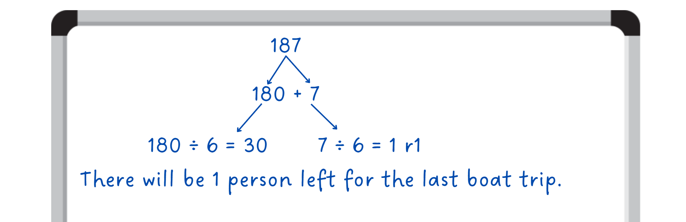
- Ask the selected students to identify how many people would be on the final boat trip and to explain how they determined their answer.
- Display Resource 10 – problems to solve Students complete the following problems:
- The local soccer club is making prize bags for the end of year celebration. Each bag must have 8 prizes. If they have 214 prizes to begin with, how many prize bags can they make? Will there be any remaining prizes not in a bag?
- The school raffle raised $2140. Each of the 8 classes received the same amount to spend on resources. How much money did each class get?
- A train from Cairns to Sydney travels at an average speed of 80 km/h. How long would it take to travel approximately 2140 km to Sydney if the train does not stop?
- Discuss with students the similarities and differences between each question.
Note: the word problems all have variations of the numbers 214 and 8. The last word problem refers to distance and travel times. Encourage students to think about how to calculate these numbers when working with numbers involving multiplies of tens and hundreds. The number 80 is made up of 8 tens, and the number 2140 is made up of 214 tens.
- Remind students that in the Lesson 3 Daily number sense activity, the division problem involved money which did not have a remainder as there are dollars and cents in Australian currency. This can be applied to the raffle problem.
- Explain that for the travel word problem, there are no remainders as time is measured in hours and minutes.
This table details opportunities for differentiation.
Too hard? | Too easy?
Students cannot apply and record appropriate strategies to solve division word problems.  - Support students to use standard and non-standard partitioning to solve division word problems.  - Provide students with more word problems with a 3-digit by a one-digit divisor. For example, the school raffle raised $214. Each of the 8 classes received the same amount to spend on resources. How much money did each class get? | Students can apply and record appropriate strategies to solve division word problems.  - Students create their own word problems involving 3- and 4-digit numbers by one-digit divisors for a partner to solve.  - Pose the following problem: A train is travelling from Cairns to Sydney then from Sydney to Adelaide. It is approximately 2140 km from Cairns to Sydney and 1400 km from Sydney to Adelaide. The train travels at an average speed of 80 km/h. How long will the train journey take Cairns to Adelaide?

Consolidation and meaningful practice – 15 minutes
- Challenge students to write 2 different word problems. The first has the answer 2$\frac{1}{4}$. The second has the answer 2 and one remainder.
- Students turn and talk to discuss scenarios where fractions and remainders are used in division problems.
- In pairs, students write a word problem for each of the answers, one with fractions and one with whole number remainders.
- Ask:
- What type of scenarios were appropriate for fraction answers?
- What type of scenarios were appropriate for remainder answers?
- What strategies made this easiest to complete?
- Is there more than one solution to the problem?
This table details opportunities for assessment.
Assessment opportunities | Links
What to look for:  - Can students estimate the result of dividing by a one-digit divisor? [MAO-WM-01, MA3-MR-01]  - Can students apply and record appropriate strategies to solve division word problems? [MAO-WM-01, MA3-MR-01]  - Can students use and interpret remainders in solutions to division problems? [MAO-WM-01, MA3-MR-01] | Links to National Numeracy Learning Progressions (NNLP):  - MuS6, MuS7, MuS8.

Resource 1 – candy possibilities
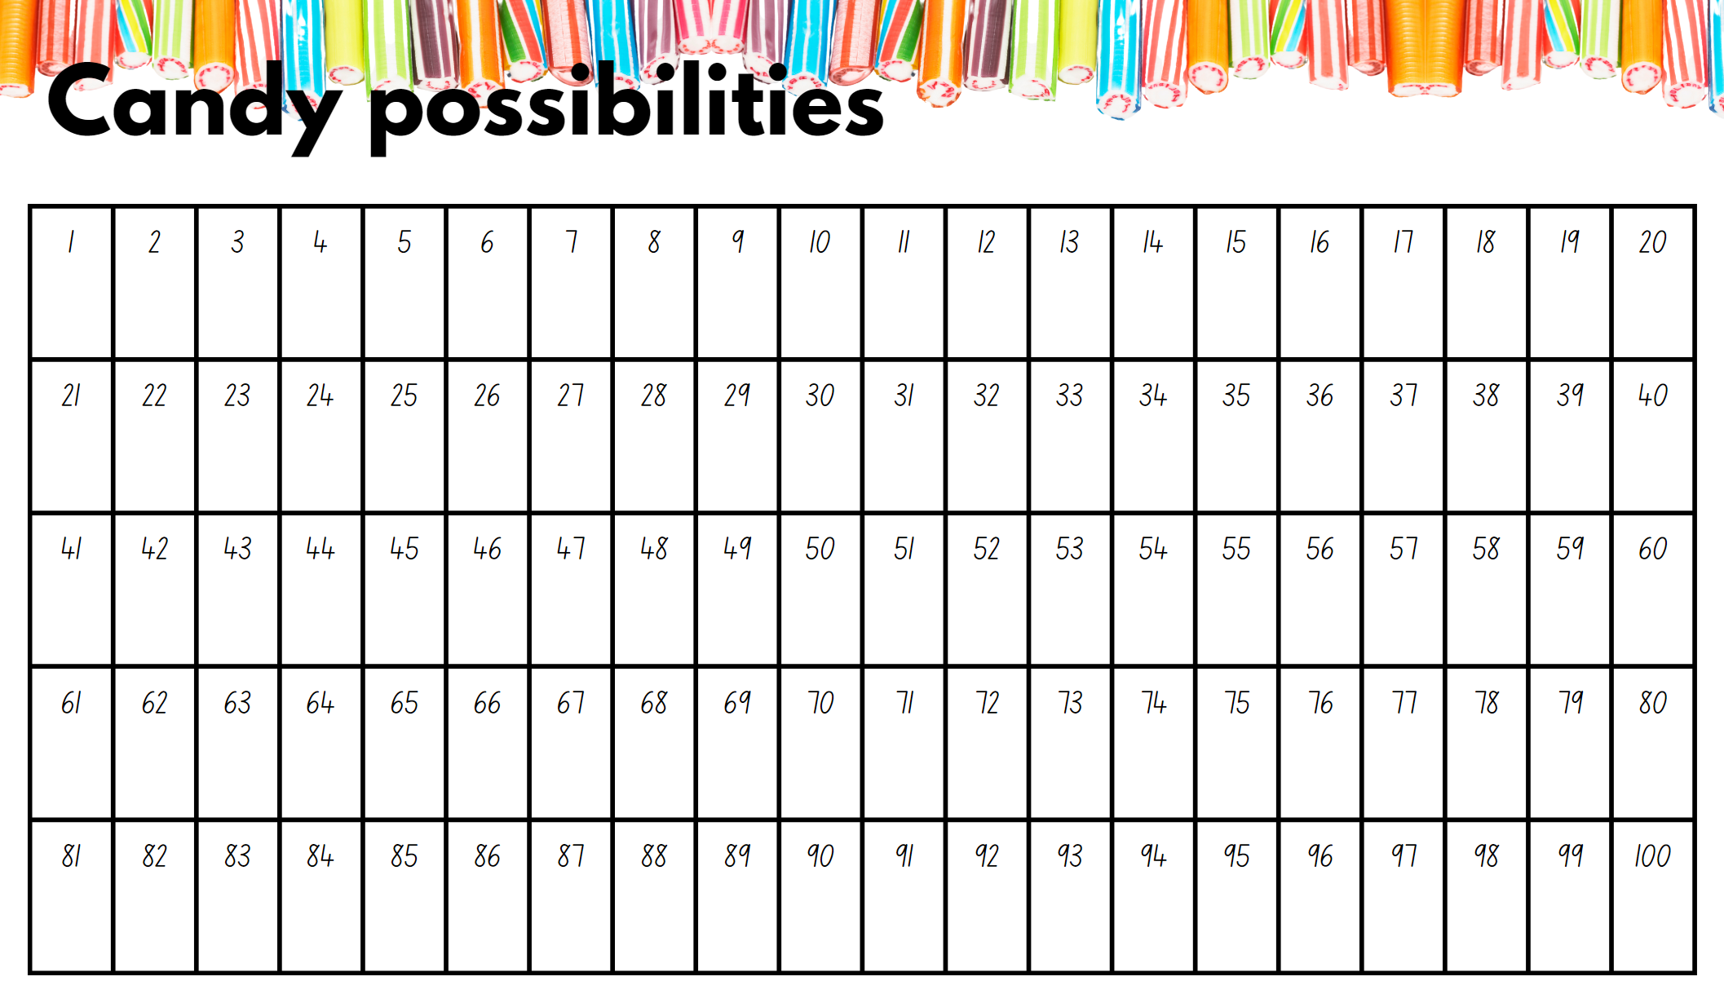

Resource 2 – Are we allowed?
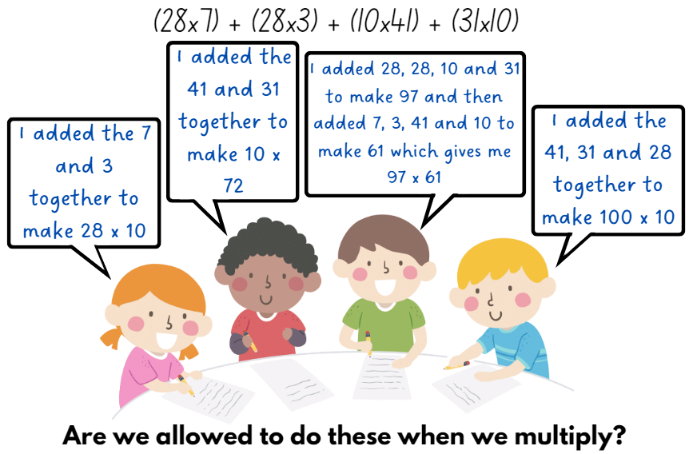

Resource 3 – What am I?
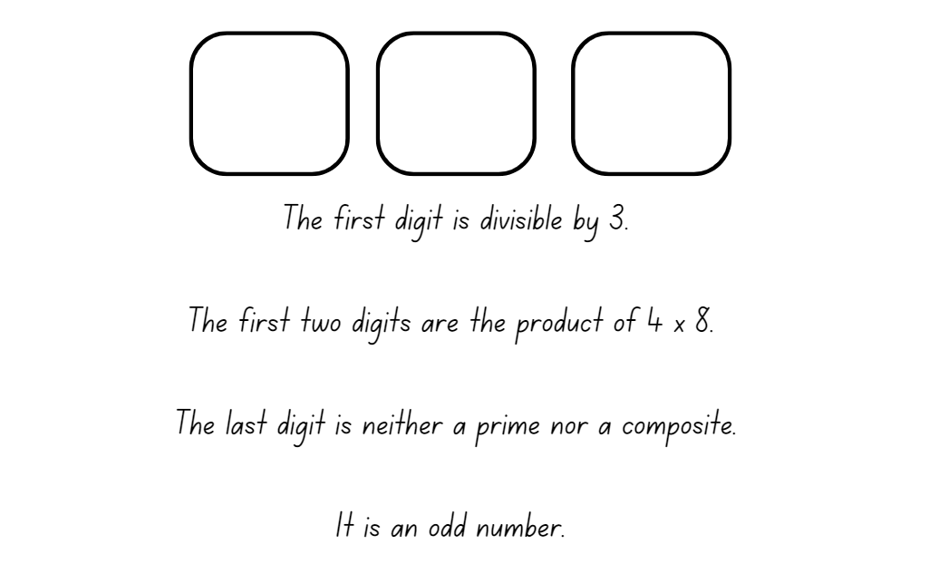

Resource 4 – task cards
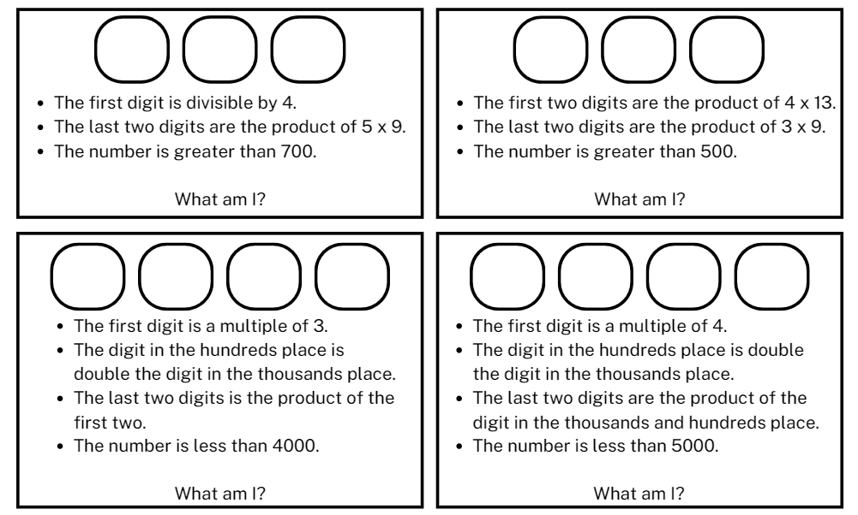

Resource 5 – box puzzle
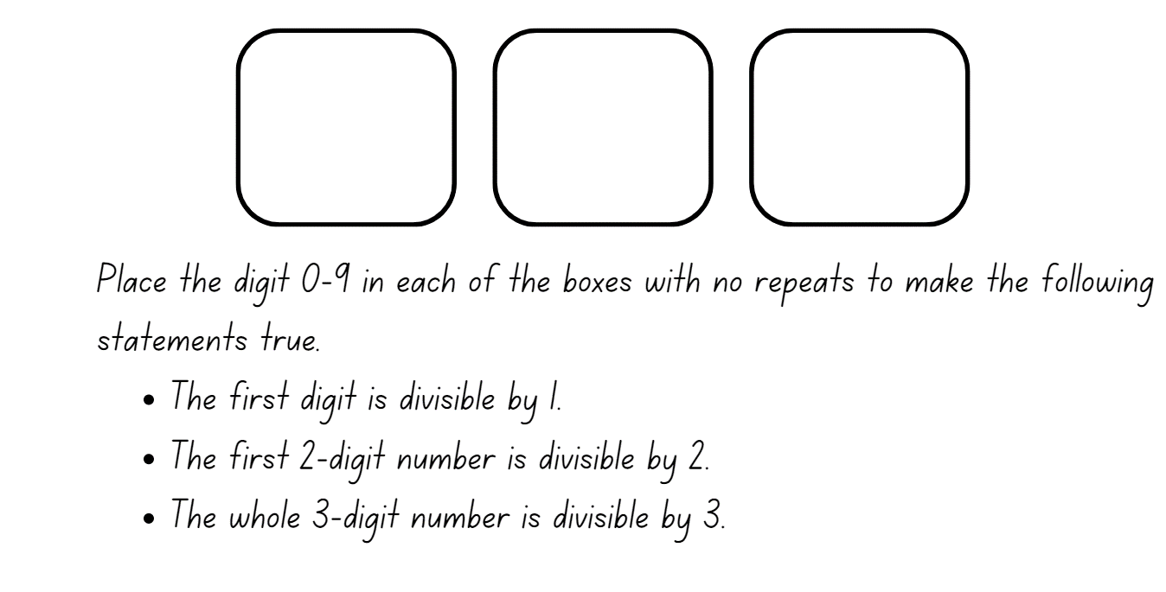

Resource 6 – addition algorithm errors
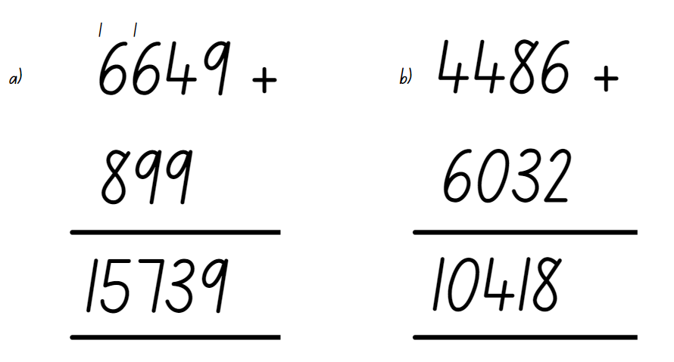

Resource 7 – carnival ribbons
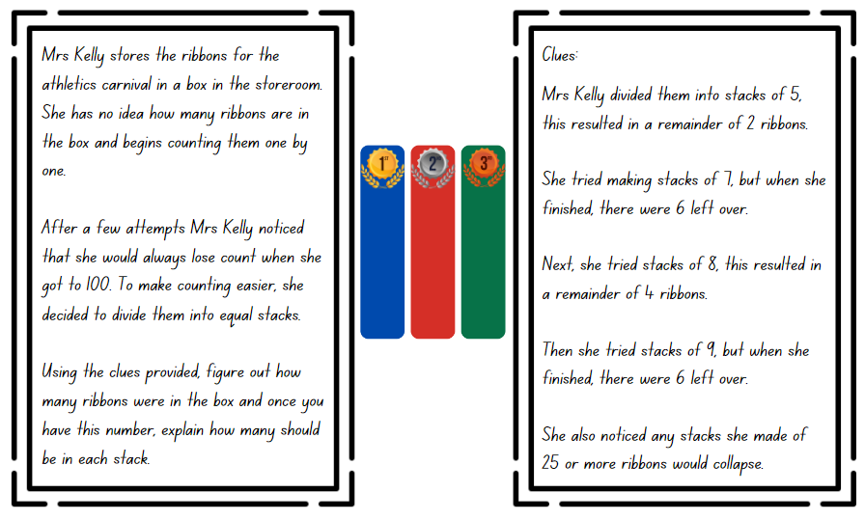

Resource 8 – number chart
101 | 102 | 103 | 104 | 105 | 106 | 107 | 108 | 109 | 110
111 | 112 | 113 | 114 | 115 | 116 | 117 | 118 | 119 | 120
121 | 122 | 123 | 124 | 125 | 126 | 127 | 128 | 129 | 130
131 | 132 | 133 | 134 | 135 | 136 | 137 | 138 | 139 | 140
141 | 142 | 143 | 144 | 145 | 146 | 147 | 148 | 149 | 150

Resource 9 – table recording
Number of groups | 1 | 2 | 3 | 4 | 5 | 6 | 7 | 8 | 9 | 10 | 11 | 12 | 13
Groups of 3 students with 1 student left over | 4 | 7 | 10 | 13 | 16 | 19 | 22 | 25 | 28 | 31 | 34 | 37 | 40
Groups of 4 students with 2 students left over | 6 | 10 | 14 | 18 | 22 | 26 | 30 | 34 | 38 | 42 | 46 | 50 | 54

Resource 10 – problems to solve
The local soccer club is making prize bags for the end of year celebration. Each bag must have 8 prizes. If they have 214 prizes to begin with, how many prize bags can they make?
Will there be any remaining prizes not in a bag?

The school raffle raised $2140. Each of the 8 classes received the same amount to spend on resources. How much money did each class get?

A train from Cairns to Sydney travels at an average speed of 80 km/h. How long would it take to travel approximately 2140 km to Sydney if the train does not stop?

Syllabus outcomes and content
The table below outlines the syllabus outcomes and range of relevant syllabus content covered in this unit. Content is linked to National Numeracy Learning Progression (version 3).
Outcomes and content | 1 | 2 | 3 | 4 | 5 | 6 | 7 | 8
Represent numbers A: Whole numbers: Apply place value to partition, regroup and rename numbers to 1 billion
MAO-WM-01, MA3-RN-01
- Regroup numbers in different forms (Reasons about quantity) |  |  | x | x | x |  | x
Additive relations A: Use estimation and place value understanding to determine the reasonableness of solutions
MAO-WM-01, MA3-AR-01
- Use place value understanding to check for errors in calculations |  |  |  |  | x | x | x
- Use estimation to check the reasonableness of solutions to addition and subtraction calculations |  |  |  |  |  | x | x
Multiplicative relations A: Determine products and factors
MAO-WM-01, MA3-MR-01
- Use the term product to describe the result of multiplying 2 or more numbers |  | x
- Determine factors for a given whole number | x |  |  | x
- Determine whether a number is prime, composite or neither (0 or 1) | x
Multiplicative relations A: Use partitioning and place value to multiply 2-, 3- and 4-digit numbers by one-digit numbers
MAO-WM-01, MA3-MR-01
- Use mental strategies to multiply one-digit numbers by 10, 100, 1000 and their multiples |  | x | x
- Estimate the product of 2 numbers (one-digit by 2- or 3-digit numbers) using multiples of 10 or 100 |  | x | x
- Use the distributive property with the area model to partition numbers in representing multiplication problems |  |  |  |  |  | x
- Use the distributive property with partial products to solve problems by multiplying the hundreds, then the tens and then the ones |  |  | x | x | x
Multiplicative relations A: Select and apply mental and written strategies to multiply 2- and 3-digit numbers by 2-digit numbers
MAO-WM-01, MA3-MR-01
- Extend the area model to represent 2-digit by 2-digit multiplication |  |  |  |  |  | x
- Use a multiplication algorithm with understanding (Reasons about relations) |  |  |  |  |  | x
Multiplicative relations A: Represent and solve division problems with whole number remainders
MAO-WM-01, MA3-MR-01
- Model division, including where the answer involves a remainder, using materials or diagrams |  |  |  |  |  |  | x
- Record remainders in words to division problems |  |  |  |  |  |  | x
- Show the connection between division and multiplication involving the divisor and quotient |  |  |  |  |  |  | x
Multiplicative relations A: Select and apply strategies to divide a number with 3 or more digits by a one-digit divisor
MAO-WM-01, MA-MR-01
- Estimate the result of dividing by a one-digit divisor |  |  |  |  |  |  |  | x
- Use knowledge of multiples to partition as appropriate and divide | x | x
- Apply and record appropriate strategies to solve division word problems | x |  | x |  |  |  |  | x
- Use and interpret remainders in solutions to division problems |  |  | x |  |  |  |  | x
Multiplicative relations A: Use estimation and rounding to check the reasonableness of answers to calculations
MAO-WM-01, MA3-MR-01
- Use estimation to check the reasonableness of answers to multiplication and division calculations |  |  |  | x
Mathematics K–10 Syllabus © NSW Education Standards Authority (NESA) for and on behalf of the Crown in right of the State of New South Wales, 2022.

References
This resource contains NSW Curriculum and syllabus content. The NSW Curriculum is developed by the NSW Education Standards Authority. This content is prepared by NESA for and on behalf of the Crown in right of the State of New South Wales. The material is protected by Crown copyright.
Please refer to the NESA Copyright Disclaimer for more information https://educationstandards.nsw.edu.au/wps/portal/nesa/mini-footer/copyright.
NESA holds the only official and up-to-date versions of the NSW Curriculum and syllabus documents. Please visit the NSW Education Standards Authority (NESA) website https://educationstandards.nsw.edu.au/wps/portal/nesa/home/ and the NSW Curriculum website https://curriculum.nsw.edu.au.
Mathematics K–10 Syllabus © NSW Education Standards Authority (NESA) for and on behalf of the Crown in right of the State of New South Wales, 2022.
National Numeracy Learning Progression © Australian Curriculum, Assessment and Reporting Authority (ACARA) 2010 to present, unless otherwise indicated. This material was downloaded from the Australian Curriculum website (National Numeracy Learning Progression) (accessed 27 November 2023) and was not modified.
Katz N (2023) ‘Distributive Property with Four’, Grade 4, Open Middle website, accessed 23 November 2023.
New Zealand Ministry of Education (n.d.) ‘Checking addition and subtraction by estimation’, Resource Finder, NZ Maths website, accessed 23 November 2023.
NSW Education Standards Authority (NESA) (2022) Teaching advice for Multiplicative relations A, NESA website, accessed 26 March 2024.
State Government of Victoria (Department of Education) (2020) ‘Liquorice Factory’, It’s All in the Numbers, Arc Learning Sequences website, accessed 23 November 2023.
State Government of Victoria (Department of Education) (n.d.) ‘Susie’s dilemma’, Number and place value, Arc Learning: Mathematics Curriculum Companion website, accessed 23 November 2023.
Sullivan P (2017) Challenging mathematical tasks: Unlocking the potential of all students, Oxford University Press Australia & New Zealand.
Sullivan P (2021) Building Engagement in Middle Years Mathematics: Learning sequences for mixed-ability classrooms, 1st edn, Oxford University Press Australia & New Zealand.
Sullivan P and Lilburn P (2017) Open-ended maths activities: Using ‘good’ questions to enhance learning in mathematics, Oxford University Press, Australia.
Tolomeo P (2023) ‘Multiplying Two-Digit Numbers – Closest to 7,000’, Grade 4, Open Middle website, accessed 23 November 2023.

Further reading
Siemon D, Warren E, Beswick K, Faragher R, Miller J, Horne Marj, Jazby D, Breed M, Clark J, Brady K (2020) Teaching Mathematics: Foundation to middle years, 3rd edn, Oxford University Press, Australia.
Van de Walle J, Karp K, Bay-Williams JM, Brass A, Bentley B, Ferguson S, Goff W, Livy S, Marshman M, Martin D, Pearn C, Prodromou T, Symons D and Wilkie K (2019) Primary and Middle Years Mathematics: Teaching Developmentally, 1st Australian edn, Pearson Education Australia, Melbourne.

© State of New South Wales (Department of Education), 2024
The copyright material published in this resource is subject to the Copyright Act 1968 (Cth) and is owned by the NSW Department of Education or, where indicated, by a party other than the NSW Department of Education (third-party material).
Copyright material available in this resource and owned by the NSW Department of Education is licensed under a Creative Commons Attribution 4.0 International (CC BY 4.0) license.
This license allows you to share and adapt the material for any purpose, even commercially.
Attribution should be given to © State of New South Wales (Department of Education), 2024.
Material in this resource not available under a Creative Commons license:
- the NSW Department of Education logo, other logos and trademark-protected material
- material owned by a third party that has been reproduced with permission. You will need to obtain permission from the third party to reuse its material.
Links to third-party material and websites
Please note that the provided (reading/viewing material/list/links/texts) are a suggestion only and implies no endorsement, by the New South Wales Department of Education, of any author, publisher, or book title. School principals and teachers are best placed to assess the suitability of resources that would complement the curriculum and reflect the needs and interests of their students.
If you use the links provided in this document to access a third-party's website, you acknowledge that the terms of use, including licence terms set out on the third-party's website apply to the use which may be made of the materials on that third-party website or where permitted by the Copyright Act 1968 (Cth). The department accepts no responsibility for content on third-party websites.

