Mathematics Stage 2 – Unit 40

Our number system extends infinitely to very large and very small numbers

Contents

Unit description and duration 5

Syllabus outcomes 5

Working mathematically 6

Student prior learning 6

Lesson overview and resources 8

Lesson 1 14

Daily number sense – efficient strategies – 10 minutes 14

Core lesson – non-standard partitioning – 35 minutes 16

Consolidation and meaningful practice – 15 minutes 18

Lesson 2 20

Daily number sense – ‘King of cards’ – 10 minutes 20

Core lesson – ordering decimals – 40 minutes 22

Discuss and connect the mathematics – 10 minutes 28

Lesson 3 30

Daily number sense – What’s missing? – 10 minutes 30

Core lesson – comparing decimals – 35 minutes 33

Consolidation and meaningful practice – 15 minutes 38

Lesson 4 40

Daily number sense – 10 minutes 40

Core lesson 1 – add to 200 – 15 minutes 40

Core lesson 2 – ‘Take the plunge!’ – 25 minutes 43

Discuss and connect the mathematics – 10 minutes 45

Lesson 5 49

Daily number sense – ‘Mystery equation’ – 10 minutes 49

Core lesson – fun day planning – 40 minutes 51

Consolidation and meaningful practice – 20 minutes 53

Lesson 6 58

Daily number sense – find the numbers – 10 minutes 58

Core lesson 1 – vegetable garden – 10 minutes 60

Core lesson 2 – ‘Multiplication toss’ – 30 minutes 62

Discuss and connect the mathematics – 10 minutes 65

Lesson 7 67

Daily number sense – array fact families – 15 minutes 67

Core lesson – factors fun – 30 minutes 69

Consolidation and meaningful practice – 20 minutes 72

Lesson 8 74

Daily number sense – 10 minutes 74

Core lesson 1 – grid references – 10 minutes 74

Core lesson 2 – ‘Battleship’ – 30 minutes 76

Discuss and connect the mathematics – 10 minutes 78

Resource 1 – additive strategies 80

Resource 2 – ‘Partition bingo’ 81

Resource 3 – number expander 86

Resource 4 – ‘Decimal flip’ cards 87

Resource 5 – number line 89

Resource 6 – place value mat 90

Resource 7 – student heights 91

Resource 8 – point scoring 92

Resource 9 – pole vault heights 93

Resource 10 – ‘Take the plunge!’ 95

Resource 11 – strategies checklist 96

Resource 12 – strategies checklist 2 97

Resource 13 – fun day budget 98

Resource 14 – Games Galore catalogue 99

Resource 15 – ‘Beanbag target’ scores 101

Resource 16 – What’s the score? 102

Resource 17 – vegetable garden strategies 103

Resource 18 – ‘Multiplication toss’ gameboard 1 104

Resource 19 – ‘Multiplication toss’ gameboard 2 105

Resource 20 – spinner 106

Resource 21 – arrays and products 107

Resource 22 – ‘Factors fun’ 109

Resource 23 – multiplication chart 111

Resource 24 – code breaking 112

Resource 25 – grid reference map 114

Resource 26 – ‘Battleship’ gameboards 115

Syllabus outcomes and content 117

References 123

Further reading 124

# Unit description and duration

This unit develops the big idea that our number system extends infinitely to very large and very small numbers.

In this 2-week unit students are provided opportunities to:

* extend the place value system from whole numbers to tenths and hundredths, and make connections between fractions and decimal notation
* select strategies flexibly to solve addition, subtraction, multiplication and division problems, including money and budgeting
* create and interpret grid maps and locate positions on grid maps.

## Syllabus outcomes

* **MAO-WM-01** develops understanding and fluency in mathematics through exploring and connecting mathematical concepts, choosing and applying mathematical techniques to solve problems, and communicating their thinking and reasoning coherently and clearly
* **MA2-RN-01** applies an understanding of place value and the role of zero to represent numbers to at least tens of thousands
* **MA2-RN-02** represents and compares decimals up to 2 decimal places using place value
* **MA2-AR-01** selects and uses mental and written strategies for addition and subtraction involving 2- and 3-digit numbers
* **MA2-AR-02** completes number sentences involving addition and subtraction by finding missing values
* **MA2-MR-01** represents and uses the structure of multiplicative relations to 10 × 10 to solve problems
* **MA2-MR-02** completes number sentences involving multiplication and division by finding missing values
* **MA2-GM-01** uses grid maps and directional language to locate positions and follow routes

## Working mathematically

In the Mathematics K–10 Syllabus, there is one overarching Working mathematically outcome (**MAO-WM-01**). The Working mathematically processes should be embedded within the concepts being taught. The Working mathematically processes present in the Mathematics K–10 Syllabus are:

* communicating
* understanding and fluency
* reasoning
* problem solving.

[Mathematics K–10 Syllabus](https://curriculum.nsw.edu.au/learning-areas/mathematics/mathematics-k-10-2022/overview) © NSW Education Standards Authority (NESA) for and on behalf of the Crown in right of the State of New South Wales, 2022.

## Student prior learning

Before engaging in these teaching and learning activities, students would benefit from prior experience with:

* reading, representing, partitioning and ordering numbers up to thousands and comparing tenths as decimals using linear representations
* using arrays and fact families to represent and solve multiplication problems featuring multiples of 2 and 4, 5 and 10
* describing and following directions to position objects in simple maps.

In NSW classrooms there is a diverse range of students, including Aboriginal and/or Torres Strait Islander students, students learning English as an additional language or dialect, high potential and gifted students, and students with disability. Some students may identify with more than one of these groups or possibly all of them. Refer to [Curriculum planning for every student – advice](https://education.nsw.gov.au/teaching-and-learning/curriculum/planning-programming-and-assessing-k-12/advice-on-curriculum-planning-for-every-student-k-12) for further information.

# Lesson overview and resources

The table below outlines the sequence and approximate timing of lessons, learning intentions and resources.

|  |  |  |
| --- | --- | --- |
| Lesson | Content | Duration and resources |
| **Lesson 1**  **Daily number sense learning intention**:   * partition, rearrange and regroup numbers to at least 1000 to solve additive problems | **Lesson core concept**: numbers can be renamed in equivalent ways using place value.  **Core concept learning intention**:   * apply place value to partition, regroup and rename numbers up to 6 digits | **Lesson duration**: 60 minutes   * Resource 1 – additive strategies * Resource 2 – 'Partition bingo' * Resource 3 – number expander * [Website: Interactive 10-sided dice](https://toytheater.com/dice/) * Counters * Individual whiteboards * One-minute timer * Writing materials |
| **Lesson 2**  **Daily number sense learning intention**:   * partition, rearrange and regroup numbers to at least 1000 to solve additive problems | **Lesson core concept**:zero in decimals play an important role.  **Core concept learning intentions**:   * extend the application of the place value system from whole numbers to tenths and hundredths * make connections between fractions and decimal notation | **Lesson duration**: 60 minutes   * Resource 4 – ‘Decimal flip’ cards * Resource 5 – number line * Resource 6 – place value mat * Individual whiteboards and markers * Decks of playing cards * Student workbooks * Writing materials |
| **Lesson 3**  **Daily number sense learning intention:**   * partition, rearrange and regroup numbers to at least 1000 to solve additive problems | **Lesson core concept**: connections can be made between fractions and decimals.  **Core concept learning intentions**:   * extend the application of the place value system from whole numbers to tenths and hundredths * make connections between fractions and decimal notation | **Lesson duration**: 60 minutes   * Resource 4 – ‘Decimal flip’ cards * Resource 5 – number line * Resource 7 – student heights * Resource 8 – point scoring * Resource 9 – pole vault heights * Individual whiteboards and markers * Student workbooks * Writing materials |
| **Lesson 4**  **Daily number sense learning intention**:   * teacher-identified task based on student needs | **Lesson core concept**: mathematicians compare and evaluate strategies used to solve addition and subtraction problems.  **Core concept learning intentions**:   * use the principle of equality * select strategies flexibly to solve addition and subtraction problems of up to 3 digits | **Lesson duration**: 60 minutes   * Resource 1 – additive strategies * Resource 10 – 'Take the plunge!' * Resource 11 – strategies checklist * Resource 12 – strategies checklist 2 * Calculators * Counters * Student workbooks * Writing materials |
| **Lesson 5**  **Daily number sense learning intention**:   * recall multiplication facts of 2 and 4, 5 and 10 and related division facts | **Lesson core concept**: when solving addition and subtraction problems, mathematicians reflect on strategies chosen.  **Core concept learning intentions**:   * apply addition and subtraction to familiar contexts, including money and budgeting * partition, rearrange and regroup numbers to at least 1000 to solve additive problems | **Lesson duration**: 70 minutes   * Resource 1 – additive strategies * Resource 13 – fun day budget * Resource 14 – Games Galore catalogue * Resource 15 – ‘Beanbag target’ scores * Resource 16 – What’s the score? * Individual whiteboards * Student workbooks * Writing materials |
| **Lesson 6**  **Daily number sense learning intention**:   * recall multiplication facts of 2 and 4, 5 and 10 and related division facts | **Lesson core concept**: commutative properties can be used to solve multiplication problems.  **Core concept learning intention**:   * operate with multiples of 10 | **Lesson duration**: 60 minutes   * Resource 17 – vegetable garden strategies * Resource 18 – ‘Multiplication toss’ gameboard 1 * Resource 19 – ‘Multiplication toss’ gameboard 2 * Resource 20 – spinner * 6-sided dice * 10-sided dice * Individual whiteboards * Plastic sleeves * Writing materials |
| **Lesson 7**  **Daily number sense learning intention**:   * recall multiplication facts of 2 and 4, 5 and 10 and related division facts | **Lesson core concept**: number properties can be used to solve multiplication problems.  **Core concept learning intention**:   * represent and solve word problems with number sentences involving multiplication or division | **Lesson duration**: 65 minutes   * Resource 21 – arrays and products * Resource 22 – 'Factors fun' * Resource 23 – multiplication chart * Resource 24 – code breaking * Counters * Glue * Paper * Paper clips * Scissors * Writing materials |
| **Lesson 8**  **Daily number sense learning intention**:   * teacher-identified task based on student needs | **Lesson core concept**: locations can be identified using grid references.  **Core concept learning intentions**:   * locate positions on grid maps * create and interpret grid maps | **Lesson duration**: 60 minutes   * Resource 25 – grid reference map * Resource 26 – ‘Battleship’ gameboards * **Books for barriers** * **Counters** * **Plastic sleeves** * **Writing materials** |

# Lesson 1

**Core concept**: numbers can be renamed in equivalent ways using place value.

## Daily number sense – efficient strategies – 10 minutes

Daily number sense activities for Lessons 1 to 3 ‘activate’ prior number knowledge and support the learning of new content in the unit. These activities can also assist teachers to identify the starting points for learning by revealing the extent of students’ existing knowledge.

The table below contains a suggested learning intention and success criteria. These are best co-constructed with students.

|  |  |
| --- | --- |
| Daily number sense learning intention | Daily number sense success criteria |
| Students are learning to:   * partition, rearrange and regroup numbers to at least 1000 to solve additive problems. | Students can:   * model addition and subtraction with and without regrouping and record the method used * use an algorithm with understanding to record addition and subtraction calculations. |

**Note**: Resource 1 – additive strategies was introduced in [Stage 2 Year A Unit 15](https://education.nsw.gov.au/teaching-and-learning/curriculum/mathematics/mathematics-curriculum-resources-k-12/mathematics-k-6-resources/mathematics-stage-2-year-a-unit-15) and may already be printed as a class resource. This resource can be referred to for this week’s Daily number sense. [Talk moves](https://education.nsw.gov.au/teaching-and-learning/curriculum/literacy-and-numeracy/teaching-and-learning-resources/numeracy/talk-moves) can be used during this lesson to support rich, meaningful classroom discussions about the strategies used by students.

1. Write on the board: 249 + 368.
2. Students solve the number sentence in 2 ways, recording an algorithm and one other strategy on an individual whiteboard. For example, a flexible strategy might be 250 + 350 + 17.
3. In pairs, students explain their strategies and reason about the efficiency of each.
4. Regroup to share and record various strategies on the board, naming the strategies and reflecting on the efficiency of each when used to solve the additive example.

This table details opportunities for assessment.

|  |  |
| --- | --- |
| Assessment opportunities | Links |
| What to look for:   * Can students model addition and subtraction with and without regrouping and record the method used? **[MAO-WM-01, MA2-AR-01]** * Can students use an algorithm with understanding to record addition and subtraction calculations? **[MAO-WM-01, MA2-AR-01]** | Links to [National Numeracy Learning Progressions](https://www.australiancurriculum.edu.au/resources/national-literacy-and-numeracy-learning-progressions/version-3-of-national-literacy-and-numeracy-learning-progressions/) (NNLP):   * AdS8.   Links to suggested [Interview for Student Reasoning](https://education.nsw.gov.au/teaching-and-learning/curriculum/literacy-and-numeracy/assessment-resources/ifsr) (IfSR) tasks:   * IfSR-AT: 3A.2. |

## Core lesson – non-standard partitioning – 35 minutes

The table below contains a suggested learning intention and success criteria. These are best co-constructed with students.

|  |  |
| --- | --- |
| Core concept learning intention | Core concept success criteria |
| Students are learning to:   * apply place value to partition, regroup and rename numbers up to 6 digits. | Students can:   * partition numbers of up to 6 digits in non-standard forms. |

**Note**: Resource 2 – 'Partition bingo' is a game for 2 to 6 players. Copy and prepare accordingly.

1. Write ‘64 hundreds’ on the board.
2. Students [turn and talk](https://education.nsw.gov.au/teaching-and-learning/curriculum/literacy-and-numeracy/teaching-and-learning-resources/numeracy/talk-moves), determining the number this represents and brainstorming other non-standard forms of partitioning.

**Note**: standard place value partitioning reflects the individual values of each digit in a number. In the number 6400, this would be 6 thousands and 4 hundreds or 6000 + 400. Examples of non-standard partitioning, showing flexible ways to break numbers up, include 60 hundreds and 40 tens, 5 thousands and 1400 ones or 3400 + 3000.

1. Select students to share, recording responses on the board.
2. Write on the board: 6400 + 5000. Ask:

* How could non-standard partitioning be used efficiently to solve this?
* Why is it helpful to partition numbers into non-standard forms?

1. Explain the game instructions using Resource 2 – 'Partition bingo':
2. Shuffle the calling cards and place in a pile facedown.
3. Each player takes a bingo card.
4. Moving clockwise, players take turns to flip over a calling card and read it aloud.
5. If a player has a matching number on their game card, place a counter on top.
6. The first player to get 4 in a row, either vertically, horizontally or diagonally, wins!

**Note**: matching numbers refer to an equivalent representation of a number. For example, 9250 could be 925 tens or 5000 + 4000 + 250.

1. Distribute counters and Resource 2 – 'Partition bingo' to groups of up to 6 students.

This table details opportunities for differentiation.

|  |  |
| --- | --- |
| Too hard? | Too easy? |
| Students cannot partition numbers of up to 6 digits in non-standard forms.   * Students use MAB materials to represent and partition. * Provide Resource 3 – number expander to support partitioning, reminding students to start at the ones columns. | Students can partition numbers of up to 6 digits in non-standard forms.   * Players provide an additional non-standard partition for each card. * For each partitioned number, students give an example of when the partitioning would be useful. |

## Consolidation and meaningful practice – 15 minutes

1. Display 5 [interactive 10-sided dice](https://toytheater.com/dice/) and a one-minute timer.
2. Explain that students will have one minute to record as many non-standard partitions for the number created from the 5 dice as they can on an individual whiteboard.
3. Roll the dice and ask students to record the 5-digit number in the corner of their whiteboard.
4. Start the timer, counting in students with ‘Ready, set, go.’
5. After one minute, students swap whiteboards with a partner to check for accuracy and compare partitions.
6. Regroup and select one or 2 student responses to compare and contrast as a class. Repeat multiple times.

This table details an opportunity for assessment.

|  |  |
| --- | --- |
| Assessment opportunity | Links |
| What to look for:   * Can students partition numbers of up to 6 digits in non-standard forms? **[MAO-WM-01, MA2-RN-01]** | Links to [National Numeracy Learning Progressions](https://www.australiancurriculum.edu.au/resources/national-literacy-and-numeracy-learning-progressions/version-3-of-national-literacy-and-numeracy-learning-progressions/) (NNLP):   * NPV6, NPV7. |

# Lesson 2

**Core concept**: zero in decimals play an important role.

## Daily number sense – ‘King of cards’ – 10 minutes

The table below contains a suggested learning intention and success criteria. These are best co-constructed with students.

|  |  |
| --- | --- |
| Daily number sense learning intention | Daily number sense success criteria |
| Students are learning to:   * partition, rearrange and regroup numbers to at least 1000 to solve additive problems. | Students can:   * use an algorithm with understanding to record addition and subtraction calculations. |

1. In pairs, provide students with their workbooks and a deck of playing cards with the tens and picture cards removed.
2. Review how to play ‘King of cards’:
3. Shuffle the cards and deal 5 cards to each player.
4. Players arrange the cards to form a 3-digit plus 2-digit algorithm (see Figure 1).

Figure 1 – ‘King of cards’ example

Three playing cards along the top row: A 3 of spades, 6 of spades and 2 of hearts making 362.

The second row has 2 cards, 5 of hearts and 7 of spades, making 57.

On the left, in between the 2 rows, is an addition sign. Under the bottom row is a straight line.

1. Each player records and solves the algorithm in their workbook.
2. The largest sum recorded wins.
3. Once each pair has completed 2 addition algorithms, students then create, record and solve subtraction algorithms. The smallest difference of the recorded algorithms wins.

**Note**: one of the most common misconceptions associated with the subtraction algorithm is known as the smaller-from-larger error (Resnick 2020). When students focus only on the values of the individual digits in the subtraction, some will reorder the numbers to always subtract the smaller value from the larger digit.

This table details an opportunity for assessment.

|  |  |
| --- | --- |
| Assessment opportunity | Links |
| What to look for:   * Can students use an algorithm with understanding to record addition and subtraction calculations? **[MAO-WM-01, MA2-AR-01]** | Links to [National Numeracy Learning Progressions](https://www.australiancurriculum.edu.au/resources/national-literacy-and-numeracy-learning-progressions/version-3-of-national-literacy-and-numeracy-learning-progressions/) (NNLP):   * AdS8. |

## Core lesson – ordering decimals – 40 minutes

The table below contains suggested learning intentions and success criteria. These are best co-constructed with students.

|  |  |
| --- | --- |
| Core concept learning intentions | Core concept success criteria |
| Students are learning to:   * extend the application of the place value system from whole numbers to tenths and hundredths * make connections between fractions and decimal notation. | Students can:   * subdivide tenths into 10 equal parts and record hundredths using place value * locate and order decimals representing tenths and hundredths on a number line, describing their relative size * distinguish between the role of zero in various positions * connect fraction strips, showing tenths to a number line marked in hundredths. |

**Note:** ‘Decimal flip’ is a 2-player game. Copy and prepare Resource 4 – ‘Decimal flip’ cards accordingly.

1. Draw a fraction strip on the board. Model partitioning the strip into fifths, then halve each fifth to make tenths.
2. Revise what students know about the fraction strip representation, including why this model represents tenths and how to record in fraction and decimal notation.
3. Directly underneath and aligned with the fraction strip, draw a 0–1 number line.
4. Ask students where the following would be marked, encouraging justification of placement and labelling with the decimal:

* 0.5 (5 tenths)
* 0.8 (8 tenths)
* 0.3 (3 tenths).

1. Mark the remaining tenths intervals.
2. Mark an interval in the centre, between 0.2 and 0.3.
3. Students [turn and talk](https://education.nsw.gov.au/teaching-and-learning/curriculum/literacy-and-numeracy/teaching-and-learning-resources/numeracy/talk-moves), discussing the decimal notation for this interval mark and how they know.
4. Discuss as a class and label on a number line using decimal notation.
5. Display Resource 5 – number line and ask the following prompting questions from the table below.

The table below outlines stimulus prompts to generate conversation about the topic, along with anticipated responses from students.

|  |  |
| --- | --- |
| Prompts | Anticipated student responses |
| * What do the interval lines represent on the number line? | * The long interval lines represent tenths. * The short interval lines represent hundredths. |
| * How can you use the number line to prove that $\frac{1}{10}$ = $\frac{10}{100}$? | * The number line has been subdivided into 10 equal parts and the tenths have been subdivided into 10 equal parts, creating hundredths. The interval markings for one tenth is the same as 10 hundredths. |

**Note**:to support place value conceptual understanding, 2.37 would be read as ‘two and thirty-seven hundredths’. The word ‘and’ connects the decimal fraction with the whole number and makes a connection with common fractions.

1. Write the following decimals on the board: 1.5, 1.25, 0.75. Students [turn and talk](https://education.nsw.gov.au/teaching-and-learning/curriculum/literacy-and-numeracy/teaching-and-learning-resources/numeracy/talk-moves) to discuss and justify where each decimal would be marked on the number line.
2. Select students to share and record decimals on the number line.
3. Check for student understanding by asking:

* Which was the largest decimal?
* How could these decimals be renamed?
* Where would 0.40 be marked? How do you know?
* Where would 1.04 be marked? How do you know?

**Note**:less than < and greater than > symbols are not specifically referenced in the Mathematics K–10 Syllabus but are important symbols for students to understand. This lesson provides an opportunity to use these symbols in context.

1. Explain the instructions for ‘Decimal flip’:
2. Place cards facedown into 2 piles: blue numerals are whole numbers, brown numerals will represent tenths and hundredths.
3. Each player has one decimal point card in front of them.
4. Each player flips over one blue numeral card, placing it to the left of the decimal point and 2 brown numeral cards, placing them next to each other on the right of the decimal point (see Figure 2).
5. Players read their decimal aloud.
6. Players compare their decimals and determine which is the largest, proving it on Resource 5 – number line.
7. Players take turns to record as a number sentence, using symbols for ‘greater than’, ‘less than’ or ‘equal to’. For example, 1.03 >0.60.
8. The player with the largest decimal receives a point.
9. The player with the most points at the end of the assigned time-period, wins!

Figure 2 – ‘Decimal flip’ card placement

Four cards next to each other: a number one in blue text, a decimal point in blue text, a zero and a number 3, both in brown text. 

These cards represent the decimal 1.03.

1. Provide pairs with Resource 4 – ‘Decimal flip’ cards, Resource 5 – number line, an individual whiteboard and a marker to play the game.
2. Regroup and ask:

* How did you prove to your partner that a decimal was larger than the other?
* Were there any examples of decimals which were equal?
* Why does zero play an important role in decimals?

This table details opportunities for differentiation.

|  |  |
| --- | --- |
| Too hard? | Too easy? |
| Students cannot locate and order decimals representing tenths and hundredths on a number line, describing their relative size.   * Students locate and order decimals representing tenths only and determine the difference. For example, 0.6 is 2 tenths larger than 0.4. * Create a [decimat](https://education.nsw.gov.au/teaching-and-learning/curriculum/mathematics/mathematics-curriculum-resources-k-12/thinking-mathematically-resources/mathematics-s2-s3-decimats-understanding-fractions) by folding a piece of paper into tenths, then one of the tenths into 10 equal segments, creating hundredths (see Figure 3). Students visualise or colour the segments to represent decimals. | Students can locate and order decimals representing tenths and hundredths on a number line, describing their relative size.   * Students determine the difference between decimals, making statements such as ‘1.03 is 43 hundredths larger than 0.60.’ * Students determine how many more tenths and hundredths are required to bridge to the next whole number and record it as a decimal. For example, ‘1.03 needs 9 tenths and 7 hundredths, recorded as 0.97, to get to 2.’ |

Figure 3 – decimat

A rectangle separated into 2 rows of 5 equal segments, creating tenths. 

The last segment in the bottom row is further segmented into tenths with 2 columns and 5 rows, creating hundredths.

## Discuss and connect the mathematics – 10 minutes

1. Write the following decimals on the board: 0.20, 0.02, 2.0, 0.22, 0.2. Ask:

* Which is the largest?
* Which is the smallest?
* Which zeros have no effect on the value of the decimal? (zeros at the end of 0.20 and 2.0)

1. Students [turn and talk](https://education.nsw.gov.au/teaching-and-learning/curriculum/literacy-and-numeracy/teaching-and-learning-resources/numeracy/talk-moves) to order the decimals, communicating their reasoning.

**Note**: students may use individual whiteboards, Resource 5– number line and/or Resource 6 – place value mat to support their understanding if required.

1. Regroup and ask:

* Which decimal was the first for your group to order? Why?
* What helped you determine the order of the decimals? How did you prove your thinking?
* Were any decimals ‘equal to’ or equivalent? How did you know?

This table details opportunities for assessment.

|  |  |
| --- | --- |
| Assessment opportunities | Links |
| What to look for:   * Can students subdivide tenths into 10 equal parts and record hundredths using place value? **[MAO-WM-01, MA2-RN-02]** * Can students locate and order decimals representing tenths and hundredths on a number line, describing their relative size? **[MAO-WM-01, MA2-RN-02]** * Can students distinguish between the role of zero in various positions? **[MAO-WM-01, MA2-RN-02]** * Can students connect fraction strips showing tenths to a number line marked in hundredths? **[MAO-WM-01, MA2-RN-02]** | Links to [National Numeracy Learning Progressions](https://www.australiancurriculum.edu.au/resources/national-literacy-and-numeracy-learning-progressions/version-3-of-national-literacy-and-numeracy-learning-progressions/) (NNLP):   * NPV6, NPV7.   Links to suggested [Interview for Student Reasoning](https://education.nsw.gov.au/teaching-and-learning/curriculum/literacy-and-numeracy/assessment-resources/ifsr) (IfSR) tasks:   * IfSR-NP: 4D.1, 4D.2, 4D.4. |

# Lesson 3

**Core concept**: connections can be made between fractions and decimals.

## Daily number sense – What’s missing? – 10 minutes

The table below contains a suggested learning intention and success criteria. These are best co-constructed with students.

|  |  |
| --- | --- |
| Daily number sense learning intention | Daily number sense success criteria |
| Students are learning to:   * partition, rearrange and regroup numbers to at least 1000 to solve additive problems. | Students can:   * solve subtraction questions with missing digits, given the difference. |

1. Write the following subtraction algorithm with missing digits on the board (see Figure 4).

Figure 4 – subtraction equation with missing digits example

A column subtraction equation, where a missing 2-digit number, represented by 2 empty boxes, is subtracted from a missing 3-digit number, represented by 3 empty boxes.

It equals the number 5, which is in a box underneath, with a line above and below it.

1. Students find the possible missing 2-digit and 3-digit numbers to make the subtraction equation true. They record their solutions on individual whiteboards.

The table below outlines stimulus prompts to generate conversation about the topic, along with anticipated responses from students.

|  |  |
| --- | --- |
| Prompts | Anticipated student responses |
| * How did the answer help you find the missing numbers? | * It is a subtraction, so the answer is the difference between the 3-digit number and the 2-digit number. |
| * What strategy did you use to find the missing numbers? | * I started at the smallest 3-digit number I could think of because the difference between the 3-digit number and the 2-digit number was only 5. * I counted back 5 from the 3-digit number to find the 2-digit number. * I picked a really large 2-digit number and counted on 5 to find the 3-digit number. |
| * Did you find more than one way to represent the missing numbers in the subtraction equation? | * Yes. Once I found the first set of missing numbers, I realised there could be more than one way to solve it * 100 − 95 = 5 * 101 − 96 = 5 * 102 − 97 = 5 * 103 − 98 = 5 * 104 − 99 = 5. |

This table details an opportunity for assessment.

|  |  |
| --- | --- |
| Assessment opportunity | Links |
| What to look for:   * Can students solve subtraction questions with missing digits given the difference? **[MAO-WM-01, MA2-AR-02]** | Links to [National Numeracy Learning Progressions](https://www.australiancurriculum.edu.au/resources/national-literacy-and-numeracy-learning-progressions/version-3-of-national-literacy-and-numeracy-learning-progressions/) (NNLP):   * n/a. |

## Core lesson – comparing decimals – 35 minutes

The table below contains suggested learning intentions and success criteria. These are best co-constructed with students.

|  |  |
| --- | --- |
| Core concept learning intentions | Core concept success criteria |
| Students are learning to:   * extend the application of the place value system from whole numbers to tenths and hundredths * make connections between fractions and decimal notation. | Students can:   * interpret zero digits at the end of a decimal * distinguish between the role of zero in various positions * compare and order decimals of up to 2 decimal places * make connections between fractions and decimal notation for key benchmark values. |

1. Display Resource 7 – student heights.

**Note**: interpreting decimals used in different contexts can change the way that students read them. In the context of measuring heights, it is appropriate to read the decimal 1.75 as ‘one point seven five metres’. Without a relevant context, this decimal is read as ‘one and seventy-five hundredths’.

1. Students [turn and talk](https://education.nsw.gov.au/teaching-and-learning/curriculum/literacy-and-numeracy/teaching-and-learning-resources/numeracy/talk-moves) to discuss how to order the students from shortest to tallest, communicating their reasoning.

The table below outlines stimulus prompts to generate conversation about the topic, along with anticipated responses from students.

|  |  |
| --- | --- |
| Prompts | Anticipated student responses |
| * What steps did you take to order the students? | * I changed all the measurements to be decimals as hundredths, so Norah would be 1.50, Jay would be 1.40 and Zayn would be 1.25. I noticed they were all one metre and then could easily compare the hundredths. * I looked at the number line and visualised where each student would be marked. I could see that Zayn would be marked halfway between 1.2 and 1.3, Jay would be marked on the 1 and 4 tenths line and I knew that 1 and a half was the same as 1 and 5 tenths. * I compared the ones, then the tenths. They all have one metre, then Zayn has 2 tenths, Jay has 4 tenths and Norah has 5 tenths. |
| * How much taller is Norah than Zayn? How do you know? | * I know that 1.25 means one and a quarter. A quarter and a quarter make a half, so Norah is 0.25 or 25 hundredths taller than Zayn. Comparing benchmark fractions or decimals made it easy. * If I compare on the number line, I can see they both have one metre. Zayn has 25 hundredths and Norah 50 hundredths. To get to 50 hundredths, I can add to get to the next decimal place. If I add 5 hundredths to 25 hundredths, I get to 3 tenths. Then I add 2 tenths to get to 5 tenths, or one and a half. So, I added 2 tenths and 5 hundredths, which is 25 hundredths or 0.25. |
| * What is the difference in height between Jay and Zayn? How do you know? | * I can see they both have one metre. Zayn has 25 hundredths and Jay 4 tenths. I can add to get to the next decimal place. If I add 5 hundredths to 25 hundredths, I get to 3 tenths. Then I add 1 tenth to get to 4 tenths. So, I added 1 tenth and 5 hundredths, which is 15 hundredths or 0.15. * I can see they both have one metre. I needed their heights to be the same fraction to make it easy to compare. I know 4 tenths is 40 hundredths, so I found the difference between 25 hundredths and 40 hundredths by bridging to 10. |

1. Explain to students that they will be playing ‘Decimal flip’ from Lesson 2 but with an added step and different point scoring. When players take turns to record the number sentences, they will record the difference between the numbers. For example, 1.03 $>$ 0.60 by 43 hundredths or 0.43.
2. Display Resource 5 – number line. Model the example on the board, using a [think aloud](https://evidenceforlearning.org.au/news/planning-a-think-aloud-in-mathematics), to bridge to the next decimal place (see Figure 5):
3. Player 1 flipped 1.03, which I am going to mark on the number line and record it underneath.
4. Player 2 flipped 0.60 (mark and label).
5. To work out the difference, I am going to start from the smallest decimal and bridge to the next decimal place. The smallest decimal is 0.60. There are no hundredths, so I can start from tenths.
6. From 6 tenths, I need to get to 1 whole, or 10 tenths to make 1.0, so I need to add to 4 tenths (draw an arrow on the number line).
7. Then I need 3 more hundredths to get to 1.03 (drawing an arrow on the number line).
8. I can see that I have added 4 tenths and 3 hundredths, so the difference is 43 hundredths.

Figure 5 – think aloud example

Zero to 2 number line marked with tenths and hundredths.

There is a +0.4 number jump from 0.60 to 1 and a +0.03 jump from 1 to 1.03. This makes a difference of 0.43. 

**Note**:depending on class needs, provide additional examples to ensure students are confident to determine the difference between 2 decimals by bridging to the next decimal place.

1. Display Resource 8 – point scoring. Explain that points can be given once the difference is known. In the previous example, the difference of 43 hundredths (or 0.43) is between a quarter (or 0.25) and a half (or 0.5), so Player 1 will receive 2 points. The first to 50 points, or the player with the most points at the end of the assigned time-period, wins!
2. Provide pairs with Resource 4 – ‘Decimal flip’ cards, Resource 5 – number line, an individual whiteboard and a marker to play the game.
3. Without rubbing whiteboards clean, students regroup, sitting next to their partner.
4. Ask students to circle one number sentence on their board which was challenging to work out and put a star next to one that felt easy to work out. Ask:

* What strategies helped you to determine the difference between the 2 decimals?
* In the starred example, what made the decimals easier to compare?
* In the circled example, what made the decimals challenging to compare?

This table details opportunities for differentiation.

|  |  |
| --- | --- |
| Too hard? | Too easy? |
| Students cannot compare and order decimals of up to 2 decimal places.   * Students use Resource 6 – place value mat to support comparing decimals and marking on Resource 5 – number line. Encourage students to determine the difference using the number line interval markings. | Students can compare and order decimals of up to 2 decimal places.   * Play 3 rounds of the game, ordering the 6 decimals created. Each player receives points by comparing their largest decimal overall to the other player’s smallest decimal. |

## Consolidation and meaningful practice – 15 minutes

**Note**:this task provides an assessment opportunity. Resource 5 – number line can be provided to students if they require support. Conferencing with students will help to gain a deeper understanding of their thinking and reasoning, particularly for Questions 2 and 3.

1. Provide students with Resource 9 – pole vault heights.
2. Individually, students refer to the table to answer the questions in their workbooks, showing working out where appropriate.

This table details opportunities for assessment.

|  |  |
| --- | --- |
| Assessment opportunities | Links |
| What to look for:   * Can students interpret zero digits at the end of a decimal? **[MAO-WM-01, MA2-RN-02]** * Can students distinguish between the role of zero in various positions? **[MAO-WM-01, MA2-RN-02]** * Can students compare and order decimals of up to 2 decimal places? **[MAO-WM-01, MA2-RN-02]** * Can students make connections between fractions and decimal notation for key benchmark values? **[MAO-WM-01, MA2-RN-02]** | Links to [National Numeracy Learning Progressions](https://www.australiancurriculum.edu.au/resources/national-literacy-and-numeracy-learning-progressions/version-3-of-national-literacy-and-numeracy-learning-progressions/) (NNLP):   * NPV6, NPV7 * InF6.   Links to suggested [Interview for Student Reasoning](https://education.nsw.gov.au/teaching-and-learning/curriculum/literacy-and-numeracy/assessment-resources/ifsr) (IfSR) tasks:   * IfSR-NP: 4D.1, 4D.2, 4D.3, 4D.4. |

# Lesson 4

**Core concept**: mathematicians compare and evaluate strategies used to solve addition and subtraction problems.

## Daily number sense – 10 minutes

1. From a class need surfaced through formative assessment data, identify a short, focused activity that targets students’ knowledge, understanding and skills. Example activities may be drawn from the following resources:

* [Mathematics K–6 resources](https://education.nsw.gov.au/teaching-and-learning/curriculum/mathematics/mathematics-curriculum-resources-k-12/mathematics-k-6-resources)
* [Universal Resources Hub](https://resources.education.nsw.gov.au/home).

## Core lesson 1 – add to 200 – 15 minutes

The table below contains suggested learning intentions and success criteria. These are best co-constructed with students.

|  |  |
| --- | --- |
| Core concept learning intentions | Core concept success criteria |
| Students are learning to:   * use the principle of equality * select strategies flexibly to solve addition and subtraction problems of up to 3 digits. | Students can:   * apply the associative property of addition to forming multiples of 10 * compare and evaluate strategies used to solve addition and subtraction problems, reasoning which strategy may be most efficient. |

This activity is an adaptation of ‘[Add to 200](https://nrich.maths.org/problems/add-200)’ from [NRICH](https://nrich.maths.org/) by the University of Cambridge.

1. Referring to Resource 1 – additive strategies, remind students that using the associative property of addition to form multiples of 10 is a useful strategy. For example, 27 + 36 + 63 + 41 = 27 + 63 + 36 + 41. Explain that forming multiples of 10 makes it is easier to solve, for example 27 + 63 = 90, and then add on 36 + 41 (see Figure 6).

**Associative property**: when more than 2 numbers are added or multiplied, the result is unchanged, regardless of how they are grouped or associated. For example, 22 + 13 + 8 = 22 + 8 + 13 = 30 + 13 = 43.

Figure 6 – associative property example

Student whiteboard with 4 rows of working out. The numbers 27 and 63 are in red text.

Row 1: 27 + 36 + 63 + 41 = 27 + 63 + 36 + 41.

Row 2: 27 + 63 = 90.

Row 3: 36 + 41 = 77.

Row 4: 90 + 77 = 167.

1. Students draw a square, divide it into quarters and write one digit in each box. The aim is to find 4 digits that make four 2-digit numbers which add to a total of 200 (see Figure 7). The numbers are read horizontally and vertically to create four 2-digit numbers.

Figure 7 – example of possible recordings

Two squares divided into quarters with numbers in each quarter.
Square 1 has the numbers: 9, 1, 1, 0.

The text underneath reads: This gives four two-digit numbers: 

91 (reading along the first row)

10 (reading along the second row)
91 (reading down the left-hand column)

10 (reading down the right-hand column)

In this case, their sum is 202.

Square 2 has the numbers: 7, 2, 2, 8.

The text underneath reads: This gives four two-digit numbers: 

72 (reading along the first row)

28 (reading along the second row)

72 (reading down the left-hand column)

28 (reading down the right-hand column)

In this case, their sum is 200.

1. In pairs, students problem-solve and record the solutions in their workbook. For example, with 36 + 64 + 36 + 64 =_?, 36 + 64 is 100 and double this is 200.
2. Regroup as a class and discuss the different strategies used to find equations close to 200.

## Core lesson 2 – ‘Take the plunge!’ – 25 minutes

1. Display Resource 10 – 'Take the plunge!' and Resource 11 – strategies checklist.
2. Explain the game rules for ‘Take the plunge!’:
3. One player begins on the left-hand side of the gameboard and the other player starts on the right-hand side of the gameboard, aiming to move from one side of the pool to the other.
4. Players move across the pool by moving pool ring to pool ring in any direction, as long as the rings are next to one another.
5. Players take turns moving one pool ring at a time, using Resource 11 – strategies checklist to select a strategy and record their working out to the addition or subtraction problem (see Figure 8).
6. Each strategy listed can be used only once. Resource 1 – additive strategies can be displayed or provided to students to refer to, if required.
7. Players can use a calculator to check their partner’s answer. If the answer is correct, the player places one of their counters on that pool ring and that space is now out of play.
8. The first player to reach the other side of the pool is the winner.

Figure 8 – example of a student recording

Illustrating partitioning and algorithms in elementary arithmetic.

The left side showcases partitioning of the sum $325 + $47 into simpler components: 300 + 20 + 5 + 40 + 7 = 300 + 60 + 12 = 300 + 70 + 2 = 372.

The right side displays an algorithm for subtraction, breaking down 682 − 54: 600 + 80 + 2 − 50 + 4 = 600 + 20 + 8 = 628.

**Note**: most students should be able to move from one side of the pool to the other in 9 moves. Ten strategy choices have been provided in Resource 11 – strategies checklist, in case another move is necessary to reach the other side of the pool. If more than 10 moves are needed by a player, students can choose the strategy they would like to use for each move to complete the game.

1. Provide pairs with at least 20 counters, a calculator, Resource 10 – 'Take the plunge!' and 2 copies of Resource 11 – strategies checklist (one for each player).
2. While students are playing the game, move around the room to select a few student examples to compare the strategies used during Discuss and connect the mathematics.

## Discuss and connect the mathematics – 10 minutes

1. Regroup as a class. Display student examples of Resource 11 – strategies checklist.

**Note**: the following prompts are an example of the discussion that can be had about the different strategies used by students. It provides the opportunity to compare and evaluate strategies used to solve the addition and subtraction problems. Students should be encouraged and supported to communicate their thinking and reasoning coherently and clearly when explaining which strategy may be most efficient.

The table below outlines stimulus prompts to generate conversation about the topic, along with anticipated responses from students.

|  |  |
| --- | --- |
| Prompts | Anticipated student responses |
| * Which strategy would be most efficient to solve 297 + 297? Why? | * **Levelling**: 297 is close to a landmark number of 300. You can use levelling to adjust the numbers to 300 + 294 = 594. This only has a few steps and the numbers are easier to add. * **Doubling and compensating***:* 297 + 297 is the same as doubling 297. If you double 300, you get 600. Then take away 6 to compensate gives you 594. |
| * Which strategy would be most efficient to solve $895 − $199? Why? | * **Compensation:** $199 is close to $200, so I adjusted the numbers to $895 − $200 = $695. Then I added back the 1 that was added to $199 to make $696. So, $895 − $199 = $696. Compensation strategy was efficient for this question because you can solve it mentally in a few steps, instead of having to write it out. * **Constant difference**: $199 is close to the landmark number 200. You can add $1 to both numbers to keep a constant difference, for example, $896 − 200. It has a few steps and it is easy to keep track of the numbers. * **Algorithm**: there were too many steps needed for regrouping. |
| * Which strategy would be most efficient to solve 145 − 90? Why? | * **Inverse operations***:* 90 + 55 = 145 so 145 − 90 = 55. This is the most efficient because you can quickly recall 2 numbers that can be added together to make the larger number in a subtraction equation. * **Non-standard partitioning**: I split 90 into 45 and 45. Then I did 145 − 45 = 100 and 100 − 45 = 55. This is the most efficient because it allowed me to get 145 back to the landmark number of 100. Then subtracting from 100 is easier. |

This table details opportunities for differentiation.

|  |  |
| --- | --- |
| Too hard? | Too easy? |
| Students cannot compare and evaluate strategies used to solve addition and subtraction problems, reasoning which strategy may be most efficient.   * Provide students with concrete materials to model the number sentence. * Allow students to use a preferred strategy multiple times for the ‘Take the plunge!’ game, using Resource 12 – strategies checklist 2. | Students can compare and evaluate strategies used to solve addition and subtraction problems, reasoning which strategy may be most efficient.   * In pairs, students create their own game with additional rules around the strategies to be used. * Students create addition and subtraction word problems with a nominated strategy to apply. The problems are given to other students to solve, using the nominated strategy. |

This table details opportunities for assessment.

|  |  |
| --- | --- |
| Assessment opportunities | Links |
| What to look for:   * Can students apply the associative property of addition to forming multiples of 10? **[MAO-WM-01, MA2-AR-01]** * Can students compare and evaluate strategies used to solve addition and subtraction problems, reasoning which strategy may be most efficient? **[MAO-WM-01, MA2-AR-01]** | Links to [National Numeracy Learning Progressions](https://www.australiancurriculum.edu.au/resources/national-literacy-and-numeracy-learning-progressions/version-3-of-national-literacy-and-numeracy-learning-progressions/) (NNLP):   * AdS7.   Links to suggested [Interview for Student Reasoning](https://education.nsw.gov.au/teaching-and-learning/curriculum/literacy-and-numeracy/assessment-resources/ifsr) (IfSR) tasks:   * IfSR-AT: 3A.2. |

# Lesson 5

**Core concept**: when solving addition and subtraction problems, mathematicians reflect on strategies chosen.

## Daily number sense – ‘Mystery equation’ – 10 minutes

Daily number sense activities for Lessons 5 to 7 ‘loop’ back to concepts and procedures covered in previous units to assist students to build an increasingly connected network of ideas. These concepts may differ from the core concepts being covered by the unit.

The table below contains a suggested learning intention and success criteria. These are best co-constructed with students.

|  |  |
| --- | --- |
| Daily number sense learning intention | Daily number sense success criteria |
| Students are learning to:   * recall multiplication facts of 2 and 4, 5 and 10 and related division facts. | Students can:   * recognise and use the symbols for multiplied by (×), divided by (÷) and equals (=). |

1. In pairs, students play ‘Mystery equation’ using multiplication (×) and division (÷). Review the instructions:
2. Prepare the playing board by drawing 6 boxes on an individual whiteboard.
3. Student A secretly writes a multiplication or division equation with 6 elements to fit in the boxes.
4. Student B guesses what the equation may be by writing each element in the boxes.
5. Student A places a tick above any numbers or symbols that are correct in the correct place, an ‘o’ above any correct numbers or symbols in the wrong place and an ‘x’ above any incorrect numbers or symbols (see Figure 9).
6. Student B continues to guess until the correct equation is discovered.
7. Repeat this process, swapping roles.

Figure 9 – ‘Mystery equation’

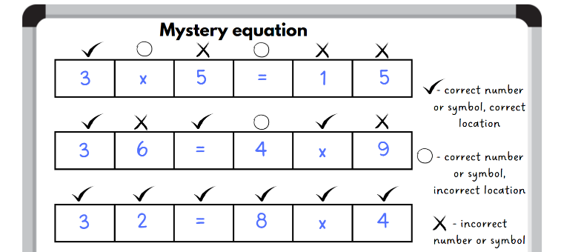

This table details an opportunity for assessment.

|  |  |
| --- | --- |
| Assessment opportunity | Links |
| What to look for:   * **Can students** recognise and use the symbols for multiplied by (×), divided by (÷) and equals (=)**? [MAO-WM-01, MA2-MR-01]** | Links to [National Numeracy Learning Progressions](https://www.australiancurriculum.edu.au/resources/national-literacy-and-numeracy-learning-progressions/version-3-of-national-literacy-and-numeracy-learning-progressions/) (NNLP):   * MuS6.   Links to suggested [Interview for Student Reasoning](https://education.nsw.gov.au/teaching-and-learning/curriculum/literacy-and-numeracy/assessment-resources/ifsr) (IfSR) tasks:   * IfSR-MT: 2A.5, 2A.6 |

## Core lesson – fun day planning – 40 minutes

The table below contains suggested learning intentions and success criteria. These are best co-constructed with students.

|  |  |
| --- | --- |
| Core concept learning intentions | Core concept success criteria |
| Students are learning to:   * apply addition and subtraction to familiar contexts, including money and budgeting * partition, rearrange and regroup numbers to at least 1000 to solve additive problems. | Students can:   * reflect on a chosen strategy for solving a problem, considering whether it can be improved * solve subtraction questions with missing digits given the difference. |

1. Display Resource 13 – fun day budget. Allow students to read the task and provide time for students to ask any clarifying questions.
2. Provide pairs with Resource 14 – Games Galore catalogue and student workbooks to record their calculations.

**Note**: students may wish to refer to Resource 1 – additive strategies to discuss with their partner which strategies they should choose to complete their calculations for the task.

1. After providing time for students to complete the task, regroup and ask:

* Which games did you decide to purchase and why?
* What strategy or strategies did you use when adding the prices of the games together?
* Was there a more effective strategy you could have chosen? If yes, why do you believe using that strategy would have been more effective?
* What was the total cost of your planned purchases? Did you have any money left?
* What strategy did you choose to use for finding the difference between the total cost of all the games and the $1000 budget?
* What did you find challenging about completing this task? Explain.

This table details opportunities for differentiation.

|  |  |
| --- | --- |
| Too hard? | Too easy? |
| Students cannot reflect on a chosen strategy for solving a problem, considering whether it can be improved.   * Provide students with concrete materials or calculators to assist with the addition and subtraction. * Allow students to work with a smaller budget and/or reduce the prices to whole dollars only. Support them to choose an efficient strategy to use to complete the task. | Students can reflect on a chosen strategy for solving a problem, considering whether it can be improved.   * Students work with a larger budget of $4500 and consider what items they can purchase from Resource 14 – Games Galore catalogue. * Provide students with digital devices to conduct research into each of the items on Resource 14 – Games Galore catalogue. Can they find the items for a cheaper price? What is the difference between the prices? Which is the better deal? |

## Consolidation and meaningful practice – 20 minutes

1. Display Resource 15 – ‘Beanbag target’ scores and read the problem aloud.

The table below outlines stimulus prompts to generate conversation about the topic, along with anticipated responses from students.

|  |  |
| --- | --- |
| Prompts | Anticipated student responses |
| * What information is needed to help solve this problem? | * Otis and Leo played 2 games. They had 10 throws each. * Otis and Leo both got a score that was a 3-digit number. * The difference between Otis and Leo’s scores is 10. * The numbers on the target are 5, 10, 25 and 50. |
| * How can the number of throws and numbers on the target help us decide what Otis and Leo’s scores might be? | * The range of scores on the target are multiples of 5. Therefore, Otis and Leo’s scores would end in zero or 5. * If Otis or Leo were to throw all 10 beanbags into the middle of the target, the highest possible score is 500. * The lowest possible 3-digit score is 100. * Because the difference between the 2 scores is 10, Otis and Leo’s scores would both end in either a zero or a 5. |
| * Can there be more than one answer to this problem? | * Yes. The ranges of possible 3-digit number scores for 2 games of ‘Beanbag target’ is from 100 to 500. |

1. Model a [think aloud](https://evidenceforlearning.org.au/news/planning-a-think-aloud-in-mathematics) to solve the problem on Resource 15 – ‘Beanbag target’ scores, providing a few possible answers.
2. Display Resource 16 – What’s the score?
3. Students solve each of the problems displayed on the resource in their workbook.
4. Remind students that there can be more than one solution to each of the problems. Encourage students to find as many solutions as possible to each of the problems.

The table below outlines stimulus prompts to generate conversation about the topic, along with anticipated responses from students.

|  |  |
| --- | --- |
| Prompts | Anticipated student responses |
| * How did the answer help you find the missing numbers? | * They are subtraction equations, so the answer is the difference between the 2 numbers. |
| * Did the numbers displayed on the ring toss help you in deciding what scores the players may have gotten? | * The numbers on the ring toss were a bit tricky to see, but I noticed the numbers 10, 25 and 50 written on the wooden planks. The range of scores you can get when playing ring toss are multiples of 5, just like in the beanbag game. Therefore, Claire or Lachlan’s scores would end in zero or 5. |
| * What strategy did you use to find the missing numbers? | * I thought about the highest score someone could get playing ring toss. If Claire or Lachlan got all 9 rings on 50 points, the highest score possible is 450. * I thought about the highest score someone could get playing 2 rounds of 10-pin bowling. If Claire or Lachlan knocked down every pin each game, their score would be 200. I worked from this number to find possible solutions. * I counted back from the larger number to the smaller number to determine the difference. * I counted on from the smaller number to the larger number to determine the difference. |

This table details opportunities for differentiation.

|  |  |
| --- | --- |
| Too hard? | Too easy? |
| Students cannot solve subtraction questions with missing digits given the difference.   * Provide students with concrete materials, such as a number chart, to model subtraction and find at least one possible solution to each of the problems. | Students can solve subtraction questions with missing digits given the difference.   * Allow students to create their own word problems with missing digits and the difference given, to swap with a partner to solve. |

This table details opportunities for assessment.

|  |  |
| --- | --- |
| Assessment opportunities | Links |
| What to look for:   * Can students reflect on a chosen strategy for solving a problem, considering whether it can be improved? **[MAO-WM-01, MA2-AR-01]** * Can students solve subtraction questions with missing digits given the difference (Reasons about relations)? **[MAO-WM-01, MA2-AR-02]** | Links to [National Numeracy Learning Progressions](https://www.australiancurriculum.edu.au/resources/national-literacy-and-numeracy-learning-progressions/version-3-of-national-literacy-and-numeracy-learning-progressions/) (NNLP):   * n/a. |

# Lesson 6

**Core concept**: commutative properties can be used to solve multiplication problems.

## Daily number sense – find the numbers – 10 minutes

The table below contains a suggested learning intention and success criteria. These are best co-constructed with students.

|  |  |
| --- | --- |
| Daily number sense learning intention | Daily number sense success criteria |
| Students are learning to:   * recall multiplication facts of 2 and 4, 5 and 10 and related division facts. | Students can:   * link multiplication and division fact families * generate multiplication fact families for multiples of 4. |

This activity is an adaptation of [What's in the Box?](https://nrich.maths.org/problems/whats-box) from [NRICH](https://nrich.maths.org/) by the University of Cambridge.

1. Pose the following scenario: I placed 4 numbers into a box. This box multiplied these numbers by a secret number and 4 new numbers came out. The new numbers that came out were 12, 28, 36 and 44. What 4 numbers did I place in the box to begin with? What is the secret number in the box that is multiplying to make 4 new numbers? (see Figure 10).

Figure 10 – numbers in a box

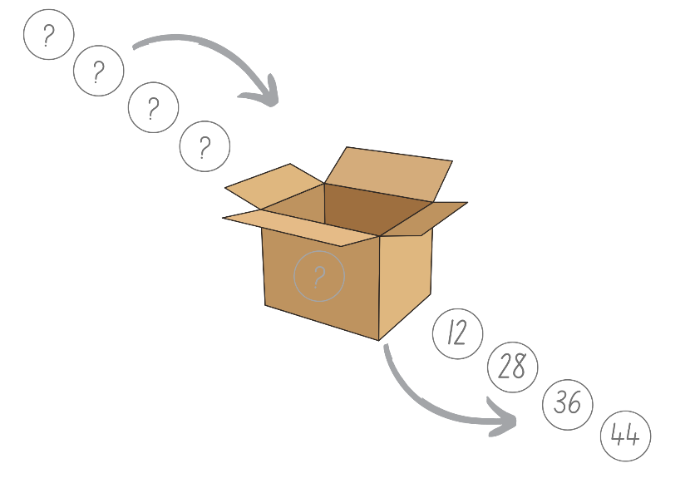

1. Students [Think-Pair-Share](https://app.education.nsw.gov.au/digital-learning-selector/LearningActivity/Card/645) how they would solve this problem.
2. Ask the following questions:

* What secret number multiplication happened inside the box to get the answers in the picture above? (2 or 4)
* Is there more than one possibility for the secret number inside the box? How do you know? (Yes, the secret number could be 2 or 4.)
* Can you identify 4 more numbers to go into the box and determine what would come out?
* How can you check your answer using division?
* Can you generate a fact family triangle for each of the numbers? Can you give an example of this?

1. In pairs, students choose their own set of 4 numbers that will be placed in the box, along with a secret number. Swap with another pair to solve the problem.

This table details opportunities for assessment.

|  |  |
| --- | --- |
| Assessment opportunities | Links |
| What to look for:   * **Can students** link multiplication and division fact families? **[MAO-WM-01, MA2-MR-01]** * **Can students generate multiplication fact families for multiples of 4? [MAO-WM-01, MA2-MR-01]** | Links to [National Numeracy Learning Progressions](https://www.australiancurriculum.edu.au/resources/national-literacy-and-numeracy-learning-progressions/version-3-of-national-literacy-and-numeracy-learning-progressions/) (NNLP):   * MuS6.   Links to suggested [Interview for Student Reasoning](https://education.nsw.gov.au/teaching-and-learning/curriculum/literacy-and-numeracy/assessment-resources/ifsr) (IfSR) tasks:   * IfSR-MT: 2A.4, 2A.5, 2A.6. |

## Core lesson 1 – vegetable garden – 10 minutes

The table below contains a suggested learning intention and success criteria. These are best co-constructed with students.

|  |  |
| --- | --- |
| Core concept learning intention | Core concept success criteria |
| Students are learning to:   * operate with multiples of 10. | Students can:   * use place value to rename groups of 10 to multiply * apply the commutative and associative properties to multiply by multiples of 10. |

1. Tell the class that 28 carrot seeds were planted in equal rows.
2. Students use individual whiteboards to record their thinking. Discuss the various options.
3. Explain that the carrots were planted in 2 rows of 14 (see Figure 11).

Figure 11 – vegetable garden

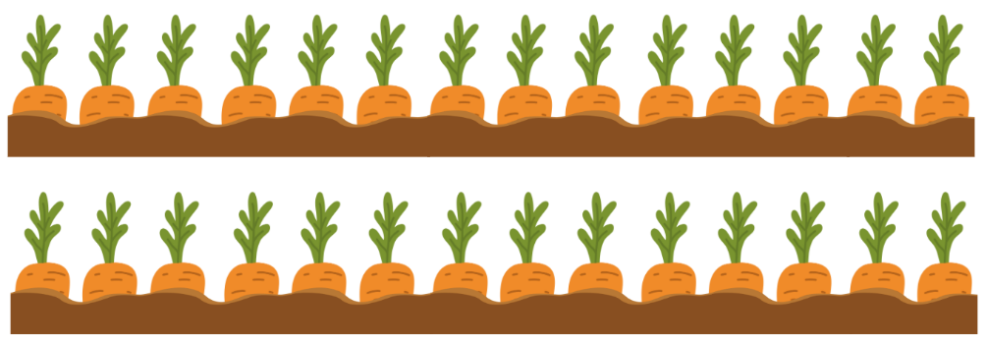

1. Explain that 2 more rows of carrots were planted. Ask:

* Can you draw what this looks like now?
* How can this be represented as a number sentence? (Do not provide answers for the number sentence at this stage.)
* What strategies could be used to solve 14 × 4?

1. Highlight that this is not a simple multiplication fact that can be recalled quickly. Ask:

* How can you use what you know about 10 to solve this?
* Can you use the diagram you drew?
* Can you represent this using an area model?
* Can you write a number sentence?

1. Display Resource 17 – vegetable garden strategies.
2. Discuss the different strategies that can be used to solve this problem. Explain that the dots are used to help show how the number can be partitioned in different ways.

## Core lesson 2 – ‘Multiplication toss’ – 30 minutes

1. Review the instructions to play ‘Multiplication toss’:
2. Player 1 rolls the 10-sided dice and uses the numbers rolled to create an array. For example, if a 3 and 5 are rolled, make either 3 fives or 5 threes. The player decides which array they prefer, drawing an outline of the array around the correct number of rows and columns on Resource 18 – ‘Multiplication toss’ gameboard 1 and naming the array in the middle (see Figure 12).

Figure 12 – ‘Multiplication toss’ gameplay

A 10 by 10 grid background.

In the top left-hand corner, an array of 3 rows by 5 columns has been outlined in green. The text '3 fives' is written inside the rectangle created.

1. Player 2 then rolls the dice and uses the numbers rolled to create an array that will fit without overlapping. For example, a 4 and 7 are rolled and the player chooses 7 fours. Player 2 draws an outline of the array around the correct number of rows and columns and names the array in the middle (see Figure 13).

Figure 13 – ‘Multiplication toss’ gameplay

A 10 by 10 grid background.

In the top left-hand corner, an array of 5 columns by 3 rows has been outlined in green. The text '3 fives' is written inside the rectangle created.

Under this, starting in the top-left square, an array of 4 columns by 7 rows is outlined in orange. The text '7 fours' is written inside the rectangle created.

1. If a player rolls numbers that cannot make an array without overlapping, they miss a turn.
2. Players continue to take turns until there is no more room for either player. The player with the most squares covered is the winner.

**Note**: place Resource 18 – ‘Multiplication toss’ gameboard 1 in a plastic sleeve to play multiple rounds or students can use their grid workbook.

1. Pairs play ‘Multiplication toss’ using Resource 18 – ‘Multiplication toss’ gameboard 1, a 10-sided dice and writing materials.
2. Once students have played multiple rounds with the 10-sided dice and 10 × 10 board, introduce the variation using Resource 19 – ‘Multiplication toss’ gameboard 2:
3. For each turn, a player spins Resource 20 – spinner to determine the first number of their multiplication sentence and rolls a 6-sided die to determine the number that they will multiply the first number by.
4. Players solve the multiplication problem using flexible partitioning and their knowledge of multiples of 10. For example, a student spins 13 and rolls a 6. They have made 13 × 6. They solve this by partitioning the number into 10 × 6 = 60, 3 × 6 = 18. They can then add 60 and 18 to make 78.
5. Players then plot this onto Resource 19 – ‘Multiplication toss’ gameboard 2. They can do as 13 × 6 or split into 10 × 6 and 3 × 6.
6. The game continues until the grid is full or after 10 spins, whichever happens first.
7. The player with the largest area blocked out is the winner.
8. Pairs use Resource 19 – ‘Multiplication toss’ gameboard 2 and Resource 20 – spinner, a 6-sided die and writing materials to play.

This table details opportunities for differentiation.

|  |  |
| --- | --- |
| Too hard? | Too easy? |
| Students cannot use flexible partitioning within multiplication.   * Model the use of concrete materials to create an array to model flexible partitioning. | Students can use flexible partitioning within multiplication.   * Challenge students partition the array into more than 2 parts. Demonstrate the strategy used to solve this problem. |

## Discuss and connect the mathematics – 10 minutes

1. Revise and discuss how students solved 16 × 5, highlighting different strategies used.
2. Summarise lessons by asking:

* Which numbers did you find easier to multiply after they had been partitioned?
* Which numbers were challenging to multiply?
* How might this strategy help us recall multiplication facts or solve problems?

1. Revise that the associative property of multiplication allows students to regroup factors and multiply them in an easier way.

This table details opportunities for assessment.

|  |  |
| --- | --- |
| Assessment opportunities | Links |
| What to look for:   * Can students use place value to rename groups of 10 to multiply? **[MAO-WM-01, MA2-MR-01]** * Can students apply the commutative and associative properties to multiply by multiples of 10? **[MAO-WM-01, MA2-MR-01]** | Links to [National Numeracy Learning Progressions](https://www.australiancurriculum.edu.au/resources/national-literacy-and-numeracy-learning-progressions/version-3-of-national-literacy-and-numeracy-learning-progressions/) (NNLP):   * MuS7.   Links to suggested [Interview for Student Reasoning](https://education.nsw.gov.au/teaching-and-learning/curriculum/literacy-and-numeracy/assessment-resources/ifsr) (IfSR) tasks:   * IfSR-MT: 3A.1, 3A.2. |

# Lesson 7

**Core concept**: number properties can be used to solve multiplication problems.

## Daily number sense – array fact families – 15 minutes

The table below contains a suggested learning intention and success criteria. These are best co-constructed with students.

|  |  |
| --- | --- |
| Daily number sense learning intention | Daily number sense success criteria |
| Students are learning to:   * recall multiplication facts of 2 and 4, 5 and 10 and related division facts. | Students can:   * recognise and use the symbols for multiplied by (×), divided by (÷) and equals (=) * link multiplication and division fact families using arrays. |

**Note**: pairs of students will require a copy of Resource 21 – arrays and products cut into cards. This can be done prior to the lesson or after students receive the resource.

1. Provide pairs of students with Resource 21 – arrays and products, scissors, glue and a piece of paper.
2. Students cut out the arrays and number cards.
3. Students match each array with its product and glue it onto the paper. They record the multiplication and division number sentences that link to each (see Figure 14).

Figure 14 – possible student recording

An example of a student response with an array containing 5 rows of 8 and the product of 40.

The fact family number sentences recorded are: 5 × 8 = 40, 8 × 5 = 40, 40 divided by 5 = 8 and 40 divided by 8 = 5.

1. After recording an array, its product, and its multiplication and division number sentences, students take turns to describe each of the arrays. For example, 5 rows of 8 is 40, 8 columns of 5 is 40, 40 shared into 5 rows is 8 and 40 shared into 8 columns is 5.

This table details opportunities for assessment.

|  |  |
| --- | --- |
| Assessment opportunities | Links |
| What to look for:   * Can students recognise and use the symbols for multiplied by (×), divided by (÷) and equals (=)? **[MAO-WM-01, MA2-MR-01]** * **Can students link multiplication and division fact families using arrays? [MAO-WM-01, MA2-MR-01]** | Links to [National Numeracy Learning Progressions](https://www.australiancurriculum.edu.au/resources/national-literacy-and-numeracy-learning-progressions/version-3-of-national-literacy-and-numeracy-learning-progressions/) (NNLP):   * MuS6.   Links to suggested [Interview for Student Reasoning](https://education.nsw.gov.au/teaching-and-learning/curriculum/literacy-and-numeracy/assessment-resources/ifsr) (IfSR) tasks:   * IfSR-MT: 2A.4, 2A.5, 2A.6. |

## Core lesson – factors fun – 30 minutes

The table below contains a suggested learning intention and success criteria. These are best co-constructed with students.

|  |  |
| --- | --- |
| Core concept learning intention | Core concept success criteria |
| Students are learning to:   * represent and solve word problems with number sentences involving multiplication or division. | Students can:   * complete number sentences involving multiplication and division by calculating missing numbers * represent and solve multiplication and division word problems using number sentences. |

1. Review products and factors:

**Product**: the result of multiplying 2 or more numbers together. For example, 12 is the product of 4 × 3.

**Factor**: a number which divides another number without a remainder. For example, 1, 2, 3 and 6 are factors of 6 but 4 and 5 are not.

1. Write 24 = 4 × _ on the board and ask:

* How could you determine the missing number?
* What multiplication fact families would help?
* What division number sentences could you write for this problem?

1. Ask students to write different ways of representing these facts as number sentences using multiplication and division. Anticipated responses include:

* 4 × 6 = 24 and 6 × 4 = 24
* 24 ÷ 4 = 6 and 24 ÷ 6 = 4.

1. Explain to students that 24 is the product, while 4 and 6 are the factors.
2. Model for other fact families, as required.
3. Provide pairs with Resource 22 – 'Factors fun', a paper clip, counters and writing materials.
4. Explain how to play the game:
5. Players decide on a factor and fill in the spinner with multiples of that number, for example, multiples of 6.
6. Students take turns to spin the spinner and divide by the chosen factor.
7. Players work out the solution and explain their thinking to their partner.
8. The partner records their thinking and, if they agree, the player places one of their counters on the number on the gameboard, claiming that place.
9. If the number is taken, students miss a turn.
10. If there are no new counters that can be added to the gameboard, players move an existing counter to a new place.
11. Players win by getting 4 counters in a row.
12. While students are playing, walk around and observe student reasoning and completed gameboards.

This table details opportunities for differentiation.

|  |  |
| --- | --- |
| Too hard? | Too easy? |
| Students cannot complete number sentences involving multiplication and division by calculating missing numbers.   * Support students to locate and colour the relevant facts on Resource 23 – multiplication chart. * Focus on multiplication facts for 2, 4, 5, 10. Support students by providing grid paper to draw a rectangle that represents the equation using the area model. | Students can complete number sentences involving multiplication and division by calculating missing numbers.   * Extend to multiples of other numbers. For example, multiples of 12 or 14. * Challenge students to play [The Remainders Game](https://nrich.maths.org/remaindersgame/main.html) from [NRICH](https://nrich.maths.org/). Ask students to record their guesses and explain their reasoning process. |

## Consolidation and meaningful practice – 20 minutes

1. Provide students with Resource 24 – code breaking.
2. Students solve the multiplication and division word problems, recording the problem and solution as a number sentence.
3. Each solution will provide a letter for the code (see Figure 15).

Figure 15 – code breaking example

The table displays letters A to Z with associated numeric values below each letter. 

A is 5, B is 30, C is 20, D is 18, E is 6, F is 16, G is 4, H is 7, I is 48, J is 24, K is 56, L is 21, M is 9, N is 50, O is 14, P is 63, Q is 12, R is 35, S is 8, T is 42, U is 15, V is 81, W is 36, X is 28, Y is 2 and Z is 10. 

Under each number there are 12 empty boxes labelled with a question number to record the corresponding letter, which will create a 3-word phrase. For example, the answer to question 1 is the letter A.

At the bottom, there is a word problem which reads: 1. Sam is sharing biscuits between himself and 4 friends. if there are 25 in the pack, how many will they each get?

The solution is written as a number sentence on a line: 25 divided by 5 equals 5.

1. Once students have completed the code, regroup as a class and select students to share and explain their solutions.

This table details opportunities for assessment.

|  |  |
| --- | --- |
| Assessment opportunities | Links |
| What to look for:   * Can students complete number sentences involving multiplication and division by calculating missing numbers? **[MAO-WM-01, MA2-MR-01, MA2-MR-02]** * Can students represent and solve multiplication and division word problems using number sentences? **[MAO-WM-01, MA2-MR-01, MA2-MR-02]** | Links to [National Numeracy Learning Progressions](https://www.australiancurriculum.edu.au/resources/national-literacy-and-numeracy-learning-progressions/version-3-of-national-literacy-and-numeracy-learning-progressions/) (NNLP):   * NPA4.   Links to suggested [Interview for Student Reasoning](https://education.nsw.gov.au/teaching-and-learning/curriculum/literacy-and-numeracy/assessment-resources/ifsr) (IfSR) tasks:   * IfSR-MT: 2A.4, 2A.5, 2A.6. |

# Lesson 8

**Core concept**: locations can be identified using grid references.

## Daily number sense – 10 minutes

1. From a class need surfaced through formative assessment data, identify a short, focused activity that targets students’ knowledge, understanding and skills. Example activities may be drawn from the following resources:

* [Mathematics K–6 resources](https://education.nsw.gov.au/teaching-and-learning/curriculum/mathematics/mathematics-curriculum-resources-k-12/mathematics-k-6-resources)
* [Universal Resources Hub](https://resources.education.nsw.gov.au/home).

## Core lesson 1 – grid references – 10 minutes

The table below contains suggested learning intentions and success criteria. These are best co-constructed with students.

|  |  |
| --- | --- |
| Core concept learning intentions | Core concept success criteria |
| Students are learning to:   * locate positions on grid maps * create and interpret grid maps. | Students can:   * locate positions by coordinating horizontal and vertical references * use the array structure of grid maps to locate position, horizontal before vertical * identify and mark locations on maps and plans, given their grid references. |

This activity has been adapted from [Battleship](https://education.nsw.gov.au/teaching-and-learning/curriculum/mathematics/everyday-maths/primary/resources/battleship) from [Maths Trains Brains](https://education.nsw.gov.au/teaching-and-learning/curriculum/mathematics/everyday-maths/primary/resources/battleship) by State of New South Wales (Department of Education).

1. Revise students’ knowledge of using grid references to describe and locate position on maps and plans. Remind them that the horizontal is read before the vertical, for example, B9.
2. Display Resource 25 – grid reference map. Ask:

* How can you describe the position of the post office?
* What is the location of the fire station using a grid reference?
* Is a grid reference helpful in describing position? Why or why not?
* Why is it important to say the horizontal before the vertical?

**Note**: repeat asking for locations and giving grid references on Resource 25 – grid reference map until students are confident.

## Core lesson 2 – ‘Battleship’ – 30 minutes

**Note**: place Resource 26 – ‘Battleship’ gameboards in a reuseable plastic sleeve to enable students to play multiple rounds.

1. Provide pairs with 4 copies of Resource 26 – ‘Battleship’ gameboards, a book for a barrier, markers and 12 counters each. Review ‘Battleship’ rules:
2. Both players place ships (counters) on one of their gameboards.
3. Players take turns guessing the location of each of the ships using grid references, for example, F7.
4. The other player responds with 'Hit’ or 'Miss’.
5. Players mark the hits and misses on the other gameboard with a circle or cross (see Figure 16).
6. The first player to ‘hit’ all ships belonging to their opponent, wins!

Figure 16 – battleship gameplay

Battleships board game layout showing 2 grids with an open book icon above.

The left grid, labelled 'Player 1', has counters indicating ship positions and the right grid shows 'Player 1' battlefield with X and O markers, indicating hits and misses.

1. Move around the room during this activity to ensure students are correctly locating positions using the horizontal reference before the vertical reference.

This table details opportunities for differentiation.

|  |  |
| --- | --- |
| Too hard? | Too easy? |
| Students cannot describe and locate positions using grid references.   * Support students by removing the barrier and allowing them to see their opponent’s board. Students need to say the correct grid reference for the ships. * Students draw a large 5 × 5 grid in the classroom or outside and play, using cones and chalk. | Students can describe and locate positions using grid references.   * Challenge students by adding obstacles to the gameboard that need to be missed. * Each player has 2 shots each game that can hit 4 squares at a time. |

## Discuss and connect the mathematics – 10 minutes

1. Regroup and ask:

* Where have you seen the grid reference system used before?
* Does using a grid make it easier to represent or visualise a location?
* Is using a grid system more effective than using only landmarks?
* Are there times when one system would be better than the other?
* What was challenging about this activity? How did you overcome these challenges?

This table details opportunities for assessment.

|  |  |
| --- | --- |
| Assessment opportunities | Links |
| What to look for:   * Can students locate positions by coordinating horizontal and vertical references? **[MAO-WM-01, MA2-GM-01]** * Can students use the array structure of grid maps to locate position, horizontal before vertical? **[MAO-WM-01, MA2-GM-01]** * Can students identify and mark locations on maps and plans, given their grid references? **[MAO-WM-01, MA2-GM-01]** | Links to [National Numeracy Learning Progressions](https://www.australiancurriculum.edu.au/resources/national-literacy-and-numeracy-learning-progressions/version-3-of-national-literacy-and-numeracy-learning-progressions/) (NNLP):   * PoL5. |

# Resource 1 – additive strategies

A poster listing 10 types of additive strategies as follows:
1. Compensation – adjusting numbers to make a calculation more efficient. 
2. Commutative property of addition – two numbers can be added in any order and the sum is equivalent. 
3. Constant difference – a common difference between pairs of numbers when completing subtraction. 
4. Inverse operations – addition and subtraction are inverse operations. 
5. Equivalence - different equations can have the same value. 
6. Landmark numbers – ‘friendly numbers’ that are easy to work with fluently, flexibly and efficiently. 
7. Levelling – adjusting to landmark numbers to add efficiently. 
8. Partitioning – splitting numbers into smaller parts to make calculations easier. 
9. Algorithms – a set of written steps to calculate, using partitioning and regrouping.
10. Associative property of addition – more than two numbers can be added in any order to make it more efficient. 


# Resource 2 – ‘Partition bingo’

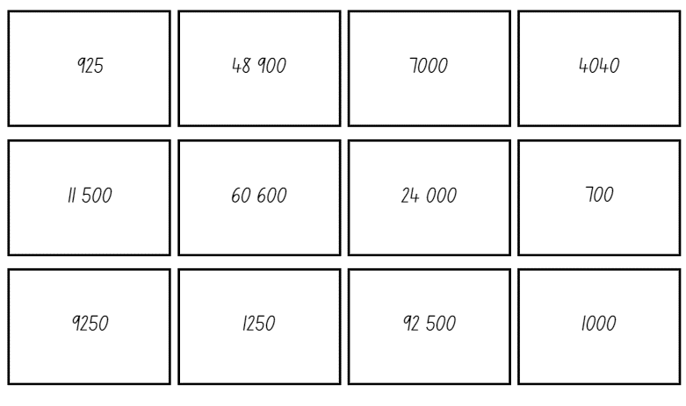

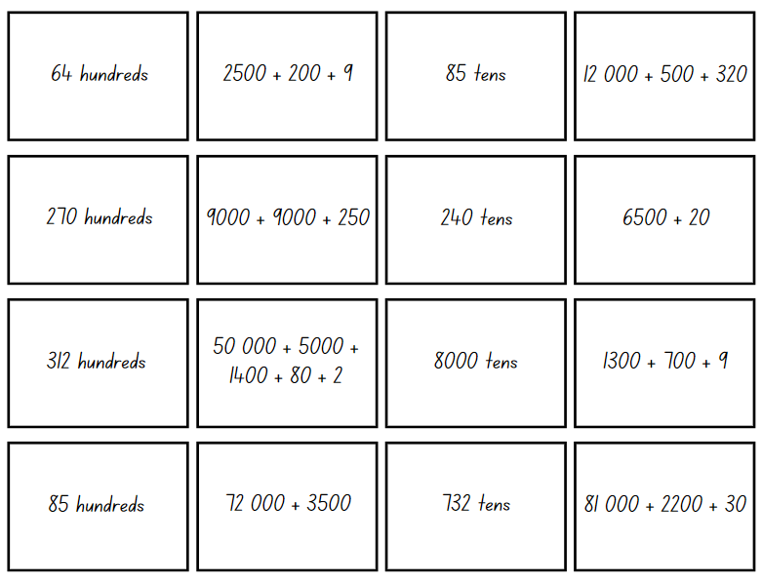

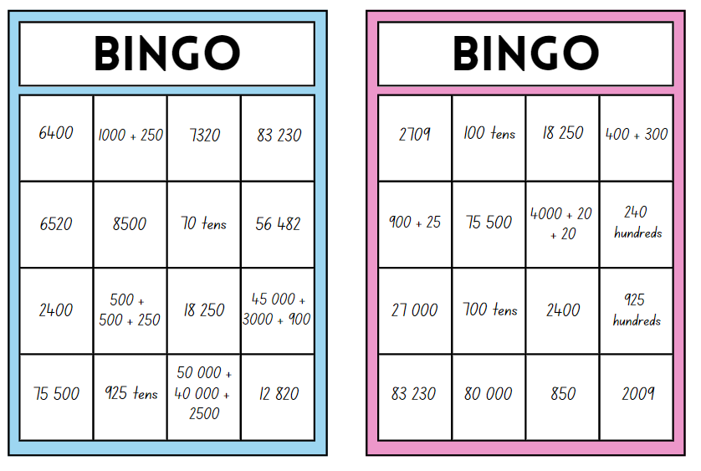

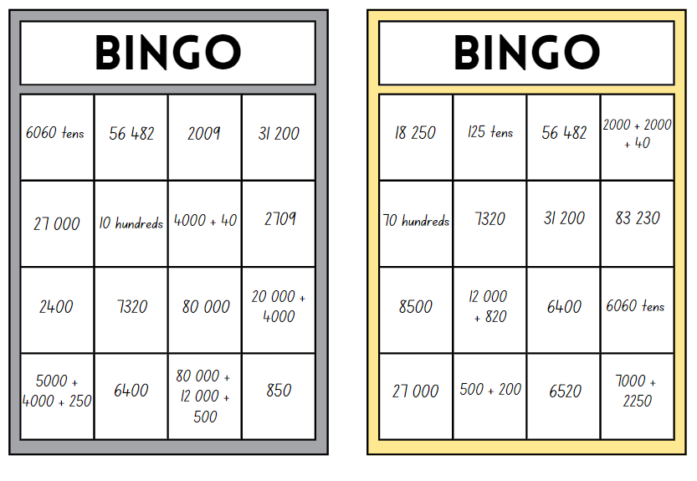

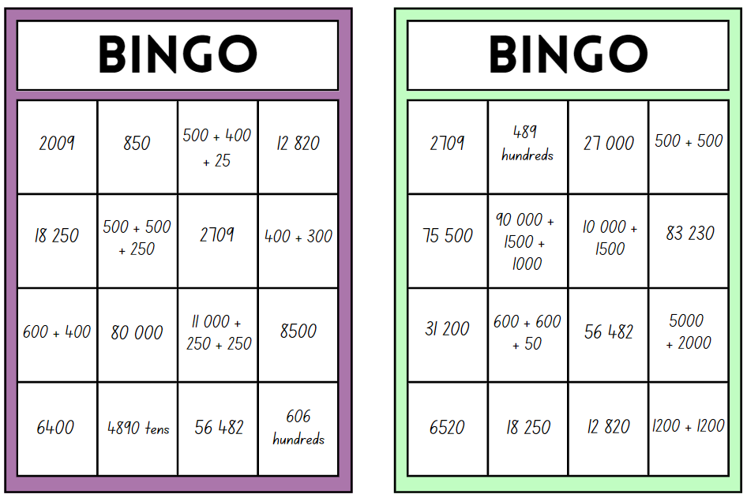

# Resource 3 – number expander

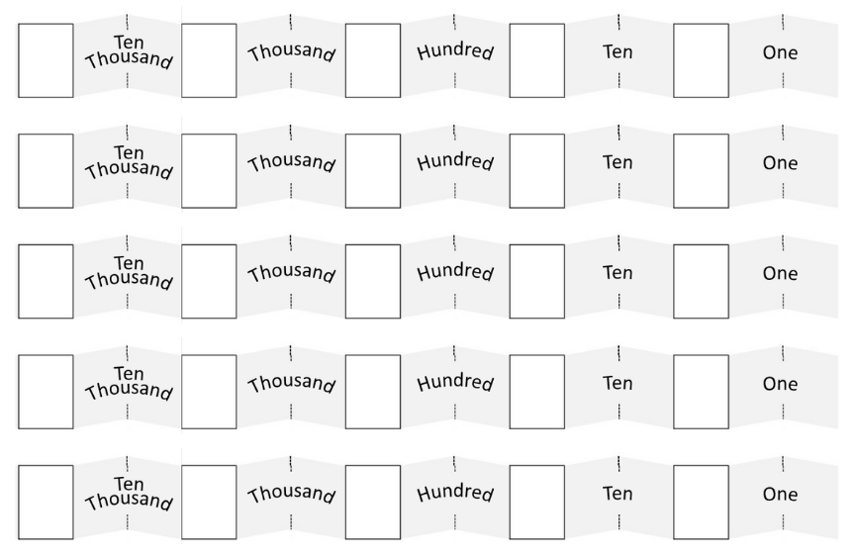

# Resource 4 – ‘Decimal flip’ cards

Full-sized cards arranged in an array of 5 columns and 4 rows. 

Eight cards are blue zeros, 7 cards are blue number ones, one card is a blue number 2, 4 cards are brown zeros and 4 quarter-width cards have a blue decimal point.

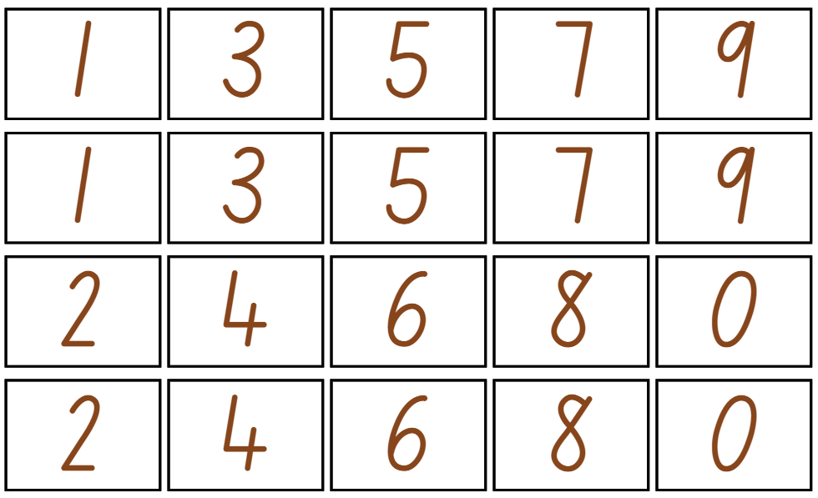

# Resource 5 – number line



# Resource 6 – place value mat

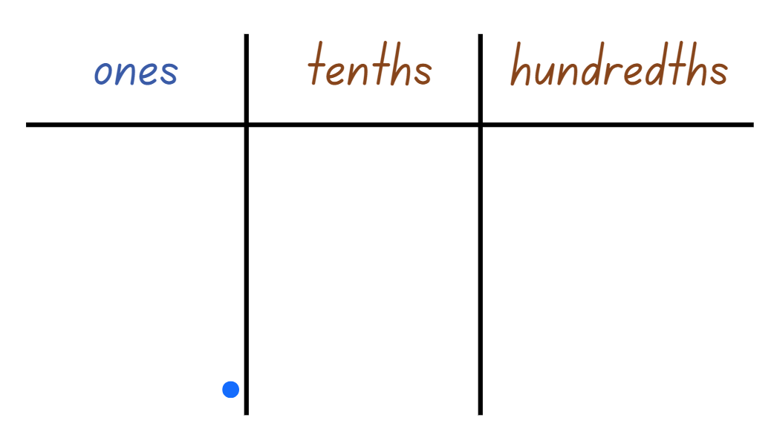

# Resource 7 – student heights

Three students with their names and heights displayed. The first is Jay: 1.4 metres. The second is Norah: one and a half metres. The third is Zayn: 1.25m.

Underneath the image is a number line from zero to 2, partitioned into tenths and hundredths with a small line representing every fifth hundredth.

# Resource 8 – point scoring

A zero to 2 number line.

Above the number line, is a bar partitioned into 8 equal parts, aligning with 0 and 2 on the number line, so that the end of the fourth equal part is aligned with one.

Each segment represents a quarter or 0.25.

The segments are labelled from left to right: 1 point, 2 points, 3 points, 4 points, 6 points, 8 points, 10 points and 12 points.

# Resource 9 – pole vault heights

|  |  |  |  |  |  |
| --- | --- | --- | --- | --- | --- |
| Athlete | Year | Gender | Country | Athlete height | Pole vault world record |
| Armand Duplantis | 2024 | Male | Sweden | 1.81 m | 6.24 m |
| Emma George | 1999 | Female | Australia | 1.72 m | 4.60 m |
| Pierre Quinon | 1983 | Male | France | 1.8 m | 5.82 m |
| Renaud Lavillenie | 2014 | Male | France | 1.77 m | 6.16 m |
| Sergey Bubka | 1994 | Male | Ukraine | 1.83 m | 6.14 m |
| Stacy Dragila | 2001 | Female | United States | 1.72 m | 4.81 m |
| Svetlana Feofanova | 2004 | Female | Russia | 1.6 m | 4.88 m |
| Yelena Isinbayeva | 2009 | Female | Russia | 1.74 m | 5.06 m |

Source: Wikipedia contributors (2024a, 2024b)

1. Order the items below from shortest to tallest or longest:

* male heights
* overall top 3 pole vault world record heights.

1. Compare and determine the difference in pole vault world records between:

* Emma George and Stacy Dragila
* Yelena Isinbayeva and Renaud Lavillenie.

1. Compare and determine the difference in heights between:

* the athletes from France
* the athletes from Russia
* the tallest and shortest athletes overall.

1. Create a number line, marking the heights for 5 athletes, using athlete initials to label.
2. Challenge task: create a number line, mark the heights for 5 pole vault world records, using athlete initials to label.

# Resource 10 – ‘Take the plunge!’

A rectangular swimming pool with columns of stacked inflatable pool rings, each with an addition or subtraction number sentence in the centre.


# Resource 11 – strategies checklist

Checklist containing 9 additive strategies as follows: Landmark Numbers, Levelling, Partitioning, Algorithms, Compensation, Inverse Operations, Compensation, Algorithms and partitioning. 

Next to each strategy is a blank rectangular text box. The last box has text that reads: Choose a strategy!


# Resource 12 – strategies checklist 2

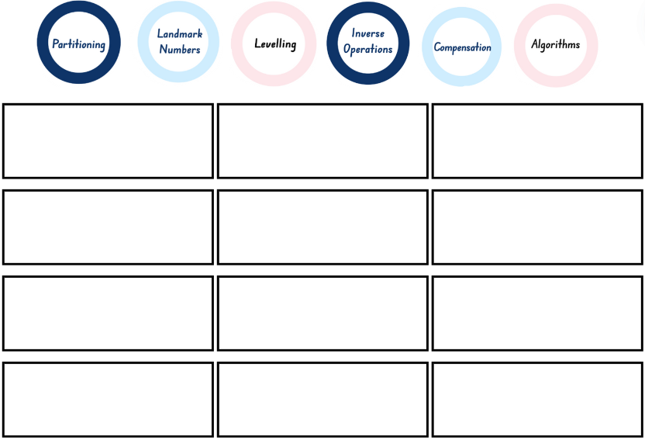

# Resource 13 – fun day budget

**Challenge**: purchase a range of outdoor games for the end of year fun day.

**Budget**: $1000

**Brief**

* The games chosen must be suitable for students from Kindergarten to Year 6.
* Consider purchasing a range of 2 player and multiplayer games and activities.
* You are allowed to purchase one or more of the same games, if you believe they will be a popular choice on the day.
* Your purchases must not go over the $1000 budget. Try to get as close as possible to the budget without going over.
* You may like to record more than one list of games to compare value for money and then decide on your final choice.
* The names of the games and their prices must be recorded. Decide on which strategies you are going to use to add the prices together and find the difference between the total of the games and the $1000 budget.

# Resource 14 – Games Galore catalogue

A Games Galore Big Sale catalogue. 

The following items are listed for sale: ten-pin bowling $49.50, jumbo pick-up sticks $50.75, giant chess set $279.00, ring toss $25.25, set of 12 hula hoops $102.00, set of 8 mixed balls $80.25, giant checkers $225.00, roundnet $89.50 and outdoor tic-tac-toe $95.00.

A Games Galore Big Sale catalogue.

The following items are listed for sale: tug-of-war rope $58.25, parachute $252.50, beanbag target $47.25, giant 4-in-a-row $87.75, cornhole $110.00, bocce $35.00, croquet $75.00, large stacking tower $186.00, jumbo snakes and ladders $119.50.

# Resource 15 – ‘Beanbag target’ scores

At the fun day, Otis and Leo played 2 games of ‘Beanbag target’ together.

Otis and Leo had a total of 10 throws each in the 2 games they played together.

Otis’ score was a 3-digit number and Leo’s score was a 3-digit number.

The difference between their scores was 10.

What might their scores have been?

To the left is a whiteboard with 6 empty boxes representing a 3-digit number subtracted by a 3-digit number with the result equalling 10. 

To the right is a target scoreboard with 5 beanbags resting on it. The target scores are: 5 (outer ring), 10 (second ring), 25 (third ring) and 50 (inner ring).

# Resource 16 – What’s the score?

|  |  |  |
| --- | --- | --- |
| A whiteboard with 6 empty boxes representing a 3-digit number being subtracted from another 3-digit number with the answer equalling 5. | At the Fun Day, Claire and Lachlan played 3 games of Ring toss together.  Each player tosses 3 rings in one game.  Claire’s final score was a 3-digit number and Lachlan’s final score was a 3-digit number.  The difference between their scores was 5.  What might their scores have been? | A ring toss game. |
| A whiteboard with 6 empty boxes representing a 3-digit number being subtracted from another 3-digit number with the answer equalling 7. | At the Fun Day, Kelly and Michelle played 2 rounds of Ten-pin bowling together.  Players get 10 bowls each round.  Kelly’s score was a 3-digit number and Michelle’s score was a 3-digit number.  The difference between their scores was 7.  What might their scores have been? | Fallen bowling pins and a bowling ball. |

# Resource 17 – vegetable garden strategies

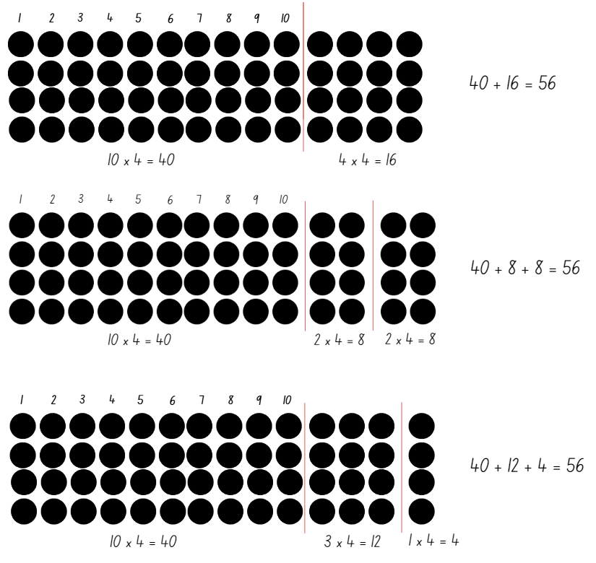

# Resource 18 – ‘Multiplication toss’ gameboard 1

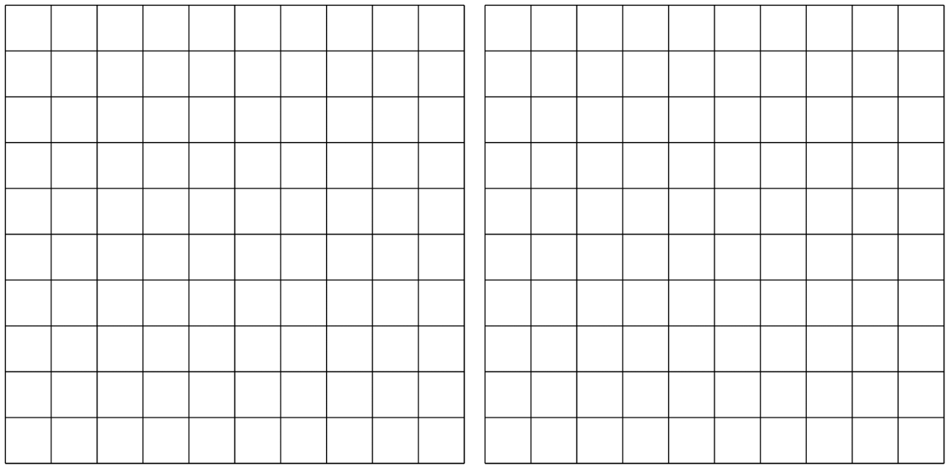

# Resource 19 – ‘Multiplication toss’ gameboard 2



# Resource 20 – spinner

Two spinners segmented into 8 equal parts.

The numbers on each spinner read: 12, 16, 13, 15, 19, 11, 17, 14.

# Resource 21 – arrays and products

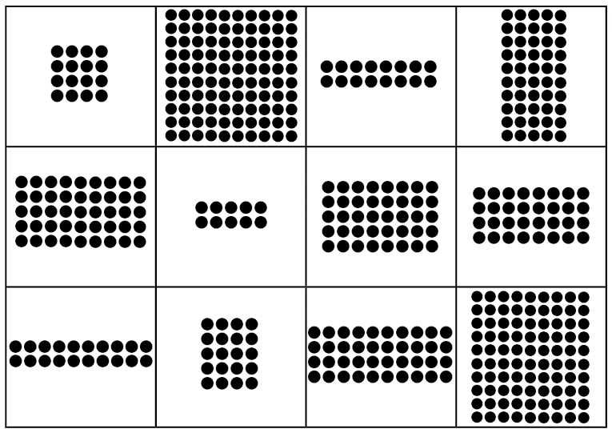

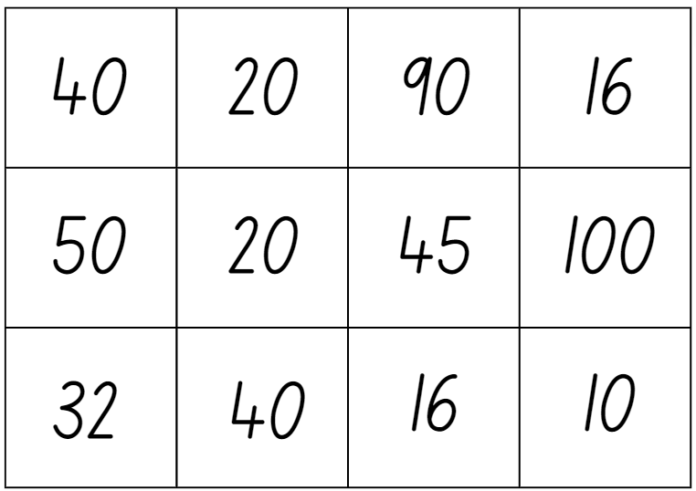

# Resource 22 – ‘Factors fun’

|  |  |
| --- | --- |
| **Equipment** | Gameboard, paper clip, 6 counters per player and writing materials |
| **Instructions** | 1. Select a series of numbers to focus on, for example, multiples of 9, and fill in the spinner with examples of your chosen multiple. 2. Take turns to spin the spinner and divide the number by the chosen divisor. 3. Players work out the solution and explain their thinking to their partner. 4. The partner records their thinking and if they agree, the player can place one of their counters on the number on the gameboard, claiming that place. 5. If the number is taken, students miss a turn. 6. If there are no new counters that can be added to the gameboard, players must move an existing counter to a new place. 7. Players win by getting 4 counters in a row (in any orientation, including a square). 8. If preferred, students can use 5 or 6 counters, looking for 4 in a row. |

A 5 × 5 number grid with numbers from 1 to 10 listed. Each number has been listed more than once.

To the right of the number grid is a blank spinner with 10 spaces.

There are 2 student game cards underneath the number grid and spinner with space to record the spun number, number sentence and covered.

# Resource 23 – multiplication chart

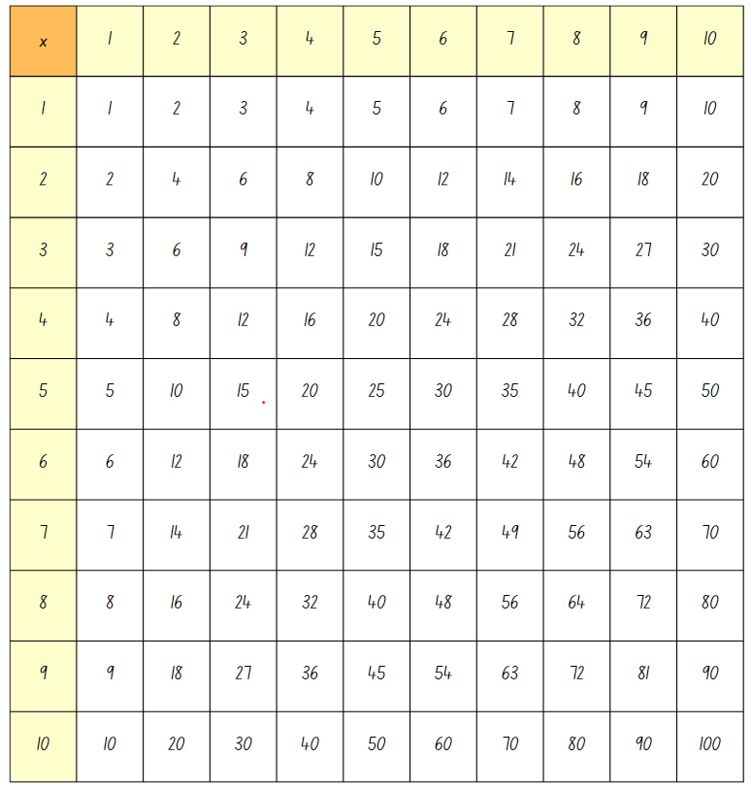

# Resource 24 – code breaking

|  |  |  |  |  |  |  |  |  |  |  |  |  |
| --- | --- | --- | --- | --- | --- | --- | --- | --- | --- | --- | --- | --- |
| **A** | **B** | **C** | **D** | **E** | **F** | **G** | **H** | **I** | **J** | **K** | **L** | **M** |
| 5 | 30 | 20 | 18 | 6 | 16 | 4 | 7 | 48 | 24 | 56 | 21 | 9 |
| **N** | **O** | **P** | **Q** | **R** | **S** | **T** | **U** | **V** | **W** | **X** | **Y** | **Z** |
| 50 | 14 | 63 | 12 | 35 | 8 | 42 | 15 | 81 | 36 | 28 | 2 | 10 |

|  |  |  |  |  |  |  |  |  |  |  |  |  |  |
| --- | --- | --- | --- | --- | --- | --- | --- | --- | --- | --- | --- | --- | --- |
| **Q3** | **Q1** | **Q2** | **Q9** | **Q8** |  | **Q5** | **Q8** |  | **Q7** | **Q6** | **Q4** | **Q1** | **Q2** |
|  | A |  |  |  |  |  |  |  |  |  |  | A |  |

**Word problems**

Find the answer to the multiplication and division word problems below.

|  |  |
| --- | --- |
| 1. Sam is sharing biscuits between himself and 4 friends. If there are 25 in the pack, how many will they each get? |  |
| 1. Lisa shot 5 arrows. Three arrows scores 8 each and 2 arrows score 9 each. What is her total score? |  |
| 1. Andrew needs 36 cans of lemonade for the party. They are sold in packs of 4. How many packs does he need to buy? |  |
| 1. Nat downloaded the same number of apps for her phone each week. She downloaded 54 apps over 9 weeks. How many apps did she download each week? |  |
| 1. Movie tickets are $8 each. If 6 people go to watch a movie, how much will it cost? |  |
| 1. If 7 taxis arrive at the party at the same time, each carrying 5 passengers, how many guests arrive at once? |  |
| 1. I bought 6 pens and the total cost was $24. What was the cost of each pen? |  |
| 1. If 64 books were put on 8 shelves, how many books were on each shelf? |  |
| 1. There are 17 boys and 14 girls in a class. The children sit at tables of 3. How many tables are needed? |  |

# Resource 25 – grid reference map

A 6  by 6 grid map of a town. The x-axis is labelled from A to F and the y-axis is labelled 1 to 6. Grey squares indicate a road and are left blank.

Location references are as follows: 
A6: post office
B6: pond
C6: flower shop
D6: car wash
F6: house.
F5: pool.
A4: house
C4: school
D4: police station
F4: small shop.
A3: water slide
F3: garden bench.
A2: house
C2: bank
D2: hospital
F2: toy shop.
A1: store
C1: house
D1: fire station
F1: circus tent.

# Resource 26 – ‘Battleship’ gameboards

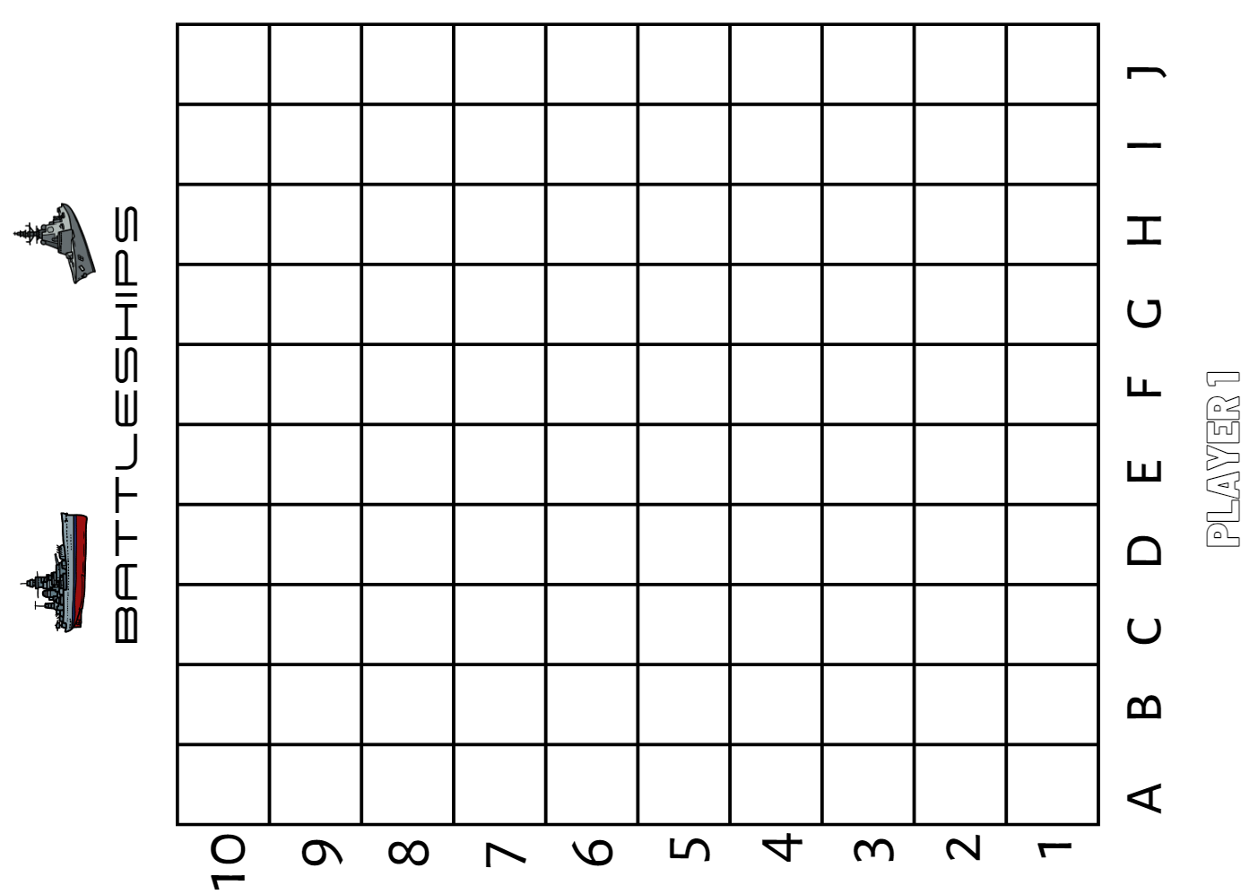

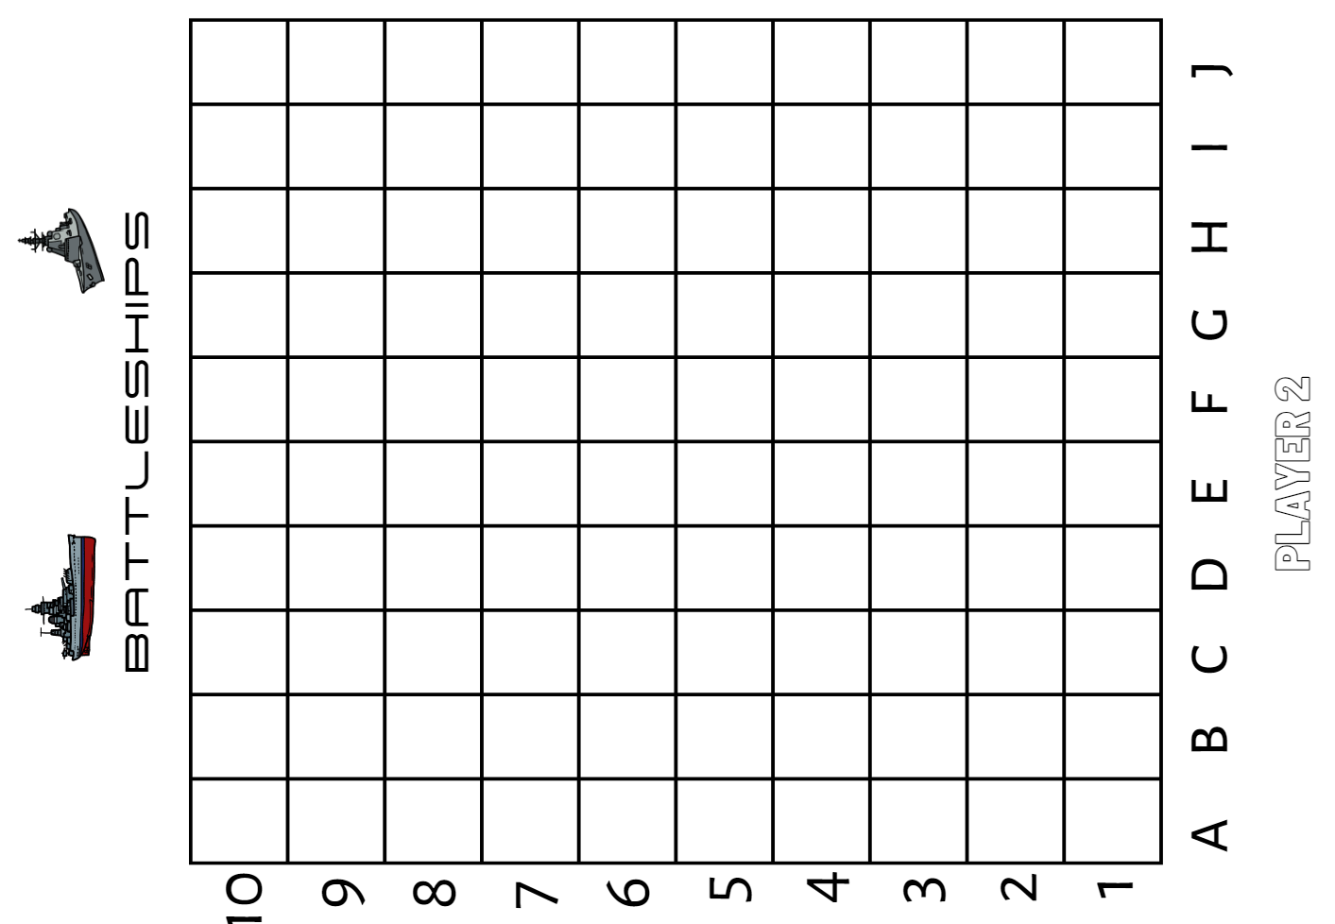

# Syllabus outcomes and content

The table below outlines the [syllabus outcomes](https://curriculum.nsw.edu.au/learning-areas/mathematics/mathematics-k-10-2022/overview) and range of relevant syllabus content covered in this unit. Content is linked to [National Numeracy Learning Progression](https://www.australiancurriculum.edu.au/resources/national-literacy-and-numeracy-learning-progressions/version-3-of-national-literacy-and-numeracy-learning-progressions/) (version 3).

|  |  |  |  |  |  |  |  |  |
| --- | --- | --- | --- | --- | --- | --- | --- | --- |
| Outcomes and content | 1 | 2 | 3 | 4 | 5 | 6 | 7 | 8 |
| **Representing numbers using place value B**:Whole numbers: Apply place value to partition, regroup and rename numbers up to 6 digits  **[MAO-WM-01, MA2-RN-01, MA2-RN-02]** |  |  |  |  |  |  |  |  |
| * Partition numbers of up to 6 digits in non-standard forms | x |  |  |  |  |  |  |  |
| **Representing numbers using place value B:** Decimals: Extend the application of the place value system from whole numbers to tenths and hundredths  **[MAO-WM-01, MA2-RN-01, MA2-RN-02]** |  |  |  |  |  |  |  |  |
| * Subdivide tenths into 10 equal parts and record hundredths using place value |  | x |  |  |  |  |  |  |
| * Locate and order decimals representing tenths and hundredths on a number line, describing their relative size |  | x |  |  |  |  |  |  |
| * Interpret zero digits at the end of a decimal |  |  | x |  |  |  |  |  |
| * Distinguish between the role of zero in various positions |  | x | x |  |  |  |  |  |
| **Representing numbers using place value B**: Decimals: Make connections between fractions and decimal notation  **[MAO-WM-01, MA2-RN-01, MA2-RN-02]** |  |  |  |  |  |  |  |  |
| * Connect fraction strips showing tenths to a number line marked in hundredths |  | x |  |  |  |  |  |  |
| * Compare and order decimals of up to 2 decimal places |  |  | x |  |  |  |  |  |
| * Make connections between fractions and decimal notation for key benchmark values (Reasons about relations) |  |  | x |  |  |  |  |  |
| **Additive relations A**:Use the principle of equality  **[MAO-WM-01, MA2-AR-01, MA2-AR-02]** |  |  |  |  |  |  |  |  |
| * Apply the associative property of addition to forming multiples of 10 (Reasons about relations) |  |  |  | x |  |  |  |  |
| **Additive relations A**: Select strategies flexibly to solve addition and subtraction problems of up to 3 digits  **[MAO-WM-01, MA2-AR-01, MA2-AR-02]** |  |  |  |  |  |  |  |  |
| * Compare and evaluate strategies used to solve addition and subtraction problems, reasoning which strategy may be most efficient |  |  |  | x |  |  |  |  |
| **Additive relations B**: Partition, rearrange and regroup numbers to at least 1000 to solve additive problems  **[MAO-WM-01, MA2-AR-01, MA2-AR-02]** |  |  |  |  |  |  |  |  |
| * Model addition with and without regrouping and record the method used | x |  |  |  |  |  |  |  |
| * Model subtraction with and without regrouping and record the method used | x |  |  |  |  |  |  |  |
| * Use an algorithm with understanding to record addition and subtraction calculations, where efficient, involving 3-digit numbers | x | x |  |  |  |  |  |  |
| * **Solve subtraction questions with missing digits given the difference (Reasons about relations)** |  |  | x |  | x |  |  |  |
| **Additive relations B**: Apply addition and subtraction to familiar contexts, including money and budgeting  **[MAO-WM-01, MA2-AR-01, MA2-AR-02]** |  |  |  |  |  |  |  |  |
| * **Reflect on a chosen strategy for solving a problem, considering whether it can be improved** |  |  |  |  | x |  |  |  |
| **Multiplicative relations A**: Recall multiplication facts of 2 and 4, 5 and 10 and related division facts  **[MAO-WM-01, MA2-MR-01, MA2-MR-02]** |  |  |  |  |  |  |  |  |
| * Recognise and use the symbols for multiplied by (×), divided by (÷) and equals (=) |  |  |  |  | x |  | x |  |
| * Link multiplication and division fact families using arrays |  |  |  |  |  | x | x |  |
| * Generate multiplication fact families for multiples of 2 and 4, 5 and 10 |  |  |  |  |  | x |  |  |
| **Multiplicative relations B**:Operate with multiples of 10  **[MAO-WM-01, MA2-MR-01, MA2-MR-02]** |  |  |  |  |  |  |  |  |
| * **Use place value to rename groups of 10 to multiply** |  |  |  |  |  | x |  |  |
| * Apply the commutative and associative properties to multiply by multiples of 10 |  |  |  |  |  | x |  |  |
| **Multiplicative relations B:** Represent and solve word problems with number sentences involving multiplication or division  **[MAO-WM-01, MA2-MR-01, MA2-MR-02]** |  |  |  |  |  |  |  |  |
| * Complete number sentences involving multiplication and division by calculating missing numbers (Reasons about relations) |  |  |  |  |  |  | x |  |
| * **Represent and solve multiplication and division (both sharing and grouping) word problems using number sentences** |  |  |  |  |  |  | x |  |
| **Geometric measure A**: Position: Locate positions on grid maps  **[MAO-WM-01, MA2-GM-01]** |  |  |  |  |  |  |  |  |
| * **Locate positions by coordinating horizontal and vertical references** |  |  |  |  |  |  |  | x |
| * **Use the array (row and column) structure of grid maps to locate position, horizontal before vertical** |  |  |  |  |  |  |  | x |
| **Geometric measure B**:Position: Create and interpret grid maps  **[MAO-WM-01, MA2-GM-01]** |  |  |  |  |  |  |  |  |
| * Identify and mark locations on maps and plans, given their grid references |  |  |  |  |  |  |  | x |

[Mathematics K–10 Syllabus](https://curriculum.nsw.edu.au/learning-areas/mathematics/mathematics-k-10-2022/overview) © NSW Education Standards Authority (NESA) for and on behalf of the Crown in right of the State of New South Wales, 2022.

# References

This resource contains NSW Curriculum and syllabus content. The NSW Curriculum is developed by the NSW Education Standards Authority. This content is prepared by NESA for and on behalf of the Crown in right of the State of New South Wales. The material is protected by Crown copyright.

Please refer to the NESA Copyright Disclaimer for more information <https://educationstandards.nsw.edu.au/wps/portal/nesa/mini-footer/copyright>.

NESA holds the only official and up-to-date versions of the NSW Curriculum and syllabus documents. Please visit the NSW Education Standards Authority (NESA) website <https://educationstandards.nsw.edu.au> and the NSW Curriculum website [https://curriculum.nsw.edu.au](https://curriculum.nsw.edu.au/).

[Mathematics K–10 Syllabus](https://curriculum.nsw.edu.au/learning-areas/mathematics/mathematics-k-10-2022/overview) © NSW Education Standards Authority (NESA) for and on behalf of the Crown in right of the State of New South Wales, 2022.

[National Numeracy Learning Progression](https://www.australiancurriculum.edu.au/resources/national-literacy-and-numeracy-learning-progressions/version-3-of-national-literacy-and-numeracy-learning-progressions/) © Australian Curriculum, Assessment and Reporting Authority (ACARA) 2010 to present, unless otherwise indicated. This material was downloaded from the [Australian Curriculum](http://www.australiancurriculum.edu.au/) website (National Numeracy Learning Progression) (accessed 18 June 2024) and was not modified.

Resnick LB (2020) 'Syntax and semantics in learning to subtract', in Carpenter TP, Moser JM, Romberg TA (eds) Addition and subtraction: A cognitive perspective, Routledge, London.

State of New South Wales (Department of Education) (2023) ‘[Battleship](https://education.nsw.gov.au/teaching-and-learning/curriculum/mathematics/everyday-maths/primary/resources/battleship)’, *Maths Trains Brains*, NSW Department of Education website, accessed 10 September 2024.

Toy Theater (2001–2024) ‘[Dice](https://toytheater.com/dice/)’, Probability Manipulatives, Toy Theater website, accessed 20 June 2024.

University of Cambridge (n.d.a)[*Add to 200*](https://nrich.maths.org/problems/add-200), NRICH website, accessed 14 June 2024.

——(n.d.b) [*The Remainders Game*](https://nrich.maths.org/remaindersgame/main.html), NRICH website, accessed 6 August 2024.

——(n.d.c)[*What’s in the Box?*](https://nrich.maths.org/problems/whats-box), NRICH website, accessed 14 June 2024.

Wikipedia contributors (2024a) [*Men's pole vault world record progression*](https://en.wikipedia.org/wiki/Men%27s_pole_vault_world_record_progression), Wikipedia, The Free Encyclopedia website, accessed 17 June 2024.

Wikipedia contributors (2024b) [*Women's pole vault world record progression*](https://en.wikipedia.org/wiki/Women%27s_pole_vault_world_record_progression), Wikipedia, The Free Encyclopedia website, accessed 17 June 2024.

## Further reading

Roche A (2010) ‘Decimats: Helping Students To Make Sense Of Decimal Place Value', *APMC (Australian Primary Mathematics Classroom)*, 15(2):4–10, accessed 14 June 2024.

**© State of New South Wales (Department of Education), 2024**

The copyright material published in this resource is subject to the Copyright Act 1968 (Cth) and is owned by the NSW Department of Education or, where indicated, by a party other than the NSW Department of Education (third-party material).

Copyright material available in this resource and owned by the NSW Department of Education is licensed under a [Creative Commons Attribution 4.0 International (CC BY 4.0) license](https://creativecommons.org/licenses/by/4.0/).

[](https://creativecommons.org/licenses/by/4.0/)

This license allows you to share and adapt the material for any purpose, even commercially.

Attribution should be given to © State of New South Wales (Department of Education), 2024.

Material in this resource not available under a Creative Commons license:

* the NSW Department of Education logo, other logos and trademark-protected material
* material owned by a third party that has been reproduced with permission. You will need to obtain permission from the third party to reuse its material.

**Links to third-party material and websites**

Please note that the provided (reading/viewing material/list/links/texts) are a suggestion only and implies no endorsement, by the New South Wales Department of Education, of any author, publisher, or book title. School principals and teachers are best placed to assess the suitability of resources that would complement the curriculum and reflect the needs and interests of their students.

If you use the links provided in this document to access a third-party's website, you acknowledge that the terms of use, including licence terms set out on the third-party's website apply to the use which may be made of the materials on that third-party website or where permitted by the Copyright Act 1968 (Cth). The department accepts no responsibility for content on third-party websites.