Mathematics Stage 2 – Unit 37
Multiplicative thinking involves flexible use of multiplication and division concepts, strategies and representations
Contents
Unit description and duration 5
Syllabus outcomes 5
Working mathematically 6
Student prior learning 6
Lesson overview and resources 8
Lesson 1 14
Daily number sense – tiling problem – 10 minutes 14
Core lesson – shape sort – 35 minutes 16
Discuss and connect the mathematics – 15 minutes 18
Lesson 2 20
Daily number sense – partial array bingo – 15 minutes 20
Core lesson – tray arrays – 35 minutes 21
Discuss and connect the mathematics – 10 minutes 24
Lesson 3 26
Daily number sense – partial grid – 10 minutes 26
Core lesson – torn shapes – 40 minutes 27
Discuss and connect the mathematics – 10 minutes 31
Lesson 4 33
Daily number sense – 10 minutes 33
Core lesson – equivalent areas – 40 minutes 33
Discuss and connect the mathematics – 15 minutes 36
Lesson 5 38
Daily number sense – benchmark fractions – 10 minutes 38
Core lesson – playground areas – 40 minutes 40
Discuss and connect the mathematics – 10 minutes 43
Consolidation and meaningful practice – 10 minutes 44
Lesson 6 46
Daily number sense – comparing decimal heights – 10 minutes 46
Core lesson 1 – nets of prisms – 25 minutes 48
Core lesson 2 – different views – 25 minutes 50
Lesson 7 52
Daily number sense – decimal chains – 10 minutes 52
Core lesson – pop-up box – 40 minutes 54
Discuss and connect the mathematics – 10 minutes 58
Consolidation and meaningful practice – 10 minutes 60
Lesson 8 61
Daily number sense – 10 minutes 61
Core lesson – volume word problems – 45 minutes 61
Discuss and connect the mathematics – 10 minutes 64
Resource 1 – How many tiles? 66
Resource 2 – student shapes 67
Resource 3 – additional shapes 68
Resource 4 – teacher shape sort 69
Resource 5 – partial array cards 70
Resource 6 – partial array products 71
Resource 7 – cupcake arrays 72
Resource 8 – lots of cupcakes 73
Resource 9 – smaller cupcake order 74
Resource 10 – missing muffins array 75
Resource 11 – partial grid 76
Resource 12 – untorn rectangles 77
Resource 13 – torn shapes 78
Resource 14 – grey rectangle 79
Resource 15 – chocolate problem 80
Resource 16 – units of measurement 81
Resource 17 – decimal height fight 82
Resource 18 – different nets 83
Resource 19 – building blocks 84
Resource 20 – decimal chains 85
Resource 21 – prism volume 86
Resource 22 – recording sheet 87
Resource 23 – volume problem 88
Resource 24 – volume problem 2 89
Syllabus outcomes and content 90
References 96

Unit description and duration
This unit develops the big idea that multiplicative thinking involves flexible use of multiplication and division concepts, strategies and representations.
In this 2-week unit students are provided opportunities to:
- investigate arrays and partially covered area models to support multiplicative thinking
- apply knowledge of multiplication to estimate, measure and compare area using square centimetres and square metres
- measure and compare volume using the layer structure and recording in cubic centimetres.

Syllabus outcomes
- MAO-WM-01 develops understanding and fluency in mathematics through exploring and connecting mathematical concepts, choosing and applying mathematical techniques to solve problems, and communicating their thinking and reasoning coherently and clearly
- MA2-RN-02 represents and compares decimals up to 2 decimal places using place value
- MA2-MR-01 represents and uses the structure of multiplicative relations to 10 × 10 to solve problems
- MA2-MR-02 completes number sentences involving multiplication and division by finding missing values
- MA2-2DS-01 compares two-dimensional shapes and describes their features
- MA2-2DS-03 estimates, measures and compares areas using square centimetres and square metres
- MA2-3DS-01 makes and sketches models and nets of three-dimensional objects including prisms and pyramids
- MA2-3DS-02 estimates, measures and compares capacities (internal volumes) using litres, millilitres and volumes using cubic centimetres

Working mathematically
In the Mathematics K–10 Syllabus, there is one overarching Working mathematically outcome (MAO-WM-01). The Working mathematically processes should be embedded within the concepts being taught. The Working mathematically processes present in the Mathematics K–10 Syllabus are:
- communicating
- understanding and fluency
- reasoning
- problem solving.
Mathematics K–10 Syllabus © NSW Education Standards Authority (NESA) for and on behalf of the Crown in right of the State of New South Wales, 2022.

Student prior learning
Before engaging in these teaching and learning activities, students would benefit from prior experience with:
- using patterns and array structures to support multiplicative thinking
- applying knowledge of multiplication to estimate, measure and compare area
- applying knowledge of multiplication to measure and compare volume using the row, column, layer structure.
In NSW classrooms there is a diverse range of students, including Aboriginal and/or Torres Strait Islander students, students learning English as an additional language or dialect, high potential and gifted students, and students with disability. Some students may identify with more than one of these groups or possibly all of them. Refer to Curriculum planning for every student – advice for further information.

Lesson overview and resources
The table below outlines the sequence and approximate timing of lessons, learning intentions and resources.
Lesson | Content | Duration and resources
Lesson 1  Daily number sense learning intention:  - use the structure of the area model to represent multiplication and division | Lesson core concept: comparing features adds precision to the description of shapes and objects.  Core concept learning intention:  - compare and describe features of two-dimensional shapes | Lesson duration: 60 minutes  - Resource 1 – How many tiles?  - Resource 2 – student shapes  - Resource 3 – additional shapes  - Resource 4 – teacher shape sort  - Large sheet of paper  - Scissors  - Writing materials
Lesson 2  Daily number sense learning intention:  - use the structure of the area model to represent multiplication and division | Lesson core concept: multiplicative thinking is based on pattern and structures.  Core concept learning intentions:  - use known number facts and strategies  - use number properties to find related multiplication facts | Lesson duration: 60 minutes  - Resource 5 – partial array cards  - Resource 6 – partial array products  - Resource 7 – cupcake arrays  - Resource 8 – lots of cupcakes  - Resource 9 – smaller cupcake order  - Resource 10 – missing muffins array  - Large sheets of paper  - Scissors (optional)  - Square-centimetre grid paper  - Writing materials
Lesson 3  Daily number sense learning intention:  - use the structure of the area model to represent multiplication and division | Lesson core concept: structures can support multiplicative thinking.  Core concept learning intentions:  - use the structure of the area model to represent multiplication and division  - use square centimetres to measure and estimate the areas of rectangles | Lesson duration: 60 minutes  - Resource 11 – partial grid  - Resource 12 – untorn rectangles  - Resource 13 – torn shapes  - Resource 14 – grey rectangle  - Multiplication grid  - Individual whiteboards  - Square-centimetre grid paper  - Writing materials
Lesson 4  Daily number sense learning intention:  - teacher-identified task based on student needs | Lesson core concept: area relates to the measurement of two-dimensional space.  Core concept learning intentions:  - use square centimetres to measure and estimate the areas of rectangles  - measure the areas of shapes using the grid structure  - use number properties to find related multiplication facts | Lesson duration: 65 minutes  - Resource 15 – chocolate problem  - 30 cm rulers  - Scissors  - Square-centimetre grid paper  - Writing materials
Lesson 5  Daily number sense learning intention:  - make connections between fractions and decimal notation | Lesson core concept: mathematicians estimate, measure and compare area.  Core concept learning intentions:  - represent and solve problems involving multiplication fact families  - use square metres to measure and estimate the areas of rectangles  - compare surfaces using familiar metric units of area | Lesson duration: 70 minutes  - Resource 16 – units of measurement  - Chalk  - Cones or witches hats  - Individual whiteboards or student workbooks  - Metre rulers
Lesson 6  Daily number sense learning intention:  - make connections between fractions and decimal notation | Lesson core concept: volume relates to the measurement of three-dimensional space.  Core concept learning intentions:  - make models of three-dimensional objects to compare and describe key features  - compare objects using familiar metric units of volume  - connect three-dimensional objects and two-dimensional representations | Lesson duration: 70 minutes  - Resource 17 – decimal height fight  - Resource 18 – different nets  - Resource 19 – building blocks  - Polypad  - Connecting cubes  - Isometric dot paper  - Student devices
Lesson 7  Daily number sense learning intention:  - make connections between fractions and decimal notation | Lesson core concept: standard units are an efficient way to communicate volume.  Core concept learning intentions:  - use square centimetres to measure and estimate the areas of rectangles  - compare objects using familiar metric units of volume | Lesson duration: 60 minutes  - Resource 20 – decimal chains  - Resource 21 – prism volume  - Resource 22 – recording sheet  - 20 cm × 10 cm grid paper  - MAB units  - Scissors  - Sticky tape  - Writing materials
Lesson 8  Daily number sense learning intention:  - teacher-identified task based on student needs | Lesson core concept: mathematicians measure and compare volumes.  Core concept learning intentions:  - represent and solve word problems with number sentences involving multiplication or division  - compare objects using familiar metric units of volume  - connect three-dimensional objects and two-dimensional representations | Lesson duration: 65 minutes  - Resource 23 – volume problem  - Resource 24 – volume problem 2  - Connecting cubes  - Square-centimetre grid paper  - Student whiteboards  - Writing materials

Lesson 1
Core concept: comparing features adds precision to the description of shapes and objects.

Daily number sense – tiling problem – 10 minutes
Daily number sense activities for Lessons 1 to 3 ‘activate’ prior number knowledge and support the learning of new content in the unit. These activities can also assist teachers to identify the starting points for learning by revealing the extent of students’ existing knowledge.
The table below contains a suggested learning intention and success criteria. These are best co-constructed with students.
Daily number sense learning intention | Daily number sense success criteria
Students are learning to:  - use the structure of the area model to represent multiplication and division. | Students can:  - create and represent multiplicative structure, moving from arrays to partially covered area models.
This activity is an adaptation of Partial Arrays from AAMT by The Australian Association of Mathematics Teachers (AAMT) Inc.
- Display Resource 1 – How many tiles? Ask the following questions:
- How many tiles can you see?
- How many tiles would there be if this was a complete grid? How do you know?
- What multiplication and division facts are represented by this grid?
- What would it look like if the complete grid was doubled?
- How many tiles would there be then?
- With a partner, students create their own partial arrays or grids on an individual whiteboard. Students ask their partner to determine how many tiles they would need if it was complete.
This table details an opportunity for assessment.
Assessment opportunity | Links
What to look for:  - Can students create and represent multiplicative structure, moving from arrays to partially covered area models?  [MAO-WM-01, MA2-MR-01] | Links to National Numeracy Learning Progressions (NNLP):  - MuS5, MuS6.  Links to suggested Interview for Student Reasoning (IfSR) tasks:  - IfSR-MT: 2A.1, 2A.2, 2A.3.

Core lesson – shape sort – 35 minutes
The table below contains a suggested learning intention and success criteria. These are best co-constructed with students.
Core concept learning intention | Core concept success criteria
Students are learning to:  - compare and describe features of two-dimensional shapes. | Students can:  - describe and compare two-dimensional shapes, including parallelograms, rectangles, rhombuses, squares, trapeziums and kites  - identify and describe polygons that have parallel sides and those that do not  - identify right angles in shapes.
- Revise the definition of parallel lines, angles and right angles with students.
Parallel lines: two lines in the same plane that have no points of intersection and have the same gradient (slope).
Angle: the amount of turn or opening between 2 straight arms.
Right angle: two perpendicular straight lines or arms that meet at a vertex (corner) which makes a square. It can also be described as a quarter-turn.
- Display Resource 2 – student shapes. Ask the following questions:
- What features distinguish these shapes from one another?
- What mathematical words could you use to describe these shapes?
- What do you notice about the angles in these shapes?
- Display Resource 4 – teacher shape sort. Explain that this is a Venn diagram. It is used to sort different categories and show where there may be similarities. Ask the following questions:
- What might the labels be for these categories? (at least one pair of parallel lines, has at least one right angle).
- Why is there an overlap with the circles in the Venn diagram? (The square and rectangle have at least one pair of parallel lines and at least one right angle. They fit into both categories).
- Students work together in small groups to cut and sort the shapes into categories and label the categories according to specific features. Give each group Resource 2 – student shapes and a pair of scissors.
- Conduct a gallery walk. Ask the following questions:
- Which shapes were easy to sort?
- Which shapes were difficult to sort?
- Do you notice any similarities between your ideas and other groups?
- What new ideas do you have?
- Are there shapes that can fit into more than one group?
- Are there ways of sorting so that there are more than 2 groups?
- Give students the opportunity to sort their shapes again.
This table details opportunities for differentiation.
Too hard? | Too easy?
Students cannot describe and compare two-dimensional shapes, including parallelograms, rectangles, rhombuses, squares, trapeziums and kites.  - Provide students with one specific feature at a time for sorting the shapes. For example, right angles. Support students to identify that feature in each shape.  - Students compare 2 shapes. For example, support students to identify and describe what is the same and what is different between a square and a trapezium. | Students can describe and compare two-dimensional shapes, including parallelograms, rectangles, rhombuses, squares, trapeziums and kites.  - Provide students with Resource 3 – additional shapes. Challenge students to sort them into as many combinations as possible.  - Provide students with Maths Venns. Challenge students to draw a quadrilateral that could belong in each of the regions.

Discuss and connect the mathematics – 15 minutes
- Conduct another gallery walk after the second opportunity for sorting shapes. Ask the following questions:
- What new ideas do you have now?
- What are some new categories that have been created?
- Record student ideas onto an anchor chart that displays the properties of the shapes discussed. Emphasise the use of the terms ‘parallel lines’, ‘angles’ and ‘right angles’.
This table details opportunities for assessment.
Assessment opportunities | Links
What to look for:  - Can students describe and compare two-dimensional shapes, including parallelograms, rectangles, rhombuses, squares, trapeziums and kites? [MAO-WM-01, MA2-2DS-01]  - Can students identify and describe polygons that have parallel sides and those that do not? [MAO-WM-01, MA2-2DS-01]  - Can students identify right angles in shapes?  [MAO-WM-01, MA2-2DS-01] | Links to National Numeracy Learning Progressions (NNLP):  - UGP2, UGP3, UGP4, UGP6.

Lesson 2
Core concept: multiplicative thinking is based on pattern and structures.

Daily number sense – partial array bingo – 15 minutes
The table below contains a suggested learning intention and success criteria. These are best co-constructed with students.
Daily number sense learning intention | Daily number sense success criteria
Students are learning to:  - use the structure of the area model to represent multiplication and division. | Students can:  - create and represent multiplicative structure, moving from arrays to partially covered area models.
This activity is an adaptation of Array bingo – partially covered arrays from Mathematics K–6 resources by the State of New South Wales (Department of Education).
- Prior to the lesson print and cut Resource 5 – partial array cards and Resource 6 – partial array products ensuring there is one set between each pair of students.
- Give pairs of students Resource 5 – partial array cards and Resource 6 – partial array products.
- Each player selects 6 partial array cards and places them face up in a row. Students set aside the remaining array cards.
- Students place the product cards in a pile facing down.
- Players take turns to pick up a product card and check if they have the matching partial array card. If they do, the student turns the array card face down. If both players have the matching array card, they both turn their matching array card face down.
- If neither player has the matching array card, that turn is missed and the product card is set aside. The next player turns over a product card from the pile.
- The winner is the first player to turn down all their partial array cards and say bingo.
This table details an opportunity for assessment.
Assessment opportunity | Links
What to look for:  - Can students create and represent multiplicative structure, moving from arrays to partially covered area models?  [MAO-WM-01, MA2-MR-01] | Links to National Numeracy Learning Progressions (NNLP):  - MuS5, MuS6.  Links to suggested Interview for Student Reasoning (IfSR) tasks:  - IfSR-MT: 2A.1, 2A.2, 2A.3.

Core lesson – tray arrays – 35 minutes
The table below contains suggested learning intentions and success criteria. These are best co-constructed with students.
Core concept learning intentions | Core concept success criteria
Students are learning to:  - use known number facts and strategies  - use number properties to find related multiplication facts. | Students can:  - apply the known strategy of doubling to connect multiples of 3 to 6 and 4 to 8  - use flexible partitioning within multiplication.
This activity is adapted from Multiplication: reSolve Bakery from reSolve by Australian Academy of Science.
- Display Resource 7 – cupcake arrays. Ask the following questions:
- How many cupcakes are in this box?
- How do you know?
- Allow students time to record a strategy or multiple strategies on individual whiteboards.
- Ask the following questions:
- How many were in one row?
- How did you group the cakes to work out how many cupcakes were in the box in total?
- How could you partition the rows of cupcakes to make it easier to work with?
- Select students to share different responses and ways of seeing the 36 cupcakes. For example:
- Two sixes is 12. I can see 12, 24, 36. Three twelves is 36.
- Three sixes is 18, and double that make 6 sixes which is 36.
- Five sixes is 30 and one more 6 is 36.
- Display and read Resource 8 – lots of cupcakes. Explain that students are looking to find a variety of efficient ways to find the total number of mini cupcakes.
- Provide small groups of students with copies of Resource 8 – lots of cupcakes, a large sheet of paper and writing materials. Students record the strategies they use to determine the total number of mini cupcakes. They may wish to cut the arrays or use writing materials to show how they have partitioned the larger array.
This table details opportunities for differentiation.
Too hard? | Too easy?
Students cannot use flexible partitioning within multiplication.  - Provide students with Resource 9 – smaller cupcake order. Support students to partition the array into smaller parts to determine the total. For example, 2 fives and another 2 fives and another 2 fives, up to 12 fives or 10 fives and 2 more fives. Support students to partition the array into threes and then double the result.  - Provide students with square-centimetre grid paper and cut out a rectangle measuring 9 by 12. Support students to partition the rectangle into multiples they are familiar with using the grid lines. | Students can use flexible partitioning within multiplication.  - Provide students with Resource 10 – missing muffins array. Ask students to record their strategies in determining how many muffins there were initially and how many were eaten.  - Students create their own missing muffin problem for a partner to solve.

Discuss and connect the mathematics – 10 minutes
- Select a variety of student work samples to share with the class. Discuss the following:
- Which multiplication facts were most helpful to find the total number of mini cupcakes?
- How did partitioning help you to work out the total number of mini cupcakes?
- What is similar about these strategies? What is different?
- Which strategy is the most efficient? Why?
- Would these strategies be efficient with a different number of mini cupcakes?
- Highlight student work samples that demonstrate the use of the associative property. If no student work samples illustrate this idea, use Figure 1 to model for the class. Explain that 9 × 12 can be partitioned into 9 threes and then doubled and doubled again. This can be represented by the number sentence (9 × 3) × 2 × 2 (see Figure 1).
Figure 1 – associative property
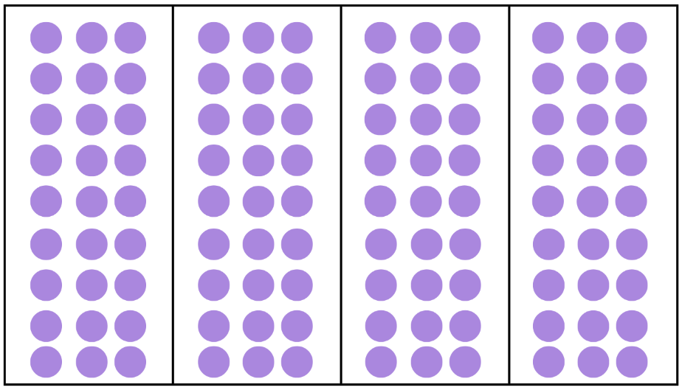
This table details opportunities for assessment.
Assessment opportunities | Links
What to look for:  - Can students apply the known strategy of doubling to connect multiples of 3 to 6 and 4 to 8? [MAO-WM-01, MA2-MR-01]  - Can students use flexible partitioning within multiplication?  [MAO-WM-01, MA2-MR-01] | Links to National Numeracy Learning Progressions (NNLP):  - MuS6, MuS7.  Links to suggested Interview for Student Reasoning (IfSR) tasks:  - IfSR-NP/AT/MT: 2A.4, 2A.11.

Lesson 3
Core concept: structures can support multiplicative thinking.

Daily number sense – partial grid – 10 minutes
The table below contains a suggested learning intention and success criteria. These are best co-constructed with students.
Daily number sense learning intention | Daily number sense success criteria
Students are learning to:  - use the structure of the area model to represent multiplication and division. | Students can:  - create and represent multiplicative structure, moving from arrays to partially covered area models.
- Display Resource 11 – partial grid. Ask students the following questions:
- What do you notice?
- How can the squares help you solve this problem?
- What are you visualising?
- How can multiplication be used to help solve division?
- What advice would you give to a friend if they didn’t know how to solve this problem?
- In pairs, each student creates their own partial grid on individual whiteboards and writes a division number sentence with a missing value. Students ask their partner to use the array to solve it.
This table details an opportunity for assessment.
Assessment opportunity | Links
What to look for:  - Can students create and represent multiplicative structure, moving from arrays to partially covered area models?  [MAO-WM-01, MA2-MR-01] | Links to National Numeracy Learning Progressions (NNLP):  - MuS5, MuS6.  Links to suggested Interview for Student Reasoning (IfSR) tasks:  - IfSR-MT: 2A.1, 2A.2, 2A.3.

Core lesson – torn shapes – 40 minutes
The table below contains suggested learning intentions and success criteria. These are best co-constructed with students.
Core concept learning intentions | Core concept success criteria
Students are learning to:  - use the structure of the area model to represent multiplication and division  - use square centimetres to measure and estimate the areas of rectangles. | Students can:  - move from arrays to partially covered area models  - create the array structure of area using squares (1 cm × 1 cm) in rows and columns.
This activity is an adaptation of Torn Shapes from NRICH by the University of Cambridge.
- Revise the definition of area.
Area: the amount of surface inside a closed flat (2D) shape.
- Display Resource 12 – untorn rectangles. Explain that these rectangles are made from grids of square centimetres. Ask the following questions:
- What is the area of the green and orange rectangles?
- What strategies did you use to calculate the area?
- How could you describe the area of the rectangles as an array? (The green rectangle shows 5 threes and the orange rectangle shows 3 fives.)
- What unit of measurement is used to describe the area? (square centimetres)
- What connections can you make between multiplication and area?
- Display Resource 13 – torn shapes. Tell students that a class has been constructing shapes on grid paper. Some students have torn a piece out of their shapes to make a puzzle for the other students. Explain that they will be working out the area of the shapes before they were torn. Draw students’ attention to shapes E and F. Explain that these are an optional challenge.
Note: calculating the area of composite shapes is a Stage 3 expectation in Two-dimensional spatial structure. Shape E and F have been included in this lesson as an optional challenge. Stage 2 students use flexible and derived strategies to work out the missing grid squares and find the total area.
- Provide small groups of students with Resource 13 – torn shapes. Move around the room to check for understanding. Ensure that students are recording the area of the rectangles using square centimetres and describing the array. Support any students using one-to-one counting strategies to think about multiplication facts to find the total area. Ask the following questions:
- What strategies can you use to determine the area of the whole rectangle?
- Do you have all the information necessary to work out the area of the whole rectangle?
- What multiplication facts could you use?
- How did your thinking change when calculating the area of shape E and F?
- Select students to share their strategies for determining the area of the different shapes. Address any errors or student misconceptions.
- Display Resource 14 – grey rectangle and provide a copy to the students. Ask the following questions:
- What is the smallest area possible for this shape?
- What are some other possible areas for this rectangle?
- I think it is possible for the area to be 39 square centimetres. Do you agree?
- Is it possible for the area to be 22 square centimetres? How do you know?
- Students record their strategies and solutions to the discussion questions.
- Select students to share their solutions. Ask the following questions:
- Why are there so many possibilities for the area of this shape?
- What patterns do you notice in all the possibilities?
This table details opportunities for differentiation.
Too hard? | Too easy?
Students cannot move from arrays to partially covered area models.  - Students recreate shapes A, B, C and D from Resource 13 – torn shapes as complete grids on square-centimetre grid paper. Students identify the grid formed by the rectangle and calculate the area.  - Support students with the use of a multiplication grid to find possible products when given a partially covered area model. | Students can move from arrays to partially covered area models.  - Students tear more than 2 pieces from their more complex shapes and swap with a partner to determine the possible areas of the whole shape.  - Students create shapes composed of 2 or more rectangles joined together and determine the area of the composite shape.

Discuss and connect the mathematics – 10 minutes
- Write the following problem on the board: A rectangle had an area of 36 square centimetres. What might it look like?
- Students work individually to record their ideas on a whiteboard. Ask the following questions:
- What strategies did you use to solve this problem?
- How many different solutions are there?
- How do you know you have found all the possible solutions?
- How did multiplication and division help you with this problem?
Note: Stage 2 students calculate the area of rectangles and squares. Remind students that squares are a special type of rectangle with all 4 sides equal in length.
This table details opportunities for assessment.
Assessment opportunities | Links
What to look for:  - Can students move from arrays to partially covered area models? [MAO-WM-01, MA2-MR-01]  - Can students create the array structure of area using squares (1 cm × 1 cm) in rows and columns? [MAO-WM-01, MA2-2DS-03] | Links to National Numeracy Learning Progressions (NNLP):  - MuS5, MuS6  - UuM5.  Links to suggested Interview for Student Reasoning (IfSR) tasks:  - IfSR-MT: 2A.1, 2A.2, 2A.3.

Lesson 4
Core concept: area relates to the measurement of two-dimensional space.

Daily number sense – 10 minutes
- From a class need surfaced through formative assessment data, identify a short, focused activity that targets students’ knowledge, understanding and skills. Example activities may be drawn from the following resources:
- Mathematics K–6 resources
- Universal Resources Hub.

Core lesson – equivalent areas – 40 minutes
The table below contains suggested learning intentions and success criteria. These are best co-constructed with students.
Core concept learning intentions | Core concept success criteria
Students are learning to:  - use square centimetres to measure and estimate the areas of rectangles  - measure the areas of shapes using the grid structure  - use number properties to find related multiplication facts. | Students can:  - recognise that rectangles with different side lengths can have the same area  - use the associative property within multiplication to regroup the factors.
- Display and read aloud Resource 15 – chocolate problem.
- Provide pairs or small groups of students with square-centimetre grid paper, scissors and writing materials.
- Students use the materials to model the problem.
- Discuss:
- Who was correct, Rohan or Hawon?
- How did you work this out?
- What is a multiplication number sentence that can be written to describe how the area of each chocolate bar was calculated?
- How is the number sentence 8 × 4 the same as 16 × 2?
- Can you see a connection with the numbers (factors) that would explain why this is true?
- What properties of multiplication make this true?
- Explain to students that 8 × 4 = 16 × 2 and we can explain this using the associative property. Demonstrate that 8 × 4 can be rewritten as 8 × (2 × 2) where the grouping symbols indicate that 2 × 2 is the first part of the multiplication. Demonstrate that 16 × 2 can also be rewritten as (8 × 2) × 2, where the grouping symbols have moved to indicate that 8 × 2 is the first part of the multiplication. The grouping symbols demonstrate how the factors have been regrouped.
- Pose the following problem: Which will increase the area of a rectangle more, doubling the width or doubling the length?
- Ask students to make a prediction. Provide small groups of students with square-centimetre grid paper, writing materials and rulers to investigate this problem.
This table details opportunities for differentiation.
Too hard? | Too easy?
Students cannot recognise that rectangles with different side lengths can have the same area.  - Supply students with 24 counters to model different rectangles that make an array of 24. Support students to transfer each of the different arrays onto grid paper. Use the drawings to identify that rectangles with different side lengths can have the same area.  - Support students to partition a larger rectangle by identifying smaller arrays so that they can calculate the total area. | Students can recognise that rectangles with different side lengths can have the same area.  - Pose the following question to students: What would happen if the rectangle was quadrupled in width or length? What happens to the dimensions and area of the rectangle?  - Students create a large rectangle with clearly labelled dimensions. Students swap with a partner and ask their partner to calculate the original dimension of a smaller rectangle that has been quadrupled in length or width to form the larger rectangle.

Discuss and connect the mathematics – 15 minutes
- Ask students the following questions:
- What did you discover when investigating the question: Which will increase the area of a rectangle more, doubling the width or doubling the length?
- What happened to the dimensions of the rectangles after the length was doubled?
- What happened to the dimensions of the rectangles after the width was doubled?
- What patterns do you notice in the numbers used?
- How could this be represented in a multiplication sentence to show what happened to the original rectangle?
- How can you use grouping symbols to communicate your thinking to someone else?
- What properties of multiplication did you notice during this activity?
- Draw a rectangle with dimensions 5 cm × 3 cm. Explain that when this rectangle’s length dimension is doubled, the new dimensions are 10 cm × 3 cm. Explain that when this rectangle’s width dimension is doubled, the new dimensions are 5 cm × 6 cm. Even though the dimensions of the new rectangles are different to one another, the area is the same. We can explain this as the dimensions of the rectangles doubling on one side but halving on the other. For example, 5 cm doubled becomes 10 cm and 6 cm halved becomes 3 cm. The associative property is also demonstrated when a rectangle with the dimensions 5 cm × 3 cm is doubled. This can be represented by 5 cm × (3 cm × 2 cm) or (5 cm × 2 cm) × 3 cm.
This table details opportunities for assessment.
Assessment opportunities | Links
What to look for:  - Can students recognise that rectangles with different side lengths can have the same area? [MAO-WM-01, MA2-2DS-03]  - Can students use the associative property within multiplication to regroup the factors? [MAO-WM-01, MA2-MR-01] | Links to National Numeracy Learning Progressions (NNLP):  - UuM6, UuM7  - UGP6  - MuS6.

Lesson 5
Core concept: mathematicians estimate, measure and compare area.

Daily number sense – benchmark fractions – 10 minutes
Daily number sense activities for Lessons 5 to 7 ‘loop’ back to concepts and procedures covered in previous units to assist students to build an increasingly connected network of ideas. These concepts may differ from the core concepts being covered by the unit.
The table below contains a suggested learning intention and success criteria. These are best co-constructed with students.
Daily number sense learning intention | Daily number sense success criteria
Students are learning to:  - make connections between fractions and decimal notation. | Students can:  - make connections between fractions and decimal notation for key benchmark values.
This activity is an adaptation of Simple fractions as percentages at NZ Maths by the New Zealand Ministry of Education.
- Show students a stack of 2 interlocking cubes of different colours (see Figure 2).
Figure 2 – two interlocking cubes
- Ask the following questions:
- What fractions can be seen?
- Could we use interlocking cubes to represent the same fraction in another way?
- Model half as 5 blue cubes and 5 yellow cubes. Explain that the model shows the fraction $\frac{1}{2}$ and $\frac{5}{10}$.
- Ask: How is half written as a decimal? Explain that we read the decimal 0.5 as half or 5 tenths.
- Give students interlocking cubes. Ask students to use the cubes to represent $\frac{1}{4}$and $\frac{3}{4}$. For example, $\frac{1}{4}$ can be represented as 2 blue cubes connected to 6 yellow cubes or 1 blue cube connected to 3 yellow cubes. Ask the following questions:
- How did you represent $\frac{1}{4}$?
- How did you represent $\frac{3}{4}$?
- How do you know you’ve represented these fractions accurately?
- Why are there so many ways of representing a fraction?
- How are $\frac{1}{4}$and $\frac{3}{4}$ written as decimals?
This table details opportunities for assessment.
Assessment opportunities | Links
What to look for:  - Can students make connections between fractions and decimal notation for key benchmark values? [MAO-WM-01, MA2-RN-02] | Links to National Numeracy Learning Progressions (NNLP):  - NPV6, NPV7  - InF6.  Links to suggested Interview for Student Reasoning (IfSR) tasks:  - IfSR-NP: 4D.3.

Core lesson – playground areas – 40 minutes
The table below contains suggested learning intentions and success criteria. These are best co-constructed with students.
Core concept learning intentions | Core concept success criteria
Students are learning to:  - represent and solve problems involving multiplication fact families  - use square metres to measure and estimate the areas of rectangles  - compare surfaces using familiar metric units of area. | Students can:  - describe multiplication problems using for each and times as many  - record areas in square metres using numerals and words  - estimate the areas of squares and rectangles in square metres  - estimate before measuring to determine the larger of 2 rectangular areas in square metres.
- Display Resource 16 – units of measurement. Ask the following questions:
- What is similar? What is different?
- When might square metres be used for measurement?
- Are these images true to size? How do you know?
- Show students the size of a square metre by using several metre rulers.
- Explain to students that the school principal wants to know how to organise the class in different seating arrangements in the playground to take up different areas. The principal wants to compare the area taken up by a class when they are sitting in 2, 3, 4 and 5 rows.
- Take the class outside and seat them in 2 rows. Mark out the rectangular area taken up by the class using cones or witches’ hats on each of the 4 corners (see Figure 3).
Figure 3 – area marked by cones
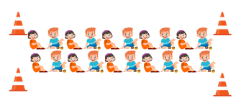
- Explain that the corners of the rectangular area are identified by the cones. The length and width of each rectangle will need to be marked out with chalk. Demonstrate how to use metre rulers and chalk to mark out the outline of the first rectangle.
- Repeat the same process for 3, 4 and 5 rows. Mark the corners of the rectangles with cones but don’t mark out the length and width chalk lines.
- Label each area with a different letter, for example area A, B, C and D.
- Ask students to predict:
- Which of these rectangles has the largest area?
- What do you estimate the area of each rectangle to be?
- Is your estimate reasonable? How do you know?
- What unit of measurement would be used to record your estimate?
- Students record their estimates for each area on a whiteboard or in their student workbook. Ensure that students record areas using square metres.
- Provide small groups of students with a metre ruler and chalk. Allocate groups to the different rectangle areas. Students mark out the length and width, measure the dimensions and calculate the area. Encourage students to round their measurements to the nearest metre when determining the area.
This table details opportunities for differentiation.
Too hard? | Too easy?
Students cannot record areas in square metres using numerals and words.  - Support students to use a metre ruler and chalk to draw square metres inside each area.  - Support students to recognise the array structure within the rectangle and use multiplicative strategies to determine the total area. | Students can record areas in square metres using numerals and words.  - Ask students to determine other possible dimensions for a quadrilateral that covers a square metre.

Discuss and connect the mathematics – 10 minutes
- Gather students together. Ask the following questions:
- How did the actual measurements compare to your estimation?
- What did you do to ensure the accuracy of your measurements?
- Were the areas covered by students sitting in different arrangements similar in size? Why? (The different areas should be similar in size as each student sitting down should take up approximately the same area regardless of the arrangement.)

Consolidation and meaningful practice – 10 minutes
- Pose the following problem to students: Five classes want to sit in the playground for assembly. Is there enough space for each class if the playground has an area of 100 square metres?
- Students turn and talk with a partner to answer this problem based on the measurements from the lesson.
- Pose the following problem to students: How much space would a class that was 3 times as large as ours take up in the playground?
- Students turn and talk with a partner to answer this problem based on the measurements from the lesson.
This table details opportunities for assessment.
Assessment opportunities | Links
What to look for:  - Can students describe multiplication problems using for each and times as many? [MAO-WM-01, MA2-MR-01]  - Can students record areas in square metres using numerals and words? [MAO-WM-01, MA2-2DS-03]  - Can students estimate the areas of squares and rectangles in square metres? [MAO-WM-01, MA2-2DS-03]  - Can students estimate before measuring to determine the larger of 2 rectangular areas in square metres?  [MAO-WM-01 MA2-2DS-03] | Links to National Numeracy Learning Progressions (NNLP):  - MuS5  - UuM5, UuM6, UuM7.

Lesson 6
Core concept: volume relates to the measurement of three-dimensional space.

Daily number sense – comparing decimal heights – 10 minutes
The table below contains a suggested learning intention and success criteria. These are best co-constructed with students.
Daily number sense learning intention | Daily number sense success criteria
Students are learning to:  - make connections between fractions and decimal notation. | Students can:  - compare and order decimals of up to 2 decimal places.
- Display Resource 17 – decimal height fight. Ask the following questions:
- Who is correct? How do you know?
- What misconceptions about decimals might Rose have? How could you explain this to her?
- What is the difference between Martine and Rose’s height? How can you calculate this?
- Revise how to read these decimals. 1.09 is read as 1 and 9 hundredths, 1.3 is read as ‘one and three-tenths’.
Note: interpreting decimals used in different contexts can change the way that we read them. In the context of measuring height, it is appropriate to read the decimal 1.3 metres as ‘one point three’ metres. Without the context, this decimal is read as ‘one and three-tenths’. The use of the place value language to read decimals supports students conceptual understanding of the size of each part and to develop a mental image of hundredths compared to tenths. When comparing these 2 decimals, it makes more sense to compare 1 and 9 hundredths to 1 and 3 tenths.
- Select 4 students and record their heights in decimal notation on the board. Ask:
- Can you order these decimals from smallest to largest?
- What is the difference between the smallest and largest decimal?
This table details an opportunity for assessment.
Assessment opportunity | Links
What to look for:  - Can students compare and order decimals of up to 2 decimal places? [MAO-WM-01, MA2-RN-02] | Links to National Numeracy Learning Progressions (NNLP):  - NPV6, NPV7.  Links to suggested Interview for Student Reasoning (IfSR) tasks:  - IfSR-NP: 4D.4.

Core lesson 1 – nets of prisms – 25 minutes
The table below contains suggested learning intentions and success criteria. These are best co-constructed with students.
Core concept learning intentions | Core concept success criteria
Students are learning to:  - make models of three-dimensional objects to compare and describe key features  - compare objects using familiar metric units of volume  - connect three-dimensional objects and two-dimensional representations. | Students can:  - investigate the variety of nets that can be used to create a particular prism  - compare the volumes of 2 or more objects made from cubic-centimetre blocks  - draw different views on isometric grids of an object constructed from connecting cubes  - interpret given drawings to make models of three-dimensional objects using connecting cubes (Reasons about spatial visualisation).
- Brainstorm terminology used to describe 3D objects. Ensure students include mathematical words such as face, edge, vertex and net.
- Display Resource 18 – different nets. Ask the following questions:
- What is a net?
- What three-dimensional objects do these nets form? How do you know?
- How are the nets for a prism and pyramid similar? How are they different?
- Display Polypad and select Geometry. Demonstrate how to recreate the nets on Resource 18 – different nets and the fold net function.
- For the triangular based pyramid, click on 3D solids and select Tetrahedron.
- For the cube, click on 3D solids and select Cube.
- For the hexagonal based pyramid, click on 3D solids and select Pyramid.
- For the square prism, click on Polygons and Shapes. Select the Square. Right click the square and select copy. Select the Rectangle. Click on the rectangle and rotate it using the black circle. Then right click on the rectangle and press copy. Create 4 rectangles and then click and drag to the desired position.
- To fold the net, left click and hold to drag so that the whole net is outlined in black. Release the mouse and click on Fold net.
- Explain to students that they will be using Polypad to find different nets to make a triangular based pyramid and a square prism.
- Provide pairs of students with a device. Move around the room to support students to find different possibilities and check for understanding.
- Ask the following questions:
- How many different nets did you find? (2 for the triangular based pyramid and 16 for the square prism (see Figure 4).
- What strategy did you use to find all the possibilities?
Figure 4 – nets of a square prism
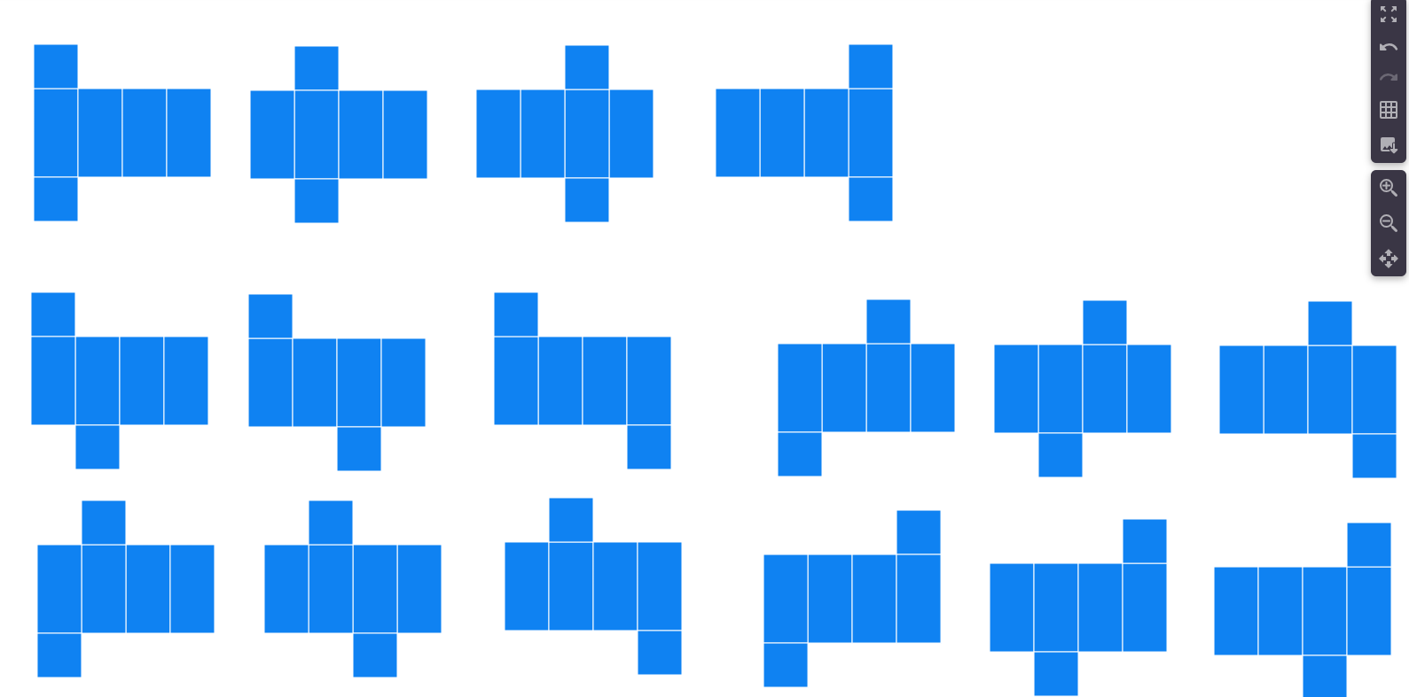
Image created using the free virtual manipulatives from Polypad by Amplify.

Core lesson 2 – different views – 25 minutes
This activity is an adaptation of Building Blocks from NRICH by the University of Cambridge.
- Display Resource 19 – building blocks. Ask:
- How might you use connecting cubes to recreate these three-dimensional objects?
- What would they look like from different positions?
- Which of these objects has the largest volume? Which has the smallest volume?
- Provide small groups of students with connecting cubes, writing materials and isometric dot paper. Students construct the three-dimensional objects using the cubes and draw their object on the isometric dot paper. Encourage students to draw their prisms from more than one viewpoint.
This table details opportunities for differentiation.
Too hard? | Too easy?
Students cannot investigate the variety of nets that can be used to create a particular prism.  - Provide students with a deconstructed tissue box. Support students to recognise how the net can be folded to reconstruct the box. Students recreate this net using Polypad.  Students cannot draw different views on isometric grids of an object constructed from connecting cubes.  - Provide students with a digital device to access the interactive Isometric Drawing Tool. Support students to view their models from different viewpoints and recreate it using the cube tool. | Students can investigate the variety of nets that can be used to create a particular prism.  - Students explore the nets of more challenging three-dimensional objects. For example, tetrahedrons and icosahedrons.  Students can draw different views on isometric grids of an object constructed from connecting cubes.  - Students create their own three-dimensional objects using 10 to 20 connecting cubes and sketch one view. Students swap sketches with a partner. Their partner attempts to recreate the three-dimensional object and draws it from a different view.

Lesson 7
Core concept: standard units are an efficient way to communicate volume.

Daily number sense – decimal chains – 10 minutes
The table below contains a suggested learning intention and success criteria. These are best co-constructed with students.
Daily number sense learning intention | Daily number sense success criteria
Students are learning to:  - make connections between fractions and decimal notation. | Students can:  - make connections between fractions and decimal notation for key benchmark values.
This activity is an adaptation of Doughnut Percents from NRICH by the University of Cambridge.
- Prior to the lesson print and cut Resource 20 – decimal chains ensuring there is one set between each pair of students.
- Explain that students will work together to create one long domino chain or 2 smaller chains. Touching ends need to have equal values (see Figure 5).
Figure 5 – example decimals in a chain
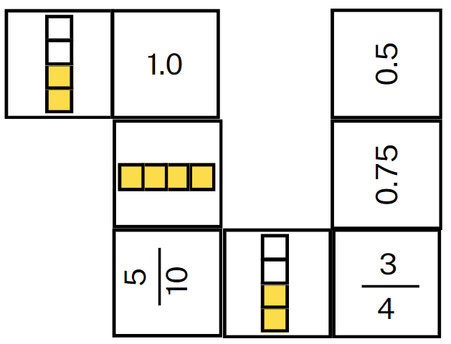
- Teamwork and collaboration are the key to this task. Explain that:
- all dominoes are face up and visible to both players
- players take turns to place a domino to add to the chain
- players discuss their moves, communicating their reasoning connecting fractions and decimals.
- Reflect on the activity, asking questions such as:
- Which dominoes were the hardest to match? Why?
- Were there any that you didn’t know? Were you still able to match them? What strategy did you use?
This table details an opportunity for assessment.
Assessment opportunity | Links
What to look for:  - Can students make connections between fractions and decimal notation for key benchmark values? [MAO-WM-01, MA2-RN-02] | Links to National Numeracy Learning Progressions (NNLP):  - NPV6, NPV7  - InF6.  Links to suggested Interview for Student Reasoning (IfSR) tasks:  - IfSR-NP: 4D.3.

Core lesson – pop-up box – 40 minutes
The table below contains suggested learning intentions and success criteria. These are best co-constructed with students.
Core concept learning intentions | Core concept success criteria
Students are learning to:  - use square centimetres to measure and estimate the areas of rectangles  - compare objects using familiar metric units of volume. | Students can:  - use efficient strategies for counting large numbers of square centimetres  - record volumes using numerals and words  - construct rectangular prisms and describe the volumes in terms of layers.
This activity is an adaptation of Making Boxes from NRICH by the University of Cambridge.
- Display Resource 21 – prism volume. Ask the following questions:
- How could you describe the volume of this prism? (2 layers of 4 sixes).
- What is the volume of this prism? How do you know? (48 cubic centimetres. Four sixes make 24 and 2 layers of 24 makes 48).
- What unit of measurement is used to describe volume? (cubic centimetres).
- Explain to students that it is possible to make open-top boxes by cutting out a square in each corner of a sheet of paper and folding up the sides (see Figure 6).
Figure 6 – making open-top boxes
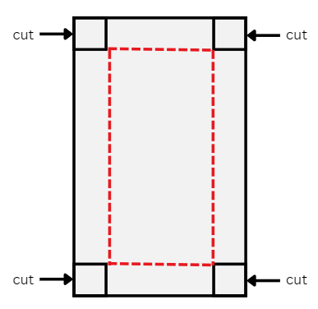
- Model with a piece of square-centimetre grid paper that measures 20 cm × 10 cm. Demonstrate how to cut a 1 cm × 1 cm square from each corner of the sheet of paper and fold the sides up to make a box.
- Ask students the following questions:
- What is the area of the base of this box?
- What strategies could we use to determine the area of the base?
- How could we use the word layers to describe the volume of this box?
- What will happen to the volume and area if we cut out a 2 cm × 2 cm square from each corner?
- What will happen to the volume and area if we continue to cut larger squares from each corner of the paper?
- Provide small groups of students Resource 22 – recording sheet, 20 cm × 10 cm grid paper, scissors and sticky tape.
Note: the same task could be completed with a plain piece of A4 paper. The benefit of using grid paper is that students will be able to quickly cut out corners of the same size and calculate the area of the base through the grid structure.
The table below outlines anticipated responses from students and possible teacher prompts to further support students.
Anticipated response | Possible teacher prompt
Students cut out different sized squares in the sides. | Draw attention to different sides of the box when it is folded. Show an example of an open-top box with equal sides.
Students create a box but are having difficulty finding the area of the base. | Ask:  - How many are in each row?  - How many rows are there?  - Can you name the array that makes the base?
Students create a box but are using count-by-one strategies to work out the area of the base. | Ask: If you know there are __ centimetre squares in one row, how can you use this information for 2 rows? What about 4 rows?
Students create a box but are having difficulty seeing the layers of the box (height). | Ask:  - Can you fill your box with MAB units?  - How many MAB units will stack on top of one another before they reach the top of the box?
This table details opportunities for differentiation.
Too hard? | Too easy?
Students cannot construct rectangular prisms and describe the volumes in terms of layers.  - Provide students with square-centimetre grid paper measuring 10 cm × 10 cm. Support students to cut out the corners and create a box.  - Provide students with MAB units to cover the base of the box. Support students to partition the base into smaller arrays to determine the larger area. Support students to stack MAB units to determine the number of layers within the box. | Students can construct rectangular prisms and describe the volumes in terms of layers.  - Provide students with square-centimetre grid paper measuring 15 cm × 15 cm. Students determine the volume of each box formed.  - Provide students with the NRICH problem Open Boxes. Students work out how many cubes are needed to make boxes of varying sizes.

Discuss and connect the mathematics – 10 minutes
- Ask the following questions:
- What strategies did you use to work out the area of the base?
- Did the volume of the box increase or decrease when the cut-out squares were bigger?
- What patterns do you notice between the dimensions of each box?
- How is the box similar and different to a rectangular prism?
This table details opportunities for assessment.
Assessment opportunities | Links
What to look for:  - Can students use efficient strategies for counting large numbers of square centimetres? [MAO-WM-01, MA2-2DS-03]  - Can students record volumes using numerals and words?  [MAO-WM-01, MA2-3DS-02]  - Can students construct rectangular prisms using cubic-centimetre blocks and describe the volumes in terms of layers?  [MAO-WM-01, MA2-3DS-02] | Links to National Numeracy Learning Progressions (NNLP):  - UuM5, UuM6.

Consolidation and meaningful practice – 10 minutes
- Pose the following question: How can the features of a net be used to determine what three-dimensional object it will create?
- Students turn and talk with a partner.
- Record students’ ideas on a class anchor chart.
This table details opportunities for assessment.
Assessment opportunities | Links
What to look for:  - Can students investigate the variety of nets that can be used to create a particular prism? [MAO-WM-01, MA2-3DS-01]  - Can students compare the volumes of 2 or more objects made from cubic-centimetre blocks? [MAO-WM-01, MA2-3DS-01]  - Can students draw different views on isometric grids of an object constructed from connecting cubes? [MAO-WM-01, MA2-3DS-01]  - Can students interpret given drawings to make models of three-dimensional objects using connecting cubes?  [MAO-WM-01, MA2-3DS-01] | Links to National Numeracy Learning Progressions (NNLP):  - UGP3.

Lesson 8
Core concept: mathematicians measure and compare volumes.

Daily number sense – 10 minutes
- From a class need surfaced through formative assessment data, identify a short, focused activity that targets students’ knowledge, understanding and skills. Example activities may be drawn from the following resources:
- Mathematics K–6 resources
- Universal Resources Hub.

Core lesson – volume word problems – 45 minutes
The table below contains suggested learning intentions and success criteria. These are best co-constructed with students.
Core concept learning intentions | Core concept success criteria
Students are learning to:  - represent and solve word problems with number sentences involving multiplication or division  - compare objects using familiar metric units of volume  - connect three-dimensional objects and two-dimensional representations. | Students can:  - represent and solve multiplication and division (both sharing and grouping) word problems using number sentences  - construct rectangular prisms using cubic-centimetre blocks and describe the volumes in terms of layers  - create sketches of three-dimensional objects from different views, including top, front and side views.
- Display and read aloud Resource 23 – volume problem.
- Students turn and talk with a partner and record their ideas on a whiteboard.
- Use the questions below to help scaffold the problem-solving process.
The table below outlines stimulus prompts to generate conversation about the topic, along with anticipated responses from students.
Prompts | Anticipated student responses
How can this problem be represented as a number sentence? | 60 = 12 × ? or 60 ÷ 12 = ?
Is there more than one way of having a base of 12 cubes? What might the prism look like? | I could have 12 cubes as one 12, 2 sixes or 3 fours. Then each of these bases would have 5 layers to make a prism of 60 cubic centimetres or cubes.
How many possibilities are there to this problem? How do you know? | There are 3 possibilities. I found all of them by thinking about the different ways to arrange 12 into an array.
- Provide pairs of students with connecting cubes. Ask students to construct the rectangular prisms from the problem to check their calculations.
- Provide students with square-centimetre grid paper and writing materials. Ask students to record the top, front and side view of the prisms on the grid paper.
- Display Resource 24 – volume problem 2. Ask the following questions:
- If the prism only has one layer, how many cubes would be in a layer?
- If the prism has 2 layers, how many cubes would be in a layer?
- How many different prisms can be made with 2 layers with a volume of 60 cubic centimetres?
- What would these prisms look like from different views?
- Students work individually or in pairs to develop different solutions to the problem posed and record the top, front and side view on the grid paper.
- Select a variety of student work samples to share. Ask the following questions:
- What was the largest number of cubes in each layer?
- What was the smallest number of cubes possible in each layer?
- What patterns do you see between the number of layers and the number of cubes in each layer?
- How many ways did you find to rearrange each layer?
- How did multiplication and division help you with this problem?
This table details opportunities for differentiation.
Too hard? | Too easy?
Students cannot represent and solve word problems with number sentences involving multiplication or division.  - Change the problem to a prism with 24 cubes. Support students to generate solutions systematically by starting with one layer, before moving to 2, 3 and 4 layers.  - Support students to rearrange each layer into different arrays. For example, 6 blocks can be arranged as 6 ones or 3 twos. | Students can represent and solve word problems with number sentences involving multiplication or division.  - Ask students to find all the possible dimensions of a rectangular prism made of 96 cubes.  - Pose the following problem: The volume of a rectangular prims is 48 cubic centimetres. What might the dimensions be? If you double the lengths of the sides, what happens to the volume? (Sullivan 2018).

Discuss and connect the mathematics – 10 minutes
- Pose the following problem to students: A rectangular prism is made of 28 cubes and has 7 layers. How many are in each layer?
- Ask the following questions:
- How can this problem be represented as a multiplication sentence?
- How can this problem be represented as a division sentence?
This table details opportunities for assessment.
Assessment opportunities | Links
What to look for:  - Can students represent and solve multiplication and division (both sharing and grouping) word problems using number sentences? [MAO-WM-01, MA2-MR-02]  - Can students construct rectangular prisms using cubic centimetre blocks and describe the volumes in terms of layers?  [MAO-WM-01, MA2-3DS-01]  - Can students create sketches of three-dimensional objects from different views, including top, front and side views?  [MAO-WM-01, MA2-3DS-01] | Links to National Numeracy Learning Progressions (NNLP):  - NPA4  - UuM5  - UGP3.

Resource 1 – How many tiles?
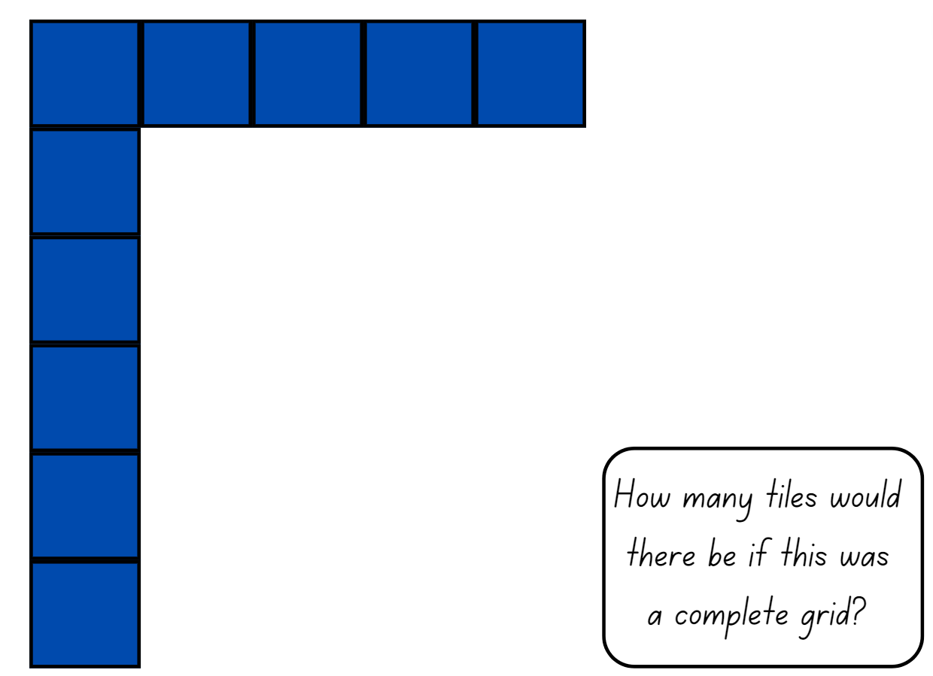

Resource 2 – student shapes
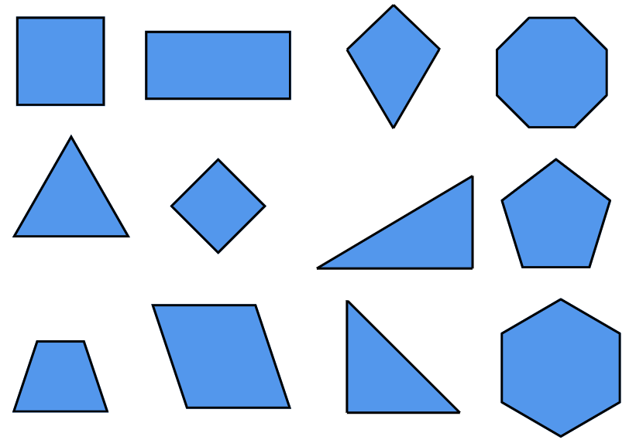

Resource 3 – additional shapes
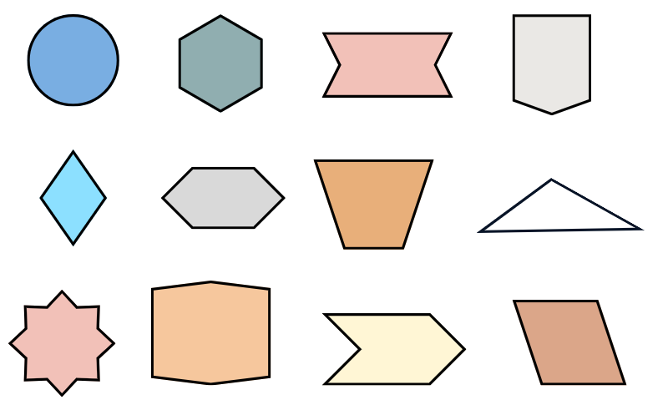

Resource 4 – teacher shape sort
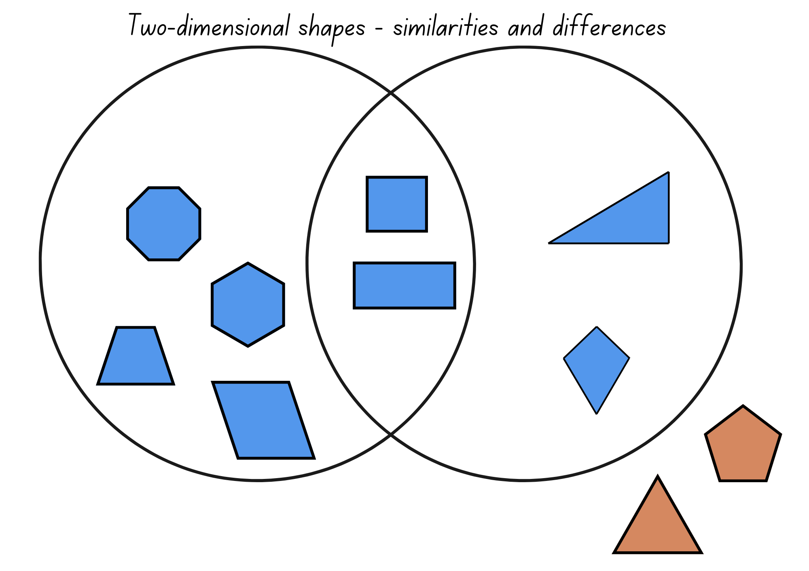

Resource 5 – partial array cards
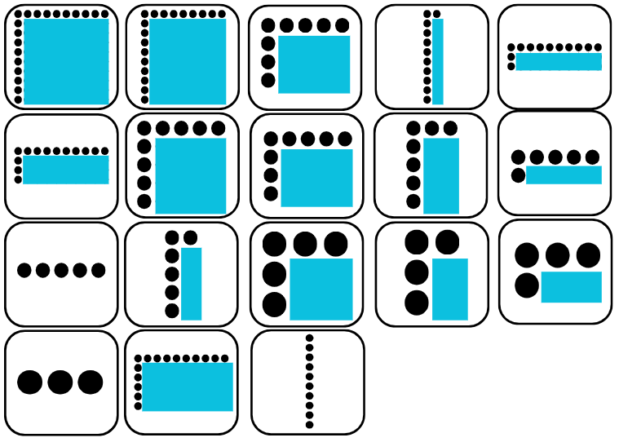

Resource 6 – partial array products
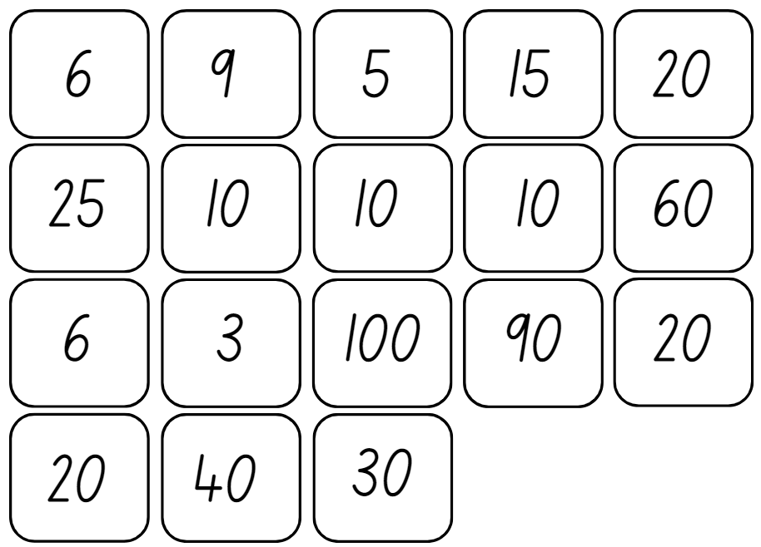

Resource 7 – cupcake arrays
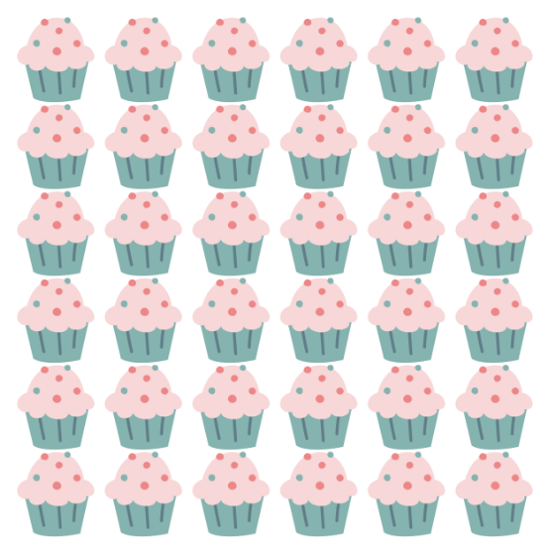

Resource 8 – lots of cupcakes
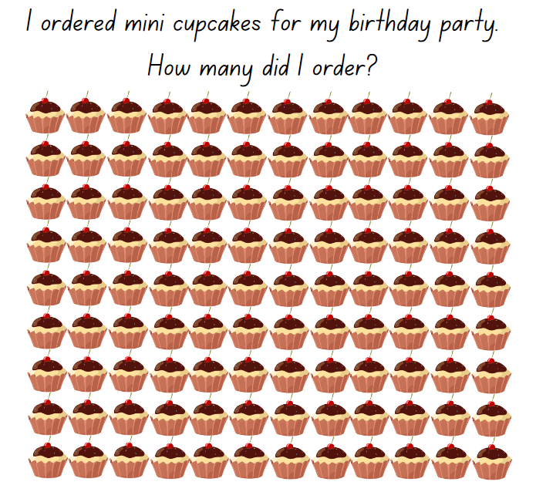

Resource 9 – smaller cupcake order
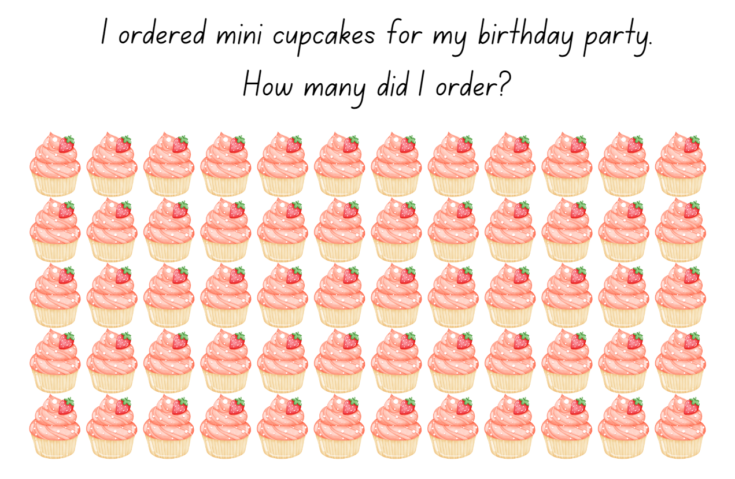

Resource 10 – missing muffins array
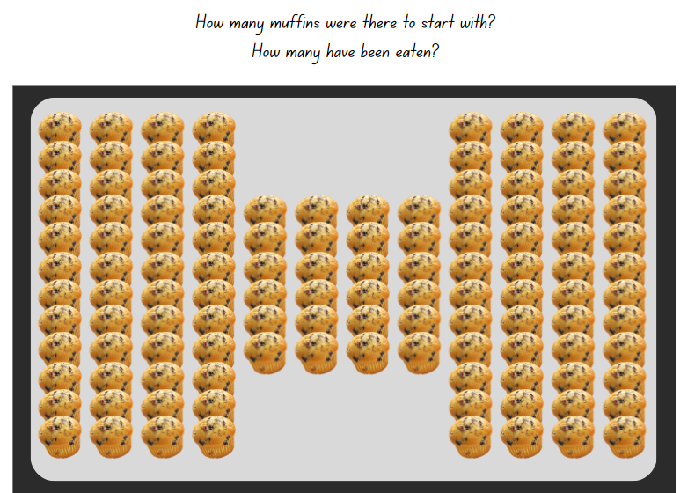

Resource 11 – partial grid
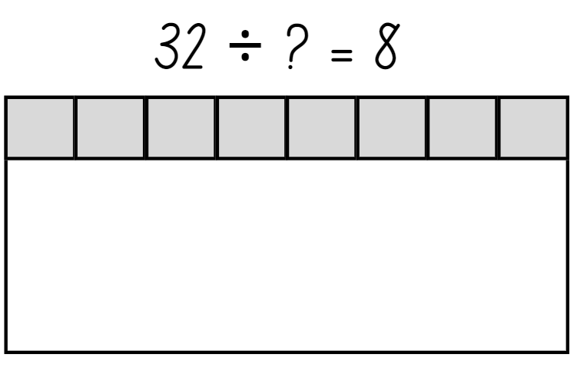

Resource 12 – untorn rectangles
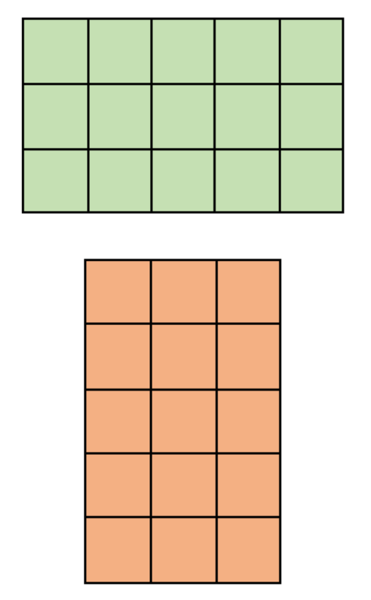

Resource 13 – torn shapes
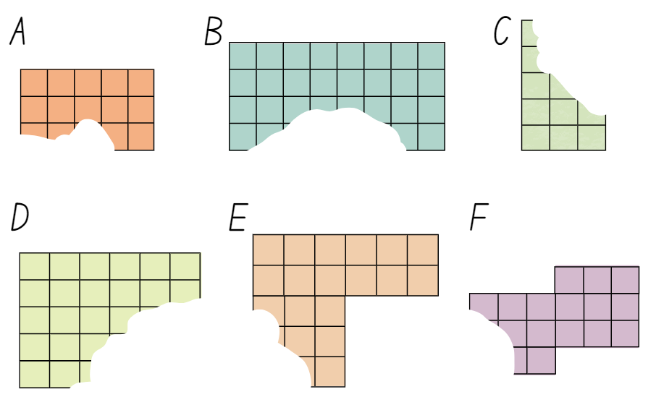

Resource 14 – grey rectangle
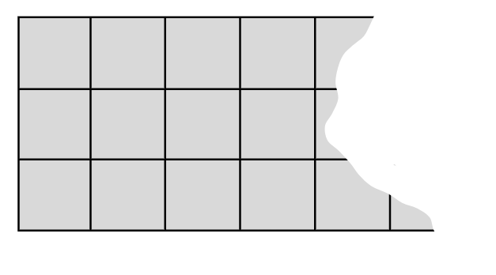

Resource 15 – chocolate problem
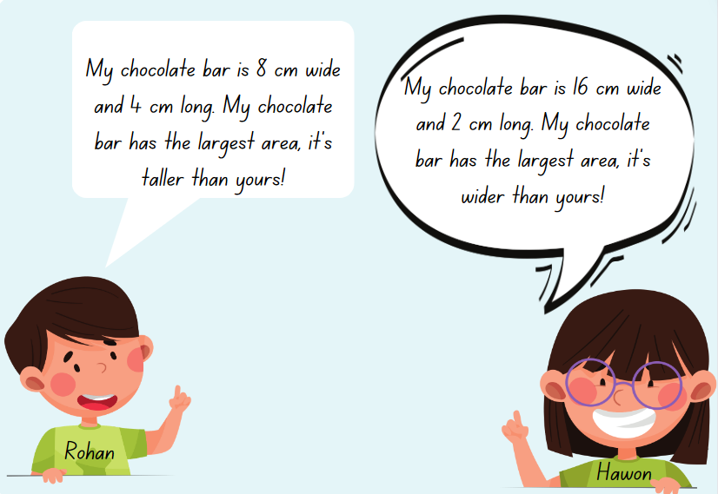

Resource 16 – units of measurement

Resource 17 – decimal height fight
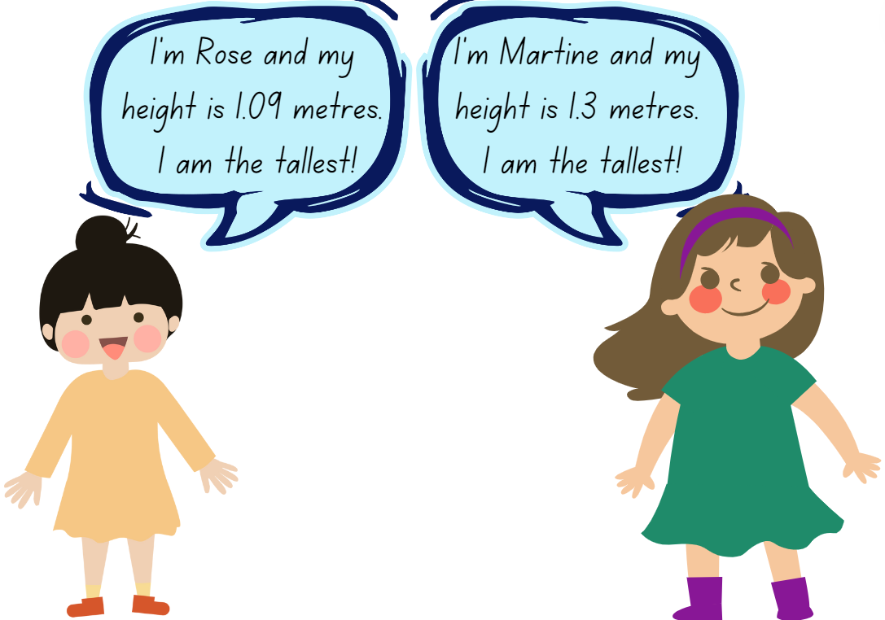

Resource 18 – different nets
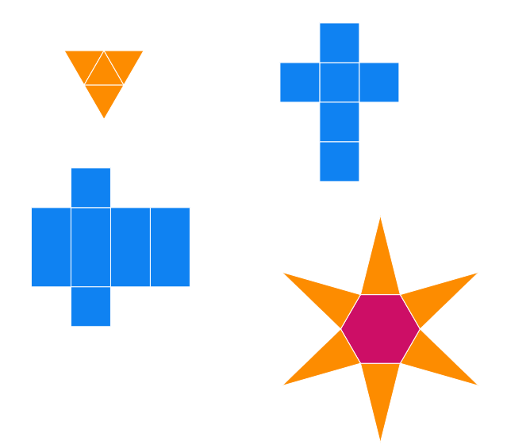
Image created using the free virtual manipulatives from Polypad by Amplify.

Resource 19 – building blocks
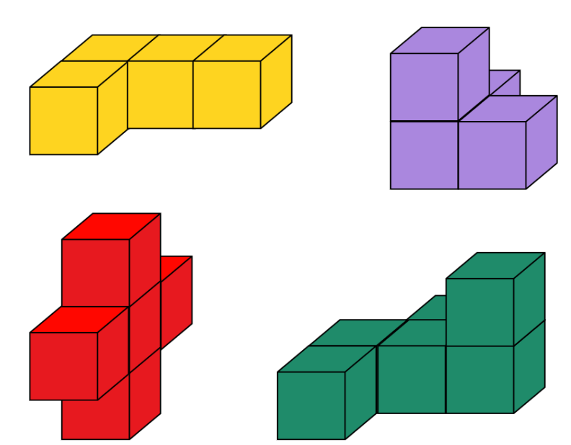

Resource 20 – decimal chains
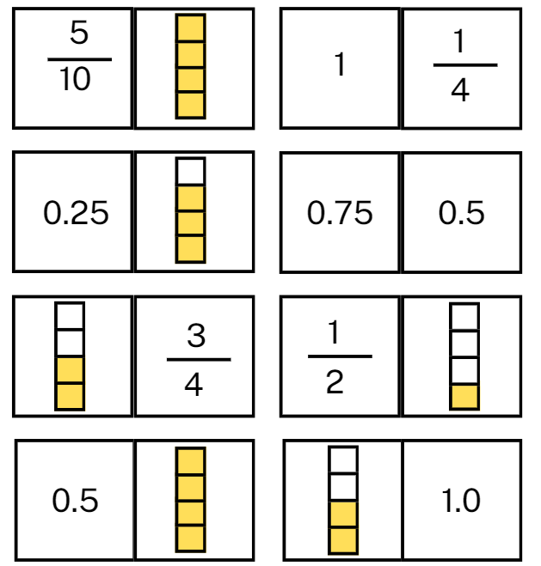

Resource 21 – prism volume
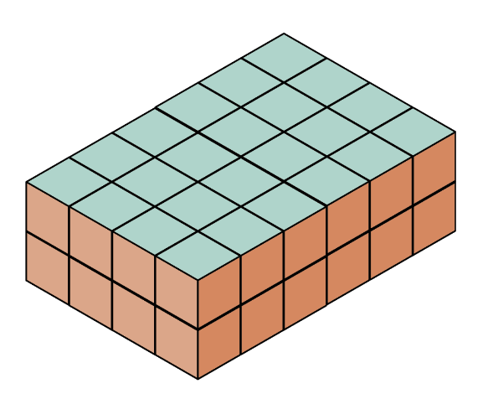

Resource 22 – recording sheet
Length and width of the square cut out | Area of the base | Describe the volume in layers
1 cm | cm²
2 cm | cm²
3 cm | cm²
4 cm | cm²

Resource 23 – volume problem
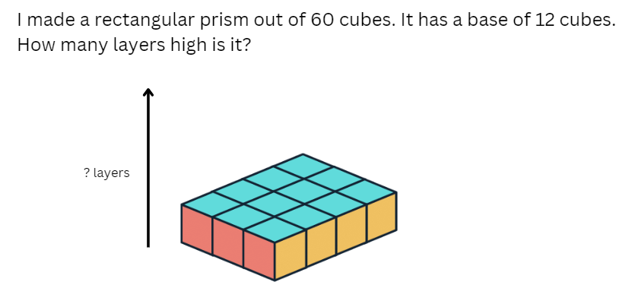

Resource 24 – volume problem 2
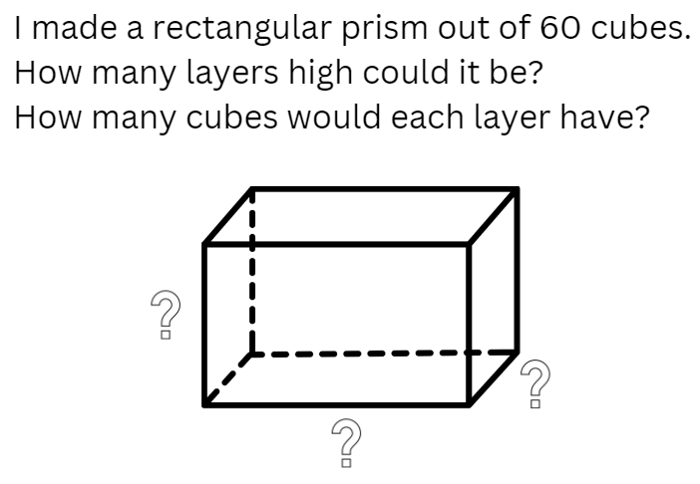

Syllabus outcomes and content
The table below outlines the syllabus outcomes and range of relevant syllabus content covered in this unit. Content is linked to National Numeracy Learning Progression (version 3).
Outcomes and content | 1 | 2 | 3 | 4 | 5 | 6 | 7 | 8
Representing numbers using place value B: Decimals: Make connections between fractions and decimal notation
[MAO-WM-01, MA2-RN-02]
- Compare and order decimals of up to 2 decimal places |  |  |  |  |  | x
- Make connections between fractions and decimal notation for key benchmark values (Reasons about relations) |  |  |  |  | x |  | x
Multiplicative relations A: Represent and solve problems involving multiplication fact families
[MAO-WM-01, MA2-MR-01]
- Describe multiplication problems using for each and times as many |  |  |  |  | x
Multiplicative relations B: Use known number facts and strategies
[MAO-WM-01, MA2-MR-01]
- Apply the known strategy of doubling to connect multiples of 3 to 6 and 4 to 8 (Reasons about relations) |  | x
Multiplicative relations B: Use the structure of the area model to represent multiplication and division
[MAO-WM-01, MA2-MR-01]
- Create and represent multiplicative structure, moving from arrays to partially covered area models | x | x | x
Multiplicative relations B: Use number properties to find related multiplication facts
[MAO-WM-01, MA2-MR-01]
- Use the associative property within multiplication to regroup the factors (Reasons about structure) |  | x |  | x
- Use flexible partitioning within multiplication (Reasons about relations) |  | x
Multiplicative relations B: Represent and solve word problems with number sentences involving multiplication or division
[MAO-WM-01, MA2-MR-01, MA2-MR-02]
- Represent and solve multiplication and division (both sharing and grouping) word problems using number sentences |  |  |  |  |  |  |  | x
Two-dimensional spatial structure A: 2D shapes: Compare and describe features of two-dimensional shapes
[MAO-WM-01, MA2-2DS-01]
- Describe and compare two-dimensional shapes, including parallelograms, rectangles, rhombuses, squares, trapeziums and kites | x
- Identify and describe polygons that have parallel sides and those that do not | x
- Identify right angles in shapes | x
Two-dimensional spatial structure A: Area: Use square centimetres to measure and estimate the areas of rectangles
[MAO-WM-01, MA2-2DS-03]
- Create the array structure of area using squares (1 cm × 1 cm) in rows and columns |  |  | x | x
- Recognise that area can be measured in square centimetres |  |  | x | x
- Record area in square centimetres using numerals and words |  |  | x | x |  |  | x
- Use efficient strategies for counting large numbers of square centimetres |  |  |  |  |  |  | x
Two-dimensional spatial structure A: Area: Use square metres to measure and estimate the areas of rectangles
[MAO-WM-01, MA2-2DS-03]
- Recognise the need for a formal unit larger than the square centimetre to measure area |  |  |  |  | x
- Record areas in square metres using numerals and words |  |  |  |  | x
- Estimate the areas of squares and rectangles in square metres |  |  |  |  | x
Two-dimensional spatial structure B: Area: Measure the areas of shapes using the grid structure
[MAO-WM-01, MA2-2DS-03]
- Recognise that rectangles with different side lengths can have the same area |  |  |  | x
Two-dimensional spatial structure B: Area: Compare surfaces using familiar metric units of area
[MAO-WM-01, MA2-2DS-03]
- Estimate before measuring to determine the larger of 2 rectangular areas in square metres |  |  |  |  | x
Three-dimensional spatial structure A: 3D objects: Make models of three-dimensional objects to compare and describe key features
[MAO-WM-01, MA2-3DS-01]
- Investigate the variety of nets that can be used to create a particular prism |  |  |  |  |  | x
Three-dimensional spatial structure A: Volume: Compare objects using familiar metric units of volume
[MAO-WM-01, MA2-3DS-02]
- Construct rectangular prisms using cubic-centimetre blocks and describe the volumes in terms of layers |  |  |  |  |  |  | x | x
- Record volumes using numerals and words |  |  |  |  |  |  | x
- Compare the volumes of 2 or more objects made from cubic-centimetre blocks |  |  |  |  |  | x
Three-dimensional spatial structure B: 3D objects: Connect three-dimensional objects and two-dimensional representations
[MAO-WM-01, MA2-3DS-01]
- Create sketches of three-dimensional objects from different views, including top, front and side views (Reasons about spatial relations) |  |  |  |  |  |  |  | x
- Draw different views on isometric grids of an object constructed from connecting cubes |  |  |  |  |  | x
- Interpret given drawings to make models of three-dimensional objects using connecting cubes (Reasons about spatial visualisation) |  |  |  |  |  | x
Mathematics K–10 Syllabus © NSW Education Standards Authority (NESA) for and on behalf of the Crown in right of the State of New South Wales, 2022.

References
This resource contains NSW Curriculum and syllabus content. The NSW Curriculum is developed by the NSW Education Standards Authority. This content is prepared by NESA for and on behalf of the Crown in right of the State of New South Wales. The material is protected by Crown copyright.
Please refer to the NESA Copyright Disclaimer for more information https://educationstandards.nsw.edu.au/wps/portal/nesa/mini-footer/copyright.
NESA holds the only official and up-to-date versions of the NSW Curriculum and syllabus documents. Please visit the NSW Education Standards Authority (NESA) website https://educationstandards.nsw.edu.au and the NSW Curriculum website https://curriculum.nsw.edu.au.
Mathematics K–10 Syllabus © NSW Education Standards Authority (NESA) for and on behalf of the Crown in right of the State of New South Wales, 2022.
National Numeracy Learning Progression © Australian Curriculum, Assessment and Reporting Authority (ACARA) 2010 to present, unless otherwise indicated. This material was downloaded from the Australian Curriculum website (National Literacy Learning Progression) (accessed 4 April 2024 and was not modified.
AAMT (The Australian Association of Mathematics Teachers) (n.d.) Partial Arrays, Top Drawer Teachers website, accessed 3 April 2024.
Amplify Education (2024) Polypad, Polypad website, accessed 3 April 2024.
Australian Academy of Science (2020) Multiplication: reSolve Bakery, reSolve: Maths by Inquiry website, accessed 3 April 2024.
Barton C (2018) Parallel Sides, Right-Angle, Equal Sides, Maths Venns Website, accessed 3 April 2024.
National Council for Teachers of Mathematics (2024) ‘Isometric Drawing Tool’, Classroom Resources, NCTM website, accessed 3 April 2024
New Zealand Ministry of Education (n.d.) ‘In Your Prime’, Resource Finder, NZ Maths website, accessed 9 April 2024.
State of New South Wales (Department of Education) (2023) ‘Array Bingo – Partially Covered Arrays’, Mathematics K–6 resources, NSW Department of Education website, accessed 3 April 2024.
Sullivan P (2018) Challenging Mathematical Tasks, Oxford University Press Australia and New Zealand.
Toy Theatre (2001–2024) Multiplication Chart 1-12, Toy Theatre website, accessed 3 April 2024.
University of Cambridge (n.d.a) Building Blocks, NRICH website, accessed 3 April 2024.
——(n.d.b) Cut Nets, NRICH website, accessed 3 April 2024.
——(n.d.c) Doughnut Percents, NRICH website, accessed 3 April 2024.
——(n.d.d) Making Boxes, NRICH website, accessed 3 April 2024.
——(n.d.e) Open Boxes, NRICH website, accessed 3 April 2024.
——(n.d.f) Simple fractions as percentages, NRICH website, accessed 3 April 2024.
——(n.d.g) Torn Shapes, NRICH website, accessed 3 April 2024.

© State of New South Wales (Department of Education), 2024
The copyright material published in this resource is subject to the Copyright Act 1968 (Cth) and is owned by the NSW Department of Education or, where indicated, by a party other than the NSW Department of Education (third-party material).
Copyright material available in this resource and owned by the NSW Department of Education is licensed under a Creative Commons Attribution 4.0 International (CC BY 4.0) license.
This license allows you to share and adapt the material for any purpose, even commercially.
Attribution should be given to © State of New South Wales (Department of Education), 2024.
Material in this resource not available under a Creative Commons license:
- the NSW Department of Education logo, other logos and trademark-protected material
- material owned by a third party that has been reproduced with permission. You will need to obtain permission from the third party to reuse its material.
Links to third-party material and websites
Please note that the provided (reading/viewing material/list/links/texts) are a suggestion only and implies no endorsement, by the New South Wales Department of Education, of any author, publisher, or book title. School principals and teachers are best placed to assess the suitability of resources that would complement the curriculum and reflect the needs and interests of their students.
If you use the links provided in this document to access a third-party's website, you acknowledge that the terms of use, including licence terms set out on the third-party's website apply to the use which may be made of the materials on that third-party website or where permitted by the Copyright Act 1968 (Cth). The department accepts no responsibility for content on third-party websites.

