Mathematics Stage 2 – Unit 36
Fractions represent multiple ideas and can be represented in different ways

Contents
Unit description and duration 5
Syllabus outcomes 5
Working mathematically 6
Student prior learning 6
Lesson overview and resources 8
Lesson 1 13
Daily number sense – recreating the whole – 10 minutes 13
Core lesson – comparing fractions – 40 minutes 15
Discuss and connect the mathematics – 10 minutes 21
Lesson 2 23
Daily number sense – fractional parts beyond one – 15 minutes 23
Core lesson – vertical fraction walls – 40 minutes 25
Consolidation and meaningful practice – 10 minutes 30
Lesson 3 32
Daily number sense – fraction line beyond 1 – 10 minutes 32
Core lesson – from bar models to number lines – 40 minutes 34
Consolidation and meaningful practice – 10 minutes 37
Lesson 4 39
Daily number sense – 10 minutes 39
Core lesson – fraction lines beyond one – 40 minutes 39
Discuss and connect the mathematics – 10 minutes 44
Lesson 5 47
Daily number sense – make the amount – 15 minutes 47
Core lesson – making, naming and recording tenths – 45 minutes 49
Discuss and connect the mathematics – 5 minutes 55
Lesson 6 56
Daily number sense – money wall – 15 minutes 56
Core lesson – making, naming and recording hundredths – 40 minutes 59
Discuss and connect the mathematics – 10 minutes 64
Lesson 7 67
Daily number sense – canteen challenge – 10 minutes 67
Core lesson – fractions and decimals – 40 minutes 68
Discuss and connect the mathematics – 10 minutes 71
Lesson 8 73
Daily number sense – 10 minutes 73
Core lesson – become the teacher – 40 minutes 73
Discuss and connect the mathematics – 10 minutes 77
Resource 1 – Zainab’s work sample 79
Resource 2 – fraction comparisons 80
Resource 3 – the whole strip 81
Resource 4 – equivalent fractions 82
Resource 5 – water jugs 1 83
Resource 6 – water jugs 2 84
Resource 7 – whole water jug 85
Resource 8 – number line 0–2 86
Resource 9 – fraction patterns 87
Resource 10 – representations 1 88
Resource 11 – representations 2 89
Resource 12 – representations beyond 1 90
Resource 13 – money wall 91
Resource 14 – Australian coins 92
Resource 15 – tenths and hundredths 93
Resource 16 – hundredths number line 94
Resource 17 – hundredths 95
Resource 18 – Maths Busters 96
Resource 19 – canteen price list 97
Resource 20 – number line 0–3 98
Resource 21 – missing symbols 99
Resource 22 – two groups 100
Resource 23 – student misconceptions 101
Syllabus outcomes and content 102
References 106

Unit description and duration
This unit develops the big idea that fractions represent multiple ideas and can be represented in different ways.
In this 2-week unit students are provided opportunities to:
- explore equivalence and multiplicative relationships of fractions
- represent fractional quantities equal to and greater than one on a number line
- make connections between fractions and decimal notation.

Syllabus outcomes
- MAO-WM-01 develops understanding and fluency in mathematics through exploring and connecting mathematical concepts, choosing and applying mathematical techniques to solve problems, and communicating their thinking and reasoning coherently and clearly
- MA2-RN-02 represents and compares decimals up to 2 decimal places using place value
- MA2-AR-02 completes number sentences involving addition and subtraction by finding missing values
- MA2-MR-01 represents and uses the structure of multiplicative relations to 10 × 10 to solve problems
- MA2-PF-01 represents and compares halves, quarters, thirds and fifths as lengths on a number line and their related fractions formed by halving (eighths, sixths and tenths)

Working mathematically
In the Mathematics K–10 Syllabus, there is one overarching Working mathematically outcome (MAO-WM-01). The Working mathematically processes should be embedded within the concepts being taught. The Working mathematically processes present in the Mathematics K–10 Syllabus are:
- communicating
- understanding and fluency
- reasoning
- problem solving.
Mathematics K–10 Syllabus © NSW Education Standards Authority (NESA) for and on behalf of the Crown in right of the State of New South Wales, 2022.

Student prior learning
Before engaging in these teaching and learning activities, students would benefit from prior experience with:
- creating fractional and complementary parts of a length
- modelling, labelling and describing fractions through fraction strips and fraction walls
- recreating the whole from a fractional part.
In NSW classrooms there is a diverse range of students, including Aboriginal and/or Torres Strait Islander students, students learning English as an additional language or dialect, high potential and gifted students and students with disability. Some students may identify with more than one of these groups or possibly all of them. Refer to Curriculum planning for every student – advice for further information.

Lesson overview and resources
The table below outlines the sequence and approximate timing of lessons, learning intentions and resources.
Lesson | Content | Duration and resources
Lesson 1  Daily number sense learning intentions:  - model and represent unit fractions, and their multiples, to complete a whole on a number line  - represent fractional quantities equal to and greater than one | Lesson core concept: a fraction is part of a whole.  Core concept learning intention:  - model equivalent fractions as lengths | Lesson duration: 60 minutes  - Resource 1 – Zainab’s work sample  - Resource 2 – fraction comparisons  - Digital devices  - Writing materials
Lesson 2  Daily number sense learning intention:  - represent fractional quantities equal to and greater than one | Lesson core concept: fractions can be represented as measures by partitioning length.  Core concept learning intentions:  - generate and describe patterns  - model equivalent fractions as lengths | Lesson duration: 65 minutes  - Resource 3 – the whole strip  - Resource 4 – equivalent fractions  - Digital devices  - Writing materials
Lesson 3  Daily number sense learning intention:  - represent fractional quantities equal to and greater than one | Lesson core concept: number lines are important models used to represent fractions.  Core concept learning intentions:  - investigate number sequences involving related multiples  - model and represent unit fractions, and their multiples, to a complete a whole on a number line | Lesson duration: 60 minutes  - Resource 5 – water jugs 1  - Resource 6 – water jugs 2  - Resource 7 – whole water jug  - Digital devices  - Writing materials
Lesson 4  Daily number sense learning intention:  - teacher-identified task based on student needs | Lesson core concept: there are fractions between any 2 whole numbers on a number line.  Core concept learning intentions:  - generate and describe patterns  - represent fractional quantities equal to and greater than one | Lesson duration: 60 minutes  - Resource 8 – number line 0–2  - Resource 9 – fraction patterns  - Writing materials
Lesson 5  Daily number sense learning intention:  - represent money values in multiple ways | Lesson core concept: connections can be made between fractions and decimals.  Core concept learning intentions:  - extend the application of the place value system from whole numbers to tenths and hundredths  - represent fractional quantities equal to and greater than one | Lesson duration: 65 minutes  - Resource 10 – representations 1  - Resource 11 – representations 2  - Resource 12 – representations beyond 1  - Digital devices  - Glue  - Paper strips  - Plastic Australian coins and notes  - Writing materials
Lesson 6  Daily number sense learning intention:  - represent money values in multiple ways | Lesson core concept: comparisons can be made between fractions.  Core concept learning intentions:  - make connections between fractions and decimal notation  - model equivalent fractions as lengths | Lesson duration: 65 minutes  - Resource 13 – money wall  - Resource 14 – Australian coins  - Resource 15 – tenths and hundredths  - Resource 16 – hundredths number line  - Resource 17 – hundredths  - Resource 18 – Maths Busters  - Digital devices  - Plastic Australian coins and notes  - Writing materials
Lesson 7  Daily number sense learning intention:  - represent money values in multiple ways | Lesson core concept: fractions can make and exceed the whole.  Core concept learning intentions:  - make connections between fractions and decimal notation  - model equivalent fractions as lengths  - represent fractional quantities equal to and greater than one | Lesson duration: 60 minutes  - Resource 19 – canteen price list  - Resource 20 – number line 0–3  - Resource 21 – missing symbols  - Resource 22 – two groups  - Writing materials  - Workbooks
Lesson 8  Daily number sense learning intention:  - teacher-identified task based on student needs | Lesson core concept: number lines can be extended beyond one.  Core concept learning intentions:  - make connections between fractions and decimal notation  - represent fractional quantities equal to and greater than one | Lesson duration: 60 minutes  - Resource 23 – student misconceptions  - Digital devices  - Writing materials

Lesson 1
Core concept: a fraction is part of a whole.

Daily number sense – recreating the whole – 10 minutes
Daily number sense activities for Lessons 1 to 3 ‘activate’ prior number knowledge and support the learning of new content in the unit. These activities can also assist teachers to identify the starting points for learning by revealing the extent of students’ existing knowledge.
The table below contains a suggested learning intention and success criteria. These are best co-constructed with students.
Daily number sense learning intention | Daily number sense success criteria
Students are learning to:  - model and represent unit fractions, and their multiples, to complete a whole on a number line  - represent fractional quantities equal to and greater than one. | Students can:  - recreate the whole unit from a fractional part ($\frac{1}{2}$, $\frac{1}{4}$, $\frac{1}{3}$ and $\frac{1}{8}$)  - rename 2 halves, 3 thirds, 4 quarters, 5 fifths, 6 sixths, 8 eighths and 10 tenths as one whole.
- Display Polypad – Virtual manipulatives. Place an orange whole length and pink one-quarter length onto the workspace (see Figure 1).
Figure 1 – example of a fraction bar showing one whole and 4 quarters
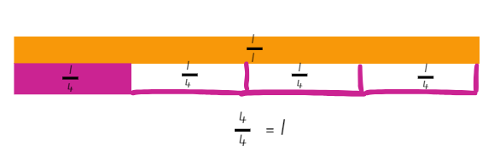
Note: when a fraction bar is selected and added to the workspace, it will represent the whole. Each bar will need to be split and fractional parts deleted to leave one remaining fractional part (see Figure 1). If possible, pre-prepare the workspace with one-quarter ( $\frac{1}{4}$ ), one-third ( $\frac{1}{3}$ ), one-fifth
( $\frac{1}{5}$ ), one-sixth ( $\frac{1}{6}$ ) and one-tenth ( $\frac{1}{10}$ ) placed on the side of the screen.
- Model using the pen tool to recreate the whole length. Draw rectangular bars to represent the missing quarters.
- Explain that the length of the pink bar can be named as 4 quarters or one whole. Label each fractional part with one-quarter ( $\frac{1}{4}$ ) and record the fractional notation $\frac{4}{4}$= 1 (see Figure 1).
- Draw attention to the equals sign (=). Explain that the symbol represents equality between the values written on both sides of the sign.
- Repeat recreating the whole using thirds, fifths, sixths and tenths. Select students to draw and label the missing fractional parts and record the fractional notation for the whole using the equals sign. For example, $\frac{3}{3}$ = 1.
This table details opportunities for assessment.
Assessment opportunities | Links
What to look for:  - Can students recreate the whole unit from a fractional part ( $\frac{1}{2}$, $\frac{1}{4}$, $\frac{1}{3}$ and $\frac{1 }{8}$)? [MAO-WM-01, MA2-PF-01]  - Can students rename 2 halves, 3 thirds, 4 quarters, 5 fifths, 6 sixths, 8 eighths and 10 tenths as one whole?  [MAO-WM-01, MA2-PF-01] | Links to National Numeracy Learning Progressions (NNLP):  - InF5.

Core lesson – comparing fractions – 40 minutes
The table below contains a suggested learning intention and success criteria. These are best co-constructed with students.
Core concept learning intention | Core concept success criteria
Students are learning to:  - model equivalent fractions as lengths. | Students can:  - recognise the need to have equal wholes to compare partitioned fractions  - represent fractions with the same-size whole to make valid comparisons (denominators of 2, 4 and 8; 3 and 6; 5 and 10).
- Display Resource 1 – Zainab’s work sample. Explain that Zainab says these 2 bar models prove that one-quarter ( $\frac{1}{4}$ ) is equal to one-half ( $\frac{1}{2}$ ). Ask:
- Do you agree or disagree with Zainab? Why or why not?
- What do you notice about the 2 bar models?
- What might Zainab have misunderstood to make this statement? (The need for same-sized wholes to compare the size of fractional parts).
- Students use a whiteboard to draw how Zainab should change her bar models to make a more accurate comparison.
Note: this is an opportunity for formative assessment which could guide the next steps in the lesson.
- Display Fractions by The Math Learning Center. Select the second icon from the left on the bottom navigation pane to add rectangular fraction bars to the workspace.
- Create 2 fraction bars showing quarters and 2 fraction bars showing eighths.
- Position the fraction bars so that one representing quarters is above one representing eighths.
- Use the arrows on the fraction bars to change the sizes of the wholes. Create an example where quarters and eighths are represented on different-sized wholes. Make a second example where they are on the same-sized whole (see Figure 2).
Figure 2 – non-example and example of same-sized whole
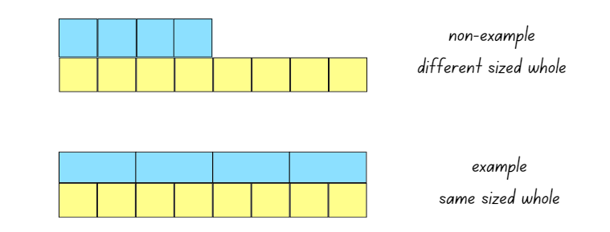
- Explain that to compare the fractional parts of a length, the same-sized whole is required. For example, if Zainab wanted to compare one-quarter ( $\frac{1}{4}$ ) and one-eighth ( $\frac{1}{8}$ ), the same-sized whole is required.
- Model creating a fraction wall displaying halves, thirds, quarters, fifths, sixths, eighths and tenths using Fractions ensuring that each whole is equal in length to one another.
- Students recreate the modelled fraction wall on their own device using Fractions.
Note: fraction notation can be added to the side of each bar by selecting the fourth icon from the left on the bottom navigation pane. Fractional parts of each bar can be coloured by using the sixth icon from the left on the bottom navigation pane. The fraction notation will change to match the number of coloured segments for each fraction bar. The pen or text tools on the right-hand side navigation pane can be used to record student thinking.
- Colour fractional parts to represent equivalence to one-half. Use fraction notation and the equals sign to show equivalence (see Figure 3).
Figure 3 – coloured fractional parts equivalent to one-half
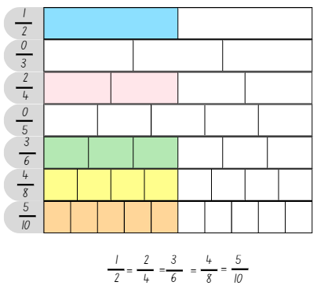
- Ask: Is it possible to represent a fraction equivalent to one-half using thirds or fifths on the fraction wall?
- Explain that when a whole is partitioned into an odd number of parts, for example thirds or fifths, there is no equivalent fraction to one-half.
- Students take a screenshot of the workspace to record equivalent fractions equivalent to one-half.
- Fraction walls are reset by students. They click on the coloured fractional parts to return them to white.
- Students use colours on the fraction wall to identify equivalent fractions for:
- $\frac{2}{3}$
- $\frac{4}{5}$
- $\frac{1}{4}$.
- Students share the equivalent fractions identified.
- Draw the symbols for greater than $>$and less than $<$on the board. Explain that these symbols can be used to record comparisons between numbers.
Note: less than $<$ and greater than $>$ symbols are not specifically referenced in the Mathematics K–10 Syllabus but are important symbols for students to understand. This lesson provides an opportunity to use these symbols in context.
- Model comparing partitioned fractions by colouring $\frac{3}{4}$ and $\frac{7}{8}$ on the fraction wall using Fractions.
- Discuss the use of the less than $<$ and greater than $>$ symbols.
- Ask: Which fraction is smaller? Students record this on the workspace using the symbol for less than $<$ (see Figure 4).
Figure 4 – using the less than symbol to compare partitioned fractions
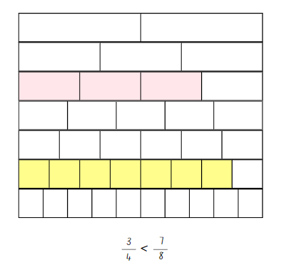
- Students compare fractions by representing and recording greater than, less than or equal to number sentences on Resource 2 – fraction comparisons.
This table details opportunities for differentiation.
Too hard? | Too easy?
Students cannot represent fractions with the same-size whole to make valid comparisons (denominators of 2, 4 and 8; 3 and 6; 5 and 10).  - Students make comparisons between fractional amounts with denominators of 2, 4 and 8 only. They discuss and compare the unit fractions.  - Students use 2 different length strips of paper to repeatedly halve them, creating eighths. They colour one-eighth ( $\frac{1}{8}$ )on both strips and compare the size of the fractional part. | Students can represent fractions with the same-size whole to make valid comparisons (denominators of 2, 4 and 8; 3 and 6; 5 and 10).  - Students make comparisons by plotting fractions on a number line.  - Challenge students to create number sentences using 2 or more greater than or less than symbols. For example, $\frac{1}{2}$ $> \frac{1}{4}$ $>$ $\frac{1}{8}$.

Discuss and connect the mathematics – 10 minutes
- Display the fraction wall on Fractions used at the start of the lesson.
- Students turn and talk to identify any fractions greater than three-quarters ( $\frac{3}{4}$ ).
- Record class responses on the board. Ask: What did you notice? (There is more than one fractional amount that is greater than three-quarters.)
This table details opportunities for assessment.
Assessment opportunities | Links
What to look for:  - Can students recognise the need to have equal wholes to compare partitioned fractions? [MAO-WM-01, MA2-PF-01]  - Can students represent fractions with the same-size whole to make valid comparisons (denominators of 2, 4 and 8; 3 and 6; 5 and 10)? [MAO-WM-01, MA2-PF-01] | Links to National Numeracy Learning Progressions (NNLP):  - InF5.  Links to suggested Interview for Student Reasoning (IfSR) tasks:  - IfSR-MT: 3B.3.

Lesson 2
Core concept: fractions can be represented as measures by partitioning length.

Daily number sense – fractional parts beyond one – 15 minutes
The table below contains a suggested learning intention and success criteria. These are best co-constructed with students.
Daily number sense learning intention | Daily number sense success criteria
Students are learning to:  - represent fractional quantities equal to and greater than one. | Students can:  - regroup fractional parts beyond one.
Note: fractions can be renamed in multiple ways. For example, $1\frac{4}{5}$ can be renamed $\frac{9}{5}$or $\frac{18}{10}$ or $1\frac{8}{10}$. In the syllabus, the expression ‘fraction greater than one’ is used instead of the terms ‘improper fraction’ or ‘mixed numeral’.
- Explain that when representing quantities greater than one whole, the fraction can be renamed in multiple ways. For example, one and one-third (1 $\frac{1}{3}$ ) can be renamed as four-thirds ( $\frac{4}{3}$ ) and still represent the same fractional amount.
- Draw a rectangular strip on the board and explain that the strip represents a whole length. Ask: How could you create a strip 3 halves the length of the original whole?
- Students Think-Pair-Share how a strip 3 halves the length of the original whole could be created.
- Draw a strip the same length as the whole and model partitioning it in half. Draw an additional half-length to represent 3 halves. Record the fractional notation next to the strip as $\frac{3}{2}$. Explain that 3 halves can also be renamed as one and a half ( $1\frac{1}{2}$ ).
- Provide students with Resource 3 – the whole strip. Students continue the strip by drawing to represent 6 quarters, 5 thirds and 7 sixths the length of the whole. Record the fractional notation next to each strip. For example, $\frac{6}{4}$ = $1\frac{2}{4}$; $\frac{5}{3}$ = $1\frac{2}{3}$; $\frac{7}{6}$ = $1\frac{1}{6}$.
- Students regroup and share their work with a peer. Ask the following questions:
- Are your drawings the same length as a classmate’s?
- What strategy did you use to determine how long the drawing of the strip needed to be?
This table details opportunities for assessment.
Assessment opportunities | Links
What to look for:  - Can students regroup fractional parts beyond one?  [MAO-WM-01, MA2-PF-01] | Links to National Numeracy Learning Progressions (NNLP):  - InF5.

Core lesson – vertical fraction walls – 40 minutes
The table below contains suggested learning intentions and success criteria. These are best co-constructed with students.
Core concept learning intentions | Core concept success criteria
Students are learning to:  - generate and describe patterns  - model equivalent fractions as lengths. | Students can:  - model, describe and record patterns of multiples  - represent the equivalence of fractions with related denominators as lengths, using concrete materials, diagrams and number lines.
- Display Polypad fraction bars and create a vertical fraction wall showing one-whole, halves, quarters and eighths (see Figure 5).
Note: this may be the first time students have seen a vertical fraction wall and number line. To create it, first build a horizontal fraction wall, then click and highlight it. Rotate the entire wall 90 degrees to the left using the black circle attached to the top bar. When creating a vertical number line, zero should be placed at the bottom and one should be placed at the top. Connections can be made to a thermometer, height measurement, measuring jugs or alternative scaled instruments.
Figure 5 – example of a vertical fraction wall and number line
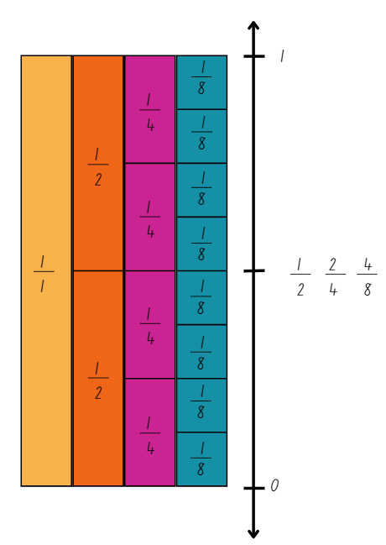
- Using the construction and drawing tools, create a number line to the right of the vertical fraction wall. Make it slightly longer than the whole. Label 0 and 1 in line with the start and end of the fraction wall. Draw arrows at either end to indicate that the number line continues.
- Make a mark at the halfway point. Ask students to identify any fractions that could be placed on the number line at this point. Record the fraction notation for $\frac{1}{2}$, $\frac{2}{4}$ and $\frac{4}{8}$ (see Figure 5).
- Using a digital device, students use Polypad fraction bars to create their own vertical fraction wall representing halves, thirds, fifths, sixths and tenths and number line from 0–1.
- Students identify and record the equivalent fractions for the following on their number line (see Figure 6):
- $\frac{1}{5}$
- $\frac{4}{6}$
- $\frac{8}{10}$
- $\frac{1}{3}$.
Figure 6 – students recording of equivalent fractions on a vertical number line
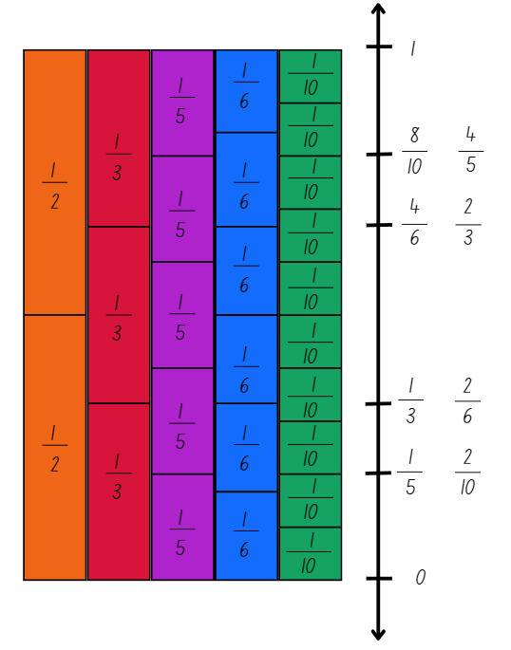
- Students take a screenshot of their number line to record their work.
- Regroup and select students to share the equivalent fractions they identified.
- Record these equivalent fractions on the board using the equal symbol. For example, $\frac{8}{10}$= $\frac{4}{5}$, $\frac{4}{6}$= $\frac{2}{3}$.
- Students Think-Pair-Share using the questions from the prompt table.
The table below outlines stimulus prompts to generate conversation about the topic, along with anticipated responses from students.
Prompts | Anticipated student responses
- Consider the fractions $\frac{8}{10}$= $\frac{4}{5}$ and $\frac{4}{6}$ = $\frac{2}{3}$. What patterns do you notice between these equivalent fractions? | - When I represent $\frac{2}{3}$on a bar, I can make the thirds into sixths by halving. For every third there are 2 sixths $\frac{1}{3}$= $\frac{2}{6}$. So, $\frac{2}{3}$ = $\frac{4}{6}$, $\frac{3}{3}$ = $\frac{6}{6}$, $\frac{4}{3}$ = $\frac{8}{6}$ and so on.  - When I represent $\frac{4}{5}$ on a bar, I can make the fifths into tenths by halving. For every fifth there are 2 tenths $\frac{1}{5}$=$\frac{2}{10}$. So, $\frac{2}{5}$= $\frac{4}{10}$, $\frac{3}{5}$= $\frac{6}{10}$, $\frac{4}{5}$ = $\frac{8}{10}$ and so on.  - In the example $\frac{8}{10}$= $\frac{4}{5}$, I can see a pattern of halving. The number of parts we have (numerator) are 8 or 4 and the number of parts in the whole (denominator) are 10 or 5. Four is half of 8 and 5 is half of 10. This pattern works for $\frac{4}{6}$= $\frac{2}{3}$ as well.
- Do you notice the same patterns with the equivalent fractions $\frac{1}{2}$, $\frac{3}{6}$ and $\frac{5}{10}$? | - For each fraction, the number of fractional parts we have (numerator) is always half the total number of parts that makes up the whole (denominator). For example, in $\frac{3}{6}$, 3 is half of 6.  - When I represent these fractions on a bar model, the number of parts the whole has been partitioned into (halves, sixths and tenths) can be halved. Each fraction $\frac{1}{2}$, $\frac{3}{6}$ and $\frac{5}{10}$ represents half of the whole.  - I realised that if the whole is partitioned into an even number of parts, you could always find an equivalent fraction to half. If the whole is partitioned into an odd number of parts, there is no equivalent fraction to half. For example, I can’t represent an equivalent fraction using fifths or thirds.
Note: fractions represent the relationship between multiplication and division. They are a comparison of the fractional part to the whole.
This table details opportunities for differentiation.
Too hard? | Too easy?
Students cannot represent and describe patterns modelled as lengths for equivalent fractions.  - Provide coloured rods to model equivalent fraction lengths. Support students to name and label the equivalent fractions.  - Support students to use their fraction wall. Identify equivalent lengths and fractions beginning with halves, quarters and eighths. | Students can represent and describe patterns modelled as lengths for equivalent fractions.  - Students explore patterns and equivalent fractions including ninths and twelfths.  - Challenge students to create an equivalent fraction pattern with missing elements for a partner to solve.

Consolidation and meaningful practice – 10 minutes
- Display Resource 4 – equivalent fractions. Students write the number sentences on Polypad fraction bars using the drawing tool.
- Ask:
- How did your knowledge of multiples help you solve the problems?
- Can you think of another equivalent fraction for one of the number sentences? For example, $\frac{1}{4}$= $\frac{2}{8}$ = $\frac{3}{12}$.
Note: although twelfths are not explicitly included in the syllabus, the example highlights the multiplicative pattern of equivalent fractions.
This table details opportunities for assessment.
Assessment opportunities | Links
What to look for:  - Can students model, describe and record patterns of multiples? [MAO-WM-01, MA2-MR-01]  - Can students model represent the equivalence of fractions with related denominators as lengths, using concrete materials, diagrams and number lines? [MAO-WM-01, MA2-PF-01] | Links to National Numeracy Learning Progressions (NNLP):  - NPA3, NPA4  - InF5.  Links to suggested Interview for Student Reasoning (IfSR) tasks:  - IfSR-MT: 3B.3.

Lesson 3
Core concept: number lines are important models used to represent fractions.

Daily number sense – fraction line beyond 1 – 10 minutes
The table below contains a suggested learning intention and success criteria. These are best co-constructed with students.
Daily number sense learning intention | Daily number sense success criteria
Students are learning to:  - represent fractional quantities equal to and greater than one. | Students can:  - represent totals of halves, thirds, quarters and fifths that extend beyond one.
- Draw a number line on the board and label it 0–2. Ask:
- What does a number line from 0–2 tell us? (There are 2 wholes. Fractions bigger than 1 can also be placed on this number line).
- Where would 1 be placed on this number line? (In between 0 and 2. It must be exactly halfway).
Note: this is an opportunity for formative assessment which could guide the next steps in the lesson.
- Students use writing materials to draw a 0–2 number line and label the position of 0, 1 and 2. They partition the number line into fifths from 0–2.
- Students record the following fractions on their number line:
- $\frac{3}{5}$
- $1\frac{4}{5}$
- $\frac{7}{5}$.
- Draw attention to the fraction $1\frac{4}{5}$. Ask: How this fraction could be renamed? (9 fifths). Students record $\frac{9}{5}$ on their number lines.
- Students rename and label seven-fifths on their number line ($1\frac{2}{5}$).
This table details opportunities for assessment.
Assessment opportunities | Links
What to look for:  - Can students represent totals of halves, thirds, quarters and fifths that extend beyond one? [MAO-WM-01, MA2-PF-01] | Links to National Numeracy Learning Progressions (NNLP):  - InF5.

Core lesson – from bar models to number lines – 40 minutes
The table below contains suggested learning intentions and success criteria. These are best co-constructed with students.
Core concept learning intentions | Core concept success criteria
Students are learning to:  - investigate number sequences involving related multiples  - model and represent unit fractions, and their multiples, to a complete a whole on a number line. | Students can:  - investigate number patterns involving related multiples  - determine the complementary fractional part needed to complete one whole (halves, quarters, eighths, thirds) (Reasons about relations)  - recreate the whole unit from a fractional part ($\frac{1}{2}$ ,$\frac{1}{4}$, $\frac{1}{3}$ and $\frac{1}{8}$).
This activity is an adaption of Unit Fractions from National Centre for Excellence in the Teaching of Mathematics by the Tribal Group PLC.
- Display Resource 5 – water jugs 1. Explain that it shows a water jug that is one-quarter full. One-quarter ( $\frac{1}{4}$ ) can be represented on a bar model or a number line.
- Model recording one-quarter ($\frac{1}{4}$ ) on the bar models and number lines (see Figure 7).
Figure 7 – example of recordings for $\frac{1}{4}$
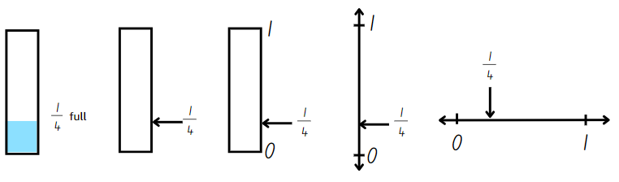
- Ask: How much more water would be needed to make the jug full if the jug was one-quarter ($\frac{1}{4}$ ) full?
- Explain that a complementary fraction is the fractional part needed to complete the whole. Record three-quarters ( $\frac{3}{4}$ ) as the complement on the right-hand side of Resource 5 – water jugs 1.
- Select students to model completing the second example showing half, on the class display.
- Provide students with Resource 6 – water jugs 2. Students label each representation for the first and second jugs with the appropriate fraction. Then they record the complementary fraction for each.
- Regroup and explain that for the third jug, students need to use the fractional part one-eighth ($\frac{1}{8}$ ) to recreate the whole jug.
- Students explain the steps they take to recreate the whole on Resource 6 – water jugs 2. They record their thinking in words, diagrams or number lines.
- Regroup and select students with different methods of recreating the whole to share their process with the class. Reflect on the efficiency and accuracy of the methods used.
- Pose the following question: A jug is one-quarter ( $\frac{1}{4}$ ) full. How could this be represented as an equivalent fraction using eighths?
- Students Think-Pair-Share using the questions from the prompt table.
The table below outlines stimulus prompts to generate conversation about the topic, along with anticipated responses from students.
Prompts | Anticipated student responses
- How did you solve the task? | - I knew that eighths are made when I halve quarters (repeated halving). There was $\frac{1}{4}$ and I halved it. It gave me 2 parts which is $\frac{2}{8}$.
- What did you visualise or draw to solve this task? | - I visualised partitioning a line into 4 and 8 parts. I could see that two-eighths would be the same as one-quarter.
- Write the statements below on the board. Students Think-Pair-Share and determine whether they are true or false:
- If a jug is $\frac{2}{8}$ full, I need $\frac{3}{4}$ to make it full.
- If a jug is $\frac{4}{6}$ full, the complementary fraction is $\frac{2}{3}$.
- Students share their thinking and justify their responses, linking back to patterns of multiples.
This table details opportunities for differentiation.
Too hard? | Too easy?
Students cannot determine the complementary fractional part needed to complete one whole (halves, quarters, eighths, thirds).  - Students refer to a fraction wall to determine the complementary fraction required to fill each jug.  - Provide students with a small strip of paper. They use it to iterate the fractional parts required to create the whole. | Students can determine the complementary fractional part needed to complete one whole (halves, quarters, eighths, thirds).  - Students find the complementary fraction with related denominators. For example, the complementary fraction of $\frac{1}{2}$= $\frac{2}{4}$, $\frac{3}{6}$, $\frac{4}{8}$.  - Challenge students to represent 4 halves, 8 fifths and 5 thirds on bar models and number lines.

Consolidation and meaningful practice – 10 minutes
- Provide students with a copy of Resource 7 – whole water jug. Students recreate the whole unit from the given fractional amount by drawing the whole jug and labelling the number line.
- Ask students how this task proves that the size of the fractional parts is dependent on the size of the whole.
This table details opportunities for assessment.
Assessment opportunities | Links
What to look for:  - Can students investigate number patterns involving related multiples? [MAO-WM-01, MA2-MR-01]  - Can students determine the complementary fractional part needed to complete one whole (halves, quarters, eighths, thirds) (Reasons about relations)? [MAO-WM-01, MA2-PF-01]  - Can students recreate the whole unit from a fractional part ($\frac{1}{2}$ ,$\frac{1}{4}$, $\frac{1}{3}$ and $\frac{1}{8}$)? [MAO-WM-01, MA2-PF-01] | Links to National Numeracy Learning Progressions (NNLP):  - NPA3, NPA4  - InF5.  Links to suggested Interview for Student Reasoning (IfSR) tasks:  - IfSR-NP: 4A.1, 4A.2, 4A.3.

Lesson 4
Core concept: there are fractions between any 2 whole numbers on a number line.

Daily number sense – 10 minutes
- From a class need surfaced through formative assessment data, identify a short, focused activity that targets students’ knowledge, understanding and skills. Example activities may be drawn from the following resources:
- Mathematics K–6 resources
- Universal Resources Hub.

Core lesson – fraction lines beyond one – 40 minutes
The table below contains suggested learning intentions and success criteria. These are best co-constructed with students.
Core concept learning intentions | Core concept success criteria
Students are learning to:  - generate and describe patterns  - represent fractional quantities equal to and greater than one. | Students can:  - create and continue a variety of number patterns that increase or decrease by a constant amount  - represent totals of halves, thirds, quarters and fifths that extend beyond one  - determine the relative location of one-quarter and one-half when a number line extends beyond one.
- Explain that fractions expand our number system. They provide an infinite set of numbers between any 2 whole numbers. This allows for the number system to be very precise.
- Draw a number line from 0–2 on the board. Record $1\frac{1}{2}$ on the number line by segmenting the section between 1 and 2 into half.
- Identify $1\frac{1}{4}$ on the number line by halving the line between 1 and $1\frac{1}{2}$. Ask:
- Is it possible to rename $1\frac{1}{2}$ and $1\frac{1}{4}$? (Yes. Record $\frac{3}{2}$ and $\frac{5}{4}$ on the number line).
- Can you identify any additional numbers that come between 1 and 2?
- Students Think-Pair-Share to identify additional numbers that come between 1 and 2.
- Provide pairs with Resource 8 – number line 0–2. Students partition the number lines and record the fractions to match the titles (see Figure 8).
Figure 8 – student work sample
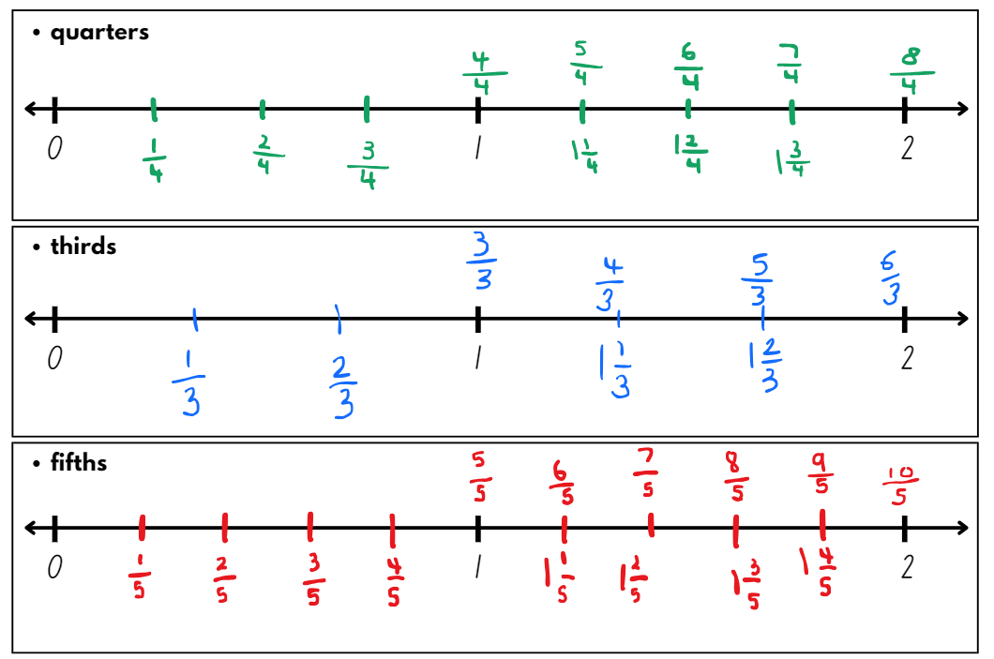
- Students name and record the fractions in multiple ways. For example, $\frac{7}{5}$ and $1\frac{2}{5}$.
- Regroup and select a student work sample to display for discussion.
- Students Think-Pair-Share using the questions from the prompt table below.
Prompts | Anticipated student responses
- How could we rename the numbers 1 and 2 on the number lines? | - 1 could be renamed 3 thirds, 4 quarters or 5 fifths and 2 could be renamed 6 thirds, 8 quarters and 10 fifths.
- Did finding half help you to find quarters, thirds or fifths? | - I visualised half of the halves to locate quarters.  - I knew from practising the thirding strategy that thirds were smaller than halves and could visualise the markings for thirds.  - I looked at a fraction wall and saw that the position of $\frac{1}{2}$ is halfway between $\frac{2}{5}$ and $\frac{3}{5}$.  - I visualised 5 equal parts in between 0 and 1 and 1 and 2 and made marks on the number line to make fifths.
- How could you use your knowledge of related multiples to find additional fractions between 0–2? (Try using, eighths, sixths or tenths). | - I could add eighths to my number line marked in quarters by halving the quarters.  - I know that 10 is a multiple of 5 so I could find tenths on the number line partitioned into fifths. I would halve each fifth to place tenths on the number line.
- Refer to the 0–2 number line on the board. Record the fractions between 1 and 2 in fifths on the number line.
- Display Resource 9 – fraction patterns underneath or next to the number line.
- Students Think-Pair-Share using the questions from the prompt table below.
Prompts | Anticipated student responses
- Can you see any patterns? | - When I read the table horizontally, the numbers in each row are increasing by one-fifth.  - When I read the table vertically, the fraction in the first row has been renamed in the second row.
- How can you compare the fractions in the first row to one? | - The numbers in the first row represent a whole and an additional fractional part.
- How can you compare the fractions in the second row to one? | - In the second row, the number of parts we have is greater than the number of parts the whole has been partitioned into. For example, six-fifths is one whole and one extra fifth.  - $\frac{10}{5}$ represents 2 wholes because double 5 is 10.
- What would come next in each pattern? | - $2\frac{1}{5}$  - $\frac{11}{5}$
This table details opportunities for differentiation.
Too hard? | Too easy?
Students cannot create and continue a variety of number patterns that increase or decrease by a constant amount.  - Provide students with interlocking cubes to physically represent each fractional amount in the pattern.  Students cannot determine the relative location of one-quarter and one-half when a number line extends beyond one.  - Provide 2 paper strips of equal length and fold each into quarters. Students paste the first strip on a piece of paper. They draw a number line from 0–1 using the edge of the strip, labelling the position of halves and quarters. Students paste the second strip to the right of the first, ensuring no gaps between the strips. They extend the number line to 2 and label the additional halves and quarters between 1 and 2. | Students can create and continue a variety of number patterns that increase or decrease by a constant amount.  - Students create and continue fraction number patterns involving sixths, eighths or tenths.  Students can determine the relative location of one-quarter and one-half when a number line extends beyond one.  - Students determine the relative location for fifths, sixths, eighths and tenths on a number line that extends beyond one.  - Challenge students to create number lines that extend between 2 consecutive 2-digit numbers. For example, between 11 and 12.

Discuss and connect the mathematics – 10 minutes
- Students refer to their number lines and name a fraction:
- close to zero
- close to $1\frac{1}{4}$
- close to $\frac{8}{5}$.
- Write the following problem on the board: Kevin says there is a fraction between $1\frac{2}{4}$ and $1\frac{3}{4}$. Is he correct? Ask:
- How can you show that Kevin’s thinking is correct or incorrect?
- How can you use a number line to prove this?
- Students can refer to the fraction wall or draw a diagram to help solve this task.
This table details opportunities for assessment.
Assessment opportunities | Links
What to look for:  - Can students create and continue a variety of number patterns that increase or decrease by a constant amount?  [MAO-WM-01, MA2-MR-01]  - Can students represent totals of halves, thirds, quarters and fifths that extend beyond one? [MAO-WM-01, MA2-PF-01]  - Can students determine the relative location of one-quarter and one-half when a number line extends beyond one?  [MAO-WM-01, MA2-PF-01] | Links to National Numeracy Learning Progressions (NNLP):  - NPA3  - InF5, InF6.

Lesson 5
Core concept: connections can be made between fractions and decimals.

Daily number sense – make the amount – 15 minutes
Daily number sense activities for Lessons 5 to 7 ‘loop’ back to concepts and procedures covered in previous units to assist students to build an increasingly connected network of ideas. These concepts may differ from the core concepts being covered by the unit.
The table below contains a suggested learning intention and success criteria. These are best co-constructed with students.
Daily number sense learning intention | Daily number sense success criteria
Students are learning to:  - represent money values in multiple ways. | Students can:  - recognise the relationship between dollars and cents  - represent equivalent amounts of money using different denominations.
- Revise Australian coin and note denominations. Record these on a class anchor chart.
Note: plastic coins and notes can be used during this activity. Current Australian coins in circulation can be identified at Royal Australian Mint. Current Australian notes in circulation can be identified at Reserve Bank of Australia.
- In pairs, provide students access to a digital device and the following website: Maths Is Fun.
- Students take turns creating different combinations of coins that combine to make one dollar.
- Ask:
- How many ways could you make one dollar?
- Did you find all the ways? How do you know?
- Did you notice any patterns? Describe them.
- What is the least or greatest number of coins used to make one dollar?
- What was challenging about the activity?
- Tell students that Gemma has 5 coins. Ask:
- How much money might she have?
- What is the smallest amount of money she could have? How do you know?
- What is the largest amount of money she could have? How do you know?
- What if she still had 5 coins, but only 10 cents and/or 20 cent coins? How much might she have now? Can you find all the possibilities?
How do you know you have found them all?
Note: challenge students by varying the amount, for example making $5 in different ways.
This table details opportunities for assessment.
Assessment opportunities | Links
What to look for:  - Can students recognise the relationship between dollars and cents? [MAO-WM-01, MA2-AR-01]  - Can students represent equivalent amounts of money using different denominations? [MAO-WM-01, MA2-AR-01] | Links to National Numeracy Learning Progressions (NNLP):  - UnM2, UnM3, UnM4.

Core lesson – making, naming and recording tenths – 45 minutes
The table below contains suggested learning intentions and success criteria. These are best co-constructed with students.
Core concept learning intentions | Core concept success criteria
Students are learning to:  - extend the application of the place value system from whole numbers to tenths and hundredths  - represent fractional quantities equal to and greater than one. | Students can:  - recognise that 10-tenths is recorded as 1.0 and regroup when using decimal notation  - represent and compare tenths as decimals using linear representations  - regroup fractional parts beyond one.
This activity is an adaptation of ‘The fifthing strategy’ from Teaching Mathematics: Foundation to middle years by Siemon et al and Partitioning by Siemon.
Note: photocopy Resource 11 – representations 2 back-to-back, as students will need 2 copies.
- Model folding a paper strip into fifths by visualising quarters. Then, estimate a fifth as less than one-quarter ($\frac{1}{4}$ ). Use the fifth to create the first fold.
- The rest of the strip can be folded in half, then half again. If 5 equal partitions are not created, adjust the first fold and try again (see Figure 9).
Figure 9 – folding fifths
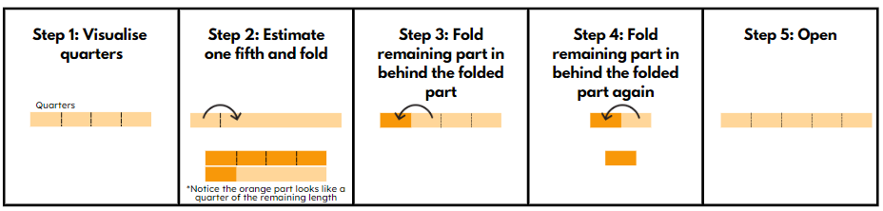
- Students explore this method of folding fifths.
- Ask:
- How did you know that the strip had been accurately partitioned into fifths? (The 5 parts have an equal size.)
- How can 10 equal parts or tenths be made from a strip folded into fifths? (The fifths can be folded in half to make tenths.)
- How are tenths and fifths related multiplicatively? (10 is a multiple of 5 so tenths are related to fifths.)
- When working with whole numbers, double 5 is 10. Why doesn’t this work for fractions? (The denominator shows how many parts one whole has been partitioned into. The larger the denominator, the smaller each part is. Tenths are small than fifths.)
Note: fractions behave differently to whole numbers. Students often have a misconception that any time multiplication is used as an operation, it will result in a larger number. This is not the case where multiplication involves a fraction. This results in a smaller number.
- Students fold their strip of paper to produce tenths.
- Draw a 0–1 number line on the board. Partition the line into 5 equal parts and model halving the fifths to create tenths.
- Label the number line in tenths. For example, $\frac{1}{10}$, $\frac{2}{10}$, $\frac{3}{10}$, $\frac{4}{10}$ and so on.
- Write 0.1 on the number line at the same point as $\frac{1}{10}$ . Explain that even though the way we record the decimal and the fraction look different, they are equivalent. Both the decimal 0.1 and the fraction $\frac{1}{10}$ are read as ‘one-tenth’.
- Record the decimals 0.3, 0.5 and 0.8 on the number line. Ask:
- How would these be read? (three-tenths, five-tenths and eight-tenths).
- Can 0.5 be read a half? Why or why not? (Yes, because five-tenths is equivalent to a half.)
- Students turn and talk about their answer, explaining their reasoning.
- Select students to record the remaining decimals on the number line.
- Display Resource 10 – representations 1. Model how to make, name and record three-tenths ( $\frac{3}{10}$ ) (see Figure 10).
Figure 10 – example of modelling and recording tenths
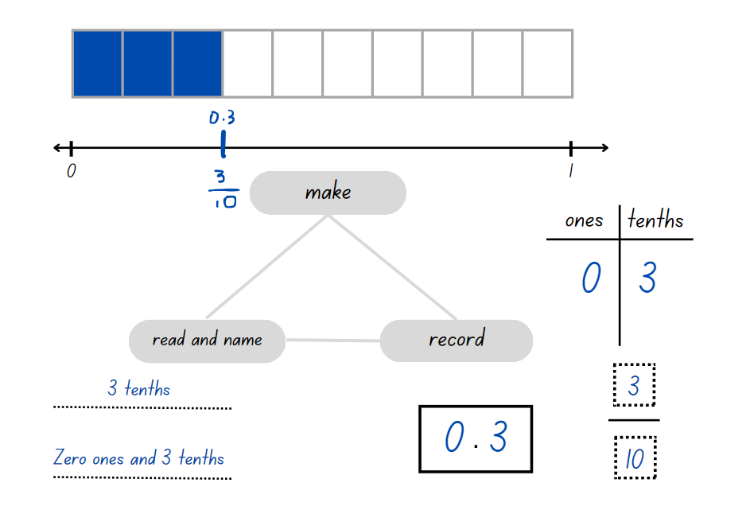
- Students glue their strip of paper with fold lines indicating tenths, at the top of Resource 11 – representations 2. They draw a number line underneath the strip. Students label their number line with decimals and fractions as tenths.
- Students complete Resource 11 – representations 2 for:
- 4 tenths
- 5 tenths
- 9 tenths
- 10 tenths.
- Regroup and ask students to share what they noticed when making, naming and recording 10 tenths. Identify that 5 tenths is a half, and 10 tenths is a whole.
- Write the numbers $1\frac{4}{10}$ and 1.4 on the board. Ask: What do you notice? What these numbers indicate? (They are both one whole and four-tenths.)
- Draw a number line 0–2 on the board and ask where $1\frac{4}{10}$ or 1.4 would be placed.
- Using Resource 12 – representations beyond 1, students make, name and record the multiple ways $1\frac{4}{10}$ or 1.4 can be represented.
This table details opportunities for differentiation.
Too hard? | Too easy?
Students cannot represent and compare tenths as decimals using linear representations.  - Support students to connect the partitioned fraction strip on Resource 11 – representations 2 to the number line below, representing five-tenths and ten-tenths only. | Students can represent and compare tenths as decimals using linear representations.  - Students use a number line to compare the decimals 2.1, 1.8, 0.9 and 0.3.  - Challenge students to choose some decimals for a partner to represent on a number line.

Discuss and connect the mathematics – 5 minutes
- Regroup and discuss the ways one whole and 4 tenths can be represented.
- Students identify a decimal larger than 1.4 but smaller than 2.
This table details opportunities for assessment.
Assessment opportunities | Links
What to look for:  - Can students recognise that 10-tenths is recorded as 1.0 and regroup when using decimal notation?  [MAO-WM-01, MA2-RN-02]  - Can students represent and compare tenths as decimals using linear representations? [MAO-WM-01, MA2-RN-02]  - Can students regroup fractional parts beyond one?  [MAO-WM-01, MA2-PF-01] | Links to National Numeracy Learning Progressions (NNLP):  - NPV6  - InF5.  Links to suggested Interview for Student Reasoning (IfSR) tasks:  - IfSR-NP: 4D.3, 4D.7, 4D.8.

Lesson 6
Core concept: comparisons can be made between fractions.

Daily number sense – money wall – 15 minutes
The table below contains a suggested learning intention and success criteria. These are best co-constructed with students.
Daily number sense learning intention | Daily number sense success criteria
Students are learning to:  - represent money values in multiple ways. | Students can:  - represent equivalent amounts of money using different denominations  - perform calculations with money, including finding change.
This activity is an adaptation of Classroom talk: Money Wall moments [PDF 275 KB] from the Mathematics Hub by the Commonwealth of Australia.
- Display Resource 13 – money wall. Ask: What do you notice about the blank money wall?
- Ensure students recognise and understand that each row in the money wall is made up of double the parts of the row above. Make connections to a fraction wall that shows one whole, 2 halves, and 4 quarters. Identify that every row is equivalent; they have the same value.
- Provide pairs of students with Resource 13 – money wall and four 5 cent coins, eight 10 cent coins, eight 20 cent coins, four 50 cent coins, two $1 coins and one $2 coin.
Note: if no plastic Australian coins are available, use Resource 14 – Australian coins.
- Model placing a 20-cent coin in the top row of the money wall (see Figure 11).
Figure 11 – example of the first row representing the one whole of a money wall
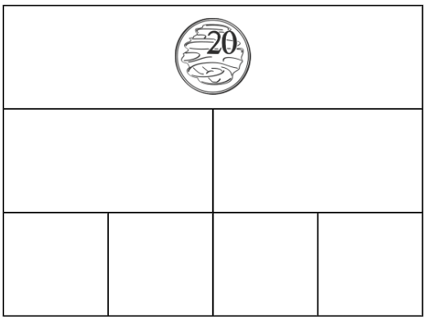
- Ask: What would make the next row of coins? Remind students the next row demonstrates 2 coins that are equivalent to 20 cents. Select students to share their ideas (see Figure 12).
Figure 12 – example of the second row of a money wall
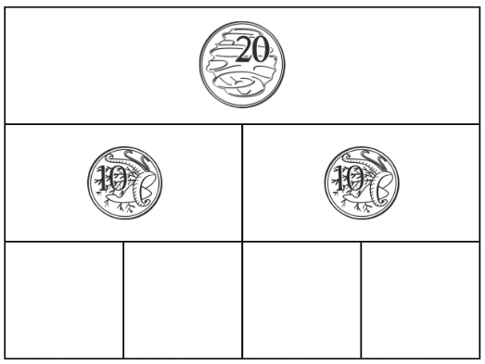
- Ask: What would make the next row of coins? Remind students that the next row demonstrates 4 coins that are equivalent to 20 cents. Students add the total of the coins together (see Figure 13).
Figure 13 – example of a completed money wall
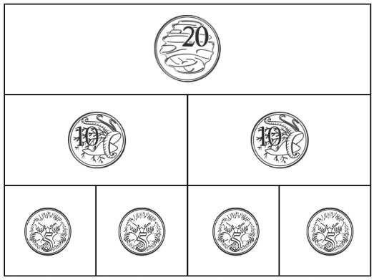
- Students create money walls with 80 cents, $1.40 and $2.80 in the top row. Add the total for each money wall.
- Share responses as a class. Ask:
- Is there only one solution for each amount? How do you know?
- Did you notice any patterns? Can you describe them?
- Can you complete a money wall with $3.25 in the top row? Why or why not?
This table details opportunities for assessment.
Assessment opportunities | Links
What to look for:  - Can students represent equivalent amounts of money using different denominations? [MAO-WM-01, MA2-AR-01]  - Can students perform calculations with money, including finding change? [MAO-WM-01, MA2-AR-01] | Links to National Numeracy Learning Progressions (NNLP):  - UnM4, UnM5, UnM6.

Core lesson – making, naming and recording hundredths – 40 minutes
The table below contains suggested learning intentions and success criteria. These are best co-constructed with students.
Core concept learning intentions | Core concept success criteria
Students are learning to:  - make connections between fractions and decimal notation  - model equivalent fractions as lengths. | Students can:  - compare and order decimals of up to 2 decimal places  - make connections between fractions and decimal notation for key benchmark values  - represent the equivalence of fractions with related denominators as lengths, using concrete materials, diagrams and number lines.
Note: the concepts explored in this lesson were introduced in Stage 2 Unit 31.
- Draw a number line from 0–1 on the board.
- Model marking fifths on the number line. Halve each fifth and make a mark to indicate tenths. Record tenths on the line using decimal notation.
- Pose the following problem: Bianca says that decimals could be placed on the number line between two-tenths ( $\frac{2}{10}$) and three-tenths ( $\frac{3}{10}$). Is this true?
- Students turn and talk and determine whether this statement is true.
- Display Resource 15 – tenths and hundredths. Explain that hundredths can also be placed on a number line in between tenths.
- Ask:
- If there are 10 tenths between any 2 whole numbers, how many hundredths would be between any 2 whole numbers?
- If tenths are represented with one numeral after the decimal point, how would hundredths be represented as decimals?
- How would hundredths be represented on a number line 0.2–0.3 in decimal notation? (Record the values for hundredths between 0.2 and 0.3 on Resource 15 – tenths and hundredths).
- How do we read decimals with hundredths? (For example, 0.27 is named as 27 hundredths).
- How are hundredths written as a fraction? (Highlight for students that the language of hundredths gives a clue to the fractional notation).
Note: to support place value conceptual understanding, 5.37 would be read as ‘five and thirty-seven hundredths’. The word ‘and’ connects the decimal fraction with the whole number and makes a connection with common fractions.
- Write $\frac{1}{10}$ = $\frac{10}{100}$ on the board and ask whether this statement is true. Ensure students understand that these are equivalent fractions.
- Display Resource 16 – hundredths number line. Ask:
- What do you notice about this number line?
- How can you use the number line to prove that $\frac{1}{10}$ $=$ $\frac{10}{100}$?
- Where would 0.5 (read as 50 hundredths) be placed on this number line? How can we name this as a fraction? ( $\frac{1}{2}$ or $\frac{50}{100}$).
- Where would 0.25 (read as 25 hundredths) be placed on this number line? How can we name this as a fraction? ($\frac{1}{4}$ or $\frac{25}{100}$).
- Display Resource 17 – hundredths and model making, naming and recording 25 hundredths (see Figure 14).
Figure 14 – example of modelling and recording hundredths
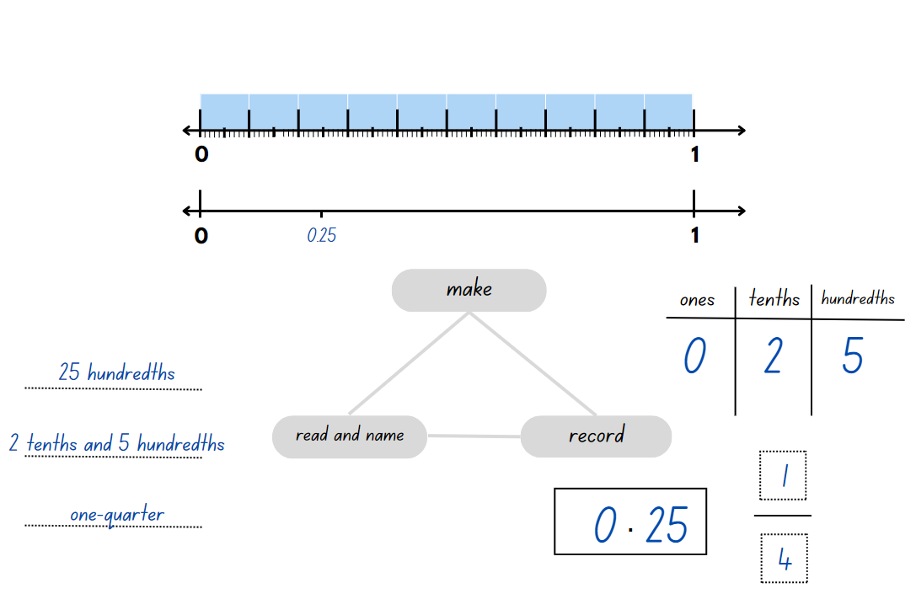
Note: when students first encounter decimals, the most common misconception is the belief that longer decimals are always larger decimals. A student who believes this will indicate that 0.75 is larger than 0.8. To reduce this misconception, establish the benchmark values $\frac{1}{2}$ = 0.5 and $\frac{1}{4}$ = 0.25. Then prompt students to pay particular attention to the digit in the tenths place as shown on a length divided into tenths.
- Students make, name and record 50 hundredths (0.5) and 75 hundredths (0.75) on Resource 17 – hundredths.
- Regroup and select students to share their work.
- Ask:
- Is 0.5 less than, equal to or greater than 0.50? (It is equal to, as both represent 5 tenths and 50 hundredths which are equivalent.)
- Is 75 hundredths $<$, = or $>$ 7 tenths and 5 hundredths? (It is equal to, as 75 hundredths are made up of 7 tenths and 5 hundredths.)
- Which is larger, 0.5 or 0.25? How do you know? (0.5 is larger as it represents 5 tenths. 0.25 represents 2 tenths and 5 hundredths.)
- Record the amounts below on the board. Students compare and order the numbers by placing them on a number line 0–1:
- 0.25
- $\frac{2}{5}$
- 0.8
- $\frac{5}{10}$
- $\frac{75}{100}$.
This table details opportunities for differentiation.
Too hard? | Too easy?
Students cannot compare and order decimals of up to 2 decimal places.  - Refer to Resource 16 – hundredths number line to locate the decimal amounts of 0.25, 0.5 and 0.75 to support students’ understanding.  Students cannot make connections between fractions and decimal notation for key benchmark values.  - Students use Polypad – Virtual Manipulatives to make a fraction wall using fraction bars labelled with halves and quarters. They Add fraction bars labelled with the equivalent decimals of 0.25 and 0.5. | Students can compare and order decimals of up to 2 decimal places.  - Students create a number line to locate and compare the numbers 2.25, 1.5, 1 $\frac{3}{4}$ and 2 $\frac{1}{2}$.  Students can make connections between fractions and decimal notation for key benchmark values.  - Challenge students to prove why 0.75 is equivalent to $\frac{3}{4}$. They use number lines or diagrams to record their thinking.

Discuss and connect the mathematics – 10 minutes
- Display Resource 18 – Maths Busters. Explain that the Maths Buster’s team received an email from Amala. She is asking for help to prove or disprove Rebecca’s statement.
- In pairs, students reason and justify their thinking to prove or disprove each number sentence. They decide whether Rebecca’s statement ‘longer decimals are always larger decimals’ is true or false.
The table below outlines number sentence prompts to generate conversation about the topic, along with anticipated responses from students.
Number sentence prompts | Anticipated student responses
0.75 > 0.8 | - 0.75 represents 75 hundredths. 0.8 represents 8 tenths which is equivalent to 80 hundredths. This number sentence is false and proves that Rebecca’s statement is false. 75 is a bigger whole number than 8, so maybe Rebecca thought 0.75 was a larger decimal. She thinks decimals behave the same way as whole numbers.  - In 0.75 (75 hundredths) there are 7 tenths and 5 hundredths. In 0.8 there are 8 tenths. Eight tenths is greater than 7 tenths. Rebecca’s statement is false.
0.25 > 0.7 | - 0.7 is greater than 0.25. Rebecca’s statement is incorrect.  - In 0.25 there are 2 tenths and 5 hundredths. In 0.7 there are 7 tenths. 7 tenths is greater than 2 tenths. This proves that Rebecca’s statement is false.
0.40 > 0.4 | - The extra zero in 0.40 just means there are 4 tenths and zero hundredths. 0.40 and 0.4 are equivalent, so this number sentence is false and proves that Rebecca is incorrect, and her statement is a myth.
This table details opportunities for assessment.
Assessment opportunities | Links
What to look for:  - Can students compare and order decimals of up to 2 decimal places? [MAO-WM-01, MA2-RN-02]  - Can students make connections between fractions and decimal notation for key benchmark values? [MAO-WM-01, MA2-RN-02]  - Can students represent the equivalence of fractions with related denominators as lengths, using concrete materials, diagrams and number lines? [MAO-WM-01, MA2-PF-01] | Links to National Numeracy Learning Progressions (NNLP):  - NPV6, NPV7  - InF5, InF6.  Links to suggested Interview for Student Reasoning (IfSR) tasks:  - IfSR-NP: 4D.3, 4D.4, 4D.7, 4D.8.

Lesson 7
Core concept: fractions can make and exceed the whole.

Daily number sense – canteen challenge – 10 minutes
The table below contains a suggested learning intention and success criteria. These are best co-constructed with students.
Daily number sense learning intention | Daily number sense success criteria
Students are learning to:  - represent money values in multiple ways. | Students can:  - perform calculations with money, including finding change.
- Display Resource 19 – canteen price list. Ask pairs of students to solve the following questions:
- If you bought an ice cream, an apple, a juice and a sandwich, how much change would you receive from $12?
- What 5 different items could you purchase to get the least amount of change from $10?
- What is the largest number of different items you can purchase with $10?
- If you received $3.50 change from $15, what could you have bought?
- You bought a baklava, a yoghurt and a water and received $1.65 change from $12. Did you receive the correct change? How do you know?
This table details opportunities for assessment.
Assessment opportunities | Links
What to look for:  - Can students perform calculations with money, including finding change? [MAO-WM-01, MA2-AR-01] | Links to National Numeracy Learning Progressions (NNLP):  - UnM5, UnM6.

Core lesson – fractions and decimals – 40 minutes
The table below contains suggested learning intentions and success criteria. These are best co-constructed with students.
Core concept learning intentions | Core concept success criteria
Students are learning to:  - model equivalent fractions as lengths  - represent fractional quantities equal to and greater than one. | Students can:  - represent the equivalence of fractions with related denominators as lengths, using concrete materials, diagrams and number lines  - determine the relative location of one-quarter and one-half when a number line extends beyond one.
- Display and provide students with a copy of Resource 20 – number line 0–3.
- Explain that these fractional amounts can also be represented in decimal notation. They can also be renamed to represent fractional quantities equal to and greater than one.
- Students complete Resource 20 – number line 0–3 by:
- recording the equivalent decimal notation for each fraction on the grey cards in the second row
- renaming and recording these on the white cards in the third row (see Figure 15).
Figure 15 – example of number line 0–3
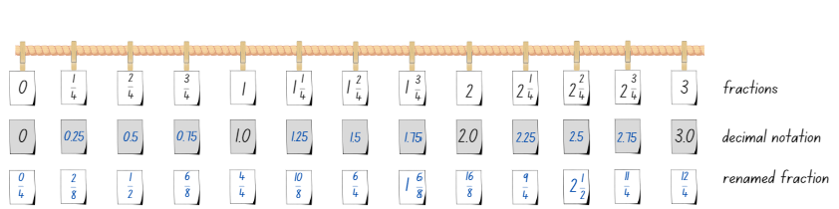
- Regroup as a class. Students compare their work with a partner.
- Students share their responses about the renamed fractions. Ensure they understand that equivalent fractions can be renamed in multiple ways. There can be more than one correct way of representing the amount.
- Using Resource 20 – number line 0–3, students identify a number:
- between 2 and 3
- very close to 3
- as a decimal between 2 and 3
- equivalent to 0.75.
- Provide copies of Resource 21 – missing symbols. Students use the less or greater than and equal symbols to make each number sentence true.
- Using Resource 21 – missing symbols, students create and record 2 number sentences with missing symbols for a partner to solve.
This table details opportunities for differentiation.
Too hard? | Too easy?
Students cannot represent the equivalence of fractions with related denominators as lengths, using concrete materials, diagrams and number lines.  - Model using paper strips to create a fraction wall, supporting students to identify equivalent fractions. They draw a number line underneath each strip as they build the fraction wall and label the equivalent fractions. Students glue their fraction wall into their workbooks. | Students can represent the equivalence of fractions with related denominators as lengths, using concrete materials, diagrams and number lines.  - Ask: Can you prove that $\frac{16}{10}$ and $1\frac{3}{5}$ are equivalent fractions? Students use Polypad – Virtual Manipulatives to create a representation proving that $\frac{16}{10}$ and $1\frac{3}{5}$ are equivalent fractions.

Discuss and connect the mathematics – 10 minutes
This activity is an adaption of ‘What's the split?’ from Maths Teaching Circles by Epstein.
- Display Resource 22 – two groups. Students think about the 4 representations and sort them into 2 groups.
- Select students to share their groupings and provide justification for their choices.
Note: the 2 groups do not need to be equal. For example, one group may have one representation and the other group may have 3. Students must be able to reason as to why they have organised the representations into each group. This task is dependent on students’ ability to reason and provide justifications for their choices.
The table below outlines possible solutions, along with anticipated responses from students.
Possible solutions | Anticipated student responses
- Group 1: A and B. Group 2: C and D. | - A and B are written in fraction notation. C and D are written in decimal notation.
- Group 1: B and C. Group 2: A and D. | - B and C both exceed one whole.  - A and D are equivalent as $\frac{6}{8}$ is the same as 0.75. B and C are equivalent as $\frac{10}{8}$ is the same as 1.25.
This table details opportunities for assessment.
Assessment opportunities | Links
What to look for:  - Can students represent the equivalence of fractions with related denominators as lengths, using concrete materials, diagrams and number lines? [MAO-WM-01, MA2-PF-01]  - Can students determine the relative location of one-quarter and one-half when a number line extends beyond one?  [MAO-WM-01, MA2-PF-01] | Links to National Numeracy Learning Progressions (NNLP):  - InF5, InF6.  Links to suggested Interview for Student Reasoning (IfSR) tasks:  - IfSR-NP: 4D.3, 4D.4, 4D.7, 4D.8.

Lesson 8
Core concept: number lines can be extended beyond one.

Daily number sense – 10 minutes
- From a class need surfaced through formative assessment data, identify a short, focused activity that targets students’ knowledge, understanding and skills. Example activities may be drawn from the following resources:
- Mathematics K–6 resources
- Universal Resources Hub.

Core lesson – become the teacher – 40 minutes
The table below contains suggested learning intentions and success criteria. These are best co-constructed with students.
Core concept learning intentions | Core concept success criteria
Students are learning to:  - make connections between fractions and decimal notation  - represent fractional quantities equal to and greater than one. | Students can:  - compare and order decimals of up to 2 decimal places  - represent totals of halves, thirds, quarters and fifths that extend beyond one.
- Display Resource 23 – student misconceptions. Explain that 3 students from Oceanview Public School completed a similar task, however they made some mistakes.
- Students Think-Pair-Share to discuss what they notice.
- In pairs, students select either Estelle, Jaxon or Samouel’s work sample.
- Ask pairs to consider the following questions:
- What mistakes has the student made and why this may have happened?
- If you were the teacher, how would you explain and support the student to correct their mistakes?
- Pairs use writing materials or digital devices to answer these questions. Encourage the use of mathematical vocabulary and detailed explanations.
- If available, students create a recording to explain their diagrams and number lines, using digital devices with a voice-over function.
Note: this is an opportunity for formative assessment. It can provide information on student progress and inform future teaching.
The table below identifies possible misconceptions to address for each student as well as ways to support their understanding.
Student | Possible misconceptions to address and ways to support student understanding
Estelle | - Estelle understands that the fractional pieces increase by the same amount each time. She understands that beyond one, fractions are represented as one whole and a fractional part, for example $1\frac{1}{3}$. Estelle has misunderstood how many parts the line has been partitioned into (thirds instead of quarters). This may be because there are 3 lines marked in between each whole number.  - Estelle may benefit from further support finding fractions of a line, segmenting a strip of paper and labelling each fractional part ‘one-quarter’, prior to finding fractions on a line. By looking at the number of segments, rather than the number of marks made, she may be supported to correctly identify the fractions. Pasting the strip on a piece of paper and drawing a number line directly below may support Estelle to see the relationship between 4 quarters and one whole.
Jaxon | - Jaxon has correctly labelled the number line from zero to one. He has misunderstood how to represent fractional quantities equal to and greater than one. Jaxon’s work sample indicates that he is unable to correctly label fractions on a number line that extends beyond one. He also needs support renaming 4 quarters as one whole.  - Jaxon may benefit from being provided with 2 strips of paper, both folded into quarters. It may be useful for him to label the fractional parts of the strip, then transfer this to a number line. Being able to physically see one whole, and then an additional whole, Jaxon can be supported to represent fractions on a number line that extends beyond one.
Samuel | - Samuel has misunderstood how many parts the line has been partitioned into (thirds instead of quarters). He also has a misunderstanding around tenths and hundredths, as he has labelled the number line from 1–2 in hundredths.  - Samuel may benefit from seeing 2 number lines that illustrate $\frac{1}{2}$ is the same as 0.5, $\frac{1}{4}$ is the same as 0.25 and $\frac{3}{4}$ is the same as 0.75. Connecting fraction strips showing tenths to a number line marked in hundredths, may further support him to understand tenths and hundredths.
This table details opportunities for differentiation.
Too hard? | Too easy?
Students cannot compare and order decimals of up to 2 decimal places.  - In small groups, present a jumbled sequence of decimals using sticky notes, such as 0.15, 0.35, 0.45, 0.25. Support students to use Polypad – number tiles and cubes to create visual representations for each decimal amount, then correctly sequence these in ascending order.  Students cannot represent totals of halves, thirds, quarters and fifths that extend beyond one.  - Place sticky notes with fractions, $\frac{1}{4}$, $\frac{2}{4}$, $\frac{3}{4}$ on a masking tape line that is labelled 0–1. Display sticky notes with $\frac{5}{4}$, $\frac{6}{4}$, $\frac{7}{4}$ and $\frac{8}{4}$. Students problem solve what needs to be done to the masking tape number line to include all the additional fractions. | Students can compare and order decimals of up to 2 decimal places.  - Students play Spiralling Decimals from NRICH.  Students can represent totals of halves, thirds, quarters and fifths that extend beyond one.  - Students represent totals of sixths, eighths and tenths on a number line 0–3. Then they rename the fractional amount beyond one in multiple ways. For example, $\frac{8}{6}$ and $1\frac{2}{6}$.

Discuss and connect the mathematics – 10 minutes
- Students participate in a gallery walk to view the tutorials or explanations.
- Regroup and ask:
- What did you find challenging about explaining how to correct the misconceptions to the student?
- What is something another group did well in their explanation that could help Estelle, Jaxon or Samuel?
- What advice would you give someone who is learning about fractions for the first time?
This table details opportunities for assessment.
Assessment opportunities | Links
What to look for:  - Can students compare and order decimals of up to 2 decimal places? [MAO-WM-01, MA2-RN-02]  - Can students represent totals of halves, thirds, quarters and fifths that extend beyond one? [MAO-WM-01, MA2-PF-01] | Links to National Numeracy Learning Progressions (NNLP):  - NPV6, NPV7  - InF5.  Links to suggested Interview for Student Reasoning (IfSR) tasks:  - IfSR-NP: 4D.3, 4D.4, 4D.7, 4D.8.

Resource 1 – Zainab’s work sample
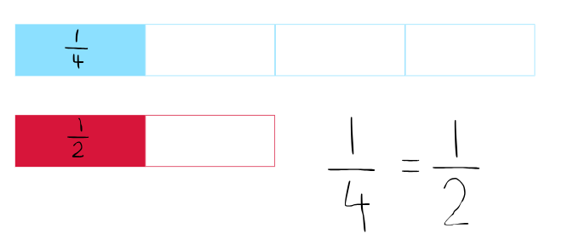

Resource 2 – fraction comparisons
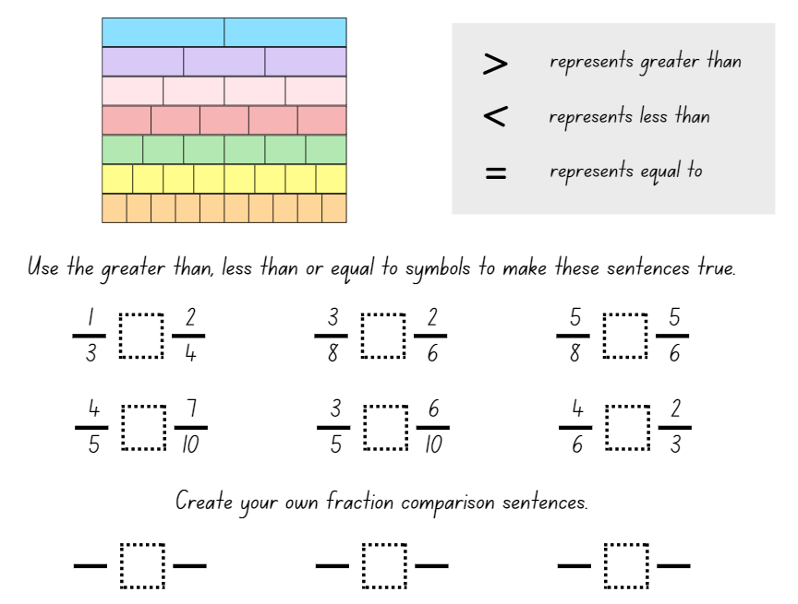

Resource 3 – the whole strip
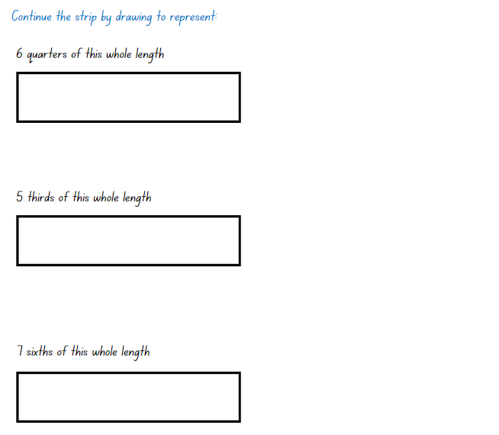

Resource 4 – equivalent fractions
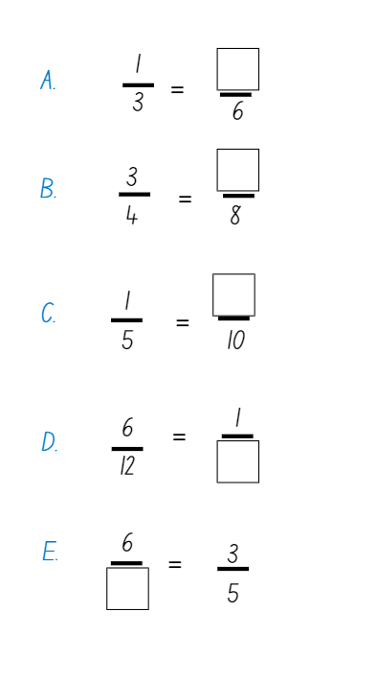

Resource 5 – water jugs 1
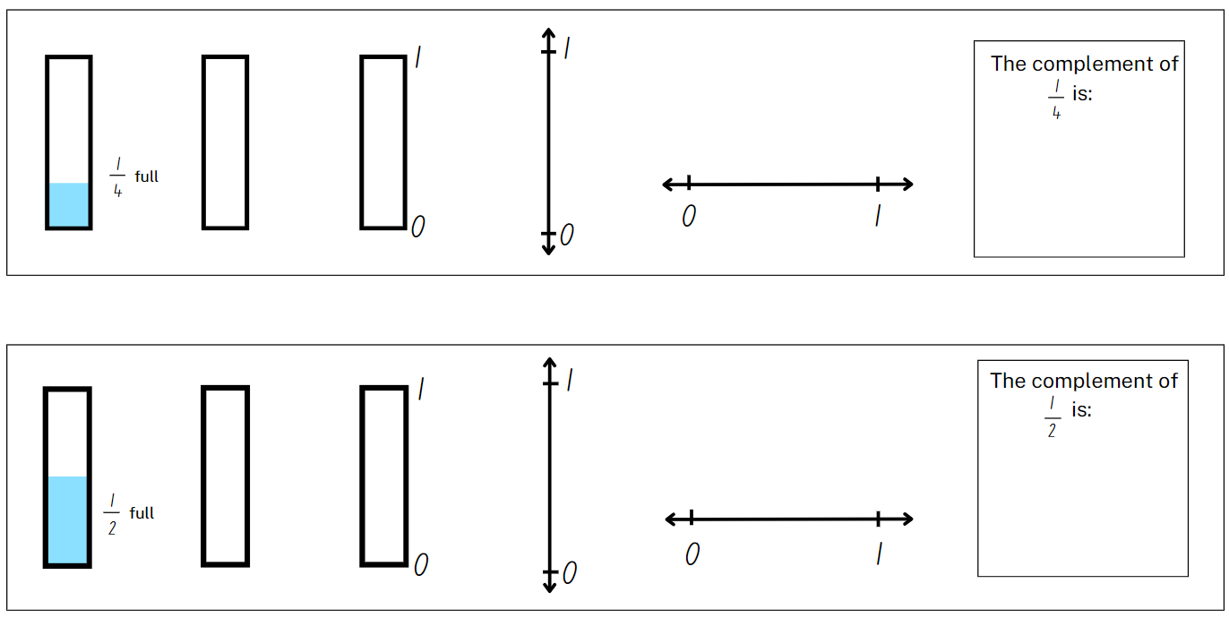

Resource 6 – water jugs 2
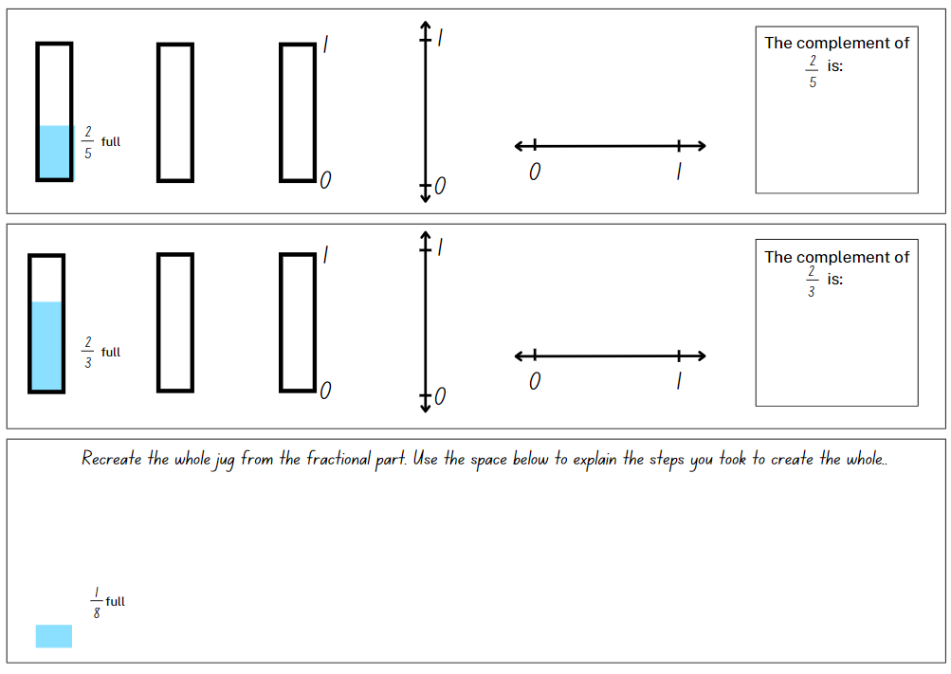

Resource 7 – whole water jug
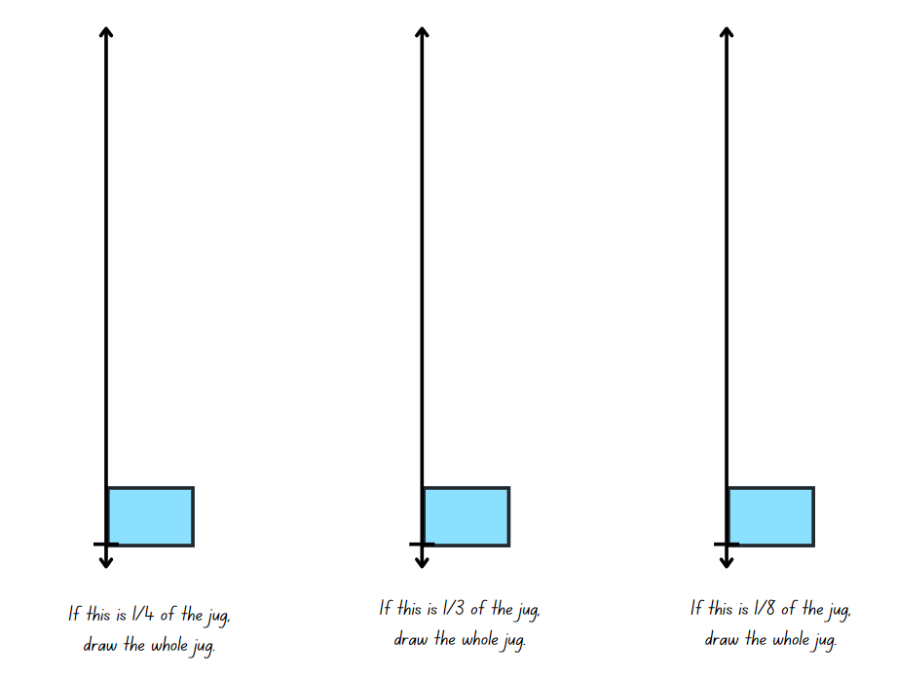

Resource 8 – number line 0–2
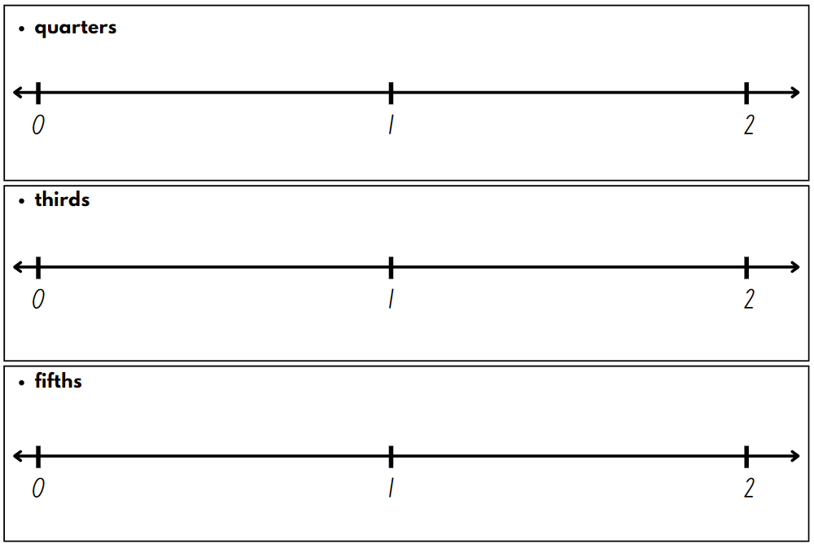

Resource 9 – fraction patterns
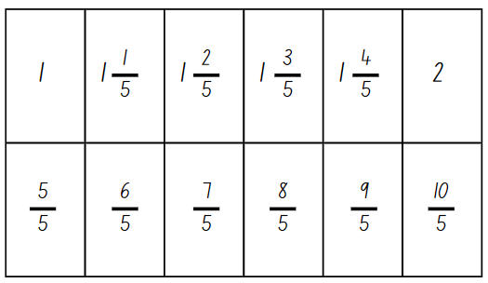

Resource 10 – representations 1
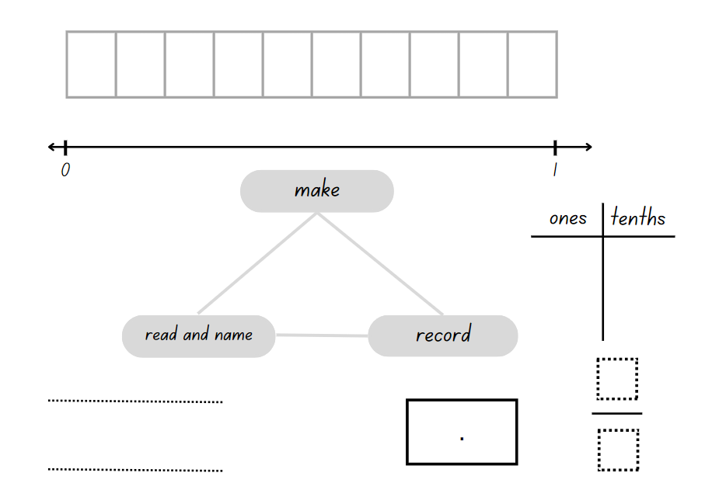

Resource 11 – representations 2
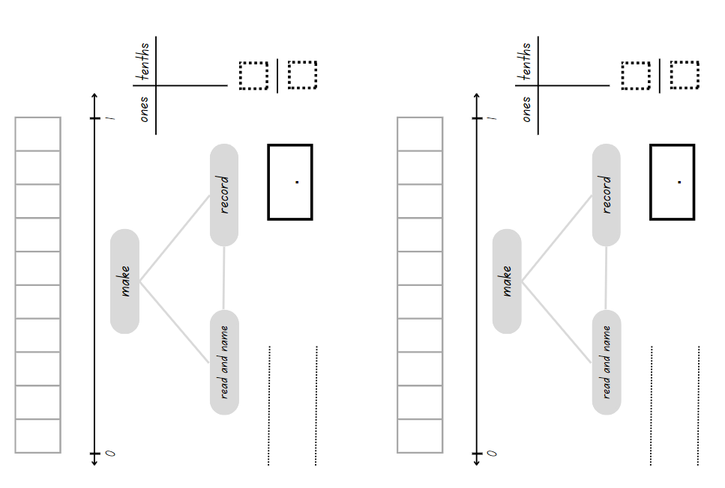

Resource 12 – representations beyond 1
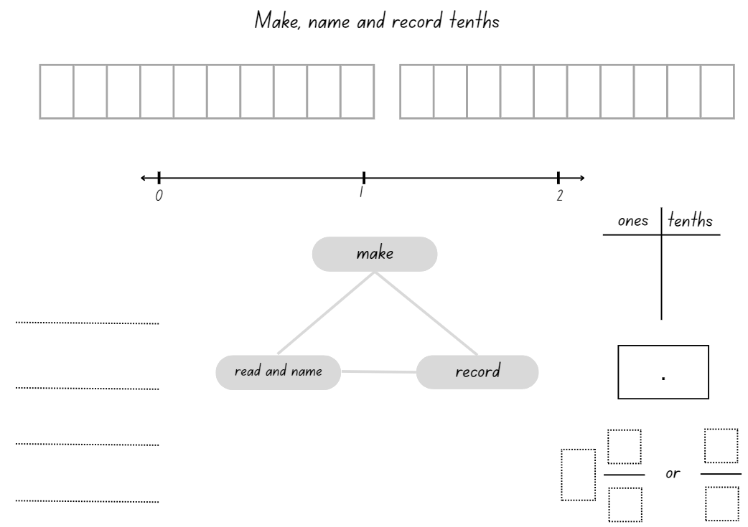

Resource 13 – money wall

Resource 14 – Australian coins
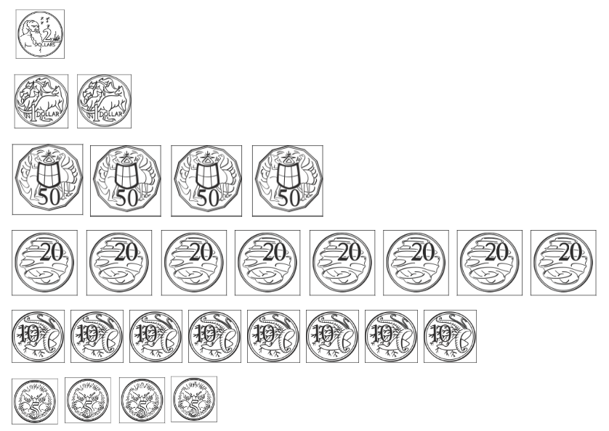

Resource 15 – tenths and hundredths
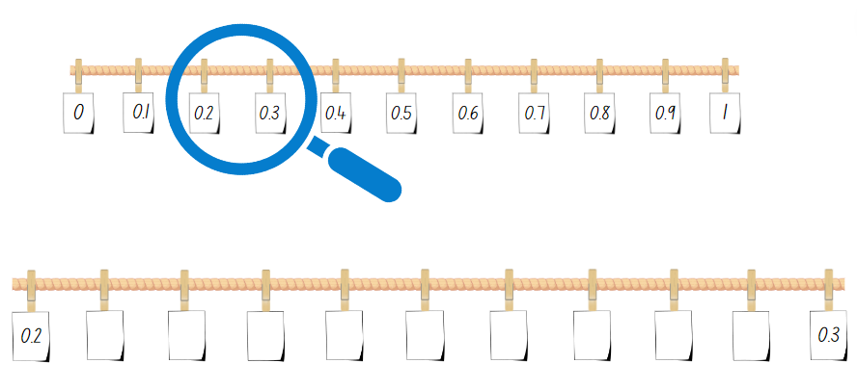

Resource 16 – hundredths number line
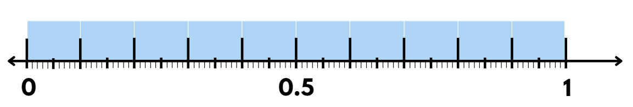

Resource 17 – hundredths
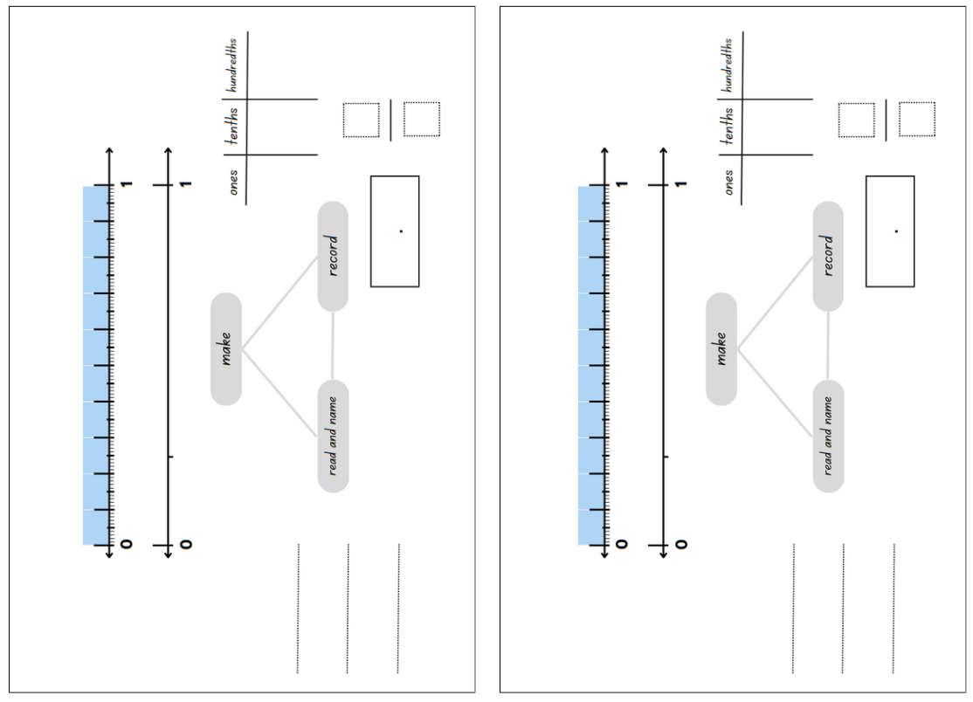

Resource 18 – Maths Busters
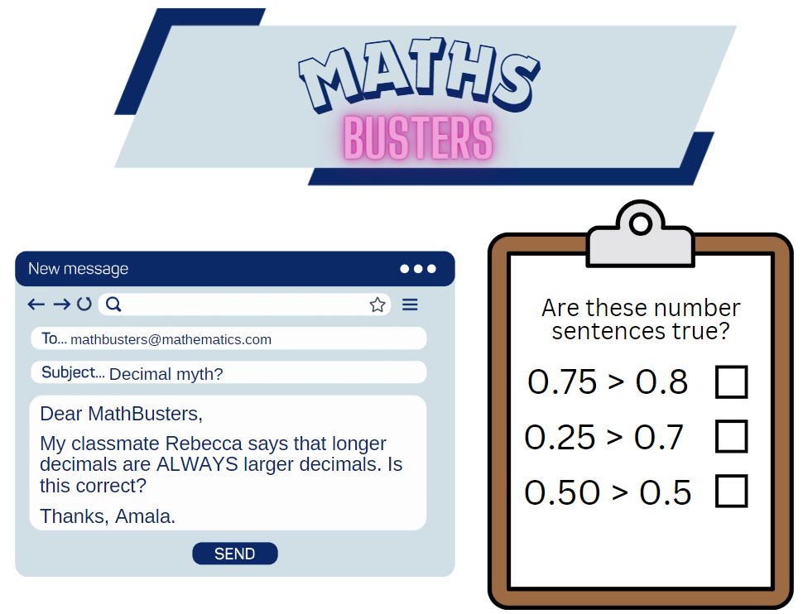

Resource 19 – canteen price list
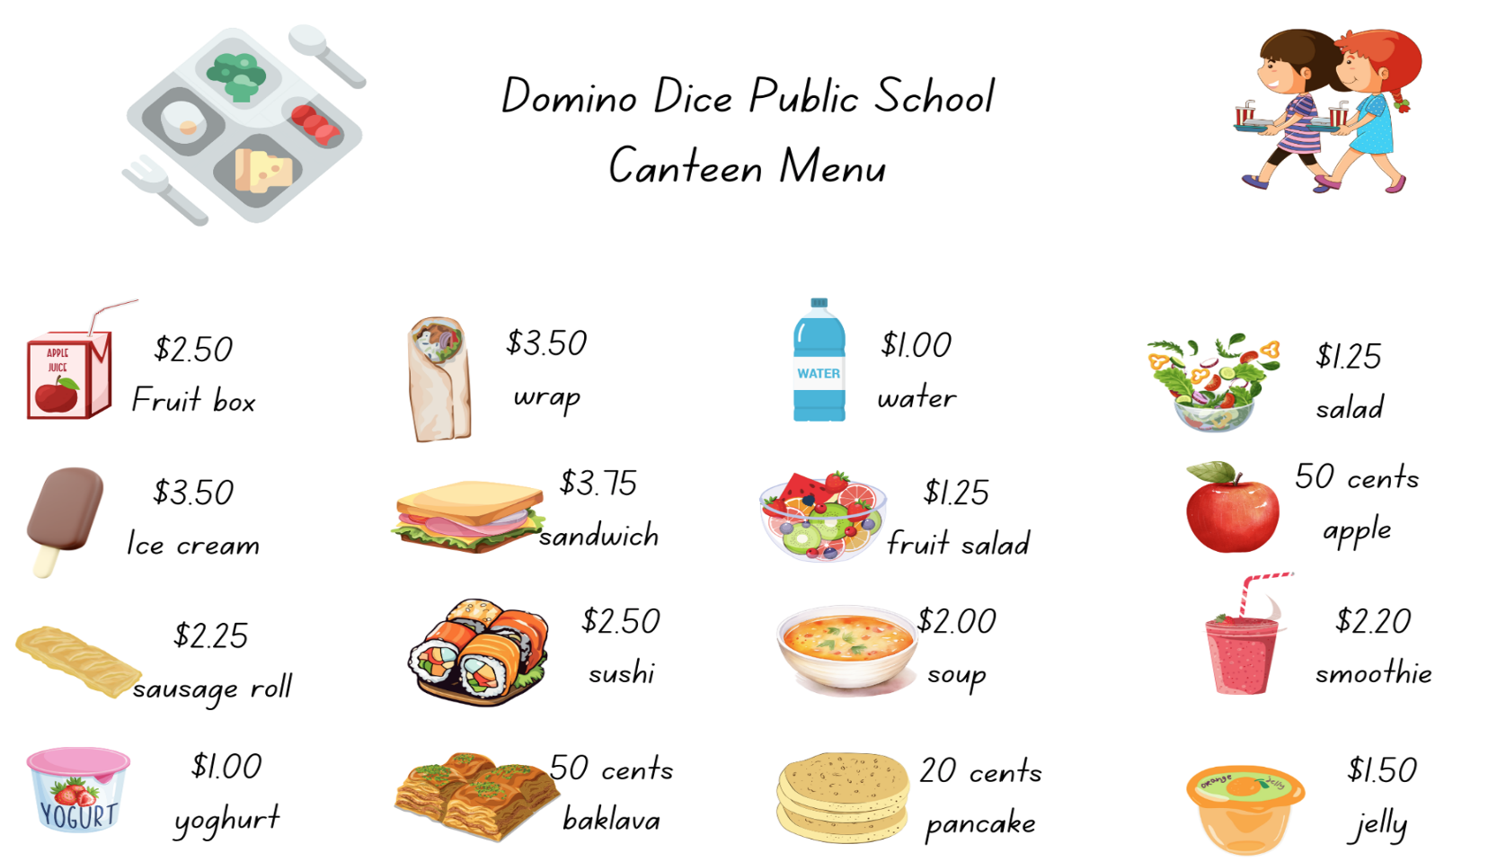

Resource 20 – number line 0–3
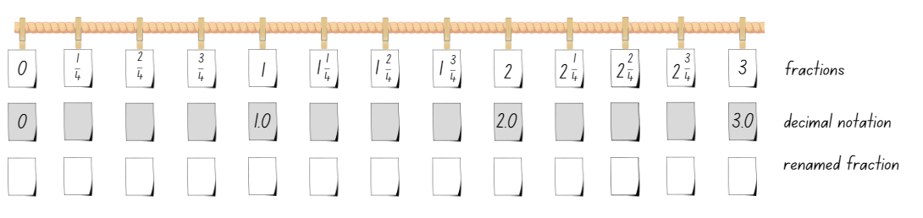

Resource 21 – missing symbols
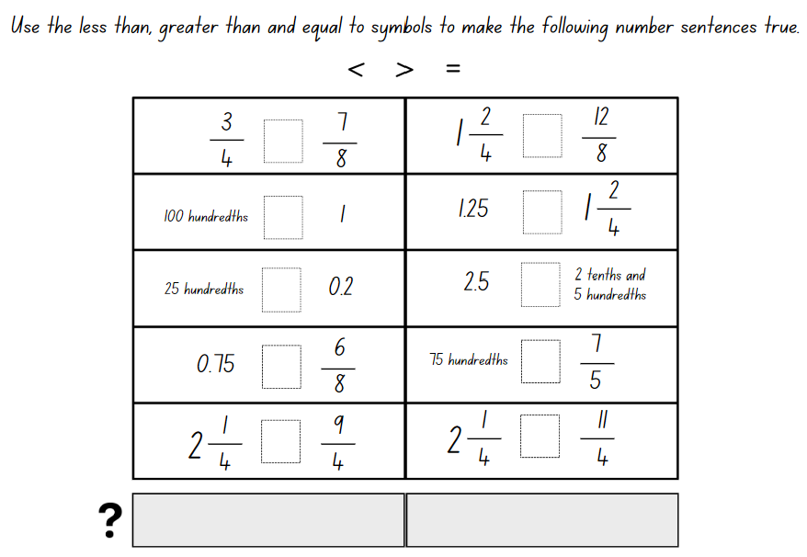

Resource 22 – two groups
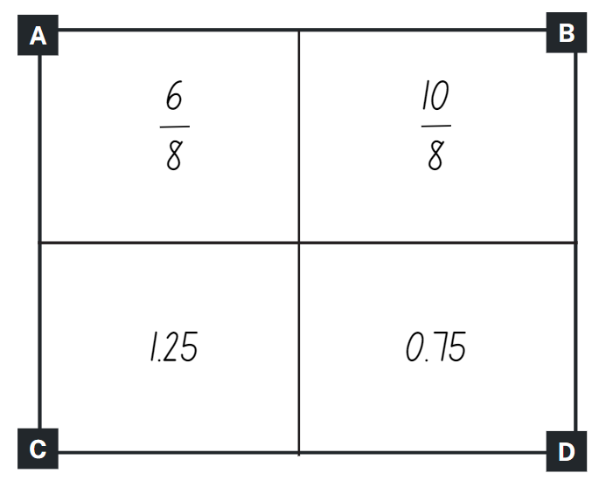

Resource 23 – student misconceptions
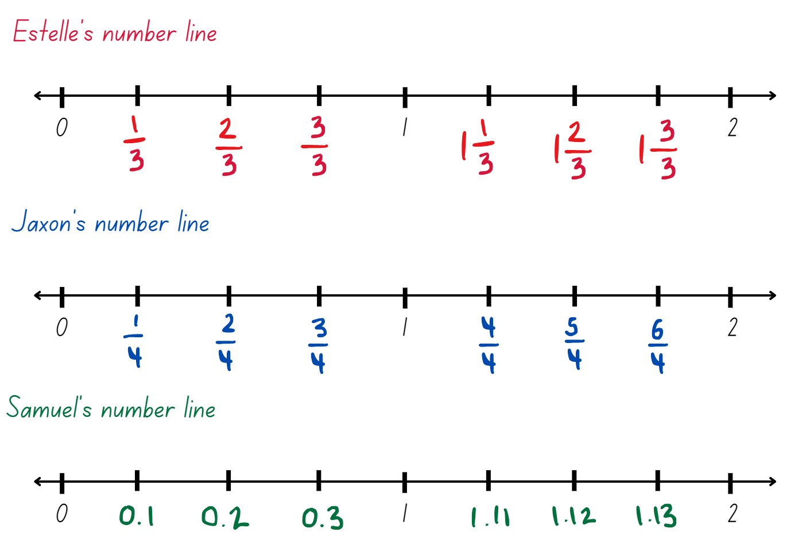

Syllabus outcomes and content
The table below outlines the syllabus outcomes and range of relevant syllabus content covered in this unit. Content is linked to National Numeracy Learning Progression (version 3).
Outcomes and content | 1 | 2 | 3 | 4 | 5 | 6 | 7 | 8
Representing numbers using place value B: Decimals: Extend the application of the place value system from whole numbers to tenths and hundredths
MAO-WM-01, MA2-RN-02
- Recognise that 10-tenths is recorded as 1.0 and regroup when using decimal notation |  |  |  |  | x | x | x | x
- Represent and compare tenths as decimals using linear representations (Reasons about relations) |  |  |  |  | x | x
Representing numbers using place value B: Decimals: Make connections between fractions and decimal notation
MAO-WM-01, MA2-RN-02
- Compare and order decimals of up to 2 decimal places |  |  |  |  |  | x | x | x
- Make connections between fractions and decimal notation for key benchmark values (Reasons about relations) |  |  |  |  |  | x | x | x
Additive relations A: Represent money values in multiple ways
MAO-WM-01, MA2-AR-02
- Recognise the relationship between dollars and cents |  |  |  |  | x
- Represent equivalent amounts of money using different denominations |  |  |  |  | x | x
- Perform calculations with money, including finding change |  |  |  |  |  | x | x
Multiplicative relations A: Generate and describe patterns
MAO-WM-01, MA2-MR-01
- Model, describe and record patterns of multiples |  | x
- Create and continue a variety of number patterns that increase or decrease by a constant amount |  |  |  | x
Multiplicative relations B: Investigate number sequences involving related multiples
MAO-WM-01, MA2-MR-01
- Investigate number patterns involving related multiples |  |  | x | x
Partitioned fractions A: Model and represent unit fractions, and their multiples, to a complete whole on a number line
MAO-WM-01, MA2-PF-01
- Determine the complementary fractional part needed to complete one whole (halves, quarters, eighths, thirds) (Reasons about relations) |  |  | x
- Recreate the whole unit from a fractional part ($\frac{1}{2}$ , $\frac{1}{4},\frac{1}{3}$ and $\frac{1}{8}$ ) (Reversible reasoning) | x |  | x
Partitioned fractions B: Model equivalent fractions as lengths
MAO-WM-01, MA2-PF-01
- Represent the equivalence of fractions with related denominators as lengths, using concrete materials, diagrams and number lines | x | x | x | x |  | x | x
- Recognise the need to have equal wholes to compare partitioned fractions (Reasoning about relations) | x
- Represent fractions with the same-size whole to make valid comparisons (denominators of 2, 4 and 8; 3 and 6; 5 and 10) | x | x
Partitioned fractions B: Represent fractional quantities equal to and greater than one
MAO-WM-01, MA2-PF-01
- Rename 2 halves, 3 thirds, 4 quarters, 5 fifths, 6 sixths, 8 eighths and 10 tenths as one whole | x | x | x | x |  |  | x
- Regroup fractional parts beyond one |  | x | x |  | x
- Represent totals of halves, thirds, quarters and fifths that extend beyond one |  |  | x | x |  |  | x | x
- Determine the relative location of one-quarter and one-half when a number line extends beyond one |  |  | x | x |  |  | x | x
Mathematics K–10 Syllabus © NSW Education Standards Authority (NESA) for and on behalf of the Crown in right of the State of New South Wales, 2022.

References
This resource contains NSW Curriculum and syllabus content. The NSW Curriculum is developed by the NSW Education Standards Authority. This content is prepared by NESA for and on behalf of the Crown in right of the State of New South Wales. The material is protected by Crown copyright.
Please refer to the NESA Copyright Disclaimer for more information https://educationstandards.nsw.edu.au/wps/portal/nesa/mini-footer/copyright.
NESA holds the only official and up-to-date versions of the NSW Curriculum and syllabus documents. Please visit the NSW Education Standards Authority (NESA) website https://educationstandards.nsw.edu.au and the NSW Curriculum website https://curriculum.nsw.edu.au.
Mathematics K–10 Syllabus © NSW Education Standards Authority (NESA) for and on behalf of the Crown in right of the State of New South Wales, 2022.
National Numeracy Learning Progression © Australian Curriculum, Assessment and Reporting Authority (ACARA) 2010 to present, unless otherwise indicated. This material was downloaded from the Australian Curriculum website (National Numeracy Learning Progression) (accessed 29 March 2024) and was not modified.
Amplify Education (n.d.) Polypad, Amplify website, accessed 29 February 2024.
Commonwealth of Australia (2020) Classroom talk: Money Wall moments [PDF 275 KB], Mathematics Hub, accessed 29 February 2024.
Commonwealth of Australia (2023) Circulating coins, Australian Government (Royal Australian Mint) website, accessed 29 February 2024.
Epstein M (5 November 2020, updated 5 June 2021) ‘Exploring the Edges of Mathematical Ideas’, Mathematics Education, accessed 29 February 2024.
Pierce R (2023) Make the Amount, Math Is Fun website, accessed 29 February 2024.
Reserve Bank of Australia (2012–2024) Banknotes in Circulation, Reserve Bank of Australia website, accessed 29 February 2024.
Siemon D (2002) Partitioning – The missing link in building fraction knowledge and confidence [PDF 103 KB], RMIT University, Victoria, Australia.
Siemon D, Warren E, Beswick K, Faragher R, Miller J, Horne M, Jazby D, Breed M, Clark J and Brady K (2021) Teaching Mathematics: Foundations to Middle Years, 3rd edn, Oxford University Press Australia and New Zealand.
The Maths Learning Centre (2005–2024) Fractions, Math Learning Centre website, accessed 29 February 2024.
Tribal Group PLC (n.d.) ‘Unit Fractions’, Year 3 curriculum map, National Centre for Excellence in the Teaching of Mathematics (NCETM) website, accessed 29 February 2024.
University of Cambridge (n.d.) Spiralling Decimals, NRICH website, accessed 29 February 2024.

© State of New South Wales (Department of Education), 2024
The copyright material published in this resource is subject to the Copyright Act 1968 (Cth) and is owned by the NSW Department of Education or, where indicated, by a party other than the NSW Department of Education (third-party material).
Copyright material available in this resource and owned by the NSW Department of Education is licensed under a Creative Commons Attribution 4.0 International (CC BY 4.0) license.
This license allows you to share and adapt the material for any purpose, even commercially.
Attribution should be given to © State of New South Wales (Department of Education), 2024.
Material in this resource not available under a Creative Commons license:
- the NSW Department of Education logo, other logos and trademark-protected material
- material owned by a third party that has been reproduced with permission. You will need to obtain permission from the third party to reuse its material.
Links to third-party material and websites
Please note that the provided (reading/viewing material/list/links/texts) are a suggestion only and implies no endorsement, by the New South Wales Department of Education, of any author, publisher, or book title. School principals and teachers are best placed to assess the suitability of resources that would complement the curriculum and reflect the needs and interests of their students.
If you use the links provided in this document to access a third-party's website, you acknowledge that the terms of use, including licence terms set out on the third-party's website apply to the use which may be made of the materials on that third-party website or where permitted by the Copyright Act 1968 (Cth). The department accepts no responsibility for content on third-party websites.

