Mathematics Stage 2 – Unit 35
Addition and subtraction problems can be solved by using a variety of strategies
Contents
Unit description and duration 5
Syllabus outcomes 5
Working mathematically 6
Student prior learning 6
Lesson overview and resources 8
Lesson 1 14
Daily number sense – number detective – 10 minutes 14
Core lesson 1 – revising equivalence – 15 minutes 16
Core lesson 2 – anchor chart – 20 minutes 21
Core lesson 3 – partitioning – 15 minutes 23
Discuss and connect the mathematics – 10 minutes 25
Lesson 2 27
Daily number sense – balancing challenge – 10 minutes 27
Core lesson 1 – comparing strategies – 20 minutes 29
Core lesson 2 – composition and decomposition – 20 minutes 30
Discuss and connect the mathematics – 10 minutes 34
Lesson 3 36
Daily number sense – canteen price list – 10 minutes 36
Core lesson 1 – budget estimates – 15 minutes 37
Core lesson 2 – party budget – 25 minutes 39
Discuss and connect the mathematics – 10 minutes 40
Lesson 4 42
Daily number sense – 10 minutes 42
Core lesson 1 – partitioning versus levelling – 20 minutes 42
Core lesson 2 – partitioning versus constant difference – 20 minutes 45
Consolidation and meaningful practice – 10 minutes 48
Lesson 5 50
Daily number sense – money, money – 15 minutes 50
Core lesson – models for additive relations – 35 minutes 53
Discuss and connect the mathematics – 15 minutes 57
Lesson 6 61
Daily number sense – multiples on a 100 grid – 10 minutes 61
Core lesson 1 – written versus mental strategies – 20 minutes 63
Core lesson 2 – addition algorithms with regrouping – 20 mins 64
Discuss and connect the mathematics – 10 minutes 66
Lesson 7 69
Daily number sense – sweets in a box – 10 minutes 69
Core lesson 1 – subtraction algorithm – 10 minutes 70
Core lesson 2 – subtraction surprise – 30 minutes 72
Discuss and connect the mathematics – 10 minutes 77
Lesson 8 79
Daily number sense – 10 minutes 79
Core lesson 1 – number sentences – 25 minutes 79
Core lesson 2 – word problems – 15 minutes 82
Consolidation and meaningful practice – 20 minutes 83
Resource 1 – additive strategies 86
Resource 2 – bingo cards 90
Resource 3 – bingo caller sheet 92
Resource 4 – place value chart 93
Resource 5 – reflection chart 94
Resource 6 – self-assessment 95
Resource 7 – comparing strategies grid 96
Resource 8 – canteen price list 97
Resource 9 – party activities 98
Resource 10 – planning sheet 100
Resource 11 – pocket money 101
Resource 12 – different strategies 102
Resource 13 – different models 103
Resource 14 – 100 grid 104
Resource 15 – blank 100 grid 105
Resource 16 – addition questions 106
Resource 17 – subtraction surprise 107
Resource 18 – balancing number sentences 109
Resource 19 – matching cards 110
Syllabus outcomes and content 115
References 121

Unit description and duration
This unit develops the big idea that addition and subtraction problems can be solved by using a variety of strategies.
In this 2-week unit students are provided opportunities to:
- select, represent and explain flexible strategies when solving additive relations problems
- partition, rearrange and regroup numbers to at least 1000 to solve additive problems
- apply addition and subtraction to familiar contexts, including money and budgeting.

Syllabus outcomes
- MAO-WM-01 develops understanding and fluency in mathematics through exploring and connecting mathematical concepts, choosing and applying mathematical techniques to solve problems, and communicating their thinking and reasoning coherently and clearly
- MA2-RN-01 applies an understanding of place value and the role of zero to represent numbers to at least tens of thousands
- MA2-AR-01 selects and uses mental and written strategies for addition and subtraction involving 2- and 3-digit numbers
- MA2-AR-02 completes number sentences involving addition and subtraction by finding missing values
- MA2-MR-01 represents and uses the structure of multiplicative relations to 10 × 10 to solve problems

Working mathematically
In the Mathematics K–10 Syllabus, there is one overarching Working mathematically outcome (MAO-WM-01). The Working mathematically processes should be embedded within the concepts being taught. The Working mathematically processes present in the Mathematics K–10 Syllabus are:
- communicating
- understanding and fluency
- reasoning
- problem solving.
Mathematics K–10 Syllabus © NSW Education Standards Authority (NESA) for and on behalf of the Crown in right of the State of New South Wales, 2022.

Student prior learning
Before engaging in these teaching and learning activities, students would benefit from prior experience with:
- recognising and recording equal differences in number sentences using the equals sign to mean 'the same as', rather than to perform an operation
- representing numbers up to and including thousands using physical or virtual manipulatives, words, numerals, diagrams and digital displays
- representing equivalent amounts of money using different denominations.
In NSW classrooms there is a diverse range of students, including Aboriginal and/or Torres Strait Islander students, students learning English as an additional language or dialect, high potential and gifted students and students with disability. Some students may identify with more than one of these groups or possibly all of them. Refer to Curriculum planning for every student – advice for further information.

Lesson overview and resources
The table below outlines the sequence and approximate timing of lessons, learning intentions and resources.
Lesson | Content | Duration and resources
Lesson 1  Daily number sense learning intention:  - complete number sentences involving additive relations to find unknown quantities | Lesson core concept: place value understanding helps solve addition and subtraction problems.  Core concept learning intentions:  - use the principle of equality  - partition, rearrange and regroup numbers to at least 1000 to solve additive problems | Lesson duration: 70 minutes  - Resource 1 – additive strategies  - Resource 2 – bingo cards  - Resource 3 – bingo caller sheet  - Resource 4 – place value chart  - Resource 5 – reflection chart  - Chart paper  - Counters  - Individual whiteboards  - Markers  - Writing materials
Lesson 2  Daily number sense learning intention:  - complete number sentences involving additive relations to find unknown quantities | Lesson core concept: numbers can be built up or taken apart in a variety of ways to make the numbers easier to work with.  Core concept learning intentions:  - apply place value to partition, regroup and rename numbers up to 6 digits  - partition, rearrange and regroup numbers to at least 1000 to solve additive problems | Lesson duration: 60 minutes  - Resource 1 – additive strategies  - Resource 4 – place value chart  - Resource 5 – reflection chart  - Resource 6 – self-assessment  - Resource 7 – comparing strategies grid  - Class anchor chart  - Writing materials
Lesson 3  Daily number sense learning intention:  - complete number sentences involving additive relations to find unknown quantities | Lesson core concept: addition can help solve subtraction problems.  Core concept learning intentions:  - represent money values in multiple ways  - apply addition and subtraction to familiar contexts, including money and budgeting  - partition, rearrange and regroup numbers to at least 1000 to solve additive problems | Lesson duration: 60 minutes  - Resource 1 – additive strategies  - Resource 8 – canteen price list  - Resource 9 – party activities  - Resource 10 – planning sheet  - Resource 11 – pocket money  - Class anchor chart  - Individual whiteboards  - Writing materials
Lesson 4  Daily number sense learning intention:  - teacher-identified task based on student needs | Lesson core concept: flexible methods of addition and subtraction involve decomposing and composing numbers.  Core concept learning intentions:  - select strategies flexibly to solve addition and subtraction problems of up to 3 digits  - partition, rearrange and regroup numbers to at least 1000 to solve additive problems | Lesson duration: 60 minutes  - Resource 1 – additive strategies  - Resource 5 – reflection chart  - Resource 12 – different strategies  - Class anchor chart  - Writing materials
Lesson 5  Daily number sense learning intentions:  - investigate number sequences involving related multiples  - represent money values in multiple ways | Lesson core concept: models help us solve addition and subtraction problems.  Core concept learning intentions:  - read, represent and order numbers to thousands  - recognise and explain the connection between addition and subtraction  - select strategies flexibly to solve addition and subtraction problems of up to 3 digits | Lesson duration: 65 minutes  - Resource 1 – additive strategies  - Resource 13 – different models  - 0–9 dice  - Class anchor chart  - Individual whiteboards  - Writing materials
Lesson 6  Daily number sense learning intention:  - investigate number sequences involving related multiples | Lesson core concept: mathematicians use algorithms with understanding to solve addition problems.  Core concept learning intentions:  - select strategies flexibly to solve addition and subtraction problems of up to 3 digits  - partition, rearrange and regroup numbers to at least 1000 to solve additive problems | Lesson duration: 60 minutes  - Resource 1 – additive strategies  - Resource 5 – reflection chart  - Resource 14 – 100 grid  - Resource 15 – blank 100 grid  - Resource 16 – addition questions  - Class anchor chart  - Coloured pencils  - MAB materials  - Writing materials
Lesson 7  Daily number sense learning intention:  - investigate number sequences involving related multiples | Lesson core concept: mathematicians use algorithms with understanding to solve subtraction problems.  Core concept learning intention:  - recognise and represent numbers that are 10, 100 or 1000 times as large  - partition, rearrange and regroup numbers to at least 1000 to solve additive problems | Lesson duration: 60 minutes  - Resource 1 – additive strategies  - Resource 5 – reflection chart  - Resource 17 – subtraction surprise  - Class anchor chart  - Counters  - Grid paper  - Writing materials
Lesson 8  Daily number sense learning intention:  - teacher-identified task based on student needs | Lesson core concept: mathematicians compare and evaluate strategies used to solve addition and subtraction problems, reasoning which strategy may be most efficient.  Core concept learning intentions:  - complete number sentences involving additive relations to find unknown quantities  - select strategies flexibly to solve addition and subtraction problems of up to 3 digits | Lesson duration: 70 minutes  - Resource 1 – additive strategies  - Resource 5 – reflection chart  - Resource 18 – balancing number sentences  - Resource 19 – matching cards  - Class anchor chart  - Writing materials

Lesson 1
Core concept: place value understanding helps solve addition and subtraction problems.

Daily number sense – number detective – 10 minutes
Daily number sense activities for Lessons 1 to 3 ‘activate’ prior number knowledge and support the learning of new content in the unit. These activities can also assist teachers to identify the starting points for learning by revealing the extent of students’ existing knowledge.
The table below contains a suggested learning intention and success criteria. These are best co-constructed with students.
Daily number sense learning intention | Daily number sense success criteria
Students are learning to:  - complete number sentences involving additive relations to find unknown quantities. | Students can:  - calculate missing numbers by completing number sentences involving addition and subtraction.
- Explain that students will participate in a challenge to find the missing numbers that make both sides of a number sentence equal.
- Select and display several number sentences on the board that have appropriate challenge for the class. Examples may include:
- _? − 15 = 19
- _? + 9 = 17
- 32 − _? = 19
- 25 + _? = 48
- _? − 14 = 6
- 56 = _? + 27
- 78 − _? = 42
- _? + 16 = 35
- 49 = 37 + _?
- 83 = 55 + _?
- Students solve the number sentences to find the missing number and record it on an individual whiteboard.
- Encourage students to show and explain the strategies they used.
- Discuss the strategies used to solve the problems.
Note: algebraic reasoning relates to generalising about number relationships and operating on unknown quantities, such as using inverse operations or determining a rule for a pattern and using the rule to find other terms in the pattern (NESA 2022).
- Students can create their own missing number sentence and challenge classmates to solve it.
This table details an opportunity for assessment.
Assessment opportunity | Links
What to look for:  - Can students calculate missing numbers by completing number sentences involving addition and subtraction (Algebraic reasoning)? [MAO-WM-01, MA2-AR-02] | Links to National Numeracy Learning Progressions (NNLP):  - AdS7, AdS8.  Links to suggested Interview for Student Reasoning (IfSR) tasks:  - IfSR-AT: 2A.1, 2A.4, 2A.5, 3A.1, 3A.3.

Core lesson 1 – revising equivalence – 15 minutes
The table below contains suggested learning intentions and success criteria. These are best co-constructed with students.
Core concept learning intentions | Core concept success criteria
Students are learning to:  - use the principle of equality  - partition, rearrange and regroup numbers to at least 1000 to solve additive problems. | Students can:  - recognise equal differences and record them in number sentences  - use the equals sign to mean 'the same as', rather than to perform an operation  - use quantity values and non-standard partitioning to solve addition and subtraction problems
- Display the equals sign. Ask students what it represents. Record class responses around the sign (see Figure 1).
Figure 1 – equals sign
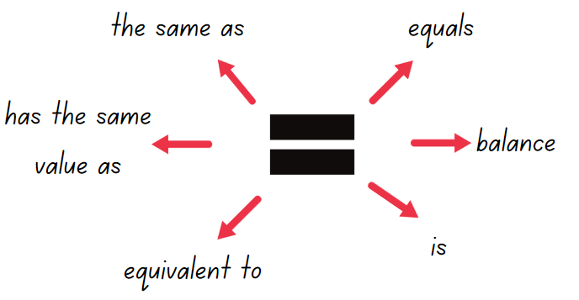
- Draw an equal-arm balance like that shown in Figure 2. Ask students what numbers could go in the boxes to balance the scale. Emphasise that the numbers in the boxes on the right-hand-side can, but do not have to, be equal.
Figure 2 – equal-arm balance
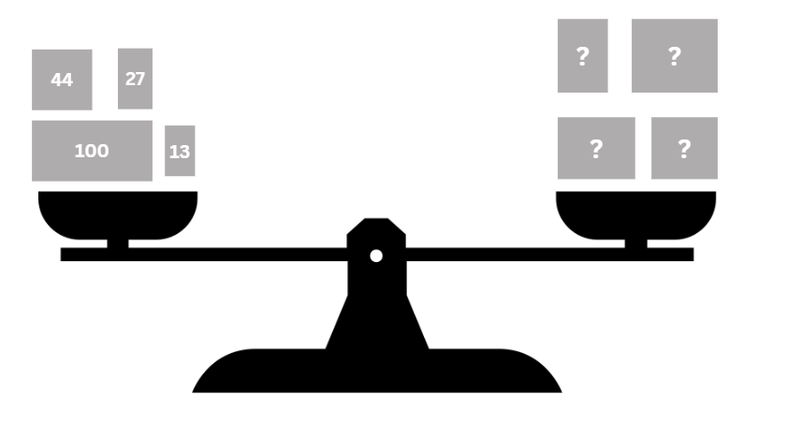
- Establish that the equal-arm balance in Figure 2 needs 184 on both sides to balance. The difference between each side is zero because they are equal.
- Draw a different equal-arm balance where both sides have a subtraction number sentence (see Figure 3).
Figure 3 – constant difference scale
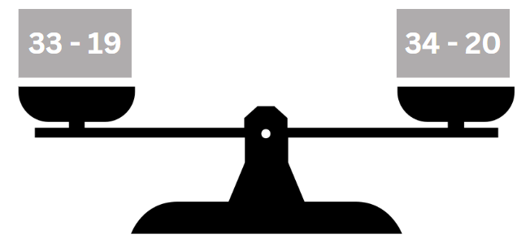
- Discuss how the numbers have been adjusted on both sides to keep an equal value. Refer to this as a ‘constant difference’.
- Explain the meaning of ‘constant’ – something that does not change.
Note: many pairs of numbers can have the same difference between them. To simplify finding the difference between 2-digit numbers, the same amount can be added to or subtracted from both numbers to reach landmark numbers. For example, 46 and 93 share the same difference as 50 and 97 because 4 has been added to both numbers. Adjusting numbers in this way to support subtraction is referred to as ‘constant difference’.
- Ask students:
- What other subtraction number sentences could be added to balance the number sentence 33 − 19 = _? (Any number sentence with a difference of 14.)
- How can a constant difference help with mental subtraction? (Allows you to adjust to landmark numbers, making calculations simpler and with fewer steps.)
- Present number sentences for students to adjust to landmark numbers such as 25 − 17 = 30 − 22 = 28 − 20. Examples could include:
- 23 − 8 = _?
- _ = 46 − 17
- 78 − 23 = _?
- _ = 62 − 17
- 53 − 26 = _?
- Model the associative property of addition by bridging to the decade for example, 22 + 13+ 8 = 22 + 8 + 13 = 30 + 13 = 43.
Note: the associative property of addition means that when adding 3 or more numbers, the value remains unchanged regardless of how you group or order the numbers. For example, (7 + 9) + 8 = 7 + (9 + 8).
- Explain how reordering the numbers in a number sentence can make addition and subtraction more efficient. Provide other examples, particularly where pairs of numbers add or subtract to 10, 100 or 1000.
- Emphasise the link to equality – changing the order of the numbers for addition does not change the value (see Figure 4).
Figure 4 – associative property of addition
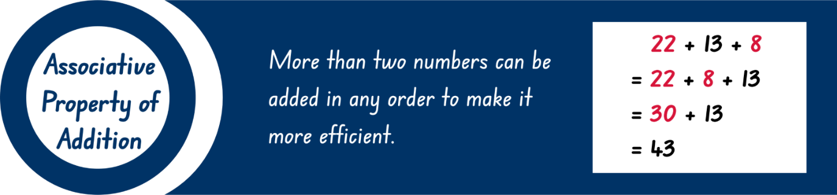

Core lesson 2 – anchor chart – 20 minutes
- Display an equivalent number sentence using stage appropriate numbers, such as 267 + _ = 605 − 117.
- In pairs, students solve the number sentence and explain the strategies used to solve it.
- As a class, record the strategies students use when solving addition and subtraction. Ask students if they can name the strategy. The list may include equivalence, inverse operations, commutative property, associative property, algorithms, levelling, constant difference, partitioning or splitting, regrouping or renaming, bridging to landmark numbers and compensation.
- Provide small groups with writing materials. Ask each group to design a section of an anchor chart, writing a definition for an additive strategy and to record an example.
- Regroup as a class and ask each group to explain their choice of definition and example.
- Combine all sections to make a class anchor chart (see Figure 5).
Figure 5 – example of class chart
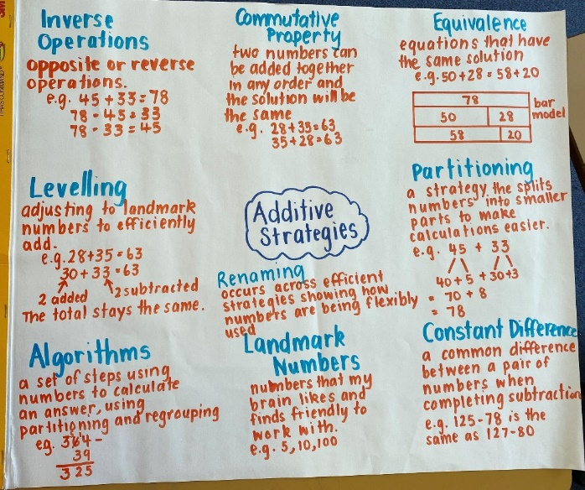
Note: as an alternative, Resource 1 – additive strategies may be displayed or provided to students to support their learning.

Core lesson 3 – partitioning – 15 minutes
- Display 60 807 and 687. Ask students what they notice.
- Ask students what the value of the zeros are and what role zero has in place value.
- Model non-standard and standard partitioning as a drawing, in words and expanded notation with students offering ideas for a 3- and a 4-digit number (see Figure 6).
Figure 6 - partitioning example
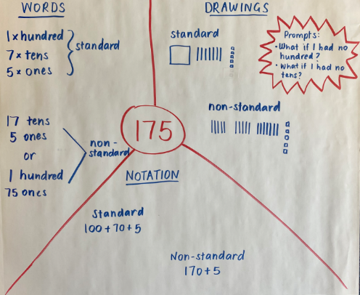
Optional game: students play non-standard partitioning bingo which includes 4-digit numbers. Provide each student with Resource 2 – bingo cards. Call out numbers from Resource 3 – bingo caller sheet. Students place a counter on any number that is worth the same amount as the called number. The person that covers all their numbers first wins.
This table details opportunities for differentiation.
Too hard? | Too easy?
Students cannot use non-standard partitioning to solve addition and subtraction problems.  - Students use standard partitioning to practice reading, writing and modelling numbers.  - Students use MAB materials and Resource 4 – place value chart to represent numbers rolled with 2 or 3 dice. Ask students to explore various non-standard ways to partition numbers by considering scenarios where there are no tens or hundreds. | Students can model addition and subtraction with and without regrouping and record the method used.  - Provide students with subtraction problems that include non-standard partitioning of larger numbers with internal zeros. For example, 40 300 − 1 408.  - Students write clues for the game ‘What mystery number am I?’ For example, ‘My number has 4 digits and when you add them together, you get 9. The tens digit is greater than 5. What mystery number am I?’

Discuss and connect the mathematics – 10 minutes
- Write the number sentence 397 – 149 on the board. Ask students to solve it using a mental strategy such as constant difference or partitioning. Ask students to turn and talk to share approaches and answers.
- Write the number sentence 397 + 45 + 54 + 5 + 3 − 4. Ask students to solve it using the associative property of addition. Again, ask students to turn and talk to share approaches and answers.
- Display Resource 5 – reflection chart and discuss the meaning of each idea.
- Ask students to select one of the strategies used to solve the problems and to reflect on the 4 statements:
- Flexible – I have a range of strategies to choose from.
- Fluent – I can use my strategy easily.
- Understanding – I can connect different ideas, show maths in different ways and use ideas in new ways.
- Efficient – I have used a strategy with a small number of steps.
This table details opportunities for assessment.
Assessment opportunities | Links
What to look for:  - Can students recognise equal differences and record them in number sentences? [MAO-WM-01, MA2-AR-01, MA2-AR-02]  - Can students use the equals sign to mean 'the same as', rather than to perform an operation? [MAO-WM-01, MA2-AR-01,  MA2-AR-02]  - Can students use quantity values and non-standard partitioning to solve addition and subtraction problems?  [MAO-WM-01, MA2-AR-01] | Links to National Numeracy Learning Progressions (NNLP):  - AdS7, AdS8.  Links to suggested Interview for Student Reasoning (IfSR) tasks:  - IfSR-AT: Section 2 and Section 3.

Lesson 2
Core concept: numbers can be built up or taken apart in a variety of ways to make the numbers easier to work with.

Daily number sense – balancing challenge – 10 minutes
The table below contains a suggested learning intention and success criteria. These are best co-constructed with students.
Daily number sense learning intention | Daily number sense success criteria
Students are learning to:  - complete number sentences involving additive relations to find unknown quantities. | Students can:  - find the missing number in an equivalent number sentence involving operations of addition or subtraction on both sides of the equals sign.
- Explain to students that they are going to participate in a challenge to find the missing numbers that make both sides of a number sentence equal.
- Display several number sentences suited to the learning needs of your students:
- _ + 7 = 23 + 12
- 23 – 8 = _ − 3
- _ + 15 = 35 − 4
- _ + 16 = 54 − 22
- 54 – 16 = _ + 29
- _ + 20 = 75 − 27
- 103 +_ = _ − 18
- _ – 24 = 155 − _
- Ask students to record and solve the number sentences.
- Select students to show and explain the strategies they used.
- Ask students if they were efficient strategies and how many steps they used.
This table details an opportunity for assessment.
Assessment opportunity | Links
What to look for:  - Can students find the missing number in an equivalent number sentence involving operations of addition or subtraction on both sides of the equals sign (Algebraic reasoning)?  [MAO-WM-01, MA2-AR-02] | Links to National Numeracy Learning Progressions (NNLP):  - AdS7, AdS8.  Links to suggested Interview for Student Reasoning (IfSR) tasks:  - IfSR-AT: 2A.1, 2A.4, 2A.5, 3A.1, 3A.3.

Core lesson 1 – comparing strategies – 20 minutes
The table below contains suggested learning intentions and success criteria. These are best co-constructed with students.
Core concept learning intentions | Core concept success criteria
Students are learning to:  - apply place value to partition, regroup and rename numbers up to 6 digits  - partition, rearrange and regroup numbers to at least 1000 to solve additive problems. | Students can:  - use place value to expand the number notation  - partition numbers of up to 6 digits in non-standard forms  - use quantity values and non-standard partitioning to solve addition and subtraction problems  - model addition and subtraction with and without regrouping and record the method used.
- Provide students with Resource 6 – self-assessment.
- Ask students to score their confidence with each skill.
Note: at the end of the lesson, students will repeat this self-assessment in a different colour to identify learning.
- Review and discuss the anchor chart made in Lesson 1 or review Resource 1 – additive strategies.
- Provide pairs of students with a copy of Resource 7 – comparing strategies grid.
- Students check the number sentence in the middle of the grid and circle the most efficient strategies.
- Students may add other strategies that can be used to solve the number sentence.
- Regroup as a class and select students to share their reasons for the most efficient strategies selected.
- Repeat the activity with other number sentences to suit the needs of students in the class.

Core lesson 2 – composition and decomposition – 20 minutes
- Model decomposition of 4-digit numbers as a bar model on a place value chart and as a part-whole diagram (see Figure 7).
Figure 7 – representations of decomposition
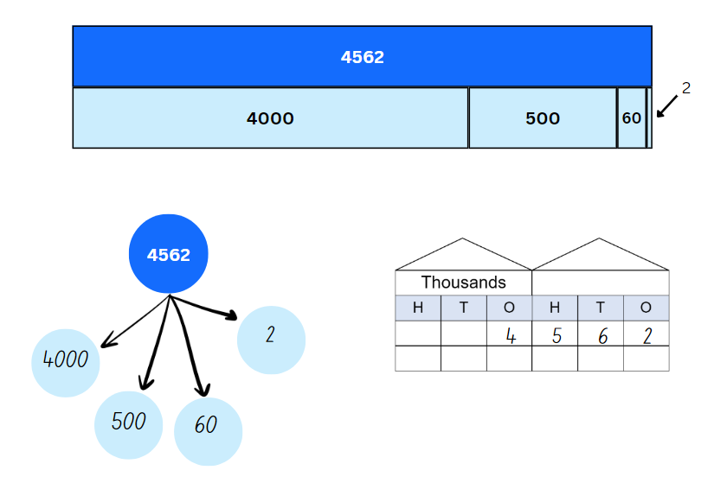
- Revise how the associative property of addition means that the order in which the parts of 4562 are added together again does not make a difference to the total.
- Ask students how these number properties can be applied to addition and subtraction.
- Display 78 + 24 + 18. Ask students how composition and/or decomposition can be used efficiently to calculate the total.
- Display and repeat the question for 58 + 13 + 8.
The table below outlines stimulus prompts to generate conversation about the topic, along with anticipated responses from students.
Prompts | Anticipated student responses
- How can we use place value knowledge to answer 78 + 24 + 18 (or 3-digit numbers to suit your context)? | - By using place value knowledge, I can break down the quantities into their tens and ones, combine the tens to form 100, and combine the ones to make 2 more tens.  - I know that 78 + 22 = 100. I can split 24 into 22 and 2. Now I have 100 + 2 + 18 which totals 120.  - I know that 24 = 12 + 12. With those twelves I can make 90 from 78 and 30 from 18. 90 plus 30 makes 120.
- How can we use partitioning to answer 58 + 13 + 8? | - I can break down numbers into their smaller parts and use them flexibly in my calculations. Here, I can partition 8 into 7 and 1, then combine 13 and 7 to make 20. Then, I have 58 + 20 + 1 = 79.
- Students solve number sentences, showing how composition, decomposition and the associative property can be used. Examples could include:
- 62 + 18 + 15 = _
- 55 + 9 + 25 = _
- 81 + 17 + 29 = _
- 142 + 41 + 11 = _
- 495 + 106 + 25 = _
- 458 − 39 = _
- 777 – 87 = _
This table details opportunities for differentiation.
Too hard? | Too easy?
Students cannot use quantity values and non-standard partitioning to solve addition and subtraction problems.  - With a deck of cards (1–9), students create a 3-digit number by selecting 3 cards and represent it using MAB materials on Resource 4 – place value chart. Then, students choose 2 cards to form a 2-digit number with MAB materials. Students calculate the total, regrouping as necessary. Students write a matching number sentence.  - Vary the addition activity above by asking students to find the difference between the 2 numbers. Students write a matching number sentence. | Students can use quantity values and non-standard partitioning to solve addition and subtraction problems.  - Ask students to investigate and record at least 10 separate ways of changing one number to another, using any operation. For example, to move from 12 to 240, students could add 228, double 12 and multiply by 10, multiply 12 by 20, add 238 and subtract 10 and so on. To promote efficiency, set a limit of 5 operations.  - Once they have a list, invite students to share their list with a group. Ask students to respond to questions such as:  - Did you notice any patterns?  - What strategies did you use to help you make your list?  - Is it possible to work out how many ways one number can be related to another?

Discuss and connect the mathematics – 10 minutes
- Display Resource 5 – reflection chart. Ask students to turn and talk to share their reflections.
- Students return to Resource 6 – self-assessment from the start of the lesson and indicate their understanding using a different colour.
This table details opportunities for assessment.
Assessment opportunities | Links
What to look for:  - Can students use place value to expand the number notation? [MAO-WM-01, MA2-AR-01]  - Can students partition numbers of up to 6 digits in non-standard forms? [MAO-WM-01, MA2-AR-01]  - Can students use quantity values and non-standard partitioning to solve addition and subtraction problems?  [MAO-WM-01, MA2-AR-01]  - Can students model addition and subtraction with and without regrouping and record the method used?  [MAO-WM-01, MA2-AR-01] | Links to National Numeracy Learning Progressions (NNLP):  - AdS7, AdS8.  Links to suggested Interview for Student Reasoning (IfSR) tasks:  - IfSR-AT: Section 2 and Section 3.

Lesson 3
Core concept: addition can help solve subtraction problems.

Daily number sense – canteen price list – 10 minutes
The table below contains a suggested learning intention and success criteria. These are best co-constructed with students.
Daily number sense learning intention | Daily number sense success criteria
Students are learning to:  - complete number sentences involving additive relations to find unknown quantities. | Students can:  - create word problems that correspond to given addition and subtraction number sentences.
- Revise the class constructed additive strategies anchor chart from Lesson 1 or Resource 1 – additive strategies.
- Display Resource 8 – canteen price list.
- Model writing a number sentence, such as 50c + 25c = 75c.
- Ask students to turn and talk to prepare a word problem from the canteen list that matches that sentence.
- Ask students to use individual whiteboards to write number sentences and matching word problems.
- Select students to share their word problems.
This table details an opportunity for assessment.
Assessment opportunity | Links
What to look for:  - Can students create word problems that correspond to given addition and subtraction number sentences? [MAO-WM-01,  MA2-AR-01, MA2-AR-02] | Links to National Numeracy Learning Progressions (NNLP):  - AdS7, AdS8.  Links to suggested Interview for Student Reasoning (IfSR) tasks:  - IfSR-AT: 4A.1-3.

Core lesson 1 – budget estimates – 15 minutes
The table below contains suggested learning intentions and success criteria. These are best co-constructed with students.
Core concept learning intentions | Core concept success criteria
Students are learning to:  - represent money values in multiple ways  - apply addition and subtraction to familiar contexts, including money and budgeting  - partition, rearrange and regroup numbers to at least 1000 to solve additive problems. | Students can:  - perform calculations with money, including finding change  - interpret problems involving money as requiring either addition or subtraction  - use estimation to check the validity of solutions to addition and subtraction problems, including those involving money  - model addition and subtraction with and without regrouping and record the method used.
- Discuss how rounding can be used to estimate the cost of items to ensure students have enough money.
- Explain that students should not calculate totals but use approximation to help answer the questions.
- Display and read Resource 9 – party activities. Ask:
- With a $500 budget, can you organise the petting zoo and karaoke? What about outdoor toys and face painting?
- About how many sushi platters can you buy with $150? Explain your thinking.
- About how many fruit platters can you buy with $160? Explain your thinking.
- Is $60 enough to buy 10 pizzas? How do you know?
- With $200, can you get 3 photo booths? Explain your reasoning.
- Is $50 enough to buy 10 juice packs? Why or why not?
- List 5 snacks or drinks you can buy for under $20 without calculating. Are there any other combinations?

Core lesson 2 – party budget – 25 minutes
- Present the following scenario: The school principal has told the class that they have won the prize for being the best class in the school. For this honour, they will have a class party worth $999. The students get to decide how to spend the money.
- Explain that students will have the opportunity to prepare and present a budget following these rules:
- stay within the budget of $999
- purchase at least 2 items from each list.
Optional challenge: purchase enough of each item so that every student and teacher in the class receives the same amount of food and drink.
- Display and read Resource 9 – party activities.
- Provide small groups Resource 10 – planning sheet to determine the total cost of the party.
- Ask groups to calculate how much of the $999 budget will be left.
- Encourage students to use both addition and subtraction during their budgeting.
This table details opportunities for differentiation.
Too hard? | Too easy?
Students cannot model addition and subtraction with and without regrouping and record the method used.  - Provide Australian play money to make the amounts for each item students select when working through the task.  - Change the costs of all items to whole dollars only. | Students can model addition and subtraction with and without regrouping and record the method used.  - Provide students with Resource 11 – pocket money. Students determine which pocket money option they would choose.  - Ask students to be the auditors of the class party budgets, ensuring the mathematics has been completed correctly.

Discuss and connect the mathematics – 10 minutes
- Once completed, students present their ideas and reflect on the mathematical strategies. Ask:
- How did your group ensure all members provided input and engaged in the mathematics?
- What did you find easy in the task?
- Can you explain how you used addition and subtraction in your calculations?
- Did you use any other operations? Which ones and why?
- Did you have any mathematical challenges and how did you overcome them?
- Did your group use the most efficient method to work out the total cost? Why do you think this?
- How might the skills you used in this activity apply to real-life situations? For example, managing personal finances and planning events.
This table details opportunities for assessment.
Assessment opportunities | Links
What to look for:  - Can students perform calculations with money, including finding change? [MAO-WM-01, MA2-AR-01]  - Can students interpret problems involving money as requiring either addition or subtraction? [MAO-WM-01, MA2-AR-01]  - Can students model addition and subtraction with and without regrouping and record the method used? [MAO-WM-01,  MA2-AR-01]  - Can students use estimation to check the validity of solutions to addition and subtraction problems, including those involving money? [MAO-WM-01, MA2-AR-01] | Links to National Numeracy Learning Progressions (NNLP):  - AdS7, AdS8.  Links to suggested Interview for Student Reasoning (IfSR) tasks:  - IfSR-AT: Section 2 and Section 3, 4A.1.

Lesson 4
Core concept: flexible methods of addition and subtraction involve decomposing and composing numbers.

Daily number sense – 10 minutes
- From a class need surfaced through formative assessment data, identify a short, focused activity that targets students’ knowledge, understanding and skills. Example activities may be drawn from the following resources:
- Mathematics K–6 resources
- Universal Resources Hub.

Core lesson 1 – partitioning versus levelling – 20 minutes
The table below contains suggested learning intentions and success criteria. These are best co-constructed with students.
Core concept learning intentions | Core concept success criteria
Students are learning to:  - select strategies flexibly to solve addition and subtraction problems of up to 3 digits  - partition, rearrange and regroup numbers to at least 1000 to solve additive problems. | Students can:  - apply known mental strategies that use partitioning to add and subtract, such as bridging the decades  - apply levelling and constant difference strategies  - model addition with and without regrouping and record the method used  - model subtraction with and without regrouping and record the method used.
- Revise the class constructed additive strategies anchor chart from Lesson 1 or Resource 1 – additive strategies.
- Display the number sentence 79 + 37 and ask students to solve it mentally. Students share their responses and strategies with a partner.
- Display Resource 12 – different strategies.
- Discuss the strategies used by the cartoon students and reflect on how flexible and efficient they are, using Resource 5 – reflection chart for support. Ask:
- Can you name the strategies used by the cartoon students? (Student A uses standard partitioning, Student B uses levelling and Student C uses non-standard partitioning.)
- How would you have solved the number sentence?
- Would you have used the same strategy as one of the cartoon students?
- Which strategy is the most efficient? Will everyone agree? Why or why not?
- Model the use of standard partitioning using the number sentence 79 + 37. (For example, 70 + 30 + 9 + 7 = 116)
- Model the use of non-standard partitioning using the number sentence 79 + 37. (For example, 79 + 21 + 16 = 116.)
- Model the use of levelling using the same number sentence 79 + 37. (For example, 80 + 36 = 116.)
- Explain that when using levelling, numbers can be adjusted up and down to the most efficient landmark number (see Figure 8).
Figure 8 – levelling examples
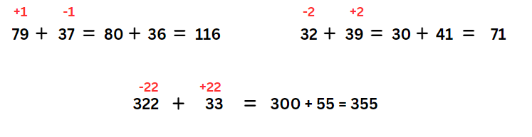
Levelling: adjusting to landmark numbers to add efficiently, for example, 79 + 35 becomes 80 + 34.
- Students use standard partitioning, non-standard partitioning and levelling to solve number sentences in their workbooks. Examples may include:
- 79 + 37
- 62 + 43
- 87 + 49
- 64 + 38
- 179 + 47
- 221 + 198
- 342 + 213
- Display 221 + 198 and discuss different ways standard partitioning, non-standard partitioning and the levelling strategy can be used. Ask:
- Which way is more efficient, partitioning or levelling?
- Is it always more efficient to level? Why or why not?
- What strategy is more efficient as the numbers get larger? Why?

Core lesson 2 – partitioning versus constant difference – 20 minutes
- Display the following number sentence: 213 − 68.
- Ask students how to solve this efficiently using mental strategies. Record all responses.
- Identify student responses using standard and non-standard partitioning.
- Revise the concept of constant difference introduced in Lesson 1. Explain that numbers can be adjusted up or down flexibly to the most efficient landmark number (see Figure 9).
Figure 9 – constant difference
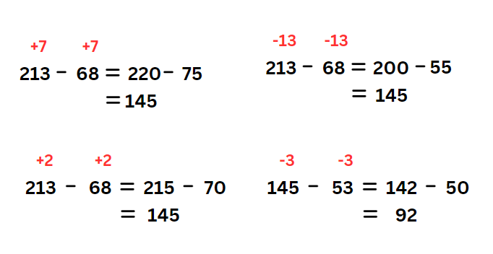
Constant difference: a common difference between a pair of numbers when completing subtraction, for example, 71 − 36 becomes 70 − 35.
- Explain that students cannot use levelling for subtraction, as the associative and commutative properties of addition do not apply to subtraction. For subtraction, the order of the numbers does matter: 9 − 7 is not the same as 7 − 9.
- Students use standard partitioning, non-standard partitioning and constant difference to record and solve the number sentences in their workbooks:
- 66 − 28
- 125 − 79
- 323 − 137
- 791 − 246
- 152 − 88
- 931 − 146
- 813 – 318.
Note: for constant difference, it may be easier to focus on first adjusting the number being subtracted (subtrahend) to a landmark or ‘friendly’ number. In the example, 323 − 137, adjusting the numbers to 326 − 140 may make the subtraction easier than the alternative 320 − 134. Encourage students to experiment with flexible approaches and to look for options that help them.
- Display 813 − 318. Discuss ways to use standard and non-standard partitioning and constant difference to solve it.
- Which way is more efficient, partitioning or constant difference?
- Is it always more efficient to partition? Why or why not?
- What strategy is more efficient as the numbers get larger? Why?
This table details opportunities for differentiation.
Too hard? | Too easy?
Students cannot model addition and subtraction with and without regrouping and record the method used (levelling and constant difference).  - Use MAB materials to support student understanding that in levelling, the total remains the same.  - Students use single digits to solve addition and subtraction questions and then level to landmark numbers, for example, 10 and 20. | Students can model addition and subtraction with and without regrouping and record the method used (levelling and constant difference).  - Ask students to investigate Sums and Differences 2 of 2-digit numbers, recording their findings in a table.  - Create a bank of questions of up to 6-digit numbers that would be suitable for levelling and a bank suitable for constant difference. What numbers are best suited to those strategies?

Consolidation and meaningful practice – 10 minutes
- Ask students to complete an exit slip showing 2 ways to solve following questions: 348 + 235 and 497 − 386.
- Ask students to label the strategies used and circle the most efficient strategy. Asks students to explain why the strategy picked is the most efficient.
This table details opportunities for assessment.
Assessment opportunities | Links
What to look for:  - Can students apply known mental strategies that use partitioning to add and subtract, such as bridging the decades? [MAO-WM-01, MA2-AR-01]  - Can students apply the levelling and constant difference strategies? [MAO-WM-01, MA2-AR-01]  - Can students model addition with and without regrouping and record the method used? [MAO-WM-01, MA2-AR-01]  - Can students model subtraction with and without regrouping and record the method used? [MAO-WM-01, MA2-AR-01] | Links to National Numeracy Learning Progressions (NNLP):  - AdS7, AdS8.  Links to suggested Interview for Student Reasoning (IfSR) tasks:  - IfSR-AT: Section 2 and Section 3.

Lesson 5
Core concept: models help us solve addition and subtraction problems.

Daily number sense – money, money – 15 minutes
Daily number sense activities for Lessons 5 to 7 ‘loop’ back to concepts and procedures covered in previous units to assist students to build an increasingly connected network of ideas. These concepts may differ from the core concepts being covered by the unit.
The table below contains suggested learning intentions and success criteria. These are best co-constructed with students.
Daily number sense learning intentions | Daily number sense success criteria
Students are learning to:  - investigate number sequences involving related multiples  - represent money values in multiple ways. | Students can:  - generate number patterns using related multiples  - represent equivalent amounts of money using different denominations
This activity is an adaptation of Penny, Nickel, Dime from Math for Love by Finkel.
- The aim of the activity is to use multiplication by 2, 5 and 10 to add coins to the total of $2.
- Explain that when multiplying by 5 and by 20, multiplying by 10 is helpful because:
- 5 is 10 ÷ 2 (or 5 is half of 10)
- 20 is 10 × 2 (or 20 is double 10).
- Provide an example of how multiplying by 10 can be used to multiply by 5 and 20, such as:
- 6 × 10 = 60, so 6 × 5 = 6 × 10 ÷ 2 = 30
- 6 × 20 = 6 × 10 × 2 = 120.
- Link multiplication by 5, 10 and 20 to coins of those denominations.
- Provide students with a die and an individual whiteboard.
- Students form a table with columns labelled 5 cents, 10 cents and 20 cents on their whiteboard (see Figure 10).
Figure 10 – blank gameboard
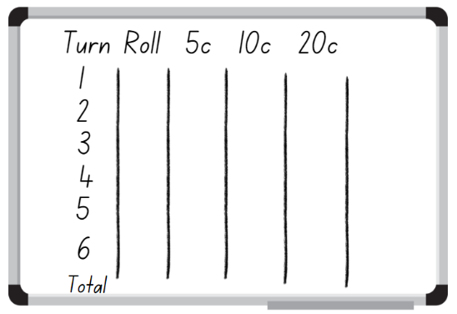
- In pairs, students take turns rolling a die. Player 1 rolls the die, then multiplies the number by 5c, 10c or 20c and records the total in the respective column. Encourage students to use multiplication facts. Player 2 then has a turn rolling the die, then calculating and recording the total.
- Each player rolls 6 times in total, choosing whether each number goes in the 5c, 10c or 20c column.
- The winner is the player who comes as close to $2 without going over (see Figure 11).
Figure 11 – completed gameboards
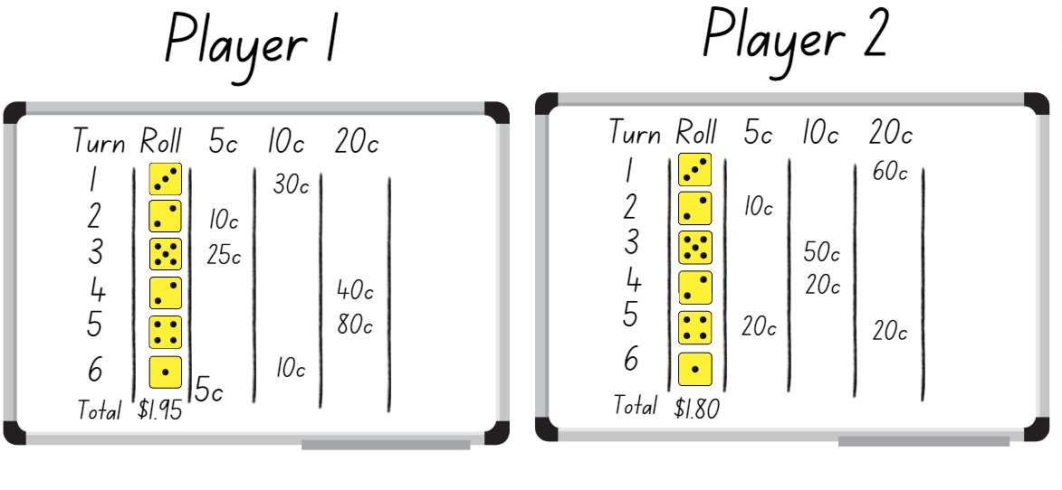
This table details opportunities for assessment.
Assessment opportunities | Links
What to look for:  - Can students generate number patterns using related multiples? [MAO-WM-01, MA2-MR-01]  - Can students represent equivalent amounts of money using different denominations? [MAO-WM-01, MA2-MR-01] | Links to National Numeracy Learning Progressions (NNLP):  - AdS7, AdS8, MuS6.  Links to suggested Interview for Student Reasoning (IfSR) tasks:  - IfSR-AT: 4A.1, 4A.2, 4A.3.

Core lesson – models for additive relations – 35 minutes
The table below contains suggested learning intentions and success criteria. These are best co-constructed with students.
Core concept learning intentions | Core concept success criteria
Students are learning to:  - read, represent and order numbers to thousands  - recognise and explain the connection between addition and subtraction  - select strategies flexibly to solve addition and subtraction problems of up to 3 digits. | Students can:  - represent numbers up to and including thousands using physical or virtual manipulatives, words, numerals, diagrams and digital displays  - demonstrate how addition and subtraction are inverse operations  - represent solutions to addition and subtraction problems, including word problems, using an empty number line or bar model  - compare and evaluate strategies used to solve addition and subtraction problems, reasoning which strategy may be most efficient.
This lesson is an adaptation of The Bar Model Method from reSolve: Maths by Inquiry by the Australian Academy of Science.
- Revise the class constructed additive strategies anchor chart from Lesson 1 or Resource 1 – additive strategies.
- Display this problem: Joanne has 160 bookmarks in her store. She sells 43 bookmarks. How many bookmarks does she have now?
- Model or revise how to represent this problem using an empty number line and the bar model (see Figure 12). Draw attention to the proportionate sizes of the bar model pieces.
Figure 12 – different models
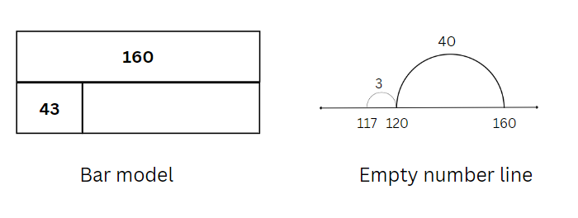
Note: the bar model is an effective problem-solving tool for use in many mathematics topics. It promotes the visualisation, organisation and concrete representation of mathematical quantities and relationships within a problem. It makes visible the part-whole thinking that is key to many mathematics problems (Australian Academy of Science 2022). The bar model forms a foundation for algebra in helping students to represent problems symbolically.
- Explain that both the bar model and the number line show the inverse relationship between addition and subtraction.
- Discuss efficient strategies for solving the problem and record the related number sentences: 160 − 43 = 117; 160 − 117 = 43; 117 + 43 = 160 and 43 + 117 = 160.
- Provide pairs of students with a 9-sided die and writing materials. Students roll the 9-sided die 3 times to create and record a 3-digit number. Students roll the die again to create and record a second 3-digit number.
- Provide time for students to write a subtraction number sentence and model subtraction problems using the bar model and empty number line (see Figure 13).
Figure 13 – student example
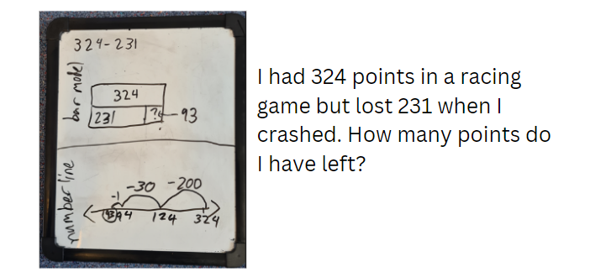
- Ask students to select one example and write a matching word problem.
- Provide time for students to write an addition number sentence and model addition problems using both the bar model and empty number line.
- Again, ask students to select one example and write a matching word problem.
- After suitable practice time, ask students to participate in a gallery walk to share ideas and strategies.
This table details opportunities for differentiation.
Too hard? | Too easy?
Students cannot represent solutions to addition and subtraction problems, including word problems, using an empty number line or bar model.  - Use a digital number line to explore the addition and subtraction of 2-digit numbers  - Use coloured strips of paper to create a physical bar model with students.  - Use MAB materials to model addition and subtraction of 2-digit numbers. | Students can represent solutions to addition and subtraction problems, including word problems, using an empty number line or bar model.  - Students create addition models with missing elements for a partner to solve. Ask students to extend their models that represent problems with more than 2 values.  - Students extend models to represent numbers up to one million or to 2 decimal places.

Discuss and connect the mathematics – 15 minutes
- Display Resource 13 – different models.
The table below outlines stimulus prompts to generate conversation about the topic, along with anticipated responses from students.
Prompts | Anticipated student responses
- What are some questions that could go with these models? | - Answers will vary. Prompt students to form addition and subtraction questions suited to the models.
- How are the bar model and number line similar or different? | - Both are a clear visual representation that make abstract concepts easier to understand.  - Both show how addition and subtraction are inverse operations. One model can show 4 different but related number sentences.  - Number lines can show the direction of a calculation (addition to the right and subtraction to the left).  - Number lines can show the steps of a calculation.  - Bar models show part-part-whole relationships and the relative sizes of the parts.
- How are the 2 bar models the same or different? | - There is a constant difference of 117 in both. The sizes of the other pieces are different.  - Both representations show the relationship between numbers and help guide the operation in solving the problem.
- How are the 2 number lines the same or different? | - Both show a constant difference of 117.  - In both, it is not clear whether you are adding or subtracting.  - The starting or finishing numbers and jump sizes are different.
- How do these models represent the idea of constant difference? | - For the bar model, the yellow box in each one shows a difference of 117. The other numbers are different.  - For the number lines, the jumps are both 117. The starting or finishing numbers are different.
- Can you provide an example where a bar model or number line can be used in everyday life? | - Anything where you are adding or subtracting, such as budgets, discounts or recipe adjustments.
This table details opportunities for assessment.
Assessment opportunities | Links
What to look for:  - Can students represent numbers up to and including thousands using physical or virtual manipulatives, words, numerals, diagrams and digital displays? [MAO-WM-01, MA2-AR-01]  - Can students demonstrate how addition and subtraction are inverse operations? [MAO-WM-01, MA2-AR-01]  - Can students represent solutions to addition and subtraction problems, including word problems, using an empty number line or bar model? [MAO-WM-01, MA2-AR-01]  - Can students compare and evaluate strategies used to solve addition and subtraction problems, reasoning which strategy may be most efficient? [MAO-WM-01, MA2-AR-01] | Links to National Numeracy Learning Progressions (NNLP):  - AdS7, AdS8.  Links to suggested Interview for Student Reasoning (IfSR) tasks:  - IfSR-AT: Section 2 and Section 3.

Lesson 6
Core concept: mathematicians use algorithms with understanding to solve addition problems.

Daily number sense – multiples on a 100 grid – 10 minutes
The table below contains a suggested learning intention and success criteria. These are best co-constructed with students.
Daily number sense learning intention | Daily number sense success criteria
Students are learning to:  - investigate number sequences involving related multiples. | Students can:  - generate number patterns using related multiples  - investigate number patterns involving related multiples.
This activity is an adaptation of Multiples Grid from NRICH by the University of Cambridge.
- Display Resource 14 – 100 grid.
- Explain that this is a 100 grid with some numbers shaded in yellow, some in blue and some in green. Ask students:
- What do all the colours shaded in yellow have in common?
- What do you notice about all the numbers shaded in blue?
- Can you think of a reason there are some numbers shaded in green?
- Students Think-Pair-Share their responses. Yellow numbers are factors of 4, blue numbers are factors of 5 and green numbers are factors of both 4 and 5.
- Provide students with Resource 15 – blank 100 grid. Ask students to shade other multiples patterns on the grid using coloured pencils and describe to a peer.
This table details opportunities for assessment.
Assessment opportunities | Links
What to look for:  - Can students generate number patterns using related multiples? [MAO-WM-01, MA2-MR-01]  - Can students investigate number patterns involving related multiples? [MAO-WM-01, MA2-MR-01] | Links to National Numeracy Learning Progressions (NNLP):  - AdS7, AdS8, MuS6.

Core lesson 1 – written versus mental strategies – 20 minutes
The table below contains suggested learning intentions and success criteria. These are best co-constructed with students.
Core concept learning intentions | Core concept success criteria
Students are learning to:  - select strategies flexibly to solve addition and subtraction problems of up to 3 digits  - partition, rearrange and regroup numbers to at least 1000 to solve additive problems | Students can:  - apply known mental strategies that use partitioning to add and subtract, such as bridging the decades  - use an algorithm with understanding to record addition calculations, where efficient, involving 3-digit numbers  - recognise how hundreds are exchanged in addition algorithms requiring regrouping  - recognise when mental strategies would be more efficient than a vertical algorithm for addition.
This activity is an adaptation of ‘Sum Pattern’ from Favourite Problems by Seymour.
- Revise the class constructed additive strategies anchor chart from Lesson 1 or Resource 1 – additive strategies.
- Display Resource 16 – addition questions. Draw attention to the side titled ‘Sum Pattern’.
- Students turn and talk to look for patterns and to solve it mentally.
- Select students to share their strategies and name different mental strategies used, such as using landmark numbers (10, 50, 100), levelling, partitioning, using rows, using doubling or using columns.
Note: the ability to add two 2-digit numbers mentally by an efficient method is considered a crucial test of readiness for written computation. Encourage students to consider the values of the numbers involved in an arithmetical operation before selecting a method to solve the problem (Lucenta and Kelemanik 2022; Ewbank 1977).
- Display Resource 16 – addition questions. Draw attention to the side titled ‘Algorithm or mental strategies?’
- Ask students to turn and talk and identify problems best solved using written algorithms and those best solved by mental strategies.
- Select students to share their responses for each example, providing reasons for their choices. Ask:
- Is there a problem that everyone agrees should be written? Why is that?
- Is there a problem that everyone agrees can be solved mentally? Why is that?

Core lesson 2 – addition algorithms with regrouping – 20 mins
- Explain that students may have heard of a term called ‘trading’. Explain that mathematicians use the term ‘regrouping’ to help describe reorganising place values.
- Provide students with MAB and writing materials. Display the digits 6, 7, 8, and 9.
- Ask students to create and record two 3-digit numbers using only the digits displayed in an addition sentence in their workbook such as 689 + 976 (see Figure 14).
Figure 14 – addition regrouping
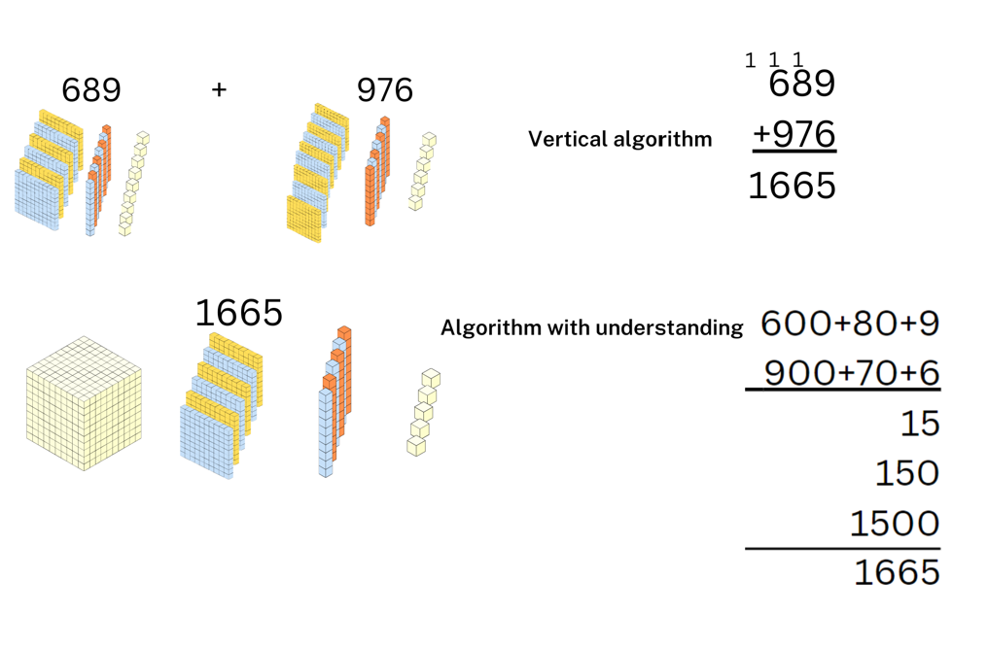
- Students use MAB materials to demonstrate regrouping to a partner, then record the corresponding addition algorithm.
- Repeat the process of writing a 3-digit addition sentence, regrouping with MAB materials and recording the algorithm.
Note: take time to ensure that students recognise how hundreds are exchanged in addition algorithms requiring regrouping. Revise how regrouping relies on recognising the number of tens, hundreds or thousands in a number and renaming them as needed.
This table details opportunities for differentiation.
Too hard? | Too easy?
Students cannot recognise how hundreds are exchanged in addition algorithms requiring regrouping.  - Ask students to use MAB materials to model regrouping from one to tens using 2- and 3-digit numbers that require regrouping.  - Use a digital place value mat (with a regrouping function) to support student calculations. | Students can recognise how hundreds are exchanged in addition algorithms requiring regrouping.  - Use 4- and 5-digit numbers that require regrouping in different place values positions.  - Display solutions using multiple methods, such as algorithm, MAB materials, bar model or empty number line. Ask students to describe groups of problems suited and not suited to algorithms, explaining their groupings.  - Students investigate options for Open Middle questions such as Close to 1000 or Adding 3-digit numbers.

Discuss and connect the mathematics – 10 minutes
- Display 1000 + 637. Ask students to solve it using a vertical algorithm.
- Display Resource 5 – reflection chart. Ask students:
- Was an algorithm efficient for this question? Why or why not?
- What general rule could we apply for next time? (For example, numbers with several zeros as placeholders are time consuming as algorithms – use another method.)
- What additive strategy might have been better?
- If appropriate for the class, display 1000 − 637. Ask students the same reflection questions.
Note: the subtraction algorithm for this problem is procedurally complex. Instead, students can use part-part-whole knowledge or partitioning knowledge to jump from 637 to 1000 or backwards from 1000 to 637.
This table details opportunities for assessment.
Assessment opportunities | Links
What to look for:  - Can students apply known mental strategies that use partitioning to add and subtract, such as bridging the decades? [MAO-WM-01, MA2-AR-01]  - Can students use an algorithm with understanding to record addition calculations, where efficient, involving 3-digit numbers? [MAO-WM-01, MA2-AR-01]  - Can students recognise how hundreds are exchanged in addition algorithms requiring regrouping? [MAO-WM-01, MA2-AR-01]  - Can students recognise when mental strategies would be more efficient than a vertical algorithm for addition? [MAO-WM-01, MA2-AR-01] | Links to National Numeracy Learning Progressions (NNLP):  - AdS7, AdS8.  Links to suggested Interview for Student Reasoning (IfSR) tasks:  - IfSR-AT: Section 2 and Section 3.

Lesson 7
Core concept: mathematicians use algorithms with understanding to solve subtraction problems.

Daily number sense – sweets in a box – 10 minutes
The table below contains a suggested learning intention and success criteria. These are best co-constructed with students.
Daily number sense learning intention | Daily number sense success criteria
Students are learning to:  - investigate number sequences involving related multiples. | Students can:  - generate number patterns using related multiples  - investigate number patterns involving related multiples.
This activity is an adaptation of Sweets in a Box from NRICH by the University of Cambridge.
- Tell students: ‘A lolly manufacturer has decided to design some gift boxes for a new kind of lolly. Each box will contain 36 lollies placed in lines in a single layer in a geometric shape without gaps. Each line contains the same number of lollies. How many different shaped boxes can be designed?’
- In pairs, students use 36 counters as lollies to arrange in various-shaped gift boxes and discuss the patterns made.
- Students draw designs on grid paper and share ideas with the class.
- Students can also try different numbers of ‘lollies’ such as 24 or 60 in each box.
This table details opportunities for assessment.
Assessment opportunities | Links
What to look for:  - Can students generate number patterns using related multiples? [MAO-WM-01, MA2-MR-01]  - Can students investigate number patterns involving related multiples? [MAO-WM-01, MA2-MR-01] | Links to National Numeracy Learning Progressions (NNLP):  - AdS7, AdS8, MuS6.  Links to suggested Interview for Student Reasoning (IfSR) tasks:  - IfSR-MT: 2A.1-6.

Core lesson 1 – subtraction algorithm – 10 minutes
The table below contains suggested learning intentions and success criteria. These are best co-constructed with students.
Core concept learning intentions | Core concept success criteria
Students are learning to:  - recognise and represent numbers that are 10, 100 or 1000 times as large  - partition, rearrange and regroup numbers to at least 1000 to solve additive problems. | Students can:  - recognise the number of tens, hundreds or thousands in a number  - use an algorithm with understanding to record addition and subtraction calculations, where efficient, involving 3-digit numbers  - recognise how hundreds are exchanged in subtraction algorithms requiring regrouping  - recognise when mental strategies would be more efficient than a vertical algorithm for subtraction.
- Review the anchor chart from Lesson 1 or Resource 1 – additive strategies.
- Display the number sentence 736 − 247. Ask students to identify strategies to solve the number sentence.
- Revise writing a subtraction algorithm.
- Remind students numbers may need to be exchanged or regrouped across place value columns to solve the number sentence (See Figure 15).
Figure 15 – subtraction algorithm
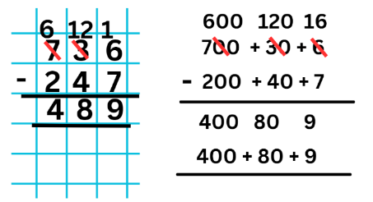
Note: ensure students recognise how hundreds are exchanged in subtraction algorithms requiring regrouping. Revise how regrouping relies on recognising the number of tens, hundreds or thousands in a number and renaming them as needed.
- Provide other examples for students, before commencing the next activity.

Core lesson 2 – subtraction surprise – 30 minutes
This lesson is an adaptation of Subtraction Surprise from NRICH by the University of Cambridge. The NRICH website is supported with video resources which may support student learning and engagement with this activity. Alternatively, provide students with the examples on Resource 17 – subtraction surprise.
Note: a common misconception with the subtraction algorithm is known as the ‘smaller-from-larger error’. When students focus only on the values of the digits in the subtraction, some ‘simplify’ by reordering the terms to always subtract the smaller value from the larger digit. Emphasising the quantity value of the digits and using number expanders can assist in addressing this error. Starting by estimating the answer can also help.
- Display the problem 723 − 327 as a vertical algorithm. Ask students what they notice about the numbers.
- Model the procedure for solving the algorithm or provide students with writing materials to solve it.
- Once solved as 396, continue the algorithm by flipping the answer to 693 and adding it to 396. Ask students what they notice about the numbers.
- Model the procedure for solving the algorithm or provide students with writing materials to solve it.
- Display the additional problems 856 − 658 and 352 − 253. Ask:
- What is the same in each example?
- What is different?
- Do you need algorithms for all 3 number sentences? Could you solve these more efficiently using a mental strategy? Explain.
- Pose the question: ‘I wonder if this works for all 3-digit numbers?’
- Ask students:
- What do you think?
- Are there 3-digit numbers that you can tell straight away will not follow the pattern? (111, 222, 333 … or 101, 202, 303)
- How could we find out?
- Allow students time to Think-Pair-Share before investigating their ideas.
- As students work through the investigation, ask questions to check understanding.
Note: Figure 16 has been labelled for reference. Students are not expected to know or use technical vocabulary to explain their thinking.
Figure 16 – labelled example
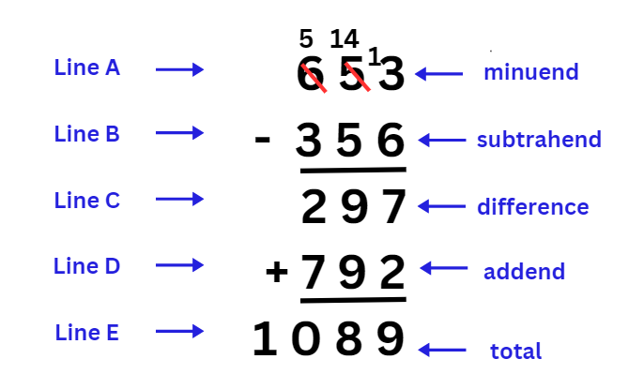
The table below outlines stimulus prompts to generate conversation about the topic, along with anticipated responses from students.
Prompts | Anticipated student responses
- What is the same about each calculation? | - Each subtraction algorithm needs regrouping.  - Line A is always larger than Line B for subtraction.  - The digit in the ones place of Line A must be smaller than the digit in the hundreds place.  - The digits in the tens place of Lines A and B are the same before and after reversal.  - There is always a 9 in the tens place of Line C which means there is also a 9 in the tens place of Line D.  - In Lines C and D, the digits in the hundreds and ones place add to 9.
- What is different? | - There are different digits being used, resulting in a variety of differences.  - The third example (352 − 253) has a difference of 99. It does not follow the pattern.
- Why do you always get a 9 in the tens column when you perform the subtraction? | - As the digit in the Line B ones place will be larger than in the Line A ones place, trading is required. As the middle digit of Lines A and B are the same, after trading, the difference will be 9.
- Extension question: Why do the hundreds and ones places of Line C add to 9? | - Line C will always be a multiple of 99, for example, 099, 198, 297, 396, 495 and so on. Multiples of 99 are also multiples of 9 which can be determined by having a digit sum of 9. As the digit in the tens place is a 9, then the digits in the hundreds and ones places must also add to 9.
This table details opportunities for differentiation.
Too hard? | Too easy?
Students cannot use an algorithm with understanding to record addition and subtraction calculations, where efficient, involving 3-digit numbers.  - Ask students to complete Resource 17 – subtraction surprise with 2-digit numbers, reversing the subtrahend to find the difference. Add the difference to the reversed addend to find the solution. (Note: these will all add to 99.)  - Ask students to complete the 2-digit task above using MAB materials or other concrete materials. | Students can use an algorithm with understanding to record addition and subtraction calculations, where efficient, involving 3-digit numbers.  - Provide students with the extension question in the prompts table above. Ask students why this happens. Have students provide reasons and proof for this.  - Students are given the following problem: ‘If you take the 4-digit number 4321, reverse the digits and subtract, reverse the digits of the answer and add, you get 10 890.’  Invite students to explore whether it will work for all 4-digit numbers. If so, can they prove it? If not, can they find the conditions required to give an answer of 10 890?

Discuss and connect the mathematics – 10 minutes
- Bring students back together to discuss their learning and ideas from the lesson.
- Record a list of numbers that did not follow the pattern. Discuss what those numbers have in common.
- Display Resource 5 – reflection chart. Students use thumbs up, down or sideways to self-assess whether algorithms are fluent or efficient strategies for them.
This table details opportunities for assessment.
Assessment opportunities | Links
What to look for:  - Can students recognise the number of tens, hundreds or thousands in a number? [MAO-WM-01, MA2-RN-01]  - Can students use an algorithm with understanding to record addition and subtraction calculations, where efficient, involving 3-digit numbers? [MAO-WM-01, MA2-AR-01]  - Can students recognise how hundreds are exchanged in subtraction algorithms requiring regrouping? [MAO-WM-01,  MA2-AR-01]  - Can students recognise when mental strategies would be more efficient than a vertical algorithm for subtraction? [MAO-WM-01, MA2-AR-01] | Links to National Numeracy Learning Progressions (NNLP):  - AdS7, AdS8.  Links to suggested Interview for Student Reasoning (IfSR) tasks:  - IfSR-AT: Section 2 and Section 3.

Lesson 8
Core concept: mathematicians compare and evaluate strategies used to solve addition and subtraction problems, reasoning which strategy may be most efficient.

Daily number sense – 10 minutes
- From a class need surfaced through formative assessment data, identify a short, focused activity that targets students’ knowledge, understanding and skills. Example activities may be drawn from the following resources:
- Mathematics K–6 resources
- Universal Resources Hub.

Core lesson 1 – number sentences – 25 minutes
The table below contains suggested learning intentions and success criteria. These are best co-constructed with students.
Core concept learning intentions | Core concept success criteria
Students are learning to:  - complete number sentences involving additive relations to find unknown quantities  - select strategies flexibly to solve addition and subtraction problems of up to 3 digits. | Students can:  - calculate missing numbers by completing number sentences involving addition and subtraction  - find the missing number in an equivalent number sentence involving operations of addition or subtraction on both sides of the equals sign  - create word problems that correspond to given addition and subtraction number sentences  - compare and evaluate strategies used to solve addition and subtraction problems, reasoning which strategy may be most efficient.
Note: prior to the lesson, prepare sets of Resource 19 – matching cards for use in the conclusion of the lesson.
- Review the anchor chart from Lesson 1 or Resource 1 – additive strategies.
- Write 562 + _? = 798 + 100 on the board.
- Ask students to Think-Pair-Share how to find and check the missing number.
- Select students to report back a range of different approaches.
- If it does not arise, demonstrate the use of a bar model to represent number sentences (see Figure 17).
Figure 17 – missing number bar model
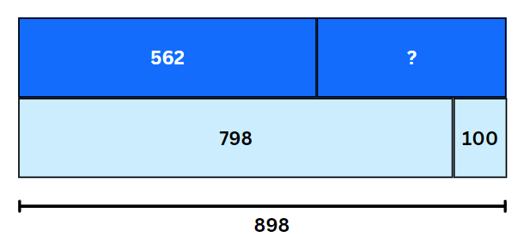
- Display and read Resource 5 – reflection chart.
- Ask students to compare and evaluate the strategies reported by considering:
- How are the strategies the same or different to each other?
- Which strategy are you most fluent with? Why?
- Which do you think is the most efficient strategy? Why?
- Display Resource 18 – balancing number sentences.
- Ask students to work through the equivalent number sentences with missing values in their workbook, recording at least one representation of their calculations for each number sentence.
- Share student responses.

Core lesson 2 – word problems – 15 minutes
- Display the question 492 + 209 = _? Jointly construct a word problem to match this question.
- Students solve the word problem and record the strategy used.
- Display the question 396 + _? = 234 + _? Jointly construct a word problem to match this style of number sentence.
- Students solve the word problem and record the strategy used.
Note: an example might be: Two players scored the same number of points in a game. Player 1 started on 396 points and player 2 started on 234. How many more points did they each score?
- Display the question 908 − 752 = _?
- Ask students to write a word problem to match this question and share with a partner. Repeat with a second subtraction number sentence.
- Display the question 596 = 982 − _? Ask students to write a word problem to match this question.
This table details opportunities for differentiation.
Too hard? | Too easy?
Students cannot find the missing number in an equivalent number sentence involving operations of addition or subtraction on both sides of the equals sign.  - Provide students with the following template: 100 = _? + _? or 100 − _? = _? Students roll a 0–9 die twice to form a 2-digit number and record this in one of the spaces. Students use MAB materials to model the known number and determine the missing value. Change the target from 100 as required.  - Students write word problems that match the number sentences from the die rolling activity above. | Students can find the missing number in an equivalent number sentence involving operations of addition or subtraction on both sides of the equals sign.  - Students write their own equivalent number sentences (addition and subtraction) using up to 6-digit numbers with more than one missing value. Ask students to identify when a calculator would be a more efficient strategy.  - Provide students the following word problem: ‘Mary had $450. She gave more than $115 to her friend and spent half of the remaining money. How much money does Mary have left? List 5 responses.’  - Ask students to create their own word problems based on finding the missing number. Students exchange their word problems with peers to solve by recording the accurate number sentence.

Consolidation and meaningful practice – 20 minutes
- Display Resource 19 – matching cards.
- Explain that some cards have a small dot on them. Each of those cards have a matching card without a dot.
Note: cards can be matched as an activity or in a game, such as Memory, Go Fish or Snap! Students can make their own matching cards that have additive concepts and representations and add them to the set provided.
- Provide pairs or small groups of students with a copy of Resource 19 – matching cards.
- Once matched, ask students to solve cards with questions or incomplete number sentences.
- Select students to share responses.
This table details opportunities for assessment.
Assessment opportunities | Links
What to look for:  - Can students calculate missing numbers by completing number sentences involving addition and subtraction? [MAO-WM-01, MA2-AR-01, MA2-AR-02]  - Can students find the missing number in an equivalent number sentence involving operations of addition or subtraction on both sides of the equals sign? [MAO-WM-01, MA2-AR-01,  MA2-AR-02]  - Can students create word problems that correspond to given addition and subtraction number sentences? [MAO-WM-01,  MA2-AR-01]  - Can students compare and evaluate strategies used to solve addition and subtraction problems, reasoning which strategy may be most efficient? [MAO-WM-01, MA2-AR-01, MA2-AR-02] | Links to National Numeracy Learning Progressions (NNLP):  - AdS7, AdS8.  Links to suggested Interview for Student Reasoning (IfSR) tasks:  - IfSR-AT: Section 2 and Section 3.

Resource 1 – additive strategies
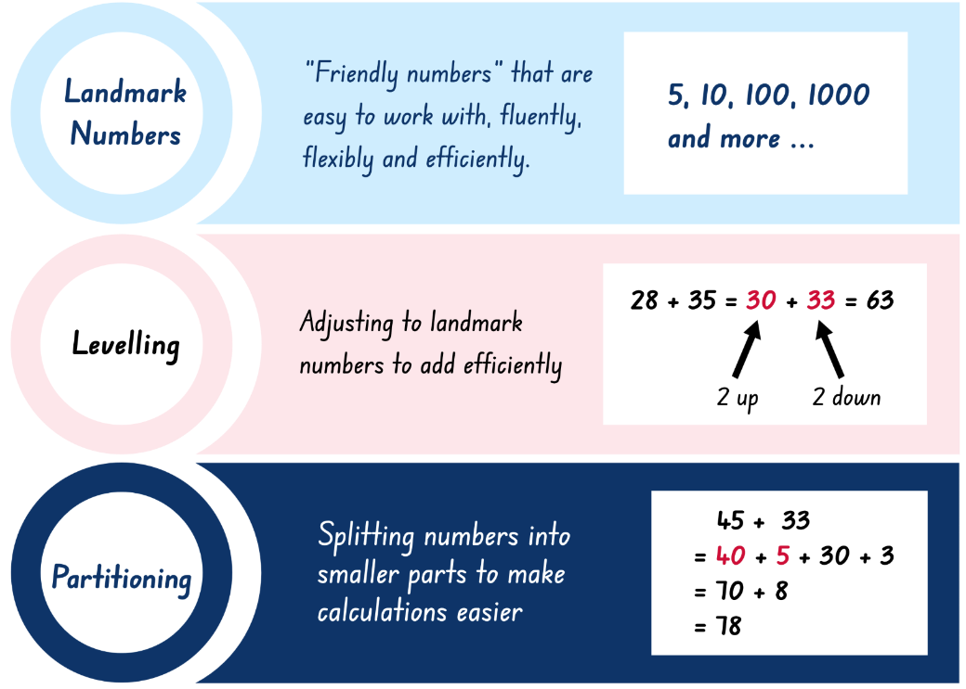
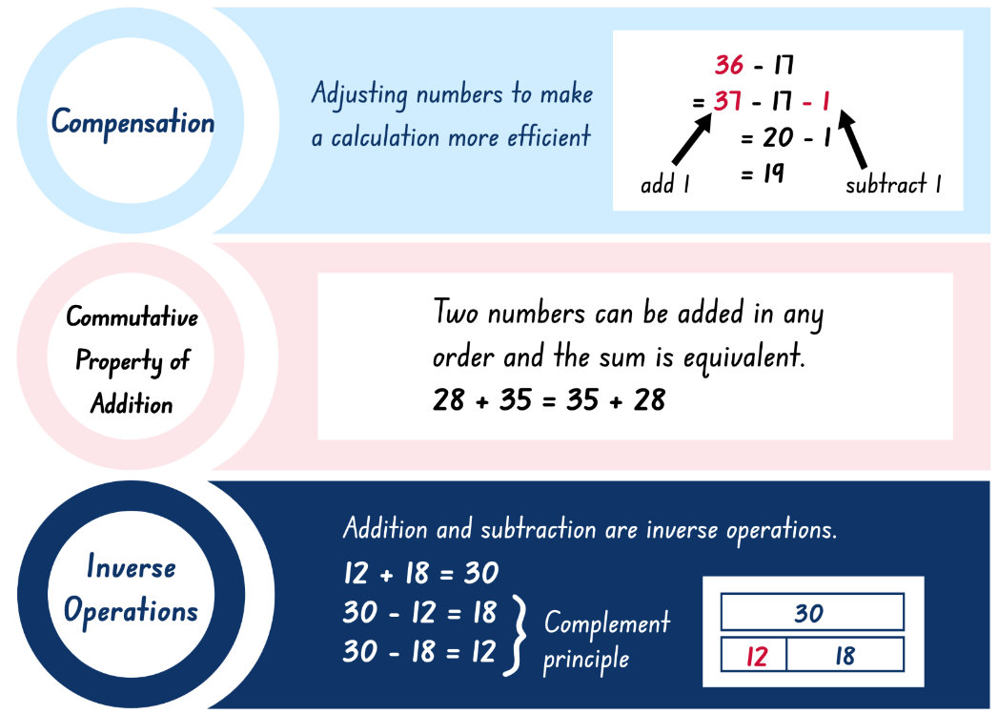
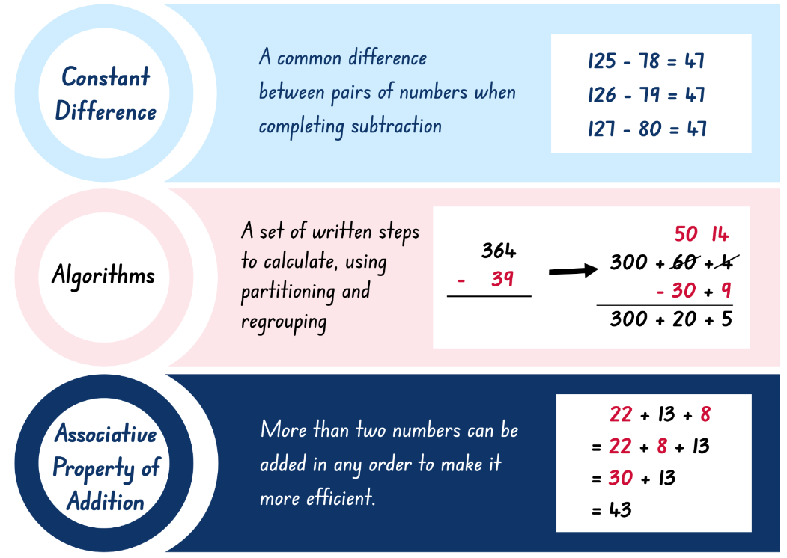
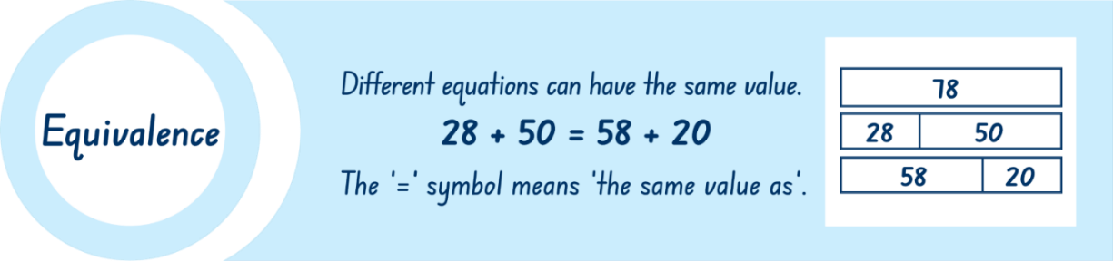

Resource 2 – bingo cards
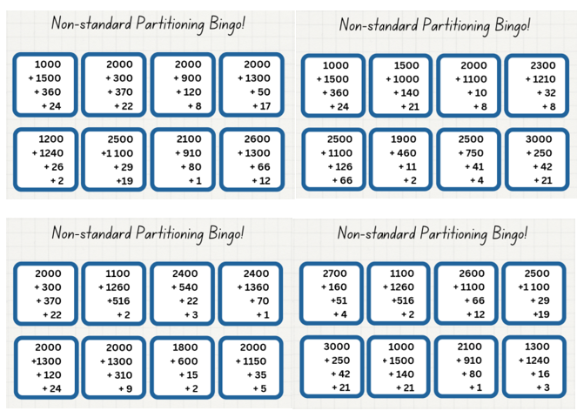
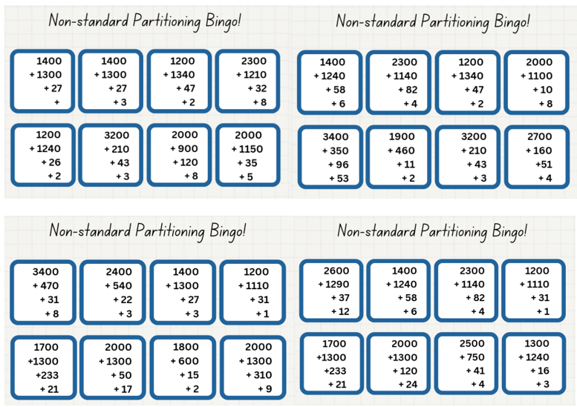

Resource 3 – bingo caller sheet
2342 | 2373 | 2417 | 2468 | 2559 | 2589 | 2661
2692 | 2704 | 2730 | 2878 | 2884 | 2915 | 2965
3028 | 3091 | 3118 | 3190 | 3254 | 3295 | 3313
3367 | 3444 | 3456 | 3526 | 3550 | 3619 | 3648
3778 | 3792 | 3831 | 3899 | 3909 | 3939 | 3978

Resource 4 – place value chart
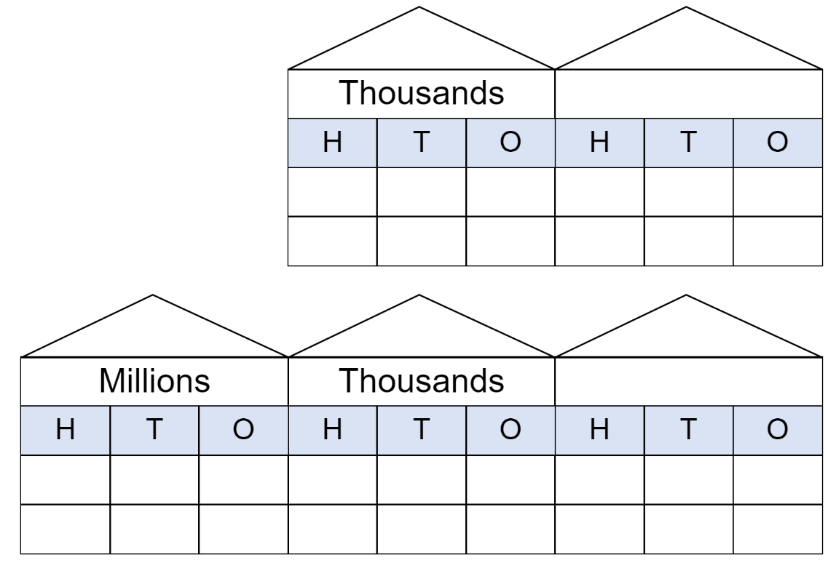

Resource 5 – reflection chart
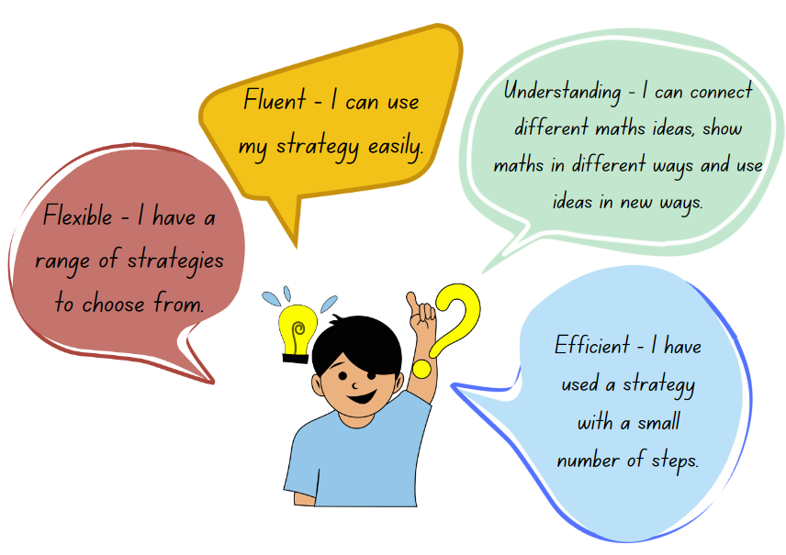

Resource 6 – self-assessment
Self-assessment statements | No | Sometimes | Yes
I am learning to apply place value to partition, regroup and rename numbers.
I can identify the place value of each digit in a number up to 6 digits.
I can use place value to expand numbers in standard form.
I can partition numbers in non-standard forms.
I can use composition and decomposition to flexibly partition numbers to suit my thinking.
I can use the associative property of addition to make my calculations more efficient.

Resource 7 – comparing strategies grid
Standard partitioning  590 − 257 = 500 − 200 − 90 − 50 − 7  = 300 − 40 − 3  = 333 | Estimation  600 − 250 = 350 | Algorithm with understanding  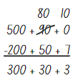
Constant difference | 590 − 257 | Number line
Non-standard partitioning | Free choice | Free choice

Resource 8 – canteen price list
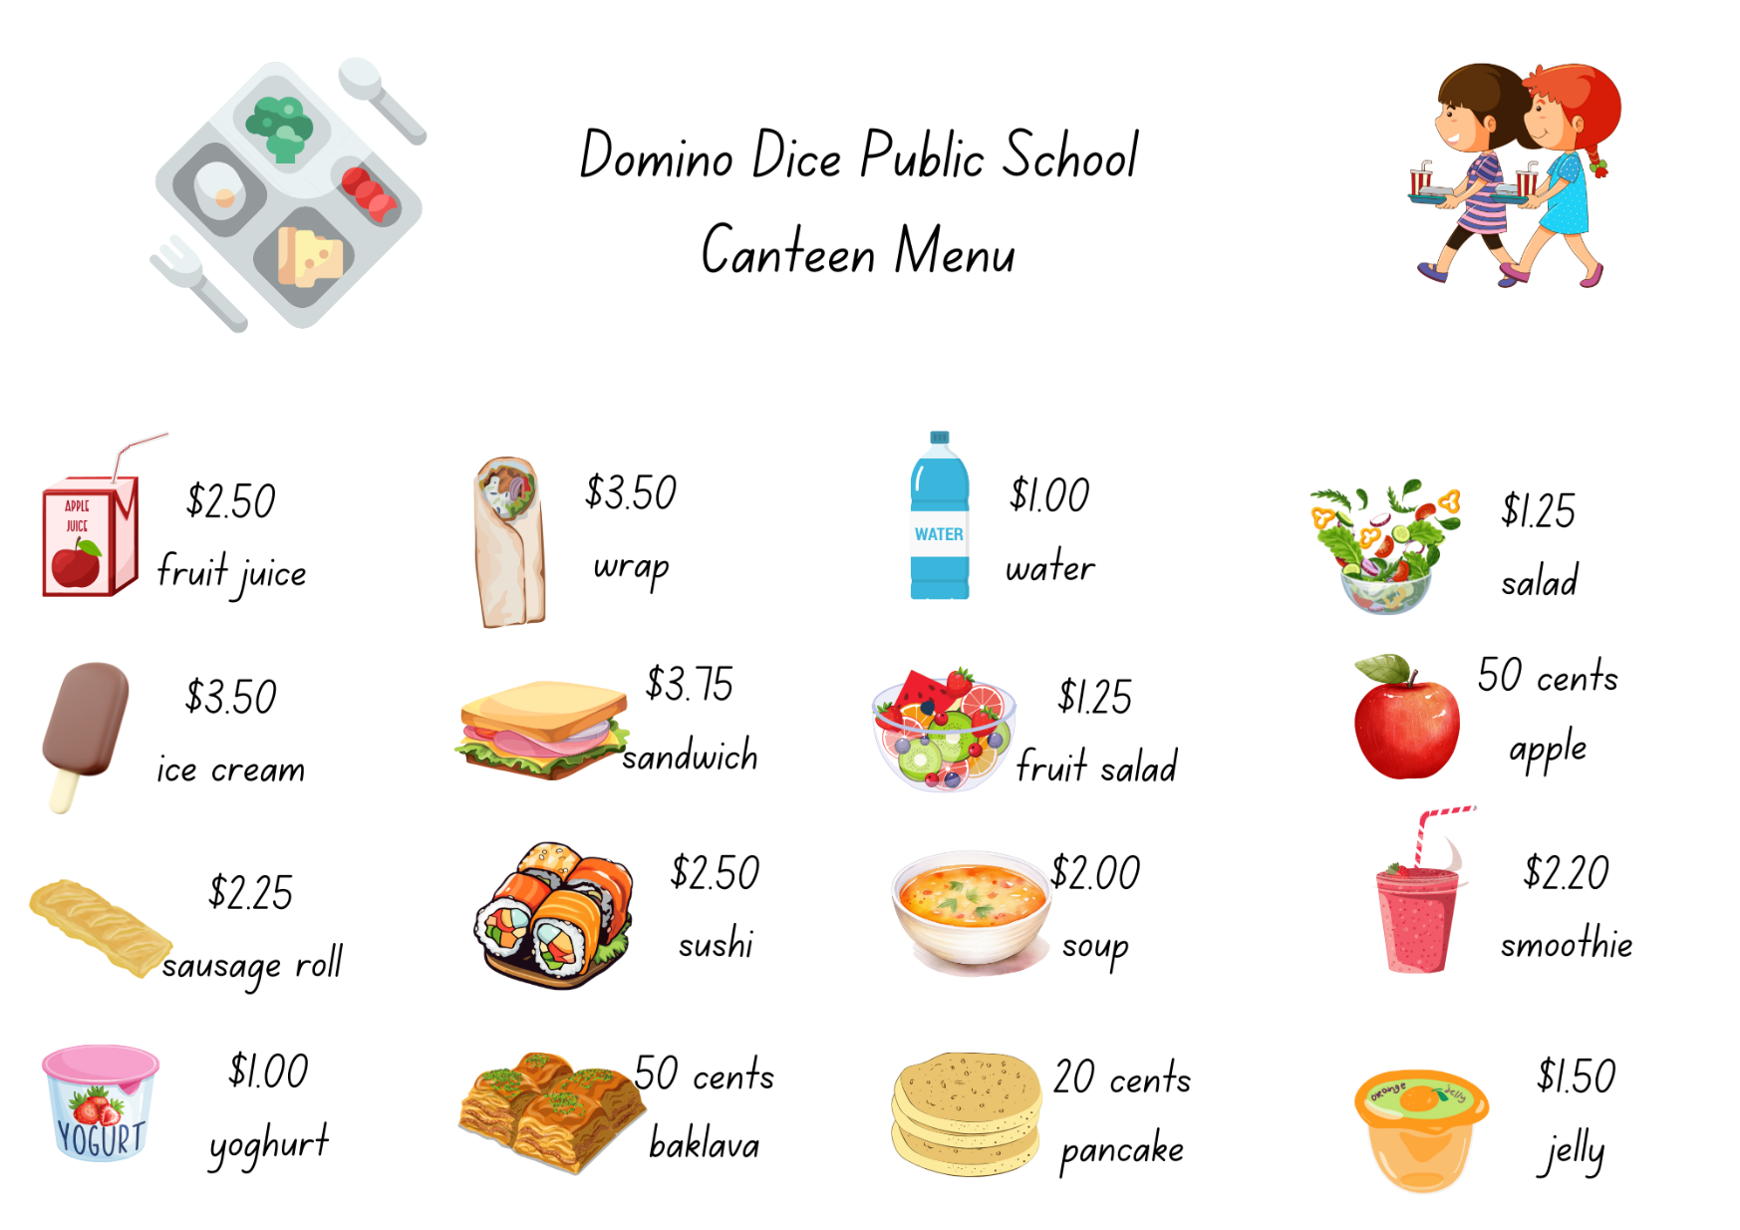

Resource 9 – party activities
List 1: activity items | Cost | List 3: lunch items | Cost
Jumping castle | $368.00 | Party meat pies (12 pieces) | $6.80
Outdoor toys rental | $215.90 | Party sausage rolls (12 pieces) | $6.80
Face Painting and hair spray | $149.00 | Lunch size pizzas (1 per child) | $5.65
Petting zoo | $432.00 | Chicken nuggets (12 pieces) | $4.40
Outdoor cinema | $153.50 | Spring rolls (12 pieces) | $7.65
Karaoke machine | $204.30 | Sushi platter (serves 15) | $65.80
Inflatable obstacle course | $576.00 | Fruit platter (serves 15) | $36.75
Piñata (unfilled) | $65.85 | BBQ sauce (1 bottle) | $2.10
Lollies for piñata | $47.00 | Tomato sauce (1 bottle) | $1.95

List 2: supply items | Cost | List 4: snacks and drinks | Cost
Balloon garland (large) | $68.00 | Box of lolly bags (10 packets) | $13.50
Ballon garland (small) | $34.45 | Box of chips (10 packets) | $8.90
Colourful foil door curtain | $14.00 | Popcorn (10 packets) | $6.75
Coloured streamers | $8.90 | Ice blocks (10 pack) | $4.80
Disco light | $56.95 | Chocolate frogs (12 pack) | $4.50
Best class banner | $10.50 | Ice cream cake (serves 15) | $14.00
Photo booth (backdrop and props) | $74.65 | Sparkling flavoured water (12 pack) | $6.40
Serviettes (50 pack) | $4.95 | Bottled water (12 pack) | $5.95
Paper plates (20 pack) | $3.35 | Juice (12 pack) | $10.10
Tablecloths (one per 3 student desks) | $4.75 | Flavoured milk (12 pack) | $12.50

Resource 10 – planning sheet
Item | Price per Item | Quantity needed | Total cost
 |  | TOTAL

Resource 11 – pocket money
Imagine your family agreed to give you some pocket money every day for a month. You can choose from the following options:
- $10 every day
- $3 on the first day, $3.50 on the second, $4 on the third and so on, increasing by 50 cents per day
- 5 cents on the first day, 10 cents on the second, 20 cents on the third and so on, doubling each day.
Without doing any working out, which one would you choose and why?
In a month with 31 days, how much money would you have by the end of the month, under each system? You may wish to explore using a spreadsheet.
Here are some questions you might like to consider:
- In which months would option 1 be better than option 2?
- If your family stopped your pocket money on day 8, which option would give you the most?
- On which day of the month does option 3 become the most fruitful?
- If you chose option 3, how many days would it be before you became a millionaire?
This activity is an adaption of Pocket money from NRICH by the University of Cambridge.

Resource 12 – different strategies
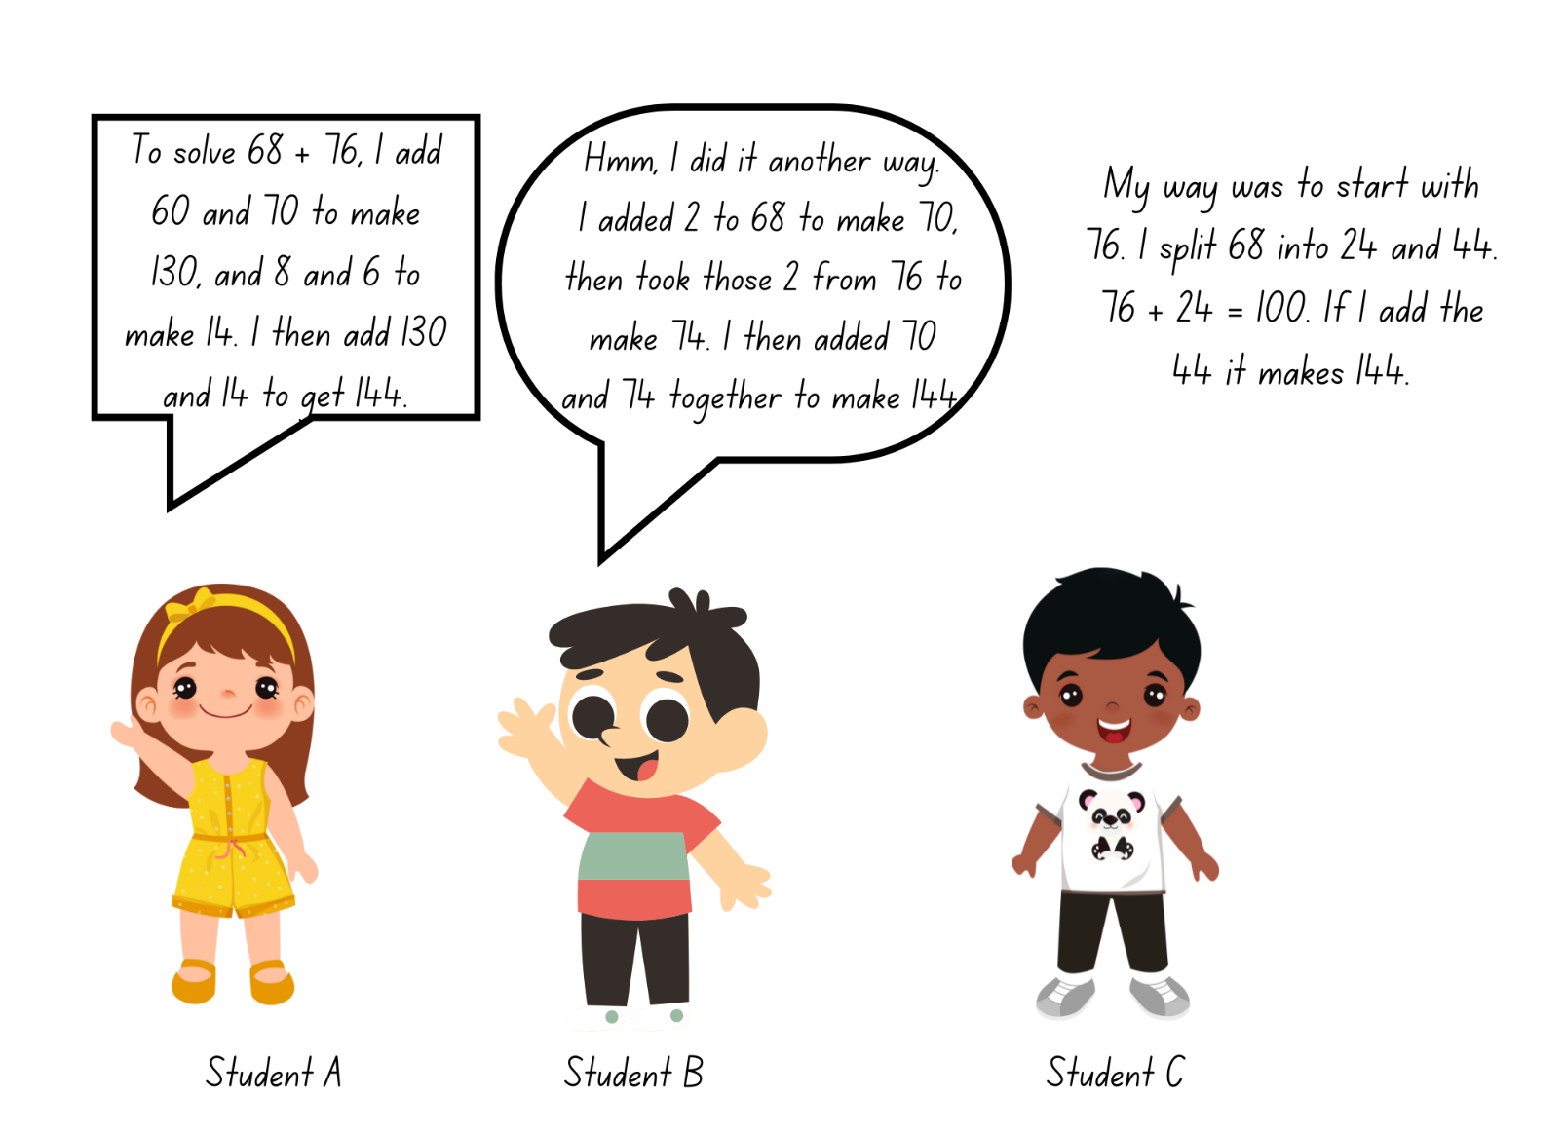

Resource 13 – different models
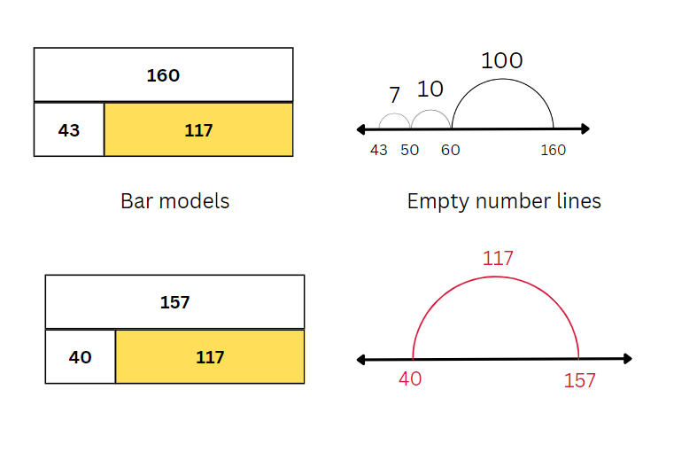

Resource 14 – 100 grid
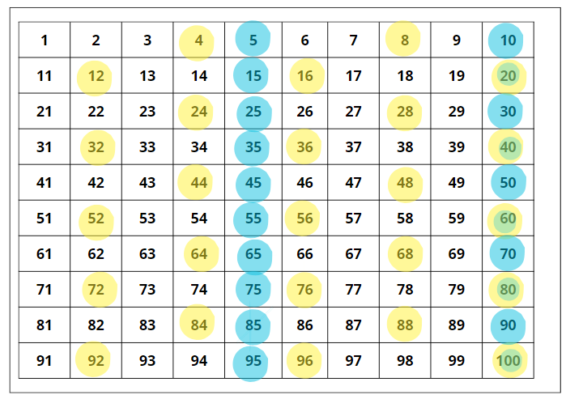

Resource 15 – blank 100 grid
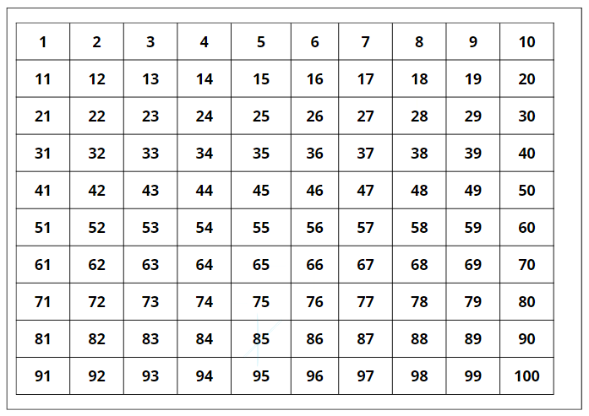

Resource 16 – addition questions
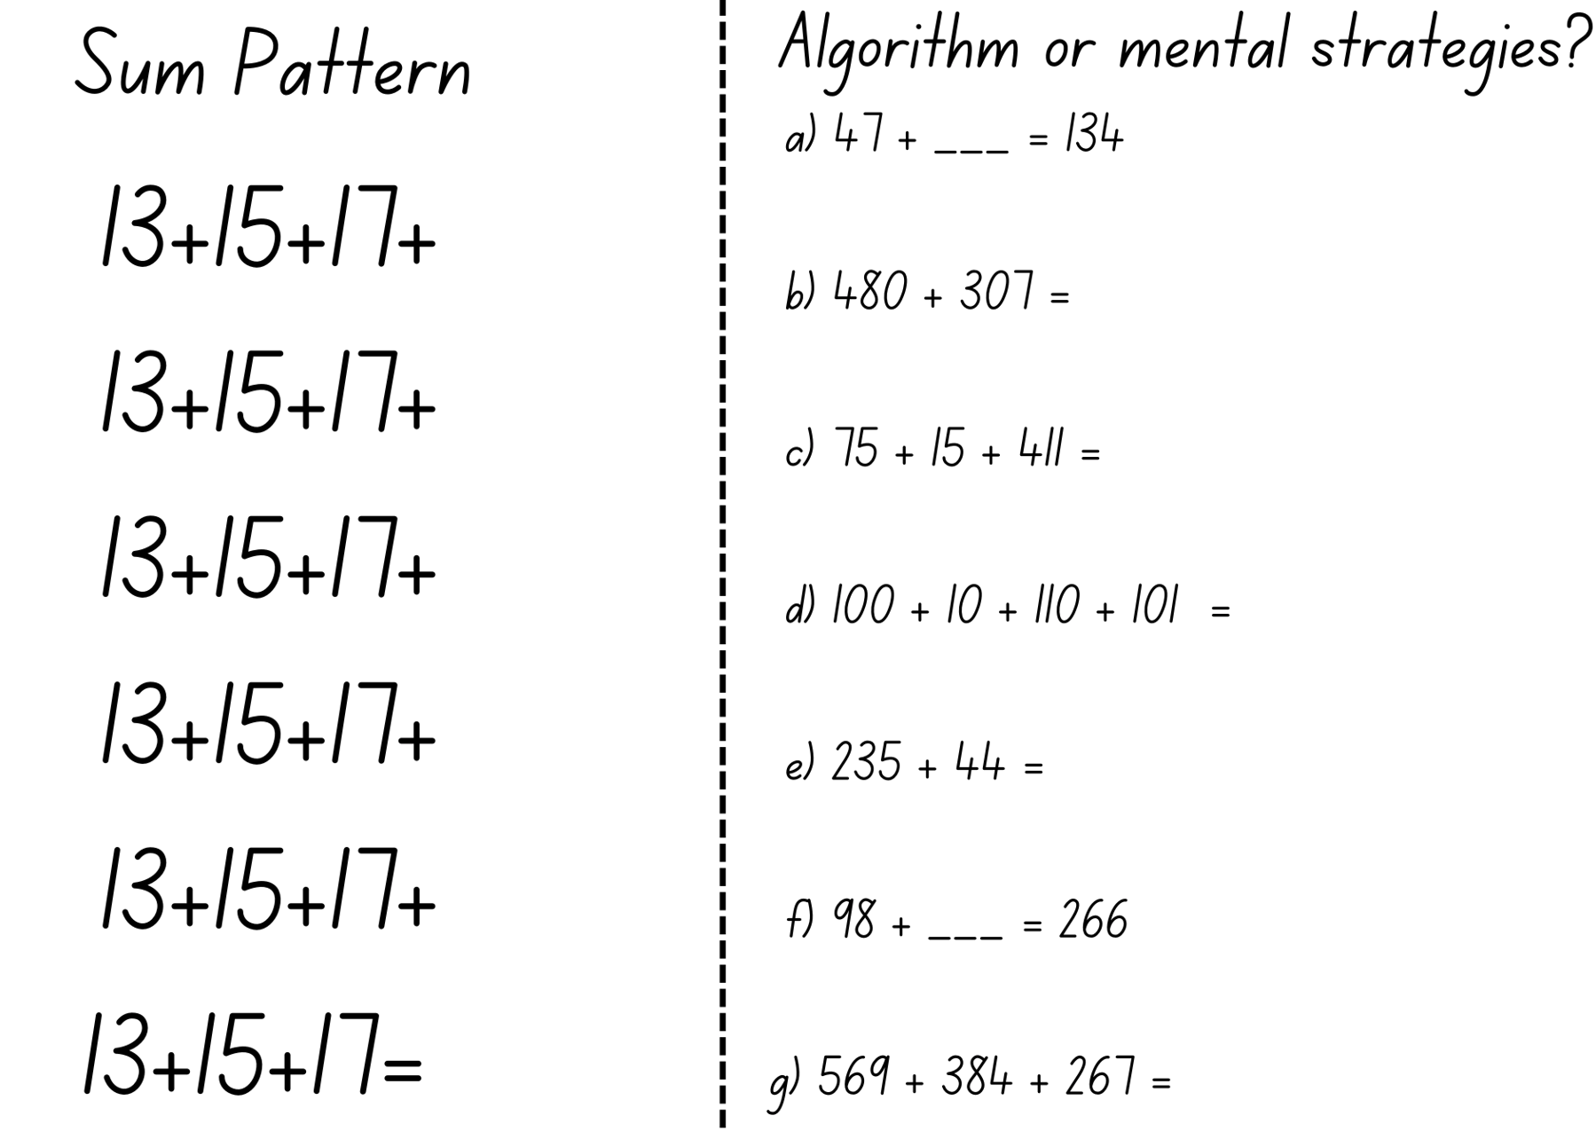

Resource 17 – subtraction surprise
Three-digit numbers
Investigate: consider the examples below. Does the same pattern occur when subtracting the reversed digits of any 3-digit number? Can you prove it by using your own examples? Why do you think this is so?
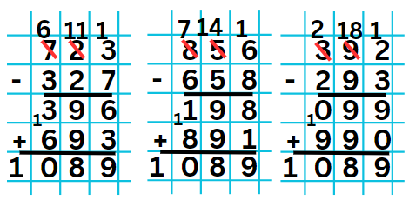
Variations
Two-digit numbers | Four-digit numbers
- Does the same pattern occur when subtracting the reversed digits of any 2-digit number?  - What is the solution?  - Can you prove it by using your own examples?  - Why do you think this happens?  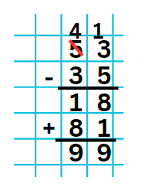 | - If you take a 4-digit number, reverse the digits and subtract, reverse the digits of the answer and add, will you get a pattern like we see in the 3-digit subtraction?  - Explore whether it will work for all 4-digit numbers. If so, can you prove it?  - If not, can you find the conditions required to give a similar pattern for many 4-digit numbers?  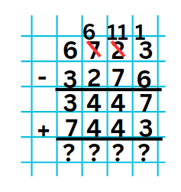
This activity is an adaptation of Subtraction Surprise from NRICH by University of Cambridge.

Resource 18 – balancing number sentences
+ 110 = 34 + 135
− 110 = 34 + 135
129 + = 424 + 146
129 + = 424 − 146
633 − 326 = + 242
633 + 326 = + 242
Provide multiple answers for
+ 295 = − 221
− 295 = +

Resource 19 – matching cards
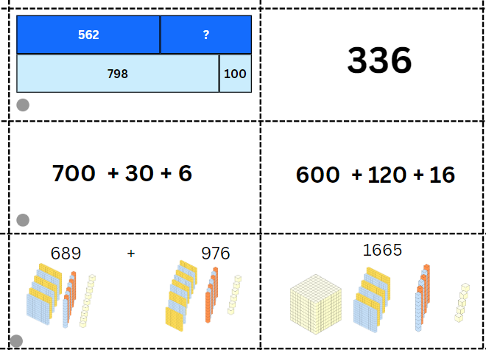
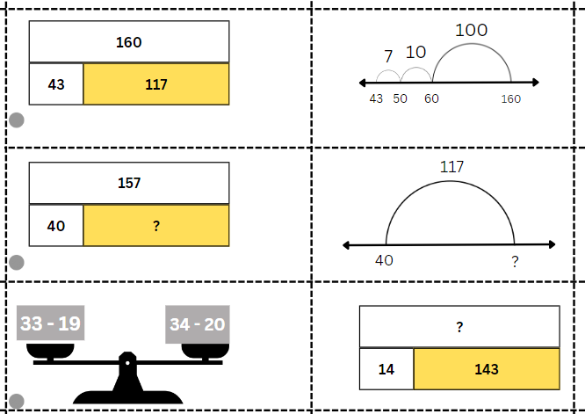
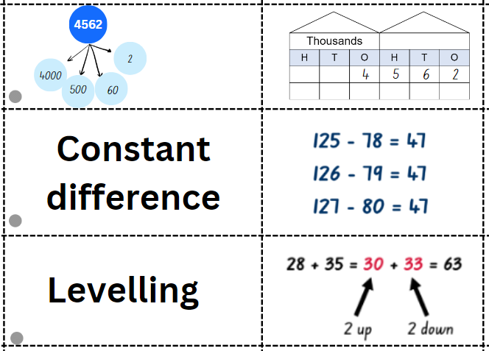
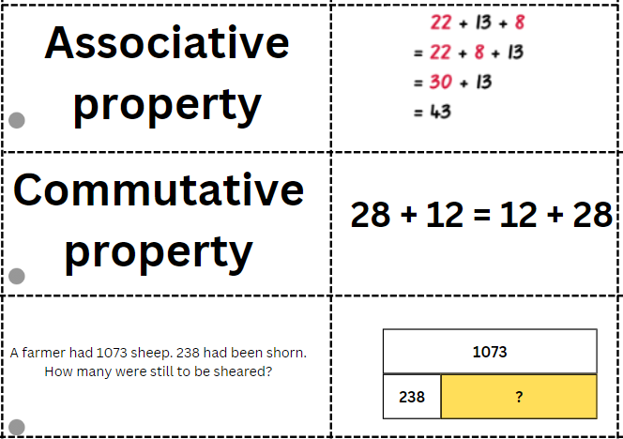
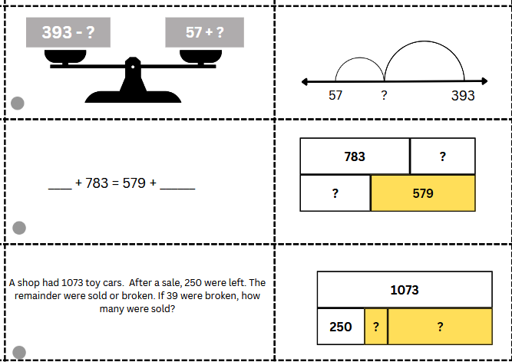

Syllabus outcomes and content
The table below outlines the syllabus outcomes and range of relevant syllabus content covered in this unit. Content is linked to National Numeracy Learning Progression (version 3).
Outcomes and content | 1 | 2 | 3 | 4 | 5 | 6 | 7 | 8
Representing numbers using place value A: Whole numbers: Read, represent and order numbers to thousands
MAO-WM-01, MA2-RN-01
- Regroup numbers flexibly, recognising one thousand as 10 hundreds and one hundred as 10 tens or 100 ones | x | x | x | x | x | x | x | x
- Represent numbers up to and including thousands using physical or virtual manipulatives, words, numerals, diagrams and digital displays | x | x | x | x | x | x | x | x
Representing numbers using place value A: Whole numbers: Apply place value to partition and regroup numbers up to 4 digits
MAO-WM-01, MA2-RN-01
- Record numbers using standard place value form | x | x | x | x | x | x | x | x
- Partition numbers of up to 4 digits in non-standard forms (Reasons about quantity) |  | x |  | x |  | x
Representing numbers using place value B: Whole numbers: Apply place value to partition, regroup and rename numbers up to 6 digits
MAO-WM-01, MA2-RN-01
- Use place value to expand the number notation |  | x |  | x
- Partition numbers of up to 6 digits in non-standard forms |  | x |  | x |  | x | x
Representing numbers using place value B: Whole numbers: Recognise and represent numbers that are 10, 100 or 1000 times as large
MAO-WM-01, MA2-RN-01
- Recognise the number of tens, hundreds or thousands in a number | x | x | x | x | x | x | x | x
Additive relations A: Use the principle of equality
MAO-WM-01, MA2-AR-01, MA2-AR-02
- Recognise equal differences and record them in number sentences | x |  |  | x
- Use the equals sign to mean 'the same as', rather than to perform an operation | x |  |  | x
Additive relations A: Recognise and explain the connection between addition and subtraction
MAO-WM-01, MA2-AR-01, MA2-AR-02
- Demonstrate how addition and subtraction are inverse operations |  |  |  |  | x
Additive relations A: Select strategies flexibly to solve addition and subtraction problems of up to 3 digits
MAO-WM-01, MA2-AR-01, MA2-AR-02
- Apply known mental strategies that use partitioning to add and subtract, such as bridging the decades |  | x | x | x | x | x |  | x
- Apply the levelling and constant difference strategies (Reasons about relations) |  |  |  | x
- Represent solutions to addition and subtraction problems, including word problems, using an empty number line or bar model |  |  |  |  | x
- Compare and evaluate strategies used to solve addition and subtraction problems, reasoning which strategy may be most efficient |  | x | x | x | x | x | x | x
Additive relations A: Represent money values in multiple ways
MAO-WM-01, MA2-AR-01, MA2-AR-02
- Represent equivalent amounts of money using different denominations |  |  |  |  | x
- Perform calculations with money, including finding change |  |  | x
Additive relations B: Partition, rearrange and regroup numbers to at least 1000 to solve additive problems
MAO-WM-01, MA2-AR-01, MA2-AR-02
- Use quantity values and non-standard partitioning to solve addition and subtraction problems | x | x | x | x |  |  |  | x
- Model addition with and without regrouping and record the method used |  | x |  | x |  | x | x | x
- Model subtraction with and without regrouping and record the method used |  | x |  | x |  | x | x | x
- Use an algorithm with understanding to record addition and subtraction calculations, where efficient, involving 3-digit numbers |  |  |  |  |  | x | x | x
- Recognise how hundreds are exchanged in subtraction algorithms requiring regrouping |  |  |  |  |  |  | x | x
- Recognise when mental strategies would be more efficient than a vertical algorithm for subtraction (Reasons about relations) |  |  |  |  |  | x | x
Additive relations B: Apply addition and subtraction to familiar contexts, including money and budgeting
MAO-WM-01, MA2-AR-01, MA2-AR-02
- Use estimation to check the validity of solutions to addition and subtraction problems, including those involving money |  |  | x
- Interpret problems involving money as requiring either addition or subtraction |  |  | x
Additive relations B: Complete number sentences involving additive relations to find unknown quantities
MAO-WM-01, MA2-AR-01, MA2-AR-02
- Calculate missing numbers by completing number sentences involving addition and subtraction (Algebraic reasoning) | x |  |  |  |  |  |  | x
- Find the missing number in an equivalent number sentence involving operations of addition or subtraction on both sides of the equals sign (Algebraic reasoning) |  | x |  |  |  |  |  | x
- Create word problems that correspond to given addition and subtraction number sentences |  |  | x |  |  |  |  | x
Multiplicative relations B: Investigate number sequences involving related multiples
MAO-WM-01, MA2-MR-01
- Generate number patterns using related multiples |  |  |  |  | x | x | x
- Investigate number patterns involving related multiples |  |  |  |  |  | x | x
Mathematics K–10 Syllabus © NSW Education Standards Authority (NESA) for and on behalf of the Crown in right of the State of New South Wales, 2022.

References
This resource contains NSW Curriculum and syllabus content. The NSW Curriculum is developed by the NSW Education Standards Authority. This content is prepared by NESA for and on behalf of the Crown in right of the State of New South Wales. The material is protected by Crown copyright.
Please refer to the NESA Copyright Disclaimer for more information https://educationstandards.nsw.edu.au/wps/portal/nesa/mini-footer/copyright.
NESA holds the only official and up-to-date versions of the NSW Curriculum and syllabus documents. Please visit the NSW Education Standards Authority (NESA) website https://educationstandards.nsw.edu.au/wps/portal/nesa/home/ and the NSW Curriculum website https://curriculum.nsw.edu.au.
Mathematics K–10 Syllabus © NSW Education Standards Authority (NESA) for and on behalf of the Crown in right of the State of New South Wales, 2022.
National Numeracy Learning Progression © Australian Curriculum, Assessment and Reporting Authority (ACARA) 2010 to present, unless otherwise indicated. This material was downloaded from the Australian Curriculum website (National Numeracy Learning Progression) (accessed 20 December 2023) and was not modified.
Australian Academy of Science (2022) ‘Bar Model Method: Introduction’, Classic sequences for AC V8.4, reSolve: Maths by Inquiry website, accessed 18 April 2024.
Coolmath4Kids (2019) ‘Base Ten Blocks’, Manipulatives, Coolmath4Kids website, accessed 19 December 2023.
Ewbank WA (1977) Mental Arithmetic: A Neglected Topic?', Mathematics in School, 6(5):28–31.
Finkel D (2017) ‘Penny, Nickel, Dime’, Free Lesson Library, Math for Love website, accessed 20 December 2023.
Kaplinsky R (2021) Adding 3-Digit Numbers, Grade 3, Open Middle website, accessed 19 December 2023.
Lucenta A and Kelemanik G (2022) ‘Contemplate Then Calculate', Mathematics Teacher: Learning and Teaching PK-12, 115(1):16–25.
NESA (New South Wales Education Standards Authority) (2022) ‘Reasoning support in Mathematics K–6’, Mathematics K–10 Syllabus: Teaching and learning support, NESA website, accessed 15 December 2023.
Seymour D (1982) Favourite Problems, Dale Seymour Publications, Palo Alta, California USA.
State of New South Wales (Department of Education) (2023) ‘Flexible additive strategies – 3-digit numbers’, Numeracy, NSW Department of Education website, accessed 20 December 2023.
Ulbright J and Kaplinsky R (2016) ‘Close to 1000’, Grade 2, Open Middle website, accessed 19 December 2023.
University of Cambridge (n.d.) Multiples Grid, NRICH website, accessed 19 December 2023.
University of Cambridge (n.d.) Pocket Money, NRICH website, accessed 19 December 2023.
University of Cambridge (n.d.) Sort Them Out (1), NRICH website, accessed 19 December 2023.
University of Cambridge (n.d.) Sums and Differences 2, NRICH website, accessed 19 December 2023.
University of Cambridge (n.d.) Sweets in a Box, NRICH website, accessed 19 December 2023.

© State of New South Wales (Department of Education), 2024
The copyright material published in this resource is subject to the Copyright Act 1968 (Cth) and is owned by the NSW Department of Education or, where indicated, by a party other than the NSW Department of Education (third-party material).
Copyright material available in this resource and owned by the NSW Department of Education is licensed under a Creative Commons Attribution 4.0 International (CC BY 4.0) license.
This license allows you to share and adapt the material for any purpose, even commercially.
Attribution should be given to © State of New South Wales (Department of Education), 2024.
Material in this resource not available under a Creative Commons license:
- the NSW Department of Education logo, other logos and trademark-protected material
- material owned by a third party that has been reproduced with permission. You will need to obtain permission from the third party to reuse its material.
Links to third-party material and websites
Please note that the provided (reading/viewing material/list/links/texts) are a suggestion only and implies no endorsement, by the New South Wales Department of Education, of any author, publisher, or book title. School principals and teachers are best placed to assess the suitability of resources that would complement the curriculum and reflect the needs and interests of their students.
If you use the links provided in this document to access a third-party's website, you acknowledge that the terms of use, including licence terms set out on the third-party's website apply to the use which may be made of the materials on that third-party website or where permitted by the Copyright Act 1968 (Cth). The department accepts no responsibility for content on third-party websites.

