Mathematics Stage 2 – Unit 34
What needs to be measured determines the unit of measurement

Contents
Unit description and duration 5
Syllabus outcomes 5
Working mathematically 6
Student prior learning 6
Lesson overview and resources 8
Lesson 1 14
Daily number sense – place the digit – 10 minutes 14
Core lesson – measuring in kilograms and grams – 40 minutes 16
Discuss and connect the mathematics – 10 minutes 19
Lesson 2 21
Daily number sense – place the digits – 10 minutes 21
Core lesson – measuring in grams – 40 minutes 23
Consolidation and meaningful practice – 10 minutes 27
Lesson 3 29
Daily number sense – mixed up decimals – 15 minutes 29
Core lesson – grocery mass – 35 minutes 31
Consolidation and meaningful practice – 15 minutes 34
Lesson 4 36
Daily number sense – 10 minutes 36
Core lesson – exploring measuring tools – 50 minutes 36
Investigation task 1 – mass 38
Investigation task 2 – length 38
Investigation task 3 – combining mass and length 39
Consolidation and meaningful practice – 10 minutes 40
Lesson 5 43
Daily number sense – using arrays – 10 minutes 43
Core lesson – quadrilateral perimeters – 30 minutes 45
Consolidation and meaningful practice – 20 minutes 47
Lesson 6 50
Daily number sense – fact families – 10 minutes 50
Core lesson – how far can an animal jump? – 45 minutes 52
Consolidation and meaningful practice – 15 minutes 54
Lesson 7 57
Daily number sense – solving problems with fact families – 10 minutes 57
Core lesson – ball throwing challenge – 40 minutes 58
Discuss and connect the mathematics – 15 minutes 61
Lesson 8 63
Daily number sense – 10 minutes 63
Core lesson – house plan – 40 minutes 63
Consolidation and meaningful practice – 10 minutes 66
Resource 1 – place the digits 1 68
Resource 2 – 1 kg balance 69
Resource 3 – mass sort 70
Resource 4 – about a kilogram 71
Resource 5 – place the digits 2 72
Resource 6 – number cards 73
Resource 7 – cube model mass 74
Resource 8 – fractions of kilograms 75
Resource 9 – pumpkin competition 76
Resource 10 – mixed up decimals 77
Resource 11 – grocery mass 78
Resource 12 – kilogram fractions 79
Resource 13 – calculating perimeter 80
Resource 14 – squared paper 81
Resource 15 – making fact families 82
Resource 16 – animal jumps 83
Resource 17 – lots of buttons 84
Resource 18 – ball throwing 85
Resource 19 – house plan 86
Resource 20 – house plan investigation 87
Syllabus outcomes and content 88
References 92
Further reading 93

Unit description and duration
This unit develops the big idea that what needs to be measured determines the unit of measurement.
In this 2-week unit students are provided opportunities to:
- use a scaled instrument to relate 1000 grams to one kilogram
- interpret commonly used fractions of a kilogram, including $\frac{1}{2}$ , $\frac{1}{4}$ , $\frac{3}{4}$, and relate these to the number of grams
- select and use appropriate units to estimate, measure and compare lengths and distances and convert between units of measure.

Syllabus outcomes
- MAO-WM-01 develops understanding and fluency in mathematics through exploring and connecting mathematical concepts, choosing and applying mathematical techniques to solve problems, and communicating their thinking and reasoning coherently and clearly
- MA2-RN-01 applies an understanding of place value and the role of zero to represent numbers to at least tens of thousands
- MA2-RN-02 represents and compares decimals up to 2 decimal places using place value
- MA2-PF-01 represents and compares halves, quarters, thirds and fifths as lengths on a number line and their related fractions formed by halving (eighths, sixths and tenths)
- MA2-GM-02 measures and estimates lengths in metres, centimetres and millimetres
- MA2-NSM-01 estimates, measures and compares the masses of objects using kilograms and grams

Working mathematically
In the Mathematics K–10 Syllabus, there is one overarching Working mathematically outcome (MAO-WM-01). The Working mathematically processes should be embedded within the concepts being taught. The Working mathematically processes present in the Mathematics K–10 Syllabus are:
- communicating
- understanding and fluency
- reasoning
- problem solving.
Mathematics K–10 Syllabus © NSW Education Standards Authority (NESA) for and on behalf of the Crown in right of the State of New South Wales, 2022.

Student prior learning
Before engaging in these teaching and learning activities, students would benefit from prior experience with:
- estimating, measuring and comparing the masses of objects using kilograms and grams
- representing and comparing decimals up to 2 decimal places using place value
- measuring and comparing lengths of objects using metres (m), centimetres (cm) and millimetres (mm).
In NSW classrooms there is a diverse range of students, including Aboriginal and/or Torres Strait Islander students, students learning English as an additional language or dialect, high potential and gifted students and students with disability. Some students may identify with more than one of these groups or possibly all of them. Refer to Curriculum planning for every student – advice for further information.

Lesson overview and resources
The table below outlines the sequence and approximate timing of lessons, learning intentions and resources.
Lesson | Content | Duration and resources
Lesson 1  Daily number sense learning intention:  - extend the application of the place value system from whole numbers to tenths and hundredths | Lesson core concept: the context determines the most suitable standard unit; sometimes a kilogram is too large.  Core concept learning intention:  - use scaled instruments to measure and compare masses | Lesson duration: 60 minutes  - Resource 1 – place the digits 1  - Resource 2 – 1 kg balance  - Resource 3 – mass sort  - Resource 4 – about a kilogram  - 6-sided dice  - Digital scales (one per group)  - Materials such as sand, pebbles, bark, chips, rice, or counters.  - Measuring cups (for example, plastic cups)  - Resealable bags  - Writing materials
Lesson 2  Daily number sense learning intention:  - extend the application of the place value system from whole numbers to tenths and hundredths | Lesson core concept: estimation of mass is guided by using known masses as benchmarks.  Core concept learning intention:  - use scaled instruments to measure and compare masses | Lesson duration: 60 minutes  - Resource 5 – place the digits 2  - Resource 6 – number cards  - Resource 7 – cube model mass  - Resource 8 – fractions of kilograms  - Resource 9 – pumpkin competition  - Digital kitchen scales  - Individual whiteboards  - Large collection of interlocking cubes  - Writing materials
Lesson 3  Daily number sense learning intention:  - extend the application of the place value system from whole numbers to tenths and hundredths | Lesson core concept: measuring tools need to be carefully handled, aligned and read.  Core concept learning intention:  - use scaled instruments to measure and compare masses | Lesson duration: 65 minutes  - Resource 10 – mixed up decimals  - Resource 11 – grocery mass  - Resource 12 – kilogram fractions  - Digital kitchen scales  - Individual whiteboards  - Masking tape  - Selection of pantry items, such as flour, rice or can of soup  - Writing materials
Lesson 4  Daily number sense learning intention:  - teacher-identified task based on student needs | Lesson core concept: measuring tools help to become familiar with common measures.  Core concept learning intentions:  - use scaled instruments to measure and compare masses  - use scaled instruments to measure and compare lengths | Lesson duration: 70 minutes  - Digital kitchen scales  - Equal-arm balances  - Metric weights  - Selection of measuring tools, such as 30 cm rulers, trundle wheels, metre rulers  - Writing materials
Lesson 5  Daily number sense learning intention:  - recall multiplication facts of 2 and 4, 5 and 10 and related division facts | Lesson core concept: length can measure a straight line, a perimeter, or an edge.  Core concept learning intention:  - use scaled instruments to measure and compare perimeters | Lesson duration: 60 minutes  - Resource 13 – calculating perimeter  - Resource 14 – squared paper  - 30 cm rulers  - 6-sided dice  - 10-sided dice  - Masking tape or chalk  - Metre rulers  - Writing materials
Lesson 6  Daily number sense learning intention:  - recall multiplication facts of 2 and 4, 5 and 10 and related division facts | Lesson core concept: decimal numbers are often seen in measurement.  Core concept learning intentions:  - use scaled instruments to measure and compare lengths  - extend the application of the place value system from whole numbers to tenths and hundredths | Lesson duration: 70 minutes  - Resource 15 – making fact families  - Resource 16 – animal jumps  - 30 cm rulers  - Metre rulers  - Trundle wheels  - Writing materials
Lesson 7  Daily number sense learning intention:  - recall multiplication facts of 2 and 4, 5 and 10 and related division facts | Lesson core concept: decimal numbers add precision to descriptions of objects.  Core concept learning intentions:  - use scaled instruments to measure and compare lengths  - extend the application of the place value system from whole numbers to tenths and hundredths | Lesson duration: 65 minutes  - Resource 17 – lots of buttons  - Resource 18 – ball throwing  - 30 cm rulers  - Metre rulers  - Sports cones or beanbags for markers  - Tape measures  - Trundle wheels  - Variety of sport balls (for example, tennis balls, footballs or basketballs)  - Writing materials
Lesson 8  Daily number sense learning intention:  - teacher-identified task based on student needs | Lesson core concept: comparing and converting units of measurement helps to make sense of our world.  Core concept learning intention:  - use scaled instruments to measure and compare lengths and perimeters | Lesson duration: 60 minutes  - Resource 19 – house plan  - Resource 20 – house plan investigation  - 30 cm rulers  - Writing materials

Lesson 1
Core concept: the context determines the most suitable standard unit; sometimes a kilogram is too large.

Daily number sense – place the digit – 10 minutes
Daily number sense activities for Lessons 1 to 3 ‘activate’ prior number knowledge and support the learning of new content in the unit. These activities can also assist teachers to identify the starting points for learning by revealing the extent of students’ existing knowledge.
The table below contains a suggested learning intention and success criteria. These are best co-constructed with students.
Daily number sense learning intention | Daily number sense success criteria
Students are learning to:  - extend the application of the place value system from whole numbers to tenths and hundredths. | Students can:  - use the decimal point as a marker to identify the position of the ones digit when expressing tenths as decimals.
This activity is an adaptation of Place the Digits from NZ Maths by the New Zealand Ministry of Education.

- Provide pairs of students with Resource 1 – place the digits 1 and a 6-sided die.
- The objective of the game is to make the largest decimal number after 2 rolls. Players take turns to roll the die, deciding in which column, ones or tenths, they will place the digit. After 2 rolls, players must have a number in each column. The player with the largest decimal number in each round is awarded one point.
- After each round, explain that each player must say their decimal number aloud. For example, 2.4 is read aloud as ‘two and four-tenths’.
Note: to support place value conceptual understanding, 6.1 would be read as ‘six and one-tenth’. The word ‘and’ connects the decimal fraction with the whole number and makes a link with common fractions. The primary purpose of the decimal point is to show where the whole number ‘ones’ column is.
- After a few rounds, explain that there is an adjustment to the rules of the game. Once players have filled both columns, they can choose to trade one of the digits from either the ones or the tenths column and roll a third time trying to make an even larger decimal number.
- After a few rounds, students play the game to make the smallest decimal number possible after 2 rolls.
Note: to allow for Resource 1 – place the digits 1 to be used multiple times, place the gameboard in a plastic sleeve and provide students with non-permanent markers and an eraser.

This table details opportunities for assessment.
Assessment opportunities | Links
What to look for:  - Can students use the decimal point as a marker to identify the position of the ones digit when expressing tenths as decimals? [MA2-RN-02] | Links to National Numeracy Learning Progressions (NNLP):  - NPV8, NPV9.  Links to suggested Interview for Student Reasoning (IfSR) tasks:  - IfSR-NP: 4B.6.

Core lesson – measuring in kilograms and grams – 40 minutes
The table below contains a suggested learning intention and success criteria. These are best co-constructed with students.
Core concept learning intention | Core concept success criteria
Students are learning to:  - use scaled instruments to measure and compare masses. | Students can:  - recognise the need for a formal unit smaller than the kilogram  - use a scaled instrument to relate 1000 grams to one kilogram  - identify familiar objects that can be measured in grams  - measure and record mass in grams (g) using a scaled instrument.
- Display Resource 2 – 1 kg balance and discuss that formal units are used to measure mass. Explain that 1000 grams (g) is the same as 1 kilogram (kg). Record that ‘1000 g is the same as 1 kg’ on an anchor chart.
- Display Resource 3 – mass sort. Students indicate their estimate (thumbs down if it is less than one kilogram or thumbs up if it is greater than one kilogram). Select students to explain their reasoning
- Display Resource 4 – about a kilogram. Discuss objects that weigh one kilogram or are about the same as one kilogram. For example, a bottle of water, a pineapple, a small toaster or a small laptop.
- Present students with a variety of different materials such as sand, pebbles, bark chips, rice or counters and a measuring cup.
- In pairs, students fill a measuring cup with one material, then place the cupful into a resealable bag. Repeat for each type of material. Students compare 2 bags at a time by hefting. Students decide which bag is the lightest and which is the heaviest and justify their thinking to their partner.
- Students order the bags from lightest to heaviest and record results in their workbooks.
- As a class, discuss:
- What is the order of the materials from lightest to heaviest? How did you make this decision?
- How did you determine which is the heaviest or the lightest material?
- Did any bags seem to be about the same mass when you hefted? Which ones?
- Revise how to use a digital scale to record mass. Discuss that when using any measuring instrument, students must know how to read the scale and check that it always starts from zero for accuracy. Ask:
- Why is starting from zero important?
- What tasks or activities can be affected if the mass is incorrect?
- In their workbooks, students draw and label a table, as in Figure 1.
Figure 1 – mass recording table
- Students write the materials they ordered and are now measuring in each column. They check their estimates by using digital scales to measure the mass of each bag, recording the results in the column directly underneath.
Note: connecting decimal representations to the metric system occurs in the Stage 3 component of the syllabus. In Stage 2, students are expected to record mass of 1.2 kg as 1 kg 200 grams.

This table details opportunities for differentiation.
Too hard? | Too easy?
Students cannot use scaled instruments to measure and compare masses.  - Support students to order the bags from lightest to heaviest by hefting.  - Provide students with bags filled with materials and labelled with their gram measurement for students to order. | Students can use scaled instruments to measure and compare masses.  - Challenge students to calculate the mass of all the bags together or 6 bags of each type of material.  - Ask students to calculate which 2 bags of materials could be combined to make a mass of one kilogram.

Discuss and connect the mathematics – 10 minutes
- Regroup as a class and summarise the key mathematical idea that objects with a mass of one kilogram can be a variety of shapes and sizes. Ensure students provide reasoning as part of their responses. Ask:
- Is there any difference in the order of materials between when you heft and when you measure?
- Each bag contains a cupful. Why do the masses differ if the materials all take up the same space?
- How many bags of sand, pebbles, bark chips, rice, flour and/or counters will you need to make close to one kilogram?
- Which material will take the least amount of bags to equal one kilogram?
- Which material will take the most amount of bags to equal one kilogram?
- Which will weigh more – one kilogram of feathers or one kilogram of bricks?
This table details opportunities for assessment.
Assessment opportunities | Links
What to look for:  - Can students recognise the need for a formal unit smaller than the kilogram? [MAO-WM-01, MA2-NSM-01]  - Can students use a scaled instrument to relate 1000 grams to one kilogram? [MAO-WM-01, MA2-NSM-01]  - Can students identify familiar objects that could be measured in grams? [MAO-WM-01, MA2-NSM-01]  - Can students measure and record mass in grams (g) using a scaled instrument? [MAO-WM-01, MA2-NSM-01] | Links to National Numeracy Learning Progressions (NNLP):  - UuM4, UuM6.

Lesson 2
Core concept: estimation of mass is guided by using known masses as benchmarks.

Daily number sense – place the digits – 10 minutes
The table below contains a suggested learning intention and success criteria. These are best co-constructed with students.
Daily number sense learning intention | Daily number sense success criteria
Students are learning to:  - extend the application of the place value system from whole numbers to tenths and hundredths. | Students can:  - express decimals as both tenths and hundredths  - distinguish between the role of zero in various positions.
This activity is an adaptation of Place the Digits from NZ Maths by the New Zealand Ministry of Education.
- Students repeat the game, ‘Place the digit’ from Lesson 1, however this time use Resource 5 – place the digits 2 and Resource 6 – number cards.
Note: revisit the impact zero has on a number when it is in different place value positions. The placement of the zero in these examples changes how we say, write and understand decimals. For example, 0.78, 7.08 or 7.80.
- The objective of the game is to make the largest decimal number after drawing 3 cards. Explain that Player 1 draws a card from the deck and records the digit in the ones, tenths or hundredths column on Resource 5 – place the digits 2. The player returns the drawn card to the bottom of the deck before the next player draws a card and records their digit. Repeat until each player has drawn 3 cards.
- After each round, each player must say their decimal number aloud. For example, 2.45 is read aloud as ‘two and forty-five hundredths’. The winner gets one point for winning the round.
- After a few rounds, explain that there is an adjustment to the rules of the game. Once players have filled all 3 columns, players can choose to trade one of the digits from either the ones, tenths or hundredths column and can draw a new card, trying to make an even larger decimal number.
- After a few rounds, students play the game to make the smallest decimal number possible after drawing 3 cards.
Note: to allow for Resource 5 – place the digits 2 to be used multiple times, place the gameboard in a plastic sleeve and provide students with non-permanent markers and an eraser.

This table details opportunities for assessment.
Assessment opportunities | Links
What to look for:  - Can students express decimals as both tenths and hundredths? [MAO-WM-01, MA2-RN-02]  - Can students recognise the role of zero in various positions? [MAO-WM-01, MA2-RN-02] | Links to National Numeracy Learning Progressions (NNLP):  - NPV8, NPV9.  Links to suggested Interview for Student Reasoning (IfSR) tasks:  - IfSR-NP: 4B.6.

Core lesson – measuring in grams – 40 minutes
The table below contains a suggested learning intention and success criteria. These are best co-constructed with students.
Core concept learning intention | Core concept success criteria
Students are learning to:  - use scaled instruments to measure and compare masses. | Students can:  - recognise the need for a formal unit smaller than the kilogram  - use a scaled instrument to relate 1000 grams to one kilogram  - identify familiar objects that could be measured in grams  - measure and record mass in grams (g) using a scaled instrument  - interpret commonly used fractions of a kilogram, including $\frac{1}{2}$, $\frac{1}{4}$, $\frac{3}{4}$ and relate these to the number of grams.
This lesson is an adaptation of “Mass-ive” model from Stage 2 – mass by State of New South Wales (Department of Education).
- Revise that formal units are used to measure mass and that 1000 grams (g) is the same as 1 kilogram (kg). Ask:
- How many grams (g) are in half a kilogram (kg)?
- How many grams are in a quarter of a kilogram (kg)?
- How will you record each of these masses?
- What fraction of a kilogram (kg) is 750 grams (g)?
- Refer to the anchor chart developed in Lesson 1 showing 1000 g is the same as 1 kg. Add the following:
- 250 grams is the same as a quarter of a kilogram
- 500 grams is the same as half of a kilogram
- 750 grams is the same as three-quarters of a kilogram.
- Ask students to recall and discuss the measurements recorded for the materials in Lesson 1 and how the mass measurements helped to order them.
- Display an interlocking cube and ask students to estimate the mass using knowledge from Lesson 1. Ask:
- What strategy did you use to make your estimate and how do you know it is accurate?
- Which material from Lesson 1 do you think has a mass the same or almost the same as one interlocking cube? Explain.
- Select a student to measure the mass of the interlocking cube using a digital scale and discuss how close student estimates are.
- In pairs, students build a model using 20 interlocking cubes (or other cubes). Ask students to estimate the mass of their model and record on Resource 7 – cube model mass.
- Pairs use digital kitchen scales to measure the mass of their model in grams and record on Resource 7 – cube model mass. Discuss how close student estimates are to the actual mass.
- Pairs add more cubes to their model until there are 40 altogether. Ask students to estimate the mass, then measure and record the mass in grams on Resource 7 – cube model mass.
- Ask students:
- What do you notice? What are you wondering?
- Is there a relationship between the recorded mass of 20 and 40 cubes? Does it double the same way the number of cubes doubles?
- Repeat with other cube amounts such as 50, 60 and 80.
- Tell students that eventually there will be no more cubes to build bigger models so students will need to predict the mass of larger models of cubes using what they know. Ask:
- What do you notice about the numbers you have recorded in your estimate column? Is there a number pattern or a relationship between the number of cubes and the mass?
- What strategy can you use to measure the mass of 100 cubes?
- Pairs estimate the mass of 100, 200 and 1000 cubes and write estimates on Resource 7 – cube model mass. Share estimates with the class.
- Look at the anchor chart and revise how many grams (g) are in one kilogram (kg), half a kilogram, one quarter of a kilogram and three-quarters of a kilogram.
- Using this chart together with the results on Resource 7 – cube model mass, students work out how many cubes will make a mass of 250 grams, 750 grams, half of a kilogram and one kilogram. Record answers on Resource 8 – fractions of kilograms.
- Students select the correct word from the brackets in the following statement, writing the statement in their workbooks: ‘You use grams as a unit of measurement to find the mass of an object (lighter/heavier) than a kilogram.’
This table details opportunities for differentiation.
Too hard? | Too easy?
Students cannot use scaled instruments to measure and compare masses.  - Provide students with the mass of a 20-cube model to use for their estimate of a 40-cube model.  - Ask students to estimate the mass of models made of less cubes. For example, one cube, 5 cubes and 10 cubes. | Students can use scaled instruments to measure and compare masses.  - Students calculate the mass of models with 15, 45 and 75 cubes.  - Students work out how many cubes will be needed to build a model with a mass of one and a quarter kg.

Consolidation and meaningful practice – 10 minutes
This activity is an adaptation of Watermelons from NRICH by University of Cambridge.
- Display Resource 9 – pumpkin competition and explain that there are 3 pumpkins. The middle one in the picture weighs 4 kilograms and 250 grams. The one on the left weighs 8 kilograms and 500 grams. The one on the right weighs 6 kilograms and 750 grams. In a pumpkin-growing competition, a pumpkin is awarded a point for each gram that it weighs.
- Provide students with an individual whiteboard to record their working. Ask:
- How many points does each pumpkin earn?
- Can you show your work and explain how you solved this?
- What will the mass of a pumpkin be that earns 1500 points? Write your answer in grams and kilograms.
This table details opportunities for assessment.
Assessment opportunities | Links
What to look for:  - Can students recognise the need for a formal unit smaller than the kilogram? [MAO-WM-01, MA2-NSM-01]  - Can students use a scaled instrument to relate 1000 grams to one kilogram? [MAO-WM-01, MA2-NSM-01]  - Can students measure and record mass in grams (g) using a scaled instrument? [MAO-WM-01, MA2-NSM-01]  - Can students interpret commonly used fractions of a kilogram, including $\frac{1}{2}$, $\frac{1}{4}$, $\frac{3}{4}$ and relate these to the number of grams?  [MAO-WM-01, MA2-NSM-01] | Links to National Numeracy Learning Progressions (NNLP):  - UuM4, UuM6.

Lesson 3
Core concept: measuring tools need to be carefully handled, aligned and read.

Daily number sense – mixed up decimals – 15 minutes
The table below contains a suggested learning intention and success criteria. These are best co-constructed with students.
Daily number sense learning intention | Daily number sense success criteria
Students are learning to:  - extend the application of the place value system from whole numbers to tenths and hundredths. | Students can:  - use the decimal point as a marker to identify the position of the ones digit when expressing tenths as decimals  - represent and compare tenths as decimals using linear representations  - express decimals as both tenths and hundredths.
- Display Resource 10 – mixed up decimals, explaining that the printer is jammed and did not print the list correctly as the decimal point is missing from the decimal numbers and they are no longer in order.
- Explain that there is one thing that you know and that is, that the decimals were going to be placed in ascending order on a number line.
- Provide students with Resource 10 – mixed up decimals and individual whiteboards, asking:
- How many possibilities are there for where the decimal point can go in each of the numbers?
- How can you convince me?
- How do you think they are going to be arranged on a number line? Explain.
- As a class discuss the possible strategies and solutions to arrange the decimals on a number line.
- Ensure students justify their reasoning by explaining how the markers are equally spaced on the number line, the decimal point is consistently placed to show the place value for each digit and the decimals are recorded in ascending order.
- Select students to name the decimal numbers in order along the number line and to identify the place value for each digit. For example, 29.3 is 2 tens, 9 ones and 3 tenths or 29 and 3 tenths or 2.93 is 2 and 9 tenths and 3 hundredths or 2 and 93 hundredths (see Figure 2).
Figure 2 – examples of solutions
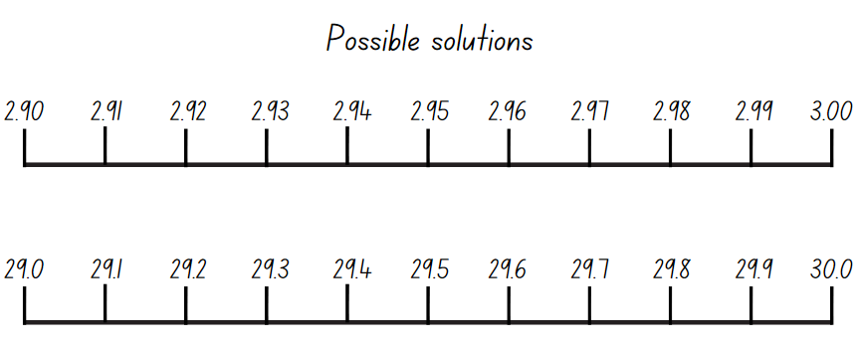
This table details opportunities for assessment.
Assessment opportunities | Links
What to look for:  - Can students use the decimal point as a marker to identify the position of the ones digit when expressing tenths as decimals? [MAO-WM-01, MA2-RN-02]  - Can students represent and compare tenths as decimals using linear representation? [MAO-WM-01, MA2-RN-02]  - Can students express decimals as both tenths and hundredths [MAO-WM-01, MA2-RN-02] | Links to National Numeracy Learning Progressions (NNLP):  - NPV8, NPV9.  Links to suggested Interview for Student Reasoning (IfSR) tasks:  - IfSR-NP: 4B.6.

Core lesson – grocery mass – 35 minutes
The table below contains a suggested learning intention and success criteria. These are best co-constructed with students.
Core concept learning intention | Core concept success criteria
Students are learning to:  - use scaled instruments to measure and compare masses. | Students can:  - use a scaled instrument to relate 1000 grams to one kilogram  - measure and record mass in grams (g) using a scaled instrument  - interpret commonly used fractions of a kilogram, including $\frac{1}{2}$, $\frac{1}{4}$, $\frac{3}{4}$ and relate these to the number of grams  - record masses greater than a kilogram using kilograms and grams.
This activity is an adaptation of Weighing stations from NZ Maths by the New Zealand Ministry of Education.
Note: teachers will need a selection of pantry items for measuring mass. Place masking tape over the weight on the packaging.
- Revise that formal units are used to measure mass and that 1000 grams (g) is the same as one kilogram (kg).
- Display Resource 11 – grocery mass and a selection of grocery items. Model choosing a grocery item and completing Resource 11 – grocery mass by estimating the mass of the selected grocery item. Demonstrate using kitchen scales to accurately measure and record the mass of the item and calculating the difference between the estimation and the actual measurement.
- Provide pairs of students with Resource 11 – grocery mass. Students choose a grocery item and complete Resource 11 – grocery mass. Repeat the process with different grocery items.
- Students compare and discuss their estimated mass and the actual mass of each item.
- Once students have weighed multiple grocery items, reveal the mass recorded on the packaging label. Ask:
- Is the stated mass on the packaging different to the measured mass for any items?
- Why might this be?
This table details opportunities for differentiation.
Too hard? | Too easy?
Students cannot use scaled instruments to measure and compare masses.  - Provide metric weights to assist students with hefting and estimating mass of grocery items.  - Provide students with concrete materials or a calculator to assist with calculating the difference. | Students can use scaled instruments to measure and compare masses.  - Challenge students to combine the mass of 3 or 4 grocery items and find the total.  - Students calculate: Mrs Baker needs $\frac{3}{4}$ of a kilogram of flour to bake a cake. She only has 600 grams. How much more flour does she need?  - Students calculate: Sarah has one kilogram of strawberries. She wants to share them equally between 4 friends. How many grams will each friend get?

Consolidation and meaningful practice – 15 minutes
- Refer to the anchor chart from Lesson 2 and review the amount of grams that are in $\frac{1}{2}$, $\frac{1}{4}$, $\frac{3}{4}$ of a kilogram.
- Display Resource 12 – kilogram fractions and model how to solve fractions of a kilogram questions.
- Provide students with Resource 12 – kilogram fractions to complete independently.
This table details opportunities for assessment.
Assessment opportunities | Links
What to look for:  - Can students use a scaled instrument to relate 1000 grams to one kilogram? [MAO-WM-01, MA2-NSM-01]  - Can students measure and record mass in grams (g) using a scaled instrument? [MAO-WM-01, MA2-NSM-01]  - Can students interpret commonly used fractions of a kilogram, including $\frac{1}{2}$, $\frac{1}{4}$, $\frac{3}{4}$ and relate these to the number of grams?  [MAO-WM-01, MA2-NSM-01]  - Can students record masses greater than a kilogram using kilograms and grams? [MAO-WM-01, MA2-NSM-01] | Links to National Numeracy Learning Progressions (NNLP):  - UuM4, UuM6.

Lesson 4
Core concept: measuring tools help us become familiar with common measures.

Daily number sense – 10 minutes
- From a class need surfaced through formative assessment data, identify a short, focused activity that targets students’ knowledge, understanding and skills. Example activities may be drawn from the following resources:
- Mathematics K–6 resources
- Universal Resources Hub.

Core lesson – exploring measuring tools – 50 minutes
The table below contains suggested learning intentions and success criteria. These are best co-constructed with students.
Core concept learning intentions | Core concept success criteria
Students are learning to:  - use scaled instruments to measure and compare masses  - use scaled instruments to measure and compare lengths. | Students can:  - measure and record mass in grams (g) and kilograms (kg) using a scaled instrument  - compare 2 or more objects by mass measured in kilograms and grams using a set of scales  - select and use an appropriate unit to estimate, measure and compare lengths and distances  - convert lengths between metres and centimetres.
- Display a selection of measuring tools such as an equal-arm balance, measuring tape, 30 cm ruler, kitchen scale, trundle wheel, metre ruler or bathroom scales. For each measuring tool ask:
- What does it measure? (length or mass)
- What units of measurement will you use with this tool? (mm, cm, m, g, kg)
- Where have you seen this measuring tool outside of school? (grocery store, building site)
- What occupations use this tool?

Investigation task 1 – mass
- Place students into small groups to find 4 objects around the room that have a combined mass between one-and-a-half kilograms and 2 kilograms.
- Students choose the appropriate tool to measure the mass of the objects and record their findings in their workbooks.
- Select groups to share and explain their results. Ask:
- What objects did you choose to make the combined mass?
- What measuring tool did you use and why?
- Can you use a different measuring tool and achieve the same results?

Investigation task 2 – length
- Groups find 3 objects around the room that are between 15 centimetres and 1.2 metres. Measure and record the length of each object in centimetres and metres and record findings in workbooks from shortest to longest. Ask:
- What measuring tool did you use and why?
- What unit did you record your answers in? Why?
- Can you use a different measuring tool and achieved the same results?

Investigation task 3 – combining mass and length
- Groups find 2 objects that when combined have a mass between 500 grams and 1500 grams and a combined length between 50 centimetres and 70 centimetres (see Figure 3).
Figure 3 – example of 2 objects
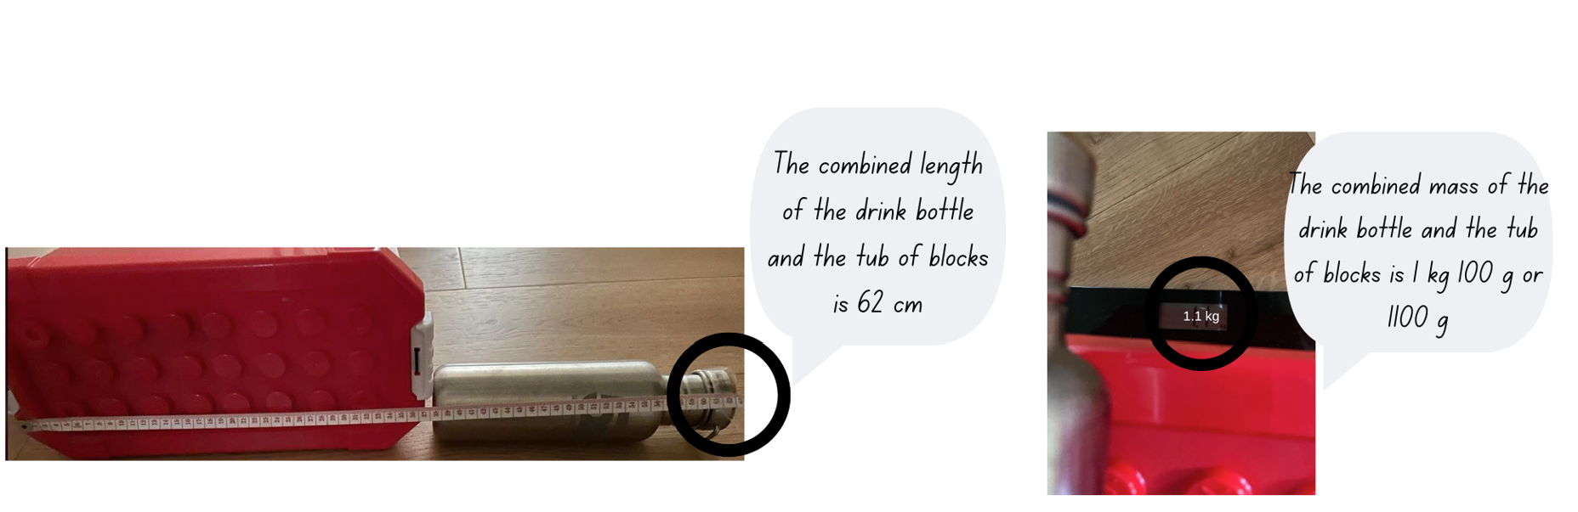
- Students record findings in their workbooks. Groups share their results. Ask:
- What measuring tools did you use and why?
- What units did you record your answers in? Why?
- What was the biggest challenge with this task?
- If you do this task again, will you do it differently? How?
This table details opportunities for differentiation.
Too hard? | Too easy?
Students cannot use scaled instruments to measure and compare masses and lengths.  - Instruct students to find one object that has a mass between one kilogram and 1.5 kilograms.  - Support students to measure 3 objects individually and record the lengths in centimetres. | Students can use scaled instruments to measure and compare masses and lengths.  - Challenge students to find 2 objects that have a difference in mass of 200 grams.  - Students combine the lengths of the 3 objects and record the measurement in millimetres before converting to centimetres and metres.

Consolidation and meaningful practice – 10 minutes
- A one-metre-long chocolate bar has a total mass of 2000 grams. The chocolate bar has been broken into quarters to share. Using masking tape, select students to mark out the whole chocolate bar. Provide students with individual whiteboards to record their working when answering the following questions:
- In grams what is the mass of one-half, and one-quarter, of the chocolate bar?
- What is the mass of 75 centimetres of the chocolate bar?
- What is the mass of 50 centimetres of the chocolate bar?
- I have 500 grams of the chocolate bar. How long is the piece of chocolate?
- I have 750 grams of the chocolate bar. How long is the piece of chocolate?
Note: revise that the fractions $\frac{1}{2}$ and $\frac{1}{4}$ represent parts of the whole chocolate bar (2000 grams or 2 kilograms) and that when comparing fractions, the denominators need to be the same. Ensure students are exploring and explaining multiplicative strategies being used (multiplication and division) as they find solutions using fractions, lengths and the mass. For example, 75 centimetres is $\frac{3}{4}$ of a metre and 750 grams is $\frac{3}{4}$ of a kilogram; $\frac{1}{2}$ of 2000 grams is 1000 grams or one kilogram and 500 grams is $\frac{1}{2}$of a kilo.
This table details opportunities for assessment.
Assessment opportunities | Links
What to look for:  - Can students measure and record mass in grams (g) and kilograms (kg) using a scaled instrument? [MAO-WM-01,  MA2-NSM-01]  - Can students compare 2 or more objects by mass measured in kilograms and grams using a set of scales? [MAO-WM-01,  MA2-NSM-01]  - Can students select and use an appropriate unit to estimate, measure and compare lengths and distances? [MAO-WM-01, MA2-GM-02]  - Can students convert lengths between metres and centimetres? [MAO-WM-01, MA2-GM-02] | Links to National Numeracy Learning Progressions (NNLP):  - UuM4, UuM6.

Lesson 5
Core concept: length can measure a straight line, a perimeter, or an edge.

Daily number sense – using arrays – 10 minutes
Daily number sense activities for Lessons 5 to 7 ‘loop’ back to concepts and procedures covered in previous units to assist students to build an increasingly connected network of ideas. These concepts may differ from the core concepts being covered by the unit.
The table below contains a suggested learning intention and success criteria. These are best co-constructed with students.
Daily number sense learning intention | Daily number sense success criteria
Students are learning to:  - recall multiplication facts of 2 and 4, 5 and 10 and related division facts. | Students can:  - link multiplication and division fact families using arrays.
- Demonstrate how to link multiplication and division using arrays by rolling two 10-sided dice and using the numbers rolled to form an array with counters.
- From the array, record 2 multiplication and 2 division number sentences as a fact family on the board (see Figure 4).
Figure 4 – array number sentences
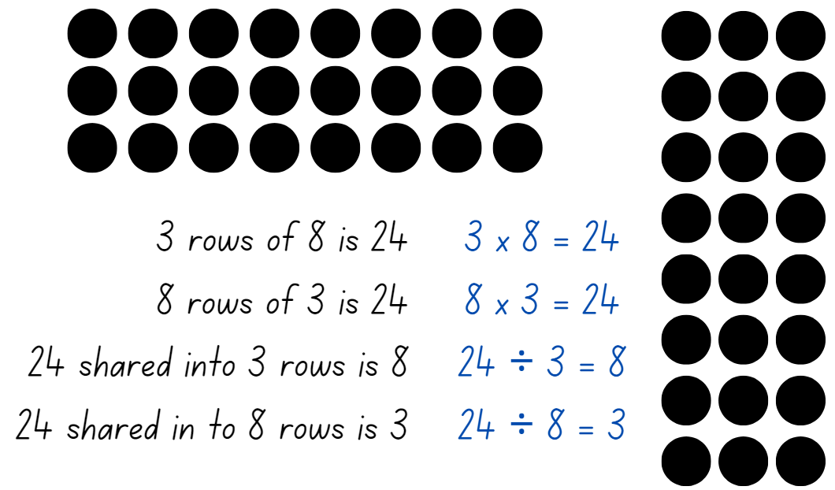
- Highlight:
- the link between multiplication and division
- the commutative property of multiplication.
- Provide students with two 10-sided dice and their workbooks. Students record the fact families in their workbook.
Note: provide counters to students that need to support their multiplicative thinking by making the array.
- Select students to share and explain their arrays and number sentences.
This table details opportunities for assessment.
Assessment opportunities | Links
What to look for:  - Can students link multiplication and division fact families using arrays? [MAO-WM-01, MA2-MR-01] | Links to National Numeracy Learning Progressions (NNLP):  - MuS6.

Core lesson – quadrilateral perimeters – 30 minutes
The table below contains a suggested learning intention and success criteria. These are best co-constructed with students.
Core concept learning intention | Core concept success criteria
Students are learning to:  - use scaled instruments to measure and compare perimeters. | Students can:  - use the term perimeter to describe the distance around the boundary  - estimate and measure the perimeter of quadrilaterals.
Note: prior to the lesson, teachers will need to put some masking tape or chalk quadrilaterals on the floor and/or desks.
- Review students’ knowledge of perimeter. Ask:
- If I measure the perimeter of something, what am I measuring?
- What measurement tools would be useful for measuring perimeter? Why?
- When will measuring perimeter be useful?
- Explain that the perimeter of an object, shape or location is the same as the boundary. Perimeter is the length around an object, shape or location and is calculated by combining the length of all sides.
- Explain that students will be measuring the perimeter of the masking tape shapes. Model how to measure and record the perimeter of a masking tape quadrilateral, reminding students to use the ruler along the edge of the shape without leaving any gaps and starting at zero.
- Using Resource 13 – calculating perimeter, students estimate, measure and record the perimeter of various objects and shapes in and/or out of the classroom. For example, a desk, a book, handball court, basketball court, path or garden bed.
- Regroup as a class and select students to share what they measured and how they measured the perimeter.
This table details opportunities for differentiation.
Too hard? | Too easy?
Students cannot use scaled instruments to measure and compare lengths.  - Provide students with the length of one side of the shape to assist with measuring perimeter.  - Provide students with a long piece of string to lay over the boundary/perimeter, then stretch it out to show the total length. Support students to measure the length. | Students can use scaled instruments to measure and compare lengths.  - Challenge students to double and triple the perimeter of an item measured.  - Pose the following: a rectangular paddock has a perimeter of 80 metres. In workbooks, students draw and label 2 alternative plans for what this paddock might look like.

Consolidation and meaningful practice – 20 minutes
This game is an adaptation of Dicey Perimeter, Dicey Area from NRICH by University of Cambridge.
- Display Resource 14 – squared paper and demonstrate how to play the game ‘Dicey Perimeter’ to the students. The aim of the game is to stop each other from recording any more quadrilaterals.
- Players decide who will go first.
- Player 1 rolls two 6-sided dice. Each dice represents a pair of opposite side of the quadrilateral. Player 1 chooses the orientation of the shape, draws the quadrilateral and records the perimeter inside the shape (see Figure 5).
Figure 5 – example of gameplay
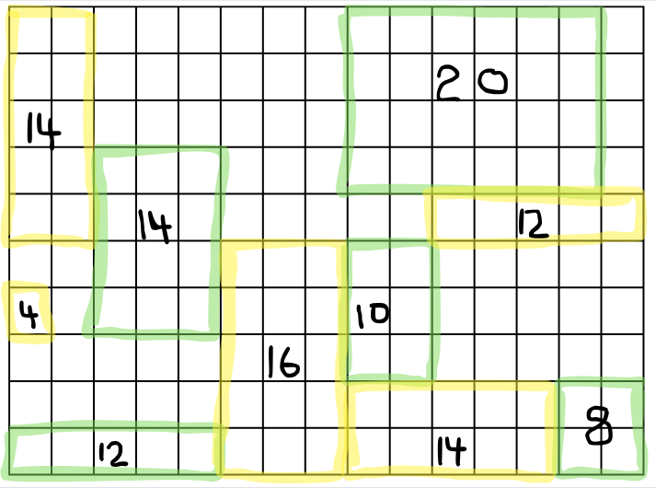
- Player 2 then rolls the dice, draws their chosen quadrilateral and records the perimeter.
- The game ends when a player cannot draw their quadrilateral in any remaining space on the board.
- Once students are confident playing the game, provide pairs of students with multiples copies of Resource 14 – squared paper, two 6-sided dice and 2 different coloured highlighters. Students play multiple rounds.
Note: to allow for Resource 14 – squared paper to be used multiple times, place the gameboard in a plastic sleeve and provide students with non-permanent markers and an eraser.

- After students have played the game, ask:
- What are good numbers to throw? Why?
- What are not very good numbers to throw? Why?
- Do you notice anything about the perimeter of shapes?
- Does it matter who goes first or second?
This table details opportunities for assessment.
Assessment opportunities | Links
What to look for:  - Can students use the term perimeter to describe the distance around the boundary? [MAO-WM-01, MA2-GM-02]  - Can students estimate and measure the perimeters of quadrilaterals? [MAO-WM-01, MA2-GM-02] | Links to National Numeracy Learning Progressions (NNLP):  - UuM7.

Lesson 6
Core concept: decimal numbers are often seen in measurement.

Daily number sense – fact families – 10 minutes
The table below contains a suggested learning intention and success criteria. These are best co-constructed with students.
Daily number sense learning intention | Daily number sense success criteria
Students are learning to:  - recall multiplication facts of 2 and 4, 5 and 10 and related division facts. | Students can:  - generate multiplication and division fact families for multiples of 2 and 4, 5 and 10.
- Display Resource 15 – making fact families and explain that 8 is a multiple of 2 and of 4. Write the skip counting pattern of 2 and then of 4 to confirm that 8 is in both patterns. Explain that 2 and 4 are factors of 8.
- Record the terms multiple and factor on an anchor chart or word wall.
Factor: a number which divides another number without a remainder. For example, 1, 2, 3 and 6 are factors of 6 but 4 and 5 are not.
- Select one fact family from Resource 15 – making fact families to model:
- how to write multiplication and division sentences using fact families
- using arrays to prove the commutative property of multiplication.
Note: highlight to students that the number at the top of the triangle is the product of the 2 factors at the bottom of the triangle. For division, ensure students understand that the product of the fact family must be at the start of the sentence. Division is not commutative, so 2 ÷ 4 = 8 is not correct.
Product: the result of multiplying 2 or more numbers together, for example, 12 is the product of 4 × 3.
- Record the term product on the anchor chart or word wall.
- Provide students with Resource 15 – making fact families. Students identify the fact families for the remaining triangles and record the number sentences.
Note: some students may need concrete materials, such as counters, to manipulate while completing the activity. This activity can be differentiated by having students find other factors of the product and writing out the fact families.
- Select students to share and explain their work. Record student responses for the class to see.

This table details opportunities for assessment.
Assessment opportunities | Links
What to look for:  - Can students generate multiplication and division fact families for multiples of 2 and 4, 5 and 10? [MAO-WM-01, MA2-MR-01] | Links to National Numeracy Learning Progressions (NNLP):  - MuS6.

Core lesson – how far can an animal jump? – 45 minutes
The table below contains suggested learning intentions and success criteria. These are best co-constructed with students.
Core concept learning intentions | Core concept success criteria
Students are learning to:  - extend the application of the place value system from whole numbers to tenths and hundredths  - use scaled instruments to measure and compare lengths. | Students can:  - use the decimal point as a marker to identify the position of the ones digit when expressing tenths as decimals  - convert between metres and centimetres  - record lengths and distances using decimal notation to 2 decimal places.
This activity is an adaptation of Measurement: Jump! from reSolve by Australian Academy of Science.
- Students imagine they are a kangaroo. Ask, ‘How far do you think you can jump?’
- Share that a kangaroo can jump 4 times its height. This means a kangaroo can jump over 4 kangaroos lying on the ground head to toe.
- Demonstrate this by having 4 students of a similar height lie head to toe along the ground.
- Explain that students will be using their height measurement to calculate the equivalent distances various animals can jump. Ask:
- What measurement tools can we use to measure height?
- How can we ensure our measurements are precise?
- What unit(s) of measurement are the most appropriate to measure and record height?
- Demonstrate measuring and recording teacher height on Resource 16 – animal jumps. Highlight that when recording heights more than one metre, a decimal point is used to express the tenths of a metre.
- Show students how to create a personal ratio table.
- Provide students with Resource 16 – animal jumps. Students measure and record their height in centimetres.
- Model different strategies to create a personal ratio table. Some strategies might include:
- measuring out the required number of height lengths
- repeated addition
- multiplying their height
- doubling or tripling a repeated amount.
- Demonstrate using the personal ratio table to calculate jumping distance as a kangaroo. Record on Resource 16 – animal jumps. Show students how to convert the ‘kangaroo jump’ from centimetres (cm) to metres (m). Remind students that 100 cm = 1 m and that the decimal point is used to express tenths of a metre. For example, 2.47 m is 2 metres and 47 cm.
- Explain that grasshoppers can jump 8 times their height, frogs can jump 12 times their height and a flea can jump 20 times its height. Ask students to calculate how far they could jump based on their own height if they were each of these animals, recording in centimetres and then converting to metres.
- Allow students to use their own strategies.
- Students explain and justify the strategy used to calculate their ‘animal jumps.’ Ask:
- What animal jumps present a challenge when calculating?
- After listening to others will you use a different strategy next time?
- Which strategy? Why?

Consolidation and meaningful practice – 15 minutes
- Students mark out their kangaroo, frog, grasshopper or flea jumps in the school playground. Ask:
- What animal jumps are easy to measure?
- What are the best tools to make the measurements? Why?
- Why would you use different tools?
- Will some tools produce more accurate measurements?
- What tools did you use when measuring in both centimetres and metres?
- Did you mark out the jumps using centimetres or metres or a combination of both?
This table details opportunities for differentiation.
Too hard? | Too easy?
Students cannot extend the application of the place value system from whole numbers to tenths and hundredths and use scaled instruments to measure and compare lengths.  - Provide concrete materials, number charts or calculators for students to use when adding their height.  - Support students to measure out the length of animal jumps rather than calculate. | Students can extend the application of the place value system from whole numbers to tenths and hundredths and use scaled instruments to measure and compare lengths.  - Challenge students to calculate the height of the kangaroo if it can jump 620 centimetres, recording in their workbook.  - Challenge students to calculate the combined distance a kangaroo, frog, grasshopper and flea can jump.
This table details opportunities for assessment.
Assessment opportunities | Links
What to look for:  - Can students use the decimal point as a marker to identify the position of the ones digit when expressing tenths as decimals? [MAO-WM-01, MA2-RN-01, MA2-RN-02]  - Can students convert between metres and centimetres, and between centimetres and millimetres? [MAO-WM-01,  MA2-GM-02]  - Can students record lengths and distances using decimal notation to 2 decimal places? [MAO-WM-01, MA2-GM-02] | Links to National Numeracy Learning Progressions (NNLP):  - UuM8.

Lesson 7
Core concept: decimal numbers add precision to descriptions of objects.

Daily number sense – solving problems with fact families – 10 minutes
The table below contains a suggested learning intention and success criteria. These are best co-constructed with students.
Daily number sense learning intention | Daily number sense success criteria
Students are learning to:  - recall multiplication facts of 2 and 4, 5 and 10 and related division facts. | Students can:  - generate multiplication and division fact families for multiples of 2 and 4, 5 and 10  - use knowledge of fact families to solve problems.
- Display Resource 17 – lots of buttons and explain that students will work in pairs to solve the problem. Ask:
- What is the problem asking you to find out?
- Where will you start to solve the problem?
- How many different parts are there to the problem? Can you use the same strategy to solve each part?
- Which strategy do you think will work best to find a solution for this problem? Why?
- How can you record the solution?
- After students have had the opportunity to work on the solution, ask:
- How do you know the strategy you are using is working?
- How can you check that the answer is correct?
This table details opportunities for assessment.
Assessment opportunities | Links
What to look for:  - Can students generate multiplication and division fact families for multiples of 2 and 4, 5 and 10? [MAO-WM-01, MA2-MR-01]  - Can students use knowledge of fact families to solve problems? [MAO-WM-01, MA2-MR-01] | Links to National Numeracy Learning Progressions (NNLP):  - MuS6.

Core lesson – ball throwing challenge – 40 minutes
The table below contains suggested learning intentions and success criteria. These are best co-constructed with students.
Core concept learning intentions | Core concept success criteria
Students are learning to:  - use scaled instruments to measure and compare lengths  - extend the application of the place value system from whole numbers to tenths and hundredths. | Students can:  - use the decimal point as a marker to identify the position of the ones digit when expressing tenths as decimals  - recognise that 10-tenths is recorded as 1.0 and regroup when using decimal notation  - convert between metres and centimetres  - record lengths and distances using decimal notation to 2 decimal places.
Note: prior to the lesson teachers will need to collect a variety of balls such as: tennis balls, footballs, table tennis balls, netballs, cricket balls, basketballs and golf balls. Sports cones or beanbags will be required to use as markers.
- Take the class outside and place students into small groups. Provide each student with Resource 18 – ball throwing. Each group selects 3 different sports balls.
- Establish a starting line in the playground and explain that one student will throw the ball whilst the other students mark where the ball has landed with a cone or beanbag.
- Groups work together to throw each ball 2 times, measuring the distance after each throw with a trundle wheel and metre ruler or tape measure.
- Students record measured distances in metres using decimal notation on Resource 18 – ball throwing.
- Once groups have completed 2 throws for each ball, demonstrate how to convert between metres and centimetres.
Note: avoid the ‘move the decimal point’ shortcut as this can develop misconceptions regarding place value understanding. The numbers should move around the decimal point. Model a think aloud: I want to convert my 2 metres to centimetres. I know there are 100 centimetres in a metre, so I will multiply 2 by 100. 2 metres × 100 = 200 centimetres. If I threw 1.42 metres, I would multiply 1.42 by 100. Just like 1 × 100 is 100, all the digits in the decimal number move 2 place value places when multiplied by 100. So, 1.42 m × 100 is 142 cm.
- Students convert their measurements from metres to centimetres and record on Resource 18 – ball throwing.
This table details opportunities for differentiation.
Too hard? | Too easy?
Students convert between units of measurement.  - Support students to only measure in metres, rounding up and down to the nearest whole metre.  - Provide students with concrete materials to assist with finding the difference between their shortest and longest throws. | Students convert between units of measurement.  - Challenge students to place the throws into ascending order and calculate the difference in both centimetres and millimetres between the longest and shortest throws.  - Challenge students to justify if the weight of the different balls has an impact on the length of the throw.

Discuss and connect the mathematics – 15 minutes
- Return to the classroom and record group results.
- Which ball went the greatest distance? Is this the same ball for all groups? Why or why not?
- Which ball went the least distance? Is this the same ball for all groups? Why or why not?
- If you do this activity again, will you measure in a different way? How?
- Using workbooks, students answer the following questions in metres using decimal notation:
- What is the difference between your group’s shortest and longest throw?
- What is the total distance of your group’s 3 best throws?
- What is the total distance of all your group’s throws?
- What is the length in centimetres if I threw the ball 5.67 metres?
- What is the length in metres if the throw is 452 centimetres?
This table details opportunities for assessment.
Assessment opportunities | Links
What to look for:  - Can students use the decimal point as a marker to identify the position of the ones digit when expressing tenths as decimals? [MAO-WM-01, MA2-RN-01, MA2-RN-02]  - Can students recognise that 10-tenths is recorded as 1.0 and regroup when using decimal notation? [MAO-WM-01,  MA2-RN-01, MA2-RN-02]  - Can students convert between metres and centimetres, and between centimetres and millimetres? [MAO-WM-01,  MA2-GM-02]  - Can students record lengths and distances using decimal notation to 2 decimal places? [MAO-WM-01, MA2-GM-02] | Links to National Numeracy Learning Progressions (NNLP):  - UuM8.

Lesson 8
Core concept: comparing and converting units of measurement helps to make sense of our world.

Daily number sense – 10 minutes
- From a class need surfaced through formative assessment data, identify a short, focused activity that targets students’ knowledge, understanding and skills. Example activities may be drawn from the following resources:
- Mathematics K–6 resources
- Universal Resources Hub.

Core lesson – house plan – 40 minutes
The table below contains a suggested learning intention and success criteria. These are best co-constructed with students.
Core concept learning intention | Core concept success criteria
Students are learning to:  - use scaled instruments to measure and compare lengths and perimeters. | Students can:  - convert between metres and centimetres, and between centimetres and millimetres  - estimate and measure the perimeters of quadrilaterals  - record lengths and distances using decimal notation to 2 decimal places  - use the decimal point as a marker to identify the position of the ones digit when expressing tenths as decimals.
- Display Resource 19 – house plan and ask:
- What is this a diagram of?
- Has anyone seen a diagram like this before?
- Who would need/use a diagram like this?
- What do the symbols on the diagram represent? For example: doors, windows and furniture.
- Does it need to be accurate? Why or why not?
- How is accuracy ensured?
- What do the numbers on the diagram represent?
- If the numbers are a measurement, what unit would they be? Justify your answer.
- Model using the information on the house plan to find a measurement. For example, finding the length of the southern wall in the living room.
- Show students how to convert the millimetre (mm) length to centimetres (cm) and metres (m), recording using decimals (see Figure 6).
Figure 6 – example of think aloud
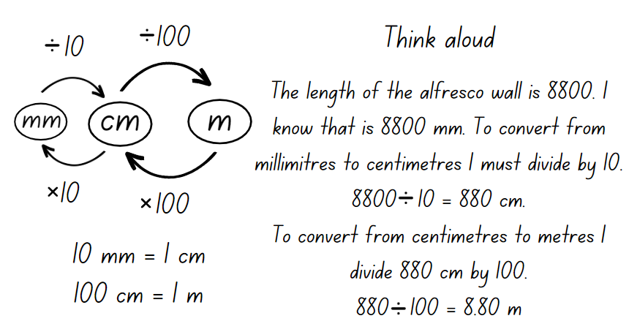
- Provide students with Resource 19 – house plan, Resource 20 – house plan investigation and their workbook. Students use the information on the house plan to answer the questions on Resource 20 – house plan investigation and record in their workbook.
This table details opportunities for differentiation.
Too hard? | Too easy?
Students cannot measure and compare lengths and convert between units of measurement.  - Reduce the number of questions for students to answer on Resource 20 – house plan investigation.  - Support students to provide answers in millimetres only, consolidating students’ knowledge of one unit of measurement. | Students measure and compare lengths and convert between units of measurement.  - Challenge students to calculate the combined perimeter of all the bedrooms. Record answers in metres, centimetres and millimetres.  - Challenge students to answer: The homeowner planted shrubs along the total length of the property boundary. The shrubs are 50 millimetres apart. How many shrubs are required?

Consolidation and meaningful practice – 10 minutes
- Explain that students will design a backyard area for the house.
- The homeowner wants a fenced in rectangular pool, a garden shed and flower gardens in the backyard space outside Bed 1 and Bed 2. Each of these features will need to include measurements in millimetres (mm).
- Once students have drawn their backyard design, they calculate the perimeter of the pool and the shed and record in millimetres (mm), centimetres (cm) and metres (m).

This table details opportunities for assessment.
Assessment opportunities | Links
What to look for:  - Can students convert between metres and centimetres, and between centimetres and millimetres? [MAO-WM-01,  MA2-GM-02]  - Can students estimate and measure the perimeters of quadrilaterals? [MAO-WM-01, MA2-GM-02]  - Can students record lengths and distances using decimal notation to 2 decimal places? [MAO-WM-01, MA2-GM-02]  - Can students use the decimal point as a marker to identify the position of the ones digit when expressing tenths as decimals? [MAO-WM-01, MA2-RN-01, MA2-RN-02] | Links to National Numeracy Learning Progressions (NNLP):  - UuM7, UuM8.

Resource 1 – place the digits 1
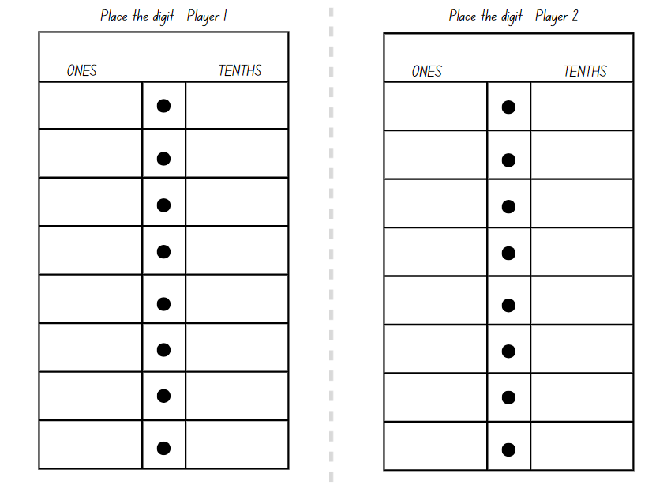

Resource 2 – 1 kg balance
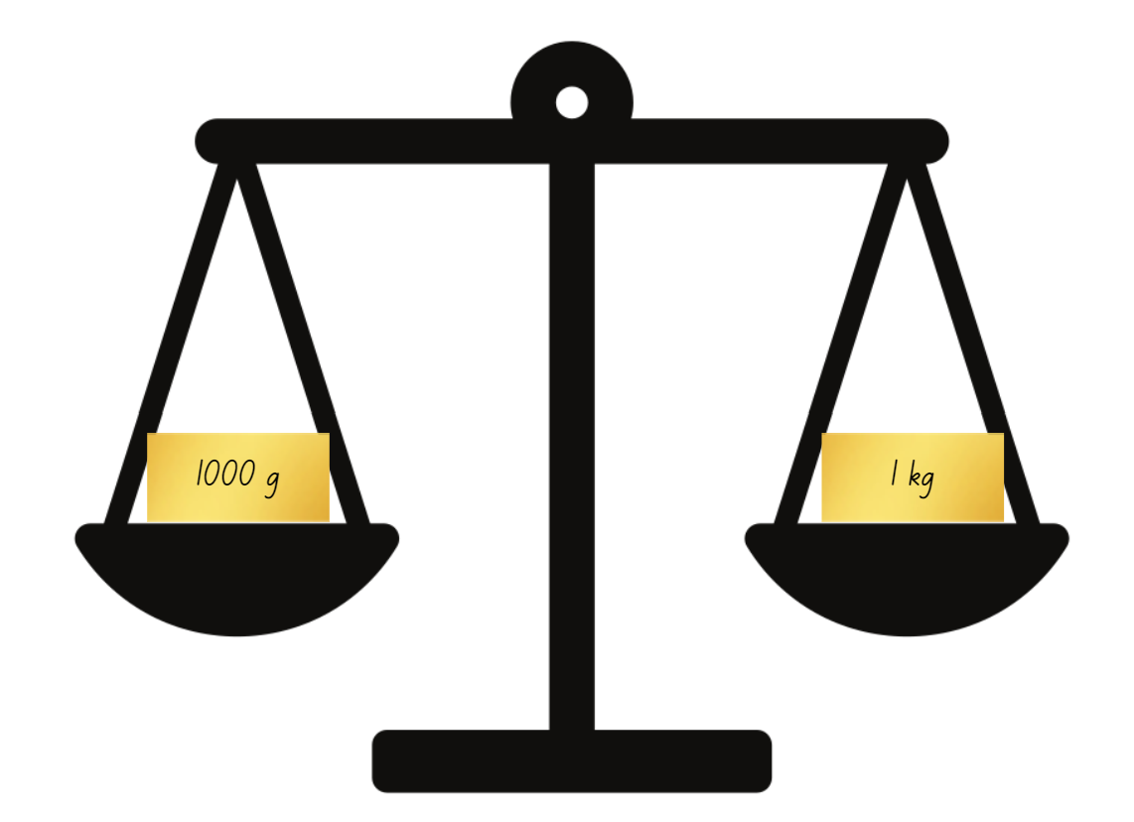

Resource 3 – mass sort

Resource 4 – about a kilogram

Resource 5 – place the digits 2
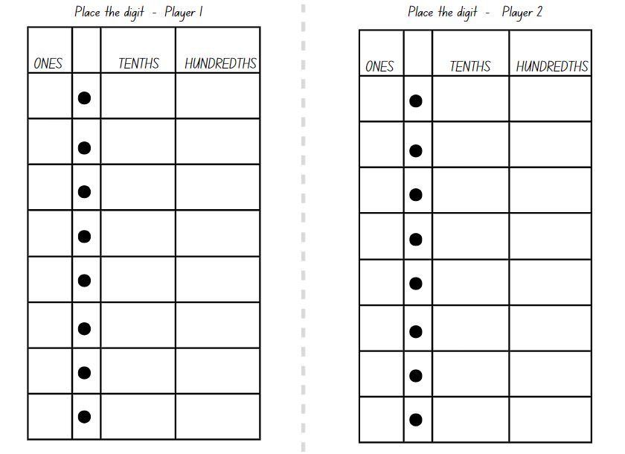

Resource 6 – number cards
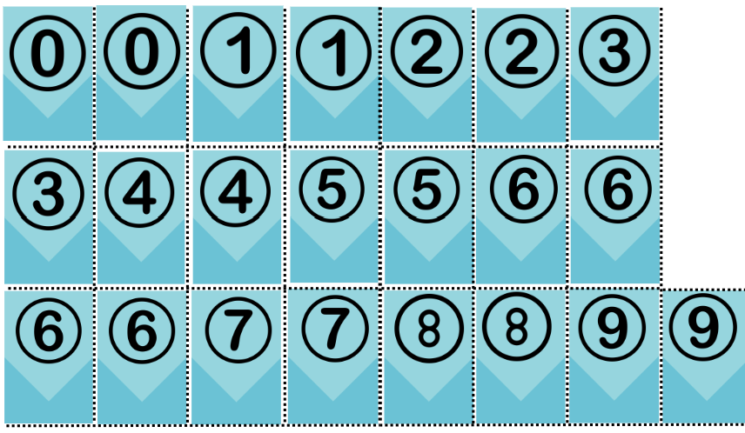

Resource 7 – cube model mass
Number of cubes | Estimate | Measure
20 | g | g
40 | g | g
50 | g | g
60 | g | g
100 | g | g
200 | g | g
1000 | g | g

Resource 8 – fractions of kilograms
Number of cubes | Measure | Fraction of a kilo
 | 250 g
 | 750 g
 |  | $$\frac{1}{2}$$
 | 1 kg

Resource 9 – pumpkin competition
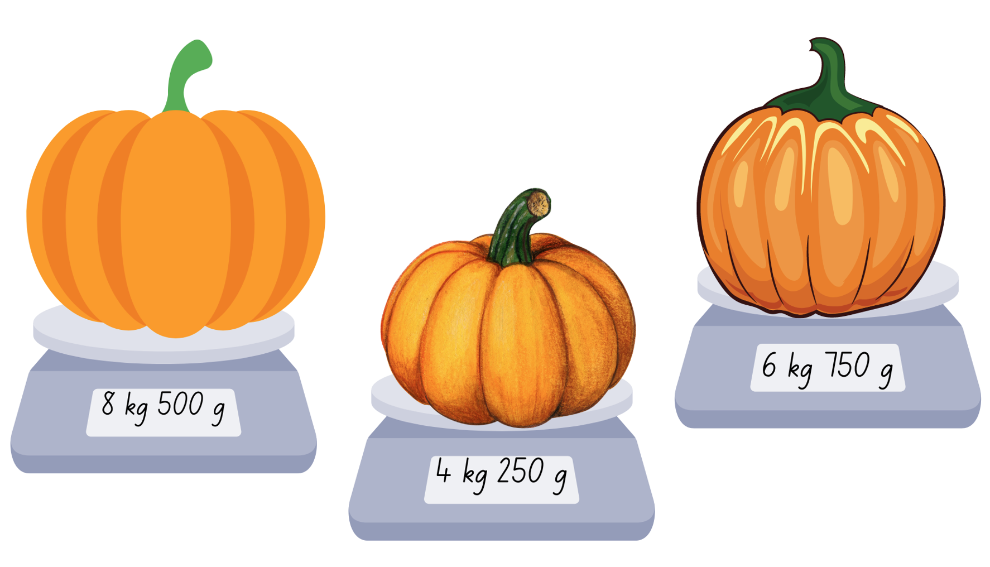

Resource 10 – mixed up decimals
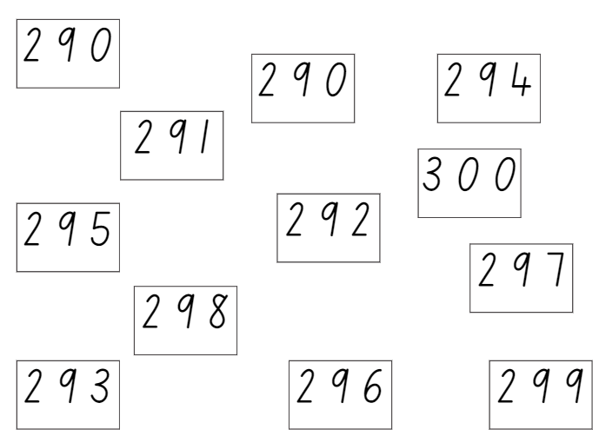

Resource 11 – grocery mass
Item | Estimated mass | Measured mass | What was the difference?

Resource 12 – kilogram fractions
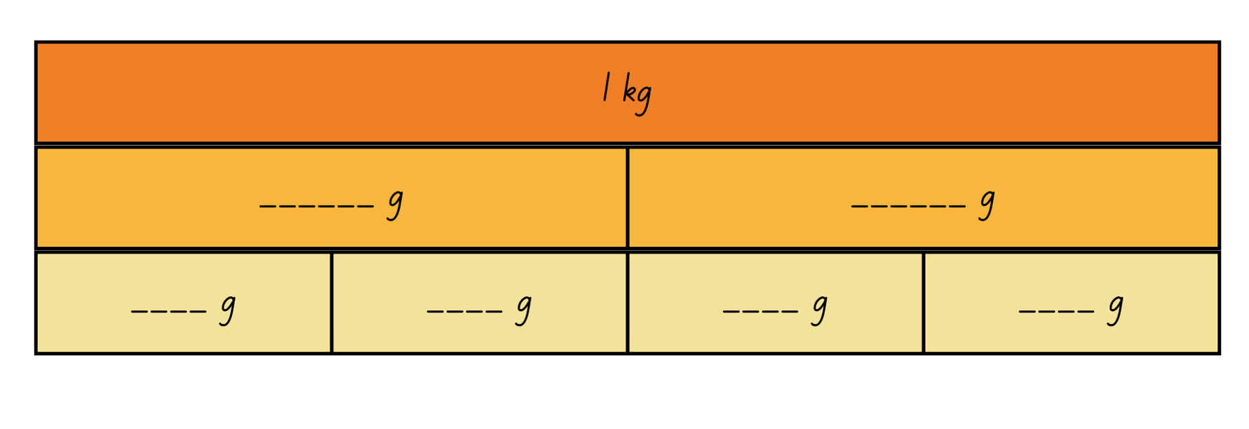
- 1 kg is equal to how many grams?
- How many grams in $\frac{1}{2}$ kg?
- How many grams in $\frac{3}{4}$ kg?
- 500 g is equal to how many kilograms?

Resource 13 – calculating perimeter
Quadrilateral | Estimation | Measure

Resource 14 – squared paper

Resource 15 – making fact families
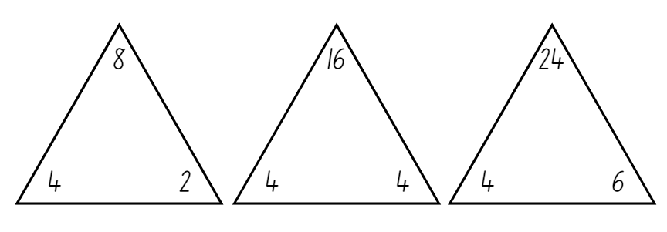

Resource 16 – animal jumps
Personal ratio table
My height is ______ | ×2 | ×3 | ×6 | ×10
Equals (cm)
My height is:
Animal | Times as many | Equals (cm) | Equals (m)
Kangaroo | 4
Grasshopper | 8
Frog | 12
Flea | 20
100 cm = 1 m

Resource 17 – lots of buttons
Lots of buttons
The tailor received a delivery of buttons.
In the box there are 6 packets of buttons.
In each packet there are 10 buttons.
How many buttons are there altogether?
If the tailor is using the new buttons to sew onto 12 shirts, how many buttons will she use on each shirt?

Resource 18 – ball throwing
Ball throwing challenge
Ball type | First throw | Distance (m) | Distance (cm) | Second throw | Distance (m) | Distance (cm)

Resource 19 – house plan
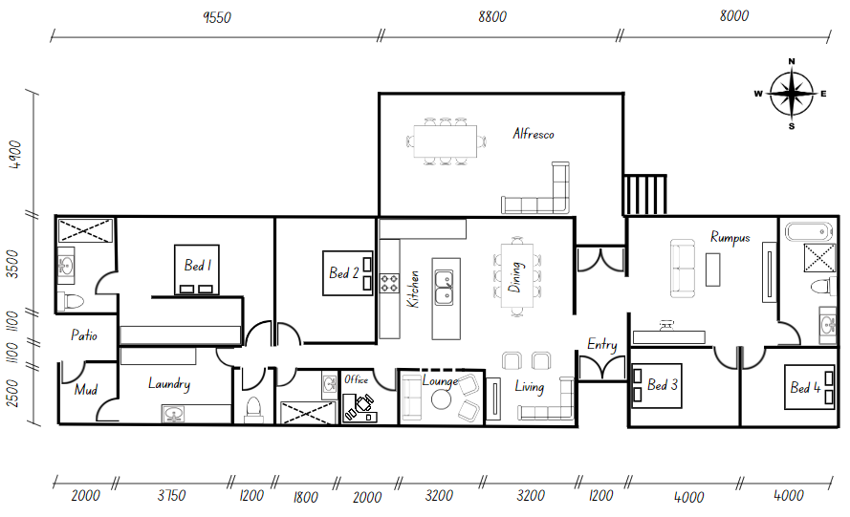

Resource 20 – house plan investigation
- What is the perimeter of the alfresco area?
- What is the perimeter of the office?
- What is the length of the southern wall of the lounge?
- What is the perimeter of the lounge?
- What is the width of the entry if doubled?
- What is the length of the eastern wall of the house?
- A wall painting has a length of 2600 mm. Would it fit on the eastern wall of the office? Yes/No. Why?
- What is the perimeter of the outside walls of the house?

Syllabus outcomes and content
The table below outlines the syllabus outcomes and range of relevant syllabus content covered in this unit. Content is linked to National Numeracy Learning Progression (version 3).
Outcomes and content | 1 | 2 | 3 | 4 | 5 | 6 | 7 | 8
Representing numbers using place value B: Decimals: Extend the application of the place value system from whole numbers to tenths and hundredths
MAO-WM-01, MA2-RN-02
- Use the decimal point as a marker to identify the position of the ones digit when expressing tenths as decimals | x | x | x |  |  | x | x
- Recognise that 10-tenths is recorded as 1.0 and regroup when using decimal notation |  |  |  |  |  | x | x
- Express decimals as both tenths and hundredths | x | x | x |  |  | x
- Distinguish between the role of zero in various positions |  | x | x
- Locate and order decimals representing tenths and hundredths on a number line, describing their relative size |  |  | x
Multiplicative relations A: Recall multiplication facts of 2 and 4, 5 and 10 and related division facts
MAO-WM-01, MA2-MR-02
- Recognise and use the symbols for multiplied by (x), divided by (÷) and equals (=) |  |  |  |  | x | x | x
- Link multiplication and division fact families using arrays |  |  |  |  | x | x
- Generate multiplication fact families for multiples of 2 and 4, 5 and 10 |  |  |  |  | x | x | x
Geometric measure B: Use scaled instruments to measure and compare lengths
MAO-WM-01, MA2-GM-02
- Select and use an appropriate unit to estimate, measure and compare lengths and distances |  |  |  | x
- Use the term perimeter to describe the distance around the boundary |  |  |  |  | x |  |  | x
- Estimate and measure the perimeters of quadrilaterals |  |  |  |  | x |  |  | x
- Convert between metres and centimetres, and between centimetres and millimetres |  |  |  | x |  | x | x | x
- Record lengths and distances using decimal notation to 2 decimal places |  |  |  |  |  | x | x | x
Non-spatial measure A: Mass: Compare objects using the kilogram
MAO-WM-01, MA2-NSM-01
- Recognise the need for a formal unit to measure mass | x
- Identify familiar objects that have a mass of about one kilogram | x
Non-spatial measure B: Mass: Use scaled instruments to measure and compare masses
MAO-WM-01, MA2-NSM-01
- Recognise the need for a formal unit smaller than the kilogram | x | x | x
- Use a scaled instrument to relate 1000 grams to one kilogram | x | x | x
- Identify familiar objects that could be measured in grams | x | x | x
- Measure and record mass in grams (g) using a scaled instrument | x | x | x | x
- Compare 2 or more objects by mass measured in kilograms and grams using a set of scales |  |  |  | x
- Interpret commonly used fractions of a kilogram, including $\frac{1}{2}$, $\frac{1}{4}$, $\frac{3}{4}$, and relate these to the number of grams |  | x | x
- Record masses greater than a kilogram using kilograms and grams |  |  | x
Mathematics K–10 Syllabus © NSW Education Standards Authority (NESA) for and on behalf of the Crown in right of the State of New South Wales, 2022.

References
This resource contains NSW Curriculum and syllabus content. The NSW Curriculum is developed by the NSW Education Standards Authority. This content is prepared by NESA for and on behalf of the Crown in right of the State of New South Wales. The material is protected by Crown copyright.
Please refer to the NESA Copyright Disclaimer for more information https://educationstandards.nsw.edu.au/wps/portal/nesa/mini-footer/copyright.
NESA holds the only official and up-to-date versions of the NSW Curriculum and syllabus documents. Please visit the NSW Education Standards Authority (NESA) website https://educationstandards.nsw.edu.au/wps/portal/nesa/home/ and the NSW Curriculum website https://curriculum.nsw.edu.au.
Mathematics K–10 Syllabus © NSW Education Standards Authority (NESA) for and on behalf of the Crown in right of the State of New South Wales, 2022.
National Numeracy Learning Progression © Australian Curriculum, Assessment and Reporting Authority (ACARA) 2010 to present, unless otherwise indicated. This material was downloaded from the Australian Curriculum website (National Numeracy Learning Progression) accessed 11 September 2023 and was not modified.
Australian Academy of Science (2024) ‘Measurement: Jump!’, Teaching resources, reSolve: Maths by Inquiry website, accessed 7 September 2023.
New Zealand Ministry of Education (n.d.) ‘Place the Digits’, Resource, NZ Maths website, accessed 7 September 2023.
New Zealand Ministry of Education (n.d.) ‘Weighing stations’, Resource, NZ Maths website, accessed 7 September 2023.
University of Cambridge (2023) Watermelons, NRICH website, accessed 7 September 2023.
University of Cambridge (2023) Dicey Perimeter, Dicey Area, NRICH website, accessed 7 September 2023.
State of New South Wales (Department of Education) (2022) Stage 2 – mass, NSW Department of Education website, accessed 7 September 2023.
State of New South Wales (Department of Education) (2022) ‘“Mass-ive” Model’, Stage 2 – mass, NSW Department of Education website accessed 7 September 2023.

Further reading
Siemon D, Warren E, Beswick K, Faragher R, Miller J, Horne Marj, Jazby D, Breed M, Clark J, Brady K (2020) Teaching Mathematics: Foundation to Middle Years, 3rd edn, Oxford University Press, Australia and New Zealand.
Van de Walle J, Karp K, Bay-Williams JM, Brass A, Bentley B, Ferguson S, Goff W, Livy S, Marshman M, Martin D, Pearn C, Prodromou T, Symons D and Wilkie K (2019) Primary and Middle Years Mathematics: Teaching Developmentally, 1st Australian edn, Pearson Education Australia, Melbourne.

© State of New South Wales (Department of Education), 2024
The copyright material published in this resource is subject to the Copyright Act 1968 (Cth) and is owned by the NSW Department of Education or, where indicated, by a party other than the NSW Department of Education (third-party material).
Copyright material available in this resource and owned by the NSW Department of Education is licensed under a Creative Commons Attribution 4.0 International (CC BY 4.0) license.
This licence allows you to share and adapt the material for any purpose, even commercially.
Attribution should be given to © State of New South Wales (Department of Education), 2024.
Material in this resource not available under a Creative Commons licence:
- the NSW Department of Education logo, other logos and trademark-protected material
- material owned by a third party that has been reproduced with permission. You will need to obtain permission from the third party to reuse its material.
Links to third-party material and websites
Please note that the provided (reading/viewing material/list/links/texts) are a suggestion only and implies no endorsement, by the New South Wales Department of Education, of any author, publisher, or book title. School principals and teachers are best placed to assess the suitability of resources that would complement the curriculum and reflect the needs and interests of their students.
If you use the links provided in this document to access a third-party's website, you acknowledge that the terms of use, including licence terms set out on the third-party's website apply to the use which may be made of the materials on that third-party website or where permitted by the Copyright Act 1968 (Cth). The department accepts no responsibility for content on third-party websites.

