Mathematics Stage 2 – Unit 33
Multiplicative thinking involves flexible use of multiplication and division concepts, strategies and representations

Contents
Unit description and duration 5
Syllabus outcomes 5
Working mathematically 6
Student prior learning 6
Lesson overview and resources 8
Lesson 1 12
Daily number sense – balance the scales – 10 minutes 12
Core lesson 1 – number slides – 20 minutes 14
Core lesson 2 – large number multiplication – 20 minutes 17
Discuss and connect the mathematics – 10 minutes 18
Lesson 2 20
Daily number sense – guess the numbers on the dice – 15 minutes 20
Core lesson 1 – using known strategies – 20 minutes 22
Core lesson 2 – footy final frenzy – 20 minutes 23
Discuss and connect the mathematics – 10 minutes 25
Lesson 3 27
Daily number sense – double double – 10 minutes 27
Core lesson – reasoning chains – 35 minutes 28
Consolidation and meaningful practice – 15 minutes 32
Lesson 4 34
Daily number sense – 10 minutes 34
Core lesson 1 – inverse relations – 15 minutes 34
Core lesson 2 – ‘Keep in step’ – 20 minutes 35
Consolidation and meaningful practice – 15 minutes 37
Lesson 5 39
Daily number sense – make it true – 10 minutes 39
Core lesson – doubling and halving are powerful strategies – 40 minutes 41
Consolidation and meaningful practice – 10 minutes 44
Lesson 6 46
Daily number sense – create an equation – 15 minutes 46
Core lesson 1 – fact family bonanza – 30 minutes 47
Consolidation and meaningful practice – 15 minutes 51
Lesson 7 53
Daily number sense – worded problems – 15 minutes 53
Core lesson – multiple factors game – 35 minutes 54
Discuss and connect the mathematics – 15 minutes 58
Lesson 8 60
Daily number sense – 10 minutes 60
Core lesson 1 – challenging facts – 15 minutes 60
Core lesson 2 – Prove it! – 25 minutes 63
Consolidation and meaningful practice – 15 minutes 64
Resource 1 – balance the scales 66
Resource 2 – large number spinners 67
Resource 3 – best strategy 68
Resource 4 – footy final cards 69
Resource 5 – How much? 70
Resource 6 – What number? 71
Resource 7 – multiplication toss spinner 72
Resource 8 – multiples gameboard 73
Resource 9 – score sheet 74
Resource 10 – partitioned arrays 75
Resource 11 – too many dice 76
Syllabus outcomes and content 77
References 83
Further reading 84

Unit description and duration
This unit develops the big idea that multiplicative thinking involves flexible use of multiplication and division concepts, strategies and representations.
In this 2-week unit students are provided opportunities to:
- investigate and apply the use of multiples to determine unknown values
- use number properties to find related multiplication facts
- represent and solve word problems with number sentences involving multiplication or division.

Syllabus outcomes
- MAO-WM-01 develops understanding and fluency in mathematics through exploring and connecting mathematical concepts, choosing and applying mathematical techniques to solve problems, and communicating their thinking and reasoning coherently and clearly
- MA2-RN-01 applies an understanding of place value and the role of zero to represent numbers to at least tens of thousands
- MA2-AR-02 completes number sentences involving addition and subtraction by finding missing values
- MA2-MR-01 represents and uses the structure of multiplicative relations to 10 × 10 to solve problems
- MA2-MR-02 completes number sentences involving multiplication and division by finding missing values

Working mathematically
In the Mathematics K–10 Syllabus, there is one overarching Working mathematically outcome (MAO-WM-01). The Working mathematically processes should be embedded within the concepts being taught. The Working mathematically processes are:
- communicating
- understanding and fluency
- reasoning
- problem solving.
Mathematics K–10 Syllabus © NSW Education Standards Authority (NESA) for and on behalf of the Crown in right of the State of New South Wales, 2022.

Student prior learning
Before engaging in these teaching and learning activities, students would benefit from prior experience with:
- investigating and implementing derived strategies for multiplication facts to 10 × 10
- exploring and applying the inverse relationship between multiplication and division
- exploring and applying the associative, commutative and distributive properties of multiplication.
In NSW classrooms there is a diverse range of students, including Aboriginal and/or Torres Strait Islander students, students learning English as an additional language or dialect, high potential and gifted students and students with disability. Some students may identify with more than one of these groups or possibly all of them. Refer to Curriculum planning for every student – advice for further information.

Lesson overview and resources
The table below outlines the sequence and approximate timing of lessons, learning intentions and resources.
Lesson | Content | Duration and resources
Lesson 1  Daily number sense learning intention:  - represent and solve word problems with number sentences involving multiplication or division | Lesson core concept: number patterns can be multiplicative.  Core concept learning intentions:  - investigate number sequences involving related multiples  - recognise and represent numbers that are 10, 100 or 1000 times as large | Lesson duration: 60 minutes  - Resource 1 – balance the scales  - Resource 2 – large number spinners  - Calculators  - Individual whiteboards  - Writing materials
Lesson 2  Daily number sense learning intention:  - represent and solve word problems with number sentences involving multiplication or division | Lesson core concept: known number facts and strategies support multiplicative understanding.  Core concept learning intention:  - use known number facts and strategies | Lesson duration: 65 minutes  - Resource 3 – best strategy  - Resource 4 – footy final cards  - 6-sided dice  - Individual whiteboards  - Writing materials
Lesson 3  Daily number sense learning intention:  - represent and solve word problems with number sentences involving multiplication or division | Lesson core concept: structures can support multiplicative thinking.  Core concept learning intentions:  - use the structure of the area model to represent multiplication and division  - apply place value to partition and regroup numbers up to 4 digits | Lesson duration: 60 minutes  - Resource 5 – How much?  - Digital area model tool  - Individual whiteboards  - Writing materials
Lesson 4  Daily number sense learning intention:  - teacher-identified task based on student needs | Lesson core concept: multiplication and division are related.  Core concept learning intentions:  - represent and solve problems involving multiplication fact families  - represent and solve word problems with number sentences involving multiplication or division | Lesson duration: 60 minutes  - 10-sided dice  - Individual whiteboards  - Writing materials
Lesson 5  Daily number sense learning intention:  - complete number sentences involving additive relations to find unknown quantities | Lesson core concept: doubling and halving are powerful strategies.  Core concept learning intentions:  - use known number facts and strategies  - use arrays to establish multiplication facts from multiples of 2 and 4, 5 and 10 | Lesson duration: 60 minutes  - Resource 6 – What number?  - Grid paper (one sheet per student or grid workbooks)  - Writing materials
Lesson 6  Daily number sense learning intention:  - complete number sentences involving additive relations to find unknown quantities | Lesson core concept: number properties can be used to solve multiplication problems.  Core concept learning intentions:  - use number properties to find related multiplication facts  - operate with multiples of 10 | Lesson duration: 60 minutes  - Resource 7 – multiplication toss spinner  - Grid paper (one sheet per student or grid workbooks)  - Paperclips  - Writing materials
Lesson 7  Daily number sense learning intention:  - complete number sentences involving additive relations to find unknown quantities | Lesson core concept: number properties can be used to solve multiplication problems.  Core concept learning intention:  - use number properties to find related multiplication facts | Lesson duration: 65 minutes  - Resource 8 – multiples gameboard  - Resource 9 – score sheet  - Website: Factors and multiples game  - Counters  - Writing materials
Lesson 8  Daily number sense learning intention:  - teacher-identified task based on student needs | Lesson core concept: number properties can be used to solve multiplication problems.  Core concept learning intentions:  - use number properties to find related multiplication facts  - apply place value to partition and regroup numbers | Lesson duration: 65 minutes  - Resource 10 – partitioned arrays  - Resource 11 – too many dice  - Writing materials

Lesson 1
Core concept: number patterns can be multiplicative.

Daily number sense – balance the scales – 10 minutes
Daily number sense activities for Lessons 1 to 3 ‘activate’ prior number knowledge and support the learning of new content in the unit. These activities can also assist teachers to identify the starting points for learning by revealing the extent of students’ existing knowledge.
The table below contains a suggested learning intention and success criteria. These are best co-constructed with students.
Daily number sense learning intention | Daily number sense success criteria
Students are learning to:  - represent and solve word problems with number sentences involving multiplication or division. | Students can:  - use the equals sign to record equivalent number relationships involving multiplication.
- Display Resource 1 – balance the scales.
- Write 5 × 4 in the box on the left of the scales and write the ÷ sign in the yellow box on the right.
- Students Think-Pair-Share to solve 5 × 4.
- Explain that the equation is on a balance scale and the scale is level which shows that both sides are equal. Discuss students’ understanding of equivalence and how to indicate equivalence when writing equations. Ensure students understand that equivalence means the same value.
- Ask students to determine a division that can be on the right side of the scale that will ensure the scale remains level.
- On whiteboards, ask students to record as many different answers for this equation as possible (see Figure 1).
Figure 1 – student work example
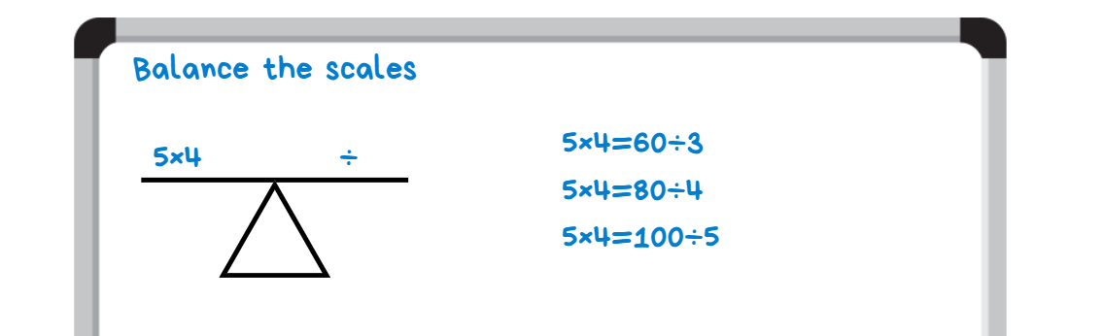
- Students compare answers, communicating and justifying their reasoning.
- Repeat this process for the following equations:
- 7 × 4
- 6 × 8.
- Change the sign in the yellow box to × and repeat the process for the following equations:
- 24 ÷ 3
- 48 ÷ 4
- 70 ÷ 5.
This table details opportunities for assessment.
Assessment opportunities | Links
What to look for:  - Can students use the equals sign to record equivalent number relationships involving multiplication? [MAO-WM-01, MA2-MR-01, MA2-MR-02] | Links to National Numeracy Learning Progressions (NNLP):  - NPA4.  Links to suggested Interview for Student Reasoning (IfSR) tasks:  - IfSR-MT: 2A.11.

Core lesson 1 – number slides – 20 minutes
The table below contains suggested learning intentions and success criteria. These are best co-constructed with students.
Core concept learning intentions | Core concept success criteria
Students are learning to:  - investigate number sequences involving related multiples  - recognise and represent numbers that are 10, 100 or 1000 times as large. | Students can:  - investigate number patterns involving related multiples  - describe how making a number 10, 100 or 1000 times as large changes the place value of digits.
This activity is an adaptation of Multiplication of large numbers from Arc Learning: Mathematics Curriculum Companion by State Government of Victoria (Department of Education).
- Establish fact family knowledge by writing on the whiteboard 8 × 3 = _. Ask students to record the equation and answer on their own whiteboard.
- Ask students what would happen if the 3 became 10 times as large, that is, if the 3 was 30. Students record the equation and answer on their whiteboard.
- Ask students what would happen if the 3 became 100 times as large, that is, if the 3 was 300. Students record the equation and answer on their whiteboard.
- Ask students what would happen if the 3 and the 8 became 10 times as large, that is, if the 3 was 30 and the 8 was 80. Students record the equation and answer on their whiteboard.
- Ask students what would happen if the 3 and the 8 became 100 times as large, that is, if the 3 was 300 and the 8 was 800. Students record the equation and answer on their whiteboard (see Figure 2).
Figure 2 – student whiteboard example
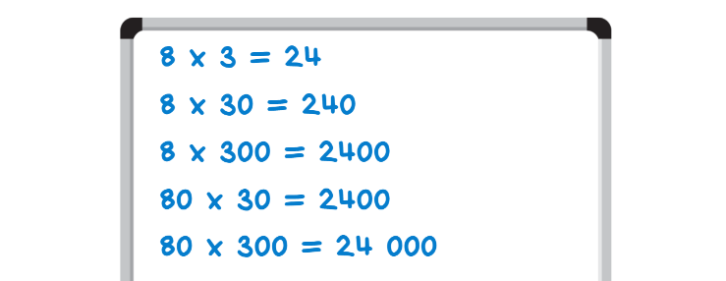
- As a class discuss:
- What do you notice about the numbers as the tens become bigger?
- What stays the same? What changes?
- Does this pattern help us to predict what will happen when looking at other numbers?
- Draw place value houses on the whiteboard with the numbers 24 and 240. Explain that using place value houses highlights how the numbers slide from one place value to the next when multiplying by powers of 10. Each time the numbers 8 or 3 (the multiplier and the multiplicand) are increased by 10, the digits in the answer move to the left by one place. For example, 24 increases to 240 (see Figure 3).
Figure 3 – teacher demonstration of number movement
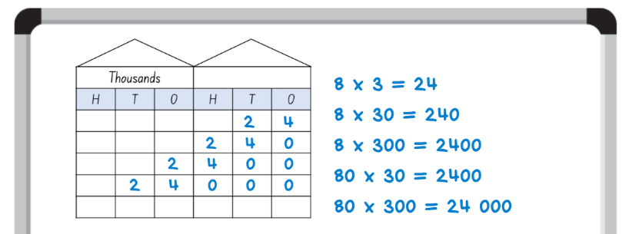

Core lesson 2 – large number multiplication – 20 minutes
This activity is an adaptation of Multiplication of large numbers from Arc Learning: Mathematics Curriculum Companion by State Government of Victoria (Department of Education).
- The aim of this activity is to complete multiplication number sentences. Students work in pairs, using their knowledge of place value to multiply large numbers.
- When it is Player A’s turn, Player B chooses 2 of the spinners from Resource 2 – large number spinners to be used. Each player spins one spinner.
- Player A determines the product of the 2 numbers selected by the spinners, recording these as an equation on a whiteboard. Player B checks their answer using a calculator (see Figure 4).
Figure 4 – large number multiplication student work
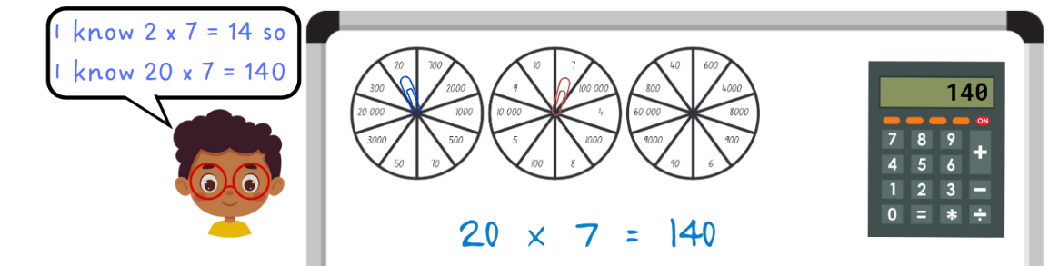
- Students repeat swapping roles.
This table details opportunities for differentiation.
Too hard? | Too easy?
Students cannot describe how making a number 10, 100 or 1000 times as large changes the place value of digits.  - Focus on making numbers 10 times as large before moving on to 100 times as large.  - Support students to use a calculator to make numbers 10, 100 or 1000 times as large and highlight the pattern that occurs. | Students can describe how making a number 10, 100 or 1000 times as large changes the place value of digits.  - In pairs, students create a number for their partner (initially using 2- or 3-digits numbers). Students must make their number 20, 200 and 2000 as large, explaining their reasoning to their partner.  - In pairs, students use yes and no questions to play Mastermind.

Discuss and connect the mathematics – 10 minutes
- Write 7 × 4 =_ on the whiteboard.
- Ask the students to record the equation and answer on their whiteboard, before making the multiplicand and the multiplier 10, 100 and 1000 times as large.
- Students record as many different equations as possible on their whiteboards.
- Students complete a gallery walk to observe the equations recorded by their classmates.
- Ask:
- Did you recognise any of the equations you recorded?
- Did you see some different equations?
- Can you describe the pattern to someone else?
- What makes this activity tricky?
- What do you already know that can make this activity easier?
This table details opportunities for assessment.
Assessment opportunities | Links
What to look for:  - Can students investigate number patterns involving related multiples? [MAO-WM-01, MA2-MR-01]  - Can students describe how making a number 10, 100 or 1000 times as large changes the place value of digits? [MAO-WM-01, MA2-RN-01] | Links to National Numeracy Learning Progressions (NNLP):  - NPA3, NPA4  - NPV8, NPV9.  Links to suggested Interview for Student Reasoning (IfSR) tasks:  - IfSR-NP: 4B.6.

Lesson 2
Core concept: known number facts and strategies support multiplicative understanding.

Daily number sense – guess the numbers on the dice – 15 minutes
The table below contains a suggested learning intention and success criteria. These are best co-constructed with students.
Daily number sense learning intention | Daily number sense success criteria
Students are learning to:  - represent and solve word problems with number sentences involving multiplication or division. | Students can:  - complete number sentences involving multiplication and division by calculating missing numbers.
- Provide pairs with two 6-sided dice and a whiteboard each.
- Player A closes their eyes or turns their back. Player B rolls 2 dice.
- Player B multiplies the numbers together and says the game chant. For example, after rolling a 3 and 4, Player B would say, ‘12 is the product to be precise, so guess the numbers on the dice’.
- Player B then covers the dice using their hand. Player A opens their eyes or turns back to face Player B.
- Player A uses their fact family knowledge to determine 2 numbers that would have that product. In the example above, Player A could guess either 3 and 4 or 6 and 2.
- Once Player A has guessed the correct numbers, both students use these numbers to write the fact family multiplication and division equations (see Figure 5).
Figure 5 – student work example
- Students share and compare equations, acknowledging the idea that ‘if I know this, then I also know this’. For example, if I know 3 times 4 is 12 then I also know 12 divided by 3 is 4.
This table details opportunities for assessment.
Assessment opportunities | Links
What to look for:  - Can students complete number sentences involving multiplication and division by calculating missing numbers? [MAO-WM-01,  MA2-MR-01, MA2-MR-02] | Links to National Numeracy Learning Progressions (NNLP):  - NPA4.

Core lesson 1 – using known strategies – 20 minutes
The table below contains a suggested learning intention and success criteria. These are best co-constructed with students.
Core concept learning intention | Core concept success criteria
Students are learning to:  - use known number facts and strategies. | Students can:  - apply the known strategy of doubling to connect multiples of 3 to 6 and 4 to 8  - use known facts to find unknown multiples.
- Display Resource 3 – best strategy.
- Explain to students that Anthony does not know how to work out 9 × 8 but his friends have some ideas that may help.
- In pairs, students determine:
- What strategies have been used by the friends?
- Are their solutions correct?
- Is any strategy better than the others? Why or why not?
- Which strategy is the same as, or closest to, their own preferred strategy?
- As a class, discuss the findings, ensuring that the strategies of double double, double double plus one and using multiple and benchmark number knowledge are established.

Core lesson 2 – footy final frenzy – 20 minutes
This activity is an adaptation of Build an Army: Times Tables from TES by Barton.
- Give each student a copy of Resource 4 – footy final cards to cut out.
- Students use their Resource 4 – footy final cards to create 10 players for their footy or soccer team. Each player is made by creating a different multiplication equation such as 12 × 6. Each card can only be used once. Students also determine a team list that puts each player in the order they will be played in the game.
- Once they have created their team, students play against another team. Students takes turns to put forward a player to match up against a player from the opposing team. The player who has the highest product scores a try or goal for their team (see Figure 6).
Figure 6 – game example with reduced players
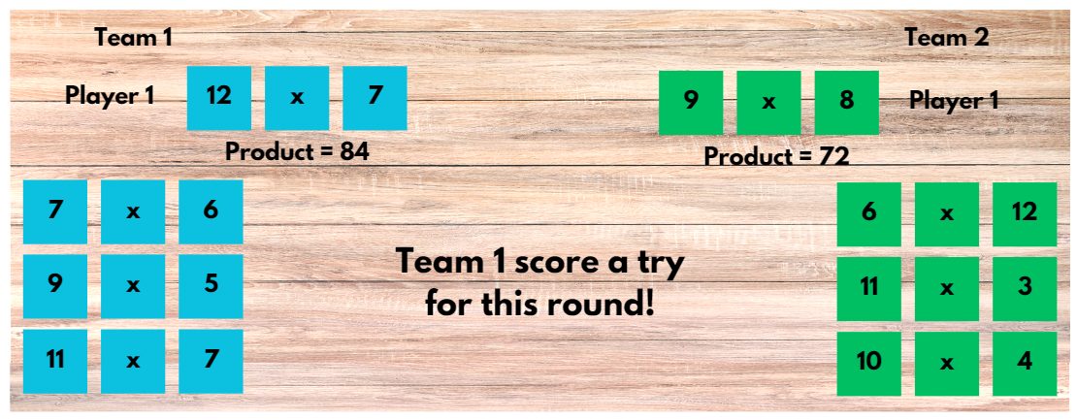
- The game is over once all players have been used. The team with the most tries or goals is the winner.
- Students remake their players, create a new team list and find a new opponent to play against.
This table details opportunities for differentiation.
Too hard? | Too easy?
Students cannot use known facts to find unknown multiples.  - Ask students to make only 5 players for their teams and use known multiplication facts.  - Assist students by providing support materials/resources such as multiplication fact grids or calculators. | Students can use known facts to find unknown multiples.  - Students can make a joker card. They can negotiate what the joker card can do during the game. Some suggestions include: it could swap out a number and become any number they like, the joker might reduce a partner's number by half or it could double one of your numbers.  - Challenge students to make players that must contain both odd and even numbers.

Discuss and connect the mathematics – 10 minutes
- Ask:
- What strategies did you use to help calculate the product of the player cards?
- What was your strategy when creating your player list?
- Did you find a strategy that helped you win most of the time? Why or why not?
This table details opportunities for assessment.
Assessment opportunities | Links
What to look for:  - Can students apply the known strategy of doubling to connect multiples of 3 to 6 and 4 to 8? [MAO-WM-01, MA2-MR-01]  - Can students use known facts to find unknown multiples?  [MAO-WM-01, MA2-MR-01] | Links to National Numeracy Learning Progressions (NNLP):  - MUS6.  Links to suggested Interview for Student Reasoning (IfSR) tasks:  - IfSR-MT: 2A.2, 2A.4, 2A.6.

Lesson 3
Core concept: structures can support multiplicative thinking.

Daily number sense – double double – 10 minutes
The table below contains a suggested learning intention and success criteria. These are best co-constructed with students.
Daily number sense learning intention | Daily number sense success criteria
Students are learning to:  - represent and solve word problems with number sentences involving multiplication or division. | Students can:  - represent and solve multiplication word problems using number sentences.
- Display Resource 5 – How much?
- As a class, discuss strategies the students think will help work this out. If not suggested by the students, ask if the doubling or double double strategy would be helpful here.
- Together, work through how the double double strategy could work, recording ideas on a whiteboard. For example, one shirt is $16, so double means 2 shirts are $32, so double again means 4 shirts are $64. One extra shirt is still required, which means 5 shirts will cost $80.
- Ask students to use the same strategy to solve the following problem: One cake costs $22. What is the cost of buying 5 cakes?
- Independently or in pairs, students use the double double strategy to solve this problem.
- Students share and compare their solutions. Ask students to identify where and how they used the double double strategy in their solution.
This table details opportunities for assessment.
Assessment opportunities | Links
What to look for:  - Can students represent and solve multiplication word problems using number sentences? [MAO-WM-01, MA2-MR-01,  MA2-MR-02] | Links to National Numeracy Learning Progressions (NNLP):  - NPA4.

Core lesson – reasoning chains – 35 minutes
The table below contains suggested learning intentions and success criteria. These are best co-constructed with students.
Core concept learning intentions | Core concept success criteria
Students are learning to:  - use the structure of the area model to represent multiplication and division  - apply place value to partition and regroup numbers up to 4 digits. | Students can:  - create and represent multiplicative structure  - record numbers using standard place value form.
This activity is an adaptation of ‘Reasoning chains’ from A Practical Guide to Transforming Primary Mathematics: Activities and tasks that really work by Askew.
- Draw a 4 × 3 area model and a rectangle which would create a 4 × 3 grid if completed (see Figure 7). Ask students to explain how they know the total area covered is 12 in both diagrams. Record the equation and correct answer.
Figure 7 – 4 × 3 area model
- Write 4 × 10 on the whiteboard.
- Students record the equation onto their own whiteboard and draw a diagram to determine the answer.
- Ask students to share their answers, recording their ideas on the whiteboard.
- Draw a 4 × 10 area model and a rectangle which would create a 4 × 10 grid if extended. Record the equation and correct answer (see Figure 8).
Figure 8 – 4 × 10 area model
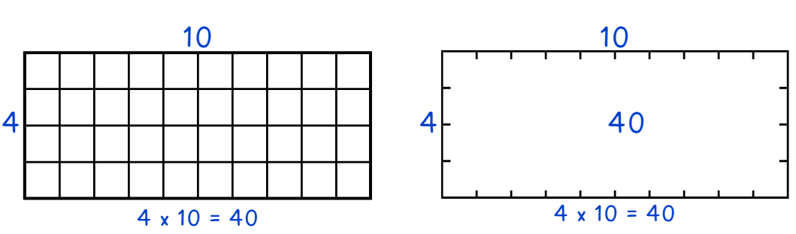
- Write 4 × 13 on the whiteboard.
- Ask:
- Could partitioning be used to solve this problem?
- How could this be represented using the area model?
- Is there more than one way that the area model could be used here?
- Students record the equation onto their own whiteboard and draw a diagram to determine the answer.
- Ask students to share their answers, explaining how the strategy was used.
- Draw a 4 × 13 area model on the whiteboard, recording the equation and correct answer below it (see Figure 9).
Figure 9 – 4 × 13 array
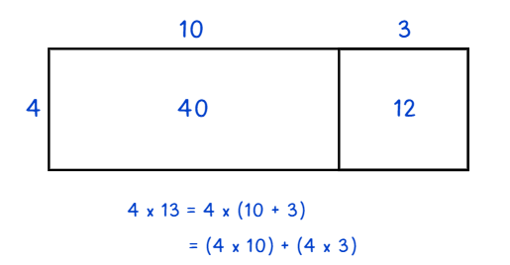
- Discuss how this is similar or different to the student's ideas.
- Write 5 × 4, 5 × 10 and 5 × 14 as a list on the whiteboard.
- Students complete the same steps as above to calculate these equations using the area model for multiplication.
- In pairs, students compare their results, explaining their use of the strategies.
This table details opportunities for differentiation.
Too hard? | Too easy?
Students cannot create and represent multiplicative structure.  - Support students by reducing the size of the numbers they are trying to partition and multiply. For example, students could use the chain 4 × 2, 4 × 5, 4 × 7.  - Assist students by providing support materials/resources such as MAB materials, counters, times table grids, grid paper or the digital area model tool. | Students can create and represent multiplicative structure.  - Challenge students to use this strategy to multiply larger numbers such as 36, 57 or 84 by a single digit number of their choosing.  - Ask students to use this strategy to find the solution to 5 × 6 and 5 × 9. Ask students if these answers can then help them to determine the answer to 5 × 15 or 5 × 18 more easily. Explain to a classmate how they used these equations effectively.

Consolidation and meaningful practice – 15 minutes
- Write 7 × 16 on the whiteboard.
- Ask students to identify ways to partition the numbers to make the multiplication easier or more efficient.
- Students record the equations that could be added together to have the same product as 7 × 16. For example, 7 × 10 and 7 × 6 or 7 × 11 and 7 × 5. Students draw an area model diagram to show how these partitioned equations have the same product as 7 × 16.
- Select students to share their solution with the class.
This table details opportunities for assessment.
Assessment opportunities | Links
What to look for:  - Can students create and represent multiplicative structure?  [MAO-WM-01, MA2-MR-01]  - Can students record numbers using standard place value form? [MAO-WM-01, MA2-RN-01] | Links to National Numeracy Learning Progressions (NNLP):  - MuS5, MuS6  - NPV4, NPV5, NPV6.  Links to suggested Interview for Student Reasoning (IfSR) tasks:  - IfSR-MT: 2A.3  - IfSR-AT: 3B.2.

Lesson 4
Core concept: multiplication and division are related.

Daily number sense – 10 minutes
- From a class need surfaced through formative assessment data, identify a short, focused activity that targets students’ knowledge, understanding and skills. Example activities may be drawn from the following resources:
- Mathematics K–6 resources
- Universal Resources Hub.

Core lesson 1 – inverse relations – 15 minutes
The table below contains suggested learning intentions and success criteria. These are best co-constructed with students.
Core concept learning intentions | Core concept success criteria
Students are learning to:  - represent and solve problems involving multiplication fact families  - represent and solve word problems with number sentences involving multiplication or division. | Students can:  - apply the inverse relationship of multiplication and division  - complete number sentences involving multiplication and division by calculating missing numbers.
- Write 8 × 5 on the whiteboard.
- Students record it in their workbook and complete the equation.
- Select students share their solutions and communicate their thinking. Record strategies and solutions on the whiteboard and ask students to turn and talk to discuss.
- Ask students: What else is known if we know 8 × 5 = 40?
- Students record the multiplication and division fact families in their workbook or on a whiteboard and share with a classmate.
- Write 8 × 7 on the whiteboard. Ask students to use what they know about 8 × 5 to work out 8 × 7. Discuss different strategies.
- Students to record all the multiplication and division facts they know about this combination.

Core lesson 2 – ‘Keep in step’ – 20 minutes
- Provide groups of 3 students a 10-sided dice (1–10), a whiteboard and 3 different coloured markers.
- One player rolls the dice to determine the starting number.
- Player A uses that number to make a known multiplication equation, using numbers below 12. For example, if a 4 was rolled the chosen equation could be 4 × 3 = 12. This is recorded on the whiteboard.
- Player B uses the answer to create a division equation. They can use a fact from the multiplication and division fact family or create a different equation altogether, such as 12 ÷ 6 = 2. This is recorded on the whiteboard, under the original equation, lining up the connecting number (see Figure 10).
- Player C uses the answer to create a new multiplication equation. This is recorded on the whiteboard, following the step pattern (see Figure 10).
Figure 10 – ‘Keep in step’ game example
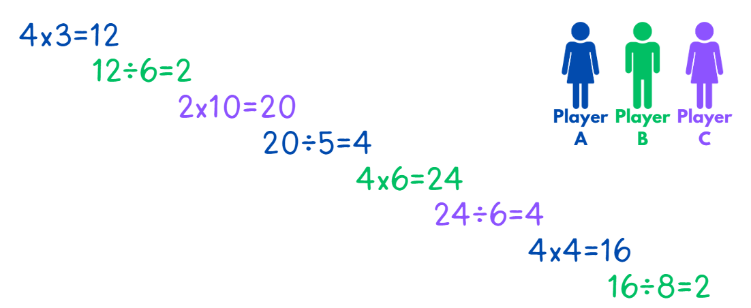
- Players are unable to repeat an equation again during the game. The players continue to take turns until one player is unable to go.
- After the game, ask:
- Did you roll any numbers that made starting the game difficult?
- Which numbers were easiest or hardest to use when multiplying?
- Which numbers were easiest or hardest to use when dividing?
This table details opportunities for differentiation.
Too hard? | Too easy?
Students cannot apply the inverse relationship of multiplication and division.  - Support students by reducing the size of the numbers they multiply and divide. For example, students could use a 6-sided dice.  - Assist students by providing support materials/resources such as counters, number lines and multiplication grids. | Students can apply the inverse relationship of multiplication and division.  - Challenge students to use a 12- or 20-sided dice to begin.  - Encourage students to investigate which numbers can or can’t be used at the start of the game. If the game was to start with division, would those numbers be the same. Identify if these numbers belong to the same group in any way.

Consolidation and meaningful practice – 15 minutes
- Present the following problem: Nuggets come in boxes of 6. We need 24 nuggets altogether. How many boxes of nuggets do we need?
- Ask students to represent this using both a multiplication and division equation. For example, 6 × 4 = 24 and 24 ÷ 6 = 4.
- Students compare answers with a classmate and justify their solutions.
- Ask students to determine how many chicken nuggets people would get if there were 8 people at the party.
- Students record their answer using both a multiplication and division equation.
This table details opportunities for assessment.
Assessment opportunities | Links
What to look for:  - Can students apply the inverse relationship of multiplication and division? [MAO-WM-01, MA2-MR-01, MA2-MR-02]  - Can students complete number sentences involving multiplication and division by calculating missing numbers? [MAO-WM-01,  MA2-MR-02] | Links to National Numeracy Learning Progressions (NNLP):  - MuS7  - NPA4.  Links to suggested Interview for Student Reasoning (IfSR) tasks:  - IfSR-MT: 2A.5, 2A.10.

Lesson 5
Core concept: doubling and halving are powerful strategies.

Daily number sense – make it true – 10 minutes
Daily number sense activities for Lessons 5 to 7 ‘loop’ back to concepts and procedures covered in previous units to assist students to build an increasingly connected network of ideas. These concepts may differ from the core concepts being covered by the unit.
The table below contains a suggested learning intention and success criteria. These are best co-constructed with students.
Daily number sense learning intention | Daily number sense success criteria
Students are learning to:  - complete number sentences involving additive relations to find unknown quantities. | Students can:  - calculate missing numbers by completing number sentences involving addition and subtraction.
This activity is an adaptation of Subtraction with Regrouping 2 by Ignaciuk from the Open Middle website.
- Draw Figure 11 on the whiteboard.
Figure 11 – number sign
- In pairs, students use digits 1–9 (only once each), placing a digit in each box to make the number sentence correct. For example, 56 − 17.
- As a class, share and compare solutions. Ask students to identify the strategies they used and justify their choices.
This table details opportunities for assessment.
Assessment opportunities | Links
What to look for:  - Can students calculate missing numbers by completing number sentences involving addition and subtraction? [MAO-WM-01, MA2-AR-01, MA2-AR-02] | Links to National Numeracy Learning Progressions (NNLP):  - NPA3, NPA4.  Links to suggested Interview for Student Reasoning (IfSR) tasks:  - IfSR-AT: 2A.1, 2A.4, 2A.5.

Core lesson – doubling and halving are powerful strategies – 40 minutes
The table below contains suggested learning intentions and success criteria. These are best co-constructed with students.
Core concept learning intentions | Core concept success criteria
Students are learning to:  - use known number facts and strategies  - use arrays to establish multiplication facts from multiples of 2 and 4, 5 and 10. | Students can:  - use known facts to find unknown multiples  - recognise that doubling is multiplying by 2 and halving is dividing by 2  - recognise the relationship between one multiple and its double.
This lesson is an adaptation of Doubling and halving: number talk from Mathematics K–6 resources by State of New South Wales (Department of Education). Review Doubling and halving: number talk prior to the lesson to become familiar with this number talk protocol.
- Record the equations 3 × 10 and 6 × 5 on the board. Ask students to represent the equations by drawing 2 separate arrays on grid paper.
- Discuss the 2 arrays using the following prompts for guidance.

The table below outlines stimulus prompts to generate conversation about the topic, along with anticipated responses from students.
Prompts | Anticipated student responses
- What do you notice about the 2 arrays? | - The arrays look different but still have the same number of squares.
- What is the same and/or different about these 2 arrays? | - Both have an odd and even number of rows and columns.  - Both arrays have the same product but different factors.  - Both arrays have the same number of squares but are arranged in a different way.
- Can you see any connections between the 2 arrays? | - The factors of one array are double and half the factors of the other.
- Record 2 more equations on the board, 4 × 9 and 2 × 18. Ask:
- Without multiplying or drawing the arrays, can you work out whether both equations have the same product?
- How do you know?
- Explain that doubling one factor and halving the other factor can be a very efficient way to solve multiplication problems.
- Students choose different pairs of 1- or 2-digit factors and investigate how they could use the doubling and halving strategy to find the product. Students record their thinking, for example using grid paper or dot paper.
- Students then find 3 examples where doubling and halving is not a helpful strategy.
- Regroup as a class to reflect on the strategy, using the prompts below for guidance.
The table below outlines stimulus prompts to generate conversation about the topic, along with anticipated responses from students.
Prompts | Anticipated student responses
- Does doubling and halving always or only sometimes work? Why? | - It always works because it regroups the factors.  - It always works because it uses the associative properties of multiplication.
- When is doubling and halving an efficient strategy for solving multiplication problems? | - It works best when one or both factors are even.  - It works best when one factor is a benchmark number like 5, 10, 25, 50 or 100.  - It works best when you don’t have to double and halve too many times before you find a known fact.
- Summarise the lesson, reinforcing the relationship between doubling as multiplying by 2 and halving as dividing by 2. Ask students:
- Is doubling and halving a useful multiplication strategy? Why or why not?
- How might the doubling and halving strategy help solve multiplication problems with larger numbers?
- Which types of problems are not suited to the doubling and halving strategy? Why?
This table details opportunities for differentiation.
Too hard? | Too easy?
Students cannot use known facts to find unknown multiples.  - Provide students with concrete materials to model the relationship between doubling and halving.  - Provide students with pairs of one-digit factors to double and halve.  - Students use connecting cubes or arrays to help them identify doubles and halves of larger factors. | Students can use known facts to find unknown multiples.  - Students apply the strategy to 2-digit and 3-digit numbers.  - Students build on the doubling and halving strategy to investigate tripling and thirding, such as 5 × 6 = 15 × 2.

Consolidation and meaningful practice – 10 minutes
- Display Resource 6 – What number?
- Allow students independent thinking time before working together in pairs to solve the problem.
- Regroup and select students to explain their answers.
- Record all responses on the whiteboard.
- Ask students what they notice about all the answers. Anticipated responses include:
- The starting number will be even because it can be halved into 2 whole numbers.
- The number is a multiple of 32.
This table details opportunities for assessment.
Assessment opportunities | Links
What to look for:  - Can students use known facts to find unknown multiples?  [MAO-WM-01, MA2-MR-01]  - Can students recognise that doubling is multiplying by 2 and halving is dividing by 2? [MAO-WM-01, MA2-MR-01]  - Can students record numbers using standard place value form? [MAO-WM-01, MA2-RN-01] | Links to National Numeracy Learning Progressions (NNLP):  - MuS6  - InF2, InF6  - NPA3, NPA4.

Lesson 6
Core concept: number properties can be used to solve multiplication problems.

Daily number sense – create an equation – 15 minutes
The table below contains a suggested learning intention and success criteria. These are best co-constructed with students.
Daily number sense learning intention | Daily number sense success criteria
Students are learning to:  - complete number sentences involving additive relations to find unknown quantities. | Students can:  - find the missing number in an equivalent number sentence involving operations of addition or subtraction on both sides of the equals sign.
This activity is an adaptation of Adding and subtraction two-digit whole numbers by Errey from the Open Middle website.
- Teacher draws Figure 12 on the whiteboard.
Figure 12 – equation
- In pairs, students use digits 0–9 (only once each), placing a digit in each box to make a correct equation. For example, 78 − 40 = 15 + 23.
- As a class, share and compare solutions. Ask students to identify the strategies they used and justify their choices.
This table details opportunities for assessment.
Assessment opportunities | Links
What to look for:  - Can students find the missing number in an equivalent number sentence involving operations of addition or subtraction on both sides of the equals sign? [MAO-WM-01, MA2-AR-01,  MA2-AR-02] | Links to National Numeracy Learning Progressions (NNLP):  - NPA3, NPA4.  Links to suggested Interview for Student Reasoning (IfSR) tasks:  - IfSR-AT: 2A.1, 2A.4, 2A.5.

Core lesson 1 – fact family bonanza – 30 minutes
The table below contains suggested learning intentions and success criteria. These are best co-constructed with students.
Core concept learning intentions | Core concept success criteria
Students are learning to:  - use number properties to find related multiplication facts  - operate with multiples of 10. | Students can:  - use the commutative property of multiplication  - use multiplication facts with multiples of 10 to multiply a one-digit number by a multiple of 10  - use place value to rename groups of 10 to multiply.
Note: understanding the commutative property of multiplication gives students flexibility with strategies and reduces the number of multiplication facts students need to memorise.
- Draw 3 fact family triangles on the board: 6, 2, 3 and 60, 20, 3 and 600, __, 3 (see Figure 13).
Figure 13 – fact family triangles
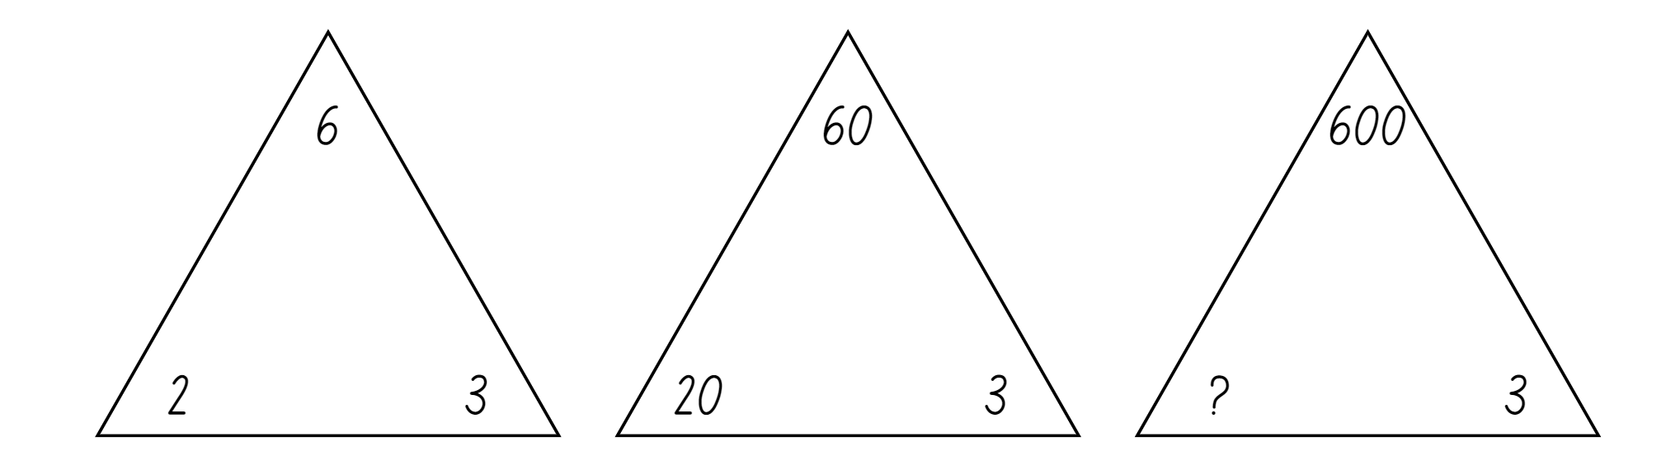
- Ask students:
- What do you notice about the fact families?
- How does the value of the digit 6 change in the numbers?
- How can renaming 60 as 6 tens help find its fact families?
- How do the multiplication and division facts for 6 relate to the fact family for 60?
- What number is missing in the third fact family? Explain how you know.
- Draw a table on the whiteboard and record the number 60 above it. Label one side division facts and the other side multiplication facts.
- Students provide as many multiplication and division facts as they can for both sides. Record the equations in the table (see Figure 14).
Figure 14 – facts for 60
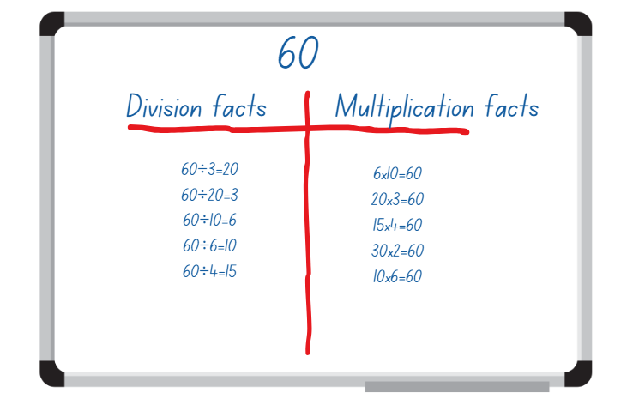
- Remind students that factors can be multiplied in any order and the product remains the same. This is called the commutative property of multiplication.
- Select students to identify facts from the table which show the commutative property. For example, 6 × 10 = 60 and 10 × 6 = 60. Circle these equations. Ask students to offer a fact that would show the commutative property of another multiplication fact.
Commutative property: commutative property of addition or multiplication means that 2 numbers can be added or multiplied in any order and the solution will be the same. Commutative law, commutativity and turn-around facts are interchangeable terms.
- Record the numbers 12 and 120 on the board.
- Students find as many multiplication and division facts as they can for 12 and record them in a table in their workbooks. They use these facts to help them complete a fact table for 120. Identify equations that show the commutative property.
- Regroup and ask:
- How does understanding place value help find factors and multiples of numbers 10 times or 100 times as large?
- Did you find all of factors of 120? How do you know?
- Were there more division or multiplication equations recorded? Why or why not?
- How would you explain the commutative property to someone who did not know about it yet?
- Students repeat this activity using the numbers 8 and 800.

This table details opportunities for differentiation.
Too hard? | Too easy?
Students cannot use place value to rename groups of 10 to multiply.  - Provide students with manipulatives, such as linking cubes or counters, to rearrange numbers into different forms without changing their value.  - Students sort and then re-sort a variety of 1-, 2- and 3-digit numbers based on the place value of a single digit. | Students can use place value to rename groups of 10 to multiply.  - Students investigate fact families for multiplies of 100 and 1000.  - Students play Mastermind to explore patterns including the pattern of ones, tens and hundreds inside each place value period.

Consolidation and meaningful practice – 15 minutes
This activity is an adaptation of Multiplication toss from Mathematics K–6 resources by State of New South Wales (Department of Education).
- Provide pairs of students with Resource 7 – multiplication toss spinner, one sheet of grid paper, paperclips to use as spinners and 2 different coloured markers.
- Each player takes a turn to spin the spinners. If a 5 and 6 are spun, the player can enclose a block of 5 rows of 6 (5 sixes) or use the commutative property and enclose 6 rows of 5 (6 fives). The player records their turn as a number sentence, for example 5 × 6 = 30.
- Players can also choose to use the distributive property and partition numbers if that helps fit the block on the game board. For example, 5 sixes can be renamed as 2 sixes and 3 sixes and recorded as (2 × 6) + (3 × 6) = 30.
- Students are not allowed to overlap their area with another player’s area.
- The winner is the player with the largest area blocked out after 10 spins.
This table details opportunities for assessment.
Assessment opportunities | Links
What to look for:  - Can students use the commutative property of multiplication? [MAO-WM-01, MA2-MR-01]  - Can students use multiplication facts with multiples of 10 to multiply a one-digit number by a multiple of 10? [MAO-WM-01, MA2-MR-01]  - Can students use place value to rename groups of 10 to multiply? [MAO-WM-01, MA2-MR-01] | Links to National Numeracy Learning Progressions (NNLP):  - MuS6, MuS7.  Links to suggested Interview for Student Reasoning (IfSR) tasks:  - IfSR-NP: 4B.6.

Lesson 7
Core concept: number properties can be used to solve multiplication problems.

Daily number sense – worded problems – 15 minutes
The table below contains a suggested learning intention and success criteria. These are best co-constructed with students.
Daily number sense learning intention | Daily number sense success criteria
Students are learning to:  - complete number sentences involving additive relations to find unknown quantities. | Students can:  - create word problems that correspond to given addition and subtraction number sentences.
- Write 15 + _ = 38 on the whiteboard.
- Ask students to write a word problem to match this addition equation. For example, Farmer Kai collected 15 eggs from his chickens in week one, but he forgot to count how many eggs he collected in week 2. He collected 38 eggs altogether, how many eggs did Farmer Kai collect in week 2?
- In pairs, students share their word problems, ensuring that the equation is correct.
- Write 24 − _ = 13 on the whiteboard.
- In pairs, ask students to write a word problem to suit this subtraction equation. For example, Dawn placed 24 fish in her new pond. When she checked on her fish the next day, Dawn could only find 13 fish. How many fish were missing from the pond?
- Students share their word problems, ensuring that the equation is correct.
- Students take turns to write an equation for their partner to answer with a worded problem.
This table details opportunities for assessment.
Assessment opportunities | Links
What to look for:  - Can students create word problems that correspond to given addition and subtraction number sentences? [MAO-WM-01,  MA2-AR-01, MA2-AR-02] | Links to National Numeracy Learning Progressions (NNLP):  - NPA3, NPA4.  Links to suggested Interview for Student Reasoning (IfSR) tasks:  - IfSR-AT: 2A.1, 2A.4, 2A.5.

Core lesson – multiple factors game – 35 minutes
The table below contains a suggested learning intention and success criteria. These are best co-constructed with students.
Core concept learning intention | Core concept success criteria
Students are learning to:  - use number properties to find related multiplication facts. | Students can:  - use the associative property within multiplication to regroup factors  - use flexible partitioning within multiplication  - generate and recall multiplication fact families up to 10 × 10.
This activity is an adaptation of Factors and Multiples Game from NRICH by University of Cambridge.
- Write the number 18 on the whiteboard. Have students write down one pair of factors for that product. Students compare and discuss their choice of factors with a partner.
- Record the pairs of factors presented by the class.
- Students turn and talk to identify patterns in the list of factors, such as the commutative property or doubling and halving.
- Identify one pair of factors, 9 × 2, and ask students if this is the same or different from 3 × 3 × 2.
- Ask students what other pair of factors could also be expressed as 3 × 3 × 2.
- Remind students that when 2 or more numbers are multiplied, the product stays the same regardless of how the factors are grouped. This is called the associative property of multiplication.
Associative property: when more than 2 numbers are added or multiplied, the result is unchanged regardless of how they are grouped or associated. For example, 6 × 3 × 2 can be calculated as 18 × 2 or 6 × 6 or 12 × 3.
- Repeat this sequence with other numbers, for example 12, 24, or 36.
- Display Resource 8 – multiple gameboard.
- Explain that the game needs 2 players. The teacher will be Player A while the class will play the role of Player B.
- As Player A, choose a 2-digit number from the gameboard. Highlight it and record the number in the score sheet. This is Player A’s total number of points for the round.
- Player B, the class, now identifies sets of factors. Highlight these factors on the gameboard and record them in their score sheet. Find the sum of these factors and record the total as Player B’s points for this round (see Figure 15).
Figure 15 – sample score sheets 1
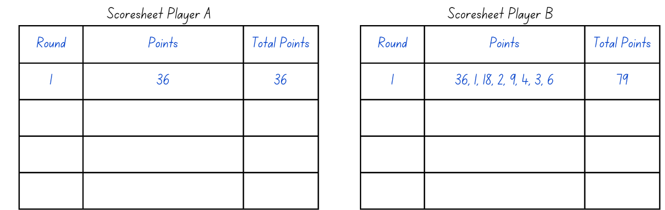
- If Player B misses any factors, Player A may cover them and add the points to their total.
- For the next round, Player B selects a 2-digit product and Player A identifies the factors. Player A highlights all factors on the gameboard that are not already highlighted (see Figure 16).
Figure 16 – sample score sheets 2
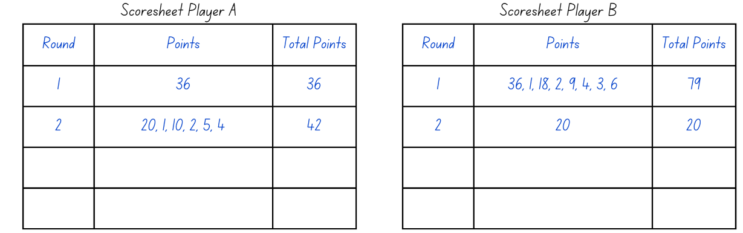
- Model several rounds until students are familiar with the game.
- Explain that factors and products can be highlighted more than once. The game continues until all possible factors and products have been highlighted. Players total their scores and the player with the highest score wins.
- Distribute one Resource 8 – multiple gameboard and 2 different coloured markers to pairs of students. Each student will need their own copy of Resource 9 – score sheet. Students play the game with a partner.
- When students have completed the game, ask:
- How did you find the factors of the target numbers?
- Did you use a strategy to choose your target number? If yes, which one?
- How did your understanding of the associative property help you to find the factors of the target number?
- Did your understanding of the commutative property help you in playing this game? Why or why not?
This table details opportunities for differentiation.
Too hard? | Too easy?
Students cannot use the associative property within multiplication to regroup factors.  - Students play the online version of Factors and multiples to get immediate feedback on their choice of factors.  - Students identify and partition the factors of the target numbers on the gameboard before starting the game.  - Students access a multiplication grid to identify factors of a target number. | Students can use the associative property within multiplication to regroup factors.  - Students determine which numbers on the gameboard have more than 2 sets of factor pairs and discuss how this can be used as a strategy to choose target numbers.  - Students make their own ‘Multiples’ gameboard by choosing different products.

Discuss and connect the mathematics – 15 minutes
- Display the problem: On our classroom wall there are 8 shelves with 25 books on each shelf. How many books are there on our wall?
- Explain that students will use the associative property to solve this problem.
- Regroup as a class and discuss:
- What was the first step you took to solve this problem?
- Do you think using the associative property helped in solving the task? Why or why not?
- Would you use this strategy to solve this problem if there were 100 books on each shelf? Why or why not?
- Can you write an equation using the associative property to express your grouping ideas?
- Can you think of other real-life situations where the associative property could help make calculations easier?
This table details opportunities for assessment.
Assessment opportunities | Links
What to look for:  - Can students use the associative property within multiplication to regroup factors? [WAO-WM-01, MA2-MR-01]  - Can students use flexible partitioning within multiplication?  [MAO-WM-01, MA2-MR-01]  - Can students generate and recall multiplication fact families up to 10 × 10? [WAO-WM-01, MA2-MR-01] | Links to National Numeracy Learning Progressions (NNLP):  - MuS6, MuS7.  Links to suggested Interview for Student Reasoning (IfSR) tasks:  - IfSR-MT: 2A.7.

Lesson 8
Core concept: number properties can be used to solve multiplication problems.

Daily number sense – 10 minutes
- From a class need surfaced through formative assessment data, identify a short, focused activity that targets students’ knowledge, understanding and skills. Example activities may be drawn from the following resources:
- Mathematics K–6 resources
- Universal Resources Hub.

Core lesson 1 – challenging facts – 15 minutes
The table below contains suggested learning intentions and success criteria. These are best co-constructed with students.
Core concept learning intentions | Core concept success criteria
Students are learning to:  - use number properties to find related multiplication facts  - apply place value to partition and regroup numbers. | Students can:  - use flexible partitioning within multiplication  - generate and recall multiplication fact families up to 10 × 10  - record numbers using standard place value form.
This activity is an adaptation of Mathematical proofs in primary school by Russo.
- Remind students that when solving multiplication problems, some numbers can be partitioned using knowledge of place value and addition to make the numbers easier to work with. This is due to the distributive property of multiplication. It can help students work out unknown multiplication facts from known multiplication facts.
The distributive property: multiplication of numbers is distributive over addition because the product of one number with the sum of 2 others equals the sum of the products of the first number with each of the others. For example, the product of 3 with (4 + 5) gives the same result as the sum of 3 × 4 + 3 × 5.
- Display Resource 10 – partitioned arrays. Ask students how many dots are in the array and consider how they could make the array easier to work with by partitioning it into different sections. For example, see Figure 17.
Figure 17 – examples of partitioned arrays
- Ask:
- Which multiplication and division facts up to 10 × 10 do you find the easiest to recall. Why?
- Which multiplication and division facts do you find more challenging to recall? Why?
- Record the challenging recall facts on the whiteboard.
- Select a challenging recall fact from the whiteboard and ask students to consider what numbers could be partitioned to help generate this fact, such as 8 × 6 = (4 × 6) + (4 × 6) or (5 × 6) + (3 × 6). Students turn and talk and discuss their strategies.
- Regroup and ask individual students to explain which factors they partitioned and demonstrate their thinking by drawing a partitioned array.
- Students apply the distributive law to the remaining examples in the list of challenging multiplication facts. They record their thinking using arrays or tables and write the matching number sentences.

Core lesson 2 – Prove it! – 25 minutes
- Pose the following scenario: A student in another class said that having all the multiplication facts up to 10 × 10 is all you need to easily work out facts up to 10 × 12.
- Ask students if this statement is true or false.
- Students pair with another student who has adopted the same position, true or false. The pair work together to prove that the statement is true or false and justify their thinking. For example, they use partitioned arrays and number sentences.
- Emphasise that the focus will be on their reasoning and representations as well as the language used to communicate thinking.
- Ask:
- How did you begin to think about the problem?
- How did you start to organise and represent your thinking? Did this change as you worked through the activity?
- Which skills or concepts, such as known facts or the distributive property, did you use?
- How confident are you that you have proven the statement is true or false? Why?
- Can you explain how your answer is the same as or different from another student’s answer?
- Does anyone want to change their position from true to false or false to true?
This table details opportunities for differentiation.
Too hard? | Too easy?
Students cannot use flexible partitioning within multiplication.  - Draw a 6 × 6 array on grid paper and partition the array by cutting it into smaller arrays. Support students to connect the addition of these arrays to 6 × 6 multiplication facts.  - Students use concrete materials to partition 24 into equal groups and identify that the product remains the same even if the number of equal groups changes. | Students can use flexible partitioning within multiplication.  - Students roll 2 dice to find ways of multiplying more challenging numbers using the distributive property. For example, 14 × 5 becomes (7 × 5) + (7 × 5).  - Students create word problems using a number sentence and the distributive property.

Consolidation and meaningful practice – 15 minutes
- Display Resource 11 – too many dice.
- Ask students:
- What do you notice about this image?
- Can you see any patterns?
- How many dots are on top of each of the dice?
- What strategies did you use to count them?
- Which strategies do you think were most efficient?
This table details opportunities for assessment.
Assessment opportunities | Links
What to look for:  - Can students use flexible partitioning within multiplication?  [MAO-WM-01, MA2-MR-01]  - Can students generate and recall multiplication fact families up to 10 × 10? [MAO-WM-01, MA2-MR-01]  - Can students record numbers using standard place value form? [MAO-WM-01, MA2-RN-01] | Links to National Numeracy Learning Progressions (NNLP):  - MuS7, MuS8  - NPV4, NPV5, NPV6.

Resource 1 – balance the scales

Resource 2 – large number spinners
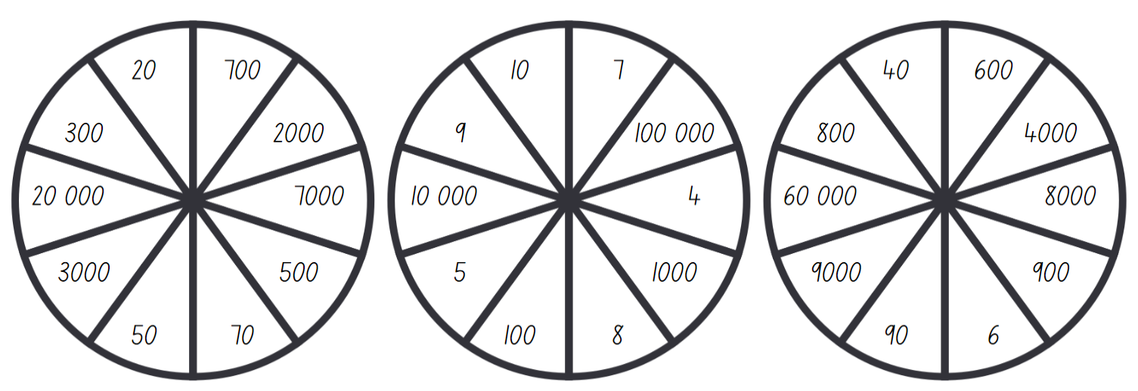

Resource 3 – best strategy
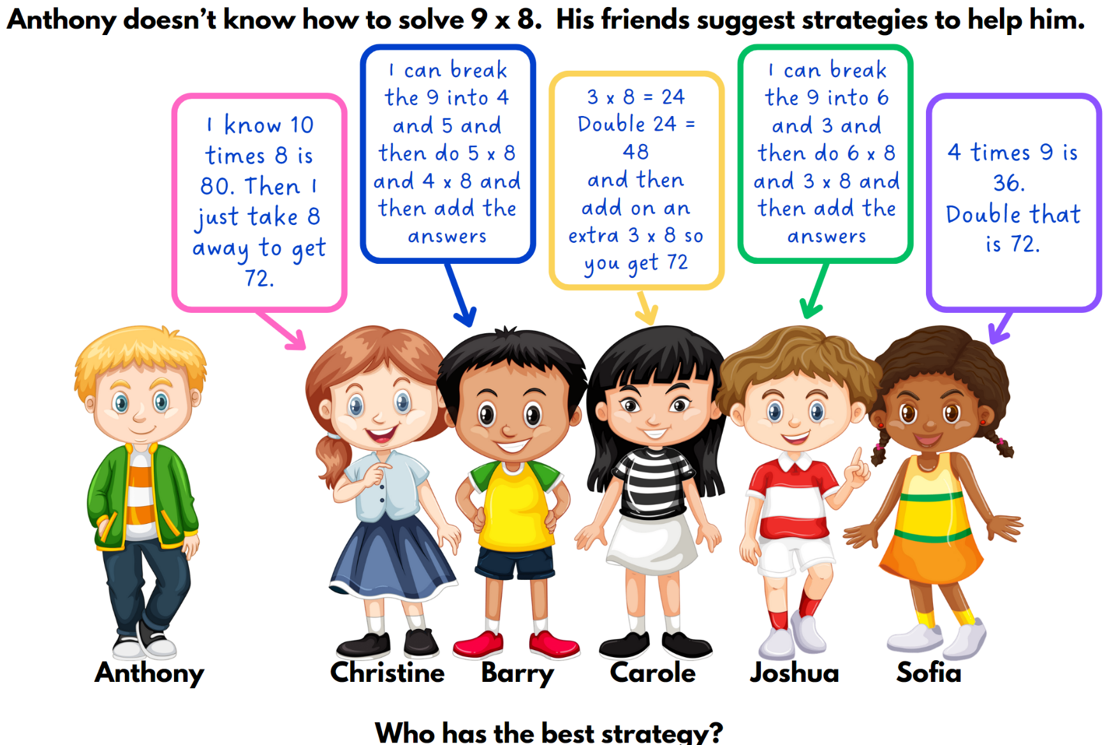

Resource 4 – footy final cards
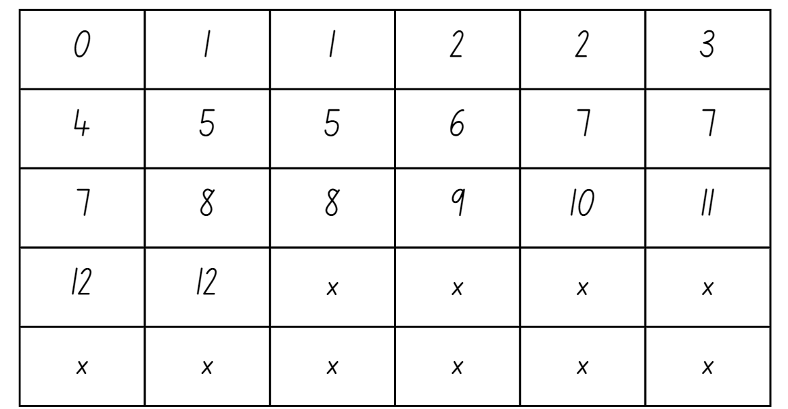

Resource 5 – How much?

Resource 6 – What number?
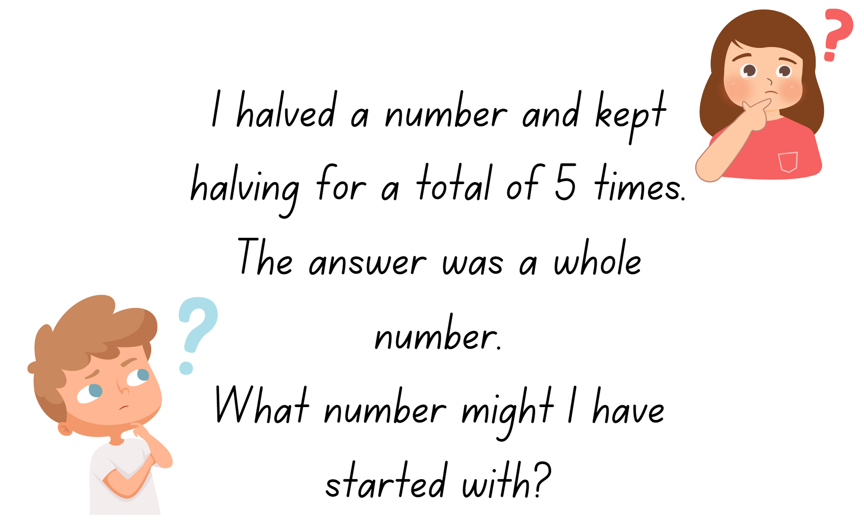

Resource 7 – multiplication toss spinner
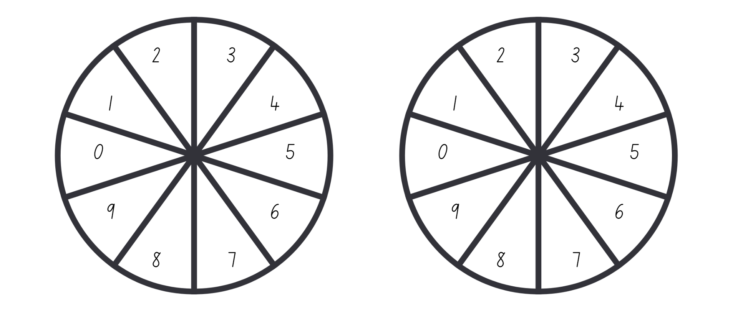

Resource 8 – multiples gameboard
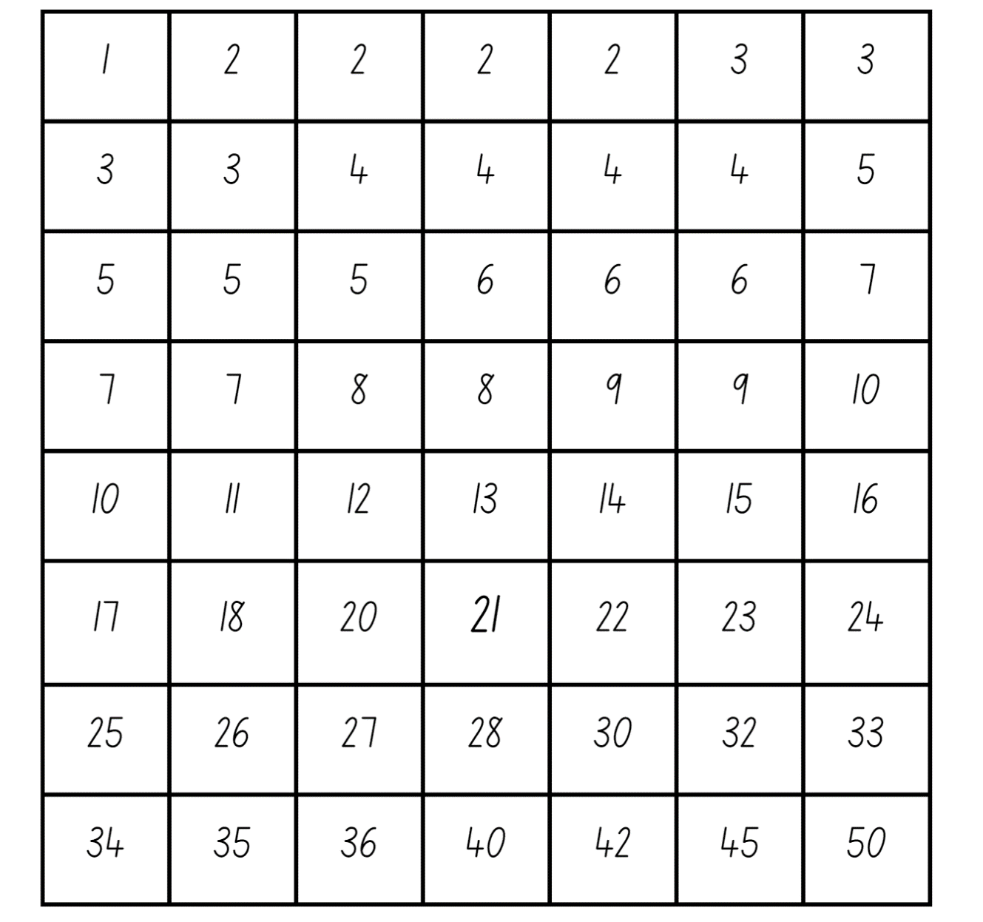

Resource 9 – score sheet
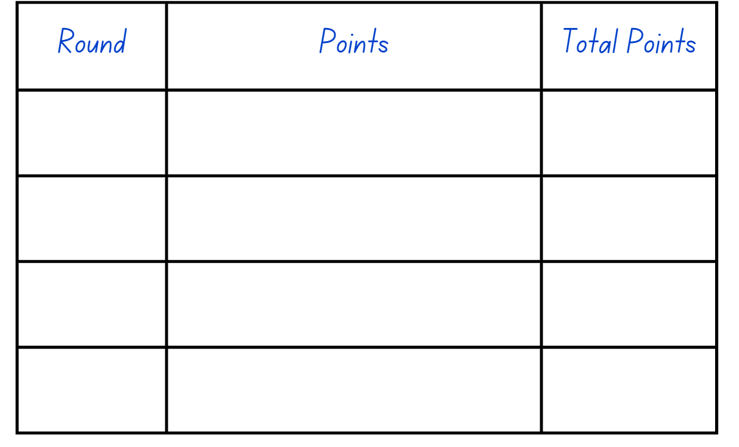

Resource 10 – partitioned arrays

Resource 11 – too many dice

Syllabus outcomes and content
The table below outlines the syllabus outcomes and range of relevant syllabus content covered in this unit. Content is linked to National Numeracy Learning Progression (version 3).
Outcomes and content | 1 | 2 | 3 | 4 | 5 | 6 | 7 | 8
Representing numbers using place value A: Whole numbers: Apply place value to partition and regroup numbers up to 4 digits
MAO-WM-01, MA2-RN-01
- Record numbers using standard place value form |  |  | x |  |  |  |  | x
Representing numbers using place value B: Whole numbers: Apply place value to partition, regroup and rename numbers up to 6 digits
MAO-WM-01, MA2-RN-01
- Name thousands using the place value grouping of ones, tens and hundreds of thousands | x
Representing numbers using place value B: Whole numbers: Recognise and represent numbers that are 10, 100 or 1000 times as large
MAO-WM-01, MA2-RN-01
- Recognise the number of tens, hundreds or thousands in a number | x |  |  |  |  | x
- Describe how making a number 10, 100 or 1000 times as large changes the place value of digits | x |  |  |  |  | x
Additive relations B: Complete number sentences involving additive relations to find unknown quantities
MAO-WM-01, MA2-AR-02
- Calculate missing numbers by completing number sentences involving addition and subtraction (Algebraic reasoning) |  |  |  |  | x
- Find the missing number in an equivalent number sentence involving operations of addition or subtraction on both sides of the equals sign (Algebraic reasoning) |  |  |  |  |  | x
- Create word problems that correspond to given addition and subtraction number sentences |  |  |  |  |  |  | x
Multiplicative relations A: Use arrays to establish multiplication facts from multiples of 2 and 4, 5 and 10
MAO-WM-01, MA2-MR-01
- Recognise that doubling is multiplying by 2 and halving is dividing by 2 (Reasons about relations) |  |  |  |  | x
- Recognise the relationship between one multiple and its double (Reasons about relations) |  |  |  |  | x
Multiplicative relations A: Represent and solve problems involving multiplication fact families
MAO-WM-01, MA2-MR-01
- Apply the inverse relationship of multiplication and division (Reasons about relations) |  |  | x | x
Multiplicative relations B: Investigate number sequences involving related multiples
MAO-WM-01, MA2-MR-01
- Generate number patterns using related multiples |  |  |  |  | x
- Investigate number patterns involving related multiples | x
Multiplicative relations B: Use known number facts and strategies
MAO-WM-01, MA2-MR-01
- Apply the known strategy of doubling to connect multiples of 3 to 6 and 4 to 8 (Reasons about relations) |  | x
- Use known facts to find unknown multiples (Reasons about relations) |  | x |  |  | x
Multiplicative relations B: Use the structure of the area model to represent multiplication and division
MAO-WM-01, MA2-MR-01
- Create and represent multiplicative structure, moving from arrays to partially covered area models |  |  | x
Multiplicative relations B: Use number properties to find related multiplication facts
MAO-WM-01, MA2-MR-01
- Use the commutative property of multiplication |  |  |  |  |  | x
- Use the associative property within multiplication to regroup the factors (Reasons about structure) |  |  |  |  |  |  | x
- Use flexible partitioning within multiplication (Reasons about relations) |  |  |  |  |  |  | x | x
- Generate and recall multiplication fact families up to 10 × 10 |  |  |  |  |  | x | x | x
Multiplicative relations B: Operate with multiples of 10
MAO-WM-01, MA2-MR-01
- Use multiplication facts with multiples of 10 to multiply a one-digit number by a multiple of 10 |  |  |  |  |  | x
- Use place value to rename groups of 10 to multiply |  |  |  |  |  | x
- Apply the commutative and associative properties to multiply by multiples of 10 |  |  |  |  |  | x
Multiplicative relations B: Represent and solve word problems with number sentences involving multiplication or division
MAO-WM-01, MA2-MR-01, MA2-MR-02
- Use the equals sign to record equivalent number relationships involving multiplication (Reasons about relations) | x |  |  |  |  | x
- Complete number sentences involving multiplication and division by calculating missing numbers (Reasons about relations) |  | x |  | x
- Represent and solve multiplication and division (both sharing and grouping) word problems using number sentences |  |  | x | x
Mathematics K–10 Syllabus © NSW Education Standards Authority (NESA) for and on behalf of the Crown in right of the State of New South Wales, 2022.

References
This resource contains NSW Curriculum and syllabus content. The NSW Curriculum is developed by the NSW Education Standards Authority. This content is prepared by NESA for and on behalf of the Crown in right of the State of New South Wales. The material is protected by Crown copyright.
Please refer to the NESA Copyright Disclaimer for more information https://educationstandards.nsw.edu.au/wps/portal/nesa/mini-footer/copyright.
NESA holds the only official and up-to-date versions of the NSW Curriculum and syllabus documents. Please visit the NSW Education Standards Authority (NESA) website https://educationstandards.nsw.edu.au/wps/portal/nesa/home/ and the NSW Curriculum website https://curriculum.nsw.edu.au.
Mathematics K–10 Syllabus © NSW Education Standards Authority (NESA) for and on behalf of the Crown in right of the State of New South Wales, 2022.
National Numeracy Learning Progression © Australian Curriculum, Assessment and Reporting Authority (ACARA) 2010 to present, unless otherwise indicated. This material was downloaded from the Australian Curriculum website (National Numeracy Learning Progression) (accessed 7 November 2023) and was not modified.
Askew M (2016) A Practical Guide to Transforming Primary Mathematics: Activities and tasks that really work, 1st edn, Routledge, United States of America.
Barton C (2015) Build an Army: Times Tables, TES website, accessed 7 November 2023.
Errey B (2020) ‘Adding and Subtracting Two-Digit Whole Numbers’, Grade 2, Open Middle website, accessed 11 November 2023.
Ignaciuk C (2020) ‘Subtraction with Regrouping 2’, Grade 2, Open Middle website, accessed 11 November 2023.
Russo J (2018) ‘Mathematic proofs in primary schools’, Mathematics Teaching, 261:32–35, accessed 7 November 2023.
State of New South Wales (Department of Education) (2023) ‘Multiplication toss’, Mathematics K–6 resources, NSW Department of Education website, accessed 7 November 2023.
State Government of Victoria (Department of Education) (n.d.) ‘Multiplication of large numbers’, Number and place value, Arc Learning: Mathematics Curriculum Companion website, accessed 7 November 2023.
University of Cambridge (n.d) Factors and multiples game, NRICH website, accessed 7 November 2023.

Further reading
Siemon D, Warren E, Beswick K, Faragher R, Miller J, Horne Marj, Jazby D, Breed M, Clark J, Brady K (2020) Teaching Mathematics: Foundation to Middle Years, 3rd edn, Oxford University Press, Australia and New Zealand.
Van de Walle J, Karp K, Bay-Williams JM, Brass A, Bentley B, Ferguson S, Goff W, Livy S, Marshman M, Martin D, Pearn C, Prodromou T, Symons D and Wilkie K (2019) Primary and Middle Years Mathematics: Teaching Developmentally, 1st Australian edn, Pearson Education Australia, Melbourne.

© State of New South Wales (Department of Education), 2024
The copyright material published in this resource is subject to the Copyright Act 1968 (Cth) and is owned by the NSW Department of Education or, where indicated, by a party other than the NSW Department of Education (third-party material).
Copyright material available in this resource and owned by the NSW Department of Education is licensed under a Creative Commons Attribution 4.0 International (CC BY 4.0) license.
This license allows you to share and adapt the material for any purpose, even commercially.
Attribution should be given to © State of New South Wales (Department of Education), 2024.
Material in this resource not available under a Creative Commons license:
- the NSW Department of Education logo, other logos and trademark-protected material
- material owned by a third party that has been reproduced with permission. You will need to obtain permission from the third party to reuse its material.
Links to third-party material and websites
Please note that the provided (reading/viewing material/list/links/texts) are a suggestion only and implies no endorsement, by the New South Wales Department of Education, of any author, publisher, or book title. School principals and teachers are best placed to assess the suitability of resources that would complement the curriculum and reflect the needs and interests of their students.
If you use the links provided in this document to access a third-party's website, you acknowledge that the terms of use, including licence terms set out on the third-party's website apply to the use which may be made of the materials on that third-party website or where permitted by the Copyright Act 1968 (Cth). The department accepts no responsibility for content on third-party websites.

