Mathematics Stage 2 – Unit 31
Our number system extends infinitely to very large and very small numbers

Contents
Unit description and duration 5
Syllabus outcomes 5
Working mathematically 6
Student prior learning 6
Lesson overview and resources 8
Lesson 1 13
Daily number sense – number patterns – 10 minutes 13
Core lesson 1 – adding ten, hundred or a thousand to a number – 25 minutes 16
Core lesson 2 – to the nearest – 15 minutes 20
Discuss and connect the mathematics – 10 minutes 22
Lesson 2 24
Daily number sense – finding multiples – 10 minutes 24
Core lesson – representing numbers in non-standard form – 40 minutes 26
Discuss and connect the mathematics – 10 minutes 28
Lesson 3 30
Daily number sense – multiples on a 100 grid – 10 minutes 30
Core lesson 1 – locating decimals on a number line – 20 minutes 31
Core lesson 2 – hundredths – 20 minutes 34
Discuss and connect the mathematics – 10 minutes 36
Lesson 4 38
Daily number sense – 10 minutes 38
Core lesson – decimals and fractions on a number line – 35 minutes 38
Consolidation and meaningful practice – 15 minutes 43
Lesson 5 45
Daily number sense – word problems – 15 minutes 45
Core lesson – investigating multiples – 35 minutes 48
Discuss and connect the mathematics – 10 minutes 50
Lesson 6 52
Daily number sense – word problems 2 – 10 minutes 52
Core lesson – area model – 35 minutes 54
Discuss and connect the mathematics – 15 minutes 56
Lesson 7 58
Daily number sense – multiplication or division – 10 minutes 58
Core lesson – number problems using associative property – 20 minutes 60
Consolidation and meaningful practice – 25 minutes 62
Discuss and connect the mathematics – 15 minutes 64
Lesson 8 66
Daily number sense – 10 minutes 66
Core lesson 1 – Farmer Mark’s strawberry patch – 20 minutes 66
Core lesson 2 – flexible partitioning spin – 30 minutes 69
Consolidation and meaningful practice – 10 minutes 70
Resource 1 – number chart 72
Resource 2 – misconception – crossing decades 73
Resource 3 – to the nearest 74
Resource 4 – carpark image 75
Resource 5 – jellybean spinner 76
Resource 6 – jellybean sort 77
Resource 7 – 100 grid 78
Resource 8 – build a decimal 79
Resource 9 – hundredths 80
Resource 10 – decimal concentration 81
Resource 11 – multiplication problems 82
Resource 12 – multiples gameboard 83
Resource 13 – division problems 84
Resource 14 – my piggy bank 85
Resource 15 – multiplication or division? 86
Resource 16 – Would you rather…? 87
Resource 17 – recording sheet 88
Resource 18 – strawberry patch 89
Resource 19 – strawberry patch strategies 90
Resource 20 – spinner 91
Syllabus outcomes and content 92
References 100
Further reading 101

Unit description and duration
This unit develops the big idea that our number system extends indefinitely to very large and very small numbers.
In this 2-week unit students are provided opportunities to:
- partition, rename, represent and order numbers up to 6-digits
- apply place value knowledge to recognise, name and order decimals to hundredths
- explore and apply the associative, distributive and inverse properties of multiplication and division to real-world number problems.

Syllabus outcomes
- MAO-WM-01 develops understanding and fluency in mathematics through exploring and connecting mathematical concepts, choosing and applying mathematical techniques to solve problems, and communicating their thinking and reasoning coherently and clearly
- MA2-RN-01 applies an understanding of place value and the role of zero to represent numbers to at least tens of thousands
- MA2-RN-02 represents and compares decimals up to 2 decimal places using place value
- MA2-MR-01 represents and uses the structure of multiplicative relations to 10 × 10 to solve problems

Working mathematically
In the Mathematics K–10 Syllabus, there is one overarching Working mathematically outcome (MAO-WM-01). The Working mathematically processes should be embedded within the concepts being taught. The Working mathematically processes are:
- communicating
- understanding and fluency
- reasoning
- problem solving.
Mathematics K–10 Syllabus © NSW Education Standards Authority (NESA) for and on behalf of the Crown in right of the State of New South Wales, 2022.

Student prior learning
Before engaging in these teaching and learning activities, students would benefit from prior experience with:
- reading, representing, partitioning and ordering numbers up to thousands
- representing and comparing tenths as decimals using linear representations
- using arrays and fact families represent and solve multiplication problems featuring multiples of 2 and 4, 5 and 10.
In NSW classrooms there is a diverse range of students, including Aboriginal and/or Torres Strait Islander students, students learning English as an additional language or dialect, high potential and gifted students and students with disability. Some students may identify with more than one of these groups or possibly all of them. Refer to Curriculum planning for every student – advice for further information.

Lesson overview and resources
The table below outlines the sequence and approximate timing of lessons, learning intentions and resources.
Lesson | Content | Duration and resources
Lesson 1  Daily number sense learning intention:  - investigate number sequences involving related multiples | Lesson core concept: reading and recording large numbers is a key component of place value.  Core concept learning intentions:  - read, represent and order numbers to thousands  - order numbers in the thousands | Lesson duration: 60 minutes  - Resource 1 – number chart  - Resource 2 – misconception – crossing decades  - Resource 3 – to the nearest  - 10-sided dice (virtual or physical)  - Counters (2 different colours for each student)  - Individual whiteboards  - Large sheets of paper  - Writing materials
Lesson 2  Daily number sense learning intention:  - investigate number sequences involving related multiples | Lesson core concept: numbers can be renamed in equivalent ways using place value.  Core concept learning intention:  - apply place value to partition and regroup numbers up to 6 digits | Lesson duration: 60 minutes  - Resource 4 – carpark image  - Resource 5 – jellybean spinner  - Resource 6 – jellybean sort  - Writing materials
Lesson 3  Daily number sense learning intention:  - investigate number sequences involving related multiples | Lesson core concept: the place value system can be extended.  Core concept learning intention:  - extend the application of the place value system from whole numbers to tenths and hundredths  - make connections between fractions and decimal notation | Lesson duration: 60 minutes  - Resource 7 – 100 grid  - Resource 8 – build a decimal  - Resource 9 – hundredths  - 10-sided dice  - Craft sticks  - Toothpicks  - Writing materials
Lesson 4  Daily number sense learning intention:  - teacher-identified task based on student needs | Lesson core concept: connections can be made between fractions and decimals.  Core concept learning intention:  - make connections between benchmark fractions and decimals | Lesson duration: 60 minutes  - Resource 10 – decimal concentration  - Writing materials
Lesson 5  Daily number sense learning intention:  - represent and solve word problems with number sentences involving multiplication or division | Lesson core concept: number patterns can be multiplicative.  Core concept learning intention:  - generate and describe patterns  - investigate number sequences involving related multiples | Lesson duration: 60 minutes  - Resource 11 – multiplication problems  - Resource 12 – multiples gameboard  - Coloured tiles  - 10-sided dice  - Individual whiteboards  - Writing materials
Lesson 6  Daily number sense learning intention:  - represent and solve word problems with number sentences involving multiplication or division | Lesson core concept: structures can support multiplicative thinking.  Core concept learning intention:  - use the structure of the area model to represent multiplication and division  - use number properties to find related multiplication facts | Lesson duration: 60 minutes  - Resource 13 – division problems  - Resource 14 – my piggy bank  - Coloured tiles  - Writing materials
Lesson 7  Daily number sense learning intention:  - represent and solve word problems with number sentences involving multiplication or division | Lesson core concept: number properties can be used to solve multiplication problems.  Core concept learning intention:  - use number properties to find multiplication facts | Lesson duration: 70 minutes  - Resource 15 – multiplication or division?  - Resource 16 – Would you rather...?  - Resource 17 – recording sheet  - Coloured tiles  - Writing materials
Lesson 8  Daily number sense learning intention:  - teacher-identified task based on student needs | Lesson core concept: number properties can be used to solve multiplication problems.  Core concept learning intention:  - use number properties to find multiplication facts  - operate with multiples of 10 | Lesson duration: 70 minutes  - Resource 18 – strawberry patch  - Resource 19 – strawberry patch strategies  - Resource 20 – spinner  - Individual whiteboards  - Writing materials

Lesson 1
Core concept: reading and recording large numbers is a key component of place value.

Daily number sense – number patterns – 10 minutes
Daily number sense activities for Lessons 1 to 3 ‘activate’ prior number knowledge and support the learning of new content in the unit. These activities can also assist teachers to identify the starting points for learning by revealing the extent of students’ existing knowledge.
The table below contains a suggested learning intention and success criteria. These are best co-constructed with students.
Daily number sense learning intention | Daily number sense success criteria
Students are learning to:  - investigate number sequences involving related multiples. | Students can:  - generate number sequences using related multiples  - investigate number patterns involving related multiples.
This activity is an adaptation of Number Patterns (PDF 134 KB) from Australian Mathematical Sciences Institute by Lowry.
- Provide students with Resource 1 – number chart and 2 different colours of counters.
- Students place the counters on the number chart in a pattern until all the numbers are covered. An example of a pattern includes blue, blue, red (see Figure 1).
Figure 1 – example of pattern
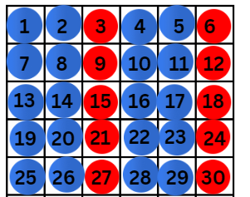
- Students remove the red counters to reveal all the multiples of 3 (see Figure 2).
Figure 2 – example of multiples
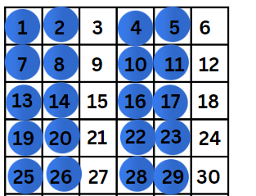
- Students then record these numbers vertically on their whiteboards, to identify the pattern of multiples, for example, 3, 6, 9, 12, 15, 18, 21, 24, 27, 30.
- Ask:
- What is the first term in this number sequence?
- Can you describe any patterns in the sequence?
- What is the next term in this sequence after 30?
- What will be the twentieth term in this number sequence?
- Students create a different pattern with their counters, again removing the red counters and identifying the number sequence created.
- Students pair up and describe the first term in their number sequence as well as the pattern created.
This table details opportunities for assessment.
Assessment opportunities | Links
What to look for:  - Can students generate number sequences using different multiples? [MAO-WM-01, MA2-MR-01]  - Can students investigate number patterns involving related multiples? [MAO-WM-01, MA2-MR-01] | Links to National Numeracy Learning Progressions (NNLP):  - NPA3, NPA4.

Core lesson 1 – adding ten, hundred or a thousand to a number – 25 minutes
The table below contains suggested learning intentions and success criteria. These are best co-constructed with students.
Core concept learning intentions | Core concept success criteria
Students are learning to:  - read, represent and order numbers to thousands  - order numbers in the thousands. | Students can:  - count forwards and backwards by tens, hundreds and thousands on and off the decade  - arrange numbers in the thousands in ascending and descending order  - recognise and describe how rearranging digits changes the size of a number  - identify the nearest thousand, 10 thousand or 100 thousand to numbers.
This activity is an adaptation of ‘Close your eyes and count’ from Engaging maths: 25 Favourite lessons by Clarke and Roche.
- Display Resource 2 – misconception – crossing decades.
- Explain that some students were asked to add 100 to 4961. These were their answers.
- Students turn and talk to a partner and discuss:
- Which ones are incorrect?
- Which one is correct?
- How do you know?
- Display large sheets of paper around the classroom, see Figure 3.
Figure 3 – add ten, a hundred or a thousand sheets of paper
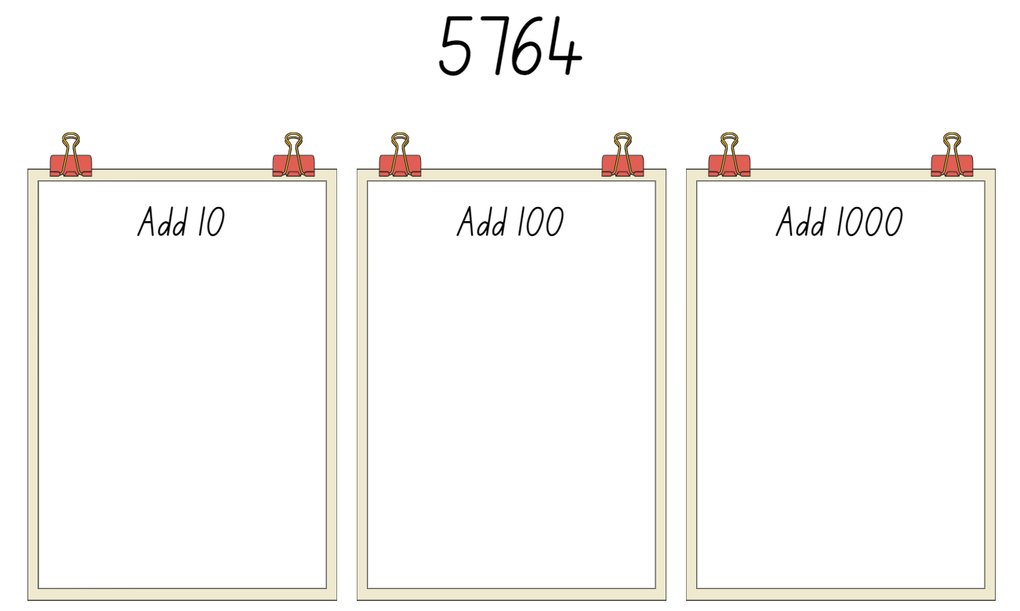
- State that the aim of this activity is for students to add either 10, a hundred or a thousand to the initial starting number of 5764.
- Organise students in lines behind each sheet of paper.
- Explain that the activity is like a relay. Student A records the next number in the sequence on their piece of paper. They then hand the marker to Student B to add the next number onto the pattern as Student A returns to the end of the line.
- Repeat this process until each student has had time to add at least 2 responses to their sheet and then ask teams to stop.
- Gather the students together and display each sheet of paper.
- Discuss the accuracy of what each group has recorded when adding 10, hundred or thousand, asking the students to highlight instances where the pattern has not remained consistent.
- Prompt students to provide the correct answer where values are incorrect.
- Ask:
- Can you see a pattern?
- What is the same?
- What is different?
- What happens when you reach a 9 in your place value column?
- Identify the final number in each sequence.
- Students order these numbers on their whiteboards in ascending order.
- Students read the numbers on their whiteboards aloud in descending order.
This table details opportunities for differentiation.
Too hard? | Too easy?
Students cannot count forwards and backwards by tens, hundreds and thousands on and off the decade.  - Support students to use MAB materials to create numbers as they add 10.  - Assist students by modelling strategies that could be used to support the count.  - Use a number chart 100–200 to revise adding tens patterns. | Students can count forwards and backwards by tens, hundreds and thousands on and off the decade.  - Students add a thousand, a hundred and a ten to each place value column of the one number. For example, students start with the number 5764 and add 1110 to make 6874.  - In pairs, students roll a 10-sided dice 6 times and create a 6-digit number. Student A determines which place value they will be changing. Both students record the next 10 numbers from their number changing only the place value chosen by Student A. Students compare answers to check accuracy. Repeat the process, swapping roles.

Core lesson 2 – to the nearest – 15 minutes
- Remind students that, when working with large numbers sometimes they change the quantity value of the number to the nearest thousand, ten thousand or hundred thousand to make it easier to work with the number.
- Roll a virtual 10-sided dice 6 times to create a 6-digit number.
- Students identify the nearest thousand, ten thousand and hundred thousand to the number they created.
- Students turn and talk with a partner, recording their ideas on a whiteboard.
- Students discuss their answers as a class, using place value knowledge to justify their answers.
- In pairs, students use virtual or physical 10-sided dice to repeat the process of making a new 6-digit number. Students take turns to decide whether they will identify the nearest thousand, ten thousand or hundred thousand to the number they have created.
- Students record their new numbers on whiteboards.
- Students compare their answers with their partner to check for accuracy.
This table details opportunities for differentiation.
Too hard? | Too easy?
Students cannot identify the nearest thousand, 10 thousand or 100 thousand to numbers.  - Support students by reducing the number they identify to the nearest 10.  - Provide structures such as a 100 chart to support the count. | Students can identify the nearest thousand, 10 thousand or 100 thousand to numbers.  - Students work in pairs. Student A states several parameters for a potential number, such as the numbers nearest hundred thousand is 500 000, its nearest ten thousand is 20 000 and its nearest thousand is 1000. Both students work out what the number could be, if there are any other numbers that it could be and if their partners numbers are correct. Repeat this process, swapping roles.  - In pairs, Student A writes down a 6-digit number without showing the other player. Student B tries to guess the secret number by writing it down on a whiteboard. Student A must tell Student B if any of the numbers are correct and in the correct position, correct but in the wrong position or incorrect. Student B continues to guess the secret number, adjusting their guess depending on feedback. When Student B guesses the correct number, swap roles and repeat.

Discuss and connect the mathematics – 10 minutes
- Display Resource 3 – to the nearest. Ask:
- Which number is the nearest thousand?
- Which number is the nearest ten thousand?
- Which number is the nearest hundred thousand?
- How do you know?
- Ensure that students are using their place value knowledge to communicate their reasoning.
This table details opportunities for assessment.
Assessment opportunities | Links
What to look for:  - Can students count forwards and backwards by tens, hundreds and thousands on and off the decade?  [MAO-WM-01, MA2-RN-01]  - Can students arrange numbers in the thousands in ascending and descending order? [MAO-WM-01, MA2-RN-01]  - Can students recognise and describe how rearranging digits changes the size of a number? [MAO-WM-01, MA2-RN-01]  - Can students identify the nearest thousand, 10 thousand or 100 thousand to a given number? [MAO-WM-01, MA2-RN-01] | Links to National Numeracy Learning Progressions (NNLP):  - CPr6, CPr7  - NPV7.  Links to suggested Interview for Student Reasoning (IfSR) tasks:  - IfSR-NP: 4C.1, 4C.2, 4C.3, 4C.4, 4C.5, 4C.6, 4C.7, 4C.8.

Lesson 2
Core concept: numbers can be renamed in equivalent ways using place value.

Daily number sense – finding multiples – 10 minutes
The table below contains a suggested learning intention and success criteria. These are best co-constructed with students.
Daily number sense learning intention | Daily number sense success criteria
Students are learning to:  - investigate number sequences involving related multiples. | Students can:  - generate number patterns using related multiples  - investigate number patterns involving related multiples.
This activity is an adaptation of Number Patterns (PDF 134 KB) from Australian Mathematical Sciences Institute by Lowry.
- Display a number on the board that is a multiple of 2, 4, and 8, or 3, 6 and 9.
- Say the rule for the number sequence. For example, start at 20 and go up by fours.
- Students record this starting number in their workbooks and continue the number sequence until told to stop.
- With the help of students, record the number sequence on the board and identify patterns together.
- Ask:
- What is the first term in this number sequence?
- Can you describe any patterns in the sequence?
- What will be the tenth term and the twentieth term in this number sequence?
- What multiple is used in this number sequence?
This table details opportunities for assessment.
Assessment opportunities | Links
What to look for:  - Can students generate number sequences using different multiples? [MAO-WM-01, MA2-MR-01]  - Can students investigate number patterns involving related multiples? [MAO-WM-01, MA2-MR-01] | Links to National Numeracy Learning Progressions (NNLP):  - NPA3, NPA4.

Core lesson – representing numbers in non-standard form – 40 minutes
The table below contains suggested learning intentions and success criteria. These are best co-constructed with students.
Core concept learning intentions | Core concept success criteria
Students are learning to:  - apply place value to partition and regroup numbers up to 6 digits. | Students can:  - name thousands using the place value grouping of ones, tens and hundreds of thousands  - use place value to expand the number notation  - partition numbers of up to 6 digits in non-standard forms.
- Display Resource 4 – carpark image. Ask:
- What do you think this is an image of?
- Do you see more than a thousand objects?
- Do you see fewer than 10 000 objects?
- How many do you think there are altogether?
- Read the following scenario: You have been asked to order jellybeans for the school fete. You can order blue jellybeans in boxes of 1000, yellow jellybeans in boxes of 100, red jellybeans in boxes of 10 or single green jellybeans. Ask:
- If I ordered one box of blue jellybeans and 2 boxes of yellow jellybeans, how many jellybeans would I have in total?
- What is another possible number of jellybeans that could be ordered? How many boxes of each colour would I need?
- In small groups, use the Resource 5 – jellybean spinner to determine how many of each box you need to order. Record quantities using Resource 6 – jellybean sort in the non-standard partitioning section of the table. The first spin will determine how many blue, second how many yellow, third how many red and the fourth how many green.
Note: coloured counters can be used to represent the boxes of jellybeans, to assist with regrouping and renaming.
- Students calculate how many jellybeans they have in total by converting their number using standard partitioning (see Figure 4).
Figure 4 – jellybean total
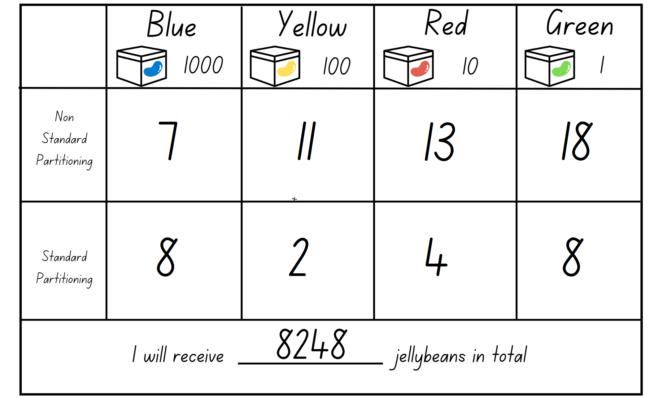
- Students repeat this process with a new quantity made by using Resource 5 – jellybean spinner to select new values.
Note: writing the numbers in expanded notation on a whiteboard can support students to recognise the value of the number in each column.
This table details opportunities for differentiation.
Too hard? | Too easy?
Students cannot partition numbers up to 6 digits in non-standard form.  - Support students to represent their numbers by providing MAB materials.  - Decrease the value of the numbers on spinner. | Students can partition numbers up to 6 digits in non-standard form.  - Add a fifth box size that holds 10 000 jellybeans. Students use Resource 5 – jellybean spinner to determine how many jellybeans.  - Students sit back-to-back, each with a whiteboard. Student A writes a 6-digit number, written using standard or non-standard partitioning. Student B asks place value questions about the number until they work out the number. Students compare numbers. Swap roles and repeat.

Discuss and connect the mathematics – 10 minutes
- Ask:
- In what ways have you been a mathematician today?
- What strategy did you use when your number was over 10 in a place value column?
- Can you explain the process you followed to rename your number?
- Can you represent your number using expanded notation?
This table details opportunities for assessment.
Assessment opportunities | Links
What to look for:  - Can students name thousands using the place value grouping of ones, tens and hundreds of thousands?  [MAO-WM-01, MA2-RN-01]  - Can students use place value to expand the number notation? [MAO-WM-01, MA2-RN-01]  - Can students partition numbers up to 6-digits in non-standard form? [MAO-WM-01, MA2-RN-01] | Links to National Numeracy Learning Progressions (NNLP):  - NPV6, NPV7  Links to suggested Interview for Student Reasoning (IfSR) tasks:  - IfSR-NP: 4B.1, 4B.3, 4B.4, 4B.5.

Lesson 3
Core concept: the place value system can be extended.

Daily number sense – multiples on a 100 grid – 10 minutes
The table below contains a suggested learning intention and success criteria. These are best co-constructed with students.
Daily number sense learning intention | Daily number sense success criteria
Students are learning to:  - investigate number sequences involving related multiples. | Students can:  - generate number sequences using related multiples  - investigate number patterns involving related multiples.
This activity is an adaptation of Multiples grid from NRICH by University of Cambridge.
- Display Resource 7 – 100 grid.
- Explain that this is a 100 grid with some numbers shaded in yellow, blue and green.
- Ask the students the following:
- What do all the colours shaded in yellow have in common?
- What do you notice about all the numbers shaded in blue?
- Can you think of a reason why there are some numbers shaded in green?
- Students Think-Pair-Share the questions and share their answers with the class. Answers include: yellow numbers are multiples of 6, blue numbers are multiples of 5 and green numbers are multiples of both 6 and 5.
This table details opportunities for assessment.
Assessment opportunities | Links
What to look for:  - Can students generate number sequences using different multiples? [MAO-WM-01, MA2-MR-01]  - Can students investigate number patterns involving related multiples? [MAO-WM-01, MA2-MR-01] | Links to National Numeracy Learning Progressions (NNLP):  - NPA3, NPA4.

Core lesson 1 – locating decimals on a number line – 20 minutes
The table below contains suggested learning intentions and success criteria. These are best co-constructed with students.
Core concept learning intentions | Core concept success criteria
Students are learning to:  - extend the application of the place value system from whole numbers to tenths and hundredths  - make connections between fractions and decimal notation. | Students can:  - express decimals as both tenths and hundredths  - locate and order decimals representing tenths and hundredths on a number line, describing their relative size  - compare and order decimals of up to 2 decimal places.
Note: to support place value conceptual understanding, 6.13 would be read as six and thirteen hundredths. The language connects the decimal fraction with the whole number and makes a connection with common fractions.
- Display a premade number line (see Figure 5).
Figure 5 – blank number line
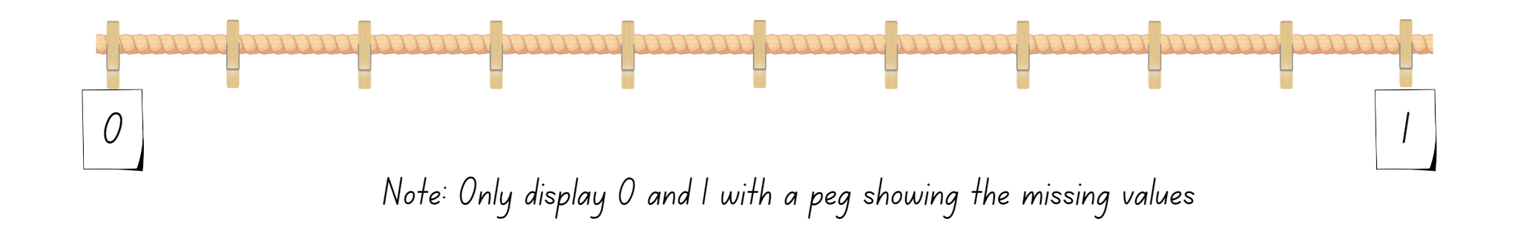
- Say that the number line has been stretched to show the space between zero and one. There are numbers between zero and one. There are some hints on the number line with the equally spaced pegs. Ask what could be missing on the number line.
- Students turn and talk to discuss what the missing values could be. Share responses as a class.
- Fill in the missing values on the number line as a class. Starting at the smallest value of 0.1 up to 0.9.
Note: ensure the correct decimal language is modelled. For example, the decimal parts are called tenths. 0.4 is read as 4 tenths.
- Provide pairs of students with a copy of Resource 8 – build a decimal and 10 craft sticks, representing one-tenth each.
- Students work in pairs and take turns rolling a 10-sided dice. This number tells them how many tenths they need to make using their craft sticks.
- Students record this on Resource 8 – build a decimal (see Figure 6). Students plot their decimal and their partner’s decimal together and record the total on the number line. This continues for 3 rounds.
Figure 6 – build a decimal
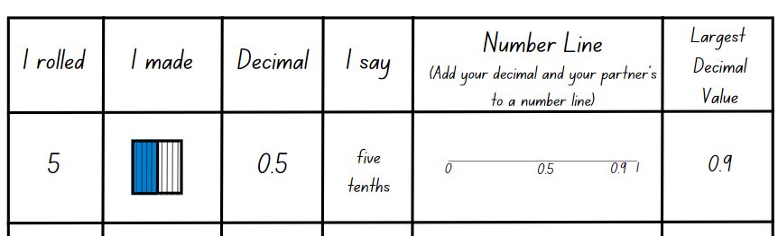
- Observe students as they complete the task, questioning their understanding of tenths. Ask:
- How many more tenths would be needed to make one whole?
- How many more tenths does your partner have than you?
- How could this be recorded in words or numbers?
- Keep the number line for next lesson.
This table details opportunities for differentiation.
Too hard? | Too easy?
Students cannot express decimals as tenths.  - Assist students to use manipulatives only to represent decimals.  - Model how to use support structures, such as number lines, to identify tenths. | Students can express decimals as tenths.  - Students use 2 dice to complete Resource 8 – build a decimal. The first dice represents a whole number and the second dice represents the tenth.  - Challenge students to order the decimals they create on a number line. Students show a classmate and discuss how they know their decimals are in the correct places.

Core lesson 2 – hundredths – 20 minutes
- Revise the number line from Core lesson 1 – locating decimals on a number line. Highlight that the space between zero and one can be divided into tenths.
- Ask what students think would be found between 0.5 and 0.6.
- Display Resource 9 – hundredths.
Note: ensure the correct decimal language is modelled. For example, the decimal parts are called hundredths. 0.52 is read as 52 hundredths.
- As a class, complete the values for hundredths between 0.5 and 0.6.
- Students use Resource 8 – build a decimal again, this time introducing toothpicks or small blocks to represent hundredths. They roll a 10-sided dice twice to find tenths and hundredths. The numbers are recorded using Resource 8 – build a decimal (see Figure 7).
Figure 7 – hundredths – build a decimal
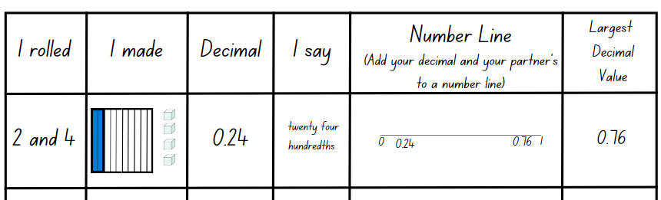
This table details opportunities for differentiation.
Too hard? | Too easy?
Students cannot express decimals as hundredths.  - Consolidate students’ knowledge of place value by only representing decimals involving tenths.  - Model how 20 hundredths (20 toothpicks or blocks) can be renamed as 2 tenths.  - Use support structures such as number lines to identify hundredths. | Students can express decimals as hundredths.  - Students use 3 dice to complete Resource 8 – build a decimal. The first dice represents a whole number, the second dice represents the tenths and the third dice represents the hundredths.  - Challenge students to order the decimals they create on a number line. Students show a classmate and discuss how they know their decimals are in the correct places.

Discuss and connect the mathematics – 10 minutes
- Choose some students to share a decimal from their game board. Ask:
- How do you read your number?
- How many tenths does your decimal have?
- How many hundredths does your decimal have?
- How would you represent 100 hundredths?
- How would you represent one whole and 14 hundredths?
- Discuss student responses.
This table details opportunities for assessment.
Assessment opportunities | Links
What to look for:  - Can students express decimals as both tenths and hundredths? [MAO-WM-01, MA2-RN-02]  - Can students locate and order decimals representing tenths and hundredths on a number line, describing their relative size?  [MAO-WM-01, MA2-RN-02]  - Can students compare and order decimals of up to 2 decimal places? [MAO-WM-01, MA2-RN-02] | Links to National Numeracy Learning Progressions (NNLP):  - NPV6, NPV7, NPV8.  Links to suggested Interview for Student Reasoning (IfSR) tasks:  - IfSR-NP: 4D.1, 4D.2, 4D.3, 4D.4, 4D.6.

Lesson 4
Core concept: connections can be made between fractions and decimals.

Daily number sense – 10 minutes
- From a class need surfaced through formative assessment data, identify a short, focused activity that targets students’ knowledge, understanding and skills. Example activities may be drawn from the following resources:
- Mathematics K–6 resources
- Universal Resources Hub.

Core lesson – decimals and fractions on a number line – 35 minutes
The table below contains suggested learning intentions and success criteria. These are best co-constructed with students.
Core concept learning intentions | Core concept success criteria
Students are learning to:  - extend the application of the place value system from whole numbers to tenths and hundredths  - make connections between fractions and decimal notation. | Students can:  - locate and order decimals representing tenths and hundredths on a number line, describing their relative size  - record equivalent measurements using decimals  - make connections between fractions and decimal notation for key benchmark values.
- Using the number line from the previous lesson, revise tenths and hundredths. Ask:
- If I was to fold this number line in half, where would half be?
- How could I write half as a fraction? How do you know?
- How would I write half as a decimal? How do you know?
- What would happen if I was to fold this section of the number line (0–0.5) in half? Gesture to show the section from 0 to 0.5 on the number line.
- Students turn and talk to determine what decimal would be at the halfway point.
- Identify that the halfway point is not on a tenth, it lands between 0.2 and 0.3.
Note: ensure that the term ‘halfway point’ is used, not ‘half’. Half is only marked once on a number line.
- Determine that this would be known as 0.25 and mark it on the number line. Explain that this is the ‘halfway point’ not ‘half’, as half is marked only once on a number line.
- Ask how this could be recorded as a fraction. Students turn and talk to determine what the fraction would be and then discuss as a class.
- Add this fraction to the number line, see Figure 8.
Figure 8 – fractions on number line
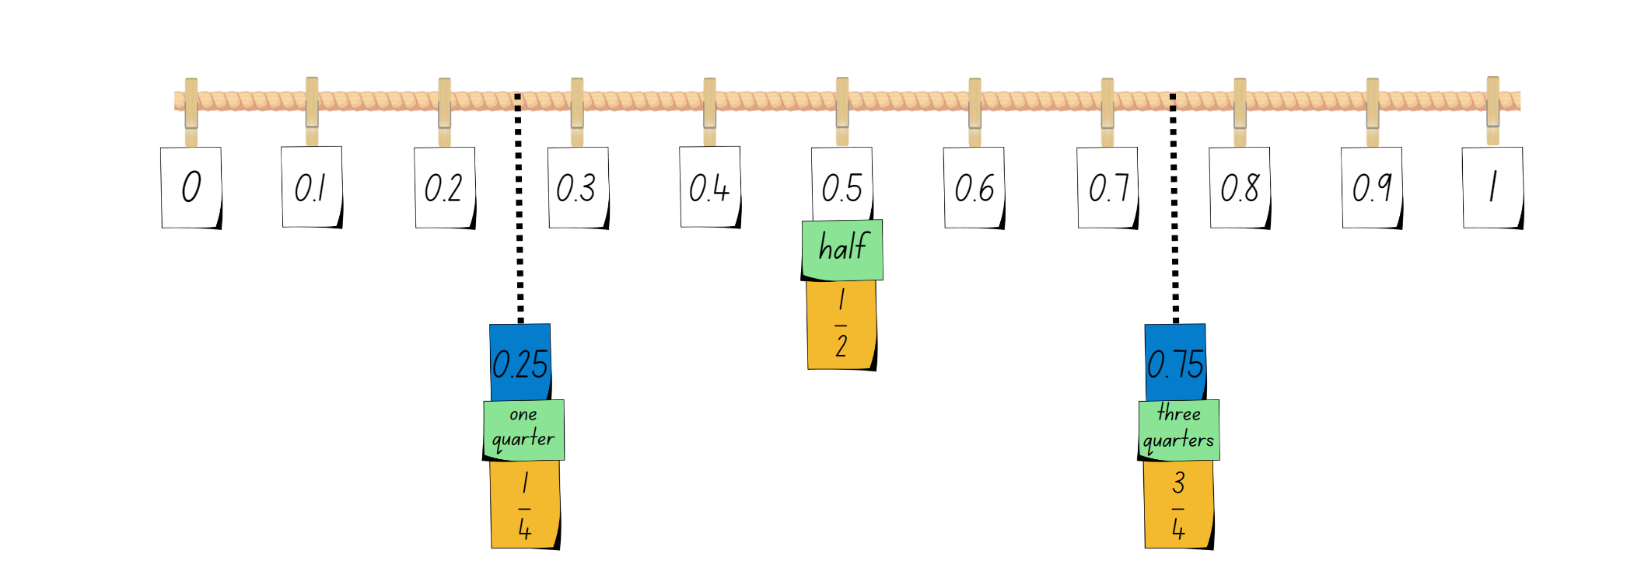
- Repeat the process by folding the number line between 0.5 and 1. Determine that this would be known as 0.75 and mark it on the number line, adding the fraction $\frac{3}{4}$ as well.
- Highlight that 0.25 is the same as $\frac{1}{4}$. 0.5 is the same as $\frac{1}{2}$. 0.75 is the same as $\frac{3}{4}$.
- In grid books or on grid paper, students construct their own number line from 0–1. Label each tenth with its decimal, fraction and how you would say it. Include 0.25, 0.75 and write the fractions to match (see Figure 9).
Figure 9 – student number line
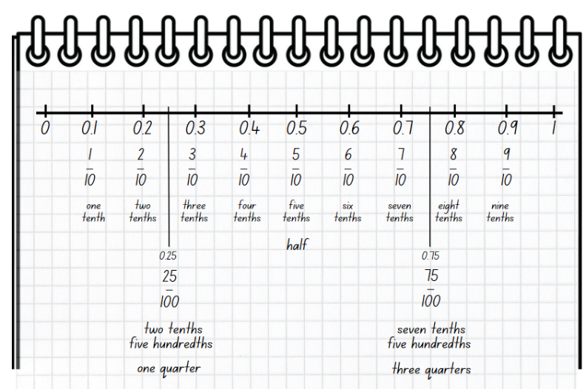
Note: it is important to highlight the need to have numbers evenly spaced on the number line.
- Students complete their number lines. Ask which decimal is the biggest, 0.35 or 0.8?
- Students turn and talk to determine which fraction they believe would be the biggest. then discuss as a class.
The table below outlines stimulus prompts to generate conversation about the topic, along with anticipated responses from students.
Prompts | Anticipated student responses
- Who thinks 0.35 is the biggest decimal? | - 0.35 is the biggest decimal because 35 is larger than 8.
- Who thinks 0.8 is the biggest decimal? | - 0.8 is the biggest decimal because 0.8 has 8 tenths and 0.35 is 3 tenths and 5 hundredths.
- How could 0.8 be rewritten to have 2 decimal places? | - It could be rewritten as 0.80.
- What happens when there is a zero at the end of a decimal? | - It doesn’t change the value of the decimal.
- How could 0.35 and 0.8 be described using the words tenths and hundredths? | - 0.35 is 3 tenths and 5 hundredths and 0.8 is 8 tenths.
- Students find and add these decimals to their number line.
This table details opportunities for differentiation.
Too hard? | Too easy?
Students cannot make connections between fractions and decimal notation for key benchmark values.  - Model how to use hands-on materials and support structures such as number lines, to identify equivalence.  - Support students to have a clear understanding of half and whole using manipulatives, before moving onto other values. | Students can make connections between fractions and decimal notation for key benchmark values.  - Students divide a length between 0–1 into 10 equal parts and label them as tenths. With a partner, students identify a part of the whole and label it using words, decimals and fractions. For example, 5 tenths is 0.5, $\frac{5}{10}$.  - In pairs, Student A writes a benchmark decimal on their whiteboard and shows it to Student B. Student B records the equivalent fraction on their whiteboard and shows it to Student A to check for accuracy. Swap roles and repeat.

Consolidation and meaningful practice – 15 minutes
- In groups of 3, students use Resource 10 – decimal concentration to match decimals, fractions and decimal wording.
This table details opportunities for assessment.
Assessment opportunities | Links
What to look for:  - Can students locate and order decimals representing tenths and hundredths on a number line, describing their relative size?  [MAO-WM-01, MA2-RN-01, MA2-RN-02]  - Can students record equivalent measurements using decimals? [MAO-WM-01, MA2-RN-01, MA2-RN-02]  - Can students make connections between fractions and decimal notation for key benchmark values?  [MAO-WM-01, MA2-RN-01, MA2-RN-02] | Links to National Numeracy Learning Progressions (NNLP):  - NPV6, NPV7, NPV 8  - InF6.  Links to suggested Interview for Student Reasoning (IfSR) tasks:  - IfSR-NP: 4D.4, 4D.7  - IfSR-PT: 1A.6, 1A.7.

Lesson 5
Core concept: number patterns can be multiplicative.

Daily number sense – word problems – 15 minutes
Daily number sense activities for Lessons 5 to 7 ‘loop’ back to concepts and procedures covered in previous units to assist students to build an increasingly connected network of ideas. These concepts may differ from the core concepts being covered by the unit.
The table below contains a suggested learning intention and success criteria. These are best co-constructed with students.
Daily number sense learning intention | Daily number sense success criteria
Students are learning to:  - represent and solve word problems with number sentences involving multiplication or division. | Students can:  - complete number sentences involving multiplication and division by calculating missing numbers  - represent and solve multiplication and division (both sharing and grouping) word problems using number sentences.
This activity is an adaptation of Solving Multiplication and Division Word Problems from SAS by Commonwealth of Pennsylvania.
- Explain that they will be using multiplication and division to solve some problems.
- Read the following problem to the students: Volleyball is played in teams of 6. There were enough players to make 3 teams. How many players are there altogether?
- Students Think-Pair-Share how they would solve this problem and share this with the class. Ask:
- How many teams are there?
- How many players does each team have?
- How can we represent this using coloured tiles?
- Produce a model with the help of students. Use 3 circles to represent the teams and coloured tiles to represent the players (see Figure 10).
Figure 10 – circle representation of teams
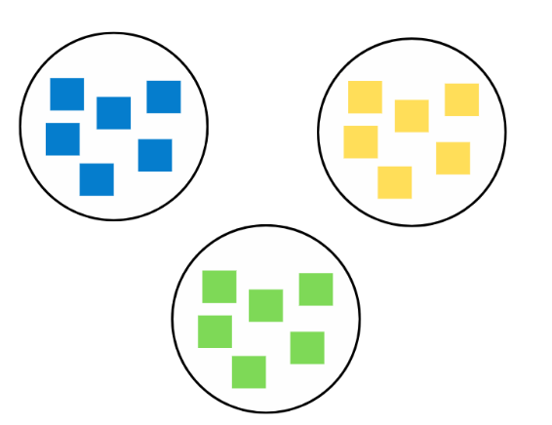
- Ask what number sentence students could write for this problem.
Note: it is likely that some students will suggest 6 + 6 + 6 = 18, while others will suggest 3 × 6 = 18 and 6 × 3 = 18. It is important to focus on the multiplication number sentence and remind students that it is more efficient than repeated addition.
- Distribute Resource 11 – multiplication problems and coloured tiles to students. Students solve the problems using manipulatives and record the corresponding number sentences in their workbooks.
This table details opportunities for assessment.
Assessment opportunities | Links
What to look for:  - Can students complete number sentences involving multiplication and division by calculating missing numbers?  [MAO-WM-01, MA2-MR-02]  - Can students represent and solve multiplication and division (both sharing and grouping) word problems using number sentences? [MAO-WM-01, MA2-MR-02] | Links to National Numeracy Learning Progressions (NNLP):  - NPA4.

Core lesson – investigating multiples – 35 minutes
The table below contains suggested learning intentions and success criteria. These are best co-constructed with students.
Core concept learning intentions | Core concept success criteria
Students are learning to:  - generate and describe patterns  - investigate number sequences involving related multiples. | Students can:  - model, describe and record patterns of multiples  - create and continue a variety of number patterns that increase or decrease by a constant amount  - generate number patterns using related multiples  - investigate number patterns involving related multiples.
This lesson is an adaptation of Multihive – Practice Multiples by Mathcurious.
- Draw a dot pattern on the board (see Figure 11).
Figure 11 – dot pattern
- Ask:
- What do you notice?
- Can you complete the next 2 rows of dots?
- How could the term multiples be used to describe this pattern?
- Explain that the dot pattern represents multiples of 2. The first line of dots represents the first multiple of 2 which is the same as double one and 2 × 1. The second line of dots continues the pattern and represents the second multiple of 2, which is the same as double 2 and 2 × 2.
- Students record on individual whiteboards the first 10 multiples formed by counting by twos.
- In pairs, student play multiples game using Resource 12 – multiples gameboard.
- Students roll a 10-sided dice. They record the number pattern for the number they rolled up to the tenth value. For example, if a student rolled a 3, they would record 3, 6, 9, 12, 15, 18, 21, 27, 30, 33.
- Each student selects one multiple from their number pattern to plot on the gameboard. Students repeat this process until someone connects 4 boxes on the gameboard.
This table details opportunities for differentiation.
Too hard? | Too easy?
Students cannot model, describe and record patterns of multiples.  - Model using counters to create number patterns for the number rolled.  - Provide students with fact families for multiples of numbers up to 10. | Students can model, describe and record patterns of multiples.  - Students create their own variation of the gameboard to challenge their classmates. Students could consider extending number patterns beyond 10 values.  - In pairs, students sit back-to-back. Student A rolls a 10-sided dice. They then list 5 multiples for this number. Student B must use this information to identify the number that was rolled. Swap roles and repeat.

Discuss and connect the mathematics – 10 minutes
- As a class, discuss the patterns students observed and record the multiples for numbers from 1–10 on large sheets of paper to display.
Note: draw attention to related multiples for example: 2 and 4, 3 and 6, 4 and 8, 5 and 10.
- Explore number sequences involving the related multiples.
- Highlight the patterns of odd and even numbers within related multiples.
This table details opportunities for assessment.
Assessment opportunities | Links
What to look for:  - Can students model, describe and record patterns of multiples? [MAO-WM-01, MA2-MR-01]  - Can students create and continue a variety of number patterns that increase or decrease by a constant amount?  [MAO-WM-01, MA2-MR-01]  - Can students generate number patterns using related multiples? [MAO-WM-01, MA2-MR-01]  - Can students investigate number patterns involving related multiples? [MAO-WM-01, MA2-MR-01] | Links to National Numeracy Learning Progressions (NNLP):  - NPA3, NPA4  - CPr6, CPr7.  Links to suggested Interview for Student Reasoning (IfSR) tasks:  - IfSR-NP: 4A.3, 4A.4.

Lesson 6
Core concept: structures can support multiplicative thinking.

Daily number sense – word problems 2 – 10 minutes
The table below contains a suggested learning intention and success criteria. These are best co-constructed with students.
Daily number sense learning intention | Daily number sense success criteria
Students are learning to:  - represent and solve word problems with number sentences involving multiplication or division. | Students can:  - complete number sentences involving multiplication and division by calculating missing numbers  - represent and solve multiplication and division (both sharing and grouping) word problems using number sentences.
This activity is an adaptation of Solving Multiplication and Division Word Problems from SAS by Commonwealth of Pennsylvania.
- Display the word problem from the previous lesson on the board: ‘Volleyball is played in teams of 6. There were enough players to make 3 teams. How many players are there altogether?’
- Explain that you are going to change the problem: If there are 3 teams, 18 people are playing and there are an equal number of people in each team, how many people are in each team?
- Students Think-Pair-Share how to solve the problem.
- Guide students to realise that this situation requires division (18 ÷ 3 = 6). Also emphasize the inverse relationship between the original multiplication problem (3 × 6 = 18) and the new division problem (18 ÷ 3 = 6).
Note: linking multiplication and division is an important understanding for students by the end of Stage 2. They should come to realise that division 'undoes' multiplication and multiplication 'undoes' division. Students use multiplication facts to divide, for example 35 ÷ 7 = is the same as _ × 7 = 35. They should be encouraged to check the answer to a division question by multiplying their answer by the divisor.
- Discuss what students noticed when solving the problem.
The table below outlines stimulus prompts to generate conversation about the topic, along with anticipated responses from students.
Prompts | Anticipated student responses
- How did you know what operation to use? | - I used multiplication when there was repeated addition.
- How do you know when you should multiply or divide a problem? | - I used division when I needed to share a number into equal groups.
- Distribute Resource 13 – division problems and coloured tiles to students. Students solve the problems using manipulatives and record the corresponding number sentences in their workbooks.
This table details opportunities for assessment.
Assessment opportunities | Links
What to look for:  - Can students complete number sentences involving multiplication and division by calculating missing numbers?  [MAO-WM-01, MA2-MR-02]  - Can students represent and solve multiplication and division (both sharing and grouping) word problems using number sentences? [MAO-WM-01, MA2-MR-02] | Links to National Numeracy Learning Progressions (NNLP):  - NPA4.  Links to suggested Interview for Student Reasoning (IfSR) tasks:  - IfSR-MT: 2A.4, 2A.5, 2A.7, 2A.10.

Core lesson – area model – 35 minutes
The table below contains suggested learning intentions and success criteria. These are best co-constructed with students.
Core concept learning intentions | Core concept success criteria
Students are learning to:  - use the structure of the area model to represent multiplication and division  - use number properties to find related multiplication facts. | Students can:  - create and represent multiplicative structure, moving from arrays to partially covered area models  - use the associative property within multiplication to regroup the factors  - use flexible partitioning within multiplication.
This lesson is an adaptation of ‘Arrays’ from Challenging mathematical tasks: Unlocking the potential of all students by Sullivan.
- Display Resource 14 – my piggy bank.
- Explain that a piggy bank is emptied onto the table and the $1 coins are arranged in an array without gaps. Ask the students to identify 2 ways to work out how much money there is.
- Challenge students to move beyond drawing an array to solve the problem. As a class, discuss the strategies involved, decide on the most efficient strategy and the solution. Encourage students to use an area model as a strategy (see Figure 12).
Figure 12 – area model examples
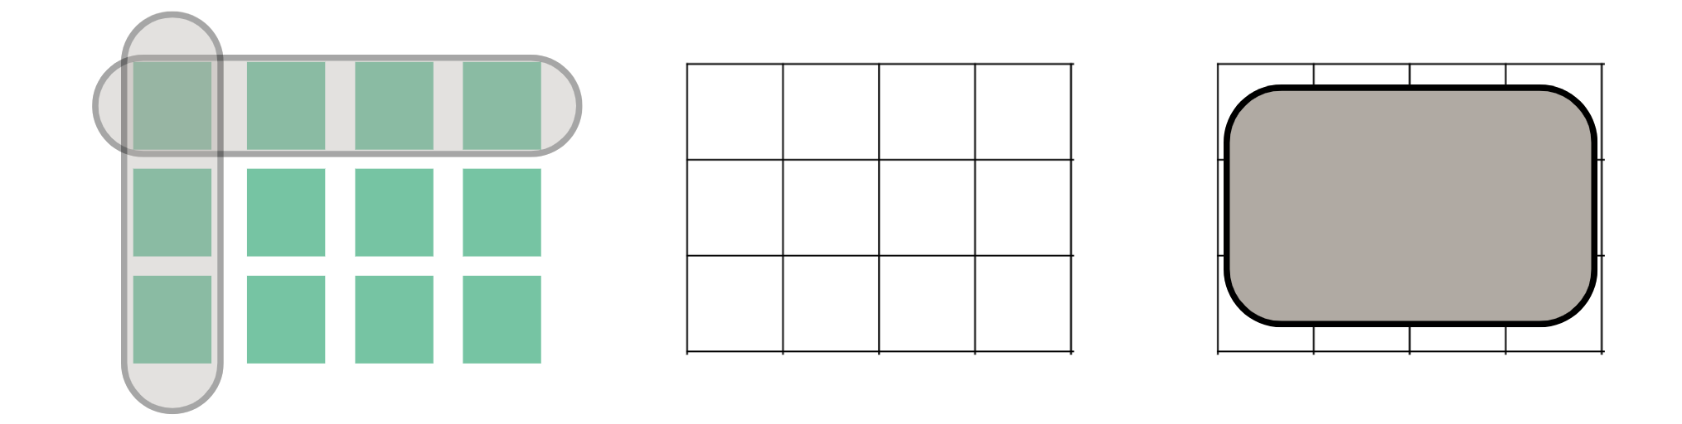
- Pose the problem: I have 36 chocolates. I want to make a box for them. What might the box look like?
- In pairs, students draw the possible solutions as area models in their workbooks.
This table details opportunities for differentiation.
Too hard? | Too easy?
Students cannot create and represent multiplicative structure, moving from arrays to partially covered area models.  - Assist students by providing grid paper to help create their area model.  - Adjust the number of chocolates to be a multiple of 5. Draw attention to the relationship between the arrangement of the area model and the corresponding multiplication number sentence. | Students can create and represent multiplicative structure, moving from arrays to partially covered area models.  - Students design possible area models for boxes holding a larger number of chocolates.  - Challenge students to solve the word problem using more than one strategy.  - In pairs, students create their own word problems for their partner to solve. Students then discuss their solutions and the possible area model arrangements.

Discuss and connect the mathematics – 15 minutes
- Join pairs of students with other pairs to make larger groups.
- Students in these new groups discuss the strategies they used to find possible area model solutions.
- After students have had an opportunity to discuss this as a group, ask the class:
- Can you clearly explain the strategy another pair used?
- Which of the strategies seems the most efficient when solving this problem? Why?
- Were you able to use your knowledge of factors to find solutions to the problem? Which factors did you use?
- Why is the area model a useful strategy to solve multiplication problems?
This table details opportunities for assessment.
Assessment opportunities | Links
What to look for:  - Can students create and represent multiplicative structure, moving from arrays to partially covered area models?  [MAO-WM-01, MA2-MR-01]  - Can students use the associative property within multiplication to regroup the factors? [MAO-WM-01, MA2-MR-01]  - Can students use flexible partitioning within multiplication?  [MAO-WM-01, MA2-MR-01] | Links to National Numeracy Learning Progressions (NNLP):  - MuS5, MuS6, Mus7.  Links to suggested Interview for Student Reasoning (IfSR) tasks:  - IfSR-MT: 2A.1, 2A.3.

Lesson 7
Core concept: number properties can be used to solve multiplication problems.

Daily number sense – multiplication or division – 10 minutes
The table below contains a suggested learning intention and success criteria. These are best co-constructed with students.
Daily number sense learning intention | Daily number sense success criteria
Students are learning to:  - represent and solve word problems with number sentences involving multiplication or division. | Students can:  - use the equals sign to record equivalent number relationships involving multiplication  - complete number sentences involving multiplication and division by calculating missing numbers  - represent and solve multiplication and division (both sharing and grouping) word problems using number sentences.
- Revise with students that the following questions should be considered when solving word problems:
- What can you use to help choose which operation to use?
- How do you decide when you should multiply or divide a problem?
- Distribute Resource 15 – multiplication or division? and coloured tiles to students. In pairs, students solve the problems using manipulatives and record the corresponding number sentences in their workbooks.
This table details opportunities for assessment.
Assessment opportunities | Links
What to look for:  - Can students use the equals sign to record equivalent number relationships involving multiplication? [MAO-WM-01, MA2-MR-02]  - Can students complete number sentences involving multiplication and division by calculating missing numbers?  [MAO-WM-01, MA2-MR-02]  - Can students represent and solve multiplication and division (both sharing and grouping) word problems using number sentences? [MAO-WM-01, MA2-MR-02] | Links to National Numeracy Learning Progressions (NNLP):  - NPA4.  Links to suggested Interview for Student Reasoning (IfSR) tasks:  - IfSR-MT: 2A.4, 2A.5, 2A.7, 2A.10.

Core lesson – number problems using associative property – 20 minutes
The table below contains suggested learning intentions and success criteria. These are best co-constructed with students.
Core concept learning intention | Core concept success criteria
Students are learning to:  - use number properties to find multiplication facts. | Students can:  - use associative property within multiplication to regroup the factors  - use flexible partitioning within multiplication.
This lesson is an adaptation of ‘Commutative and associative properties of multiplication’ from Primary and Middle Years Mathematics: Teaching Developmentally by Van De Walle et al.
- Explain that ice creams are sold in boxes of 4. Each ice cream costs $2. Ask how much it would cost for 7 boxes of ice creams.
- Guide students to consider the problem in 2 ways:
- Find the cost of each box and then the total cost (4 × 2) × 7
- Find out how many ice creams in total and then the cost (7 × 4) × 2.
Note: this style of grouping symbols (…) is called parentheses in the Mathematics K–10 Syllabus teaching advice. Grouping symbols are not necessary in this context but may be used by students to indicate which part of the number sentence is completed first.
- Ask if students would rather complete 4 × 2 then multiply by 7, or 7 × 4 and then multiply by 2? Why?
- Remind students that being able to change the order of multiplication when there are more than 2 numbers is called the associative property or associative law. Share the following definition:
Associative property: when more than 2 numbers are added or multiplied, the result is unchanged regardless of how they are grouped or associated. For example, 6 × 3 × 2 can be calculated as 18 × 2 or 6 × 6 or 12 × 3.
- Pose the problem: The ice cream manufacturer has changed how they pack ice creams and will pack them in boxes of 5. Now that there is more in a box, you only want to purchase 6 boxes. The ice creams are still $2 each. Use number sentences and the associative property to find how much 6 boxes will cost.
- Students solve the problem in pairs using associative property. They show their working out on whiteboards or in their workbooks.
This table details opportunities for differentiation.
Too hard? | Too easy?
Students cannot use associative property within multiplication to regroup the factors.  - Support students to use concrete materials to represent the problem. Then, model how to write a corresponding number sentence.  - After writing one solution as a number sentence, assist students to use the associative property to regroup the factors to find another possible solution. | Students can use associative property within multiplication to regroup the factors.  - Students increase the cost of the ice creams and use the associative property to solve the new problem.  - Challenge students to create their own word problems using a number sentence and the associative property. Students ask a classmate to solve it.

Consolidation and meaningful practice – 25 minutes
- Students share their chosen strategy for solving the ice cream problem. For example, they may choose to solve it 2 × 5 × 6, as 2 × 5 makes 10, then this is simpler to multiply by 6.
- Draw a rectangle and 5 × 8 on the board. Explain that the rectangle is an array that represents 5 × 8.
- Explain that flexible partitioning can be used to rewrite 5 × 8 as 5 × 2 × 4. Ask:
- Would you rather solve 5 × 8, or 5 × 2 × 4?
- Why would you solve it this way?
- Is there another way that the factors could be partitioned flexibly, to make it easier to calculate?
- Display Resource 16 – Would you rather...? and Resource 17 – recording sheet. Explain that this game allows students to use associative properties of numbers and flexible partitioning to make number sentences easier to solve.
- Read the instructions with the students and share an example (see Figure 13).
- Provide pairs of students with a copy of Resource 16 – Would you rather...? and Resource 17 – recording sheet. Students play the game with their partner.
Figure 13 – gameboard example
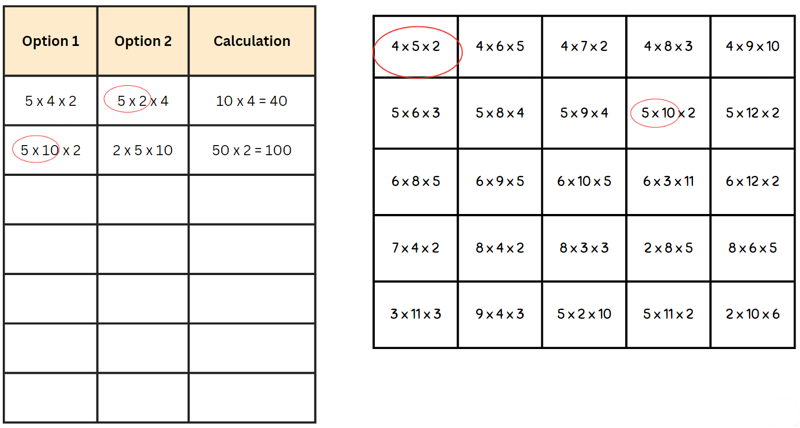
This table details opportunities for differentiation.
Too hard? | Too easy?
Students cannot break numbers into factors or use the associative property within multiplication to regroup factors.  - Provide students with number sentences and guide them to choose 2 numbers that can be multiplied easily.  - Students rewrite gameboard facts using the commutative property, such as 4 × 5 = 5 × 4, and ask what sentence they would rather solve. | Students can use the associative property within multiplication to regroup factors.  - Students roll dice to create more challenging numbers to factorise, such as 14 × 5 becomes 7 × (2 × 5).  - Students create word problems using a number sentence and the associative property.

Discuss and connect the mathematics – 15 minutes
- Discuss student’s strategies. Ask:
- Which numbers did you find easier to multiply after they had been partitioned?
- Why might different people have different strategies to solve problems?
- How might this strategy help us recall multiplication facts or solve problems?
- Highlight any new multiplication strategies students identify.
- Revise that the associative property of multiplication allows students to regroup factors and multiply them in an easier way.
- Present the problem 5 × 5 × 5 × 4 × 4 × 4. Guide students to notice that by regrouping the factors they can rewrite it as (5 × 4) × (5 × 4) × (5 × 4) = 8000.
This table details opportunities for assessment.
Assessment opportunities | Links
What to look for:  - Can students use associative property within multiplication to regroup the factors? [MAO-WM-01, MA2-MR-01, MA2-MR-02]  - Can students apply flexible partitioning within multiplication? [MAO-WM-01, MA2-MR-01, MA2-MR-02] | Links to National Numeracy Learning Progressions (NNLP):  - MuS6, MuS7.  Links to suggested Interview for Student Reasoning (IfSR) tasks:  - IfSR-MT: 2A.7.

Lesson 8
Core concept: number properties can be used to solve multiplication problems.

Daily number sense – 10 minutes
- From a class need surfaced through formative assessment data, identify a short, focused activity that targets students’ knowledge, understanding and skills. Example activities may be drawn from the following resources:
- Mathematics K–6 resources
- Universal Resources Hub.

Core lesson 1 – Farmer Mark’s strawberry patch – 20 minutes
The table below contains suggested learning intentions and success criteria. These are best co-constructed with students.
Core concept learning intentions | Core concept success criteria
Students are learning to:  - use number properties to find multiplication facts  - operate with multiples of 10. | Students can:  - use flexible partitioning within multiplication  - use place value to rename groups of 10 to multiply  - apply the commutative and associative properties to multiply by multiples of 10.
- Explain that Farmer Mark plants 36 strawberry plants in even rows. Ask what these might look like.
- Students use whiteboards to record their thinking. Discuss the various options as a class.
- Show Resource 18 – strawberry patch, showing that Farmer Mark plants them in 2 rows of 18.
- Explain that Farmer Mark has added an extra 2 rows.
- Ask:
- What does this look like now?
- How can we represent Farmer Mark’s strawberry plants as a number sentence? (Do not provide answers for the number sentence at this stage).
- How can we solve 18 × 4?
- Highlight that this is not a simple multiplication fact that we can recall quickly.
- Ask:
- How can we use what we know about 10 to solve this number?
- Can you draw a picture?
- Can you represent this using an area model?
- Can you write a number sentence?
- Display Resource 19 – strawberry patch strategies.
- Discuss the different strategies that can be used to solve this problem. Explain that the dots are used to help show how the number can be partitioned in different ways.
Note: students are not expected to draw this many dots when solving a problem like this and the use of an area model to represent their thinking is more efficient (see Figure 14).
Figure 14 – dots to area model
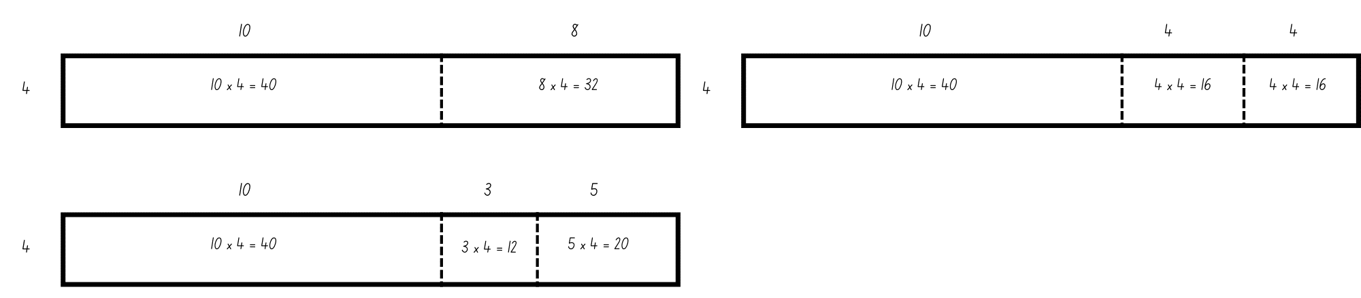

Core lesson 2 – flexible partitioning spin – 30 minutes
This part of the lesson is an adaptation of Multiplication toss from Mathematics K–6 resources by the State of New South Wales (Department of Education).
- In pairs, students play multiplication toss. Students spin the Resource 20 – spinner. This selects the first number of their multiplication sentence.
- Next, students roll a 6-sided die. This selects the number that they will multiply the first number by.
- Using students solve the multiplication problem using flexible partitioning and their knowledge of multiples of 10. For example, a student spins 13 and rolls a 6. They have made 13 × 6. They solve this by partitioning the number into 10 × 6 = 60, 3 × 6 = 18. They can then add 60 and 18 to make 78.
- Players then plot this onto the grid paper. They can do as 13 × 6 or split into 10 × 6 and 3 × 6.
- The game continues until the grid is full or after 10 spins, whichever happens first.
- The player with the largest area blocked out is the winner.
This table details opportunities for differentiation.
Too hard? | Too easy?
Students cannot use flexible partitioning within multiplication.  - Assist students by specifying the areas to partition.  - Model the use of concrete materials to create an array to model flexible partitioning. | Students can use flexible partitioning within multiplication.  - Students partition the array into more than 2 parts. Demonstrate the strategy used to solve this problem now.  - Explain that Farmer Mark has doubled the amount of orange trees. Students determine what this garden will look like and how many orange trees he will have.

Consolidation and meaningful practice – 10 minutes
- Discuss student’s strategies. Ask:
- Which numbers did you find easier to multiply after they had been partitioned?
- How might this strategy help us recall multiplication facts or solve problems?
- Revise that the associative property of multiplication allows students to regroup factors and multiply them in an easier way.
This table details opportunities for assessment.
Assessment opportunities | Links
What to look for:  - Can students use flexible partitioning within multiplication?  [MAO-WM-01, MA2-RN-01, MA2-MR-01, MA2-MR-02]  - Can students use place value to rename groups of 10 to multiply? [MAO-WM-01, MA2-MR-01, MA2-MR-02]  - Can students apply the commutative and associative properties to multiply by multiples of 10?  [MAO-WM-01, MA2-MR-01, MA2-MR-02] | Links to National Numeracy Learning Progressions (NNLP):  - MuS6, MuS7.  Links to suggested Interview for Student Reasoning (IfSR) tasks:  - IfSR-MT: 3A.1, 3A.2, 3A.3.

Resource 1 – number chart
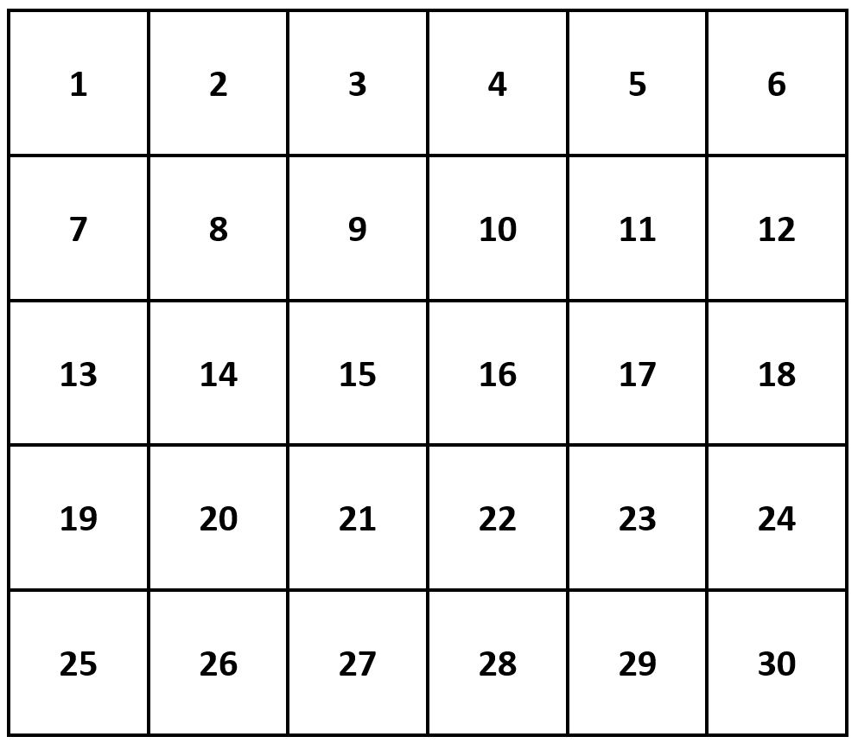

Resource 2 – misconception – crossing decades
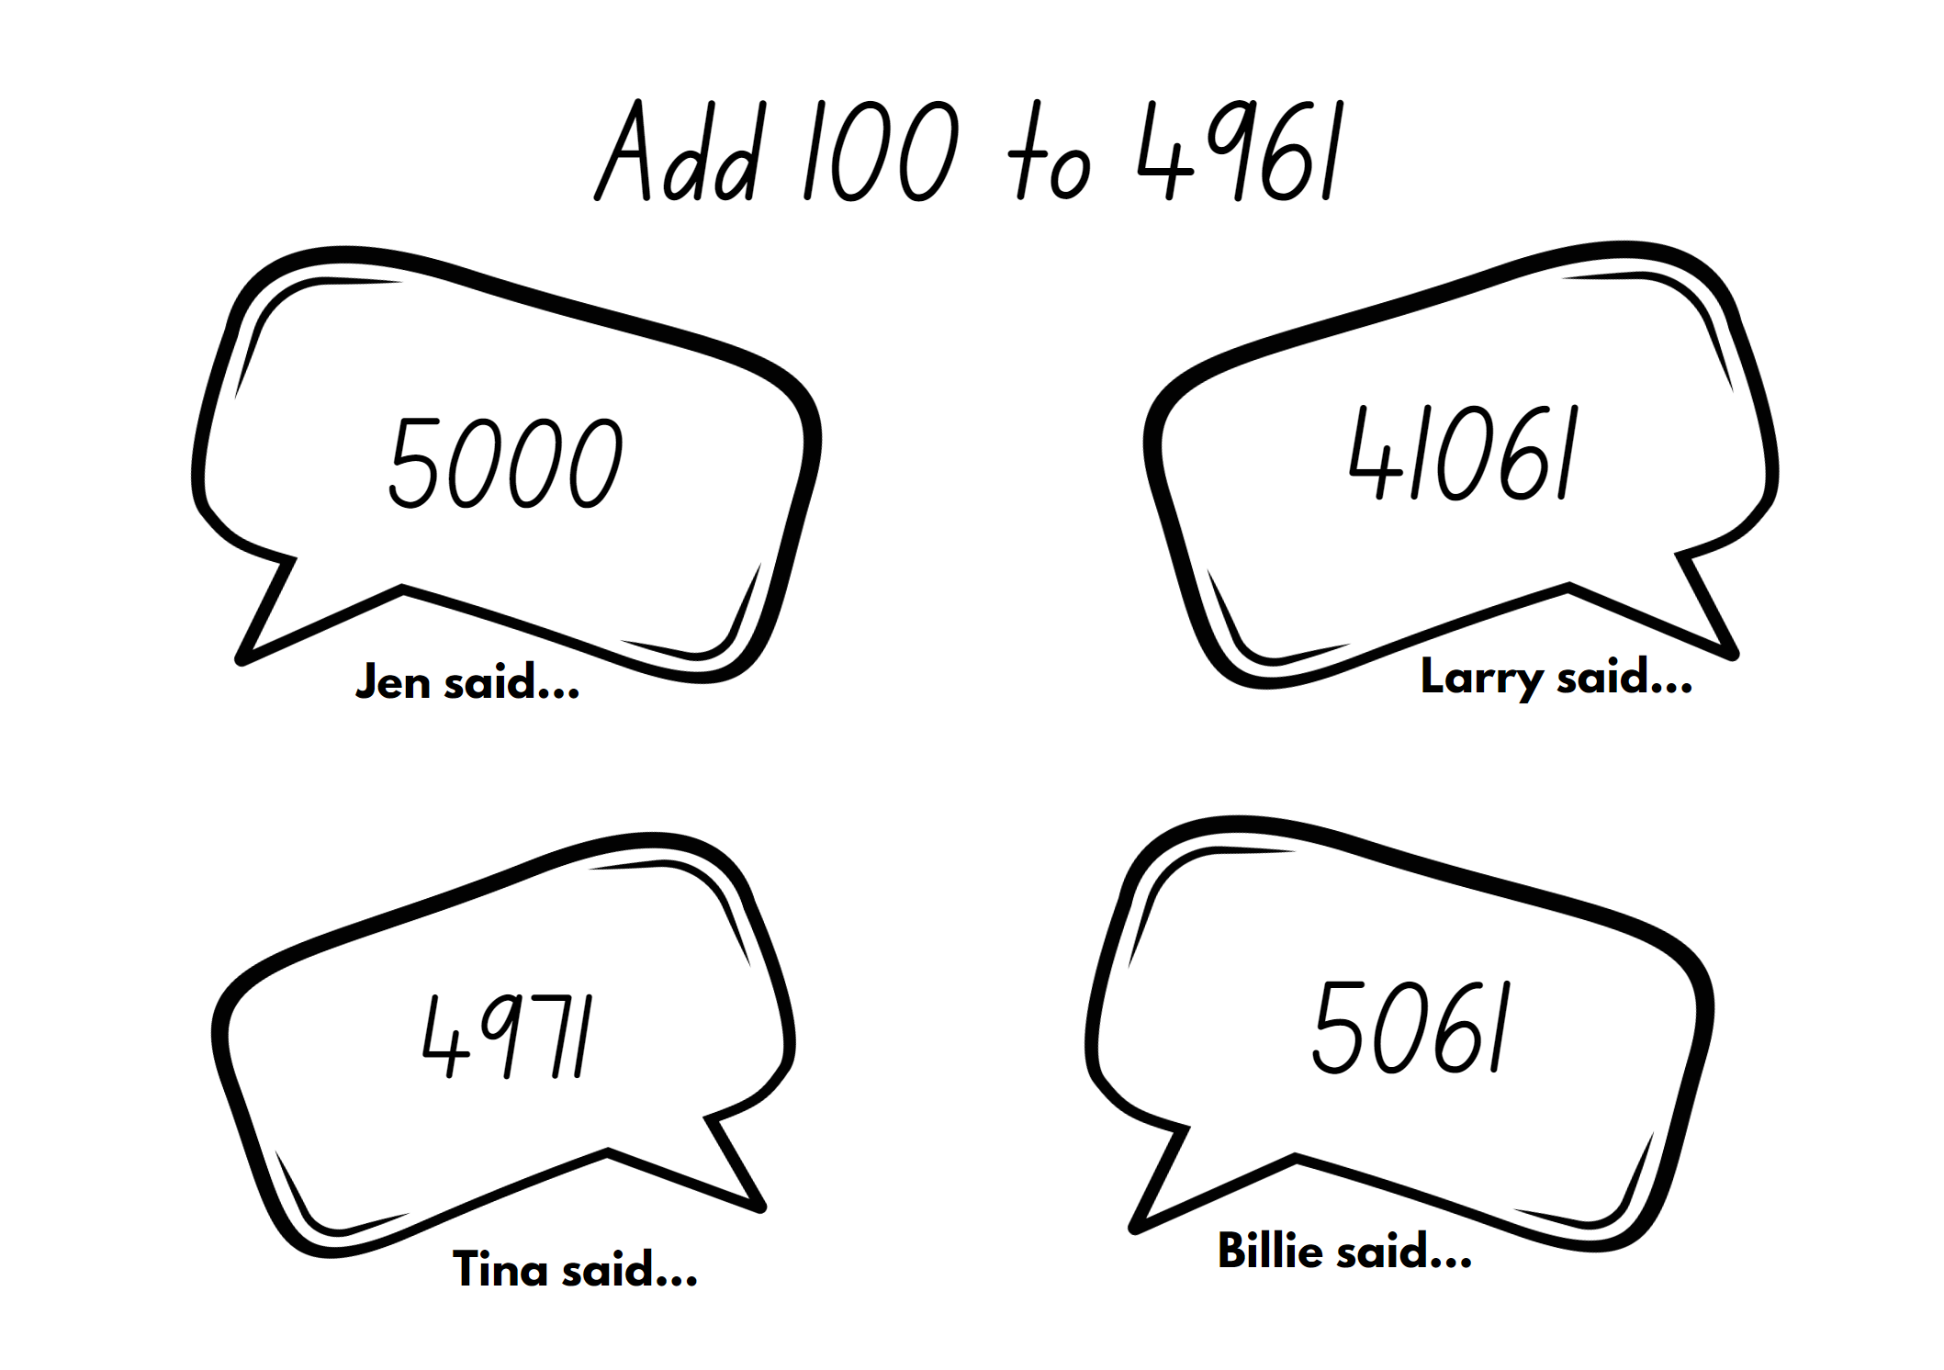

Resource 3 – to the nearest
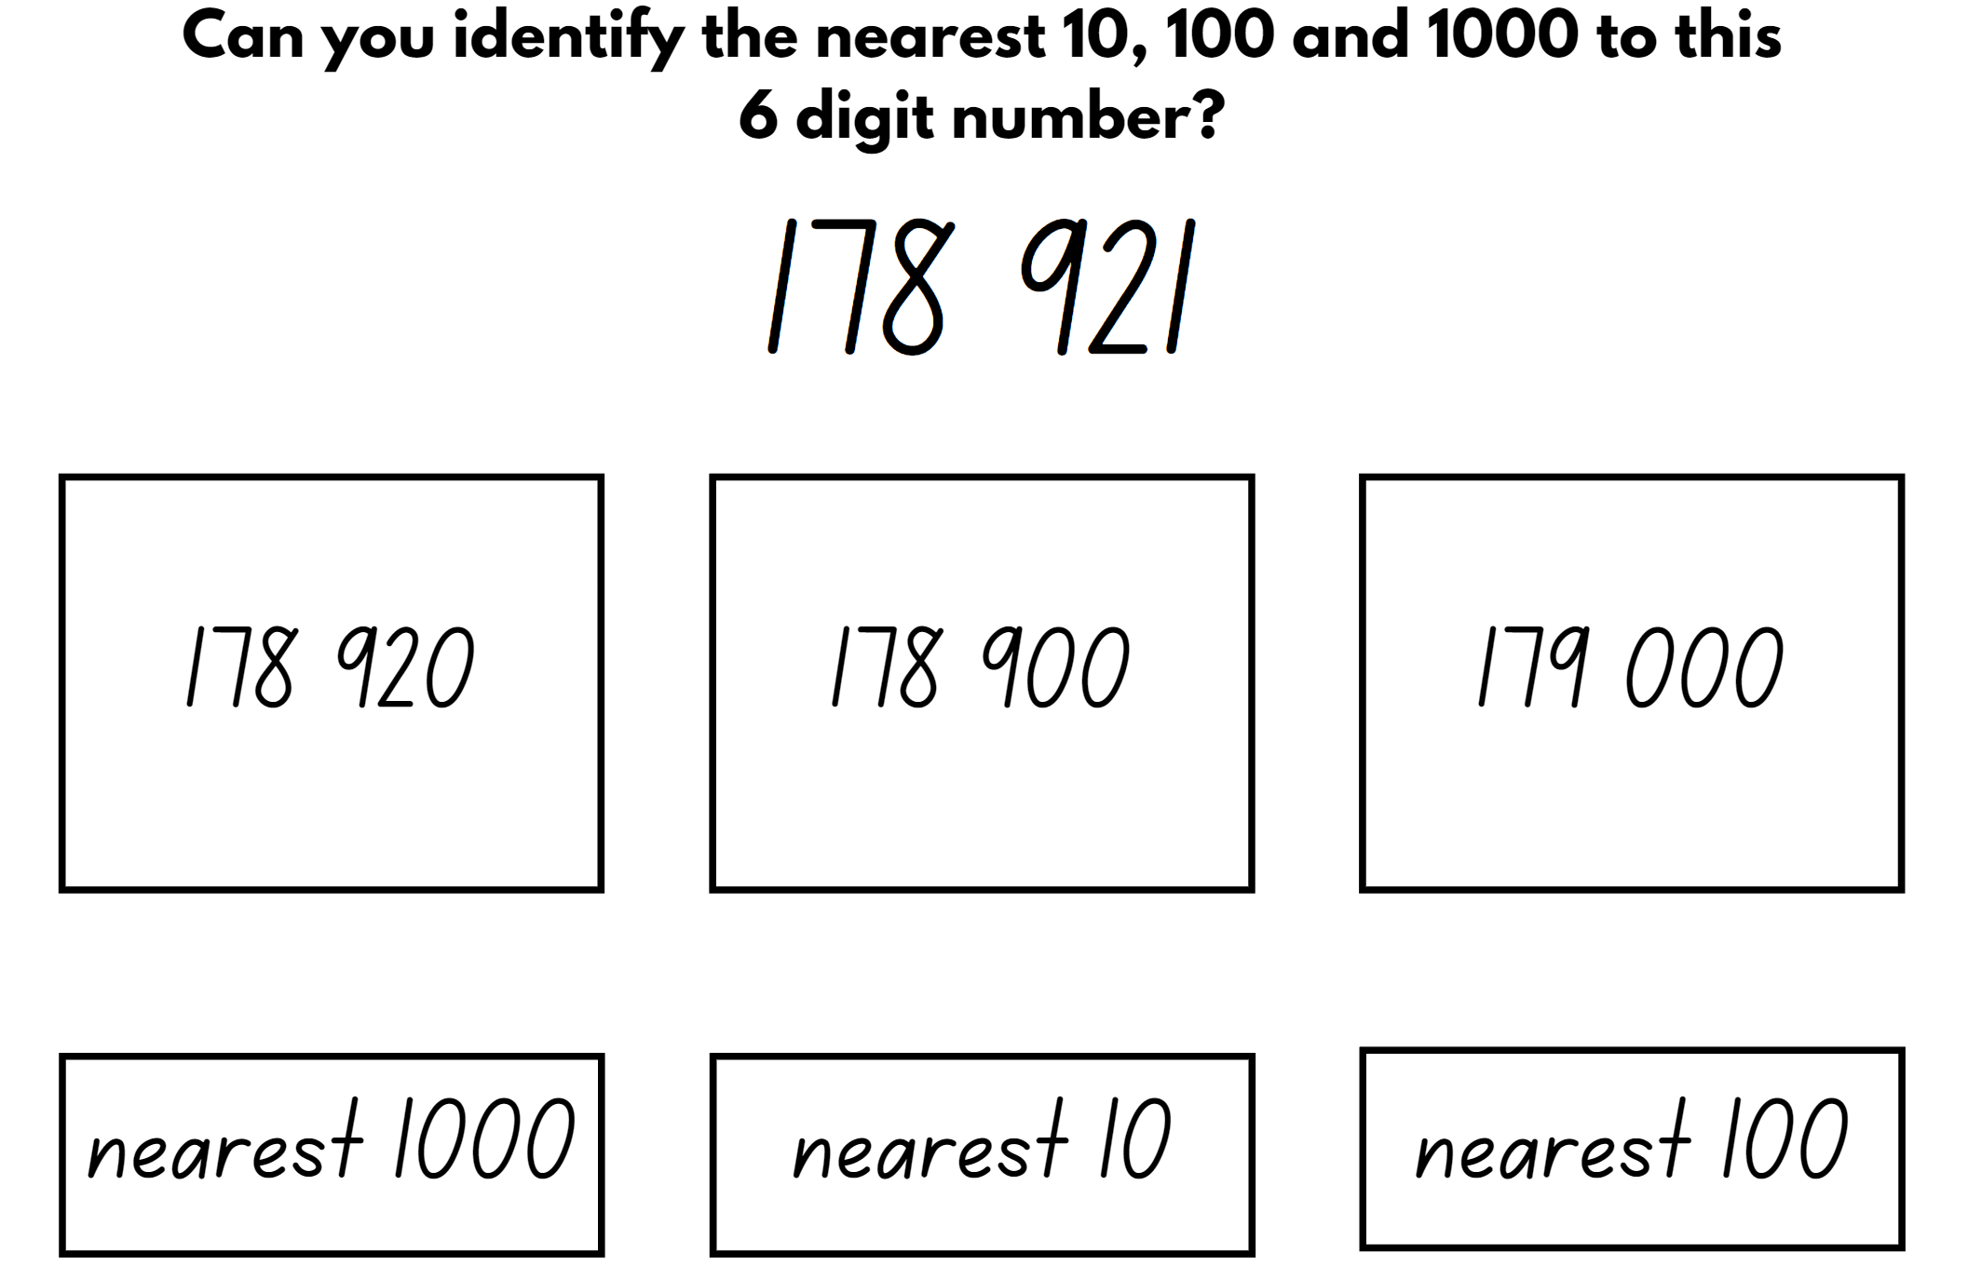

Resource 4 – carpark image
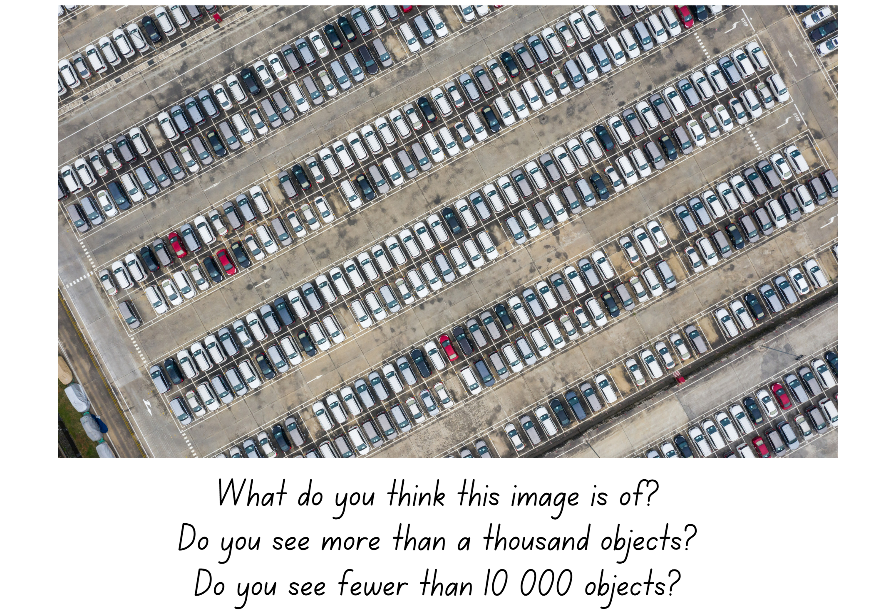

Resource 5 – jellybean spinner
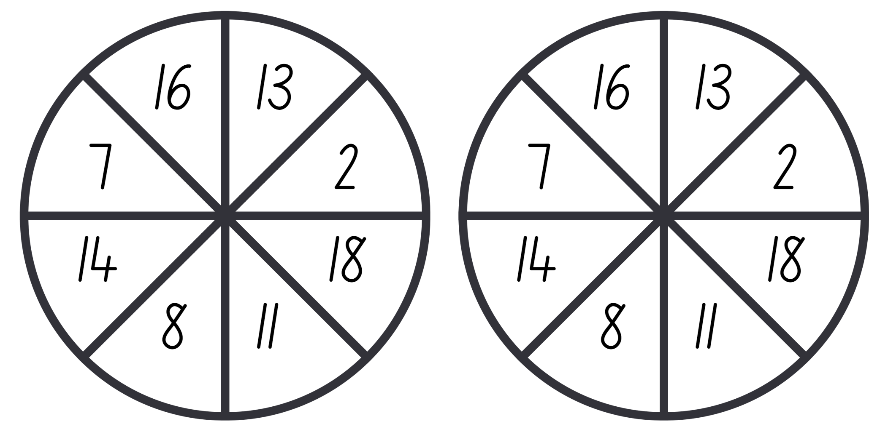

Resource 6 – jellybean sort
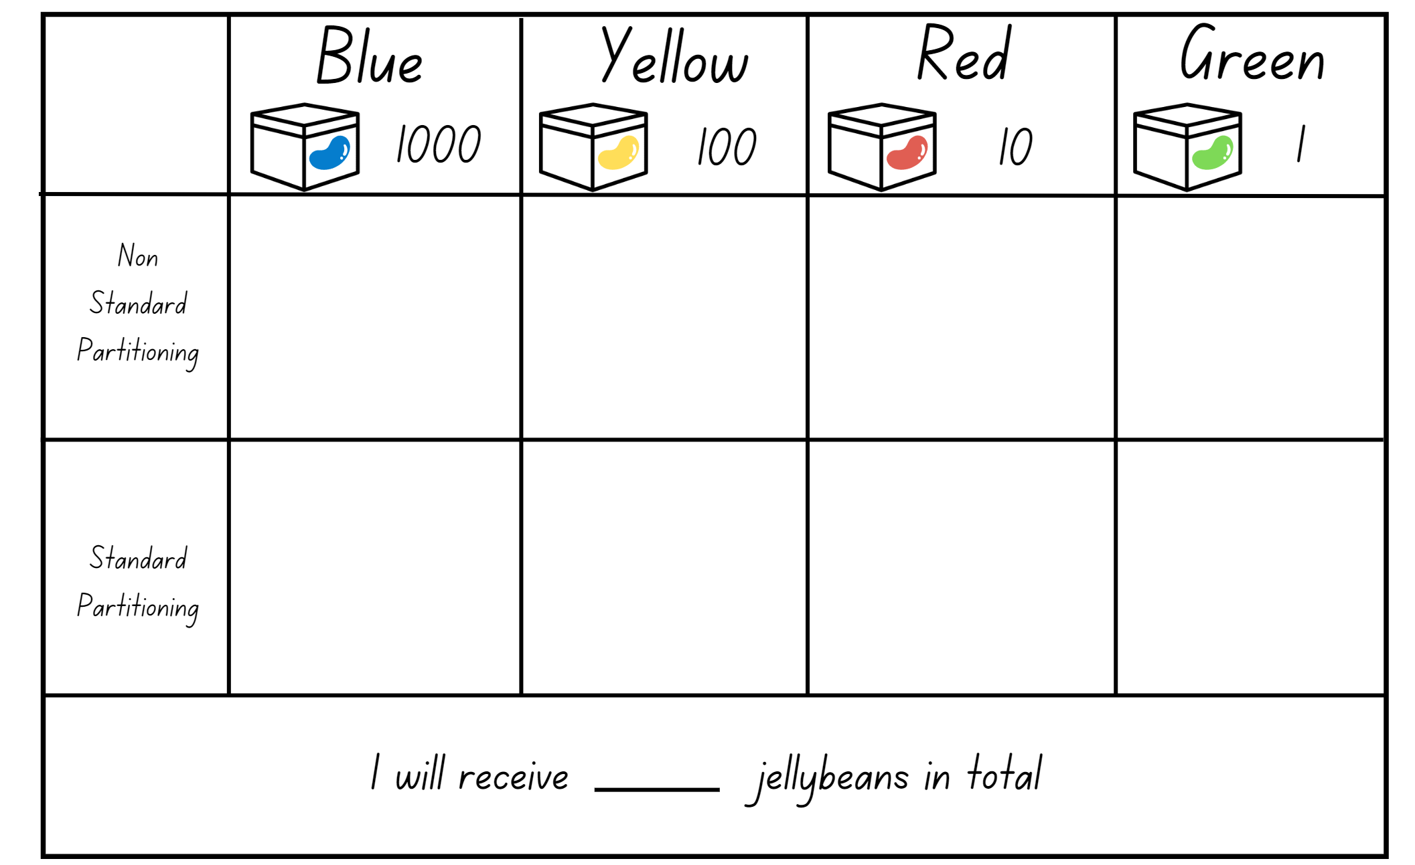

Resource 7 – 100 grid
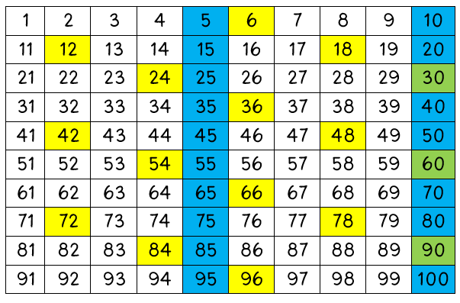

Resource 8 – build a decimal
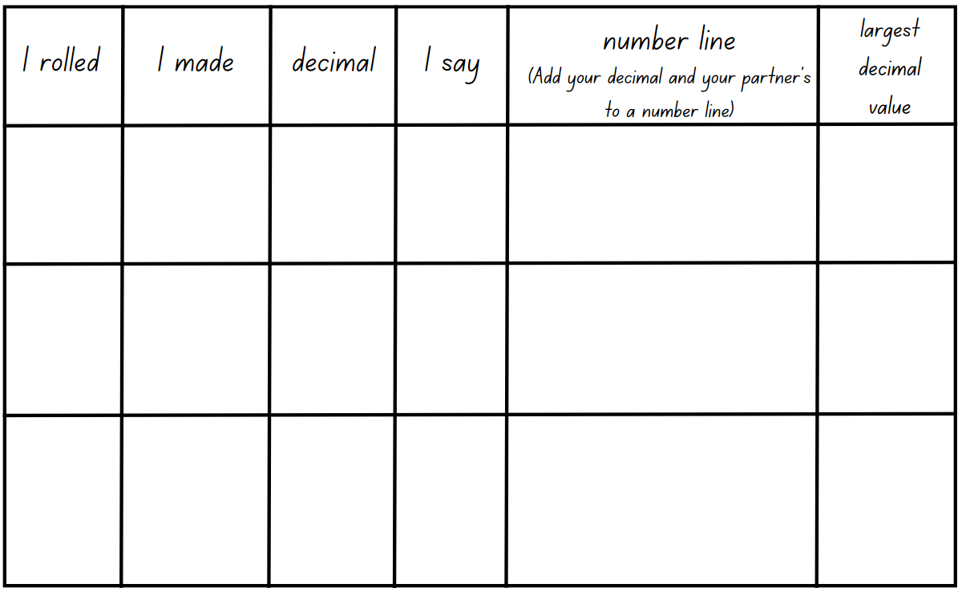

Resource 9 – hundredths
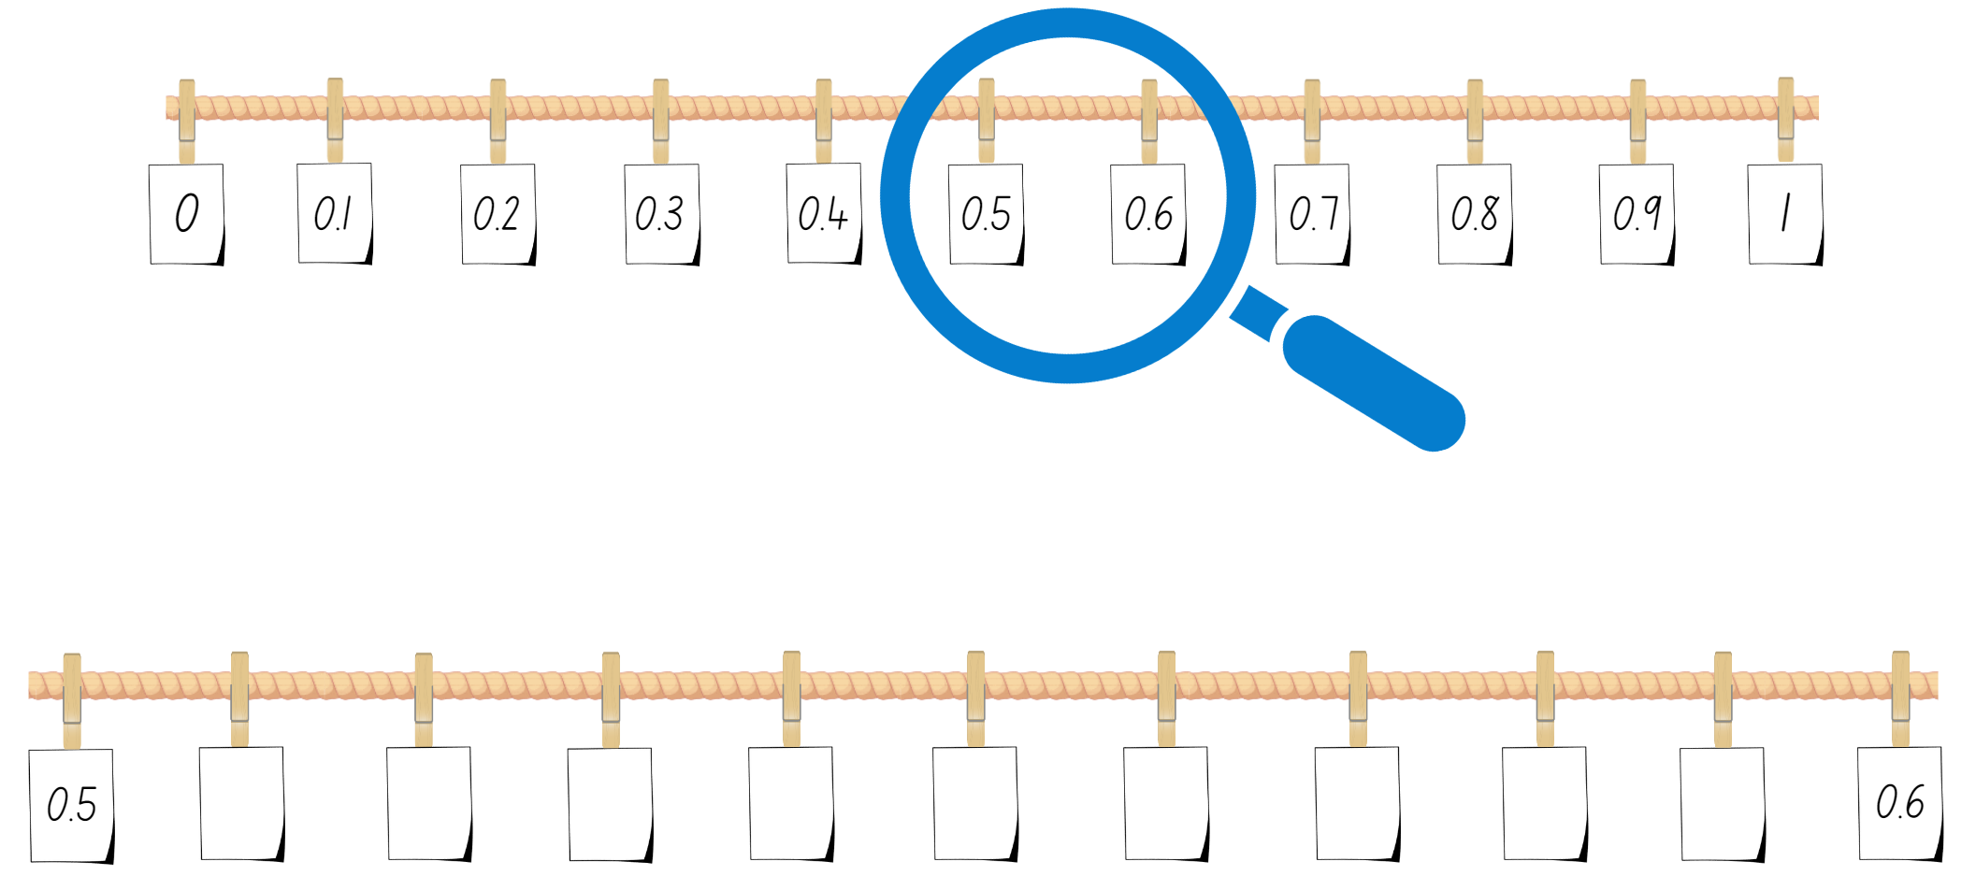

Resource 10 – decimal concentration
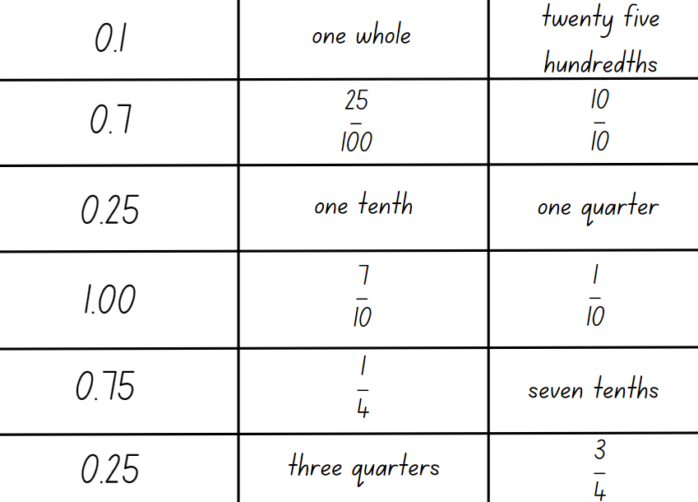

Resource 11 – multiplication problems
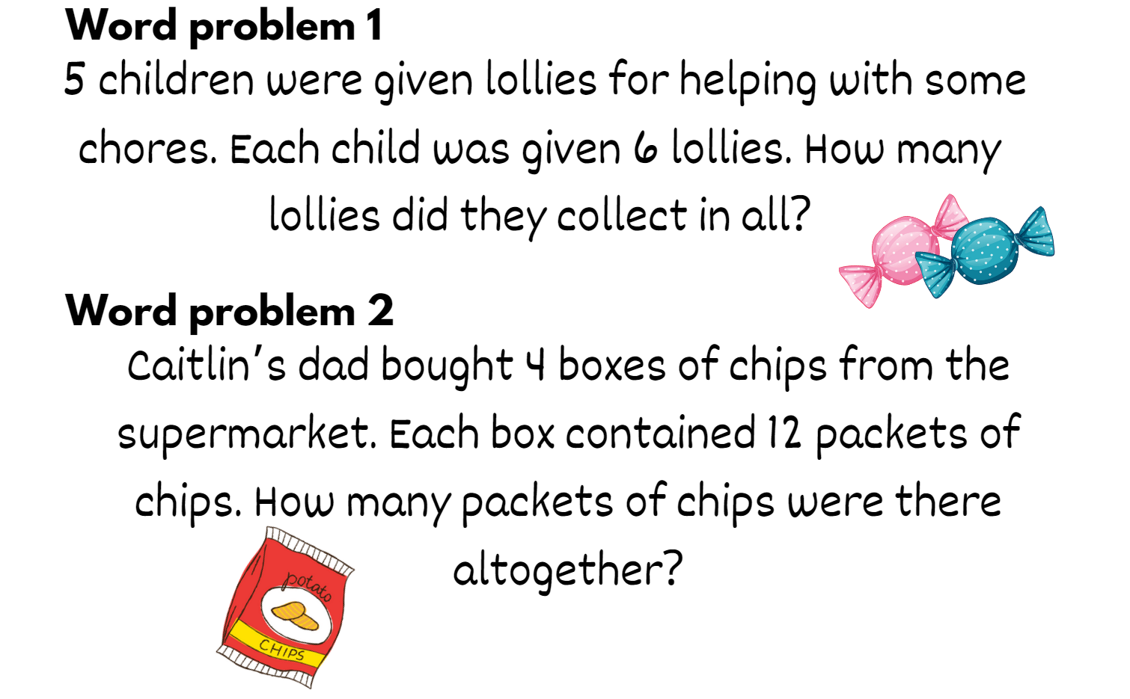

Resource 12 – multiples gameboard
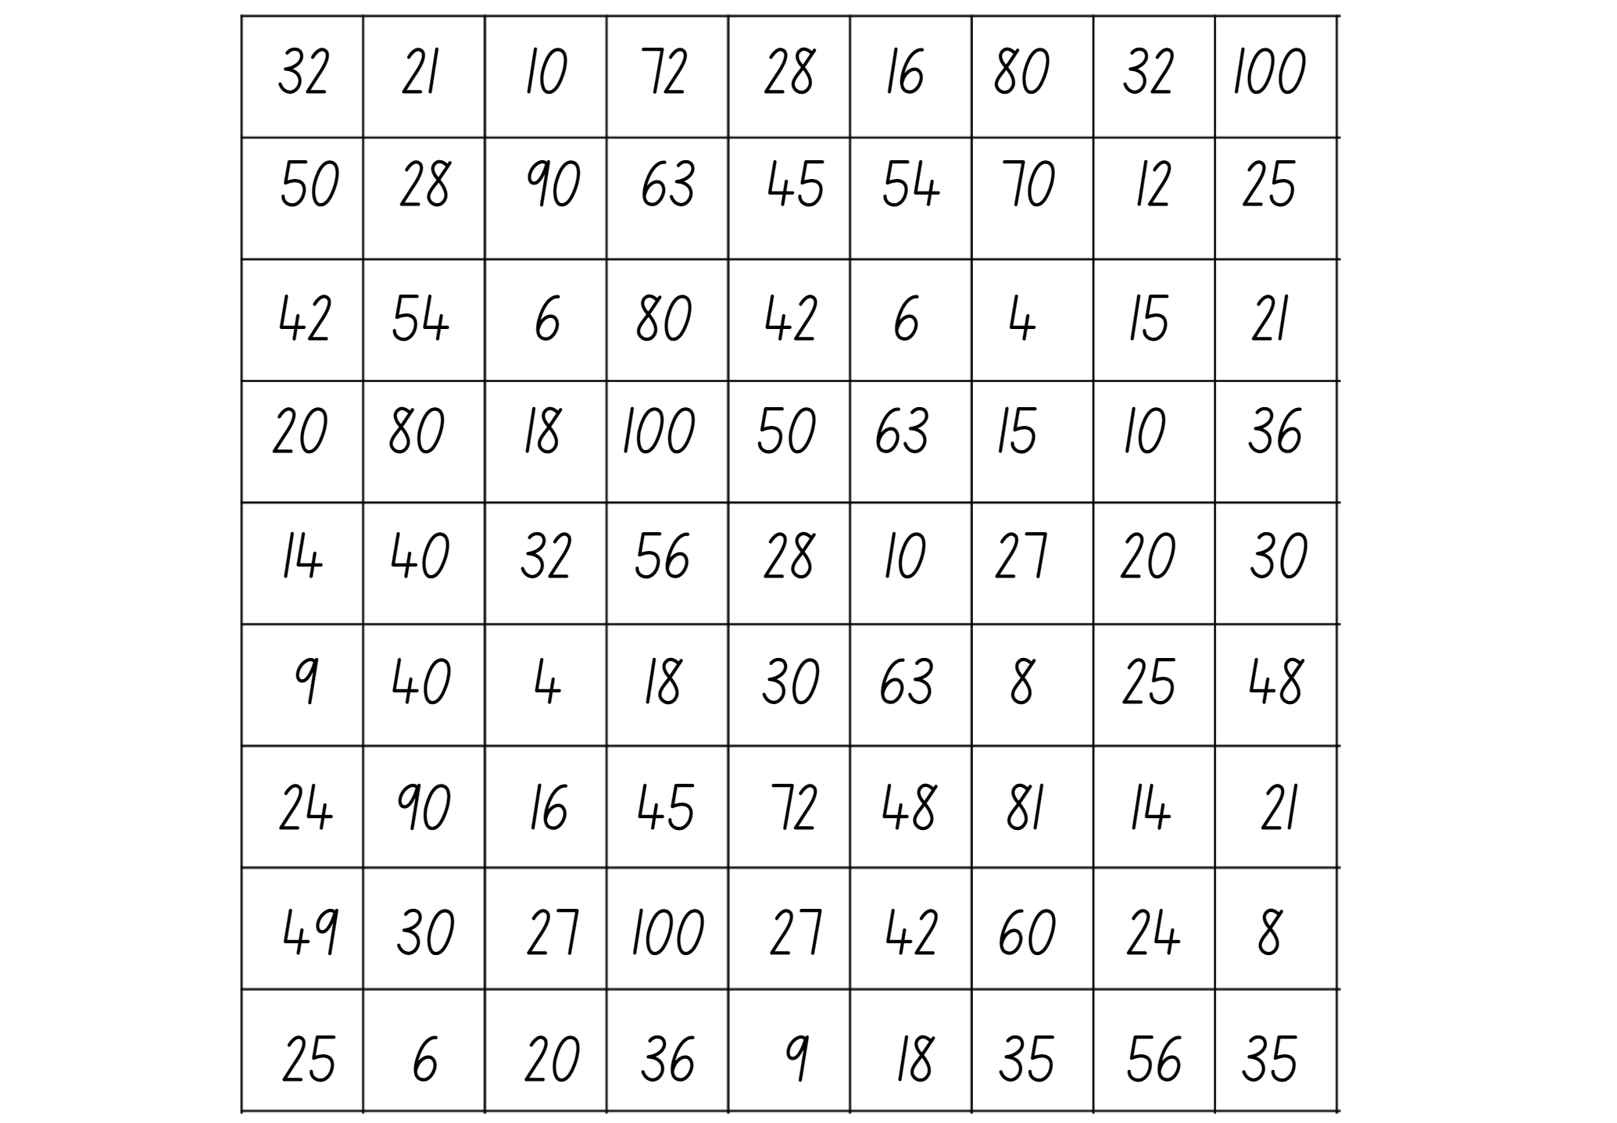

Resource 13 – division problems
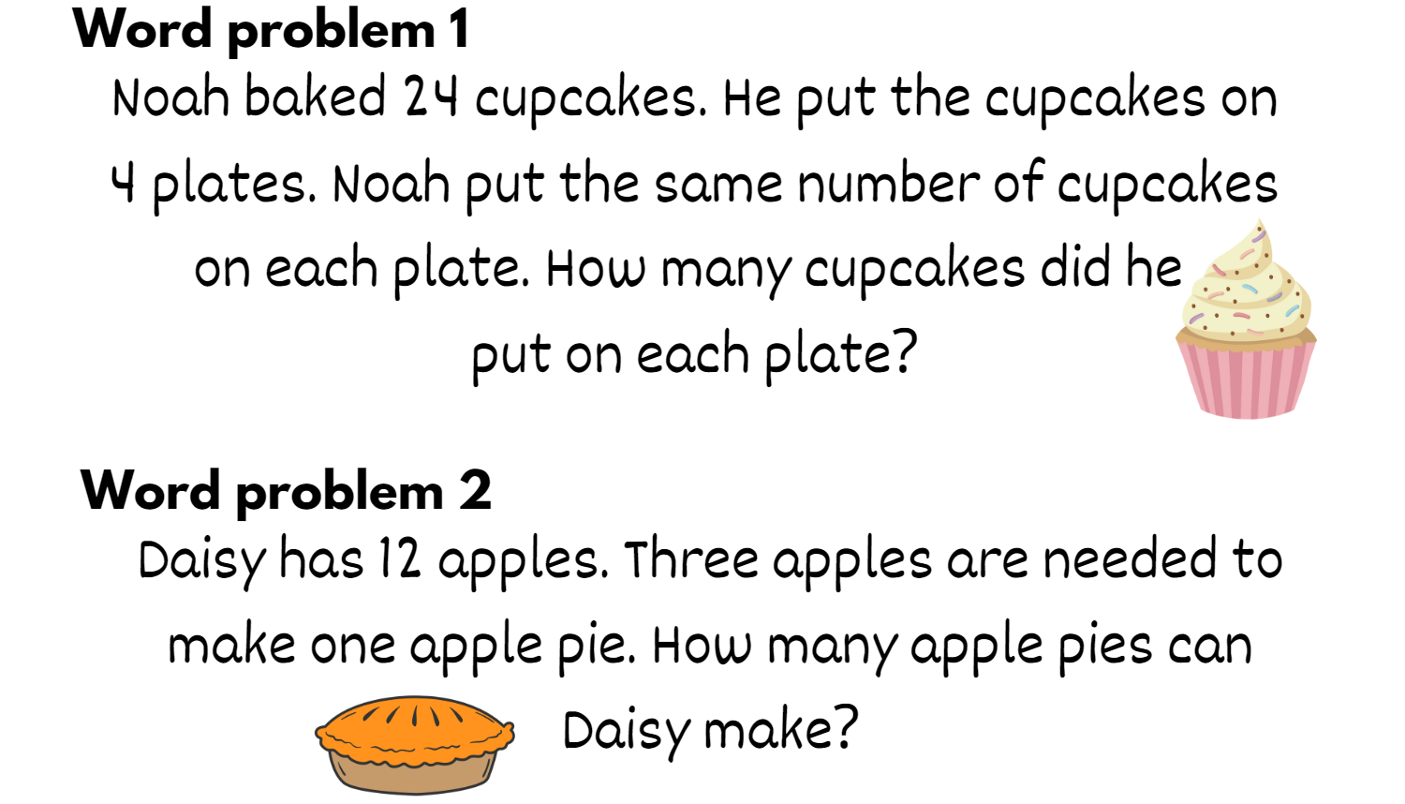

Resource 14 – my piggy bank
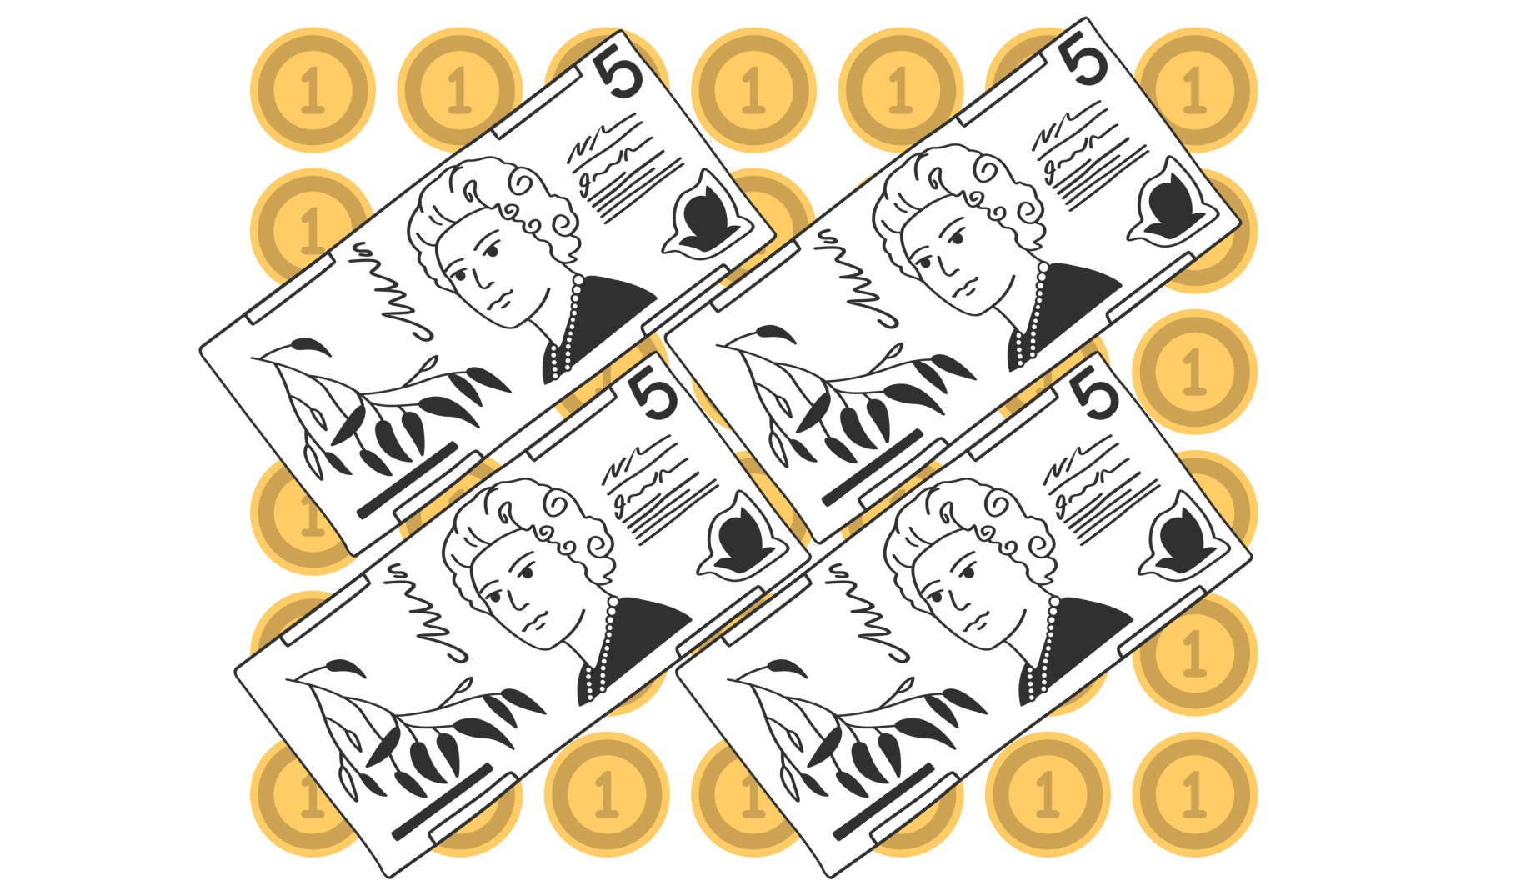

Resource 15 – multiplication or division?
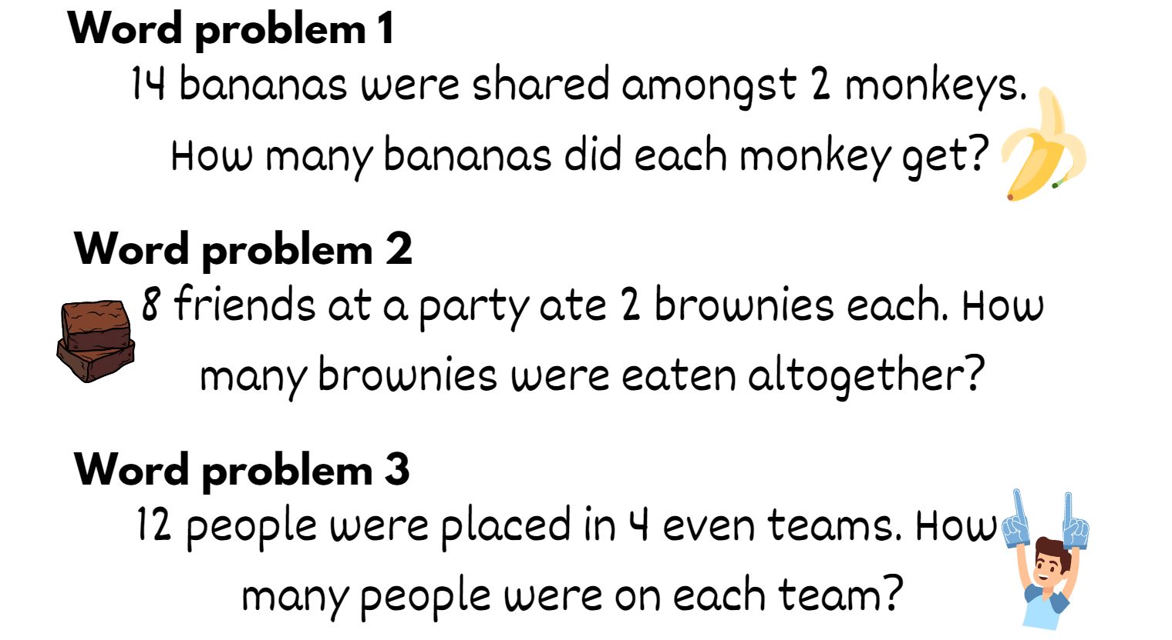

Resource 16 – Would you rather…?
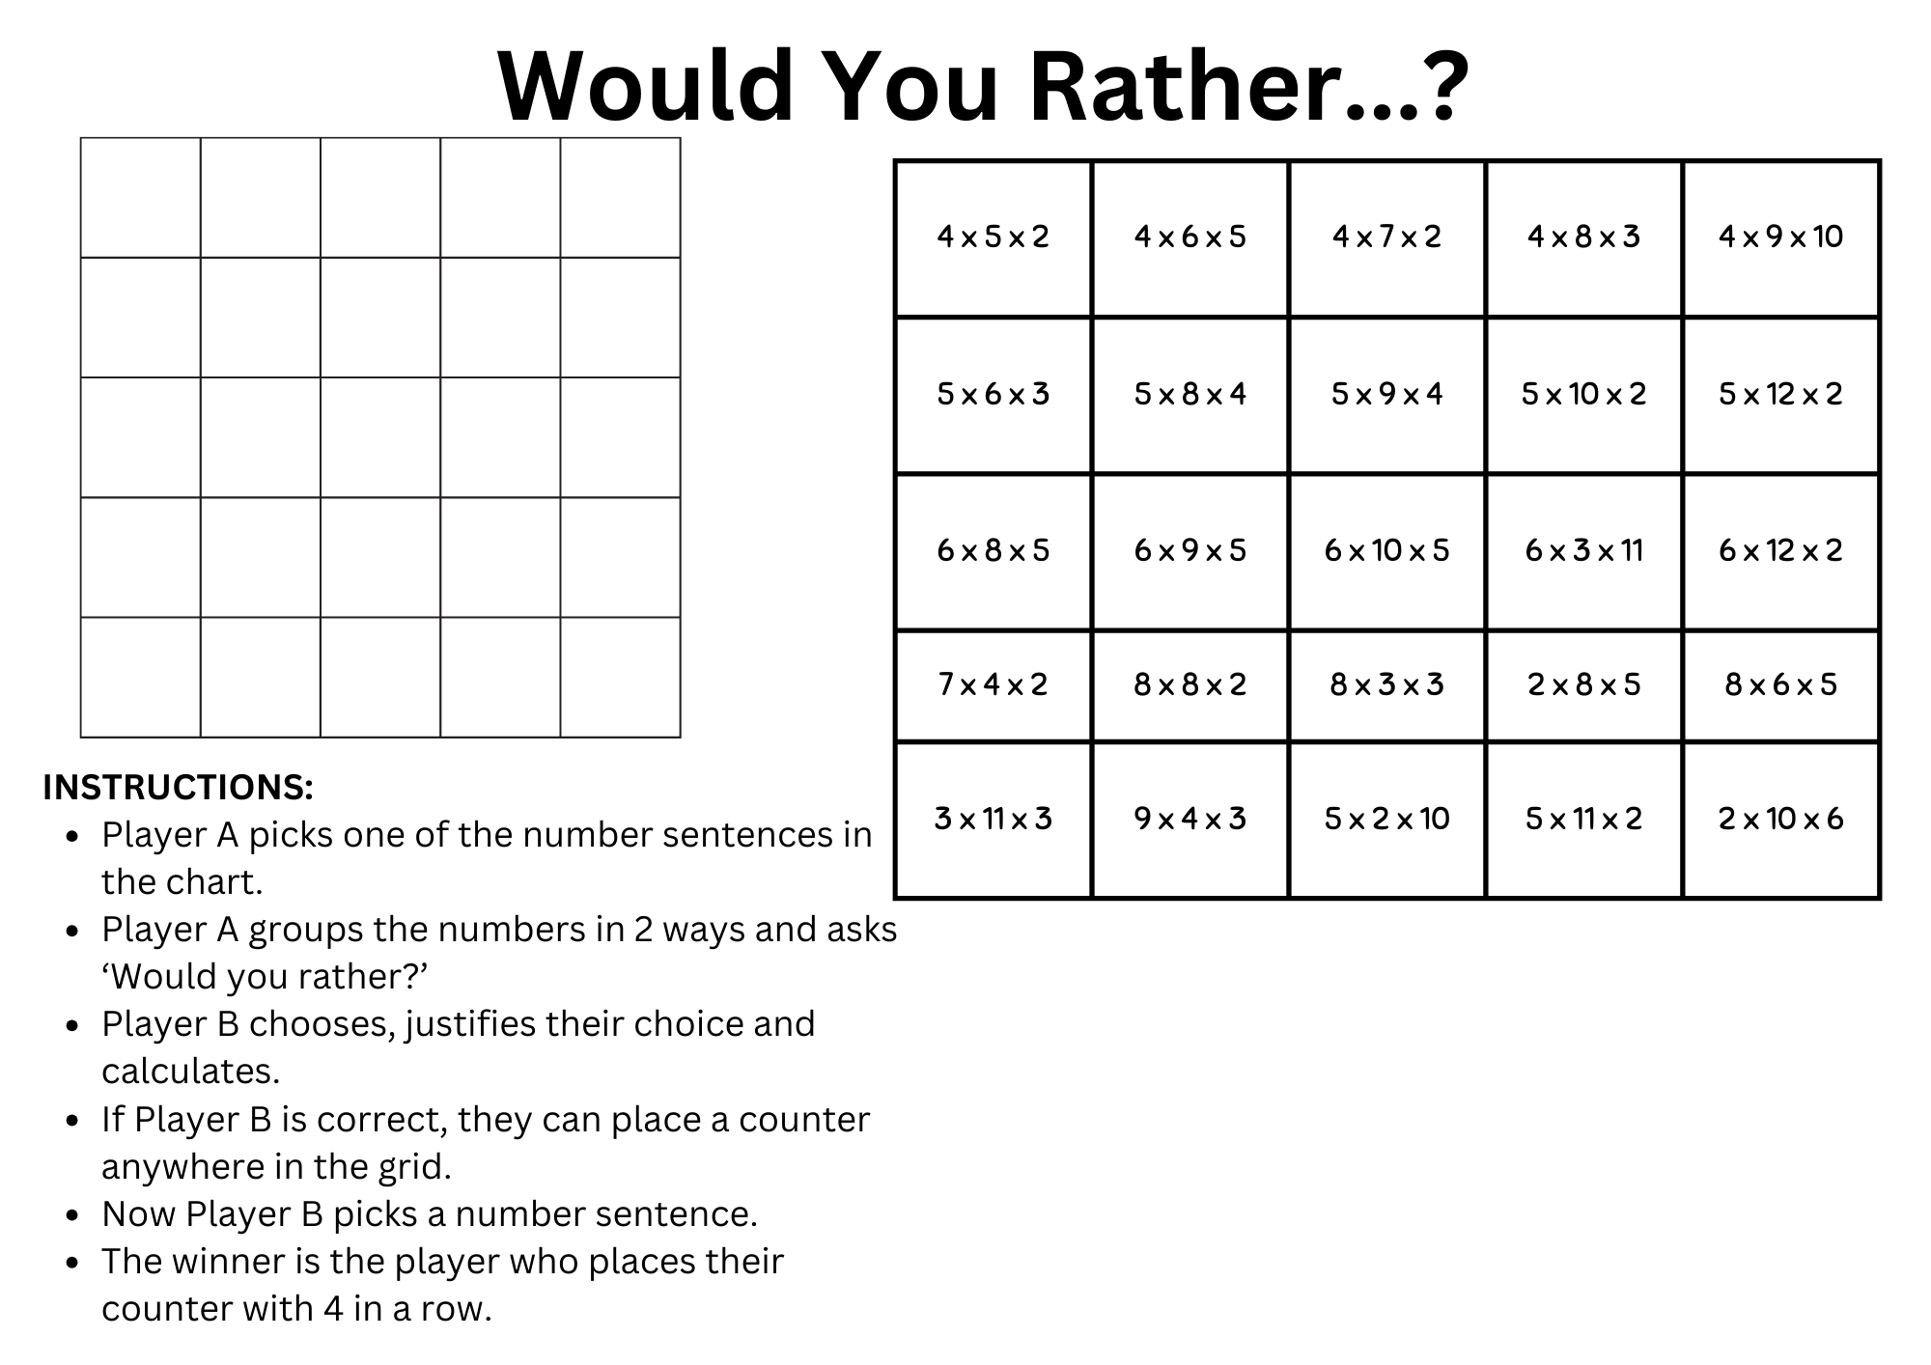

Resource 17 – recording sheet
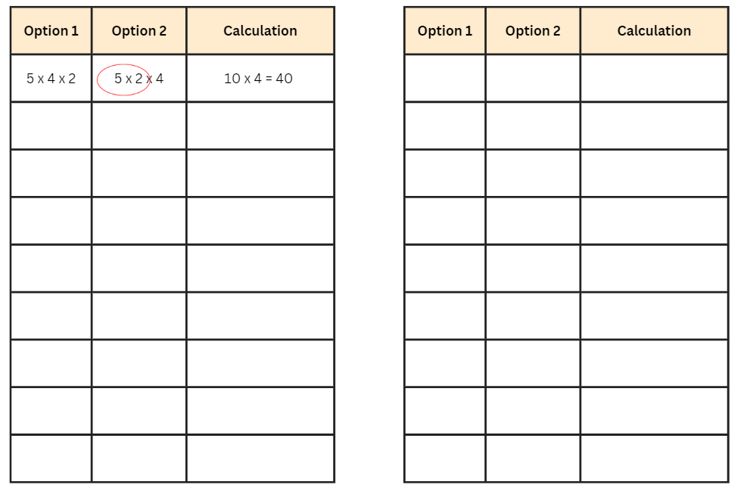

Resource 18 – strawberry patch
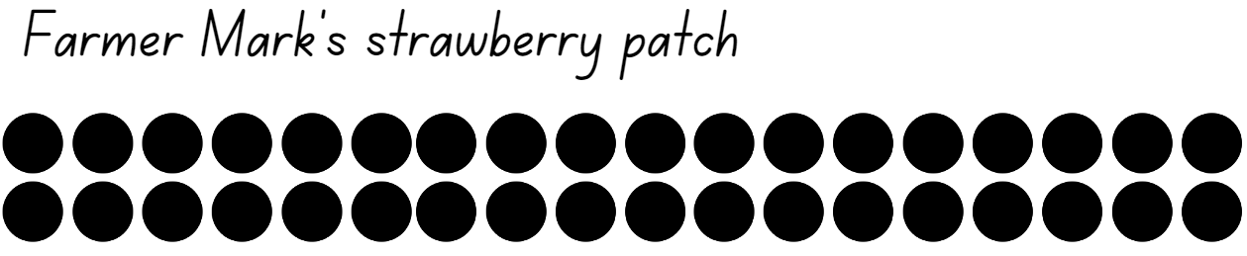

Resource 19 – strawberry patch strategies
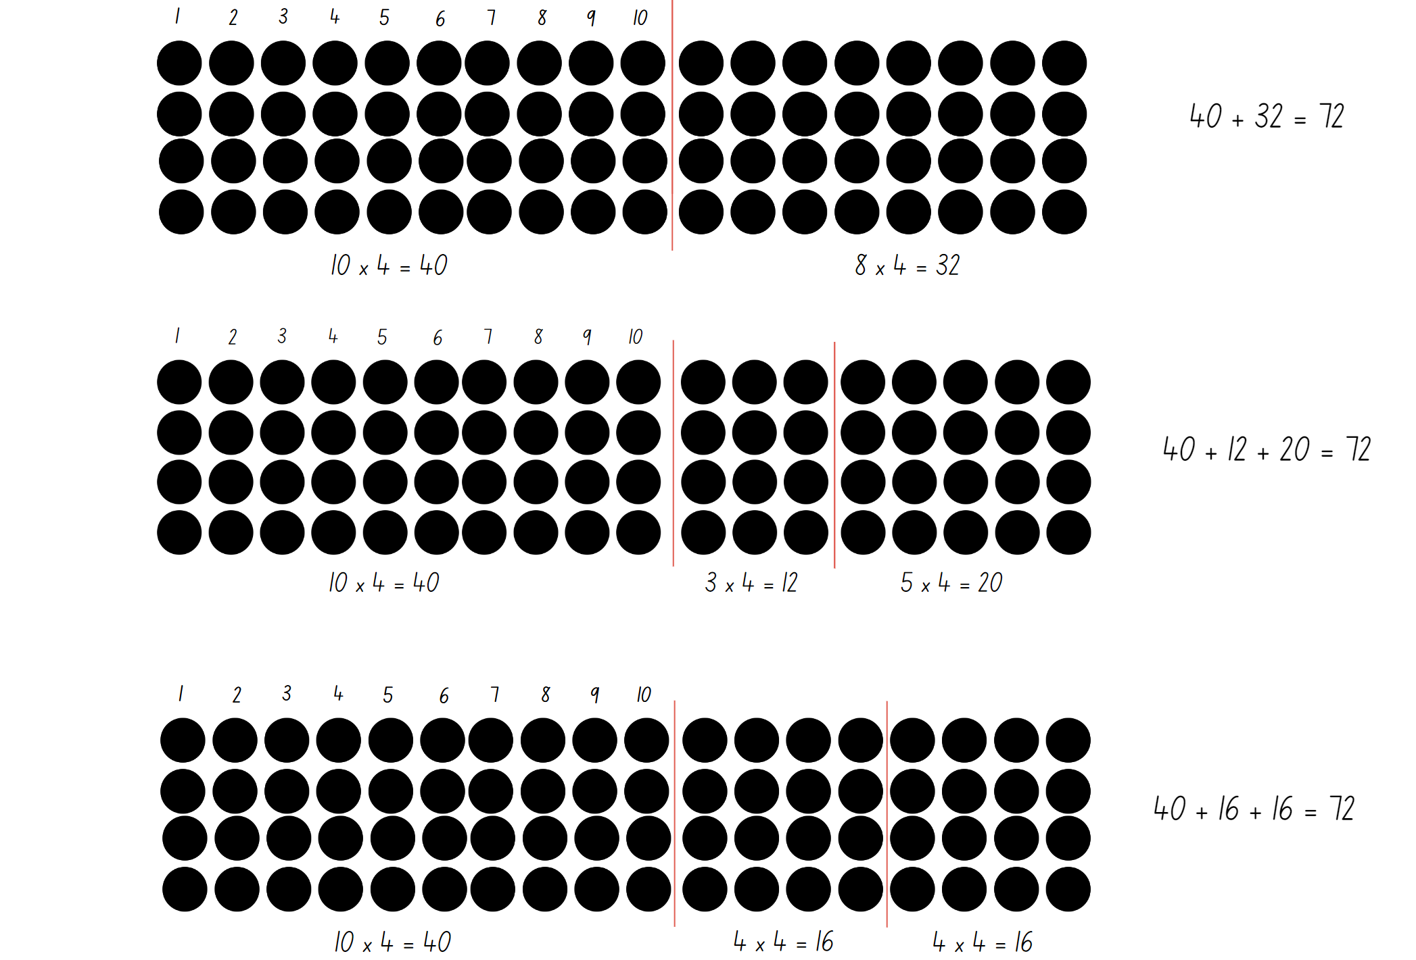

Resource 20 – spinner
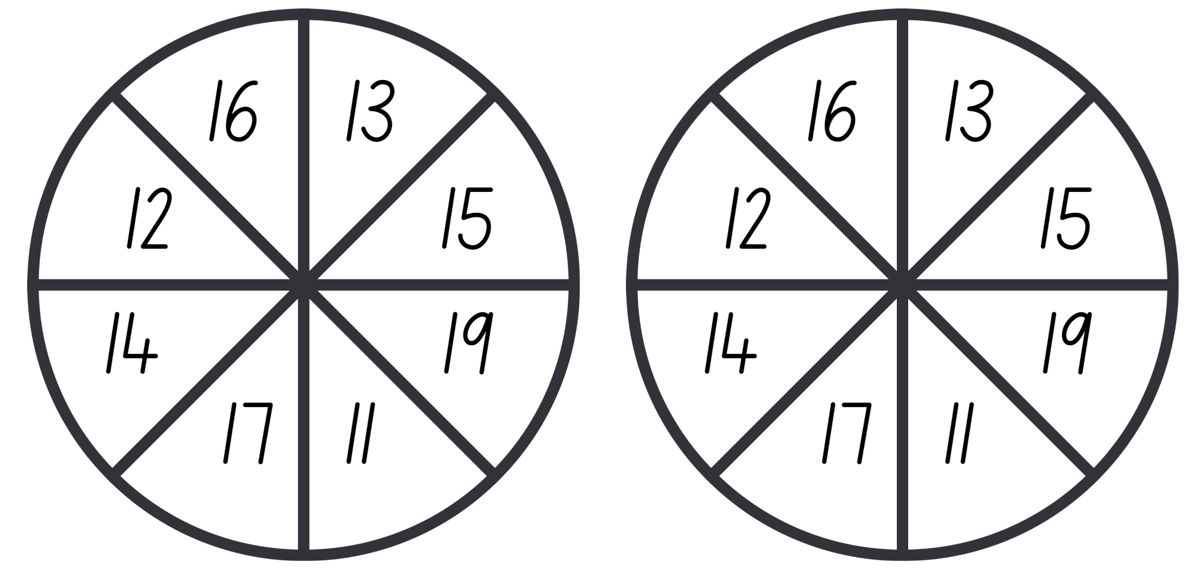

Syllabus outcomes and content
The table below outlines the syllabus outcomes and range of relevant syllabus content covered in this unit. Content is linked to National Numeracy Learning Progression version (3).
Outcomes and content | 1 | 2 | 3 | 4 | 5 | 6 | 7 | 8
Representing numbers using place value A: Whole numbers: Read, represent and order numbers to thousands
MAO-WM-01, MA2-RN-01
- Group physical or virtual objects to show the structure of tens, hundreds and a thousand |  | x
- Regroup numbers flexibly, recognising one thousand as 10 hundreds and one hundred as 10 tens or 100 ones |  | x
- Count forwards and backwards by tens and hundreds on and off the decade | x
- Represent numbers up to and including thousands using physical or virtual manipulatives, words, numerals, diagrams and digital displays | x | x
- Read and order numbers of up to at least 4 digits | x
Representing numbers using place value A: Whole number: Apply place value to partition and regroup numbers up to 4 digits
MAO-WM-01, MA2-RN-01
- Record numbers using standard place value form |  | x
- Partition numbers of up to 4 digits in non-standard forms (Reasons about quantity) |  | x
Representing numbers using place value B: Whole numbers: Order numbers in the thousands
MAO-WM-01, MA2-RN-01
- Arrange numbers in the thousands in ascending and descending order | x
- Recognise and describe how rearranging digits changes the size of a number | x
- Identify the nearest thousand, 10 thousand or 100 thousand to numbers | x
Representing numbers using place value B: Whole numbers: Apply place value to partition, regroup and rename numbers up to 6 digits
MA0-WM-01, MA2-RN-01
- Name thousands using the place value grouping of ones, tens and hundreds of thousands | x | x
- Partition numbers of up to 6 digits in non-standard forms |  | x
Representing numbers using place value B: Whole numbers: Recognise and represent numbers that are 10, 100 or 1000 times as large
MA0-WM-01, MA2-RN-01
- Recognise the number of tens, hundreds or thousands in a number | x | x |  |  |  |  |  | x
Representing numbers using place value B: Decimals: Extend the application of the place value system from whole numbers to tenths and hundredths
MA0-WM-01, MA2-RN-02
- Divide a length representing one whole into 10 equal parts and label the divisions using decimal notation |  |  | x | x
- Use the decimal point as a marker to identify the position of the ones digit when expressing tenths as decimals |  |  | x
- Recognise that 10-tenths is recorded as 1.0 and regroup when using decimal notation |  |  | x
- Subdivide tenths into 10 equal parts and record hundredths using place value |  |  | x
- Express decimals as both tenths and hundredths |  |  | x | x
- Locate and order decimals representing tenths and hundredths on a number line, describing their relative size |  |  | x | x
Representing numbers using place value B: Decimals: Make connections between fractions and decimal notation
MA0-WM-01, MA2-RN-02
- Record equivalent measurements using decimals |  |  |  | x
- Make connections between fractions and decimal notation for key benchmark values (Reasons about relations) |  |  |  | x
Multiplicative relations A: Generate and describe patterns
MAO-WM-01, MA2-MR-01
- Model, describe and record patterns of multiples |  |  |  |  | x
- Create and continue a variety of number patterns that increase or decrease by a constant amount |  |  |  |  | x
- Recognise the significance of the final digit of a whole number in determining whether a given number is even or odd (Reasons about relations) |  |  |  |  | x
- Recognise the connection between even numbers and the multiplication facts for 2 (Reasons about relations) |  |  |  |  | x
Multiplicative relations B: Investigate number sequences involving related multiples
MAO-WM-01, MA2-MR-01
- Generate number patterns using related multiples | x | x | x |  | x
- Investigate number patterns involving related multiples | x | x | x |  | x
Multiplicative relations B: Use known number facts and strategies
MAO-WM-01, MA2-MR-01
- Use known facts to find unknown multiples (Reasons about relations) |  |  |  |  | x | x
Multiplicative relations B: Use the structure of the area model to represent multiplication and division
MAO-WM-01, MA2-MR-01
- Create and represent multiplicative structure, moving from arrays to partially covered area models |  |  |  |  |  | x
Multiplicative relations B: Use number properties to find related multiplication facts
MAO-WM-01, MA2-MR-01
- Use the commutative property of multiplication |  |  |  |  |  | x
- Use the associative property within multiplication to regroup the factors (Reasons about structure) |  |  |  |  |  | x | x | x
- Use flexible partitioning within multiplication (Reasons about relations) |  |  |  |  |  | x | x | x
- Generate and recall multiplication fact families up to 10 x 10 |  |  |  |  |  | x | x
Multiplicative relations B: Operate with multiples of 10
MAO-WM-01, MA2-MR-01
- Use multiplication facts with multiples of 10 to multiply a one-digit number by a multiple of 10 |  |  |  |  |  |  |  | x
- Use place value to rename groups of 10 to multiply |  |  |  |  |  |  |  | x
- Apply the commutative and associative properties to multiply by multiples of 10 |  |  |  |  |  |  |  | x
Multiplicative relations B: Represent and solve word problems with number sentences involving multiplication or division
MAO-WM-01, MA2-MR-01
- Use the equals sign to record equivalent number relationships involving multiplication (Reasons about relations) |  |  |  |  |  |  | x
- Complete number sentences involving multiplication and division by calculating missing numbers (Reasons about relations) |  |  |  |  | x | x | x
- Represent and solve multiplication and division (both sharing and grouping) word problems using number sentences |  |  |  |  | x | x | x
Mathematics K–10 Syllabus © NSW Education Standards Authority (NESA) for and on behalf of the Crown in right of the State of New South Wales, 2022.

References
This resource contains NSW Curriculum and syllabus content. The NSW Curriculum is developed by the NSW Education Standards Authority. This content is prepared by NESA for and on behalf of the Crown in right of the State of New South Wales. The material is protected by Crown copyright.
Please refer to the NESA Copyright Disclaimer for more information https://educationstandards.nsw.edu.au/wps/portal/nesa/mini-footer/copyright.
NESA holds the only official and up-to-date versions of the NSW Curriculum and syllabus documents. Please visit the NSW Education Standards Authority (NESA) website https://educationstandards.nsw.edu.au/wps/portal/nesa/home/ and the NSW Curriculum website https://curriculum.nsw.edu.au.
Mathematics K–10 Syllabus © NSW Education Standards Authority (NESA) for and on behalf of the Crown in right of the State of New South Wales, 2022.
National Numeracy Learning Progression © Australian Curriculum, Assessment and Reporting Authority (ACARA) 2010 to present, unless otherwise indicated. This material was downloaded from the Australian Curriculum website (National Numeracy Learning Progression) (accessed January 2024) and was not modified.
Clarke D and Roche A (2014) Engaging Maths: 25 favourite lessons, 2nd edn, Mathematics Teaching and Learning Centre, Australian Catholic University and Catholic Education office.
Commonwealth of Pennsylvania (2013) Solving Multiplication and Division Word Problems, Pennsylvania Department of Education: SAS (Standards Aligned System) website, accessed 7 August 2023.
Lowry C (n.d.) Number Patterns (PDF 134 KB), AMSI (Australian Mathematical Sciences Institute), accessed 9 February 2024.
Mathcurious.com (2020) Multihive – Practice multiples, Mathcurious website, accessed 7 August 2023.
State of New South Wales (Department of Education) (2023) ‘Multiplication toss’, Mathematics K–6 resources, NSW Department of Education website, accessed 7 August 2023.
Sullivan P (2018) Challenging Mathematical Tasks: Unlocking the Potential of all Students, Oxford University Press, Australia.
University of Cambridge (n.d.) Multiples Grid, NRICH website, accessed 7 August 2023.
Van de Walle J, Karp K, Bay-Williams JM, Brass A, Bentley B, Ferguson S, Goff W, Livy S, Marshman M, Martin D, Pearn C, Prodromou T, Symons D and Wilkie K (2019) Primary and Middle Years Mathematics: Teaching Developmentally, 1st Australian edn, Pearson Education Australia, Melbourne.

Further reading
Siemon D, Warren E, Beswick K, Faragher R, Miller J, Horne M, Jazby D, Breed M, Clark J and Brady K (2020) Teaching Mathematics: Foundations to Middle Years, 3rd edn, Oxford University Press Australia and New Zealand.

© State of New South Wales (Department of Education), 2024
The copyright material published in this resource is subject to the Copyright Act 1968 (Cth) and is owned by the NSW Department of Education or, where indicated, by a party other than the NSW Department of Education (third-party material).
Copyright material available in this resource and owned by the NSW Department of Education is licensed under a Creative Commons Attribution 4.0 International (CC BY 4.0) license.
This license allows you to share and adapt the material for any purpose, even commercially.
Attribution should be given to © State of New South Wales (Department of Education), 2024.
Material in this resource not available under a Creative Commons license:
- the NSW Department of Education logo, other logos and trademark-protected material
- material owned by a third party that has been reproduced with permission. You will need to obtain permission from the third party to reuse its material.
Links to third-party material and websites
Please note that the provided (reading/viewing material/list/links/texts) are a suggestion only and implies no endorsement, by the New South Wales Department of Education, of any author, publisher, or book title. School principals and teachers are best placed to assess the suitability of resources that would complement the curriculum and reflect the needs and interests of their students.
If you use the links provided in this document to access a third-party's website, you acknowledge that the terms of use, including licence terms set out on the third-party's website apply to the use which may be made of the materials on that third-party website or where permitted by the Copyright Act 1968 (Cth). The department accepts no responsibility for content on third-party websites.

