Mathematics Stage 2 – Unit 17
Multiplicative thinking involves flexible use of multiplication and division concepts, strategies and representations
Contents
Unit description and duration 6
Syllabus outcomes 6
Working mathematically 7
Student prior learning 7
Lesson overview and resources 9
Lesson 1 16
Daily number sense – groups to arrays – 15 minutes 16
Core lesson – odds and evens – 30 minutes 19
Discuss and connect the mathematics – 15 minutes 20
Lesson 2 24
Daily number sense – array bingo – 15 minutes 24
Core lesson – magic multiples – 35 minutes 26
Discuss and connect the mathematics – 10 minutes 28
Lesson 3 31
Daily number sense – What comes next? – 15 minutes 31
Core lesson – rectangular robots – 30 minutes 33
Discuss and connect the mathematics – 15 minutes 38
Lesson 4 40
Daily number sense – 10 minutes 40
Core lesson – sticker arrays – 35 minutes 40
Discuss and connect the mathematics – 15 minutes 46
Lesson 5 48
Daily number sense – ascending and descending order – 10 minutes 48
Core lesson – finding areas – 30 minutes 49
Discuss and connect the mathematics – 10 minutes 52
Consolidation and meaningful practice – 20 minutes 52
Lesson 6 54
Daily number sense – What’s the nearest? – 10 minutes 54
Core lesson – constructing and drawing prisms – 50 minutes 55
Discuss and connect the mathematics – 10 minutes 61
Lesson 7 63
Daily number sense – nice or nasty – 10 minutes 63
Core lesson – making prisms – 45 minutes 65
Discuss and connect the mathematics – 15 minutes 67
Lesson 8 69
Daily number sense – 10 minutes 69
Core lesson – jube cubes – 40 minutes 69
Discuss and connect the mathematics – 20 minutes 72
Resource 1 – Farmer Cluck 74
Resource 2 – egg carton arrays 75
Resource 3 – always, sometimes, never 76
Resource 4 – array bingo cards 77
Resource 5 – array descriptor cards 78
Resource 6 – How many twos? 79
Resource 7 – How many fours? 80
Resource 8 – How many fives? 81
Resource 9 – How many threes? 82
Resource 10 – What comes next? 83
Resource 11 – exploring arrays 84
Resource 12 – making the link 85
Resource 13 – rectangular robot 86
Resource 14 – robot areas 87
Resource 15 – sticker album solution 88
Resource 16 – sticker problem 89
Resource 17 – fact family triangles 90
Resource 18 – comparing 2 leaves 91
Resource 19 – leaf grid overlay 92
Resource 20 – Julie’s strategy 93
Resource 21 – Michelle’s strategy 94
Resource 22 – pallet of boxes 95
Resource 23 – top, front, side 96
Resource 24 – three prism views 97
Resource 25 – student prisms 98
Resource 26 – sample student responses 99
Resource 27 – JMS lolly company 100
Resource 28 – different views 101
Syllabus outcomes and content 102
References 108

Unit description and duration
This unit develops the big idea that multiplicative thinking involves flexible use of multiplication and division concepts, strategies and representations.
In this 2-week unit students are provided opportunities to:
- use patterns and array structures to support multiplicative thinking
- apply knowledge of multiplication to estimate, measure and compare area
- apply knowledge of multiplication to measure and compare volume using the row, column, layer structure.

Syllabus outcomes
- MAO-WM-01 develops understanding and fluency in mathematics through exploring and connecting mathematical concepts, choosing and applying mathematical techniques to solve problems, and communicating their thinking and reasoning coherently and clearly
- MA2-RN-01 applies an understanding of place value and the role of zero to represent numbers to at least tens of thousands
- MA2-MR-01 represents and uses the structure of multiplicative relations to 10 × 10 to solve problems
- MA2-2DS-01 compares two-dimensional shapes and describes their features
- MA2-2DS-03 estimates, measures and compares areas using square centimetres and square metres
- MA2-3DS-01 makes and sketches models and nets of three-dimensional objects including prisms and pyramids
- MA2-3DS-02 estimates, measures and compares capacities (internal volumes) using litres, millilitres and volumes using cubic centimetres

Working mathematically
In the Mathematics K–10 Syllabus, there is one overarching Working mathematically outcome (MAO-WM-01). The Working mathematically processes should be embedded within the concepts being taught. The Working mathematically processes present in the Mathematics K–10 Syllabus are:
- communicating
- understanding and fluency
- reasoning
- problem solving.
Mathematics K–10 Syllabus © NSW Education Standards Authority (NESA) for and on behalf of the Crown in right of the State of New South Wales, 2022.

Student prior learning
Before engaging in these teaching and learning activities, students would benefit from prior experience with:
- using the array structure to coordinate the number of groups with the number in each group
- recognising the grid structure of rows and columns to help find the area
- using formal units to measure capacity (internal volume) and recognising the difference between volume and capacity.
In NSW classrooms there is a diverse range of students, including Aboriginal and/or Torres Strait Islander students, students learning English as an additional language or dialect, high potential and gifted students and students with disability. Some students may identify with more than one of these groups or possibly all of them. Refer to Curriculum planning for every student – advice for further information.

Lesson overview and resources
The table below outlines the sequence and approximate timing of lessons, learning intentions and resources.
Lesson | Content | Duration and resources
Lesson 1  Daily number sense learning intention:  - use arrays to establish multiplication facts from multiples of 2 and 4, 5 and 10 | Lesson core concept: multiplicative thinking is based on patterns and structures.  Core concept learning intention:  - generate and describe patterns | Lesson duration: 60 minutes  - Resource 1 – Farmer Cluck  - Resource 2 – egg carton arrays  - Resource 3 – always, sometimes, never  - Hundreds chart  - 6-sided dice  - Counters  - Individual whiteboards  - Writing materials
Lesson 2  Daily number sense learning intention:  - use arrays to establish multiplication facts from multiples of 2 and 4, 5 and 10 | Lesson core concept: structures can support multiplicative thinking.  Core concept learning intention:  - use arrays to establish multiplication facts from multiples of 2 and 4, 5 and 10 | Lesson duration: 60 minutes  - Resource 4 – array bingo cards  - Resource 5 – array descriptor cards  - Resource 6 – How many twos?  - Resource 7 – How many fours?  - Resource 8 – How many fives?  - Resource 9 – How many threes?  - Website: Dozens  - Website: Colour Counters  - Counters  - Dot die  - Writing materials
Lesson 3  Daily number sense learning intention:  - use arrays to establish multiplication facts from multiples of 2 and 4, 5 and 10 | Lesson core concept: area relates to multiplication.  Core concept learning intentions:  - recall multiplication facts of 2 and 4, 5 and 10 and related division facts  - measure the areas of shapes using the grid structure  - compare and describe features of two-dimensional shapes | Lesson duration: 60 minutes  - Resource 10 – What comes next?  - Resource 11 – exploring arrays  - Resource 12 – making the link  - Resource 13 – rectangular robot  - Resource 14 – robot areas  - Website: Dicey Perimeter, Dicey Area  - 9-sided dice  - Counters  - Individual whiteboards  - Square-centimetre grid paper  - Writing materials
Lesson 4  Daily number sense learning intention:  - teacher-identified task based on student needs | Lesson core concept: areas can be measured using arrays and square centimetres.  Core concept learning intentions:  - recall multiplication facts of 2 and 4, 5 and 10 and related division facts  - use square centimetres to measure the areas of rectangles | Lesson duration: 60 minutes  - Resource 15 – sticker album solution  - Resource 16 – sticker problem  - Resource 17 – fact family triangles  - Counters  - Square-centimetre grid paper  - Writing materials
Lesson 5  Daily number sense learning intention:  - order numbers in the thousands | Lesson core concept: mathematicians estimate, measure and compare area.  Core concept learning intentions:  - compare surfaces using familiar metric units of area  - use square centimetres to measure and estimate the areas of rectangles  - use arrays to establish multiplication facts from multiples of 2 and 4, 5 and 10 | Lesson duration: 70 minutes  - Resource 18 – comparing 2 leaves  - Resource 19 – leaf grid overlay  - Resource 20 – Julie’s strategy  - Resource 21 – Michelle’s strategy  - 9-sided dice  - Square-centimetre grid paper  - Sticky notes  - Writing materials
Lesson 6  Daily number sense learning intention:  - order numbers in the thousands | Lesson core concept: volume relates to the measurement of three-dimensional space.  Core concept learning intentions:  - make models of three-dimensional objects to compare and describe key features  - connect three-dimensional objects and two-dimensional representations | Lesson duration: 70 minutes  - Resource 22 – pallet of boxes  - Resource 23 – top, front, side  - 9-sided dice  - Cubic centimetre blocks  - Individual whiteboards  - Isometric dot paper  - Sticky notes  - Writing materials
Lesson 7  Daily number sense learning intention:  - order numbers in the thousands | Lesson core concept: standard units are an efficient way to communicate volume.  Core concept learning intention:  - compare objects using familiar metric units of volume | Lesson duration: 70 minutes  - Resource 24 – three prism views  - Resource 25 – student prisms  - Resource 26 – sample student responses  - 9-sided dice  - Cubic centimetre blocks  - Individual whiteboards  - Writing materials
Lesson 8  Daily number sense learning intention:  - teacher-identified task based on student needs | Lesson core concept: mathematicians measure and compare volume.  Core concept learning intentions:  - compare objects using familiar metric units of volume  - connect three-dimensional objects and two-dimensional representations | Lesson duration: 70 minutes  - Resource 27 – JMS lolly company  - Resource 28 – different views  - Cubic centimetre blocks  - Sticky notes  - Writing materials

Lesson 1
Core concept: multiplicative thinking is based on patterns and structures.

Daily number sense – groups to arrays – 15 minutes
Daily number sense activities for Lessons 1 to 3 ‘activate’ prior number knowledge and support the learning of new content in the unit. These activities can also assist teachers to identify the starting points for learning by revealing the extent of students’ existing knowledge.
The table below contains a suggested learning intention and success criteria. These are best co-constructed with students.
Daily number sense learning intention | Daily number sense success criteria
Students are learning to:  - use arrays to establish multiplication facts from multiples of 2 and 4, 5 and 10. | Students can:  - use the array structure to coordinate the number of groups with the number in each group.
This activity is an adaptation of Loops and Groups from Math Learning Center.
- Give pairs of students a 6-sided die, counters and individual whiteboards.
- Player 1 rolls the die and draws the resulting number of loops on their whiteboard. Player 1 rolls again and places that number of counters in each loop.
Note: when students are describing an array, encourage them to read an array like a book from left to right to determine how many in each row. For example, 5 rows (groups) of 3 becomes 5 threes with the ‘rows of’ or ‘groups of’ implied. This then leads to one three is 3, 2 threes are 6, 3 threes are nine, and so on.
- Player 1 rearranges the counters into an array and labels the array, for example 4 fives are 20 (see Figure 1).
Figure 1 – possible student recording
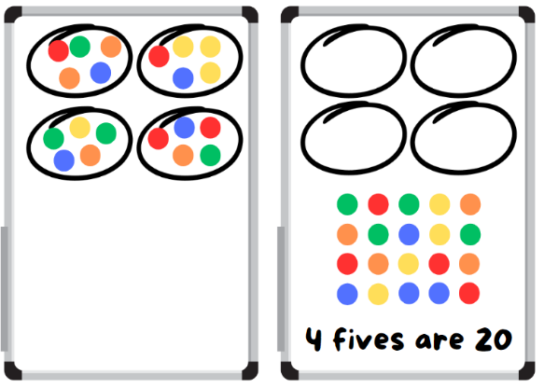
- Player 2 repeats the process.
- At the end of the round, the player with the highest product wins and scores a point. The player who scores the most points by the end of the game is the winner.
This table details opportunities for assessment.
Assessment opportunities | Links
What to look for:  - Can students use the array structure to coordinate the number of groups with the number in each group? [MAO-WM-01,  MA2-MR-01] | Links to National Numeracy Learning Progressions (NNLP):  - MuS5.  Links to suggested Interview for Student Reasoning (IfSR) tasks:  - IfSR-MT: 2A.2.

Core lesson – odds and evens – 30 minutes
The table below contains a suggested learning intention and success criteria. These are best co-constructed with students.
Core concept learning intention | Core concept success criteria
Students are learning to:  - generate and describe patterns. | Students can:  - model, describe and record patterns of multiples  - recognise the significance of the final digit of a whole number in determining whether a given number is even or odd.
- Display Resource 1 – Farmer Cluck. Ask:
- How could we record our ideas?
- What will it look like if the rows are full in the egg cartons?
- What could it look like if the eggs aren’t in rows of 2?
- Students work in small groups. Give students 30 counters and Resource 2 – egg carton arrays. Students to keep track of the numbers they test and the numbers that fit Farmer Cluck’s criteria.
This table details opportunities for differentiation.
Too hard? | Too easy?
Students cannot model, describe and record patterns of multiples.  - Give students a smaller number of counters and support students to arrange counters into rows of 2.  - Support students to start with 2 counters and work systematically to test different numbers. | Students can model, describe and record patterns of multiples.  - Give students Resource 3 – always, sometimes, never. Ask students to record whether the statements are always, sometimes or never true.  - Ask students to create their own statements for a partner to test.

Discuss and connect the mathematics – 15 minutes
- Regroup and ask:
- Which numbers could work for Farmer Cluck?
- Which numbers didn’t work?
- How did you test your ideas?
- How did you know that a number would work or not?
- What patterns do you notice?
- Collate student responses and record their ideas on a hundreds chart. Colour the even numbers green and the odd numbers yellow to highlight the pattern created. For example, all the numbers that worked will be coloured green and all the numbers that did not work will be coloured yellow (see Figure 2).
Figure 2 – odd and even
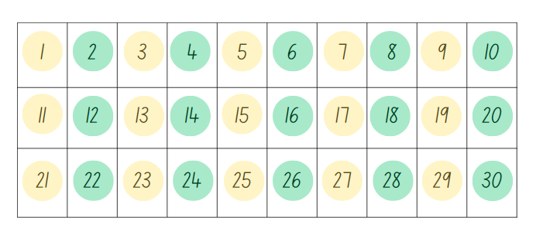
- Ask students:
- What do you notice about the numbers coloured in green?
- How can we describe the green numbers by using the word multiples?
- Is there another way that we can describe the green numbers?
- What do you notice about the numbers coloured in yellow?
- How are these numbers different to the green numbers?
- What patterns do you see in the final digit of each number?
- Would 36 be a green or yellow number? How do you know?
- Would 39 be a green or yellow number? How do you know?
- Revise that the numbers that are coloured green are called ‘even’ numbers because they are multiples of 2. The numbers that are coloured yellow are called ‘odd’ numbers because when they are divided by 2, there is one left over.
Multiples: products formed using the same base number multiplied by different whole numbers, for example, 2, 4, 6, 8 …
- Students complete an exit slip to answer the following questions:
- Is 374 an odd or even number? How do you know?
- Can you give an example of an odd and even number larger than 50?
This table details opportunities for assessment.
Assessment opportunities | Links
What to look for:  - Can students model, describe and record patterns of multiples? [MAO-WM-01, MA2-MR-01]  - Can students recognise the significance of the final digit of a whole number in determining whether a given number is even or odd? [MAO-WM-01, MA2-MR-01] | Links to National Numeracy Learning Progressions (NNLP):  - NPA3, NPA4.

Lesson 2
Core concept: structures can support multiplicative thinking.

Daily number sense – array bingo – 15 minutes
The table below contains a suggested learning intention and success criteria. These are best co-constructed with students.
Daily number sense learning intention | Daily number sense success criteria
Students are learning to:  - use arrays to establish multiplication facts from multiples of 2 and 4, 5 and 10. | Students can:  - use the array structure to coordinate the number of groups with the number in each group.
This activity is an adaptation of Array bingo from Mathematics K–6 resources by State of New South Wales (Department of Education).
- Give pairs of students Resource 4 – array bingo cards and Resource 5 – array descriptor cards.
- Each player creates a gameboard using 6 dotted array cards, setting aside any remaining array cards.
- Students place the descriptor cards in a pile facing down.
- Players take turns to pick up a descriptor card and check if they have the matching array card. If they do, they can turn the array card face down. If both players have the matching array card, they can both turn their matching array card face down.
- Students can use the commutative property to rotate and rename the arrays. For example, 3 twos can be rotated to show 2 threes.
- If neither player has the matching array card, turn over the next descriptor card in the pile.
- The winner is the first player to turn all their array cards face down and say ‘Bingo!’
This table details opportunities for assessment.
Assessment opportunities | Links
What to look for:  - Can students use the array structure to coordinate the number of groups with the number in each group? [MAO-WM-01,  MA2-MR-01] | Links to National Numeracy Learning Progressions (NNLP):  - MuS5.  Links to suggested Interview for Student Reasoning (IfSR) tasks:  - IfSR-MT: 2A.9.

Core lesson – magic multiples – 35 minutes
The table below contains a suggested learning intention and success criteria. These are best co-constructed with students.
Core concept learning intention | Core concept success criteria
Students are learning to:  - use arrays to establish multiplication facts from multiples of 2 and 4, 5 and 10. | Students can:  - create and represent multiplicative structure, using the term multiples when connecting grouping to arrays.
- Revise with students the definition of odd and even numbers from Lesson 1. Ask students to identify how understanding multiples helps to work out whether a number can be divided by another number.
- Display Resource 6 – How many twos?. Ask students to show how they know the number of dots can be divided by 2 without counting the dots.
- Provide small groups of students with Resource 6 – How many twos?
- Ask:
- Were the number of dots able to be divided by 2? How do you know?
- What strategies did you use to check whether the number of dots were able to be divided by 2 without counting?
- Are the number of dots on this page able to be divided by 4? How do you know?
- Provide small groups of students with copies of Resource 7 – How many fours? and Resource 8 – How many fives?.
- Allow students time to explore and show how they know the number of dots on Resource 7 – How many fours? is able to be divided by 4 and how they know the number of dots on Resource 8 – How many fives? is not able to be divided by 5.
- Regroup and ask:
- What strategies did you use to show the dots were able to be divided by 4?
- Why did you choose this strategy?
- How did your multiplication facts for multiples of 4 help you with this task?
- What strategies did you use to show the dots weren’t able to be divided by 5?
- Why did you choose this strategy?
- How did your multiplication facts for multiples of 5 help you with this task?
- Would the number of dots on Resource 8 – How many fives? be able to be divided by 10? How do you know?
This table details opportunities for differentiation.
Too hard? | Too easy?
Students cannot create and represent multiplicative structure, using the term multiples when connecting grouping to arrays.  - Support students to recreate Resource 8 – How many fives? using counters. Support students to rearrange counters into fives to determine if the number of counters is divisible by 5.  - Provide students with a representation of 4 as shown on a dot die. Support students to identify fours in Resource 7 – How many fours? and rearrange additional dots to recreate the dot die representation. | Students can recreate and represent multiplicative structure, using the term multiples when connecting grouping to arrays.  - Provide students with a copy of Resource 9 – How many threes?. Students show how they know the number of dots is a multiple of 3 without counting.  - Students explore ideas of divisibility and how they can quickly prove a number is a multiple of 2, 3, 4 or 5, see Dozens for more information.

Discuss and connect the mathematics – 10 minutes
- Display Colour Counters with Resource 7 – How many fours? recreated using the interactive counters. Ask:
- How can the counters be rearranged to make an array of fours?
- What is the least amount of moves that you can use to do this? Answer: 2 (see Figure 3).
- How does this array help prove that the number of dots is able to be divided by 4?
Figure 3 – dots rearranged
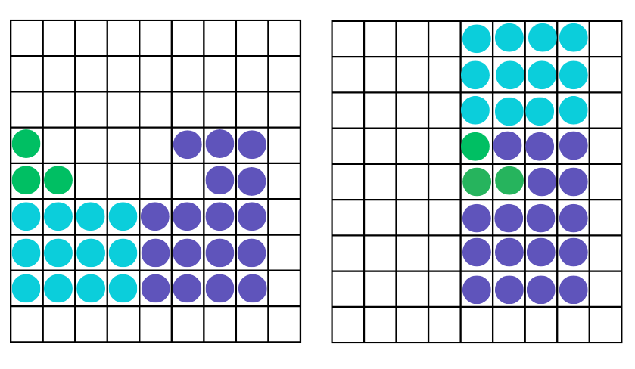
Note: the dots in Figure 3 have been colour-coded to represent where the dots have moved to from their original arrangement to the new configuration.
- Display Colour Counters and repeat the process with Resource 8 – How many fives?. Ask:
- How can the counters be rearranged to make an array of fives?
- What is the least amount of moves that you can use to do this?
- How does this array help prove that the number of dots is not able to be divided by 5?
This table details an opportunity for assessment.
Assessment opportunity | Links
What to look for:  - Can students create and represent multiplicative structure, using the term multiples when connecting grouping to arrays?  [MAO-WM-01, MA2-MR-01] | Links to National Numeracy Learning Progressions (NNLP):  - UuM5, UuM6, UuM7  - UGP4.

Lesson 3
Core concept: area relates to multiplication.

Daily number sense – What comes next? – 15 minutes
The table below contains a suggested learning intention and success criteria. These are best co-constructed with students.
Daily number sense learning intention | Daily number sense success criteria
Students are learning to:  - use arrays to establish multiplication facts from multiples of 2 and 4, 5 and 10. | Students can:  - record the multiples formed by counting by twos, fours, fives and tens.
This activity is an adaptation of What comes next? Fruit Stand from Math Learning Center.
- Display Resource 10 – What comes next?. Ask:
- What do you notice? What do you wonder?
- How would you describe this pattern to someone?
- What comes next? How do you know?
- Will there be a picture with 40 apples? How do you know?
- What might earlier pictures look like? How do you know?
- Ask students to show what the fruit pattern would look like if recording multiples of twos, fives or tens, using an individual whiteboard.
- Students share their pattern with a partner and ask:
- What comes next? How do you know?
- How would you describe this pattern to someone?
This table details opportunities for assessment.
Assessment opportunities | Links
What to look for:  - Can students record the multiples formed by counting by twos, fours, fives and tens? [MAO-WM-01, MA2-MR-01] | Links to National Numeracy Learning Progressions (NNLP):  - CPr6  - NPA4.  Links to suggested Interview for Student Reasoning (IfSR) tasks:  - IfSR-MT: 2A.4, 2A.6.

Core lesson – rectangular robots – 30 minutes
The table below contains suggested learning intentions and success criteria. These are best co-constructed with students.
Core concept learning intentions | Core concept success criteria
Students are learning to:  - recall multiplication facts of 2 and 4, 5 and 10 and related division facts  - measure the areas of shapes using the grid structure  - compare and describe features of two-dimensional shapes. | Students can:  - generate multiplication fact families for multiples of 2 and 4, 5 and 10  - recognise that rectangles with different side lengths can have the same area  - identify right angles in shapes.
- Display Resource 11 – exploring arrays. Ask:
- What is similar about these 3 images?
- How are these 3 images different to one another?
- How could you use multiplication to describe them?
- What are the fact family triangles that match each image?
- Can you create another image or picture that would belong with these 3 images?
- Students create fact family triangles on individual whiteboards to match the images on Resource 11 – exploring arrays. Students may discover that there are additional images and fact families that relate to the number 24 (see Figure 4).
Figure 4 – student triangle examples
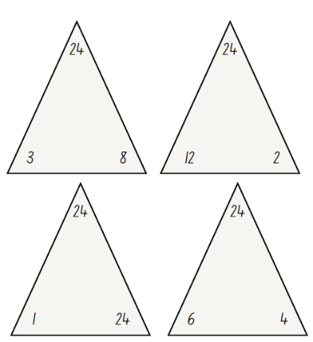
- Students turn and talk to share their fact family triangles and other images that relate to 24.
- Remind students that the number at the top of the triangle is the product of the 2 factors at the bottom of the triangle.
- Display Resource 12 – making the link. Ask:
- How many small squares are filling the space in image 1? How do you know?
- Is it possible to visualise how many small squares would fill the space in image 2, by looking at the numbers on the side of the rectangle?
- How does the fact family triangle in image 3, relate to image 1 and 2?
- How can the fact family triangle help determine the space that is covered by a rectangle?
- Explain that the space inside a closed flat (two-dimensional) shape is called the area. The area covered by a rectangle can be calculated with the help of an array or by looking at the length of its sides to visualise the array. Tell students that image 2 has an area of 24 because the side lengths of the rectangle are 4 and 6. When the array is visualised, 4 sixes can be used to describe the array within the rectangle, which means that the rectangle has an area of 24.
- Ask:
- How can we use the fact family triangles with a product of 24 to create other rectangles that have an area of 24?
- What would the side lengths of each rectangle be?
- Students use individual whiteboards to draw rectangles and label the dimensions. Students turn and talk to share their ideas with a partner.
- Ask:
- How many different possibilities did you come up with?
- Are there any rectangles that look the same?
- Is it possible for a rectangle to have the same area but different dimensions?
- Display Resource 13 – rectangular robot. Explain that the students will be creating a robot using rectangles of a given area.
- Display Resource 14 – robot areas. Explain that the table displayed in the resource lists the area of each robot feature. Students will decide on the dimensions of each robot feature to meet the criteria, draw the feature and create the matching fact family triangle.
- Give each student a copy of Resource 14 – robot areas and square-centimetre grid paper. Students complete the table and create their robot on grid paper (see Figure 5).
Figure 5 – possible student response
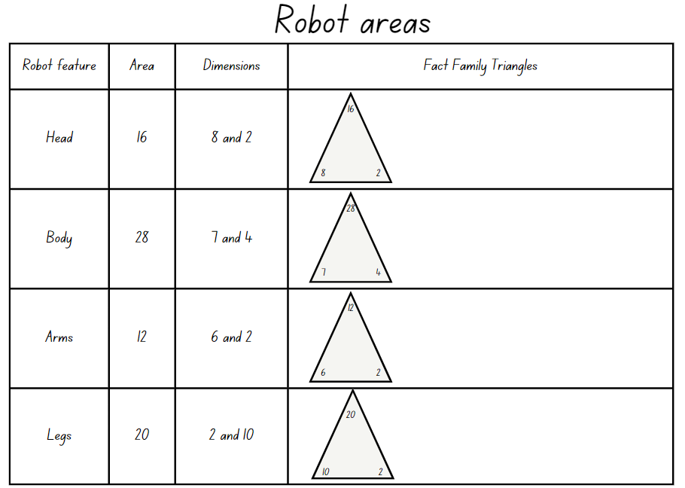
This table details opportunities for differentiation.
Too hard? | Too easy?
Students cannot generate multiplication fact families for multiples of 2 and 4, 5 and 10.  - Provide students with counters to create arrays that match the given areas.  - Support students to record the dimensions and use these as factors in the fact families to match the given areas. | Students can generate multiplication fact families for multiples of 2 and 4, 5 and 10.  - Students create additional features for their robot. Record the dimensions and the corresponding fact families.  - Students play Dicey Perimeter, Dicey Area with a 6-sided or 9-sided die.

Discuss and connect the mathematics – 15 minutes
- Conduct a gallery walk. Ask:
- Are there any rectangles that have the same area but different dimensions?
- How many different fact families can be created for one product?
- Which product had the largest number of fact families?
- Were there any fact families that you had not thought of?
This table details opportunities for assessment.
Assessment opportunities | Links
What to look for:  - Can students generate multiplication fact families for multiples of 2 and 4, 5 and 10? [MAO-WM-01, MA2-MR-01]  - Can students recognise that rectangles with different side lengths can have the same area? [MAO-WM-01, MA2-2DS-03]  - Can students identify right angles in shapes? [MAO-WM-01,  MA2-2DS-01] | Links to National Numeracy Learning Progressions (NNLP):  - MuS5  - UuM5, UuM6, UuM7  - UGP6.  Links to suggested Interview for Student Reasoning (IfSR) tasks:  - IfSR-MT: 2A.7.

Lesson 4
Core concept: areas can be measured using arrays and square centimetres.

Daily number sense – 10 minutes
- From a class need surfaced through formative assessment data, identify a short, focused activity that targets students’ knowledge, understanding and skills. Example activities may be drawn from the following resources:
- Mathematics K–6 resources
- Universal Resources Hub.

Core lesson – sticker arrays – 35 minutes
The table below contains suggested learning intentions and success criteria. These are best co-constructed with students.
Core concept learning intentions | Core concept success criteria
Students are learning to:  - recall multiplication facts of 2 and 4, 5 and 10 and related division facts  - use square centimetres to measure the areas of rectangles. | Students can:  - model and apply the commutative property of multiplication  - create the array structure of area using squares (1 cm x 1 cm) in rows and columns  - recognise that area can be measured in square centimetres.
This activity is an adaptation of ‘Stamp Arrays’ from Teaching and Assessing Maths Through Open-ended Activities by Lilburn and Sawczak.
- Pose the following question: Sian has 12 stickers and wants to display them in her sticker album. She wants to arrange them in arrays. Ask:
- How many possibilities are there?
- What strategies did you use to make sure you found all the possibilities?
- Are there any sticker arrays that look similar to each other? Why does this happen?
- Display Resource 15 – sticker album solution. Explain that the reason some sticker arrays are similar to each other is due to the commutative property of multiplication.
Commutative property: commutative property of addition or multiplication means that 2 numbers can be added or multiplied in any order and the solution will be the same.
- Revise that area is the flat surface enclosed within a shape. Ask:
- What unit of measurement can be used to measure the area of the sticker arrays?
- If the dimensions of each sticker are 1 cm wide and 1 cm high, how could multiplication be used to describe the area of the sticker arrays?
- How could the area of the stickers be recorded by reading the array? For example, 3 fours is 12 square centimetres.
- Display Resource 15 – sticker album solution. Ask students if it is possible to record the area of these stickers by reading the array.
- Record student responses alongside the corresponding array on Resource 15 – sticker album solution (see Figure 6).
Figure 6 – recording arrays and area
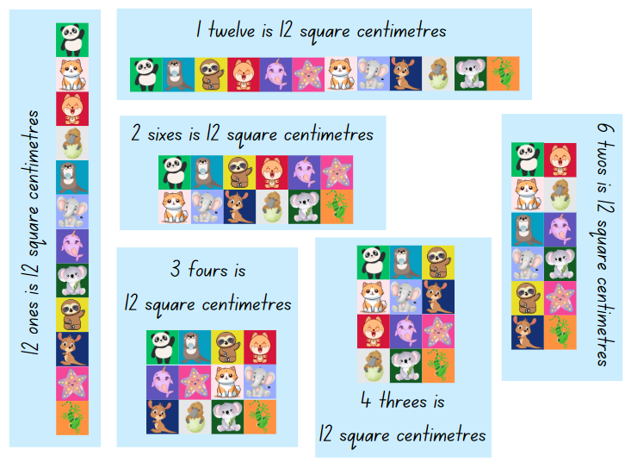
- Display Resource 16 – sticker problem. Ask:
- How many possibilities do you think there are?
- How can arrays be used to record our ideas?
- What is the area covered by the stickers?
- How can this be recorded by using the array?
- Provide students with square-centimetre grid paper. Students work in small groups to record their solutions. Students label their ideas using the array structure, for example 6 sevens, 21 twos (see Figure 7).
Figure 7 – example of student response
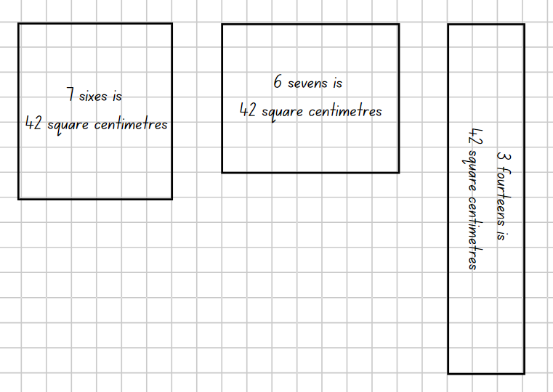
Note: the Stage 2 Teaching advice for Multiplicative relations A states when students begin to produce multiplication facts it may help to use a language pattern of words that relates back to concrete materials such as arrays. As students become more confident with recalling multiplication facts, they may use less language. For example, 5 rows (groups) of 3 becomes 5 threes with the rows of or groups of implied. This then leads to one three is 3, 2 threes are 6, 3 threes are nine, and so on (NESA 2024a).
This table details opportunities for differentiation.
Too hard? | Too easy?
Students cannot create the array structure of area using squares (1 cm × 1 cm) in rows and columns.  - Provide students with 24 counters and ask them to arrange these so that there is an equal number of counters in each row.  - Use Resource 17 – fact family triangles to support students to identify the links between arrays and fact families for 24. | Students can create the array structure of area using squares (1 cm × 1 cm) in rows and columns.  - Pose the following question to students. What if the teacher wanted to print 108 stickers on a sheet? Is there a way of working out all the possibilities without drawing an array?  - Pose the following question to students. What would happen to the area of the rectangles if the stickers were 2 cm wide and 1 cm high instead of 1 cm wide and 1 cm high?

Discuss and connect the mathematics – 15 minutes
- Ask:
- How many solutions did you find?
- What do you notice about the solutions?
- How did the commutative property help you find multiple solutions?
- Are there any rectangles that are similar to each other? How?
- Does the area of the sticker sheet change when the stickers are arranged differently?
This table details opportunities for assessment.
Assessment opportunities | Links
What to look for:  - Can students model and apply the commutative property of multiplication? [MAO-WM-01, MA2-MR-01]  - Can students create the array structure of area using squares (1 cm × 1 cm) in rows and columns? [MAO-WM-01, MA2-MR-01]  - Can students recognise that area can be measured in square centimetres? [MAO-WM-01, MA2-2DS-03] | Links to National Numeracy Learning Progressions (NNLP):  - MuS6  - UuM5, UuM6, UuM7.  Links to suggested Interview for Student Reasoning (IfSR) tasks:  - IfSR-MT: 2A.9.

Lesson 5
Core concept: mathematicians estimate, measure and compare area.

Daily number sense – ascending and descending order – 10 minutes
Daily number sense activities for Lessons 5 to 7 ‘loop’ back to concepts and procedures covered in previous units to assist students to build an increasingly connected network of ideas. These concepts may differ from the core concepts being covered by the unit.
The table below contains a suggested learning intention and success criteria. These are best co-constructed with students.
Daily number sense learning intention | Daily number sense success criteria
Students are learning to:  - order numbers in the thousands. | Students can:  - arrange 4-digit numbers in ascending and descending order.
- Small groups of students roll a 9-sided dice 4 times to create a 4-digit number. Students read the number aloud and record on a sticky note.
- Roll the dice again and repeat the process. Arrange the 2 numbers made so far in ascending order.
- Repeat 3 or 4 more times, arranging the numbers in ascending order.
- Students read the list of numbers aloud starting from the smallest.
- Repeat the process with new numbers, this time using descending order to arrange the numbers.
- As a class, discuss how to order one set of pre-prepared numbers that include internal zeros. For example, 2030, 2300, 2506 and 2650.
This table details opportunities for assessment.
Assessment opportunities | Links
What to look for:  - Can students arrange 4-digit numbers in ascending order? [MAO-WM-01, MA2-RN-01]  - Can students arrange 4-digit numbers in descending order? [MAO-WM-01, MA2-RN-01] | Links to National Numeracy Learning Progressions (NNLP):  - NPV6.  Links to suggested Interview for Student Reasoning (IfSR) tasks:  - IfSR-NP: 4B.2.

Core lesson – finding areas – 30 minutes
The table below contains suggested learning intentions and success criteria. These are best co-constructed with students.
Core concept learning intentions | Core concept success criteria
Students are learning to:  - use square centimetres to measure and estimate the areas of rectangles  - use arrays to establish multiplication facts from multiples of 2 and 4, 5 and 10. | Students can:  - estimate before measuring to determine the larger of 2 areas in square centimetres  - estimate the areas of shapes found in the environment using efficient strategies (non-count-by-one) with a grid overlay  - use the array structure to coordinate the number of groups with the number in each group.
- Display Resource 18 – comparing 2 leaves. Ask:
- Which leaf do you think has the biggest area? How do you know?
- How could we use a grid overlay to help us estimate the area?
- Why is it almost impossible to accurately measure the area of the leaves?
- What strategies can we use to estimate the area of these leaves?
- Display Resource 19 – leaf grid overlay. Students record their estimates for which leaf has the largest area.
- Display Resource 20 – Julie’s strategy. Explain that Julie saw that her leaf covered an area of 8 tens. She saw this when she looked at how many squares high and wide the whole leaf was. She used this to create an array. Then she looked at the leaf and looked for other arrays that she could see. She saw 5 threes, 6 threes and 2 twos. Julie now knows that her leaf has an area more than 37 square centimetres and less than 80 square centimetres.
- Provide students with Resource 19 – leaf grid overlay. Students work in pairs to estimate the area of Michelle’s leaf using the strategies discussed while estimating the area of Julie’s leaf.
This table details opportunities for differentiation.
Too hard? | Too easy?
Students cannot estimate the areas of shapes found in the environment using efficient strategies (non-count-by-one) with a grid overlay.  - Support students to find arrays within the grid overlay using multiples that they are familiar with.  - Support students to find the largest array and record how the array is read, rather than the total number of squares covered. For example, the largest array is 9 eights instead of 72 square centimetres. | Students can estimate the areas of shapes found in the environment using efficient strategies (non-count-by-one) with a grid overlay.  - Ask students to estimate and work out how many leaves would fit on an A4 page if the area of an A4 page is 625 square centimetres?  - Pose question: What would be the combined area of a leaf pattern if each of the leaves was used 3 times?

Discuss and connect the mathematics – 10 minutes
- Ask:
- What does the area of Michelle’s leaf have to be more than?
- What does the area of Michelle’s leaf have to be less than?
- What arrays did you see?
- Display Resource 21 – Michelle’s strategy. Ask:
- How is Michelle’s strategy different to Julie’s strategy?
- What is similar between Michelle’s and Julie’s strategy?
- Which strategy do you prefer? Why?

Consolidation and meaningful practice – 20 minutes
- Students trace their hands onto square-centimetre grid paper and estimate the area by looking for arrays.
- Students describe the area of their hands as a value that it is ‘more than but less than’. For example, my hand has an area that is more than 20 square centimetres but less than 180 square centimetres.
- Students turn and talk to compare their estimates with a partner.
This table details opportunities for assessment.
Assessment opportunities | Links
What to look for:  - Can students estimate before measuring to determine the larger of 2 areas in square centimetres? [MAO-WM-01, MA2-2DS-03]  - Can students estimate the areas of shapes found in the environment using efficient strategies (non-count-by-one) with a grid overlay? [MAO-WM-01, MA2-2DS-03]  - Can students use the array structure to coordinate the number of groups with the number in each group? [MAO-WM-01,  MA2-MR-01] | Links to National Numeracy Learning Progressions (NNLP):  - UuM5, UuM6  - MuS5.  Links to suggested Interview for Student Reasoning (IfSR) tasks:  - IfSR-MT: 2A.3

Lesson 6
Core concept: volume relates to the measurement of three-dimensional space.

Daily number sense – What’s the nearest? – 10 minutes
The table below contains a suggested learning intention and success criteria. These are best co-constructed with students.
Daily number sense learning intention | Daily number sense success criteria
Students are learning to:  - order numbers in the thousands. | Students can:  - identify the closest thousand to a 4-digit number  - arrange 4-digit numbers in ascending or descending order.
- In small groups, students roll four 9-sided dice to make a 4-digit number. Students read the number aloud and record it on a sticky note.
- Students repeat the process multiple times.
- Students order the collection of 4-digit numbers in ascending or descending order and explain their reasoning.
- Students identify the nearest thousand for each recorded number. For example, 7984 is closest to 8000 and 6021 is closest to 6000.
- Display 9548 and discuss how the closest thousand is 10 000.
This table details opportunities for assessment.
Assessment opportunities | Links
What to look for:  - Can students identify the closest thousand to a 4-digit number? [MAO-WM-01, MA2-RN-01]  - Can students arrange 4-digit numbers in ascending or descending order? [MAO-WM-01, MA2-RN-01] | Links to National Numeracy Learning Progressions (NNLP):  - NPV6, NPV7.  Links to suggested Interview for Student Reasoning (IfSR) tasks:  - IfSR-NP: 4B.2, 4C.4, 4C.8.

Core lesson – constructing and drawing prisms – 50 minutes
The table below contains suggested learning intentions and success criteria. These are best co-constructed with students.
Core concept learning intentions | Core concept success criteria
Students are learning to:  - make models of three-dimensional objects to compare and describe key features  - connect three-dimensional objects and two-dimensional representations. | Students can:  - construct models of prisms using physical manipulatives, identifying their features  - create sketches of three-dimensional objects from different views, including top, front and side views  - draw different views on isometric grids of an object constructed from cubes.
- Revise with students the difference between volume and capacity. Volume is the space taken up by a three-dimensional object(s). Capacity is the internal volume, which is how much a three-dimensional object can hold.
Note: the Stage 2 Teaching advice for Three-dimensional spatial structure A states that volume relates to the measurement of three-dimensional space, in the same way that area relates to the measurement of two-dimensional space, and length relates to the measurement of one dimension. The attribute of volume is the amount of space occupied by an object and is usually measured in cubic units, for example, cubic centimetres (NESA 2024b).
- Display Resource 22 – pallet of boxes. Ask:
- How can we describe the space taken up by the boxes?
- How could we use the word layers to describe the space taken up?
- How many boxes are there altogether? How do you know?
- Are boxes an appropriate unit of measurement for measuring volume? Why or why not?
- Provide students with a cubic-centimetre block. Ask:
- What do you notice?
- Where have you seen something like this before?
- What might this be used for?
- Explain that the block is called a cubic centimetre and it is one of the formal units of measurement for volume.
Note: the Stage 2 Teaching advice for Three-dimensional spatial structure A states that students should be introduced to the cubic centimetre but the standard abbreviation for cubic centimetres is not introduced until Stage 3. In Stage 2, the units are recorded in words or using less formal abbreviations, such as cc (NESA 2024b).
- Provide students additional cubic centimetres and model how to create a 4-cube prism.
- What would the volume of this prism be? How do you know?
- If we were to draw the prism from the top, front and side view, what would that look like?
- How could we describe this using the word layers?
- Explain that we can describe this as one layer of 2 twos. Explain that we know this because the top view of the prism shows an array of 2 twos and there is only one layer of blocks.
- Students use individual whiteboards to draw the top, front and side view of the prism (see Figure 8).
Figure 8 – student responses
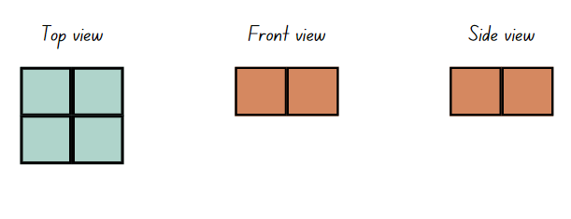
- Ask students to share their drawings. Ask students to determine if the top, front and side view change for this prism. Why or why not?
- Ask students to change the orientation of the prism. Ask:
- Have the views changed? Explain your answer.
- Has the volume of the prism changed? Why or why not?
- Model using isometric paper to show how to draw the different views of the new orientation identifying the changes (see Figure 9).
Figure 9 – teacher example
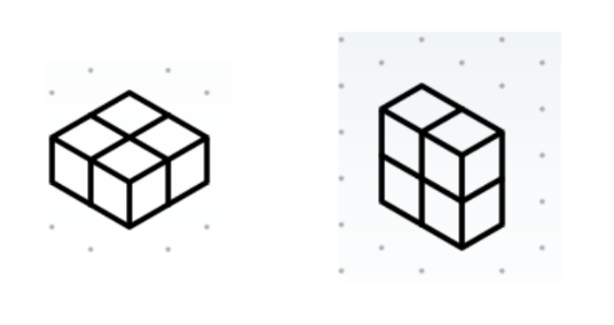
- Give students 12 cubes each and isometric dot paper. Ask students to create a prism with their 12 cubes.
- Students draw the top, front and side view of their prism on isometric dot paper, labelling each view. Students also draw their 12-cube prism in 2 different orientations and use the word layers to describe their prisms (see Figure 10).
Figure 10 – student example
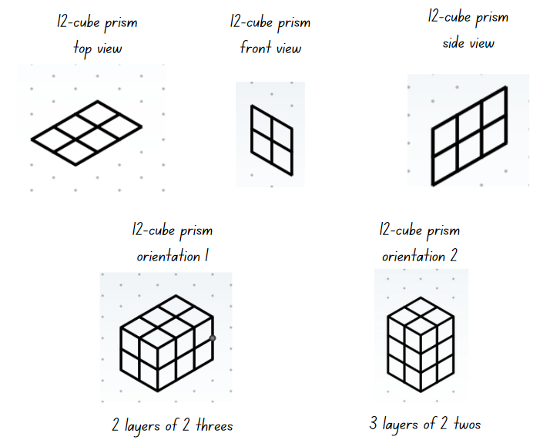
This table details opportunities for differentiation.
Too hard? | Too easy?
Students cannot draw different views on isometric grids of an object constructed from cubes.  - Support students to draw the top, front and side views of the 12-cube prism.  - Give students one cube to draw on isometric dot paper. Model to students how lines need to be on an angle to show depth. | Students can draw different views on isometric grids of an object constructed from cubes.  - Provide students with Resource 23 – top, front, side and cubic-centimetre blocks. Students recreate the prism based on these views.  - Students create their own top, front and side views with a larger number of blocks. Students swap with a partner and their partner recreates the prism based on these views.

Discuss and connect the mathematics – 10 minutes
- Students go on a gallery walk to view the 12-cube prisms and drawings. Ask:
- Does the top, front and side view match the prism?
- What is the maximum number of layers a 12-cube prism can have?
- Do the drawings accurately represent the different orientations of the prism?
- Did you notice any prisms that were different to yours?
- Why aren’t there many options for differences in prisms?
This table details opportunities for assessment.
Assessment opportunities | Links
What to look for:  - Can students construct models of prisms using physical manipulatives, identifying their features? [MAO-WM-01,  MA2-3DS-01]  - Can students create sketches of three-dimensional objects from different views, including top, front and side views? [MAO-WM-01, MA2-3DS-01]  - Can students draw different views on isometric grids of an object constructed from cubes? [MAO-WM-01, MA2-3DS-01] | Links to National Numeracy Learning Progressions (NNLP):  - UGP3.

Lesson 7
Core concept: standard units are an efficient way to communicate volume.

Daily number sense – nice or nasty – 10 minutes
The table below contains a suggested learning intention and success criteria. These are best co-constructed with students.
Daily number sense learning intention | Daily number sense success criteria
Students are learning to:  - order numbers in the thousands. | Students can:  - recognise and describe how rearranging digits changes the size of a number.
This activity is an adaptation of Nice or Nasty from NRICH by University of Cambridge.
- Give pairs of students a 9-sided die and an individual whiteboard each.
- Each student draws a set of 4 boxes (see Figure 11).
Figure 11 – gameboard set-up
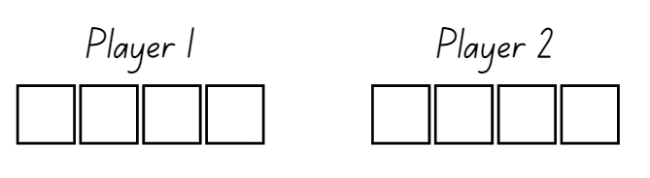
- Students take turns to roll the die and decide which of the 4 boxes to fill to create the largest 4-digit number possible.
- The player with the largest 4-digit number wins and scores a point. The first player to score 10 points wins the game.
- Ask:
- What was your strategy for creating the largest 4-digit number?
- How would your strategy change if you were making the smallest 4-digit number?
This table details opportunities for assessment.
Assessment opportunities | Links
What to look for:  - Can students recognise and describe how rearranging digits changes the size of a number? [MAO-WM-01, MA2-RN-01] | Links to National Numeracy Learning Progressions (NNLP):  - NPV6.

Core lesson – making prisms – 45 minutes
The table below contains a suggested learning intention and success criteria. These are best co-constructed with students.
Core concept learning intention | Core concept success criteria
Students are learning to:  - compare objects using familiar metric units of volume. | Students can:  - construct rectangular prisms using cubic-centimetre blocks and describe the volumes in terms of layers  - record volumes using numerals and words  - compare the volumes of 2 or more objects made from cubic-centimetre blocks.
- Display Resource 24 – three prism views. Ask:
- If these were a face on a rectangular prism, what might the whole prism look like?
- How could we record our ideas?
- How can we use the word layers to describe our ideas?
- How many different prisms could be made?
- What unit of measurement can we use to describe what we’ve made?
- In small groups, give students 30 cubic centimetre blocks and blank paper. Students record their ideas on Resource 25 – student prisms. Move around the room, ensuring students use the terms cubic centimetres and layers to describe what has been drawn.
Note: the Stage 2 Teaching advice for Three-dimensional spatial structure A states that students should be introduced to the cubic centimetre but the standard abbreviation for cubic centimetres is not introduced until Stage 3. In Stage 2, the units are recorded in words or using less formal abbreviations, such as cc (NESA 2024b).
- Ask students to select 2 of their prisms and discuss the following:
- What is the volume of each object?
- What is the difference in volume between each prism?
- What similarities are there?
- How would you describe the differences between them?
This table details opportunities for differentiation.
Too hard? | Too easy?
Students cannot construct rectangular prisms using cubic-centimetre blocks and describe the volumes in terms of layers.  - Support students to construct an array of 1 four. Demonstrate how this can be repeated to make layers.  - Support students to recognise the array structure of the first layer of the rectangular prism. | Students can construct rectangular prisms using cubic-centimetre blocks and describe the volumes in terms of layers.  - Students create their own top view of a rectangular prism and give to a partner to record what the prism might look like.  - Pose the question: You have a rectangular prism made of 48 cubic centimetres. What could the top view of the prism be?

Discuss and connect the mathematics – 15 minutes
- Display Resource 26 – sample student responses. Ask:
- What do you notice about these ideas?
- What is similar about these prisms?
- What is different between these prisms?
- What patterns do you notice?
- What multiplication and division facts do you notice?
Note: where possible, it would be ideal to use student samples here to highlight the multiplicative properties of layers.
This table details opportunities for assessment.
Assessment opportunities | Links
What to look for:  - Can students construct rectangular prisms using cubic-centimetre blocks and describe the volumes in terms of layers?  [MAO-WM-01, MA2-3DS-02]  - Can students record volumes using numerals and words?  [MAO-WM-01, MA2-3DS-02]  - Can students compare the volumes of 2 or more objects made from cubic-centimetre blocks? [MAO-WM-01, MA2-3DS-02] | Links to National Numeracy Learning Progressions (NNLP):  - UuM5.

Lesson 8
Core concept: mathematicians measure and compare volume.

Daily number sense – 10 minutes
- From a class need surfaced through formative assessment data, identify a short, focused activity that targets students’ knowledge, understanding and skills. Example activities may be drawn from the following resources:
- Mathematics K–6 resources
- Universal Resources Hub.

Core lesson – jube cubes – 40 minutes
The table below contains suggested learning intentions and success criteria. These are best co-constructed with students.
Core concept learning intentions | Core concept success criteria
Students are learning to:  - compare objects using familiar metric units of volume  - connect three-dimensional objects and two-dimensional representations. | Students can:  - construct rectangular prisms using cubic-centimetre blocks and describe the volumes in terms of layers  - record volumes using numerals and words  - create sketches of three-dimensional objects from different views, including top, front and side views.
- Display Resource 27 – JMS lolly company.
- Show students what 36 cubes in one layer could look like using cubic centimetre blocks. For example, one layer of 6 sixes.
- Tell students they are going to predict how many ways 36 jube cubes can be stacked in 2 or 3 layers to form a rectangular prism.
- Ask:
- How can we use our knowledge of multiplication to help us?
- How can making an array help us?
- How can we record our solutions?
- How could we describe what we’ve made?
- Give students a sticky note each and ask them to record their prediction of how many possibilities there are.
- Give groups of students 36 cubes and Resource 28 – different views.
- Students work in small groups to discuss the problem and develop solutions. Each student must keep a record of possible solutions using sketches and labelling (see Figure 12).
Figure 12 – possible student solutions
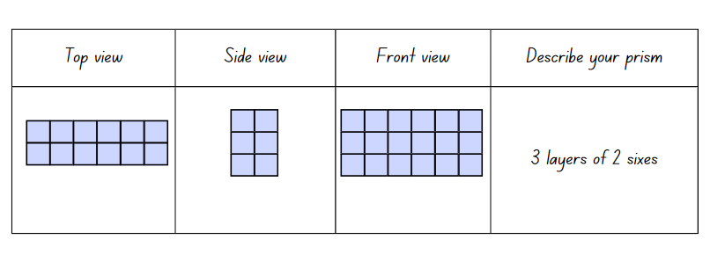
This table details opportunities for differentiation.
Too hard? | Too easy?
Students cannot construct rectangular prisms using cubic-centimetre blocks and describe the volumes in terms of layers.  - Support students to draw the top view only of the prism.  - Support students to create arrays using 4, 9 and 12 blocks as their first layer. Ask students how these arrays can be layered to make 36 cubes in total. | Students can construct rectangular prisms using cubic-centimetre blocks and describe the volumes in terms of layers.  - Pose question: How many possibilities are there for stacking 36 cubes if we can have any number of layers?  - Pose question: JMS Lolly Company sells the boxes to shops in cartons of 12 boxes – what might the cartons look like? How many jubes are in the carton?

Discuss and connect the mathematics – 20 minutes
- Ask:
- How many solutions did you find?
- Were there more or fewer than you predicted?
- Students place labelled sketches on their desks and conduct a gallery walk. Ask:
- Did you see any solutions you hadn’t thought of?
- How does multiplication help us know that we’ve found all the possibilities?
- What patterns do you notice about the dimensions of the prisms?
This table details opportunities for assessment.
Assessment opportunities | Links
What to look for:  - Can students construct rectangular prisms using cubic-centimetre blocks and describe the volumes in terms of layers?  [MAO-WM-01, MA2-3DS-02]  - Can students record volumes using numerals and words?  [MAO-WM-01, MA2-3DS-02]  - Can students create sketches of three-dimensional objects from different views, including top, front and side views? [MAO-WM-01, MA2-3DS-01] | Links to National Numeracy Learning Progressions (NNLP):  - UuM5  - UGP3.  Links to suggested Interview for Student Reasoning (IfSR) tasks:  - IfSR-MT: 2A.7.

Resource 1 – Farmer Cluck
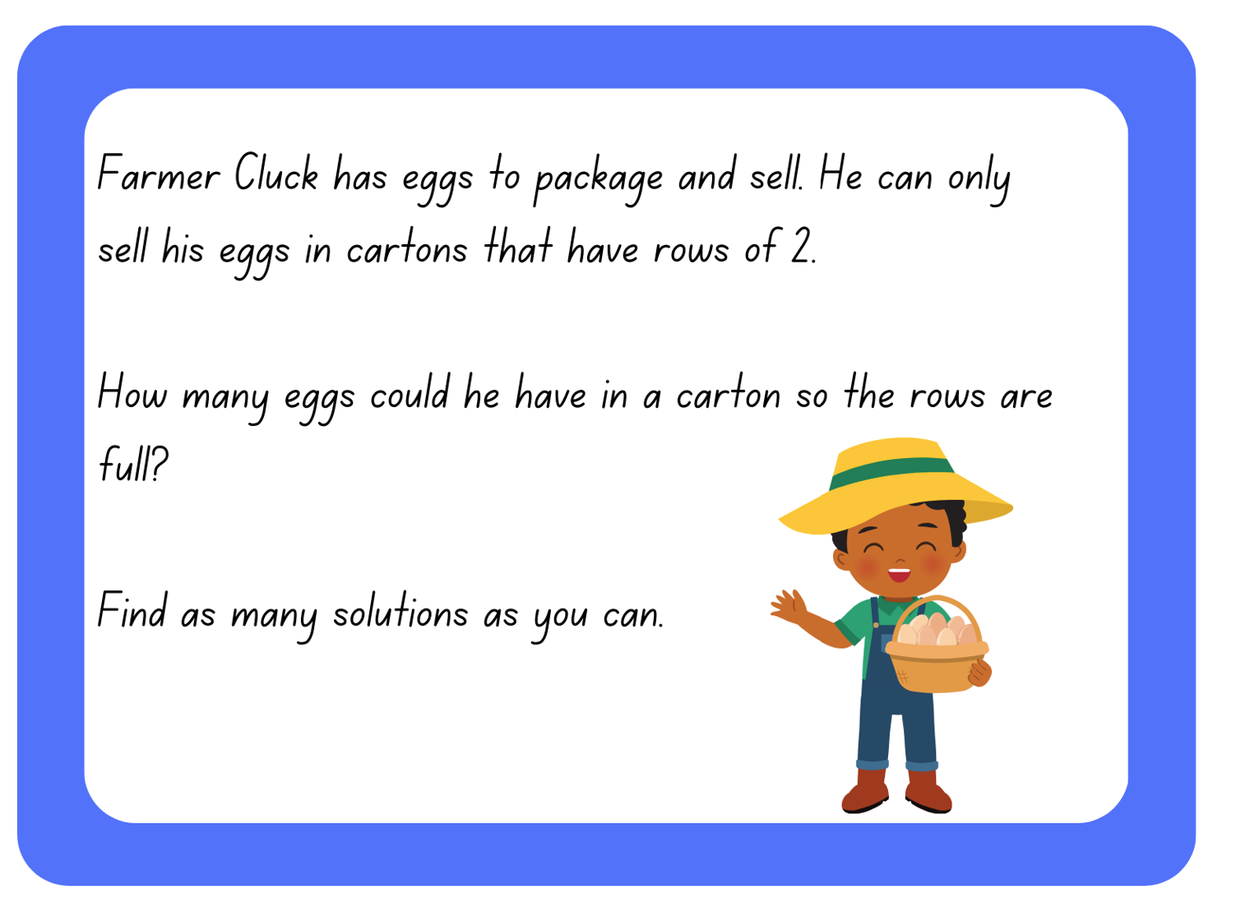

Resource 2 – egg carton arrays
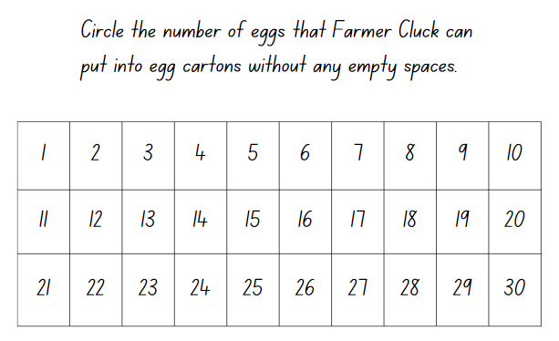

Resource 3 – always, sometimes, never
The sum of 3 numbers is odd. | If you add one to an odd number, you get an even number. | When you add even numbers, the answer is an even number.
If you add 2 odd numbers, you get an odd number. | When you add an even number and an odd number, you get an even number. | Multiples of 5 end in a 5.
If you add a multiple of 10 to a multiple of 5 the answer is a multiple of 5. | When you multiply 2 numbers you will always get a bigger number. | Every multiple of an odd number is an odd number.

Resource 4 – array bingo cards
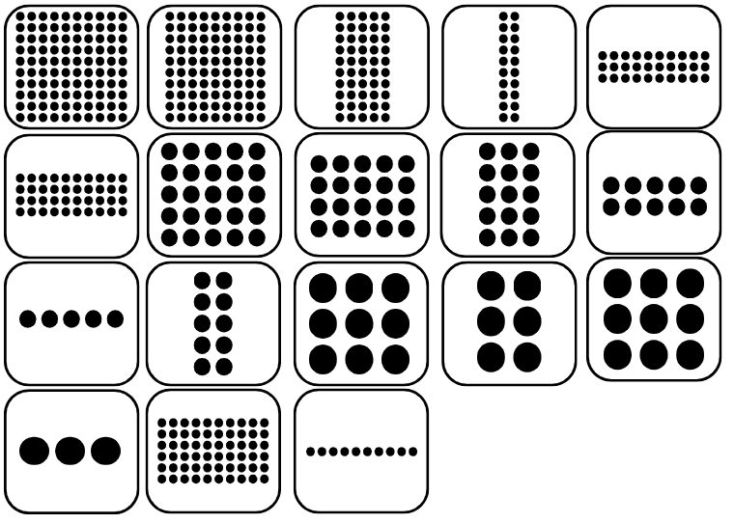

Resource 5 – array descriptor cards
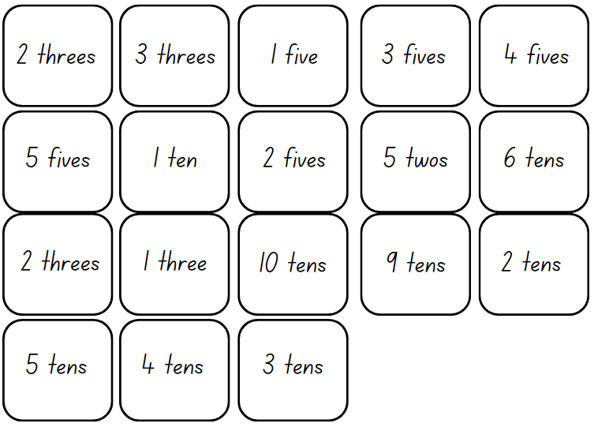

Resource 6 – How many twos?

Resource 7 – How many fours?

Resource 8 – How many fives?
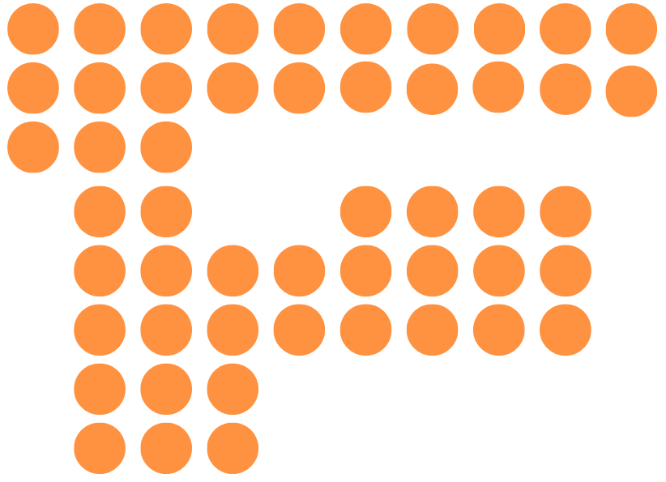

Resource 9 – How many threes?

Resource 10 – What comes next?
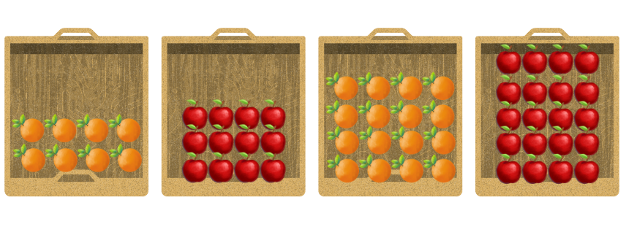

Resource 11 – exploring arrays
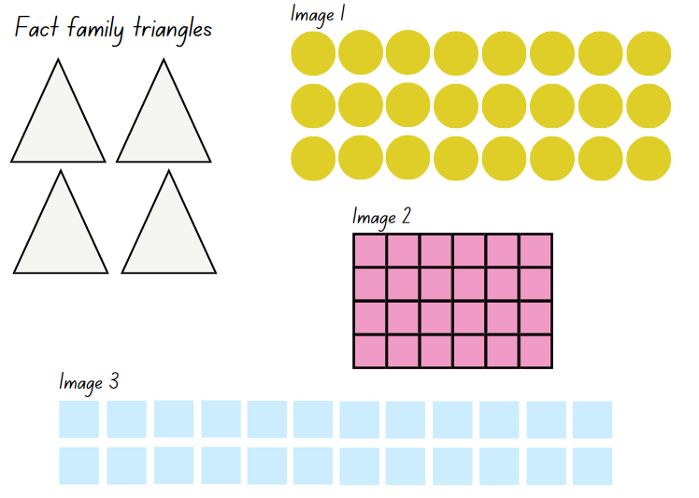

Resource 12 – making the link
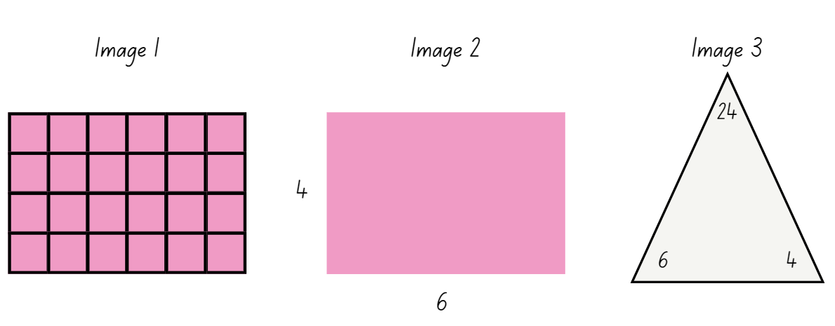

Resource 13 – rectangular robot
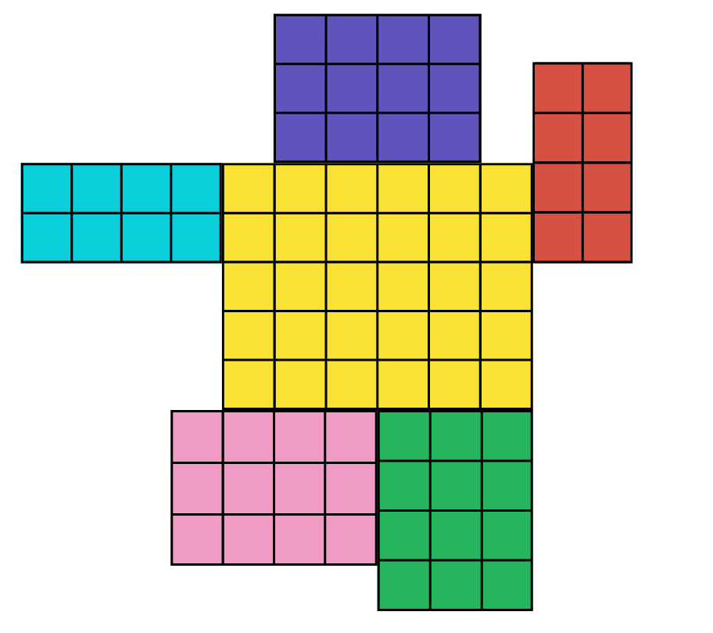

Resource 14 – robot areas
Robot feature | Area | Dimensions | Fact family triangles
Head | 16
Body | 28
Arms | 12
Legs | 20

Resource 15 – sticker album solution
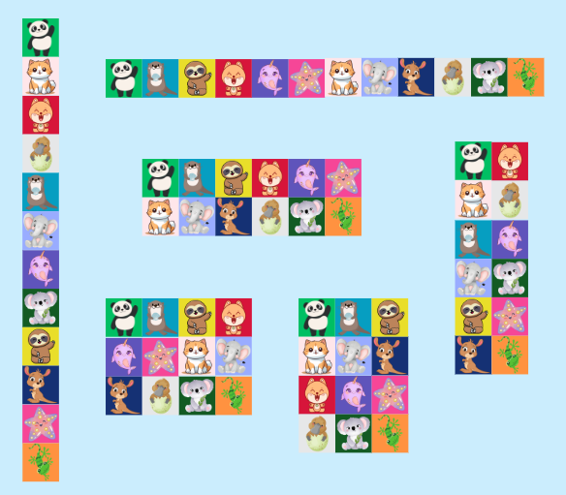

Resource 16 – sticker problem
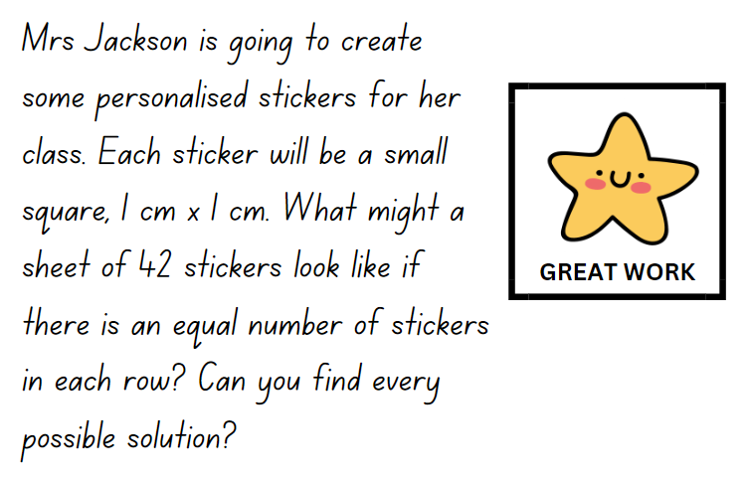

Resource 17 – fact family triangles
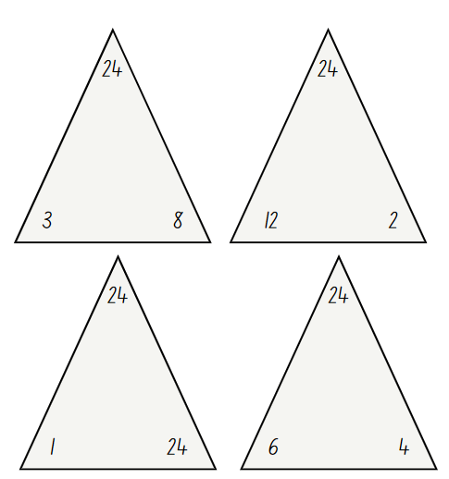

Resource 18 – comparing 2 leaves
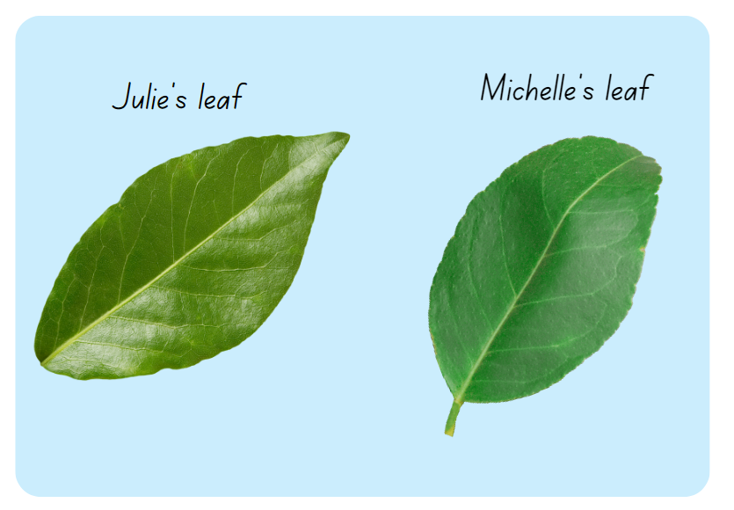

Resource 19 – leaf grid overlay
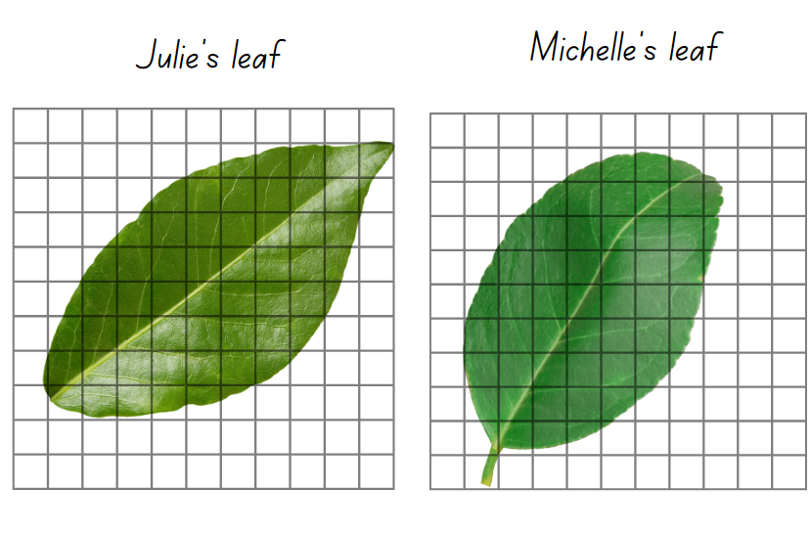

Resource 20 – Julie’s strategy
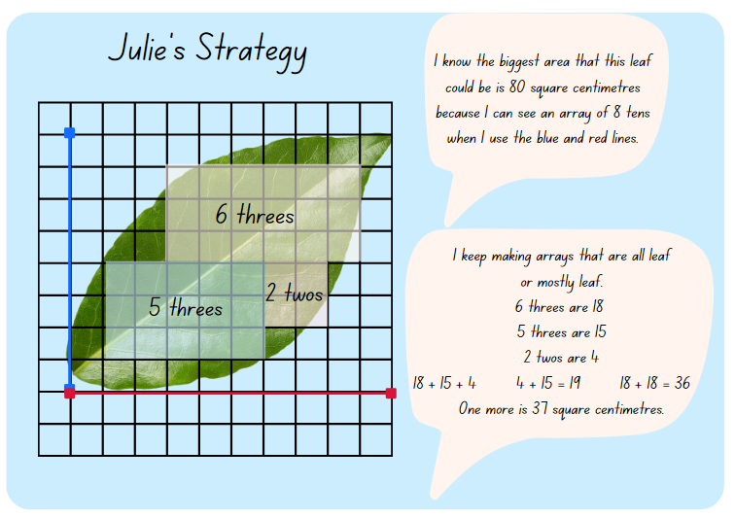

Resource 21 – Michelle’s strategy
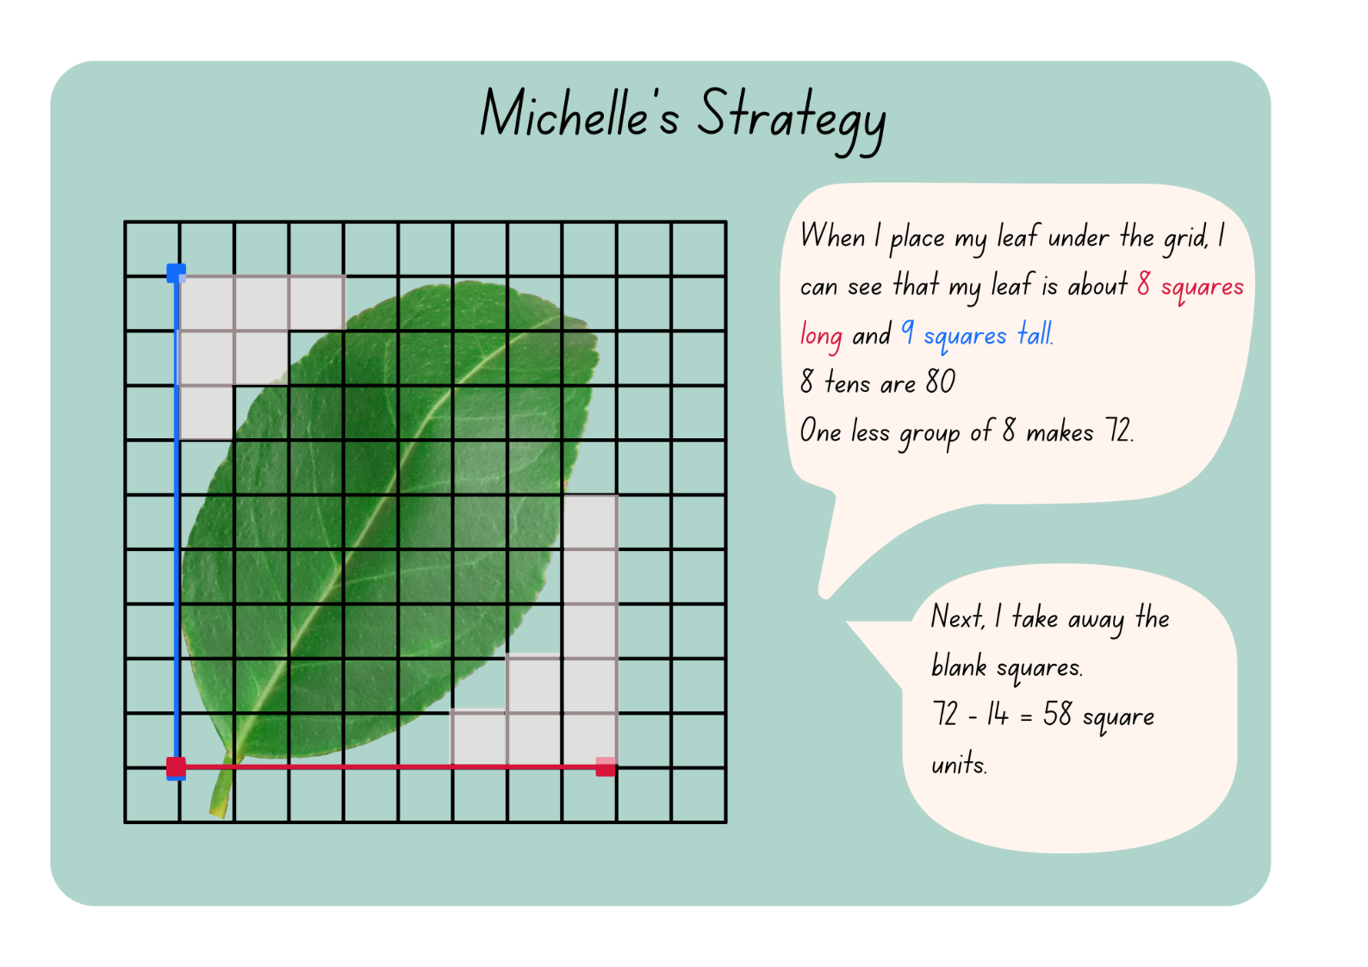

Resource 22 – pallet of boxes
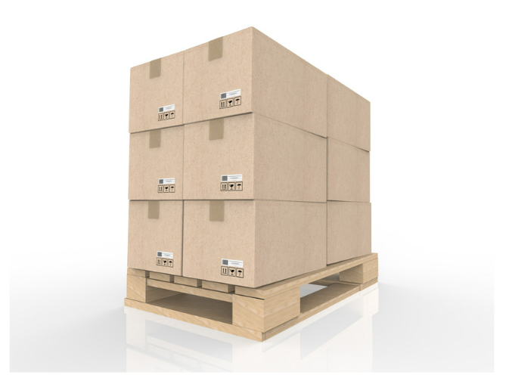

Resource 23 – top, front, side
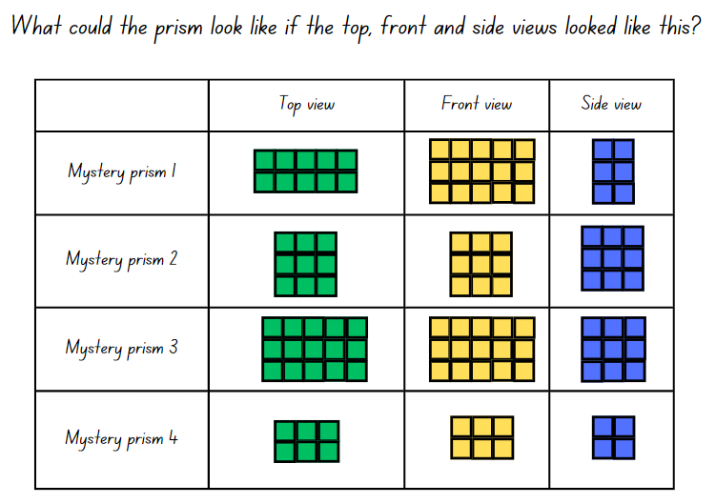

Resource 24 – three prism views
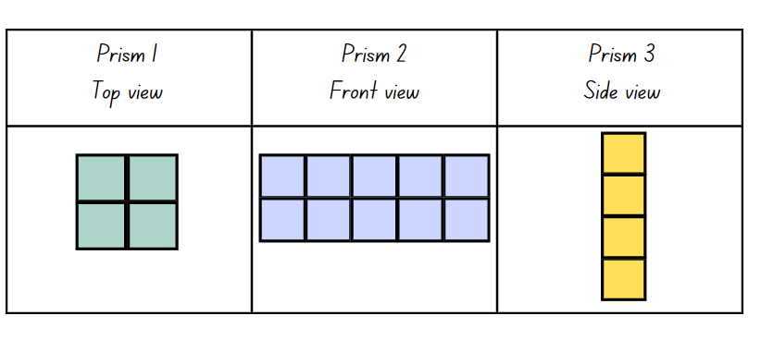

Resource 25 – student prisms
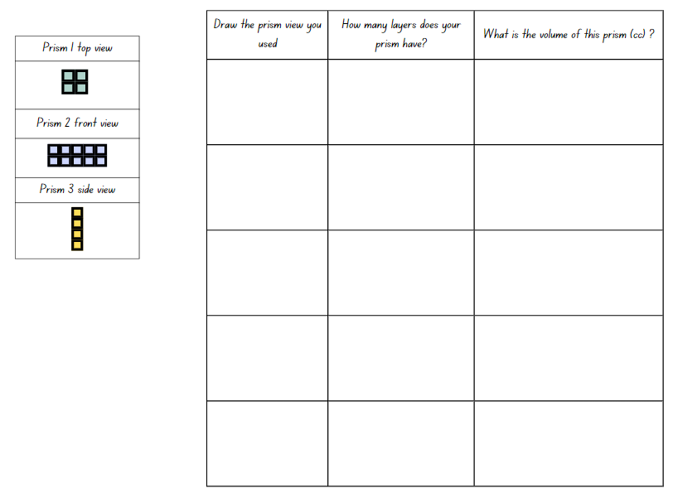

Resource 26 – sample student responses
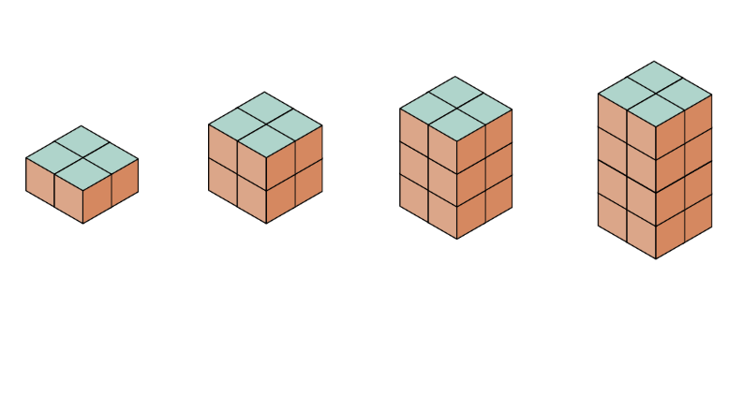

Resource 27 – JMS lolly company
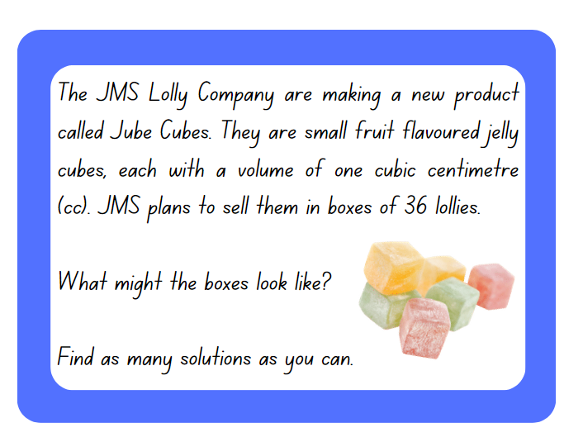

Resource 28 – different views
Top view | Side view | Front view | Describe your prism

Syllabus outcomes and content
The table below outlines the syllabus outcomes and range of relevant syllabus content covered in this unit. Content is linked to National Numeracy Learning Progression (version 3).
Outcomes and content | 1 | 2 | 3 | 4 | 5 | 6 | 7 | 8
Representing numbers using place value B: Whole numbers: Order numbers in the thousands
[MAO-WM-01, MA2-RN-01]
- Arrange numbers in the thousands in ascending and descending order |  |  |  |  | x | x
- Recognise and describe how rearranging digits changes the size of a number (Reasons about relations) |  |  |  |  |  |  | x
- Identify the nearest thousand, 10 thousand or 100 thousand to numbers |  |  |  |  |  | x
Multiplicative relations A: Generate and describe patterns
[MAO-WM-01, MA2-MR-01]
- Model, describe and record patterns of multiples | x
- Recognise the significance of the final digit of a whole number in determining whether a given number is even or odd (Reasons about relations) | x
Multiplicative relations A: Use arrays to establish multiplication facts from multiples of 2 and 4, 5 and 10
[MAO-WM-01, MA2-MR-01]
- Create and represent multiplicative structure, using the term multiples when connecting grouping to arrays |  | x
- Use the array structure to coordinate the number of groups with the number in each group | x | x |  |  | x
- Record the first 10 multiples formed by counting by twos, fours, fives and tens |  |  | x
Multiplicative relations A: Recall multiplication facts of 2 and 4, 5 and 10 and related division facts
[MAO-WM-01, MA2-MR-01]
- Generate multiplication fact families for multiples of 2 and 4, 5 and 10 |  |  | x
- Model and apply the commutative property of multiplication |  |  |  | x
Two-dimensional spatial structure A: 2D shapes: Compare and describe features of two-dimensional shapes
[MAO-WM-01, MA2-2DS-01]
- Identify right angles in shapes |  |  | x
Two-dimensional spatial structure A: Area: Use square centimetres to measure and estimate the areas of rectangles
[MAO-WM-01, MA2-2DS-03]
- Create the array structure of area using squares (1 cm × 1 cm) in rows and columns |  |  |  | x
- Recognise that area can be measured in square centimetres |  |  |  | x
Two-dimensional spatial structure B: Area: Measure the areas of shapes using the grid structure
[MAO-WM-01, MA2-2DS-03]
- Estimate the areas of shapes found in the environment using efficient strategies (non-count-by-one) with a grid overlay |  |  |  |  | x
- Recognise that rectangles with different side lengths can have the same area |  |  | x
Two-dimensional spatial structure B: Area: Compare surfaces using familiar metric units of area
[MAO-WM-01, MA2-2DS-03]
- Estimate before measuring to determine the larger of 2 rectangular areas in square centimetres |  |  |  |  | x
Three-dimensional spatial structure A: 3D objects: Make models of three-dimensional objects to compare and describe key features
[MAO-WM-01, MA2-3DS-01]
- Construct models of prisms, pyramids and cylinders using physical or virtual manipulatives, identifying their features |  |  |  |  |  | x
Three-dimensional spatial structure A: Volume: Compare objects using familiar metric units of volume
[MAO-WM-01, MA2-3DS-02]
- Construct rectangular prisms using cubic-centimetre blocks and describe the volumes in terms of layers |  |  |  |  |  |  | x | x
- Record volumes using numerals and words |  |  |  |  |  |  | x | x
- Compare the volumes of 2 or more objects made from cubic-centimetre blocks |  |  |  |  |  |  | x
Three-dimensional spatial structure B: 3D objects: Connect three-dimensional objects and two-dimensional representations
[MAO-WM-01, MA2-3DS-01]
- Create sketches of three-dimensional objects from different views, including top, front and side views (Reasons about spatial relations) |  |  |  |  |  | x |  | x
- Draw different views on isometric grids of an object constructed from connecting cubes |  |  |  |  |  | x
Mathematics K–10 Syllabus © NSW Education Standards Authority (NESA) for and on behalf of the Crown in right of the State of New South Wales, 2022.

References
This resource contains NSW Curriculum and syllabus content. The NSW Curriculum is developed by the NSW Education Standards Authority. This content is prepared by NESA for and on behalf of the Crown in right of the State of New South Wales. The material is protected by Crown copyright.
Please refer to the NESA Copyright Disclaimer for more information https://educationstandards.nsw.edu.au/wps/portal/nesa/mini-footer/copyright.
NESA holds the only official and up-to-date versions of the NSW Curriculum and syllabus documents. Please visit the NSW Education Standards Authority (NESA) website https://educationstandards.nsw.edu.au/ and the NSW Curriculum website https://curriculum.nsw.edu.au.
Mathematics K–10 Syllabus © NSW Education Standards Authority (NESA) for and on behalf of the Crown in right of the State of New South Wales, 2022.
National Numeracy Learning Progression © Australian Curriculum, Assessment and Reporting Authority (ACARA) 2010 to present, unless otherwise indicated. This material was downloaded from the Australian Curriculum website (National Literacy Learning Progression) (accessed 10 May 2024) and was not modified.
Lilburn P and Sawczak I (2011) Teaching and Assessing Maths Through Open-ended Activities, 1st Australian edn, Pearson Education Australia, Melbourne.
NESA (NSW Education Standards Authority) (2024a) ‘Teaching advice for Multiplicative relations A’, Stage 2, NESA website, accessed 28 May 2024.
NESA (NSW Education Standards Authority) (2024b) ‘Teaching advice for Three-dimensional spatial structure A’, Stage 2, NESA website, accessed 28 May 2024.
The Math Learning Center (MLC) (n.d.) Work Place Instructions 2A Loops & Groups, MLC website, accessed 28 May 2024.
The Math Learning Center (MLC) (2024) What Comes Next? Fruit Stand, Math at Home website, accessed 28 May 2024.
NSW Department of Education (2023) ‘Array bingo’, Mathematics K–6 Resources, NSW Department of Education website, accessed 28 May 2024.
Toy Theater (2001–2024a) Colour Counters, Toy Theater website, accessed 28 May 2024.
Toy Theater (2001–2024b) Hundreds Chart, Toy Theater website, accessed 28 May 2024.
University of Cambridge (n.d.a) Dicey Perimeter, Dicey Area, NRICH website, accessed 28 May 2024.
——(n.d.b) Dozens, NRICH website, accessed 28 May 2024.
——(n.d.c) Nice or Nasty, NRICH website, accessed 28 May 2024.
© State of New South Wales (Department of Education), 2024
The copyright material published in this resource is subject to the Copyright Act 1968 (Cth) and is owned by the NSW Department of Education or, where indicated, by a party other than the NSW Department of Education (third-party material).
Copyright material available in this resource and owned by the NSW Department of Education is licensed under a Creative Commons Attribution 4.0 International (CC BY 4.0) license.
This license allows you to share and adapt the material for any purpose, even commercially.
Attribution should be given to © State of New South Wales (Department of Education), 2024.
Material in this resource not available under a Creative Commons license:
- the NSW Department of Education logo, other logos and trademark-protected material
- material owned by a third party that has been reproduced with permission. You will need to obtain permission from the third party to reuse its material.
Links to third-party material and websites
Please note that the provided (reading/viewing material/list/links/texts) are a suggestion only and implies no endorsement, by the New South Wales Department of Education, of any author, publisher, or book title. School principals and teachers are best placed to assess the suitability of resources that would complement the curriculum and reflect the needs and interests of their students.
If you use the links provided in this document to access a third-party's website, you acknowledge that the terms of use, including licence terms set out on the third-party's website apply to the use which may be made of the materials on that third-party website or where permitted by the Copyright Act 1968 (Cth). The department accepts no responsibility for content on third-party websites.

