Mathematics Stage 2 – Unit 16
Fractions represent multiple ideas and can be represented in different ways

Contents
Unit description and duration 4
Syllabus outcomes 4
Working mathematically 5
Student prior learning 5
Lesson overview and resources 7
Lesson 1 12
Daily number sense – Is it half? – 10 minutes 12
Core lesson – halves, quarters and eighths – 40 minutes 13
Consolidation and meaningful practice – 10 minutes 18
Lesson 2 20
Daily number sense – Is he correct? – 10 minutes 20
Core lesson – fractions on a line – 35 minutes 21
Consolidation and meaningful practice – 15 minutes 27
Lesson 3 30
Daily number sense – fractured fraction wall – 10 minutes 30
Core lesson 1 – the thirding strategy – 20 minutes 31
Core lesson 2 – the fifthing strategy – 20 minutes 33
Discuss and connect the mathematics – 10 minutes 36
Lesson 4 38
Daily number sense – 10 minutes 38
Core lesson – fractions with related denominators – 40 minutes 38
Discuss and connect the mathematics – 10 minutes 42
Lesson 5 44
Daily number sense – looking for squares – 10 minutes 44
Core lesson – fraction wall game – 35 minutes 46
Discuss and connect the mathematics – 15 minutes 52
Lesson 6 56
Daily number sense – using arrays – 10 minutes 56
Core lesson – Which does not belong? – 35 minutes 58
Discuss and connect the mathematics – 15 minutes 60
Lesson 7 62
Daily number sense – solve the problem – 15 minutes 62
Core lesson – recreate the whole – 35 minutes 64
Discuss and connect the mathematics – 10 minutes 66
Lesson 8 69
Daily number sense – 10 minutes 69
Core lesson – fractions beyond a whole – 40 minutes 69
Discuss and connect the mathematics – 10 minutes 74
Resource 1 – Is it half? 76
Resource 2 – Is he correct? 77
Resource 3 – fractured fraction wall 1 78
Resource 4 – fractured fraction wall 2 79
Resource 5 – fraction wall 80
Resource 6 – gameboard and spinners 81
Resource 7 – Which doesn’t belong? 82
Resource 8 – word problems 83
Resource 9 – recreate the whole 84
Resource 10 – recreate the whole memory 85
Resource 11 – chocolate bars 88
Resource 12 – blocks of chocolate 89
Resource 13 – number lines 90
Syllabus outcomes and content 91
References 95

Unit description and duration
This unit develops the big idea that fractions represent multiple ideas and can be represented in different ways.
In this 2-week unit students are provided opportunities to:
- identify fractional parts and complementary parts of a length
- model and represent unit fractions, and their multiples, to a complete whole on a number line
- explore equivalence and multiplicative relationships of fractions.

Syllabus outcomes
- MAO-WM-01 develops understanding and fluency in mathematics through exploring and connecting mathematical concepts, choosing and applying mathematical techniques to solve problems, and communicating their thinking and reasoning coherently and clearly
- MA2-MR-01 represents and uses the structure of multiplicative relations to 10 × 10 to solve problems
- MA2-PF-01 represents and compares halves, quarters, thirds and fifths as lengths on a number line and their related fractions formed by halving (eighths, sixths and tenths)

Working mathematically
In the Mathematics K–10 Syllabus, there is one overarching Working mathematically outcome (MAO-WM-01). The Working mathematically processes should be embedded within the concepts being taught. The Working mathematically processes present in the Mathematics K–10 Syllabus are:
- communicating
- understanding and fluency
- reasoning
- problem solving.
Mathematics K–10 Syllabus © NSW Education Standards Authority (NESA) for and on behalf of the Crown in right of the State of New South Wales, 2022.

Student prior learning
Before engaging in these teaching and learning activities, students would benefit from prior experience with:
- using concrete materials such as fraction strips and fraction walls to model, label and describe fractions
- using representations, such as drawings, diagrams and/or words to explore a half, a quarter or an eighth, and explain their thinking
- identifying and describing patterns.
In NSW classrooms there is a diverse range of students, including Aboriginal and/or Torres Strait Islander students, students learning English as an additional language or dialect, high potential and gifted students and students with disability. Some students may identify with more than one of these groups or possibly all of them. Refer to Curriculum planning for every student – advice for further information.

Lesson overview and resources
The table below outlines the sequence and approximate timing of lessons, learning intentions and resources.
Lesson | Content | Duration and resources
Lesson 1  Daily number sense learning intention:  - model and represent unit fractions, and their multiples, to complete a whole on a number line | Lesson core concept: a fraction is part of a whole.  Core concept learning intention:  - model and represent unit fractions, and their multiples, to a complete a whole on a number line | Lesson duration: 60 minutes  - Resource 1 – Is it half?  - Masking tape  - Paper strips  - String  - Writing materials
Lesson 2  Daily number sense learning intention:  - model and represent unit fractions, and their multiples, to complete a whole on a number line | Lesson core concept: bar models and fractions strips can be used to represent fractions.  Core concept learning intentions:  - model and represent unit fractions, and their multiples, to a complete whole on a number line  - generate and describe patterns | Lesson duration: 60 minutes  - Resource 2 – Is he correct?  - Glue  - Paper strips  - Workbooks or grid paper  - Writing materials
Lesson 3  Daily number sense learning intention:  - model and represent unit fractions, and their multiples, to complete a whole on a number line | Lesson core concept: fractions can be represented as measures by partitioning length.  Core concept learning intentions:  - create fractional parts of a length using techniques other than repeated halving  - model and represent unit fractions, and their multiples, to a complete whole on a number line | Lesson duration: 60 minutes  - Resource 3 – fractured fraction wall 1  - Resource 4 – fractured fraction wall 2  - Resource 5 – fraction wall  - Glue  - Paper strips  - Workbooks or grid paper  - Writing materials
Lesson 4  Daily number sense learning intention:  - teacher-identified task based on student needs | Lesson core concept: bar models and fractions strips can be used to represent fractions.  Core concept learning intentions:  - create fractional parts of a length using techniques other than repeated halving  - model and represent unit fractions, and their multiples, to a complete whole on a number line  - generate and describe patterns | Lesson duration: 60 minutes  - Glue  - Paper strips  - Workbooks or grid paper  - Writing materials
Lesson 5  Daily number sense learning intention:  - recall multiplication facts of 2 and 4, 5 and 10 and related division facts | Lesson core concept: equivalent fractions have related denominators.  Core concept learning intentions:  - model and represent unit fractions, and their multiples, to a complete whole on a number line  - model equivalent fractions as lengths  - represent fractional quantities equal to and greater than one | Lesson duration: 60 minutes  - Resource 5 – fraction wall  - Resource 6 – gameboard and spinners  - 10-sided dice  - Counters  - Individual whiteboards  - Paper clips  - Workbooks  - Writing materials
Lesson 6  Daily number sense learning intention:  - recall multiplication facts of 2 and 4, 5 and 10 and related division facts | Lesson core concept: equivalent fractions have related denominators.  Core concept learning intentions:  - generate and describe patterns  - model equivalent fractions as lengths | Lesson duration: 60 minutes  - Resource 5 – fraction wall  - Resource 7 – Which doesn't belong?  - Website: Polypad – The Mathematical Playground  - Writing materials
Lesson 7  Daily number sense learning intention:  - recall multiplication facts of 2 and 4, 5 and 10 and related division facts | Lesson core concept: identifying a complementary fractional part is needed to complete one whole.  Core concept learning intention:  - model and represent unit fractions, and their multiples, to a complete whole on a number line | Lesson duration: 60 minutes  - Resource 8 – word problems  - Resource 9 – recreate the whole  - Resource 10 – recreate the whole memory  - Individual whiteboards  - Writing materials
Lesson 8  Daily number sense learning intention:  - teacher-identified task based on student needs | Lesson core concept: fractional quantities can be equal to and greater than one.  Core concept learning intentions:  - model and represent unit fractions, and their multiples, to a complete whole on a number line  - represent fractional quantities equal to and greater than one | Lesson duration: 60 minutes  - Resource 11 – chocolate bars  - Resource 12 – blocks of chocolate  - Resource 13 – number lines  - Writing materials

Lesson 1
Core concept: a fraction is part of a whole.

Daily number sense – Is it half? – 10 minutes
Daily number sense activities for Lessons 1 to 3 ‘activate’ prior number knowledge and support the learning of new content in the unit. These activities can also assist teachers to identify the starting points for learning by revealing the extent of students’ existing knowledge.
The table below contains a suggested learning intention and success criteria. These are best co-constructed with students.
Daily number sense learning intention | Daily number sense success criteria
Students are learning to:  - model and represent unit fractions, and their multiples, to complete a whole on a number line. | Students can:  - model fractions with fraction strips and diagrams for halves.
- Revise that the term 'half' can be used in everyday language as well as in the mathematics classroom.
- Students Think-Pair-Share to provide examples of the term ‘half’ being used in both contexts. For example, the phrases ‘half a sandwich’, ‘8-and-a-half years old’ and ‘half-back in a rugby league match’ use the term ‘half’ in everyday language. ‘Half a length of wood’, ‘half a cup of flour’ and ‘half a collection of counters’ are precise mathematical terms which describe 2 equal-sized parts.
- Remind students that when the word ‘half’ is used in mathematics, it is a precise measurement which requires the creation of 2 equal-sized parts.
- Display Resource 1 – Is it half?
- In pairs, students determine which of the children have provided an example of half, justifying their choices.
- Give each student a strip of paper and ask them to model half.
- Discuss the conditions that need to be present for their folding to be considered half, such as 2 equal parts and accurate folding.
This table details opportunities for assessment.
Assessment opportunities | Links
What to look for:  - Can students model fractions with fraction strips and diagrams for halves? [MAO-WM-01, MA2-PF-01] | Links to National Numeracy Learning Progressions (NNLP):  - InF2, InF3, InF4.

Core lesson – halves, quarters and eighths – 40 minutes
The table below contains a suggested learning intention and success criteria. These are best co-constructed with students.
Core concept learning intention | Core concept success criteria
Students are learning to:  - model and represent unit fractions, and their multiples, to a complete a whole on a number line. | Students can:  - model fractions with fraction strips for halves, quarters and eighths.
Note: in Stage 2, fractions are represented by partitioning lengths. This enables students to measure with partitioned unit fractions. Stage 2 focuses on fractions with denominators of 2, 3, 4, 6 and 8, as well as 5 and 10. They are represented as measures by partitioning lengths.
- Prior to the lesson, place masking tape strips of various lengths around the classroom. These could be placed on tables, floors or walls. Ensure there are enough strips for pairs of students to each have one.
- Review student understanding of fractions.
- Remind students that fractions can be recorded in words or with symbols. Display the symbol for one-half (see Figure 1). Explain that the 2 shows how much the whole is (2 parts) and the 1 shows how many equal parts of the whole are selected (1 part).
Figure 1 – fraction notation
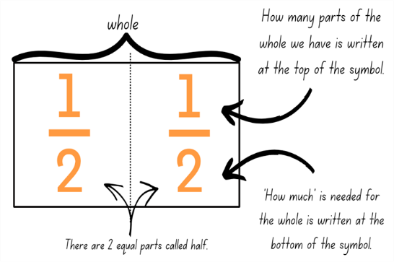
Note: use language that will assist students to develop early fraction ideas. For example, rather than saying ‘1 over 2’, ‘1 of 2’ or ‘1 on 2’ (describing the symbol only), refer to the fractional relationship by saying ‘one half of the whole strip’. The teaching advice states that the terms ‘numerator’ and ‘denominator’ are used in Stage 3.
- Remind students that to halve a length, 2 equal-sized parts must be created.
- Ask students to determine how they would find half of a length if they were unable to fold it.
- Students turn and talk to a partner to identify other ways to find half.
- In pairs, students choose one of the masking tape lengths. Pairs estimate half of the length without folding, by making a pencil mark and recording their initials where they believe the halfway point to be. Pairs should use visualisation to help them estimate halfway. Encourage students to justify their placement of the halfway mark.
Note: visualisation is used throughout this lesson as a technique to support student understanding of the thirding and fifthing strategy in Lessons 3 and 4.
- Each pair repeats this process for 4 other masking tape lengths.
- Regroup and ask:
- How did you estimate the halfway point on the masking tape strips?
- Did you find locating the halfway point on any of the strips challenging? Why or why not?
- Revise that half is the precise creation of 2 equal parts, so the marks recorded on each strip are estimations of the halfway point. To determine the precise halfway point, students use a piece of string to fold and check their estimates.
- Pairs cut a piece of string that is the same length as one of the masking tape strips. Using the string, pairs accurately measure and mark half by drawing a line with a marker or highlighter.
- Students complete a gallery walk to see where other pairs marked half on their lengths.
- Ask:
- How close were your estimates?
- What would you change to ensure greater accuracy next time?
- Revise that to find a quarter of a length, 4 equal-sized parts must be created.
- Pairs repeat steps 14–18 to indicate how the masking tape length could be partitioned into quarters, using a pencil.
- Regroup and ask:
- How did you determine where the masking tape strip would be partitioned into quarters?
- Did you use any different strategies to help you this time? Why or why not?
- How close were you to the correct partition lines?
This table details opportunities for differentiation.
Too hard? | Too easy?
Students cannot model fractions with fraction strips for halves, quarters and eighths.  - Support students by modelling the use of other resources such as interlocking blocks or coloured rods, to identify the halfway point of the masking tape strip.  - Assist students by encouraging them to create halves by folding an equivalent paper strip into 2 equal parts to see the relationship between the parts and the whole length. | Students can model fractions with fraction strips for halves, quarters and eighths.  - Students make a poster describing the different ways of ensuring equal parts when making fractions. Strategies might include ensuring corners and edges are aligned when folding or placing parts on top of one another to check that they are equal.

Consolidation and meaningful practice – 10 minutes
- Students choose a new partner to work with. Each pair selects a masking tape strip they have not used previously.
- Using what they know about halves and quarters, pairs determine how the masking tape length could be partitioned into eighths and mark this with a pencil.
- Pairs check their partitions using a piece of string.
- Students join with another pair to identify their partitions and explain their thinking.
- Regroup and ask:
- Did you use any different strategies to help you this time? Why or why not?
- How close were you to the correct partition lines?
- How did you find eighths of a length?
- Were you able to find eighths of a length without folding?
- Highlight the relationship between halves, quarters and eighths for students, if not already uncovered in the class discussion. Ensure students understand that halves can be created by folding a strip and lining up the corners to create 2 parts. Quarters are created by halving a half. When quarters are halved, eighths are created.
This table details opportunities for assessment.
Assessment opportunities | Links
What to look for:  - Can students model fractions with fraction strips for halves, quarters and eighths? [MAO-WM-01, MA2-PF-01]  - Can students create fractional parts of a length using techniques other than repeated halving? [MAO-WM-01, MA2-PF-01] | Links to National Numeracy Learning Progressions (NNLP):  - InF2, InF3, InF4.

Lesson 2
Core concept: bar models and fractions strips can be used to represent fractions.

Daily number sense – Is he correct? – 10 minutes
The table below contains a suggested learning intention and success criteria. These are best co-constructed with students.
Daily number sense learning intention | Daily number sense success criteria
Students are learning to:  - model and represent unit fractions, and their multiples, to complete a whole on a number line. | Students can:  - recreate the whole unit from a fractional part.
- Display Resource 2 – Is he correct?
- Ask students to consider:
- Is Fred correct? How do you know?
- What has Fred done incorrectly?
- If he is not correct, what would be the correct answer? How could you work it out?
- Students turn and talk with a partner to compare their thoughts.
- As a class, regroup and discuss.
- Draw a short line on the whiteboard.
- Ask:
- If this is a quarter, what is the whole?
- If this is an eighth, what is the whole?
- If this is a half, what is the whole?
This table details an opportunity for assessment.
Assessment opportunity | Links
What to look for:  - Can students recreate the whole unit from a fractional part? [MAO-WM-01, MA2-PF-01] | Links to National Numeracy Learning Progressions (NNLP):  - InF5.

Core lesson – fractions on a line – 35 minutes
The table below contains suggested learning intentions and success criteria. These are best co-constructed with students.
Core concept learning intentions | Core concept success criteria
Students are learning to:  - model and represent unit fractions, and their multiples, to a complete whole on a number line  - generate and describe patterns. | Students can:  - model fractions with fraction strips and diagrams for halves, quarters and eighths  - recreate the whole unit from a fractional part ($\frac{1}{2}$, $\frac{1}{4}$ and $\frac{1}{8}$)  - model, describe and record patterns of multiples.
Note: this lesson, along with others in this unit, expands upon the fraction folding activities that students have already encountered. Students need to have repeated opportunities to fold and manipulate fractional parts to ensure a thorough understanding of the part-part-whole relationship. This should include materials of different lengths.
When completing the paper folding activities throughout this unit of work, it is suggested (where possible) that students use paper with different coloured sides to help highlight proportion.
- Provide each student with 3 equal strips of paper. Ensure each strip of paper is a different colour.
- Students select one strip of paper and fold it in half. Remind students that the folds must be precise and produce 2 equal-sized parts.
- Using fraction notation, students identify and label each of the folded sections as one-half ( $\frac{1}{2}$ ).
- Students select the second paper strip and fold it in half and then half again to produce quarters.
- Using fraction notation, students identify and label each of the folded sections as one-quarter ( $\frac{1}{4}$ ).
- Ask students to use their knowledge of folding halves and quarters to fold the final strip into eighths.
- Using fraction notation, students identify and label each of the folded sections as one-eighth ( $\frac{1}{8}$ ).
- Place the 3 paper strips underneath each other (see Figure 2).
Figure 2 – three paper strips
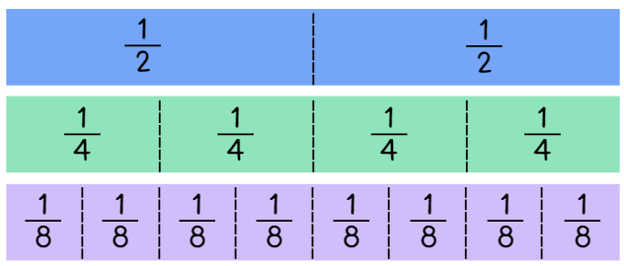
- Ask:
- How many halves make up the whole strip of paper?
- How many quarters make up the whole strip of paper?
- How many eighths make up the whole strip of paper?
- How can the same length strip have 2 halves but 8 eighths?
- Students glue the halves strip into their workbook or onto a piece of grid paper.
- Under the paper strip, students draw a number line that includes zero, one and an arrow to indicate that the number line continues. Students mark and label the fractions along the line (see Figure 3).
Figure 3 – student work sample 1
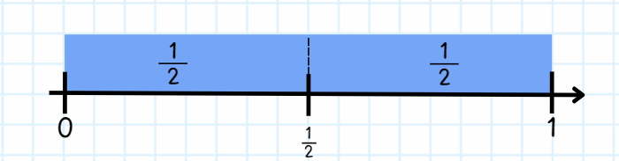
- Students repeat this process for the remaining 2 paper strips (see Figure 4).
Figure 4 – student work sample 2
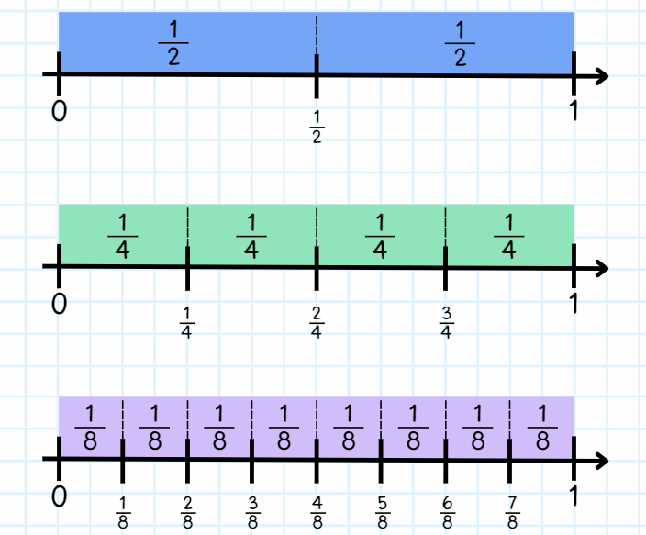
- Remind students that when they mark the paper strip, they are highlighting fractions on a line, when they draw the markers along the number line, they are highlighting fractions of a line.
- Ask the following questions:
- What patterns can you see when looking at the paper strips?
- Why do these patterns occur? (They occur because the parts are repeatedly halved.)
- What would happen if the pattern continued? (There would be 16 parts in the next strip.)
- What do you notice about the fractions $\frac{1}{2}$, $\frac{2}{4}$ and $\frac{4}{8}$?
- Can you see any other equivalent fractions?
Note: fractions of a length indicate a ‘part’ of a line or length and fractions as a number sit at a ‘point’ on a number line. This may be the first time students understand that there are numbers between zero and one.
- Revise the similarities and/or differences of fractions of a line (bar model) and on a line (number line).
This table details opportunities for differentiation.
Too hard? | Too easy?
Students cannot model fractions with fraction strips and diagrams for halves, quarters and eighths.  - Demonstrate the halving technique step-by-step for students to follow.  - Model fractions using concrete materials such as coloured rods.  - Students use a fraction wall to explore halves, quarters and eighths. | Students can model fractions with fraction strips and diagrams for halves, quarters and eighths.  - Students explore equivalence by folding strips of paper. They identify, create and label as many fractions equivalent to one-half as possible.

Consolidation and meaningful practice – 15 minutes
- Provide students with a small strip of paper and writing materials.
- Ask students to represent their thinking by drawing labelled diagrams to answer the following questions:
- If the strip is one-half ( $\frac{1}{2} )$, how long is the whole?
- If your strip is one-quarter ( $\frac{1}{4}$ ) of the whole, how long is the whole?
- If your strip is one-eighth ( $\frac{1}{8}$ ) of the whole, label two-eighths ( $\frac{2}{8}$ ), four-eighths ( $\frac{4}{8}$ ), six-eighths ( $\frac{6}{8}$ ) and eight-eighths ( $\frac{8}{8}$ ) of the whole.
- If your strip represents 4 wholes, can you draw the length of one-whole?
- Students turn and talk to discuss and compare their diagrams.
This table details opportunities for differentiation.
Too hard? | Too easy?
Students cannot recreate the whole unit from a fractional part.  - Provide multiple equal paper strips for students to use to visualise the whole. Tape the pieces together so students can identify the fractional parts.  - Provide hands-on materials such as coloured rods to manipulate the fractional parts. | Students can recreate the whole unit from a fractional part.  - Students recreate the whole from non-unit fractions, for example three-quarters ( $\frac{3}{4 }$ ) or three-eighths ( $\frac{3}{8}$ ).  - In pairs, students select and label one fractional part. Their partner must identify the fractional part needed to recreate one whole. For example, if Student A selected one-quarter, Student B must identify three-quarters as the fractional part needed to recreate the whole.
This table details opportunities for assessment.
Assessment opportunities | Links
What to look for:  - Can students model fractions with fraction strips and diagrams for halves, quarters and eighths? [MAO-WM-01, MA2-PF-01]  - Can students recreate the whole unit from a fractional part? [MAO-WM-01, MA2-PF-01]  - Can students model, describe and record patterns of multiples? [MAO-WM-01, MA2-PF-01] | Links to National Numeracy Learning Progressions (NNLP):  - InF2, InF3, InF4, InF5.

Lesson 3
Core concept: fractions can be represented as measures by partitioning length.

Daily number sense – fractured fraction wall – 10 minutes
The table below contains a suggested learning intention and success criteria. These are best co-constructed with students.
Daily number sense learning intention | Daily number sense success criteria
Students are learning to:  - model and represent unit fractions, and their multiples, to complete a whole on a number line. | Students can:  - determine the fractional part needed to make a whole.
- Display Resource 3 – fractured fraction wall 1.
- Read the following scenario: The class had a fraction wall up in the classroom. One day, the teacher left the door open during lunch time and the wind blew some of the fractions off the wall. It is your job to fix the fraction wall so that each row represents one whole.
- Ask students to turn and talk to discuss how they can ensure the correct fractional parts are returned in the correct quantities.
- Give each student a copy of either Resource 3 – fractured fraction wall 1 or Resource 4 – fractured fraction wall 2 to complete the fraction wall.
- Students compare their fraction wall with a partner, discussing the strategies they used to ensure it was complete.
This table details an opportunity for assessment.
Assessment opportunity | Links
What to look for:  - Can students determine the fractional part needed to make a whole? [MAO-WM-01, MA2-PF-01] | Links to National Numeracy Learning Progressions (NNLP):  - InF3, InF4.

Core lesson 1 – the thirding strategy – 20 minutes
The table below contains suggested learning intentions and success criteria. These are best co-constructed with students.
Core concept learning intentions | Core concept success criteria
Students are learning to:  - create fractional parts of a length using techniques other than repeated halving  - model and represent unit fractions, and their multiples, to a complete whole on a number line. | Students can:  - create thirds and fifths of a length  - describe fraction families formed by dividing the whole into the same total number of equal parts as having the same denominator.
This activity is an adaptation of ‘The thirding strategy’ from Teaching Mathematics: Foundation to Middle Years by Siemon et al.
- Pose the following question: We know how to fold halves, quarters and eighths. Can we use this information to help us fold thirds?
- Give students some paper strips and an opportunity to explore their ideas with a partner.
- Select students to share ideas with the class. If not already stated, explain that one-third is slightly less than half.
- Model and explain the thirding strategy to students: when folding the paper strip into thirds, you can visualise half. Then estimate a third as less than that and create your first fold. The rest of the strip can be folded in half into that fold. If you have not created 3 equal parts, adjust your first fold and try again (see Figure 5).
Figure 5 – folding thirds
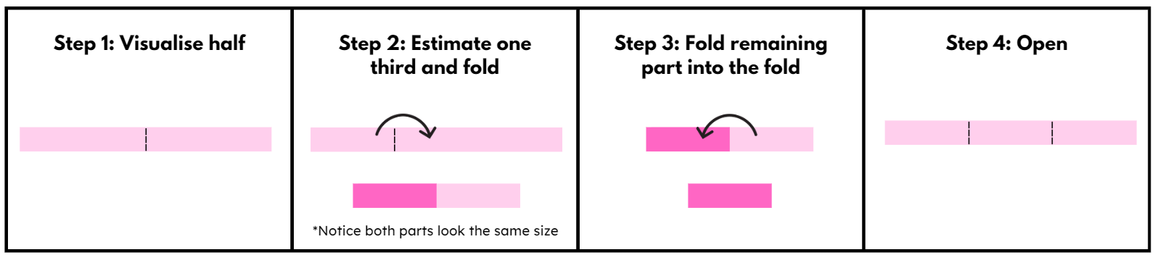
- Give students several opportunities to explore this method of folding thirds.
- Students trace the thirds fold lines and glue the thirds strip into their workbook or onto a piece of grid paper.
Note: in Lesson 5, students will create sixths and tenths. It is important that they leave space beneath the thirds strip for the sixths and beneath the fifths strip for the tenths. This will help them recognise the equivalence between these fractions.
- As in Lesson 2, under the paper strip, students draw a number line that includes zero, one and an arrow to indicate the number line continues. Students mark and label the fractions $\frac{1}{3}$, $\frac{2}{3}$, $\frac{3}{3}$ along the line and label each part of the strip with $\frac{1}{3}$ (see Figure 7).

Core lesson 2 – the fifthing strategy – 20 minutes
This activity is an adaptation of ‘The fifthing strategy’ from Teaching Mathematics: Foundation to Middle Years by Siemon et al.
- Pose question: Can we use a similar strategy to the thirding strategy to create fifths?
- Give students some paper strips and an opportunity to explore their ideas with a partner.
- Select students to share their ideas with the class. If not already stated, explain that one-fifth is slightly less than a quarter.
- Model and explain the fifthing strategy to students: when folding the paper strip into fifths, you can visualise quarters by estimating half and then half again. We can then estimate a fifth as less than the quarter and create our first fold. The rest of the strip can be folded in half into that fold and then folded in half into that fold again. If you have not created 5 equal parts, adjust your first fold and try again (see Figure 6).
Figure 6 – folding fifths
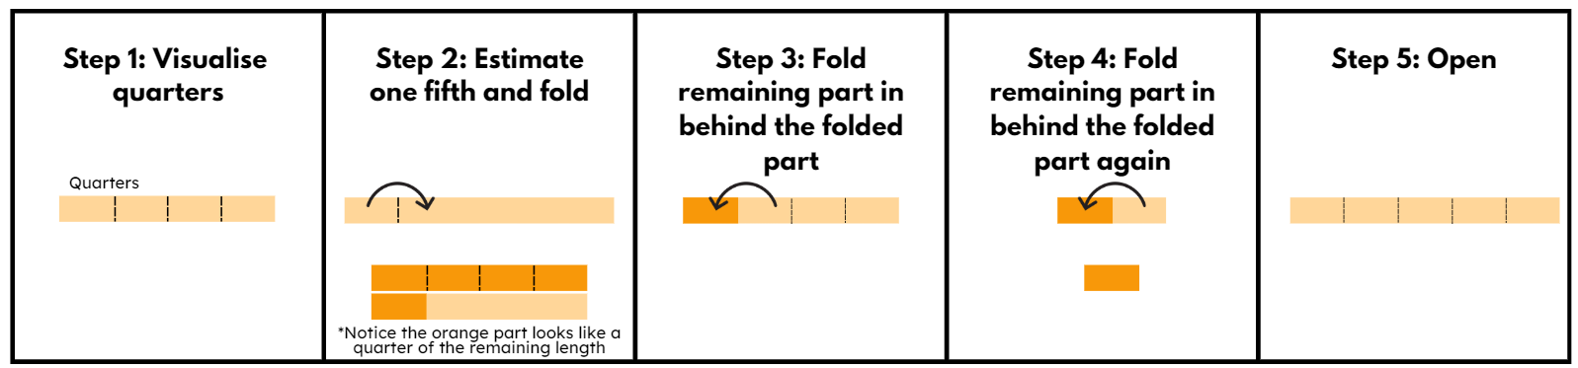
- Give students several opportunities to explore this method of folding fifths.
- Students trace the fifths fold lines and glue the fifths strip into their workbook or onto a piece of grid paper.
- As in Lesson 2, under the paper strip, students draw a number line that includes zero, one and an arrow to indicate the number line continues. Students mark and label the fractions $\frac{1}{5}$, $\frac{2}{5}$, $\frac{3}{5}$, $\frac{4}{5}$, $\frac{5}{5}$ along the line and label each part of the strip with $\frac{1}{5}$ (see Figure 7).
Figure 7 – student work sample
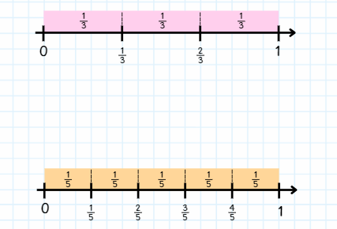
This table details opportunities for differentiation.
Too hard? | Too easy?
Students cannot create thirds and fifths of a length.  - Support students to estimate half on a paper strip. Students place a pencil mark where they estimate a third to be prior to folding. Using the pencil mark as a guide, support students to make a third before halving the remaining strip. Students use a similar strategy for fifths by placing a pencil mark where they estimate fifths to be prior to folding.  - Students use Resource 5 – fraction wall to explore thirds and fifths. | Students can create thirds and fifths of a length.  - Students explore equivalence by folding strips of paper. They identify, create and label as many fractions equivalent to one-third as possible.

Discuss and connect the mathematics – 10 minutes
Note: in the syllabus, a fraction family is formed by dividing the whole into the same total number of equal parts while having the same denominator.
- Revise student understanding of fraction families. For example, one quarter, 2 quarters, 3 quarters and 4 quarters.
- Students look at the folded fraction strips on the number lines. Ask:
- How did your knowledge of halves and quarters help you to make thirds and fifths?
- When looking at the thirds folded strip on the number line, are you able to identify the fraction family it belongs to?
- What fractions belong in the thirds fraction family?
- When looking at the fifths folded strip on the number line, are you able to identify the fraction family it belongs to?
- What fractions belong in the fifths fraction family?
This table details opportunities for assessment.
Assessment opportunities | Links
What to look for:  - Can students create thirds and fifths of a length?  [MAO-WM-01, MA2-PF-01]  - Can students describe fraction families formed by dividing the whole into the same total number of equal parts as having the same denominator? [MAO-WM-01, MA2-PF-01] | Links to National Numeracy Learning Progressions (NNLP):  - InF4.

Lesson 4
Core concept: bar models and fractions strips can be used to represent fractions.

Daily number sense – 10 minutes
- From a class need surfaced through formative assessment data, identify a short, focused activity that targets students’ knowledge, understanding and skills. Example activities may be drawn from the following resources:
- Mathematics K–6 resources
- Universal Resources Hub.

Core lesson – fractions with related denominators – 40 minutes
The table below contains suggested learning intentions and success criteria. These are best co-constructed with students.
Core concept learning intentions | Core concept success criteria
Students are learning to:  - create fractional parts of a length using techniques other than repeated halving  - model and represent unit fractions, and their multiples, to a complete whole on a number line  - generate and describe patterns. | Students can:  - create thirds and fifths of a length  - model fractions with fraction strips and diagrams  - model, describe and record patterns of multiples.
- Revise the folding of thirds and fifths from Lesson 3.
- Pose the following question: When we halved quarters, we created eighths. When we halve thirds, what will happen? Ensure students understand that halving thirds will create sixths.
- Provide pairs with paper strips to explore ideas about how to create sixths.
- Select students to demonstrate and discuss how they folded their paper strip to create sixths. Highlight that the most efficient method is to fold thirds and then fold in half again.
- Pose the following question: Using our knowledge of halving quarters to make eighths, and halving thirds to make sixths, how could tenths be made?
- Provide pairs with paper strips to explore ideas about how to create tenths.
- Select students to demonstrate and discuss how they folded their paper strip into 10 equal parts. Remind students that the most efficient method is to fold fifths and then fold in half again.
- Students glue the sixths and tenths strips into their workbook or onto a piece of grid paper, where they left space in Lesson 3.
- As in Lesson 2, under each paper strip, students draw a number line that includes zero, one and an arrow to indicate that the number line continues. Students mark and label the fractions on the line (see Figure 8).
Figure 8 – student work sample
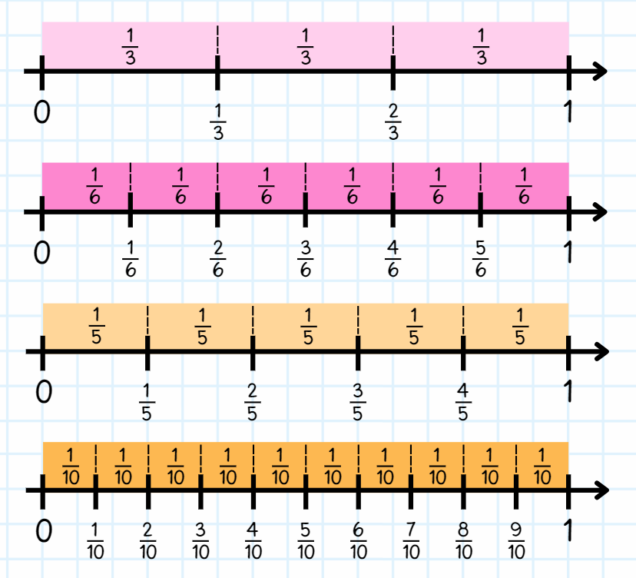
The table below outlines stimulus prompts to generate conversation about the topic, along with anticipated responses from students.
Prompts | Anticipated student responses
- What do you notice happens when you halve thirds? | - When you halve thirds, you end up with 6 parts – the number of parts doubles. The size of each part is halved.
- What do you notice happens when you halve fifths? | - When you halve fifths, you end up with 10 parts – the number of parts doubles. The size of each part is halved.
- How are thirds different to sixths? | - They differ in the number of equal parts that divide the whole. The size of each part is also different if the same sized whole is used to represent thirds and sixths.
- Refer students to the thirds and sixths strips in their workbook. Can you identify what is similar and different between one-third  ( $\frac{1}{3}$ ) and two-sixths ( $\frac{2}{6}$ )? | - One-third and two-sixths are equivalent, but the number of parts needed are different because the size of the parts are different. When the same sized whole is used, one-third is the same as two-sixths.
This table details opportunities for differentiation.
Too hard? | Too easy?
Students cannot model fractions with fraction strips and diagrams.  - Model fractions using concrete materials such as coloured rods.  - Students use their fraction wall to explore thirds, fifths, sixths and tenths. | Students can model fractions with fraction strips and diagrams.  - Present students with story problems that involve fractions in realistic scenarios, such as sharing food among friends or dividing resources equally. Encourage them to solve the problems using fractions and explain their reasoning.  - Students explore equivalence by folding strips of paper. They identify, create and label as many fractions equivalent to non-unit fractions for thirds and fifths as possible.

Discuss and connect the mathematics – 10 minutes
- Ask students to prove that two-thirds ( $\frac{2}{3}$ ) is equivalent to four-sixths ( $\frac{4}{6}$ ), using concrete materials, diagrams and number lines to demonstrate their understanding.
- Students turn and talk to discuss their decisions and the strategies they used.
- Ask students to repeat the process to prove that three-fifths ( $\frac{3}{5}$ )is equivalent to six-tenths ( $\frac{6}{10}$ ).
- Students share responses.
This table details opportunities for assessment.
Assessment opportunities | Links
What to look for:  - Can students create thirds and fifths of a length?  [MAO-WM-01, MA2-PF-01]  - Can students model fractions with fraction strips and diagrams? [MAO-WM-01, MA2-PF-01]  - Can students model, describe and record patterns of multiples? [MAO-WM-01, MA2-PF-01] | Links to National Numeracy Learning Progressions (NNLP):  - InF2, InF3, InF4.

Lesson 5
Core concept: equivalent fractions have related denominators.

Daily number sense – looking for squares – 10 minutes
Daily number sense activities for Lessons 5 to 7 ‘loop’ back to concepts and procedures covered in previous units to assist students to build an increasingly connected network of ideas. These concepts may differ from the core concepts being covered by the unit.
The table below contains a suggested learning intention and success criteria. These are best co-constructed with students.
Daily number sense learning intention | Daily number sense success criteria
Students are learning to:  - recall multiplication facts of 2 and 4, 5 and 10 and related division facts. | Students can:  - recognise and use the symbols for multiplied by (×), divided by (÷) and equals (=)  - link multiplication and division fact families using arrays.
- Ask: What are square numbers?
- Discuss students' responses and provide an example if necessary, such as 3 × 3 = 9. Demonstrate by drawing an array of 3 × 3 for students to visualise the connection with its definition.
Square numbers: the result of multiplying a number by itself. For example, 3 × 3 = 9.
- Display the following numbers: 16, 22, 25 and 9. Ask students to prove which number is not a square number.
- Students record their responses by including an array and a description linking multiplication and division fact families for each pair (see Figure 9).
Figure 9 – student sample
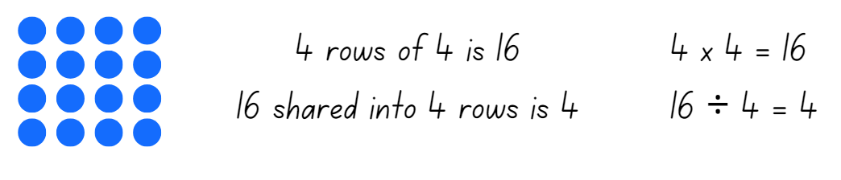
- Ask:
- Can you provide another example of a square number? Prove it.
- What patterns do you notice with square numbers?
This table details opportunities for assessment.
Assessment opportunities | Links
What to look for:  - Can students recognise and use the symbols for multiplied by (×), divided by (÷) and equals (=)?  [MAO-WM-01, MA2-MR-01, MA2-MR-02]  - Can students link multiplication and division fact families using arrays? [MAO-WM-01, MA2-MR-01, MA2-MR-02] | Links to National Numeracy Learning Progressions (NNLP):  - MuS5, MuS6.  Links to suggested Interview for Student Reasoning (IfSR) tasks:  - IfSR-MT: 2A.9, 2A.10.

Core lesson – fraction wall game – 35 minutes
The table below contains suggested learning intentions and success criteria. These are best co-constructed with students.
Core concept learning intentions | Core concept success criteria
Students are learning to:  - model and represent unit fractions, and their multiples, to a complete whole on a number line  - model equivalent fractions as lengths  - represent fractional quantities equal to and greater than one. | Students can:  - represent fractions with the same-size whole to make valid comparisons (denominators of 2, 4 and 8; 3 and 6; 5 and 10)  - represent the equivalence of fractions with related denominators as lengths, using concrete materials, diagrams and number lines  - rename 2 halves, 3 thirds, 4 quarters, 5 fifths, 6 sixths, 8 eighths and 10 tenths as one whole.
This activity is an adaptation of ‘Fraction wall game’ from Top Drawer Teachers by the Australian Government Department of Education, Employment and Workplace Relations.
- Display Resource 5 – fraction wall and ask how a fraction wall can help identify fractions that are equivalent.
- Encourage students to use fractional language. For example, ‘three-quarters’ instead of ‘3 out of 4’. This is helpful for understanding fractional parts within the part-whole and greater than one, for example six-fifths.
- Highlight that the fraction wall enables students to ‘line up’ particularly difficult fractions to generate equivalent combinations, for example, lining up six-eights ( $\frac{6}{8}$ ) demonstrates its equivalence to three-quarters ( $\frac{3}{4}$ ).
- Explain that students will use Resource 6 – gameboard and spinners to form fractions and represent these on the fraction wall, attempting to colour in the whole gameboard.
- Model using a think aloud strategy to help students draw out equivalence. Ask how the fraction wall can be coloured to show two-eights ( $\frac{2}{8}$ ) (see Figure 10).
Figure 10 – first attempt
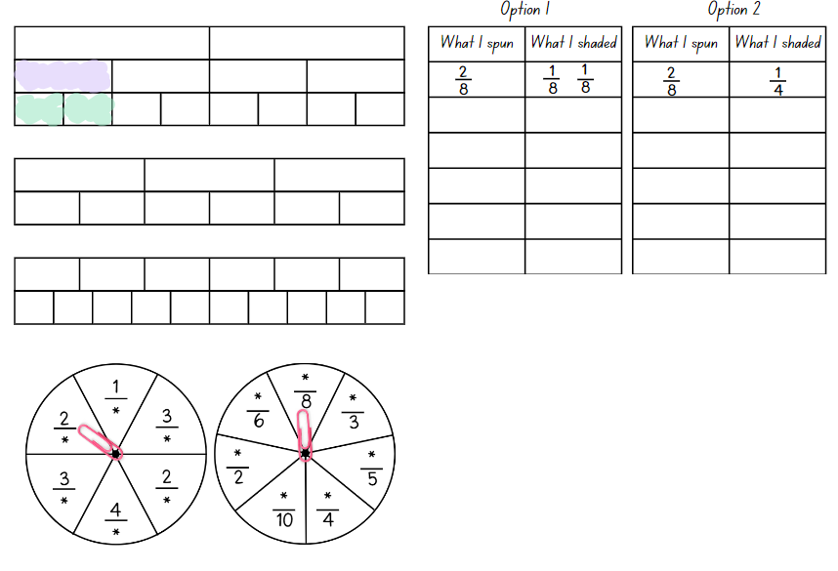
- Ask the following questions:
- Is there more than one way this could be done?
- What could you do if you didn’t have enough eighths?
- Could I use halves? Why or why not?
- Model another example, such as three-quarters ( $\frac{3}{4}$ ), and discuss the equivalent options on the gameboard (see Figure 11).
Figure 11 – second attempt
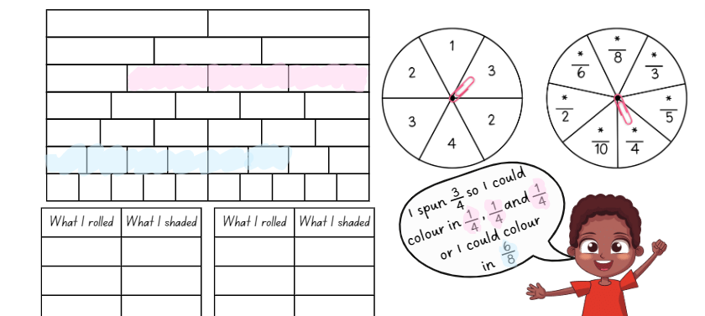
- Provide each student with Resource 6 – gameboard and spinners.
- Pairs of students take turns spinning the spinners and decide how to colour the fraction on their gameboard.
- Each pair decides what they shade on the wall, for example $\frac{4}{8}$, could be $\frac{1}{2}$ or $\frac{4}{8}$ or $\frac{2}{4}$.
Note: remind students that fractions can be renamed, for example 2 halves, 3 thirds, 4 quarters, 5 fifths, 6 sixths, 8 eighths and 10 tenths as one whole.
- If a student is unable to take their turn, they simply pass. This may happen if a student spins a fraction greater than one or cannot colour the fraction spun. The winner is the first student who colours in their entire wall. However, the other player is encouraged to continue, with the support of the first player, to fill their fraction wall if there is still time remaining.
- To finish off the game, students must roll exactly what they need. A larger fraction is not acceptable to finish, for example, if they need $\frac{1}{8}$ to finish and they roll $\frac{2}{4}$ (more than what is needed), they must miss a turn.
- Students record each turn on Resource 6 – gameboard and spinners (see Figure 12). Encourage students to use different colours for each choice made during the game. This helps with understanding each decision made at each stage of the game. For example, a student might have spun $\frac{1}{4}$, but shaded $\frac{1}{8}$and $\frac{1}{8}$.
Figure 12 – colour fractions gameboard
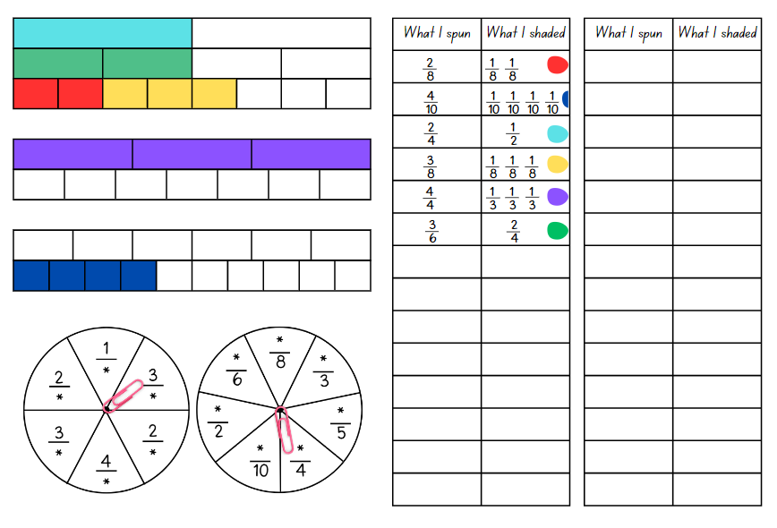
This table details opportunities for differentiation.
Too hard? | Too easy?
Students cannot represent the equivalence of fractions with related denominators as lengths, using concrete materials, diagrams and number lines.  - Use a set of fraction cards (for example, $\frac{1}{2}$, $\frac{1}{3}$, $\frac{1}{4}$, $\frac{2}{3}$, $\frac{2}{4}$) that support the representation of the fractions. The first student to complete a row wins the game.  - Provide a reduced fraction wall and in pairs students shade the fraction wall and the first student to complete a row wins the game. For example, students could use the top of the gameboard with only halves, quarters and eighths. | Students can represent the equivalence of fractions with related denominators as lengths, using concrete materials, diagrams and number lines.  - Students fold additional strips to extend their fraction wall with fractions using denominators of their own choosing. For example, twelfths and twentieths.  - Challenge students to create their own rules to fill the board and play with a partner using adjusted rules.

Discuss and connect the mathematics – 15 minutes
- Regroup and ask students to share and describe what they spun and what they shaded.
The table below outlines stimulus prompts to generate conversation about the topic, along with anticipated responses from students.
Prompts | Anticipated student responses
- How many thirds make one whole? | - Three-thirds.
- When you look at a fraction wall, how can you tell if 2 fractions are equivalent? | - If 2 fractions are the same length on the fraction wall, they are equivalent fractions.
- How can you use the fraction wall to compare fractions and see which one is bigger or smaller? | - If I am comparing unit fractions I can look at the size of the pieces. If one fraction's pieces are longer than another fraction's pieces, then that fraction is bigger.  - If I am comparing other fractions I can look at the length of each fraction. Even if the fractional parts look short, the fraction can still be bigger. For example, $\frac{9}{10}$is bigger than $\frac{3}{5} ,$even though each tenth is shorter than each fifth on the fraction wall.
- Can you give an example of a fraction family? | - An example of a fraction family is $\frac{1}{4}$, $\frac{2}{4}$, $\frac{3}{4}, \frac{4}{4}.$I know they are a fraction family because these are all fractions where the whole has been divided into 4 equal parts.
- How could you extend your fraction wall to show a fraction larger than one whole? | - Four-thirds is three-thirds and one-third.  - Three-halves is two-halves and one-half$.$
- Why is it important to find equivalent fractions? Can you give an example? | - It helps us compare and operate with fractions more easily. For example, if you are baking and a recipe needs half a cup of flour, but you only have a one-quarter measuring cup, knowing two-quarters is equivalent to one-half helps you measure the right amount.
This table details opportunities for assessment.
Assessment opportunities | Links
What to look for:  - Can students represent fractions with the same-size whole to make valid comparisons (denominators of 2, 4 and 8; 3 and 6; 5 and 10)? [MAO-WM-01, MA2-PF-01]  - Can students represent the equivalence of fractions with related denominators as lengths, using concrete materials, diagrams and number lines? [MAO-WM-01, MA2-PF-01]  - Can students rename 2 halves, 3 thirds, 4 quarters, 5 fifths, 6 sixths, 8 eighths and 10 tenths as one whole?  [MAO-WM-01, MA2-PF-01] | Links to National Numeracy Learning Progressions (NNLP):  - InF3, InF4, InF5.

Lesson 6
Core concept: equivalent fractions have related denominators.

Daily number sense – using arrays – 10 minutes
The table below contains a suggested learning intention and success criteria. These are best co-constructed with students.
Daily number sense learning intention | Daily number sense success criteria
Students are learning to:  - recall multiplication facts of 2 and 4, 5 and 10 and related division facts. | Students can:  - recognise and use the symbols for multiplied by (×), divided by (÷) and equals (=)  - link multiplication and division fact families using arrays.
- Roll two 10-sided dice and use the numbers rolled to form an array. For example, if 3 and 8 are rolled, an array of 3 eights is created.
- From the array, record multiplication and division number sentences, see Figure 13.
Figure 13 – array number sentences
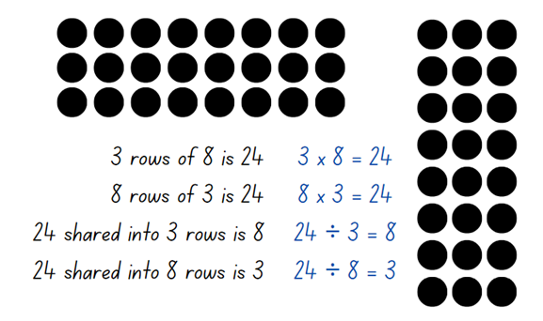
- Highlight to students:
- the link between multiplication and division
- the commutative property of multiplication.
- Once students are confident, provide them with two 10-sided dice, counters and their workbooks. Students record the array and their number sentences in their workbook.
Note: students may wish to use grid paper rather than counters to help draw arrays, particularly with larger arrays.
- Select students to share and explain their arrays and number sentences.
This table details opportunities for assessment.
Assessment opportunities | Links
What to look for:  - Can students recognise and use the symbols for multiplied by (×), divided by (÷) and equals (=)?  [MAO-WM-01, MA2-MR-01, MA2-MR-02]  - Can students link multiplication and division fact families using arrays? [MAO-WM-01, MA2-MR-01, MA2-MR-02] | Links to National Numeracy Learning Progressions (NNLP):  - MuS6.  Links to suggested Interview for Student Reasoning (IfSR) tasks:  - IfSR-MT: 2A.9, 2A.10.

Core lesson – Which does not belong? – 35 minutes
The table below contains suggested learning intentions and success criteria. These are best co-constructed with students.
Core concept learning intentions | Core concept success criteria
Students are learning to:  - generate and describe patterns  - model equivalent fractions as lengths. | Students can:  - model, describe and record patterns of multiples  - represent the equivalence of fractions with related denominators as lengths, using concrete materials, diagrams and number line.
- Ask students to identify and record any fractions equivalent to one-half, one-third, one-quarter and one-fifth on an individual whiteboard by using concrete materials, diagrams or number lines, see Figure 14. Students may wish to use Resource 5 – fraction wall.
Figure 14 – equivalent fractions
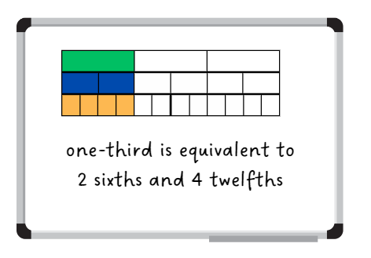
- Ask students what they notice about these groups of fractions. Highlight the multiplicative relationship between the equivalent fractions. For example, a student may reason that one-fifth ( $\frac{1}{5}$ ) is equivalent to two-tenths ( $\frac{2}{10}$) because if fifths were halved, each fifth would be equivalent to two-tenths ( $\frac{2}{10}$ ).
- Have students use the fraction wall or Polypad – The Mathematical Playground to identify any other equivalent fractions and record these in their workbooks. Encourage students to find equivalent fractions for non-unit fractions such as two-thirds ( $\frac{2}{3}$ ), six-tenths ( $\frac{6}{10}$ ), and so on.
- Ask students to record any additional equivalent fractions that go beyond the fraction wall and justify their responses.
Note: although fractions with other denominators are not explicitly included in the syllabus, this activity highlights the multiplicative pattern of equivalent fractions.
- Display Resource 7 – Which doesn't belong?.
- Select one example from Resource 7 – Which doesn't belong?. Ask students to turn and talk to determine which fraction does not belong.
- Regroup and select students to share the strategies used to determine the answer.
- Provide pairs or small groups of students with Resource 7 – Which doesn't belong? and writing materials. Students work together to determine the fraction that does not belong using concrete materials, diagrams or number lines.
- Regroup and ask students to explain and justify the answer for each card.
This table details opportunities for differentiation.
Too hard? | Too easy?
Students cannot represent the equivalence of fractions with related denominators as lengths, using concrete materials, diagrams and number line.  - Support students to identify the fractions on Resource 7 – Which doesn't belong? on Resource 5 – fraction wall. | Students can represent the equivalence of fractions with related denominators as lengths, using concrete materials, diagrams and number line.  - Students create their own series of cards and share then with their peers to justify why some fractions do not belong.

Discuss and connect the mathematics – 15 minutes
- Display Resource 5 – fraction wall. Ask:
- What patterns do you notice on the fraction wall?
- Can you identify any patterns with equivalent fractions?
- What pattern is created when a whole is repeatedly halved?
- What patterns do you notice with equivalent fractions for one-half?
This table details opportunities for assessment.
Assessment opportunities | Links
What to look for:  - Can students model, describe and record patterns of multiples? [MAO-WM-01, MA2-MR-01]  - Can students represent the equivalence of fractions with related denominators as lengths, using concrete materials, diagrams and number lines? [MAO-WM-01, MA2-PF-01] | Links to National Numeracy Learning Progressions (NNLP):  - InF5  - NPA3, NPA4.

Lesson 7
Core concept: identifying a complementary fractional part is needed to complete one whole.

Daily number sense – solve the problem – 15 minutes
The table below contains a suggested learning intention and success criteria. These are best co-constructed with students.
Daily number sense learning intention | Daily number sense success criteria
Students are learning to:  - recall multiplication facts of 2 and 4, 5 and 10 and related division facts. | Students can:  - recognise and use the symbols for multiplied by (×), divided by (÷) and equals (=)  - generate multiplication fact families for multiples of 2 and 4, 5 and 10.
This activity is an adaptation of the National Assessment Program by ACARA.
- Display and read Resource 8 – word problems.
- In pairs, students solve and record their solutions on a whiteboard.
- Regroup as a class and ask:
- How could you represent the problem using a number sentence?
- Can you explain the steps you took to solve the problems?
- How did your knowledge of fact families help you solve the problems?
- Did you find any patterns while working on this activity?
- Is there anything you would do differently next time?
This table details opportunities for assessment.
Assessment opportunities | Links
What to look for:  - Can students recognise and use the symbols for multiplied by (×), divided by (÷) and equals (=)?  [MAO-WM-01, MA2-MR-01, MA2-MR-02]  - Can students generate multiplication fact families for multiples of 2 and 4, 5 and 10? [MAO-WM-01, MA2-MR-01, MA2-MR-02] | Links to National Numeracy Learning Progressions (NNLP):  - MuS6.  Links to suggested Interview for Student Reasoning (IfSR) tasks:  - IfSR-MT: 2A.4, 2A.5, 2A.6.

Core lesson – recreate the whole – 35 minutes
The table below contains suggested learning intention and success criteria. These are best co-constructed with students.
Core concept learning intention | Core concept success criteria
Students are learning to:  - model and represent unit fractions, and their multiples, to a complete whole on a number line. | Students can:  - determine the complementary fractional part needed to complete one whole (halves, quarters, eighths, thirds)  - recreate the whole unit from a fractional part ($\frac{1}{2} , \frac{1}{4}$ and $\frac{1}{8})$.
- Display Resource 9 – recreate the whole.
- Explain that a number line has been drawn underneath each red paper strip. Draw attention to the position of 0 and 1 on the number lines to indicate that each red strip represents a fractional part of a whole strip.
- Revise the term ‘complementary fraction’ as the unit fraction needed to create one whole.
- Discuss and model identifying the complementary fractional part for the example nine-tenths ( $\frac{9}{10} )$. Explain that one-tenth ( $\frac{1}{10} )$is the unit fraction that is complementary as they represent 2 fractional parts needed to complete one whole (see Figure 15).
Figure 15 – finding the complement
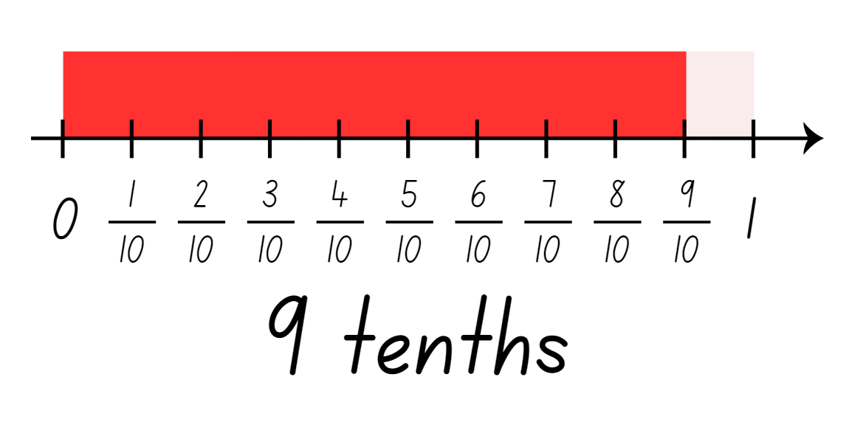
- Explain that sometimes the fractional part needed to create a whole unit is not a unit fraction. Ask: What fraction would be needed to recreate the whole from the fractions given?
- Students turn and talk to identify the fractional part needed for the other examples.
- Regroup and ask students how they used the number line to determine the fraction required to recreate the whole.
- In pairs, provide students with Resource 10 – recreate the whole memory. Explain the following game instructions:
- Shuffle the cards and lay out all the cards face down in an array formation.
- Take turns flipping over 2 cards at a time, aiming to find pairs of fractions that will create a whole.
- Keep the cards and take another turn if the fractions on the cards make a whole.
- Flip the cards back over. The next player has a turn if the fractions do not make a whole.
- The game continues until all fractions have been matched.
- Regroup and discuss some of the fraction pairs.
This table details opportunities for differentiation.
Too hard? | Too easy?
Students cannot determine the complementary fractional part needed to complete one whole (halves, quarters, eighths, thirds).  - Model using Fraction number line to create a green bar and 4 orange quarter-bars. Remove one quarter-bar to demonstrate the complement.  - Support students to use a fraction wall to identify complementary unit fractional parts. | Students can determine the complementary fractional part needed to complete one whole (halves, quarters, eighths, thirds).  - Students find the non-unit fractional part used to recreate the whole. Express them as an equivalent fraction. For example, $\frac{3}{4}$ is $\frac{2}{8}$.

Discuss and connect the mathematics – 10 minutes
- Display the following fractions:
- $\frac{5}{10}$
- $\frac{1}{3}$
- $\frac{1}{2}$
- $\frac{2}{6}$
- $\frac{3}{5}$
- $\frac{4}{8}$.
- Ask students to identify the complementary fraction or the fractional part needed to recreate the whole. Students record their answers on an individual whiteboard to check for understanding. Students can use the fraction wall, number lines or bar models to support their reasoning.
- Regroup as a class and ask students to share their strategies.
This table details opportunities for assessment.
Assessment opportunities | Links
What to look for:  - Can students determine the complementary fractional part needed to complete one whole (halves, quarters, eighths, thirds)?  [MAO-WM-01, MA2-PF-01]  - Can students recreate the whole from a fractional part ($\frac{1}{2}$ , $\frac{1}{4}$ and $\frac{1}{8}$)? [MAO-WM-01, MA2-PF-01] | Links to National Numeracy Learning Progressions (NNLP):  - InF5.

Lesson 8
Core concept: fractional quantities can be equal to and greater than one.

Daily number sense – 10 minutes
- From a class need surfaced through formative assessment data, identify a short, focused activity that targets students’ knowledge, understanding and skills. Example activities may be drawn from the following resources:
- Mathematics K–6 resources
- Universal Resources Hub.

Core lesson – fractions beyond a whole – 40 minutes
The table below contains suggested learning intentions and success criteria. These are best co-constructed with students.
Core concept learning intentions | Core concept success criteria
Students are learning to:  - model and represent unit fractions, and their multiples, to a complete whole on a number line  - represent fractional quantities equal to and greater than one. | Students can:  - recreate the whole unit from a fractional part ($\frac{1}{2},$ $\frac{1}{4},\frac{1}{3}$ and $\frac{1}{8}$)  - regroup fractional parts beyond one  - represent totals of halves, thirds, quarters and fifths that extend beyond one  - determine the relative location of one-quarter and one-half when a number line extends beyond one.
This activity is an adaptation of ‘Fractions beyond one whole’ from BetterLesson by Valentine.
- Display Resource 11 – chocolate bars. Highlight the first piece of chocolate and explain that this represents one-quarter ( $\frac{1}{4}$ ) of a whole chocolate bar.
- Students turn and talk to discuss how the whole bar could be recreated from this fractional part. Model drawing and labelling how to recreate the whole (see Figure 16).
Figure 16 – sample of a whole
- Provide students with Resource 11 – chocolate bars to recreate the whole chocolate bar if the pieces represent one-quarter ( $\frac{1}{4}$ ), one-third ( $\frac{1}{3}$ ) and one-fifth ( $\frac{1}{5}$ ) of the whole.
- Regroup and ask the following questions:
- What strategy did you use to determine the size of the whole chocolate bar?
- How did you know how many parts would be needed to make the whole chocolate bar?
- What do you know about fractions that helped you with this task?
- Display Resource 12 – blocks of chocolate and pose the following questions. Model the first example, with students completing the following 2 in pairs or independently.
The table below outlines stimulus prompts to generate conversation about the topic, along with anticipated responses from students.
Prompts | Anticipated student responses
- If this is the whole chocolate bar, what might a chocolate bar 3 halves the size look like? | - Two halves make a whole, so 3 halves would be bigger than one.  - I know 2 halves make a whole. If I partition this chocolate bar into 2 equal parts, this helps me find the size of one-half.  - I can see after partitioning that I already have 2 halves. Now I just need to extend the bar by one more half. This is now 3 halves.
- How could 3 halves be renamed as a fraction greater than one? | - Three halves can also be renamed as 1$\frac{1}{2}$.
Note: fractions can be renamed in multiple ways. For example, 1$\frac{4}{5}$ can be renamed $\frac{9}{5}$. In the syllabus, the expression ‘fraction greater than one’ is used instead of the terms ‘improper fraction’ or ‘mixed numeral’.
- Provide students with Resource 12 – blocks of chocolate to solve the following problems:
- If this is the whole chocolate bar, what might a chocolate bar $\frac{5}{4}$ the size look like? How could it be renamed?
- If this is the whole chocolate bar, what might a chocolate bar $\frac{7}{4}$ the size look like? How could it be renamed?
- Write $\frac{1}{2}$ and $\frac{1}{4}$ on the board and ask:
- Where would these fractions go on a number line marked with zero and one?
- What strategy can you use to determine their location? (Half is between 0 and 1. The line can be partitioned into 2 equal parts and then a quarter is half of a half.)
- How does the relationship between halves and quarters help you place them on a number line?
- In pairs, students locate one-quarter and one-half on the first number line marked 0–1 on Resource 13 – number lines.
- Draw students’ attention to the second number line marked 0–2 on Resource 13 – number lines and ask:
- Where would one go on this number line? How do you know?
- Where would halves and quarters be placed on the 0–2 number line?
- What is similar between the 2 number lines? What is different? (They both have 0, 1, $\frac{1}{2},\frac{1 }{4}$marked$\frac{1}{2}$, and $\frac{1}{4}$ are between 0 and 1, however the second number line will need other fractions between 1 and 2).
- What fractions might go between 1 and 2?
- Where might $\frac{3}{2}$ go?
- How does renaming $\frac{3}{2}$ as a fraction greater than one, help you decide where it goes?
- Write $\frac{3}{2},\frac{5}{4}$ and $\frac{7}{4}$ on the board. Ask students to place these on the number line marked 0–2.
- Regroup as a class and ask:
- Where did you place $\frac{3}{2},\frac{5}{4}$ and $\frac{7}{4}$?
- What strategies did you use to help you place these fractions?
- What do you know about fractions, halves and quarters that helped you with this task?
This table details opportunities for differentiation.
Too hard? | Too easy?
Students cannot regroup fractional parts beyond one.  - Provide strips of paper to represent each fractional part of the chocolate bar. Use the strips to model adding on the remaining fractions to make the whole bar. | Students can regroup fractional parts beyond one.  - Students draw and label their own fractional parts of chocolate bars, such as thirds, fifths or eighths. They swap with another student, who solves them by finding the size of a full bar or a bar larger than one.

Discuss and connect the mathematics – 10 minutes
- Display the following question: How could you use diagrams and words to explain what you understand about the fraction $\frac{10}{8}$? How could it be renamed?
- Ask students to reflect on the strategies used and write a response in their workbooks including a visual representation of their work. Students should recognise that ten-eighths ( $\frac{10}{8}$ ) is larger than one because if the whole has been partitioned into 8 parts, 8 eighths make a whole. There are an additional 2 eighths, therefore ten-eighths ( $\frac{10}{8}$ ) is equivalent to 1$\frac{2}{8}$.
This table details opportunities for assessment.
Assessment opportunities | Links
What to look for:  - Can students recreate the whole unit from a fractional part ($\frac{1}{2},$ $\frac{1}{4},\frac{1}{3}$ and $\frac{1}{8}$)? [MAO-WM-01, MA2-PF-01]  - Can students regroup fractional parts beyond one?  [MAO-WM-01, MA2-PF-01]  - Can students represent totals of halves, thirds, quarters and fifths that extend beyond one? [MAO-WM-01, MA2-PF-01]  - Can students determine the relative location of one-quarter and one-half when a number line extends beyond one?  [MAO-WM-01, MA2-PF-01] | Links to National Numeracy Learning Progressions (NNLP):  - InF5, InF6.

Resource 1 – Is it half?
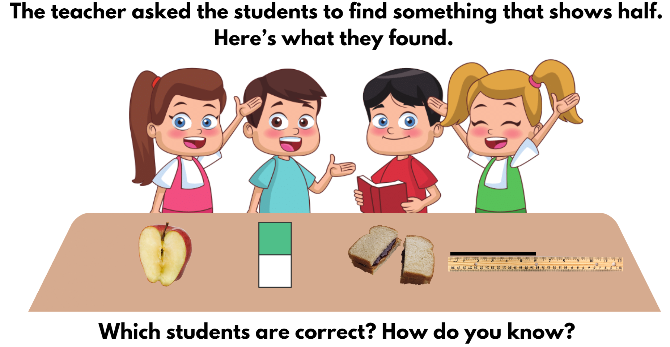

Resource 2 – Is he correct?
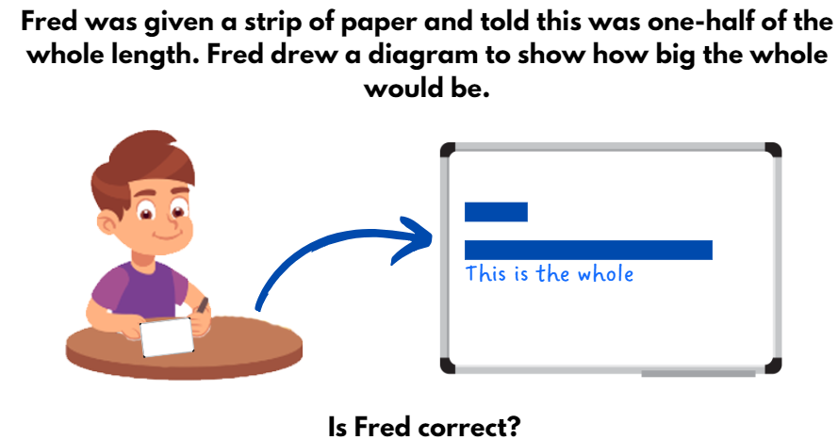

Resource 3 – fractured fraction wall 1
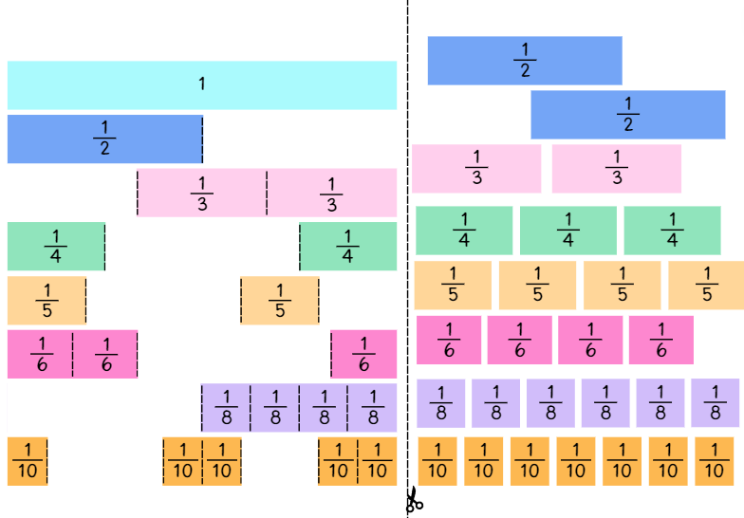

Resource 4 – fractured fraction wall 2
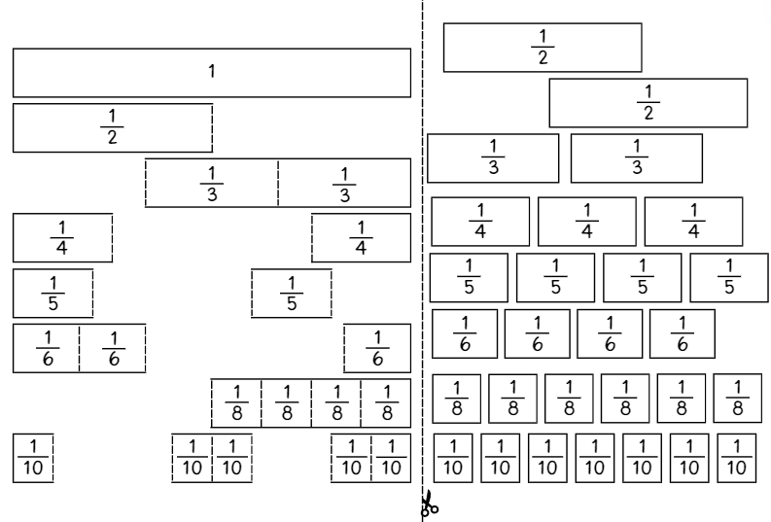

Resource 5 – fraction wall
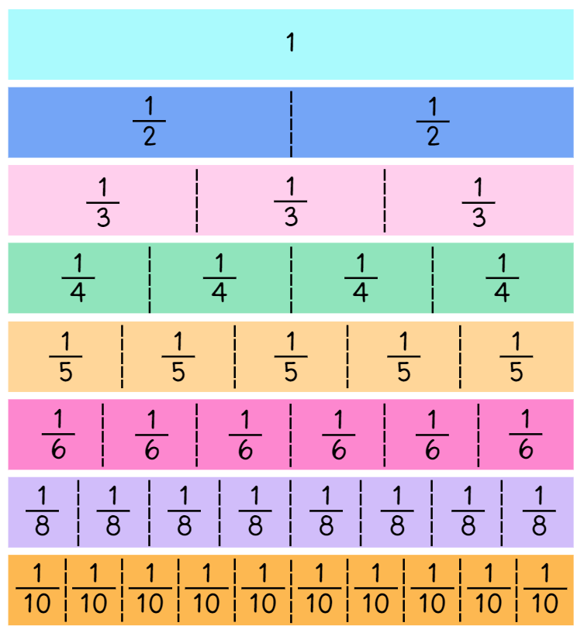

Resource 6 – gameboard and spinners
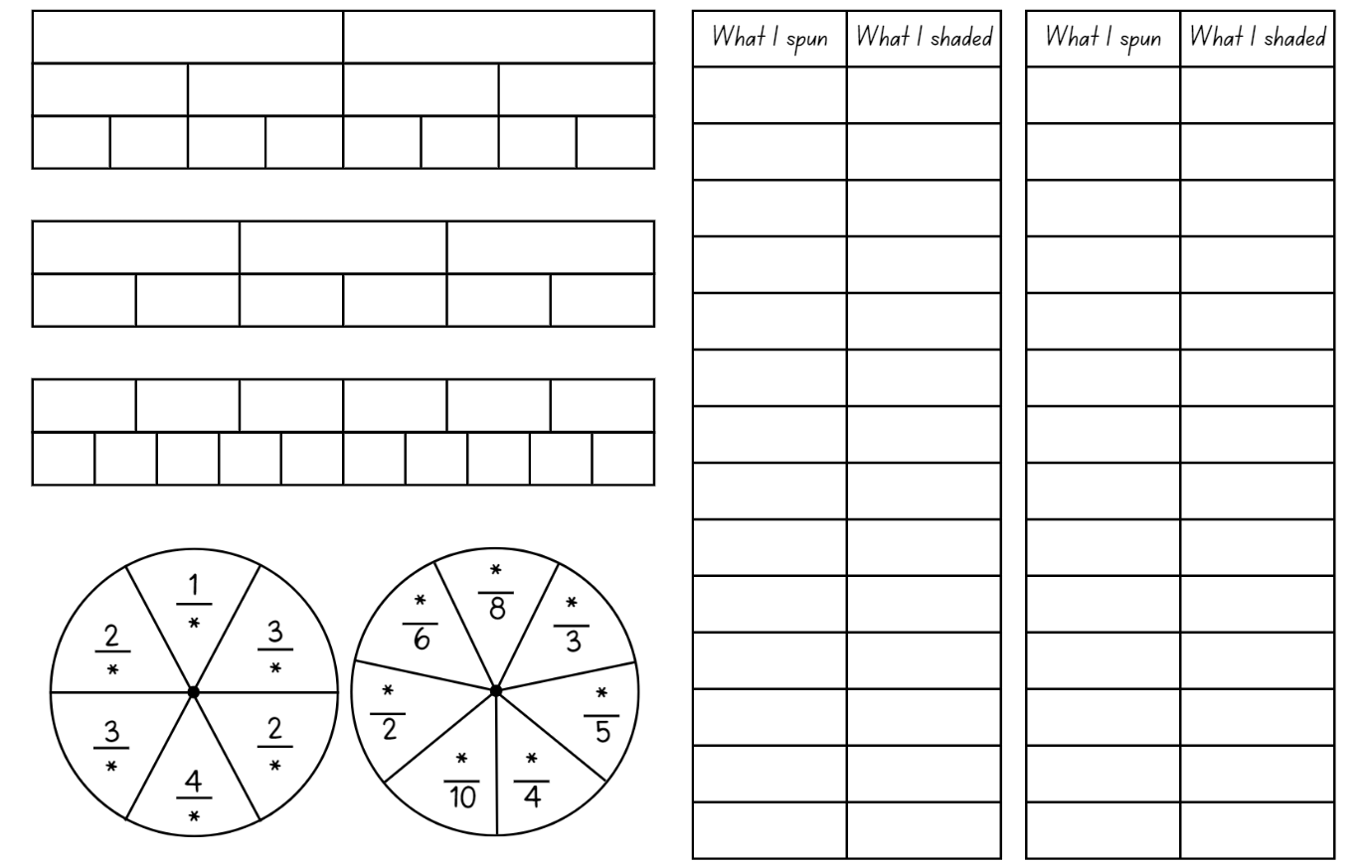

Resource 7 – Which doesn’t belong?
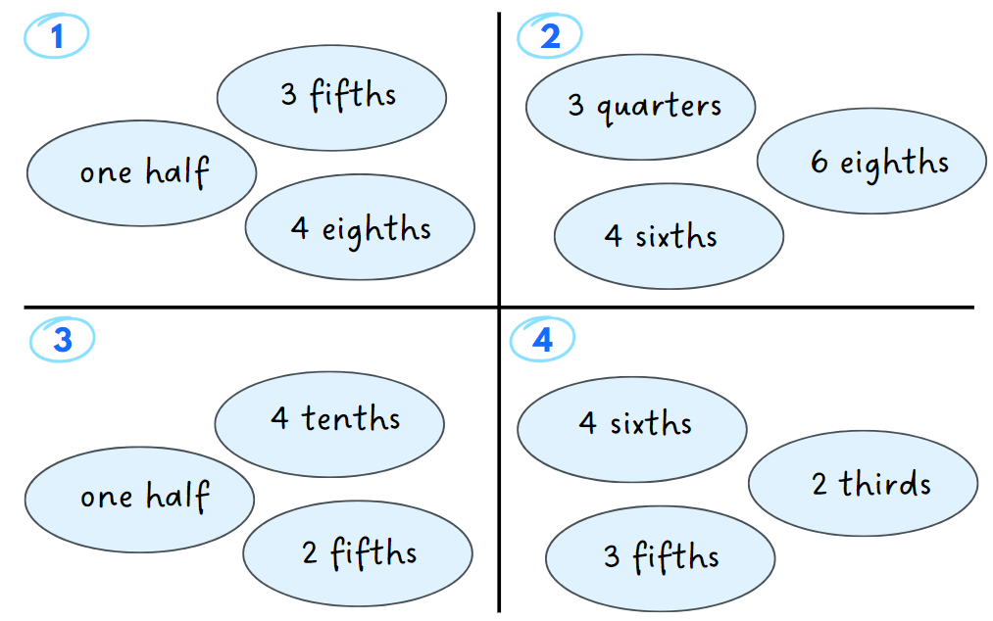

Resource 8 – word problems
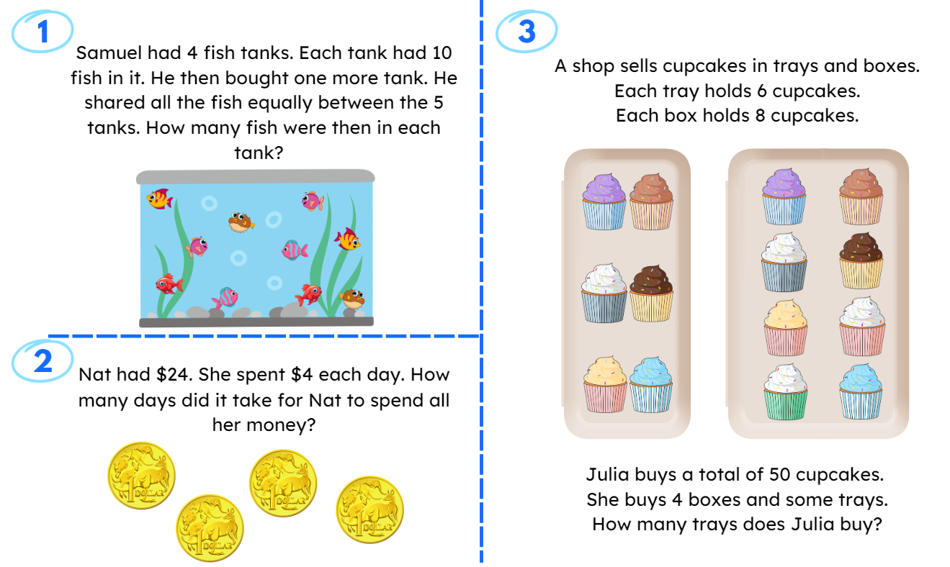

Resource 9 – recreate the whole
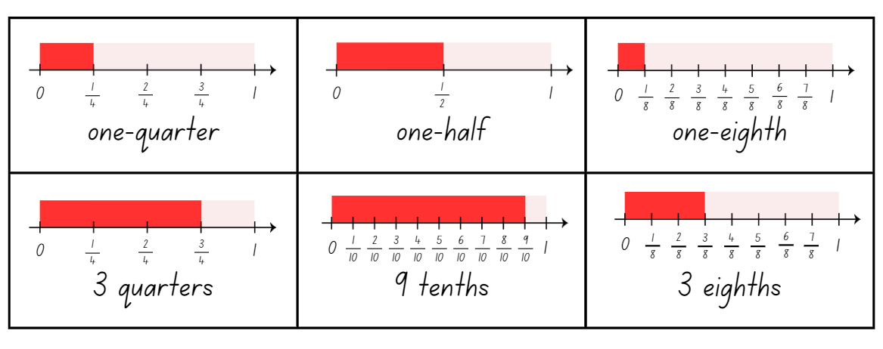

Resource 10 – recreate the whole memory
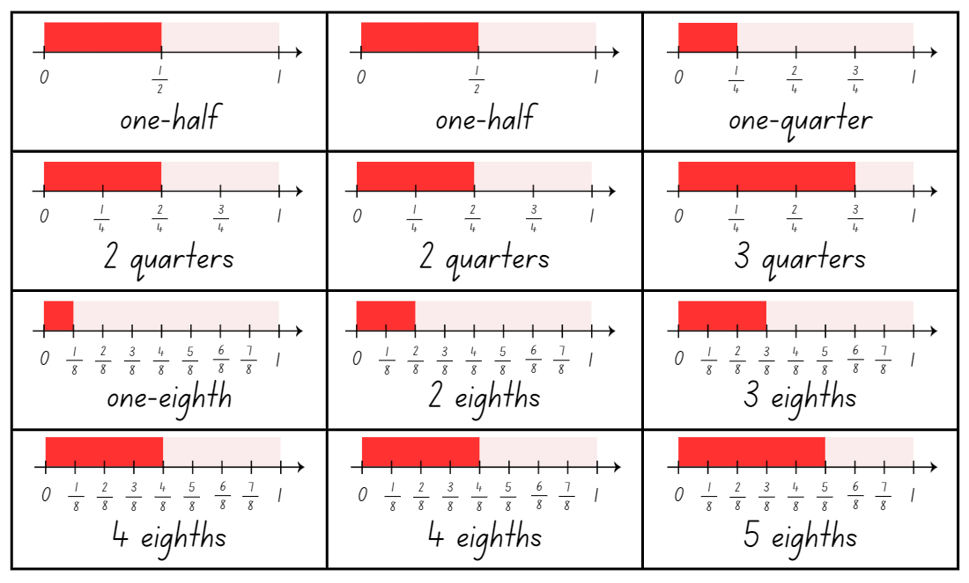
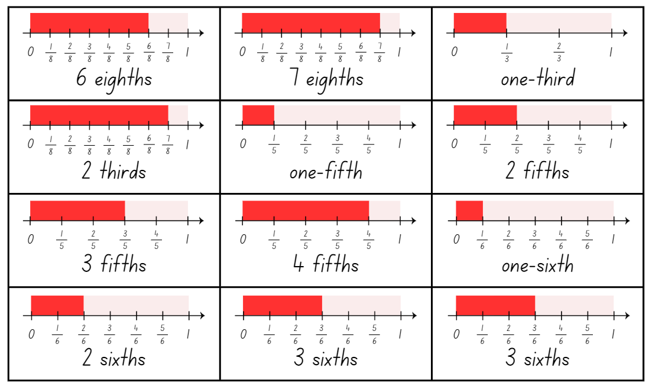
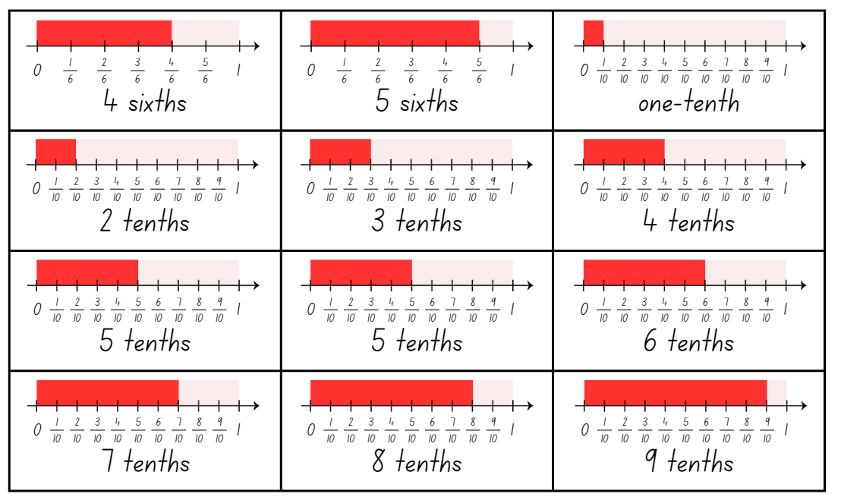

Resource 11 – chocolate bars
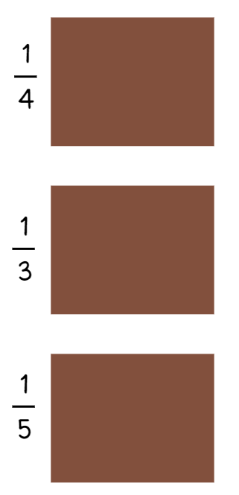

Resource 12 – blocks of chocolate

Resource 13 – number lines

Syllabus outcomes and content
The table below outlines the syllabus outcomes and range of relevant syllabus content covered in this unit. Content is linked to National Numeracy Learning Progression (version 3).
Outcomes and content | 1 | 2 | 3 | 4 | 5 | 6 | 7 | 8
Multiplicative relations A: Generate and describe patterns
MAO-WM-01, MA2-MR-01
- Model, describe and record patterns of multiples |  | x |  | x |  | x
Multiplicative relations A: Recall multiplication facts of 2 and 4, 5 and 10 and related division facts
MAO-WM-01, MA2-MR-01
- Recognise and use the symbols for multiplied by (×), divided by (÷) and equals (=) |  |  |  |  | x | x | x
- Link multiplication and division fact families using arrays |  |  |  |  | x | x
- Generate multiplication fact families for multiples of 2 and 4, 5 and 10 |  |  |  |  |  |  | x
Partitioned fractions A: Create fractional parts of a length using techniques other than repeated halving
MAO-WM-01, MA2-PF-01
- Make thirds of a length |  |  | x | x
- Create fifths of a length |  |  | x | x
Partitioned fractions A: Model and represent unit fractions, and their multiples, to a complete whole on a number line
MAO-WM-01, MA2-PF-01
- Model fractions with fraction strips and diagrams for halves, quarters, eighths, thirds | x | x |  | x | x
- Describe fraction families formed by dividing the whole into the same total number of equal parts as having the same denominator |  |  | x |  | x
- Determine the complementary fractional part needed to complete one whole (halves, quarters, eighths, thirds) (Reasons about relations) |  |  |  |  |  |  | x
- Recreate the whole unit from a fractional part ($\frac{1}{2}$, $\frac{1}{4},$ $\frac{1}{3}$ and $\frac{1}{8}$) (Reversible reasoning) |  | x |  |  |  |  | x | x
Partitioned fractions B: Model equivalent fractions as lengths
MAO-WM-01, MA2-PF-01
- Represent the equivalence of fractions with related denominators as lengths, using concrete materials, diagrams and number lines |  |  |  |  | x | x
- Represent fractions with the same-size whole to make valid comparisons (denominators of 2, 4 and 8; 3 and 6; 5 and 10) |  |  |  |  | x
Partitioned fractions B: Represent fractional quantities equal to and greater than one
MAO-WM-01, MA2-PF-01
- Rename 2 halves, 3 thirds, 4 quarters, 5 fifths, 6 sixths, 8 eighths and 10 tenths as one whole |  |  |  |  | x |  |  | x
- Regroup fractional parts beyond one |  |  |  |  |  |  |  | x
- Represent totals of halves, thirds, quarters and fifths that extend beyond one |  |  |  |  |  |  |  | x
- Determine the relative location of one-quarter and one-half when a number line extends beyond one |  |  |  |  |  |  |  | x
Mathematics K–10 Syllabus © NSW Education Standards Authority (NESA) for and on behalf of the Crown in right of the State of New South Wales, 2022.

References
This resource contains NSW Curriculum and syllabus content. The NSW Curriculum is developed by the NSW Education Standards Authority. This content is prepared by NESA for and on behalf of the Crown in right of the State of New South Wales. The material is protected by Crown copyright.
Please refer to the NESA Copyright Disclaimer for more information https://educationstandards.nsw.edu.au/wps/portal/nesa/mini-footer/copyright.
NESA holds the only official and up-to-date versions of the NSW Curriculum and syllabus documents. Please visit the NSW Education Standards Authority (NESA) website https://educationstandards.nsw.edu.au and the NSW Curriculum website https://curriculum.nsw.edu.au.
Mathematics K–10 Syllabus © NSW Education Standards Authority (NESA) for and on behalf of the Crown in right of the State of New South Wales, 2022.
National Numeracy Learning Progression © Australian Curriculum, Assessment and Reporting Authority (ACARA) 2010 to present, unless otherwise indicated. This material was downloaded from the Australian Curriculum website (National Numeracy Learning Progression) (accessed 29 February 2024) and was not modified.
ACARA (2023a) NAPLAN 2014 Final test, Numeracy, Year 3 test papers and answers [PDF 4.48 MB], NAPLAN, accessed 29 February 2024.
ACARA (2023b) NAPLAN 2015 Final test, Numeracy, Year 3 test papers and answers [PDF 2.89 MB], NAPLAN, accessed 29 February 2024.
Amplify Education (n.d.) Virtual manipulatives, Amplify Polypad website, accessed 29 February 2024.
Clarke D and Roche A (2014) ‘Colour in fractions’ in Clarke D and Roche A (eds) Engaging Maths: 25 favourite lessons, 2nd edn, Mathematics Teaching and Learning Centre, Australia.
Didax, Inc (2023) ‘Fraction number line’, Virtual Manipulatives, Didax website, accessed 29 February 2024.
ESA (Education Services Australia Ltd) and AAMT (The Australian Association of Mathematics Teachers) (n.d.) ‘Fraction wall game’, Fractions, Top Drawer Teachers: Resources for Teachers of Mathematics website, accessed 29 February 2024.
Siemon D, Warren E, Beswick K, Faragher R, Miller J, Horne M, Jazby D, Breed M, Clark J and Brady K (2022) Teaching Mathematics: Foundations to Middle Years, 3rd edn, Oxford University Press, Australia.
Valentine J (2024) ‘Fractions on a Number Line - Beyond One Whole’, Unit 9: Fractions, BetterLesson website, accessed 29 February 2024.

© State of New South Wales (Department of Education), 2024
The copyright material published in this resource is subject to the Copyright Act 1968 (Cth) and is owned by the NSW Department of Education or, where indicated, by a party other than the NSW Department of Education (third-party material).
Copyright material available in this resource and owned by the NSW Department of Education is licensed under a Creative Commons Attribution 4.0 International (CC BY 4.0) license.
This license allows you to share and adapt the material for any purpose, even commercially.
Attribution should be given to © State of New South Wales (Department of Education), 2024.
Material in this resource not available under a Creative Commons license:
the NSW Department of Education logo, other logos and trademark-protected material
material owned by a third party that has been reproduced with permission. You will need to obtain permission from the third party to reuse its material.
Links to third-party material and websites
Please note that the provided (reading/viewing material/list/links/texts) are a suggestion only and implies no endorsement, by the New South Wales Department of Education, of any author, publisher, or book title. School principals and teachers are best placed to assess the suitability of resources that would complement the curriculum and reflect the needs and interests of their students.
If you use the links provided in this document to access a third-party's website, you acknowledge that the terms of use, including licence terms set out on the third-party's website apply to the use which may be made of the materials on that third-party website or where permitted by the Copyright Act 1968 (Cth). The department accepts no responsibility for content on third-party websites.

