Mathematics Stage 2 – Unit 15
Addition and subtraction problems can be solved by using a variety of strategies
Contents
Unit description and duration 5
Syllabus outcomes 5
Working mathematically 6
Student prior learning 6
Lesson overview and resources 8
Lesson 1 13
Daily number sense – make a dollar – 15 minutes 13
Core lesson – equivalence – 30 minutes 15
Consolidation and meaningful practice – 15 minutes 19
Lesson 2 23
Daily number sense – make a value – 15 minutes 23
Core lesson – addition algorithm – 35 minutes 25
Discuss and connect the mathematics – 15 minutes 30
Lesson 3 33
Daily number sense – number talk – 10 minutes 33
Core lesson 1 – subtraction algorithm – 20 minutes 34
Core lesson 2 – anchor chart – 20 minutes 40
Discuss and connect the mathematics – 10 minutes 43
Lesson 4 44
Daily number sense – 15 minutes 44
Core lesson – price tag purchasing – 35 minutes 44
Discuss and connect the mathematics – 10 minutes 47
Lesson 5 48
Daily number sense – prove it – 10 minutes 48
Core lesson – comparing money – 40 minutes 50
Discuss and connect the mathematics – 10 minutes 53
Lesson 6 55
Daily number sense – grab it – 15 minutes 55
Core lesson – canteen lunch planning – 30 minutes 56
Discuss and connect the mathematics – 15 minutes 58
Lesson 7 60
Daily number sense – How many? – 10 minutes 60
Core lesson – problem solving – 40 minutes 62
Discuss and connect the mathematics – 10 minutes 64
Lesson 8 66
Daily number sense – 15 minutes 66
Core lesson – using flexible strategies – 30 minutes 66
Consolidation and meaningful practice – 15 minutes 69
Resource 1 – strategy reflection chart 71
Resource 2 – balancing equations 72
Resource 3 – dice bowling 73
Resource 4 – Frayer model 74
Resource 5 – place value chart 75
Resource 6 – additive strategies 76
Resource 7 – money equivalence 80
Resource 8 – price tags 81
Resource 9 – money mat 82
Resource 10 – time to shop 83
Resource 11 – shopping questions 84
Resource 12 – canteen menu 85
Resource 13 – money problem 1 86
Resource 14 – money problem 2 87
Syllabus outcomes and content 88
References 93
Further reading 94

Unit description and duration
This unit develops the big idea that addition and subtraction problems can be solved using a variety of strategies.
In this 2-week unit students are provided opportunities to:
- use the equals sign to mean 'the same as' to show equivalence, rather than to perform an operation
- select, represent and explain flexible strategies when solving addition and subtraction problems
- perform calculations with money, including finding change.

Syllabus outcomes
- MAO-WM-01 develops understanding and fluency in mathematics through exploring and connecting mathematical concepts, choosing and applying mathematical techniques to solve problems, and communicating their thinking and reasoning coherently and clearly
- MA2-RN-01 applies an understanding of place value and the role of zero to represent numbers to at least tens of thousands
- MA2-AR-01 selects and uses mental and written strategies for addition and subtraction involving 2- and 3-digit numbers
- MA2-AR-02 completes number sentences involving addition and subtraction by finding missing values
- MA2-MR-02 completes number sentences involving multiplication and division by finding missing values.

Working mathematically
In the Mathematics K–10 Syllabus, there is one overarching Working mathematically outcome (MAO-WM-01). The Working mathematically processes should be embedded within the concepts being taught. The Working mathematically processes present in the Mathematics K–10 Syllabus are:
- communicating
- understanding and fluency
- reasoning
- problem solving.
Mathematics K–10 Syllabus © NSW Education Standards Authority (NESA) for and on behalf of the Crown in right of the State of New South Wales, 2022.

Student prior learning
Before engaging in these teaching and learning activities, students would benefit from prior experience with:
- partitioning, rearranging and regrouping numbers to the thousands to solve additive problems
- identifying Australian notes and coins and representing equivalent amounts of money using different denominations
- solving addition and subtraction problems using written and mental strategies.
In NSW classrooms there is a diverse range of students, including Aboriginal and/or Torres Strait Islander students, students learning English as an additional language or dialect, high potential and gifted students and students with disability. Some students may identify with more than one of these groups or possibly all of them. Refer to Curriculum planning for every student – advice for further information.

Lesson overview and resources
The table below outlines the sequence and approximate timing of lessons, learning intentions and resources.
Lesson | Content | Duration and resources
Lesson 1  Daily number sense learning intention:  - represent money values in multiple ways | Lesson core concept: the equals sign identifies a relationship in mathematics.  Core concept learning intentions:  - use the principle of equality  - complete number sentences involving additive relations to find unknown quantities | Lesson duration: 60 minutes  - Resource 1 – strategy reflection chart  - Resource 2 – balancing equations  - Resource 3 – dice bowling  - Individual whiteboards  - Plastic Australian coins  - Sticky notes  - Writing materials
Lesson 2  Daily number sense learning intention:  - represent money values in multiple ways | Lesson core concept: place value understanding helps solve addition and subtraction problems.  Core concept learning intentions:  - select strategies flexibly to solve addition and subtraction problems of up to 3 digits  - partition, rearrange and regroup numbers up to 1000 to solve additive problems | Lesson duration: 65 minutes  - Resource 4 – Frayer model  - Grid paper  - MAB materials  - Plastic Australian coins  - Writing materials
Lesson 3  Daily number sense learning intention:  - represent money values in multiple ways | Lesson core concept: addition and subtraction are connected.  Core concept learning intentions:  - recognise and explain the connection between addition and subtraction  - select strategies flexibly to solve addition and subtraction problems of up to 3 digits | Lesson duration: 60 minutes  - Resource 1 – strategy reflection chart  - Resource 5 – place-value chart  - Resource 6 – additive strategies  - Individual whiteboards  - Grid paper  - MAB materials  - Writing materials
Lesson 4  Daily number sense learning intention:  - teacher-identified task based on student needs | Lesson core concept: there is a relationship between dollars and cents.  Core concept learning intention:  - represent money values in multiple ways | Lesson duration: 60 minutes  - Resource 1 – strategy reflection chart  - Resource 7 – money equivalence  - Resource 8 – price tags  - Resource 9 – money mat  - Plastic Australian coins
Lesson 5  Daily number sense learning intention:  - represent and solve problems involving multiplication fact families | Lesson core concept: money values can be represented in different ways.  Core concept learning intentions:  - represent money values in multiple ways  - apply addition and subtraction to familiar contexts, including money and budgeting | Lesson duration: 60 minutes  - Resource 1 – strategy reflection chart  - Resource 10 – time to shop  - Resource 11 – shopping questions  - Class set of calculators  - Individual whiteboards  - Plastic Australian coins  - Writing materials
Lesson 6  Daily number sense learning intention:  - represent and solve problems involving multiplication fact families | Lesson core concept: models help us solve addition and subtraction problems with money.  Core concept learning intention:  - represent money values in multiple ways | Lesson duration: 60 minutes  - Resource 12 – canteen menu  - A collection of coloured counters, beads or interlocking unit cubes  - Writing materials
Lesson 7  Daily number sense learning intention:  - represent and solve problems involving multiplication fact families | Lesson core concept: mathematicians compare and evaluate strategies used to solve addition and subtraction problems, reasoning which strategy may be most efficient.  Core concept learning intention:  - select strategies flexibly to solve addition and subtraction problems of up to 3 digits | Lesson duration: 60 minutes  - Resource 6 – additive strategies  - Resource 13 – money problem 1  - Resource 14 – money problems 2  - A4 cardboard  - Counters  - Individual whiteboards  - Plastic Australian coins
Lesson 8  Daily number sense learning intention:  - teacher-identified task based on student needs | Lesson core concept: mathematicians select the most efficient strategies when solving problems.  Core concept learning intention:  - select strategies flexibly to solve addition and subtraction problems of up to 3 digits | Lesson duration: 60 minutes  - Resource 6 – additive strategies or class anchor chart from Lesson 3  - Individual whiteboards  - Writing materials

Lesson 1
Core concept: the equals sign identifies a relationship in mathematics.

Daily number sense – make a dollar – 15 minutes
Daily number sense activities for Lessons 1 to 3 ‘activate’ prior number knowledge and support the learning of new content in the unit. These activities can also assist teachers to identify the starting points for learning by revealing the extent of students’ existing knowledge.
The table below contains a suggested learning intention and success criteria. These are best co-constructed with students.
Daily number sense learning intention | Daily number sense success criteria
Students are learning to:  - represent money values in multiple ways. | Students can:  - recognise the relationship between dollars and cents  - represent equivalent amounts of money using different denominations.
- Write the words ‘Australian coins’ on the board and ask students what they know about Australian coin denominations.
- Select students to share their prior knowledge. Record each Australian coin denomination on the board.
- Draw attention to the $1 coin. Students turn and talk to discuss different ways to make a dollar using coins, such as two 50c coins.
- Select students to share their ideas.
- Model how to record student ideas as an addition sentence, such as 50c + 50c = $1.
- Provide students with a collection of plastic Australian coins and writing materials.
- Ask students to represent and record as many ways to make one dollar as possible using the coins provided.
- Regroup as a class. Ask:
- How many ways could you make one dollar?
- Did you find all the ways? How do you know?
- Did you notice any patterns? Describe them.
- What is the least or greatest number of coins used to make $1?
- What was challenging about this activity?
This table details opportunities for assessment.
Assessment opportunities | Links
What to look for:  - Can students recognise the relationship between dollars and cents? [MAO-WM01, MA2-AR-01]  - Can students represent equivalent amounts of money using different denominations? [MAO-WM01, MA2-AR-01] | Links to National Numeracy Learning Progressions (NNLP):  - UnM2, UnM3, UnM4.

Core lesson – equivalence – 30 minutes
The table below contains suggested learning intentions and success criteria. These are best co-constructed with students.
Core concept learning intentions | Core concept success criteria
Students are learning to:  - use the principle of equality  - complete number sentences involving additive relations to find unknown quantities. | Students can:  - use the equals sign to mean 'the same as', rather than to perform an operation  - find the missing number in an equivalent number sentence involving operations of addition or subtraction on both sides of the equals sign.
This activity is an adaptation of Equivalent number sentences by the State of New South Wales (Department of Education) and Make it equal by Rawding from the Open Middle website. This lesson supports students to gain a deeper understanding of the structure of related, equivalent number sentences. There is a particular focus on reasoning and communicating as students justify their solutions.
- Brainstorm a class additive relations vocabulary chart that students can add to throughout the unit. Include vocabulary such as add, addition, increase, plus, decrease, minus, subtract, inverse relationship. Other vocabulary such as equivalence, landmark numbers, adjusting numbers, partitioning and renaming are introduced in this unit.
- Display the number sentence 27 + 13 = 80 – 20 and ask what students notice.
- After some discussion, ensure students understand that this is a false number sentence because both sides do not have the same value; both sides are not equivalent.
- Discuss what equivalence is and how number sentences can be equivalent even if students use different operations.
- Discuss adjustments to be made to form an equivalent number sentence such as 27 + 33 = 80 − 20.
- Display the equals sign on the board and ask what it represents.
- Record student responses around the sign (see Figure 1).
Figure 1 – equals sign
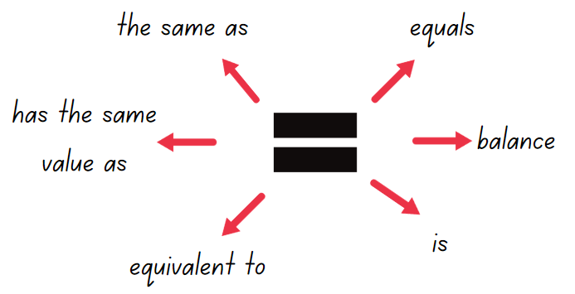
Equivalent: two things are equivalent if they have the same value.
- Display the problem 38 + 17 = _ − _.
- In pairs, students find various solutions and record them on a whiteboard.
- Ask students to share their solutions and the strategies used to solve the number sentence.
- Record the various solutions presented and strategies used, for example, a bar model, number line and equal-arm balance (see Figure 2).
Figure 2 – student representations
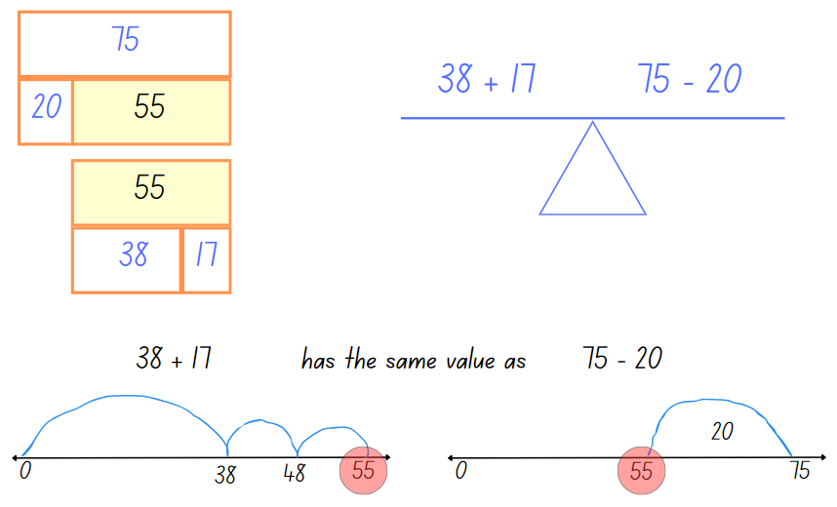
- Display Resource 1 – strategy reflection chart and discuss the meaning of each word.
- Ask students to select one of the additive strategies they used to solve the problem, for example, the compensation strategy. They reflect on the 4 statements, to see if they describe their use of their selected strategy:
- Flexible – I have a range of strategies to choose from.
- Fluent – I can use my strategy easily.
- Understanding – I can connect different ideas, show maths in different ways and use ideas in new ways.
- Efficient – I have used a strategy with a small number of steps.
- Discuss students’ reflections on the statements in relation to their chosen additive strategies.
- Provide Resource 2 – balancing equations. In pairs, students find solutions to balance the equations.
- Regroup as a class and ask:
- What strategies did you use to solve the number? Were they efficient?
- Can you explain the concept of equivalence?
- Were there any number sentences that you found challenging? How did you overcome the challenges?

Consolidation and meaningful practice – 15 minutes
- Draw Figure 3 on the board.
Figure 3 – make it equal
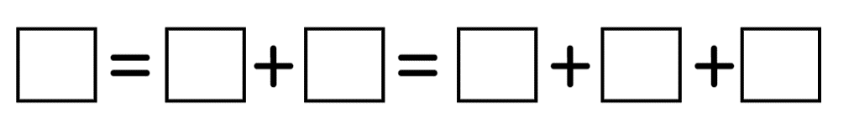
- Explain that students will work in pairs to record solutions using digits 1 to 9 only once to create a true statement. Explain the rules:
- You can only use the digits 1–9.
- You can only use a digit once in each equation.
- You can only put one digit in each box.
- Students share their responses in small groups.
- Record a collection of class solutions (see Figure 4).
Figure 4 – example solutions
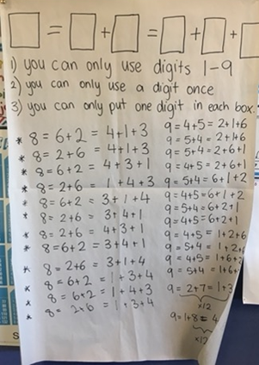
- As a class, update the vocabulary brainstorm chart.
- Students record on a sticky note one thing that is ‘clear’ and one thing that is still ‘cloudy’ (what they are having trouble understanding, for example, a word or a new strategy). This can be used as an exit slip to support formative assessment.
This table details opportunities for differentiation.
Too hard? | Too easy?
Students cannot use the equals sign to mean 'the same as', rather than to perform an operation.  - Adjust the ‘Make it equal’ activity to be _ = _ + _.  - Provide each student with Resource 3 – dice bowling. In pairs, students roll 3 dice, record the digits and write number sentences (using only those 3 digits). Record each number sentence and cross out the corresponding bowling pin. Students try eliminating all numbers for a strike. | Students can use the equals sign to mean 'the same as', rather than to perform an operation.  - Pose the problem: __ +__ = __ +__ = __ +__ Students find as many different solutions as possible. Students explain their preferred strategy and communicate this to the class or a small group.  - Students order their strategies from being the most to least flexible, fluent and efficient and communicate their reasoning.
This table details opportunities for assessment.
Assessment opportunities | Links
What to look for:  - Can students use the equals sign to mean 'the same as', rather than to perform an operation? [MAO-WM-01, MA2-AR-01]  - Can students find the missing number in an equivalent number sentence involving operations of addition or subtraction on both sides of the equals sign (Algebraic reasoning)? [MAO-WM-01, MA2-AR-02] | Links to National Numeracy Learning Progressions (NNLP):  - NPA3, NPA4.  Links to suggested Interview for Student Reasoning (IfSR) tasks:  - IfSR-AT: 2A.1, 3A.1.

Lesson 2
Core concept: place value understanding helps solve addition and subtraction problems.

Daily number sense – make a value – 15 minutes
The table below contains a suggested learning intention and success criteria. These are best co-constructed with students.
Daily number sense learning intention | Daily number sense success criteria
Students are learning to:  - represent money values in multiple ways. | Students can:  - recognise the relationship between dollars and cents  - represent equivalent amounts of money using different denominations.
- Revise Australian coins. Remind students of the ways to make a dollar that were explored in Lesson 1.
- Select a new target value or values to challenge students, for example, $1.75.
- Ask students to turn and talk about different ways to make the target value. Select students to share ideas.
- Model how to record the student ideas as an addition sentence.
- Provide students with a collection of play coins and writing materials.
- Ask students to represent and record as many ways as possible to make the target value using the coins provided.
- Regroup as a class. Ask:
- How many ways could you make the target value?
- Did you notice any patterns? Can you describe them?
- What is the least or greatest number of coins used?
- What was challenging about that activity?
This table details opportunities for assessment.
Assessment opportunities | Links
What to look for:  - Can students recognise the relationship between dollars and cents? [MAO-WM01, MA2-AR-01]  - Can students represent equivalent amounts of money using different denominations? [MAO-WM01, MA2-AR-01] | Links to National Numeracy Learning Progressions (NNLP):  - UnM2, UnM3, UnM4.

Core lesson – addition algorithm – 35 minutes
The table below contains suggested learning intentions and success criteria. These are best co-constructed with students.
Core concept learning intentions | Core concept success criteria
Students are learning to:  - select strategies flexibly to solve addition and subtraction problems of up to 3 digits  - partition, rearrange and regroup numbers to at least 1000 to solve additive problems. | Students can:  - apply known mental strategies that use partitioning to add and subtract, such as bridging the decades  - compare and evaluate strategies, reasoning which strategy may be most efficient  - model addition with and without regrouping and record the method used.
- Provide students with grid paper and MAB materials or use digital base-10 blocks.
- Ask students to model a two-digit number using the MAB materials. Have students turn and talk to a partner to share the number formed and explain how they know.
- Select students to explain the concept of partitioning into standard expanded form.
- Students record their response on grid paper, placing one digit in each box (see Figure 5).
Figure 5 – standard partition
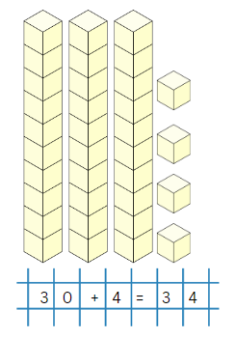
- Display two 2-digit numbers (with a total less than 100) side-by-side on the board.
- Ask students to:
- represent both numbers using the MAB materials side-by-side.
- combine the MAB materials to find the sum and record the equation on their grid paper (see Figure 6).
Figure 6 – horizontal addition
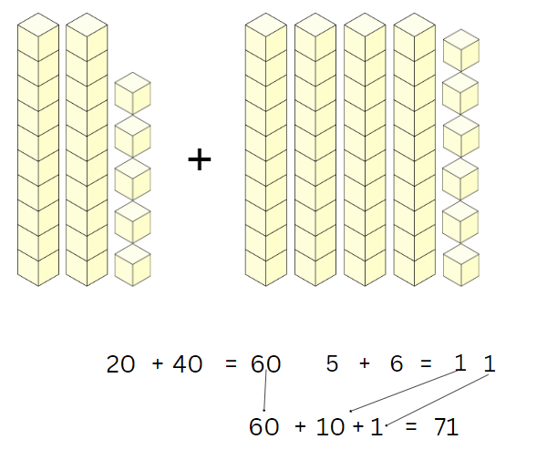
- Provide further horizontal examples for students to develop understanding and fluency.
- Display another two 2-digit numbers (with a total of less than 100) vertically on the board. Ensure the place value columns are aligned.
- Ask students to represent these numbers with the MAB materials, this time placing one model above the other.
- Explain that algorithms are another strategy for working with operations such as addition. Model writing the algorithm using expanded notation, aligning the tens and ones.
- Provide time for students to combine their MAB materials and calculate a solution.
- Discuss which column each digit of the solution will go in. Students write their solution (see Figure 7).
Figure 7 – vertical addition
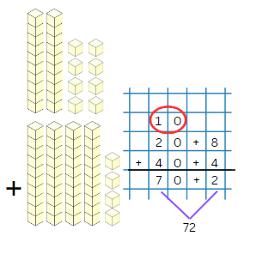
- Display the vertical algorithm just completed together on the board.
- Discuss numerical standard notation and expanded notation, for example 72 (standard notation) and 70 + 2 (expanded notation).
- Explain that vertical algorithms use standard notation (see Figure 8).
Figure 8 – expanded and standard notation.
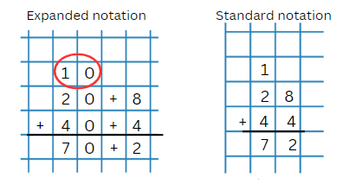
- Explain the procedure of starting algorithms on the right-hand side. Use explicit language for modelling the steps:
- Always start with the column on the right. This is the ones’ column. Eight ones and 4 ones make 12 ones.
- Now regroup 12 ones as one 10 and 2 ones. I record 2 ones in the ones column and record the 10 in the tens column (shown in the red circle).
- Now add the tens. One 10, plus 2 tens, plus 4 tens make 7 tens which is 70.
- The sum is 72.
- Display another vertical algorithm on the board for the students to solve.
- Ask students to check their answer using MAB materials and discuss their solutions with a peer.
- Provide students with further algorithms to practice.
Note: provide students with numbers that will need regrouping and renaming. It is important for students to develop an understanding of working from right to left in algorithms. Algorithms with no regrouping and renaming will provide a correct solution no matter the order.
This table details opportunities for differentiation.
Too hard? | Too easy?
Students cannot model addition with and without regrouping and record the method used.  - Support students to use concrete materials to engage in grouping and regrouping numbers.  - Use digital MAB materials to explore decomposition and composition of tens and hundreds. | Students can model addition with and without regrouping and record the method used.  - Students complete algorithms with 3- or 4-digit numbers. Ask students to compare and evaluate the algorithm method with other known addition strategies.  - Provide students with word problems using additive strategies. Students use the algorithm to solve them.

Discuss and connect the mathematics – 15 minutes
- Display 84 + 67.
- Provide each student with Resource 4 – Frayer model. Explain that students will be using this model to show their thinking when solving problems.
- Explain that:
- The problem being solved goes in the centre box.
- In the strategy boxes, students use 3 different strategies to solve the problem, then circle the strategy that is most efficient.
- In the final box, students explain their reasoning to support why the circled strategy is the most efficient (see Figure 9).
Figure 9 – completed Frayer Model
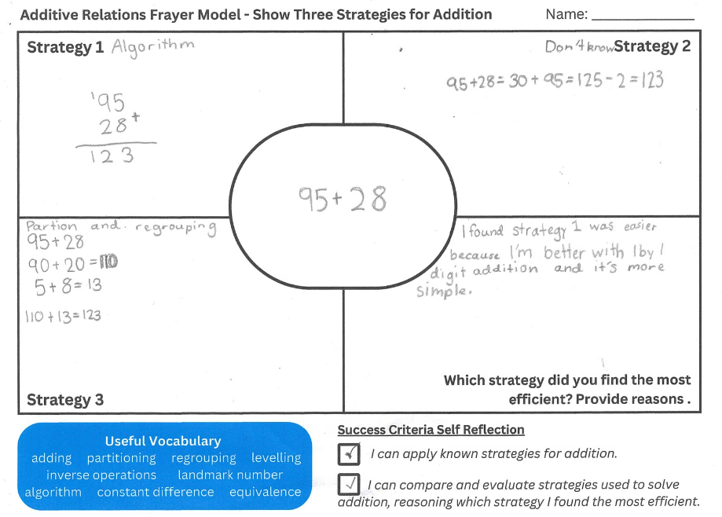
- Regroup as a class and ask:
- What strategy did you find most efficient? Why?
- What strategy did you find least efficient? Why?
Note: students may not have 3 strategies. Use this activity as a formative assessment opportunity to identify strategies used by students and the names or labels that students give the strategies. Names for strategies are identified and defined in Lesson 3.
This table details opportunities for assessment.
Assessment opportunities | Links
What to look for:  - Can students apply known mental strategies that use partitioning to add and subtract, such as bridging the decades?  [MAO-WM-01, MA2-AR-01]  - Can students compare and evaluate strategies used to solve addition and subtraction problems, reasoning which strategy may be most efficient? [MAO-WM-01, MA2-AR-01]  - Can students model addition with and without regrouping and record the method used? [MAO-WM-01, MA2-AR-01] | Links to National Numeracy Learning Progressions (NNLP):  - NPV4, NPV5, NPV6.  - AdS7, AdS8.  Links to suggested Interview for Student Reasoning (IfSR) tasks:  - IfSR-AT: 3A.1, 3A.2.

Lesson 3
Core concept: addition and subtraction are connected.

Daily number sense – number talk – 10 minutes
The table below contains a suggested learning intention and success criteria. These are best co-constructed with students.
Daily number sense learning intention | Daily number sense success criteria
Students are learning to:  - represent money values in multiple ways. | Students can:  - perform calculations with money, including finding change.
This activity is an adaptation of Let’s talk – number talk (230 minus 190) from Mathematics K–6 resources by the State of New South Wales (Department of Education). In preparation for the number talk, watch the Let's talk 1 – Stage 2 video (15:58) for support.
- Revisit Resource 1 – strategy reflection chart. Discuss how all 4 aspects are important in the process of solving problems.
- Display the following number sentence $23 – $19 = _. Alternatively, display a subtraction statement suitable for the learning needs of the class.
- Ask students to record their solutions on individual whiteboards.
- Provide time to solve the problem. Encourage students to record more than one strategy to solve the problem.
- Regroup as a class and ask:
- How many different strategies did you use to solve the problem?
- What was the most efficient strategy you used? (Record all the strategies provided by the students).
- How many steps did it take?
- Can you use the same strategy with other problems?
- Is there a strategy you have not used before, that you could use next time?
This table details opportunities for assessment.
Assessment opportunities | Links
What to look for:  - Can students perform calculations with money, including finding change? [MAO-WM01, MA2-AR-01] | Links to National Numeracy Learning Progressions (NNLP):  - UnM5, UnM6.

Core lesson 1 – subtraction algorithm – 20 minutes
The table below contains suggested learning intentions and success criteria. These are best co-constructed with students.
Core concept learning intentions | Core concept success criteria
Students are learning to:  - recognise and explain the connection between addition and subtraction  - select strategies flexibly to solve addition and subtraction problems of up to 3 digits. | Students can:  - demonstrate how addition and subtraction are inverse operations  - apply known mental strategies that use partitioning to add and subtract, such as bridging the decades  - compare and evaluate strategies, reasoning which strategy may be most efficient.
- Provide students with grid paper, Resource 5 – place-value chart and MAB materials (or use digital base-10 blocks).
- As in Lesson 2, ask students to form a 2-digit number using the MAB materials, excluding numbers with zero.
- Revise expanded notation in standard partitions.
- Students record their response on grid paper, placing one digit in each box, as shown in Figure 10.
Figure 10 – standard partition
Note: for the remainder of the lesson, use a shop sale as a context. For example, I went to buy a video game (or other item of interest to your students). The price of $74 was reduced by $11. How much did the game cost?
- Students record a horizontal equation, for example, 74 – 11 = 63 on the grid paper.
- Remind students of vertical addition algorithms in Lesson 2.
- Brainstorm how this could be done for subtraction, placing a strong emphasis on:
- place value positioning, so that the columns align
- the larger number being on the top of the vertical algorithm.
- Display the example vertical algorithm on the board.
- Ask students how to check subtraction solutions to ensure they are correct. Students turn and talk to share ideas.
- Explain that inverse operations can help students check their work. For example, if 63 + 11 = 74, then 74 – 11 = 63.
- Students form the number 62 using MAB materials on Resource 5 – place value chart.
- Display 62 – 24 = _? Ask students to subtract 24 from 62, using MAB materials. Students turn and talk to explain how the MAB materials were regrouped to move from 62 to 38 (see Figure 11).
Figure 11 – subtraction with MAB
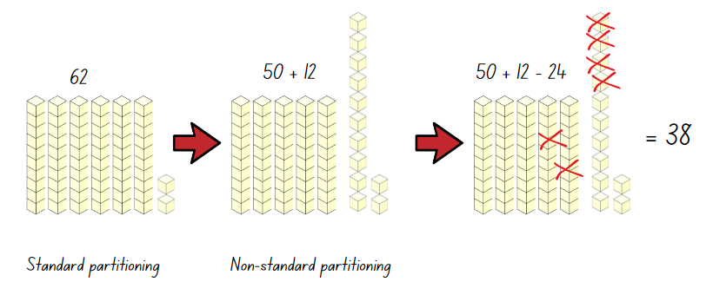
Note: some students will provide the answer quickly using mental strategies. Acknowledge that the answer is 38 but explain that the process is important to ensure understanding of the strategy.
- Display 62 – 24 as a vertical algorithm. Explain the decomposition method of partitioning and regrouping each of the numbers to determine the solution (see Figure 12).
Figure 12 – expanded notation decomposition
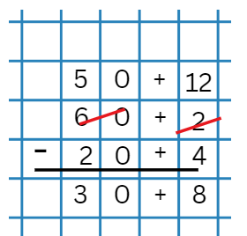
- Use addition as the inverse operation to check the solution.
- Provide more examples to promote fluency and efficiency.
- Show students that, like addition, regrouping numbers in the vertical algorithm can be more efficient (see Figure 13).
Figure 13 – standard notation decomposition
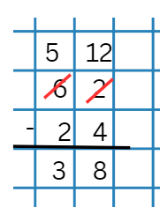
- Provide students with further vertical algorithms to solve.
Note: the syllabus teaching advice for Stage 2 – Additive Relations B has an 8-part recommended sequence for introducing students to exchanging of units. For example, the advice recommends exchanging tens for ones before exchanging hundreds for tens. When developing a formal vertical algorithm, sequence the examples to cover the range of possibilities.
This table details opportunities for differentiation.
Too hard? | Too easy?
Students cannot compare and evaluate strategies, reasoning which strategy may be most efficient.  - Provide students with concrete materials to engage in grouping and regrouping numbers.  - Use digital MAB materials to explore decomposition and composition of tens and hundreds. | Students can compare and evaluate strategies, reasoning which strategy may be most efficient.  - Students complete algorithms with 3- or 4-digit numbers. Ask students to compare and evaluate the algorithm method with other known additive strategies.  - Provide students with word problems using additive strategies. Students use the algorithm to solve the word problems.

Core lesson 2 – anchor chart – 20 minutes
- Brainstorm strategies students use when solving addition and subtraction. Write these on the board and ask students to name the strategy. For example:
- inverse relations
- commutative property
- associative property
- algorithms
- levelling
- constant difference
- partitioning
- regrouping
- equivalence
- Provide small groups with writing materials.
- Ask each group to design a section of an anchor chart, writing a definition for an additive strategy and recording an example.
- Regroup as a class and ask each group to explain their choice of definition and example.
- Combine all sections to make a class anchor chart (see Figure 14).
Figure 14 – example anchor chart
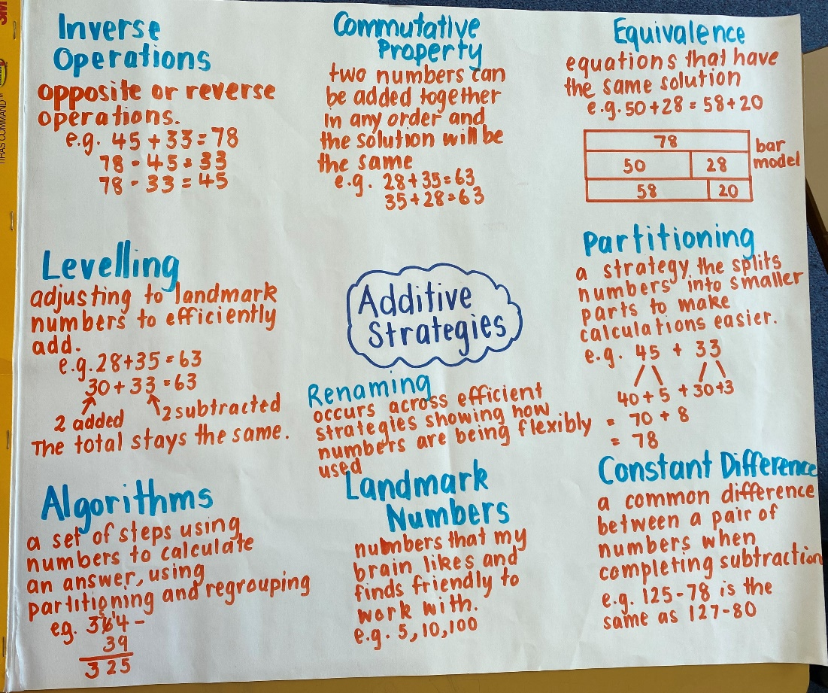
Note: alternatively, Resource 6 – additive strategies may be displayed or provided to students to support their learning.

Discuss and connect the mathematics – 10 minutes
- Provide students with an exit slip to record understanding of inverse operations. Prompts could include:
- How are addition and subtraction related?
- Draw a diagram to show how addition and subtraction are related.
This table details opportunities for assessment.
Assessment opportunities | Links
What to look for:  - Can students demonstrate how addition and subtraction are inverse operations? [MAO-WM-01, MA2-AR-01]  - Can students apply known mental strategies that use partitioning to add and subtract, such as bridging the decades?  [MAO-WM-01, MA2-AR-01]  - Can students compare and evaluate strategies used to solve addition and subtraction problems, reasoning which strategy may be most efficient? [MAO-WM-01, MA2-AR-01] | Links to National Numeracy Learning Progressions (NNLP):  - NPV4, NPV5, NPV6.  - AdS7.  Links to suggested Interview for Student Reasoning (IfSR) tasks:  - IfSR-AT: 3A.2, 3B.2.

Lesson 4
Core concept: there is a relationship between dollars and cents.

Daily number sense – 15 minutes
- From a class need surfaced through formative assessment data, identify a short, focused activity that targets students’ knowledge, understanding and skills. Example activities may be drawn from the following resources:
- Mathematics K–6 resources
- Universal Resources Hub.

Core lesson – price tag purchasing – 35 minutes
The table below contains a suggested learning intention and success criteria. These are best co-constructed with students.
Core concept learning intention | Core concept success criteria
Students are learning to:  - represent money values in multiple ways. | Students can:  - represent equivalent amounts of money using different denominations  - perform calculations with money, including finding change.
- Provide students with an assortment of Australian play money coins.
- Write $1.85 on the whiteboard. Ask students to make different combinations of coins that represent this amount.
- Students record or draw their representations. Students turn and talk with peers, sharing the variations made.
Note: providing multiple opportunities for students to show money equivalence with different combinations using bar models, the equals sign or equal arm balances will encourage students to make connections with number and place value.
- Display Resource 7 – money equivalence.
- Read and discuss the different representations of equivalence. Ask:
- What is the same and what is different about the representations?
- Which representation is easiest to understand? Why?
- Which representation is the easiest to create? Why?
- Display Resource 8 – price tags. Explain that students will work with a partner to find at least 2 ways to make each of the totals, then record these. If necessary, students can use a copy of Resource 9 – money mat to help them organise their totals.
- Allow students time to explore making the totals, representing these in a variety of ways.
- Ask students to select one price tag and to record the equivalence as a bar model, equal-arm balance and using the equals sign. Resource 7 – money equivalence can be shown as an example.
This table details opportunities for differentiation.
Too hard? | Too easy?
Students cannot represent equivalent amounts of money using different denominations.  - Support students to add small amounts of money, using multiples of 10c or 20c. Then, model how to make an equivalent amount of money using different denominations.  - Set up a ‘shop’ in the classroom for students to buy and sell, exploring with money. Model making equivalent amounts of money using different denominations to buy and sell items. | Students can represent equivalent amounts of money using different denominations.  - Ask students to provide the change from $10 after buying one item from the price tag activity.  - Use an online shopping catalogue and pose the following problem: If you had $100 and needed to buy something for every member of your family from one shop, what would you buy and how much would it all cost? Would there be any change?

Discuss and connect the mathematics – 10 minutes
- Display Resource 1 – strategy reflection chart. Ask:
- Were there any money combinations that you found useful?
- What efficient additive strategies did you use to make the various combinations?
- Did you have any challenges? How did you overcome them?
- Ask students to create an exit slip to show at least 2 ways of making $2 without using a $2 coin.
This table details opportunities for assessment.
Assessment opportunities | Links
What to look for:  - Can students represent equivalent amounts of money using different denominations? [MAO-WM-01, MA2-AR-01]  - Can students perform calculations with money, including finding change? [MAO-WM-01, MA2-AR-01] | Links to National Numeracy Learning Progressions (NNLP):  - UnM4, UnM5, UnM6.

Lesson 5
Core concept: money values can be represented in different ways.

Daily number sense – prove it – 10 minutes
Daily number sense activities for Lessons 5 to 7 ‘loop’ back to concepts and procedures covered in previous units to assist students to build an increasingly connected network of ideas. These concepts may differ from the core concepts being covered by the unit.
The table below contains a suggested learning intention and success criteria. These are best co-constructed with students.
Daily number sense learning intention | Daily number sense success criteria
Students are learning to:  - represent and solve problems involving multiplication fact families. | Students can:  - describe multiplication problems using for each and times as many.
- Display and read the scenario to students: Sam is saving up to buy a smartphone and plans to earn the money by doing household chores. On Saturday, he completes 3 chores. On Sunday, he does 3 times as many chores as he did on Saturday. If each chore pays $5, how much money does Sam earn in total for these 2 days?
Note: vary the challenge by adjusting the amount per chore.
- Independently or in pairs, students work on whiteboards to solve the problem.
- Ask students to use diagrams, words or symbols to record their answer. Ask:
- How did you record your thinking?
- Is there another way of working it out?
- How could you check that your calculations are accurate?
- Repeat the task for one of the following scenarios:
- A teacher has a roll of 100 stickers. He gave out some stickers before lunch. After lunch, he gave out 3 times as many stickers as he did before lunch. How many stickers could the teacher have given out? Record your thinking.
- A baker sells cupcakes for $4 each. In the morning, she sold 6 cupcakes. In the afternoon, she sold 4 times as many cupcakes as she did in the morning. How much money did the baker make from selling cupcakes that day?
This table details opportunities for assessment.
Assessment opportunities | Links
What to look for:  - Can students describe multiplication problems using for each and times as many? [MAO-WM-01, MA2-MR-01] | Links to suggested Interview for Student Reasoning (IfSR) tasks:  - IfSR-MT: 2A.12, 2A.13, 2A.14.

Core lesson – comparing money – 40 minutes
The table below contains suggested learning intentions and success criteria. These are best co-constructed with students.
Core concept learning intentions | Core concept success criteria
Students are learning to:  - represent money values in multiple ways  - apply addition and subtraction to familiar contexts, including money and budgeting. | Students can:  - represent equivalent amounts of money using different denominations  - perform calculations with money, including finding change  - interpret problems involving money as requiring either addition or subtraction.
- Tell students that Pat has $36 in his pocket. Ask:
- What notes or coins might he have?
- What notes or coins might he have if there are exactly 10 notes and coins in his pocket?
- What notes or coins might he have if there are exactly 15 notes and coins?
- In pairs, students record as many different possibilities as they can to make $36.
- Model how to use a table to record the different possibilities for each note and coin. Students can use play money to support making various combinations.
- Provide students with a copy of Resource 10 – time to shop.
Note: you may wish to use online or local supermarket catalogues.
- Select students to read the grocery items and their prices.
- Discuss the concept of change for spending cash on an item. Share student methods for calculating change.
- Remind students that addition and subtraction are inverse operations.
- Introduce the ‘shopkeeper’ method of counting change from the price of an item to the value of the amount tendered to pay for it.
- Explain that this is a counting on strategy. Demonstrate this using the example below:
- If a customer gave a $5 note for a packet of chips costing $2.75, a shopkeeper could count the $2.25 change as:
- $2.80 (providing 5c)
- $3.00 (providing 20c)
- $5.00 (providing $2).
- Prompt students to select 4 items to buy. Ask:
- What is the total cost of the 4 items?
- Can you use the shopkeeper method to find the change you would you from $20?
- Students select a different collection of 4 items to buy. They find the total cost of these, then calculate the change from $20 using the shopkeeper method.
- Display and read Resource 11 – shopping questions.
- Demonstrate how to use a calculator with decimals, using the addition, subtraction and equals buttons.
- Students investigate at least 2 of the questions presented, using a calculator if required to check their costings and change.
This table details opportunities for differentiation.
Too hard? | Too easy?
Students cannot represent equivalent amounts of money using different denominations.  - Connect combinations to 10 with money so that students represent $10 using a variety of notes and coins.  - Students make target amounts using play money or coin rubbing for example, different ways to make $2.50. | Students can represent equivalent amounts of money using different denominations.  - Resource 10 – time to shop shows 50% or half-price reductions on grocery items. Ask students to look at other catalogues and find discounts shown. They have been given the job as the mathematicians of the company to find any errors in the discounts. They must check every discount provided.  - Ask students to compare and evaluate the ‘shopkeeper’ and the bar model method for calculating change. Explain which is easier and why.

Discuss and connect the mathematics – 10 minutes
- Write the amounts $1.75 and $2.25 on the board.
- Ask students to use an efficient strategy to find the sum of the 2 amounts and the difference between them.
- Display Resource 1 – strategy reflection chart. Discuss strategies students found to be most fluent, flexible, efficient and supportive of understanding.
- Ask students to calculate the change from $10 for each amount.
- Select students to share and compare strategies.
This table details opportunities for assessment.
Assessment opportunities | Links
What to look for:  - Can students represent equivalent amounts of money using different denominations? [MAO-WM-01, MA2-AR-01]  - Can students perform calculations with money, including finding change? [MAO-WM-01, MA2-AR-01]  - Can students interpret problems involving money as requiring either addition or subtraction? [MAO-WM-01, MA2-AR-01] | Links to National Numeracy Learning Progressions (NNLP):  - AdS8  - UnM4, UnM5, UnM6, UnM7.

Lesson 6
Core concept: models help us solve addition and subtraction problems with money.

Daily number sense – grab it – 15 minutes
The table below contains a suggested learning intention and success criteria. These are best co-constructed with students.
Daily number sense learning intention | Daily number sense success criteria
Students are learning to:  - represent and solve problems involving multiplication fact families. | Students can:  - describe multiplication problems using for each and times as many.
- In pairs, provide students with writing materials and a collection of coloured counters, beads or interlocking unit cubes.
- Assign a value to each colour in the collection, for example red counters are worth 5, blue counters 10. Continue this pattern for other colours as needed, supporting the learning needs in the class.
- Each player takes turns grabbing a handful of materials from the collection.
- Students calculate the total value of the handful by using multiplicative and additive strategies.
- Each player records their total after each turn, for their partner to check.
- The player with the highest total score at the end of a set number of rounds, such as 5 rounds, wins the game.
- Regroup as a class and ask:
- Are the multiplication calculations you solved accurate? Prove it.
- Can you simplify the multiplication problems in your head to make it easier to solve them?
- What strategy did you use to maximise your score in this game?
This table details opportunities for assessment.
Assessment opportunities | Links
What to look for:  - Can students describe multiplication problems using the terms for each and times as many? [MAO-WM-01, MA2-MR-01] | Links to suggested Interview for Student Reasoning (IfSR) tasks:  - IfSR-MT: 2A.12, 2A.13, 2A.14.

Core lesson – canteen lunch planning – 30 minutes
The table below contains a suggested learning intention and success criteria. These are best co-constructed with students.
Core concept learning intention | Core concept success criteria
Students are learning to:  - represent money values in multiple ways. | Students can:  - recognise the relationship between dollars and cents  - represent equivalent amounts of money using different denominations  - perform calculations with money, including finding change.
- Assign students into groups of 3 or 4.
- Display Resource 12 – canteen menu or provide copies to students.
- Ask each student to select a meal, a drink and a snack. Students calculate the cost of their lunch.
- As a group, students work together to determine the total cost of their group lunch.
- Ask groups to provide solutions for the following questions:
- Which notes and/or coins could you use to pay for your group's lunch?
- What other combinations of notes and/or coins could you use?
- How much change would you receive from $50?
- Which combination of notes/and or coins might you receive as change?
This table details opportunities for assessment.
Too hard? | Too easy?
Students cannot perform calculations with money, including finding change.  - Students buy one item and calculate change using play money and the shopkeeper or counting on strategy. They use a calculator to check their total amounts and calculate the change.  - Provide students with tens frames and a collection of 10c pieces. Students use 10c pieces to represent the total value of items from the menu. | Students can perform calculations with money, including finding change.  - Students buy multiple items and calculate change from an irregular total such as $32 or $27.  - Buy different combinations of items to spend as close to $40 as possible and make change from $50.

Discuss and connect the mathematics – 15 minutes
Note: teachers may like to use this activity as an independent task (verbal or written) to assess student understanding.
- Ask students to explain the relationship between dollars and cents using words and/or pictures.
- Ask students to select 2 snacks to purchase from the canteen menu and calculate how much change there will be from $5.00.
This table details opportunities for assessment.
Assessment opportunities | Links
What to look for:  - Can students recognise the relationship between dollars and cents? [MAO-WM01, MA2-AR-01]  - Can students represent equivalent amounts of money using different denominations? [MAO-WM01, MA2-AR-01]  - Can students perform calculations with money, including finding change? [MAO-WM01, MA2-AR-01] | Links to National Numeracy Learning Progressions (NNLP):  - UnM2-UnM6.

Lesson 7
Core concept: mathematicians compare and evaluate strategies used to solve addition and subtraction problems, reasoning which strategy may be most efficient.

Daily number sense – How many? – 10 minutes
The table below contains a suggested learning intention and success criteria. These are best co-constructed with students.
Daily number sense learning intention | Daily number sense success criteria
Students are learning to:  - represent and solve problems involving multiplication fact families. | Students can:  - find the total of partially covered arrays.
- Provide pairs of students with 30 counters and a piece of cardboard.
Note: alternatively, use plastic Australian coins to strengthen links to money and its value. If doing so, ensure that students understand they must use coins of the same denomination.
- To set up the task, Student A arranges some counters in an array form, before partially covering the array with the cardboard so that only the top of one row and one column can be seen (see Figure 15). Student A does this without Student B seeing.
Figure 15 – partially covered array
- Student A shows the partially covered array to Student B.
- Student B uses the information that can be seen to record the total number of counters on a whiteboard as an array and a sentence, for example, 4 rows of 6 is 24.
- Student A uncovers the array and Student B checks the accuracy of their answer.
- Repeat the activity with students swapping roles.
This table details opportunities for assessment.
Assessment opportunities | Links
What to look for:  - Can students find the total of partially covered arrays?  [MAO-WM-01, MA2-MR-01] | Links to National Numeracy Learning Progressions (NNLP):  - MuS5.  Links to suggested Interview for Student Reasoning (IfSR) tasks:  - IfSR-MT: 2A.1.

Core lesson – problem solving – 40 minutes
The table below contains a suggested learning intention and success criteria. These are best co-constructed with students.
Core concept learning intention | Core concept success criteria
Students are learning to:  - select strategies flexibly to solve addition and subtraction problems of up to 3 digits. | Students can:  - represent solutions to addition and subtraction problems, including word problems, using an empty number line or bar model  - compare and evaluate strategies used to solve addition and subtraction problems, reasoning which strategy may be most efficient.
This activity is an adaptation of Fruity pairs and How Much? from NRICH by University of Cambridge. Common strategies for solving word problems may include underlining key words and numbers, circling the question, using a visual representation (drawing, table, list, number line, bar model) and breaking a problem into small parts.
- Brainstorm and record helpful strategies students use for solving word problems in mathematics.
- Display or provide students with a copy of Resource 13 – money problem 1.
- Ask pairs of students to select a problem and work it out using a strategy from the Resource 6 – additive strategies.
- Students identify and name the successful strategy used.
- Students choose another problem and repeat the process, using Resource 14 – money problems 2 or other sources of money problems.
This table details opportunities for differentiation.
Too hard? | Too easy?
Students cannot compare and evaluate strategies used to solve addition and subtraction problems, reasoning which strategy may be most efficient.  - Modify Resource 13 – money problem 1 to use whole-dollar values. Support students to use an empty number line or bar model to solve the problems.  - Provide plastic Australian notes and coins for the student to represent a solution for Resource 14 – money problems 2. | Students can compare and evaluate strategies used to solve addition and subtraction problems, reasoning which strategy may be most efficient.  - Students investigate what happens when calculating the difference of a 2-digit number and its reverse, for example, 74 − 47? What patterns do they notice? Can they explain that pattern? Does the same pattern hold for 3-digit numbers? (See Subtracting reverses for more information).  - Students write their own open-ended money problems following the structure of Resource 13 – money problem 1. They share these with another student to solve.

Discuss and connect the mathematics – 10 minutes
- Display the class anchor chart from Lesson 3, or Resource 6 – additive strategies.
- Ask students to reflect on their favourite strategy and answer the following questions:
- What was successful?
- What was difficult?
- Was there another strategy you could have used to solve the same problem?
This table details opportunities for assessment.
Assessment opportunities | Links
What to look for:  - Can students represent solutions to addition and subtraction problems, including word problems, using an empty number line or bar model? [MAO-WM-01, MA2-AR-01]  - Can students compare and evaluate strategies used to solve addition and subtraction problems, reasoning which strategy may be most efficient? [MAO-WM-01, MA2-AR-01] | Links to National Numeracy Learning Progressions (NNLP):  - AdS6.  Links to suggested Interview for Student Reasoning (IfSR) tasks:  - IfSR-AT: 2A.5, 2A.6.

Lesson 8
Core concept: mathematicians select the most efficient strategies when solving problems.

Daily number sense – 15 minutes
- From a class need surfaced through formative assessment data, identify a short, focused activity that targets students’ knowledge, understanding and skills. Example activities may be drawn from the following resources:
- Mathematics K–6 resources
- Universal Resources Hub.

Core lesson – using flexible strategies – 30 minutes
The table below contains a suggested learning intention and success criteria. These are best co-constructed with students.
Core concept learning intention | Core concept success criteria
Students are learning to:  - select strategies flexibly to solve addition and subtraction problems of up to 3 digits. | Students can:  - represent solutions to addition and subtraction problems, including word problems, using an empty number line or bar model  - compare and evaluate strategies used to solve addition and subtraction problems, reasoning which strategy may be most efficient.
This activity is adapted from Open Ended Maths Activities by Sullivan and Lilburn.
- Display the class anchor chart from Lesson 3, or Resource 6 – additive strategies.
- Pose the problem: I did a subtraction task and the answer was 215, but I cannot remember the other numbers. The only thing I can remember is that one number was even and one was odd. Can you help find at least 10 solutions that equal 215?
- Students work through the problem and record solutions individually, with a partner or in small groups.
- Discuss which strategies students found the most efficient, providing reasons why.
- Identify any strategies from the class anchor chart or Resource 6 – additive strategies that students did not use. Discuss why students did not select those strategies, considering if they were suitable for the problem.
- Pose a second problem: Last night I added together 2 numbers, each with 2 digits. I got an answer of 146 but cannot remember the numbers. Can you help work out some possibilities?
- Explain that students can try new strategies or use the ones they found to be most efficient to solve the problem.
- Students work through the problem and record solutions individually, with a partner or in small groups.
- Discuss which strategies students found the most efficient, providing reasons why.
- Ask:
- Did you change the way you were solving the problem? Why or why not?
- Which strategy was the most effective? Why?
This table details opportunities for differentiation.
Too hard? | Too easy?
Students cannot compare and evaluate strategies used to solve addition and subtraction problems, reasoning which strategy may be most efficient.  - Change the target numbers in the problem to 2-digit numbers.  - Provide concrete materials for students to use. Support students to use these, as well as an empty number line or bar model. | Students can compare and evaluate strategies used to solve addition and subtraction problems, reasoning which strategy may be most efficient.  - Increase the problems to 4-digit numbers and include operations to solve.  - Add other requirements to the problem, for example, the 2 numbers added or subtracted require regrouping.

Consolidation and meaningful practice – 15 minutes
This activity is an adaptation of Make it equal by Rawding from the Open Middle website.
- Display the following blank number sentence (see Figure 16).
Figure 16 – subtraction
- Explain that for this task, students place a digit in the boxes to make a subtraction number sentence. They can only use the digits 1–9 once.
- Students record all the possible solutions on an individual whiteboard.
- As a class, share all possible solutions. Ask:
- Could you solve the subtraction problem efficiently?
- Can you think of more than one way to solve the problem?
- When solving the problem, how do you make sure your answers are accurate? How do you check your work?
- When you encounter a maths problem that seems difficult, how do you approach it?
This table details opportunities for assessment.
Assessment opportunities | Links
What to look for:  - Can students represent solutions to addition and subtraction problems, including word problems, using an empty number line or bar model? [MAO-WM-01, MA2-MR-01]  - Can students compare and evaluate strategies used to solve addition and subtraction problems, reasoning which strategy may be most efficient? [MAO-WM-01, MA2-MR-01] | Links to National Numeracy Learning Progressions (NNLP):  - AdS6.  Links to suggested Interview for Student Reasoning (IfSR) tasks:  - IfSR-AT: 2A.5, 2A.6.

Resource 1 – strategy reflection chart
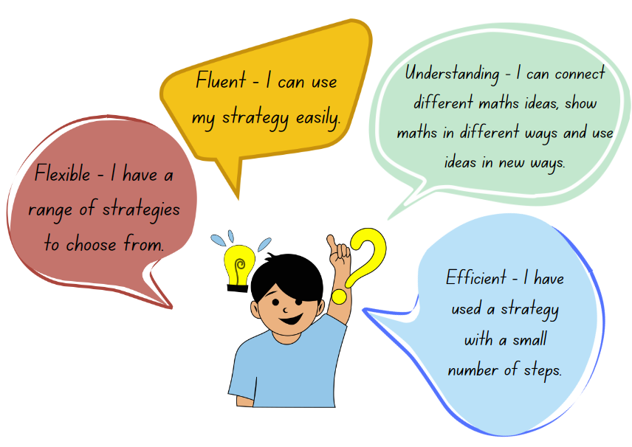

Resource 2 – balancing equations
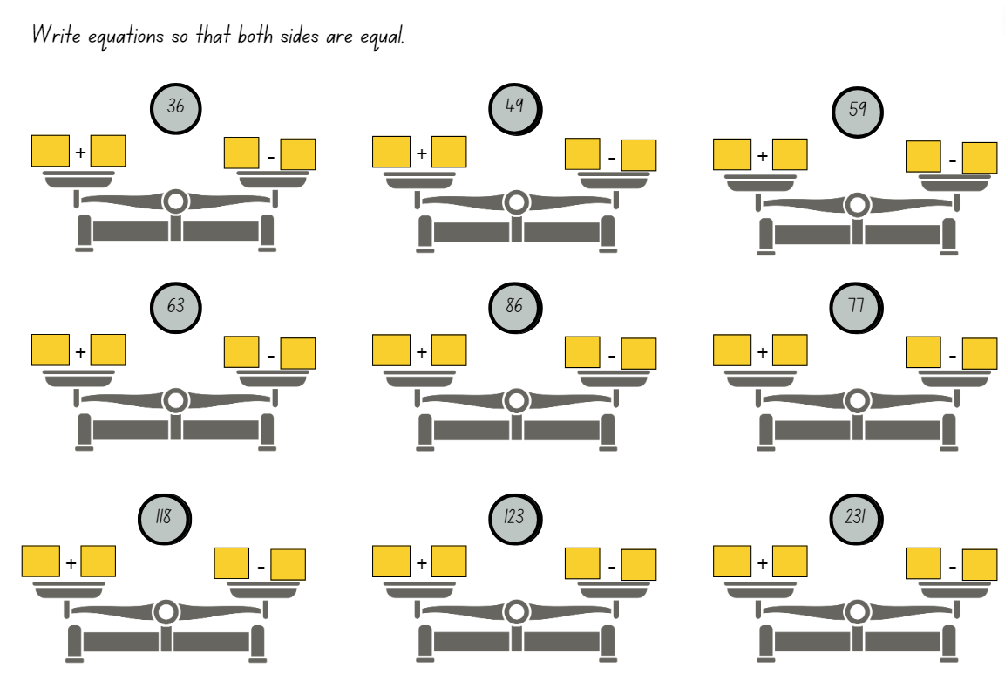

Resource 3 – dice bowling
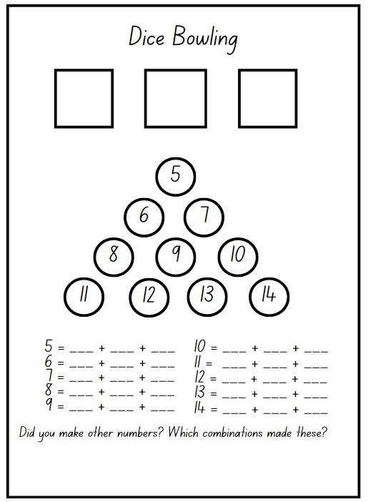
Adapted from Stanford University (n.d)

Resource 4 – Frayer model
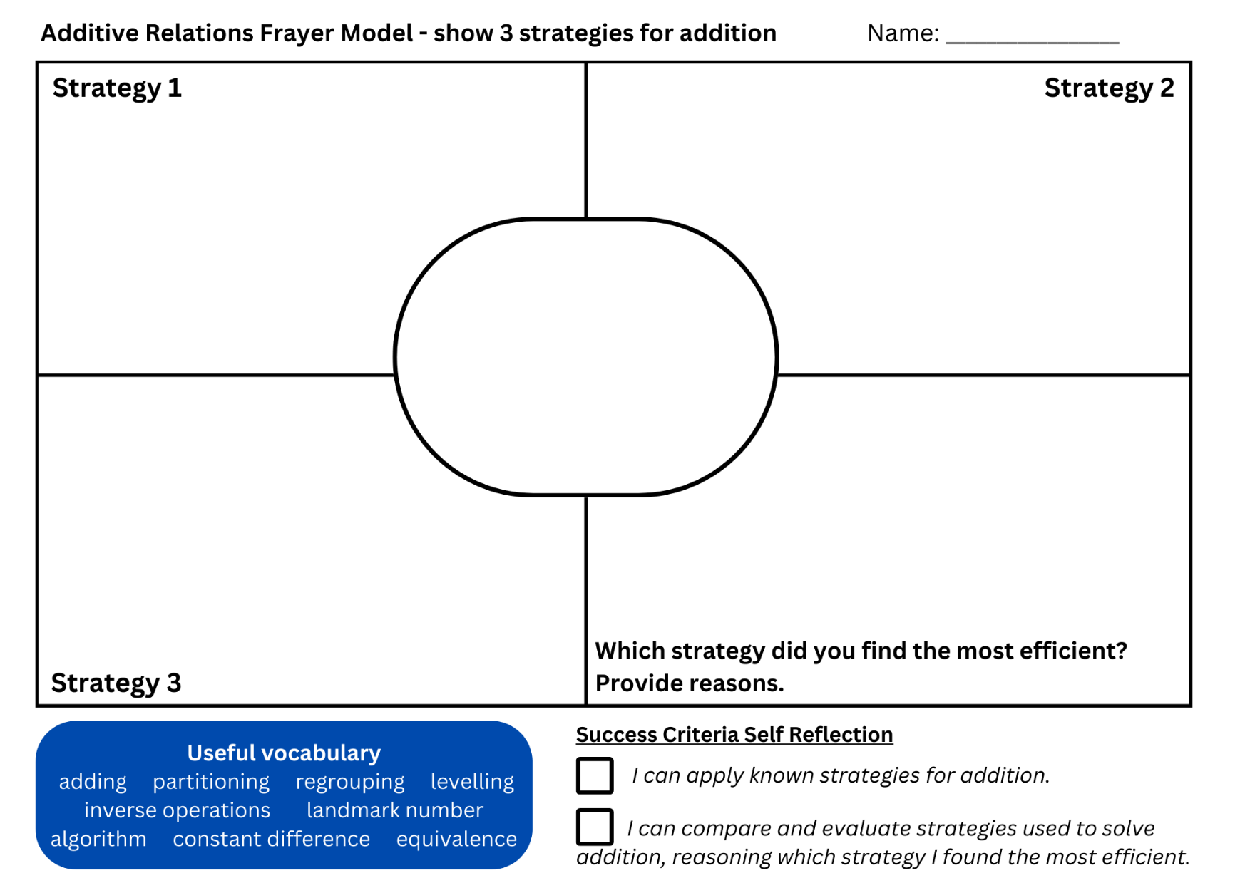

Resource 5 – place value chart
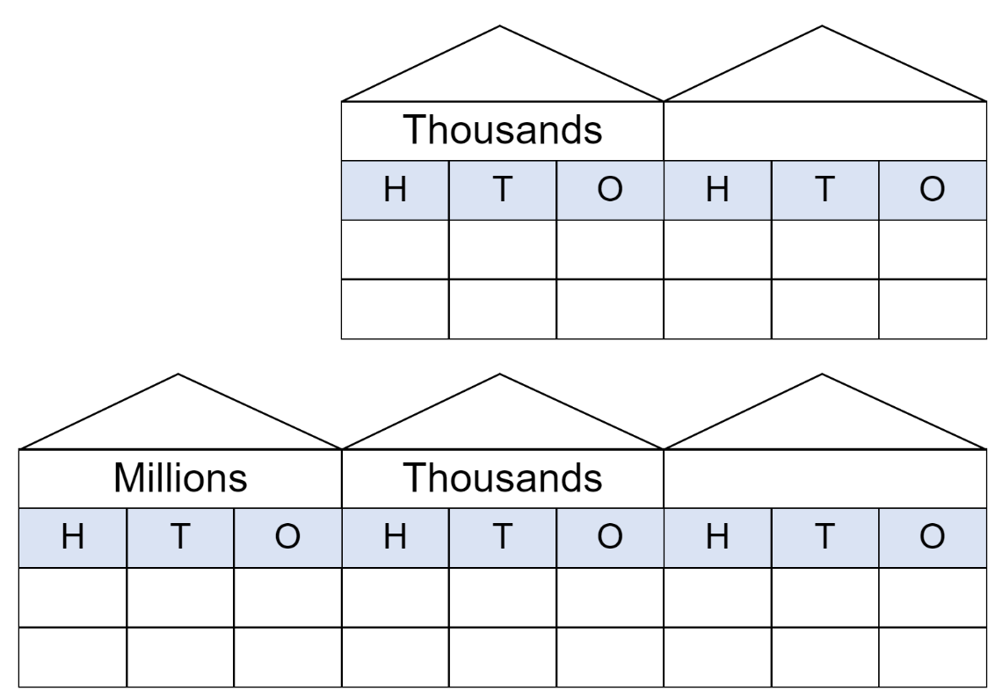

Resource 6 – additive strategies
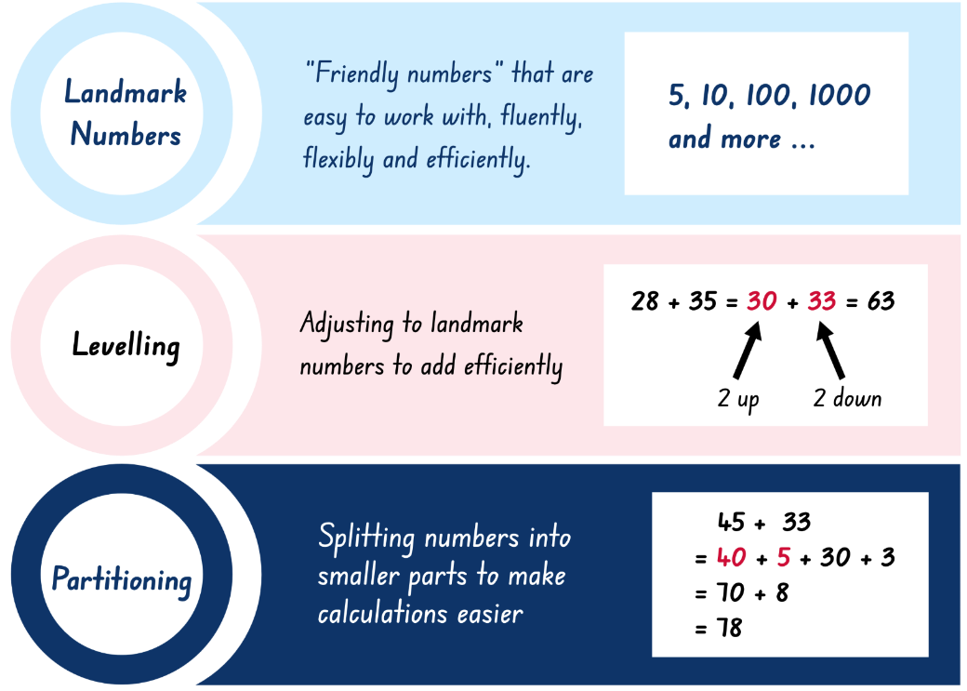
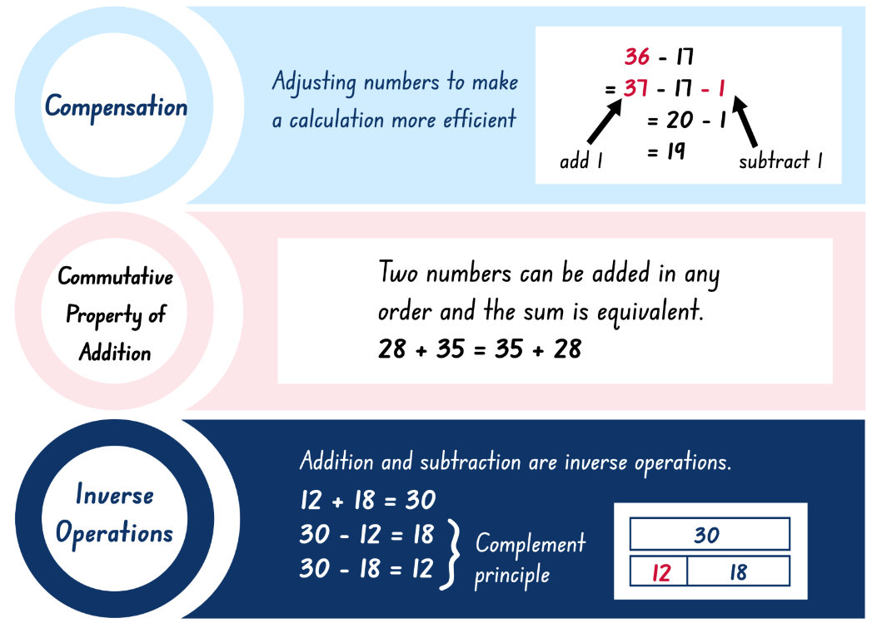
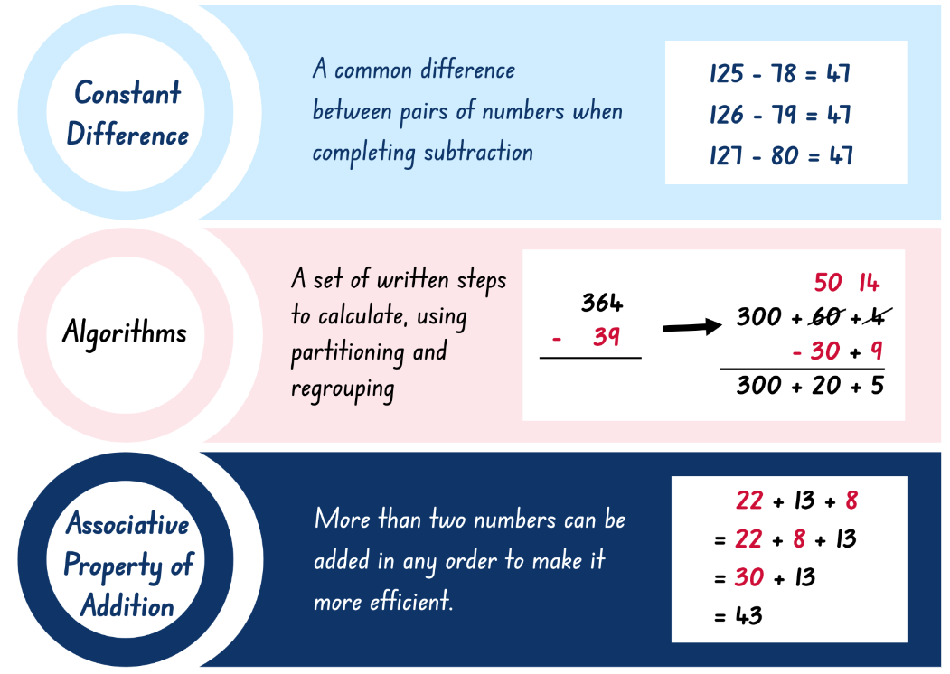
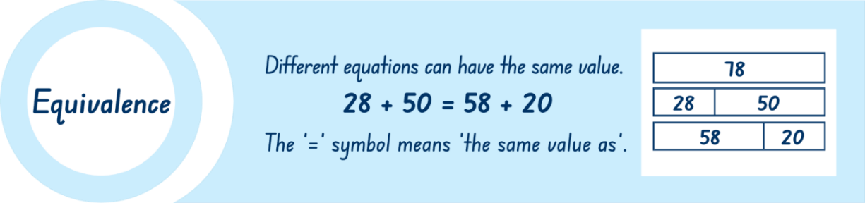

Resource 7 – money equivalence
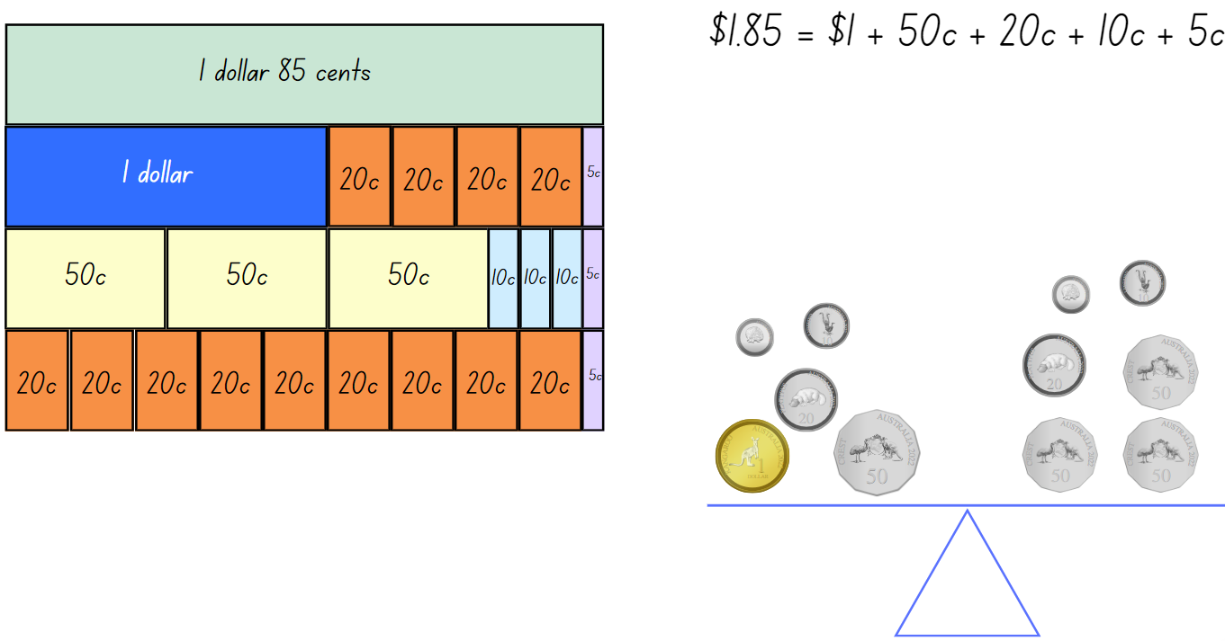

Resource 8 – price tags
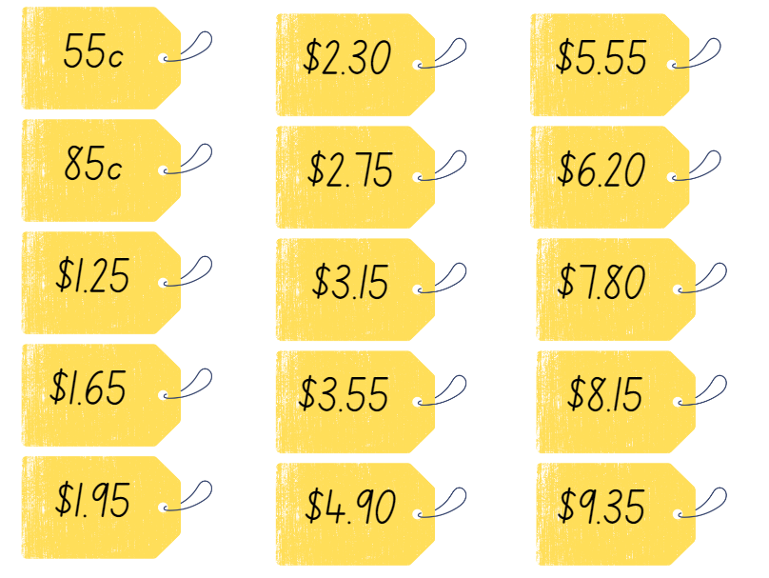

Resource 9 – money mat
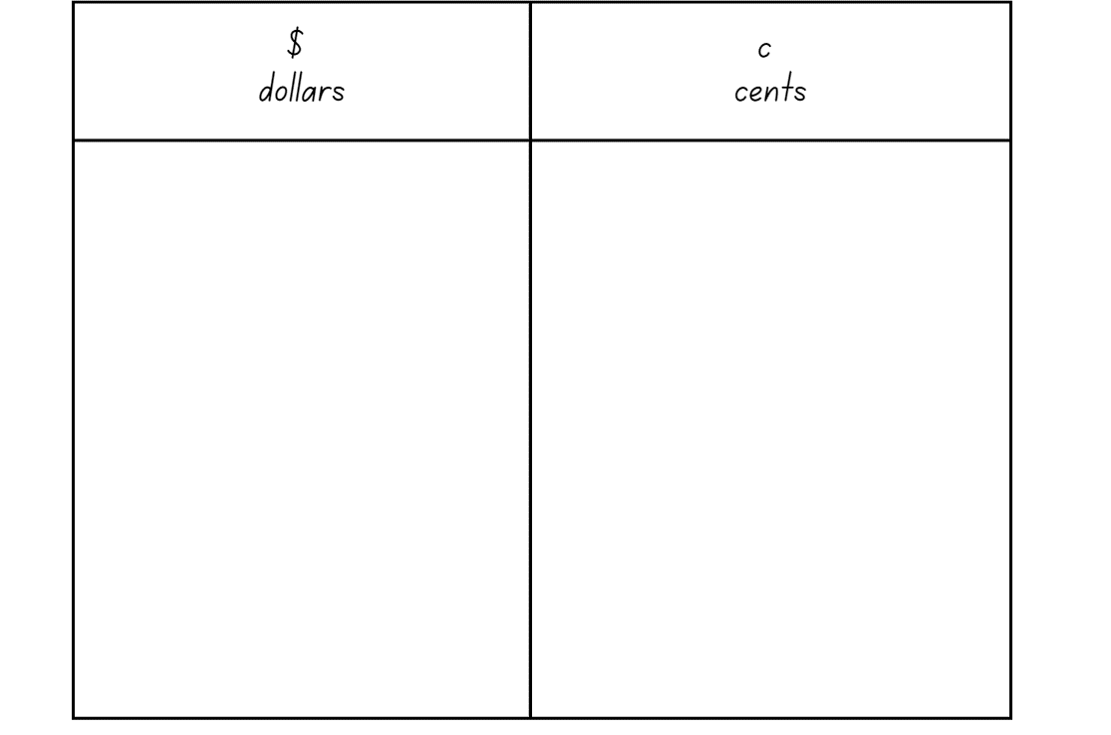

Resource 10 – time to shop
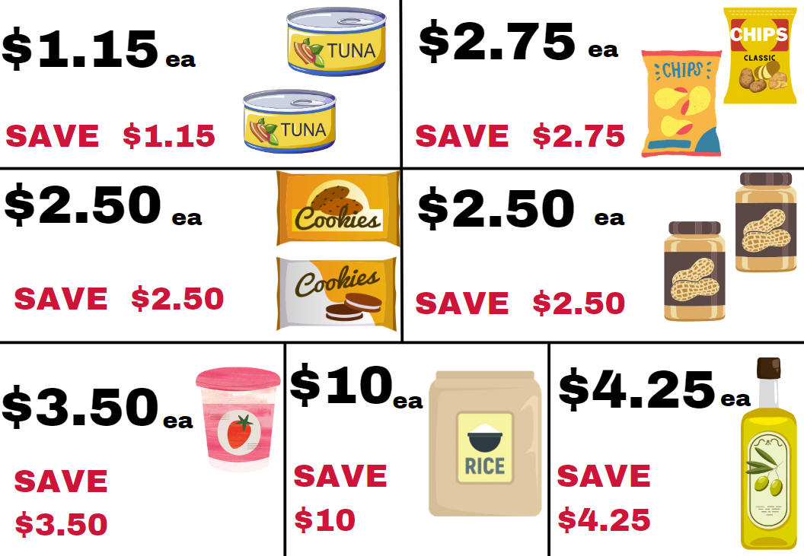

Resource 11 – shopping questions
- How close can you get to spending $20 on these groceries?
- What is the least number of items you could buy for a total of $20 when you can only buy one of any item?
- What is the greatest number of items you could buy for a total of $20 when you can only buy one of any item?
- What is the greatest number of items you could buy for $20 if the products were all full price but they had run out of rice?
- How close to spending $20 could you get if you had to buy 2 of each item that you selected?
- How many items could you buy if you have a total of $17.50 to spend, but you could only buy one of any item that you choose?

Resource 12 – canteen menu
Canteen food | Price | Salads | Price | Hot food | Price
Banana muffin | $1.00 | Greek salad | $6.50 | Chicken burger | $5.50
Energy choc balls | 50c | Garden salad | $6.00 | Beef burger | $5.50
Popcorn | 45c | Chicken salad | $8.00 | Chicken wrap | $6.00
Custard cup | 90c | Tuna salad | $8.00 | Beef lasagna | $5.00
Jelly cup | 70c | Egg salad | $7.00 | Cheese pizza | $3.50
Breadsticks | 25c | Fruit salad | $4.50 | Sausage roll | $4.00
Fruit | 60c | Frozen treats | Price | Sandwiches | Price
Drinks | Price | Juice tubs | $1.50 | Egg | $2.00
Juice | $2.50 | Frozen fruit | $1.00 | Ham | $3.00
Flavoured milk | $2.00 | Sweet stick | $1.00 | Salad | $4.00
Water – 600mL | $2.00 | Frozen Yoghurt | $2.00 | Cheese | $2.00

Resource 13 – money problem 1
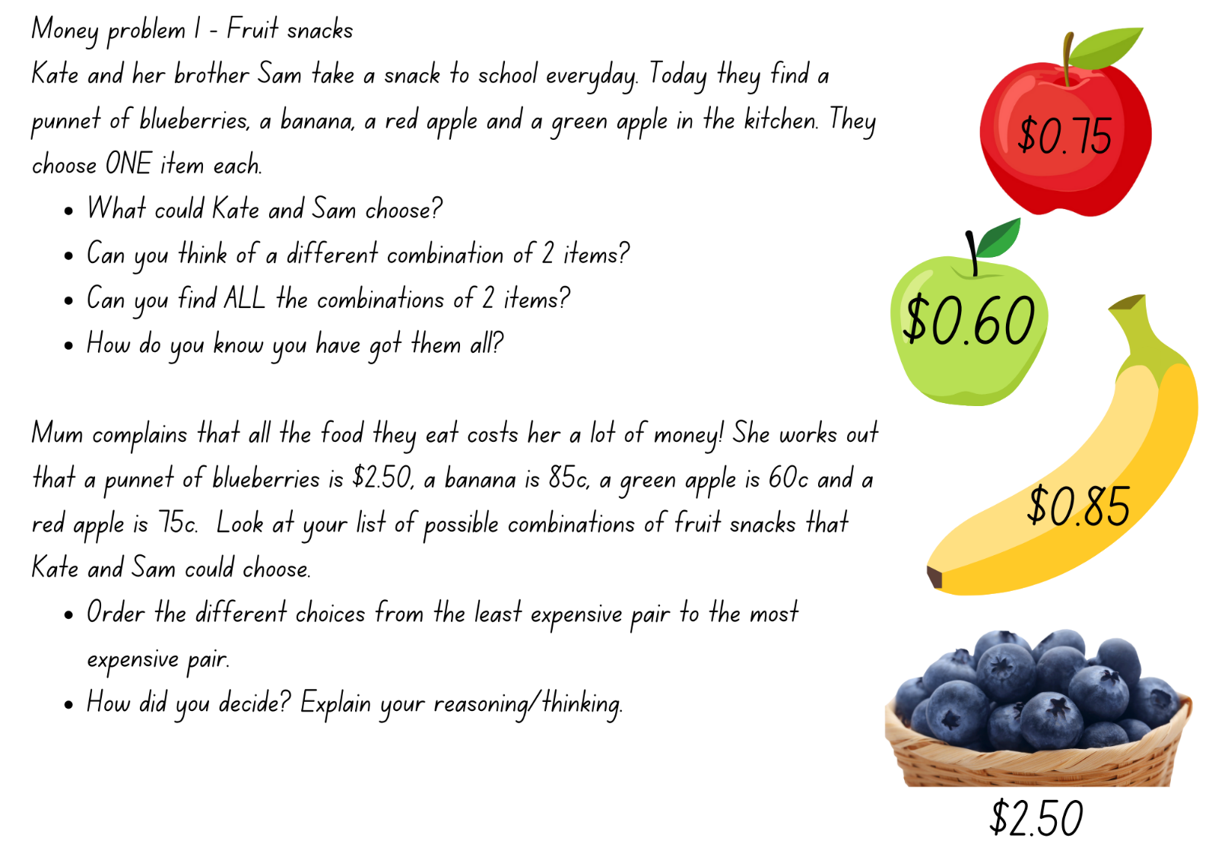
Adapted from ‘Fruity Pairs’ by University of Cambridge (n.d)

Resource 14 – money problem 2
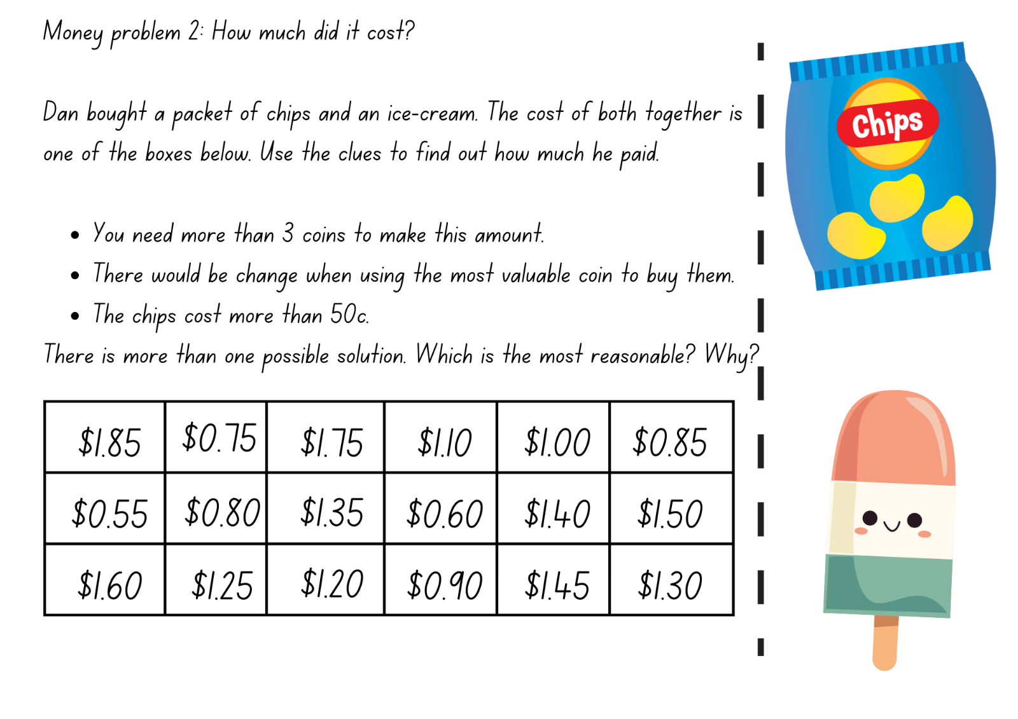
Adapted from ‘How Much Did it Cost?’ by University of Cambridge (n.d)

Syllabus outcomes and content
The table below outlines the syllabus outcomes and range of relevant syllabus content covered in this unit. Content is linked to National Numeracy Learning Progression (version 3).
Outcomes and content | 1 | 2 | 3 | 4 | 5 | 6 | 7 | 8
Representing numbers using place value A: Whole numbers: Read, represent and order numbers to thousands
MAO-WM-01, MA2-RN-01
- Represent numbers up to and including thousands using physical or virtual manipulatives, words, numerals, diagrams and digital displays | x
Representing numbers using place value A: Apply place value to partition and regroup numbers up to 4 digits
MAO-WM-01, MA2-RN-01
- Record numbers using standard place value form |  | x | x
Representing numbers using place value B: Whole numbers: Apply place value to partition, regroup and rename numbers up to 6 digits
MAO-WM-01, MA2-RN-01
- Use place value to expand the number notation |  | x | x
Additive relations A: Use the principle of equality
MAO-WM-01, MA2-AR-01, MAR-AR-02
- Use the equals sign to mean 'the same as', rather than to perform an operation | x
Additive relations A: Recognise and explain the connection between addition and subtraction
MAO-WM-01, MA2-AR-01, MAR-AR-02
- Demonstrate how addition and subtraction are inverse operations |  |  | x
Additive relations A: Select strategies flexibly to solve addition and subtraction problems of up to 3 digits
MAO-WM-01, MA2-AR-01, MAR-AR-02
- Apply known mental strategies that use partitioning to add and subtract, such as bridging the decades |  | x | x
- Represent solutions to addition and subtraction problems, including word problems, using an empty number line or bar model |  |  |  |  |  |  | x | x
- Compare and evaluate strategies used to solve addition and subtraction problems, reasoning which strategy may be most efficient |  | x | x |  |  |  | x | x
Additive relations A: Represent money values in multiple ways
- MAO-WM-01, MA2-AR-01, MAR-AR-02
- Recognise the relationship between dollars and cents | x | x |  |  |  | x
- Represent equivalent amounts of money using different denominations | x | x |  | x | x | x
- Perform calculations with money, including finding change |  |  | x | x | x | x
Additive relations B: Partition, rearrange and regroup numbers to at least 1000 to solve additive problems
- MAO-WM-01, MA2-AR-01, MAR-AR-02
- Model addition with and without regrouping and record the method used |  | x
Additive relations B: Apply addition and subtraction to familiar contexts, including money and budgeting
- MAO-WM-01, MA2-AR-01, MAR-AR-02
- Interpret problems involving money as requiring either addition or subtraction |  |  |  |  | x
Additive relations B: Complete number sentences involving additive relations to find unknown quantities
- MAO-WM-01, MA2-AR-01, MAR-AR-02
- Find the missing number in an equivalent number sentence involving operations of addition or subtraction on both sides of the equals sign (Algebraic reasoning) | x
Multiplicative relations A: Represent and solve problems involving multiplication fact families
- MAO-WM-01, MA2-MR-02
- Describe multiplication problems using for each and times as many |  |  |  |  | x | x
- Find the total of partially covered arrays |  |  |  |  |  |  | x
Mathematics K–10 Syllabus © NSW Education Standards Authority (NESA) for and on behalf of the Crown in right of the State of New South Wales, 2022.

References
This resource contains NSW Curriculum and syllabus content. The NSW Curriculum is developed by the NSW Education Standards Authority. This content is prepared by NESA for and on behalf of the Crown in right of the State of New South Wales. The material is protected by Crown copyright.
Please refer to the NESA Copyright Disclaimer for more information https://educationstandards.nsw.edu.au/wps/portal/nesa/mini-footer/copyright.
NESA holds the only official and up-to-date versions of the NSW Curriculum and syllabus documents. Please visit the NSW Education Standards Authority (NESA) website https://educationstandards.nsw.edu.au/wps/portal/nesa/home and the NSW Curriculum website https://curriculum.nsw.edu.au/.
Mathematics K–10 Syllabus © NSW Education Standards Authority (NESA) for and on behalf of the Crown in right of the State of New South Wales, 2022.
National Numeracy Learning Progression © Australian Curriculum, Assessment and Reporting Authority (ACARA) 2010 to present, unless otherwise indicated. This material was downloaded from the Australian Curriculum website (National Numeracy Learning Progression) (accessed 15 December 2023) and was not modified.
Finkel D (2019) ‘Subtracting Reverses’, Free Lessons, Math for Love website, accessed 14 December 2023.
NSW Education Standards Authority (NESA) (2022a) Teaching advice for Additive relations B, NESA website, accessed 2 April 2024.
Rawding M (2016-2024) Make it equal, Open Middle website, accessed 14 December 2023.
Stanford University (n.d) Bowl A Fact, youcubed website, accessed 14 December 2023.
State of New South Wales (Department of Education) (2023) Let’s talk – number talk (230 minus 190), Department of Education website, accessed 17 December 2023.
State of New South Wales (Department of Education) (2024) Equivalent number sentences, Universal Resources Hub, accessed 17 December 2023.
Sullivan P and Lilburn P (2017) Open-ended maths activities: Using ‘good’ questions to enhance learning in mathematics, Oxford University Press, Australia.
University of Cambridge (n.d) Fruity Pairs, NRICH website, accessed 14 December 2023.
University of Cambridge (n.d.) How Much?, NRICH website, NRICH website, accessed 14 December 2023

Further reading
Australian Securities and Investment Commission (n.d) Moneysmart for teachers, Moneysmart website, accessed 17 December 2023.
Siemon D, Warren E, Beswick K, Faragher R, Miller J, Horne M, Jazby D, Breed M, Clark J and Brady K (2020) Teaching Mathematics: Foundations to Middle Years, 3rd edition, Oxford University Press, Australia.
State of New South Wales (Department of Education) (2024) Stage 2 Addition and subtraction with money (DOCX 1.15 MB), accessed 17 December 2023.
Van de Walle J, Karp K, Bay-Williams JM, Brass A, Bentley B, Ferguson S, Goff W, Livy S, Marshman M, Martin D, Pearn C, Prodromou T, Symons D and Wilkie K (2019) Primary and Middle Years Mathematics: Teaching Developmentally, 1st Australian edn, Pearson Education Australia, Melbourne.
© State of New South Wales (Department of Education), 2024
The copyright material published in this resource is subject to the Copyright Act 1968 (Cth) and is owned by the NSW Department of Education or, where indicated, by a party other than the NSW Department of Education (third-party material).
Copyright material available in this resource and owned by the NSW Department of Education is licensed under a Creative Commons Attribution 4.0 International (CC BY 4.0) license.
This license allows you to share and adapt the material for any purpose, even commercially.
Attribution should be given to © State of New South Wales (Department of Education), 2024.
Material in this resource not available under a Creative Commons license:
- the NSW Department of Education logo, other logos and trademark-protected material
- material owned by a third party that has been reproduced with permission. You will need to obtain permission from the third party to reuse its material.
Links to third-party material and websites
Please note that the provided (reading/viewing material/list/links/texts) are a suggestion only and implies no endorsement, by the New South Wales Department of Education, of any author, publisher, or book title. School principals and teachers are best placed to assess the suitability of resources that would complement the curriculum and reflect the needs and interests of their students.
If you use the links provided in this document to access a third-party's website, you acknowledge that the terms of use, including licence terms set out on the third-party's website apply to the use which may be made of the materials on that third-party website or where permitted by the Copyright Act 1968 (Cth). The department accepts no responsibility for content on third-party websites.

