Mathematics Stage 2 – Unit 13
Multiplicative thinking involves flexible use of multiplication and division concepts, strategies, and representations
Contents
Unit description and duration 6
Syllabus outcomes 6
Working mathematically 7
Student prior learning 7
Lesson overview and resources 9
Lesson 1 14
Daily number sense – How many books? – 15 minutes 14
Core lesson 1 – product patterns – 20 minutes 15
VNPS: Vertical Non-Permanent Surfaces 16
Core lesson 2 – odd and even numbers – 20 minutes 19
Discuss and connect the mathematics – 5 minutes 22
Lesson 2 23
Daily number sense – splats – 10 minutes 23
Core lesson 1 – partially covered arrays – 15 minutes 25
Core lesson 2 – array games – 20 minutes 28
Consolidation and meaningful practice – 15 minutes 29
Lesson 3 32
Daily number sense – reverse rolls – 15 minutes 32
Core lesson 1 – doubling 2, 4 and 8 – 20 minutes 35
Core lesson 2 – number strings – 15 minutes 40
Discuss and connect the mathematics – 10 minutes 42
Lesson 4 44
Daily number sense – 10 minutes 44
Core lesson – tackling times tables – 40 minutes 44
Discuss and connect the mathematics – 10 minutes 48
Lesson 5 50
Daily number sense – how much change? – 10 minutes 50
Core lesson – bakery partitioning – 40 minutes 52
Discuss and connect the mathematics – 10 minutes 57
Lesson 6 59
Daily number sense – equivalent change – 10 minutes 59
Core lesson 1 – sharing 36 – 20 minutes 61
Core lesson 2 – sharing solutions – 20 minutes 62
Discuss and connect the mathematics – 10 minutes 64
Lesson 7 66
Daily number sense – missing number sentence – 15 minutes 66
Core lesson 1 – missing numbers – 15 minutes 68
Core lesson 2 – games for practise/fluency/mastery – 25 minutes 70
Discuss and connect the mathematics – 5 minutes 71
Lesson 8 74
Daily number sense – 10 minutes 74
Core lesson – multiplicative problem solving – 40 minutes 74
Discuss and connect the mathematics – 5 minutes 77
Resource 1 – How many books? 79
Resource 2 – pattern table 80
Resource 3 – caught red-handed 81
Resource 4 – red-handed questions 82
Resource 5 – splats 83
Resource 6 – partially covered arrays 84
Resource 7 – matching cards 85
Resource 8 – matching card templates 86
Resource 9 – doubles and halves 91
Resource 10 – doubles bingo 92
Resource 11 – arrays 93
Resource 12 – plug board examples 94
Resource 13 – combined plug boards 95
Resource 14 – prove it’s 36 96
Resource 15 – plug boards 97
Resource 16 – How many cupcakes? 98
Resource 17 – a special order 99
Resource 18 – busy cupcake day 100
Resource 19 – sharing crackers 101
Resource 20 – sharing solutions 102
Resource 21 – missing numbers 103
Resource 22 – Salute! 104
Resource 23 – fill the chart 105
Resource 24 – Open Middle problem 106
Resource 25 – word problems 107
Resource 26 – How many ribbons? 108
Resource 27 – How many cones? 109
Resource 28 – four arrays 110
Syllabus outcomes and content 111
References 116
Further reading 119

Unit description and duration
This unit develops the big idea that multiplicative thinking involves flexible use of multiplication and division concepts, strategies and representations.
In this 2-week unit students are provided opportunities to:
- generate and describe multiplicative patterns and structures
- use arrays to establish and extend multiplication facts from multiples of 2 and 4, 5 and 10
- represent and solve problems using multiplication fact families, arrays and number sentences.

Syllabus outcomes
- MAO-WM-01 develops understanding and fluency in mathematics through exploring and connecting mathematical concepts, choosing and applying mathematical techniques to solve problems, and communicating their thinking and reasoning coherently and clearly
- MA2-AR-01 selects and uses mental and written strategies for addition and subtraction involving 2- and 3-digit numbers
- MA2-AR-02 completes number sentences involving addition and subtraction by finding missing values
- MA2-MR-01 represents and uses the structure of multiplicative relations to 10 × 10 to solve problems
- MA2-MR-02 completes number sentences involving multiplication and division by finding missing values

Working mathematically
In the Mathematics K–10 Syllabus, there is one overarching Working mathematically outcome (MAO-WM-01). The Working mathematically processes should be embedded within the concepts being taught. The Working mathematically processes present in the Mathematics K–10 Syllabus are:
- communicating
- understanding and fluency
- reasoning
- problem solving.
Mathematics K–10 Syllabus © NSW Education Standards Authority (NESA) for and on behalf of the Crown in right of the State of New South Wales, 2022.

Student prior learning
Before engaging in these teaching and learning activities, students would benefit from prior experience with:
- generating and describing patterns
- using arrays to establish multiplication facts from multiples of 2 and 4, 5 and 10
- representing and solving problems involving multiplication fact families.
In NSW classrooms there is a diverse range of students, including Aboriginal and/or Torres Strait Islander students, students learning English as an additional language or dialect, high potential and gifted students and students with disability. Some students may identify with more than one of these groups or possibly all of them. Refer to Curriculum planning for every student – advice for further information.

Lesson overview and resources
The table below outlines the sequence and approximate timing of lessons, learning intentions and resources.
Lesson | Content | Duration and resources
Lesson 1  Daily number sense learning intention:  - represent and solve problems involving multiplication fact families | Lesson core concept: multiplicative thinking is based on patterns and structures.  Core concept learning intention:  - generate and describe patterns | Lesson duration: 60 minutes  - Resource 1 – How many books?  - Resource 2 – pattern table  - Resource 3 – caught red-handed  - Resource 4 – red-handed questions  - Coloured markers or pens  - Counters  - Writing materials
Lesson 2  Daily number sense learning intention:  - represent and solve problems involving multiplication fact families | Lesson core concept: structures can support multiplicative thinking (arrays).  Core concept learning intentions:  - use arrays to establish multiplication facts from multiples of 2 and 4, 5 and 10  - represent and solve problems involving multiplication fact families | Lesson duration: 60 minutes  - Resource 5 – splats  - Resource 6 – partially covered arrays  - Resource 7 – matching cards  - Resource 8 – matching cards templates  - Writing materials
Lesson 3  Daily number sense learning intention:  - represent and solve problems involving multiplication fact families | Lesson core concept: doubling is a powerful strategy (2, 4, 8 patterns).  Core concept learning intentions:  - use arrays to establish multiplication facts from multiples of 2 and 4, 5 and 10  - use known number facts and strategies | Lesson duration: 60 minutes  - Resource 9 – doubles and halves  - Resource 10 – doubles bingo  - 6-sided dice  - Individual whiteboards  - Writing materials
Lesson 4  Daily number sense learning intention:  - teacher-identified task based on student needs | Lesson core concept: flexible methods of computation in multiplication and division involve composing and decomposing numbers.  Core concept learning intentions:  - recall multiplication facts of 2 and 4, 5 and 10 and related division facts  - use number properties to find related multiplication facts | Lesson duration: 60 minutes  - Resource 11 – arrays  - Resource 12 – plug board examples  - Resource 13 – combined plug boards  - Resource 14 – prove it’s 36  - Resource 15 – plug boards  - Individual whiteboards  - Scissors  - Writing materials
Lesson 5  Daily number sense learning intention:  - represent money values in multiple ways | Lesson core concept: collections can be partitioned in more than one way.  Core concept learning intention:  - use number properties to find related multiplication facts | Lesson duration: 60 minutes  - Resource 16 – How many cupcakes?  - Resource 17 – a special order  - Resource 18 – busy cupcake day  - Individual whiteboards  - Play money (if available)  - Writing materials
Lesson 6  Daily number sense learning intention:  - represent money values in multiple ways | Lesson core concept: multiplication and division are related.  Core concept learning intentions:  - recall multiplication facts of 2 and 4, 5 and 10 and related division facts  - represent and solve problems involving multiplication fact families | Lesson duration: 60 minutes  - Resource 19 – sharing crackers  - Resource 20 – sharing solutions  - Counters or square tiles  - Individual whiteboards  - Play money (if available)  - Writing materials
Lesson 7  Daily number sense learning intention:  - represent money values in multiple ways | Lesson core concept: fact families support fluency.  Core concept learning intentions:  - recall multiplication facts of 2 and 4, 5 and 10 and related division facts  - represent and solve word problems with number sentences involving multiplication or division | Lesson duration: 60 minutes  - Resource 10 – doubles bingo  - Resource 21 – missing numbers  - Resource 22 – Salute!  - Resource 23 – fill the chart  - Resource 24 – Open Middle problem  - Individual whiteboards  - Play money (if available)  - Writing materials
Lesson 8  Daily number sense learning intention:  - teacher-identified task based on student needs | Lesson core concept: problems can be solved using multiplicative thinking.  Core concept learning intentions:  - represent and solve problems involving multiplication fact families  - represent and solve word problems with number sentences involving multiplication or division | Lesson duration: 55 minutes  - Resource 25 – word problems  - Resource 26 – How many ribbons?  - Resource 27 – How many cones?  - Resource 28 – four arrays  - Individual whiteboards  - Writing materials

Lesson 1
Core concept: multiplicative thinking is based on patterns and structures.

Daily number sense – How many books? – 15 minutes
Daily number sense activities for Lessons 1 to 3 ‘activate’ prior number knowledge and support the learning of new content in the unit. These activities can also assist teachers to identify the starting points for learning by revealing the extent of students’ existing knowledge.
The table below contains a suggested learning intention and success criteria. These are best co-constructed with students.
Daily number sense learning intention | Daily number sense success criteria
Students are learning to:  - represent and solve problems involving multiplication fact families. | Students can:  - describe multiplication problems using for each and times as many  - find the total of partially covered arrays.
- Explain that Sam’s school is participating in the Premier’s Reading Challenge. He is trying to work out how many books he and his friends have each read.
- Display Resource 1 – How many books? and read the first 2 problems aloud.
- In pairs, students find solutions to the first 2 problems using writing materials or counters if needed.
- Discuss the solutions as a class, comparing the strategies that students used. Students explain their thinking.
- Students complete the other questions and share their strategies and solutions.
This table details opportunities for assessment.
Assessment opportunities | Links
What to look for:  - Can students describe multiplication problems using for each and times as many? [MAO-WM-01, MA2-MR-01]  - Can students find the total of partially covered arrays?  [MAO-WM-01, MA2-MR-01] | Links to National Numeracy Learning Progressions (NNLP):  - MuS5.  Links to suggested Interview for Student Reasoning (IfSR) tasks:  - IfSR-MT: 2A.1, 2A.12, 2A.13, 2A.14.

Core lesson 1 – product patterns – 20 minutes
The table below contains a suggested learning intention and success criteria. These are best co-constructed with students.
Core concept learning intention | Core concept success criteria
Students are learning to:  - generate and describe patterns. | Students can:  - model, describe and record patterns of multiples  - recognise the significance of the final digit of a whole number in determining whether a given number is even or odd  - recognise the connection between even numbers and the multiplication facts for 2.

VNPS: Vertical Non-Permanent Surfaces
Using Vertical Non-Permanent Surfaces (VNPS) is a practice to enhance students’ mathematical thinking and communication. VNPS provide a space where groups of students stand, collaboratively develop solutions and share their mathematical reasoning. This practice encourages students to actively communicate their thinking within and across groups, increases student autonomy and lowers the stakes for making mistakes. Other techniques to support this practice include using one marker per group, alternating writers and encouraging groups to compare thinking on each other’s VNPS (Liljedahl 2021). This approach aligns with many of the practices for Setting up Positive Norms in Math Class (PDF 1.18 MB) by Boaler (2022).

This lesson is an adaptation of ‘Playing with pairs’ from Mindset Mathematics: Visualizing and Investigating Big Ideas, Grade 3 by Boaler et al. If your class prepared an anchor chart for Stage 2 – Unit 7, display and review this chart prior to starting this lesson. This part of the lesson is an opportunity for students to use VNPS to collaborate.
- Explain that students will complete 2 investigations to look for patterns in addition and in multiplication.
- Present the first investigation: Two numbers add up to 10. What might you get if you multiply these numbers?
- Revise the meaning of the word product:
Product: the result of multiplying 2 or more numbers together. For example, 12 is the product of 4 × 3.
- Students turn and talk to answer:
- What does this task mean?
- Can you think of an example? (7 + 3 = 10; 7 × 3 = 21).
- How can you represent the products? (Drawings, arrays, number sentences.)
- How can you organise your responses to look for patterns? (A table.)
- Organise students into groups to investigate the questions:
- What products are possible?
- What is the largest product?
- What is the lowest product?
- What patterns do you notice in the products? (The products get larger, then smaller. The products are in an odd or even pattern.)
- As a class, make a list of the patterns students notice.
- Present the second investigation: Will the patterns be the same for a sum other than 10?
- Students turn and talk to answer:
- What does this task mean?
- Can you think of an example? 7 + 4 = 11; 7 × 4 = 28
- Do you think the patterns will be the same? Why or why not?
- Will the patterns be the same for all numbers? Why or why not?
- Assign pairs of students the numbers 11, 13, 14 or 15 to investigate.
- Once completed, conduct a gallery walk to consider the questions:
- What patterns are always true?
- Are there patterns that only apply to certain numbers?
- How has your thinking changed from the beginning of the lesson?
- Keep the VNPS on display for part 2 of the lesson.

Core lesson 2 – odd and even numbers – 20 minutes
Note: a conceptual understanding of number properties, including odd and even numbers, supports student understanding of later syllabus content. This includes divisibility and prime numbers.
- As a class, revise and co-construct a definition of odd and even so that students can identify odd and even numbers. For example:
- An even number is divisible by 2 and ends in 2, 4, 6, 8, 0.
- An odd number is a number that is not divisible by 2 (without a remainder) and ends in 1, 3, 5, 7, 9.
- Draw attention to the connection between even numbers and the multiplication facts for 2.
- Provide students with 2 different coloured markers or pens.
- Students return to their earlier investigations to circle or underline the odd and even numbers to answer:
- What rules can you identify about adding odd or even numbers?
- What rules can you identify about multiplying odd or even numbers?
- Once complete, discuss the rules identified by students.
The table below outlines stimulus prompts to generate conversation about the topic, along with anticipated responses from students.
Prompts | Anticipated student responses
- What rules can you say about addition? | - Odd + odd = even  - Even + even = even  - Odd + even = odd
- Why do these addition rules work? | - Even + even: since both numbers can be divided by 2, the total will also be divisible by 2, making the total even.  - Odd + odd: since an odd number is an even number +1, when you add two odd numbers you end up with an even number +2.  - Odd + even: since an odd number is an even number +1, you end up with even + even + 1, making the total impossible to divide by 2 without a remainder.
- What rules can you say about multiplication? | - Odd × odd = odd  - Even × even = even  - Odd × even = even
- Why do these multiplication rules work? | - Odd × odd: if you have an array with an odd number of rows, and an odd number in each row, such as 3 × 5, there is no way to divide this into 2 without a remainder.  - Even × even/odd: any array with an even number of rows can always be split into 2 equal groups with no remainder.
- Add the rules to the class anchor chart from Stage 2 – Unit 7 or create a display for future reference.
This table details opportunities for differentiation.
Too hard? | Too easy?
Students cannot model, describe and record patterns of multiples.  - For part 1 of the lesson, provide Resource 2 – pattern table for students to complete. Explain how students can complete the table. Students may draw representations of products in the blank space provided, if needed.  - For part 2 of the lesson, model the use of concrete materials for 2 × 8, and 3 × 7 in arrays. Establish that 16 can be divided by 2 but 21 cannot. Link to the commutative property of 8 × 2 and 7 × 3. | Students can model, describe and record patterns of multiples.  - Students investigate to determine rules and explanations for adding and multiplying three numbers, such as odd + odd + odd and odd × odd × odd.  - Provide students with Resource 3 – caught red-handed. After at least 5 games, present the questions on Resource 4 – red-handed questions for students to consider.

Discuss and connect the mathematics – 5 minutes
- Students turn and talk to answer the following questions:
- The sum of some numbers is odd. What do we know about the numbers being added together?
- Kaija multiplies 2 numbers together and the product is even. What do we know about the numbers being multiplied together?
- How can odd and even patterns help us with calculations?
This table details opportunities for assessment.
Assessment opportunities | Links
What to look for:  - Can students model, describe and record patterns of multiples? [MAO-WM-01, MA2-MR-01]  - Can students recognise the significance of the final digit of a whole number in determining whether a given number is even or odd? [MAO-WM-01, MA2-MR-01]  - Can students recognise the connection between even numbers and the multiplication facts for 2? [MAO-WM-01, MA2-MR-01] | Links to National Numeracy Learning Progressions (NNLP):  - NPA3, NPA4.

Lesson 2
Core concept: structures can support multiplicative thinking (arrays).

Daily number sense – splats – 10 minutes
The table below contains a suggested learning intention and success criteria. These are best co-constructed with students.
Daily number sense learning intention | Daily number sense success criteria
Students are learning to:  - represent and solve problems involving multiplication fact families. | Students can:  - apply the inverse relationship of multiplication and division.
This activity is an adaptation of ‘Splats’ by Wyborney.
- Display Resource 5 – splats.
- Explain that some of the arrays are hidden by a ‘splat’ and the total number of dots in each image is shown in the circle.
- Students turn and talk to identify the complete array hidden by the splat.
- Discuss the solutions as a class, comparing the strategies that students used. Students explain their thinking that accompanied each strategy.
The table below outlines stimulus prompts to generate conversation about the topic, along with anticipated responses from students.
Prompts | Anticipated student responses
- Splat A | - I think the array is 4 fives. The last row of 5 is almost visible. There would be 4 fives altogether. I know that 4 fives is 20, so that makes sense.
- Splat B | - I think the array is 4 sixes. It is clearly 4 rows, but 4 more than Splat A, so each row should be one longer than 5. Also, I know that 4 sixes are 24.
- Splats C, D and E | - Reasons and explanations will vary but should reflect language suitable for arrays.
- Ask students:
- How is the splat like a fact family triangle?
- How can the inverse relationship between multiplication and division help us with this task?
This table details opportunities for assessment.
Assessment opportunities | Links
What to look for:  - Can students apply the inverse relationship of multiplication and division? [MAO-WM-01, MA2-MR-01, MA2-MR-02] | Links to National Numeracy Learning Progressions (NNLP):  - MuS7.  Links to suggested Interview for Student Reasoning (IfSR) tasks:  - IfSR-MT: 2A.5, 2A.10.

Core lesson 1 – partially covered arrays – 15 minutes
The table below contains suggested learning intentions and success criteria. These are best co-constructed with students.
Core concept learning intentions | Core concept success criteria
Students are learning to:  - use arrays to establish multiplication facts from multiples of 2 and 4, 5 and 10  - represent and solve problems involving multiplication fact families. | Students can:  - create and represent multiplicative structure, using the term multiples when connecting grouping to arrays  - use the array structure to coordinate the number of groups with the number in each group  - find the total of partially covered arrays.
- Remind students of the meaning of an array:
Array: an array is used to model multiplicative situations involving whole numbers. It is made by arranging a set of objects into columns and rows. Each row must contain the same number of objects as the other rows, and each column must contain the same number of objects as the other columns.
- Display Resource 6 – partially covered arrays.
- Students turn and talk to discuss:
- How many counters are displayed in Array A? (60)
- How did you calculate the total? (Responses may include: 10 × 6, double 5 × 6, double 10 × 3.)
- What fact family triangle would go with this array? See Figure 1.
Figure 1 – fact family triangle
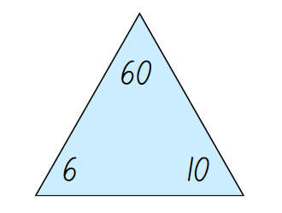
- Explain that for this fact family triangle (Figure 1 above), 60 is the product of multiplying 6 and 10.
- Focus student attention on Array B. Ask:
- What is different?
- What is still the same?
- Explain that even though the card covers the dots, the quantity remains the same.
- Focus student attention on Array C.
- Explain that this is called a partially covered array. The dots are covered by the card, leaving 2 edges of the array visible. Ask students:
- Has the number of dots changed from Array A or B? How do you know?
- How does seeing the edges help you calculate the total?
- Can you use the same strategies you used for Array A?
- Does the same fact family triangle still apply? (See Figure 1 above).

Core lesson 2 – array games – 20 minutes
Note: for 2 examples of partially covered arrays in games, see Go fish! – partially covered arrays or Math Cards (3-6).
- Display Resource 7 – matching cards.
- Revise and establish that the 4 cards are representations of the same multiplicative idea.
- Display Resource 8 – matching cards templates.
- Explain that there are 6 sets of 4 matching cards. There are also some blank templates for students to make their own sets.
- Organise the students into groups of 3 or 4.
- For each group, distribute one copy of Resource 8 – matching card templates and writing materials.
- Using the cards provided, students arrange them in sets of 4 matching cards.
- Groups then choose a number. They use the blank card templates to make their own set of matching cards.
- Once students have made their cards, they can play ‘Go fish’ or matching games with the cards.
This table details opportunities for differentiation.
Too hard? | Too easy?
Students cannot use arrays to establish multiplication facts from multiples of 2 and 4, 5 and 10.  - Use concrete materials to make the connection between equal groups and the array structure. Students skip count rows in the arrays they construct to determine the total. Students can also use the dot arrays interactive as another resource to support their thinking.  - Explore the use of arrays for multiplication and division using the Disco goats game. | Students can use arrays to establish multiplication facts from multiples of 2 and 4, 5 and 10.  - Expand the content of the matching cards to other multiplication facts.  - Expand contexts for multiplication by selecting activities from the Open Middle website such as Building Shelves 1 and Building Shelves 2.

Consolidation and meaningful practice – 15 minutes
- Present this problem: Sarah planted 24 seeds in her garden in equal rows. How many seeds are in each row? Find all the possible answers.
- Students turn and talk to share ideas.
- Select students to respond. Draw a partially covered array, a fact family triangle and a number sentence to match student responses, such as Figure 2.
Figure 2 – possible responses
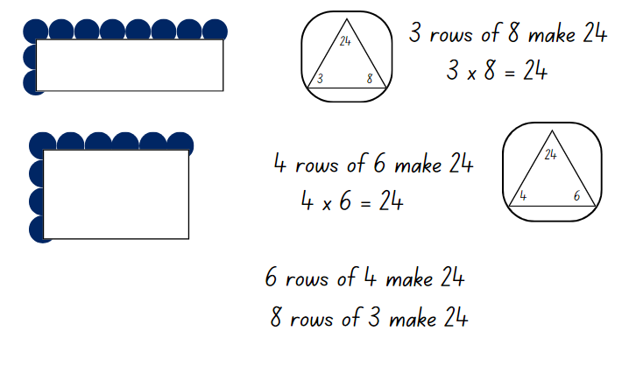
Note: identify the commutative property of multiplication so that 24 can also be 6 fours and 8 threes. Some students may suggest 1 row of 24, or 2 twelves and 12 twos.
- Discuss why 5, 7 or 9 rows could not be possible responses.
- Write the numbers 12, 16, 17, 18, 36, 40, and 72 on the board.
- Explain that these are the number of seeds used in other gardens, also planted in equal rows.
- In groups, students choose one or two numbers to investigate the possible combinations of rows.
This table details opportunities for assessment.
Assessment opportunities | Links
What to look for:  - Can students create and represent multiplicative structure, using the term multiples when connecting grouping to arrays?  [MAO-WM-01, MA2-MR-01]  - Can students use the array structure to coordinate the number of groups with the number in each group? [MAO-WM-01,  MA2-MR-01]  - Can students find the total of partially covered arrays?  [MAO-WM-01, MA2-MR-01]. | Links to National Numeracy Learning Progressions (NNLP):  - MuS5.  Links to suggested Interview for Student Reasoning (IfSR) tasks:  - IfSR-MT: 2A.1.

Lesson 3
Core concept: doubling is a powerful strategy (2, 4, 8 patterns).

Daily number sense – reverse rolls – 15 minutes
The table below contains a suggested learning intention and success criteria. These are best co-constructed with students.
Daily number sense learning intention | Daily number sense success criteria
Students are learning to:  - represent and solve problems involving multiplication fact families. | Students can:  - apply the inverse relationship of multiplication and division.
Note: consider using a digital manipulative for this lesson to draw, rotate and divide arrays, such as the number frames on Amplify Polypad. Users can make, copy and arrange rows of virtual counters into arrays. The arrays can then be rotated to model the commutative property and represent related multiplication and division facts.
- Explain that students are going to play a game.
- Start the game by rolling two 6-sided dice. Use the numbers to draw an array and write corresponding multiplication number sentences.
- For example, if a 4 and a 6 is rolled, draw an array as 4 rows of 6 dots and write 4 × 6 = 24. Remind students that the array can be rotated to match 6 × 4 = 24.
- Remind students about the meaning of inverse:
Inverse operation: the operation that reverses the effect of another operation. For example, multiplication and division are inverse operations. When you multiply 6 by 2 you get 12. If you then divide 12 by 2 you get back to 6.
- Show how division is the inverse of multiplication by writing 24 ÷ 4 = 6 and separating the array of 24 dots into 4 rows of 6 dots.
- Show that the rotated array of 6 fours can be divided into 6 rows of 4 dots, or 24 ÷ 6 = 4.
- With a partner, students take turns to roll 2 dice. The 2 numbers are used to write a multiplication number sentence. This is then represented by drawing an array.
- Their partner then works inversely by writing a division number sentence to return to the original numbers. They represent this by drawing lines to break the array into the original values from the number sentence, see Figure 3.
Figure 3 – reverse rolls
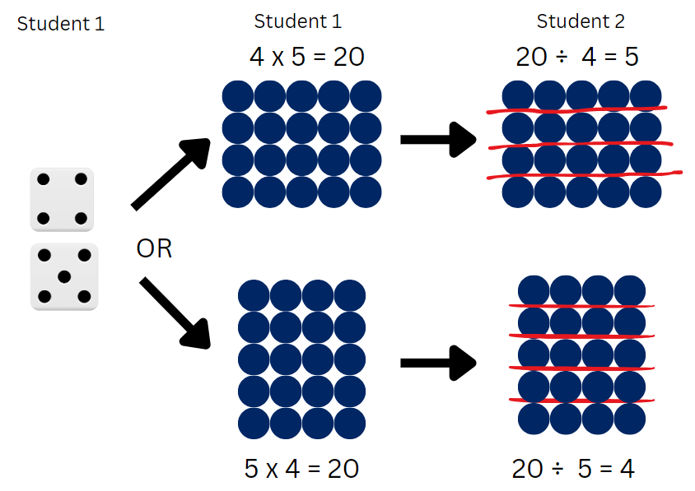
- Students swap roles and repeat the activity.
This table details opportunities for assessment.
Assessment opportunities | Links
What to look for:  - Can students apply the inverse relationship of multiplication and division? [MAO-WM-01, MA2-MR-01, MA2-MR-02] | Links to National Numeracy Learning Progressions (NNLP):  - MuS7.  Links to suggested Interview for Student Reasoning (IfSR) tasks:  - IfSR-MT: 2A.5, 2A.10.

Core lesson 1 – doubling 2, 4 and 8 – 20 minutes
The table below contains suggested learning intentions and success criteria. These are best co-constructed with students.
Core concept learning intentions | Core concept success criteria
Students are learning to:  - use arrays to establish multiplication facts from multiples of 2 and 4, 5 and 10  - use known number facts and strategies. | Students can:  - relate doubling to multiplication facts for multiples of 2  - recognise that doubling is multiplying by 2 and halving is dividing by 2  - recognise the relationship between one multiple and its double  - apply the known strategy of doubling to connect multiples of 4 to 8.
- Students read aloud as the first 10 multiples of 2, 4 and 8 are written on the board, keeping the multiples aligned, as follows:
- Two: 2, 4, 6, 8, 10, 12, 14, 16, 18, 20
- Four: 4, 8, 12, 16, 20, 24, 28, 32, 36, 40.
- Eight: 8, 16, 24, 32, 40, 48, 56, 64, 72, 80.
- Revise the meaning of the words ‘pattern’, ‘multiples’ and ‘product’.
Pattern: a pattern in mathematics is made up of a number of elements that repeat or follow a rule.
Multiples: products are formed using the same base number multiplied by different whole numbers, for example, 3, 6, 9, 12…
Product: the result of multiplying 2 or more numbers together, for example, 12 is the product of 4 × 3.
- Discuss the pattern rule for each row, identifying that the pattern grows by + 2, + 4 and +8 respectively.
- Explain that each multiple is a product of its position in the pattern, for example 1 × 2 = 2, 8 × 2 = 16.
- Students turn and talk to answer:
- What patterns can you see in each multiple list?
- What patterns can you see between each multiple list?
- What do you notice about the final number in each list (20, 40, 80)?
The table below outlines stimulus prompts to generate conversation about the topic, along with anticipated responses from students.
Prompts | Anticipated student responses
- What patterns can you see in each multiple list? | - All multiples: the numbers are all even.  - Twos: 2, 4, 6, 8, 0 for last digit.  - Twos: the tens are repeated every 5 steps.  - Twos: there is a doubles pattern 2, 4, 8, 16.  - Fours: 4, 8, 2, 6, 0 for last digit.  - Fours: the tens are repeated every 5 steps.  - Fours: there is a doubles pattern 4, 8, 16, 32.  - Eights: 8, 6, 4, 2, 0 for the last digit.  - Eights: the tens are repeated every 5 steps.  - Eights: there is a doubles pattern 8,16, 32, 64.
- What patterns do you see between each multiple list? | - Some numbers appear in 2 rows.  - 8 and 16 appear in all 3 rows.  - Two doubles to 4 which doubles to 8.  - Each item in the row doubles if you read the columns down, such as 20, 40, 80 (see Figure 4).  - Each item in the row halves if you read the columns up (see Figure 4).
- What do you notice about the final number in each list? | - They are 10 times the starting number.  - They are 10 twos, 10 fours and 10 eights.  - 20 doubles to 40 doubles to 80 in the same pattern as 2, 4, 10.
Figure 4 – example of responses
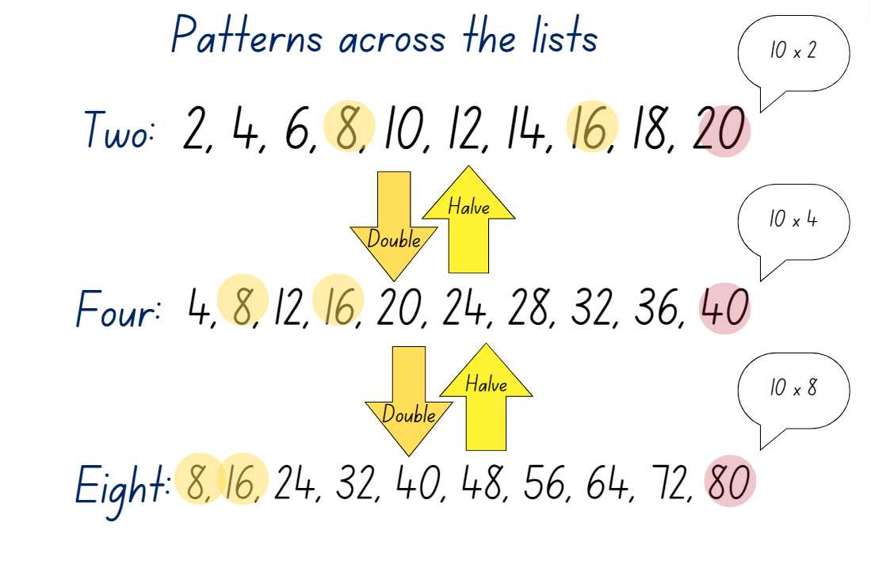
- Explicitly draw out the doubling and halving relationship between the 2 sets of multiples.
- Display Resource 9 – doubles and halves.
- Students turn and talk to discuss the relationships between the arrays and the triangles.
- Select students to share their responses, drawing out the doubling and halving patterns, such as those shown in Figure 5.
Figure 5 – doubling is powerful
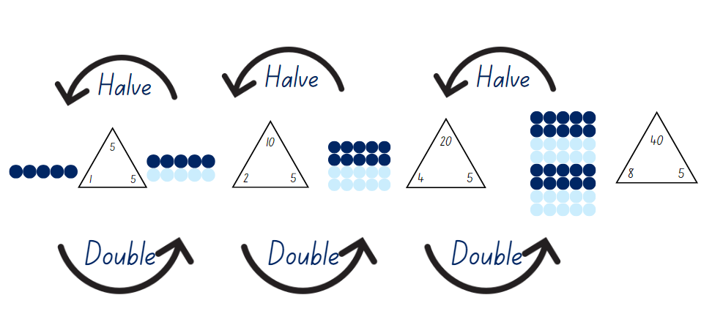
- Repeat the doubling process for other starting numbers, as appropriate for the learning needs in the class.

Core lesson 2 – number strings – 15 minutes
Note: for teachers unfamiliar with the structure and purpose of number strings, read Number strings factsheet (PDF 188 KB) and/or view Number Strings to Encourage Multiplication Strategies Part 1 and Part 2.
- Provide students with individual whiteboards and writing materials.
- Explain that a series of multiplication statements will be displayed for students to calculate. They should use doubling or halving to help with each calculation.
- Use the string displayed in Figure 6 or design one to suit the learning needs of the class.
Figure 6 – sample number string
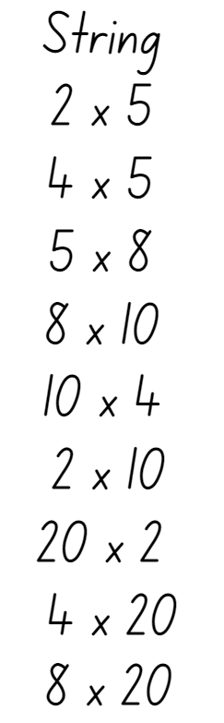
- Display one number sentence at time.
- For each statement, select students to share their response and reasoning. Invite multiple approaches for each statement.
- When moving to the next statement, leave the previous question and answer visible for students to use with the next problem.
This table details opportunities for differentiation.
Too hard? | Too easy?
Students cannot recognise that doubling is multiplying by 2 and halving is dividing by 2.  - Guide students to draw double and double(s) of dot dice patterns.  - Guide students to recreate the whole if given the half. For example: If 3 dots are half, what is the whole? | Students can recognise that doubling is multiplying by 2 and halving is dividing by 2.  - Play the game Double or Halve? from NRICH. Allow students to differentiate the game with choice of target number, selection of dice and/or using 2 or more dice to multiply.  - Provide students with Resource 10 – doubles bingo and the materials needed to play. After more than 5 games, students explain the best 3 numbers to select.

Discuss and connect the mathematics – 10 minutes
- Write the numbers 100, 200, 400 and 800 on the board.
- Students turn and talk to discuss:
- Would you draw arrays to represent these numbers? Why or why not?
- How do these numbers relate to doubling?
- What difference does having the 2 zeros make to doubling?
- What other doubling patterns are bigger than one hundred?
- Select students to share their responses.
This table details opportunities for assessment.
Assessment opportunities | Links
What to look for:  - Can students relate doubling to multiplication facts for multiples of 2? [MAO-WM-01, MA2-MR-01]  - Can students recognise that doubling is multiplying by 2 and halving is dividing by 2? [MAO-WM-01, MA2-MR-01]  - Can students recognise the relationship between one multiple and its double? [MAO-WM-01, MA2-MR-01]  - Can students apply the known strategy of doubling to connect multiples of 4 to 8? [MAO-WM-01, MA2-MR-01] | Links to National Numeracy Learning Progressions (NNLP):  - MuS6  - InF2, InF6.  Links to suggested Interview for Student Reasoning (IfSR) tasks:  - IfSR-MT: 2A.2, 2A.4, 2A.6.

Lesson 4
Core concept: flexible methods of computation in multiplication and division involve composing and decomposing numbers.

Daily number sense – 10 minutes
- From a class need surfaced through formative assessment data, identify a short, focused activity that targets students’ knowledge, understanding and skills. Example activities may be drawn from the following resources:
- Mathematics K–6 resources
- Universal Resources Hub.

Core lesson – tackling times tables – 40 minutes
The table below contains suggested learning intentions and success criteria. These are best co-constructed with students.
Core concept learning intentions | Core concept success criteria
Students are learning to:  - recall multiplication facts of 2 and 4, 5 and 10 and related division facts  - use number properties to find related multiplication facts. | Students can:  - recognise and use the symbols for multiplied by (×), divided by (÷) and equals (=)  - use the commutative property of multiplication  - use flexible partitioning within multiplication.
This activity is an adaptation of ‘Tackling tables’ from Maths300 by Australian Association of Mathematics Teachers (AAMT) Inc.
- Display Resource 11 – arrays. Explain that each pair of arrays is the same but has been rotated 90 degrees.
- On individual whiteboards, students record the fact family with 4 number sentences for Set A.
- Students share their completed boards with a partner and discuss any differences.
- Select students to share their responses and record on the board.
- Repeat the process for each set on Resource 11 – arrays.
- Display Resource 12 – plug board examples. Explain that in some classes, students use plug boards to represent arrays. The blue circles can be flipped around to the yellow side, so they are not counted in the array.
- Ask students:
- How is this different to the way you represent arrays? (Limited to 5 by 5 instead of 10 by 10.)
- What are some arrays that can be represented on a single board? (Arrays up to 5 by 5.)
- What is the smallest/largest array? (1 by 1; 5 by 5.)
- What is an array that cannot be represented? (For example, 6 by 5.)
- How could students represent multiplication facts to 10 by 10? (By combining boards.)
- Display Resource 13 – combined plug boards. Say that some students have combined their boards to represent arrays larger than 5 by 5.
- Discuss whether Set D and Set F are arrays. Explain that they are not because the blue plugs are not arranged into equal rows.
- Provide students with individual whiteboards and ask:
- What arrays are represented in Set A, B, C and E?
- What is a different array that would need 2 boards to show it?
- Is there an array that would need 3 boards to show it?
- How many boards would you need to show…?
- Display Resource 14 – prove it’s 36. Discuss how 4 boards are used to represent 6 rows of 6.
- Students turn and talk to share ways they see the arrays.
- Explain that known facts can be built on to learn and remember new ones, for example 5 × 6 is the same as 5 × 5 and 5 × 1 because 6 can be split into 5 and 1.
- Select students to share responses and record them on the board, such as 6 × 5 + 1 × 6 = 36.
- Display Resource 15 – plug boards. Students turn and talk to answer:
- Using one tile, what multiplication facts can be represented in arrays?
- Using only 2 tiles, what multiplication facts can be represented in arrays?
- Using 3 or 4 tiles, what multiplication facts can be represented in arrays?
- Select students to share responses and record them on the board.
- Provide students with copies of Resource 15 – plug boards, scissors and writing materials.
- Students cut the plug board tiles out. Then combine them to make multiplication facts larger than 5 by 5.
- Students draw array tiles and write number sentences in their workbook.
This table details opportunities for differentiation.
Too hard? | Too easy?
Students cannot use flexible partitioning within multiplication.  - Make arrays using one or two plugboard tiles and recreate using counters. Record number sentences to match the arrays.  - Make a 5 × 5 array using concrete materials. Students split a row off to show 4 × 5 and 1 × 5. Establish that the total is the same. Students draw and write the matching number sentences. Students repeat the steps with other arrays. | Students can use flexible partitioning within multiplication.  - Students identify multiplication facts to 100 that cannot be created using the tiles on Resource 15 – plug boards. Students make the tiles needed to recreate those facts.  - Students draw an array, such as 8 by 8. Students draw lines through the array to show how it can be decomposed into other facts. Students represent the same array in at least 3 ways and record matching number sentences, such as Figure 7.
Figure 7 – decomposing 8 × 8
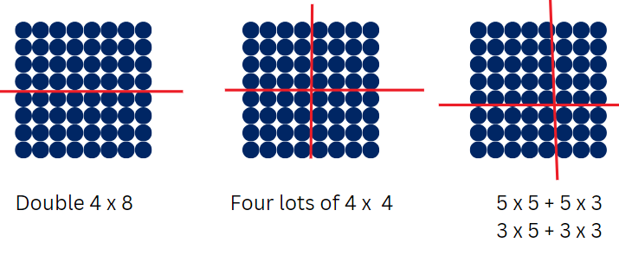

Discuss and connect the mathematics – 10 minutes
- Select students to share an array that uses 2, 3, or 4 plugboard tiles. Record an example of each on the board.
- Ask students if there is anything that they noticed during the activity.
- Ask students if there is anything that they are still wondering about doubling or halving.
This table details opportunities for assessment.
Assessment opportunities | Links
What to look for:  - Can students recognise and use the symbols for multiplied by (×), divided by (÷) and equals (=)? [MAO-WM-01, MA2-MR-02]  - Can students use the commutative property of multiplication? [MAO-WM-01, MA2-MR-01, MA2-MR-02]  - Can students use flexible partitioning within multiplication? [MAO-WM-01, MA2-MR-01] | Links to National Numeracy Learning Progressions (NNLP):  - MuS5, MuS6, MuS7.  Links to suggested Interview for Student Reasoning (IfSR) tasks:  - IfSR-MT: 2A.9.

Lesson 5
Core concept: collections can be partitioned in more than one way.

Daily number sense – how much change? – 10 minutes
Daily number sense activities for Lessons 5 to 7 ‘loop’ back to concepts and procedures covered in previous units to assist students to build an increasingly connected network of ideas. These concepts may differ from the core concepts being covered by the unit.
The table below contains a suggested learning intention and success criteria. These are best co-constructed with students.
Daily number sense learning intention | Daily number sense success criteria
Students are learning to:  - represent money values in multiple ways. | Students can:  - recognise the relationship between dollars and cents  - represent equivalent amounts of money using different denominations  - perform calculations with money, including finding change.
This activity is an adaptation of ‘What might the change have looked like?’ from Open-Ended Maths Activities: Using Good Questions to Enhance Learning Mathematics by Sullivan and Lilburn. Provide play money to students if available.
- Display the following problem: I gave change of $1 using 20c, 10c and 5c coins. What might the change have looked like?
- In pairs, students use whiteboards to find different ways to make change of $1 using 20c, 10c and 5c coins.
- Ask:
- How many ways did you and your partner make change of $1 using the coins?
- Which combination of coins was the most efficient, or had the least coins?
- Which combination of coins was the least efficient, or had the most coins?
- What strategies and number combinations did you and your partner use to help you?
This table details opportunities for assessment.
Assessment opportunities | Links
What to look for:  - Can students recognise the relationship between dollars and cents? [MAO-WM-01, MA2-AR-01]  - Can students represent equivalent amounts of money using different denominations? [MAO-WM-01, MA2-AR-01]  - Can students perform calculations with money, including finding change? [MAO-WM-01, MA2-AR-01] | Links to National Numeracy Learning Progressions (NNLP):  - UnM2, UnM3, UnM4, UnM5, UnM6.

Core lesson – bakery partitioning – 40 minutes
The table below contains a suggested learning intention and success criteria. These are best co-constructed with students.
Core concept learning intention | Core concept success criteria
Students are learning to:  - use number properties to find related multiplication facts. | Students can:  - use flexible partitioning within multiplication.
This activity is an adaptation of Multiplication: reSolve Bakery from reSolve: Maths by Inquiry by Australian Government Department of Education.
- Display Resource 16 – How many cupcakes? and introduce the problem to the class. Ask:
- How many cupcakes can be baked at one time in this tin?
- How do you know?
- Allow different responses and different ways of seeing the 24 spaces in the cupcake tray. For example:
- partitioning into rows of 6 and multiplying it by the 4 columns
- counting by 2 across the top 2 rows to total 12, then doubling it.
- Display and read Resource 17 – a special order. Do not take answers from students at this point.
- Provide pairs of students with 3 or more copies of Resource 17 – a special order and a large sheet of paper or VNPS.
- Say that counting the cupcakes by ones is not an efficient strategy and to look for efficient ways to find the total.
- Explain that students can partition the collection into smaller groups to make it easier to find the total, as they did with the 24 spaces in the cupcake tray. They will record these on a poster to explain how their strategies work.
- Students solve the problem and present their solution as a poster that shows how they solved the problem.
Note: the goal at this point is to not direct students to use particular strategies, but to allow them to explore their own way of solving the problem. The strategies used by students will be diverse and will reveal a lot about their understanding of multiplication and their fluency.
Counting is the most basic strategy. Link skip counting with repeated addition and then with multiplication. Students using tens can consider the number of tens in each section to reinforce the connection between counting by tens and multiples of 10, see Figure 8.
Figure 8 – counting strategies
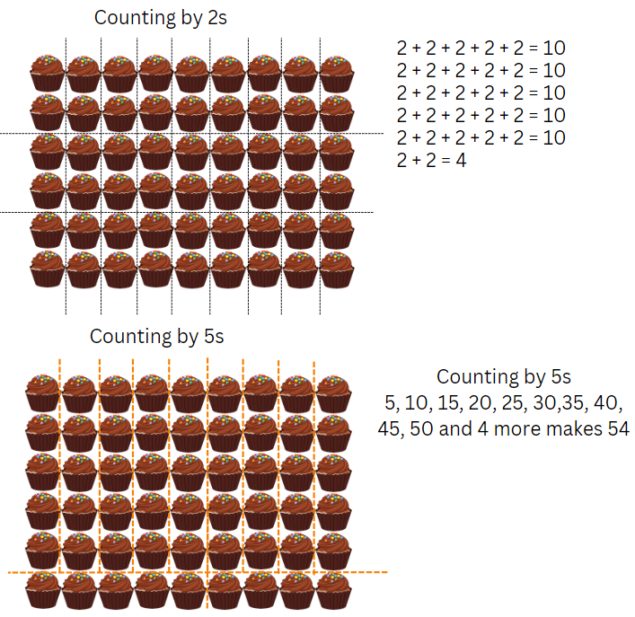
Note: one strategy involves partitioning the array into smaller sections, then multiplying to find the number of cupcakes in each section. This applies the distributive property: a × (b + c) = (a × b) + (a × c), see Figure 9.
Figure 9 – distributive strategies
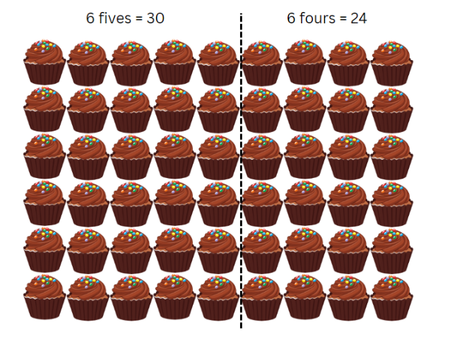
Note: compensation involves making a ‘friendlier’ number of rows or columns, by extending the array and later subtracting. This is another use of the distributive property of multiplication. See Figure 10.
Figure 10 – compensation
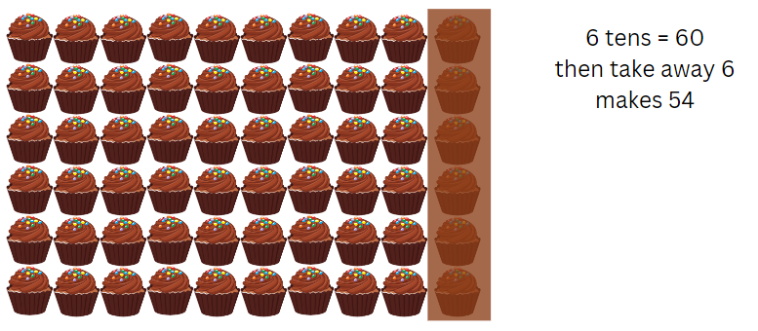
Note: Figure 11 uses doubling. Repeated doubling using multiplication uses the associative property. To multiply by 4, first multiply by 2, then 2 again. The associative property can be used with factors of numbers. a × (b × c) = (a × b) × c.
Figure 11 – doubling with addition
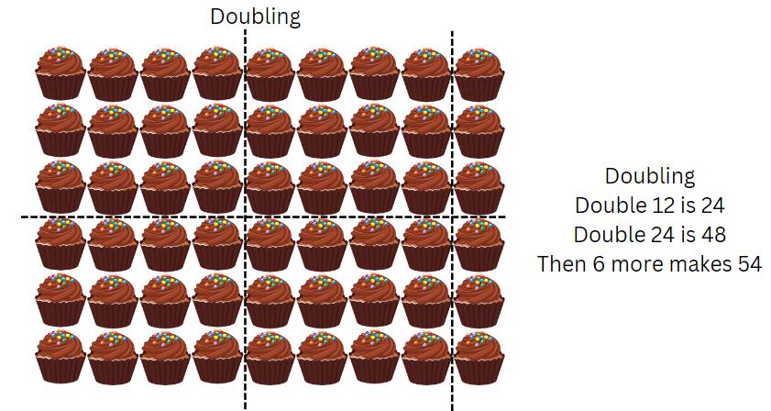
This table details opportunities for differentiation.
Too hard? | Too easy?
Students cannot use flexible partitioning within multiplication.  - Support students by making the problem smaller. Ask them to consider how many cupcakes are on 2 trays of 24. Model how to use a smaller partition they are familiar with to find the total of the cupcakes on 2 trays.  - Once students have found an answer for 2 trays, support them to build up to 4 and 8 trays. | Students can use flexible partitioning within multiplication.  - Explain that Charlie has been asked to donate 96 muffins for the local school fete. What combinations of his special tin (6 muffins) and his regular tin (24 muffins) could he use to bake these muffins? For example, 4 regular trays. Ask students how to find all the possible combinations.  - Provide students with copies of Resource 18 – busy cupcake day. Pose the problem: On a very busy day, Charlie baked 12 regular trays of cupcakes for a large catering order. How many cupcakes are there altogether? Students create a poster to show their thinking.

Discuss and connect the mathematics – 10 minutes
- Select students to present their work to the class. Discuss and connect their strategies by asking:
- In what ways are these strategies similar and different? (Highlight the connections between strategies.)
- How efficient are the different strategies?
- How well would each strategy work with a different set of numbers? (For example, doubling works well with 4, but not with 7. Multi-digit numbers can be partitioned based on their place-value parts, for example, 24 = 20 + 4.)
- Display students’ posters to refer to in future lessons.
This table details opportunities for assessment.
Assessment opportunities | Links
What to look for:  - Can students use flexible partitioning within multiplication?  [MAO-WM-01, MA2-MR-01, MA2-MR-02] | Links to National Numeracy Learning Progressions (NNLP):  - MuS7.

Lesson 6
Core concept: multiplication and division are related.

Daily number sense – equivalent change – 10 minutes
The table below contains a suggested learning intention and success criteria. These are best co-constructed with students.
Daily number sense learning intention | Daily number sense success criteria
Students are learning to:  - represent money values in multiple ways. | Students can:  - recognise the relationship between dollars and cents  - represent equivalent amounts of money using different denominations  - perform calculations with money, including finding change.
This activity is an adaptation of ‘Equivalent change’ from Open-Ended Maths Activities: Using Good Questions to Enhance Learning Mathematics by Sullivan and Lilburn. Provide play money to students, if available.
- Display the following problem: Show some different ways to give change from $2 for an item costing $1.35.
- In pairs, students use whiteboards to record different ways to give the required change. Ask:
- How did you work out the amount of change that was given from $2?
- How many ways did you and your partner make the change?
- Which combination of coins was the most efficient, or had the least coins?
- Which combination of coins was the least efficient, or had the most coins?
- What strategies and number combinations did you and your partner use to help you?
This table details opportunities for assessment.
Assessment opportunities | Links
What to look for:  - Can students recognise the relationship between dollars and cents? [MAO-WM-01, MA2-AR-01]  - Can students represent equivalent amounts of money using different denominations? [MAO-WM-01, MA2-AR-01]  - Can students perform calculations with money, including finding change? [MAO-WM-01, MA2-AR-01] | Links to National Numeracy Learning Progressions (NNLP):  - UnM2, UnM3, UnM4, UnM5, UnM6.

Core lesson 1 – sharing 36 – 20 minutes
The table below contains suggested learning intentions and success criteria. These are best co-constructed with students.
Core concept learning intentions | Core concept success criteria
Students are learning to:  - recall multiplication facts of 2 and 4, 5 and 10 and related division facts  - represent and solve problems involving multiplication fact families. | Students can:  - recognise and use the symbols for multiplied by (×), divided by (÷) and equals (=)  - link multiplication and division fact families using arrays  - apply the inverse relationship of multiplication and division (Reasons about relations).
This activity is an adaptation of ‘Sharing crackers’ from Mindset Mathematics: Visualizing and Investigating Big Ideas, Grade 3 by Boaler et al.
- Display 36 counters, square tiles or Resource 19 – sharing crackers. Say that they represent crackers that need to be shared equally for a snack. Pose the questions:
- How many students can share the crackers?
- How many crackers will each student get?
- Point out that there are many answers to this task.
- Provide pairs of students with 36 counters, square tiles or a copy of Resource 19 – sharing crackers to answer the 2 questions in multiple ways.
- Students record each solution in pictures and number sentences using divided by (÷) and equals (=).
- Students also record any attempts that do not work, showing why it did not lead to equal shares.
Note: as students work, draw their attention to the ways they are thinking about their solutions to generate new solutions. For example, students may use the commutative property to turn the solution of 4 students with 9 crackers each into 9 students with 4 crackers each. Students might use a doubling and halving pattern to move from 2 students with 18 crackers each to 18 students with 2 crackers each. Each of these is useful in finding solutions and looking for possible missing solutions. Further, these patterns apply to all multiplication and division relationships and are worth testing, sharing and discussing. Ask students if these patterns always work and why.

Core lesson 2 – sharing solutions – 20 minutes
- Share and discuss student solutions.
- Organise the solutions by displaying them in the table on Resource 20 – sharing solutions.
The table below outlines stimulus prompts to generate conversation about the topic, along with anticipated responses from students.
Prompts | Anticipated student responses
- Have you found all the ways of sharing 36 crackers? Why or why not? | - Yes, because we have worked systematically through all the options (factors) in order from 1 through to 18.
- How could you organise the solutions you have found to see patterns? | - Put them in order of factors starting with one.
- What patterns do you notice in the solutions you found? | - As the number of students increases, the number of crackers each student gets decreases.  - There are some facts reversed after 6 by 6, such as 4 students have 9 crackers, or 9 students have 4 crackers each.
- Do these patterns always work? Convince me. | - Yes, in multiplication, if one factor increases, the other factor will decrease.  - Student explanations will vary based on examples from known multiplication facts.
This table details opportunities for differentiation.
Too hard? | Too easy?
Students cannot link multiplication and division fact families using arrays.  - Model how to arrange the 36 crackers in an array, then share them equally between different numbers of students.  - Support students to look for connections between multiplication and division fact families in their results. | Students can link multiplication and division fact families using arrays.  - Students test the patterns found when sharing a different number of crackers, such as 24, 32 or 48.  - Partners explore the question: How do you know when you have found all possible solutions?

Discuss and connect the mathematics – 10 minutes
- Display Resource 20 – sharing solutions and discuss the following questions:
- What patterns did you notice?
- Have we found all the solutions? How do you know?
Note: when students discuss the patterns they notice and the strategies they used, take this opportunity to name what they have been doing. Breaking a large group into smaller equal sized groups is division. Some students will have used multiplication to help them by making equal groups to build up to this total. If students do not yet have the language to describe these concepts, this is an opportunity to label and explain clearly. Highlight how multiplication and division are related and both can be used to think about making equal groups.
This table details opportunities for assessment.
Assessment opportunities | Links
What to look for:  - Can students recognise and use the symbols for multiplied by (×), divided by (÷) and equals (=)? [MAO-WM-01, MA2-MR-01,  MA2-MR-02]  - Can students link multiplication and division fact families using arrays? [MAO-WM-01, MA2-MR-01, MA2-MR-02]  - Can students apply the inverse relationship of multiplication and division (Reasons about relations)? [MAO-WM-01, MA2-MR-01, MA2-MR-02] | Links to National Numeracy Learning Progressions (NNLP):  - MuS5, MuS6, MuS7  - NPA4.  Links to suggested Interview for Student Reasoning (IfSR) tasks:  - IfSR- MT: 2A.5, 2A.10.

Lesson 7
Core concept: fact families support fluency.

Daily number sense – missing number sentence – 15 minutes
The table below contains a suggested learning intention and success criteria. These are best co-constructed with students.
Daily number sense learning intention | Daily number sense success criteria
Students are learning to:  - represent money values in multiple ways. | Students can:  - recognise the relationship between dollars and cents  - represent equivalent amounts of money using different denominations  - perform calculations with money, including finding change.
This activity is an adaptation of ‘Missing number sentence’ from Open-Ended Maths Activities: Using Good Questions to Enhance Learning Mathematics by Sullivan and Lilburn. Provide students with play money, if available.
- Display the following problem: A number sentence uses at least 2 of these amounts: $1.50, $2, $6, 50c, $3.75, $3.00, 75c. What might the number sentence be?
- In pairs, students use whiteboards to create different number sentences using at least 2 of the amounts or numbers provided.
- Ask:
- What number sentences did you and your partner make?
- Which operations did you use?
- Did you use more than one operation in a number sentence?
- Which operations did you find the easiest to make a number sentence with?
- Were there any operations you could not make a number sentence with?
- Which number sentences might represent giving change? Why?
This table details opportunities for assessment.
Assessment opportunities | Links
What to look for:  - Can students recognise the relationship between dollars and cents? [MAO-WM-01, MA2-AR-01]  - Can students represent equivalent amounts of money using different denominations? [MAO-WM-01, MA2-AR-01]  - Can students perform calculations with money, including finding change? [MAO-WM-01, MA2-AR-01, MA2-AR-02] | Links to National Numeracy Learning Progressions (NNLP):  - UnM2, UnM3, UnM4, UnM5, UnM6.

Core lesson 1 – missing numbers – 15 minutes
The table below contains suggested learning intentions and success criteria. These are best co-constructed with students.
Core concept learning intentions | Core concept success criteria
Students are learning to:  - recall multiplication facts of 2 and 4, 5 and 10 and related division facts  - represent and solve word problems with number sentences involving multiplication or division. | Students can:  - generate multiplication fact families for multiples of 2 and 4, 5 and 10  - use the equals sign to record equivalent number relationships involving multiplication  - complete number sentences involving multiplication and division by calculating missing numbers.
Note: the syllabus support material explains fluency in this way: Students’ communication of their understanding reveals their mathematical fluency. Mathematical fluency is developed when students choose and use appropriate strategies; carry out procedures flexibly, accurately and efficiently; recall factual knowledge and concepts to solve problems; and use known facts, and reason about relationships to find solutions (NESA 2023).
- Display and read Resource 21 – missing numbers.
- Select a known multiplication fact such as 2 × 9 and draw the related fact family triangle.
- Present the fact family in a variety of number sentences with missing values. For example:
- 18 = 9 × ♣
- 2 × ♥ = 18
- 18 ÷ ♣ = 9
- 18 ÷ ♥ = 2.
- Students identify another fact families with 18 as the product, such as 6 × 3.
- Model recording the equation 2 × 9 = 6 × 3.
- Remind students that the equals sign means both sides have equivalent value.
- Students identify any other fact family triangle with 2 as a factor, such as 2, 6 and 12.
- Model recording the equation 18 ÷ 9 = 12 ÷ 6.
Note: to support students to master multiplication facts, identify known and unknown facts, explicitly teach strategies applicable to unknown facts (such as for 6 times – multiply by 5 and add one more set) and provide engaging activities that emphasise collaboration (Van de Walle et al. 2019).

Core lesson 2 – games for practise/fluency/mastery – 25 minutes
Some of the resources in this unit have been adapted from other sources. There are many other engaging and purposeful games for operations, including multiplication and division on the Love Maths website by Minas.
- Play games that promote fluency of multiplication facts. Games should focus on revising known fact families and adding a few new facts (that are worked out using a strategy) at a time.
- For each activity discuss reasoning strategies that can help students learn new facts based on existing knowledge.
- Resource 10 – doubles bingo, Resource 22 – Salute! and Resource 23 – fill the chart are examples of multiplicative games that can be differentiated for students.
- Digital activities that allow students to focus on a targeted groups of related facts include:
- Fun for the Brain – multiplication games
- Maths is Fun – Math Trainer - Multiplication.
- Divide the class into groups to play one of the multiplication games that is suited to their learning needs.
- As they play the game, select students to pause and record the fact family triangle for the fact that they are up to in the game.
This table details opportunities for differentiation.
Too hard? | Too easy?
Students cannot generate multiplication fact families for multiples of 2 and 4, 5 and 10 and/or use the equals sign to record equivalent number relationships involving multiplication.  - For part 1, students make their own set of fact family cards for a target set of facts, including dot arrays that match the facts. Students have their cards visible when playing Salute! or Fill the chart.  - For part 2, provide students with a set of 12 counters. Guide students to make and record differing sets of equal groups, such as 6 twos or 3 fours. Model how to write those as equivalent number sentences: 6 × 2 = 3 × 4. Students find all groupings for 12 and then do the same for 16, 20 and 24. | Students can generate multiplication fact families for multiples of 2 and 4, 5 and 10 and/or use the equals sign to record equivalent number relationships involving multiplication.  - Students can apply known facts and game strategy with the NCTM Product Game.  - Students explore the connection between multiplication and division, with Resource 24 – Open Middle problem.

Discuss and connect the mathematics – 5 minutes
- Display a fact family triangle for 6 × 7 = 42.
- Discuss what known facts could be used to work this out, such as 5 × 7 plus one more 7, or double 3 × 7.
- Students turn and talk to share missing values and equivalent number sentences related to that family fact triangle.
- Select students to share their responses and record them on the board. Examples include:
- 42 = 7 × Δ
- 6 × ♥ = 42
- 42 ÷ Δ = 7
- 42 ÷ ♥ = 6
- 18 ÷ 3 = 42 ÷ 7
- 6 × 7 = 3 × 2 × 7 = 3 × 14.
This table details opportunities for assessment.
Assessment opportunities | Links
What to look for:  - Can students generate multiplication fact families for multiples of 2 and 4, 5 and 10? [MAO-WM-01, MA2-MR-01, MA2-MR-02]  - Can students use the equals sign to record equivalent number relationships involving multiplication? [MAO-WM-01, MA2-MR-01, MA2-MR-02]  - Can students complete number sentences involving multiplication and division by calculating missing numbers? [MAO-WM-01,  MA2-MR-01, MA2-MR-02] | Links to National Numeracy Learning Progressions (NNLP):  - MuS6  - NPA4.  Links to suggested Interview for Student Reasoning (IfSR) tasks:  - IfSR-MT: 2A.11.

Lesson 8
Core concept: problems can be solved using multiplicative thinking.

Daily number sense – 10 minutes
- From a class need surfaced through formative assessment data, identify a short, focused activity that targets students’ knowledge, understanding and skills. Example activities may be drawn from the following resources:
- Mathematics K–6 resources
- Universal Resources Hub.

Core lesson – multiplicative problem solving – 40 minutes
The table below contains suggested learning intentions and success criteria. These are best co-constructed with students.
Core concept learning intentions | Core concept success criteria
Students are learning to:  - represent and solve problems involving multiplication fact families  - represent and solve word problems with number sentences involving multiplication or division. | Students can:  - describe multiplication problems using for each and times as many  - represent and solve multiplication and division (both sharing and grouping) word problems using number sentences.
- Explain that multiplication can be used to solve a range of problems. For this lesson focus will be on the phrases times as many, much and for each.
- Display and discuss Resource 25 – word problems.
- Students turn and talk to discuss:
- What are some other for each questions we could write with the same fact family?
- What are some other times as many questions we could write with the same fact family?
- What are some other fact families we could use to change the questions?
- How would those questions read with a new fact family?
- Select students to share their thinking.
- Explain the scenario: Students are organising equipment for the school athletics carnival.
- Brainstorm a list of equipment that may be required, such as cones, ribbons, hurdles, relay batons and items for novelty races such as an obstacle course.
- Display and read Resource 26 – How many ribbons?
- Explain that it is not known how many races there will be for each age group as the number of students is not the same.
- Focus on the phrase for each, linking it explicitly to multiplication.
- Revise how to build an array for unknown facts with arrays, such as in Figure 12.
Figure 12 – building new facts
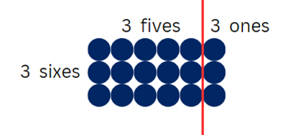
- Group students into threes, using VNPS or individual whiteboards to explore at least 3 possible numbers of ribbons.
- Share student responses.
- Display and read Resource 27 – How many cones?
Note: students may not realise that they will need an extra row of cones than there are lanes. For example, with 4 lanes they will need 5 rows of cones.
- Return students to their groups to explore at least 3 possible results.
- Share student responses.
This table details opportunities for differentiation.
Too hard? | Too easy?
Students cannot describe multiplication problems using for each and times as many.  - Provide concrete materials for students to make arrays to represent the for each and times as many ideas.  - Students focus on examples where multiples of 2, 4, 5 and 10 are used. Students draw pictures or arrays to show their thinking and calculations. | Students can describe multiplication problems using for each and times as many.  - Students create a novelty event for the carnival. Students write other for each and times as many questions for other athletics carnival events.  - For ‘How many cones?’ Students show all possible combinations of cones in a system like a table in Lesson 1.

Discuss and connect the mathematics – 5 minutes
- Display Resource 28 – four arrays.
- Students turn and talk to discuss:
- What patterns do you see? (A doubling pattern.)
- How does an array show the for each idea of multiplication? (There are x counters for each row; there are x counters for each column.)
- How do the arrays show the times as many idea of multiplication? (For example, Array D has 8 times as many as Array A.)
This table details opportunities for assessment.
Assessment opportunities | Links
What to look for:  - Can students describe multiplication problems using for each and times as many? [MAO-WM-01, MA2-MR-01, MA2-MR-02]  - Can students represent and solve multiplication and division (both sharing and grouping) word problems using number sentences? [MAO-WM-01, MA2-MR-01, MA2-MR-02] | Links to National Numeracy Learning Progressions (NNLP):  - NPA4.  Links to suggested Interview for Student Reasoning (IfSR) tasks:  - IfSR-MT: 2A.12, 2A.13, 2A.14.

Resource 1 – How many books?
- Isaac has read 6 books, but Chris has read 4 times as many. How many books has Chris read?
- Sam has read 7 books. Imogen has read twice as many as Sam. Jamie has read twice as many as Imogen. How many books have they each read?
- Chanel put the books she had read on the floor. There were 4 rows of 8 books. How many books has she read?
- Before recess Max laid out his books on the floor in 5 equal rows. When he returned, some of his books had been borrowed by someone else. By looking at the remaining books in the picture, how many books did Max start with?
- How many books have Isaac, Chris, Chanel, Sam, Imogen, Jamie and Max read altogether?
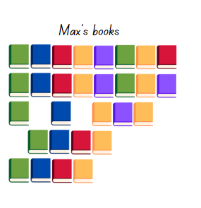

Resource 2 – pattern table
Sum of 10 | Product
0 + 10 | 0 × 10 = 0
1 + 9 | 1 × 9 = 9
2 + 8 | 2 × 8 = 16
3 + 7 | 3 × 7 = 21
4 + 6 | 4 ×
5 + 5 | 5 ×
6 + 4 | 6 ×
7 + 3 | 7 ×
8 + 2 | 8 ×
9 + 1 | 9 ×
10 + 0 | 10 ×

Resource 3 – caught red-handed
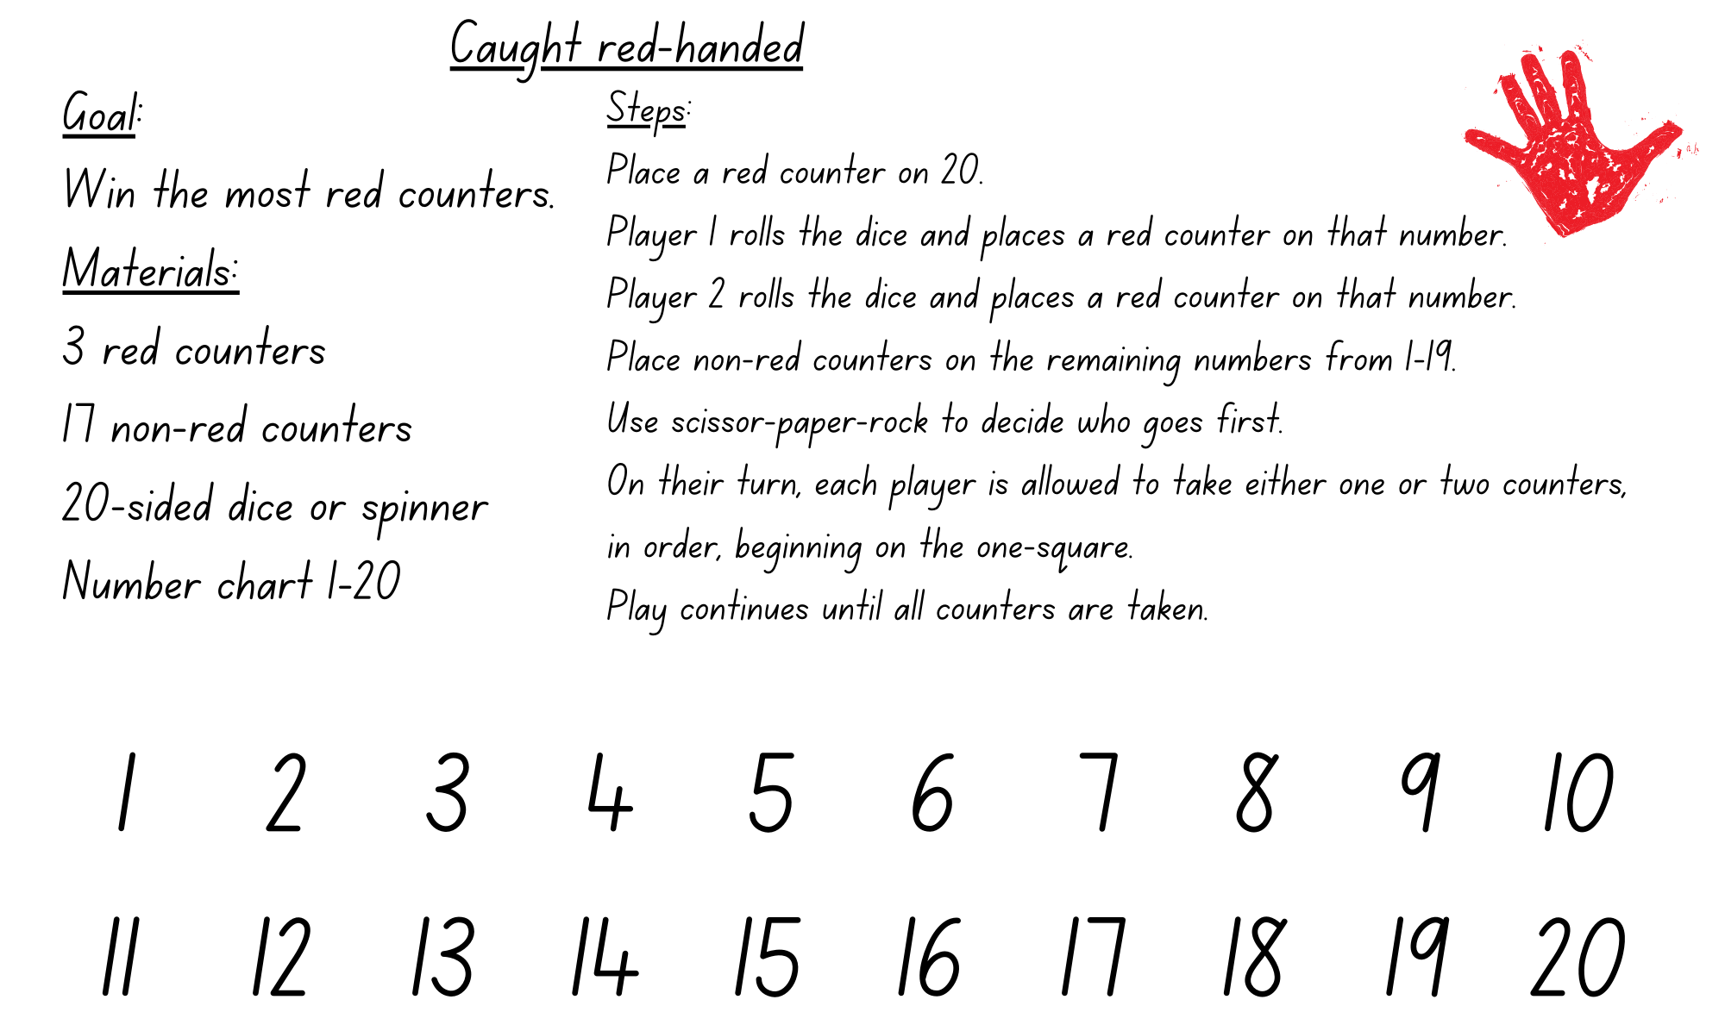
Adapted from Russo (2017).

Resource 4 – red-handed questions
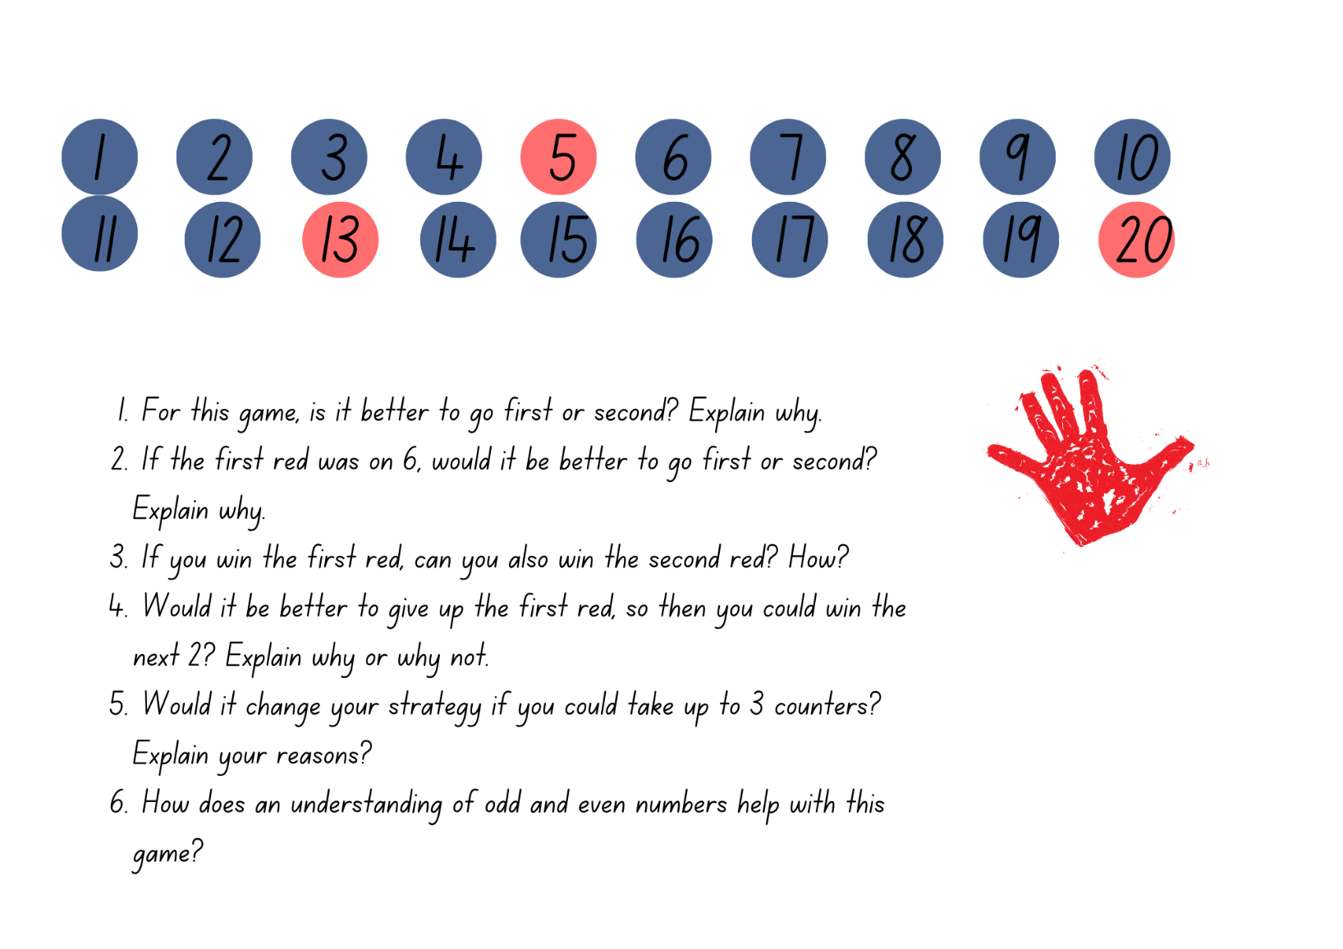
Adapted from Russo (2017).

Resource 5 – splats
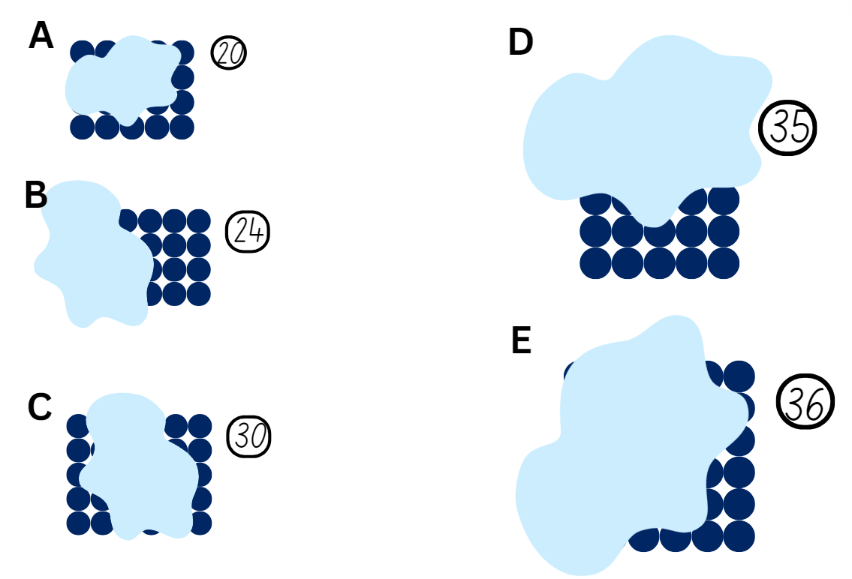
Adapted from Wyborney (2017).

Resource 6 – partially covered arrays
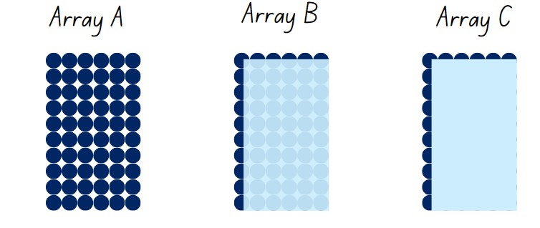

Resource 7 – matching cards
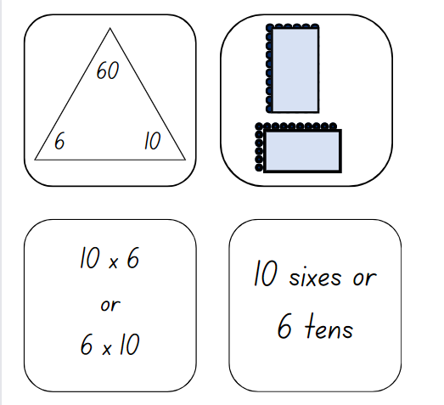

Resource 8 – matching card templates
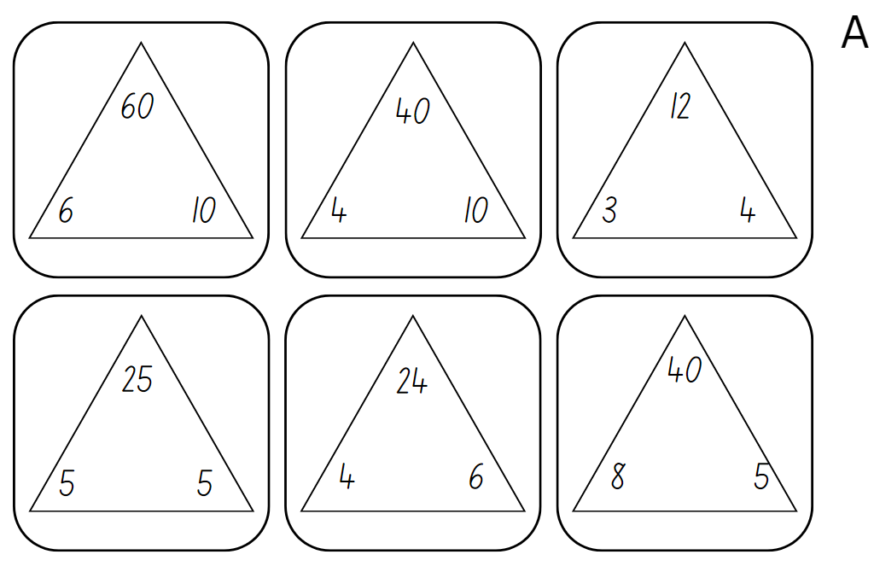
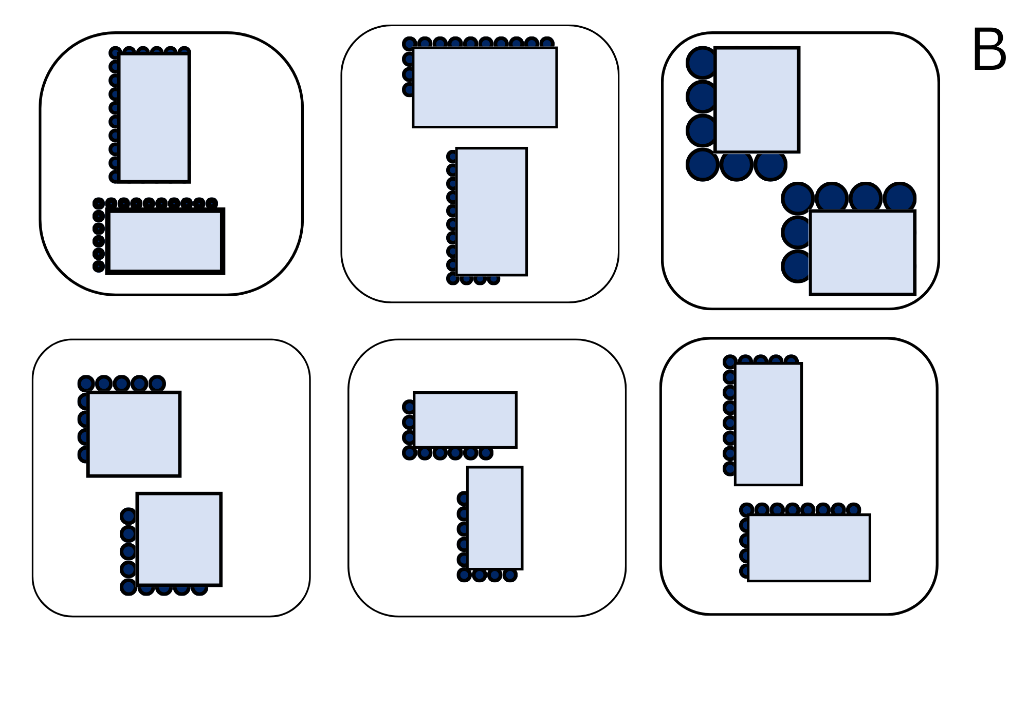
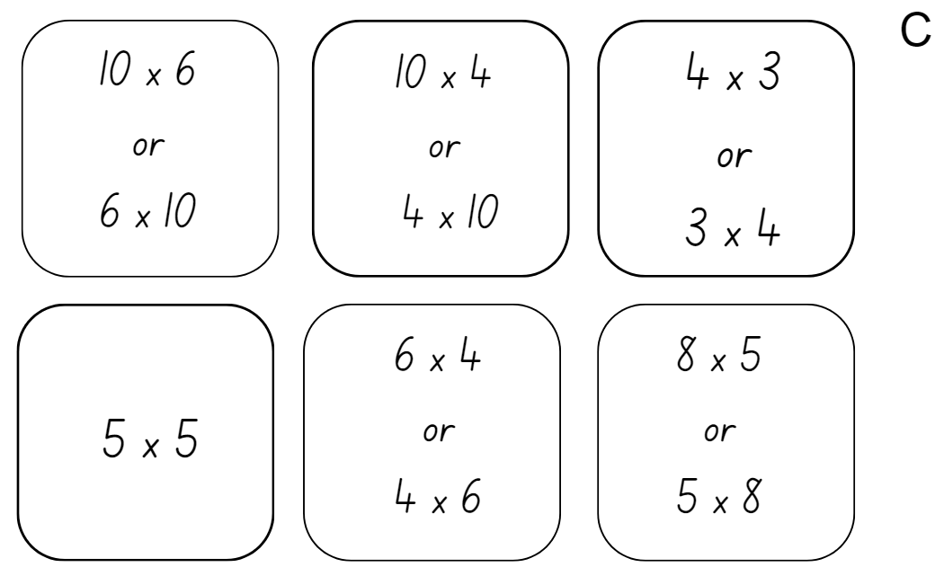

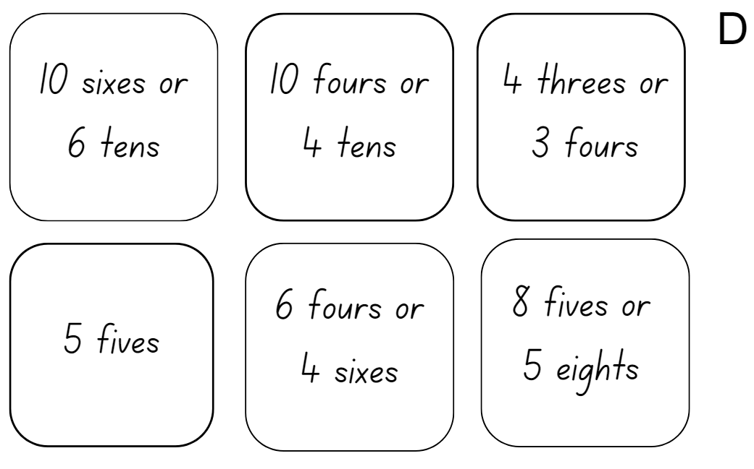

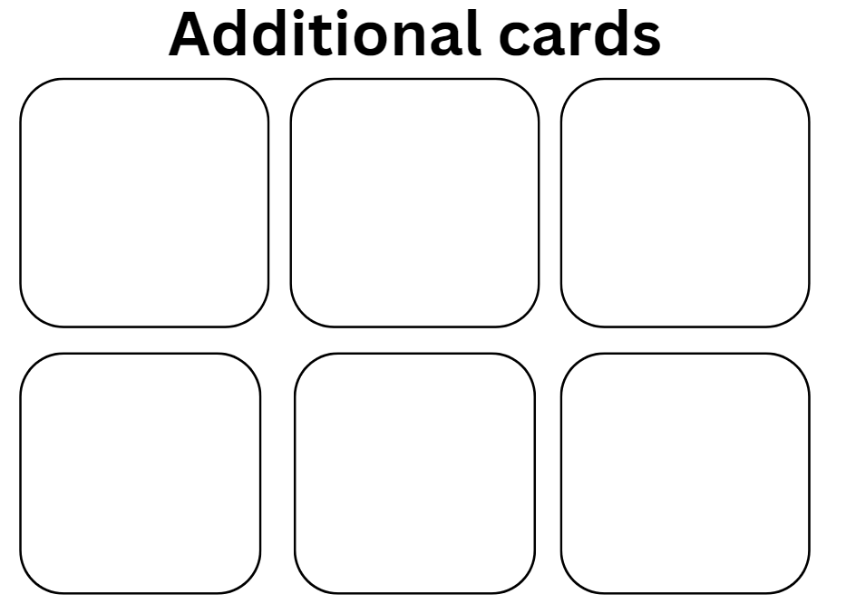

Resource 9 – doubles and halves
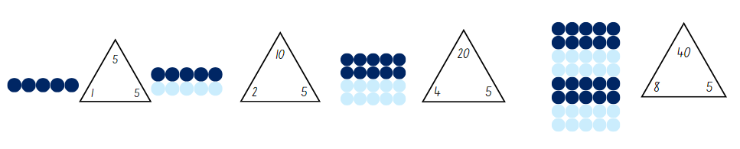

Resource 10 – doubles bingo
Aim: to be the first player to remove their counters from the board.
Materials
- Number chart to 120
- Dice (either 1–6, 1–10, 1–20)
- 3 coloured counters per player
Steps
- Take turns to place your counters on 3 numbers greater than 20 on the number chart.
- Player 1 rolls the die and repeatedly doubles the number until a counter is reached or the highest number is passed. For each roll, write a number chain to show your doubling, for example: 2, 4, 6, 8, 16, 32, 64.
- Players take turns rolling and doubling. Play continues until one player removes all 3 of their own counters.
Variations
- Choose a die that suits you.
- Choose numbers between 10 and 50.
- If a player rolls a 1, they may move a counter to a different number.
Adapted from Russo (2016).

Resource 11 – arrays
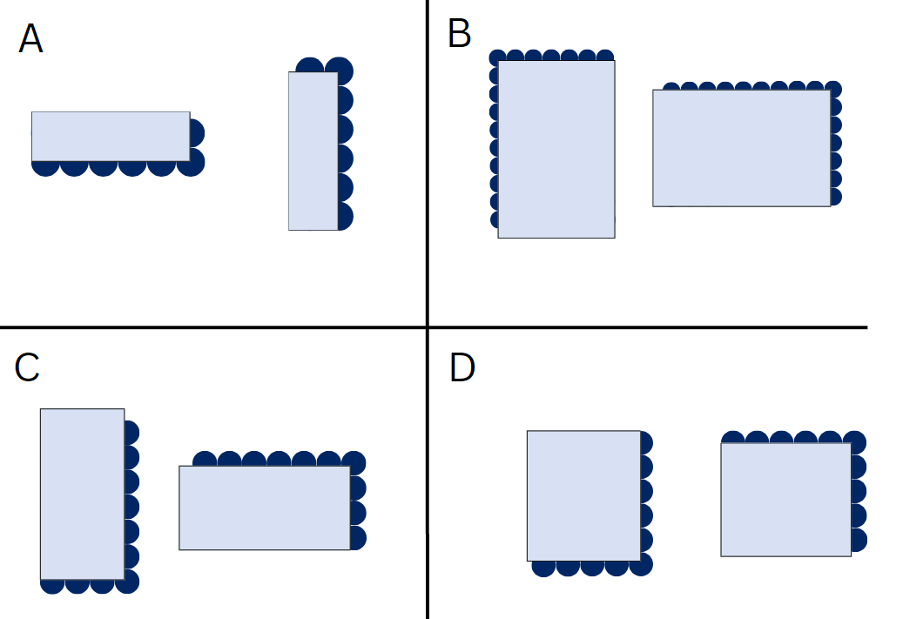

Resource 12 – plug board examples
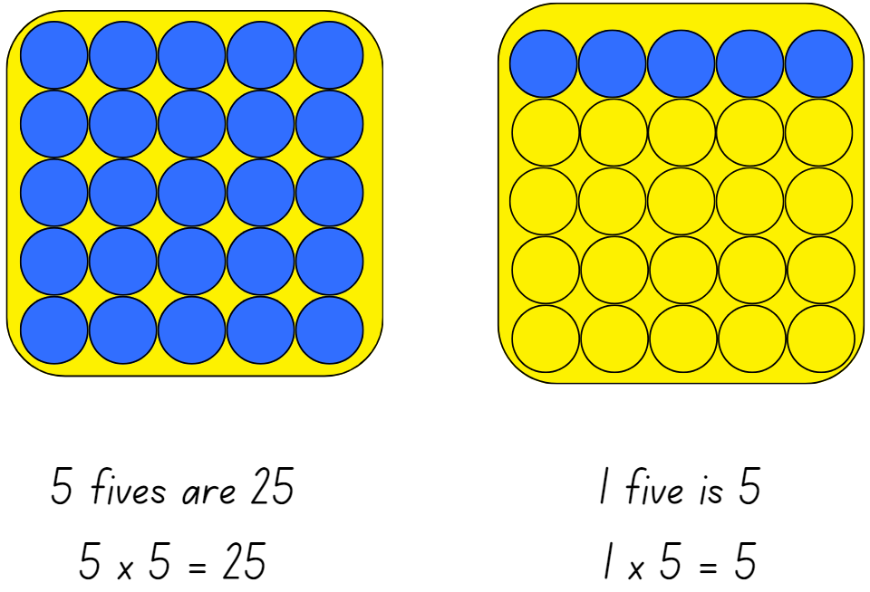

Resource 13 – combined plug boards
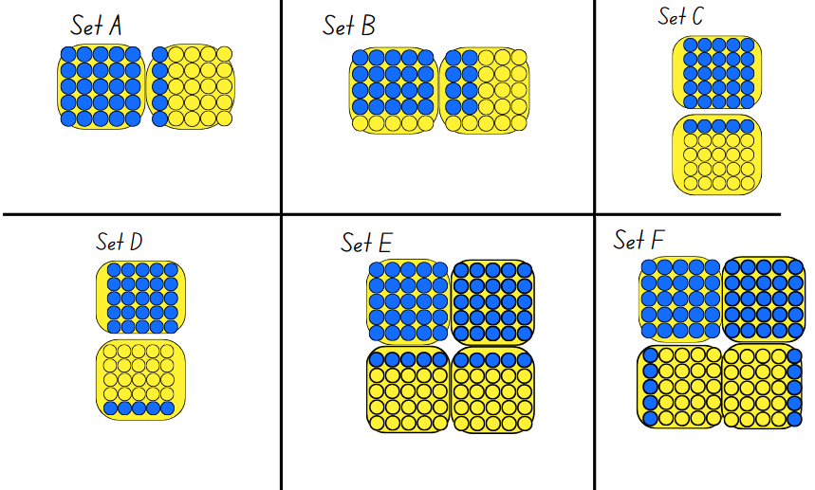

Resource 14 – prove it’s 36
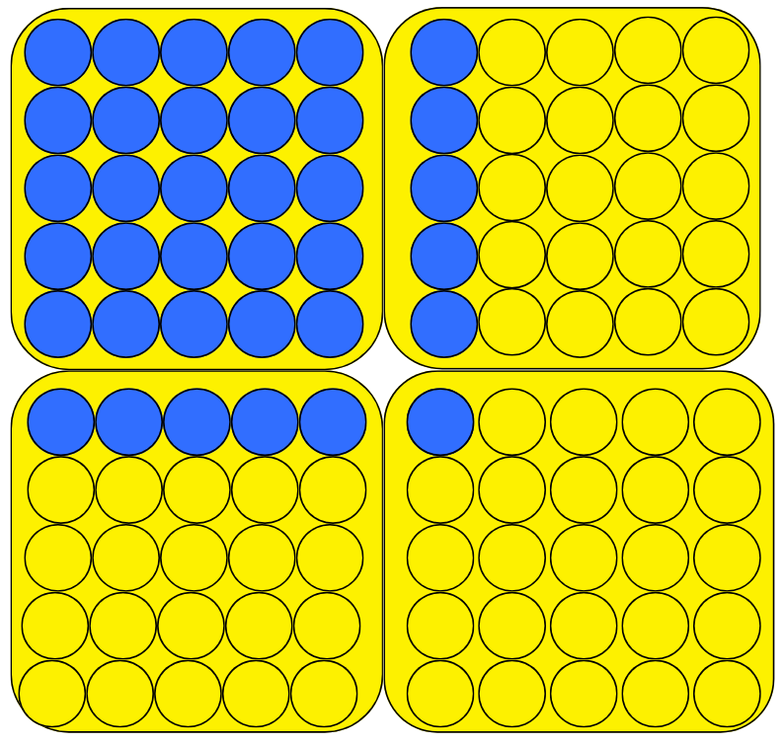

Resource 15 – plug boards
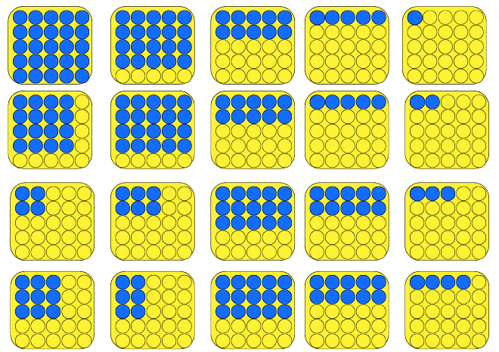

Resource 16 – How many cupcakes?
Charlie is a baker who has his own cupcake shop. It is a small shop but extremely popular! Each day he bakes fresh cupcakes to be sold. The cupcakes are baked in his regular tin that looks like this.
How many cupcakes can be baked at one time in this tin? How do you know?
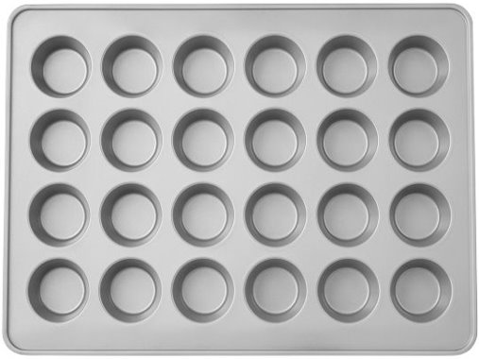

Resource 17 – a special order
For a special order, Charlie bakes these extra delicious cupcakes using his special tray. How many cupcakes are there altogether? Show different ways that you can calculate the total.
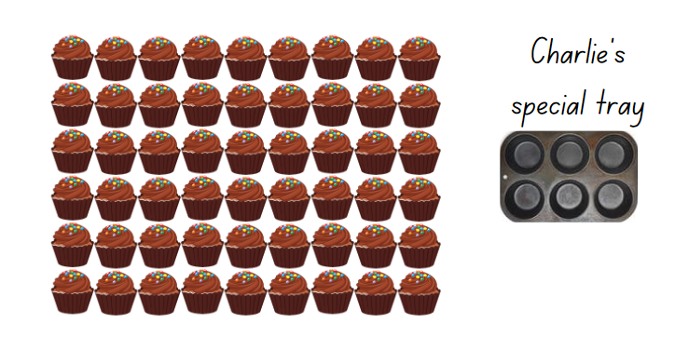
Adapted from Australian Government Department of Education (2023).

Resource 18 – busy cupcake day
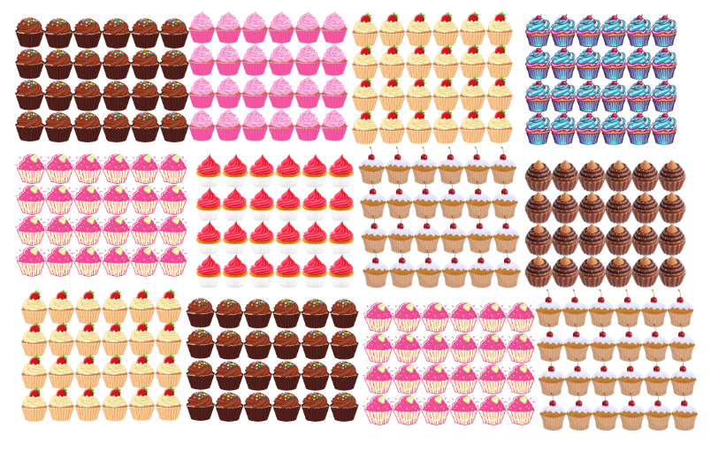
Adapted from Australian Government Department of Education (2023).

Resource 19 – sharing crackers
- How many students can share the crackers?
- How many crackers will each student get?

Resource 20 – sharing solutions
Number of crackers: | How many students are sharing? | How many crackers will each student get? | What strategy was used?
36 | 1 | 36 | Only one student
36 | 2
36
36
36
36
36
36
36

Resource 21 – missing numbers
Step 1: pick a known multiplication fact.
Step 2: draw the family fact triangle.
Step 3: write 4 different number sentences with missing values:
- 18 = 9 × ♣
- 2 × ♥ = 18
- 18 ÷ ♣ = 9
- 18 ÷ ♥ = 2
Step 4: identify another fact family with the same product.
Step 5: write a number sentence in the form Δ × ♥ = ♦ × ♠
Step 6: identify another fact family with a same factor.
Step 7: write a number sentence in the form ☺ ÷ _ = ♣ ÷ _

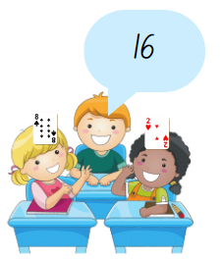
Resource 22 – Salute!
Aim: for 3 players to practise multiplication.
Materials: pack of cards: Ace is 1, Jack is 10, Queen is 100 and King is 1000.
How to play:
- Place the cards in a pile, face down. Two players pick up a card each.
- Players do not look at their card but hold the card, facing out, on their foreheads in a ‘salute’.
- Player 3 multiplies the numbers on the 2 cards they can see and calls the answer.
- Player 1 and Player 2 must work out from the answer the value of the card on their forehead.
- The game is repeated with the players swapping their roles.
Variations
- To start, cards from 1–5 could be selected to form the pack face down on the table. As familiarity with the game increases, the higher numbers could be added.
- The game could also be extended with 4 players, 3 with a card on their forehead and one adding or multiplying the numbers together.
Adapted from New Zealand Ministry of Education (n.d.).

Resource 23 – fill the chart
Aim: to be the first player to fill your chart
Steps
- Each player draws a board like the one shown below.
- Select a known multiplication fact and a target multiplication fact.
- On your turn, roll a 1–10 die. Multiply it by one of your target numbers.
- Record the product in the empty space below that digit. Record only one product per roll.
 | 1 | 2 | 3 | 4 | 5 | 6 | 7 | 8 | 9 | 10
Known fact
Target fact
Adapted from Bay-Williams JM and SanGiovanni JJ (2021).

Resource 24 – Open Middle problem
Directions: using the digits 2 to 9 once each, place a digit in each box to make 2 correct equations: one where the value is greater than 30 and one where the value is less than 30. You may reuse all the digits in each equation.
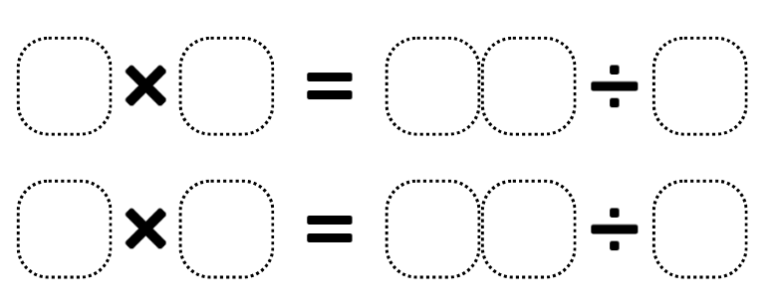
Adapted from Kaplinsky R (2016–2024).

Resource 25 – word problems
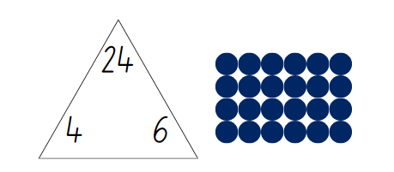
For each: Ashok has 6 bags, each with 4 apples. How many apples does he have altogether?
Times as many: Aisha saved $4 pocket money last month. This month she saved 6 times as much. How much did she save this month?

Resource 26 – How many ribbons?
We need 3 ribbons per race.
There will be between 5 and 10 races for each age group.
How many ribbons might be needed for each age group?
Record at least 3 possible solutions using fact families, arrays and number sentences to show your thinking.
Challenge: if there are 5 age groups, how many ribbons would be needed altogether?

Resource 27 – How many cones?
At the local oval there are no lane lines for the races.
You will need between 5 and 10 cones for each lane. You know that there will be between 4 and 8 lanes. How many cones might you need altogether?
Record at least 3 possible solutions using fact families, arrays and number sentences to show your thinking.
Challenge: if 10 cones are positioned an equal distance apart, how far apart will each cone be for the 70 m, 100 m, 200 m and 400 m races?

Resource 28 – four arrays
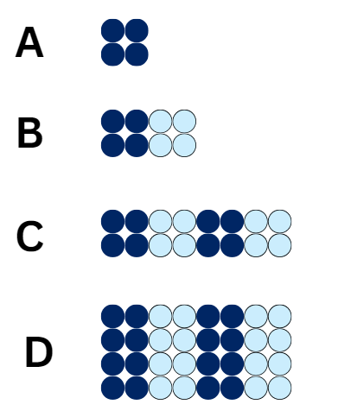

Syllabus outcomes and content
The table below outlines the syllabus outcomes and range of relevant syllabus content covered in this unit. Content is linked to National Numeracy Learning Progression (version 3).
Outcomes and content | 1 | 2 | 3 | 4 | 5 | 6 | 7 | 8
Additive relations A: Represent money values in multiple ways
[MAO-WM-01, MA2-AR-01, MA2-AR-02]
- Recognise the relationship between dollars and cents |  |  |  |  | x | x | x
- Represent equivalent amounts of money using different denominations |  |  |  |  | x | x | x
- Perform calculations with money, including finding change |  |  |  |  | x | x | x
Multiplicative relations A: Generate and describe patterns
[MAO-WM-01, MA2-MR-01, MA2-MR-02]
- Model, describe and record patterns of multiples | x
- Recognise the significance of the final digit of a whole number in determining whether a given number is even or odd (Reasons about relations) | x
- Recognise the connection between even numbers and the multiplication facts for 2 (Reasons about relations) | x
Multiplicative relations A: Use arrays to establish multiplication facts from multiples of 2 and 4, 5 and 10
[MAO-WM-01, MA2-MR-01, MA2-MR-02]
- Create and represent multiplicative structure, using the term multiples when connecting grouping to arrays |  | x
- Use the array structure to coordinate the number of groups with the number in each group |  | x
- Relate doubling to multiplication facts for multiples of 2 |  |  | x
- Recognise that doubling is multiplying by 2 and halving is dividing by 2 (Reasons about relations) |  |  | x
- Recognise the relationship between one multiple and its double (Reasons about relations) |  |  | x
Multiplicative relations A: Recall multiplication facts of 2 and 4, 5 and 10 and related division facts
[MAO-WM-01, MA2-MR-01, MA2-MR-02]
- Recognise and use the symbols for multiplied by (×), divided by (÷) and equals (=) |  |  |  | x |  | x
- Link multiplication and division fact families using arrays |  |  |  |  |  | x
- Generate multiplication fact families for multiples of 2 and 4, 5 and 10 |  |  |  |  |  |  | x
Multiplicative relations A: Represent and solve problems involving multiplication fact families
[MAO-WM-01, MA2-MR-01, MA2-MR-02]
- Describe multiplication problems using for each and times as many | x |  |  |  |  |  |  | x
- Find the total of partially covered arrays | x | x
- Apply the inverse relationship of multiplication and division (Reasons about relations) |  | x | x |  |  | x | x | x
Multiplicative relations B: Use known number facts and strategies
[MAO-WM-01, MA2-MR-01, MA2-MR-02]
- Apply the known strategy of doubling to connect multiples of 3 to 6 and 4 to 8 (Reasons about relations) |  |  | x
- Use known facts to find unknown multiples (Reasons about relations) |  |  |  | x
Multiplicative relations B: Use number properties to find related multiplication facts
[MAO-WM-01, MA2-MR-01, MA2-MR-02]
- Use the commutative property of multiplication |  |  |  | x
- Use flexible partitioning within multiplication (Reasons about relations) |  |  |  | x | x
Multiplicative relations B: Represent and solve word problems with number sentences involving multiplication or division
[MAO-WM-01, MA2-MR-01, MA2-MR-02]
- Use the equals sign to record equivalent number relationships involving multiplication (Reasons about relations) |  |  |  |  |  |  | x
- Complete number sentences involving multiplication and division by calculating missing numbers (Reasons about relations) |  |  |  |  |  |  | x
- Represent and solve multiplication and division (both sharing and grouping) word problems using number sentences |  |  |  |  |  | x |  | x
Mathematics K–10 Syllabus © NSW Education Standards Authority (NESA) for and on behalf of the Crown in right of the State of New South Wales, 2022.

References
This resource contains NSW Curriculum and syllabus content. The NSW Curriculum is developed by the NSW Education Standards Authority. This content is prepared by NESA for and on behalf of the Crown in right of the State of New South Wales. The material is protected by Crown copyright.
Please refer to the NESA Copyright Disclaimer for more information https://educationstandards.nsw.edu.au/wps/portal/nesa/mini-footer/copyright.
NESA holds the only official and up-to-date versions of the NSW Curriculum and syllabus documents. Please visit the NSW Education Standards Authority (NESA) website https://educationstandards.nsw.edu.au/wps/portal/nesa/home and the NSW Curriculum website https://curriculum.nsw.edu.au/.
Mathematics K–10 Syllabus © NSW Education Standards Authority (NESA) for and on behalf of the Crown in right of the State of New South Wales, 2022.
National Numeracy Learning Progression © Australian Curriculum, Assessment and Reporting Authority (ACARA) 2010 to present, unless otherwise indicated. This material was downloaded from the Australian Curriculum website (National Numeracy Learning Progression) (accessed 10 November 2023) and was not modified.
Amplify Education (2024) Amplify Polypad, Amplify Polypad website, accessed 20 January 2024.
Australian Association of Mathematics Teachers (AAMT) Inc (n.d) Maths 300 [website], accessed 20 January 2024.
Australian Broadcasting Corporation (2024) Disco goats, ABC Education website, accessed 1 November 2023.
Australian Government Department of Education (2023) Multiplication: reSolve Bakery, reSolve website, accessed 13 November 2023.
Bay-Williams JM and SanGiovanni JJ (2021) Figuring Out Fluency in Mathematics Teaching and Learning, Grades K-8, SAGE Publications Inc, United States.
Boaler J (2022) Setting up Positive Norms in Math Class (PDF 1.18 MB), youcubed website, accessed 1 November 2023.
Boaler J, Munson J, Williams C (2018) Mindset Mathematics: Visualizing and Investigating Big Ideas, Grade 3, Jossey-Bass, San Francisco.
Edmonton Regional Learning Consortium - ERLC (1 May 2016) ‘Number Strings to Encourage Multiplication Strategies – Part 1’ [video], Edmonton Regional Learning Consortium - ERLC, YouTube, accessed 10 November 2023.
Edmonton Regional Learning Consortium - ERLC (3 May 2019) ‘Number Strings to Encourage Multiplication Strategies – Part 2’ [video], Edmonton Regional Learning Consortium - ERLC, YouTube, accessed 10 November 2023.
Fun4theBrain (2019) Multiplication games, Fun4theBrain website, accessed 20 January 2024.
Kaplinsky R (2016–2024) Multiply and Divide Within A Hundred 1, Open Middle website, accessed 9 November 2023.
Liljedahl P (2021) Building Thinking Classrooms in Mathematics, Grades K-12: 14 Teaching Practices for Enhancing Learning, Sage Publications Inc, United States.
Minas M (n.d) Love Maths [website], accessed 20 January 2024.
National Council for Teachers of Mathematics (NCTM) (2024) Product Game, NCTM website, accessed 6 November 2023.
NESA (2023) ‘Elaborating on Working mathematically in K–10’, Teaching and learning support, NESA website, accessed 17 November 2023.
New Zealand Ministry of Education (n.d.) Salute, NZ Maths website, accessed 20 January 2024.
Orton C (2016–2024) Building Shelves 1, Open Middle website, accessed 9 November 2023.
Orton C (2016–2024) Building Shelves 2, Open Middle website, accessed 9 November 2023.
Pierce R (2023) Math Trainer – Multiplication, Maths is Fun website, accessed 9 November 2023.
Russo J (2016) ‘Doubles Bingo’, Teaching Children Mathematics, 23(1):56, doi: 10.5951/teacchilmath.23.1.0056.
Russo J (2017) ‘Short activity: Learning to think strategically - Caught Red-handed’, Australian Primary Mathematics Classroom, 22(1): 40.
Stanford University (n.d) Math Cards 3-6, youcubed website, accessed 17 November 2023.
State of New South Wales (Department of Education) (2023) ‘Go fish! – partially covered arrays’, Mathematics K-6 resources, NSW Department of Education website, accessed 1 November 2023.
State of Queensland (Queensland Curriculum & Assessment Authority) (2022) Number strings factsheet (PDF 188 KB), QCAA website, accessed 17 November 2023.
Sullivan P and Lilburn P (2017) Open-Ended Maths Activities: Using Good Questions to Enhance Learning Mathematics, 2nd edn, Oxford University Press Australia and New Zealand, Great Britain.
Swan P (n.d) Dot arrays interactive, Dr Paul Swan website, accessed 9 November 2023.
University of Cambridge (n.d) Double or Halve?, NRICH website, accessed 2 November 2023.
Van de Walle J, Karp K, Bay-Williams JM, Brass A, Bentley B, Ferguson S, Goff W, Livy S, Marshman M, Martin D, Pearn C, Prodromou T, Symons D and Wilkie K (2019) Primary and Middle Years Mathematics: Teaching Developmentally, 1st Australian edn, Pearson Education Australia, Melbourne.
Wyborney S (9 February 2017) ‘Splat!’, Steve Wyborney’s Blog: I’m on a Learning Mission, accessed 20 January 2024.

Further reading
Australian Association of Mathematics Teachers (2023) Number fact fluency, AAMT top drawer teachers website, accessed 17 November 2023.
Watson A and Sullivan P (2008) ‘Teachers learning about tasks and lessons’, in Tirosh D and Wood T (eds), Tools and processes in mathematics teacher education, Sense Publishers, Rotterdam, Netherlands.

© State of New South Wales (Department of Education), 2024
The copyright material published in this resource is subject to the Copyright Act 1968 (Cth) and is owned by the NSW Department of Education or, where indicated, by a party other than the NSW Department of Education (third-party material).
Copyright material available in this resource and owned by the NSW Department of Education is licensed under a Creative Commons Attribution 4.0 International (CC BY 4.0) license.
This license allows you to share and adapt the material for any purpose, even commercially.
Attribution should be given to © State of New South Wales (Department of Education), 2024.
Material in this resource not available under a Creative Commons license:
- the NSW Department of Education logo, other logos and trademark-protected material
- material owned by a third party that has been reproduced with permission. You will need to obtain permission from the third party to reuse its material.
Links to third-party material and websites
Please note that the provided (reading/viewing material/list/links/texts) are a suggestion only and implies no endorsement, by the New South Wales Department of Education, of any author, publisher, or book title. School principals and teachers are best placed to assess the suitability of resources that would complement the curriculum and reflect the needs and interests of their students.
If you use the links provided in this document to access a third-party's website, you acknowledge that the terms of use, including licence terms set out on the third-party's website apply to the use which may be made of the materials on that third-party website or where permitted by the Copyright Act 1968 (Cth). The department accepts no responsibility for content on third-party websites.

