Mathematics Stage 2 – Unit 12
Understanding relationships between the properties of 2D shapes helps visualise and organise spaces in the world

Contents
Unit description and duration 5
Syllabus outcomes 5
Working mathematically 6
Student prior learning 6
Lesson overview and resources 8
Lesson 1 13
Daily number sense – find the numbers – 10 minutes 13
Core lesson 1 – sorting polygons – 20 minutes 15
Core lesson 2 – using features to compare quadrilaterals – 20 minutes 18
Consolidation and meaningful practice – 10 minutes 19
Lesson 2 21
Daily number sense – fact families – 15 minutes 21
Core lesson 1 – Is it a rectangle? – 20 minutes 23
Core lesson 2 – Is it a rhombus? – 15 minutes 25
Consolidation and meaningful practice – 10 minutes 26
Lesson 3 28
Daily number sense – array relationships – 15 minutes 28
Core lesson 1 – symmetry – 25 minutes 30
Core lesson 2 – symmetry in the classroom – 15 minutes 33
Discuss and connect the mathematics – 10 minutes 34
Lesson 4 36
Daily number sense – 10 minutes 36
Core lesson 1 – symmetrical world – 15 minutes 36
Core lesson 2 – alphabet symmetry investigation – 30 minutes 38
Discuss and connect the mathematics – 10 minutes 39
Lesson 5 41
Daily number sense – number talk – 15 minutes 41
Core lesson 1– seeing symmetry – 10 minutes 42
Core lesson 2 – triangle transformations – 30 minutes 44
Discuss and connect the mathematics – 10 minutes 46
Lesson 6 48
Daily number sense – finding the best way – 15 minutes 48
Core lesson 1 – tessellation talk – 10 minutes 49
Core lesson 2 – testing tessellations – 30 minutes 51
Discuss and connect the mathematics – 15 minutes 52
Lesson 7 54
Daily number sense – finding the best way – 15 minutes 54
Core lesson – finding area with square centimetres – 30 minutes 55
Consolidation and meaningful practice – 10 minutes 58
Discuss and connect the mathematics – 5 minutes 59
Lesson 8 60
Daily number sense – 10 minutes 60
Core lesson – finding area with square metres – 35 minutes 60
Discuss and connect the mathematics – 10 minutes 63
Consolidation and meaningful practice – 5 minutes 64
Resource 1 – fact families 66
Resource 2 – rectangles and non-rectangles 67
Resource 3 – rhombus and non-rhombus 68
Resource 4 – shape talk 69
Resource 5 – symmetrical world 70
Resource 6 – alphabet symmetry 71
Resource 7 – seeing symmetry 72
Resource 8 – triangle symmetry 1 73
Resource 9 – triangle symmetry 2 74
Resource 10 – tessellation talk 75
Resource 11 – quadrilateral quiz 76
Resource 12 – testing tessellations 77
Resource 13 – squares 78
Syllabus outcomes and content 79
References 86

Unit description and duration
This unit introduces the big idea that understanding relationships between the properties of 2D shapes helps visualise and organise spaces in the world.
In this 2-week unit students are provided opportunities to:
- describe and compare features of two-dimensional shapes
- explore transformations through combining and splitting two-dimensional shapes
- learn how to estimate and find area using standard units of measurement.

Syllabus outcomes
- MAO-WM-01 develops understanding and fluency in mathematics through exploring and connecting mathematical concepts, choosing and applying mathematical techniques to solve problems, and communicating their thinking and reasoning coherently and clearly
- MA2-MR-02 completes number sentences involving multiplication and division by finding missing values
- MA2-2DS-01 compares two-dimensional shapes and describes their features
- MA2-2DS-02 performs transformations by combining and splitting two-dimensional shapes
- MA2-2DS-03 estimates, measure and compares areas using square centimetres and square metres

Working mathematically
In the Mathematics K–10 Syllabus, there is one overarching Working mathematically outcome (MAO-WM-01). The Working mathematically processes should be embedded within the concepts being taught. The Working mathematically processes present in the Mathematics K–10 Syllabus are:
- communicating
- understanding and fluency
- reasoning
- problem solving.
Mathematics K–10 Syllabus © NSW Education Standards Authority (NESA) for and on behalf of the Crown in right of the State of New South Wales, 2022.

Student prior learning
Before engaging in these teaching and learning activities, students would benefit from prior experience with:
- making new shapes by joining (combining) or partitioning (breaking apart) existing shapes
- using features to sort objects
- estimate, measure and record area using uniform informal units of measurement.
In NSW classrooms there is a diverse range of students, including Aboriginal and/or Torres Strait Islander students, students learning English as an additional language or dialect, high potential and gifted students and students with disability. Some students may identify with more than one of these groups or possibly all of them. Refer to Curriculum planning for every student – advice for further information.

Lesson overview and resources
The table below outlines the sequence and approximate timing of lessons, learning intentions and resources.
Lesson | Content | Duration and resources
Lesson 1  Daily number sense learning intention:  - recall multiplication facts of 2 and 4, 5 and 10 and related division facts | Lesson core concept: attributes, such as sides and angles, are used to classify and compare shapes.  Core concept learning intention:  - compare and describe features of two-dimensional shapes. | Lesson duration: 60 minutes  - Elastic bands – one per student  - Geoboards – one per student  - Writing materials
Lesson 2  Daily number sense learning intention:  - recall multiplication facts of 2 and 4, 5 and 10 and related division facts | Lesson core concept: quadrilaterals do not always have equal sides and angles.  Core concept learning intention:  - compare and describe features of two-dimensional shapes | Lesson duration: 60 minutes  - Resource 1 – fact families  - Resource 2 – rectangles and non-rectangles  - Resource 3 – rhombuses and non-rhombuses  - Elastic bands – one per student  - Geoboards – one per student  - Writing materials
Lesson 3  Daily number sense learning intention:  - recall multiplication facts of 2 and 4, 5 and 10 and related division facts | Lesson core concept: symmetry and repeating patterns can be found everywhere in the world.  Core concept learning intention:  - transform shapes by reflecting, translating and rotating | Lesson duration: 65 minutes  - Resource 4 – shape talk  - 6-sided dice  - Scissors  - Writing materials
Lesson 4  Daily number sense learning intention:  - teacher-identified task based on student needs | Lesson core concept: not all shapes have lines of symmetry or they may have several lines of symmetry.  Core concept learning intention:  - transform shapes by reflecting, translating and rotating | Lesson duration: 65 minutes  - Resource 5 – symmetrical world  - Resource 6 – alphabet symmetry cards  - Individual whiteboards and markers  - Scissors  - Writing materials
Lesson 5  Daily number sense learning intention:  - partition, rearrange and regroup numbers to at least 1000 to solve additive problems | Lesson core concept: mathematicians reflect, rotate and translate shapes to transform them.  Core concept learning intention:  - transform shapes by reflecting, translating and rotating | Lesson duration: 65 minutes  - Resource 7 – seeing symmetry  - Resource 8 – triangle symmetry 1  - Resource 9 – triangle symmetry 2  - Individual whiteboards and markers  - Triangle pattern blocks  - Writing materials
Lesson 6  Daily number sense learning intention:  - partition, rearrange and regroup numbers to at least 1000 to solve additive problems | Lesson core concept: shapes do not change when their orientation changes.  Core concept learning intentions:  - compare and describe features of two-dimensional shapes  - create symmetrical patterns and shapes | Lesson duration: 70 minutes  - Resource 10 – tessellation talk  - Resource 11 – quadrilateral quiz  - Resource 12 – testing tessellations  - Grid paper  - Individual whiteboards and markers  - Pattern blocks  - Writing materials
Lesson 7  Daily number sense learning intention:  - partition, rearrange and regroup numbers to at least 1000 to solve additive problems | Lesson core concept: area is the number of square units enclosed by the shape.  Core concept learning intention:  - use square centimetres to measure the areas of rectangles | Lesson duration: 60 minutes  - Resource 13 – squares  - Coloured pencils  - Grid paper  - Writing materials
Lesson 8  Daily number sense learning intention:  - teacher-identified task based on student needs | Lesson core concept: a square metre measures an area and can be any shape.  Core concept learning intention:  - use square metres to measure and estimate the areas of rectangles | Lesson duration: 60 minutes  - Glue or tape  - Large plain paper to make square metres  - Metre rulers  - Scissors  - Writing materials

Lesson 1
Core concept: attributes, such as sides and angles, are used to classify and compare shapes.

Daily number sense – find the numbers – 10 minutes
Daily number sense activities for Lessons 1 to 3 ‘activate’ prior number knowledge and support the learning of new content in the unit. These activities can also assist teachers to identify the starting points for learning by revealing the extent of students’ existing knowledge.
The table below contains a suggested learning intention and success criteria. These are best co-constructed with students.
Daily number sense learning intention | Daily number sense success criteria
Students are learning to:  - recall multiplication facts of 2 and 4, 5 and 10 and related division facts. | Students can:  - generate multiplication fact families for multiples 5.
This activity is an adaptation of What’s in the Box? from NRICH by University of Cambridge.
- Pose the following scenario: I placed 4 numbers into a box. This box multiplied these numbers by another number and 4 new numbers came out. The new numbers that came out were 15, 35, 50 and 75. What 4 numbers did I place in the box to begin with? What is the rule in the box that is multiplying all 4 numbers? (see Figure 1).
Figure 1 – numbers in a box
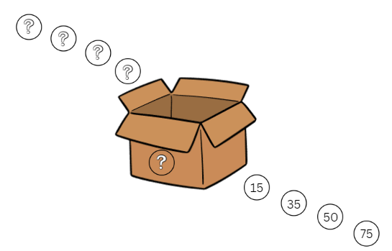
- Students Think-Pair-Share how they would solve this problem. Ask students:
- What multiplication might have happened to each number inside the box to get the answers in the picture above?
- Are there any other possibilities? How do you know?
- Can you identify 4 more numbers to go into the box and determine what would come out?
- How can you check your answer using division?
- Can you generate a fact family triangle for each of the numbers?
- In pairs, students choose their own set of 4 numbers that will be placed in the box along with a rule. Swap with another pair to solve the problem.
This table details opportunities for assessment.
Assessment opportunities | Links
What to look for:  - Can students generate multiplication fact families for multiples of 5? [MAO-WM-01, MA2-MR-01] | Links to National Numeracy Learning Progressions (NNLP):  - MuS6.

Core lesson 1 – sorting polygons – 20 minutes
The table below contains a suggested learning intention and success criteria. These are best co-constructed with students.
Core concept learning intention | Core concept success criteria
Students are learning to:  - compare and describe features of two-dimensional shapes. | Students can:  - describe and compare quadrilaterals, including parallelograms, rectangles, rhombuses, squares and trapeziums  - identify and describe polygons that have parallel sides and those that do not  - identify and name quadrilaterals that have all sides equal in length.
This activity is an adaptation of Classifying Quadrilaterals from Standards Aligned System by Commonwealth of Pennsylvania.
- Explain that a polygon is a flat two-dimensional shape with straight sides that are fully closed. Polygons can have any number of sides. Explain that the prefix ‘poly’ comes from the Greek language and means ‘many’. Students are not expected to use the term ‘polygon’.
- Ask students if they know the names of any polygons. Find everyday examples of polygons in the classroom. For example, a book is a rectangle, and a window is a square.
- Students use geoboards and an elastic band to construct a polygon.
Note: if geoboards are not available, they can be accessed digitally on Math Playground Geoboard.
- Once students have created their polygons, show them 2 geoboards and explain that one geoboard has a quadrilateral, while the other has a non-quadrilateral. For example, a rectangle and a regular pentagon (see Figure 2).
Figure 2 – quadrilateral and non-quadrilateral
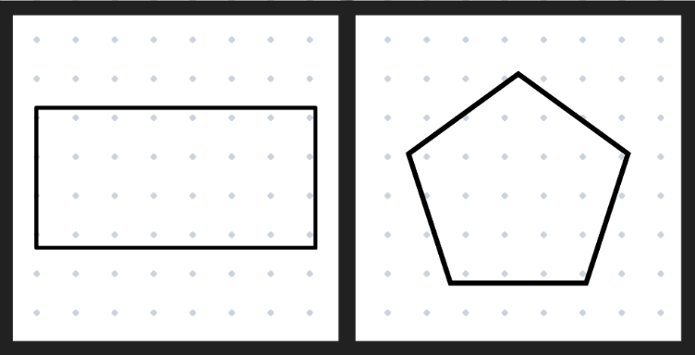
- Ask students to describe the differences between the 2 shapes. Answers may include:
- The quadrilateral has 4 sides and the other shape has more/less.
- The quadrilateral has 4 angles, and the other shape has more/less.
- Explain that the word ‘quad’ comes from Latin and means 4, and ‘lateral’ from the Latin meaning ‘belonging to the side’. Ask how this knowledge can help to explain the maths term quadrilateral.
- Tell students that they are going to sort themselves into 2 groups, those who made quadrilaterals and those who made non-quadrilaterals. Students join a group and justify why their shape belongs there.
- Revise how, although the shapes are being split into quadrilaterals and non-quadrilaterals, all the shapes are polygons.
- Write a class definition for a polygon and a quadrilateral and have students draw examples.

Core lesson 2 – using features to compare quadrilaterals – 20 minutes
- Students use geoboards to construct a quadrilateral.
Note: students who created a quadrilateral in the first part of the lesson will create a different quadrilateral.
- Explain that this time the quadrilaterals will be sorted into 3 categories: parallelograms, trapeziums and quadrilaterals with no parallel sides (see Figure 3). Unpack the definitions for parallelograms and trapeziums.
Figure 3 – types of quadrilaterals
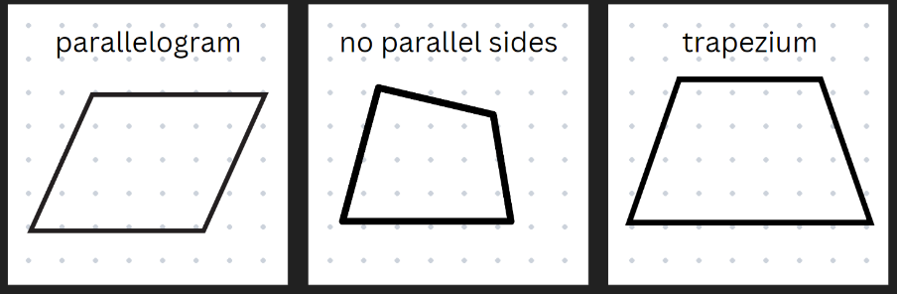
Parallelogram: a polygon with 4 straight sides. The opposite sides are parallel and equal. The opposite angles are equal.
Trapezium: a quadrilateral with one set of parallel lines.
- Once students have made their quadrilaterals ask:
- What is a parallelogram? What other 2D shapes are parallelograms? (square, rectangle, rhombus)
- What is a trapezium?
- Students Think-Pair-Share to answer the questions and then discuss ideas as a class. Revise that squares, rectangles and rhombuses are also parallelograms.
- Students take their geoboard and sort themselves into the correct group – parallelograms, trapeziums and other quadrilaterals. They justify why their quadrilateral belongs in that group.
This table details opportunities for differentiation.
Too hard? | Too easy?
Students cannot identify types of quadrilaterals and/or describe their features.  - Model different quadrilaterals on the geoboard and identify their features.  - Students are provided with quadrilaterals and describe the differences between them. | Students can identify and describe features of different quadrilaterals.  - Students create clue cards for different quadrilaterals and swap with another student for them to create on their geoboard. Discuss whether there were multiple solutions.  - Students research other words with the prefix ‘quad’ and their meanings. For example, quadrangle, quadruped, quadruplet.

Consolidation and meaningful practice – 10 minutes
- Display a trapezium on the board and ask students to give reasons why it is not a parallelogram or a rhombus. Support student understanding that the trapezium only has one set of parallel sides.
- Students turn and talk and then share ideas as a class.
This table details opportunities for assessment.
Assessment opportunities | Links
What to look for:  - Can students describe and compare quadrilaterals, including parallelograms, rectangles, rhombuses, squares and trapeziums? [MAO-WM-01, MA2-2DS-01]  - Can students identify and describe polygons that have parallel sides and those that do not? [MAO-WM-01, MA2-2DS-01]  - Identify quadrilaterals that have all sides equal in length? [MAO-WM-01, MA2-2DS-01] | Links to National Numeracy Learning Progressions (NNLP):  - UGP2, UGP3, UGP4, UGP6.

Lesson 2
Core concept: quadrilaterals do not always have equal sides and angles.

Daily number sense – fact families – 15 minutes
The table below contains a suggested learning intention and success criteria. These are best co-constructed with students.
Daily number sense learning intention | Daily number sense success criteria
Students are learning to:  - recall multiplication facts of 2 and 4, 5 and 10 and related division facts. | Students can:  - recognise and use the symbols for multiplication and division, including the equals sign  - generate multiplication fact families for multiples of 2 and 4, 5 and 10  - model and apply the commutative property of multiplication.
- Display Resource 1 – fact families. Revise fact family triangles. Model how to write multiplication and division sentences (see Figure 4).
Figure 4 – fact families
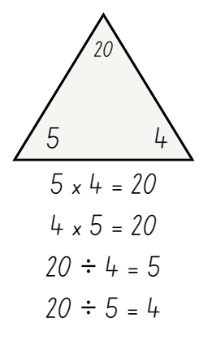
- Use arrays to prove the commutative property of multiplication.
Note: emphasise that the number at the top of the triangle is the product of the 2 factors at the bottom of the triangle. For division, ensure students understand that the product of the fact family must be at the start of the sentence. Division is not commutative, so 2 ÷ 4 = 8 is not correct.
- Students create the fact families for the remaining triangles.
- Share student responses and record student ideas.

This table details opportunities for assessment.
Assessment opportunities | Links
What to look for:  - Can students recognise and use the symbols for multiplication and division, including the equals sign? [MAO-WM-01, MA2-MR-01]  - Can students generate multiplication fact families for multiples of 2 and 4, 5 and 10? [MAO-WM-01, MA2-MR-01]  - Can students model and apply the commutative property of multiplication? [MAO-WM-01, MA2-MR-01] | Links to National Numeracy Learning Progressions (NNLP):  - MuS6.  Links to suggested Interview for Student Reasoning (IfSR) tasks:  - IfSR-MT: 2A.5, 2A.9 and 2A.10.

Core lesson 1 – Is it a rectangle? – 20 minutes
The table below contains a suggested learning intention and success criteria. These are best co-constructed with students.
Core concept learning intention | Core concept success criteria
Students are learning to:  - compare and describe features of two-dimensional shapes. | Students can:  - identify quadrilaterals that have all sides equal in length  - identify right angles in shapes and group quadrilaterals using one or more attributes.
This activity is an adaptation of Classifying Quadrilaterals from Standards Aligned System by Commonwealth of Pennsylvania.
- Students create a quadrilateral using a geoboard and an elastic band.
- Display Resource 2 – rectangles and non-rectangles. Ask students to describe the differences between rectangles and non-rectangles.
- As a class determine that rectangles have 4 straight sides, and the angles are all right angles. Non-rectangles have more than one kind of angle.
- Students sort themselves into 2 groups, those who made rectangles and those who made non-rectangles. Students join a group and justify why their shape belongs there.
Note: explain to students that a square has 4 right angles and 4 equal sides, so a square is a special type of rectangle. All squares are rectangles with one additional feature, that is 4 equal sides.
- Ask some students to share with the class why their quadrilateral belongs in that group.

Core lesson 2 – Is it a rhombus? – 15 minutes
- Ask students to create a different quadrilateral with their geoboard and elastic band.
- Display Resource 3 – rhombuses and non-rhombuses. Ask what the differences are between rhombuses and non-rhombuses.
- Support students to recognise that rhombuses have:
- sides that are all equal
- opposite angles that are equal
- opposite sides that are parallel to each other.
- Ask students to look at their geoboard and decide which group their quadrilateral belongs to.
Note: explain that squares and rhombuses have the same features which means that all squares are rhombuses. Squares have an additional feature, that is 4 equal angles.
- Students join the rhombus or non-rhombus group with their geoboard and justify why their shape belongs there.
- Ask some students to share their reasoning with the class.

This table details opportunities for differentiation.
Too hard? | Too easy?
Students cannot recognise the difference between a rectangle and/or a rhombus and other quadrilaterals.  - Students create a quadrilateral on their geoboards and describe the features together. Support students to identify the quadrilateral.  - Repeat this process with other quadrilaterals. | Students can recognise the difference between a rectangle, a rhombus and other quadrilaterals.  - Students identify and describe quadrilaterals they can see in the classroom. For example, parallelograms, rectangles, rhombuses, squares, and trapeziums.  - Students communicate one of their descriptions to another student who guesses which classroom object(s) it could be.

Consolidation and meaningful practice – 10 minutes
- Display the following sentences on the board: All squares are rectangles. All rectangles are squares.
- Students consider whether each statement is true or false, both true or both false.
- Ask students to draw or construct a square that is not a rectangle. Agree that it is impossible as all squares are rectangles.

This table details opportunities for assessment.
Assessment opportunities | Links
What to look for:  - Can students identify quadrilaterals that have all sides equal in length? [MAO-WM-01, MA2-2DS-01]  - Can students identify right angles in shapes and group quadrilaterals using one or more attributes?  [MAO-WM-01, MA2-2DS-01] | Links to National Numeracy Learning Progressions (NNLP):  - UGP4.

Lesson 3
Core concept: symmetry and repeating patterns can be found everywhere in the world.

Daily number sense – array relationships – 15 minutes
The table below contains a suggested learning intention and success criteria. These are best co-constructed with students.
Daily number sense learning intention | Daily number sense success criteria
Students are learning to:  - recall multiplication facts of 2 and 4, 5 and 10 and related division facts. | Students can:  - link multiplication and division fact families in a given array.
- Display the following numbers 8, 12, 24, 25, 30 and 35.
- Students make an array to represent the number. For example, 12 dots could be used to make arrays of one row of 12, 12 rows of one, 2 rows of 6, 6 rows of 2, 3 rows of 4 or 4 rows of 3.
- Students record the multiplication and division fact families. For example, 3 × 4 = 12, 4 × 3 = 12, 12 ÷ 3 = 4, 12 ÷ 4 = 3. Support students to use words rather than symbols if appropriate (see Figure 5).
Figure 5 – multiplication and division facts in an array
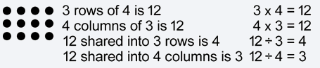
Image sourced from Mathematics K–10 Syllabus (Stage 2)
- Repeat the process using a different possible array for the same number of dots.
- When all possibilities have been used, students roll the dice to get a new total and repeat the process.
This table details opportunities for assessment.
Assessment opportunities | Links
What to look for:  - Can students link multiplication and division fact families in a given array? [MAO-WM-01, MA2-MR-01] | Links to National Numeracy Learning Progressions (NNLP):  - MuS6.  Links to suggested Interview for Student Reasoning (IfSR) tasks:  - IfSR-MT: 2A.5, 2A.9 and 2A.10.

Core lesson 1 – symmetry – 25 minutes
The table below contains a suggested learning intention and success criteria. These are best co-constructed with students.
Core concept learning intention | Core concept success criteria
Students are learning to:  - transform shapes by reflecting, translating and rotating. | Students can:  - identify lines of symmetry in pictures, artefacts, designs and the environment  - draw lines of symmetry on given shapes and identify shapes that do not have lines of symmetry.
Note: one difficulty with symmetry is that students recognise lines which are north south on the page more easily than horizontal lines of symmetry (Siemon 2021).
- Display Resource 4 – shape talk and ask students what they notice about the features of the images.
The table below outlines stimulus prompts to generate conversation about the topic, along with anticipated responses from students.
Prompts | Anticipated student responses
- What do you notice about the features of the images? | - All the shapes are ‘flat’ or two-dimensional.  - Some are known shapes.  - Most of the shapes can be folded in half. This means that they are symmetrical or have at least one line of symmetry.  - Some shapes have more than one line of symmetry. They can be folded in half in more than one way.
- Have students identify where lines of symmetry can be found and mark these on the images using lines.
Symmetry: when 2 or more parts are identical after a flip, slide or turn.
Line of symmetry: the line that separates the 2 identical parts.
In symmetrical shapes, like a regular polygon, this means that if you were to fold or cut the shape along the line of symmetry, both halves would match exactly and be mirror images of each other.

Note: in Stage 2 students are expected to transform shapes by reflecting, translating and rotating. Shapes and objects can be transformed through different processes. The main ones are the isometric transformations which create congruent shapes and objects. The 3 isometric transformations are reflection, translation and rotation. ‘Translation maintains the orientation of the shape or object but moves it to a different position. Reflection relates to seeing the image of the shape or object as it would be in a mirror. Rotation holds one point fixed and turns the shape or object about that fixed point’ (Siemon et al. 2015:713).
- Draw a parallelogram on the board and ask students to identify lines of symmetry. Agree that there are none.
- Ask students if they can think of other places in the world where they can see symmetry. For example, signs, features of buildings, letters or numbers.
- Provide pairs of students with a copy of Resource 4 – shape talk to cut out the shapes.
- Students predict how many lines of symmetry there are in each shape. They fold each shape as many times as needed to test for reflectional symmetry. Students draw a line on the crease to show each line of symmetry. They group the shapes as having zero, one or 2 or more lines of symmetry.
- Check answers as a class. See Figure 6 for solutions.
Figure 6 – symmetry solutions
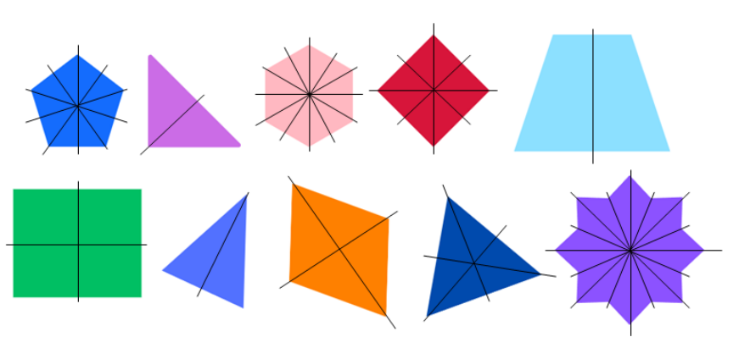

Core lesson 2 – symmetry in the classroom – 15 minutes
- In pairs, students look for images in the classroom that have zero, one and 2 or more lines of symmetry.
- Students record images by sketching or taking photographs. They draw on the lines of symmetry.
- Student pairs compare and discuss their ideas with another pair.
This table details opportunities for differentiation.
Too hard? | Too easy?
Students cannot find symmetry and/or identify shapes with no symmetry.  - Model how to identify a line of symmetry by folding a shape in half to see if the 2 halves are equal.  - Model folding a shape that has more than one line of symmetry.  - Show students how to sort shapes or images into groups of no symmetry, one line of symmetry or more than one line of symmetry. | Students can draw lines of symmetry on given shapes and identify quadrilaterals that do not have lines of symmetry.  - Students draw a shape for their partner to find how many lines of symmetry it has. These can be added to their sort.  - Ask students to design a shape that has as many lines of symmetry as possible.  - Challenge students to consider another attribute that shapes could be sorted by, for example, number of sides, vertices or angle sizes. Students look for patterns with lines of symmetry data. For example, a regular pentagon has 5 equal angles, 5 equal sides and 5 lines of symmetry.

Discuss and connect the mathematics – 10 minutes
- Remind students that shapes can be sorted by their attributes in different ways. For example, shapes can be sorted by colour, size, number of sides, vertices or angles.
- As a class, compare the symmetry sorts completed by students. Where students disagree about the number of lines of symmetry a shape has, retest it as a class to decide.
- Create a class anchor chart of definitions and examples of symmetry.
This table details opportunities for assessment.
Assessment opportunities | Links
What to look for:  - Can students identify lines of symmetry in pictures, artefacts, designs and the environment? [MAO-WM-01, MA2-2DS-01]  - Can students draw lines of reflectional and/or rotational symmetry on shapes? [MAO-WM-01, MA2-2DS-01]  - Can students identify quadrilaterals that do not have lines of symmetry? [MAO-WM-01, MA2-2DS-01] | Links to National Numeracy Learning Progressions (NNLP):  - UGP3.

Lesson 4
Core concept: not all shapes have lines of symmetry or they may have several lines of symmetry.

Daily number sense – 10 minutes
- From a class need surfaced through formative assessment data, identify a short, focused activity that targets students’ knowledge, understanding and skills. Example activities may be drawn from the following resources:
- Mathematics K–6 resources
- Universal Resources Hub.

Core lesson 1 – symmetrical world – 15 minutes
The table below contains a suggested learning intention and success criteria. These are best co-constructed with students.
Core concept learning intention | Core concept success criteria
Students are learning to:  - transform shapes by reflecting, translating and rotating. | Students can:  - identify lines of symmetry in pictures, artefacts, designs and the environment  - draw lines of symmetry on given shapes and identify quadrilaterals that do not have lines of symmetry.
Note: ‘Understanding symmetry and being able to rotate and reflect shapes were important skills for First Nations people. Hunting animals for food and clothing was an integral part of life, so part of growing up was learning what different animal tracks looked like; rotation and reflection were important skills for working out what direction an animal had headed in. Symmetry was also evident in art, whether painted on sand, rocks, animal skins or human bodies. In many cases, the symmetries in a design were intimately connected with the sacred meaning of the design. This kind of knowledge continues to be an important part of cultural identity for many First Nations people today’ (Australians Together n.d).
- Display Resource 5 – symmetrical world. Explain that understanding symmetry and being able to rotate and reflect shapes were important skills for Aboriginal people. This helped with hunting animals; rotation and reflection were important skills for working out what direction an animal had travelled in. Symmetry was also used in art on sand, rocks, animal skins or human bodies. In many cases, the symmetries in a design were intimately connected with the sacred meaning of the design.
- Ask students to think about which images in Resource 5 – symmetrical world have symmetry.
- Students share their thinking. Draw lines on the images in Resource 5 – symmetrical world to show the lines of symmetry.
- Discuss student responses.
Note: some pictures will give the idea of rotational symmetry, even if they are not ‘perfect’. For example, flowers or wheel covers on a car have small features such as petals or tyre valves that disrupt the symmetry (Siemon 2021).
- If not identified by students, draw attention to the images of the Aboriginal dot paintings, flower and wheel cover. Point out that, although these images give the idea of rotational symmetry, they have small features that mean that they do not have ‘perfect’ symmetry. For example, they have features such as paint marks, petals or tyre valves that are not repeated to ensure reflectional or rotational lines of symmetry.

Core lesson 2 – alphabet symmetry investigation – 30 minutes
This activity is an adaptation of ‘Exploring symmetry’ from Teaching Mathematics – Foundations to Middle Years by Siemon.
- Tell students that they will be investigating lines of symmetry in upper case letters of the alphabet.
- Provide pairs of students with a copy of Resource 6 – alphabet symmetry cards. Some students may benefit from having this resource copied onto A3 paper. Students cut out the cards and the group labels.
- Students work in pairs to sort the letters according to lines of symmetry by folding, turning and drawing on the letters to investigate symmetry. Students can use mini whiteboards to record and discuss reasoning. They sort using the group labels:
- zero lines of symmetry
- one line of symmetry
- 2 or more lines of symmetry.
This table details opportunities for differentiation.
Too hard? | Too easy?
Students cannot identify shapes and/or letters that have symmetry.  - Model how to identify a line of symmetry by folding a letter in half so the 2 halves are equal.  - Show students how to sort shapes and/or letters into those with one line of symmetry and those with more. | Students can identify shapes that have reflectional and rotational symmetry.  - Students explore the numerals for lines of symmetry.  - Ask students to write their first and family names in capitals. They calculate the total number of lines of symmetry in the letters of each name to find which has the most.  - Challenge students to think of other ways that alphabet letters could be sorted.

Discuss and connect the mathematics – 10 minutes
- As a class, compare the symmetry sorts.
- If students disagree about the number of lines of symmetry a shape has, retest it as a class to clarify.
- Ask students to think of other places that symmetry could be useful, for example, in construction designs, artworks or dance movements.

This table details opportunities for assessment.
Assessment opportunities | Links
What to look for:  - Can students draw lines of symmetry on shapes? [MAO-WM-01, MA2-2DS-01]  - Can students identify shapes that have reflectional and/or rotational symmetry? [MAO-WM-01, MA2-2DS-01] | Links to National Numeracy Learning Progressions (NNLP):  - UGP3.

Lesson 5
Core concept: mathematicians reflect, rotate and translate shapes to transform them.

Daily number sense – number talk – 15 minutes
Daily number sense activities for Lessons 5 to 7 ‘loop’ back to concepts and procedures covered in previous units to assist students to build an increasingly connected network of ideas. These concepts may differ from the core concepts being covered by the unit.
The table below contains a suggested learning intention and success criteria. These are best co-constructed with students.
Daily number sense learning intention | Daily number sense success criteria
Students are learning to:  - partition, rearrange and regroup numbers to at least 1000 to solve additive problems. | Students can:  - use quantity values and non-standard partitioning to solve addition and subtraction problems.
- Write the equation 527 + 383 = ? on the board.
- Ask students to turn and talk to a partner about how they could solve the problem.
- In pairs, students record their strategy on a whiteboard. Once they have solved it one way, challenge students to see if they can apply another strategy.
- As a class, discuss the strategies used to find the solution. Model and record a range of strategies. Strategies could include partitioning the numbers into place value parts or adding them mentally. Identify whether strategies used standard or non-standard partitioning. If not already discussed, draw student attention to the number bonds to 10 in the equation (2 and 8, 7 and 3) and ask how this knowledge could be used to solve the problem effectively.
This table details opportunities for assessment.
Assessment opportunities | Links
What to look for:  - Can students partition, rearrange and regroup numbers to at least 1000 to solve additive problems? [MAO-WM-01, MA2-AR-01] | Links to National Numeracy Learning Progressions (NNLP):  - AdS8.  Links to suggested Interview for Student Reasoning (IfSR) tasks:  - IfSR-AT: 3A.2.

Core lesson 1– seeing symmetry – 10 minutes
The table below contains a suggested learning intention and success criteria. These are best co-constructed with students.
Core concept learning intention | Core concept success criteria
Students are learning to:  - transform shapes by reflecting, translating and rotating. | Students can:  - create and record tessellating designs by reflecting, translating and rotating triangles  - apply and describe amounts of rotation including half-turns, quarter-turns and 3-quarter-turns when creating designs.
Note: Islamic geometric designs are called girih. These are elaborate interlacing patterns formed by 5 standardised shapes. The style is used in Persian Islamic architecture and in decorative wood, brick and tilework. Most girih designs are based on a partially hidden geometric grid which provides a regular array of points; this is made into a pattern using rotations which typically seem to weave over and under each other (Wikipedia 2023).
- Ask students to recall the ways that Aboriginal people have used symmetry from Lesson 4.
- Explain that Islamic cultures have also used symmetrical patterns in artworks and to decorate buildings. Display Resource 7 – seeing symmetry and tell students that these are examples of Islamic geometric designs called girih.
- Ask students to look for examples of transformations and tessellations in the girih images.
- As a class, discus the examples identified.

Core lesson 2 – triangle transformations – 30 minutes
Translation: in a translation (slide) every point on the original image moves in the same direction for the same distance to transform the new image.
Reflection: a reflection (flip) requires a line of reflection. A reflection is a transformation in which an object is flipped across the line of reflection.
Rotation: a rotation (turn) requires a centre of rotation (a point) and a degree of rotation, for example, 90 degrees or a $\frac{1}{4}$ turn.
- Tell students that they will be looking at geometric patterns and creating patterns using triangles and symmetry.
- Display Resource 8 – triangle symmetry 1. Ask students to turn and talk to a partner, describing what is happening to the triangle in each row of the patterns.
- As a class, discuss the student thinking and explain that:
- the movement of the triangle in the first pattern is called a translation (slide). The triangle moves in the same direction for the same distance for each image.
- the second pattern has repeated reflections (flips), when an object is flipped across a line of reflection. The line of reflection is outside the shape.
- the third pattern has repeated rotations (turns) around a centre of rotation, or point. There can be different sizes of turns used, for example, a quarter or half turn. However, the amount of turn in the sequence must be consistent to form a pattern. This is called rotation.
- Provide pairs of students with Resource 8 – triangle symmetry 1, whiteboards and triangle pattern blocks.
- Students identify the pattern in each row of triangles. Discuss findings as a class.
- Provide pairs of students with Resource 9 – triangle symmetry 2, whiteboards and triangle pattern blocks. Explain that they will be creating some triangle patterns of their own for another group to solve. Students must:
- create one pattern using translations, one with reflections and another with rotations
- choose the amount of turn they will use in their rotation pattern, for example, quarter-turns, half-turns or 3-quarter turns
- record and describe the patterns using diagrams and words.
- After students have recorded their patterns, they swap with another pair of students. Students identify the patterns and record the transformation of the shape. For example, translation, reflection or rotation, and the amount of rotation or turn used.
This table details opportunities for differentiation.
Too hard? | Too easy?
Students cannot create and/or record tessellating designs by reflecting, translating and rotating triangles or describe amounts of rotation.  - Use a triangle shape block to recreate each pattern from Resource 8 – triangle symmetry 1. Model how to describe each step of the pattern.  - Support students to record their patterns with triangle blocks using translations, reflections or rotations. | Students can create and record tessellating designs by reflecting, translating and rotating triangles and describe amounts of rotation.  - Students create one pattern using a combination of translation, reflection and rotation. They swap their pattern with another student to solve.  - Challenge students to create and describe pattern sequences using symbols. For example, arrows, shapes, letters or numbers.

Discuss and connect the mathematics – 10 minutes
- As a class, discuss the strategies used to identify the patterns. For example, students may have recreated them using blocks or on a whiteboard.
- Ask students to nominate a pattern they found challenging and display it.
- Use strategies suggested by students to re-create and describe what happened in each step of the pattern.
This table details opportunities for assessment.
Assessment opportunities | Links
What to look for:  - Can students create and record tessellating designs by reflecting, translating and rotating triangles? [MAO-WM-01, MA2-2DS-01, MA2-2DS-02]  - Can students apply and describe amounts of rotation including half-turns, quarter-turns and three-quarter-turns when creating designs? [MAO-WM-01, MA2-2DS-01, MA2-2DS-02] | Links to National Numeracy Learning Progressions (NNLP):  - UGP3, UGP4, UGP5, UGP6.

Lesson 6
Core concept: shapes do not change when their orientation changes.

Daily number sense – finding the best way – 15 minutes
The table below contains a suggested learning intention and success criteria. These are best co-constructed with students.
Daily number sense learning intention | Daily number sense success criteria
Students are learning to:  - partition, rearrange and regroup numbers to at least 1000 to solve additive problems. | Students can:  - use quantity values and non-standard partitioning to solve addition problems.
- Display the equation 431+ 689 = ? Discuss standard and non-standard partitioning strategies to add the 2 numbers. Students discuss and record ideas with a partner on mini whiteboards and then with the class. Label strategies as standard and non-standard. Some examples are:
- Add the hundreds, tens and ones from the 2 numbers together first and use these to find the total. For example, 400 + 600 =1000 + 30 + 80 = 110 + 9 + 1 =10 = 1120 (standard).
- Take 11 ones from 431 and add them to 689 first to make 700 and then add the remaining 420 to make 1120 (non-standard).
- Repeat the process with 2 new numbers.
- Ask students to justify when a standard and non-standard partitioning strategy is more or less effective.
This table details opportunities for assessment.
Assessment opportunities | Links
What to look for:  - Can students use quantity values and non-standard partitioning to solve addition problems? [MAO-WM-01, MA2-AR-01] | Links to National Numeracy Learning Progressions (NNLP):  - AdS8.  Links to suggested Interview for Student Reasoning (IfSR) tasks:  - IfSR-AT: 3A.2.

Core lesson 1 – tessellation talk – 10 minutes
The table below contains suggested learning intentions and success criteria. These are best co-constructed with students.
Core concept learning intentions | Core concept success criteria
Students are learning to:  - compare and describe features of two-dimensional shapes  - create symmetrical patterns and shapes. | Students can:  - describe and compare two-dimensional shapes  - create and record tessellating designs by reflecting, translating and rotating triangles or quadrilaterals  - apply and describe amounts of rotation, including half-turns, quarter-turns and three-quarter-turns, when creating designs.
- Review how translations, reflections and rotations were used in the shape patterns created by students in Lesson 5.
- Display Resource 10 – tessellation talk and ask students what they notice.
The table below outlines stimulus prompts to generate conversation about the topic, along with anticipated responses from students.
Prompts | Anticipated student responses
- What do you notice about these patterns? | - They are all made of two-dimensional shapes.  - They are colourful and creative.  - The patterns use slides, flips and turns (translations, reflections and rotations).
- What are they called? | - These are called tessellations.
- Have you seen patterns like these anywhere else? | - I have seen patterns like this used in brick walls, bathroom tiles and on a chess board.
- Is there anything else you are wondering? | - I am wondering whether you can create a tessellation with any two-dimensional shape?
Tessellation: a tessellation is the tiling of an area using one or more shapes in a repeating pattern with no gaps or overlaps. A regular tessellation is made of a single polygon, whereas a semi-regular tessellation is made of 2 or more regular polygons. (Van de Walle 2019).
- Explain that a tessellation is a repeating pattern of one or more shapes with no gaps or overlaps.

Core lesson 2 – testing tessellations – 30 minutes
- Display Resource 11 – quadrilateral quiz and tell students that you need their help to match the 4-sided shapes with their definitions.
- As a class, match the quadrilaterals with the definitions, discussing the features of each.
- Explain that students will investigate the conjecture: All triangles and quadrilaterals tessellate.
- Show Resource 12 – testing tessellations and explain that they will use it to investigate tessellations with triangles and quadrilaterals.
- Model how to use grid paper to draw a tessellation of a rectangle. Show how a tessellation has no overlaps or gaps.
- Provide pairs of students with a copy of Resource 12 – testing tessellations, pattern blocks, grid paper and whiteboards. In pairs, students create tessellations using a range of triangles and quadrilaterals to test the conjecture: All triangles and quadrilaterals tessellate.
This table details opportunities for differentiation.
Too hard? | Too easy?
Students cannot create and/or record tessellations by reflecting, translating and rotating triangles or quadrilaterals.  - Use shape blocks of one two-dimensional shape to model a simple tessellating pattern.  - Support students to describe if the pattern is reflecting, translating or rotating the shapes. | Students can create and record tessellating designs by reflecting, translating and rotating triangles and quadrilaterals.  - Students investigate semi-regular tessellating patterns.  - Challenge students to create a tessellation with 2 shapes, for example, a rectangle and a trapezium, to create a semi-regular tessellating pattern of their own.

Discuss and connect the mathematics – 15 minutes
- Share the tessellations created. Ask students if they have found an answer to the conjecture: All triangles and quadrilaterals tessellate.
- Ask students to consider the types of transformations they used to create their tessellations, either reflecting, translating or rotating the shapes.
- Draw attention to the difference between regular shapes and other shapes, for example, an equilateral triangle and a square. Revise that a regular shape has all equal sides and all equal angles. Discuss which other 3 and 4 sided shapes tessellated.
- Allow students to re-test any shapes if needed.
This table details opportunities for assessment.
Assessment opportunities | Links
What to look for:  - Can students compare and describe features of two-dimensional shapes? [MAO-WM-01, MA2-2DS-01, MA2-2DS-02]  - Can students create and record tessellating designs by reflecting, translating and rotating triangles or quadrilaterals?  [MAO-WM-01, MA2-2DS-01, MA2-2DS-02] | Links to National Numeracy Learning Progressions (NNLP):  - UGP3, UGP4, UGP5, UGP6.

Lesson 7
Core concept: area is the number of square units enclosed by the shape.

Daily number sense – finding the best way – 15 minutes
The table below contains a suggested learning intention and success criteria. These are best co-constructed with students.
Daily number sense learning intention | Daily number sense success criteria
Students are learning to:  - partition, rearrange and regroup numbers to at least 1000 to solve additive problems. | Students can:  - use quantity values and non-standard partitioning to solve addition problems
- In small groups, students solve the equations 314 + 596 and 987 + 321 using the process modelled in Lesson 6. Explore 2 or 3 solutions each time and label as standard or non-standard.
- Students discuss which strategy is most effective and why. The most effective solution may vary; the important thing is that students can explain why it is effective for them.
- Some students may enjoy the challenge of trying this with subtraction strategies. To do this, throw four 9-sided dice to make two 4-digit numbers. Find 2 or 3 strategies to subtract the smaller number from the larger using standard and non-standard partitioning.
This table details opportunities for assessment.
Assessment opportunities | Links
What to look for:  - Can students use quantity values and non-standard partitioning to solve subtraction problems? [MAO-WM-01, MA2-AR-01] | Links to National Numeracy Learning Progressions (NNLP):  - AdS8.  Links to suggested Interview for Student Reasoning (IfSR) tasks:  - IfSR-AT: 3A.2.

Core lesson – finding area with square centimetres – 30 minutes
The table below contains a suggested learning intention and success criteria. These are best co-constructed with students.
Core concept learning intention | Core concept success criteria
Students are learning to:  - use square centimetres to measure the areas of rectangles. | Students can:  - explain how the grid structure of rows and columns helps to find area  - recognise that area can be measured in square centimetres  - record area in square centimetres using numerals and words.
- Revise that area is the flat surface enclosed within a shape.
- Use grid paper to model how to represent different rectangles with an area of 6 squares. Each square needs to touch another square along a whole side. Support students to use rows and columns to find the area of a standard shape such as a rectangle.
- Ask students:
- How can you prove without counting each square that each rectangle has an area of 6? (Look at rows and columns and use colour as necessary to support understanding.)
- Do any of the rectangles look different but are congruent when rotated or flipped? For example, 3 rows of 2 squares and 2 rows of 3 squares have the same area and shape. Finding the area can be described as 3 multiplied by 2 or 2 multiplied by 3. Revise that this is the commutative rule.
Congruency: an exact match between every part of one figure with the corresponding part of another figure; congruent figures can be exactly superimposed on each other.
- Model describing and labelling rectangles using numerals and words. For example, 3 rows of 2 squares gives an area of 6 square centimetres because each of the squares is one square centimetre.
- In small groups, students choose a number and use grid paper to explore rectangles that can be made with that number of squares.
Note: groups that choose an odd number may need support to understand why they cannot find many solutions. Numbers that will provide numerous solutions include multiples of 12, for example, 12, 24, 36, 48 and so on.
- Move between groups, supporting students to use colour to show rows or columns. This may will help them to find solutions.
- Students label each of their rectangles. For example, 4 rows of 3 = 12 square centimetres, 6 rows of 2 = 12 square centimetres, one row of 12 = 12 square centimetres.
- Students go on a gallery walk and look for similarities and differences between their area representations.
- As a class, ask each group to describe how they can prove that each of their rectangles has the same area. Revise how multiplication of rows and columns can be used to find the area of a rectangle.
This table details opportunities for differentiation.
Too hard? | Too easy?
Students cannot use the grid structure of rows and columns to make rectangles with a given area.  - Using large, coloured paper squares or square pattern blocks, model one row of 3 squares. Discuss how this rectangle has an area of 3 because it has one row of 3.  - Add another row of 3 squares in a different colour. Discuss how this rectangle has an area of 6 because it has 2 rows of 3. Students continue the process.  - Students repeat the process for a new rectangle, beginning with a row of 4. | Students use the grid structure of rows and columns to make several rectangles with a given area.  - Students make non-standard shapes with their chosen area.  - Ask how students can prove the areas of non-standard shapes without counting each unit. For example, an array of 3 by 2 squares makes 6 square centimetres plus one on either side makes an area of 8 square centimetres.

Consolidation and meaningful practice – 10 minutes
- Display a small everyday rectangular object from the classroom. For example, a book, calculator or folder. Ask students to visualise rows and columns to estimate its area in square centimetres.
- Place the object on grid paper and draw around it. Count the square centimetres and compare the answer to the estimate. Record the area using words and numbers. For example, this book has 5 rows of 8 centimetres, so it measures 40 square centimetres.
- In pairs, students repeat the process with another everyday rectangular object.
This table details opportunities for assessment.
Assessment opportunities | Links
What to look for:  - Can students create rectangles with arrays and explain how the grid structure of rows and columns helps to find area? [MAO-WM-01, MA2-2DS-03]  - Do students recognise that area can be measured in square centimetres? [MAO-WM-01, MA2-2DS-03]  - Can students record area in square centimetres using numerals and words? [MAO-WM-01, MA2-2DS-03] | Links to National Numeracy Learning Progressions (NNLP):  - UuM5, UuM6, UuM7.

Discuss and connect the mathematics – 5 minutes
- Display Resource 13 – squares
- Ask students to use multiplication of rows and columns to find the area of each square. Discuss why it is simpler to find the area of a square than the area of a rectangle.

Lesson 8
Core concept: a square metre measures an area and can be any shape.

Daily number sense – 10 minutes
- From a class need surfaced through formative assessment data, identify a short, focused activity that targets students’ knowledge, understanding and skills. Example activities may be drawn from the following resources:
- Mathematics K–6 resources
- Universal Resources Hub.

Core lesson – finding area with square metres – 35 minutes
The table below contains a suggested learning intention and success criteria. These are best co-constructed with students.
Core concept learning intention | Core concept success criteria
Students are learning to:  - use square metres to measure and estimate the areas of rectangles. | Students can:  - recognise that an area of one square metre need not be a square  - estimate and record areas in square metres using numerals and words.
This activity is an adaptation of Inquiring into the Square Metre from Enquiry-Based Maths by Anshaw.
- Take students outside where they have access to large areas. For example, a netball court or footpath.
- In small groups, students use metre rulers to make one square metre with paper. Revise that it will need to be a square that has one metre on each side and all the angles will be right angles. Students could draw a square metre on the ground and then make their square if this helps them to visualise it better first. As a class, compare the square metres and agree that each is accurate.
- Each group cuts a section off their metre and adds it to one side of the main area. Discuss how it is still a square metre and correct any misconceptions. Place the cut off part back in the main square to prove it is still one square metre (see Figure 7).
Figure 7 – Is it still one square metre?
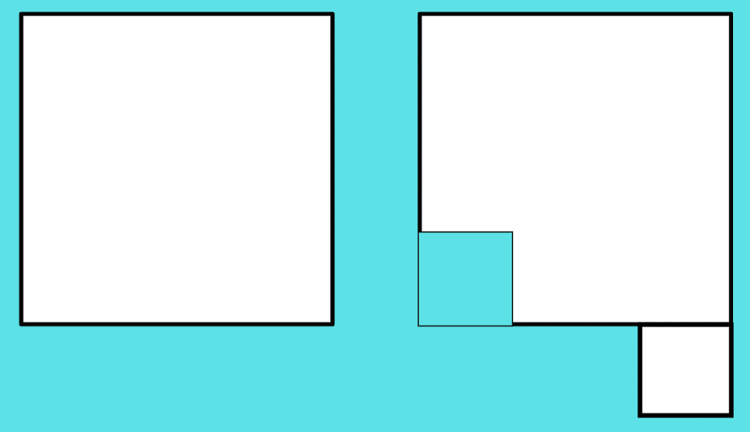
- Repeat the process a few times, moving the cut section somewhere else and revising that the total area is still one square metre.
- Small groups of students make another square metre and choose an area of the space to estimate and measure in square metres. Groups use chalk to mark what has been measured and keep a tally of square metres.
- Move between groups, supporting students to use their square metre as a square or cut as necessary. For example, an area might need to be measured in part square metres as students get close to the edge. When students are about halfway through measuring, they refer to their original estimate and discuss whether to refine it.
This table details opportunities for differentiation.
Too hard? | Too easy?
Students cannot understand that one square metre can be made in different ways and/or measure a large regular area.  - Model cutting a section off a square metre and placing it on one side. Place it back in its original position and discuss how the area is the same for both shapes.  - Model placing a square metre at the beginning of an area, marking it with chalk and then moving it until half the space is measured. Students continue to measure the rest of the area. | Students can understand that one square metre can be made in different ways and measure a large regular area.  - Students estimate and find the area of a large irregular area. They discuss the challenges involved with this task.  - Students use their understanding of rows and columns to work out how many square centimetres there are in one square metre.

Discuss and connect the mathematics – 10 minutes
- Ask students:
- Which were the biggest and smallest areas measured?
- What challenges were there?
- How close were you to your original estimate?
- Did anyone revise their estimate halfway through? Why?
- Did anyone find a way of measuring an area without having to use the square metre over the whole area? For example, if the first half of a shape measured 6 square metres, the whole area would be 12 square metres.
This table details opportunities for assessment.
Assessment opportunities | Links
What to look for:  - Can students recognise that an area of one square metre need not be a square and apply this knowledge to measuring a large area? [MAO-WM-01, MA2-2DS-03]  - Can students estimate and record areas in square metres using numerals and words? [MAO-WM-01, MA2-2DS-03] | Links to National Numeracy Learning Progressions (NNLP):  - UuM5, UuM6, UuM7.

Consolidation and meaningful practice – 5 minutes
- Show students a one square metre paper. Discuss the areas of the following using numerals and words:
- Cut the square into half and make a 2 m by 0.5 m rectangle. (still one square metre)
- Put the 2 halves on top of each other. (half a square metre)
- Cut the halves into half again and make a cross. (back to one square metre)
- Put the 4 quarters on top of each other. (a quarter of a square metre)
This table details opportunities for assessment.
Assessment opportunities | Links
What to look for:  - Can students recognise when an area is the same as or less than one square metre and why? [MAO-WM-01, MA2-2DS-03]  - Can students describe the areas using numerals and words? [MAO-WM-01, MA2-2DS-03] | Links to National Numeracy Learning Progressions (NNLP):  - UuM5, UuM6, UuM7.

Resource 1 – fact families
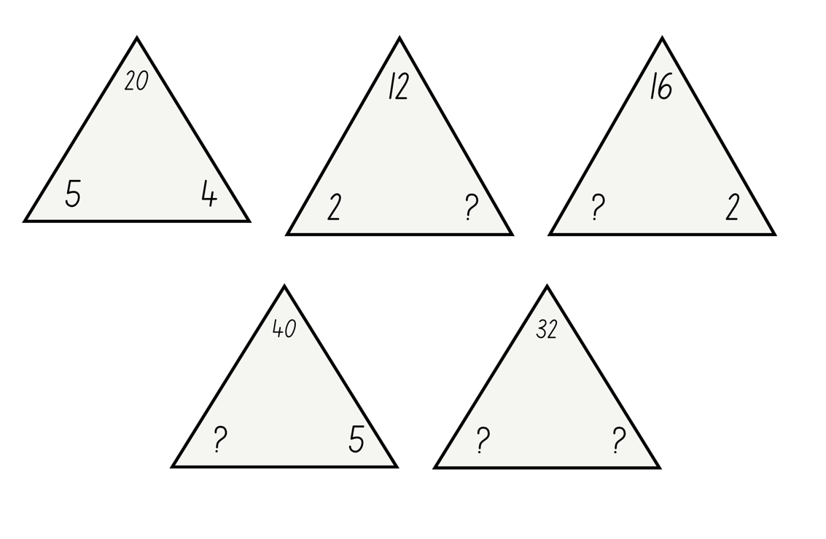

Resource 2 – rectangles and non-rectangles
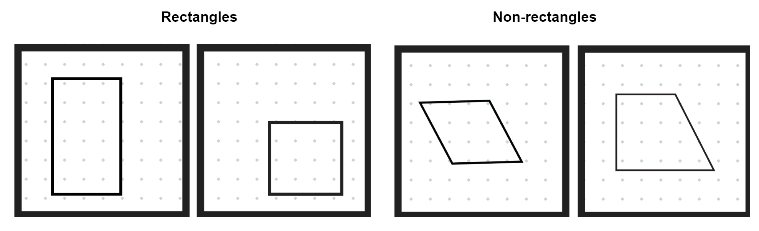

Resource 3 – rhombus and non-rhombus
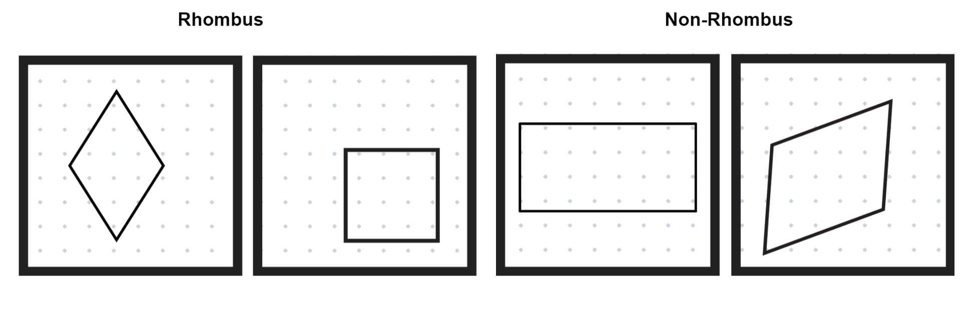

Resource 4 – shape talk
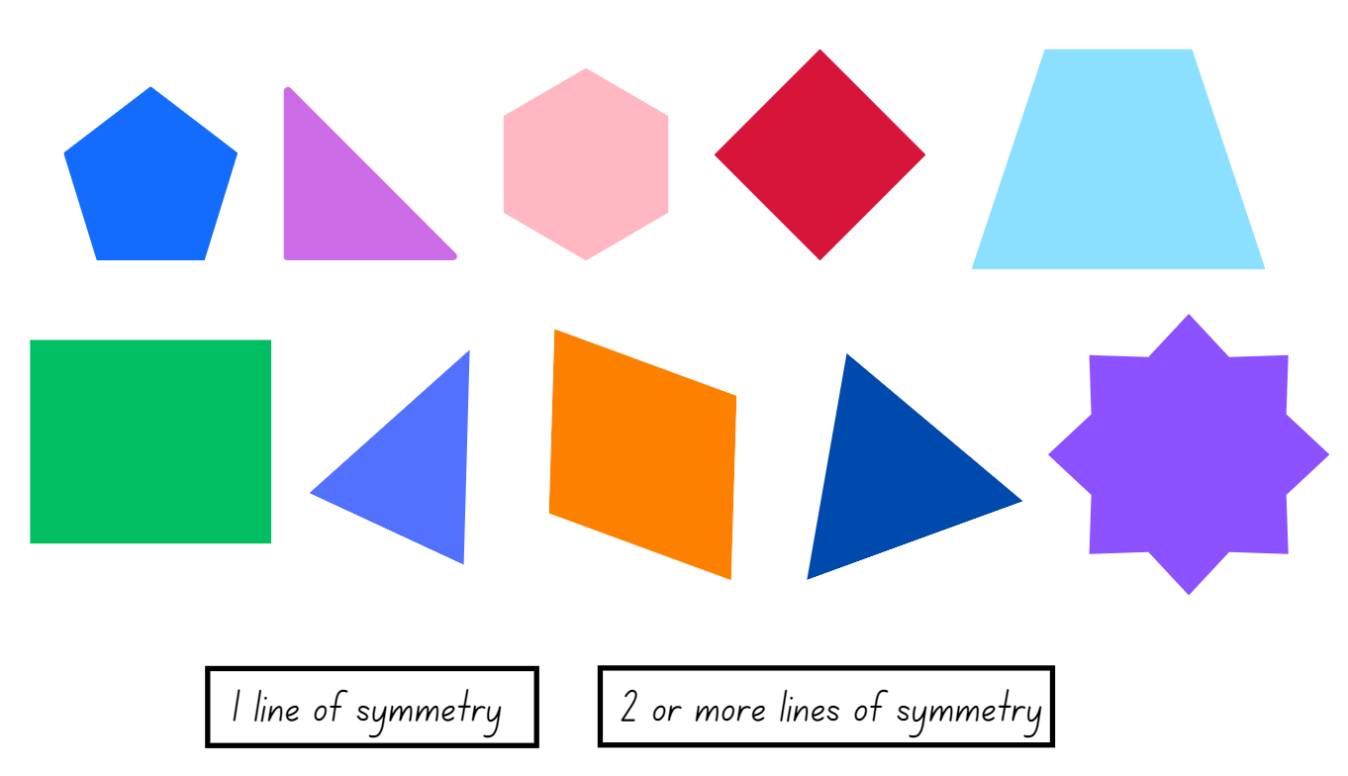

Resource 5 – symmetrical world
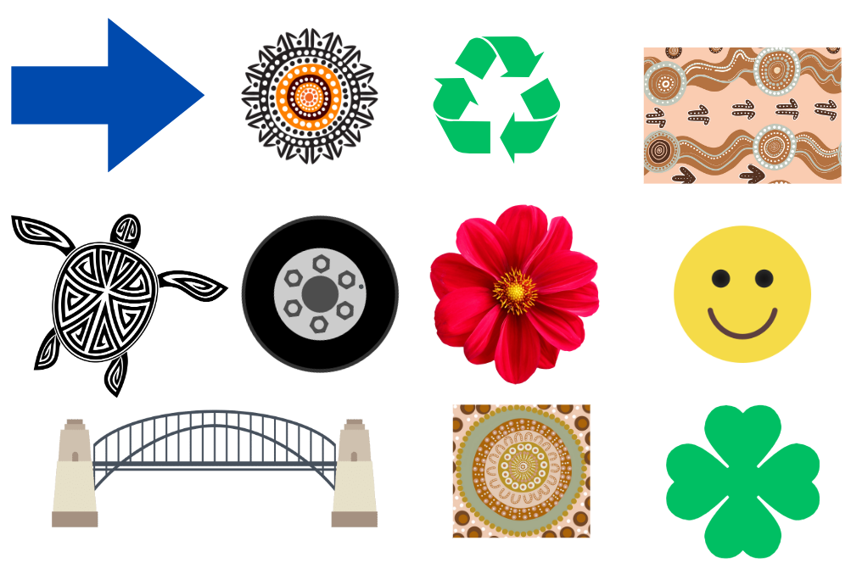

Resource 6 – alphabet symmetry
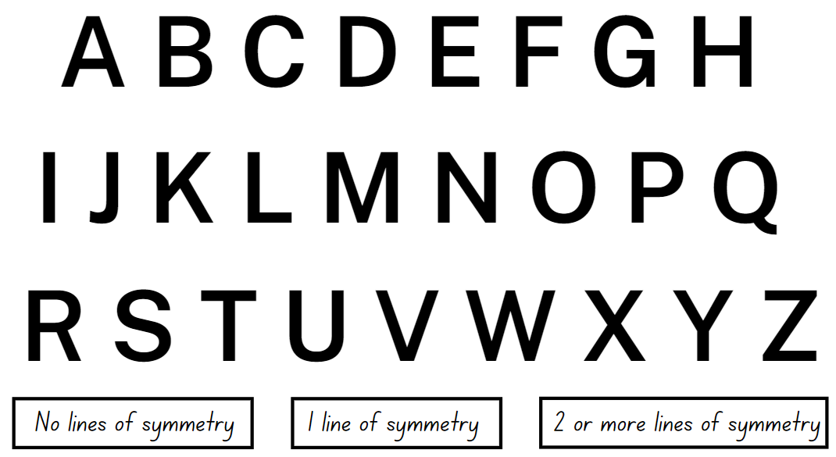

Resource 7 – seeing symmetry
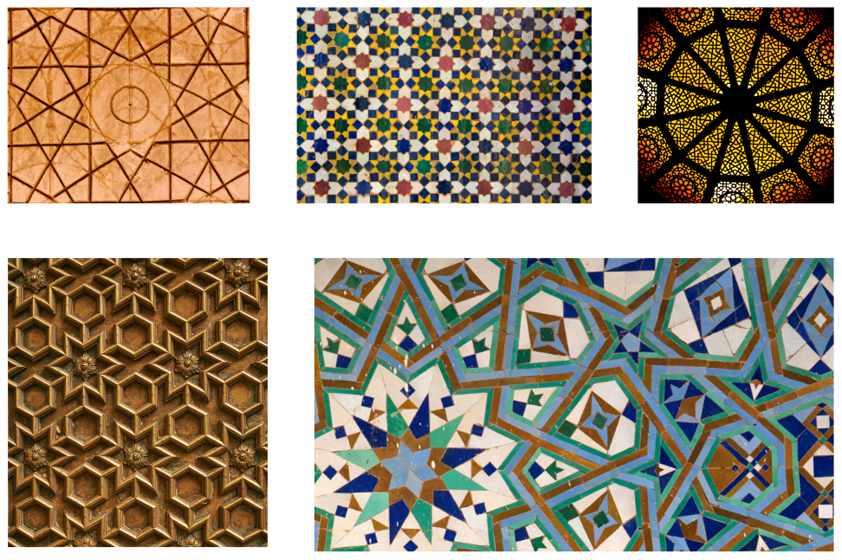

Resource 8 – triangle symmetry 1
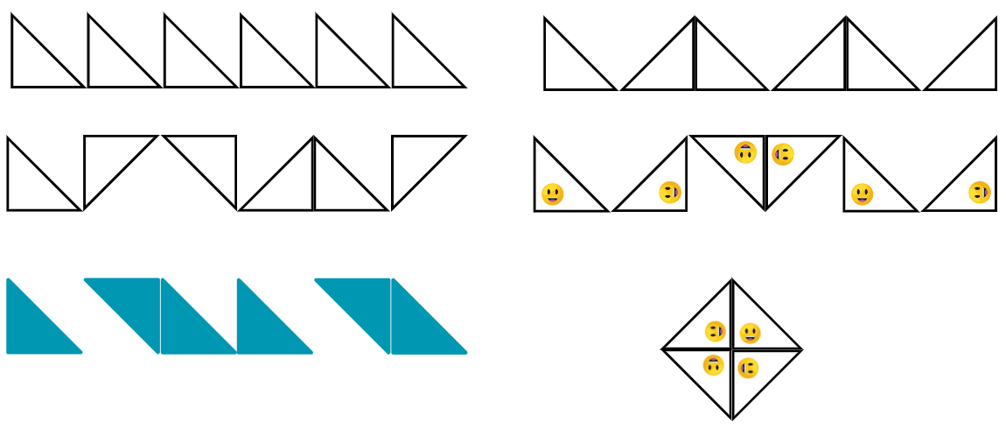

Resource 9 – triangle symmetry 2
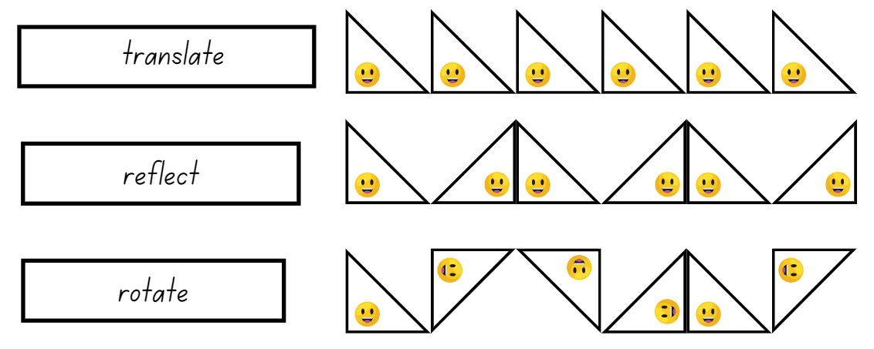

Resource 10 – tessellation talk
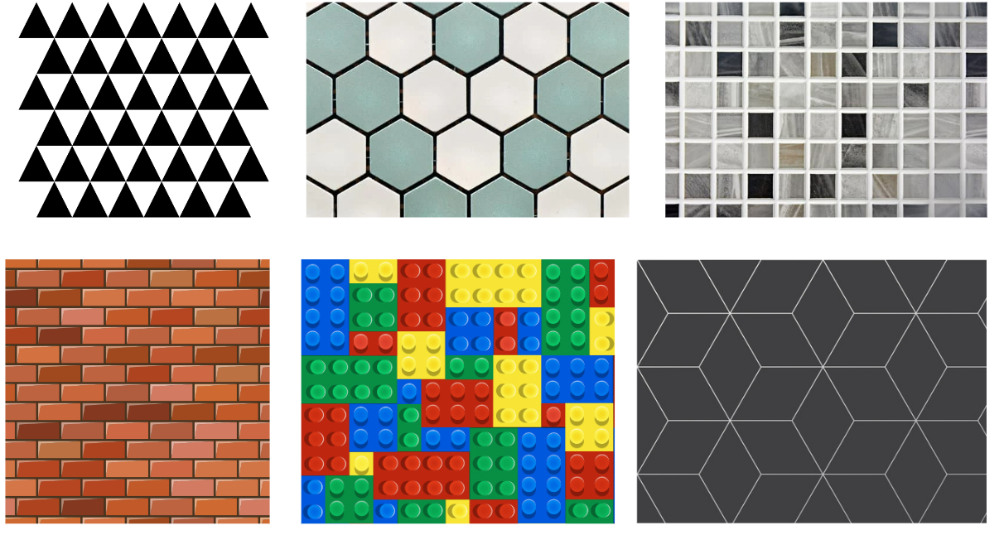

Resource 11 – quadrilateral quiz
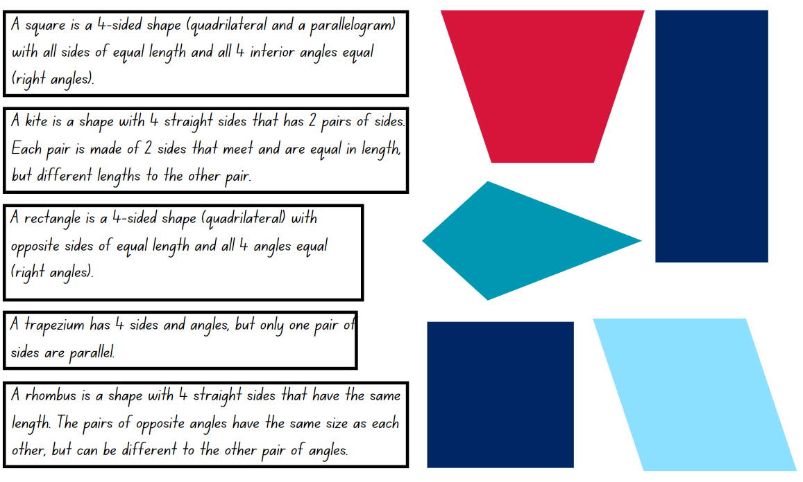

Resource 12 – testing tessellations
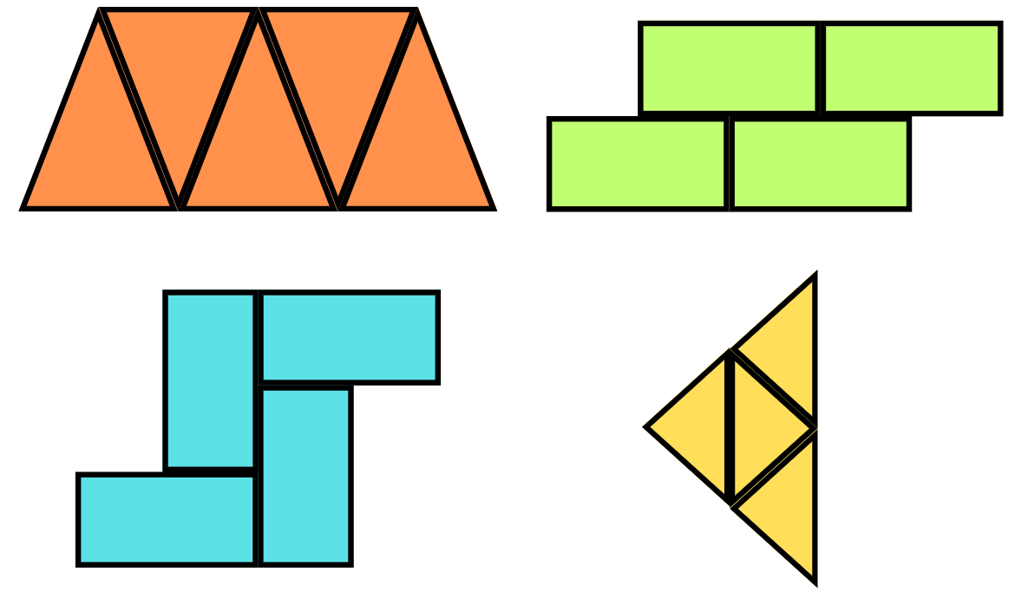

Resource 13 – squares
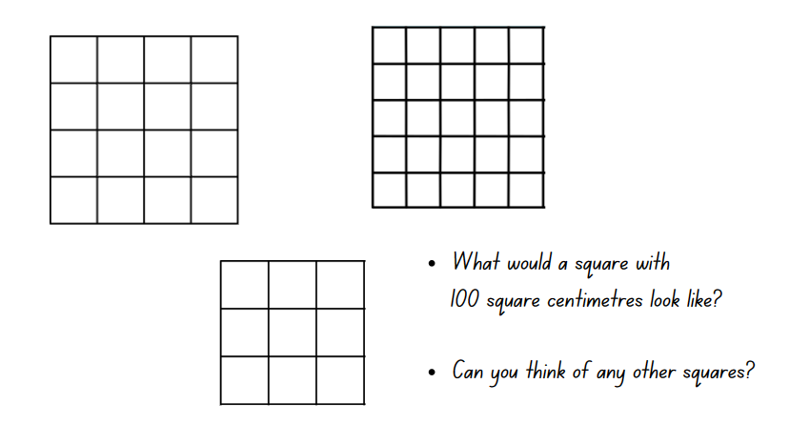

Syllabus outcomes and content
The table below outlines the syllabus outcomes and range of relevant syllabus content covered in this unit. Content is linked to National Numeracy Learning Progression version (3).
Outcomes and content | 1 | 2 | 3 | 4 | 5 | 6 | 7 | 8
Additive relations B: Partition, rearrange and regroup numbers to at least 1000 to solve additive problems
[MAO-WM-01, MA2-RN-01]
- Use quantity values and non-standard partitioning to solve addition and subtraction problems |  |  |  |  | x | x | x
- Model addition with and without regrouping and record the method used |  |  |  |  | x | x | x
- Use an algorithm with understanding to record addition and subtraction calculations, where efficient, involving 3-digit numbers |  |  |  |  | x | x | x
Multiplicative relations A: Generate and describe patterns
[MAO-WM-01, MA2-MR-01, MA2-MR-02]
- Model, describe and record patterns of multiples | x | x |  |  |  |  | x | x
- Create and continue a variety of number patterns that increase or decrease by a constant amount | x |  |  |  |  |  | x | x
- Recognise the significance of the final digit of a whole number in determining whether a given number is even or odd (Reasons about relations) | x
Multiplicative relations A: Use arrays to establish multiplication facts from multiples of 2 and 4, 5 and 10
[MAO-WM-01, MA2-MR-01, MA2-MR-02]
- Create and represent multiplicative structure, using the term multiples when connecting grouping to arrays |  |  | x |  |  |  | x | x
- Use the array structure to coordinate the number of groups with the number in each group |  |  | x |  |  |  | x | x
Multiplicative relations A: Recall multiplication facts of 2 and 4, 5 and 10 and related division facts
[MAO-WM-01, MA2-MR-01, MA2-MR-02]
- Recognise and use the symbols for multiplied by (×), divided by (÷) and equals (=) | x | x | x |  |  |  | x | x
- Link multiplication and division fact families using arrays |  | x | x |  |  |  | x | x
- Generate multiplication fact families for multiples of 2 and 4, 5 and 10 | x | x | x
- Model and apply the commutative property of multiplication |  | x | x |  |  |  | x
Two-dimensional spatial structure A: 2D shapes: Compare and describe features of two-dimensional shapes
[MAO-WM-01, MA2-2DS-01]
- Describe and compare two-dimensional shapes, including parallelograms, rectangles, rhombuses, squares, trapeziums and kites | x | x |  |  |  | x
- Identify and describe polygons that have parallel sides and those that do not | x | x
- Identify quadrilaterals that have all sides equal in length | x | x
- Identify right angles in shapes | x | x
- Group quadrilaterals using one or more attributes | x | x
Two-dimensional spatial structure A: 2D shapes: Transform shapes by reflecting, translating and rotating
[MAO-WM-01, MA2-2DS-02]
- Identify lines of symmetry in pictures, artefacts, designs and the environment |  |  | x | x
- Draw lines of symmetry on given shapes and identify quadrilaterals that do not have lines of symmetry |  |  | x | x
- Create and record tessellating designs by reflecting, translating and rotating triangles |  |  |  |  | x | x
- Apply and describe amounts of rotation including half-turns, quarter-turns and three-quarter-turns when creating designs |  |  |  |  | x | x
Two-dimensional spatial structure A: Area: Use square centimetres to measure and estimate the areas of rectangles
[MAO-WM-01, MA2-2DS-03]
- Create the array structure of area using squares (1 cm × 1 cm) in rows and columns |  |  |  |  |  |  | x
- Recognise that area can be measured in square centimetres |  |  |  |  |  |  | x
- Discuss strategies to estimate area in square centimetres |  |  |  |  |  |  | x
- Explain how the grid structure of rows and columns helps to find the area (Reasons about spatial structure) |  |  |  |  |  |  | x
- Estimate and measure the areas of squares and rectangles (within the range of 100 square centimetres) |  |  |  |  |  |  | x
- Record area in square centimetres using numerals and words |  |  |  |  |  |  | x
- Use efficient strategies for counting large numbers of square centimetres |  |  |  |  |  |  | x
Two-dimensional spatial structure A: Area: Use square metres to measure and estimate the areas of rectangles
[MAO-WM-01, MA2-2DS-03]
- Recognise the need for a formal unit larger than the square centimetre to measure area |  |  |  |  |  |  |  | x
- Construct a square metre and use it to measure the areas of large squares and rectangles |  |  |  |  |  |  |  | x
- Recognise that an area of one square metre need not be a square (Reasons about spatial structure) |  |  |  |  |  |  |  | x
- Record areas in square metres using numerals and words |  |  |  |  |  |  |  | x
- Estimate the areas of squares and rectangles in square metres |  |  |  |  |  |  |  | x
Two-dimensional spatial structure B: 2D shapes: Create symmetrical patterns and shapes
[MAO-WM-01, MA2-2DS-02]
- Create and record tessellating designs by reflecting, translating and rotating triangles or quadrilaterals |  |  |  |  | x | x
- Apply and describe amounts of rotation, including half-turns, quarter-turns and three-quarter-turns, when creating designs |  |  |  |  | x | x
Two-dimensional spatial structure B: Area: Measure the areas of shapes using the grid structure
[MAO-WM-01, MA2-2DS-03]
- Measure the areas of rectangles and right-angled triangles using a square-centimetre grid overlay |  |  |  |  |  |  |  | x
- Estimate the areas of shapes found in the environment using efficient strategies (non-count-by-one) with a grid overlay |  |  |  |  |  |  |  | x
- Recognise that rectangles with different side lengths can have the same area |  |  |  |  |  |  |  | x
Mathematics K–10 Syllabus © NSW Education Standards Authority (NESA) for and on behalf of the Crown in right of the State of New South Wales, 2022.

References
This resource contains NSW Curriculum and syllabus content. The NSW Curriculum is developed by the NSW Education Standards Authority. This content is prepared by NESA for and on behalf of the Crown in right of the State of New South Wales. The material is protected by Crown copyright.
Please refer to the NESA Copyright Disclaimer for more information https://educationstandards.nsw.edu.au/wps/portal/nesa/mini-footer/copyright.
NESA holds the only official and up-to-date versions of the NSW Curriculum and syllabus documents. Please visit the NSW Education Standards Authority (NESA) website https://educationstandards.nsw.edu.au/wps/portal/nesa/home/ and the NSW Curriculum website https://curriculum.nsw.edu.au.
Mathematics K–10 Syllabus © NSW Education Standards Authority (NESA) for and on behalf of the Crown in right of the State of New South Wales, 2022.
National Numeracy Learning Progression © Australian Curriculum, Assessment and Reporting Authority (ACARA) 2010 to present, unless otherwise indicated. This material was downloaded from the Australian Curriculum website (National Literacy Learning Progression) (accessed 11 September 2023) and was not modified.
Anshaw G (n.d) ‘Inquiring into the Square Metre’, Enquiry-Based Maths, accessed 11 September 2023.
Australians Together (n.d.) ‘Rotation and symmetry in animal tracks and symbolic language from Indigenous cultures’, Australians Together website, accessed 11 September 2023.
Commonwealth of Pennsylvania (2013) Classifying Quadrilaterals, Pennsylvania Department of Education, Standards Aligned System website, accessed 11 September 2023.
Siemon D, Beswick K, Brady K, Clark J, Faragher R, Warren E (2015) Teaching Mathematics – Foundations to Middle years, 2nd edn, Oxford University Press Australian and New Zealand.
University of Cambridge (n.d.) What’s in the Box, NRICH website, accessed 11 September 2023.
University of Cambridge Picture Your Method, NRICH website, accessed 11 September 2023.
Van de Walle J, Karp K, Bay-Williams JM, Brass A, Bentley B, Ferguson S, Goff W, Livy S, Marshman M, Martin D, Pearn C, Prodromou T, Symons D and Wilkie K (2019) Primary and Middle Years Mathematics: Teaching Developmentally, 1st Australian edn, Pearson Education Australia, Melbourne.
Wikipedia contributors (2023) Islamic geometric patterns Wikipedia The Free Encyclopedia, accessed 11 September 2023.
© State of New South Wales (Department of Education), 2024
The copyright material published in this resource is subject to the Copyright Act 1968 (Cth) and is owned by the NSW Department of Education or, where indicated, by a party other than the NSW Department of Education (third-party material).
Copyright material available in this resource and owned by the NSW Department of Education is licensed under a Creative Commons Attribution 4.0 International (CC BY 4.0) license.
This license allows you to share and adapt the material for any purpose, even commercially.
Attribution should be given to © State of New South Wales (Department of Education), 2024.
Material in this resource not available under a Creative Commons license:
- the NSW Department of Education logo, other logos and trademark-protected material
- material owned by a third party that has been reproduced with permission. You will need to obtain permission from the third party to reuse its material.
Links to third-party material and websites
Please note that the provided (reading/viewing material/list/links/texts) are a suggestion only and implies no endorsement, by the New South Wales Department of Education, of any author, publisher, or book title. School principals and teachers are best placed to assess the suitability of resources that would complement the curriculum and reflect the needs and interests of their students.
If you use the links provided in this document to access a third-party's website, you acknowledge that the terms of use, including licence terms set out on the third-party's website apply to the use which may be made of the materials on that third-party website or where permitted by the Copyright Act 1968 (Cth). The department accepts no responsibility for content on third-party websites.

