Mathematics Stage 2 – Unit 11
Our number system extends infinitely to very large and very small numbers
Contents
Unit description and duration 5
Syllabus outcomes 5
Working mathematically 5
Student prior learning 6
Lesson overview and resources 7
Lesson 1 12
Daily number sense – prove it – 10 minutes 12
Core lesson 1 – place value houses – 15 minutes 14
Core lesson 2 – creating larger numbers – 30 minutes 16
Discuss and connect the mathematics – 5 minutes 19
Lesson 2 20
Daily number sense – How many? – 10 minutes 20
Core lesson – representing numbers – 40 minutes 22
Consolidation and meaningful practice – 10 minutes 24
Lesson 3 26
Daily number sense – find the missing numbers – 10 minutes 26
Core lesson 1 – let’s talk numbers – 10 minutes 28
Core lesson 2 – non-standard partitioning – 30 minutes 29
Consolidation and meaningful practice – 10 minutes 31
Lesson 4 33
Daily number sense – 10 minutes 33
Core lesson – representing using non-standard partitioning – 35 minutes 33
Consolidation and meaningful practice – 15 minutes 36
Lesson 5 38
Daily number sense – Can you see a pattern? – 10 minutes 38
Core lesson 1 – One Is a Snail, Ten Is a Crab – 20 minutes 40
Core lesson 2 – arrays – 15 minutes 42
Consolidation and meaningful practice – 15 minutes 44
Lesson 6 46
Daily number sense – Odd one out? – 15 minutes 46
Core lesson – multiplication and division facts – 40 minutes 47
Consolidation and meaningful practice – 15 minutes 50
Lesson 7 52
Daily number sense – number patterns – 10 minutes 52
Core lesson – multiplication and division are related – 40 minutes 54
Discuss and connect the mathematics – 10 minutes 57
Lesson 8 60
Daily number sense – 10 minutes 60
Core lesson – problem solving – 40 minutes 60
Discuss and connect the mathematics – 10 minutes 63
Resource 1 – prove it 65
Resource 2 – place value houses 66
Resource 3 – MAB visual 67
Resource 4 – think board 68
Resource 5 – Which doesn’t belong? 69
Resource 6 – playing board 70
Resource 7 – 7211 MAB visual 71
Resource 8 – MAB representations 72
Resource 9 – non-standard partitioning match 73
Resource 10 – Pattern or not? 74
Resource 11 – crab image 75
Resource 12 – dog + snail A 76
Resource 13 – 15 array 77
Resource 14 – dog + snail B 78
Resource 15 – show your thinking 79
Resource 16 – dog + snail C 80
Resource 17 – Odd one out? 81
Resource 18 – Convince me! 82
Resource 19 – array/fact family 83
Resource 20 – problems to solve 84
Syllabus outcomes and content 85
References 90
Further reading 90

Unit description and duration
This unit develops the big idea that our number system extends infinitely to very large and very small numbers.
In this 2-week unit students are provided opportunities to:
- partition, rename, represent and order numbers up to 6 digits
- use partitioning and place value knowledge when multiplying and dividing
- see the inverse relationship between multiplication and division, using the associative and distributive properties of multiplication.

Syllabus outcomes
- MAO-WM-01 develops understanding and fluency in mathematics through exploring and connecting mathematical concepts, choosing and applying mathematical techniques to solve problems, and communicating their thinking and reasoning coherently and clearly
- MA2-RN-01 applies an understanding of place value and the role of zero to represent numbers to at least tens of thousands
- MA2-MR-01 represents and uses the structure of multiplicative relations to 10 × 10 to solve problems

Working mathematically
In the Mathematics K–10 Syllabus, there is one overarching Working mathematically outcome (MAO-WM-01). The Working mathematically processes should be embedded within the concepts being taught. The Working mathematically processes are:
- communicating
- understanding and fluency
- reasoning
- problem solving.
Mathematics K–10 Syllabus © NSW Education Standards Authority (NESA) for and on behalf of the Crown in right of the State of New South Wales, 2022.

Student prior learning
Before engaging in these teaching and learning activities, students would benefit from prior experience with:
- reading, representing, partitioning and ordering numbers up to thousands
- partitioning 2- and 3-digit numbers
- using arrays and fact families to establish and represent multiplication facts from multiples of 2 and 4, 5 and 10.
In NSW classrooms there is a diverse range of students, including Aboriginal and/or Torres Strait Islander students, students learning English as an additional language or dialect, high potential and gifted students and students with disability. Some students may identify with more than one of these groups or possibly all of them. Refer to Curriculum planning for every student – advice for further information.

Lesson overview and resources
The table below outlines the sequence and approximate timing of lessons, learning intentions and resources.
Lesson | Content | Duration and resources
Lesson 1  Daily number sense learning intention:  - represent and solve problems involving multiplication fact families | Lesson core concept: reading and recording large numbers is a key component of place value.  Core concept learning intentions:  - read, represent and order numbers to thousands  - recognise and represent numbers that are 10, 100 and 1000 times as large | Lesson duration: 60 minutes  - Resource 1 – prove it  - Resource 2 – place value houses  - Resource 3 – MAB visual  - Individual whiteboards  - MAB materials  - Writing materials
Lesson 2  Daily number sense learning intention:  - represent and solve problems involving multiplication fact families | Lesson core concept: collections of tens, hundreds and thousands are really useful.  Core concept learning intentions:  - apply place value to partition and regroup numbers up to 4 digits  - order numbers in the thousands | Lesson duration: 60 minutes  - Resource 4 – think board  - Resource 5 – Which doesn’t belong?  - 6-sided dice  - 9-sided dice  - A4 cardboard (one per pair of students)  - Counters (30 per pair of students)  - Individual whiteboards  - Writing materials
Lesson 3  Daily number sense learning intention:  - represent and solve problems involving multiplication fact families | Lesson core concept: numbers can be renamed in equivalent ways using place value.  Core concept learning intention:  - apply place value to partition and regroup numbers up to 4 digits | Lesson duration: 60 minutes  - Resource 6 – playing board  - Resource 7 – 7211 MAB visual  - Resource 8 – MAB representations  - Resource 9 – non-standard partitioning match  - MAB materials (physical or digital)
Lesson 4  Daily number sense learning intention:  - teacher-identified task based on student needs | Lesson core concept: numbers can be changed and renamed and still maintain their value.  Core concept learning intention:  - apply place value to partition and regroup numbers up to 4 digits | Lesson duration: 60 minutes  - Individual whiteboards  - MAB materials  - Writing materials
Lesson 5  Daily number sense learning intention:  - generate and describe patterns | Lesson core concept: multiplicative thinking is based on patterns and structures.  Core concept learning intentions:  - identify and represent multiplicative patterns and structures  - use arrays to establish multiplication facts from multiples of 2 and 4, 5 and 10 | Lesson duration: 60 minutes  - Resource 10 – Pattern or not?  - Resource 11 – crab image  - Resource 12 – dog + snail A  - Resource 13 – 15 array  - Resource 14 – dog + snail B  - Resource 15 – show your thinking  - Resource 16 – dog + snail C  - Sayre AP and Sayre J (2010) One Is a Snail, Ten Is a Crab: A Counting by Feet Book (Cecil R illus), Candlewick Press, United States.  - Individual whiteboards  - Writing materials
Lesson 6  Daily number sense learning intention:  - generate and describe patterns | Lesson core concept: multiplication and division are related.  Core concept learning intention:  - recall multiplication facts of 2 and 4, 5 and 10 and related division facts | Lesson duration: 70 minutes  - Resource 17 – Odd one out?  - Resource 18 – Convince me!  - Counters (30 per group)  - Individual whiteboards  - Writing materials
Lesson 7  Daily number sense learning intention:  - generate and describe patterns. | Lesson core concept: fact families support fluency.  Core concept learning intentions:  - recall multiplication facts of 2 and 4, 5 and 10 and related division facts  - represent and solve word problems with number sentences involving multiplication or division | Lesson duration: 60 minutes  - Resource 19 – array/fact family  - Individual whiteboards  - Writing materials
Lesson 8  Daily number sense learning intention:  - teacher-identified task based on student needs | Lesson core concept: worded problems can be solved using multiplicative thinking.  Core concept learning intentions:  - represent and solve problems involving multiplication fact families  - use arrays to establish multiplication facts from multiples of 2 and 4, 5 and 10 | Lesson duration: 60 minutes  - Resource 20 – problems to solve  - Individual whiteboards  - Writing materials

Lesson 1
Core concept: reading and recording large numbers is a key component of place value.

Daily number sense – prove it – 10 minutes
Daily number sense activities for Lessons 1 to 3 ‘activate’ prior number knowledge and support the learning of new content in the unit. These activities can also assist teachers to identify the starting points for learning by revealing the extent of students’ existing knowledge.
The table below contains a suggested learning intention and success criteria. These are best co-constructed with students.
Daily number sense learning intention | Daily number sense success criteria
Students are learning to:  - represent and solve problems involving multiplication fact families. | Students can:  - describe multiplication problems using ‘times as many’.
- Display Resource 1 – prove it and read the scenario to students.
- Independently or in pairs, students work on individual whiteboards to determine how many carrots the farmer planted. They use this to decide which student’s statement is correct.
- Students use diagrams, words or symbols to record their answer.
- Ask:
- How did you determine if the answer was correct?
- How did you record your thinking?
- Is there another way of working it out?
- Repeat these steps for the following scenarios:
- The teacher gives out 4 stickers before lunch. She gives out 3 times as many stickers after lunch. How many stickers does she hand out?
- A baker bakes 6 cupcakes in the morning. He bakes 4 times as many cupcakes in the afternoon. How many cupcakes does he bake that day?
This table details an opportunity for assessment.
Assessment opportunity | Links
What to look for:  - Can students describe multiplication problems using times as many? [MAO-WM-01, MA2-MR-01] | Links to suggested Interview for Student Reasoning (IfSR) tasks:  - IfSR-MT: 2A.12, 2A.13, 2A.14.

Core lesson 1 – place value houses – 15 minutes
The table below contains suggested learning intentions and success criteria. These are best co-constructed with students.
Core concept learning intentions | Core concept success criteria
Students are learning to:  - read, represent and order numbers to thousands  - recognise and represent numbers that are 10, 100 and 1000 times as large. | Students can:  - read and order numbers of up to at least 4 digits  - describe how making a number 10, 100 or 1000 times as large changes the place value of digits.
- Display the numbers 275, 5722 and 2572.
- Ask:
- Can you read these numbers?
- What do you notice about these numbers?
- Which number is the largest? How do you know?
- Which number is the smallest? How do you know?
- Display Resource 2 – place value houses.
- Remind students that each house is divided into hundreds, tens and ones. Extra houses are added as the number grows in size.
- Say the number 8361.
- Ask a student to write the numbers into the columns based on the place value of each digit.
- Remind students that the purpose of the place value houses is to assist in reading larger numbers. Discuss how this structure makes reading and recording large numbers easier.
- Read out a 4-digit number.
- Students record this number using Resource 2 – place value houses.
- Students turn and talk to a partner, comparing where they have written each number and discussing its relative value. For example, the number 3 is recorded in the hundreds column because the number 8361 contains 3 hundreds.
- Display the numbers 2, 7, 9 and 4 (see Figure 1). Explain that students are to create 2 different 4-digit numbers using these numbers.
Figure 1 – numbers displayed on whiteboard
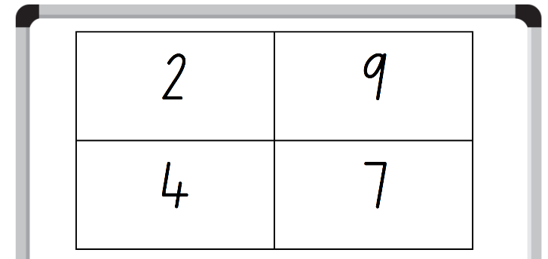
- Students record their numbers using the Resource 2 – place value houses.
- Students turn and talk to a partner, sharing their numbers and explaining the value of each numeral.
- Ask 2 students to share the 4-digit numbers they created and list these on the whiteboard.
- Choose a different student to order numbers in ascending order on the board, using place value knowledge to justify the order.
- Vertically list these numbers, with the smallest on top, on the whiteboard.
- As a class, discuss the order of the numbers, making adjustments as needed.
This table details opportunities for differentiation.
Too hard? | Too easy?
Students cannot read and order numbers of up to at least 4 digits.  - Assist students by reducing their number to a 2- or 3-digit number.  - Support students by using MAB materials to represent the numbers. | Students can read and order numbers of up to at least 4 digits.  - Extend students by increasing their number to a 5- or 6- digit number.  - Challenge students by modifying the numbers to include a zero.

Core lesson 2 – creating larger numbers – 30 minutes
- Display Resource 3 – MAB visual.
- Ask:
- What do you notice?
- What is the value of the 5 in each of these numbers?
- How has the value of the 5 changed?
- Record numbers into Resource 2 – place value houses (see Figure 2).
Figure 2 – example of number recording
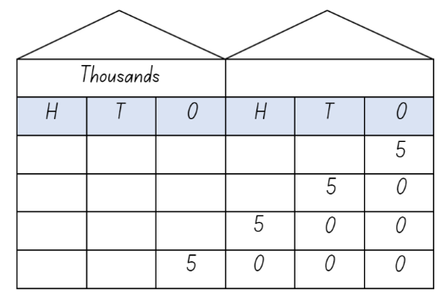
- Highlight how the MAB representation of each number becomes larger when its value changes. Emphasise how the value of the 5 changes as it is in a different place in each of the houses.
Note: explicitly teach and make connections between the different quantities and the size of the number, ensuring that students understand that changing the quantity value affects the number’s size. For example, 50 is 10 times as large as 5 but 500 is 100 times as large as 5.
- Ask: When might you see 5, 50, 500 or 5000 people in real life? (For example, in their family, at a party, at the beach or watching a concert). Discuss briefly as a class.
- Explain that, in pairs, students will be making a number which is 10, 100 and 1000 times larger than their original number.
- Assign each pair a number from 1–9 (excluding 5).
- Students use place value houses and MAB materials to make their assigned number 10 times, 100 times and 1000 times as large as their original number.
- Complete a gallery walk to observe other pairs’ representations.
This table details opportunities for differentiation.
Too hard? | Too easy?
Students cannot describe how making a number 10, 100 or 1000 times as large changes the place value of digits.  - Provide MAB materials to create each of the numbers.  - Students explore making a number 10 times as large using MAB materials to demonstrate their thinking. | Students can describe how making a number 10, 100 or 1000 times as large changes the place value of digits.  - Challenge students by adding 50 000 to the 10 000 place value house.  - Challenge students by beginning with a larger number. For example, begin with 11 and explain that 10 times as large is 110, 100 times as large is 1100, 1000 times as large is 11 000.

Discuss and connect the mathematics – 5 minutes
- Ask:
- What did you observe from the gallery walk?
- What did you notice about the numbers?
- Can you notice any patterns?
- Who had the largest number? How do you know?
This table details opportunities for assessment.
Assessment opportunities | Links
What to look for:  - Can students read and order numbers of up to at least 4 digits? [MAO-WM-01, MA2-RN-01]  - Can students describe how making a number 10, 100 or 1000 times as large changes the place value of digits?  [MAO-WM-01, MA2-RN-01] | Links to National Numeracy Learning Progressions (NNLP):  - NPV5, NPV6.  Links to suggested Interview for Student Reasoning (IfSR) tasks:  - IfSR-NP: 4B.2, 4C.5.

Lesson 2
Core concept: collections of tens, hundreds and thousands are really useful.

Daily number sense – How many? – 10 minutes
The table below contains a suggested learning intention and success criteria. These are best co-constructed with students.
Daily number sense learning intention | Daily number sense success criteria
Students are learning to:  - represent and solve problems involving multiplication fact families. | Students can:  - describe multiplication problems using for each and times as many  - find the total of partially covered arrays.
- Students work in pairs.
- Give each pair 30 counters and a piece of cardboard.
- To set up the task, Student A rolls two 6-sided dice. The numbers rolled are used to make an array using counters, for example, 6 and 4. They partially cover the array with the cardboard so that only the top of one row and one column can be seen (see Figure 3). Student A does this without being observed by Student B.
Figure 3 – partially covered array
- Student A shows the partially covered array to Student B.
- Student B uses the information they can see to record the total number of counters on their whiteboard as an array and a sentence, for example, 4 rows of 6 is 24.
- Student A uncovers the array and Student B counts the counters to check the accuracy of their answer.
- Repeat the activity with students swapping roles.
This table details opportunities for assessment.
Assessment opportunities | Links
What to look for:  - Can students describe multiplication problems using for each and times as many? [MAO-WM-01, MA2-MR-01, MA2-MR-02]  - Can students find the total of partially covered arrays?  [MAO-WM-01, MA2-MR-01, MA2-MR-02] | Links to National Numeracy Learning Progressions (NNLP):  - MuS5.  Links to suggested Interview for Student Reasoning (IfSR) tasks:  - IfSR-MT: 2A.1, 2A.12, 2A.13, 2A.14.

Core lesson – representing numbers – 40 minutes
The table below contains suggested learning intentions and success criteria. These are best co-constructed with students.
Core concept learning intentions | Core concept success criteria
Students are learning to:  - apply place value to partition and regroup numbers up to 4 digits  - order numbers in the thousands. | Students can:  - record numbers using standard place value form  - arrange numbers in the thousands in ascending and descending order.
- Ask for examples of different ways a number can be represented.
Note: ensure responses include MAB visuals, numerals or words, expanded notation, partitioning, place value houses, the value of each digit and real-life examples.
- Display the number 6048.
- Ask for examples of different ways this number could be represented.
- Students record their representations on an individual whiteboard.
- Discuss and share representations to create a class anchor chart (see Figure 4.).
Figure 4 – example of completed anchor chart
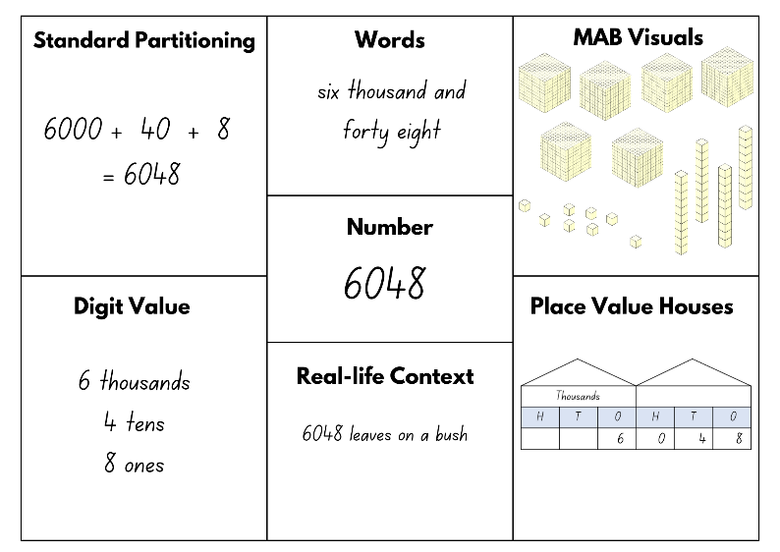
- Students roll a 9-sided die 4 times to create a 4-digit number.
- Students record the number and complete Resource 4 – think board using this number.
- Have students find someone with the same value in the thousands column to share their think board with, discussing the different ways they have represented the number. If unsuccessful, choose a different number value. For example, the same value in the hundreds column and share.
- Students use their place value knowledge to justify why their think board representations are correct.
- Revise the concept of ascending and descending order by selecting 6 students to call out the numbers they created and listing them on the whiteboard.
- As a group, arrange these numbers in ascending order. Discuss how the order will change if they are asked to place the numbers in descending order.
- Students form small groups and arrange their numbers in ascending and descending order and record on an individual whiteboard.
This table details opportunities for differentiation.
Too hard? | Too easy?
Students cannot record numbers using standard place value form.  - Modify Resource 4 – think board to represent only MAB visuals, place value houses and standard partitioning.  - Reduce the numbers to 2- or 3-digits.  - Support students using MAB materials to create each of the numbers. | Students can record numbers using standard place value form.  - Challenge students to use numbers into ten of thousands.  - Working in pairs, students write a 4-digit number on an individual whiteboard without showing their partner. Students take turns to ask questions to guess their partner’s number. For example, students can ask if the number has a 4 in the hundreds place or if the numeral in the tens place is higher than 5. When they think they have enough information, students guess their partner’s number. This number can be recorded and represented using Resource 4 – think board.

Consolidation and meaningful practice – 10 minutes
- Display Resource 5 – Which doesn’t belong? which is a completed think board.
- Say that some of the sections have been completed incorrectly.
- Students turn and talk to a partner to try and identify which section doesn't belong, using their place value knowledge to justify their reasons.
- As a class, decide on which section they believe doesn't belong.
- Students record the accurate representation of those sections using individual whiteboards or their workbooks.
This table details opportunities for assessment.
Assessment opportunities | Links
What to look for:  - Can students record numbers using standard place value form? [MAO-WM-01, MA2-RN-01]  - Can students arrange numbers in the thousands in ascending and descending order? [MAO-WM-01, MA2-RN-01] | Links to National Numeracy Learning Progressions (NNLP):  - NPV4, NPV5, NPV6

Lesson 3
Core concept: numbers can be renamed in equivalent ways using place value.

Daily number sense – find the missing numbers – 10 minutes
The table below contains a suggested learning intention and success criteria. These are best co-constructed with students.
Daily number sense learning intention | Daily number sense success criteria
Students are learning to:  - represent and solve problems involving multiplication fact families. | Students can:  - apply the inverse relationship of multiplication and division.
- Provide pairs of students with Resource 6 – playing board.
- Explain that this board contains a variety of multiplication and division cards with equations. Each of the division cards has one number that is missing. For each multiplication card there are 2 matching division cards.
- Students must use the numbers provided to fill in the missing spaces in the division cards.
- When all the missing numbers from the division cards have been filled in, the matching sets of equations are grouped together. Each matching set consists of one multiplication and 2 division cards (see Figure 5).
Figure 5 – set of matching equations
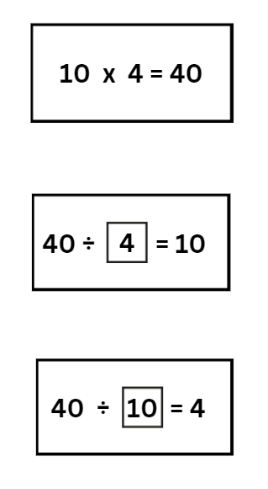
- Once all the matching sets are found, students ask another pair to check their sets.
This table details an opportunity for assessment.
Assessment opportunity | Links
What to look for:  - Can students apply the inverse relationship of multiplication and division? [MAO-WM-01, MA2-MR-01, MA2-MR-02] | Links to National Numeracy Learning Progressions (NNLP):  - MuS7  Links to suggested Interview for Student Reasoning (IfSR) tasks:  - IfSR-MT: 2A.5, 2A.10.

Core lesson 1 – let’s talk numbers – 10 minutes
The table below contains a suggested learning intention and success criteria. These are best co-constructed with students.
Core concept learning intention | Core concept success criteria
Students are learning to:  - apply place value to partition and regroup numbers up to 4 digits. | Students can:  - record numbers using standard place value form  - partition numbers of up to 4 digits in non-standard forms.
- Display Resource 7 – 7211 MAB visual which shows the number 7211 using standard and non-standard partitioning. Ask:
- What do you notice?
- Are they the same or different values?
- How do you know?
- Ask if these are all the possible ways of making this number using MAB materials.
- As a class, use digital manipulatives, physical MAB materials or Resource 8 – MAB representations to create another way to represent this number using non-standard partitioning.
Note: ensure the vocabulary of standard and non-standard partitioning is used.

Core lesson 2 – non-standard partitioning – 30 minutes
- Write the number 2493 on the whiteboard.
- Use digital manipulatives, physical MAB materials or Resource 8 – MAB representations to create the number displayed using non-standard partitioning.
- Ask if 2493 can be represented another way using non-standard partitioning.
- In pairs, students represent this number using MAB materials in a different non-standard form.
- Students complete a gallery walk, observing their classmates’ representations of the same number.
- During the gallery walk, students note:
- Did anyone represent this number the same way as you?
- What was the most efficient way to represent this number? Why?
- Did you see a representation that you would use next time?
- Select 3 different representations of the number 2493 completed by the students.
- Challenge the students to convince the class that all these representations have the same value.
- Students use their knowledge of place value to demonstrate how they know each of these representations have the same value.
This table details opportunities for differentiation.
Too hard? | Too easy?
Students cannot record numbers using standard place value form.  - Assist students by reducing the number to 2- or 3- digits.  - Support students by providing Resource 2 – place value houses to help highlight the change of digits.  Students cannot partition numbers of up to 4 digits in non-standard forms.  - Assist students by reducing the number to 2- or 3- digits.  - Model the use of MAB materials to represent numbers when using non-standard partitioning. | Students can record numbers using standard place value form.  - Use 5- or 6-digit numbers.  - Challenge students to use a number with an internal zero.  Students can partition numbers of up to 4 digits in non-standard forms.  - Students work in pairs. Student A records a secret number then makes the number with MAB materials using non-standard partitioning. Student B works out what the secret number is. Swap roles and repeat.  - Students sit back-to-back, each with an individual whiteboard. Student A writes a 4-digit number on their whiteboard, reads it aloud and represents it using standard partitioning. Student B writes down the number they have heard and represents it using non-standard partitioning. Students compare results and swap roles.

Consolidation and meaningful practice – 10 minutes
- Display Resource 9 – non-standard partitioning match.
- As a class, discuss which number matches each of the non-standard forms.
- Ask:
- How did you count the MAB visual representations?
- How would you explain this to someone else?
- Could you show me another way we could represent the same number?
- What happens if we try to represent this number without using thousands?
- Students attempt to make one of the numbers a different way using non-standard partitioning.
- Students turn and talk with a partner to compare their representations, justifying their choice of materials.
This table details opportunities for assessment.
Assessment opportunities | Links
What to look for:  - Can students record numbers using standard place value form? [MAO-WM-01, MA2-RN-01]  - Can students partition numbers of up to 4 digits in non-standard forms? [MAO-WM-01, MA2-RN-01] | Links to National Numeracy Learning Progressions (NNLP):  - NPV4, NPV5, NPV6.  Links to suggested Interview for Student Reasoning (IfSR) tasks:  - IfSR-AT: 3B.2.

Lesson 4
Core concept: numbers can be changed and renamed and still maintain their value.

Daily number sense – 10 minutes
- From a class need surfaced through formative assessment data, identify a short, focused activity that targets students’ knowledge, understanding and skills. Example activities may be drawn from the following resources:
- Mathematics K–6 resources
- Universal Resources Hub.

Core lesson – representing using non-standard partitioning – 35 minutes
The table below contains a suggested learning intention and success criteria. These are best co-constructed with students.
Core concept learning intention | Core concept success criteria
Students are learning to:  - apply place value to partition and regroup numbers up to 4 digits. | Students can:  - record numbers using standard place value form  - represent and record numbers up to 4 digits using non-standard partitioning.
- In pairs, students sit back-to-back.
- Display the number 4536.
- Using concrete MAB materials, students represent the given number using standard partitioning.
- When complete, students turn back to their partner and compare representations. If their representations differ, students discuss which one shows an accurate representation of standard partitioning for that number.
- Students return to sitting back-to-back. They represent the same number using non-standard partitioning and record on their individual whiteboard (see Figure 6).
Figure 6 – example of student work
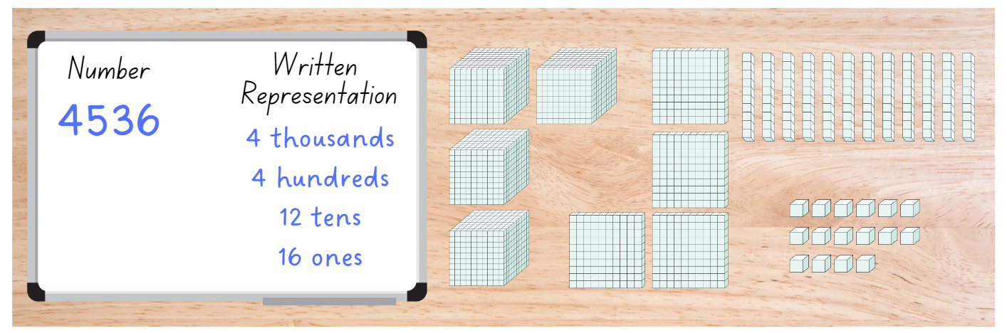
- Pairs discuss how their partitions are similar or different, how the representation can be counted and the most efficient way to partition the number.
- Students share their answers and reasoning with the class.
- Individually, students partition the number again using non-standard partitioning in a different way.
- Ask if the numbers have the same value when they are represented using standard and non-standard partitioning. Discuss student answers.
This table details opportunities for differentiation.
Too hard? | Too easy?
Students cannot record numbers using standard place value form.  - Assist students by reducing the number to 2- or 3- digits.  - Support students by providing Resource 2 – place value houses to help highlight the value of each digit.  Students cannot represent numbers up to 4 digits using non-standard partitioning.  - Assist students by reducing the number to 2- or 3- digits.  - Model the use of MAB materials to represent numbers when using non-standard partitioning. | Students can record numbers using standard place value form.  - Increase the complexity of the task by using 5- or 6- digits.  - Challenge students to use a number with an internal zero.  Students can represent numbers up to 4 digits using non-standard partitioning.  - Students create their own version of Resource 9 – non-standard partitioning match. Ask a classmate to solve it.  - Students sit back-to-back, each with an individual whiteboard. Student A writes a 4-digit number on their whiteboard, reads it aloud and represents it using standard partitioning. Student B writes down the number they have heard and represents it using non-standard partitioning. Students compare results, then swap roles and repeat.

Consolidation and meaningful practice – 15 minutes
- Students choose a 4-digit number to represent as many ways as they can.
- Students turn and talk with a partner to compare their representations, discussing the strategies they used for each different representation.
- Ask:
- Are some representations easier to read? Why?
- Are some representations easier to create? Why?
- How would you explain this to someone else?
- Is your way the only correct way?
This table details opportunities for assessment.
Assessment opportunities | Links
What to look for:  - Can students record numbers using standard place value form? [MAO-WM-01, MA2-RN-01]  - Can students represent and record numbers up to 4 digits using non-standard partitioning? [MAO-WM-01, MA2-RN-01] | Links to National Numeracy Learning Progressions (NNLP):  - NPV4, NPV5, NPV6.  Links to suggested Interview for Student Reasoning (IfSR) tasks:  - IfSR-AT: 3B.2.

Lesson 5
Core concept: multiplicative thinking is based on patterns and structures.

Daily number sense – Can you see a pattern? – 10 minutes
Daily number sense activities for Lessons 5 to 7 ‘loop’ back to concepts and procedures covered in previous units to assist students to build an increasingly connected network of ideas. These concepts may differ from the core concepts being covered by the unit.
The table below contains a suggested learning intention and success criteria. These are best co-constructed with students.
Daily number sense learning intention | Daily number sense success criteria
Students are learning to:  - generate and describe patterns. | Students can:  - model, describe and record patterns of multiples  - create and continue a variety of number patterns that increase or decrease by a constant amount.
- Display Resource 10 – Pattern or not?
- Students look for a pattern. They turn and talk to a partner to describe what they can see.
- Pose questions, such as:
- If this is a pattern, can you describe it?
- Based on what you can see, can you predict what comes next?
- Students record their ideas on individual whiteboards using diagrams, numbers and symbols.
- Discuss answers as a class with students, providing reasoning to support their ideas.
- Challenge students:
- If we know that the first picture is step one, how many steps will it take to make a number over 50?
- How many steps will it take to make a number over 100?
This table details opportunities for assessment.
Assessment opportunities | Links
What to look for:  - Can students model, describe and record patterns of multiples? [MAO-WM-01, MA2-MR-01, MA2-MR-02]  - Can students create and continue a variety of number patterns that increase or decrease by a constant amount?  [MAO-WM-01, MA2-MR-01, MA2-MR-02] | Links to National Numeracy Learning Progressions (NNLP):  - NPA3, NPA4.  Links to suggested Interview for Student Reasoning (IfSR) tasks:  - IfSR-NP: 4A.1, 4A.2, 4A.3.

Core lesson 1 – One Is a Snail, Ten Is a Crab – 20 minutes
The table below contains suggested learning intentions and success criteria. These are best co-constructed with students.
Core concept learning intentions | Core concept success criteria
Students are learning to:  - identify and represent multiplicative patterns and structures  - use arrays to establish multiplication facts from multiples of 2 and 4, 5 and 10. | Students can:  - model, describe and record patterns of multiples  - create and continue a variety of number patterns that increase or decrease by a constant amount  - create and represent multiplicative structure, using the term multiples when connecting grouping to arrays.
- Read One Is a Snail, Ten Is a Crab: A Counting by Feet Book by April Pulley Sayre and Jeff Sayre.
- As you read, stop and ask:
- What do you notice?
- Can you spot any patterns?
- What do you notice about odd and even numbers?
- Show Resource 11 – crab image. Ask:
- What is the value of one crab?
- What is the value of 2 crabs?
- If we know that, what do we know about the value of 4 crabs?
- How many crabs would you need to represent 100?
- How many groups is that?
Note: highlight that one crab is one group of 10 and 4 crabs is 4 groups of 10. The 10 claws of the crab are pictured as 5 and 5. This can be linked to double 5 is 10 and half of 10 is 5.
This table details opportunities for differentiation.
Too hard? | Too easy?
Students cannot model, describe and record patterns of multiples that increase and decrease by a constant amount.  - Support students by using Resource 11 – crab image to help establish and record the pattern.  - Model strategies, such as recording on individual whiteboards or highlighting on hundreds chart, that could assist students to maintain the constant difference. | Students can model, describe and record patterns of multiples that increase and decrease by a constant amount.  - Starting at 100, students continue to skip count by tens until they have added 8 more values. Ask what number they end up at.  - Students calculate  - How many crabs would be needed for 220 feet?  - Can you use crabs to represent the number 115? Why or why not?  - What creatures would be best to represent 115?

Core lesson 2 – arrays – 15 minutes
- Display Resource 12 – dog + snail A.
- Students identify the pattern.
- Label pictures on Resource 12 – dog + snail A using skip counting.
- Display Resource 13 – 15 array.
- Students identify which array accurately represents the number pattern above. They communicate their reasoning to justify answers, for example, it can’t be the first array as it shows 5 rows of 3. The pattern with the dog and snail was 3 groups of 5.
- Label arrays with skip counting pattern, ‘groups of’ and multiplication fact. Highlight why the correct array shows 3 rows of 5.
- Display Resource 14 – dog + snail B.
- Students discuss how they would represent this using skip counting, an array, ‘groups of’ and a multiplication fact.
- Students record their ideas on Resource 15 – show your thinking.
This table details opportunities for differentiation.
Too hard? | Too easy?
Students cannot create and represent multiplicative structure, using the term multiples when connecting grouping to arrays.  - Support students to use physical manipulatives such as counters to make the arrays.  - Model the use of the language of ‘groups of’ and drawing diagrams to assist students to establish the pattern. | Students can create and represent multiplicative structure, using the term multiples when connecting grouping to arrays.  - Working in pairs, Student A creates an array using counters. Student B records the skip counting and related multiplication fact to match. Swap roles and repeat.  - Students challenge a classmate by posing a question from the book to solve, showing their reasoning. For example:  - If I could see 32 feet, what number would I be skip counting by?  - What would that array look like?  - Is that the only skip counting pattern that would give us that answer?

Consolidation and meaningful practice – 15 minutes
- Gather students and turn and talk to share their Resource 15 – show your thinking board.
- Students check and justify answers, making modifications as needed.
- Display Resource 16 – dog + snail C.
- Ask questions:
- What do you notice about the amount in each picture?
- What is it increasing by?
- What would be the next 5 numbers in the pattern? Students record the multiplication fact.
- What would be the numbers before 15 in the pattern?
- What do you notice about the odd and even numbers in this pattern?
- How does the final digit determine whether a given number is even or odd?
This table details opportunities for assessment.
Assessment opportunities | Links
What to look for:  - Can students model, describe and record patterns of multiples? [MAO-WM-01, MA2-MR-01]  - Can students create and continue a variety of number patterns that increase or decrease by a constant amount?  [MAO-WM-01, MA2-MR-01]  - Can students create and represent multiplicative structure, using the term multiples when connecting grouping to arrays?  [MAO-WM-01, MA2-MR-01] | Links to National Numeracy Learning Progressions (NNLP):  - NPA3, NPA4, CPr6, MuS6.  Links to suggested Interview for Student Reasoning (IfSR) tasks:  - IfSR-NP: 4A.1, 4A.2, 4A.3.

Lesson 6
Core concept: multiplication and division are related.

Daily number sense – Odd one out? – 15 minutes
The table below contains a suggested learning intention and success criteria. These are best co-constructed with students.
Daily number sense learning intention | Daily number sense success criteria
Students are learning to:  - generate and describe patterns. | Students can:  - model, describe and record patterns of multiples.
- Display Resource 17 – Odd one out?
- In pairs, students must decide which picture doesn’t belong and why. For example, there are 25 lemon pieces. 25 is the only number that is a multiple of 5. Students record their ideas on an individual whiteboard.
- Challenge students who finish quickly to make a case for why each of the pictures does not belong.
- Encourage all pairs to find at least one solution. Students report back to the class, explaining which picture they decided didn’t belong and why.
This table details an opportunity for assessment.
Assessment opportunity | Links
What to look for:  - Can students model, describe and record patterns of multiples? [MAO-WM-01, MA2-MR-01] | Links to National Numeracy Learning Progressions (NNLP):  - NPA3, NPA4.

Core lesson – multiplication and division facts – 40 minutes
The table below contains a suggested learning intention and success criteria. These are best co-constructed with students.
Core concept learning intention | Core concept success criteria
Students are learning to:  - recall multiplication facts of 2 and 4, 5 and 10 and related division facts. | Students can:  - recognise and use the symbols for multiplied by (×), divided by (÷) and equals (=)  - link multiplication and division fact families using arrays  - model and apply the commutative property of multiplication.
- Display Resource 18 – Convince me!.
- Explain that the class needs to decide which student from the display has written the correct answer. Students justify why they have chosen that particular student.
- Students record their answer on an individual whiteboard. Their answer must include the student’s name and why they think that choice is correct.
- Students turn and talk to a partner to share and discuss their choices.
- If they are convinced by their partner that their choice is incorrect, they can change their answers.
- As a class, discuss that both students have represented the array correctly. Ask:
- Is this the only array that can be made from this number of counters?
- How can we record these arrays differently?
Note: arrays are always read across as ‘rows of’, not ‘columns of’.
- In small groups, give students 30 counters. Ask:
- How can we represent this collection as an array?
- How can we record this as a written representation?
- Students arrange the counters into an array and record using diagrams and written representation in their workbooks (see Figure 7).
Figure 7 – student workbook example
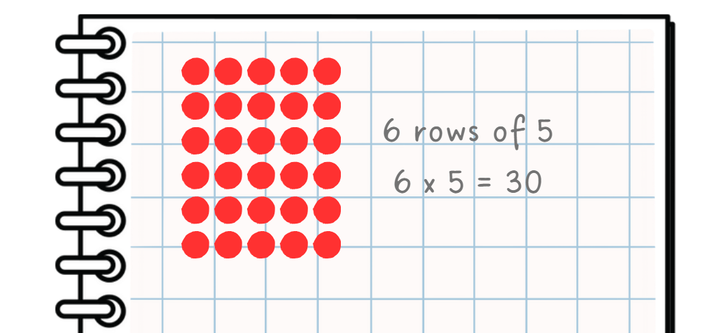
- As groups complete this task, ask if they can use this information to work out anything else about the 30 counters.
Note: highlight the commutative property. For example, 30 is 3 rows of 10 and 10 rows of 3. The related division facts are 30 shared into 3 rows is 10 and 30 shared into 10 rows is 3. This process enables students to create a fact family for 30.
- Write the sentence stems on the whiteboard and model completing one example (see Figure 8).
Figure 8 – example of sentence stems and diagrams
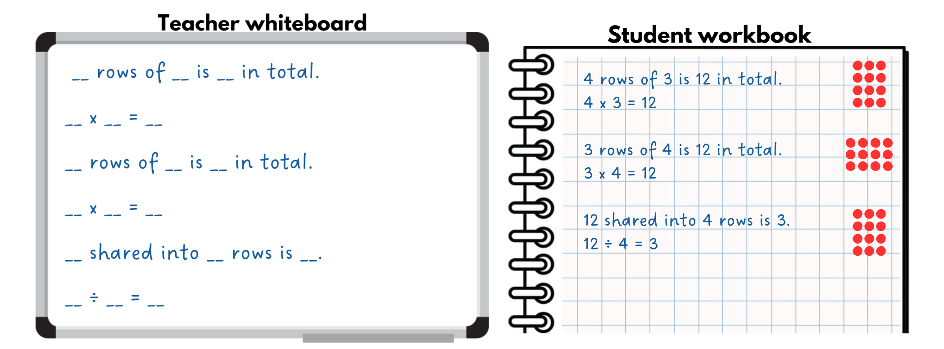
- Students repeat this activity in their workbooks or on individual whiteboards.
This table details opportunities for differentiation.
Too hard? | Too easy?
Students cannot link multiplication and division fact families using arrays.  - Support students by reducing the number of counters they are manipulating to a smaller number, such as 6 or 10.  - Model the use of manipulatives to help record fact families. | Students can link multiplication and division fact families using arrays.  - Students solve the problem: ‘In the classroom, we have tote tray holders. Each tote tray holder holds 12 tote trays. What could the tote tray holder look like? How many holders do you need for 36 tote trays? Draw and explain your thinking.’  - In pairs, students use their knowledge of multiplication to give their partner a number which is their answer. The student lists as many related fact family statements as they can. Then they show their partner and discuss, before swapping roles and repeating the process.

Consolidation and meaningful practice – 15 minutes
- Give students 15 counters each. Ask:
- How can we represent this collection as an array?
- How can we record this as a written representation?
- How many facts can you record about the collection using this information?
- Students record as many facts as they can about the 15 counters on their whiteboards using diagrams and written representations.
This table details opportunities for assessment.
Assessment opportunities | Links
What to look for:  - Can students link multiplication and division fact families using arrays? [MAO-WM-01, MA2-MR-01, MA2-MR-02]  - Can students model and apply the commutative property of multiplication? [MAO-WM-01, MA2-MR-01, MA2-MR-02]  - Can students recognise and use the symbols for multiplied by (×), divided by (÷) and equals (=)? [MAO-WM-01, MA2-MR-01] | Links to National Numeracy Learning Progressions (NNLP):  - MuS5, MuS6.  Links to suggested Interview for Student Reasoning (IfSR) tasks:  - IfSR-MT: 2A.5, 2A.9, 2A.10.

Lesson 7
Core concept: fact families support fluency.

Daily number sense – number patterns – 10 minutes
The table below contains a suggested learning intention and success criteria. These are best co-constructed with students.
Daily number sense learning intention | Daily number sense success criteria
Students are learning to:  - generate and describe patterns. | Students can:  - model, describe and record patterns of multiples  - create and continue a variety of number patterns that increase or decrease by a constant amount.
- Display the number pattern 5, 10, 15, 20, 25…
- Ask what students can see. Answers may include numbers going up by fives, add 5 every time, the 5 times table or multiples of 5.
- Display the number pattern 8, 13, 18, 23, 28…
- Ask students what they see. Draw their attention to the numbers going up by 5 but the starting number is different.
- Explain that the pattern is the same but the numbers have been shifted by 3.
- Display the number patterns below. Students explain to a partner how they worked out the pattern each time. Ask if their method will always work.
- 5, 9, 13, 17, 21…
- 111, 116, 121, 126, 131…
- 76, 86, 96, 106, 116…
- 33, 29, 25, 21, 17…
- Students continue the number patterns to find the next 5 values.
This table details opportunities for assessment.
Assessment opportunities | Links
What to look for:  - Can students model, describe and record patterns of multiples? [MAO-WM-01, MA2-MR-01, MA2-MR-02]  - Can students create and continue a variety of number patterns that increase or decrease by a constant amount?  [MAO-WM-01, MA2-MR-01, MA2-MR-02] | Links to National Numeracy Learning Progressions (NNLP):  - NPA3, NPA4.  Links to suggested Interview for Student Reasoning (IfSR) tasks:  - IfSR-NP: 4A.1, 4A.2, 4A.3.

Core lesson – multiplication and division are related – 40 minutes
The table below contains suggested learning intentions and success criteria. These are best co-constructed with students.
Core concept learning intentions | Core concept success criteria
Students are learning to:  - recall multiplication facts of 2 and 4, 5 and 10 and related division facts  - represent and solve word problems with number sentences involving multiplication or division. | Students can:  - link multiplication and division fact families using arrays  - model and apply commutative property of multiplication  - complete number sentences involving multiplication and division by calculating missing numbers.
- Display Resource 19 – array/fact family.
- Students turn and talk to decide which fact family triangle matches each array, using their knowledge of arrays and related facts.
- In pairs, students discuss and record the written representations related to each fact family on individual whiteboards.
- Select students to share one of their written representations and describe the strategies they used to create it.
- Select a number sentence for students to reframe using the word ‘half’. For example, 8 divided by 2 is 4 and half of 8 is 4.
- Draw the fact family triangle for the number 10 with one missing value (see Figure 9).
Figure 9 – fact family triangle
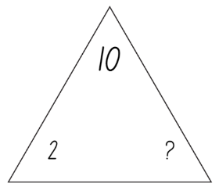
- Ask students which number is missing from the fact family.
- Students use their multiplicative knowledge to justify their answer. Encourage the use of the concept of ‘half’.
- Students record the fact family triangle for the number 10, the 2 arrays, the multiplication number sentences and the division number sentences associated with that fact family (see Figure 10).
Figure 10 – student workbook recording
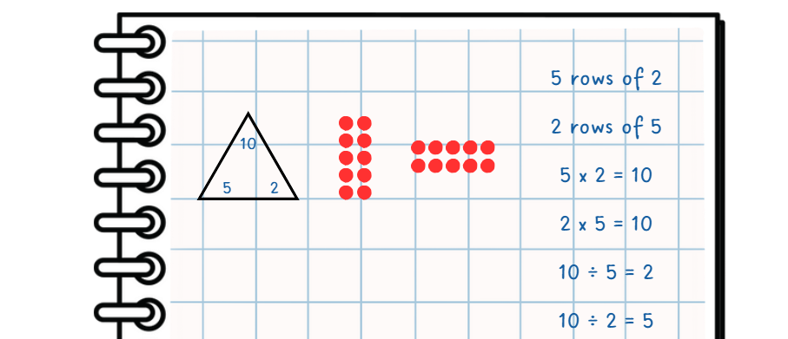
- Draw the fact family triangle for the number 30 with one missing value. For example, display the numbers 30 and 10 only.
- In pairs, students repeat the previous process to record the fact family triangle, 2 arrays, the multiplication number sentences and the division number sentences associated with this fact family.
This table details opportunities for differentiation.
Too hard? | Too easy?
Students cannot complete number sentences involving multiplication and division by calculating missing numbers.  - Support students to apply the correct multiplicative strategy by helping them identify one of the missing values.  - Model strategies to use support structures, such as using a set of pre-prepared multiplication fact families, to help students determine missing quantities. | Students can complete number sentences involving multiplication and division by calculating missing numbers.  - Students create their own missing value fact family triangle. They ask a classmate to solve it using 2 arrays and the associated multiplication and division number sentences.  - In pairs, students play ‘Mystery equation’ using multiplication (×) and division (÷). Student A draws 6 joined boxes on their whiteboard and secretly creates a multiplication or division equation to fit in the boxes. Student B guesses what the equation may be by writing it in the boxes. Student A places a tick above any numbers or symbols that are the correct number in the correct place, a circle above any correct numbers or symbols in the wrong place and a cross above any incorrect numbers or symbols (see Figure 11). Student B continues to guess until the correct equation is discovered. Repeat this process, swapping roles.  Figure 11 – mystery equation  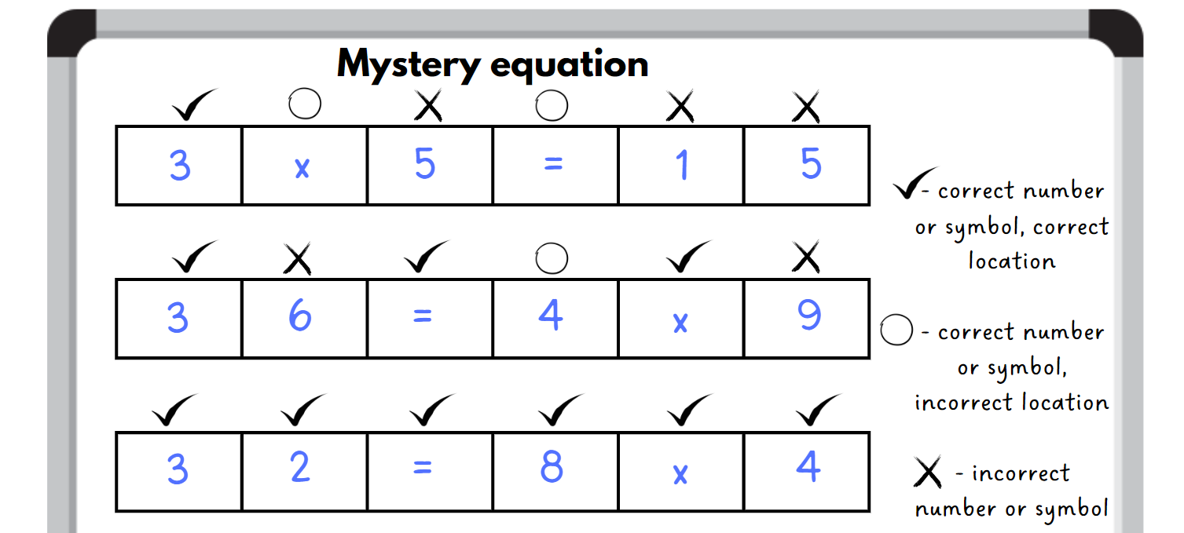

Discuss and connect the mathematics – 10 minutes
- On the whiteboard, draw the fact family triangle for 10 with multiples of 2 and 5, and 100 with multiples of 2 and 50 (see Figure 12).
Figure 12 – fact family 10 and 100
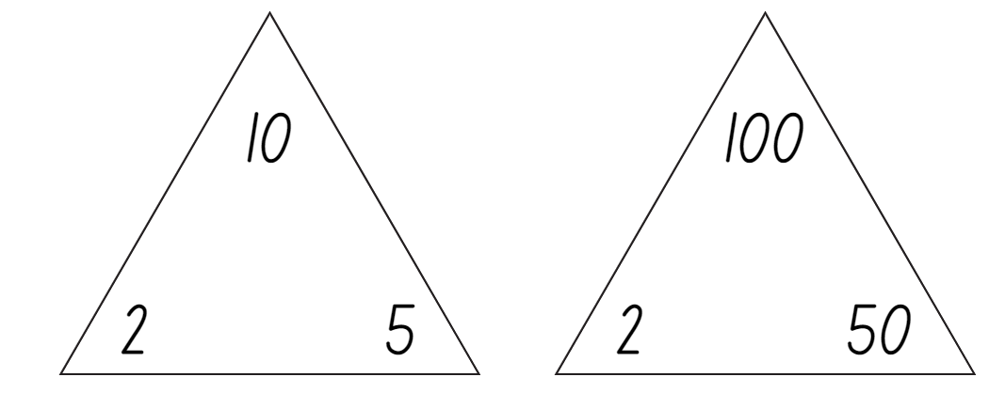
- Ask:
- How has the fact family changed?
- Do you see a pattern?
- How many times larger is the total of the second triangle?
This table details opportunities for assessment.
Assessment opportunities | Links
What to look for:  - Can students link multiplication and division fact families using arrays? [MAO-WM-01, MA2-MR-01, MA2-MR-02]  - Can students model and apply commutative property of multiplication? [MAO-WM-01, MA2-MR-01, MA2-MR-02]  - Can students complete number sentences involving multiplication and division by calculating missing number quantities?  [MAO-WM-01, MA2-MR-01, MA2-MR-02] | Links to National Numeracy Learning Progressions (NNLP):  - MuS6, NPA4  Links to suggested Interview for Student Reasoning (IfSR) tasks:  - IfSR-MT: 2A.5, 2A.9, 2A.10.

Lesson 8
Core concept: worded problems can be solved using multiplicative thinking.

Daily number sense – 10 minutes
- From a class need surfaced through formative assessment data, identify a short, focused activity that targets students’ knowledge, understanding and skills. Example activities may be drawn from the following resources:
- Mathematics K–6 resources
- Universal Resources Hub.

Core lesson – problem solving – 40 minutes
The table below contains suggested learning intentions and success criteria. These are best co-constructed with students.
Core concept learning intentions | Core concept success criteria
Students are learning to:  - represent and solve problems involving multiplication fact families  - use arrays to establish multiplication facts from multiples of 2 and 4, 5 and 10. | Students can:  - describe multiplication problems using for each and times as many  - apply the inverse relationship of multiplication and division  - recognise that doubling is multiplying by 2 and halving is dividing by 2.
- Students turn and talk to revise the strategies and ideas from the previous 3 lessons. They record these on an individual whiteboard.
- Share these as a class, highlighting ‘groups of’, arrays, halving, doubling, ‘for each’, 10 times as many and fact families.
- Read the following word problem aloud: Larissa has some marbles and shares them equally into 4 groups. Each group receives 5 marbles. Ask:
- How many marbles will Larissa share with her friends?
- How can this problem be represented visually?
- How can this problem be represented using 2 different strategies?
- Divide the whiteboard into 2 and demonstrate how to record both strategies side-by-side, as students communicate their ideas (see Figure 13).
Figure 13 – word problem recording example
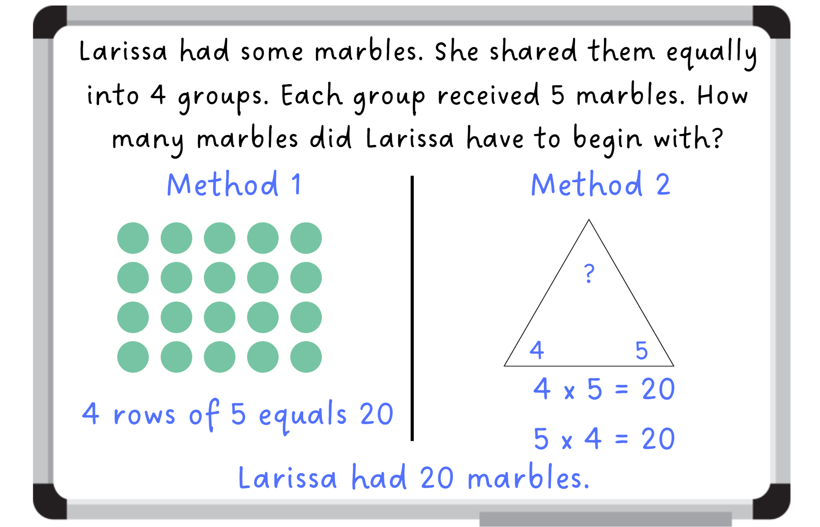
- Read the following word problem to students: Madison and Rachael went to pick oranges. Madison picks 2 oranges and Rachael picks 10 times as many. How many oranges does Rachael pick in total?
- Discuss with students the meaning of the phrase ‘10 times as many’ and link this explicitly to multiplication.
- Ask how this problem could be represented using 2 different strategies.
- Students record their 2 strategies, following the example demonstrated during the previous word problem.
- Display Resource 20 – problems to solve.
- Students record their answers to the word problems in at least 2 ways, using the same layout as in Figure 13.
This table details opportunities for differentiation.
Too hard? | Too easy?
Students cannot represent and solve problems using for each and times as many.  - Use concrete materials to model the problem.  - Support students to select a strategy appropriate to their level of understanding. | Students can represent and solve problems using for each and times as many.  - Pose questions such as  - The number 32 appears somewhere in a multiplicative word problem. What might the problem be?  - What strategies can you use to solve this problem efficiently?  - Can you create a different word problem that also uses the number 32?  - Students write multiplicative word problems for a classmate to solve.

Discuss and connect the mathematics – 10 minutes
- Select several student work samples.
- Students identify and describe the strategies used in these to solve the word problems and communicate their reasoning.
- Ask:
- Are all strategies appropriate or efficient for all problems?
- Are some strategies better to solve certain problems?
- What strategy do you find the easiest to use? Why?
This table details opportunities for assessment.
Assessment opportunities | Links
What to look for:  - Can students describe multiplication problems using for each and times as many? [MAO-WM-01, MA2-MR-01, MA2-MR-02]  - Can students apply the inverse relationship of multiplication and division? [MAO-WM-01, MA2-MR-01, MA2-MR-02]  - Can students recognise that doubling is multiplying by 2 and halving is dividing by 2? [MAO-WM-01, MA2-MR-01] | Links to National Numeracy Learning Progressions (NNLP):  - MuS7.  Links to suggested Interview for Student Reasoning (IfSR) tasks:  - IfSR-MT: 2A.5, 2A.10, 2A.12, 2A.13, 2A.14.

Resource 1 – prove it
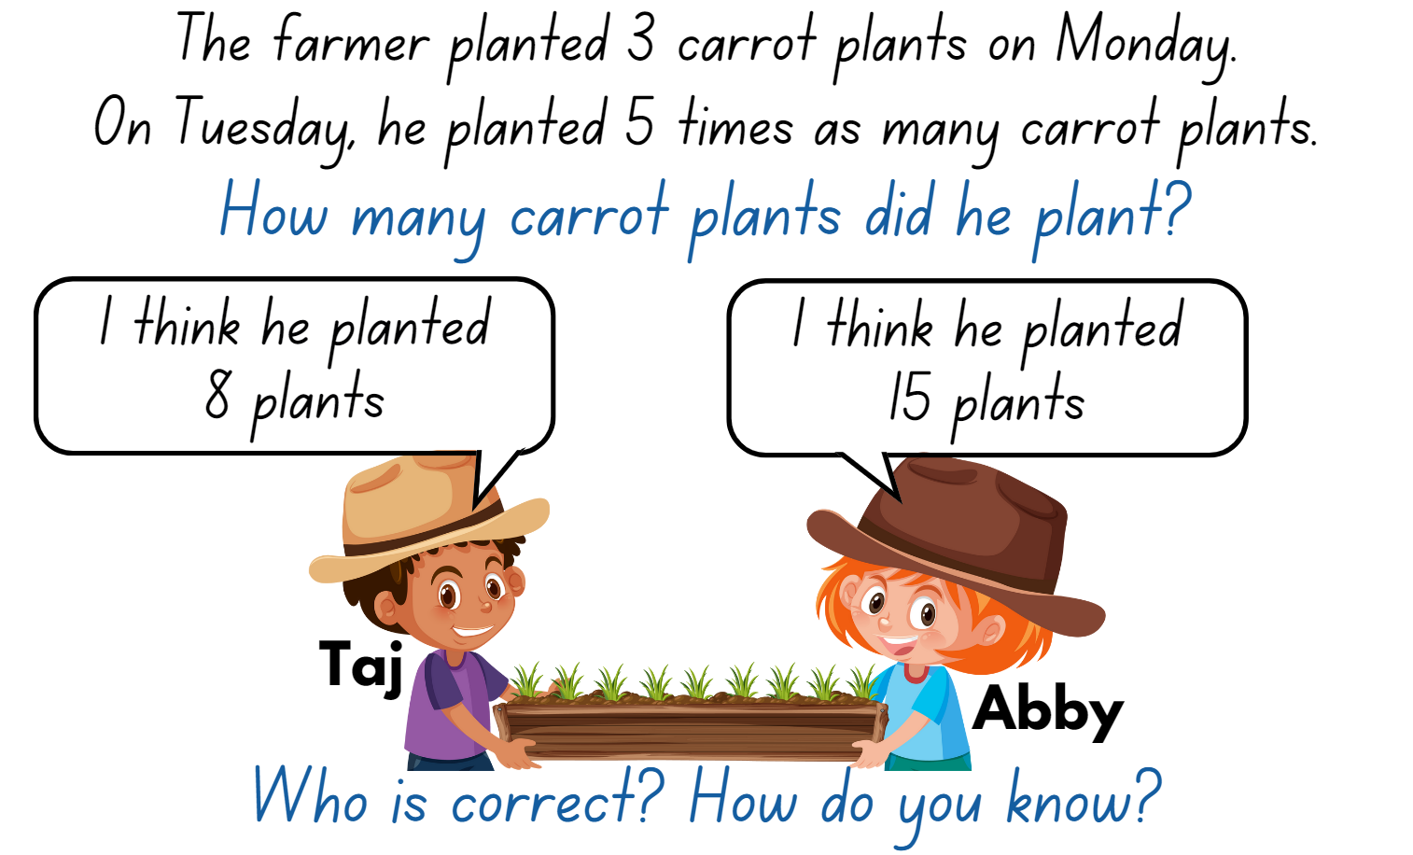

Resource 2 – place value houses
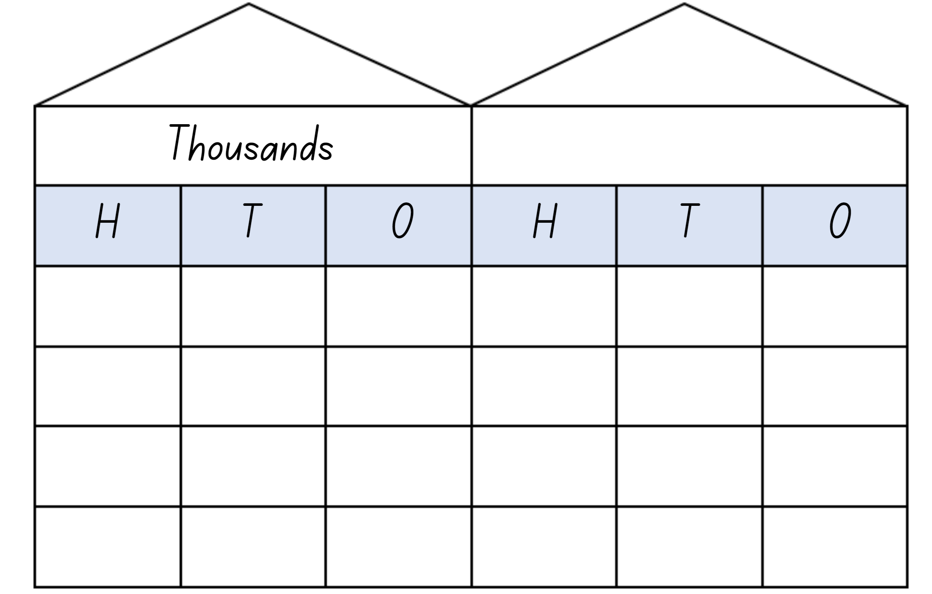

Resource 3 – MAB visual
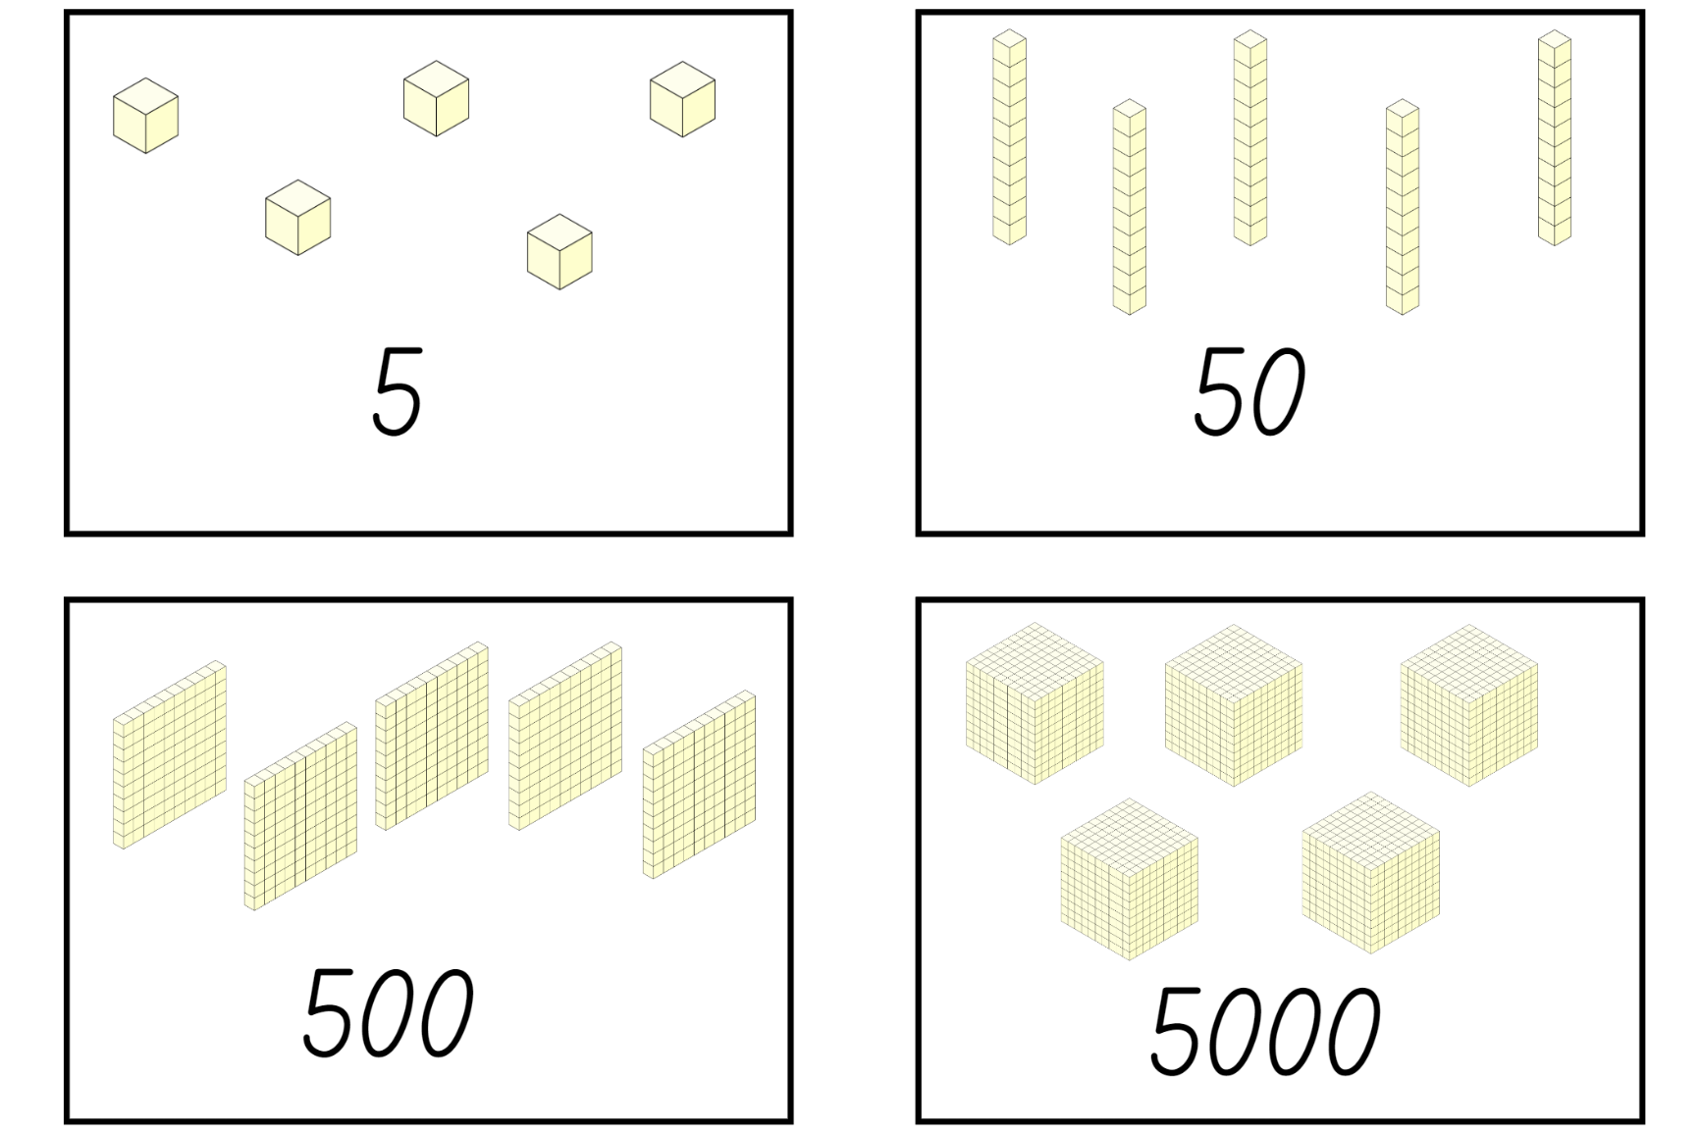

Resource 4 – think board
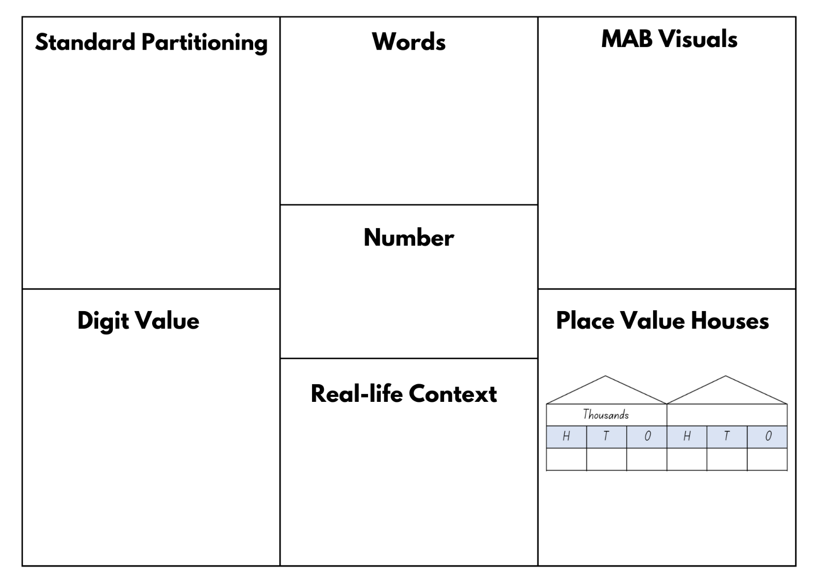

Resource 5 – Which doesn’t belong?
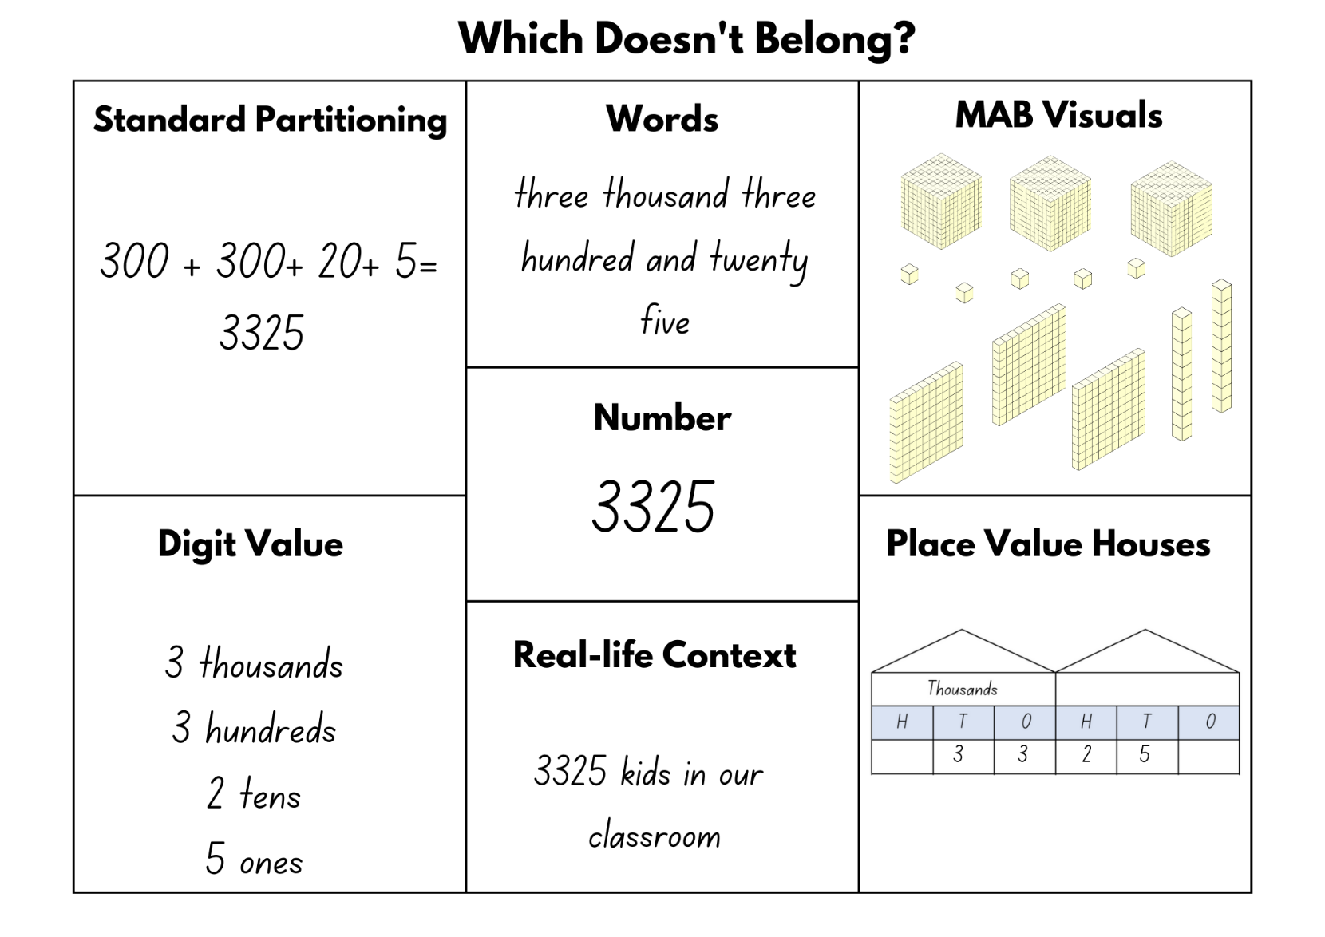

Resource 6 – playing board
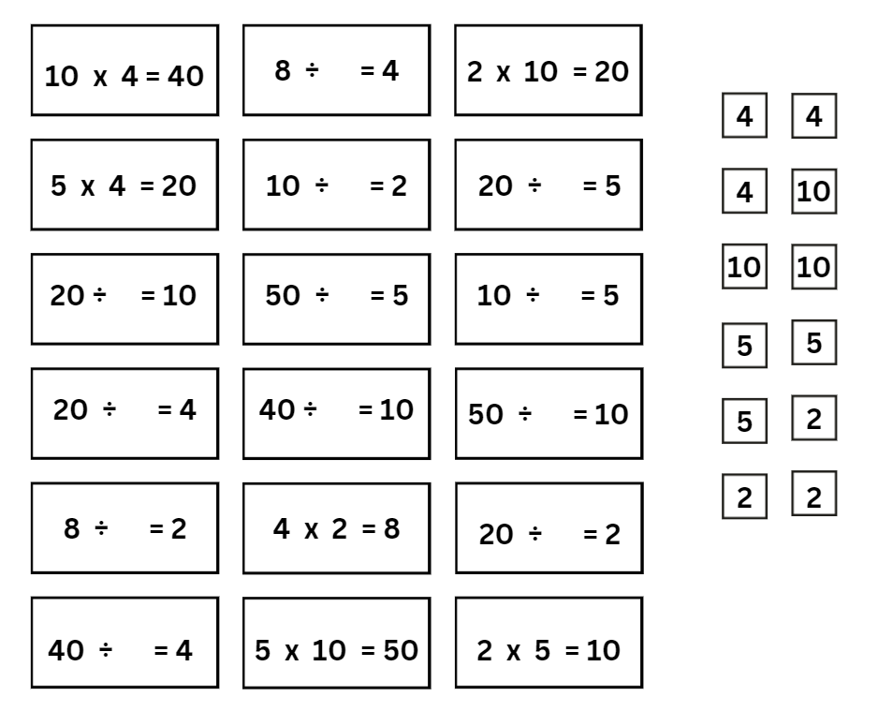

Resource 7 – 7211 MAB visual
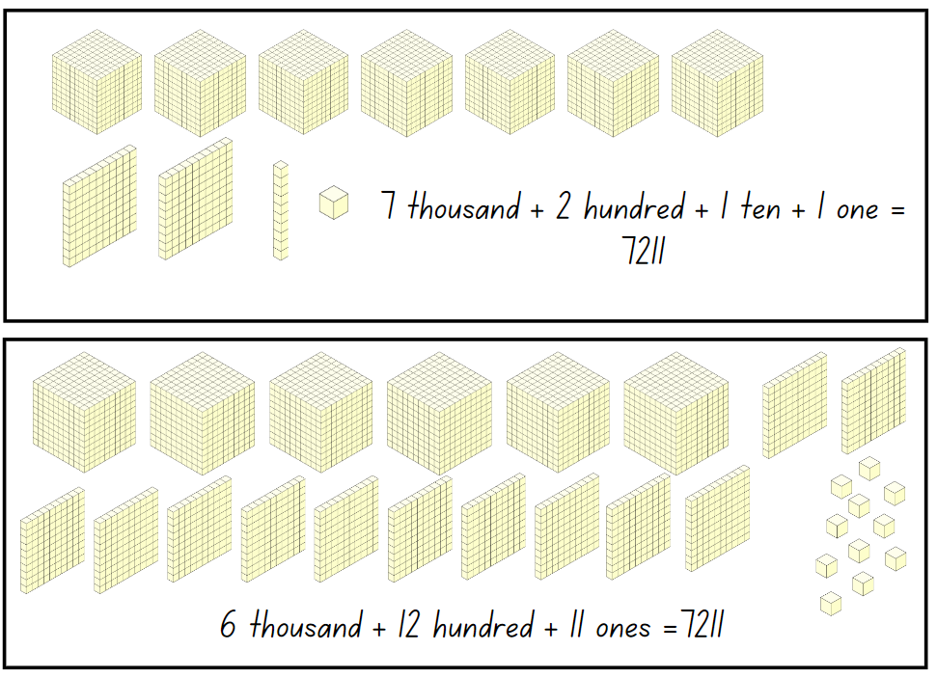

Resource 8 – MAB representations
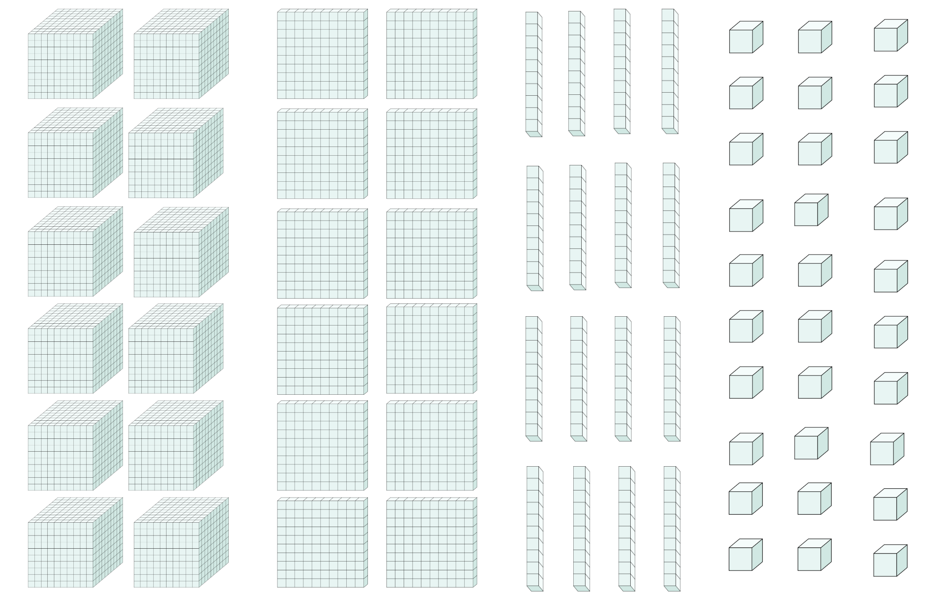

Resource 9 – non-standard partitioning match
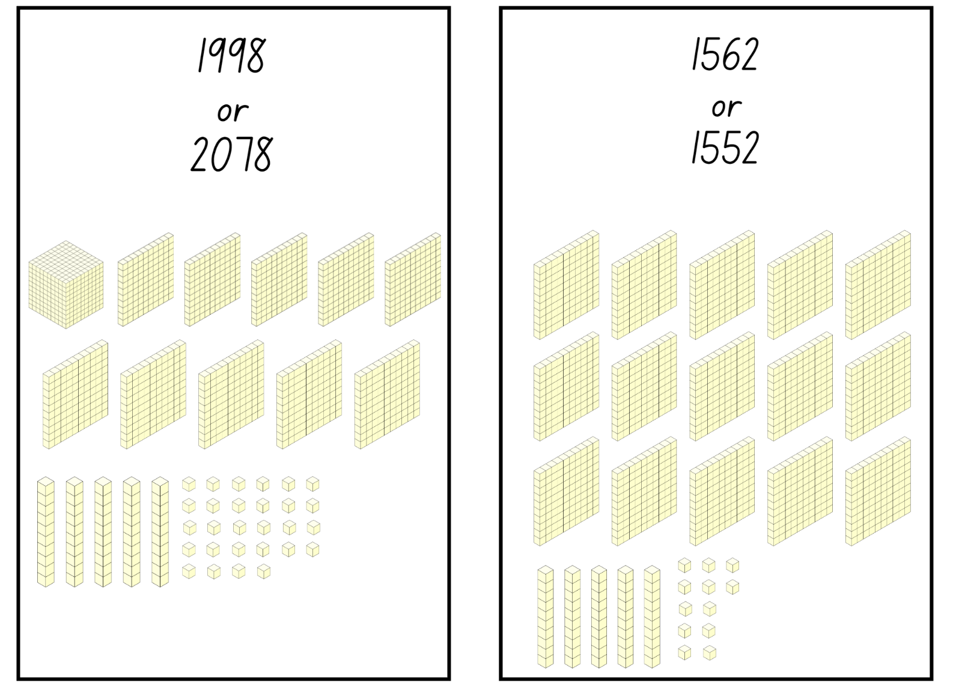

Resource 10 – Pattern or not?
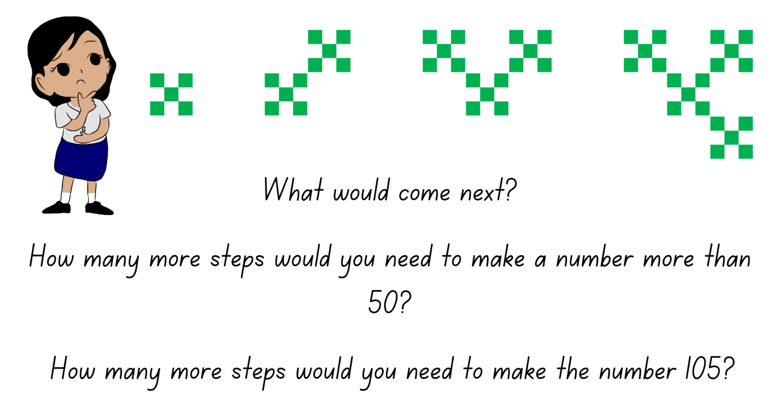

Resource 11 – crab image
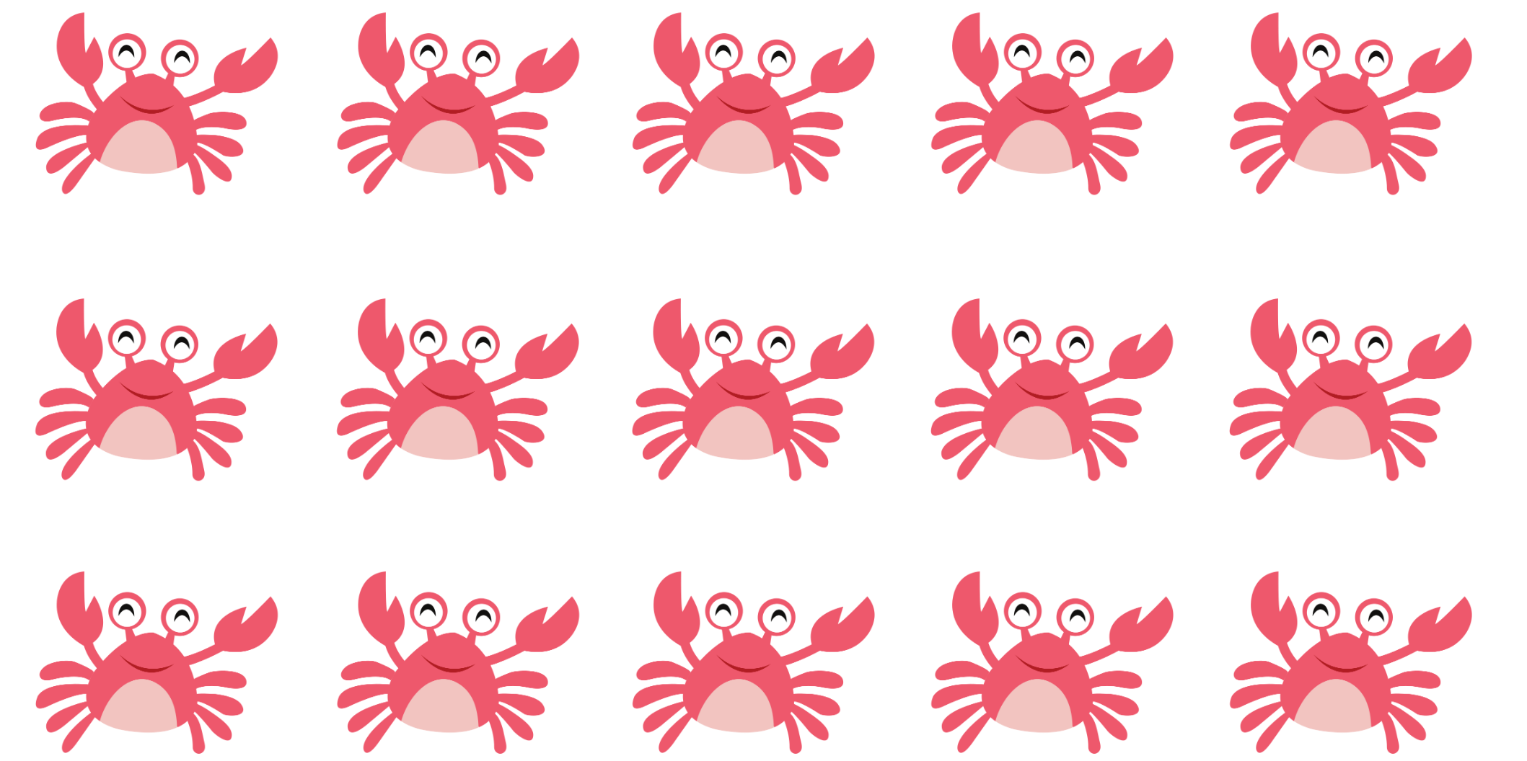
© totallyjamie via Canva.com

Resource 12 – dog + snail A

Resource 13 – 15 array

Resource 14 – dog + snail B
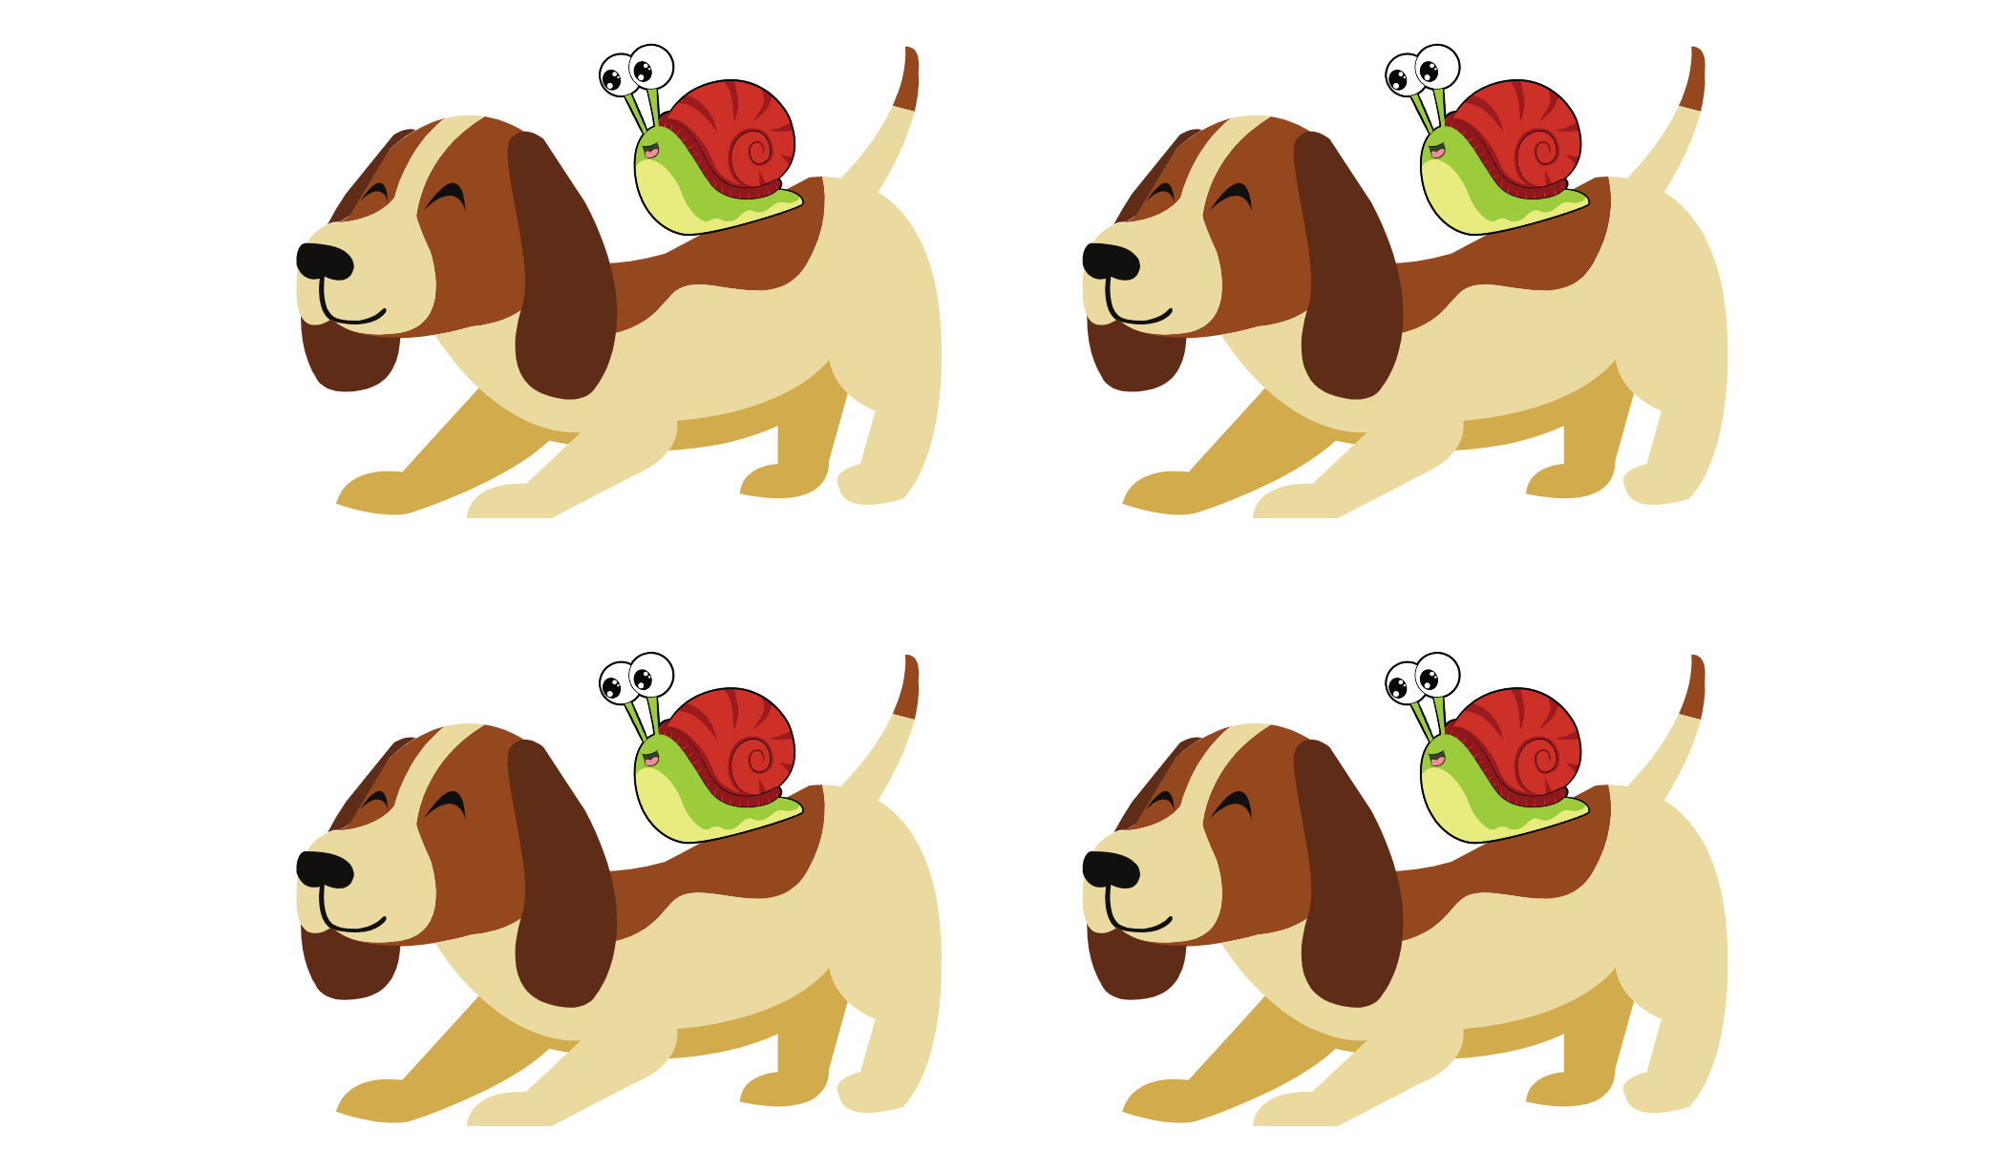

Resource 15 – show your thinking
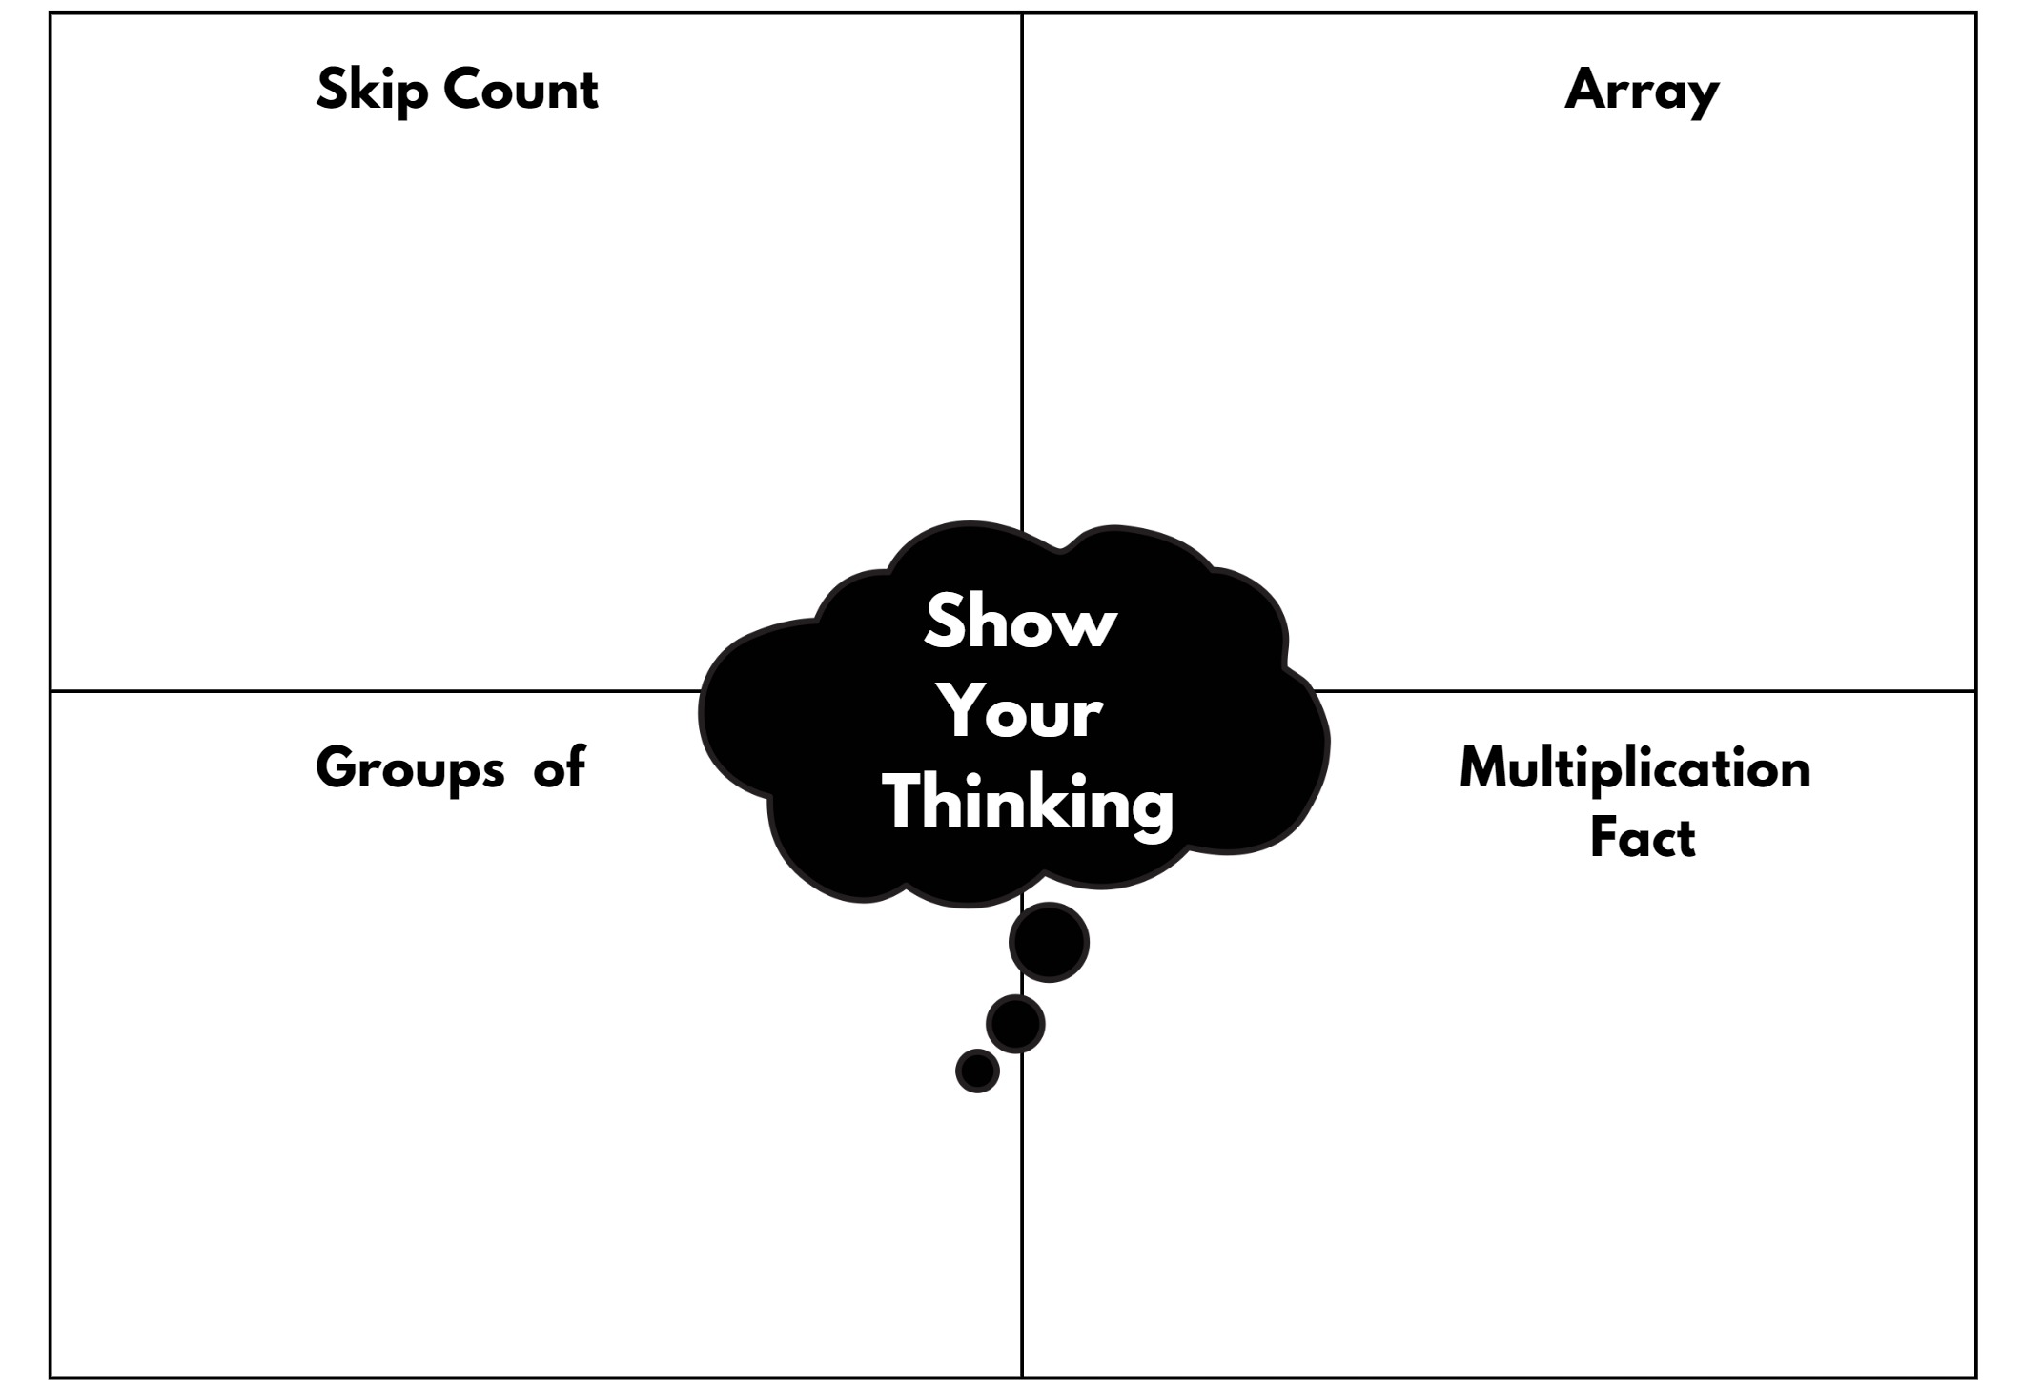

Resource 16 – dog + snail C
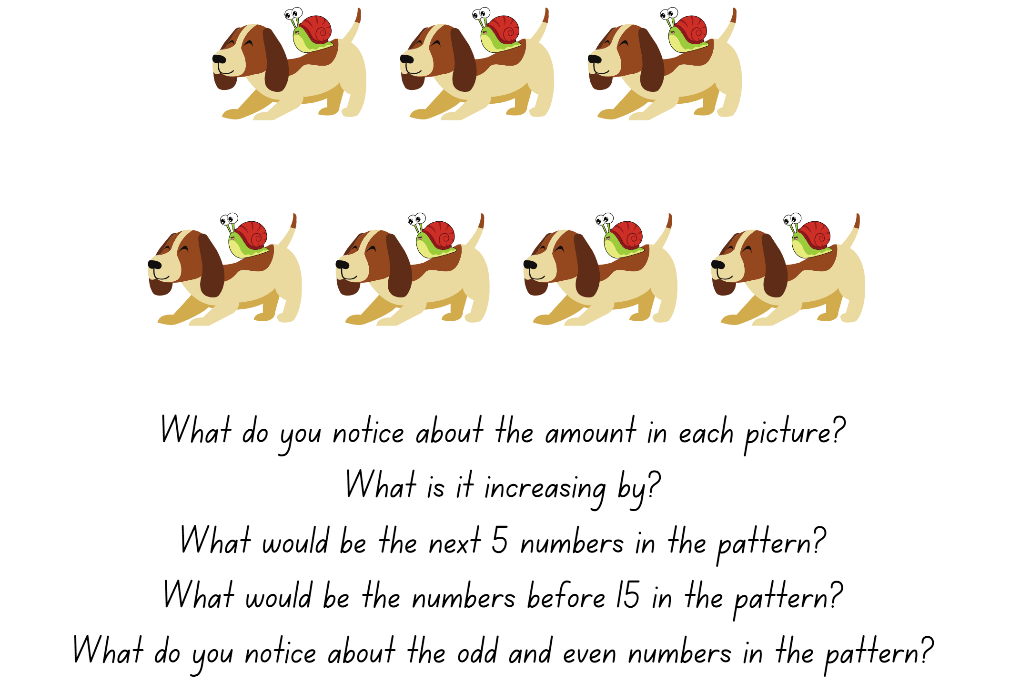

Resource 17 – Odd one out?
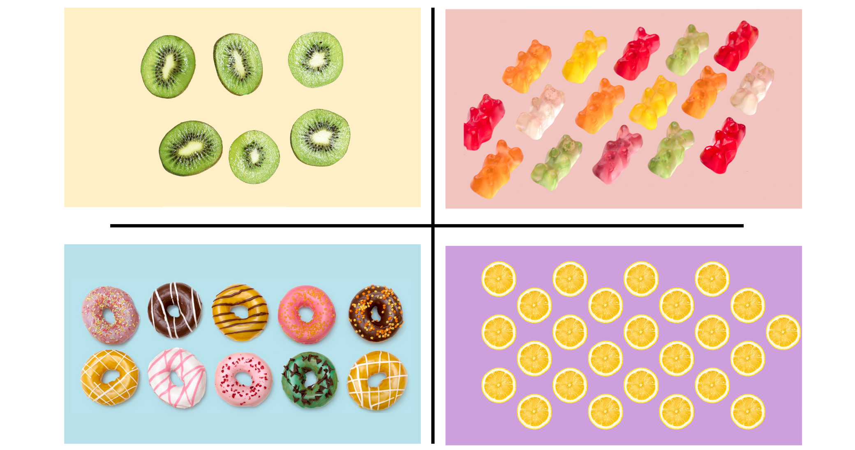

Resource 18 – Convince me!
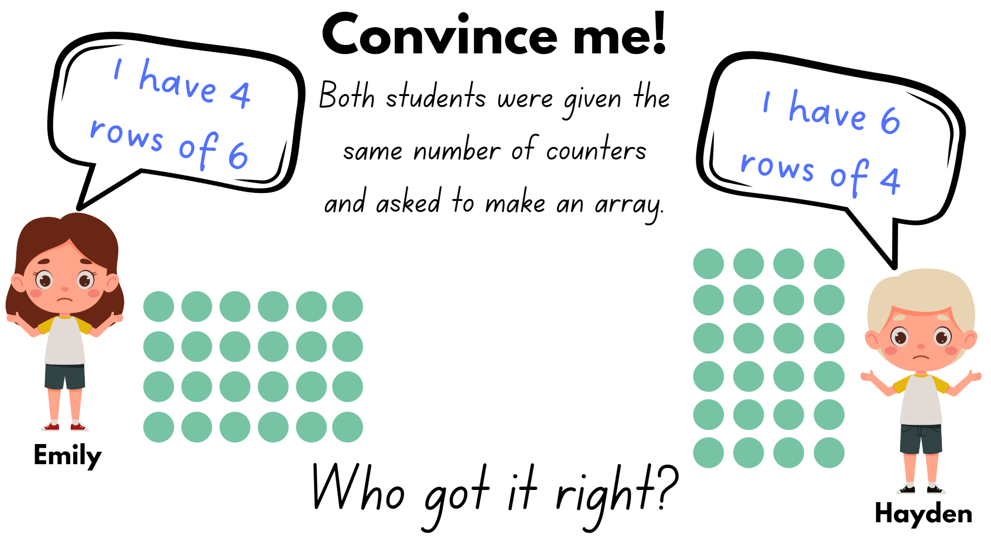

Resource 19 – array/fact family
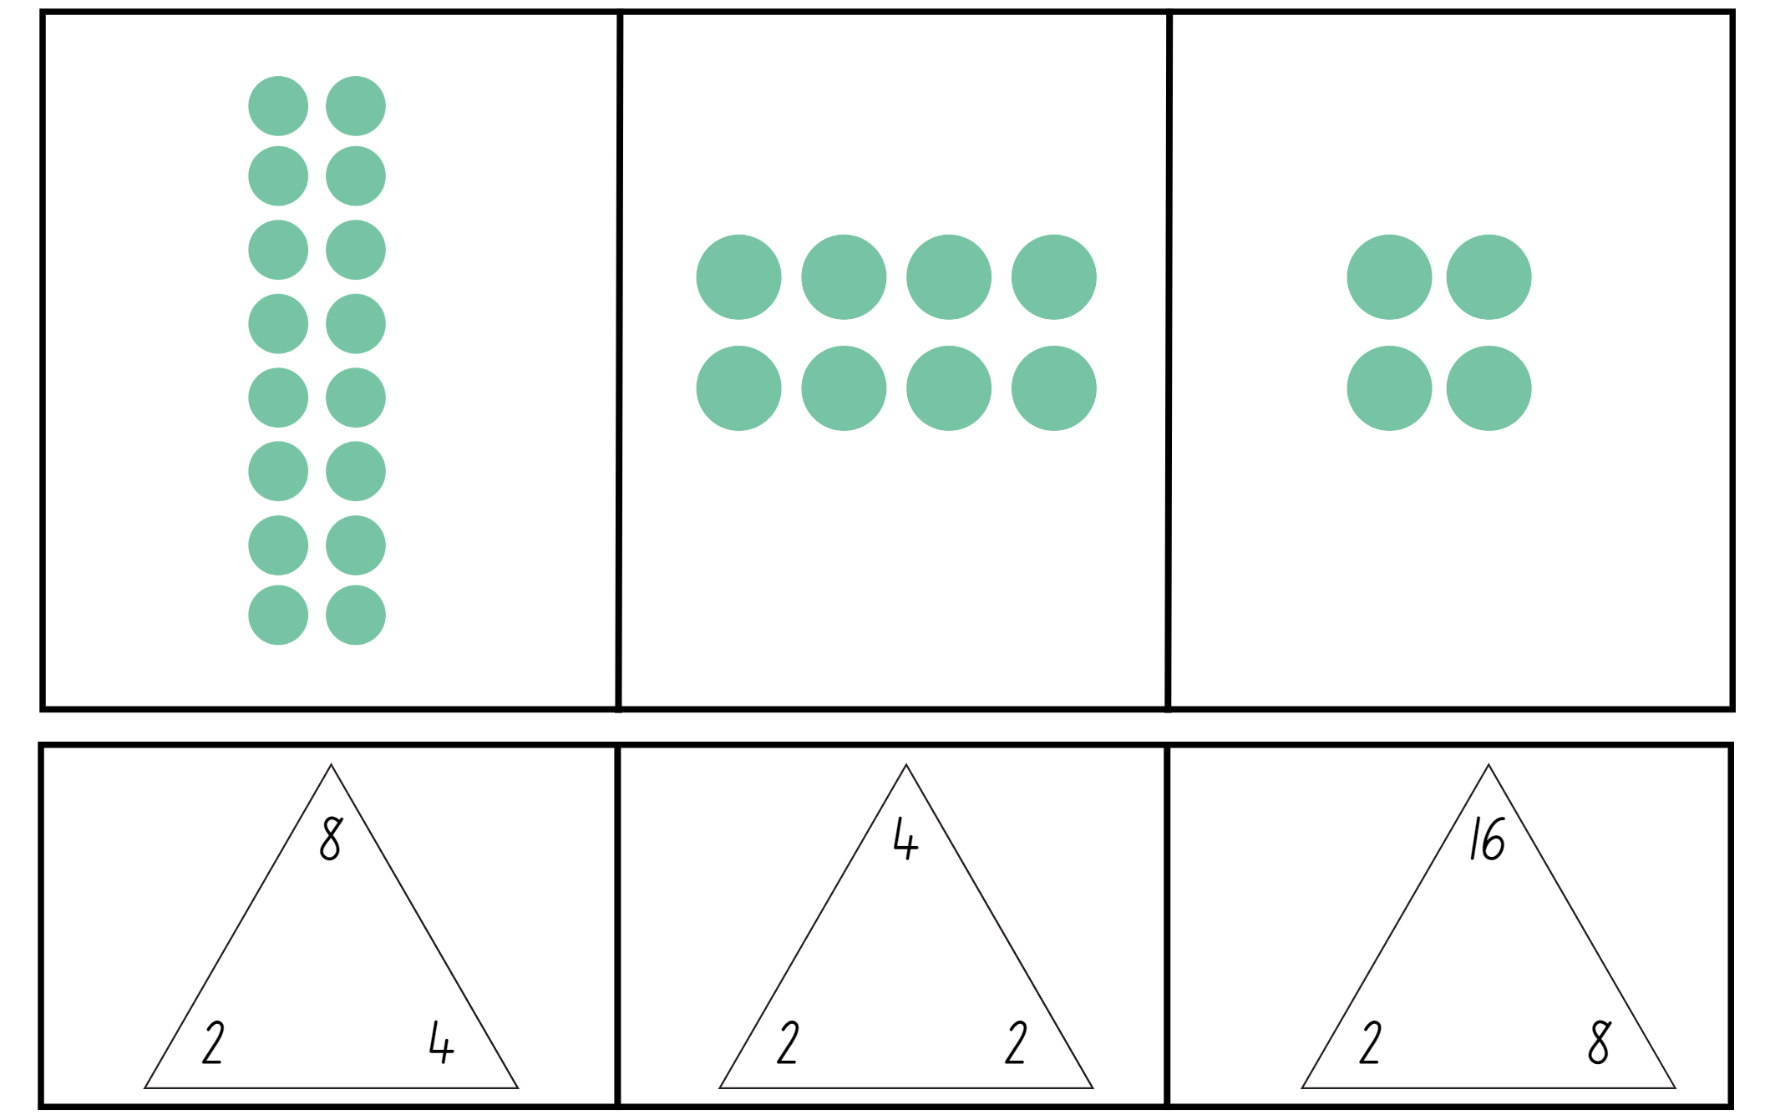

Resource 20 – problems to solve
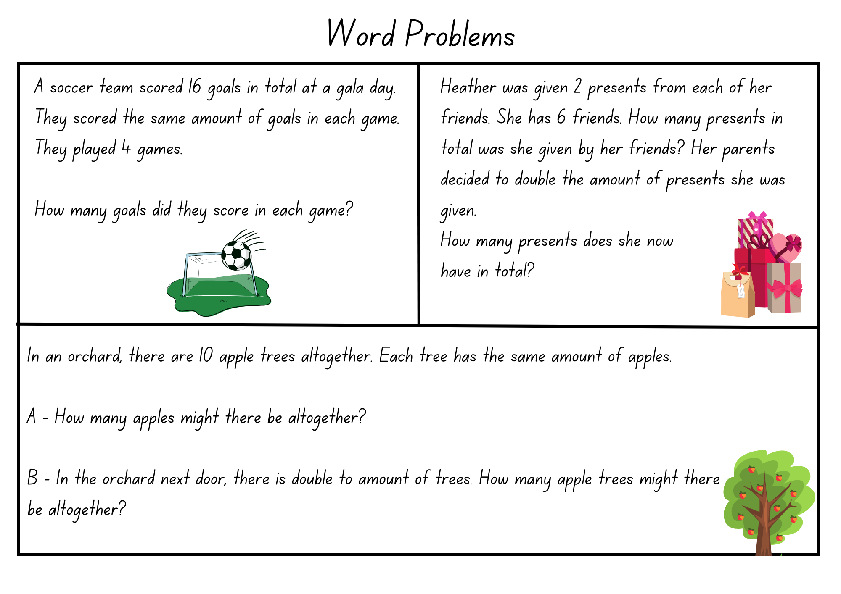

Syllabus outcomes and content
The table below outlines the syllabus outcomes and range of relevant syllabus content covered in this unit. Content is linked to National Numeracy Learning Progression version (3).
Outcomes and content | 1 | 2 | 3 | 4 | 5 | 6 | 7 | 8
Representing numbers using place value A: Whole numbers: Read, represent and order numbers to thousands
MAO-WM-01, MA2-RN-01
- Group physical or virtual objects to show the structure of tens, hundreds and a thousand | x | x | x | x
- Regroup numbers flexibly, recognising one thousand as 10 hundreds and one hundred as 10 tens or 100 ones |  |  | x | x
- Compare and describe the relative size of numbers by positioning numbers on a number line (Reasons about quantity) |  | x
- Represent numbers up to and including thousands using physical or virtual manipulatives, words, numerals, diagrams and digital displays | x | x | x | x | x
- Read and order numbers of up to at least 4 digits | x | x |  | x
Representing numbers using place value A: Apply place value to partition and regroup numbers up to 4 digits
MAO-WM-01, MA2-RN-01
- Record numbers using standard place value form |  | x | x | x
- Partition numbers of up to 4 digits in non-standard forms (Reasons about quantity) |  |  | x | x
Representing numbers using place value B: Whole numbers: Order numbers in the thousands
MAO-WM-01, MA2-RN-01
- Arrange numbers in the thousands in ascending and descending order | x | x
- Recognise and describe how rearranging digits changes the size of a number (Reasons about relations) | x
Representing numbers using place value B: Whole numbers: Recognise and represent numbers that are 10, 100 or 1000 times as large
MAO-WM-01, MA2-RN-01
- Recognise the number of tens, hundreds or thousands in a number | x
- Describe how making a number 10, 100 or 1000 times as large changes the place value of digits | x
Multiplicative relations A: Generate and describe patterns
MAO-WM-01, MA2-MR-01
- Model, describe and record patterns of multiples |  |  |  |  | x | x | x
- Create and continue a variety of number patterns that increase or decrease by a constant amount |  |  |  |  | x |  | x
- Recognise the significance of the final digit of a whole number in determining whether a given number is even or odd (Reasons about relations) |  |  |  |  | x
Multiplicative relations A: Use arrays to establish multiplication facts from multiples of 2 and 4, 5 and 10
MAO-WM-01, MA2-MR-01
- Create and represent multiplicative structure, using the term multiples when connecting grouping to arrays |  |  |  |  | x
- Use the array structure to coordinate the number of groups with the number in each group |  |  |  |  | x
- Recognise that doubling is multiplying by 2 and halving is dividing by 2 (Reasons about relations) |  |  |  |  | x |  | x
Multiplicative relations A: Recall multiplication facts of 2 and 4, 5 and 10 and related division facts
MAO-WM-01, MA2-MR-01
- Recognise and use the symbols for multiplied by (×), divided by (÷) and equals (=) |  |  |  |  |  | x | x | x
- Link multiplication and division fact families using arrays |  |  |  |  |  | x | x
- Generate multiplication fact families for multiples of 2 and 4, 5 and 10 |  |  |  |  |  |  | x | x
- Model and apply the commutative property of multiplication |  |  |  |  |  | x | x
Multiplicative relations A: Represent and solve problems involving multiplication fact families
MAO-WM-01, MA2-MR-01
- Describe multiplication problems using for each and times as many | x | x |  |  |  |  |  | x
- Find the total of partially covered arrays |  | x
- Apply the inverse relationship of multiplication and division (Reasons about relations) |  |  | x |  |  |  | x | x
Mathematics K–10 Syllabus © NSW Education Standards Authority (NESA) for and on behalf of the Crown in right of the State of New South Wales, 2022.

References
This resource contains NSW Curriculum and syllabus content. The NSW Curriculum is developed by the NSW Education Standards Authority. This content is prepared by NESA for and on behalf of the Crown in right of the State of New South Wales. The material is protected by Crown copyright.
Please refer to the NESA Copyright Disclaimer for more information https://educationstandards.nsw.edu.au/wps/portal/nesa/mini-footer/copyright.
NESA holds the only official and up-to-date versions of the NSW Curriculum and syllabus documents. Please visit the NSW Education Standards Authority (NESA) website https://educationstandards.nsw.edu.au/wps/portal/nesa/home/ and the NSW Curriculum website https://curriculum.nsw.edu.au.
Mathematics K–10 Syllabus © NSW Education Standards Authority (NESA) for and on behalf of the Crown in right of the State of New South Wales, 2022.
National Numeracy Learning Progression © Australian Curriculum, Assessment and Reporting Authority (ACARA) 2010 to present, unless otherwise indicated. This material was downloaded from the Australian Curriculum website (National Numeracy Learning Progression) (accessed 5 September 2023) and was not modified.
Sayre AP and Sayre J (2010) One Is a Snail, Ten Is a Crab: A Counting by Feet Book (Cecil R illus), Candlewick Press, United States.

Further reading
Siemon D, Warren E, Beswick K, Faragher R, Miller J, Horne M, Jazby D, Breed M, Clark J and Brady K (2020) Teaching Mathematics: Foundations to Middle Years, 3rd edn, Oxford University Press Australia and New Zealand.
Van de Walle J, Karp K, Bay-Williams JM, Brass A, Bentley B, Ferguson S, Goff W, Livy S, Marshman M, Martin D, Pearn C, Prodromou T, Symons D and Wilkie K (2019) Primary and Middle Years Mathematics: Teaching Developmentally, 1st Australian edn, Pearson Education Australia, Melbourne.
© State of New South Wales (Department of Education), 2024
The copyright material published in this resource is subject to the Copyright Act 1968 (Cth) and is owned by the NSW Department of Education or, where indicated, by a party other than the NSW Department of Education (third-party material).
Copyright material available in this resource and owned by the NSW Department of Education is licensed under a Creative Commons Attribution 4.0 International (CC BY 4.0) license.
This license allows you to share and adapt the material for any purpose, even commercially.
Attribution should be given to © State of New South Wales (Department of Education), 2024.
Material in this resource not available under a Creative Commons license:
- the NSW Department of Education logo, other logos and trademark-protected material
- material owned by a third party that has been reproduced with permission. You will need to obtain permission from the third party to reuse its material.
Links to third-party material and websites
Please note that the provided (reading/viewing material/list/links/texts) are a suggestion only and implies no endorsement, by the New South Wales Department of Education, of any author, publisher, or book title. School principals and teachers are best placed to assess the suitability of resources that would complement the curriculum and reflect the needs and interests of their students.
If you use the links provided in this document to access a third-party's website, you acknowledge that the terms of use, including licence terms set out on the third-party's website apply to the use which may be made of the materials on that third-party website or where permitted by the Copyright Act 1968 (Cth). The department accepts no responsibility for content on third-party websites.

