Mathematics 3–6 Multi-age – Year B – Unit 17
Multiplicative thinking involves flexible use of multiplication and division concepts, strategies and representations

Contents
Unit description and duration 7
Syllabus outcomes 7
Stage 2 8
Stage 3 8
Working mathematically 9
Student prior learning 9
Lesson overview and resources 11
Lesson 1 21
Daily number sense – Mental or written? – 10 minutes 21
Core lesson 1 – tray arrays – 15 minutes 23
Core lesson 2 – 35 minutes 26
Stage 2 task – multiplication array problem 26
Stage 3 task – prime number problem 26
Discuss and connect the mathematics – 10 minutes 30
Lesson 2 32
Daily number sense – better deal – 10 minutes 32
Core lesson 1 – prove it – 20 minutes 35
Core lesson 2 – 30 minutes 37
Stage 2 task – area of whole rectangles 37
Stage 3 task – fence perimeter 38
Discuss and connect the mathematics – 10 minutes 40
Lesson 3 43
Daily number sense – broken calculator – 10 minutes 43
Core lesson 1 – What’s my shape? – 20 minutes 45
Core lesson 2 – 25 minutes 48
Stage 2 task – shape sort 48
Stage 3 task – parallelogram biscuits 49
Consolidation and meaningful practice – 10 minutes 51
Lesson 4 53
Daily number sense – 10 minutes 53
Core lesson – 40 minutes 53
Stage 2 task – investigating square metres 53
Stage 3 task – areas and shapes 56
Discuss and connect – 10 minutes 61
Lesson 5 64
Daily number sense – decimal chains – 10 minutes 64
Core lesson 1 – 10 minutes 67
Core lesson 2 – 30 minutes 69
Stage 2 task – investigating prisms 69
Stage 3 task – exploring prisms 69
Discuss and connect the mathematics – 10 minutes 72
Lesson 6 75
Daily number sense – decimals and percentages – 10 minutes 75
Core lesson – prism volumes – 40 minutes 77
Discuss and connect the mathematics – 10 minutes 81
Lesson 7 83
Daily number sense – heights and discounts – 10 minutes 83
Core lesson – green thumbs – 40 minutes 85
Stage 2 task – square centimetres 86
Stage 3 task – cubic centimetres 88
Discuss and connect the mathematics – 10 minutes 90
Lesson 8 93
Daily number sense – 10 minutes 93
Core lesson 1 – volume word problems – 10 minutes 93
Core Lesson 2 – 35 minutes 95
Stage 2 task – volume of blocks 95
Stage 3 task – parcel dimensions 97
Discuss and connect the mathematics – 10 minutes 100
Resource 1 – multiplication problems 101
Resource 2 – cupcake arrays 102
Resource 3 – lots of cupcakes 103
Resource 4 – sorted numbers 104
Resource 5 – primes 105
Resource 6 – smaller cupcake order 106
Resource 7 – missing muffin trays 107
Resource 8 – better deal 108
Resource 9 – untorn rectangles 109
Resource 10 – torn shapes 110
Resource 11 – block options 111
Resource 12 – fence it 112
Resource 13 – possible fencing dimensions 113
Resource 14 – student shapes 114
Resource 15 – teacher shape sort 115
Resource 16 – biscuit problem 116
Resource 17 – additional shapes 117
Resource 18 – units of measurement 118
Resource 19 – Kindergarten chairs 119
Resource 20 – more area questions 120
Resource 21 – parallelogram proof 121
Resource 22 – triangle 122
Resource 23 – parallelogram Venn 123
Resource 24 – decimal chains 1 124
Resource 25 – decimal chains 2 125
Resource 26 – prisms 126
Resource 27 – recording boxes 127
Resource 28 – decimals and percentages 128
Resource 29 – problem solving 129
Resource 30 – prism volume 130
Resource 31 – patterns in volume 131
Resource 32 – recording table 1 132
Resource 33 – recording table 2 133
Resource 34 – heights and discounts 134
Resource 35 – seedling boxes recording sheet 135
Resource 36 – garden beds 136
Resource 37 – garden bed recording sheet 137
Resource 38 – Lisa’s landscapes 138
Resource 39 – volume problems 139
Resource 40 – building blocks 140
Resource 41 – Nanna Meg’s mail 141
Resource 42 – post office information 142
Syllabus outcomes and content 143
Stage 2 143
Stage 3 149
References 154

Unit description and duration
This unit develops the big idea that multiplicative thinking involves flexible use of multiplication and division concepts, strategies and representations.
In this 2-week unit, students are provided opportunities to:
- measure and compare volume using the layer structure and recording in cubic centimetres, recognising the multiplicative structure for finding volume
- investigate arrays and partially covered area models to support multiplicative thinking (Stage 2)
- apply knowledge of multiplication to estimate, measure and compare area using square centimetres and square metres (Stage 2)
- select and apply strategies to solve problems involving multiplication and division with whole numbers (Stage 3)
- dissect two-dimensional shapes and rearrange them using translations, reflections and rotations (Stage 3).
This multi-age unit is informed by the lessons in Stage 2 Year B Unit 37 and Stage 3 Year B Unit 37. Please refer to these units for additional lesson guidance.

Syllabus outcomes
- MAO-WM-01 develops understanding and fluency in mathematics through exploring and connecting mathematical concepts, choosing and applying mathematical techniques to solve problems, and communicating their thinking and reasoning coherently and clearly

Stage 2
- MA2-RN-02 represents and compares decimals up to 2 decimal places using place value
- MA2-MR-01 represents and uses the structure of multiplicative relations to 10 × 10 to solve problems
- MA2-MR-02 completes number sentences involving multiplication and division by finding missing values
- MA2-2DS-01 compares two-dimensional shapes and describes their features
- MA2-2DS-03 estimates, measures and compares areas using square centimetres and square metres
- MA2-3DS-01 makes and sketches models and nets of three-dimensional objects including prisms and pyramids
- MA2-3DS-02 estimates, measures and compares capacities (internal volumes) using litres, millilitres and volumes using cubic centimetres

Stage 3
- MA3-RN-03 determines percentages of quantities, and finds equivalent fractions and decimals for benchmark percentage values
- MA3-MR-01 selects and applies appropriate strategies to solve multiplication and division problems
- MA3-GM-02 selects and uses the appropriate unit and device to measure lengths and distances including perimeters
- MA3-2DS-02 selects and uses the appropriate unit to calculate areas, including areas of rectangles
- MA3-2DS-03 combines, splits and rearranges shapes to determine the area of parallelograms and triangles
- MA3-3DS-02 selects and uses the appropriate unit to estimate, measure and calculate volumes and capacities

Working mathematically
In the Mathematics K–10 Syllabus, there is one overarching Working mathematically outcome (MAO-WM-01). The Working mathematically processes should be embedded within the concepts being taught. The Working mathematically processes present in the Mathematics K–10 Syllabus are:
- communicating
- understanding and fluency
- reasoning
- problem solving.
Mathematics K–10 Syllabus © NSW Education Standards Authority (NESA) for and on behalf of the Crown in right of the State of New South Wales, 2022.

Student prior learning
Before engaging in these teaching and learning activities students would benefit from prior experience with:
- using patterns and array structures to support multiplicative thinking (Stage 2)
- applying knowledge of multiplication to measure and compare area and volume using the row, column, layer structure (Stage 2)
- using partitioning and place value to multiply 2-, 3- and 4-digit numbers by one-digit numbers to calculate the areas of rectangles using familiar metric units (Stage 3)
- measuring lengths to find perimeters (Stage 3)
- using cubic metres for measurement of volume (Stage 3).
In NSW classrooms there is a diverse range of students, including Aboriginal and/or Torres Strait Islander students, students learning English as an additional language or dialect, high potential and gifted students, and students with disability. Some students may identify with more than one of these groups or possibly all of them. Refer to Curriculum planning for every student – advice for further information.

Lesson overview and resources
To cover the content of the syllabus across Stage 2 and Stage 3, some core lessons in the unit contain both a Stage 2 and a Stage 3 task. Teachers are encouraged to adapt and contextualise the units to meet the needs of their students.
The table below outlines the sequence and approximate timing of lessons, learning intentions and resources.
Lesson | Content | Duration and resources
Lesson 1  Daily number sense  Stage 2:  - Multiplicative relations B: Use the structure of the area model to represent multiplication and division  Stage 3:  - Multiplicative relations B: Select and apply strategies to solve problems involving multiplication and division with whole numbers | Lesson core concept: multiplicative thinking and understanding is based on patterns and known number facts.  Stage 2:  - Multiplicative relations B: Use known number facts and strategies  - Multiplicative relations B: Use number properties to find related multiplication facts  Stage 3:  - Multiplicative relations A: Determine products and factors  - Multiplicative relations A: Use partitioning and place value to multiply 2-, 3- and 4-digit numbers by one-digit numbers | Lesson duration: 70 minutes  - Resource 1 – multiplication problems  - Resource 2 – cupcake arrays  - Resource 3 – lots of cupcakes  - Resource 4 – sorted numbers  - Resource 5 – primes  - Resource 6 – smaller cupcake order  - Resource 7 – missing muffin trays  - A4 paper  - Counters  - Individual whiteboards  - Large sheets of paper  - Scissors  - Square-centimetre grid paper  - Student workbooks  - Writing materials
Lesson 2  Daily number sense  Stage 2:  - Multiplicative relations B: Use the structure of the area model to represent multiplication and division  Stage 3:  - Multiplicative relations B: Select and apply strategies to solve problems involving multiplication and division with whole numbers | Lesson core concept: structures can support multiplicative thinking.  Stage 2:  - Multiplicative relations B: Use number properties to find related multiplication facts  - Two-dimensional spatial structure B: Measure the areas of shapes using the grid structure  Stage 3:  - Geometric measure A: Measure lengths to find perimeters  - Two-dimensional spatial structure A: Calculate the areas of rectangles using familiar metric units | Lesson duration: 70 minutes  - Resource 8 – better deal  - Resource 9 – untorn rectangles  - Resource 10 – torn shapes  - Resource 11 – block options  - Resource 12 – fence it  - Resource 13 – possible fencing dimensions  - Individual whiteboards  - Scissors  - Square-centimetre grid paper  - Writing materials
Lesson 3  Daily number sense  Stage 2:  - Multiplicative relations B: Use the structure of the area model to represent multiplication and division  Stage 3:  - Multiplicative relations B: Select and apply strategies to solve problems involving multiplication and division with whole numbers | Lesson core concept: comparing features adds precision to the description and measurement of shapes.  Stage 2:  - Two-dimensional spatial structure A: Compare and describe features of two-dimensional shapes  Stage 3:  - Two-dimensional spatial structure B: Dissect two-dimensional shapes and rearrange them using translations, reflections and rotations  - Two-dimensional spatial structure B: Calculate the area of a parallelogram using subdivision and rearrangement | Lesson duration: 65 minutes  - Resource 14 – student shapes  - Resource 15 – teacher shape sort  - Resource 16 – biscuit problem  - Resource 17 – additional shapes  - Calculators  - Individual whiteboards  - Rulers  - Scissors  - Square-centimetre grid paper  - Writing materials
Lesson 4  Daily number sense  - teacher-identified task based on student needs | Lesson core concept: mathematicians estimate, measure and compare the area of larger shapes using the known areas of smaller shapes.  Stage 2:  - Multiplicative relations A: Represent and solve problems involving multiplication fact families  - Two-dimensional spatial structure A: Use square centimetres to measure and estimate the areas of rectangles  - Two-dimensional spatial structure B: Compare surfaces using familiar metric units of area  Stage 3:  - Two-dimensional spatial structure B: Dissect two-dimensional shapes and rearrange them using translations, reflections and rotations  - Two-dimensional spatial structure B: Calculate the area of a parallelogram using subdivision and rearrangement  - Two-dimensional spatial structure B: Determine the area of a triangle | Lesson duration: 60 minutes  - Resource 18 – units of measurement  - Resource 19 – Kindergarten chairs  - Resource 20 – more area questions  - Resource 21 – parallelogram proof  - Resource 22 – triangle  - Resource 23 – parallelogram Venn  - Individual whiteboards  - Metre rulers  - Rulers  - Scissors  - Square-centimetre grid paper  - Student workbooks  - Writing materials
Lesson 5  Daily number sense  Stage 2:  - Representing numbers using place value B: Make connections between fractions and decimal notation  Stage 3:  - Represents numbers B: Make connections between benchmark fractions, decimals and percentages. | Lesson core concept: the multiplicative relationship between the length, width and height of an object can be used to determine volume.  Stage 2:  - Three-dimensional spatial structure A: Make models of three-dimensional objects to compare and describe key features  - Three-dimensional spatial structure A: Compare objects using familiar metric units of volume  - Three-dimensional spatial structure B: Connect three-dimensional objects and two-dimensional representations  Stage 3:  - Three-dimensional spatial structure B: Recognise the multiplicative structure for finding volume  - Three-dimensional spatial structure B: Find the volumes of rectangular prisms in cubic centimetres and cubic metres | Lesson duration: 60 minutes  - Resource 24 – decimal chains 1  - Resource 25 – decimal chains 2  - Resource 26 – prisms  - Resource 27 – recording boxes  - Connecting cubes  - Grid paper  - Writing materials
Lesson 6  Daily number sense  Stage 2:  - Representing numbers using place value B: Make connections between fractions and decimal notation  Stage 3:  - Represents numbers B: Make connections between benchmark fractions, decimals and percentages | Lesson core concept: mathematicians measure and record volume of three-dimensional space.  Stage 2:  - Three-dimensional spatial structure A: Compare objects using familiar metric units of volume  Stage 3:  - Three-dimensional spatial structure B: Find the volumes of rectangular prisms in cubic centimetres and cubic metres | Lesson duration: 60 minutes  - Resource 28 – decimals and percentages  - Resource 29 – problem solving  - Resource 30 – prism volume  - Resource 31 – patterns in volume  - Resource 32 – recording table 1  - Resource 33 – recording table 2  - Connecting cubes  - Individual whiteboards  - Isometric paper  - Writing materials
Lesson 7  Daily number sense  Stage 2:  - Representing numbers using place value B: Make connections between fractions and decimal notation  Stage 3:  - Represents numbers B: Make connections between benchmark fractions, decimals and percentages | Lesson core concept: standard units are an efficient way to communicate volume.  Stage 2:  - Two-dimensional spatial structure A: Use square centimetres to measure and estimate the areas of rectangles  - Three-dimensional spatial structure A: Compare objects using familiar metric units of volume  Stage 3:  - Multiplicative relations B: Select and apply strategies to solve problems involving multiplication and division with whole numbers  - Three-dimensional spatial structure B: Recognise the multiplicative structure for finding volume  - Three-dimensional spatial structure B: Find the volumes of rectangular prisms in cubic centimetres and cubic metres | Lesson duration: 60 minutes  - Resource 34 – heights and discounts  - Resource 35 – seedling boxes recording sheet  - Resource 36 – garden beds  - Resource 37 – garden bed recording sheet  - Resource 38 – Lisa’s landscapes  - Individual whiteboards  - Scissors  - Square-centimetre grid paper  - Sticky tape  - Writing materials
Lesson 8  Daily number sense  - teacher-identified task based on student needs | Lesson core concept: mathematicians measure and compare volumes.  Stage 2:  - Multiplicative relations B: Represent and solve word problems with number sentences involving multiplication or division  - Three-dimensional spatial structure A: Compare objects using familiar metric units of volume  - Three-dimensional spatial structure B: Connect three-dimensional objects and two-dimensional representations  Stage 3:  - Multiplicative relations B: Select and apply strategies to solve problems involving multiplication and division with whole numbers  - Three-dimensional spatial structure B: Find the volumes of rectangular prisms in cubic centimetres and cubic metres | Lesson duration: 65 minutes  - Resource 39 – volume problems  - Resource 40 – building blocks  - Resource 41 – Nanna Meg’s mail  - Resource 42 – post office information  - Calculators  - Connecting cubes  - Isometric paper  - Sticky notes  - Writing materials

Lesson 1
Core concept: multiplicative thinking and understanding is based on patterns and known number facts.

Daily number sense – Mental or written? – 10 minutes
Daily number sense activities for Lessons 1 to 3 ‘activate’ prior number knowledge and support the learning of new content in the unit. These activities can also assist teachers to identify the starting points for learning by revealing the extent of students’ existing knowledge.
The table below contains suggested learning intentions and success criteria. These are best co-constructed with students.
Daily number sense learning intentions | Daily number sense success criteria
Students working towards Stage 2 outcomes are learning to:  - use the structure of the area model to represent multiplication and division.  Students working towards Stage 3 outcomes are learning to:  - select and apply strategies to solve problems involving multiplication and division with whole numbers. | Students working towards Stage 2 outcomes can:  - create and represent multiplicative structure, moving from arrays to partially covered area models.  Students working towards Stage 3 outcomes can:  - select and use efficient strategies to multiply whole numbers of up to 4 digits by one- and 2-digit numbers.
This Stage 2 activity is an adaptation of Partial Arrays from AAMT by The Australian Association of Mathematics Teachers (AAMT) Inc.
- Display Resource 1 – multiplication problems.
- Explain to students that they will be using efficient strategies to think multiplicatively and solve multiplication questions.
- Students work in pairs with a whiteboard each and solve the multiplication problems using mental and written strategies.
- Regroup and ask:
- How did your knowledge of multiplication and division facts help you solve the array problem? (Stage 2)
- Did you solve these problems with a mental or written strategy? (Stage 3)
- Which strategy was more efficient, the mental strategy or the written strategy? Why? (Stage 3)
This table details opportunities for assessment.
Assessment opportunities | Links
What to look for:  - Can Stage 2 students create and represent multiplicative structure, moving from arrays to partially covered area models? [MAO-WM-01, MA2-MR-01]  - Can Stage 3 students select and use efficient strategies to multiply whole numbers of up to 4 digits by one- and 2-digit numbers? [MAO-WM-01, MA3-MR-01] | Links to National Numeracy Learning Progressions (NNLP):  - Stage 2 – MuS5, MuS6  - Stage 3 – MuS7, MuS8.  Links to suggested Interview for Student Reasoning (IfSR) tasks:  - Stage 2 – IfSR-MT: 2A.1, 2A.2, 2A.3  - Stage 3 – IfSR-MT: 3A.1, 3A.2, 3A.3, 3A.4, 3A.5.

Core lesson 1 – tray arrays – 15 minutes
The table below contains suggested learning intentions and success criteria. These are best co-constructed with students.
Core concept learning intentions | Core concept success criteria
Students working towards Stage 2 outcomes are learning to:  - use known number facts and strategies  - use number properties to find related multiplication facts.  Students working towards Stage 3 outcomes are learning to:  - determine products and factors  - use partitioning and place value to multiply 2-, 3- and 4-digit numbers by one-digit numbers. | Students working towards Stage 2 outcomes can:  - apply the known strategy of doubling to connect multiples of 3 to 6 and 4 to 8  - use flexible partitioning within multiplication.  Students working towards Stage 3 outcomes can:  - use the term product to describe the result of multiplying 2 or more numbers  - determine factors for a given whole number  - determine whether a number is prime, composite or neither (0 or 1)  - use informal written strategies such as the area model to solve multiplication and division problems.
This activity is an adaptation of Multiplication: reSolve Bakery from reSolve by Australian Academy of Science.
- Display Resource 2 – cupcake arrays. Ask:
- How many cupcakes are in this box?
- How do you know?
- Allow students time to record a strategy or multiple strategies on individual whiteboards.
- Ask:
- How did you group the cakes to work out how many are in the box?
- How many are in one row?
- How could you partition the row of cupcakes to make it easier to work with?
- Select students to share different responses for seeing the 36 cupcakes. For example:
- Two sixes is 12. I can see 12, 24, 36. Three twelves is 36.
- Three sixes is 18, and double that make 6 sixes which is 36.
- Five sixes is 30 and one more 6 is 36.
- Provide pairs of students with 36 counters and pieces of A4 paper. Explain to students that each counter represents a cupcake while each A4 piece of paper represents a baking tray.
- Demonstrate how 12 × 3 can be partitioned into 3 threes and doubled and then doubled again. This can be represented by the number sentence (3 × 3) × 2 × 2. Explain that this is the distributive property of multiplication (see Figure 1).
Figure 1 – partitioning example
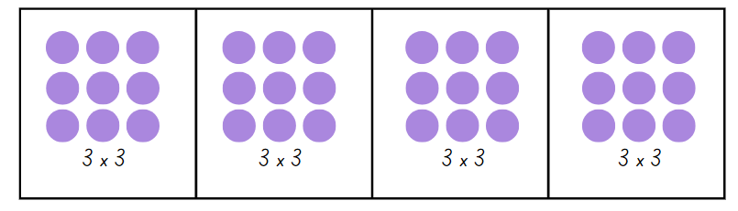
- Students replicate the partitioning of 12 × 3 and record in their workbooks.
- Students work in pairs to find other possible ways to partition 36 cupcakes into arrays and record in their workbooks.

Core lesson 2 – 35 minutes

Stage 2 task – multiplication array problem
- Provide students with individual copies of Resource 3 – lots of cupcakes, a large sheet of paper and writing materials.
- Explain that they are looking to find efficient ways to determine the total number of cupcakes.
- Students record the strategies they used to determine the total number of cupcakes. They may cut the arrays out or use writing materials to show how they have partitioned the larger array.

Stage 3 task – prime number problem
This activity is an adaptation of In Your Prime from NZ Maths by the New Zealand Government.
- Display Resource 4 – sorted numbers and ask:
- How have these numbers been sorted?
- What could the headings of this table be? (Prime numbers, Composite numbers)
- What strategy did you use to work this out?
- Can you think of another number that could go into each category?
- Would the number one belong in any of these categories? (No, one is neither prime nor composite as it has exactly one unique factor.)
- Revise with students the definition of prime and composite numbers. If necessary, ask students to create an array for 11 and 12 to highlight the difference between a prime and composite number.
Prime numbers: a number that has only 2 factors (itself and one).
Composite numbers: a number with more than 2 factors.
- Display Resource 5 – primes. Explain that these are the first 4 prime numbers. If the first 2 cards are multiplied, a product of 6 is achieved. Ask:
- Which 2 cards would be multiplied to get a product of 21?
- What other numbers are products of 2 cards if no card can be used twice?
- What other products would be possible if a card could be used twice?
- How can you use arrays to determine if a product is prime, composite or neither?
- Students work in pairs to investigate the number of possibilities of products for the 4 given numbers. Ask:
- What products did you get?
- How do you know you have generated all the possibilities?
- How could you categorise the products made from multiplying 2 cards together? (Square and composite numbers)
- Pose the problem: What products from 3 cards can be made using each card one, 2 or 3 times?
- Move around the room and support students to use appropriate strategies, such as the area model when working with larger numbers. For example, 7 × 7 × 7.
Note: formative assessment data can be gathered by observing strategies that students use to multiply 3 single-digit numbers. This data will inform whether students are ready to approach the tasks on volume in this unit.
When solving problems such as 7 × 5 × 2, students should be encouraged to draw on the associative property of multiplication to look for multiplication facts that simplify the problem, such as 5 × 2. When solving 7 × 7 × 7, students might see that 7 × 7 × 7 = 49 × 7, which could be solved by thinking about 50 × 7.
This table details opportunities for differentiation.
Too hard? | Too easy?
Stage 2 students cannot use flexible partitioning within multiplication.  - Provide students with Resource 6 – smaller cupcake order. Support students to partition the array into smaller parts to determine the total. For example, 2 fives and 2 fives and another 2 fives up to 12 fives or 10 fives and 2 more fives. Support students to partition the array into threes and then double the result.  - Provide students with square-centimetre grid paper and cut out a rectangle measuring 9 by 12. Support students to partition the rectangle into multiples they are familiar with using the grid lines.  Stage 3 students cannot use informal written strategies such as the area model to solve multiplication and division problems.  - Reduce Resource 5 – primes. Students complete the task using the first 3 prime numbers (2, 3, 5).  - Model an example of how the associative property of multiplication can help to simplify problems such as 9 × 5 × 2. Model identifying known multiplication facts first, such as 5 × 2.  - A multiplication chart can be used to support students’ multiplication. When multiplying numbers larger than 12, students may benefit from having the area model drawn on grid paper. | Stage 2 students can use flexible partitioning within multiplication.  - Provide students with Resource 7 – missing muffin trays. Ask students to record their strategies in determining how many muffins there were initially and how many were eaten.  - Students create their own missing muffin problem for a partner to solve.  Stage 3 students can use informal written strategies such as the area model to solve multiplication and division problems.  - Students explore whether it is possible that the numbers from 1–100 are products of the numbers on Resource 5 – primes. Ask students what they notice about the numbers that cannot be made.  - Pose the question: Is it possible that all the numbers from 2–200 are products of 2, 3, 5, 7 and 11? If not, what numbers need to be used?

Discuss and connect the mathematics – 10 minutes
- Regroup as a class and discuss:
- Which multiplication strategies did you use to solve the task?
- How did you know that you found all possibilities?
- Would these strategies be efficient when working with different numbers? (Stage 2)
- Would these strategies be efficient when finding the factors of numbers from a given product? (Stage 3)
- Are any of the products created prime numbers? Why or why not? (Stage 3)
This table details opportunities for assessment.
Assessment opportunities | Links
What to look for:  - Can Stage 2 students apply the known strategy of doubling to connect multiples of 3 to 6 and 4 to 8? [MAO-WM-01,  MA2-MR-01]  - Can Stage 2 students use flexible partitioning within multiplication? [MAO-WM-01, MA2-MR-01]  - Can Stage 3 students use informal written strategies such as the area model to solve multiplication and division problems?  [MAO-WM-01, MA3-MR-01]  - Can Stage 3 students use the term product to describe the result of multiplying 2 or more numbers? [MAO-WM-01, MA3-MR-01]  - Can Stage 3 students determine factors for a given whole number? [MAO-WM-01, MA3-MR-01]  - Can Stage 3 students determine whether a number is prime, composite or neither (0 or 1)? [MAO-WM-01, MA3-MR-01] | Links to National Numeracy Learning Progressions (NNLP):  - Stage 2 – MuS6-7  - Stage 3 – MuS6-7.  Links to suggested Interview for Student Reasoning (IfSR) tasks:  - Stage 2 – IfSR-MT: 2A.4, 2A.11  - Stage 3 – IfSR-MT: 2A.7.

Lesson 2
Core concept: structures can support multiplicative thinking.

Daily number sense – better deal – 10 minutes
The table below contains suggested learning intentions and success criteria. These are best co-constructed with students.
Daily number sense learning intentions | Daily number sense success criteria
Students working towards Stage 2 outcomes are learning to:  - use the structure of the area model to represent multiplication and division.  Students working towards Stage 3 outcomes are learning to:  - select and apply strategies to solve problems involving multiplication and division with whole numbers. | Students working towards Stage 2 outcomes can:  - create and represent multiplicative structure, moving from arrays to partially covered area models.  Students working towards Stage 3 outcomes can:  - solve word problems involving rates using multiplication and division.
This activity is an adaptation of ‘Best Value’ from Open-Ended Maths Activities by Sullivan and Lilburn.
- Display Resource 8 – better deal and provide students with individual whiteboards. Tell students that 12 bottles of water costs $8.00 and single bottles cost $0.75. Ask:
- How could the 12 bottles of water be packed in a rectangular box? Draw the arrays. (Stage 2)
- If there were 24 bottles of water, how could the bottles be arranged? Draw arrays or an area model to represent your thinking. (Stage 2)
- If I want to buy 12 bottles of water, which is the better deal? (Stage 3)
- What strategies can be used to determine the better deal? (Stage 3)
- How can this problem be presented visually and numerically? (Stage 3)
- Provide students with time to solve the problems using a variety of strategies on individual whiteboards.
- Students turn and talk to discuss their strategies with a partner.
- Select a range of student solutions and representations to share with the class, include a variety of equations and visual representations (see Figure 2 for Stage 2 examples and Figure 3 for Stage 3 examples).
Figure 2 – Stage 2 example
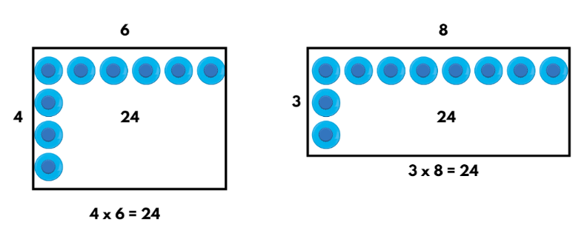
Figure 3 – Stage 3 example
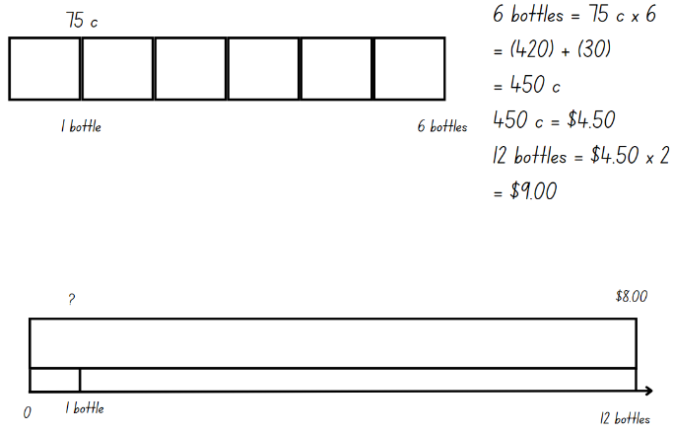
This table details opportunities for assessment.
Assessment opportunities | Links
What to look for:  - Can Stage 2 students create and represent multiplicative structure, moving from arrays to partially covered area models? [MAO-WM-01, MA2-MR-01]  - Can Stage 3 students solve word problems involving rates using multiplication and division? [MAO-WM-01, MA3-MR-01] | Links to National Numeracy Learning Progressions (NNLP):  - Stage 2 – MuS5, MuS6  - Stage 3 – MuS7, MuS8, PrT4.  Links to suggested Interview for Student Reasoning (IfSR) tasks:  - Stage 2 – IfSR-MT: 2A.1, 2A.2, 2A.3  - Stage 3 – IfSR-PT: 3A.2.

Core lesson 1 – prove it – 20 minutes
The table below contains suggested learning intentions and success criteria. These are best co-constructed with students.
Core concept learning intentions | Core concept success criteria
Students working towards Stage 2 outcomes are learning to:  - use number properties to find related multiplication facts  - measure the areas of shapes using the grid structure.  Students working towards Stage 3 outcomes are learning to:  - measure lengths to find perimeters  - calculate the areas of rectangles using familiar metric units. | Students working towards Stage 2 outcomes can:  - recognise that rectangles with different side lengths can have the same area  - use the associative property within multiplication to regroup the factors.  Students working towards Stage 3 outcomes can:  - recognise that rectangles with the same perimeter may have different dimensions  - calculate areas of rectangles in square metres (m²)  - investigate and compare the areas of rectangles that have the same perimeter.
- Revise the definition of area.
Area: the amount of surface inside a closed flat (two-dimensional) shape.
- Display Resource 9 – untorn rectangles and ask:
- What is the area of the green and orange rectangles?
- What strategies did you use to calculate the area?
- How could you describe the area of the rectangles as an array? (The green rectangle shows 5 threes and the orange rectangle shows 3 fives.)
- What unit of measurement is used to describe the area? (Square centimetres.)
- What connections can you make between multiplication and area?
- If the squares within the rectangles are rearranged to form new shapes, does the size of the new shape remain the same?
- Explain that 3 fives is equivalent to 5 threes because the multiplication facts are commutative. So, both rectangles have the same area.

Core lesson 2 – 30 minutes

Stage 2 task – area of whole rectangles
This activity is an adaptation of Torn Shapes from NRICH by University of Cambridge.
- Provide students with Resource 10 – torn shapes, square-centimetre grid paper, scissors and writing materials.
- Tell students these diagrams are representative of a council’s drawings of local paddocks. Parts of each drawing have been damaged over time.
- Explain that students have been asked to assist the council with calculating the total area of each paddock. They must record the area of the paddocks using square centimetres and describe the arrays.
- In pairs, students discuss:
- What strategies can be used to determine the area of the whole rectangles?
- Is the information provided sufficient to work out the area of the whole rectangles?
- What multiplication facts could you use?
- How does each strategy change when calculating the area of shape E and F?
- Select students to share their strategies for determining the area of the different shapes.
- Provide students with Resource 11 – block options and tell students that Farmer Bob has been allocated an area of land of 30 m².
- Students turn and talk to discuss:
- How can you describe the area of each block option?
- Which option gives Farmer Bob the most land?
- Students record their thinking using individual whiteboards and writing materials.
- Explain to students that 5 × 6 = 2 × 15. Using the associative property, 2 × 15 can be rewritten as 2 × (5 × 3) where the grouping symbols indicate that 5 × 3 is the first part of the multiplication completed. This is represented in option 2. All 5 options are possible allocations as they give Farmer Bob an allocated area of land of 30 m².

Stage 3 task – fence perimeter
This activity is an adaptation of Fence It from NRICH by University of Cambridge.
- Explain that a farmer wants to fence off a rectangular block of his land so that it has a perimeter of 40 metres. Ask:
- How many ways can the farmer fence his land?
- Will each rectangle have the same area? Why or why not?
- How can the farmer calculate which rectangle gives him the biggest block?
- Provide pairs of students with square-centimetre grid paper, individual whiteboards and writing materials to investigate. Explain that each centimetre grid is representative of a metre.
- Regroup and select students to share different solutions. Ask:
- What strategies did you use to help you find the different possibilities?
- Do you notice a pattern between the different possible dimensions of the rectangles?
- Do rectangles with the same perimeter have the same area?
- What was the largest possible area? (100 m²)
- How is area different to perimeter?
- Provide small groups of students with Resource 12 – fence it. Encourage students to draw a diagram where necessary and record the possibilities generated.
This table details opportunities for differentiation.
Too hard? | Too easy?
Stage 2 students cannot recognise that rectangles with different side lengths can have the same area.  - Support students to partition a larger rectangle by identifying smaller arrays so that they can calculate the total area.  Stage 3 students cannot recognise that rectangles with the same perimeter may have different dimensions.  - Provide students with a starting value for the width of the rectangle when using 40 metres of fencing without a wall. Support students to work systematically and determine possible dimensions.  - Provide students with a supplementary task using a different amount of fencing, for example, 60 metres. | Stage 2 students can recognise that rectangles with different side lengths can have the same area.  - Pose the following question to students: What would happen if the rectangle was quadrupled in width or length? What happens to the dimensions and area of the rectangle?  - Students create a large rectangle with clearly labelled dimensions. Students swap with a partner and ask their partner to calculate the original dimension of a smaller rectangle that has been quadrupled in length or width to form the larger rectangle.  Stage 3 students can recognise that rectangles with the same perimeter may have different dimensions.  - Display Resource 13 – possible fencing dimensions. Students complete the missing values in the table. What patterns do you notice between the possible areas in the column and second column? What is the largest possible area for each task. The largest area for the first task can be represented by 10 × 10. The largest area for the second task can be represented by 20 × 10.  - Challenge students to calculate the cost if the areas were covered in synthetic grass that is $26.75 per square metre.

Discuss and connect the mathematics – 10 minutes
- Regroup as a class and ask:
- What strategies did you use to solve these problems?
- How did your knowledge of multiplication and division help you solve the problems?
- How would you explain to a new student how to find an area of a rectangle?
This table details opportunities for assessment.
Assessment opportunities | Links
What to look for:  - Can Stage 2 students recognise that rectangles with different side lengths can have the same area? [MAO-WM-01, MA2-2DS-03]  - Can Stage 2 students use the associative property within multiplication to regroup the factors? [MAO-WM-01, MA2-MR-01]  - Can Stage 3 students use informal written strategies such as the area model to solve multiplication and division problems?  [MAO-WM-02, MA3-MR-01]  - Can Stage 3 students calculate areas of rectangles in square metres (m²)? [MAO-WM-01, MA3-2DS-02]  - Can Stage 3 students investigate and compare the areas of rectangles that have the same perimeter? [MAO-WM-01,  MA3-2DS-02]  - Can Stage 3 students recognise that rectangles with the same perimeter may have different dimensions? [MAO-WM-01,  MA3-GM-02] | Links to National Numeracy Learning Progressions (NNLP):  - Stage 2 – MuS6, UuM6-7, UGP6  - Stage 3 – MuS6-7, UuM6-7, UGP6.

Lesson 3
Core concept: comparing features adds precision to the description and measurement of shapes.

Daily number sense – broken calculator – 10 minutes
The table below contains suggested learning intentions and success criteria. These are best co-constructed with students.
Daily number sense learning intentions | Daily number sense success criteria
Students working towards Stage 2 outcomes are learning to:  - use the structure of the area model to represent multiplication and division.  Students working towards Stage 3 outcomes are learning to:  - select and apply strategies to solve problems involving multiplication and division with whole numbers. | Students working towards Stage 2 outcomes can:  - create and represent multiplicative structure, moving from arrays to partially covered area models.  Students working towards Stage 3 outcomes can:  - select and use efficient strategies to multiply whole numbers of up to 4 digits by one- and 2-digit numbers.
This activity is an adaptation from Open-Ended Maths Activities by Sullivan and Lilburn.
- Pose the following problem for Stage 2 students: How could you represent 8 × 9 in an area model without using the number 9? Ask:
- How could the distributive property help solve this problem? (For example, 8 × 5 + 8 × 4)
- How many ways could 9 be split to solve this task?
- Pose the following problem for Stage 3 students: How could you calculate 19 × 22 if the 9 button on your calculator is broken? Ask:
- How would you approach this task?
- What properties of multiplication might help solve this problem?
- How could we use grouping symbols to show our thinking?
- What other operations might need to be considered?
- Provide students with individual whiteboards to represent their thinking.
- Select a variety of students’ solutions and strategies to share with the class. Look for:
- different ways students have split 9 to use the distributive property, for example, 8 × 8 + 8 × 1 or 8 × 5 + 8 × 4 (Stage 2)
- answers that show students realise that 19 can be partitioned in ways other than 10 and 9, for example, 8 and 11 (Stage 3)
- answers where students multiply 22 by another number and then add or subtract, for example, 20 × 22 + 22. (Stage 3)
- Ask:
- How could you use the compensation strategy to solve the problem? (Stage 2)
- Can factorising the numbers help you solve this problem mentally? (Stage 3)
- Is it more efficient to use a calculator, mental or written strategy to solve this problem? (Stage 3)
This table details opportunities for assessment.
Assessment opportunities | Links
What to look for:  - Can Stage 2 students create and represent multiplicative structure, moving from arrays to partially covered area models? [MAO-WM-01, MA2-MR-01]  - Can Stage 3 students select and use efficient strategies to multiply whole numbers of up to 4 digits by one- and 2-digit numbers? [MAO-WM-01, MA3-MR-01] | Links to National Numeracy Learning Progressions (NNLP):  - Stage 2 – MuS5, MuS6  - Stage 3 – MuS7, MuS8.  Links to suggested Interview for Student Reasoning (IfSR) tasks:  - Stage 2 – IfSR-MT: 2A.1, 2A.2, 2A.3  - Stage 3 – IfSR-MT: 3A.1, 3A.2, 3A.3, 3A.4, 3A.5.

Core lesson 1 – What’s my shape? – 20 minutes
The table below contains suggested learning intentions and success criteria. These are best co-constructed with students.
Core concept learning intentions | Core concept success criteria
Students working towards Stage 2 outcomes are learning to:  - compare and describe features of two-dimensional shapes.  Students working towards Stage 3 outcomes are learning to:  - dissect two-dimensional shapes and rearrange them using translations, reflections and rotations  - calculate the area of a parallelogram using subdivision and rearrangement. | Students working towards Stage 2 outcomes can:  - describe and compare two-dimensional shapes, including parallelograms, rectangles, rhombuses, squares, trapeziums and kites  - identify and describe polygons that have parallel sides and those that do not  - identify right angles in shapes.  Students working towards Stage 3 outcomes can:  - dissect and rearrange one shape to make another  - show how to transform a parallelogram into a rectangle to find its area.
This activity is an adaptation of That Takes the Biscuit from NZ Maths by University of Cambridge.
- Write the words ‘square’, ‘rectangle’ and ‘parallelogram’ on the board. Ask: How are these shapes similar and/or different?
- Students turn and talk to discuss their ideas.
- Regroup as a class and revise:
- definition of parallel lines, angles and right angles
- properties of squares, rectangles and parallelograms.
Parallel lines: two lines in the same plane that have no points of intersection and have the same gradient (slope).
Angle: the amount of turn or opening between 2 straight arms.
Right angle: two perpendicular straight lines or arms that meet at a vertex (corner) which makes a square. It can also be described as a quarter turn.
Rectangle: a polygon with 4 straight sides and 4 angles that are equal. The opposite sides are equal in length and parallel. The angles are right angles (90°). A square is a rectangle that has all 4 sides equal in length.
Parallelogram: a polygon with 4 straight sides. The opposite sides are parallel and equal. The opposite angles are equal.
- Display Resource 14 – student shapes. Ask:
- What features distinguish these shapes from one another?
- What mathematical words could you use for describing shapes?
- What do you notice about the angles in these shapes?
- Display Resource 15 – teacher shape sort. Ask:
- What might the labels be for these groups? (At least one pair of parallel lines, has at least one right angle.)
- Why is there an overlap with the circles? (The square and rectangle have at least one pair of parallel lines and at least one right angle. They fit into both categories.)

Core lesson 2 – 25 minutes

Stage 2 task – shape sort
- Provide individual students with Resource 14 – student shapes and a pair of scissors.
- Students cut and sort the shapes into groups and label the groups according to features.
- In pairs, students compare how they sorted the shapes and discuss:
- Which shapes were easy to sort?
- Which shapes were difficult to sort?
- Are there shapes that can fit into more than one group?
- Are there ways of sorting so that there are more than 2 groups?
- Pairs sort their shapes again to determine a final sort to present to another pair.

Stage 3 task – parallelogram biscuits
- Display and read aloud Resource 16 – biscuit problem. Ask: How could Mei check whether the dog biscuits are the same size? Brainstorm some approaches to checking the biscuits are the same size. Explain that same size means the same area in this context.
- Provide pairs of students with 2 copies of Resource 16 – biscuit problem and scissors to test their ideas.
Note: instruct students to only use one copy of Resource 16 – biscuit problem to test their ideas for this activity.
- Regroup to discuss student findings. Explain and model how shapes can be dissected and rearranged to make another (see Figure 4).
Figure 4 – dissected and rearranged example
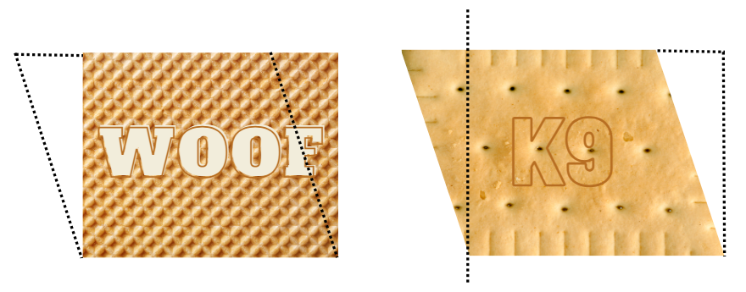
- Ask:
- Is it possible to change any rectangle to a parallelogram?
- Is it possible to change any parallelogram into a rectangle?
- Does the area of each shape stay the same?
- How can you use what you’ve discovered to determine the area of a parallelogram?
- Explain that the area of a parallelogram can be determined in a similar way to a rectangle. The area of a parallelogram = base × height.
- Instruct students to use the second copy of Resource 16 – biscuit problem, square-centimetre grid paper, rulers, scissors and writing materials to compare both shapes and calculate the area.
This table details opportunities for differentiation.
Too hard? | Too easy?
Stage 2 students cannot describe and compare two-dimensional shapes, including parallelograms, rectangles, rhombuses, squares, trapeziums and kites.  - Provide students with labels for sorting the shapes. Support students to identify features that match these groups  - Support students to sort fewer shapes, for example, square, rectangle, right-angled triangle, parallelogram.  Stage 3 students cannot dissect and rearrange one shape to make another.  - Provide students with pattern blocks to combine and rearrange shapes. Students trace the outline of shapes and swap with a partner to dissect the drawn outline. | Stage 2 students can describe and compare two-dimensional shapes, including parallelograms, rectangles, rhombuses, squares, trapeziums and kites.  - Provide students with Resource 17 – additional shapes. Challenge students to sort them into as many combinations as possible.  - Provide students with Maths Venns. Challenge students to draw a quadrilateral that could belong in each of the regions.  Stage 3 students can dissect and rearrange one shape to make another.  - Provide students with square-centimetre grid paper to draw parallelograms with different dimensions. Students work in pairs to test if a parallelogram can be dissected into 2 or more shapes to make another shape.

Consolidation and meaningful practice – 10 minutes
- Stage 2 students record their ideas onto an anchor chart that displays the properties of the shapes discussed. Emphasise the use of the terms parallel lines, angles and right angles.
- Stage 3 students use this question to check for understanding: A parallelogram has an area of 36 cm². What might its dimensions be? Students record their ideas on an individual whiteboard.
This table details opportunities for assessment.
Assessment opportunities | Links
What to look for:  - Can Stage 2 students describe and compare two-dimensional shapes, including parallelograms, rectangles, rhombuses, squares, trapeziums and kites? [MAO-WM-01, MA2-2DS-01]  - Can Stage 2 students identify and describe polygons that have parallel sides and those that do not? [MAO-WM-01, MA2-2DS-01]  - Can Stage 2 students identify right angles in shapes?  [MAO-WM-01, MA2-2DS-01]  - Can Stage 3 students dissect and rearrange one shape to make another? [MAO-WM-01, MA3-2DS-03]  - Can Stage 3 students show how to transform a parallelogram into a rectangle to find its area? [MAO-WM-01, MA3-2DS-03] | Links to National Numeracy Learning Progressions (NNLP):  - Stage 2 – UGP2-4, UGP6  - Stage 3 – UuM7, UuM10.

Lesson 4
Core concept: mathematicians estimate, measure and compare the area of larger shapes using the known areas of smaller shapes.

Daily number sense – 10 minutes
- From a class need surfaced through formative assessment data, identify a short, focused activity that targets students’ knowledge, understanding and skills. Example activities may be drawn from the following resources:
- Mathematics K–6 resources
- Universal Resources Hub.

Core lesson – 40 minutes

Stage 2 task – investigating square metres
The table below contains suggested learning intentions and success criteria. These are best co-constructed with students.
Core concept learning intentions | Core concept success criteria
Students working towards Stage 2 outcomes are learning to:  - represent and solve problems involving multiplication fact families  - use square metres to measure and estimate the areas of rectangles  - compare surfaces using familiar metric units of area. | Students working towards Stage 2 outcomes can:  - describe multiplication problems using for each and times as many  - record areas in square metres using numerals and words  - estimate the areas of squares and rectangles in square metres  - estimate before measuring to determine the larger of 2 rectangular areas in square metres.
- Ask: What do we know about area? Record student’s ideas on an anchor chart.
- Display Resource 18 – units of measurement. Ask:
- What is similar? What is different?
- What connections can you make between these images and areas of shapes?
- When might square metres be used for measurement?
- Are these images true to size? How do you know?
- Why are these images drawn using a scale?
- Show students the size of a square metre by using several metre rulers.
- Display Resource 19 – Kindergarten chairs and explain that 4 Kindergarten chairs fit into one square metre.
- Explain that the principal wants to compare the area taken up by 24 Kindergarten chairs when they are arranged in 2, 3 and 6 rows. Students work in small groups to estimate which arrangement would take up the largest area.
- 2 rows of 12 chairs
- 6 rows of 4 chairs
- 3 rows of 8 chairs
- Students record their thinking on square-centimetre grid paper (see Figure 5).
Figure 5 – student responses
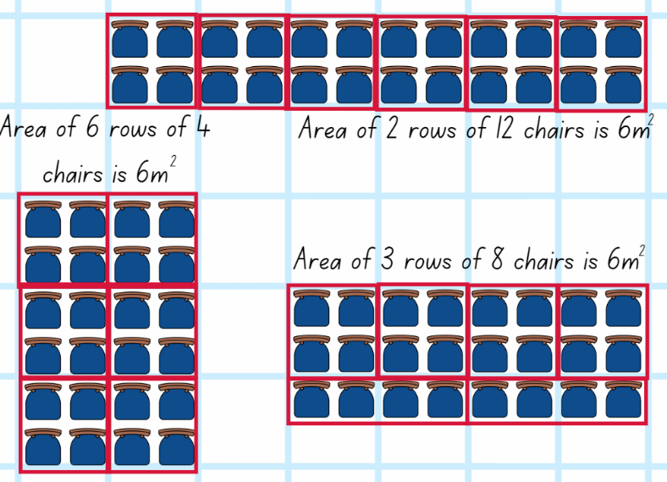
- Regroup and ask students:
- How did you determine the area of the 3 rows of 8 chairs?
- Did the arrangement of the 24 chairs in different arrays change the area? Why or why not?
- Provide pairs with Resource 20 – more area questions.
- Students turn and talk to solve the problems using the measurements from the lesson. Students record their thinking and their solutions in their workbooks.
This table details opportunities for differentiation.
Too hard? | Too easy?
Stage 2 students cannot record areas in square metres using numerals and words.  - Support students to recognise the array structures within each rectangle and use multiplicative strategies to find the total area. | Stage 2 students can record areas in square metres using numerals and words.  - Students measure their own classroom chairs and determine how many chairs would fit inside a 50 square metre area.

Stage 3 task – areas and shapes
The table below contains suggested learning intentions and success criteria. These are best co-constructed with students.
Core concept learning intentions | Core concept success criteria
Students working towards Stage 3 outcomes are learning to:  - dissect two-dimensional shapes and rearrange them using translations, reflections and rotations  - calculate the area of a parallelogram using subdivision and rearrangement  - determine the area of a triangle. | Students working towards Stage 3 outcomes can:  - use the terms translate, reflect and rotate to describe transformations of two-dimensional shapes  - dissect and rearrange one shape to make another  - show how to transform a parallelogram into a rectangle to find its area  - investigate the area of a triangle by comparing it to the area of a parallelogram with the same base length and height  - establish the relationship between the area of a triangle and the area of a parallelogram formed by duplicating and rotating the triangle  - record, using words, a method for finding the area of any parallelogram and triangle.
This activity is an adaptation of ‘Area of a triangle’ from Primary and Middle Years Mathematics: Teaching Developmentally by Van de Walle et al.
- Write the word ‘transformations’ on the board. Students brainstorm other words they could use to describe transformations of two-dimensional shapes. Revise the terms translate, reflect and rotate.
Translation: in a translation (slide) every point on the original image moves in the same direction for the same distance to transform the new image.
Reflection: a reflection (flip) requires a line of reflection. A reflection is a transformation in which an object is flipped across the line of reflection.
Rotation: a rotation (turn) requires a centre of rotation (a point) and a degree of rotation, for example, 90 degrees or a quarter-turn.
- Explain to students that they will be testing whether any parallelogram can be transformed into a rectangle.
- Provide pairs of students with Resource 21 – parallelogram proof, square-centimetre grid paper, rulers, scissors and writing materials to explore the task.
- Regroup and share findings. Ask:
- How did you dissect the parallelograms to transform it into a rectangle (see Figure 6)?
- Is it possible to rearrange any parallelogram into a rectangle?
- How can you use what you have discovered to determine the area of a parallelogram?
Figure 6 – parallelogram proof
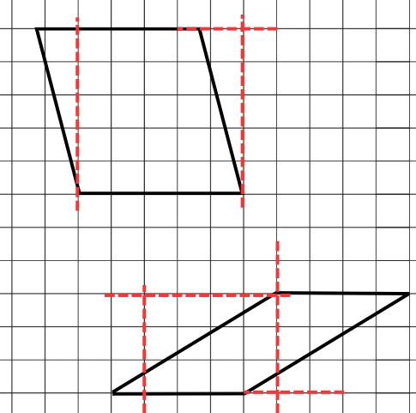
- Revise that the area of a parallelogram can be determined in a similar way to a rectangle. The area of a parallelogram = base × height.
Note: some students may have a misconception that the height of a parallelogram is the same as its length. Clarify for students that the height of a parallelogram is the perpendicular distance between the base and the opposite parallel side.
- Ask:
- How could a triangle be transformed to compare its size to a rectangle or parallelogram?
- Will a triangle have the same area as a parallelogram or rectangle with the same width and height?
- Provide students with Resource 22 – triangle and explain that a parallelogram can be formed when a triangle is duplicated and rotated. Students duplicate and rotate the triangle to form a parallelogram. Encourage students to experiment with different triangles and dimensions.
Note: ensure that students label the width (base) and height of the triangles and the parallelograms formed.
- Regroup and share student’s findings. Highlight that a triangle is half of a parallelogram with the same base and height (see Figure 7).
Figure 7 – triangle is half a parallelogram
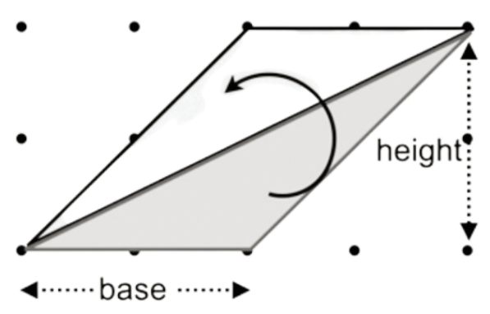
- Students use what they have learnt about parallelograms to find the area of the triangles. They record their strategies and answers on individual whiteboards. For example, the area of a triangle is half the area of a parallelogram with the same base and height.
This table details opportunities for differentiation.
Too hard? | Too easy?
Students cannot show how to transform a parallelogram into a rectangle to find its area.  - Support students to draw parallelograms on square-centimeter grid paper where the diagonals bisect each grid. Encourage students to combine bisected grids to determine the area.  Students cannot investigate the area of a triangle by comparing it to the area of a parallelogram.  - Students fold a piece of paper in half. They draw a triangle on the folded paper and cut it out, making 2 identical copies. They fit the 2 triangles together to make a parallelogram. | Students can show how to transform a parallelogram into a rectangle to find its area.  - Provide students with Resource 23 – parallelogram Venn to solve.  Students cannot investigate the area of a triangle by comparing it to the area of a parallelogram.  - Provide students with blank paper to draw a triangle and calculate the area.

Discuss and connect – 10 minutes
- Regroup and summarise the lesson together drawing out key mathematical ideas. Ask:
- How accurate were your measurements? (Stage 2)
- How could you improve the accuracy of your estimations and measurements next time? (Stage 2)
- What strategy did you apply to work out the area of the triangle? (Stage 3)
- Did your knowledge about the area of parallelograms help you to work out the area? (Stage 3)
- How could this be changed into a rectangle? (Stage 3)
- How are the areas of a parallelogram, rectangle and triangle related to each other? (Stage 3)
This table details opportunities for assessment.
Assessment opportunities | Links
What to look for:  - Can Stage 2 students describe multiplication problems using for each and times as many? [MAO-WM-01, MA2-MR-01]  - Can Stage 2 students record areas in square metres using numerals and words? [MAO-WM-01, MA2-2DS-03]  - Can Stage 2 students estimate the areas of squares and rectangles in square metres? [MAO-WM-01, MA2-2DS-03]  - Can Stage 2 students estimate before measuring to determine the larger of 2 rectangular areas in square metres? [MAO-WM-01, MA2-2DS-03]  - Can Stage 3 students use the terms translate, reflect and rotate to describe transformations of two-dimensional shapes?  [MAO-WM-01, MA3-2DS-03]  - Can Stage 3 students dissect and rearrange one shape to make another? [MAO-WM-01, MA3-2DS-03]  - Can Stage 3 students show how to transform a parallelogram into a rectangle to find its area? [MAO-WM-01, MA3-2DS-03]  - Can Stage 3 students investigate the area of a triangle by comparing it to the area of a parallelogram with the same base length and height? [MAO-WM-01, MA3-2DS-03]  - Can Stage 3 students record, using words, a method for finding the area of any parallelogram and triangle? [MAO-WM-01,  MA3-2DS-03] | Links to National Numeracy Learning Progressions (NNLP):  - Stage 2 – MuS5, UuM5-7  - Stage 3 – UuM7, UuM10.

Lesson 5
Core concept: the multiplicative relationship between the length, width and height of an object can be used to determine volume.

Daily number sense – decimal chains – 10 minutes
Daily number sense activities for Lessons 5 to 7 ‘loop’ back to concepts and procedures covered in previous units to assist students to build an increasingly connected network of ideas. These concepts may differ from the core concepts being covered by the unit.
The table below contains suggested learning intentions and success criteria. These are best co-constructed with students.
Daily number sense learning intentions | Daily number sense success criteria
Students working towards Stage 2 outcomes are learning to:  - make connections between fractions and decimal notation.  Students working towards Stage 3 outcomes are learning to:  - make connections between benchmark fractions, decimals and percentages. | Students working towards Stage 2 outcomes can:  - make connections between fractions and decimal notation for key benchmark values.  Students working towards Stage 3 outcomes can:  - recall commonly used equivalent percentages, decimals and fractions including $\frac{1}{2}, \frac{1}{4}$ and $\frac{3}{4}$.
This activity is an adaptation of Doughnut Percents from NRICH by University of Cambridge.
- Provide Stage 2 students with Resource 24 – decimal chains 1 and Stage 3 students with Resource 25 – decimal chains 2. Distribute the domino cards to pairs of students so that each student has an equal amount.
- Explain that students will work together to create one long domino chain or 2 smaller chains. Touching ends need to have equal values (see Figure 7).
Figure 7 – example dominos in a chain
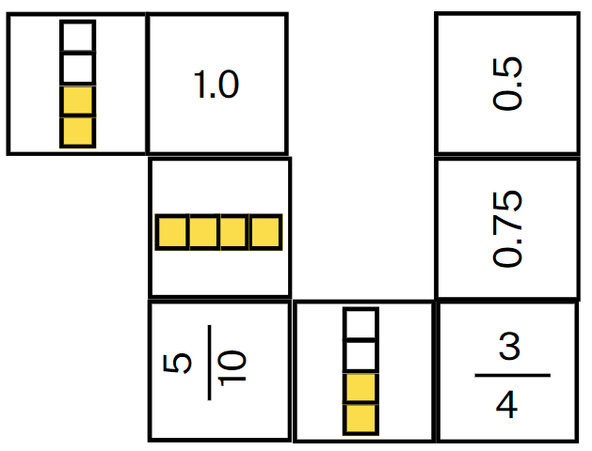
- Teamwork and collaboration are the key to this task. Explain that:
- All dominoes are face up and visible to both players.
- Players take turns to place a domino to add to the chain.
- Players discuss their moves, communicating their reasoning connecting fractions and decimals.
- Reflect on the activity, asking questions, such as:
- Which domino ends were the hardest to match? Why?
- Were there any that you did not know?
- Were you still able to match them?
- What strategy did you use?
This table details opportunities for assessment.
Assessment opportunities | Links
What to look for:  - Can Stage 2 students make connections between fractions and decimal notation for key benchmark values? [MAO-WM-01,  MA2-RN-02]  - Can Stage 3 students recall commonly used equivalent percentages, decimals and fractions including $\frac{1}{2}$, $\frac{1}{4}$ and $\frac{3}{4}$?  [MAO-WM-01, MA3-RN-03] | Links to National Numeracy Learning Progressions (NNLP):  - Stage 2 – NPV6, NPV7, InF6  - Stage 3 – PrT2, UuM8.  Links to suggested Interview for Student Reasoning (IfSR) tasks:  - Stage 2 – IfSR-NP: 4D.3  - Stage 3 – IfSR-PT: 2A.1.

Core lesson 1 – 10 minutes
The table below contains suggested learning intentions and success criteria. These are best co-constructed with students.
Core concept learning intentions | Core concept success criteria
Students working towards Stage 2 outcomes are learning to:  - make models of three-dimensional objects to compare and describe key features  - compare objects using familiar metric units of volume  - connect three-dimensional objects and two-dimensional representations.  Students working towards Stage 3 outcomes are learning to:  - recognise the multiplicative structure for finding volume  - find the volumes of rectangular prisms in cubic centimetres and cubic metres. | Students working towards Stage 2 outcomes can:  - investigate the variety of nets that can be used to create a particular prism  - compare the volumes of 2 or more objects made from cubic-centimetre blocks  - draw different views on isometric grids of an object constructed from connecting cubes  - interpret given drawings to make models of three-dimensional objects using connecting cubes (Reasons about spatial visualisation).  Students working towards Stage 3 outcomes can:  - establish the relationship between the number of cubes in one layer and the number of layers to find the volume of a rectangular prism  - recognise that rectangular prisms with the same volume may have different dimensions.
This activity is an adaptation of ‘A box of boxes’ from Mindset Mathematics: Visualizing and Investigating Big Ideas, Grade 5 by Boaler et al.
- Display Resource 26 – prisms.
- Students Think-Pair-Share what they notice about the 4 prisms. Ask:
- Which two-dimensional shapes would be needed to create the net of Prism 1? How do you know? (Stage 2)
- Which two-dimensional shapes would be needed to create the net of Prism 3? How do you know? (Stage 2)
- Which prism has the largest volume? (Stage 2 and 3)
- What is the difference between the largest volume and the smallest volume? How did you determine the difference? (Stage 3)

Core lesson 2 – 30 minutes

Stage 2 task – investigating prisms
- Provide pairs with connecting cubes and have them construct the 4 prisms from Resource 26 – prisms.
- Students compare the volume of each prism and place them in order from smallest to largest.
- Students draw the top, front and side views of Prisms 2 and 4 on grid paper. Students label their drawings.
- Students draw nets for Prism 1 and 3 on grid paper. Challenge students to investigate the variety of nets that can be used to create Prism 3 (cube).

Stage 3 task – exploring prisms
- Describe the following scenario: You need to send a package in the post with all the prisms from Resource 26 – prisms and you want to make sure there is as little empty space as possible. This prevents the objects inside from rattling around, it saves paper and it protects the box from getting squashed.
- Explain that the goal is for students to design a box that will hold all 4 smaller boxes (prisms) and have the least amount of empty space. The box must be a rectangular prism, as most packing boxes and parcels are.
- Provide pairs of students with grid paper.
- Students turn and talk to discuss:
- What are some different ways you could stack the 4 prisms?
- How could building a model with connecting cubes help you determine the dimensions of your box?
- How could building a model help you estimate the layers needed for the larger box?
- How could you record your thinking and your solution?
- Provide students with connecting cubes and have them create models of each of the prisms.
- In pairs, students try to create a box with the smallest volume of empty space. They record their solutions on Resource 27 – recording boxes to compare the dimensions and volumes of the possible larger packing boxes (see Figure 8).
Figure 8 – example of student recording
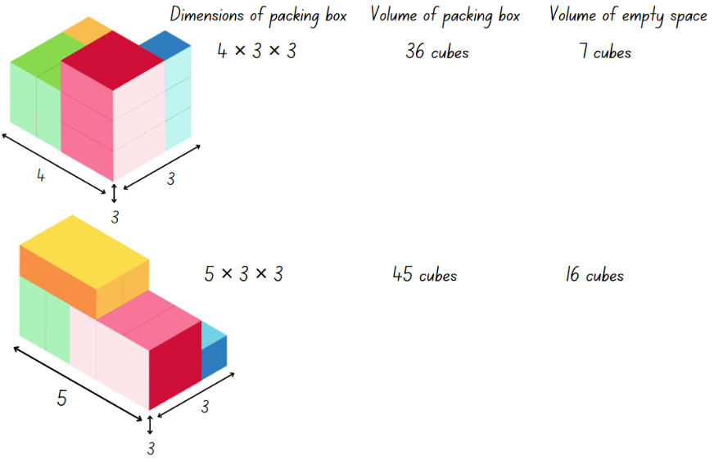
- Discuss students’ solutions. Ask:
- What is the smallest packing box you can make that will hold all the boxes?
- What are the dimensions of your box? What is its volume?
- How did you find the amount of empty space in each of your packing boxes?
- What strategies did you come up with to minimise the empty space?
Note: if not identified by students, draw attention to the way that multiplicative structure can be used to support their thinking. Encourage students to look for the relationship between the number of cubes in one layer and the number of layers for finding the volume of a rectangular prism.
This table details opportunities for differentiation.
Too hard? | Too easy?
Stage 2 students cannot investigate the variety of nets that can be used to create a particular prism.  - Provide students with a deconstructed tissue box. Support students to recognise how the net can be folded to reconstruct the box. Students recreate this net using Polypad.  Stage 2 students cannot draw different views on isometric grids of an object constructed from connecting cubes.  - Provide students with a digital device and access the interactive Isometric Drawing Tool. Support students to view their models from different viewpoints and recreate it using the cube tool.  Stage 3 students cannot establish the relationship between the number of cubes in one layer and the number of layers to find the volume of a rectangular prism.  - Reduce the sizes of the smaller boxes and support students to arrange them efficiently. Identify the number of cubes in one layer of each box, then the number of layers.  - Model how to use the dimensions to calculate the space taken up by the smaller boxes and the volume of the larger box. Support students to find the difference, to identify the empty space in the larger packing box. | Stage 2 students can investigate the variety of nets that can be used to create a particular prism.  - Provide students with the NRICH problem Cut Nets. Students are provided with nets of 9 solids which have been cut into 2 pieces. Students work out which pieces go together.  Stage 2 students can draw different views on isometric grids of an object constructed from connecting cubes.  - Students create their own three-dimensional objects with a volume of 24 connecting cubes. Students draw the objects from top, side and front views.  Stage 3 students can establish the relationship between the number of cubes in one layer and the number of layers to find the volume of a rectangular prism.  - Students create a new set of little boxes, each with different volumes to fit in a new larger box. They look for ways they can use multiplication to simplify their calculations. For example, students might combine several smaller boxes that have some dimensions in common, to create a larger shape and reduce the number of calculations they need to make.  - Students investigate designing a large box that will provide a similar amount of space between the smaller boxes inside it.

Discuss and connect the mathematics – 10 minutes
- Students conduct a gallery walk looking at other pairs’ packing boxes.
- Regroup as a class and ask:
- Did you notice any similarities between your ideas and other groups?
- How does multiplicative thinking help to find the volume of any prism?
This table details opportunities for assessment.
Assessment opportunities | Links
What to look for:  - Can Stage 2 students investigate the variety of nets that can be used to create a particular prism? [MAO-WM-01, MA2-3DS-01]  - Can Stage 2 students compare the volumes of 2 or more objects made from cubic-centimetre blocks? [MAO-WM-01, MA2-3DS-01]  - Can Stage 2 students draw different views on isometric grids of an object constructed from connecting cubes? [MAO-WM-01,  MA2-3DS-01]  - Can Stage 2 students interpret given drawings to make models of three-dimensional objects using connecting cubes? [MAO-WM-01, MA2-3DS-01]  - Can Stage 3 students recognise that rectangular prisms with the same volume may have different dimensions? [MAO-WM-01, MA3-3DS-02]  - Can Stage 3 students establish the relationship between the number of cubes in one layer and the number of layers to find the volume of a rectangular prism? [MAO-WM-01, MA3-3DS-02] | Links to National Numeracy Learning Progressions (NNLP):  - Stage 2 – UGP3  - Stage 3 – UuM5.

Lesson 6
Core concept: mathematicians measure and record volume of three-dimensional space.

Daily number sense – decimals and percentages – 10 minutes
The table below contains suggested learning intentions and success criteria. These are best co-constructed with students.
Daily number sense learning intentions | Daily number sense success criteria
Students working towards Stage 2 outcomes are learning to:  - make connections between fractions and decimal notation.  Students working towards Stage 3 outcomes are learning to:  - make connections between benchmark fractions, decimals and percentages. | Students working towards Stage 2 outcomes can:  - connect fraction strips showing tenths to a number line marked in hundredths  - compare and order decimals of up to 2 decimal places.  Students working towards Stage 3 outcomes can:  - recognise that 10% is one-tenth of 100% and use this to find 10% of a quantity.
- Display Resource 28 – decimals and percentages.
- Ask students to turn and talk and discuss where the following decimals and percentages would be placed:
- 0.4 (read as ‘four-tenths’) (Stage 2 and Stage 3)
- 1.0 (Stage 2 and Stage 3)
- 0.5 (read as ‘five-tenths’) (Stage 2 and Stage 3)
- 100% (Stage 3)
- 20% (Stage 3)
- 30% (Stage 3).
- Select students to mark and record the decimals and percentages on the number line. Students explain their reasoning.
- Display Resource 29 – problem solving.
- Allow students time to solve the problems and record their ideas on individual whiteboards.
- Gather students to discuss their findings. Ask:
- What strategies did you use to answer the questions? (Stage 2 and 3)
- How can calculating 10% help calculate other percentages? (Stage 3)
- How can a bar model help solve problems related to finding a percentage of a quantity? (Stage 3)
Note: Stage 3 students may notice the commutative property of percentages from this activity. For example, 50% of 10 is the same as 10% of 50. This property may be something to explore further with students if time permits.
This table details opportunities for assessment.
Assessment opportunities | Links
What to look for:  - Can Stage 2 students connect fraction strips showing tenths to a number line marked in hundredths? [MAO-WM-01, MA2-RN-02]  - Can Stage 2 students compare and order decimals of up to 2 decimal places? [MAO-WM-01, MA2-RN-02]  - Can Stage 3 students recognise that 10% is one-tenth of 100% and use this to find 10% of a quantity? [MAO-WM-01,  MA3-RN-03] | Links to National Numeracy Learning Progressions (NNLP):  - Stage 2 – NPV6, NPV7  - Stage 3 – UnM8.  Links to suggested Interview for Student Reasoning (IfSR) tasks:  - Stage 2 – IfSR-NP: 4D.4  - Stage 3 – IfSR-PT: 2A.5.

Core lesson – prism volumes – 40 minutes
The table below contains suggested learning intentions and success criteria. These are best co-constructed with students.
Core concept learning intentions | Core concept success criteria
Students working towards Stage 2 outcomes are learning to:  - compare objects using familiar metric units of volume.  Students working towards Stage 3 outcomes are learning to:  - find the volumes of rectangular prisms in cubic centimetres and cubic metres. | Students working towards Stage 2 outcomes can:  - construct rectangular prisms and describe the volumes in terms of layers  - record volumes using numerals and words.  Students working towards Stage 3 outcomes can:  - record, using words, the method for finding the volumes of rectangular prisms  - calculate volumes of rectangular prisms in cubic centimetres (cm³) and cubic metres (m³).
- Display Resource 30 – prism volume. Ask:
- How many blocks are in one layer of this prism?
- How could you describe the volume of this prism? (Two layers of 4 sixes)
- What unit of measurement would be used for the prism’s volume? (Cubic centimetres)
- What is the volume of this prism? How do you know? (48 cubic centimetres; 4 sixes make 24 and 2 layers of 24 makes 48.)
- Display Resource 31 – patterns in volume and explain that students will calculate the volume of the 3 prisms and record their thinking in a table.
- Some students may choose to construct the prisms with connecting cubes to enable them to individually count the number of cubes that make up each layer and the total volume.
Multi-age: provide Stage 2 students with Resource 32 – recording table 1 and Stage 3 students with Resource 33 – recording table 2 to record their thinking.
- Use the prompt table below to facilitate a discussion about students’ findings.
The table below outlines stimulus prompts to generate conversation about the topic, along with anticipated responses from students.
Prompts | Anticipated student responses
- How did you determine the volume of each prism? | - I counted the blocks in the top layer of each prism and then multiplied that number by the number of layers. (Stage 2)  - I made a model of the prisms with connecting cubes and counted the cubes individually. (Stage 2)  - For the first prism, I multiplied 2 cm × 2 cm × 2 cm = 8 cm³, then took one off. The volume is 7 cm³. (Stage 3)  - The second prism has 19 cubes. I multiplied 3 cm × 3 cm × 3 cm = 27 cm³, then took 8 cm³ off. (Stage 3)
- Can you use multiplication to calculate the volume efficiently? | - Yes, I can multiply the number of blocks in a layer by the number of layers. (Stage 2)  - Yes, I found the area of the bottom layer and multiplied it by the number of layers to find the total volume. (Stage 2)  - Yes, I multiplied 4 cm × 4 cm × 4 cm = 64 cm³. The missing cube from it measured 3 cm × 3 cm × 3 cm, which is 27 cubes. 64 cm³ – 27 cm³ = 37 cm³. (Stage 3)
- What do you notice about these objects? Is there a pattern? | - They are all cubes. They get bigger each time by the same amount. (Stage 2)  - They are all cubes, each with a smaller missing cube. They get bigger each time by the same amount. It is a pattern. (Stage 3)  - I saw a pattern, that the volume of the object before is the volume of the cube being taken away in the next object. (Stage 3)
This table details opportunities for differentiation.
Too hard? | Too easy?
Stage 2 students cannot construct rectangular prisms and describe the volumes in terms of layers.  - Support students to arrange the connecting cubes into arrays and calculate the number of cubes in one layer. Stack the arrays to determine the number of layers within the prisms.  Stage 3 students cannot calculate volumes of rectangular prisms in cubic centimetres (cm³) and cubic metres (m³).  - Provide students with blocks to build a 5 cm × 5 cm × 5 cm cube.  - Support student to work out that a 5 cm × 5 cm × 5 cm cube has a volume of 125 cm³. | Stage 2 students can construct rectangular prisms and describe the volumes in terms of layers.  - Provide students with the NRICH problem Open Boxes. Students work out how many cubes are needed to make boxes of varying sizes.  Stage 3 students can calculate volumes of rectangular prisms in cubic centimetres (cm³) and cubic metres (m³).  - Ask: Will the remaining volume always have a prime number value? Can you prove or disprove it?  Note: this is disproved by (8 cm × 8 cm × 8 cm) − (7 cm × 7 cm × 7 cm) = 169 cm3 (which is 13 × 13).  - Students create a rule to describe the pattern and predict the result for (7 cm × 7 cm × 7 cm) − (6 cm × 6 cm × 6 cm).

Discuss and connect the mathematics – 10 minutes
- Ask students to turn and talk and determine what the next object in the pattern would look like.
- Students sketch the object on isometric grid paper and label the dimensions.
- Stage 2 object would be a 5 cm × 5 cm × 5 cm = 125 cm³ cube.
- Stage 3 object would be a 5 cm × 5 cm × 5 cm cube with a 4 cm × 4 cm × 4 cm cube removed = 61 cm³.
This table details opportunities for assessment.
Assessment opportunities | Links
What to look for:  - Can Stage 2 students record volumes using numerals and words? [MAO-WM-01, MA2-3DS-02]  - Can Stage 2 students construct rectangular prisms using cubic-centimetre blocks and describe the volumes in terms of layers? [MAO-WM-01, MA2-3DS-02]  - Can Stage 3 students record, using words, the method for finding the volumes of rectangular prisms? [MAO-WM-01, MA3-3DS-02]  - Can Stage 3 students calculate volumes of rectangular prisms in cubic centimetres (cm³)? [MAO-WM-01, MA3-3DS-02] | Links to National Numeracy Learning Progressions (NNLP):  - Stage 2 – UuM5, UuM6  - Stage 3 – UuM5, UuM6.

Lesson 7
Core concept: standard units are an efficient way to communicate volume.

Daily number sense – heights and discounts – 10 minutes
The table below contains suggested learning intentions and success criteria. These are best co-constructed with students.
Daily number sense learning intentions | Daily number sense success criteria
Students working towards Stage 2 outcomes are learning to:  - make connections between fractions and decimal notation.  Students working towards Stage 3 outcomes are learning to:  - make connections between benchmark fractions, decimals and percentages. | Students working towards Stage 2 outcomes can:  - compare and order decimals of up to 2 decimal places  Students working towards Stage 3 outcomes can:  - recognise that 10% is one-tenth of 100% and use this to find 10% of a quantity.
This lesson is an adaptation of ‘Percentage Challenge 2’ from Enrich-e-matics! A graded maths enrichment programme – Book F by Joshua.
- Display Resource 34 – heights and discounts.
- Give students time to discuss the problems and record their ideas on individual whiteboards.
- Discuss students’ findings. Ask:
- What did you discover? (Stage 2 and 3)
- Is Rose or Martine correct? Who is taller? How do you know? (Stage 2)
- What misconceptions about decimals might Rose have? How could you explain this to her? (Stage 2)
- What is the difference between Martine and Rose’s height? How can you calculate this? (Stage 2)
- Why might the employee think they were entitled to a 20% discount? (Stage 3)
- How much did the employee have to pay for the dress? (Stage 3)
This table details opportunities for assessment.
Assessment opportunities | Links
What to look for:  - Can Stage 2 students compare and order decimals of up to 2 decimal places? [MAO-WM-01, MA2-RN-02]  - Can Stage 3 students recognise that 10% is one-tenth of 100% and use this to find 10% of a quantity? [MAO-WM-01,  MA3-RN-03] | Links to National Numeracy Learning Progressions (NNLP):  - Stage 2 – NPV6, NPV7  - Stage 3 – UnM8.  Links to suggested Interview for Student Reasoning (IfSR) tasks:  - Stage 2 – IfSR-NP: 4D.4  - Stage 3 – IfSR-PT: 2A.5.

Core lesson – green thumbs – 40 minutes
The table below contains suggested learning intentions and success criteria. These are best co-constructed with students.
Core concept learning intentions | Core concept success criteria
Students working towards Stage 2 outcomes are learning to:  - use square centimetres to measure and estimate the areas of rectangles  - compare objects using familiar metric units of volume.  Students working towards Stage 3 outcomes are learning to:  - select and apply strategies to solve problems involving multiplication and division with whole numbers  - recognise the multiplicative structure for finding volume  - find the volumes of rectangular prisms in cubic centimetres and cubic metres. | Students working towards Stage 2 outcomes can:  - use efficient strategies for counting large numbers of square centimetres  - construct rectangular prisms and describe the volumes in terms of layers  - record volumes using numerals and words.  Students working towards Stage 3 outcomes can:  - solve word problems involving rates using multiplication and division  - establish the relationship between the number of cubes in one layer and the number of layers to find the volume of a rectangular prism  - calculate volumes of rectangular prisms in cubic centimetres (cm³) and cubic metres (m³).
- Revise the previous lesson and how multiplicative relationships between the dimensions of an object can be used to find its volume.
- Explain that the General Assistant (GA) at your school is planning to build some garden beds. They need assistance creating rectangular seedling boxes which will be used to grow some small plants. They also need assistance determining how much mulch to order for each garden bed.

Stage 2 task – square centimetres
This activity is an adaptation of Making Boxes from NRICH by University of Cambridge.
- Explain to students that they will make open-top seedling boxes by cutting out a square in each corner of a sheet of grid paper and folding up the sides (see Figure 9).
Figure 9 – making open-top seedling boxes
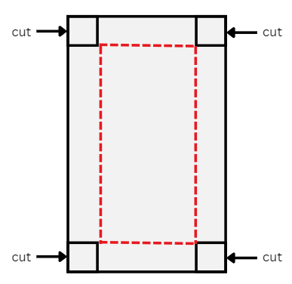
- Show students a piece of square-centimetre grid paper that measures 20 cm × 10 cm. Demonstrate how to cut a 1 cm × 1 cm square from each corner of the sheet of paper and fold the sides up to make a box. Ask:
- What is the area of the base of this box?
- What strategies could we use, if we did not know how to determine the area of the base?
- How could we use the word ‘layers’ to describe the volume of this box?
- What will happen to the volume and area if we cut out a 2 cm × 2 cm square from each corner?
- What will happen to the volume and area if we continue to cut larger squares from each corner of the paper?
- Provide pairs with Resource 35 – seedling boxes recording sheet, 20 cm × 10 cm grid paper, scissors and sticky tape.

Stage 3 task – cubic centimetres
This activity is an adaptation of ‘Green thumbs’ from Teaching Measurement: Stage 2 - Stage 3 by NSW Department of Education Learning and Teaching Directorate.
- Display Resource 36 – garden beds.
- Explain that students will be working in pairs to calculate the amount of mulch needed for each of the 4 garden beds displayed on Resource 36 – garden beds, to a depth of 10 cm.
- Highlight that the dimensions of Garden Bed 1 and Garden Bed 2 have been recorded in metres and the measurements will need to be converted to centimetres to record the area of the garden bed base in square centimetres.
- Model calculating the amount of mulch required for Garden Bed 1 by multiplying the area of the base (200 cm × 300 cm = 60 000 cm²) by the height of the mulch required (10 cm): 60 000 × 10 = 600 000 cm³.
- Pairs calculate the area of each garden bed’s base and record their calculations on Resource 37 – garden bed recording sheet.
- Display Resource 38 – Lisa’s landscapes. Explain that 1 000 000 cm³ is equivalent to 1 m³.
- Draw attention to the image of a cubic metre. Use the prompt table below to discuss the 10 cm layers.
The table below outlines stimulus prompts to generate conversation about the topic, along with anticipated responses from students.
Prompts | Anticipated student responses
- In each cubic metre of mulch, how many 10 cm thick layers would there be? | - For each cubic metre of mulch, there are 10 × 10 cm layers.
- What would the area of each 10 cm thick layer cover in the garden bed? | - Each 10 cm thick layer has an area of one square metre (m²).
- How many square metres of garden bed would each cubic metre of mulch cover to a depth of 10 cm? | - The 10 × 10 cm layers cover 10 square metres (10 m²).
- Students record the total volume of mulch required for each garden bed on the recording sheet in cm³ and m³.
- Refer to Resource 38 – Lisa’s landscapes and explain that students must calculate the cost of each garden bed’s mulch if the school was to purchase the basic mix and the native mix mulch varieties. Students record the costs on Resource 37 – garden bed recording sheet.
This table details opportunities for differentiation.
Too hard? | Too easy?
Stage 2 students cannot construct rectangular prisms and describe the volumes in terms of layers.  - Provide students with square-centimetre grid paper measuring 10 cm × 10 cm. Support students to create a box.  - Provide students with MAB units to cover the base of the box. Support students to partition the base into smaller arrays to determine the larger area. Support students to stack MAB units to determine the number of layers within the box.  Stage 3 students cannot calculate volumes of rectangular prisms in cubic centimetres (cm³) and cubic metres (m³).  - Reduce the number of garden beds students calculate on Resource 37 – garden bed recording sheet.  - Support students to identify the relationship between the length, width, height and volume of the garden bed through teacher modelling with concrete materials. For example, connecting cubes.  - Model using a calculator to convert cm³ to m³. | Stage 2 students can construct rectangular prisms and describe the volumes in terms of layers.  - Provide students with square-centimetre grid paper measuring 15 cm × 15 cm. Students determine the volume of each box formed.  - Provide students with the NRICH problem Open Boxes. Students work out how many cubes are needed to make boxes of varying sizes.  Stage 3 students can calculate volumes of rectangular prisms in cubic centimetres (cm³) and cubic metres (m³).  - Ask students to investigate finding the cost of mulching a garden bed that is a composite shape. They can also investigate the cost of mulching each garden bed to a depth of 15 cm.  - Students design their own garden bed within the school and calculate the cost of covering it with a deluxe mulch that costs $167.90 per cubic metre.

Discuss and connect the mathematics – 10 minutes
- Students conduct a gallery walk. Use these questions to check for understanding:
- What strategies did you use to work out the area of the base?
- How did you calculate the volumes?
- How are the seedling boxes and garden beds similar and different to a rectangular prism?
This table details opportunities for assessment.
Assessment opportunities | Links
What to look for:  - Can Stage 2 students use efficient strategies for counting large numbers of square centimetres? [MAO-WM-01, MA2-2DS-03]  - Can Stage 2 students record volumes using numerals and words? [MAO-WM-01, MA2-3DS-02]  - Can Stage 2 students construct rectangular prisms using cubic-centimetre blocks and describe the volumes in terms of layers? [MAO-WM-01, MA2-3DS-02]  - Can Stage 3 students recognise that rectangular prisms with the same volume may have different dimensions? [MAO-WM-01, MA3-3DS-02]  - Can Stage 3 students calculate volumes of rectangular prisms in cubic centimetres (cm³) and cubic metres (m³)? [MAO-WM-01, MA3-3DS-02]  - Can Stage 3 students establish the relationship between the number of cubes in one layer and the number of layers to find the volume of a rectangular prism? [MAO-WM-01, MA3-3DS-02] | Links to National Numeracy Learning Progressions (NNLP):  - Stage 2 – UuM5, UuM6  - Stage 3 – UuM5, UuM6, Uum7, UuM8.

Lesson 8
Core concept: mathematicians measure and compare volumes.

Daily number sense – 10 minutes
- From a class need surfaced through formative assessment data, identify a short, focused activity that targets students’ knowledge, understanding and skills. Example activities may be drawn from the following resources:
- Mathematics K–6 resources
- Universal Resources Hub.

Core lesson 1 – volume word problems – 10 minutes
The table below contains suggested learning intentions and success criteria. These are best co-constructed with students.
Core concept learning intentions | Core concept success criteria
Stage 2 students are learning to:  - represent and solve word problems with number sentences involving multiplication or division  - compare objects using familiar metric units of volume  - connect three-dimensional objects and two-dimensional representations.  Stage 3 students are learning to:  - select and apply strategies to solve problems involving multiplication and division with whole numbers  - find the volumes of rectangular prisms in cubic centimetres and cubic metres. | Students working towards Stage 2 outcomes can:  - represent and solve multiplication and division (both sharing and grouping) word problems using number sentences  - construct rectangular prisms using cubic-centimetre blocks and describe the volumes in terms of layers  - create sketches of three-dimensional objects from different views, including top, front and side views.  Students working towards Stage 3 outcomes can:  - solve word problems involving rates using multiplication and division  - recognise that rectangular prisms with the same volume may have different dimensions.
- Display and read aloud Resource 39 – volume problems.
- Provide Stage 2 students with connecting cubes and Stage 3 students with writing materials to solve the problems.
- Regroup and ask:
- How many layers high was the prism? (Stage 2)
- What other ways did you find to arrange the base layer of 12 cubes? (Stage 2)
- How many ways did you find to represent a rectangular prism with a volume of 60 cm³? (Stage 3)
- Can you describe the volume of your prisms in terms of the arrangements of the cubic centimetre blocks? (Stage 3)

Core Lesson 2 – 35 minutes

Stage 2 task – volume of blocks
This activity is an adaptation of Building Blocks from NRICH by University of Cambridge.
- Display Resource 40 – building blocks. Ask:
- How might you use these drawings to recreate the three-dimensional objects using connecting cubes?
- What would they look like from different positions?
- Which of these objects has the largest volume? Which has the smallest volume? How do you know?
- Provide small groups of students with connecting cubes, writing materials and isometric dot paper. Students construct the three-dimensional objects using the cubes and draw their object from the top, front and side views on the isometric dot paper.
- Allow students time to create their own three-dimensional objects using 4–10 connecting cubes. Students draw their objects from top, front and side views.
This table details opportunities for differentiation.
Too hard? | Too easy?
Students cannot represent and solve word problems with number sentences involving multiplication or division.  - Amend the Core lesson 1 problem so that the prism is made of 24 cubes. Support students to generate solutions systematically by starting with one layer, before moving to 2 layers.  - Support students to rearrange each layer into different arrays. For example, 6 blocks can be arranged as 6 ones or 3 twos.  Students cannot draw different views on isometric grids of an object constructed from connecting cubes.  - Build 4 rectangular prisms collaboratively with the students. Students draw the top, front and side views. | Students can represent and solve word problems with number sentences involving multiplication or division.  - Challenge students to find all the possible dimensions of a rectangular prism made of 96 cubes.  - Pose the following problem to students: The volume of a rectangular prism is 48 cubic centimetres. What might the dimensions be? If you double the lengths of the sides, what happens to the volume?  Students can draw different views on isometric grids of an object constructed from connecting cubes.  - Students create their own three-dimensional objects using 10 to 20 connecting cubes and sketch one view. Students swap sketches with a partner. Their partner attempts to recreate the three-dimensional object and draws it from a different view.
This table details opportunities for assessment.
Assessment opportunities | Links
What to look for:  - Can Stage 2 students represent and solve multiplication and division (both sharing and grouping) word problems using number sentences? [MA0-WM-01, MA2-MR-02]  - Can Stage 2 students construct rectangular prisms using cubic-centimetre blocks and describe the volumes in terms of layers? [MAO-WM-01, MA2-3DS-01]  - Can Stage 2 students create sketches of three-dimensional objects from different views, including top, front and side views? [MAO-WM-01, MA2-3DS-01] | Links to National Numeracy Learning Progressions (NNLP):  - NPA4  - UuM5  - UGP3.

Stage 3 task – parcel dimensions
This activity is an adaptation of Measurement: Parcel in the Post from reSolve by Australian Academy of Science.
- Display Resource 41 – Nanna Meg’s mail and read the problem as a class.
- Students turn and talk to discuss the following questions. Ask:
- What strategy could you use to determine the volume of the towel?
- How might the dimensions of the towel change if it is folded in half? (The dimensions would measure 80 cm × 80 cm × 2 cm or 160 cm × 40 cm × 2 cm.)
- How could drawing a diagram help you determine the dimensions of a folded towel?
- Model how the dimensions of the towel change if it is folded in quarters. (The dimensions would measure 80 cm × 40 cm × 4 cm or 160 cm × 10 cm × 4 cm.)
- What dimensions would be most suitable for posting?
- Hand out calculators. Display Resource 42 – post office information and discuss the tables. Provide an opportunity to clarify any questions students may have.
- Provide students with Resource 41 – Nanna Meg’s mail and Resource 42 – post office information. Students work on the problems individually, with a partner or as a group.
- The answers to the questions in Resource 41 – Nanna Meg’s mail are:
- 1053 cm³, 2244 cm³, 13 020 cm³, 2880 cm³, 15 288 cm³, 20 944 cm^{3.}
- The extra-large satchel (volume = 13 020 cm³), the large box (volume = 15 288 cm³) and the extra-large box (volume = 20 944 cm³).
- The large box at $22.
- It would be cheaper to buy them individually (22 × 8 = $176 instead of 18 × 8 + 48 = $192).
This table details opportunities for differentiation.
Too hard? | Too easy?
Students cannot use efficient strategies to multiply whole numbers of up to 4 digits by one- and 2-digit numbers.  - Model to students how to use diagrams to find the volume of the first box. Support them to use diagrams to represent their thinking as they find the volumes of the other boxes.  - Provide students with calculators to support them as they find the volumes of the other boxes. | Students can use efficient strategies to multiply whole numbers of up to 4 digits by one- and 2-digit numbers.  - Provide the problem: Nanna bought the towels and paid for the cheapest postage. In total, she spent $616. If all the towels were the same price, how much did each one cost?  - Provide the problem: Nanna gets offered a deal for a discount on satchels. What percentage discount would she need to make the satchels a cheaper option than the box?
This table details opportunities for assessment.
Assessment opportunities | Links
What to look for:  - Can Stage 3 students select and use efficient strategies to multiply whole numbers of up to 4 digits by one- and 2-digit numbers? [MAO-WM-01, MA3-MR-01]  - Can Stage 3 students solve word problems involving rates using multiplication and division? [MAO-WM-01, MA3-MR-01]  - Can Stage 3 students recognise that rectangular prisms with the same volume may have different dimensions? [MAO-WM-01, MA3-3DS-01] | Links to National Numeracy Learning Progressions (NNLP):  - MuS7, MuS8  - PrT4.

Discuss and connect the mathematics – 10 minutes
- Ask students to Think-Pair-Share and explain how the flexible use of multiplication and division concepts, strategies and representations support mathematicians to solve area and volume problems.
- On a sticky note, students record 3 important takeaways from this unit of work as an exit slip.

Resource 1 – multiplication problems
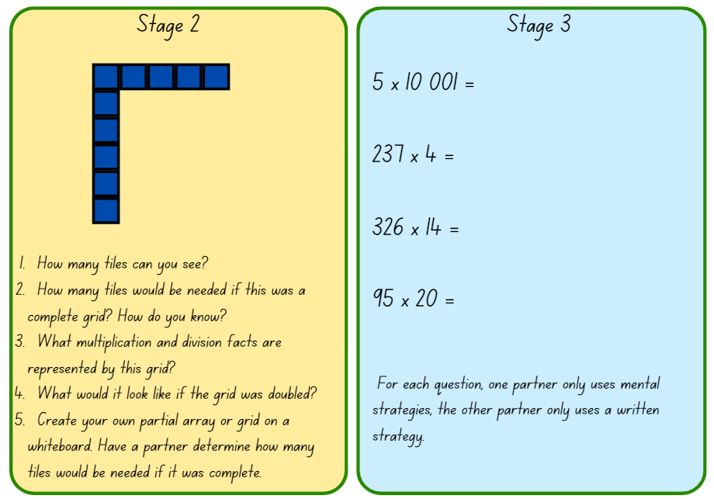

Resource 2 – cupcake arrays
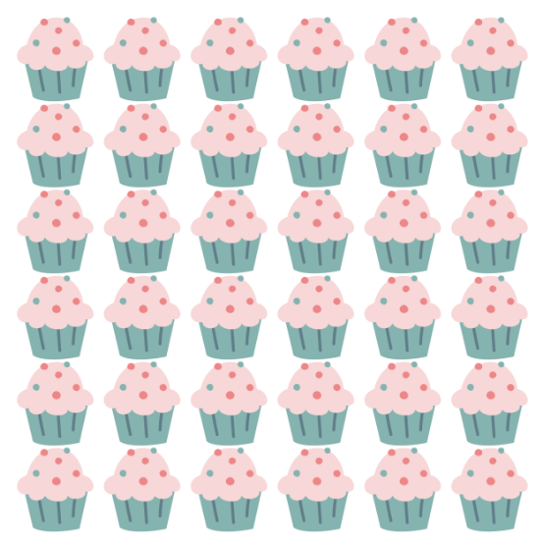

Resource 3 – lots of cupcakes
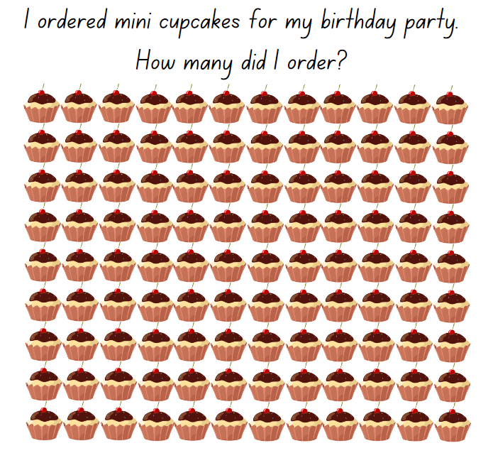

Resource 4 – sorted numbers
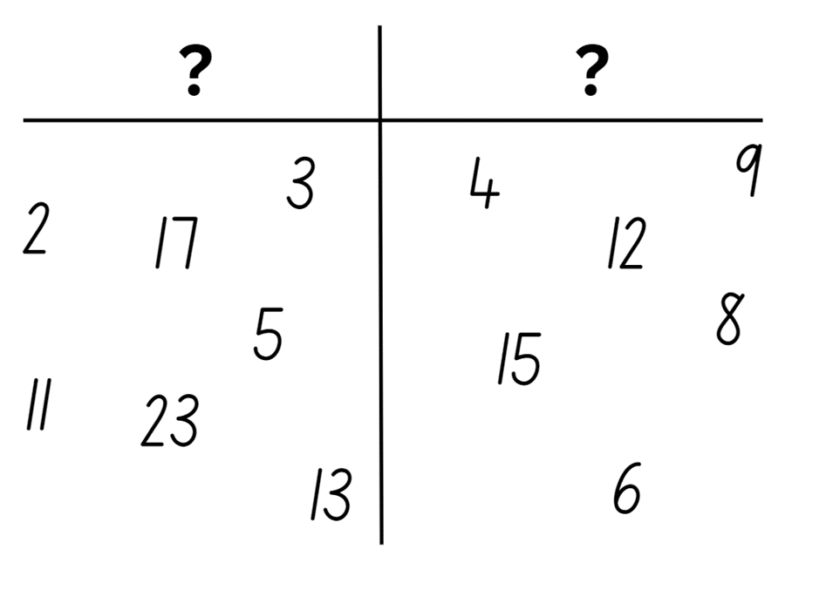

Resource 5 – primes
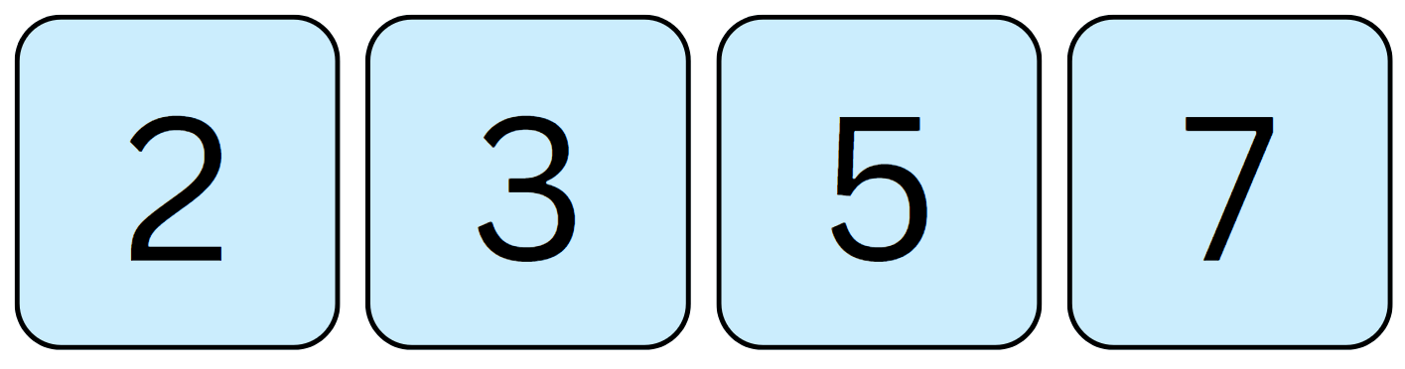

Resource 6 – smaller cupcake order
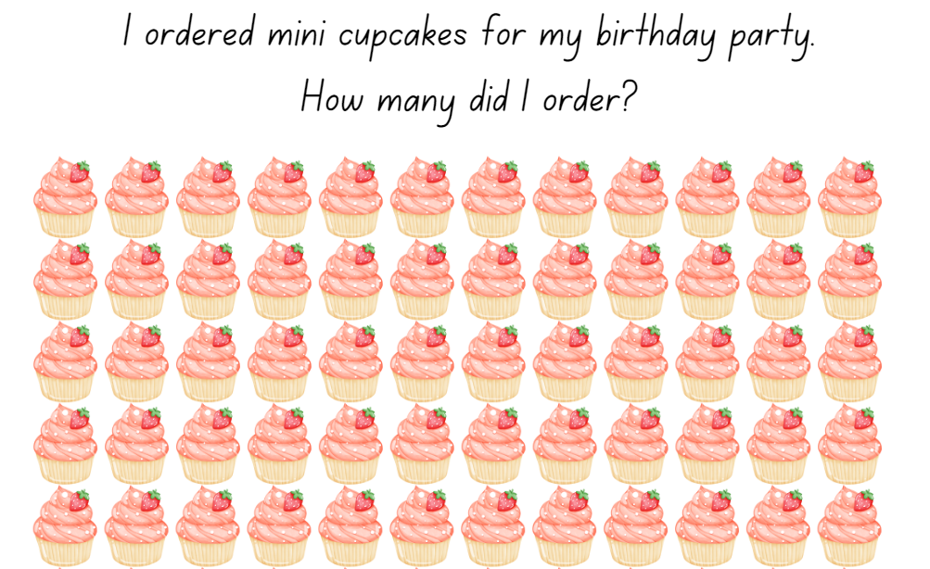

Resource 7 – missing muffin trays
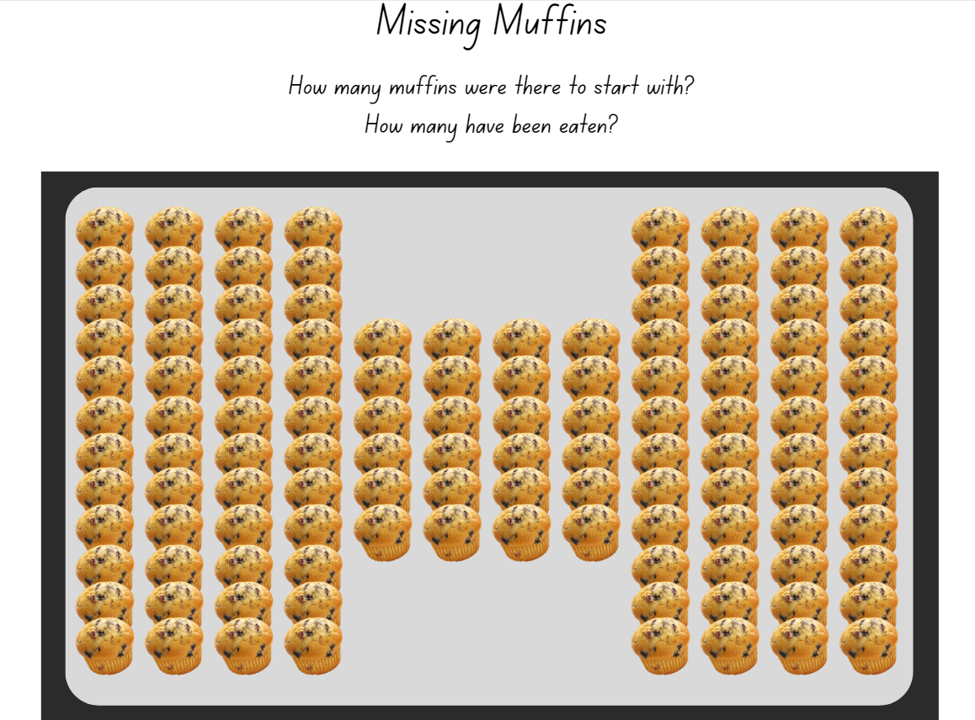

Resource 8 – better deal
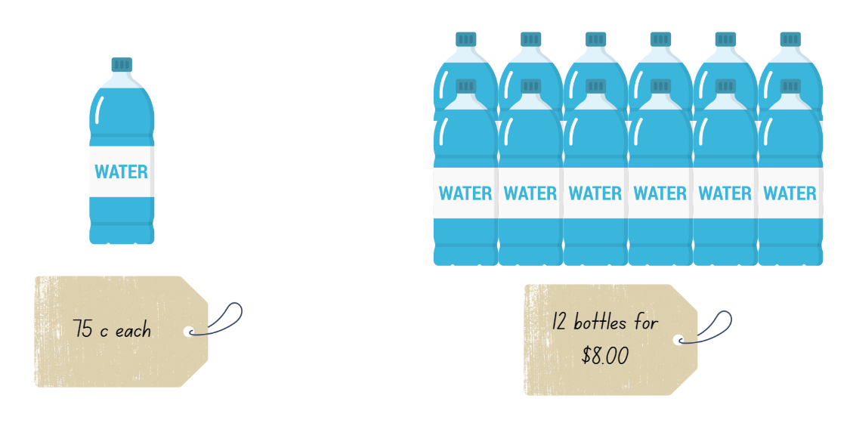

Resource 9 – untorn rectangles
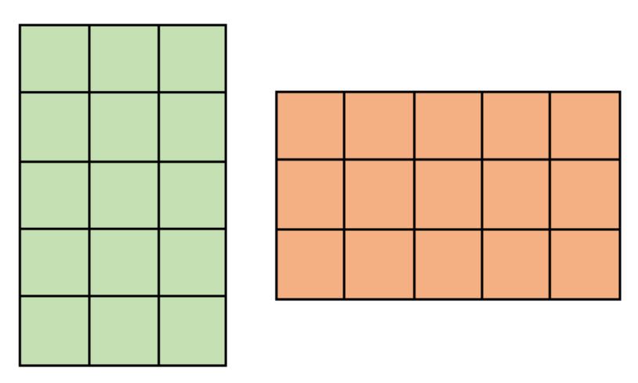

Resource 10 – torn shapes
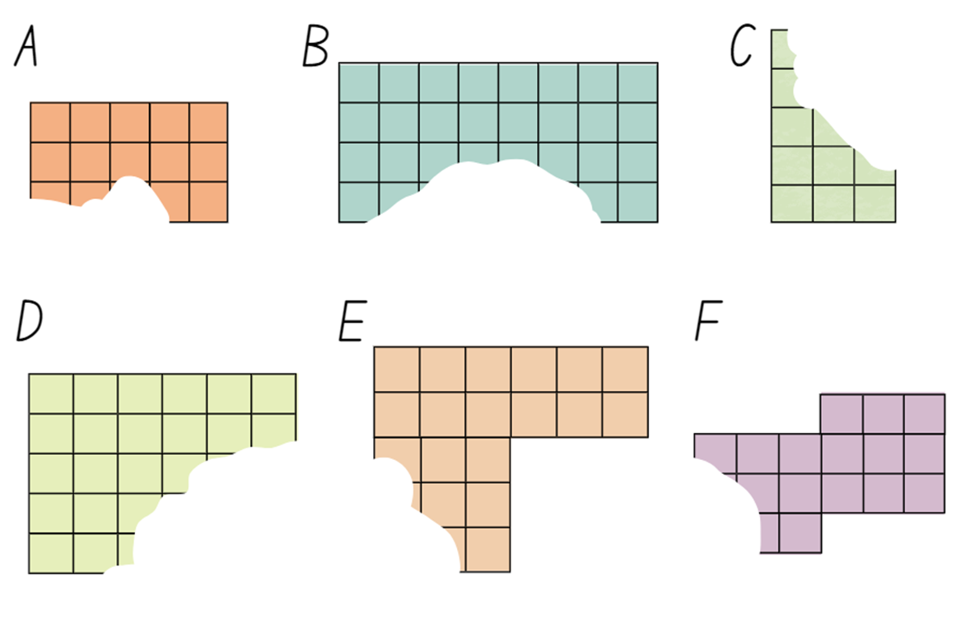

Resource 11 – block options
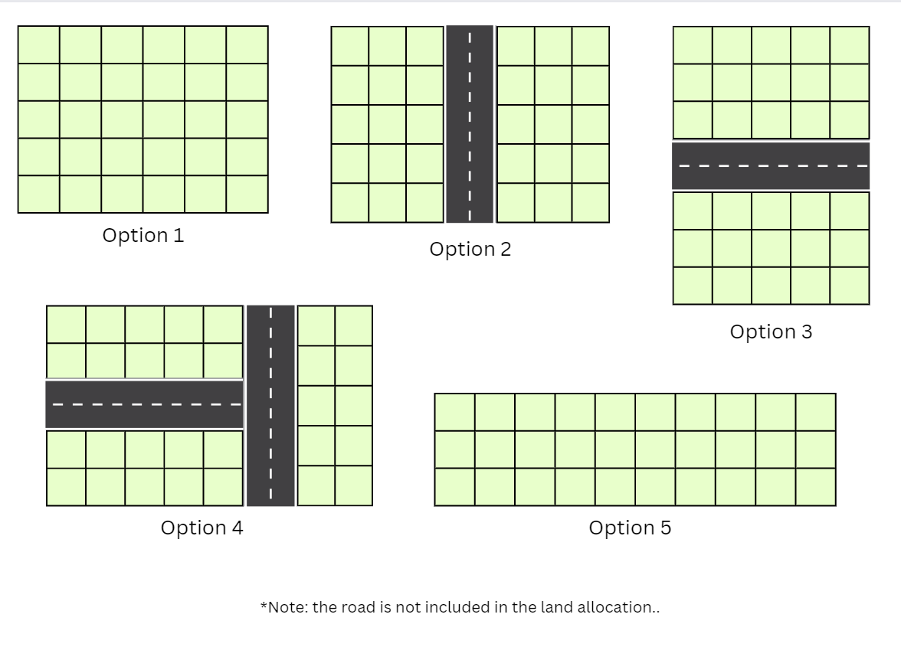

Resource 12 – fence it
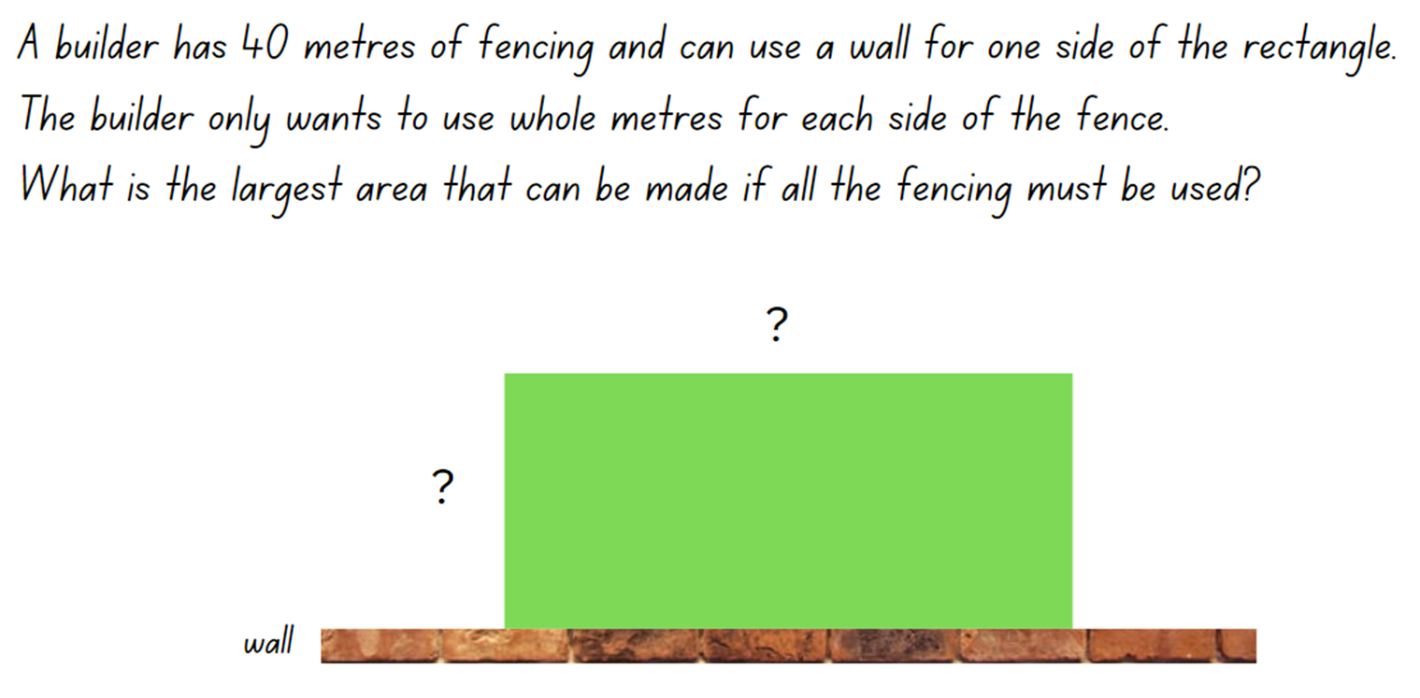

Resource 13 – possible fencing dimensions
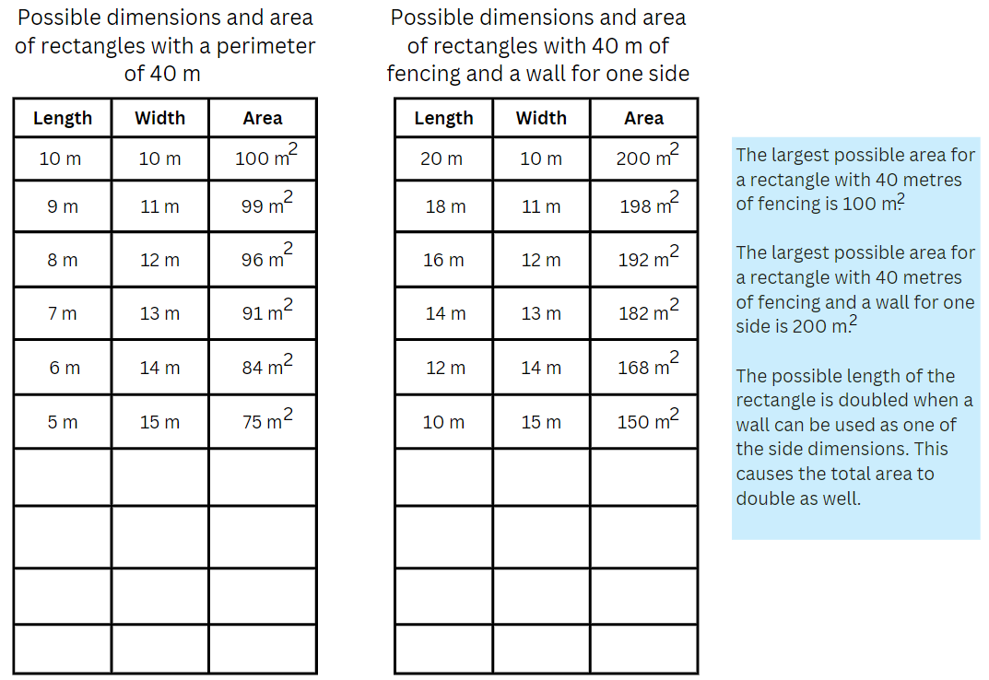

Resource 14 – student shapes
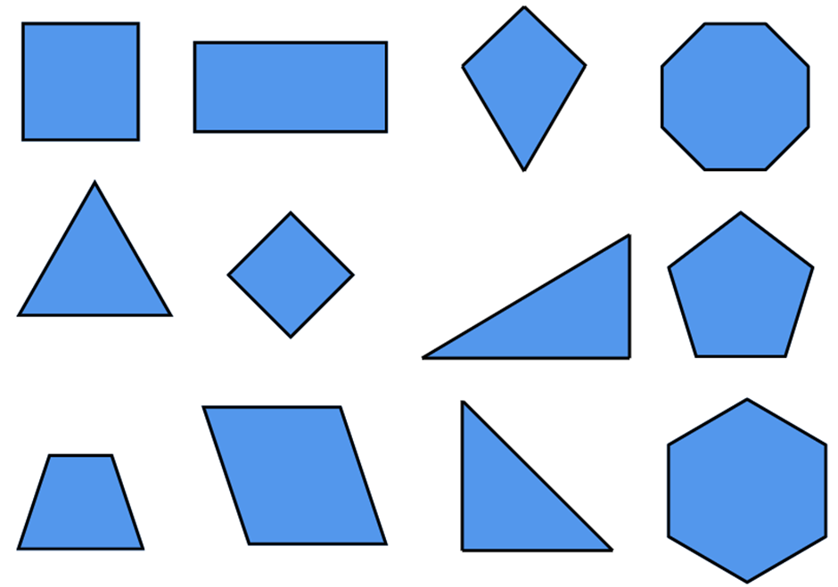

Resource 15 – teacher shape sort
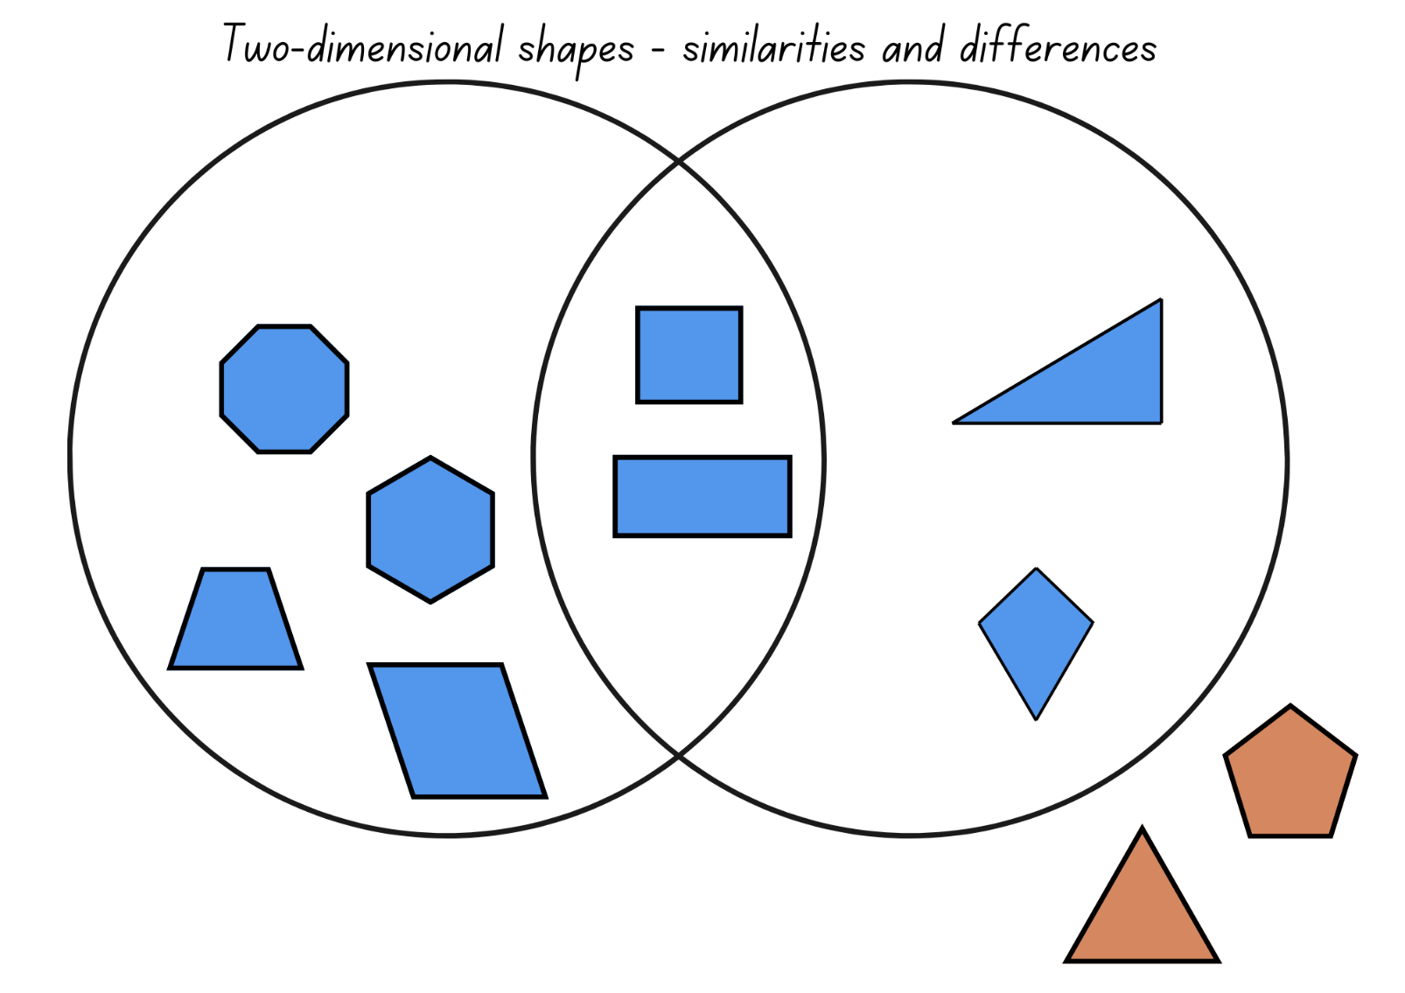

Resource 16 – biscuit problem
Mei bought 2 types of biscuits for her dogs. She wants to make sure that the biscuits are the same size.
Is it possible that a rectangular biscuit is the same size as a parallelogram shaped biscuit?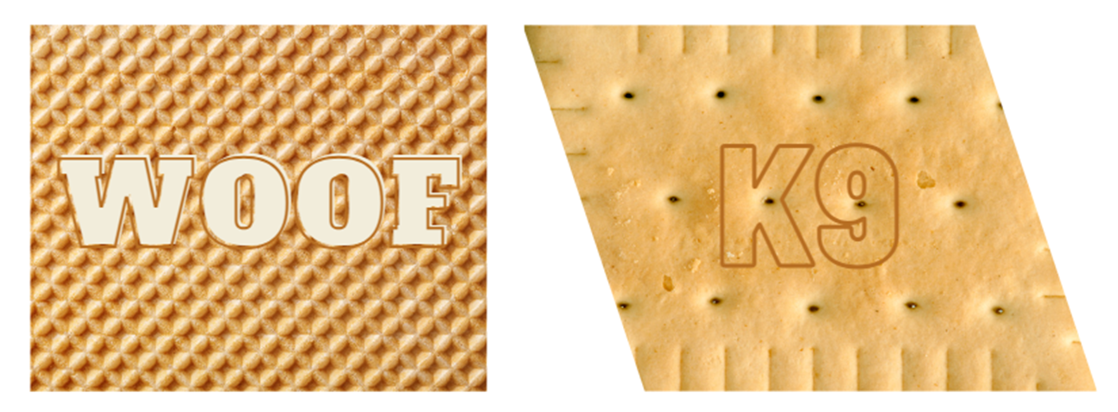

Resource 17 – additional shapes
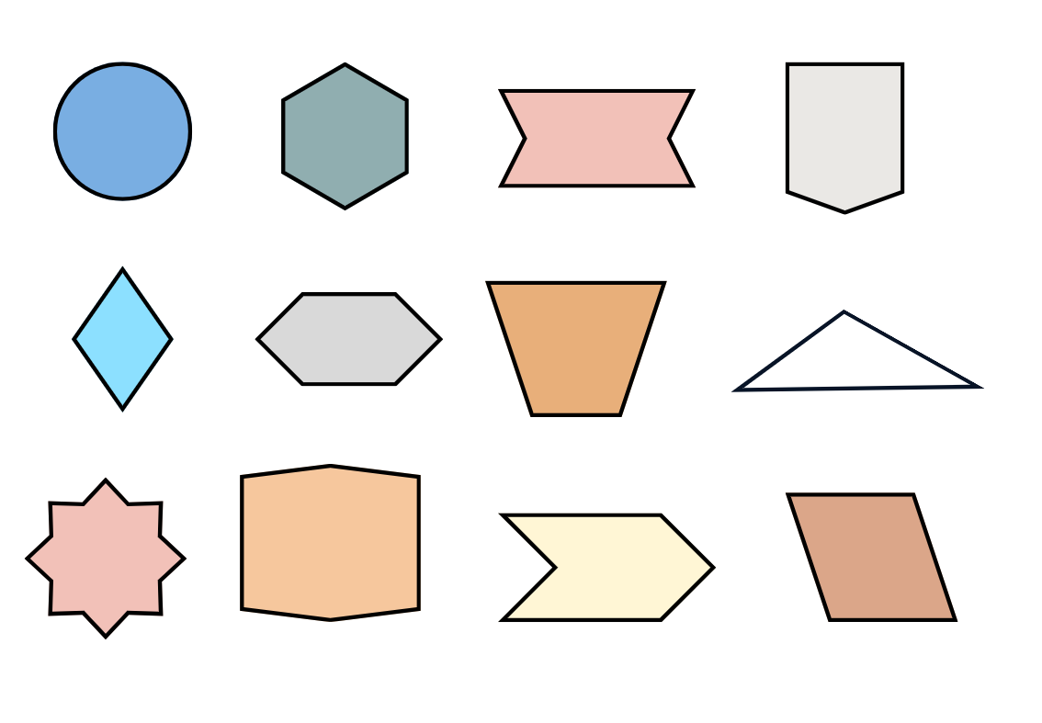

Resource 18 – units of measurement

Resource 19 – Kindergarten chairs
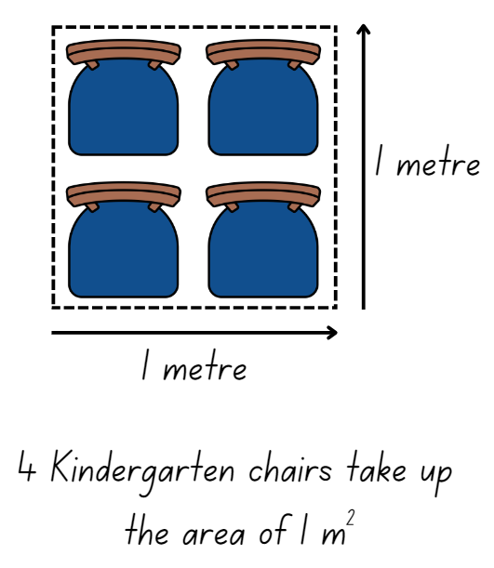

Resource 20 – more area questions
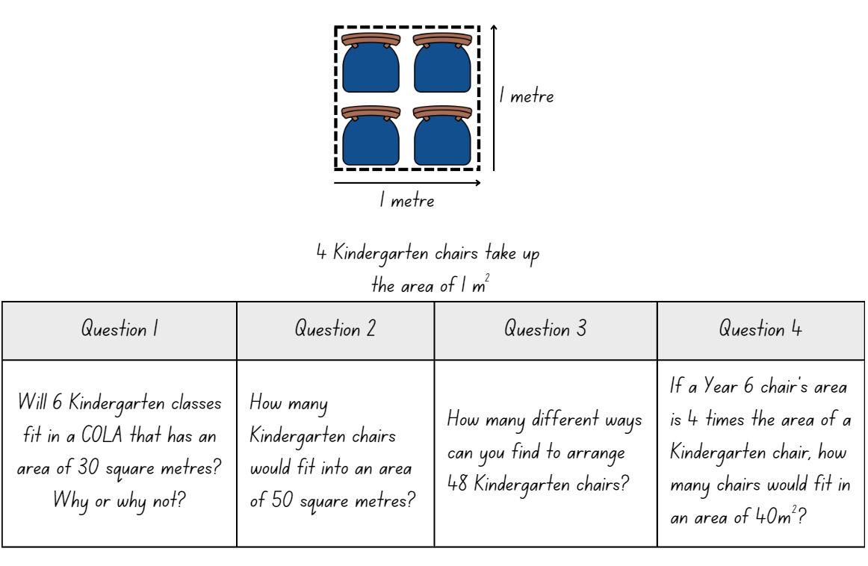

Resource 21 – parallelogram proof
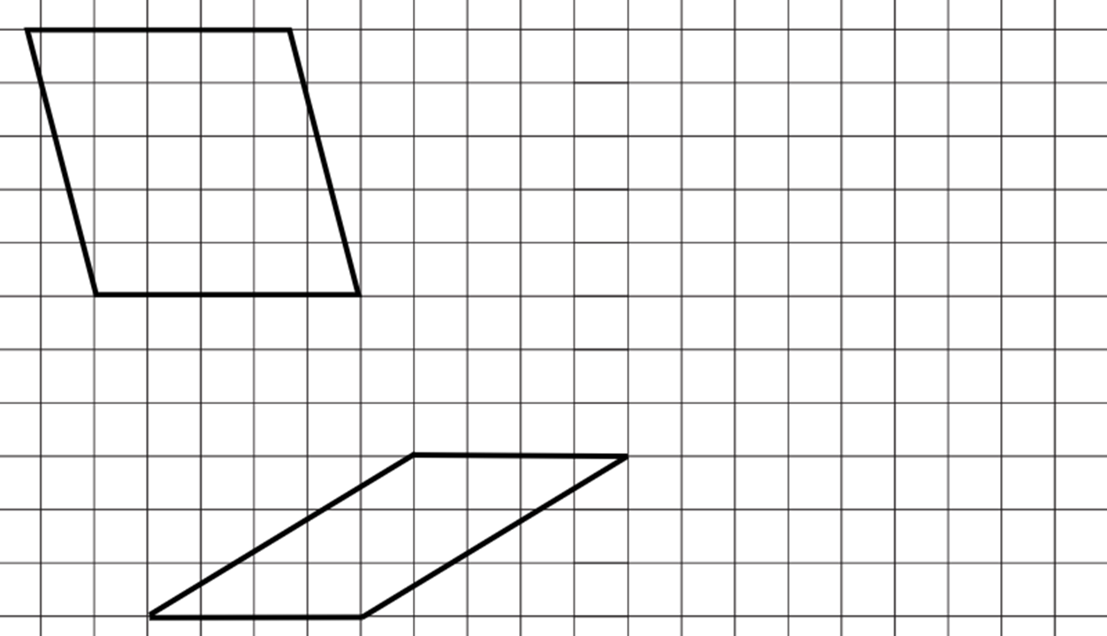

Resource 22 – triangle
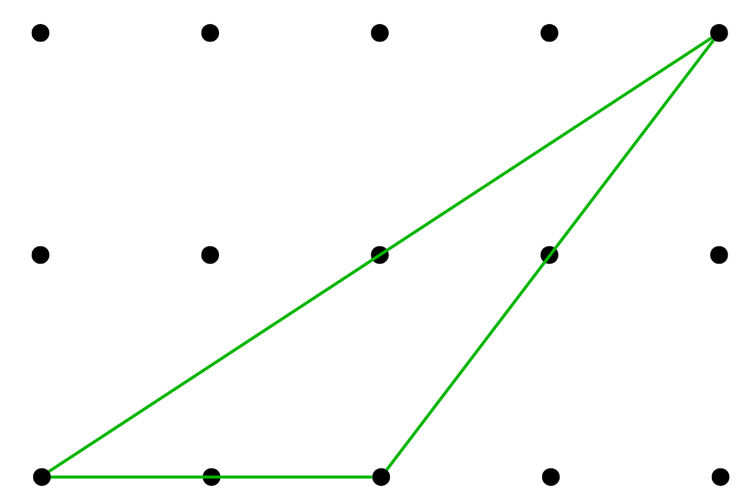

Resource 23 – parallelogram Venn
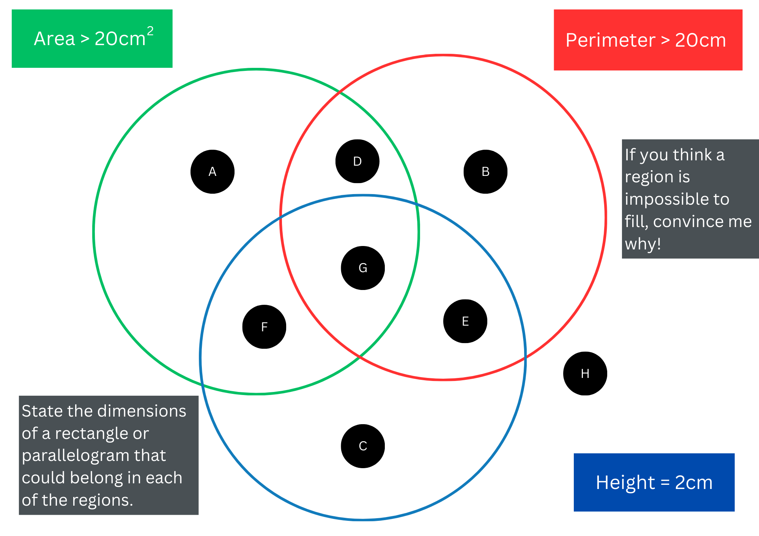
Adapted from Barton (2018).

Resource 24 – decimal chains 1
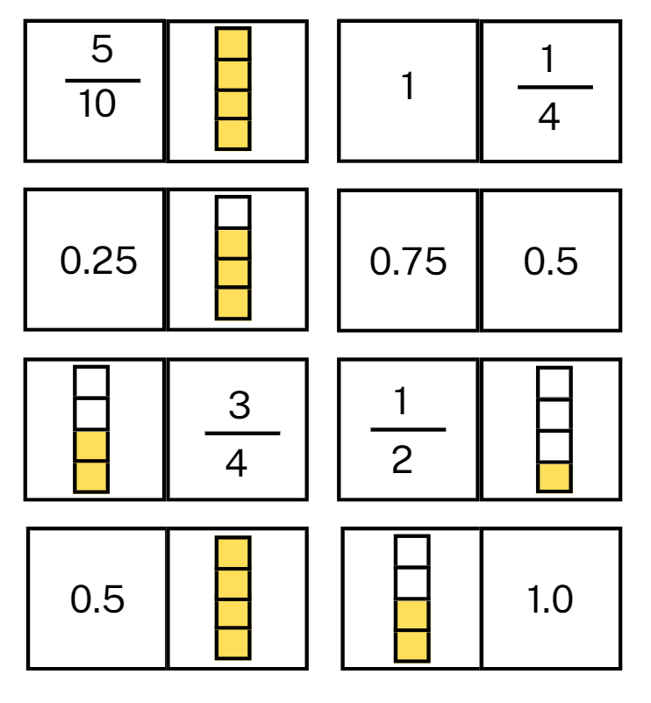

Resource 25 – decimal chains 2
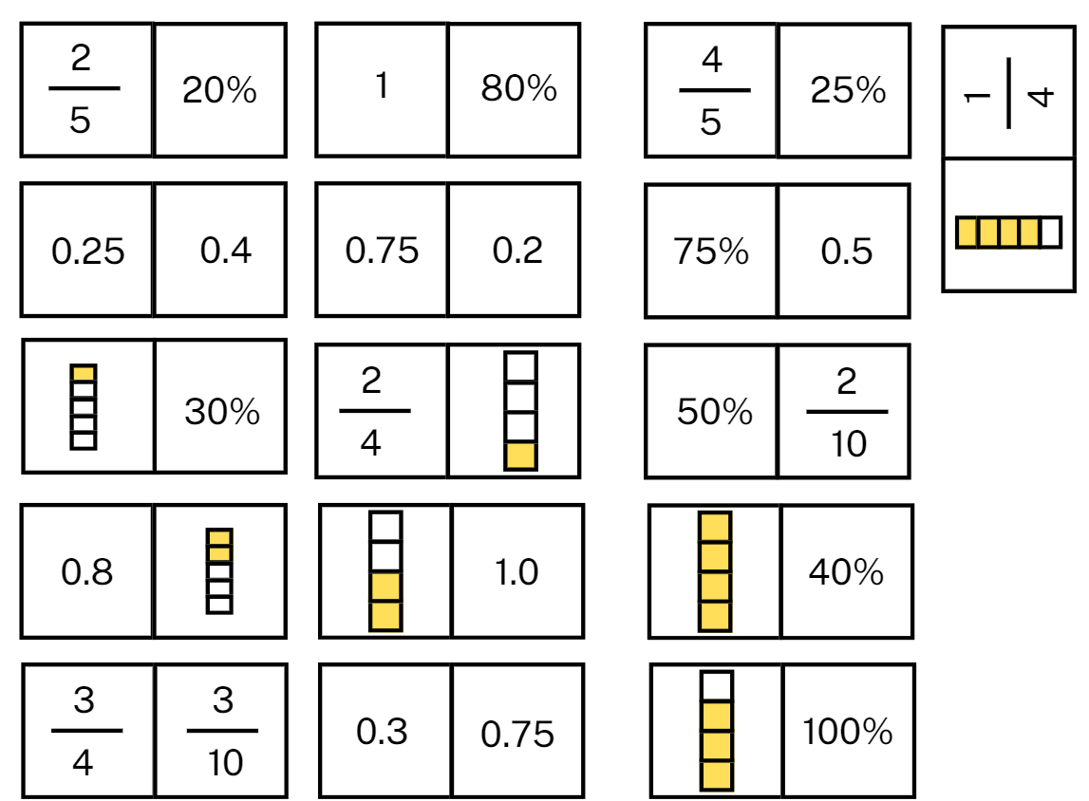

Resource 26 – prisms
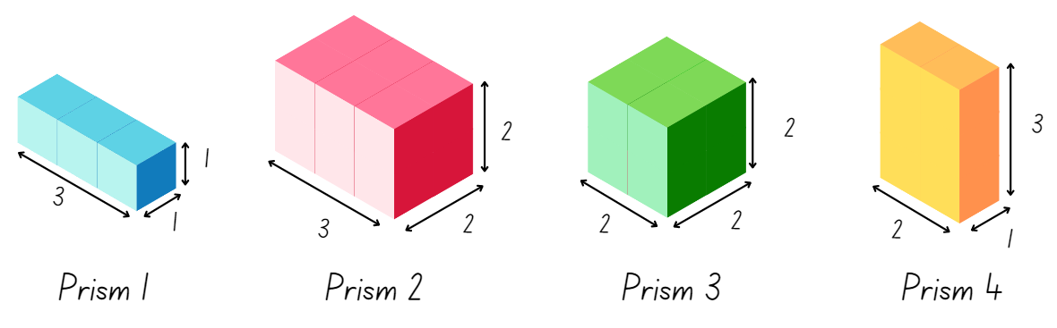

Resource 27 – recording boxes
Dimensions of packing box | Volume of packing box | Volume of empty space
Adapted from Boaler et al. (2018).

Resource 28 – decimals and percentages
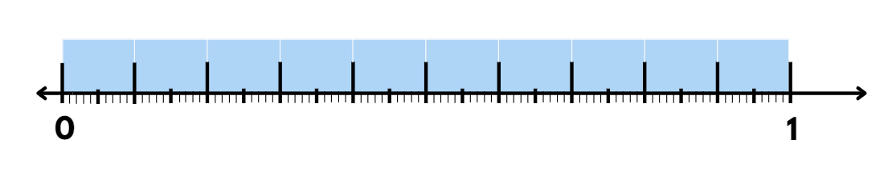

Resource 29 – problem solving
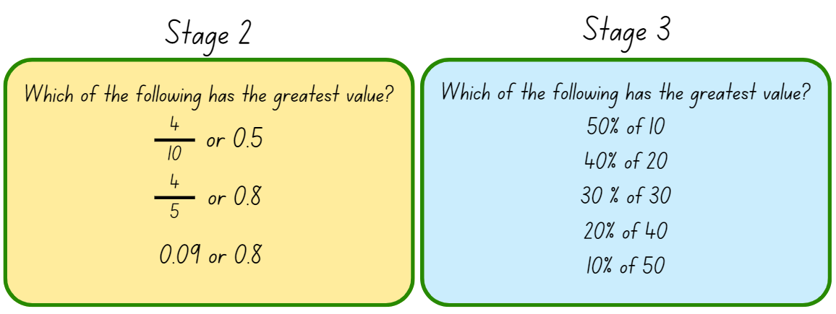

Resource 30 – prism volume
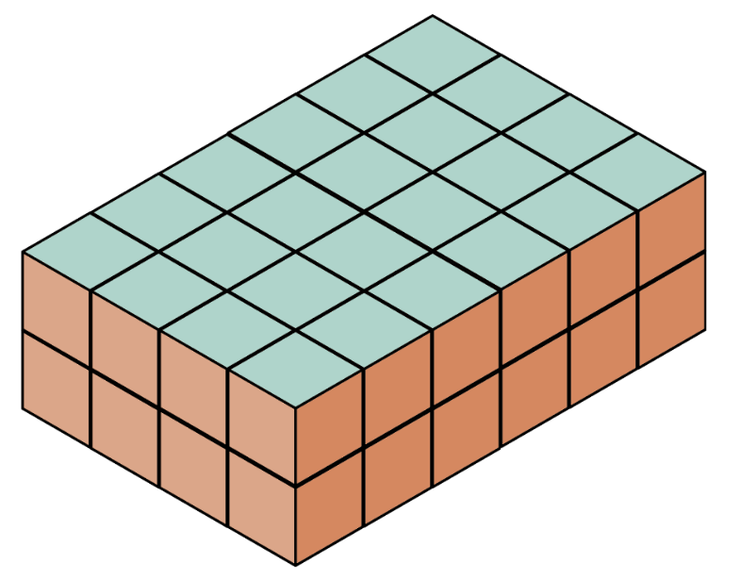

Resource 31 – patterns in volume
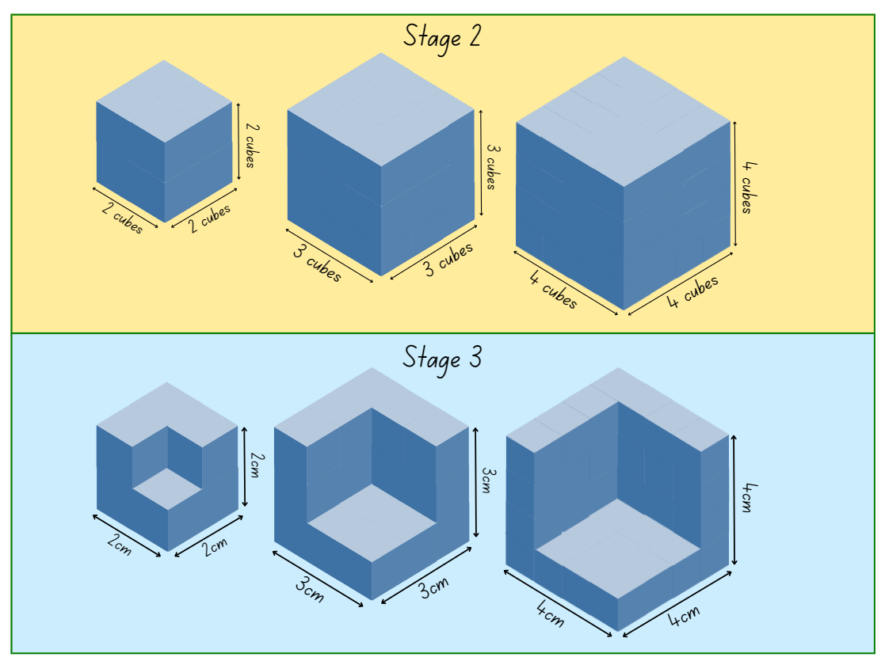

Resource 32 – recording table 1
Number of blocks in each layer | Number of layers | Total volume

Resource 33 – recording table 2
Dimensions | Original cube volume | Missing cube volume | Remaining volume

Resource 34 – heights and discounts
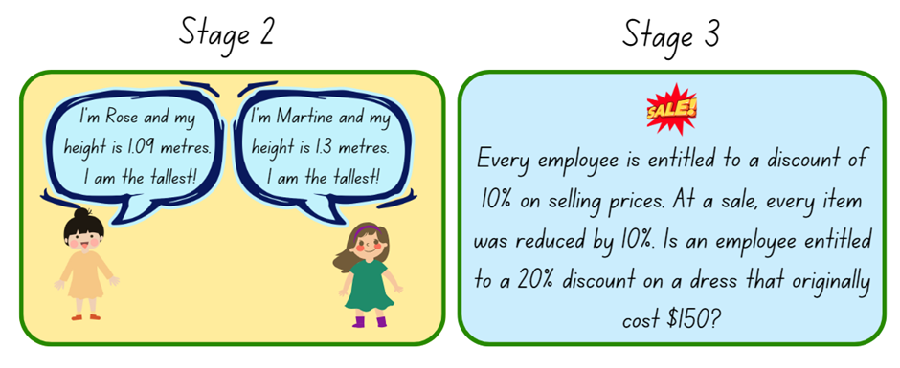

Resource 35 – seedling boxes recording sheet
Length and width of the square cut out | Area of the base | Describe the volume in layers
1 cm × 1 cm | cm²
2 cm × 2 cm | cm²
3 cm × 3 cm | cm²
4 cm × 4 cm | cm²

Resource 36 – garden beds
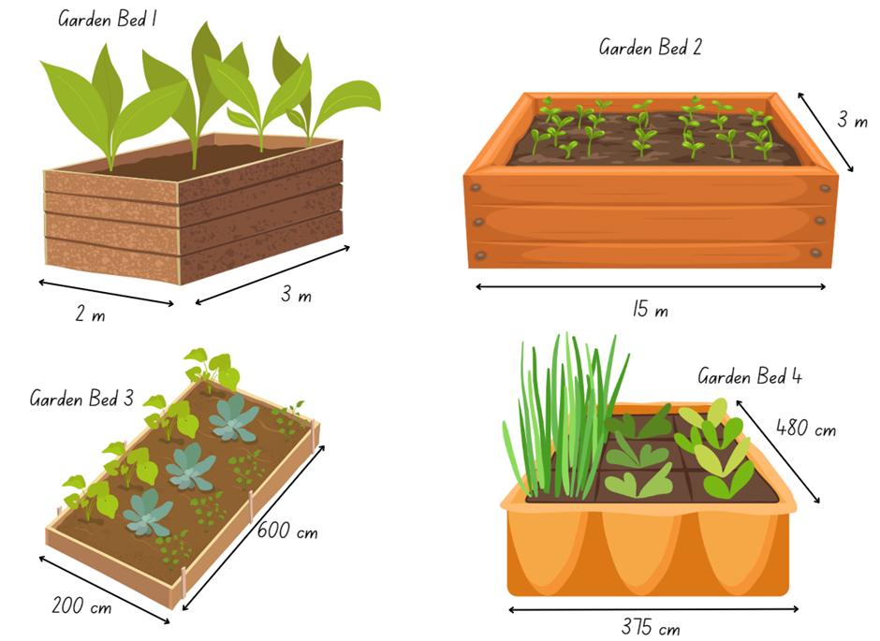

Resource 37 – garden bed recording sheet
Garden bed | Area of the garden bed base (length x width) in cm² | Height of mulch | Volume of mulch required in cm³ | Convert to volume of mulch required in m³ | Cost of basic mix | Cost of native mix
1 | cm² | 10 cm | cm³ | m³
2 | cm² | 10 cm | cm³ | m³
3 | cm² | 10 cm | cm³ | m³
4 | cm² | 10 cm | cm³ | m³

Resource 38 – Lisa’s landscapes
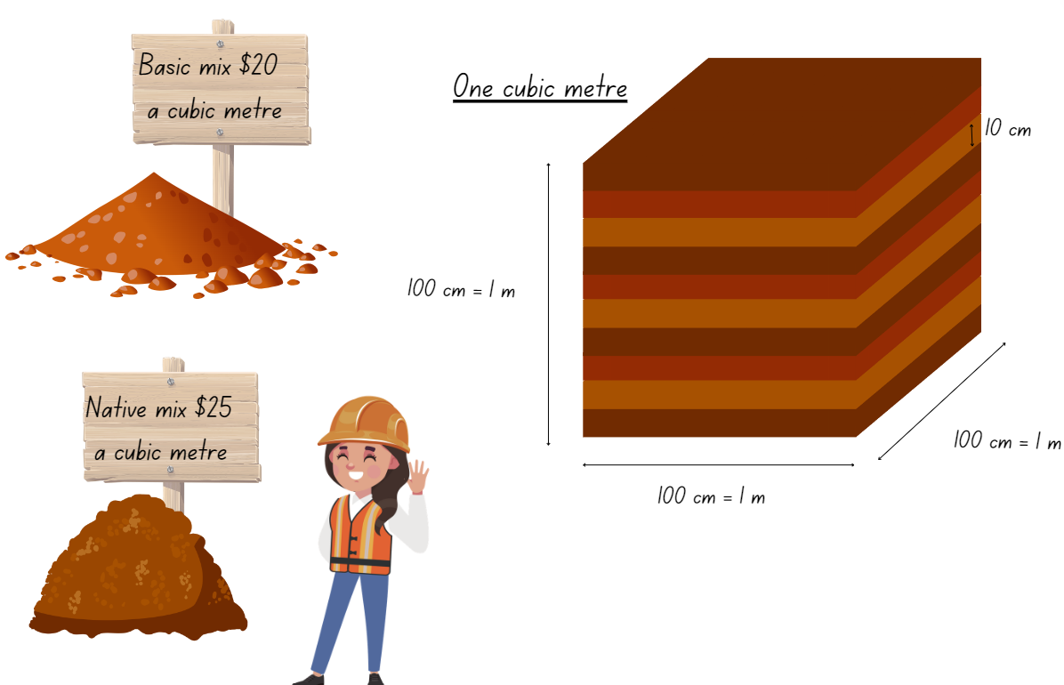

Resource 39 – volume problems
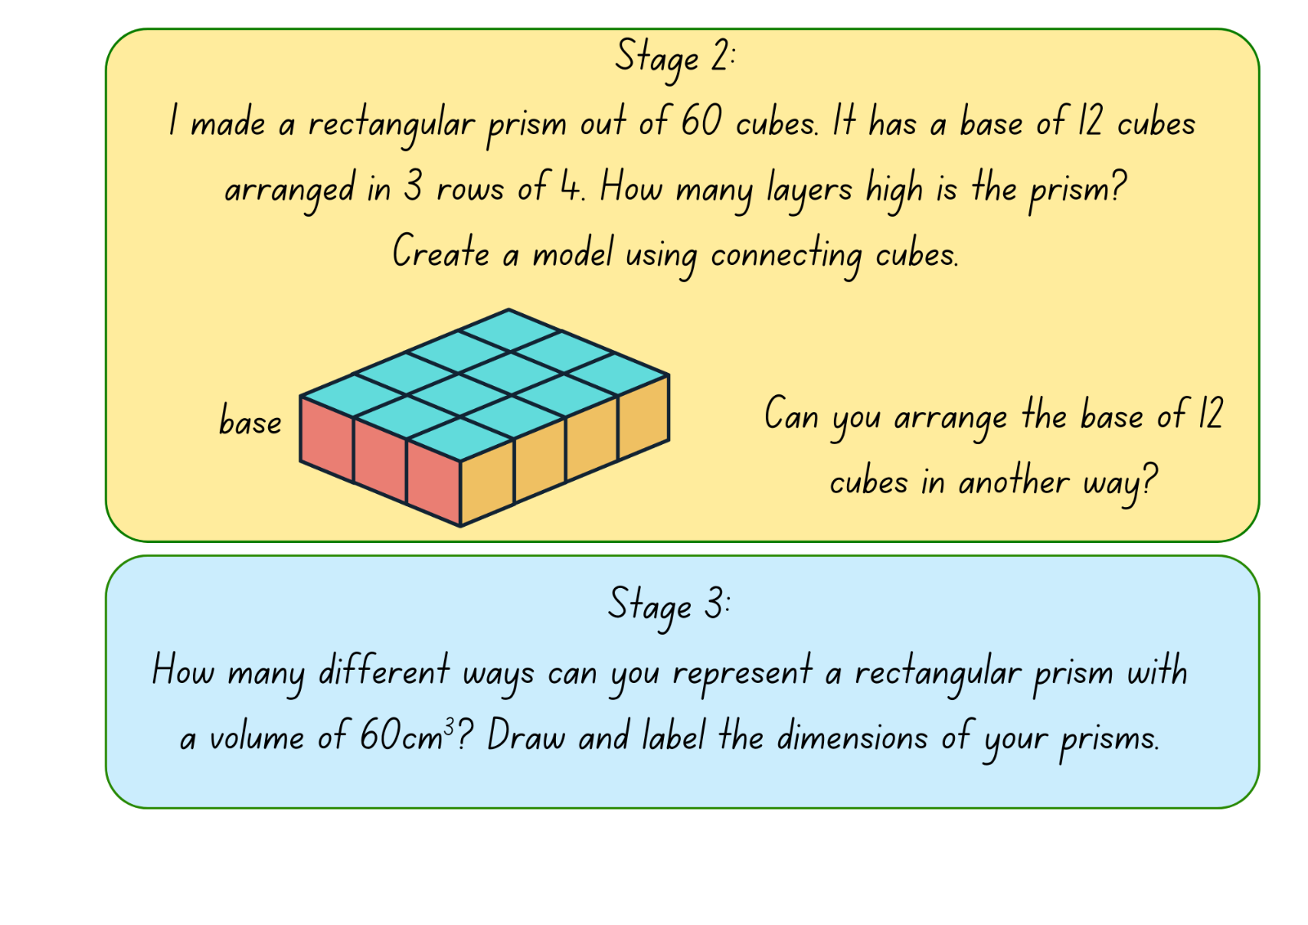

Resource 40 – building blocks
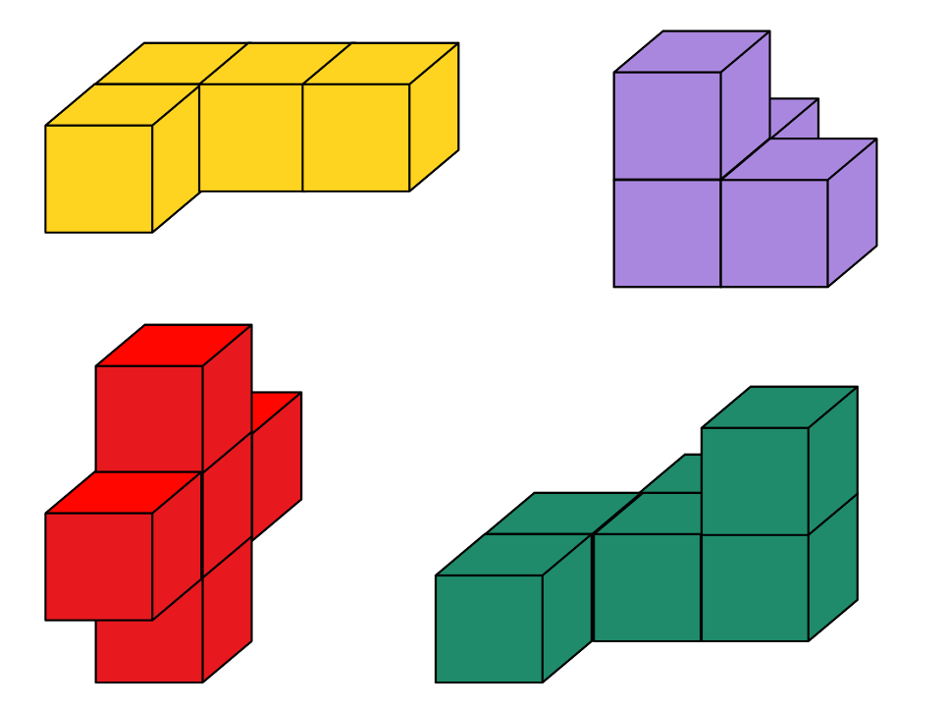

Resource 41 – Nanna Meg’s mail
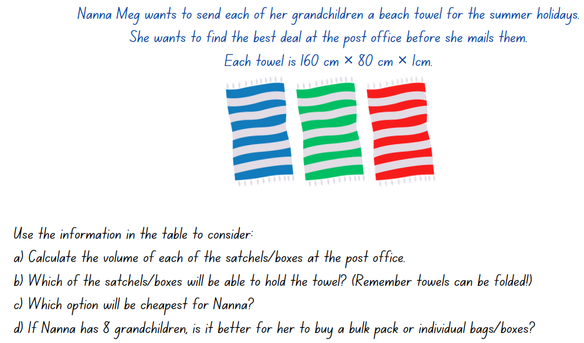

Resource 42 – post office information
Bags/satchels – postage included
Satchel size | Satchel dimensions | Cost/bag | Cost/10 bags
Medium | 39 × 27 × 1 cm | $15 | $145
Large | 51 × 44 × 1 cm | $23 | $219
Extra large | 70 × 62 × 3 cm | $30 | $289
Boxes – postage needs to be added
Box size | Box dimensions | Cost/box | Cost/20 boxes | Postage/each
Medium | 24 × 10 × 12 cm | $3 | $38 | $14
Large | 39 × 28 × 14 cm | $4 | $48 | $18
Extra large | 44 × 28 × 17 cm | $5 | $55 | $21

Syllabus outcomes and content

Stage 2
The table below outlines the syllabus outcomes and range of relevant syllabus content covered in this unit. Content is linked to National Numeracy Learning Progression (version 3).
Outcomes and content | 1 | 2 | 3 | 4 | 5 | 6 | 7 | 8
Representing numbers using place value B: Decimals: Make connections between fractions and decimal notation
[MAO-WM-01, MA2-RN-02]
- Connect fraction strips showing tenths to a number line marked in hundredths |  |  |  |  |  | x
- Compare and order decimals of up to 2 decimal places |  |  |  |  |  | x | x
- Make connections between fractions and decimal notation for key benchmark values (Reasons about relations) |  |  |  |  | x
Multiplicative relations A: Represent and solve problems involving multiplication fact families
[MAO-WM-01, MA2-MR-01]
- Describe multiplication problems using for each and times as many |  |  |  | x
Multiplicative relations B: Use known number facts and strategies
[MAO-WM-01, MA2-MR-01]
- Apply the known strategy of doubling to connect multiples of 3 to 6 and 4 to 8 (Reasons about relations) | x
Multiplicative relations B: Use the structure of the area model to represent multiplication and division
[MAO-WM-01, MA2-MR-01]
- Create and represent multiplicative structure, moving from arrays to partially covered area models | x | x | x
Multiplicative relations B: Use number properties to find related multiplication facts
[MAO-WM-01, MA2-MR-01]
- Use the associative property within multiplication to regroup the factors (Reasons about structure) |  | x
- Use flexible partitioning within multiplication (Reasons about relations) | x
Multiplicative relations B: Represent and solve word problems with number sentences involving multiplication or division
[MAO-WM-01, MA2-MR-01, MA2-MR-02]
- Represent and solve multiplication and division (both sharing and grouping) word problems using number sentences |  |  |  |  |  |  |  | x
Two-dimensional spatial structure A: 2D shapes: Compare and describe features of two-dimensional shapes
[MAO-WM-01, MA2-2DS-01]
- Describe and compare two-dimensional shapes, including parallelograms, rectangles, rhombuses, squares, trapeziums and kites |  |  | x
- Identify and describe polygons that have parallel sides and those that do not |  |  | x
- Identify right angles in shapes |  |  | x
Two-dimensional spatial structure A: Area: Use square centimetres to measure and estimate the areas of rectangles
[MAO-WM-01, MA2-2DS-03]
- Record area in square centimetres using numerals and words |  |  |  | x
- Use efficient strategies for counting large numbers of square centimetres |  |  |  |  |  |  | x
Two-dimensional spatial structure A: Area: Use square metres to measure and estimate the areas of rectangles
[MAO-WM-01, MA2-2DS-03]
- Estimate the areas of squares and rectangles in square metres |  |  |  | x
Two-dimensional spatial structure B: Area: Measure the areas of shapes using the grid structure
[MAO-WM-01, MA2-2DS-03]
- Recognise that rectangles with different side lengths can have the same area |  | x
Two-dimensional spatial structure B: Area: Compare surfaces using familiar metric units of area
[MAO-WM-01, MA2-2DS-03]
- Estimate before measuring to determine the larger of 2 rectangular areas in square metres |  |  |  | x
Three-dimensional spatial structure A: 3D objects: Make models of three-dimensional objects to compare and describe key features
[MAO-WM-01, MA2-3DS-01]
- Investigate the variety of nets that can be used to create a particular prism |  |  |  |  | x
Three-dimensional spatial structure A: Compare objects using familiar metric units of volume
[MAO-WM-01, MA2-3DS-02]
- Construct rectangular prisms using cubic-centimetre blocks and describe the volumes in terms of layers |  |  |  |  |  | x | x | x
- Record volumes using numerals and words |  |  |  |  |  | x | x
- Compare the volumes of 2 or more objects made from cubic-centimetre blocks |  |  |  |  | x
Three-dimensional spatial structure B: 3D objects: Connect three-dimensional objects and two-dimensional representations
[MAO-WM-01, MA2-3DS-01]
- Create sketches of three-dimensional objects from different views, including top, front and side views (Reasons about spatial relations) |  |  |  |  |  |  |  | x
- Draw different views on isometric grids of an object constructed from connecting cubes |  |  |  |  | x
- Interpret given drawings to make models of three-dimensional objects using connecting cubes (Reasons about spatial visualisation) |  |  |  |  | x
Mathematics K–10 Syllabus © NSW Education Standards Authority (NESA) for and on behalf of the Crown in right of the State of New South Wales, 2022.

Stage 3
The table below outlines the syllabus outcomes and range of relevant syllabus content covered in this unit. Content is linked to National Numeracy Learning Progression (version 3).
Outcomes and content | 1 | 2 | 3 | 4 | 5 | 6 | 7 | 8
Represents numbers B: Decimals and percentages: Make connections between benchmark fractions, decimals and percentages
[MAO-WM-01, MA3-RN-02, MA3-RN-03]
- Recall commonly used equivalent percentages, decimals and fractions including $\frac{1}{2}$, $\frac{1}{4}$, and $\frac{3}{4}$ |  |  |  |  | x
- Recognise that 10% is one-tenth of 100% and use this to find 10% of a quantity (Reasons about relations) |  |  |  |  |  | x | x
Multiplicative relations A: Determine products and factors
[MAO-WM-01, MA3-MR-01]
- Use the term product to describe the result of multiplying 2 or more numbers | x
- Determine factors for a given whole number | x
- Determine whether a number is prime, composite or neither (0 or 1) | x
Multiplicative relations A: Use partitioning and place value to multiply 2-, 3- and 4-digit numbers by one-digit numbers
[MAO-WM-01, MA3-MR-01]
- Use informal written strategies such as the area model to solve multiplication and division problems | x
Multiplicative relations B: Select and apply strategies to solve problems involving multiplication and division with whole numbers
[MAO-WM-01, MA3-MR-01]
- Select and use efficient strategies to multiply whole numbers of up to 4 digits by one- and 2-digit numbers | x |  | x
- Solve word problems involving rates using multiplication and division (Reasons about relations) |  | x |  |  |  |  | x | x
Geometric measure A: Length: Measure lengths to find perimeters
[MAO-WM-01, MA3-GM-02]
- Recognise that rectangles with the same perimeter may have different dimensions (Spatial reasoning) |  | x
Two-dimensional spatial structure A: Area: Calculate the areas of rectangles using familiar metric units
[MAO-WM-01, MA3-2DS-02]
- Calculate areas of rectangles in square centimetres (cm²), square metres (m²) and square kilometres (km²) |  | x
- Investigate and compare the areas of rectangles that have the same perimeter |  | x
Two-dimensional spatial structure B: Dissect two-dimensional shapes and rearrange them using translations, reflections and rotations
[MAO-WM-01, MA3-2DS-03]
- Use the terms translate, reflect and rotate to describe transformations of two-dimensional shapes |  |  |  | x
- Dissect and rearrange one shape to make another |  |  | x | x
Two-dimensional spatial structure B: Calculate the area of a parallelogram using subdivision and rearrangement
[MAO-WM-01, MA3-2DS-02, MA3-2DS-03]
- Show how to transform a parallelogram into a rectangle to find its area |  |  | x | x
Two-dimensional spatial structure B: Determine the area of a triangle
[MAO-WM-01, MA3-2DS-02]
- Investigate the area of a triangle by comparing it to the area of a parallelogram with the same base length and height |  |  |  | x
- Establish the relationship between the area of a triangle and the area of a parallelogram formed by duplicating and rotating the triangle |  |  |  | x
- Record, using words, a method for finding the area of any triangle |  |  |  | x
Three-dimensional spatial structure B: Volume: Recognise the multiplicative structure for finding volume
[MAO-WM-01, MA3-3DS-02]
- Establish the relationship between the number of cubes in one layer and the number of layers to find the volume of a rectangular prism (Reasons about spatial structure) |  |  |  |  | x |  | x
Three-dimensional spatial structure B: Volume: Find the volumes of rectangular prisms in cubic centimetres and cubic metres
[MAO-WM-01, MA3-3DS-02]
- Record, using words, the method for finding the volumes of rectangular prisms |  |  |  |  |  | x
- Recognise that rectangular prisms with the same volume may have different dimensions (Reasons about spatial structure) |  |  |  |  | x |  |  | x
- Calculate volumes of rectangular prisms in cubic centimetres (cm³) and cubic metres (m³) |  |  |  |  |  | x | x
Mathematics K–10 Syllabus © NSW Education Standards Authority (NESA) for and on behalf of the Crown in right of the State of New South Wales, 2022.

References
This resource contains NSW Curriculum and syllabus content. The NSW Curriculum is developed by the NSW Education Standards Authority. This content is prepared by NESA for and on behalf of the Crown in right of the State of New South Wales. The material is protected by Crown copyright.
Please refer to the NESA Copyright Disclaimer for more information https://educationstandards.nsw.edu.au/wps/portal/nesa/mini-footer/copyright.
NESA holds the only official and up-to-date versions of the NSW Curriculum and syllabus documents. Please visit the NSW Education Standards Authority (NESA) website https://educationstandards.nsw.edu.au and the NSW Curriculum website https://curriculum.nsw.edu.au/.
Mathematics K–10 Syllabus © NSW Education Standards Authority (NESA) for and on behalf of the Crown in right of the State of New South Wales, 2022.
National Numeracy Learning Progression © Australian Curriculum, Assessment and Reporting Authority (ACARA) 2010 to present, unless otherwise indicated. This material was downloaded from the Australian Curriculum website (National Numeracy Learning Progression) (accessed 24 April 2024) and was not modified.
AAMT (The Australian Association of Mathematics Teachers) (n.d) Partial arrays, Top Drawer Teachers website, accessed 24 April 2024.
Australian Academy of Science (2020a) Measurement: Parcel in the Post, reSolve website, accessed 24 April 2024.
Australian Academy of Science (2020b) Multiplication: reSolve Bakery, reSolve website, accessed 3 April 2024.
Barton C (2018) Area > 20, perimeter > 20, height = 2, Maths Venns website, accessed 24 April 2024.
Boaler J, Munson J and Williams C (2018) Mindset Mathematics: Visualizing and Investigating Big Ideas, Grade 5, 1st edn, Jossey-Bass, San Francisco.
Joshua A (1997) Enrich-e-matics! A graded maths enrichment programme – Book F, Addison Wesley Longman Australia, Melbourne.
New Zealand Ministry of Education (n.d.a) In Your Prime, NZmaths website, accessed 24 April 2024.
New Zealand Ministry of Education (n.d.b) That Takes the Biscuit, NZmaths website, accessed 24 April 2024.
NSW Department of Education Learning and Teaching Directorate (2017) Teaching Measurement: Stage 2 - Stage 3 [PDF 685 KB], NSW Government, accessed 8 April 2024.
Sullivan P (2018) Challenging Mathematical Tasks, Oxford University Press ANZ, Australia and New Zealand.
Sullivan P and Lilburn P (2017) Open-Ended Maths Activities, Oxford University Press ANZ, Australia and New Zealand.
University of Cambridge (Faculty of Mathematics) (n.d.a) Building Blocks, NRICH website, accessed 24 April 2024.
——(n.d.b) Doughnut Percents, NRICH website, accessed 24 April 2024.
——(n.d.c) Fence It, NRICH website, accessed 24 April 2024.
——(n.d.d) Making Boxes, NRICH website, accessed 24 April 2024.
——(n.d.e) Open Boxes, NRICH website, accessed 24 April 2024.
——(n.d.f) Torn Shapes, NRICH website, accessed 24 April 2024.
Van de Walle J, Karp K, Bay-Williams JM, Brass A, Bentley B, Ferguson S, Goff W, Livy S, Marshman M, Martin D, Pearn C, Prodromou T, Symons D and Wilkie K (2019) Primary and Middle Years Mathematics: Teaching Developmentally, 1st Australian edn, Pearson Education Australia, Melbourne.

© State of New South Wales (Department of Education), 2024
The copyright material published in this resource is subject to the Copyright Act 1968 (Cth) and is owned by the NSW Department of Education or, where indicated, by a party other than the NSW Department of Education (third-party material).
Copyright material available in this resource and owned by the NSW Department of Education is licensed under a Creative Commons Attribution 4.0 International (CC BY 4.0) license.
This license allows you to share and adapt the material for any purpose, even commercially.
Attribution should be given to © State of New South Wales (Department of Education), 2024.
Material in this resource not available under a Creative Commons license:
- the NSW Department of Education logo, other logos and trademark-protected material
- material owned by a third party that has been reproduced with permission. You will need to obtain permission from the third party to reuse its material.
Links to third-party material and websites
Please note that the provided (reading/viewing material/list/links/texts) are a suggestion only and implies no endorsement, by the New South Wales Department of Education, of any author, publisher, or book title. School principals and teachers are best placed to assess the suitability of resources that would complement the curriculum and reflect the needs and interests of their students.
If you use the links provided in this document to access a third-party's website, you acknowledge that the terms of use, including licence terms set out on the third-party's website apply to the use which may be made of the materials on that third-party website or where permitted by the Copyright Act 1968 (Cth). The department accepts no responsibility for content on third-party websites.

