Mathematics 3–6 Multi-age – Year B – Unit 15
Addition and subtraction problems can be solved by using a variety of strategies
Contents
Unit description and duration 8
Syllabus outcomes 8
Stage 2 8
Stage 3 9
Working mathematically 9
Student prior learning 10
Lesson overview and resources 11
Lesson 1 21
Daily number sense – big fruit barn – 15 minutes 21
Core lesson – additive strategies – 45 minutes 24
Stage 2 and 3 – anchor chart – 10 minutes 25
Stage 2 – revising equivalence and exploring partitioning – 30 minutes 26
Stage 3 – travel plan – 30 minutes 31
Discuss and connect the mathematics – 15 minutes 33
Stage 2 task 33
Stage 3 task 34
Lesson 2 37
Daily number sense – balancing challenge – 15 minutes 37
Core lesson – 40 minutes 40
Stage 2 task 1 – comparing strategies – 20 minutes 41
Stage 2 task 2 – composition and decomposition – 20 minutes 42
Stage 3 task 1 – additive strategies – 20 minutes 44
Stage 3 task 2 – number lines – 20 minutes 47
Discuss and connect the mathematics – 10 minutes 51
Lesson 3 54
Daily number sense – canteen price list – 15 minutes 54
Core lesson – 45 minutes 56
Stage 2 and 3 – decimal addition and subtraction – 15 minutes 57
Stage 2 – class party – 30 minutes 60
Stage 3 – party problems – 30 minutes 61
Discuss and connect the mathematics – 10 minutes 63
Lesson 4 66
Daily number sense – 10 minutes 66
Core lesson – 40 minutes 66
Stage 2 task 1 – partitioning versus levelling – 20 minutes 68
Stage 2 task 2 – partitioning versus constant difference – 20 minutes 70
Stage 3 task 1 – price of chocolate – 20 minutes 72
Stage 3 task 2 – clothing shop – 20 minutes 75
Consolidation and meaningful practice – 10 minutes 77
Stage 2 task 77
Stage 3 task 77
Lesson 5 80
Daily number sense – inverse operations – 10 minutes 80
Core lesson – 45 minutes 83
Stage 2 task – models for additive relations – 40 minutes 84
Stage 3 task 1 – decimal fluency – 15 minutes 87
Stage 3 task 2 – benchmark percentages – 15 minutes 87
Stage 3 task 3 – celebrity concert – 15 minutes 89
Discuss and connect the mathematics – 15 minutes 92
Stage 2 task 92
Stage 3 task 94
Lesson 6 97
Daily number sense – hundred grids – 10 minutes 97
Core lesson – 40 minutes 99
Stage 2 task 1 – written and mental strategies – 20 minutes 101
Stage 2 task 2 – addition algorithms with regrouping – 20 minutes 102
Stage 3 task – rounding and estimating – 40 minutes 103
Discuss and connect the mathematics – 10 minutes 106
Stage 2 task 106
Stage 3 task 107
Lesson 7 110
Daily number sense – equivalent number sentences – 10 minutes 110
Core lesson – zoo investigation – 40 minutes 112
Discuss and connect the mathematics – 10 minutes 116
Lesson 8 119
Daily number sense – 10 minutes 119
Core lesson – zoo investigation – 30 minutes 119
Discuss and connect the mathematics – 20 minutes 122
Resource 1 – shopping receipt 125
Resource 2 – additive strategies 126
Resource 3 – bingo cards 130
Resource 4 – bingo caller sheet 132
Resource 5 – superstar sightseeing 133
Resource 6 – map 134
Resource 7 – place value chart 135
Resource 8 – reflection chart 136
Resource 9 – self-assessment 137
Resource 10 – comparing strategies grid 138
Resource 11 – place value houses 139
Resource 12 – data sources 140
Resource 13 – data activities 142
Resource 14 – garden designs 143
Resource 15 – decimats 144
Resource 16 – canteen price list 145
Resource 17 – 1–3 spinner 146
Resource 18 – party activities 147
Resource 19 – planning sheet 149
Resource 20 – party problems 150
Resource 21 – pocket money 151
Resource 22 – different strategies 152
Resource 23 – chocolate costs 1 153
Resource 24 – chocolate costs 2 154
Resource 25 – raw to retail 155
Resource 26 – Imogen’s T-shirt shop 156
Resource 27 – product costs 157
Resource 28 – score 4 158
Resource 29 – blank grid 159
Resource 30 – concert hall 160
Resource 31 – different models 161
Resource 32 – 100 grids 162
Resource 33 – blank 100 grid 163
Resource 34 – addition questions 164
Resource 35 – mountain climbing think board 165
Resource 36 – estimation activities 166
Resource 37 – think board 167
Resource 38 – zoo excursion planner (Stage 2) 168
Resource 39 – zoo excursion planner (Stage 3) 171
Resource 40 – zoo map 173
Resource 41 – entry and zoo menu (Stage 2) 174
Resource 42 – entry and activities (Stage 3) 175
Resource 43 – zoo menu (Stage 3) 176
Syllabus outcomes and content 177
Stage 2 177
Stage 3 183
References 188

Unit description and duration
This unit develops the big idea that addition and subtraction problems can be solved using a variety of strategies.
In this 2-week unit, students are provided opportunities to:
- partition, rearrange and regroup numbers to at least 1000 to solve additive problems (Stage 2)
- choose and use efficient strategies to solve addition and subtraction problems including decimals and percentages (Stage 3)
- select and apply known strategies to flexibly add and subtract large numbers and decimals, including in rich real word tasks.
This multi-age unit is informed by the lessons in Stage 2 Year B Unit 35 and Stage 3 Year B Unit 35. Please refer to these units for additional lesson guidance.

Syllabus outcomes
- MAO-WM-01 develops understanding and fluency in mathematics through exploring and connecting mathematical concepts, choosing and applying mathematical techniques to solve problems, and communicating their thinking and reasoning coherently and clearly

Stage 2
- MA2-RN-01 applies an understanding of place value and the role of zero to represent numbers to at least tens of thousands
- MA2-AR-01 selects and uses mental and written strategies for addition and subtraction involving 2- and 3-digit numbers
- MA2-AR-02 completes number sentences involving addition and subtraction by finding missing values
- MA2-MR-01 represents and uses the structure of multiplicative relations to 10 × 10 to solve problems

Stage 3
- MA3-RN-03 determines percentages of quantities, and finds equivalent fractions and decimals for benchmark percentage values
- MA3-AR-01 selects and applies appropriate strategies to solve addition and subtraction problems
- MA3-MR-02 constructs and completes number sentences involving multiplicative relations, applying the order of operations to calculations
- MA3-NSM-02 measures and compares duration, using 12- and 24-hour time and am and pm notation

Working mathematically
In the Mathematics K–10 Syllabus, there is one overarching Working mathematically outcome (MAO-WM-01). The Working mathematically processes should be embedded within the concepts being taught. The Working mathematically processes present in the Mathematics K–10 Syllabus are:
- communicating
- understanding and fluency
- reasoning
- problem solving.
Mathematics K–10 Syllabus © NSW Education Standards Authority (NESA) for and on behalf of the Crown in right of the State of New South Wales, 2022.

Student prior learning
Before engaging in these teaching and learning activities, students would benefit from prior experience with:
- recognising equal differences and recording them in number sentences, using the equals sign to mean 'the same as', rather than to perform an operation (Stage 2)
- performing calculations with money, including finding change (Stage 2)
- modelling the addition and subtraction of decimals up to 3 decimal places using appropriate representations (Stage 3)
- equating 10% to dividing by 10, 25% to finding a quarter by dividing by 4, and 50% to finding half (Stage 3)
- using start and finish times to calculate the elapsed time of events and adding and subtracting time mentally using bridging strategies (Stage 3).
In NSW classrooms there is a diverse range of students, including Aboriginal and/or Torres Strait Islander students, students learning English as an additional language or dialect, high potential and gifted students and students with disability. Some students may identify with more than one of these groups or possibly all of them. Refer to Curriculum planning for every student – advice for further information.

Lesson overview and resources
To cover the content of the syllabus across Stage 2 and Stage 3, some core lessons in the unit contain both a Stage 2 and a Stage 3 task. Teachers are encouraged to adapt and contextualise the units to meet the needs of their students.
The table below outlines the sequence and approximate timing of lessons, learning intentions and resources.
Lesson | Content | Duration and resources
Lesson 1  Daily number sense  Stage 2:  - Additive relations B: apply addition and subtraction to familiar contexts, including money and budgeting  Stage 3:  - Additive relations B: apply known strategies to add and subtract decimals | Lesson core concept: place value understanding helps solve addition and subtraction problems.  Stage 2:  - Additive relations A: use the principle of equality  - Additive relations B: partition, rearrange and regroup numbers to at least 1000 to solve additive problems  Stage 3:  - Additive relations A: apply efficient mental and written strategies to solve addition and subtraction problems  - Non-spatial measure B: solve problems involving duration, using 12- and 24-hour time | Lesson duration: 75 minutes  - Resource 1 – shopping receipt  - Resource 2 – additive strategies  - Resource 3 – bingo cards  - Resource 4 – bingo caller sheet  - Resource 5 – superstar sightseeing  - Resource 6 – map  - Resource 7 – place value chart  - Resource 8 – reflection chart  - 10-sided dice  - Calculators  - Chart paper  - Counters  - MAB materials  - Markers  - Writing materials
Lesson 2  Daily number sense  Stage 2:  - Additive relations B: complete number sentences involving additive relations to find unknown quantities  Stage 3:  - Additive relations A: apply efficient mental and written strategies to solve addition and subtraction problems | Lesson core concept: numbers can be built up or taken apart in a variety of ways to make the numbers easier to work with (Stage 2) and addition can help solve subtraction problems (Stage 3).  Stage 2:  - Representing numbers using place value B: recognise and represent numbers that are 10, 100 or 1000 times as large  - Additive relations B: partition, rearrange and regroup numbers to at least 1000 to solve additive problems  Stage 3:  - Additive relations A: apply efficient mental and written strategies to solve addition and subtraction problems  - Additive relations B: choose and use efficient strategies to solve addition and subtraction problems | Lesson duration: 65 minutes  - Resource 2 – additive strategies  - Resource 8 – reflection chart  - Resource 9 – self-assessment  - Resource 10 – comparing strategies grid  - Resource 11 – place value houses  - Resource 12 – data sources  - Resource 13 – data activities  - Resource 14 – garden designs  - Resource 15 – decimats  - Calculator  - Deck of cards (numeral cards only)  - MAB materials  - Writing materials
Lesson 3  Daily number sense  Stage 2:  - Additive relations B: complete number sentences involving additive relations to find unknown quantities  Stage 3:  - Additive relations B: apply known strategies to add and subtract decimals | Lesson core concept: addition can help solve subtraction problems.  Stage 2:  - Additive relations A: represent money values in multiple ways  - Additive relations B: apply addition and subtraction to familiar contexts, including money and budgeting  Stage 3:  - Represents numbers A: recognise that the place value system can be extended beyond hundredths  - Additive relations B: apply known strategies to add and subtract decimals | Lesson duration: 70 minutes  - Resource 2 – additive strategies  - Resource 15 – decimats  - Resource 16 – canteen price list  - Resource 17 – 1–3 spinner  - Resource 18 – party activities  - Resource 19 – planning sheet  - Resource 20 – party problems  - Resource 21 – pocket money  - Website: NSWPSSA Athletics championships  - Australian play money  - Individual whiteboards  - Numeral cards (0–9)  - Paper clips  - Sticky notes  - Writing materials
Lesson 4  Daily number sense  - teacher-identified task based on student needs | Lesson core concept: flexible methods of addition and subtraction involve decomposing and composing numbers (Stage 2) and place value understanding helps us to make use of benchmark percentages (Stage 3).  Stage 2:  - Additive relations A: select strategies flexibly to solve addition and subtraction problems of up to 3 digits  - Additive relations B: partition, rearrange and regroup numbers to at least 1000 to solve additive problems  Stage 3:  - Represents numbers B: make connections between benchmark fractions, decimals and percentages  - Represents numbers B: determine percentage discounts of 10%, 25% and 50% | Lesson duration: 60 minutes  - Resource 2 – additive strategies  - Resource 8 – reflection chart  - Resource 22 – different strategies  - Resource 23 – chocolate costs 1  - Resource 24 – chocolate costs 2  - Resource 25 – raw to retail  - Resource 26 – Imogen’s T-shirt shop  - Resource 27 – product costs  - MAB materials  - Writing materials
Lesson 5  Daily number sense  Stage 2:  - Multiplicative relations A: represent and solve problems involving multiplication fact families  Stage 3:  - Multiplicative relations B: use equivalent number sentences involving multiplication and division to find unknown quantities | Lesson core concept: models help us solve addition and subtraction problems (Stage 2) and number lines and bar models help solve addition and subtraction problems (Stage 3).  Stage 2:  - Additive relations A: recognise and explain the connection between addition and subtraction  - Additive relations A: select strategies flexibly to solve addition and subtraction problems of up to 3 digits  Stage 3:  - Represents numbers B: determine percentage discounts of 10%, 25% and 50%  - Additive relations B: apply known strategies to add and subtract decimals | Lesson duration: 70 minutes  - Resource 2 – additive strategies  - Resource 28 – score 4  - Resource 29 – blank grid  - Resource 30 – concert hall  - Resource 31 – different models  - 9-sided dice  - Sticky notes  - String (1 metre per 3 students)  - Website: digital number line  - Writing materials
Lesson 6  Daily number sense  Stage 2:  - Multiplicative relations B: investigate number sequences involving related multiples  Stage 3:  - Multiplicative relations A: determine products and factors | Lesson core concept: mathematicians use algorithms with understanding to solve addition problems (Stage 2) and estimating and place value understanding helps to determine the reasonableness of solutions (Stage 3).  Stage 2:  - Additive relations A: select strategies flexibly to solve addition and subtraction problems of up to 3 digits  - Additive relations B: partition, rearrange and regroup numbers to at least 1000 to solve additive problems  Stage 3:  - Additive relations A: use estimation and place value understanding to determine the reasonableness of solutions  - Additive relations B: apply known strategies to add and subtract decimals | Lesson duration: 60 minutes  - Resource 8 – reflection chart  - Resource 32 – 100 grids  - Resource 33 – blank 100 grid  - Resource 34 – addition questions  - Resource 35 – mountain climbing think board  - Resource 36 – estimation activities  - Resource 37 – think board  - MAB materials  - Website: digital place value mat  - Writing materials
Lesson 7  Daily number sense  Stage 2:  - Multiplicative relations B: represent and solve word problems with number sentences involving multiplication or division  Stage 3:  - Multiplicative relations B: use equivalent number sentences involving multiplication and division to find unknown quantities | Lesson core concept: mathematicians solve addition and subtraction problems using a variety of strategies.  Stage 2:  - Additive relations B: apply addition and subtraction to familiar contexts, including money and budgeting  - Additive relations B: complete number sentences involving additive relations to find unknown quantities  Stage 3:  - Additive relations B: choose and use efficient strategies to solve addition and subtraction problems  - Additive relations B: apply known strategies to add and subtract decimals | Lesson duration: 60 minutes  - Resource 38 – zoo excursion planner (Stage 2)  - Resource 39 – zoo excursion planner (Stage 3)  - Resource 40 – zoo map  - Resource 41 – entry and zoo menu (Stage 2)  - Resource 42 – entry and activities (Stage 3)  - Resource 43 – zoo menu (Stage 3)  - Calculators  - Counters  - MAB materials  - Writing materials
Lesson 8  Daily number sense  - teacher-identified task based on student needs | Lesson core concept: mathematicians compare and evaluate strategies used to solve addition and subtraction problems, reasoning which strategy may be most efficient.  Stage 2:  - Additive relations A: select strategies flexibly to solve addition and subtraction problems of up to 3 digits  - Additive relations B: complete number sentences involving additive relations to find unknown quantities  Stage 3:  - Additive relations B: choose and use efficient strategies to solve addition and subtraction problems  - Additive relations B: apply known strategies to add and subtract decimals | Lesson duration: 60 minutes  - Resource 38 – zoo excursion planner (Stage 2)  - Resource 39 – zoo excursion planner (Stage 3)  - Resource 40 – zoo map  - Resource 41 – entry and zoo menu (Stage 2)  - Resource 42 – entry and activities (Stage 3)  - Resource 43 – zoo menu (Stage 3)  - Calculators  - Counters  - MAB materials  - Writing materials

Lesson 1
Core concept: place value understanding helps solve addition and subtraction problems.

Daily number sense – big fruit barn – 15 minutes
Daily number sense activities for Lessons 1 to 3 ‘activate’ prior number knowledge and support the learning of new content in the unit. These activities can also assist teachers to identify the starting points for learning by revealing the extent of students’ existing knowledge.
The table below contains suggested learning intentions and success criteria. These are best co-constructed with students.
Daily number sense learning intentions | Daily number sense success criteria
Students working towards Stage 2 outcomes are learning to:  - apply addition and subtraction to familiar contexts, including money and budgeting.  Students working towards Stage 3 outcomes are learning to:  - apply known strategies to add and subtract decimals. | Students working towards Stage 2 outcomes can:  - interpret problems involving money as requiring either addition or subtraction.  Students working towards Stage 3 outcomes can:  - solve word problems involving the addition and subtraction of decimals up to 3 decimal places  - justify why the strategy used to solve addition and subtraction word problems is appropriate.
- Display Resource 1 – shopping receipt for Stage 3 students. Explain how to read the figures on the receipt.
Multi-age: students working towards Stage 2 outcomes will be interpreting problems involving money. Students working towards Stage 3 outcomes will be solving true or false statements using the information in Resource 1 – shopping receipt.
- Stage 2 students solve the following problems in pairs:
- I spent $3 on cherry tomatoes, $7 on grapes and $2 on bananas. How much change would I receive from $20?
- I spent $5 on zucchinis and $4 on potatoes. How much change would I receive from $20?
- I spent $6 on Brussel sprouts, $5 on broccoli, $3 on snow peas and $2 on lettuce. How much change would I receive from $20?
- I spent $14 on fruit and $11 on vegetables. How much change would I receive from $30?
- I spent $13 on fruit and $18 on vegetables. How much change would I receive from $40?
- I spent $19 on fruit and $12 on vegetables. How much change would I receive from $50?
- Stage 3 students solve the following true or false statements using the information on the receipt.
- The total cost of the shopping trip is $39.80 before the loyalty discount. (False: $39.20)
- The total mass of the top 2 items on the receipt is 1.228 kg. (False: 1.22 kg)
- The total mass of the broccoli, Brussels sprouts, grapes and peas is 2.522 kg. (True)
- If you ate 0.550 kg of the grapes on your way home, only 0.885 kgs is left for your family. (False: 0.624 kg)
- You were over-charged on the 3 special items if you paid $4.98. (False: $3.48)
- You paid using a $50 note and received $11.20 change. (False: $10.80)
- Regroup as a class. Students share their answers and the various strategies they used.
- Discuss the efficiency and accuracy of the various strategies used by students.
This table details opportunities for assessment.
Assessment opportunities | Links
What to look for:  - Can Stage 2 students interpret problems involving money as requiring either addition or subtraction?  [MAO-WM-01, MA2-AR-01]  - Can Stage 3 students solve word problems involving the addition and subtraction of decimals up to 3 decimal places?  [MAO-WM-01, MA3-AR-01]  - Can Stage 3 students justify why the strategy used to solve addition and subtraction word problems is appropriate?  [MAO-WM-01, MA3-AR-01] | Links to National Numeracy Learning Progressions (NNLP):  - Stage 2 – AdS8, UnM6, UnM7  - Stage 3 – AdS9.  Links to suggested Interview for Student Reasoning (IfSR) tasks:  - Stage 3 – IfSR-AT: 4A.1, 4A.2, 4A.3, 4A.4.

Core lesson – additive strategies – 45 minutes
The table below contains suggested learning intentions and success criteria. These are best co-constructed with students.
Core concept learning intentions | Core concept success criteria
Students working towards Stage 2 outcomes are learning to:  - use the principle of equality  - partition, rearrange and regroup numbers to at least 1000 to solve additive problems.  Students working towards Stage 3 outcomes are learning to:  - apply efficient mental and written strategies to solve addition and subtraction problems  - solve problems involving duration, using 12- and 24-hour time. | Students working towards Stage 2 outcomes can:  - recognise equal differences and record them in number sentences  - use the equals sign to mean 'the same as', rather than to perform an operation  - use quantity values and non-standard partitioning to solve addition and subtraction problems.  Students working towards Stage 3 outcomes can:  - use place value to add or subtract 3 or more numbers with different numbers of digits  - determine when it would be more efficient to use a calculator to add numbers  - use start and finish times to calculate the elapsed time of events.

Stage 2 and 3 – anchor chart – 10 minutes
- Brainstorm the strategies students use when solving addition and subtraction. Write these on the board, for example, inverse relations, commutative property, associative property, algorithms, levelling, constant difference, partitioning, regrouping and equivalence.
- Co-construct an additive strategy anchor chart with examples for each (see Figure 1).
Figure 1 – anchor chart example
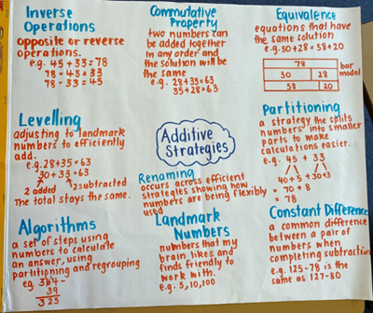
- Alternatively, display or provide Resource 2 – additive strategies to support students.

Stage 2 – revising equivalence and exploring partitioning – 30 minutes
- Display the equals sign and ask students what it represents. Record class responses around the sign (see Figure 2).
Figure 2 – equal sign
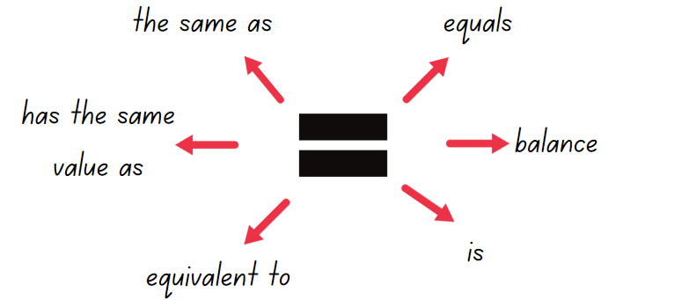
- Draw a balance scale as shown in Figure 3. Ask: What numbers could go in the boxes to balance the scale? (Emphasise that the numbers in the boxes on the right-hand-side can, but do not have to, be equal).
Figure 3 – equal-arm balance
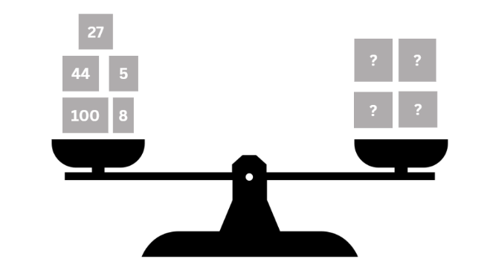
- Establish that the scales in Figure 3 need 184 on both sides to balance. The difference between each side is zero because they are equal.
- Draw a different set of balance scales where both sides have a subtraction number sentence, such as Figure 4.
Figure 4 – constant difference scale
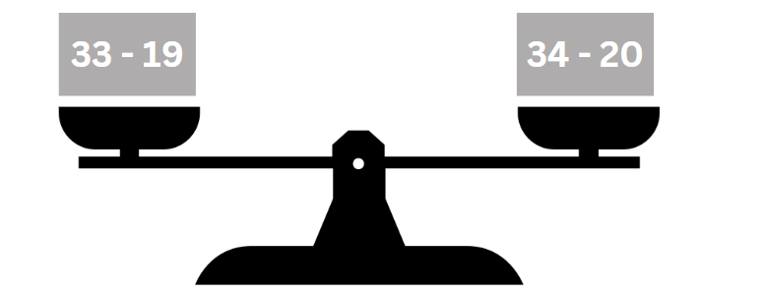
- Discuss how the numbers have been adjusted on both sides to keep an equal value. Refer to this as a ‘constant difference’.
- Explain the meaning of ‘constant’ – something that does not change.
Note: many pairs of numbers can have the same difference between them. To simplify finding the difference between 2-digit numbers, you can add or subtract the same amount from both numbers to reach landmark numbers. For example, 46 and 93 share the same difference as 50 and 97 because 4 has been added to both numbers. Adjusting numbers in this way to support subtraction is referred to as ‘constant difference’.
- Ask:
- What other subtraction number sentences could balance the number sentence 33 − 19? (Any number sentence with a difference of 14).
- How can a constant difference help with mental subtraction? (It allows you to adjust to landmark numbers, make calculations simpler and with fewer steps).
- Present number sentences for students to adjust to landmark numbers such as 25 − 17 = 30 − 22 = 28 − 20. Examples could include:
- 23 − 8 = _?
- _ = 46 − 17
- 78 − 23 = _?
- _ = 62 − 17
- 53 − 26 = _?
- Model the associative property of addition by bridging to the decade for example, 22 + 13 + 8 = 22 + 8 + 13 = 30 + 13 = 43.
Note: the associative property of addition means that when adding 3 or more numbers, the value remains unchanged regardless of how you group or order the numbers. For example, (7 + 9) + 8 = 7 + (9 + 8).
- Explain how reordering the numbers in a number sentence can make addition and subtraction more efficient. Provide other examples, particularly where pairs of numbers add or subtract to 10, 100 or 1000.
- Emphasise the link to equality – changing the order of the numbers for addition does not change the value (see Figure 5).
Figure 5 – associative property of addition
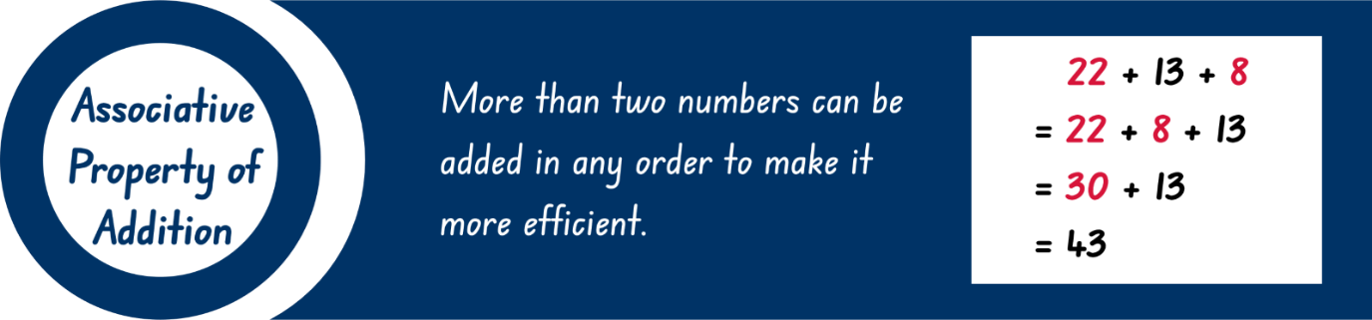
- Display the numbers 60 807 and 687. Ask students what they notice.
- Discuss the value of the zeros and what role zero has in place value.
- Model non-standard and standard partitioning as a drawing, in words and expanded notation with students offering ideas for a 3- and 4-digit number (see Figure 6).
Figure 6 – partitioning example
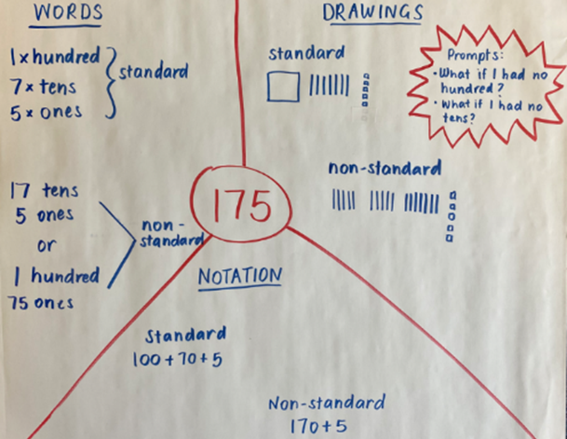
- Optional game: students play non-standard partitioning bingo, which includes 4-digit numbers. Provide each student with a copy of Resource 3 – bingo cards. Call out numbers from Resource 4 – bingo caller sheet. Students place a counter on any number that is worth the same amount as the called number. The person that covers all their numbers first wins.

Stage 3 – travel plan – 30 minutes
This activity is an adaptation of Celebrity Travel Planning [PDF 195 KB] by Liljedahl.
- Display and discuss Resource 5 – superstar sightseeing. Ask:
- Which superstar might it be?
- How will you know you have successfully completed the task?
- Co-design a checklist of important items that students may need to consider, including:
- arrival time
- time at each venue
- rate of pay
- travel time between the venues
- departure time.
- Provide copies of Resource 5 – superstar sightseeing, Resource 6 – map and writing materials.
- Students work individually or in pairs. They can create a table to help organise their travel plan.
This table details opportunities for differentiation.
Too hard? | Too easy?
Stage 2 students cannot use non-standard partitioning to solve addition and subtraction problems.  - Support students to use standard partitioning to practice reading, writing and modelling numbers.  - Students use MAB materials and Resource 7 – place value chart to represent numbers rolled with 2 or 3 dice. They explore various non-standard ways to partition numbers by considering scenarios where there are no tens or hundreds.  Stage 3 students cannot use place value to add or subtract 3 or more numbers with different numbers of digits.  - Adjust the figures in Resource 5 – superstar sightseeing to whole dollar amounts. Provide students with calculators to work out the amounts raised.  - Provide students with Resource 7 – place value chart. Students use dice or cut the cards from the resource to create a deck. They randomly select and read cards to make a number sentence to solve. For example: How many more to make a whole number, such as 23.4 + 0.6 = _? | Stage 2 students can model addition and subtraction with and without regrouping and record the method used.  - Provide students with subtraction problems that include non-standard partitioning of larger numbers with internal zeros. For example, 40 300 − 1408.  - Students write clues for the game ‘What mystery number am I?’ for a partner to solve. For example, my number has 4 digits, and when you add them together, you get 9. The tens digit is greater than 5. What mystery number am I?  Stage 3 students can use place value to add or subtract 3 or more numbers with different numbers of digits.  - Students plan the optional challenge on Resource 5 – superstar sightseeing, visiting each capital city in Australia for one event at each stop.  - Provide the following scenario: If the celebrity is between 10 and 20 minutes late there is a $120 payment reduction. If they are more than 20 minutes late, there is a $150 payment reduction. Students calculate penalties for being late to events.

Discuss and connect the mathematics – 15 minutes

Stage 2 task
- Write the number sentence 397 − 149 on the board. Students solve it using a mental strategy such as constant difference or partitioning. They turn and talk to share approaches and answers.
- Write the number sentence 397 + 45 + 54 + 5 + 3 − 4. Students solve it using the associative property of addition. They turn and talk to share approaches and answers.
- Display Resource 8 – reflection chart and discuss the meaning of each idea.
- Students select one of the strategies used to solve the problems and to reflect on the 4 statements:
- Flexible – I have a range of strategies to choose from.
- Fluent – I can use my strategy easily.
- Understanding – I can connect different ideas, show maths in different ways and use ideas in new ways.
- Efficient – I have used a strategy with a small number of steps.

Stage 3 task
- Discuss when it will be more efficient to use a calculator to add numbers.
- Students swap their work with another group and use a calculator to check the calculations.
- Students give each other any feedback and corrections needed.
- Groups review the comments on their work and ask clarifying questions if necessary.
- Regroup as a class and display the anchor chart. Ask:
- What additive strategies did you use?
- Were there strategies that you did not use?
- Did you use more than one strategy? Why or why not?
- Are there strategies that you used that are not on the anchor chart?
- What approaches did you take to raise the most money? Did they work?
- Where did your celebrity lose time or money?
- Share the amounts the groups raised.
This table details opportunities for assessment.
Assessment opportunities | Links
What to look for:  - Can Stage 2 students recognise equal differences and record them in number sentences?  [MAO-WM-01, MA2-AR-01, MA2-AR-02]  - Can Stage 2 students use the equals sign to mean 'the same as', rather than to perform an operation?  [MAO-WM-01, MA2-AR-01, MA2-AR-02]  - Can Stage 2 students use quantity values and non-standard partitioning to solve addition and subtraction problems?  [MAO-WM-01, MA2-AR-01]  - Can Stage 3 students use place value to add or subtract 3 or more numbers with different numbers of digits?  [MAO-WM-01, MA3-AR-01]  - Can Stage 3 students determine when it would be more efficient to use a calculator to add numbers? [MAO-WM-01, MA3-AR-01]  - Can Stage 3 students use start and finish times to calculate the elapsed time of events? [MAO-WM-01, MA3-NSM-02] | Links to National Numeracy Learning Progressions (NNLP):  - Stage 2 – NPA3, AdS7, AdS8  - Stage 3 – AdS7, AdS8, AdS9, MeT4.  Links to suggested Interview for Student Reasoning (IfSR) tasks:  - Stage 2 – IfSR-AT: Section 2 and Section 3  - Stage 3 – IfSR-AT: 3A.5.

Lesson 2
Core concept: numbers can be built up or taken apart in a variety of ways to make the numbers easier to work with (Stage 2) and addition can help solve subtraction problems (Stage 3).

Daily number sense – balancing challenge – 15 minutes
The table below contains suggested learning intentions and success criteria. These are best co-constructed with students.
Daily number sense learning intentions | Daily number sense success criteria
Students working towards Stage 2 outcomes are learning to:  - complete number sentences involving additive relations to find unknown quantities.  Students working towards Stage 3 outcomes are learning to:  - apply efficient mental and written strategies to solve addition and subtraction problems. | Students working towards Stage 2 outcomes can:  - find the missing number in an equivalent number sentence involving operations of addition or subtraction on both sides of the equals sign.  Students working towards Stage 3 outcomes can:  - use place value to add or subtract 3 or more numbers with different numbers of digits.
- Explain that there is a number challenge for students. They will be looking for missing numbers to make both sides of a number sentence equal.
- Display several number sentences suited to the learning needs of Stage 2 students. For example:
- _ + 7 = 23 + 12
- 23 – 8 = _ − 3
- _ + 15 = 35 − 4
- _ + 16 = 54 − 22
- 54 – 16 = _ + 29
- _ + 20 = 75 − 27
- 103 +_ = _ − 18
- _ – 24 = 155 − _
- Display several number sentences suited to the learning needs of Stage 3 students. For example:
- _ + 769 = 23 023 + 4512 + 234
- 28 798 − 7564 − 11 = _ − 10 000
- _ + 11 555 = 35 576 − 555 – 15 000
- 75 987 – 22 743 + 1250 = _ + 23 062
- _ + _ − 33 = 5349 − 227 + 11
- 98 514 − 504 = _ + 50 − _
- 1036 + 2843 + 100 + _ = _ − 20
- _ − 24 324 + 286 + 50 = 50 000 − _
- Students record and solve the number sentences. They can work independently or with a partner.
- Select students to show and explain the strategies used. Ask:
- Was it an efficient strategy to use?
- How many steps did this strategy take?
This table details opportunities for assessment.
Assessment opportunities | Links
What to look for:  - Can Stage 2 students find the missing number in an equivalent number sentence involving operations of addition or subtraction on both sides of the equals sign? [MAO-WM-01, MA2-AR-02]  - Can Stage 3 students use place value to add or subtract 3 or more numbers with different numbers of digits?  [MAO-WM-01, MA3-AR-01] | Links to National Numeracy Learning Progressions (NNLP):  - Stage 2 – AdS7, AdS8  - Stage 3 – AdS7, AdS8.  Links to suggested Interview for Student Reasoning (IfSR) tasks:  - Stage 2 – IfSR-AT: 2A.1, 2A.4, 2A.5, 3A.1, 3A.3  - Stage 3 – IfSR-AT: 3A.5.

Core lesson – 40 minutes
The table below contains suggested learning intentions and success criteria. These are best co-constructed with students.
Core concept learning intentions | Core concept success criteria
Students working towards Stage 2 outcomes are learning to:  - recognise and represent numbers that are 10, 100 or 1000 times as large  - partition, rearrange and regroup numbers to at least 1000 to solve additive problems.  Students working towards Stage 3 outcomes are learning to:  - apply efficient mental and written strategies to solve addition and subtraction problems  - choose and use efficient strategies to solve addition and subtraction problems. | Students working towards Stage 2 outcomes can:  - recognise the number of tens, hundreds or thousands in a number  - use quantity values and non-standard partitioning to solve addition and subtraction problems  - model addition and subtraction with and without regrouping and record the method used.  Students working towards Stage 3 outcomes can:  - apply known strategies such as levelling, addition for subtraction, using constant difference, and bridging  - use place value to add or subtract 3 or more number with different numbers of digits  - compare, evaluate and communicate strategies used to solve addition and subtraction problems.

Stage 2 task 1 – comparing strategies – 20 minutes
- Provide students with a copy of Resource 9 – self-assessment.
- Students score their confidence with each skill.
Note: at the end of the lesson, students will repeat this self-assessment in a different colour to identify their learning.
- Review and discuss the anchor chart made in Lesson 1 or review Resource 2 – additive strategies.
- Provide pairs of students with a copy of Resource 10 – comparing strategies grid.
- Students check the number sentence in the middle of the grid and circle the strategies that are the most efficient.
- Students may add other strategies that can be used to solve the number sentence.
- Regroup as a class. Select students to share the efficient strategies they chose, justifying their choices.
- Repeat the activity with other number sentences to suit the needs of students.

Stage 2 task 2 – composition and decomposition – 20 minutes
- Write the number 4562 on the whiteboard.
- Students identify the number of ones, tens, hundreds and thousands that can be found in this number. Encourage them to use both standard and non-standard partitioning in their responses. For example, there are 5 hundreds or 45 hundreds in this number.
- Model decomposition of 4-digit numbers as a bar model, on a Resource 11 – place value houses and as a part whole diagram (see Figure 7).
Figure 7 – representations of decomposition
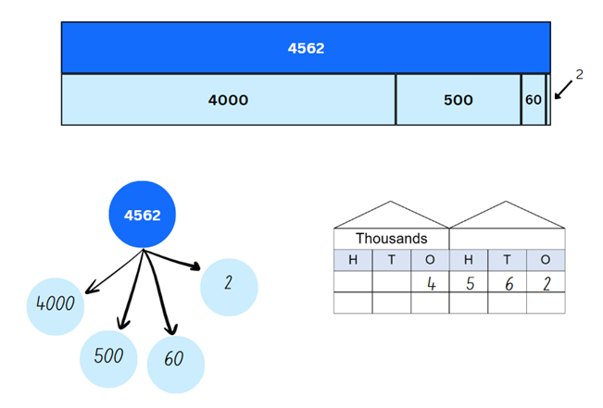
- Revise the associative property of addition. Explain that this means that the order that the parts of 4562 are added back together again does not make a difference to the total.
- Ask: How can these number properties be applied to addition and subtraction?
- Display 78 + 24 + 18. Ask: How can composition and/or decomposition be used efficiently to calculate the total?
- Display 58 + 13 + 8 and repeat the process.
The table below outlines stimulus prompts to generate conversation about the topic, along with anticipated responses from students.
Prompts | Anticipated student responses
- How can we use our place value knowledge to answer 78 + 24 + 18? | - By using place value knowledge, I can break down the quantities into their tens and ones, combine the tens to form 100, and combine the ones to make 2 more tens.  - I know that 78 + 22 = 100. I can split 24 into 22 and 2. Now I have 100 + 2 + 18 which totals 120.  - I know that 24 = 12 + 12. With those twelves I can make 90 from 78 and 30 from 18. 90 + 30 makes 120.
- How can we use partitioning to answer 58 + 13 + 8? | - I can break down numbers into their smaller parts and use them flexibly in my calculations. Here I can partition 8 into 7 and 1, then combine 13 and 7 to make 20. Then I have 58 + 20 + 1 = 79.
- Students solve number sentences showing how composition, decomposition and the associative property can be used. Examples could include:
- 62 + 18 + 15 = _
- 55 + 9 + 25 = _
- 81 + 17 + 29 = _
- 142 + 41 + 11 = _
- 495 + 106 + 25 = _
- 458 − 39 = _
- 777 – 87 = _
- Students return to Resource 9 – self-assessment from the start of the lesson. They indicate their understanding using a different colour.

Stage 3 task 1 – additive strategies – 20 minutes
- Review the anchor chart from Lesson 1 or Resource 2 – additive strategies.
- Draw attention to inverse operations. Remind students that addition can be used for subtraction problems. For example, to solve 5009 − 3997, start at 3997 and add until 5009 is reached. Adding 3 to 3997 makes 4000, then 1009 to get to 5009. The difference is 1012.
- Model ‘addition for subtraction’ on an empty number line. Repeat as needed.
- Add ‘addition for subtraction’ to the anchor chart.
Note: ‘addition for subtraction’ is a specific strategy referred to in Additive relations A, alongside levelling, using constant difference, and bridging. It is part of the inverse relationship between addition and subtraction.
- Display and discuss Resource 12 – data sources. Draw student attention to the approximate totals available in the column graph.
- Provide students with a copy of Resource 12 – data sources.
- Display and read Resource 13 – data activities. Students answer the questions using the ‘addition for subtraction’ strategy where appropriate and to show their working on a number line.
The table below outlines stimulus prompts to generate conversation about the topic, along with anticipated responses from students.
Prompts | Anticipated student responses
- Calculate the difference in total attendance for World Cup matches in 2023 and 2003. | - This anticipated response is around 1 300 000.  - (2023) 1 950 000 − (2003) 650 000 = 1 300 000.
- How many additional people attended per match in 1999 compared to 1995? | - (1999) 37 944 − (1995) 4316 = 33 628  - 37 944 − 4316 add 84 makes 4400 plus 33 544, so the difference is 33 628.
- Calculate the difference between the smallest and largest match attendance total. | - (2023) 1 950 000 − (1995) 110 000 = 1 840 000  - 1 950 000 − 110 000 add 90 000 makes 200 000 plus 1 750 000, so the difference is around 1 840 000.
- What is the difference between the smallest and largest attendance per match? | - (2023) 30 911 − (1995) 4316 = 26 595  - 30 911 − 4316 add 684 makes 5000 plus 25 911, so the difference is 26 595.
- About how much more rainfall does Oodnadatta SA need to reach the shaded purple level (3000 mm)? | - 3000 − 50 = 2950 mm  - Inverse operations 2950 + 50 = 3000 mm.
- Calculate the additional rainfall needed for Bourke NSW to be shaded dark blue (2000 mm). | - 2000 − 300 = 1700 mm  - Inverse operations 300 + 1700 = 2000 mm.
- What is the difference in average annual rainfall between Mildura NSW and Darwin NT? | - 1500 − 200 = 1300 mm  - 200 add 800 makes 1000 plus 500, so the difference is 1300 mm.

Stage 3 task 2 – number lines – 20 minutes
- Display and read Resource 14 – garden designs.
- Remind students that they can use the addition for subtraction strategy to compare lengths or calculate differences.
- Encourage students to answer the questions using an empty number line to support their calculations but they may choose another effective strategy.
The table below outlines stimulus prompts to generate conversation about the topic, along with anticipated responses from students.
Prompts | Anticipated student responses
- What is the final length of the garden? | Final garden length:  - 7.95 + 2.15 + 3.85 − 1.15 = 12.8 m
- What is the difference between the initial and final garden length? | Final length – initial length:  - 12.8 m − 7.95 m = 4.85 m
- How much shorter is the flower bed than the fruit trees? | Fruit trees – flower bed:  - 3.85 − 2.15 = 1.7 m (see Figure 8).  Figure 8 – example of solution 1  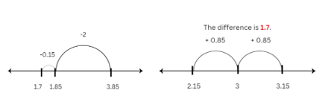
- How much longer is the flower bed than the path? | Flower bed – path:  - 2.15 m −1.15 m = 1.00 m.
- Where would the middle of the garden be for the path? | - Final length is 12.8 m. The middle is 6.4 m (see Figure 9).  Figure 9 – example of solution 2  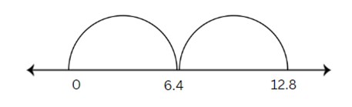
- If you divide the garden into 4 equal sections, what would be the length of each section? | The final garden is divided into 4 equal parts:  - 12.8 divided by 4, half and half again, making 3.2 m (see Figure 10).  Figure 10 – example of solution 3  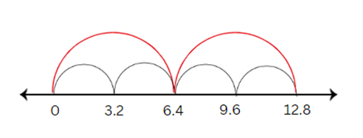
- If the owner asked you to make the garden 25% longer, how much would you need to add? How long would the garden now be? | - 25% is the same as a quarter.  - You would need to add 3.2 m.  - This would make the garden 12.8 + 3.2 = 16 metres long.
This table details opportunities for differentiation.
Too hard? | Too easy?
Stage 2 students cannot use quantity values and non-standard partitioning to solve addition and subtraction problems.  - With a deck of cards (1–9), students create a 3-digit number by selecting 3 cards and represent it using MAB materials and on Resource 11 – place value houses. They choose 2 cards to form a 2-digit number, then represent it with MAB materials. Students calculate the total, regrouping as necessary, and write a matching number sentence.  - Students follow a similar process as described above to find the difference between 2 numbers by using subtraction. They write a matching number sentence.  Stage 3 students cannot apply known strategies such as levelling, addition for subtraction, using constant difference, and bridging.  - Students use whole numbers to solve the garden bed and calculator problems.  - Provide concrete materials such as Resource 15 – decimats to support students in solving the decimal problems. Note: the decimats can be used to represent decimals, helping students understand decimal size and place value (see Figure 11). | Stage 2 students can use quantity values and non-standard partitioning to solve addition and subtraction problems.  - Students investigate and record at least 10 separate ways of changing one number to another, using any operation. For example, to move from 12 to 240, students could add 228, double 12 and multiply by 10, multiply 12 by 20, add 238 and subtract 10 and so on. To promote efficiency, set a limit of 5 operations.  - Once they have a list, invite students to share their list with a group. Students respond to questions such as:  - Did you notice any patterns?  - What strategies did you use to help you make your list?  - Is it possible to work out how many ways one number can be related to another?  Stage 3 students can apply known strategies such as levelling, addition for subtraction, using constant difference, and bridging.  - Provide a budget and a cost per metre for the flowers, trees and path. Challenge students to create the most visually appealing garden while staying within the allocated budget.  - Students write their own garden problems and share them with their peers. They need to consider the strategies used and justify their efficiency in solving the problem.
Figure 11 – decimats
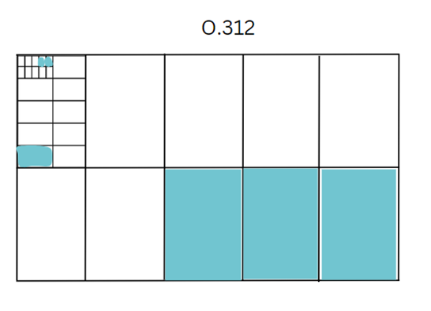

Discuss and connect the mathematics – 10 minutes
- Display and discuss Resource 8 – reflection chart. Students turn and talk to share their reflections.
- Discuss and reflect on the efficiency and accuracy of the strategies used by students.
- Students share their responses.
This table details opportunities for assessment.
Assessment opportunities | Links
What to look for:  - Can Stage 2 students recognise the number of tens, hundreds or thousands in a number? [MAO-WM-01, MA2-RN-01]  - Can Stage 2 students use quantity values and non-standard partitioning to solve addition and subtraction problems?  [MAO-WM-01, MA2-AR-01]  - Can Stage 2 students model addition and subtraction with and without regrouping and record the method used?  [MAO-WM-01, MA2-AR-01]  - Can Stage 3 students apply known strategies such as levelling, addition for subtraction, using constant difference, and bridging? [MAO-WM-01, MA3-AR-01]  - Can Stage 3 students use place value to add or subtract 3 or more number with different numbers of digits?  [MAO-WM-01, MA3-AR-01]  - Can Stage 3 students compare, evaluate and communicate strategies used to solve addition and subtraction problems? [MAO-WM-01, MA3-AR-01] | Links to National Numeracy Learning Progressions (NNLP):  - Stage 2 – NPV6, NPV7, AdS7, AdS8  - Stage 3 – AdS7, AdS8.  Links to suggested Interview for Student Reasoning (IfSR) tasks:  - Stage 2 – IfSR-AT: Section 2 and Section 3  - Stage 3 – IfSR-AT: 3A.4, 3A.5.

Lesson 3
Core concept: addition can help solve subtraction problems.

Daily number sense – canteen price list – 15 minutes
The table below contains suggested learning intentions and success criteria. These are best co-constructed with students.
Daily number sense learning intentions | Daily number sense success criteria
Students working towards Stage 2 outcomes are learning to:  - complete number sentences involving additive relations to find unknown quantities.  Students working towards Stage 3 outcomes are learning to:  - apply known strategies to add and subtract decimals. | Students working towards Stage 2 outcomes can:  - create word problems that correspond to given addition and subtraction number sentences.  Students working towards Stage 3 outcomes can:  - model the addition and subtraction of decimals up to 3 decimal places using appropriate representations.
- Display Resource 16 – canteen price list.
- Model writing a number sentence for Stage 2 students, such as 50c + 25c = 75c. Model writing a number sentence for Stage 3 students, such as $2.60 + 50c + $4.25 = $7.35.
- Students turn and talk with a partner. They use prices from the canteen list to create a word problem to match the sentence.
- Students use individual whiteboards to write number sentences and matching word problems.
Multi-age: students working towards Stage 3 outcomes are encouraged to write a number sentence that includes adding 2 or more items together from the canteen list. Students then add another step of calculating change. They subtract the total amount purchased from a larger denomination of money paid. For example, $2.75 + $4.25 + 25c + $1.25 = $8.50. $20 − $8.50 = $11.50 change.
- Select students to share their problems.
This table details opportunities for assessment.
Assessment opportunities | Links
What to look for:  - Can Stage 2 students create word problems that correspond to given addition and subtraction number sentences?  [MAO-WM-01, MA2-AR-01, MA2-AR-02]  - Can Stage 3 students model the addition and subtraction of decimals up to 3 decimal places using appropriate representations? [MAO-WM-01, MA3-AR-01] | Links to National Numeracy Learning Progressions (NNLP):  - Stage 3 – AdS9.  Links to suggested Interview for Student Reasoning (IfSR) tasks:  - Stage 2 – IfSR-AT: 4A.1, 4A.2, 4A.3.

Core lesson – 45 minutes
The table below contains suggested learning intentions and success criteria. These are best co-constructed with students.
Core concept learning intentions | Core concept success criteria
Students working towards Stage 2 outcomes are learning to:  - represent money values in multiple ways  - apply addition and subtraction to familiar contexts, including money and budgeting.  Students working towards Stage 3 outcomes are learning to:  - recognise that the place value system can be extended beyond hundredths  - apply known strategies to add and subtract decimals. | Students working towards Stage 2 outcomes can:  - perform calculations with money, including finding change  - use estimation to check the validity of solutions to addition and subtraction problems, including those involving money  - interpret problems involving money as requiring either addition or subtraction.  Students working towards Stage 3 outcomes can:  - express thousandths as decimals  - use place value to partition decimals  - model the addition and subtraction of decimals up to 3 decimal places using appropriate representations  - justify why the strategy used to solve addition and subtraction word problems is appropriate.

Stage 2 and 3 – decimal addition and subtraction – 15 minutes
- Review the anchor chart from Lesson 1 or Resource 2 – additive strategies.
- Provide students with Resource 17 – 1–3 spinner, sticky notes, a paper clip and cards (numeral cards 0–9).
- Stage 2 students: In pairs, students randomly select cards to make 2 numbers with 4 digits which turn into numbers with decimals.
- Stage 3 students: In pairs, students randomly select cards to make 2 numbers with 6 digits which turn into numbers with decimals.
- Students use the spinner to determine the position of the decimal point, for example, spin a 2 and create a number with 2 decimal places.
Note: Stage 2 students are only expected to use the numbers 1 and 2 on the spinner to make number with up to 2 decimals places.
- Students write an addition or subtraction sign onto a sticky note to complete an equation (see Figure 12).
Figure 12 – decimal equation
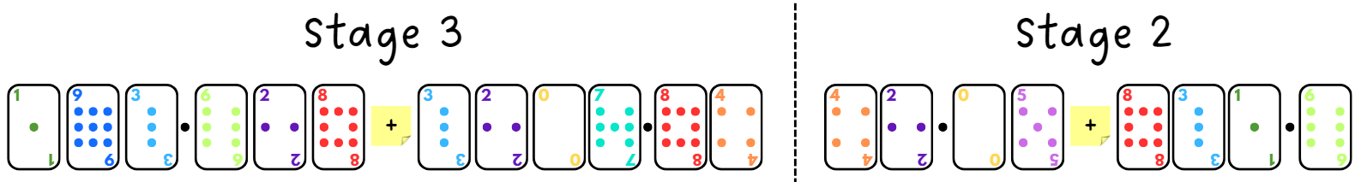
- Students select a number to partition and represent the calculation using an empty number line.
- Revise different models of representations to support students efficiently solve the equations (see Figure 13).
Figure 13 – visual representation examples
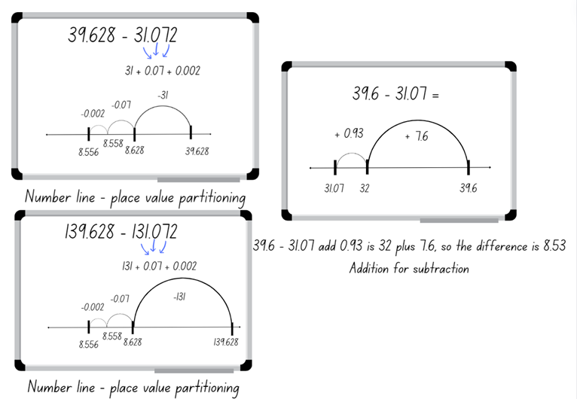
- Repeat the activity, ensuring students alternate between addition and subtraction.
- Regroup as a class and select students to share which number they chose to partition and why.
- Students repeat this task and add or subtract another 2 numbers. They use what they believe is the most efficient strategy from those displayed.
- Students record their work on a sticky note and attach it to the anchor chart or Resource 2 – additive strategies.

Stage 2 – class party – 30 minutes
- Discuss how rounding can be used to estimate the cost of items to ensure students have enough money.
- Explain that students are not to calculate totals. Instead, they use approximation to help answer the questions.
- Display and read Resource 18 – party activities. Ask:
- With a $500 budget, can you organise the petting zoo and karaoke? What about outdoor toys and face painting?
- About how many sushi platters can you buy with $150?
- Approximately how many fruit platters can you buy with $160?
- Is $60 enough to buy 10 pizzas?
- With $200 can you get 3 photo booths?
- Is $50 enough to buy 10 juice packs?
- List 5 snacks or drinks you can buy for under $20 without calculating.
- Present the following scenario: The school’s principal has told the class they have won the prize for being the best class in the school. For this honour, they will be able to have a class party worth $1000. The students get to decide how to spend the money.
- Explain that students will have the opportunity to prepare and present a budget. They must follow these rules:
- Stay within the budget of $1000.
- Purchase at least 2 items from each list.
- Optional challenge: purchase enough of each item so that every student and teacher in the class receives the same amount of food and drink.
- Display and read Resource 18 – party activities.
- Provide small groups Resource 19 – planning sheet to determine the total cost of their party.
- Groups calculate how much of their $1000 budget they will have left.
- Encourage students to use both addition and subtraction during their budgeting.

Stage 3 – party problems – 30 minutes
This activity is an adaptation of Shopping Basket from NRICH by University of Cambridge.
- Display and read Resource 20 – party problems. Discuss how students might begin to solve these problems using fluent and efficient strategies.
- Students work on each question, considering the most fluent and efficient strategy they could use.
Note: for an optional challenge, change the total of question 4 to $100 or another total that promotes calculation with decimals. For $100, the prices will be $55, $27.50 and $17.50. Encourage students to use a bar model or another visual representation.
- Regroup as a class and ask several students to share their working out. Ask them about the most fluent and efficient strategy they used to solve the word problems, justifying their choice.
This table details opportunities for differentiation.
Too hard? | Too easy?
Stage 2 students cannot perform calculations with money, including finding change.  - Provide Australian play money to make the amounts for each item students select when working through the task.  - Change the costs of all items to whole dollars.  Stage 3 students cannot model the addition and subtraction of decimals up to 3 decimal places using appropriate representations.  - Revise student knowledge of whole number partitioning of numbers up to 5-digits. Guide the transfer of those skills to partitioning and naming decimals.  - Provide concrete materials such as Resource 15 – decimats to support students to solve the decimal problems. Note: the decimats can be used to represent decimals, helping students understand decimal size and place value. | Stage 2 students can perform calculations with money, including finding change.  - Provide students with Resource 21 – pocket money. Students determine which pocket money option they would choose.  - Students act as the auditors of the class party budgets, ensuring the mathematics has been completed correctly.  Stage 3 students can model the addition and subtraction of decimals up to 3 decimal places using appropriate representations.  - Choose events from the NSWPSSA Athletics championships results. Students calculate comparisons between different results, such as first and second place, or 8-year-olds and 12-year-olds.  - Challenge students to create multistep decimal problems that represent real-world additive situations. Students swap these problems with peers to solve, explaining the strategies they used.

Discuss and connect the mathematics – 10 minutes
- Once completed, students present their ideas and solutions, reflecting on the mathematical strategies. Ask:
- How did your group ensure all members provided input and engaged in the mathematics?
- What did you find easy in the task?
- Can you explain how you used addition and subtraction in your calculations?
- Did you use any other operations? Which ones and why?
- Did you have any mathematical challenges, and how did you overcome them?
- Did your group use the most efficient method to work out the total cost? Why do you think this?
- How might the skills you used in this activity apply to real-life situations? (For example, managing personal finances and planning events.)
This table details opportunities for assessment.
Assessment opportunities | Links
What to look for:  - Can Stage 2 students perform calculations with money, including finding change? [MAO-WM-01, MA2-AR-01]  - Can Stage 2 students use estimation to check the validity of solutions to addition and subtraction problems, including those involving money? [MAO-WM-01, MA2-AR-01]  - Can Stage 2 students interpret problems involving money as requiring either addition or subtraction?  [MAO-WM-01, MA2-AR-01]  - Can Stage 2 students model addition and subtraction with and without regrouping and record the method used?  [MAO-WM-01, MA2-AR-01]  - Can Stage 3 students express thousandths as decimals?  [MAO-WM-01, MA3-RN-02]  - Can Stage 3 students use place value to partition decimals? [MAO-WM-01, MA3-RN-02]  - Can Stage 3 students model the addition and subtraction of decimals up to 3 decimal places using appropriate representations? [MAO-WM-01, MA3-AR-01]  - Can Stage 3 students justify why the strategy used to solve addition and subtraction word problems is appropriate?  [MAO-WM-01, MA3-AR-01] | Links to National Numeracy Learning Progressions (NNLP):  - Stage 2 – UnM5, UnM6, UnM7, AdS7, AdS8  - Stage 3 – NPV7, NPV8, AdS9.  Links to suggested Interview for Student Reasoning (IfSR) tasks:  - Stage 2 – IfSR-AT: Section 2 and Section 3, 4A.1  - Stage 3 – IfSR-AT: 4A.1, 4A.2, 4A.3, 4A.4.

Lesson 4
Core concept: flexible methods of addition and subtraction involve decomposing and composing numbers (Stage 2) and place value understanding helps us to make use of benchmark percentages (Stage 3).

Daily number sense – 10 minutes
- From a class need surfaced through formative assessment data, identify a short, focused activity that targets students’ knowledge, understanding and skills. Example activities may be drawn from the following resources:
- Mathematics K–6 resources
- Universal Resources Hub.

Core lesson – 40 minutes
The table below contains suggested learning intentions and success criteria. These are best co-constructed with students.
Core concept learning intentions | Core concept success criteria
Students working towards Stage 2 outcomes are learning to:  - select strategies flexibly to solve addition and subtraction problems of up to 3 digits  - partition, rearrange and regroup numbers to at least 1000 to solve additive problems.  Students working towards Stage 3 outcomes are learning to:  - make connections between benchmark fractions, decimals and percentages  - determine percentage discounts of 10%, 25% and 50%. | Students working towards Stage 2 outcomes can:  - apply known mental strategies that use partitioning to add and subtract, such as bridging the decades  - apply the levelling and constant difference strategies  - model addition with and without regrouping and record the method used  - model subtraction with and without regrouping and record the method used.  Students working towards Stage 3 outcomes can:  - represent common percentages of quantities and lengths as fractions and decimals  - recognise that 10% is one-tenth of 100% and use this to find 10% of a quantity  - equate 10% to dividing by 10, 25% to finding a quarter by dividing by 4, and 50% to finding half.

Stage 2 task 1 – partitioning versus levelling – 20 minutes
- Revise the anchor chart from Lesson 1 or Resource 2 – additive strategies.
- Display Resource 22 – different strategies.
- Discuss the strategies used. Reflect on how flexible and efficient they are, using Resource 8 – reflection chart for support. Ask:
- Can you name the strategies used by the students? (Student A uses standard partitioning, Student B uses levelling and Student C uses non-standard partitioning.)
- How would you have solved the number sentence?
- Would you have used the same strategy as one of the students?
- Which strategy is the most efficient? Will everyone agree? Why or why not?
- Model the use of standard partitioning using the number sentence 79 + 37. (70 + 30 + 9 + 7 = 116).
- Model the use of non-standard partitioning using the number sentence 79 + 37. (For example, 79 + 21 + 16 = 116).
- Model the use of levelling using the number sentence 79 + 37. (For example, 80 + 36 = 116).
- Explain that when using levelling, numbers can be adjusted up and down to the most efficient landmark number (see Figure 14).
Figure 14 – levelling examples
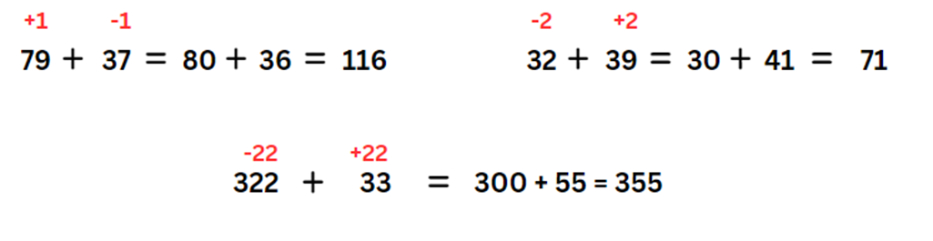
Levelling: adjusting to landmark numbers to add efficiently, for example, 79 + 35 becomes 80 + 34.
- Students use standard partitioning, non-standard partitioning and levelling to solve number sentences in their workbooks. Examples include:
- 79 + 37
- 62 + 43
- 87 + 49
- 64 + 38
- 179 + 47
- 221 + 198
- 342 + 213.
- Display 221 + 198 and discuss different ways standard partitioning, non-standard partitioning and levelling can be used. Ask:
- Which way is more efficient – partitioning or levelling?
- Is it always more efficient to level? Why or why not?
- What strategy is more efficient as the numbers get larger? Why?

Stage 2 task 2 – partitioning versus constant difference – 20 minutes
- Display the following number sentence: 213 − 68.
- Ask how students could solve this efficiently using mental strategies. Record all responses.
- Identify responses using standard and non-standard partitioning.
- Revise the concept of constant difference introduced in Lesson 1. Explain that numbers can be adjusted up or down flexibly to the most efficient landmark number (see Figure 15).
Figure 15 – constant difference
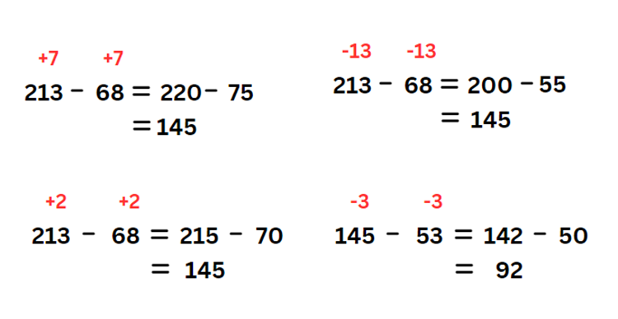
Constant difference: a common difference between a pair of numbers when completing subtraction, for example, 71 − 36 becomes 70 − 35.
Note: explain that students cannot use levelling for subtraction, as the associative and commutative properties of addition does not apply to subtraction. For subtraction, the order of the numbers does matter: 9 − 7 is not the same as 7 − 9.
- Students use standard partitioning, non-standard partitioning and constant difference to solve these number sentences in their workbooks:
- 66 − 28
- 125 − 79
- 323 − 137
- 791 − 246
- 152 − 88
- 931 − 146
- 813 – 318.
Note: for constant difference, it can sometimes be easier to focus on first adjusting the number being subtracted (subtrahend) to a landmark or ‘friendly’ number. In the example 323 − 137, adjusting the numbers to 326 − 140 may make the subtraction easier than the alternative 320 − 134. Encourage students to experiment with flexible approaches, and to look for options that help them.
- Display 813 − 318. Discuss ways to use standard and non-standard partitioning and constant difference to solve it. Ask:
- Which way is more efficient – partitioning or constant difference?
- Is it always more efficient to partition? Why or why not?
- What strategy is more efficient as the numbers get larger? Why?

Stage 3 task 1 – price of chocolate – 20 minutes
- Ask students:
- Have you ever wondered where your clothes, food and furniture come from?
- Have you thought about what happens before these items reach the shop?
- What do you know about how chocolate is made?
- What do you know about how T-shirts are made?
- Display Resource 23 – chocolate costs 1. Use the table below to guide discussion.
The table below outlines stimulus prompts to generate conversation about the topic, along with anticipated responses from students.
Prompts | Anticipated student responses
- What do you notice? What do you wonder? | - Varied responses depending on background knowledge.  - There are chocolate bars made from small squares.  - There are 20 rows of 5.  - There are 100 squares in the block altogether.  - The number of squares matches the percentage recorded on it, for example, there are 30 squares on the 30% for retailers.  - A markup is the amount added to the cost price of goods to cover overheads and profit.
- What does the bar of chocolate represent? | - The entire cost of a chocolate bar. Note: the percentages are not a true representation of chocolate manufacturing. Proportions were provided to support the task.
- Who receives the highest or lowest percentage? | - Manufacturers (highest); Transportation (lowest)
- Why do you think manufacturers need the largest percentage? | - They have the highest costs such as workers or employees, utilities, rent, taxes, quality assurance, insurance, marketing, profit.
- Do you think the share is fair? Why or why not? | - Varied responses depending on background knowledge.
- If the chocolate bar costs $10, how much does each sector receive? How can you work that out? | - Half of 10 is $5, and half goes to the manufacturer.  - 10% means the same as one tenth, so 10% is $1. The farmer gets $1.  - 30% is 3 times 10%, so the retailer gets $3.  - 5% is half of 10%, so transport and other costs are half of a dollar which is 50c each.
- Provide a copy of Resource 24 – chocolate costs 2, or have students complete the activity in their workbooks.
- Ask students:
- What is the same or different with Resource 23 – chocolate costs 1?
- What strategies can you use to work out the cost for each component?
- What is the first cost you would work out? Why?

Stage 3 task 2 – clothing shop – 20 minutes
This activity is an adaptation of ‘Raw to retail’ from Middle School Mathematics Lessons to Explore, Understand, and Respond to Social Injustice by Conway et al.
- Display Resource 25 – raw to retail.
- Discuss the process from raw materials to a finished product in a retail shop:
- Raw materials are grown by farmers or mined, then transported to processing or manufacturing plants.
- There, the raw materials are made into products, sometimes being transported again to be created into further products. For example, zippers may be made in one factory and then transported to another factory to be used in clothing.
- When complete, products are transported to wholesalers, also known as intermediary businesses, that help move the goods from one business to another.
- Next, the goods are branded ready for sale.
- Finally, the goods are transported to shops for retailers to sell.
- Optional task: using digital devices, have the students find a piece of clothing they would like to purchase. Students could also use catalogues or Resource 26 – Imogen’s T-shirt shop.
- Explain that students can now find the percentages that are paid to each sector represented in Resource 25 – raw to retail for their chosen item.
- Students complete Resource 27 – product costs.
Note: the percentages for each sector are intentionally left blank in Resource 27 – product costs. Students can estimate their own, or use the percentages provided in Resource 24 – chocolate costs 2. Students may also explore uncommon percentages during this investigation. Stage 3 content requires the understanding of common or benchmark percentages of 10%, 25%, 50% and 75%.
This table details opportunities for differentiation.
Too hard? | Too easy?
Stage 2 students cannot model addition with and without regrouping and record the method used (levelling and constant difference).  - Use MAB materials to support student understanding that in levelling the total remains the same.  - Students use single digits and level to landmark numbers, for example, 10 and 20.  Stage 3 students cannot represent common percentages of quantities and lengths as fractions and decimals.  - Provide students with MAB materials to make 100. Explain that 100% represents the whole cost of the item. Guide students to allocate MAB materials to each step in Resource 25 – raw to retail.  - Students select an item that costs $10 or $100. They use benchmark percentages of 50%, 25% and 10% for the cost components. | Stage 2 students can model addition with and without regrouping and record the method used (levelling and constant difference).  - Students investigate Sums and differences of 2-digit numbers, recording their findings in a table.  - Create a bank of questions up to 6-digit numbers that would be suitable for levelling, and a bank suitable for constant difference. Ask: What numbers are best suited to those strategies?  Stage 3 students can represent common percentages of quantities and lengths as fractions and decimals.  - Students use uncommon or non-benchmark percentages.  - Using the percentages determined for the item of clothing, ask: What would happen if the retailer decided to have a 50% off sale? Would they make a profit or a loss? How much by? What percentage discount would still provide some profit?

Consolidation and meaningful practice – 10 minutes

Stage 2 task
- Students complete an exit slip showing 2 ways to solve the following questions: 348 + 235 and 497 – 386.
- Students label the strategies used and circle the strategy that they consider the most efficient.

Stage 3 task
- Students complete an exit slip showing as many different percentage discounts as possible for an item that originally cost $80.
- Students share the strategies used and determine the strategy they consider the most efficient.
This table details opportunities for assessment.
Assessment opportunities | Links
What to look for:  - Can Stage 2 students apply known mental strategies that use partitioning to add and subtract, such as bridging the decades? [MAO-WM-01, MA2-AR-01]  - Can Stage 2 students apply the levelling and constant difference strategies? [MAO-WM-01, MA2-AR-01]  - Can Stage 2 students model addition with and without regrouping and record the method used? [MAO-WM-01, MA2-AR-01]  - Can Stage 2 students model subtraction with and without regrouping and record the method used? [MAO-WM-01,  MA2-AR-01]  - Can Stage 3 students represent common percentages of quantities and lengths as fractions and decimals?  [MAO-WM-01, MA3-RN-03]  - Can Stage 3 students recognise that 10% is one-tenth of 100% and use this to find 10% of a quantity?  [MAO-WM-01, MA3-RN-03]  - Can Stage 3 students equate 10% to dividing by 10, 25% to finding a quarter by dividing by 4, and 50% to finding half?  [MAO-WM-01, MA3-RN-03] | Links to National Numeracy Learning Progressions (NNLP):  - Stage 2 – AdS7, AdS8  - Stage 3 – InF7, PrT1, PrT2, UnM8.  Links to suggested Interview for Student Reasoning (IfSR) tasks:  - Stage 2 – IfSR-AT: Section 2 and Section 3.

Lesson 5
Core concept: models help us solve addition and subtraction problems (Stage 2) and number lines and bar models help solve addition and subtraction problems (Stage 3).

Daily number sense – inverse operations – 10 minutes
Daily number sense activities for Lessons 5 to 7 ‘loop’ back to concepts and procedures covered in previous units to assist students to build an increasingly connected network of ideas. These concepts may differ from the core concepts being covered by the unit.
The table below contains suggested learning intentions and success criteria. These are best co-constructed with students.
Daily number sense learning intentions | Daily number sense success criteria
Students working towards Stage 2 outcomes are learning to:  - represent and solve problems involving multiplication fact families.  Students working towards Stage 3 outcomes are learning to:  - use equivalent number sentences involving multiplication and division to find unknown quantities. | Students working towards Stage 2 outcomes can:  - apply the inverse relationship of multiplication and division.  Students working towards Stage 3 outcomes can:  - identify and use inverse operations to assist with the solution of number sentences.
- Pose the following problem to Stage 2 students: Jason arranged 9 shelves in his bedroom and each shelf held 8 books. How many books did he arrange in total?
- Pose the following problem to Stage 3 students: Jason arranged 34 shelves in his bookstore and each shelf held 12 books. How many books did he arrange in total?
- Ask:
- How would you solve this problem?
- How would you check your answer?
- Select students to share responses.
- Once students work out that the Stage 2 answer is 72 and the Stage 3 answer is 408, ask:
- What is the inverse operation to multiplication?
- How can this problem be changed so that division is used to solve it?
- Divide students into pairs. Ask students if they can use the 72 books (Stage 2) and 408 books (Stage 3) to create a division problem. Remind students that if they know that 9 × 8 is 72 (Stage 2) and 34 × 12 is 408 (Stage 3), they can use the inverse operation to help create this new problem.
- Students share their new problem with the class. For example:
- Jason arranged 72 books on 9 shelves. How many books were on each shelf? (Stage 2)
- Jason arranged 72 books so that each shelf contained 8 books. How many shelves were there? (Stage 2)
- Jason arranged 72 books on some shelves. What other combinations of books and shelves can you make? Use a pattern to explore as many combinations as possible. For example, one shelf with 72 books, 2 shelves with 36 books, 3 shelves with ... and so on (Stage 2).
- Jason arranged 408 books on 34 shelves. How many books were on each shelf? (Stage 3)
- Jason arranged 408 books so that each shelf contained 12 books. How many shelves were there? (Stage 3)
- Jason arranged 408 books on some shelves. What other combinations of books and shelves can you make? Use a pattern to explore as many combinations as possible. For example, one shelf with 408 books, 2 shelves with 204 books, 3 shelves with ... and so on (Stage 3).
This table details opportunities for assessment.
Assessment opportunities | Links
What to look for:  - Can Stage 2 students apply the inverse relationship of multiplication and division (Reasons about relations)?  [MAO-WM-01, MA2-MR-01]  - Can Stage 3 students identify and use inverse operations to assist with the solution of number sentences?  [MAO-WM-01, MA3-MR-02] | Links to National Numeracy Learning Progressions (NNLP):  - Stage 2 – MuS7  - Stage 3 – NPA3, NPA4, MuS7.  Links to suggested Interview for Student Reasoning (IfSR) tasks:  - Stage 2 – IfSR-MT: 2A.5, 2A.10  - Stage 3 – IfSR-MT: 3A.10.

Core lesson – 45 minutes
The table below contains suggested learning intentions and success criteria. These are best co-constructed with students.
Core concept learning intentions | Core concept success criteria
Students working towards Stage 2 outcomes are learning to:  - recognise and explain the connection between addition and subtraction  - select strategies flexibly to solve addition and subtraction problems of up to 3 digits.  Students working towards Stage 3 outcomes are learning to:  - determine percentage discounts of 10%, 25% and 50%  - apply known strategies to add and subtract decimals. | Students working towards Stage 2 outcomes can:  - demonstrate how addition and subtraction are inverse operations  - represent solutions to addition and subtraction problems, including word problems, using an empty number line or bar model  - compare and evaluate strategies used to solve addition and subtraction problems, reasoning which strategy may be most efficient.  Students working towards Stage 3 outcomes can:  - equate 10% to dividing by 10, 25% to finding a quarter by dividing by 4, and 50% to finding half  - model the addition and subtraction of decimals up to 3 decimal places using appropriate representations.

Stage 2 task – models for additive relations – 40 minutes
This lesson is an adaptation of The Bar Model Method from reSolve: Maths by Inquiry by the Australian Academy of Science.
- Revise the anchor chart from Lesson 1 or Resource 2 – additive strategies.
- Display the problem: Joanne has 160 bookmarks in her store. She sells 43 bookmarks. How many bookmarks does she have now?
- Model or revise how to represent this problem using an empty number line and the bar model (see Figure 16). Draw attention to the proportionate sizes of the bar model pieces.
Figure 16 – different models
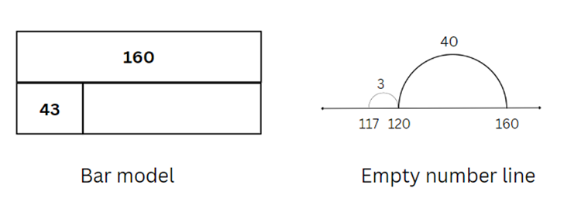
Note: the bar model is an effective problem-solving tool for use in many mathematics topics. It promotes the visualisation, organisation and concrete representation of mathematical quantities and relationships within a problem. It makes visible the part-whole thinking that is key to many mathematics problems (Australian Academy of Science 2022). The bar model forms a foundation for algebra in helping students to represent problems symbolically.
- Explain that both the bar model and the number line show the inverse relationship between addition and subtraction.
- Discuss efficient strategies for solving the problem and record the related number sentences: 160 − 43 = 117; 160 − 117 = 43; 117 + 43 = 160 and 43 + 117 = 160.
- Provide pairs of students with a 9-sided die and writing materials.
- Students roll the 9-sided die 3 times to create and record a 3-digit number. They repeat this to create and record a second 3-digit number.
- Students use the numbers to write subtraction number sentences. They solve them using a bar model and empty number line (see Figure 17).
Figure 17 – student example
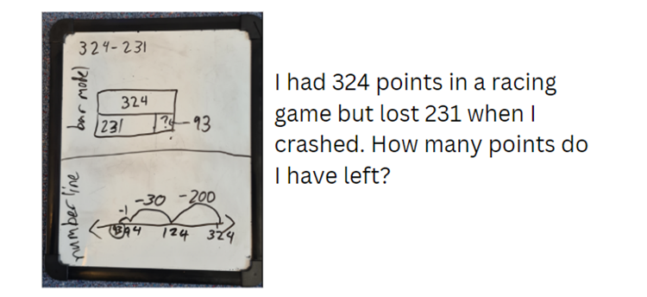
- Students select one of their number sentences and write a matching word problem.
- Using the 9-sided die, students create and record new 3-digit numbers to write subtraction number sentences. They model solving them using both the bar model and an empty number line.
- Again, students select one example and write a matching word problem.
- After suitable practice time, display student work on tables. Students participate in a gallery walk to share ideas and strategies.

Stage 3 task 1 – decimal fluency – 15 minutes
This activity is an adaptation of ‘Adding and subtracting decimals’ from Decimals: Connect 4 by JustMaths.
To develop fluency in addition and subtraction of decimals, students are encouraged to use various additive strategies and representations. For example, students can use number lines, partitioning place value and bar models to solve decimal equations.
- Display and read Resource 28 – score 4. Explain the rules:
- In pairs, students take turns to choose a question from the question grid.
- The correct solution will be found in the answer grid. If their solution is not in the grid, they need to reconsider your answer.
- Students colour or cover the solution in the box on the answer grid. To win, they need to connect 4 answers in a box or a line (horizontally, vertically, or diagonally) on the answer grid.
- Students play the game and record their calculations.
- Select students to share the strategies and representations they used to solve the decimal equations.
- Optional: provide students Resource 29 – blank grid to create their own game for other students to play.

Stage 3 task 2 – benchmark percentages – 15 minutes
- Place students into groups of 3.
- Provide each group with sticky notes and one metre of string.
- Students construct a number line between zero and one, showing known decimals and fractions.
Note: monitor the construction of the number lines as a formative assessment opportunity.
- Explain that percent relies on an understanding of common fractions and decimals.
Note: a percentage is a fraction out of 100 and can be expressed as a decimal with hundredths. Students can make connections easily when both fractions and decimals are illustrated as hundredths, for example, $\frac{75}{100}$ equals 0.75, which is equivalent to 75%. At this level, it is appropriate to focus on known benchmarks such as 50%, 25 % and 10%. The link between hundredths and percent can be made using a hundredths diagram (Siemon et al. 2021).
- Introduce the benchmark percentages of 10%, 25%, 50%, 75% and 100%. Connect these percentages to known decimals and fractions for example 50% = 50/100 = $\frac{1}{2}$, 25% = $\frac{25}{100}$ = $\frac{1}{4}$ and so on.
- Discuss that the base-10 number system makes it easy to find 10% of a quantity. For example, 10% of 150 is 15, so 20% of 150 is 2 lots of 15, 30% is 3 lots of 15 and so on. Explain that 10% is dividing by 10, 25% is dividing by 4 and 50% is dividing by 2. 75% is dividing by 4 to determine 25%, then multiplying by 3.
- Students represent these on a number line, as in Figure 18.
Figure 18 – number line
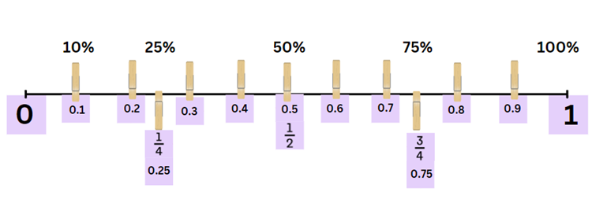

Stage 3 task 3 – celebrity concert – 15 minutes
- Display Resource 30 – concert hall. Explain that the celebrity from Lesson 1 has decided to put on a special charity concert for 100 people in your local hall. The celebrity has insisted that you must have 3 categories of tickets:
- Category 1 – $200 each
- Category 2 – $100 each
- Category 3 – $50 each.
- Using copies of Resource 30 – concert hall, students design at least 2 different seating plans for the concert. They need to include at least one benchmark percentage of 10%, 25% or 50%, as in Figure 19.
Figure 19 – concert hall examples
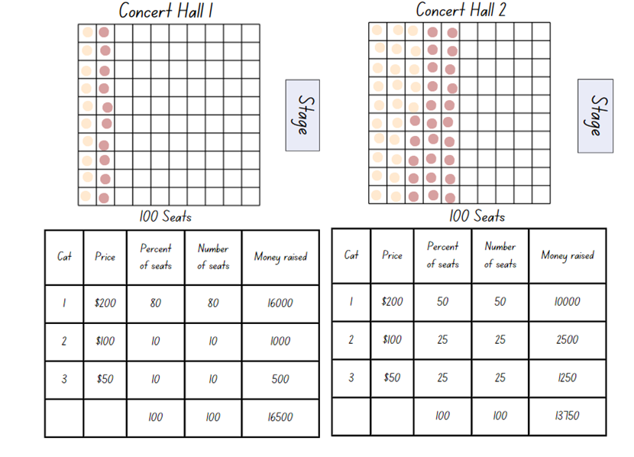
This table details opportunities for differentiation.
Too hard? | Too easy?
Stage 2 students cannot represent solutions to addition and subtraction problems, including word problems, using an empty number line or bar model.  - Use a digital number line to explore addition and subtraction of 2-digit numbers (see Figure 20). Coloured strips of paper can also be used to create a physical bar model with students.  - Use MAB materials to model addition and subtraction of 2-digit numbers.  Stage 3 students cannot model the addition and subtraction of decimals up to 3 decimal places or make connections between benchmark fractions, decimals and percentages.  - Support students to partition decimal numbers. Model how to use place value knowledge to assist with number line jump increments for each partitioned amount.  - For the concert activity, use MAB materials to model the seating plan. Guide students to flexibly partition 100 tickets into the 3 categories using only 10, 25 and 50. Link the partitions to percentages. | Stage 2 students can represent solutions to addition and subtraction problems, including word problems, using an empty number line or bar model.  - Students create addition models with missing elements for a partner to solve.  - Students extend their models to represent numbers up to one million or to 2 decimal places.  Stage 3 students can model the addition and subtraction of decimals up to 3 decimal places or make connections between benchmark fractions, decimals and percentages.  - Play Matching Fractions, Decimals and Percentages from NRICH. Students can self-select from 5 levels of challenge and try to beat their own best times.  - Students complete the concert hall activity for 300 tickets, not 100. Ask: Can this be achieved using only benchmark percentages?  - Students use non-benchmark fractions to allocate seating, linking 10% to 1%. They can add platinum seats with a price of $500.
Figure 20 – digital number lines
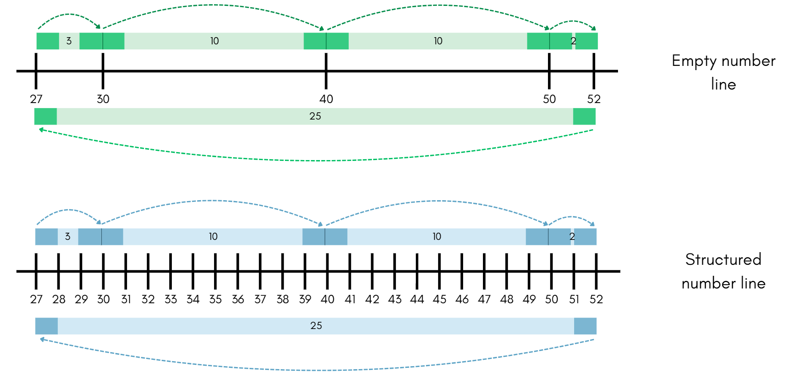

Discuss and connect the mathematics – 15 minutes

Stage 2 task
- Display Resource 31 – different models and ask students questions to stimulate discussion.
The table below outlines stimulus prompts to generate conversation about the topic, along with anticipated responses from students.
Prompts | Anticipated student responses
- What are some questions that could go with these models? | - Answers will vary. Prompt students to form addition and subtraction questions suited to the models.
- How are the bar model and number line similar or different? | - Both are a clear visual representation that make abstract concepts easier to understand.  - Both show how addition and subtraction are inverse operations. One model can show 4 different but related number sentences.  - Number lines can show direction of a calculation (addition to the right and subtraction to the left).  - Number lines can show steps of a calculation.  - Bar models show part-part-whole relationships and the relative sizes of the parts.
- How are the 2 bar models the same or different? | - There is a constant difference of 117 in both. The size of the other pieces is different.  - Both representations show the relationship between numbers and help guide the operation in solving the problem.
- How are the 2 number lines the same or different? | - Both show a constant difference of 117.  - In both it is not clear whether you are adding or subtracting.  - The starting or finishing numbers and jump sizes are different.
- How do these models represent the idea of constant difference? | - For the bar model, the yellow box in each one shows a difference of 117. The other numbers are different.  - For the number lines, the jumps are both 117. The starting or finishing numbers are different.
- Can you provide an example where a bar model or number line can be used in everyday life? | - Anything where you are adding or subtracting such as budgets, discounts or recipe adjustments.

Stage 3 task
- Display the following questions for students to reflect on:
- Which seating plan raised the most money?
- Which seating plan raised the least money?
- Did anyone else raise more money than you?
- Which arrangement is the fairest? Why?
- Students turn and talk, sharing connections they made between fractions, decimals and percentages.
- Select students to share their responses.
This table details opportunities for assessment.
Assessment opportunities | Links
What to look for:  - Can Stage 2 students represent numbers up to and including thousands using physical or virtual manipulatives, words, numerals, diagrams and digital displays?  [MAO-WM-01, MA2-AR-01]  - Can Stage 2 students demonstrate how addition and subtraction are inverse operations? [MAO-WM-01, MA2-AR-01]  - Can Stage 2 students represent solutions to addition and subtraction problems, including word problems, using an empty number line or bar model? [MAO-WM-01, MA2-AR-01]  - Can Stage 2 students compare and evaluate strategies used to solve addition and subtraction problems, reasoning which strategy may be most efficient? [MAO-WM-01, MA2-AR-01]  - Can Stage 3 students equate 10% to dividing by 10, 25% to finding a quarter by dividing by 4, and 50% to finding half?  [MAO-WM-01, MA3-RN-03]  - Can Stage 3 students model the addition and subtraction of decimals up to 3 decimal places using appropriate representations? [MAO-WM-01, MA3-AR-01] | Links to National Numeracy Learning Progressions (NNLP):  - Stage 2 – AdS6, AdS7  - Stage 3 –PrT1, PrT2, AdS9.  Links to suggested Interview for Student Reasoning (IfSR) tasks:  - Stage 2 – IfSR-AT: Section 2 and Section 3.

Lesson 6
Core concept: mathematicians use algorithms with understanding to solve addition problems (Stage 2) and estimating and place value understanding helps to determine the reasonableness of solutions (Stage 3).

Daily number sense – hundred grids – 10 minutes
The table below contains suggested learning intentions and success criteria. These are best co-constructed with students.
Daily number sense learning intentions | Daily number sense success criteria
Students working towards Stage 2 outcomes are learning to:  - investigate number sequences involving related multiples.  Students working towards Stage 3 outcomes are learning to:  - determine products and factors. | Students working towards Stage 2 outcomes can:  - generate number patterns using related multiples  - investigate number patterns involving related multiples.  Students working towards Stage 3 outcomes can:  - determine whether a number is prime, composite or neither (0 or 1).
This activity is an adaptation of Multiples Grid from NRICH by the University of Cambridge.
- Display Resource 32 – 100 grids and explain that they have some numbers shaded. Ask:
- What do all the colours shaded in yellow have in common? (Stage 2)
- What do the colours shaded in pink have in common? (Stage 3)
- What do you notice about all the numbers shaded in blue? (Stage 2)
- Are there more prime numbers that can be shaded pink in the 100 grid? (Stage 3)
- Can you think of a reason there are some numbers shaded in green? (Stage 2)
- What are the other numbers on the grid that aren’t prime numbers? (Stage 3).
Multi-age: if required, revise with Stage 3 students that prime numbers are a positive integer with exactly 2 distinct factors; itself and 1. Composite numbers are a positive integer which has more than 2 factors. The number one is neither prime or composite as it has exactly one unique factor.
- Students Think-Pair-Share their responses. (Stage 2 – yellow numbers are factors of 4, blue numbers are factors of 5 and green numbers are factors of both 4 and 5. Stage 3 – pink numbers are prime numbers and the other numbers on the grid are composite or neither).
- Provide each student with a copy of Resource 33 – blank 100 grid.
- Stage 2 students shade other multiples patterns on the grid. They share it with a peer to describe.
- Stage 3 students shade other prime numbers on the grid and share with a peer to describe. They discuss with their peer what makes a number prime, composite or neither.
This table details opportunities for assessment.
Assessment opportunities | Links
What to look for:  - Can Stage 2 students generate number patterns using related multiples? [MAO-WM-01, MA2-MR-01]  - Can Stage 2 students investigate number patterns involving related multiples? [MAO-WM-01, MA2-MR-01]  - Can Stage 3 students determine whether a number is prime, composite or neither (0 or 1)? [MAO-WM-01, MA3-MR-01] | Links to National Numeracy Learning Progressions (NNLP):  - Stage 2 – NPA3, NPA4.

Core lesson – 40 minutes
The table below contains suggested learning intentions and success criteria. These are best co-constructed with students.
Core concept learning intentions | Core concept success criteria
Students working towards Stage 2 outcomes are learning to:  - select strategies flexibly to solve addition and subtraction problems of up to 3 digits  - partition, rearrange and regroup numbers to at least 1000 to solve additive problems.  Students working towards Stage 3 outcomes are learning to:  - use estimation and place value understanding to determine the reasonableness of solutions  - apply known strategies to add and subtract decimals. | Students working towards Stage 2 outcomes can:  - apply known mental strategies that use partitioning to add and subtract, such as bridging the decades  - use an algorithm with understanding to record addition calculations, where efficient, involving 3-digit numbers  - recognise when mental strategies would be more efficient than a vertical algorithm for addition.  Students working towards Stage 3 outcomes can:  - round numbers appropriately when obtaining estimates to numerical calculations  - use estimation to check the reasonableness of solutions to addition and subtraction calculations  - solve word problems involving the addition and subtraction of decimals up to 3 decimal places.

Stage 2 task 1 – written and mental strategies – 20 minutes
This activity is an adaptation of ‘Sum Pattern’ from Favourite Problems by Seymour.
- Revise the anchor chart from Lesson 1 or Resource 2 – additive strategies.
- Display Resource 34 – addition questions. Draw attention to the side titled ‘Sum Pattern’.
- Students turn and talk to look for patterns and to solve it mentally.
- Select students to share their strategies. Name the different mental strategies used, such as using landmark numbers (10, 50, 100), levelling, partitioning, using rows, doubling, or using columns.
Note: the ability to add two 2-digit numbers mentally by an efficient method is considered a crucial test of readiness for written computation. Encourage students to consider the values of the numbers involved in an arithmetical operation before selecting a method to solve the problem (Lucenta and Kelemanik 2022; Ewbank 1977).
- Display Resource 34 – addition questions. Draw attention to the side titled ‘Algorithm or brain?’
- Students turn and talk, identifying problems that would be best suited to solving with an algorithm, or using mental strategies.
- Select students to share their responses for each example, providing reasons for their choices. Ask:
- Is there a problem that everyone agrees should be written? Why is that?
- Is there a problem that everyone agrees can be solved mentally? Why is that?

Stage 2 task 2 – addition algorithms with regrouping – 20 minutes
- Explain to students that they may have heard of a term called ‘trading’. Explain that mathematicians use the term ‘regrouping’ to help describe reorganising place values.
- Provide students with MAB and writing materials. Display the digits 6, 7, 8, and 9.
- Students create and record two 3-digit numbers using the digits from an addition sentence in their workbook, such as 689 + 976 (see Figure 21.)
Figure 21 – addition regrouping
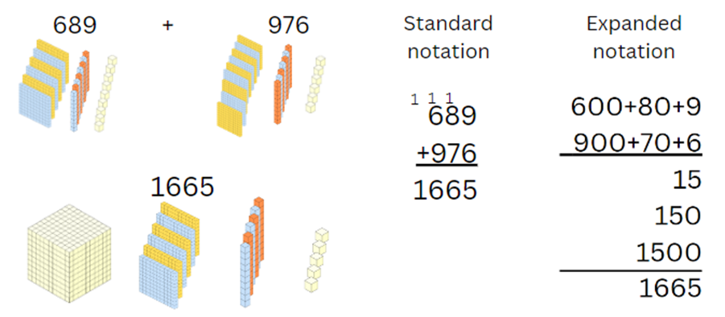
- Students use MAB materials to demonstrate regrouping to a partner, then record the corresponding addition algorithm.
- Repeat the process of writing a 3-digit addition sentence, regrouping with MAB materials and recording the algorithm.
Note: take time to ensure that students recognise how hundreds are exchanged in addition algorithms requiring regrouping. Revise how regrouping relies on recognising the number of tens, hundreds or thousands in a number and renaming them as needed.

Stage 3 task – rounding and estimating – 40 minutes
This activity is an adaptation of Applications with decimals by State of New South Wales (Department of Education).
Note: estimation is used widely in everyday life. A deep understanding of place value supports students to produce reasonable estimates. In the following activities, students are not asked to calculate answers but instead value their estimate. Using language such as ‘about,’ ‘close,’ ‘just about’ or ‘approximate’ emphasises that there is not one correct answer. Students can compare estimates to evaluate if they fall within an acceptable range. Having students reflect on the strategies used by peers supports additional strategy development (Van de Walle et al. 2023:274).
- Discuss contexts for estimation in everyday life. Ask:
- When is it important to be precise? (Measuring medicine, measuring for recipes, time for exams, paying the right amount for an item in a shop).
- When is an estimate good enough? (How long to walk to school, how long a movie goes for, the distance of a long drive).
- Display and read Resource 35 – mountain climbing think board.
- Jointly complete the think board with the students to match the mountain climbing problem (see Figure 22).
Figure 22 – estimation think board example
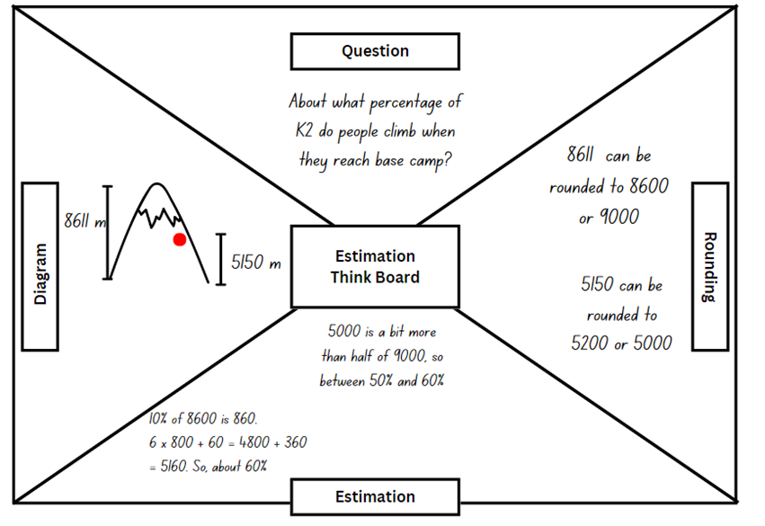
- Ask for different approaches to calculating percentages, linking back to content from Lesson 4. Reinforce that there is no requirement for a precise calculation.
- Display and read Resource 36 – estimation activities.
- Students select activities and to record their thinking on Resource 37 – think board, or a similar learning scaffold in their workbook.
- The answers to the questions are approximations, not precise calculations.
- Students compare their solutions after each activity. If there is a notable difference in their solutions, students pair up with a peer and work through the rounding and estimating together.
This table details opportunities for differentiation.
Too hard? | Too easy?
Stage 2 students cannot use an algorithm with understanding to record addition calculations, where efficient, involving 3-digit numbers.  - Support students to use MAB materials to model regrouping from one to tens using 2- and 3-digit numbers that require regrouping.  - Use a digital place value mat (with a regrouping function) to support students’ calculations.  Stage 3 students cannot round numbers appropriately when obtaining estimates to numerical calculations.  - Provide numbers of varying sizes for students to round to the nearest hundred, ten, tenth or hundredth. Guide students to round the numbers in Resource 36 – estimation activities.  - Students round 2 amounts such as $25.60 and $14.10 to estimate the total (about $40), and the difference between them (about $10). Guide students to round and estimate totals and differences in the activities on Resource 36 – estimation activities. | Stage 2 students can use an algorithm with understanding to record addition calculations, where efficient, involving 3-digit numbers.  - Use 4- and 5-digit numbers that require regrouping in different place values positions.  - Students show solutions using multiple methods, such as algorithms, MAB materials, a bar model or empty number line. They group problems as suited or not suited to algorithms, explaining their thinking.  - Students investigate options for open-middled questions such as Close to 1000 or Adding 3-digit numbers.  Stage 3 students can round numbers appropriately when obtaining estimates to numerical calculations.  - Students research the kilojoules (kJ) in some of their favourite foods. They plan a day or week menu, estimating their total kilojoule intake. They round and add the total of added sugars to find if this would be more or less than 10% of their dietary intake.  - Students plan an end of term movie day with a variety of snack options. Estimate the kilojoules and sugar content of each food. They present the options to their peers, allowing them to make an informed choice of preferred snack for the movie day.

Discuss and connect the mathematics – 10 minutes

Stage 2 task
- Display 1 000 + 637. Students solve it using a vertical algorithm.
- Display Resource 8 – reflection chart. Ask:
- Was an algorithm efficient for this question? Why or why not?
- What general rule could we apply for next time? (For example, numbers with several zeros as placeholders are time consuming as algorithms – use another method).
- What additive strategy might have been better?
- If appropriate for the class, display 1000 – 637. Ask students the same reflection questions.
Note: the subtraction algorithm for this problem is procedurally complex. Instead, students can use part-part-whole knowledge or partitioning knowledge to jump from 637 to 1000, or backwards from 1000 to 637.

Stage 3 task
- Regroup as a class. Select some questions from the list below to prompt reflection and discussion:
- Did your estimation skills improve while working on the think board activities?
- Can you identify a specific part of an activity where rounding played a role in arriving at an accurate estimate?
- Reflect on the process of comparing solutions with your peer. How did this collaboration help your understanding of estimation?
- Were there any challenges you faced in the estimation activities, and how did you overcome them?
- Describe a situation where the think board helped you visualise and organise your thoughts to solve a problem effectively.
- Reflect on the importance of estimation skills in real-life situations. How might these skills be applicable beyond the classroom?
- Share an example where rounding played a key role in simplifying a complex mathematical problem during the think board activities.
- How did discussing and working through rounding and estimating with a peer contribute to your overall learning experience?
- In what ways do you think the think board activities have strengthened your overall mathematical reasoning and problem-solving abilities?
- Was there an activity where you thought that estimation was not appropriate, and you should have made a precise calculation instead? Why?
This table details opportunities for assessment.
Assessment opportunities | Links
What to look for:  - Can Stage 2 students apply known mental strategies that use partitioning to add and subtract, such as bridging the decades? [MAO-WM-01, MA2-AR-01]  - Can Stage 2 students use an algorithm with understanding to record addition calculations, where efficient, involving 3-digit numbers? [MAO-WM-01, MA2-AR-01]  - Can Stage 2 students recognise when mental strategies would be more efficient than a vertical algorithm for addition?  [MAO-WM-01, MA2-AR-01]  - Can Stage 3 students round numbers appropriately when obtaining estimates to numerical calculations?  [MAO-WM-01, MA3-AR-01]  - Can Stage 3 students use estimation to check the reasonableness of solutions to addition and subtraction calculations?  [MAO-WM-01, MA3-AR-01]  - Can Stage 3 students solve word problems involving the addition and subtraction of decimals up to 3 decimal places?  [MAO-WM-01, MA3-AR-01] | Links to National Numeracy Learning Progressions (NNLP):  - Stage 2 – AdS7, AdS8  - Stage 3 – NPV6, NPV7, AdS8, AdS9.  Links to suggested Interview for Student Reasoning (IfSR) tasks:  - Stage 2 – IfSR-AT: Section 2 and Section 3.

Lesson 7
Core concept: mathematicians solve addition and subtraction problems using a variety of strategies.

Daily number sense – equivalent number sentences – 10 minutes
The table below contains suggested learning intentions and success criteria. These are best co-constructed with students.
Daily number sense learning intentions | Daily number sense success criteria
Students working towards Stage 2 outcomes are learning to:  - represent and solve word problems with number sentences involving multiplication or division.  Students working towards Stage 3 outcomes are learning to:  - use equivalent number sentences involving multiplication and division to find unknown quantities. | Students working towards Stage 2 outcomes can:  - complete number sentences involving multiplication and division by calculating missing numbers.  Students working towards Stage 3 outcomes can:  - complete number sentences that involve more than one operation by calculating missing numbers.
This activity is an adaptation of Multiply and Divide Within A Hundred 1 by Kaplinsky from the Open Middle website.
- Draw Figure 23 on the whiteboard.
Figure 23 – multiply and divide equation
- In pairs, students use digits 2 to 9 (only once each), placing a digit in each box to make an equation. For example, 3 × 6 = 72 ÷ 4.
Multi-age: the task can be made easier by allowing students to use digits more than once. Stage 2 students can work on a number sentence with just one operation. For example, _ × _ = _ _?
- As a class, share and compare solutions. Students identify the strategies they used and justify their choices.
This table details opportunities for assessment.
Assessment opportunities | Links
What to look for:  - Can Stage 2 students complete number sentences involving multiplication and division by calculating missing numbers (Reasons about relations)? [MAO-WM-01, MA2-MR-02]  - Can Stage 3 students complete number sentences that involve more than one operation by calculating missing numbers?  [MAO-WM-01, MA3-MR-02] | Links to National Numeracy Learning Progressions (NNLP):  - Stage 2 – NPA4  - Stage 3 – NPA3, MuS8.  Links to suggested Interview for Student Reasoning (IfSR) tasks:  - Stage 3 – IfSR-MT: 3A.8, 3A.9.

Core lesson – zoo investigation – 40 minutes
The table below contains suggested learning intentions and success criteria. These are best co-constructed with students.
Core concept learning intentions | Core concept success criteria
Students working towards Stage 2 outcomes are learning to:  - apply addition and subtraction to familiar contexts, including money and budgeting  - complete number sentences involving additive relations to find unknown quantities.  Students working towards Stage 3 outcomes are learning to:  - choose and use efficient strategies to solve addition and subtraction problems  - apply known strategies to add and subtract decimals. | Students working towards Stage 2 outcomes can:  - interpret problems involving money as requiring either addition or subtraction  - calculate missing numbers by completing number sentences involving addition and subtraction  - find the missing number in an equivalent number sentence involving operations of addition or subtraction on both sides of the equals sign.  Students working towards Stage 3 outcomes can:  - solve multistep word problems, including problems that require more than one operation  - compare, evaluate and communicate strategies used to solve addition and subtraction problems  - solve word problems involving the addition and subtraction of decimals up to 3 decimal places.
Note: this investigation is designed to be completed over Lesson 7 and Lesson 8 of this unit. Groups can work at their own pace, with teacher assistance when required.
- Explain that the class have been asked to write a review about a new zoo in the area. The principal has given permission for the class to organise the whole excursion, including the budgeting for the day.
- Brainstorm what information students might need to include in their excursion planning, including:
- When will you go?
- How will you travel to and from the zoo?
- When will you need to leave? When will you arrive back at school?
- How much will your excursion cost?
- Display and read Resource 38 – zoo excursion planner (Stage 2) and Resource 39 – zoo excursion planner (Stage 3). Clarify any elements of the task as needed.
Note: the investigation can be approached in sections that suit the needs of your class, bringing the students back together when ready to move on to the next section. Students can make calculations for the cost of the excursion based on the exact number of students in your class or stage at your school. Alternatively, students calculate the cost per student as if there were 50 students attending the excursion.
- Group students into stage-based investigation teams. Provide each group with a copy of the appropriate resources from the following:
- Resource 38 – zoo excursion planner (Stage 2) or Resource 39 – zoo excursion planner (Stage 3)
- Resource 40 – Zoo map (all groups)
- Resource 41 – entry and zoo menu (Stage 2) or Resource 42 – entry and activities (Stage 3)
- Resource 43 – zoo menu (Stage 3).
- Monitor the organisation of the task and student progress.
Note: for Stage 3, the most efficient strategy for some of these problems will include the use of a multiplicative strategy. Some students may require support to recognise this. Calculating The Heights Bus costs and ticket prices involve the use of multiplication and division.
This table details opportunities for differentiation.
Too hard? | Too easy?
Stage 2 students cannot calculate missing numbers by completing number sentences involving addition and subtraction.  - Provide concrete materials such as counters or MAB materials to model the addition and subtraction number sentences.  - Support students by providing calculators, allowing students to engage with the same tasks.  - Guide students to complete one part of the investigation.  Stage 3 students cannot solve multistep word problems, including problems that require more than one operation.  - For the cost of buses, link 25% with quarters. Guide students to use non-standard partitions that support finding quarters (562 = 400 + 160 + 2). Use a bar model, such as Figure 24.  - Provide students with calculators to engage with the same tasks.  - Guide students to complete one aspect of the investigation with teacher support. | Stage 2 students can calculate missing numbers by completing number sentences involving addition and subtraction.  - Challenge students to write some zoo scenarios that involve addition and/or subtraction for their classmates to solve.  - Develop a report to provide the principal with feedback about how much the buses cost, the entry fees for the class or grade, scenarios throughout the day and value for money purchases from the cafe.  Stage 3 students can solve multistep word problems, including problems that require more than one operation.  - Students use the map to investigate the distances and time between exhibits. For example, the zoo has asked you to design a tour with the distance and time recorded between each exhibit.  - Develop a report to provide the zoo with feedback and information from your investigation.
Figure 24 – non-standard partition
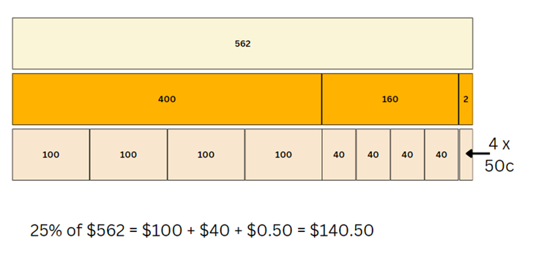

Discuss and connect the mathematics – 10 minutes
- Invite students to a whole class discussion about their excursion planning so far. Prompts could include:
- Have you found any calculations challenging?
- Which strategies have you used?
- Were you able to solve any calculations mentally?
- Have you checked your solutions using another method?
This table details opportunities for assessment.
Assessment opportunities | Links
What to look for:  - Can Stage 2 students interpret problems involving money as requiring either addition or subtraction?  [MAO-WM-01, MA2-AR-01]  - Can Stage 2 students calculate missing numbers by completing number sentences involving addition and subtraction?  [MAO-WM-01, MA2-AR-02]  - Can Stage 2 students find the missing number in an equivalent number sentence involving operations of addition or subtraction on both sides of the equals sign? [MAO-WM-01, MA2-AR-02]  - Can Stage 3 students solve multistep word problems, including problems that require more than one operation?  [MAO-WM-01, MA3-AR-01]  - Can Stage 3 students compare, evaluate and communicate strategies used to solve addition and subtraction problems? [MAO-WM-01, MA3-AR-01]  - Can Stage 3 students solve word problems involving the addition and subtraction of decimals up to 3 decimal places?  [MAO-WM-01, MA3-AR-01] | Links to National Numeracy Learning Progressions (NNLP):  - Stage 2 – AdS8, UnM6, UnM7, NPA3, NPA4  - Stage 3 – AdS7, AdS8, AdS9, MuS8.  Links to suggested Interview for Student Reasoning (IfSR) tasks:  - Stage 2 – IfSR-AT: Section 2 and Section 3  - Stage 3 – IfSR-AT: 3A.5.

Lesson 8
Core concept: mathematicians compare and evaluate strategies used to solve addition and subtraction problems, reasoning which strategy may be most efficient.

Daily number sense – 10 minutes
- From a class need surfaced through formative assessment data, identify a short, focused activity that targets students’ knowledge, understanding and skills. Example activities may be drawn from the following resources:
- Mathematics K–6 resources
- Universal Resources Hub.

Core lesson – zoo investigation – 30 minutes
The table below contains suggested learning intentions and success criteria. These are best co-constructed with students.
Core concept learning intentions | Core concept success criteria
Students working towards Stage 2 outcomes are learning to:  - select strategies flexibly to solve addition and subtraction problems of up to 3 digits  - complete number sentences involving additive relations to find unknown quantities.  Students working towards Stage 3 outcomes are learning to:  - choose and use efficient strategies to solve addition and subtraction problems  - apply known strategies to add and subtract decimals. | Students working towards Stage 2 outcomes can:  - compare and evaluate strategies used to solve addition and subtraction problems, reasoning which strategy may be most efficient  - calculate missing numbers by completing number sentences involving addition and subtraction  - find the missing number in an equivalent number sentence involving operations of addition or subtraction on both sides of the equals sign.  Students working towards Stage 3 outcomes can:  - solve multistep word problems, including problems that require more than one operation  - compare, evaluate and communicate strategies used to solve addition and subtraction problems  - solve word problems involving the addition and subtraction of decimals up to 3 decimal places.
Note: Lesson 8 is a continuation of Lesson 7 – a 2-lesson investigation into designing a zoo excursion. You may like to start your lesson with feedback from Lesson 7, including if you noticed any challenges students were facing.
- Students return to their groups and continue with their investigation.
- Monitor progress as students work, assisting with the organisation of the task. Whilst prompts have been provided, if students are working collaboratively and proceeding well, allow them to determine their own strategies and methods.
This table details opportunities for differentiation.
Too hard? | Too easy?
Stage 2 students cannot calculate missing numbers by completing number sentences involving addition and subtraction.  - Provide concrete materials such as counters or MAB materials to model the addition and subtraction number sentences.  - Support student learning by providing calculators, allowing students to engage with the same tasks.  - Guide students to complete one aspect of the investigation with teacher support.  Stage 3 students cannot solve multistep word problems, including problems that require more than one operation.  - For the cost of buses, link 25% with quarters. Guide students to use non-standard partitions that support finding quarters (562 = 400 + 160 + 2). Use a bar model to represent their thinking.  - Provide students with calculators to engage with the same tasks.  - Guide students to complete one aspect of the investigation. | Stage 2 students can calculate missing numbers by completing number sentences involving addition and subtraction.  - Challenge students to write some zoo scenarios that involve addition and/or subtraction for their classmates to solve.  - Develop a report for the principal about how much the buses cost, the entry fees for the class or grade, scenarios throughout the day and cost of purchases from the cafe.  Stage 3 students can solve multistep word problems, including problems that require more than one operation.  - Students further explore the map and investigate the distances and time between exhibits. For example, design a tour with the distance and time recorded between each exhibit.  - Students develop a report to provide the zoo with feedback and information from their investigation.

Discuss and connect the mathematics – 20 minutes
- Pair groups together to share and compare their calculations and findings. Ask each group to:
- explain their excursion plans
- share strategies they used and how they checked their answers
- identify sections they found challenging and those that were easier.
- At the end of the discussion, students write a personal reflection of their learning in additive relations. Some prompts may include:
- Where have you been flexible in your mathematics?
- When did you explain your thinking clearly?
- Can you provide an example of when you were accurate and efficient?
- What are 2 connections you can make about additive relations?
This table details opportunities for assessment.
Assessment opportunities | Links
What to look for:  - Can Stage 2 students compare and evaluate strategies used to solve addition and subtraction problems, reasoning which strategy may be most efficient? [MAO-WM-01, MA2-AR-01]  - Can Stage 2 students calculate missing numbers by completing number sentences involving addition and subtraction?  [MAO-WM-01, MA2-AR-02]  - Can Stage 2 students find the missing number in an equivalent number sentence involving operations of addition or subtraction on both sides of the equals sign? [MAO-WM-01, MA2-AR-02]  - Can Stage 3 students solve multistep word problems, including problems that require more than one operation?  [MAO-WM-01, MA3-AR-01]  - Can Stage 3 students compare, evaluate and communicate strategies used to solve addition and subtraction problems? [MAO-WM-01, MA3-AR-01]  - Can Stage 3 students solve word problems involving the addition and subtraction of decimals up to 3 decimal places?  [MAO-WM-01, MA3-AR-01] | Links to National Numeracy Learning Progressions (NNLP):  - Stage 2 – NPA3, NPA4  - Stage 3 – AdS7, AdS8, AdS9, MuS8.  Links to suggested Interview for Student Reasoning (IfSR) tasks:  - Stage 2 – IfSR-AT: Section 2 and Section 3  - Stage 3 – IfSR-AT: 3A.5.

Resource 1 – shopping receipt
BIG FRUIT BARN – Shopping Receipt | Cost
Zucchini 0.778kg NET @ $5.99/kg | $4.66
Bananas 0.442kg NET @ $2.99/kg | $1.32
Special | $0.99
Special | $1.50
Potatoes 1.328kg NET @ $2.99/kg | $3.97
Brussel sprouts 0.322kg NET @ $15.99/kg | $5.15
Broccoli 0.808kg NET @ $5.99 | $4.84
Special | $0.99
Grapes green 1.174kg NET @ $5.99/kg | $7.03
Snow peas 0.218kg NET @ $14.99 | $3.27
Cherry tomatoes | $2.99
Lettuce Iceberg | $2.49
Subtotal | $39.20
Loyalty card discount | -$15.00
Total | $24.20
Cash | $50.00
Change | $25.80

Resource 2 – additive strategies
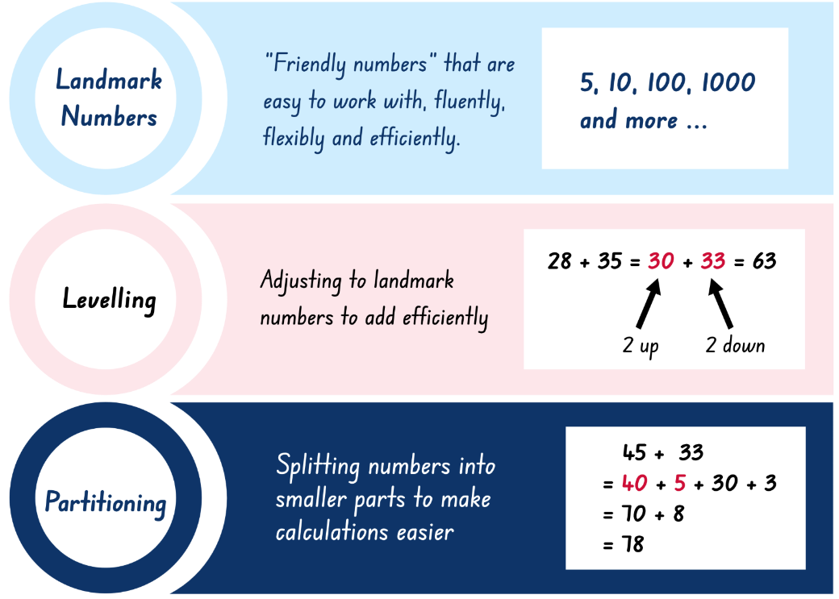
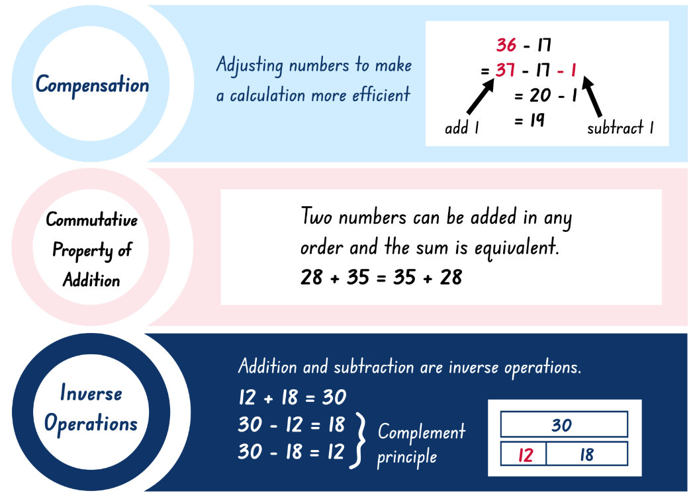
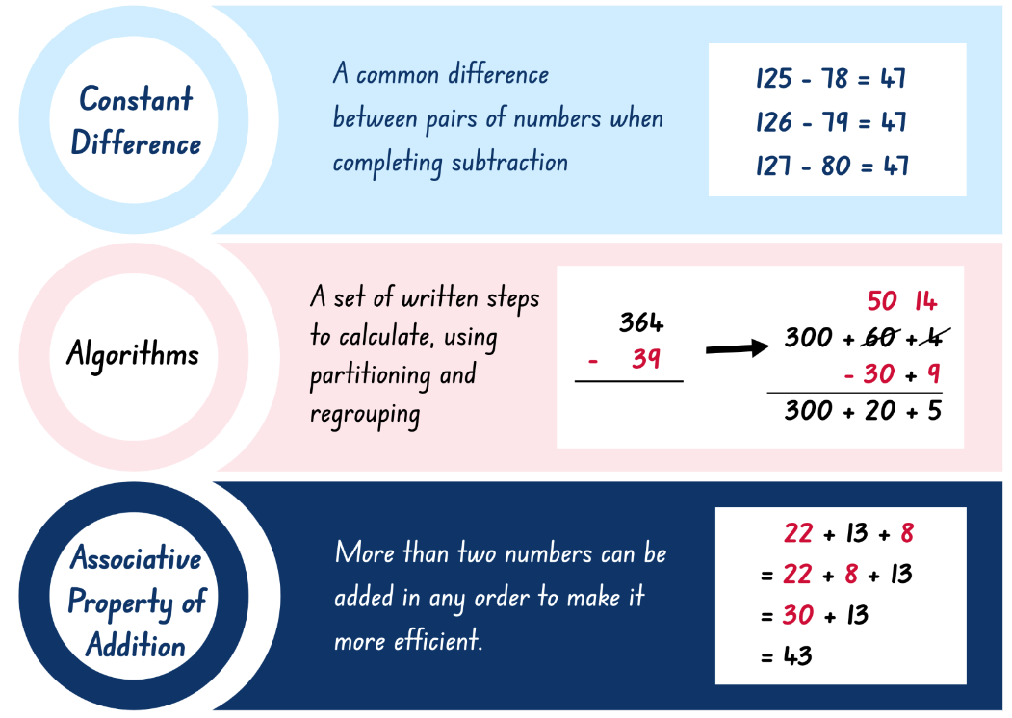
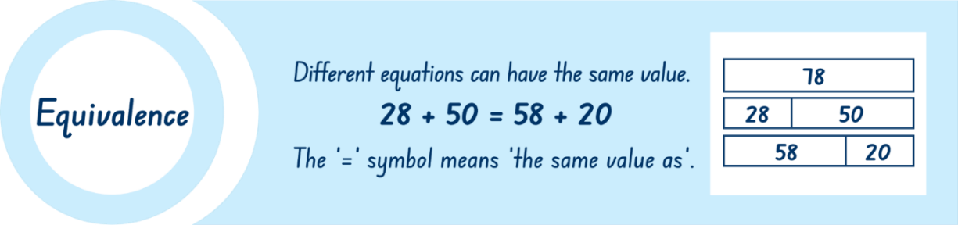

Resource 3 – bingo cards
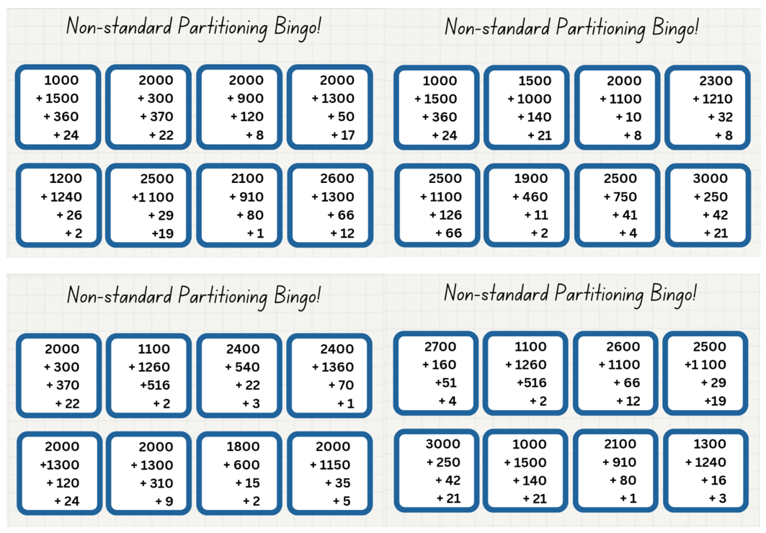
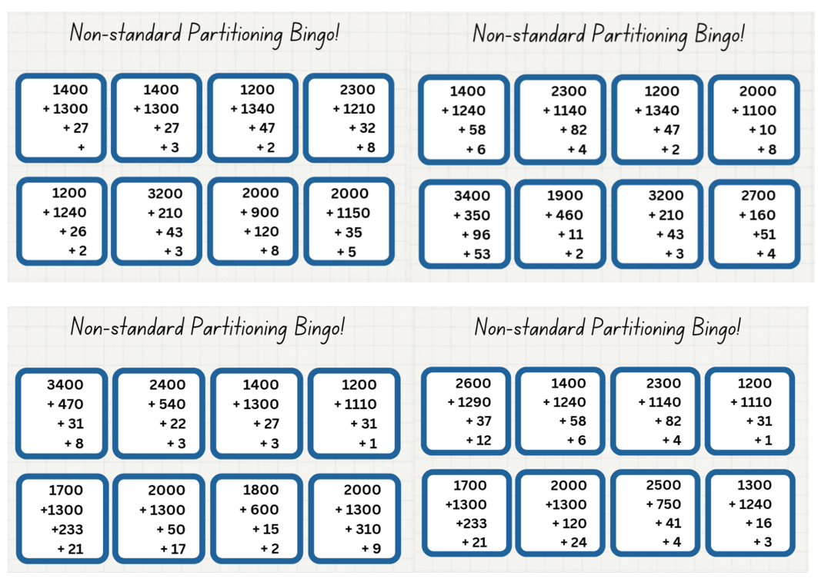

Resource 4 – bingo caller sheet
2342 | 2373 | 2417 | 2468 | 2559 | 2589 | 2661
2692 | 2704 | 2730 | 2878 | 2884 | 2915 | 2965
3028 | 3091 | 3118 | 3190 | 3254 | 3295 | 3313
3367 | 3444 | 3456 | 3526 | 3550 | 3619 | 3648
3778 | 3792 | 3831 | 3899 | 3909 | 3939 | 3978

Resource 5 – superstar sightseeing
You are the organiser of a new superstar singer’s sightseeing tour of your town. The singer and entourage will be arriving at 9:00 am on a private plane. Once here, they want to visit as many places as they can to earn money for their cause, ‘Children in Crisis.’
As the organiser, you need to design a schedule for the group to visit as many places as they can, before being back at the airport by 4:00 pm, where they will fly to their next destination. Along with a map of the possible places to visit and the time taken to drive between these, you have also been given a payment guide that states how much money each location will pay towards the charity.
There is one condition; your celebrity can visit any of the places as many times and for as long as you plan. However, they will only be paid for one visit and only for the time indicated. The only exception is the shopping centre, which will pay $52 for every half hour the superstar is there.
Do not forget: the superstar and their entourage must be at the airport by 4 pm!
Design your schedule to make as much money for the charity as you can.
Optional challenge
Create a schedule of visits that will allow your celebrity to attend an event at every state or territory capital city in Australia within 5 days and earn as much money as possible for their charity. You will need to track the kilometres travelled.
Payment for each event varies. Melbourne, Sydney and Brisbane are $802 per 30 minutes. All other capitals are $715 per 30 minutes.

Resource 6 – map
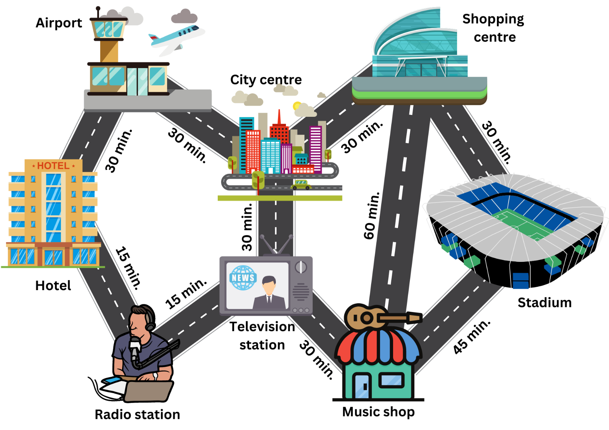

Resource 7 – place value chart
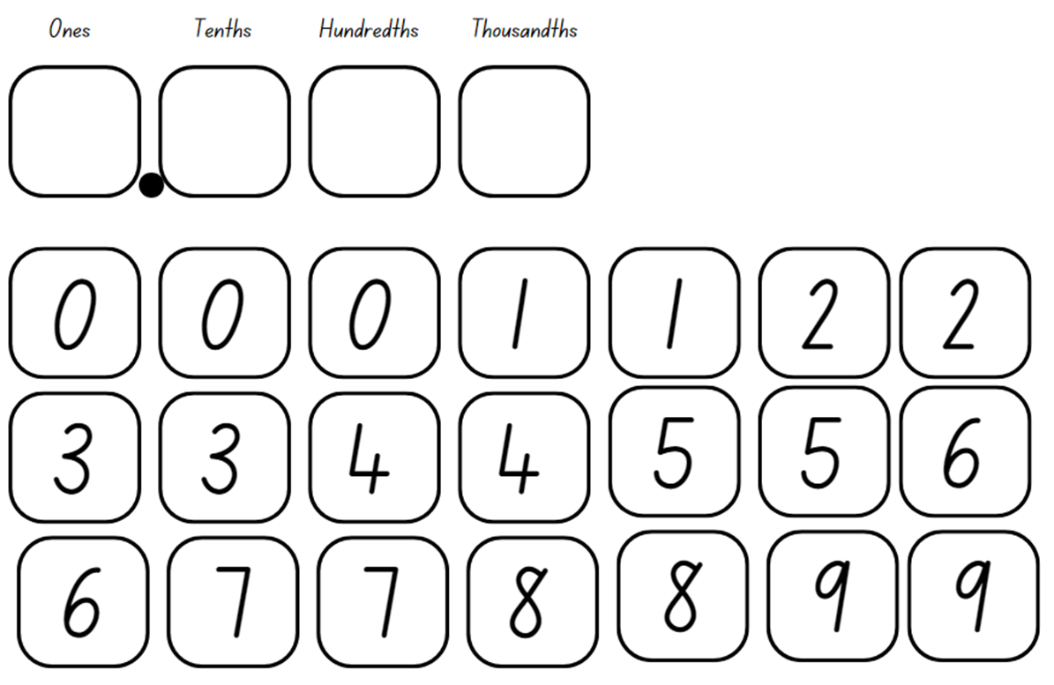

Resource 8 – reflection chart
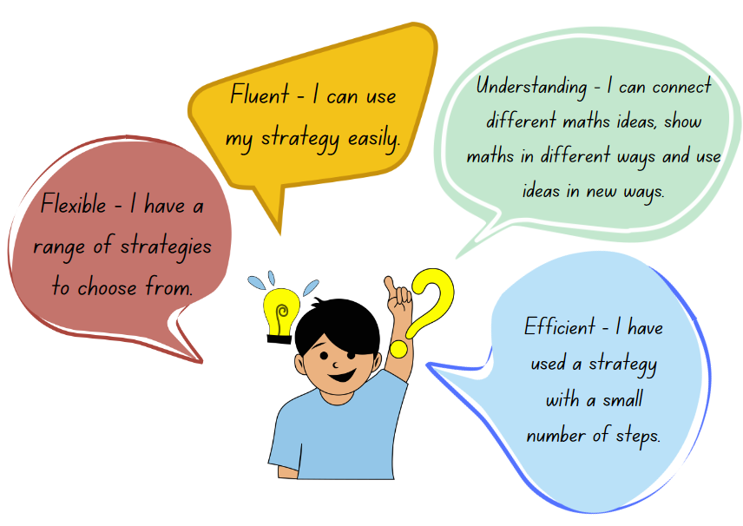

Resource 9 – self-assessment
Self-assessment statements | No | Sometimes | Yes
I am learning to apply place value to partition, regroup and rename numbers.
I can identify the place value of each digit in a number up to 6 digits.
I can use place value to expand numbers in standard form.
I can partition numbers in non-standard forms.
I can use composition and decomposition to flexibly partition numbers to suit my thinking.
I can use the associative property of addition to make my calculations more efficient.

Resource 10 – comparing strategies grid
Standard partitioning  590 − 257 = 500 − 200 − 90 − 50 − 7  = 300 − 40 − 3  = 333 | Estimation  600 − 250 = 350 | Algorithm with understanding  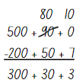
Constant difference | 590 − 257 | Number line
Non-standard partitioning | Free choice | Free choice

Resource 11 – place value houses
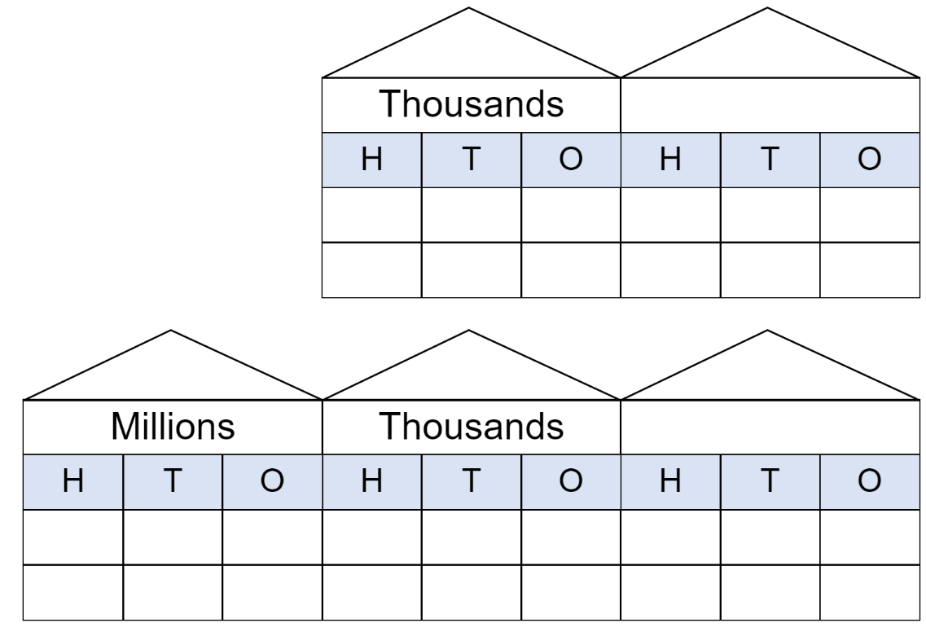

Resource 12 – data sources
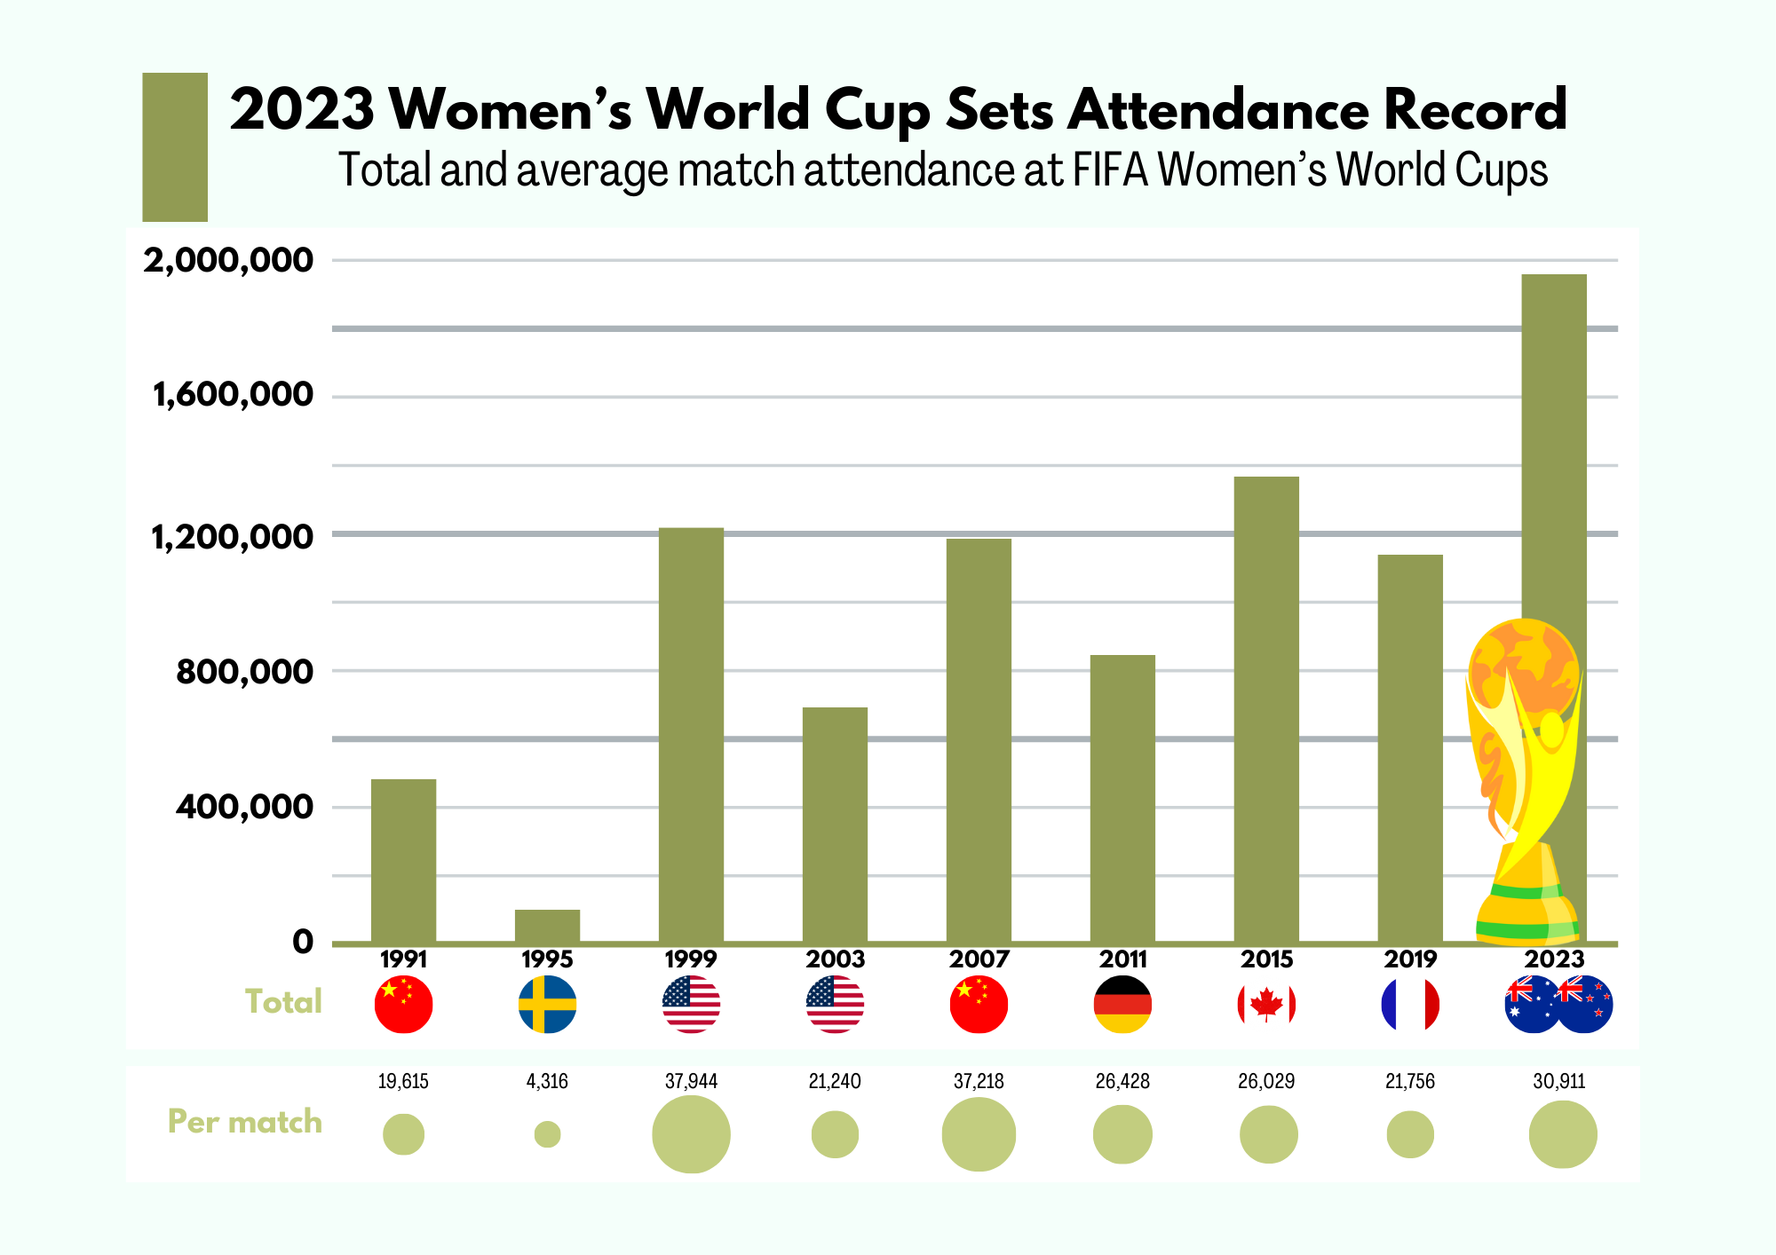
‘2023 Women’s World Cup Sets Attendance Record’ by statista.com is licensed under the Creative Commons License CC BY-ND 3.0
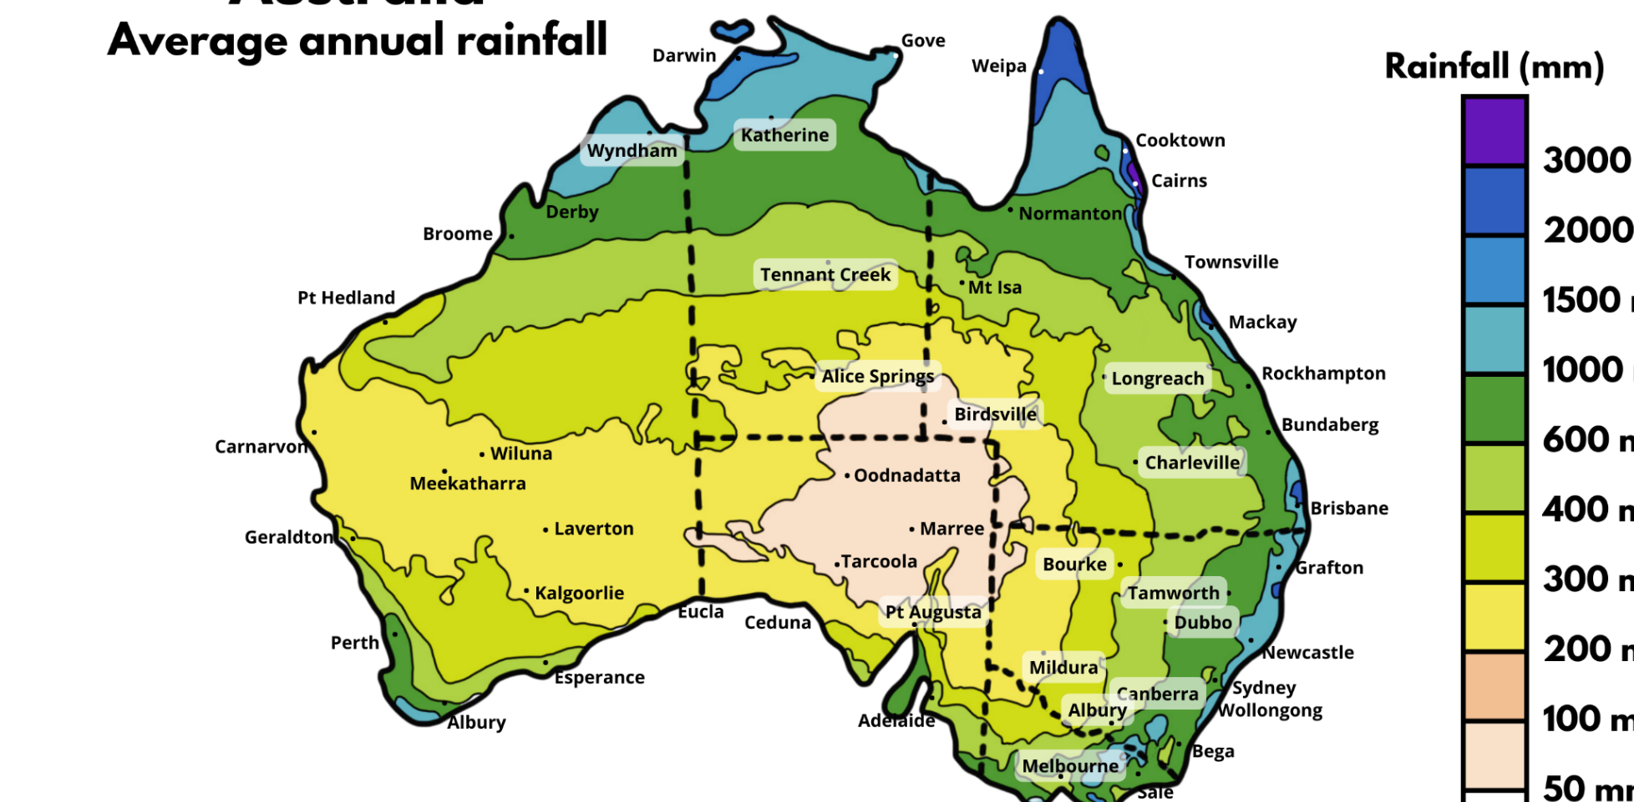
Adapted from Commonwealth of Australia (2021)

Resource 13 – data activities
- Calculate the difference in total attendance for World Cup matches in 2023 and 2003.
- How many additional people attended per match in 1999 compared to 1995?
- Calculate the difference between the smallest and largest match attendance total.
- What is the difference between the smallest and largest attendance per match?
- About how much more rainfall does Oodnadatta SA need to reach the shaded purple level (3000 mm)?
- Calculate the additional rainfall needed for Bourke NSW to be shaded dark blue (2000 mm).
- What is the difference in average annual rainfall between Mildura NSW and Darwin NT?

Resource 14 – garden designs
Your task is to look after a rectangular garden measuring 7.95 metres long. You decide to extend the garden by planting more flowers, which adds 2.15 m to the garden’s length. Later, you extend the garden length by an extra 3.85 m to plant fruit trees. Finally, a brick path is added across middle of the garden, reducing the total garden length by 1.15 m.
Questions:
- What is the final length of the garden?
- What is the difference between the initial and final garden length?
- How much shorter is the flower bed than the fruit trees?
- How much longer is the flower bed than the path?
- Where would the middle of the garden be for the path?
- If you divide the garden into 4 equal sections, what would be the length of each section?
- If the owner asked you to make the garden 25% longer, how much would you need to add? How long would the garden now be?

Resource 15 – decimats
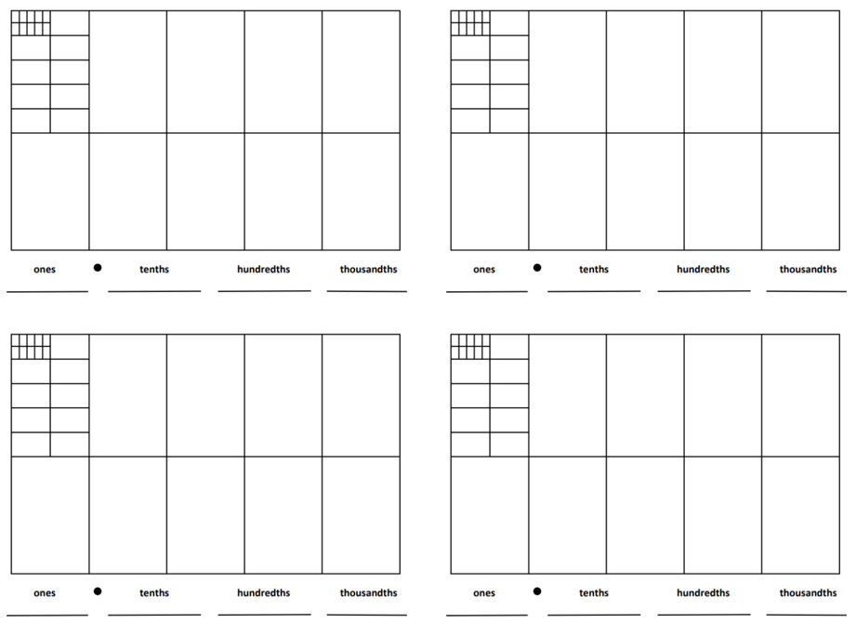

Resource 16 – canteen price list
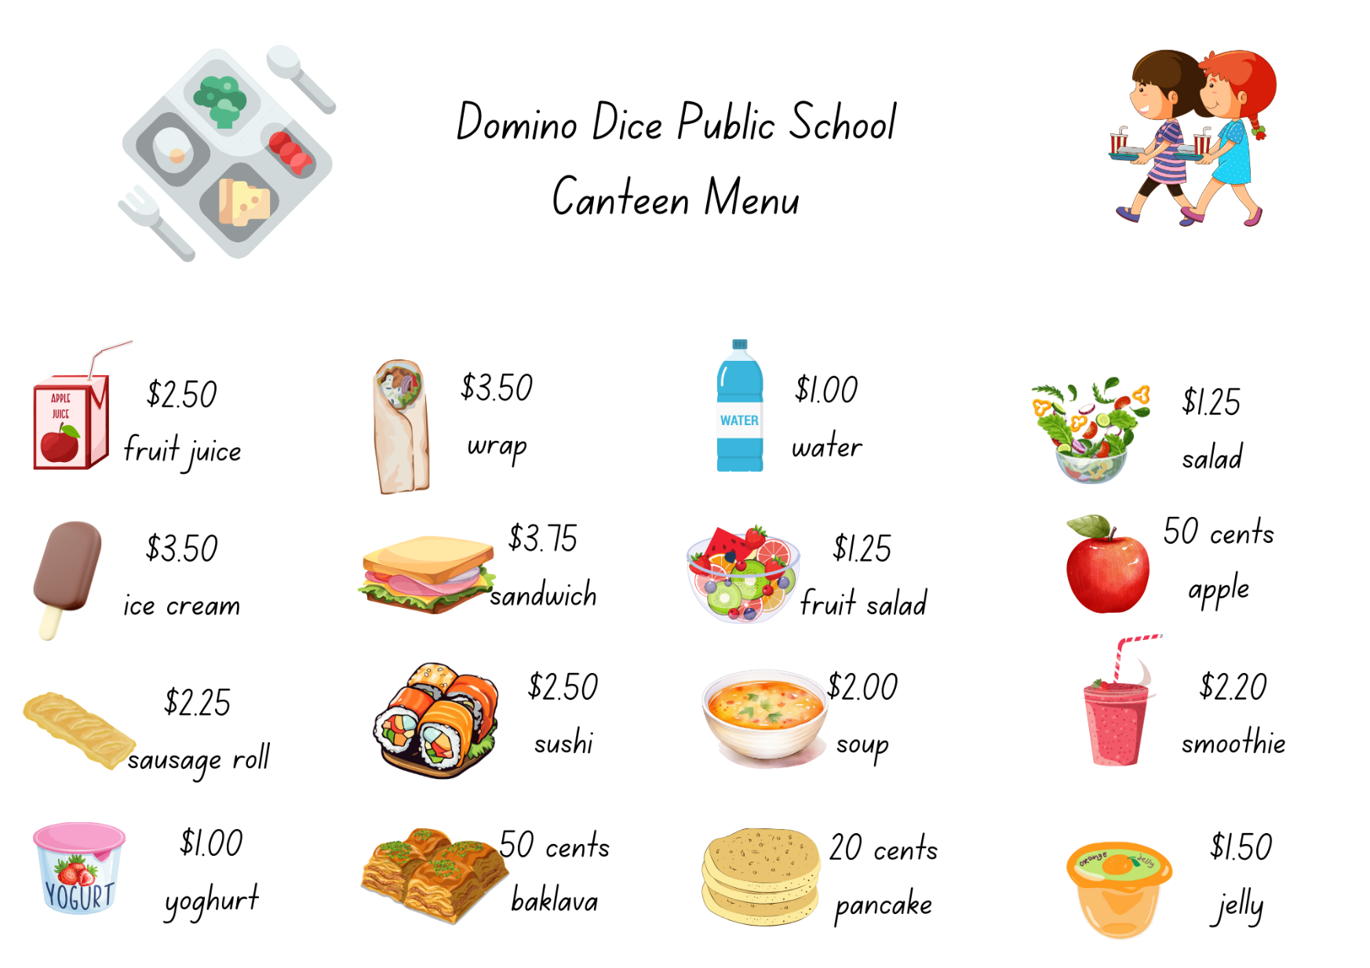

Resource 17 – 1–3 spinner
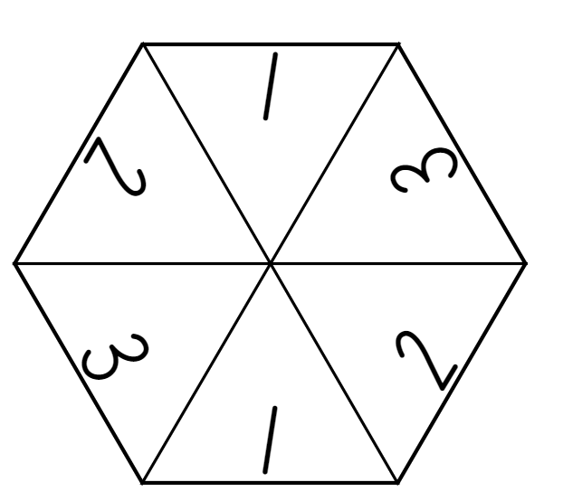

Resource 18 – party activities
List 1: activity items | Cost | List 3: lunch items | Cost
Jumping castle | $368.00 | Party meat pies (12 pieces) | $6.80
Outdoor toys rental | $215.90 | Party sausage rolls (12 pieces) | $6.80
Face Painting and hair spray | $149.00 | Lunch size pizzas (1 per child) | $5.65
Petting zoo | $432.00 | Chicken nuggets (12 pieces) | $4.40
Outdoor cinema | $153.50 | Spring rolls (12 pieces) | $7.65
Karaoke machine | $204.30 | Sushi platter (serves 15) | $65.80
Inflatable obstacle course | $576.00 | Fruit platter (serves 15) | $36.75
Piñata (unfilled) | $65.85 | BBQ sauce (1 bottle) | $2.10
Lollies for piñata | $47.00 | Tomato sauce (1 bottle) | $1.95

List 2: supply items | Cost | List 4: snacks and drinks | Cost
Balloon garland (large) | $68.00 | Box of lolly bags (10 packets) | $13.50
Ballon garland (small) | $34.45 | Box of chips (10 packets) | $8.90
Colourful foil door curtain | $14.00 | Popcorn (10 packets) | $6.75
Coloured streamers | $8.90 | Ice blocks (10 pack) | $4.80
Disco light | $56.95 | Chocolate frogs (12 pack) | $4.50
Best class banner | $10.50 | Ice cream cake (serves 15) | $14.00
Photo booth (backdrop and props) | $74.65 | Sparkling flavoured water (12 pack) | $6.40
Serviettes (50 pack) | $4.95 | Bottled water (12 pack) | $5.95
Paper plates (20 pack) | $3.35 | Juice (12 pack) | $10.10
Tablecloths (one per 3 student desks) | $4.75 | Flavoured milk (12 pack) | $12.50

Resource 19 – planning sheet
Item | Price per Item | Quantity needed | Total cost
 |  | TOTAL

Resource 20 – party problems
Problem 1
A teenager goes into a party shop and buys 4 items for their party, each costing one dollar or more. The sale assistant tells the teenager the total is $8.95. Calculate the possible prices of the 4 items.
Problem 2
A shopper visits a party store and buys large helium balloon decorations, each more than $25. At the checkout, the sales assistant tells her the total is $120.75. Calculate the possible prices of the 3 items.
Problem 3
The birthday boy purchased 4 party favours. The total cost was $42.69 but he was overcharged $6.55. Calculate the possible prices of the 4 items.
Problem 4
In a party store, Alex gets 3 large party decorations. The prices are a bit unclear and when Alex goes to pay the total is $110. The first party decoration costs twice as much as the second, and the third-party decoration costs $10 less than the second. Can you find out how much each party decoration costs?

Resource 21 – pocket money
Imagine your family agreed to give you some pocket money every day for a month. You can choose from the following options:
- $10 every day
- $3 on the first day, $3.50 on the second, $4 on the third and so on, increasing by 50 cents per day
- 5 cents on the first day, 10 cents on the second, 20 cents on the third and so on, doubling each day.
Without doing any working out, which one would you choose and why?
In a month with 31 days, how much money would you have by the end of the month, under each system? You may wish to explore using a spreadsheet.
Here are some questions you might like to consider:
- In which months would option 1 be better than option 2?
- If your family stopped your pocket money on day 8, which option would give you the most?
- On which day of the month does option 3 become the most fruitful?
- If you chose option 3, how many days would it be before you became a millionaire?
This activity is an adaption of Pocket money from NRICH by the University of Cambridge.

Resource 22 – different strategies
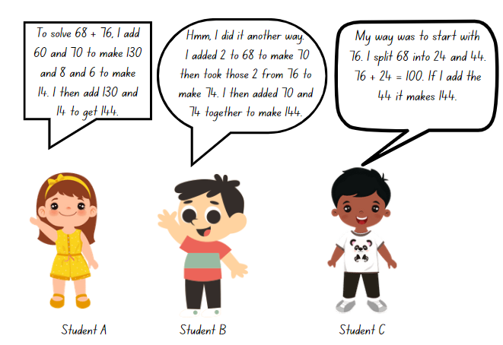

Resource 23 – chocolate costs 1
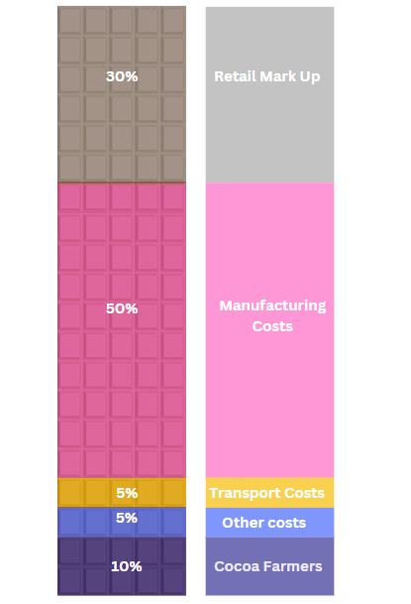

Resource 24 – chocolate costs 2
You have just purchased a block of chocolate for $4.00. Using the grid below, show how the costs are distributed. Record how much money each sector would receive out of your block of chocolate.
Sector | Percentage | Amount | Sector | Percentage | Amount
Cocoa farmer | 10% |  | Manufacturing | 50%
Other costs | 5% |  | Retail | 30%
Transportation | 5%

Resource 25 – raw to retail
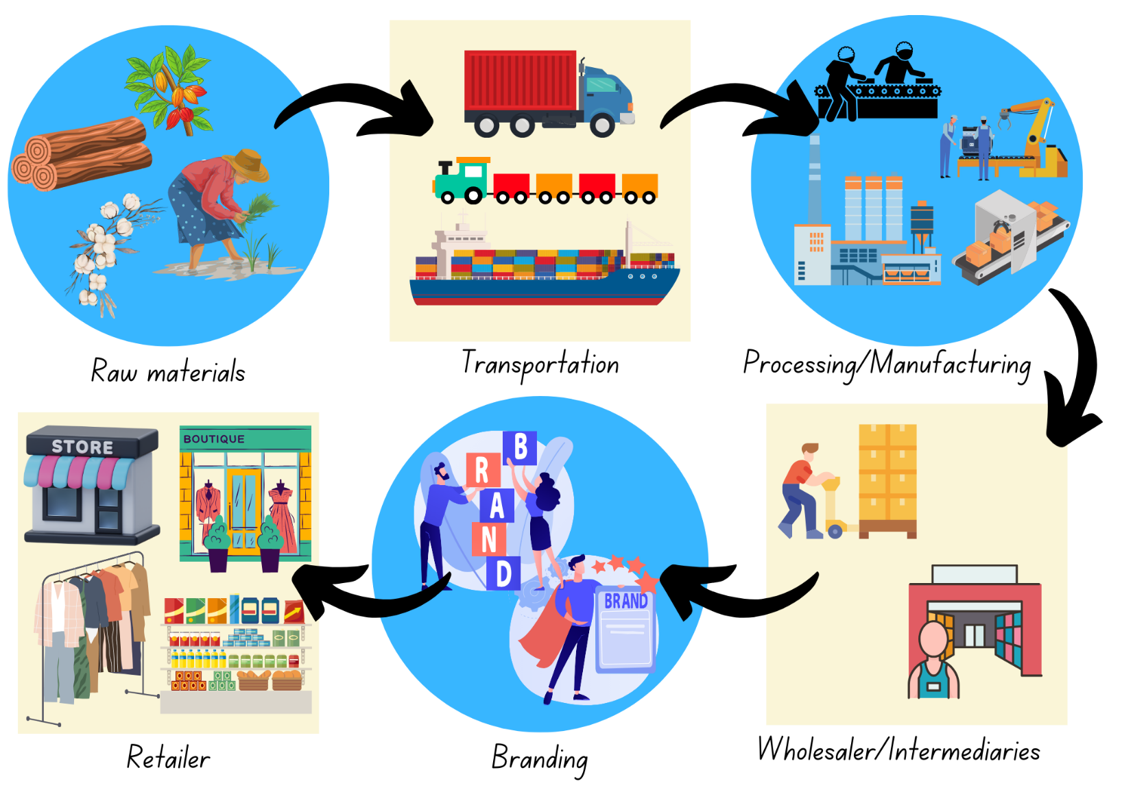

Resource 26 – Imogen’s T-shirt shop

Resource 27 – product costs
Complete the grid and table for your chosen item of clothing, stating the percentages and money distributed between each sector.
What is the cost of your item?
Sector | Percentage | Amount | Sector | Percentage | Amount
Raw materials |  |  | Branding
Transportation |  |  | Wholesalers
Manufacturing |  |  | Retail

Resource 28 – score 4
Questions |  |  |  | Answers
0.4 + 0.1 | 0.88 − 0.34 | 72.2 − 4.95 | 0.772 + 0.201 | 0.54 | 39.018 | 1.30 | 34.15
0.48 + 0.99 | 6.198 + 63.91 | 0.6 + 0.2 | 0.96 − 0.25 | 39.46 | 0.973 | 0.45 | 77.03
5.14 + 26.3 | 0.54 + 0.74 | 0.82 − 0.33 | 86.7 − 9.67 | 0.49 | 0.50 | 67.25 | 1.66
0.59 − 0.14 | 41.8 − 2.782 | 1.76 + 37.7 | 0.5 + 0.8 | 1.28 | 2.94 | 70.108 | 1.20
4.2 − 1.26 | 0.8 + 0.4 | 0.96 + 0.7 | 3.25 + 30.9 | 0.8 | 31.44 | 1.47 | 0.71

Resource 29 – blank grid
Questions |  |  |  | Answers

Resource 30 – concert hall
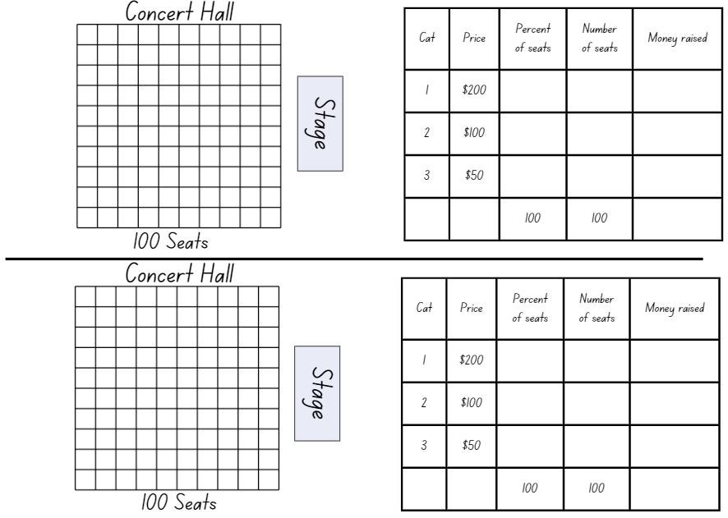

Resource 31 – different models
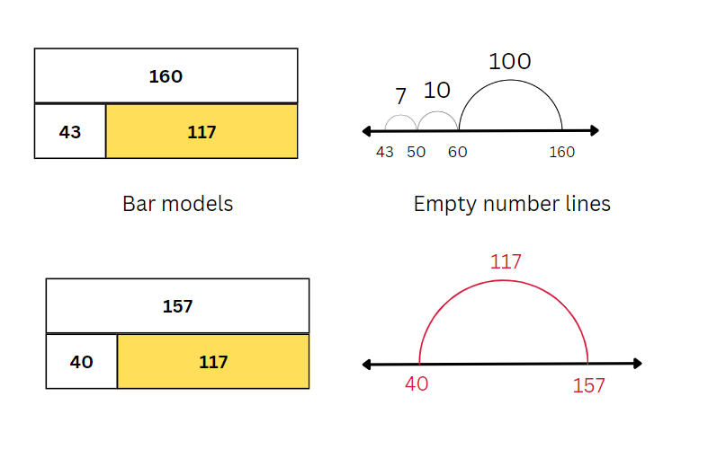

Resource 32 – 100 grids
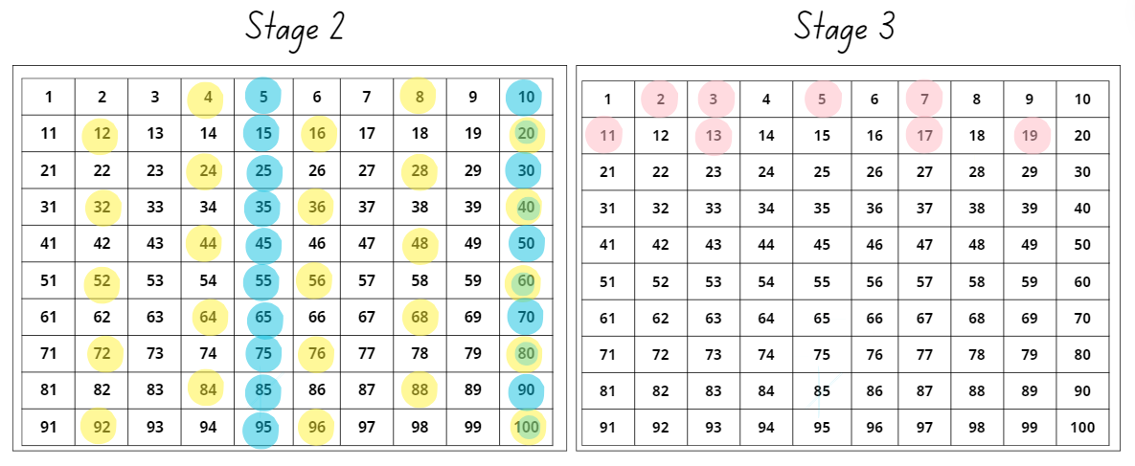

Resource 33 – blank 100 grid
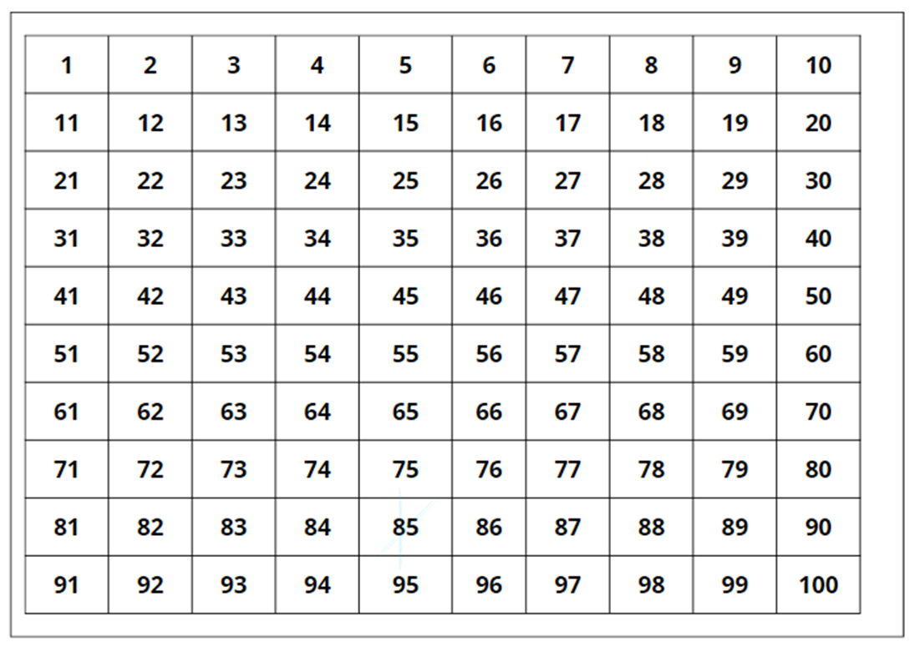

Resource 34 – addition questions
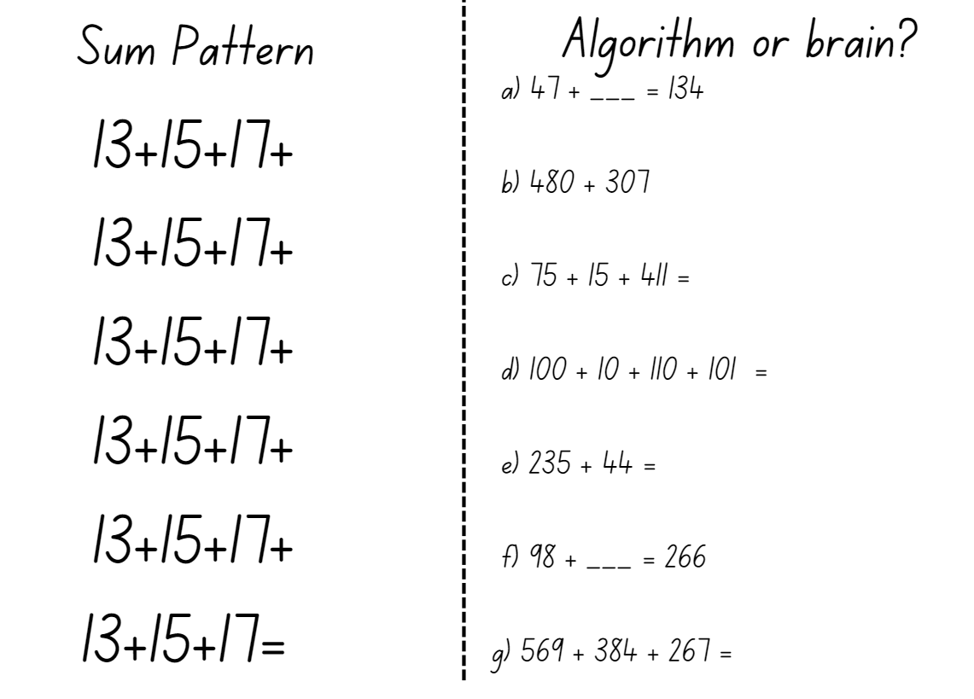

Resource 35 – mountain climbing think board
K2 is the world’s second highest mountain. Of the 5 highest mountains in the world, K2 is the deadliest.
The highest point of the mountain (summit) is 8611 m above sea level. Many people who attempt to climb K2 only reach Base Camp, which is 5150 m above sea level. About what percentage of the mountain do the mountaineers climb when they reach base camp?
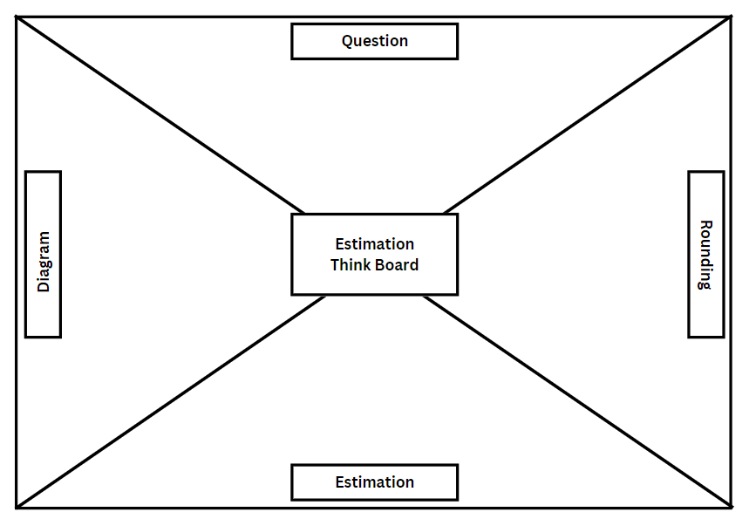

Resource 36 – estimation activities
Activity 1: Temperature readings
The playground temperature was monitored every hour in the morning, as seen in the table below. What was the approximate temperature difference between the highest and lowest temperature? What was the approximate percentage increase?
Time | 8:00 am | 9:00 am | 10:00 am | 11:00 am | 12:00 pm
Temperature | 17.37℃ | 18.4℃ | 19.29℃ | 22.08℃ | 25.46℃
Activity 2: Easter Show budget
Mike went to the Easter Show. He was given $150 spending money for the day. He spent money on the following items. Estimate how much money Mike had left at the end of the day.
Item | Cost
Return train ticket | $10.90
Entry ticket to the show | $32.00
Rides | 5 rides for $12.00 each
Food and drinks | $23.40
Show bag | $7.50

Resource 37 – think board
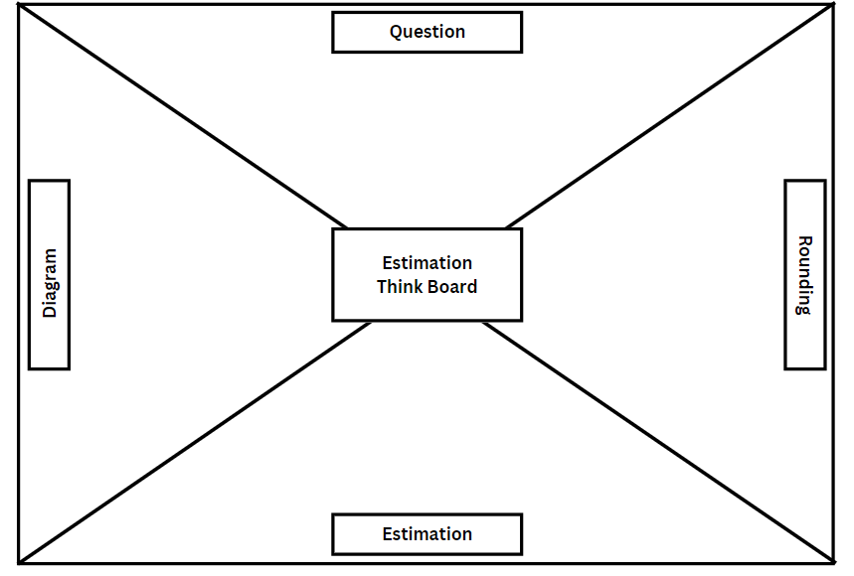

Resource 38 – zoo excursion planner (Stage 2)
You are going on an excursion. Each class that attends the excursion will have a teacher and adult helper supervising them. Transport to and from the excursion will be by bus. There will be food available for purchase at the cafe.
Bus hire
The school has booked 2 buses to take the students to the zoo. Each bus can hold up to 65 people. The first bus has 7 more people than the second bus. How many people could be on each bus?
Provide 3 possible solutions to this problem. Show your calculations.
Entry tickets
The zoo’s rules say that school excursion groups must enter the gates 4 people at a time. How much could it cost for your group to enter the zoo?
Provide 3 possible combinations for group entry costs. For example, your group could contain 4 students, or it may contain 3 students and a teacher.
Lunch
Students can buy their lunch from the cafe. Each student will have $20 to spend to buy one lunch food, one snack and one drink. Students must calculate how much they have spent and the change they would receive from $20.

Zoo scenarios
During the day, the students encountered several interesting scenarios. Students must read the following scenarios and show how they would solve each of the problems:
- The lions and tigers needed to be transported by truck to the vet for their yearly injections. The truck can carry 350 kg. The weights of lions and tigers can be found below.
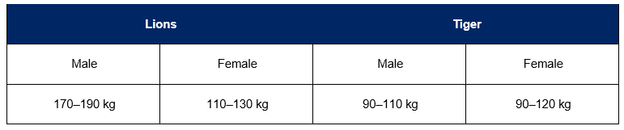
- The zoo has 5 lions and 4 tigers. Provide possible combinations of animals for their transportation to the vets and determine how many trips it would take for all animals to have their injections.
- The crocodile escaped! There are 4 safe areas within the zoo for people to go to when this happens. Each of the safe areas can hold between 100 and 150 people. On this day there were 586 visitors at the zoo. Provide 3 possible solutions for how many people could have been in each of the safe areas.
- Each day one koala can eat between 150 and 200 eucalyptus leaves. The zoo has 5 koalas.
- What is the minimum number of leaves the zoo will need each day?
- What is the maximum number of leaves the zoo will need each day?
- If each of the koalas eat a different number of leaves, what could those amounts be?
- The animals were taken on a parade around the zoo. One of the bridges within the zoo has a limit of 120 kg. The weights of the animals can be found below.
Animal | Number of animal in the zoo | Weight (kg) |  | Animal | Number of animal in the zoo | Weight (kg)
Seal | 5 | 60 |  | Monkey | 6 | 47
Snake | 3 | 15 |  | Meerkat | 15 | 1
Giraffe (baby) | 2 | 70 |  | Koala | 5 | 12
Gorilla | 4 | 112 |  | Flamingo | 9 | 3
Tortoise | 2 | 95 |  | Kangaroo | 4 | 54
- List the combination of animals that could cross the bridge together without exceeding the weight limit.
Note: each problem could be solved in more than one way. If time permits, demonstrate more than one solution to each of the problems.

Resource 39 – zoo excursion planner (Stage 3)
The cost of the zoo excursion needs to include hiring a bus, entry tickets and cafe food.
Bus hire
- You only need one bus for your excursion. There are 2 bus companies to choose from:
- Eppinorm Buses charges $562 to hire a bus for the day, but because you are a local school, they will give you a 25% discount.
- The Heights Buses costs $250 to hire for the day plus $3.25 for every kilometre it travels. The zoo is 21.5 km away.
Which company would be the cheapest? How much would each student have to pay? Show your calculations.
Entry tickets
The zoo’s rules say that there needs to be a supervision ratio of 1:10. Do you have enough teachers for this rule, or will you need to bring some parents? Explain your reasons.
Using the prices on the Entry and Activities boards, work out the cheapest way of buying tickets for everyone. Do not forget the teachers/adults.
For school excursions, the ticket cost for teachers/adults is paid for by the students. Using the best price you found, find the cost for each student. Add this to the bus hire fee per student. How much does each student need to pay for the excursion now?

Lunch packs
To ensure the zoo has enough food on the day, they have asked you to form a lunch pack. Use the zoo menu to make a lunch pack that includes one lunch food, one snack and one drink without going over $15 and then add to the total cost.
Schedule for the day
Make a timetable for the day that includes visits to all the animals. To complete this, you must consider the following:
- What time does school start? Will you need to leave earlier than this to get the most out of the day?
- What time do you need to get back to school?
- How long will it take the bus to get to the zoo and return to school?
- How long do you need for recess and lunch breaks?
- There are daily experiences at the zoo shown on the Entry and Activities board. Which feeding or talks will students attend? Are there any that are not possible?
- A map has been provided. How long will it take to move between each animal exhibit?
Note: Eppinorm Zoo opens at 9 am and closes at 4:30 pm. Zoo staff say that it takes about 30 minutes to walk from the zoo shop to the penguin exhibit, past the elephants and lions. The bus company has estimated the bus ride to the zoo will take 40 minutes in the morning and 30 minutes to return to the school in the afternoon.

Resource 40 – zoo map
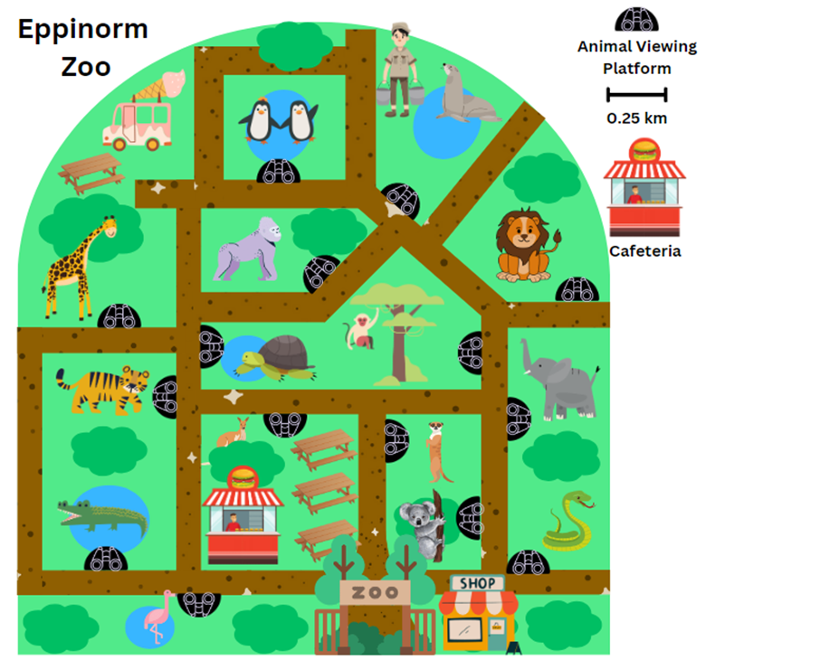

Resource 41 – entry and zoo menu (Stage 2)
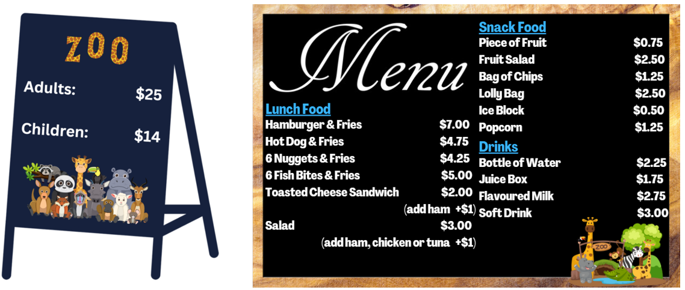

Resource 42 – entry and activities (Stage 3)
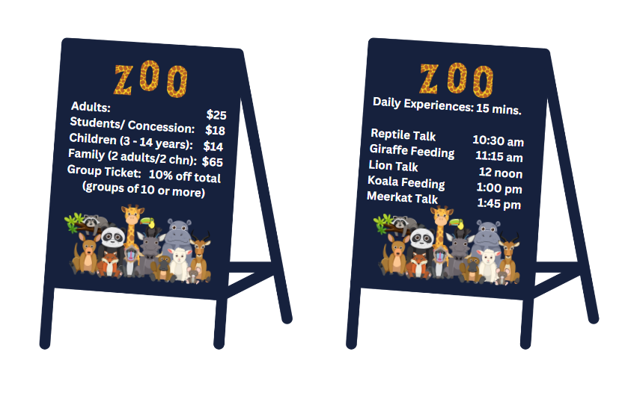

Resource 43 – zoo menu (Stage 3)
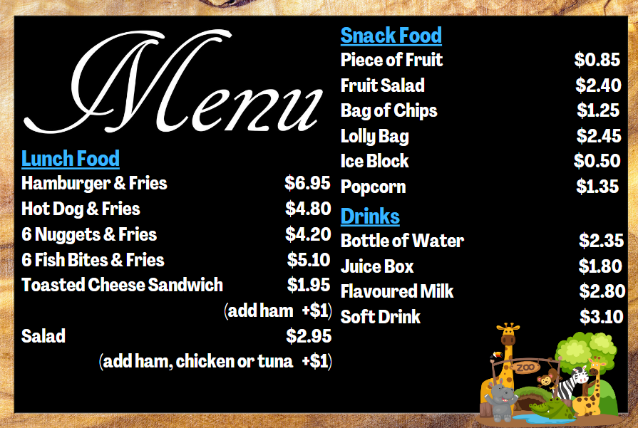

Syllabus outcomes and content

Stage 2
The table below outlines the syllabus outcomes and range of relevant syllabus content covered in this unit. Content is linked to National Numeracy Learning Progression (version 3).
Outcomes and content | 1 | 2 | 3 | 4 | 5 | 6 | 7 | 8
Representing numbers using place value A: Whole numbers: Read, represent and order numbers to thousands
MAO-WM-01, MA2-RN-01
- Represent numbers up to and including thousands using physical or virtual manipulatives, words, numerals, diagrams and digital displays |  |  |  |  | x
Representing numbers using place value B: Whole numbers: Apply place value to partition, regroup and rename numbers up to 6 digits
MAO-WM-01, MA2-RN-01
- Use place value to expand the number notation |  | x
- Partition numbers of up to 6 digits in non-standard forms |  | x
Representing numbers using place value B: Whole numbers: Recognise and represent numbers that are 10, 100 or 1000 times as large
MAO-WM-01, MA2-RN-01
- Recognise the number of tens, hundreds or thousands in a number |  | x
Additive relations A: Use the principle of equality
MAO-WM-01, MA2-AR-01, MA2-AR-02
- Recognise equal differences and record them in number sentences | x
- Use the equals sign to mean 'the same as', rather than to perform an operation | x
Additive relations A: Recognise and explain the connection between addition and subtraction
MAO-WM-01, MA2-AR-01, MA2-AR-02
- Demonstrate how addition and subtraction are inverse operations |  |  |  |  | x
Additive relations A: Select strategies flexibly to solve addition and subtraction problems of up to 3 digits
MAO-WM-01, MA2-AR-01, MA2-AR-02
- Apply known mental strategies that use partitioning to add and subtract, such as bridging the decades |  |  |  | x |  | x
- Apply the levelling and constant difference strategies (Reasons about relations) |  |  |  | x
- Represent solutions to addition and subtraction problems, including word problems, using an empty number line or bar model |  |  |  |  | x
- Compare and evaluate strategies used to solve addition and subtraction problems, reasoning which strategy may be most efficient |  |  |  |  | x |  | x | x
Additive relations A: Represent money values in multiple ways
MAO-WM-01, MA2-AR-01, MA2-AR-02
- Perform calculations with money, including finding change |  |  | x
Additive relations B: Partition, rearrange and regroup numbers to at least 1000 to solve additive problems
MAO-WM-01, MA2-AR-01, MA2-AR-02
- Use quantity values and non-standard partitioning to solve addition and subtraction problems | x | x
- Model addition with and without regrouping and record the method used |  | x | x | x
- Model subtraction with and without regrouping and record the method used |  | x | x | x
- Use an algorithm with understanding to record addition and subtraction calculations, where efficient, involving 3-digit numbers |  |  |  |  |  | x
- Recognise how hundreds are exchanged in subtraction algorithms requiring regrouping |  |  |  |  |  | x
Additive relations B: Apply addition and subtraction to familiar contexts, including money and budgeting
MAO-WM-01, MA2-AR-01, MA2-AR-02
- Use estimation to check the validity of solutions to addition and subtraction problems, including those involving money |  |  | x
- Interpret problems involving money as requiring either addition or subtraction | x |  | x |  |  |  | x | x
Additive relations B: Complete number sentences involving additive relations to find unknown quantities
MAO-WM-01, MA2-AR-01, MA2-AR-02
- Calculate missing numbers by completing number sentences involving addition and subtraction (Algebraic reasoning) |  |  |  |  |  |  | x | x
- Find the missing number in an equivalent number sentence involving operations of addition or subtraction on both sides of the equals sign (Algebraic reasoning) |  | x |  |  |  |  | x | x
- Create word problems that correspond to given addition and subtraction number sentences |  |  | x
Multiplicative relations A: Represent and solve problems involving multiplication fact families
MAO-WM-01, MA2-MR-01
- Apply the inverse relationship of multiplication and division (Reasons about relations) |  |  |  |  | x
Multiplicative relations B: Investigate number sequences involving related multiples
MAO-WM-01, MA2-MR-01, MA2-MR-02
- Generate number patterns using related multiples |  |  |  |  | x | x
- Investigate number patterns involving related multiples |  |  |  |  |  | x
Multiplicative relations B: Represent and solve word problems with number sentences involving multiplication or division
MAO-WM-01, MA2-MR-01, MA2-MR-02
- Complete number sentences involving multiplication and division by calculating missing numbers (Reasons about relations) |  |  |  |  |  |  | x
Mathematics K–10 Syllabus © NSW Education Standards Authority (NESA) for and on behalf of the Crown in right of the State of New South Wales, 2022.

Stage 3
The table below outlines the syllabus outcomes and range of relevant syllabus content covered in this unit. Content is linked to National Numeracy Learning Progression (version 3).
Outcomes and content | 1 | 2 | 3 | 4 | 5 | 6 | 7 | 8
Represents numbers A: Decimals and percentages: Recognise that the place value system can be extended beyond hundredths
MAO-WM-01, MA3-RN-02, MA3-RN-03
- Express thousandths as decimals |  |  | x
- Use place value to partition decimals |  |  | x
Representing numbers B: Decimals and percentages: Make connections between benchmark fractions, decimals and percentages:
MAO-WM-01, MA3-RN-02, MA3-RN-03
- Represent common percentages of quantities and lengths as fractions and decimals |  |  |  | x
- Recognise that 10% is one-tenth of 100% and use this to find 10% of a quantity (Reasons about relations) |  |  |  | x | x
Representing numbers B: Decimals and percentages: Determine percentage discounts of 10%, 25% and 50%
MAO-WM-01, MA3-RN-03
- Equate 10% to dividing by 10, 25% to finding a quarter by dividing by 4, and 50% to finding half |  |  |  | x | x
- Use mental strategies to estimate discounts of 10%, 25% and 50% |  |  |  |  |  | x
Additive relations A: Apply efficient mental and written strategies to solve addition and subtraction problems
MAO-WM-01, MA3-AR-01
- Apply known strategies such as levelling, addition for subtraction, using constant difference, and bridging (Reasons about relations) |  | x
- Use place value to add or subtract 3 or more numbers with different numbers of digits | x | x
- Determine when it would be more efficient to use a calculator to add numbers | x
Additive relations A: Use estimation and place value understanding to determine the reasonableness of solutions
MAO-WM-01, MA3-AR-01
- Round numbers appropriately when obtaining estimates to numerical calculations |  |  |  |  |  | x
- Use estimation to check the reasonableness of solutions to addition and subtraction calculations |  |  |  |  |  | x
Additive relations B: Choose and use efficient strategies to solve addition and subtraction problems
MAO-WM-01, MA3-AR-01
- Solve multistep word problems, including problems that require more than one operation |  |  |  |  |  |  | x | x
- Compare, evaluate and communicate strategies used to solve addition and subtraction problems | x | x |  |  |  |  | x | x
Additive relations B: Applies known strategies to add and subtract decimals
MAO-WM-01, MA3-AR-01
- Model the addition and subtraction of decimals up to 3 decimal places using appropriate representations |  |  | x |  | x
- Solve word problems involving the addition and subtraction of decimals up to 3 decimal places | x |  |  |  |  | x | x | x
- Justify why the strategy used to solve addition and subtraction word problems is appropriate (Reasons about quantity) | x |  | x
Multiplicative relations A: Determine products and factors
MAO-WM-01, MA3-MR-02
- Determine whether a number is prime, composite or neither (0 or 1) |  |  |  |  |  | x
Multiplicative relations B: Use equivalent number sentences involving multiplication and division to find unknown quantities
MAO-WM-01, MA3-MR-02
- Complete number sentences that involve more than one operation by calculating missing numbers |  |  |  |  |  |  | x
- Identify and use inverse operations to assist with the solution of number sentences |  |  |  |  | x
Non-spatial measure B: Time: Solve problems involving duration, using 12- and 24-hour time
MAO-WM-01, MA3-NSM-02
- Use start and finish times to calculate the elapsed time of events lesson | x |  |  |  |  |  | x | x
Mathematics K–10 Syllabus © NSW Education Standards Authority (NESA) for and on behalf of the Crown in right of the State of New South Wales, 2022.

References
This resource contains NSW Curriculum and syllabus content. The NSW Curriculum is developed by the NSW Education Standards Authority. This content is prepared by NESA for and on behalf of the Crown in right of the State of New South Wales. The material is protected by Crown copyright.
Please refer to the NESA Copyright Disclaimer for more information https://educationstandards.nsw.edu.au/wps/portal/nesa/mini-footer/copyright.
NESA holds the only official and up-to-date versions of the NSW Curriculum and syllabus documents. Please visit the NSW Education Standards Authority (NESA) website https://educationstandards.nsw.edu.au and the NSW Curriculum website https://curriculum.nsw.edu.au.
Mathematics K–10 Syllabus © NSW Education Standards Authority (NESA) for and on behalf of the Crown in right of the State of New South Wales, 2022.
National Numeracy Learning Progression © Australian Curriculum, Assessment and Reporting Authority (ACARA) 2010 to present, unless otherwise indicated. This material was downloaded from the Australian Curriculum website (National Numeracy Learning Progression) (accessed 8 February 2024) and was not modified.
Australian Academy of Science (2022) ‘Bar Model Method: Introduction’, Classic sequences for AC V8.4, reSolve: Maths by Inquiry website, accessed 20 December 2023.
Commonwealth of Australia (2021) Average annual, seasonal and monthly rainfall maps, Bureau of Meteorology website, accessed 9 November 2023.
Conway IV B, Id-Deen L, Raygoza MC, Ruiz A, Staley JW and Thanheiser E (2023) Middle School Mathematics Lessons to Explore, Understand, and Respond to Social Injustice, Corwin Press Inc, USA.
Ewbank WA (1977) Mental Arithmetic: A Neglected Topic?', Mathematics in School, 6(5):28–31.
JustMaths (2013) Decimals: Connect 4, STEM Learning website, accessed 9 November 2023.
Kaplinsky R (2021) Adding 3-Digit Numbers, Grade 3, Open Middle website, accessed 19 December 2023.
Kaplinsky R (2023) Multiply and Divide Within A Hundred 1, Open Middle website, accessed 9 November 2023.
Liljedahl P (n.d.) Celebrity Travel Planning [PDF 195 KB], Peter Liljedahl website, accessed 9 November 2023.
Lucenta A and Kelemanik G (2022) ‘Contemplate Then Calculate', Mathematics Teacher: Learning and Teaching PK-12, 115(1):16–25.
NESA (New South Wales Education Standards Authority) (2022) ‘Reasoning support in Mathematics K–6’, Mathematics K–10 Syllabus: Teaching and learning support, NESA website, accessed 15 December 2023.
NSW Education Standards Authority (NESA) (2022) Mathematics Stage 3: Activity 2 – Work samples (Additive relations), NESA website, accessed 25 January 2024.
Richter F (21 August 2023) ‘2023 Women's World Cup Sets Attendance Record’, Statista, accessed 9 November 2023.
Seymour D (1982) Favourite Problems, Dale Seymour Publications, Palo Alta, California USA.
Siemon D, Warren E, Beswick K, Faragher R, Miller J, Horne M, Jazby D, Breed M, Clark J and Brady K (2021) Teaching Mathematics Foundations to Middle Years, 3rd edn, Oxford University Press, Australia and New Zealand.
State of New South Wales (Department of Education) (2023a) Applications with decimals (DOCX 1.57 MB), NSW Department of Education, accessed 25 January 2024.
State of New South Wales (Department of Education) (2023b) 2023 Results for NSWPSSA - Athletics - Championship, School Sport Unit website, accessed 25 January 2024.
Ulbright J and Kaplinsky R (2016) ‘Close to 1000’, Grade 2, Open Middle website, accessed 19 December 2023.
University of Cambridge (2023) Pocket Money, NRICH website, accessed 19 December 2023.
University of Cambridge (n.d.) Matching Fractions, Decimals and Percentages, NRICH website, accessed 18 January 2024.
University of Cambridge (n.d.) Multiples Grid, NRICH website, accessed 19 December 2023.
University of Cambridge (n.d.) Shopping Basket, NRICH website, accessed 18 January 2024.
University of Cambridge (n.d.) Sums and Differences 2, NRICH website, accessed 19 December 2023.
Van de Walle J, Karp K, Bay-Williams JM, Brass A, Bentley B, Ferguson S, Goff W, Livy S, Marshman M, Martin D, Pearn C, Prodromou T, Symons D and Wilkie K (2019) Primary and Middle Years Mathematics: Teaching Developmentally, 1st Australian edn, Pearson Education Australia, Melbourne.

© State of New South Wales (Department of Education), 2024
The copyright material published in this resource is subject to the Copyright Act 1968 (Cth) and is owned by the NSW Department of Education or, where indicated, by a party other than the NSW Department of Education (third-party material).
Copyright material available in this resource and owned by the NSW Department of Education is licensed under a Creative Commons Attribution 4.0 International (CC BY 4.0) license.
This license allows you to share and adapt the material for any purpose, even commercially.
Attribution should be given to © State of New South Wales (Department of Education), 2024.
Material in this resource not available under a Creative Commons license:
- the NSW Department of Education logo, other logos and trademark-protected material
- material owned by a third party that has been reproduced with permission. You will need to obtain permission from the third party to reuse its material.
Links to third-party material and websites
Please note that the provided (reading/viewing material/list/links/texts) are a suggestion only and implies no endorsement, by the New South Wales Department of Education, of any author, publisher, or book title. School principals and teachers are best placed to assess the suitability of resources that would complement the curriculum and reflect the needs and interests of their students.
If you use the links provided in this document to access a third-party's website, you acknowledge that the terms of use, including licence terms set out on the third-party's website apply to the use which may be made of the materials on that third-party website or where permitted by the Copyright Act 1968 (Cth). The department accepts no responsibility for content on third-party websites.

