Mathematics 3–6 Multi-age – Year B – Unit 14
What needs to be measured determines the unit of measurement

Contents
Unit description and duration 6
Syllabus outcomes 6
Stage 2 7
Stage 3 7
Working mathematically 8
Student prior learning 8
Lesson overview and resources 10
Lesson 1 18
Daily number sense – decimals – 15 minutes 18
Core lesson 1 – pumpkin mass – 40 minutes 21
Core lesson 2 – 15 minutes 24
Stage 2 task – about one kilogram 24
Stage 3 task – pumpkin problems 24
Discuss and connect the mathematics – 5 minutes 27
Lesson 2 29
Daily number sense – ordering decimals – 10 minutes 29
Core lesson – 50 minutes 31
Stage 2 task – measuring in grams 31
Stage 3 task – masses of rubbish 34
Discuss and connect the mathematics – 5 minutes 38
Lesson 3 40
Daily number sense – Swap, steal, sit – 15 minutes 40
Core lesson 1 – grocery mass – 30 minutes 42
Core lesson 2 – 20 minutes 45
Stage 2 task – kilogram fractions 45
Stage 3 task – mass problems 46
Discuss and connect the mathematics – 5 minutes 47
Lesson 4 49
Daily number sense – 10 minutes 49
Core lesson – measuring and recording length and mass – 40 minutes 49
Consolidation and meaningful practice – 20 minutes 53
Lesson 5 57
Daily number sense – build to the whole – 10 minutes 57
Core lesson 1 – perimeter – 30 minutes 59
Core lesson 2 – 25 minutes 62
Stage 2 task – quadrilateral perimeters 62
Stage 3 task –perimeter problems 63
Discuss and connect the mathematics – 5 minutes 64
Lesson 6 67
Daily number sense – build to the whole 2 – 10 minutes 67
Core lesson – 45 minutes 69
Stage 2 task – animal jump 69
Stage 3 task – how much fencing? 71
Discuss and connect the mathematics – 5 minutes 74
Lesson 7 77
Daily number sense – complementary fractional parts – 10 minutes 77
Core lesson – mystery bones – 50 minutes 79
Discuss and connect the mathematics – 10 minutes 82
Lesson 8 85
Daily number sense – 10 minutes 85
Core lesson – House plan – 40 minutes 85
Consolidation and meaningful practice – 20 minutes 89
Resource 1 – decimals 92
Resource 2 – 1 kg balance 93
Resource 3 – mass sort 94
Resource 4 – world’s largest pumpkin 95
Resource 5 – cube model mass 96
Resource 6 – fractions of kilograms 97
Resource 7 – Grams, kilograms, tonnes? 98
Resource 8 – masses of rubbish 99
Resource 9 – grocery mass (Stage 2) 100
Resource 10 – grocery mass (Stage 3) 101
Resource 11 – kilogram fractions 102
Resource 12 – mass word problems 103
Resource 13 – crocodile measurements 107
Resource 14 – crocodile conversion chart 108
Resource 15 – perimeter modelling 109
Resource 16 – calculating perimeter 110
Resource 17 – missing perimeter problems 111
Resource 18 – unit fractions 113
Resource 19 – animal jumps 114
Resource 20 – Darryl’s fencing 115
Resource 21 – mystery bones 116
Resource 22 – bone measurement prediction 117
Resource 23 – house plan 118
Resource 24 – house plan investigation (Stage 2) 119
Resource 25 – house plan investigation (Stage 3) 120
Syllabus outcomes and content 121
Stage 2 121
Stage 3 126
References 130

Unit description and duration
This unit develops the big idea that what needs to be measured determines the unit of measurement.
In this 2-week unit, students are provided opportunities to:
- interpret commonly used fractions of a kilogram, including $\frac{1}{2}$ , $\frac{1}{4}$ , $\frac{3}{4}$ , and relate these to the number of grams (Stage 2)
- select and use appropriate units to estimate, measure, compare and record lengths and masses
- convert between common metric units of mass and length
- use efficient strategies to calculate the perimeter of various shapes
- make connections between benchmark fractions and decimals (Stage 2 and 3) and percentages (Stage 3 only).
This multi-age unit is informed by the lessons in Stage 2 Year B Unit 34 and Stage 3 Year B Unit 34. Please refer to these units for additional lesson guidance.

Syllabus outcomes
- MAO-WM-01 develops understanding and fluency in mathematics through exploring and connecting mathematical concepts, choosing and applying mathematical techniques to solve problems, and communicating their thinking and reasoning coherently and clearly

Stage 2
- MA2-RN-02 represents and compares decimals up to 2 decimal places using place value
- MA2-PF-01 represents and compares halves, quarters, thirds and fifths as lengths on a number line and their related fractions formed by halving (eighths, sixths and tenths)
- MA2-GM-02 measures and estimates lengths in metres, centimetres and millimetres
- MA2-NSM-01 estimates, measures and compares the masses of objects using kilograms and grams

Stage 3
- MA3-RN-02 compares and orders decimals up to 3 decimal places
- MA3-RN-03 determines percentages of quantities, and finds equivalent fractions and decimals for benchmark percentage values
- MA3-RQF-02 determines $\frac{1}{2}$ , $\frac{1}{4}$ , $\frac{1}{5}$ , and $\frac{1}{10}$ of measures and quantities
- MA3-GM-02 selects and uses the appropriate unit and device to measure lengths and distances including perimeters
- MA3-2DS-02 selects and uses the appropriate unit to calculate areas, including areas of rectangles
- MA3-NSM-01 selects and uses the appropriate unit and device to measure the masses of objects

Working mathematically
In the Mathematics K–10 Syllabus, there is one overarching Working mathematically outcome (MAO-WM-01). The Working mathematically processes should be embedded within the concepts being taught. The Working mathematically processes present in the Mathematics K–10 Syllabus are:
- communicating
- understanding and fluency
- reasoning
- problem solving.
Mathematics K–10 Syllabus © NSW Education Standards Authority (NESA) for and on behalf of the Crown in right of the State of New South Wales, 2022.

Student prior learning
Before engaging in these teaching and learning activities, students would benefit from prior experience with:
- using a variety of measuring devices to estimate, measure and record lengths and distances in different contexts
- estimating, measuring and comparing the masses of objects
- representing and comparing decimals up to 2 decimal places using place value (Stage 2)
- recognising the equivalence of whole-number and decimal representations of measurements of mass (Stage 3).
In NSW classrooms there is a diverse range of students, including Aboriginal and/or Torres Strait Islander students, students learning English as an additional language or dialect, high potential and gifted students and students with disability. Some students may identify with more than one of these groups or possibly all of them. Refer to Curriculum planning for every student – advice for further information.

Lesson overview and resources
To cover the content of the syllabus across Stage 2 and Stage 3, some core lessons in the unit contain both a Stage 2 and a Stage 3 task. Teachers are encouraged to adapt and contextualise the units to meet the needs of their students.
The table below outlines the sequence and approximate timing of lessons, learning intentions and resources.
Lesson | Content | Duration and resources
Lesson 1  Daily number sense  Stage 2:  - Representing numbers using place value B: Decimals: Extend the application of the place value system from whole numbers to tenths and hundredths  Stage 3:  - Represents numbers B: Decimals and percentages: Compare, order and represent decimals | Lesson core concept: the context determines the most suitable standard unit.  Stage 2:  - Non-spatial measure A: Mass: Compare objects using the kilogram  - Non-spatial measure B: Mass: Use scaled instruments to measure and compare masses  Stage 3:  - Non-spatial measure B: Mass: Convert between common metric units of mass | Lesson duration: 75 minutes  - Resource 1 – decimals  - Resource 2 – 1 kg balance  - Resource 3 – mass sort  - Resource 4 – world’s largest pumpkin  - 1 kg weight  - A whole pumpkin and 5 different sized pieces of pumpkin labelled A, B, C, D, E  - Digital scales (one per group)  - Sticky notes  - Writing materials
Lesson 2  Daily number sense  Stage 2:  - Representing numbers using place value B: Decimals: Extend the application of the place value system from whole numbers to tenths and hundredths  Stage 3:  - Represents numbers B: Decimals and percentages: Compare, order and represent decimals | Lesson core concept: estimation of mass is guided by using known masses as benchmarks (Stage 2) and the larger the unit, the smaller the measure (Stage 3).  Stage 2:  - Non-spatial measure B: Mass: Use scaled instruments to measure and compare masses  Stage 3:  - Non-spatial measure B: Mass: Convert between common metric units of mass | Lesson duration: 65 minutes  - Resource 5 – cube model mass  - Resource 6 – fractions of kilograms  - Resource 7 – Grams, kilograms, tonnes?  - Resource 8 – masses of rubbish  - Digital kitchen scales  - Individual whiteboards  - Large collection of interlocking cubes  - Playing cards  - Writing materials
Lesson 3  Daily number sense  Stage 2:  - Representing numbers using place value B: Decimals: Extend the application of the place value system from whole numbers to tenths and hundredths  Stage 3:  - Represents numbers B: Decimals and percentages: Compare, order and represent decimals | Lesson core concept: a mass can be renamed using different units of measurement.  Stage 2:  - Non-spatial measure B: Mass: Use scaled instruments to measure and compare masses  Stage 3:  - Non-spatial measure A: Mass: Connect decimal representations to the metric system  - Non-spatial measure A: Mass: Convert between common metric units of mass | Lesson duration: 70 minutes  - Resource 9 – grocery mass (Stage 2)  - Resource 10 – grocery mass (Stage 3)  - Resource 11 – kilogram fractions  - Resource 12 – mass word problems  - Digital kitchen scales  - Masking tape  - Number cards 0–9  - Selection of grocery items, such as flour, rice or can of soup  - Writing materials
Lesson 4  Daily number sense  - teacher-identified task based on student needs | Lesson core concept: metric units of measurement can be described using the decimal place value system.  Stage 2:  - Geometric measure B: Use scaled instruments to measure and compare lengths  - Non-spatial measure B: Mass: Use scaled instruments to measure and compare masses  Stage 3:  - Geometric measure B: Length: Connect decimal representations to the metric system  - Non-spatial measure A: Mass: Connect decimal representations to the metric system | Lesson duration: 70 minutes  - Resource 13 – crocodile measurements  - Resource 14 – crocodile conversion chart  - Selection of measuring tools, such as 30 cm ruler, metre ruler, measuring tape, trundle wheel, equal-arm balance, kitchen scale, bathroom scales  - Writing materials
Lesson 5  Daily number sense  Stage 2:  - Partitioned fractions A: Model and represent unit fractions, and their multiples, to a complete whole on a number line  Stage 3:  - Representing quality fractions B: Build up to the whole from a given fractional part | Lesson core concept: different shapes can have the same perimeter.  Stage 2:  - Geometric measure B: Use scaled instruments to measure and compare lengths  Stage 3:  - Geometric measure B: Length: Solve problems involving the comparison of lengths using appropriate units | Lesson duration: 70 minutes  - Resource 15 – perimeter modelling  - Resource 16 – calculating perimeter  - Resource 17 – missing perimeter problems  - 1 cm grid paper  - 30 cm rulers  - 6-sided dice  - A4 paper  - Individual whiteboards  - Masking tape or chalk  - Metre rulers  - Whiteboard markers  - Writing materials
Lesson 6  Daily number sense  Stage 2:  - Partitioned fractions A: Model and represent unit fractions, and their multiples, to a complete whole on a number line  Stage 3:  - Representing quality fractions B: Build up to the whole from a given fractional part | Lesson core concept: decimal numbers are often seen in measurement.  Stage 2:  - Representing numbers using place value B: Decimals: Extend the application of the place value system from whole numbers to tenths and hundredths  - Geometric measure B: Use scaled instruments to measure and compare lengths  Stage 3:  - Geometric measure B: Length: Connect decimal representations to the metric system  - Geometric measure B: Length: Solve problems involving the comparison of lengths using appropriate units | Lesson duration: 60 minutes  - Resource 18 – unit fractions  - Resource 19 – animal jumps  - Resource 20 – Darryl’s fencing  - Individual whiteboards  - Whiteboard markers  - Writing materials
Lesson 7  Daily number sense  Stage 2:  - Partitioned fractions A: Model and represent unit fractions, and their multiples, to a complete whole on a number line  Stage 3:  - Representing quality fractions B: Build up to the whole from a given fractional part | Lesson core concept: mathematicians compare and evaluate strategies used to solve measurement problems.  Stage 2:  - Representing numbers using place value B: Decimals: Extend the application of the place value system from whole numbers to tenths and hundredths  - Geometric measure B: Use scaled instruments to measure and compare lengths  Stage 3:  - Geometric measure B: Length: Solve problems involving the comparison of lengths using appropriate units | Lesson duration: 70 minutes  - Resource 18 – unit fractions  - Resource 21 – mystery bones  - Resource 22 – bone measurement prediction  - Individual whiteboards  - Soft measuring tapes  - Strips of paper (Stage 2)  - Whiteboard markers  - Writing materials
Lesson 8  Daily number sense  - teacher-identified task based on student needs | Lesson core concept: comparing and converting units of measurement helps to make sense of our world.  Stage 2:  - Representing numbers using place value B: Decimals: Extend the application of the place value system from whole numbers to tenths and hundredths  - Geometric measure B: Use scaled instruments to measure and compare lengths  Stage 3:  - Geometric measure B: Length: Convert between common metric units of length  Geometric measure B: Length: Solve problems involving the comparison of lengths using appropriate units | Lesson duration: 70 minutes  - Resource 23 – house plan  - Resource 24 – house plan investigation (Stage 2)  - Resource 25 – house plan investigation (Stage 3)  - 30 cm rulers  - Writing materials

Lesson 1
Core concept: the context determines the most suitable standard unit.

Daily number sense – decimals – 15 minutes
Daily number sense activities for Lessons 1 to 3 ‘activate’ prior number knowledge and support the learning of new content in the unit. These activities can also assist teachers to identify the starting points for learning by revealing the extent of students’ existing knowledge.
The table below contains suggested learning intentions and success criteria. These are best co-constructed with students.
Daily number sense learning intentions | Daily number sense success criteria
Students working towards Stage 2 outcomes are learning to:  - extend the application of the place value system from whole numbers to tenths and hundredths.  Students working towards Stage 3 outcomes are learning to:  - compare order and represent decimals. | Students working towards Stage 2 outcomes can:  - locate and order decimals representing tenths and hundredths on a number line, describing their relative size  - interpret zero digits at the end of a decimal  - distinguish between the role of zero in various positions.  Students working towards Stage 3 outcomes can:  - interpret zero digit(s) at the end of a decimal  - approximate the size of decimals  - place decimal numbers of up to 3 decimal places on a number line.
- Display the following 3 decimals on the board: 1.05, 0.5, 1.50. In pairs, ask students to prove which decimal is larger. As a class, discuss student responses and the role of zero.
- Provide students with Resource 1 – decimals and writing materials. Stage 2 students receive the first table with decimals up to hundredths and Stage 3 students receive the second table with decimals up to thousandths
- Students record the decimals on a number line in workbooks.
- Regroup as a class. Ask:
- What is the role of zero in decimal numbers?
- Are longer decimal numbers always larger numbers? Explain your answer.
- How does an understanding of place value help you determine the size of decimals?
This table details opportunities for assessment.
Assessment opportunities | Links
What to look for:  - Can Stage 2 students locate and order decimals representing tenths and hundredths on a number line, describing their relative size? [MAO-WM-01, MA2-RN-02]  - Can Stage 2 students interpret zero digits at the end of a decimal? [MAO-WM-01, MA2-RN-02]  - Can Stage 2 students distinguish between the role of zero in various positions? [MAO-WM-01, MA2-RN-02]  - Can Stage 3 students interpret zero digit(s) at the end of a decimal? [MAO-WM-01, MA3-RN-02]  - Can Stage 3 students approximate the size of decimals?  [MAO-WM-01, MA3-RN-02]  - Can Stage 3 students place decimal numbers of up to 3 decimal places on a number line? [MAO-WM-01, MA3-RN-02] | Links to National Numeracy Learning Progressions (NNLP):  - Stage 2 – NPV4–NPV8  - Stage 3 – NPV7, NPV8  Links to suggested Interview for Student Reasoning (IfSR) tasks:  - Stage 2 – IfSR-NP: 4D.2, 4D.3  - Stage 2 – IfSR-PT: 1A.10  - Stage 3 – IfSR-NP: 4D.5–4D.8  - Stage 3 – IfSR-PT: 1A.4–1A.8.

Core lesson 1 – pumpkin mass – 40 minutes
The table below contains suggested learning intentions and success criteria. These are best co-constructed with students.
Core concept learning intentions | Core concept success criteria
Students working towards Stage 2 outcomes are learning to:  - compare objects using the kilogram  - use scaled instruments to measure and compare masses.  Students working towards Stage 3 outcomes are learning to:  - convert between common metric units of mass. | Students working towards Stage 2 outcomes can:  - identify familiar objects that have a mass of about one kilogram  - find objects that have an estimated mass of more than, less than and about the same as one kilogram and check by comparing to a 1 kg mass  - recognise the need for a formal unit smaller than the kilogram  - measure and record mass in grams (g) using a scaled instrument.  Students working towards Stage 3 outcomes can:  - convert between kilograms and grams and between kilograms and tonnes  - solve problems involving different units of mass.
- Display Resource 2 – 1 kg balance and discuss that formal units are used to measure mass. Ask:
- What units are represented in Resource 2 – 1 kg balance?
- What is the image trying to communicate? (1000 grams is equivalent to one kilogram)
- Record ‘1000 g is the same as 1 kg’ on an anchor chart.
- Display Resource 3 – mass sort. Students indicate their estimate (thumbs down if it is less than one kilogram or thumbs up if it is greater than one kilogram). Select students to explain their reasoning.
Note: students should be made aware that the images in Resource 3 – mass sort are not to scale.
- Investigate the mass of the whole pumpkin by passing the pumpkin around the class. After hefting, students estimate its mass and record on a sticky note. Display sticky notes on the board and ask:
- What unit(s) of mass did you use in your estimate? Why?
- Are the estimates close or within a small range? Why might this be?
- What is the best measuring device to measure the whole pumpkin? Why?
- What is the difference between the largest and smallest estimate? (Stage 3)
- Students work in pairs to heft the 5 labelled pieces of pumpkin (A, B, C, D and E). Stage 2 students order the pumpkin pieces from lightest to heaviest and record results in their workbooks. Stage 3 students record the estimated mass of each piece of pumpkin in their workbooks.
- Revise how to use a digital scale to measure and record mass. Discuss that when using any measuring instrument, students must know how to read the scale and check that it always starts from zero for accuracy.
- Students measure the mass of each piece of the pumpkin. Students record the results in grams. Stage 3 convert the masses to kilograms, using decimal notation.
Note: ensure the digital scales are displaying mass in grams.
- Students compare their estimates and recorded measurements then order from lightest to heaviest, giving themselves a star rating – 5 stars = excellent, 1 star = needs more practice.
This table details opportunities for differentiation.
Too hard? | Too easy?
Students cannot use scaled instruments to measure and compare masses.  - Students heft only 2 pieces of pumpkin to determine which is heaviest.  - Provide students with pieces of pumpkins labelled with their gram measurement for students to order. | Students can use scaled instruments to measure and compare masses.  - Challenge students to calculate the mass of all the pumpkin pieces.  - Students calculate which 2 pumpkin pieces could be combined to make a mass of approximately one kilogram.

Core lesson 2 – 15 minutes

Stage 2 task – about one kilogram
- Discuss objects that weigh one kilogram or are about the same as one kilogram.
- In their workbooks, students draw and label a table, as in Figure 1.
Figure 1 – mass of items in grams
- In pairs, students collect 4 items from around the classroom that they estimate to weigh approximately one kilogram.
- Students heft a one-kilogram weight to determine if their items are more than, less than or about one kilogram.
- Students record the items in the table in their workbooks and check their estimates by using digital scales to measure the mass of each item. Students record the mass of each item in grams.

Stage 3 task – pumpkin problems
- Tell students that each year farmers in different countries grow giant pumpkins, trying to break the world record for the heaviest pumpkin. Display Resource 4 – world’s largest pumpkins. In their workbooks, students answer the following questions:
- What is the mass of each pumpkin in tonnes?
- What year was the heaviest pumpkin grown?
- What is the difference in mass between the lightest and heaviest pumpkin grown?
- What is the difference in grams between the 2020 and the 2022 pumpkin?
- How many more grams did the 2017 pumpkin weigh than the 2020 pumpkin?
- Explain that Grandma Florence has a pumpkin scone recipe that requires 225 grams of cooked, mashed pumpkin to make 15 scones.
- Students record answers to the following questions:
- How many grams of pumpkin would be in each scone?
- How much pumpkin is needed to make 45 scones?
- How many batches of scones could be made using the 2021 champion pumpkin?
- Discuss answers, with students justifying their responses and communicating their reasoning.
This table details opportunities for differentiation.
Too hard? | Too easy?
Stage 2 students cannot use scaled instruments to measure and compare masses.  - Provide students with an item that is exactly one kilogram to heft as they collect items from around the classroom.  - Provide students with 4 items and ask them to identify if each item is less than, more than or about one kilogram.  Stage 3 students cannot convert between kilograms and grams and between kilograms and tonnes to solve problems involving different units of mass.  - Provide students with a list of pumpkin masses in tonnes for students to match to the corresponding pumpkin mass in kilograms in Resource 4 – world’s largest pumpkins.  - Provide students with a list of pumpkin masses in grams for students to match to the corresponding pumpkin mass in kilograms in Resource 4 – world’s largest pumpkins to answer the questions. | Stage 2 students can use scaled instruments to measure and compare masses.  - Students record the mass of each item in kilograms and grams.  - Students order their items from lightest to heaviest.  Stage 3 students can convert between kilograms and grams and between kilograms and tonnes to solve problems involving different units of mass.  - Students calculate the total mass of all the world’s largest pumpkins. Record answer in tonnes and kilograms.  - Students calculate how many of Grandma Florence’s scones can be made using the whole pumpkin the class weighed at the start of the lesson.

Discuss and connect the mathematics – 5 minutes
- Regroup as a class and summarise the key mathematical ideas. Ask:
- How did you work as a mathematician today?
- How did you accurately use the digital scales? What would cause an inaccurate reading?
- Where would you use estimation in your everyday life?
- Which will weigh more – one kilogram of feathers or one kilogram of bricks?
This table details opportunities for assessment.
Assessment opportunities | Links
What to look for:  - Can Stage 2 students identify familiar objects that have a mass of about one kilogram? [MAO-WM-01, MA2-NSM-01]  - Can Stage 2 students find objects that have an estimated mass of more than, less than and about the same as one kilogram and check by comparing to a 1 kg mass? [MAO-WM-01,  MA2-NSM-01]  - Can Stage 2 students recognise the need for a formal unit smaller than the kilogram? [MAO-WM-01, MA2-NSM-01]  - Can Stage 2 students measure and record mass in grams (g) using a scaled instrument? [MAO-WM-01, MA2-NSM-01]  - Can Stage 3 students convert between kilograms and grams and between kilograms and tonnes? [MA-WM-01, MA3-NSM-01]  - Can Stage 3 students solve problems involving different units of mass? [MA-WM-01, MA3-NSM-01] | Links to National Numeracy Learning Progressions (NNLP):  - Stage 2 – UuM4, UuM6  - Stage 3 – UuM6, UuM8.

Lesson 2
Core concept: estimation of mass is guided by using known masses as benchmarks (Stage 2) and the larger the unit, the smaller the measure (Stage 3).

Daily number sense – ordering decimals – 10 minutes
The table below contains suggested learning intentions and success criteria. These are best co-constructed with students.
Daily number sense learning intentions | Daily number sense success criteria
Students working towards Stage 2 outcomes are learning to:  - extend the application of the place value system from whole numbers to tenths and hundredths.  Students working towards Stage 3 outcomes are learning to:  - compare order and represent decimals. | Students working towards Stage 2 outcomes can:  - locate and order decimals representing tenths and hundredths on a number line, describing their relative size.  Students working towards Stage 3 outcomes can:  - approximate the size of decimals  - place decimal numbers of up to 3 decimal places on a number line.
- In pairs, students divide a deck of cards (using number cards and aces for one) between them.
- Each students’ cards remain face down in a pile in front of them.
- On a whiteboard, Stage 2 students draw a box large enough to fit a playing card, a decimal point and then 2 more large boxes. Stage 3 students draw a box large enough to fit a playing card, a decimal point and then 3 more large boxes.
- At the same time, each student turns over 3 cards (Stage 2) or 4 cards (Stage 3), placing them into the boxes on their whiteboard.
- Each student records their number on a sticky note and repeats the process until each student has 5 sticky notes. Students combine their sticky notes and place them in a line in the correct order justifying their decisions.
This table details opportunities for assessment.
Assessment opportunities | Links
What to look for:  - Can Stage 2 students locate and order decimals representing tenths and hundredths on a number line, describing their relative size? [MAO-WM-01, MA2-RN-02]  - Can Stage 3 students approximate the size of decimals? [MAO-WM-01, MA3-RN-02]  - Can Stage 3 students place decimal numbers of up to 3 decimal places on a number line? [MAO-WM-01, MA3-RN-02] | Links to National Numeracy Learning Progressions (NNLP):  - Stage 2 – NPV4–NPV8  - Stage 3 – NPV7, NPV8  Links to suggested Interview for Student Reasoning (IfSR) tasks:  - Stage 2 – IfSR-NP: 4D.2, 4D.3  - Stage 2 – IfSR-PT: 1A.10  - Stage 3 – IfSR-NP: 4D.5–4D.8  - Stage 3 – IfSR-PT: 1A.4–1A.8

Core lesson – 50 minutes

Stage 2 task – measuring in grams
The table below contains a suggested learning intention and success criteria. These are best co-constructed with students.
Core concept learning intention | Core concept success criteria
Students working towards Stage 2 outcomes are learning to:  - use scaled instruments to measure and compare masses. | Students working towards Stage 2 outcomes can:  - use a scaled instrument to relate 1000 grams to one kilogram  - identify familiar objects that could be measured in grams  - measure and record mass in grams (g) using a scaled instrument  - interpret commonly used fractions of a kilogram, including $\frac{1}{2}$, $\frac{1}{4}$, $\frac{3}{4}$ and relate these to the number of grams.
This lesson is an adaptation of “Mass-ive” model from Stage 2 – mass by State of New South Wales (Department of Education).
- Revise that formal units are used to measure mass and that 1000 grams is the same as one kilogram. Ask:
- How many grams are in half a kilogram?
- How many grams are a quarter of a kilogram?
- How will you record each of these masses?
- What fraction of a kilogram is 750 grams?
- Refer to the anchor chart developed in Lesson 1 showing 1000 grams is the same as one kilogram. Add the following:
- 250 grams is the same as a quarter of a kilogram
- 500 grams is the same as half of a kilogram
- 750 grams is the same as three-quarters of a kilogram.
- Display an interlocking cube and ask students to estimate the mass. Ask what strategy students used to make their estimate and how they knew it was accurate.
- Select a student to measure the mass of the interlocking cube using a digital scale and discuss how close student estimates are to the actual mass.
- In pairs, students build a model using 20 interlocking cubes (or other cubes). Ask students to estimate the mass of their model and record on Resource 5 – cube model mass.
- Student pairs use digital kitchen scales to measure the mass of their model in grams and record on Resource 5 – cube model mass. Discuss how close student estimates are to the actual mass.
- Pairs add more cubes to their model until there are 40 altogether. Ask students to estimate the mass, measure and record the mass in grams.
- Ask students:
- What do you notice? What are you wondering?
- Is there a relationship between the recorded mass of 20 and 40 cubes? Does it double the same way the number of cubes doubles?
- Repeat with other cube amounts such as 50, 60 and 80.
- Tell students that eventually there will be no more cubes to build bigger models so students will need to predict the mass of larger models of cubes using what they know. Ask:
- What do you notice about the numbers you have recorded in your estimate column? Is there a number pattern or a relationship between the number of cubes and the mass?
- What strategy can you use to measure the mass of 100 cubes?
- Pairs estimate the mass of 100, 200 and 1000 cubes and write estimates on Resource 5 – cube model mass. Share estimates with the class.
- Look at the anchor chart and revise how many grams are in one kilogram, half a kilogram, one-quarter of a kilogram and three-quarters of a kilogram.
- Using this chart together with the results on Resource 5 – cube model mass, students work out how many cubes will make a mass of 250 grams, 750 grams, half of a kilogram and one kilogram. Record answers on Resource 6 – fractions of kilograms.
- Students select the correct word from the brackets in the following statement, writing the statement in their workbooks: ‘You use grams as a unit of measurement to find the mass of an object (lighter/heavier) than a kilogram.’
This table details opportunities for differentiation.
Too hard? | Too easy?
Stage 2 students cannot use scaled instruments to measure and compare masses.  - Provide students with the mass of a 20-cube model to use for their estimate of a 40-cube model.  - Students estimate the mass of models made of less cubes. For example, one cube, 5 cubes and 10 cubes. | Stage 2 students can use scaled instruments to measure and compare masses.  - Students calculate the mass of models with 15, 45 and 75 cubes.  - Students work out how many cubes will be needed to build a model with a mass of one-and-a-quarter kilogram.

Stage 3 task – masses of rubbish
The table below contains a suggested learning intention and success criteria. These are best co-constructed with students.
Core concept learning intention | Core concept success criteria
Students working towards Stage 3 outcomes are learning to:  - convert between common metric units of mass. | Students working towards Stage 3 outcomes can:  - convert between kilograms and grams and between kilograms and tonnes  - solve problems involving different units of mass.
- Display Resource 7 – Grams, kilograms, tonnes? Students write the list of items into their workbooks.
- Students consider each item and record the best unit of measurement to measure the mass of the item, then turn and talk with a partner to explain and justify their choices.
- Select students to share and communicate their reasoning. Ask:
- Would a bag of apples be measured in tonnes? Why or why not?
- Are grams a sensible unit to measure a school bag? Why or why not? Is there a more appropriate unit?
- A dining table has a mass of 100 000 grams, 100 kilograms or 0.1 tonnes. What do you notice about how these numbers change? Which unit of mass is best to use and why?
- Do we measure the mass of everything in grams? Why or why not?
- Remind students how to convert between kilograms and tonnes, drawing Figure 2 on the board if needed.
Figure 2 – conversion between kilograms and tonnes
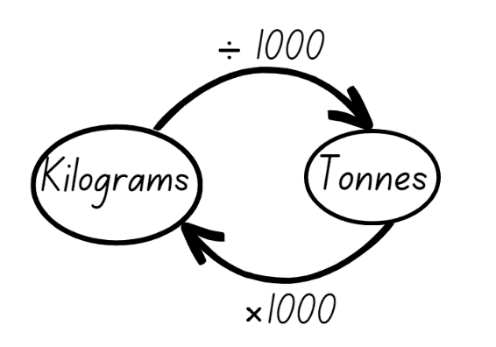
- Provide students Resource 8 – masses of rubbish. Students complete the conversions between units of measurement in the first table.
- Using the information from the first table on Resource 8 – masses of rubbish, students calculate the following and record in their workbooks:
- Based on the number of people who live in your household, how much rubbish is produced per week?
- Based on the number of people who live in your household, how much rubbish is produced per year?
- What would be the difference in the mass of rubbish produced weekly between a 6-person household and a 2-person household?
- How much waste have you produced already in your lifetime?
- By the time you turn 30, what will be the total mass of waste you have produced?
This lesson has been adapted from Types of Rubbish from NZ Maths by New Zealand Ministry of Education.
- Explain to students that according to Clean Up Australia, in 2017 approximately 22 million tonnes of waste generated by Australians was disposed of in landfill (Clean Up Australia 2024).
- Students complete conversions from tonnes to kilograms in the second table in Resource 8 – masses of rubbish.
- Based on the information in the second table, students answer the following questions in their workbooks:
- What is the combined total mass of waste in tonnes per year? In kilograms?
- What is the total mass of timber and rubble, metals and hazardous material in tonnes per year? In kilograms?
- If paper and plastic waste was recycled, how much less waste would there be each year?
- If there are 115 000 tonnes of organic waste produced each year, how much is produced each week?
- How much less hazardous material goes into landfill compared to timber and rubble?
- How do you think the mass of each type of waste is measured?
This table details opportunities for differentiation.
Too hard? | Too easy?
Stage 3 students cannot convert between kilograms and grams and between kilograms and tonnes to solve problems involving different units of mass.  - Provide students with converted answers to match with the correct place for Resource 8 – masses of rubbish.  - Provide students with smaller numbers to complete landfill waste calculations. | Stage 3 students can convert between kilograms and grams and between kilograms and tonnes to solve problems involving different units of mass.  - Ask, ‘If you reduced the amount of household waste you produce per week to 7 kilograms, how much less waste would you produce per year?’  - Challenge students to calculate the following: If we produced $\frac{1}{4}$ less of each type of landfill waste per year, what would the combined total mass be?

Discuss and connect the mathematics – 5 minutes
- Regroup as a class and summarise the lesson, drawing out key mathematical ideas. Ask:
- Can Stage 2 students explain the main idea of their lesson to Stage 3 students?
- Can Stage 3 students explain the main idea of their lesson to Stage 2 students?
- What did you find most challenging during the lesson?
- What does the statement ‘the larger the unit, the smaller the measure’ mean? (Stage 3)
This table details opportunities for assessment.
Assessment opportunities | Links
What to look for:  - Can Stage 2 students use a scaled instrument to relate 1000 grams to one kilogram? [MAO-WM-01, MA2-NSM-01]  - Can Stage 2 students measure and record mass in grams (g) using a scaled instrument? [MAO-WM-01, MA2-NSM-01]  - Can Stage 2 students interpret commonly used fractions of a kilogram, including $\frac{1}{2}$, $\frac{1}{4}$, $\frac{3}{4}$ and relate these to the number of grams? [MAO-WM-01, MA2-NSM-01]  - Can Stage 3 students convert between kilograms and grams and between kilograms and tonnes? [MA-WM-01, MA3-NSM-01]  - Can Stage 3 students solve problems involving different units of mass? [MA-WM-01, MA3-NSM-01] | Links to National Numeracy Learning Progressions (NNLP):  - Stage 2 – UuM4, UuM6  - Stage 3 – UuM6, UuM8.

Lesson 3
Core concept: a mass can be renamed using different units of measurement.

Daily number sense – Swap, steal, sit – 15 minutes
The table below contains suggested learning intentions and success criteria. These are best co-constructed with students.
Daily number sense learning intentions | Daily number sense success criteria
Students working towards Stage 2 outcomes are learning to:  - extend the application of the place value system from whole numbers to tenths and hundredths.  Students working towards Stage 3 outcomes are learning to:  - compare order and represent decimals. | Students working towards Stage 2 outcomes can:  - locate and order decimals representing tenths and hundredths on a number line, describing their relative size.  Students working towards Stage 3 outcomes can:  - approximate the size of decimals  - place decimal numbers of up to 3 decimal places on a number line.
- Students play in groups of 3 or 4.
- Provide students with a large variety of number cards 0–9. For this game each deck will need at least 30 cards.
- Each student is dealt 3 cards (Stage 2) or 4 cards stage (Stage 3). Students do not share their cards with the group.
- Students make the largest number they can that must include tenths and hundredths (Stage 2) and thousandths (Stage 3). For example, if a student is dealt a 3, 4 and 9 they would create the number 9.43.
- Players take turns to make 1–2 moves:
- Swap: return an unwanted card to the deck and swap for another one
- Steal: steal an unseen card from an opponent and give them an unwanted card in return
- Sit: do nothing and retain the cards dealt.
- After 2 moves students display their number and place them on a line in order. The player with the largest number wins a point.
- Repeat the game until a player reaches 10 points.
This table details opportunities for assessment.
Assessment opportunities | Links
What to look for:  - Can Stage 2 students locate and order decimals representing tenths and hundredths on a number line, describing their relative size? [MAO-WM-01, MA2-RN-02]  - Can Stage 3 students approximate the size of decimals?  [MAO-WM-01, MA3-RN-02]  - Can Stage 3 students place decimal numbers of up to 3 decimal places on a number line? [MAO-WM-01, MA3-RN-02] | Links to National Numeracy Learning Progressions (NNLP):  - Stage 2 – NPV4–NPV8  - Stage 3 – NPV7, NPV8.  Links to suggested Interview for Student Reasoning (IfSR) tasks:  - Stage 2 – IfSR-NP: 4D.2, 4D.3  - Stage 2 – IfSR-PT: 1A.10  - Stage 3 – IfSR-NP: 4D.5–4D.8  - Stage 3 – IfSR-PT: 1A.4–1A.8.

Core lesson 1 – grocery mass – 30 minutes
The table below contains suggested learning intentions and success criteria. These are best co-constructed with students.
Core concept learning intentions | Core concept success criteria
Students working towards Stage 2 outcomes are learning to:  - use scaled instruments to measure and compare masses.  Students working towards Stage 3 outcomes are learning to:  - connect decimal representations to the metric system  - convert between common metric units of mass. | Students working towards Stage 2 outcomes can:  - measure and record mass in grams (g) using a scaled instrument  - interpret commonly used fractions of a kilogram, including $\frac{1}{2}$, $\frac{1}{4}$, $\frac{3}{4}$ and relate these to the number of grams  - record masses greater than a kilogram using kilograms and grams.  Students working towards Stage 3 outcomes can:  - measure mass using scales and record using decimal notation of up to 3 decimal places  - convert between kilograms and grams and between kilograms and tonnes  - solve problems involving different units of mass.
Note: before the lesson, place masking tape over the mass displayed on each grocery item.
This activity is an adaptation of Weighing stations from NZ Maths by the New Zealand Ministry of Education.
- Revise that formal units are used to measure mass and that 1000 grams is the same as one kilogram.
- Distribute Resource 9 – grocery mass (Stage 2) to Stage 2 students and Resource 10 – grocery mass (Stage 3) to Stage 3 students. Students record the names of each grocery item displayed at the front of the classroom in column 1.
- Model choosing a grocery item and completing Resource 9 – grocery mass (Stage 2) and Resource 10 – grocery mass (Stage 3) by estimating the mass of the selected grocery item. Demonstrate using kitchen scales to accurately measure and record the mass in grams. Model calculating the difference between the estimation and the actual mass. Model for Stage 3 students how to convert and record the mass in kilograms using decimal notation, for example 1100 g = 1.1 kg.
Note: connecting decimal representations to the metric system occurs in the Stage 3 component of the syllabus. In Stage 2 students are expected to record mass of 1.2 kg as 1 kg 200 grams.
- Students choose a grocery item and complete Resource 9 – grocery mass (Stage 2) or Resource 10 – grocery mass (Stage 3) independently. Repeat the process with different grocery items to complete the table.
- Students compare and discuss their estimated mass and the actual mass of each item.
- Reveal the mass recorded on the packaging label of each grocery item. Ask:
- Is the stated mass on the packaging different to the measured mass for any items?
- Why might this be?
This table details opportunities for differentiation.
Too hard? | Too easy?
Stage 2 students cannot use scaled instruments to measure and compare masses.  - Provide a one-kilogram metric weight to assist students with hefting and estimating mass of grocery items.  Students to order the 3 items from lightest to heaviest and indicate whether each item is greater than, less than or equal to one kilogram.  Stage 3 students cannot convert between common metric units of mass.  - Students to weigh grocery item on bathroom scales as well as kitchen scales to assist conversion from grams to kilograms.  - Provide students with a metric conversion chart to assist them completing Resource 10 – grocery mass (Stage 3) | Stage 2 students can use scaled instruments to measure and compare masses.  - Students calculate the total mass of all their grocery items.  - Challenge students to determine which grocery items could be combined to have a total mass of approximately 2 kilograms.  Stage 3 students can convert between common metric units of mass.  - Students to calculate the total mass of all their grocery items and record the total in grams and kilograms using decimal notation.  - Challenge students to determine which grocery items could be combined to have a total mass of approximately 3.5 kilograms.

Core lesson 2 – 20 minutes

Stage 2 task – kilogram fractions
- Display Resource 11 – kilogram fractions and review the number of grams that are in $\frac{1}{4}$, $\frac{1}{2}$, and $\frac{3}{4}$ of a kilogram.
- Provide students with Resource 11 – kilogram fractions to complete independently, converting fractions of a kilogram to grams.
This table details opportunities for differentiation.
Too hard? | Too easy?
Stage 2 students cannot interpret commonly used fractions of a kilogram, including $\frac{1}{4}$, $\frac{1}{2}$, $\frac{3}{4}$ and relate these to the number of grams.  - Support students to write the correct fraction next to the corresponding measurement on Resource 11 – kilogram fractions, for example 500 g = $\frac{1}{2}$ kg.  - Cut Resource 11 – kilogram fractions into strips and support students to physically move the pieces to solve each question, for example $\frac{3}{4}$ kg = 250 g + 250 g + 250 g. Use more strips as needed. | Stage 2 students can interpret commonly used fractions of a kilogram, including $\frac{1}{4}$, $\frac{1}{2}$, $\frac{3}{4}$ and relate these to the number of grams.  - Students write a mass word problem for a partner to solve using commonly used fractions of a kilogram, including $\frac{1}{4}$ , $\frac{1}{2}$, $\frac{3}{4}$ and convert these to grams.  - Pose the following: What would be the total mass of 3 bags of potatoes, each weighing $\frac{3}{4}$ kg?

Stage 3 task – mass problems
- Provide small groups of students with a set of Resource 12 – mass word problems Students complete the challenge cards and record answers.
- Share challenge card responses in a group discussion. Select students to justify their answers and explain strategies used. Ask:
- Which card was the most challenging? Why?
- After listening to your classmates, would you use any different strategies? Which ones? Why?
- What do you notice about the numbers when you convert between units of mass?
This table details opportunities for differentiation.
Too hard? | Too easy?
Stage 3 students cannot convert between common metric units of mass.  - Assist students to break down the word problem into a sequence of steps.  - Assist students to complete challenge cards in one unit of measurement only. | Stage 3 students can convert between common metric units of mass.  - Students write their own mass challenge question for a partner to solve.  - Pose the following question to students: A recycling centre collected 4.5 tonnes of paper in a month. The paper is stored in bags holding 250 kilograms each. How many bags will be needed?

Discuss and connect the mathematics – 5 minutes
- Regroup as a class. Ask:
- What were the key mathematical ideas from today’s lesson?
- How did you work as a mathematician today?
- What did you do when faced with a challenge?
- What would you like to revise or practise next time?
This table details opportunities for assessment.
Assessment opportunities | Links
What to look for:  - Can Stage 2 students measure and record mass in grams (g) using a scaled instrument? [MAO-WM-01, MA2-NSM-01]  - Can Stage 2 students interpret commonly used fractions of a kilogram, including $\frac{1}{2}$, $\frac{1}{4}$, $\frac{3}{4}$ and relate these to the number of grams? [MAO-WM-01, MA2-NSM-01]  - Can Stage 2 students record masses greater than a kilogram using kilograms and grams? [MAO-WM-01, MA2-NSM-01]  - Can Stage 3 students measure mass using scales and record using decimal notation of up to 3 decimal places? [MA-WM-01, MA3-NSM-01]  - Can Stage 3 students convert between kilograms and grams and between kilograms and tonnes? [MA-WM-01, MA3-NSM-01]  - Can Stage 3 students solve problems involving different units of mass? [MA-WM-01, MA3-NSM-01] | Links to National Numeracy Learning Progressions (NNLP):  - Stage 2 – UuM4, UuM6  - Stage 2 – UuM6, UuM8.

Lesson 4
Core concept: metric units of measurement can be described using the decimal place value system.

Daily number sense – 10 minutes
- From a class need surfaced through formative assessment data, identify a short, focused activity that targets students’ knowledge, understanding and skills. Example activities may be drawn from the following resources:
- Mathematics K–6 resources
- Universal Resources Hub.

Core lesson – measuring and recording length and mass – 40 minutes
The table below contains suggested learning intentions and success criteria. These are best co-constructed with students.
Core concept learning intentions | Core concept success criteria
Students working towards Stage 2 outcomes are learning to:  - use scaled instruments to measure and compare lengths  - use scaled instruments to measure and compare masses.  Students working towards Stage 3 outcomes are learning to:  - connect decimal representations to the metric system. | Students working towards Stage 2 outcomes can:  - select and use an appropriate unit to estimate, measure and compare lengths and distances  - convert lengths between metres and centimetres, and between centimetres and millimetres  - record lengths and distances using decimal notation to 2 decimal places  - measure and record mass in grams (g) and kilograms (kg) using a scaled instrument.  Students working towards Stage 3 outcomes can:  - recognise the equivalence of whole-number and decimal representations of measurements of mass and length  - interpret decimal notation for masses and lengths  - record mass and length using decimal notation of up to 3 decimal places.
- Display a selection of measuring tools such as an equal-arm balance, measuring tape, 30 cm ruler, kitchen scale, trundle wheel, metre ruler or bathroom scales. For each measuring tool ask:
- What does it measure? (length or mass)
- What units of measurement will you use with this tool? (mm, cm, m, g, kg)
- Where have you seen this measuring tool outside of school? (grocery store, building site)
- What occupations use this tool?
- Place students into small groups to find 4 objects around the room that have a combined mass of between 1.5 kilograms and 2 kilograms.
- Students choose the appropriate tool to measure the mass of the objects and record their findings in their workbooks.
- Stage 3 to convert the mass of each object and the total mass to grams (g).
- Select groups to share and explain their results. Ask:
- What objects did you choose to make the combined mass?
- What measuring tool did you use and why?
- Can you use a different measuring tool and achieve the same results?
- Groups find 3 objects around the room that are between 15 centimetres and 1.2 metres. Groups measure and record the length of each object in centimetres and metres and record their findings in their workbooks from shortest to longest. Ask:
- What measuring tool did you use and why?
- Can you use a different measuring tool and achieved the same results?
- Groups find 2 objects that when combined have a mass between 500 grams and 1500 grams and a combined length between 50 centimetres and 70 centimetres (see Figure 3).
Figure 3 – example of 2 objects
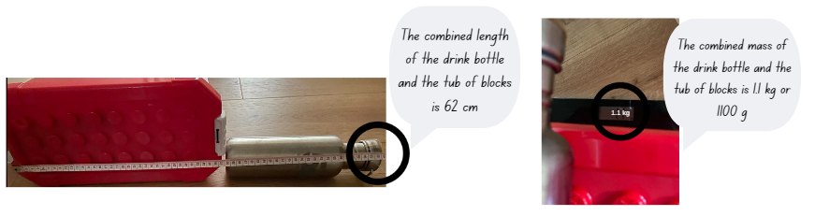
- Students record their findings in their workbooks.
- Stage 3 students record each object in centimetres and metres, and grams and kilograms, using decimal notation where appropriate.
- Groups share their results. Ask:
- What measuring tools did you use and why?
- What was the biggest challenge with this task?
- If you do this task again, will you do it differently? How?
This table details opportunities for differentiation.
Too hard? | Too easy?
Stage 2 students cannot use scaled instruments to measure and compare masses and lengths.  Students to find one object that has a mass between one kilogram and 1.5 kilograms.  - Students measure 3 objects individually and record the lengths in centimetres.  Stage 3 students cannot record mass and length using decimal notation.  - Students only record whole-number representations of mass in grams.  - Students only record whole-number representations of length in centimetres. | Stage 2 students can use scaled instruments to measure and compare masses and lengths.  Challenge students to find 2 objects that have a difference in mass of 200 grams.  - Students combine the lengths of the 3 objects and record the measurement in millimetres before converting to centimetres and metres.  Stage 3 students can record mass and length using decimal notation.  - Challenge students to find 2 objects that have a difference in mass of 1.1 kilograms.  - Challenge students to find 3 objects in the playground that have a combined length between 15.25 metres and 15.75 metres.

Consolidation and meaningful practice – 20 minutes
- Tell students that saltwater crocodiles are the largest living reptile in the world. They are found throughout the world in warm tropical areas.
- Provide students with Resource 13 – crocodile measurements and Resource 14 – crocodile conversion chart
- All students complete the table for length by converting measurements between metres, centimetres and millimetres. Stage 3 students complete the table for mass by converting between tonnes, kilograms and grams.
- Using the information on their completed crocodile conversion chart, students answer the following questions in their workbooks, answering in all units of measurement.
- How much longer is Crocodile D than Crocodile A?
- What is the combined length of all the crocodiles?
- What is the combined mass of Crocodiles C, G and H? (Stage 3)
- What 3 crocodiles have a combined mass of 3680 kilograms? (Stage 3)
This table details opportunities for differentiation.
Too hard? | Too easy?
Stage 2 students cannot convert lengths between metres and centimetres, and between centimetres and millimetres or Stage 3 cannot interpret decimal notation for masses and lengths.  - Give students a completed copy of Resource 14 – crocodile conversion chart with the crocodiles de-identified. Students match measurements with the crocodiles.  - Supports students to use a metric conversion chart to record and complete Resource 14 – crocodile conversion chart. | Stage 2 students can convert lengths between metres and centimetres, and between centimetres and millimetres.  - Students order the crocodiles in ascending length.  - Challenge students to determine which 3 crocodiles have a combined length of 680 centimetres.  Stage 3 students can interpret decimal notation for masses and lengths.  - Tell students the mass of an average car is 2 tonnes and the average baby saltwater crocodile is 70 grams. Students to calculate how many baby saltwater crocodiles would equal the mass of an average car.  - Tell students the average weight of a golden retriever is 30 kilograms and the average male saltwater crocodile is 1.5 tonnes. Challenge students to calculate how many golden retrievers are equivalent to a male saltwater crocodile.
This table details opportunities for assessment.
Assessment opportunities | Links
What to look for:  - Can Stage 2 students select and use an appropriate unit to estimate, measure and compare lengths and distances?  [MAO-WM-01, MA2-GM-02]  - Can Stage 2 students convert lengths between metres and centimetres, and between centimetres and millimetres?  [MAO-WM-01, MA2-GM-02]  - Can Stage 2 students record lengths and distances using decimal notation to 2 decimal places? [MAO-WM-01, MA2-GM-02]  - Can Stage 2 students measure and record mass in grams (g) and kilograms (kg) using a scaled instrument? [MAO-WM-01,  MA2-NSM-01]  - Can Stage 3 students recognise the equivalence of whole-number and decimal representations of measurements of mass and length? [MAO-WM-01, MA3-GM-02, MA3-NSM-01]  - Can Stage 3 students interpret decimal notation for masses and lengths? [MAO-WM-01, MA3-GM-02, MA3-NSM-01]  - Can Stage 3 students record mass and length using decimal notation of up to 3 decimal places? [MAO-WM-01, MA3-GM-02, MA3-NSM-01] | Links to National Numeracy Learning Progressions (NNLP):  - Stage 2 – UuM4, UuM6, UuM8  - Stage 3 – NPV7, NPV8, NPV9, UuM8.

Lesson 5
Core concept: different shapes can have the same perimeter.

Daily number sense – build to the whole – 10 minutes
Daily number sense activities for Lessons 5 to 7 ‘loop’ back to concepts and procedures covered in previous units to assist students to build an increasingly connected network of ideas. These concepts may differ from the core concepts being covered by the unit.
The table below contains suggested learning intentions and success criteria. These are best co-constructed with students.
Daily number sense learning intentions | Daily number sense success criteria
Students working towards Stage 2 outcomes are learning to:  - model and represent unit fractions, and their multiples, to a complete whole on a number line.  Students working towards Stage 3 outcomes are learning to:  - build up to the whole from a given fractional part. | Students working towards Stage 2 outcomes can:  - recreate the whole unit from a fractional part ($\frac{1}{2}$, $\frac{1}{4}$, $\frac{1}{3}$ and $\frac{1}{8}$).  Students working towards Stage 3 outcomes can:  - generate the whole quantity from non-unit fractional parts.
- Ask, 'If you are given one-quarter of a length of rope, how can you find the total length?’
- Provide students with an individual whiteboard and whiteboard marker. Allow time for students to think and turn and talk to discuss how they could find the total length. Support Stage 2 students by providing them with a strip of A4 paper. Stage 2 students represent their thinking by folding the paper into a fraction strip.
- Select students to share and explain their strategy. Record and test student responses.
- Ask students:
- How did the fraction of the length of rope determine what strategy you used?
- Can you use the same strategy to find the total length if you are given other fractions of a length? Select students to test and justify strategies used.
- Repeat activity with unit fractions such as one-half ($\frac{1}{2}$), one-third ($\frac{1}{3}$) and one-eighth ($\frac{1}{8}$) for Stage 2 and non-unit fractions such as three-quarters ($\frac{3}{4}$), two-fifths ($\frac{2}{5}$) and five-eighths ($\frac{5}{8}$) for Stage 3.
Multi-age: adjust fractions to allow stage appropriate practice. Stage 2 work with unit fractions (with a numerator of one). Stage 3 students work with non-unit fractions (with a numerator other than one).
This table details opportunities for assessment.
Assessment opportunities | Links
What to look for:  - Can Stage 2 students recreate the whole unit from a fractional part ($\frac{1}{2}$, $\frac{1}{4}$, $\frac{1}{3}$ and $\frac{1}{8}$)? [MAO-WM-01, MA2-PF-01]  - Can Stage 3 students generate the whole quantity from non-unit fractional parts? [MAO-WM-01, MA3-RQF-02] | Links to National Numeracy Learning Progressions (NNLP):  - Stage 2 – InF2, InF3, InF4  - Stage 3 – InF5.

Core lesson 1 – perimeter – 30 minutes
The table below contains suggested learning intentions and success criteria. These are best co-constructed with students.
Core concept learning intentions | Core concept success criteria
Students working towards Stage 2 outcomes are learning to:  - use scaled instruments to measure and compare lengths.  Students working towards Stage 3 outcomes are learning to:  - solve problems involving the comparison of lengths using appropriate units. | Students working towards Stage 2 outcomes can:  - use the term perimeter to describe the distance around the boundary  - estimate and measure the perimeters of quadrilaterals.  Students working towards Stage 3 outcomes can:  - investigate and compare perimeters of rectangles with the same area  - determine the number of different rectangles that can be formed using whole-number dimensions for a given area  - solve a variety of problems involving length and perimeter, including problems involving different units of length.
Note: the perimeter of an object, shape or location is the same as the boundary. Perimeter is the length around an object, shape or location. Perimeter is calculated by adding the length of all the sides. Area is the measure of the amount of space enclosed by the boundaries or sides of a two-dimensional shape. It is expressed in square units, such as square centimetres (cm²) and square metres (m²).
- Review students' knowledge of perimeter. Ask:
- If I measure the perimeter of something, what am I measuring?
- What measurement tools would be useful for measuring perimeter? Why?
- Explain that the perimeter of an object, shape or location is the same as the boundary. Perimeter is the length around an object, shape or location and is calculated by combining the length of all sides.
- Review student’s understanding of area. Ask:
- If I measure the area of something, what am I measuring?
- How do I calculate the area of something?
- Explain that area is the measure of the amount of space enclosed by the boundaries or sides of a two-dimensional shape. It is expressed in square units, such as square centimetres (cm2) and square metres (m2).
- Display Resource 15 – perimeter modelling Explain that each of the shapes has an area of 12 squares, but all have different perimeters. For the purpose of this activity, the scale is 1 square = 1 cm².
- Model calculating the perimeter of each of the shapes on Resource 15 – perimeter modelling.
- Provide students with 1 cm grid paper or their grid workbook and two 6-sided dice.
- Students make a weird robot using measurements of perimeter. Students roll the dice 6 times. Each roll provides 2 side measurements of a rectangle or square that form a different body part of their robot:
- Roll 1 – head
- Roll 2 – body
- Roll 3 – arm 1
- Roll 4 – arm 2
- Roll 5 – leg 1
- Roll 6 – leg 2.
- Students calculate the perimeter for each body part of their robot and record the measurement on the part.
- Stage 3 students calculate the total perimeter of the robot and record in centimetres.

Core lesson 2 – 25 minutes

Stage 2 task – quadrilateral perimeters
Note: prior to the task, mark out quadrilaterals on the floor and/or desks with masking tape or chalk.
- Explain that students will be measuring the perimeter of the masking tape shapes. Model how to measure and record the perimeter (including units) of a masking tape quadrilateral, reminding students to use the ruler along the edge of the shape without leaving any gaps and starting at zero.
- Using Resource 16 – calculating perimeter , students estimate, measure and record the perimeter of various objects and shapes around the classroom. For example, a desk, a book, a door.
- Select students to share what they measured. Ask:
- How did you measure the perimeter of each shape?
- What units did you use to record perimeter? Why?
- How close were your estimates to the actual perimeters?
This table details opportunities for differentiation.
Too hard? | Too easy?
Stage 2 students cannot estimate and measure the perimeters of quadrilaterals.  - Provide students with the length of one side of the shape to assist with measuring perimeter.  - Provide students with a long piece of string to lay over the boundary/perimeter, then stretch it out to show the total length. Support students to measure the length. | Stage 2 students can estimate and measure the perimeters of quadrilaterals.  - Challenge students to double and triple the perimeter of an item measured.  - Pose the following: A rectangular paddock has a perimeter of 80 metres. Students draw and label 2 alternative plans, including dimensions, of what the paddock might look like.

Stage 3 task –perimeter problems
- Provide students with 1 cm grid paper and a 30 cm ruler. Students create as many squares or rectangles as they can that have an area of 24 cm².
- Students calculate the perimeter of each shape they have drawn.
- Ask students:
- Did you make all possible rectangles with an area of 24 cm²? How do you know?
- What was the length of the longest perimeter?
- What was the length of the shortest perimeter?
- What is the quickest way to calculate the area of a rectangle? Explain your answer.
- How could you work out the perimeter of a shape if all side lengths are not labelled?
- Provide Resource 17 – missing perimeter problems. Students complete problems independently.
This table details opportunities for differentiation.
Too hard? | Too easy?
Stage 3 students cannot solve problems involving length and perimeter, including problems involving different units of length.  - Provide students with the missing side measurements on Resource 17 – missing perimeter problems.  - Students complete the problems with only one unit of measure. | Stage 3 students can solve problems involving length and perimeter, including problems involving different units of length.  - Students calculate the area of each shape in Resource 17 – missing perimeter problems.  - Pose the following: You have an irregular shaped garden. The perimeter fencing totals 15.5 metres. What could the length of its 4 sides be?

Discuss and connect the mathematics – 5 minutes
- Regroup as a class and summarise the lesson drawing out key mathematical ideas. Ask:
- What challenges did you face when completing today’s tasks?
- How did you overcome these challenges?
- How did you ensure you accurately measured the perimeter of various shapes?
- When would measuring perimeter be useful?
This table details opportunities for assessment.
Assessment opportunities | Links
What to look for:  - Can Stage 2 students use the term perimeter to describe the distance around the boundary? [MAO-WM-01, MA2-GM-02]  - Can Stage 2 students estimate and measure the perimeters of quadrilaterals? [MAO-WM-01, MA2-GM-02]  - Can Stage 3 students investigate and compare perimeters of rectangles with the same area? [MAO-WM-01, MA3-GM-02,  MA3-2DS-02]  - Can Stage 3 students determine the number of different rectangles that can be formed using whole-number dimensions for a given area? [MAO-WM-01, MA3-GM-02, MA3-2DS-02]  - Can Stage 3 students solve a variety of problems involving length and perimeter, including problems involving different units of length? [MAO-WM-01, MA3-GM-02] | Links to National Numeracy Learning Progressions (NNLP):  - Stage 2 – UuM6, UuM7  - Stage 3 – UuM6, UuM7.

Lesson 6
Core concept: decimal numbers are often seen in measurement.

Daily number sense – build to the whole 2 – 10 minutes
The table below contains suggested learning intentions and success criteria. These are best co-constructed with students.
Daily number sense learning intentions | Daily number sense success criteria
Students working towards Stage 2 outcomes are learning to:  - model and represent unit fractions and their multiples to a complete whole on a number line.  Students working towards Stage 3 outcomes are learning to:  - build up to the whole from a given fractional part. | Students working towards Stage 2 outcomes can:  - recreate the whole unit from a fractional part ($\frac{1}{2}$, $\frac{1}{4}$, $\frac{1}{3}$ and $\frac{1}{8}$).  Students working towards Stage 3 outcomes can:  - generate the whole quantity from non-unit fractional parts.
- Pose the following: If you know four-eighths of the length of a table, how can you find the total length?
- Provide students with an individual whiteboard and whiteboard marker. Allow time for students to think and turn and talk to discuss how they could find the total length.
- Display Resource 18 – unit fractions to support Stage 2 students, highlighting how to use multiples of eighths to solve the question.
- Select students to share and explain their strategy. Record and test student responses.
- Ask students:
- What strategy did you use to answer the question?
- Can you use the same strategy to find the total length if you are given other fractions of a length?
Multi-age: adjust fractions to allow stage appropriate practice. Stage 2 use unit fractions (with a numerator of one) and their multiples. Stage 3 students use non-unit fractions (with a numerator other than one).
This table details opportunities for assessment.
Assessment opportunities | Links
What to look for:  - Can Stage 2 students recreate the whole unit from a fractional part ($\frac{1}{2}$, $\frac{1}{4}$, $\frac{1}{3}$ and $\frac{1}{8}$)? [MAO-WM-01, MA2-PF-01]  - Can Stage 3 students generate the whole quantity from non-unit fractional parts? [MAO-WM-01, MA3-RQF-02] | Links to National Numeracy Learning Progressions (NNLP):  - Stage 2 – InF2, InF3, InF4  - Stage 3 – InF5.

Core lesson – 45 minutes

Stage 2 task – animal jump
The table below contains suggested learning intentions and success criteria. These are best co-constructed with students.
Core concept learning intentions | Core concept success criteria
Students working towards Stage 2 outcomes are learning to:  - extend the application of the place value system from whole numbers to tenths and hundredths  - use scaled instruments to measure and compare lengths. | Students working towards Stage 2 outcomes can:  - use the decimal point as a marker to identify the position of the ones digit when expressing tenths as decimals  - convert between metres and centimetres  - record lengths and distances using decimal notation to 2 decimal places.
This activity is an adaptation of Measurement: Jump! from reSolve by Australian Academy of Science.
- Students imagine they are a kangaroo. Ask: ‘How far do you think you can jump?’
- Share that the average male kangaroo is approximately 120 centimetres tall. Share that a kangaroo can jump 4 times its height. This means a kangaroo can jump over 4 kangaroos lying on the ground head to toe.
- Demonstrate this by having 4 students of a similar height lie head to toe along the ground.
- Explain that students will be using their height measurement to calculate the equivalent distances various animals can jump. Ask:
- What measurement tools can measure height?
- What is required to ensure that measurements are precise?
- What unit(s) of measurement are the most appropriate to measure and record your height?
- Demonstrate measuring and recording teacher height on Resource 19 – animal jumps, in the personal ratio table.
- Provide students with Resource 19 – animal jumps. Students measure and record their height in centimetres.
- Model different strategies to complete the personal ratio table. Some strategies might include:
- measuring out the required number of height lengths
- repeated addition
- multiplying their height
- doubling or tripling a repeated amount.
- Use the personal ratio table to calculate jumping distance of a kangaroo. Record on Resource 19 – animal jumps Show students how to convert the ‘kangaroo jump’ from centimetres to metres. Remind students that 100 cm = 1 m and that the decimal point is used to express tenths of a metre. For example, 2.47 m is 2 m and 47 cm.
- Explain that grasshoppers can jump 8 times their height, frogs can jump 12 times their height and a flea can jump 20 times its height.
- Students calculate how far they could jump based on their own height if they were each of these animals, recording in centimetres and then converting to metres.
- Students explain and justify the strategy used to calculate their ‘animal jumps.’ Ask:
- Which animal jumps presented a challenge when calculating?
- After listening to others, will you use a different strategy next time? Why?
This table details opportunities for differentiation.
Too hard? | Too easy?
Stage 2 students cannot extend the application of the place value system from whole numbers to tenths and hundredths.  - Provide concrete materials or number charts for students to use when adding their height.  - Support students to measure out the length of animal jumps rather than calculating them. | Stage 2 students can extend the application of the place value system from whole numbers to tenths and hundredths.  - Challenge students to calculate the height of the kangaroo if it can jump 620 centimetres. Students to record the height in metres.  - Challenge students to calculate the distance a frog can jump if it is 12 centimetres in height. Students to represent their answer in centimetres and metres.

Stage 3 task – how much fencing?
The table below contains suggested learning intentions and success criteria. These are best co-constructed with students.
Core concept learning intentions | Core concept success criteria
Students working towards Stage 3 outcomes are learning to:  - connect decimal representations to the metric system  - solve problems involving the comparison of lengths using appropriate units. | Students working towards Stage 3 outcomes can:  - recognise the equivalence of whole-number and decimal representations of measurements of length  - investigate and compare perimeters of rectangles with the same area  - determine the number of different rectangles that can be formed using whole-number dimensions for a given area  - solve a variety of problems involving length and perimeter, including problems involving different units of length.
This activity is adapted from Fred’s Rent-a-fence from NZ Maths by New Zealand Ministry of Education.
- Revise perimeter and area.
- Pose the following: Darryl rents out fences. Today he is putting up some fences to help keep the crowds safe at the showground during the annual show. Darryl’s fence panels come in panel lengths of 100 centimetres and 120 centimetres long. He is using them to fence rectangular spaces.
- Provide students with Resource 20 – Darryl’s fencing. Students solve each task and answer the questions in their workbooks.
- Ask:
- What strategy did you use to convert the fence panel measurement from centimetres to metres?
- Did you convert from centimetres to metres at the beginning of the problem-solving process or at the end? Why?
- What fenced off area was best for the skydivers to land safely? Justify your answer.
- Would this also be the best fence arrangement for spectators? Why or why not?
- Draw Figure 4 on the board and tell students that Darryl has fenced off a space for the Whirling Cup ’n’ Saucer ride.
Figure 4 – Whirling Cup 'n' Saucer ride area
- Ask:
- What is the length of the long side?
- What is the perimeter of the fenced space?
- How many 120-centimetre fence panels will be needed to fence the Cup ‘n’ Saucer ride?
- How many 100-centimetre fence panels will be needed to fence the Cup ‘n’ Saucer ride?
- Choose students to share and justify answers.
This table details opportunities for differentiation.
Too hard? | Too easy?
Stage 3 students cannot solve problems involving the comparison of lengths using appropriate units.  - Provide students with factors of 80 and 48, a decimal place value chart and/or a hundred chart to assist with completing Resource 20 – Darryl’s fencing  - Students to complete Task 1 from Resource 20 – Darryl’s fencing using 100 centimetre fencing. | Stage 3 students can solve problems involving the comparison of lengths using appropriate units.  - Challenge students to design an irregular rectangle that has an area of 65 m² and is enclosed with fencing panels that are 120.5 centimetres in length.  - Ask students: What is the difference between the cost of fencing a rectangular area with a perimeter of 24 metres using the 100-centimetre panels or the 120-centimetre panels?

Discuss and connect the mathematics – 5 minutes
- Regroup as a class and summarise the lesson drawing out key mathematical ideas. Ask:
- What was the most challenging part of the task? Why?
- When measuring length or distance, why would you use different tools? (Stage 2)
- Will some tools produce more accurate measurements? (Stage 2)
- What strategy did you use to convert centimetres to metres? (Stage 2)
- Can 2 shapes have the same perimeter but different areas? Explain your answer. (Stage 3)
- Can 2 shapes have the same area but different perimeters? Explain your answer. (Stage 3)
This table details opportunities for assessment.
Assessment opportunities | Links
What to look for:  - Can Stage 2 students use the decimal point as a marker to identify the position of the ones digit when expressing tenths as decimals? [MAO-WM-01, MA2-RN-01, MA2-RN-02]  - Can Stage 2 students convert between metres and centimetres? [MAO-WM-01, MA2-GM-02]  - Can Stage 2 students record lengths and distances using decimal notation to 2 decimal places? [MAO-WM-01, MA2-GM-02]  - Can Stage 3 students recognise the equivalence of whole-number and decimal representations of measurements of length?  [MAO-WM-01, MA3-NSM-01, MA3-GM-02]  - Can Stage 3 students investigate and compare perimeters of rectangles with the same area? [MAO-WM-01, MA3-2DS-02, MA3-GM-02]  - Can Stage 3 students determine the number of different rectangles that can be formed using whole-number dimensions for a given area? [MAO-WM-01, MA3-2DS-02, MA3-GM-02]  - Can Stage 3 students solve a variety of problems involving length and perimeter, including problems involving different units of length? [MAO-WM-01, MA3-GM-02] | Links to National Numeracy Learning Progressions (NNLP):  - Stage 2 – NPV6, NPV7, UuM6, UuM8.  - Stage 3 – NPV7, UuM6, UuM7, UuM8.  Links to suggested Interview for Student Reasoning (IfSR) tasks:  - Stage 2 – IfSR-NP: 4D.2, 4D.3, 4D.4.

Lesson 7
Core concept: mathematicians compare and evaluate strategies used to solve measurement problems.

Daily number sense – complementary fractional parts – 10 minutes
The table below contains suggested learning intentions and success criteria. These are best co-constructed with students.
Daily number sense learning intentions | Daily number sense success criteria
Students working towards Stage 2 outcomes are learning to:  - model and represent unit fractions and their multiples to a complete whole on a number line.  Students working towards Stage 3 outcomes are learning to:  - build up to the whole from a given fractional part. | Students working towards Stage 2 outcomes can:  - determine the complementary fractional part needed to complete one whole (halves, quarters, eighths, thirds).  Students working towards Stage 3 outcomes can:  - generate the whole quantity from non-unit fractional parts.
- Ask, 'What is the complementary fraction of one-third?’. Remind students that a complementary fraction is that which is needed to complete one whole.
- Provide students with an individual whiteboard and whiteboard marker. Allow time for students to think and turn and talk to discuss how they could find the complementary fraction. Provide Stage 2 students with strips of paper.
- Select students to share and explain strategies. Record and test student responses.
- Ask:
- What strategy did you use to answer the question?
- Can you use the same strategy to find the total length if you are given other fractions of a length? Explain your answer.
- Repeat activity with unit fractions such as one-quarter ($\frac{1}{4}$) and one-eighth ($\frac{1}{8}$) for Stage 2 and non-unit fractions such as three-fifths ($\frac{3}{5}$) and six-eighths ($\frac{6}{8}$) for Stage 3. Display Resource 18 – unit fractions to support Stage 2 students if needed.
- Ask Stage 3, if two-thirds ($\frac{2}{3}$) of a class is 18 students, what is the total number of students in the class?
- Select students to share and explain their strategy.
This table details opportunities for assessment.
Assessment opportunities | Links
What to look for:  - Can Stage 2 determine the complementary fractional part needed to complete one whole (halves, quarters, eighths, thirds)?  [MAO-WM-01, MA2-PF-01]  - Can Stage 3 students generate the whole quantity from non-unit fractional parts? [MAO-WM-01, MA3-RQF-02] | Links to National Numeracy Learning Progressions (NNLP):  - Stage 2 – InF2, InF3, InF4, InF5  - Stage 3 – InF5.

Core lesson – mystery bones – 50 minutes
The table below contains suggested learning intentions and success criteria. These are best co-constructed with students.
Core concept learning intentions | Core concept success criteria
Students working towards Stage 2 outcomes are learning to:  - use scaled instruments to measure and compare lengths.  Students working towards Stage 3 outcomes are learning to:  - solve problems involving the comparison of lengths using appropriate units. | Students working towards Stage 2 outcomes can:  - use an appropriate unit to measure and compare lengths and distances  - convert between metres and centimetres, and between centimetres and millimetres  - record lengths and distances using decimal notation to 2 decimal places.  Students working towards Stage 3 outcomes can:  - solve a variety of problems involving length including problems involving different units of length.
This lesson is adapted from The Case of the Mystery Bone: A Unit of Work on Measurement for Grades 5 to 8 by Clarke.
- Revise how to use a soft measuring tape. Students use a soft measuring tape to find 2 objects in the room with a length between 15 centimetres and 20 centimetres.
- Regroup as a class and ask:
- What do you need to remember when you are using a measuring tape?
- Was it easy to find 3 objects within this length range? Why or why not?
- How did you choose objects to measure for this task?
- Explain that forensic anthropologists assess skeletal remains to determine a range of details about a person. Pose the following: At a museum, forensic anthropologists have discovered 2 unlabelled bones from a display set. They have established that one of the bones is a radius and belongs to a female. The bone measures 28 centimetres in length. The other bone is a 44-centimetre tibia, possibly belonging to the same person.
- Discuss where on the body the radius and tibia bones are found.
- Provide students Resource 21 – mystery bones. Students to measure the height, length of the radius and tibia bone of 5 people in the class (person A, B, C, D and E). Students to record the lengths in centimetres on Resource 21 – mystery bones
- Students complete questions on Resource 21 – mystery bones. Discuss student responses as a whole class.
- Stage 2 students measure their own height, radius and tibia length and record in millimetres, centimetres and metres.
- Display Resource 22 – bone measurement prediction for Stage 3 students. Explain that forensic anthropologists use these formulas to calculate the height of a person when they only have partial skeletal remains.
- Stage 3 students use the formulas from Resource 22 – bone measurement prediction to answer the following questions in their workbooks:
- Calculate the height of the mystery person with a radius length of 28 centimetres, knowing they are female.
- Calculate the height of the mystery person with a tibia length of 44 centimetres. What would their height be if they were a female?
- What would their height be if they were a male?
- Do you think the 2 bones belong to the same person? Justify your answer.
This table details opportunities for differentiation.
Too hard? | Too easy?
Stage 2 students cannot use scaled instruments to measure and compare lengths.  - Students measure height and bone length using string. Students determine length by holding the string taut against a metre ruler.  - Supports students to use a metric conversion chart to convert their height and bone lengths to millimetres and metres.  Stage 3 students cannot solve problems involving the comparison of lengths using appropriate units.  - Select 2 students that are of a different height. Model measuring each radius and tibia bone, recording results in centimetres. Using the formulas on Resource 22 – bone measurement prediction, predict the height for each student. Students then use a measuring tape to measure the height of each student and compare and discuss the results.  - Support students to calculate the height of the mystery persons using a calculator. | Stage 2 students can use scaled instruments to measure and compare lengths.  - Students record the 5 students’ heights from Resource 23 – mystery bones in ascending order.  - Students convert each of the 5 students’ heights to metres using decimal notation.  Stage 3 students can solve problems involving the comparison of lengths using appropriate units.  - Challenge students to calculate the height of a person with a radius of 230 millimetres in length, recording their answer in millimetres and centimetres.  - The tallest female twins in the world are Ann and Claire Recht, volleyball players who are 200.7 centimetres tall. Predict the length of their radius and tibia bones.

Discuss and connect the mathematics – 10 minutes
- Regroup as a class. Stage 3 students to share their mystery person heights with Stage 2.
- Ask:
- What surprised you about the activity and why?
- What type of bone would not be suitable to determine the height of a person?
- What other body parts could forensic scientists measure to work out the height of a person?
- Can you think of another career that uses the length of bones to determine the height of the animal?
- What challenges did you face during the activity? How did you overcome them?
This table details opportunities for assessment.
Assessment opportunities | Links
What to look for:  - Can Stage 2 students use an appropriate unit to measure and compare lengths and distances? [MAO-WM-01, MA2-GM-02]  - Can Stage 2 students convert between metres and centimetres, and between centimetres and millimetres? [MAO-WM-01,  MA2-GM-02]  - Can Stage 2 students record lengths and distances using decimal notation to 2 decimal places? [MAO-WM-01, MA2-GM-02]  - Can Stage 3 students solve a variety of problems involving length including problems involving different units of length?  [MAO-WM-01, MA3-GM-02] | Links to National Numeracy Learning Progressions (NNLP):  - Stage 2 – UuM6, UuM8  - Stage 3 – UuM6.

Lesson 8
Core concept: comparing and converting units of measurement helps to make sense of our world.

Daily number sense – 10 minutes
- From a class need surfaced through formative assessment data, identify a short, focused activity that targets students’ knowledge, understanding and skills. Example activities may be drawn from the following resources:
- Mathematics K–6 resources
- Universal Resources Hub.

Core lesson – House plan – 40 minutes
The table below contains suggested learning intentions and success criteria. These are best co-constructed with students.
Core concept learning intentions | Core concept success criteria
Students working towards Stage 2 outcomes are learning to:  - use scaled instruments to measure and compare lengths.  Students working towards Stage 3 outcomes are learning to:  - convert between common metric units of length  - solve problems involving the comparison of lengths using appropriate units. | Students working towards Stage 2 outcomes can:  - estimate and measure the perimeters of quadrilaterals  - convert between metres and centimetres, and between centimetres and millimetres  - record lengths and distances using decimal notation to 2 decimal places.  Students working towards Stage 3 outcomes can:  - use decimal place value system to convert between metres and kilometres  - convert measurements to the same unit to compare lengths and distances  - solve a variety of problems involving length and perimeter, including problems involving different units of length.
- Display Resource 23 – house plan and ask:
- What does this diagram show?
- Has anyone seen a diagram like this before?
- Who would need/use this type of diagram?
- What do the symbols on the diagram represent? For example: doors, windows and furniture.
- Does a diagram like this need to be accurate? Why or why not?
- How is accuracy ensured?
- What do the numbers on the diagram represent?
- If the numbers are a measurement, what unit would they be? Justify your answer.
- Model how to find a measurement using the information on the house plan. For example, finding the length of the southern wall in the living room.
- Show students how to convert the millimetre length to centimetres and metres, recording using decimals. For example, see Figure 5.
Figure 5 – example of think aloud
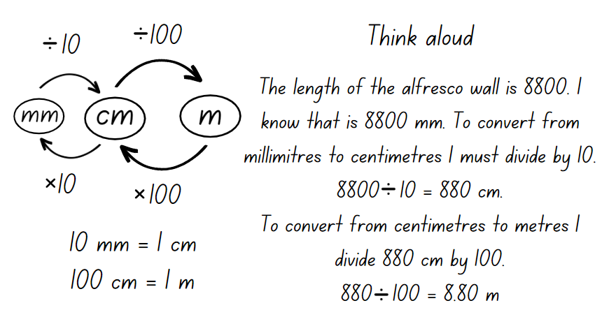
- Show Stage 3 students how to convert between metres and kilometres, recording using decimals (see Figure 6).
Figure 6 – conversion between metres and kilometres
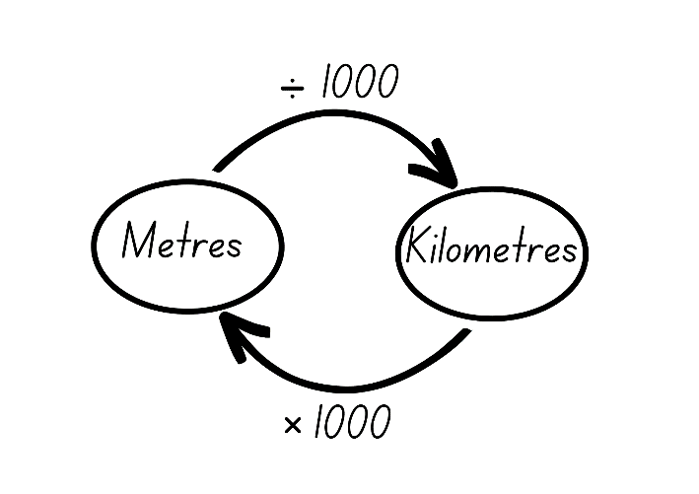
- Provide students with Resource 23 – house plan and Resource 24 – house plan investigation (Stage 2) or Resource 25 – house plan investigation (Stage 3)
- Students use the information on the house plan to answer the questions in their workbook. For each question, Stage 2 students convert the millimetre (mm) length to centimetres (cm) and metres (m), recording using decimals.
This table details opportunities for differentiation.
Too hard? | Too easy?
Stage 2 students cannot use scaled instruments to measure and compare lengths.  - Support students to provide answers in millimetres only, consolidating students' knowledge of one unit of measurement.  - Provide students with a copy of Resource 23 – house plan with the measurements required to complete the investigation problems written directly onto the corresponding walls.  Stage 3 students cannot convert between common metric units to solve problems involving the comparison of lengths.  - Support students to work in millimetres first by providing a table for students to show the relationship between conversions of millimetres, centimetres, metres and kilometres.  - Students convert millimetre lengths on Resource 23 – house plan to centimetres and metres. | Stage 2 students can use scaled instruments to measure and compare lengths.  - Challenge students to calculate the combined perimeter of all the bedrooms. Students record answers in metres, centimetres and millimetres.  - Challenge students to calculate the perimeter of the outside walls of the house.  Stage 3 students can convert between common metric units to solve problems involving the comparison of lengths.  - Challenge students to find 2 rooms in Resource 23 – house plan that have the same area.  - Challenge students to calculate the total area of the house in square metres.

Consolidation and meaningful practice – 20 minutes
- Explain that students will design a backyard area for the house. The homeowner wants a fenced-in rectangular pool, a garden shed and flower gardens in the backyard space outside Bed 1 and Bed 2. Each of these features will need to include labelled measurements in millimetres. Students to use a scale of 1 cm = 1 m.
- Once students have drawn their backyard design, they calculate the perimeter of the pool and the shed and record in millimetres, centimetres and metres.
This table details opportunities for assessment.
Assessment opportunities | Links
What to look for:  - Can Stage 2 students estimate and measure the perimeters of quadrilaterals? [MAO-WM-01, MA2-GM-02]  - Can Stage 2 students convert between metres and centimetres, and between centimetres and millimetres? [MAO-WM-01,  MA2-GM-02]  - Can Stage 2 students record lengths and distances using decimal notation to 2 decimal places? [MAO-WM-01, MA2-GM-02]  - Can Stage 3 students use decimal place value system to convert between metres and kilometres? [MAO-WM-01, MA3-GM-02]  - Can Stage 3 students convert measurements to the same unit to compare lengths and distances? [MAO-WM-01, MA3-GM-02]  - Can Stage 3 students solve a variety of problems involving length and perimeter, including problems involving different units of length? [MAO-WM-01, MA3-GM-02] | Links to National Numeracy Learning Progressions (NNLP):  - Stage 2 – NPV7, UuM7, UuM8  - Stage 3 – NPV8, UuM7, UuM8.

Resource 1 – decimals
Stage 2
0.07 | 0.6 | 1.66 | 0.55
1.20 | 1.01 | 2.0 | 1.02
1.75 | 0.01 | 0.36 | 0.9
Stage 3
0.070 | 0.65 | 1.966 | 0.055
1.209 | 1.01 | 2.10 | 1.002
1.750 | 0.001 | 0.306 | 0.09

Resource 2 – 1 kg balance
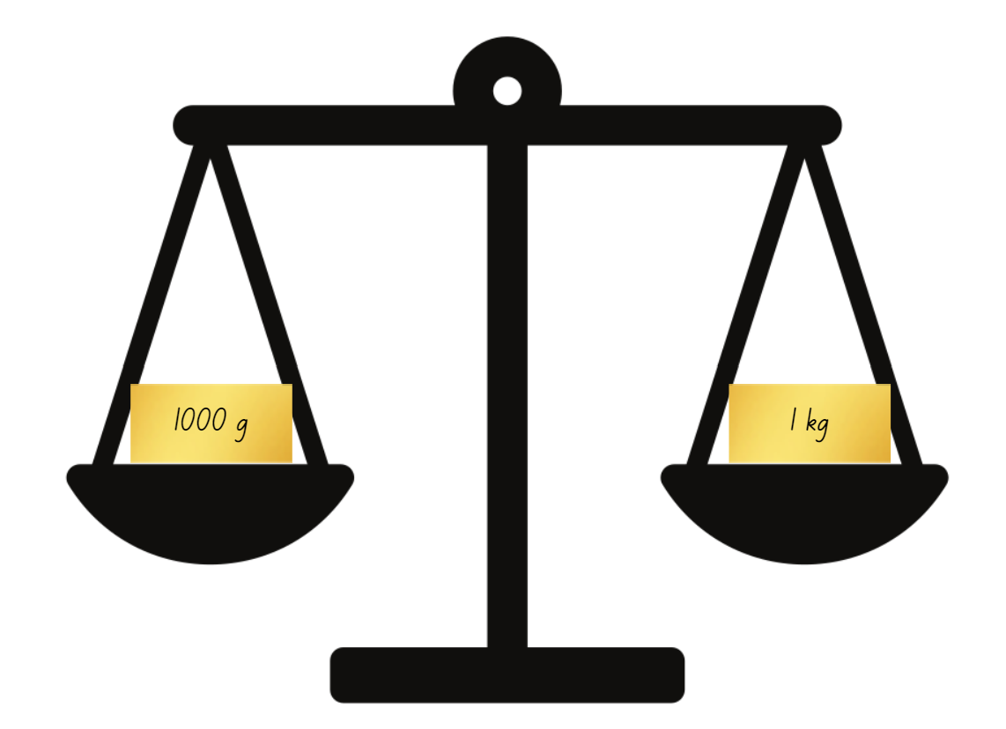

Resource 3 – mass sort

Resource 4 – world’s largest pumpkin
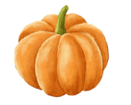World’s largest pumpkins
Year pumpkin was grown | Mass in kilograms (kg) | Mass in tonnes (t)
2017 | 1190.5 kg
2019 | 1136.7 kg
2020 | 1176.5 kg
2022 | 1119 kg
2023 | 1204.8 kg

Resource 5 – cube model mass
Number of cubes | Estimate | Measure
20 | g | g
40 | g | g
50 | g | g
60 | g | g
100 | g | g
200 | g | g
1000 | g | g

Resource 6 – fractions of kilograms
Number of cubes | Measure | Fraction of a kilo
 | 250 g
 | 750 g
 |  | $$\frac{1}{2}$$
 | 1 kg

Resource 7 – Grams, kilograms, tonnes?
Object | Grams (g) | Kilograms (kg) | Tonnes (t)
Bag of apples
One apple
School bag
Car
Person
Pencil
Table
Truck

Resource 8 – masses of rubbish
Rubbish produced per person | Grams (g) | Kilograms (kg) | Tonnes (t)
Per week | 10 000 g
Per year |  | 520 kg

Types of waste per year | Tonnes (t) | Kilograms (kg)
Timber and rubble | 130 000
Organic | 115 000
Paper | 75 000
Hazardous material | 55 000
Plastics | 45 000
Other (glass/rubber/textiles) | 40 000
Metals | 25 000

Resource 9 – grocery mass (Stage 2)
Item | Estimated mass (g) | Measured mass (g) | Measured mass in kilograms (kg) and grams (g) | What was the difference between estimated and measured mass in grams (g)
A packet of rice | 900 g | 1100 g | 1 kg and 100 g | 200 g

Resource 10 – grocery mass (Stage 3)
Item | Estimated mass (g) | Measured mass (g) | Measured mass in kilograms (kg) and grams (g) using decimal notation | What was the difference between estimated and measured mass in grams (g)
A packet of rice | 900 g | 1100 g | 1.1 kg | 200 g

Resource 11 – kilogram fractions
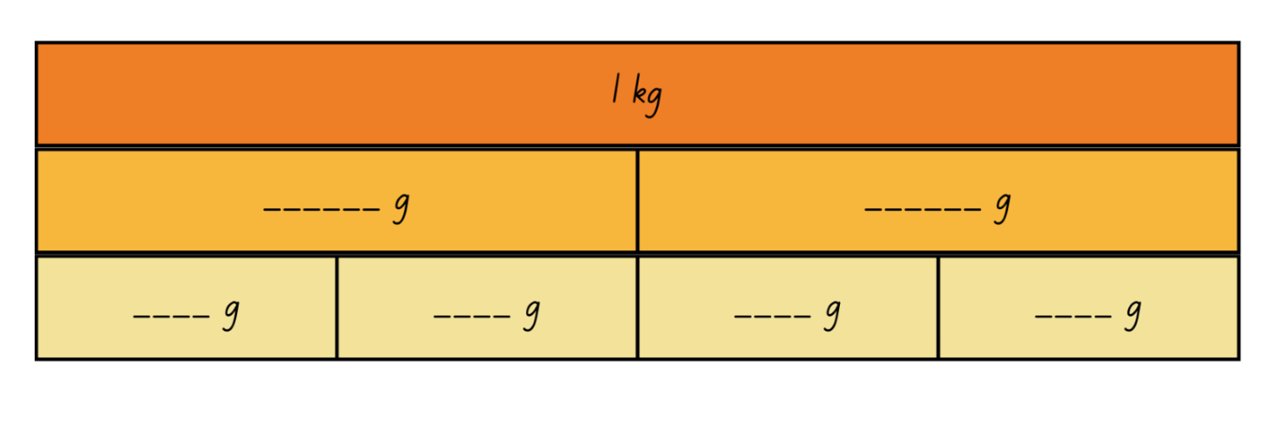
- 1 kg is equal to how many grams?
- How many grams in $\frac{1}{2}$ kg?
- How many grams in $\frac{3}{4}$ kg?
- 500 g is equal to how many kilograms?

Resource 12 – mass word problems
1. The baker has 5 dozen eggs that weigh 550 g per dozen. She also has 300 g of butter and 735 g of sugar. What is the total mass of her ingredients?  Answer in grams and kilograms and then order the masses in ascending order.  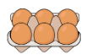 |  | 2. Find the total mass of 5 items weighing 8005 g, 8.60 kg, 2340 g, 3025 g and 4.05 kg.  Answer in grams and kilograms and then order the masses in ascending order.  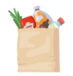
3. A cook prepares 3700 g of flour, 0.81 kg of melted butter and 1 kg 225 g of brown sugar. What is the total mass of ingredients?  Answer in grams and kilograms and then order the masses in descending order. |  | 4. A florist orders 4 boxes of flowers. The boxes contain 3.75 kg of yellow roses, 2.95 kg of purple irises and 6325 g of flannel flowers.  Answer in grams and kilograms and then round your answer up to the nearest kg.  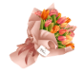
5. Regina buys 4 kg of red lollies, a box of chocolate weighing 3.75 kg, a 1.25 kg box of cupcakes and a 1.5 kg container of ice cream. How much does she have altogether?  Answers in grams and kilograms and then order the masses in descending order. |  | 6. You are opening a new gym. You purchase a medicine ball weighing 8 kg, 2 sets of 15.5 kg barbells and a weighted skipping rope that weighs 3.5 kg.  Order the masses in descending order. What is the difference in mass between the medicine ball and the skipping rope? What is the total mass of all the equipment? Record answers in grams and kilograms.
7. Sarah orders a dress that weighs 750 g, a necklace that weighs 525 g and a pair of high heels that weigh 873 g. What is the weight of her 3 items?  Answers in grams and kilograms and then order the masses in descending order.  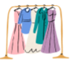 |  | 8. Find the total mass of 3 items weighing 897 g, 9.44 kg and 476 g.  Answers in grams and kilograms and then order the masses in descending order.
9. Find the total mass of 3 vehicles weighing 1900 kg, 2.6 t and 3240 kg.  What is the difference in mass between the heaviest and lightest vehicles? Answer in kilograms and tonnes. |  | 10. A landscape gardener had 5.2 t of topsoil, 3400 kg of bark chips and 2.95 t of pebbles delivered.  How many more kg of topsoil than pebbles did he order? What is the combined total mass of materials? Answer in tonnes and kilograms.
11. There are 6.82 t of rice, 7425 kg of wheat and 5.79 t of barley stored in a warehouse. What is the combined total mass? What is the difference in mass between rice and barley?  Answer in tonnes and kilograms.  How many 10 tonne loads would be required to move the grain?  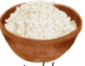 |  | 12. Over 3 consecutive years a mine produced 1985 000 t coal. The amount produced in the second year was double the yield from the first year. The third year also produced more than the first year. What could the amounts of coal produced each year be?  Justify your answer.  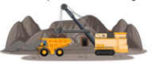
13. A chef has one dozen eggs that weigh 845 g. He also has 3.55 kg of flour and 2045 g of melted butter. What is the total mass of his ingredients?  Answers in grams and kilograms and then order the masses in descending order. |  | 14. A father orders 3 boxes of flowers for his 3 daughters. Each box contains 5 kg of red roses, 5450 g of gardenias and 2.5 kg of baby’s breath. What is the total mass of flowers ordered?  Answers in grams and kilograms and then order the masses in descending order.  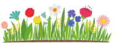
15. Thomas purchases food for his camping trip. He buys 2764 g of strawberries, a 1.60 kg box of cereal and a 2500 g box of fruit. What is the total mass of the food he buys?  Answers in grams and kilograms and then order the masses in descending order.  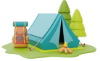 |  | 16. Find the total mass of 3 items weighing 6.45 kg, 1.976 kg and 1877 g.  Answers in grams and kilograms and then order the masses in descending order.  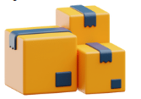

Resource 13 – crocodile measurements
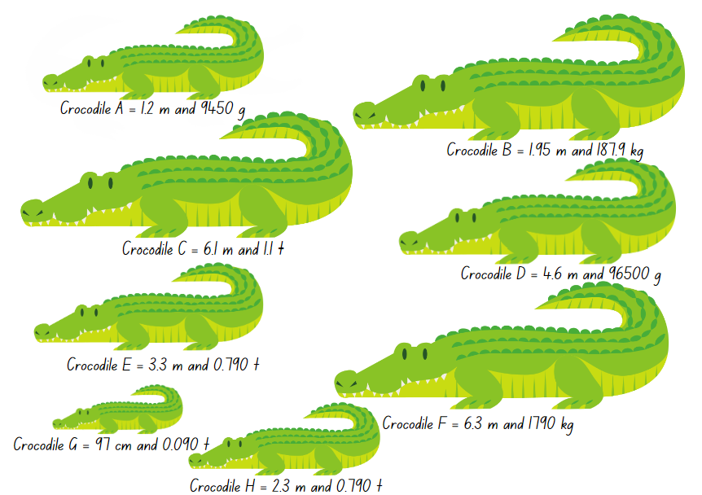

Resource 14 – crocodile conversion chart
Crocodile | Metres (m) | Centimetres (cm) | Tonnes (t) | Kilograms (kg) | Grams (g)
Crocodile A
Crocodile B
Crocodile C
Crocodile D
Crocodile E
Crocodile F
Crocodile G
Crocodile H

Resource 15 – perimeter modelling
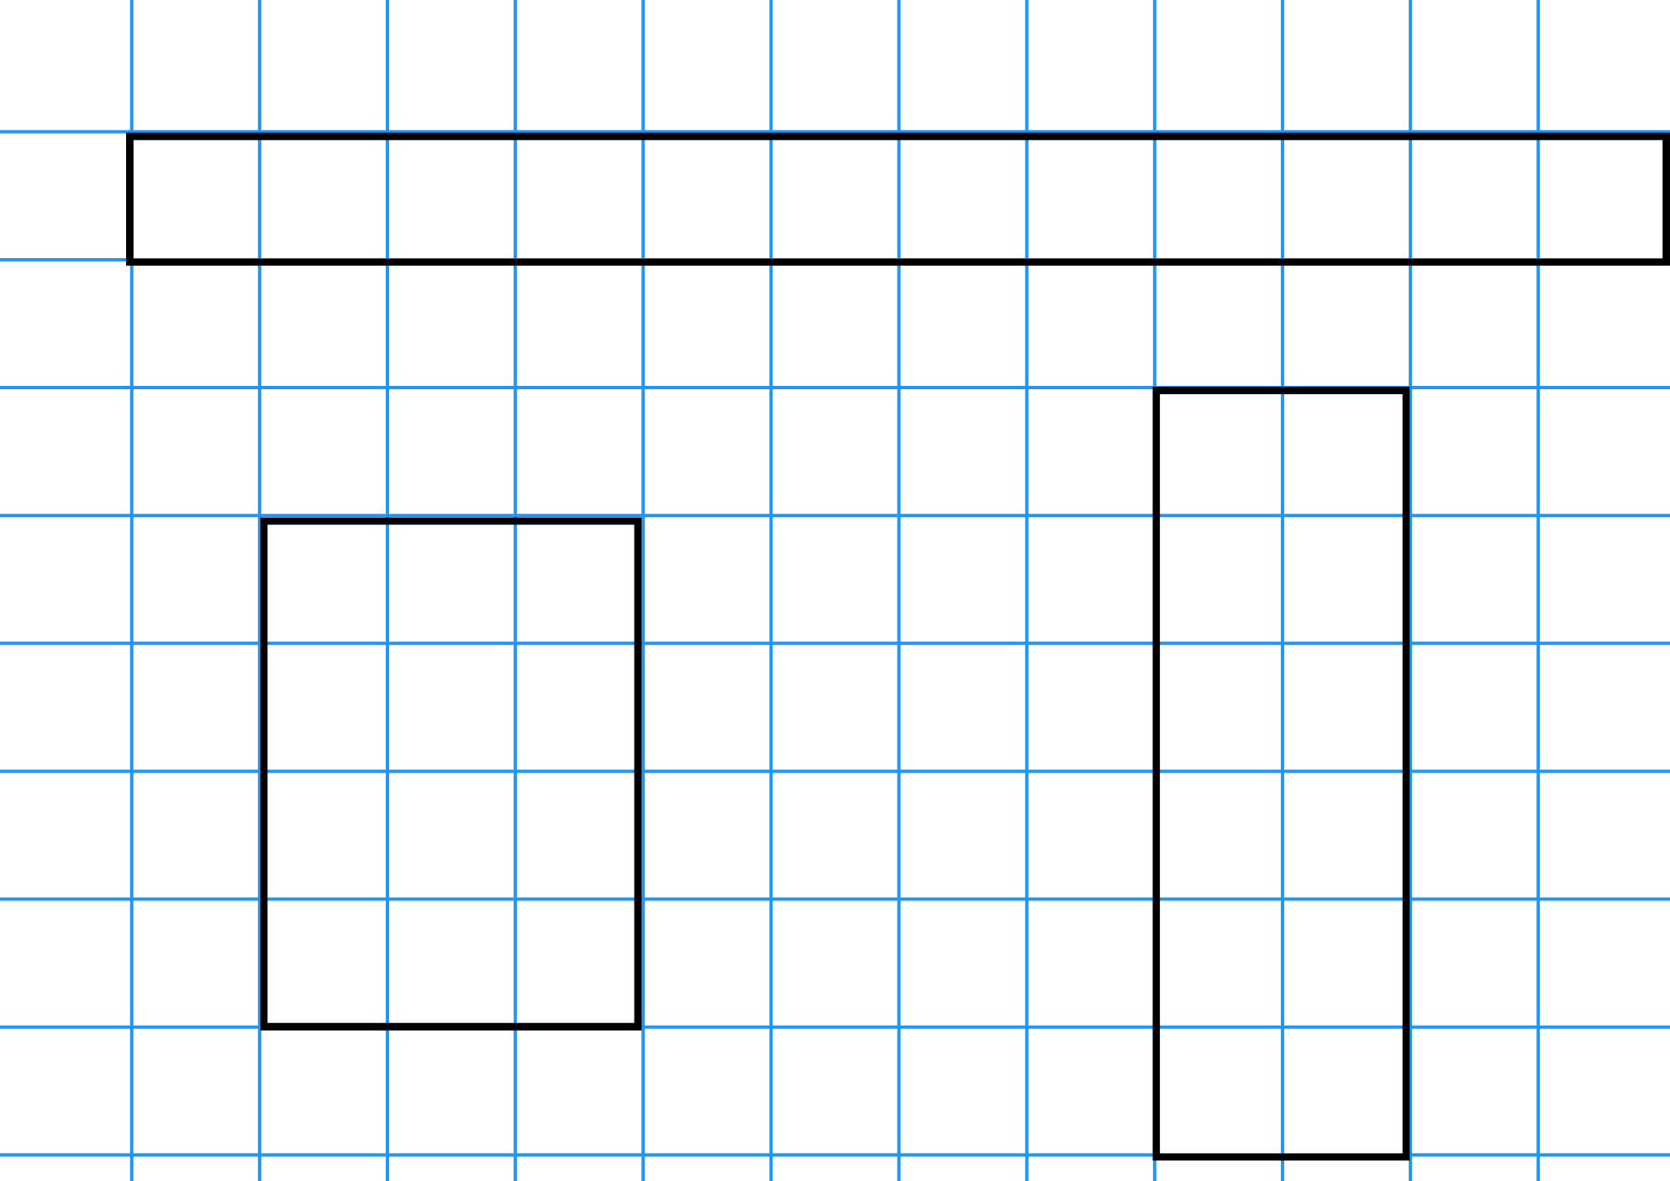

Resource 16 – calculating perimeter
Quadrilateral | Estimation | Measure

Resource 17 – missing perimeter problems
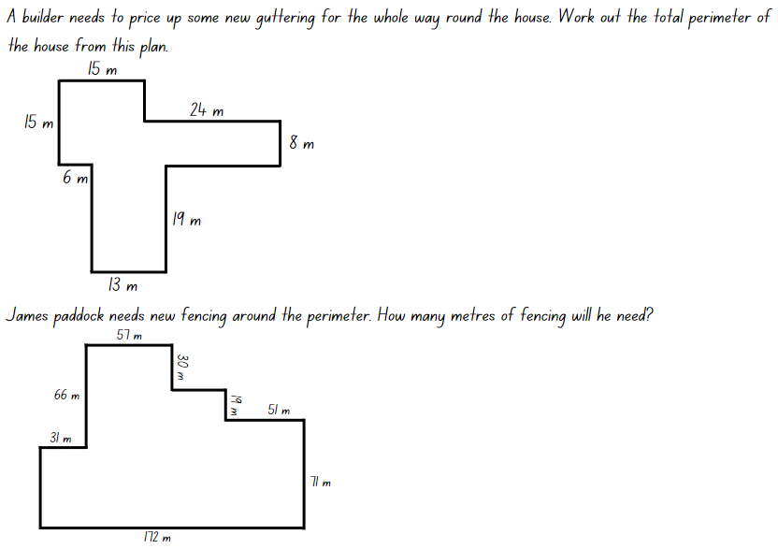
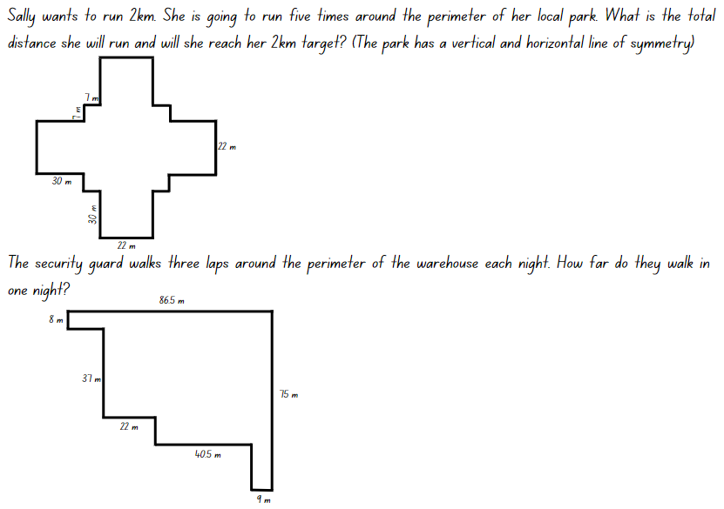

Resource 18 – unit fractions
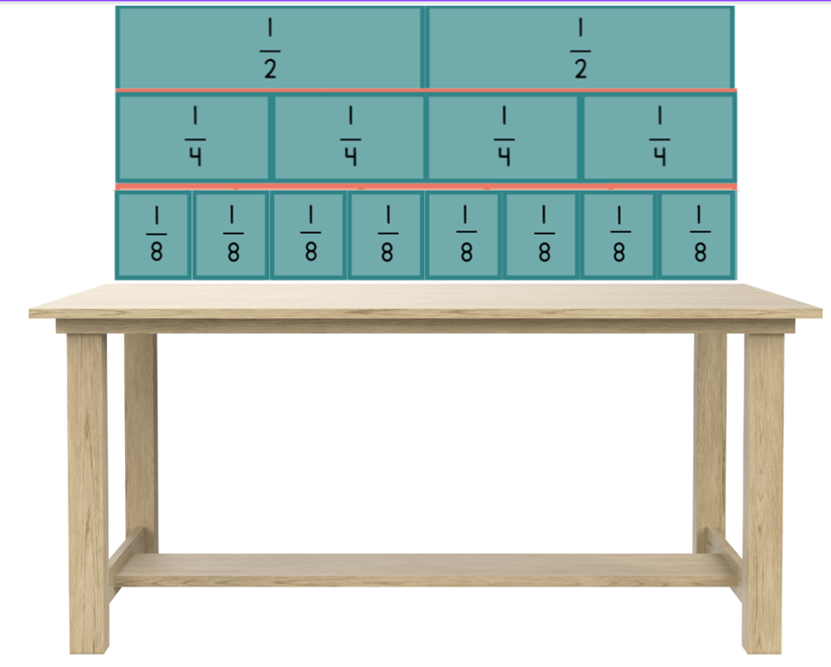

Resource 19 – animal jumps
Personal ratio table
My height is ______ | ×2 | ×3 | ×6 | ×10
Equals (cm)
My height is:
Animal | Times as many | Equals (cm) | Equals (m)
Kangaroo | 4
Grasshopper | 8
Frog | 12
Flea | 20
100 cm = 1 m

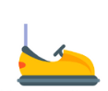
Resource 20 – Darryl’s fencing
Task 1: Darryl is fencing off a space for the dodgems with his 120 cm length panels. They have rented 80 square metres of space.  Draw and label the different rectangular shapes that Darryl could enclose with his fence posts to cover 80 square metres.  - Which of these would be suitable for the dodgems? Why?  - Fencing costs $3.50 per 120 cm panel to hire. Find the cheapest way to fence 80 square metres.  - What would be the most expensive fence design?  - Is this one of the shapes that will suite the dodgems? Why?  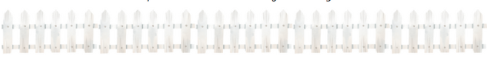 | Task 2: Darryl is fencing off space for the skydivers to land in. For this job he will use his fence panels that are 100 cm in length.  - How many different-shaped rectangles could he make using 48 one-metre panels?  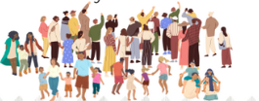  - The skydivers are nervous about landing with all the people around and want the biggest possible area fenced off. What is the largest rectangular area that can be made with 48 metres of fencing?

Resource 21 – mystery bones
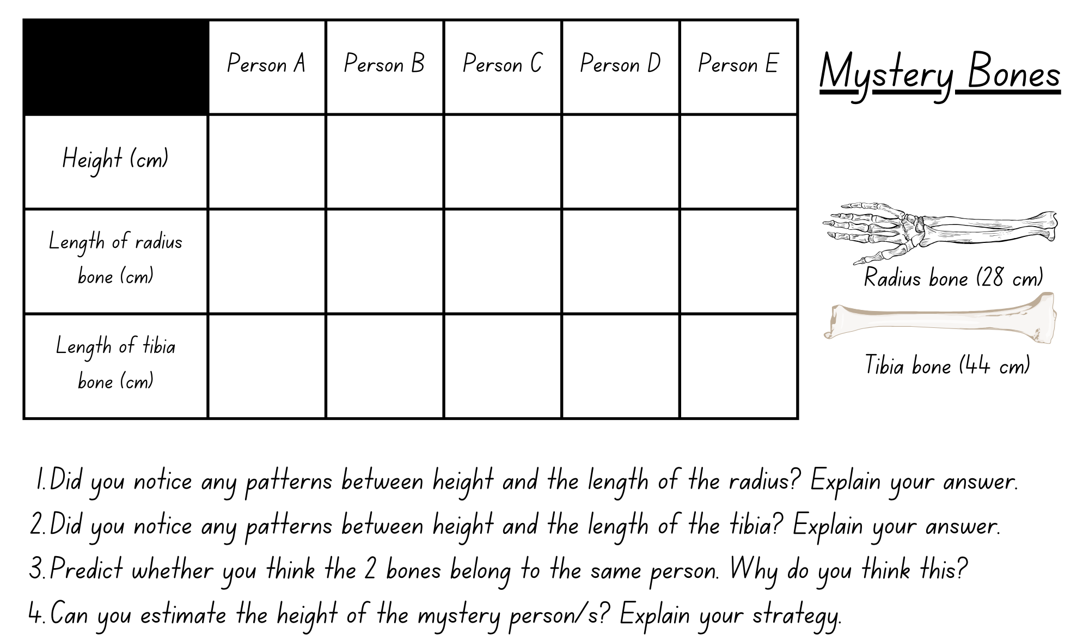

Resource 22 – bone measurement prediction
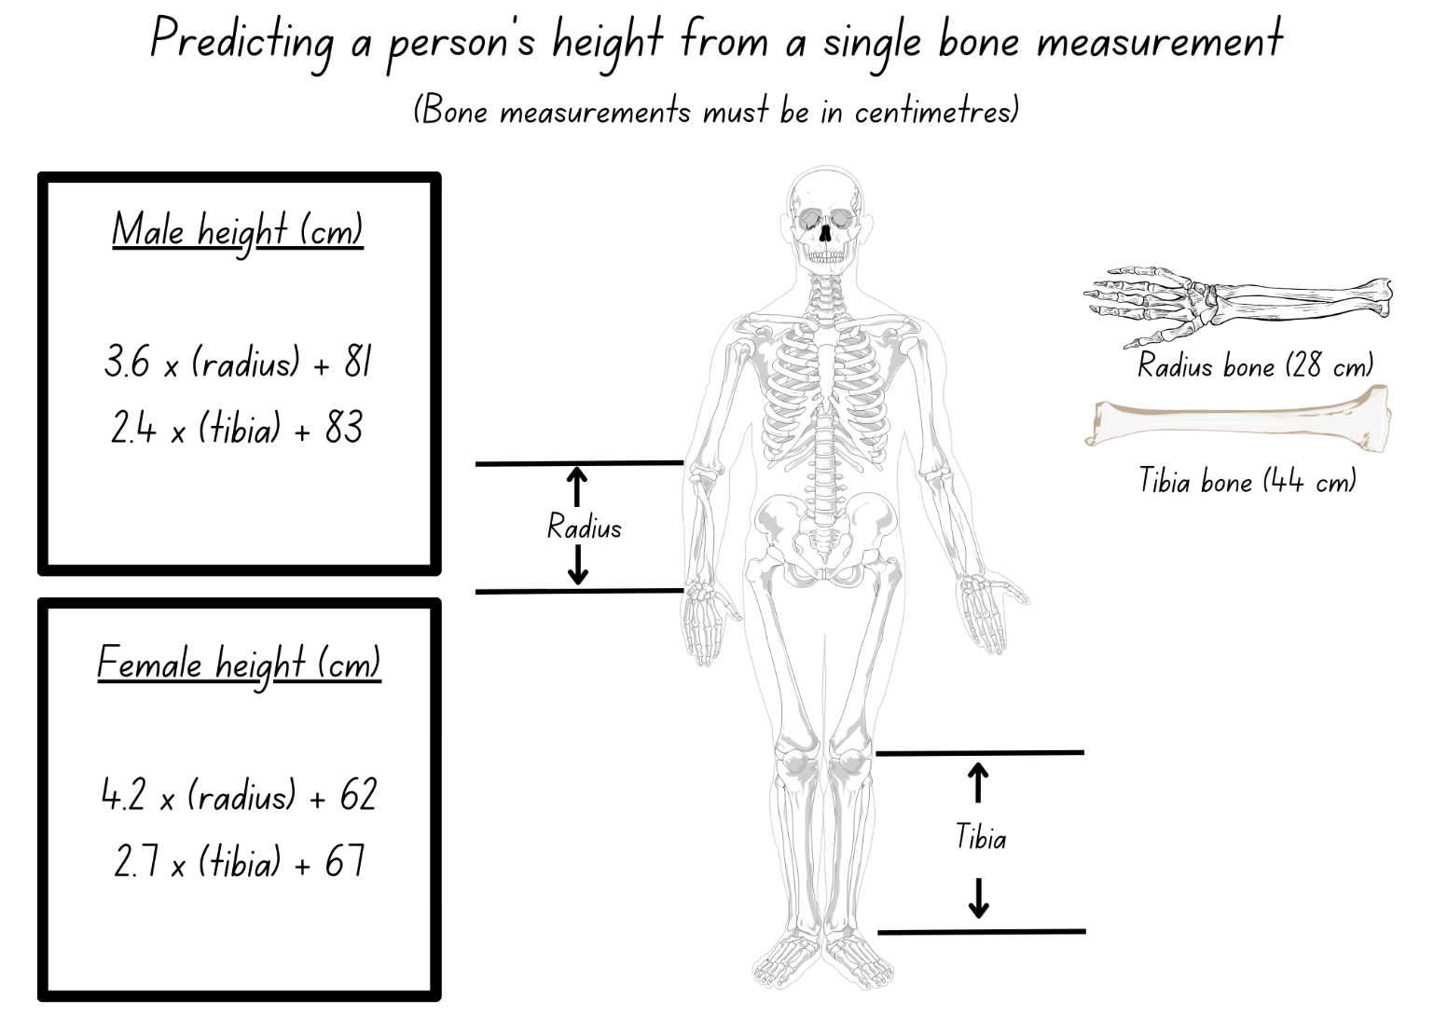

Resource 23 – house plan
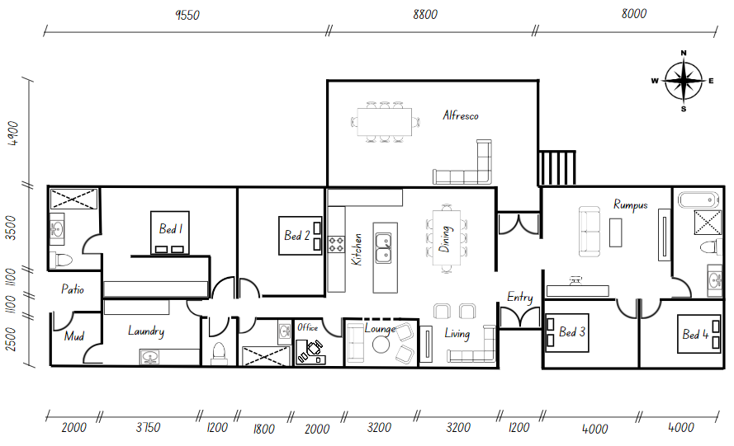

Resource 24 – house plan investigation (Stage 2)
- What is the perimeter of the alfresco area?
- What is the perimeter of the office?
- What is the length of the southern wall of the lounge?
- What is the perimeter of the lounge?
- What is the width of the entry if doubled?
- What is the length of the eastern wall of the house?
- A wall painting has a length of 2600 mm. Would it fit on the eastern wall of the office? Yes/No. Why?
- What is the perimeter of the outside walls of the house?

Resource 25 – house plan investigation (Stage 3)
- What is the perimeter of the alfresco area in millimetres?
- What is the perimeter of the office and lounge combined in centimetres (cm)?
- What is the perimeter of the outside walls of the house in metres (m)?
- A cupboard has a width of 1.25 m. Would it fit through the entry?
- A lounge has a length of 240 cm. Would it fit against the western wall of the lounge?
- A wall painting has a length of 2.6 m. Would it fit on the eastern wall of the office?
- The primary school is 2750 m from the house. How far is it in kilometres (km)?
- The sports fields are 3.890 km from the house. How far away are they in metres (m)?
- The local shop is 1.065 km from the house. How far is the round trip to and from the shop in metres (m)?

Syllabus outcomes and content

Stage 2
The table below outlines the syllabus outcomes and range of relevant syllabus content covered in this unit. Content is linked to National Numeracy Learning Progression (version 3).
Outcomes and content | 1 | 2 | 3 | 4 | 5 | 6 | 7 | 8
Representing numbers using place value B: Decimals: Extend the application of the place value system from whole numbers to tenths and hundredths
[MAO-WM-01, MA2-RN-02]
- Use the decimal point as a marker to identify the position of the ones digit when expressing tenths as decimals | x | x |  | x |  | x | x | x
- Recognise that 10-tenths is recorded as 1.0 and regroup when using decimal notation |  |  |  |  |  | x
- Express decimals as both tenths and hundredths | x | x | x | x |  | x | x | x
Representing numbers using place value B: Decimals: Extend the application of the place value system from whole numbers to tenths and hundredths
[MAO-WM-01, MA2-RN-02]
- Divide a length representing one whole into 10 equal parts and label the divisions using decimal notation | x | x | x
- Use the decimal point as a marker to identify the position of the ones digit when expressing tenths as decimals | x | x | x
- Express decimals as both tenths and hundredths | x | x | x
- Locate and order decimals representing tenths and hundredths on a number line, describing their relative size | x | x | x
- Interpret zero digits at the end of a decimal | x
- Distinguish between the role of zero in various positions | x |  | x
Partitioned fractions A: Model and represent unit fractions, and their multiples, to a complete whole on a number line
[MAO-WM-01, MA2-PF-01]
- Model fractions with fraction strips and diagrams for halves, quarters, eighths, thirds |  |  |  |  | x | x
- Determine the complementary fractional part needed to complete one whole (halves, quarters, eighths, thirds) (Reasons about relations) |  |  |  |  |  |  | x
- Recreate the whole unit from a fractional part ($\frac{1}{2}$, $\frac{1}{4}$, $\frac{1}{3}$ and $\frac{1}{8}$) (Reversible reasoning) |  |  |  |  | x | x | x
Geometric measure B: Use scaled instruments to measure and compare lengths
[MAO-WM-01, MA2-GM-02]
- Select and use an appropriate unit to estimate, measure and compare lengths and distances |  |  |  | x |  | x | x
- Use the term perimeter to describe the distance around the boundary |  |  |  |  | x |  |  | x
- Estimate and measure the perimeters of quadrilaterals |  |  |  |  | x |  |  | x
- Convert between metres and centimetres, and between centimetres and millimetres |  |  |  | x |  | x | x | x
- Record lengths and distances using decimal notation to 2 decimal places |  |  |  | x |  | x | x | x
Non-spatial measure A: Mass: Compare objects using the kilogram
[MAO-WM-01, MA2-NSM-01]
- Recognise the need for a formal unit to measure mass | x | x
- Identify familiar objects that have a mass of about one kilogram | x
- Find objects that have an estimated mass of more than, less than and about the same as one kilogram and check by comparing to a 1 kg mass | x
Non-spatial measure B: Mass: Use scaled instruments to measure and compare masses
[MAO-WM-01, MA2-NSM-01]
- Recognise the need for a formal unit smaller than the kilogram | x | x | x
- Use a scaled instrument to relate 1000 grams to one kilogram | x | x | x
- Identify familiar objects that could be measured in grams | x | x | x
- Measure and record mass in grams (g) using a scaled instrument | x | x | x | x
- Compare 2 or more objects by mass measured in kilograms and grams using a set of scales |  |  |  | x
- Interpret commonly used fractions of a kilogram, including $\frac{1}{2}$, $\frac{1}{4}$, $\frac{3}{4}$, and relate these to the number of grams |  | x | x
- Record masses greater than a kilogram using kilograms and grams |  |  | x | x
Mathematics K–10 Syllabus © NSW Education Standards Authority (NESA) for and on behalf of the Crown in right of the State of New South Wales, 2022.

Stage 3
The table below outlines the syllabus outcomes and range of relevant syllabus content covered in this unit. Content is linked to National Numeracy Learning Progression (version 3).
Outcomes and content | 1 | 2 | 3 | 4 | 5 | 6 | 7 | 8
Represents numbers A: Decimals and percentages: Compare, order and represent decimals
[MAO-WM-01, MA3-RN-01, MA3-RN-02]
- Compare and order decimal numbers of up to 3 decimal places | x | x | x
- Interpret zero digit(s) at the end of a decimal | x |  | x
- Approximate the size of decimals | x | x | x
- Place decimal numbers of up to 3 decimal places on a number line | x | x | x
Representing quantity fractions B: Build up to the whole from a given fractional part
[MAO-WM-01, MA3-RQF-02]
- Generate the whole quantity from non-unit fractional parts such as quarters, eighths, thirds, sixths, fifths and tenths (Reversible reasoning) |  |  |  |  | x | x | x
Geometric measure B: Length: Connect decimal representations to the metric system
[MAO-WM-01, MA3-GM-02]
- Recognise the equivalence of whole-number and decimal representations of measurements of length |  |  |  | x |  | x |  | x
- Interpret decimal notation for lengths and distances |  |  |  | x
- Record lengths and distances using decimal notation |  |  |  | x |  | x | x | x
Geometric measure B: Length: Convert between common metric units of length
[MAO-WM-01, MA3-GM-02]
- Use decimal place value system to convert between metres and kilometres |  |  |  |  |  |  |  | x
- Convert measurements to the same unit to compare lengths and distances |  |  |  | x |  | x |  | x
- Explain and use the relationship between the size of a unit and the number of units needed |  | x |  |  |  |  | x | x
Geometric measure B: Length: Solve problems involving the comparison of lengths using appropriate units
[MAO-WM-01, MA3-GM-02]
- Investigate and compare perimeters of rectangles with the same area |  |  |  |  | x | x
- Determine the number of different rectangles that can be formed using whole-number dimensions for a given area (Reasons about spatial structure) |  |  |  |  | x | x
- Solve a variety of problems involving length and perimeter, including problems involving different units of length |  |  |  |  | x | x | x | x
Two-dimensional spatial structure A: Area: Calculate the areas of rectangles using familiar metric units
- Establish the relationship between the lengths, widths and areas of rectangles |  |  |  |  | x | x
- Recognise that rectangles with the same area may have different dimensions |  |  |  |  | x | x
- Investigate and compare the areas of rectangles that have the same perimeter |  |  |  |  | x | x
Non-spatial measure A: Mass: Connect decimal representations to the metric system
[MAO-WM-01, MA3-NSM-01]
- Recognise the equivalence of whole-number and decimal representations of measurements of mass | x | x | x | x
- Interpret decimal notation for masses | x |  | x | x
- Measure mass using scales and record using decimal notation of up to 3 decimal places | x |  | x | x
Non-spatial measure B: Mass: Convert between common metric units of mass
[MAO-WM-01, MA3-NSM-01]
- Convert between kilograms and grams and between kilograms and tonnes | x | x | x | x
- Solve problems involving different units of mass | x | x | x
Mathematics K–10 Syllabus © NSW Education Standards Authority (NESA) for and on behalf of the Crown in right of the State of New South Wales, 2022.

References
This resource contains NSW Curriculum and syllabus content. The NSW Curriculum is developed by the NSW Education Standards Authority. This content is prepared by NESA for and on behalf of the Crown in right of the State of New South Wales. The material is protected by Crown copyright.
Please refer to the NESA Copyright Disclaimer for more information https://educationstandards.nsw.edu.au/wps/portal/nesa/mini-footer/copyright.
NESA holds the only official and up-to-date versions of the NSW Curriculum and syllabus documents. Please visit the NSW Education Standards Authority (NESA) website https://educationstandards.nsw.edu.au/wps/portal/nesa/home and the NSW Curriculum website https://curriculum.nsw.edu.au/.
Mathematics K–10 Syllabus © NSW Education Standards Authority (NESA) for and on behalf of the Crown in right of the State of New South Wales, 2022.
National Numeracy Learning Progression © Australian Curriculum, Assessment and Reporting Authority (ACARA) 2010 to present, unless otherwise indicated. This material was downloaded from the Australian Curriculum website (National Numeracy Learning Progression) (accessed 11/03/2024) and was not modified.
Australian Academy of Science (2024) ‘Measurement: Jump!’, Teaching resources, reSolve: Maths by Inquiry website, accessed 13 February 2024.
Clarke D (1996) The Case of the Mystery Bone: A Unit of Work on Measurement for Grades 5 to 8, Australian Association of Mathematics Teachers Inc, Australia.
Clean Up Australia (2024) Clean Up Our Waste, Clean Up Australia website, accessed 18 April 2024.
New Zealand Ministry of Education (n.d.) ‘Fred’s Rent-a-Fence’, Resource, NZ Maths website, accessed 13 February 2024.
New Zealand Ministry of Education (n.d.) ‘Types of Rubbish’, Resource, NZ Maths website, accessed 6 February 2024.
New Zealand Ministry of Education (n.d.) ‘Weighing stations’, Resource, NZ Maths website, accessed 12 February 2024.
State of New South Wales (Department of Education) (2022) Stage 2 – mass, NSW Department of Education website, accessed 6 February 2024.

© State of New South Wales (Department of Education), 2024
The copyright material published in this resource is subject to the Copyright Act 1968 (Cth) and is owned by the NSW Department of Education or, where indicated, by a party other than the NSW Department of Education (third-party material).
Copyright material available in this resource and owned by the NSW Department of Education is licensed under a Creative Commons Attribution 4.0 International (CC BY 4.0) license.
This licence allows you to share and adapt the material for any purpose, even commercially.
Attribution should be given to © State of New South Wales (Department of Education), 2024.
Material in this resource not available under a Creative Commons licence:
- the NSW Department of Education logo, other logos and trademark-protected material
- material owned by a third party that has been reproduced with permission. You will need to obtain permission from the third party to reuse its material.
Links to third-party material and websites
Please note that the provided (reading/viewing material/list/links/texts) are a suggestion only and implies no endorsement, by the New South Wales Department of Education, of any author, publisher, or book title. School principals and teachers are best placed to assess the suitability of resources that would complement the curriculum and reflect the needs and interests of their students.
If you use the links provided in this document to access a third-party's website, you acknowledge that the terms of use, including licence terms set out on the third-party's website apply to the use which may be made of the materials on that third-party website or where permitted by the Copyright Act 1968 (Cth). The department accepts no responsibility for content on third-party websites.

