Mathematics 3–6 Multi-age – Year B – Unit 13
Multiplicative thinking involves flexible use of multiplication and division concepts, strategies and representations
Contents
Unit description and duration 5
Syllabus outcomes 5
Stage 2 6
Stage 3 6
Working mathematically 6
Student prior learning 7
Lesson overview and resources 9
Lesson 1 16
Daily number sense – balance the scales – 15 minutes 16
Core lesson – fencing – 40 minutes 19
Consolidation and meaningful practice – 15 minutes 26
Lesson 2 29
Daily number sense – target number – 15 minutes 29
Core lesson 1 – using known strategies – 20 minutes 31
Core lesson 2 – footy final frenzy – 30 minutes 35
Discuss and connect the mathematics – 5 minutes 37
Lesson 3 40
Daily number sense – which is correct? – 15 minutes 40
Core lesson 1 – multiplication and division are related – 20 minutes 42
Core lesson 2 – ‘Keep in step’ – 20 minutes 44
Consolidation and meaningful practice – 10 minutes 46
Lesson 4 49
Daily number sense – 10 minutes 49
Core lesson – 45 minutes 49
Stage 2 task – multiplicative structures 49
Stage 3 task – vertical double number lines 53
Discuss and connect the mathematics – 5 minutes 57
Lesson 5 59
Daily number sense – make it true – 10 minutes 59
Core lesson 1 – number slides – 20 minutes 61
Core lesson 2 – spinners – 20 minutes 66
Consolidation and meaningful practice – 15 minutes 69
Lesson 6 71
Daily number sense – create an equation – 15 minutes 71
Core lesson 1 – powers of 10 – 25 minutes 73
Core lesson 2 – multiplication strategies – 15 minutes 77
Consolidation and meaningful practice – 10 minutes 78
Lesson 7 80
Daily number sense – worded problems – 15 minutes 80
Core lesson – 45 minutes 82
Stage 2 task – number properties 82
Stage 3 task – benchmark operations 87
Discuss and connect the mathematics – 10 minutes 90
Lesson 8 92
Daily number sense – 10 minutes 92
Core lesson – 50 minutes 92
Stage 2 task – flexible partitioning 92
Stage 3 task – using grouping symbols 96
Discuss and connect the mathematics – 5 minutes 100
Resource 1 – balance the scales 102
Resource 2 – think board 103
Resource 3 – footy final cards (Stage 2) 104
Resource 4 – footy final cards (Stage 3) 105
Resource 5 – Which is correct? 106
Resource 6 – large number spinners 107
Resource 7 – decimal spinners 108
Resource 8 – partitioned arrays 109
Resource 9 – multiplication toss spinner 110
Resource 10 – Who is correct? 111
Resource 11 – more grouping symbols 112
Syllabus outcomes and content 113
Stage 2 113
Stage 3 119
References 123

Unit description and duration
This unit develops the big idea that multiplicative thinking involves flexible use of multiplication and division concepts, strategies and representations.
In this 2-week unit, students are provided opportunities to:
- select and apply strategies to solve problems involving multiplication and division with whole numbers
- investigate and apply the use of multiples to determine unknown values (Stage 2)
- use number properties to find related multiplication facts (Stage 2)
- multiply and divide decimals by powers of 10 (Stage 3)
- investigate the order of operations using real-life contexts (Stage 3).
This multi-age unit is informed by the lessons in Stage 2 Year B Unit 33 and Stage 3 Year B Unit 33. Please refer to these units for additional lesson guidance.

Syllabus outcomes
- MAO-WM-01 develops understanding and fluency in mathematics through exploring and connecting mathematical concepts, choosing and applying mathematical techniques to solve problems, and communicating their thinking and reasoning coherently and clearly

Stage 2
- MA2-RN-01 applies an understanding of place value and the role of zero to represent numbers to at least tens of thousands
- MA2-AR-02 completes number sentences involving addition and subtraction by finding missing values
- MA2-MR-01 represents and uses the structure of multiplicative relations to 10 × 10 to solve problems
- MA2-MR-02 completes number sentences involving multiplication and division by finding missing values

Stage 3
- MA3-RN-01 applies an understanding of place value and the role of zero to represent the properties of numbers
- MA3-AR-01 selects and applies appropriate strategies to solve addition and subtraction problems
- MA3-MR-01 selects and applies appropriate strategies to solve multiplication and division problems
- MA3-MR-02 constructs and completes number sentences involving multiplicative relations, applying the order of operations to calculations

Working mathematically
In the Mathematics K–10 Syllabus, there is one overarching Working mathematically outcome (MAO-WM-01). The Working mathematically processes should be embedded within the concepts being taught. The Working mathematically processes present in the Mathematics K–10 Syllabus are:
- communicating
- understanding and fluency
- reasoning
- problem solving.
Mathematics K–10 Syllabus © NSW Education Standards Authority (NESA) for and on behalf of the Crown in right of the State of New South Wales, 2022.

Student prior learning
Before engaging in these teaching and learning activities, students would benefit from prior experience with:
- investigating and implementing derived strategies for multiplication facts to 10 × 10
- exploring and applying the inverse relationship between multiplication and division
- exploring and applying the associative, commutative and distributive properties of multiplication (Stage 2)
- using partitioning and place value to multiply 2-, 3- and 4-digit numbers by one-digit numbers (Stage 3)
- determining products and factors (Stage 3).
In NSW classrooms there is a diverse range of students, including Aboriginal and/or Torres Strait Islander students, students learning English as an additional language or dialect, high potential and gifted students and students with disability. Some students may identify with more than one of these groups or possibly all of them. Refer to Curriculum planning for every student – advice for further information.

Lesson overview and resources
To cover the content of the syllabus across Stage 2 and Stage 3, some core lessons in the unit contain both a Stage 2 and a Stage 3 task. Teachers are encouraged to adapt and contextualise the units to meet the needs of their students.
The table below outlines the sequence and approximate timing of lessons, learning intentions and resources.
Lesson | Content | Duration and resources
Lesson 1  Daily number sense  Stage 2:  - Multiplicative relations B: Represent and solve word problems with number sentences involving multiplication or division  Stage 3:  - Multiplicative relations B: Explore the use of brackets and the order of operations to write number sentences | Lesson core concept: number patterns can be multiplicative.  Stage 2:  - Multiplicative relations B: Investigate number sequences involving related multiples  Stage 3:  - Multiplicative relations B: Represent and describe number patterns formed by multiples | Lesson duration: 70 minutes  - Resource 1 – balance the scales  - Individual whiteboards  - Whiteboard markers  - Writing materials
Lesson 2  Daily number sense  Stage 2:  - Multiplicative relations B: Represent and solve word problems with number sentences involving multiplication or division  Stage 3:  - Multiplicative relations B: Explore the use of brackets and the order of operations to write number sentences | Lesson core concept: known number facts and strategies support multiplicative understanding.  Stage 2:  - Multiplicative relations B: Use known number facts and strategies  Stage 3:  - Represents numbers A: Whole numbers: Apply place value to partition, regroup and rename numbers to 1 billion  - Multiplicative relations B: Select and apply strategies to solve problems involving multiplication and division with whole numbers | Lesson duration: 70 minutes  - Resource 2 – think board  - Resource 3 – footy final cards (Stage 2)  - Resource 4 – footy final cards (Stage 3)  - Calculators  - Individual whiteboards  - Scissors  - Whiteboard markers  - Writing materials
Lesson 3  Daily number sense  Stage 2:  - Multiplicative relations B: Represent and solve word problems with number sentences involving multiplication or division  Stage 3:  - Multiplicative relations B: Explore the use of brackets and the order of operations to write number sentences | Lesson core concept: multiplication and division are related.  Stage 2:  - Multiplicative relations A: Represent and solve problems involving multiplication fact families  - Multiplicative relations B: Represent and solve word problems with number sentences involving multiplication or division  Stage 3:  - Multiplicative relations B: Use equivalent number sentences involving multiplication and division to find unknown quantities | Lesson duration: 65 minutes  - Resource 5 – Which is correct?  - 10-sided die (1–10)  - Individual whiteboards  - Whiteboard markers in 3 different colours  - Writing materials
Lesson 4  Daily number sense  - teacher-identified task based on student needs | Lesson core concept: visual representations can support multiplicative thinking.  Stage 2:  - Multiplicative relations B: Use the structure of the area model to represent multiplication and division  Stage 3:  - Multiplicative relations B: Select and apply strategies to solve problems involving multiplication and division with whole numbers | Lesson duration: 60 minutes  - Individual whiteboards  - Whiteboard markers  - Writing materials
Lesson 5  Daily number sense  Stage 2:  - Additive relations B: Complete number sentences involving additive relations to find unknown quantities  Stage 3:  - Additive relations A: Apply efficient mental and written strategies to solve addition and subtraction problems | Lesson core concept: place value understanding supports mathematicians with multiplicative thinking.  Stage 2:  - Representing numbers using place value B: Whole numbers: Recognise and represent numbers that are 10, 100 or 1000 times as large  - Multiplicative relations B: Investigate number sequences involving related multiples  Stage 3:  - Multiplicative relations B: Multiply and divide decimals by powers of 10 | Lesson duration: 65 minutes  - Resource 6 – large number spinners  - Resource 7 – decimal spinners  - Calculators  - Individual whiteboards  - Paper clips  - Whiteboard markers  - Writing materials
Lesson 6  Daily number sense  Stage 2:  - Additive relations B: Complete number sentences involving additive relations to find unknown quantities  Stage 3:  - Additive relations A: Apply efficient mental and written strategies to solve addition and subtraction problems | Lesson core concept: flexible methods of computation in multiplication and division involve composing and decomposing numbers.  Stage 2:  - Representing numbers using place value B: Whole numbers: Recognise and represent numbers that are 10, 100 or 1000 times as large  - Multiplicative relations B: Operate with multiples of 10  Stage 3:  - Multiplicative relations B: Multiply and divide decimals by powers of 10 | Lesson duration: 65 minutes  - Individual whiteboards  - Whiteboard makers  - Writing materials
Lesson 7  Daily number sense  Stage 2:  - Additive relations B: Complete number sentences involving additive relations to find unknown quantities  Stage 3:  - Additive relations A: Apply efficient mental and written strategies to solve addition and subtraction problems | Lesson core concept: number properties can be used to solve multiplication problems (Stage 2) and flexible methods of computation in multiplication and division involve composing and decomposing numbers (Stage 3).  Stage 2:  - Multiplicative relations B: Use number properties to find related multiplication facts  - Multiplicative relations B: Operate with multiples of 10  Stage 3:  - Multiplicative relations B: Select and apply strategies to solve problems involving multiplication and division with whole numbers  - Multiplicative relations B: Multiply and divide decimals by powers of 10 | Lesson duration: 70 minutes  - Resource 5 – Which is correct?  - Individual whiteboards  - Whiteboard makers  - Writing materials
Lesson 8  Daily number sense  - teacher-identified task based on student needs | Lesson core concept: number properties can be used to solve multiplication problems (Stage 2) and the order of operations is important to solve mathematics problems (Stage 3).  Stage 2:  - Multiplicative relations B: Use number properties to find related multiplication facts  Stage 3:  - Multiplicative relations B: Explore the use of brackets and the order of operations to write number sentences | Lesson duration: 65 minutes  - Resource 8 – partitioned arrays  - Resource 9 – multiplication toss spinner  - Resource 10 – Who is correct?  - Resource 11 – more grouping symbols  - Different coloured markers (at least 2)  - Grid paper  - Individual whiteboards  - Paperclips  - Whiteboard makers  - Writing materials

Lesson 1
Core concept: number patterns can be multiplicative.

Daily number sense – balance the scales – 15 minutes
Daily number sense activities for Lessons 1 to 3 ‘activate’ prior number knowledge and support the learning of new content in the unit. These activities can also assist teachers to identify the starting points for learning by revealing the extent of students’ existing knowledge.
The table below contains suggested learning intentions and success criteria. These are best co-constructed with students.
Daily number sense learning intentions | Daily number sense success criteria
Students working towards Stage 2 outcomes are learning to:  - represent and solve word problems with number sentences involving multiplication or division.  Students working towards Stage 3 outcomes are learning to:  - explore the use of brackets and the order of operations to write number sentences. | Students working towards Stage 2 outcomes can:  - use the equals sign to record equivalent number relationships involving multiplication.  Students working towards Stage 3 outcomes can:  - recognise the need to agree on the order in which to perform operations  - use grouping symbols ( ) in number sentences to indicate operations that must be performed first.
- Display the first scale for both Stage 2 and Stage 3 students from Resource 1 – balance the scales.
- Explain that each side of the balance scale has an equation and that because the scale is level, both equations are equal. Discuss ‘equivalence’ and how to indicate equivalence when writing equations. Ensure students understand that ‘equivalence’ means the same value and is represented by an equals sign.
- Revise with Stage 3 students that all multiplication and division operations are completed by working left to right, before adding and subtracting. To change this order, grouping symbols are used to indicate what to do first.
- Stage 2 students Think-Pair-Share to determine a division equation for the right side of the scale on Resource 1 – balance the scales that will ensure the scale remains level. Stage 3 students Think-Pair-Share to determine how grouping symbols can be used to ensure the scale Resource 1 – balance the scales remains level.
- Stage 2 students record as many different answers as possible on individual whiteboards (see Figure 1).
Figure 1 – Stage 2 balance the scales example
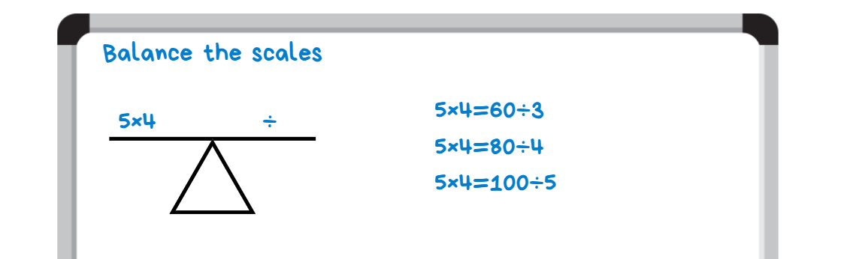
- Stage 3 students record all the ways grouping symbols could be used to solve 7 + 6 × 4 − 2 on individual whiteboards to determine which variation will make the equation equal 26 (see Figure 2).
Figure 2 – Stage 3 balance the scales example
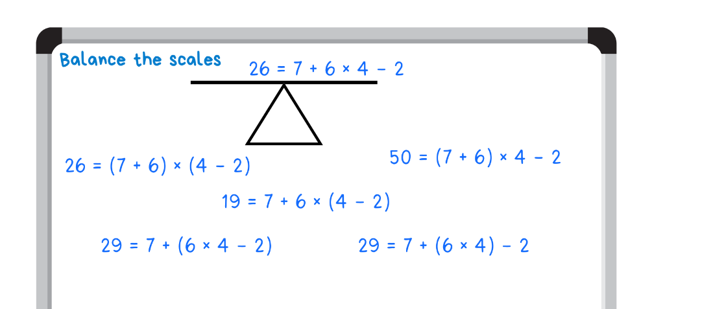
- Students share and compare answers, communicating and justifying their reasoning.
- Repeat process with the remaining equations on Resource 1 – balance the scales.
This table details opportunities for assessment.
Assessment opportunities | Links
What to look for:  - Can Stage 2 students use the equals sign to record equivalent number relationships involving multiplication? [MAO-WM-01, MA2-MR-01, MA2-MR-02]  - Can Stage 3 students recognise the need to agree on the order in which to perform operations? [MAO-WM-01, MA3-MR-02]  - Can Stage 3 students use grouping symbols in number sentences to indicate operations that must be performed first? [MAO-WM-01, MA3-MR-02] | Links to National Numeracy Learning Progressions (NNLP):  - Stage 2 – NPA4  - Stage 3 – NPA5.  Links to suggested Interview for Student Reasoning (IfSR) tasks:  - Stage 2 – IfSR-MT: 2A.11, 3A.9.

Core lesson – fencing – 40 minutes
The table below contains suggested learning intentions and success criteria. These are best co-constructed with students.
Core concept learning intentions | Core concept success criteria
Students working towards Stage 2 outcomes are learning to:  - investigate number sequences involving related multiples.  Students working towards Stage 3 outcomes are learning to:  - represent and describe number patterns formed by multiples. | Students working towards Stage 2 outcomes can:  - generate number patterns using related multiples  - investigate number patterns involving related multiples.  Students working towards Stage 3 outcomes can:  - describe a pattern formed by multiples in words, in terms of multiplication rather than addition  - determine a rule describing the relationship between the bottom number and the top number in a table.
This lesson is an adaptation of Fencing the Freeway (PDF 69.7 KB) from Scaffolding Numeracy in the Middle Years by State of Victoria Department of Education and Early Childhood Development (DEECD).
- Pose the following question to Stage 2 students: Farmer Cal has recently purchased a block of land for his new cattle business. To keep his cattle safe, he needs to fence his property. Farmer Cal knows that he will need 2 posts for every one metre of fencing. A metre of fencing is sold with a post on each side. How many posts are required for 2 metres of fencing?
- Pose the following question to Stage 3 students: Farmer Cal has recently purchased a block of land for his new cattle business. To keep his cattle safe, he needs to fence his property. Farmer Cal knows that he will need one post for every 2 metres of fencing and one at each end. How many posts are required for 4 metres of fencing?
- Provide individual whiteboards for students to record a visual representation of the number of posts (see Figure 3 for Stage 2 students and Figure 4 for Stage 3 students).
Figure 3 – Stage 2 visual representation example
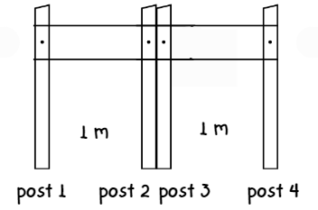
Figure 4 – Stage 3 visual representation example
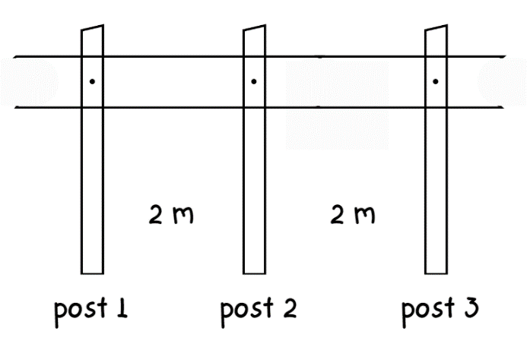
- In pairs, Stage 2 students discuss and record the number of posts required for:
- 4 metres of fencing
- 6 metres of fencing
- 8 metres of fencing
- 20 metres of fencing.
- In pairs, Stage 3 students discuss and record the number of posts required for:
- 8 metres of fencing
- 12 metres of fencing
- 24 metres of fencing.
- Regroup as a class and select pairs of students to share their visual representations and answers.
- Discuss the different strategies used to calculate the number of posts required for each length of fencing.
- Ask:
- What do you notice?
- Is there a more effective way to calculate the number of posts required?
- Draw the following table on the board to show how information from the Stage 2 visual representation can be organised:
Length of fencing  (in metres) | 2 | 4 | 6 | 8 | … | 20
Number of posts | 4 | 8 | 12 | 16 | … | 40
- Draw the following table on the board to show how information from the Stage 3 visual representation can be organised:
Length of fencing  (in metres) | 2 | 4 | 6 | 8 | 10 | 12 | … | 24 | … | 36
Number of posts | 2 | 3 | 4 | 5 | 6 | 7 | … | 13 | … | 19
- Ask students:
- Do you notice a pattern forming?
- Can you describe the pattern?
- Ensure that Stage 2 students see the pattern formed by the related multiples of 2.
- Explain to Stage 3 students that, as well as a pattern, there is a rule. The rule describes the relationship between the length of fencing and number of posts.
- Ask Stage 3 students:
- Can you see a relationship between the numbers in the bottom row and the top row in the table?
- Can you describe it?
- Ensure that Stage 3 students understand that for every 2 metres of fencing, there is a need for one post and there is always an existing post at the beginning of the fence line. The rule is that the number of posts required is determined by the total length of fencing divided by 2 posts plus one starting post. The equation is represented as (length of fencing ÷ 2) + 1.
- In pairs, Stage 2 students calculate and record the number of posts required for the following lengths of fencing using a table:
- 30 metres of fencing
- 36 metres of fencing
- 48 metres of fencing.
- In pairs, Stage 3 students calculate and record the number of posts required for the following lengths of fencing using a table:
- 120 metres of fencing
- 156 metres of fencing
- 198 metres of fencing.
- Select pairs of students to justify their calculations.
- Discuss when it is important to find a pattern and a rule to describe the relationship between the bottom and the top number in a table. For example, placing an order for the correct number of posts to be delivered before fencing the property.
This table details opportunities for differentiation.
Too hard? | Too easy?
Stage 2 students cannot investigate number sequences involving related multiples.  - Provide students with visual representations of number patterns. Students record the number sequence represented in the visual representation and describe the pattern.  - Provide a number chart for students to visually represent the number patterns.  Stage 3 students cannot determine a rule describing the relationship between the bottom number and the top number in a table.  - Support students to complete a simpler problem involving related multiples. For example, Farmer Pat wants a new vegetable garden. He needs to put a small fence along the edge of the garden. Farmer Pat knows he needs one post for every 4 metres of fencing. How many posts will he need for 8, 12 and 16 metres of fencing?  - Students draw an additional row in the table. Model recording a visual representation of the posts in the first few cells. Use ~ and * to represent a length of fencing and a post. For example, * ~ ~ * ~ ~ * represents 3 posts and 4 metres of fencing. This provides a visual representation of the pattern with the first few numbers in the set. | Stage 2 students can investigate number sequences involving related multiples.  - Students draw a visual representation of a number pattern. Students swap representations with a partner and record the number sequence and pattern represented in their partner’s visual representation.  - Students circle a number pattern on a number chart. Students swap number charts with a partner and draw a visual representation of their partner’s number pattern.  Stage 3 students can determine a rule describing the relationship between the bottom number and the top number in a table.  - Students create a word problem for a partner to solve using a given set of values in a table.  - Pose the question: Farmer Cal wishes to install barbed wire along the top of his new fencing to prevent trespassers. For every one metre of barbed wire, he needs to hammer a nail into each post to secure the clip to hold the wire. How many clips and nails will he need for 100 metres of barbed wire?

Consolidation and meaningful practice – 15 minutes
- Pose the following question to Stage 2 students: Farmer Cal has decided to plant some flowers along the fence line. For every one metre, he plants 3 flowers. How many flowers does he need for 12 metres of fencing?
- Pose the following question to Stage 3 students: Farmer Cal is ordering the materials to build a fence. The company advises that to make the fence sturdy, he needs to use a combination of 10- and 20-centimetre-wide posts. For every 2 metres, he will install a 10-centimetre-wide post. After every 4 metres, he will need to install a 20-centimetre-wide post. How many 20-centimetre-wide posts are required to fence 50 metres?
- Discuss the different possible strategies to solve the problems. Students record a visual representation of the fencing (see Figure 5 for Stage 2 and Figure 6 for Stage 3).
Figure 5 – Stage 2 visual representation of flowers
Figure 6 – Stage 3 visual representation of different posts
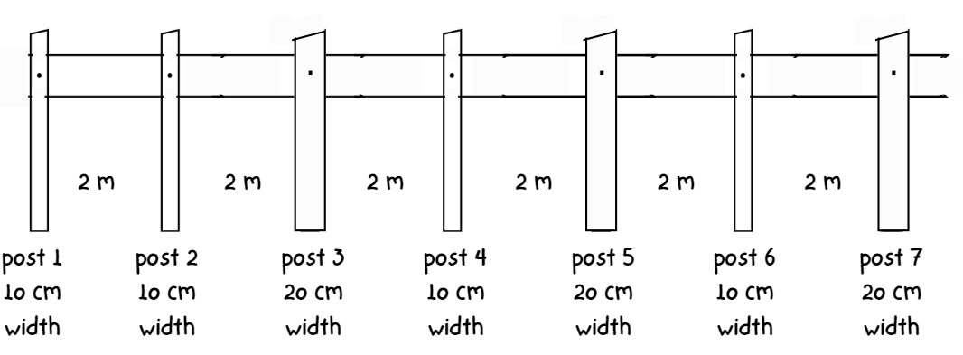
- Students turn and talk to discuss how they could record the information in a table.
- Regroup as a class and select pairs of students to share their table.
This table details opportunities for assessment.
Assessment opportunities | Links
What to look for:  - Can Stage 2 students generate number patterns using related multiples? [MAO-WM-01, MA2-MR-01]  - Can Stage 2 students investigate number patterns involving related multiples? [MAO-WM-01, MA2-MR-01]  - Can Stage 3 students describe a pattern formed by multiples in words, in terms of multiplication rather than addition?  [MAO-WM-01, MA3-MR-01]  - Can Stage 3 students determine a rule describing the relationship between the bottom number and the top number in a table? [MAO-WM-01, MA3-MR-01] | Links to National Numeracy Learning Progressions (NNLP):  - Stage 2 – NPA3, NPA4  - Stage 3 – NPA4, NPA5.

Lesson 2
Core concept: known number facts and strategies support multiplicative understanding.

Daily number sense – target number – 15 minutes
The table below contains suggested learning intentions and success criteria. These are best co-constructed with students.
Daily number sense learning intentions | Daily number sense success criteria
Students working towards Stage 2 outcomes are learning to:  - represent and solve word problems with number sentences involving multiplication or division.  Students working towards Stage 3 outcomes are learning to:  - explore the use of brackets and the order of operations to write number sentences. | Students working towards Stage 2 outcomes can:  - complete number sentences involving multiplication and division by calculating missing numbers.  Students working towards Stage 3 outcomes can:  - use grouping symbols ( ) in number sentences to indicate operations that must be performed first.
- Write the target number 20 on the board.
- Stage 2 students use fact family knowledge to determine 2 numbers that would have a product of 20. Students use these numbers to write associated fact family multiplication and division equations on individual whiteboards (see Figure 7).
Figure 7 – Stage 2 target number example
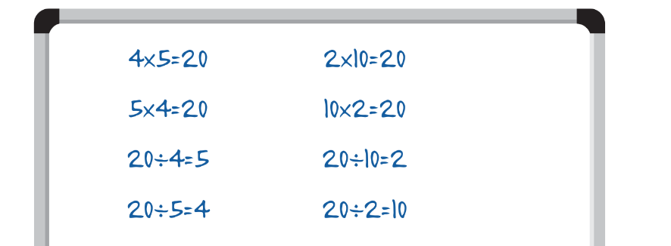
- Stage 2 students share and compare equations, acknowledging the idea that ‘If I know this, then I also know this’. For example, ‘If I know 4 times 5 is 20, then I also know 20 divided by 4 is 5.’
- Stage 3 students use a combination of any 4 different numbers to achieve the target number of 20 using grouping symbols and order of operations.
- Demonstrate writing a number sentence with grouping symbols to achieve the target number of 20 (see Figure 8).
Figure 8 – Stage 3 target number example
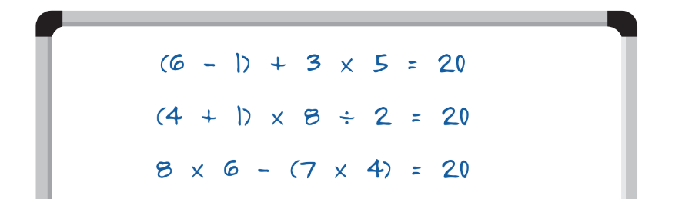
- Repeat using different target numbers such as 36, 24 and 48.
This table details opportunities for assessment.
Assessment opportunities | Links
What to look for:  - Can Stage 2 students complete number sentences involving multiplication and division by calculating missing numbers?  [MAO-WM-01, MA2-MR-01, MA2-MR-02]  - Can Stage 3 students use grouping symbols () in number sentences to indicate operations that must be performed first? [MAO-WM-01, MA3-MR-02] | Links to National Numeracy Learning Progressions (NNLP):  - Stage 2 – NPA4  - Stage 3 – NPA5.

Core lesson 1 – using known strategies – 20 minutes
The table below contains suggested learning intentions and success criteria. These are best co-constructed with students.
Core concept learning intentions | Core concept success criteria
Students working towards Stage 2 outcomes are learning to:  - use known number facts and strategies.  Students working towards Stage 3 outcomes are learning to:  - select and apply strategies to solve problems involving multiplication and division with whole numbers  - apply place value to partition, regroup and rename numbers to 1 billion. | Students working towards Stage 2 outcomes can:  - apply the known strategy of doubling to connect multiples of 3 to 6 and 4 to 8  - use known facts to find unknown multiples.  Students working towards Stage 3 outcomes can:  - select and use efficient strategies to multiply whole numbers of up to 4 digits by one- and 2-digit numbers  - regroup numbers in different forms.
- Write the equations 9 × 8 for Stage 2 students and 248 × 52 for Stage 3 students on the board. Explain to students that a friend does not know how to solve these equations.
- In pairs, students discuss strategies that could help solve the equation and record on individual whiteboards.
- Display Resource 2 – think board.
- Model and record some of the strategies on the think board (see Figure 9 for Stage 2 and Figure 10 for Stage 3). Highlight strategies such as double double, double double plus one, and multiple and benchmark number knowledge to Stage 2 students. Highlight strategies such as the distributive property, the area model, and partial products and mental strategies such as estimating and rounding to Stage 3 students.
Figure 9 – Stage 2 think board example
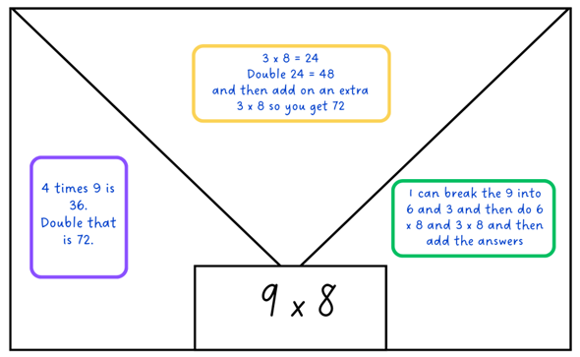
Figure 10 – Stage 3 think board example
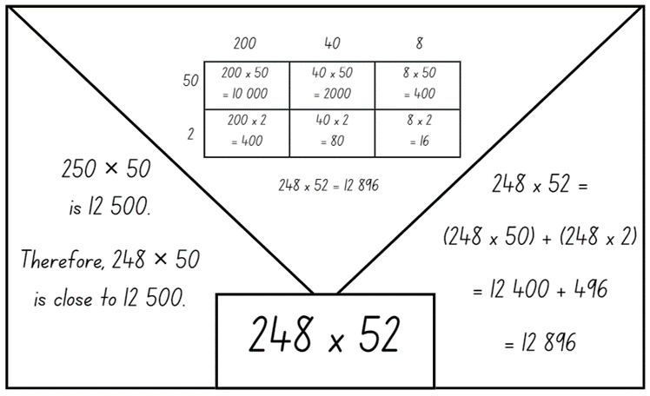
- Ask:
- Is there only one strategy that works? Why or why not?
- Are some strategies better than the others? Why or why not?
- Provide Stage 2 and Stage 3 students with Resource 2 – think board. Provide Stage 3 students with calculators.
- Display the equations:
- 12 × 6 (Stage 2)
- 11 × 8 (Stage 2)
- 24 × 3 (Stage 2)
- 275 × 42 (Stage 3)
- 315 × 54 (Stage 3)
- 4512 × 58 (Stage 3).
- Students use Resource 2 – think board to record different strategies they could use to find the product for each equation.
- After recording their strategies, Stage 3 students check their answers using a calculator.
Note: Resource 2 – think board can be put into a plastic sleeve to allow students to use the resource more than once. Alternatively, students can draw their own representation of a think board on an individual whiteboard or in their workbook.
- Regroup as a class to discuss the different strategies used. Determine if there is a preferred choice of strategy when multiplying, asking students to justify their reasoning.

Core lesson 2 – footy final frenzy – 30 minutes
This activity is an adaptation of Build an Army: Times Tables from TES by Barton.
- Give Stage 2 students a copy of Resource 3 – footy final cards (Stage 2) and Stage 3 students a copy of Resource 4 – footy final cards (Stage 3) to cut out.
- Students use all 20 numbers on the cut-out cards to create 10 players (equations) for their footy team. Each player is made by creating a different multiplication equation, for example, Player 1 could be 12 × 7 for Stage 2, or 84 × 4 for Stage 3. Stage 3 students must make an equation by using one yellow card and one purple card. Each card can only be used once.
- Students place the 10 players (equations) into the order the players (equations) will be played in the game. Once the order is determined, they cannot change the order.
- Students play the game in pairs. Each student takes a turn to put forward the player (equation) from their team to play against a player (equation) from the opposing student’s team.
- Students use individual whiteboards as a working space to solve the equation and check their opponent’s equation. Encourage students to use strategies such as double double, double double plus one, and multiple and benchmark number knowledge (Stage 2) and distributive property, area model, and partial products and mental strategies such as estimating and rounding (Stage 3).
- Once an answer is achieved, Stage 3 students check the answer with a calculator.
- The player who has the highest product in each round scores a try for their team (see Figure 11 for Stage 2 and Figure 12 for Stage 3).
Figure 11 – Stage 2 game example reduced players
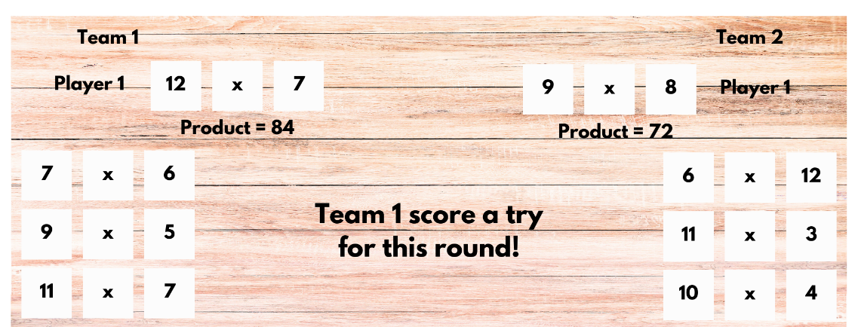
Figure 12 – Stage 3 game example with reduced players
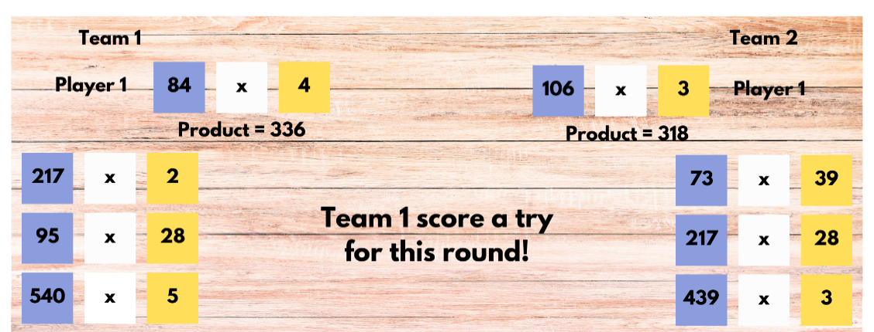
- The game is over once all players have been used. The team with the most tries or goals is the winner.

Discuss and connect the mathematics – 5 minutes
- Regroup as a class and ask:
- What strategies did you use to help calculate the product of the player cards?
- What was your strategy when creating your player list?
- Did you find a strategy that helped you win most of the time? Why or why not?
This table details opportunities for differentiation.
Too hard? | Too easy?
Stage 2 students cannot use known facts to find unknown multiples.  - Ask students to make 5 players for their teams and use known multiplication facts.  - Provide multiplication fact grids or calculators.  Stage 3 students cannot select and/or use different strategies to multiply whole numbers of up to 4 digits by one- and 2-digit numbers.  - Support students to use the area model to multiply whole numbers of up to 3 digits by one- and 2-digit numbers. Demonstrate adding an extra column or row when a new place value is introduced. Students use the online digital area model tool.  - Support students to use the distributive property to write the equation, allowing them to use calculators to determine their answers. | Stage 2 students can use known facts to find unknown multiples and Stage 3 students can select and/or use different strategies to multiply whole numbers of up to 4 digits by one- and 2-digit numbers.  - Students make a joker card. They negotiate what the joker card can do during the game. Some suggestions include: it could swap out a number and become any number they like, the joker might reduce a partner's number by half or it could double one of the numbers.  - Students create their own footy final cards and swap with a partner to solve.
This table details opportunities for assessment.
Assessment opportunities | Links
What to look for:  - Can Stage 2 students apply the known strategy of doubling to connect multiples of 3 to 6 and 4 to 8? [MAO-WM-01,  MA2-MR-01]  - Can Stage 2 students use known facts to find unknown multiples? [MAO-WM-01, MA2-MR-01]  - Can Stage 3 students select and use efficient strategies to multiply whole numbers of up to 4 digits by one- and 2-digit numbers? [MAO-WM-01, MA3-MR-01]  - Can Stage 3 students regroup numbers in different forms?  [MAO-WM-01, MA3-RN-01] | Links to National Numeracy Learning Progressions (NNLP):  - Stage 2 – MUS6  - Stage 3 – MuS7, MuS8.  Links to suggested Interview for Student Reasoning (IfSR) tasks:  - Stage 2 – IfSR-MT: 2A.2, 2A.4, 2A.6.

Lesson 3
Core concept: multiplication and division are related.

Daily number sense – which is correct? – 15 minutes
The table below contains suggested learning intentions and success criteria. These are best co-constructed with students.
Daily number sense learning intentions | Daily number sense success criteria
Students working towards Stage 2 outcomes are learning to:  - represent and solve word problems with number sentences involving multiplication or division.  Students working towards Stage 3 outcomes are learning to:  - explore the use of brackets and the order of operations to write number sentences. | Students working towards Stage 2 outcomes can:  - represent and solve multiplication word problems using number sentences.  Students working towards Stage 3 outcomes can:  - investigate the order of operations using real-life contexts.
- Display Resource 5 – Which is correct?
- Explain that there are 3 word problems on display but only one matches the number sentence.
- Students read the word problems and turn and talk to discuss which of the problems is true for the equation.
- As a class, discuss the strategies used. Ask Stage 2 students how the doubling or double double strategy could be used. Ask Stage 3 students how grouping symbols could be used.
- Display the equations 55 × 2 = 110 (Stage 2) and 50 × 2 + 1 = 101 (Stage 3) on the board.
- Students Think-Pair-Share a real-life context that would match the equation and record it as a word problem on individual whiteboards.
- Students swap with another pair to test and confirm if the word problem matches the number sentence.
This table details opportunities for assessment.
Assessment opportunities | Links
What to look for:  - Can Stage 2 students represent and solve multiplication word problems using number sentences? [MAO-WM-01, MA2-MR-01, MA2-MR-02]  - Can Stage 3 students investigate the order of operations using real-life contexts? [MAO-WM-01, MA3-MR-02] | Links to National Numeracy Learning Progressions (NNLP):  - Stage 2 – NPA4  - Stage 3 – NPA5.

Core lesson 1 – multiplication and division are related – 20 minutes
The table below contains suggested learning intentions and success criteria. These are best co-constructed with students.
Core concept learning intentions | Core concept success criteria
Students working towards Stage 2 outcomes are learning to:  - represent and solve problems involving multiplication fact families  - represent and solve word problems with number sentences involving multiplication or division.  Students working towards Stage 3 outcomes are learning to:  - select and apply strategies to solve problems involving multiplication and division with whole numbers  - use equivalent number sentences involving multiplication and division to find unknown quantities. | Students working towards Stage 2 outcomes can:  - apply the inverse relationship of multiplication and division  - complete number sentences involving multiplication and division by calculating missing numbers.  Students working towards Stage 3 outcomes can:  - select and use efficient strategies to multiply whole numbers of up to 4 digits by one- and 2-digit numbers  - determine why different division questions have the same answer  - identify and use inverse operations to assist with the solution of number sentences.
- Write 8 × 5 for Stage 2 and 42 ÷ 2 and 84 ÷ 4 for Stage 3 on the board.
- Students record and complete the equations.
- Select students to share solutions and communicate their thinking. Record strategies and solutions on the board.
- Ask Stage 2 students: What else is known if we know 8 × 5 = 40?
- Stage 2 students record the multiplication and division fact families and share with a classmate.
- Write 8 × 7 on the board for Stage 2 students. Students to use what they know about 8 × 5 to work out 8 × 7. Students turn and talk to discuss different strategies.
- Stage 2 students record all the multiplication and division facts they know about these 2 equations.
- Stage 2 students repeat with 5 × 6 and 7 × 6 if time allows.
- Ask Stage 3 students: What do you notice about the 2 equations? What else is known if we know 42 $÷$ 2 = 21 and 84 $÷$ 4 = 21?
- Explain that although both have a different dividend and divisor, they both have the same quotient.
- Model for Stage 3 students how to use inverse operations to find different multiplication and division equations with the same multiplier and quotient. For example, 4 equations that could be written for the multiplier or quotient of 13 could be 13 × 2 = 26, 26 ÷ 2 = 13, 13 × 4 = 52 and 52 ÷ 4 = 13
- In pairs, Stage 3 students choose a multiplier and quotient between 15 and 25 and write a set of 4 equations that demonstrate the use of inverse operations. Repeat with a different number if time allows.

Core lesson 2 – ‘Keep in step’ – 20 minutes
- Students work in groups of 3. Provide each group with a whiteboard and 3 different coloured markers. Provide each Stage 2 group with one 10-sided die (1–10) and each Stage 3 group with two 10-sided dice (1–10).
- Player A in the Stage 2 groups rolls the die to determine the starting number and uses that number to make a known multiplication equation, using numbers below 12. For example, if a 4 was rolled, the chosen equation could be 4 × 3 = 12. This is recorded on the whiteboard.
- Player B uses the answer to create a division equation. They can use a fact from the multiplication and division fact family or create a different equation altogether, such as 12 ÷ 6 = 2. This is recorded on the whiteboard under the original equation, lining up the connecting number (see Figure 13).
Figure 13 – Stage 2 ‘Keep in step’ example
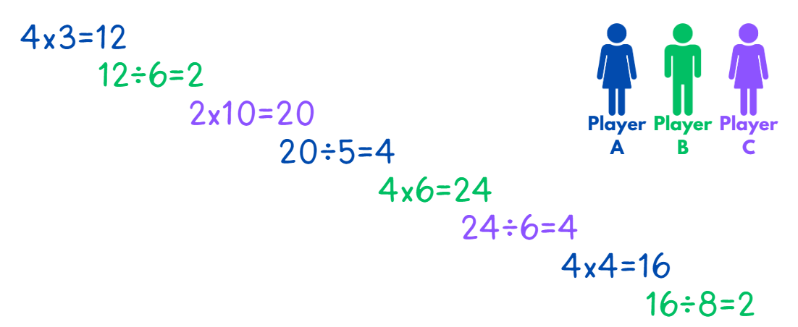
- Player C uses the answer to create a new multiplication equation. This is recorded on the whiteboard, following the step pattern (see Figure 13).
- Player A in the Stage 3 groups rolls the dice to determine a 2-digit number and uses that number as either a multiplier or a quotient to make a known multiplication equation. For example, if a 4 and a 5 were rolled, the chosen equation could be 5 × 9 = 45. This is recorded on the whiteboard.
- Player B uses the answer to create a division equation. Remind students to use inverse operations to find different multiplication and division equations with the same multiplier or quotient. For example, 5 × 9 = 45 and 45 ÷ 9 = 5 and 45 × 2 = 90 and 90 ÷ 2 = 45. This is recorded on the whiteboard, under the original equation (see Figure 14).
Figure 14 – Stage 3 ‘Keep in step’ example
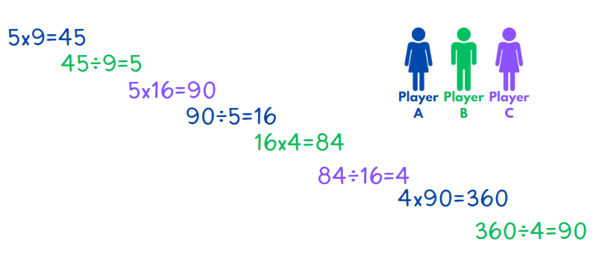
- Player C uses the answer to create a new multiplication or division equation. This is recorded on the whiteboard, following the step pattern (see Figure 14).
- Players are unable to repeat an equation during the game. The players continue to take turns until one player is unable to record a different equation or is unable to solve an equation.
- After the game, ask:
- Did you roll any numbers that made starting or playing the game difficult?
- Which numbers were the easiest or hardest to use when multiplying?
- Which numbers were the easiest or hardest to use when dividing?

Consolidation and meaningful practice – 10 minutes
- Present the following problem to Stage 2 students: Chicken nuggets come in boxes of 6. We need 48 chicken nuggets altogether. How many boxes of chicken nuggets do we need?
- Ask students to represent the problem using both a multiplication and division equation. For example, 6 × 4 = 48 and 48 ÷ 6 = 4.
- Present the following problem to Stage 3 students: Chicken nuggets come in boxes of 6. We need 480 chicken nuggets altogether. How many boxes of chicken nuggets do we need?
- Ask students to represent this using both a multiplication and division equation. For example, 6 × 80 = 480 and 480 ÷ 6 = 80.
- Students compare answers with a classmate and justify their solutions.
- Ask Stage 2 students to determine how many chicken nuggets each person would get if there were 8 people at the party.
- Ask Stage 3 students to determine how many chicken nuggets each person would get if there were 60 people at the party.
- Students record their answer using both a multiplication and division equation.
This table details opportunities for differentiation.
Too hard? | Too easy?
Stage 2 students cannot apply the inverse relationship of multiplication and division.  - Support students by reducing the size of the numbers they multiply and divide. For example, students could use one 6-sided die.  - Assist students by providing support materials or resources, such as counters and multiplication grids.  Stage 3 students cannot identify and use inverse operations to assist with the solution of number sentences.  - Reduce the size of the numbers that students multiply and divide. For example, students use one 10-sided dice (1–10) so that the multiplier or quotient is a one-digit number.  - Support students to use the distributive property to write the equation, allowing them to use calculators to determine their answers. | Stage 2 students can apply the inverse relationship of multiplication and division.  - Challenge students to use a 12-sided or 20-sided die.  - Encourage students to investigate which numbers can or can’t be used at the start of the game. If the game was to start with division, would those numbers be the same? Identify if these numbers belong to the same group in any way.  Stage 3 students can identify and use inverse operations to assist with the solution of number sentences.  - Challenge students to write as many equations as they can which have 3- and 4-digit multipliers or quotients.
This table details opportunities for assessment.
Assessment opportunities | Links
What to look for:  - Can Stage 2 students apply the inverse relationship of multiplication and division? [MAO-WM-01, MA2-MR-01,  MA2-MR-02]  - Can Stage 2 students complete number sentences involving multiplication and division by calculating missing numbers?  [MAO-WM-01, MA2-MR-02]  - Can Stage 3 students select and use efficient strategies to multiply whole numbers of up to 4 digits by one- and 2-digit numbers? [MAO-WM-01, MA3-MR-01]  - Can Stage 3 students determine why different division questions have the same answer? [MAO-WM-01, MA3-MR-01]  - Can Stage 3 students identify and use inverse operations to assist with the solution of number sentences? [MAO-WM-01,  MA3-MR-01] | Links to National Numeracy Learning Progressions (NNLP):  - Stage 2 – MuS6, MuS7, NPA4  - Stage 3 – MuS7, MuS8, NPA3, NPA4.  Links to suggested Interview for Student Reasoning (IfSR) tasks:  - Stage 2 – IfSR-MT: 2A.5, 2A.11  - Stage 3 – IfSR-MT: 3A.9, 3A.10.

Lesson 4
Core concept: visual representations can support multiplicative thinking.

Daily number sense – 10 minutes
- From a class need surfaced through formative assessment data, identify a short, focused activity that targets students’ knowledge, understanding and skills. Example activities may be drawn from the following resources:
- Mathematics K–6 resources
- Universal Resources Hub.

Core lesson – 45 minutes

Stage 2 task – multiplicative structures
The table below contains a suggested learning intention and success criteria. These are best co-constructed with students.
Core concept learning intention | Core concept success criteria
Students working towards Stage 2 outcomes are learning to:  - use the structure of the area model to represent multiplication and division. | Students working towards Stage 2 outcomes can:  - create and represent multiplicative structure.
This activity is an adaptation of ‘Reasoning chains’ from A Practical Guide to Transforming Primary Mathematics: Activities and tasks that really work by Askew.
- Draw a 4 × 3 area model and a rectangle which would create a 4 × 3 grid if completed, on the board (see Figure 15).
- Students explain how they know the total area covered is 12 in both diagrams. Record the equation and correct answer below each representation.
Figure 15 – 4 × 3 area model
- Write 4 $×$ 10 on the board. Students record the equation on individual whiteboards and draw a diagram to determine the answer.
- Students share and compare their answers.
- Draw a 4 × 10 area model and a rectangle which would create a 4 × 10 grid if extended. Record the equation and correct answer (see Figure 16).
Figure 16 – 4 × 10 area model
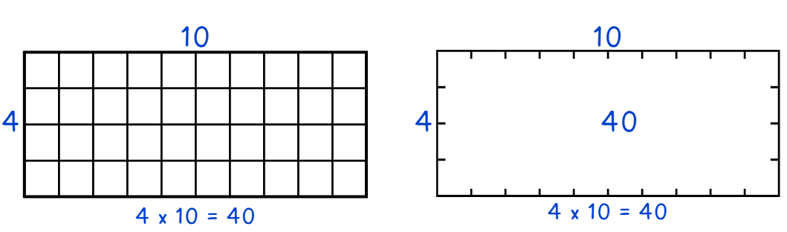
- Write 4 $×$ 13 on the board and ask:
- Could partitioning be used to solve this problem?
- How could this be represented using the area model?
- Could it be represented in more than one way?
- Students record the equation on their own whiteboard and draw a diagram to determine the answer.
- Students share their answers and representations.
- Draw a 4 × 13 area model on the board, recording the equation and correct answer below it (see Figure 17).
Figure 17 – 4 × 13 area model
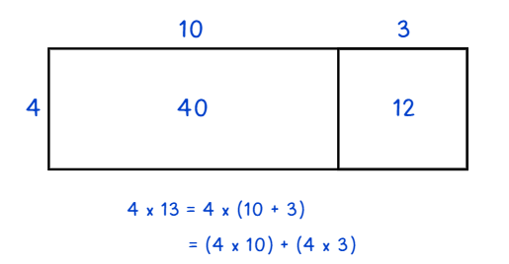
- Discuss how the representation is similar or different to students’ ideas.
- Write 5 × 4, 5 × 10 and 5 × 14 as a list on the board.
- Students complete the same steps as above to calculate these equations using the area model for multiplication.
- In pairs, students compare their results.
- Write 7 × 16 on the board. Students identify ways to partition the numbers to make multiplication easier or more efficient.
- Students record the equations that could be added together to have the same product as 7 × 16. For example, 7 × 10 and 7 × 6 or 7 × 11 and 7 × 5. Students draw an area model diagram to show how these partitioned equations have the same product as 7 × 16.
- Students share and compare their answers and representations.
This table details opportunities for differentiation.
Too hard? | Too easy?
Stage 2 students cannot create and represent multiplicative structure.  - Support students by reducing the size of the numbers they are trying to partition and multiply. For example, students could use the chain 4 × 2, 4 × 5, 4 × 7.  - Assist students by providing support resources such as MAB materials, counters, times table grids, grid paper or the digital area model tool. | Stage 2 students can create and represent multiplicative structure.  - Challenge students to use the strategy to multiply larger numbers such as 36, 57 or 84 by a single-digit number of their choosing.  - Students use the strategy to find the solution to 8 × 7 and 8 × 9. Students to determine if the answers can help them answer 8 × 27 or 8 × 19 more easily.

Stage 3 task – vertical double number lines
The table below contains a suggested learning intention and success criteria. These are best co-constructed with students.
Core concept learning intention | Core concept success criteria
Students working towards Stage 3 outcomes are learning to:  - select and apply strategies to solve problems involving multiplication and division with whole numbers. | Students working towards Stage 3 outcomes can:  - select and use efficient strategies to multiply whole numbers of up to 4 digits by one- and 2-digit numbers  - solve word problems involving rates using multiplication and division.
This activity is an adaptation of ‘Double number line’ from A Practical Guide to Transforming Primary Mathematics: Activities and tasks that really work by Askew.
- Pose the problem: A baby frog takes 4 jumps for every one jump that her mother takes. How many jumps will the baby frog take if the mother frog takes 8 jumps?
- Draw a vertical double number line on the board (see Figure 18). Explain that the vertical double number line has 2 different scales on it that are in proportion to each other.
Figure 18 – vertical double number line
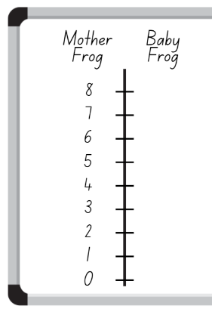
- Students use the information from the problem to complete the other side of the vertical double number line. For example, the baby frog takes 4 jumps for every jump the mother takes, so the first number on the right of the vertical double number line is 4.
- Select students to share their answers and use these to fill in the right side of the vertical double number line on the board.
- Pose the problem: If the baby frog takes 16 jumps, how many jumps will the mother frog have taken?
- Students use the vertical double number line to calculate the answer.
- Students turn and talk to compare and discuss their results.
This activity is an adaptation of ‘Equivalent ratio problems’ from Teaching Mathematics: Foundations to Middle Years by Siemon et al.
- Pose the problem: Rob laid 36 bricks in 45 minutes. How many bricks might Rob lay in 9 hours?
- Draw a vertical double number line on the board (see Figure 19).
Figure 19 – Rob’s bricklaying double number line
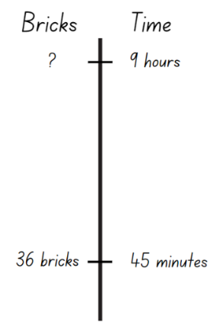
- Students turn and talk, discussing how they would use the vertical double number line to solve this problem.
- Select students to share their ideas.
- Add to the vertical double number line on the board (see Figure 20). Discuss that one way to solve the problem is to reduce the quantities to something easier. The quantities on both sides of the vertical number line are divisible by 3. This means the 45-minute section can be partitioned into 15-minute periods. At this rate, Rob can lay 12 bricks in 15 minutes.
Figure 20 – solving Rob’s bricklaying problem
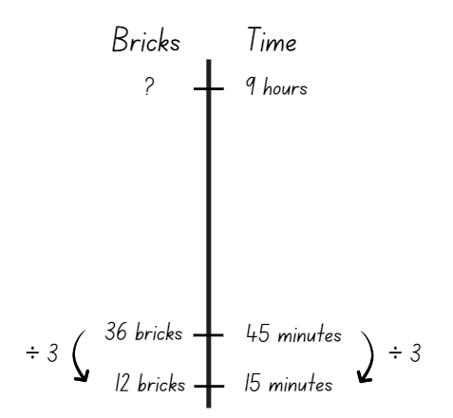
- On individual whiteboards, students use this information to solve the original problem of how many bricks Rob will lay in 9 hours.
- Students complete a gallery walk to observe how other students have recorded their ideas on the vertical double number line.
This table details opportunities for differentiation.
Too hard? | Too easy?
Stage 3 students cannot solve word problems involving rates using multiplication and division.  - Provide a scaffolded version of the vertical double number line with 15-minute periods already marked.  - Provide concrete materials such as counters to assist calculations and visualise proportions. | Stage 3 students can solve word problems involving rates using multiplication and division.  - Pose the problem: If Rob worked at the same rate the next day and laid a total of 264 bricks, how many hours did Rob work?  - Students create their own word problems involving rates for their classmates to complete. Students should use the vertical double number line to solve the word problems.

Discuss and connect the mathematics – 5 minutes
- Regroup as a class and summarise the key mathematical ideas. Ask:
- How did visual representations (area model and vertical double number line) help you solve the problems?
- Did you notice someone who used the same strategy as you?
- Did you notice someone who used a different strategy to you?
- Did you notice someone who used another representation to help solve the problems?
- When would visual representations not be useful?
This table details opportunities for assessment.
Assessment opportunities | Links
What to look for:  - Can Stage 2 students create and represent multiplicative structure? [MAO-WM-01, MA2-MR-01]  - Can Stage 3 students select and use efficient strategies to multiply whole numbers of up to 4 digits by one- and 2-digit numbers? [MAO-WM-01, MA3-MR-01]  - Can Stage 3 students solve word problems involving rates using multiplication and division? [MAO-WM-01, MA3-MR-01] | Links to National Numeracy Learning Progressions (NNLP):  - Stage 2 – MuS5, MuS6  - Stage 3 – MuS7, MuS8, PrT4.  Links to suggested Interview for Student Reasoning (IfSR) tasks:  - Stage 2 – IfSR-MT: 2A.3.

Lesson 5
Core concept: place value understanding supports mathematicians with multiplicative thinking.

Daily number sense – make it true – 10 minutes
Daily number sense activities for Lessons 5 to 7 ‘loop’ back to concepts and procedures covered in previous units to assist students to build an increasingly connected network of ideas. These concepts may differ from the core concepts being covered by the unit.
The table below contains suggested learning intentions and success criteria. These are best co-constructed with students.
Daily number sense learning intentions | Daily number sense success criteria
Students working towards Stage 2 outcomes are learning to:  - complete number sentences involving additive relations to find unknown quantities.  Students working towards Stage 3 outcomes are learning to:  - apply efficient mental and written strategies to solve addition and subtraction problems. | Students working towards Stage 2 outcomes can:  - calculate missing numbers by completing number sentences involving addition and subtraction.  Students working towards Stage 3 outcomes can:  - use place value to add or subtract 3 or more numbers with different numbers of digits.
This activity is an adaptation of Subtraction with Regrouping 2 by Ignaciuk from the Open Middle website.
- Draw Figure 21 on the board.
Figure 21 – Stage 2 make it true
- In pairs, Stage 2 students use digits 1–9 (only once each), placing a digit in each box to make the number sentence correct. For example, 56 – 17 = 39.
- Draw Figure 22 on the board.
Figure 22 – Stage 3 make it true
- In pairs, Stage 3 students place a digit in each box to make the number sentence correct. Stage 3 students can use digits more than once. For example, 1045 – 981 – 25 = 39.
- Encourage students to find more than one solution for their given equation.
- As a class, share and compare solutions. Students identify the strategies they used and justify their choices.
This table details opportunities for assessment.
Assessment opportunities | Links
What to look for:  - Can Stage 2 students calculate missing numbers by completing number sentences involving addition and subtraction?  [MAO-WM-01, MA2-AR-02]  - Can Stage 3 students use place value to add or subtract 3 or more numbers with different numbers of digits? [MAO-WM-01,  MA3-AR-01] | Links to National Numeracy Learning Progressions (NNLP):  - Stage 2 – NPA3, NPA4  - Stage 3 – AdS7, AdS8.  Links to suggested Interview for Student Reasoning (IfSR) tasks:  - Stage 2 – IfSR-AT: 2A.4, 2A.5  - Stage 3 – IfSR-AT: 3A.3, 3A.4, 3A.5.

Core lesson 1 – number slides – 20 minutes
The table below contains suggested learning intentions and success criteria. These are best co-constructed with students.
Core concept learning intentions | Core concept success criteria
Students working towards Stage 2 outcomes are learning to:  - recognise and represent numbers that are 10, 100 or 1000 times as large  - investigate number sequences involving related multiples.  Students working towards Stage 3 outcomes are learning to:  - multiply and divide decimals by powers of 10. | Students working towards Stage 2 outcomes can:  - describe how making a number 10, 100 or 1000 times as large changes the place value of digits  - investigate number patterns involving related multiples.  Students working towards Stage 3 outcomes can:  - compare the relative place value of digits to multiply and divide a decimal by powers of 10.
This activity is an adaptation of Multiplication of large numbers from Arc Learning: Mathematics Curriculum Companion by State Government of Victoria (Department of Education).
- Write 8 $×$ 3 = for Stage 2 students and 0.024 $×$ 10 = for Stage 3 students on the board. Students record the equation and answer on individual whiteboards.
- Ask Stage 2 students what would happen if:
- the 3 becomes 10 times as large
- the 3 becomes 100 times as large
- the 3 and the 8 become 10 times as large
- the 3 becomes 100 times as large and the 8 becomes 10 times as large.
- Ask Stage 3 students what would happen if:
- the 10 becomes 10 times as large
- the 10 becomes 100 times as large
- the 10 and the 0.024 become 10 times as large
- the 10 becomes 100 times as large and the 0.024 becomes 10 times as large.
- Students record the equations and answer on their whiteboard (see Figure 23 for Stage 2 and Figure 24 for Stage 3).
Figure 23 – Stage 2 student whiteboard
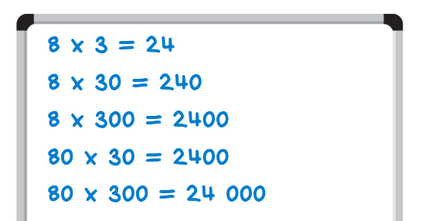
Figure 24 – Stage 3 student whiteboard
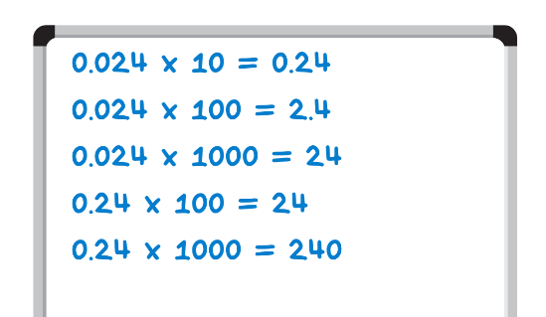
- As a class discuss:
- What do you notice about the answers in each equation?
- What stays the same? What changes?
- Does this pattern help us to predict what will happen when looking at other numbers?
- Draw place value houses on the board. Explain that using place value houses highlights how the numbers slide from one place value to the next when multiplying by powers of 10. Explain that each time the multiplier or the multiplicand are increased by a power of 10, the digits in the answer move to the left by one place (see Figure 25 for Stage 2 and Figure 26 for Stage 3).
Figure 25 – Stage 2 teacher demonstration of number movement for
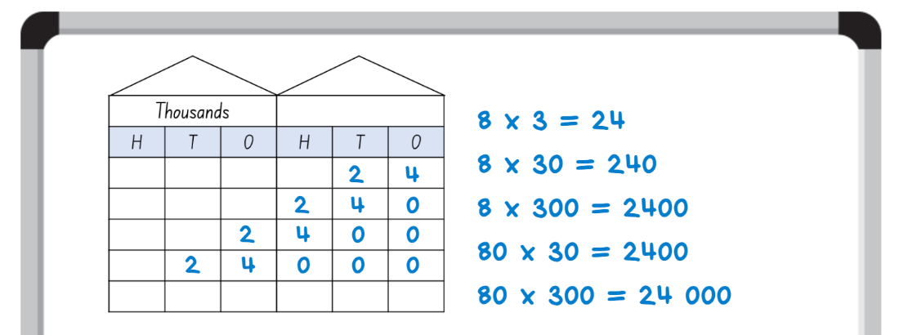
Figure 26 – Stage 3 teacher demonstration of multiplication number movement for
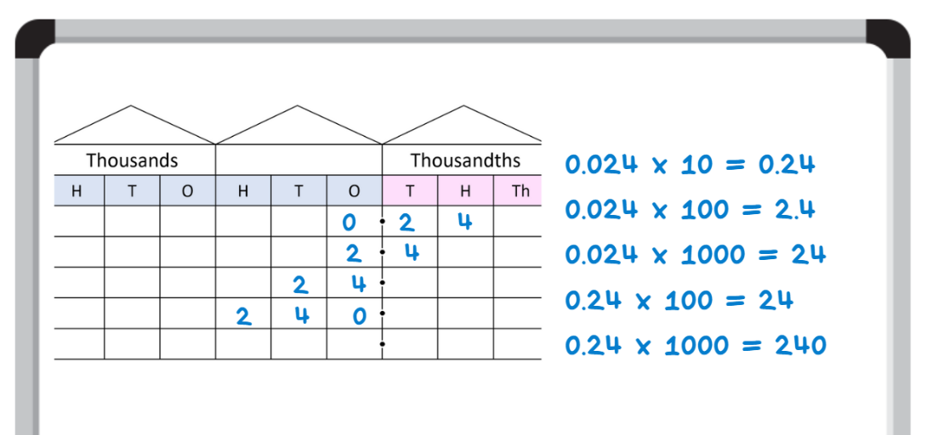
- Model to Stage 3 students the change in place value when dividing by powers of 10 using the starting equation of 240 ÷ 10 = 24. Explain that each time the multiplier or the multiplicand are decreased by a power of 10, the digits in the answer move to the right by one place (see Figure 27).
Figure 27 – Stage 3 teacher demonstration of division number movement for
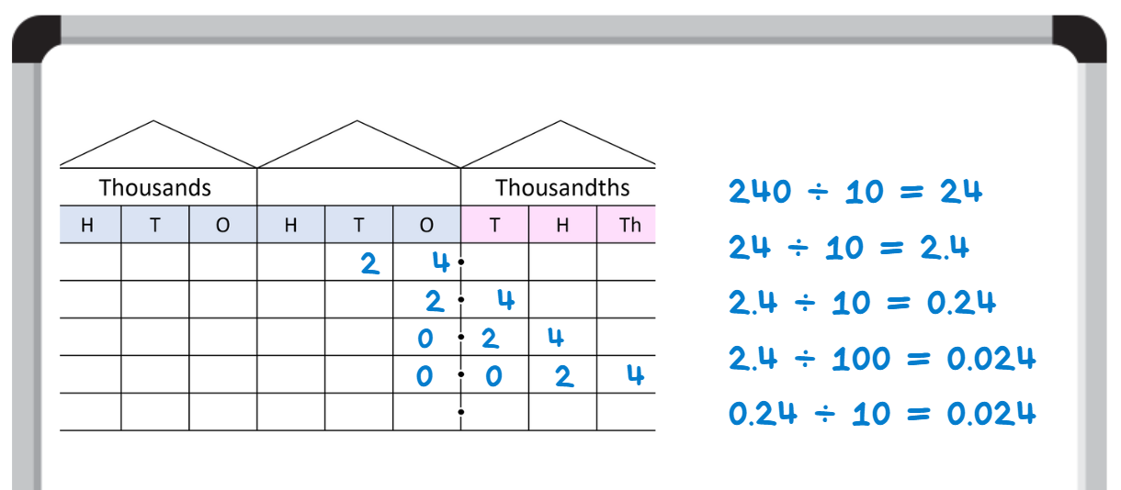

Core lesson 2 – spinners – 20 minutes
This activity is an adaptation of Multiplication of large numbers from Arc Learning: Mathematics Curriculum Companion by State Government of Victoria (Department of Education).
- Explain that the aim of the activity is to complete multiplication number sentences. Students work in pairs, using their knowledge of place value to multiply large numbers (Stage 2) or decimals (Stage 3).
- For Stage 2 pairs, when it is Player A’s turn, Player B chooses 2 of the spinners from Resource 6 – large number spinners. Each player spins one spinner using a paper clip.
- Player A determines the product of the 2 numbers selected by the spinners, recording these as an equation on an individual whiteboard. Player B checks their answer using a calculator (see Figure 28).
Figure 28 – large number spinners student work
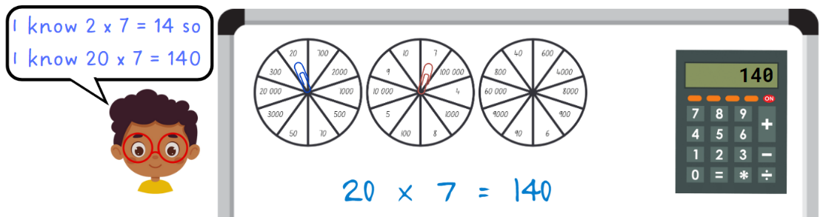
- For Stage 3 pairs, both spinners from Resource 7 – decimal spinners are to be used. Each player spins one spinner using a paperclip.
- Player A determines the product of the 2 numbers selected by the spinners, recording these as an equation on an individual whiteboard. Player B checks their answer using a calculator.
- For each answer, Stage 3 students record a way they can create the number by dividing by powers of 10. For example, if the answer is 0.06, it can be created by dividing 6 by 100.
- Students repeat, swapping roles.
This table details opportunities for differentiation.
Too hard? | Too easy?
Stage 2 students cannot describe how making a number 10, 100 or 1000 times as large changes the place value of digits.  - Focus on making numbers 10 times as large before moving on to 100 times as large.  - Support students to use a calculator to make numbers 10, 100 or 1000 times as large and highlight the pattern that occurs.  Stage 3 students cannot compare the relative place value of digits to multiply and divide a decimal by powers of 10.  - Focus on multiplying and dividing decimals by 10 before moving on to 100 and 1000.  - Assist students by providing resources such as a number slider or place value houses to support multiplicative understanding. | Stage 2 students can describe how making a number 10, 100 or 1000 times as large changes the place value of digits.  - In pairs, students create 4-digit numbers for their partner to make 10, 100 and 1000 times as large.  - In pairs, students give their partner a number, for example, 850. The partner shows how they can create the number using powers of 10. For example, 85 multiplied by 10.  Stage 3 students can compare the relative place value of digits to multiply and divide a decimal by powers of 10.  - In pairs, students create a decimal number for their partner. Students must make their number 20, 200 and 2000 as large.  - In pairs, students give their partner a decimal, for example, 0.85. The partner shows 2 different ways they can create the decimal, using either multiplication or division by a power of 10. For example, 8.5 divided by 10, 850 divided by 1000.

Consolidation and meaningful practice – 15 minutes
- Write 7 × 4 = for Stage 2 students and 0.009 × 10 = for Stage 3 students on the board.
- Students record the equation on an individual whiteboard. Students then write as many variations of the equation as they can, making the multiplicand and/or multiplier 10, 100 or 1000 times as large.
- Students record as many different equations as possible on their whiteboards.
- Students complete a gallery walk to observe the equations recorded by their classmates.
- Ask:
- Did you recognise any of the equations you recorded?
- Did you see some different equations that you did record on your own whiteboard?
- What made this activity tricky?
- What did you already know that made this activity easier?
This table details opportunities for assessment.
Assessment opportunities | Links
What to look for:  - Can Stage 2 students describe how making a number 10, 100 or 1000 times as large changes the place value of digits?  [MAO-WM-01, MA2-RN-01]  - Can Stage 2 students investigate number patterns involving related multiples? [MAO-WM-01, MA2-MR-01]  - Can Stage 3 students compare the relative place value of digits to multiply and divide a decimal by powers of 10? [MAO-WM-01, MA3-MR-01] | Links to National Numeracy Learning Progressions (NNLP):  - Stage 2 – NPA3, NPA4, NPV8, NPV9  - Stage 3 – NPV8, MuS9.  Links to suggested Interview for Student Reasoning (IfSR) tasks:  - Stage 2 – IfSR-NP: 4B.6  - Stage 3 – IfSR-MT: 4A.3, 4A.4, 4A.5.

Lesson 6
Core concept: flexible methods of computation in multiplication and division involve composing and decomposing numbers.

Daily number sense – create an equation – 15 minutes
The table below contains suggested learning intentions and success criteria. These are best co-constructed with students.
Daily number sense learning intentions | Daily number sense success criteria
Students working towards Stage 2 outcomes are learning to:  - complete number sentences involving additive relations to find unknown quantities.  Students working towards Stage 3 outcomes are learning to:  - apply efficient mental and written strategies to solve addition and subtraction problems. | Students working towards Stage 2 outcomes can:  - find the missing number in an equivalent number sentence involving operations of addition or subtraction on both sides of the equals sign.  Students working towards Stage 3 outcomes can:  - use place value to add or subtract 3 or more numbers with different numbers of digits.
This activity is an adaptation of Adding and subtraction two-digit whole numbers by Errey from the Open Middle website.
- Draw Figure 29 on the board.
Figure 29 – Stage 2 equation
- In pairs, Stage 2 students use digits 0–9 (only once each), placing a digit in each box to make a correct equation. For example, 78 – 40 = 15 + 23.
- Draw Figure 30 on the board.
Figure 30 – Stage 3 equation
- In pairs, Stage 3 students use digits 1–9 (only once each), placing a digit in each box to make the sum as close to 1000 as possible. For example, 918 + 75 + 6 = 999.
- Encourage students to find more than one solution for their given equation.
- As a class, share and compare solutions. Students identify the strategies they used and justify their choices.
This table details opportunities for assessment.
Assessment opportunities | Links
What to look for:  - Can Stage 2 students find the missing number in an equivalent number sentence involving operations of addition or subtraction on both sides of the equals sign? [MAO-WM-01, MA2-AR-02]  - Can Stage 3 students use place value to add or subtract 3 or more numbers with different numbers of digits? [MAO-WM-01,  MA3-AR-01] | Links to National Numeracy Learning Progressions (NNLP):  - Stage 2 – NPA3, NPA4  - Stage 3 – AdS7, AdS8.  Links to suggested Interview for Student Reasoning (IfSR) tasks:  - Stage 2 – IfSR-AT: 2A.1, 2A.4, 2A.5  - Stage 3 – IfSR-AT: 3A.3, 3A.4, 3A.5.

Core lesson 1 – powers of 10 – 25 minutes
The table below contains suggested learning intentions and success criteria. These are best co-constructed with students.
Core concept learning intentions | Core concept success criteria
Students working towards Stage 2 outcomes are learning to:  - recognise and represent numbers that are 10, 100 or 1000 times as large  - operate with multiples of 10.  Students working towards Stage 3 outcomes are learning to:  - multiply and divide decimals by powers of 10. | Students working towards Stage 2 outcomes can:  - describe how making a number 10, 100 or 1000 times as large changes the place value of digits  - use multiplication facts with multiples of 10 to multiply a one-digit number by a multiple of 10  - apply the commutative and associative properties to multiply by multiples of 10.  Students working towards Stage 3 outcomes can:  - compare the relative place value of digits to multiply and divide a decimal by powers of 10  - use mental strategies to multiply benchmark decimals by single-digit numbers.
- Write the number 142 on the board for Stage 2 students and the number 1.425 on the board for Stage 3 students.
- Students to find the number 10 times larger.
Note: Stage 3 students may be able to complete this mentally; however, support can be provided by using the area model (see Figure 31).
Figure 31 – Stage 3 area model for 1.425 x 10
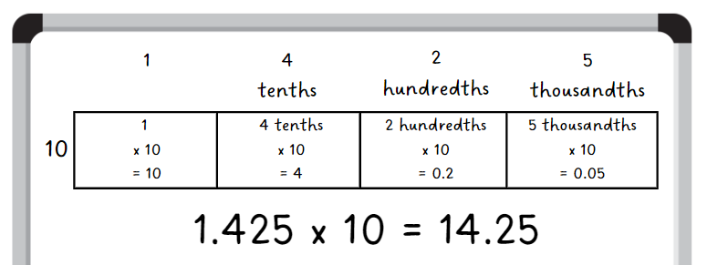
- Select students to demonstrate the strategy they used to calculate the answer.
- Stage 2 students find the number 100 times larger than 142. Stage 3 students find the number 100 times larger than 1.425.
- Select students to demonstrate the strategy they used to calculate the answer.
- Stage 2 students then find the number 1000 times larger than 142 and Stage 3 students find the number 1000 times larger than 1.425.
- Select students to demonstrate the strategy they used to calculate the answer.
- Write the number 387 on the board. Stage 2 students find the number 10, 100 and 1000 times larger.
- Write the number 3875 on the board. Stage 3 students find the number 10, 100 and 1000 times smaller.
- Select students to demonstrate the strategies they used to calculate the answers.
This table details opportunities for differentiation.
Too hard? | Too easy?
Stage 2 students cannot recognise and represent numbers that are 10, 100 or 1000 times as large or Stage 3 students cannot multiply and divide decimals by powers of 10.  - Support students by only working with numbers that are 10 times as large before moving on to other powers of 10.  - Assist students by providing resources such as a number slider or multiplication chart to support multiplicative understanding. | Stage 2 students can recognise and represent numbers that are 10, 100 or 1000 times as large.  - In pairs, students create a number for their partner (initially using 2- or 3-digit numbers). Students must make their number 20, 200 and 2000 as large.  - In pairs, students use ‘yes and no’ questions to play Mastermind.  Stage 3 students can multiply and divide decimals by powers of 10.  - Challenge students to investigate the inverse nature of multiplication and division by identifying as many facts as they can using the one decimal. For example, using 0.65, we know that 0.65 times 10 is 6.5 and 6.5 divided by 10 is 0.65.  - Students write a 2-step word problem in which the beginning number is 365 and the final answer is 3.65. For example, Joe’s mother gave him $365 for a day at a theme park with 9 friends. His mother said he had to share the money equally between himself and his friends. At the theme park, he was required to pay a tenth of his share of the money for each ride. How much did one ride cost? Students write a second 2-step word problem in which the beginning number is 4.79 and the final answer is 479.

Core lesson 2 – multiplication strategies – 15 minutes
- Write 3 equations on the board for Stage 2 students:
- 2 × 40
- 5 × 60
- 8 × 90.
- Write 3 equations on the board for Stage 3 students:
- 3.5 × 2
- 7.25 × 2
- 9.5 × 5.
- Provide students with individual whiteboards to solve each equation.
- Students turn and talk to a partner to discuss the strategies they used.
- Ask:
- Could you use the same strategy to solve each of the equations?
- Was your strategy the same as the one used by your partner?
- Which one was the easiest and which was the most challenging?
- How did you think about the decimals to solve the equations? (Stage 3)
- Can you think of another way to solve these equations?
- Remind Stage 2 students that when 2 or more numbers are multiplied, the product stays the same, regardless of how the factors are grouped. This is called the ‘associative property’ of multiplication.
Associative property: when more than 2 numbers are added or multiplied, the result is unchanged, regardless of how they are grouped or associated. For example, 5 × 60 can be calculated as 5 × 6 × 10 or 30 × 10 or 50 × 6.

Consolidation and meaningful practice – 10 minutes
- Write the number 245 on the board.
- All students record the numbers 10, 100 and 1000 times larger on their whiteboard.
- Stage 3 students will also record the numbers 10, 100 and 1000 times smaller on their whiteboard.
- Students compare their numbers with a partner, reading the numbers aloud and explaining the strategy they used to complete the task.
This table details opportunities for assessment.
Assessment opportunities | Links
What to look for:  - Can Stage 2 students describe how making a number 10, 100 or 1000 times as large changes the place value of digits?  [MAO-WM-01, MA2-RN-01]  - Can Stage 2 students use multiplication facts with multiples of 10 to multiply a one-digit number by a multiple of 10? [MAO-WM-01, MA2-MR-01]  - Can Stage 2 students apply the commutative and associative properties to multiply by multiples of 10? [MAO-WM-01,  MA2-MR-01]  - Can Stage 3 students use mental strategies to multiply benchmark decimals by single-digit numbers? [MAO-WM-01, MA3-MR-01]  - Can Stage 3 students compare the relative place value of digits to multiply and divide a decimal by powers of 10? [MAO-WM-01, MA3-MR-01] | Links to National Numeracy Learning Progressions (NNLP):  - Stage 2 – MuS6, MuS7  - Stage 3 – NPV8, MuS9.  Links to suggested Interview for Student Reasoning (IfSR) tasks:  - Stage 2 – IfSR-NP: 4B.6  - Stage 3 – IfSR-MT: 4A.3, 4A.4, 4A.7.

Lesson 7
Core concept: number properties can be used to solve multiplication problems (Stage 2) and flexible methods of computation in multiplication and division involve composing and decomposing numbers (Stage 3).

Daily number sense – worded problems – 15 minutes
The table below contains suggested learning intentions and success criteria. These are best co-constructed with students.
Daily number sense learning intentions | Daily number sense success criteria
Students working towards Stage 2 outcomes are learning to:  - complete number sentences involving additive relations to find unknown quantities.  Students working towards Stage 3 outcomes are learning to:  - apply efficient mental and written strategies to solve addition and subtraction problems. | Students working towards Stage 2 outcomes can:  - create word problems that correspond to given addition and subtraction number sentences.  Students working towards Stage 3 outcomes can:  - solve word problems, including multistep problems.
- Write 15 + _= 38 on the board for Stage 2 students.
- Stage 2 students write a word problem to match the addition equation. For example, Farmer Kai collected 15 eggs from his chickens in week one, but he forgot to count how many eggs he collected in week 2. He collected 38 eggs altogether. How many eggs did Farmer Kai collect in week 2?
- In pairs, Stage 2 students share their word problems, ensuring that their partner’s word problem matches the equation.
- Write 866 + _ = 1040 on the board for Stage 3 students.
- Stage 3 students write one correct and 2 incorrect word problems for the equation. To see an example of different word problems for an equation, see Resource 5 – Which is correct?
- In pairs, Stage 3 students share their word problems and determine which word problem matches the equation.
- Repeat by writing 24 − _ = 13 on the board for Stage 2 students and 78 + _ − _ = 56 for Stage 3 students.
This table details opportunities for assessment.
Assessment opportunities | Links
What to look for:  - Can Stage 2 students create word problems that correspond to given addition and subtraction number sentences? [MAO-WM-01, MA2-AR-02]  - Can Stage 3 students solve word problems, including multistep problems? [MAO-WM-01, MA3-AR-01] | Links to National Numeracy Learning Progressions (NNLP):  - Stage 2 – NPA3  - Stage 3 – AdS8.  Links to suggested Interview for Student Reasoning (IfSR) tasks:  - Stage 2 – IfSR-AT: 2A.4, 2A.5.

Core lesson – 45 minutes

Stage 2 task – number properties
The table below contains suggested learning intentions and success criteria. These are best co-constructed with students.
Core concept learning intentions | Core concept success criteria
Students working towards Stage 2 outcomes are learning to:  - use number properties to find related multiplication facts  - operate with multiples of 10. | Students working towards Stage 2 outcomes can:  - use the commutative property of multiplication  - use the associative property within multiplication to regroup factors  - use multiplication facts with multiples of 10 to multiply a one-digit number by a multiple of 10.
Note: understanding the commutative and associative property of multiplication gives students flexibility with strategies and reduces the number of multiplication facts students need to memorise.
- Draw 3 fact family triangles on the board: 6, 2, 3 and 60, 20, 3 and 600, __, 3 (see Figure 32).
Figure 32 – fact family triangles
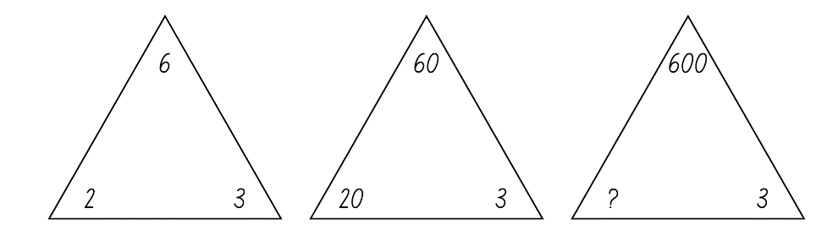
- Ask:
- What do you notice about the fact families?
- How does the value of the digit 6 change in the numbers?
- How can renaming 60 as 6 tens help find its fact families?
- How do the multiplication and division facts for 6 relate to the fact family for 60?
- What number is missing in the third fact family? Explain how you know.
- Draw a table on the board and record the number 60 above it. Label one side ‘Division facts’ and the other side ‘Multiplication facts’.
- Students provide as many multiplication and division facts as they can for both sides. Record the equations in the table (see Figure 33).
Figure 33 – facts for 60
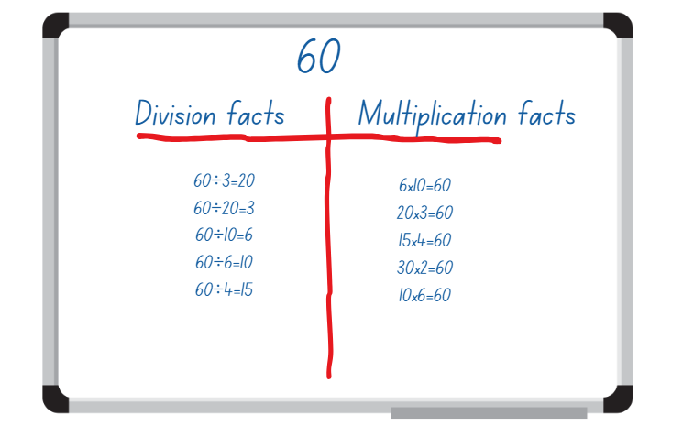
- Remind students that factors can be multiplied in any order and the product remains the same. This is called the ‘commutative property’ of multiplication.
Commutative property: commutative property of addition or multiplication means that 2 numbers can be added or multiplied in any order and the solution will be the same. Commutative law, commutativity and turn-around facts are interchangeable terms.
- Select students to identify facts from the table which show the commutative property. For example, 6 × 10 = 60 and 10 × 6 = 60. Circle these equations.
- Ask students to offer a fact that would show the commutative property of another multiplication fact.
- Record the numbers 12 and 120 on the board.
- Students find as many multiplication and division facts as they can for 12 and record them in a table in their workbooks. They use these facts to help them complete a fact table for 120 and identify equations that show the commutative property.
- Ask:
- Did you find all the factors of 120? How do you know?
- Were there more division or multiplication equations recorded? Why?
- Write the number 18 on the board. Students write down one pair of factors for that product in their workbooks. Students compare and discuss their choice of factors with a partner.
- Record the pairs of factors presented by the class.
- Students turn and talk to identify patterns in the list of factors, such as the commutative property or doubling and halving.
- Identify one pair of factors, 9 $×$ 2, and ask students if it is the same or different from 3 × 3 × 2.
- Ask students what other pair of factors could also be expressed as 3 × 3 × 2.
- Remind students that when 2 or more numbers are multiplied, the product stays the same, regardless of how the factors are grouped. This is called the ‘associative property’ of multiplication.
- Repeat this sequence with other numbers, for example, 12, 24 or 36.
- Pose the following problem: On our classroom wall, there are 8 shelves with 25 books on each shelf. How many books are there on our wall?
- Students use the associative property to solve the problem.
- Ask:
- What was the first step you took to solve this problem?
- Do you think using the associative property helped in solving the task? Why or why not?
- Would you use this strategy to solve this problem if there were 100 books on each shelf? Why or why not?
This table details opportunities for differentiation.
Too hard? | Too easy?
Stage 2 students cannot use number properties to find related multiplication facts.  - Provide students with manipulatives, such as linking cubes or counters, to rearrange numbers into different forms without changing their value.  - Support students by providing a multiplication grid to identify factors. | Stage 2 students can use number properties to find related multiplication facts.  - Students investigate fact families for multiples of 100 and 1000.  - Students play the online game Factors and Multiples by NRICH.

Stage 3 task – benchmark operations
The table below contains suggested learning intentions and success criteria. These are best co-constructed with students.
Core concept learning intentions | Core concept success criteria
Students working towards Stage 3 outcomes are learning to:  - select and apply strategies to solve problems involving multiplication and division with whole numbers  - multiply and divide decimals by powers of 10. | Students working towards Stage 3 outcomes can:  - solve word problems involving rates using multiplication and division  - use mental strategies to multiply benchmark decimals by single-digit numbers  - compare the relative place value of digits to multiply and divide a decimal by powers of 10.
This activity is an adaptation of ‘Multiplying and dividing numbers with decimal parts by 10, 100, etc.’ from Building Engagement in Middle Years Mathematics: Learning sequences for mixed-ability classrooms by Sullivan.
- Pose the following question: If 5 × 2 = 10 and 50 × 2 = 100, can you work out the product of 0.5 × 2?
- In pairs, students represent how they would solve the equation on an individual whiteboard.
- Explain that when multiplying or dividing by 10 or 100, it is the value of the number that changes as each digit changes in place value. For example, 0.5 × 2 will be less than 10. The answer is one.
Note: remind students that the benchmark decimal of 0.5 is equivalent to the fraction of $\frac{1}{2}$.
- Pose the following question: If 5 × 2 = 10 and 0.5 × 2 = 1, what is the product of 1.5 × 2?
- Students use their whiteboards to record a visual representation to solve 1.5 × 2.
- Demonstrate the use of the area model as an effective visual representation to multiply 1.5 × 2 (see Figure 34).
Figure 34 – use of area model to solve 1.5 × 2
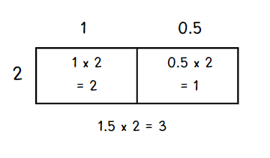
- If students did not use an area model to find a solution, they can record the example on their whiteboard.
- Write the equations 25 × 9 = 225 and 25 × 90 = 2250 on the board.
- Using these equations, students estimate the product of the following number sentences before solving:
- 2.5 × 9
- 25 × 0.9
- 0.25 × 9.
- Invite students to share their solutions and how close their estimates were to the answers.
- Pose the following scenario: Farmer Joe owns a small plot of land that grows apple trees. Each year at Christmas, he harvests the apples and produces jugs of apple juice to sell. Each jug is filled with 2.25 litres of apple juice.
- In pairs, students work out the following:
- How many litres of juice will Farmer Joe need for 10 jugs?
- How many litres of juice will he need for 100 jugs?
- How many litres of juice will he need for 5 jugs?
- Ask students to share the strategies used to solve each problem. Ensure they understand that 0.25 litres becomes 1.25 litres when multiplied by 5.
This table details opportunities for differentiation.
Too hard? | Too easy?
Stage 3 students cannot compare the relative place value of digits to multiply and divide decimals by powers of 10.  - Support students to say the equation aloud to reinforce the connection to fractional language. For example, students say aloud, ‘half of 9 is zero and 5 tenths times 9’.  - Support students to use an area model as a visual representation of each equation. | Stage 3 students can compare the relative place value of digits to multiply and divide decimals by powers of 10.  - Pose the following question: If 75 × 5 = 375 and 75 × 50 = 3750, what is 7.5 × 5 and 75 × 0.5?  - Provide students with a 10-sided die. Students roll the die 3 times and record different multiplication statements using the 3 digits. For example, dice rolls of 5, 6 and 9 can be written as 5.6 × 9,  6.5 × 9 or 9.6 × 5. Students estimate the product through reasoning, then record the product of each.

Discuss and connect the mathematics – 10 minutes
- Regroup as a class and summarise the key mathematical ideas. Ask:
- How does understanding multiplication facts help with finding multiples of numbers 10 times or 100 times as large? (Stage 2)
- How would you explain the commutative property to someone who did not know about it yet? (Stage 2)
- How does understanding multiplication facts help find multiples of decimals 10 times or 100 times as large? (Stage 3)
- How does the area model help when multiplying decimal numbers? (Stage 3)
This table details opportunities for assessment.
Assessment opportunities | Links
What to look for:  - Can Stage 2 students use the commutative property of multiplication? [WAO-WM-01, MA2-MR-01]  - Can Stage 2 students use the associative property within multiplication to regroup factors? [WAO-WM-01, MA2-MR-01]  - Can Stage 2 students use multiplication facts with multiples of 10 to multiply a one-digit number by a multiple of 10? [WAO-WM-01, MA2-MR-01]  - Can Stage 3 students solve word problems involving rates using multiplication and division? [MAO-WM-01, MA3-MR-01]  - Can Stage 3 students use mental strategies to multiply benchmark decimals by single-digit numbers? [MAO-WM-01, MA3-MR-01]  - Can Stage 3 students compare the relative place value of digits to multiply and divide a decimal by powers of 10? [MAO-WM-01, MA3-MR-01] | Links to National Numeracy Learning Progressions (NNLP):  - Stage 2 – MuS6, MuS7  - Stage 3 – NPV8, MuS7, MuS8, MuS9, PrT4.  Links to suggested Interview for Student Reasoning (IfSR) tasks:  - Stage 2 – IfSR-MT: 2A.9  - Stage 3 – IfSR-MT: 4A.3, 4A.4, 4A.7.

Lesson 8
Core concept: number properties can be used to solve multiplication problems (Stage 2) and the order of operations is important to solve mathematics problems (Stage 3).

Daily number sense – 10 minutes
- From a class need surfaced through formative assessment data, identify a short, focused activity that targets students’ knowledge, understanding and skills. Example activities may be drawn from the following resources:
- Mathematics K–6 resources
- Universal Resources Hub.

Core lesson – 50 minutes

Stage 2 task – flexible partitioning
The table below contains a suggested learning intention and success criteria. These are best co-constructed with students.
Core concept learning intention | Core concept success criteria
Students working towards Stage 2 outcomes are learning to:  - use number properties to find related multiplication facts. | Students working towards Stage 2 outcomes can:  - use the commutative property of multiplication  - use flexible partitioning within multiplication.
This activity is an adaptation of Mathematical proofs in primary school by Russo.
- Remind students that when solving multiplication problems, some numbers can be partitioned using knowledge of place value and addition to make the numbers easier to work with. This is due to the ‘distributive property’ of multiplication. It can help students work out unknown multiplication facts from known multiplication facts.
The distributive property: multiplication of numbers is distributive over addition because the product of one number with the sum of 2 others equals the sum of the products of the first number with each of the others. For example, the product of 3 with (4 + 5) gives the same result as the sum of 3 × 4 + 3 × 5.
- Display Resource 8 – partitioned arrays. Ask students how many dots are in the array and to consider how they could make the array easier to work with by partitioning it into different sections (see Figure 35).
Figure 35 – examples of partitioned arrays
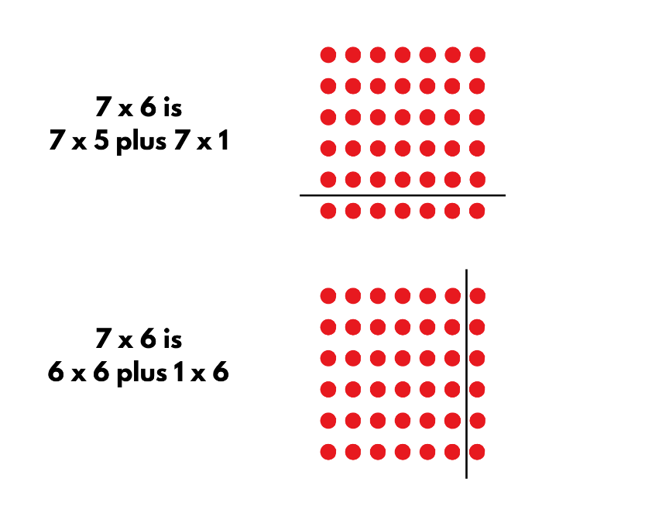
- Ask:
- Which multiplication and division facts up to 10 × 10 do you find the easiest to recall. Why?
- Which multiplication and division facts do you find more challenging to recall? Why?
- Record the challenging recall facts on the board.
- Select a challenging recall fact from the board and ask students to consider what numbers could be partitioned to help generate this fact, such as 8 × 6 $=$(4 × 6) $+$(4 × 6) or (5 × 6) $+$(3 × 6). Students turn and talk and discuss their strategies.
- Regroup and select individual students to explain which factors they partitioned and demonstrate their thinking by drawing a partitioned array.
- Students apply the distributive law to the remaining examples in the list of challenging multiplication facts. They record their thinking using arrays or tables and write the matching number sentences.
This activity is an adaptation of Multiplication toss from Mathematics K–6 Resources by State of New South Wales (Department of Education).
- Provide pairs of students with Resource 9 – multiplication toss spinner, one sheet of grid paper, paperclips to use as spinners and 2 different coloured markers.
- Each player takes a turn to spin the spinners. If a 5 and 6 are spun, the player can enclose a block of 5 rows of 6 (5 sixes) or use the commutative property and enclose 6 rows of 5 (6 fives). The player records their turn as a number sentence, for example, 5 × 6 = 30.
- Players can also choose to use the distributive property and partition numbers if that helps fit the block on the grid paper. For example, 5 sixes can be renamed as 2 sixes and 3 sixes and recorded as (2 × 6) $+$ (3 × 6) = 30.
- Students are not allowed to overlap their area with another player’s area.
- The winner is the player with the largest area blocked out after 10 spins.
This table details opportunities for differentiation.
Too hard? | Too easy?
Stage 2 students cannot use flexible partitioning within multiplication.  - Draw a 6 × 6 array on grid paper and partition the array by cutting it into smaller arrays. Support students to connect the addition of these arrays to 6 × 6 multiplication facts.  - Students use concrete materials to partition 24 into equal groups and identify that the product remains the same even if the number of equal groups changes. | Stage 2 students can use flexible partitioning within multiplication.  - Students roll 3 dice to find ways of multiplying 2-digit numbers with a single-digit number. For example, if they roll a 1, 4 and 5, the number sentence created is 14 × 5. This can be solved and renamed as (7 × 5) $+$(7 × 5).  - Students create word problems using their number sentences and the distributive property.

Stage 3 task – using grouping symbols
The table below contains a suggested learning intention and success criteria. These are best co-constructed with students.
Core concept learning intention | Core concept success criteria
Students working towards Stage 3 outcomes are learning to:  - explore the use of brackets and the order of operations to write number sentences. | Students working towards Stage 3 outcomes can:  - use grouping symbols ( ) in number sentences to indicate operations that must be performed first  - investigate the order of operations using real-life contexts  - solve problems involving grouping symbols.
This activity is an adaptation of ‘Order of operations’ from Teaching Mathematics: Foundations to Middle Years by Siemon et al.
- Revise the role of order of operations in equations. Demonstrate that when grouping symbols are used, the combination of numbers and operations will affect the final answer. For example, 1 + 2 × 3 = 7, but (1 + 2) × 3 = 9.
Note: the Stage 3 teaching advice states that the order of operations convention is to be used to reduce the risk of misunderstanding. In this way, complete all multiplications and divisions working left to right before adding and subtracting. Grouping symbols are used to indicate what to do first or to make certain the order is clear. Mnemonics like BOMDAS, BIDMAS or PEMDAS are often misleading as they suggest an absolute order between addition (A) and subtraction (S) or multiplication (M) and division (D) (NESA 2022).
- Display Resource 10 – Who is correct? and provide students with individual whiteboards to solve the problem.
- Students turn and talk to discuss which answer is correct and why.
- Ask:
- How do you know which response is the correct answer?
- How did you work this out?
- What errors were made in the incorrect calculation?
- Revise that:
- grouping symbols are used to change the order by indicating what to do first when solving an equation
- grouping symbols ensure the equation is accurately communicating the problem needing to be solved
- in the absence of grouping symbols, all multiplication and division operations are still completed first by working from left to right. Adding and subtracting happens after this.
- Display Resource 11 – more grouping symbols. Students work in pairs to solve each word problem by using grouping symbols in a number sentence to indicate the order in which it should be solved.
- Select students to demonstrate how they were able to use grouping symbols to solve each equation, discussing the strategies they used.
This activity is an adaptation of Order of Operations 5 by Rawding from the Open Middle website.
- Draw Figure 36 on the board.
Figure 36 – order of operations task
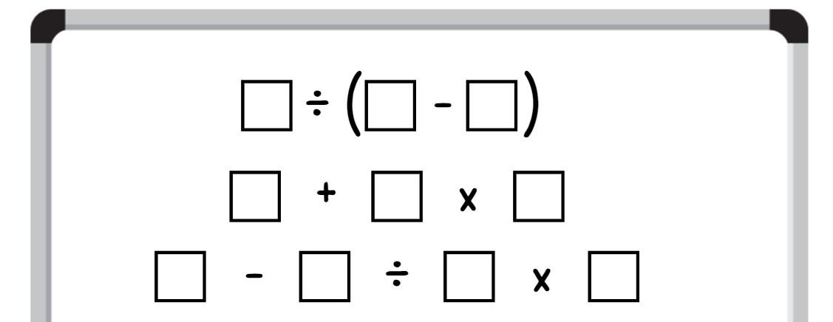
- Using the digits 0–9 only once each, students place a digit in each box so that each equation equals a different odd number. For example, 7 ÷ (6 − 5) = 7, 1 + 2 × 0 = 1, 9 − 8 ÷ 4 × = 3.
- Students compare their answers with a partner, discussing the strategies they used.
This table details opportunities for differentiation.
Too hard? | Too easy?
Stage 3 students cannot explore the use of brackets and the order of operations to write number sentences.  - Provide students with concrete materials such as counters to assist them when calculating the answer to each equation.  - Support students by allowing the use of a calculator to determine the total of their equations. | Stage 3 students can explore the use of brackets and the order of operations to write number sentences.  - Pose the problem: I found 6 frogs and 4 spiders. How many creatures’ legs did I find altogether? If we had 5 boxes and each box could only contain creatures with a total of 12 legs, which combinations could be used? (For example, boxes 1 to 4 would contain a frog and a spider each, but box 5 would contain 3 frogs).  - Allow students to select any 4 digits. Once selected, the digits must be placed in an order and must remain in that order for the duration of the task. For example, 1, 9, 3 and 7. Using any mathematical operation, students must create equations that equal as many numbers between zero and 100 as possible. For example, 19 + 3 − 7 = 15 and (1 + 9) × 3 + 7 = 37.

Discuss and connect the mathematics – 5 minutes
- Regroup as a class and summarise the key mathematical ideas. Ask:
- How would you explain the distributive property to someone who did not know about it yet? (Stage 2)
- Can you think of real-life situations where the distributive property could help make calculations easier? (Stage 2)
- How would you explain the purpose of grouping symbols to someone who did not know about them yet? (Stage 3)
- Can you think of real-life situations where grouping symbols could help make calculations easier? (Stage 3)
This table details opportunities for assessment.
Assessment opportunities | Links
What to look for:  - Can Stage 2 students use the commutative property of multiplication? [MAO-WM-01, MA2-MR-01]  - Can Stage 2 students use flexible partitioning within multiplication? [MAO-WM-01, MA2-MR-01]  - Can Stage 3 students use grouping symbols ( ) in number sentences to indicate operations that must be performed first? [MAO-WM-01, MA3-MR-02]  - Can Stage 3 students investigate the order of operations using real-life contexts? [MAO-WM-01, MA3-MR-02]  - Can Stage 3 students solve problems involving grouping symbols? [MAO-WM-01, MA3-MR-02] | Links to National Numeracy Learning Progressions (NNLP):  - Stage 2 – MuS6, MuS7  - Stage 3 – NPA5.  Links to suggested Interview for Student Reasoning (IfSR) tasks:  - Stage 2 – IfSR-MT: 2A.9.

Resource 1 – balance the scales
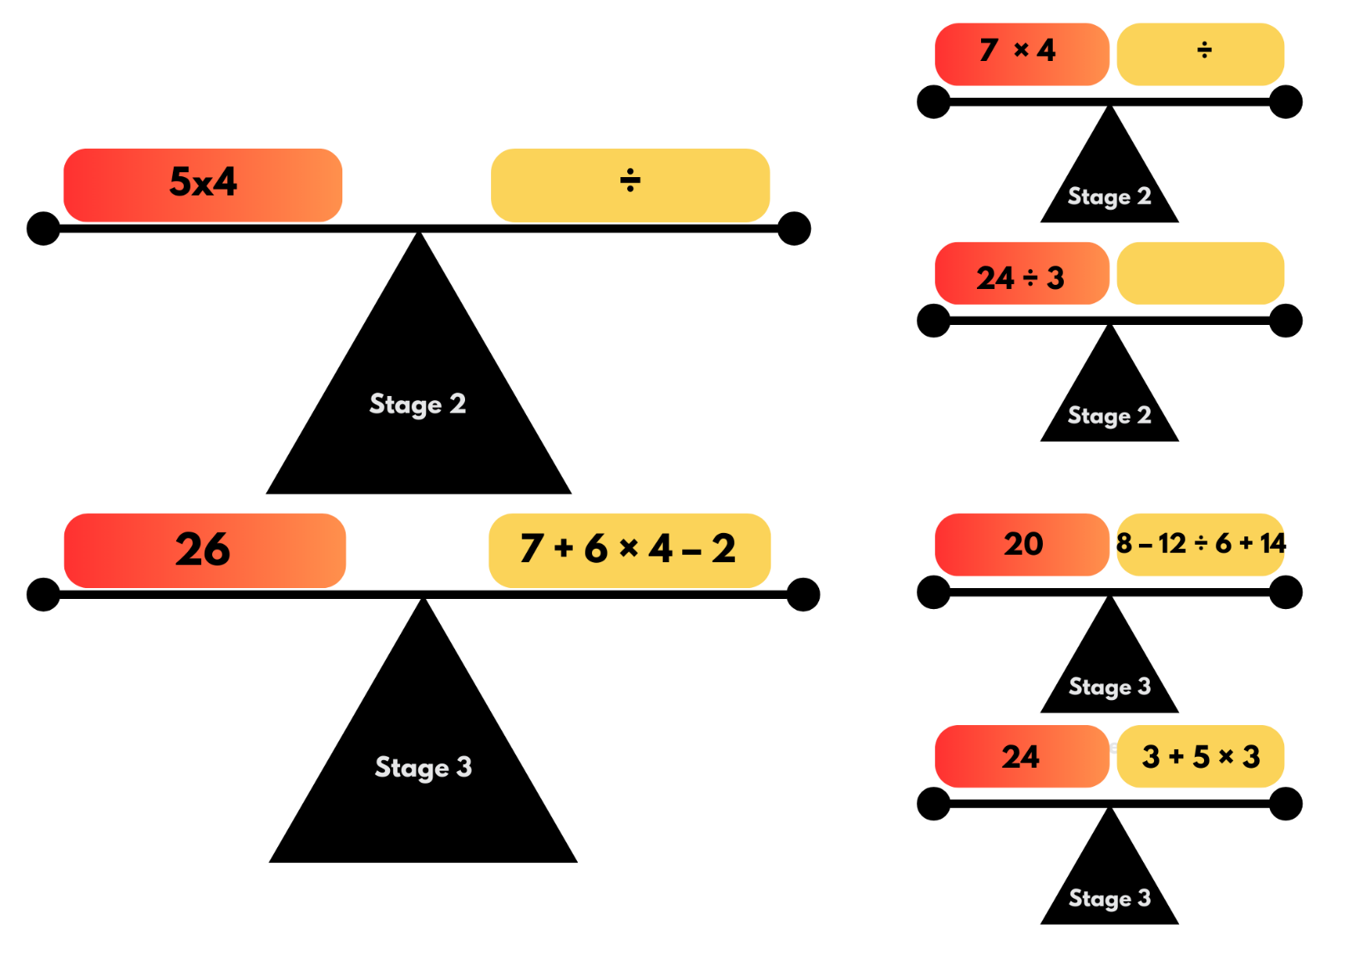

Resource 2 – think board
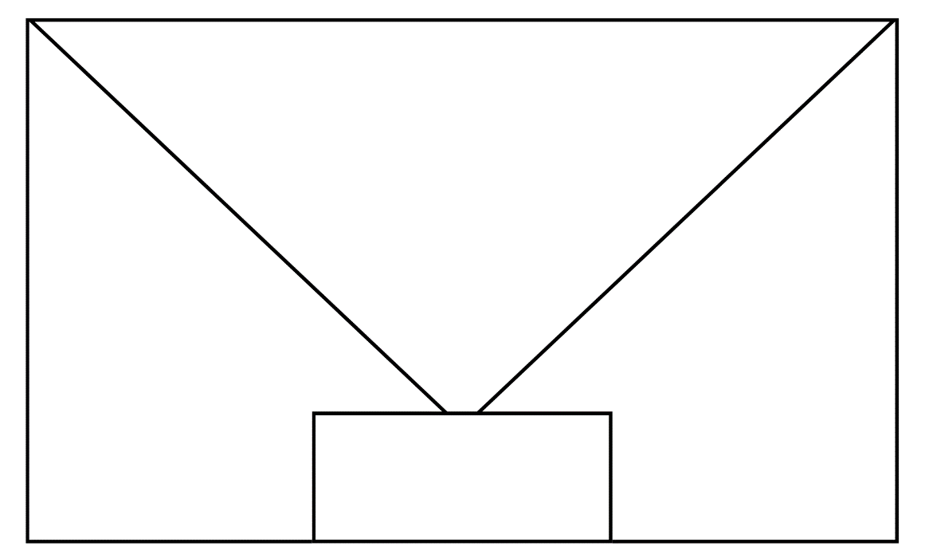

Resource 3 – footy final cards (Stage 2)
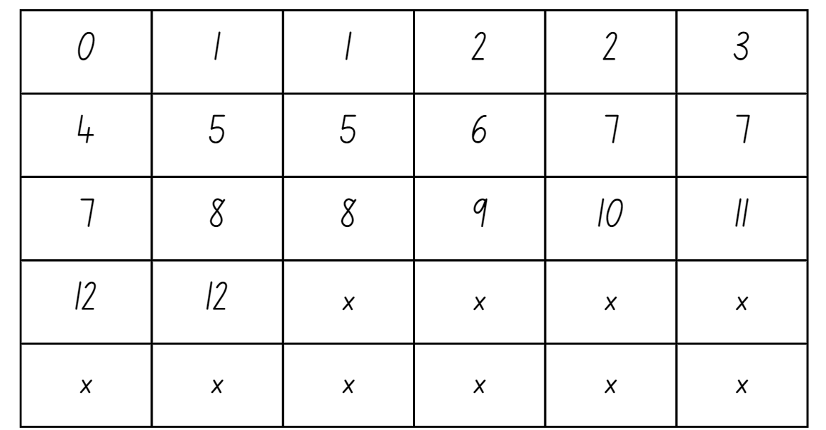

Resource 4 – footy final cards (Stage 3)
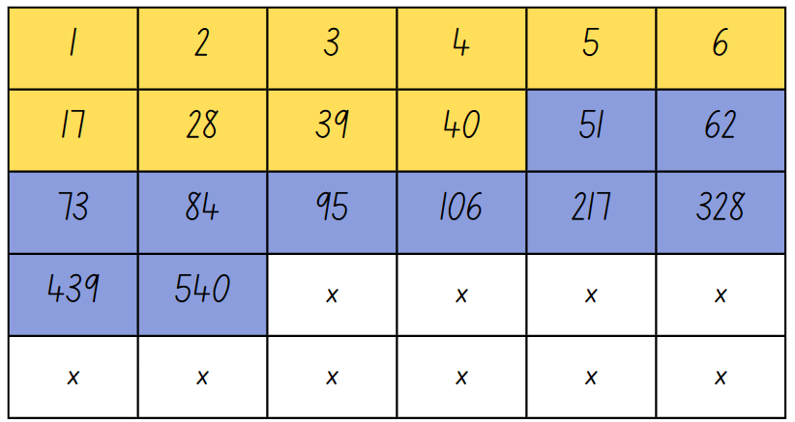

Resource 5 – Which is correct?
Stage 2
5 × 16 = 80
- I bought 2 shirts for $16 each. I then paid $34 for another 2 shirts. I went back to the store one more time and bought another shirt for $16. How much did I pay altogether?
- I paid $32 for 2 shirts. I had double that much money to spend so bought another 2 shirts. I then found some more money in my pocket and bought one more shirt for $16. How much did I pay altogether?
- I bought one shirt for $16. I then paid double that price for another 2 shirts. I went back one more time and bought another 4 shirts at $16 each. I decided that was too many so I returned one shirt. How much did I pay altogether?
Stage 3
50 ÷ 2 + 1 = 26
- There are 50 students going on an excursion. Two buses have been booked. The students have been allocated a bus each, with one supervising teacher on each bus. How many people will board each bus?
- There are 50 students going on an excursion. Two buses have been booked for an even allocation of students on each bus. A new student has recently enrolled and will be attending the excursion. How many students will there be on each bus?
- There are 50 students in Year 5. They will be evenly allocated to 2 different Year 6 classes next year.

Resource 6 – large number spinners
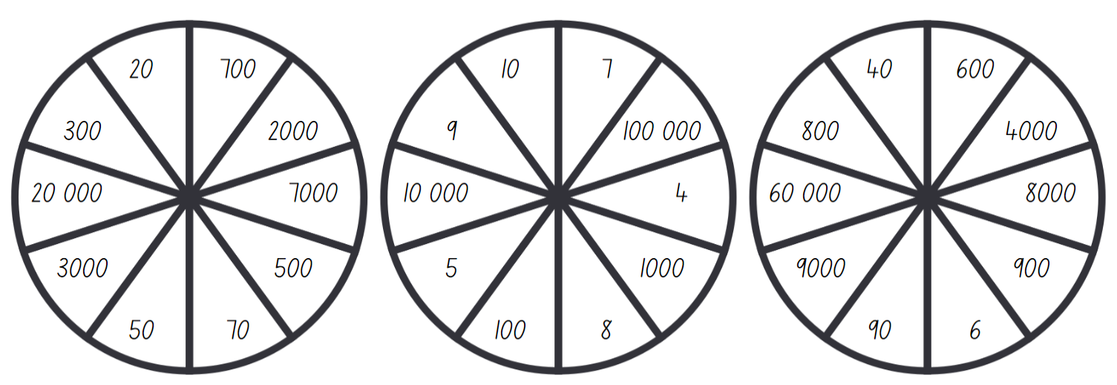

Resource 7 – decimal spinners
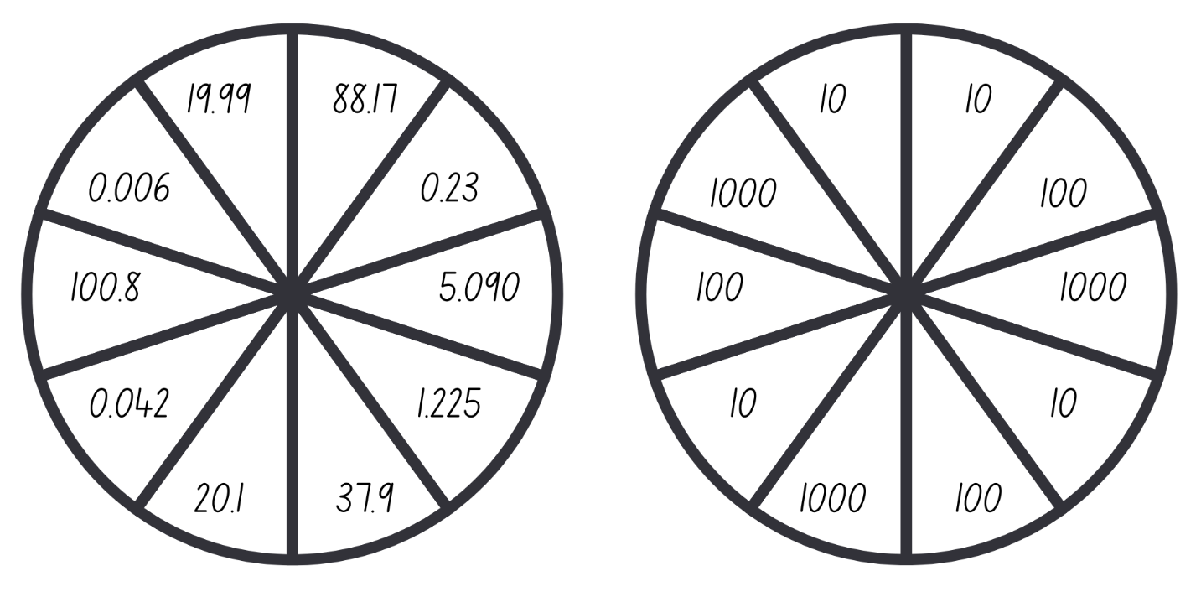

Resource 8 – partitioned arrays

Resource 9 – multiplication toss spinner
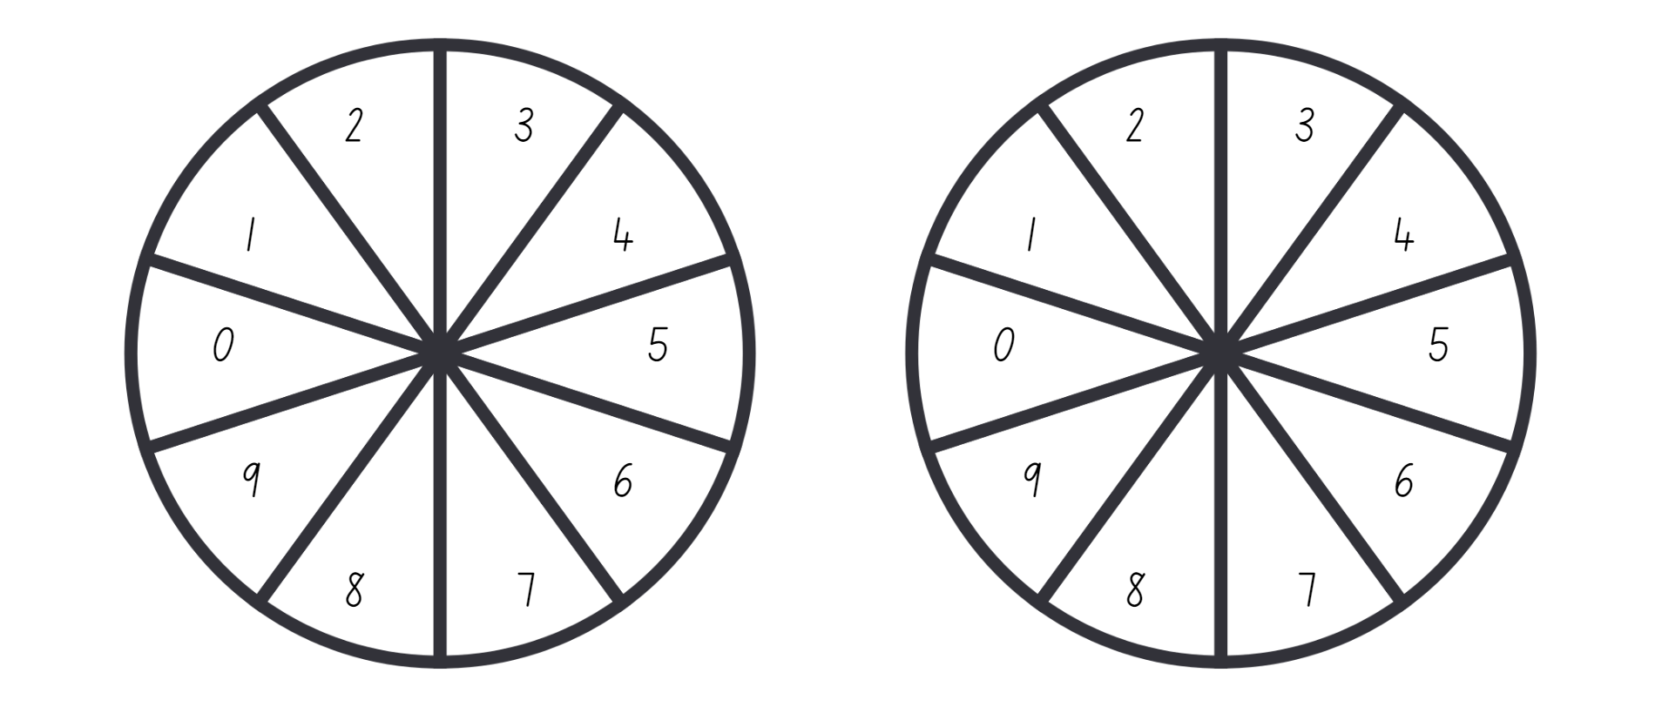

Resource 10 – Who is correct?
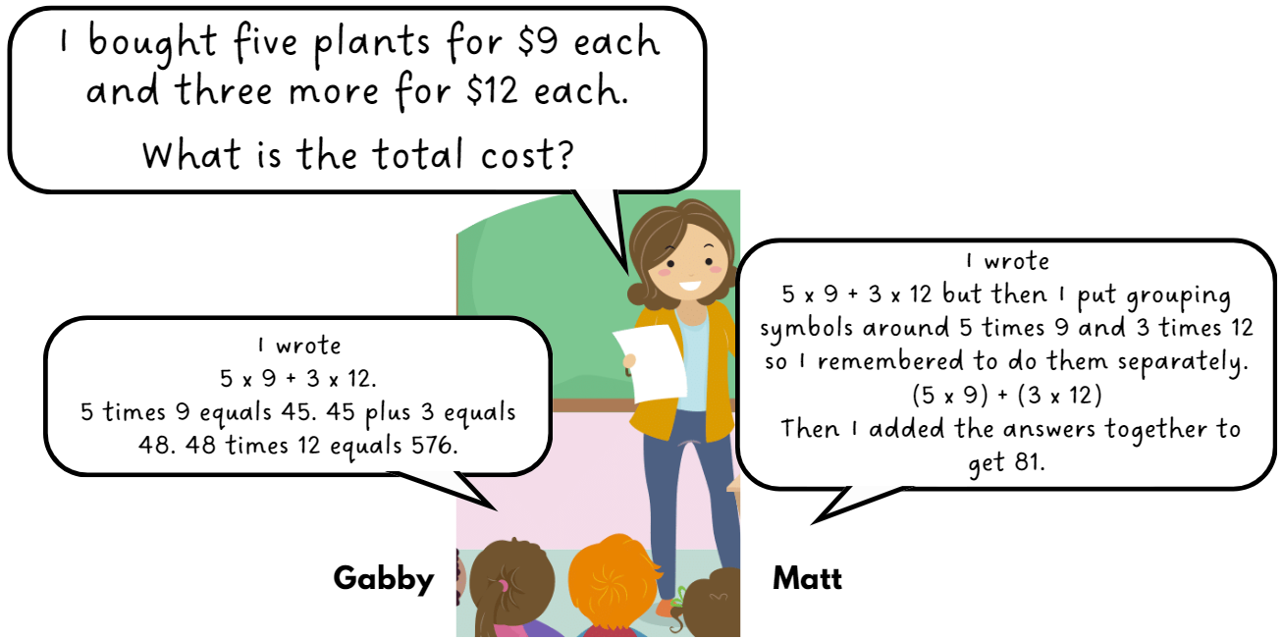

Resource 11 – more grouping symbols
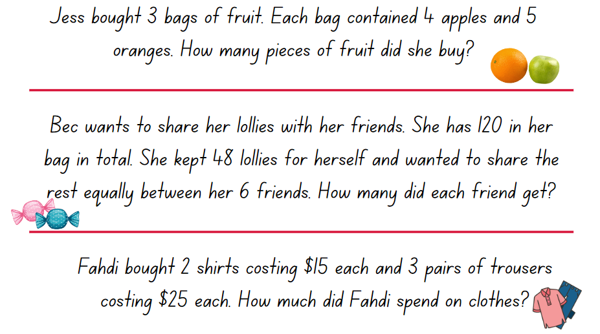

Syllabus outcomes and content

Stage 2
The table below outlines the syllabus outcomes and range of relevant syllabus content covered in this unit. Content is linked to National Numeracy Learning Progression (version 3).
Outcomes and content | 1 | 2 | 3 | 4 | 5 | 6 | 7 | 8
Representing numbers using place value A: Whole numbers: Apply place value to partition and regroup numbers up to 4 digits
MAO-WM-01, MA2-RN-01
- Record numbers using standard place value form |  |  |  | x | x | x
Representing numbers using place value B: Whole numbers: Apply place value to partition, regroup and rename numbers up to 6 digits
MAO-WM-01, MA2-RN-01
- Name thousands using the place value grouping of ones, tens and hundreds of thousands |  |  |  |  | x | x
Representing numbers using place value B: Whole numbers: Recognise and represent numbers that are 10, 100 or 1000 times as large
MAO-WM-01, MA2-RN-01
- Recognise the number of tens, hundreds or thousands in a number |  |  |  |  | x | x | x
- Describe how making a number 10, 100 or 1000 times as large changes the place value of digits |  |  |  |  | x | x | x
Additive relations B: Complete number sentences involving additive relations to find unknown quantities
MAO-WM-01, MA2-AR-02
- Calculate missing numbers by completing number sentences involving addition and subtraction (Algebraic reasoning) |  |  |  |  | x
- Find the missing number in an equivalent number sentence involving operations of addition or subtraction on both sides of the equals sign (Algebraic reasoning) |  |  |  |  |  | x
- Create word problems that correspond to given addition and subtraction number sentences |  |  |  |  |  |  | x
Multiplicative relations A: Use arrays to establish multiplication facts from multiples of 2 and 4, 5 and 10
MAO-WM-01, MA2-MR-01
- Recognise that doubling is multiplying by 2 and halving is dividing by 2 (Reasons about relations) |  |  | x
Multiplicative relations A: Represent and solve problems involving multiplication fact families
MAO-WM-01, MA2-MR-01
- Apply the inverse relationship of multiplication and division (Reasons about relations) |  |  | x
Multiplicative relations B: Investigate number sequences involving related multiples
MAO-WM-01, MA2-MR-01
- Generate number patterns using related multiples | x
- Investigate number patterns involving related multiples | x |  |  |  | x
Multiplicative relations B: Use known number facts and strategies
MAO-WM-01, MA2-MR-01
- Apply the known strategy of doubling to connect multiples of 3 to 6 and 4 to 8 (Reasons about relations) |  | x
- Use known facts to find unknown multiples (Reasons about relations) |  | x
Multiplicative relations B: Use the structure of the area model to represent multiplication and division
MAO-WM-01, MA2-MR-01
- Create and represent multiplicative structure, moving from arrays to partially covered area models |  |  |  | x
Multiplicative relations B: Use number properties to find related multiplication facts
MAO-WM-01, MA2-MR-01
- Use the commutative property of multiplication |  |  |  |  |  |  | x | x
- Use the associative property within multiplication to regroup the factors (Reasons about structure) |  |  |  |  |  | x | x
- Use flexible partitioning within multiplication (Reasons about relations) |  |  |  |  |  |  |  | x
- Generate and recall multiplication fact families up to 10 × 10 |  | x | x |  |  |  | x
Multiplicative relations B: Operate with multiples of 10
MAO-WM-01, MA2-MR-01
- Use multiplication facts with multiples of 10 to multiply a one-digit number by a multiple of 10 |  |  |  |  |  | x | x
- Apply the commutative and associative properties to multiply by multiples of 10 |  |  |  |  |  | x | x
Multiplicative relations B: Represent and solve word problems with number sentences involving multiplication or division
MAO-WM-01, MA2-MR-01, MA2-MR-02
- Use the equals sign to record equivalent number relationships involving multiplication (Reasons about relations) | x |  | x |  |  |  | x
- Complete number sentences involving multiplication and division by calculating missing numbers (Reasons about relations) |  | x | x
- Represent and solve multiplication and division (both sharing and grouping) word problems using number sentences |  |  | x
Mathematics K–10 Syllabus © NSW Education Standards Authority (NESA) for and on behalf of the Crown in right of the State of New South Wales, 2022.

Stage 3
The table below outlines the syllabus outcomes and range of relevant syllabus content covered in this unit. Content is linked to National Numeracy Learning Progression (version 3).
Outcomes and content | 1 | 2 | 3 | 4 | 5 | 6 | 7 | 8
Represents numbers A: Whole numbers: Apply place value to partition, regroup and rename numbers to 1 billion
MAO-WM-01, MA3-RN-01
- Regroup numbers in different forms (Reasons about quantity) |  | x
Additive relations A: Apply efficient mental and written strategies to solve addition and subtraction problems
MAO-WM-01, MA3-AR-01
- Solve word problems, including multistep problems |  |  |  |  |  |  | x
- Use place value to add or subtract 3 or more numbers with different numbers of digits |  |  |  |  | x | x
Multiplicative relations B: Select and apply strategies to solve problems involving multiplication and division with whole numbers
MAO-WM-01, MA3-MR-01
- Select and use efficient strategies to multiply whole numbers of up to 4 digits by one- and 2-digit numbers |  | x | x | x
- Solve word problems involving rates using multiplication and division (Reasons about relations) |  |  |  | x |  |  | x
- Determine why different division questions have the same answer (Reasons about relations) |  |  | x
Multiplicative relations B: Multiply and divide decimals by powers of 10
MAO-WM-01, MA3-MR-01
- Use mental strategies to multiply benchmark decimals by single-digit numbers |  |  |  |  |  | x | x
- Compare the relative place value of digits to multiply and divide a decimal by powers of 10 |  |  |  |  | x | x | x
Multiplicative relations B: Use equivalent number sentences involving multiplication and division to find unknown quantities
MAO-WM-01, MA3-MR-01
- Identify and use inverse operations to assist with the solution of number sentences |  |  | x
Multiplicative relations B: Represent and describe number patterns formed by multiples
MAO-WM-01, MA3-MR-01
- Describe a pattern formed by multiples in words, in terms of multiplication rather than addition | x
- Determine a rule describing the relationship between the bottom number and the top number in a table (Algebraic reasoning) | x
Multiplicative relations B: Explore the use of brackets and the order of operations to write number sentences
MAO-WM-01, MA3-MR-01, MA3-MR-02
- Recognise the need to agree on the order in which to perform operations | x |  |  |  |  |  |  | x
- Use grouping symbols () in number sentences to indicate operations that must be performed first | x | x |  |  |  |  |  | x
- Investigate the order of operations using real-life contexts |  |  | x |  |  |  |  | x
- Solve problems involving grouping symbols |  |  | x |  |  |  |  | x
Mathematics K–10 Syllabus © NSW Education Standards Authority (NESA) for and on behalf of the Crown in right of the State of New South Wales, 2022.

References
This resource contains NSW Curriculum and syllabus content. The NSW Curriculum is developed by the NSW Education Standards Authority. This content is prepared by NESA for and on behalf of the Crown in right of the State of New South Wales. The material is protected by Crown copyright.
Please refer to the NESA Copyright Disclaimer for more information https://educationstandards.nsw.edu.au/wps/portal/nesa/mini-footer/copyright.
NESA holds the only official and up-to-date versions of the NSW Curriculum and syllabus documents. Please visit the NSW Education Standards Authority (NESA) website https://educationstandards.nsw.edu.au/wps/portal/nesa/home/ and the NSW Curriculum website https://curriculum.nsw.edu.au.
Mathematics K–10 Syllabus © NSW Education Standards Authority (NESA) for and on behalf of the Crown in right of the State of New South Wales, 2022.
National Numeracy Learning Progression © Australian Curriculum, Assessment and Reporting Authority (ACARA) 2010 to present, unless otherwise indicated. This material was downloaded from the Australian Curriculum website (National Numeracy Learning Progression) (accessed 22 April 2024) and was not modified.
Askew M (2016) A Practical Guide to Transforming Primary Mathematics: Activities and tasks that really work, 1st edn, Routledge, United States of America.
Barton C (2015) Build an Army: Times Tables, TES website, accessed 22 March 2024.
Errey B (2020) ‘Adding and Subtracting Two-Digit Whole Numbers’, Grade 2, Open Middle website, accessed 13 March 2024.
Ignaciuk C (2020) ‘Subtraction with Regrouping 2’, Grade 2, Open Middle website, accessed 13 March 2024.
NESA (NSW Education Standards Authority) (2022) Teaching advice for Multiplicative relations B, NESA website, accessed 26 March 2024.
Rawding M (2018) ‘Order of Operations 5’, Grade 5, Open Middle website, accessed 26 March 2024.
Russo J (2018) ‘Mathematic proofs in primary schools’, Mathematics Teaching, 261:32–35, accessed 26 March 2024.
Siemon D, Warren E, Beswick K, Faragher R, Miller J, Horne Marj, Jazby D, Breed M, Clark J, Brady K (2020) Teaching Mathematics: Foundations to Middle Years, 3rd edn, Oxford University Press Australia and New Zealand.
State of New South Wales (Department of Education) (2023) ‘Multiplication toss’, Mathematics K–6 resources, NSW Department of Education website, accessed 26 March 2024.
State Government of Victoria (Department of Education) (n.d.) ‘Multiplication of large numbers’, Number and place value, Arc Learning: Mathematics Curriculum Companion website, accessed 2 April 2024.
State of Victoria Department of Education and Early Childhood Development (DEECD) (2008) Fencing the Freeway (PDF 69.7 KB), Victoria State Government Department of Education, accessed 2 April 2024.
Sullivan P (2021) Building Engagement in Middle Years Mathematics: Learning sequences for mixed-ability classrooms, 1st edn, Oxford University Press Australia and New Zealand, Victoria.
© State of New South Wales (Department of Education), 2024
The copyright material published in this resource is subject to the Copyright Act 1968 (Cth) and is owned by the NSW Department of Education or, where indicated, by a party other than the NSW Department of Education (third-party material).
Copyright material available in this resource and owned by the NSW Department of Education is licensed under a Creative Commons Attribution 4.0 International (CC BY 4.0) license.
This license allows you to share and adapt the material for any purpose, even commercially.
Attribution should be given to © State of New South Wales (Department of Education), 2024.
Material in this resource not available under a Creative Commons license:
- the NSW Department of Education logo, other logos and trademark-protected material
- material owned by a third party that has been reproduced with permission. You will need to obtain permission from the third party to reuse its material.
Links to third-party material and websites
Please note that the provided (reading/viewing material/list/links/texts) are a suggestion only and implies no endorsement, by the New South Wales Department of Education, of any author, publisher, or book title. School principals and teachers are best placed to assess the suitability of resources that would complement the curriculum and reflect the needs and interests of their students.
If you use the links provided in this document to access a third-party's website, you acknowledge that the terms of use, including licence terms set out on the third-party's website apply to the use which may be made of the materials on that third-party website or where permitted by the Copyright Act 1968 (Cth). The department accepts no responsibility for content on third-party websites.

