Mathematics 3–6 Multi-age – Year B – Unit 11
Our number system extends infinitely to very large and very small numbers

Contents
Unit description and duration 6
Syllabus outcomes 6
Stage 2 6
Stage 3 7
Working mathematically 7
Student prior learning 8
Lesson overview and resources 9
Lesson 1 17
Daily number sense – multiplication number sentences – 15 minutes 17
Stage 2 task – multiplication number sentences 18
Stage 3 task – inverse operations (part 1) 19
Core lesson – thousands and millions – 45 minutes 20
Consolidation and meaningful practice – 10 minutes 23
Lesson 2 26
Daily number sense – inverse operations (part 2) – 15 minutes 26
Core lesson – 35 minutes 28
Stage 2 task – representing numbers in non-standard form 28
Stage 3 task – equivalent number sentences 31
Discuss and connect the mathematics – 10 minutes 35
Lesson 3 37
Daily number sense – multiply and divide – 15 minutes 37
Core lesson – decimals – 45 minutes 38
Discuss and connect the mathematics – 10 minutes 44
Lesson 4 47
Daily number sense – 10 minutes 47
Core lesson 1 – equivalent fractions, decimals and percentages – 30 minutes 47
Core lesson 2 – 20 minutes 53
Stage 2 task – concentration 53
Stage 3 task – Would you rather? 54
Discuss and connect the mathematics – 10 minutes 56
Lesson 5 58
Daily number sense – multiplication word problems – 15 minutes 58
Core lesson – number patterns formed by multiples – 40 minutes 61
Discuss and connect the mathematics – 10 minutes 67
Lesson 6 69
Daily number sense – division word problems – 15 minutes 69
Core lesson – 35 minutes 71
Stage 2 task – associative property 71
Stage 3 task – rate word problems 74
Consolidation and meaningful practice – 10 minutes 77
Lesson 7 79
Daily number sense – multiplication or division – 15 minutes 79
Core lesson – 40 minutes 80
Stage 2 task – arrays to area models 80
Stage 3 task – multiplying and dividing decimals 83
Discuss and connect the mathematics – 10 minutes 85
Lesson 8 88
Daily number sense – 15 minutes 88
Core lesson – 30 minutes 88
Stage 2 task – flexible partitioning 88
Stage 3 task – open-ended multiplication problems 91
Consolidation and meaningful practice – 20 minutes 94
Resource 1 – video views 97
Resource 2 – matching game (Stage 2) 98
Resource 3 – matching game (Stage 3) 100
Resource 4 – jellybean spinner 102
Resource 5 – jellybean sort 103
Resource 6 – build a decimal 104
Resource 7 – hundredths and thousandths 105
Resource 8 – decimal concentration 106
Resource 9 – Would you rather? 107
Resource 10 – multiplication problems 108
Resource 11 – division problems 109
Resource 12 – problems to solve 110
Resource 13 – Multiplication or division? 112
Resource 14 – my piggy bank 113
Resource 15 – number slider 114
Resource 16 – Multiply or divide? 116
Resource 17 – strawberry patch 117
Resource 18 – strawberry patch strategies 118
Resource 19 – spinner 119
Syllabus outcomes and content 120
Stage 2 120
Stage 3 128
References 135

Unit description and duration
This unit develops the big idea that the number system extends infinitely to very large and very small numbers.
In this 2-week unit students are provided opportunities to:
- recognise, represent, order and partition large numbers
- apply place value knowledge to recognise, name and order decimals
- make connections between benchmark fractions, decimals (Stage 2 and 3) and percentages (Stage 3)
- develop flexible methods of computation in multiplication and division.
This multi-age unit is informed by the lessons in Stage 2 Year B Unit 31 and Stage 3 Year B Unit 31. Please refer to these units for additional lesson guidance.

Syllabus outcomes
- MAO-WM-01 develops understanding and fluency in mathematics through exploring and connecting mathematical concepts, choosing and applying mathematical techniques to solve problems, and communicating their thinking and reasoning coherently and clearly

Stage 2
- MA2-RN-01 applies an understanding of place value and the role of zero to represent numbers to at least tens of thousands
- MA2-RN-02 represents and compares decimals up to 2 decimal places using place value
- MA2-MR-01 represents and uses the structure of multiplicative relations to 10 × 10 to solve problems
- MA2-MR-02 completes number sentences involving multiplication and division by finding missing values

Stage 3
- MA3-RN-01 applies an understanding of place value and the role of zero to represent the properties of numbers
- MA3-RN-02 compares and orders decimals up to 3 decimal places
- MA3-RN-03 determines percentages of quantities, and finds equivalent fractions and decimals for benchmark percentage values
- MA3-MR-01 selects and applies appropriate strategies to solve multiplication and division problems

Working mathematically
In the Mathematics K–10 Syllabus, there is one overarching Working mathematically outcome (MAO-WM-01). The Working mathematically processes should be embedded within the concepts being taught. The Working mathematically processes present in the Mathematics K–10 Syllabus are:
- communicating
- understanding and fluency
- reasoning
- problem solving.
Mathematics K–10 Syllabus © NSW Education Standards Authority (NESA) for and on behalf of the Crown in right of the State of New South Wales, 2022.

Student prior learning
Before engaging in these teaching and learning activities, students would benefit from prior experience with:
- applying place value to recognise, name and order numbers up to thousands and decimals to hundredths
- using arrays and fact families to represent and solve multiplication problems featuring multiples of 2 and 4, 5 and 10 (Stage 2)
- identifying, describing and applying multiplicative patterns (Stage 3).
In NSW classrooms there is a diverse range of students, including Aboriginal and/or Torres Strait Islander students, students learning English as an additional language or dialect, high potential and gifted students and students with disability. Some students may identify with more than one of these groups or possibly all of them. Refer to Curriculum planning for every student – advice for further information.

Lesson overview and resources
To cover the content of the syllabus across Stage 2 and Stage 3, some core lessons in the unit contain both a Stage 2 and a Stage 3 task. Teachers are encouraged to adapt and contextualise the units to meet the needs of their students.
The table below outlines the sequence and approximate timing of lessons, learning intentions and resources.
Lesson | Content | Duration and resources
Lesson 1  Daily number sense  Stage 2:  - Multiplicative relations B: Represent and solve word problems with number sentences involving multiplication or division  Stage 3:  - Multiplicative relations B: Use equivalent number sentences involving multiplication and division to find unknown quantities | Lesson core concept: reading and recording large numbers is a key component of place value.  Stage 2:  - Representing numbers using place value A: Whole numbers: Read, represent and order numbers to thousands  - Representing numbers using place value B: Whole numbers: Recognise and represent numbers that are 10, 100 or 1000 times as large  Stage 3:  - Represents numbers A: Whole numbers: Recognise, represent and order numbers in the millions | Lesson duration: 70 minutes  - Resource 1 – video views  - Resource 2 – matching game (Stage 2)  - Resource 3 – matching game (Stage 3)  - Writing materials
Lesson 2  Daily number sense  Stage 2:  - Multiplicative relations A: Represent and solve problems involving multiplication fact families  Stage 3:  - Multiplicative relations B: Use equivalent number sentences involving multiplication and division to find unknown quantities | Lesson core concept: numbers can be renamed in equivalent ways using place value (Stage 2) and understanding equivalence can help determine unknown quantities (Stage 3).  Stage 2:  - Representing numbers using place value B: Whole numbers: Apply place value to partition and regroup numbers up to 6 digits  Stage 3:  - Multiplicative relations B: use equivalent number sentences involving multiplication and division to find unknown quantities | Lesson duration: 60 minutes  - Resource 4 – jellybean spinner  - Resource 5 – jellybean sort  - Coloured counters  - Individual whiteboards  - Whiteboard markers  - Writing materials
Lesson 3  Daily number sense  Stage 2:  - Multiplicative relations A: Recall multiplication facts of 2 and 4, 5 and 10 and related division facts  Stage 3:  - Multiplicative relations B: Use equivalent number sentences involving multiplication and division to find unknown quantities | Lesson core concept: the place value system can be extended.  Stage 2:  - Representing numbers using place value B: Decimals: Extend the application of the place value system from whole numbers to tenths and hundredths  Stage 3:  - Represents numbers A: Decimals and percentages: Recognise that the place value system can be extended beyond hundredths  - Represents numbers A: Decimals and percentages: Compare, order and represent decimals | Lesson duration: 70 minutes  - Resource 6 – build a decimal  - Resource 7 – hundredths and thousandths  - 10-sided dice  - Craft sticks  - MAB units  - Writing materials
Lesson 4  Daily number sense  - teacher-identified task based on student needs | Lesson core concept: connections can be made between benchmark fractions, decimals and percentages.  Stage 2:  - Representing numbers using place value B: Decimals: Extend the application of the place value system from whole numbers to tenths and hundredths  - Representing numbers using place value B: Decimals: Make connections between fractions and decimal notation  Stage 3:  - Represents numbers B: Decimals and percentages: Make connections between benchmark fractions, decimals and percentages | Lesson duration: 70 minutes  - Resource 8 – decimal concentration  - Resource 9 – Would you rather?  - Grid books or paper  - Writing materials
Lesson 5  Daily number sense  Stage 2:  - Multiplicative relations B: Represent and solve word problems with number sentences involving multiplication or division  Stage 3:  - Multiplicative relations A: Select and apply mental and written strategies to multiply 2- and 3-digit numbers by 2-digit numbers | Lesson core concept: number patterns can be multiplicative.  Stage 2:  - Multiplicative relations B: Investigate number sequences involving related multiples  Stage 3:  - Multiplicative relations B: Represent and describe number patterns formed by multiples | Lesson duration: 65 minutes  - Resource 10 – multiplication problems  - Coloured tiles  - Writing materials
Lesson 6  Daily number sense  Stage 2:  - Multiplicative relations B: Represent and solve word problems with number sentences involving multiplication or division  Stage 3:  - Multiplicative relations A: Select and apply strategies to divide a number with 3 or more digits by a one-digit divisor | Lesson core concept: number properties can be used to solve multiplication problems (Stage 2) and flexible methods of computation in multiplication and division involve composing and decomposing numbers (Stage 3).  Stage 2:  - Multiplicative relations B: Use number properties to find related multiplication facts  Stage 3:  - Multiplicative relations B: Select and apply strategies to solve problems involving multiplication and division with whole numbers | Lesson duration: 60 minutes  - Resource 11 – division problems  - Resource 12 – problems to solve  - Individual whiteboards  - Whiteboard markers  - Writing materials
Lesson 7  Daily number sense  Stage 2:  - Multiplicative relations B: Represent and solve word problems with number sentences involving multiplication or division  Stage 3:  - Multiplicative relations A: Select and apply mental and written strategies to multiply 2- and 3-digit numbers by 2-digit numbers  - Multiplicative relations A: Select and apply strategies to divide a number with 3 or more digits by a one-digit divisor | Lesson core concept: structures can support multiplicative thinking (Stage 2) and decimals can be divided and multiplied by powers of 10 (Stage 3).  Stage 2:  - Multiplicative relations B: Use the structure of the area model to represent multiplication and division  - Multiplicative relations B: Use number properties to find related multiplication facts  Stage 3:  - Multiplicative relations B: Multiply and divide decimals by power of 10 | Lesson duration: 65 minutes  - Resource 13 – Multiplication or division?  - Resource 14 – my piggy bank  - Resource 15 – number slider  - Resource 16 – Multiply or divide?  - Scissors  - Writing materials
Lesson 8  Daily number sense  - teacher-identified task based on student needs | Lesson core concept: number properties can be used to solve multiplication problems.  Stage 2:  - Multiplicative relations B: Use number properties to find related multiplication facts  - Multiplicative relations B: Operate with multiples of 10  Stage 3:  - Multiplicative relations A: Use partitioning and place value to multiply 2-, 3- and 4-digit numbers by one-digit numbers  - Multiplicative relations B: Select and apply strategies to solve problems involving multiplication and division with whole numbers | Lesson duration: 65 minutes  - Resource 17 – strawberry patch  - Resource 18 – strawberry patch strategies  - Resource 19 – spinner  - 1 cm grid paper  - 6-sided dice  - Writing materials

Lesson 1
Core concept: reading and recording large numbers is a key component of place value.

Daily number sense – multiplication number sentences – 15 minutes
Daily number sense activities for Lessons 1 to 3 ‘activate’ prior number knowledge and support the learning of new content in the unit. These activities can also assist teachers to identify the starting points for learning by revealing the extent of students’ existing knowledge.
The table below contains suggested learning intentions and success criteria. These are best co-constructed with students.
Daily number sense learning intentions | Daily number sense success criteria
Students working towards Stage 2 outcomes are learning to:  - represent and solve word problems with number sentences involving multiplication or division.  Students working towards Stage 3 outcomes are learning to:  - use equivalent number sentences involving multiplication and division to find unknown quantities. | Students working towards Stage 2 outcomes can:  - represent and solve multiplication word problems using number sentences.  Students working towards Stage 3 outcomes can:  - identify and use inverse operations to assist with the solution of number sentences.

Stage 2 task – multiplication number sentences
- Pose the following problem: Ava planted 6 rows of 8 trees. How many trees did she plant?
- Ask:
- How would you solve this problem?
- Can you represent the word problem as a number sentence?
- What is the answer?
- Students work out that this problem requires multiplying 6 and 8 and the answer is 48. Ask how many trees Ava would have if she planted:
- 9 rows of 6 trees
- 7 rows of 6 trees
- 9 rows of 6 trees.
- Stage 2 students solve the problems representing them as number sentences.

Stage 3 task – inverse operations (part 1)
- Pose the following problem: Ava planted 21 rows of 15 trees. How many trees did she plant?
- Ask:
- How would you solve this problem?
- Can you represent the word problem as a number sentence?
- What is the answer?
- Once students have worked out that this problem requires multiplying 21 and 15 and the answer is 315, pose the following questions:
- What is the inverse operation to multiplication?
- How can this problem be changed so that division instead of multiplication is needed to solve it?
- In pairs, ask students if they can use the 315 trees to create a division problem, reminding them that if they know that 21 times 15 is 315, they can use the inverse operation to help create this new problem.
- Students share their new problem with the class. Answers may include:
- Ava planted 315 trees in 21 straight rows. How many trees were in each row?
- Ava planted 315 trees so that each row contained 15 trees. How many rows were there?
This table details opportunities for assessment.
Assessment opportunities | Links
What to look for:  - Can Stage 2 students represent and solve multiplication word problems using number sentences? [MAO-WM-01, MA2-MR-01, MA2-MR-02]  - Can Stage 3 students identify and use inverse operations to assist with the solution of number sentences? [MAO-WM-01,  MA3-MR-02] | Links to National Numeracy Learning Progressions (NNLP):  - Stage 2 – NPA4  - Stage 3 – NPA3, NPA4, MuS7.  Links to suggested Interview for Student Reasoning (IfSR) tasks:  - Stage 3 – IfSR-MT: 3A.10.

Core lesson – thousands and millions – 45 minutes
The table below contains suggested learning intentions and success criteria. These are best co-constructed with students.
Core concept learning intentions | Core concept success criteria
Students working towards Stage 2 outcomes are learning to:  - read, represent and order numbers to thousands  - recognise and represent numbers that are 10, 100 or 1000 times as large.  Students working towards Stage 3 outcomes are learning to:  - recognise, represent and order numbers in the millions. | Students working towards Stage 2 outcomes can:  - read and order numbers of up to at least 4 digits  - recognise the number of tens, hundreds or thousands in a number  - describe how making a number 10, 100 or 1000 times as large changes the place value of digits.  Students working towards Stage 3 outcomes can:  - name millions using the place value grouping of ones, tens and hundreds  - arrange numbers in the millions in ascending and descending order using place value.
- Display Resource 1 – video views, instructing Stage 2 to focus on ‘Views this year’ and Stage 3 students to focus on ‘Total views’. Ask students what they can interpret from this information.
- Discuss how to read each number. Ask students to take turns reading a number to a partner before they record the number in words and numerals.
- Ask Stage 2 students:
- Which has the greatest value? How do you know?
- Which is the closest to 10 000?
- Which is closest to half of a thousand?
- Ask Stage 3 students:
- Which has the greatest value? How do you know?
- Which is the closest to one million?
- Which is closest to half a million?
- Ask students to order the numbers from smallest to largest. Discuss how they decided on the order.
- Choose one of the numbers from Resource 1 – video views and demonstrate making the number 10 times larger, asking students to read the new number. Discuss how this changes the place value of each digit.
- Repeat the process making the number 100 times larger and 1000 times larger than the original number.
- In pairs, students take turns writing numbers from Resource 1 – video views 10, 100 or 1000 times larger for their partner to read.
- As a class discuss how this changed the place value of digits.
- Provide copies of Resource 2 – matching game (Stage 2) or Resource 3 – matching game (Stage 3) to pairs of students in each stage.
- Students match a number card with its corresponding place value clue and the word clue or example.
This table details opportunities for differentiation.
Too hard? | Too easy?
Stage 2 students cannot read and order numbers of up to at least 4 digits.  - Assist students by reducing the size of their numbers.  - Support students to use MAB materials to create numbers.  Stage 3 students cannot name millions using the place value grouping of ones, tens and hundreds.  - Assist students by reducing the size of their numbers.  - Support students by using materials such as MAB materials, labelled place value houses or number lines to identify and name their number. | Stage 2 students can read and order numbers of up to at least 4 digits.  - Direct students to use ‘Total views’ and order the numbers from smallest to largest.  - Students choose 3 numbers from the ‘Total views’ column, making each number 10, 100 and 1000 times larger and reading it to a partner.  Stage 3 students can name millions using the place value grouping of ones, tens and hundreds.  - Students research other things that can be recorded using millions.  - Provide students with the scenario: they have one billion dollars that they can donate to 7 different charities. Ask them to consider which charities they would choose, how much each might need and why.

Consolidation and meaningful practice – 10 minutes
- Students order their number cards in descending order (see Figure 1).
Figure 1 – matching cards descending order
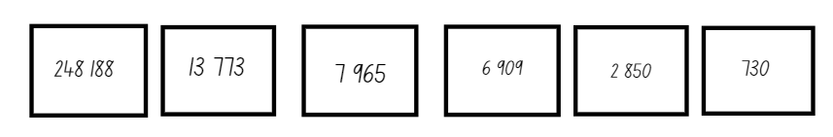
- In pairs, students take it in turns to read their numbers aloud. Each partner must listen to ensure the numbers have been placed in the correct order.
- For each number, students record the closest 1000, 10 000 or 100 000.
This table details opportunities for assessment.
Assessment opportunities | Links
What to look for:  - Can Stage 2 students read and order numbers of up to at least 4 digits? [MAO-WM-01, MA2-RN-01]  - Can Stage 2 students recognise the number of tens, hundreds or thousands in a number? [MAO-WM-01, MA2-RN-01]  - Can Stage 2 students describe how making a number 10, 100 or 1000 times as large changes the place value of digits?  [MAO-WM-01, MA2-RN-01]  - Can Stage 3 students name millions using the place value grouping of ones, tens and hundreds? [MAO-WM-01,  MA3-RN-01]  - Can Stage 3 students arrange numbers in the millions in ascending and descending order using place value?  [MAO-WM-01, MA3-RN-01] | Links to National Numeracy Learning Progressions (NNLP):  - Stage 2 – NPV4, NPV5, NPV6, NPV7, NPV8, NPV9  - Stage 3 – NPV6, NPV7.  Links to suggested Interview for Student Reasoning (IfSR) tasks:  - Stage 2 – IfSR-AT: 3B.4  - Stage 2 – IfSR-NP: 4B.2, 4B.5, 4B.6, 4C.5.

Lesson 2
Core concept: numbers can be renamed in equivalent ways using place value (Stage 2) and understanding equivalence can help determine unknown quantities (Stage 3).

Daily number sense – inverse operations (part 2) – 15 minutes
The table below contains suggested learning intentions and success criteria. These are best co-constructed with students.
Daily number sense learning intentions | Daily number sense success criteria
Students working towards Stage 2 outcomes are learning to:  - represent and solve problems involving multiplication fact families.  Students working towards Stage 3 outcomes are learning to:  - use equivalent number sentences involving multiplication and division to find unknown quantities. | Students working towards Stage 2 outcomes can:  - apply the inverse relationship of multiplication and division.  Students working towards Stage 3 outcomes can:  - identify and use inverse operations to assist with the solution of number sentences.
- Draw a rectangle on the whiteboard marking one side with 7 m and the area in the middle as 119 m² (see Figure 2).
Figure 2 – rectangle
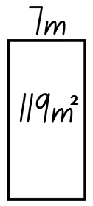
- Write 7 m × __ m = 119 m² on the board.
Note: modify the rectangle for Stage 2 students by using one-digit numbers as the sides.
- Ask:
- Which operation would you use to find the unknown length? (Explain that the inverse operation, division, is needed to solve the problem.)
- Can you write the division number sentence?
- What is the answer?
- In pairs, students create a word problem to go with Figure 2. For example, the rectangular playground has an area of 119 m²and one side is 7 m long. How long is the other side?
- Students write another problem with the same playground area context where the inverse operation (multiplication) is required.
This table details opportunities for assessment.
Assessment opportunities | Links
What to look for:  - Can Stage 2 students apply the inverse relationship of multiplication and division? [MAO-WM-01, MA2-MR-01,  MA2-MR-02]  - Can Stage 3 students identify and use inverse operations to assist with the solution of number sentences? [MAO-WM-01,  MA3-MR-02] | Links to National Numeracy Learning Progressions (NNLP):  - Stage 2 – MuS7  - Stage 3 – NPA3, NPA4, MuS7.  Links to suggested Interview for Student Reasoning (IfSR) tasks:  - Stage 2 – IfSR-MT: 2A.5, 2A.10  - Stage 3 – IfSR-MT: 3A.10.

Core lesson – 35 minutes

Stage 2 task – representing numbers in non-standard form
The table below contains suggested learning intentions and success criteria. These are best co-constructed with students.
Core concept learning intentions | Core concept success criteria
Students working towards Stage 2 outcomes are learning to:  - apply place value to partition and regroup numbers up to 6 digits. | Students working towards Stage 2 outcomes can:  - partition numbers up to 6 digits in non-standard form.
- Read the following scenario: Jellybeans need to be ordered for the school fete. Blue jellybeans can be ordered in boxes of 1000, yellow jellybeans in boxes of 100, red jellybeans in boxes of 10 or single green jellybeans.
- Ask:
- If the order includes one box of blue jellybeans and 2 boxes of yellow jellybeans, how many jellybeans will there be in total?
- What is another possible number of jellybeans that can be ordered? How many boxes of each colour would be needed?
- In small groups, students use Resource 4 – jellybean spinner to determine how many of each box need to be ordered. They spin it 4 times to determine how many blue, yellow, red and green jellybeans they need to record.
- Students record these quantities on Resource 5 – jellybean sort in the non-standard partitioning section of the table.
Note: students can use blue, yellow, red and green counters to represent the boxes of jellybeans they are regrouping and renaming.
- Students calculate how many jellybeans they have in total by converting their number using standard partitioning (see Figure 3).
Figure 3 – jellybean total
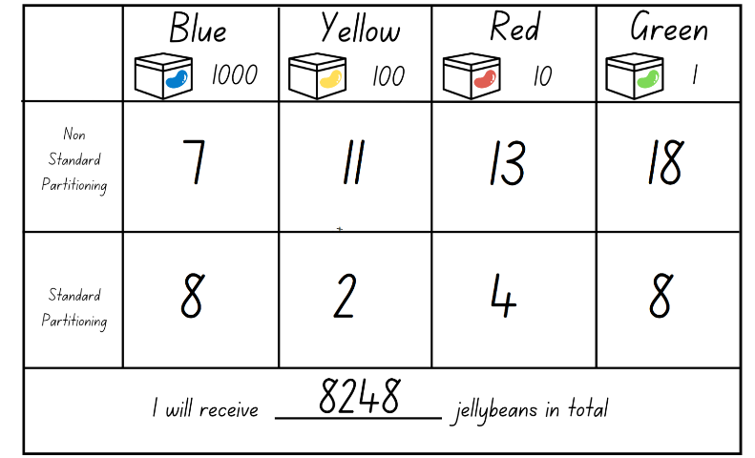
- Students repeat this process with a new quantity made by using Resource 4 – jellybean spinner to select new values.
This table details opportunities for differentiation.
Too hard? | Too easy?
Stage 2 students cannot partition numbers up to 6 digits in non-standard form.  - Support students to represent their numbers by providing MAB materials.  - Decrease the value of the numbers on the spinner or use dice to create appropriate numbers. | Stage 2 students can partition numbers up to 6 digits in non-standard form.  - Challenge students to add a fifth box size that holds 10 000 jellybeans.  - Students sit back-to-back, each with a whiteboard. Student A writes a 6-digit number, written using standard or non-standard partitioning. Student B asks place value questions about the number until they work out the number. Students compare numbers. They swap roles and repeat.

Stage 3 task – equivalent number sentences
The table below contains suggested learning intentions and success criteria. These are best co-constructed with students.
Core concept learning intentions | Core concept success criteria
Students working towards Stage 3 outcomes are learning to:  - use equivalent number sentences involving multiplication and division to find unknown quantities. | Students working towards Stage 3 outcomes can:  - complete number sentences that involve more than one operation by calculating missing numbers  - identify and use inverse operations to assist with the solution of number sentences.
- Write 5 × _ = 40 ÷ _ on the board.
- Ask the students what they notice about the number sentence.
- Using whiteboards, students determine the missing values.
- Ask questions, such as:
- What are the missing values? How do you know?
- What strategies did you use to determine the missing values?
- How many possibilities are there? Can you prove it?
- Is it possible for the same number to appear in both the missing value boxes?
- What is the fact family in this problem? Is there more than one fact family? How?
- What is the fact family represented by the left-hand side of the equation?
- What is the fact family represented by the right-hand side of the equation?
- What do the 2 fact families have in common?
- How do the factors of 40 and multiples of 5 help with this problem?
- Explain that the value of each number sentence has to be a factor of 40 and a multiple of 5. It must be a multiple of 5 because of the × after the 5, as well as a factor of 40 because of the ÷ after the 40.
- Write 4 _ 15 _ 120 _ 2 on the board.
- Using whiteboards, students determine what is missing.
- Ask:
- What was the first symbol you put into the number sentence?
- How did placing the = sign help you work out which other symbols were missing from the number sentence?
- How did the size of the numbers help you work out which symbols were missing from the number sentence?
Note: highlight that the = sign positioned in the middle of the number sentence represents equivalence, rather than an answer.
Equivalent: two things are equivalent if they have the same value.
- Display the following number sentence: 50 × 7 = _ ÷ _.
- Ask:
- What does the value of the division sentence need to be to make this an equivalent number sentence?
- What would the missing number be if the number sentence was 50 × 7 = _ ÷ 1?
- What are some other possibilities for the missing values 50 × 7 = _ ÷ _?
- What are some different values that could appear in the multiplication sentence so that it is equivalent to 350?
- Students work independently to record their ideas.
- Ask:
- How did multiplication help with the missing values in the division sentence?
- What patterns do you notice in the division sentences?
- Using the number 350, students create a balanced equation using multiplication and division. For example, 50 × 7 = 2800 ÷ 8.
- In pairs, students share their answer and determine if they have represented 350 as an equivalent number sentence in similar or different ways.
- Repeat the process with the number 324. Encourage students to not repeat the use of a number throughout the number sentence. For example: 108 × 3 = 648 ÷ 2.
- Using the number 840, make as many balanced equations as possible.
- Class to share and discuss responses.
This table details opportunities for differentiation.
Too hard? | Too easy?
Stage 3 students cannot complete number sentences that involve more than one operation by calculating missing numbers.  - Modify the equations so there is less missing information.  - Support students with concrete materials, such as counters, to model the different operations required to determine the missing values. | Stage 3 students can complete number sentences that involve more than one operation by calculating missing numbers.  - Increase the digits in the equation to 4 digits.  - Students complete similar problems at Solvemoji.

Discuss and connect the mathematics – 10 minutes
- Summarise the lesson together drawing out key mathematical ideas. Ask:
- What strategy did you use when a number was larger than 10 in a place value column? (Stage 2)
- Can you explain the process you followed to rename your number? (Stage 2)
- What strategies did you use to determine the missing values? (Stage 3)
- How did you know when you had calculated all the possible solutions? (Stage 3)
- What did you find challenging in today’s lesson? How did you overcome it?
- How did you work like a mathematician today?
This table details opportunities for assessment.
Assessment opportunities | Links
What to look for:  - Can Stage 2 students record numbers using standard place value form? [MAO-WM-01, MA2-RN-01]  - Can Stage 2 students partition numbers up to 6 digits in non-standard form? [MAO-WM-01, MA2-RN-01]  - Can Stage 3 students complete number sentences that involve more than one operation by calculating missing numbers?  [MAO-WM-01, MA3-MR-02]  - Can Stage 3 students identify and use inverse operations to assist with the solution of number sentences? [MAO-WM-01,  MA3-MR-02] | Links to National Numeracy Learning Progressions (NNLP):  - Stage 2 –NPV4, NPV5, NPV6  - Stage 3 – NPA3, NPA4, MuS7, MuS8.  Links to suggested Interview for Student Reasoning (IfSR) tasks:  - Stage 2 – IfSR-AT: 3B.2, 3B.4  - Stage 3 – IfSR-MT: 3A.8, 3A.9, 3A.10.

Lesson 3
Core concept: the place value system can be extended.

Daily number sense – multiply and divide – 15 minutes
The table below contains suggested learning intentions and success criteria. These are best co-constructed with students.
Daily number sense learning intentions | Daily number sense success criteria
Students working towards Stage 2 outcomes are learning to:  - recall multiplication facts of 2 and 4, 5 and 10 and related division facts.  Students working towards Stage 3 outcomes are learning to:  - use equivalent number sentences involving multiplication and division to find unknown quantities. | Students working towards Stage 2 outcomes can:  - generate multiplication fact families for multiples of 2 and 4, 5 and 10.  Students working towards Stage 3 outcomes can:  - complete number sentences that involve more than one operation by calculating missing numbers.
This activity is an adaptation of Multiply and Divide Within a Hundred 1 from Open Middle by Kaplinsky.
- Write _ × _ = _ ÷ _ on the whiteboard.
- In pairs, students use whiteboards to record equal equations. Ask Stage 2 students to record 2, 4, 5 or 10 multiplication facts and the associated division facts, for example 2 × 6 = 24 ÷ 2. Ask Stage 3 students to record equivalent number sentences involving multiplication and division to find unknown quantities with a combination of one-, 2- or 3-digit numbers, such as 12 × 15 = 720 ÷ 4.
- As a class, share and compare solutions. Ask students to identify the strategies they used and justify their choices.
This table details opportunities for assessment.
Assessment opportunities | Links
What to look for:  - Can Stage 2 students generate multiplication fact families for multiples of 2 and 4, 5 and 10? [MAO-WM-01, MA2-MR-01]  - Can Stage 3 students complete number sentences that involve more than one operation by calculating missing numbers?  [MAO-WM-01, MA3-MR-02] | Links to National Numeracy Learning Progressions (NNLP):  - Stage 2 – MuS6  - Stage 3 – NPA3, MuS8.  Links to suggested Interview for Student Reasoning (IfSR) tasks:  - Stage 3 – IfSR-MT: 3A.10.

Core lesson – decimals – 45 minutes
The table below contains suggested learning intentions and success criteria. These are best co-constructed with students.
Core concept learning intentions | Core concept success criteria
Students working towards Stage 2 outcomes are learning to:  - extend the application of the place value system from whole numbers to tenths and hundredths.  Students working towards Stage 3 outcomes are learning to:  - recognise that the place value system can be extended beyond hundredths  - compare, order and represent decimals. | Students working towards Stage 2 outcomes can:  - express decimals as both tenths and hundredths  - locate and order decimals representing tenths and hundredths on a number line, describing their relative size.  Students working towards Stage 3 outcomes can:  - express thousandths as decimals  - interpret decimal notation for thousandths  - compare and order decimal numbers of up to 3 decimal places  - place decimal numbers of up to 3 decimal places on a number line.
Note: to support place value conceptual understanding, 6.13 would be read as six and thirteen hundredths. The language connects the decimal fraction with the whole number and makes a connection with common fractions.
- Display a pre-made number line from 0–1 with markings, but no labels for tenths (see Figure 4).
Figure 4 – blank number line
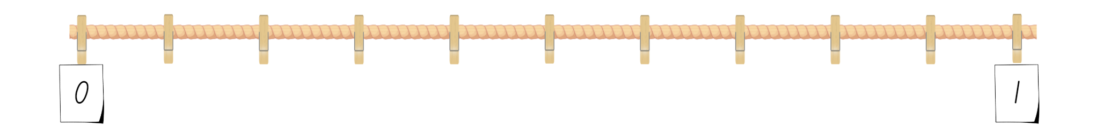
- Say that the number line shows the space between zero and one. There are numbers between zero and one. Ask what could be missing on the number line.
- Student turn and talk to discuss what the missing values could be.
- Select students to share responses with the class and fill in the missing values on the number line.
Note: ensure the correct decimal language is modelled. For example, the decimal parts are called tenths. 0.4 is read as 4 tenths.
- Distribute Resource 6 – build a decimal and 10 craft sticks (each representing one tenth) to each student.
- In pairs, students play ‘Build a decimal’ by:
- taking turns to roll a 10-sided die. This number represents how many tenths they need to make using their craft sticks.
- recording their die roll as a number. Students draw their craft sticks, recording the decimal and how to read it on Resource 6 – build a decimal.
- plotting their decimal and their partner’s decimal on a number line on Resource 6 – build a decimal. For example, see Figure 5.
- The game continues for 3 rounds.
Figure 5 – ‘Build a decimal’ tenths example
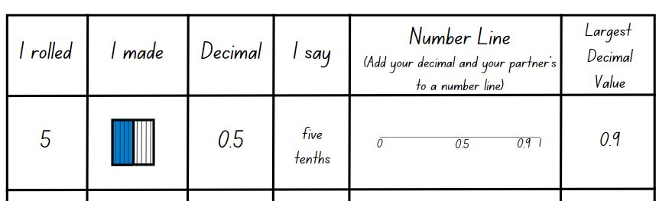
- Observe students as they play the game, questioning their understanding of tenths. Ask:
- What happens if 2 decimals added together is 10 tenths or greater?
- How could this be recorded in words or numbers?
Note: 13 tenths is equivalent to one and 3 tenths and is written using place value 1.3.
- Highlight that students already know that the space between zero and one can be divided into tenths. Ask students what they think is between 0.5 and 0.6.
- Ask Stage 3 students what they think is between 0.55 and 0.56.
- Display Resource 7 – hundredths and thousandths. As a class, complete the values for hundredths between 0.5 and 0.6.
- Stage 3 students complete the values for thousandths between 0.55 and 0.56.
- Students play ‘Build a decimal’ again with the following amendments:
- Stage 2 students roll the die twice to represent the number of tenths and hundredths. Use MAB units to represent hundredths. For example, see Figure 6.
Figure 6 – Stage 2 ‘Build a decimal’ hundredths example
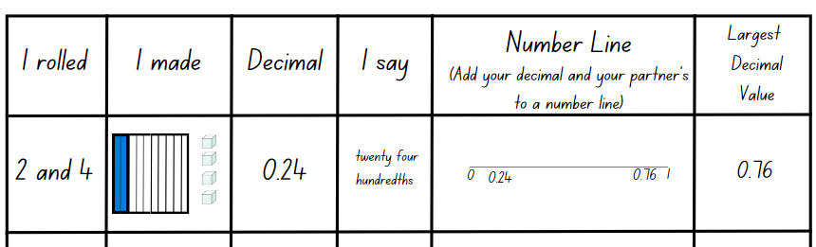
- Stage 3 students roll the die 3 times to represent the number of tenths, hundredths and thousandths. Use counters to represent thousands. For example, see Figure 7.
Figure 7 – Stage 3 ‘Build a decimal’ thousandths example
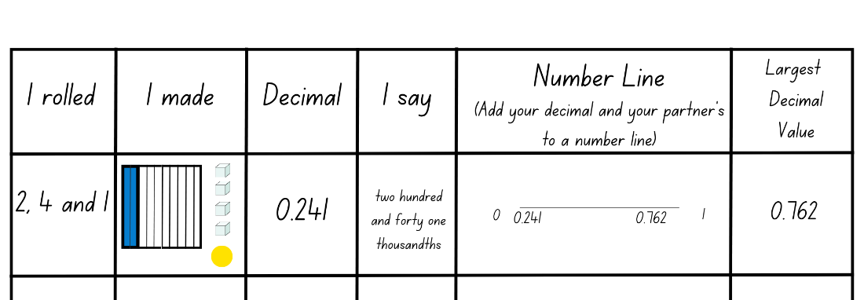
- In pairs, students list the decimals created by both partners in ascending order.
This table details opportunities for differentiation.
Too hard? | Too easy?
Stage 2 students cannot express decimals as both tenths and hundredths.  - Students use manipulatives only to represent decimals.  - Model how 20 hundredths (20 craft sticks) can be renamed as 2 tenths.  - Students consolidate their knowledge of place value by only representing and creating decimals involving tenths.  Stage 3 students cannot express thousandths as decimals.  - Provide support materials, such as labelled place value houses or structured number lines.  - Students consolidate their knowledge of place value by only representing and creating decimals involving tenths and hundredths. | Stage 2 students can express decimals as both tenths and hundredths.  - Students roll the die 3 times to complete Resource 6 – build a decimal. The first roll represents a whole number, the second roll represents tenths and the third roll represents hundredths.  - Students represent their ordered decimals on a number line. They show a classmate and justify why their decimals are in the correct places.  Stage 3 students can express thousandths as decimals.  - Students roll the die 4 times to complete Resource 6 – build a decimal. The first roll represents a whole number, the second roll represents tenths, the third roll represents hundredths and the fourth roll represent thousandths.  - Students play the ladder game using decimals. In pairs, students draw a ladder on a whiteboard. The aim of the game is to roll a 10-sided die 4 times to create a number with 3 decimal places and place them in order between the rungs of the ladder. If a student creates a number that cannot be placed on the ladder or places a number in the wrong position, they miss a turn. The winner is the student with the most numbers on the ladder.

Discuss and connect the mathematics – 10 minutes
- Students share a decimal they created during ‘Build a decimal’. Ask:
- How do you read your number?
- How many tenths does your decimal have?
- How many hundredths does your decimal have?
- How many thousandths does your decimal have? (Stage 3)
- How would you represent 10 tenths? (Stage 2)
- How would you represent 100 hundredths? (Stage 2)
- If the 6 in the hundredths’ column was replaced with a zero, would this increase or decrease the value of the number?
- If the number in the thousandths’ column was replaced with a zero, would this increase or decrease the value of the number? (Stage 3)
- How is the role of zero different when placed at the end of a decimal compared to when it is used in the middle? (Stage 3)
Note: highlight the role of the zero when placed at the end of a decimal. These can be described as ‘trailing zeros’ and are used to show precision in measurement. Internal zeros in whole numbers can be described as syntactic zeros. They represent a null quantity for a specific power of ten.
This table details opportunities for assessment.
Assessment opportunities | Links
What to look for:  - Can Stage 2 students express decimals as both tenths and hundredths? [MAO-WM-01, MA2-RN-02]  - Can Stage 2 students locate and order decimals representing tenths and hundredths on a number line, describing their relative size? [MAO-WM-01, MA2-RN-02]  - Can Stage 3 students express thousandths as decimals?  [MAO-WM-01, MA3-RN-02]  - Can Stage 3 students interpret decimal notation for thousandths? [MAO-WM-01, MA3-RN-02]  - Can Stage 3 students compare and order decimal numbers of up to 3 decimal places? [MAO-WM-01, MA3-RN-02]  - Can Stage 3 students place decimal numbers of up to 3 decimal places on a number line? [MAO-WM-01, MA3-RN-02] | Links to National Numeracy Learning Progressions (NNLP):  - Stage 2 – NPV7, NPV8  - Stage 3 – NPV7, NPV8.  Links to suggested Interview for Student Reasoning (IfSR) tasks:  - Stage 2 – IfSR-NP: 4D.1, 4D.2, 4D.3, 4D.4  - Stage 3 – IfSR-NP: 4D.2, 4D.6  - Stage 3 – IfSR-PT: 1A.5, 1A.7.

Lesson 4
Core concept: connections can be made between benchmark fractions, decimals and percentages.

Daily number sense – 10 minutes
- From a class need surfaced through formative assessment data, identify a short, focused activity that targets students’ knowledge, understanding and skills. Example activities may be drawn from the following resources:
- Mathematics K–6 resources
- Universal Resources Hub.

Core lesson 1 – equivalent fractions, decimals and percentages – 30 minutes
The table below contains suggested learning intentions and success criteria. These are best co-constructed with students.
Core concept learning intentions | Core concept success criteria
Students working towards Stage 2 outcomes are learning to:  - extend the application of the place value system from whole numbers to tenths and hundredths  - make connections between fractions and decimal notation.  Students working towards Stage 3 outcomes are learning to:  - make connections between benchmark fractions, decimals and percentages. | Students working towards Stage 2 outcomes can:  - locate and order decimals representing tenths and hundredths on a number line  - make connections between fractions and decimal notation for key benchmark values.  Students working towards Stage 3 outcomes can:  - recall commonly used equivalent percentages, decimals and fractions including $\frac{1}{2}$ , $\frac{1}{4}$, and $\frac{3}{4}$  - recognise that 10% is one-tenth of 100% and use this to find 10% of a quantity.
- Draw Figure 8 on the board.
Figure 8 – labelled number line
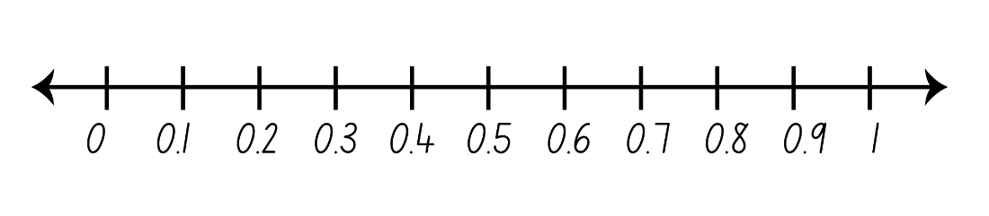
- Ask:
- If I fold this number line in half, where will the halfway point be?
- How can I write half as a fraction? How do you know?
- How will I write half as a decimal? How do you know?
- How will I write half as a percentage? How do you know? (Stage 3)
- Gesture to show the section 0–0.5 on the number line. Ask:
- What will happen if I fold this section of the number line (0–0.5) in half?
- What decimal will be at the halfway point?
Note: ensure that the term ‘halfway point’ is used, not ‘half’. Half is only marked once on a number line.
- Highlight that the halfway point is not on a tenth, it lands between 0.2 and 0.3. Determine that this will be known as 0.25 and mark it on the number line.
- Ask students how they will record 0.25 as a fraction (Stage 2 and 3) and a percentage (Stage 3).
- Add the fraction and percentage to the number line on the board (see Figure 9).
Figure 9 – fractions and percentages on a number line
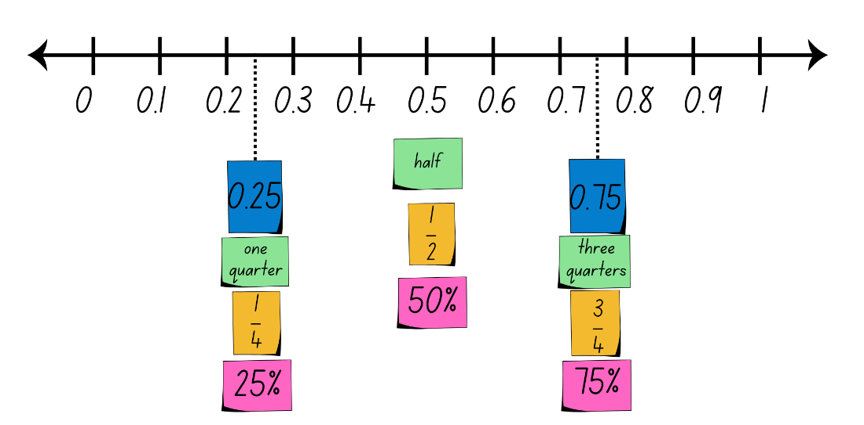
- Repeat for the halfway point between 0.5 and 1. Determine that this will be known as 0.75 and mark it on the number line, adding the fraction $\frac{3}{4}$ and percentage 75%.
- Highlight that 0.25 is the same as $\frac{1}{4}$ and 25%, 0.5 is the same as $\frac{1}{2}$ and 50% and 0.75 is the same as $\frac{3}{4}$ and 75%.
- In grid books or on grid paper, students construct their own number line from 0–1. Label each tenth with its decimal, fraction and how it is said. Students include 0.25, 0.75 and write the fractions to match, see black text in Figure 10.
- Stage 3 students add the equivalent percentage for all decimals marked on their number line, see red text in Figure 10.
Figure 10 – student number line
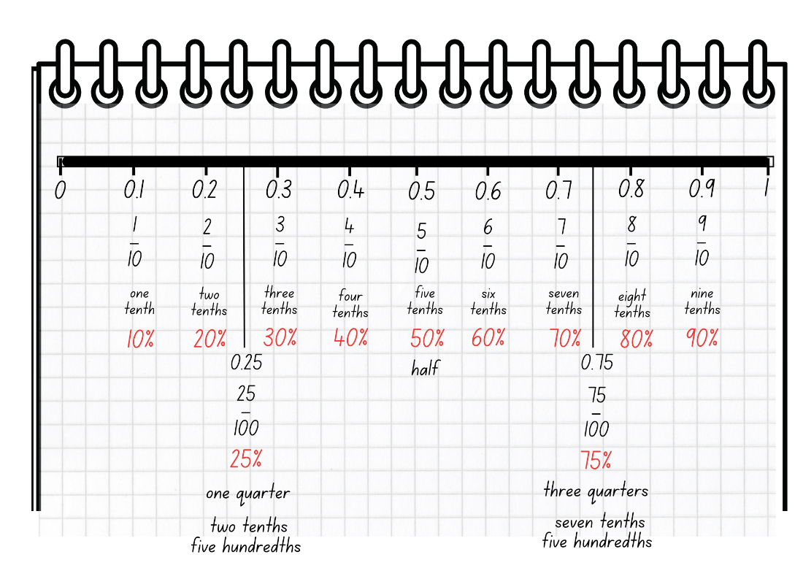
- Ask students which decimal is the biggest, 0.35 or 0.8?
The table below outlines stimulus prompts to generate conversation about the topic, along with anticipated responses from students.
Prompts | Anticipated student responses
- Who thinks 0.35 is the largest decimal? | - 0.35 is the largest decimal because 35 is larger than 8.
- Who thinks 0.8 is the largest decimal? | - 0.8 is the largest decimal because 0.8 has 8 tenths and 0.35 is 3 tenths and 5 hundredths.
- How could 0.8 be rewritten to have 2 decimal places? | - 0.8 could be rewritten as 0.80.
- What happens when there is a zero at the end of a decimal? | - A zero at the end does not change the value of the decimal.
- How could 0.35 and 0.8 be described using the words tenths and hundredths? | - 0.35 is 3 tenths and 5 hundredths and 0.8 is 8 tenths.
- Students add 0.35 and 0.8 to their number line.
This table details opportunities for differentiation.
Too hard? | Too easy?
Students cannot make connections between benchmark fractions, decimals (Stage 2 and 3) and percentages (Stage 3).  - Model using concrete materials and representations such as number lines to identify equivalence.  - Support students to have a clear understanding of half and whole using manipulatives before including more complex values. | Students can make connections between benchmark fractions, decimals and percentages.  - In pairs, Student A writes a benchmark decimal on their whiteboard and shows it to Student B. Student B records the equivalent fraction (Stage 2 and 3) and percentage (Stage 3) on their whiteboard and shows it to Student A to check for accuracy. Students swap roles and repeat.  - Students add non-benchmark decimals to their number line with the equivalent fraction (Stage 2 and 3) and percentage (Stage 3).

Core lesson 2 – 20 minutes

Stage 2 task – concentration
- In groups of 3, students use Resource 8 – decimal concentration to match decimals, fractions and decimal wording to play Concentration. To play the game:
- Students place all the cards face down between them.
- Students take it in turns to turn over 3 cards.
- Students who turn over the equivalent decimal, fraction and decimal wording keep the cards.
- If no match is made, the cards are turned back over.
- The game continues until all matches are made.
- The student with the greatest number of cards wins.
This table details opportunities for differentiation.
Too hard? | Too easy?
Stage 2 students cannot make connections between fractions and decimal notation for key benchmark values.  - Students place the cards facing upwards and work together to match the cards without playing it as a memory game.  - Students only match the decimal and the fraction cards, removing the decimal wording cards. | Stage 2 students can make connections between fractions and decimal notation for key benchmark values.  - Students create their own decimal concentration cards.  - Students swap their cards with another group to play concentration.

Stage 3 task – Would you rather?
- Ask: Would rather 20% of a chocolate bar, or 0.4 of the same sized chocolate bar?
- Allow students time to turn and talk with a partner and then represent their thinking by writing or drawing images in their workbooks (see Figure 11).
Figure 11 – example of chocolate bar representations
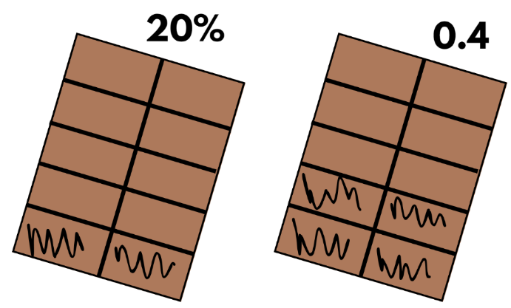
- Students identify the option they would prefer and how they came to that decision.
- As a group, discuss different responses, taking the opportunity to highlight the connection between 10% equalling $\frac{1}{10}$ and using this knowledge to find 10% of any quantity.
- In pairs, students complete Resource 9 – Would you rather? by circling their preferred option and recording the justification.
This table details opportunities for differentiation.
Too hard? | Too easy?
Stage 3 students cannot recall commonly used equivalent percentages, decimals and fractions including $\frac{1}{2}$ , $\frac{1}{4}$, and $\frac{3}{4}$.  - Students use grids divided into halves, quarters and tenths.  - Provide manipulatives for students to use to make the equivalent percentages, decimals and fractions. | Stage 3 students can recall commonly used equivalent percentages, decimals and fractions including $\frac{1}{2}$ , $\frac{1}{4}$, and $\frac{3}{4}$.  - Students find 10% of each of their answers from ‘Would you rather?’  - Students create their own ‘Would you rather?’ scenarios. They share and complete these in small groups.

Discuss and connect the mathematics – 10 minutes
- Summarise the lesson together, drawing out key mathematical ideas. Ask:
- In what other ways can you represent $\frac{7}{10}$?
- Can you explain the process you followed to convert a decimal to a fraction (Stage 2 and 3) and percentage (Stage 3)?
- What did you find challenging in today’s lesson? How did you overcome it?
- How did you work like a mathematician today?
This table details opportunities for assessment.
Assessment opportunities | Links
What to look for:  - Can Stage 2 students make connections between fractions and decimal notation for key benchmark values? [MAO-WM-01,  MA2-RN-02]  - Can Stage 2 students locate and order decimals representing tenths and hundredths on a number line? [MAO-WM-01,  MA2-RN-02]  - Can Stage 3 students recall commonly used equivalent percentages, decimals and fractions including $\frac{1}{2}$, $\frac{1}{4}$, and $\frac{3}{4}$?  [MAO-WM-01, MA3-RN-01, MA3-RN-03]  - Can Stage 3 students recognise that 10% is one-tenth of 100% and use this to find 10% of a quantity? [MAO-WM-01,  MA3-RN-01, MA3-RN-03] | Links to National Numeracy Learning Progressions (NNLP):  - Stage 2 – NPV6, NPV7, NPV 8, InF6  - Stage 3 – PrT2, UnM8.  Links to suggested Interview for Student Reasoning (IfSR) tasks:  - Stage 2 – IfSR-NP: 4D.3, 4D.6, 4D.7  - Stage 2 – IfSR-PT: 1A.6, 1A.7.

Lesson 5
Core concept: number patterns can be multiplicative.

Daily number sense – multiplication word problems – 15 minutes
Daily number sense activities for Lessons 5 to 7 ‘loop’ back to concepts and procedures covered in previous units to assist students to build an increasingly connected network of ideas. These concepts may differ from the core concepts being covered by the unit.
The table below contains suggested learning intentions and success criteria. These are best co-constructed with students.
Daily number sense learning intentions | Daily number sense success criteria
Students working towards Stage 2 outcomes are learning to:  - represent and solve word problems with number sentences involving multiplication or division.  Students working towards Stage 3 outcomes are learning to:  - select and apply mental and written strategies to multiply 2- and 3-digit numbers by 2-digit numbers. | Students working towards Stage 2 outcomes can:  - represent and solve multiplication word problems using number sentences.  Students working towards Stage 3 outcomes can:  - solve multiplication word problems.
This activity is an adaptation of Solving Multiplication and Division Word Problems from SAS by Commonwealth of Pennsylvania.
- Read the following problem to Stage 2 students: Volleyball is played in teams of 6. There are enough players to make 3 teams. How many players are there altogether?
- Read the following problem to Stage 3 students: A farmer has 14 rows of apple trees, and each row has 25 apple trees. How many apple trees does the farmer have in total?
- Students Think–Pair–Share how they can solve the problem and share with the class.
- Using 3 circles to represent the teams and coloured tiles to represent the players, model the Stage 2 problem with the help of students (see Figure 12).
Figure 12 – representation of Stage 2 problem
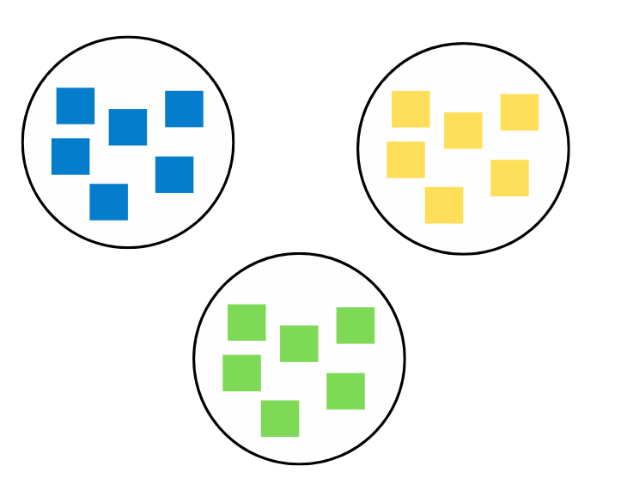
- All students represent the problem as an algorithm in their workbooks.
Note: it is likely that some Stage 2 students will suggest 6 + 6 + 6 = 18 while others will suggest 3 × 6 = 18 and 6 × 3 = 18. It is important to focus on the multiplication number sentence and remind students that it is more efficient than repeated addition.
- Display Resource 10 – multiplication problems. Stage 2 students can use manipulatives to support them to solve the problems. All students record the corresponding number sentences and written strategies in their workbooks.
This table details opportunities for assessment.
Assessment opportunities | Links
What to look for:  - Can Stage 2 students represent and solve multiplication word problems using number sentences? [MAO-WM-01, MA2-MR-01, MA2-MR-02]  - Can Stage 3 students solve multiplication word problems?  [MAO-WM-01, MA3-MR-01] | Links to National Numeracy Learning Progressions (NNLP):  - Stage 2 – NPA4  - Stage 3 – MuS6, MuS7, MuS8.  Links to suggested Interview for Student Reasoning (IfSR) tasks:  - Stage 2 – IfSR-MT: 2A.2, 2A.4.

Core lesson – number patterns formed by multiples – 40 minutes
The table below contains suggested learning intentions and success criteria. These are best co-constructed with students.
Core concept learning intentions | Core concept success criteria
Students working towards Stage 2 outcomes are learning to:  - investigate number sequences involving related multiples.  Students working towards Stage 3 outcomes are learning to:  - represent and describe number patterns formed by multiples. | Students working towards Stage 2 outcomes can:  - generate number patterns using related multiples  - investigate number patterns involving related multiples.  Students working towards Stage 3 outcomes can:  - use a given geometric pattern involving multiples to create a table of values  - determine a rule describing the relationship between the bottom number and the top number in a table.
This lesson is an adaptation from Talking about Patterns & Algebra: Early Stage 1 to Stage 3 by State of NSW Department of Education and Training.
- Draw an 8-sided shape on the board. Ask students how many sides there are. Record the number 8 below it (see Figure 13).
Figure 13 – 8-sided shape
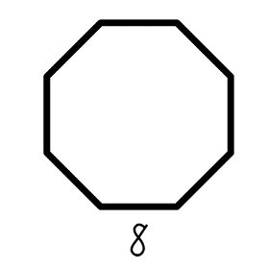
- Replicate the same shape next to the first one and pose the question: I have drawn another one of these shapes next to the first, how many sides have I drawn altogether? Record the number 16 below the second diagram.
- Students continue the sequence to the tenth term and these are displayed on the board.
- Stage 3 students record their data in a table of values (see Figure 14).
Figure 14 – table of values example
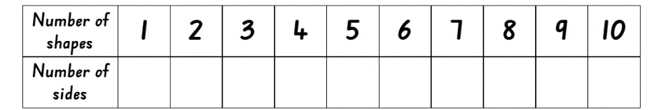
- Ask students the prompts in the table below.
The table below outlines stimulus prompts to generate conversation about the topic, along with anticipated responses from students.
Prompts | Anticipated student responses
- How many ways can you describe the pattern? | - The numbers in the pattern are increasing by 8.  - The pattern is made up of numbers that are multiples of 8. The third number in the pattern is 3 × 8 and the fourth number in the pattern is 4 × 8 and it continues.
- How many sides will there be if there are 15 shapes? How did you work it out? (Stage 3) | - There would be 120 sides if there were 15 shapes.  - I know this because one shape has 8 sides so 15 shapes means that I multiply 15 and 8 together. I can use repeated doubling to work this out. Double 15 is 30, double 30 is 60 and double 60 is 120.
- If there are 360 sides altogether, how many shapes will there be? How did you work it out? (Stage 3) | - There would be 45 shapes.  - I worked it out by dividing 360 by 8. I could use repeated halving, or I also know that 320 ÷ 8 = 40 and 40 ÷ 8 = 5 so 360 ÷ 8 = 45.
- How does the table help determine the relationship between the number of shapes and the number of sides? (Stage 3) | - The table helps me see that I do not need to add 8 to continue the pattern. I can see that if I take the number of shapes and multiply it by 8, it will give me the number of sides.
- Can you create a rule using multiplication to determine the number of sides for any given number of shapes? Highlight that the number of shapes multiplied by 8 always determines the number of sides. (Stage 3) | - The rule is number of shapes × 8 = number of sides.
- Stage 2 students:
- repeat the steps above for a 4-sided shape such as a square and describe the number pattern in words
- compare the number patterns for the octagon and square to demonstrate the link between related multiples 4 and 8
- repeat the steps above for related multiples 3 and 6 by representing number patterns for a triangle and hexagon.
- Stage 3 students:
- repeat the process with two-dimensional shapes of their choice and record the data in a table of values. For example, the letters in Figure 15 can be investigated
- create a written multiplication rule describing the relationship between the bottom number and the top number in each of their table of values. For example, ‘to work out the number of sides, you need to multiply the number of shapes by 3’
- swap rules with a partner and attempt to draw the geometric pattern.
Figure 15 – geometric shapes
This table details opportunities for differentiation.
Too hard? | Too easy?
Stage 2 students cannot generate number patterns using related multiples.  - Students generate number patterns for related multiples 2 and 4.  - Model using counters to create number patterns instead of using shapes.  - Provide students with fact families for multiples of numbers explored.  Stage 3 students cannot use a given geometric pattern involving multiples to create a table of values.  - Students complete a table of values for a triangle or square.  - Students use concrete materials. For example, toothpicks or cut up straws to represent the geometric shapes. | Stage 2 students can generate number patterns using related multiples.  - Students calculate the fifteenth, twentieth and thirtieth value for their number patterns.  - In pairs, students sit back-to-back. Student A rolls a 10-sided die and lists 5 multiples for this number. Student B uses this information to identify the number that was rolled. Swap roles and repeat.  Stage 3 students can use a given geometric pattern involving multiples to create a table of values.  - Challenge students to use a hexadecagon (a 16-sided shape) to create patterns, record the results in a table of values and describe the multiplication rule.  - Students play the counting game ‘Multiples’. In pairs, students select a target number and then a unit multiple that will allow them to reach their target number. On their turn, players can count on by saying the next 1, 2 or 3 numbers in the counting sequence. The goal is to be the player who says or records the target number. For example, see Figure 16.
Figure 16 – example of multiples
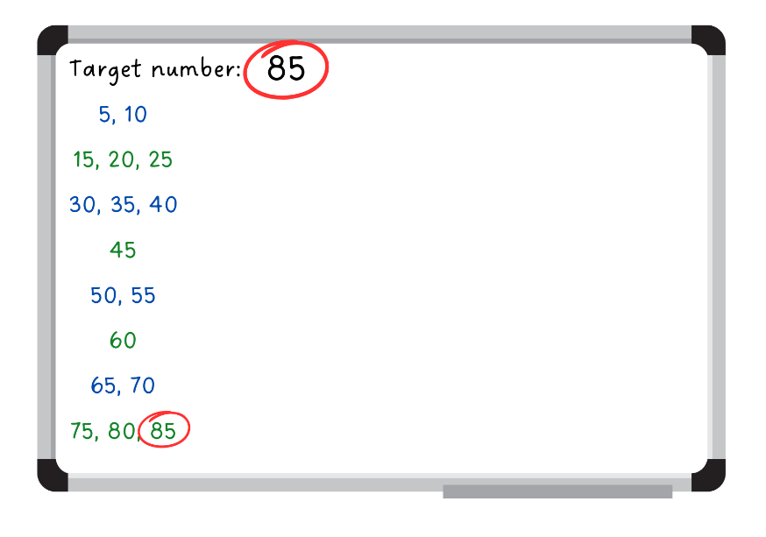

Discuss and connect the mathematics – 10 minutes
- Summarise the lesson together by drawing out key mathematical ideas. Ask:
- What is the relationship between number sequences for related multiples, for example 4 and 8? (Stage 2)
- What is the pattern of odd and even numbers within related multiples? (Stage 2)
- Is using a table of values helpful? How? (Stage 3)
- How does using a table of values help when calculating large, unknown quantities? (Stage 3)
- How can determining a rule for a number sequence help? (Stage 3)
This table details opportunities for assessment.
Assessment opportunities | Links
What to look for:  - Can Stage 2 students generate number patterns using related multiples? [MAO-WM-01, MA2-MR-01]  - Can Stage 2 students investigate number patterns involving related multiples? [MAO-WM-01, MA2-MR-01]  - Can Stage 3 students use a given geometric pattern involving multiples to create a table of values? [MAO-WM-01, MA3-MR-01]  - Can Stage 3 students determine a rule describing the relationship between the bottom number and the top number in a table? [MAO-WM-01, MA3-MR-01] | Links to National Numeracy Learning Progressions (NNLP):  - Stage 2 – NPA3, NPA4  - Stage 3 – NPA5.  Links to suggested Interview for Student Reasoning (IfSR) tasks:  - Stage 2 – IfSR-NP: 4A.1, 4A.3, 4A.4.

Lesson 6
Core concept: number properties can be used to solve multiplication problems (Stage 2) and flexible methods of computation in multiplication and division involve composing and decomposing numbers (Stage 3).

Daily number sense – division word problems – 15 minutes
The table below contains suggested learning intentions and success criteria. These are best co-constructed with students.
Daily number sense learning intentions | Daily number sense success criteria
Students working towards Stage 2 outcomes are learning to:  - represent and solve word problems with number sentences involving multiplication or division.  Students working towards Stage 3 outcomes are learning to:  - select and apply strategies to divide a number with 3 or more digits by a one-digit divisor. | Students working towards Stage 2 outcomes can:  - represent and solve division word problems using number sentences.  Students working towards Stage 3 outcomes can:  - apply and record appropriate strategies to solve division word problems.
This activity is an adaptation of Solving Multiplication and Division Word Problems from SAS by Commonwealth of Pennsylvania.
- Display the word problems from Lesson 5 Daily number sense on the board:
- Stage 2: Volleyball is played in teams of 6. There are enough players to make 3 teams. How many players are there altogether?
- Stage 3: A farmer has 14 rows of apple trees, and each row has 25 apple trees. How many apple trees does the farmer have in total?
- Explain that you are going to change the problems to:
- Stage 2: There are 18 people playing volleyball in 3 equal teams. How many people are in each team?
- Stage 3: A farmer collects 350 apples from 14 rows of apple trees. How many rows of apples trees are there?
- Students Think–Pair–Share how to solve the problem.
- Guide students to realise that the new problem requires division. Emphasise the inverse relationship between the original multiplication problem and the new division problem:
- Stage 2: 3 × 6 = 18 and 18 ÷ 3 = 6
- Stage 3: 14 × 25 = 350 and 350 ÷ 14 = 25
- Ask students how they determine if a problem should be solved using multiplication or division.
- Display Resource 11 – division problems. Stage 2 students can use manipulatives to support them to solve the problems. All students to record the corresponding algorithms in their workbooks.
This table details opportunities for assessment.
Assessment opportunities | Links
What to look for:  - Can Stage 2 students represent and solve division word problems using number sentences? [MAO-WM-01, MA2-MR-01,  MA2-MR-02]  - Can Stage 3 students apply and record appropriate strategies to solve division word problems? [MAO-WM-01, MA3-MR-01] | Links to National Numeracy Learning Progressions (NNLP):  - Stage 2 – NPA4  - Stage 3 – MuS6, MuS7, MuS8.  Links to suggested Interview for Student Reasoning (IfSR) tasks:  - Stage 2 – IfSR-MT: 2A.5, 2A.10.

Core lesson – 35 minutes

Stage 2 task – associative property
The table below contains suggested learning intentions and success criteria. These are best co-constructed with students.
Core concept learning intentions | Core concept success criteria
Students working towards Stage 2 outcomes are learning to:  - use number properties to find related multiplication facts. | Students working towards Stage 2 outcomes can:  - use the associative property within multiplication to regroup the factors  - use flexible partitioning within multiplication.
This lesson is an adaptation of ‘Commutative and associative properties of multiplication’ from Primary and Middle Years Mathematics: Teaching Developmentally by Van De Walle et al.
- Share the problem: Ice creams are sold in boxes of 4. Each ice cream costs $2. How much would it cost for 7 boxes of ice creams?
- Guide students to consider the problem in 2 ways:
- Find the cost of each box and then the total cost (4 × 2) × 7.
- Find out how many ice creams in total and then the cost (7 × 4) × 2.
Note: this style of grouping symbols (…) is called parentheses in the Mathematics K–10 Syllabus teaching advice. Grouping symbols are not necessary in this context but may be used by students to indicate which part of the number sentence is completed first.
- Ask students which method they prefer and why.
- Remind students that being able to change the order of multiplication when there are more than 2 numbers is called the associate property or associative law. Share the definition.
Associate property: when more than 2 numbers are added or multiplied, the result is unchanged regardless of how they are grouped or associated. For example, 6 × 3 × 2 can be calculated as 18 × 2 or 6 × 6 or 12 × 3.
- Explain that the manufacturer has changed the way they pack ice creams and now pack them in boxes of 5. Now that there are more in each box, only 6 boxes need to be purchased. The ice creams are still $2 each. How much will 6 boxes cost?
- Students solve the problem using associative property. They show their working out on whiteboards or in their workbooks.
- Provide the following questions for Stage 2 students to answer in their workbooks:
- A family orders 5 small pizzas from a pizza restaurant. Each pizza contains 8 slices and each slice costs $3. How much does the family pay for dinner?
- A toy store has packets of toy cars, and each packet contains 4 cars. If a child buys 9 packets, and each car costs $4, how much will the child pay in total?
This table details opportunities for differentiation.
Too hard? | Too easy?
Stage 2 students cannot use the associative property within multiplication to regroup the factors.  - Model the use of concrete materials to represent the word problem. Show how this can be represented in a number sentence.  - Support students by breaking the word problem into 2 steps. | Stage 2 students can use the associative property within multiplication to regroup the factors.  - For each of the word problems, students record 2 possible number sentences to solve the problem.  - Students create their own word problems using the number sentence 6 × 3 × 8 and the associative property.

Stage 3 task – rate word problems
The table below contains suggested learning intentions and success criteria. These are best co-constructed with students.
Core concept learning intentions | Core concept success criteria
Students working towards Stage 3 outcomes are learning to:  - select and apply strategies to solve problems involving multiplication and division with whole numbers. | Students working towards Stage 3 outcomes can:  - select and use efficient strategies to multiply whole numbers of up to 4 digits by one- and 2-digit numbers  - solve word problems involving rates using multiplication and division.
This lesson is an adaptation of ‘Best Value’ in Challenging Mathematical Tasks: Unlocking the Potential for All Students by Sullivan.
- Share the following problem: Jake has 4 books. Harry has 5 times as many books as Jake. Can you use a bar model to represent how many books they have?
Note: multiplicative comparison problems use expressions like times as many or times as much to express a comparison. Mathematical tools and representations, for example bar models, assist students in representing the relationship between the units of ‘4 books’. The bar model in Figure 17 demonstrates the idea of scaling up and how this is related to multiplication. It assists a student to answer a ‘How many more books...’ question as well a ‘How many books altogether...’ question. It can also be used to show that multiplying 4 by 5 is the same as dividing 20 by 4.
Figure 17 – books bar model
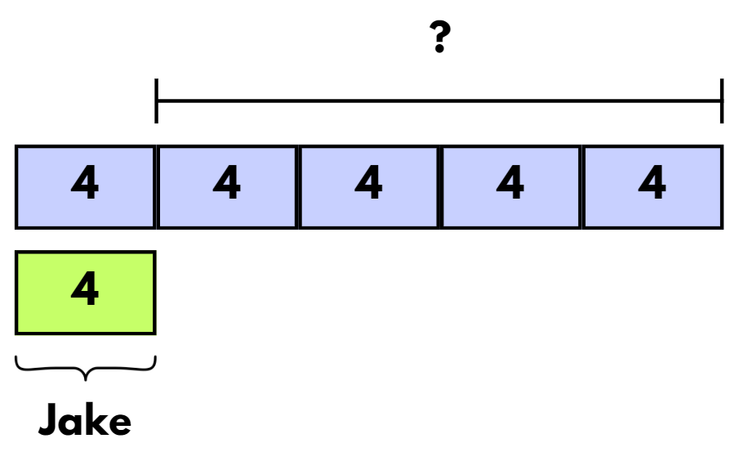
- Students work with a partner to use a bar model to find a solution to the problem.
- Share several examples of students’ work with the class and discuss the features. Ask: are there any other ways we could represent a solution to the problem? (For example, table of values, ratio tables, tape diagrams or number lines).
- Explain that multiplicative comparison problems use expressions including ‘times as many’ or ‘times as much’ to describe comparisons. Identify the mathematical tools and representations we can use to solve these problems, including table of values, ratio tables, tape diagrams or number lines.
- Display Resource 12 – problems to solve and draw students’ attention to the first 2 problems.
- In pairs, students discuss tools they could use to find solutions.
- Model the use of different tools and representations such as a bar model, table of values, ratio table, tape diagram and number line to help solve the problem, for example see Figure 18.
Figure 18 – tools and representations to solve problems
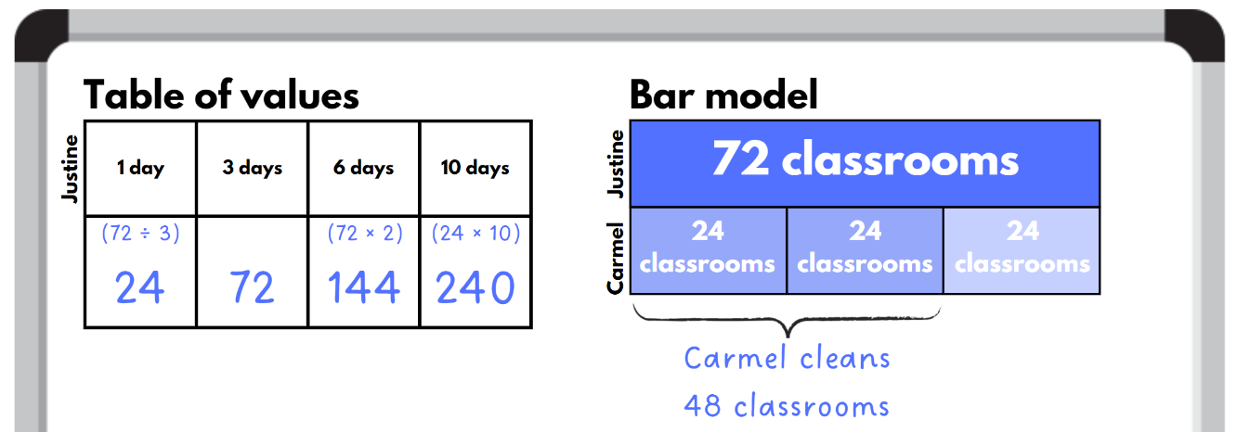
- Provide students with copies of Resource 12 – problems to solve, to complete problems 3, 4 and 5. Encourage them to use a range of strategies to represent and answer the problems. These can include tools and representations such as bar models, ratio tables, tape diagrams and number lines that were used during the previous example.
- Students share their solutions with a partner, using their calculations to justify their answers.
- As a group, discuss the solution to each question. Ask:
- Which mathematical tools and representations did you use to find your solutions?
- What properties of numbers did you use to help with the question?
- What mathematical operations were you using to find the solutions?
This table details opportunities for differentiation.
Too hard? | Too easy?
Stage 3 students cannot solve word problems involving rates using multiplication and division.  - Guide students to determine the value of one unit for each of the word problems.  - Create a visual representations of the word problem. Students use the solution to create a second representation. | Stage 3 students can solve word problems involving rates using multiplication and division.  - Students solve the problem from APSMO: At a store, one doughnut and 2 eclairs costs $4.00. Two doughnuts and 3 eclairs cost $6.50. Three doughnuts and one eclair cost $4.50. How much will Geoff pay for one eclair and one doughnut?  - Students write their own rate word problem and answer the question using a tool or representation of their choice. Students swap representations without showing their partner their word problem. Students guess their partner’s word problem using the representation.

Consolidation and meaningful practice – 10 minutes
- Stage 2 students create their own word problem involving associative property. Stage 3 students create their own rate word problem.
- Students swap problems with a stage-based partner and solve each other’s problem. They discuss their reasoning.
- Select a range of student problems, solutions and representations to share with the class.
This table details opportunities for assessment.
Assessment opportunities | Links
What to look for:  - Can Stage 2 students use the associative property within multiplication to regroup the factors? [MAO-WM-01, MA2-MR-01]  - Can Stage 2 students use flexible partitioning within multiplication? [MAO-WM-01, MA2-MR-01]  - Can Stage 3 students select and use efficient strategies to multiply whole numbers of up to 4 digits by one- and 2-digit numbers? [MAO-WM-01, MA3-MR-01]  - Can Stage 3 students solve word problems involving rates using multiplication and division? [MAO-WM-01, MA3-MR-01] | Links to National Numeracy Learning Progressions (NNLP):  - Stage 2 – MuS6, MuS7  - Stage 3 – MuS7, MuS8, PrT4.  Links to suggested Interview for Student Reasoning (IfSR) tasks:  - Stage 2 – IfSR-MT: 2A.7, 2A.9.

Lesson 7
Core concept: structures can support multiplicative thinking (Stage 2) and decimals can be divided and multiplied by powers of 10 (Stage 3).

Daily number sense – multiplication or division – 15 minutes
The table below contains suggested learning intentions and success criteria. These are best co-constructed with students.
Daily number sense learning intentions | Daily number sense success criteria
Students working towards Stage 2 outcomes are learning to:  - represent and solve word problems with number sentences involving multiplication or division.  Students working towards Stage 3 outcomes are learning to:  - select and apply strategies to divide a number with 3 or more digits by a one-digit divisor. | Students working towards Stage 2 outcomes can:  - represent and solve multiplication and division word problems using number sentences.  Students working towards Stage 3 outcomes can:  - apply and record appropriate strategies to solve multiplication and division word problems.
- Revise with students how they know when to multiply or divide when solving a word problem.
- Explain that the class will be solving word problems and will need to determine whether multiplication or division is needed to solve each problem.
- Display Resource 13 – Multiplication or division?. Stage 2 students can use manipulatives to support them to solve the problems. All students to record the corresponding algorithms in their workbooks.
This table details opportunities for assessment.
Assessment opportunities | Links
What to look for:  - Can Stage 2 students represent and solve multiplication and division word problems using number sentences? [MAO-WM-01, MA2-MR-01, MA2-MR-02]  - Can Stage 3 students apply and record appropriate strategies to solve multiplication and division word problems? [MAO-WM-01, MA3-MR-01] | Links to National Numeracy Learning Progressions (NNLP):  - Stage 2 – NPA4  - Stage 3 – MuS6, MuS7, MuS8.  Links to suggested Interview for Student Reasoning (IfSR) tasks:  - Stage 2 – IfSR-MT: 2A.7, 2A.8.

Core lesson – 40 minutes

Stage 2 task – arrays to area models
The table below contains suggested learning intentions and success criteria. These are best co-constructed with students.
Core concept learning intentions | Core concept success criteria
Students working towards Stage 2 outcomes are learning to:  - use the structure of the area model to represent multiplication and division  - use number properties to establish multiplication facts. | Students working towards Stage 2 outcomes can:  - create and represent multiplicative structure, moving from arrays to partially covered area models  - use the associative property within multiplication to regroup the factors  - use flexible partitioning within multiplication.
This lesson is an adaptation of ‘Arrays’ from Challenging mathematical tasks: Unlocking the potential of all students by Sullivan.
- Display Resource 14 – my piggy bank. Explain that a piggy bank is emptied onto the table. The $1 coins are arranged in an array without gaps.
- Students identify 2 strategies for determining how much money there is in total. Challenge students to move beyond drawing an array to solve the problem.
- As a group, discuss possible strategies and model how to use an area model to solve the problem (see Figure 19).
Figure 19 – array to area model
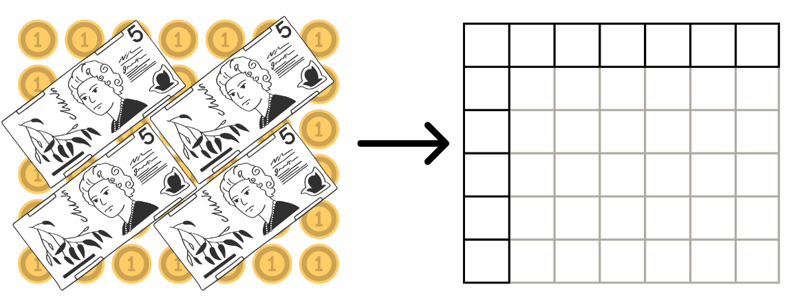
- Pose the problem: I have 36 chocolates. I want to make a box for them. What might the box look like?
- In pairs, students represent their solution as an array and then an area model in their workbooks.
- As a group, discuss all the possible solutions and invite pairs of students to share their representations.
- Students complete the following problems in their workbooks using an area model:
- In a garden, there are 6 rows of flowers, and each row has 9 sunflowers planted. How many sunflowers are there in total?
- Emma is designing a rectangular room for her art studio. The room is 5 meters in length and 8 meters in width. She wants to calculate the total floor area to determine how much paint she will need to cover the floor. Can you find the area of the room's floor?
This table details opportunities for differentiation.
Too hard? | Too easy?
Stage 2 students cannot create and represent multiplicative structure, moving from arrays to partially covered area models.  - Assist students by providing grid paper to help create area models.  - Support students by adjusting the word problems to include multiples of 5. | Stage 2 students can create and represent multiplicative structure, moving from arrays to partially covered area models.  - Challenge students to find all the possible solutions for the chocolate box problem.  - In pairs, students create their own word problems for their partner. Students swap word problems and solve them using an area model.

Stage 3 task – multiplying and dividing decimals
The table below contains a suggested learning intention and success criteria. These are best co-constructed with students.
Core concept learning intention | Core concept success criteria
Students working towards Stage 3 outcomes are learning to:  - multiply and divide decimals by powers of 10. | Students working towards Stage 3 outcomes can:  - compare the relative place value of digits to multiply and divide a decimal by powers of 10.
This lesson has been adapted from ‘Dividing by 10, 100 and 1000’ in Multiplying and dividing decimals (DOCX 687 KB) by State of New South Wales (Department of Education).
- Students use Resource 15 – number slider to create a number slider.
- In small groups students investigate the use of the number slider and determine how the slider can be used to explain the concept of multiplying and dividing by the powers of 10 (10, 100, 1000).
Note: a common misunderstanding is the belief that the decimal point moves when a number is multiplied by a power of 10. The number slide, with its fixed decimal marker, can be an effective way of addressing this misunderstanding. Ensure students understand that when representing 0.5 and moving the slider one place to the right, they have divided the number by 10. This creates the decimal 0.05, which is 10 times smaller than 0.5. Identify that adding the zero digits into the previous place value enables these numbers to hold their positions.
- Students complete Resource 16 – Multiply or divide? using their number slider. For example, see Figure 20.
Figure 20 – multiply or divide example
This table details opportunities for differentiation.
Too hard? | Too easy?
Stage 3 students cannot compare the relative place value of digits to multiply and divide a decimal by powers of 10.  - Use a tens, hundreds or thousands grid to visually compare the relative place value of digits to multiply and divide.  - Students use calculators to investigate and record patterns when multiplying and dividing decimals by powers of 10 (10, 100, 1000). | Stage 3 students can compare the relative place value of digits to multiply and divide a decimal by powers of 10.  - Working in pairs, students give their partner a decimal, for example 0.75. The partner shows 2 different ways they can create this decimal using either multiplication or division. For example, 7.5 divided by 10, 750 divided by 1000.  - Challenge students to investigate the inverse nature of multiplication and division by identifying as many facts as they can using the one decimal. For example, using 0.75 we know that 0.75 times 10 is 7.5 and 7.5 divided by 10 is 0.75.

Discuss and connect the mathematics – 10 minutes
- Ask Stage 2 students:
- Is drawing arrays or area models more efficient when solving the problems?
- Why is the area model a useful strategy when solving multiplication problems?
- How is partitioning used when solving multiplication problems?
- Ask Stage 3 students:
- Explain what happens when you move your slider to the left? Can you give an example?
- Explain what happens when you move your slider to the right? Can you give an example?
- How can you explain the use of the slider to someone else?
This table details opportunities for assessment.
Assessment opportunities | Links
What to look for:  - Can Stage 2 students create and represent multiplicative structure, moving from arrays to partially covered area models? [MAO-WM-01, MA2-MR-01]  - Can Stage 2 students use the associative property within multiplication to regroup the factors? [MAO-WM-01, MA2-MR-01]  - Can Stage 2 students use flexible partitioning within multiplication? [MAO-WM-01, MA2-MR-01]  - Can Stage 3 students compare the relative place value of digits to multiply and divide a decimal by powers of 10? [MAO-WM-01, MA3-MR-01] | Links to National Numeracy Learning Progressions (NNLP):  - Stage 2 – MuS5, MuS6  - Stage 3 – NPV8, MuS9.  Links to suggested Interview for Student Reasoning (IfSR) tasks:  - Stage 2 – IfSR-MT: 2A.1, 2A.3, 2.A7  - Stage 3 – IfSR-MT: 4A.3, 4A.4, 4A.5, 4A.6.

Lesson 8
Core concept: number properties can be used to solve multiplication problems.

Daily number sense – 15 minutes
- From a class need surfaced through formative assessment data, identify a short, focused activity that targets students’ knowledge, understanding and skills. Example activities may be drawn from the following resources:
- Mathematics K–6 resources
- Universal Resources Hub.

Core lesson – 30 minutes

Stage 2 task – flexible partitioning
The table below contains suggested learning intentions and success criteria. These are best co-constructed with students.
Core concept learning intentions | Core concept success criteria
Students working towards Stage 2 outcomes are learning to:  - use number properties to find related multiplication facts  - operate with multiples of 10. | Students working towards Stage 2 outcomes can:  - use flexible partitioning within multiplication  - use multiplication facts with multiples of 10 to multiply a one-digit number by a multiple of 10  - use place value to rename groups of 10 to multiply.
- Display Resource 17 – strawberry patch and explain that Farmer Mark plants 36 strawberry plants in 2 rows of 18.
- Explain that Farmer Mark wants to add 2 extra rows.
- Ask:
- What would this look like?
- How can we represent Farmer Mark’s strawberry plants as a number sentence? (Do not answer number sentence at this stage.)
- How can we solve 18 × 4?
- Highlight to students that it is not a simple multiplication fact that can be recalled quickly.
- Ask:
- How can we use what we know about 10 to solve this number?
- Can you represent this in a picture?
- Can you represent this using an area model?
- Can you write a number sentence?
- Display Resource 18 – strawberry patch strategies and discuss the different strategies used to solve the problem. Explain that the dots are used to help show how the number can be partitioned in different ways. Students are not expected to draw an array when solving a problem like this and the use of an area model is more efficient.
- Students draw an area model for each of the arrays in Resource 18 – strawberry patch strategies (see Figure 21).
Figure 21 – strawberry patch strategies
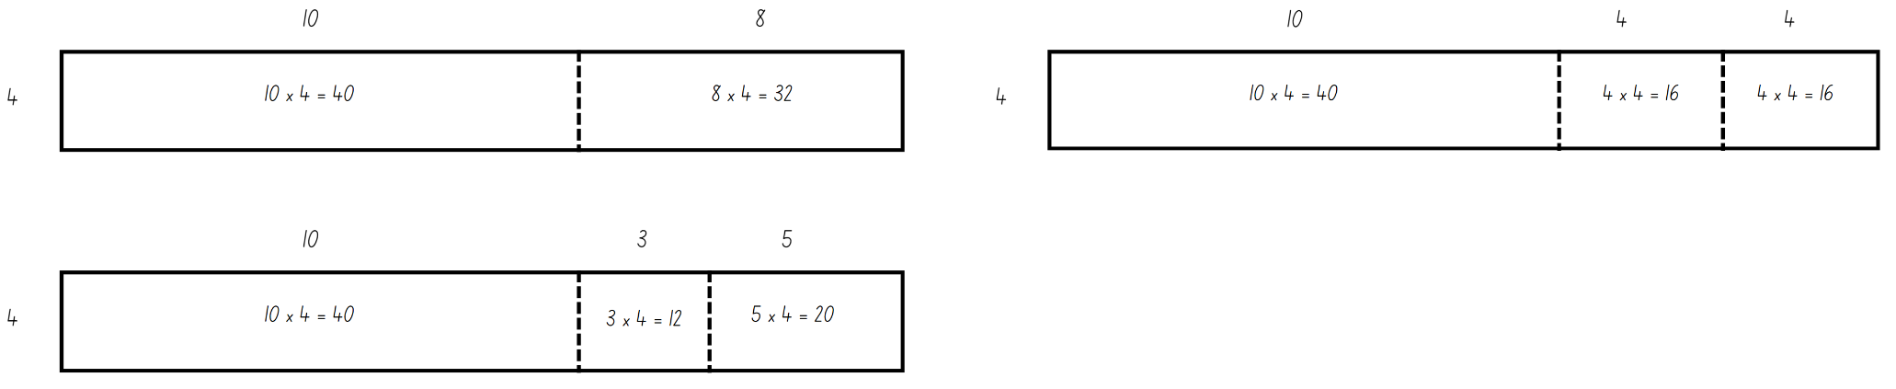
This table details opportunities for differentiation.
Too hard? | Too easy?
Stage 2 students cannot use flexible partitioning within multiplication.  - Assist students by specifying how to partition the numbers.  - Model the use of concrete materials to create an array to model flexible partitioning. | Stage 2 students can use flexible partitioning within multiplication.  - Explain that Farmer Mark has doubled the number of strawberry plants again. Students to determine what the garden will look like and how many strawberry plants he will have in total.  - Students to represent their answer using 2 different area models with different partitioning.

Stage 3 task – open-ended multiplication problems
The table below contains suggested learning intentions and success criteria. These are best co-constructed with students.
Core concept learning intentions | Core concept success criteria
Students working towards Stage 3 outcomes are learning to:  - use partitioning and place value to multiply 2-, 3- and 4-digit numbers by one-digit numbers  - select and apply strategies to solve problems involving multiplication with whole numbers. | Students working towards Stage 3 outcomes can:  - use the distributive property with the area model to partition numbers in representing multiplication problems  - record the product of multiplying by a one-digit number using a formal algorithm  - select and use efficient strategies to multiply whole numbers of up to 4 digits by one- and 2-digit numbers.
This activity is adapted from Challenging Mathematical Tasks: Unlocking the Potential for All Students by Sullivan.
- Students work in pairs to solve the following open-ended problems. Students record the problem, solution, and strategy they use to solve the problem in their workbooks. Encourage students to use a variety of strategies, for example, area model, partitioning using place value and formal algorithm, see Figure 22.
- Using the numbers 6, 5 and 4 set out in a number sentence _ _ × _ how many different answers can you get?
- Using the numbers 6, 5, 4 and 0 set out in a number sentence _ _ × _ _ how many different answers can you get?
- Using the numbers 6, 5, 4 and 0 set out in a number sentence _ _ _ × _ how many different answers can you get?
- Using the numbers 6, 5, 4, 3 and 0 set out in a number sentence _ _ _ _ × _ how many different answers can you get?
Figure 22 – student strategies
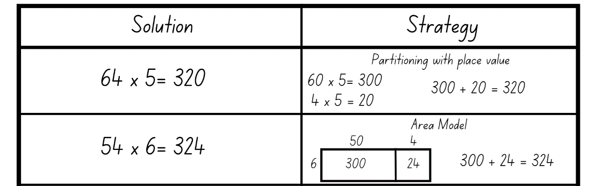
- Students work independently to solve the following open-ended problem: ♥ × Δ = 1140.
- Students display their solutions to the problems and complete a gallery walk.
- Ask:
- What strategies do you notice?
- Did anyone use the same strategy as you?
- Did anyone use a different strategy you would like to use next time? If so, what was it?
This table details opportunities for differentiation.
Too hard? | Too easy?
Stage 3 students cannot select and use efficient strategies to multiply whole numbers of up to 4 digits by one- and 2-digit numbers.  - Provide students with multiplication fact tables for up to 10 × 10 to support ease of recall.  - Students use the area model digital tool to solve multiplication problems. | Stage 3 students can select and use efficient strategies to multiply whole numbers of up to 4 digits by one- and 2-digit numbers.  - Students create their own open-ended multiplication questions to share with a partner.  - Challenge students by increasing the number of digits up to 4 digits by 3-digits.

Consolidation and meaningful practice – 20 minutes
This activity is an adaptation of Multiplication toss from Mathematics K–6 resources by the State of New South Wales (Department of Education).
- Students play multiplication toss in pairs by taking turns to:
- spin Resource 19 – spinner to select the first number of their multiplication sentence
- roll a 6-sided die to select the number that they will multiply the first number by
- solve the multiplication problem
- plot their answer on grid paper. They can plot it as a 13 × 6 block or a 10 × 6 and 3 × 6 block.
Note: encourage Stage 2 students to use their knowledge of 10 to solve the multiplication problem. For example, a student spins 13 and rolls a 6. They have made 13 × 6. They solve this by partitioning the number into 10 × 6 = 60 and 3 × 6 = 18. They add 60 and 18 to make 78.
- The game continues with no overlapping areas until the grid is full or after 10 spins, whichever happens first.
- The player with the largest area blocked out is the winner.
This table details opportunities for assessment.
Assessment opportunities | Links
What to look for:  - Can Stage 2 students use flexible partitioning within multiplication? [MAO-WM-01, MA2-MR-01]  - Can Stage 2 students use multiplication facts with multiples of 10 to multiply a one-digit number by a multiple of 10? [MAO-WM-01, MA2-MR-01]  - Can Stage 2 students use place value to rename groups of 10 to multiply? [MAO-WM-01, MA2-MR-01]  - Can Stage 3 students use the distributive property with the area model to partition numbers in representing multiplication problems? [MAO-WM-01, MA3-MR-01]  - Can Stage 3 students record the product of multiplying by a one-digit number using a formal algorithm? [MAO-WM-01,  MA3-MR-01]  - Can Stage 3 students select and use efficient strategies to multiply whole numbers of up to 4 digits by one- and 2-digit numbers? [MAO-WM-01, MA3-MR-01] | Links to National Numeracy Learning Progressions (NNLP):  - Stage 2 – MuS7  - Stage 3 – MuS6, MuS7, MuS8.  Links to suggested Interview for Student Reasoning (IfSR) tasks:  - Stage 2 – IfSR-MT: 3A.1, 3A.2, 3A.3  - Stage 3 – IfSR-MT: 3A.1, 3A.2, 3A.3, 3A.4, 3A.5.

Resource 1 – video views
Video name | Views this year | Total views | Publication date
Baby whale dance | 3 542 | 13 billion | 2023
Ya Ya cup song | 12 750 | 79 000 000 000 | 2018
Jangnam star | 17 778 | 67 345 897 001 | 1999
Let it grow | 19 905 | 1 billion and 500 million | 2000
Good blood | 65 000 | 55 879 091 | 2022
Wheels on the trike | 8 223 | Seven and a half million | 2015
Woko woko hey | 5 541 | 999 998 | 2002

Resource 2 – matching game (Stage 2)
7965 |  | The value of the tens is 60. |  | The local high school has nearly 8000 students.
248 188 |  | When rounded to the nearest thousand, the value of the thousand would be 8000. |  | Sophia bought a unit in South Australia for just under $250 000.
13 773 |  | The value of the ten thousands is 10 000. |  | The distance from Sydney to the North Pole is nearly fourteen thousand kilometres.

2850 |  | The value of the hundreds is 800. |  | The school had to pay $300 more than the budget of $2550 for the buses to the swimming carnival.
730 |  | When rounded to the nearest hundred, the value of the hundred is 700. |  | It’s Rowan’s 11th birthday today. He is counting down the days until he turns 13.
6909 |  | When rounded to the nearest thousand, the value of the thousand is 7000. |  | There are close to 7000 known spoken languages in the world.

Resource 3 – matching game (Stage 3)
7 346 202 |  | Two million less than nine million three hundred and forty six thousand two hundred and two. |  | The company earned a profit of over seven million this financial year.
1 000 000 000 |  | one billion |  | The song had about nine hundred and ninety million views.
15 000 060 |  | The value of the tens is 60. |  | The band’s world tour has 30 million tickets for sale. Approximately 50% of tickets have been sold so far.

985 254 000 |  | The value of the hundred thousands is 200 000. |  | The road upgrade was able to be completed within the budget of nine hundred and ninety million dollars.
25 690 000 |  | When rounded to the nearest 100 000, the value of the hundred thousand is 700 000. |  | The Australian population in 2022 was about half of 50 million.
38 781 291 |  | 40 million to the nearest 10 million. |  | The Canadian population today is nearly 4 million more than the 35 million in 2014.

Resource 4 – jellybean spinner
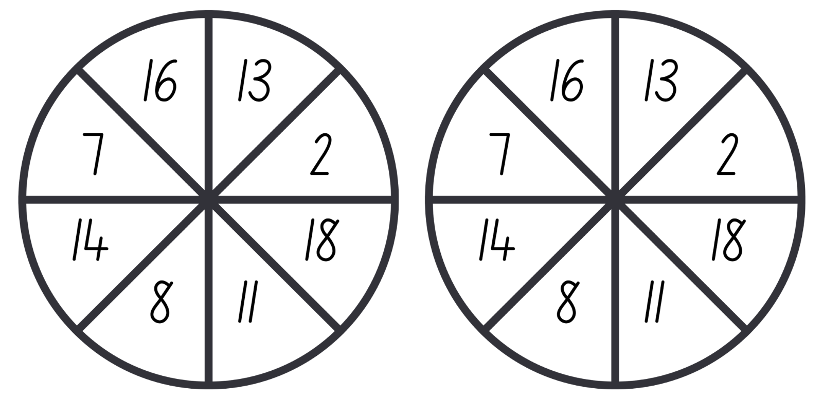

Resource 5 – jellybean sort
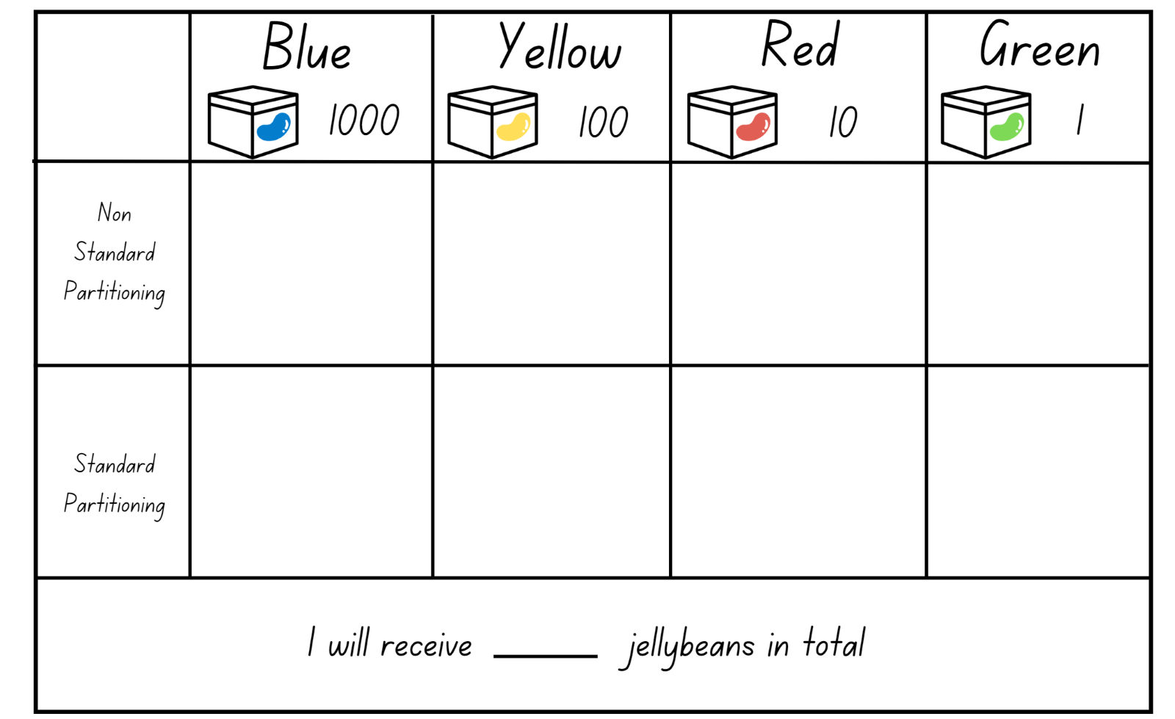

Resource 6 – build a decimal
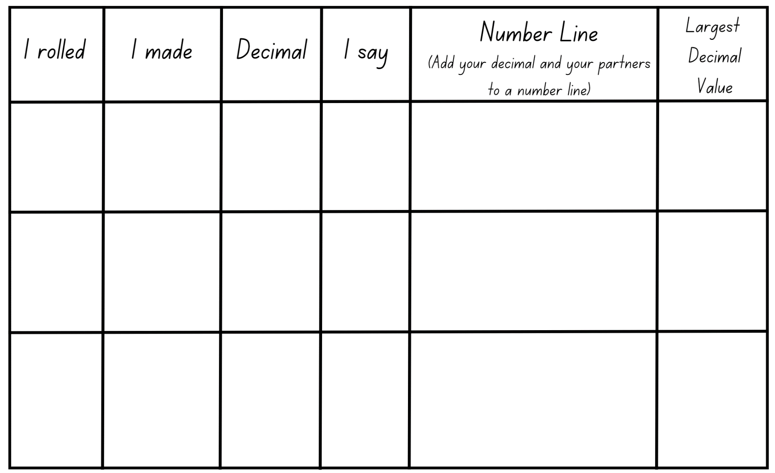

Resource 7 – hundredths and thousandths
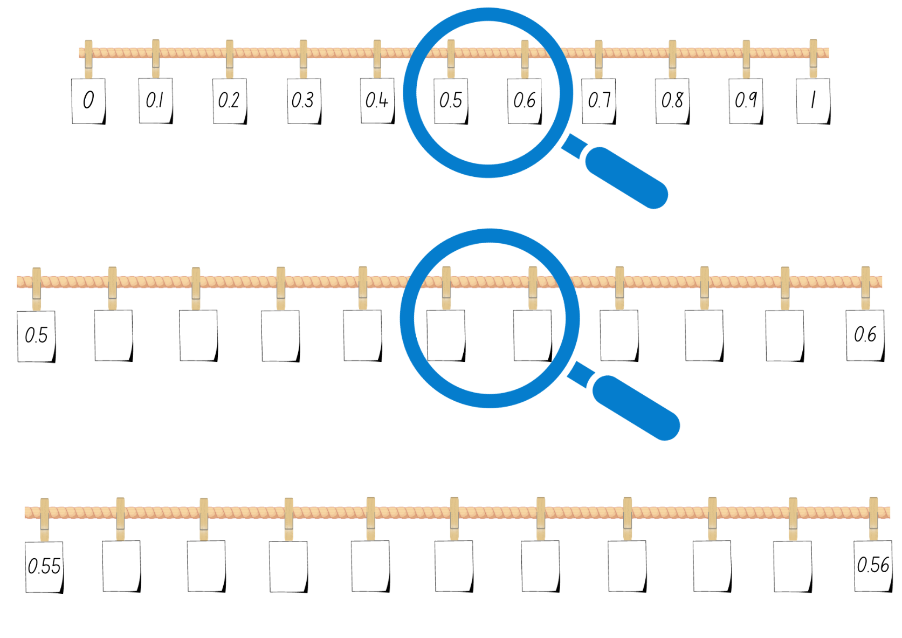

Resource 8 – decimal concentration
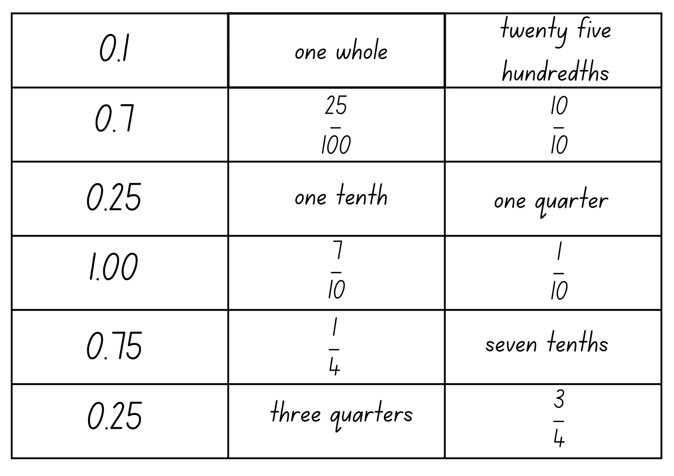

Resource 9 – Would you rather?
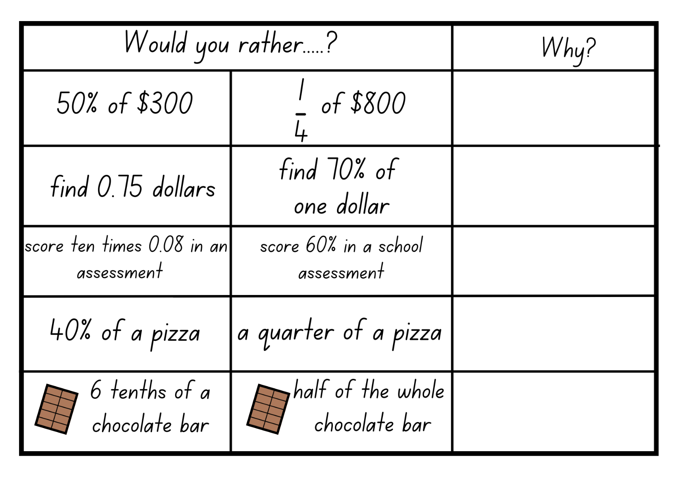

Resource 10 – multiplication problems
Stage 2:
- 5 children were given lollies for helping at home. Each child was given 9 lollies. How many lollies did they collect in total?
- Caitlin’s dad bought 6 boxes of chips from the supermarket. Each box contained 12 packets of chips. How many packets of chips were there altogether?
Stage 3:
- Sally is planning a school fundraiser, and she needs to make 36 gift baskets. Each gift basket requires 28 small toys. How many small toys does Sally need in total for all the gift baskets?
- A bakery sells 124 cupcakes each day. They are open every day of the week. How many cupcakes does the bakery sell in 2 weeks?

Resource 11 – division problems
Stage 2:
- Noah baked 24 cupcakes. He put the cupcakes on 4 plates. Noah put the same number of cupcakes on each plate. How many cupcakes did he put on each plate?
- Daisy has 48 apples. Six apples are needed to make one apple pie. How many apple pies can Daisy make?
Stage 3:
- Lisa has saved $315, and she wants to buy some books. If each book costs $15, how many books can she buy with her savings?
- There are 567 students in a school, and the school is arranging buses to take them on an excursion. The bus company sends 9 buses to the school. The teachers want an equal number of students on each bus. How many students can travel on each bus?

Resource 12 – problems to solve
- Justine cleans 72 classrooms in 3 days. How many classrooms can Justine clean in 6 days? How many classrooms can Justine clean in 10 days?

- Carmel cleans $\frac{1}{3}$ less. How many classrooms does Carmel clean in 3 days? 6 days? 10 days?

- Cases of 24 water bottles cost $40. It is also possible to buy single bottles for $1.90 each. If I want to buy 24 bottles of water, which is the better deal?

- The school bell rings 8 times per day on school days. How many times does it ring in a week? How many times does it ring in an 11-week term? How many times would it ring in the 11-week term if there were 3 pupil free days?

- Stella and Siena each have a part-time job. Stella earns $17.50 per hour and Sienna earns $23 per hour. On Saturday Stella worked for 4 hours and Sienna worked one hour less. Who took home the most pay?
- I solved a division problem, and the answer was 8. What could the question be?

- When I was trying to work out my division problem with the answer of 8, I used two 2-digit numbers. What could the question be?

Resource 13 – Multiplication or division?
Stage 2:
- 36 bananas were shared amongst 4 monkeys. How many bananas did each monkey get?
- 7 friends at a party ate 3 brownies each. How many brownies were eaten altogether?
- 40 people were placed in 5 even teams. How many people were in each team?
Stage 3:
- A grocery store ordered 68 crates of oranges, with each crate containing 153 oranges. How many oranges will the store receive in total?
- A factory produced 864 toys, and they need to package them in boxes of 8 toys each. How many boxes of toys can the factory fill?
- A car rental agency has 42 cars, and each car can hold 128 litres of petrol. How many litres of petrol does the agency need to fill up all their cars?

Resource 14 – my piggy bank
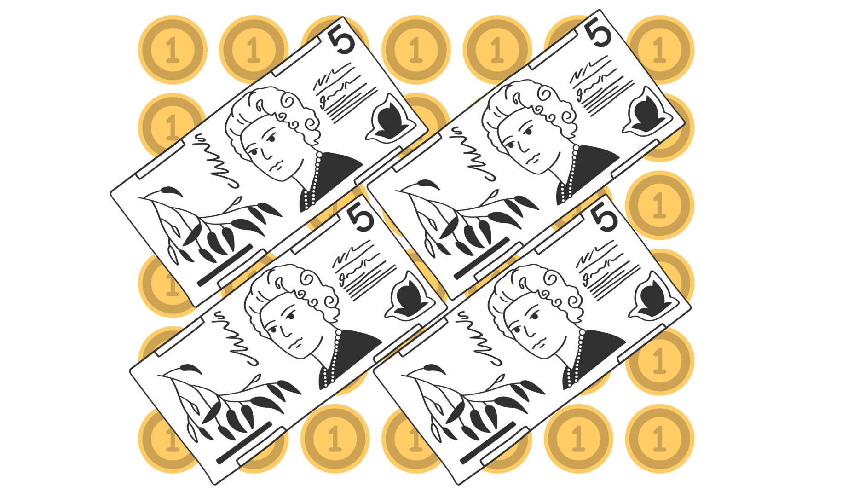

Resource 15 – number slider
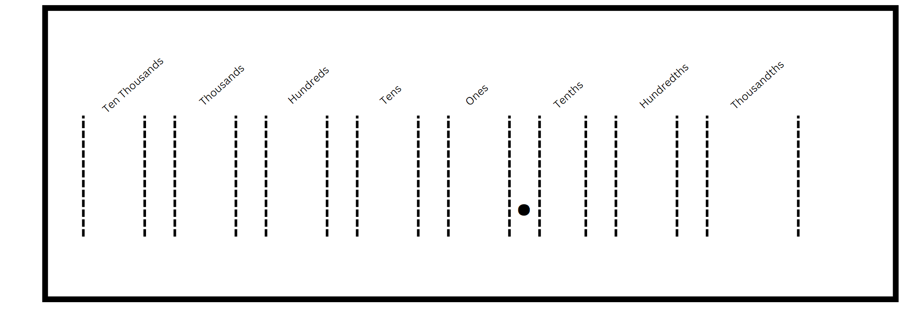

Resource 16 – Multiply or divide?
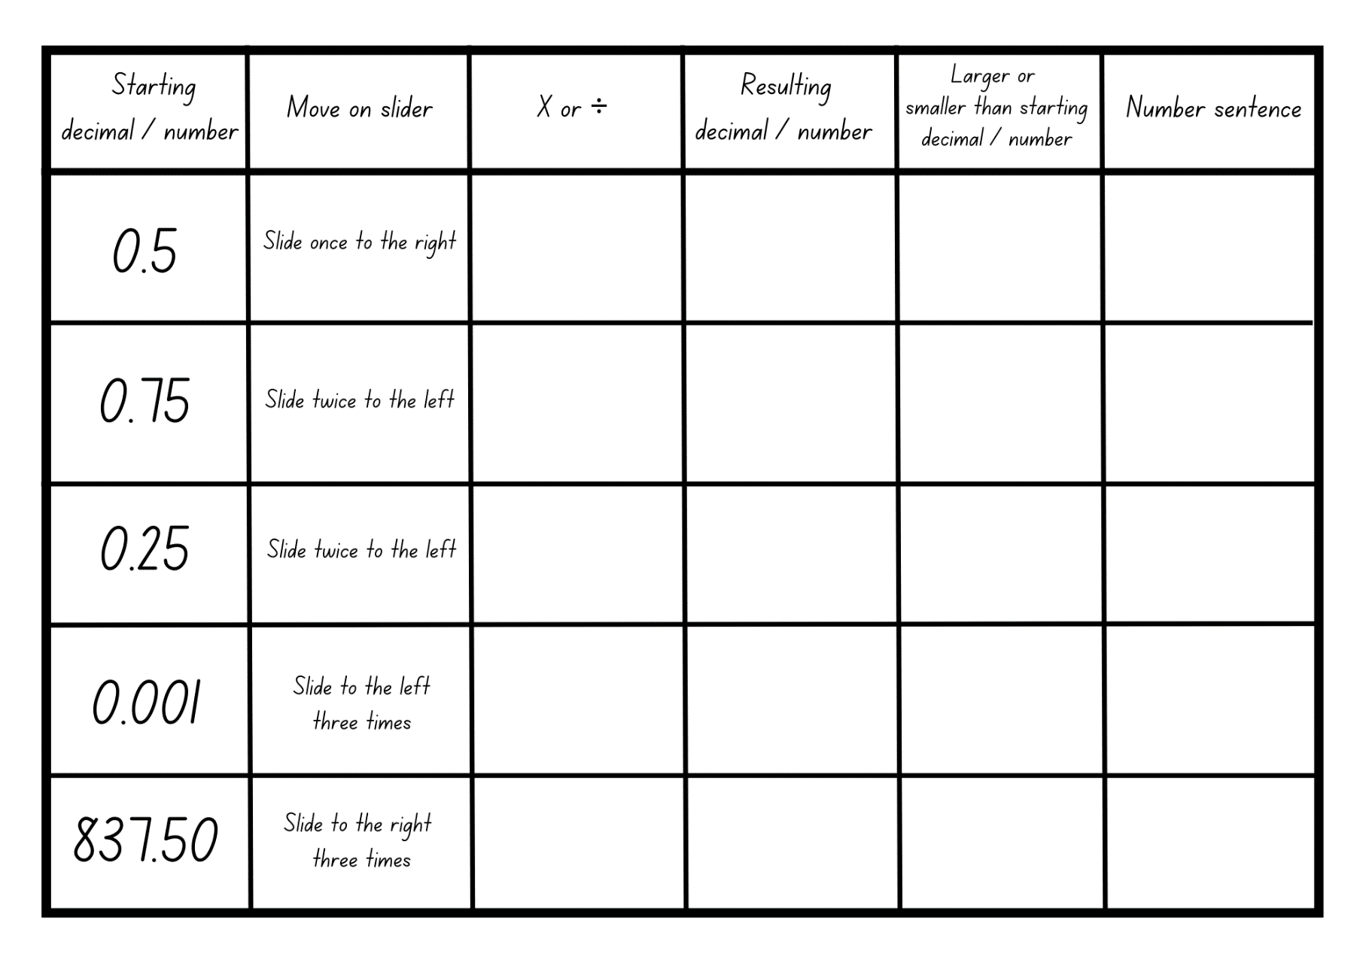

Resource 17 – strawberry patch

Resource 18 – strawberry patch strategies
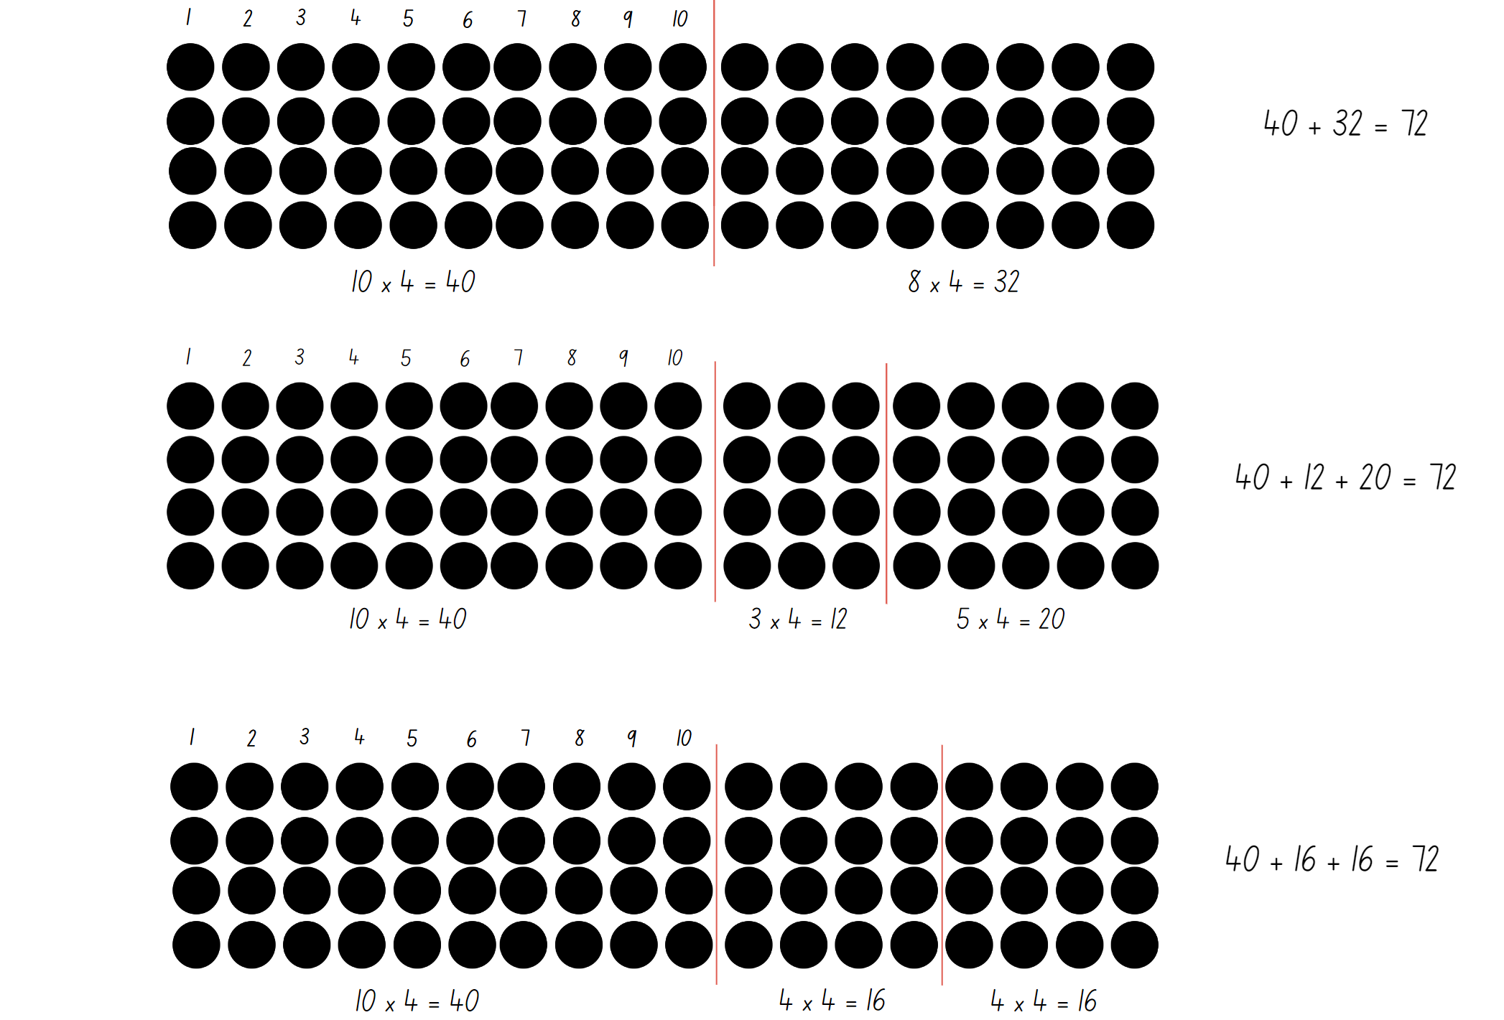

Resource 19 – spinner
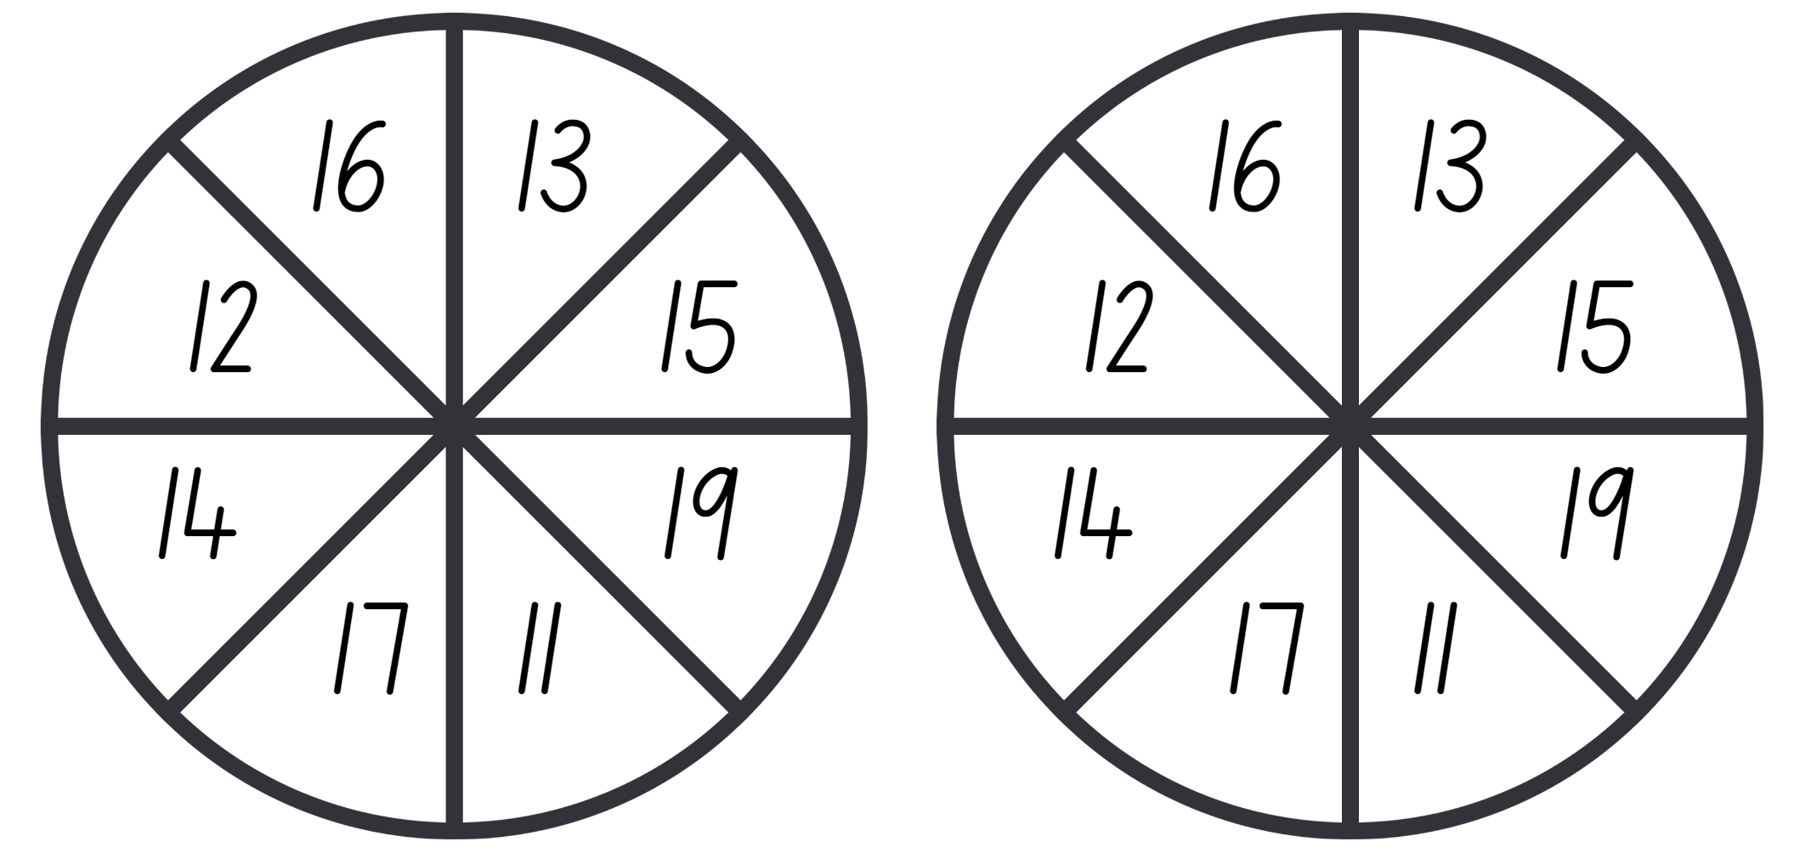

Syllabus outcomes and content

Stage 2
The table below outlines the syllabus outcomes and range of relevant syllabus content covered in this unit. Content is linked to National Numeracy Learning Progression (version 3).
Outcomes and content | 1 | 2 | 3 | 4 | 5 | 6 | 7 | 8
Representing numbers using place value A: Whole numbers: Read, represent and order numbers to thousands
MAO-WM-01, MA2-RN-01
- Group physical or virtual objects to show the structure of tens, hundreds and a thousand |  | x
- Regroup numbers flexibly, recognising one thousand as 10 hundreds and one hundred as 10 tens or 100 ones |  | x
- Represent numbers up to and including thousands using physical or virtual manipulatives, words, numerals, diagrams and digital displays | x | x
- Read and order numbers of up to at least 4 digits | x
Representing numbers using place value A: Whole number: Apply place value to partition and regroup numbers up to 4 digits
MAO-WM-01, MA2-RN-01
- Record numbers using standard place value form |  | x
- Partition numbers of up to 4 digits in non-standard forms (Reasons about quantity) |  | x
Representing numbers using place value B: Whole numbers: Order numbers in the thousands
MAO-WM-01, MA2-RN-01
- Arrange numbers in the thousands in ascending and descending order | x
- Identify the nearest thousand, 10 thousand or 100 thousand to numbers | x
Representing numbers using place value B: Whole numbers: Apply place value to partition, regroup and rename numbers up to 6 digits
MA0-WM-01, MA2-RN-01
- Name thousands using the place value grouping of ones, tens and hundreds of thousands | x | x
- Partition numbers of up to 6 digits in non-standard forms |  | x | x
Representing numbers using place value B: Whole numbers: Recognise and represent numbers that are 10, 100 or 1000 times as large
MA0-WM-01, MA2-RN-01
- Recognise the number of tens, hundreds or thousands in a number | x | x |  |  |  |  |  | x
- Describe how making a number 10, 100 or 1000 times as large changes the place value of digits | x
Representing numbers using place value B: Decimals: Extend the application of the place value system from whole numbers to tenths and hundredths
MA0-WM-01, MA2-RN-02
- Divide a length representing one whole into 10 equal parts and label the divisions using decimal notation |  |  | x | x
- Use the decimal point as a marker to identify the position of the ones digit when expressing tenths as decimals |  |  | x
- Recognise that 10-tenths is recorded as 1.0 and regroup when using decimal notation |  |  | x
- Subdivide tenths into 10 equal parts and record hundredths using place value |  |  | x
- Express decimals as both tenths and hundredths |  |  | x | x
- Locate and order decimals representing tenths and hundredths on a number line, describing their relative size |  |  | x | x
- Interpret zero digits at the end of a decimal |  |  | x | x
Representing numbers using place value B: Decimals: Make connections between fractions and decimal notation
MA0-WM-01, MA2-RN-02
- Make connections between fractions and decimal notation for key benchmark values (Reasons about relations) |  |  |  | x
Multiplicative relations A: Generate and describe patterns
MAO-WM-01, MA2-MR-01
- Model, describe and record patterns of multiples |  |  |  |  | x
- Create and continue a variety of number patterns that increase or decrease by a constant amount |  |  |  |  | x
- Recognise the significance of the final digit of a whole number in determining whether a given number is even or odd (Reasons about relations) |  |  |  |  | x
Multiplicative relations A: Recall multiplication facts of 2 and 4, 5 and 10 and related division facts
MAO-WM-01, MA2-MR-01
- Generate multiplication fact families for multiples of 2 and 4, 5 and 10 |  |  | x
Multiplicative relations A: Represent and solve problems involving multiplication fact families
- Apply the inverse relationship of multiplication and division (Reasons about relations) |  | x
Multiplicative relations B: Investigate number sequences involving related multiples
MAO-WM-01, MA2-MR-01
- Generate number patterns using related multiples |  |  |  |  | x
- Investigate number patterns involving related multiples |  |  |  |  | x
Multiplicative relations B: Use known number facts and strategies
MAO-WM-01, MA2-MR-01
- Use known facts to find unknown multiples (Reasons about relations) |  |  |  |  | x | x | x
Multiplicative relations B: Use the structure of the area model to represent multiplication and division
MAO-WM-01, MA2-MR-01
- Create and represent multiplicative structure, moving from arrays to partially covered area models |  |  |  |  |  |  | x
Multiplicative relations B: Use number properties to find related multiplication facts
MAO-WM-01, MA2-MR-01
- Use the commutative property of multiplication |  |  |  |  |  | x | x | x
- Use the associative property within multiplication to regroup the factors (Reasons about structure) |  |  |  |  |  | x | x | x
- Use flexible partitioning within multiplication (Reasons about relations) |  |  |  |  |  | x | x | x
- Generate and recall multiplication fact families up to 10 x 10 |  |  |  |  |  | x | x
Multiplicative relations B: Operate with multiples of 10
MAO-WM-01, MA2-MR-01
- Use multiplication facts with multiples of 10 to multiply a one-digit number by a multiple of 10 |  |  |  |  |  |  |  | x
- Use place value to rename groups of 10 to multiply |  |  |  |  |  |  |  | x
- Apply the commutative and associative properties to multiply by multiples of 10 |  |  |  |  |  |  |  | x
Multiplicative relations B: Represent and solve word problems with number sentences involving multiplication or division
MAO-WM-01, MA2-MR-01
- Represent and solve multiplication and division (both sharing and grouping) word problems using number sentences | x |  |  |  | x | x | x
Mathematics K–10 Syllabus © NSW Education Standards Authority (NESA) for and on behalf of the Crown in right of the State of New South Wales, 2022.

Stage 3
The table below outlines the syllabus outcomes and range of relevant syllabus content covered in this unit. Content is linked to National Numeracy Learning Progression (version 3).
Outcomes and content | 1 | 2 | 3 | 4 | 5 | 6 | 7 | 8
Represents numbers A: Whole numbers: Recognise, represent and order numbers in the millions
MAO-WM-01, MA3-RN-01
- Name millions using the place value grouping of ones, tens and hundreds | x
- Arrange numbers in the millions in ascending and descending order using place value | x
Represents numbers A: Whole numbers: Apply place value to partition, regroup and rename numbers to 1 billion
MAO-WM-01, MA3-RN-01
- Recognise 1000 thousands is 1 million and 1000 millions is 1 billion | x
Represents numbers A: Decimals and percentages: Recognise that the place value system can be extended beyond hundredths
MAO-WM-01, MA3-RN-02
- Express thousandths as decimals |  |  | x |  |  |  | x
- Interpret decimal notation for thousandths |  |  | x |  |  |  | x
- Indicate the place value of digits in decimal numbers of up to 3 decimal places |  |  | x |  |  |  | x
Represents numbers A: Decimals and percentages: Compare, order and represent decimals
MAO-WM-01, MA3-RN-02
- Compare and order decimal numbers of up to 3 decimal places |  |  | x
- Interpret zero digit(s) at the end of a decimal |  |  | x
- Compare the place value of digits by determining numbers that are 10 or 100 times the original decimal number as well as$\frac{1}{10}$ or $\frac{1}{100}$ times the original decimal numbers |  |  |  |  |  |  | x
- Place decimal numbers of up to 3 decimal places on a number line |  |  | x
Represents numbers B: Decimals and percentages: Make connections between benchmark fractions, decimals and percentages
MAO-WM-01, MA3-RN-01, MA3-RN-02, MA3-RN-03
- Recognise that the symbol % means percent and 100% is the whole amount |  |  |  | x
- Recall commonly used equivalent percentages, decimals and fractions including $\frac{1}{2}$, $\frac{1}{4}$, and $\frac{3}{4}$ |  |  |  | x
- Represent common percentages of quantities and lengths as fractions and decimals |  |  |  | x
- Recognise that 10% is one-tenth of 100% and use this to find 10% of a quantity (Reasons about relations) |  |  |  | x
Multiplicative relations A: Determine products and factors
MAO-WM-01, MA3-MR-01
- Determine factors for a given whole number |  |  |  |  | x
Multiplicative relations A: Use partitioning and place value to multiply 2-, 3- and 4-digit numbers by one-digit numbers
MAO-WM-01, MA3-MR-01
- Use mental strategies to multiply one-digit numbers by 10, 100, 1000 and their multiples |  |  |  |  |  |  |  | x
- Use informal written strategies such as the area model to solve multiplication and division problems |  |  |  |  |  |  |  | x
- Use the distributive property with the area model to partition numbers in representing multiplication problems |  |  |  |  |  |  |  | x
- Record the product of multiplying by a one-digit number using a formal algorithm |  |  |  |  |  |  |  | x
Multiplicative relations A: Select and apply mental and written strategies to multiply 2- and 3-digit numbers by 2-digit numbers
- Extend the area model to represent 2-digit by 2-digit multiplication |  |  |  |  |  |  |  | x
- Use a multiplication algorithm with understanding |  |  |  |  |  |  |  | x
- Solve multiplication word problems |  |  |  |  | x | x | x
Multiplicative relations A: Select and apply strategies to divide a number with 3 or more digits by a one-digit divisor
- Apply and record appropriate strategies to solve division word problems |  |  |  |  |  | x | x
Multiplicative relations B: Select and apply strategies to solve problems involving multiplication and division with whole numbers
MAO-WM-01, MA3-MR-01
- Select and use efficient strategies to multiply whole numbers of up to 4 digits by one- and 2-digit numbers |  |  |  |  |  | x |  | x
- Solve word problems involving rates using multiplication and division (Reasons about relations) |  |  |  |  |  | x
Multiplicative relations B: Multiply and divide decimals by powers of 10
MAO-WM-01, MA3-MR-01
- Use mental strategies to multiply benchmark decimals by single-digit numbers |  |  |  |  |  |  | x
- Compare the relative place value of digits to multiply and divide a decimal by powers of 10 |  |  |  |  |  |  | x
Multiplicative relations B: Use equivalent number sentences involving multiplication and division to find unknown quantities
- MAO-WM-01, MA3-MR-01
- Complete number sentences that involve more than one operation by calculating missing numbers |  | x | x
- Identify and use inverse operations to assist with the solution of number sentences | x | x
Multiplicative relations B: Represent and describe number patterns formed by multiples
MAO-WM-01, MA3-MR-01
- Use a given geometric pattern involving multiples to create a table of values |  |  |  |  | x
- Describe a pattern formed by multiples in words, in terms of multiplication rather than addition |  |  |  |  | x
- Determine a rule describing the relationship between the bottom number and the top number in a table (Algebraic reasoning) |  |  |  |  | x
Mathematics K–10 Syllabus © NSW Education Standards Authority (NESA) for and on behalf of the Crown in right of the State of New South Wales, 2022.

References
This resource contains NSW Curriculum and syllabus content. The NSW Curriculum is developed by the NSW Education Standards Authority. This content is prepared by NESA for and on behalf of the Crown in right of the State of New South Wales. The material is protected by Crown copyright.
Please refer to the NESA Copyright Disclaimer for more information https://educationstandards.nsw.edu.au/wps/portal/nesa/mini-footer/copyright.
NESA holds the only official and up-to-date versions of the NSW Curriculum and syllabus documents. Please visit the NSW Education Standards Authority (NESA) website https://educationstandards.nsw.edu.au/wps/portal/nesa/home/ and the NSW Curriculum website https://curriculum.nsw.edu.au.
Mathematics K–10 Syllabus © NSW Education Standards Authority (NESA) for and on behalf of the Crown in right of the State of New South Wales, 2022.
National Numeracy Learning Progression © Australian Curriculum, Assessment and Reporting Authority (ACARA) 2010 to present, unless otherwise indicated. This material was downloaded from the Australian Curriculum website (National Numeracy Learning Progression) (accessed November, 2023) and was not modified.
APSMO (Australasian Problem Solving Mathematical Olympiads) (2021) ‘Eclairs and Doughnuts’, Problems, APSMO website, accessed 26 October 2023.
Kaplinsky R (2016–2023) ‘Multiply and Divide Within a Hundred 1’, Grade 3, Open Middle website, accessed 7 November 2023.
State of New South Wales through the NSW Department of Education and Training (2010) Houses, Talking about Patterns & Algebra: Early Stage 1 to Stage 3, NSW Department of Education website, accessed 1 November 2023.
State of New South Wales (Department of Education) (2023) Dividing with Decimals, Multiplying and dividing decimals (DOCX 687 KB), NSW Department of Education website, accessed 27 October 2023.
State of New South Wales (Department of Education) (2023) ‘Multiplication toss’, Mathematics K–6 resources, NSW Department of Education website, accessed 2 November 2023.
Commonwealth of Pennsylvania (2013) Solving Multiplication and Division Word Problems, Pennsylvania Department of Education: SAS (Standards Aligned System) website, accessed 20 October 2023.
Sullivan P (2018) Challenging mathematical tasks: Unlocking the potential of all students, Oxford University Press Australia and New Zealand, Great Britain.
Sullivan P and Lilburn P (2017) Open-ended maths activities: Using ‘Good’ Questions to Enhance Learning in Mathematics, Revised edn, Oxford University Press Australia and New Zealand, Great Britain.
Van de Walle J, Karp K, Bay-Williams JM, Brass A, Bentley B, Ferguson S, Goff W, Livy S, Marshman M, Martin D, Pearn C, Prodromou T, Symons D and Wilkie K (2019) Primary and Middle Years Mathematics: Teaching Developmentally, 1st Australian edn, Pearson Education Australia, Melbourne.

© State of New South Wales (Department of Education), 2024
The copyright material published in this resource is subject to the Copyright Act 1968 (Cth) and is owned by the NSW Department of Education or, where indicated, by a party other than the NSW Department of Education (third-party material).
Copyright material available in this resource and owned by the NSW Department of Education is licensed under a Creative Commons Attribution 4.0 International (CC BY 4.0) license.
This license allows you to share and adapt the material for any purpose, even commercially.
Attribution should be given to © State of New South Wales (Department of Education), 2024.
Material in this resource not available under a Creative Commons license:
- the NSW Department of Education logo, other logos and trademark-protected material
- material owned by a third party that has been reproduced with permission. You will need to obtain permission from the third party to reuse its material.
Links to third-party material and websites
Please note that the provided (reading/viewing material/list/links/texts) are a suggestion only and implies no endorsement, by the New South Wales Department of Education, of any author, publisher, or book title. School principals and teachers are best placed to assess the suitability of resources that would complement the curriculum and reflect the needs and interests of their students.
If you use the links provided in this document to access a third-party's website, you acknowledge that the terms of use, including licence terms set out on the third-party's website apply to the use which may be made of the materials on that third-party website or where permitted by the Copyright Act 1968 (Cth). The department accepts no responsibility for content on third-party websites.

