Mathematics 3–6 Multi-age – Year A – Unit 20

Our number system extends infinitely to very large and very small numbers

Contents

Unit description and duration 10

Syllabus outcomes 10

Stage 2 11

Stage 3 11

Working mathematically 12

Student prior learning 12

Lesson overview and resources 14

Lesson 1 23

Daily number sense – Hit it! – 15 minutes 23

Core lesson 1 – camp map – 20 minutes 26

Core lesson 2 – adventure island – 20 minutes 31

Consolidation and meaningful practice – 15 minutes 33

Lesson 2 36

Daily number sense – place value game – 15 minutes 36

Core lesson – 40 minutes 39

Stage 2 task 1 – 10, 100, 1000 times as large 39

Stage 2 task 2 – ‘Epic money’ game 43

Stage 3 task – integer bingo 46

Consolidation and meaningful practice – 20 minutes 50

Stage 2 50

Stage 52

Lesson 3 54

Daily number sense – ‘Mastermind’ – 10 minutes 54

Core lesson – 45 minutes 57

Stage 2 task – equivalent equations 57

Stage 3 task – estimation fun 62

Discuss and connect the mathematics – 10 minutes 66

Stage 2 66

Stage 3 66

Lesson 4 68

Daily number sense – 10 minutes 68

Core lesson – revising strategies – 25 minutes 68

Consolidation and meaningful practice – 25 minutes 74

Lesson 5 78

Daily number sense – King’s tax – 15 minutes 78

Core lesson – 25 minutes 81

Stage 2 task – addition and subtraction dominoes 81

Stage 3 task – percentages in action 84

Consolidation and meaningful practice – 25 minutes 87

Stage 2 87

Stage 3 88

Lesson 6 90

Daily number sense – dice addition – 10 minutes 90

Core lesson – 40 minutes 93

Stage 2 task – super summer sale 93

Stage 3 task – sale shopping 96

Discuss and connect the mathematics – 10 minutes 99

Lesson 7 102

Daily number sense – dice difference – 10 minutes 102

Core lesson 1 – 20 minutes 105

Core lesson 2 – 20 minutes 109

Stage 2 task – array game 109

Stage 3 task – division as a fraction 111

Consolidation and meaningful practice – 10 minutes 114

Lesson 8 116

Daily number sense – 10 minutes 116

Core lesson – 45 minutes 116

Stage 2 task – multiplication and division fact families 116

Stage 3 task – factorising numbers 119

Discuss and connect the mathematics – 10 minutes 121

Stage 2 121

Stage 3 122

Resource 1 – camp map (Stage 2) 124

Resource 2 – camp map (Stage 3) 125

Resource 3 – camp locations (Stage 2) 126

Resource 4 – camp locations (Stage 3) 127

Resource 5 – adventure island (Stage 2) 128

Resource 6 – adventure island (Stage 3) 129

Resource 7 – gameboard 1 130

Resource 8 – gameboard 2 131

Resource 9 – place value visual 132

Resource 10 – place value houses 133

Resource 11 – spinners 134

Resource 12 – cards 135

Resource 13 – ‘Epic money’ game 136

Resource 14 – partitioning $473 137

Resource 15 – integer number line 138

Resource 16 – integer spinner 139

Resource 17 – number sentence board 140

Resource 18 – True or false? 141

Resource 19 – additive strategies poster 142

Resource 20 – King’s tax 143

Resource 21 – dominoes 144

Resource 22 – adapted dominoes 145

Resource 23 – blank dominoes 146

Resource 24 – bar models 147

Resource 25 – complement principle 148

Resource 26 – percentages jigsaw 149

Resource 27 – dollars and cents 150

[There are 2 children sitting, Zac and Gigi. They both have speech bubbles coming from their mouths.

Zac’s says: ‘I have more money because I have got gold coins and they're worth more!’

Gigi’s says: ‘I have more money because I have 10 coins and you only have 2!’

Underneath Zac is a piggy bank containing two $1.00 coins.

Underneath GiGi is a piggy bank containing: two 50 cent coins, three 20 cent coins, three 10 cent coins and two 5 cent coins.

In the centre of the image, there is text that reads ‘Who has more money?’Resource 28 – super summer saleA Super Summer Sale catalogue with discounts from 10–50% off. 

The sale prices for the items that have been reduced by 50% are:
Tennis paddles $10.
Flamingo float $7.50.
Beach umbrella $60.

The sale prices for the items that have been reduced by 25% are:
Beach ball $7.50.
Cricket set $18.75.
Fishing rod $22.50.

The sale prices for the items that have been reduced by 10% are:
Beach toys $10.80.
Stand-up paddleboard $162.
Snorkel set $13.50. 150](#_Toc176937185)

Resource 29 – money problems 152

Resource 30 – 2-way radios 153

Resource 31 – super camping sale 154

Resource 32 – 3 arrays 155

Resource 33 – Wanda’s ponder 156

Resource 34 – dividing jellybeans 157

Resource 35 – matching representations 158

Resource 36 – array cards 159

Resource 37 – Which is equivalent? 160

Resource 38 – dividing wafers 161

Resource 39 – division ‘I have’ 162

Resource 40 – Creature Cards problem 164

Resource 41 – recording grid 165

Resource 42 – multiplicative properties 167

Resource 43 – camper breakfast problem 168

Resource 44 – Hugo, Jeremy, Rana 169

Resource 45 – word problems 170

Syllabus outcomes and content 171

Stage 2 171

Stage 3 176

References 181

# Unit description and duration

This unit develops the big idea that our number system extends infinitely to very large and very small numbers.

In this 2-week unit, students are provided opportunities to:

* represent and partition numbers using place value (Stage 2)
* recognise that negative whole numbers can result from subtraction (Stage 3)
* make connections between benchmark fractions, decimals, and percentages (Stage 3)
* create a simple map and mark locations
* select strategies to efficiently solve problems in addition, subtraction, multiplication and division.

This multi-age unit is informed by the lessons in [Stage 2 Year A Unit 20](https://education.nsw.gov.au/teaching-and-learning/curriculum/mathematics/planning-programming-and-assessing-mathematics-k-6/mathematics-3-6-units#:~:text=syllabus%20focus%20areas.-,Stage%202%20%E2%80%93%20Year%20A,-NSW%20students%20in) and [Stage 3 Year A Unit 20](https://education.nsw.gov.au/teaching-and-learning/curriculum/mathematics/planning-programming-and-assessing-mathematics-k-6/mathematics-3-6-units#:~:text=DOCX%201.6%20MB)-,Stage%202%20%E2%80%93%20Year%20B,-NSW%20students%20in). Please refer to these units for additional lesson guidance.

## Syllabus outcomes

* **MAO-WM-01** develops understanding and fluency in mathematics through exploring and connecting mathematical concepts, choosing and applying mathematical techniques to solve problems, and communicating their thinking and reasoning coherently and clearly.

### Stage 2

* **MA2-RN-01 applies an understanding of place value and the role of zero to represent numbers to at least tens of thousands**
* **MA2-AR-01 selects and uses mental and written strategies for addition and subtraction involving 2- and 3-digit numbers**
* **MA2-AR-02 completes number sentences involving addition and subtraction by finding missing values**
* **MA2-MR-01 represents and uses the structure of multiplicative relations to 10 × 10 to solve problems**
* **MA2-MR-02 completes number sentences involving multiplication and division by finding missing values**
* **MA2-GM-02 uses grid maps and directional language to locate positions and follow routes.**

### Stage 3

* **MA3-RN-01 applies an understanding of place value and the role of zero to represent the properties of numbers**
* **MA3-RN-02 compares and orders decimals up to 3 decimal places**
* **MA3-RN-03 determines percentages of quantities, and finds equivalent fractions and decimals for benchmark percentage values**
* **MA3-AR-01 selects and applies appropriate strategies to solve addition and subtraction problems**
* **MA3-MR-01 selects and applies appropriate strategies to solve multiplication and division problems**
* **MA3-MR-02 constructs and completes number sentences involving multiplicative relations, applying the order of operations to calculations**
* **MA3-GM-01 locates and describes points on a coordinate plane**
* **MA3-2DS-02 selects and uses the appropriate unit to calculate areas, including areas of rectangles.**

## Working mathematically

In the Mathematics K–10 Syllabus, there is one overarching Working mathematically outcome (**MAO-WM-01**). The Working mathematically processes should be embedded within the concepts being taught. The Working mathematically processes present in the Mathematics K–10 Syllabus are:

* communicating
* understanding and fluency
* reasoning
* problem solving.

[Mathematics K–10 Syllabus](https://curriculum.nsw.edu.au/learning-areas/mathematics/mathematics-k-10-2022/overview) © NSW Education Standards Authority (NESA) for and on behalf of the Crown in right of the State of New South Wales, 2022.

## Student prior learning

Before engaging in these teaching and learning activities, students would benefit from prior experience with:

* partitioning, rearranging and regrouping numbers (Stage 2)
* interpret simple maps by identifying objects in different locations (Stage 2)
* locating and representing integers on a number line (Stage 3)
* determining percentage discounts of 10%, 25% and 50% (Stage 3)
* solving problems using written and mental addition, subtraction, multiplication and division strategies.

In NSW classrooms there is a diverse range of students, including Aboriginal and/or Torres Strait Islander students, students learning English as an additional language or dialect, high potential and gifted students, and students with disability. Some students may identify with more than one of these groups or possibly all of them. Refer to [Curriculum planning for every student – advice](https://education.nsw.gov.au/teaching-and-learning/curriculum/planning-programming-and-assessing-k-12/advice-on-curriculum-planning-for-every-student-k-12) for further information.

# Lesson overview and resources

To cover the content of the syllabus across Stage 2 and Stage 3, some core lessons in the unit contain both a Stage 2 and a Stage 3 task. Teachers are encouraged to adapt and contextualise the units to meet the needs of their students.

The table below outlines the sequence and approximate timing of lessons, learning intentions and resources.

|  |  |  |
| --- | --- | --- |
| Lesson | Content | Duration and resources |
| **Lesson 1**  **Daily number sense**  **Stage 2:**   * **Representing numbers using place value A:** Read, represent and order numbers to thousands   **Stage 3:**   * **Represents numbers A:** Recognise, represent and order numbers in the millions | **Lesson core concept**: map locations can be identified using grid references and Cartesian planes.  **Stage 2**:   * **Geometric measure A**: Locate positions on grid maps * **Geometric measure B:** Create and interpret grid maps   **Stage 3**:   * **Geometric measure A**: Explore the Cartesian coordinate system | **Lesson duration**: 70 minutes   * Resource 1 – camp map (Stage 2) * Resource 2 – camp map (Stage 3) * Resource 3 – camp locations (Stage 2) * Resource 4 – camp locations (Stage 3) * Resource 5 – adventure island (Stage 2) * Resource 6 – adventure island (Stage 3) * 10-sided dice (2 per pair) * Counters * Glue * Grid paper/grid book * Individual whiteboards * Scissors * Writing materials |
| **Lesson 2**  **Daily number sense**  **Stage 2**:   * **Representing numbers using place value A:** Read, represent and order numbers to thousands   **Stage 3**:   * **Represents numbers B**: Locate and represent integers on a number line | **Lesson core concept**: numbers can be renamed in equivalent ways using place value (Stage 2) and negative whole numbers can result from subtraction (Stage 3).  **Stage 2**:   * **Representing numbers using place value B:** Apply place value to partition and regroup numbers up to 4 digits * **Representing numbers using place value B:** Recognise and represent numbers that are 10, 100 or 1000 times as large.   **Stage 3**:   * **Represents numbers B:** Locate and represent integers on a number line | **Lesson duration**: 75 minutes   * Resource 7 – gameboard 1 * Resource 8 – gameboard 2 * Resource 9 – place value visual * Resource 10 – place value houses * Resource 11 – spinners * Resource 12 – cards * Resource 13 – ‘Epic money’ game * Resource 14 – partitioning $473 * Resource 15 – integer number line * Resource 16 – integer spinner * Website: [Super Spinner](http://www.superteachertools.com/spinner/spinner.php?title=Super+Spinner&directions=Click+the+wheel+below+to+spin%3A&colorscheme=color1&labels=100%2C10%2C1000%2C10%2C100%2C1000%2C10%2C100%2C1000%2C10) * Website: [Dice](https://toytheater.com/dice/) * 10-sided dice * 6-sided dice * 9-sided dice * Individual whiteboards * MAB materials * Paperclips * Writing materials |
| **Lesson 3**  **Daily number sense**  **Stage 2**:   * **Representing numbers using place value A:** Read, represent and order numbers to thousands   **Stage 3**:   * **Represents numbers A:** Recognise, represent and order numbers in the millions | **Lesson core concept**: the equal sign identifies a relationship in mathematics (Stage 2) and rounding helps estimate and verify the reasonableness of numerical calculations (Stage 3).  **Stage 2**:   * **Additive relations A**: Use the principle of equality   **Stage 3**:   * **Additive relations A**: Use estimation and place value understanding to determine the reasonableness of solutions | **Lesson duration**: 65 minutes   * Resource 17 – number sentence board * Resource 18 – True or false? * 10-sided dice * Calculators * Individual whiteboards * Playing cards * Sticky notes * Writing materials |
| **Lesson 4**  **Daily number sense**   * teacher-identified task based on student needs | **Lesson core concept**: numbers can be built up or taken apart in a variety of ways to make the numbers easier to work with (Stage 2) and identify efficient subtraction strategies and use place value for addition estimation (Stage 3).  **Stage 2**:   * **Additive relations A**: Select strategies flexibly to solve addition and subtraction problems of up to 3 digits   **Stage 3**:   * **Additive relations A**: Apply efficient mental and written strategies to solve addition and subtraction problems * **Additive relations A**: Use estimation and place value understanding to determine the reasonableness of solutions | **Lesson duration**: 60 minutes   * Resource 19 – additive strategies poster * Individual whiteboards * Playing cards * Writing materials |
| **Lesson 5**  **Daily number sense**  **Stage 2**:   * **Additive relations A**: Select strategies flexibly to solve addition and subtraction problems of up to 3 digits   **Stage 3**:   * **Additive relations B:** Applies known strategies to add and subtract decimals | **Lesson core concept**: addition and subtraction are connected (Stage 2) and represent percentages as fractions and decimals and find any quantity (Stage 3).  **Stage 2**:   * **Additive relations A**: Recognise and explain the connection between addition and subtraction * **Additive relations A**: Select strategies flexibly to solve addition and subtraction problems of up to 3 digits   **Stage 3**:   * **Represents numbers B**: Make connections between benchmark fractions, decimals and percentages | **Lesson duration**: 65 minutes   * Resource 19 – additive strategies poster * Resource 20 – King’s tax * Resource 21 – dominoes * Resource 22 – adapted dominoes * Resource 23 – blank dominoes * Resource 24 – bar models * Resource 25 – complement principle * Resource 26 – percentages jigsaw * Playing cards or an [[online card generator](https://toytheater.com/playing-cards/)](https://www.random-ize.com/cards/1.php) * Writing materials |
| **Lesson 6**  **Daily number sense**  **Stage 2**:   * **Additive relations A**: Select strategies flexibly to solve addition and subtraction problems of up to 3 digits   **Stage 3**:   * **Additive relations A**: Apply efficient mental and written strategies to solve addition and subtraction problems | **Lesson core concept**: money values can be represented in different ways (Stage 2) and benchmark percentages help to determine percentage discounts (Stage 3).  **Stage 2**:   * **Additive relations A**: Represent money values in multiple ways   **Stage 3**:   * **Represents numbers B**: Determine percentage discounts of 10%, 25% and 50% | **Lesson duration**: 60 minutes   * Resource 27 – dollars and cents * Resource 28 – super summer sale * Resource 29 – money problems * Resource 30 – 2-way radios * Resource 31 – super camping sale * 10-sided dice (3 per pair) * Calculators * Individual whiteboards * Writing materials |
| **Lesson 7**  **Daily number sense**  **Stage 2**:   * **Additive relations A**: Select strategies flexibly to solve addition and subtraction problems of up to 3 digits   **Stage 3**:   * **Additive relations A**: Apply efficient mental and written strategies to solve addition and subtraction problems | **Lesson core concept**: multiplication and division are related (Stage 2) and division can be recorded using fractions (Stage 3).  **Stage 2**:   * **Multiplicative relations A:** Recall multiplication facts of 2 and 4, 5 and 10 and related division facts   **Stage 3**:   * **Multiplicative relations B**: Use equivalent number sentences involving multiplication and division to find unknown quantities | **Lesson duration**: 60 minutes   * Resource 32 – 3 arrays * Resource 33 – Wanda’s ponder * Resource 34 – dividing jellybeans * Resource 35 – matching representations * Resource 36 – array cards * Resource 37 – Which is equivalent? * Resource 38 – dividing wafers * Resource 39 – division ‘I have’ * 10-sided dice (3 per pair) * Individual whiteboards * Writing materials |
| **Lesson 8**  **Daily number sense**   * teacher-identified task based on student needs | **Lesson core concept**: number properties can be used to solve multiplication problems (Stage 2) and factorising numbers aids mental multiplication (Stage 3).  **Stage 2**:   * **Multiplicative relations A**: Recall multiplication facts of 2 and 4, 5 and 10 and related division facts * **Multiplicative relations B**: Use number properties to find related multiplication facts   **Stage 3**:   * **Multiplicative relations A**: Select and apply mental and written strategies to multiply 2- and 3-digit numbers by 2-digit numbers | **Lesson duration**: 65 minutes   * Resource 40 – Creature Cards problem * Resource 41 – recording grid * Resource 42 – multiplicative properties * Resource 43 – camper breakfast problem * Resource 44 – Hugo, Jeremy, Rana * Resource 45 – word problems * Individual whiteboards * **Writing materials** |

# Lesson 1

**Core concept**: map locations can be identified using grid references and Cartesian planes.

## Daily number sense – Hit it! – 15 minutes

Daily number sense activities for Lessons 1 to 3 ‘activate’ prior number knowledge and support the learning of new content in the unit. These activities can also assist teachers to identify the starting points for learning by revealing the extent of students’ existing knowledge.

The table below contains suggested learning intentions and success criteria. These are best co-constructed with students.

|  |  |
| --- | --- |
| Daily number sense learning intentions | Daily number sense success criteria |
| Students working towards Stage 2 outcomes are learning to:   * read, represent and order numbers to thousands.   Students working towards Stage 3 outcomes are learning to:   * recognise, represent and order numbers in the millions. | Students working towards Stage 2 outcomes can:   * represent numbers up to thousands using numerals * read and order numbers of up to at least 4 digits.   Students working towards Stage 3 outcomes can:   * name millions using the place value grouping of ones, tens and hundreds * arrange numbers in the millions in ascending and descending order using place value. |

This activity is an adaptation of [Hit it (3-digit numbers)](https://education.nsw.gov.au/teaching-and-learning/curriculum/mathematics/mathematics-curriculum-resources-k-12/thinking-mathematically-resources/mathematics-s1-s2-hit-it) from [Thinking mathematically resources](https://education.nsw.gov.au/teaching-and-learning/curriculum/mathematics/mathematics-curriculum-resources-k-12/thinking-mathematically-resources) by the State of New South Wales (Department of Education).

1. Provide pairs with markers, an individual whiteboard and a 10-sided die.
2. Stage 2 students draw a gameboard on their whiteboard with 4 place value labels and 4 lines to represent the 4 digits (see Figure 1).

Figure 1 – ‘Hit it’ example (Stage 2)

‘Hit it 9999’ gameboard showing 2 whiteboards labelled ‘Student A’ and ‘Student B’. Each whiteboard has 4 place value labels for the thousands, hundreds, tens and ones columns, and 4 lines to represent each of the 4 digits rolled. Three rows of numbers have been completed, with 2 empty rows to fill in.
Student A has rolled 8741, 2968 and 8939.
Student B has rolled 5331, 9418 and 7839.
For each row, the student who has rolled the highest number scores a point.

1. Students take turns to roll the die. After each roll, write the number on one of the lines. Once the 4 blank lines are full, players read their number and identify which number is the closest to 9999. This player wins a point.
2. The player with the most points after 5 rounds is declared the winner.

**Multi-age**: Stage 3 students participate in the same game/activity as above; however, they draw up a gameboard with 7 place value labels and 7 lines to represent the digits to create a 7-digit number closest to 9 999 999 (see Figure 2).

Figure 2 – ‘Hit it’ example (Stage 3)

‘Hit it 9 999 999’ gameboard showing 2 whiteboards labelled ‘Student A’ and ‘Student B’. Each whiteboard has 7 place value labels for the millions, hundreds of thousands, tens of thousands,  thousands, hundreds, tens and ones columns, and 7 lines to represent each of the 7 digits rolled. Three rows of numbers have been completed, with 2 empty rows to fill in.
Student A has rolled 8 741 553, 2 968 671 and 8 939 425.
Student B has rolled 5 331 273, 9 418 546 and 7 839 192.
For each row, the student who has rolled the highest number scores a point.

This table details opportunities for assessment.

|  |  |
| --- | --- |
| Assessment opportunities | Links |
| What to look for:   * Can Stage 2 students represent numbers up to thousands using numerals? **[MAO-WM-01, MA2-RN-01]** * Can Stage 2 students read and order numbers of up to at least 4 digits? **[MAO-WM-01, MA2-RN-01]** * Can Stage 3 students name millions using the place value grouping of ones, tens and hundreds? **[MAO-WM-01,  MA3-RN-01]** * Can Stage 3 students arrange numbers in the millions in ascending and descending order using place value?  **[MAO-WM-01, MA3-RN-01]** | Links to [National Numeracy Learning Progressions](https://www.australiancurriculum.edu.au/resources/national-literacy-and-numeracy-learning-progressions/version-3-of-national-literacy-and-numeracy-learning-progressions/) (NNLP):   * Stage 2 – NPV4, NPV5, NPV6 * Stage 3 – NPV7.   Links to suggested [Interview for Student Reasoning](https://education.nsw.gov.au/teaching-and-learning/curriculum/literacy-and-numeracy/assessment-resources/ifsr) (IfSR) tasks:   * Stage 2 – IfSR-NP: 4B.2, 4B.5, 4C.1, 4C.5. |

## Core lesson 1 – camp map – 20 minutes

The table below contains suggested learning intentions and success criteria. These are best co-constructed with students.

|  |  |
| --- | --- |
| Core concept learning intentions | Core concept success criteria |
| Students working towards Stage 2 outcomes are learning to:   * locate positions on grid maps * create and interpret grid maps.   Students working towards Stage 3 outcomes are learning to:   * explore the Cartesian coordinate system. | Students working towards Stage 2 outcomes can:   * use the array (row and column) structure of grid maps to locate position, horizontal before vertical * create simple maps and plans from an aerial view, labelling grid references * identify and mark locations on maps and plans, given their grid references.   Students working towards Stage 3 outcomes can:   * recognise that the grid-map reference system gives the area of a location and the number plane identifies a specific point * identify that in the coordinate system the lines are numbered, not the spaces. |

This activity is an adaptation of ‘Treasure Island’ from Engaging maths: 25 Favourite lessons by Clarke and Roche.

**Multi-age**: Stage 2 students will be using Resource 1 – camp map (Stage 2) with grid references. Stage 3 will be using Resource 2 – camp map (Stage 3) with a Cartesian plane.

**Note**: there is an option for students to complete the activities in this lesson digitally. Teachers can choose whether to print the resources or allow students to complete the activities on a laptop or digital device.

1. Display Resource 1 – camp map (Stage 2). Ask:

* What landmarks can you see on the camp map?
* What view of the map is shown?
* Which directions are indicated horizontally?
* Which directions are indicated horizontally?
* How can landmarks be located on a map using grid references?

1. Explain that when using grid-reference systems, such as those found on maps, the horizontal component of direction is named first, followed by the vertical component.

**Grid reference**: locates a unique square region on a map rather than a single point.

1. Identify landmarks on the map and model finding the location of the palm trees and Blue Bay using grid references. Discuss landmarks that cross over multiple grid references such as the mountains and the lake.
2. Ask Stage 2 students:

* What position on the map is the rowboat?
* Which landmark is at grid reference F3?
* What position on the map is Black Bay?

1. Ask Stage 3 students prompting questions from the table below.

|  |  |
| --- | --- |
| Prompts | Anticipated student responses |
| * Is there another system, other than the grid reference system, that we could use to identify the location of landmarks on a map? | * Using a Cartesian plane * Separating the map into 4 quadrants |
| * How can a specific point on the map be located using a Cartesian plane? | * Using (x,y) coordinates * Locating where the horizontal and vertical line intersects at a point |
| * How is a grid reference different to a Cartesian plane? | * The grid-map reference system gives the location within a square and the Cartesian plane identifies a specific point. * The Cartesian plane is formed by 2 number lines (horizontal and vertical) that intersect at right angles at zero. This creates 4 areas (quadrants) instead of one. * The coordinates are 2 integers instead of a letter and number. |
| * What is similar between the two systems? | * Describing the horizontal position first (x), followed by the vertical position (y). |

**Cartesian plane**: the 'coordinates of a point', identifies a specific point where the horizonal and vertical lines intersect.

1. Provide Stage 2 students with Resource 1 – camp map (Stage 2) and Resource 3 – camp locations (Stage 2).
2. Students cut out the landmarks or activities and paste onto the camp map at the given location.
3. Students compare their maps with a partner or small group.
4. For Stage 3 students, display Resource 2 – camp map (Stage 3).
5. Ask students to consider the following statement: Max said that the position of hiking was (2, −2).

* What could have led to Max’s incorrect identification of the location?
* What are the correct coordinates for hiking on the camp map?

1. Emphasise the need to reference the x-coordinate first, then the y-coordinate for example, hiking is positioned at (−2, 2).
2. Provide Stage 3 students with Resource 2 – camp map (Stage 3) and Resource 4 – camp locations (Stage 3).
3. Students locate the activities on the map and record the coordinates.
4. Students plot the new landmarks or activities at the given location on the Cartesian plane and update the key on the map.
5. Students compare their maps with a partner or small group, checking the coordinates of each location.

## Core lesson 2 – adventure island – 20 minutes

1. Provide Stage 2 students with Resource 5 – adventure island (Stage 2) and Stage 3 students with Resource 6 – adventure island (Stage 3).
2. Stage 2 students begin by labelling the horizontal axis with letters and vertical axis with numbers.
3. Stage 3 students begin by labelling both axes ensuring the integers are marked at appropriate intervals.

**Note**: students may use any grid paper (or a grid book) and rule the horizontal and vertical axis themselves.

1. Explain to all students they are going to create their own adventure island map. They must:
2. draw an outline of an island from an aerial view
3. mark 8 landmarks or adventure activities on the map
4. record each landmark or activity’s grid references in the table (Stage 2) or use a key to label the landmarks or activities (Stage 3)
5. mark an ‘X’ where buried treasure is hidden.
6. Students work independently to create their map (see Figure 3).

Figure 3 – adventure island examples

Two treasure maps side by side.
The first map (Stage 2) has a grid overlaying the island. The horizontal line has letters from A to K and the vertical line has numbers from 1 to 11. Grid references contain activities or landmarks, which are outlined in a key to the right.

The second map (Stage 3) has a Cartesian plane overlaying the island. The horizontal line has letters from -5 to 5 and the vertical line has numbers from -5 to 5. Landmarks or activities are indicated by a coloured circle which corresponds with a key to the right of the map.

This table details opportunities for differentiation.

|  |  |
| --- | --- |
| Too hard? | Too easy? |
| Stage 2 students cannot identify and mark locations on maps and plans, given their grid references.   * Encourage students to use rulers to cross reference the row and column of the grid, supporting them to mark the landmarks at their given location. * Reduce the number of landmarks for the students to locate and/or mark on the treasure map.   Stage 3 students cannot recognise that the grid-map reference system gives the area of a location and the number plane identifies a specific point.   * Provide students Resource 2 – camp map (Stage 3) to assist with identifying and plotting single points in the first quadrant. * Students use a highlighting system that relate to a coloured coded x- and y-axis to support the order of the coordinates. | Stage 2 students can identify and mark locations on maps and plans, given their grid references.   * Students choose a landmark on their treasure map and describe a route to another location on their map using directional language and grid references. * Students engage with the interactive activity [Treasure Hunt](https://nrich.maths.org/problems/treasure-hunt) from [NRICH](https://nrich.maths.org/). Challenge students to use coordinates to identify the location of treasure, with the minimum number of guesses possible.   Stage 3 students can recognise that the grid-map reference system gives the area of a location and the number plane identifies a specific point.   * Students translate or reflect one of the locations over a line, resulting in a mirror image. Students describe changes to the location’s coordinates when a point is translated or reflected across an axis. * Students investigate patterns if the y-coordinate was always double the x-coordinate. For example, students explore what would happen if the y-coordinate were 4 times the x-coordinate. |

## Consolidation and meaningful practice – 15 minutes

1. Students form pairs, ensuring they join with someone who has not seen their adventure island map.
2. Explain they are going to play a barrier game. They need to find the hidden treasure on their partner’s map.
3. Students sit facing each other with a barrier between them, concealing their map. Provide counters.
4. Students take turns calling out a grid reference (Stage 2) or (x,y) coordinates (Stage 3).
5. Students mark the ‘searched' location on their own map with a counter.
6. The game continues until the location of the buried treasure is identified on one of the adventure island maps.

This table details opportunities for assessment.

|  |  |
| --- | --- |
| Assessment opportunities | Links |
| What to look for:   * Can Stage 2 students use the array (row and column) structure of grid maps to locate position, horizontal before vertical?  **[MAO-WM-01, MA2-GM-01]** * Can Stage 2 students create simple maps and plans from an aerial view, labelling grid references? **[MAO-WM-01, MA2-GM-01]** * Can Stage 2 students identify and mark locations on maps and plans, given their grid references? **[MAO-WM-01, MA2-GM-01]** * Can Stage 3 students recognise that the grid-map reference system gives the area of a location and the number plane identifies a specific point? **[MAO-WM-01, MA3-GM-01]** * Can Stage 3 students identify that in the coordinate system the lines are numbered, not the spaces? **[MAO-WM-01, MA3-GM-01]** | Links to [National Numeracy Learning Progressions](https://www.australiancurriculum.edu.au/resources/national-literacy-and-numeracy-learning-progressions/version-3-of-national-literacy-and-numeracy-learning-progressions/) (NNLP):   * Stage 2 – PoL5. |

# Lesson 2

**Core concept**: numbers can be renamed in equivalent ways using place value (Stage 2) and negative whole numbers can result from subtraction (Stage 3).

## Daily number sense – place value game – 15 minutes

The table below contains suggested learning intentions and success criteria. These are best co-constructed with students.

|  |  |
| --- | --- |
| Daily number sense learning intentions | Daily number sense success criteria |
| Students working towards Stage 2 outcomes are learning to:   * read, represent and order numbers to thousands.   Students working towards Stage 3 outcomes are learning to:   * locate and represent integers on a number line. | Students working towards Stage 2 outcomes can:   * read and order numbers of up to at least 4 digits.   Students working towards Stage 3 outcomes can:   * recognise the location of negative whole numbers in relation to zero and place them on a number line * use the term integers to describe positive and negative whole numbers and zero. |

This activity is an adaptation of the [Place value game](https://education.nsw.gov.au/teaching-and-learning/curriculum/mathematics/mathematics-curriculum-resources-k-12/thinking-mathematically-resources/mathematics-s1-s3-place-value-game) from [Thinking mathematically resources](https://education.nsw.gov.au/teaching-and-learning/curriculum/mathematics/mathematics-curriculum-resources-k-12/thinking-mathematically-resources) by the State of New South Wales (Department of Education).

1. Explain to the Stage 2 students, that the aim of the game is to order 4-digit numbers in ascending order on a gameboard.
2. Provide pairs with four 10-sided dice and Resource 7 – gameboard 1, for each player.
3. Stage 2 students roll the dice and create a 4-digit number. For example, 6, 2, 8, 3 could be recorded as 6238, 3682, 2863, 3826, 3628 and so on. Players record their chosen number in the most appropriate position between 1000 and 10 000 (see Figure 4).

Figure 4 – gameboard example (Stage 2)

A place value game board with the starting number 1000 and a pathway of blank boxes to the ending number 10 000. The number 5000 is placed in the middle of the path.

As an example of playing the game, the number 2354 has been placed in the fourth box, 4689 in the ninth box, 6239 in the twelfth box and 8556 in the fifteenth box.

1. If numbers cannot be placed, students miss their turn. Play continues until all boxes are filled.

**Note:** the game can also be played as a whole class. It is recommended to use dice that have a zero. It is important that students understand the role of zero in changing the value of the 4-digit numbers created. Using a reusable sleeve for the gameboard and non-permanent markers will allow students to play multiple games.

**Integer:** a whole number, positive, negative or zero, for example −3, −2, −1, 0, 1, 2 ...

**Negative number:** a number less than zero, written with a minus sign. These integers are read as, for example, ‘negative 3’, not ‘minus 3’.

**Multi-age**: Stage 3 students participate in the same game as above, however with a focus on integers. In pairs, Stage 3 students use two 10-sided dice, a paperclip and Resource 8 – gameboard 2. Stage 3 students roll the dice and create a 2-digit integer. For example, with a roll of 5 and 3, students could make 53 or 35. They then spin the spinner to determine if their integer is positive or negative. Players record their integer in the most appropriate position between −99 and 99 (see Figure 5). All other rules are played as above.

Figure 5 – gameboard example (Stage 3)

A gameboard starting at -99 and ending at 99. The gameboard consists of 18 squares in the shape of the number '2'. At the midpoint of the game between the squares in the numeral 0. Four examples have been completed on the gameboard, relative to their position from the starting point. The examples are −53, −2, 12 and 45.

There is a hexagonal spinner to the left divided into 6 parts, with alternating plus and minus symbols.
Two dice are displayed below the spinner with the numbers 5, and 3. 

This table details opportunities for assessment.

|  |  |
| --- | --- |
| Assessment opportunities | Links |
| What to look for:   * Can Stage 2 students read and order numbers of up to at least 4 digits? **[MAO-WM-01, MA2-RN-01]** * Can Stage 3 students use the term integers to describe positive and negative whole numbers and zero? **[MAO-WM-01,  MA3-RN-01]** * Can Stage 3 students recognise the location of negative whole numbers in relation to zero and place them on a number line? **[MAO-WM-01, MA3-RN-01]** | Links to [National Numeracy Learning Progressions](https://www.australiancurriculum.edu.au/resources/national-literacy-and-numeracy-learning-progressions/version-3-of-national-literacy-and-numeracy-learning-progressions/) (NNLP):   * Stage 2 – NPV5, NPV6 * Stage 3 – NPV9   Links to suggested [Interview for Student Reasoning](https://education.nsw.gov.au/teaching-and-learning/curriculum/literacy-and-numeracy/assessment-resources/ifsr) (IfSR) tasks:   * Stage 2 – IfSR-NP: 4B.2, 4C.5. |

## Core lesson – 40 minutes

### Stage 2 task 1 – 10, 100, 1000 times as large

The table below contains suggested learning intentions and success criteria. These are best co-constructed with students.

|  |  |
| --- | --- |
| Core concept learning intentions | Core concept success criteria |
| Students working towards Stage 2 outcomes are learning to:   * apply place value to partition and regroup numbers up to 4 digits * recognise and represent numbers that are 10, 100 or 1000 times as large. | Students working towards Stage 2 outcomes can:   * partition numbers of up to 4 digits in non-standard forms * describe how making a number 10, 100 or 1000 times as large changes the place value of digits. |

1. Display Resource 9 – place value visual. Ask students to explain how making a number 10 times, 100 times or 1000 times larger changes the place value of the digits.
2. Remind students that the MAB representation of each number becomes larger when its value changes. Emphasise how the value of the 5 changes as it is in a different place in each of the houses.
3. Display Resource 10 – place value houses. Model how the value changes in larger numbers, such as 53 made 10 times larger, 128 made 100 times larger and 64 made 1000 times larger.

**Note**: model language and reasoning that supports understanding of the multiplicative relationship between place value positions, such as moving the digit from the tens to the thousands place makes it a hundred times larger. It is important to correct language such as ‘add a zero’ or ‘take 2 zeros away’ or ‘move the decimal place to the left or right’. This language leads to conceptual misunderstandings about place value.

1. Check for individual student understanding by asking questions from the table below.

The table below outlines stimulus prompts to generate conversation about the topic, along with anticipated responses from students.

|  |  |
| --- | --- |
| Prompts | Anticipated student responses |
| * What is 10 times 987? * What happens to the place value of the number? | * 9870 * When 987 is made 10 times as large, the 9 in the hundreds place becomes a 9 in the thousands place, the 8 in the tens place becomes an 8 in the hundreds place, and the 7 in the ones place represents the number of tens in the tens place. All the values increase by 10 times as large. |
| * What is 100 times 81? * What happens to the place value of the number? | * 8100 * When 81 is made 100 times as large, the value of the digit in each place increases by a hundred times. The 80 becomes 8000 and the 1 becomes 100, making the number 8100. |
| * What is 1000 times 3? * What happens to the place value of the number? | * 3000 * When 3 is made 1000 times larger, the 3 is now in the thousands place which represents 3000. |

1. Provide students with whiteboards, two 6-sided dice and Resource 11 – spinners and Resource 12 – cards. Ask them to create a 3 × 3 bingo board on their whiteboard.
2. Explain that students will be playing bingo. They will be filling the bingo board with numbers that are 10, 100 and 1000 times larger than the 2-digit number rolled with the dice, for example if they roll a 5 and a 4 and then spin a 10, the number they would record on the bingo board is 54 times 10, which is 540 (see Figure 6).

Figure 6 – bingo board example

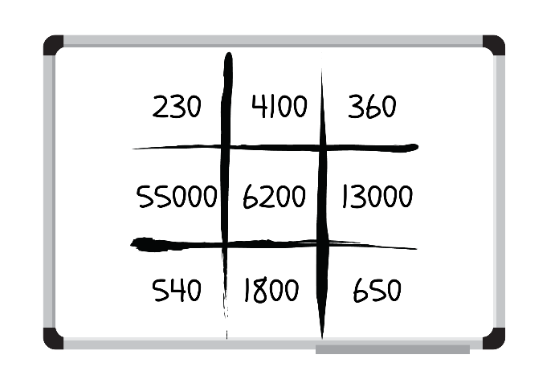

1. Students take turns rolling the dice and using the spinner to fill their gameboards with 9 different numbers.
2. Students record all the numbers on both gameboards on Resource 12 – cards and shuffle them into a pile facedown.
3. Students draw one card at a time and mark off the numbers on their bingo board.
4. The winner is the first student to mark off 3 numbers in a row.

**Note**: teachers may differentiate by choosing only one die or the number of sides to the dice. The game may be played as a whole class or in pairs. A [digital spinner](http://www.superteachertools.com/spinner/spinner.php?title=Super+Spinner&directions=Click+the+wheel+below+to+spin%3A&colorscheme=color1&labels=100%2C10%2C1000%2C10%2C100%2C1000%2C10%2C100%2C1000%2C10) may be used to reduce the number of resources to be printed and created.

### Stage 2 task 2 – ‘Epic money’ game

This activity is an adaptation of [Our epic Monopoly game: Exploring non-standard partitioning using money](https://www.researchgate.net/publication/364307525_Our_epic_Monopoly_game_Exploring_non-standard_partitioning_using_money) from Prime Number by Wang and Russo.

1. Display Resource 13 – ‘Epic money’ game.
2. Explain to students: Nash is playing a board game with his brother and sister. The goal is to earn the most amount of money. The game uses only $100, $10 and $1 notes.

**Note:** explain to students that the board game only includes notes so for this activity, $1 is represented by a note rather than a coin.

1. Ask students questions about each total.

The table below outlines stimulus prompts to generate conversation about the topic, along with anticipated responses from students.

|  |  |
| --- | --- |
| Prompts | Anticipated student responses |
| * How much does each child have? How do you know? | * Nash and Flynn have the same amount – $210. * Ava has $343. |
| * Before adding the amounts, who did you think had earned the most money? Explain your reasoning. | * I thought Ava had earned more, because she has more $100 notes plus a few of the other notes as well. * I thought Flynn had earned more than Nash because he has the largest number of notes. |
| * Can the children exchange their notes for other notes with an equal value? | * Flynn can swap his ten $10 notes for a $100 note. |

1. Display Resource 10 – place value houses. Model how the money is equivalent by representing the standard partition of 210 (2 hundreds and a 10) and non-standard partitioning (111 tens and 1 hundred, one 10 and 100 ones) (see Figure 7).

Figure 7 – modelling place value houses

Place value house template with columns for the hundred thousands, ten thousands and one thousand, hundreds, tens and ones.

The first row contains the number 210. In the next row, there is a one in the hundreds, 11 in the tens and zero in the ones.

In the third row, there is a one in the hundreds, a one in the tens and 100 in the ones.

In the final row, there is a zero in the hundreds, 11 in the tens and 100 in the ones.

1. Provide students with Resource 14 – partitioning $473. Pose the following scenario: The children played the game for 4 more hours. Nash finished with $473.
2. Ask the following questions:

* What notes might he have had?
* Is there another solution? How many solutions can you find?
* Can you identify a standard and non-standard partitioning solution? Explain your answer.

1. Students [Think-Pair-Share](https://app.education.nsw.gov.au/digital-learning-selector/LearningActivity/Card/645) and record their understanding.

This table details opportunities for differentiation.

|  |  |
| --- | --- |
| Too hard? | Too easy? |
| Students cannot partition numbers of up to 4 digits in non-standard forms.   * Allow students to partition a 2-digit number. Pose the question: Ava finished the game with $37. What notes might she have had? * Provide students with MAB materials and Resource 10 – place value houses to support their understanding. | Students can partition numbers of up to 4 digits in non-standard forms.   * Challenge students to partition a 4-digit number. Pose the question: Flynn finished the game with $2711. What notes might he have had? * Students engage with [Wishball: whole numbers](https://www.scootle.edu.au/ec/viewing/L867/index.html) on a digital device. Challenge students to reach the target number in 20 turns or less. |

### Stage 3 task – integer bingo

|  |  |
| --- | --- |
| Core concept learning intentions | Core concept success criteria |
| Students working towards Stage 3 outcomes are learning to:   * locate and represent integers on a number line. | Students working towards Stage 3 outcomes can:   * use the term integers to describe positive and negative whole numbers and zero * recognise that negative whole numbers can result from subtraction. |

This task is an adaptation of [Salamander Shoot Out – 10 to 10](https://www.math-salamanders.com/math-addition-games.html#:~:text=PDF%20version-,Salamander%20Shoot%20Out%20to%2010,-Salamander%20Shoot%2Dout) from [Math Salamanders](https://www.math-salamanders.com/).

1. Review the terms integer, positive numbers, negative numbers and whole numbers.

**Integer**: a whole number, positive, negative or zero. For example, −3, −2, −1, 0, 1, 2 …

**Negative number**: a number less than zero, written with a minus sign. These integers are read as, for example, ‘negative 3’, not ‘minus 3’.

1. Display Resource 15 – integer number line. To check for understanding ask:

* What does the word integer mean? (a whole number, positive, negative or zero)
* What do we call the numbers to the left of the zero on this number line? (negative numbers)
* Can you see any patterns? (the negative and positive numbers on either side of the zero, the integers increase by one each time)
* How do we read −5? (negative 5).

1. Display [interactive dice](https://toytheater.com/dice/) and select the option to roll 2 blue 10-sided dice. Use the 2 numbers rolled to create a subtraction sentence that results in a negative number.
2. Model using the number line and the jump strategy to solve the subtraction sentence. For example, 3 − 5 = −2 (see Figure 8).

Figure 8 – jump strategy

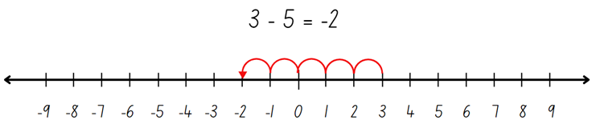

1. Provide students with a copy of Resource 15 – integer number line in a plastic sleeve and a whiteboard marker. Alternatively, students recreate the number line –9 to 9 on their whiteboards.
2. Roll the [interactive dice](https://toytheater.com/dice/) and use the 2 numbers rolled to create a subtraction sentence.
3. Students record the number sentence on their whiteboards and use the number line to solve the equation.

**Note:** when creating the subtraction equations, ensure negative numbers result from most subtraction sentences. For example, if a 3 and 4 are rolled, arrange the numbers 3 − 4 rather than 4 − 3 to ensure students are exposed to negative whole numbers that result from subtraction.

1. Repeat 3 to 5 times. Monitor student responses, check for understanding and provide feedback as necessary.
2. In pairs, students play a game of ‘Integer subtraction bingo’.
3. Explain the rules:
4. Each student draws a 3 × 3 gameboard grid and records a number between −9 and 9 in each square.
5. At least 6 of the numbers recorded must be negative numbers.
6. Students take turns to roll two 10-sided dice (0–9) and create a subtraction number sentence.
7. The dice can be arranged in any order. For example, if a 1 and 8 are rolled, 1− 8 or 8 − 1 could be recorded.
8. Students use a –9 to 9 number line as a representation to solve the subtraction.
9. The number sentence is recorded on each student's whiteboard and the answer crossed out if it appears on their gameboard (see Figure 9).

Figure 9 – gameboard example

A whiteboard with various subtraction problems. There is a 3 by 3 grid filled with numbers with some of the numbers crossed out.

There are mathematical equations displayed to the right of the grid. 

There are 2 dice under the grid, labelled with the numbers 7 and 8.

There is also a number line at the bottom which has been used for solving problems.


1. The winner is the first student to cross out every integer on their gameboard.
2. Provide pairs with two 10-sided dice (0-9), whiteboards and markers.
3. Students play the game multiple times, changing the numbers on their gameboard each round.
4. Regroup and ask:

* When did the answers of your subtraction result in negative whole numbers? (when the number subtracted was larger than the starting number)
* What is a mental strategy that would help with subtraction resulting in negative numbers? (subtract to zero first, then subtract the next part)

This table details opportunities for differentiation.

|  |  |
| --- | --- |
| Too hard? | Too easy? |
| Students cannot recognise that negative whole numbers can result from subtraction.   * Show students examples of number lines representing negative and positive integers. For example, thermometers that record sub-zero temperatures. Model solving a subtraction equation using the jump strategy by recording the one degree jumps on the thermometer. * Provide students with 6-sided dice to play subtraction bingo, −6 to 6. Students use concrete materials to model the subtraction before recording the number sentence. | Students can recognise that negative whole numbers can result from subtraction.   * Provide students with 20-sided dice to play subtraction bingo. Students may record numbers from −20 and 20 on their gameboard. * Students research everyday contexts where integers are placed on a number line. For example, temperatures, money (profit and loss), location (above or below sea level). Students create subtraction word problems for each context. For example, ‘It was 3 degrees in Canberra. Thredbo’s temperature was 7 degrees colder. What is the temperature in Thredbo?’ |

## Consolidation and meaningful practice – 20 minutes

### Stage 2

This activity is an adaptation of [Our epic Monopoly game: Exploring non-standard partitioning using money: Place Value Battles](https://www.researchgate.net/publication/364307525_Our_epic_Monopoly_game_Exploring_non-standard_partitioning_using_money) from Prime Numbers by Wang and Russo.

1. Group Stage 2 students into 2 to 4 teams. Appoint one student ‘Quiz Master’.

**Note**: the teacher may choose to assign themselves the job of ‘Quiz Master’ to ensure steady flow of the game and accurate calculation of non-standard partitioning.

1. Provide students with MAB materials and whiteboards.
2. Explain that the Quiz Master will roll three 9-sided dice. From the numbers rolled, they will create a 3-digit number, for example 526.
3. The Quiz Master makes the number with MAB materials using standard partitioning as a reference for the class.
4. The teams discuss different ways of renaming the number using non-standard partitioning. For example, 4 hundreds, 3 tens and 96 ones, or 3 hundreds, 14 tens and 86 ones. Each team records their renamed number (see Figure 10).

Figure 10 – place value battle

‘Place Value Battle’ gameboard example. There are 2 whiteboards labelled Team A and Team B.

Each gameboard has columns for the hundreds, tens and ones.
The example that has been rolled is 526.
Teams have recorded alternative ways that 526 can be partitioned, for example, Team A has recorded 4 hundreds, 3 tens and 96 ones. The team that records the highest numbers in each column (hundreds, tens and ones), will score a point. In the example given, Team A has scored 2 points.

1. The Quiz Master checks each team’s representation to ensure it is equivalent to the original number.
2. Beginning with the hundreds column, each team reveals their renamed number to the Quiz Master. Teams receive a point for having the highest number recorded in a column. For example, in Figure 10, Team A won the hundreds battle, Team B won the tens battle and Team A won the ones battle. Team A receives 2 points and Team B receives one point.
3. The game continues until one of the teams scores 11 points.

### Stage

**Note**: the purpose of this activity is to consolidate the students’ understanding of negative integers.

1. In pairs, Stage 3 students draw a number line on a whiteboard, marking zero in the middle, 20 at the far right and negative 20 at the far left.
2. Students take it in turns to spin Resource 16 – integer spinner to determine if they are creating a negative or positive number. They then roll two 10-sided die, add the numbers together and plot this number on the blank number line (see Figure 11).

Figure 11 – negative and positive game

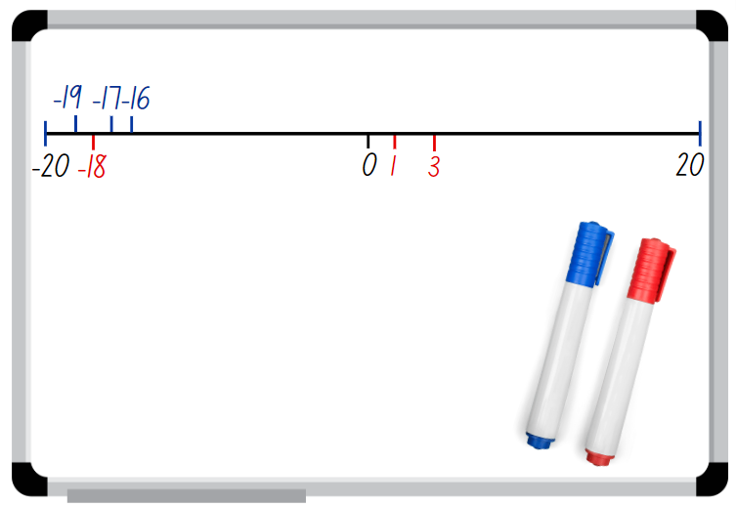

1. If their number has already been placed on the number line, the player misses a turn.
2. The winner is the player who has 3 integers in a row.

This table details opportunities for assessment.

|  |  |
| --- | --- |
| Assessment opportunities | Links |
| What to look for:   * Can Stage 2 students partition numbers of up to 4 digits in non-standard forms? **[MAO-WM-01, MA2-RN-01]** * Can Stage 2 students describe how making a number 10, 100 or 1000 times as large changes the place value of digits?  **[MAO-WM-01, MA2-RN-01]** * Can Stage 3 students use the term integers to describe positive and negative whole numbers and zero? **[MAO-WM-01,  MA3-RN-01]** * Can Stage 3 students recognise that negative whole numbers can result from subtraction? **[MAO-WM-01, MA3-RN-01]** | Links to [National Numeracy Learning Progressions](https://www.australiancurriculum.edu.au/resources/national-literacy-and-numeracy-learning-progressions/version-3-of-national-literacy-and-numeracy-learning-progressions/) (NNLP):   * Stage 2 – NPV5, NPV6, NPV8, NPV9 * Stage 3 – NPV9.   Links to suggested [Interview for Student Reasoning](https://education.nsw.gov.au/teaching-and-learning/curriculum/literacy-and-numeracy/assessment-resources/ifsr) (IfSR) tasks:   * Stage 2 – IfSR-NP: 4B.1, 4B.3, 4B.4, 4B.5. |

# Lesson 3

**Core concept**: the equal sign identifies a relationship in mathematics (Stage 2) and rounding helps estimate and verify the reasonableness of numerical calculations (Stage 3).

## Daily number sense – ‘Mastermind’ – 10 minutes

The table below contains suggested learning intentions and success criteria. These are best co-constructed with students.

|  |  |
| --- | --- |
| Daily number sense learning intentions | Daily number sense success criteria |
| Students working towards Stage 2 outcomes are learning to:   * read, represent and order numbers to thousands.   Students working towards Stage 3 outcomes are learning to:   * recognise, represent and order numbers in the millions. | Students working towards Stage 2 outcomes can:   * represent numbers up to thousands using numerals * read and order numbers of up to at least 4 digits.   Students working towards Stage 3 outcomes can:   * name millions using the place value grouping of ones, tens and hundreds * arrange numbers in the millions in ascending and descending order using place value. |

This activity is an adaptation of [Mastermind](https://education.nsw.gov.au/teaching-and-learning/curriculum/mathematics/mathematics-curriculum-resources-k-12/thinking-mathematically-resources/mathematics-s1-s3-mastermind) from [Thinking mathematically resources](https://education.nsw.gov.au/teaching-and-learning/curriculum/mathematics/mathematics-curriculum-resources-k-12/thinking-mathematically-resources) by the State of New South Wales (Department of Education).

1. In pairs, each Stage 2 student records a 4-digit number, with no repeated digits, on a sticky note. Students draw up their gameboard on an individual whiteboard (see Figure 12).

Figure 12 – ‘Mastermind’ gameboard example (Stage 2)

There is a sticky note with the number 4892 on it. To the right of the sticky note is a whiteboard showing 3 columns titled: Guess, Digits and Places. 

The first guess reads: 2859 in the Guess column, 2 in the Digits column and 1 in the Places column. 

The second guess reads: 3865 in the Guess column, 1 in the Digits column and 1 in the Places column.

The third guess reads: 1894 in the Guess column, 2 in the Digits column and 2 in the Places column.

1. Students take turns to guess their partner’s 4-digit number. Partners record the guess, the number of digits that are correct and the number of digits that are in the right place (see Figure 12). Students then use this information to refine their guesses.
2. The first student to correctly guess their partner’s number is the winner.

**Multi-age:** Stage 3 students participate in the same game as above, however with an increased number of digits. In pairs, each Stage 3 student records a 7-digit number, with no repeated digits, on a sticky note. Students draw up their gameboard on a whiteboard. They take turns to guess their partner’s 7-digit number. Partners record the guess, the number of digits that are correct, and the number of digits that are in the right place (see Figure 13). Students then use this information to refine their guesses. Stage 3 students retain their sticky note numbers to place in ascending or descending order after the completion of several rounds. All other rules are played as above.

Figure 13 – ‘Mastermind’ gameboard example (Stage 3)

There is a sticky note with the number 4 892 631 on it. To the right of the sticky note is a whiteboard showing 3 columns titled: Guess, Digits and Places. 

There are 4 guesses. Students record their guess, and their partner records how many digits were correct and how many were in the correct place. 

For example, the first guess displays the number 2 859 710, with 4 digits being correct and 1 digit in the correct place.

There are 5 sticky notes with students’ guesses displayed below the whiteboard placed in ascending order.

**Note:** this activity can be adapted by using 2-, 3-, 5- or 6-digit numbers.

This table details opportunities for assessment.

|  |  |
| --- | --- |
| Assessment opportunities | Links |
| What to look for:   * Can Stage 2 students represent numbers up to thousands using numerals? **[MAO-WM-01, MA2-RN-01]** * Can Stage 2 read and order numbers of up to at least 4 digits? **[MAO-WM-01, MA2-RN-01]** * Can Stage 3 students name millions using the place value grouping of ones, tens and hundreds? **[MAO-WM-01,  MA3-RN-01]** * Can Stage 3 students arrange numbers in the millions in ascending and descending order using place value?  **[MAO-WM-01, MA3-RN-01]** | Links to [National Numeracy Learning Progressions](https://www.australiancurriculum.edu.au/resources/national-literacy-and-numeracy-learning-progressions/version-3-of-national-literacy-and-numeracy-learning-progressions/) (NNLP):   * Stage 2 – NPV4, NPV5, NPV6 * Stage 3 – NPV7.   Links to suggested [Interview for Student Reasoning](https://education.nsw.gov.au/teaching-and-learning/curriculum/literacy-and-numeracy/assessment-resources/ifsr) (IfSR) tasks:   * Stage 2 – IfSR-NP: 4B.2, 4B.5, 4C.1, 4C.5. |

## Core lesson – 45 minutes

### Stage 2 task – equivalent equations

The table below contains suggested learning intentions and success criteria. These are best co-constructed with students.

|  |  |
| --- | --- |
| Core concept learning intentions | Core concept success criteria |
| Students working towards Stage 2 outcomes are learning to:   * use the principle of equality. | Students working towards Stage 2 outcomes can:   * recognise equal differences and record them in number sentences * use the equals sign to mean 'the same as', rather than to perform an operation * apply the associative property of addition to forming multiples of 10. |

This activity is an adaptation of ‘[Let's Play: The Same As](https://www.researchgate.net/publication/360321217_Let's_Play_The_Same_As)’ from Prime Number by Russo.

**Associative property**: more than 2 numbers can be added in any order to make it more efficient. For example, bridging to multiples of 10 (22 +3 + 8 is the same as 22 + 8 + 13).

1. Write the number sentence 53 + 24 + 17 on the board. Students complete the number sentence and record solutions on whiteboards. Observe if students use multiples of 10 to obtain their answer.
2. Regroup and select students to share the different strategies used, including bridging the decades.

**Note**: if the bridging the decades strategy was not used by any students in the class, use the [think-aloud](https://evidenceforlearning.org.au/news/planning-a-think-aloud-in-mathematics) strategy to model before moving on.

1. Revisit that using the associative property of addition to form multiples of 10 is a useful strategy, for example, 62 + 15 + 8 = 62 + 8 + 15 = 85. Explain that using place value understanding flexibly makes it easier to solve 62 + 8 = 70 and then add on 15.
2. Using this strategy, students solve the following problems on their whiteboards.

* 67 + 29 + 13 = _
* 23 + 34 + 56 = _
* 51 + 17 + 33 = _.

1. Regroup and discuss.
2. Discuss the term ‘equal differences’.
3. Write 18 − 11 on the board. Ask:

* What is the difference between 18 and 11?
* What is another number sentence that has a difference of 7?
* Is there more than one possibility?
* How can the equals sign be used to show that 2 number sentences have equal differences?

1. If not discussed by students, model how the equals sign can be used to record equal differences. For example, 18 – 11 = 9 − 2.
2. Write 23 − 14 on the board. Students record on individual whiteboards other number sentences that show equal differences.
3. Provide students with a deck of cards (Jack = 17, Queen = 18, King = 19, Joker = 20 and Ace can be 1 or 21) and Resource 17 – number sentence board.

**Note**: encourage students to use both addition and subtraction during the game.

1. Explain the rules of the game to students:
2. Student A turns over 4 cards, placing them face up on the board.
3. Student A uses the cards to try to make a number sentence that is true. For example, Student A picks up a King and places the cards in one of the slots and reads out the number sentence stating whether it is true or not. For example, ‘Ten plus nineteen is not the same as eighteen plus three’ (see Figure 14).

Figure 14 – cards flipped example

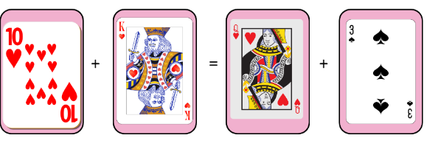

1. Student A can continue to place cards in various orders to see if they can make a sentence that is true. If they cannot, it is Student B’s turn.
2. Student B flips over 4 different cards and states whether their sentence is true or not. Student B continues to place cards in various orders to see if they can make a sentence that is true. If they cannot, it is Student A’s turn.
3. Students record true number sentences on their whiteboards.
4. The game ends once a player has 5 equivalent number sentences.
5. Regroup and ask:

* What was easy or challenging about the game?
* How many times did you have to draw 4 cards to create a number sentence that was true?
* Which strategy did you use that was the most efficient to obtain the answer?

This table details opportunities for differentiation.

|  |  |
| --- | --- |
| Too hard? | Too easy? |
| Students cannot recognise equal differences and record them in number sentences.   * Assist students by lowering the value of the picture cards. * Students use concrete materials such as MAB, to model the number sentence. | Students can recognise equal differences and record them in number sentences   * Challenge students to flip 6 number cards and make two 2-digit numbers. These numbers are used to create a number sentence that is true. * Provide students with Resource 18 – True or false?. Ask students to decide if the number sentences are true or false. Challenge students to determine how they could make the false statements true. |

### Stage 3 task – estimation fun

The table below contains suggested learning intentions and success criteria. These are best co-constructed with students.

|  |  |
| --- | --- |
| Core concept learning intentions | Core concept success criteria |
| Students working towards Stage 3 outcomes are learning to:   * use estimation and place value understanding to determine the reasonableness of solutions. | Students working towards Stage 3 outcomes can:   * round numbers appropriately when obtaining estimates to numerical calculations * use estimation to check the reasonableness of solutions to addition and subtraction calculations. |

1. Pose the problem: ‘A school camp needs approximately 140 snacks a week, which is 7280 for the year, for students that visit the campsite. The school camp coordinators, Sarah and Jack, bought 4582 muesli bars and 2691 packets of pretzels.’ Estimate the total number of snack supplies they bought for the school camp and determine if this amount is reasonable based on the weekly need.

Many procedures used when rounding numbers emphasise the digit values more than the units of ten and hundred, for example, rounding up if the last digit is 5 or more. Instead of teaching procedures for rounding to the nearest 10 or 100, place the emphasis on:

* developing the quantity value of numbers
* identifying the nearest 10 or 100 to a number.

1. Explain that numbers can be rounded to the nearest ten, hundred, thousand, ten thousand, or even million, depending on the context and the level of precision required. For example, if you are estimating a budget, rounding to the nearest thousand might be appropriate, while rounding to the nearest hundred or ten might be better for estimating quantities of items. For example, with the numbers 4582 and 2691:

* rounding to the nearest ten would give you 4580 and 2690 (7270)
* rounding to the nearest hundred would give you 4600 and 2700 (7300)
* rounding to the nearest thousand would give you 5000 and 3000 (8000).

1. Explain that rounding to the nearest ten (resulting in an estimate of 7270) is an accurate estimation method when dealing with specific quantities. The close match between the actual total number of snacks purchased (7273) and the estimated total (7270) confirms the reasonableness of the solution within this context.
2. Introduce the task, ‘Dice toss estimation challenge’. Explain that the purpose of this task is to use place value understanding to accurately estimate the result of an addition or subtraction number sentence.
3. In pairs, students need four 10-sided dice (0–9), calculators, individual whiteboards or workbooks to record their answers. State the instructions:
4. Students roll four 10-sided dice (0–9) twice and form two 4-digit numbers.
5. Use the numbers to create 2 addition and 2 subtraction number sentences. Students estimate the answers without using a calculator.

**Note**: when choosing to subtract, ensure that the first number is larger than the second number to avoid negative results.

1. After both students have made their estimates, they record the strategy used.
2. Students then use a calculator to check the answers.
3. Students draw a table in their workbooks and record their work (see Table 1).

Table 1 – student work sample

|  |  |  |  |  |
| --- | --- | --- | --- | --- |
| Addition or subtraction number sentence | Estimation – rounding to the nearest ten | Estimation – rounding to the nearest hundred | Estimation – rounding to the nearest thousand | Calculator answer |
| For example: 4892 − 3718 = | 4890 − 3720 = 1170 | 4900 − 3700 = 1200 | 5000 − 4000 = 1000 | 1174 |
|  |  |  |  |  |

1. After recording their results, students can analyse the table of information and compare the accuracy of their estimates and identify patterns or strategies that lead to more accurate estimates.
2. This table details opportunities for differentiation.

|  |  |
| --- | --- |
| Too hard? | Too easy? |
| Students cannot round numbers appropriately when obtaining estimates to numerical calculations.   * Teacher provides a target number for example, 800. Students create two 2- or 3-digit numbers using dice. Students arrange the numbers on the dice and use estimation to create an addition or subtraction number sentence that results in a total as close as possible to the target number. | Students can round numbers appropriately when obtaining estimates to numerical calculations.   * Students design their own estimation game to share with peers. * Repeat the ‘Dice toss estimation challenge’ with an additional dice so students can form 5-digit numbers. Provide a target number of 20 000 for the game. Students try to reach as close as they can to the target number by using estimation when adding or subtracting. |

## Discuss and connect the mathematics – 10 minutes

### Stage 2

1. Ask students:

* When is the associative property of addition to bridging to multiples of 10 an efficient strategy to use? Explain your thinking.
* When could this be an inefficient strategy to use?
* When could this strategy be helpful to use in real life situations?

### Stage 3

1. Regroup and discuss the following scenarios. Students identify if rounding to the nearest ten, hundred or thousand will be reasonable to help with estimating. Estimate the:

* total cost of items in a shopping cart (tens). When shopping, you might want to quickly estimate if you have enough money to buy everything in your cart without having to calculate the exact total.
* cost of building a house (thousands). When planning a construction project, an estimate in thousands can help in budgeting and financial planning.
* population of a small town (thousands). For purposes like planning community resources or events, an estimate in thousands can provide a good sense of scale without needing an exact count.
* driving distance for a road trip (hundreds). Knowing the approximate distance in hundreds of kilometres can help you plan for fuel stops and travel time.
* number of pencils needed for a class of students (tens). Estimating in tens can ensure you have a sufficient supply without over-purchasing.
* number of attendees for a school event (hundreds). This helps in arranging adequate seating, food and other resources.

This table details opportunities for assessment.

|  |  |
| --- | --- |
| Assessment opportunities | Links |
| What to look for:   * Can Stage 2 students recognise and record equal number sentences? **[MAO-WM-01, MA2-AR-01]** * Can Stage 3 students round numbers appropriately when obtaining estimates to numerical calculations? **[MAO-WM-01, MA3-AR-01]** * Can Stage 3 students use estimation to check the reasonableness of solutions to addition and subtraction calculations?  **[MAO-WM-01, MA3-AR-01]**? | Links to [National Numeracy Learning Progressions](https://www.australiancurriculum.edu.au/resources/national-literacy-and-numeracy-learning-progressions/version-3-of-national-literacy-and-numeracy-learning-progressions/) (NNLP):   * Stage 2 – AdS7, AdS8 * Stage 3 – NPV5, NPV6, NPV7, AdS8.   Links to suggested [Interview for Student Reasoning](https://education.nsw.gov.au/teaching-and-learning/curriculum/literacy-and-numeracy/assessment-resources/ifsr) (IfSR) tasks:   * Stage 2 – IfSR-AT: 3A.2 - 3A.4. |

# Lesson 4

**Core concept**: numbers can be built up or taken apart in a variety of ways to make the numbers easier to work with (Stage 2) and identify efficient subtraction strategies and use place value for addition estimation (Stage 3).

## Daily number sense – 10 minutes

1. From a class need surfaced through formative assessment data, identify a short, focused activity that targets students’ knowledge, understanding and skills. Example activities may be drawn from the following resources:

* [Mathematics K–6 resources](https://education.nsw.gov.au/teaching-and-learning/curriculum/mathematics/mathematics-curriculum-resources-k-12/mathematics-k-6-resources)
* [Universal Resources Hub](https://resources.education.nsw.gov.au/home).

## Core lesson – revising strategies – 25 minutes

The table below contains suggested learning intentions and success criteria. These are best co-constructed with students.

|  |  |
| --- | --- |
| Core concept learning intentions | Core concept success criteria |
| Students working towards Stage 2 outcomes are learning to:   * select strategies flexibly to solve addition and subtraction problems of up to 3 digits.   Students working towards Stage 3 outcomes are learning to:   * apply efficient mental and written strategies to solve addition and subtraction problems * use estimation and place value understanding to determine the reasonableness of solutions. | Students working towards Stage 2 outcomes can:   * use the compensation strategy to add and subtract * apply the levelling and constant difference strategies * compare and evaluate strategies used to solve addition and subtraction problems, reasoning which strategy may be most efficient.   Students working towards Stage 3 outcomes can:   * apply known strategies such as levelling, addition for subtraction, using constant difference, and bridging * identify efficient and inefficient multidigit subtraction strategies * round numbers appropriately when obtaining estimates to numerical calculations. |

1. Display Resource 19 – additive strategies poster. Discuss each strategy on the poster and how each helps to identify different ways to solve problems efficiently.
2. Remind students that when they work with numbers, the aim is to be flexible, efficient and accurate.

**Note:** Stage 2 students need to focus on the compensation, levelling and constant difference strategies.

1. Display the following questions and ask students to [Think-Pair-Share](https://app.education.nsw.gov.au/digital-learning-selector/LearningActivity/Card/645) how they could solve the problems.

* 27 + 34 = _? (Stage 2)
* 126 – 58 = _? (Stage 2)
* 12 645 – 4597 = _? (Stage 3)
* _? – 7093 = 474 (Stage 3)
* 2027 – 418 = _? (Stage 3)

1. Regroup and ask students prompting questions from the table below.

The table below outlines stimulus prompts to generate conversation about the topic, along with anticipated responses from students.

|  |  |
| --- | --- |
| Prompts | Anticipated student responses |
| * What strategy did you use to solve 27 + 34? | * I added 3 to 27 to make 30, which then made the problem 30 + 34. This made 64. Then I subtracted 3 from 64 to get the answer of 61. (compensation strategy) * I know that 27 + 34 is the same as 30 + 31. I subtracted 3 from 34 and added it to 27 to make 30. I then added the 1 left over. (levelling) * I added 20 and 30 to make 50 and then I added 7 and 4 together which equalled 11. I then added 50 and 11 together to get the total of 61. (partitioning) |
| * What strategy did you use to solve 126 – 58? | * I know that 126 – 58 is the same as 128 – 60. I added 2 to 126 and 58 so that one of the numbers was easier to work with. This kept the difference between the 2 numbers the same. That gave me the answer of 68. (constant difference) * I added 2 to 58 to make the problem 126 – 60. That equals 66 and then I added on 2 more to get 68. (compensation strategy) |
| * 12 645 – 4597 = _? | * I used constant difference: adjust both numbers to make subtraction easier, ensuring the difference between them remains constant. * 12 645 + 3 = 12 648 and 4597 + 3 = 4600 * New equation: 12 648 − 4600 = 8048. |
| * _? − 7093 = 474 | * I used inverse operations 7093 + 474 = _? * Then I would use either a mental or written strategy such as bridging (7093 + 7 + 467). * New equation: 7093 + 7 + 467 = 7100 + 467 = 7567. |
| * 2027− 418 = _? | * I used partitioning: splitting numbers into smaller parts to make calculations easier. * (2000 + 27) − (400 + 18) = (2000 − 400) + (27 − 18) = 1600 + 9 = 1609. * I used landmark numbers that are easy to work with, fluently, flexibly and efficiently. * 2027 − 400 = 1627 then 1627 − 18 = 1609. * I drew a number line and used the jump strategy to solve this subtraction. I would first make four 100 jumps from 2027 to 1627. Then I would make one 10 jump, landing on 1617. Finally, I would make an 8 jump, which gives me the answer of 1609. |

1. Regroup and revise the strategies used. Ask students to communicate their reasoning and choice of strategy. Check for correct answers.
2. Check for understanding by asking:

* When would you choose to use a mental strategy over a written strategy?
* When would levelling be an efficient strategy?
* When would an algorithm be an efficient strategy?
* How can you check your answer after solving a subtraction equation to ensure it is correct?

This table details opportunities for differentiation.

|  |  |
| --- | --- |
| Too hard? | Too easy? |
| Stage 2 students cannot compare and evaluate strategies used to solve addition and subtraction problems, reasoning which strategy may be most efficient.   * Provide students with MAB materials to assist with addition and subtraction. Guide students through examples where the compensation, levelling and constant difference strategies are appropriate.   Stage 3 students cannot identify efficient and inefficient multidigit subtraction strategies.   * Provide students with equations using 2-digit numbers to solve. They identify a number-based strategy to support more efficient calculations. For example, partitioning numbers. | Stage 2 students can compare and evaluate strategies used to solve addition and subtraction problems, reasoning which strategy may be most efficient.   * Ask students to create word problems and share with their peers. When solving the problems, students reflect on the most efficient strategies used.   Stage 3 students can identify efficient and inefficient multidigit subtraction strategies.   * Students write example equations to demonstrate understanding of when each mental and written strategy would be the most efficient. |

## Consolidation and meaningful practice – 25 minutes

This activity is an adaptation of [Closest to 100 (additive strategies)](https://education.nsw.gov.au/teaching-and-learning/curriculum/mathematics/mathematics-curriculum-resources-k-12/thinking-mathematically-resources/mathematics-s2-s3-closest-to-100) from [Thinking mathematically resources](https://education.nsw.gov.au/teaching-and-learning/curriculum/mathematics/mathematics-curriculum-resources-k-12/thinking-mathematically-resources) by the State of New South Wales (Department of Education).

1. Explain that students will be using various additive strategies and estimating to solve addition equations in the game ‘Closest to 100 or 1000’. Students work in pairs against another pair of students to allow for mathematical conversations.

**Multi-age:** Stage 2 students will play closest to 100 and Stage 3 students will play closest to 1000.

1. Explain the rules for ‘Closest to 100’ (Stage 2) or ‘Closest to 1000’ (Stage 3):
2. Students work in pairs against another pair of students to allow for mathematical conversations.
3. The aim of the game is to use addition or subtraction to get close to a total of 100 (Stage 2) or 1000 (Stage 3).
4. Provide pairs with a whiteboard and a pack of cards, Ace to 10. Ace is equal to one. Pair A shuffles the cards and puts them in a central pile. Pair B takes 6 cards and places them face up for everyone to see.
5. Each card can only be used once, and it can be used to form a 2-digit number, or a 3-digit number. These numbers can either be added or subtracted to get as close as possible to 100. Not all cards need to be used.

**Note:** students should use estimation strategies to check validity of solutions.

1. Players score zero points if they can reach exactly 100 or 1000. Otherwise, they work out their points based on the difference between their total of 100 or 1000. For example, if a Stage 2 student got 94, they would score 6 points. If a Stage 3 student got 912, they would score 88 points.
2. Players record their working out and the cumulative total of their difference to 100 or 1000 in their workbooks. The winner is the team with the lowest point score at the end.
3. Regroup and ask:

* What did you notice when you were playing ‘Closest to 100 or 1000’?
* What strategy did you find most efficient? Why?
* What strategy did you find least efficient? Why?
* How did estimation help you? (Stage 3)

**Note:** encourage students to share reasoning for their ideas. Highlight different ideas that promote the understanding that different strategies can be more efficient for different problems.

This table details opportunities for assessment.

|  |  |
| --- | --- |
| Assessment opportunities | Links |
| What to look for:   * Can Stage 2 students solve addition and subtraction problems using the compensation strategy? **[MAO-WM-01, MA2-AR-01, MA2-AR-02]** * Can Stage 2 students apply the leveling strategy to addition problems? **[MAO-WM-01, MA2-AR-01, MA2-AR-02]** * Can Stage 2 students apply the constant difference strategy to subtraction problems? **[MAO-WM-01, MA2-AR-01, MA2-AR-02]** * Can Stage 2 students compare and evaluate strategies used to solve addition and subtraction problems, reasoning which strategy may be most efficient? **[MAO-WM-01, MA2-AR-01]**? * Can Stage 3 students apply known strategies such as levelling, addition for subtraction, using constant difference, and bridging? **[MAO-WM-01, MA3-AR-01]** * Can Stage 3 students identify efficient and inefficient multidigit subtraction strategies? **[MAO-WM-01, MA3-AR-01]** * Can Stage 3 students round numbers appropriately when obtaining estimates to numerical calculations? **[MAO-WM-01, MA3-AR-01]** | Links to [National Numeracy Learning Progressions](https://www.australiancurriculum.edu.au/resources/national-literacy-and-numeracy-learning-progressions/version-3-of-national-literacy-and-numeracy-learning-progressions/) (NNLP):   * Stage 2 – AdS7, AdS8 * Stage 3 – AdS8.   Links to suggested [Interview for Student Reasoning](https://education.nsw.gov.au/teaching-and-learning/curriculum/literacy-and-numeracy/assessment-resources/ifsr) (IfSR) tasks:   * Stage 2 – IfSR-AT: 3A.2, 3A.3, 3A.4 * Stage 3 – IfSR- AT: 3A.4. |

# Lesson 5

**Core concept**: addition and subtraction are connected (Stage 2) and represent percentages as fractions and decimals and find any quantity (Stage 3).

## Daily number sense – King’s tax – 15 minutes

Daily number sense activities for Lessons 5 to 7 ‘loop’ back to concepts and procedures covered in previous units to assist students to build an increasingly connected network of ideas. These concepts may differ from the core concepts being covered by the unit.

The table below contains suggested learning intentions and success criteria. These are best co-constructed with students.

|  |  |
| --- | --- |
| Daily number sense learning intentions | Daily number sense success criteria |
| Students working towards Stage 2 outcomes are learning to:   * select strategies flexibly to solve addition and subtraction problems of up to 3 digits.   Students working towards Stage 3 outcomes are learning to:   * applies known strategies to add and subtract decimals. | Students working towards Stage 2 outcomes can:   * apply known mental strategies to add.   Students working towards Stage 3 outcomes can:   * model the addition and subtraction of decimals up to 3 decimal places using appropriate representations. |

This activity is an adaptation of ‘[Unpacking game mechanics: Five types of whole-class mathematical games: King’s Tax](https://www.researchgate.net/publication/378964831_Unpacking_game_mechanics_Five_types_of_whole-class_mathematical_games)’ from Australian Primary Mathematics Classroom by Russo and Russo.

**Note**: the game is to be played as a whole class. You may choose to use a deck of cards or an [online card generator](https://toytheater.com/playing-cards/).

1. Provide students with individual whiteboards and ask them to stand up to start the game.
2. Display Resource 20 – King's tax and discuss the different card values for Stage 2 and Stage 3 students.
3. One card is drawn from the pack. This is the amount of money that has been earned. For example, if a 5 is turned over, the Stage 2 students have earned $5 and the Stage 3 students have earned $5.05.
4. After each turn, students choose whether they will ‘bank’ their money (by sitting down and recording their amount on their whiteboard) or whether to play on. The players who stay in, continue to add to their money.
5. The following rules apply:
6. If a Jack is turned over, the Stage 2 students receive a $15 bonus and Stage 3 students receive a $15.25 bonus.
7. If a Queen is turned over, the amount is doubled for that round (For example, if 6 is turned over, the players receive $12).
8. If a King is turned over, he collects his taxes. Anyone who is still standing loses their money for that round.
9. For Stage 3 students, the Joker is wild. The winner of the previous round (or the teacher in Round 1) determines the value of the joker before the round begins. For example, the Joker could triple the round total, halve the round total or have a value such as $100. The Joker has no value to Stage 2 students.
10. A round ends after the King collects his taxes or if nobody is left standing.
11. After 4 rounds, students add up the amount they have banked. The winner is the student from each stage with the most money in their bank.
12. Ask students:

* What strategy did you use to add your money?
* Did you use the same strategy each time? Why or why not?
* Was one strategy more efficient than another one you tried?

This table details opportunities for assessment.

|  |  |
| --- | --- |
| Assessment opportunities | Links |
| What to look for:   * Can Stage 2 students apply known mental strategies to add? **[MAO-WM-01, MA2-AR-01]** * Can Stage 3 students model the addition and subtraction of decimals up to 3 decimal places using appropriate representations? **[MAO-WM-01, MA3-AR-01]** | Links to [National Numeracy Learning Progressions](https://www.australiancurriculum.edu.au/resources/national-literacy-and-numeracy-learning-progressions/version-3-of-national-literacy-and-numeracy-learning-progressions/) (NNLP):   * Stage 2 – AdS7 * Stage 3 – AdS9.   Links to suggested [Interview for Student Reasoning](https://education.nsw.gov.au/teaching-and-learning/curriculum/literacy-and-numeracy/assessment-resources/ifsr) (IfSR) tasks:   * Stage 2 – IfSR-AT: 3A.1, 3A.2, 3A.3 * Stage 3 – IfSR-AT: 4A.1, 4A.2, 4A.3. |

## Core lesson – 25 minutes

### Stage 2 task – addition and subtraction dominoes

The table below contains suggested learning intentions and success criteria. These are best co-constructed with students.

|  |  |
| --- | --- |
| Core concept learning intentions | Core concept success criteria |
| Students working towards Stage 2 outcomes are learning to:   * recognise and explain the connection between addition and subtraction * select strategies flexibly to solve addition and subtraction problems of up to 3 digits. | Students working towards Stage 2 outcomes can:   * use the complement principle of addition and subtraction * compare and evaluate strategies used to solve addition and subtraction problems, reasoning which strategy may be most efficient. |

1. Revisit Resource 19 – additive strategies poster.
2. Place students in pairs or groups of 3.
3. Provide each pair/group with Resource 21 – dominoes.
4. Students use known strategies for addition and subtraction, to join the dominoes ensuring that each number sentence that is joined is true (see Figure 15).

Figure 15 – domino example

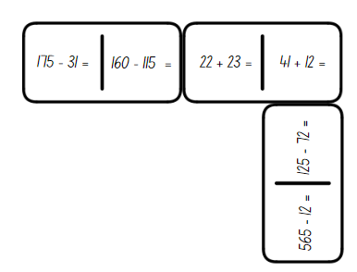

1. Students record the strategies used in their workbook. Explain that the game continues until all dominoes have been used.
2. Regroup and explain that students will be creating their own dominoes that match the totals of existing dominoes. For example, the equation on the domino of 125 − 72 could connect to a new domino that has 242 − 189.
3. Students give their dominoes to a friend to solve using one of the following strategies: compensation strategy, levelling strategy or constant difference strategy.
4. Ask students:

* Which strategy was the most efficient to solve the problem? Why?
* How did you decide what strategy to use each time? Was it always the most efficient? Why or why not?
* What advice would you give to another student if they did not know which strategy would be the most efficient to use?

This table details opportunities for differentiation.

|  |  |
| --- | --- |
| **Too hard?** | **Too easy?** |
| Students cannot compare and evaluate strategies used to solve addition and subtraction problems, reasoning which strategy may be most efficient.   * Provide students with Resource 22 – adapted dominoes to complete. * Provide students with MAB materials to model solving equations. | Students can compare and evaluate strategies used to solve addition and subtraction problems, reasoning which strategy may be most efficient.   * Provide students with Resource 23 – blank dominoes. Students create their own for a partner to complete. * Students solve the problem of [Amy’s dominoes](https://nrich.maths.org/problems/amys-dominoes) from [NRICH](https://nrich.maths.org). |

### Stage 3 task – percentages in action

The table below contains suggested learning intentions and success criteria. These are best co-constructed with students.

|  |  |
| --- | --- |
| Core concept learning intentions | Core concept success criteria |
| Students working towards Stage 3 outcomes are learning to:   * make connections between benchmark fractions, decimals and percentages. | Students working towards Stage 3 outcomes can:   * represent common percentages of quantities and lengths as fractions and decimals * recognise that 10 $\%$ is one-tenth of 100 $\%$ and use this to find 10 $\%$ of a quantity. |

1. Revise that the symbol % means percent and that 100% means the whole amount.
2. Explain that percentages are often used for presenting data, discount sales, bank interest rates and taxes. Percentages are another way of expressing fractions. Discuss where students have seen the percentage symbol, for example at the grocery shop, in advertisements and so on.
3. Explain that fractions, decimals, and percentages are all different ways to represent the same value. Highlight the relationship between fractions, decimals and percentages by drawing a bar model representing one-quarter on the board. Label $\frac{1}{4}$ as equivalent to 0.25 and 25%.
4. State that ‘25 percent’ means 25 out of 100 or $\frac{25}{100}$. Read the decimal 0.25 as ‘twenty-five hundredths’ and record as $\frac{25}{100}$. Link to one-quarter of 100 is 25.
5. Display Resource 24 – bar models. Ask:

* What percentage of each bar is shaded?
* Which one is easy to know?
* What fraction of each bar is shaded?
* How could you record this as an equivalent decimal?

1. Students solve the following questions using a bar to represent their thinking (see Figure 16):

* 50% of $200
* 25% of $160
* 75% of $300.

Figure 16 – bar model sample

Two bar model examples of $160. The first bar model is divided into two $80 parts.

The second bar model is underneath the first and is divided into four $40 sections, with one section highlighted in green to illustrate that 25% of $160 equals $40.

The sentence: 25% of $160 = $40 is written under the bar models.

1. Check for understanding by asking students to explain their thinking and strategies used to determine the answers.
2. Explain that 10% is one-tenth of 100%, so it can be found by dividing a quantity by 10.
3. Demonstrate equating 10% to dividing by 10 on the board, for example, 10% of 100 = 10, 10% of 50 = 5, 10% of 200 = 20 on the board.
4. Students practice by finding 10% of the following values and recording their answers on a whiteboard:

* 300
* 70
* 550
* 45

1. To extend student thinking, ask students to consider how to calculate 20% of each quantity.

**Note**: our base-10 number system makes it easy to find 10% of a quantity. For example, 10% of 150 is 15, so 20% of 150 is 2 lots of 15, 30% is 3 lots of 15 and so on.

1. Regroup as a class and pose the following problem: A camping store has a box of 110 key rings. The store wants to put 90% of the key rings on display. How many key rings will be put on display?
2. Explain that thinking about 10% of the quantity will be helpful. Students represent their thinking using a bar model.

This table details opportunities for differentiation.

|  |  |
| --- | --- |
| Too hard? | Too easy? |
| Students cannot represent common percentages of quantities and lengths as fractions and decimals.   * Model a connection between the bar model with a specific length, for example, 10 cm or 100 cm. Support students to calculate a given percentage of that length. Students can fold a strip if needing more concrete support. * Provide a 100 grid and ask students to represent various benchmark fractions, decimals and percentages. | Students can represent common percentages of quantities and lengths as fractions and decimals.   * Pose the following scenario: You are preparing for a camping trip with an $800 budget. Use a digital device to research the prices of camping gear such as a tent, sleeping bag, and backpack, checking for discounts. Add up the costs after applying any discounts. Write down the discounts as fractions and decimals. Investigate what percentage of your budget each item costs, showing it as a fraction and a decimal. |

## Consolidation and meaningful practice – 25 minutes

### Stage 2

1. Pose question: If 56 – 23 = 33, what is 56 − 33?
2. Ask students to share their thinking.
3. Write 23 + _? = 56. What is the missing value?
4. Display Resource 25 – complement principle.
5. Students record their thinking on individual whiteboards.
6. Ask students:

* How does the complement principle help you make connections between addition and subtraction?
* Can you explain to a partner the relationship between addition and subtraction?

### Stage 3

1. Use Resource 26 – percentages jigsaw to demonstrate how to solve the percentage problems and connect the corresponding jigsaw tiles.
2. In pairs or small groups, students collaborate to solve the percentages jigsaw.
3. To check for understanding ask:

* What is 50% of 220?
* What is 10% of 60?
* What is 25% of 300?
* What strategies did you use to calculate the percentages on the puzzle pieces?
* Which percentage calculations did you solve first?
* Were there any challenging percentage calculations? Explain your thinking and your strategy.

This table details opportunities for assessment.

|  |  |
| --- | --- |
| Assessment opportunities | Links |
| What to look for:   * Can Stage 2 students use the complement principle of addition and subtraction? **[MAO-WM-01, MA2-AR-01, MA2-AR-02]** * Can Stage 2 students compare and evaluate strategies used to solve addition and subtraction problems, reasoning which strategy may be most efficient? **[MAO-WM-01, MA2-AR-01, MA2-AR-02]** * Can Stage 3 students represent common percentages of quantities and lengths as fractions and decimals? **[MAO-WM-01, MA3-RN-03]** * Can Stage 3 students recognise that 10% is one-tenth of 100% and use this to find 10% of a quantity (Reasons about relations)? **[MAO-WM-01, MA3-RN-03]** | Links to [National Numeracy Learning Progressions](https://www.australiancurriculum.edu.au/resources/national-literacy-and-numeracy-learning-progressions/version-3-of-national-literacy-and-numeracy-learning-progressions/) (NNLP):   * Stage 2 – AdS7, AdS8 * Stage 3 – InF7, PrT2, UnM8.   Links to suggested [Interview for Student Reasoning](https://education.nsw.gov.au/teaching-and-learning/curriculum/literacy-and-numeracy/assessment-resources/ifsr) (IfSR) tasks:   * Stage 2 – IfSR-AT: 3A.2 - 3A.4 * Stage 3 – IfSR- PT: 2A.1. |

# Lesson 6

**Core concept**: money values can be represented in different ways (Stage 2) and benchmark percentages help to determine percentage discounts (Stage 3).

## Daily number sense – dice addition – 10 minutes

The table below contains suggested learning intentions and success criteria. These are best co-constructed with students.

|  |  |
| --- | --- |
| Daily number sense learning intentions | Daily number sense success criteria |
| Students working towards Stage 2 outcomes are learning to:   * select strategies flexibly to solve addition and subtraction problems of up to 3 digits.   Students working towards Stage 3 outcomes are learning to:   * apply efficient mental and written strategies to solve addition and subtraction problems. | Students working towards Stage 2 outcomes can:   * apply known mental strategies to add * represent solutions to addition problems, including word problems, using an empty number line or bar model.   Students working towards Stage 3 outcomes can:   * apply known strategies such as levelling, addition for subtraction, using constant difference, and bridging. |

1. Revise mental strategies to add 2 numbers together including bridging the decades.
2. Provide each student with an individual whiteboard and ask them to draw an empty number line and a bar model (see Figure 17).

Figure 17 – empty number line and bar model

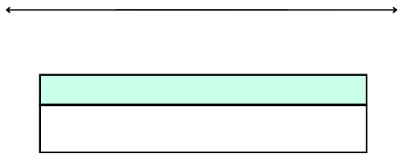

1. Working in pairs, Stage 2 students roll three 10-sided dice.
2. Students use the numbers rolled to form two 3-digit numbers, for example 264 and 642.
3. The aim is to use mental strategies to calculate the sum of the 2 numbers. Students then represent their solution using a bar model or number line (see Figure 18).
4. Ask:

* Which strategy did you use? Explain why.
* Can you explain your representation to a partner?

Figure 18 – dice addition example (Stage 2)

Number line with the numbers 426, 430, 630, 690. There is a +4 jump from 426 to 430, a +200 jump from 430 to 630 and a +60 jump from 630 to 690.

The bar model has 690 in the top and 426 and 264 split in the bottom.

1. Students roll the dice again and repeat the activity.

**Multi-age**: Stage 3 students participate in the same game as above, however using larger numbers. Stage 3 students roll 4 dice and create two 4-digit numbers, such as 5723 and 2537. All other steps are completed as above (see Figure 19).

Figure 19 – dice addition example (Stage 3)

Number line with the numbers 5723, 5730, 8030, 8260. There is a +7 jump from 5723 to 5730, a +2300 jump from 5730 to 8030 and a +230 jump from 8030 to 8260.

The bar model has 8260 in the top and 5723 and 2537 split in the bottom.

This table details opportunities for assessment.

|  |  |
| --- | --- |
| Assessment opportunities | Links |
| What to look for:   * Can Stage 2 students apply known mental strategies to add? **[MAO-WM-01, MA2-AR-01]** * Can Stage 2 students represent solutions to addition problems, including word problems, using an empty number line or bar model? **[MAO-WM-01, MA2-AR-01]** * Can Stage 3 students apply known strategies such as levelling, addition for subtraction, using constant difference, and bridging? **[MAO-WM-01, MA3-AR-01]** | Links to [National Numeracy Learning Progressions](https://www.australiancurriculum.edu.au/resources/national-literacy-and-numeracy-learning-progressions/version-3-of-national-literacy-and-numeracy-learning-progressions/) (NNLP):   * Stage 2 – AdS6, AdS7 * Stage 3 – AdS7, AdS8.   Links to suggested [Interview for Student Reasoning](https://education.nsw.gov.au/teaching-and-learning/curriculum/literacy-and-numeracy/assessment-resources/ifsr) (IfSR) tasks:   * Stage 2 – IfSR-AT: 3A.3. |

## Core lesson – 40 minutes

### Stage 2 task – super summer sale

The table below contains suggested learning intentions and success criteria. These are best co-constructed with students.

|  |  |
| --- | --- |
| Core concept learning intentions | Core concept success criteria |
| Students working towards Stage 2 outcomes are learning to:   * represent money values in multiple ways. | Students working towards Stage 2 outcomes can:   * recognise the relationship between dollars and cents * represent equivalent amounts of money using different denominations * perform calculations with money, including finding change. |

**Note:** this activity consolidates concepts covered in [Stage 2 Year A Unit 15](https://education.nsw.gov.au/teaching-and-learning/curriculum/mathematics/mathematics-curriculum-resources-k-12/mathematics-k-6-resources/mathematics-stage-2-year-a-unit-15). Concepts such as money equivalence and the ‘shopkeeper’ method of counting change are explored in the unit and can be applied to the following problems.

1. Display Resource 27 – dollars and cents.
2. Highlight the coins in each piggy bank and the statements made by Zac and Gigi.
3. Students [turn and talk](https://education.nsw.gov.au/teaching-and-learning/curriculum/literacy-and-numeracy/teaching-and-learning-resources/numeracy/talk-moves) to determine who has more money.
4. Ask pairs to share their reasoning with the class.
5. Explain to students that Zac and Gigi’s statements may be true in other circumstances, but in this example the amounts are equivalent.
6. Provide students with whiteboards. Ask them to divide the whiteboard in half vertically and to label one side Zac and the other side Gigi.
7. Explain that students are going to record $5 in coins on each side. On Zac’s side, they will record the amount with the least number of coins possible, and on Gigi’s side using exactly 10 coins.
8. Select students to share their solutions.
9. Discuss how they could change each side so that Zac’s statement is true, or Gigi’s statement is true.
10. Display Resource 28 – super summer sale. Highlight the items for sale and the new reduced prices underneath. Explain that the catalogue will be used to answer questions.
11. Provide students with Resource 28 – super summer sale and Resource 29 – money problems.

**Note:** ensure a collection of play notes and coins are available for students who require concrete materials to perform the calculations.

1. Students work in pairs to record solutions to the problems in their workbook.

This table details opportunities for differentiation.

|  |  |
| --- | --- |
| Too hard? | Too easy? |
| Students cannot perform calculations with money, including finding change.   * Support students by using play money and modelling the shopkeeper’s method or counting on strategy to calculate change. * Round the amounts to the nearest dollar and have students perform calculations with whole dollars. | Students can perform calculations with money, including finding change.   * Students work through the catalogue and calculate the difference between the original price and the reduced price for each item. * Students use a catalogue from their favourite shop to create problems for a partner to answer. |

### Stage 3 task – sale shopping

The table below contains suggested learning intentions and success criteria. These are best co-constructed with students.

|  |  |
| --- | --- |
| Core concept learning intentions | Core concept success criteria |
| Students working towards Stage 3 outcomes are learning to:   * determine percentage discounts of 10%, 25% and 50%. | Students working towards Stage 3 outcomes can:   * equate 10% to dividing by 10, 25% to finding a quarter by dividing by 4, and 50% to finding half * calculate the sale price of an item after a discount of 10%, 25% and 50%. |

1. Revise previous lesson including strategies to find common percentages of quantities.
2. Display Resource 30 – 2-way radios. Pose the scenario: Juno wanted to buy some 2-way radios for her camping trip. The original price was $80. She wanted to work out the sale price from the local shop, online store and garage sale.

**Note:** the term ‘recommended retail price’ or ‘RRP’ is referred to in the resources for this lesson. The recommended retail price (RRP) refers to the price the manufacturer suggests that the retailer should sell an item for.

1. Explain that when calculating the sale price, the percentage of the total price must first be determined and then subtracted from the original price.
2. Ask students to [Think-Pair-Share](https://app.education.nsw.gov.au/digital-learning-selector/LearningActivity/Card/645) and calculate 10%, 25% and 50% of $80. Prompt students to share the strategies they used to determine their answers.

The table below outlines stimulus prompts to generate conversation about the topic, along with anticipated responses from students.

|  |  |
| --- | --- |
| Prompts | Anticipated student responses |
| * How did you determine 10% of $80? | * I knew 10% meant one-tenth of the total amount, so I divided 80 by 10. 10% of 80 is 8, so the saving would be $8. |
| * How did you find 25%? | * 25% is the same as one-quarter. To find one-quarter, I can halve and halve again. I can halve 80 which is 40 and then halve again which is 20. If the discount is 25 $\%$ off, Juno would save $20. |
| * How did you determine 50% of $80? | * Finding 50% of a quantity, is the same as finding half. I know half of 80 is 40. A 50% saving would be $40. |

1. Model subtracting the savings from the original amount to determine the sale price. For example, a price after a 25% discount is found by calculating $80 − $20 = $60.
2. Display Resource 31 – super camping sale. Explain that Juno also saw that there was a sale at the local camping store. She had saved $300 from her birthday and Eid celebrations and wanted to know what she could purchase.
3. Students work through following tasks:

* How much money is saved on each item during this sale?
* What is the sale price of each item?
* What different combinations of items could Juno afford?
* If you were Juno, which items would you purchase with your $300?

1. Students record the savings, sale prices and combinations in their workbooks. Provide a calculator for checking answers, if required.

This table details opportunities for differentiation.

|  |  |
| --- | --- |
| Too hard? | Too easy? |
| Students cannot calculate the sale price of an item after a discount of 10%, 25% and 50%.   * Demonstrate how to find 10%, 25% and 50% off an item worth $100, $200 and $300 by dividing by 10, 4 and 2 and subtracting that amount from the total. * Use tape diagrams to represent the total cost of $100, $200 and $300. Model how to partition the bars into 10, 4 and 2 equal parts to find the percentages. | Students can calculate the sale price of an item after a discount of 10%, 25% and 50%.   * Students calculate the price for each item if there was a 15%, 20% or 75% discount. Students record their strategies used to determine the discount using words and/or diagrams. * Students determine the discount Juno received if she purchased all 9 items at their sale price. |

## Discuss and connect the mathematics – 10 minutes

1. Stage 2 students regroup to share solutions to the money problems, modelling multiple variations and strategies.

**Note:** teachers have the option of facilitating this discussion as a whole class or allowing students to share their solutions in small groups.

1. Ask students:

* Which strategy did you use to determine the greatest number of notes and/or coins?
* Which strategy did you use when adding the amounts?
* Did you use the same strategy for all questions, or did you select different strategies? Why?
* Which question(s) could you use the addition for subtraction strategy (shopkeeper’s method). Why is this an effective strategy?

1. Stage 3 students record a reflection in their workbooks outlining the steps required to calculate the sale price of an item after a percentage discount.
2. Regroup and ask:

* If dividing by 10 equates to 10% of the total price, how would you determine 20% of an amount? (divide by 10 and then double)
* How could you use your understanding of 10%, to calculate a discount of 90%? (divide by 10 and subtract from the original amount)
* How could the strategies used to calculate a discount of 25% help to determine the sale price of an item after a discount of 75%? (find 25% and then multiply by 3 or use the complement principle of 25% and 75%)

This table details opportunities for assessment.

|  |  |
| --- | --- |
| Assessment opportunities | Links |
| What to look for:   * Can Stage 2 students recognise the relationship between dollars and cents? **[MAO-WM-01, MA2-AR-01]** * Can Stage 2 students represent equivalent amounts of money using different denominations? **[MAO-WM-01, MA2-AR-01]** * Can Stage 2 students perform calculations with money, including finding change? **[MAO-WM-01, MA2-AR-01]** * Can Stage 3 students equate 10% to dividing by 10, 25% to finding a quarter by dividing by 4, and 50% to finding half? **[MAO-WM-01, MA3-RN-03]** * Can Stage 3 students calculate the sale price of an item after a discount of 10%, 25% and 50%? **[MAO-WM-01, MA3-RN-03]** | Links to [National Numeracy Learning Progressions](https://www.australiancurriculum.edu.au/resources/national-literacy-and-numeracy-learning-progressions/version-3-of-national-literacy-and-numeracy-learning-progressions/) (NNLP):   * Stage 2 – UnM2, UnM3, UnM4, UnM5, UnM6 * Stage 3 – PrT1, PrT2, UnM8.   Links to suggested [Interview for Student Reasoning](https://education.nsw.gov.au/teaching-and-learning/curriculum/literacy-and-numeracy/assessment-resources/ifsr) (IfSR) tasks:   * Stage 3 – IfSR-PT: 2A.5, 2A.8. |

# Lesson 7

**Core concept**: multiplication and division are related (Stage 2) and division can be recorded using fractions (Stage 3).

## Daily number sense – dice difference – 10 minutes

The table below contains suggested learning intentions and success criteria. These are best co-constructed with students.

|  |  |
| --- | --- |
| Daily number sense learning intentions | Daily number sense success criteria |
| Students working towards Stage 2 outcomes are learning to:   * select strategies flexibly to solve addition and subtraction problems of up to 3 digits.   Students working towards Stage 3 outcomes are learning to:   * apply efficient mental and written strategies to solve addition and subtraction problems. | Students working towards Stage 2 outcomes can:   * apply known mental strategies to subtract * represent solutions to subtraction problems, including word problems, using an empty number line or bar model.   Students working towards Stage 3 outcomes can:   * apply known strategies such as levelling, addition for subtraction, using constant difference, and bridging. |

1. Provide each student with an individual whiteboard and ask them to draw an empty number line and a bar model (see Figure 20).

Figure 20 – empty number line and bar model

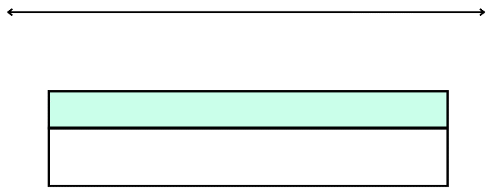

1. Working in pairs, students roll three 10-sided dice.
2. Students use the numbers rolled to form two 3-digit numbers. For example, 827 and 278.
3. The aim is to use mental strategies to calculate the difference between the 2 numbers. Students then represent their solution using a bar model or number line (see Figure 21).
4. Ask:

* Which strategy did you use? Explain why.
* Can you explain your representation to a partner?

Figure 21 –dice difference example (Stage 2)

Number line with the numbers 278, 280, 820, 827. There is a −7  jump from 827 to 820, a −540 jump from 820 to 280 and a −2 jump from 280 to 278.

The bar model below has 827 in the top and 278 and 549 split in the bottom.

1. Students roll the dice again and repeat the activity.

**Multi-age**: Stage 3 students participate in the same activity as above, using larger numbers. Stage 3 students roll 4 dice and create a 4-digit number and a 3-digit number, such as 5726 and 256. All other steps are completed as above (see Figure 22).

Figure 22 – dice difference example (Stage 3)

Number line with the numbers 5470, 5500, 5700, 5726. There is a −26  jump from 5726 to 5700,, a −200 jump from 5700 to 5500 and a −30 jump from 5500 to 5470.

The bar model below has 5726 in the top and 256 and 5470 split in the bottom.

This table details opportunities for assessment.

|  |  |
| --- | --- |
| Assessment opportunities | Links |
| What to look for:   * Can Stage 2 students apply known mental strategies to subtract? **[MAO-WM-01, MA2-AR-01]** * Can Stage 2 students represent solutions to subtraction problems, including word problems, using an empty number line or bar model? **[MAO-WM-01, MA2-AR-01]** * Can Stage 3 students apply known strategies such as levelling, addition for subtraction, using constant difference, and bridging? **[MAO-WM-01, MA3-AR-01]** | Links to [National Numeracy Learning Progressions](https://www.australiancurriculum.edu.au/resources/national-literacy-and-numeracy-learning-progressions/version-3-of-national-literacy-and-numeracy-learning-progressions/) (NNLP):   * Stage 2 – AdS6, AdS7 * Stage 3 – AdS7, AdS8.   Links to suggested [Interview for Student Reasoning](https://education.nsw.gov.au/teaching-and-learning/curriculum/literacy-and-numeracy/assessment-resources/ifsr) (IfSR) tasks:   * Stage 2 – IfSR-AT: 3A.3. |

## Core lesson 1 – 20 minutes

The table below contains suggested learning intentions and success criteria. These are best co-constructed with students.

|  |  |
| --- | --- |
| Core concept learning intentions | Core concept success criteria |
| Students working towards Stage 2 outcomes are learning to:   * recall multiplication facts of 2 and 4, 5 and 10 and related division facts.   Students working towards Stage 3 outcomes are learning to:   * use equivalent number sentences involving multiplication and division to find unknown quantities. | Students working towards Stage 2 outcomes can:   * link multiplication and division fact families using arrays * generate multiplication fact families for multiples of 2 and 4, 5 and 10 * model and apply the commutative property of multiplication.   Students working towards Stage 3 outcomes can:   * recognise that division can be recorded using fractions. |

**Multi-age:** The lesson begins with the students combined, discussing Resource 32 – 3 arrays (Stage 2) and Resource 33 – Wanda’s ponder (Stage 3). The students separate into different tasks later in the lesson.

1. For Stage 2 students, display Resource 32 – 3 arrays.
2. For Stage 3 students, display Resource 33 – Wanda’s ponder and explain that Wanda overheard Walter state: ‘Three divided by four can be represented as three-quarters.’
3. Students [turn and talk](https://education.nsw.gov.au/teaching-and-learning/curriculum/literacy-and-numeracy/teaching-and-learning-resources/numeracy/talk-moves) to determine whether they agree with either Dom and Samira (Stage 2) or Walter (Stage 3).
4. Ask Stage 2 students:

* How are the arrays in the image different?
* What fact families could be seen in the arrays?
* What could be done to the arrays to make them all the same?
* Why are arrays useful?
* Where can arrays be seen in everyday life?

1. Ask Stage 3 students:

* Do you agree with Walter? Why or why not?
* Can you justify your thinking using a model or drawing?
* Do you have any questions or wonderings about Walter’s statement?

1. Explain that mathematical concepts and ideas are expressed in a variety of representations, including symbolic forms. Arrays link multiplication and division fact families (Stage 2). The fraction bar and the division symbol (÷) both represent the process of division (Stage 3).

**Note**: the term ‘fraction bar’ is recommended to describe the line between the numerator and denominator. Other Latin terms for the fraction bar include the solidus (/) and vinculum. In Stage 1, fractions are introduced through equal sharing problems. In Stage 2 and 3, students connect the words and symbols for fractions to the parts created in the process of solving problems. The concept of a fraction is then based on the process of division, rather than counting parts. This lays the foundations for fractions as indicating division and fractions as numbers.

1. Display Resource 34 – dividing jellybeans. Read through the word problem and highlight the representation of 20 jellybeans.
2. Stage 2 students draw the array that represents the word problem on whiteboards.
3. Pose the question: If I know 20 ÷ 5 = 4, what else do I know?
4. Students record all fact family information they know from this array on a whiteboard. For example, students would record 5 × 4 = 20, 4 × 5 = 20, 20 ÷ 5 = 5 and 20 ÷ 5 = 4 (see Figure 23).

Figure 23 – array sample (Stage 2)

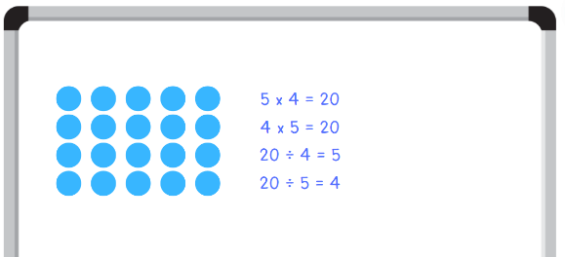

1. Ask Stage 3 students to [Think-Pair-Share](https://app.education.nsw.gov.au/digital-learning-selector/LearningActivity/Card/645) what they notice.
2. Highlight that 20 divided by 5 can also be represented as twenty-fifths. In both instances, the answer is 4. (20 ÷ 5 = 4 and $\frac{20}{5}$ = 4 wholes)
3. Display Resource 35 – matching representations.
4. Students [turn and talk](https://education.nsw.gov.au/teaching-and-learning/curriculum/literacy-and-numeracy/teaching-and-learning-resources/numeracy/talk-moves) to match the blue division symbol representations with the pink fractional representations.
5. Students record their responses on individual whiteboards (see Figure 24).

Figure 24 – matching sample (Stage 3)

A whiteboard with 7 division equations on the left, an equals sign in the middle and a fraction written aligning to each problem on the right.

The equations are: 12 divided by 4 equals twelve-fourths, 3 divided by 4 equals three-fourths, 20 divided by 5 equals twenty-fifths, 9 divided by 4 equals nine-fourths , 15 divided by 5 equals fifteen-fifths, 16 divided by 4 equals sixteen-fourths and 8 divided by 3 equals eight-thirds.


## Core lesson 2 – 20 minutes

### Stage 2 task – array game

1. Select students to share their array and fact family equations from the jellybean problem. Ask:

* What do you notice? Can you spot any patterns?
* How many facts can you record about the array?
* How are the multiplication and division facts related? (inverse operations)
* What do you notice about both the division facts?
* Is this the only array that can be made from 20 dots?

1. In pairs, students cut up Resource 36 – array cards and place facedown in a central pile.
2. Students take turns to flip the top card. Both students record the fact family for the array shown. They also record the alternative array arrangement, where the array is rotated (see Figure 25).

Figure 25 – student work sample

A card containing an array consisting of 2 rows of 4. 

To the right of the card is a whiteboard that has the inverse array of 4 rows of 2 and the following number sentences written on it: 4 × 2 = 8, 2 × 4 = 8, 8 ÷ 2 = 4 and 8 ÷ 4 = 2.

1. Students compare their recordings, discussing the relationship between the multiplication and division facts and the commutative property.

**Commutative property**: commutativity (commutative property) of addition or multiplication means that 2 numbers can be added or multiplied in any order and the solution will be the same. Commutative law, commutativity and turn-around facts are interchangeable terms.

1. Regroup and ask:

* When you rotated the array, did the number of dots change?
* How can knowing the multiplication fact help you solve division problems?
* Is there another way you could represent fact families? (fact family triangles)

### Stage 3 task – division as a fraction

1. Display Resource 37 – Which is equivalent? Pairs [turn and talk](https://education.nsw.gov.au/teaching-and-learning/curriculum/literacy-and-numeracy/teaching-and-learning-resources/numeracy/talk-moves) to identify the correct answer for each question and create a scenario which matches the fraction and division representation.
2. Regroup and select students to share their thinking.

The table below outlines stimulus questions, along with anticipated responses from students.

|  |  |
| --- | --- |
| Prompts | Anticipated student responses |
| * Which equation is equivalent to $\frac{1}{4}$? | * C (1 ÷ 4) is the correct answer because the fraction one-quarter is the same as one divided by 4. If I had one sandwich and I needed to share it with 4 people, I would divide it by 4. Each person would receive one-quarter of the sandwich. |
| * Which equation is equivalent to $\frac{8}{5}$? | * 8 ÷ 5 or C is the equivalent equation. They tried to trick us with A (5 ÷ 8), but the equivalent to that would be $\frac{5}{8}$ not $\frac{8}{5}$. If there were 8 jelly snakes and they needed to be shared amongst 5 children, each child would receive $\frac{8}{5}$ which is also equivalent to 1 $\frac{3}{5}$. That means each child would get one whole snake and $\frac{3}{5}$ of another whole snake. |
| * Which fraction is equivalent to 5 $÷$ 4? | * B ($\frac{5}{4}$) is equivalent to 5 ÷ 4. I first thought C and D could be a correct answer, but then realised 5 quarters is equivalent to 1 $\frac{1}{4}$ not 1 $\frac{4}{5}$ or 1 $\frac{5}{4}$. If this was referring to pizzas, there would be 5 pizzas to be shared between 4 people. Each person would get five-quarters or one whole pizza and an additional one-quarter. |
| * Which fraction is equivalent to 5 $÷$ 6? | * B ($\frac{5}{6}$) is the same as 5 ÷ 6. It cannot be C as 5 ÷ 6 will be smaller than one whole. 5 ÷ 6 could represent 6 friends who are sharing 5 chocolate bars. Each friend would get $\frac{5}{6}$ of a chocolate bar. |

1. Display Resource 38 – dividing wafers. Students [Think-Pair-Share](https://app.education.nsw.gov.au/digital-learning-selector/LearningActivity/Card/645):

* What do you notice?
* What do you wonder?
* How could this resource support Wanda to understand Walter’s statement?

This table details opportunities for differentiation.

|  |  |
| --- | --- |
| Too hard? | Too easy? |
| Stage 2 students cannot model and apply the commutative property of multiplication.   * Provide students with counters to make and rotate the arrays to find the multiplication facts. Encourage students to separate the arrays into equal groups to recognise the related division fact. * Reduce the number of cards or the size of the arrays on the cards they are using.   Stage 3 students cannot recognise that division can be recorded using fractions.   * Provide students with a strip of paper to represent a whole. Ask students to fold the paper into quarters by repeatedly halving. Record 1 ÷ 4 on the board to represent 1 whole being divided into 4 equal parts. Ask students to refer to the strip of paper to identify what the answer to 1 ÷ 4 could be. 1 ÷ 4 = $\frac{1}{4}$. Repeat with eighths, sixths and tenths. | Stage 2 students can model and apply the commutative property of multiplication.   * Challenge students to play ‘Blockout’ in groups of 2 to 4. Make a gameboard by drawing a large rectangle on grid paper. Players choose a colour each, then take turns rolling the dice and colouring in the rectangle given by 2 dice rolls. For example, if you roll a 2 and a 5, you can shade in a 2 by 5 (or 5 by 2) rectangle. No one can colour in a square that has already been coloured. If there is no room to fit the rectangle you rolled on the board, you pass. If all players pass in a row, the game is over. An electronic version of the game can be found on [Polypad](https://mathigon.org/polypad/JQHDndMjUbbTPA). * In pairs, students play ‘[3 in a row](https://www.lovemaths.me/operations-36)’ by Michael Minas. While playing the game, students can record their number sentences on a whiteboard as many ways as they can.   Stage 3 students can recognise that division can be recorded using fractions.   * Students create division problems where the answer is recorded as a fraction. Students record the division equation and the word problem in their workbooks. For example, If there were 4 pizzas shared equally between 5 people, how much pizza does each person receive? Each person receives $\frac{4}{5}$ of a pizza. This could be recorded as 4 ÷ 5. |

## Consolidation and meaningful practice – 10 minutes

1. Separate students into stage groups.
2. Provide each student with one card from Resource 39 – division ‘I have’.

**Multi-age**: the first page of the resource is for Stage 2 students and is recalling multiplication and division facts of 2, 4, 5 and 10. The second page is for Stage 3 students and is recognising the equivalence between division facts and fractions.

1. Select one student to start by reading their card aloud. The student that has the matching statement then reads their card aloud. Play continues until all students have read their cards aloud.

This table details opportunities for assessment.

|  |  |
| --- | --- |
| Assessment opportunities | Links |
| What to look for:   * Can Stage 2 students link multiplication and division fact families using arrays? **[MAO-WM-01, MA2-MR-01, MA2-MR-02]** * Can Stage 2 students generate multiplication fact families for multiples of 2 and 4, 5 and 10? **[MAO-WM-01, MA2-MR-01,  MA2-MR-02]** * Can Stage 2 students model and apply the commutative property of multiplication? **[MAO-WM-01, MA2-MR-01, MA2-MR-02]** * Can Stage 3 students recognise that division can be recorded using fractions? **[MAO-WM-01, MA3-MR-01, MA3-MR-02]** | Links to [National Numeracy Learning Progressions](https://www.australiancurriculum.edu.au/resources/national-literacy-and-numeracy-learning-progressions/version-3-of-national-literacy-and-numeracy-learning-progressions/) (NNLP):   * Stage 2 – MuS5 * Stage 3 – InF6.   Links to suggested [Interview for Student Reasoning](https://education.nsw.gov.au/teaching-and-learning/curriculum/literacy-and-numeracy/assessment-resources/ifsr) (IfSR) tasks:   * Stage 2 – IfSR-MT: 1A.9, 2A.1, 2A.3, 2A.4, 2A.6, 2A.12. |

# Lesson 8

**Core concept**: number properties can be used to solve multiplication problems (Stage 2) and factorising numbers aids mental multiplication (Stage 3).

## Daily number sense – 10 minutes

1. From a class need surfaced through formative assessment data, identify a short, focused activity that targets students’ knowledge, understanding and skills. Example activities may be drawn from the following resources:

* [Mathematics K–6 resources](https://education.nsw.gov.au/teaching-and-learning/curriculum/mathematics/mathematics-curriculum-resources-k-12/mathematics-k-6-resources)
* [Universal Resources Hub](https://resources.education.nsw.gov.au/home).

## Core lesson – 45 minutes

### Stage 2 task – multiplication and division fact families

The table below contains suggested learning intentions and success criteria. These are best co-constructed with students.

|  |  |
| --- | --- |
| Core concept learning intentions | Core concept success criteria |
| Students working towards Stage 2 outcomes are learning to:   * recall multiplication facts of 2 and 4, 5 and 10 and related division facts * use number properties to find related multiplication facts. | Students working towards Stage 2 outcomes can:   * link multiplication and division fact families using arrays * use the commutative property of multiplication * generate and recall multiplication fact families up to 10 × 10. |

1. Display Resource 40 – Creature Cards problem. Read through the problem and discuss the strategies students may use to complete the recording grid.
2. Pose the scenario: Kilian has 12 Creature Cards he wants to attach to page 12. How could he arrange the cards?
3. Students record their arrangement ideas and multiplication and division fact families on whiteboards.
4. Select students to share their answers and justifications.
5. Provide students with Resource 41 – recording grid.
6. Independently or in pairs, students complete Resource 41 – recording grid, ensuring they record the array and multiplication and division fact families for each appropriate number.

**Note**: Resource 41 – recording grid may be printed as an A3 size to allow for easier recording of larger arrays.

This table details opportunities for differentiation.

|  |  |
| --- | --- |
| Too hard? | Too easy? |
| Students cannot generate and recall multiplication fact families up to 10 × 10.   * Support students to use concrete materials to represent the arrays, starting with the range 1 to 20 on Resource 41 – recording grid. Once the array has been created, model how to write a corresponding multiplication and division number sentence. * Assist students by reducing the size of the grid on Resource 41 – recording grid. | Students can generate and recall multiplication fact families up to 10 × 10.   * In groups of 3, students place playing cards in a pile, facedown. Student A and Student B pick up a card each and hold it facing out on their forehead. These students **do not** look at their own card. Student C multiplies the numbers on the 2 cards they can see and calls out the answer. Students A and B must work out from the answer, the value of the card on their forehead. The game is repeated with the players swapping their roles. * In pairs, students play Scissors, Paper, Rock. As they say the final word such as scissors, paper, **rock**, they reveal a number with their fingers. For example, Student A may hold up 6 fingers and Student B may hold up 3. The calculation that needs to be solved is 6 × 3. The first student to get the correct answer gets a point. Repeat. |

### Stage 3 task – factorising numbers

The table below contains suggested learning intentions and success criteria. These are best co-constructed with students.

|  |  |
| --- | --- |
| Core concept learning intentions | Core concept success criteria |
| Students working towards Stage 3 outcomes are learning to:   * select and apply mental and written strategies to multiply 2- and 3-digit numbers by 2-digit numbers. | Students working towards Stage 3 outcomes can:   * factorise numbers to aid mental multiplication * solve multiplication word problems. |

1. Display Resource 42 – multiplicative properties.
2. Explain that the number sentences represented in the grey rectangles are examples of the multiplicative properties: commutative, associative and distributive.
3. Ask students to [Think-Pair-Share](https://app.education.nsw.gov.au/digital-learning-selector/LearningActivity/Card/645) and match each multiplicative property to the number sentence A, B or C, and provide reasons for their choices.
4. Highlight that the associative property may support working flexibly when factorising. For example, to determine the factors of 40, 5 × 8 is the same as 5 × (2 × 4), which is the same as (5 × 2) × 4 which becomes 10 × 4. This helps to find 5, 8, 2, 4 and 10 as factors of 40 (as well as 1, 40 and 20).
5. Display Resource 43 – camper breakfast problem.

The table below outlines stimulus prompts to generate conversation about the topic, along with anticipated responses from students.

|  |  |
| --- | --- |
| Prompts | Anticipated student responses |
| * What is the key information that will help solve the word problem? | * 15 campers * Each camper ate 2 cups of cereal every morning * Each cup contained 40 grams of cereal. |
| * What information is not needed to solve the word problem? | * I did not need the 3 types of cereal information to solve this problem. |

1. Display Resource 44 – Hugo, Jeremy, Rana.
2. Students consider the ways these students solved the campers breakfast problem. Ask:

* Which student’s approach do you think is efficient?
* Which multiplicative properties have been represented in the students’ solutions? (Rana used the commutative property to multiply 10 by 15 before multiplying by 8. Jeremy and Rana have both represented the associative property, by starting with 15 × 80 rather than 15 × 40 × 2)
* How did Hugo, Jeremy and Rana use factorisation to help them solve the problem?
* Can you think of another way to use factorisation to aid mental multiplication for this question?

1. Provide pairs with Resource 45 – word problems. Students work together to solve the problems by factorising numbers to aid in mental multiplication. Students record at least 2 ways to solve each problem.
2. Regroup and select students to share answers and strategies, highlighting solution methods that used factorisation.

This table details opportunities for differentiation.

|  |  |
| --- | --- |
| Too hard? | Too easy? |
| Students cannot factorise numbers to aid mental multiplication.   * Use concrete materials like blocks or counters to demonstrate how factors work. For example, show how 12 can be represented as 2 rows of 6 counters or 3 rows of 4 counters. * Students determine all the factors for each problem prior to deciding on a solution method. | Students can factorise numbers to aid mental multiplication.   * Students create their own multiplicative word problems using 2- and 3-digit numbers for a partner to solve. * Students create word problems where factorisation is unable to be used to aid mental multiplication and justify their reasoning. |

## Discuss and connect the mathematics – 10 minutes

### Stage 2

1. Regroup and referring to Resource 41 – recording grid, ask:

* Have you created the same array for each number as your classmates? Why or why not?
* Why can some numbers only be represented one way, whereas other numbers have multiple options?
* Do you notice any patterns in the numbers that can be represented in several different ways?

### Stage 3

1. To check for understanding, ask students to solve 24 × 16 = _? using a strategy with factorisation on their whiteboard.
2. As a class discuss:

* Is factorisation helpful to solve this problem? Why or why not? (both numbers have multiple factors which offers lots of flexible options)
* What other strategies could be used to aid mental computation to solve this problem? (24 × 10 = 240 and 24 × 6 = 144. 240 + 144 = 384 or 24 × 2 × 2 × 2 × 2)
* Which strategy would be considered most efficient? Explain your reasoning and justification.

This table details opportunities for assessment.

|  |  |
| --- | --- |
| Assessment opportunities | Links |
| What to look for:   * Can Stage 2 students link multiplication and division fact families using arrays? **[MAO-WM-01, MA2-MR-01]** * Can Stage 2 students use the commutative property of multiplication? **[MAO-WM-01, MA2-MR-01]** * Can Stage 2 students generate and recall multiplication fact families up to 10 × 10? **[MAO-WM-01, MA2-MR-01]** * Can Stage 3 students factorise numbers to aid mental multiplication? **[MAO-WM-01, MA3-MR-01]** * Can Stage 3 students solve multiplication word problems?  **[MAO-WM-01, MA3-MR-01]** | Links to [National Numeracy Learning Progressions](https://www.australiancurriculum.edu.au/resources/national-literacy-and-numeracy-learning-progressions/version-3-of-national-literacy-and-numeracy-learning-progressions/) (NNLP):   * Stage 2 – MuS6, MuS7 * Stage 3 – MuS6, MuS7.   Links to suggested [Interview for Student Reasoning](https://education.nsw.gov.au/teaching-and-learning/curriculum/literacy-and-numeracy/assessment-resources/ifsr) (IfSR) tasks:   * Stage 2 – IfSR-MT: 2A.4 - 2A.7 * Stage 3 – IfSR-MT: 3A.3. |

# Resource 1 – camp map (Stage 2)

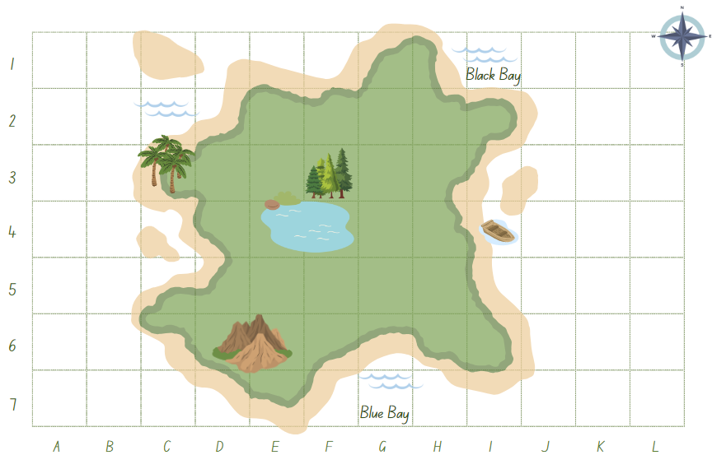

# Resource 2 – camp map (Stage 3)

A camp adventure map divided into a grid with various symbols.

The map includes icons for canoeing at −3, −2, archery at −1, −1, campfire at 2, 4, campground at 3, −1, camp kitchen at 1, 1, hiking at −2, 2 and toilets at −1, −4.

A compass rose indicates directions. Coordinates range from −5 to 5 on both axes.

# Resource 3 – camp locations (Stage 2)

The instruction reads: Cut out and paste the camp activities and landmarks on the map at their grid references. 

There is a table containing images and their grid references below.  Shipwreck: K5, hiking: E2, canoeing: C5, Blue campground: H5, camp kitchen: G3, archery: E5, campfire: G1 and toilets: F6.

# Resource 4 – camp locations (Stage 3)

A map activity with the instructions: Locate the landmark or activity on the map and record the coordinates.

It shows tables to record coordinates of specific landmarks/activities like a campground, camp kitchen, camp fire, toilets, archery, hiking, canoeing and compass. 

Below, there is an instruction to plot the following locations on the Cartesian plane and update the map’s key.
The landmarks/activities are, fishing spot (-2,4), high ropes (1,-1), snorkelling (-4,-1) and night walk (1,2).

# Resource 5 – adventure island (Stage 2)

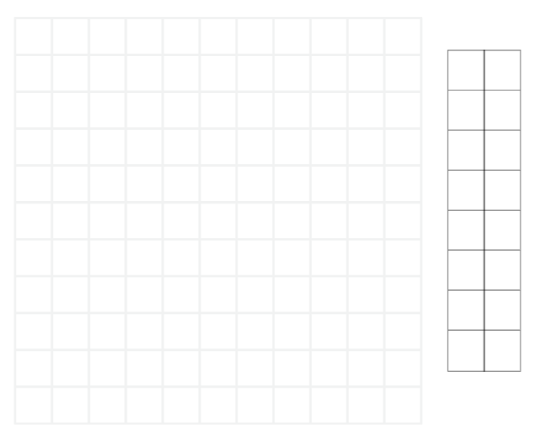

# Resource 6 – adventure island (Stage 3)

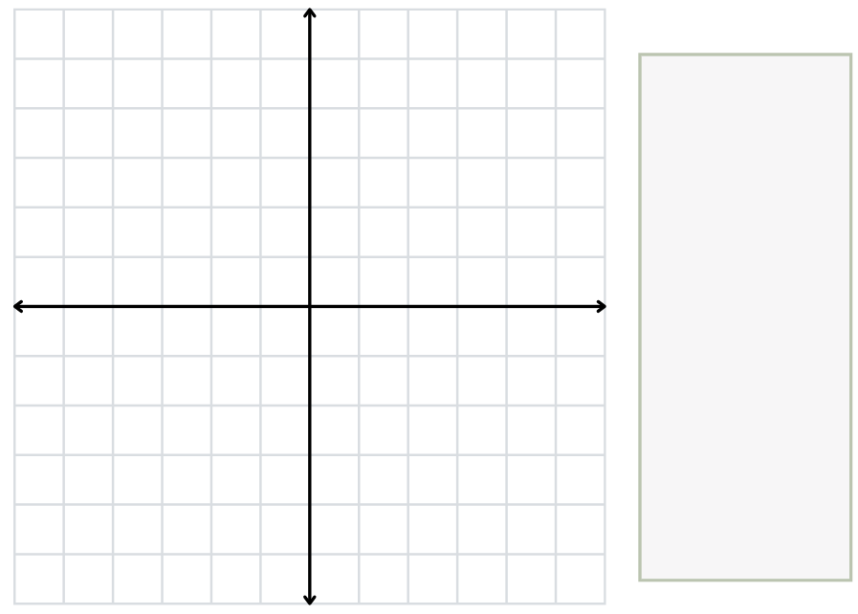

# Resource 7 – gameboard 1

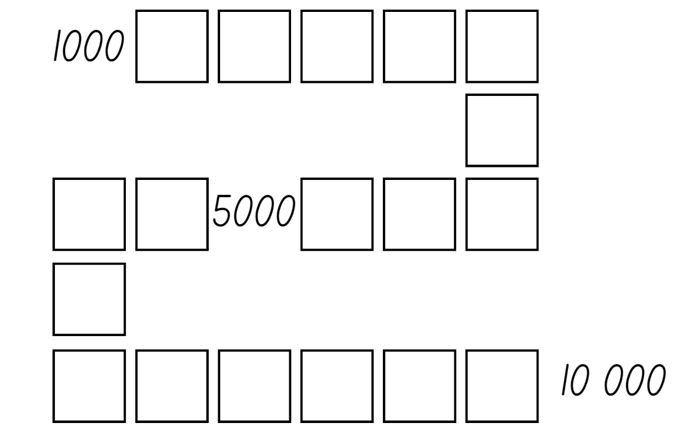

# Resource 8 – gameboard 2

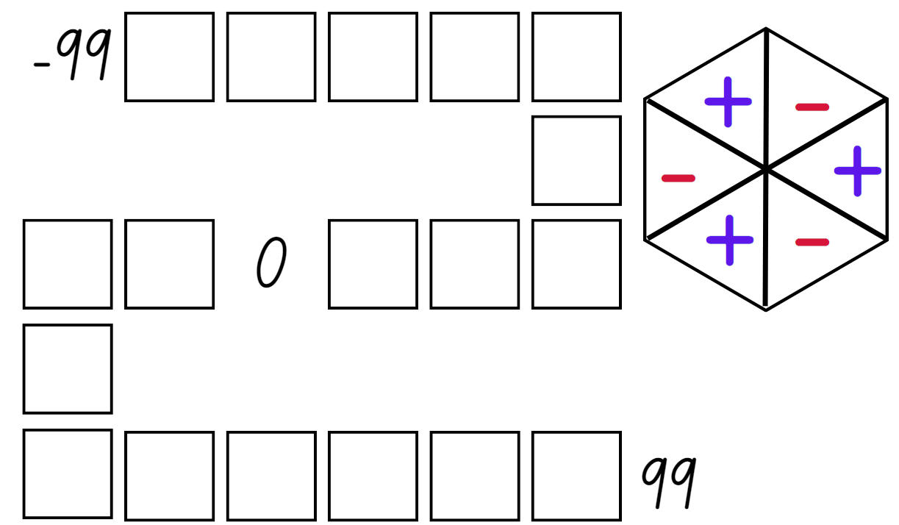

# Resource 9 – place value visual

Four boxes containing MAB materials and place value houses side-by-side.

Each box contains a number and the equivalent number of MAB materials. The numbers 5, 50, 500 and 5000 are represented.

The place value houses contain a number increasing by 10 in each row from 5 to 5000. For example, 5, 50, 500, 5000.

# Resource 10 – place value houses

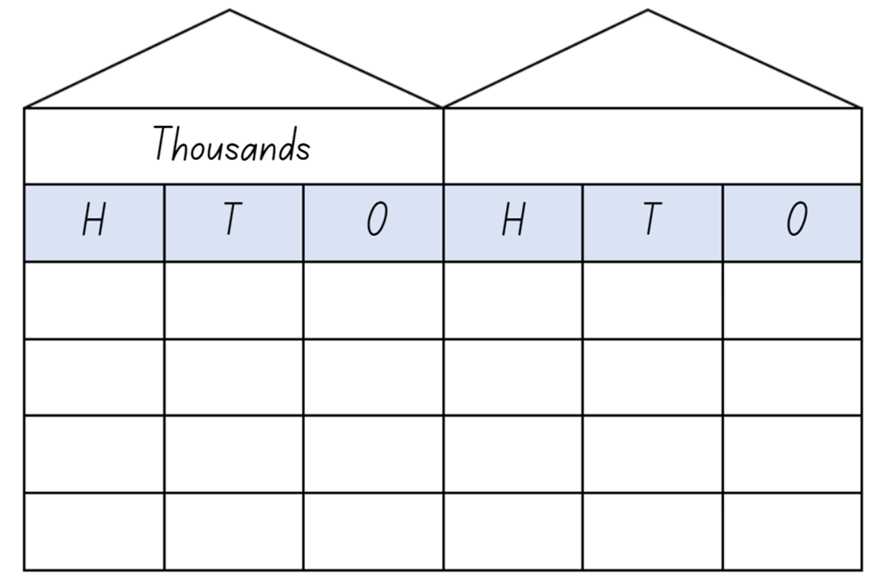

# Resource 11 – spinners

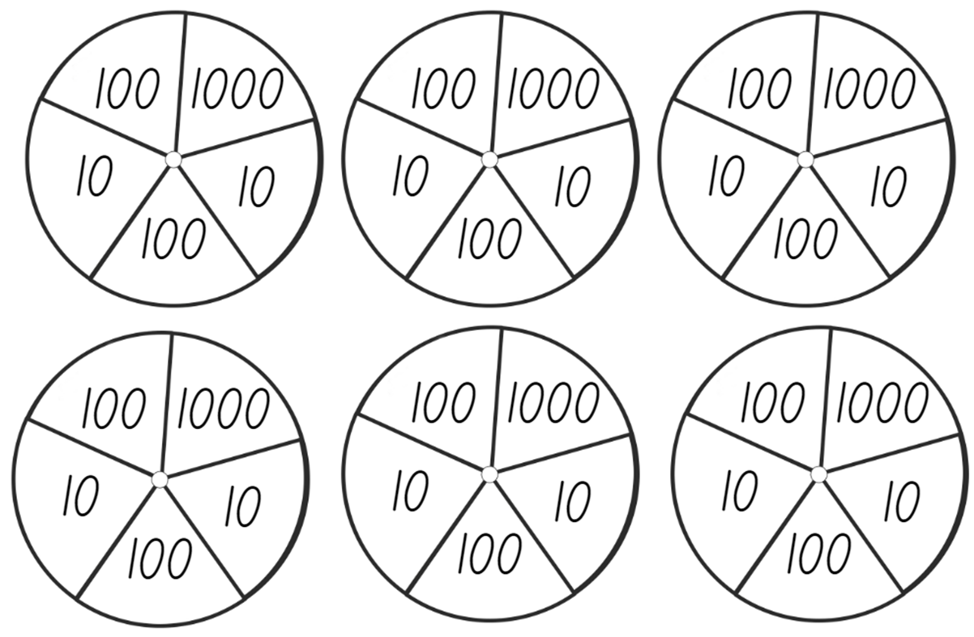

# Resource 12 – cards

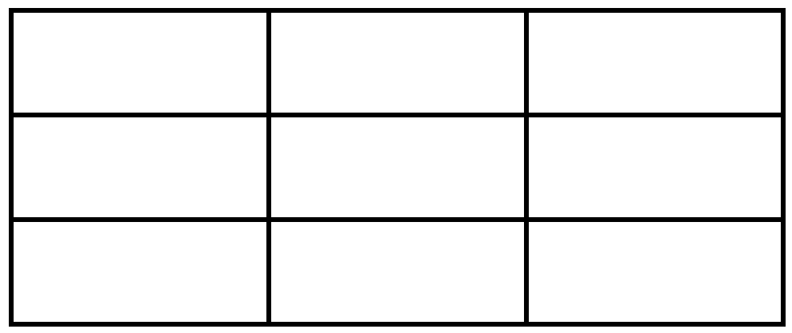

# Resource 13 – ‘Epic money’ game

There are 3 children: Nash, Flynn and Ava. Underneath the children are piles of money.

Nash has two $100 notes and a $10 note.

Flynn has one $100 note and eleven $10 notes.

Ava has three $100 notes, four $10 notes and three $1.00 notes.

# Resource 14 – partitioning $473

A Frayer model with 3 sections: 2 smaller equal sections at the top and a larger section at the bottom. 

The amount $473 is written in the centre.

The instructions read: Can you find different ways to make $473 with $100, $10 and $1 notes?

# Resource 15 – integer number line

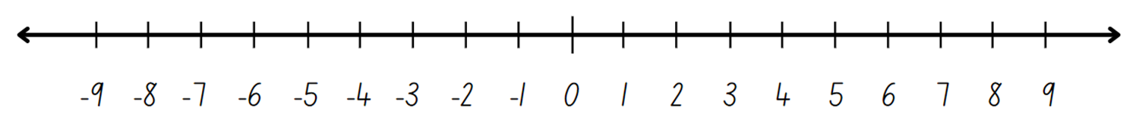

# Resource 16 – integer spinner

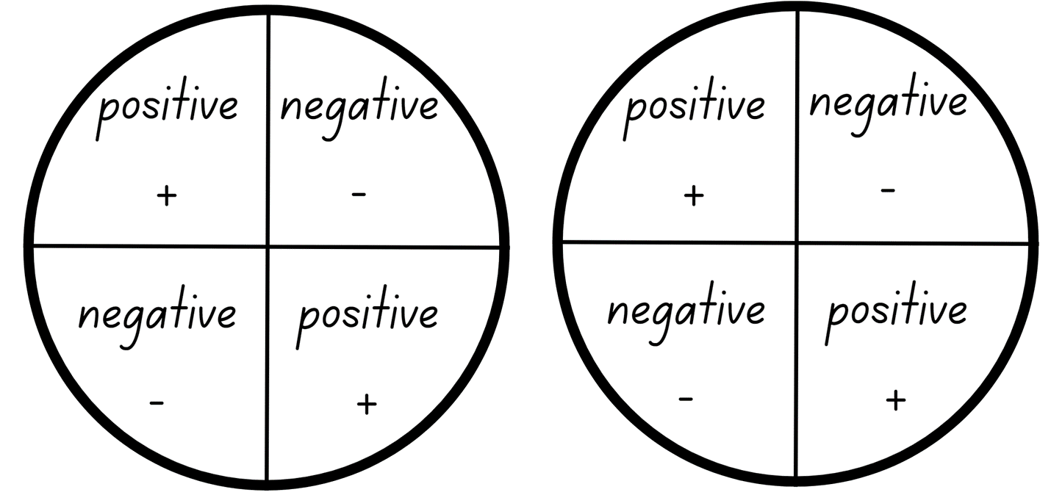

# Resource 17 – number sentence board

Empty number sentences. Space for the numbers are in the shape or size of a playing card.

The order is: card + card = card + card and in the second row, the order is: card − card = card − card.

# Resource 18 – True or false?

|  |  |  |
| --- | --- | --- |
| 569 + 365 = 651 + 283  True or false? | 191 + 711 = 679 + 134  True or false? | 4124 + 3641 = 2048 + 5717  True or false? |
| 428 + 798 = 568 + 658  True or false? | 5564 + 1457 = 5148 + 2085  True or false? | 2887 + 3564 = 4013 + 2438  True or false? |

# Resource 19 – additive strategies poster

A poster listing 10 types of additive strategies as follows:
1. Compensation – adjusting numbers to make a calculation more efficient. 
2. Commutative property of addition – two numbers can be added in any order and the sum is equivalent. 
3. Constant difference – a common difference between pairs of numbers when completing subtraction. 
4. Inverse operations – addition and subtraction are inverse operations. 
5. Equivalence - different equations can have the same value. 
6. Landmark numbers – ‘friendly numbers’ that are easy to work with fluently, flexibly and efficiently. 
7. Levelling – adjusting to landmark numbers to add efficiently. 
8. Partitioning – splitting numbers into smaller parts to make calculations easier. 
9. Algorithms – a set of written steps to calculate, using partitioning and regrouping.
10. Associative property of addition – more than two numbers can be added in any order to make it more efficient. 


# Resource 20 – King’s tax

|  |  |  |
| --- | --- | --- |
| **Card** | **Stage 2 values** | **Stage 3 values** |
| 1 Ace of hearts. | $1 | $1.25 |
| 2 Two of diamonds. | $2 | $2.10 |
| 3 Three of diamonds. | $3 | $3.50 |
| 4 Four of spades. | $4 | $4.75 |
| 5 Five of spades. | $5 | $5.05 |
| 6 Six of hearts. | $6 | $6.45 |
| 7 Seven of diamonds. | $7 | $7.70 |
| 8 Eight of hearts. | $8 | $8.15 |
| 9 Nine of clubs. | $9 | $9.80 |
| 10 Ten of diamonds. | $10 | $10.20 |
| Jack Jack. | Bonus $15 | Bonus $15.25 |
| Queen Queen. | Double your total for this round | Double your total for this round |
| King King. | King collects his taxes | King collects his taxes |
| Joker Joker. | – | Determined by the winner of the last round |

# Resource 21 – dominoes

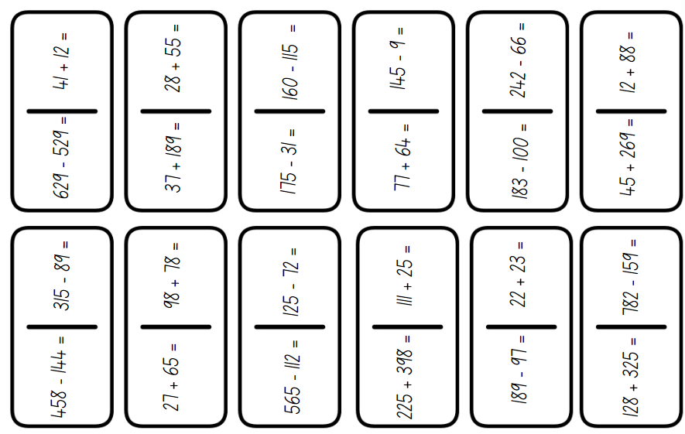

# Resource 22 – adapted dominoes

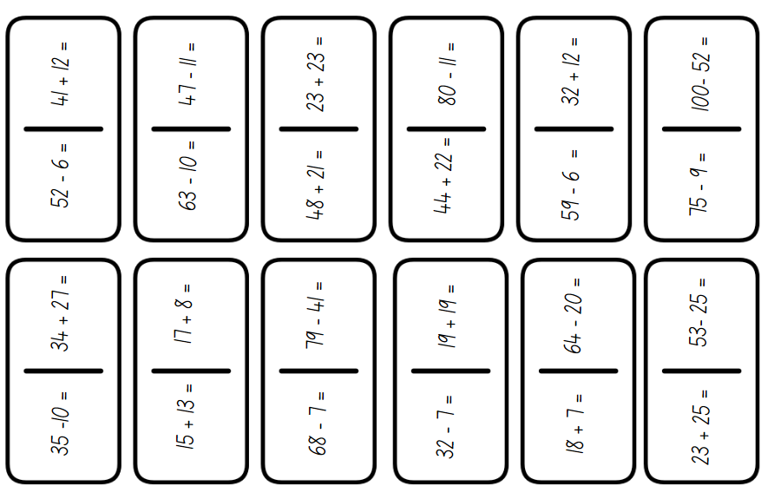

# Resource 23 – blank dominoes

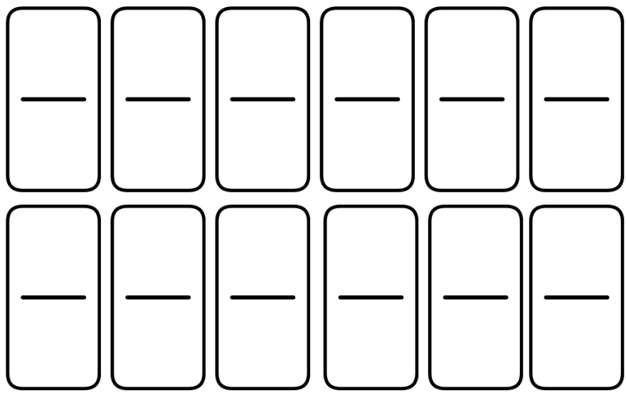

# Resource 24 – bar models

Four horizontal bar models labeled A, B, C and D, partially shaded in different colours.

A is three-quarters blue, B is one-quarter yellow, C has all 4 quarters shaded red and D is two-quarters green.

Written at the bottom of the image are 3 questions: What percentage of each bar is shaded? What fraction of each bar is shaded? How could you record this as an equivalent decimal?


# Resource 25 – complement principle

Four bar models. The first bar model has the number 89 in the top bar and 67 + 22 split in the bottom. Next to the model is text that reads: If 89 − 22 = 67, what is 89 − 67?.

The second bar model has the number 76 in the top bar and blank + 36 split in the bottom.

The third bar model has the number 55 in the top bar and 45 + blank split in the bottom.

The fourth bar model has the number 97 in the top bar and blank + 33 split in the bottom.

The instruction reads: Write addition and subtraction number sentences using the complement principal.

# Resource 26 – percentages jigsaw

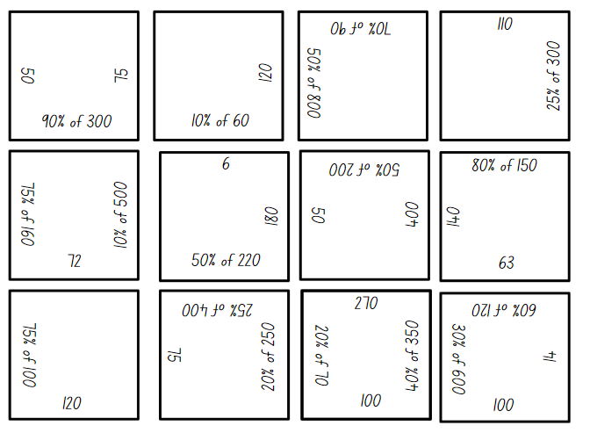

# Resource 27 – dollars and cents

# There are 2 children sitting, Zac and Gigi. They both have speech bubbles coming from their mouths. Zac’s says: ‘I have more money because I have got gold coins and they're worth more!’ Gigi’s says: ‘I have more money because I have 10 coins and you only have 2!’ Underneath Zac is a piggy bank containing two $1.00 coins. Underneath GiGi is a piggy bank containing: two 50 cent coins, three 20 cent coins, three 10 cent coins and two 5 cent coins. In the centre of the image, there is text that reads ‘Who has more money?’Resource 28 – super summer saleA Super Summer Sale catalogue with discounts from 10–50% off. The sale prices for the items that have been reduced by 50% are: Tennis paddles $10. Flamingo float $7.50. Beach umbrella $60. The sale prices for the items that have been reduced by 25% are: Beach ball $7.50. Cricket set $18.75. Fishing rod $22.50. The sale prices for the items that have been reduced by 10% are: Beach toys $10.80. Stand-up paddleboard $162. Snorkel set $13.50.

# Resource 29 – money problems

1. Narlah wanted to buy the beach toys. Represent and record 5 different ways she could make $10.80 with notes and coins. Which combination did you record that used the least number of notes and/or coins and the most number of notes and/or coins?
2. Maddox bought the cricket set. What would his change be from $20?
3. Piper has $25. What could she buy from the super summer sale? Try and find more than one possibility.
4. Elle, Eve and Chloe want to combine their money to buy the paddleboard. Elle has $60, Eve has $55 and Chloe has $35. Do they have enough money? How do you know? What is the difference between their combined money and the cost of the paddleboard?
5. Vacation care needs to order supplies for their beach day during the school holidays. They have a budget of $250. What would you suggest they buy? (Remember, they may need more than one of each item.)

# Resource 30 – 2-way radios

Promotional graphic showing a pair of 2-way radios with the recommended retail price of $80. 

A local shop is advertising 10% off all products, an online store is advertising 25% off all products and a garage sale is advertising 50% off all products.

# Resource 31 – super camping sale

A Super Camping Sale catalogue with discounts from 10–50% off. Students are to calculate the discounted price after being shown the recommended retail price (RRP).

The RRP prices for the items that have been reduced by 50% are:
Camp stove and kettle $166.
Drone $370.
Fishing rod $248.

The RRP prices for the items that have been reduced by 25% are:
Instant pop-up tent $280.
Sleeping bag and camp bed $140.
Portable speaker $180.

The RRP prices for the items that have been reduced by 10% are:
Deluxe camp chair $120.
Stand-up paddleboard $380.
Kayak $360.

# Resource 32 – 3 arrays

The title reads: The students were shown these 3 arrays. A: 8 by 3, B: 3 by 5 and C: 5 by 3.
They were asked which array is the odd one out. 

Dom has a speech bubble that says: A is the odd one out because its total isn't 15.

Samira has a speech bubble that says: B is the odd one out because it has not got 3 rows.

The text below reads: There is a question asking: Who is correct?

# Resource 33 – Wanda’s ponder

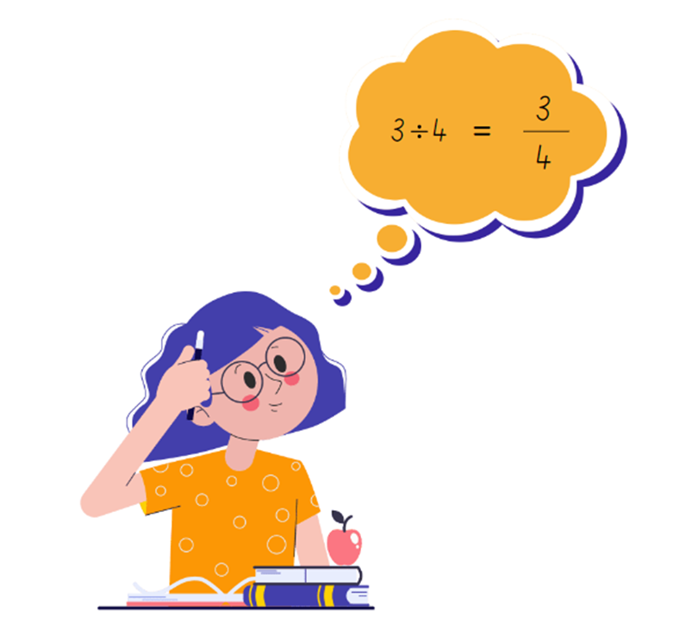

# Resource 34 – dividing jellybeans

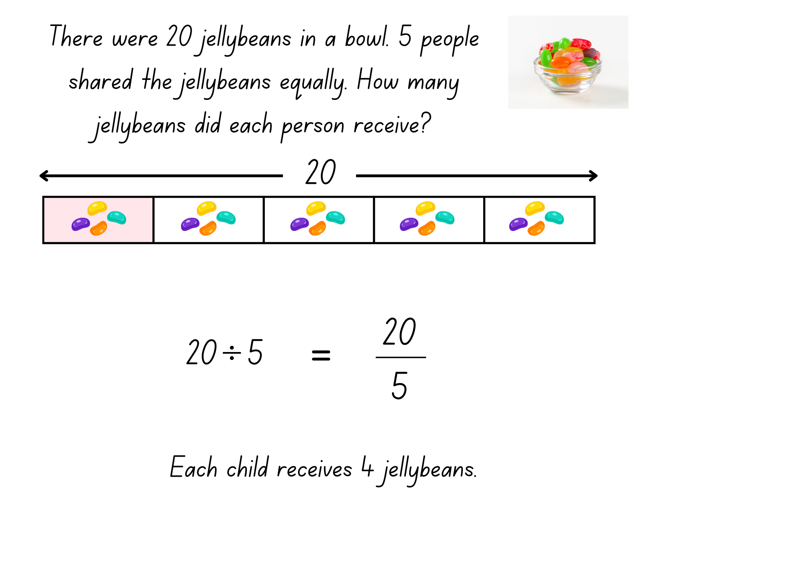

# Resource 35 – matching representations

A worksheet featuring division problems and simplified fractions.

The left-hand column, highlighted in blue, contains the following division problems: A: 12 ÷ 4, B: 3 ÷ 4, C: 20 ÷ 5, D: 9 ÷ 4, E: 15 ÷ 5, F: 16 ÷ 4 and G: 8 ÷ 3.

The right-hand column, highlighted in pink, contains the following simplified fractions: A: 20/5, B: 9/4, C: 3/4, D: 12/4, E: 16/4, F: 15/5 and G: 8/3.

# Resource 36 – array cards

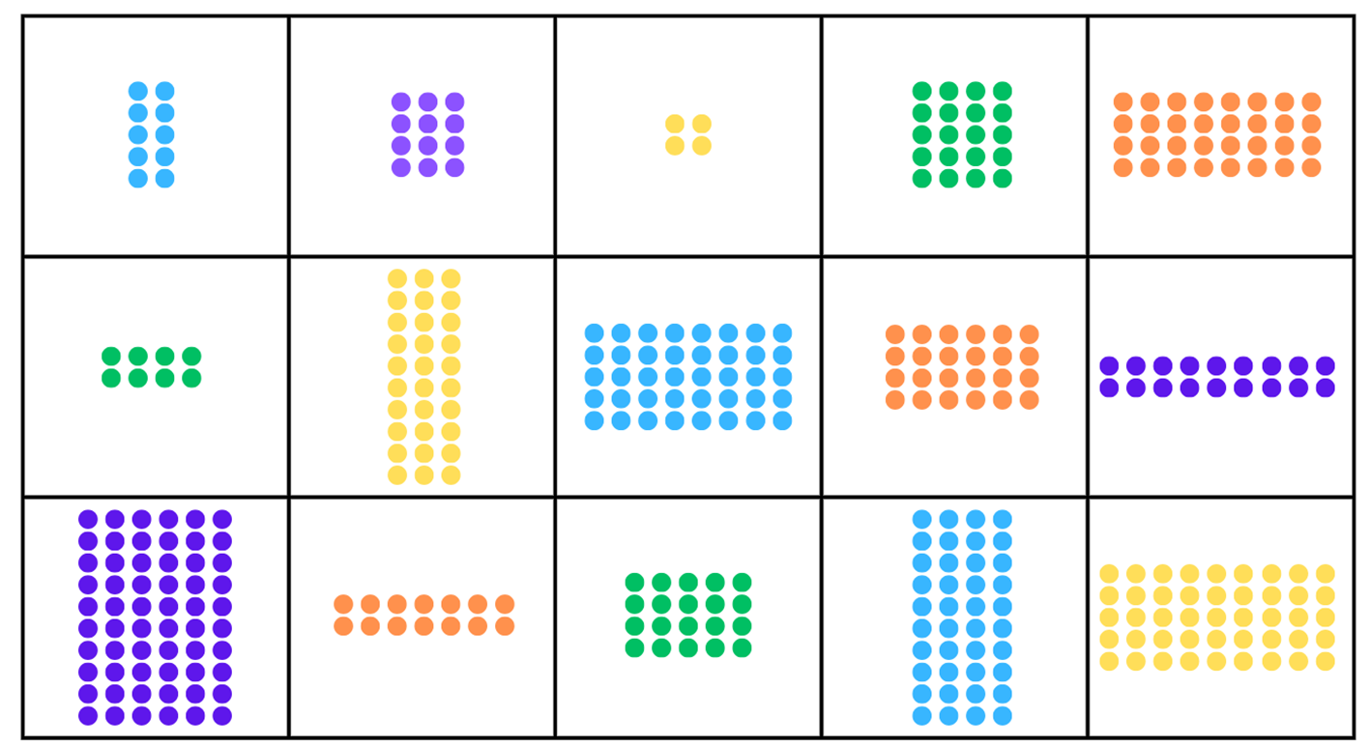

# Resource 37 – Which is equivalent?

Four problems asking for equivalent equations or fractions.

Problem 1 reads: Which equation is equivalent to 1/4? A: 4 ÷ 1 B: 3 ÷ 4 C: 1 ÷ 4 D: 2 ÷ 4.

Problem 2 reads: Which equation is equivalent to 8/5? A: 5 ÷ 8, B: 10 ÷ 4, C: 8 ÷ 5, and D: 4 ÷ 5.

Problem 3 reads: Which fraction is equivalent to 5 divided by 4? A: 4/5, B: 5/4, C: 1 and 4/5 and D: 1 and 5/4. 

Problem 4 reads: Which fraction is equivalent to 5 divided by 6? A: 6/5, B: 5/6, C 1 and 1/6 and D: 1/5.

# Resource 38 – dividing wafers

A mathematical diagram showing how 3 wafers can be divided equally among 4 children, with each child receiving 3/4 of a wafer.

The problem at the top of the image is: There were 3 wafers left in a packet. How could the wafers be shared equally amongst 4 children?

Written at the bottom of the diagram is 3 divided by 4 equals 3/4. Each child gets 3 quarters of a wafer.

# Resource 39 – division ‘I have’

|  |  |  |  |  |
| --- | --- | --- | --- | --- |
| **I have 12.**  Who has 20 shared between 5? | **I have 4.**  Who has 5 twos? | **I have 10.**  Who has 15 shared between 3? | **I have 5.**  Who has 4 tens? | **I have 40.**  Who has 90 shared between 10? |
| **I have 9.**  Who has 2 eights? | **I have 16.**  Who has 30 shared between 5? | **I have 6.**  Who has 2 fours? | **I have 8.**  Who has 10 shared between 10? | **I have 1.**  Who has 10 fives? |
| **I have 50.**  Who has 12 shared between 4? | **I have 3.**  Who has 2 twelves? | **I have 24**.  Who has 20 shared between 10? | **I have 2.**  Who has 3 fives? | **I have 15.**  Who has 3 fours? |

|  |  |  |  |  |  |
| --- | --- | --- | --- | --- | --- |
| **I have 12 thirds.**  Who has 25 divided by 5? | **I have 25 fifths.**  Who has 3 ÷ 2? | **I have 3 halves.**  Who has 24 divided by 4? | **I have 24 quarters.**  Who has 15 thirds? | **I have 15 ÷ 3.**  Who has 8 halves? | **I have 8 divided by 2.**  Who has 18 halves? |
| **I have 18 ÷ 2.**  Who has 20 quarters? | **I have 20 divided by 4.**  Who has 9 thirds? | **I have 9 divided by 3.**  Who has 20 divided by 5? | **I have 20 fifths.**  Who has 6 divided by 2? | **I have 6 halves.**  Who has 10 fifths? | **I have 10 divided by 5.**  Who has 30 fifths? |
| **I have 30 divided by 5.**  Who has 35 fifths? | **I have 35 ÷ 5.**  Who has 28 quarters? | **I have 28 divided by 4.**  Who has 42 ÷ 6? | **I have 42 sixths.**  Who has 48 sixths? | **I have 48 divided by 6.**  Who has 50 tenths? | **I have 50 divided by 10.**  Who has 12 ÷ 4? |
| **I have 12 quarters.**  Who has 21 divided by 3? | **I have 21 thirds.**  Who has 5 divided by 2? | **I have 5 halves.**  Who has 8 divided by 3? | **I have 8 thirds.**  Who has 12 divided by 2? | **I have 12 halves.**  Who has 4 ÷ 4? | **I have 4 quarters.**  Who has 10 tenths? |
| **I have 10 ÷ 10.**  Who has 6 divided by 3? | **I have 6 thirds.**  Who has 5 divided by 5? | **I have 5 fifths.**  Who has 7 divided by 3? | **I have 7 thirds.**  Who has 14 divided by 2? | **I have 14 halves.**  Who has 24 divided by 2? | **I have 24 halves.**  Who has 12 divided by 3? |

# Resource 40 – Creature Cards problem

An illustrated guide on using a ‘Creature Cards’ collector’s album to display and organise trading cards. 

It includes rules for placing cards and a multiplication and division facts example page layout.

The rules are as follows:
⦁ the page number indicates the amount of cards that can be attached to the page
⦁ each page must contain an array at least 2 rows high and 2 columns wide
⦁ the maximum array size for the collectors album is 100.
⦁ pages used must be recorded on the recording page. It must include the array and both the multiplication and division facts.

Students must determine which pages of the collectors album can be used, what the array could look like and record the relevant multiplication and division facts.

# Resource 41 – recording grid

|  |  |  |  |  |  |  |  |  |  |
| --- | --- | --- | --- | --- | --- | --- | --- | --- | --- |
| 1 | 2 | 3 | 4 | 5 | 6 | 7 | 8 | 9 | 10 |
| 11 | 12 | 13 | 14 | 15 | 16 | 17 | 18 | 19 | 20 |
| 21 | 22 | 23 | 24 | 25 | 26 | 27 | 28 | 29 | 30 |
| 31 | 32 | 33 | 34 | 35 | 36 | 37 | 38 | 39 | 40 |
| 41 | 42 | 43 | 44 | 45 | 46 | 47 | 48 | 49 | 50 |
| 51 | 52 | 53 | 54 | 55 | 56 | 57 | 58 | 59 | 60 |
| 61 | 62 | 63 | 64 | 65 | 66 | 67 | 68 | 69 | 70 |
| 71 | 72 | 73 | 74 | 75 | 76 | 77 | 78 | 79 | 80 |
| 81 | 82 | 83 | 84 | 85 | 86 | 87 | 88 | 89 | 90 |
| 91 | 92 | 93 | 94 | 95 | 96 | 97 | 98 | 99 | 100 |

# Resource 42 – multiplicative properties

Question; A camp organiser needs to set up 25 tents. Each tent requires 15 stakes to secure it to the ground. How many stakes are needed in total?
Three equations have been displayed:
A. 25 × 15 = (5 × 5) × (3 × 5)
B. (25 × 10) + (25 × 5)
C. 25 × 15 = 15 × 25.

Underneath the equations are explanations for 3 multiplicative strategies.

1. Commutative property: Commutative property related to multiplication means that two numbers can be multiplied in any order and the product is the same, 4 × 6 = 6 × 4. Commutative law, commutativity and turn-around facts are interchangeable terms.

2. Associative property: The associative property applies when more than 2 numbers are added or multiplied, the result is unchanged regardless of how they are grouped or associated. For example, 6 × 3 × 2 can be calculated as 18 × 2 or 6 × 6 or 12 × 3.

3. Distributive property: This allows us to distribute a given number in the operation to solve the multiplication more easily. Multiplying the sum of two or more numbers is the same as multiplying the addends separately.

For example, 7 × 3 is the same as the sum of 5 × 3 and 2 × 3. The 7 has been partitioned (distributed).

# Resource 43 – camper breakfast problem

Camp Adventure has 15 campers for breakfast each morning. They serve breakfast with 3 different kinds of cereal. If each camper eats 2 cups of cereal, and each cup contains 40 grams of cereal, how many grams of cereal are needed for breakfast each morning?

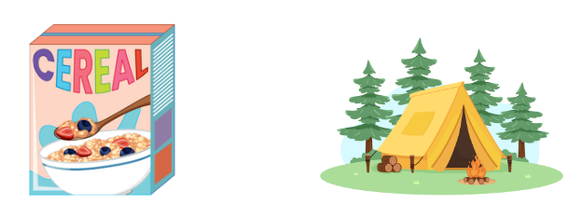

# Resource 44 – Hugo, Jeremy, Rana

Three students holding whiteboards with different methods to solve the camper breakfast problem. 

Hugo used the factors of 40 to solve 15 × 40 × 2, Jeremy used doubling and halving to solve 15 × 80 and Rana used factors of 80 to solve 15 × 80.

The multiplication problem has been written in expanded notation on each whiteboard for each strategy used.

# Resource 45 – word problems

|  |  |
| --- | --- |
| 1. A class of students are going on a camping trip to celebrate the end of the school year. The cost will be $65 for a student to camp per night. The students are planning to stay for 12 nights. How much will the trip cost for each student if they stay for 12 nights? | 1. A group of 15 students have volunteered to help clean up a local campsite after a big storm. The campsite manager is extremely grateful and has decided to give each student $220 for their hard work. If each student receives $220, how much money in total will the campsite manager pay the group? |
| 1. 22 students are preparing for a big hiking challenge during their camping trip. The students have to hike 180 metres of elevation to reach the top of a nearby hill. The teacher wants to calculate the total elevation gain for the entire class once all students have reached the top. What is the total elevation for all 22 students combined? | 1. A team of 14 explorers are embarking on a camping expedition. Each explorer needs to carry 40 kilograms of supplies, including food, water and equipment. If each explorer carries 40 kilograms of supplies, what is the total weight of all the supplies the team will be carrying? |
| 1. A group of Scouts is setting up a campsite for their annual camping competition. They have 18 tents and each tent can accommodate 15 Scouts. How many Scouts can the campsite accommodate in total if all tents are full? | 1. A group of 13 explorers are setting up their campsite. Each explorer is responsible for measuring 22 metres of the safety perimeter needed for their designated camping area. How many meters of safety perimeter will the entire group measure for their camping area? If the safety perimeter was rectangular, what would be the dimensions of the camping area? |

# Syllabus outcomes and content

## Stage 2

The table below outlines the [syllabus outcomes](https://curriculum.nsw.edu.au/learning-areas/mathematics/mathematics-k-10-2022/overview) and range of relevant syllabus content covered in this unit. Content is linked to [National Numeracy Learning Progression](https://www.australiancurriculum.edu.au/resources/national-literacy-and-numeracy-learning-progressions/version-3-of-national-literacy-and-numeracy-learning-progressions/) (version 3).

|  |  |  |  |  |  |  |  |  |
| --- | --- | --- | --- | --- | --- | --- | --- | --- |
| Outcomes and content | 1 | 2 | 3 | 4 | 5 | 6 | 7 | 8 |
| **Representing numbers using place value A: Whole numbers: Read, represent and order numbers to thousands**  **MAO-WM-01, MA2-RN-01** |  |  |  |  |  |  |  |  |
| * Represent numbers up to and including thousands using physical or virtual manipulatives, words, numerals, diagrams and digital displays | x |  | x |  |  |  |  |  |
| * Read and order numbers of up to at least 4 digits | x | x | x |  |  |  |  |  |
| **Representing numbers using place value A: Whole numbers: Apply place value to partition and regroup numbers up to 4 digits**  **MAO-WM-01, MA2-RN-01** |  |  |  |  |  |  |  |  |
| * Partition numbers of up to 4 digits in non-standard forms (Reasons about quantity) |  | x |  |  |  |  |  |  |
| **Representing numbers using place value B: Whole numbers: Recognise and represent numbers that are 10, 100 or 1000 times as large**  **MAO-WM-01, MA2-RN-01** |  |  |  |  |  |  |  |  |
| * Describe how making a number 10, 100 or 1000 times as large changes the place value of digits |  | x |  |  |  |  |  |  |
| **Additive relations A: Use the principle of equality**  **MAO-WM-01, MA2-AR-01** |  |  |  |  |  |  |  |  |
| * Recognise equal differences and record them in number sentences |  |  | x |  |  |  |  |  |
| * Use the equals sign to mean 'the same as', rather than to perform an operation |  |  | x |  |  |  |  |  |
| * Apply the associative property of addition to forming multiples of 10 (Reasons about relations) |  |  | x |  |  |  |  |  |
| **Additive relations A: Recognise and explain the connection between addition and subtraction**  **MAO-WM-01, MA2-AR-01** |  |  |  |  |  |  |  |  |
| * Use the complement principle of addition and subtraction (Reasons about relations) |  |  |  |  | x |  |  |  |
| **Additive relations A: Select strategies flexibly to solve addition and subtraction problems of up to 3 digits**  **MAO-WM-01, MA2-AR-01** |  |  |  |  |  |  |  |  |
| * Apply known mental strategies that use partitioning to add and subtract, such as bridging the decades |  |  |  |  | x | x | x |  |
| * Use the compensation strategy to add and subtract (Reasons about relations) |  |  |  | x |  |  |  |  |
| * Apply the levelling and constant difference strategies (Reasons about relations) |  |  |  | x |  |  |  |  |
| * Represent solutions to addition and subtraction problems, including word problems, using an empty number line or bar model |  |  |  |  |  | x | x |  |
| * Compare and evaluate strategies used to solve addition and subtraction problems, reasoning which strategy may be most efficient |  |  |  | x | x |  |  |  |
| **Additive relations A: Represent money values in multiple ways**  **MAO-WM-01, MA2-AR-01, MA2-AR-02** |  |  |  |  |  |  |  |  |
| * Recognise the relationship between dollars and cents |  |  |  |  |  | x |  |  |
| * Represent equivalent amounts of money using different denominations |  |  |  |  |  | x |  |  |
| * Perform calculations with money, including finding change |  |  |  |  |  | x |  |  |
| **Multiplicative relations A: Recall multiplication facts of 2 and 4, 5 and 10 and related division facts**  **MAO-WM-01, MA2-MR-01, MA2-MR-02** |  |  |  |  |  |  |  |  |
| * Link multiplication and division fact families using arrays |  |  |  |  |  |  | x | x |
| * Generate multiplication fact families for multiples of 2 and 4, 5 and 10 |  |  |  |  |  |  | x |  |
| * Model and apply the commutative property of multiplication |  |  |  |  |  |  | x |  |
| **Multiplicative relations B: Use number properties to find related multiplication facts**  **MAO-WM-01, MA2-MR-01, MA2-MR-02** |  |  |  |  |  |  |  |  |
| * Use the commutative property of multiplication |  |  |  |  |  |  |  | x |
| * Generate and recall multiplication fact families up to 10 × 10 |  |  |  |  |  |  |  | x |
| **Geometric measure A: Position: Locate positions on grid maps**  **MAO-WM-01, MA2-GM-01** |  |  |  |  |  |  |  |  |
| * Use the array (row and column) structure of grid maps to locate position, horizontal before vertical | x |  |  |  |  |  |  |  |
| **Geometric measure B: Position: Create and interpret grid maps**  **MAO-WM-01, MA2-GM-01** |  |  |  |  |  |  |  |  |
| * Create simple maps and plans from an aerial view, labelling grid references | x |  |  |  |  |  |  |  |
| * Identify and mark locations on maps and plans, given their grid references | x |  |  |  |  |  |  |  |

[Mathematics K–10 Syllabus](https://curriculum.nsw.edu.au/learning-areas/mathematics/mathematics-k-10-2022/overview) © NSW Education Standards Authority (NESA) for and on behalf of the Crown in right of the State of New South Wales, 2022.

## Stage 3

The table below outlines the [syllabus outcomes](https://curriculum.nsw.edu.au/learning-areas/mathematics/mathematics-k-10-2022/overview) and range of relevant syllabus content covered in this unit. Content is linked to [National Numeracy Learning Progression](https://www.australiancurriculum.edu.au/resources/national-literacy-and-numeracy-learning-progressions/version-3-of-national-literacy-and-numeracy-learning-progressions/) (version 3).

|  |  |  |  |  |  |  |  |  |
| --- | --- | --- | --- | --- | --- | --- | --- | --- |
| Outcomes and content | 1 | 2 | 3 | 4 | 5 | 6 | 7 | 8 |
| **Represents numbers A**: Whole numbers: Recognise, represent and order numbers in the millions  **[MAO-WM-01, MA3-RN-01]** |  |  |  |  |  |  |  |  |
| * Name millions using the place value grouping of ones, tens and hundreds | x |  | x |  |  |  |  |  |
| * Arrange numbers in the millions in ascending and descending order using place value | x |  | x |  |  |  |  |  |
| **Represents numbers B: Whole numbers: Locate and represent integers on a number line**  **MAO-WM-01, MA3-RN-01** |  |  |  |  |  |  |  |  |
| * Recognise the location of negative whole numbers in relation to zero and place them on a number line |  | x |  |  |  |  |  |  |
| * Use the term integers to describe positive and negative whole numbers and zero |  | x |  |  |  |  |  |  |
| * Recognise that negative whole numbers can result from subtraction (Reasons about quantity) |  | x |  |  |  |  |  |  |
| **Represents numbers B: Decimals and percentages: Make connections between benchmark fractions, decimals and percentages**  **MAO-WM-01, MA3-RN-03** |  |  |  |  |  |  |  |  |
| * Represent common percentages of quantities and lengths as fractions and decimals |  |  |  |  | x |  |  |  |
| * Recognise that 10% is one-tenth of 100% and use this to find 10% of a quantity (Reasons about relations) |  |  |  |  | x |  |  |  |
| **Represents numbers B: Decimals and percentages: Determine percentage discounts of 10%, 25% and 50%**  **MAO-WM-01, MA3-RN-03** |  |  |  |  |  |  |  |  |
| * Equate 10% to dividing by 10, 25% to finding a quarter by dividing by 4, and 50% to finding half |  |  |  |  |  | x |  |  |
| * Calculate the sale price of an item after a discount of 10%, 25% and 50% |  |  |  |  |  | x |  |  |
| **Additive relations A: Apply efficient mental and written strategies to solve addition and subtraction problems**  **MAO-WM-01, MA3-AR-01** |  |  |  |  |  |  |  |  |
| * Apply known strategies such as levelling, addition for subtraction, using constant difference, and bridging (Reasons about relations) |  |  |  | x |  | x | x |  |
| * Identify efficient and inefficient multidigit subtraction strategies |  |  |  | x |  |  |  |  |
| **Additive relations A: Use estimation and place value understanding to determine the reasonableness of solutions**  **MAO-WM-01, MA3-AR-01** |  |  |  |  |  |  |  |  |
| * Round numbers appropriately when obtaining estimates to numerical calculations |  |  | x | x |  |  |  |  |
| * Use estimation to check the reasonableness of solutions to addition and subtraction calculations |  |  | x |  |  |  |  |  |
| **Additive relations B**: Applies known strategies to add and subtract decimals  **MAO-WM-01, MA3-AR-01** |  |  |  |  |  |  |  |  |
| * Model the addition and subtraction of decimals up to 3 decimal places using appropriate representations |  |  |  |  | x |  |  |  |
| **Multiplicative relations A: Select and apply mental and written strategies to multiply 2- and 3-digit numbers by 2-digit numbers**  **MAO-WM-01, MA3-MR-01** |  |  |  |  |  |  |  |  |
| * Factorise numbers to aid mental multiplication |  |  |  |  |  |  |  | x |
| * Solve multiplication word problems |  |  |  |  |  |  |  | x |
| **Multiplicative relations B: Use equivalent number sentences involving multiplication and division to find unknown quantities**  **MAO-WM-01, MA3-MR-01, MA3-MR-02** |  |  |  |  |  |  |  |  |
| * Recognise that division can be recorded using fractions |  |  |  |  |  |  | x |  |
| **Geometric measure A: Position: Explore the Cartesian coordinate system**  **MAO-WM-01, MA3-GM-01** |  |  |  |  |  |  |  |  |
| * Recognise that the grid-map reference system gives the area of a location and the number plane identifies a specific point | x |  |  |  |  |  |  |  |
| * Identify that in the coordinate system the lines are numbered, not the spaces | x |  |  |  |  |  |  |  |

[Mathematics K–10 Syllabus](https://curriculum.nsw.edu.au/learning-areas/mathematics/mathematics-k-10-2022/overview) © NSW Education Standards Authority (NESA) for and on behalf of the Crown in right of the State of New South Wales, 2022.

# References

This resource contains NSW Curriculum and syllabus content. The NSW Curriculum is developed by the NSW Education Standards Authority. This content is prepared by NESA for and on behalf of the Crown in right of the State of New South Wales. The material is protected by Crown copyright.

Please refer to the NESA Copyright Disclaimer for more information <https://educationstandards.nsw.edu.au/wps/portal/nesa/mini-footer/copyright>.

NESA holds the only official and up-to-date versions of the NSW Curriculum and syllabus documents. Please visit the NSW Education Standards Authority (NESA) website <https://educationstandards.nsw.edu.au> and the NSW Curriculum website [https://curriculum.nsw.edu.au](https://curriculum.nsw.edu.au/).

[Mathematics K–10 Syllabus](https://curriculum.nsw.edu.au/learning-areas/mathematics/mathematics-k-10-2022/overview) © NSW Education Standards Authority (NESA) for and on behalf of the Crown in right of the State of New South Wales, 2022.

[National Numeracy Learning Progression](https://www.australiancurriculum.edu.au/resources/national-literacy-and-numeracy-learning-progressions/version-3-of-national-literacy-and-numeracy-learning-progressions/) © Australian Curriculum, Assessment and Reporting Authority (ACARA) 2010 to present, unless otherwise indicated. This material was downloaded from the [Australian Curriculum](http://www.australiancurriculum.edu.au/) website (National Numeracy Learning Progression) accessed 5 August 2024 and was not modified.

Amplify Education, Inc (2024) [*Polypad*](https://polypad.amplify.com/p/JQHDndMjUbbTPA), Amplify website, accessed 13 August 2024.

Clarke D and Roche A (2014) Engaging Maths: 25 favourite lessons*,* 2nd edn, Mathematics Teaching and Learning Centre, Australian Catholic University and Catholic Education office.

Education Services Australia Ltd (2016)[*Wishball: whole numbers*](https://www.scootle.edu.au/ec/viewing/L867/index.html), Scootle website, accessed 13 June 2024.

Math Salamanders Limited (2010–2024) ‘[Salamander Shoot Out to 10’](https://www.math-salamanders.com/math-addition-games.html#:~:text=PDF%20version-,Salamander%20Shoot%20Out%20to%2010,-Salamander%20Shoot%2Dout), Math Salamanders Limited, accessed 13 June 2024.

Minas M (n.d.) ‘[3 in a Row](https://www.lovemaths.me/operations-36)’, Operations Games (3-6), Love Maths, accessed 18 June 2024.

Russo J (2022) ‘[Let's Play: The Same As](https://www.researchgate.net/publication/360321217_Let's_Play_The_Same_As)’, Prime Number*, 37*(2):14–15, accessed 13 June 2024.

Russo J and Russo T (2023) ‘[Unpacking game mechanics: Five types of whole-class mathematical games](https://www.researchgate.net/publication/378964831_Unpacking_game_mechanics_Five_types_of_whole-class_mathematical_games)’, Australian Primary Mathematics Classroom*,* 28(3):8–16, accessed 13 June 2024.

State of New South Wales (Department of Education) (2024a) ‘[Closest to 100 (additive strategies)](https://education.nsw.gov.au/teaching-and-learning/curriculum/mathematics/mathematics-curriculum-resources-k-12/thinking-mathematically-resources/mathematics-s2-s3-closest-to-100)’, Thinking mathematically resources, NSW Department of Education website, accessed 13 June 2024.

——(2024b) [‘Hit it (3-digit numbers)](https://education.nsw.gov.au/teaching-and-learning/curriculum/mathematics/mathematics-curriculum-resources-k-12/thinking-mathematically-resources/mathematics-s1-s2-hit-it)’, Thinking mathematically resources, NSW Department of Education website, accessed 15 August 2024.

——(2024c) ‘[Mastermind](https://education.nsw.gov.au/teaching-and-learning/curriculum/mathematics/mathematics-curriculum-resources-k-12/thinking-mathematically-resources/mathematics-s1-s3-mastermind)’, Thinking mathematically resources, NSW Department of Education website, accessed 15 August 2024.

——(2024d) ‘[Place value game](https://education.nsw.gov.au/teaching-and-learning/curriculum/mathematics/mathematics-curriculum-resources-k-12/thinking-mathematically-resources/mathematics-s1-s3-place-value-game)’, Thinking mathematically resources, NSW Department of Education website, accessed 15 August 2024.

Super Teacher Tools (2009–2024)[*Super Spinner*](http://www.superteachertools.com/spinner/spinner.php?title=Super+Spinner&directions=Click+the+wheel+below+to+spin%3A&colorscheme=color1&labels=100%2C10%2C1000%2C10%2C100%2C1000%2C10%2C100%2C1000%2C10)*,* Super Teacher Tools website, accessed 26th June 2024*.*

Toy Theater (2001–2024) ‘[Dice](https://toytheater.com/dice/)’, Probability Manipulatives, Toy Theater website, accessed 13 June 2024.

Toy Theater (2001–2024)‘[*Playing Cards*](https://toytheater.com/playing-cards/)’, Probability Manipulatives, Toy Theater website, accessed 26 June 2024.

University of Cambridge (n.d.a)[*Amy’s Dominoes*](https://nrich.maths.org/problems/amys-dominoes), NRICH website, accessed 13 June 2024.

University of Cambridge (n.d.b) [*Treasure Hunt*](https://nrich.maths.org/problems/treasure-hunt),NRICH website, accessed 13 June 2024.

Wang E and Russo J (2022) ‘[Our epic Monopoly game: Exploring non-standard partitioning using money](https://www.researchgate.net/publication/364307525_Our_epic_Monopoly_game_Exploring_non-standard_partitioning_using_money)’, Prime Number, 37(4):21–23, accessed 13 June 2024.

**© State of New South Wales (Department of Education), 2024**

The copyright material published in this resource is subject to the *Copyright Act 1968* (Cth) and is owned by the NSW Department of Education or, where indicated, by a party other than the NSW Department of Education (third-party material).

Copyright material available in this resource and owned by the NSW Department of Education is licensed under a [Creative Commons Attribution 4.0 International (CC BY 4.0) license](https://creativecommons.org/licenses/by/4.0/).

[](https://creativecommons.org/licenses/by/4.0/)

This license allows you to share and adapt the material for any purpose, even commercially.

Attribution should be given to © State of New South Wales (Department of Education), 2024.

Material in this resource not available under a Creative Commons license:

* the NSW Department of Education logo, other logos and trademark-protected material
* material owned by a third party that has been reproduced with permission. You will need to obtain permission from the third party to reuse its material.

**Links to third-party material and websites**

Please note that the provided (reading/viewing material/list/links/texts) are a suggestion only and implies no endorsement, by the New South Wales Department of Education, of any author, publisher, or book title. School principals and teachers are best placed to assess the suitability of resources that would complement the curriculum and reflect the needs and interests of their students.

If you use the links provided in this document to access a third-party's website, you acknowledge that the terms of use, including licence terms set out on the third-party's website apply to the use which may be made of the materials on that third-party website or where permitted by the *Copyright Act 1968* (Cth). The department accepts no responsibility for content on third-party websites.