Mathematics 3–6 Multi-age – Year A – Unit 17
Multiplicative thinking involves flexible use of multiplication and division concepts, strategies, and representations

Contents
Unit description and duration 8
Syllabus outcomes 8
Stage 2 9
Stage 3 9
Working mathematically 10
Student prior learning 10
Lesson overview and resources 12
Lesson 1 22
Daily number sense – forming arrays – 15 minutes 22
Core lesson – multiplicative patterns – 40 minutes 25
Stage 2 task – odd and even 27
Stage 3 task – product pathways 28
Discuss and connect the mathematics – 10 minutes 30
Stage 2 task 30
Stage 3 task 30
Lesson 2 33
Daily number sense – factors fun – 15 minutes 33
Core lesson – multiplicative structures – 40 minutes 36
Stage 2 task – magic multiples 38
Stage 3 task – playground problem 40
Discuss and connect the mathematics – 10 minutes 43
Lesson 3 45
Daily number sense – fruit boxes – 10 minutes 45
Core lesson – area exploration – 40 minutes 47
Stage 2 task – rectangular robots 51
Stage 3 task – composite robots 53
Discuss and connect the mathematics – 10 minutes 55
Lesson 4 58
Daily number sense – 10 minutes 58
Core lesson – area models – 40 minutes 58
Stage 2 task – sticker problem 61
Stage 3 task – partitioning area 63
Discuss and connect the mathematics – 10 minutes 67
Lesson 5 70
Daily number sense – naming and ordering numbers – 10 minutes 70
Core lesson – investigating metric units – 40 minutes 73
Stage 2 task – unbe-leaf-able areas 75
Stage 3 task – same volume, different shape 76
Discuss and connect the mathematics – 10 minutes 80
Lesson 6 82
Daily number sense – fill the stairs – 10 minutes 82
Core lesson – exploring prisms – 50 minutes 84
Stage 2 task – drawing prisms 88
Stage 3 task – calculating volume 89
Discuss and connect the mathematics – 10 minutes 93
Lesson 7 95
Daily number sense – nice or nasty – 10 minutes 95
Core lesson – measuring volume – 45 minutes 98
Stage 2 task – making prisms 100
Stage 3 task – cubic metres 101
Discuss and connect the mathematics – 10 minutes 104
Lesson 8 107
Daily number sense – 10 minutes 107
Core lesson – exploring volume – 45 minutes 107
Stage 2 task – jube cubes 111
Stage 3 task – classroom cubic metres 112
Discuss and connect the mathematics – 15 minutes 116
Stage 2 task 116
Stage 3 task 116
Resource 1 – Farmer Cluck 119
Resource 2 – pictures of cartons 120
Resource 3 – egg carton arrays 121
Resource 4 – odd and even 122
Resource 5 – route product 123
Resource 6 – place value houses 124
Resource 7 – always, sometimes, never 125
Resource 8 – factors fun gameboard 126
Resource 9 – factors fun spinner 127
Resource 10 – garden view 128
Resource 11 – How many twos? 129
Resource 12 – How many fours? 130
Resource 13 – How many fives? 131
Resource 14 – garden bed 132
Resource 15 – area problem 133
Resource 16 – How many threes? 134
Resource 17 – fruit boxes 135
Resource 18 – exploring arrays 136
Resource 19 – rectangular robot 137
Resource 20 – combining arrays 138
Resource 21 – array solutions 139
Resource 22 – combining arrays 2 140
Resource 23 – sticker album solution 141
Resource 24 – sticker problem 142
Resource 25 – four-digit numbers 143
Resource 26 – decimal cards 144
Resource 27 – comparing 2 leaves 145
Resource 28 – leaf grid overlay 146
Resource 29 – Julie’s strategy 147
Resource 30 – Michelle’s strategy 148
Resource 31 – two prisms 149
Resource 32 – Aaron’s leaf 150
Resource 33 – fill the stairs 1 151
Resource 34 – fill the stairs 2 152
Resource 35 – pallet of boxes 153
Resource 36 – 4-cube prism 154
Resource 37 – different orientations 155
Resource 38 – prism clue 156
Resource 39 – prism solution 157
Resource 40 – calculating volume 158
Resource 41 – top, front, side 159
Resource 42 – three prism views 160
Resource 43 – student prisms 161
Resource 44 – cubic metre 162
Resource 45 – JMS lolly company 163
Resource 46 – different views 164
Syllabus outcomes and content 165
Stage 2 165
Stage 3 170
References 176

Unit description and duration
This unit develops the big idea that multiplicative thinking involves flexible use of multiplication and division concepts, strategies, and representations.
In this 2-week unit, students are provided opportunities to:
- use patterns and array structures to support multiplicative thinking (Stage 2)
- apply knowledge of multiplication to estimate, measure and compare area (Stage 2)
- apply knowledge of multiplication to measure and compare volume using the row, column, layer structure (Stage 2)
- select and apply appropriate strategies to solve multiplication and division problems (Stage 3)
- estimate and measure areas of rectangles and composite shapes using square centimetres and square metres (Stage 3)
- recognise the relationship between the dimensions of a prism and its volume to calculate volumes in cubic centimetres and cubic metres (Stage 3).
This multi-age unit is informed by the lessons in Stage 2 Year A Unit 17 and Stage 3 Year A Unit 17. Please refer to these units for additional lesson guidance.

Syllabus outcomes
- MAO-WM-01 develops understanding and fluency in mathematics through exploring and connecting mathematical concepts, choosing and applying mathematical techniques to solve problems, and communicating their thinking and reasoning coherently and clearly.

Stage 2
- MA2-RN-01 applies an understanding of place value and the role of zero to represent numbers to at least tens of thousands
- MA2-MR-01 represents and uses the structure of multiplicative relations to 10 × 10 to solve problems
- MA2-2DS-01 compares two-dimensional shapes and describes their features
- MA2-2DS-03 estimates, measures and compares areas using square centimetres and square metres
- MA2-3DS-01 makes and sketches models and nets of three-dimensional objects including prisms and pyramids
- MA2-3DS-02 estimates, measures and compares capacities (internal volumes) using litres, millilitres and volumes using cubic centimetres.

Stage 3
- MA3-RN-01 applies an understanding of place value and the role of zero to represent the properties of numbers
- MA3-RN-02 compares and orders decimals up to 3 decimal places
- MA3-MR-01 selects and applies appropriate strategies to solve multiplication and division problems
- MA3-GM-02 selects and uses the appropriate unit and device to measure lengths and distances including perimeters
- MA3-2DS-02 selects and uses the appropriate unit to calculate areas, including areas of rectangles
- MA3-3DS-02 selects and uses the appropriate unit to estimate, measure and calculate volumes and capacities.

Working mathematically
In the Mathematics K–10 Syllabus, there is one overarching Working mathematically outcome (MAO-WM-01). The Working mathematically processes should be embedded within the concepts being taught. The Working mathematically processes present in the Mathematics K–10 Syllabus are:
- communicating
- understanding and fluency
- reasoning
- problem solving.
Mathematics K–10 Syllabus © NSW Education Standards Authority (NESA) for and on behalf of the Crown in right of the State of New South Wales, 2022.

Student prior learning
Before engaging in these teaching and learning activities, students would benefit from prior experience with:
- using the array structure to coordinate the number of groups with the number in each group (Stage 2)
- recognising the grid structure of rows and columns to help find the area (Stage 2)
- using formal units to measure capacity (internal volume) and recognising the difference between volume and capacity (Stage 2)
- applying a range of strategies to solve multiplication and division problems (Stage 3)
- estimating, measuring and comparing areas using square centimetres and metres (Stage 3)
- describing and calculating volumes of rectangular prisms (Stage 3).
In NSW classrooms there is a diverse range of students, including Aboriginal and/or Torres Strait Islander students, students learning English as an additional language or dialect, high potential and gifted students, and students with disability. Some students may identify with more than one of these groups or possibly all of them. Refer to Curriculum planning for every student – advice for further information.

Lesson overview and resources
To cover the content of the syllabus across Stage 2 and Stage 3, some core lessons in the unit contain both a Stage 2 and a Stage 3 task. Teachers are encouraged to adapt and contextualise the units to meet the needs of their students.
The table below outlines the sequence and approximate timing of lessons, learning intentions and resources.
Lesson | Content | Duration and resources
Lesson 1  Daily number sense  Stage 2:  - Multiplicative relations A: Use arrays to establish multiplication facts from multiples of 2 and 4, 5 and 10  Stage 3:  - Multiplicative relations A: Determine products and factors | Lesson core concept: multiplicative thinking is based on patterns and structures (Stage 2) and known number facts and strategies support multiplicative understanding (Stage 3).  Stage 2:  - Multiplicative relations A: Generate and describe patterns  Stage 3:  - Multiplicative relations A: Determine products and factors  - Multiplicative relations A: Use partitioning and place value to multiply 2-, 3- and 4-digit numbers by one-digit numbers | Lesson duration: 65 minutes  - Resource 1 – Farmer Cluck  - Resource 2 – pictures of cartons  - Resource 3 – egg carton arrays  - Resource 4 – odd and even  - Resource 5 – route product  - Resource 6 – place value houses  - Resource 7 – always, sometimes, never  - 6-sided dice  - Counters  - Writing materials
Lesson 2  Daily number sense  Stage 2:  - Multiplicative relations A: Recall multiplication facts of 2 and 4, 5 and 10 and related division facts  Stage 3:  - Multiplicative relations A: Determine products and factors | Lesson core concept: structures can support multiplicative thinking.  Stage 2:  - Multiplicative relations A: Use arrays to establish multiplication facts from multiples of 2 and 4, 5 and 10  Stage 3:  - Multiplicative relations A: Use partitioning and place value to multiply 2-, 3- and 4-digit numbers by one-digit numbers  - Two-dimensional spatial structure A: Area: Calculate the areas of rectangles using familiar metric units  - Geometric measure A: Length: measure lengths to find perimeters | Lesson duration: 65 minutes  - Resource 8 – factors fun gameboard  - Resource 9 – factors fun spinner  - Resource 10 – garden view  - Resource 11 – How many twos?  - Resource 12 – How many fours?  - Resource 13 – How many fives?  - Resource 14 – garden bed  - Resource 15 – area problem  - Resource 16 – How many threes?  - Website: Dozens  - Website: Colour Counters  - Counters  - Dot die  - Paperclips  - Square-centimetre grid paper  - Writing materials
Lesson 3  Daily number sense  Stage 2:  - Multiplicative relations A: Use arrays to establish multiplication facts from multiples of 2 and 4, 5 and 10  Stage 3:  - Multiplicative relations A: Determine products and factors | Lesson core concept: area relates to multiplication (Stage 2) and parts of a composite figure can be split, duplicated and rotated to find the total area (Stage 3).  Stage 2:  - Multiplicative relations A: Recall multiplication facts of 2 and 4, 5 and 10 and related division facts  - Two-dimensional spatial structure B: Area: Measure the areas of shapes using the grid structure  - Two-dimensional spatial structure A: 2D shapes: Compare and describe features of two-dimensional shapes  Stage 3:  - Two-dimensional spatial structure B: Area: Find the area of composite figures | Lesson duration: 60 minutes  - Resource 17 – fruit boxes  - Resource 18 – exploring arrays  - Resource 19 – rectangular robot  - Resource 20 – combining arrays  - Resource 21 – array solutions  - Resource 22 – combining arrays 2  - Website: Dicey Perimeter, Dicey Area  - Website: Rod Area  - 6-sided or 9-sided dice  - Counters  - Rulers  - Square-centimetre grid paper  - Writing materials
Lesson 4  Daily number sense  - teacher-identified task based on student needs | Lesson core concept: areas can be measured using arrays and square centimetres (Stage 2) and area underpins multiplication and the use of the area model (Stage 3).  Stage 2:  - Multiplicative relations A: Recall multiplication facts of 2 and 4, 5 and 10 and related division facts  - Two-dimensional spatial structure A: Area: Use square centimetres to measure and estimate the areas of rectangles  Stage 3:  - Multiplicative relations A: Use partitioning and place value to multiply 2-, 3- and 4-digit numbers by one-digit numbers  - Two-dimensional spatial structure A: Area: Calculate the areas of rectangles using familiar metric units | Lesson duration: 60 minutes  - Resource 23 – sticker album solution  - Resource 24 – sticker problem  - Website: Area and Perimeter  - Counters  - Square-centimetre grid paper  - Writing materials
Lesson 5  Daily number sense  Stage 2:  - Representing number place value B: Whole numbers: Order numbers in the thousands  Stage 3:  - Represents numbers A: Decimals and percentages: Compare, order and represent decimals | Lesson core concept: mathematicians estimate, measure and compare area (Stage 2) and objects with the same volume may be different shapes (Stage 3).  Stage 2:  - Two-dimensional spatial structure B: Area: Compare surfaces using familiar metric units of area  - Two-dimensional spatial structure B: Area: Measure the areas of shapes using the grid structure  - Multiplicative relations A: Use arrays to establish multiplication facts from multiples of 2 and 4, 5 and 10  Stage 3:  - Three-dimensional spatial structure B: Volume: Find the volumes of rectangular prisms in cubic centimetres and cubic metres | Lesson duration: 60 minutes  - Resource 25 – four-digit numbers  - Resource 26 – decimal cards  - Resource 27 – comparing 2 leaves  - Resource 28 – leaf grid overlay  - Resource 29 – Julie’s strategy  - Resource 30 – Michelle’s strategy  - Resource 31 – two prisms  - Resource 32 – Aaron’s leaf  - Interlocking cubes  - Pegs  - Square-centimetre grid paper  - String  - Writing materials
Lesson 6  Daily number sense  Stage 2:  - Representing number place value B: Whole numbers: Order numbers in the thousands  Stage 3:  - Represents numbers A: Decimals and percentages: Compare, order and represent decimals | Lesson core concept: volume relates to the measurement of three-dimensional space (Stage 2) and the multiplicative relationship between the length, width and height of an object can be used to determine volume (Stage 3).  Stage 2:  - Three-dimensional spatial structure A: 3D objects: Make models of three-dimensional objects to compare and describe key features  Stage 3:  - Multiplicative relations B: Select and apply strategies to solve problems involving multiplication and division with whole numbers  - Three-dimensional spatial structure B: Volume: Recognise the multiplicative structure for finding volume | Lesson duration: 70 minutes  - Resource 33 – fill the stairs 1  - Resource 34 – fill the stairs 2  - Resource 35 – pallet of boxes  - Resource 36 – 4-cube prism  - Resource 37 – different orientations  - Resource 38 – prism clue  - Resource 39 – prism solution  - Resource 40 – calculating volume  - Resource 41 – top, front, side  - Website: Volume of a Cuboid Maths Venn  - 9-sided dice  - 10-sided dice  - Cubic centimetre blocks  - Interlocking cubes  - Isometric dot paper  - MAB ones block  - Writing materials
Lesson 7  Daily number sense  Stage 2:  - Representing numbers using place value B: Order numbers in the thousands  Stage 3:  - Represents numbers A: Compare, order and represent decimals | Lesson core concept: standard units are an efficient way to communicate volume (Stage 2) and the context determines the most suitable standard unit for measuring volume, sometimes a cubic centimetre is too small (Stage 3).  Stage 2:  - Three-dimensional spatial structure A: Compare objects using familiar metric units of volume  Stage 3:  - Three-dimensional spatial structure B: Use cubic metres for measurement of volume | Lesson duration: 65 minutes  - Resource 42 – three prism views  - Resource 43 – student prisms  - Resource 44 – cubic metre  - 9-sided dice  - Cardboard  - Cubic centimetre blocks  - Everyday objects from the classroom  - MAB ones block  - Masking tape  - Metre rulers  - Newspaper  - Writing materials
Lesson 8  Daily number sense  - teacher-identified task based on student needs | Lesson core concept: mathematicians measure and compare volume (Stage 2) and mathematicians estimate, measure and record volume using m³ (Stage 3).  Stage 2:  - Three-dimensional spatial structure A: Compare objects using familiar metric units of volume  - Three-dimensional spatial structure B: Connect three-dimensional objects and two-dimensional representations  Stage 3:  - Multiplicative relations A: Use estimation and rounding to check the reasonableness of answers to calculations  - Three-dimensional spatial structure B: Use cubic metres for measurement of volume  - Three-dimensional spatial structure B: Find the volumes of rectangular prisms in cubic centimetres and cubic metres | Lesson duration: 70 minutes  - Resource 45 – JMS lolly company  - Resource 46 – different views  - Cubic centimetre blocks  - Metre rulers  - Sticky notes  - Writing materials

Lesson 1
Core concept: multiplicative thinking is based on patterns and structures (Stage 2) and known number facts and strategies support multiplicative understanding (Stage 3).

Daily number sense – forming arrays – 15 minutes
Daily number sense activities for Lessons 1 to 3 ‘activate’ prior number knowledge and support the learning of new content in the unit. These activities can also assist teachers to identify the starting points for learning by revealing the extent of students’ existing knowledge.
The table below contains suggested learning intentions and success criteria. These are best co-constructed with students.
Daily number sense learning intentions | Daily number sense success criteria
Students working towards Stage 2 outcomes are learning to:  - use arrays to establish multiplication facts from multiples of 2 and 4, 5 and 10.  Students working towards Stage 3 outcomes are learning to:  - determine products and factors. | Students working towards Stage 2 outcomes can:  - use the array structure to coordinate the number of groups with the number in each group.  Students working towards Stage 3 outcomes can:  - model different ways to show a whole number as a product  - determine factors for a given whole number.
This activity is an adaptation of Loops and Groups from Math Learning Center.
- Give pairs of students a 6-sided die, counters and an individual whiteboard.
- Player 1 rolls the die and draws the resulting number of loops on their whiteboard. Player 1 rolls again and places that number of counters in each loop.
Note: when students are describing an array, encourage them to read an array like a book from left to right to determine how many in each row. For example, 5 rows (groups) of 3 becomes 5 threes with the ‘rows of’ or ‘groups of’ implied. This then leads to one three is 3, 2 threes are 6, 3 threes are nine, and so on.
- Player 1 rearranges the counters into an array and labels the array, for example 4 fives are 20 (see Figure 1).
Figure 1 – possible student recording
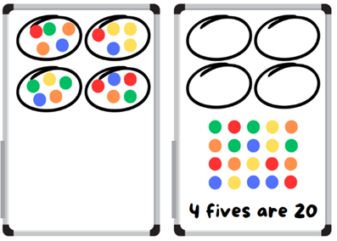
- Player 2 repeats the process.
- At the end of the round, the player with the highest product wins and scores a point. The player who scores the most points by the end of the game is the winner.
Multi-age: students working towards Stage 3 outcomes roll 2 dice and find the product. Students then model the different ways the total can be arranged and record the factors of the number. For example, 36 is a product of 9 × 4, 6 × 6, 12 × 3. The factors of 36 are 1, 2, 3, 4, 6, 9, 12, 18, 36. Students receive a point for the total number of factors identified for each roll.
Factor: a number which divides another number without a remainder. For example, 1, 2, 3 and 6 are factors of 6 but 4 and 5 are not.
Product: the result of multiplying 2 or more numbers together, for example, 12 is the product of 4 × 3.
This table details opportunities for assessment.
Assessment opportunities | Links
What to look for:  - Can Stage 2 students use the array structure to coordinate the number of groups with the number in each group?  [MAO-WM-01, MA2-MR-01]  - Can Stage 3 students model different ways to show a whole number as a product? [MAO-WM-01, MA3-MR-01]  - Can Stage 3 students determine factors for a given whole number? [MAO-WM-01, MA3-MR-01] | Links to National Numeracy Learning Progressions (NNLP):  - Stage 2 – MuS5  - Stage 3 – MuS6, MuS7.  Links to suggested Interview for Student Reasoning (IfSR) tasks:  - Stage 2 – IfSR-MT: 2A.2  - Stage 3 – IfSR-MT: 2A.7.

Core lesson – multiplicative patterns – 40 minutes
The table below contains suggested learning intentions and success criteria. These are best co-constructed with students.
Core concept learning intentions | Core concept success criteria
Students working towards Stage 2 outcomes are learning to:  - generate and describe patterns.  Students working towards Stage 3 outcomes are learning to:  - determine products and factors  - use partitioning and place value to multiply 2-, 3- and 4-digit numbers by one-digit numbers. | Students working towards Stage 2 outcomes can:  - model, describe and record patterns of multiples  - recognise the significance of the final digit of a whole number in determining whether a given number is even or odd.  Students working towards Stage 3 outcomes can:  - use the term product to describe the result of multiplying 2 or more numbers  - use mental strategies to multiply one-digit numbers by 10, 100, 1000 and their multiples  - estimate the product of 2 numbers (one-digit by 2- or 3-digit numbers) using multiples of 10 or 100.
- Display Resource 1 – Farmer Cluck and ask the following questions:
- How could we record our ideas?
- What will it look like if the rows are full in the egg cartons?
- What could it look like if the eggs are not in rows of 2?
- Pose the following question to Stage 3 students: Farmer Cluck realised that the local supermarket needs 90 cartons delivered. What are the various combinations that can be placed on the pallet to be delivered safely to the supermarket? Use the term product to describe the results, for example, the product of 9 and 10 is 90.
- Students share their responses.

Stage 2 task – odd and even
- Display Resource 2 – pictures of cartons and ask students to identify which of the pictures show rows of 2.
- Give small groups of students 30 counters and Resource 3 – egg carton arrays to record the numbers they test and the numbers that fit Farmer Cluck’s criteria.
- Regroup and ask the following questions:
- Which numbers could work for Farmer Cluck?
- Which numbers did not work?
- How did you test your ideas?
- How did you know that a number would work or not?
- What patterns do you notice?
- Provide Resource 4 – odd and even and ask students to record their responses in their workbooks.
- Regroup and share responses.
- Revise that the numbers that are coloured green are called even numbers because they are multiples of 2. The numbers that are coloured yellow are called odd numbers because when they are divided by 2, there is one left over.
Multiples: products formed using the same base number multiplied by different whole numbers, for example 2, 4, 6.

Stage 3 task – product pathways
This lesson is an adaptation of Route Product from NRICH by the University of Cambridge.
- Write the number sentence 29 × 98 on the board and ask the following questions:
- How could you use rounding to help estimate the product?
- Is 2900 or 3000 a better estimate? Why?
- Is there ever a situation where it might be better to underestimate?
Note: the purpose of this discussion is to explore mental estimation strategies. Rounding 98 to 100 will give you 2900. Rounding both to the nearest decade will give you 3000.
- Display and provide a copy of Resource 5 – route product to students. Explain that Farmer Cluck needs to get from A to B. There are many different routes from A to B in the diagram. The task is to work out the product of the numbers on the different routes from A to B without visiting a point more than once. Students record their number sentences and products of each route.
- After some exploration time, regroup and discuss the following questions:
- Which route do you estimate will give the largest product? Why?
- Which route do you estimate will give the smallest product? Why?
- There are numbers on the diagram that are multiples of 10. How might this help you?
- How do you know you have all the possible routes?
- What strategies can be used to calculate the product each time?
Note: if not discussed, highlight the use of factorising and halving as strategies. For example, 6 × 50 can be represented as 6 × 5 × 10 or 3 × 2 × 50 with factorisation. 6 × 50 can also be represented as 6 × 100 ÷ 2 using a halving strategy.
This table details opportunities for differentiation.
Too hard? | Too easy?
Stage 2 students cannot model, describe and record patterns of multiples.  - Give students a smaller number of counters and support them to arrange counters into rows of 2.  - Support students to start with 2 counters and work systematically to test different numbers.  Stage 3 students cannot use mental strategies to multiply one-digit numbers by 10, 100, 1000 and their multiples.  - Provide students with a copy of Resource 6 – place value houses. Support students to identify the changes in place value when multiplying by 10 and their multiples. | Stage 2 students can model, describe and record patterns of multiples.  - Students form a table with the following headings: ‘Always’, ‘Sometimes’ and ‘Never’. Provide Resource 7 – always, sometimes, never and have students place cards under the suitable headings.  - Ask students to create their own Always, Sometimes, Never cards to swap with a partner to solve.  Stage 3 students can use mental strategies to multiply one-digit numbers by 10, 100, 1000 and their multiples.  - Students create their own grid so that the product of all routes is 100 without using the number 100.

Discuss and connect the mathematics – 10 minutes

Stage 2 task
- Students complete an exit slip to answer the following questions:
- Is 374 an odd or even number? How do you know?
- Can you give an example of an odd and even number larger than 50?

Stage 3 task
- Ask the following questions:
- Which route gives the largest product? (40 × 50 × 20 × 10 = 400 000)
- What strategy did you use to calculate the largest product?
- Which route gives the smallest product? (5 × 10)
- How many possible routes were there in total?
- How did your understanding of place value and factorisation help with this task?
- Does multiplying more numbers together give you a larger product? Is this always the case? (No, it depends on the size of the numbers being multiplied).
- Write the number sentence 7 × 5 on the board. Ask the following questions:
- How does this number sentence help you solve 70 × 5?
- What is another problem that this number sentence could help you solve? (700 × 5, 7 × 50 are some examples.)
- Could this number sentence help you solve 49 × 5?
- What are some other ways you could solve 49 × 5?
- How could estimation help you check your answer?
Note: it is a common misconception that multiplying by 10 can be done by simply ‘adding a zero’ and multiplying by 100 can be done by ‘adding 2 zeros’. This should be avoided as it detracts from a deeper understanding of place value, multiplicative thinking and the link between them.
This table details opportunities for assessment.
Assessment opportunities | Links
What to look for:  - Can Stage 2 students model, describe and record patterns of multiples? [MAO-WM-01, MA2-MR-01]  - Can Stage 2 students recognise the significance of the final digit of a whole number in determining whether a given number is even or odd? [MAO-WM-01, MA2-MR-01]  - Can Stage 3 students use the term product to describe the result of multiplying 2 or more numbers? [MAO-WM-01, MA3-MR-01]  - Can Stage 3 students estimate the product of 2 numbers (one-digit by 2- or 3-digit numbers) using multiples of 10 or 100?  [MAO-WM-01, MA3-MR-01]  - Can Stage 3 students use mental strategies to multiply one-digit numbers by 10, 100, 1000 and their multiples?  [MAO-WM-01, MA3-MR-01] | Links to National Numeracy Learning Progressions (NNLP):  - Stage 2 – NPA3, NPA4  - Stage 3 – MuS6, MuS7.  Links to suggested Interview for Student Reasoning (IfSR) tasks:  - Stage 2 – IfSR-NP: 4A.1, 4A.2, 4A.3  - Stage 3 – IfSR-MT: 3A.1, 3A.2, 3A.3, 3A.4, 3A.5.

Lesson 2
Core concept: structures can support multiplicative thinking.

Daily number sense – factors fun – 15 minutes
The table below contains suggested learning intentions and success criteria. These are best co-constructed with students.
Daily number sense learning intentions | Daily number sense success criteria
Students working towards Stage 2 outcomes are learning to:  - recall multiplication facts of 2 and 4, 5 and 10 and related division facts.  Students working towards Stage 3 outcomes are learning to:  - determine products and factors. | Students working towards Stage 2 outcomes can:  - generate multiplication fact families for multiples of 2 and 4, 5 and 10.  Students working towards Stage 3 outcomes can:  - determine factors for a given whole number.
This lesson is an adaptation of Factors fun from Mathematics K–6 resources by the State of New South Wales (Department of Education).
- Provide pairs of students with Resource 8 – factors fun gameboard, Resource 9 – factors fun spinner, counters, a paperclip and pencils.
Note: the Factors fun video demonstrates each step and reasoning used in this game.
- Explain the Factors fun game. Students:
- take turns to spin the spinner and divide the number by the chosen divisor. For example, 5.
- record their solution and explain their thinking. The partner records their thinking and, if they agree, the player places one of their counters on the number on the gameboard, claiming that place.
- miss a turn if the number is already taken.
- move an existing counter to a new place if there are no new counters that can be added to the gameboard.
- win by getting 4 counters in a row (in any orientation, including a square).
- Observe student reasoning and completed gameboards (see Figure 2).
Figure 2 – factors fun gameboard
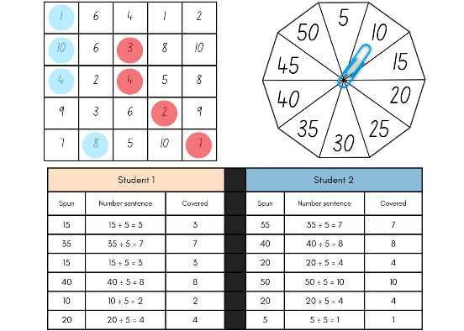
Multi-age: students working towards Stage 2 outcomes focus on multiplication facts of 2 and 4, 5 and 10 and related division facts.
This table details opportunities for assessment.
Assessment opportunities | Links
What to look for:  - Can Stage 2 students generate multiplication fact families for multiples of 2 and 4, 5 and 10? [MAO-WM-01, MA2-MR-01]  - Can Stage 3 students determine factors for a given whole number? [MAO-WM-01, MA3-MR-01] | Links to National Numeracy Learning Progressions (NNLP):  - Stage 2 – MuS5  - Stage 3 – MuS6, MuS7.  Links to suggested Interview for Student Reasoning (IfSR) tasks:  - Stage 2 – IfSR-MT: 2A.9  - Stage 3 – IfSR-MT: 2A.7.

Core lesson – multiplicative structures – 40 minutes
The table below contains suggested learning intentions and success criteria. These are best co-constructed with students.
Core concept learning intentions | Core concept success criteria
Students working towards Stage 2 outcomes are learning to:  - use arrays to establish multiplication facts from multiples of 2 and 4, 5 and 10.  Students working towards Stage 3 outcomes are learning to:  - use partitioning and place value to multiply 2-, 3- and 4-digit numbers by one-digit numbers  - calculate the areas of rectangles using familiar metric units  - measure lengths to find perimeters. | Students working towards Stage 2 outcomes can:  - create and represent multiplicative structure, using the term multiples when connecting grouping to array.  Students working towards Stage 3 outcomes can:  - use informal written strategies such as the area model to solve multiplication and division problems  - calculate areas of rectangles in square metres (m²)  - recognise that rectangles with the same area may have different dimensions  - use efficient strategies to calculate the perimeter of a large rectangular area in metres.
- Provide students with Resource 10 – garden view. Ask the following questions:
- How many rows of garden beds can you see from the aerial view?
- What is the total number of garden beds?
- What information did you use to calculate the total?
- Did you consider any alternative methods for calculating the total number of garden beds? If so, what were they?
- What strategies did you use to check the accuracy of your calculation?
Multi-age: students working towards Stage 2 outcomes can use arrays to model and describe patterns. Students working towards Stage 3 outcomes can determine the products and factors to find the total number of garden beds.

Stage 2 task – magic multiples
This lesson is an adaptation of ‘Don't Count the Dots!’ from Mathstodon by Butler.
- Revise the definition of odd and even numbers from Lesson 1. Ask students to describe how understanding multiples help us work out whether a number can be divided by another number.
- Display Resource 11 – How many twos? and ask the following questions:
- How many dots can you see?
- Are the number of dots able to be divided by 2? How do you know?
- What strategies did you use to check whether the number of dots were able to be divided by 2 without counting?
- Are the number of dots on this page able to be divided by 4? How do you know?
- Provide small groups with Resource 12 – How many fours? and Resource 13 – How many fives?
- Allow students time to explore and show how they know the number of dots on Resource 12 – How many fours? can be divided by 4 and how they know the number of dots on Resource 13 – How many fives? cannot be divided by 5.
- Regroup and ask the following questions:
- What strategies did you use to show the dots were able to be divided by 4? Why did you choose this strategy?
- How did your multiplication facts for multiples of 4 help you with this task?
- What strategies did you use to show the dots were not able to be divided by 5? Why did you choose this strategy?
- How did your multiplication facts for multiples of 5 help you with this task?
- Would the number of dots on Resource 13 – How many fives? be able to be divided by 10? How do you know?
- Display Colour Counters with Resource 12 – How many fours? recreated using the interactive counters. Ask the following questions:
- How can the counters be rearranged to make an array of fours?
- What is the least amount of moves that you can use to do this? Answer: 2 (see Figure 3).
- How does this array help prove that the number of dots can be divided by 4?
Figure 3 – dots rearranged
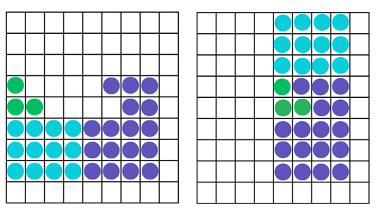
Note: the dots in Figure 3 have been colour-coded to represent where the dots have moved to from their original arrangement to the new configuration.
- Display Colour counters and repeat the process with Resource 13 – How many fives?. Ask the following questions:
- How can the counters be rearranged to make an array of fives?
- What is the least amount of moves that you can use to do this?
- How does this array help prove that the number of dots cannot be divided by 5?

Stage 3 task – playground problem
- Revise the term ‘area’ with students. Ask the following questions:
- What does area measure?
- What units of measurement are used for area?
- How are these units of measurement different to those used for length?
Area: the amount of surface inside a closed flat (2D) shape.
- Explain that measurements in square centimetres can be recorded as cm² and square metres can be recorded as m².
- Display Resource 14 – garden bed and pose the following problem: The length of the garden bed is 12 m and the area is 60 m². What is the width of the garden bed?
- Students turn and talk to discuss the problem. Ask the following questions:
- What number sentence could be used to represent this problem? (12 × _ = 60 or 60 ÷ 12 = _)
- How could you calculate the missing length?
- What would the perimeter of the garden bed be?
- What unit of measurement is used to communicate the perimeter?
- If another garden bed was constructed with an area of 60 m², could it have different dimensions? What might they be? (Some examples include 30 m × 2 m, 15 m × 4 m)
- Display Resource 15 – area problem and ask students to work independently or with a partner to explore and record different solutions.
- Regroup and students share their thinking. Ask the following questions:
- Which areas gave you the most possibilities with dimensions?
- Were there any areas that only had one possible set of dimensions? What do you notice about these areas? (If the area chosen was a prime number there is only one solution as there are only 2 factors).
- What strategies did you use to calculate the perimeter of a rectangle?
- What is the most efficient strategy to calculate the perimeter of a rectangle or square?
- Do all rectangles with the same area have the same perimeter? Why or why not?
- Pose the following problem: The area of the grass playground is 36 m². What might be the perimeter of the space? Pairs of students record at least 3 different answers.
- Students share their responses with their peers and check their answers.
This table details opportunities for differentiation.
Too hard? | Too easy?
Stage 2 students cannot create and represent multiplicative structure, using the term ‘multiples’ when connecting grouping to arrays.  - Support students to recreate Resource 13 – How many fives? using counters. Support students to rearrange counters into fives to determine if the number of counters is divisible by 5.  - Provide students with a representation of 4 as shown on a dot die. Support students to identify fours in Resource 12 – How many fours? and rearrange additional dots to recreate the dot die representation.  Stage 3 students cannot recognise that rectangles with the same area may have different dimensions.  - Provide students with square-centimetre grid paper to model their areas with rows and columns.  - Provide students with an area such as 24 m². Support students to use a multiplication grid to find possible dimensions by identifying factors of 24. | Stage 2 students can recreate and represent multiplicative structure, using the term ‘multiples’ when connecting grouping to arrays.  - Provide students with a copy of Resource 16 – How many threes? Students show how they know the number of dots is a multiple of 3 without counting.  - Students explore ideas of divisibility and how they can quickly prove a number is a multiple of 2, 3, 4 or 5. See Dozens for more information.  Stage 3 students can recognise that rectangles with the same area may have different dimensions.  - Pose the problem: Can you find any solutions where the perimeter is the same as the area?  - Pose the problem: What could the area and perimeter of a grassy space be if it was a square? What patterns do you notice?

Discuss and connect the mathematics – 10 minutes
- As a class, discuss and reflect on the core learning activities. Ask the following questions:
- What was new learning for you today?
- How did you use what you already knew to complete the task?
- How could you apply these skills to different situations?
This table details opportunities for assessment.
Assessment opportunities | Links
What to look for:  - Can Stage 2 students create and represent multiplicative structure, using the term ‘multiples’ when connecting grouping to arrays? [MAO-WM-01, MA2-MR-01]  - Can Stage 3 students use informal written strategies such as the area model to solve multiplication and division problems?  [MAO-WM-01, MA3-MR-01]  - Can Stage 3 students calculate areas of rectangles in square metres (m²)? [MAO-WM-01, MA3-2DS-02]  - Can Stage 3 students recognise that rectangles with the same area may have different dimensions?  [MAO-WM-01, MA3-2DS-03]  - Can Stage 3 students use efficient strategies to calculate the perimeter of a large rectangular area in metres?  [MAO-WM-01, MA3-GM-02] | Links to National Numeracy Learning Progressions (NNLP):  - Stage 2 – UuM5, UuM6, UuM7, UGP4  - Stage 3 – MuS6, MuS7, UuM5, UuM6, UuM7, UGP6.  Links to suggested Interview for Student Reasoning (IfSR) tasks:  - Stage 2 – IfSR-MT: 1A.9, 2A.1, 2A.4, 2A.6  - Stage 3 – IfSR-MT: 3A.1, 3A.2, 3A.3, 3A.4, 3A.5.

Lesson 3
Core concept: area relates to multiplication (Stage 2) and parts of a composite figure can be split, duplicated and rotated to find the total area (Stage 3).

Daily number sense – fruit boxes – 10 minutes
The table below contains suggested learning intentions and success criteria. These are best co-constructed with students.
Daily number sense learning intentions | Daily number sense success criteria
Students working towards Stage 2 outcomes are learning to:  - use arrays to establish multiplication facts from multiples of 2 and 4, 5 and 10.  Students working towards Stage 3 outcomes are learning to:  - determine products and factors. | Students working towards Stage 2 outcomes can:  - record the multiples formed by counting by twos, fours, fives and tens.  Students working towards Stage 3 outcomes can:  - model different ways to show a whole number as a product.
This activity is an adaptation of What comes next? Fruit Stand from Math Learning Center.
- Display Resource 17 – fruit boxes.
- Looking at shelf 1, ask the following questions:
- What do you notice? What do you wonder?
- How would you describe this pattern to someone?
- What comes next? How do you know?
- Will there be a picture with 40 apples? How do you know?
- What might earlier pictures look like? How do you know?
- Ask Stage 2 students to use an individual whiteboard to show what the shelf 1 fruit pattern would look like if recording multiples of twos, fives or tens.
- Students share their pattern with a partner. Ask the following questions:
- What comes next? How do you know?
- How would you describe this pattern to someone?
- Ask Stage 3 students to look at shelf 2. Students identify and record the number of different ways the blueberries and lemons can be rearranged as an array.
- Students share their ideas with a partner. Ask the following questions:
- How many possibilities are there for each box?
- What strategies did you use to make sure you found all the possibilities?
- Do the lemons, blueberries and strawberries have the same or similar number of possible arrays?
- Why do the strawberries only have 2 possible arrays?
This table details opportunities for assessment.
Assessment opportunities | Links
What to look for:  - Can Stage 2 students record the multiples formed by counting by twos, fours, fives and tens? [MAO-WM-01, MA2-MR-01]  - Can Stage 3 students model different ways to show a whole number as a product? [MAO-WM-01, MA3-MR-01] | Links to National Numeracy Learning Progressions (NNLP):  - Stage 2 – CPr6, NPA4.  Links to suggested Interview for Student Reasoning (IfSR) tasks:  - Stage 2 – IfSR-MT: 2A.4, 2A.6  - Stage 3 – IfSR-MT: 2A.7, 3A.8.

Core lesson – area exploration – 40 minutes
The table below contains suggested learning intentions and success criteria. These are best co-constructed with students.
Core concept learning intentions | Core concept success criteria
Students working towards Stage 2 outcomes are learning to:  - recall multiplication facts of 2 and 4, 5 and 10 and related division facts  - measure the areas of shapes using the grid structure  - compare and describe features of two-dimensional shapes.  Students working towards Stage 3 outcomes are learning to:  - find the area of composite figures. | Students working towards Stage 2 outcomes can:  - generate multiplication fact families for multiples of 2 and 4, 5 and 10  - recognise that rectangles with different side lengths can have the same area  - identify right angles in shapes.  Students working towards Stage 3 outcomes can:  - find different ways to calculate the area of a composite L-shape figure.
This activity is an adaptation of ‘Combining Arrays’ and ‘Composite Shapes’, in Challenging Mathematical Tasks: Unlocking the potential of all students by Sullivan.
- Display Resource 18 – exploring arrays. Ask the following questions:
- What is similar about these 3 images?
- How are these 3 images different to one another?
- How could you use multiplication to describe them?
- What are the fact family triangles that match each image?
- Can you create another image or picture that would belong with these 3 images?
- Students create fact family triangles on individual whiteboards to match the images on Resource 18 – exploring arrays. Students may discover that there are additional images and fact families that relate to the number 24 (see Figure 4).
Figure 4 – student triangle examples
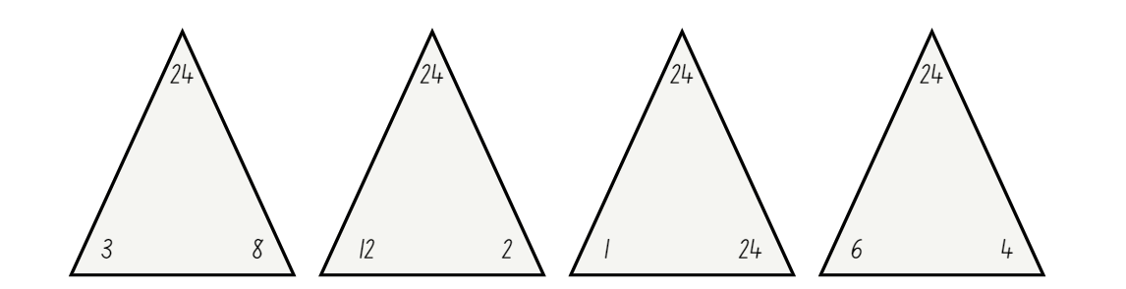
- Students turn and talk to share their fact family triangles and other images that relate to 24.
- Remind students that the number at the top of the triangle is the product of the 2 factors at the bottom of the triangle.
- Draw Figure 5 on the board.
Figure 5 – making the link
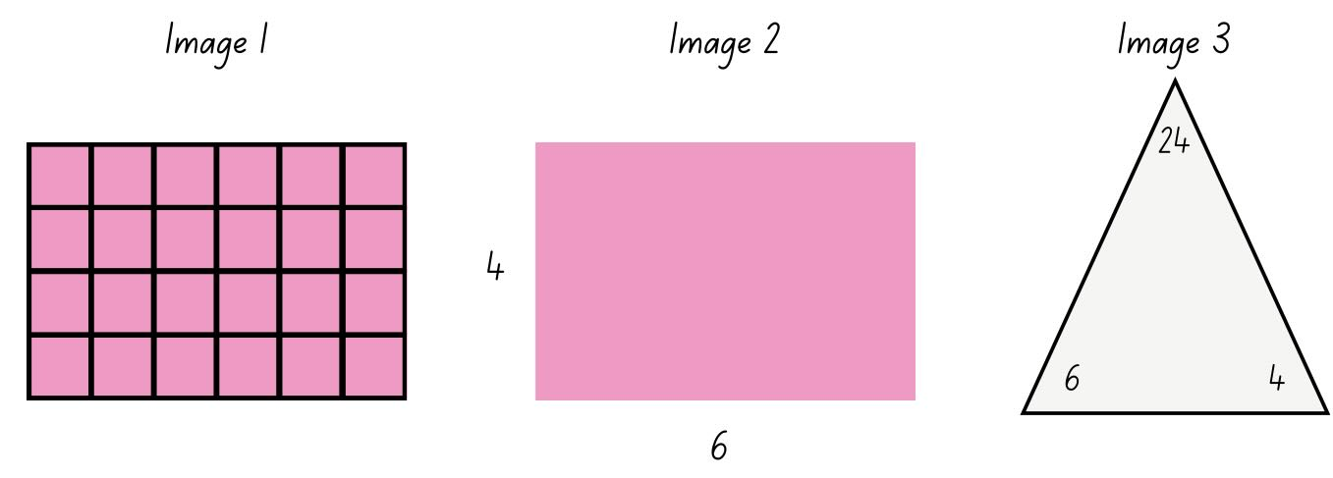
- Ask the following questions:
- How many small squares are filling the space in Image 1? How do you know?
- Is it possible to visualise how many small squares would fill the space in Image 2, by looking at the numbers on the side of the rectangle?
- How does the fact family triangle in Image 3, relate to Image 1 and 2?
- How can the fact family triangle help determine the space that is covered by a rectangle?
- Explain that the space inside a closed flat (two-dimensional) shape is called the area. The area covered by a rectangle can be calculated with the help of an array or by looking at the length of its sides to visualise the array. Tell students that Image 2 has an area of 24 because the side lengths of the rectangle are 4 and 6. When the array is visualised, 4 sixes can be used to describe the array within the rectangle, which means that the rectangle has an area of 24.
- Ask the following questions:
- How can we use the fact family triangles with a product of 24 to create other rectangles that have an area of 24?
- What would the side lengths of each rectangle be?
- Students use individual whiteboards to draw rectangles and label the dimensions. Students turn and talk to share their ideas with a partner.
- Ask the following questions:
- How many different possibilities did you come up with?
- Are there any rectangles that look the same?
- Is it possible for a rectangle to have the same area but different dimensions?

Stage 2 task – rectangular robots
- Display Resource 19 – rectangular robot. Explain that the students will be creating a robot using rectangles of a given area.
- Draw Table 1 on the board.
Table 1 – robot areas
Robot feature | Area | Dimensions | Fact family triangles
Head | 16
Body | 28
Arms | 12
Legs | 20
- Explain that the table displayed on the board lists the area of each robot feature. Students will decide on the dimensions of each robot feature to meet the criteria, draw the feature and create the matching fact family triangle.
- Students draw their own table on an individual whiteboard using the same values. Students complete the table and create their robot using square-centimetre grid paper (see Figure 6).
Figure 6 – possible student response
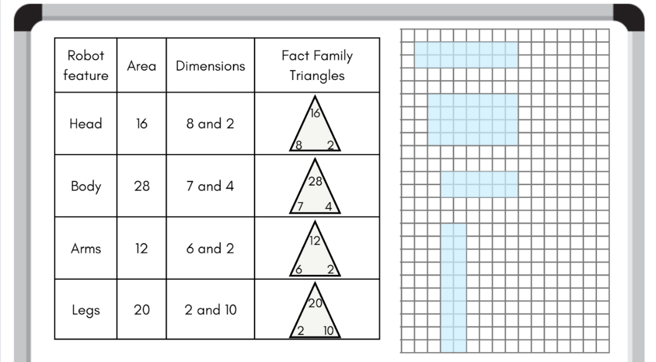

Stage 3 task – composite robots
This activity is an adaptation of ‘Combining Arrays’ and ‘Composite Shapes’, in Challenging Mathematical Tasks: Unlocking the potential of all students by Sullivan.
- Display Resource 20 – combining arrays. Ask the following questions:
- How many small squares have been used to make this shape?
- How might you partition or rearrange this shape to complete this task?
- Can you find the answer in 2 or more different ways?
- Provide pairs of students with Resource 20 – combining arrays, scissors and writing materials. Allow students time to explore the task and record their strategies.
- Select students to share the variety of strategies used by asking the following questions:
- What strategy did you use to determine the number of small squares in this shape?
- How did multiplication help you with this task?
- How could you represent your strategy using a number sentence?
- How did partitioning or rearranging the shape help with calculating the total number of small squares?
- Display Resource 21 – array solutions and draw students’ attention to any strategies that were not already discussed.
- Display Resource 22 – combining arrays 2. Explain that students need to determine the number of small squares used to make this shape. Ask the following questions:
- How might the grid paper in the background be used to complete this task?
- Can you find the answer in 2 or more different ways?
- Provide each student with Resource 22 – combining arrays 2. Encourage students to find multiple solutions and record the corresponding number sentences.
This table details opportunities for differentiation.
Too hard? | Too easy?
Stage 2 students cannot generate multiplication fact families for multiples of 2 and 4, 5 and 10.  - Provide students with counters to create arrays that match the given areas.  - Support students to record the dimensions and use these as factors in the fact families to match the given areas.  Stage 3 students cannot find different ways to calculate the area of a composite L-shape figure.  - Provide students with a copy of Resource 22 – combining arrays 2 and a ruler. Ask students to rule the lines over the white areas to help calculate the number of small squares. They could then cut up the diagram to assist in counting.  - Support students to partition the shapes into separate rectangular shapes. Support students to identify arrays and utilise a multiplication chart where necessary. | Stage 2 students can generate multiplication fact families for multiples of 2 and 4, 5 and 10.  - Students create additional features for their robot. Record the dimensions and the corresponding fact families.  - Students play Dicey Perimeter, Dicey Area with a 6-sided or 9-sided die.  Stage 3 students can find different ways to calculate the area of a composite L-shape figure.  - Pose the following question: What would a shape like the letter ‘L’ made from 60 squares look like?  - Provide students with Rod Area from NRICH. Students design a U-shape which has a perimeter of 20 cm. Challenge students to design a shape which has an area that is an odd number as well as an even number.

Discuss and connect the mathematics – 10 minutes
- Conduct a gallery walk. Ask the following questions:
- Are there any rectangles that have the same area but different dimensions? (Stage 2)
- How many different fact families can be created for one product? (Stage 2)
- Which product had the largest number of fact families? (Stage 2)
- Were there any fact families that you hadn’t thought of? (Stage 2)
- Are there any right angles in your robot? (Stage 2)
- How many right angles are there in a rectangle? (Stage 2)
- How many right angles are there in your robot? (Stage 2)
- How can we calculate this without counting by ones? (Stage 2)
- Is it possible to have 26 right angles in a robot made of rectangles? Why or why not? (Stage 2)
- Did you see any strategies that you had not thought of? (Stage 3)
- Which strategy was the most efficient? Why? (Stage 3)
This table details opportunities for assessment.
Assessment opportunities | Links
What to look for:  - Can Stage 2 students generate multiplication fact families for multiples of 2 and 4, 5 and 10? [MAO-WM-01, MA2-MR-01]  - Can Stage 2 students recognise that rectangles with different side lengths can have the same area?  [MAO-WM-01, MA2-2DS-03]  - Can Stage 2 students identify right angles in shapes?  [MAO-WM-01, MA2-GM-03]  - Can Stage 3 students find different ways to calculate the area of a composite L-shape figure? [MAO-WM-01, MA3-2DS-02] | Links to National Numeracy Learning Progressions (NNLP):  - Stage 2 – MuS5, UuM5, UuM6, UuM7, UGP6  - Stage 3 – UuM7, UuM10.  Links to suggested Interview for Student Reasoning (IfSR) tasks:  - Stage 2 – IfSR-MT: 2A.7.

Lesson 4
Core concept: areas can be measured using arrays and square centimetres (Stage 2) and area underpins multiplication and the use of the area model (Stage 3).

Daily number sense – 10 minutes
- From a class need surfaced through formative assessment data, identify a short, focused activity that targets students’ knowledge, understanding and skills. Example activities may be drawn from the following resources:
- Mathematics K–6 resources
- Universal Resources Hub.

Core lesson – area models – 40 minutes
The table below contains suggested learning intentions and success criteria. These are best co-constructed with students.
Core concept learning intentions | Core concept success criteria
Students working towards Stage 2 outcomes are learning to:  - recall multiplication facts of 2 and 4, 5 and 10 and related division facts  - use square centimetres to measure the areas of rectangles.  Students working towards Stage 3 outcomes are learning to:  - use partitioning and place value to multiply 2-, 3- and 4-digit numbers by one-digit numbers  - calculate the areas of rectangles using familiar metric units. | Students working towards Stage 2 outcomes can:  - model and apply the commutative property of multiplication  - create the array structure of area using squares (1 cm × 1 cm) in rows and columns  - recognise that area can be measured in square centimetres.  Students working towards Stage 3 outcomes can:  - use informal written strategies such as the area model to solve multiplication and division problems  - recognise the importance of using the same units of length on the sides of rectangles to create ‘square units’  - establish the relationship between the lengths, widths and areas of rectangles  - investigate and compare the areas of rectangles that have the same perimeter.
This activity is an adaptation of ‘Stamp Arrays’ from Teaching and Assessing Maths Through Open-ended Activities by Lilburn and Sawczak.
- Pose the following problem: Sian has 12 stickers and wants to display them in her sticker album. She wants to arrange them in arrays.
- In pairs, students record arrays that could be used to display the 12 stickers on individual whiteboards.
- Ask the following questions:
- How many possibilities are there?
- What strategies did you use to make sure you found all the possibilities?
- Are there any sticker arrays that look similar to each other? Why does this happen?
- Display Resource 23 – sticker album solution. Explain that the reason some sticker arrays are similar to each other is due to the commutative property of multiplication.
Commutative property: commutative property of addition or multiplication means that 2 numbers can be added or multiplied in any order and the solution will be the same.
- Revise that area is the flat surface enclosed within a shape. Ask students the following questions:
- What unit of measurement can be used to measure the area of the sticker arrays?
- If the dimensions of each sticker is 1 cm wide and 1 cm high, how could multiplication be used to describe the area of the sticker arrays?
- How could the area of the stickers be recorded by reading the array? For example, 3 fours is 12 square centimetres.
- Display Resource 23 – sticker album solution. Ask students if it is possible to record the area of these stickers by reading the array.
- Record student responses alongside the corresponding array on Resource 23 – sticker album solution (see Figure 7).
Figure 7 – recording arrays and area
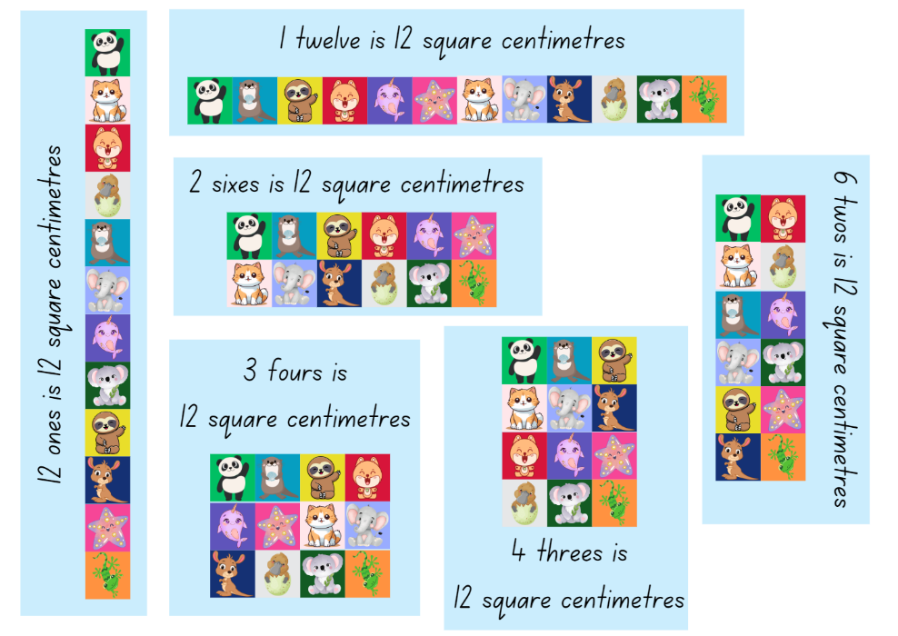

Stage 2 task – sticker problem
- Display Resource 24 – sticker problem. Ask the following questions:
- How many possibilities do you think there are?
- How can arrays be used to record our ideas?
- What is the area covered by the stickers?
- How can this be recorded by using the array?
- Provide students with square-centimetre grid paper. Students work in small groups to record their solutions. They label their ideas using the array structure. For example 6 sevens, 21 twos (see Figure 8).
Figure 8 – example of student response
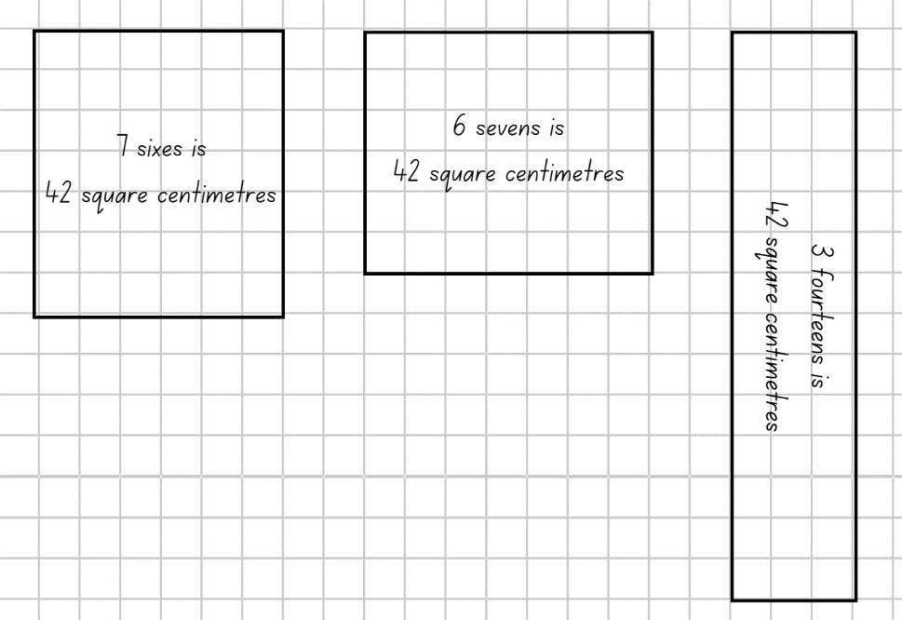

Note: the Stage 2 Teaching advice for Multiplicative relations A states when students begin to produce multiplication facts it may help to use a language pattern of words that relates back to concrete materials such as arrays. As students become more confident with recalling multiplication facts, they may use less language. For example, 5 rows (groups) of 3 becomes 5 threes with the rows of or groups of implied. This then leads to one three is 3, 2 threes are 6, 3 threes are nine, and so on (NESA 2024a).

Stage 3 task – partitioning area
- Draw Figure 9 on the board.
Figure 9 – partitioning area
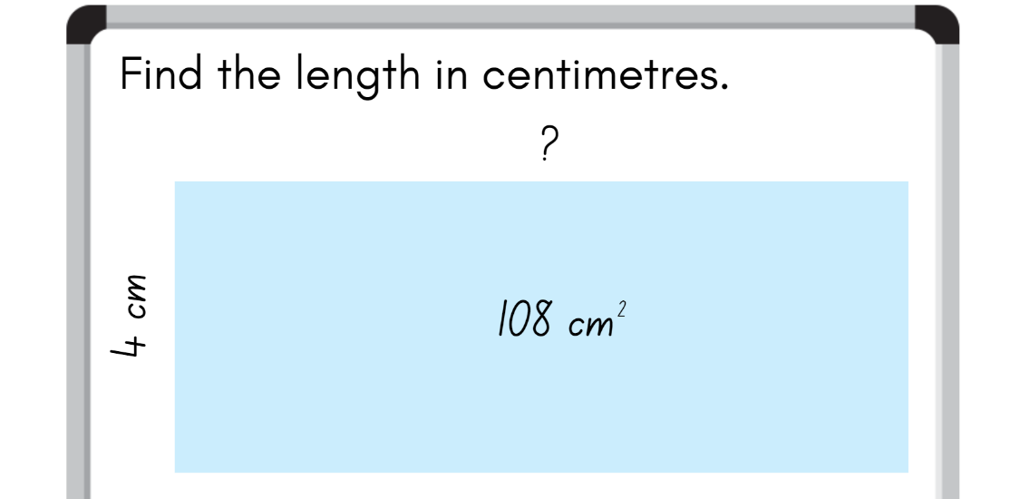
- Ask the following questions:
- What unit of measurement would the missing value use?
- How might the missing measurement be determined?
- What mathematical ideas have you explored before that are useful in solving this problem?
- How could partitioning 108 cm² help you solve this problem?
- What is the perimeter of this shape?
- Students turn and talk and record their ideas on an individual whiteboard.
- Allow students to share strategies used, by asking the following questions:
- What strategy did you use?
- How did you partition the numbers to solve this problem?
- How could using inverse operations help you check your answer?
- How could you describe the relationship between the length, width and area of a rectangle?
- How did this help you with solving the problem?
- What strategies can be used to determine the perimeter of a rectangle?
- Confirm that the missing value on Figure 9 is 27 cm and the perimeter is 62 cm.
- Pose the following conjecture: Any rectangle that has a perimeter of 62 cm will have an area of 108 cm².
- Ask the following questions:
- What might the dimensions be of a rectangle with a perimeter of 62 cm?
- How can partitioning 31 m in multiple ways help you with this task?
- How could division and addition help you with determining different dimensions? (Half the perimeter is 31 cm. I can then use my addition and subtraction knowledge to generate different lengths and widths that total 31 cm).
- Students work in pairs or groups of 3 to test the conjecture. Students draw Figure 10 on an individual whiteboard to record their results.
Figure 10 – student recording
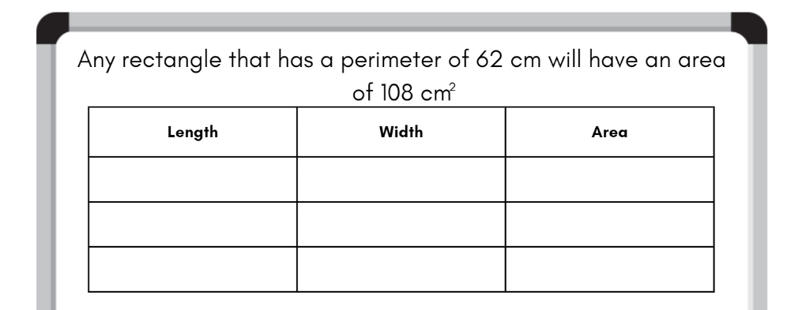
- Move around the room and support students where necessary. As students progress with the task, encourage students to look for patterns that may assist them in generating all possible solutions.
This table details opportunities for differentiation.
Too hard? | Too easy?
Stage 2 students cannot create the array structure of area using squares (1 cm × 1 cm) in rows and columns.  - Provide students with 24 counters and ask them to arrange these so that there is an equal number of counters in each row.  - Encourage students to represent the arrays created with counters as fact family triangles to identify the links between arrays and fact families for 24.  Stage 3 students cannot investigate and compare the areas of rectangles that have the same perimeter.  - Provide students with a smaller perimeter to work with such as 40 cm. Support students to make the connection between the side properties of a rectangle and how the given perimeter can be partitioned accordingly.  - Provide students with square-centimetre grid paper to record their rectangles. Support students to partition the area into smaller arrays to determine the total area. | Stage 2 students can create the array structure of area using squares (1 cm × 1 cm) in rows and columns.  - Pose the following question: What if the teacher wanted to print 108 stickers on a sheet? Is there a way of working out all the possibilities without drawing an array?  - Pose the following question: What would happen to the area of the rectangles if the stickers were 2 cm wide and 1 cm high instead of 1 cm wide and 1 cm high?  Stage 3 students can investigate and compare the areas of rectangles that have the same perimeter.  - Provide students with a copy of Area and Perimeter by NRICH. Students design shapes to meet the criteria posed in the problem.

Discuss and connect the mathematics – 10 minutes
- Ask the following questions:
- How many solutions did you find? (Stage 2)
- What do you notice about the solutions? (Stage 2)
- How did the commutative property help you find multiple solutions? (Stage 2)
- Are there any rectangles that are similar to each other? How? (Stage 2)
- Does the area of the sticker sheet change when the stickers are arranged differently? (Stage 2)
- What patterns did you notice? (Stage 3)
- How could you use these patterns to determine all the possible dimensions of a rectangle with a perimeter of 62 cm? (Stage 3)
- What strategies did you use to calculate the area? (Stage 3)
- Do rectangles with the same perimeter have the same area? (Stage 3)
This table details opportunities for assessment.
Assessment opportunities | Links
What to look for:  - Can Stage 2 students model and apply the commutative property of multiplication? [MAO-WM-01, MA2-MR-01]  - Can Stage 2 create the array structure of area using squares (1 cm × 1 cm) in rows and columns? [MAO-WM-01, MA2-MR-01]  - Can Stage 2 recognise that area can be measured in square centimetres? [MAO-WM-01, MA2-MR-01]  - Can Stage 3 students use informal written strategies such as the area model to solve multiplication and division problems?  [MAO-WM-01, MA3-MR-01]  - Can Stage 3 students recognise the importance of using the same units of length on the sides of rectangles to create ‘square units’? [MAO-WM-01, MA3-2DS-02]  - Can Stage 3 students establish the relationship between the lengths, widths and areas of rectangles?  [MAO-WM-01, MA3-2DS-02]  - Can Stage 3 students investigate and compare the areas of rectangles that have the same perimeter?  [MAO-WM-01, MA3-2DS-02] | Links to National Numeracy Learning Progressions (NNLP):  - Stage 2 – MuS6, UuM5, UuM6, Uum7  - Stage 3 – MuS6, MuS7, UuM6, UuM7, UGP6.  Links to suggested Interview for Student Reasoning (IfSR) tasks:  - Stage 2 – IfSR-MT: 2A.9  - Stage 3 – IfSR-MT: 3A.1, 3A.2, 3A.3.

Lesson 5
Core concept: mathematicians estimate, measure and compare area (Stage 2) and objects with the same volume may be different shapes (Stage 3).

Daily number sense – naming and ordering numbers – 10 minutes
Daily number sense activities for Lessons 5 to 7 ‘loop’ back to concepts and procedures covered in previous units to assist students to build an increasingly connected network of ideas. These concepts may differ from the core concepts being covered by the unit.
The table below contains suggested learning intentions and success criteria. These are best co-constructed with students.
Daily number sense learning intentions | Daily number sense success criteria
Students working towards Stage 2 outcomes are learning to:  - order numbers in the thousands.  Students working towards Stage 3 outcomes are learning to:  - compare, order and represent decimals. | Students working towards Stage 2 outcomes can:  - arrange 4-digit numbers in ascending and descending order.  Students working towards Stage 3 outcomes can:  - compare and order numbers of up to 3 decimal places  - interpret zero digit(s) at the end of a decimal  - place decimal numbers of up to 3 decimal places on a number line.
- Create 2 large, blank number lines using string and place them on the floor in different parts of the classroom. Provide pegs as markers when attaching the number cards.
- Explain to Stage 2 students that they will each get a card from Resource 25 – four-digit numbers to arrange on the number line. In the first round, students will arrange the cards in ascending order. After the task has been completed, cards will be collected, shuffled and redistributed. Students then arrange the cards in descending order for the next round.
- For each round, instruct students to read their number aloud and then as a group, decide which card should be pegged on the number line first to assist with arranging all the other cards (see Figure 11).
- Explain to Stage 3 students that they will each get a card from Resource 26 – decimal cards. Ask students to identify which decimal cards should be placed first to provide a benchmark for other numbers. For example, 0.0, 1.0, 2.0, 3.0 and 4.0.
- Ask students with benchmark number cards to say their numbers aloud and peg them onto the blank number line. The remaining students say their number aloud and then decide where it should be pegged on the number line (see Figure 11).
Figure 11 – decimal number line
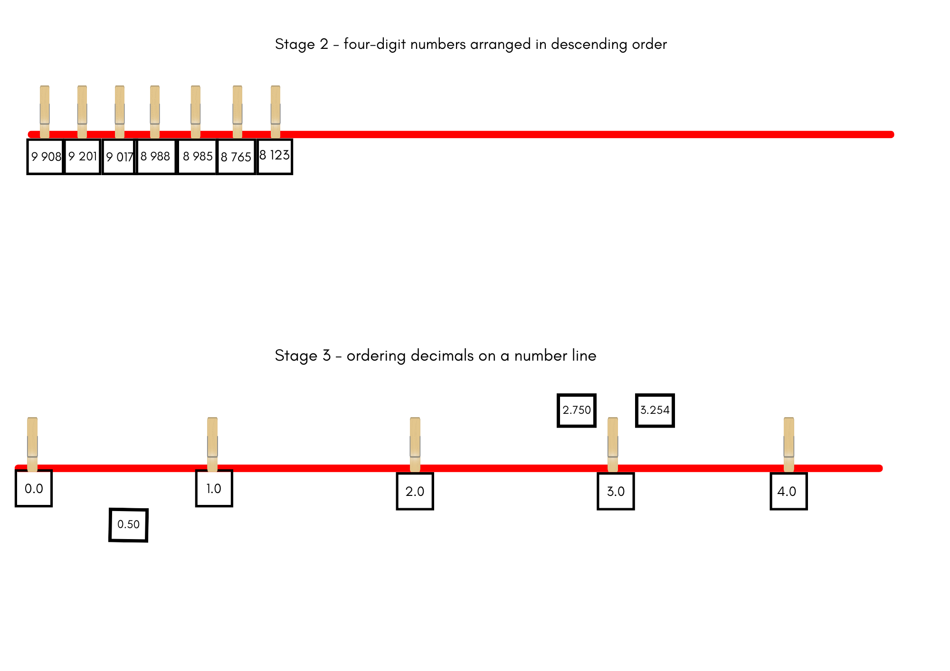

This table details opportunities for assessment.
Assessment opportunities | Links
What to look for:  - Can Stage 2 students arrange 4-digit numbers in ascending order? [MAO-WM-01, MA2-RN-01]  - Can Stage 2 students arrange 4-digit numbers in descending order? [MAO-WM-01, MA2-RN-01]  - Can Stage 3 students compare and order decimal numbers of up to 3 decimal places? [MAO-WM-01, MA3-RN-02]  - Can Stage 3 students interpret zero digit(s) at the end of a decimal? [MAO-WM-01, MA3-RN-02]  - Can Stage 3 students place decimal numbers of up to 3 decimal places on a number line? [MAO-WM-01, MA3-RN-02] | Links to National Numeracy Learning Progressions (NNLP):  - Stage 2 – NPV6  - Stage 3 – NPV8.  Links to suggested Interview for Student Reasoning (IfSR) tasks:  - Stage 2 – IfSR-NP: 4B.2  - Stage 3 – IfSR-NP: 4D.1, 4D.4, 4D.6.

Core lesson – investigating metric units – 40 minutes
The table below contains suggested learning intentions and success criteria. These are best co-constructed with students.
Core concept learning intentions | Core concept success criteria
Students working towards Stage 2 outcomes are learning to:  - compare surfaces using familiar metric units of area  - measure the areas of shapes using the grid structure  - use arrays to establish multiplication facts from multiples of 2 and 4, 5 and 10.  Students working towards Stage 3 outcomes are learning to:  - find the volumes of rectangular prisms in cubic centimetres. | Students working towards Stage 2 outcomes can:  - estimate before measuring to determine the larger of 2 areas in square centimetres  - estimate the areas of shapes found in the environment using efficient strategies (non-count-by-one) with a grid overlay  - use the array structure to coordinate the number of groups with the number in each group.  Students working towards Stage 3 outcomes can:  - recognise that rectangular prisms with the same volume may have different dimensions  - calculate volumes of rectangular prisms in cubic centimetres (cm³).
- Display Resource 27 – comparing 2 leaves. Ask the following questions:
- Which leaf do you think has the biggest area? How do you know?
- When comparing area, what do you need to know?
- How could we use a grid overlay to help us estimate the area?
- Why is it almost impossible to accurately measure the area of the leaves?
- What strategies can we use to estimate the area of these leaves?
- Display Resource 28 – leaf grid overlay and provide pairs with an individual whiteboard. Students record their estimate for which leaf has the largest area.
- Display Resource 29 – Julie’s strategy. Explain that Julie saw that her leaf covered an area of 8 tens. She saw this when she looked at how many squares high and wide the whole leaf was. She used this to create an array. Then she looked at the leaf and looked for other arrays that she could see. She saw 5 threes, 6 threes and 2 twos. Julie now knows that her leaf has an area more than 37 square centimetres and less than 80 square centimetres.
- Provide Stage 2 students with an individual whiteboard and explain that they will use Julie’s strategy to explore if her area estimate was in fact less than 80 square centimetres and how can this be proven. Students turn and talk to compare their findings with a partner.
- Explain to Stage 3 students that Julie identified an array of 6 threes on a section of her leaf as she was estimating the area. What might this have looked like? Provide students with an individual whiteboard to record their ideas. Students turn and talk to compare their arrays with a partner.

Stage 2 task – unbe-leaf-able areas
- Display Resource 29 – Julie’s strategy. Students work in pairs to estimate the area of Michelle’s leaf using the strategies discussed while estimating the area of Julie’s leaf.
- Ask the following questions:
- What does the area of Michelle’s leaf have to be more than?
- What does the area of Michelle’s leaf have to be less than?
- What arrays did you see?
- Display Resource 30 – Michelle’s strategy. Ask the following questions:
- How is Michelle’s strategy different to Julie’s strategy?
- What is similar between Michelle’s and Julie’s strategy?
- Which strategy do you prefer? Why?
- Display Resource 29 – Julie’s strategy and Resource 30 – Michelle’s strategy. Provide pairs with an individual whiteboard and square-centimetre grid paper. Explain that they will create a leaf model that has an estimated area that is greater than Julie’s leaf area, but less than Michelle’s.
- Explain that students can select to use either Julie’s strategy or Michelles strategy to calculate and record the estimated area of their leaf design. Students record arrays and how each array is read to justify that the area of their leaf is greater than Julie’s but less than Michelle’s.

Stage 3 task – same volume, different shape
- Revise that Julie identified an array of 6 threes on a section of her leaf. Select students to share an example of what the array may have looked like. (6 rows of 3 or 3 rows of 6 or 2 rows of 9 or 9 rows of 2, or 1 row of 18)
- Explain that these arrays represent one layer. Display Resource 31 – two prisms. Ask the following questions:
- How could you describe the volume of these prisms in layers?
- What is the volume of these prisms?
- What unit of measurement is used to communicate the volume of a prism?
- Can you record how you calculated the volume of each prism using a number sentence?
- How is it possible that prisms with different dimensions have the same volume?
- Remind students that volume is measured using cubic centimetres. Explain that this can be recorded using the notation cm³.
- Pose the following problem: A rectangular prism has a volume of 128 cubic centimetres. What might it look like?
- Ask the following questions:
- What is the smallest number of layers a prism can have?
- How can multiplication and division help with this task?
- How can you use this to start the task?
- How could you work out the dimensions of the prism if it had 2 layers?
- Draw Table 2 on the board and ask students to replicate it in their workbooks.

Table 2 – same volume prism
Number of layers | Number of cubes in one layer | Possible dimensions of each layer
- Students use the table to record the number of layers in each prism and the number of cubes in one layer to complete the task. Encourage students to explore different possibilities for the dimensions of each layer. For example, if the prism has 2 layers, each layer will have 64 cubic centimetres. This could be an array of 8 × 8, 16 × 4, 32 × 2, 64 × 1 (see Table 3).
Table 3 – possible student solutions
Number of layers | Number of cubes in one layer | Possible dimensions of each layer
2 | 64 | 8 cm × 8 cm, 16 cm × 4 cm, 32 cm × 2 cm, 64 cm × 1 cm
This table details opportunities for differentiation.
Too hard? | Too easy?
Stage 2 students cannot estimate the areas of shapes found in the environment using efficient strategies (non-count-by-one) with a grid overlay.  - Support students to find arrays within the grid overlay using multiples that they are familiar with.  - Support students to find the largest array and record how the array is read, rather than the total number of squares covered. For example, the largest array is 9 eights instead of 72 square centimetres.  Stage 3 students cannot recognise that rectangular prisms with the same volume may have different dimensions:  - Using interlocking cubes, model the creation of a smaller prism using 32 cubic centimetres. Have students write its dimensions and then create another prism with the same volume.  - Give students the layers and area of the base for example, Layers = 2, base = 64. Have students create possible dimensions for 64. | Stage 2 students can estimate the areas of shapes found in the environment using efficient strategies (non-count-by-one) with a grid overlay.  - Ask students to estimate and work out how many leaves would fit on an A4 page if the area of an A4 page is 625 square centimetres?  - Pose the following question: What would be the combined area of a leaf pattern if each of the leaves was used 3 times?  Stage 3 students can recognise that rectangular prisms with the same volume may have different dimensions:  - Pose the following question: What could the dimensions be for a prism that has a volume of 1 000 000 cubic centimetres?  - Pose the following question: What might an object look like with a volume of 128 cubic centimetres if it is not a regular prism?

Discuss and connect the mathematics – 10 minutes
- Display Resource 32 – Aaron’s leaf. Explain that Aaron cannot decide whether to use Julie’s or Michelle’s strategy to work out the estimated area of his leaf. Ask the following questions:
- Which of the 2 strategies would you recommend? Why?
- Aaron recorded that the estimated area for his leaf was 42 square centimetres. Do you agree?
- Can you identify an array that can help Aaron estimate the area of this leaf? (Stage 2)
- Aaron wants to create a three-dimensional model of his leaf using MAB ones. He knows that he needs an array that uses 24 cubes for the centre of the leaf. What could this look like? If he wants 3 layers, what is the volume of the prism he is making? (Stage 3)
This table details opportunities for assessment.
Assessment opportunities | Links
What to look for:  - Can Stage 2 students estimate before measuring to determine the larger of 2 areas in square centimetres?  [MAO-WM-01, MA2-2DS-03]  - Can Stage 2 students estimate the areas of shapes found in the environment using efficient strategies (non-count-by-one) with a grid overlay? [MAO-WM-01, MA2-2DS-03]  - Can Stage 2 students use the array structure to coordinate the number of groups with the number in each group?  [MAO-WM-01, MA2-MR-01]  - Can Stage 3 students explain that objects with the same volume may be different shapes? [MAO-WM-01, MA3-3DS-02]  - Can Stage 3 students recognise that rectangular prisms with the same volume may have different dimensions?  [MAO-WM-01, MA3-3DS-02]  - Can Stage 3 students calculate volumes of rectangular prisms in cubic centimetres and cubic metres? [MAO-WM-01, MA3-3DS-02] | Links to National Numeracy Learning Progressions (NNLP):  - Stage 2 – UuM5, UuM6, MuS5  - Stage 3 – UuM5.  Links to suggested Interview for Student Reasoning (IfSR) tasks:  - Stage 2 – IfSR-MT: 2A.3.

Lesson 6
Core concept: volume relates to the measurement of three-dimensional space (Stage 2) and the multiplicative relationship between the length, width and height of an object can be used to determine volume (Stage 3).

Daily number sense – fill the stairs – 10 minutes
The table below contains suggested learning intentions and success criteria. These are best co-constructed with students.
Daily number sense learning intentions | Daily number sense success criteria
Students working towards Stage 2 outcomes are learning to:  - order numbers in the thousands.  Students working towards Stage 3 outcomes are learning to:  - compare, order and represent decimals. | Students working towards Stage 2 outcomes can:  - identify the nearest thousand to a 4-digit number  - arrange 4-digit numbers in ascending or descending order.  Students working towards Stage 3 outcomes can:  - compare and order decimal numbers of up to 3 decimal places.
Note: this lesson is an adaptation of Fill the Stairs from Math for Love by Finkel.
- Display Resource 33 – fill the stairs 1 (Stage 2 students) and Resource 34 – fill the stairs 2 (Stage 3 students).
- Explain to Stage 2 students that the numbers on the staircase are going to be either decreasing or increasing, depending on which side of the staircase they are placed. Draw student’s attention to the zero on the base step on the left (ascending order) and the 10 000 on the top step. Point out that on the right side, the base and top steps are labelled in the opposite order (descending order).
- Provide teams of 4 players (2 pairs) with Resource 33 – fill the stairs 1 and 2 different coloured markers. Each pair takes a turn to roll four 9-sided dice to make a 4-digit number to place on the staircase. With their partner, students decide on which side of the staircase (ascending or descending) the number is best placed and record the number using their coloured marker. If the dice are rolled and a 4-digit number cannot be made and placed on the staircase, the pair skips a turn. Teams continue playing until the staircase is filled on both sides with all numbers correctly placed. The winning pair are the ones who have placed the most numbers correctly on the staircase.
- Model one turn of the game for students, highlighting the strategies that can be used once the 4 dice are rolled. Discuss with students the possible combinations for the 4-digit number that can be formed.
- Explain to Stage 3 students that the decimal numbers must increase as they go up the stairs. The number at the base of the stairs is zero and the number at the top of the stairs is one. In pairs, provide Resource 34 – fill the stairs 2 and 2 different coloured markers. Each player rolls three 10-sided dice. One die will represent the ‘tenths’, one die will represent ‘hundredths’ and one die will be the ‘thousandths’ die. For example, if 3, 7 and 8 are rolled, some possible combinations are 0.378, 0.873 or 0.387. Students take turns rolling all 3 dice to make a number with 3 decimal places and write it on one of the stairs using their coloured marker. If a number can’t be used, the player skips a turn.
- Model one turn of the game highlighting the strategies that can be used once the 3 dice are rolled. Discuss with students the possible combinations for the decimal number that can be formed.
- Regroup and ask the following questions:
- How did you reorder the numbers to make sure it can fit on a step?
- What did you and your partner consider before deciding where to place the 4-digit number? (Stage 2)
- What strategy was most useful when deciding where to place each decimal number? (Stage 3)
This table details opportunities for assessment.
Assessment opportunities | Links
What to look for:  - Can Stage 2 students identify the nearest thousand to a 4-digit number? [MAO-WM-01, MA2-RN-01]  - Can Stage 2 students arrange 4-digit numbers in ascending or descending order? [MAO-WM-01, MA2-RN-01]  - Can Stage 3 students compare and order decimal numbers of up to 3 decimal places? [MAO-WM-01, MA3-RN-02] | Links to National Numeracy Learning Progressions (NNLP):  - Stage 2 – NPV6, NPV7  - Stage 3 – NPV8.  Links to suggested Interview for Student Reasoning (IfSR) tasks:  - Stage 2 – IfSR-NP: 4B.2, 4C.4, 4C.8  - Stage 3 – IfSR-NP: 4D.1, 4D.4, 4D.6.

Core lesson – exploring prisms – 50 minutes
The table below contains suggested learning intentions and success criteria. These are best co-constructed with students.
Core concept learning intentions | Core concept success criteria
Students working towards Stage 2 outcomes are learning to:  - make models of three-dimensional objects to compare and describe key features  - connect three-dimensional objects and two-dimensional representations.  Students working towards Stage 3 outcomes are learning to:  - select and apply strategies to solve problems involving multiplication and division with whole numbers  - recognise the multiplicative structure for finding volume. | Students working towards Stage 2 outcomes can:  - construct models of prisms using physical manipulatives, identifying their features  - create sketches of three-dimensional objects from different views, including top, front and side views  - draw different views on isometric grids of an object constructed from cubes.  Students working towards Stage 3 outcomes can:  - select and use efficient strategies to multiply whole numbers of up to 4 digits by one- and 2-digit numbers  - describe the length, width and height of a rectangular prism as the dimensions of the prism  - describe arrangements of cubic-centimetre blocks in terms of layers  - establish the relationship between the number of cubes in one layer and the number of layers to find the volume of a rectangular prism.
- Revise the difference between volume and capacity. Volume is the space taken up by a three-dimensional object. Capacity is the internal volume, which is how much a three-dimensional object can hold.
- Display Resource 35 – pallet of boxes. Ask the following questions:
- How can we describe the space taken up by the boxes?
- How could we use the word ‘layers’ to describe the space?
- How many boxes are there altogether? How do you know?
- Are boxes an appropriate unit of measurement for measuring volume?
- What unit of measurement do we use to describe volume? (Stage 3)
- Display an MAB ones block. Students estimate its length, width and height. Explain that a block this size represents a cubic centimetre. Cubic centimetres are a formal unit of measurement for volume.
Note: the Stage 2 Teaching advice for Three-dimensional spatial structure A states that students should be introduced to the cubic centimetre but the standard abbreviation for cubic centimetres is not introduced until Stage 3. In Stage 2, the units are recorded in words or using less formal abbreviations, such as ‘cc’ (NESA 2024b).
- Display Resource 36 – 4-cube prism on the board. Ask the following questions:
- If this prism were made of MAB ones blocks, what would the volume be? How do you know?
- How could we describe this using the word ‘layers’?
- Select students to draw the top, front and side view for the class (see Figure 12).
Figure 12 – student responses
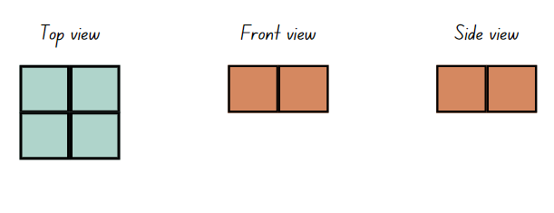
- Display Resource 37 – different orientations. Explain that changing the orientation of the 4-cube prism will change the top, front and side view.
- Model how to draw the top, front and side views of the 4-cube prism on isometric dot paper and label each of the views (see Figure 13).
Figure 13 – teacher example
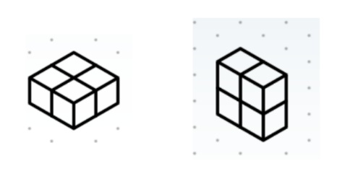

Stage 2 task – drawing prisms
- Provide each student with 12 cubes and isometric dot paper. Using all 12 cubes, students create a prism.
- Students draw the top, front and side view of their prism on isometric dot paper, labelling each view. They also draw their 12-cube prism in 2 different orientations and use the word ‘layers’ to describe their prisms (see Figure 14).
Figure 14 – student example
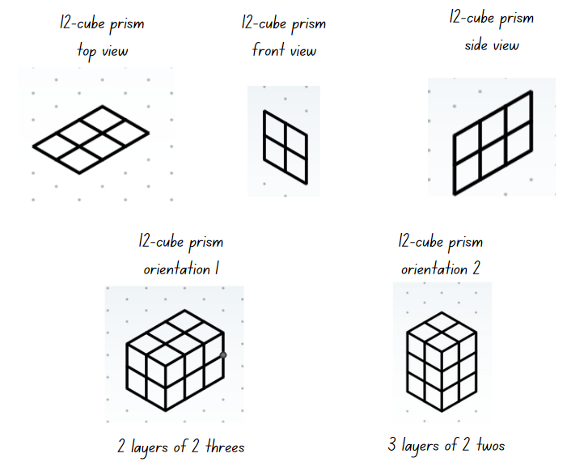

Stage 3 task – calculating volume
Note: volume is calculated by developing the row by column structure (base array) of each layer, multiplied by the number of layers. In this way, the multiplicative relationship between the dimensions (length, width and height) of a prism can be used to determine volume.
- Display Resource 38 – prism clue. Explain that each cube represents a cubic centimetre.
- Students use isometric dot paper to draw the top view of the shape.
- Provide time for students to use the clue to determine the volume of the prism and draw it.
The table below outlines stimulus prompts to generate conversation about the topic, along with anticipated responses from students.
Prompts | Anticipated student responses
- What are the dimensions of the prism? | - The top face has a length of 3 cm and a length of 2 cm. The clue says that it has 4 layers, so the height is 4 cm.
- How did you use the dimensions determine the volume of this prism? | - I thought each square could be 1 cm long. I multiplied the length of 3 cm by the width of 2 cm to get the number of cubes in one layer. This would be 6 cubes which is the same as 6 cm². Then I multiplied 6 cm² by the height of 4 cm to get a volume of 24 cm³.  - I used the row by column by layer structure.
- How did multiplication help you with calculating the volume of this prism? | - I multiplied the number of cubes in the layer by the number of layers.
- How could you record this using a number sentence? | - I recorded it as 3 × 2 × 4 = 24. With centimetre units this is 3 cm × 2 cm × 4 cm = 24 cm³.
- Do you need to use grouping symbols for this number sentence? | - No, because they are all the same operation. Grouping symbols could be used to show numbers that are easier to multiply first.
- Could you determine the volume without drawing the prism? What information helps you calculate this? | - Yes, by multiplying the length by the width helps determine the number of cubes in one layer. Then the height determines how many layers there are altogether. The dimensions could be counted using the square lines on the image.
- What are the properties of rectangular prisms that helps you calculate the volume without seeing the whole prism? | - Even if you cannot see the rectangular prism, if you know the dimensions you can multiply them to calculate the volume.
- Display Resource 39 – prism solution and ask the following questions:
- Do you agree that this prism has been created correctly?
- Can you explain why or why not? (Yes, because multiplying the base area by the height equals 24 cm³. This is the same as multiplying the length, width and height, which also equals 24 cm³).
- Display Resource 40 – calculating volume and provide students with a copy each. Explain that the table provides the base area of the prism. The task is to determine the volume of the prism with varying numbers of layers.
- Students work independently or in pairs to calculate the volume of each rectangular prism.
This table details opportunities for differentiation.
Too hard? | Too easy?
Stage 2 students cannot draw different views on isometric grids of an object constructed from cubes.  - Support students to draw the top, front and side views of the 12-cube prism.  - Give students one cube to draw on isometric dot paper. Model to students how lines need to be on an angle to show depth.  Stage 3 students cannot establish the relationship between the number of cubes in one layer and the number of layers to find the volume of a rectangular prism.  - Model how to use the table to record mathematical thinking.  - Provide concrete materials such as cubes or interlocking blocks. Support students to use blocks to build a 3 × 2 array as a base and find the area. Model how to add another layer, writing the multiplication number sentence that calculates the volume. | Stage 2 students can draw different views on isometric grids of an object constructed from cubes.  - Provide students with Resource 41 – top, front, side and cubic centimetre blocks. Students recreate the prism based on these views.  - Students create their own top, front and side views with a larger number of blocks. Students swap with a partner and their partner recreates the prism based on these views.  Stage 3 students can establish the relationship between the number of cubes in one layer and the number of layers to find the volume of a rectangular prism.  - Students find 2 strategies to work out the last problem in the table. They justify to another student why they think it is the most efficient strategy.  - Provide students with Volume of a Cuboid Maths Venn (Barton 2019). Students generate different solutions for various prisms that meet the criteria of the task.

Discuss and connect the mathematics – 10 minutes
- Students conduct a gallery walk to view the prisms and drawings. Ask the following questions:
- Do the top, front and side views match the prism you were asked to draw?
- Were there any other prisms that could be created? Why? (Stage 2 no, Stage 3 yes)
- Do the drawings accurately represent the different orientations of the prism? (Stage 2)
- How did you use your knowledge of multiplication to find the volumes of each rectangular prism? (Stage 3)
This table details opportunities for assessment.
Assessment opportunities | Links
What to look for:  - Can Stage 2 students construct models of prisms using physical manipulatives, identifying their features?  [MAO-WM-01, MA2-3DS-01]  - Can Stage 2 students create sketches of three-dimensional objects from different views, including top, front and side views? [MAO-WM-01, MA2-3DS-01]  - Can Stage 2 students draw different views on isometric grids of an object constructed from cubes? [MAO-WM-01, MA2-3DS-01]  - Can Stage 3 students select and use efficient strategies to multiply whole numbers of up to 4 digits by one- and 2-digit numbers? [MAO-WM-01, MA3-MR-01]  - Can Stage 3 students describe the length, width and height of a rectangular prism as the dimensions of the prism?  [MAO-WM-01, MA3-3DS-02]  - Can Stage 3 students describe arrangements of cubic-centimetre blocks in terms of layers? [MAO-WM-01, MA3-3DS-02]  - Can Stage 3 students establish the relationship between the number of cubes in one layer and the number of layers to find the volume of a rectangular prism? [MAO-WM-01, MA3-3DS-02] | Links to National Numeracy Learning Progressions (NNLP):  - Stage 2 – UGP3  - Stage 3 – MuS7, MuS8, MuM5.  Links to suggested Interview for Student Reasoning (IfSR) tasks:  - Stage 2 – IfSR-MT: 2A.7  - Stage 3 – IfSR-MT: 3A.1, 3A.2, 3A.3, 3A.4, 3A.5.

Lesson 7
Core concept: standard units are an efficient way to communicate volume (Stage 2) and the context determines the most suitable standard unit for measuring volume, sometimes a cubic centimetre is too small (Stage 3).

Daily number sense – nice or nasty – 10 minutes
The table below contains suggested learning intentions and success criteria. These are best co-constructed with students.
Daily number sense learning intentions | Daily number sense success criteria
Students working towards Stage 2 outcomes are learning to:  - order numbers in the thousands.  Students working towards Stage 3 outcomes are learning to:  - compare, order and represent decimals. | Students working towards Stage 2 outcomes can:  - recognise and describe how rearranging digits changes the size of a number.  Students working towards Stage 3 outcomes can:  - approximate the size of decimals  - compare and order decimal numbers of up to 3 decimal places.
This activity is an adaptation of Nice or Nasty from NRICH by the University of Cambridge.
- On the board, draw a gameboard set up as in Figure 15. Instruct students to draw 5 gameboards, vertically on their individual whiteboards. Explain that each round of the game requires that Stage 2 students make the largest 4-digit number. Stage 3 students make a decimal number that is smaller than 10 and then approximate the number to 2 decimal places.
Figure 15 – gameboard set up
- Model how to play. For example, if the numbers 6, 4, 9 and 2 are rolled, model for Stage 2 students, by thinking aloud and state ‘the largest number I can make is 9642 and record each digit in a box on the gameboard. For Stage 3 students, think aloud and state ‘a decimal number that is smaller than 10, is 6.249. When I approximate this number to 2 decimal places, I look at the last digit in the thousandths place and consider whether to round up or down, the number in the hundredths place. Because it is 9, a number greater than 5, I can round the hundredths digit up. So, the decimal number is now 6.25 (see Figure 16).
Figure 16 – example of student recordings
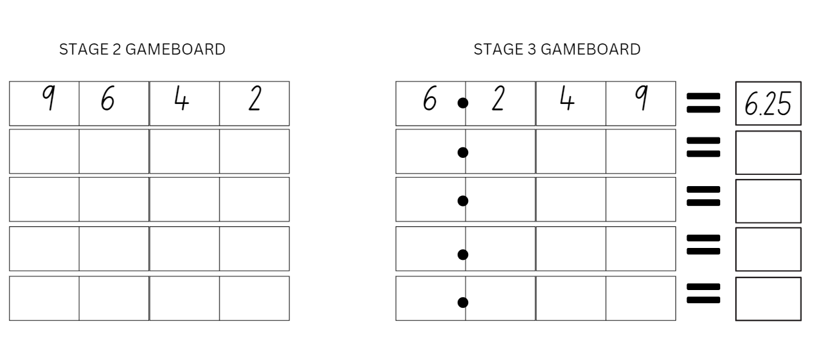
- Explain that you will roll four 9-sided dice or 4 digital 9-sided dice. Students view the digits displayed on the dice and record the numbers on their gameboard, as per the instructions above. After 5 rounds, regroup as a class and ask the following questions:
- What was the largest 4-digit number you recorded? (Stage 2)
- What was the smallest 4-digit number you recorded? (Stage 2)
- What was the largest approximated decimal you recorded? (Stage 3)
- What was the smallest approximated decimal you recorded? (Stage 3)
- If you ordered your recorded 4-digit numbers in descending order, what would be the first and last number in the sequence? (Stage 2)
- If you ordered your recorded approximated numbers in descending order, what would be the first and last number in the sequence? (Stage 3)
This table details opportunities for assessment.
Assessment opportunities | Links
What to look for:  - Can Stage 2 students recognise and describe how rearranging digits changes the size of a number? [MAO-WM-01, MA2-RN-01]  - Can Stage 3 students approximate the size of decimals?  [MAO-WM-01, MA3-RN-02]  - Can Stage 3 students compare and order decimal numbers of up to 3 decimal places? [MAO-WM-01, MA3-RN-02] | Links to National Numeracy Learning Progressions (NNLP):  - Stage 2 – NPV6  - Stage 3 – NPV8.  Links to suggested Interview for Student Reasoning (IfSR) tasks:  - Stage 3 – IfSR-NP: 4D.1, 4D.4, 4D.6.

Core lesson – measuring volume – 45 minutes
The table below contains suggested learning intentions and success criteria. These are best co-constructed with students.
Core concept learning intentions | Core concept success criteria
Students working towards Stage 2 outcomes are learning to:  - compare objects using familiar metric units of volume.  Students working towards Stage 3 outcomes are learning to:  - use cubic metres for measurement of volume. | Students working towards Stage 2 outcomes can:  - construct rectangular prisms using cubic-centimetre blocks and describe the volumes in terms of layers  - record volumes using numerals and words  - compare the volumes of 2 or more objects made from cubic-centimetre blocks.  Students working towards Stage 3 outcomes can:  - recognise the need for a formal unit larger than the cubic centimetre  - construct and use the cubic metre as a unit to measure larger volumes.
Note: it is recommended that the cubic metre used in the Stage 3 task is constructed prior to the lesson. It can then be used as a model for students while they are constructing their own cubic metre with newspaper, cardboard and masking tape. It will also assist students to visualise the space taken up by a cubic metre.
- Display Resource 42 – three prism views. Explain that a student said Prism 2 has the largest volume. Ask the following questions:
- Is this statement sometimes, always or never right? Why?
- How could we record our ideas to represent our thinking?
- How can we use the word layers to describe our ideas?
- How does Prism 1 differ from Prism 2 and Prism 3 when we think about its layers? (The number of layers in Prism 1 isn't visible.)
- Ask students what units of measurement are used to describe the prism when we discuss its:
- length (mm, cm, m)
- height and width (mm, cm, m)
- area of a face (square centimetres and square metres)
- volume or capacity (cubic centimetres and cubic metres)
- weight (grams and kilograms).

Stage 2 task – making prisms
- Provide small groups of Stage 2 students with 30 cubic centimetre blocks and blank paper. Students make prisms which match the 3 prism views and record their ideas on Resource 43 – student prisms. Move around the room, ensuring students use the terms ‘cubic centimetres’ and ‘layers’ to describe what has been drawn.
Note: the Stage 2 Teaching advice for Three-dimensional spatial structure A states that students should be introduced to the cubic centimetre but the standard abbreviation for cubic centimetres is not introduced until Stage 3. In Stage 2, the units are recorded in words or using less formal abbreviations, such as ‘cc’ (NESA 2024b).
- Ask students to select 2 of their prisms and discuss the following:
- What is the volume of each object?
- What is the difference in volume between each prism?
- What similarities are there?
- How would you describe the differences between them?

Stage 3 task – cubic metres
- Revise with students the difference between volume and capacity:
- volume is the space taken up by a three-dimensional object
- capacity is the internal volume, which is how much a three-dimensional object can hold.

Note: the Stage 3 Teaching advice for Three-dimensional spatial structure A states that capacity refers to the amount a container can hold (internal volume) and is measured in units, such as millilitres (mL) and litres (L). Capacity is only used in relation to containers and generally refers to liquid measurement (although internal volume can be measured with cubic units as well). The capacity of a closed container will be slightly less than its volume – capacity is based on the inside dimensions, while volume is determined by the outside dimensions of the container. It is not necessary to refer to these definitions with students in K–6 (capacity is not taught as a concept separate from volume until Stage 4) (NESA 2024c).
- Display an MAB ones block. Ask students to determine if this would be a suitable unit to measure the volume of the classroom. Why or why not? (No, it is a very small unit for the space. They would be difficult to stack and count.)
- Display Resource 44 – cubic metre and use the prompt box below to elicit students’ thinking.
The table below outlines stimulus prompts to generate conversation about the topic, along with anticipated responses from students.
Prompts | Anticipated student responses
- Why are some volumes measured in cubic metres and not cubic centimetres? | - The context determines the most suitable standard unit for measuring volume, sometimes a cubic centimetre is too small.
- What are the labelled dimensions of this prism? | - The dimensions are the length, width and depth. They are all one metre.
- Can you use your body to show how big you think a cubic metre would be in real life? | - Students try to indicate the approximate length, width and depth of a cubic metre.
- What might we measure in cubic metres? | - Various responses including the volume or capacity of a room, furniture, large appliances and garden mulch.
- What is the product of 1 × 1 × 1? | - The product of 1 × 1 × 1 = 1.
- If this is a cubic metre, how do we write the abbreviation? | - The abbreviation of a cubic metre is 1 m³.
- How many cubic centimetres do you think are in one cubic metre? | - A cubic metre’s dimensions are a length of 1 m (100 cm), a width of 1 m (100 cm) and a height of 1 m (100 cm). Multiplying these as 100 × 100 × 100 = 1 000 000 cm³, or one million cubic centimetres.
- Demonstrate how newspaper can be folded and taped to make the edges of a three-dimensional skeletal model. Before joining the edges to form the cubic metre, explain that the edges need to be measured with precision to create an accurate cubic metre.
- Stage 3 students work in small groups to construct a cubic metre using newspaper or rigid cardboard, masking tape and metre rulers.
This table details opportunities for differentiation.
Too hard? | Too easy?
Stage 2 students cannot construct rectangular prisms using cubic-centimetre blocks and describe the volumes in terms of layers.  - Support students to construct an array of 1 fours. Demonstrate how this can be repeated to make layers.  - Support students to recognise the array structure of the first layer of the rectangular prism.  Stage 3 students cannot construct and use the cubic metre as a unit to measure larger volumes.  - Mark out a square metre on the floor and stack the space (to a height of one metre) with everyday objects from the classroom to support students’ ability to visualise a cubic metre. | Stage 2 students can construct rectangular prisms using cubic-centimetre blocks and describe the volumes in terms of layers.  - Students create their own top view of a rectangular prism and give to a partner to record what the prism might look like.  - Pose the following question: You have a rectangular prism made of 48 cubic centimetres. What could the top view of the prism be?  Stage 3 students can construct and use the cubic metre as a unit to measure larger volumes.  - Pose the following question: What would the dimensions be on a different prism that had volume of a cubic metre?

Discuss and connect the mathematics – 10 minutes
- Students conduct a gallery walk of the prisms and cubic metres made by the class. Ask the following questions:
- What is similar about the prisms? What is different?
- What multiplication and division factors did you notice when calculating the volume? (Stage 2)
- How are the prisms similar and different to the cubic metres?
- How does constructing a prism or a cubic metre connect to learning about the volume of a space? (need to consider space, size, dimensions, equivalence, layers)
- What do you still find challenging when you are working out the volume of objects?
- How accurate are you in estimating volume using cubic centimetres (Stage 2), or cubic metres (Stage 3)? How do you know?
This table details opportunities for assessment.
Assessment opportunities | Links
What to look for:  - Can Stage 2 students construct rectangular prisms using cubic-centimetre blocks and describe the volumes in terms of layers? [MAO-WM-01, MA2-3DS-01]  - Can Stage 2 students record volumes using numerals and words? [MAO-WM-01, MA2-3DS-01]  - Can Stage 2 students compare the volumes of 2 or more objects made from cubic-centimetre blocks? [MAO-WM-01, MA2-3DS-01]  - Can Stage 3 students recognise the need for a formal unit larger than the cubic centimetre? [MAO-WM-01, MA3-3DS-02]  - Can Stage 3 students construct and use the cubic metre as a unit to measure larger volumes? [MAO-WM-01, MA3-3DS-02] | Links to National Numeracy Learning Progressions (NNLP):  - Stage 2 – UuM5  - Stage 3 – UuM5.  Links to suggested Interview for Student Reasoning (IfSR) tasks:  - Stage 2 – IfSR-MT: 2A.7.

Lesson 8
Core concept: mathematicians measure and compare volume (Stage 2) and mathematicians estimate, measure and record volume using m³ (Stage 3).

Daily number sense – 10 minutes
- From a class need surfaced through formative assessment data, identify a short, focused activity that targets students’ knowledge, understanding and skills. Example activities may be drawn from the following resources:
- Mathematics K–6 resources
- Universal Resources Hub.

Core lesson – exploring volume – 45 minutes
The table below contains suggested learning intentions and success criteria. These are best co-constructed with students.
Core concept learning intentions | Core concept success criteria
Students working towards Stage 2 outcomes are learning to:  - compare objects using familiar metric units of volume  - connect three-dimensional objects and two-dimensional representations.  Students working towards Stage 3 outcomes are learning to:  - use estimation and rounding to check the reasonableness of answers to calculations  - use cubic metres for measurement of volume  - find the volumes of rectangular prisms in cubic centimetres and cubic metres. | Students working towards Stage 2 outcomes can:  - construct rectangular prisms using cubic-centimetre blocks and describe the volumes in terms of layers  - record volumes using numerals and words  - create sketches of three-dimensional objects from different views, including top, front and side views.  Students working towards Stage 3 outcomes can:  - use estimation to check the reasonableness of answers to multiplication and division calculations  - estimate and measure volumes in cubic metres  - calculate volumes of rectangular prisms in cubic metres (m³).
- Draw Figure 17 on the board.
Figure 17 – box representation
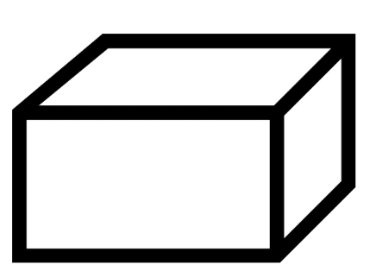
- Ask students to brainstorm ways to describe the box. Encourage students to use vocabulary related to three-dimensional objects and volume.
Note: the Stage 2 and Stage 3 teaching advice states that students should be provided with opportunities to develop confidence in using terms related to three-dimensional objects and volume to communicate.
- Record responses on the board, discussing how best to label the box with the vocabulary given (see Figure 18).
Figure 18 – possible student responses
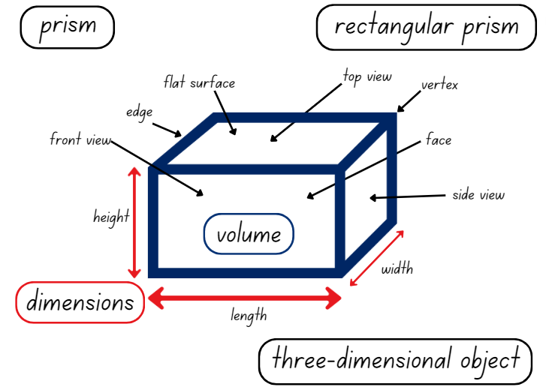
- Draw students’ attention to the word ‘volume’ recorded on the board. Revise that volume is the space taken up by a three-dimensional object. Ask the following questions:
- What do you imagine might be inside the box?
- Based on what you imagine is inside, is the volume of the box measured in cubic centimetres or cubic metres?
- Ask students to turn and talk, discussing what they imagine is in the box and explaining what cubic unit is needed to describe the dimensions of the box.
Multi-age: students working towards Stage 2 outcomes are introduced to the cubic centimetre only. Students working towards Stage 3 outcomes use the formal units of cubic centimetres (cm³) and cubic metres (m³) when exploring volume.

Stage 2 task – jube cubes
- Display Resource 45 – JMS lolly company.
- Show students what 36 cubes in one layer could look like using cubic centimetre blocks. For example, one layer of 6 sixes.
- Tell students they are going to predict how many ways 36 jube cubes can be stacked in 2 or 3 layers to form a rectangular prism. Ask the following questions:
- How can we use our knowledge of multiplication to help us?
- How can making an array help us?
- How can we record our solutions?
- How could we describe what we’ve made?
- Give students a sticky note each and ask them to record their prediction of how many possibilities there are.
- Provide groups of students 36 cubes and Resource 46 – different views.
- Students work in small groups to discuss the problem and develop solutions. Each student must keep a record of possible solutions using sketches and labelling (see Figure 19).
Figure 19 – possible student solution
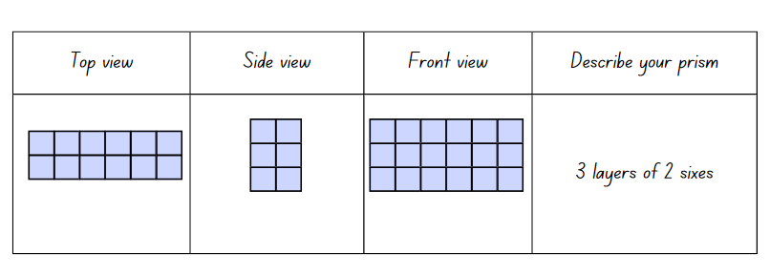

Stage 3 task – classroom cubic metres
This lesson is an adaptation of ‘Claustrophobia’ from Teaching Measurement: Stage 2 and 3 [PDF 685 KB] by Department of Education Learning and Teaching Directorate.
- Revise with students the use and dimensions of a cubic metre. Ask the following questions:
- How big is a cubic metre?
- What could be measured with a cubic metre?
- How can cubic metres be recorded as an abbreviation?
- How many students could fit in a cubic metre?
- Students turn and talk and record their estimates on how many students could fit into a cubic metre.
- Regroup and determine how many students fit into a cubic metre. Encourage students to trial several methods of arranging themselves before a result is recorded.
- Students turn and talk to discuss the following questions. Ask the following questions:
- What do you estimate the volume of the classroom to be in cubic metres?
- What information could we use to guide the estimate?
- How could a model of a cubic metre help you make a reasonable estimate?
- How do I calculate the volume of the classroom to the nearest cubic metre?
- What other information might I need to complete this task? (Clarify for students whether the volume includes cabinets, shelves and storerooms).
- Students turn and talk and record their estimates. Ensure that students understand that the dimensions of the classroom must be measured to then determine the volume of the classroom.
- Provide groups of 3 with a metre ruler to measure the dimensions of the classroom. Students may wish to record their measurements using a labelled diagram of the classroom.
- Regroup and compare measurements. Ask the following questions:
- What strategy did your group use to get an accurate measurement?
- Did every group get the exact same measurements? Why or why not?
- Do you want to change your estimation for the volume of the classroom?
- How can you use your measurements to calculate the volume of the classroom?
- Allow students to reflect on their estimation before calculating the volume of the classroom.
- Select students to share their calculations. Ask the following questions:
- What strategy did you use to calculate the volume of the classroom?
- How did rounding help you when calculating the volume of the classroom?
- Did you round your measurements up or down?
- Is there a situation where it would be better to round up or down?
- How close was your first estimate to your final calculation?
- Using the number of students that fit into a cubic metre, how many students could occupy the volume of the classroom?
Note: the purpose of the final calculation is to provide students with another opportunity to visualise and appreciate the size of a cubic metre.
This table details opportunities for differentiation.
Too hard? | Too easy?
Stage 2 students cannot construct rectangular prisms using cubic-centimetre blocks and describe the volumes in terms of layers.  - Support students to draw the top view only of the prism.  - Support students to create arrays using 4, 9 and 12 blocks as their first layer. Ask students how these arrays can be layered to make 36 cubes in total.  Stage 3 students cannot estimate and measure volumes in cubic metres.  - Support students to compare the length, width and height of the classroom to the cubic metre models made in Lesson 7.  - Revise with students the relationship between the number of cubes in one layer and the number of layers to find the volume of a rectangular prism. | Stage 2 students can construct rectangular prisms using cubic-centimetre blocks and describe the volumes in terms of layers.  - Pose the following question: How many possibilities are there for stacking 36 cubes if we can have any number of layers?  - Pose the following question: JMS Lolly Company sells the boxes to shops in cartons of 12 boxes – What might the cartons look like? How many jubes are in the carton?  Stage 3 students can estimate and measure volumes in cubic metres.  - Ask students to estimate the volume of large items in the classroom such as a cupboard, bookshelf and teacher desk. Students then measure and calculate the volume of these items.

Discuss and connect the mathematics – 15 minutes

Stage 2 task
- Ask the following questions:
- How many solutions did you find?
- Were there more or fewer than you predicted?
- Students place labelled sketches on their desks and conduct a gallery walk. Ask the following questions:
- Did you see any solutions you hadn’t thought of?
- How does multiplication help us know that we’ve found all the possibilities?
- What patterns do you notice about the dimensions of the prisms?

Stage 3 task
- Write this problem on the board: A classroom has a length of 9.95 m, height of 3.5 m and width of 7.89 metres. Ask the following questions:
- Is 250 m³ or 300 m³ a better estimate for the volume of the classroom?
- How should the measurements be rounded to get the closest estimate?
- Students turn and talk to discuss their ideas and then share their responses with the class.
- Pose the following problem: Andrew states that the volume of a classroom is 400 cubic metres. What might the dimensions of the classroom be? What would be reasonable?
- Students work individually or in pairs to determine possible dimensions for the classroom.
- Regroup and select students to share their ideas and strategies.
This table details opportunities for assessment.
Assessment opportunities | Links
What to look for:  - Can Stage 2 students construct rectangular prisms using cubic-centimetre blocks and describe the volumes in terms of layers? [MAO-WM-01, MA2-3DS-02]  - Can Stage 2 students record volumes using numerals and words? [MAO-WM-01, MA2-3DS-02]  - Can Stage 2 students create sketches of three-dimensional objects from different views, including top, front and side views? [MAO-WM-01, MA2-3DS-01]  - Can Stage 3 students use estimation to check the reasonableness of answers to multiplication and division calculations?  [MAO-WM-01, MA3-MR-01]  - Can Stage 3 students estimate and measure volumes in cubic metres? [MAO-WM-01, MA3-3DS-02]  - Can Stage 3 students calculate volumes of rectangular prisms in cubic centimetres (cm³) and cubic metres (m³)?  [MAO-WM-01, MA3-3DS-02] | Links to National Numeracy Learning Progressions (NNLP):  - Stage 2 – UuM5, UGP3  - Stage 3 – MuS7, UuM5.  Links to suggested Interview for Student Reasoning (IfSR) tasks:  - Stage 2 – IfSR-MT: 2A.7.

Resource 1 – Farmer Cluck
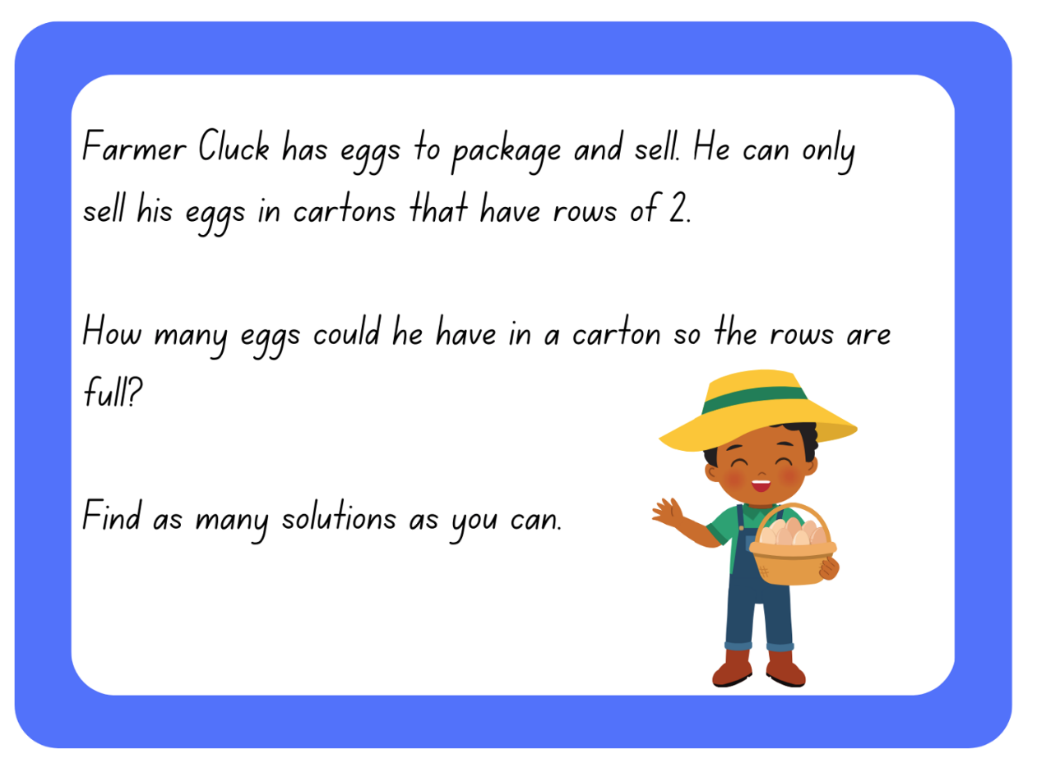

Resource 2 – pictures of cartons
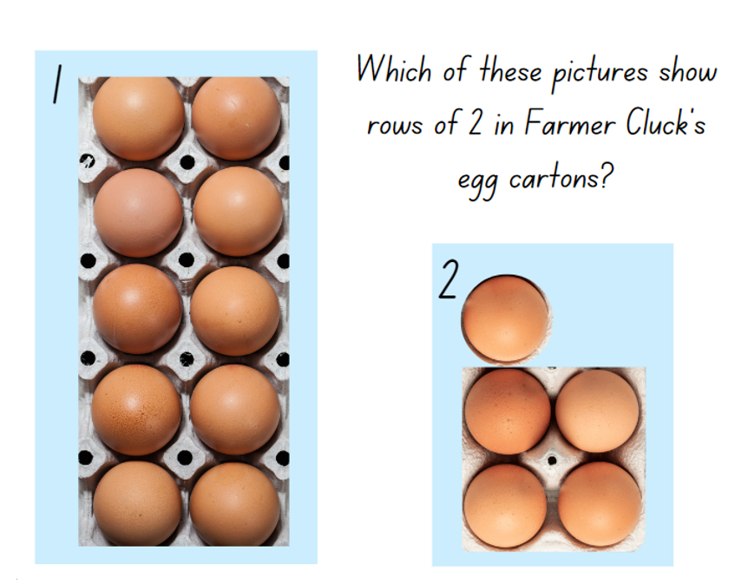

Resource 3 – egg carton arrays
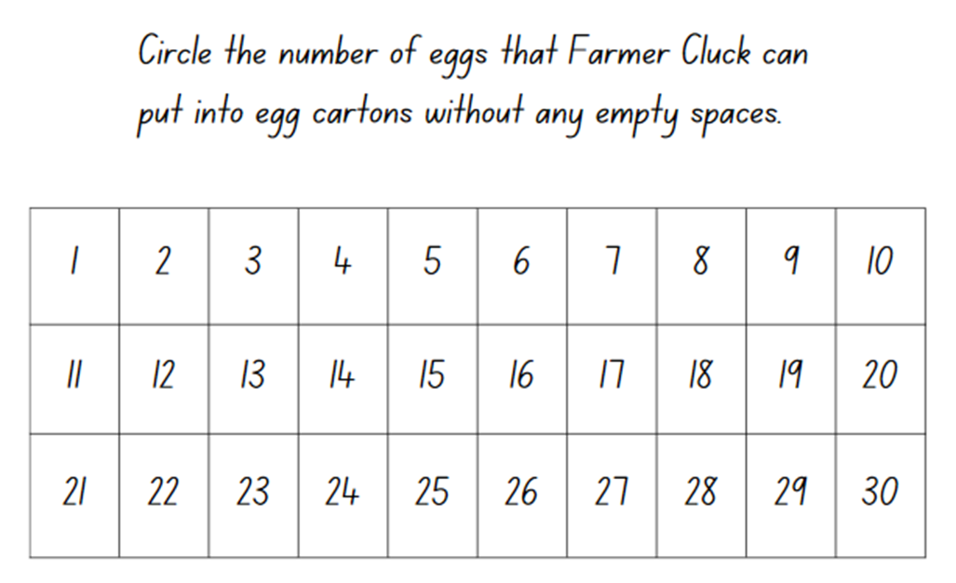

Resource 4 – odd and even
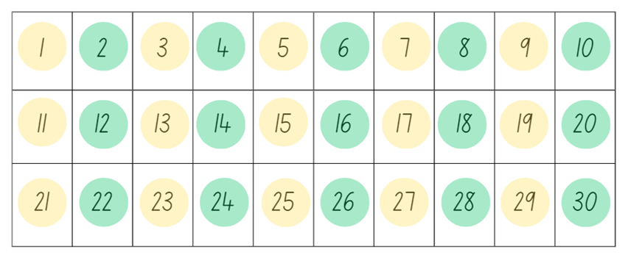 | - What do you notice about the numbers coloured in green?  - How can we describe the green numbers by using the word multiples?  - Is there another way that we can describe the green numbers?  - What do you notice about the numbers coloured in yellow?  - How are these numbers different to the green numbers?  - What patterns do you see in the final digit of each number?  - Would 36 be a green or yellow number? How do you know?  - Would 39 be a green or yellow number? How do you know?

Resource 5 – route product
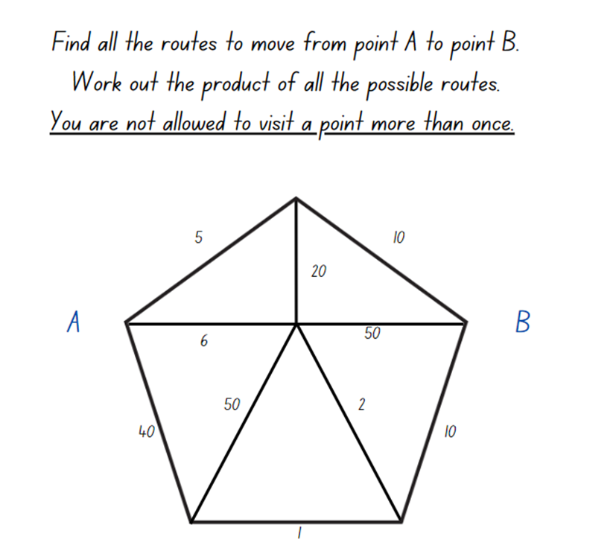

Resource 6 – place value houses
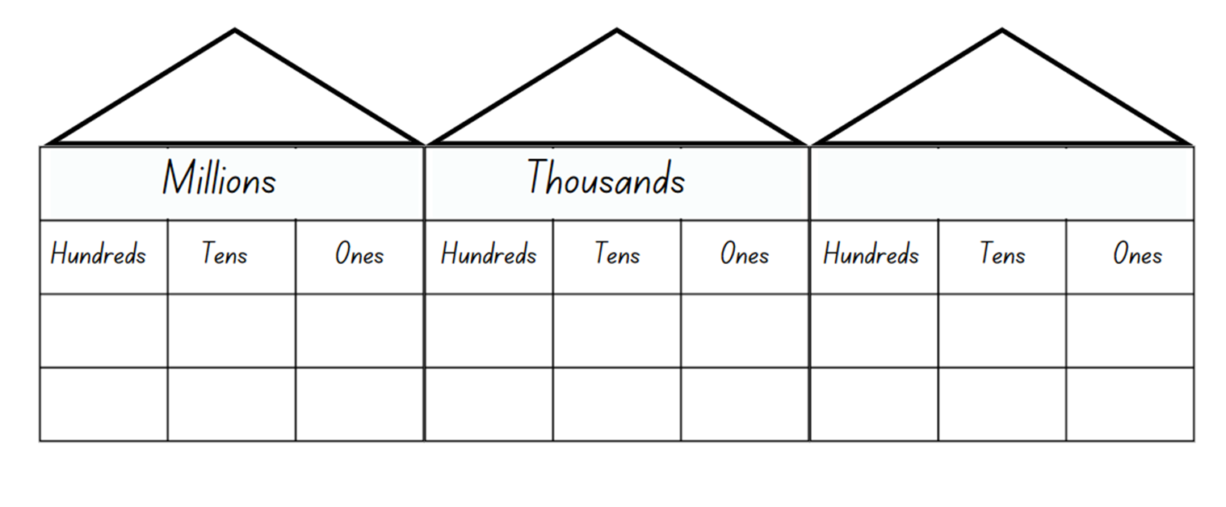

Resource 7 – always, sometimes, never
The sum of 3 numbers is odd. | If you add one to an odd number, you get an even number. | When you add even numbers, the answer is an even number.
If you add 2 odd numbers, you get an odd number. | When you add an even number and an odd number, you get an even number. | Multiples of 5 end in a 5.
If you add a multiple of 10 to a multiple of 5 the answer is a multiple of 5. | When you multiply 2 numbers you will always get a bigger number. | Every multiple of an odd number is an odd number.

Resource 8 – factors fun gameboard
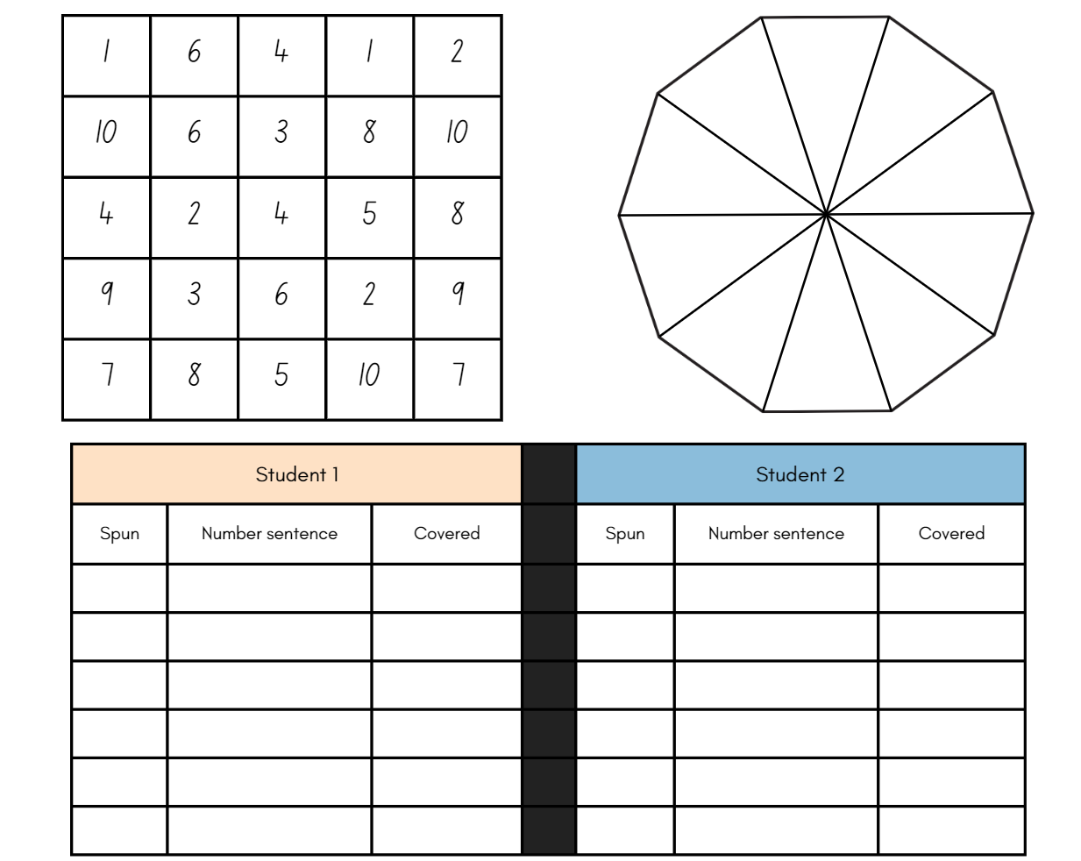

Resource 9 – factors fun spinner
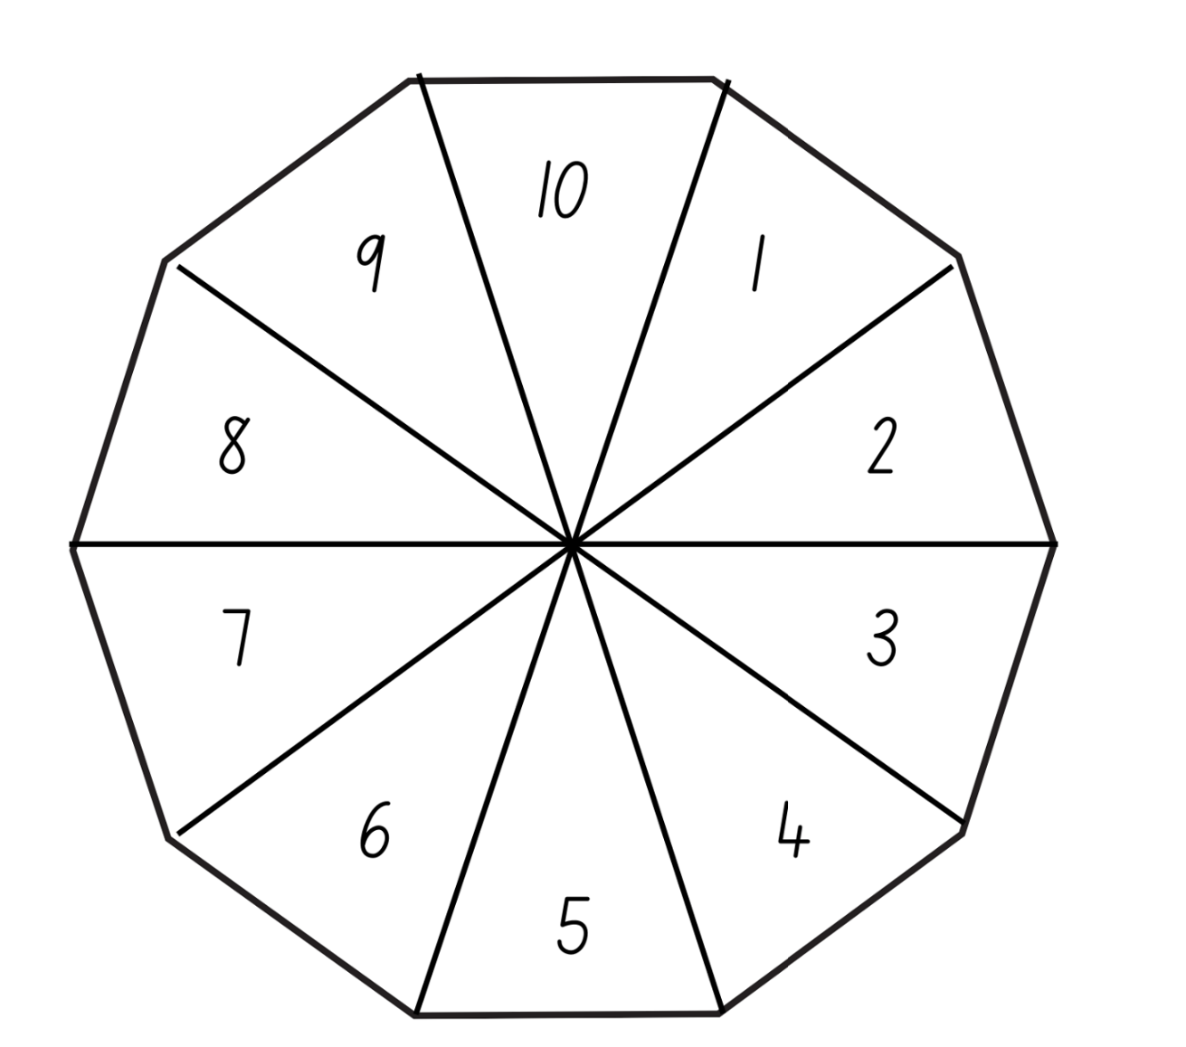

Resource 10 – garden view
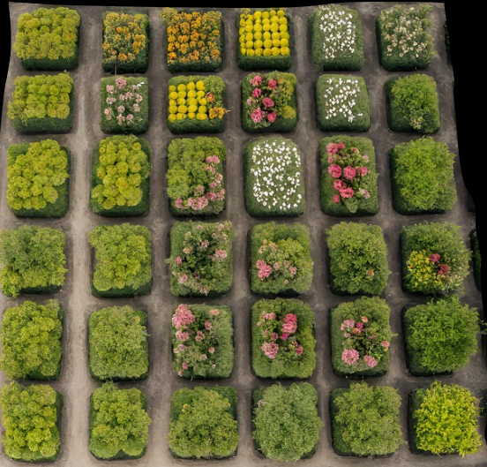

Resource 11 – How many twos?

Resource 12 – How many fours?

Resource 13 – How many fives?
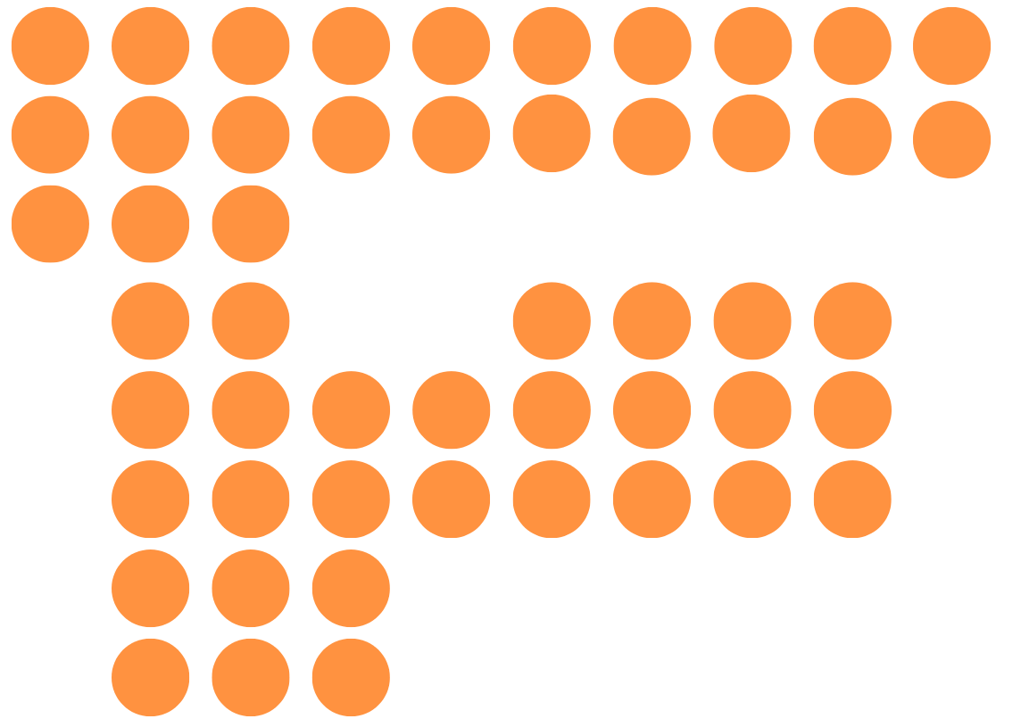

Resource 14 – garden bed
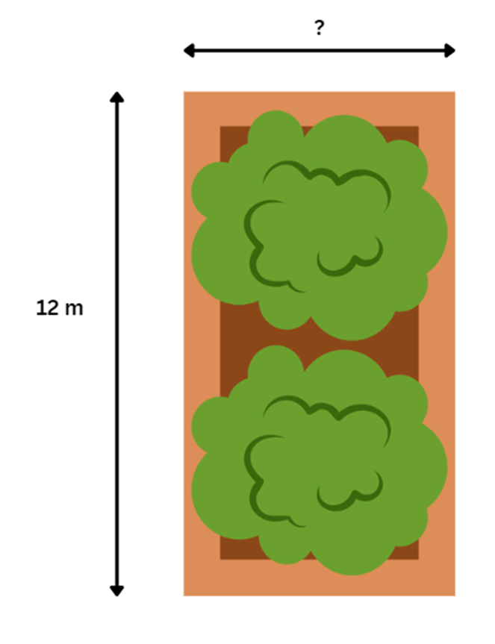

Resource 15 – area problem
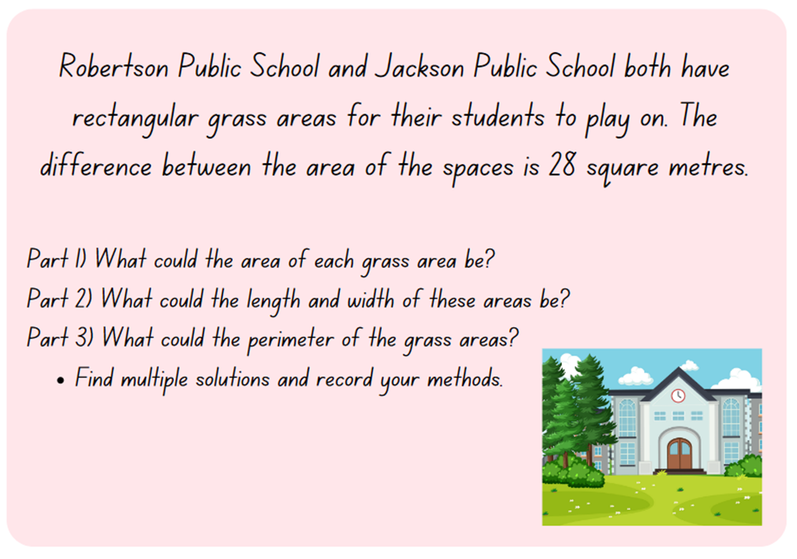

Resource 16 – How many threes?

Resource 17 – fruit boxes
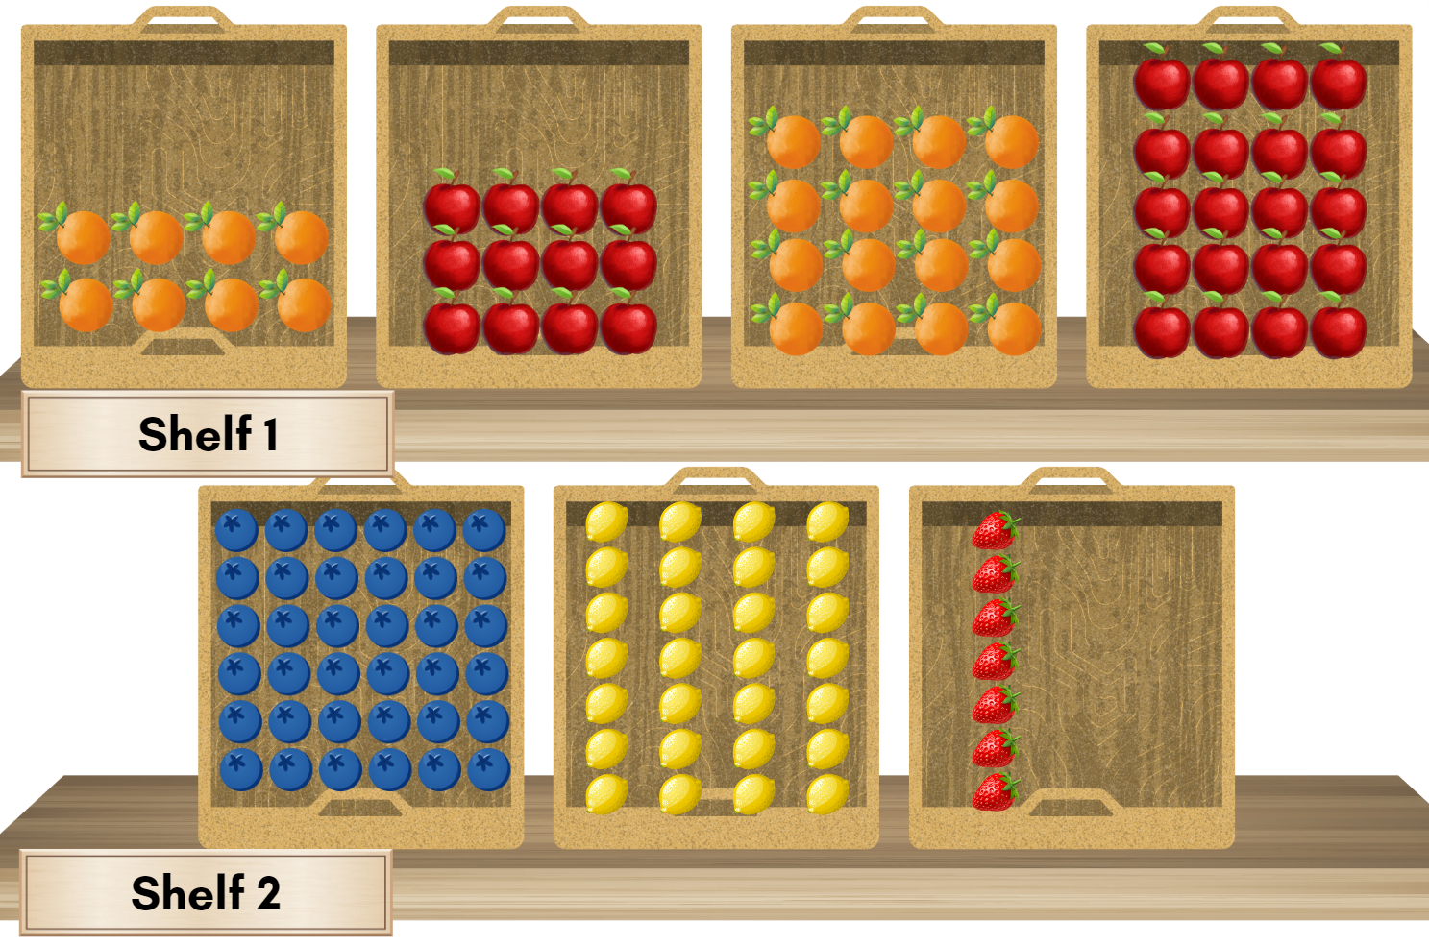

Resource 18 – exploring arrays
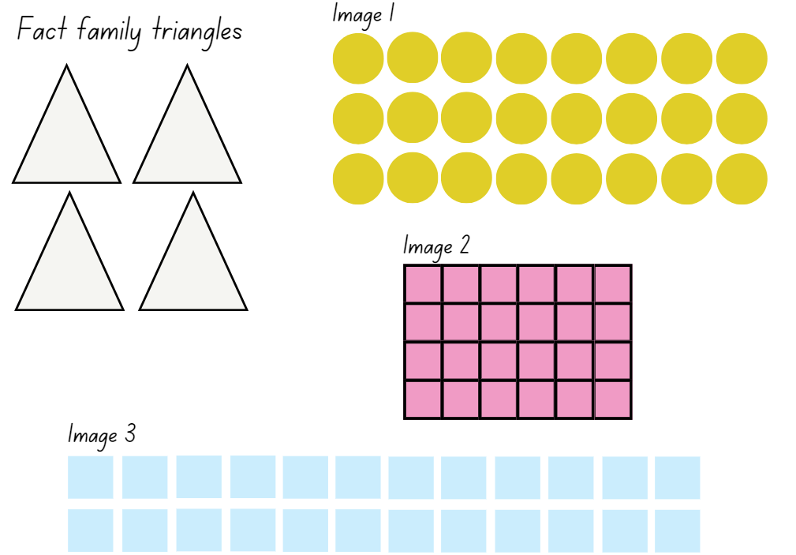

Resource 19 – rectangular robot
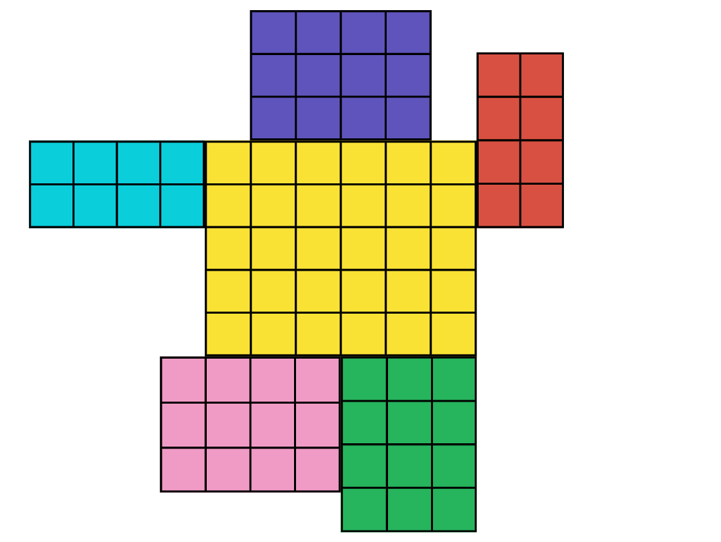

Resource 20 – combining arrays
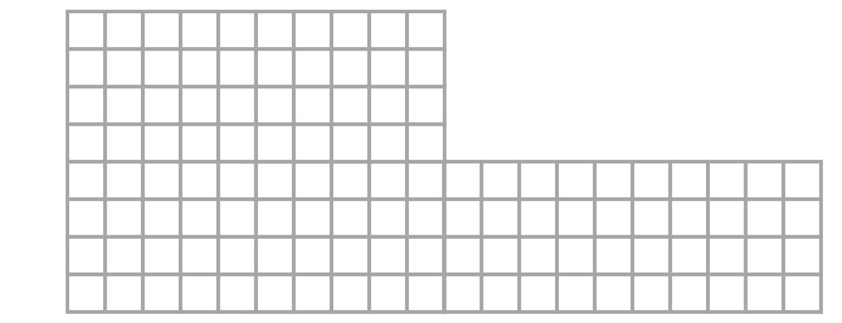

Resource 21 – array solutions
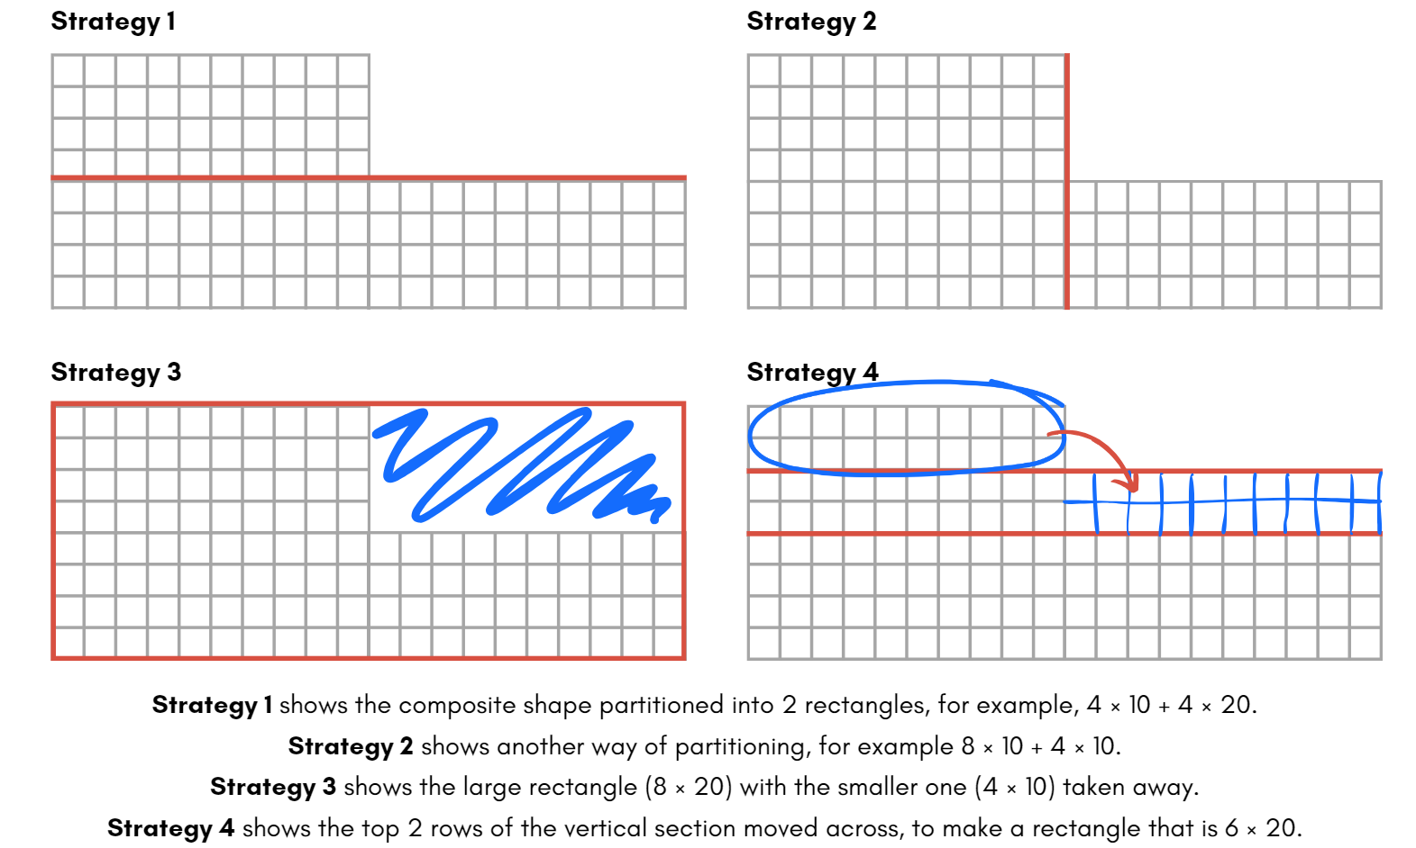

Resource 22 – combining arrays 2

Resource 23 – sticker album solution
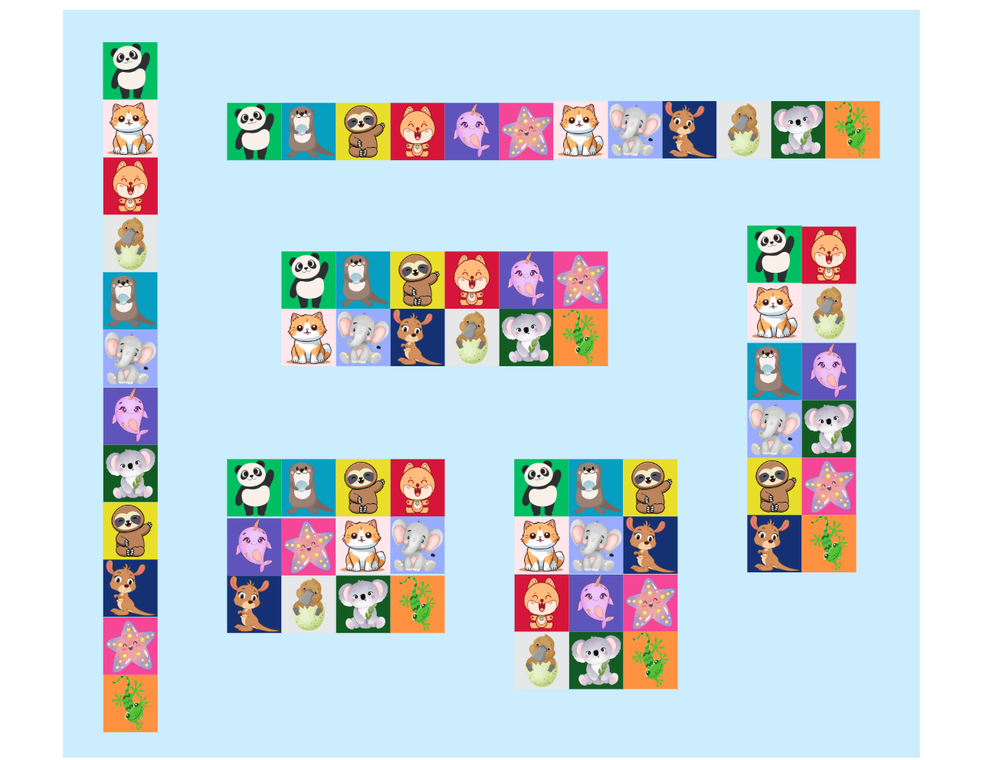

Resource 24 – sticker problem
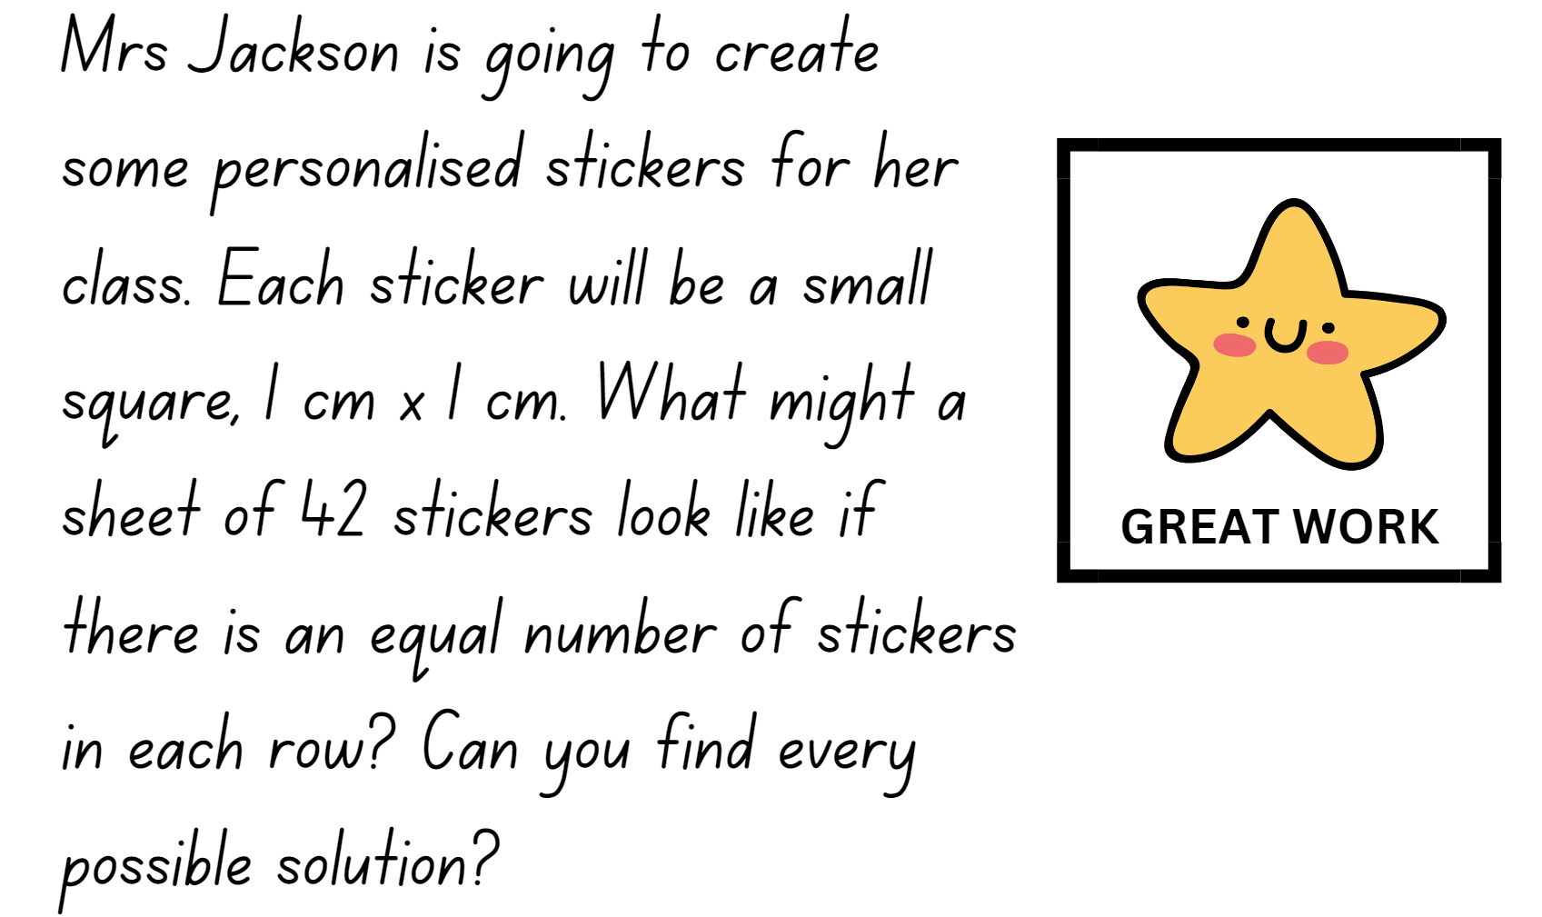

Resource 25 – four-digit numbers
2555 | 3500 | 8985 | 7008 | 4211 | 4125
9201 | 5643 | 8988 | 8123 | 9017 | 2759
2375 | 6799 | 6001 | 7591 | 8765 | 5825
1009 | 7080 | 5430 | 4327 | 1936 | 4095
5789 | 1222 | 2453 | 6999 | 1938 | 6130
9908 | 3405 | 3765 | 7018 | 1965 | 3452

Resource 26 – decimal cards
1.0 | 2.705 | 0.50 | 1.522 | 3.901 | 4.125
3.025 | 0.001 | 1.49 | 3.0 | 0.625 | 2.750
0.90 | 2.0 | 3.5 | 1.68 | 0.595 | 3.825
2.75 | 1.490 | 0.25 | 3.254 | 2.40 | 1.909
1.842 | 2.59 | 0.337 | 2.22 | 4.0 | 3.61
0.0 | 2.220 | 3.50 | 1.25 | 2.914 | 3.708

Resource 27 – comparing 2 leaves
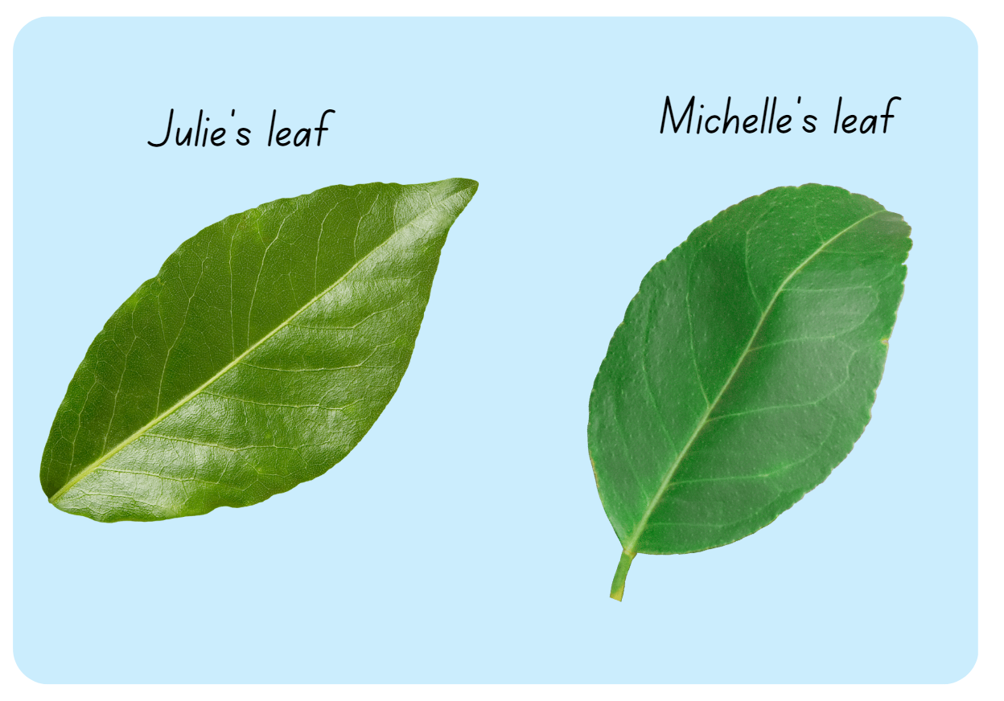

Resource 28 – leaf grid overlay
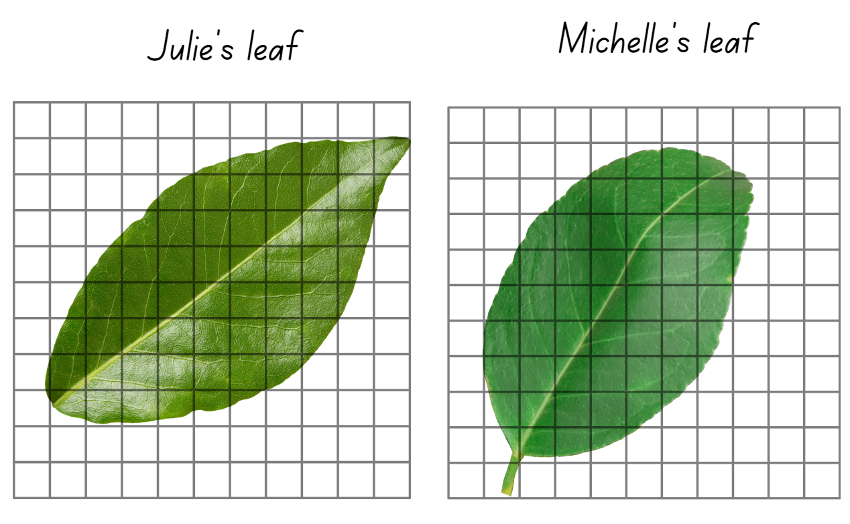

Resource 29 – Julie’s strategy
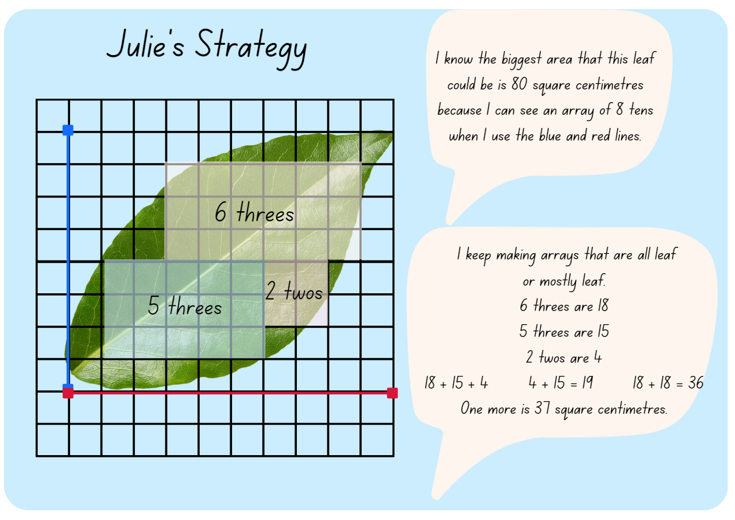

Resource 30 – Michelle’s strategy
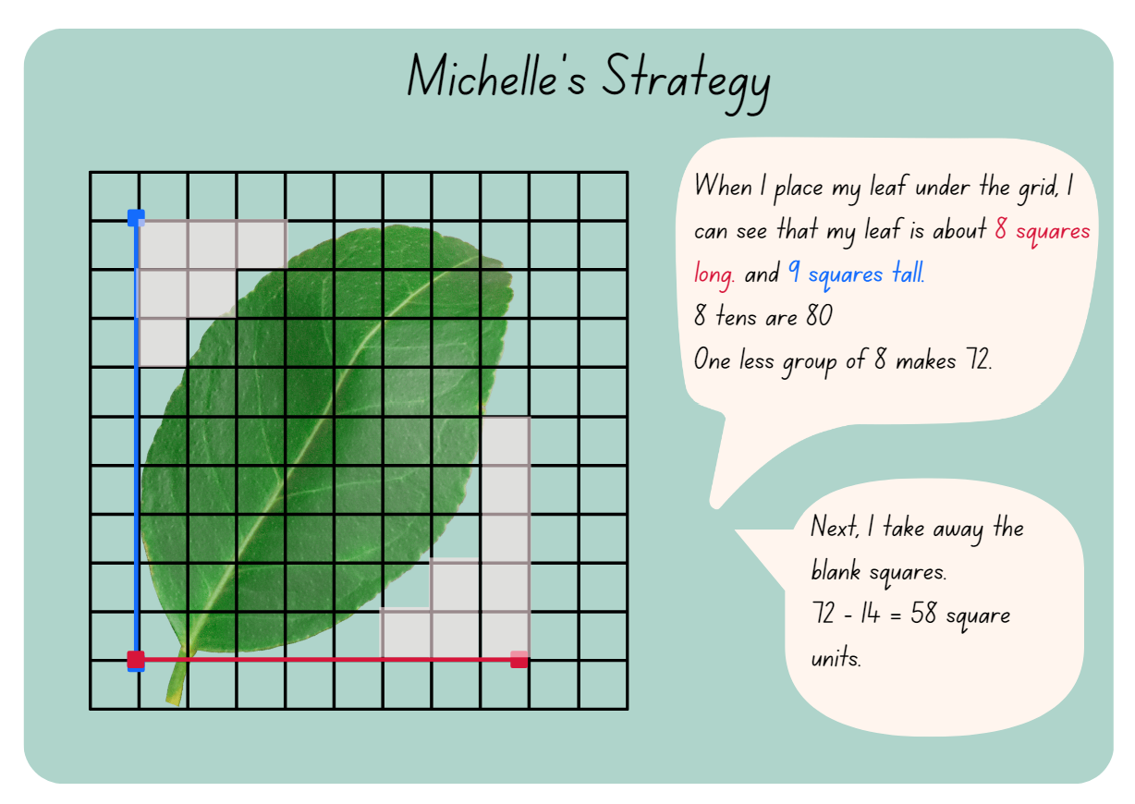

Resource 31 – two prisms
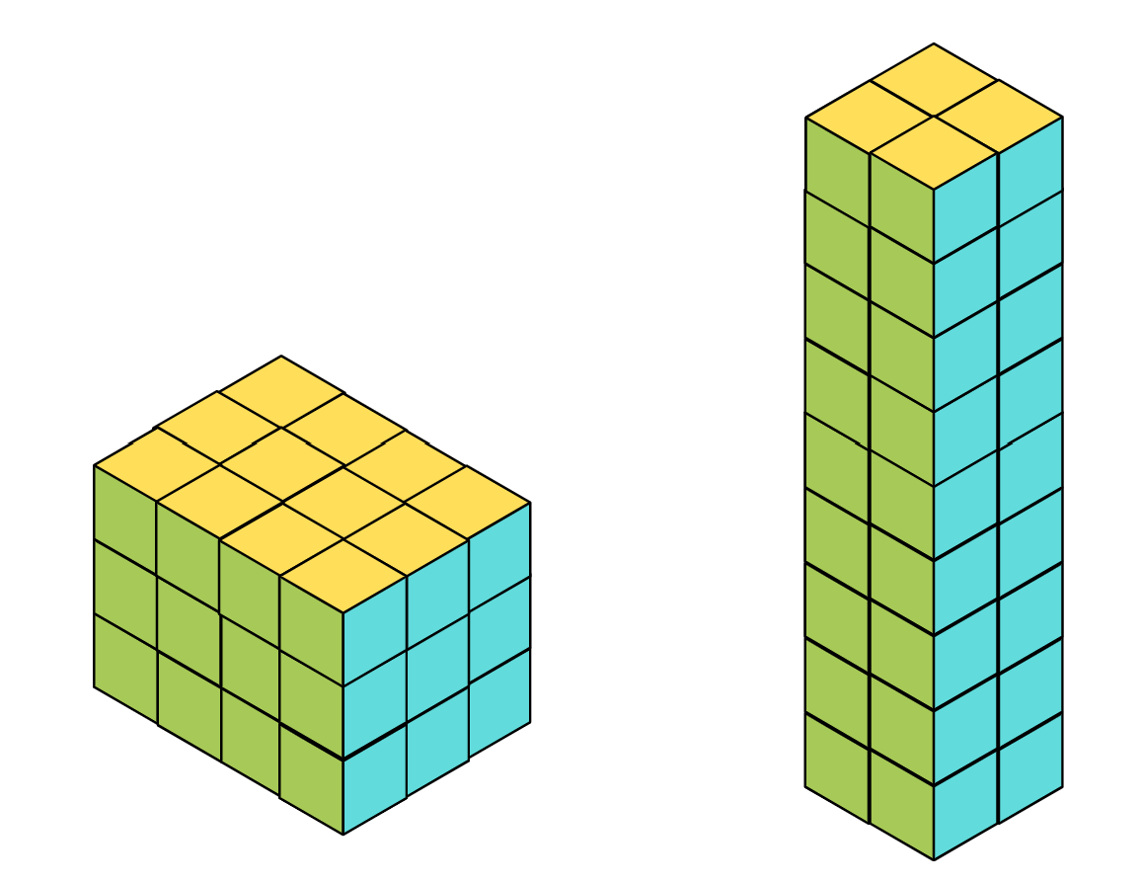

Resource 32 – Aaron’s leaf
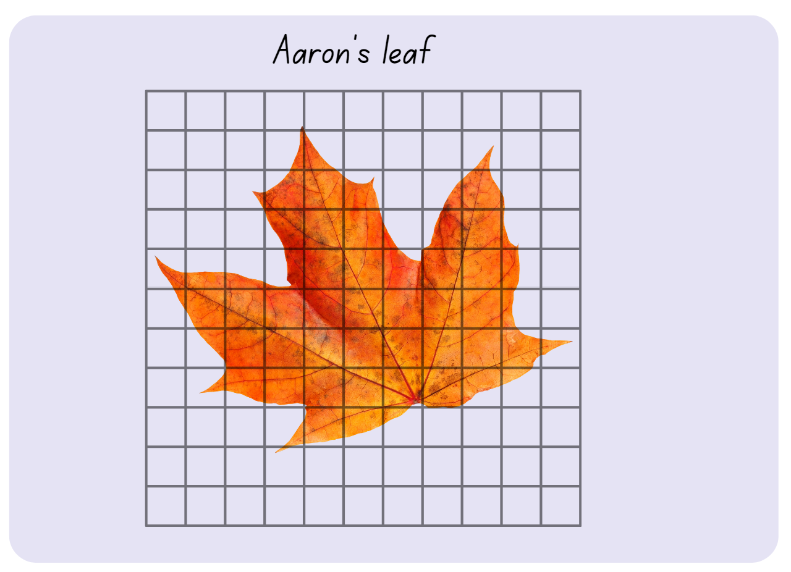

Resource 33 – fill the stairs 1
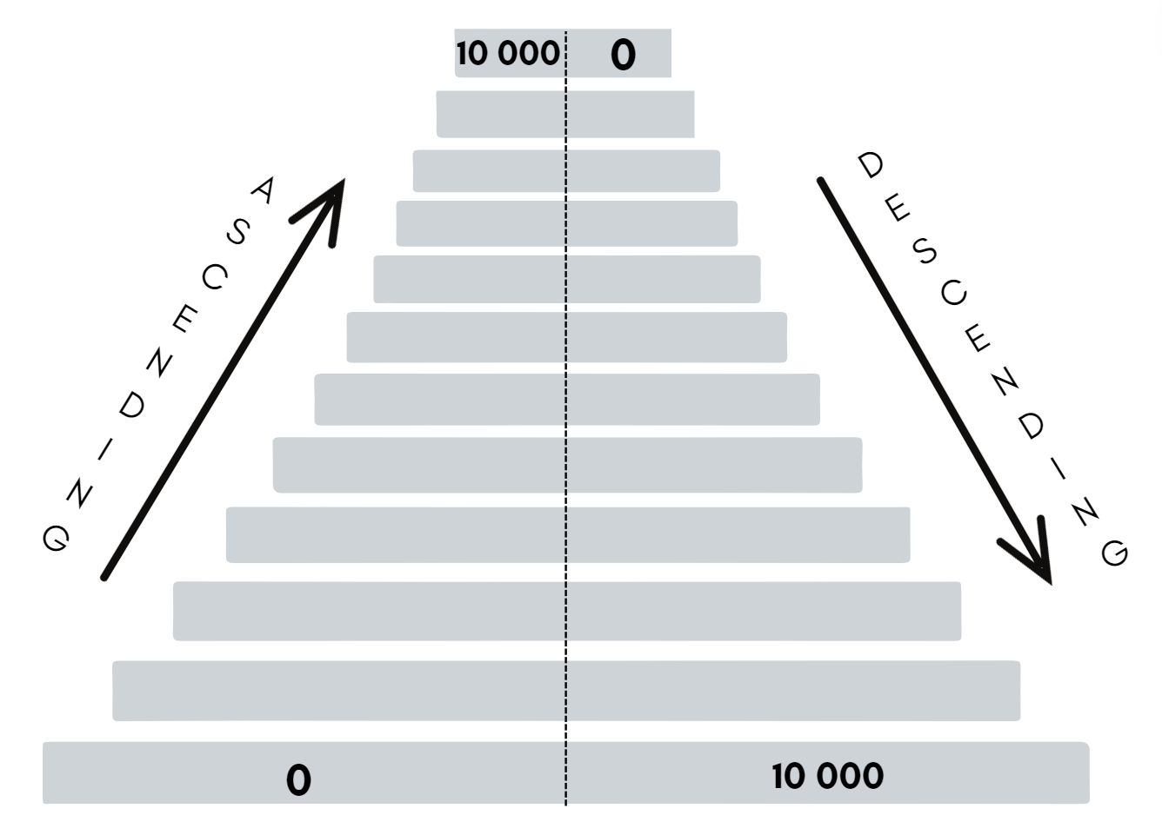

Resource 34 – fill the stairs 2
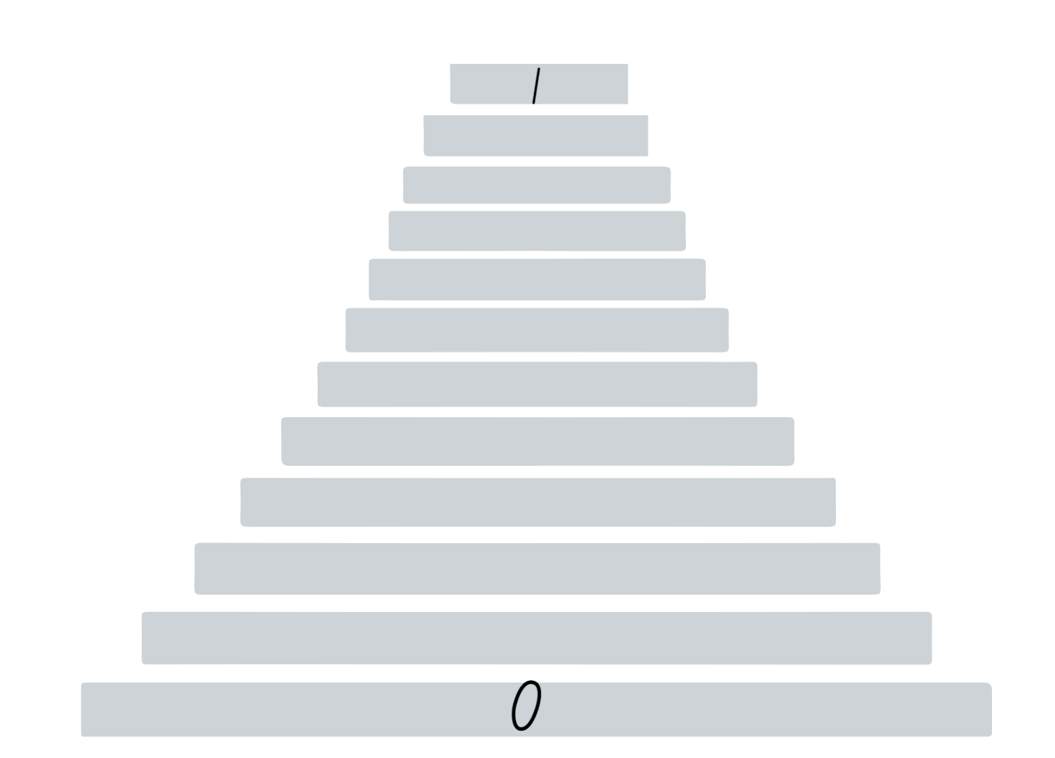

Resource 35 – pallet of boxes
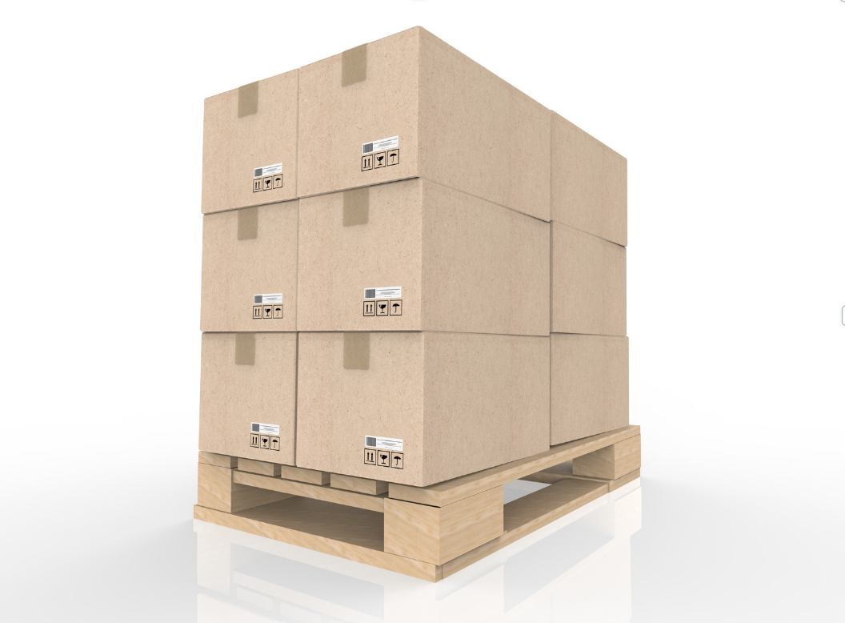

Resource 36 – 4-cube prism
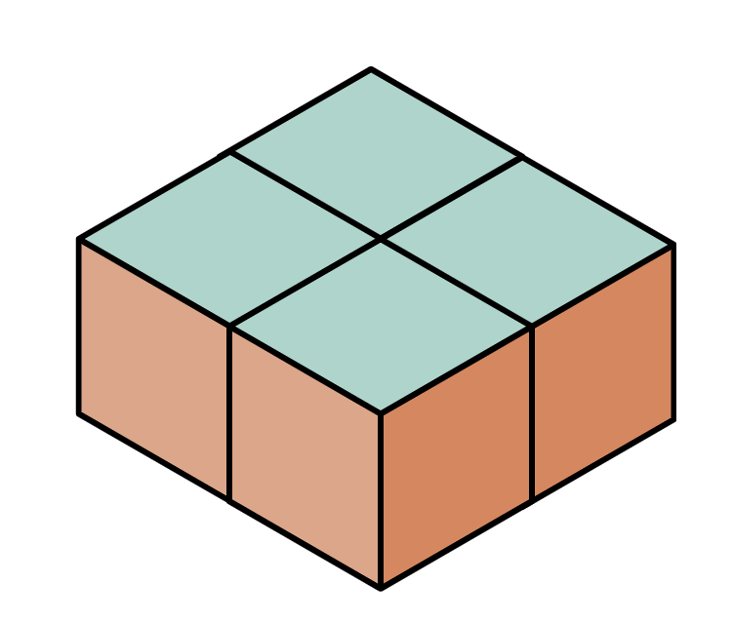

Resource 37 – different orientations
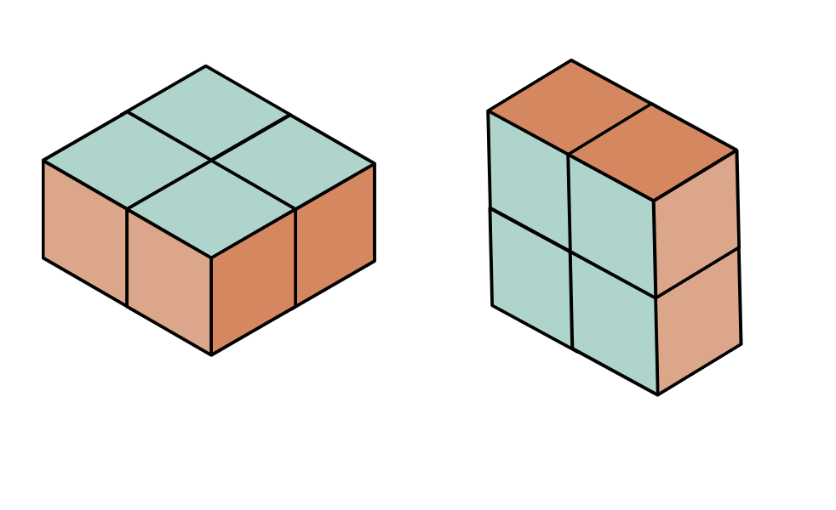

Resource 38 – prism clue
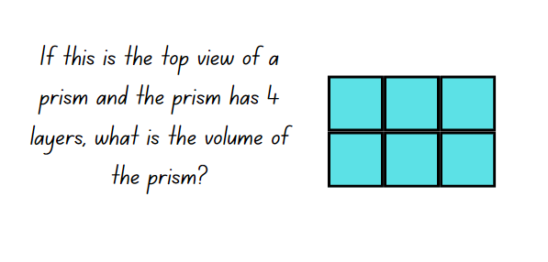

Resource 39 – prism solution
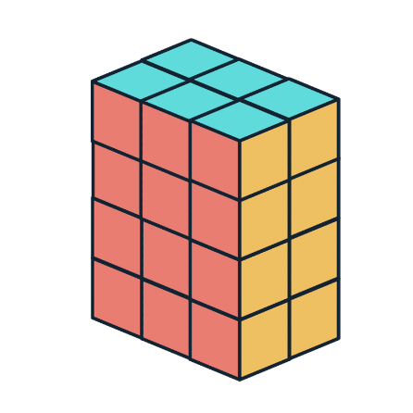

Resource 40 – calculating volume
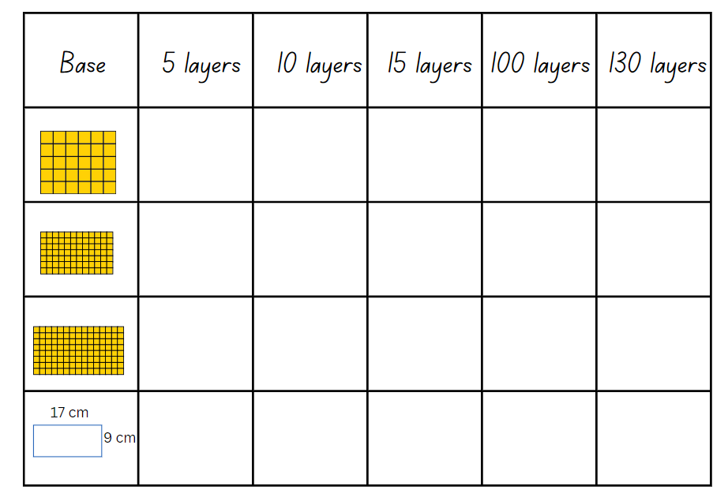

Resource 41 – top, front, side
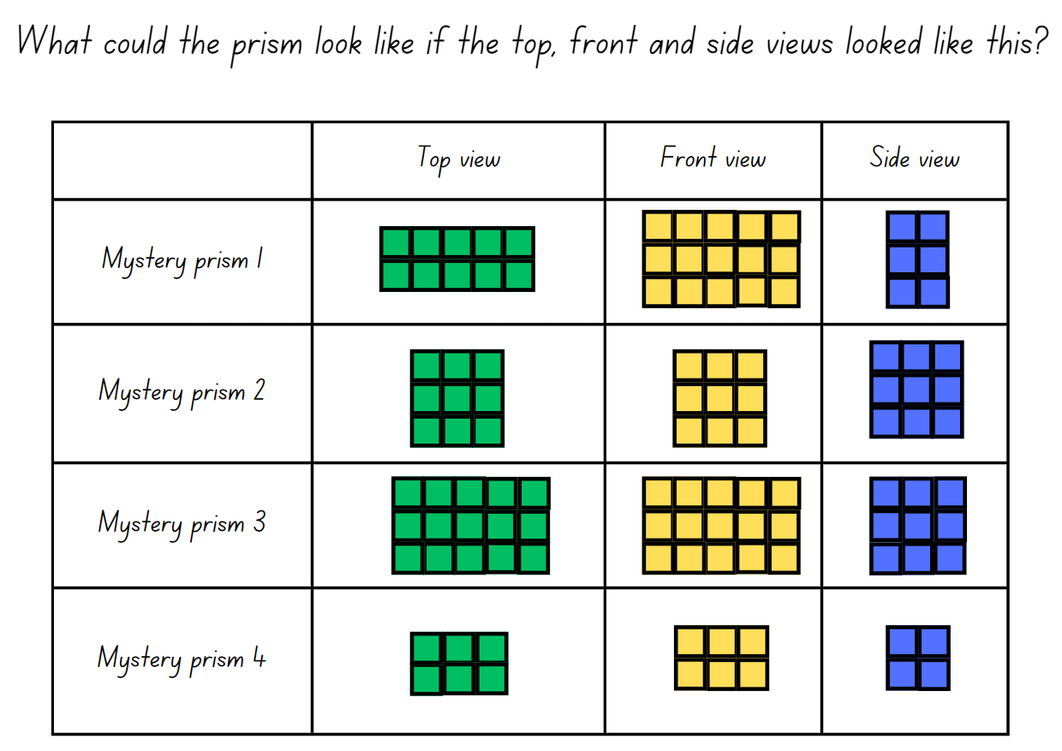

Resource 42 – three prism views
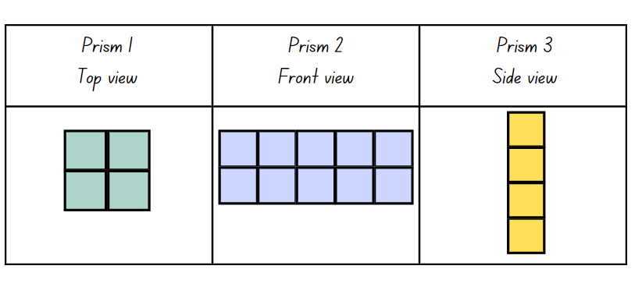

Resource 43 – student prisms
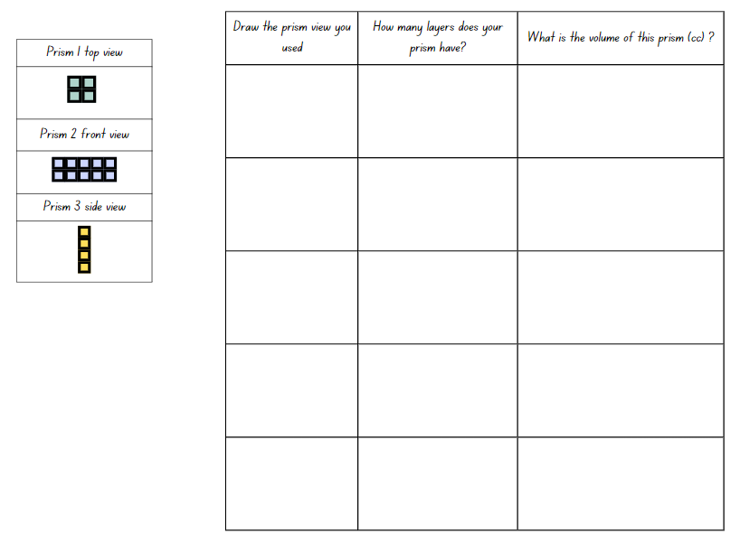

Resource 44 – cubic metre
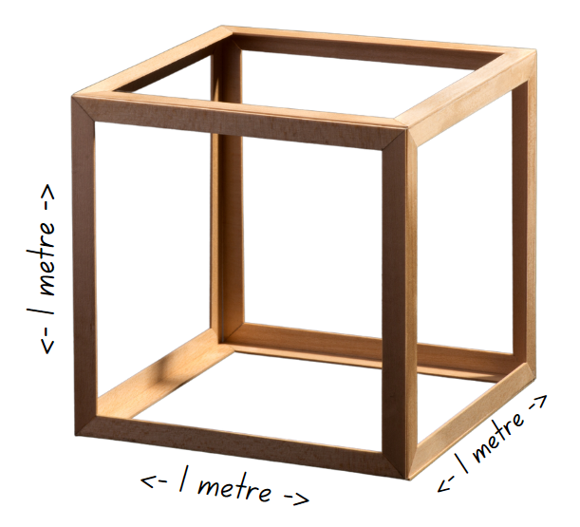

Resource 45 – JMS lolly company
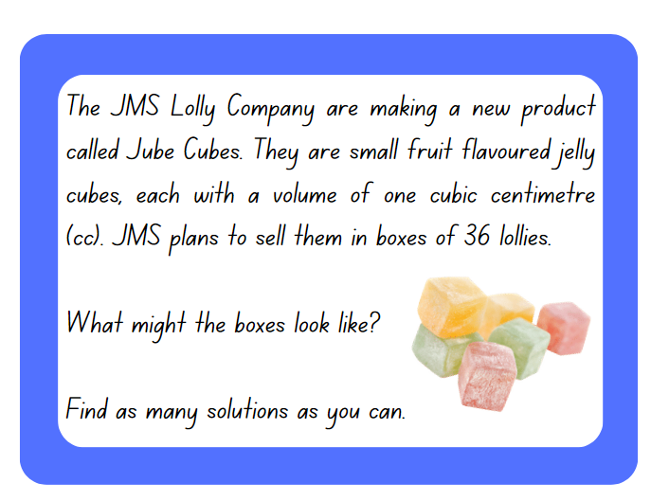

Resource 46 – different views
Top view | Side view | Front view | Describe your prism

Syllabus outcomes and content

Stage 2
The table below outlines the syllabus outcomes and range of relevant syllabus content covered in this unit. Content is linked to National Numeracy Learning Progression (version 3).
Outcomes and content | 1 | 2 | 3 | 4 | 5 | 6 | 7 | 8
Representing numbers using place value B: Whole numbers: Order numbers in the thousands
[MAO-WM-01, MA2-RN-01]
- Arrange numbers in the thousands in ascending and descending order |  |  |  |  | x | x
- Recognise and describe how rearranging digits changes the size of a number (Reasons about relations) |  |  |  |  |  |  | x
- Identify the nearest thousand, 10 thousand or 100 thousand to numbers |  |  |  |  |  | x
Multiplicative relations A: Generate and describe patterns
[MAO-WM-01, MA2-MR-01]
- Model, describe and record patterns of multiples | x
- Recognise the significance of the final digit of a whole number in determining whether a given number is even or odd (Reasons about relations) | x
Multiplicative relations A: Use arrays to establish multiplication facts from multiples of 2 and 4, 5 and 10
[MAO-WM-01, MA2-MR-01]
- Create and represent multiplicative structure, using the term multiples when connecting grouping to arrays |  | x
- Use the array structure to coordinate the number of groups with the number in each group | x |  |  |  | x
- Record the first 10 multiples formed by counting by twos, fours, fives and tens |  |  | x
Multiplicative relations A: Recall multiplication facts of 2 and 4, 5 and 10 and related division facts
[MAO-WM-01, MA2-MR-01]
- Generate multiplication fact families for multiples of 2 and 4, 5 and 10 |  | x | x
- Model and apply the commutative property of multiplication |  |  |  | x
Two-dimensional spatial structure A: 2D shapes: Compare and describe features of two-dimensional shapes
[MAO-WM-01, MA2-2DS-01]
- Identify right angles in shapes |  |  | x
Two-dimensional spatial structure A: Area: Use square centimetres to measure and estimate the areas of rectangles
[MAO-WM-01, MA2-2DS-03]
- Create the array structure of area using squares (1 cm × 1 cm) in rows and columns |  |  |  | x
- Recognise that area can be measured in square centimetres |  |  |  | x
Two-dimensional spatial structure B: Area: Measure the areas of shapes using the grid structure
[MAO-WM-01, MA2-2DS-03]
- Estimate the areas of shapes found in the environment using efficient strategies (non-count-by-one) with a grid overlay |  |  |  |  | x
- Recognise that rectangles with different side lengths can have the same area |  |  | x
Two-dimensional spatial structure B: Area: Compare surfaces using familiar metric units of area
[MAO-WM-01, MA2-2DS-03]
- Estimate before measuring to determine the larger of 2 rectangular areas in square centimetres |  |  |  |  | x
Three-dimensional spatial structure A: 3D objects: Make models of three-dimensional objects to compare and describe key features
[MAO-WM-01, MA2-3DS-01]
- Construct models of prisms, pyramids and cylinders using physical or virtual manipulatives, identifying their features |  |  |  |  |  | x
Three-dimensional spatial structure A: Volume: Compare objects using familiar metric units of volume
[MAO-WM-01, MA2-3DS-02]
- Construct rectangular prisms using cubic-centimetre blocks and describe the volumes in terms of layers |  |  |  |  |  |  | x | x
- Record volumes using numerals and words |  |  |  |  |  |  | x | x
- Compare the volumes of 2 or more objects made from cubic-centimetre blocks |  |  |  |  |  |  | x
Three-dimensional spatial structure B: 3D objects: Connect three-dimensional objects and two-dimensional representations
[MAO-WM-01, MA2-3DS-01]
- Create sketches of three-dimensional objects from different views, including top, front and side views (Reasons about spatial relations) |  |  |  |  |  | x |  | x
- Draw different views on isometric grids of an object constructed from connecting cubes |  |  |  |  |  | x
Mathematics K–10 Syllabus © NSW Education Standards Authority (NESA) for and on behalf of the Crown in right of the State of New South Wales, 2022. ￼

Stage 3
The table below outlines the syllabus outcomes and range of relevant syllabus content covered in this unit. Content is linked to National Numeracy Learning Progression (version 3).
Outcomes and content | 1 | 2 | 3 | 4 | 5 | 6 | 7 | 8
Represents numbers A: Decimals and percentages: Compare, order and represent decimals
[MAO-WM-01, MA3-RN-01, MA3-RN-02]
- Compare and order decimal numbers of up to 3 decimal places |  |  |  |  | x | x | x
- Interpret zero digit(s) at the end of a decimal |  |  |  |  | x
- Approximate the size of decimals |  |  |  |  |  |  | x
- Place decimal numbers of up to 3 decimal places on a number line |  |  |  |  | x
Multiplicative relations A: Determine products and factors
[MAO-WM-01, MA3-MR-01]
- Use the term product to describe the result of multiplying 2 or more numbers | x
- Model different ways to show a whole number as a product (Reasons about structure) | x |  | x
- Determine factors for a given whole number | x | x
Multiplicative relations A: Use partitioning and place value to multiply 2-, 3- and 4-digit numbers by one-digit numbers
[MAO-WM-01, MA3-MR-01]
- Use mental strategies to multiply one-digit numbers by 10, 100, 1000 and their multiples | x
- Estimate the product of 2 numbers (one-digit by 2- or 3-digit numbers) using multiples of 10 or 100 | x
- Use informal written strategies such as the area model to solve multiplication and division problems |  | x | x | x
Multiplicative relations A: Use estimation and rounding to check the reasonableness of answers to calculations
[MAO-WM-01, MA3-MR-01]
- Use estimation to check the reasonableness of answers to multiplication and division calculations |  |  |  |  |  |  |  | x
Multiplicative relations B: Select and apply strategies to solve problems involving multiplication and division with whole numbers
[MAO-WM-01, MA3-MR-01]
- Select and use efficient strategies to multiply whole numbers of up to 4 digits by one- and 2-digit numbers |  |  |  |  |  | x
Geometric measure A: Length: Measure lengths to find perimeters
[MAO-WM-01, MA3-GM-02]
- Use efficient strategies to calculate the perimeter of a large rectangular area in metres |  | x
- Calculate perimeters of common two-dimensional shapes, including squares, rectangles and triangles
- Recognise that rectangles with the same perimeter may have different dimensions (Spatial reasoning) |  |  |  | x
Two-dimensional spatial structure A: Area: Calculate the areas of rectangles using familiar metric units
[MAO-WM-01, MA3-2DS-02]
- Recognise the importance of using the same units of length on the sides of rectangles to create ‘square units’ |  |  |  | x
- Establish the relationship between the lengths, widths and areas of rectangles |  |  |  | x
- Calculate areas of rectangles in square centimetres (cm²), square metres (m²) and square kilometres (km²) |  | x
- Recognise that rectangles with the same area may have different dimensions |  | x
- Investigate and compare the areas of rectangles that have the same perimeter |  |  |  | x
Two-dimensional spatial structure B: Area: Find the area of composite figures
[MAO-WM-01, MA3-2DS-02]
- Find different ways to calculate the area of a composite L-shape figure |  |  | x
Three-dimensional spatial structure B: Volume: Use cubic metres for measurement of volume
[MAO-WM-01, MA3-3DS-02]
- Recognise the need for a formal unit larger than the cubic centimetres |  |  |  |  |  |  | x
- Construct and use the cubic metre as a unit to measure larger volumes |  |  |  |  |  |  | x
- Estimate and measure volumes in cubic metres |  |  |  |  |  |  |  | x
Three-dimensional spatial structure B: Volume: Recognise the multiplicative structure for finding volume
[MAO-WM-01, MA3-3DS-02]
- Describe the length, width and height of a rectangular prism as the dimensions of the prism |  |  |  |  |  | x
- Describe arrangements of cubic-centimetre blocks in terms of layers |  |  |  |  |  | x
- Establish the relationship between the number of cubes in one layer and the number of layers to find the volume of a rectangular prism (Reasons about spatial structure) |  |  |  |  |  | x
Three-dimensional spatial structure B: Volume: Find the volumes of rectangular prisms in cubic centimetres and cubic metres
[MAO-WM-01, MA3-3DS-02]
- Construct rectangular prisms using cubic-centimetre blocks and determine the volumes
- Explain that objects with the same volume may be different shapes (Reasons about spatial structure)
- Record, using words, the method for finding the volumes of rectangular prisms |  |  |  |  |  | x
- Recognise that rectangular prisms with the same volume may have different dimensions (Reasons about spatial structure) |  |  |  |  | x
- Calculate volumes of rectangular prisms in cubic centimetres (cm³) and cubic metres (m³) |  |  |  |  | x |  |  | x
Mathematics K–10 Syllabus © NSW Education Standards Authority (NESA) for and on behalf of the Crown in right of the State of New South Wales, 2022.

References
This resource contains NSW Curriculum and syllabus content. The NSW Curriculum is developed by the NSW Education Standards Authority. This content is prepared by NESA for and on behalf of the Crown in right of the State of New South Wales. The material is protected by Crown copyright.
Please refer to the NESA Copyright Disclaimer for more information https://educationstandards.nsw.edu.au/wps/portal/nesa/mini-footer/copyright.
NESA holds the only official and up-to-date versions of the NSW Curriculum and syllabus documents. Please visit the NSW Education Standards Authority (NESA) website https://educationstandards.nsw.edu.au and the NSW Curriculum website https://curriculum.nsw.edu.au.
Mathematics K–10 Syllabus © NSW Education Standards Authority (NESA) for and on behalf of the Crown in right of the State of New South Wales, 2022.
National Numeracy Learning Progression © Australian Curriculum, Assessment and Reporting Authority (ACARA) 2010 to present, unless otherwise indicated. This material was downloaded from the Australian Curriculum website (National Numeracy Learning Progression) (accessed 18 April 2024) and was not modified.
Barton C (2019) Volume of a cuboid 1, Maths Venns Website, accessed 8 April 2024.
Department of Education Learning and Teaching Directorate (2017) Teaching Measurement: Stage 2 and 3 [PDF 701 KB], NSW Government, accessed 22 April 2024.
Finkel D (2019) Fill the Stairs, Math for Love website, accessed 8 April 2024.
Lilburn P and Sawczak I (2011) Teaching and Assessing Maths Through Open-ended Activities, 1st Australian edn, Pearson Education Australia, Melbourne.
NESA (NSW Education Standards Authority) (2024a) ‘Teaching advice for Multiplicative relations A’, Stage 2, NESA website, accessed 17 June 2024.
——(2024b) ‘Teaching advice for Three-dimensional spatial structure A’, Stage 2, NESA website, accessed 17 June 2024.
——(2024c) ‘Teaching advice for Three-dimensional spatial structure A’, Stage 3, NESA website, accessed 17 June 2024.
State of New South Wales (Department of Education) (2023) ‘Factors fun’, Mathematics K–6 resources, NSW Department of Education website, accessed 3 April 2024.
Sullivan P (2018) Challenging Mathematical Tasks, Oxford University Press Australia and New Zealand.
The Math Learning Center (MLC) (2024) What comes next? Fruit stand, Math at Home website, accessed 18 April 2024.
The Math Learning Center (MLC) (n.d.) Work Place Instructions 2A Loops & Groups, MLC website, accessed 31 August 2023.
Toy Theater (2001–2024) Color Counters, Toy Theater website, accessed 24 April 2024.
University of Cambridge (n.d.a) Area and Perimeter, NRICH website, accessed 23 April 2024.
——(n.d.b) Dicey Perimeter, Dicey Area, NRICH website, accessed 23 April 2024.
——(n.d.c) Dozens, NRICH website, accessed 23 April 2024.
——(n.d.d) Rod Area, NRICH website, accessed 23 April 2024.
——(n.d.e) Route Product, NRICH website, accessed 4 April 2024.

© State of New South Wales (Department of Education), 2024
The copyright material published in this resource is subject to the Copyright Act 1968 (Cth) and is owned by the NSW Department of Education or, where indicated, by a party other than the NSW Department of Education (third-party material).
Copyright material available in this resource and owned by the NSW Department of Education is licensed under a Creative Commons Attribution 4.0 International (CC BY 4.0) license.
This license allows you to share and adapt the material for any purpose, even commercially.
Attribution should be given to © State of New South Wales (Department of Education), 2024.
Material in this resource not available under a Creative Commons license:
the NSW Department of Education logo, other logos and trademark-protected material
material owned by a third party that has been reproduced with permission. You will need to obtain permission from the third party to reuse its material.
Links to third-party material and websites
Please note that the provided (reading/viewing material/list/links/texts) are a suggestion only and implies no endorsement, by the New South Wales Department of Education, of any author, publisher, or book title. School principals and teachers are best placed to assess the suitability of resources that would complement the curriculum and reflect the needs and interests of their students.
If you use the links provided in this document to access a third-party's website, you acknowledge that the terms of use, including licence terms set out on the third-party's website apply to the use which may be made of the materials on that third-party website or where permitted by the Copyright Act 1968 (Cth). The department accepts no responsibility for content on third-party websites.

