Mathematics 3–6 Multi-age – Year A – Unit 15
Addition and subtraction problems can be solved by using a variety of strategies
Contents
Unit description and duration 7
Syllabus outcomes 7
Stage 2 8
Stage 3 8
Working mathematically 9
Student prior learning 9
Lesson overview and resources 11
Lesson 1 19
Daily number sense – finding the values – 10 minutes 19
Core lesson 1 – additive strategies – 15 minutes 22
Core Lesson 2 – 30 minutes 25
Stage 2 task – equivalence 25
Stage 3 task – choosing additive strategies 28
Consolidation and meaningful practice – 10 minutes 33
Lesson 2 35
Daily number sense – target values – 15 minutes 35
Core lesson – 45 minutes 39
Stage 2 task – addition algorithm 40
Stage 3 task – flexible strategies 45
Discuss and connect the mathematics – 10 minutes 48
Lesson 3 52
Daily number sense – working out the difference – 10 minutes 52
Core lesson – 50 minutes 54
Stage 2 task – subtraction algorithm 55
Stage 3 task – reviewing decimals 59
Discuss and connect the mathematics – 10 minutes 65
Lesson 4 67
Daily number sense – 10 minutes 67
Core lesson – 50 minutes 67
Stage 2 task – price tag purchasing 68
Stage 3 task – balancing parcels 70
Discuss and connect the mathematics – 10 minutes 72
Lesson 5 75
Daily number sense – returfing the field – 15 minutes 75
Core lesson – 40 minutes 79
Stage 2 task – comparing money 80
Stage 3 task (part 1) – benchmark percentages 82
Stage 3 task (part 2) – linking percentages 84
Discuss and connect the mathematics – 10 minutes 89
Lesson 6 91
Daily number sense – grab a value –10 minutes 91
Core lesson – 40 minutes 93
Stage 2 task – canteen lunch planning 95
Stage 3 task – finding percentages 96
Discuss and connect the mathematics – 10 minutes 99
Lesson 7 102
Daily number sense – what do I have? – 10 minutes 102
Core lesson 1 – problem solving – 25 minutes 105
Core lesson 2 – 20 minutes 107
Stage 2 task – money solutions 107
Stage 3 task – first day data 107
Discuss and connect the mathematics – 10 minutes 109
Lesson 8 112
Daily number sense – 10 minutes 112
Core lesson 1 – rounding – 15 minutes 112
Core lesson 2 – 35 minutes 115
Stage 2 task – using flexible strategies 115
Stage 3 task – Fermi problems 115
Discuss and connect the mathematics – 10 minutes 117
Resource 1 – Jeff’s coins 120
Resource 2 – Eliza’s coins 121
Resource 3 – additive strategies 122
Resource 4 – reflection chart 126
Resource 5 – balancing equations 127
Resource 6 – Which strategy? 128
Resource 7 – dice bowling 129
Resource 8 – Which strategy? 2 130
Resource 9 – ABC Motors 131
Resource 10 – coin records 132
Resource 11 – money records 133
Resource 12 – place value chart 134
Resource 13 – place value slider 135
Resource 14 – levelling/constant difference 136
Resource 15 – word problems 137
Resource 16 – Frayer model 138
Resource 17 – decimal misconceptions 139
Resource 18 – money equivalence 140
Resource 19 – price tags 141
Resource 20 – money mat 142
Resource 21 – balancing parcels 143
Resource 22 – Perfect Post shipping 144
Resource 23 – Perfect Post problems 145
Resource 24 – Spring sales 146
Resource 25 – time to shop 147
Resource 26 – shopping questions 148
Resource 27 – percentages 149
Resource 28 – place value equivalence 150
Resource 29 – number wheel 151
Resource 30 – canteen menu 152
Resource 31 – percentage links 153
Resource 32 – benchmark percentages 154
Resource 33 – percent problems 155
Resource 34 – percent models 157
Resource 35 – money problem 1 158
Resource 36 – multistep problems 159
Resource 37 – money problem 2 160
Resource 38 – first day data 161
Resource 39 – open middle problems 162
Resource 40 – Fermi checklist 163
Resource 41 – Fermi problems 164
Syllabus outcomes and content 165
Stage 2 165
Stage 3 170
References 175
Further reading 177

Unit description and duration
This unit introduces the big idea that addition and subtraction problems can be solved using a variety of strategies.
In this 2-week unit, students are provided opportunities to:
- use the equals sign to mean 'the same as' to show equivalence, rather than to perform an operation (Stage 2)
- select, represent and explain flexible strategies when solving additive relations problems
- perform calculations with money, including finding change
- apply known strategies to add and subtract large numbers and decimals (Stage 3)
- make use of benchmark percentages to determine discounts. (Stage 3)
This multi-age unit is informed by the lessons in Stage 2 Year A Unit 15 and Stage 3 Year A Unit 15. Please refer to these units for additional lesson guidance.

Syllabus outcomes
- MAO-WM-01 develops understanding and fluency in mathematics through exploring and connecting mathematical concepts, choosing and applying mathematical techniques to solve problems, and communicating their thinking and reasoning coherently and clearly

Stage 2
- MA2-RN-01 applies an understanding of place value and the role of zero to represent numbers to at least tens of thousands
- MA2-RN-02 represents and compares decimals up to 2 decimal places using place value
- MA2-AR-01 selects and uses mental and written strategies for addition and subtraction involving 2- and 3-digit numbers
- MA2-AR-02 completes number sentences involving addition and subtraction by finding missing values
- MA2-MR-02 completes number sentences involving multiplication and division by finding missing values

Stage 3
- MA3-RN-01 applies an understanding of place value and the role of zero to represent the properties of numbers
- MA3-RN-02 compares and orders decimals up to 3 decimal places
- MA3-RN-03 determines percentages of quantities, and finds equivalent fractions and decimals for benchmark percentage values
- MA3-AR-01 selects and applies appropriate strategies to solve addition and subtraction problems
- MA3-MR-01 represents and uses the structure of multiplicative relations to 10 × 10 to solve problems
- MA3-MR-02 constructs and completes number sentences involving multiplicative relations, applying the order of operations to calculations

Working mathematically
In the Mathematics K–10 Syllabus, there is one overarching Working mathematically outcome (MAO-WM-01). The Working mathematically processes should be embedded within the concepts being taught. The Working mathematically processes present in the Mathematics K–10 Syllabus are:
- communicating
- understanding and fluency
- reasoning
- problem solving.
Mathematics K–10 Syllabus © NSW Education Standards Authority (NESA) for and on behalf of the Crown in right of the State of New South Wales, 2022.

Student prior learning
Before engaging in these teaching and learning activities, students would benefit from prior experience with:
- partitioning, rearranging and regrouping numbers to the thousands to solve additive problems
- identifying Australian notes and coins and representing equivalent amounts of money using different denominations (Stage 2)
- applying efficient mental and written strategies to solve addition and subtraction problems.
In NSW classrooms there is a diverse range of students, including Aboriginal and/or Torres Strait Islander students, students learning English as an additional language or dialect, high potential and gifted students and students with disability. Some students may identify with more than one of these groups or possibly all of them. Refer to Curriculum planning for every student – advice for further information.

Lesson overview and resources
To cover the content of the syllabus across Stage 2 and Stage 3, some core lessons in the unit contain both a Stage 2 and a Stage 3 task. Teachers are encouraged to adapt and contextualise the units to meet the needs of their students.
The table below outlines the sequence and approximate timing of lessons, learning intentions and resources.
Lesson | Content | Duration and resources
Lesson 1  Daily number sense  Stage 2:  - Additive relations A: represent money values in multiple ways  Stage 3:  - Additive relations A: use estimation and place value understanding to determine the reasonableness of solutions | Lesson core concept: a variety of additive strategies help solve addition and subtraction problems, and the equal sign identifies relationships in mathematics.  Stage 2:  - Additive relations A: use the principle of equality  - Additive relations B: complete number sentences involving additive relations to find unknown quantities  Stage 3:  - Additive relations A: apply efficient mental and written strategies to solve addition and subtraction problems | Lesson duration: 65 minutes  - Resource 1 – Jeff's coins  - Resource 2 – Eliza's notes  - Resource 3 – additive strategies  - Resource 4 – reflection chart  - Resource 5 – balancing equations  - Resource 6 – Which strategy?  - Resource 7 – dice bowling  - Resource 8 – Which strategy? 2  - Resource 9 – ABC Motors  - Plastic Australian coins and notes  - Writing materials
Lesson 2  Daily number sense  Stage 2:  - Additive relations A: represent money values in multiple ways  Stage 3:  - Additive relations A: use estimation and place value understanding to determine the reasonableness of solutions | Lesson core concept: addition and subtraction are connected (Stage 2) and flexible methods of addition and subtraction involve decomposing and composing numbers (Stage 3).  Stage 2:  - Additive relations A: select strategies flexibly to solve addition and subtraction problems of up to 3 digits  - Additive relations B: partition, rearrange and regroup numbers to at least 1000 to solve additive problems  Stage 3:  - Additive relations A: apply efficient mental and written strategies to solve addition and subtraction problems. | Lesson duration: 70 minutes  - Resource 10 – coin records  - Resource 11 – money records  - Resource 12 – place value chart  - Resource 13 – place value slider  - Resource 14 – levelling/constant difference  - Resource 15 – word problems  - Resource 16 – Frayer model  - 6-sided dice  - Plastic Australian notes and coins  - Writing materials
Lesson 3  Daily number sense  Stage 2:  - Additive relations A: represent money values in multiple ways  Stage 3:  - Additive relations A: use estimation and place value understanding to determine the reasonableness of solutions | Lesson core concept: place value understanding helps solve addition and subtraction problems.  Stage 2:  - Additive relations A: select strategies flexibly to solve addition and subtraction problems of up to 3 digits  - Additive relations B: partition, rearrange and regroup numbers to at least 1000 to solve additive problems  Stage 3:  - Represents numbers A: compare, order and represent decimals  - Additive relations A: use estimation and place value understanding to determine the reasonableness of solutions | Lesson duration: 70 minutes  - Resource 4 – reflection chart  - Resource 13 – place value slider  - Resource 17 – decimal misconceptions  - Writing materials
Lesson 4  Daily number sense  - teacher-identified task based on student needs | Lesson core concept: number lines help solve addition and subtraction problems.  Stage 2:  - Additive relations A: represent money values in multiple ways  - Additive relations B: apply addition and subtraction to familiar contexts, including money and budgeting  Stage 3:  - Additive relations A: apply efficient mental strategies to solve addition and subtraction problems  - Additive relations A: use estimation and place value understanding to determine the reasonableness of solutions | Lesson duration: 70 minutes  - Resource 3 – additive strategies  - Resource 18 – money equivalence  - Resource 19 – price tags  - Resource 20 – money mat  - Resource 21 – balancing parcels  - Resource 22 – Perfect Post shipping  - Resource 23 – Perfect Post problems  - Resource 24 – Spring sales  - Writing materials
Lesson 5  Daily number sense  Stage 2:  - Multiplicative relations A: represent and solve problems involving multiplication fact families  Stage 3:  - Multiplicative relations A: select and apply mental and written strategies | Lesson core concept: money values can be represented in different ways (Stage 2) and place value understanding helps make use of benchmark percentages (Stage 3).  Stage 2:  - Additive relations A: represent money values in multiple ways  - Additive relations B: apply addition and subtraction to familiar contexts, including money and budgeting  Stage 3:  - Representing numbers B: make connections between benchmark fractions, decimals and percentages | Lesson duration: 65 minutes  - Resource 25 – time to shop  - Resource 26 – shopping questions  - Resource 27 – percentages  - Resource 28 – place value equivalence  - Resource 29 – number wheel  - Individual whiteboards  - Pegs  - Plastic Australian coins and notes  - Sticky notes  - String or wool (approximately 1 m in length)  - Writing materials
Lesson 6  Daily number sense  Stage 2:  - Multiplicative relations A: represent and solve problems involving multiplication fact families  Stage 3:  - Multiplicative relations A: select and apply mental and written strategies | Lesson core concept: models help us solve addition and subtraction problems with money (Stage 2) and place value understanding helps to make use of benchmark percentages in determining discounts (Stage 3).  Stage 2:  - Additive relations A: represent money values in multiple ways  Stage 3:  - Represents number B: determine percentage discounts of 10%, 25% and 50%  - Additive relations B: choose and use efficient strategies to solve addition and subtraction problems | Lesson duration: 60 minutes  - Resource 30 – canteen menu  - Resource 31 – percentage links  - Resource 32 – benchmark percentages  - Resource 33 – percent problems  - Resource 34 – percent models  - 100 grids  - Coloured counters  - Writing materials
Lesson 7  Daily number sense  Stage 2:  - Multiplicative relations A: represent and solve problems involving multiplication fact families  Stage 3:  - Multiplicative relations A: select and apply mental and written strategies | Lesson core concept: mathematicians select the most efficient strategies when solving problems.  Stage 2:  - Additive relations A: select strategies flexibly to solve addition and subtraction problems of up to 3 digits  Stage 3:  - Additive relations A: apply efficient mental and written strategies to solve addition and subtraction problems  - Additive relations B: applies known strategies to add and subtract decimals | Lesson duration: 65 minutes  - Resource 3 – additive strategies  - Resource 35 – money problem 1  - Resource 36 – multistep problems  - Resource 37 – money problem 2  - Resource 38 – first day data  - Resource 39 – open middle problems  - A single piece of cardboard  - Counters  - Individual whiteboards  - Plastic Australian notes and coins (optional)  - Writing materials
Lesson 8  Daily number sense  - teacher-identified task based on student needs | Lesson core concept: mathematicians compare and evaluate strategies used to solve addition and subtraction problems, reasoning which strategy may be most efficient.  Stage 2:  - Additive relations A: select strategies flexibly to solve addition and subtraction problems of up to 3 digits  Stage 3:  - Additive relations A: apply efficient mental and written strategies to solve addition and subtraction problems  - Additive relations B: choose and use efficient strategies to solve addition and subtraction problems | Lesson duration: 70 minutes  - Resource 40 – Fermi checklist  - Resource 41 – Fermi problems  - Writing materials

Lesson 1
Core concept: a variety of additive strategies help solve addition and subtraction problems, and the equal sign identifies relationships in mathematics.

Daily number sense – finding the values – 10 minutes
Daily number sense activities for Lessons 1 to 3 ‘activate’ prior number knowledge and support the learning of new content in the unit. These activities can also assist teachers to identify the starting points for learning by revealing the extent of students’ existing knowledge.
The table below contains suggested learning intentions and success criteria. These are best co-constructed with students.
Daily number sense learning intentions | Daily number sense success criteria
Students working towards Stage 2 outcomes are learning to:  - represent money values in multiple ways.  Students working towards Stage 3 outcomes are learning to:  - use estimation and place value understanding to determine the reasonableness of solutions. | Students working towards Stage 2 outcomes can:  - recognise the relationship between dollars and cents  - represent equivalent amounts of money using different denominations.  Students working towards Stage 3 outcomes can:  - round numbers appropriately when obtaining estimates to numerical calculations.
- Write the words ‘Australian money’ on the board and ask students what they know about Australian notes and coins.
- Record responses and types of Australian notes and coins on the board.
- Draw the attention of Stage 2 students to the $1 coin and Stage 3 students to the $100 note.
- Stage 2 students turn and talk to discuss different ways to make a dollar using coins, such as two 50-cent coins.
- Stage 3 students turn and talk to discuss different ways to make $100 using notes, such as two $50 notes.
- Select students to share their ideas.
- Model how to record each idea as an addition sentence, for example 50c + 50c = $1.
- Provide students with a collection of plastic Australian notes and coins and writing materials.
Multi-age: provide Stage 2 students with Resource 1 – Jeff's coins and provide Stage 3 students with Resource 2 – Eliza's notes.
- In pairs, students determine as many possible solutions and record as number sentences. Ask Stage 2 students:
- How many ways could you make a dollar?
- Did you find all the ways? How do you know?
- Did you notice any patterns? Describe them.
- What is the least/greatest number of coins used to make a dollar?
- What was challenging about that activity?
Multi-age: explain to Stage 3 students that when making an estimate, it is not necessary to calculate the exact total.
- Ask Stage 3 students:
- Can you estimate the least number of notes and coins in Eliza’s pocket to make $152? (One $100 note, one $50 note and a $2 coin.)
- What strategies did you use to help you find the least number of notes Eliza had?
- If Eliza pulled out a total of 4 notes and 5 coins from her pocket, what are the possible notes and coins in her pocket?
- If Eliza only had gold coins in her pocket, what is the least number of gold coins she could have had?

This table details opportunities for assessment.
Assessment opportunities | Links
What to look for:  - Can Stage 2 students recognise the relationship between dollars and cents? [MAO-WM01, MA2-AR-01]  - Can Stage 2 students represent equivalent amounts of money using different denominations? [MAO-WM01, MA2-AR-01]  - Can Stage 3 students round numbers appropriately when obtaining estimates to numerical calculations? [MAO-WM-01, MA3-AR-01] | Links to National Numeracy Learning Progressions (NNLP):  - Stage 2 – UuM2, UuM3, UuM4  - Stage 3 – NPV6, NPV7.

Core lesson 1 – additive strategies – 15 minutes
The table below contains suggested learning intentions and success criteria. These are best co-constructed with students.
Core concept learning intentions | Core concept success criteria
Students working towards Stage 2 outcomes are learning to:  - use the principle of equality  - complete number sentences involving additive relations to find unknown quantities.  Students working towards Stage 3 outcomes are learning to:  - apply efficient mental and written strategies to solve addition and subtraction problems. | Students working towards Stage 2 outcomes can:  - use the equals sign to mean 'the same as', rather than to perform an operation  - find the missing number in an equivalent number sentence involving operations of addition or subtraction on both sides of the equal sign.  Students working towards Stage 3 outcomes can:  - apply known strategies such as levelling, addition for subtraction, using constant difference, and bridging  - identify efficient and inefficient multidigit addition and subtraction strategies.
- Brainstorm and list strategies used when solving addition and subtraction. The list may include inverse relations, commutative property, associative property, algorithms, levelling, constant difference, partitioning, regrouping, compensation or equivalence.
- As a class, co-construct an additive strategy anchor chart, recording examples for each strategy. For example, see Figure 1.
Figure 1 – example anchor chart
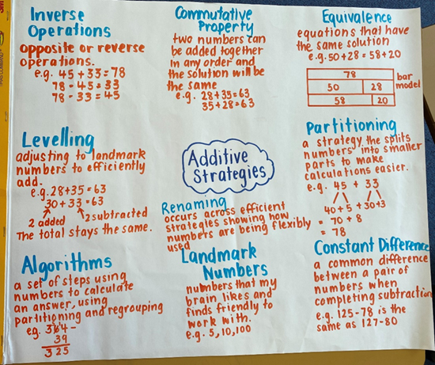
- Alternatively, Resource 3 – additive strategies can also be displayed or provided to support students.

Core Lesson 2 – 30 minutes

Stage 2 task – equivalence
This activity is an adaptation of Equivalent number sentences from the Universal Resources Hub by the State of New South Wales (Department of Education) and Make it equal by Rawding from the Open Middle website. This lesson supports students to gain a deeper understanding of the structure of related, equivalent number sentences. There is a particular focus on reasoning and communicating as students justify their solutions.
- Brainstorm a class additive relations vocabulary chart that students can add to throughout the unit. Include vocabulary such as add, addition, increase, plus, decrease, minus, subtract, inverse relationship. Other vocabulary such as equivalence, landmark numbers, adjusting numbers, partitioning and renaming are introduced in this unit.
- Display the number sentence 27 + 13 = 80 − 20 and ask what students notice.
- After some discussion, ensure students understand that this is a false number sentence. Both sides do not have the same value; both sides are not equivalent.
- Discuss what equivalence is and how number sentences can be equivalent even if students use different operations.
- Discuss the adjustments needed to form an equivalent number sentence. For example, 27 + 33 = 80 − 20.
- Display the equals sign on the board. Ask students what it represents.
- Record responses around the sign, as in Figure 2.
Figure 2 – equals sign
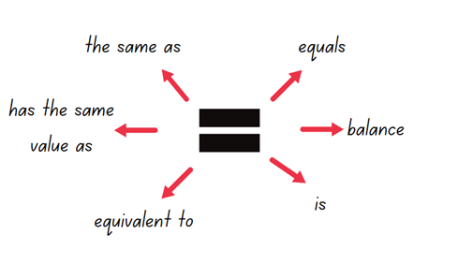
Equivalent: two things are equivalent if they have the same value.
- Display the problem 38 + 17 = _ − _.
- In pairs, students find various solutions and record them on a whiteboard.
- Ask students to share their solutions and the strategies used to solve the number sentence.
- Record the various solutions presented and strategies used. For example, a bar model, number line and equal arm balance (see Figure 3).
Figure 3 – student representations
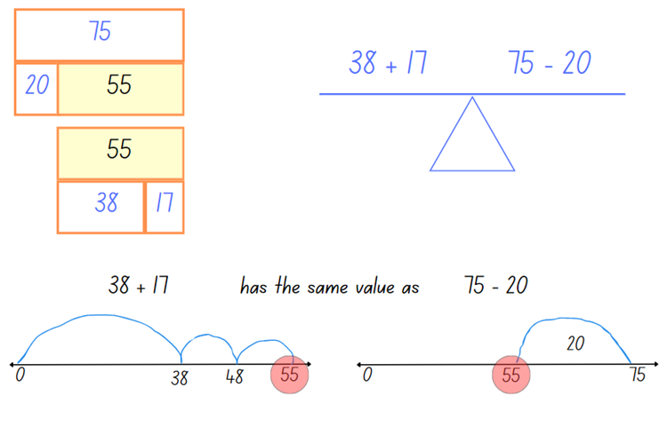
- Display Resource 4 – reflection chart and discuss the meaning of each word.
- Ask students to select one of the additive strategies they used to solve the problem, for example, the compensation strategy. They reflect on the 4 statements, to see if they describe their use of their selected strategy:
- Flexible – I have a range of strategies to choose from.
- Fluent – I can use my strategy easily.
- Understanding – I can connect different ideas, show maths in different ways and use ideas in new ways.
- Efficient – I have used a strategy with a small number of steps.
- Provide Resource 5 – balancing equations. Ask students to find solutions to balance the equations.
- Regroup as a class and ask:
- What strategies did you use to solve the number? Were they efficient?
- Can you explain what is meant by ‘equivalence?’
- Were there any number sentences that you found challenging? How did you overcome the challenges?

Stage 3 task – choosing additive strategies
This activity is an adaptation from Engaging Maths: Higher Order Thinking with Thinkers Keys by Attard.
- Display and review Resource 4 – reflection chart.
- Remind students that when they work with numbers, the aim is to be flexible, efficient and accurate.
Note: in Stage 3, mental strategies, including students’ informal recordings, need to be continually reinforced. Some strategies are more efficient than others. To foster choice and flexibility, students need opportunities to identify different strategies and what makes them appropriate. Many methods involving addition and subtraction take advantage of one number’s proximity to a multiple of 10 or 100 (NESA 2024a).
- Display the following equations on the board:
- 3597 + 5349 = _?
- _ − 8078 = 464
- 12 672 − 8 985 = _?
- Students turn and talk to discuss:
- How would you work this out?
- Would you use a written or mental strategy?
- Would you use a different strategy for each equation? Why?
- Select students to share their responses.
Prompts | Anticipated student responses
- 3597 + 5349 | - I would use a mental strategy such as:  - levelling: for example, 3600 + 5346 = 8946.  - bridging: for example, 3597 + 3 = 3600, 3600 + 5346 = 8946.  - I would use an algorithm.
- _? − 8078 = 464 | - I would use inverse relations 8078 + 464 = _?; then either a mental or written strategy such as levelling (8100 + 442) or bridging (8078 + 2 + 20 + 442).  - I would write 8078 + 464 = 8542.
- 12 672 – 8985 | - I would use a mental strategy such as constant difference, adding 15 to both sides: 12 687 − 9000 = 3687.  - I would use an inverse operation and bridging: 8985 + 15 + 1000 + 2672.  - I would use an algorithm.
- Display the class anchor chart or refer to Resource 3 – additive strategies.
- Identify the strategies used. Add any additional strategies to the class anchor chart.
- Display or provide a copy of Resource 6 – Which strategy?
- Students record in workbooks the name of the most efficient strategy and complete the equation using it. See example in Table 1 below.
Table 1 – strategy examples
Equation | Most efficient strategy | Solution
- 2364 + 407 | Mental strategy using levelling of ones | 2364 + 407 = 2370 + 401 = 2771
- 3689 − 2562 | Written strategy using constant difference then mental partitioning | 3689 − 2562 = 3690 – 2563 = 1127
- _ − 7289 = 158 | Mental strategy using inverse relations then levelling | _ − 7289 = 158  Inverse: 7289 + 158 =  Levelling: 7290 + 157 = 7447
- 67.7 + 108.67 | Using a formal written algorithm | 67.7  + 108.67  176.37
- 5440 + 266 | Mental strategy using levelling of tens place value | 5440 + 266 = 5400 + 306 = 5706
- 7302 − _ = 4861 | Written strategy using the complement principle then vertical algorithm | 7302 − _ = 4861  7302  − 4861  2441
- Students complete a gallery walk and view other student responses to the tasks.
This table details opportunities for differentiation.
Too hard? | Too easy?
Stage 2 students cannot use the equals sign to mean 'the same as', rather than to perform an operation.  - Adjust the ‘Make it equal’ activity to be __ = __ + __.  - Provide each student with Resource 7 – dice bowling. In pairs, students roll 3 dice, record the digits and write number sentences (using only those 3 digits). Record each number sentence and cross out the corresponding bowling pin. Students try eliminating all numbers for a strike. (This activity is an adaptation of Bowl A Fact from youcubed by Stanford University).  Stage 3 students cannot identify efficient and inefficient multidigit additive strategies.  - Provide students with Resource 8 – Which strategy? 2. Ask students to identify a number-based strategy to support more efficient calculations for example, partitioning numbers.  - Provide students with MAB materials to assist with addition and subtraction. | Stage 2 students can use the equals sign to mean 'the same as', rather than to perform an operation.  - Pose the problem: __ + __ = __ +__ = __ + __. Students find as many different solutions as they can. Students explain their preferred strategy and communicate this to the class or a small group.  - Students order their strategies from being the most to least flexible, fluent and efficient. They explain their reasoning.  Stage 3 students can identify efficient and inefficient multidigit additive strategies.  - Students write equations to demonstrate understanding of when each mental and written strategy would be the most efficient.  - Provide students with Resource 9 – ABC Motors. They solve the problem, reflecting on the most efficient strategies used.

Consolidation and meaningful practice – 10 minutes
- Students record all the mental and written strategies for addition and subtraction in their workbook.
- They rate them in order from easiest to most difficult to use. Use the results to form a class tally.
- Display Resource 4 – reflection chart. Discuss the class tally results, justifying and explaining the reasons for the order on each strategy.
This table details opportunities for assessment.
Assessment opportunities | Links
What to look for:  - Can Stage 2 students use the equals sign to mean 'the same as', rather than to perform an operation? [MAO-WM-01, MA2-AR-01]  - Can Stage 2 students find the missing number in an equivalent number sentence involving operations of addition or subtraction on both sides of the equals sign (Algebraic reasoning)?  [MAO-WM-01, MA2-AR-02]  - Can Stage 3 students identify efficient and inefficient multidigit addition and subtraction strategies? [MAO-WM-01, MA3-AR-01]  - Can Stage 3 students apply known strategies such as levelling, addition for subtraction, using constant difference, and bridging? [MAO-WM-01, MA3-AR-01] | Links to National Numeracy Learning Progressions (NNLP):  - Stage 2 – NPA3, NPA4  - Stage 3 – AdS7, AdS8.  Links to suggested Interview for Student Reasoning (IfSR) tasks:  - Stage 2 – IfSR-AT: 2A.1, 3A.1  - Stage 3 – IfSR-AT: 3A.4, 3A.5.

Lesson 2
Core concept: addition and subtraction are connected (Stage 2) and flexible methods of addition and subtraction involve decomposing and composing numbers (Stage 3).

Daily number sense – target values – 15 minutes
The table below contains suggested learning intentions and success criteria. These are best co-constructed with students.
Daily number sense learning intentions | Daily number sense success criteria
Students working towards Stage 2 outcomes are learning to:  - represent money values in multiple ways.  Students working towards Stage 3 outcomes are learning to:  - use estimation and place value understanding to determine the reasonableness of solutions. | Students working towards Stage 2 outcomes can:  - recognise the relationship between dollars and cents  - represent equivalent amounts of money using different denominations.  Students working towards Stage 3 outcomes can:  - use estimation to check the reasonableness of solutions to addition and subtraction calculations.
- Ask students to record on individual whiteboards different Australian notes and coins they remember from Lesson 1.
- Provide students with plastic Australian notes and coins.
- Explain that the aim of this activity is to find as many ways as possible to make the target value without repeats.
Multi-age: Stage 2 students use Resource 10 – coin records to work with coin denominations. Stage 3 students use Resource 11 – money records to work with coin and note denominations.
- In pairs, Stage 2 students use copies of Resource 10 – coin records to:
- find a combination of Australian coins required to achieve target values of a dollar
- record the correct number sentence representing the number of coins used
- only use combinations once in each game
- aim to have the most combinations in 2 minutes
- repeat the activity for target values of $2 and $5 (see Figure 4).
Figure 4 – sample student record
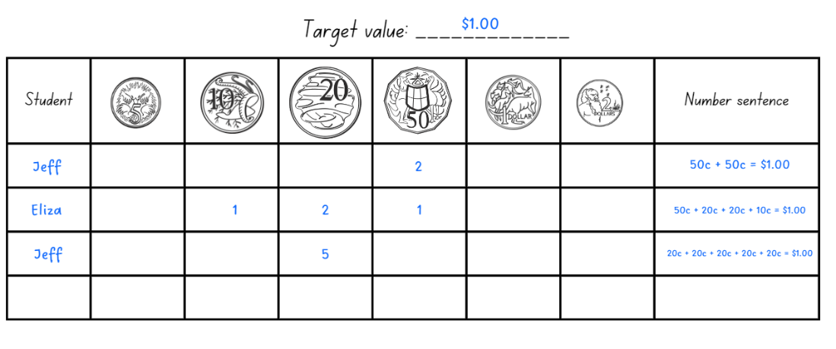
- Provide pairs of Stage 3 students with a 6-sided die and copies of Resource 11 – money records. To play the game, they:
- roll the die 3 times to create a target value (rolling a 3, 4 and 5 would make a target value of $345)
- round the combination to the closest $5 if the target value cannot be made using notes
- estimate a combination of Australian notes needed to make the target value (see Figure 5)
- record the correct number sentence representing the number of notes used
- can only use combinations once in each game
- aim to have the most combinations in 2 minutes
- estimate the total amount on the page, then check using a calculator (see Figure 5)
- repeat the activity with a new target number.
Figure 5 – possible student response
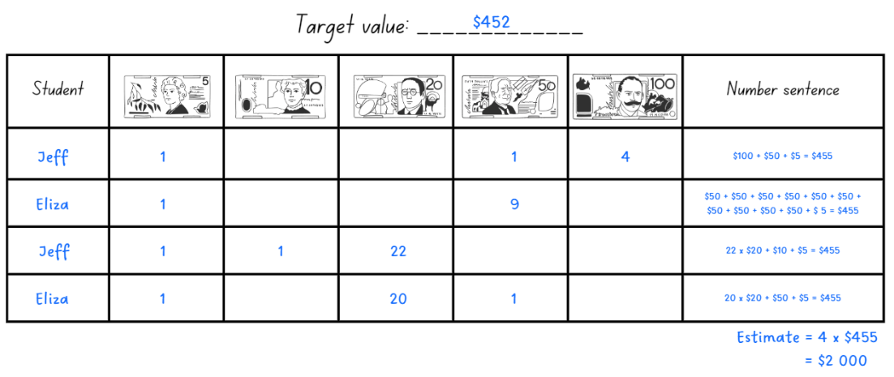
This table details opportunities for assessment.
Assessment opportunities | Links
What to look for:  - Can Stage 2 students recognise the relationship between dollars and cents? [MAO-WM-01, MA2-AR-01]  - Can Stage 2 students represent equivalent amounts of money using different denominations? [MAO-WM-01, MA2-AR-01]  - Can Stage 3 students use estimation to check the reasonableness of solutions to addition and subtraction calculations?  [MAO-WM-01, MA3-AR-01] | Links to National Numeracy Learning Progressions (NNLP):  - Stage 2 – UuM2, UuM3, UuM4  - Stage 3 – NPV6, AdS8.

Core lesson – 45 minutes
The table below contains suggested learning intentions and success criteria. These are best co-constructed with students.
Core concept learning intentions | Core concept success criteria
Students working towards Stage 2 outcomes are learning to:  - select strategies flexibly to solve addition and subtraction problems of up to 3 digits  - partition, rearrange and regroup numbers to at least 1000 to solve additive problems.  Students working towards Stage 3 outcomes are learning to:  - apply efficient mental and written strategies to solve addition and subtraction problems. | Students working towards Stage 2 outcomes can:  - apply known mental strategies that use partitioning to add and subtract, such as bridging the decades  - compare and evaluate strategies, reasoning which strategy may be most efficient  - model addition with and without regrouping and record the method used.  Students working towards Stage 3 outcomes can:  - solve word problems, including multistep problems  - apply known strategies such as levelling, addition for subtraction using constant difference, and bridging  - identify efficient and inefficient multidigit subtraction strategies.

Stage 2 task – addition algorithm
- Provide students with grid paper, Resource 12 – place value chart or Resource 13 – place value slider and MAB materials.
- Ask students to model a 2-digit number using the MAB materials. They turn and talk to a partner to share the number formed and explain how they know.
- Select students to explain the concept of partitioning into standard expanded form.
- Students record their response on grid paper, placing one digit in each box (see Figure 6).
Figure 6 – standard partition
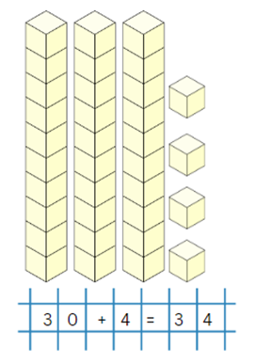
- Display two 2-digit numbers (with a total less than 100) side-by-side on the board. Students:
- represent both numbers using the MAB materials side-by-side
- combine the MAB materials to find the sum and record the equation on their grid paper (see Figure 7).
Figure 7 – horizontal addition
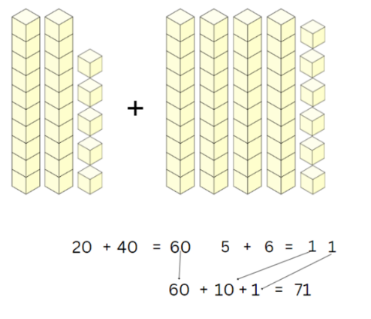
- Provide further horizontal examples for students to develop understanding and fluency.
- Display another two 2-digit numbers (with a total of less than 100) vertically on the board. Ensure the place value columns are aligned.
- Students represent these numbers with the MAB materials, this time placing one model above the other.
- Explain that algorithms are another strategy for working with operations such as addition. Model writing the algorithm using expanded notation, aligning the tens and ones.
- Provide time for students to combine their MAB materials and calculate a solution.
- Discuss which column each digit of the solution will go in. Students write their solution (see Figure 8).
Figure 8 – vertical addition
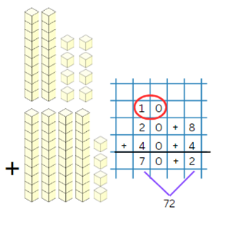
- Display the vertical algorithm just completed together on the board.
- Identify that numbers can be represented using both numerical standard notation and expanded notation. For example, 72 (standard notation) can also be represented as 70 + 2 (expanded notation).
- Explain that vertical algorithms use standard notation (see Figure 9).
Figure 9 – expanded and standard notation
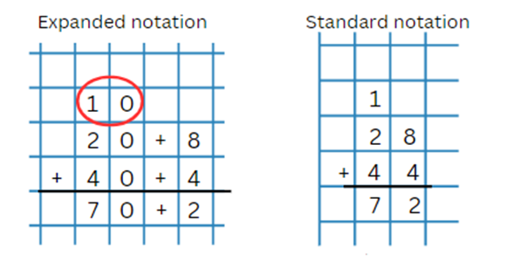
- Explain the procedure of starting algorithms on the right-hand side. Use explicit language for modelling the steps:
- Always start with the column on the right. This is the ones’ column. Eight ones and 4 ones make 12 ones.
- Now regroup 12 ones as one 10 and 2 ones. I record 2 ones in the ones column and record the 10 in the tens column (shown in the red circle).
- Now add the tens. One 10, plus 2 tens, plus 4 tens equals 7 tens, which is 70.
- The sum of these is 72.
- Display another vertical algorithm on the board for the students to solve.
- Students check their answers using MAB materials and discuss their solutions with a peer.
- Provide students with further algorithms to practice.
Note: provide students with numbers that will need regrouping and renaming. It is important for students to develop an understanding of working from right to left in algorithms. Algorithms with no regrouping and renaming will provide a correct solution no matter the order.

Stage 3 task – flexible strategies
- Review the terms levelling and constant difference.
Levelling: adjusting to landmark numbers to add efficiently. It is used to adjust the numbers in addition, for example: 28 + 35 = 30 + 33 = 63.
Constant difference: a common difference between pairs of numbers. It can be used to adjust the numbers in subtraction, for example: 148 − 68 = 150 − 70 = 80.
- Display and discuss Resource 14 – levelling/constant difference.
- Co-create examples of levelling and constant difference with students. Use decimals up to 3 decimal places and numbers up to 6 digits in the examples, as seen in Figure 13.
Figure 13 – levelling and constant difference
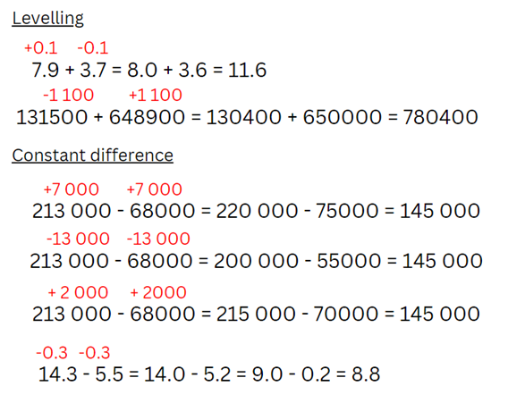
- Add levelling and constant difference to the additive strategies anchor chart from Lesson 1 if not already included.
- Provide opportunities to practise levelling and constant difference. Use numbers that can be readily rounded to 10, 100 or 1000:
- 356 + 44
- 489 − 51
- 772 + 45
- 960 − 183
- 678 + 222
- 821 − 319
- 4257 + 562
- 7870 – 1280.
- Students record their solutions and share with a partner.
- Display and read Resource 15 – word problems. Students solve the problems in their workbooks and share with a partner.
- Regroup as a class and ask:
- What strategy did you use to solve the problems?
- Are levelling and constant difference efficient strategies for solving the questions? Why or why not?
- When can levelling and constant difference be efficient? (When the numbers are adjusted to landmark numbers in an equation to make the addition or subtraction simpler).
This table details opportunities for differentiation.
Too hard? | Too easy?
Students cannot solve word problems, including multistep problems, or apply known strategies such as levelling and using constant difference.  - Students practise levelling and constant difference with 2-digit number problems instead of 3-digits. For example, 72 − 27, 53 + 28.  - Practise levelling and constant difference with single-step word problems using a digital number line. | Students can solve word problems, including multistep problems, or apply known strategies such as levelling and using constant difference.  - Students represent examples of levelling or constant difference using a digital number line for 3-digit numbers and/or decimals to thousandths. (Note: use the number line settings to adjust the place value).  - In pairs, students write a problem for their partner to solve using either levelling or constant difference. They use a digital number line to explain their reasoning.

Discuss and connect the mathematics – 10 minutes
- Display 84 + 67 (Stage 2) and 4518 + 307 (Stage 3).
- Provide each student with Resource 16 – Frayer model. Explain that they will be using this model to show their thinking when solving problems.
- Explain that:
- The problem being solved goes in the centre box.
- In the strategy boxes, students use 3 different strategies to solve the problem, then circle the strategy that is most efficient.
- In the final box, students explain their reasoning to support why the circled strategy is the most efficient (see Figure 15).
Figure 15 – completed Frayer Model
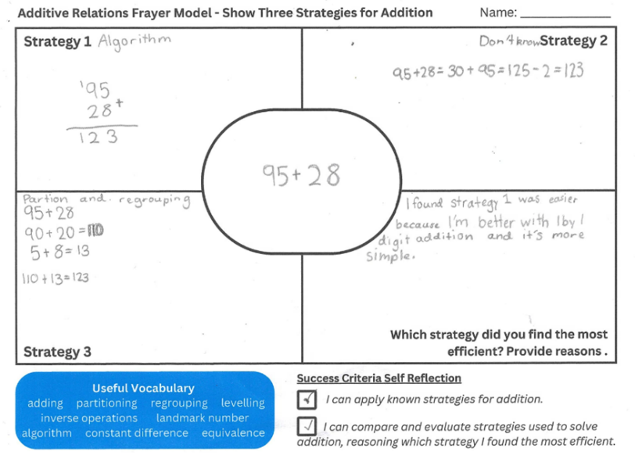
- Regroup as a class and ask:
- What strategy did you find most efficient? Why?
- What strategy did you find least efficient? Why?
Note: students may not have 3 strategies. Use this activity as a formative assessment opportunity to identify strategies used by students and the names or labels that students give the strategies.
This table details opportunities for assessment.
Assessment opportunities | Links
What to look for:  - Can Stage 2 students apply known mental strategies that use partitioning to add and subtract, such as bridging the decades and the compensation strategy? [MAO-WM-01, MA2-AR-01]  - Can Stage 2 students compare and evaluate strategies used to solve addition and subtraction problems, reasoning which strategy may be most efficient? [MAO-WM-01, MA2-AR-01]  - Can Stage 2 students model addition with and without regrouping and record the method used? [MAO-WM-01, MA2-AR-01]  - Can Stage 3 students solve word problems, including multistep problems? [MAO-WM-01, MA3-AR-01]  - Can Stage 3 students apply known strategies such as levelling, addition for subtraction, using constant difference, and bridging? [MAO-WM-01, MA3-AR-01]  - Can Stage 3 students identify efficient and inefficient multidigit subtraction strategies? [MAO-WM-01, MA3-AR-01] | Links to National Numeracy Learning Progressions (NNLP):  - Stage 2 – AdS7, NPV4, NPV5, NPV6  - Stage 3 – AdS7, AdS8.  Links to suggested Interview for Student Reasoning (IfSR) tasks:  - Stage 2 – IfSR-AT: 3A.2, 3B.2  - Stage 3 – IfSR-AT: 3A.4, 3A.5.

Lesson 3
Core concept: place value understanding helps solve addition and subtraction problems.

Daily number sense – working out the difference – 10 minutes
The table below contains suggested learning intentions and success criteria. These are best co-constructed with students.
Daily number sense learning intentions | Daily number sense success criteria
Students working towards Stage 2 outcomes are learning to:  - represent money values in multiple ways.  Students working towards Stage 3 outcomes are learning to:  - use estimation and place value understanding to determine the reasonableness of solutions. | Students working towards Stage 2 outcomes can:  - perform calculations with money, including finding change.  Students working towards Stage 3 outcomes can:  - use place value understanding to check for errors in calculations.
This activity is an adaptation of Let's talk – number talk (230 minus 190) from Mathematics K–6 resources by the State of New South Wales (Department of Education). In preparation for the number talk, watch the Let's talk 1 - Stage 2 video (15:58) for support.
- Revisit Resource 4 – reflection chart. Discuss how each of the 4 concepts are important in problem solving.
- Display the number sentence $23 – $19 = _? to Stage 2 and $123 – $19 = _? to Stage 3.
- Students turn and talk to discuss possible answers and record these on whiteboards.
Multi-age: provide Stage 3 students with number sentences that have larger numbers. They estimate their solutions before recording on whiteboards. They check their calculations for errors by using a different strategy.
- Pose the question: Cassandra went to the shops with $185 to buy things for dinner. She spent $154. How much change did she return with?
- In pairs, students record solutions on individual whiteboards. Encourage students to record more than one strategy to solve the equation.
- Regroup as a class and ask:
- What is the most efficient strategy?
- Why is this the most efficient strategy?
- Do you think the same strategy can be used with other problems?
- Is there a strategy that has not been used and can be used next time?

This table details opportunities for assessment.
Assessment opportunities | Links
What to look for:  - Can Stage 2 students perform calculations with money, including finding change? [MAO-WM-01, MA2-AR-01]  - Can Stage 3 students use place value understanding to check for errors in calculations? [MAO-WM-01, MA3-AR-01] | Links to National Numeracy Learning Progressions (NNLP):  - Stage 2 – UuM5, UuM6  - Stage 3 – NPV5, NPV6, AdS8.

Core lesson – 50 minutes
The table below contains suggested learning intentions and success criteria. These are best co-constructed with students.
Core concept learning intentions | Core concept success criteria
Students working towards Stage 2 outcomes are learning to:  - select strategies flexibly to solve addition and subtraction problems of up to 3 digits  - partition, rearrange and regroup numbers to at least 1000 to solve additive problems.  Students working towards Stage 3 outcomes are learning to:  - compare, order and represent decimals  - use estimation and place value understanding to determine the reasonableness of solutions. | Students working towards Stage 2 outcomes can:  - apply known mental strategies that use partitioning to add and subtract, such as bridging the decades  - compare and evaluate strategies, reasoning which strategy may be most efficient  - model addition with and without regrouping and record the method used.  Students working towards Stage 3 outcomes can:  - compare the place value of digits by determining numbers that are 10 or 100 times the original decimal number as well as $\frac{1}{10}$ or $\frac{1}{100}$ times the original decimal numbers  - use place value understanding to check for errors in calculations  - use estimation to check the reasonableness of solutions to addition and subtraction calculations.

Stage 2 task – subtraction algorithm
- Students record a horizontal equation, for example, 74 − 11 = 63 on the grid paper.
- Brainstorm how this could be done for subtraction, emphasising:
- place value positioning, so that the columns align
- the larger number being on the top of the vertical algorithm.
- Display the example vertical algorithm on the board.
- Ask students how to check subtraction solutions to ensure they are correct. Students turn and talk to share ideas.
- Explain that inverse operations can help students check their work. For example, if 63 + 11 = 74, the 74 − 11 = 63.
- Students form the number 62 using MAB materials on Resource 12 – place value chart.
- Display 62 − 24 = _? Ask students to subtract 24 from 62, using MAB materials. Students turn and talk to explain how they regrouped the MAB materials to move from 62 to 38 (see Figure 10).
Figure 10 – subtraction with MAB
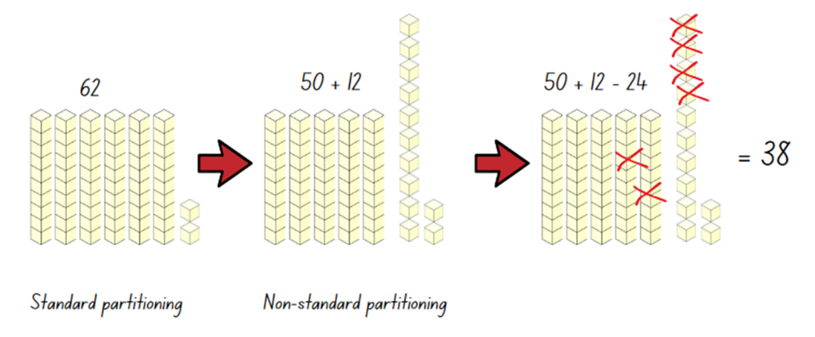
Note: some students will provide the answer quickly using mental strategies. Acknowledge that the answer is 38 but explain that the process is important to ensure understanding of the strategy.
- Display 62 − 24 as a vertical algorithm. Explain the decomposition method of partitioning and regrouping each of the numbers to determine the solution (see Figure 11).
Figure 11 – expanded notation decomposition
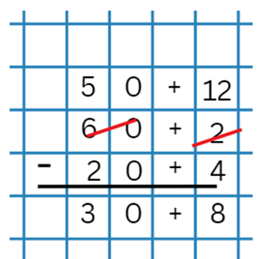
- Use addition as the inverse operation to check the solution.
- Provide more examples to encourage fluency and efficiency.
- Show students that, like addition, regrouping numbers in the vertical algorithm can be more efficient (see Figure 12).
Figure 12 – standard notation decomposition
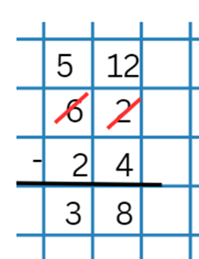
- Provide students with further vertical algorithms to solve.
Note: the syllabus teaching advice for Stage 2 – Additive Relations B has an 8-part recommended sequence for introducing students to exchanging of units. For example, the advice recommends exchanging tens for ones before exchanging hundreds for tens. When developing a formal vertical algorithm, sequence the examples to cover the range of possibilities.
This table details opportunities for differentiation.
Too hard? | Too easy?
Students cannot model addition with and without regrouping and record the method used.  - Support students to use concrete materials to engage in grouping and regrouping numbers.  - Use digital MAB materials to explore decomposition and composition of tens and hundreds. | Students can model addition with and without regrouping and record the method used.  - Students complete algorithms with 3- or 4-digit numbers. Ask them to compare and evaluate the algorithm method with other known addition strategies.  - Provide students with word problems using additive strategies. Students use the algorithm to solve them.

Stage 3 task – reviewing decimals
Note: if Stage 3 students do not have access to a place value slider from previous units, they should make one using Resource 13 – place value slider. This activity is an adaptation of (Even more) 5 minutes of fun! by Morgan.
- Explain to students they are going to play a whole class game called ‘Make a million’.
- The aim of the game is to write two 6-digit numbers that, when added together, make as close to one million as possible. Explain that the total may not go over one million.
- Ask students to draw a game board (see Figure 16).
Figure 16 – make a million
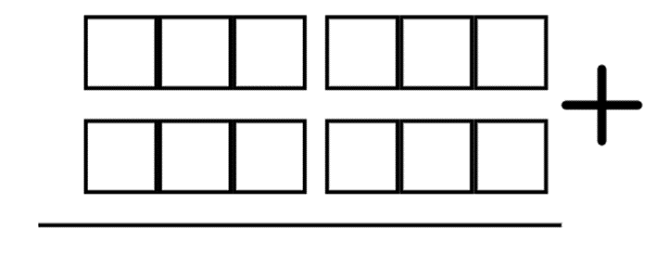
Note: 4-, 5- and 6-digit numbers are named as thousands, such as three thousand, thirty thousand, three hundred thousand. To assist in reading numbers, the convention for writing numbers of more than 4 digits requires that numerals have a space, and not a comma, to the left of each group of 3 digits, for example 16 234.
- Roll a 10-sided die (0–9) and call out the digit.
- Students build their numbers by writing a digit in a box on their board. Students may not change the position of the digits once written.
- Continue to roll until all spaces are filled.
- Ask students to read to a partner the two 6-digit numbers they have written.
- Instruct students to add the numbers together and check their partner’s addition using a calculator.
- Observe if students can read their numbers fluently and identify the place value of digits in different positions.
- The student who correctly adds their numbers, is closest to one million and who correctly reads their final number wins. Ask:
- What strategies did you use to place your numbers? Did it work? Why or why not?
- What changes would you make next time you play? Why?
- Why is a calculator more efficient when checking a partner’s calculation?
- Repeat the game to give students an opportunity to apply strategies learned from round one.
Note: modify the game with the aim to get closest to one hundred thousand using the board shown in Figure 17.
Figure 17 – one hundred thousand
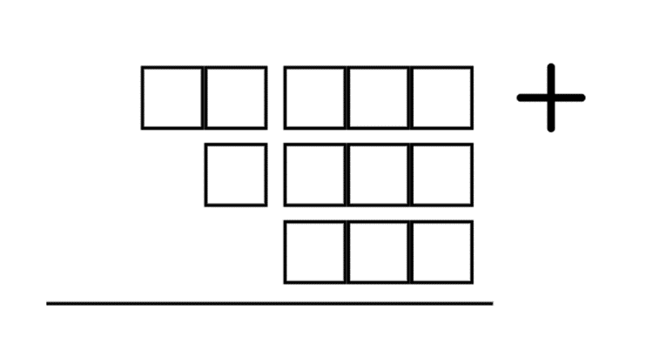
- Regroup as a class and ask students to identify the strategies used in placing digits and make estimates to get to ensure that the total was as close as possible to one million.
- Display Resource 17 – decimal misconceptions.
- Ask students to turn and talk and discuss the responses.
- Share student ideas with the class and clarify any misconceptions.
Note: both Lars and Jayden are correct. Lars’ language is the most supportive of place value understanding. Jayden’s is the most used, especially in measurement contexts. Mikayla has missed or does not understand the function of the decimal point. Angus is reading the number as 2 independent whole numbers.
- Distribute Resource 13 – place value slider. Individually or in pairs, students select a 2-digit number.
- Ask students to model multiplying and dividing their number by 10 between the millions and thousandths places using the place value slider (see Figure 18).
Figure 18 – place value slider example
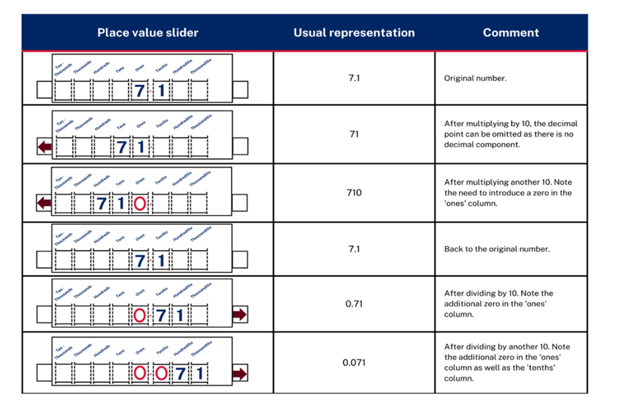
Adapted from Stacey et al. (2011).
- Students record the numbers at each step in a table, as in Figure 18.
Note: a common misunderstanding is that the decimal point moves when a number is multiplied by powers of 10. The place value slider has a fixed decimal marker and is an effective way of addressing this misunderstanding. Zeros should be added to a number slider as place holders when multiplying and dividing by powers of 10. This assists when comparing the place value of digits by determining numbers that are 10, 100 or 1000 times the original number.
- Once completed, ask students to select 2 numbers from their list and identify the relationship between them. For example, 23 is 10 times larger than 2.3 or 5400 is 1000 times smaller than 5 400 000. This step is an opportunity to develop Working mathematically outcomes with students, exploring and connecting mathematical concepts across place value and multiplicative relations.
This table details opportunities for differentiation.
Too hard? | Too easy?
Students cannot use place value understanding to check for errors in calculations.  - ‘Make a million’ can be adjusted to ‘Make a thousand’. Students can take cards (0–9) from a pack to create their numbers and place them on a place value chart before adding by using mental or written strategies.  - The place value slider can be adjusted to only represent whole numbers to reinforce place value and connection to multiplicative thinking. | Students can use place value understanding to check for errors in calculations.  - Ask students to plan a journey to 7 destinations around the world. Ask students to estimate the total distance travelled, to the nearest 1000 kilometres.  - Ask students to make a variation of ‘Make a million’ that includes decimals to play with a partner. Ask students to list 3 things that are the same and 3 that are different to the original game.

Discuss and connect the mathematics – 10 minutes
- Provide students with an exit slip to record their understanding of place value. Prompts could include:
- Why is it important to pay attention to the place value when forming numbers?
- In what ways is understanding decimal place value similar to understanding whole number place value?
- If you know the number in the tens place is greater than the number in the ones place, can you predict the relationship between the whole numbers?
- How can the place value of the digits change as you move to the right of the decimal point?
- How can understanding place value help you estimate the sum of 2 numbers quickly?
This table details opportunities for assessment.
Assessment opportunities | Links
What to look for:  - Can Stage 2 students apply known mental strategies that use partitioning to add and subtract, such as bridging the decades and the compensation strategy? [MAO-WM-01, MA2-AR-01]  - Can Stage 2 students compare and evaluate strategies used to solve addition and subtraction problems, reasoning which strategy may be most efficient? [MAO-WM-01, MA2-AR-01]  - Can Stage 2 students model addition with and without regrouping and record the method used? [MAO-WM-01, MA2-AR-01]  - Can Stage 3 students compare the place value of digits by determining numbers that are 10 or 100 times the original decimal number as well as $\frac{1}{10}$ or $\frac{1}{100}$ times the original decimal numbers? [MAO-WM-01, MA3-RN-01]  - Can Stage 3 students use place value understanding to check for errors in calculations? [MAO-WM-01, MA3-RN-01]  - Can Stage 3 students use estimation to check the reasonableness of solutions to addition and subtraction calculations?  [MAO-WM-01, MA3-RN-01] | Links to National Numeracy Learning Progressions (NNLP):  - Stage 2 – AdS7, NPV4, NPV5, NPV6  - Stage 3 – NPV5, NPV6, NPV7, NPV8, AdS8.  Links to suggested Interview for Student Reasoning (IfSR) tasks:  - Stage 2 – IfSR-AT: 3A.2, 3B.2  - Stage 3 – IfSR-PT: 1A.8  - Stage 3 – IfSR-AT: 4B.2  - Stage 3 – IfSR-NP: 4D.8.

Lesson 4
Core concept: number lines help solve addition and subtraction problems.

Daily number sense – 10 minutes
- From a class need surfaced through formative assessment data, identify a short, focused activity that targets students’ knowledge, understanding and skills. Example activities may be drawn from the following resources:
- Mathematics K–6 resources
- Universal Resources Hub.

Core lesson – 50 minutes
The table below contains suggested learning intentions and success criteria. These are best co-constructed with students.
Core concept learning intentions | Core concept success criteria
Students working towards Stage 2 outcomes are learning to:  - represent money values in multiple ways  - apply addition and subtraction to familiar contexts, including money and budgeting.  Students working towards Stage 3 outcomes are learning to:  - apply efficient mental strategies to solve addition and subtraction problems  - use estimation and place value understanding to determine the reasonableness of solutions. | Students working towards Stage 2 outcomes can:  - perform calculations with money, including finding change  - interpret problems involving money as requiring either addition or subtraction.  Students working towards Stage 3 outcomes can:  - apply known strategies such as levelling, addition for subtraction, using constant difference, and bridging  - solve word problems, including multistep problems  - round numbers appropriately when obtaining estimates to numerical calculations.

Stage 2 task – price tag purchasing
- Provide students with an assortment of Australian play money coins.
- Write $1.85 on the whiteboard. Ask students to make different combinations of coins that represent this amount.
- Students record or draw their representations. Students turn and talk with peers, sharing the variations made.
Note: providing multiple opportunities for students to show money equivalence with different combinations using bar models, the equals sign or equal-arm balances encourages students to make connections with number and place value.
- Display Resource 18 – money equivalence.
- Read and discuss the different representations of equivalence. Ask:
- What is the same and what is different about the representations?
- Which representation is easiest to understand? Why?
- Which representation is the easiest to create? Why?
- Display Resource 19 – price tags. Explain that students will work with a partner to find at least 2 ways to make each of the totals, then record these. If necessary, students can use a copy of Resource 20 – money mat to help them organise their totals.
- Allow students time to explore making the totals, representing these in a variety of ways.
- Ask students to select one price tag and to record the equivalence as a bar model, equal-arm balance and using the equals sign. Resource 18 – money equivalence can be shown as an example.

This table details opportunities for differentiation.
Too hard? | Too easy?
Students cannot perform calculations with money, including finding change.  - Support students to add small amounts of money, using multiples of 10c or 20c. Then, model how to make an equivalent amount of money using different denominations.  - Set up a ‘shop’ in the classroom for students to buy and sell, exploring with money. Model making equivalent amounts of money using different denominations to buy and sell items. | Students can perform calculations with money, including finding change.  - Ask students to provide the change from $10 after buying one item from the price tag activity.  - Use an online shopping catalogue and pose the problem: If you had $100 and needed to buy something for every member of your family from one shop, what would you buy? How much would it all cost? Would there be any change?

Stage 3 task – balancing parcels
This activity is an adaptation of Add and Subtract Decimals – Discussion Problems from Classroom Secrets.
Note: the syllabus Teaching advice for Stage 3 Additive relations A encourages reinforcement of recording mental strategies. Empty number lines can be a useful tool for students to show thinking and strategies.
- Display Resource 21 – balancing parcels. Identify and discuss the items that have a weight that extends to 3 decimal places. Indicate the place value of the digits in those weights.
- Interpret the decimal notation for thousandths in the weight of the parcels. For example, 32.713 kg is equivalent to 32 kg and 713 g.
- Explain that delivery drivers need to carry bundles of roughly equal weight. Introduce the problems for both scales:
- Scale 1 has a parcel on one side. Which combination of parcels can be used to balance the scale?
- Scale 2: create 2 groups of parcels, each with approximately equal weights. Find at least 3 different combinations of parcels.
- Students use estimating, rounding, partitioning or an empty number line to demonstrate their working out.
Note: some students may prefer to use a formal algorithm. Encourage students to first use a number line to represent their flexible thinking and then check their calculations with an algorithm.
- Encourage efficiency (fewer steps) by prompting students to identify the number that requires the least partitioning (see Figure 19).
Figure 19 – partitioning example
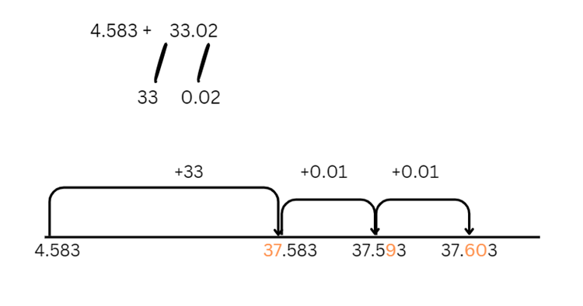
- Provide copies of Resource 22 – Perfect Post shipping, Resource 23 – Perfect Post problems and Resource 24 – Spring sales. Discuss the shipping cost and identify the domestic and international shipping rates based on parcel weight. Review the catalogue of sale items and note the prices and weights of each.
- Encourage students to use efficient strategies to solve problems on Resource 23 – Perfect Post problems.
This table details opportunities for differentiation.
Too hard? | Too easy?
Students cannot solve word problems, including multistep problems.  - Use MAB materials or change the numbers to whole numbers to support students to model addition and subtraction using a number line and bar model.  - Build a number line on the floor with masking tape and model 2-digit addition and subtraction questions using concrete materials. | Students can solve word problems, including multistep problems.  - The number 747 can be formed by adding a 3-digit number with its reversal for example, 621 + 126 = 747. Can you find the other 2 ways of making 747 in this way? Note: this is adapted from Forwards Add Backwards from NRICH by University of Cambridge.  - Students research current shipping costs from various companies and use that data to find the optimal savings when sending parcels domestically or internationally.

Discuss and connect the mathematics – 10 minutes
- Display Resource 3 – additive strategies. Ask:
- What efficient additive strategies did you use to make the various combinations?
- Did you have any challenges? How did you overcome them?
This table details opportunities for assessment.
Assessment opportunities | Links
What to look for:  - Can Stage 2 students perform calculations with money, including finding change? [MAO-WM-01, MA2-AR-01, MA2-AR-02]  - Can Stage 2 students interpret problems involving money as requiring either addition or subtraction? [MAO-WM-01,  MA2-AR-01, MA2-AR-02]  - Can Stage 3 students apply known strategies such as levelling, addition for subtraction, using constant difference, and bridging? [MAO-WM-01, MA3-AR-01]  - Can Stage 3 students solve word problems, including multistep problems? [MAO-WM-01, MA3-AR-01]  - Can Stage 3 students round numbers appropriately when obtaining estimates to numerical calculations? [MAO-WM-01, MA3-AR-01] | Links to National Numeracy Learning Progressions (NNLP):  - Stage 2 – UnM4, UnM5, UnM6  - Stage 3 – AdS7, AdS8, NPV6, NPV7.  Links to suggested Interview for Student Reasoning (IfSR) tasks:  - Stage 3 – IfSR-AT: 3A.4, 3A.5.

Lesson 5
Core concept: money values can be represented in different ways (Stage 2) and place value understanding helps make use of benchmark percentages (Stage 3).

Daily number sense – returfing the field – 15 minutes
Daily number sense activities for Lessons 5 to 7 ‘loop’ back to concepts and procedures covered in previous units to assist students to build an increasingly connected network of ideas. These concepts may differ from the core concepts being covered by the unit.
The table below contains suggested learning intentions and success criteria. These are best co-constructed with students.
Daily number sense learning intentions | Daily number sense success criteria
Students working towards Stage 2 outcomes are learning to:  - represent and solve problems involving multiplication fact families.  Students working towards Stage 3 outcomes are learning to:  - select and apply mental and written strategies to multiply 2- and 3-digit numbers by 2-digit numbers. | Students working towards Stage 2 outcomes can:  - describe multiplication problems using for each and times as many.  Students working towards Stage 3 outcomes can:  - extend the area model to represent 2-digit by 2-digit multiplication  - solve multiplication word problems.
- Display the following problem: A new section of artificial turf is being added to the local soccer club’s field. The field is 45 metres long and 20 metres wide. Artificial turf is cut and delivered in strips measuring 2 metres by one metre.
- Draw Figure 20 on the board.
Figure 20 – dimensions of soccer field
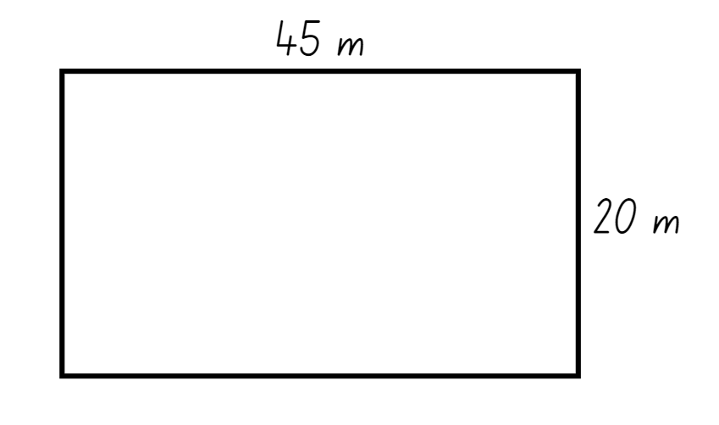
- Ask Stage 2 students:
- How many strips of artificial turf are needed to cover the field?
- If each strip costs $20, how much will it cost to cover the field?
- The landscaper installed 15 strips of turf on Saturday, and 3 times as many on Sunday. How many strips did he complete over the weekend?
- Ask Stage 3 students:
- How can you find the area of the new field?
- How can the area of the new field help find the number of strips of artificial turf needed?
- What strategies did you use to solve this problem?
- How could partitioning be used to solve this problem if the field measured 47 metres by 23 metres?
- How can partitioning be represented using the area model with the new measurements?
- Is there more than one way that the area model could be used? (See Figure 21).
Multi-age: explain to Stage 3 students that 47 × 23 is represented in 2 ways with the area model in Figure 21. One example shows 47 partitioned into its place value and the second example shows both 47 and 23 partitioned into their place values.
Figure 21 – area model
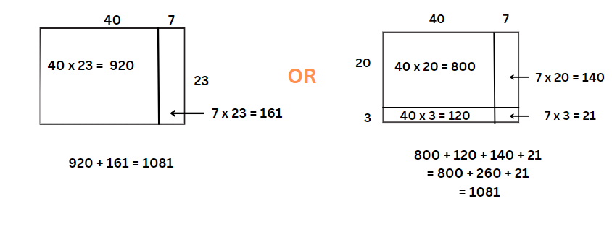
This table details opportunities for assessment.
Assessment opportunities | Links
What to look for:  - Can Stage 2 students describe multiplication problems using for each and times as many? [MAO-WM-01, MA2-MR-01]  - Can Stage 3 students solve multiplication word problems?  [MAO-WM-01, MA3-MR-01, MA3-MR-02]  - Can Stage 3 students extend the area model to represent 2-digit by 2-digit multiplication? [MAO-WM-01, MA3-MR-01, MA3-MR-02] | Links to National Numeracy Learning Progressions (NNLP):  - Stage 3 – MuS6, MuS7.  Links to suggested Interview for Student Reasoning (IfSR) tasks:  - Stage 2 – IfSR-MT: 2A.12, 2A.13, 2A.14  - Stage 3 – IfSR-MT: 3A.4, 3A.5.

Core lesson – 40 minutes
The table below contains suggested learning intentions and success criteria. These are best co-constructed with students.
Core concept learning intentions | Core concept success criteria
Students working towards Stage 2 outcomes are learning to:  - represent money values in multiple ways  - apply addition and subtraction to familiar contexts, including money and budgeting.  Students working towards Stage 3 outcomes are learning to:  - make connections between benchmark fractions, decimals and percentages. | Students working towards Stage 2 outcomes can:  - represent equivalent amounts of money using different denominations  - perform calculations with money, including finding change  - interpret problems involving money as requiring either addition or subtraction.  Students working towards Stage 3 outcomes can:  - recognise that the symbol % means percent and 100% is the whole amount  - recall commonly used equivalent percentages, decimals and fractions including $\frac{1}{2}$, $\frac{1}{4}$ and $\frac{3}{4}$.

Stage 2 task – comparing money
- Tell students Pat has $36 in his pocket. Ask:
- What notes or coins might he have?
- What notes or coins might he have if there are exactly 10 notes and coins in his pocket?
- What notes or coins might he have if there are exactly 15 notes and coins?
- In pairs, students record as many different possibilities as they can to make $36.
- Model how to use a table to record the different possibilities for each note and coin. Students can use play money to support making various combinations.
- Provide students with individual copies of Resource 25 – time to shop.
Note: online or local supermarket catalogues can also be used for this activity.
- Select students to read the grocery items and their prices.
- Discuss the concept of receiving change when spending cash on an item. Share student methods for calculating change.
- Remind students that addition and subtraction are inverse operations.
- Introduce the ‘shopkeeper’ method of counting change. Count on from the price of an item to the value of the amount given to pay for it.
- Explain that this is a counting on strategy. For example, if a customer gave a $5 note for a packet of chips costing $2.75, a shopkeeper could count the $2.25 change as:
- $2.80 (providing 5c)
- $3.00 (providing 20c)
- $5.00 (providing $2).
- Ask students to select 4 items to buy. Ask:
- What is the total cost of the 4 items?
- How much change would you get from $20 if you bought these 4 items?
- Students select a different collection of 4 items to buy. They find the total cost of these, then calculate the change from $20 using the shopkeeper method.
- Display and read Resource 26 – shopping questions.
- Demonstrate how to use a calculator with decimals, using the addition, subtraction and equals buttons.
- Students investigate at least 2 of the questions presented, using a calculator if required to check their costings and change.

This table details opportunities for differentiation.
Too hard? | Too easy?
Stage 2 students cannot represent equivalent amounts of money using different denominations.  - Connect combinations to 10 with money so that students represent $10 using a variety of notes and coins.  - Students make target amounts using play money or coin rubbing, for example, different ways to make $2.50. | Stage 2 students can represent equivalent amounts of money using different denominations.  - Resource 25 – time to shop shows 50% or half-price reductions on grocery items. Students look at other catalogues and find discounts shown. They have been given the job as mathematicians of the company to find any errors in the discounts. They check every discount for errors.  - Students compare and evaluate the ‘shopkeeper’ and the bar model method for calculating change. They explain which is easier and why.

Stage 3 task (part 1) – benchmark percentages
Note: the purpose of this activity is for students to understand the concept of percentage and the connections between decimals and fractions. It is important that this skill is developed before students are encouraged to determine strategies for solutions, such as discounts.
- Provide groups of students with a piece of string or wool (approximately 1 m in length), pegs and small pieces of paper. Students display ‘0’ at one end of the string, and ‘1’ at the other end of the string (see Figure 22).
Figure 22 – number line
- Students use the pegs and paper to mark known benchmark decimals and fractions between the zero and one.
Note: a benchmark fraction is a commonly used reference fraction for comparisons, such as one-half (50%, 0.5) or one-quarter (25%, 0.25). In Stage 3, one-tenth (10%, 0.1) is introduced as a benchmark value for its relationship to the base-10 numbering system. It is important that students have a good understanding of equivalent representations of benchmark values. Students should understand that 0.5 = $\frac{1}{2}$ and 0.5 is not $\frac{1}{5}$ (NESA 2024b).
- If students require prompting, display the following on the board, 0.1, 0.2, 0.3, 0.4, 0.5, 0.6, 0.7, 0.8, 0.9, 0.25, 0.75, $\frac{1}{2}$, $\frac{1}{4}$ and $\frac{3}{4}$.
- Students complete a gallery walk and provide feedback to peers. They make any changes to their own number line if required (see Figure 23).
Figure 23 – number line example
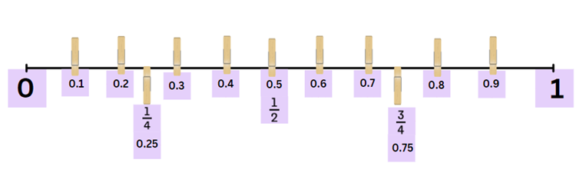
Note: monitor for 2 common misconceptions with decimals. The first misconception is sometimes called ‘Longer is larger’, where students consider that the number with more decimal places is larger. Students may think that 0.25 is larger than 0.3 based on their understanding of whole numbers. The second misconception is sometimes called ‘Shorter is larger’, where students consider that the number with fewer decimal places is larger, for example, deciding that 0.3 is larger than 0.496 (Steinle V and Stacey K 1998).

Stage 3 task (part 2) – linking percentages
- Display Resource 27 – percentages. Students turn and talk to discuss:
- What do you see or notice?
- Do you know the name of the sign?
- Where have you seen this sign before?
- What is it used for?
- What does it represent?
- Explain percent and discuss when and where it is used.
Note: percent means parts per 100 and is shown by the symbol %. Percents are often used for presenting data, discount sales, bank interest rates and taxes. Percentages are another way of expressing fractions in terms of hundredths. It is derived from the Latin words per (for) and centum (hundred).
- Provide copies of Resource 28 – place value equivalence and writing materials.
- Students shade half of the first grid and label it with $\frac{1}{2}$. Ask:
- Can $\frac{1}{2}$ be represented as a decimal? Explain why or why not.
- How many squares are shaded out of 100? How can this be represented as a fraction? ($\frac{50}{100}$).
- How did you represent the bar model? (See Figure 24).
Figure 24 – student example
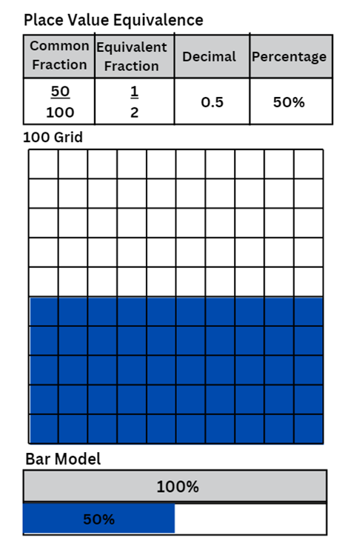
- Use the table below to discuss connections between benchmark fractions, decimals and percentages.

The table below outlines stimulus prompts to generate conversation about the topic, along with anticipated responses from students.
Prompts | Anticipated student responses
- What is half of a half?  - If you shade the next grid, how many small squares will you colour? | - A quarter  - 25
- Using your understanding of fractions, decimals and percentages, what could we include on your label to show an equivalence of $\frac{1}{4}$? | - 25%, 0.25, $\frac{25}{100}$
- How would you label the bar model? | - 25% and 75%
- Repeat the task for $\frac{3}{4}$ and $\frac{1}{10}$.
- Once students have finished, regroup as a class and discuss:
- What links can you see between the parts per hundred that have been shaded and the percentage?
- What would 100% look like on your grid? How could you represent it using fractions and/or decimals?
- What would 10% look like on your grid? How could you represent it using fractions and/or decimals?
- What could you include on your peg number line to show equivalence?
- Students add the labels 10%, 25%, 50% and 75% on their peg number line (see Figure 25).
Figure 25 – equivalence example
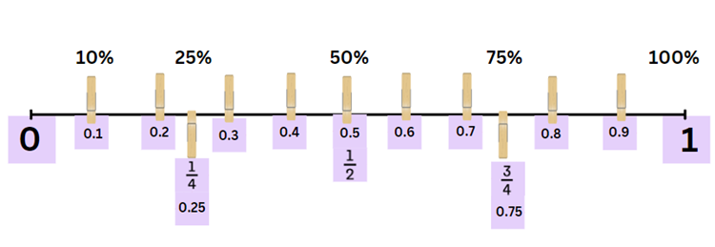
This table details opportunities for differentiation.
Too hard? | Too easy?
Stage 3 students cannot recall commonly used equivalent percentages, decimals and fractions including $\frac{1}{2}$, $\frac{1}{4}$ and $\frac{3}{4}$.  - Make a collage of everyday use of percentages from magazines and newspapers.  - Use concrete materials such as Resource 29 – number wheel and 10 × 10 grid to model and explain benchmark fractions and decimals (see Figure 26). | Stage 3 students can recall commonly used equivalent percentages, decimals and fractions including $\frac{1}{2}$, $\frac{1}{4}$ and $\frac{3}{4}$.  - Find non-benchmark equivalent percentages, decimals and fractions.  - Students play an interactive game where percentages are used on a 10 × 10 grid such as Playground Percentages – ABC Education or Matching Fractions, Decimals and Percentages from NRICH by University of Cambridge.
Figure 26 – number wheel example
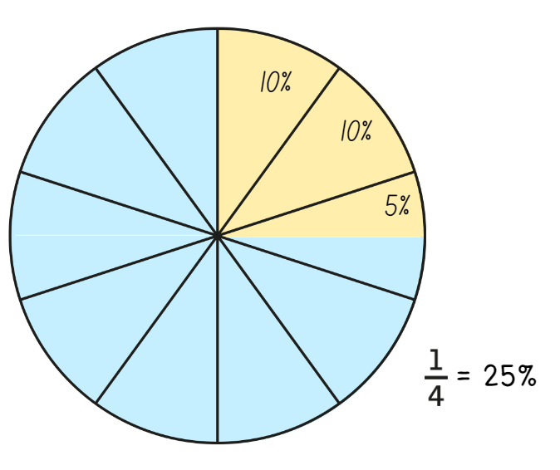

Discuss and connect the mathematics – 10 minutes
- Stage 2 students complete an exit slip on a sticky note, answering: What is the most efficient strategy to find the sum of $1.75 and $2.25? Why?
- Stage 3 students complete an exit slip on a sticky note, answering: What would be an equivalent fraction, decimal and percentage for $\frac{20}{100}$.
This table details opportunities for assessment.
Assessment opportunities | Links
What to look for:  - Can Stage 2 represent equivalent amounts of money using different denominations? [MAO-WM-01, MA2-AR-01]  - Can Stage 2 students perform calculations with money, including finding change? [MAO-WM-01, MA2-AR-01]  - Can Stage 2 students interpret problems involving money as requiring either addition or subtraction? [MAO-WM-01,  MA2-AR-01]  - Can Stage 3 students recognise that the symbol % means percent and that 100% is the whole amount? [MAO-WM-01, MA3-RN-03]  - Can Stage 3 students recall commonly used equivalent percentages, decimals and fractions including $\frac{1}{2}$, $\frac{1}{4}$ and $\frac{3}{4}$?  [MAO-WM-01, MA3-RN-03] | Links to National Numeracy Learning Progressions (NNLP):  - Stage 2 – AdS8, UuM6  - Stage 3 – PrT1, PrT2, UuM8.

Lesson 6
Core concept: models help us solve addition and subtraction problems with money (Stage 2) and place value understanding helps to make use of benchmark percentages in determining discounts (Stage 3).

Daily number sense – grab a value –10 minutes
The table below contains suggested learning intentions and success criteria. These are best co-constructed with students.
Daily number sense learning intentions | Daily number sense success criteria
Students working towards Stage 2 outcomes are learning to:  - represent and solve problems involving multiplication fact families.  Students working towards Stage 3 outcomes are learning to:  - select and apply mental and written strategies to multiply 2- and 3-digit numbers by 2-digit numbers. | Students working towards Stage 2 outcomes can:  - describe multiplication problems using for each and times as many.  Students working towards Stage 3 outcomes can:  - factorise numbers to aid mental multiplication.
- Provide students with writing materials and a collection of coloured counters.
- Assign a value to each colour, for example each red counter is worth 5, each blue counter is worth 10. Continue this pattern for other colours as needed, supporting the learning needs in the class.
- Each player takes turns to grab a handful of materials from the collection and record these on their whiteboards. They consider how they can describe their collections using the words for each and times as many.
- Students turn and talk to discuss how the total value of these counters can be found using known additive or multiplicative strategies.
Multi-age: revisit the order of operations with Stage 3 students and discuss how this can be applied to the recording of values. Demonstrate an example by writing the equation (4 × 5) + (5 × 5) + (1 × 5) and asking how this can be solved using mental strategies. Stage 3 students double their counters’ values for a greater challenge. They use the associative property of numbers to simplify their multiplicative calculations, by factorising numbers where possible. For example, 12 × 25 = 3 × 4 × 25 = 3 × 100 = 300.
- Students calculate the total value of the handful by using multiplicative and additive strategies.
- After each turn, players record their total for their partner to check.
- The player with the highest total score at the end of 5 rounds, wins the game.
- Regroup as a class and ask:
- How did you describe your collections using the words for each and times as many?
- Are the multiplication calculations you solved accurate? How can you prove it?
- Could you simplify the multiplication problems to make them easier to solve?
- What strategy did you use to maximise your score in this game?
This table details opportunities for assessment.
Assessment opportunities | Links
What to look for:  - Can Stage 2 students describe multiplication problems using for each and times as many? [MAO-WM-01, MA2-MR-01]  - Can Stage 3 students factorise numbers to aid multiplication? [MAO-WM-01, MA3-MR-01, MA3-MR-02] | Links to National Numeracy Learning Progressions (NNLP):  - Stage 2 – n/a  - Stage 3 – MuS6, MuS67.  Links to suggested Interview for Student Reasoning (IfSR) tasks:  - Stage 2 – IfSR-MT: 2A.12, 2A.13, 2A.14.  - Stage 3 – IfSR-MT: 3A.4, 3A.5.

Core lesson – 40 minutes
The table below contains suggested learning intentions and success criteria. These are best co-constructed with students.
Core concept learning intentions | Core concept success criteria
Students working towards Stage 2 outcomes are learning to:  - represent money values in multiple ways.  Students working towards Stage 3 outcomes are learning to:  - determine percentage discounts of 10%, 25% and 50%  - choose and use efficient strategies to solve addition and subtraction problems. | Students working towards Stage 2 outcomes can:  - recognise the relationship between dollars and cents  - represent equivalent amounts of money using different denominations  - perform calculations with money, including finding change.  Students working towards Stage 3 outcomes can:  - equate 10% to dividing by 10, 25% to finding a quarter by dividing by 4, and 50% to finding half  - use mental strategies to estimate discounts of 10%, 25% and 50%  - calculate the sale price of an item after a discount of 10%, 25% and 50%  - solve multistep word problems, including problems that require more than one operation.

Stage 2 task – canteen lunch planning
- Assign students into groups of 3 or 4.
- Display Resource 30 – canteen menu or provide copies to students.
- Each student selects a meal, a drink, and a snack. They calculate the cost of their lunch.
- Students work in groups to determine the total cost of their group’s lunch.
- Ask groups to provide solutions for the following questions:
- Which notes and/or coins could you use to pay for your group's lunch?
- What other combinations of notes and/or coins could you use?
- How much change would you receive from $50?
- Which combination of notes and/or coins might you receive as change?
This table details opportunities for assessment.
Too hard? | Too easy?
Students cannot perform calculations with money, including finding change.  - Students buy one item and calculate change using play money and the shopkeeper/counting on strategy. They use a calculator to check their total amounts and calculate the change.  - Provide students with ten-frames and a collection of 10c pieces. Students use 10c pieces to represent the total value of items from the menu. | Students can perform calculations with money, including finding change.  - Students buy multiple items and calculate change from an irregular total such as $32 or $27.  - Buy different combinations of items to spend as close to $40 as possible and make change from $50.

Stage 3 task – finding percentages
This activity is an adaptation of Calculating Percentages (DOC 4.7 MB) by the State of New South Wales (Department of Education).
- Revise benchmark fractions and decimals from Lesson 5.
- Display Resource 31 – percentage links.
- Pose the question: Would you rather have 10% of $50 or 25% of $20? Students turn and talk to decide on their answer. They estimate first using mental strategies, without any formal calculations.
- Students share some of their mental strategies used to estimate the answer.
- Ask: What is the same or different about the strategies that have been shared?
Note: do not answer the question for students. The same question is included in the lesson conclusion.
- Display Resource 32 – benchmark percentages. Read and discuss the columns, reviewing the examples provided.
- Explain that the ‘Description in words’ column can approximate what the percentages represent, such as ‘almost all of it’.
- Students work in small groups to complete the table, see Table 2.
Table 2 – benchmark percentages
Percent | Description in words | Efficient strategies to find | Equivalent fractions and decimals
100% | The whole thing/all | It is the same as the total. | ten-tenths, 1, $\frac{10}{10}$
90% | Nearly all, most of it | Find 10% and subtract this from the total. | nine-tenths, $\frac{9}{10}$, 0.9
80% | A bit more than three-quarters | Find 10% and double it. Then subtract this from the total. | eight-tenths, $\frac{8}{10},$ $\frac{4}{5}$, 0.8
75% | Three-quarters | Halve the total and then halve again. | $\frac{3}{4}$ or 0.75
60% | Just over a half | Add half and a quarter together. | six-tenths, $\frac{6}{10}$, $\frac{3}{5}$, 0.6
50% | Half | Halve the total. | five-tenths$,\frac{1}{2}$,$\frac{5}{10}$, 0.5
40% | Just under a half | Find 10% and multiply by 4. | four-tenths, $\frac{4}{10}$, $\frac{2}{5}$, 0.4
30% | A bit more than a quarter | Find 10% and multiply by 3. | three-tenths, $\frac{3}{10}$, 0.3
25% | A quarter, one of 4 equal parts | Halve the total and then halve again. | $\frac{1}{4}$ or 0.25
20% | A fifth, a bit less than a quarter | Find 10% and double it. | two-tenths, $\frac{2}{10}$, $\frac{1}{5}$, 0.2
10% | A tenth part | Use multiplicative thinking, divide by 10. | one-tenth, $\frac{1}{10}$, 0.1
0% | Nothing | The answer is zero. | 0
- Display, read and discuss Resource 33 – percent problems.
- Select students to share possible approaches to one of the problems.
- Provide copies of Resource 33 – percent problems, writing materials and 100 grids. Students choose efficient strategies to calculate solutions to the problems.
This table details opportunities for differentiation.
Too hard? | Too easy?
Stage 3 students cannot calculate the sale price of an item after a discount of 10%, 25% and 50%.  - Adjust the percentages in Resource 33 – percent problems to only include benchmark percentages.  - Provide Resource 34 – percent models. Guide students to show 25% of $40, 50% of $60, 75% of $120 and 10% of $90. Students draw bar models for other amounts and benchmark fractions, then make up a story that matches the model. | Stage 3 students can calculate the sale price of an item after a discount of 10%, 25% and 50%.  - Adjust the percentages in Resource 33 – percent problems to include non-benchmark percentages. Guide students to make a connection between 10% and 1% of an amount. Challenge students to determine a method to calculate 1% of an amount and when would it be useful to find 1%.  - Students investigate price increases instead of discounts, or the use of percentages over 100%.

Discuss and connect the mathematics – 10 minutes
- Stage 2 students record their responses in their workbooks to the following questions:
- Can you explain the relationship between dollars and cents using words and/or pictures?
- Choose 2 snacks to purchase from the canteen menu. Can you calculate how much change there will be from $5.00?
- Stage 3 Students reflect on their answers for ‘Which would you rather have? 10% of $50 or 25% of $20?’ Ask:
- Would you give the same answer from the beginning of the lesson, or would you change your response?
- Can you explain why? (Students record their reflection in their workbooks).
This table details opportunities for assessment.
Assessment opportunities | Links
What to look for:  - Can Stage 2 students recognise the relationship between dollars and cents? [MAO-WM01, MA2-AR-01]  - Can Stage 2 students represent equivalent amounts of money using different denominations? [MAO-WM01, MA2-AR-01]  - Can Stage 2 students perform calculations with money, including finding change? [MAO-WM01, MA2-AR-01]  - Can Stage 3 students equate 10% to dividing by 10, 25% to finding a quarter by dividing by 4, and 50% to finding half?  [MAO-WM-01, MA3-RN-03]  - Can Stage 3 students use mental strategies to estimate discounts of 10%, 25% and 50%? [MAO-WM-01, MA3-RN-03]  - Can Stage 3 students calculate the sale price of an item after a discount of 10%, 25% and 50%? [MAO-WM-01, MA3-RN-03]  - Can Stage 3 students solve multistep word problems, including problems that require more than one operation? [MAO-WM-01, MA3-AR-01] | Links to National Numeracy Learning Progressions (NNLP):  - Stage 2 – UnM2, UnM3, UnM4, UnM5, UnM6.  - Stage 3 – PrT1, PrT2, UnM8, AdS8.

Lesson 7
Core concept: mathematicians select the most efficient strategies when solving problems.

Daily number sense – what do I have? – 10 minutes
The table below contains suggested learning intentions and success criteria. These are best co-constructed with students.
Daily number sense learning intentions | Daily number sense success criteria
Students working towards Stage 2 outcomes are learning to:  - represent and solve problems involving multiplication fact families.  Students working towards Stage 3 outcomes are learning to:  - select and apply mental and written strategies to multiply 2- and 3-digit numbers by 2-digit numbers. | Students working towards Stage 2 outcomes can:  - find the total of partially covered arrays.  Students working towards Stage 3 outcomes can:  - solve multiplication word problems.
Multi-age: students in Stage 3 can be provided with 10- or 20- sided dice to multiply 2-digit by 2-digit numbers. They use the associative property of numbers to simplify their multiplicative calculations by factorising numbers where possible. For example, 12 × 25 = 3 × 4 × 25 = 3 × 100 = 300.
- Provide pairs of Stage 3 students with 30 counters and a piece of cardboard.
Note: alternatively, use plastic Australian coins to strengthen links to money and its value. If doing so, ensure that students understand they must use coins of the same denomination.
- Pose the problem: A group of students are lined up in preparation for the annual marching band festival. From the reporter’s point of view, they can only see 4 rows of students with 6 students in each row. Is there a way to represent this to determine the number of students in the marching band?
- Demonstrate arranging a partially covered array. Use counters and cardboard to only reveal the top of one row and a column (see Figure 27).
Figure 27 – partially covered array
- Ask: How could we use what we know to find the total number of students? Select students to share their thinking.
- Demonstrate recording the total number of counters as an array and a sentence, for example, 4 rows of 6 is 24.
- Remove the cardboard and select students to check accuracy of the answer.
- In pairs, students take turns to arrange counters in an array form and partially cover the array with a cardboard for their partner to determine the total number of counters.
- Students record the sentence and multiplicative statement, for example, 4 rows of 6 is 24 or 4 × 6 = 24 before unveiling the covered counters to check for accuracy of answers.
- Repeat the activity with students swapping roles.
This table details opportunities for assessment.
Assessment opportunities | Links
What to look for:  - Can Stage 2 students find the total of partially covered arrays? [MAO-WM-01, MA2-MR-01]  - Can Stage 3 students solve multiplication word problems?  [MAO-WM-01, MA3-MR-01] | Links to National Numeracy Learning Progressions (NNLP):  - Stage 2 – MuS5  - Stage 3 – MuS6, MuS7, MuS8.  Links to suggested Interview for Student Reasoning (IfSR) tasks:  - Stage 2 – IfSR-MT: 2A.1.

Core lesson 1 – problem solving – 25 minutes
The table below contains suggested learning intentions and success criteria. These are best co-constructed with students.
Core concept learning intentions | Core concept success criteria
Students working towards Stage 2 outcomes are learning to:  - select strategies flexibly to solve addition and subtraction problems of up to 3 digits.  Students working towards Stage 3 outcomes are learning to:  - apply efficient mental and written strategies to solve addition and subtraction problems  - applies known strategies to add and subtract decimals. | Students working towards Stage 2 outcomes can:  - represent solutions to addition and subtraction problems, including word problems, using an empty number line or bar model  - compare and evaluate strategies used to solve addition and subtraction problems, reasoning which strategy may be most efficient.  Students working towards Stage 3 outcomes can:  - model the addition and subtraction of decimals up to 3 decimal places using appropriate representations  - solve word problems involving the addition and subtraction of decimals up to 3 decimal places  - solve word problems, including multistep problems.
This activity is an adaptation of Fruity Pairs and How Much? from NRICH by University of Cambridge. Common strategies for solving word problems may include underlining key words and numbers, circling the question, using a visual representation (drawing, table, list, number line, bar model) and breaking a problem into small parts.
- Brainstorm and record helpful strategies students use for solving word problems in mathematics.
Multi-age: provide Stage 2 students with Resource 35 – money problem 1 and Stage 3 students with Resource 36 – multistep problems.
- Display Resource 3 – additive strategies. Pairs of students choose one of these strategies, then use it to solve a problem from either Resource 35 – money problem 1 or Resource 36 – multistep problems.
- Provide students with individual whiteboards to record their working out. They also name the strategy they used.
- Students choose another problem and repeat the process. They share their working out with members in their groups to check for accuracy of solutions.
- Regroup as a class and ask:
- Was your chosen strategy efficient in solving the problem?
- Is there a different strategy that may have been more efficient? Why?
- Students select another strategy to solve the same word problem they chose in activity 11.

Core lesson 2 – 20 minutes

Stage 2 task – money solutions
- Provide students with Resource 3 – additive strategies, Resource 37 – money problem 2, individual whiteboards and a collection of plastic Australian notes and coins.
- In pairs, students both choose a different strategy to solve the same problem from Resource 37 – money problem 2.
- Students swap their whiteboards with their partner, to check the accuracy of their solutions. They explain their choice of strategy used, then repeat the process with another problem.

Stage 3 task – first day data
- Display and discuss Resource 38 – first day data.
- Provide students with a copy of Resource 3 – additive strategies, Resource 38 – first day data and individual whiteboards.
Note: local school enrolment data can be used to contextualise some of these activities.
- In pairs, ask students to solve the following problems using the information provided in Resource 38 – first day data:
- What is the total number of students attending school from Preschool to Year 12 in NSW?
- Use the percentages to calculate how many students come from remote, regional and metropolitan areas.
- What is the total number of students that come from an Aboriginal and Torres Strait Islander cultural background and language background other than English?
- What percentage of students have an English language background?
- What percentage of students did not attend a preschool or childcare setting in 2023?
- How many teachers work in remote and regional schools?
- What is the difference between the number of students starting primary and secondary school?
This table details opportunities for differentiation.
Too hard? | Too easy?
Stage 2 students cannot compare and evaluate strategies used to solve addition and subtraction problems, reasoning which strategy may be most efficient.  - Modify Resource 35 – money problem 1 to use whole-dollar values. Support students to use an empty number line or bar model to solve the problems.  - Provide plastic Australian notes and coins for the students to represent a solution for Resource 37 – money problem 2.  Stage 3 students cannot model the addition and subtraction of decimals up to 3 decimal places using appropriate representations.  - Revisit the number slider from Lesson 2. Individually or in pairs, students select a 2-digit number. Use the number slide to model multiplying and dividing their number from the ones and tens to the millions and thousandths. They draw different representations, such as on a place value chart, number line or bar model.  - Support students to solve a question from Resource 36 – multistep problems using think-alouds and number lines. Discuss, record and evaluate the problem-solving strategies used. | Stage 2 students can compare and evaluate strategies used to solve addition and subtraction problems, reasoning which strategy may be most efficient.  - Students investigate what happens when calculating the difference of a 2-digit number and its reverse, for example, 74 − 47? What patterns do they notice? Can they explain that pattern? Does the same pattern hold for 3-digit numbers? (Note: see Subtracting Reverses for more information).  - Students write their own open-ended money problems following the structure of Resource 35 – money problem 1. They share these with another student to solve.  Stage 3 students can model the addition and subtraction of decimals up to 3 decimal places using appropriate representations.  - Students research an area of interest that they can draw statistics from, to write additive relation problems. For example, comparing large distances between planets or comparing bird migration data.  - Provide copies of Resource 39 – open middle problems. Students work on the problems, then share the strategies they used to solve them.

Discuss and connect the mathematics – 10 minutes
- Regroup as a class and display the class anchor chart from Lesson 1 and Resource 3 – additive strategies.
- Ask students to reflect on the following questions:
- Which additive strategies did you find useful for solving the problems?
- What was successful?
- What was difficult?
- Was there another strategy you could have used to solve the same problem?
This table details opportunities for assessment.
Assessment opportunities | Links
What to look for:  - Can Stage 2 students represent solutions to addition and subtraction problems, including word problems, using an empty number line or bar model? [MAO-WM-01, MA2-AR-01]  - Can Stage 2 students compare and evaluate strategies used to solve addition and subtraction problems, reasoning which strategy may be most efficient? [MAO-WM-01, MA2-AR-01]  - Can Stage 3 students model the addition and subtraction of decimals up to 3 decimal places using appropriate representations? [MAO-WM-01, MA3-AR-01]  - Can Stage 3 students solve word problems involving the addition and subtraction of decimals up to 3 decimal places?  [MAO-WM-01, MA3-AR-01]  - Can Stage 3 students solve word problems, including multistep problems? [MAO-WM-01, MA3-AR-01] | Links to National Numeracy Learning Progressions (NNLP):  - Stage 2 – AdS6  - Stage 3 – AdS8, AdS9.  Links to suggested Interview for Student Reasoning (IfSR) tasks:  - Stage 2 – IfSR-AT: 2A.5, 2A.6.

Lesson 8
Core concept: mathematicians compare and evaluate strategies used to solve addition and subtraction problems, reasoning which strategy may be most efficient.

Daily number sense – 10 minutes
- From a class need surfaced through formative assessment data, identify a short, focused activity that targets students’ knowledge, understanding and skills. Example activities may be drawn from the following resources:
- Mathematics K–6 resources
- Universal Resources Hub.

Core lesson 1 – rounding – 15 minutes
The table below contains suggested learning intentions and success criteria. These are best co-constructed with students.
Core concept learning intentions | Core concept success criteria
Students working towards Stage 2 outcomes are learning to:  - select strategies flexibly to solve addition and subtraction problems of up to 3 digits.  Students working towards Stage 3 outcomes are learning to:  - apply efficient mental and written strategies to solve addition and subtraction problems  - choose and use efficient strategies to solve addition and subtraction problems. | Students working towards Stage 2 outcomes can:  - represent solutions, using an empty number line or bar model  - compare and evaluate strategies, reasoning which strategy may be most efficient.  Students working towards Stage 3 outcomes can:  - determine when it would be more efficient to use a calculator to add numbers  - solve multistep word problems, including problems that require more than one operation  - compare, evaluate and communicate strategies used to solve addition and subtraction problems.
Note: the purpose of this lesson is to encourage students to embrace different types of problems. Fermi questions are problems that require estimation, named after the Nobel Prize winning physicist Enrico Fermi. He was known for his ability to make good approximate calculations with little or no actual data. These questions prompt students to use their reasoning, rounding and estimations when calculating.
- Explain that the goal of Fermi problems is to encourage students to think and communicate like mathematicians. When solving these problems, it is important to make reasonable estimations, not exact calculations.
- Write the numbers 456, 852 and 781 on the whiteboard and select students to read the numbers.
- Discuss the reasons for rounding numbers, for example, when looking only for an approximate number.
- Select students to round the numbers to the nearest tens, hundreds and thousands.
- Display Resource 40 – Fermi checklist and discuss each statement.
- Pose the problem: Using 10 individual counters to represent dollar coins, estimate how many coins you would need to cover your desk.
- Refer to Resource 40 – Fermi checklist and have students Think-Pair-Share the answer:
- What is the question asking you?
- What information might you need?
- What measurements might help you? Why?
- What steps would you take? Why?
- What might you have missed in your estimate?
Multi-age: depending on the needs of the class, Stage 2 students could continue working on this problem or move to using flexible strategies below.

Core lesson 2 – 35 minutes

Stage 2 task – using flexible strategies
This activity is an adaptation from Open-Ended Maths Activities by Sullivan and Lilburn pp 48–53.
- Pose the problem: ‘I did a subtraction task and the answer was 215, but I cannot remember the other numbers. The only thing I can remember is that one number was even and one was odd. Can you help find at least 10 solutions that equal 215?’
- Students work through the problem and record solutions individually, with a partner or in small groups. Solutions can be completed in workbooks, grid paper or on sticky notes for the students to add around the problem.
- In pairs, students discuss which strategies were the most efficient and provide reasons why.

Stage 3 task – Fermi problems
- Provide groups of students with Resource 40 – Fermi checklist, Resource 41 – Fermi problems, writing materials and calculators.
- Explain that students will work together to choose an investigation from Resource 41 – Fermi problems.
- Students explore their chosen problem and record their thinking.
Note: it is preferable for students to work in small groups to engage with this task before seeking teacher assistance. Encourage students to experience productive struggle before providing prompts. If required, guide students to break the task up into components, make estimates and state their assumptions. Finally, they explain and justify their solutions using visual representations and calculations.
- After a suitable amount of time, pair groups together to share their results. Students explain their steps and reasoning.
This table details opportunities for differentiation.
Too hard? | Too easy?
Stage 2 students cannot compare and evaluate strategies, reasoning which strategy may be most efficient.  - Change the target numbers in the problem to 2-digit numbers.  - Provide concrete materials for students to use. Support students to use these, as well as an empty number line or bar model.  Stage 3 students cannot solve multistep word problems, including problems that require more than one operation.  - Provide 10 coloured chocolate buttons. Guide students to organise the buttons into a rectangular array. Trace and cut the array. Use the array to find how many buttons would fit onto a table.  - Display a small container filled with counters or marbles. Students estimate the total quantity. Model how to use their estimates to calculate how many objects would fit into a large box. | Stage 2 students can compare and evaluate strategies, reasoning which strategy may be most efficient.  - Increase the problems to 4-digit numbers and include operations to solve.  - Add other requirements to the problem, for example, the 2 numbers added or subtracted require regrouping.  Stage 3 students can solve multistep word problems, including problems that require more than one operation.  - Students write and investigate their own Fermi problem using very large numbers. They add a multiplicative and additive element to their investigation.  - Students investigate a Fermi problem that involves decimals or very small objects. For example, how many bacteria could there be on a mobile phone?

Discuss and connect the mathematics – 10 minutes
- Students reflect on their group’s work. Select 3 prompts to use as part of a reflection or exit slip:
- Were your estimations reasonable?
- Did you use rounding to help with your estimates?
- How does estimation play a part in solving problems?
- When you encounter a maths problem that seems difficult, how do you approach it?
- What assumptions did you make while working on the Fermi problem?
- Describe another group’s reasoning that worked well.
- How did you communicate your reasoning to others?
- Do you think your strategies were efficient? Why or why not?
- Was the calculator a useful device to help approach the Fermi questions? Why or why not?
- What will you do differently if you tackle similar Fermi problems in the future?
This table details opportunities for assessment.
Assessment opportunities | Links
What to look for:  - Can Stage 2 students represent solutions, using an empty number line or bar model? [MAO-WM-01, MA2-MR-01]  - Can Stage 2 students compare and evaluate strategies used to solve addition and subtraction problems, reasoning which strategy may be most efficient? [MAO-WM-01, MA2-MR-01]  - Can Stage 3 students determine when it would be more efficient to use a calculator to add numbers? [MAO-WM-01, MA3-AR-01]  - Can Stage 3 students solve multistep word problems, including problems that require more than one operation? [MAO-WM-01, MA3-AR-01]  - Can Stage 3 students compare, evaluate and communicate strategies used to solve addition and subtraction problems? [MAO-WM-01, MA3-AR-01] | Links to National Numeracy Learning Progressions (NNLP):  - Stage 2 – AdS6  - Stage 3 – AdS7, AdS8, AdS9, MuS8.  Links to suggested Interview for Student Reasoning (IfSR) tasks:  - Stage 2 – IfSR-AT: 2A.5, 2A.6.  - Stage 3 – IfSR-AT: 3A.5, 4A.1, 4A.2, 4A.3, 4A.4.

Resource 1 – Jeff’s coins
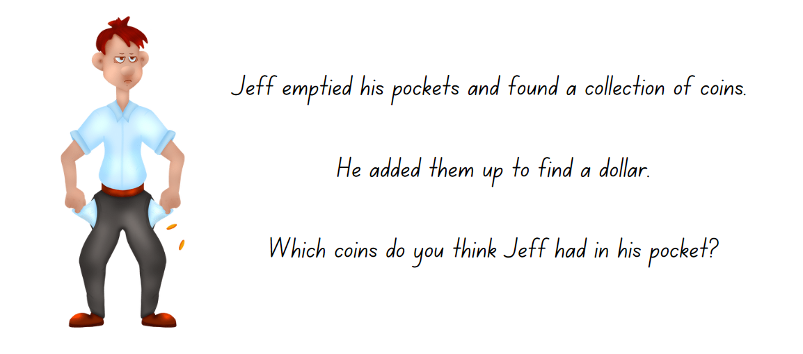

Resource 2 – Eliza’s coins
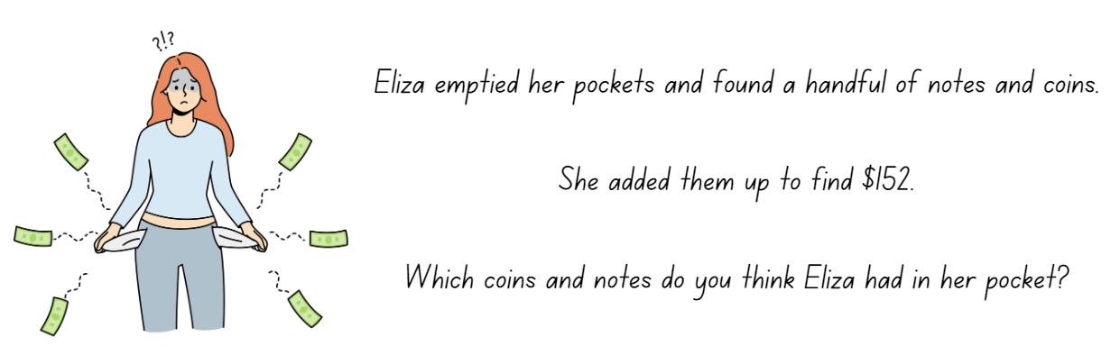

Resource 3 – additive strategies
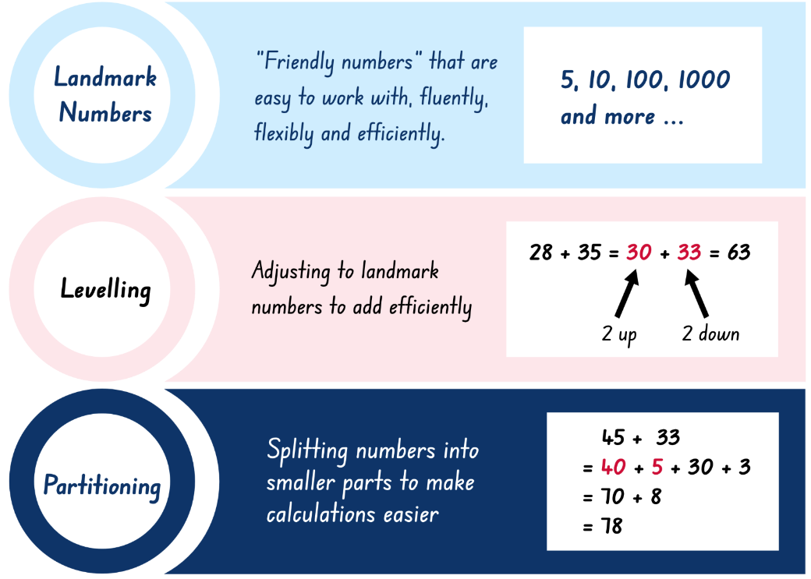
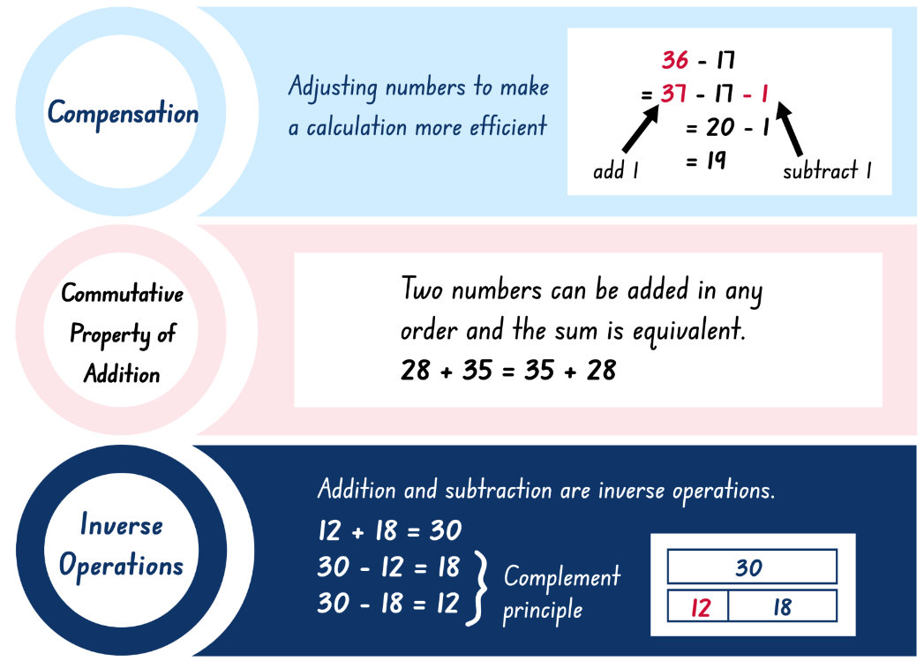
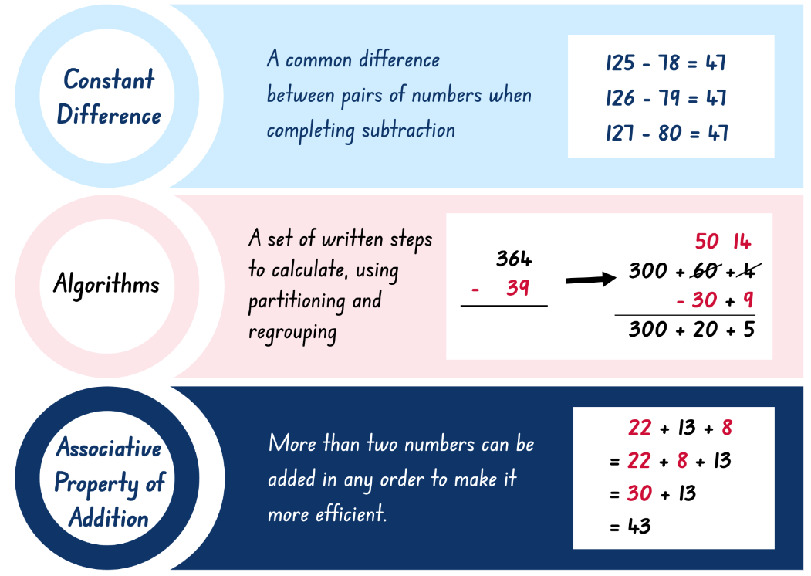
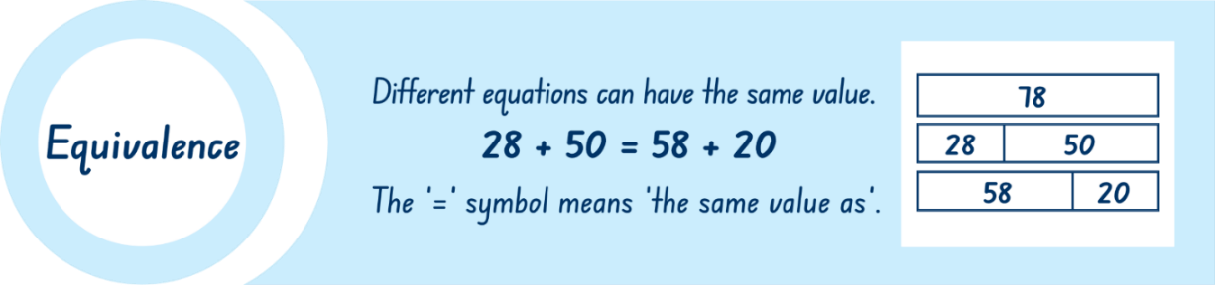

Resource 4 – reflection chart
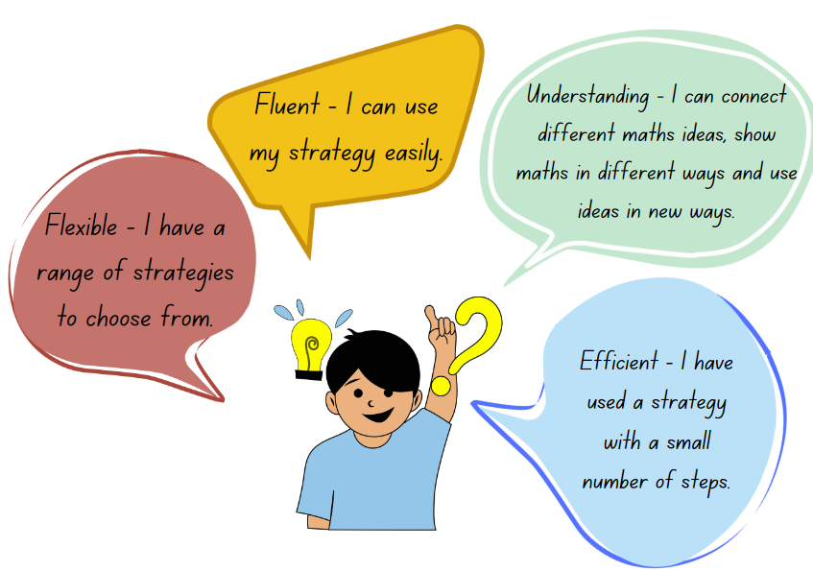

Resource 5 – balancing equations
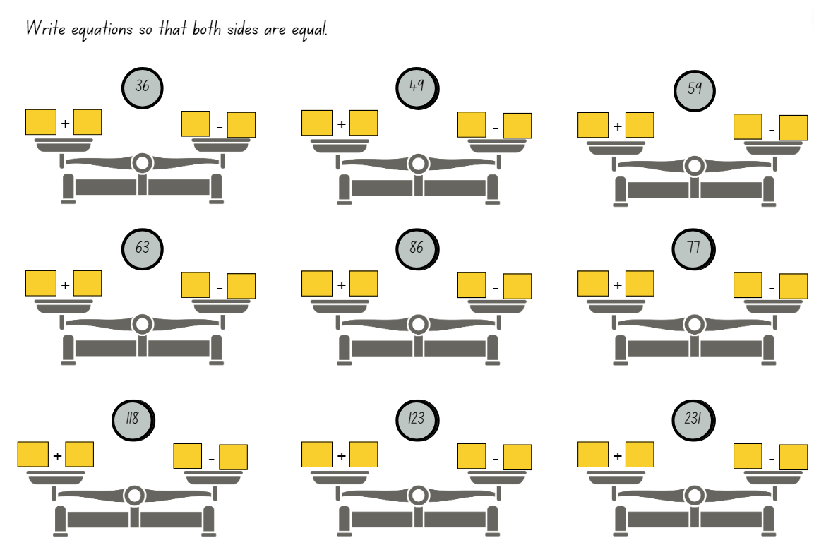

Resource 6 – Which strategy?
Equation | Most efficient strategy | Solution
- 2364 + 407
- 3689 − 2562
- _ − 7289 = 158
- 67.7 + 108.67
- 5440 + 266
- 7302 − _ = 4861
Write your own equations for the strategy provided and then solve them.
Written using inverse relations
Mentally using constant difference
Written using the complement principle then your choice.

Resource 7 – dice bowling
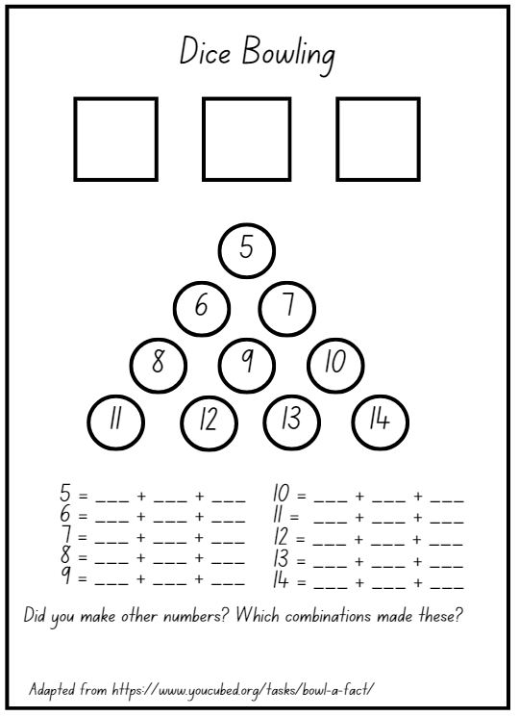
Adapted from Stanford University (n.d.)

Resource 8 – Which strategy? 2
Equation | Most efficient strategy | Solution
- 64 + 27
- 89 – 62
- _ − 99 = 58
- 77 + 67
- 40 + 66
- 102 − _ = 61
Write your own equations for the strategy provided and then solve them.
Written using inverse relations
Mentally using constant difference
Written using the complement principle then your choice.

Resource 9 – ABC Motors
ABC Motors is a popular car dealership that experienced steady growth in sales over the past 3 months. In the first month, 5678 cars were sold. In the second month, 8890 cars were sold. In the third month the sales increased further, reaching 11 567 cars. Assuming this trend continues, project the sales for the fourth and fifth month. Justify your response.

Resource 10 – coin records
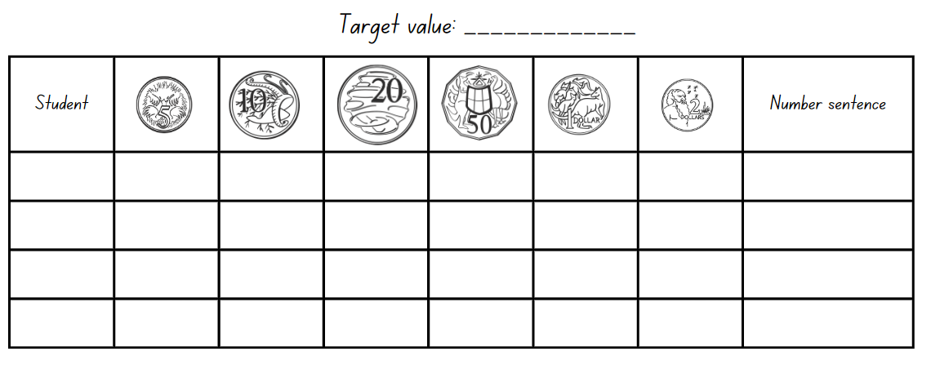

Resource 11 – money records
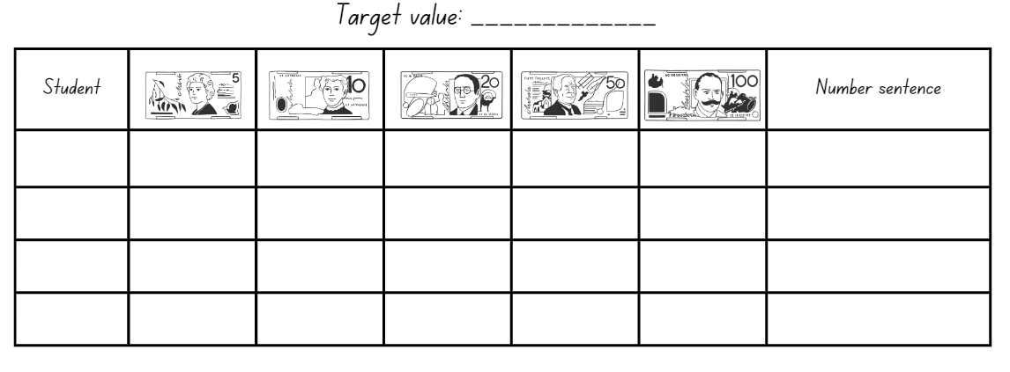

Resource 12 – place value chart
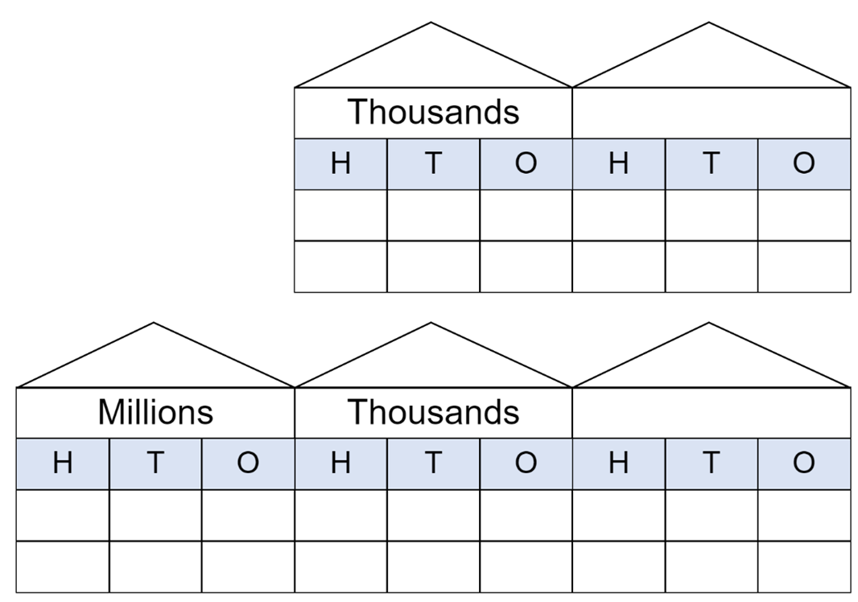

Resource 13 – place value slider
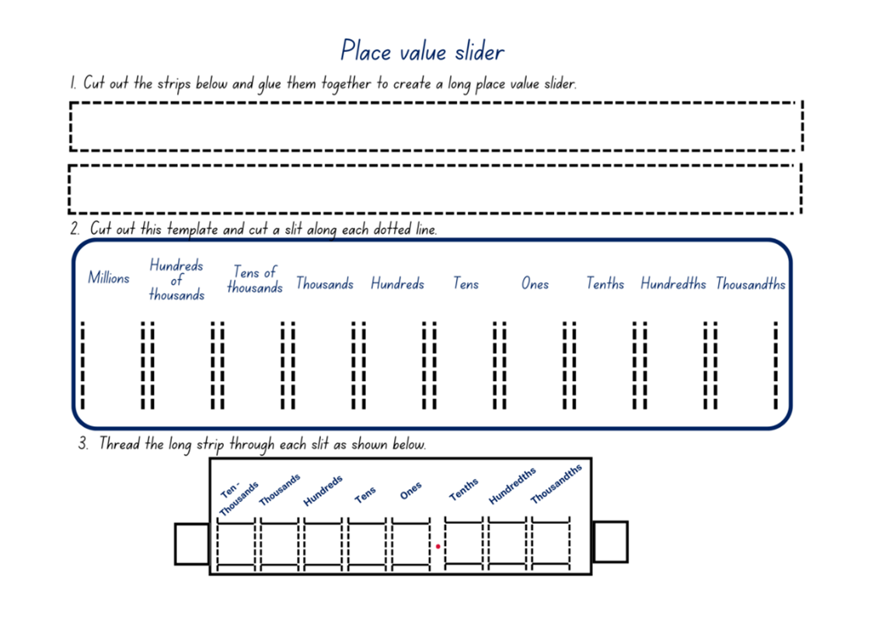

Resource 14 – levelling/constant difference
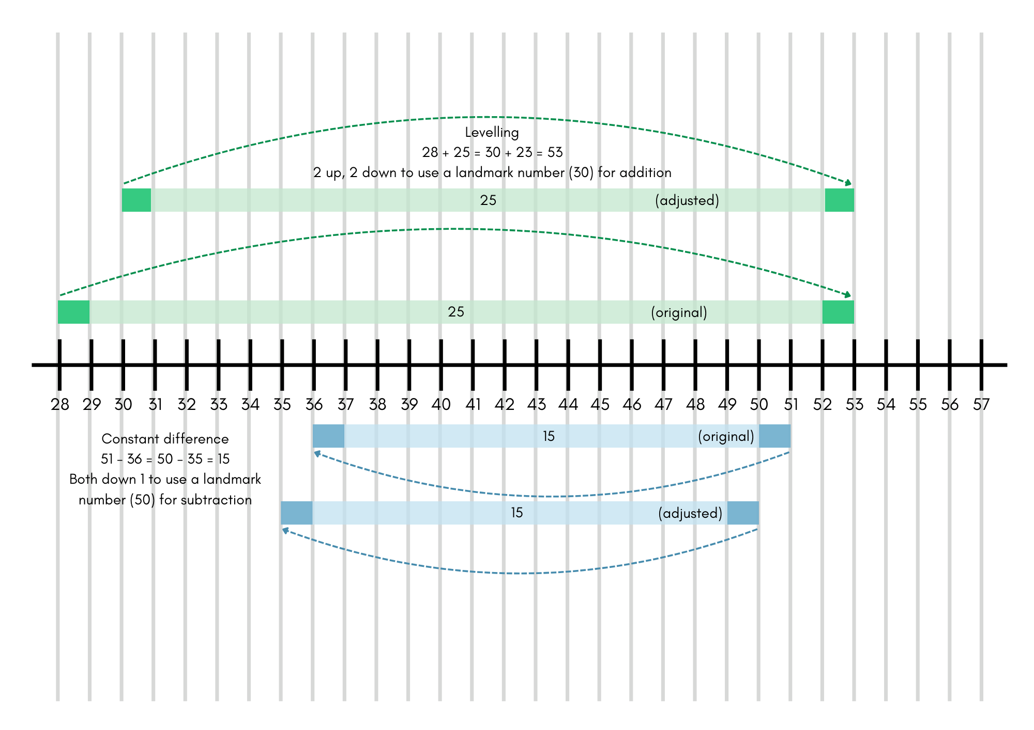

Resource 15 – word problems
Mass – a farmer weighs his chickens. Barbara the chicken is extremely underweight and weighs in at 1.998 kg. Doris the chicken has been enjoying the new chicken feed and weighs in at 7.615 kg. How much do Doris and Barbara weigh altogether?
How much more do they have to put on to reach the farmer’s goal of 11.5 kg in total for both chickens?

Length – Sydney to Perth is 3256 km. The plane needs to refuel after travelling 6506 km. Does the plane have enough fuel for the return trip to Sydney? Explain your answer.

Money – Nikhita and Monish each received $7.50 a week in pocket money for 4 weeks. They each took their savings to their favourite lolly shop. All items in the lolly shop were between $2.50 and $6.00. Nikhita purchased 4 items and Monish purchased 7 items. All items they chose were different prices. What is the most Nikhita and Monish could have spent?
How much change would they each receive?

Resource 16 – Frayer model
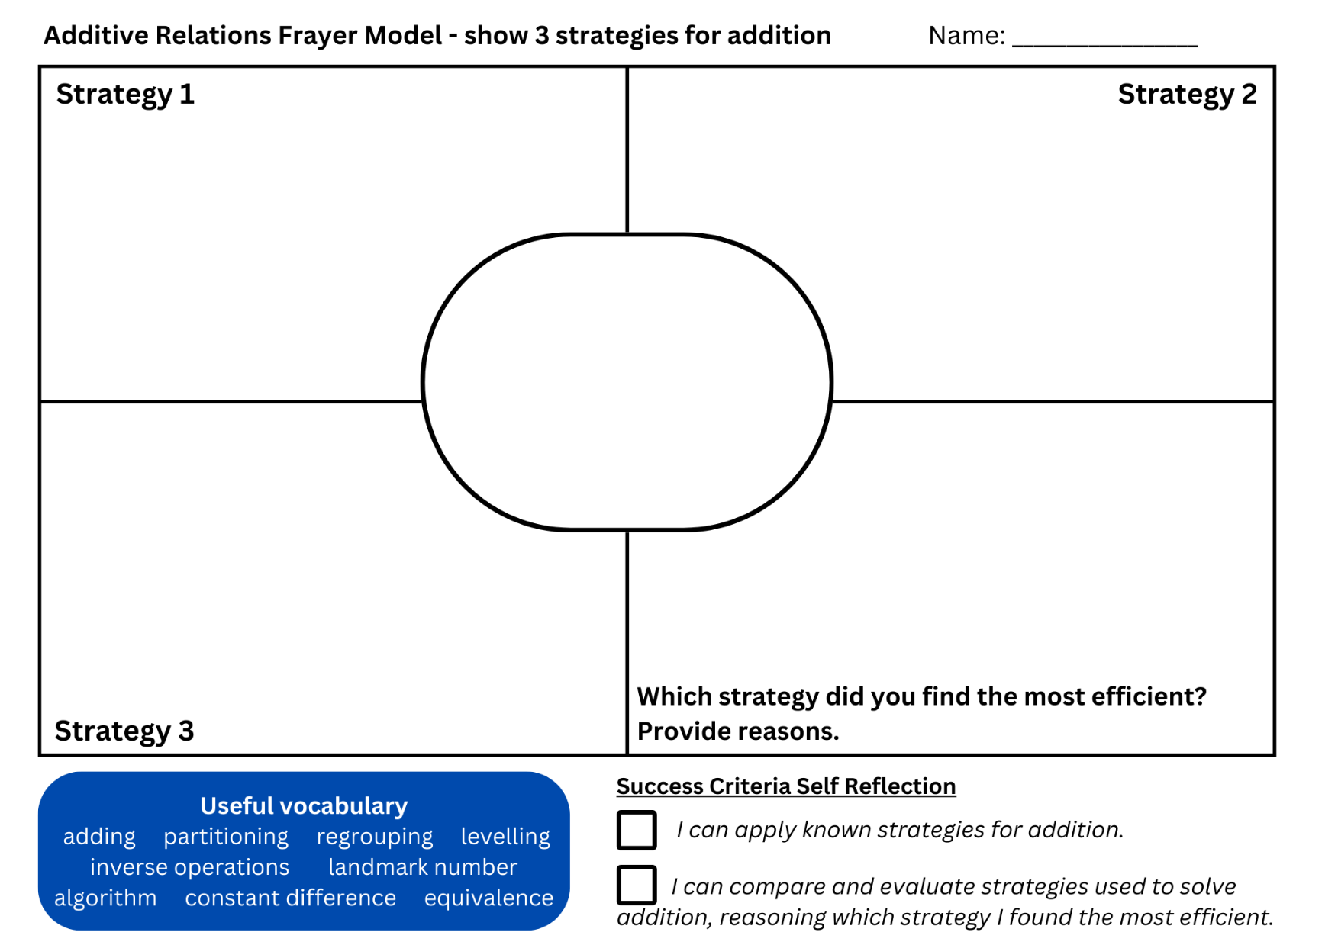

Resource 17 – decimal misconceptions
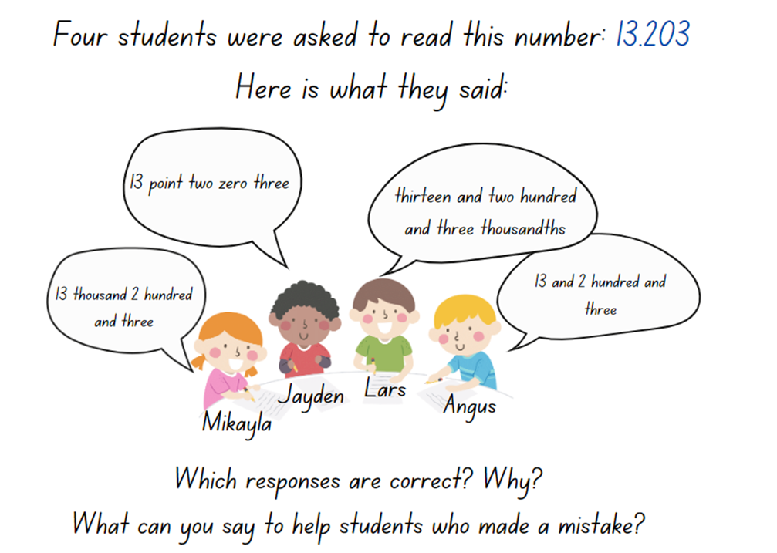

Resource 18 – money equivalence
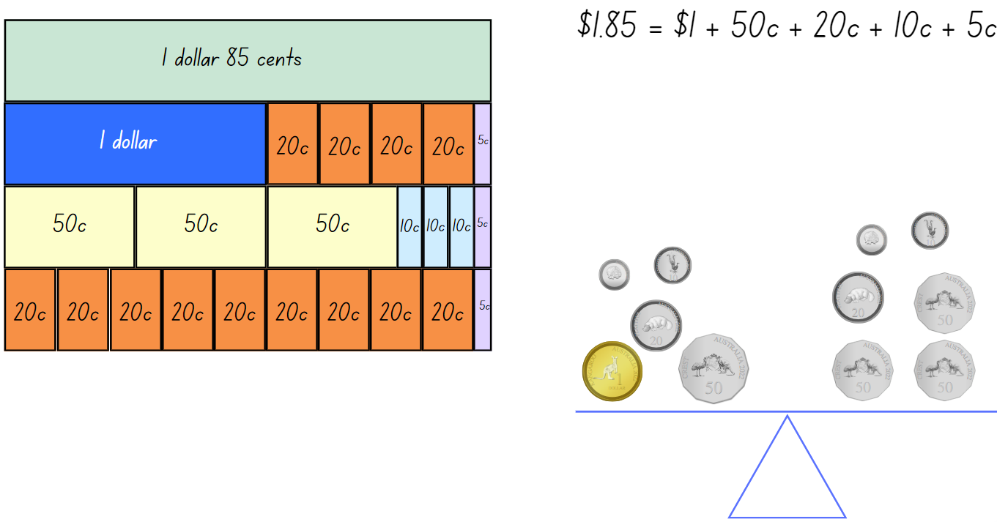

Resource 19 – price tags
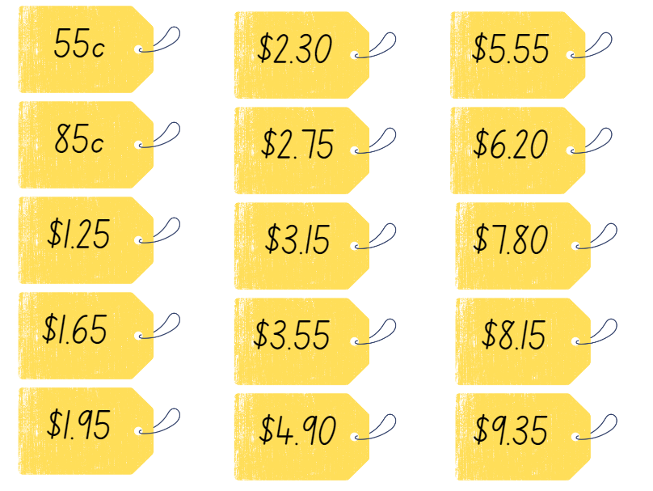

Resource 20 – money mat
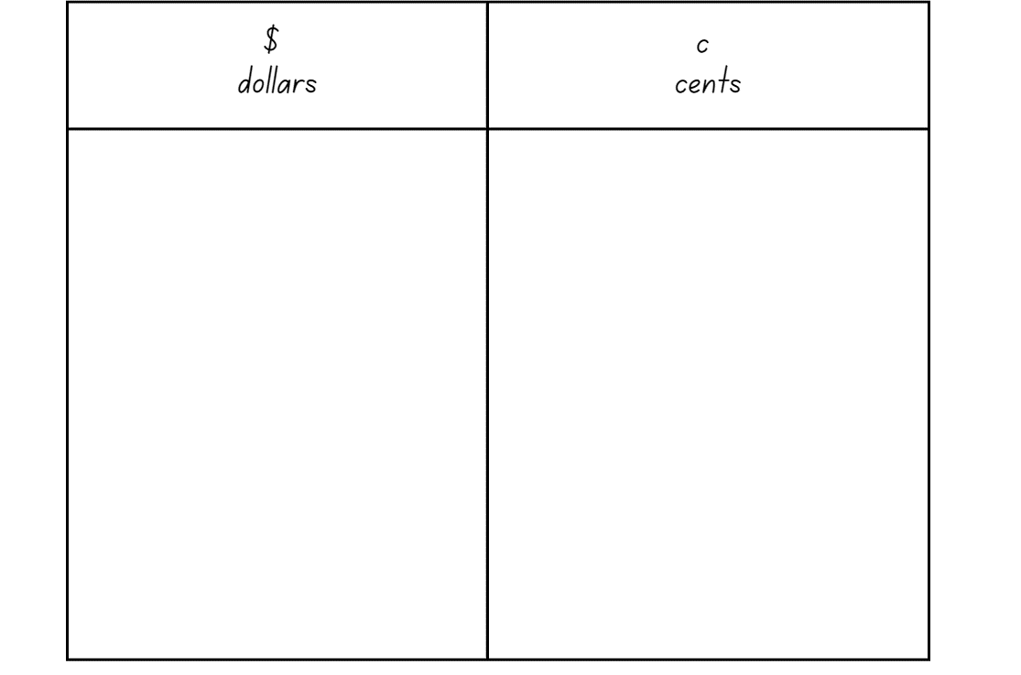

Resource 21 – balancing parcels
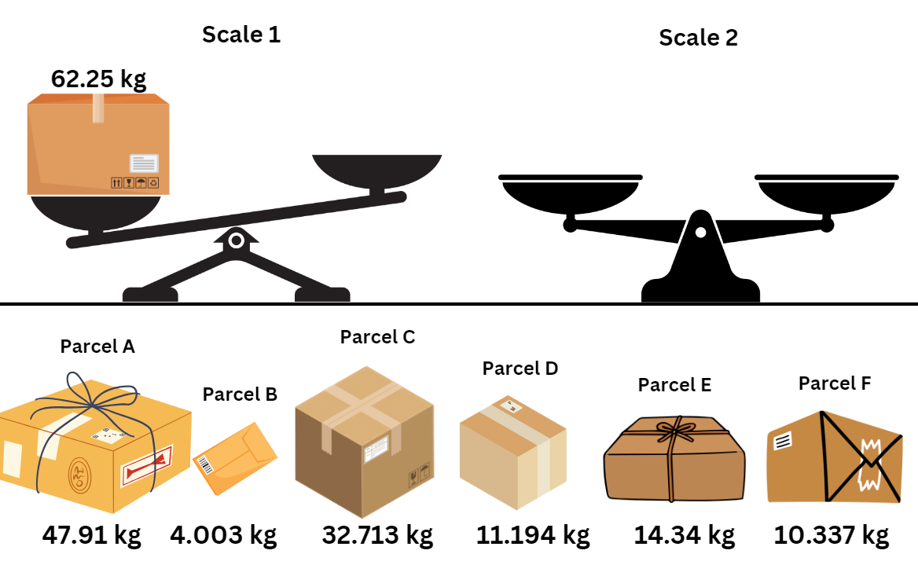

Resource 22 – Perfect Post shipping
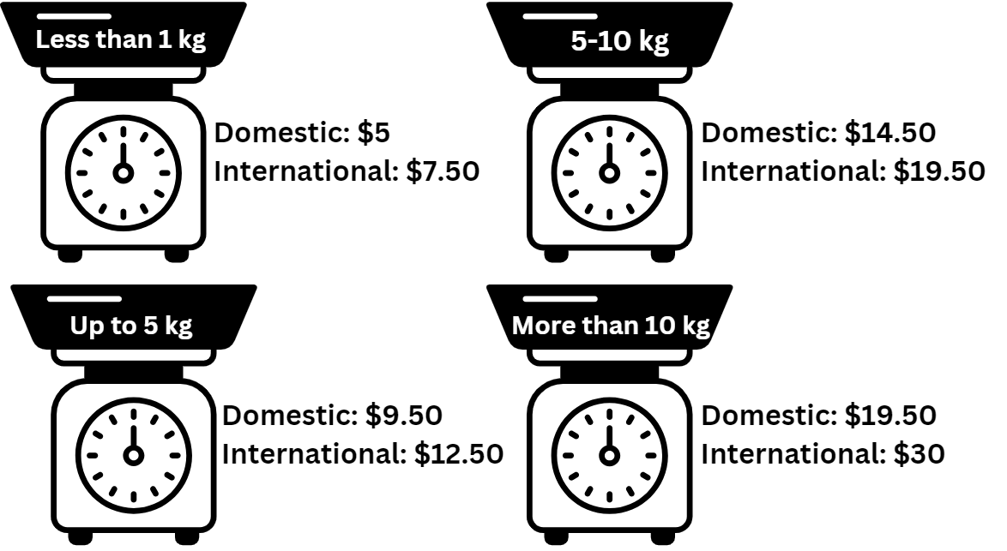

Resource 23 – Perfect Post problems
- Choose a few items from the spring sales catalogue and then:
- calculate the shipping costs for both domestic and international orders based on their weights
- compare the total cost (item price + shipping cost) for domestic and international shipping.
- Investigate combinations of items you could buy with a $700 budget. Calculate the shipping costs if the store was offering a discount of half price off shipping costs.
- Calculate how much you could spend if you purchased gifts for 3 friends overseas and 2 friends in Australia. What are the express shipping costs if you purchase next day delivery for an additional $13.50 for each of these gifts? What is the total cost?
- Kate is torn between buying a multi-game pack (6 kg, $60.70) from a local or an international store. The international store charges $19.50 for shipping, while the local store offers free shipping for orders above $70. Compare the total costs of both options and advise Kate on her decision.
- The store is introducing a special bundle offer for an electro box and multi games pack. If the bundle costs $950.70 and has a total weight of 10.16 kg, calculate the potential savings compared to buying each item individually (including the postage).
- Clare wants to buy a mix of light and heavy items for her younger siblings. She is considering a phone, a digital watch and a laptop. Calculate the total cost for domestic shipping and determine if there are any strategies to reduce costs.
- Explore the concept of bulk orders. If you were to purchase 10 laptops individually for friends in Australia and got them sent to each friend’s house, what would be the total cost compared to bulk orders delivered to one place?

Resource 24 – Spring sales

Resource 25 – time to shop
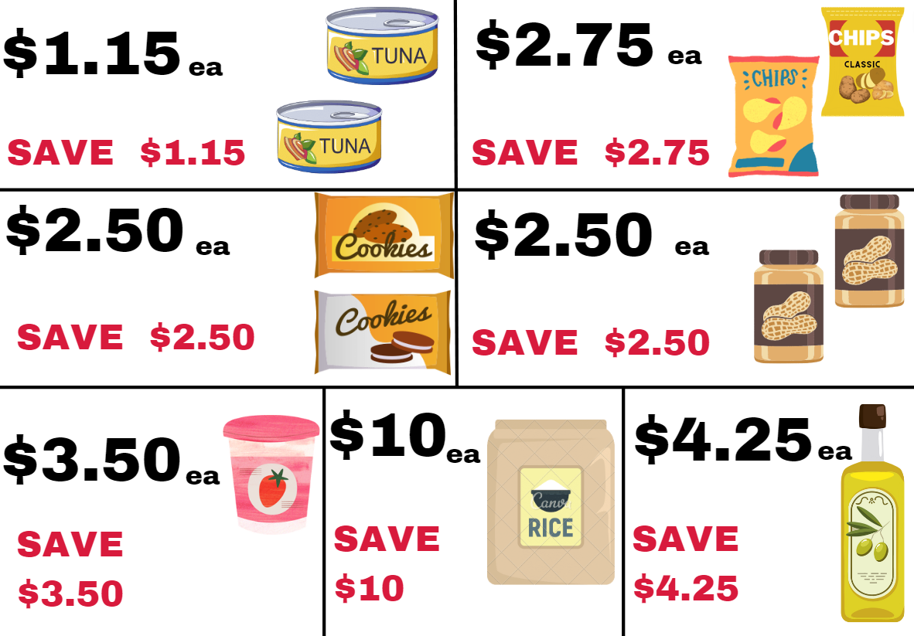

Resource 26 – shopping questions
- How close can you get to spending $20 on these groceries?
- What is the least number of items you could buy for a total of $20 when you can only buy one of any item?
- What is the greatest number of items you could buy for a total of $20 when you can only buy one of any item?
- What is the greatest number of items you could buy for $20 if the products were all full price but they had run out of rice?
- How close to spending $20 could you get if you had to buy 2 of each item that you selected?
- How many items could you buy if you have a total of $17.50 to spend but you could only buy one of any item that you choose?

Resource 27 – percentages

Resource 28 – place value equivalence
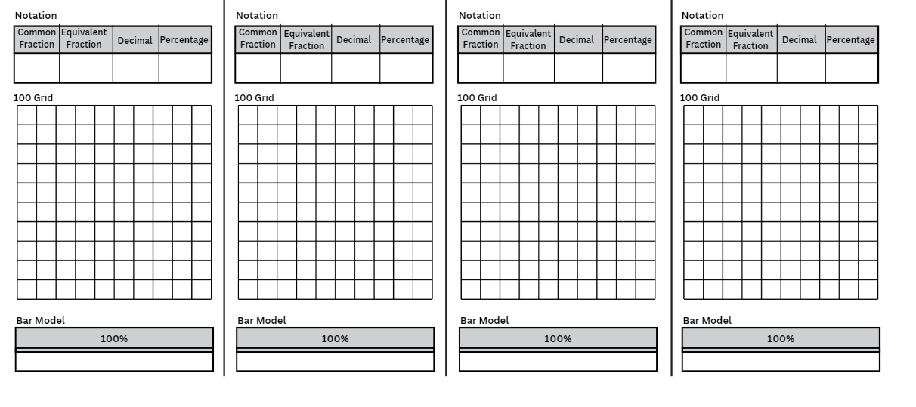

Resource 29 – number wheel
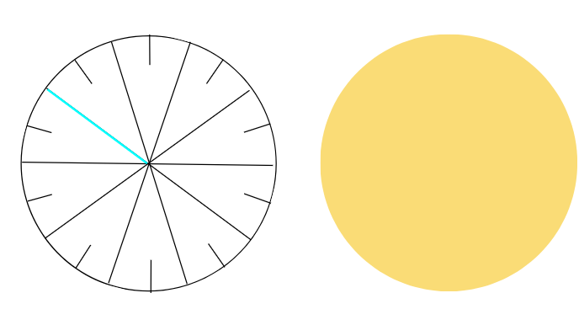
- Cut out both circles.
- Place the circles on top of each other, then cut along the bright blue line to the centre.
- Slide the 2 circles together using the cuts.
- Rotate the 2 circles to show fractions, decimals and percents.
Adapted from Van de Walle et al. (2023) p 427.

Resource 30 – canteen menu
Canteen food | Price | Salads | Price | Hot food | Price
Banana muffin | $1.00 | Greek salad | $6.50 | Chicken burger | $5.50
Energy choc balls | 50c | Garden salad | $6.00 | Beef burger | $5.50
Popcorn | 45c | Chicken salad | $8.00 | Chicken wrap | $6.00
Custard cup | 90c | Tuna salad | $8.00 | Beef lasagna | $5.00
Jelly cup | 70c | Egg salad | $7.00 | Cheese pizza | $3.50
Breadsticks | 25c | Fruit salad | $4.50 | Sausage roll | $4.00
Fruit | 60c | Frozen treats | Price | Sandwiches | Price
Drinks | Price | Juice tubs | $1.50 | Egg | $2.00
Juice | $2.50 | Frozen fruit | $1.00 | Ham | $3.00
Flavoured milk | $2.00 | Sweet stick | $1.00 | Salad | $4.00
Water – 600mL | $2.00 | Frozen yoghurt | $2.00 | Cheese | $2.00

Resource 31 – percentage links
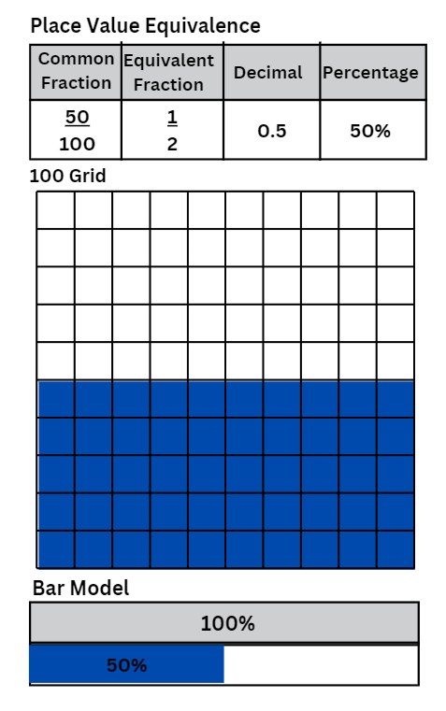

Resource 32 – benchmark percentages
Percent | Description in words | Efficient strategies to find | Equivalent fractions and decimals
100% |  |  | 1, $\frac{10}{10}$, ten-tenths
90% | Almost all; most of it
80%
75%
60%
50% |  | Divide by 2, halve
40%
30% |  |  | 0.3, $\frac{3}{10}$
25%
20%
10% |  | Divide the total by 10
0% | None, nothing

Resource 33 – percent problems
Problem 1: Calculate 25% of $40 and 75% of $80. Show your working out using a bar model.
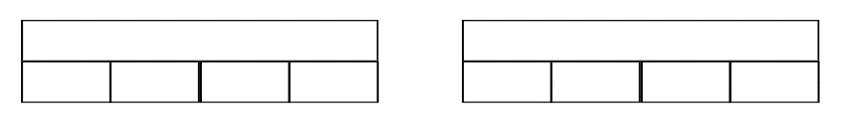

Problem 2: Sarah went to the supermarket and spent $50 on groceries. Which would she rather have? $10 off the cost or 10% off the cost? Are they the same thing? Explain your reasoning.

Problem 3: Henry lost 10% of his original weight of 80 kg in one month. How much weight did he lose? How much does he weigh now? Show your working out in a bar model or 100 grid.

Problem 4: Tony bought a new watch. It was discounted by 20% from the original price of $150. How much did Tony pay for the watch? Show your working out in a bar model.

Problem 5: Sahana works at a local café. She gets a 25% discount on anything she buys at the cafe. Write a list of items and set some prices. Calculate how much Sahana can save on each item. Show your working out in a bar model or 100 grid.

Problem 6: Yusuf bought a notebook with 240 pages for mathematics. In 8 months, he has used up 70% of it. How many pages does he have left for the rest of the year? Show your working out in a bar model or 100 grid.

Resource 34 – percent models
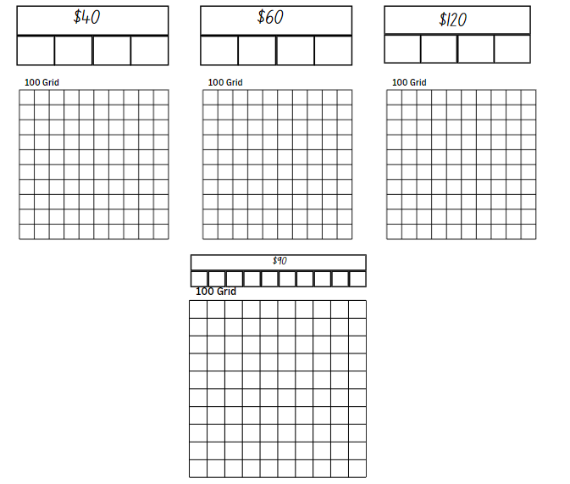

Resource 35 – money problem 1
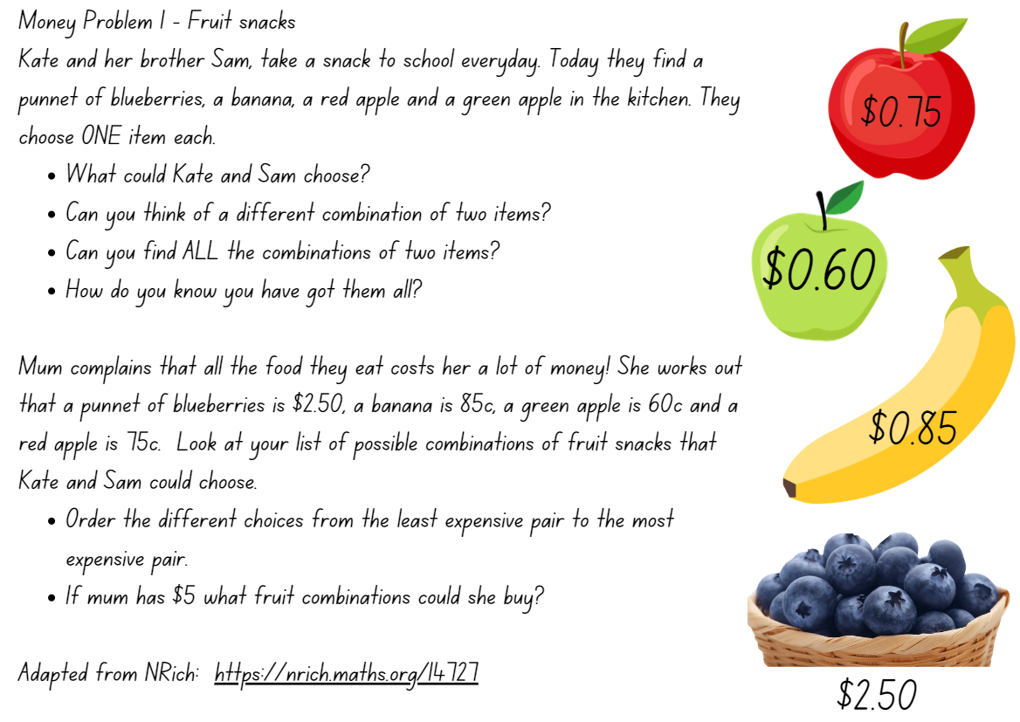
Adapted from ‘Fruity Pairs’ by University of Cambridge (n.d)

Resource 36 – multistep problems
Jim's mowing: Jim has $10. He spends $1.50 on a drink. Jim's dad gives him $50 for mowing the grass. Calculate the total amount of money Jim has now.
Finally, Jim decides to donate 10% of his money to charity. Calculate the amount he donates.
Ronnie's cupcakes: Ronnie is organising a birthday party and needs 101 cupcakes at $1.00 each. He already has 21 chocolate cupcakes and 32 vanilla cupcakes. How many more cupcakes should Ronnie buy?
Ronnie realises that he has a coupon for 25% off his cupcake purchase. Calculate the final cost of the cupcakes after applying the discount.
Janet's shopping spree: Janet's mother gave her $760 to go to the store. She decided to buy 2 birthday presents for her twin brothers at $150 each and 2 cakes for $30 each. How much money does Janet have left?
Janet decides to save 25% of her remaining money. Determine the amount she puts into savings.
Suzy's tech purchase: Suzy decides to buy an iPad for $462 and a case for $47. If she gives the cashier $550, how much change she will receive?
Suzy then decides to donate 20% of her change to a local charity. How much does Suzy donate to charity?

Resource 37 – money problem 2
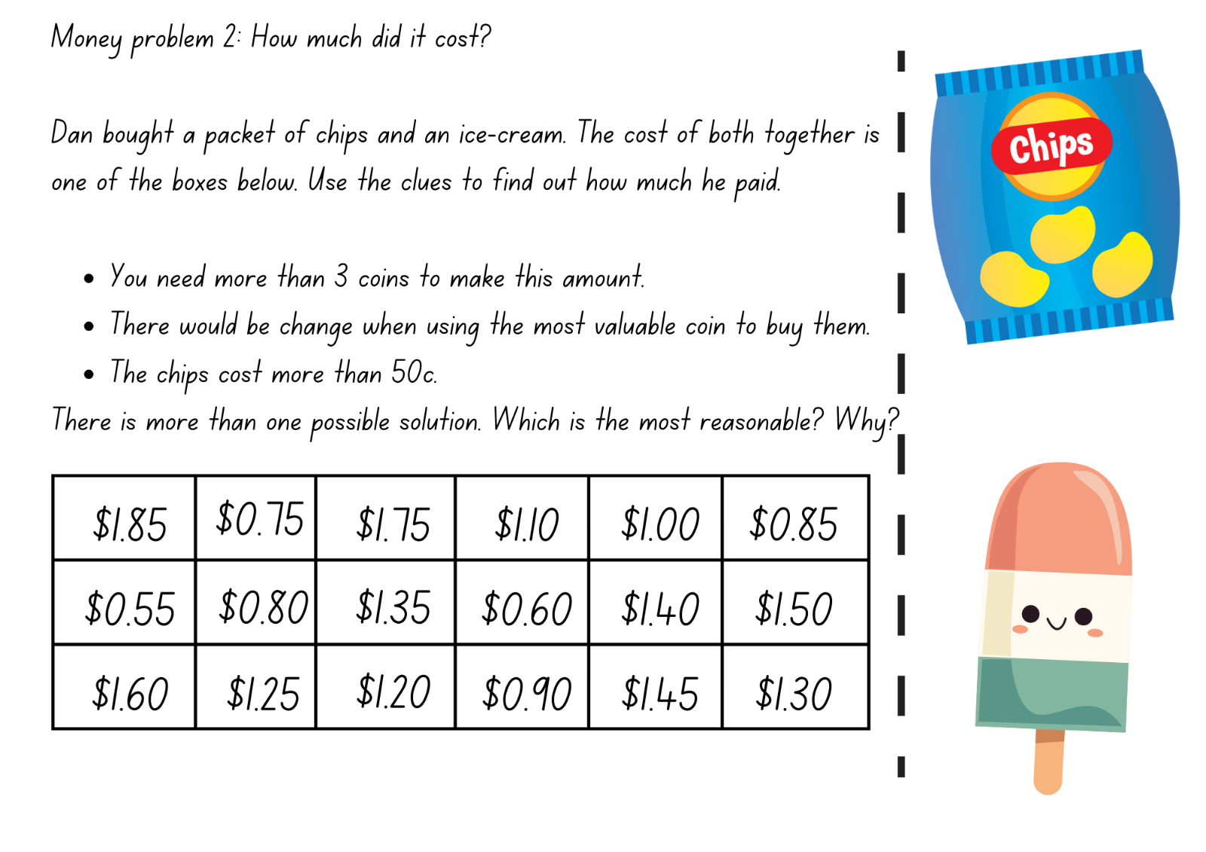
Adapted from ‘How Much Did it Cost? By University of Cambridge (n.d.)

Resource 38 – first day data
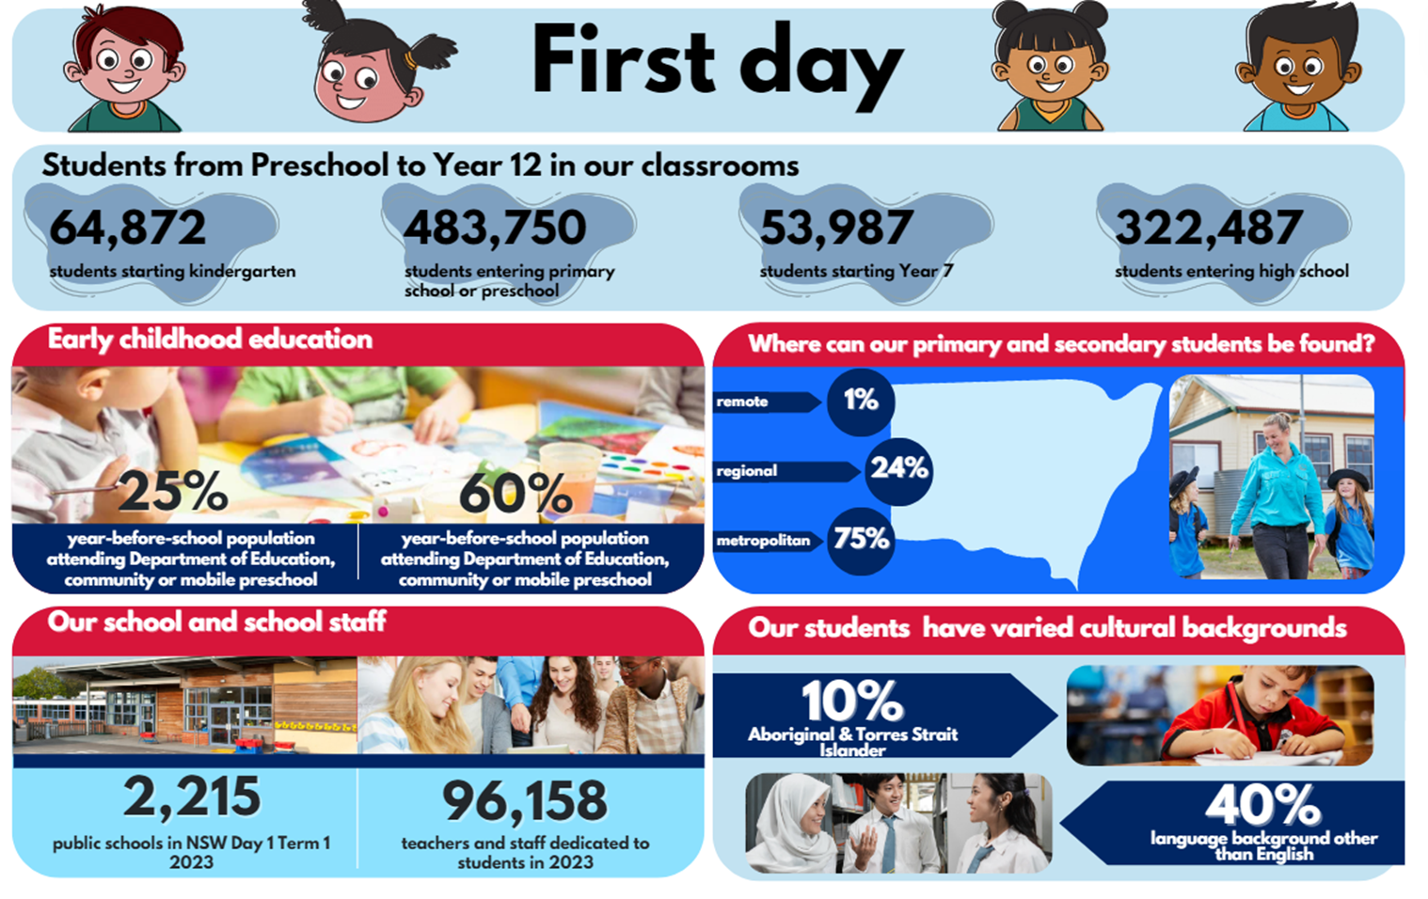

Resource 39 – open middle problems
Problem 1: using the digits 1 to 9 once each, fill in the boxes to make a true statement. Make at least 2 true statements.
Problem 2: using the digits 1 to 9 once each, fill in the boxes to make the largest difference. Then find the smallest difference.
Problem 3: using the digits 1 to 9 once each, fill in the boxes to make 3 decimals whose sum is as close to one as possible.
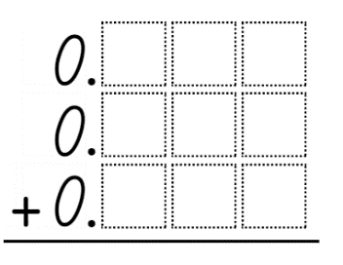
Adapted from Open Middle Partnership (2023).

Resource 40 – Fermi checklist
- Read the question aloud, as a group.
- Discuss what it is asking you to estimate.
- Take a wild guess without any calculating.
- List the pieces of information you will need.
- Gather data – perform experiments, conduct surveys, make measurements, or search for information that would help you to obtain a more precise estimate.
- Round numbers to make them easier to work with.
- Record your steps.
- Be ready to explain and justify what you did when coming up with your solution.
- Compare your approach to others. What might you have missed?

Resource 41 – Fermi problems
- Coloured chocolate buttons: using only 10 small, coloured buttons or lollies, estimate how many you would need to cover your desk, your teacher’s desk, the entire floor of your classroom and then the floor of the school hall. Calculate the difference between your estimate for the classroom and the estimate for your desk.
- Books: estimate the number of fiction and non-fiction books in your classroom. Use this estimate to work out how many books there might be in your school, and then in 2000 primary schools in New South Wales. Calculate the difference between the fiction and non-fiction books in classrooms across New South Wales.
- Pencil: Estimate how many pencils you have altogether at school. Identify the number or percentage of pencils that have a broken tip. Use this information to estimate how many pencils there might be in your school, and in 6000 primary schools around Australia. Subtract the estimated number that have a broken tip.
- Jellybeans: using only 10 jellybeans, estimate how many you would need to fill a bucket or other large container. Subtract the estimated number of yellow jellybeans from the total.
- Reading time: Calculate how many hours a week you spend reading and how many hours a week you spend on an electronic device. Estimate those amounts for all the students in your school, 400 000 students in NSW primary schools and 4 million students in Australian schools. What is the difference between the reading time and screen time for all students in Australia?
- Canteen lunch: estimate how many canteen lunches and lunches from home are made for your class each term. Estimate the number for your whole school, and 2000 primary schools in New South Wales. Calculate the difference between the estimates.

Syllabus outcomes and content

Stage 2
The table below outlines the syllabus outcomes and range of relevant syllabus content covered in this unit. Content is linked to National Numeracy Learning Progression (version 3).
Outcomes and content | 1 | 2 | 3 | 4 | 5 | 6 | 7 | 8
Representing numbers using place value A: Whole numbers: Read, represent and order numbers to thousands
MAO-WM-01, MA2-RN-01
- Represent numbers up to and including thousands using physical or virtual manipulatives, words, numerals, diagrams and digital displays |  |  | x
- Identify the number before and after a number with an internal zero digit |  |  | x
Representing numbers using place value A: Whole numbers: Apply place value to partition and regroup numbers up to 4 digits
MAO-WM-01, MA2-RN-01
- Record numbers using standard place value form |  | x | x
Representing numbers using place value B: Whole numbers: Apply place value to partition, regroup and rename numbers up to 6 digits
MAO-WM-01, MA2-RN-01
- Name thousands using the place value grouping of ones, tens and hundreds of thousands |  |  | x
- Use place value to expand the number notation |  | x | x
Representing numbers using place value B: Decimals: Extend the application of the place value system from whole numbers to tenths and hundredths
MAO-WM-01, MA2-RN-02
- Express decimals as both tenths and hundredths |  |  | x
- Distinguish between the role of zero in various positions |  |  | x
Additive relations A: Use the principle of equality
MAO-WM-01, MA2-AR-01, MA2-AR-02
- Use the equals sign to mean ‘the same as’, rather than to perform an operation | x
Additive relations A: Recognise and explain the connection between addition and subtraction
MAO-WM-01, MA2-AR-01, MA2-AR-02
- Demonstrate how addition and subtraction are inverse operations |  | x | x
Additive relations A: Select strategies flexibly to solve addition and subtraction problems of up to 3 digits
MAO-WM-01, MA2-AR-01, MA2-AR-02
- Apply known mental strategies that use partitioning to add and subtract, such as bridging the decades |  | x | x
- Represent solutions to addition and subtraction problems, including word problems, using an empty number lines or bar model |  |  |  |  |  |  | x | x
- Compare and evaluate strategies used to solve addition and subtraction problems, reasoning which strategy may be most efficient |  | x | x |  |  |  | x | x
Additive relations A: Represent money values in multiple ways
MAO-WM-01, MA2-AR-01, MA2-AR-02
- Recognise the relationship between dollar and cents | x | x |  |  |  | x
- Represent equivalent amounts of money using different denominations | x | x |  |  | x | x
- Perform calculations with money, including finding change |  |  | x | x | x | x
Additive relations B: Partition, rearrange and regroup numbers to at least 1000 to solve additive problems
MAO-WM-01, MA2-AR-01, MA2-AR-02
- Model addition with and without regrouping and record the method used |  | x | x
Additive relations B: Apply addition and subtraction to familiar contexts, including money and budgeting
MAO-WM-01, MA2-AR-01, MA2-AR-02
- Interpret problems involving money as requiring either addition or subtraction |  |  |  | x | x
Additive relations B: Complete number sentences involving additive relations to find unknown quantities
MAO-WM-01, MA2-AR-01, MA2-AR-02
- Find the missing number in an equivalent number sentence involving operations of addition or subtraction on both sides of the equals sign (Algebraic reasoning) | x
Multiplicative relations A: Represent and solve problems involving multiplication fact families
MAO-WM-01, MA2-MR-02
- Describe multiplication problems using for each and times as many |  |  |  |  | x | x
- Find the total of partially covered arrays |  |  |  |  |  |  | x
Mathematics K–10 Syllabus © NSW Education Standards Authority (NESA) for and on behalf of the Crown in right of the State of New South Wales, 2022.

Stage 3
The table below outlines the syllabus outcomes and range of relevant syllabus content covered in this unit. Content is linked to National Numeracy Learning Progression (version 3).
Outcomes and content | 1 | 2 | 3 | 4 | 5 | 6 | 7 | 8
Represents numbers A: Whole numbers: Recognise, represent and order numbers in the millions
MAO-WM-01, MA3-RN-01
- Name millions using the place value grouping of ones, tens and hundreds |  |  | x
Represents numbers A: Decimals and percentages: Compare, order and represent decimals
MAO-WM-01, MA3-RN-02
- Compare the place value of digits by determining numbers that are 10 or 100 times the original decimal number as well as $\frac{1}{10}$ or $\frac{1}{100}$ times the original decimal numbers |  |  | x
Represents numbers B: Decimals and percentages: Make connections between benchmark fractions, decimals and percentages
MAO-WM-01, MA3-RN-03
- Recognise that the symbol % means percent and 100% is the whole amount |  |  |  |  | x
- Recall commonly used equivalent percentages, decimals and fractions including $\frac{1}{2}$, $\frac{1}{4}$ and $\frac{3}{4}$ |  |  |  |  | x
Represents numbers B: Decimals and percentages: Determine percentage discounts of 10%, 25% and 50%
MAO-WM-01, MA3-RN-03
- Equate 10% to dividing by 10, 25% to finding a quarter by dividing by 4, and 50% to finding half |  |  |  |  |  | x
- Use mental strategies to estimate discounts of 10%, 25% and 50% |  |  |  |  |  | x
- Calculate the sale price of an item after a discount of 10%, 25% and 50% |  |  |  |  |  | x
Additive relations A: Apply efficient mental and written strategies to solve addition and subtraction problems
MAO-WM-01, MA3-AR-01
- Solve word problems, including multistep problems |  | x |  | x |  |  | x
- Apply known strategies such as levelling, addition for subtraction, using constant difference, and bridging (Reasons about relations) | x | x |  | x
- Determine when it would be more efficient to use a calculator to add numbers |  |  | x |  |  |  |  | x
- Identify efficient and inefficient multidigit subtraction strategies | x | x |  | x
Additive relations A: Use estimation and place value understanding to determine the reasonableness of solutions
MAO-WM-01, MA3-AR-01
- Round numbers appropriately when obtaining estimates to numerical calculations | x |  |  | x
- Use place value understanding to check for errors in calculations |  |  | x
- Use estimation to check the reasonableness of solutions to addition and subtraction calculations |  | x | x
Additive relations B: Choose and use efficient strategies to solve addition and subtraction problems
MAO-WM-01, MA3-AR-01
- Solve multistep word problems, including problems that require more than one operation |  |  |  |  |  | x |  | x
- Compare, evaluate and communicate strategies used to solve addition and subtraction problems |  |  |  |  |  |  |  | x
Additive relations B: Applies known strategies to add and subtract decimals
MAO-WM-01, MA3-AR-01
- Model the addition and subtraction of decimals up to 3 decimal places using appropriate representations |  |  |  |  |  |  | x
- Solve word problems involving the addition and subtraction of decimals up to 3 decimal places |  |  |  |  |  |  | x
- Justify why the strategy used to solve addition and subtraction word problems is appropriate (Reasons about quantity) |  |  |  |  |  |  |  | x
Multiplicative relations A: Select and apply mental and written strategies to multiply 2- and 3-digit numbers by 2-digit numbers
MAO-WM-01, MA3-MR-01, MA3-MR-02
- Factorise numbers to aid mental multiplication |  |  |  |  |  | x
- Extend the area model to represent 2-digit by 2-digit multiplication |  |  |  |  | x
- Solve multiplication word problems |  |  |  |  | x |  | x
Mathematics K–10 Syllabus © NSW Education Standards Authority (NESA) for and on behalf of the Crown in right of the State of New South Wales, 2022.

References
This resource contains NSW Curriculum and syllabus content. The NSW Curriculum is developed by the NSW Education Standards Authority. This content is prepared by NESA for and on behalf of the Crown in right of the State of New South Wales. The material is protected by Crown copyright.
Please refer to the NESA Copyright Disclaimer for more information https://educationstandards.nsw.edu.au/wps/portal/nesa/mini-footer/copyright.
NESA holds the only official and up-to-date versions of the NSW Curriculum and syllabus documents. Please visit the NSW Education Standards Authority (NESA) website https://educationstandards.nsw.edu.au/wps/portal/nesa/home and the NSW Curriculum website https://curriculum.nsw.edu.au/.
Mathematics K–10 Syllabus © NSW Education Standards Authority (NESA) for and on behalf of the Crown in right of the State of New South Wales, 2022.
National Numeracy Learning Progression © Australian Curriculum, Assessment and Reporting Authority (ACARA) 2010 to present, unless otherwise indicated. This material was downloaded from the Australian Curriculum website (National Numeracy Learning Progression) (accessed 7 January 2024) and was not modified.
AIATSIS (Australian Institute of Aboriginal and Torres Strait Islander Studies) (2023) Map of Indigenous Australia, AIATSIS website, accessed 9 November 2023.
Attard C (2013) Engaging Maths: Higher Order Thinking with Thinkers Keys, Modern Teaching Aids Pty Limited.
Classroom Secrets (2023) Add and Subtract Decimals – Discussion Problems, Classroom secrets website, accessed 12 October 2023.
Education Services Australia Ltd (2016) Playground Percentages [online game], ABC Education website, accessed 12 October 2023.
Morgan J (29 July 2016) ‘(Even more) 5 minutes of fun!’, fractionfanatic, accessed 12 October 2023.
NESA (New South Wales Education Standards Authority) (2024a) Teaching advice for Additive relations A, NESA website, accessed 15 December 2023.
NESA (2024b) Teaching advice for Represents numbers B, NESA website, accessed 15 December 2023.
Rawding M (2016–2024) Make It equal, Open Middle website, accessed 14 December 2023.
Open Middle Partnership (2023) Open Middle [website], accessed 19 December 2023.
Stacey K, Steinle V, Marston K, Chambers D, Varughese N (2011) Teaching Numeracy in the Middle Years Number Slides, the University of Melbourne, accessed 9 November 2023.
Stanford University (2023) Bowl A Fact, youcubed website, accessed 14 December 2023.
State of New South Wales (Department of Education) (2023) Calculating Percentages (DOC 4.7 MB), NSW Department of Education, accessed 13 October 2023.
State of New South Wales (Department of Education) (2023a) Equivalent number sentences, Universal Resources Hub, accessed 17 December 2023.
State of New South Wales (Department of Education) (2023) ‘Let’s talk – number talk (230 minus 190)’, Mathematics K–6 resources, Department of Education website, accessed 17 December 2023.
Steinle V & Stacey K (1998) ‘The incidence of misconceptions of decimal notation amongst students in Grades 5 to 10’ in Kanes C, Goos M & Warren E (eds) Teaching Mathematics in New Times Proceedings of the 21st Annual Conference of the Mathematics Education Research Group of Australasia, 2:548-555, Gold Coast, Australia: MERGA.
Sullivan P and Lilburn P (2017) Open-Ended Maths Activities – Using ‘good’ questions to enhance learning in mathematics, Oxford University Press.
University of Cambridge (n.d.) Forwards Add Backwards, NRICH website, accessed 18 January 2024.
University of Cambridge (n.d.) Fruity Pairs, NRICH website, accessed 14 December 2023.
University of Cambridge (n.d.) How Much?, NRICH website, accessed 14 December 2023.
University of Cambridge (n.d.) Matching Fractions, Decimals and Percentages, NRICH website, accessed 2 May 2024.

Further reading
Australian Securities and Investment Commission (n.d.) Moneysmart for teachers, Moneysmart website, accessed 17 December 2023.
Finkel D (2019) 'Subtracting Reverses', Free Lessons, Math for Love website, accessed 14 December 2023.
Parrish SD (2011) ‘Number Talks Build Numerical Reasoning’, Teaching Children Mathematics, 18(3):198–206, https://doi.org/10.5951/teacchilmath.18.3.0198.
Swan and Ridgeway (n.d.) 'Plausible Estimation' Tasks (PDF 35 KB), The Mathematics Assessment Resource Service, accessed 9 November 2023.
Siemon D, Warren E, Beswick K, Faragher R, Miller J, Horne M, Jazby D, Breed M, Clark J and Brady K (2021) Teaching Mathematics: Foundations to Middle Years, 3rd edition, Oxford University Press Australia and New Zealand.
State of New South Wales (Department of Education) (2022) Digital Learning Selector [website], accessed 17 December 2023.
State of New South Wales (Department of Education) (2024) Stage 2 Addition and subtraction with money (DOCX 1.15 MB), accessed 17 December 2023.
State of New South Wales (Department of Education) (2023) Stage 2 – number – addition and subtraction, NSW Department of Education website, accessed 3 May 2024.
State of New South Wales (Department of Education) (2023) Stage 2 – number – addition and subtraction – money, NSW Department of Education website, accessed 3 May 2024.
State of New South Wales (Department of Education) (2023) Stage 3 – addition and subtraction, NSW Department of Education website, accessed 3 May 2024.
State of New South Wales (Department of Education) (2023) Stage 3 – number – subtraction, NSW Department of Education website, accessed 3 May 2024.
Tripet K (7 September 2023) ‘Building understanding and fluency: Addition and Subtraction’ [unpublished conference paper], Mathematics Specialisation K–6 Conference, Sydney.
Van de Walle J, Karp K, Bay-Williams JM, Brass A, Bentley B, Ferguson S, Goff W, Livy S, Marshman M, Martin D, Pearn C, Prodromou T, Symons D and Wilkie K (2019) Primary and Middle Years Mathematics: Teaching Developmentally, 1st Australian edn, Pearson Education Australia, Melbourne.
Yeap BH (2011) Bar Modelling – A problem-solving Tool: From Research to Practice (An effective Singapore Math Strategy), Marshall Cavendish Education, Singapore.
© State of New South Wales (Department of Education), 2024
The copyright material published in this resource is subject to the Copyright Act 1968 (Cth) and is owned by the NSW Department of Education or, where indicated, by a party other than the NSW Department of Education (third-party material).
Copyright material available in this resource and owned by the NSW Department of Education is licensed under a Creative Commons Attribution 4.0 International (CC BY 4.0) license.
This license allows you to share and adapt the material for any purpose, even commercially.
Attribution should be given to © State of New South Wales (Department of Education), 2024.
Material in this resource not available under a Creative Commons license:
- the NSW Department of Education logo, other logos and trademark-protected material
- material owned by a third party that has been reproduced with permission. You will need to obtain permission from the third party to reuse its material.
Links to third-party material and websites
Please note that the provided (reading/viewing material/list/links/texts) are a suggestion only and implies no endorsement, by the New South Wales Department of Education, of any author, publisher, or book title. School principals and teachers are best placed to assess the suitability of resources that would complement the curriculum and reflect the needs and interests of their students.
If you use the links provided in this document to access a third-party's website, you acknowledge that the terms of use, including licence terms set out on the third-party's website apply to the use which may be made of the materials on that third-party website or where permitted by the Copyright Act 1968 (Cth). The department accepts no responsibility for content on third-party websites.

