Mathematics 3–6 Multi-age – Year A – Unit 14
What needs to be measured determines the unit of measurement
Contents
Unit description and duration 6
Syllabus outcomes 6
Stage 2 7
Stage 3 7
Working mathematically 8
Student prior learning 8
Lesson overview and resources 10
Lesson 1 19
Daily number sense – missing decimal numbers – 10 minutes 19
Core lesson – exploring the millimetre, centimetre and beyond – 40 minutes 22
Consolidation and meaningful practice – 10 minutes 25
Lesson 2 27
Daily number sense – before and after – 10 minutes 27
Core lesson 1 – using your shoe as a benchmark – 25 minutes 29
Core lesson 2 – how far can you jump? – 25 minutes 32
Discuss and connect the mathematics – 10 minutes 34
Lesson 3 37
Daily number sense – place value challenge – 10 minutes 37
Core lesson – 45 minutes 39
Stage 2 task – benchmarking a metre 39
Stage 3 task – calculating the perimeter of the school 42
Discuss and connect the mathematics – 10 minutes 45
Lesson 4 48
Daily number sense – 10 minutes 48
Core lesson – town planning – 40 minutes 48
Consolidation and meaningful practice – 10 minutes 52
Lesson 5 55
Daily number sense – ordering fractions – 10 minutes 55
Core lesson – 50 minutes 57
Stage 2 task – the gram 57
Stage 3 task – part 1 – investigating mass 61
Stage 3 task – part 2 – tonnes 63
Stage 3 task – part 3 – lasagne 64
Stage 3 task – part 4 – Rick’s cans 64
Consolidation and meaningful practice – 10 minutes 66
Lesson 6 68
Daily number sense – rolling fractions – 10 minutes 68
Core lesson – 35 minutes 70
Stage 2 task – the kilogram 70
Stage 3 task – harvest time 73
Consolidation and meaningful practice – 15 minutes 75
Lesson 7 78
Daily number sense – Who is winning? – 10 minutes 78
Core lesson – 50 minutes 80
Stage 2 task – part 1 – comparing the kilogram 80
Stage 2 task – part 2 – recognising formal units to measure mass 83
Stage 3 task – kilograms and tonnes 84
Discuss and connect the mathematics – 10 minutes 87
Lesson 8 90
Daily number sense – 10 minutes 90
Core lesson – 35 minutes 90
Stage 2 task – recipe challenge 90
Stage 3 task – dinosaur measurements 92
Discuss and connect the mathematics – 15 minutes 94
Resource 1 – decimal numbers 96
Resource 2 – metric conversion display 98
Resource 3 – millimetre ruler 99
Resource 4 – measuring objects 100
Resource 5 – before and after 101
Resource 6 – shoe measuring 103
Resource 7 – jump recording sheet 104
Resource 8 – measuring in strides 105
Resource 9 – town requirements 106
Resource 10 – fractions 107
Resource 11 – recording mass 108
Resource 12 – Which is heavier? 109
Resource 13 – making tonnes 110
Resource 14 – recording table 111
Resource 15 – harvest photos 112
Resource 16 – harvest facts 113
Resource 17 – harvest questions 114
Resource 18 – load the truck 115
Resource 19 – Who is winning? 117
Resource 20 – conversion chart 118
Resource 21 – tonnes to kilograms 119
Resource 22 – example recipe 120
Resource 23 – fruit recording 121
Resource 24 – fruit salad recipe 122
Resource 25 – dino challenge cards 123
Resource 26 – dinosaur facts 126
Syllabus outcomes and content 127
Stage 2 127
Stage 3 132
References 137

Unit description and duration
This unit develops the big idea that what needs to be measured determines the unit of measurement.
In this 2-week unit, students are provided opportunities to:
- estimate, measure and compare the masses of objects using kilograms and grams
- identify the appropriate unit and device to measure mass when solving problems
- recognise whole-number and decimal representations of mass (Stage 3)
- measure and compare lengths of objects using metres (m), centimetres (cm) and millimetres (mm)
- use a variety of measuring devices to measure lengths and distances in different contexts, including perimeter (Stage 3).
This multi-age unit is informed by the lessons in Stage 2 Year A Unit 14 and Stage 3 Year A Unit 14. Please refer to these units for additional lesson guidance.

Syllabus outcomes
- MAO-WM-01 develops understanding and fluency in mathematics through exploring and connecting mathematical concepts, choosing and applying mathematical techniques to solve problems, and communicating their thinking and reasoning coherently and clearly

Stage 2
- MA2-RN-01 applies an understanding of place value and the role of zero to represent numbers to at least tens of thousands
- MA2-RN-02 represents and compares decimals up to 2 decimal places using place value
- MA2-PF-01 represents and compares halves, quarters, thirds and fifths as lengths on a number line and their related fractions formed by halving (eighths, sixths and tenths)
- MA2-GM-02 measures and estimates lengths in metres, centimetres and millimetres
- MA2-NSM-01 estimates, measures and compares the masses of objects using kilograms and grams

Stage 3
- MA3-RN-01 applies an understanding of place value and the role of zero to represent the properties of numbers
- MA3-RN-02 compares and orders decimals up to 3 decimal places
- MA3-RQF-01 compares and orders fractions with denominators of 2, 3, 4, 5, 6, 8 and 10
- MA3-GM-02 selects and uses the appropriate unit and device to measure lengths and distances including perimeters
- MA3-NSM-01 selects and uses the appropriate unit and device to measure the masses of objects

Working mathematically
In the Mathematics K–10 Syllabus, there is one overarching Working mathematically outcome (MAO-WM-01). The Working mathematically processes should be embedded within the concepts being taught. The Working mathematically processes present in the Mathematics K–10 Syllabus are:
- communicating
- understanding and fluency
- reasoning
- problem solving.
Mathematics K–10 Syllabus © NSW Education Standards Authority (NESA) for and on behalf of the Crown in right of the State of New South Wales, 2022.

Student prior learning
Before engaging in these teaching and learning activities, students would benefit from prior experience with:
- comparing the masses of objects using an equal-arm balance (Stage 2)
- estimating and measuring mass by referring to the number and type of uniform informal units used (Stage 2)
- measuring and comparing lengths of objects using uniform informal units, metres (m), centimetres (cm) and millimetres (mm) (Stage 2)
- identifying the appropriate unit and device to measure mass, using scales to measure mass and recording using decimal notation (Stage 3)
- estimating lengths and distances using an appropriate unit and recording using the abbreviation for metres (m) and kilometres (km) (Stage 3)
- calculating perimeters of common two-dimensional shapes (Stage 3).
In NSW classrooms there is a diverse range of students, including Aboriginal and/or Torres Strait Islander students, students learning English as an additional language or dialect, high potential and gifted students and students with disability. Some students may identify with more than one of these groups or possibly all of them. Refer to Curriculum planning for every student – advice for further information.

Lesson overview and resources
To cover the content of the syllabus across Stage 2 and Stage 3, some core lessons in the unit contain both a Stage 2 and a Stage 3 task. Teachers are encouraged to adapt and contextualise the units to meet the needs of their students.
The table below outlines the sequence and approximate timing of lessons, learning intentions and resources.
Lesson | Content | Duration and resources
Lesson 1  Daily number sense  Stage 2:  - Representing numbers using place value B: Decimals: Extend the application of the place value system from whole numbers to tenths and hundredths  Stage 3:  - Represents numbers A: Decimals and percentages: Recognise that the place value system can be extended beyond hundredths | Lesson core concept: when comparing, ordering and converting measurements, standard units can be renamed in equivalent ways.  Stage 2:  - Geometric measure A: Length: Measure and compare objects using metres, centimetres and millimetres  Stage 3:  - Geometric measure A: Length: Use metres and kilometres for length and distances  - Geometric Measure B: Length: Convert between common metric units of length | Lesson duration: 60 minutes  - Resource 1 – decimal numbers  - Resource 2 – metric conversion display  - Resource 3 – millimetre ruler  - Resource 4 – measuring objects  - Video: Garden path (2:44)  - 30 cm rulers  - Tape measures or trundle wheels  - Writing materials
Lesson 2  Daily number sense  Stage 2:  - Representing numbers using place value B: Decimals: Extend the application of the place value system from whole numbers to tenths and hundredths  Stage 3:  - Represents numbers A: Decimals and percentages: Recognise that the place value system can be extended beyond hundredths | Lesson core concept: estimation of length is guided by using known lengths as benchmarks (Stage 2) and decimals can be compared by analysing the place values parts of standard units of measurement (Stage 3).  Stage 2:  - Geometric measure A: Length: Measure and compare objects using metres, centimetres and millimetres  - Geometric measure B: Length: Use scaled instruments to measure and compare lengths  Stage 3:  - Represents numbers B: Decimals and percentages: Compare, order and represent decimals  - Geometric measure A: Length: Use metres and kilometres for length and distances | Lesson duration: 70 minutes  - Resource 5 – before and after  - Resource 6 – shoe measuring  - Resource 7 – jump recording sheet  - Video: Long jump world record (0:32)  - 30 cm rulers  - A4 paper  - Masking tape  - Measuring tapes  - Metre rulers or tape measures  - Scissors  - Writing materials
Lesson 3  Daily number sense  Stage 2:  - Representing numbers using place value B: Whole numbers: Recognise represent numbers that are 10, 100 or 1000 times larger than a given number  Stage 3:  - Represents numbers A: Whole numbers: Recognise, represent and order numbers in the millions | Lesson core concept: accurate benchmarks help in estimating lengths and other measures (Stage 2) and known lengths of shapes can be used to calculate unknown lengths (Stage 3).  Stage 2:  - Geometric measure A: Length: Measure and compare objects using metres, centimetres and millimetres  Stage 3:  - Geometric measure A: Length: Use metres and kilometres for length and distances  - Geometric measure A: Length: Measure lengths to find perimeters | Lesson duration: 65 minutes  - Resource 8 – measuring in strides  - Digital place value chart  - Digital device with internet access (one per pair)  - Grid paper  - Masking tape  - Metre rulers  - Trundle wheels  - Writing materials
Lesson 4  Daily number sense  - teacher-identified task based on student needs | Lesson core concept: known lengths of shapes can be used to calculate unknown lengths.  Stage 2:  - Geometric measure A: Length: Measure and compare objects using metres, centimetres and millimetres  - Geometric measure B: Length: Use scaled instruments to measure and compare lengths  Stage 3:  - Geometric measure A: Length: Measure lengths to find perimeters | Lesson duration: 60 minutes  - Resource 9 – town requirements  - 30 cm rulers  - Grid paper (2 pieces per student)  - Writing materials
Lesson 5  Daily number sense  Stage 2:  - Partitioned fractions A: Model and represent unit fractions, and their multiples, to a complete whole on a number line  Stage 3:  - Representing quantity fractions A: Compare and order common unit fractions | Lesson core concept: the context determines the most suitable standard unit.  Stage 2:  - Non-spatial measure A: Mass: Compare objects using the kilogram  - Non-spatial measure B: Mass: Use scaled instruments to measure and compare masses  Stage 3:  - Non-spatial measure A: Mass: Choose appropriate units of measurement for mass | Lesson duration: 70 minutes  - Resource 10 – fractions  - Resource 11 – recording mass  - Resource 12 – Which is heavier?  - Resource 13 – making tonnes  - Digital device for photographs  - Equal-arm balances (one per pair)  - Grocery items, such as rice, flour, canned goods or cereal, labelled g or kg.  - Metric weights  - Modelling clay  - Resealable bags  - Writing materials
Lesson 6  Daily number sense  Stage 2:  - Partitioned fractions A: Model and represent unit fractions, and their multiples, to a complete whole on a number line  Stage 3:  - Representing quantity fractions A: Compare and order unit fractions with denominators of 2, 3, 4, 5, 6, 8 and 10 by placing them on a number line | Lesson core concept: mass (like time) is invisible, but it can still be estimated and measured using standard units (Stage 2) and estimation of mass is guided by using known masses/weights as benchmarks (Stage 3).  Stage 2:  - Non-spatial measure A: Mass: Compare objects using the kilogram  Stage 3:  - Non-spatial measure A: Mass: Choose appropriate units of measurement for mass | Lesson duration: 60 minutes  - Resource 14 – recording table  - Resource 15 – harvest photos  - Resource 16 – harvest facts  - Resource 17 – harvest questions  - Resource 18 – load the truck  - Video: Farm Kids (3:12)  - 10-sided dice (Stage 3)  - 6-sided dice (Stage 2)  - A variety of small objects, such as pebbles, paint bottles and pom poms  - A4 paper for signs  - Equal-arm balance (one per group)  - Fraction strips  - one kilogram metric weights  - Resealable bags from Lesson 5  - Whiteboards  - Writing materials
Lesson 7  Daily number sense  Stage 2:  Partitioned fractions A: Model and represent unit fractions, and their multiples, to a complete whole on a number line  Stage 3:  Representing quantity fractions A: Compare and order common unit fractions | Lesson core concept: the mass of an object is not always related to the amount of space the object fills (Stage 2) and a mass can be renamed using different units of measurement (Stage 3).  Stage 2:  - Non-spatial measure A: Mass: Compare objects using the kilogram  Stage 3:  - Non-spatial measure A: Mass: Choose appropriate units of measurement for mass  - Non-spatial measure A: Mass: Connect decimal representations to the metric system | Lesson duration: 70 minutes  - Resource 14 – recording table  - Resource 19 – Who is winning?  - Resource 20 – conversion chart  - Resource 21 – tonnes to kilograms  - A cotton ball  - A golf ball  - A pebble  - A table tennis ball  - Box labelled ‘1 kg’  - Digital scales  - Equal-arm balances  - Individual whiteboards  - Metric weights  - Mixing bowl (one per group)  - Pantry items  - Rice/lentils/beans/flour  - Writing materials
Lesson 8  Daily number sense  - teacher-identified task based on student needs | Lesson core concept: when comparing and ordering measurements, standard units can be renamed in equivalent ways (Stage 2) and the context determines the most suitable device to measure lengths and masses (Stage 3).  Stage 2:  - Non-spatial measure A: Mass: Compare objects using the kilogram  Stage 3:  Geometric measure A: Length: Use metres and kilometres for length and distances  - Non-spatial measure A: Mass: Choose appropriate units of measurement for mass | Lesson duration: 60 minutes  - Resource 22 – example recipe  - Resource 23 – fruit recording  - Resource 24 – fruit salad recipe  - Resource 25 – dino challenge cards  - Resource 26 – dinosaur facts  - Variety of fruits and vegetables for weighing  - Writing materials

Lesson 1
Core concept: when comparing, ordering and converting measurements, standard units can be renamed in equivalent ways.

Daily number sense – missing decimal numbers – 10 minutes
Daily number sense activities for Lessons 1 to 3 ‘activate’ prior number knowledge and support the learning of new content in the unit. These activities can also assist teachers to identify the starting points for learning by revealing the extent of students’ existing knowledge.
The table below contains suggested learning intentions and success criteria. These are best co-constructed with students.
Daily number sense learning intentions | Daily number sense success criteria
Students working towards Stage 2 outcomes are learning to:  - extend the application of the place value system from whole numbers to tenths and hundredths.  Students working towards Stage 3 outcomes are learning to:  - recognise that the place value system can be extended beyond hundredths. | Students working towards Stage 2 outcomes can:  - express decimals as both tenths and hundredths  - locate and order decimals representing tenths and hundredths on a number line, describing their relative size.  Students working towards Stage 3 outcomes can:  - express thousandths as decimals  - indicate the place value of digits in decimal numbers of up to 3 decimal places.
- Display Resource 1 – decimal numbers and ask:
- What do you see?
- What do you wonder?
- Explain that the labelled sticky notes fell off the number line and need to be placed back on in ascending order.
- Provide students with Resource 1 – decimal numbers and writing materials. Instruct students to read the decimal aloud as it is placed on the number line. Remind students that the decimal 0.918 is read as ‘918 thousandths’, not ‘zero point nine one eight’.
- Students turn and talk with a partner and share strategies and solutions. Ask:
- What would be the closest whole number to each of the numbers in Resource 1 – decimal numbers?
- Can you explain the place value for each of the digits in a decimal number, for example, 0.901?
- How can you check that you have placed the decimal numbers in the correct order along the number line?
- Did you place all the sticky notes? Why or why not?
- What was a useful strategy? Explain.
Multi-age: students working towards Stage 2 outcomes should use decimal numbers that contain tenths and hundredths, for example, 1.1, 1.56, 1.55, 1.12, 1.21, 1.2, which are included on the second image in Resource 1 – decimal numbers.
This table details opportunities for assessment.
Assessment opportunities | Links
What to look for:  - Can Stage 2 students express decimals as both tenths and hundredths? [MAO-WM-01, MA2-RN-02]  - Can Stage 2 students locate and order decimals representing tenths and hundredths on a number line, describing their relative size? [MAO-WM-01, MA2-RN-02]  - Can Stage 3 students express thousandths as decimals?  [MAO-WM-01, MA3-RN-02]  - Can Stage 3 students indicate the place value of digits in decimal numbers of up to 3 decimal places? [MAO-WM-01, MA3-RN-02] | Links to National Numeracy Learning Progressions (NNLP):  - Stage 2 – NPV7, NPV8  - Stage 3 – NPV7, NPV8.  Links to suggested Interview for Student Reasoning (IfSR) tasks:  - Stage 2 – IfSR-NP: 4D.3  - Stage 3 – IfSR-PT: 1A.5  - Stage 3 – IfSR-NP: 4D.2, 4D.6.

Core lesson – exploring the millimetre, centimetre and beyond – 40 minutes
The table below contains suggested learning intentions and success criteria. These are best co-constructed with students.
Core concept learning intentions | Core concept success criteria
Students working towards Stage 2 outcomes are learning to:  - measure and compare objects using millimetres and centimetres.  Students working towards Stage 3 outcomes are learning to:  - use millimetres, centimetres, metres and kilometres for measuring length and distances. | Students working towards Stage 2 outcomes can:  - identify that there are 10 millimetres in one centimetre  - use the millimetre and its abbreviation (mm) to measure lengths.  Students working towards Stage 3 outcomes can:  - measure 100 metres and recognise that 10 ×100 metres is one kilometre, for example, 1000 metres is equivalent to one kilometre  - record distances using the abbreviations for kilometres (km), metres (m), centimetres (cm) and millimetres (mm).
Multi-age: Stage 2 students will be introduced to millimetres while Stage 3 students will convert between units. The following video is aimed at Stage 3 students, but Stage 2 students can benefit from hearing the vocabulary of measurement.
- Watch only the first minute of Garden path (2.44). Ask:
- Why does Juliana measure in millimetres?
- What does Juliana do to convert her millimetre measurement into metres?
- What will Juliana have to do to convert metres back into millimetres? How do you know?
- How can Juliana convert her measurement into kilometres? (Stage 3)
- When recording numbers in decimal notation, what do the numerals before the decimal point mean? What do the numerals after the decimal point mean? (Stage 3)
- Provide pairs of Stage 3 students with a copy of Resource 2 – metric conversion display and explain how to convert units between millimetres (mm), centimetres (cm), metres (m) and kilometres (km). Model how to correctly use the conversion display. For example, 2 km converts to 2000 m then 200 000 cm as in Figure 1.
Figure 1 – example of conversions
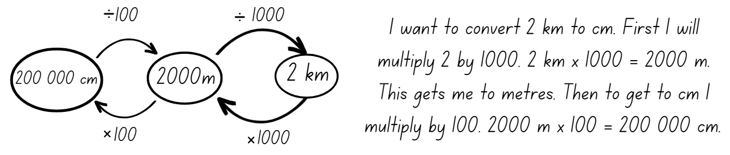
- Ask pairs of Stage 3 students to convert 5.5 kilometres to metres, centimetres and millimetres.
- Display Resource 3 – millimetre ruler and ask Stage 2 students to count the markers in between zero and one centimetre. Discuss how there are 10 millimetres in one centimetre.
- Explain to Stage 2 students that there are 2 units of measurement on the ruler: millimetres and centimetres. The lines labelled with numbers represent centimetres and the lines without numbers represent millimetres. Emphasise that millimetres are smaller than centimetres and that there are 10 millimetres in one centimetre.
- Write the words ‘millimetre’ and ‘centimetre’ on the board. Explain and demonstrate that mathematicians use the abbreviations ‘mm’ and ‘cm’ when they record measurement in these units.
- Regroup as a class and select Stage 3 students to describe how they converted between millimetres, centimetres, and kilometres.
- Ask Stage 2 students why they would need to measure objects in millimetres instead of centimetres and vice versa.
- Provide all students with Resource 4 – measuring objects. Provide each Stage 2 student with a 30 cm ruler and pairs of Stage 3 students with a tape measure or trundle wheel.
- Explain that Stage 2 students will measure objects using the standard 30 cm ruler. Students only record their numbers in the millimetres and centimetre column of Resource 4 – measuring objects. Stage 2 students add a selection of small items to the table for measuring.
- Explain that Stage 3 students will measure larger objects, such as a playground seat, handball or basketball court, and then add these items to the table. Stage 3 students complete all columns of the table.
- Take students outside. Remind students to start from zero when using a ruler, like zeroing on digital scales and to use abbreviations ‘mm’ and ‘cm’ (Stage 2) and ‘mm’, ‘cm’, ‘m’ and ‘km’ (Stage 3), when recording measurements.
This table details opportunities for differentiation.
Too hard? | Too easy?
Students cannot measure and compare objects using different units of measure.  - Support students to only measure items in one unit of measure  - Once students can use and understand one unit of measure, use a different unit of measure to measure the same objects. Students to compare the measurements. | Students can measure and compare objects using millimetres, centimetres, and kilometres.  - Measure larger objects that require the students to convert from millimetres to metres (Stage 2), and millimetres to kilometres (Stage 3).

Consolidation and meaningful practice – 10 minutes
- Students work in pairs to decide whether the following statements are true or false. Stage 3 must convert and record all answers in millimetres, centimetres, metres and kilometres before answering the true or false question. Ask if the following is true or false:
- My teacher is between 100 mm and 1000 mm tall.
- An ant is about 10 mm long.
- A sausage is about 30 mm long.
- 500 mm is the same as 5 m.
- 500 mm is the same as 0.005 km.
- Students discuss and justify their answers.
This table details opportunities for assessment.
Assessment opportunities | Links
What to look for:  - Can Stage 2 students identify that there are 10 millimetres in one centimetre? [MAO-WM-01, MA2-GM-02]  - Can Stage 2 students use the millimetre as a unit to measure lengths? [MAO-WM-01, MA2-GM-02]  - Can Stage 2 students record lengths using the abbreviation for millimetres (mm)? [MAO-WM-01, MA2-GM-02]  - Can Stage 3 students measure 100 metres and recognise that 10 times 100 metres is one kilometre, for example, 1000 metres is equivalent to one kilometre? [MAO-WM-01, MA3-GM-02]  - Can Stage 3 students record distances using the abbreviations for kilometres (km), metres (m), centimetres (cm) and millimetres (mm)? [MAO-WM-01, MA3-GM-02] | Links to National Numeracy Learning Progressions (NNLP):  - Stage 3 – UuM6, NPV8, NPV9.

Lesson 2
Core concept: estimation of length is guided by using known lengths as benchmarks (Stage 2) and decimals can be compared by analysing the place values parts of standard units of measurement (Stage 3).

Daily number sense – before and after – 10 minutes
The table below contains suggested learning intentions and success criteria. These are best co-constructed with students.
Daily number sense learning intentions | Daily number sense success criteria
Students working towards Stage 2 outcomes are learning to:  - extend the application of the place value system from whole numbers to tenths and hundredths.  Students working towards Stage 3 outcomes are learning to:  - recognise that the place value system can be extended beyond hundredths. | Students working towards Stage 2 outcomes can:  - express decimals as both tenths and hundredths  - distinguish between the role of zero in various positions.  Students working towards Stage 3 outcomes can:  - express thousandths as decimals  - indicate the place value of digits in decimal numbers of up to 3 decimal places.
- Provide students with Resource 5 – before and after and writing materials.
- Students record the decimal number that comes before and after each displayed decimal number.
- Select students to say a chosen decimal number aloud and identify the ones, tenths, hundredths and thousandths (Stage 3).
- Ask:
- Which decimal is the largest?
- Which decimal is the smallest?
- Which decimal is closest to a whole number? Explain how you know.
Multi-age: students working towards Stage 2 outcomes should use decimal numbers that contain only tenths and hundredths, for example, 1.10, 0.67, 8.55, 3.02, 0.21, 5.99.
This table details opportunities for assessment.
Assessment opportunities | Links
What to look for:  - Can Stage 2 students express decimals as both tenths and hundredths? [MAO-WM-01, MA2-RN-02]  - Can Stage 2 students distinguish between the role of zero in various positions? [MAO-WM-01, MA2-RN-02]  - Can Stage 3 students express thousandths as decimals?  [MAO-WM-01, MA3-RN-02]  - Can Stage 3 students indicate the place value of digits in decimal numbers of up to 3 decimal places? [MAO-WM-01, MA3-RN-02] | Links to National Numeracy Learning Progressions (NNLP):  - Stage 2 – NPV4, NPV5, NPV6, NPV7  - Stage 3 – NPV7, NPV8.  Links to suggested Interview for Student Reasoning (IfSR) tasks:  - Stage 2 – IfSR-NP: 4D.3  - Stage 3 – IfSR-PT: 1A.5  - Stage 3 – IfSR-NP: 4D.2, 4D.6.

Core lesson 1 – using your shoe as a benchmark – 25 minutes
The table below contains suggested learning intentions and success criteria. These are best co-constructed with students.
Core concept learning intentions | Core concept success criteria
Students working towards Stage 2 outcomes are learning to:  - measure and compare objects using centimetres  - use scaled instruments to measure and compare lengths.  Students working towards Stage 3 outcomes are learning to:  - use metres and kilometres for length and distances  - compare, order and represent decimals. | Students working towards Stage 2 outcomes can:  - estimate lengths and distances using known lengths as benchmarks, in centimetres and check by measuring  - measure and record lengths and distances using a combination of metres and centimetres  - select and use an appropriate scaled instrument to measure lengths and distances.  Students working towards Stage 3 outcomes can:  - estimate lengths and distances using an appropriate unit  - use a variety of measuring devices to measure lengths and distances in different contexts  - compare and order decimal numbers of up to 3 decimal places.
This activity is an adaptation of ‘Put Your Foot In It’ from Mathematics Assessment for Learning: Rich Tasks and Work Samples by Downton et al.
Note: a benchmark is a standard against which something can be compared or measured. Students need to develop personal benchmarks with which to estimate lengths and other measures.
- Students check their shoe size.
- Students trace the sole of their shoe on a piece of paper and cut it out.
- Ask:
- If we did not have a ruler, how could we use our shoe size to measure objects?
- Would this be a consistent measuring device?
- What could go wrong with this method of measuring?
- What would be some of the challenges when using different types of shoes?
- How can we ensure accuracy?
- Revise how there are 2 units of measurement on a ruler, millimetres and centimetres. Display Resource 3 – millimetre ruler. Emphasise that millimetres are smaller than centimetres and that there are 10 millimetres in one centimetre.
- Students use a ruler to measure the length of their shoe cut-out in centimetres and write the measurement on the cut-out. Remind students to use the abbreviation for centimetres ‘cm’ when recording.
Note: when students record their shoe size measurement, round up or down to the nearest centimetre.
- Model how to estimate and use a shoe cut-out to measure the length of a classroom table by placing the cut-out end to end with no overlaps or gaps. Record on Resource 6 – shoe measuring. Demonstrate how to convert the shoe cut-out measurement into centimetres.
- Students estimate and use their shoe cut-out to measure the length of objects outside of the classroom such as a lunch seat, handball court and a step. Record the number of shoe lengths on Resource 6 – shoe measuring.
- Return to the classroom. Students convert the number of shoe lengths for each item they measured into centimetres.
Multi-age: students working towards Stage 3 outcomes should then convert each length from centimetres to metres.
This table details opportunities for differentiation.
Too hard? | Too easy?
Stage 2 students cannot measure and compare objects using centimetres.  - Support students by modelling how to measure end to end using 2 shoe cut-outs.  - Provide concrete materials to help adding when converting total shoe lengths into centimetres.  Stage 3 students cannot order decimal numbers of up to 3 decimal places.  - Support students by modelling whole numbers, numbers with one and then 2 decimal places. | Stage 2 students can measure and compare objects using centimetres.  - Students record shoe size in centimetres and millimetres and then use these measurements to measure the length of objects.  Stage 3 students can estimate lengths and distances and use a variety of measuring devices to measure lengths and distances.  - Students combine measurements of objects to find the total length. For example, a seat and a step.

Core lesson 2 – how far can you jump? – 25 minutes
This activity is an adaptation of Measurement: Jump! from reSolve by Australian Academy of Science.
- Watch the video Long jump world record (0:32) at the Tokyo Olympic Games, 2020.
- Record 8.69 metres as the length jumped by the athlete in the video. As a class, measure out and mark this distance with masking tape on the floor or outdoor surface near the classroom. Ask:
- How far do you think you can you jump?
- Would it be easier to jump with 2 feet together, or from just one foot?
- Would it help to have a running start?
- Explain that students are going to estimate and measure their own jumps. Jumps should be measured from the starting line to the back of the foot (as with long jump), in metres using a decimal notation.
- Model how to estimate and measure each of the following jumps:
- 2 feet together from standing
- one-foot leap from standing
- one-foot leap with a small run-up.
- Provide students with Resource 7 – jump recording sheet to record their estimate for each type of jump.
- Mark a clear starting line for jumps. Students complete each type of jump, measure using a metre ruler or a tape measure and recording on Resource 7 – jump recording sheet.
- Students convert their measurements from metres to centimetres. Ask:
- How much further can you jump with a short run-up?
- What is the difference between your shortest and longest jump?
- How many of your longest jumps would it take to exceed 9 metres?
Multi-age: students working towards Stage 2 outcomes should record distances using a combination of metres and centimetres.
This table details opportunities for differentiation.
Too hard? | Too easy?
Students cannot use centimetres, metres and decimals for length and distances.  - Support students to only complete measurements in centimetres, to reinforce knowledge of centimetres.  - Support students to convert between metres and centimetres by providing Resource 2 – metric conversion display. | Students can use centimetres, metres and decimals for length and distances.  - Students combine the length of all their own jumps and record in metres and centimetres.  - Students calculate the number of Olympic record jumps that would be needed to reach a total distance. For example, one kilometre.

Discuss and connect the mathematics – 10 minutes
- Students measure and mark their personal best jump against the Olympic jump, placing their initials along the masking tape length.
- Ask: What is the difference between your longest jump and the Olympic jump?
- Select students to share and discuss their calculations.
This table details opportunities for assessment.
Assessment opportunities | Links
What to look for:  - Can Stage 2 students estimate lengths and distances using known lengths as benchmarks, in centimetres and check by measuring? [MAO-WM-01, MA2-GM-02]  - Can Stage 2 students measure and record lengths and distances using a combination of metres and centimetres? [MAO-WM-01, MA2-GM-02]  - Can Stage 2 students select and use an appropriate scaled instrument to measure lengths and distances? [MAO-WM-01, MA2-GM-02]  - Can Stage 3 students estimate lengths and distances using an appropriate unit? [MAO-WM-01, MA3-GM-02]  - Can Stage 3 students use a variety of measuring devices to measure lengths and distances in different contexts?  [MAO-WM-01, MA3-GM-02]  - Can Stage 3 students compare and order decimal numbers of up to 3 decimal places? [MAO-WM-01, MA3-RN-02] | Links to National Numeracy Learning Progressions (NNLP):  - Stage 2 – UuM6  - Stage 3 – UuM6, NPV7, NPV8.

Lesson 3
Core concept: accurate benchmarks help in estimating lengths and other measures (Stage 2) and known lengths of shapes can be used to calculate unknown lengths (Stage 3).

Daily number sense – place value challenge – 10 minutes
The table below contains suggested learning intentions and success criteria. These are best co-constructed with students.
Daily number sense learning intentions | Daily number sense success criteria
Students working towards Stage 2 outcomes are learning to:  - recognise and represent numbers that are 10, 100 or 1000 times larger.  Students working towards Stage 3 outcomes are learning to:  - recognise, represent and order numbers in the millions. | Students working towards Stage 2 outcomes can:  - recognise the numbers of tens, hundreds or thousands in a number  - describe how making a number 10, 100 or 1000 times as large changes the place value of the digits.  Students working towards Stage 3 outcomes can:  - name millions using the place value grouping of ones, tens and hundreds  - arrange numbers in the millions in ascending and descending order using place value.
- In pairs, students use a digital device and the interactive place value chart to play ‘Place value challenge’.
- Player 1 creates a 2-digit number and gives the digital device to Player 2, who makes the number that is 10 times larger and correctly names the number.
- Player 2 then returns the digital device to Player 1, who makes the number that is 100 times larger than the first number, naming the number.
- Player 2 then makes the number that is 1000 times larger, naming the number.
- The next round, Player 2 begins the game by creating a new 2-digit number.
- After a few rounds, students start with a 3-digit number and then a 4-digit number.
Multi-age: while Stage 2 students are playing, ‘Place value challenge’, students working towards Stage 3 outcomes use place value chart to create numbers in the millions that they place in ascending or descending order.
This table details opportunities for assessment.
Assessment opportunities | Links
What to look for:  - Can Stage 2 students recognise the numbers of tens, hundreds or thousands in a number? [MAO-WM-01, MA2-RN-01]  - Can Stage 2 students describe how making a number 10, 100 or 1000 times as large changes the place value of the digits?  [MAO-WM-01, MA2-RN-01]  - Can Stage 3 students name millions using the place value grouping of ones, tens and hundreds? [MAO-WM-01,  MA3-RN-01]  - Can Stage 3 students arrange numbers in the millions in ascending and descending order using place value?  [MAO-WM-01, MA3-RN-01] | Links to National Numeracy Learning Progressions (NNLP):  - Stage 2 – NPV7 - NPV9  - Stage 3 – NPV6, NPV7.  Links to suggested Interview for Student Reasoning (IfSR) tasks:  - Stage 2 – IfSR-NP: 4B.6  - Stage 3 – IfSR-NP: 4C.4, 4C.7, 4C.8.

Core lesson – 45 minutes

Stage 2 task – benchmarking a metre
The table below contains suggested learning intentions and success criteria. These are best co-constructed with students.
Core concept learning intentions | Core concept success criteria
Students working towards Stage 2 outcomes are learning to:  - measure and compare objects using metres, centimetres and millimetres. | Students working towards Stage 2 outcomes can:  - measure and record lengths and distances using metres  - estimate lengths and distances using known lengths as benchmarks in metres and check by measuring  - compare and order lengths and distances using metres.
This activity is an adaptation of Making benchmarks: Length from NZ Maths by New Zealand Ministry of Education.
- Place a piece of masking tape on the carpet that is one metre in length without telling the students that it is equal to a metre. Ask:
- How long do you think this strip of tape is? Why?
- How did you come up with that estimate?
- What is an object that is a similar length to this strip?
- How can you check the accuracy of your estimations?
- Using equipment in our room, which device will provide the most accurate answer? (metre ruler) Justify your answer.
- Model how to measure the strip of masking tape using a metre ruler. Record the measurement using the abbreviation for metre (m).
- Discuss what students could do if they did not have access to a metre ruler. What personal benchmarks could they use to measure lengths in metres? Examples may include: a stride, length of their leg or a wide leg stance. Ask:
- Which suggestion would be easier?
- Which suggestion would be practical to use? Why or why not?
- Students check their stride against the metre tape on the floor to get a known metre benchmark.
- Explain to students that they will estimate how far they can travel around the playground from a specified location with a set number of strides. For example, 20 strides from my classroom door will get me to the library.
- Provide students with Resource 8 – measuring in strides to make estimations and record strides. Provide small groups with a trundle wheel to measure and check the distance.
Note: students need to understand and be convinced that one rotation of a trundle wheel is one metre. If there is not access to enough metre rulers or trundle wheels, consider measuring and pre-cutting string or ribbon to one metre.
- Discuss the differences between student estimations and the actual measurements. Ask:
- Were your estimations close to the actual measurements? Why or why not?
- How did using the trundle wheel help you measure accurately?
This table details opportunities for differentiation.
Too hard? | Too easy?
Stage 2 students cannot measure and compare objects using metres.  - Support students with a list of examples that they could use as a personal benchmark.  - Provide markers when using the trundle wheel to keep track of how many metres to the set destination. | Stage 2 students can measure and compare objects using metres.  - Students combine measurements of 2 destinations to find the total length.  - Challenge students to list personal benchmarks they could use for half a metre.

Stage 3 task – calculating the perimeter of the school
The table below contains suggested learning intentions and success criteria. These are best co-constructed with students.
Core concept learning intentions | Core concept success criteria
Students working towards Stage 3 outcomes are learning to:  - use metres and kilometres for length and distances  - measure lengths to find perimeters. | Students working towards Stage 3 outcomes can:  - estimate lengths and distances using an appropriate unit  - record distances using the abbreviation for metres (m) and kilometres (km)  - use a variety of measuring devices to measure lengths and distances in different contexts  - determine which side lengths are needed to find the perimeter of a shape  - recognise that rectangles with the same perimeter may have different dimensions.
- Review student understanding of perimeter. Explain that the perimeter of an object, shape or location is the same as the boundary.
Perimeter: the length around an object, shape or location. Perimeter is calculated by combining the length of all the sides using addition.
- Provide students with grid paper to complete the following task: A shape has a perimeter of 24 metres. Create and label a shape with a perimeter of 24 metres.
- Students share and compare their shapes with the group. Ask:
- What do you notice?
- Are all shapes the same?
- How are the shapes different?
- What are the common lengths of some of the sides?
- Explain that students will be conducting a school perimeter investigation. List school buildings on the board that will be measured in addition to the school perimeter.
- Students draw a table titled ‘School perimeters’ in their workbooks with the headings: building, estimate and measurement. Ask:
- What would be the best measuring device to use? Why?
- Which units will you use to record your answers? Why?
- Revisit how to use a trundle wheel, including how to keep count when measuring metres. For example, using tally marks or a drawing to record the measurement for each side and then doubling or adding.
- Provide small groups with a trundle wheel. Students estimate, using their knowledge of benchmarking, then measure the perimeter of the selected buildings and record the results.
- Discuss student’s results. Ask:
- What is the perimeter of each building?
- How did you calculate the total perimeter of the buildings?
- Do measurements differ from group to group? Why or why not?
- How accurate are your estimates?
- Were there any challenges when completing this task?
- After listening to others, would you change your strategy for measuring perimeter? Explain your answer.
- Students combine the perimeter measurements of all buildings and convert the total to kilometres using decimal notation. Remind students that kilometres are recorded using the abbreviation ‘km’.
This table details opportunities for differentiation.
Too hard? | Too easy?
Stage 3 students cannot use metres and kilometres for length and distances and measure lengths to find perimeters.  - Provide students with the lengths of 2 sides of a rectangular building for them to calculate the perimeter.  - Support students to add the length of the sides together using additive strategies such as bridging the decade or compensation. | Stage 3 students can use metres and kilometres for length and distances and measure lengths to find perimeters.  - Challenge students to measure and record each side of the building, then draw a scaled diagram and label these in books.  - Students identify whether any buildings with different dimensions have a similar perimeter, or if the perimeter measurements of 2 or more buildings can be combined to match the perimeter of the largest building.

Discuss and connect the mathematics – 10 minutes
- As a class, discuss and reflect on the core learning activities. Ask:
- What was new learning for you today?
- How did you use what you already knew to complete the task?
- How could you apply these skills to different situations?
This table details opportunities for assessment.
Assessment opportunities | Links
What to look for:  - Can Stage 2 students measure and record lengths and distances using metres? [MAO-WM-01, MA2-GM-02]  - Can Stage 2 students estimate lengths and distances using known lengths as benchmarks in metres and check by measuring? [MAO-WM-01, MA2-GM-02]  - Can Stage 2 students compare and order lengths and distances using metres? [MAO-WM-01, MA2-GM-02]  - Can Stage 3 students estimate lengths and distances using an appropriate unit? [MAO-WM-01, MA3-GM-02]  - Can Stage 3 students record distances using the abbreviation for metres (m) and kilometres (km)? [MAO-WM-01, MA3-GM-02]  - Can Stage 3 students use a variety of measuring devices to measure lengths and distances in different contexts?  [MAO-WM-01, MA3-GM-02]  - Can Stage 3 students determine which side lengths are needed to find the perimeter of a shape? [MAO-WM-01, MA3-GM-02]  - Can Stage 3 students recognise that rectangles with the same perimeter may have different dimensions? [MAO-WM-01,  MA3-GM-02] | Links to National Numeracy Learning Progressions (NNLP):  - Stage 2 – UuM6.  - Stage 3 – UuM5, UuM6, UuM7.

Lesson 4
Core concept: known lengths of shapes can be used to calculate unknown lengths.

Daily number sense – 10 minutes
- From a class need surfaced through formative assessment data, identify a short, focused activity that targets students’ knowledge, understanding and skills. Example activities may be drawn from the following resources:
- Mathematics K–6 resources
- Universal Resources Hub.

Core lesson – town planning – 40 minutes
The table below contains suggested learning intentions and success criteria. These are best co-constructed with students.
Core concept learning intentions | Core concept success criteria
Students working towards Stage 2 outcomes are learning to:  - measure and compare objects using centimetres and millimetres  - measure the perimeters of quadrilaterals.  Students working towards Stage 3 outcomes are learning to:  - measure lengths to calculate perimeters. | Students working towards Stage 2 outcomes can:  - measure and record lengths and distances using a combination of centimetres and millimetres  - record lengths using the abbreviation for centimetres (cm) and millimetres (mm)  - estimate and measure the perimeters of quadrilaterals.  Students working towards Stage 3 outcomes can:  - determine which side lengths are needed to find the perimeter of a shape  - recognise that rectangles with the same perimeter may have different dimensions.
- Explain that students will become town planners and will design a new town that includes specified buildings and locations (see Figure 2).
Figure 2 – examples of buildings
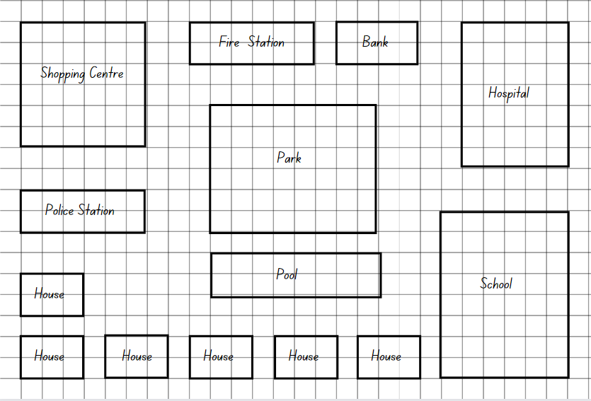
- Display Resource 9 – town requirements and brainstorm with the class what buildings and locations might be required in the town. Ask:
- What kinds of buildings do towns require?
- What would a town planner need to consider when deciding where to place houses and other buildings?
- Should certain locations be placed or not be placed near each other? Why or why not?
- Provide grid paper and a ruler and ask students to draw buildings for their new town, ensuring all required buildings and locations are included.
- Remind students to include roads so future citizens can navigate around the town.
Multi-age: Stage 3 students convert measurements using a scale of one grid square equals one metre. Stage 2 students will use a 1:1 scale by measuring lengths with the ruler only.
- Students calculate the perimeter of each building and record the value on their grid paper.
- Stage 2 students measure the perimeter using and millimetres and centimetres, and Stage 3 students calculate the perimeter in metres with the scale of one grid square equals one metre.
This table details opportunities for differentiation.
Too hard? | Too easy?
Stage 2 students cannot measure the perimeters of quadrilaterals using centimetres and millimetres.  - Support students to measure the sides of a building by counting the squares on the grid paper. Explain that each square is one centimetre.  Stage 3 students cannot measure lengths to find perimeters.  - Provide students with a shorter list of buildings and locations to be included and support them to measure the perimeter of each building by counting the number of squares.  - Provide students with specified perimeters for the buildings and locations for them to draw on their town plan. | Stage 2 students can measure the perimeters of quadrilaterals using centimetres and millimetres.  - Students calculate building perimeters using the scale of one grid square equals one metre. Record the new values on the grid paper.  Stage 3 students can measure lengths to find perimeters.  - Students calculate the combined perimeters of all buildings and locations in their town.  - Students include a natural feature such as a river or mountain in their town. Students find the length and width of the natural feature and calculate the perimeter.

Consolidation and meaningful practice – 10 minutes
This activity is an adaptation of ‘Area of Rectangles and Squares’ from Creative Problem Solving in School Mathematics by Lenchner.
- Explain that a landscaper was asked to prepare designs for a bush tucker garden. The landscaper asked for the dimensions of the garden. The client could not remember the exact dimensions but said that the garden is shaped like a rectangle and that there was a pile of fencing that could be used.
Multi-age: Stage 2 and Stage 3 students use different lengths of fencing for the purpose of this activity.
- Stage 2 students are told the fencing is in 20 m sections and the garden must be a rectangle with sides longer than the width.
- Stage 3 students received extra information from the builder: Their garden must be exactly twice as long as it is wide, and 90 m of fencing is needed to enclose it.
- Students use whiteboards or their workbooks to draw solutions to determine the dimensions of the site.
- Ask:
- Can you find the length and width of the garden site?
- Did you have to try more than once to find a solution?
- Is there more than one solution?
- What strategy worked and why?
This table details opportunities for assessment.
Assessment opportunities | Links
What to look for:  - Can Stage 2 students measure and record lengths and distances using a combination of centimetres and millimetres?  [MAO-WM-01, MA2-GM-02]  - Can Stage 2 students record lengths using the abbreviation for centimetres (cm) and millimetres (mm)? [MAO-WM-01,  MA2-GM-02]  - Can Stage 2 students estimate and measure the perimeters of quadrilaterals? [MAO-WM-01, MA2-GM-02]  - Can Stage 3 students determine which side lengths are needed to find the perimeter of a shape? [MAO-WM-01, MA3-GM-02]  - Can Stage 3 students recognise that rectangles with the same perimeter may have different dimensions? [MAO-WM-01,  MA3-GM-02] | Links to National Numeracy Learning Progressions (NNLP):  - Stage 2 – UuM6  - Stage 3 – UuM5, UuM6, UuM7.

Lesson 5
Core concept: the context determines the most suitable standard unit.

Daily number sense – ordering fractions – 10 minutes
Daily number sense activities for Lessons 5 to 7 ‘loop’ back to concepts and procedures covered in previous units to assist students to build an increasingly connected network of ideas. These concepts may differ from the core concepts being covered by the unit.
The table below contains suggested learning intentions and success criteria. These are best co-constructed with students.
Daily number sense learning intentions | Daily number sense success criteria
Students working towards Stage 2 outcomes are learning to:  - model unit fractions on a number line.  Students working towards Stage 3 outcomes are learning to:  - compare and order common unit fractions. | Students working towards Stage 2 outcomes can:  - model fractions with fraction strips and diagrams for halves, thirds, quarters and eighths.  Students working towards Stage 3 outcomes can:  - compare and order unit fractions with denominators of 2, 3, 4, 5, and 8 by placing them on a number line.
- Provide Stage 3 students with Resource 10 – fractions. Students place the fractions in the correct place on the number line. Students add any other common fractions to the number line that they know. For example, $\frac{1}{4}$ and $\frac{1}{6}$.
- Ask Stage 2 students to use fraction strips to create and compare the fractions in Resource 10 – fractions.
- Students add any other common fractions to the number line that they know. For example, $\frac{1}{4}$ f or Stage 2 and $\frac{1}{6}$ for Stage 3.
- Select students to share and explain the placement of the fractions.
This table details opportunities for assessment.
Assessment opportunities | Links
What to look for:  - Can Stage 2 students model fractions with fraction strips and diagrams for halves and thirds? [MAO-WM-01, MA2-PF-01]  - Can Stage 3 students compare and order fractions with denominators of 2, 3, 4, 5, and 8 by placing them on a number line? [MAO-WM-01, MA3-RQF-01] | Links to National Numeracy Learning Progressions (NNLP):  - Stage 2 – InF2, InF3, InF4  - Stage 3 – InF6.  Links to suggested Interview for Student Reasoning (IfSR) tasks:  - Stage 2 – n/a  - Stage 3 – n/a.

Core lesson – 50 minutes

Stage 2 task – the gram
The table below contains a suggested learning intention and success criteria. These are best co-constructed with students.
Core concept learning intention | Core concept success criteria
Students working towards Stage 2 outcomes are learning to:  - use scaled instruments to measure and compare masses. | Students working towards Stage 2 outcomes can:  - identify objects that have a mass less than one kilogram  - record masses using the abbreviation for grams (g) and kilograms (kg)  - find objects that have an estimated mass of 10 grams, 100 grams and 500 grams, and check using an equal-arm balance.

Note: the terms 'weigh' and 'weight' are common in everyday language and are acceptable for students to use, however ‘mass’ is the preferred mathematical language for this unit. Weight is a force that changes with gravity, while mass remains constant. Mass is measured in grams, kilograms and tonnes so the correct expression is that an object has a mass of one kilogram. To further support students and reduce confusion between mass and volume, it is important to display contrasting materials, such as a large piece of foam and a small piece of iron or steel so that students realise that the larger volume does not necessarily have the larger mass.
- Brainstorm and record responses on an anchor chart. Ask:
- What are some things that you weigh?
- Why is it important to weigh objects?
- Where have you seen objects being weighed?
- What tools or devices are used to weigh objects?
- Discuss measuring devices that can be used to measure mass. Record suggestions on the class anchor chart to be referred to during the lesson.
- Select students to share experiences or ideas about suggested measuring devices and how they work to measure mass.
- Explain the need for formal units of measurement and identify formal units of measurement for mass including kilograms and grams. Display the words ‘kilogram’ and ‘gram’ and ask students if they know what the abbreviation for each word is. Ensure students understand that when measuring the mass of objects, it is essential to select the units of measurement that would be most appropriate for that specific object. For example, kilograms (kg) are most useful when measuring the mass of heavier objects, such as a person, and grams (g) are most useful when measuring the mass of lighter objects, such as an orange.
- Display some everyday objects that are labelled with kilograms or grams, such as a packet of flour, biscuits, tea or a chocolate bar. Discuss the different mass displayed on the packaging. Select students to heft and compare the mass, identifying and ordering the items from lightest to heaviest.
- Ask students what they know about one gram and what it might feel like. As a class, brainstorm some objects in the classroom that would have a mass of approximately one gram.
- Use an equal-arm balance and a one-gram metric weight to test the selected objects.
- Ask:
- What is the same or different for each of the objects that had a mass of one gram?
- What is the same or different for each of the objects that had a mass that was more than one gram?
- What was most challenging about estimating one gram?
- Which object did you estimate correctly? Explain your strategy. Which object was incorrect? Do you now know why?
- Provide pairs of students with modelling clay to make a clay ball that has a mass of one gram. Students use an equal-arm balance to check if their estimates are correct.
- Students use the one-gram clay ball to help them estimate and make a new clay ball that is 10 times the mass of the first ball (10 grams).
- Students make a third clay ball that is 100 times the mass of the first ball (100 grams) or 10 × 10 grams (100 grams).
- As a group, discuss strategies used to estimate and make the clay balls that had a mass 10 times and 100 times more than one gram.
- Students use an equal-arm balance to check if their estimates are correct.
- Explain that students have investigated one gram, 10 grams and 100 grams. Ask what 1000 times one gram would be, or 10 × 100 grams.
- Using an equal-arm balance and metric weights, select students to model one kilogram, for example, using 10 × 100-gram metric weights.
- Select students to find an object they think has a mass of one kilogram. Using an equal-arm balance and the metric weights, students check their selected object. Ask:
- What strategy did you use to pick your object?
- How close was your estimate?
- Provide small groups of students with a bag and a digital device to record findings. Instruct students to find 3 objects in the classroom that have a combined mass of less than one kilogram. Students use an equal-arm balance to check their estimate and record their results as a photograph to be displayed in the classroom.
- Students repeat the process finding 3 objects that have a combined mass that is more than one kilogram.
- As a group, discuss strategies used to choose objects. Ask:
- What attribute of the object was most helpful when choosing it for the mass you needed? For example, the shape, the height or the length.
- Was there a choice you made that surprised you with a mass that was more or less than your estimate?
- Was it easier to find 3 objects with a combined mass less than one kilogram or more than one kilogram? Why?
This table details opportunities for differentiation.
Too hard? | Too easy?
Students cannot find objects that have an estimated mass of more than, less than and about the same as one kilogram.  - Students heft the100-gram metric weight and find an object in the classroom that has the same mass. Repeat the process with a 10-gram metric weight.  - Students find 2 objects in the classroom and use hefting to determine which is the heaviest and if it is more or less than one kilogram. Students use an equal-arm balance to check. | Students can find objects that have an estimated mass of more than, less than and about the same as one kilogram.  - In small groups, students find 5 objects that together have a mass less than one kilogram. Repeat the process for more than one kilogram.  - Students complete ‘What’s My Weight?’ from NRICH, recording their working.

Stage 3 task – part 1 – investigating mass
The table below contains suggested learning intentions and success criteria. These are best co-constructed with students.
Core concept learning intentions | Core concept success criteria
Students working towards Stage 3 outcomes are learning to:  - choose appropriate units of measurement for mass  - convert between common metric units of mass. | Students working towards Stage 3 outcomes can:  - recognise situations where mass would be measured in thousands of kilograms or tonnes (t)  - convert between kilograms and grams and between kilograms and tonnes  - solve problems involving mass.
Note: real examples of grocery items are needed for this lesson.
- Review what students know about measuring mass. Ask:
- When we measure mass, what are we measuring?
- What units do we use to measure mass?
- When might we need to measure the mass of objects?
- Display Resource 11 – recording mass. Select students to assist with the completion of the table. Discuss:
- When are kilograms more likely to be used and when are grams more likely to be used?
- Where do we commonly see grams and kilograms written?
- What is a unit bigger than a kilogram? How many kilograms in one tonne?
- When would we need to measure in tonnes?
- What could be measured in tonnes?
- Show examples of grocery items labelled in grams or kilograms such as rice, flour, canned goods, or cereal. Select students to convert the mass of items labelled grams into kilograms and record this on a sticky note and attach to the item. Repeat the activity converting the mass of items labelled kilograms into grams.
Note: a set of Resource 12 – Which is heavier? cards will need to be prepared for each pair of students.
- Demonstrate how to play ‘Which is heavier?’ Explain that each card has a mass written on it in either grams, kilograms, or tonnes. Cards are shuffled and dealt face down to each player. Players each turn over a card; the player who has the card with the heavier mass scores one point. Play continues until all cards have been played. The player with the highest score wins.
- Provide pairs of students with Resource 12 – Which is heavier? to play the game.

Stage 3 task – part 2 – tonnes
These investigation tasks are an adaptation of Weighty Problems from NZ Maths by the New Zealand Ministry of Education.
- Remind students that 1000 kilogram is equal to one tonne (t).
- Tell students that the largest sumo wrestler in the world had a mass of 287 kilograms.
- Students calculate how many sumo wrestlers of this size would weigh one tonne.
- Display Resource 13 – making tonnes. Students draw a table and calculate how many of each item would make a total mass of one tonne (t). Students show their working out.

Stage 3 task – part 3 – lasagne
- Pose the problem: The world’s largest lasagne was made in 2012 at a restaurant in Wieliczka, Poland. It weighed 4865 kilograms and measured 25 metres by 2.5 metres. The ingredients were: 2500 kilograms of pasta, 800 kilograms of mince, 400 kilograms of mozzarella cheese, 100 kilograms of peas, 100 kilograms of carrots, and equal amounts of white sauce and tomato sauce.
- Ask students:
- What was the mass of the white sauce and tomato sauce?
- If we had to make one-quarter of the lasagne, what would be the mass of each ingredient?
- Peas come in 500-gram packets; how many packets of peas would be required to make the lasagne?
- If there were only 200-gram packets of mozzarella cheese available at the supermarket, how many packets would need to be purchased to make 400 kilograms of mozzarella cheese?

Stage 3 task – part 4 – Rick’s cans
- Pose the problem: Rick’s shopping trolley contains a load of cans from the supermarket. The cans each have a different mass as follows: baked beans (245 grams), peaches (365 grams), pickles (125 grams) and creamed corn (650 grams).
- Ask students:
- Rick has 12 cans of baked beans, 9 cans of peaches, 7 cans of pickles and 9 cans of creamed corn. What is the total mass of the cans in kilograms?
- How many cans of pickles are required to have a mass of 5 kilograms?
- What is the difference in mass between the total amount of peaches and creamed corn in Rick’s shopping trolley?
This table details opportunities for differentiation.
Too hard? | Too easy?
Stage 3 students cannot choose appropriate units of measurement for mass.  - Provide a conversion chart to support students converting between grams and kilograms.  - Support students to use Resource 11 – recording mass when completing investigation tasks. | Stage 3 students can choose appropriate units of measurement for mass.  - Challenge students to solve the problem: A shipment of apples weighs 1.2 tonnes, and each apple weighs 150 grams. How many apples are there in the shipment?  - Students answer and explain which is heavier, 4500 kilograms of rice or 3.5 tonnes of sand?

Consolidation and meaningful practice – 10 minutes
- Display 10 gram, 100 gram and 500 gram items. Explain to Stage 2 students that they would need 10 items weighing 10 grams to make the same mass as the 100 gram item, and 50 of those to make the 500 gram item.
- Provide Stage 2 students with a resealable bag. Students find objects in the classroom that they estimate, when combined, have a mass of 10 grams, 100 grams or 500 grams. Students place the items in their resealable bag and swap their bag with a partner.
- Students check the mass of their partner’s bag using an equal-arm balance and record the findings.
- Select students to share their items and discuss how close their estimation was.
Note: keep 2 resealable bags containing objects that have a mass of 500 grams for Lesson 6.
- Stage 3 students to decide if the following statements are true or false. Students must reason and justify their answers:
- 500 grams is the same as 5 kilograms
- 3.5 tonnes are heavier than 3500 kilograms
- 455 grams is a quarter of one kilogram
- 75 kilograms is three-quarters of a tonne.
This table details opportunities for assessment.
Assessment opportunities | Links
What to look for:  - Can Stage 2 students identify objects that have a mass less than one kilogram? [MAO-WM-01, MA2-NSM-01]  - Can Stage 2 students record masses using the abbreviation for grams (g)? [MAO-WM-01, MA2-NSM-01]  - Can Stage 2 students find objects that have an estimated mass of 10 g, 100 g and 500 g and check using an equal-arm balance? [MAO-WM-01, MA2-NSM-01]  - Can Stage 3 students identify the appropriate unit and device to measure mass? [MAO-WM-01, MA3-NSM-01]  - Can Stage 3 students recognise situations where mass would be measured in thousands of kilograms or tonnes (t)? [MAO-WM-01, MA3-NSM-01] | Links to National Numeracy Learning Progressions (NNLP):  - Stage 2 – UuM4, UuM6  - Stage 3 – UuM7, UnM8.

Lesson 6
Core concept: mass (like time) is invisible, but it can still be estimated and measured using standard units (Stage 2) and estimation of mass is guided by using known masses/weights as benchmarks (Stage 3).

Daily number sense – rolling fractions – 10 minutes
The table below contains suggested learning intentions and success criteria. These are best co-constructed with students.
Daily number sense learning intentions | Daily number sense success criteria
Students working towards Stage 2 outcomes are learning to:  - model fractions on a number line.  Students working towards Stage 3 outcomes are learning to:  - compare and order common unit fractions. | Students working towards Stage 2 outcomes can:  - model fractions with fraction strips and diagrams for halves, quarters, thirds and fifths.  Students working towards Stage 3 outcomes can:  - compare and order unit fractions with denominators of 2, 3, 4, 5, 6, 8 and 10 by placing them on a number line.
- Provide Stage 3 students with 10-sided die and a whiteboard, Stage 2 students with 6-sided die and fraction strips.
- Students draw a number line from 0–1.
- Describe a fraction line and, for Stage 3 students, revise the meaning of the denominator and numerator.
Numerator: the top number is the numerator, which identifies the number of parts.
Denominator: the bottom number is called the denominator and is the total number of equal parts the whole is broken into.
Unit fraction: a unit fraction can be defined as a fraction whose numerator is 1.
- Students roll the die and use the number rolled as the denominator with the numerator always being one. For example, if students roll a 5 the fractions will be $\frac{1}{5}$.
- Stage 3 students place the fraction on the number line in the correct location.
- Stage 2 students use the fraction strip to create the fraction, before transferring the partitioned length to their whiteboard number line.
Note: sixths are not in the Stage 2 syllabus however, the use of a 6-sided die may offer opportunity for thinking and reasoning.
- Select students to share and explain the placement of the fractions.
This table details opportunities for assessment.
Assessment opportunities | Links
What to look for:  - Can Stage 2 students model fractions with fraction strips and diagrams for halves, quarters, thirds and fifths? [MAO-WM-01, MA2-PF-01]  - Can Stage 3 students compare and order unit fractions with denominators of 2, 3, 4, 5, 6, 8 and 10 by placing them on a number line? [MAO-WM-01, MA3-RQF-01] | Links to National Numeracy Learning Progressions (NNLP):  - Stage 2 – InF2 - InF4  - Stage 3 – InF6.  Links to suggested Interview for Student Reasoning (IfSR) tasks:  - Stage 2 – N/A  - Stage 3 – N/A.

Core lesson – 35 minutes

Stage 2 task – the kilogram
The table below contains suggested learning intentions and success criteria. These are best co-constructed with students.
Core concept learning intentions | Core concept success criteria
Students working towards Stage 2 outcomes are learning to:  - compare objects using the kilogram. | Students working towards Stage 2 outcomes can:  - identify familiar objects that have a mass of about a kilogram  - find objects that have an estimated mass of more than, less than and about the same as one kilogram and check by comparing to a 1 kg mass.
Note: prior to the lesson, place a variety of objects around the classroom that can be held, directly compared and explored for their size, shape and density. For example, wool, paint, toys, pom poms and rocks or pebbles. During the lesson, students will need to move to labelled areas that display the signs ‘less than one kilogram’, ‘about the same as one kilogram’ and ‘more than one kilogram’.
- Display the two 500-gram resealable bags from the previous lesson. Place them on one side of an equal-arm balance with a one-kilogram metric weight on the other side. Ask:
- What do you notice about the equal-arm balance?
- Why are the arms equal?
- How many grams are equal to one kilogram? How do you know?
- Record on the board that ‘1000 grams is the same as one kilogram’.
- Students search the room to find an object that they estimate to be one kilogram.
- Select a student to show their object to the class. Give the student the one-kilogram weight and ask them to compare it to the mass of their object by hefting. Explain that there are 3 designated labelled areas in the classroom – less than one kilogram, about the same as one kilogram and more than one kilogram. Ask the student to take their object to the labelled area that is most suitable and justify their decision.
- Model this process with another student.
- All students to compare their object to the one-kilogram metric weight and move to the labelled area that is most suitable.
- Students turn and talk to a partner to explain their decision.
- Provide students with Resource 14 – recording table. In small groups each student uses an equal-arm balance to compare their object to a one-kilogram metric weight. Students record the object name on Resource 14 – recording table after they have determined if their object is more, less or about the same mass as one kilogram.
- As a group, students find 3–4 different objects in the classroom that they estimate, when combined, have a mass of one kilogram.
- Using an equal-arm balance, students check the combined mass of their objects and record the results by drawing or naming their objects and the combined mass.
- Groups share their findings with the class.
This table details opportunities for differentiation.
Too hard? | Too easy?
Stage 2 students cannot compare objects using the kilogram.  - Provide students with a one-kilogram weight when finding objects around to room to heft and compare.  - Direct students to one-kilogram objects in the classroom suitable to complete the task. | Stage 2 students can compare objects using the kilogram.  - Challenge students to combine 6–7 objects that when weighed together equal one kilogram.  - Students to find 5 different objects that together have a mass of 2 kilograms.

Stage 3 task – harvest time
The table below contains suggested learning intentions and success criteria. These are best co-constructed with students.
Core concept learning intentions | Core concept success criteria
Students working towards Stage 3 outcomes are learning to:  - choose appropriate units of measurement for mass  - convert between common metric units of mass. | Students working towards Stage 3 outcomes can:  - recognise situations where mass would be measured in thousands of kilograms or tonnes (t)  - convert between kilograms and grams and between kilograms and tonnes  - solve problems involving different units of mass.
- Discuss the importance of agriculture in Australia and how it contributes to the country’s economy. Watch the video Farm Kids (3:12).
- Display Resource 15 – harvest photos. Discuss the meaning of the following words related to harvest:
- Harvest: the process of gathering in crops
- Silo: a tall tower or pit on a farm used to store wheat
- Wheat header: a tractor like machine used for cutting and collecting wheat
- Grain: wheat
- Crop: a cultivated plant that is grown on a large scale commercially.
- Ask students to discuss which unit they would use to measure the mass of wheat crops.
- Provide students with Resource 16 – harvest facts and their workbooks.
- Display Resource 17 – harvest questions. Students answer the questions and show their working.
This table details opportunities for differentiation.
Too hard? | Too easy?
Stage 3 students cannot choose appropriate units of measurement for mass.  - Provide students with smaller numbers to work with by reducing the total yield of the wheat crop.  - Students only complete 3 of the questions from Resource 17 – harvest questions. | Stage 3 students can choose appropriate units of measurement for mass.  - Challenge students to write 2 questions relating to ‘Farmer Joe’s Harvest Facts’ for a partner to answer.  - Students solve the problem: Farmer Joe’s rooster consumes 200 grams of wheat each day. Calculate how many days' worth of feed can be stored in a 40-kilogram bag of wheat?

Consolidation and meaningful practice – 15 minutes
- Brainstorm with Stage 2 students and record their ideas of what could be measured in kilograms. Ask:
- Why do we need a kilogram as a unit of measure?
- How many grams are in one kilogram?
- Why are some items measured in grams and not kilograms?
- Why do supermarkets sell items by kilograms?
- Did the mass of a selected object surprise you? Was it lighter or heavier than you thought?
- Did you face any challenges? How did you overcome these challenges?
- Explain to Stage 3 students how to play ‘Load the truck’. The aim of the game is to get a total as close to a truck load of 10 tonnes as possible, without going over.
- Players take turns rolling the dice.
- The number rolled indicates how many 40-kilogram bags of wheat the player will ‘load’ on their truck. For example, Player A rolls a 7, this represents 7 × 40 kilogram bags of wheat, so Player A writes 280 kilograms on their recording table.
- Students keep a running total in the third column.
- After 10 rolls each, the player closest to the truck mass limit of 10 tonnes without going over wins.
Note: to reuse Resource 18 – load the truck for multiple rounds, place it in a plastic sleeve or laminate.
- Provide pairs of students with Resource 18 – load the truck, two 6-sided dice and a whiteboard and marker. Students play multiple rounds in the time allowed.
This table details opportunities for assessment.
Assessment opportunities | Links
What to look for:  - Can Stage 2 students identify familiar objects that have a mass of about a kilogram? [MAO-WM-01, MA2-NSM-01]  - Can Stage 2 students find objects that have an estimated mass of more than, less than and about the same as one kilogram and check by comparing to a 1 kg metric weight?  [MAO-WM-01, MA2-NSM-01]  - Can Stage 3 students recognise situations where mass would be measured in thousands of kilograms or tonnes (t)? [MAO-WM-01, MA3-NSM-01]  - Can Stage 3 students convert between kilograms and grams and between kilograms and tonnes? [MAO-WM-01, MA3-NSM-01]  - Can Stage 3 students solve problems involving different units of mass? [MAO-WM-01, MA3-NSM-01] | Links to National Numeracy Learning Progressions (NNLP):  - Stage 2 – UuM4  - Stage 3 – UuM6, UuM8.

Lesson 7
Core concept: the mass of an object is not always related to the amount of space the object fills (Stage 2) and a mass can be renamed using different units of measurement (Stage 3).

Daily number sense – Who is winning? – 10 minutes
The table below contains suggested learning intentions and success criteria. These are best co-constructed with students.
Daily number sense learning intentions | Daily number sense success criteria
Students working towards Stage 2 outcomes are learning to:  - create fractional parts of length using techniques other than repeated halving.  Students working towards Stage 3 outcomes are learning to:  - compare and order fractions. | Students working towards Stage 2 outcomes can:  - create thirds of a length  - make fifths of a length.  Students working towards Stage 3 outcomes can:  - compare and order unit fractions with denominators of 2, 3, 4, 5, 6, 8 and 10 by placing them on a number line.
This activity is an adaptation of ‘Who is winning?’ from Primary and Middle Years Mathematics: Teaching Developmentally by Van de Walle et al.
- Revise with Stage 2 students how to identify thirds and fifths of a length and explain to Stage 3 students that this activity will include fractions with denominators of 2, 3, 4, 5, 6, 8 and 10.
- Display Resource 19 – Who is winning? and explain that the students are in a race. Stage 2 students will use Heat 1 and Stage 3 students will use Heat 2 from the resource. The fractions show how much of the race each student has already completed.
- Provide pairs of students with a whiteboard and Stage 2 students with a fraction strip for each runner. All students draw a number line from 0–1. Explain that number one is the finish line and 0 is the start of the race.
- Working in pairs, students compare the fractional representations for each runner and order the fraction distance completed by each runner.
- Students use the number line to locate each person’s position and decide who is winning the race.
- Select students to share and explain their strategies used to identify and represent the position of each fraction.
This table details opportunities for assessment.
Assessment opportunities | Links
What to look for:  - Can Stage 2 students model fractions with fraction strips and diagrams for halves, thirds, quarters and fifths? [MAO-WM-01, MA2-PF-01]  - Can Stage 2 students make thirds of a length? [MAO-WM-01, MA2-PF-01]  - Can Stage 3 students compare and order unit fractions with denominators of 2, 3, 4, 5, 6, 8 and 10 by placing them on a number line? [MAO-WM-01, MA3-RQF-01] | Links to National Numeracy Learning Progressions (NNLP):  - Stage 2 – InF2, InF3, InF4  - Stage 3 – InF6.  Links to suggested Interview for Student Reasoning (IfSR) tasks:  - Stage 2 – n/a  - Stage 3 – n/a.

Core lesson – 50 minutes

Stage 2 task – part 1 – comparing the kilogram
The table below contains suggested learning intentions and success criteria. These are best co-constructed with students.
Core concept learning intentions | Core concept success criteria
Students working towards Stage 2 outcomes are learning to:  - extend the application of the place value system from whole numbers to tenths and hundredths  - compare objects using the kilogram. | Students working towards Stage 2 outcomes can:  - recognise that 10-tenths are recorded as 1.0 and regroup when using decimal notation  - find objects that have an estimated mass of more than, less than and about the same as one kilogram and check by comparing to a 1 kg mass  - recognise the need for a formal unit to measure mass  - record masses using the abbreviation for kilograms (kg).
Note: a box labelled ‘1 kg’ and a variety of pantry items such as: cereal, canned food, oats, biscuits, or tea are needed for this lesson.
This activity is an adaptation of Noah’s Mystery Parcel from NZ Maths by New Zealand Ministry of Education.
- Show students a box labelled ‘1 kg’. Explain that this box arrived in the post with the label torn off. Ask:
- What could be inside?
- Why do you think that?
- Display a pebble and a cotton ball and highlight that even though the cotton ball might be bigger, it does not mean that it is heavier than the pebble. Explain that because an object is large, it does not necessarily mean that it is heavier or has a greater a mass. Little objects do not always have a lighter or small mass.
- Revise the definition of mass from Lesson 5. Explain that just because an object is large, it does not necessarily mean that it is heavier or has a greater mass. Little objects do not always have a lighter or smaller mass.
- Display a table tennis ball and a golf ball and ask:
- What do you see?
- What do you know about these 2 balls?
- Just by looking at these 2 balls, how do you know that their mass is different if they are the same shape and similar size?
- Set up stations around the classroom, each with a set of pantry items of different shapes and sizes, equal-arm balances and a one-kilogram metric weight so students can compare mass.
- Students heft the objects and decide whether they are heavier, lighter, or about the same as one kilogram, using a one-kilogram metric weight to compare. Encourage students to discuss their thoughts and estimations. Students record their estimations on Resource 14 – recording table.
- Students draw a line in their workbooks and write the name of each pantry item, ordering them from lightest to heaviest in mass. Students label each end of the line with the words ‘lightest mass’ and ‘heaviest mass’.
- Emphasise the key idea that an object's size does not always determine its mass. For example, a box of cereal may be lighter than a can of tomatoes. Ask:
- How did you make your estimation?
- Did the mass of any objects surprise you? How?
- How could you explain the mass of one kilogram to a friend?

Stage 2 task – part 2 – recognising formal units to measure mass
- Students sit in a circle; one by one students heft some of the pantry objects and share thoughts on which items are heavier and lighter. Highlight that words like ‘light’ and ‘heavy’ can be different for each person. Discuss that this is why we need a standard unit of measurement. Kilograms are a standard unit of mass.
- Select 4 students to estimate and pour one kilogram of rice, lentils, beans or flour into a cooking bowl each. Use a scale to measure the estimated masses. Ask:
- What do you notice about each bowl?
- Do they have different amounts? Why is that?
- What could be used to ensure we all have equal amount of rice, lentils, beans or flour?
- Why is it important that we ensure that the correct amount of rice, lentils, beans or flour is poured into the bowl?
- Discuss that, to ensure their estimates are accurate, students will need to measure the mass of the rice, lentils, beans or flour in a recipe.
- Demonstrate how to use a digital scale to measure mass. Explain that when using any measuring instrument students must know how to read the scale and check that the scale always starts from zero for accuracy, this is called ‘zeroing’. Ask:
- Why is starting from zero important?
- Should the scale be at zero with or without the bowl? Why?
- What tasks or activities can be affected if the mass is incorrect?
- Place students into groups and ask them to pour estimated amounts of rice, lentils, beans or flour into bowls.
- Groups measure their rice/lentils/beans/ flour on the scales and record exactly what is shown on the scale in workbooks. For example, 900 g or 1 kg and 200 g.
Note: connecting decimal representations to the metric system occurs in the Stage 3 component of the syllabus. In Stage 2 students are expected to record mass of 1.2 kg as 1 kg 200 grams.
This table details opportunities for differentiation.
Too hard? | Too easy?
Stage 2 students cannot compare objects using the kilogram.  - Provide students with a one-kilogram metric weight when finding objects around to room to heft and compare.  - Provide students with one kilogram of flour in a resealable bag. | Stage 2 students can compare objects using the kilogram.  - Challenge students to combine 6 or 7 items that when weighed together equal 1 kilogram and 200 grams.  - Students to estimate and measure one-and-a-half kilograms of flour.

Stage 3 task – kilograms and tonnes
The table below contains suggested learning intentions and success criteria. These are best co-constructed with students.
Core concept learning intentions | Core concept success criteria
Students working towards Stage 3 outcomes are learning to:  - choose appropriate units of measurement for mass  - connect decimal representations to the metric system. | Students working towards Stage 3 outcomes can:  - recognise situations where mass would be measured in thousands of kilograms or tonnes (t)  - recognise the equivalence of whole-number and decimal representations of measurements of mass  - interpret decimal notation for masses  - measure mass using scales and record using decimal notation of up to 3 decimal places.
Note: less than (<) and greater than (>) symbols are not specifically referenced in the Mathematics K–10 Syllabus but are important symbols for student to understand. This lesson provides an opportunity for students to use these symbols in context.
- Display Resource 20 – conversion chart. Ask:
- What can be measured in tonnes?
- Why do we use tonnes as a unit of measurement?
- How many kilograms are in a tonne?
- What tools are used to measure tonnes?
- Using Resource 20 – conversion chart, explain the procedure of converting tonnes to kilograms and kilograms to tonnes. Introduce the less than (<), greater than (>) and equals sign (=) and explain their meaning in relation to the size or quantity of mass.
- Students use Resource 20 – conversion chart and complete the activity on Resource 21 – tonnes to kilograms.
- Select students to explain the strategy they used to complete conversions on Resource 21 – tonnes to kilograms.
- Revise students’ understanding of the equivalence of the whole-number and decimal representations of measurements of mass. For example, 3 kilograms and 250 grams is equivalent to 3.25 kg, and 2.08 kg is the same as 2 kilograms and 80 grams.
- Reinforce this concept by displaying the following questions for students to practice converting measurements into decimals. Students copy and complete these questions in their workbooks:
- 4 kilograms and 250 grams as a decimal is __
- 3 kilograms and 126 grams as a decimal is __
- 5 kilograms and 75 grams as a decimal is __.
- Explain and use the relationship between the size of a unit and the number of units needed to determine whether multiplication or division is required when converting between units. For example, 'More grams than kilograms will be needed to measure the same mass. So, to convert from kilograms to grams, I need to multiply'. Write the following examples on the board to calculate with students:
- 1.2 kilograms is _____ grams (1200 g)
- 3.45 kilograms is _______ grams (3450 g)
- 1254 grams is _____ kilograms (1.254 kg).
This table details opportunities for differentiation.
Too hard? | Too easy?
Stage 3 students cannot convert between kilograms and grams and between kilograms and tonnes.  - Model using scaled instruments to compare 1000 g and 1 kg objects.  - Support students to use the conversion chart when completing Resource 21 – tonnes to kilograms. | Stage 3 students can convert between kilograms and grams and between kilograms and tonnes.  - Students research facts about the mass of very large animals and create a fact file about these animals. Students then create combinations of different animals’ mass. For example, one elephant equals 130 big dogs.  - Challenge students to create word problems that require converting between units of mass for a partner to solve.

Discuss and connect the mathematics – 10 minutes
- Regroup as a class and summarise the lesson together drawing out key mathematical ideas. Ask:
- What did you notice about the measurements you recorded directly from the digital scale? (Stage 2)
- Why is a kilogram unit needed to measure items? (Stage 2)
- How many grams are in one kilogram? (Stage 2)
- Why are scales needed to measure the mass of items? (Stage 2)
- What are some examples of where you have seen scales used? (Stage 2)
- Why is a tonne unit needed to measure items? (Stage 3)
- How many kilograms are in one tonne? (Stage 3)
- How might tonnes be measured? (Stage 3)
- What would you call a unit of mass that is larger than tonnes? (Stage 3) (A megatonne is one million tonnes)
- What items might be measured using megatonnes? (Stage 3)
This table details opportunities for assessment.
Assessment opportunities | Links
What to look for:  - Can Stage 2 students identify familiar objects that have a mass of about a kilogram? [MAO-WM-01, MA2-NSM-01]  - Can Stage 2 students find objects that have an estimated mass of more than, less than and about the same as one kilogram and check by comparing to a 1 kg mass? [MAO-WM-01, MA2-NSM-01]  - Can Stage 2 students identify familiar objects that have a mass of about a kilogram? [MAO-WM-01, MA2-NSM-01]  - Can Stage 2 students recognise that 10-tenths is recorded as 1.0 and regroup when using decimal notation? [MAO-WM-01, MA2-RN-02]  - Can Stage 3 students recognise situations where mass is measured in thousands of kilograms or tonnes (t)? [MAO-WM-01, MA3-NSM-01]  - Can Stage 3 students recognise the equivalence of whole-number and decimal representations of measurements of mass?  [MAO-WM-01, MA3-NSM-01]  - Can Stage 3 students interpret decimal notation for masses? [MAO-WM-01, MA3-NSM-01]  - Can Stage 3 students measure mass using scales and record using decimal notation of up to 3 decimal places? [MAO-WM-01, MA3-NSM-01] | Links to National Numeracy Learning Progressions (NNLP):  - Stage 2 – UuM4, NPV6  - Stage 3 – UuM6, UuM8.  Links to suggested Interview for Student Reasoning (IfSR) tasks:  - Stage 2 – n/a  - Stage 3 – n/a.

Lesson 8
Core concept: when comparing and ordering measurements, standard units can be renamed in equivalent ways (Stage 2). The context determines the most suitable device to measure lengths and masses (Stage 3).

Daily number sense – 10 minutes
- From a class need surfaced through formative assessment data, identify a short, focused activity that targets students’ knowledge, understanding and skills. Example activities may be drawn from the following resources:
- Mathematics K–6 resources
- Universal Resources Hub.

Core lesson – 35 minutes

Stage 2 task – recipe challenge
The table below contains suggested learning intentions and success criteria. These are best co-constructed with students.
Core concept learning intentions | Core concept success criteria
Students working towards Stage 2 outcomes are learning to:  - use scaled instruments to measure and compare masses. | Students working towards Stage 2 outcomes can:  - identify familiar objects that can be measured in grams  - measure and record masses using the abbreviation for grams (g)  - relate 1000 grams to one kilogram  - interpret commonly used fractions of a kilogram, including a half and relate these to the number of grams.
- Ask students:
- What household items can be measured in kilograms and grams?
- Where are measurements of mass often found?
- Display a variety of recipes that include measurements in grams and kilograms or display Resource 22 – example recipe. Discuss why it is important to have a standard unit of measurement when following a recipe.
- Draw students’ attention to using (g) as an abbreviation for grams and (kg) as an abbreviation for kilograms.
- Display Resource 23 – fruit recording and a variety of fruits and vegetables. Model weighing a selection of fruits recording results in the table. Use the demonstration to highlight that 10 × 100 g = 1000 g. Discuss with students a half a kilogram is 500 grams.
- Students use Resource 24 – fruit salad recipe to create their own healthy fruit salad recipe. Challenge students to have a total mass under 500 grams.
This table details opportunities for differentiation.
Too hard? | Too easy?
Students cannot measure and record mass in grams (g).  - Use an equal-arm balance with a metric weight to demonstrate balance.  - Select one piece of fruit and model using the scales and recording the mass in the table. | Students can measure and record mass in grams (g).  - Challenge students to create a recipe with an exact mass for example one kilogram and 250 grams.  - Have students investigate and identify the number of grams in a quarter of a kilogram.

Stage 3 task – dinosaur measurements
The table below contains suggested learning intentions and success criteria. These are best co-constructed with students.
Core concept learning intentions | Core concept success criteria
Students working towards Stage 3 outcomes are learning to:  - use metres and kilometres for length and distances  - choose appropriate units of measurement for mass. | Students working towards Stage 3 outcomes can:  - estimate lengths and distances using an appropriate unit  - record distances using the abbreviation for centimetres (cm), metres (m) and kilometres (km)  - identify the appropriate unit and device to measure mass  - recognise situations where mass would be measured in thousands of kilograms or tonnes (t).
This lesson is an adaptation of Weighty Problems 4: Jumbo Facts from NZ Maths by the New Zealand Ministry of Education.
Note: one set of Resource 25 – dino challenge cards per small group should be prepared prior to the lesson.
- Display Resource 26 – dinosaur facts and explain that dinosaurs are reptiles that dominated the land for over 140 million years. Fossil remains show they were some of the heaviest and longest creatures that have lived on earth.
- Students convert the measurements for each dinosaur from tonnes to kilograms and metres to centimetres.
- Put students into small groups and provide each group a set of Resource 25 – dino challenge cards
- Using Resource 26 – dinosaur facts, students work through the challenge cards and answer questions.
This table details opportunities for differentiation.
Too hard? | Too easy?
Stage 3 students cannot use metres and kilometres for length and distances and choose appropriate units of measurement for mass.  - Provide students with length and mass conversion charts.  - Students to complete answers in one unit of measurement only. | Stage 3 students can use metres and kilometres for length and distances and choose appropriate units of measurement for mass.  - Students develop their own challenge questions to pose to the class using the dinosaur facts.  - Students convert from tonnes to grams and kilometres to millimetres.

Discuss and connect the mathematics – 15 minutes
- Regroup as a class and summarise the lesson together drawing out key mathematical ideas. Select students to justify their answers and explain strategies used.
This table details opportunities for assessment.
Assessment opportunities | Links
What to look for:  - Can Stage 2 students identify familiar objects that can be measured in grams? [MAO-WM-01, MA2-NSM-01]  - Can Stage 2 students measure and record masses using the abbreviation for grams (g)? [MAO-WM-01, MA2-NSM-01]  - Can Stage 2 students relate 1000 grams to one kilogram? [MAO-WM-01, MA2-NSM-01]  - Can Stage 2 students interpret commonly used fractions of a kilogram, including a half and relate these to the number of grams? [MAO-WM-01, MA2-NSM-01]  - Can Stage 3 students record distances using the abbreviation for centimetres (cm), metres (m) and kilometres (km)? [MAO-WM-01, MA3-GM-02]  - Can Stage 3 students identify the appropriate unit and device to measure mass? [MAO-WM-01, MA3-NSM-01]  - Can Stage 3 students recognise situations where mass would be measured in thousands of kilograms or tonnes (t)? [MAO-WM-01, MA3-NSM-01] | Links to National Numeracy Learning Progressions (NNLP):  - Stage 2 – NPV6  - Stage 3 – UuM6, UuM8.

Resource 1 – decimal numbers
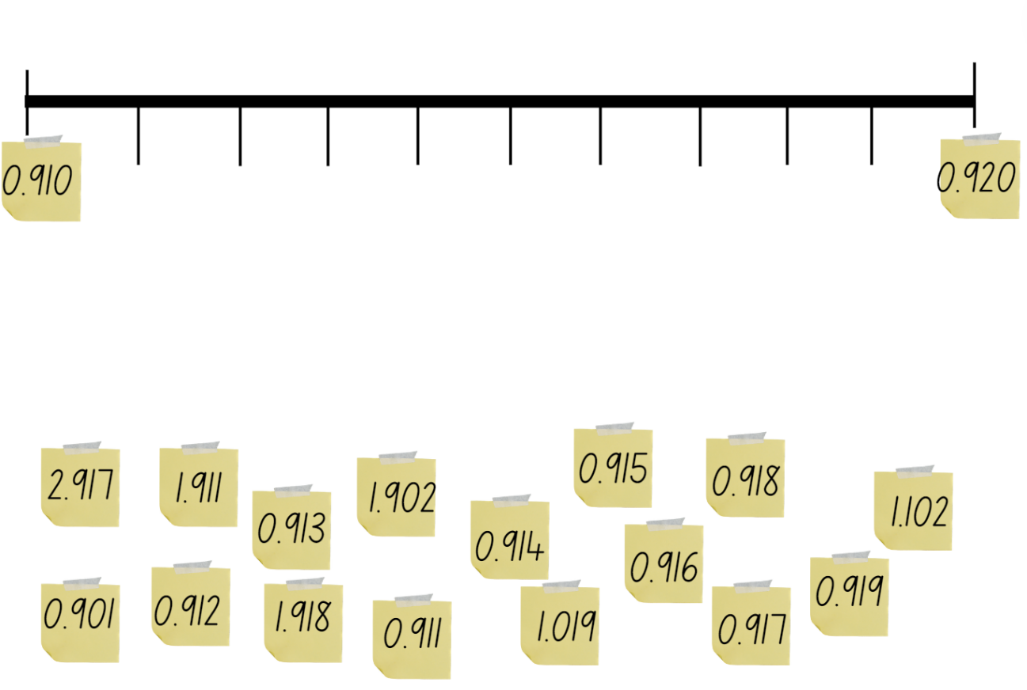

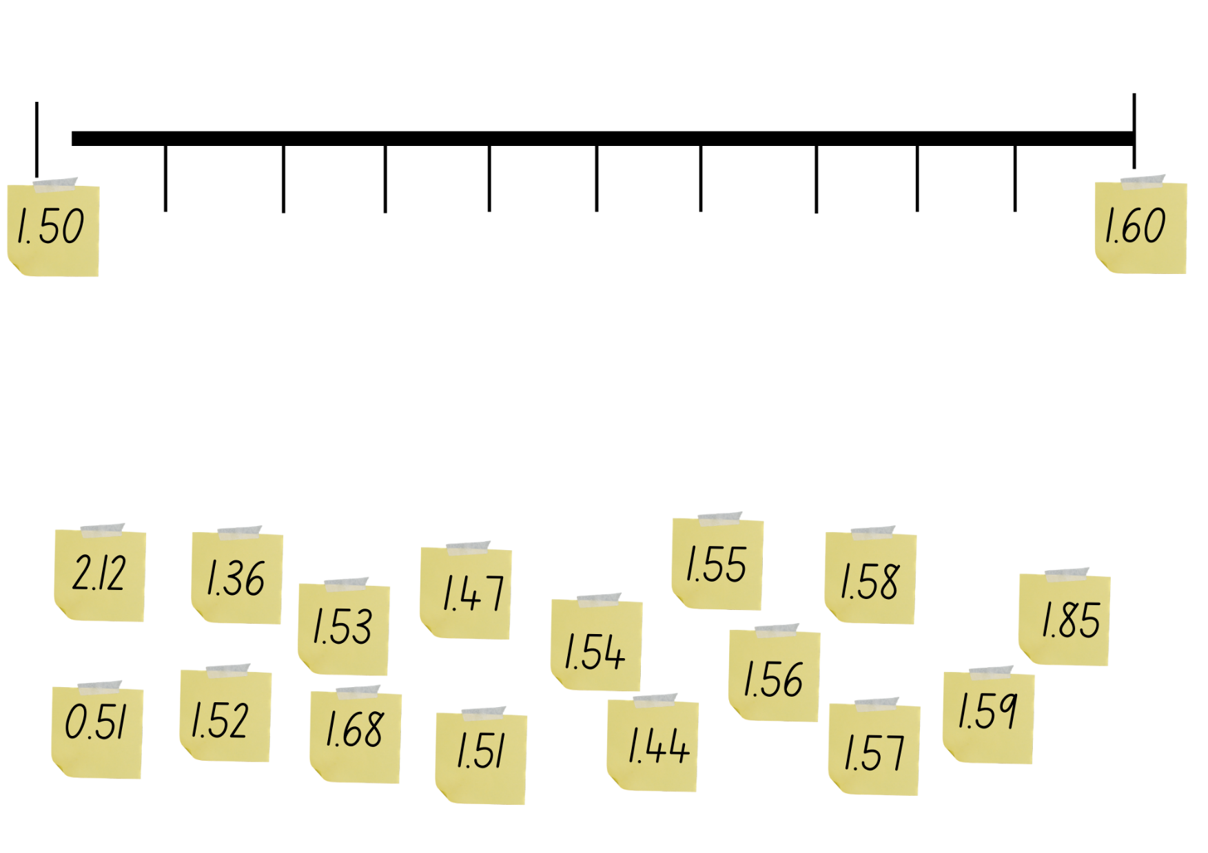

Resource 2 – metric conversion display
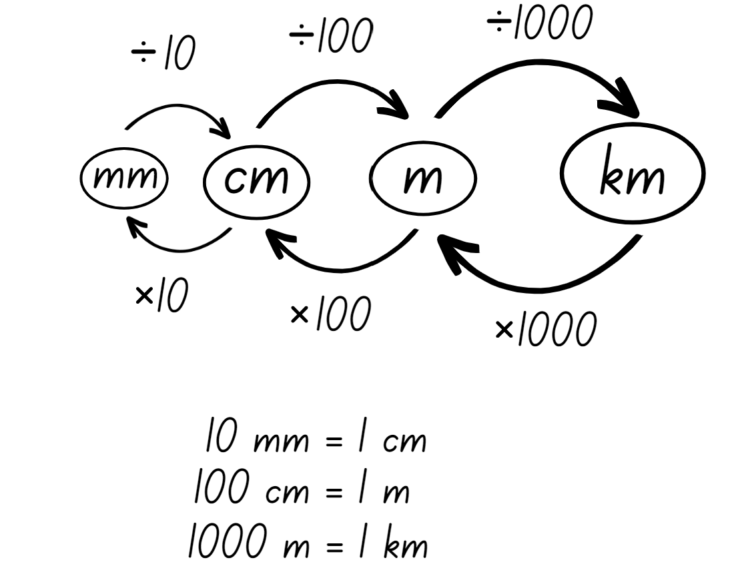

Resource 3 – millimetre ruler
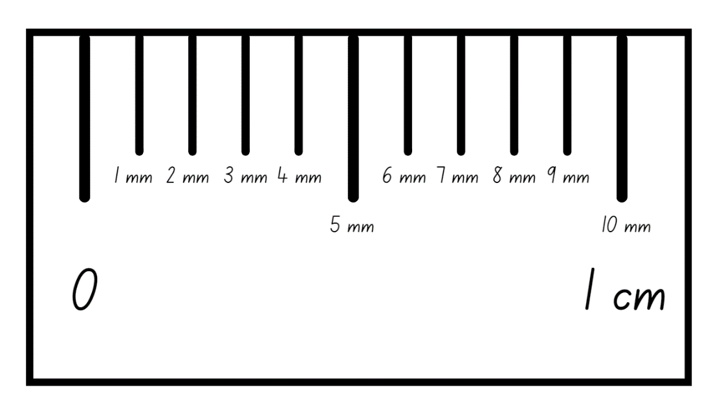

Resource 4 – measuring objects
Object | Millimetres | Centimetres | Metres | Kilometres
piece of bark
brick or paver
leaf

Resource 5 – before and after
Before | Decimal number | After
 | 0.125
 | 2.065
 | 1.988
 | 6.107
 | 0.002
 | 0.999

Before | Decimal number | After
 | 0.12
 | 2.06
 | 1.98
 | 6.10
 | 0.02
 | 0.99

Resource 6 – shoe measuring
Object being measured | Estimation of number of shoes | Number of shoe lengths | Length in cm

Resource 7 – jump recording sheet
Type of jump | Estimate (m) | Measure (m) | Convert measurement from m to cm
Two feet together
One-foot leap from standing
One-foot leap with a run up

Resource 8 – measuring in strides
Set number of strides | Estimated destination | Actual number of strides | Trundle wheel measurement
15
55
24

Resource 9 – town requirements
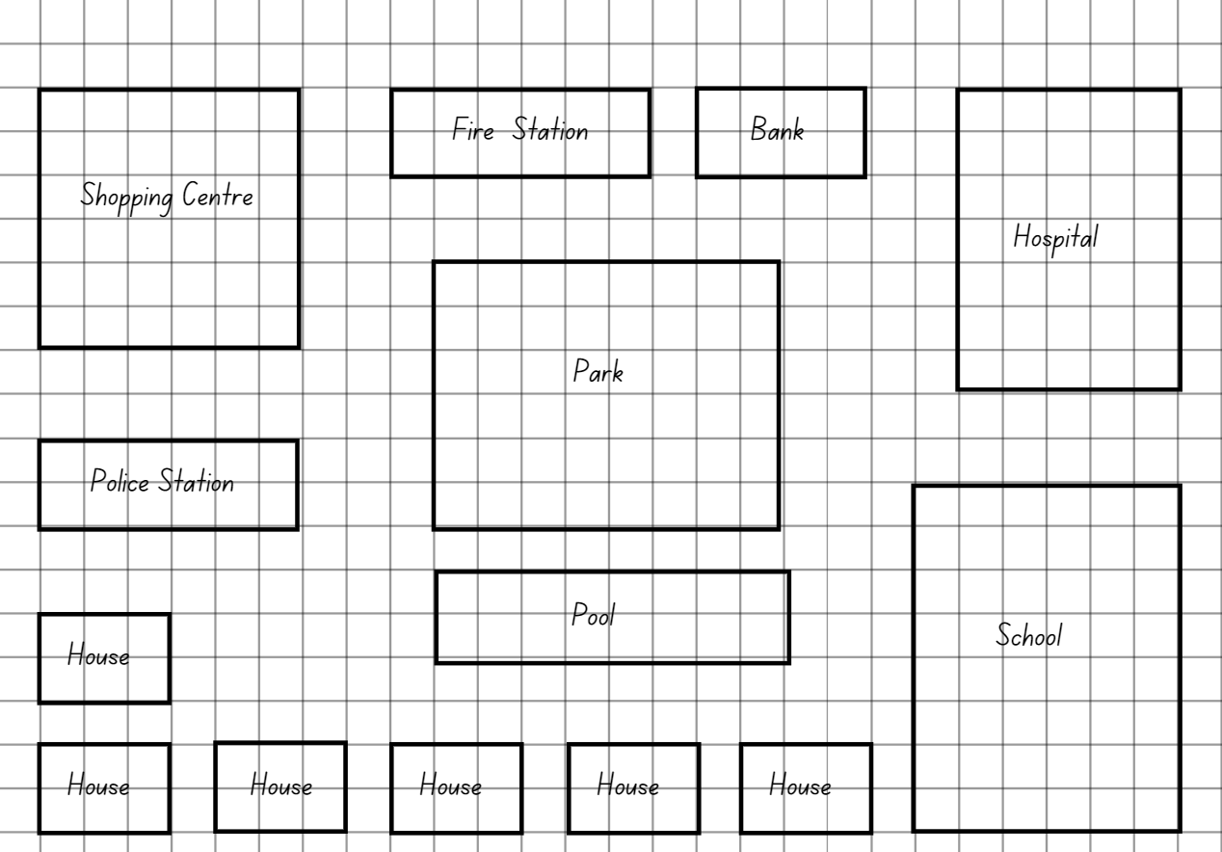

Resource 10 – fractions
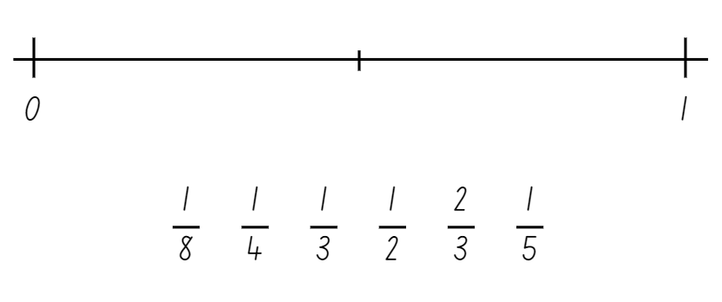

Resource 11 – recording mass
One kilogram | 1 kilogram | 1kg | 1000 grams | 1000 g
One half of a kilogram
One-quarter of a kilogram
Three-quarters of a kilogram
One tonne | 1 tonne

Resource 12 – Which is heavier?
2000 g | 5637 g | 0.234 t | 0.51 t | 0.01 kg
4.6 kg | 1 t | 2678 g | 3120 g | 3600 g
17 g | 9.8 kg | 5 kg | 1.5 t | 0.03 kg
3.1 t | 0.02 kg | 1.2 kg | 46 g | 2.8 kg

Resource 13 – making tonnes
Object | Mass (kg) | Number in one tonne (t)
Sumo wrestler | 287 kg
School bag | 5 kg
Microwave oven | 15 kg
Bag of cement | 50 kg
Watermelon | 23 kg

Resource 14 – recording table
Less than a kilogram | About a kilogram | More than a kilogram

Resource 15 – harvest photos
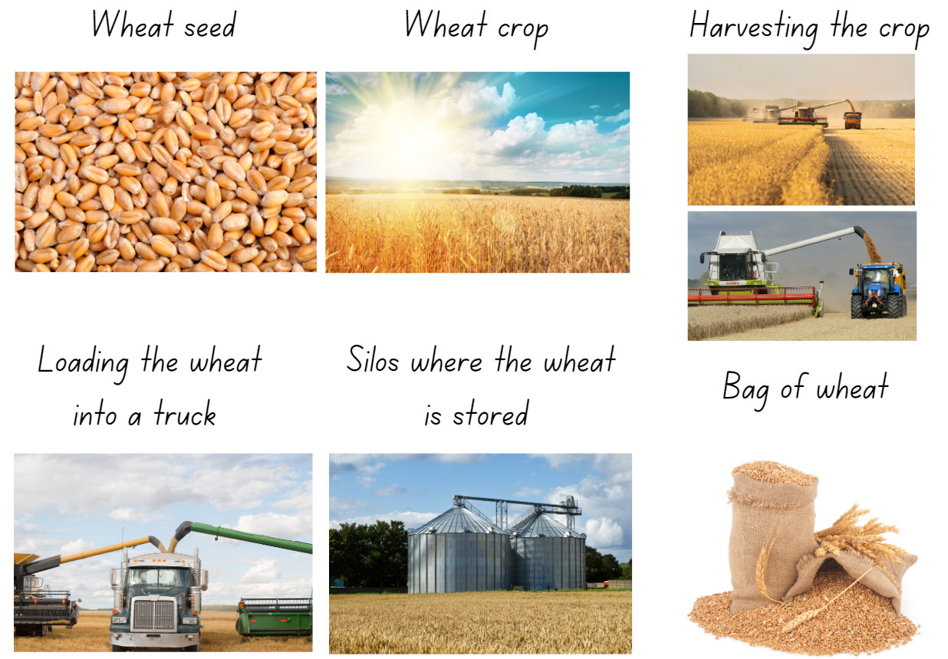

Resource 16 – harvest facts
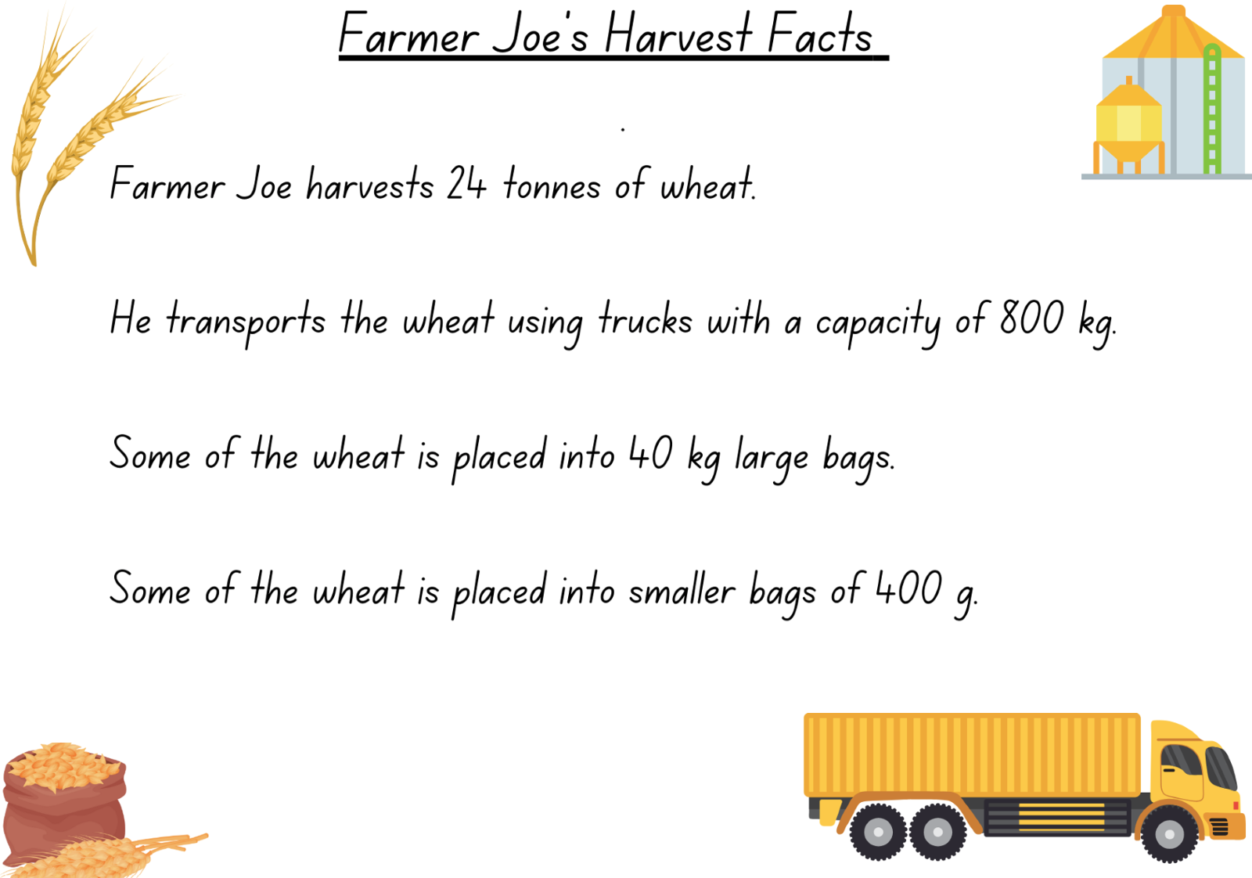

Resource 17 – harvest questions
Harvest questions
- If the harvest takes 6 days, how many tonnes were harvested each day? How many kilograms does this equal? How many grams does this equal?
- Farmer Joe took 4 tonnes of wheat to the market. How many truck loads were needed?
- What combination of large bags and small bags could be delivered to a customer wanting 245.2 kg of wheat?
- How many 40 kg bags of wheat make one fifth of a tonne?
- Farmer Joe uses 800 g of wheat each day to feed his chickens. How many days does a 40 kg bag last?
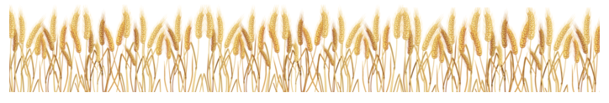

Resource 18 – load the truck
Load the truck
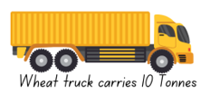
Players: 2
What you need: two 6-sided dice
Aim: To get a total as close to a truckload of 10 tonnes as possible, but not to go over.
- Players take turns rolling the dice.
- The number rolled will indicate how many 40 kg bags of wheat the player will 'load' on their truck. Example: Player A rolled a 7, this represents 7 × 40 kg bags of wheat so they put 280 kg on their recording table.
- Record the amount of wheat in kilograms on the recording sheet for each roll. Students keep a running total in the third column.
- After 10 dice rolls each, the player closest to the truck mass limit of 10 tonnes wins. If you exceed the 10 tonne mass limit, you have lost.
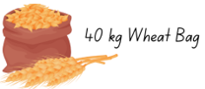
Load the truck recording sheet
Roll | Total | Running total
1
2
3
4
5
6
7
8
9
10

Resource 19 – Who is winning?
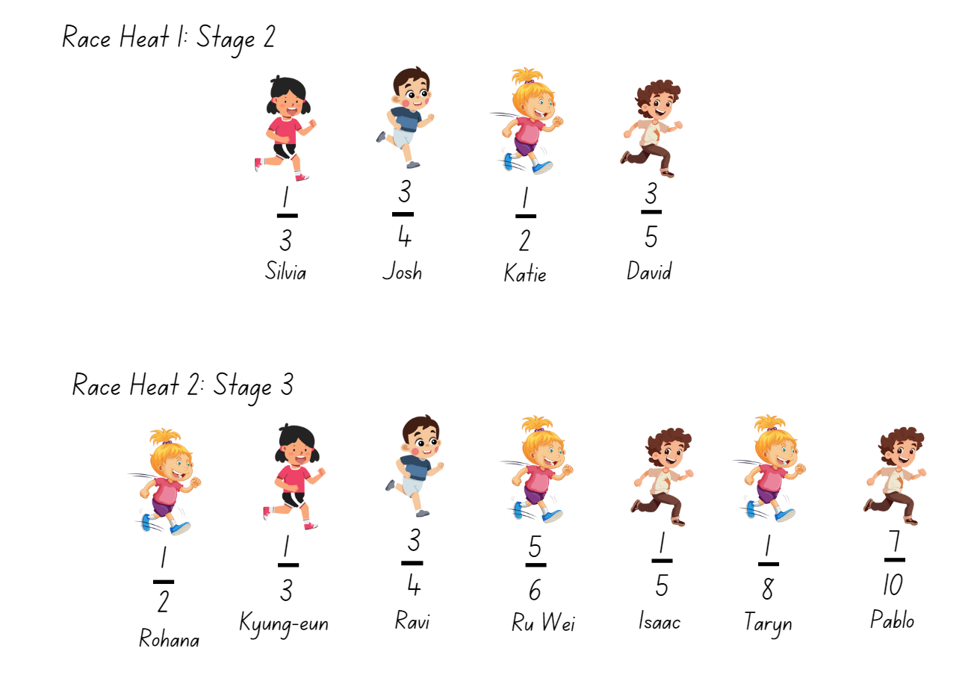

Resource 20 – conversion chart
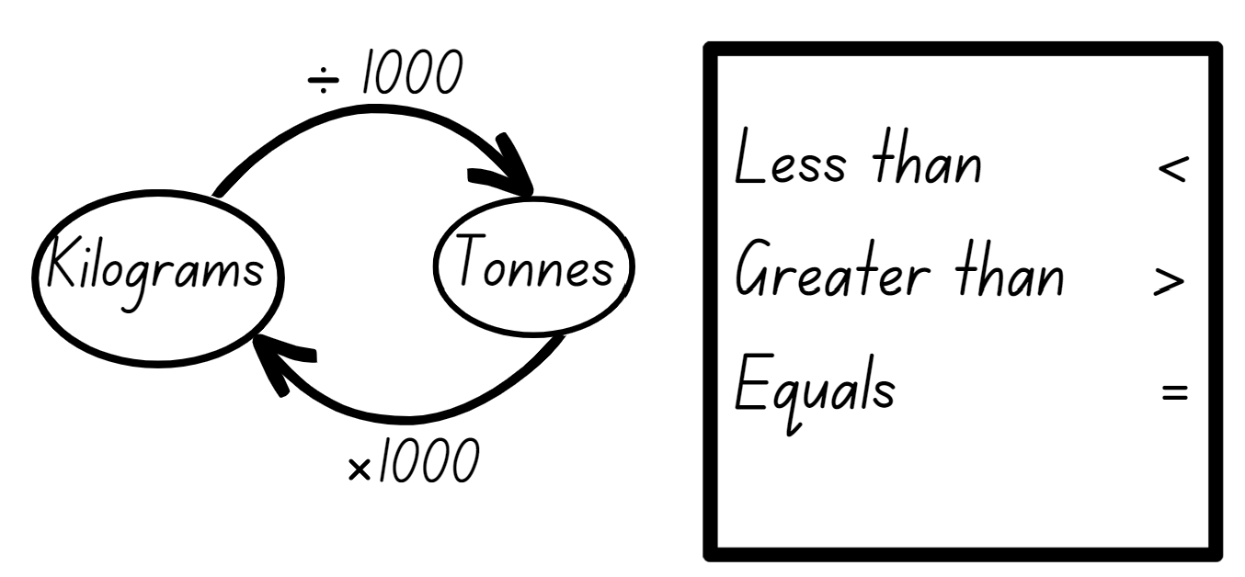

Resource 21 – tonnes to kilograms
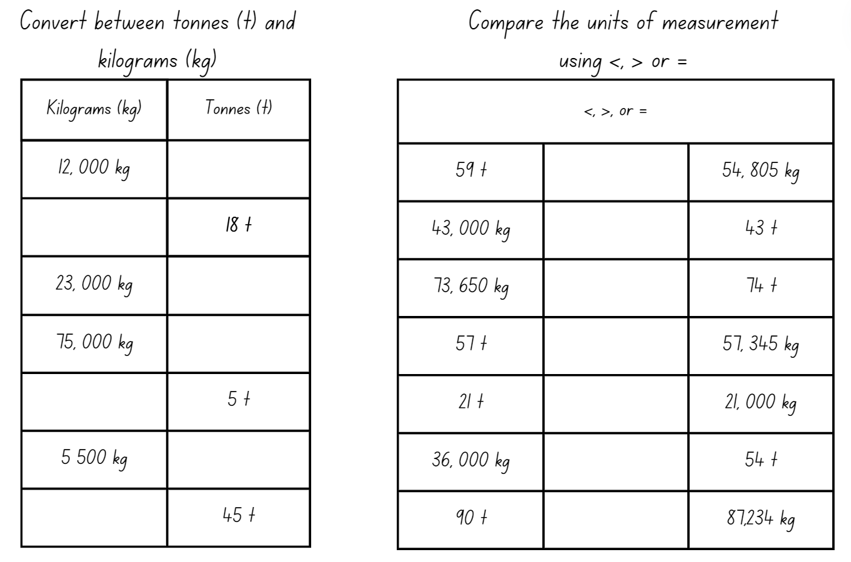

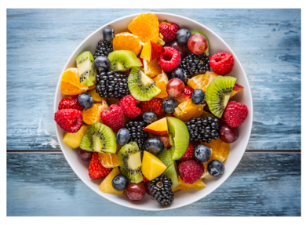
Resource 22 – example recipe
Traditional fruit salad recipe
Ingredients:
- 600 g pineapple, peeled and chopped
- 800 g of rockmelon, chopped
- 250 g of strawberries, diced
- 200 g red seedless grapes
- 150 g of mandarin
- 4 passionfruits, halved
- 1 teaspoon of lime juice.
Method:
Place pineapple, rockmelon, strawberries, grapes, mandarins, passionfruit pulp and lime juice into a large glass or ceramic bowl. Toss to combine and serve.

Resource 23 – fruit recording
Fruit or vegetable | Grams (g)
Example: Apple | 200 g

Resource 24 – fruit salad recipe
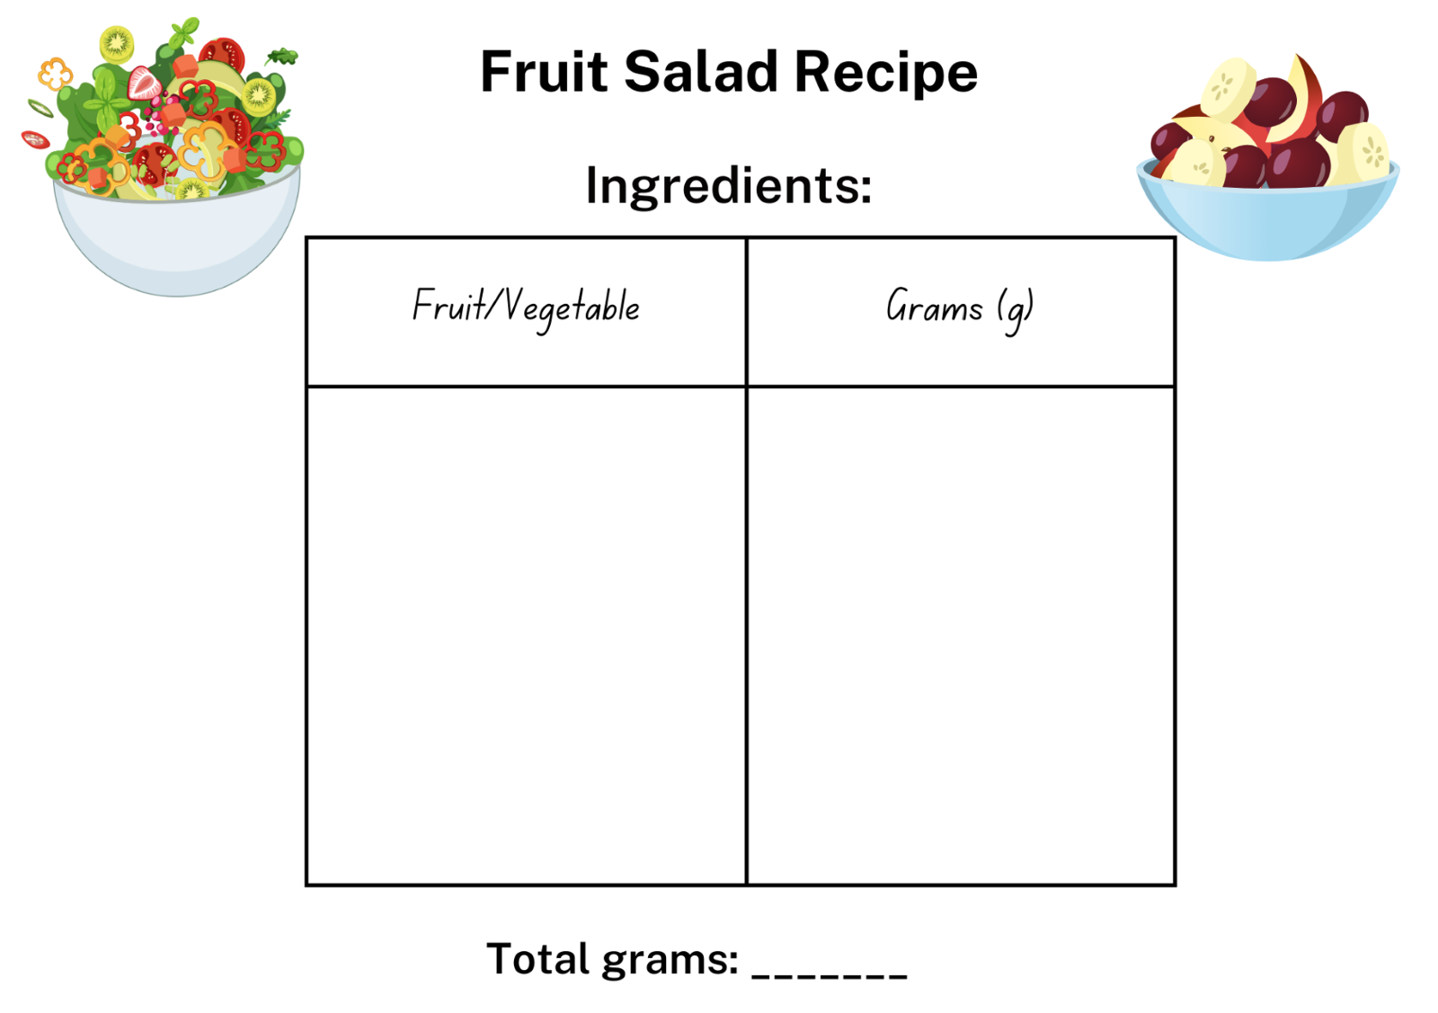

Resource 25 – dino challenge cards
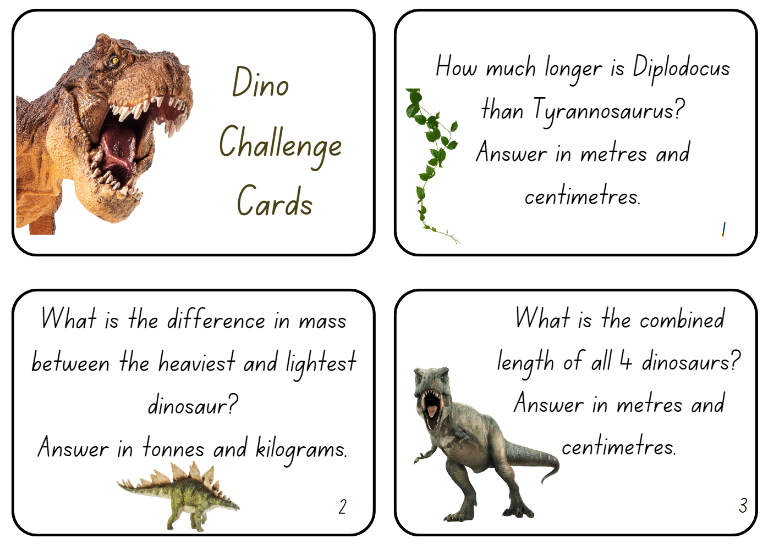
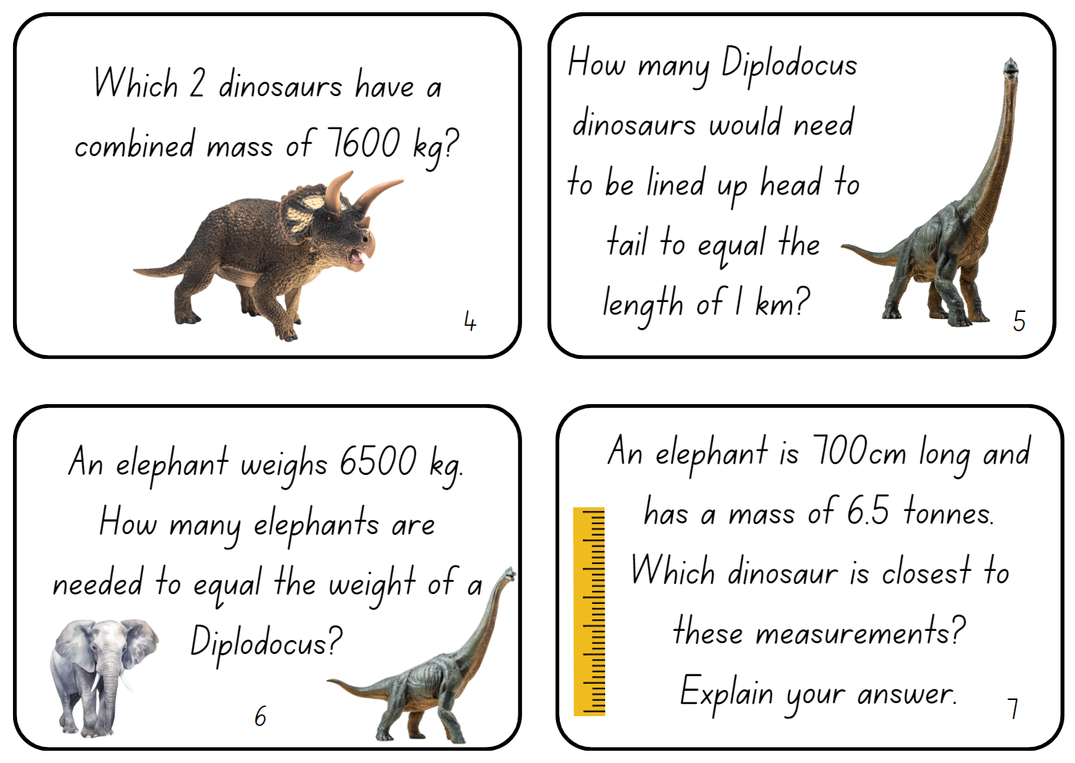
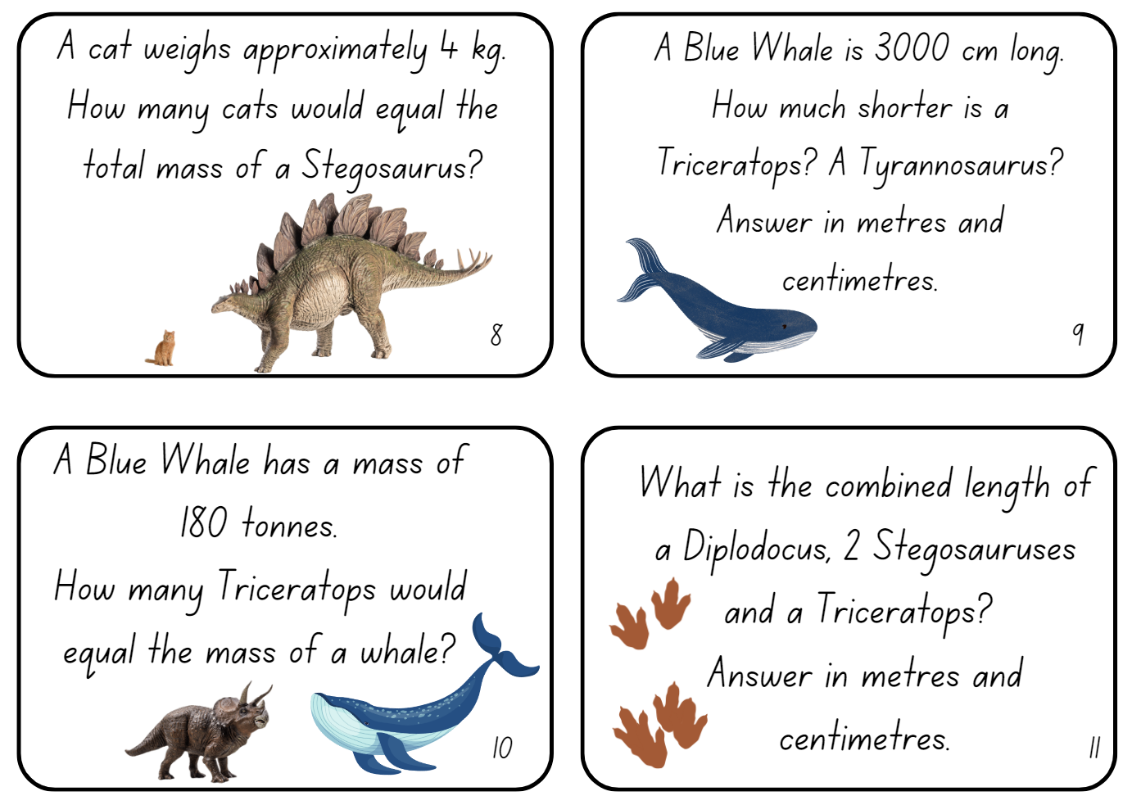

Resource 26 – dinosaur facts
Dinosaur | Mass | Length
Tyrannosaurus | 6 tonnes | 12.3 metres
Stegosaurus | 1.6 tonnes | 6.5 metres
Diplodocus | 22.6 tonnes | 28 metres
Triceratops | 8 tonnes | 9 metres
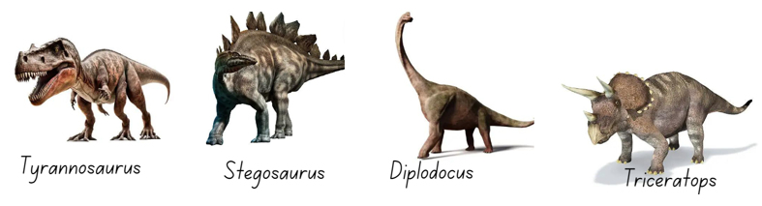

Syllabus outcomes and content

Stage 2
The table below outlines the syllabus outcomes and range of relevant syllabus content covered in this unit. Content is linked to National Numeracy Learning Progression (version 3).
Outcomes and content | 1 | 2 | 3 | 4 | 5 | 6 | 7 | 8
Representing numbers using place value B: Whole numbers: Recognise and represent numbers that are 10, 100 or 1000 times as large
[MAO-WM-01, MA2-RN-01]
- Recognise the number of tens, hundreds or thousands in a number |  |  | x
- Describe how making a number 10, 100 or 1000 times as large changes the place value of digits |  |  | x
Representing numbers using place value B: Decimals: Extend the application of the place value system from whole numbers to tenths and hundredths
[MAO-WM-01, MA2-RN-02]
- Use the decimal point as a marker to identify the position of the ones digit when expressing tenths as decimals | x | x
- Recognise that 10-tenths is recorded as 1.0 and regroup when using decimal notation |  |  |  |  |  |  | x
- Express decimals as both tenths and hundredths | x | x
- Locate and order decimals representing tenths and hundredths on a number line, describing their relative size | x | x
- Distinguish between the role of zero in various positions | x | x
Partitioned fractions A: Model and represent unit fractions, and their multiples, to a complete whole on a number line
[MAO-WM-01, MA2-PF-01]
- Model fractions with fraction strips and diagrams for halves, quarters, eighths, thirds |  |  |  |  | x | x | x
Geometric measure A: Length: Measure and compare objects using metres, centimetres and millimetres
[MAO-WM-01, MA2-GM-02]
- Measure and record lengths and distances using a combination of metres and centimetres |  | x | x
- Estimate lengths and distances using known lengths as benchmarks, in metres and centimetres and check by measuring |  | x | x
- Compare and order lengths and distances using metres and centimetres |  | x | x
- Recognise the need for a formal unit smaller than the centimetre to measure length | x
- Identify that there are 10 millimetres in one centimetre | x
- Use the millimetre as a unit to measure lengths with a ruler | x |  |  | x
- Record lengths using the abbreviation for millimetres (mm) | x |  |  | x
Geometric measure B: Length: Use scaled instruments to measure and compare lengths
[MAO-WM-01, MA2-GM-02]
- Select and use an appropriate scaled instrument to measure lengths and distances | x | x |  | x
- Use the term perimeter to describe the distance around the boundary |  |  |  | x
- Estimate and measure the perimeters of quadrilaterals |  |  |  | x
Non-spatial measure A: Mass: Compare objects using the kilogram
[MAO-WM-01, MA2-NSM-01]
- Recognise the need for a formal unit to measure mass |  |  |  |  | x | x | x | x
- Identify familiar objects that have a mass of about one kilogram |  |  |  |  | x | x | x
- Record masses using the abbreviation for kilograms (kg) |  |  |  |  |  |  | x | x
- Find objects that have an estimated mass of more than, less than and about the same as one kilogram and check by comparing to a 1 kg mass |  |  |  |  | x | x | x
Non-spatial measure B: Mass: Use scaled instruments to measure and compare masses
[MAO-WM-01, MA2-NSM-01]
- Recognise the need for a formal unit smaller than the kilogram |  |  |  |  | x
- Identify familiar objects that could be measured in grams |  |  |  |  | x | x | x | x
- Measure and record mass in grams (g) using a scaled instrument |  |  |  |  | x | x | x | x
- Interpret commonly used fractions of a kilogram, including $\frac{1}{2},$ $\frac{1}{4}$, $\frac{3}{4}$, and relate these to the number of grams |  |  |  |  |  |  |  | x
- Record masses greater than a kilogram using kilograms and grams |  |  |  |  | x |  | x | x
Mathematics K–10 Syllabus © NSW Education Standards Authority (NESA) for and on behalf of the Crown in right of the State of New South Wales, 2022.

Stage 3
The table below outlines the syllabus outcomes and range of relevant syllabus content covered in this unit. Content is linked to National Numeracy Learning Progression (version 3).
Outcomes and content | 1 | 2 | 3 | 4 | 5 | 6 | 7 | 8
Represents numbers A: Whole numbers: Recognise, represent and order numbers in the millions
[MAO-WM-01, MA2-RN-01, MA2-RN-02]
- Name millions using the place value grouping of ones, tens and hundreds |  |  | x
- Arrange numbers in the millions in ascending and descending order using place value round numbers to a specified place value |  |  | x
Represents numbers A: Decimals and percentages: Recognise that the place value system can be extended beyond hundredths
- [MAO-WM-01, MA2-RN-01, MA2-RN-02]
- Express thousandths as decimals | x | x
- Indicate the place value of digits in decimal numbers of up to 3 decimal places | x | x
Represents numbers A: Decimals and percentages: Compare, order and represent decimals
- [MAO-WM-01, MA2-RN-01, MA2-RN-02]
- Compare and order decimal numbers of up to 3 decimal places | x | x
Representing quantity fractions A: Compare and order common unit fractions
[MAO-WM-01, MA3-RQF-01]
- Compare and order unit fractions with denominators of 2, 3, 4, 5, 6, 8 and 10 by placing them on a number line |  |  |  |  | x | x | x
Geometric measure A: Length: Use metres and kilometres for length and distances
[MAO-WM-01, MA3-GM-02]
- Recognise the need for a formal unit longer than the metre for measuring distance | x
- Measure 100 metres and recognise that 10 times 100 metres is one kilometre, ie 1000 metres = 1 kilometre | x
- Estimate lengths and distances using an appropriate unit |  | x | x |  |  |  |  | x
- Record distances using the abbreviation for kilometres (km) | x |  | x |  |  |  |  | x
- Use a variety of measuring devices to measure lengths and distances in different contexts | x | x | x
Geometric measure A: Length: Measure lengths to find perimeters
[MAO-WM-01, MA3-GM-02]
- Determine which side lengths are needed to find the perimeter of a shape (Reasons about relations) |  |  | x | x
- Recognise that rectangles with the same perimeter may have different dimensions (Spatial reasoning) |  |  | x | x
Geometric measure B: Length: Convert between common metric units of length
- [MAO-WM-01, MA3-GM-02]
- Use decimal place value system to convert between metres and kilometres | x
Non-spatial measure A: Mass: Choose appropriate units of measurement for mass
[MAO-WM-01, MA3-NSM-01]
- Identify the appropriate unit and device to measure mass |  |  |  |  |  | x |  | x
- Recognise situations where mass would be measured in thousands of kilograms or tonnes (t) |  |  |  |  | x | x | x | x
Non-spatial measure A: Mass: Connect decimal representations to the metric system
[MAO-WM-01, MA3-NSM-01]
- Recognise the equivalence of whole-number and decimal representations of measurements of mass |  |  |  |  |  |  | x
- Interpret decimal notation for masses |  |  |  |  |  |  | x
- Measure mass using scales and record using decimal notation of up to 3 decimal places |  |  |  |  |  |  | x
Non-spatial measure B: Mass: Convert between common metric units of mass
[MAO-WM-01, MA3-NSM-01]
- Convert between kilograms and grams and between kilograms and tonnes |  |  |  |  | x
- Solve problems involving different units of mass |  |  |  |  | x
Mathematics K–10 Syllabus © NSW Education Standards Authority (NESA) for and on behalf of the Crown in right of the State of New South Wales, 2022.

References
This resource contains NSW Curriculum and syllabus content. The NSW Curriculum is developed by the NSW Education Standards Authority. This content is prepared by NESA for and on behalf of the Crown in right of the State of New South Wales. The material is protected by Crown copyright.
Please refer to the NESA Copyright Disclaimer for more information https://educationstandards.nsw.edu.au/wps/portal/nesa/mini-footer/copyright.
NESA holds the only official and up-to-date versions of the NSW Curriculum and syllabus documents. Please visit the NSW Education Standards Authority (NESA) website https://educationstandards.nsw.edu.au/wps/portal/nesa/home and the NSW Curriculum website https://curriculum.nsw.edu.au/.
Mathematics K–10 Syllabus © NSW Education Standards Authority (NESA) for and on behalf of the Crown in right of the State of New South Wales, 2022.
National Numeracy Learning Progression © Australian Curriculum, Assessment and Reporting Authority (ACARA) 2010 to present, unless otherwise indicated. This material was downloaded from the Australian Curriculum website (National Numeracy Learning Progression) (accessed 20/02/2024) and was not modified.
ABC (Australian Broadcasting Corporation) (1 November 2022) ‘Farm Kids’ [video], Behind the News, ABC iView, accessed 13 March 2024.
Australian Academy of Science (2024) ‘Measurement: Jump!’, Teaching resources, reSolve: Maths by Inquiry website, accessed 20 February 2024.
Downton, A, Knight R, Clarke D and Lewis G (2015) Mathematics Assessment for Learning: Rich Tasks and Work Samples, 3rd edn, Mathematics Teaching and Learning Centre, Australian Catholic University and Catholic Education office, Melbourne.
Lenchner G (2022) Creative Problem Solving in School Mathematics, Australasian Problem Solving Mathematical Olympiad (APSMO), Australia.
Maa Ki ch bete (10 October 2019) 'Long jump world record' [video], Maa Ki chu bete, YouTube, accessed 13 March 2024.
New Zealand Ministry of Education (n.d.) ‘Weighty Problems 4: Jumbo Facts’, Resource, NZ Maths website, accessed 20 February 2024.
New Zealand Ministry of Education (n.d.) ‘Making benchmarks: Length’, Resource, NZ Maths website, accessed 20 February 2024.
New Zealand Ministry of Education (n.d.) ‘Noah’s Mystery Parcel’, Resource, NZ Maths website, accessed 20 February 2024.
New Zealand Ministry of Education (n.d.) ‘Weighty Problems’, Resource, NZ Maths website, accessed 20 February 2024.
State of New South Wales (Department of Education) (2024) ‘Garden Path: Placing a decimal on a number line’ [video], accessed 17 April 2024.
State of New South Wales (Department of Education) (2023), Stage 3 Mass, NSW Department of Education website, accessed 7 March 2024.
Van de Walle J, Karp K, Bay-Williams JM, Brass A, Bentley B, Ferguson S, Goff W, Livy S, Marshman M, Martin D, Pearn C, Prodromou T, Symons D and Wilkie K (2019) Primary and Middle Years Mathematics: Teaching Developmentally, 1st Australian edn, Pearson Education Australia, Melbourne.

© State of New South Wales (Department of Education), 2024
The copyright material published in this resource is subject to the Copyright Act 1968 (Cth) and is owned by the NSW Department of Education or, where indicated, by a party other than the NSW Department of Education (third-party material).
Copyright material available in this resource and owned by the NSW Department of Education is licensed under a Creative Commons Attribution 4.0 International (CC BY 4.0) license.
This license allows you to share and adapt the material for any purpose, even commercially.
Attribution should be given to © State of New South Wales (Department of Education), 2024.
Material in this resource not available under a Creative Commons license:
- the NSW Department of Education logo, other logos, and trademark-protected material
- material owned by a third party that has been reproduced with permission. You will need to obtain permission from the third party to reuse its material.
Links to third-party material and websites
Please note that the provided (reading/viewing material/list/links/texts) are a suggestion only and implies no endorsement, by the New South Wales Department of Education, of any author, publisher, or book title. School principals and teachers are best placed to assess the suitability of resources that would complement the curriculum and reflect the needs and interests of their students.
If you use the links provided in this document to access a third-party's website, you acknowledge that the terms of use, including licence terms set out on the third-party's website apply to the use which may be made of the materials on that third-party website or where permitted by the Copyright Act 1968 (Cth). The department accepts no responsibility for content on third-party websites.

