Mathematics 3–6 Multi-age – Year A – Unit 13
Multiplicative thinking involves flexible use of multiplication and division concepts, strategies and representations

Contents
Unit description and duration 7
Syllabus outcomes 7
Stage 2 8
Stage 3 8
Working mathematically 8
Student prior learning 9
Lesson overview and resources 11
Lesson 1 20
Daily number sense – multiplicative relations – 15 minutes 20
Core lesson 1 – product patterns – 20 minutes 23
VNPS: Vertical Non-Permanent Surfaces 25
Core lesson 2 – 25 minutes 28
Stage 2 task – odd and even numbers 28
Stage 3 task – prime examples 31
Discuss and connect the mathematics – 10 minutes 35
Lesson 2 37
Daily number sense – splats – 10 minutes 37
Core lesson 1 – partially covered arrays – 15 minutes 40
Core lesson 2 – 35 minutes 44
Stage 2 task – array games 44
Stage 3 task – multiplying and dividing 46
Consolidation and meaningful practice – 10 minutes 48
Lesson 3 51
Daily number sense – reverse rolls – 15 minutes 51
Core lesson – 40 minutes 54
Stage 2 task 1 – doubling 2, 4 and 8 54
Stage 2 task 2 – number strings 59
Stage 3 task – Can I do that? 61
Consolidation and meaningful practice – 15 minutes 64
Lesson 4 67
Daily number sense – 10 minutes 67
Core lesson – 50 minutes 67
Stage 2 task – tackling times tables 67
Stage 3 task – division boxes 72
Discuss and connect the mathematics – 5 minutes 76
Lesson 5 78
Daily number sense – How much change? – 10 minutes 78
Core lesson – 40 minutes 80
Stage 2 task – bakery partitioning 80
Stage 3 task – distributive property with partial products 86
Discuss and connect the mathematics – 15 minutes 89
Lesson 6 91
Daily number sense – equivalent change – 10 minutes 91
Core lesson – 40 minutes 94
Stage 2 task – sharing 36 94
Stage 3 task – area model 1000 98
Discuss and connect the mathematics – 10 minutes 101
Lesson 7 104
Daily number sense – missing number sentence – 10 minutes 104
Core lesson – 50 minutes 107
Stage 2 task 1 – missing numbers 107
Stage 2 task 2 – games for fluency 109
Stage 3 task 1 – the athletics carnival 111
Stage 3 task 2 – ribbons for the carnival 114
Consolidation and meaningful practice – 10 minutes 117
Lesson 8 121
Daily number sense – 10 minutes 121
Core lesson – 40 minutes 121
Stage 2 task – multiplicative problem solving 121
Stage 3 task – interpreting division in worded problems 125
Discuss and connect the mathematics – 10 minutes 129
Resource 1 – How many books? 131
Resource 2 – pattern table 132
Resource 3 – caught red handed 133
Resource 4 – red handed questions 134
Resource 5 – candy possibilities 135
Resource 6 – splats 136
Resource 7 – partially covered arrays 137
Resource 8 – matching cards 138
Resource 9 – matching card templates 139
Resource 10 – doubles and halves 144
Resource 11 – doubles bingo 145
Resource 12 – Are we allowed? 146
Resource 13 – arrays 147
Resource 14 – plug board examples 148
Resource 15 – combined plug boards 149
Resource 16 – prove it’s 36 150
Resource 17 – plug boards 151
Resource 18 – What am I? 152
Resource 19 – task cards 153
Resource 20 – office catalogue 154
Resource 21 – How many cupcakes? 155
Resource 22 – a special order 156
Resource 23 – busy cupcake day 157
Resource 24 – sharing crackers 158
Resource 25 – sharing solutions 159
Resource 26 – Salute! 160
Resource 27 – fill the chart 161
Resource 28 – Open Middle problem 162
Resource 29 – carnival ribbons 163
Resource 30 – number chart 164
Resource 31 – table recording 165
Syllabus outcomes and content 166
Stage 2 166
Stage 3 171
References 175
Further reading 178

Unit description and duration
This unit develops the big idea that multiplicative thinking involves flexible use of multiplication and division concepts, strategies and representations.
In this 2-week unit, students are provided opportunities to:
- generate and describe multiplicative patterns and structures (Stage 2)
- use arrays to establish and extend multiplication facts from multiples of 2 and 4, 5 and 10 (Stage 2)
- represent and solve problems using multiplication fact families, arrays and number sentences (Stage 2)
- determine products and factors (Stage 3)
- use partitioning and place value to multiply 2-, 3- and 4-digit numbers by one-digit numbers (Stage 3)
- represent and solve division problems with whole number remainders (Stage 3).
This multi-age unit is informed by the lessons in Stage 2 Year A Unit 13 and Stage 3 Year A Unit 13. Please refer to these units for additional lesson guidance.

Syllabus outcomes
- MAO-WM-01 develops understanding and fluency in mathematics through exploring and connecting mathematical concepts, choosing and applying mathematical techniques to solve problems, and communicating their thinking and reasoning coherently and clearly

Stage 2
- MA2-RN-01 applies an understanding of place value and the role of zero to represent numbers to at least tens of thousands
- MA2-AR-01 selects and uses mental and written strategies for addition and subtraction involving 2- and 3-digit numbers
- MA2-AR-02 completes number sentences involving addition and subtraction by finding missing values
- MA2-MR-01 represents and uses the structure of multiplicative relations to 10 × 10 to solve problems
- MA2-MR-02 completes number sentences involving multiplication and division by finding missing values

Stage 3
- MAO-RN-01 applies an understanding of place value and the role of zero to represent the properties of numbers
- MA3-AR-01 selects and applies appropriate strategies to solve addition and subtraction problems
- MA3-MR-01 selects and applies appropriate strategies to solve multiplication and division problems

Working mathematically
In the Mathematics K–10 Syllabus, there is one overarching Working mathematically outcome (MAO-WM-01). The Working mathematically processes should be embedded within the concepts being taught. The Working mathematically processes present in the Mathematics K–10 Syllabus are:
- communicating
- understanding and fluency
- reasoning
- problem solving.
Mathematics K–10 Syllabus © NSW Education Standards Authority (NESA) for and on behalf of the Crown in right of the State of New South Wales, 2022.

Student prior learning
Before engaging in these teaching and learning activities, students would benefit from prior experience with:
- generating and describing patterns (Stage 2)
- using arrays to establish multiplication facts from multiples of 2 and 4, 5 and 10 (Stage 2)
- representing and solving problems involving multiplication fact families (Stage 2)
- using factors to determine whether a number is prime, composite or neither (0 or 1) (Stage 3)
- using the area model to partition numbers in multiplication problems (Stage 3)
- selecting and applying appropriate strategies to solve multiplication and division problems (Stage 3).
In NSW classrooms there is a diverse range of students, including Aboriginal and/or Torres Strait Islander students, students learning English as an additional language or dialect, high potential and gifted students and students with disability. Some students may identify with more than one of these groups or possibly all of them. Refer to Curriculum planning for every student – advice for further information.

Lesson overview and resources
To cover the content of the syllabus across Stage 2 and Stage 3, some core lessons in the unit contain both a Stage 2 and a Stage 3 task. Teachers are encouraged to adapt and contextualise the units to meet the needs of their students.
The table below outlines the sequence and approximate timing of lessons, learning intentions and resources.
Lesson | Content | Duration and resources
Lesson 1  Daily number sense  Stage 2:  - Multiplicative relations A: Represent and solve problems involving multiplication fact families  Stage 3:  - Multiplicative relations A: Select and apply strategies to divide a number with 3 or more digits by a one-digit number | Lesson core concept: multiplicative thinking is based on patterns and structures (Stage 2) and prime numbers are building blocks (Stage 3).  Stage 2:  - Multiplicative relations A: Generate and describe patterns  - Multiplicative relations A: Represent and solve problems involving multiplication fact families  Stage 3:  - Multiplicative relations A: Use partitioning and place value to multiply 2-, 3- and 4-digit numbers by one-digit numbers  - Multiplicative relations A: Determine products and factors | Lesson duration: 70 minutes  - Resource 1 – How many books?  - Resource 2 – pattern table  - Resource 3 – caught red handed  - Resource 4 – red handed questions  - Resource 5 – candy possibilities  - 20-sided dice or spinner  - Butcher’s paper  - Counters  - Different coloured markers or pens  - Individual whiteboards  - Interlocking cubes  - Writing materials
Lesson 2  Daily number sense  Stage 2:  - Multiplicative relations A: Represent and solve problems involving multiplication fact families  Stage 3:  - Multiplicative relations A: Determine products and factors | Lesson core concept: structures, known number facts and strategies can support multiplicative thinking.  Stage 2:  - Multiplicative relations A: Use arrays to establish multiplication facts from multiples of 2 and 4, 5 and 10  - Multiplicative relations A: Represent and solve problems involving multiplication fact families  Stage 3:  - Multiplicative relations A: Determine products and factors  - Multiplicative relations A: Use partitioning and place value to multiply 2-, 3- and 4-digit numbers by one-digit numbers | Lesson duration: 70 minutes  - Resource 6 – splats  - Resource 7 – partially covered arrays  - Resource 8 – matching cards  - Resource 9 – matching cards templates  - Counters  - Individual whiteboards  - Writing materials
Lesson 3  Daily number sense  Stage 2:  - Multiplicative relations A: Represent and solve problems involving multiplication fact families  Stage 3:  - Multiplicative relations A: Select and apply strategies to divide a number with 3 or more digits by a one-digit divisor | Lesson core concept: doubling is a powerful strategy (2, 4, 8 patterns) (Stage 2) and known number facts and strategies support multiplicative understanding (Stage 3).  Stage 2:  - Multiplicative relations A: Use arrays to establish multiplication facts from multiples of 2 and 4, 5 and 10  - Multiplicative relations B: Use known number facts and strategies  Stage 3:  - Multiplicative relations A: Use partitioning and place value to multiply 2-, 3- and 4-digit numbers by one-digit numbers | Lesson duration: 70 minutes  - Resource 10 – doubles and halves  - Resource 11 – doubles bingo  - Resource 12– Are we allowed?  - 1 cm grid paper  - 6-sided dice  - Individual whiteboards  - Writing materials
Lesson 4  Daily number sense  - teacher-identified task based on student needs | Lesson core concept: flexible methods of computation in multiplication and division involve composing and decomposing numbers.  Stage 2:  - Multiplicative relations A: Recall multiplication facts of 2 and 4, 5 and 10 and related division facts  - Multiplicative relations B: Use number properties to find related multiplication facts  Stage 3:  - Multiplicative relations A: Use partitioning and place value to multiply 2-, 3- and 4-digit numbers by one-digit numbers  - Multiplicative relations A: Use estimation and rounding to check the reasonableness of answers to calculations | Lesson duration: 65 minutes  - Resource 13 – arrays  - Resource 14 – plug board examples  - Resource 15 – combined plug boards  - Resource 16 – prove it’s 36  - Resource 17 – plug boards  - Resource 18 – What am I?  - Resource 19 – task cards  - Calculators  - Individual whiteboards  - Writing materials
Lesson 5  Daily number sense  Stage 2:  - Additive relations A: Represent money values in multiple ways  Stage 3:  - Additive relations A: Use estimation and place value understanding to determine the reasonableness of solutions | Lesson core concept: collections can be partitioned in more than one way (Stage 2) and structures can support multiplicative thinking (Stage 3).  Stage 2:  - Multiplicative relations B: Use number properties to find related multiplication facts  Stage 3:  - Represents numbers A: Whole numbers: Apply place value to partition, regroup and rename numbers to 1 billion  - Multiplicative relations A: Use partitioning and place value to multiply 2-, 3- and 4-digit numbers by one-digit numbers | Lesson duration: 65 minutes  - Resource 20 – office catalogue  - Resource 21 – How many cupcakes?  - Resource 22 – a special order  - Resource 23 – busy cupcake day  - Butchers paper  - Calculators  - Individual whiteboards  - Play money  - Writing materials
Lesson 6  Daily number sense  Stage 2:  - Additive relations A: Represent money values in multiple ways  Stage 3:  - Additive relations A: Use estimation and place value understanding to determine the reasonableness of solutions | Lesson core concept: multiplication and division are related (Stage 2) and mathematicians use algorithms with understanding to solve multiplicative problems (Stage 3).  Stage 2:  Multiplicative relations A: Use arrays to establish multiplication facts from multiples of 2 and 4, 5 and 10  Multiplicative relations A: Represent and solve problems involving multiplication fact families  Stage 3:  - Multiplicative relations A: Use partitioning and place value to multiply 2-, 3- and 4-digit numbers by one-digit numbers  - Multiplicative relations A: Select and apply mental and written strategies to multiply 2- and 3-digit numbers by 2-digit numbers | Lesson duration: 60 minutes  - Resource 20 – office catalogue  - Resource 24 – sharing crackers  - Resource 25 – sharing solutions  - Website: online area model tool  - 6-sided dice  - Calculators  - Counters or square tiles  - Individual whiteboards  - Play money  - Writing materials
Lesson 7  Daily number sense  Stage 2:  - Additive relations A: Represent money values in multiple ways  Stage 3:  - Additive relations A: Use estimation and place value understanding to determine the reasonableness of solutions | Lesson core concept: fact families support fluency (Stage 2) and Euclidean division emphasises the relationship between multiplication and division (Stage 3).  Stage 2:  - Multiplicative relations A: Recall multiplication facts of 2 and 4, 5 and 10 and related division facts  - Multiplicative relations A: Represent and solve problems involving multiplication fact families  Stage 3:  - Multiplicative relations A: Represent and solve division problems with whole number remainders | Lesson duration: 70 minutes  - Resource 11 – doubles bingo  - Resource 20 – office catalogue  - Resource 26 – Salute!  - Resource 27 – fill the chart  - Resource 28 – Open Middle problem  - Resource 29 – carnival ribbons  - Resource 30 – number chart  - Resource 31 – table recording  - 1–10 die  - Digital devices  - Individual whiteboards  - Play money  - Writing materials
Lesson 8  Daily number sense  - teacher-identified task based on student needs | Lesson core concept: problems can be solved using multiplicative thinking.  Stage 2:  - Multiplicative relations A: Represent and solve problems involving multiplication fact families  - Multiplicative relations B: Represent and solve word problems with number sentences involving multiplication or division  Stage 3:  - Multiplicative relations A: Select and apply strategies to divide a number with 3 or more digits by a one-digit divisor | Lesson duration: 60 minutes  - Individual whiteboards  - Writing materials

Lesson 1
Core concept: multiplicative thinking is based on patterns and structures (Stage 2) and prime numbers are building blocks (Stage 3).

Daily number sense – multiplicative relations – 15 minutes
Daily number sense activities for Lessons 1 to 3 ‘activate’ prior number knowledge and support the learning of new content in the unit. These activities can also assist teachers to identify the starting points for learning by revealing the extent of students’ existing knowledge.
The table below contains suggested learning intentions and success criteria. These are best co-constructed with students.
Daily number sense learning intentions | Daily number sense success criteria
Students working towards Stage 2 outcomes are learning to:  - represent and solve problems involving multiplication fact families.  Students working towards Stage 3 outcomes are learning to:  - select and apply strategies to divide a number with 3 or more digits by a one-digit divisor. | Students working towards Stage 2 outcomes can:  - describe multiplication problems using for each and times as many  - find the total of partially covered arrays.  Students working towards Stage 3 outcomes can:  - use knowledge of multiples to partition as appropriate and divide  - apply and record appropriate strategies to solve division word problems.
- Explain to Stage 2 students that Sam’s school is participating in the Premier’s Reading Challenge. He is trying to work out how many books he and his friends have read.
- Display Resource 1 – How many books? Read the first 2 problems aloud.
- In pairs, Stage 2 students find solutions to the first 2 problems using counters if needed.
- Discuss the solutions, comparing the strategies that students used.
- Stage 2 students complete the other questions on Resource 1 – How many books? and share their strategies and solutions.
- Pose the following problem to Stage 3 students: A new school has 128 Kindergarten students starting next year. They need to be allocated equally into one of the 4 sports groups. How many students will be in each sport group?
- Provide Stage 3 students with individual whiteboards and ask them to use partitioning to solve the problem (see Figure 1).
Figure 1 – Stage 3 sample partitioning
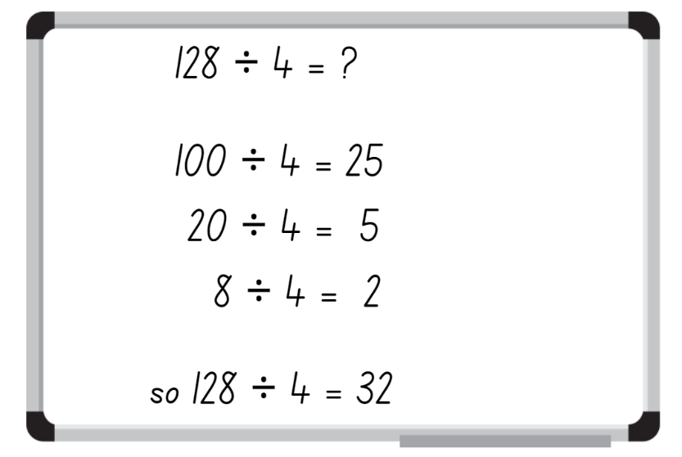
- Stage 3 students turn and talk to compare and justify their answer with a partner.
- Pose the following problem to Stage 3 students: There are 136 Year 1 students at this school. These students also need to be allocated equally into one of the 4 sports groups. How many students will be in each sport group?
- Stage 3 students record on a whiteboard how to use partitioning to solve this problem.
- Stage 3 students turn and talk to compare and justify their answer with a partner.

This table details opportunities for assessment.
Assessment opportunities | Links
What to look for:  - Can Stage 2 students describe multiplication problems using for each and times as many? [MAO-WM-01, MA2-MR-01]  - Can Stage 2 students find the total of partially covered arrays? [MAO-WM-01, MA2-MR-01]  - Can Stage 3 students use knowledge of multiples to partition as appropriate and divide? [MAO-WM-01, MA3-MR-01]  - Can Stage 3 students apply and record appropriate strategies to solve division word problems? [MAO-WM-01, MA3-MR-01] | Links to National Numeracy Learning Progressions (NNLP):  - Stage 2 – MuS5  - Stage 3 – MuS6, MuS7, MuS8.  Links to suggested Interview for Student Reasoning (IfSR) tasks:  - Stage 2 – IfSR-MT: 2A.1, 2A.12, 2A.13, 2A.14  - Stage 3 – IfSR-MT: 3A.6, 3A.7.

Core lesson 1 – product patterns – 20 minutes
The table below contains suggested learning intentions and success criteria. These are best co-constructed with students.
Core concept learning intentions | Core concept success criteria
Students working towards Stage 2 outcomes are learning to:  - generate and describe patterns.  Students working towards Stage 3 outcomes are learning to:  - determine products and factors. | Students working towards Stage 2 outcomes can:  - model, describe and record patterns of multiples  - recognise the significance of the final digit of a whole number in determining whether a given number is even or odd  - recognise the connection between even numbers and the multiplication facts for 2.  Students working towards Stage 3 outcomes can:  - determine factors for a given whole number  - determine whether a number is prime, composite or neither.

VNPS: Vertical Non-Permanent Surfaces
Using Vertical Non-Permanent Surfaces (VNPS) is a practice to enhance students’ mathematical thinking and communication. VNPS provide a space where groups of students stand, collaboratively develop solutions and share their mathematical reasoning. This practice encourages students to actively communicate their thinking within and across groups, increases student autonomy and lowers the stakes for making mistakes. Other techniques to support this practice include using one marker per group, alternating writers and encouraging groups to compare thinking on each other’s VNPS (Liljedahl 2021). This approach aligns with many of the practices for Setting up Positive Norms in Math Class (PDF 1.18 MB) (Boaler 2022).
This lesson is an adaptation of ‘Playing with pairs’ from Mindset Mathematics: Visualizing and Investigating Big Ideas, Grade 3 by Boaler et al. If your class prepared an anchor chart for Stage 2 – Unit 7, display and review this chart prior to starting this lesson. This part of the lesson is an opportunity for students to use VNPS to collaborate.
- Revise the meaning of the word product.
Product: the result of multiplying 2 or more numbers together. For example, 12 is the product of 4 × 3.
- Explain that students will complete 2 investigations to look for patterns in addition and in multiplication.
- Present the first investigation: Select 2 numbers that add up to 10. What might you get if you multiply these numbers?
- Ask students:
- Can you think of an example? (7 + 3 = 10; 7 × 3 = 21).
- How can you represent the products? (drawings, arrays, number sentences)
- How can you organise your responses to look for patterns? (a table)
- Pairs of students select numbers that add to 10 and write the product of those numbers on the VNPS (butcher’s paper or whiteboards), using the ideas from the previous discussion.
- Ask Stage 3 students if there is more than one way to make the product. For example, if 6 and 4 are selected, the product is 24. Stage 3 students identify that 24 is also the product of 8 × 3, 12 × 2 and 24 × 1.
- Stage-based groups are to investigate the following questions:
- What products are possible?
- What is the largest product?
- What is the smallest product?
- What patterns do you notice in the products? (The products get larger, then smaller. The products are in an odd/even pattern).
- Were there any products that had only one pair of products? (Stage 3)
- As a class, make a list of the patterns that students notice.
- Present the second investigation: Will the patterns be the same for a sum other than 10?
- Students turn and talk to answer:
- Can you think of an example? 7 + 4 = 11; 7 × 4 = 28
- Do you think the patterns will be the same? Why or why not?
- Will the patterns be the same for all numbers? Why or why not?
- Assign the numbers 11, 12, 13, 14 or 15 to pairs of students to investigate.
Note: ensure Stage 3 students are allocated 12 or 14 so that their number pairs include prime numbers. For example, 11 + 1 = 12, 11 × 1 = 11, and 13 + 1= 14, 13 × 1 = 13. Stage 3 students explore prime numbers in more detail in Core lesson 2.
- Stage 3 students consider the products and identify any that are only divisible by the product and one (prime numbers).
- Once completed, conduct a gallery walk to consider the questions:
- What patterns are always true?
- Are there patterns that only apply to certain numbers?
- How has your thinking changed from the beginning of the lesson?
- Did you notice any products that were only divisible by the number and one? (Stage 3)
- Keep the VNPS on display for Stage 2 students in Core lesson 2.

Core lesson 2 – 25 minutes

Stage 2 task – odd and even numbers
Note: a conceptual understanding of number properties, including odd and even numbers, supports student understanding of later syllabus content. This includes divisibility and prime numbers.
- Support students to revise and co-construct a definition of odd and even to help identify odd and even numbers. For example:
- An even number is divisible by 2 and ends in 2, 4, 6, 8, 0.
- An odd number is a number that is not divisible by 2 (without a remainder) and ends in 1, 3, 5, 7, 9.
- Draw attention to the connection between even numbers and the multiplication facts for 2.
- Provide students with 2 different coloured markers or pens.
- Students return to their earlier investigations to circle or underline the odd and even numbers to answer the following questions:
- What rules can you identify about adding odd or even numbers?
- What rules can you identify about multiplying odd or even numbers?
- Once complete, discuss the rules identified by students.

The table below outlines stimulus prompts to generate conversation about the topic, along with anticipated responses from students.
Prompts | Anticipated student responses
- What rules can you say about addition? | - Odd + odd = even  - Even + even = even  - Odd + even = odd
- Why do these addition rules work? | - Even + even: since both numbers can be divided by 2, the total will also be divisible by 2, making the total even.  - Odd + odd: since an odd number is an even number + 1, when you add 2 odd numbers you end up with an even number + 2.  - Odd + even: since an odd number is an even number + 1, you end up with even + even + 1, making the total impossible to divide by 2 without a remainder.
- What rules can you say about multiplication? | - Odd × odd = odd  - Even × even = even  - Odd × even = even
- Why do these multiplication rules work? | - Odd × odd: if you have an array with an odd number of rows, and an odd number in each row, such as 3 × 5, there is no way to divide this into 2 without a remainder.  - Even × even/odd: any array with an even number of rows can always be split into 2 equal groups with no remainder.
- Add the rules to the class anchor chart from Multi-age Year A Unit 7 or create a display for future reference.
This table details opportunities for differentiation.
Too hard? | Too easy?
Students cannot model, describe and record patterns of multiples.  - For Core lesson 1, provide Resource 2 – pattern table for students to complete. Students may draw representations of products in the blank space provided, if needed.  - For Core lesson 2, model the use of concrete materials for 2 × 8, and 3 × 7 in arrays. Establish that 16 can be divided by 2 but 21 cannot. Link to the commutative property of 8 × 2 and 7 × 3. | Students can model, describe and record patterns of multiples.  - Students investigate to determine rules and explanations for adding and multiplying 3 numbers, such as odd + odd + odd and odd × odd × odd.  - Provide students with Resource 3 – caught red handed. After 5 games, present the questions on Resource 4 – red handed questions for students to consider.

Stage 3 task – prime examples
This lesson is an adaptation of Liquorice Factory from Arc Learning Sequences by the State Government of Victoria (Department of Education).
- Explain to students: A lolly shop produces traditional rock candy by hand-rolling and stretching lengths of candy. The shop owner has decided to increase productivity by buying machines that stretch the candy. The shop owner has purchased 3 machines that produce × 2, × 3 and × 5 lengths of candy (see Figure 2).
Figure 2 – example of a × 2 and × 3 machine
- Provide students with interlocking cubes and explain that each cube represents a single unit length of candy.
- Demonstrate, for example, what would happen if a single block of candy was put through the × 2 machine followed by the × 3 machine? (The candy will double in the × 2 machine and then triple in the × 3 machine, producing a length equal to 6 units, or 6 times as long). See Figure 3.
Figure 3 – demonstration of different machines
- Students use interlocking cubes to demonstrate what would happen if they passed one unit of candy through a × 2 machine twice and then through a × 3 machine.
- Students turn and talk and compare representations.
- Ask the following questions:
- What candy lengths cannot be made with these machines?
- Why is it not possible to make a candy with the length of 61 units?
Note: ensure students understand that 61 is a prime number and it cannot be made using the × 2, × 3 or × 5 machines. The only factors for 61 are one and 61.
Prime number: a prime number is a positive integer which has exactly 2 distinct factors, itself and one. Modelled as an array, it has only one row. Zero is not an integer and therefore is neither prime nor composite.
Composite number: a non-zero natural number that has a factor other than one and itself. For example, all even numbers besides 2 are composite numbers. Some odd numbers are composite (for example, 21).
- Explain that the lolly shop owner has decided to purchase more machines to increase candy production. The factory can now produce any unit length of candy from 2–60 units long. As each piece of candy starts as one unit length, a machine for one is not needed but the one unit is included in all processes.
- Display Resource 5 – candy possibilities and inform students that each number represents a length of candy.
- Ask what different machines could make candy that is 12 units in length.
- Use the following think aloud strategy: To make a candy 12 units long, I could use the × 2 machine, then the × 6 machine, so I am going to record 2 and 6. I could also use the × 3 machine and the × 4 machine, so I will record 3 and 4 in my list. I could also use the × 12 machine so I will record one and 12 on my list (see Figure 4).
- Explain to students that the number 12 is a composite number as it has more than one factor.
Figure 4 –candy possibilities recording example
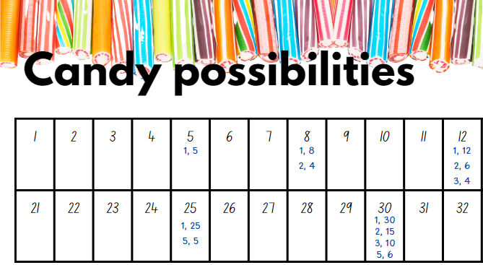
- Provide students with Resource 5 – candy possibilities.
- In pairs, students select and record some of the different combinations of machines that can be used to make lengths of candy between one and 60. Guide students to have at least 2 of the blue shaded numbers (prime numbers) in their selection. The prime number 5 is shown in Figure 4.
- Discuss the different combinations used to create the lengths of candy and ask students if they discovered any candy lengths that could only be made using one machine. Define these numbers as prime numbers and compare to composite numbers. Refer to the definition at the start of the lesson. Include in the discussion the fact that zero and one are neither prime nor composite.

This table details opportunities for differentiation.
Too hard? | Too easy?
Students cannot determine factors for a given whole number.  - Support students to model the doubling and tripling effect of the × 2 machine and the × 3 machine.  - Assist students to use a 6-sided die to generate 2 factors by rolling the die twice. Students multiply to determine the product (length of candy). If the second roll lands on the same number as the first roll, students roll again. | Students can determine factors for a given whole number.  - Students roll a 10-sided die 3 times to create a 3-digit number and record all the factors for the number.  - Pose the problem: One of the × 4 machines broke down overnight. They have had an order to produce candy that is 512 units in length. How can the lolly shop meet the demands of this order? Which machines will they use?

Discuss and connect the mathematics – 10 minutes
- Discuss the following questions with Stage 2:
- Kaija multiplies 2 numbers together and the product is even. What do we know about the numbers being multiplied together?
- How can odd and even patterns help us with calculations?
- Select a composite number between one and 100 and ask Stage 3 students (in pairs) to discuss the most efficient way to create a candy of the selected length. For example, a candy with 25 units of length can be created using the × 5 machine, passing through it twice.

This table details opportunities for assessment.
Assessment opportunities | Links
What to look for:  - Can Stage 2 students model, describe and record patterns of multiples? [MAO-WM-01, MA2-MR-01, MA2-MR-02]  - Can Stage 2 students recognise the significance of the final digit of a whole number in determining whether a given number is even or odd? [MAO-WM-01, MA2-MR-01, MA2-MR-02]  - Can Stage 2 students recognise the connection between even numbers and the multiplication facts for 2? [MAO-WM-01, MA2-MR-01, MA2-MR-02]  - Can Stage 3 students determine factors for a given whole number? [MAO-WM-01, MA3-MR-01]  - Can Stage 3 students determine whether a number is prime, composite or neither? [MAO-WM-01, MA3-MR-01] | Links to National Numeracy Learning Progressions (NNLP):  - Stage 2 – NPA3, NPA4  - Stage 3 – MuS6, MuS7.

Lesson 2
Core concept: structures, known number facts and strategies can support multiplicative thinking.

Daily number sense – splats – 10 minutes
The table below contains suggested learning intentions and success criteria. These are best co-constructed with students.
Daily number sense learning intentions | Daily number sense success criteria
Students working towards Stage 2 outcomes are learning to:  - represent and solve problems involving multiplication fact families.  Students working towards Stage 3 outcomes are learning to:  - determine products and factors. | Students working towards Stage 2 outcomes can:  - apply the inverse relationship of multiplication and division.  Students working towards Stage 3 outcomes can:  - model different ways to show a whole number as a product  - determine factors for a given whole number.
This activity is an adaptation of Splat by Wyborney.
- Display Resource 6 – splats.
- Explain that some of the arrays are hidden by a ‘splat’ and the total number of dots in each image is shown in the circle.
- Students turn and talk to identify the complete array hidden by the splat.
- Discuss solutions, comparing the strategies that students used. Students explain their thinking that accompanied each strategy.
Multi-age: students working towards Stage 3 outcomes choose at least 2 splats and rearrange the arrays in as many ways as possible, modelling different ways to show a whole number as a product. This may be done using counters or by drawing solutions. The link to factors should be made and factors recorded for each product.
The table below outlines stimulus prompts to generate conversation about the topic, along with anticipated responses from students.
Prompts | Anticipated student responses
- Splat A | - I think the array is 4 fives. The last row of 5 is almost visible. There would be 4 fives altogether. I know that 4 fives is 20, so that makes sense.
- Splat B | - I think the array is 4 sixes. It is clearly 4 rows, but 4 more than Splat A, so each row should be one longer than 5. Also, I know that 4 sixes are 24.
- Splats C, D and E | - Reasons and explanations will vary but should reflect language suitable for arrays.
- Ask students:
- How is the splat like a fact family triangle?
- How can the inverse relationship between multiplication and division help us with this task?
This table details opportunities for assessment.
Assessment opportunities | Links
What to look for:  - Can Stage 2 students apply the inverse relationship of multiplication and division? [MAO-WM-01, MA2-MR-01,  MA2-MR-02]  - Can Stage 3 students model different ways to show a whole number as a product? [MAO-WM-01, MA3-MR-01]  - Can Stage 3 students determine factors for a given whole number? [MAO-WM-01, MA3-MR-01] | Links to National Numeracy Learning Progressions (NNLP):  - Stage 2 – MuS7  - Stage 3 – MuS6, MuS7.  Links to suggested Interview for Student Reasoning (IfSR) tasks:  - Stage 2 – IfSR-MT: 2A.5, 2A.10  - Stage 3 – IfSR-MT: 2A.7, 3A.8.

Core lesson 1 – partially covered arrays – 15 minutes
The table below contains suggested learning intentions and success criteria. These are best co-constructed with students.
Core concept learning intentions | Core concept success criteria
Students working towards Stage 2 outcomes are learning to:  - recognise and represent numbers that are 10, 100 or 1000 times as large  - use arrays to establish multiplication facts from multiples of 2 and 4, 5 and 10  - represent and solve problems involving multiplication fact families.  Students working towards Stage 3 outcomes are learning to:  - determine products and factors  - use partitioning and place value to multiply 2-, 3- and 4-digit numbers by one-digit numbers. | Students working towards Stage 2 outcomes can:  - describe how making a number 10, 100 or 1000 times as large changes the place value of digits  - create and represent multiplicative structures, using the term multiples when connecting grouping to arrays  - use the array structure to coordinate the number of groups with the number in each group  - find the total of partially covered arrays.  Students working towards Stage 3 outcomes can:  - use the term product to describe the result of multiplying 2 or more numbers  - use mental strategies to multiply one-digit numbers by 10, 100, 1000 and their multiples  - estimate the product of 2 numbers (one-digit by 2- or 3-digit numbers) using multiples of 10 or 100.
- Remind students of the meaning of an array.
Array: an array is used to model multiplicative situations involving whole numbers. It is made by arranging a set of objects into columns and rows. Each row must contain the same number of objects as the other rows, and each column must contain the same number of objects as the other columns.
- Display Resource 7 – partially covered arrays.
- Students turn and talk to discuss:
- How many counters are displayed in Array A? (30).
- How did you calculate the total? (Responses may include: 5 × 6, double 5 × 3).
- What fact family triangle would go with this array? (see Figure 5).
Figure 5 – fact family triangle
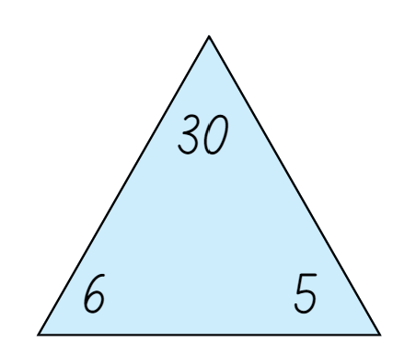
- Explain that for this fact family triangle (Figure 5 above), 30 is the product of multiplying 6 and 5.
- Write the equation 6 × 5 = 30 on the whiteboard. Then, write 6 × 50 = _.
- Teacher thinks aloud: I know 6 × 5 is 30, and 50 is 10 times larger than 5, so the answer must be 10 times larger than 30.
- Ask students to determine the answer to the question.
- Using this information, students complete the following equations recognising and representing numbers that are 10, 100 and 1000- times as large:
- 60 × 5 =
- 600 × 5 =
- 60 × 50 =
- 6 × 5000 =
Note: the purpose of this activity is for students to realise that the answer for additional equations will be ‘3’ ‘0’ something. For the first equation, students can use estimation to see that the answer is more than 100, but less than 1000, so the answer is 300.
- Ask students:
- If 6 × 5 = 30, how did you work out 6 × 50?
- What did you notice about the products?
- Do you notice any similarities or differences between the equations?
- Do you see a pattern as you solve the equations?
- How did identifying numbers that are 10 or 100 times as large help to determine the answers?
- Focus students' attention on Array B and ask the following questions:
- What is different?
- What is still the same?
- Explain that even though the card covers the dots, the quantity remains the same.
- Focus students' attention on Array C.
- Explain that this is called a partially covered array. The dots are covered by the card, leaving 2 edges of the array visible. Ask students:
- Has the number of dots changed from Array A or B? How do you know?
- How does seeing the edges help you calculate the total?
- Can you use the same strategies you used for Array A?
- Does the same fact family triangle still apply? (see Figure 5 above).

Core lesson 2 – 35 minutes

Stage 2 task – array games
Note: for 2 examples of partially covered arrays in games, see Go fish! – partially covered arrays or Math Cards (3-6).
- Display Resource 8 – matching cards.
- Revise and establish that the 4 cards are representations of the same multiplicative idea.
- Display Resource 9 – matching cards templates.
- Explain that there are 6 sets of 4 matching cards. There are also some blank templates for students to make their own sets.
- Organise the students into groups of 3 or 4.
- For each group, distribute one copy of Resource 9 – matching card templates and writing materials.
- Using the cards provided, students arrange them in sets of 4 matching cards.
- Groups then choose a number appropriate for their level of understanding. They use the blank card templates to make their own set of matching cards.
- Once students have made their cards, they play ‘Go fish’ or matching games with the cards.
This table details opportunities for differentiation.
Too hard? | Too easy?
Students cannot use arrays to establish multiplication facts from multiples of 2 and 4, 5 and 10.  - Use concrete materials to make the connection between equal groups and the array structure. Students skip count rows in the arrays they construct to determine the total.  - Students use the dot arrays interactive as another resource to support their thinking. | Students can use arrays to establish multiplication facts from multiples of 2 and 4, 5 and 10.  - Expand the content of the matching cards to other multiplication facts.  - Expand contexts for multiplication by selecting activities from the Open Middle web page such as Building Shelves 1 and Building Shelves 2.

Stage 3 task – multiplying and dividing
This lesson is an adaptation of ‘Multiplying numbers by 10, 100 …’ from Building engagement in middle years mathematics: Learning sequences for mixed-ability classrooms by Sullivan.
- Using the information from Core lesson 1, students complete the following equations without written working out:
- 30 ÷ 5 =
- 300 ÷ 6 =
- 300 ÷ 50 =
- 3000 ÷ 5 =
- 3000 ÷ 60 =
- Ask students:
- If 6 × 5 = 30, how did you work out 30 ÷ 5?
- How did your knowledge of multiplication and division help you solve these equations?
- What did you notice about the products?
- How did the pattern help to predict what would happen when changing from multiplication to division?
- Pose the question: I am thinking of 2 numbers. One of the numbers has a zero in the units place. When I multiply the 2 numbers, the product is 120. What might the numbers be?
- Students turn and talk to discuss solutions and record their ideas on individual whiteboards.
- Select students to share their solutions and communicate their strategies.
- Pose the question: I am thinking of 2 numbers. One of them has a 4 in it. When I multiply the 2 numbers, the product is 800. What might the numbers be?
- Students turn and talk to discuss solutions and record their ideas on whiteboards.
- Select students to share their solutions and to communicate their strategies.
This table details opportunities for differentiation.
Too hard? | Too easy?
Students cannot use mental strategies to multiply one-digit numbers by 10, 100, 1000 and their multiples.  - Provide resources such as a number slider, hundreds and/or multiplication charts to support multiplicative understanding.  - Support students to focus on multiplying and dividing one-digit numbers by 10 and its multiples. | Students can use mental strategies to multiply one-digit numbers by 10, 100, 1000 and their multiples.  - In pairs, students provide a starting equation for their partner to apply the same strategies as above. For example, student A provides 9 × 5 = 45. Student B completes additional equations to reflect their understanding of 10, 100, 1000 and their multiples.  - Students create their own word problems to determine the factors and products. Encourage students to write statements about each factor and product. For example, I am thinking of 2 numbers. One of the numbers is a prime number. The other number has a zero in the units place. One of the numbers has a 7 in the units place. When I multiply the 2 numbers, the product is 170. What might the numbers be?

Consolidation and meaningful practice – 10 minutes
- Pose the following question to Stage 2 students: Sarah planted 24 seeds in her garden in equal rows. How many seeds are in each row? Find all the possible answers.
- Pose the following question to Stage 3 students: I am thinking of 2 numbers. One of the digits in one of the numbers is 5. When I divide the 2 numbers, the quotient is 4. What might the numbers be?
- Students Error! Hyperlink reference not valid. to discuss solutions and record their ideas on whiteboards.
- Select students to respond. Draw a partially covered array, a fact family triangle and a number sentence to match student responses.
- Identify the commutative property of multiplication for Stage 2 students so that 24 can also be 6 fours and 8 threes. Some students may suggest one row of 24, or 2 twelves and 12 twos.

This table details opportunities for assessment.
Assessment opportunities | Links
What to look for:  - Can Stage 2 students describe how making a number 10, 100 or 1000 times as large changes the place value of digits  [MAO-WM-01, MA2-RN-01]  - Can Stage 2 students create and represent multiplicative structure, using the term multiples when connecting grouping to arrays? [MAO-WM-01, MA2-MR-01]  - Can Stage 2 students use the array structure to coordinate the number of groups with the number in each group? [MAO-WM-01, MA2-MR-01]  - Can Stage 2 students find the total of partially covered arrays? [MAO-WM-01, MA2-MR-01]  - Can Stage 3 students use the term product to describe the result of multiplying 2 or more numbers? [MAO-WM-01, MA3-MR-01]  - Can Stage 3 students use mental strategies to multiply one-digit numbers by 10, 100, 1000 and their multiples? [MAO-WM-01, MA3-MR-01]  - Can Stage 3 students estimate the product of 2 numbers (one-digit by 2- or 3-digit numbers) using multiples of 10 or 100?  [MAO-WM-01, MA3-MR-01] | Links to National Numeracy Learning Progressions (NNLP):  - Stage 2 – MuS5  - Stage 3 – MuS6, MuS7.  Links to suggested Interview for Student Reasoning (IfSR) tasks:  - Stage 2 – IfSR-MT: 2A.1  - Stage 3 – IfSR-MT: 3A.1, 3A.2, 3A.3.

Lesson 3
Core concept: doubling is a powerful strategy (2, 4, 8 patterns) (Stage 2) and known number facts and strategies support multiplicative understanding (Stage 3).

Daily number sense – reverse rolls – 15 minutes
The table below contains suggested learning intentions and success criteria. These are best co-constructed with students.
Daily number sense learning intentions | Daily number sense success criteria
Students working towards Stage 2 outcomes are learning to:  - represent and solve problems involving multiplication fact families.  Students working towards Stage 3 outcomes are learning to:  - select and apply strategies to divide a number with 3 or more digits by a one-digit divisor. | Students working towards Stage 2 outcomes can:  - apply the inverse relationship of multiplication and division.  Students working towards Stage 3 outcomes can:  - apply and record appropriate strategies to solve division word problems  - use and interpret remainders in solutions to division problems.
Multi-age: students will use numbers appropriate to stage outcomes and undertake different strategies to consider multiplication (Stage 2) and division (all students).
- Pairs of students to roll dice to create number problems to solve.
- Provide Stage 2 students with grid paper, and all students with individual whiteboards to record strategies and solve the equations.
- Stage 2 students roll two 6-sided dice once, to find 2 numbers.
- Stage 2 students use the numbers to draw an array on grid paper and write corresponding multiplication number sentences. For example, if a 4 and a 6 is rolled, draw an array as 4 rows of 6 dots and write 4 × 6 = 24. Remind students that rotating the grid paper shows the equivalent array of 6 × 4 = 24.
- Stage 3 students roll two 6-sided dice twice and create one 3-digit number and one single-digit number. Students write a division problem on their whiteboard, dividing the 3-digit number by the single digit number. For example, 123 ÷ 6 = ?.
- Stage 3 students to estimate the solution and determine if there will be a remainder, before they discuss a strategy to solve the problem.
Multi-age: although Stage 3 students are learning about division, the following reminder about inverse operations may add to their discussion about division strategies.
- Remind students about the meaning of inverse operation.
Inverse operation: the operation that reverses the effect of another operation. For example, multiplication and division are inverse operations. When you multiply 6 by 2 you get 12. If you then divide by 2 you get back to 6.
- Show how division is the inverse of multiplication by writing 24 ÷ 4 = 6 and separating the array of 24 dots into 4 rows of 6 dots.
- Show the rotated array of 6 fours can be divided into 6 rows of 4 dots, or 24 ÷ 6 = 4.
- In pairs, all students take turns to roll the dice and repeat the task with new numbers.
- Stage 2 partners work inversely by writing a division number sentence to return to the original numbers. They represent this by drawing lines to break the array into the original values from the number sentence (see Figure 6).
Figure 6 – reverse rolls
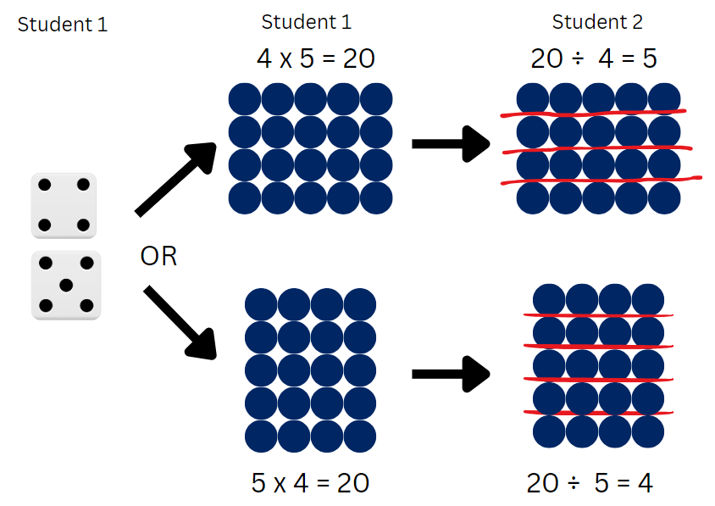
- Stage 2 students swap roles and repeat the activity.
This table details opportunities for assessment.
Assessment opportunities | Links
What to look for:  - Can Stage 2 students apply the inverse relationship of multiplication and division? [MAO-WM-01, MA2-MR-01,  MA2-MR-02]  - Can Stage 3 students apply and record appropriate strategies to solve division word problems? [MAO-WM-01, MA3-MR-01]  - Can Stage 3 students use and interpret remainders in solutions to division problems? [MAO-WM-01, MA3-MR-01] | Links to National Numeracy Learning Progressions (NNLP):  - Stage 2 – MuS7  - Stage 3 – MuS6, MuS7, MuS8.

Core lesson – 40 minutes

Stage 2 task 1 – doubling 2, 4 and 8
The table below contains suggested learning intentions and success criteria. These are best co-constructed with students.
Core concept learning intentions | Core concept success criteria
Students are learning to:  - use arrays to establish multiplication facts from multiples of 2 and 4, 5 and 10  - use known number facts and strategies. | Students can:  - relate doubling to multiplication facts for multiples of 2  - recognise that doubling is multiplying by 2 and halving is dividing by 2  - recognise the relationship between one multiple and its double  - apply the known strategy of doubling to connect multiples of 4 to 8.
- Students read aloud as the first 10 multiples of 2, 4 and 8 are written on the board, keeping the multiples aligned, as follows:
- Two: 2, 4, 6, 8, 10, 12, 14, 16, 18, 20
- Four: 4, 8, 12, 16, 20, 24, 28, 32, 36, 40.
- Eight: 8, 16, 24, 32, 40, 48, 56, 64, 72, 80.
- Revise the meaning of the words pattern, multiples and product.
Pattern: a pattern in mathematics is made up of a number of elements that repeat or follow a rule.
Multiples: products formed using the same base number multiplied by different whole numbers, for example, 3, 6, 9, 12 …
Product: the result of multiplying 2 or more numbers together, for example, 12 is the product of 4 × 3.
- Discuss the pattern rule for each row, identifying that the pattern grows by + 2, + 4 and + 8 respectively.
- Explain that each multiple is a product of its position in the pattern, for example 1 × 2 = 2, 8 × 2 = 16.
- Students turn and talk to answer the following:
- What patterns can you see in each multiple list?
- What patterns can you see between each multiple list?
- What do you notice about the final number in each list (20, 40, 80)?
The table below outlines stimulus prompts to generate conversation about the topic, along with anticipated responses from students.
Prompts | Anticipated student responses
- What patterns can you see in each multiple list? | - All multiples: the numbers are all even.  - Twos: 2, 4, 6, 8, 0 for last digit.  - Twos: the tens are repeated every 5 steps.  - Twos: there is a doubles pattern 2, 4, 8, 16.  - Fours: 4, 8, 2, 6, 0 for last digit.  - Fours: the tens are repeated every 5 steps.  - Fours: there is a doubles pattern 4, 8, 16, 32.  - Eights: 8, 6, 4, 2, 0 for last digit.  - Eights: the tens are repeated every 5 steps.  - Eights: there is a doubles pattern 8,16, 32, 64.
- What patterns do you see between each multiple list? | - Some numbers appear in 2 rows.  - 8 and 16 appear in all 3 rows.  - 2 doubles to 4, which doubles to 8.  - Each item in the row doubles if you read the columns down, such as 20, 40, 80 (see Figure 7).  - Each item in the row halves if you read the columns up (see Figure 7).
- What do you notice about the final number in each list? | - They are 10 times the starting number.  - They are 10 twos, 10 fours and 10 eights.  - 20 doubles to 40 doubles to 80 in the same pattern as 2, 4, 10.
Figure 7 – example of responses
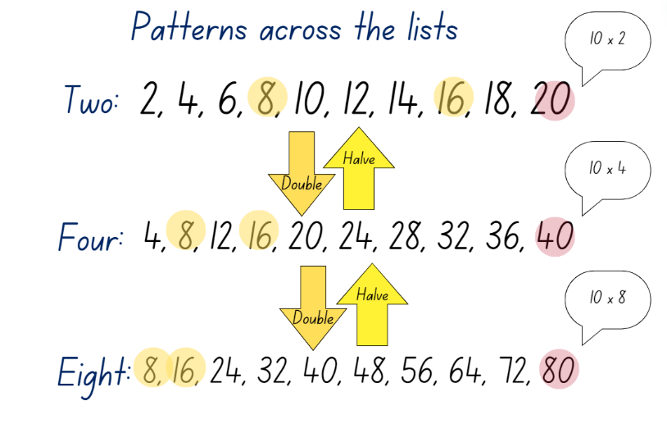
- Explicitly draw out the doubling and halving relationship between each set of multiples.
- Display Resource 10 – doubles and halves.
- Students turn and talk to discuss the relationships between the arrays and the triangles.
- Select students to share their responses, drawing out the doubling and halving patterns, such as those shown in Figure 8.
Figure 8 – doubling is powerful
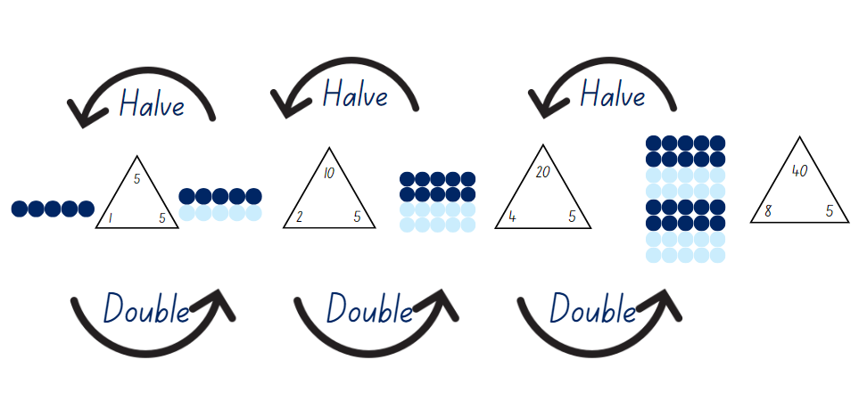
- Repeat the doubling process using other starting numbers, as appropriate for the learning needs of the class.

Stage 2 task 2 – number strings
Note: for teachers unfamiliar with the structure and purpose of number strings, read the Number strings factsheet and/or view Number Strings to Encourage Multiplication Strategies – Part 1 (7:10) and Number Strings to Encourage Multiplication Strategies – Part 2 (8:53).
- Provide students with individual whiteboards and writing materials.
- Explain that a series of multiplication statements will be displayed for students to calculate. They should use doubling or halving to help with each calculation.
- Use the string displayed in Figure 9 or design one to suit the learning needs of the class.
Figure 9 – sample number string
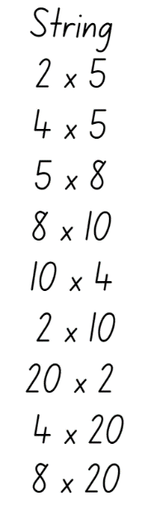
- Display one number sentence at time.
- For each statement, select students to share their response and reasoning. Invite multiple approaches for each statement.
- When moving to the next statement, leave the previous question and answer visible for students to use when solving the next problem.

This table details opportunities for differentiation.
Too hard? | Too easy?
Stage 2 students cannot recognise that doubling is multiplying by 2 and halving is dividing by 2.  - Guide students to draw double and double/doubles of dot dice patterns.  - Guide students to recreate the whole if given the half. For example, ‘If 3 dots are half, what is the whole?’ | Stage 2 students can recognise that doubling is multiplying by 2 and halving is dividing by 2.  - Play the game Double or Halve? from NRICH. Allow students to differentiate the game with their choice of target number, selection of dice and/or using 2 or more dice to multiply.  - Provide students with Resource 11 – doubles bingo and the materials needed to play. After 5 games, students explain the best 3 numbers to select.

Stage 3 task – Can I do that?
The table below contains suggested learning intentions and success criteria. These are best co-constructed with students.
Core concept learning intentions | Core concept success criteria
Students are learning to:  - use partitioning and place value to multiply 2-, 3-, and 4-digit numbers by one-digit numbers  - apply place value to partition, regroup and rename numbers to 1 billion. | Students can:  - use mental strategies to multiply one-digit numbers by 10, 100, 1000 and their multiples  - estimate the product of 2 numbers (one-digit by 2- or 3- digit numbers) using multiples of 10 or 100  - use the distributive property with partial products to solve problems by multiplying the hundreds, then the tens and then the ones  - regroup numbers in different forms.
- Display Resource 12 – Are we allowed?
- In pairs, students explore and discuss the responses reflected on the resource.
- Ask the following questions:
- Which student response is correct?
- Which student response is incorrect?
- Can you find the mistake in their calculations?
- Select pairs of students to justify their reasoning.
- Write the equation 22 × 8 on the board.
- Prompt students to think of a way to solve this equation using their knowledge of multiples of 10.
- Provide students with individual whiteboards. Using their knowledge of multiples of 10, they use the distributive property to record how the equation could be represented in different ways. For example, (20 × 8) + (2 × 8) or (10 × 8) + (10 × 8) + (2 × 8) or (10 × 8) + (12 × 8).
Distributive property: multiplication of numbers is distributive over addition because the product of one number with the sum of 2 others equals the sum of the products of the first number with each of the others. For example, the product of 3 with (4 + 5) gives the same result as the sum of 3 × 4 + 3 × 5.
- Explain the connections between this task and the first task using Resource 12 – Are we allowed?
- Write the following equations on the board:
- 39 × 5
- 4 × 881
- 7628 × 7.
- Students record the different ways each of the equations could be represented using the distributive property.
- Conduct a gallery walk to compare the strategies. Ask students:
- Did you see any representations the same as one you recorded?
- Did you see any representations different from the ones you recorded?
- What strategies did you use to partition the numbers?
This table details opportunities for differentiation.
Too hard? | Too easy?
Stage 3 students cannot use the distributive property with partial products to solve problems by multiplying the hundreds, then the tens and then the ones.  - Provide students with alternative equations to multiply 2-digit numbers by a one-digit number. For example, 22 × 4. Assist students to see the relationship between 22 × 4 and 22 × 2 by doubling the answer.  - Support students by providing access to concrete or digital manipulatives such as counters, 10 × 10 multiplication facts chart or area model digital tool. | Stage 3 students can use the distributive property with partial products to solve problems by multiplying the hundreds, then the tens and then the ones.  - Provide students with a 6-sided die. Students roll the die 4 times to generate a 2-digit number multiplied by another 2-digit number. They write 3 statements that are correct and one incorrect statement on a whiteboard. Students swap whiteboards with a partner to identify the statement that is incorrect.  - Provide students with the distributive property to reflect (400 ×_) + (30 × _) + (2 × _) = 864. They find the missing values, then create their own examples for a partner to solve.

Consolidation and meaningful practice – 15 minutes
- Write 100, 200, 400, 800 on the left side of the board and 4823 × 6 on the right side of the board.
- Stage 2 students consider the left side of the board and turn and talk to discuss the following questions:
- Would you draw arrays to represent these numbers? Why or why not?
- How do these numbers relate to doubling?
- What difference does having the 2 zeros make to doubling?
- What other doubling patterns are bigger than one hundred?
- Stage 3 students consider the equation on the right side of the board and record different ways the equation can be represented using the distributive property to multiply the thousands, hundreds, tens and ones. For example, 4823 × 6 = (4000 × 6) + (800 × 6) + (20 × 6) + (3 × 6).
- Select Stage 2 students to share their responses to the questions and Stage 3 students to describe how they used the distributive property.
This table details opportunities for assessment.
Assessment opportunities | Links
What to look for:  - Can Stage 2 students relate doubling to multiplication facts for multiples of 2? [MAO-WM-01, MA2-MR-01]  - Can Stage 2 students recognise that doubling is multiplying by 2 and halving is dividing by 2? [MAO-WM-01, MA2-MR-01]  - Can Stage 2 students recognise the relationship between one multiple and its double? [MAO-WM-01, MA2-MR-01]  - Can Stage 2 students apply the known strategy of doubling to connect multiples of 4 to 8? [MAO-WM-01, MA2-MR-01]  - Can Stage 3 students use mental strategies to multiply one-digit numbers by 10, 100, 1000 and their multiples? [MAO-WM-01, MA3-MR-01]  - Can Stage 3 students estimate the product of 2 numbers (one-digit by 2- or 3- digit numbers) using multiples of 10 or 100?  [MAO-WM-01, MA3-MR-01]  - Can Stage 3 students use the distributive property with partial products to solve problems by multiplying the hundreds, then the tens and then the ones? [MAO-WM-01, MA3-MR-01]  - Can Stage 3 students regroup numbers in different forms?  [MAO-WM-01, MA3-RN-01] | Links to National Numeracy Learning Progressions (NNLP):  - Stage 2 – MuS6, InF2, InF6  - Stage 3 – MuS6, MuS7, NPV6.  Links to suggested Interview for Student Reasoning (IfSR) tasks:  - Stage 2 – IfSR-MT: 2A.2, 2A.4, 2A.6  - Stage 3 – IfSR-MT: 3A.1, 3A.2, 3A.3.

Lesson 4
Core concept: flexible methods of computation in multiplication and division involve composing and decomposing numbers.

Daily number sense – 10 minutes
- From a class need surfaced through formative assessment data, identify a short, focused activity that targets students’ knowledge, understanding and skills. Example activities may be drawn from the following resources:
- Mathematics K–6 resources
- Universal Resources Hub.

Core lesson – 50 minutes

Stage 2 task – tackling times tables
The table below contains suggested learning intentions and success criteria. These are best co-constructed with students.
Core concept learning intentions | Core concept success criteria
Students are learning to:  - recall multiplication facts of 2 and 4, 5 and 10 and related division facts  - use number properties to find related multiplication facts. | Students can:  - recognise and use the symbols for multiplied by (×), divided by (÷) and equals (=)  - use the commutative property of multiplication  - use flexible partitioning within multiplication.
This activity is an adaptation of ‘Tackling tables’ from Maths300 by Australian Association of Mathematics Teachers (AAMT) Inc.
- Display Resource 13 – arrays. Explain that each pair of arrays is the same but has been rotated 90 degrees.
- On individual whiteboards, students record the fact family with 4 number sentences for Set A.
- Students share their completed boards with a partner and discuss any differences.
- Select students to share their responses and record on the board.
- Repeat the process for each set on Resource 13 – arrays.
- Display Resource 14 – plug board examples. Explain that in some classes, students use plug boards to represent arrays. The blue circles can be flipped around to the yellow side, so they are not counted in the array.
- Ask students:
- How is this different to the way you represent arrays? (Limited to 5 by 5 instead of 10 by 10).
- What are some arrays that can be represented on a single board? (Arrays up to 5 by 5).
- What is the smallest/largest array? (1 by 1; 5 by 5).
- What is an array that cannot be represented? (For example, 6 by 5).
- How could you represent multiplication facts to 10 by 10? (By combining boards).
- Display Resource 15 – combined plug boards. Explain that some students have combined their boards to represent arrays larger than 5 by 5.
- Discuss whether Set D and Set F are arrays. Explain that they are not because the blue plugs are not arranged into equal rows.
- Provide students with individual whiteboards and ask:
- What arrays are represented in Set A, B, C and E?
- What is a different array that would need 2 boards to show it?
- Is there an array that would need 3 boards to show it?
- How many boards would you need to show…?
- Display Resource 16 – prove it’s 36. Discuss how 4 boards are used to represent 6 rows of 6.
- Students turn and talk to share ways they see the arrays.
- Explain that known facts can be built on to learn and remember new ones, for example 5 × 6 is the same as 5 × 5 and 5 × 1 because 6 can be split into 5 and 1.
- Select students to share responses and record them on the board, such as 6 × 5 + 1 × 6 = 36.
- Display Resource 17 – plug boards. Students turn and talk to answer:
- Using one tile, what multiplication facts can be represented in arrays?
- Using only 2 tiles, what multiplication facts can be represented in arrays?
- Using 3 or 4 tiles, what multiplication facts can be represented in arrays?
- Select students to share responses and record them on the board.
- Provide students with copies of Resource 17 – plug boards, scissors and writing materials.
- Students cut the plug board tiles out. Then combine them to make multiplication facts larger than 5 by 5.
- Students draw array tiles and write number sentences in their workbook.
- Select students to share an array that uses 2, 3, or 4 plugboard tiles.

This table details opportunities for differentiation.
Too hard? | Too easy?
Students cannot use flexible partitioning within multiplication.  - Make arrays using one or 2 plugboard tiles and recreate using counters. Record number sentences to match the arrays.  - Make a 5 by 5 array using concrete materials. Students split a row off to show 4 by 5 and 1 by 5. Establish that the total is the same. Students draw and write the matching number sentences. Students repeat the steps with other arrays. | Students can use flexible partitioning within multiplication.  - Students identify multiplication facts to 100 that cannot be created using the tiles on Resource 17 – plug boards. Students make the tiles needed to recreate those facts.  - Students draw an array, such as 8 by 8. Students draw lines through the array to show how it can be decomposed into other facts. Students represent the same array in at least 3 ways and record matching number sentences, such as Figure 10.
Figure 10 – array representation example
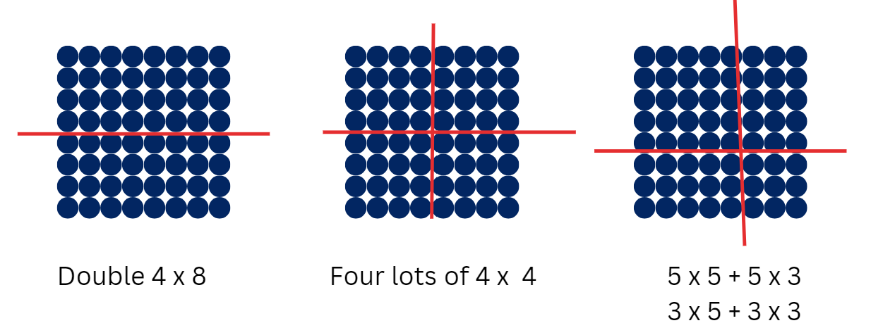

Stage 3 task – division boxes
The table below contains suggested learning intentions and success criteria. These are best co-constructed with students.
Core concept learning intentions | Core concept success criteria
Students are learning to:  - use partitioning and place value to multiply 2-, 3- and 4-digit numbers by one-digit numbers  - use estimation and rounding to check the reasonableness of answers to calculations. | Students can:  - use the distributive property with partial products to solve problems by multiplying the hundreds, then the tens and then the ones  - use estimation to check the reasonableness of answers to multiplication and division calculations.
This lesson is an adaptation of ‘Divisibility tests’ from Building engagement in middle years mathematics: Learning sequences for mixed-ability classrooms by Sullivan.
- Display Resource 18 – What am I?
- Discuss how the boxes can be filled using the digits 1–6 to make the following statements true:
- The first digit is divisible by 3.
- The first 2 digits are the product of 4 × 8.
- The last digit is neither a prime nor a composite number.
- It is an odd number.
- Demonstrate strategies that can be used to solve each statement, drawing attention to any prior knowledge required. For example:
- For a number to be divisible by 3, it must be a multiple of 3. Multiples of 3 include 3, 6 and 9.
- A product is the result of 2 numbers multiplied by each other. 4 multiplied by 8 is 32.
- If the number is neither prime nor composite, then the number must be zero or one.
Multiples: products formed using the same base number multiplied by different whole numbers. For example, 3, 6, 9, 12 …
- Write 320 and 321 on the whiteboard and discuss if either of these numbers will make all the statements true:
- The first digit is 3 and is divisible by 3.
- The product of 4 multiplied by 8 is 32.
- The first 2 digits are 3 and 2.
- The last digit is zero or one and it is not a prime or a composite number.
- 320 is not an odd number. The correct answer must be 321.
- Provide students with individual whiteboards and Resource 19 – task cards.
- In pairs, students complete task cards.
- Regroup and select students to share their solutions and justifications.
- Ask how their knowledge of the following helped solve the problem:
- prime and composite numbers
- factors and products
- place value and partitioning.
- Display the number sentence 321 × 9.
- Explain that using knowledge of multiples of 10 will help, that is, 321 × 9 will be close to, but less than, 321 × 10.
- Provide students with individual whiteboards and calculators to estimate the answer.
- Demonstrate using the distributive property by writing (300 × 9) + (20 × 9) + (1 × 9) on the board. Discuss the place value of each part, asking students to turn and talk and share their thinking.
- Provide time for students to solve the number sentence 321 × 9 and check their answer with a calculator.
- Ask if there is a way to use the distributive property and subtraction to solve this problem.
- Students turn and talk to discuss their ideas.
- Demonstrate solving the problem by using the equation (321 × 10) − (321 × 1).
- In pairs, students use the distributive property to estimate a solution then check their answers with a calculator for the following equations:
- 1384 × 8
- 2473 × 7
- 3842 × 5.
Note: the example 3842 × 5 provides an opportunity for students to explore the idea of 3842 × 10 and then halve the answer. If this is not something that is discovered naturally, students should be encouraged to explore this idea.
This table details opportunities for differentiation.
Too hard? | Too easy?
Students cannot use estimation to check the reasonableness of answers to multiplication calculations.  - Provide students with a set of 3-digit numbers multiplied by a one-digit number to estimate a solution using the distributive property. For example, 384 × 2, 423 × 3 and 842 × 4.  - Assist students in using an area model to partition the 3- and 4-digit number before estimating each part of the distributive property statement. For example, partition 1384 as 1000 + 300 + 80 + 4. Stating 1000 × 8 is close to, but less than, 1000 × 10. | Students can use estimation to check the reasonableness of answers to multiplication calculations.  - Provide students with 5-digit numbers multiplied by a one-digit number to estimate a solution using the distributive property. For example, 92 384 × 6, 79 867 × 8 and 88 675 × 9.  - Students write a set of number sentences to swap with a partner. They use estimation and justify the reason they made that estimation with their partner.

Discuss and connect the mathematics – 5 minutes
- Reflect on the lesson by asking questions, such as:
- Can you explain the commutative property for multiplication? (Stage 2)
- Can you explain the distributive property for multiplication? (Stage 3)
- How does what you learned about multiplication relate to division?
This table details opportunities for assessment.
Assessment opportunities | Links
What to look for:  - Can Stage 2 students recognise and use the symbols for multiplied by (×), divided by (÷) and equals (=)? [MAO-WM-01, MA2-MR-02]  - Can Stage 2 students use the commutative property of multiplication? [MAO-WM-01, MA2-MR-01, MA2-MR-02]  - Can Stage 2 students use flexible partitioning within multiplication? [MAO-WM-01, MA2-MR-02]  - Can Stage 3 students use the distributive property with partial products to solve problems by multiplying the hundreds, then the tens and then the ones? [MAO-WM-01, MA3-MR-01]  - Can Stage 3 students use estimation to check the reasonableness of answers to multiplication and division calculations?  [MAO-WM-01, MA3-MR-01] | Links to National Numeracy Learning Progressions (NNLP):  - Stage 2 – MuS5, MuS6, MuS7  - Stage 3 – MuS7.  Links to suggested Interview for Student Reasoning (IfSR) tasks:  - Stage 2 – IfSR-MT: 2A.9  - Stage 3 – IfSR-MT: 3A.1, 3A.2, 3A.3.

Lesson 5
Core concept: collections can be partitioned in more than one way (Stage 2) and structures can support multiplicative thinking (Stage 3).

Daily number sense – How much change? – 10 minutes
Daily number sense activities for Lessons 5 to 7 ‘loop’ back to concepts and procedures covered in previous units to assist students to build an increasingly connected network of ideas. These concepts may differ from the core concepts being covered by the unit.
The table below contains suggested learning intentions and success criteria. These are best co-constructed with students.
Daily number sense learning intentions | Daily number sense success criteria
Students working towards Stage 2 outcomes are learning to:  - represent money values in multiple ways.  Students working towards Stage 3 outcomes are learning to:  - use estimation and place value understanding to determine the reasonableness of solutions. | Students working towards Stage 2 outcomes can:  - recognise the relationship between dollars and cents  - represent equivalent amounts of money using different denominations  - perform calculations with money, including finding change.  Students working towards Stage 3 outcomes can:  - use place value understanding to check for errors in calculations.
This activity is an adaptation of ‘What might the change have looked like?’ from Open-Ended Maths Activities: Using Good Questions to Enhance Learning Mathematics by Sullivan and Lilburn. Provide students with play money, if available.
- Explain the following: Students from our class bought 3 items from Resource 20 – office catalogue and need to check their money calculations.
- Stage 2 students purchased their items and received change of $1 in 20c, 10c and 5c coins. Ask Stage 2 students what coins might have been in the change.
- In pairs, Stage 2 students use whiteboards to find different ways to make change of $1 using 20c, 10c and 5c coins.
- Stage 3 students must estimate the amount of money needed to buy a desk, chair and computer, then calculate the exact total and the change from $1500.
- Ask students:
- How many ways did you and your partner make change of $1 using the coins? (Stage 2)
- Which combinations had the least or the most coins? (Stage 2)
- What strategies and number combinations did you and your partner use to help you? (Stage 2)
- What strategy did you use to estimate the total of the purchased items? (Stage 3)
This table details opportunities for assessment.
Assessment opportunities | Links
What to look for:  - Can Stage 2 students recognise the relationship between dollars and cents? [MAO-WM-01, MA2-AR-01]  - Can Stage 2 students represent equivalent amounts of money using different denominations? [MAO-WM-01, MA2-AR-01]  - Can Stage 2 students perform calculations with money, including finding change? [MAO-WM-01, MA2-AR-01]  - Can Stage 3 students use place value understanding to check for errors in calculations? [MAO-WM-01, MA3-AR-01] | Links to National Numeracy Learning Progressions (NNLP):  - Stage 2 – UnM2, UnM3, UnM4, UnM5, UnM6  - Stage 3 – NPV5, NPV6, AdS8.

Core lesson – 40 minutes

Stage 2 task – bakery partitioning
The table below contains a suggested learning intention and success criteria. These are best co-constructed with students.
Core concept learning intention | Core concept success criteria
Students are learning to:  - use number properties to find related multiplication facts. | Students can:  - use flexible partitioning within multiplication.
This activity is an adaptation of Multiplication: reSolve Bakery from reSolve: Maths by Inquiry by Australian Academy of Science.
- Display Resource 21 – How many cupcakes? and ask students:
- How many cupcakes can be baked at one time in this tin?
- How do you know?
- Allow different responses and different ways of seeing the 24 spaces in the cupcake tray. For example:
- partitioning into rows of 6 and multiplying it by the 4 columns
- counting by 2 across the top 2 rows to total 12, then doubling it.
- Display and read Resource 22 – a special order. Do not take answers from students at this point.
- Provide pairs of students with 3 or more copies of Resource 22 – a special order and a large sheet of paper or VNPS.
- Say that counting the cupcakes by ones is not an efficient strategy and to look for efficient ways to find the total. Explain that students can partition the collection into smaller groups to make it easier to find the total, as they did with the 24 spaces in the cupcake tray. They will record these on a poster to explain how their strategies work.
- Students solve the problem and present their most efficient solution as a poster that shows how they solved the problem.
Note: the goal at this point is to not direct students to use particular strategies, but to allow them to explore their own way of solving the problem. The strategies used by students will be diverse and will reveal a lot about their understanding of multiplication and their fluency.
Counting is the most basic strategy. Link skip counting with repeated addition and then with multiplication. Students using tens can consider the number of tens in each section to reinforce the connection between counting by tens and multiples of 10 (see Figure 11).
Figure 11 – counting by 2s and counting by 5s
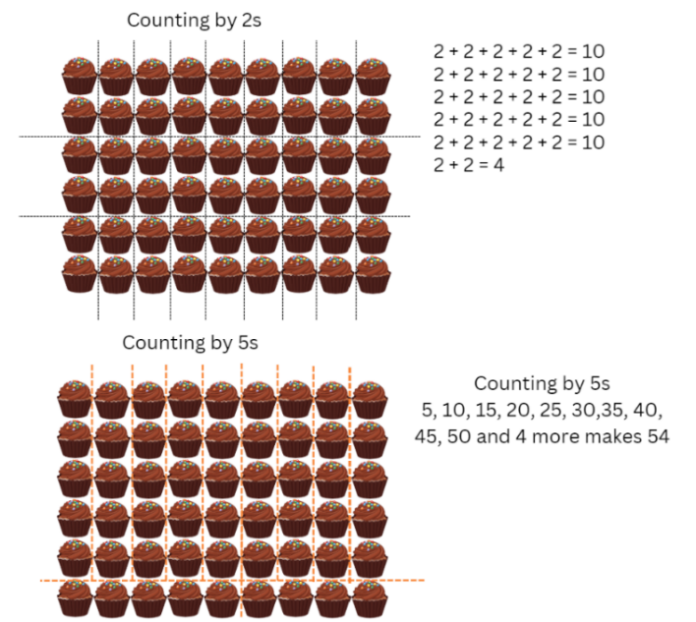
Note: one strategy involves partitioning the array into smaller sections, then multiplying to find the number of cupcakes in each section. This applies the distributive property: a × (b + c) = (a × b) + (a × c) (see Figure 12).
Figure 12 – distributive property example
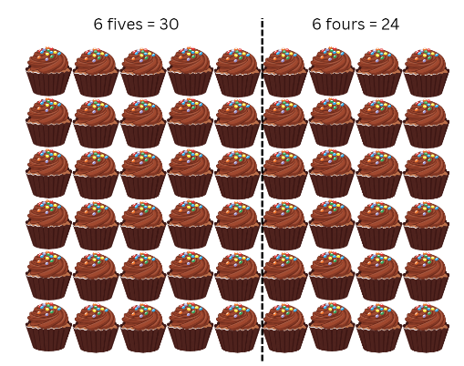
Note: compensation involves making a ‘friendlier’ number of rows or columns, by extending the array and later subtracting. This is another use of the distributive property of multiplication (see Figure 13).
Figure 13 – compensation example
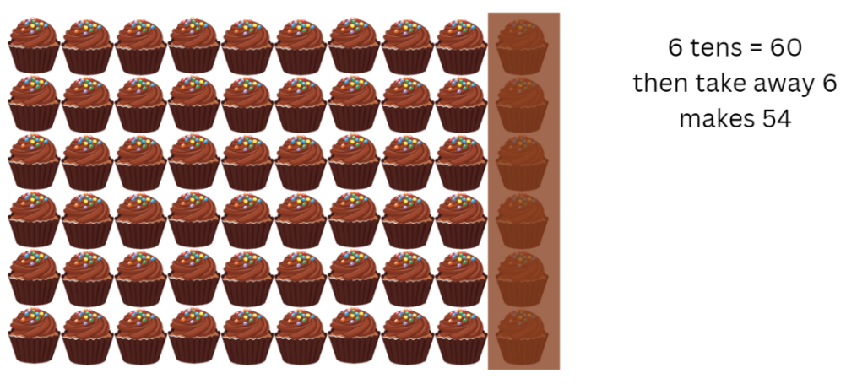
Note: Figure 14 uses doubling. Repeated doubling using multiplication uses the associative property. To multiply by 4, first multiply by 2, then 2 again. The associative property can be used with factors of numbers. a × (b × c) = (a × b) × c.
Figure 14 – doubling
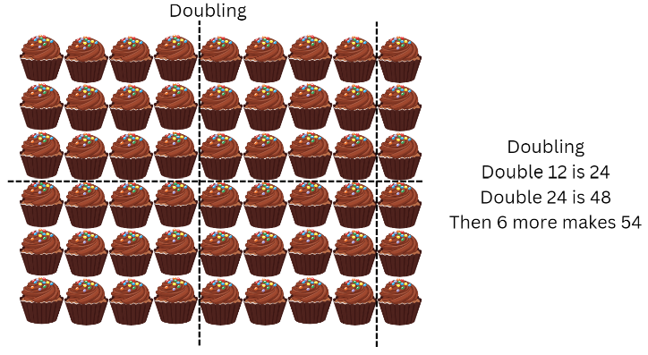
This table details opportunities for differentiation.
Too hard? | Too easy?
Students cannot use flexible partitioning within multiplication.  - Support students by making the problem smaller. Ask them to consider how many cupcakes are on 2 trays of 24. Model how to use a smaller partition they are familiar with to find the total of the cupcakes on 2 trays.  - Once students have found an answer for 2 trays, support them to build up to 4 and 8 trays. | Students can use flexible partitioning within multiplication.  - Explain that Charlie has been asked to donate 96 muffins for the local school fete. What combinations of his special tin (6 muffins) and his regular tin (24 muffins) could he use to bake these muffins? For example, 4 regular trays. Ask students how to find all the possible combinations.  - Provide students with copies of Resource 23 – busy cupcake day. Pose the problem: On a very busy day, Charlie baked 12 regular trays of cupcakes for a large catering order. How many cupcakes are there altogether? Students create a poster to show their thinking.

Stage 3 task – distributive property with partial products
The table below contains suggested learning intentions and success criteria. These are best co-constructed with students.
Core concept learning intentions | Core concept success criteria
Students are learning to:  - use partitioning and place value to multiply 2-, 3-, and 4-digit numbers by one-digit numbers  - apply place value to partition, regroup and rename numbers to 1 billion. | Students can:  - use the distributive property with partial products to solve problems by multiplying the hundreds, then the tens and then the ones  - regroup numbers in different forms.
This lesson is an adaptation of Distributive Property with Four by Katz from the Open Middle website.
- Display the number sentence 321 × 9, that was used in the previous lesson. Revise how it could be solved using the distributive property (300 × 9) + (20 × 9) + (1 × 9).
- Write 28 = ( _ _ × 2) + ( _ × 2) on the board and ask what numbers could be used to make the statement true.
- Explain that this statement is a form of distributive property using partial products.
- Work through the problem on the whiteboard, modelling thinking aloud. For this statement to be true:
- We are working backwards, so we need to use the inverse of multiplication to find the partial products (the missing numbers).
- 28 must first be divided by 2. This equals 14.
- The missing numbers in the blanks must add up to 14.
- 14 can be regrouped in different ways using standard partitioning of 10 and 4, or non-standard regrouping of 11 and 3.
- I cannot use 9 and 5 because one of the numbers needs to have 2 digits.
- Write the statements 28 = (10 × 2) + (4 × 2) and 28 = (11 × 2) + (3 × 2).
- Write another statement 456 = ( _ _ _ × 2) + ( _ _ × 2) + ( _ × 2).
- Provide students with whiteboards and calculators.
- In pairs, students discuss and solve the statement to find the missing numbers. Students can use calculators to test answers where required.
- Regroup Stage 3 and discuss how the solutions may change if the factor 2 is changed to a 4. For example, 456 = ( _ _ _ × 4) + ( _ _ × 4) + ( _ × 4).
Factor: a number which divides another number without a remainder. For example, 1, 2, 3 and 6 are factors of 6 but 4 and 5 are not.
- Rewrite the statement 456 = (100 × 4) + (10 × 4) + (4 × 4) and ask if this statement is true.
- In pairs, students find as many solutions as possible for the following statements, using calculators to test answers:
- 366 = ( _ _ _ × 3) + ( _ _ × 3) + ( _ × 3)
- 516 = ( _ _ _ × 4) + ( _ _ × 4) + ( _ × 4).
This table details opportunities for differentiation.
Too hard? | Too easy?
Students cannot use the distributive property to solve multiplication problems.  - Provide students with a set of 2-digit numbers to partition into tens and ones before multiplying by a one-digit number. Support students as they work through the steps to find the solution.  - Assist students in partitioning the number into hundreds, tens and ones before factorising each of the numbers. For example, partition 124 as 100 + 20 + 4, then factorise 100, 20 then 4. | Students can use the distributive property to solve multiplication problems.  - Students write distributive statements to solve for the product of a 4-digit number and a factor. Students generate the numbers by rolling a 10-sided die 5 times. The first die roll determines the factor, and each subsequent die roll will determine the first digit of the place value. For example, dice rolls of 5, 6, 3, 7 and 9 will produce a statement of (6000 × 5) + (300 × 5) + (70 × 5) + (9 × 5).  - Pose the question: 128 = ( _ × 4) + ( _ × 4) + ( _ _ × 4). Challenge students to fill in each blank with the digits 0–9. Each digit can only be used once. There are many possibilities. For example, 128 = (7 × 4) + (9 × 4) + (16 × 4).

Discuss and connect the mathematics – 15 minutes
- Select students to present their work.
- Discuss and connect strategies used by Stage 2 students by asking:
- In what ways are these strategies similar and different? (Highlight the connections between strategies).
- How efficient are the different strategies?
- How well would each strategy work with a different set of numbers? (For example, doubling works well with 4, but not with 7. Multi-digit numbers can be partitioned based on their place-value parts, for example, 24 = 20 + 4).
- Select Stage 3 students to share their solutions for 366 = ( _ _ _ × 3) + ( _ _ × 3) + ( _ × 3). Although 366 is a multiple of 3, there are many solutions to the number. This will depend on how it is partitioned. Students may use standard or non-standard partitioning to find:
- 366 = (100 × 3) + (20 × 3) + (2 × 3)
- 366 = (100 × 3) + (15 × 3) + (7 × 3).
- Stage 3 students may share their solutions in groups for 516 = ( _ _ _ × 4) + ( _ _ × 4) + ( _ × 4) and use calculators to check answers.
- Display Stage 2 students’ posters to refer to in future lessons.

This table details opportunities for assessment.
Assessment opportunities | Links
What to look for:  - Can Stage 2 students use flexible partitioning within multiplication? [MAO-WM-01, MA2-MR-02]  - Can Stage 3 students use the distributive property with the area model to partition numbers in representing multiplication problems? [MAO-WM-01, MA3-MR-01]  - Can Stage 3 students use the distributive property with partial products to solve problems by multiplying the hundreds, then the tens and then the ones? [MAO-WM-01, MA3-MR-01]  - Can Stage 3 students regroup numbers in different forms?  [MAO-WM-01, MA3-RN-01] | Links to National Numeracy Learning Progressions (NNLP):  - Stage 2 – MuS7  - Stage 3 – MuS7, NPV6.  Links to suggested Interview for Student Reasoning (IfSR) tasks:  - Stage 2 – N/A  - Stage 3 – IfSR-MT: 3A.1, 3A.2, 3A.3.

Lesson 6
Core concept: multiplication and division are related (Stage 2) and mathematicians use algorithms with understanding to solve multiplicative problems (Stage 3).

Daily number sense – equivalent change – 10 minutes
The table below contains suggested learning intentions and success criteria. These are best co-constructed with students.
Daily number sense learning intentions | Daily number sense success criteria
Students working towards Stage 2 outcomes are learning to:  - represent money values in multiple ways.  Students working towards Stage 3 outcomes are learning to:  - use estimation and place value understanding to determine the reasonableness of solutions. | Students working towards Stage 2 outcomes can:  - recognise the relationship between dollars and cents  - represent equivalent amounts of money using different denominations  - perform calculations with money, including finding change.  Students working towards Stage 3 outcomes can:  - use place value understanding to check for errors in calculations  - use estimation to check the reasonableness of solutions to addition and subtraction calculations.
This activity is an adaptation of ‘Equivalent change’ from Open-Ended Maths Activities: Using Good Questions to Enhance Learning Mathematics by Sullivan and Lilburn. Provide play money to students, if available.
- Display Resource 20 – office catalogue and pose the following: Students will purchase 3 items from the catalogue and need to show different ways to receive change from the shop assistant.
- Stage 2 students spend up to $5 to purchase any 3 items from the Stationery list. In pairs, students calculate the total cost of the selected items and record on whiteboards how the change may have been provided.
- Stage 3 students spend up to $1500 to purchase any 3 items from the Technology and furniture list. Students estimate the cost of items and the expected change before calculating total amounts.
Note: ensure students identify the absence of trading in the following algorithm.
- Write the algorithm $349.95 + $15.95 = $354.80 on the board and ask Stage 3 students to determine if the answer to this equation is reasonable and, if not, what error has been made in this algorithm?
- Ask all students:
- How did you work out the amount of change from $5 (Stage 2) and $1500 (Stage 3)?
- How many ways different ways could the change have been provided?
- Which combination of notes and coins was the most efficient, or had the least amount of notes and coins?
- Which combination was the least efficient, or had the most notes and coins?
- How did you determine if the algorithm was reasonable or not? (Stage 3)
- What strategies and number combinations did you and your partner use to help you?
This table details opportunities for assessment.
Assessment opportunities | Links
What to look for:  - Can Stage 2 students recognise the relationship between dollars and cents? [MAO-WM-01, MA2-AR-01]  - Can Stage 2 students represent equivalent amounts of money using different denominations? [MAO-WM-01, MA2-AR-01]  - Can Stage 2 students perform calculations with money, including finding change? [MAO-WM-01, MA2-AR-01]  - Can Stage 3 students use place value understanding to check for errors in calculations? [MAO-WM-01, MA3-AR-01]  - Can Stage 3 students use estimation to check the reasonableness of solutions to addition and subtraction calculations?  [MAO-WM-01, MA3-AR-01] | Links to National Numeracy Learning Progressions (NNLP):  - Stage 2 – UnM2, UnM3, UnM4, UnM5, UnM6  - Stage 3 – NPV5, NPV6, AdS8.

Core lesson – 40 minutes

Stage 2 task – sharing 36
The table below contains suggested learning intentions and success criteria. These are best co-constructed with students.
Core concept learning intentions | Core concept success criteria
Students are learning to:  - recall multiplication facts of 2 and 4, 5 and 10 and related division facts  - represent and solve problems involving multiplication fact families. | Students can:  - recognise and use the symbols for multiplied by (×), divided by (÷) and equals (=)  - link multiplication and division fact families using arrays  - apply the inverse relationship of multiplication and division.
This activity is an adaptation of ‘Sharing crackers’ from Mindset Mathematics: Visualizing and Investigating Big Ideas, Grade 3 by Boaler et al.
- Display 36 counters, square tiles or Resource 24 – sharing crackers. Say that they represent crackers that need to be shared equally for a snack. Pose the questions:
- How many students can share the crackers?
- How many crackers will each student get?
- Point out that there are many answers to this task.
- Provide pairs of students with 36 counters, square tiles or a copy of Resource 24 – sharing crackers to answer the 2 questions in multiple ways.
- Students record each solution in pictures and number sentences using divided by (÷) and equals (=).
- Students also record any attempts that do not work, showing why it did not lead to equal shares.
- Share and discuss student solutions.

Note: as students work, draw their attention to the ways they are thinking about their solutions to generate new solutions. For example, students may use the commutative property to turn the solution of 4 students with 9 crackers each into 9 students with 4 crackers each. Students might use a doubling and halving pattern to move from 2 students with 18 crackers each to 18 students with 2 crackers each. Each of these is useful in finding solutions and looking for possible missing solutions. Further, these patterns apply to all multiplication and division relationships and are worth testing, sharing and discussing. Ask students if these patterns always work and why.
- Organise the solutions by displaying them in the table on Resource 25 – sharing solutions.
The table below outlines stimulus prompts to generate conversation about the topic, along with anticipated responses from students.
Prompts | Anticipated student responses
- Have you found all the ways of sharing 36 crackers? Why or why not? | - Yes, because we have worked systematically through all the options (factors) in order from one through to 18.
- How could you organise the solutions you have found to see patterns? | - Put them in order of factors starting with one.
- What patterns do you notice in the solutions you found? | - As the number of students increases, the number of crackers each student gets decreases.  - There are some facts reversed after 6 × 6, such as 4 students have 9 crackers, or 9 students have 4 crackers each.
- Do these patterns always work? Convince me. | - Yes, in multiplication, if one factor increases, the other factor will decrease.  - Student explanations will vary based on examples from known multiplication facts.
This table details opportunities for differentiation.
Too hard? | Too easy?
Students cannot link multiplication and division fact families using arrays.  - Model how to arrange the 36 crackers in an array, then share them equally between different numbers of students.  - Support students to look for connections between multiplication and division fact families in their results. | Students can link multiplication and division fact families using arrays.  - Students test the patterns found when sharing a different number of crackers, such as 24, 32 or 48.  - Partners explore the question: How do you know when you have found all possible solutions?

Stage 3 task – area model 1000
The table below contains suggested learning intentions and success criteria. These are best co-constructed with students.
Core concept learning intentions | Core concept success criteria
Students are learning to:  - use partitioning and place value to multiply 2-, 3- and 4-digit numbers by one-digit numbers  - select and apply mental and written strategies to multiply 2- and 3-digit numbers by 2-digit numbers. | Students can:  - use the distributive property with the area model to partition numbers in representing multiplication problems  - extend the area model to represent 2-digit by 2-digit multiplication  - use a multiplication algorithm with understanding.
This activity is an adaptation of Multiplying Two-Digit Numbers – Closest to 7000 by Tolomeo from the Open Middle website.
- Revise using the area model to multiply 2-digit by a one-digit number.
- Provide students with a whiteboard, 6-sided die and calculator.
- Ask students: Can you predict how an area model could be used to multiply a 2-digit number by a 2-digit number? Students draw on their whiteboards how this could be represented.
- Students turn and talk to discuss their representations.
- Draw an area model to represent 24 × 35 and demonstrate the use of the area model to solve the equation (see Figure 15).
Figure 15 – area model example
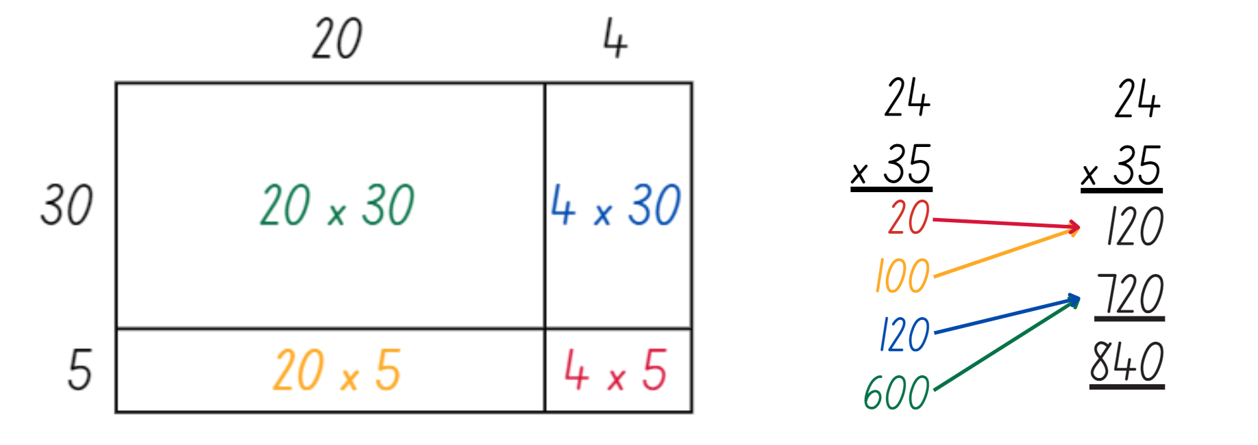
- Select students to compare similarities and differences between the use of an area model and a multiplication algorithm (see Figure 16).
Figure 16 – area model with algorithm
- Explain that the use of an algorithm involves adding a zero at the end of each subsequent line to represent the change in place values.
- In pairs, students roll a 6-sided die 4 times to generate two 2-digit numbers. The result of each die roll does not determine the order of the digits. For example, if the roll lands on 3, 4, 6 or zero, students may choose to multiply 34 × 60 or 30 × 46.
- Students use calculators to check their answers for each quadrant of the area model.
- Students repeat this task with a variation; students compete to multiply two 2-digit numbers with the aim of scoring the answer closest to 1000.
- In pairs, students roll the die 4 times. Student A decides on two 2-digit numbers from the die roll, and student B decides on another two 2-digit numbers from the die roll.
- Students solve the multiplication of their two 2-digit numbers using the area model.
- Provide calculators to check solutions, if required.
- The student with the answer closest to 1000 wins.
This table details opportunities for differentiation.
Too hard? | Too easy?
Students cannot extend the area model to represent 2-digit by 2-digit multiplication.  - Assist students to partition numbers into 2-digit by one-digit multiplication statements incorporating their understanding of 10 times as large (see Figure 17).  Figure 17 – partition and multiply  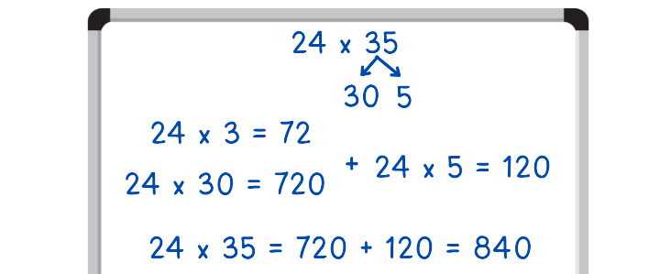  - Support students to use the online area model tool to partition and solve the equations. | Students can extend the area model to represent 2-digit by 2-digit multiplication.  - Provide students with a 10-sided die to determine the product of two 2-digit numbers up to 99. Students use the area model or multiplication algorithm to solve.  - Provide students with a 6-sided die. Students roll the die 5 times to produce a 3-digit number and a 2-digit number to multiply. Students use multiplication algorithms to solve.

Discuss and connect the mathematics – 10 minutes
- Regroup as a class and display Resource 25 – sharing solutions for Stage 2 students. Ask the following questions:
- What patterns did you notice?
- Have we found all the solutions? How do you know?

Note: take the opportunity to name what students are doing when they discuss patterns and the strategies they used: breaking a large group into smaller equal-sized groups is division. Some students will have used multiplication by making equal groups to build up to the total. If students do not yet have the language to describe these concepts, use the opportunity to label and explain concepts clearly. Highlight how multiplication and division are related and both can be used to making equal groups.
- Ask Stage 3 students to describe the strategies they used to create area models of the algorithms.
This table details opportunities for assessment.
Assessment opportunities | Links
What to look for:  - Can Stage 2 students recognise and use the symbols for multiplied by (×), divided by (÷) and equals (=)? [MAO-WM-01, MA2-MR-01, MA2-MR-02]  - Can Stage 2 students link multiplication and division fact families using arrays? [MAO-WM-01, MA2-MR-01, MA2-MR-02]  - Can Stage 2 apply the inverse relationship of multiplication and division? [MAO-WM-01, MA2-MR-01, MA2-MR-02]  - Can Stage 3 students use partitioning and place value to multiply 2-, 3- and 4-digit numbers by one-digit numbers? [MAO-WM-01, MA3-MR-01]  - Can Stage 3 students extend the area model to represent 2-digit by 2-digit multiplication? [MAO-WM-01, MA3-MR-01]  - Can Stage 3 students use a multiplication algorithm with understanding? [MAO-WM-01, MA3-MR-01] | Links to National Numeracy Learning Progressions (NNLP):  - Stage 2 – MuS5, MuS6, MuS7, NPA4  - Stage 3 – MuS6, MuS7, MuS8.  Links to suggested Interview for Student Reasoning (IfSR) tasks:  - Stage 2 – IfSR-MT: 2A.5, 2A.10  - Stage 3 – IfSR-MT: 3A.1, 3A.2, 3A.3, 3A.4, 3A.5.

Lesson 7
Core concept: fact families support fluency (Stage 2) and Euclidean division emphasises the relationship between multiplication and division (Stage 3).

Daily number sense – missing number sentence – 10 minutes
The table below contains suggested learning intentions and success criteria. These are best co-constructed with students.
Daily number sense learning intentions | Daily number sense success criteria
Students working towards Stage 2 outcomes are learning to:  - represent money values in multiple ways.  Students working towards Stage 3 outcomes are learning to:  - use estimation and place value understanding to determine the reasonableness of solutions. | Students working towards Stage 2 outcomes can:  - recognise the relationship between dollars and cents  - represent equivalent amounts of money using different denominations  - perform calculations with money, including finding change.  Students working towards Stage 3 outcomes can:  - use place value understanding to check for errors in calculations  - use estimation to check the reasonableness of solutions to addition and subtraction calculations.
This activity is an adaptation of ‘Missing number sentence’ from Open-Ended Maths Activities: Using Good Questions to Enhance Learning Mathematics by Sullivan and Lilburn. Provide students with play money, if available.
- Display Resource 20 – office catalogue. Stage 2 students are to use the Stationery column and Stage 3 students will consider the Technology and furniture column.
- Pose the following problem to Stage 2 students: A number sentence uses at least 2 of the item prices. What might the number sentence be?
- In pairs, Stage 2 students use whiteboards to create and solve different number sentences using at least 2 of the amounts provided.
- Explain to Stage 3 students that Klaus used his calculator to find the total of the first 2 items in the Technology and furniture column, as $99.05.
- In pairs, Stage 3 students discuss possible reasons for Klaus’ wrong answer. (Answer: he pressed the subtraction button rather than the addition button).
- Stage 3 students discuss a reasonable estimation for the solution of $157 + $57.95 and justify their thinking. For example, $57 + $57.95 is going to be over $100, so the answer must be just over $200.
- Ask:
- What number sentences did you and your partner make? (Stage 2)
- Did you use more than one operation in a number sentence? (Stage 2)
- Which operations did you find the easiest to use and were any operations too difficult to use? (Stage 2)
- Which number sentences might represent giving change? Why? (Stage 2)
- How did you justify your thinking when estimating? (Stage 3)
This table details opportunities for assessment.
Assessment opportunities | Links
What to look for:  - Can Stage 2 students recognise the relationship between dollars and cents? [MAO-WM-01, MA2-AR-01]  - Can Stage 2 students represent equivalent amounts of money using different denominations? [MAO-WM-01, MA2-AR-01]  - Can Stage 2 students perform calculations with money, including finding change? [MAO-WM-01, MA2-AR-01, MA2-AR-02]  - Can Stage 3 students use place value understanding to check for errors in calculations? [MAO-WM-01, MA3-AR-01]  - Can Stage 3 students use estimation to check the reasonableness of solutions to addition and subtraction calculations?  [MAO-WM-01, MA3-AR-01] | Links to National Numeracy Learning Progressions (NNLP):  - Stage 2 – UnM2, UnM3, UnM4, UnM5, UnM6  - Stage 3 – NPV5, NPV6, AdS8.

Core lesson – 50 minutes

Stage 2 task 1 – missing numbers
The table below contains suggested learning intentions and success criteria. These are best co-constructed with students.
Core concept learning intentions | Core concept success criteria
Students are learning to:  - recall multiplication facts of 2 and 4, 5 and 10 and related division facts  - represent and solve word problems with number sentences involving multiplication or division. | Students can:  - generate multiplication fact families for multiples of 2 and 4, 5 and 10  - use the equals sign to record equivalent number relationships involving multiplication  - complete number sentences involving multiplication and division by calculating missing numbers.
Note: the syllabus support material explains fluency in this way: Students’ communication of their understanding reveals their mathematical fluency. Mathematical fluency is developed when students choose and use appropriate strategies; carry out procedures flexibly, accurately and efficiently; recall factual knowledge and concepts to solve problems; and use known facts, and reason about relationships to find solutions (NESA 2023).
- Select a known multiplication fact such as 2 × 9 and draw the related fact family triangle.
- Present the fact family in a variety of number sentences with missing values. For example:
- 18 = 9 × ♣
- 2 × ♥ = 18
- 18 ÷ ♣ = 9
- 18 ÷ ♥ = 2.
- Students identify another fact family with 18 as the product, such as 6 × 3.
- Model recording the equation 2 × 9 = 6 × 3.
- Remind students that the equals sign means both sides have equivalent value.
- Students identify any other fact family triangle with 2 as a factor, such as 2, 6 and 12.
- Model recording the equation 18 ÷ 9 = 12 ÷ 6.
Note: to support students to master multiplication facts, identify known and unknown facts, explicitly teach strategies applicable to unknown facts (such as for 6 times – multiply by 5 and add one more set) and provide engaging activities that emphasise collaboration (Van de Walle et al. 2023).

Stage 2 task 2 – games for fluency
Some of the resources in this unit have been adapted from other sources. There are many other engaging and purposeful games for operations, including multiplication and division on the Love Maths website by Minas.
- Play games that promote fluency of multiplication facts. Games should focus on revising known fact families and adding a few new facts (that are worked out using a strategy) at a time.
- For each activity discuss reasoning strategies that can help students learn new facts based on existing knowledge.
- Resource 11 – doubles bingo, Resource 26 – Salute! and Resource 27 – fill the chart are examples of multiplicative games that can be differentiated for students.
- Digital activities that allow students to focus on targeted groups of related facts include:
- Fun for the Brain – multiplication games
- Maths is Fun – Math Trainer - Multiplication.
- Divide students into groups to play one of the multiplication games that is suited to their learning needs.
- As they play the game, select students to pause and record the fact family triangle for the fact that they are up to in the game.
This table details opportunities for differentiation.
Too hard? | Too easy?
Students cannot generate multiplication fact families for multiples of 2 and 4, 5 and 10 and/or use the equals sign to record equivalent number relationships involving multiplication.  - For task 1, students make their own set of fact family cards for a target set of facts, including dot arrays that match the facts. Students have their cards visible when playing Salute! or Fill the chart.  - For task 2, provide students with a set of 12 counters. Guide students to make and record differing sets of equal groups, such as 6 twos or 3 fours. Model how to write those as equivalent number sentences: 6 × 2 = 3 × 4. Students find all groupings for 12 and then do the same for 16, 20 and 24. | Students can generate multiplication fact families for multiples of 2 and 4, 5 and 10 and can use the equals sign to record equivalent number relationships involving multiplication.  - Students can apply known facts and game strategy with the NCTM Product game.  - Students explore the connection between multiplication and division, with Resource 28 – Open Middle problem.

Stage 3 task 1 – the athletics carnival
The table below contains suggested learning intentions and success criteria. These are best co-constructed with students.
Core concept learning intentions | Core concept success criteria
Students are learning to:  - represent and solve division problems with whole number remainders  - apply place value to partition, regroup and rename numbers to 1 billion. | Students can:  - model division, including where the answer involves a remainder, using materials or diagrams  - record remainders in words to division problems  - show the connection between division and multiplication involving the divisor and quotient  - regroup numbers in different forms.
This activity is an adaptation of ‘Patterns with remainders’ from Challenging mathematical tasks: Unlocking the potential of all students by Sullivan.
- Revise the idea that when solving division problems, the answers may include remainders. Explain that the context of the problem will determine if the remainders can be parts, or whether they need to be whole numbers.
- Pose the question: Some students were competing in an event at the athletics carnival. When they were put into groups of 3, one student was left over. When they were put into groups of 4 there were 2 students left over. How many students might have been competing in the event at the athletics carnival?
- Using whiteboards, students record their solutions using a table, or drawings (see Figure 18).
Figure 18 – athletics carnival example
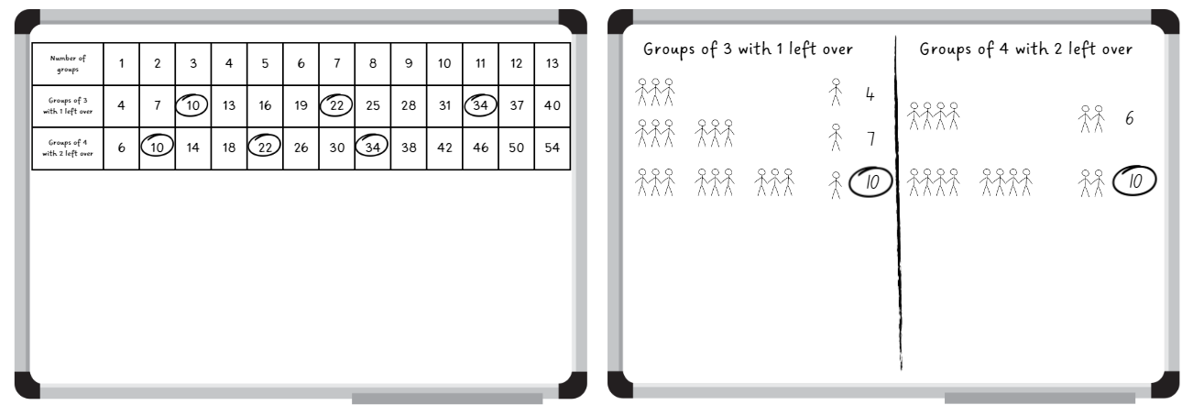
Note: there is a pattern in the possible answers, but do not mention this at first. Once students find one answer, ask them to find more and to notice if there is a pattern with the answers. Encourage students to record the solutions using a table, rather than drawings. This will allow them to see the pattern more clearly.
- Ask:
- How many students might have competed in the event at the athletics carnival?
- Can you see a pattern forming with the possible number of students competing? What is it? (The pattern is repeatedly increasing by 12).
- Now that you have noticed the pattern, can you think of more possibilities for numbers of students that you did not record? What are they?
This table details opportunities for differentiation.
Too hard? | Too easy?
Students cannot model division, including where the answer involves a remainder, using materials or diagrams.  - Provide students with counters to form equal groups of 3 with one remainder and equal groups of 4 with 2 remainders to assist in finding possible solutions.  - Support students to create a table, as in Figure 18 to record their results, drawing their attention to the pattern formed when recording numbers. | Students can model division, including where the answer involves a remainder, using materials or diagrams.  - In pairs, students consider why the pattern was increasing by 12. Explain why this was happening to another pair of students.  - Pose the following problem for students to solve: Some other students were competing in another event at the athletics carnival. When they were put into groups of 6, 2 students were left over. When they were put into groups of 8 there were 4 students left over. How many students might have competed in this event at the athletics carnival?

Stage 3 task 2 – ribbons for the carnival
This activity is an adaptation of Susie’s dilemma from Arc Learning: Mathematics Curriculum Companion by the State Government of Victoria (Department of Education).
- Explain that after the athletics carnival Mrs Kelly had to organise the ribbons for the students who came first, second and third in all the events.
- Display Resource 29 – carnival ribbons and read the problem and clues aloud.
- Provide students with a personal whiteboard and Resource 30 – number chart. The whiteboard can be used for working out. The number chart is for keeping a record of eliminated numbers based on the clues provided. It will also show the number that is the solution to the problem.
- Remind students that the problem stated that there are more than 100 ribbons in the box.
- Encourage students to use their knowledge of multiplication to assist in solving the first step of this problem. They record remainders in words. For example:
- 130 is a multiple of 5. 130 ÷ 5 = 26. 132 ÷ 5 = 26 remainder 2.
- 126 is a multiple of 7. 126 ÷ 7 = 18. 132 ÷ 7 = 18 remainder 6.
- 128 is a multiple of 8. 128 ÷ 8 = 16. 132 ÷ 8 = 16 remainder 4.
- 126 is a multiple of 9. 126 ÷ 9 = 14. 132 ÷ 9 = 14 remainder 6.
- Remind students that Mrs Kelly does not want to make stacks of 25 ribbons or more because they fall over. Encourage students to use their knowledge of multiplication and factors to assist them in solving the next step of this problem (see Figure 19).
Figure 19 – how many ribbons example
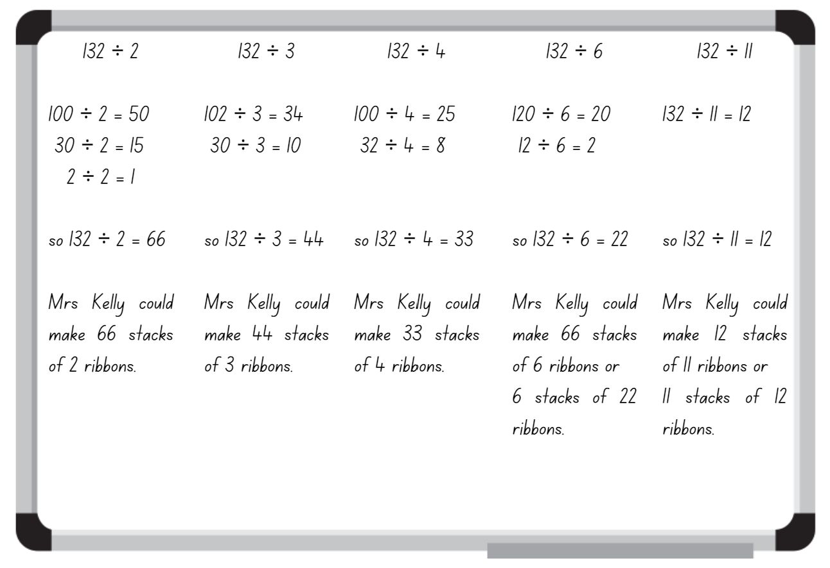

- Ask:
- How many ribbons did Mrs Kelly have in the box? (132).
- How many possible solutions did you find? What were they?
- What would be the most reasonable answer for this problem? (For example, Mrs Kelly making 66 stacks of 2, 44 stacks of 3 or 33 stacks of 4 would not be the most productive way for her to count the ribbons).
- How did your knowledge of multiplication help you to solve this problem?
This table details opportunities for differentiation.
Too hard? | Too easy?
Students cannot model division, including where the answer involves a remainder, using materials or diagrams.  - Provide students with a multiplication chart and/or a hundred chart to assist them in recognising the patterns of multiples and factors of given numbers. For example, 5 or 2.  - Assist students to use Resource 30 – number chart to find the possibilities and impossibilities to solve the problem. | Students can model division, including where the answer involves a remainder, using materials or diagrams.  - Students create their own word problem with remainders and swap with a partner to solve.  - Students use the strategies they have used during this lesson to solve the following problem: There are 6 age groups, 4 track events and 4 field events at the athletics carnival each year. Ribbons are awarded to the students who come first, second or third in each event for each age group. Ribbons come in bulk packs of 100 ribbons per box. If Mrs Kelly wanted to order ribbons for the following 6 years, how many boxes would she need to order and how many ribbons would she have remaining for the following year? (Answer: 864 = 9 boxes of 100 ribbons with 36 remaining).

Consolidation and meaningful practice – 10 minutes
- Display a fact family triangle for 6 × 7 = 42.
- Discuss what known facts could be used to work this out, such as 5 × 7 plus one more 7 or double 3 × 7.
- Stage 2 students turn and talk to share missing values and equivalent number sentences related to that family fact triangle.
Note: the Stage 3 teaching advice states that Euclidean division is whole number division with a remainder, where the remainder is recorded as a whole number. Euclidean division can also be expressed using multiplication. For example, the result 53 ÷ 3 = 17 with remainder 2, can be expressed as 53 = 3 × 17 + 2 (NESA 2022).
- Display Resource 31 – table recording. Remind students about the connection between division and multiplication.
- Write 34 ÷ 4 = 8 remainder 2 and 32 = 4 × 8 + 2 on the board. Ask students to identify what connections they see between the 2 equations.
- Explain that in the first equation, the dividend is 34, the divisor is 4, the quotient is 8 and the remainder is 2. In the second equation, 4 and 8 are multiplied together to make 30, with the 2 remainders added to equal 32.
Dividend: the number that is divided or distributed in a division problem. For example, in 12 ÷ 3 = 4, 12 is the dividend.
Divisor: a number by which another number is divided by. For example, in 12 ÷ 3 = 4, 3 is the divisor.
Quotient: the result of dividing one number or algebraic expression by another. For example, in 12 ÷ 3 = 4, 4 is the quotient.
Note: although multiplication is commutative, division is not. Therefore, distinguishing between the divisor and the dividend is important. When modelling division problems, it is important to identify the divisor and its position following the division symbol.
- Students record connected division and multiplication equations on whiteboards using the data from Resource 31 – table recording. For example, 10 ÷ 3 = 3 remainder 1 and 10 = 3 × 3 + 1.
- Select Stage 2 students to share their responses and record them on the board. Examples could include:
- 42 = 7 × Δ
- 6 × ♥ = 42
- 42 ÷ Δ = 7
- 42 ÷ ♥ = 6
- 18 ÷ 3 = 42 ÷ 7
- 6 × 7 = 3 × 2 × 7 = 3 × 14.
This table details opportunities for assessment.
Assessment opportunities | Links
What to look for:  - Can Stage 2 students generate multiplication fact families for multiples of 2 and 4, 5 and 10? [MAO-WM-01, MA2-MR-01,  MA2-MR-02]  - Can Stage 2 students use the equals sign to record equivalent number relationships involving multiplication? [MAO-WM-01, MA2-MR-01, MA2-MR-02]  - Can Stage 2 students complete number sentences involving multiplication and division by calculating missing numbers?  [MAO-WM-01, MA2-MR-01, MA2-MR-02]  - Can Stage 3 students model division, including where the answer involves a remainder, using materials or diagrams? [MAO-WM-01, MA3-MR-01]  - Can Stage 3 students record remainders in words to division problems? [MAO-WM-01, MA3-MR-01]  - Can Stage 3 students show the connection between division and multiplication involving the divisor and quotient? [MAO-WM-01, MA3-MR-01]  - Can Stage 3 students regroup numbers in different forms?  [MAO-WM-01, MA3-RN-01] | Links to National Numeracy Learning Progressions (NNLP):  - Stage 2 – MuS6, NPV4  - Stage 3 – MuS6, MuS7, NPV6.  Links to suggested Interview for Student Reasoning (IfSR) tasks:  - Stage 2 – IfSR-MT: 2A.11  - Stage 3 – N/A.

Lesson 8
Core concept: problems can be solved using multiplicative thinking.

Daily number sense – 10 minutes
- From a class need surfaced through formative assessment data, identify a short, focused activity that targets students’ knowledge, understanding and skills. Example activities may be drawn from the following resources:
- Mathematics K–6 resources
- Universal Resources Hub.

Core lesson – 40 minutes

Stage 2 task – multiplicative problem solving
The table below contains suggested learning intentions and success criteria. These are best co-constructed with students.
Core concept learning intentions | Core concept success criteria
Students are learning to:  - represent and solve problems involving multiplication fact families  - represent and solve word problems with number sentences involving multiplication or division. | Students can:  - describe multiplication problems using for each and times as many  - represent and solve multiplication and division (both sharing and grouping) word problems using number sentences.
- Explain that multiplication can be used to solve a range of problems. For this lesson focus will be on the phrases times as many, times as much and for each.
- Pose the following problems:
- For each: Ashok has 6 bags, each with 4 apples. How many apples does he have altogether?
- Times as many: Aisha saved $4 pocket money last month. This month she saved 6 times as much. How much did she save this month?
- Students turn and talk to discuss:
- What is the fact family for these questions? How do you know?
- What are some other for each questions we could write with the same fact family?
- What are some other times as many questions we could write with the same fact family?
- What are some other fact families we could use to change the questions?
- How would those questions read with a new fact family?
- Select students to share their thinking.
- Explain the scenario that students are organising equipment for the school athletics carnival.
- Brainstorm a list of equipment that may be required, such as cones, ribbons, hurdles, relay batons and items for novelty races such as an obstacle course.
- Pose the following problem: We need 3 ribbons per race. There will be between 5 and 10 races for each age group. How many ribbons might be needed for each age group? Record at least 3 possible solutions using fact families, arrays and number sentences to show your thinking. Challenge: If there are 5 age groups, how many ribbons would be needed altogether?
- Explain that it is not known how many races there will be for each age group as the number of students is not the same.
- Focus on the phrase for each, linking it explicitly to multiplication.
- Revise how to build an array for unknown facts with arrays, such as in Figure 20.
Figure 20 – array for unknown facts
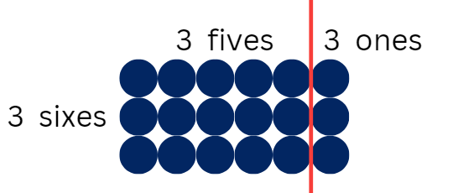
- Group students into threes, using VNPS or individual whiteboards to explore and find at least 3 possible answers for how many ribbons might be needed in total for the carnival.
- Share student responses.
- Pose the following problem: At the local oval there are no lane lines for the races. You will need between 5 and 10 cones for each lane. You know that there will be between 4 and 8 lanes. How many cones might you need altogether? Record at least 3 possible solutions using fact families, arrays and number sentences to show your thinking. Challenge: If 10 cones are positioned at equal distances for each race, how far apart will each cone be for the 70 m, 100 m, 200 m and 400 m races?
Note: students may not realise that they will need an extra row of cones than there are lanes. For example, with 4 lanes they will need 5 rows of cones.
- Return students to their groups to explore at least 3 possible results.
- Share student responses.
This table details opportunities for differentiation.
Too hard? | Too easy?
Students cannot describe multiplication problems using for each and times as many.  - Provide concrete materials for students to make arrays to represent the for each and times as many ideas.  - Students focus on examples where multiples of 2, 4, 5 and 10 are used. Students draw pictures or arrays to show their thinking and calculations. | Students can describe multiplication problems using for each and times as many.  - Students create a novelty event for the carnival. Students write other for each and times as many questions for other athletics carnival events.  - For ‘How many cones?’ Students show all possible combinations of cones in a system like a table as in Lesson 1.

Stage 3 task – interpreting division in worded problems
The table below contains suggested learning intentions and success criteria. These are best co-constructed with students.
Core concept learning intentions | Core concept success criteria
Students are learning to:  - select and apply strategies to divide a number with 3 or more digits by a one-digit divisor. | Students can:  - estimate the result of dividing by a one-digit divisor  - apply and record appropriate strategies to solve division word problems  - use and interpret remainders in solutions to division problems.
This activity is an adaptation of ‘How many are left?’ from Open-ended maths activities: Using ‘good’ questions to enhance learning in mathematics by Sullivan and Lilburn.
- Revise the idea that sometimes when solving division problems, the answers may include remainders. Depending on the context of the division, sometimes the remainders can be parts and sometimes they need to be whole numbers.
- Pose the question: There are 187 people who need to cross a crocodile infested river. The ferry can carry 6 people each trip. If they fill the boat with the maximum of 6 people each time, how many people will be left for the last trip?
- Provide whiteboards and writing materials. Students record their initial estimates.
- Select students to share their estimates and explain their reasoning.
- Explain that the number 187 can be partitioned as 180 + 7. 180 can be divided by 6 to give 30. 7 divided by 6 will give 1 remainder 1 (see Figure 21).
Figure 21 – partitioning for division
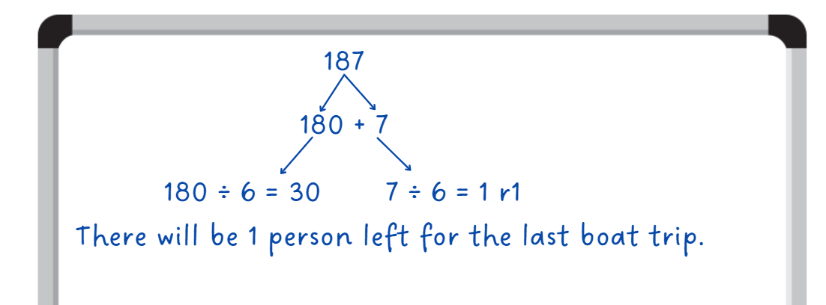
- Selected students identify how many people would be on the final boat trip and explain how they determined their answer.
- Students complete the following problems:
- The local football club is making prize bags for the end of year celebration. Each bag must have 8 prizes. If they have 214 prizes to begin with, how many prize bags can they make? Will there be any remaining prizes not in a bag?
- The school raffle raised $2140. The money was shared equally with each of the 8 classes to spend on resources. How much money did each class receive?
- A train from Cairns to Sydney travels at an average speed of 80 km/h. How long would it take to travel approximately 2140 km to Sydney if the train does not stop?
- Discuss with students the similarities and differences between each question.
Note: the word problems all have variations of the numbers 214 and 8. The last word problem refers to distance and travel times. Encourage students to think about how to calculate these numbers when working with numbers involving multiples of tens and hundreds. The number 80 is made up of 8 tens, and the number 2140 is made up of 214 tens.
- Explain that for the travel word problem, there are no remainders as time is measured in hours and minutes.
- Ask students if a word problem involving money would be similar and to justify their answer.
This table details opportunities for differentiation.
Too hard? | Too easy?
Students cannot apply and record appropriate strategies to solve division word problems.  - Support students to use standard and non-standard partitioning to solve division word problems.  - Provide students with more word problems with a 3-digit by a one-digit divisor. For example, the school raffle raised $214. Each of the 8 classes received the same amount to spend on resources. How much money did each class get? | Students can apply and record appropriate strategies to solve division word problems.  - Students create their own word problems involving 3- and 4-digit numbers by one-digit divisors for a partner to solve.  - Pose the following problem: A train is travelling from Cairns to Sydney then from Sydney to Adelaide. It is approximately 2140 km from Cairns to Sydney and 1400 km from Sydney to Adelaide. The train travels at an average speed of 80 km/h. How long will the train journey take from Cairns to Adelaide?

Discuss and connect the mathematics – 10 minutes
- Ask Stage 2 students:
- What is the difference between multiplication problems that use times as many and for each?
- Are there differences to how you solve each type of problem? Justify your answer.
- How do fact family triangles help solve multiplication and division problems?
- Ask Stage 3 students:
- What type of scenarios are appropriate for fraction answers? Why?
- What type of scenarios are appropriate for remainder answers? Why?
- What techniques were most effective for estimating? Why?
This table details opportunities for assessment.
Assessment opportunities | Links
What to look for:  - Can Stage 2 students describe multiplication problems using for each and times as many? [MAO-WM-01, MA2-MR-01,  MA2-MR-02]  - Can Stage 2 students represent and solve multiplication and division (both sharing and grouping) word problems using number sentences? [MAO-WM-01, MA2-MR-01, MA2-MR-02]  - Can Stage 3 students estimate the result of dividing by a one-digit divisor? [MAO-WM-01, MA3-MR-01]  - Can Stage 3 students apply and record appropriate strategies to solve division word problems? [MAO-WM-01, MA3-MR-01]  - Can Stage 3 students use and interpret remainders in solutions to division problems? [MAO-WM-01, MA3-MR-01] | Links to National Numeracy Learning Progressions (NNLP):  - Stage 2 – NPA4  - Stage 3 – MuS6, MuS7, MuS8.  Links to suggested Interview for Student Reasoning (IfSR) tasks:  - Stage 2 – IfSR-MT: 2A.12, 2A.13, 2A.14  - Stage 3 – N/A.

Resource 1 – How many books?
- Isaac has read 6 books, but Chris has read 4 times as many. How many books has Chris read?
- Sam has read 7 books. Imogen has read twice as many as Sam. Jamie has read twice as many as Imogen. How many books have they each read?
- Chanel put the books she had read on the floor. There were 4 rows of 8 books. How many books has she read?
- Before recess Max laid out his books on the floor in 5 equal rows. When he returned, some of his books had been borrowed by someone else. By looking at the remaining books in the picture, how many books did Max start with?
- How many books have Isaac, Chris, Chanel, Sam, Imogen, Jamie and Max read altogether?
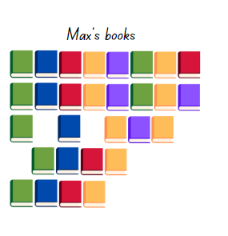

Resource 2 – pattern table
Sum of 10 | Product
0 + 10 | 0 × 10 = 0
1 + 9 | 1 × 9 = 9
2 + 8 | 2 × 8 = 16
3 + 7 | 3 × 7 = 21
4 + 6 | 4 ×
5 + 5 | 5 ×
6 + 4 | 6 ×
7 + 3 | 7 ×
8 + 2 | 8 ×
9 + 1 | 9 ×
10 + 0 | 10 ×

Resource 3 – caught red handed
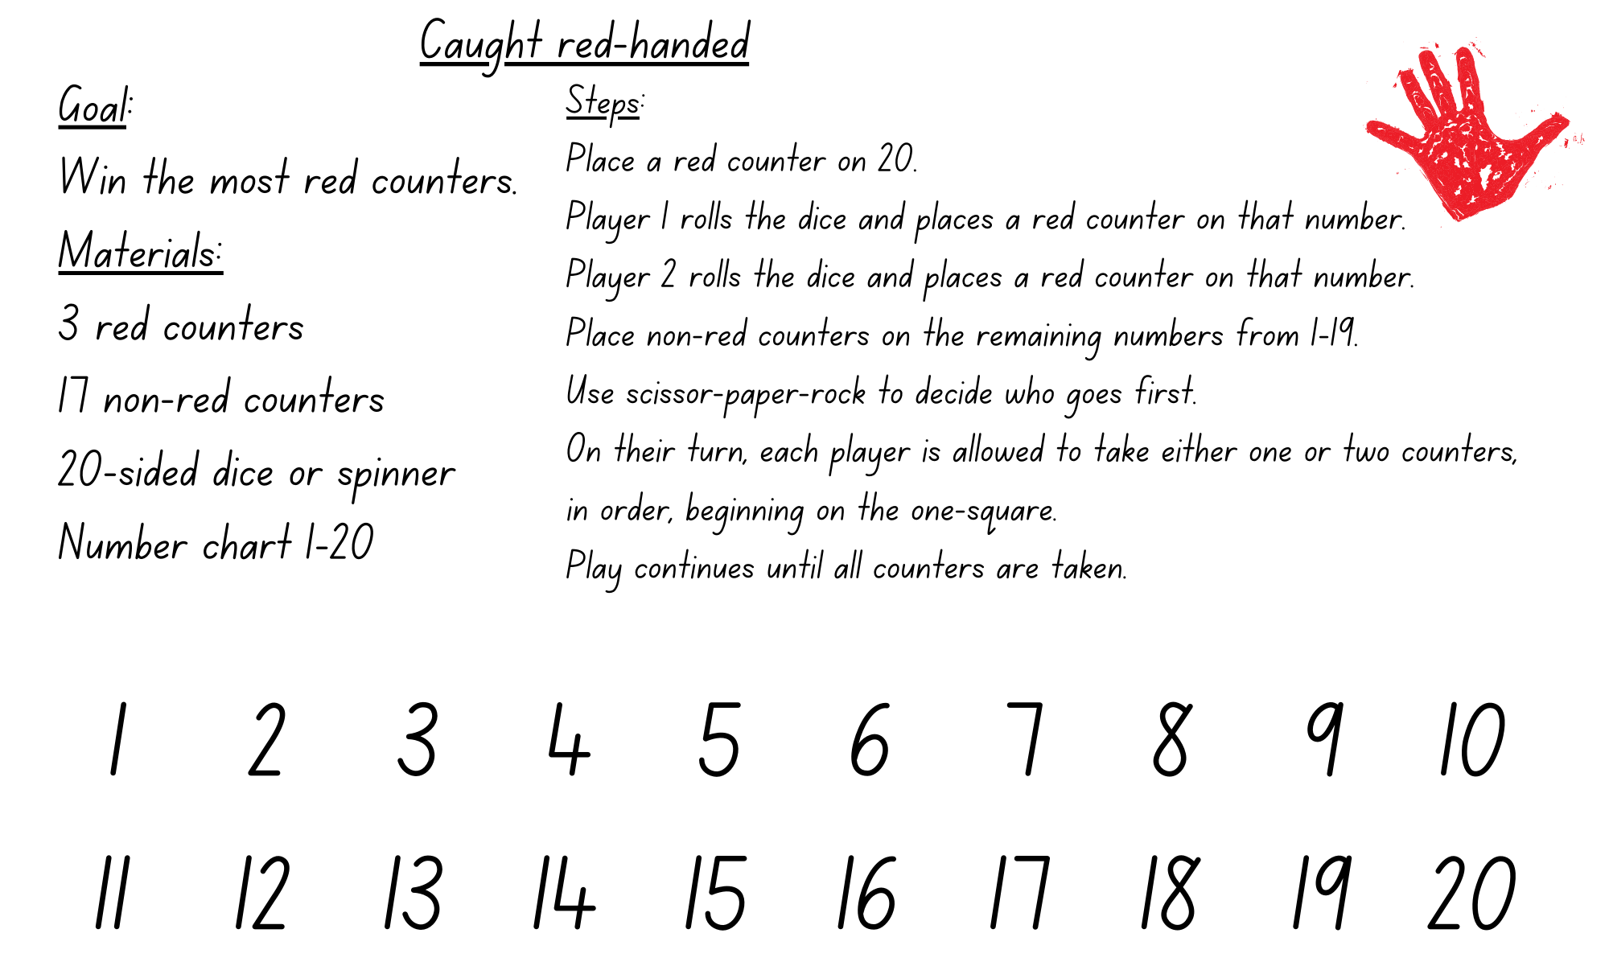
Adapted from Russo (2017).

Resource 4 – red handed questions
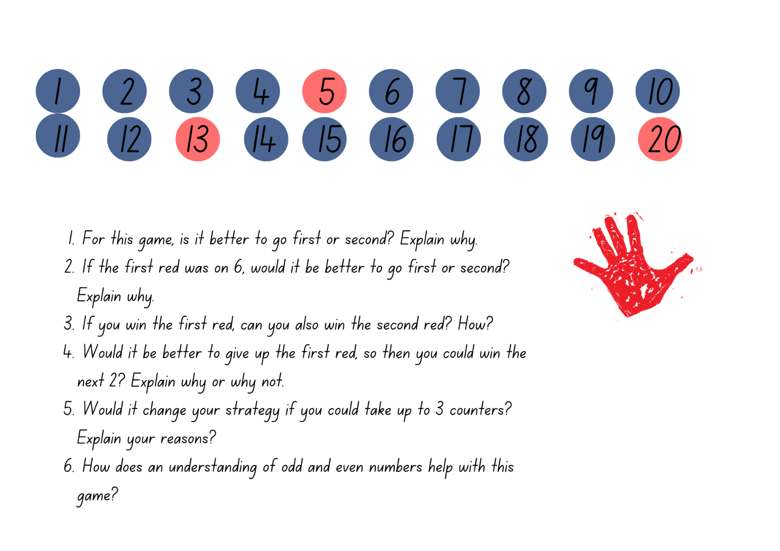
Adapted from Russo (2017).

Resource 5 – candy possibilities
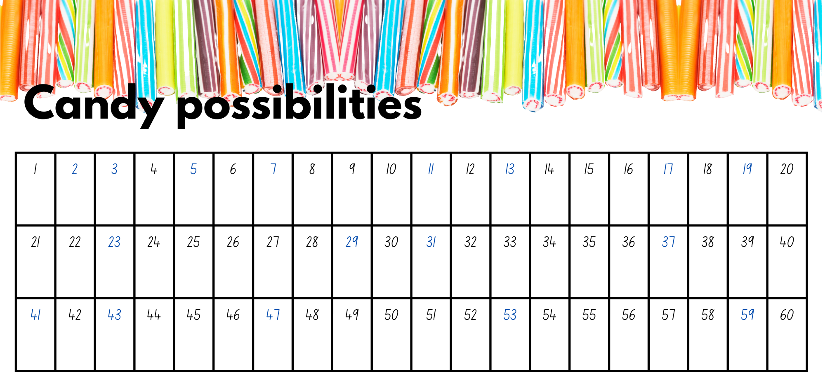

Resource 6 – splats
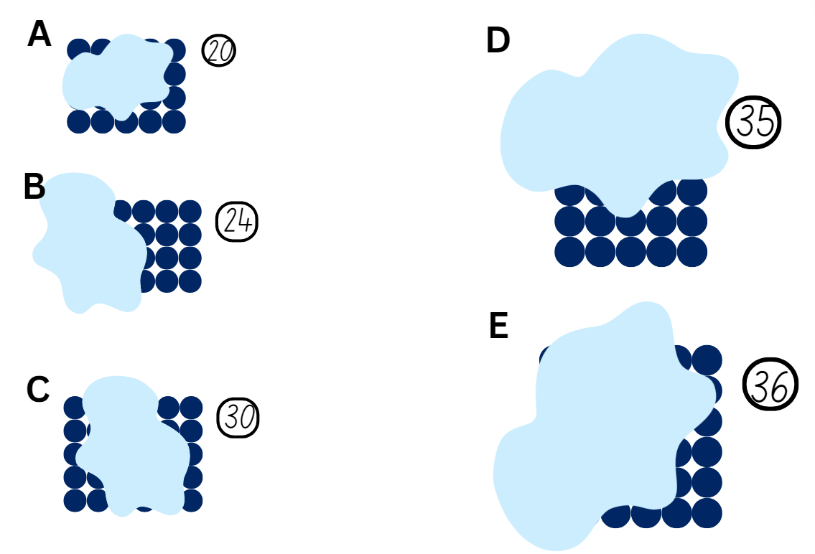
Adapted from Wyborney (2017).

Resource 7 – partially covered arrays
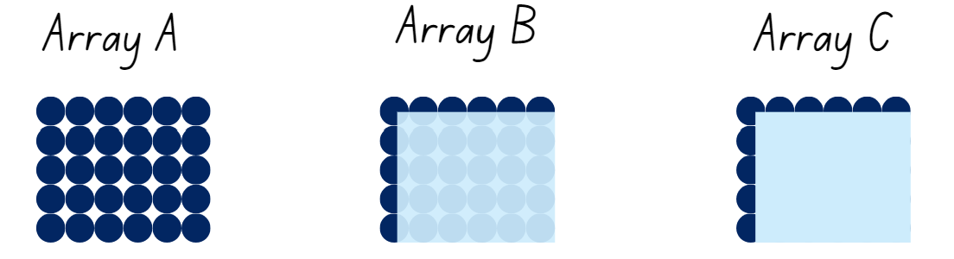

Resource 8 – matching cards
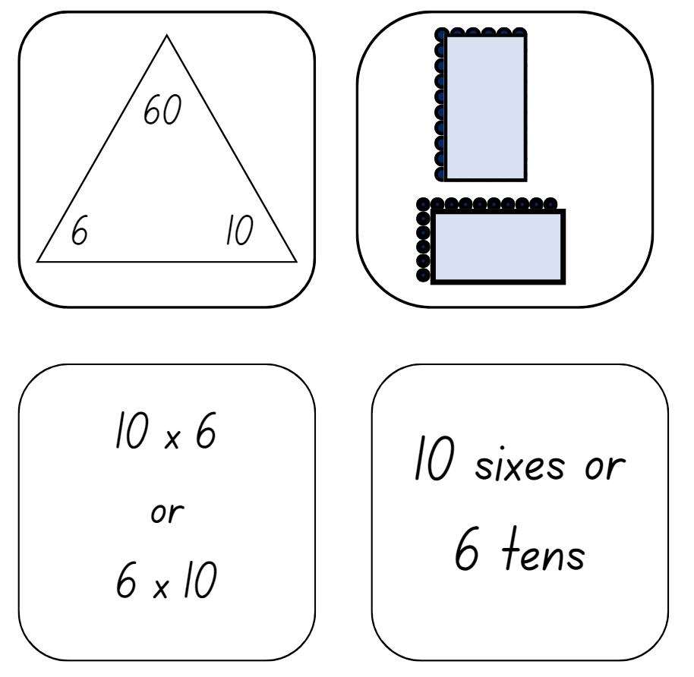

Resource 9 – matching card templates
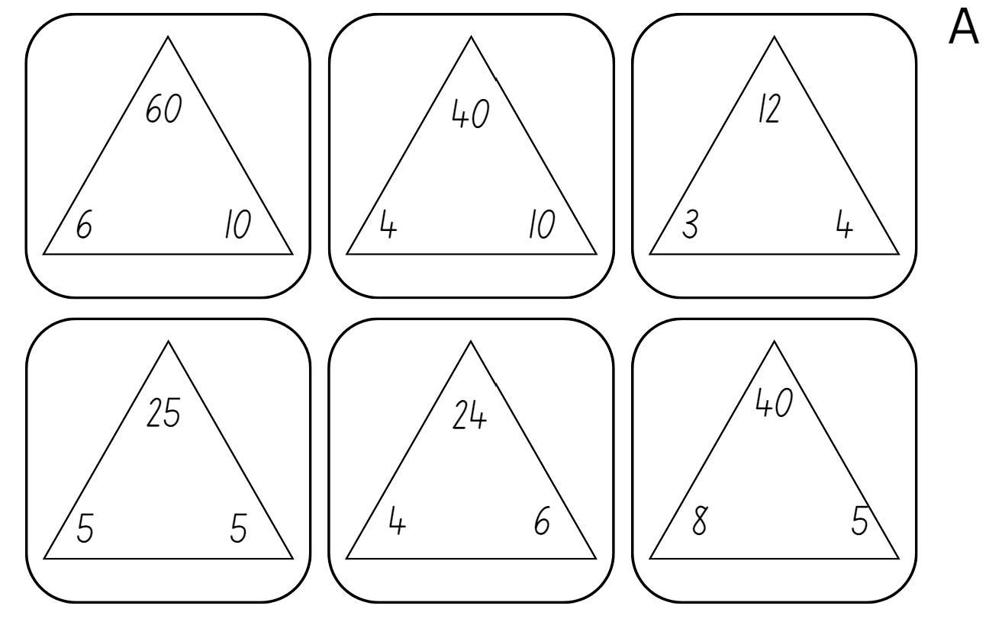

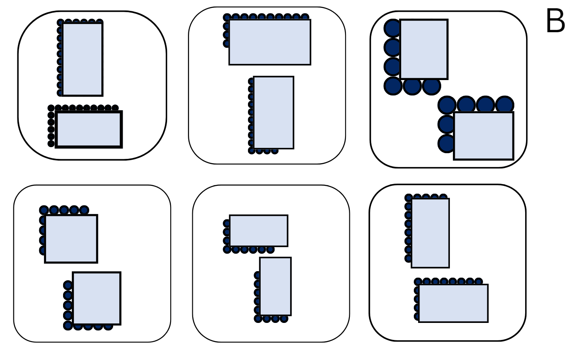

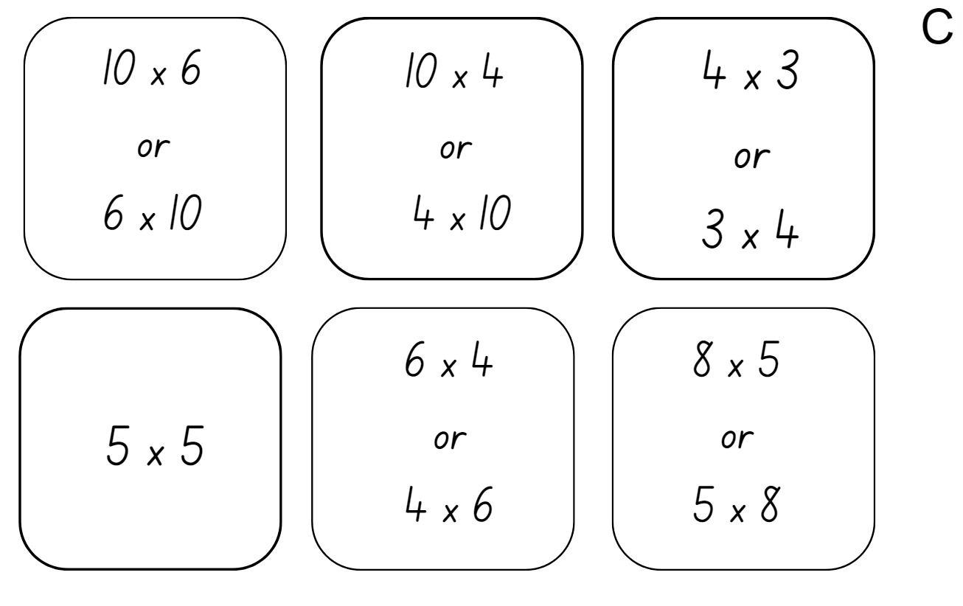

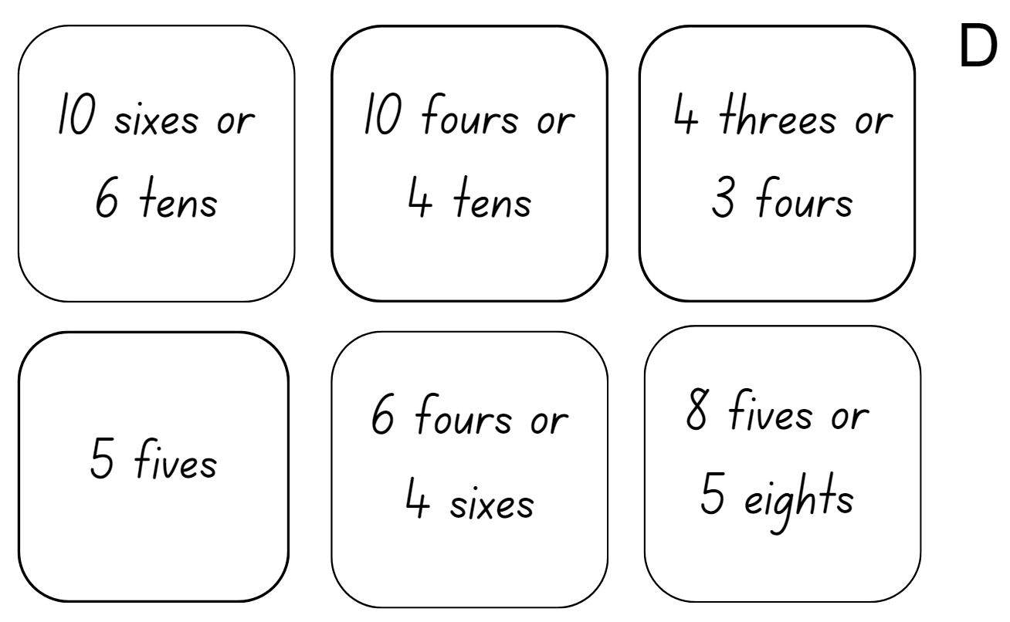

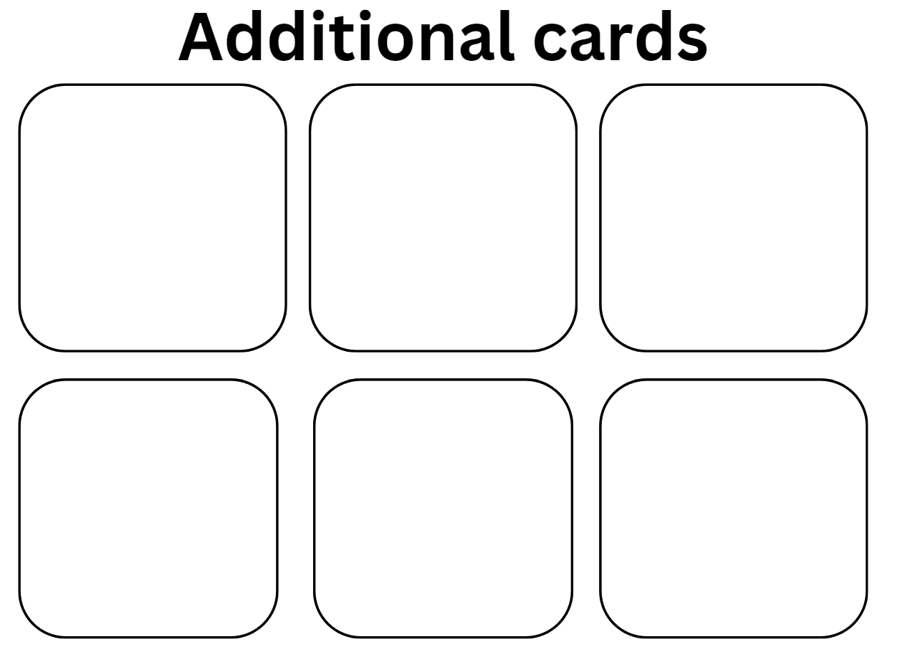

Resource 10 – doubles and halves
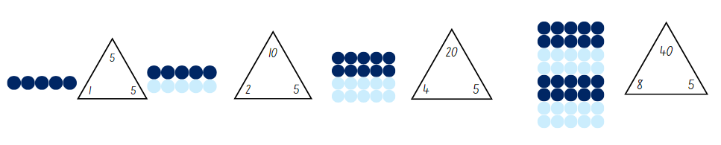

Resource 11 – doubles bingo
Aim: To be the first player to remove all counters from the board.
Materials
- Number chart to 120,
- Dice (either 1–6, 1–10, 1–20)
- 3 coloured counters per player
Steps
- Take turns to place your counters on 3 numbers greater than 20 on the number chart.
- Player 1 rolls the die and repeatedly doubles the number until a counter is reached or the highest number is passed. For each roll, write a number chain to show doubling, for example: 2, 4, 6, 8, 16, 32, 64.
- Players take turns rolling and doubling. Play continues until one player removes all 3 of their counters.
Variations
- Use a different die or choose numbers between 10 and 50.
- If a one is rolled, the player may move a counter to a different number.
Adapted from Russo (2016).

Resource 12 – Are we allowed?
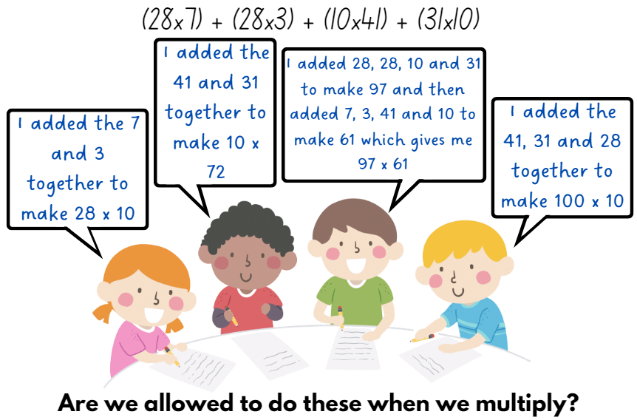

Resource 13 – arrays
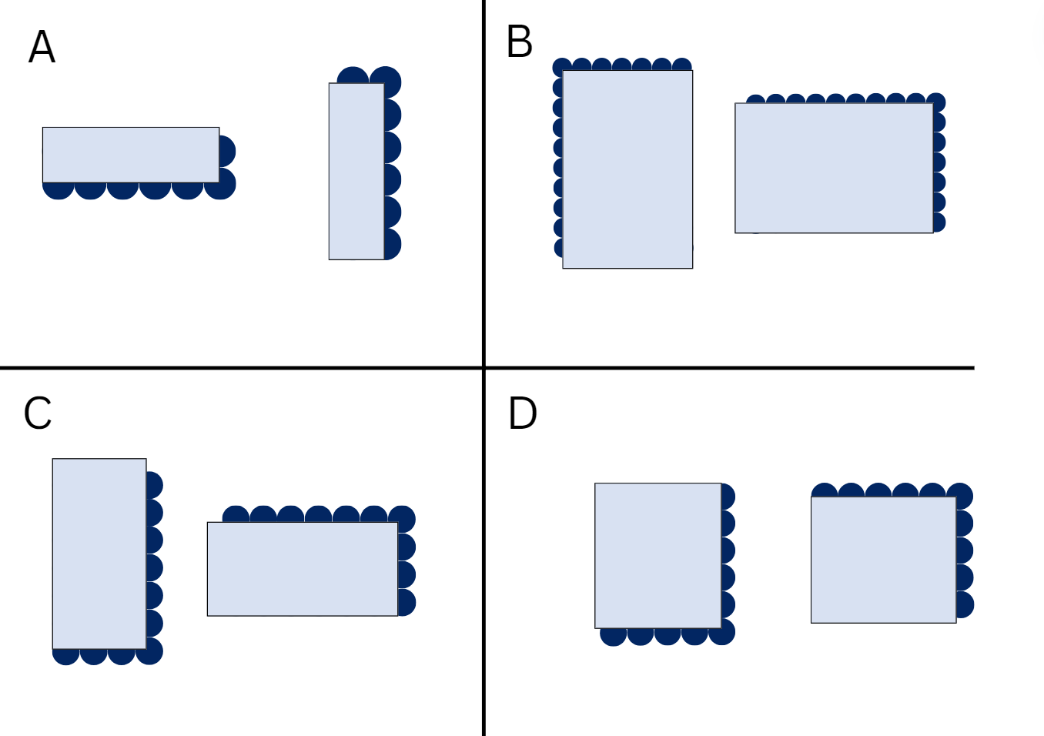

Resource 14 – plug board examples
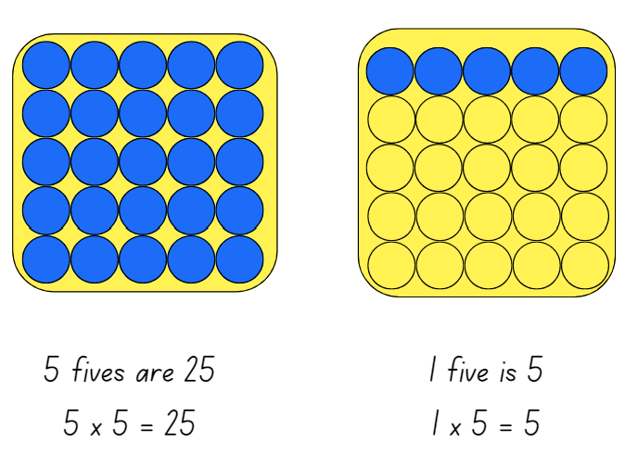

Resource 15 – combined plug boards
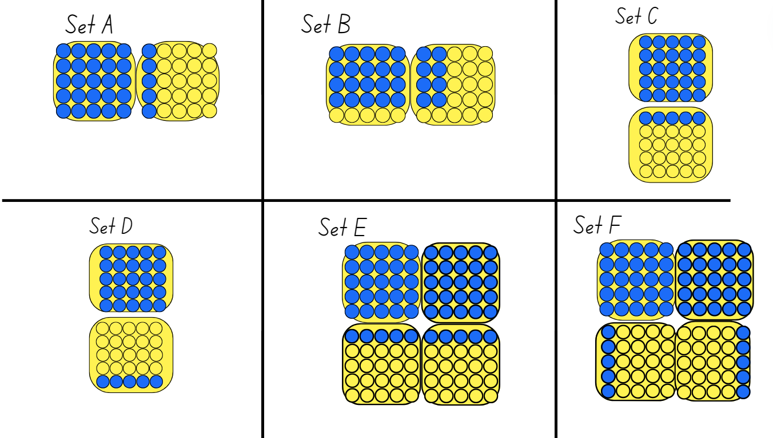

Resource 16 – prove it’s 36
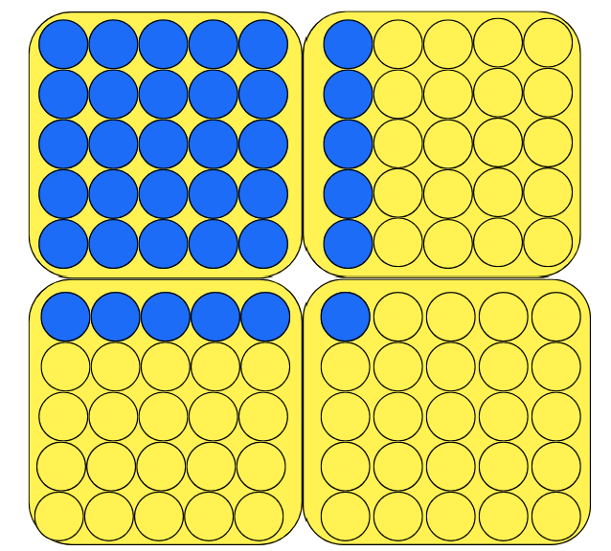

Resource 17 – plug boards
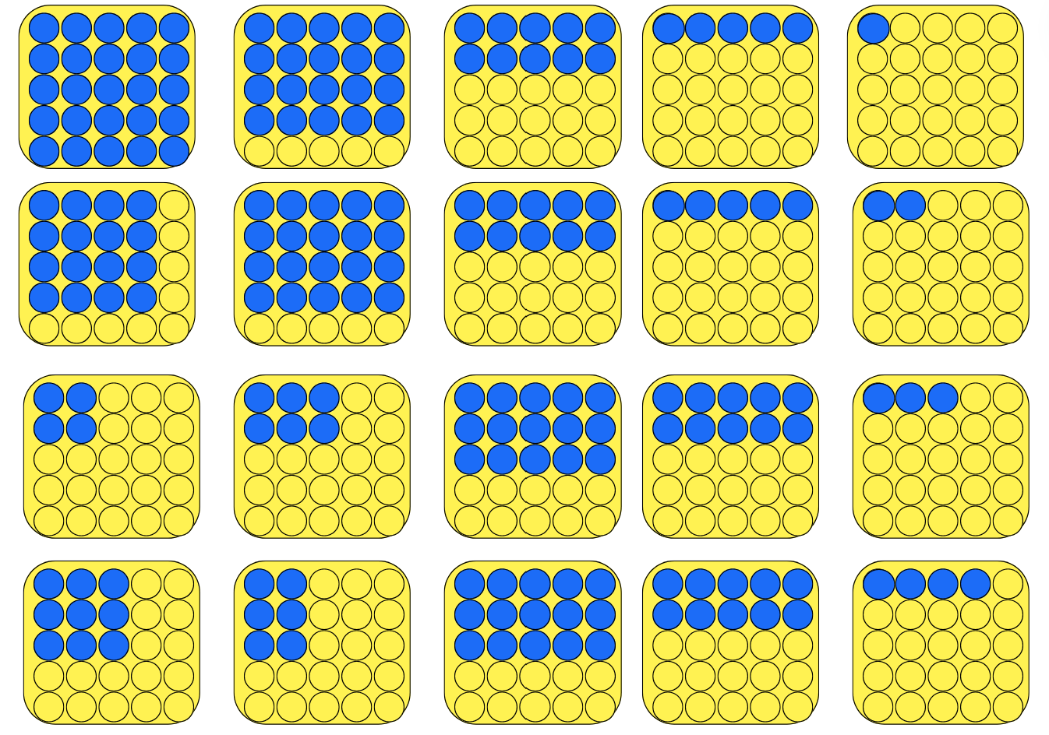

Resource 18 – What am I?
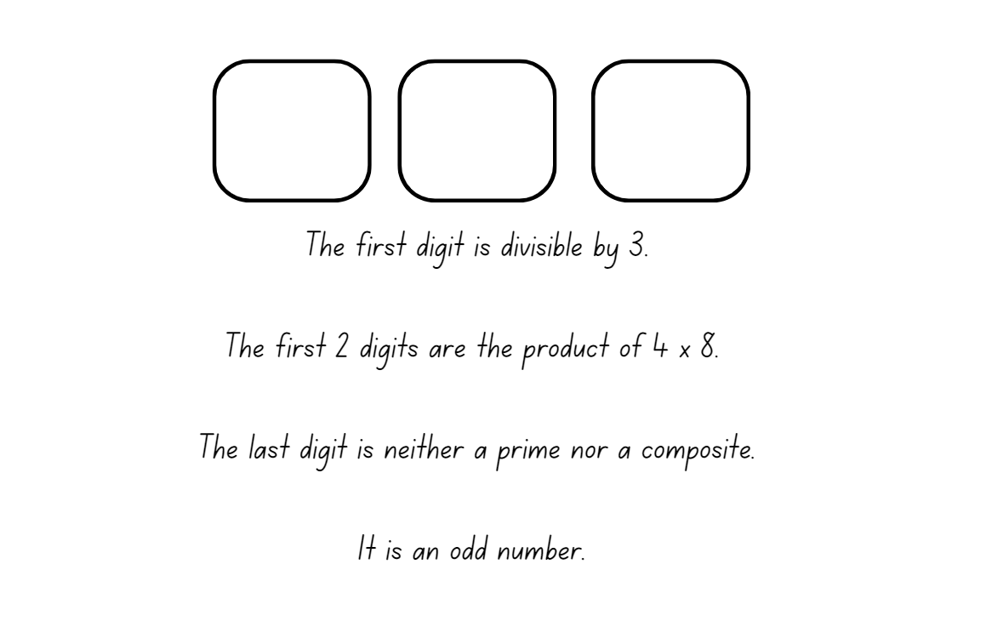

Resource 19 – task cards
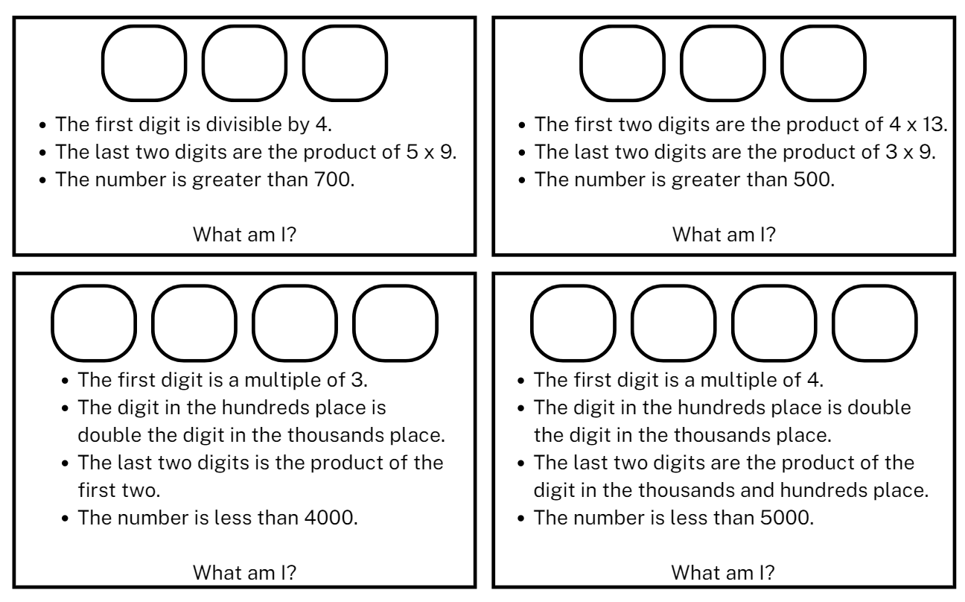

Resource 20 – office catalogue
Stationery | Cost ($) | Technology and furniture | Cost ($)
Pencil | $0.50 | Desk | $157.00
Pen | $0.60 | Chair | $57.95
Ruler | $0.45 | Desk lamp | $15.65
Sticky tape | $0.50 | Drawer tidy | $12.97
Paint brush | $1.25 | Computer | $897.95
Stickers | $1.75 | Printer | $349.95
Glue | $0.70 | Headphones | $10.87
Coloured pencils | $1.25 | Charger | $15.95

Resource 21 – How many cupcakes?
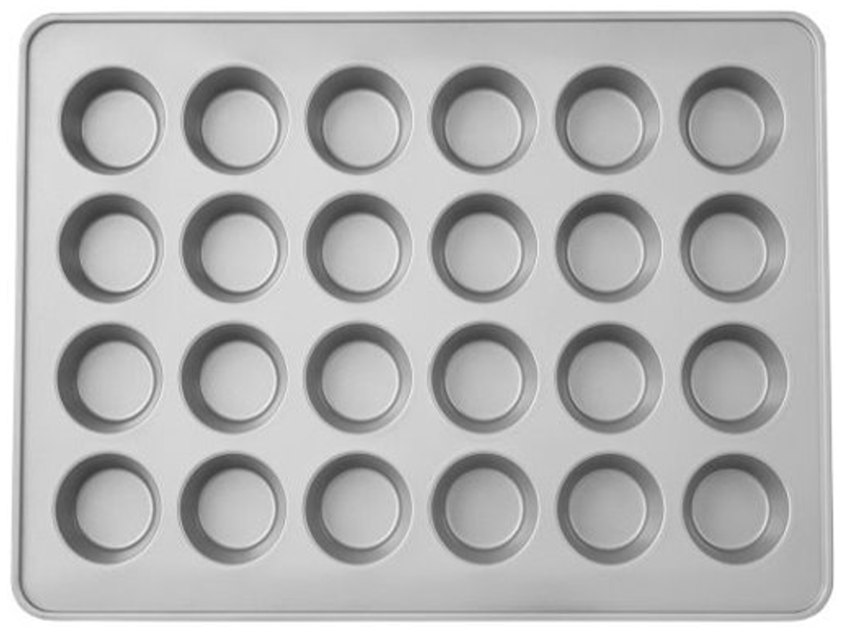

Resource 22 – a special order
For a special order, Charlie bakes these extra delicious cupcakes using his special tray. How many cupcakes are there altogether? Show different ways that you can calculate the total.
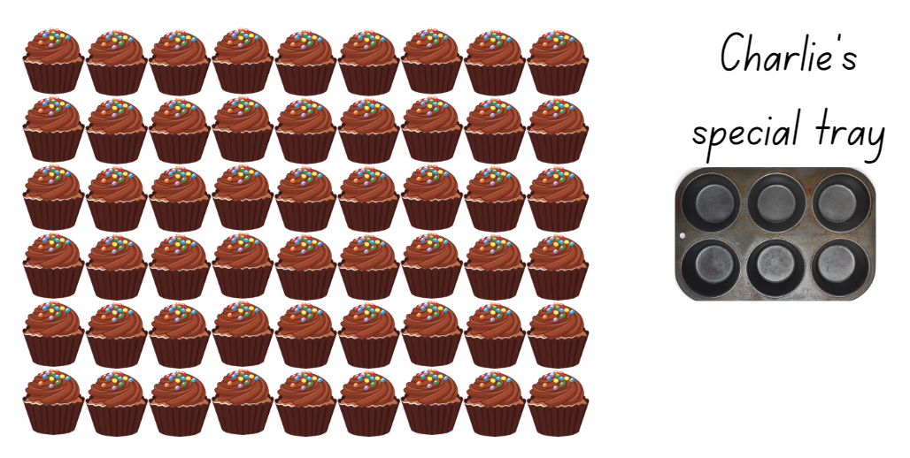
Adapted from Australian Academy of Science (2024).

Resource 23 – busy cupcake day
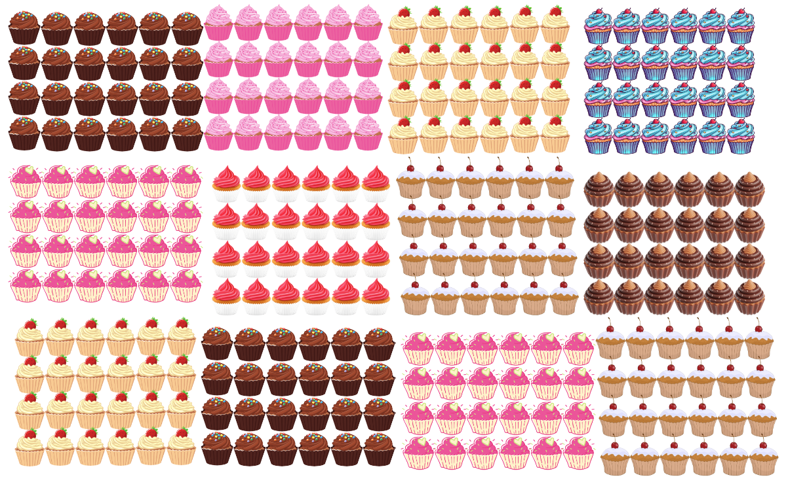
Adapted from Australian Academy of Science (2024).

Resource 24 – sharing crackers
- How many students can share the crackers?
- How many crackers will each student get?

Resource 25 – sharing solutions
Number of crackers | How many students are sharing? | How many crackers will each student get? | What strategy was used?
36 | 1 | 36 | Only one student
36 | 2
36
36
36
36
36
36
36
- Choose a die that suits you.
- Choose numbers between 10 and 50.
- If a player rolls a 1, they may move a counter to a different number.

Resource 26 – Salute!
Aim: for 3 players to practise multiplication.
Materials: pack of cards: Ace is 1, Jack is 10, Queen is 100 and King is 1000.
How to play:
- Place the cards in a pile, face down. Two players pick up a card each.
- Players do not look at their card but hold the card, facing out, on their foreheads in a ‘salute’.
- Player 3 multiplies the numbers on the 2 cards they can see and calls the answer.
- Player 1 and Player 2 must work out from the answer the value of the card on their forehead.
- The game is repeated with the players swapping their roles.
Variations
- To start, cards from 1–5 could be selected to form the pack face down on the table. As familiarity with the game increases, the higher numbers could be added.
- The game could also be extended with 4 players, 3 with a card on their forehead and one adding or multiplying the numbers together.
Adapted from New Zealand Ministry of Education (n.d.).

Resource 27 – fill the chart
Aim: to be the first player to fill your chart.
How to play:
- Each player draws a board like the one shown below.
- Select a known multiplication fact and a target multiplication fact.
- On your turn, roll a 1–10 die. Multiply it by one of your target numbers.
- Record the product in the empty space below that digit. Record only one product per roll.
Fact | 1 | 2 | 3 | 4 | 5 | 6 | 7 | 8 | 9 | 10
Known fact
Target fact
Adapted from Bay-Williams JM and SanGiovanni JJ (2021).

Resource 28 – Open Middle problem
Directions: using the digits 2 to 9 once each, place a digit in each box to make 2 correct equations: one where the value is greater than 30 and one where the value is less than 30. You may reuse all the digits in each equation.
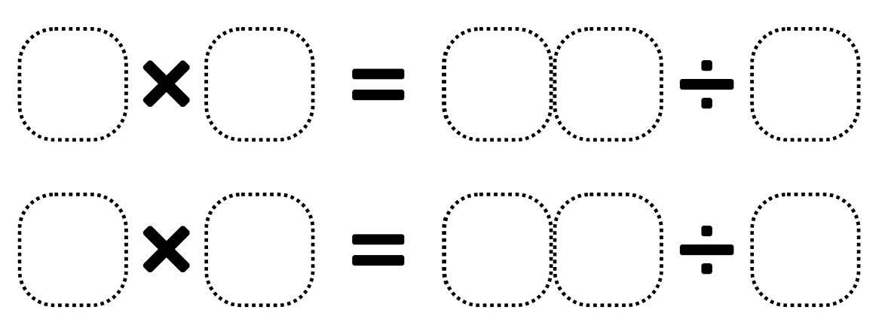
Adapted from Kaplinsky R (2016–2024).

Resource 29 – carnival ribbons
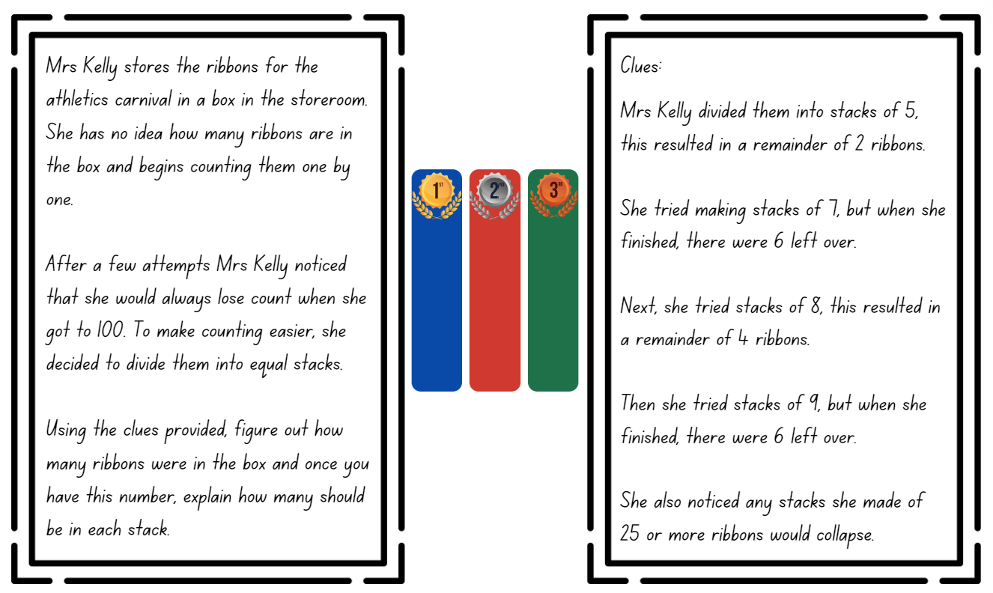

Resource 30 – number chart
101 | 102 | 103 | 104 | 105 | 106 | 107 | 108 | 109 | 110
111 | 112 | 113 | 114 | 115 | 116 | 117 | 118 | 119 | 120
121 | 122 | 123 | 124 | 125 | 126 | 127 | 128 | 129 | 130
131 | 132 | 133 | 134 | 135 | 136 | 137 | 138 | 139 | 140
141 | 142 | 143 | 144 | 145 | 146 | 147 | 148 | 149 | 150

Resource 31 – table recording
Number of groups | 1 | 2 | 3 | 4 | 5 | 6 | 7 | 8 | 9 | 10 | 11 | 12 | 13
Groups of 3 students with 1 student left over | 4 | 7 | 10 | 13 | 16 | 19 | 22 | 25 | 28 | 31 | 34 | 37 | 40
Groups of 4 students with 2 students left over | 6 | 10 | 14 | 18 | 22 | 26 | 30 | 34 | 38 | 42 | 46 | 50 | 54

Syllabus outcomes and content

Stage 2
The table below outlines the syllabus outcomes and range of relevant syllabus content covered in this unit. Content is linked to National Numeracy Learning Progression (version 3).
Outcomes and content | 1 | 2 | 3 | 4 | 5 | 6 | 7 | 8
Representing numbers using place value B: Whole numbers: Recognise and represent numbers that are 10, 100 or 1000 times as large
MA2-RN-01
- Describe how making a number 10, 100 or 1000 times as large changes the place value of digits |  | x
Additive relations A: Represent money values in multiple ways
MAO-WM-01, MA2-AR-01, MA2-AR-02
- Recognise the relationship between dollars and cents |  |  |  |  | x | x | x
- Represent equivalent amounts of money using different denominations |  |  |  |  | x | x | x
- Perform calculations with money, including finding change |  |  |  |  | x | x | x
Multiplicative relations A: Generate and describe patterns
MAO-WM-01, MA2-MR-01, MA2-MR-02
- Model, describe and record patterns of multiples | x
- Recognise the significance of the final digit of a whole number in determining whether a given number is even or odd (Reasons about relations) | x
- Recognise the connection between even numbers and the multiplication facts for 2 (Reasons about relations) | x
Multiplicative relations A: Use arrays to establish multiplication facts from multiples of 2 and 4, 5 and 10
MAO-WM-01, MA2-MR-01, MA2-MR-02
- Create and represent multiplicative structure, using the term multiples when connecting grouping to arrays |  | x
- Use the array structure to coordinate the number of groups with the number in each group |  | x
- Relate doubling to multiplication facts for multiples of 2 |  |  | x
- Recognise that doubling is multiplying by 2 and halving is dividing by 2 (Reasons about relations) |  |  | x
- Recognise the relationship between one multiple and its double (Reasons about relations) |  |  | x
Multiplicative relations A: Recall multiplication facts of 2 and 4, 5 and 10 and related division facts
MAO-WM-01, MA2-MR-01, MA2-MR-02
- Recognise and use the symbols for multiplied by (×), divided by (÷) and equals (=) |  |  |  | x |  | x
- Generate multiplication fact families for multiples of 2 and 4, 5 and 10 |  |  |  |  |  |  | x
Multiplicative relations A: Represent and solve problems involving multiplication fact families
MAO-WM-01, MA2-MR-01, MA2-MR-02
- Describe multiplication problems using for each and times as many | x |  |  |  |  |  |  | x
- Find the total of partially covered arrays | x | x
- Apply the inverse relationship of multiplication and division (Reasons about relations) |  | x | x |  |  | x | x | x
Multiplicative relations B: Use known number facts and strategies
MAO-WM-01, MA2-MR-01, MA2-MR-02
- Apply the known strategy of doubling to connect multiples of 3 to 6 and 4 to 8 (Reasons about relations) |  |  | x
- Use known facts to find unknown multiples (Reasons about relations) |  |  |  | x
Multiplicative relations B: Use number properties to find related multiplication facts
MAO-WM-01, MA2-MR-01, MA2-MR-02
- Use the commutative property of multiplication |  |  |  | x
- Use flexible partitioning within multiplication (Reasons about relations) |  |  |  | x | x
Multiplicative relations B: Represent and solve word problems with number sentences involving multiplication or division
MAO-WM-01, MA2-MR-01, MA2-MR-02
- Use the equals sign to record equivalent number relationships involving multiplication (Reasons about relations) |  |  |  |  |  |  | x
- Complete number sentences involving multiplication and division by calculating missing numbers (Reasons about relations) |  |  |  |  |  |  | x
- Represent and solve multiplication and division (both sharing and grouping) word problems using number sentences |  |  |  |  |  | x |  | x
Mathematics K–10 Syllabus © NSW Education Standards Authority (NESA) for and on behalf of the Crown in right of the State of New South Wales, 2022.

Stage 3
The table below outlines the syllabus outcomes and range of relevant syllabus content covered in this unit. Content is linked to National Numeracy Learning Progression (version 3).
Outcomes and content | 1 | 2 | 3 | 4 | 5 | 6 | 7 | 8
Represent numbers A: Whole numbers: Apply place value to partition, regroup and rename numbers to 1 billion
MAO-WM-01, MA3-RN-01
- Regroup numbers in different forms (Reasons about quantity) |  |  | x | x | x |  | x
Additive relations A: Use estimation and place value understanding to determine the reasonableness of solutions
MAO-WM-01, MA3-AR-01
- Use place value understanding to check for errors in calculations |  |  |  |  | x | x | x
- Use estimation to check the reasonableness of solutions to addition and subtraction calculations |  |  |  |  |  | x | x
Multiplicative relations A: Determine products and factors
MAO-WM-01, MA3-MR-01
- Use the term product to describe the result of multiplying 2 or more numbers |  | x
- Model different ways to show a whole number as a product (Reasons about structure) |  | x
- Determine factors for a given whole number | x | x |  | x
- Determine whether a number is prime, composite or neither (0 or 1) | x
Multiplicative relations A: Use partitioning and place value to multiply 2-, 3- and 4-digit numbers by one-digit numbers
MAO-WM-01, MA3-MR-01
- Use mental strategies to multiply one-digit numbers by 10, 100, 1000 and their multiples |  | x | x
- Estimate the product of 2 numbers (one-digit by 2- or 3-digit numbers) using multiples of 10 or 100 |  | x | x
- Use the distributive property with partial products to solve problems by multiplying the hundreds, then the tens and then the ones |  |  | x | x | x
Multiplicative relations A: Represent and solve division problems with whole number remainders
MAO-WM-01, MA3-MR-01
- Model division, including where the answer involves a remainder, using materials or diagrams |  |  |  |  |  |  | x
- Show the connection between division and multiplication involving the divisor and quotient |  |  |  |  |  |  | x
Multiplicative relations A: Select and apply strategies to divide a number with 3 or more digits by a one-digit divisor
MAO-WM-01, MA-MR-01
- Estimate the result of dividing by a one-digit divisor |  |  |  |  |  |  |  | x
- Use knowledge of multiples to partition as appropriate and divide | x | x
- Apply and record appropriate strategies to solve division word problems | x |  | x |  |  |  |  | x
- Use and interpret remainders in solutions to division problems |  |  | x |  |  |  |  | x
Multiplicative relations A: Use estimation and rounding to check the reasonableness of answers to calculations
MAO-WM-01, MA3-MR-01
- Use estimation to check the reasonableness of answers to multiplication and division calculations |  |  |  | x
Mathematics K–10 Syllabus © NSW Education Standards Authority (NESA) for and on behalf of the Crown in right of the State of New South Wales, 2022.

References
This resource contains NSW Curriculum and syllabus content. The NSW Curriculum is developed by the NSW Education Standards Authority. This content is prepared by NESA for and on behalf of the Crown in right of the State of New South Wales. The material is protected by Crown copyright.
Please refer to the NESA Copyright Disclaimer for more information https://educationstandards.nsw.edu.au/wps/portal/nesa/mini-footer/copyright.
NESA holds the only official and up-to-date versions of the NSW Curriculum and syllabus documents. Please visit the NSW Education Standards Authority (NESA) website https://educationstandards.nsw.edu.au and the NSW Curriculum website https://curriculum.nsw.edu.au.
Mathematics K–10 Syllabus © NSW Education Standards Authority (NESA) for and on behalf of the Crown in right of the State of New South Wales, 2022.
National Numeracy Learning Progression © Australian Curriculum, Assessment and Reporting Authority (ACARA) 2010 to present, unless otherwise indicated. This material was downloaded from the Australian Curriculum website (National Numeracy Learning Progression) (accessed 27 March 2024) and was not modified.
Australian Academy of Science (2024) Multiplication: reSolve Bakery, reSolve website, accessed 13 November 2023.
Australian Association of Mathematics Teachers (AAMT) Inc (n.d.) Maths300 [website], accessed 2 April 2024.
Bay-Williams JM and SanGiovanni JJ (2021) Figuring Out Fluency in Mathematics Teaching and Learning, Grades K-8, SAGE Publications Inc, United States.
Boaler J (2022) Setting up Positive Norms in Math Class (PDF 1.18 MB), youcubed website, accessed 1 November 2023.
Boaler J, Munson J, Williams C (2018) Mindset Mathematics: Visualizing and Investigating Big Ideas, Grade 3, Jossey-Bass, San Francisco.
Edmonton Regional Learning Consortium – ERLC (1 May 2016) ‘Number Strings to Encourage Multiplication Strategies – Part 1’ [video], Edmonton Regional Learning Consortium - ERLC, YouTube, accessed 8 April 2024.
Edmonton Regional Learning Consortium – ERLC (3 May 2019) ‘Number Strings to Encourage Multiplication Strategies – Part 2’ [video], Edmonton Regional Learning Consortium - ERLC, YouTube, accessed 8 April 2024.
Fun4theBrain (2019) Multiplication games, Fun4theBrain website, accessed 15 April 2024.
Kaplinsky R (2016–2024) Multiply and Divide Within A Hundred 1, Open Middle website, accessed 15 April 2024.
Katz N (2023) ‘Distributive Property with Four’, Grade 4, Open Middle website, accessed 15 April 2024.
Liljedahl P (2021) Building Thinking Classrooms in Mathematics, Grades K-12: 14 Teaching Practices for Enhancing Learning, Sage Publications Inc, United States.
Minas M (n.d.) Love Maths [website], accessed 15 April 2024.
NSW Education Standards Authority (NESA) (2023) ‘Elaborating on Working mathematically in K–10’, Teaching and learning support, NESA website, accessed 17 November 2023.
NSW Education Standards Authority (NESA) (2022) Teaching advice for Multiplicative relations A, NESA website, accessed 9 May 2024.
New Zealand Ministry of Education (n.d.) Salute, NZ Maths website, accessed 15 April 2024.
Orton C (2016–2024) Building Shelves 1, Open Middle website, accessed 8 April 2024.
Orton C (2016–2024) Building Shelves 2, Open Middle website, Open Middle website, accessed 8 April 2024.
Pierce R (2023) Math Trainer – Multiplication, Maths is Fun website, accessed 29 April 2024.
Russo J (2016) ‘Doubles Bingo’, Teaching Children Mathematics, 23(1):56, doi:10.5951/teacchilmath.23.1.0056.
Russo J (2017) ‘Short activity: Learning to think strategically - Caught Red-handed’, Australian Primary Mathematics Classroom, 22(1): 40.
Stanford University (n.d.) Math Cards 3-6, youcubed website, accessed 17 November 2023.
State of Queensland (Queensland Curriculum & Assessment Authority) (2022) Number strings factsheet (PDF 188 KB), QCAA website, accessed 8 April 2024.
State Government of Victoria (Department of Education) (2020) ‘Liquorice Factory’, It’s All in the Numbers, Arc Learning Sequences website, accessed 23 November 2023.
State Government of Victoria (Department of Education) (n.d.) ‘Susie’s dilemma’, Number and place value, Arc Learning: Mathematics Curriculum Companion website, accessed 15 April 2024.
Sullivan P (2017) Challenging mathematical tasks: Unlocking the potential of all students, Oxford University Press Australia & New Zealand.
Sullivan P (2021) Building Engagement in Middle Years Mathematics: Learning sequences for mixed-ability classrooms, 1st edn, Oxford University Press Australia & New Zealand.
Sullivan P and Lilburn P (2017) Open-Ended Maths Activities: Using Good Questions to Enhance Learning Mathematics, 2nd edn, Oxford University Press Australia and New Zealand, Great Britain.
Tolomeo P (2023) ‘Multiplying Two-Digit Numbers – Closest to 7,000’, Grade 4, Open Middle website, accessed 23 November 2023.
University of Cambridge (n.d.) Double or Halve?, NRICH website, accessed 8 April 2024.
Van de Walle J, Karp K, Bay-Williams JM, Brass A, Bentley B, Ferguson S, Goff W, Livy S, Marshman M, Martin D, Pearn C, Prodromou T, Symons D and Wilkie K (2019) Primary and Middle Years Mathematics: Teaching Developmentally, 1st Australian edn, Pearson Education Australia, Melbourne.
Wyborney S (9 February 2017) ‘Splat!’, Steve Wyborney’s Blog: I’m on a Learning Mission, accessed 2 April 2024.

Further reading
Siemon D, Warren E, Beswick K, Faragher R, Miller J, Horne Marj, Jazby D, Breed M, Clark J, Brady K (2020) Teaching Mathematics: Foundation to middle years, 3rd edn, Oxford University Press, Australia.
Van de Walle J, Karp K, Bay-Williams JM, Brass A, Bentley B, Ferguson S, Goff W, Livy S, Marshman M, Martin D, Pearn C, Prodromou T, Symons D and Wilkie K (2019) Primary and Middle Years Mathematics: Teaching Developmentally, 1st Australian edn, Pearson Education Australia, Melbourne.
© State of New South Wales (Department of Education), 2024
The copyright material published in this resource is subject to the Copyright Act 1968 (Cth) and is owned by the NSW Department of Education or, where indicated, by a party other than the NSW Department of Education (third-party material).
Copyright material available in this resource and owned by the NSW Department of Education is licensed under a Creative Commons Attribution 4.0 International (CC BY 4.0) license.
This license allows you to share and adapt the material for any purpose, even commercially.
Attribution should be given to © State of New South Wales (Department of Education), 2024.
Material in this resource not available under a Creative Commons license:
- the NSW Department of Education logo, other logos and trademark-protected material
- material owned by a third party that has been reproduced with permission. You will need to obtain permission from the third party to reuse its material.
Links to third-party material and websites
Please note that the provided (reading/viewing material/list/links/texts) are a suggestion only and implies no endorsement, by the New South Wales Department of Education, of any author, publisher, or book title. School principals and teachers are best placed to assess the suitability of resources that would complement the curriculum and reflect the needs and interests of their students.
If you use the links provided in this document to access a third-party's website, you acknowledge that the terms of use, including licence terms set out on the third-party's website apply to the use which may be made of the materials on that third-party website or where permitted by the Copyright Act 1968 (Cth). The department accepts no responsibility for content on third-party websites.

