What time is it? – Che ore sono?

Activity 1 – break the flow
Listen to your teacher reading the times and identify where the spaces should be by drawing a line between the words. The first one has been done as an example.
- Sonoletreemezza.
Sono|le|tre|e|mezza.
- Èl’unaedieci.
- Sonolenoveeunquarto.
- Sonoleundici.
- Sonoleottoeventi.
- Sonolesetteecinque.
- Sonoledueeventicinque.
- Èl’unaedieci.
- Sonolequattro.
- Sonoleseiemezza.

Activity 2 – Che ore sono?
Complete the clock face with the correct time as indicated. The first one has been done as an example.
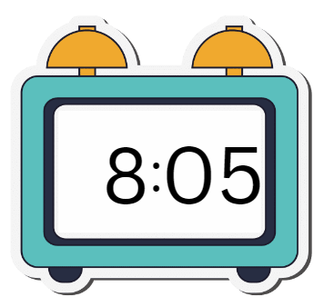 | - Sono le otto e cinque.
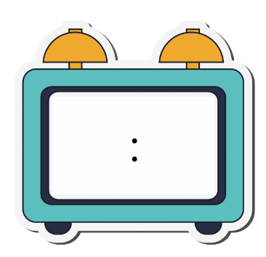 | - È l’una e dieci.
 | - Sono le undici e un quarto.
 | - Sono le sette e venti.
 | - Sono le nove e cinque.
 | - Sono le due e un quarto.
 | - Sono le sei e mezza.
 | - È mezzogiorno.
 | - Sono le dieci.
 | - Sono le tre e mezza.

Activity 3 – write the time
Write the time in Italian according to the cues provided. The first one has been done as an example.
 | 7:00 | Sono le sette.
 | 7:10
 | 8:05
 | 10:15
 | 11:20
 | 1:30
 | 2:10
 | 4:20
 | 5:25
 | 3:05

For the teacher
Remove this section before sharing this resource with students.

Activity 1 – break the flow

Audio file
Activity 1 – break the flow.mp3 (0:55)

Answers
- Sono|le|tre|e|mezza.
- È|l’una|e|dieci.
- Sono|le|nove|e|un|quarto.
- Sono|le|undici.
- Sono|le|otto|e|venti.
- Sono|le|sette|e|cinque.
- Sono|le|due|e|venticinque.
- È|l’una|e|dieci.
- Sono|le|quattro.
- Sono|le|sei|e|mezza.

Activity 2 – Che ore sono?
- 8:05
- 1:10
- 11:15
- 7:20
- 9:05
- 2:15
- 6:30
- 12:00
- 10:00
- 3:30

Activity 3 – write the time
 | 7:00 | Sono le sette.
 | 7:10 | Sono le sette e dieci.
 | 8:05 | Sono le otto e cinque.
 | 10:15 | Sono le dieci e un quarto.
 | 11:20 | Sono le undici e venti.
 | 1:30 | È l’una e mezza.
 | 2:10 | Sono le due e dieci.
 | 4:20 | Sono le quattro e venti.
 | 5:25 | Sono le cinque e venticinque.
 | 3:05 | Sono le tre e cinque.

© State of New South Wales (Department of Education), 2024
The copyright material published in this resource is subject to the Copyright Act 1968 (Cth) and is owned by the NSW Department of Education or, where indicated, by a party other than the NSW Department of Education (third-party material).
Copyright material available in this resource and owned by the NSW Department of Education is licensed under a Creative Commons Attribution 4.0 International (CC BY 4.0) license.
This licence allows you to share and adapt the material for any purpose, even commercially. Attribution should be given to © State of New South Wales (Department of Education), 2024.
Material in this resource not available under a Creative Commons licence:
- the NSW Department of Education logo, other logos and trademark-protected material
- material owned by a third party that has been reproduced with permission. You will need to obtain permission from the third party to reuse its material.
Links to third-party material and websites
Please note that the provided (reading/viewing material/list/links/texts) are a suggestion only and implies no endorsement, by the New South Wales Department of Education, of any author, publisher, or book title. School principals and teachers are best placed to assess the suitability of resources that would complement the curriculum and reflect the needs and interests of their students.
If you use the links provided in this document to access a third-party's website, you acknowledge that the terms of use, including licence terms set out on the third-party's website apply to the use which may be made of the materials on that third-party website or where permitted by the Copyright Act 1968 (Cth). The department accepts no responsibility for content on third-party websites.

