Full volume – A tutto volume

Activity 1
Read the information on the flyer below and answer the following questions:
- What event is the flyer for?
- In English, summarise the information included in the flyer.
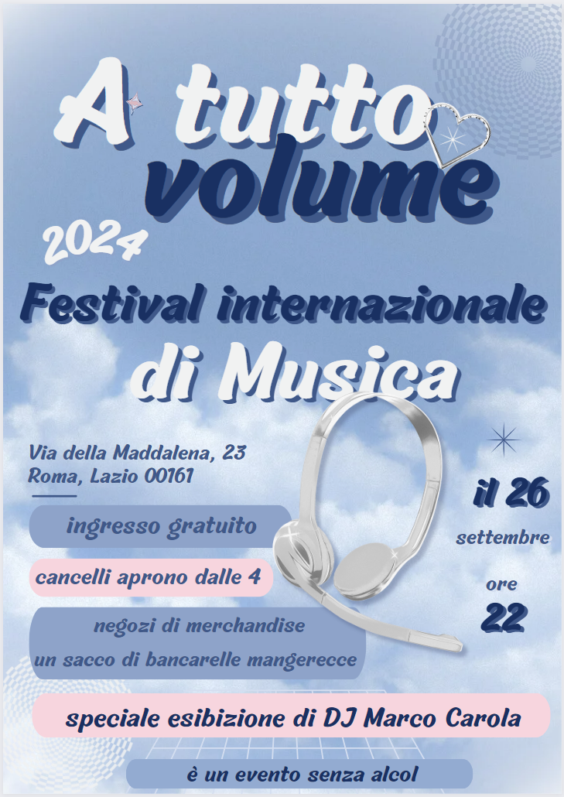

For the teacher
Remove this section before sharing this resource with students.
You can access an editable version of the resource, to amend for your own context. Alternately, an accessible version of the resource is provided below:
A tutto volume
2024
Festival Internazionale di Musica
Via della Maddalena, 23, Roma, Lazio 00161
Il 26 settembre
Ore 22
Ingresso gratuito
Negozi di merchandise
Un sacco di bancarelle mangerecce
Speciale esibizione de DJ Marco Carola
È un evento senza alcol
This text includes vocabulary which is likely unfamiliar to your students.
Introduce the reading activity by reviewing the strategies for understanding texts – find a couple of sample phrases or sentences with unfamiliar words and model the strategies for students. The strategy you choose should best meet the needs of the students.
For example, you may ask students to:
- underline words they know and circle unfamiliar words
- code texts using ‘*’ for familiar words or structures, ‘+’ for new information, ‘!’ for ‘wow’ (something they find interesting) and ‘?’ for ‘I don’t understand’
- colour code the text to identify prepositions, nouns, adjectives and verbs.
Alternatively, lead students through the following steps:
- Do I know these words?
- Do they look like English words (cognates)?
- Can I extrapolate or guess the meaning from the context?
- Help me, I need a dictionary!
Another approach is to read for context clues using the reading strategies in the table below.
Step | Action
- Read and question | Read the text carefully.  Frequently ask yourself ‘Does this make sense?’.
- Slow advance | Notice when you don’t know the meaning of a word and slow down.  Read that sentence at least once more, looking for clues.
- Stop and rewind | If necessary, go back and re-read the preceding sentence, looking for clues that will help you figure out what the word or phrase might mean.
- Read and question | When you think you have figured out what the word or phrase means, substitute your guess for the word or phrase.  If it makes sense, keep reading.  If it does not make sense, stop and rewind, and try again or check the meaning in a dictionary.
Students could also use their own strategies.
Allow students time to access the text and questions independently or, if preferred, in pairs. Provide vocabulary hints for students who need additional support.

Sample answer
- What event is the flyer for?
This is a flyer for an international music festival in 2024 called A tutto volume.
- In English, summarise the information included in the flyer.
The festival is on 26 September at 10 pm in Lazio. Marco Carola will be performing, the gates open at 4 pm, you can buy merchandise and food at the event. Entry is free and it is an alcohol-free event.
Differentiation examples
High potential and gifted students – students engage in an interaction with a partner who has the complete poster in front of them to elicit information about the event in an information-gap style activity (see edited resource below).
Students with prior learning – students write the information included in the poster in complete sentences in Italian. Alternatively, students design a poster for an event of their choosing.
Students requiring additional support – students use the edited resource (below) as a cloze passage-style activity, with the teacher providing a bank of missing text.
Use the editable link to add or remove text from the resource.
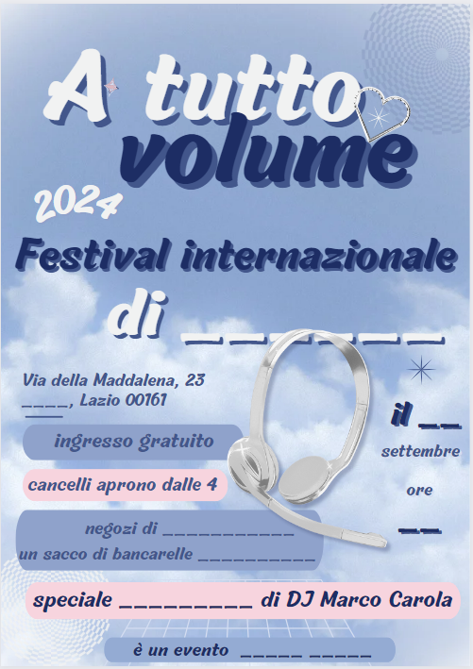
© State of New South Wales (Department of Education), 2024
The copyright material published in this resource is subject to the Copyright Act 1968 (Cth) and is owned by the NSW Department of Education or, where indicated, by a party other than the NSW Department of Education (third-party material).
Copyright material available in this resource and owned by the NSW Department of Education is licensed under a Creative Commons Attribution 4.0 International (CC BY 4.0) license.
This license allows you to share and adapt the material for any purpose, even commercially.
Attribution should be given to © State of New South Wales (Department of Education), 2024.
Material in this resource not available under a Creative Commons license:
- the NSW Department of Education logo, other logos and trademark-protected material
- material owned by a third party that has been reproduced with permission. You will need to obtain permission from the third party to reuse its material.
Links to third-party material and websites
Please note that the provided (reading/viewing material/list/links/texts) are a suggestion only and implies no endorsement, by the New South Wales Department of Education, of any author, publisher, or book title. School principals and teachers are best placed to assess the suitability of resources that would complement the curriculum and reflect the needs and interests of their students.
If you use the links provided in this document to access a third-party's website, you acknowledge that the terms of use, including licence terms set out on the third-party's website apply to the use which may be made of the materials on that third-party website or where permitted by the Copyright Act 1968 (Cth). The department accepts no responsibility for content on third-party websites.

