Do you like …? – Ti piace…?

Activity 1
In the ‘la mia opinione’ column of the table below, write your opinion of the school subject indicated. Choose from Mi piace molto (), Mi piace (), Mi piace un po’ (), Non mi piace (), Non mi piace per niente (). In the ‘la sua opinione’ column, write the opinion of the person, using the cues provided in the table. Make sure you use the correct pronoun – le piace or gli piace. The first one has been done for you as an example. Take care with ‘science’, as remember, the verb changes to piacciono.
materia | la mia opinione |  |  | la sua opinione
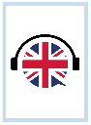 | Mi piace l’inglese. |  |  | Le piace molto l’inglese.
 |  | 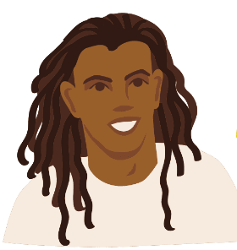
 |  | 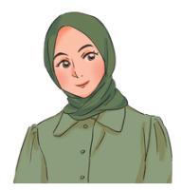
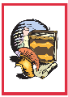
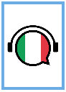 |  | 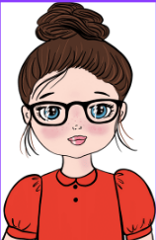
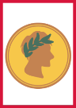
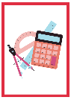 |  | 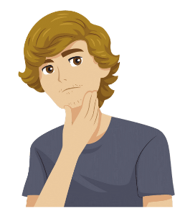
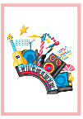 |  | 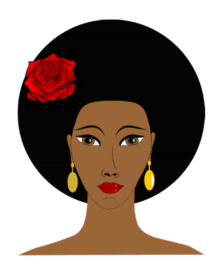
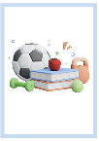 |  | 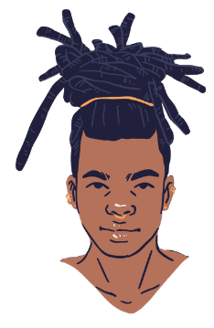
 |  | 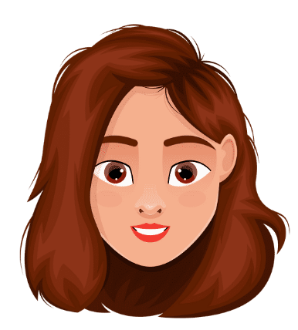

Activity 2 – a scuola
Listen to students talking about school. Complete the table below in English by identifying whether or not the statement is about a male (m) or female (f), what the school subject is, and how much they like or dislike the subject. Don't be tricked by the gender of the voice speaking! You are listening carefully for le piace or gli piace. The first one has been done for you as an example.
m or f | materie | opinione
- f or m | history | She doesn’t like it at all.
- f or m
- f or m
- f or m
- f or m
- f or m

Activity 3
Choose 3 subjects from Activity 2 and write the response as a complete sentence using the third person in the space below. The first one has been done for you as an example.
- Non le piace per niente la storia.

Activity 4
Choose any 4 subjects and give your own opinion of each of them by writing a full sentence using the space below in Italian.

For the teacher
Remove this section before sharing this resource with students.

Activity 1
materia | la mia opinione |  |  | la sua opinione
 | Mi piace l’inglese. |  |  | Le piace molto l’inglese.
 |  |  |  | Non le piace per niente il teatro.
 |  |  |  | Non gli piace l’arte.
 |  |  |  | Le piace un po’ la geografia.
 |  |  |  | Le piace la storia.
 |  |  |  | Non le piace l’italiano.
 |  |  |  | Non le piace per niente il latino.
 |  |  |  | Gli piace un po’ la matematica.
 |  |  |  | Non le piace per niente la musica.
 |  |  |  | Gli piace molto l’educazione fisica.
 |  |  |  | Non le piacciono le scienze*.
 |  |  |  | Gli piace l’informatica.
* Remind students to use the plural form of the verb piacere when talking about ‘sciences’.

Activity 2 – a scuola
Point out to students that they are listening for le piace or gli piace, rather than listening to the gender of the voice speaking.

Audio files
- Ti piace Activity 2 No.1.mp3 (0:04)
- Ti piace Activity 2 No.2.mp3 (0:03)
- Ti piace Activity 2 No.3.mp3 (0:04)
- Ti piace Activity 2 No.4.mp3 (0:05)
- Ti piace Activity 2 No.5.mp3 (0:04)
- Ti piace Activity 2 No.6.mp3 (0:04)
m or f | materie |  | opinione
- f | history |  | Doesn’t like it at all.
- m | science |  | Likes it.
- f | music |  | Likes it a bit.
- m | mathematics |  | Likes it a lot.
- f | computer studies |  | Likes it.
- m | physical education (PE) |  | Doesn’t like it.

Activity 3
- Non le piace per niente la storia.
- Gli piacciono le scienze.
- Le piace un po’ la musica.
- Gli piace molto la matematica.
- Le piace l’informatica.
- Gli piace l’educazione fisica.

© State of New South Wales (Department of Education), 2024
The copyright material published in this resource is subject to the Copyright Act 1968 (Cth) and is owned by the NSW Department of Education or, where indicated, by a party other than the NSW Department of Education (third-party material).
Copyright material available in this resource and owned by the NSW Department of Education is licensed under a Creative Commons Attribution 4.0 International (CC BY 4.0) license.
This license allows you to share and adapt the material for any purpose, even commercially.
Attribution should be given to © State of New South Wales (Department of Education), 2024.
Material in this resource not available under a Creative Commons license:
- the NSW Department of Education logo, other logos and trademark-protected material
- material owned by a third party that has been reproduced with permission. You will need to obtain permission from the third party to reuse its material.
Links to third-party material and websites
Please note that the provided (reading/viewing material/list/links/texts) are a suggestion only and implies no endorsement, by the New South Wales Department of Education, of any author, publisher, or book title. School principals and teachers are best placed to assess the suitability of resources that would complement the curriculum and reflect the needs and interests of their students.
If you use the links provided in this document to access a third-party's website, you acknowledge that the terms of use, including licence terms set out on the third-party's website apply to the use which may be made of the materials on that third-party website or where permitted by the Copyright Act 1968 (Cth). The department accepts no responsibility for content on third-party websites.

