Bingo cards
This resource is for the teacher. It provides the content and instructions you need to share with students.
Print off 2 copies of the bingo cards and cut them out – this will be sufficient for up to 30 students.
Read out sentences in Italian using a combination of the vocabulary in the table below. Place tally marks next to each phrase as you use them in a sentence, to ensure you use a good range of vocabulary.
Students listen to the sentences. If they have any of the words in the sentence, they mark them off on their card. When a student marks off 4 in a row (horizontally, vertically or diagonally), they call out Tombola!
Bingo cards can be placed in plastic sleeves, and students use whiteboard markers, or pencil on paper copies, to play the game more than once.

Days | Verb | Transport | Times
lunedì | arrivo a scuola | in autobus | alle sette e mezza
martedì | torno a casa | in macchina | alle otto
mercoledì |  | in motorino | alle nove
giovedì |  | in monopattino | alle dieci e dieci
venerdì |  | in treno | alle dodici e dodici
sabato |  | in bici | all'una e un quarto
 |  | a piedi | alle due e mezza
 |  |  | alle tre e mezza
 |  |  | alle quattro e un quarto
 |  |  | alle cinque e un quarto
 |  |  | alle sei e mezza

Cards
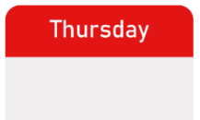 | 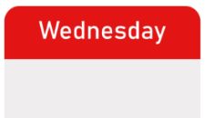 | 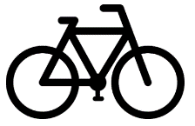 | 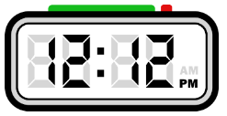
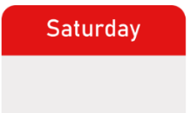 | 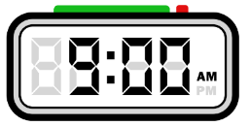 | 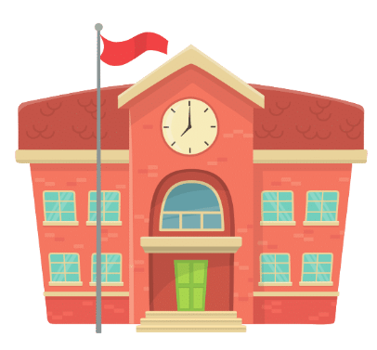 | 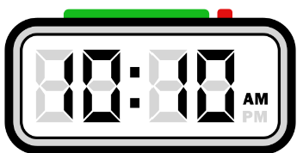
 | 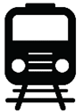 | 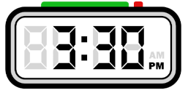 | 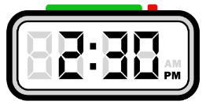
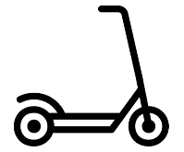 | 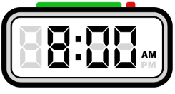 | 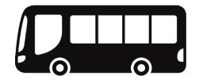 | 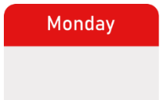

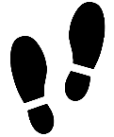 | 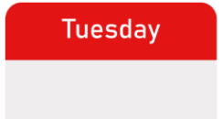 | 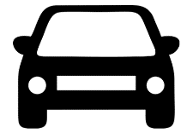
 | 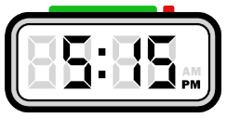 | 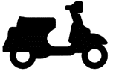

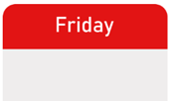 | 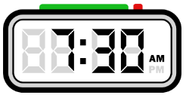 |  | 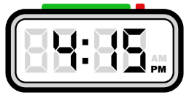

 |  | 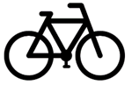
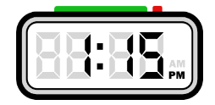 |  |  | 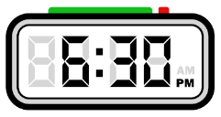

© State of New South Wales (Department of Education), 2024
The copyright material published in this resource is subject to the Copyright Act 1968 (Cth) and is owned by the NSW Department of Education or, where indicated, by a party other than the NSW Department of Education (third-party material).
Copyright material available in this resource and owned by the NSW Department of Education is licensed under a Creative Commons Attribution 4.0 International (CC BY 4.0) license.
This license allows you to share and adapt the material for any purpose, even commercially.
Attribution should be given to © State of New South Wales (Department of Education), 2024.
Material in this resource not available under a Creative Commons license:
- the NSW Department of Education logo, other logos and trademark-protected material
- material owned by a third party that has been reproduced with permission. You will need to obtain permission from the third party to reuse its material.
Links to third-party material and websites
Please note that the provided (reading/viewing material/list/links/texts) are a suggestion only and implies no endorsement, by the New South Wales Department of Education, of any author, publisher, or book title. School principals and teachers are best placed to assess the suitability of resources that would complement the curriculum and reflect the needs and interests of their students.
If you use the links provided in this document to access a third-party's website, you acknowledge that the terms of use, including licence terms set out on the third-party's website apply to the use which may be made of the materials on that third-party website or where permitted by the Copyright Act 1968 (Cth). The department accepts no responsibility for content on third-party websites.

