Are you good at …? – Sei bravo/a in…? story cubes
This resource is for the teacher. It provides the content and instructions you need to share with students.
Use the story cubes provided, or create your own using the template in this document or with the editable version on Canva.
Organise students into groups of 3 to 4, providing each group with a set of cubes. There are 2 cubes to include all the school subjects: Cubes 1a and 1b. Direct the students to alternate these for variety.
Show students the cubes and work with them to identify the questions they could ask about each cube, for example:
Cube 1a or 1b: Quale materia è?
Cube 2: Ti piace [subject]?
Cube 3: Sei bravo/a in [subject]?
(Cube 4: Perché?)

Sample conversation
Using the questions above as a scaffold, students interact to share details about their preferences for and strengths in school subjects by asking questions and answering them using the prompts on the cubes. Students take turns to ask the questions each time, choosing another student in the group to answer.
Student A rolls one of the ‘subject’ cubes and asks Student B to identify the subject: Quale materie è?
Student B identifies the subject on the cube in Italian: È la geografia.
Student A asks Student B: Ti piace la geografia?
Student B rolls the ‘likes or dislikes’ cube and replies appropriately to the prompt (😖): Non mi piace per niente la geografia.
Student A asks Student B: Perché?
Student B rolls the ‘adjectives’ cube and replies appropriately to the prompt (difficult): È difficile.
Student A asks if Student B is good at the subject: Sei bravo/a in geografia?
Student B rolls the ‘good/not good at’ cube and replies appropriately to the prompt (✔): Sono bravo/a in geografia.
Differentiation examples
The following strategies provide a starting point for how you can differentiate this activity for a range of learners. Adapt or design alternatives, to meet the needs of students in your class.
Students requiring additional support – consider including the Italian vocabulary on the cube, as well as providing the following scaffold:
Cube 1a or 1b: Quale materia è? È [name of subject].
Cube 2: Ti piace [subject]? Mi piace molto OR Mi piace OR Mi piace un po’ OR Non mi piace OR Non mi piace per niente [subject].
Cube 3: Sei bravo/a in [subject]? Sì, sono bravo/a in [subject] OR No, non sono bravo/a in [subject].
High potential and gifted students – allow students to create their own sentences based on the prompts each time. They may elect to include the adjectives cube and add an appropriate conjunction such as ma, perché or è so the sentence makes sense, for example, Non mi piace la matematica ma è utile. Students may want to also design their own competition, for example: Whose cubes are the most accurate when compared to the student’s own preferences? Or whose cubes make the silliest sentence?

Story cubes
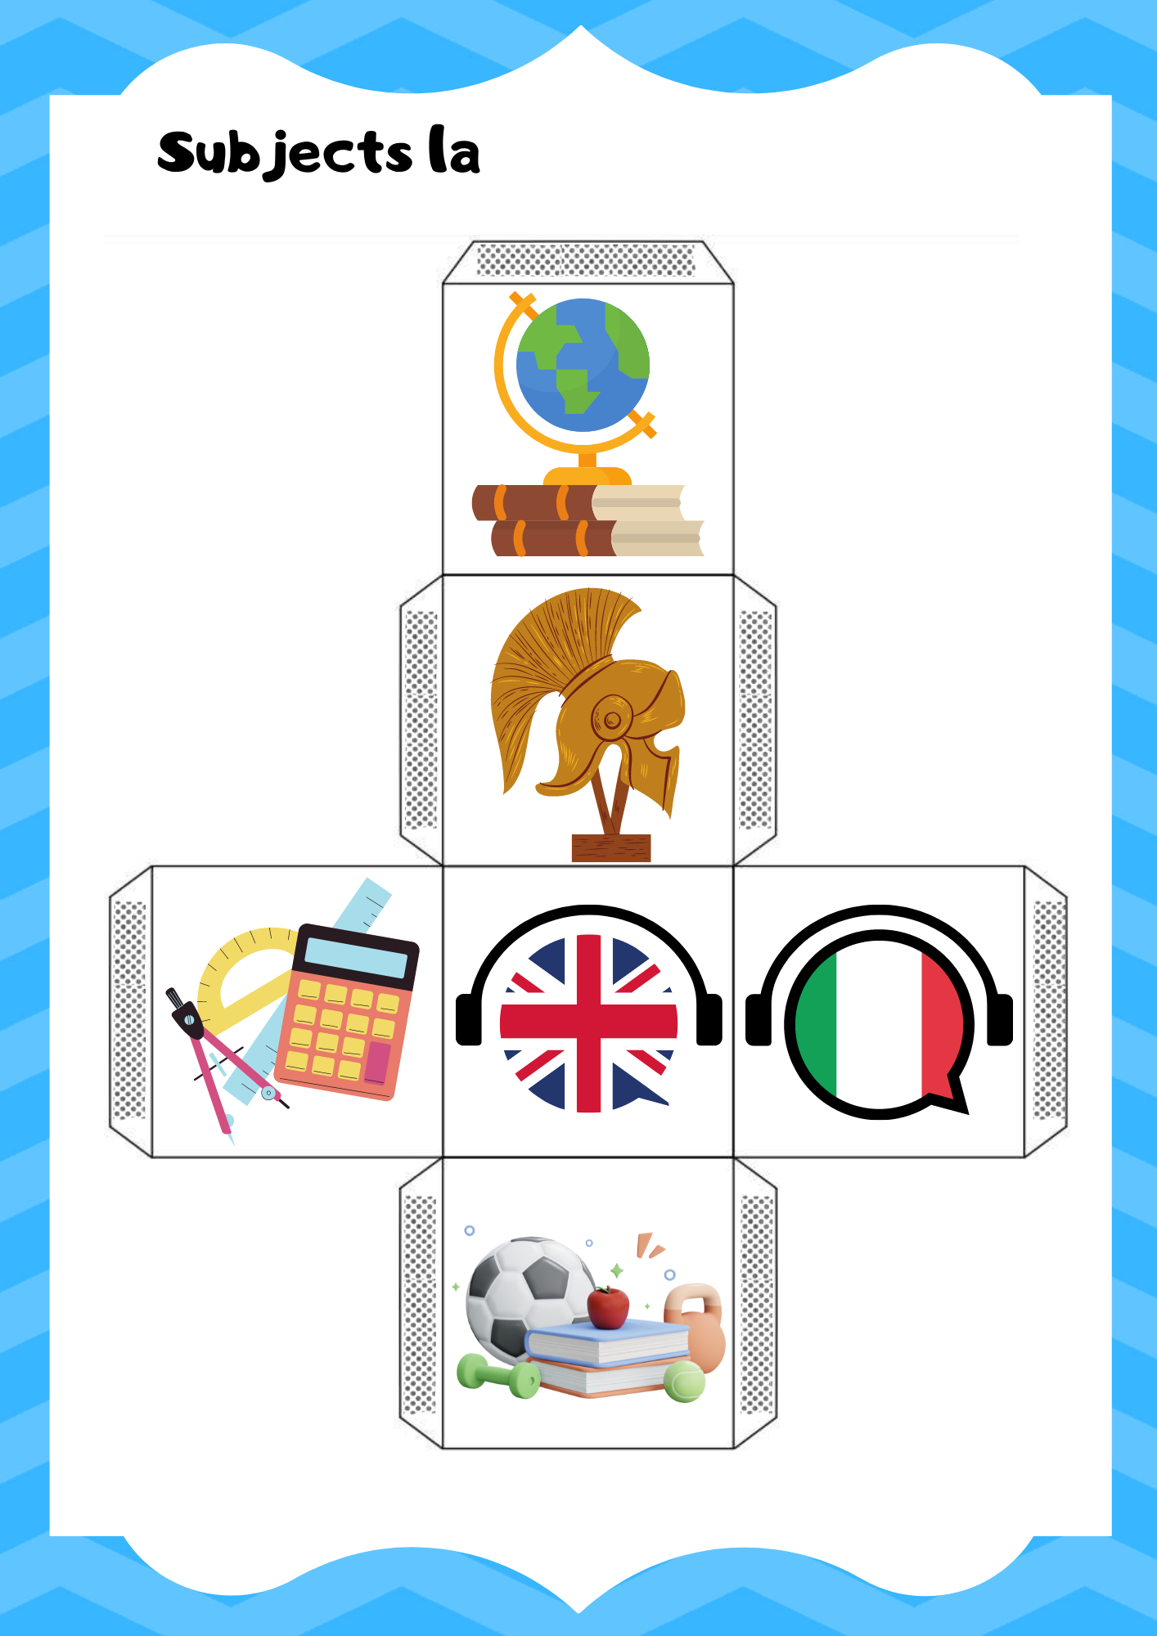
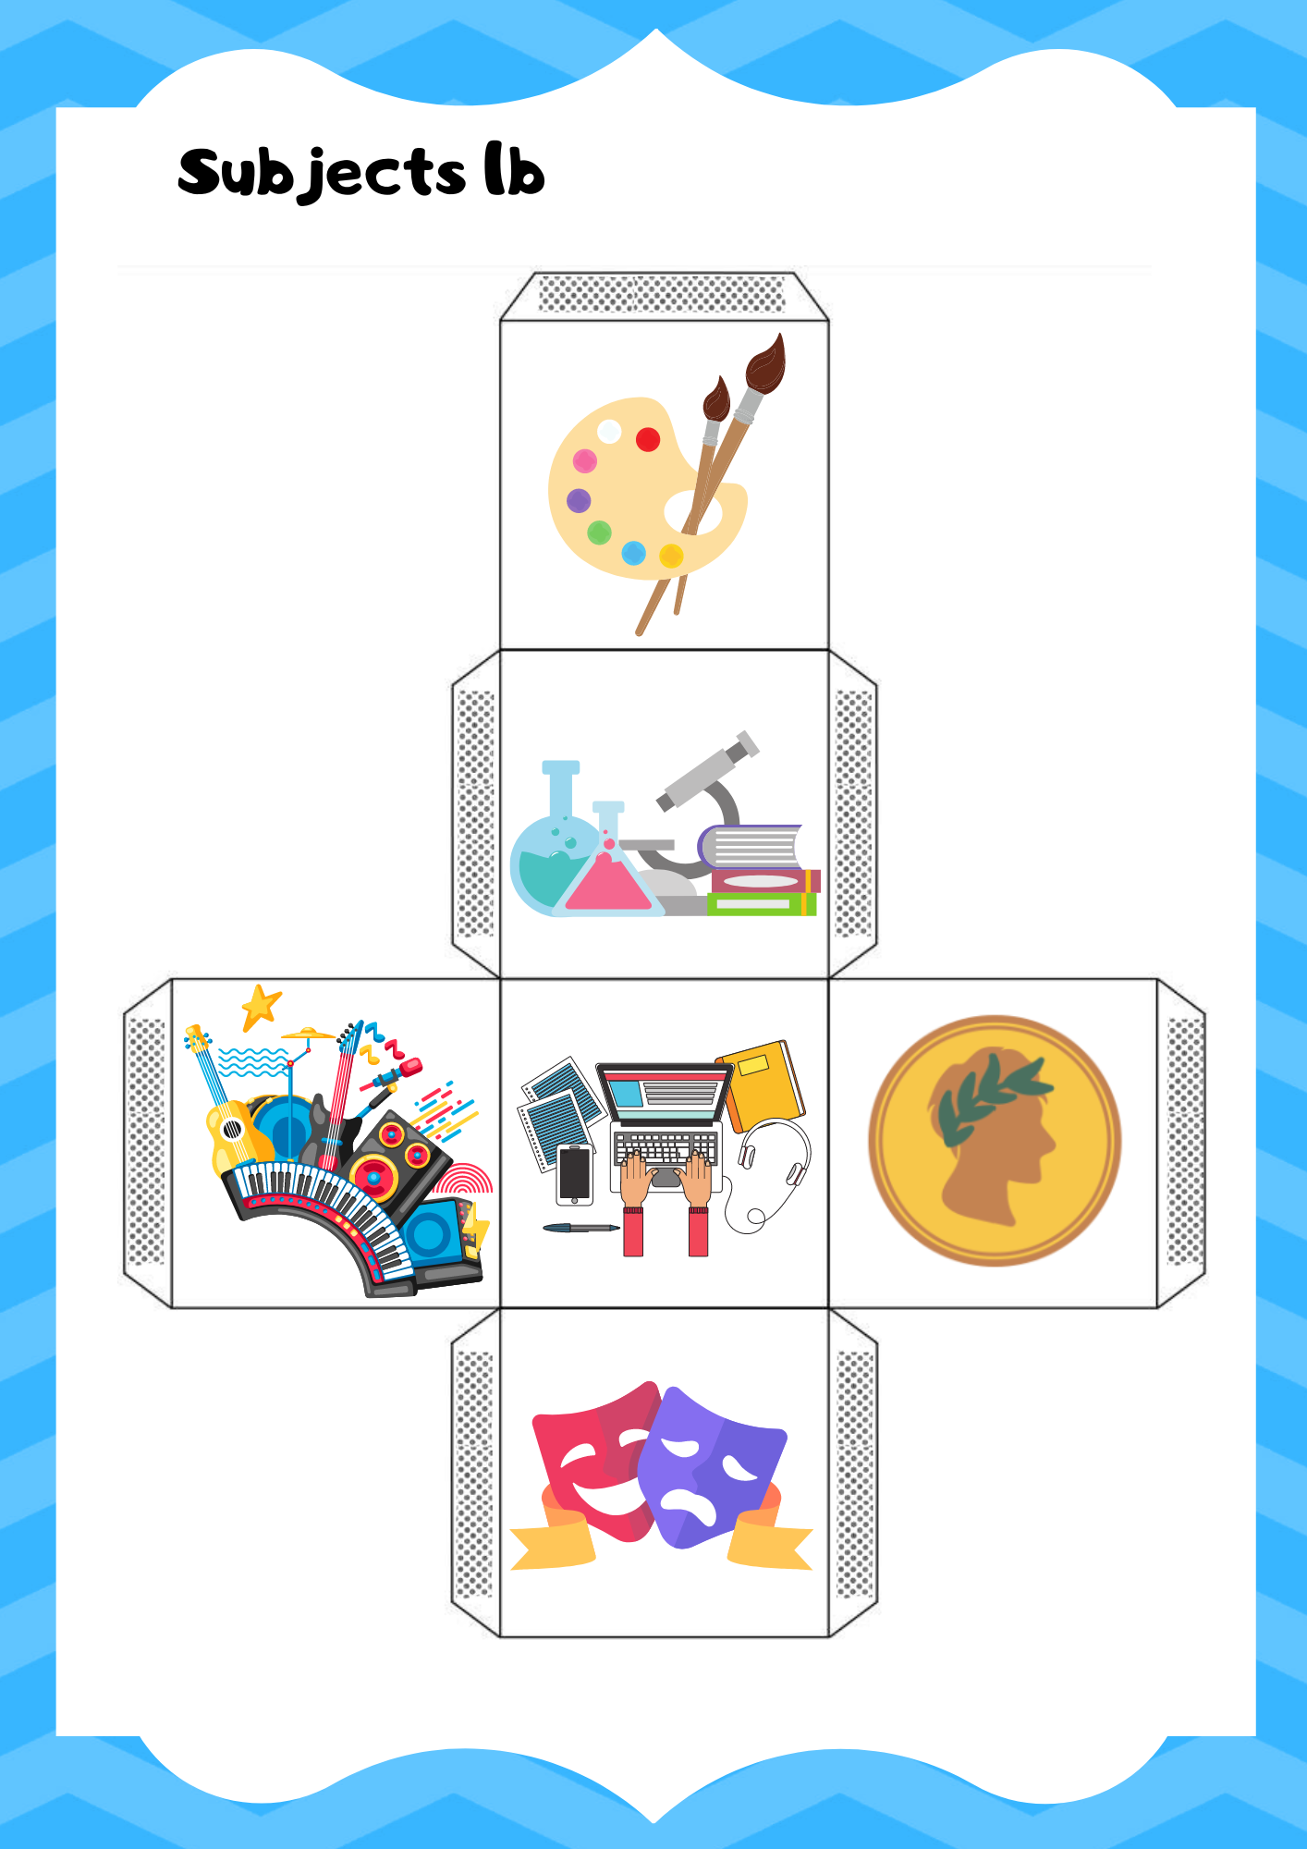
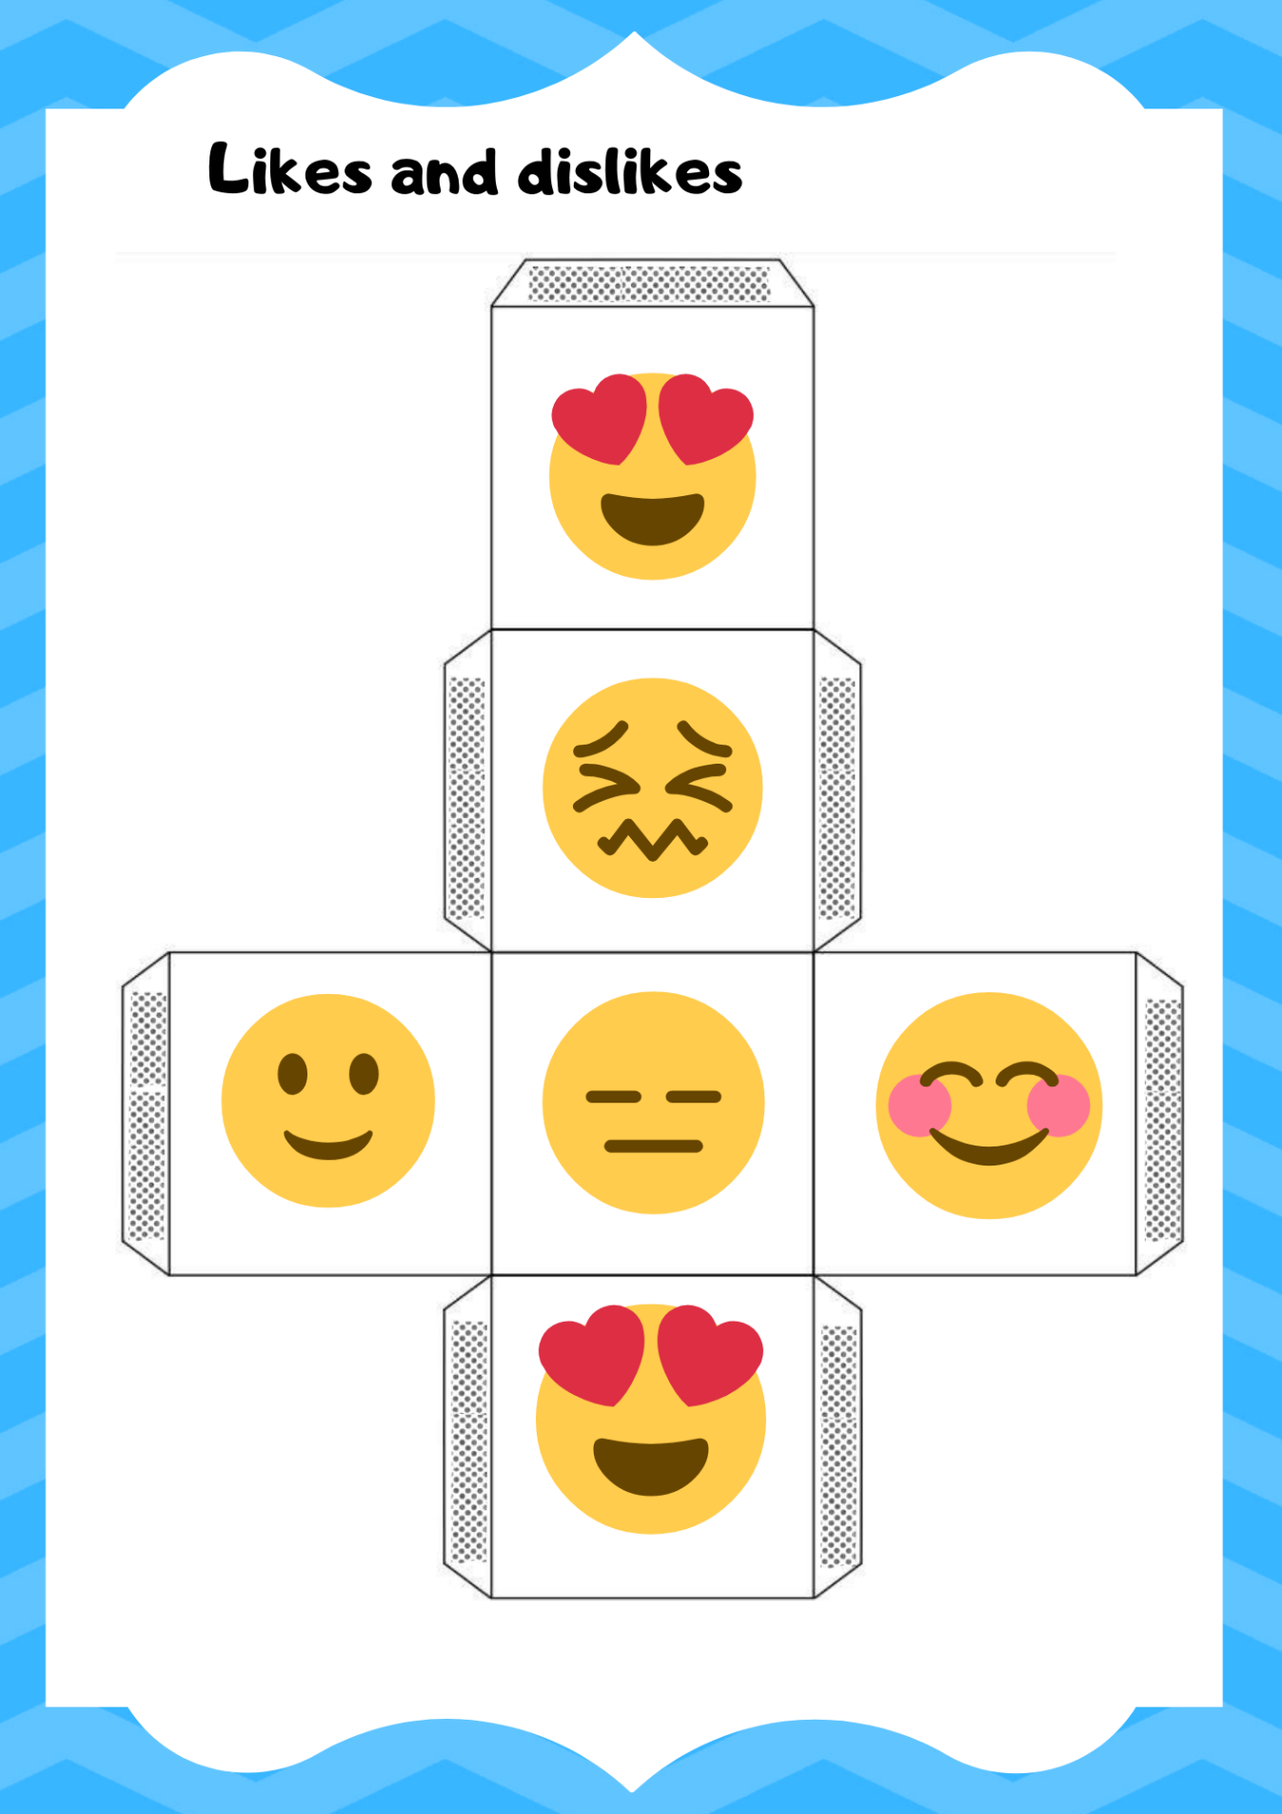
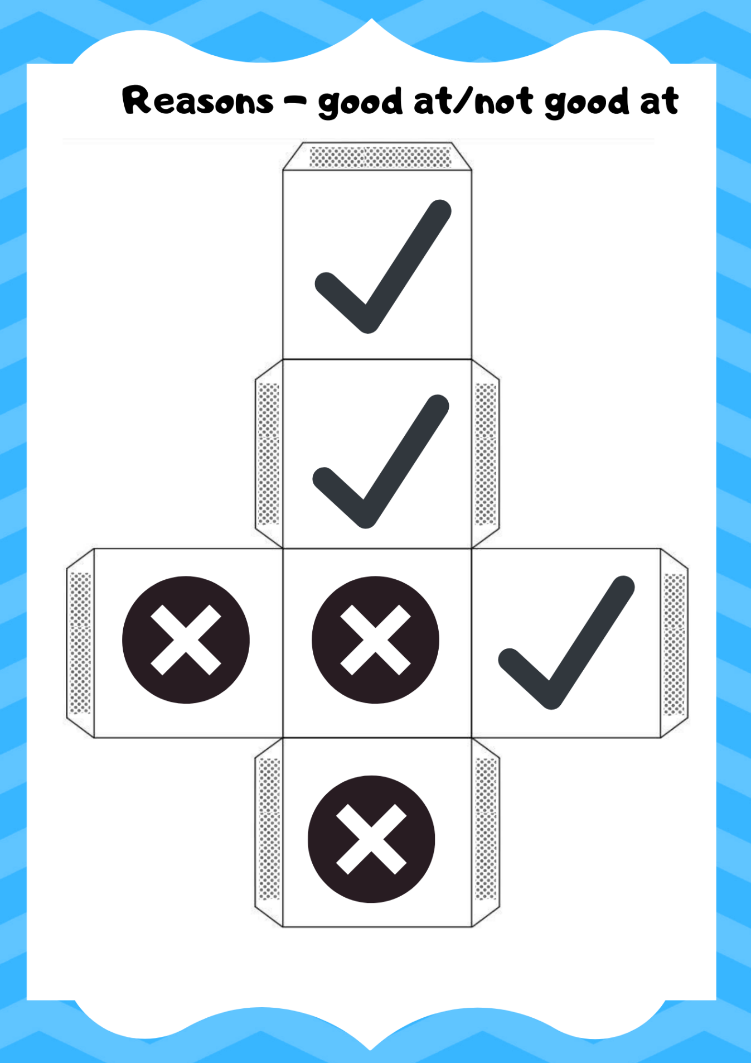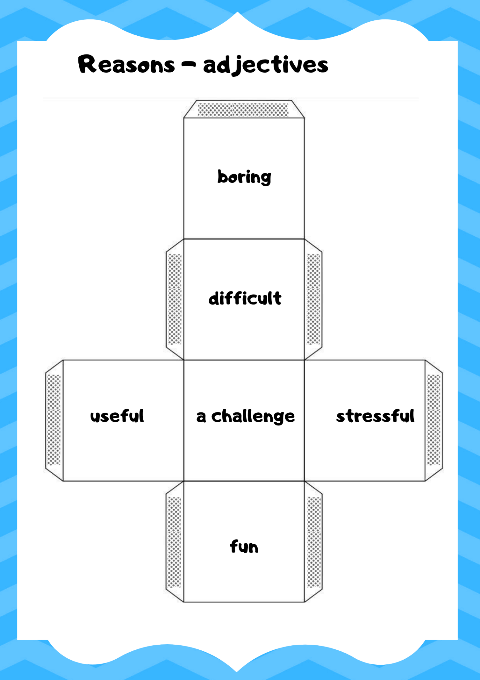

Blank template
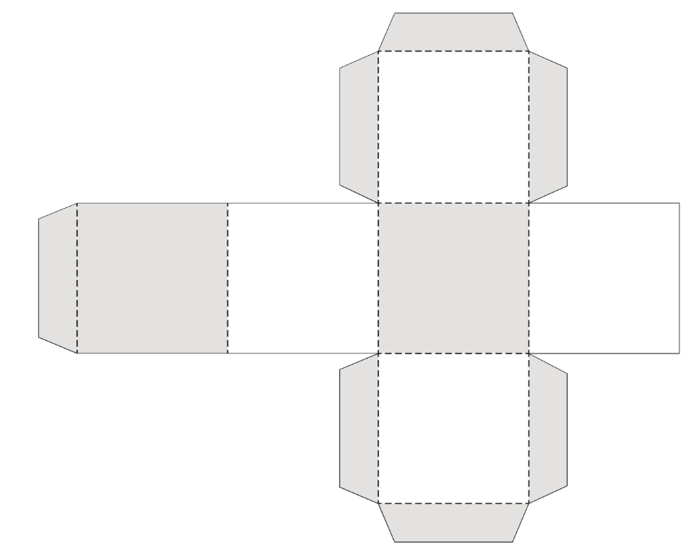

© State of New South Wales (Department of Education), 2024
The copyright material published in this resource is subject to the Copyright Act 1968 (Cth) and is owned by the NSW Department of Education or, where indicated, by a party other than the NSW Department of Education (third-party material).
Copyright material available in this resource and owned by the NSW Department of Education is licensed under a Creative Commons Attribution 4.0 International (CC BY 4.0) license.
This license allows you to share and adapt the material for any purpose, even commercially.
Attribution should be given to © State of New South Wales (Department of Education), 2024.
Material in this resource not available under a Creative Commons license:
- the NSW Department of Education logo, other logos and trademark-protected material
- material owned by a third party that has been reproduced with permission. You will need to obtain permission from the third party to reuse its material.
Links to third-party material and websites
Please note that the provided (reading/viewing material/list/links/texts) are a suggestion only and implies no endorsement, by the New South Wales Department of Education, of any author, publisher, or book title. School principals and teachers are best placed to assess the suitability of resources that would complement the curriculum and reflect the needs and interests of their students.
If you use the links provided in this document to access a third-party's website, you acknowledge that the terms of use, including licence terms set out on the third-party's website apply to the use which may be made of the materials on that third-party website or where permitted by the Copyright Act 1968 (Cth). The department accepts no responsibility for content on third-party websites

This cube is to be used later in the learning sequence once students have learned to describe their subjects.

