Adjectives – modes of transport

Activity 1
Listen to the adjectives being read aloud and tick the form you hear.
- ☐ bella
☐ bello
- ☐ sportivo
☐ sportiva
- ☐ iconica
☐ iconico
- ☐ carina
☐ carino
- ☐ piccolo
☐ piccola
- ☐ moderno
☐ moderna

Activity 2
Tick the sentence with the correct form of the adjective, describing each mode of transport in the table below. In the third column, add one to 2 different adjectives that you think can also be used to describe them. Take care to choose the correct form of the adjective. The first one has been done for you as an example.
Trasporto | Frase | Aggettivi
- 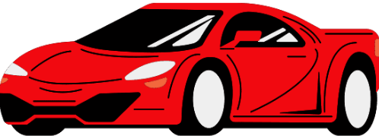 | ☒ La macchina è sportiva.  ☐ La macchina è sportivo. | bella, di moda
- 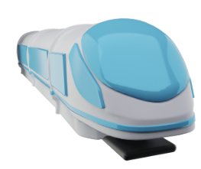 | ☐ Il treno è moderna.  ☐ Il treno è moderno.
- 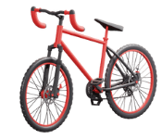 | ☐ La bici(cleta) è bello.  ☐ La bici(cleta) è bella.
- 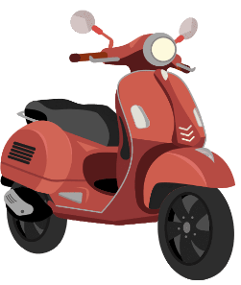 | ☐ Il motorino è carina.  ☐ Il motorino è carino.
- 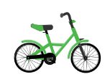 | ☐ La bici(cleta) è piccolo.  ☐ La bici(cleta) è piccola.
- 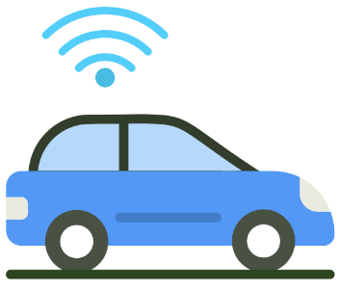 | ☐ La macchina è piccola.  ☐ La macchina è piccolo.
- 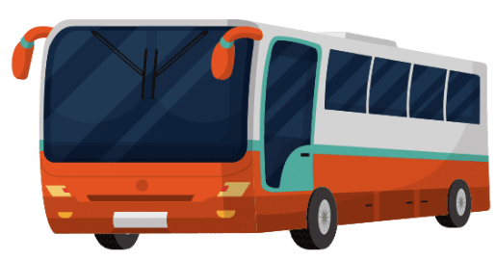 | ☐ L’autobus è moderna.  ☐ L’autobus è moderno.
- 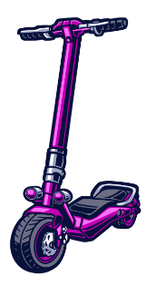 | ☐ Il monopattino è bello.  ☐ Il monopattino è bella.
- 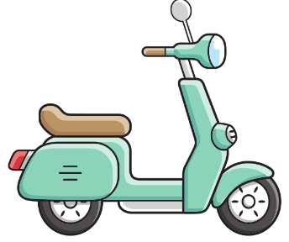 | ☐ Il motorino è iconica.  ☐ Il motorino è iconico.

Activity 3
Choose 4 vehicles from the table and write a more detailed sentence in the space below, using the additional adjectives you identified. Remember, e is the word for ‘and’.
For example: La macchina è sportiva, bella e di moda.

For the teacher
Remove this section before sharing this resource with students.

Activity 1

Audio file
Adjectives Activity 1.mp3 (0:27)
- ☒ bella
☐ bello
- ☐ sportivo
☒ sportiva
- ☐ iconica
☒ iconico
- ☐ carina
☒ carino
- ☒ piccolo
☐ piccola
- ☐ moderno
☒ moderna

Activity 2
Answers will vary for the third column. Some possible examples are provided.
Trasporto | Frase | Aggettivi
 | ☒ La macchina è sportiva.  ☐ La macchina è sportivo. | bella, tradizionale, di moda
 | ☐ Il treno è moderna.  ☒ Il treno è moderno. | grande
 | ☐ La bici(cleta) è bello.  ☒ La bici(cleta) è bella. | moderna, di moda, grande, sportiva
 | ☐ Il motorino è carina.  ☒ Il motorino è carino. | tradizionale, piccolo, iconico
 | ☐ La bici(cleta) è piccolo.  ☒ La bici(cleta) è piccola. | iconica
 | ☒ La macchina è piccola.  ☐ La macchina è piccolo. | intelligente
 | ☐ L’autobus è moderna.  ☒ L’autobus è moderno. | grande
 | ☒ Il monopattino è bello.  ☐ Il monopattino è bella. | carino, di moda
 | ☐ Il motorino è iconica.  ☒ Il motorino è iconico. | tradizionale, piccolo, bello

Activity 4
There are 4 sets of cards. Print enough sets for students to play in groups of 3 to 4. Distribute to students to cut up or prepare prior to the lesson.
Below are suggested games to play using the cards.
Option A
Using all 4 sets, students play a snap or memory-style game to match pictures or words with their equivalent in Italian.
Option B
Depending on student ability and confidence, students use the ‘English adjective cards’ and the ‘Transport image cards’ to create sentences. Students place the 2 sets face down on the table, then take turns to turn one card from each pile over. Using the prompts on the card, they then create a sentence in Italian, following the model Vado a scuola [by transport]. [The transport] è [adjective]. For example, Vado a scuola in bici. La bici è moderna.
Students must remember to agree the adjective, where required.
If they are correct, they keep their 2 cards. If they are incorrect, the cards go back to the bottom of each pile. The other students in the group decide if the response is correct, calling on the teacher where required.
Differentiation examples
High potential and gifted students – in Activities 2 and 3, students include the colour of the vehicle, using a dictionary. Explain to students that the colours viola, blu and rosa do not change to agree with the noun.
Students requiring additional support – in Activity 4, students play snap or memory-style games with transport cards first, and then with adjectives cards, to build their confidence. For the ‘Option B’ game, students use the ‘Italian adjective cards’ and the ‘Transport word cards’ (in place of the ‘English adjective cards’ and the ‘Transport image cards’). This allows students to focus on structures only.
Advanced proficiency – in place of the activities provided, students create an advertisement for an Italian car.

Transport image cards
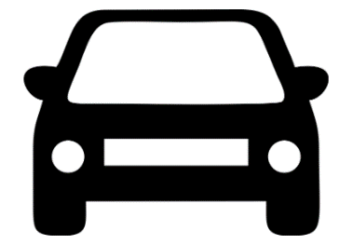
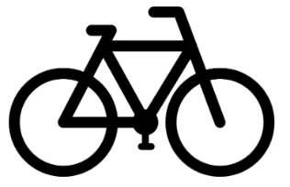
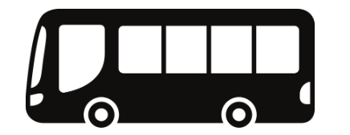
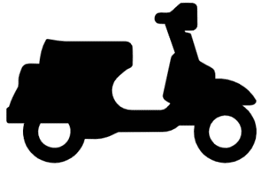
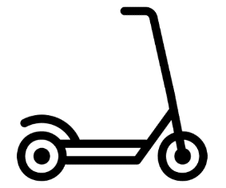
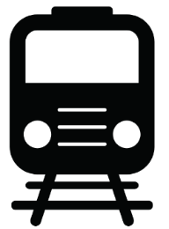

Transport word cards
in macchina
in bici
in autobus
in motorino
in monopattino
in treno

Italian adjective cards
bello/a
grande
di moda
moderno/a
piccolo/a
tradizionale
carino/a
iconico/a
sportivo/a
intelligente

English adjective cards
beautiful
big
trendy
modern
small
traditional
cute
iconic
sporty
smart

© State of New South Wales (Department of Education), 2024
The copyright material published in this resource is subject to the Copyright Act 1968 (Cth) and is owned by the NSW Department of Education or, where indicated, by a party other than the NSW Department of Education (third-party material).
Copyright material available in this resource and owned by the NSW Department of Education is licensed under a Creative Commons Attribution 4.0 International (CC BY 4.0) license.
This license allows you to share and adapt the material for any purpose, even commercially.
Attribution should be given to © State of New South Wales (Department of Education), 2024.
Material in this resource not available under a Creative Commons license:
- the NSW Department of Education logo, other logos and trademark-protected material
- material owned by a third party that has been reproduced with permission. You will need to obtain permission from the third party to reuse its material.
Links to third-party material and websites
Please note that the provided (reading/viewing material/list/links/texts) are a suggestion only and implies no endorsement, by the New South Wales Department of Education, of any author, publisher, or book title. School principals and teachers are best placed to assess the suitability of resources that would complement the curriculum and reflect the needs and interests of their students.
If you use the links provided in this document to access a third-party's website, you acknowledge that the terms of use, including licence terms set out on the third-party's website apply to the use which may be made of the materials on that third-party website or where permitted by the Copyright Act 1968 (Cth). The department accepts no responsibility for content on third-party websites.

