What are you selling?
This resource is for the teacher. It provides the content and instructions you need to share with students.
Use the visual gameboard included in this resource, or use the editable version on Canva.
Display the visual gameboard, with images of souvenirs commonly bought in Indonesia, on the board. Students play in pairs. Similar to the game ‘Guess who?’, students each choose one of the souvenirs from the gameboard that they wish to ‘sell’. Students write down the corresponding number of the item to keep them accountable.
The aim of the game is to be the first student to guess what their partner is selling. Students take turns asking questions to elicit key information such as Suvenir itu besar? (Is the souvenir big?) or Suvenir itu hijau? (Is the souvenir green?). Students must respond in the target language, for example Suvenir itu tidak besar (The souvenir is not big) or Suvenir itu kecil sekali (The souvenir is very small).
To make a guess, students use Indonesian, for example Kamu jual cincin! (You’re selling rings!). Their partner must confirm if they are correct, by saying Benar! (Correct!) and Saya jual cincin (I’m selling rings). If their guess was not correct, their partner can respond Salah! (Incorrect!) and Maaf, saya tidak jual cincin (Sorry, I am not selling rings).
Differentiation examples
Students with advanced proficiency – instead of using the gameboard, students can pick any item from the unit and ask questions to guess what item their peer is selling to incorporate a wider range of items and adjectives. Encourage students to add adverbs, conjunctions and sentence starters and make comments when guessing.
High potential and gifted students – students can include additional language structures such as Bisa saya beli suvenir ini di…? and Suvenir ini berwarna apa? which they may be familiar with.
Students requiring additional support – provide students with a list of souvenir and adjective vocabulary to assist them with the language required to participate.

Souvenir visual gameboard
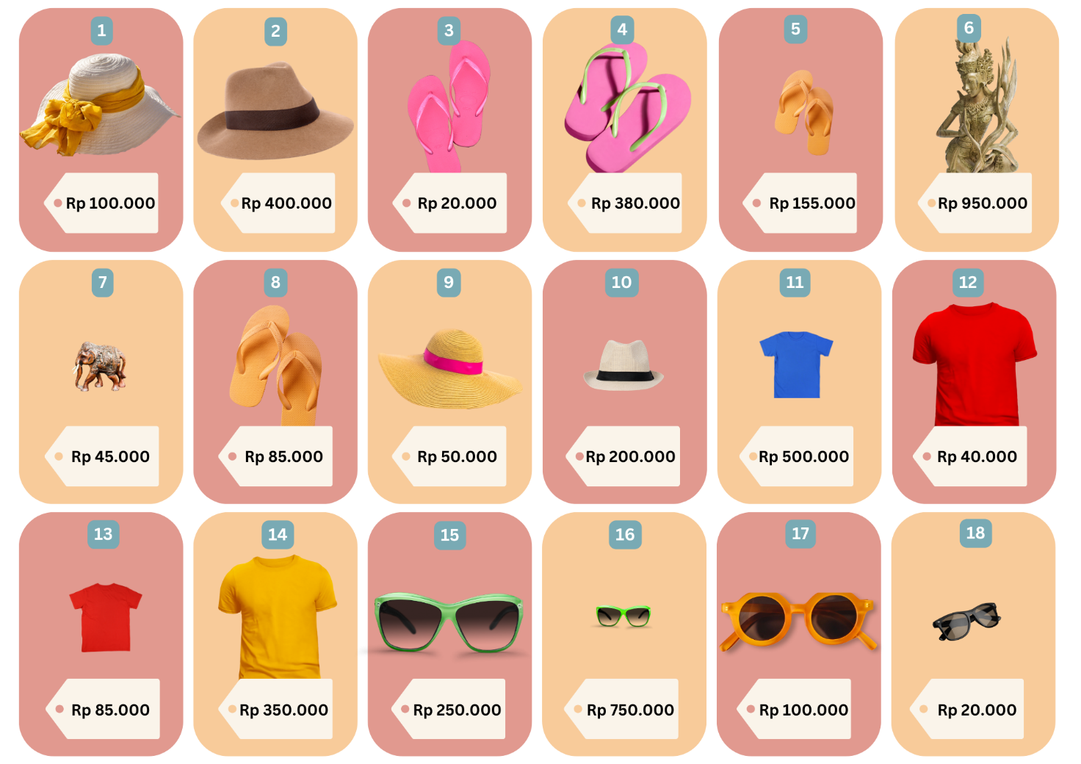

© State of New South Wales (Department of Education), 2024
The copyright material published in this resource is subject to the Copyright Act 1968 (Cth) and is owned by the NSW Department of Education or, where indicated, by a party other than the NSW Department of Education (third-party material).
Copyright material available in this resource and owned by the NSW Department of Education is licensed under a Creative Commons Attribution 4.0 International (CC BY 4.0) license.
This license allows you to share and adapt the material for any purpose, even commercially.
Attribution should be given to © State of New South Wales (Department of Education), 2024.
Material in this resource not available under a Creative Commons license:
- the NSW Department of Education logo, other logos and trademark-protected material
- material owned by a third party that has been reproduced with permission. You will need to obtain permission from the third party to reuse its material.
Links to third-party material and websites
Please note that the provided (reading/viewing material/list/links/texts) are a suggestion only and implies no endorsement, by the New South Wales Department of Education, of any author, publisher, or book title. School principals and teachers are best placed to assess the suitability of resources that would complement the curriculum and reflect the needs and interests of their students.
If you use the links provided in this document to access a third-party's website, you acknowledge that the terms of use, including licence terms set out on the third-party's website apply to the use which may be made of the materials on that third-party website or where permitted by the Copyright Act 1968 (Cth). The department accepts no responsibility for content on third-party websites.

