SuperMart board game
This resource is for the teacher. It provides the content and instructions you need to share with students.
Use the SuperMart board game provided or use the editable version on Canva. It is recommended to print the game components directly from Canva.
The resource includes the following components:
- SuperMart game board
- 22 item cards
- 4 kaus (t-shirt) cards
- 2 tas (bag) cards
- 32 bintang perak (silver stars)
- 12 bintang emas (gold stars)
- 16 kesempatan (chance) cards
- 16 mesin kas (cash machine) cards
- play money (30 × each denomination – Rp 100, 200, 1.000, 2.000, 5.000, 10.000 and 50.000).
This game can be played in groups of 2 to 8 students. Print and cut out all of the components of the game, ensuring there is enough for each group. Provide 2 dice and enough tokens or counters for every player.
There are opportunities for language use in the game to encourage students to interact in Indonesian. See the ‘Using language throughout the game’ section of this resource for examples.

Game rules for students

Objective
The objective of the game is to become the ‘wealthiest’ player through buying and lending items at the SuperMart.

Preparation
Place the game board on a desk and put the green kesempatan (chance) cards and orange mesin kas (cash machine) cards on their allotted spaces on the board. Each player needs a token or counter to represent them while moving around the board.
Each player is given Rp 150.000 divided as follows:
- 2 × Rp 50.000
- 2 × Rp 10.000
- 2 × Rp 5.000
- 6 × Rp 2.000
- 5 × Rp 1.000
- 5 × Rp 500
- 5 × Rp 100.
All remaining money and cards go to the kasir.

Kasir
Select a kasir (cashier). This player collects money and hands out items which are purchased during the game. They also pay and collect money related to kesempatan and mesin kas cards, such as bonuses, fines and refunds. The kasir never runs out of money. If the kasir runs out of money, print more or write on any piece of paper.
The kasir must keep their own personal money separate while playing the game.

Moving around the board
The youngest player in the group has their turn first. Place your token on the corner marked Buka. Roll the dice and move your token in the direction of the arrow as many spaces as the number indicated on the dice. If you land on an item which has not yet been bought by another player, you are able to buy that item if you wish. Depending on which space you land on, you may have to pay the cost of the harga pinjam (loan price) to borrow the item, pay pajak (taxes), draw a kesempatan or mesin kas card or get terkunci di luar (locked out) of the SuperMart.

Buka
Each time a player lands on or passes the Buka space, the kasir pays them Rp 20.000.

Buying an item
Whenever you land on an item which has not yet been bought by another player, you may buy that item from the kasir at its printed price. You receive the item card and place this face up in front of you.

Buying stars
When you own all the items in a colour group, you may buy stars from the kasir and increase the value of your items. There are 2 types of stars: bintang perak (silver stars) and bintang emas (gold stars).
The price you pay to buy stars is shown on each item card. You can add up to 4 bintang perak to an item. After this, you may choose to add a bintang emas. Only one bintang emas may be added to an item.

Paying to borrow an item
When you land on an item that has been bought by another player, you must ‘borrow’ that item. The owner collects money from you in accordance with the harga pinjam (loan price) printed on the item card. The loan price may be higher if the owner has added stars to their item.

Selling items
You may choose to sell or exchange items with other players as a private transaction throughout the game. Negotiate with the player to come to an agreed price.

Kesempatan and Mesin kas cards
When you land on either of these spaces, take the top card from the deck indicated, follow the instructions and return the card face down to the bottom of the deck.
The SuperMart buka! (SuperMart is open!) card can be held until you would like to use it and then returned to the bottom of the deck. If you do not wish to use it, you may sell it at any time to another player.

Pajak spaces
If you land here, you must pay pajak (tax) of the amount indicated on the space to the kasir.

Tutup
When the SuperMart is tutup (closed), it is equivalent to you being locked out or ‘in jail’. The SuperMart is closed for you when:
- you land on the corner space marked Terkunci di luar (Locked out), or
- you draw a card marked SuperMart tutup (SuperMart is closed).
When you are locked out, you cannot collect your Rp 20.000 for passing the Buka space, regardless of where your token is on the board. You must move directly to the Tutup space and your turn ends immediately.
When you are locked out, you can still collect money for harga pinjam (loan prices) from other players who land on items that you own.
If you are locked out on the Tutup space, you can get the SuperMart open again by:
- rolling doubles on any of your next 3 turns
- using a SuperMart buka! (SuperMart is open!) card, if you have one
- purchasing a SuperMart buka! card from another player; or
- paying a fine of Rp 5.000 before you roll the dice.
If you do not roll doubles by your third turn, you must pay the Rp 5.000 fine. The SuperMart immediately opens and you can continue to play normally again.
If you land on the Tutup space as a result of an ordinary roll of the dice, you are hanya berkunjung (just visiting). You move ahead in the usual way on your next turn.

Parkir gratis
A player landing on this space receives a bonus of Rp 50.000 from the kasir.

Becoming bankrut
You are declared bankrut (bankrupt) if you owe more than you can pay to another player or to the kasir. If your debt is to another player, you must turn over every item you have left to that player and retire from the game. If your debt is to the kasir, you must turn over every item you have left to the kasir.

Ending the game
There are various options to end the game:
- Play until all players, except for one, become bankrut. The remaining player is the winner. This may take some time.
- Play for a set time, for example 20 minutes. At the end of the allocated time, players calculate their ‘worth’ by adding up the value of all of the money, items and stars they have. The player with the highest worth wins.

Using language throughout the game
Indonesian | English
Giliran saya. | My turn.
Giliran kamu. | Your turn.
Lempar dadu. | Roll the dice.
Mau beli…? | Do you want to buy …?
Saya mau beli… | I want to buy …
Berapa harganya? | How much is it?
Harganya… | The price is
Berapa harga pinjam? | How much is the loan price?
Harga pinjam… | The loan price is …
Saya mau beli bintang perak. | I want to buy a silver star.
Saya mau beli bintang emas. | I want to buy a gold star.
Saya terkunci di luar. | I am locked out.
SuperMart tutup. | SuperMart is closed.
SuperMart buka. | SuperMart is open.
Saya hanya berkunjung. | I am just visiting.
Saya ambil Rp 20.000. | I collect 20 thousand rupiah.
Saya mau beli…dari kamu. | I want to buy … from you.
Saya mau jual… | I want to sell …
Aduh! | Oh no!
Saya bankrut! | I am bankrupt!
Hebat! | Great!
Terima kasih. | Thank you.

Translation of game components

Game board
Indonesian | English
buka | open
Ambil Rp 20.000 kalau melewati sini! | Collect 20 thousand rupiah if you pass here!
mesin kas | cash machine
pajak | tax
kesempatan | chance
tutup | closed
hanya berkunjung | just visiting
parkir gratis | free parking
Ambil Rp 50.000! | Collect 50 thousand rupiah!
terkunci di luar | locked out

Item cards
Indonesian | English
harga pinjam | loan price
beli | buy
untuk satu | for one
dan empat bintang perak | and 4 silver stars
Kalau sudah beli dua kaus... | If you’ve already bought 2 t-shirts …
Kalau sudah beli tiga kaus… | If you’ve already bought 3 t-shirts …
Kalau sudah beli empat kaus... | If you’ve already bought 4 t-shirts …
Kalau sudah beli satu tas, harga pinjam 40 lipat nomor pada dadu. | If you’ve already bought 1 bag, the loan price is 40 times the number on the dice.
Kalau sudah beli satu tas, harga pinjam 40 lipat nomor pada dadu. | If you’ve already bought 2 bags, the loan price is 100 times the number on the dice.

Kesempatan cards
Indonesian | English
Maju ke ‘Buka’ (ambil Rp 20.000). | Proceed to ‘Open’ (collect 20 thousand rupiah).
Mau ke Rok. Kalau melewati ‘Buka’, ambil Rp 20.000. | Proceed to ‘Dress’. If you pass ‘Open’, collect 20 thousand rupiah.
Maju ke Kalung. | Proceed to ‘Necklace’.
Maju ke Cabe. Kalau melewati ‘Buka’, ambil Rp 20.000. | Proceed to ‘Chilli’. If you pass ‘Open’, collect 20 thousand rupiah.
Maju ke Kaus yang terdekat. Kalau belum dibeli, kamu bisa beli dari kasir. | Proceed to the closest t-shirt. If it hasn’t been bought yet, you can buy it from the cashier.
Maju ke Tas yang terdekat. Kalau belum dibeli, kamu bisa beli dari kasir. | Proceed to the closest bag. If it hasn’t been bought yet, you can buy it from the cashier.
SuperMart buka! Kalau kamu dikunci luar, bisa masuk. | SuperMart is open! If you are locked out, you can enter.
Mundur 3 petak. | Go back 3 spaces.
SuperMart tutup. Langsung ke ‘Tutup’, tidak melewati ‘Buka’ dan tidak ambil Rp 20.000. | SuperMart is closed. Go directly to ‘Closed’, don’t pass ‘Open’ and don’t collect 20 thousand rupiah.
Kasir membayar kamu bonus Rp 5.000. | The cashier pays you a bonus of 5 thousand rupiah.
Bayar fee ekstra Rp 1.000. | Pay an extra fee of one thousand rupiah.
Maju ke Kaus Surf. Kalau melewati ‘Buka’, ambil Rp 20.000. | If you pass ‘Open’, collect 20 thousand rupiah.
Kamu terpilih ‘Pembeli bulan ini’. Bayar setiap pemain Rp 5.000. | You have been chosen as ‘Shopper of the month’. Pay every player 5 thousand rupiah.
Ada promosi di SuperMart hari ini. Ambil Rp 15.000. | There is a promotion at SuperMart today. Collect 15 thousand rupiah.

Mesin kas cards
Indonesian | English
Maju ke ‘Buka’ (ambil Rp 20.000). | Proceed to ‘Open’ (collect 20 thousand rupiah).
Ada uang kembali yang ekstra. Ambil Rp 20.000. | There is extra change. Collect 20 thousand rupiah.
Kamu jual buah-buahan. Ambil Rp 5.000. | You sell some fruit. Collect 5 thousand rupiah.
SuperMart buka! Kalau kamu dikunci luar, bisa masuk. | SuperMart is open! If you are locked out, you can enter.
SuperMart tutup. Langsung ke ‘Tutup’, tidak melewati ‘Buka’ dan tidak ambil Rp 20.000. | SuperMart is closed. Go directly to ‘Closed’, don’t pass ‘Open’ and don’t collect 20 thousand rupiah.
Ada promosi di SuperMart hari ini. Ambil Rp 10.000. | There is a promotion at SuperMart today. Collect 10 thousand rupiah.
Ada refund. Ambil Rp 2.000. | There is a refund. Collect 2 thousand rupiah.
Hari ulang tahun kamu! Ambil Rp 1.000 dari setiap pemain. | It’s your birthday! Collect one thousand rupiah from each player.
Kamu membantu kasir. Ambil Rp 10.000. | You help the cashier. Collect 10 thousand rupiah.
Ada upacara di jalan. Bayar Rp 10.000. | There is a ceremony in the street. Pay 10 thousand rupiah.
Kamu tidak memakai helm di motor. Bayar Rp 5.000. | You didn’t wear a helmet on your motorbike. Pay 5 thousand rupiah.
Kasir ramah sekali. Ambil Rp 2.000. | The cashier is very friendly. Collect 2 thousand rupiah.
Ada diskon besar hari ini. Ambil Rp 15.000. | There is a big discount today. Collect 15 thousand rupiah.
Kamu menang hadiah kedua dalam kontes kecantikan. Ambil Rp 1.000. | You won second prize in a beauty contest. Collect one thousand rupiah.
Kamu menemukan dompet di jalan. Ambil Rp 10.000. | You found a wallet in the street. Collect one thousand rupiah
Differentiation examples
Students with advanced proficiency and high potential and gifted students – challenge students to speak only in Indonesian during game play.
Students requiring additional support – provide a copy of the language use examples and the translations of game components to support student participation. Model the game as a class prior to beginning play.

SuperMart board game components
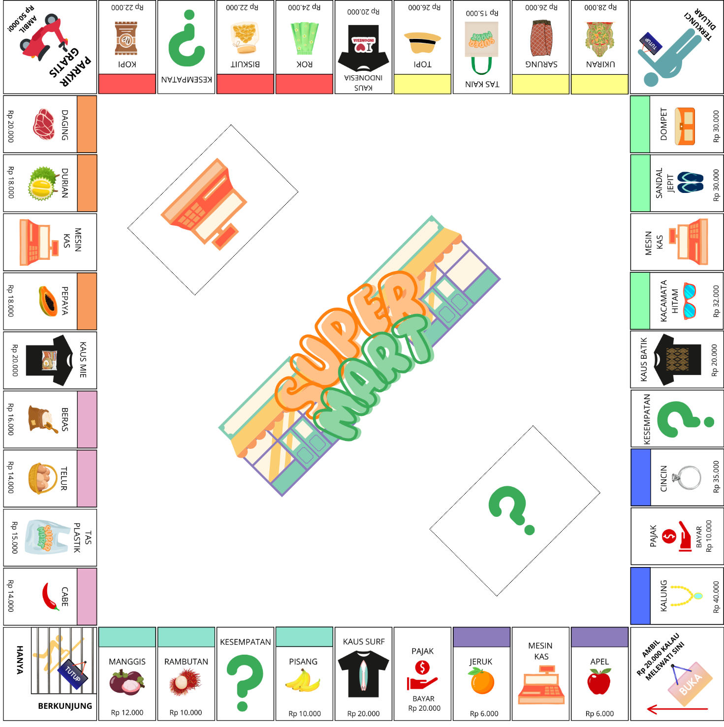
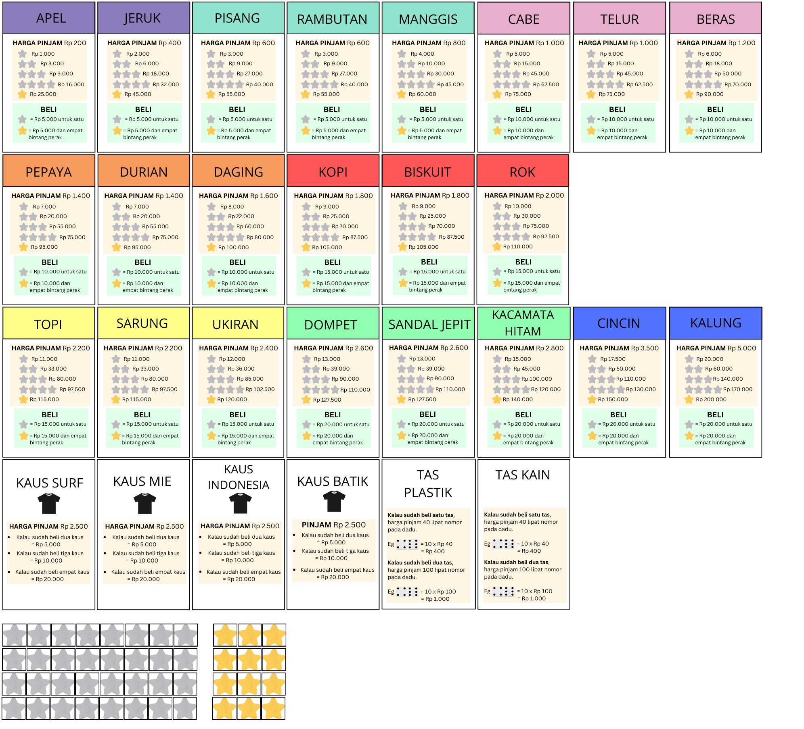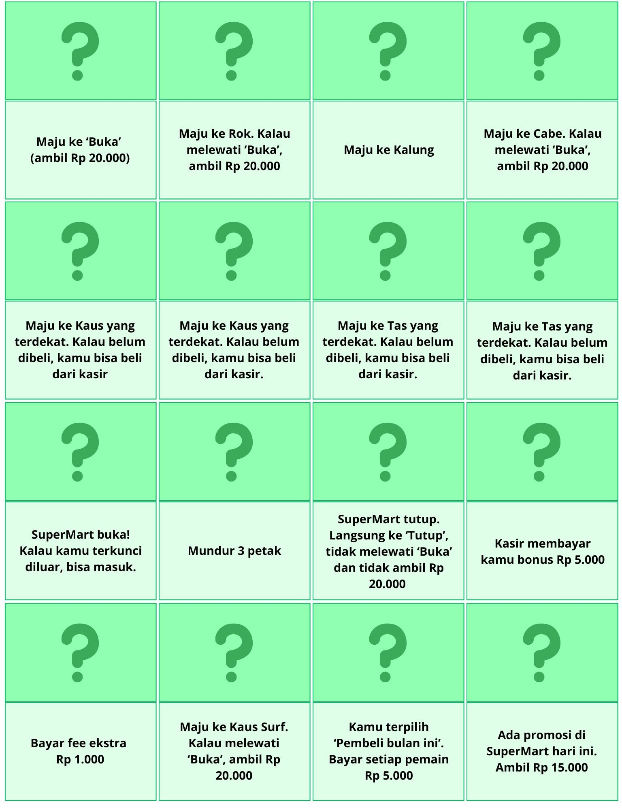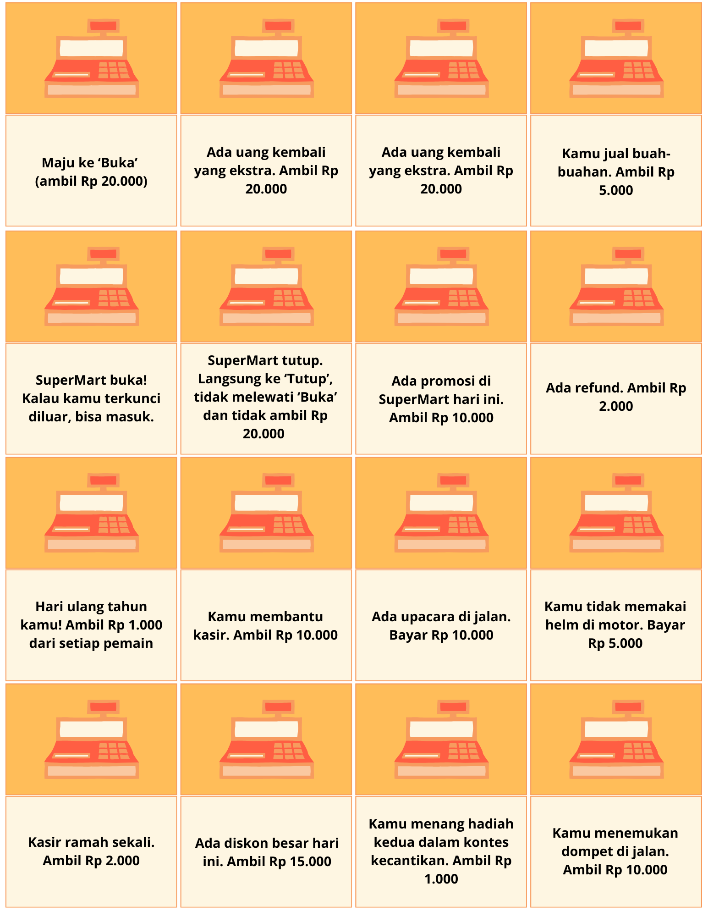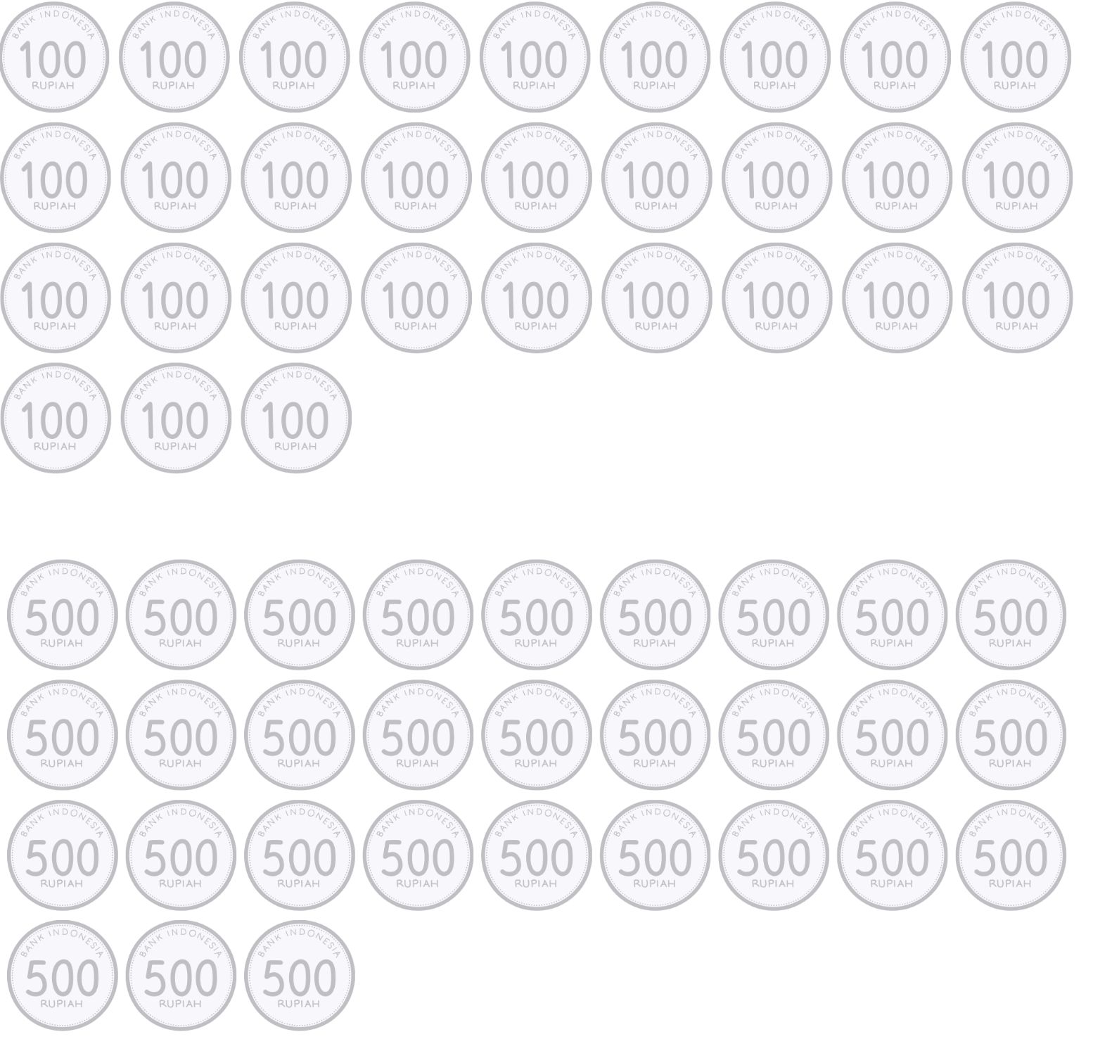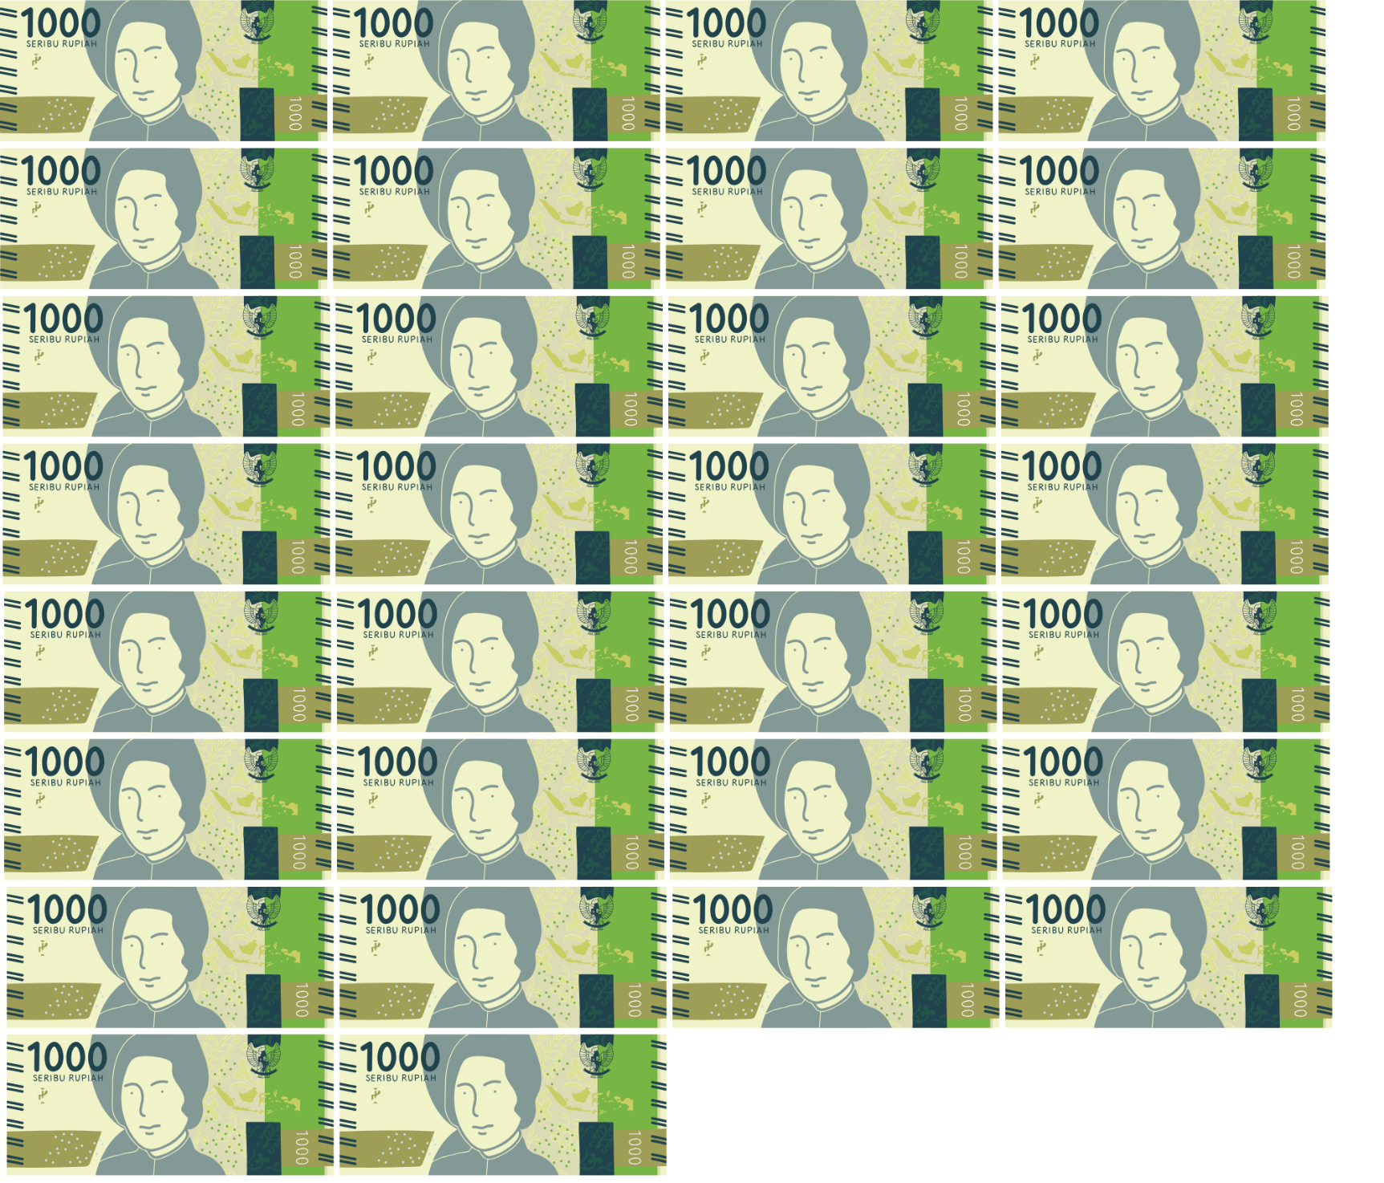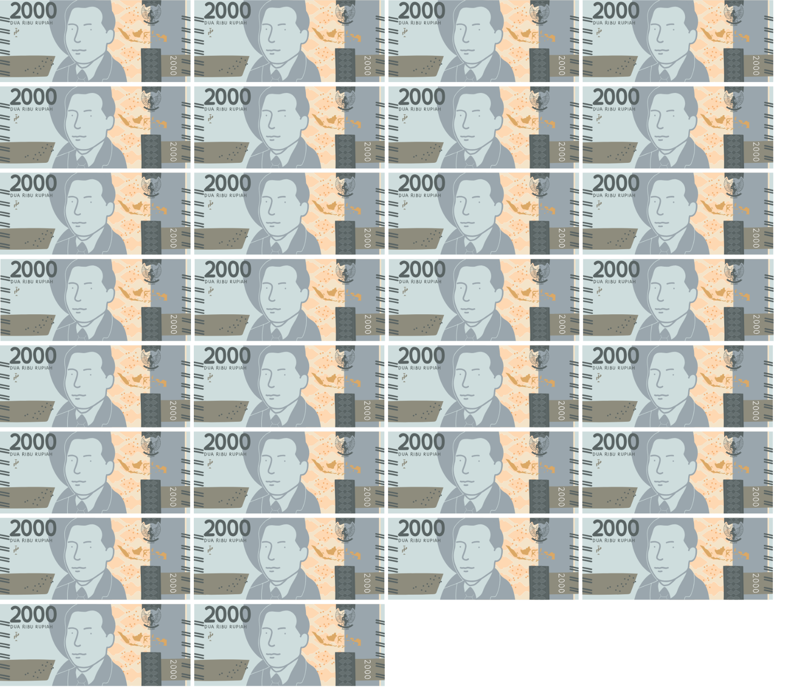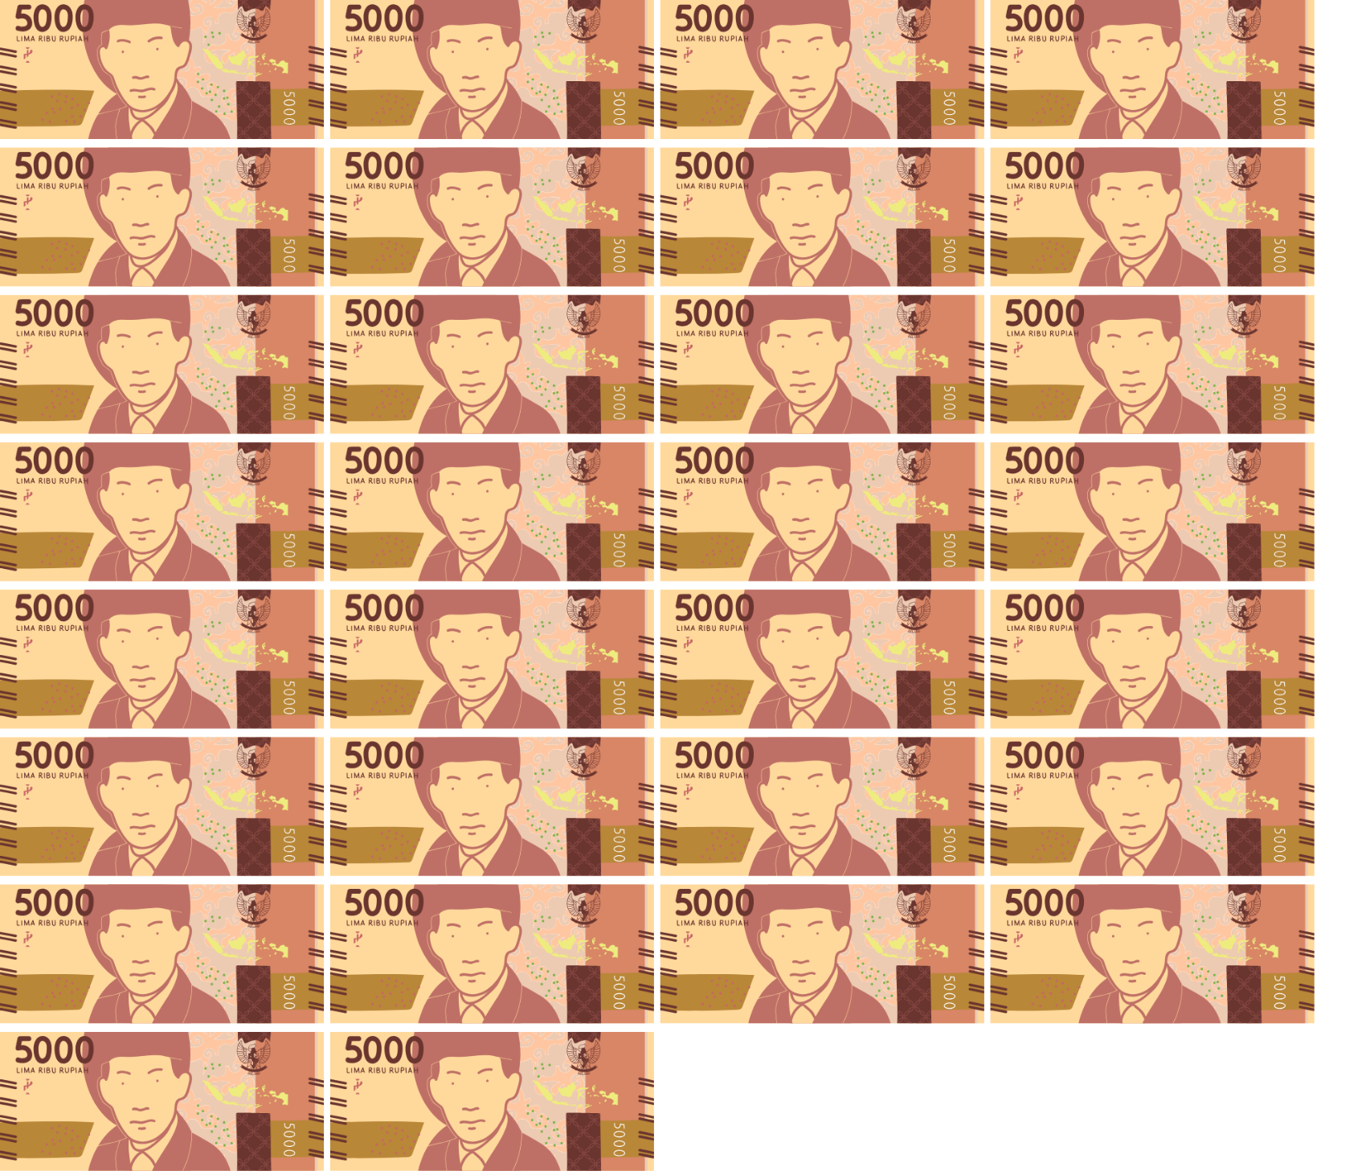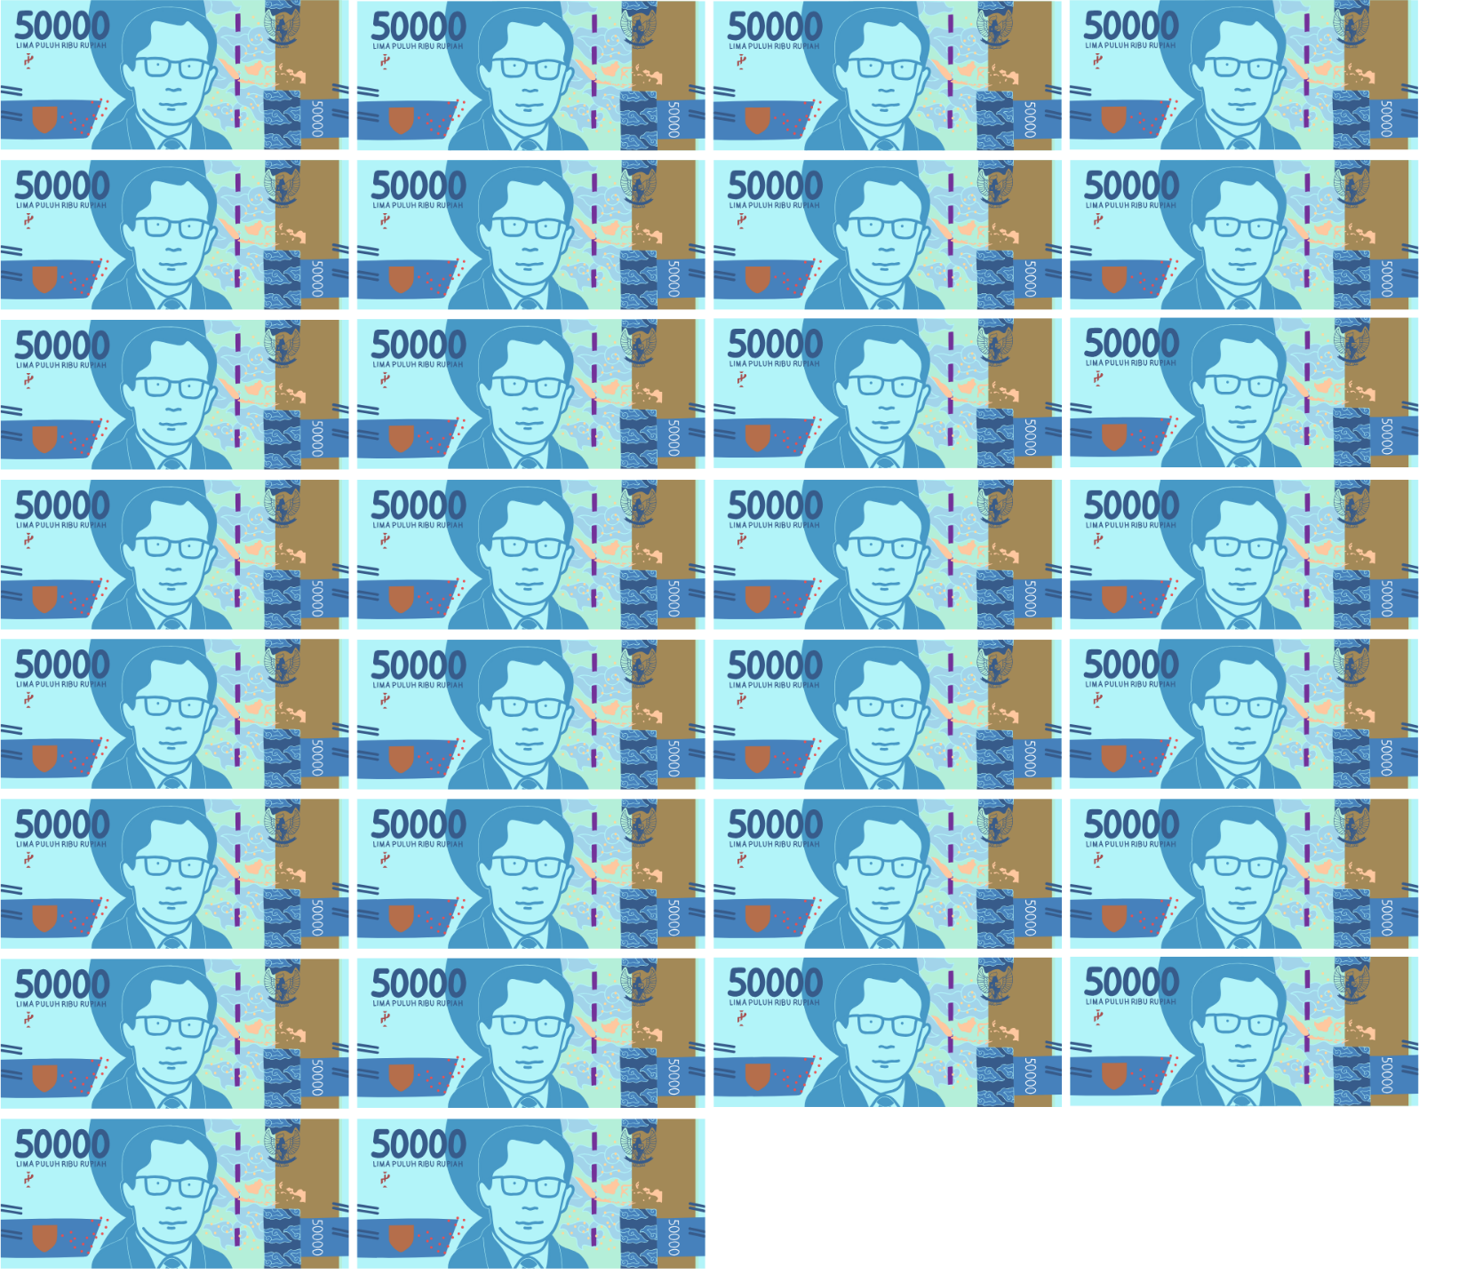
© State of New South Wales (Department of Education), 2024
The copyright material published in this resource is subject to the Copyright Act 1968 (Cth) and is owned by the NSW Department of Education or, where indicated, by a party other than the NSW Department of Education (third-party material).
Copyright material available in this resource and owned by the NSW Department of Education is licensed under a Creative Commons Attribution 4.0 International (CC BY 4.0) license.
This license allows you to share and adapt the material for any purpose, even commercially.
Attribution should be given to © State of New South Wales (Department of Education), 2024.
Material in this resource not available under a Creative Commons license:
- the NSW Department of Education logo, other logos and trademark-protected material
- material owned by a third party that has been reproduced with permission. You will need to obtain permission from the third party to reuse its material.
Links to third-party material and websites
Please note that the provided (reading/viewing material/list/links/texts) are a suggestion only and implies no endorsement, by the New South Wales Department of Education, of any author, publisher, or book title. School principals and teachers are best placed to assess the suitability of resources that would complement the curriculum and reflect the needs and interests of their students.
If you use the links provided in this document to access a third-party's website, you acknowledge that the terms of use, including licence terms set out on the third-party's website apply to the use which may be made of the materials on that third-party website or where permitted by the Copyright Act 1968 (Cth). The department accepts no responsibility for content on third-party websites.

