Find your match
This resource is for the teacher. It provides the content and instructions you need to share with students.
Use the ‘Find your match playing cards’ provided or use the editable version on Canva.
Print and cut out the cards, ensuring there is enough for one per student. Give one card to each student and tell students to keep their card hidden.
Students must walk around the classroom aiming to find the classmate who has their matching picture card. To find their match, students must ask each other Mau beli apa? (What do you want to buy?). Students respond in Indonesian, outlining what they want to buy. Their sentence must correspond to the item they have on their card and include the colour and at least one other adjective (for example, Saya mau beli kaus hijau dan kecil).
If they say an item which is different to what their classmate is looking for, their classmate will respond Tidak ada (I don’t have that) and move on to the next classmate. If their classmate responds with the same item that their peer has, they can respond Saya juga! (Me too!). The game ends when every student has found their match.
Differentiation examples
Students with advanced proficiency – where possible, give students with advanced proficiency the same cards. Once they have ‘found’ their match, encourage students to use the target language to discuss why they would or would not like to purchase this item.
High potential and gifted students – encourage students to include further details in their responses such as additional adjectives, adverbs and conjunctions.
Students requiring additional support – give students a list of sample phrases such as saya mau beli, ada, tidak ada, to support students to participate in the activity.

Find your match playing cards
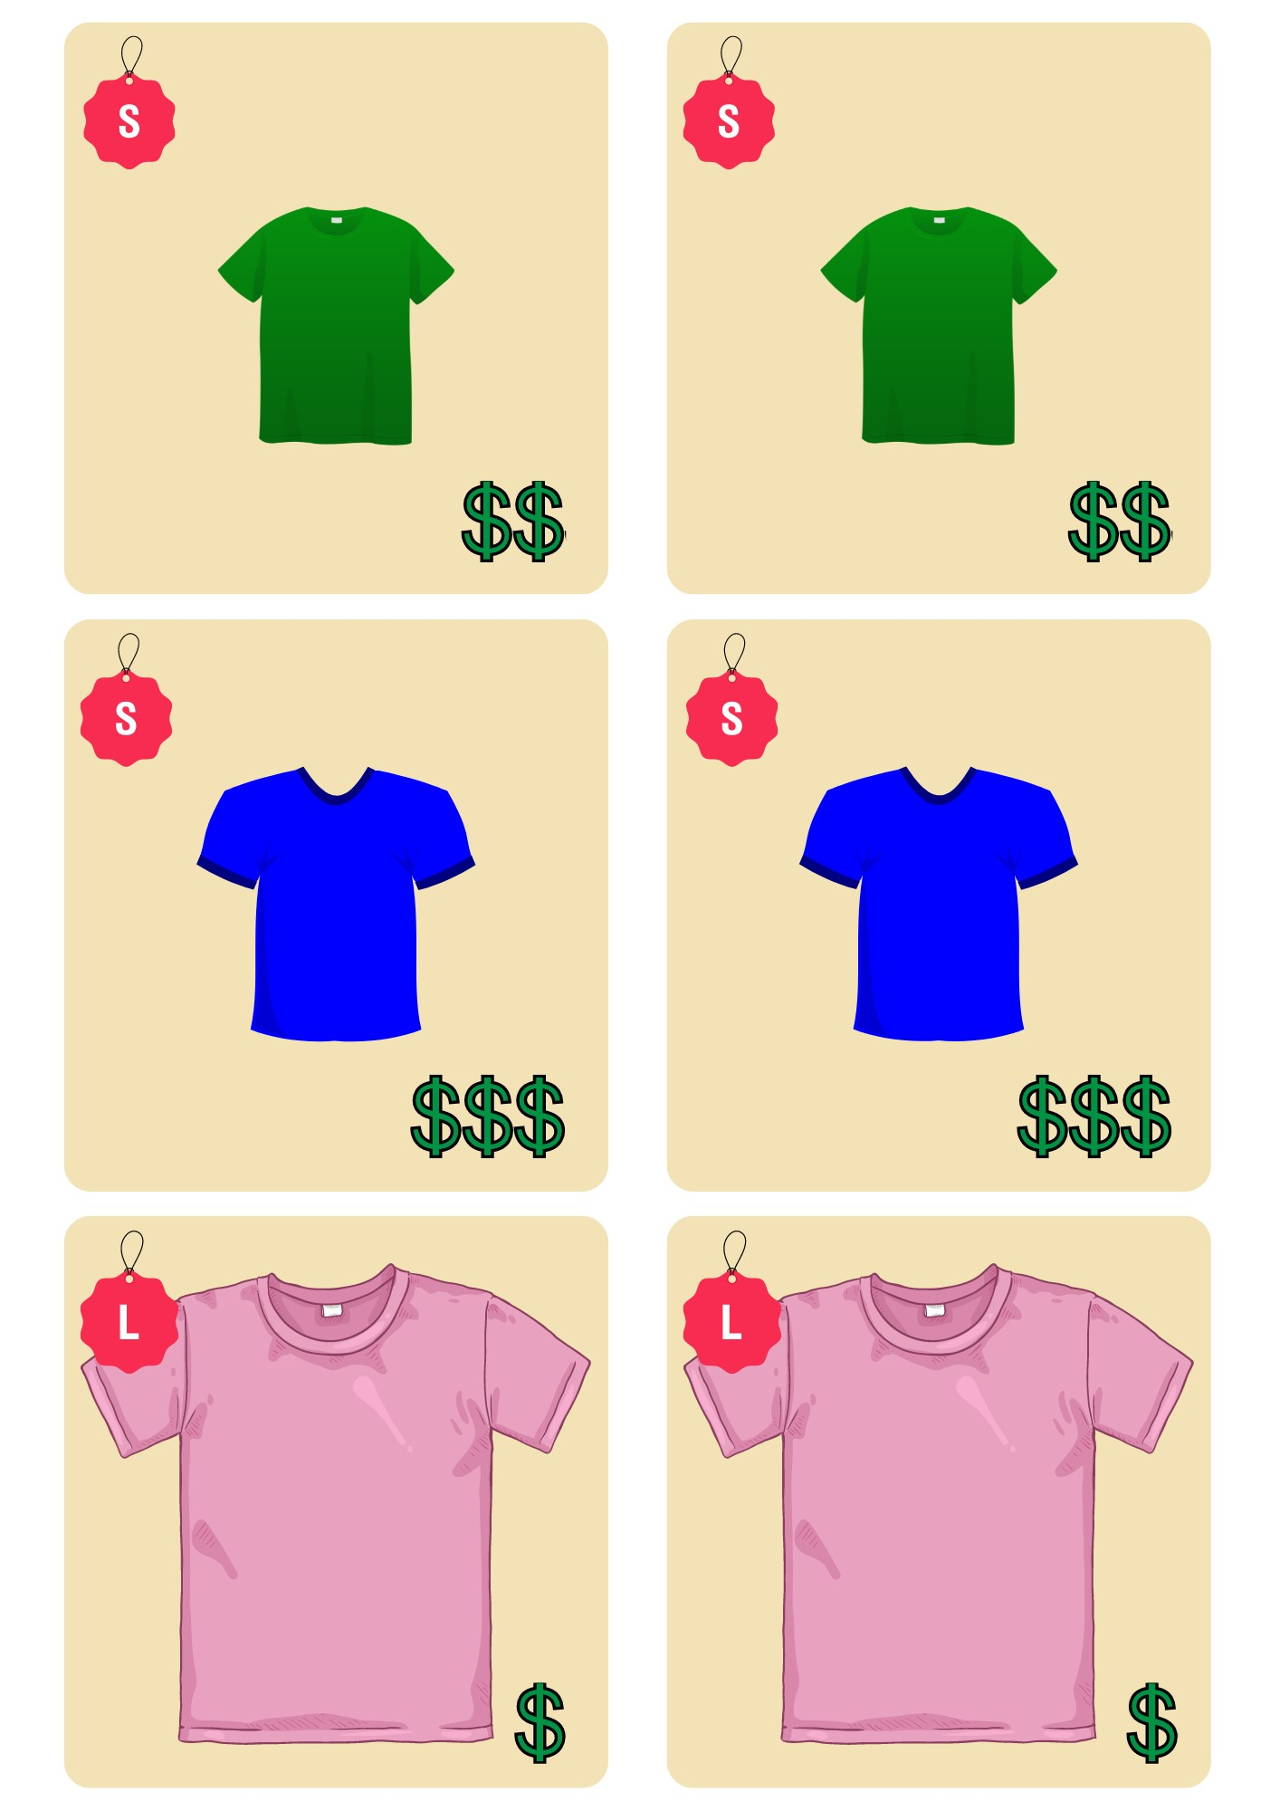
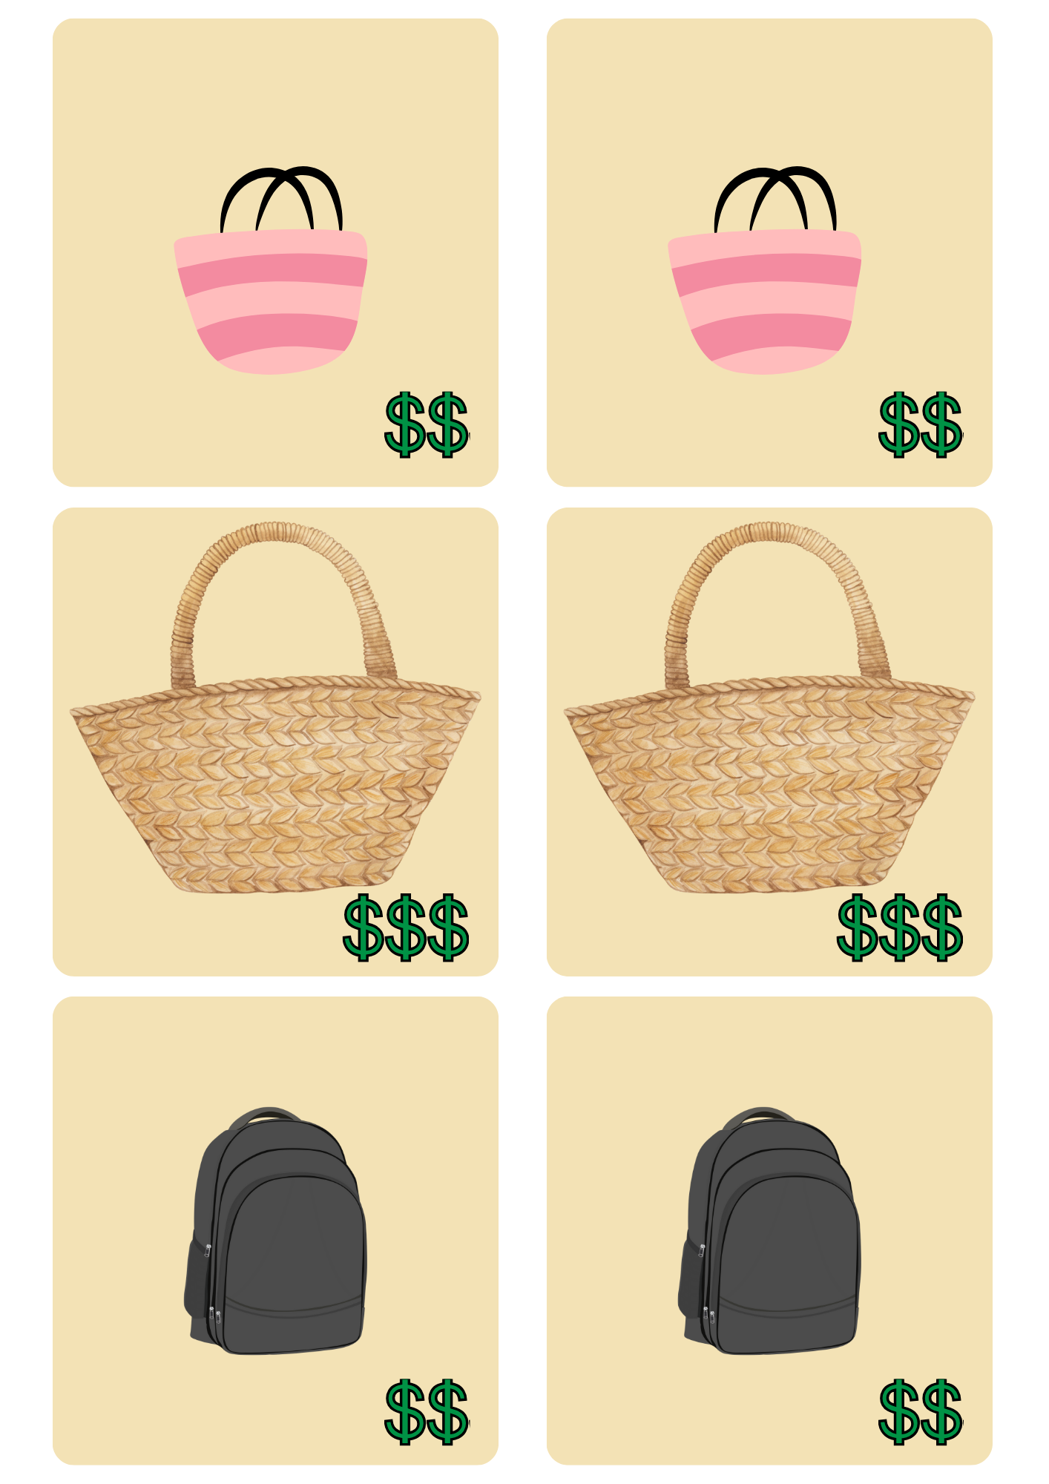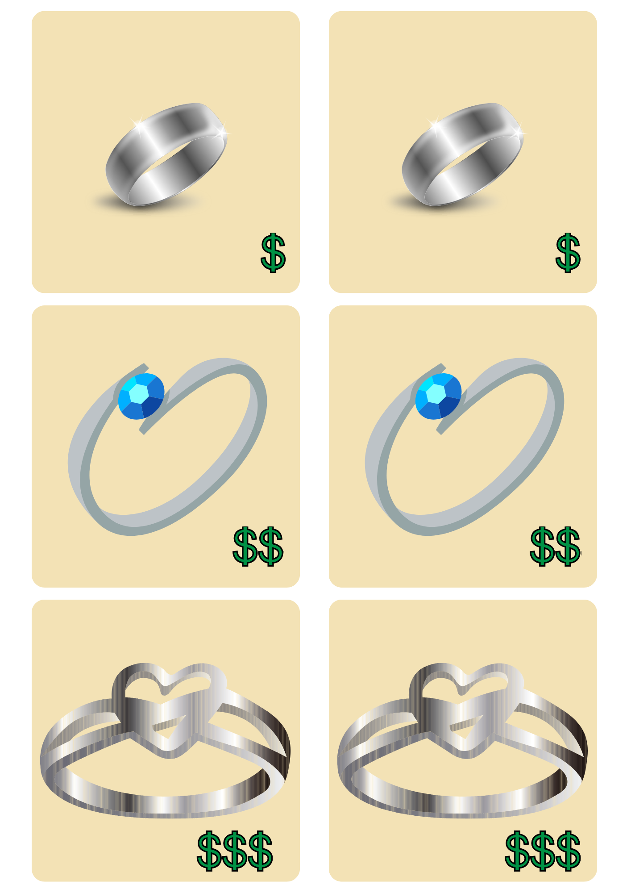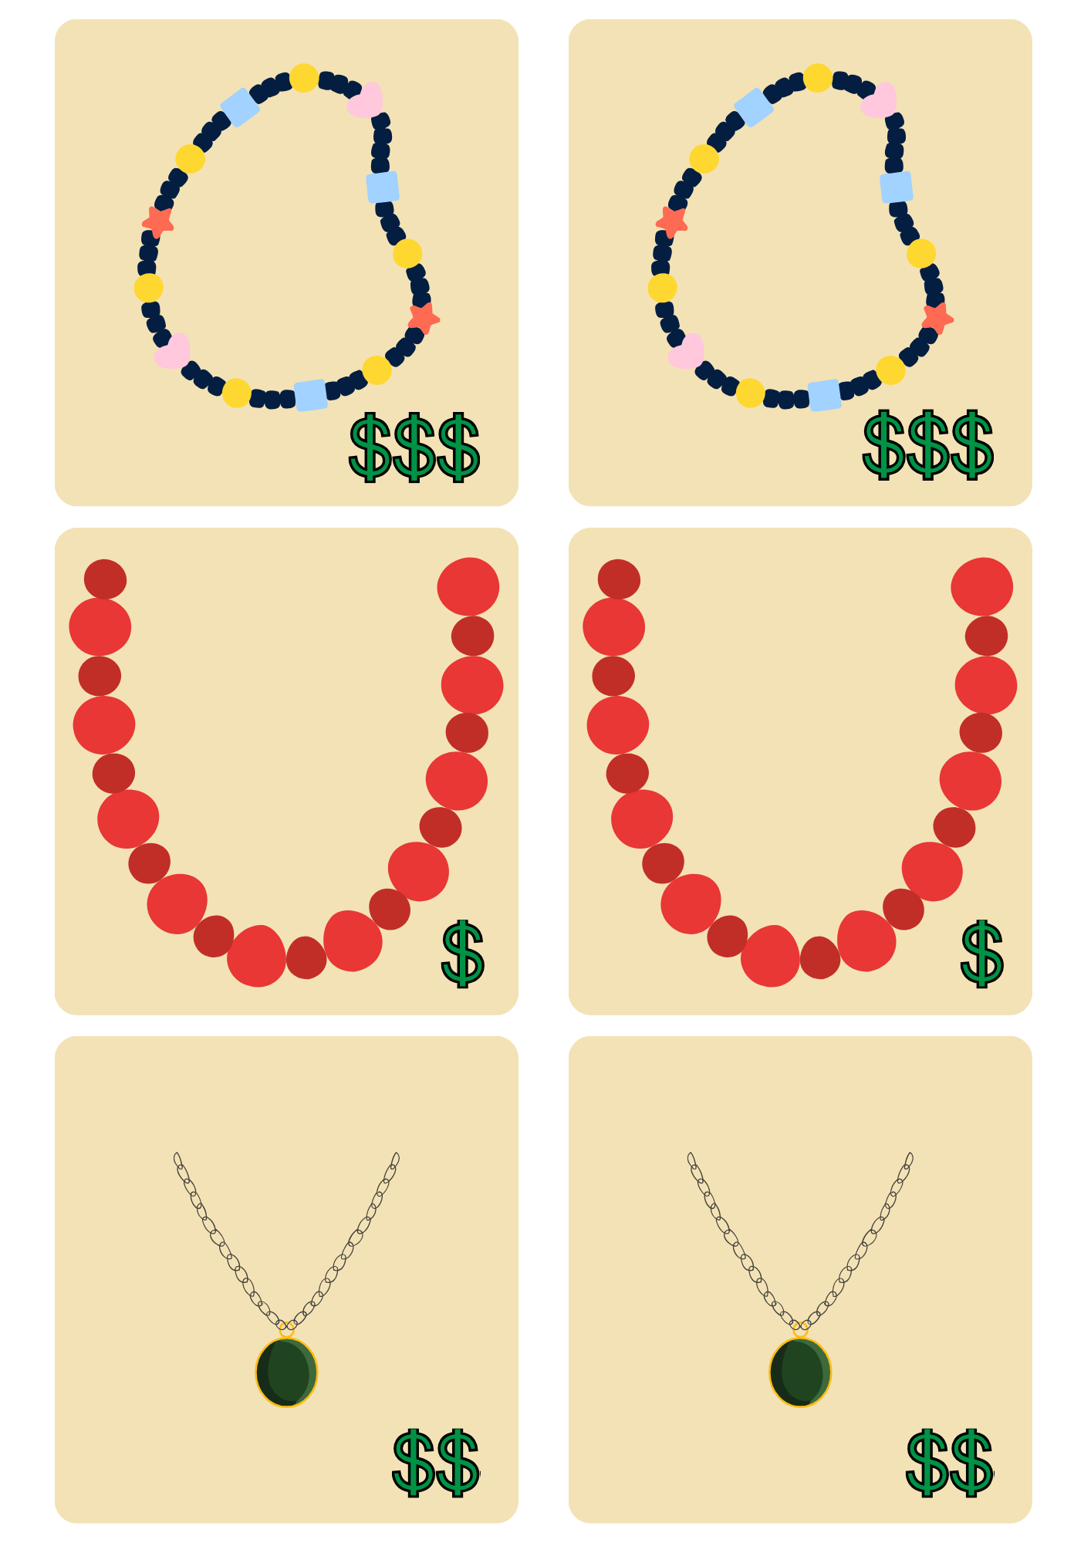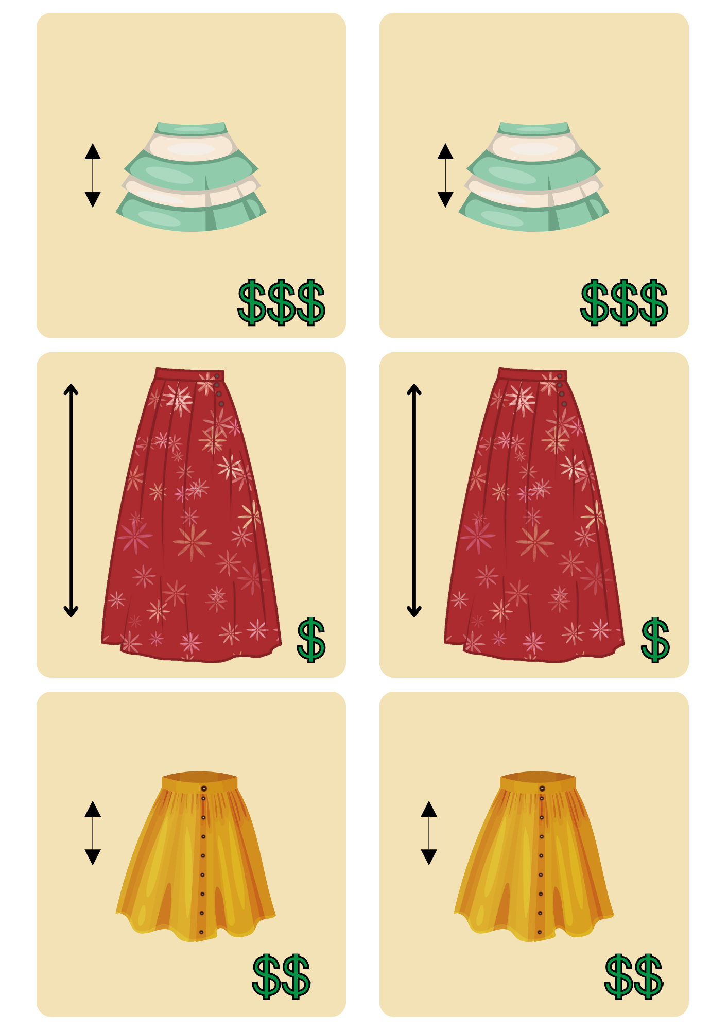

© State of New South Wales (Department of Education), 2024
The copyright material published in this resource is subject to the Copyright Act 1968 (Cth) and is owned by the NSW Department of Education or, where indicated, by a party other than the NSW Department of Education (third-party material).
Copyright material available in this resource and owned by the NSW Department of Education is licensed under a Creative Commons Attribution 4.0 International (CC BY 4.0) license.
This license allows you to share and adapt the material for any purpose, even commercially.
Attribution should be given to © State of New South Wales (Department of Education), 2024.
Material in this resource not available under a Creative Commons license:
- the NSW Department of Education logo, other logos and trademark-protected material
- material owned by a third party that has been reproduced with permission. You will need to obtain permission from the third party to reuse its material.
Links to third-party material and websites
Please note that the provided (reading/viewing material/list/links/texts) are a suggestion only and implies no endorsement, by the New South Wales Department of Education, of any author, publisher, or book title. School principals and teachers are best placed to assess the suitability of resources that would complement the curriculum and reflect the needs and interests of their students.
If you use the links provided in this document to access a third-party's website, you acknowledge that the terms of use, including licence terms set out on the third-party's website apply to the use which may be made of the materials on that third-party website or where permitted by the Copyright Act 1968 (Cth). The department accepts no responsibility for content on third-party websites.

